Hyperion Mobile — Progress Update
Versions 2.1.1 – 2.3.3 | May 2026

Google Play
App updated on Google Play. Current version: 2.3.3 (build 17).

Button Sounds & Transitions — v2.2.0
- Tap sound on every button and interactive element via a custom InteractiveInkFeatureFactory wired into the Material theme splashFactory.
- Fixed white screen flash on navigation — scaffoldBackgroundColor is now dark, and a unified PageTransitionsTheme is applied across all platforms.
- Fixed button sounds not playing on Windows (platform channel initialisation order).

Profile Page Refactor — v2.2.1
- Profile page rewritten with MVVM architecture.
- Each block has its own widget and controller: avatar, edit profile, active sessions, delete account, log upload.
- Widget tests added.

Liquid Glass Navigation Bar — v2.2.2 to v2.3.0
- Frosted blur backdrop with a translucent surface tint and a subtle rim-highlight border.
- Animated sliding selection bubble with spring physics (easeOutBack curve, 320 ms).
- Shimmer flash on tap: 80 ms rise, 120 ms fade-out.
- Icon scale animation (AnimatedScale) and font-weight transition (AnimatedDefaultTextStyle) on the active tab.
- All colours sourced from AppTheme constants.

Performance — v2.3.1 to v2.3.2
Result: median build + raster time dropped to ~7 ms. 96% of frames within the 60 fps budget (16.6 ms).

Navigation bar (v2.3.1)
- Blur layer isolated in its own RepaintBoundary — tab animations no longer dirty the blur, eliminating per-frame re-rasterisation.
- Blur sigma reduced 24 to 12, halving GPU cost with no visible quality loss.
- ImageFilter.blur allocated once as a static final instead of on every build.

Pages & background effects (v2.3.2)
- LazyIndexedStack: each tab is mounted on first visit and kept alive — switching is instant with no re-fired network requests.
- BasePage: sigma-63 falling-light blur wrapped in RepaintBoundary and cached as a GPU texture.
- Device and plugin list tiles each isolated in RepaintBoundary — a toggle animation on one tile no longer re-rasterises neighbours.

Safe Area — v2.3.3
Added correct bottom inset below the navigation bar. It is no longer covered by system controls (Android gesture bar / iOS home indicator).

Screenshots
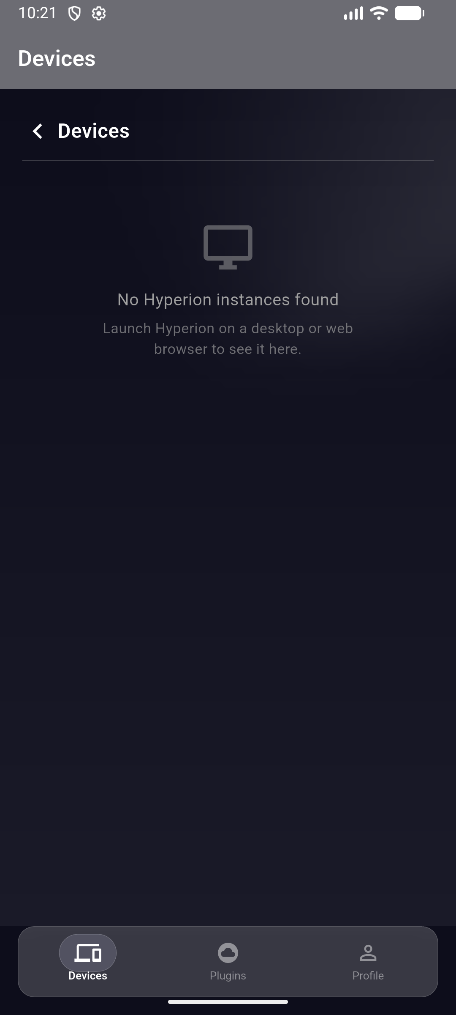

Source Code
GitHub
https://github.com/IoannTerrible/Hyperion.Flutter

Version History
Version | Build | Changes
2.1.1 | 9 | Persist password-reset step across app switches
2.2.0 | 10 | Button sounds, white-flash fix on transitions
2.2.1 | 11 | MVVM profile page refactor
2.2.2 | 12 | Liquid glass navbar, audio asset fix
2.2.3 | 13 | AppTheme constants in navbar
2.3.0 | 14 | Sliding bubble, shimmer, spring animations
2.3.1 | 15 | Navbar perf fix (blur isolation, sigma divided by 2)
2.3.2 | 16 | LazyIndexedStack, cached blur, tile isolation
2.3.3 | 17 | Bottom safe area inset

