Traineeship Application
Sprint Report

Sakellariou Ioanna, AM: 5125
Mouselimi Amalia-Georgia, AM: 5074
Zioga Despoina, AM: 5055

VERSIONS HISTORY
Date | Version | Description | Author
20.05.2025 | v.1.0.0 | A non-profitable traineeship app | Ioanna Sakellariou,  Amalia-Georgia Mouselimi,  Despoina Zioga

- Introduction
  - Purpose
The goal of this project is to create an application designed to assist the University’s traineeship committee in overseeing and managing both available and assigned traineeship opportunities. The system will enable companies to post open traineeship positions, while students will have the ability to browse and explore these opportunities. The traineeship committee will handle the assignment of positions to students based on various selection criteria. Additionally, the committee will designate professors to supervise the assigned traineeships. Both professors and company representatives will be responsible for conducting the final evaluations of the students’ performance during their traineeship.
  - Document Structure
The rest of this document is structured as follows. Section 2 describes out Scrum team and specifies this Sprint's backlog. Section 3 specifies the main design concepts for this release of the project.
- Scrum team and Sprint Backlog
  - Scrum team
Product Owner | Sakellariou Ioanna / Mouselimi Amalia-Georgia / Zioga Despoina
Scrum Master | Sakellariou Ioanna
Development Team | Sakellariou Ioanna / Mouselimi Amalia-Georgia / Zioga Despoina

  - Sprints
Sprint No | Begin Date | End Date | Number of weeks | User stories
1 | 09.03.2025 | 26.03.2025 | 2.5 | US1, US2, US3 (login-logout)
2 | 29.03.2025 | 5.04.2025 | 1 | US4, US7, US13, US16
3 | 6.04.2025 | 27.04.2025 | 3 | US5, US8, US9, US10, US11, US14
4 | 30.04.2025 | 14.05.2025 | 2 | US17, US18, US19 US20, US6
5 | 15.05.2025 | 20.05.2025 | 1 | US12, US15, US21

- Use Cases
  - Create Account
Use case ID | UC1
Actors | User
Pre conditions | The system has loaded.
Main flow of events | - The use case starts when the user presses "Register".  - The system displays user information fields: Username, Full Name, Role (Student, Company, Professor, Committee).  - The user fills in the form and presses the ‘register’ button.  - The system confirms successful registration.
Alternative flow 1 | At any time the user may leave the application.
Post conditions | The account is saved in the system.

  - Login
Use case ID | UC2
Actors | User
Pre conditions | User has an account.
Main flow of events | - The use case starts when the user presses “login”.  - The user enters the credentials.  - The system authenticates and logs the user in.
Alternative flow 1 | At any time the user may leave the application.
Alternative flow 2 | Invalid credentials, it shows an error message.
Post conditions | User is logged in.

  - Logout
Use case ID | UC3
Actors | User
Pre conditions | User is logged in.
Main flow of events | - The use case starts when the user presses “Logout”  - System ends session and redirects to login.
Alternative flow 1 | At any time the user may leave the application.
Post conditions | User is logged out.
  - Edit Student Profile
Use case ID | UC4
Actors | Student
Pre conditions | Logged in as a student.
Main flow of events | - The use case starts when the user presses "Edit Profile".  - Enters Full Name, University ID, Interests, Skills, Preferred Location.  - Submits the form.
Alternative flow 1 | At any time the user may leave the application.
Alternative flow 2 | At any time the user may leave the edit form by pressing “Back to Dashboard”.
Post conditions | Student profile is saved.
  - Edit Company Profile
Use case ID | UC5
Actors | Company
Pre conditions | Logged in as a company.
Main flow of events | - The use case starts when the user presses "Edit Profile".  - Enters Company Name and Location.  - Submits the form.
Alternative flow 1 | At any time the user may leave the application.
Alternative flow 2 | At any time the user may leave the edit form by pressing “Back to Dashboard”.
Post conditions | Company profile is saved.
  - Edit Professor Profile
Use case ID | UC6
Actors | Professor
Pre conditions | Logged in as a professor.
Main flow of events | - The use case starts when the user presses "Edit Profile".  - Enters Full Name and Interests.  - Submits the form.
Alternative flow 1 | At any time the user may leave the application.
Alternative flow 2 | At any time the user may leave the edit form by pressing “Back to Dashboard”.
Post conditions | Professor profile is saved.
  - Apply For Traineeship
Use case ID | UC7
Actors | Student
Pre conditions | Student is logged in and has a profile.
Main flow of events | - The use case starts when the student clicks “Available Positions”.  - Views the available traineeships.  - Select a position and clicks “Apply”.  - The System confirms the application.
Alternative flow 1 | At any time the user may leave the application.
Post conditions | The application is stored and visible to the committee.
  - Fill in Traineeship Logbook
Use case ID | UC8
Actors | Student
Pre conditions | Traineeship is assigned.
Main flow of events | - The use case starts when the user presses “Logbook”.  - Enters their report .  - Submits log entry.
Alternative flow 1 | At any time the user may leave the application.
Alternative flow 2 | At any time the user may leave the edit form by pressing “Back to Dashboard”.
Post conditions | Entry is saved.
  - Announce Traineeship Position
Use case ID | UC9
Actors | Company
Pre conditions | Logged in as company and user has pressed “My Posted Positions”.
Main flow of events | - The use case starts when the user presses “Add Position”  - Fills in: Start/End Dates, Description, Required Skills and Topics  - Submits the position.  - The system saves the position.
Alternative flow 1 | At any time the user may leave the application.
Alternative flow 2 | At any time the user may leave the edit form by pressing “Back to Dashboard”.
Post conditions | Position becomes available to students.
  - Assign Traineeship to Student
Use case ID | UC10
Actors | Traineeship Committee Member
Pre conditions | Application exists, logged in as committee member and has already pressed “Show Student Applications”.
Main flow of events | - The use case starts when the user presses “Suggest Positions” on the selected student.  - Filters available positions based on interests and location.  - Assign position to the student by pressing “Assign”.
Alternative flow 1 | At any time the user may leave the application.
Alternative flow 2 | At any time the user may leave the assign process by pressing “Back to Dashboard”.
Alternative flow 3 | At any time the user may leave the assign process by pressing “Back to Applications”.
Post conditions | Traineeship is assigned to student.
  - View Supervised Traineeships
Use case ID | UC11
Actors | Professor
Pre conditions | Application exists and professor is logged in.
Main flow of events | - The use case starts when the user presses “View Supervised Positions”.  - The system displays a list of traineeships assigned to them.  - The user can view details for each.
Alternative flow 1 | At any time the user may leave the application.
Alternative flow 2 | At any time the user may leave the assign process by pressing “Back to Dashboard”.
Post conditions | The professor sees their assigned traineeships.
  - Evaluate a Traineeship and Company
Use case ID | UC12
Actors | Professor
Pre conditions | The professor is logged in and supervises a traineeship.
Main flow of events | - The use case starts when the user presses “View Supervised Positions”.  - The system displays the traineeships supervised by the user.  - The user presses “Evaluate”  - The system displays an evaluation form.  - The user rates the student based on motivation, effectiveness and efficiency.  - The user evaluates the company based on facilities and guidance.  - The user submits the form by pressing “Submit Evaluation”
Alternative flow 1 | At any time the user may leave the application.
Alternative flow 2 | At any time the user may leave the evaluation process by pressing “Back to Dashboard”.
Post conditions | Evaluation data is saved and viewable by the committee.
  - Assign Supervising Professor
Use case ID | UC13
Actors | Committee Member
Pre conditions | Application exists, committee member is logged in and an active traineeship exists.
Main flow of events | - The use case starts when the user presses “Assign Supervisor”.  - The user presses “Assign” on the selected Traineeship.  - The system suggests professors based on interests or workload.  - The committee assigns a professor by pressing “Assign”.  - The system updates the record.
Alternative flow 1 | At any time the user may leave the application.
Alternative flow 2 | At any time the user may leave the assign process by pressing “Back to Dashboard”.
Post conditions | Professor is assigned to a Traineeship position.
  - View Applied Students
Use case ID | UC14
Actors | Committee Member
Pre conditions | Application exists and committee member is logged in.
Main flow of events | - The use case starts when the user presses “Show Student Applications”.  - The system loads the student applicants.
Alternative flow 1 | At any time the user may leave the application.
Alternative flow 2 | At any time the user may leave the assign process by pressing “Back to Dashboard”.
Post conditions | Committee Member views the applicants and can proceed to match with positions.
  - Monitor Traineeship Progress
Use case ID | UC15
Actors | Committee Member
Pre conditions | Application exists, committee member is logged in and traineeships are ongoing.
Main flow of events | - The use case starts when the user presses “View In-Progress Traineeships”.  - If no students have applied for a traineeship the user is shown a page that reads “No traineeships in progress”  - If a student has applied for a traineeship the user is shown a page with the information of the in-progress traineeships.
Alternative flow 1 | At any time the user may leave the application.
Alternative flow 2 | At any time the user may leave the monitor process by pressing “Back to Dashboard”.
Post conditions | The committee monitors the traineeships.
  - Complete Traineeship with Pass/Fail
Use case ID | UC16
Actors | Committee Member
Pre conditions | Application exists, committee member is logged in, evaluations of professor and company are submitted and user has pressed “View In-Progress Traineeships”.
Main flow of events | - The use case starts when the user presses “View Evaluations”.  - The user is redirected to the evaluation review page.  - The user then can complete a Traineeship with a “pass” or “fail” mark by pressing the corresponding button.  - The system is updated.
Alternative flow 1 | At any time the user may leave the application.
Alternative flow 2 | At any time the user may leave the monitor process by pressing “Back to Dashboard”.
Post conditions | The traineeship is finalized.
  - Evaluate a Traineeship
Use case ID | UC17
Actors | Company
Pre conditions | Company is logged in, hosts a traineeship and pressed “Assigned Positions”.
Main flow of events | - The use case starts when the user presses “Evaluate”.  - The system displays an evaluation form.  - The user rates the traineeship based on motivation, effectiveness and efficiency.  - The user submits the form by pressing “Submit Evaluation”
Alternative flow 1 | At any time the user may leave the application.
Alternative flow 2 | At any time the user may leave the evaluation process by pressing “Back to Dashboard”.
Post conditions | Evaluation data is saved.
  - View Available Traineeship Positions
Use case ID | UC18
Actors | Student
Pre conditions | Application exists, student is logged in, a company hosts a traineeship and student has a profile.
Main flow of events | - The use case starts when the user presses “Available Positions”.  - The user is shown a page with information about the available positions.
Alternative flow 1 | At any time the user may leave the application.
Alternative flow 2 | At any time the user may leave the evaluation process by pressing “Back to Dashboard”.
Post conditions | Student is informed about opportunities.
  - Delete Traineeship Position
Use case ID | UC19
Actors | Company
Pre conditions | Application exists, company is logged in, hosts a traineeship and the user is in the tab “Advertised Positions”.
Main flow of events | - The use case starts when the user presses “Delete”
Alternative flow 1 | At any time the user may leave the application.
Alternative flow 2 | At any time the user may leave the evaluation process by pressing “Back to Dashboard”.
Post conditions | Position is removed
  - View Assigned Traineeships
Use case ID | UC20
Actors | Company
Pre conditions | Application exists, company is logged in and a position that the company has announced has been assigned.
Main flow of events | - The use case starts when the user presses “Assigned Positions”  - The user is shown informations about the assigned Traineeships.
Alternative flow 1 | At any time the user may leave the application.
Alternative flow 2 | At any time the user may leave the evaluation process by pressing “Back to Dashboard”.
Post conditions | Company manages assignments.
  - View In-Progress Traineeships
Use case ID | UC21
Actors | Committee Member
Pre conditions | Committee member is logged in, traineeships exist and are active.
Main flow of events | - The use case starts when the user presses “View”.  - The user can track status, professor, company.
Alternative flow 1 | At any time the user may leave the application.
Alternative flow 2 | At any time the user may leave the evaluation process by pressing “Back to Dashboard”.
Post conditions | Full visibility of running traineeships.
  - Search Available Positions for Student
Use case ID | UC22
Actors | Committee Member
Pre conditions | Committee member is logged in, traineeships exist and student profile exist.
Main flow of events | - The use case starts when the user presses “View”.  - The user can track status, professor, company.
Alternative flow 1 | At any time the user may leave the application.
Alternative flow 2 | At any time the user may leave the evaluation process by pressing “Back to Dashboard”.
Post conditions | Full visibility of running traineeships.
  - View Traineeship History
Use case ID | UC23
Actors | Committee Member
Pre conditions | Committee member is logged in, there are completed traineeships stored in the system.
Main flow of events | - The use case starts when the user presses “View Completed Traineeships”.  - The user can see informations about the completed traineeships.
Alternative flow 1 | At any time the user may leave the application.
Alternative flow 2 | At any time the user may leave the evaluation process by pressing “Back to Dashboard”.
Post conditions | Full visibility of completed traineeships.

- Design
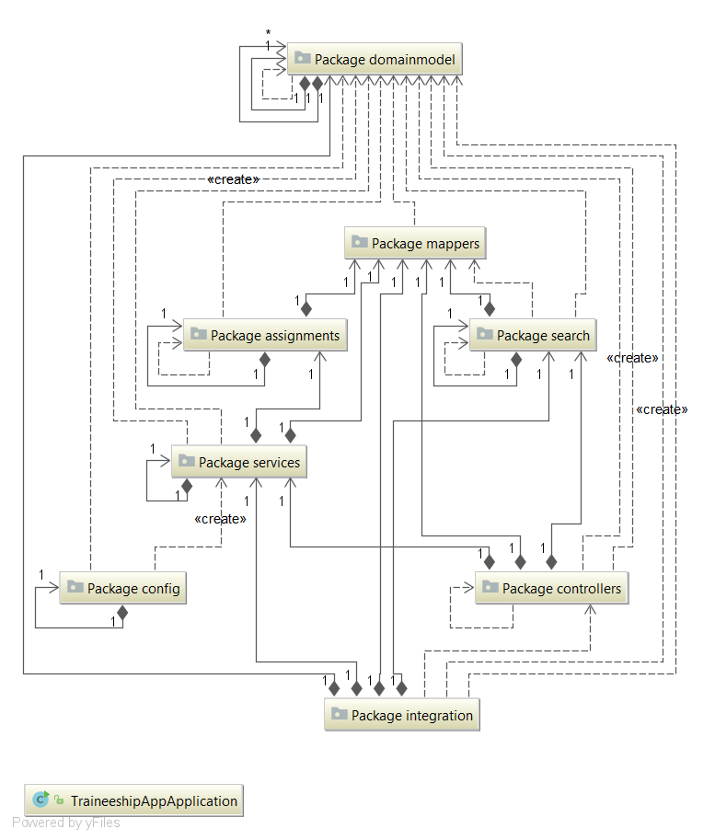
  - Architecture
  - Design
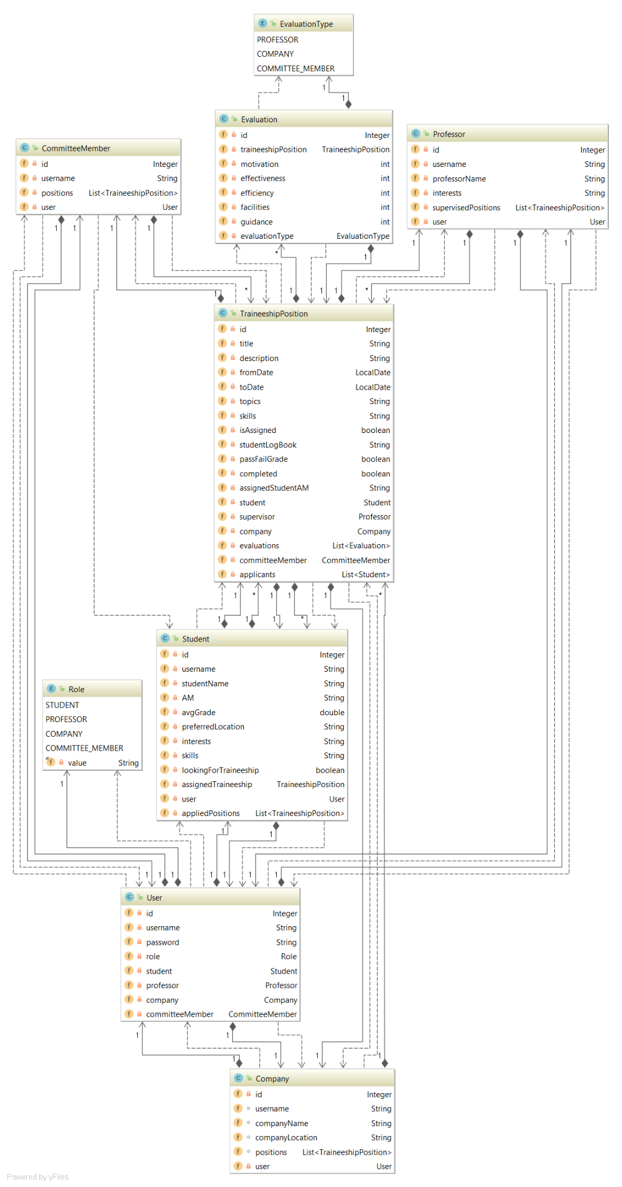
Domain model:
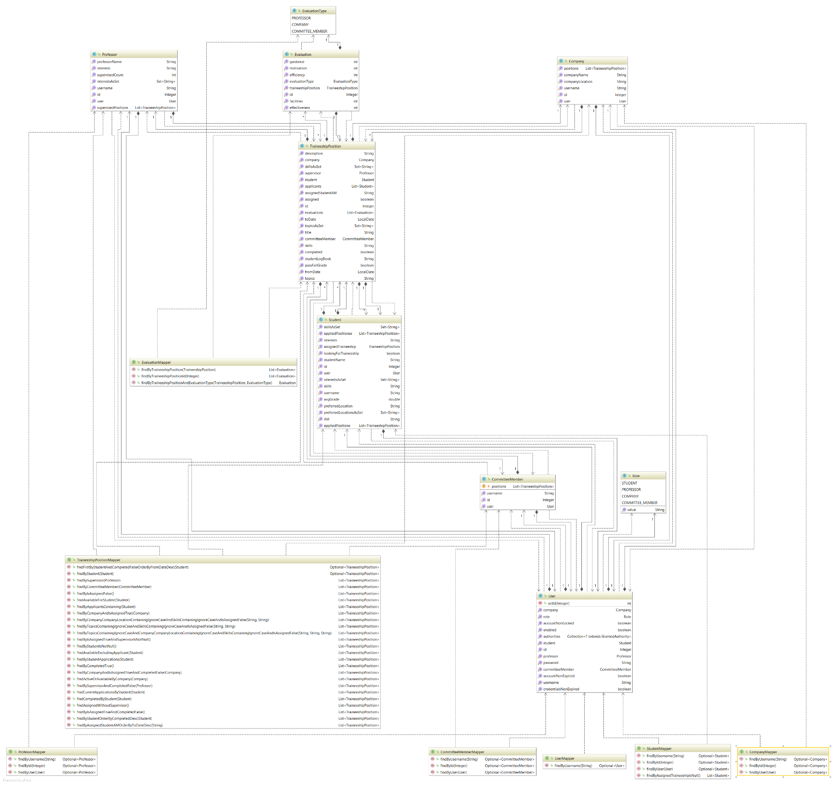
Data Mappers:

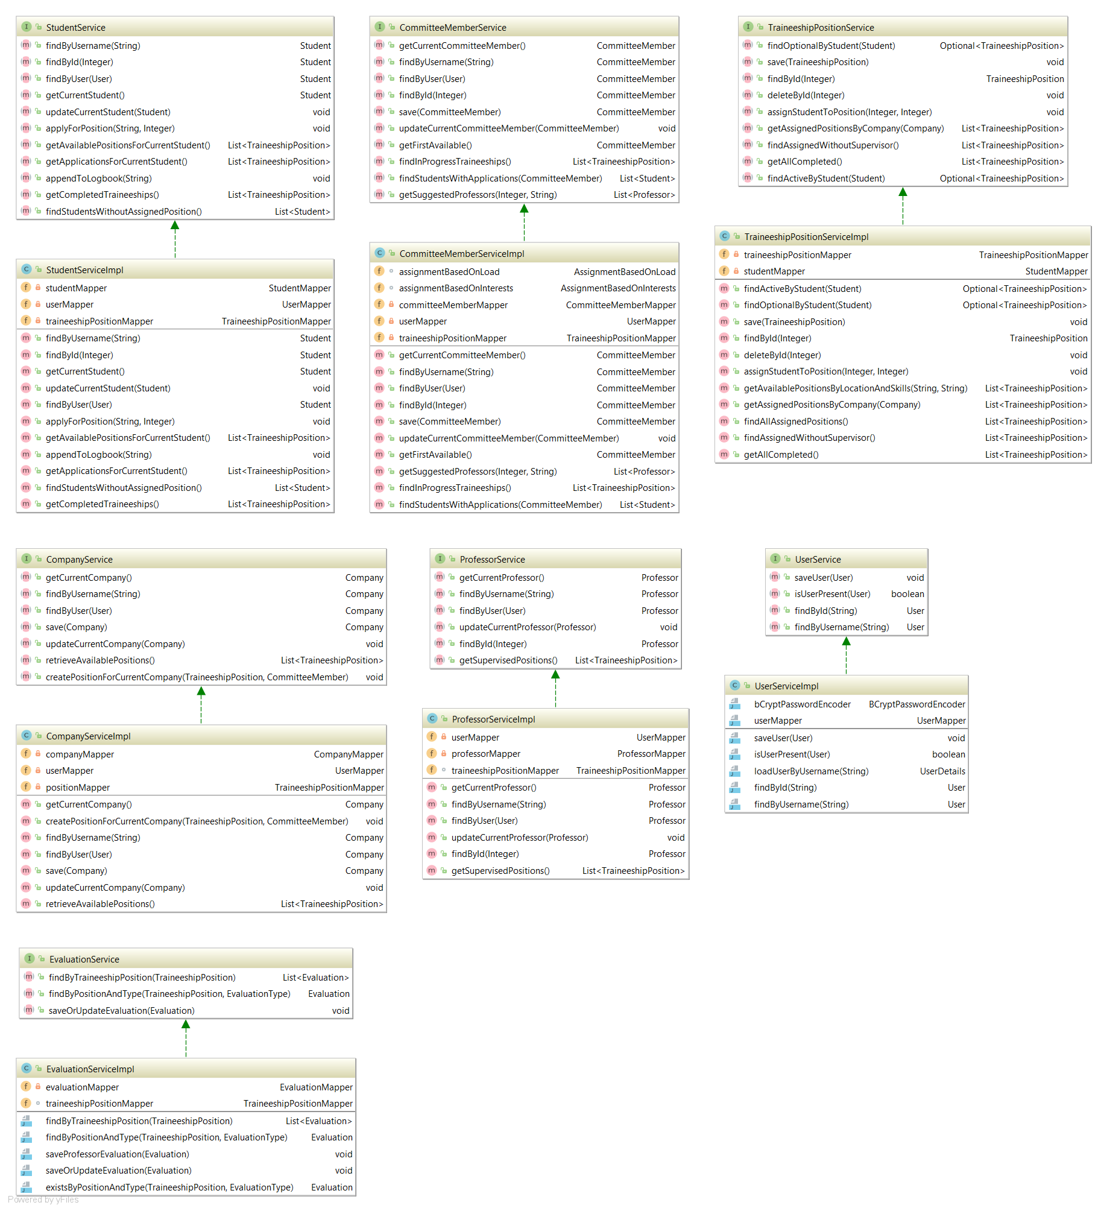
Services:
Search Strategy:
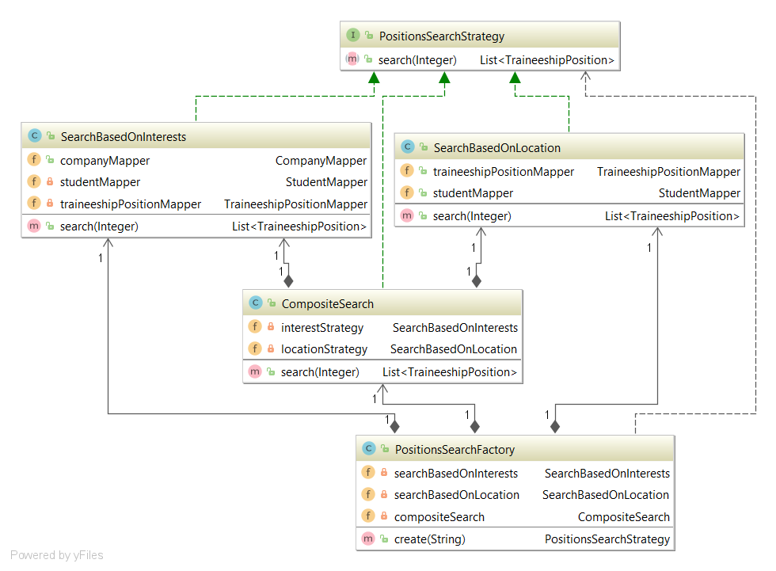

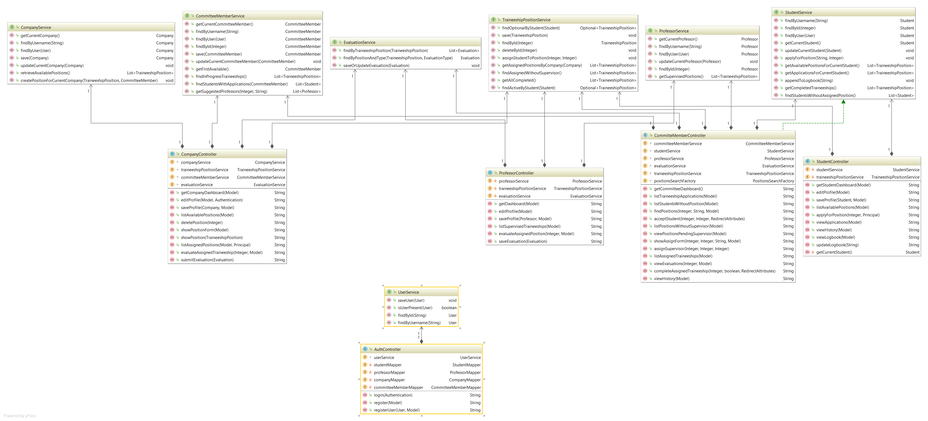
Controllers:

Student Controller:
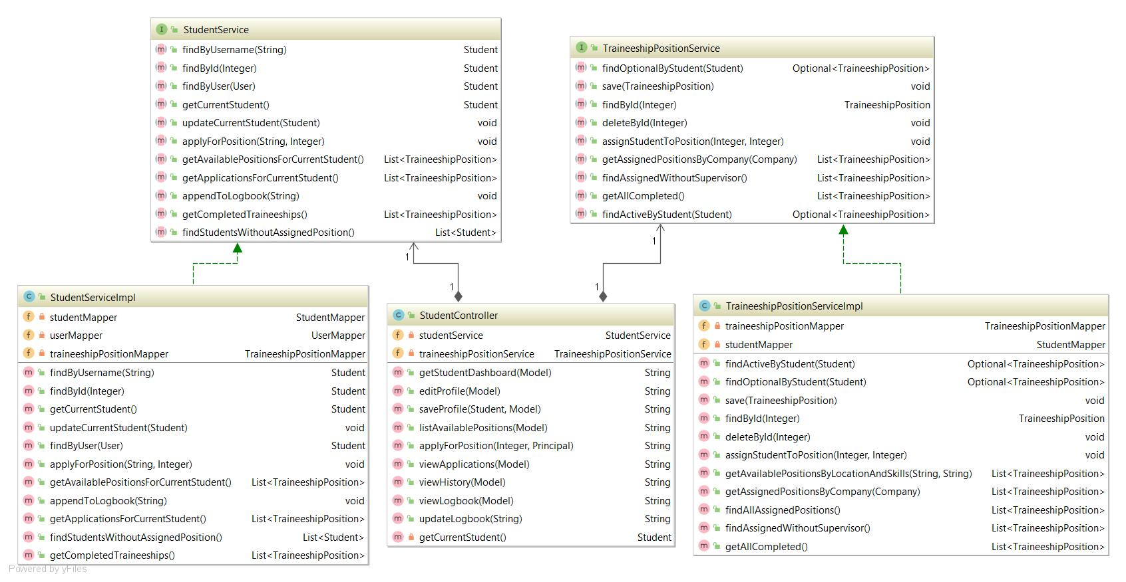
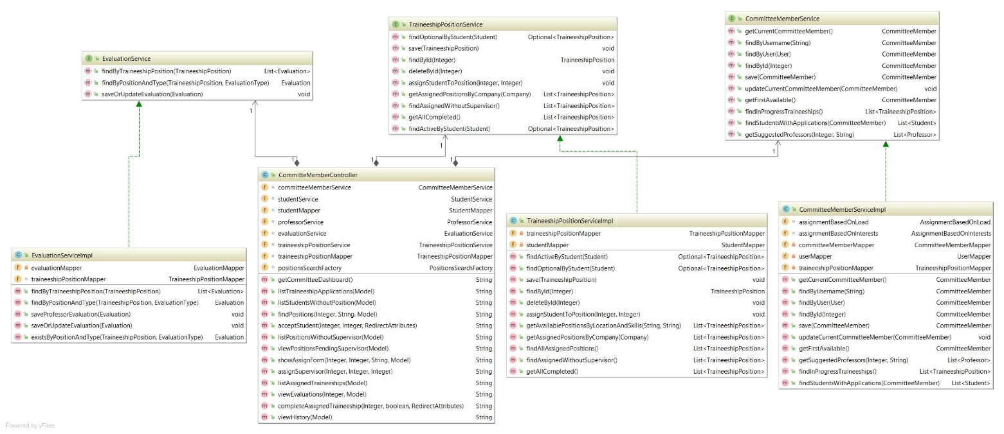
Committee Member Controller:

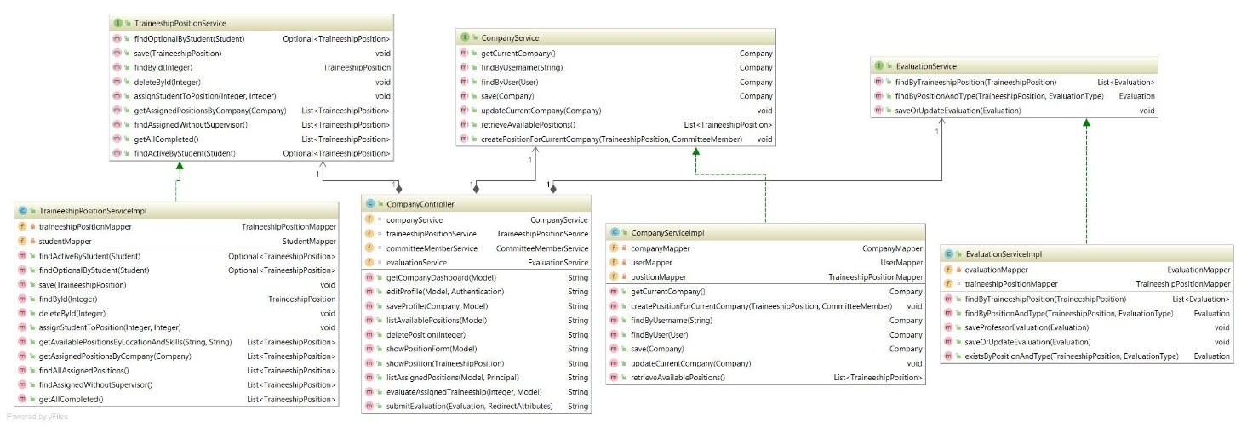
Company Controller:

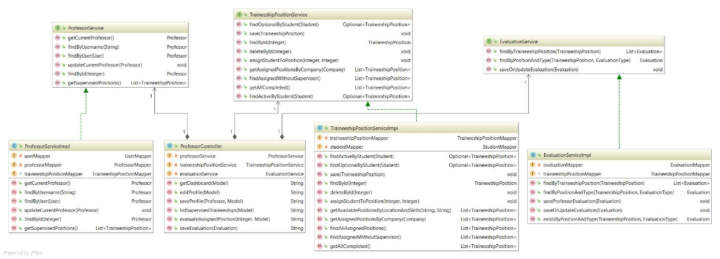
Professor Controller:

The classes that are included in this release are given below:

Class Name: AuthController
Responsibilities:  - Handles user login, registration, and redirection. | Collaborations:  - Uses UserService.  - Interacts with mappers: StudentMapper, ProfessorMapper, CompanyMapper, CommitteeMemberMapper.

Class Name: CommitteMemberController
Responsibilities:  - Committee user functionality: viewing applications, suggesting positions, assigning supervisors, and marking completions. | Collaborations:  - Uses CommitteeMemberService, ProfessorService, StudentService, TraineeshipPositionService, EvaluationService, PositionsSearchFactory.

Class Name: CompanyController
Responsibilities:  - Allows company users to edit profiles, create and manage positions, and submit evaluations. | Collaborations:  - Interacts with CompanyService, CommitteeMemberService, TraineeshipPositionService, EvaluationService.

Class Name: ProfessorController
Responsibilities:  - Handles professor dashboard, profile editing, supervision tracking, and evaluations. | Collaborations:  - Uses ProfessorService, EvaluationService, TraineeshipPositionService.

Class Name: StudentController
Responsibilities:  - Manages student dashboard, profile, available positions, applications, and logbook updates. | Collaborations:  - Works with StudentService, TraineeshipPositionService.

Class Name: Student
Responsibilities:  - Contains student profile data and preferences. | Collaborations:  - One-to-one with User.  - Many-to-many with TraineeshipPosition (applications).  - One-to-one with assigned TraineeshipPosition.

Class Name: Professor
Responsibilities:  - Contains professor profile and areas of interest.  - Supervises positions. | Collaborations:  - One-to-one with User.  - One-to-many with TraineeshipPosition as supervisor.

Class Name: Company
Responsibilities:  - Represents companies offering traineeship positions. | Collaborations:  - One-to-one with User.  - One-to-many with TraineeshipPosition.

Class Name: CommitteeMember
Responsibilities:  - Represents a committee member managing traineeship processes. | Collaborations:  - One-to-one with User.  - One-to-many with TraineeshipPosition.

Class Name: TraineeshipPosition
Responsibilities:  - Describes a traineeship, including assignment and evaluation state. | Collaborations:  - Linked to Company, Student, Professor, CommitteeMember, and Evaluation.  - Many-to-many with Student (applicants).

Class Name: Evaluation
Responsibilities:  - Captures evaluation scores and type (e.g. by professor or company). | Collaborations:  - Belongs to a TraineeshipPosition.  - Uses EvaluationType enum.

Class Name: User
Responsibilities:  - Represents application users.  - Implements Spring Security's UserDetails. | Collaborations:  - One-to-one relationship with Student, Professor, Company, and CommitteeMember.

Class Name: Role
Responsibilities:  - Enum for defining user roles: STUDENT, PROFESSOR, COMPANY, COMMITTEE_MEMBER. | Collaborations:  - Used in User for access control.

Class Name: EvaluationType
Responsibilities:  - Represents evaluation types: PROFESSOR, COMPANY, COMMITTEE_MEMBER. | Collaborations:  - Used by Evaluation to define evaluation context.

Class Name: StudentMapper
Responsibilities:  - Provides database access for Student entity. | Collaborations:  - Used in StudentServiceImpl for operations such as profile updates, application tracking, logbook updates.

Class Name: ProfessorMapper
Responsibilities:  - Manages database operations for Professor entity. | Collaborations:  - Used in ProfessorServiceImpl and assignment strategies to find suitable professors.

Class Name: CompanyMapper
Responsibilities:  - Interfaces with the database for Company entities | Collaborations:  - Used in CompanyServiceImpl to retrieve and update company data.

Class Name: CommitteeMemberMapper
Responsibilities:  - Manages persistence of CommitteeMember entities. | Collaborations:  - Used in CommitteeMemberServiceImpl for retrieving members and their responsibilities.

Class Name: TraineeshipPositionMapper
Responsibilities:  - Main interface for CRUD and custom queries on TraineeshipPosition. | Collaborations:  - Extensively used across all services and strategies (matching, assignment, evaluation).  Contains custom methods for filtering by status, company, student, supervisor, etc.

Class Name: UserMapper
Responsibilities:  - Διαχειρίζεται τους User χρήστες της εφαρμογής.  - Υπεύθυνο για την authentication (βρίσκει χρήστες με βάση το username). | Collaborations:  - Συνδέεται με User entity.  - Χρησιμοποιείται από UserService και το authentication σύστημα της Spring Security.

Class Name: EvaluationMapper
Responsibilities:  - Provides database access to Evaluation entities. | Collaborations:  - Used in EvaluationServiceImpl to fetch or save evaluations by position and type.

Class Name: StudentService
Responsibilities:  - Provides student-related operations (profile update, application, logbook). | Collaborations:  - Used in StudentController.

Class Name: StudentServiceImpl
Responsibilities:  - Implements student operations. | Collaborations:  - Works with Student, TraineeshipPosition, StudentMapper.

Class Name: ProfessorService
Responsibilities:  - Handles professor-specific features. | Collaborations:  - Interacts with TraineeshipPosition, Evaluation, Professor.

Class Name: ProfessorServiceImpl
Responsibilities:  - Implements ProfessorService. | Collaborations:  - Works with ProfessorMapper, EvaluationService, TraineeshipPositionMapper.

Class Name: CompanyService
Responsibilities:  - Manages company operations. | Collaborations:  - Used in CompanyController.

Class Name: CompanyServiceImpl
Responsibilities:  - Implements CommitteeMemberService logic. | Collaborations:  - Uses StudentMapper, ProfessorMapper, TraineeshipPositionMapper, etc.

Class Name: CommitteeMemberService
Responsibilities:  - Provides committee-related operations (student applications, professor assignment). | Collaborations:  - Used in CommitteMemberController.

Class Name: CommitteeMemberServiceImpl
Responsibilities:  - Implements CommitteeMemberService logic. | Collaborations:  - Uses StudentMapper, ProfessorMapper, TraineeshipPositionMapper, etc.

Class Name: TraineeshipPositionService
Responsibilities:  - Handles traineeship operations like create, assign, evaluate. | Collaborations:  - Used across multiple controllers.

Class Name: TraineeshipPositionServiceImpl
Responsibilities:  - Implements core logic for managing TraineeshipPosition entities. | Collaborations:  - Uses multiple mappers and services.

Class Name: EvaluationService
Responsibilities:  - Handles logic for creating and retrieving evaluations. | Collaborations:  - Used in CompanyController, ProfessorController.

Class Name: EvaluationServiceImpl
Responsibilities:  - Implements evaluation operations. | Collaborations:  - Works with EvaluationMapper, TraineeshipPositionService.

Class Name: UserService
Responsibilities:  - Handles user operations like saving and checking for duplicates. | Collaborations:  - Used by AuthController.

Class Name: UserServiceImpl
Responsibilities:  - Implements UserService logic. | Collaborations:  - Accesses user data, integrates with Spring Security.

Class Name: WebSecurityConfig
Responsibilities:  - Configures application security rules (role-based access, login/logout behavior).  - Registers the security filter chain. | Collaborations:  - Uses CustomSecuritySuccessHandler.  - Injects UserServiceImpl as UserDetailsService.

Class Name: CustomSecuritySuccessHandler
Responsibilities:  - Handles redirection after successful login based on user role. | Collaborations:  - Works with Spring Security login process.  - Uses User and its roles to determine redirection URL.

Class Name: WebMvcConfig
Responsibilities:  - Registers simple view controller for root (e.g., / → homepage). | Collaborations:  - Used by Spring MVC configuration.

Class Name: SupervisorAssignmentFactory
Responsibilities:  - Returns an assignment strategy (e.g., based on interests or load). | Collaborations:  - Returns AssignmentBasedOnLoad or AssignmentBasedOnInterests.

Class Name: AssignmentBasedOnLoad
Responsibilities:  - Assigns the least busy professor to a traineeship. | Collaborations:  - Uses ProfessorMapper and TraineeshipPositionMapper.

Class Name: AssignmentBasedOnInterests
Responsibilities:  - Assigns a professor whose interests best match the traineeship topics. | Collaborations:  - Uses ProfessorMapper and TraineeshipPositionMapper.

Class Name: SupervisorAssignmentStrategy
Responsibilities:  - Interface for professor assignment strategies. | Collaborations:  - Implemented by both AssignmentBasedOnLoad and AssignmentBasedOnInterests.

Class Name: PositionsSearchFactory
Responsibilities:  - Chooses the correct search strategy based on a given key (e.g., "interests", "location"). | Collaborations:  - Returns instances of SearchBasedOnInterests, SearchBasedOnLocation, or CompositeSearch.

Class Name: SearchBasedOnInterests
Responsibilities:  - Finds traineeships matching the student’s interests. | Collaborations:  - Uses StudentMapper, TraineeshipPositionMapper.

Class Name: SearchBasedOnLocation
Responsibilities:  - Finds traineeships based on the student’s preferred locations. | Collaborations:  - Uses StudentMapper, TraineeshipPositionMapper.

Class Name: CompositeSearch
Responsibilities:  - Combines results from interest-based and location-based search strategies. | Collaborations:  - Uses both SearchBasedOnInterests and SearchBasedOnLocation.

Class Name: PositionsSearchStrategy
Responsibilities:  - Interface for all position search strategies. | Collaborations:  - Implemented by all search strategy classes.

...................................................
...................

