# Instructions for Windows Operating System

* Install on your PC the PFX file using the given password.

*Start Windows Explorer and select and hold (or right-click) the .pfx file, then select Open to open the Certificate Import Wizard.*

*Follow the procedure in the Certificate Import Wizard to import the code-signing certificate into the Personal certificate store.*

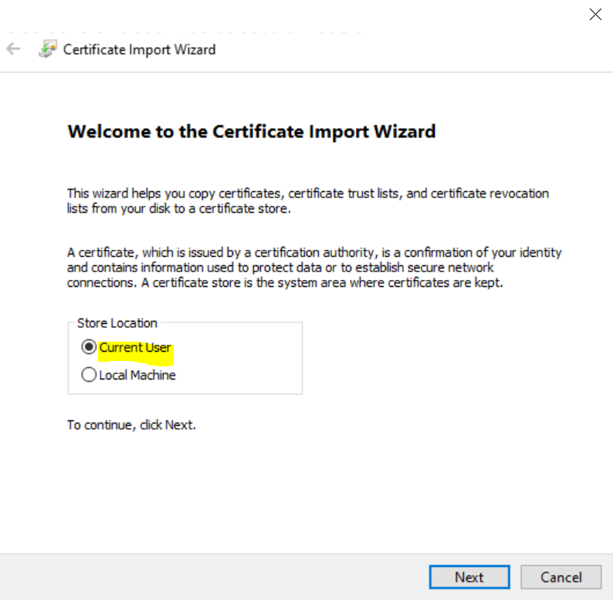

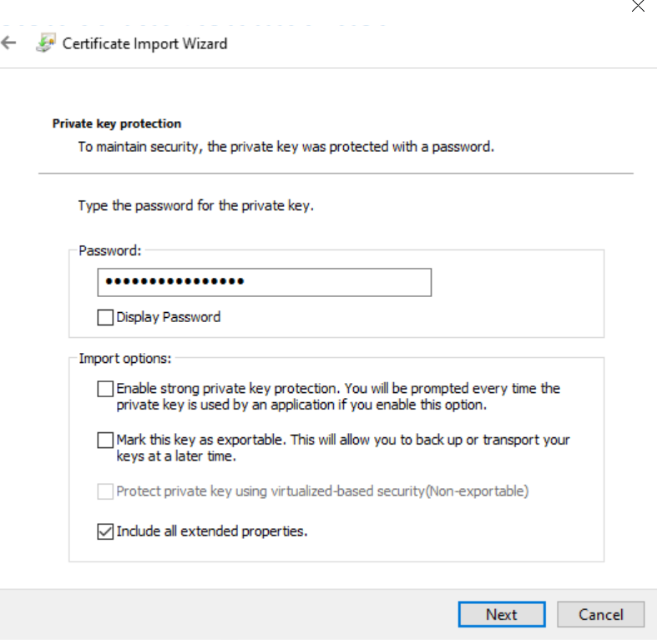

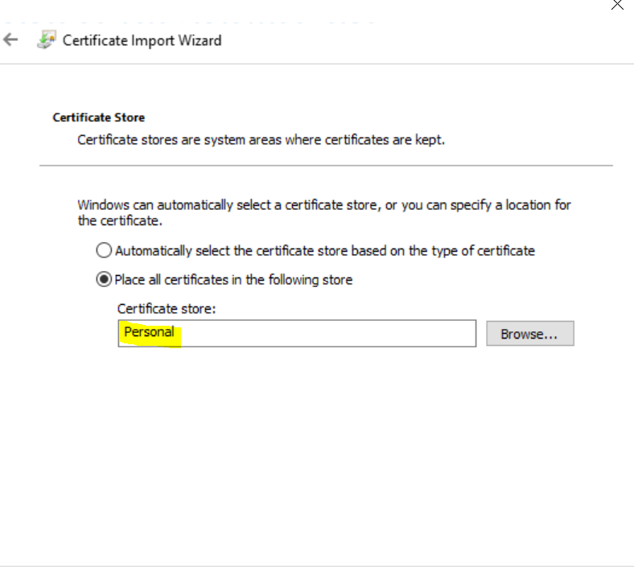

* Install the x64 VPN Client that is inside on the zip file.

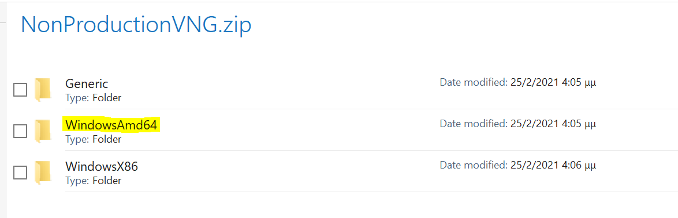

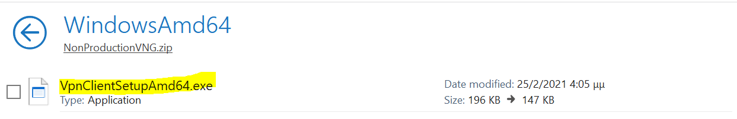

* Go to Windows Settings and search for the “VPN Settings”.

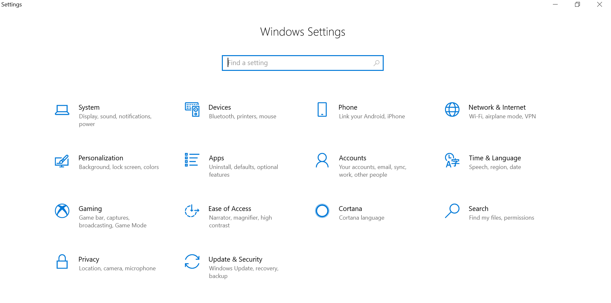

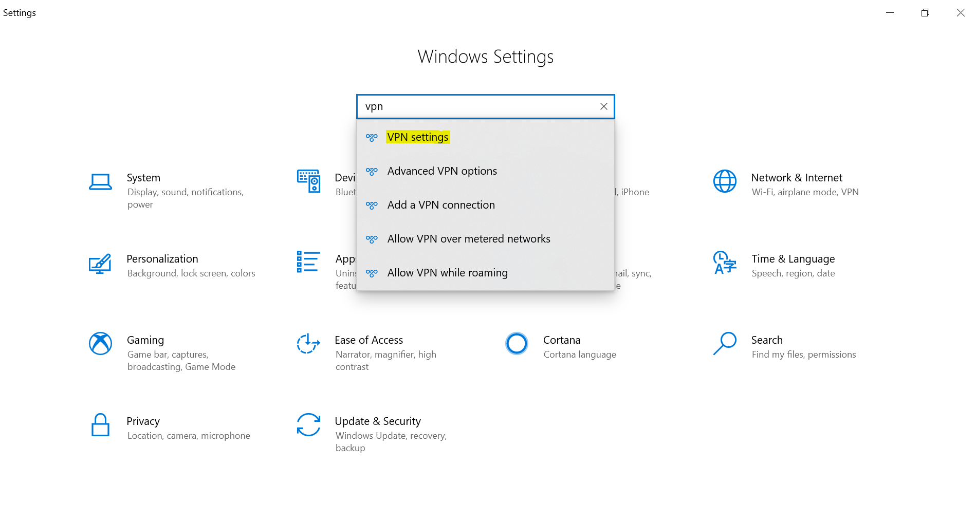

* Choose “Production” or “NonProduction” and press “Connect”.

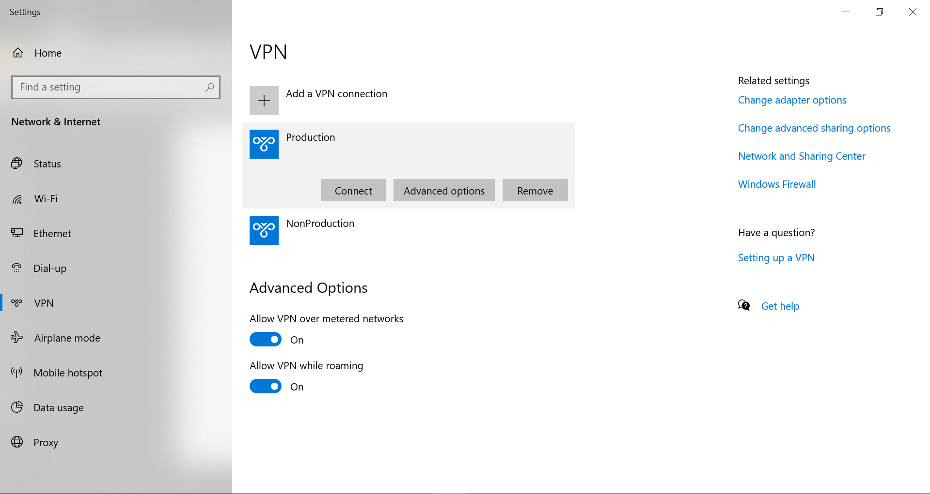

* Press again “Connect”



* Choose “More choices” and select the certificate that you installed. Press “OK” and you should be connected.

(This image is just an example; your certificate might have a different name like P2SChildCert)

