Sean White

GISG 131

27 May 2020

Ephedra Habitat Identification and Mensuration Using ENVI and ArgGIS Pro

Topic Areas

According to reporting, Afghan nationals have been harvesting increasingly large quantities of wild ephedra plants to produce methamphetamine (Mansfield, Power, Economist). This project is an attempt to use botanical, medicinal, and geological principles to identify the conditions of ideal ephedra habitat, to use cultural geographical and regional security principles to identify locations where it is most likely to have been harvested, to use open-source, free Landsat-8 OLI multispectral imagery and Esri digital elevation models to geolocate it, & to use spatial analysis and statistical modeling to estimate its quantity and decline.

Background

* Methamphetamine is a highly addictive psycho stimulant drug that was infamously used by the Japanese government to dose Kamikaze pilots before suicide missions in WWII. Even limited usage can result in permanent psychosis, heart attacks, seizures, strokes, organ failure, and death. According to the National Institute on Drug Abuse a typical dose releases 26 times more dopamine than eating an enjoyable meal and 6.5 times more dopamine than is released through intercourse.
* One growth spot of Methamphetamine use today is by combatants in warzones in Central Asia and the Middle East owing to its ability to elevate mood, productivity, alertness, to suppress appetite, and to allow fighters to go without sleep for days at a time . The spread of such a drug—even when compared to opium (which is just as addictive and used much more widely in the region, but to much less manically destructive/ homicidal effect)—could prove to be uniquely destabilizing in a vulnerable country.
* Apropos, in fall of 2019 the US-NATO coalition in Afghanistan bombed dozens of structures authorities alleged were being used as labs to produce methamphetamine in the western part of the country.
* Ephedra harvesting is thought to have been introduced to cities in Western Afghanistan, by Iran approximately 10 years ago. The practice has since spread, first gradually and now rapidly, across the country.
* Ephedra plants cluster in a relatively narrow band of dry, south facing mountain slopes below the snowline and above 2500 meters. The plants are wind pollinated, slow growing, both endemic and uniquely suited to their habitat, and most varieties will not grow back if harvested. For all these reasons the plants are not practical to cultivate.
* Stems of the ephedra plant are harvested at a rate of almost a metric ton a day per laborer on mountain slopes in the relatively dry and temperate months of late summer and early fall. The bushels are transported to and consolidated at labs where they are dried and steeped to produce methamphetamine precursors and typically processed into pills.
* The City of Herat is the capital of a NW Afghan Provence and the first major city one would encounter when heading east along the historic Khyber Pass (Route AH1) from Iran. The climate of Herat is Temperate with a dry, warm summer and it is pressed up immediately against the south, leeward side of a 300km long 2500m-3600m MSL span of the Safēd Kōh mountain range. It is located in path 157 row 37 of the Landsat 8 satellite (that began collecting imagery in 2013 and continues to today) and it should be the ideal place to select study and control areas.

Scientific Question Addressed Using Remote Sensing

As a result of human harvesting will a likely ephedra habitat study area—selected for its precipitation level, altitude, insolation, its relative ease of accessibility (proximity to major highways, population centers), its location in the NW of the country (where there should be the most historical data)—see a significant, steady & independent (of variations in annual precipitation) year over year, reduction in gross biomass (measured in NDVI) starting around 2013 and continuing until 2019 or the total removal of the plant?

Methodology/Workflow

1. Define Study Areas
   1. Import into ArcGIS Pro,
      1. ESRI Living Atlas ‘World Hillshade’ DEM
      2. My organization’s ‘Afghan Provinces Map’
      3. Any one of the Landsat Geotiff’s in the correct row and path
   2. Clip the hillshade to Afghanistan, Herat Provence, and the Landsat extent (3 clips), save each and remove the world hillshade
   3. Use the ‘Aspect (3D Analysis)’ tool on the Afghanistan DEM
   4. Clip the Aspect image to Herat & to the imagery extent
   5. Create the Elevation part of what will be the ENVI ROI (Mask)
      1. Raster to Point either the Afghan-extent or the Herat-extent elevation (note: the Afghan-extent will crash most computers a few tools from now; my PC took 10 min)
         1. Value field
         2. Label feature
      2. Create fishnet for whatever extent chose
         1. Cell size was found in the hillshade metadata (1020 x 1020)
         2. Output as polyline
      3. Feature to polygon (this will take some time)
         1. Input is fishnet
         2. Label feature is output from the to point tool
      4. Definition query the output of iii and select only cases that are 2500 or more AND 3600 or Less
   6. Create the aspect part of what will be the ENVI ROI (Mask)
      1. Use the Int tool on the aspect layer
      2. Reclassify the output with direction degrees as your classes
         1. Use the original aspect label to reclassify. There should be 10 total, -1 is flat, north will have 2 ranges, include NODATA)
      3. I created a new attribute field at this point named ‘Directions’ to make the data more meaningful
      4. Raster to point
         1. I used direction for the output
         2. Label feature
      5. Feature to polygon using the same fishnet as the elevation part of the workflow
         1. Make sure the aspect points are used
      6. Definition query the output and select only cases that = Southwest OR =South OR =SouthEast
   7. Create the Study area mask
      1. Use the ‘Intersect’ tool for the aspect and elevation layers
      2. ‘Clip’ this to the imagery extent
   8. Export this Feature Class as a .shp file usable by ENVI
      1. The imagery extent included the row and path mask but the polygons outside of the actual image are few enough to remove manually by selecting them, switching the selection in the attribute table, and making a new layer from the selection…
      2. Use Feature Class to Shapefile tool
      3. Input Data is the study area feature class
      4. Save and close ArcGIS
2. Preprocess the Multispectral Imagery in ENVI
   1. Open all the unzipped Landsat with Metadata files (7 in this case)
   2. Radiometric Calibration for radiance at sensor
      1. Use the Multispectral file for each respective layer
      2. Apply FLAASH Settings
   3. Atmospheric correction with FLAASH
      1. Input = the respective .dat files from the sensor calibration (use single scale factor)
      2. Sensor = Landsat-8 OLI, Acquisition time should be automatically uploaded, elevation = 2km, Atmospheric Model = Mid-Lat Summer, Aerosol Model = Rural
      3. Multispectral Settings: (Filter function = landsat8_oli_sli), 2BandK-T tab: standard overland retrieval
   4. Rescale FLAASH Surface reflectance data to range (0-1) with Band Math
      1. Equation: (B1 le 0)*0+(B1 ge 10000)*1+(B1 ge 0 and B1 lt 10000)*float(B1)/10000
      2. B1 = the FLAASH output
3. In ENVI, import the mask
   1. Open the study area shape file in the 2013 ROI menu using Import
      1. Import the whole file as one single ROI
4. Use the NDVI tool with each of the processed bands
   1. Apply the Study Area mask by selecting ‘Spatial Subset’, selecting ‘ROI/EVF’, and selecting the imported .shp file
   2. Do this for every year the output will be our control area
5. ‘Compute band statistics’ for the annual NDVI Control Areas and Test/Study/Habitat Area
   1. Use the ‘compute band statistics’ tool for each NDVI band without any mask applied
      1. Log the mean and sigma
   2. Use ‘compute band statistics’ again but this time select ‘mask options’, ‘build mask’, ‘options’, ‘import roi’, and select the mask you imported
      1. Log the mean and sigma
   3. The band statistics will be different because the ‘Spatial Subset’ option in the calculate NDVI step will be a contiguous polygon that encompasses all the area of the mask, and the Mask will apply the ROI pixel by pixel.
6. Visualize the Data and Test the Hypothesis
   1. In ArcGIS Pro Estimate Ephedra Habitat Land Coverage in Every Afghan Provence & Estimate Methamphetamine Risk in Every Afghan Provence
      1. Create a new feature class from the study area mask layer and the province map to determine the ephedra habitat for the various provinces
         1. Create 3 new attributes in the table of the resulting layer/geodatabase,
         2. PopulationZ, HabitatZ, CompositeZ (all are floats)
            1. PopulationZ is the z score of each province’s population
            2. Habitat Z is the z score of each province’s south-facing slopes at the correct altitude
            3. CompositZ is PopulationZ and HabitatZ added together
   2. In Excel Import, Analyze, and Graph the NDVI, Variance, and Precipitation Numbers
      1. Monthly rainfall data scraped from World Weather Online and Weather Spark and simplified as annual totals and the count of rain days
      2. Graphed rainfall by year
      3. Graphed NDVI by Study area
      4. Symbolized NDVI, Rainfall, and Variance table columns with graduated colors using conditional formatting
   3. Make an animated .gif of the annual NDVI totals
      1. Use the Snipping tool to copy the ENVI NDVI output for every year into MS paint
         1. I added years for reference
         2. Save each image individually
      2. Upload all the images to ezgif.com and follow the directions on screen
   4. Create some layouts in ArcGIS Pro
      1. For Ephedra Harvest Risk/ likelihood
      2. For the Study area creation process
      3. To indicate where in Afghanistan the study is being conducted
7. In ENVI Assess Validity of Study Areas using Unsupervised Classification of the 2013 post-processed Imagery
   1. Using the Classification workflow tool select 5 classes and apply the mask
   2. Label the classes by referencing both NDVI and the
   3. Save the file so that it can be opened in ArcGIS and exported as a layout
8. Assess Validity of Study Areas using Supervised Classification
   1. Using ROI manager create 2 layers
      1. For snow
      2. For dense vegetation found near streams
   2. Using the Classification workflow apply the same mask to the same imagery
      1. Set likelihood threshold to .90
   3. Save the file so that it can be opened in ArcGIS and exported as a layout

Results and Analysis

The study area in Western Afghanistan (a country in Central Asia) resides in Landsat 8 Path 157, Row 37 (which straddles Herat and Farah Provinces) was selected for its reported history of ephedra harvesting, its relatively high proportion of suitable ephedra habitat (a function of altitude and surface aspect), and the accessibility of its ephedra habitat to population centers.

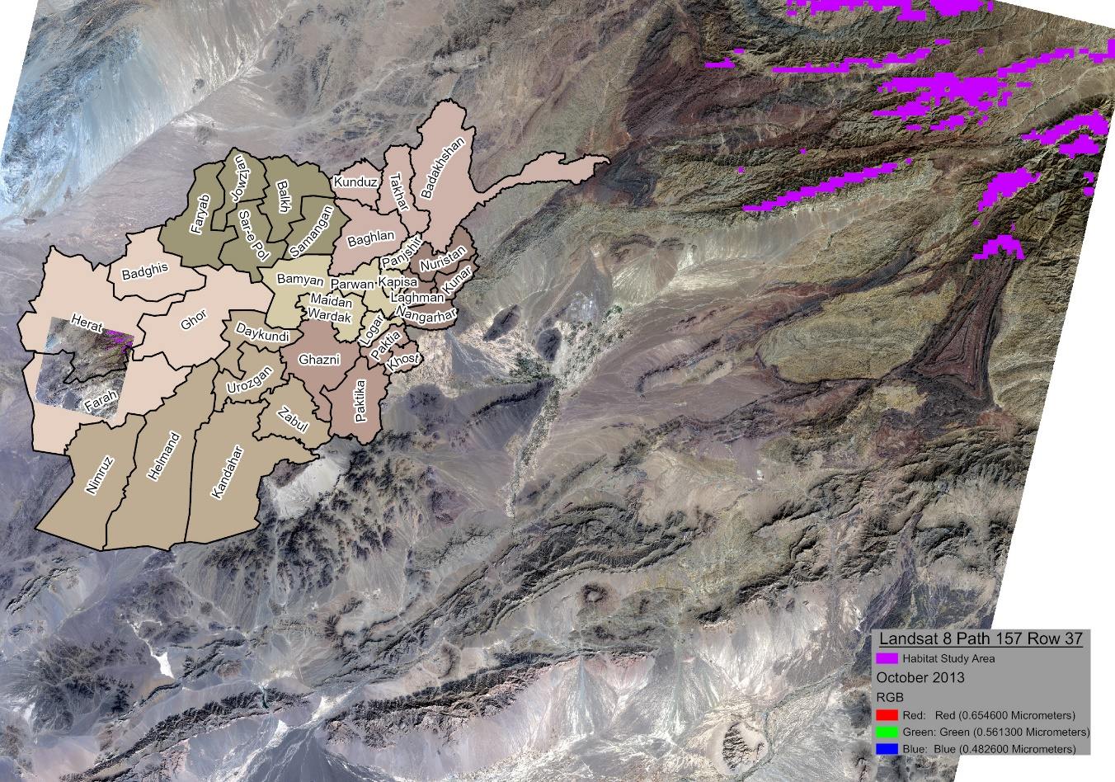

The ‘Study Area’ represents the intersect of ‘South-Facing Slopes’ and areas of ‘Elevation Above 2600m and Below 3600m’ clipped to the borders of Afghanistan and of the Path and Row of the imagery. The DEM from which the ‘Terrain Aspect’ and ‘Elevation’ feature classes were derived was found in Esri’s Living Atlas Gallery. The process of converting the rasters to polygons is processing intensive and the resolution of the DEM is still too low (more on that later).

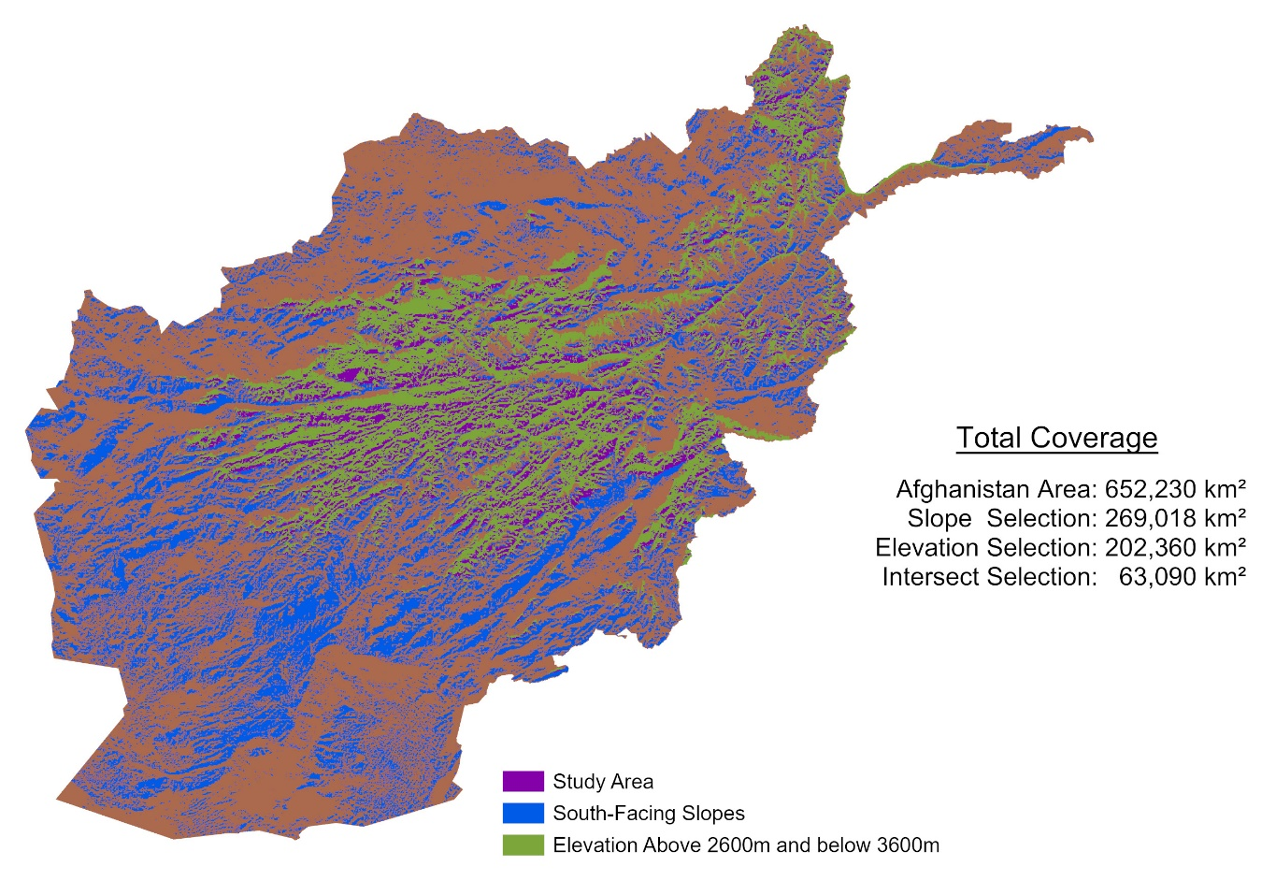

In advance of Envi processing some preliminary geodatabasing and statistical analysis illustrates the potential impact of massive ephedra harvesting could have on the country. I digitized the ‘Afghan Provinces’ layer and build the associated geodatabse in a previous project and have it available as a downloadable web map layer. I added three fields to compare the province habitat totals calculated with the Study Area Feature Class with province population levels. The “Risk” of each provinces is the sum pf the Habitat and Population attribute z (or standard) scores. The heatmap associated with the score shows that ephedra-based methamphetamine could become a national problem.

The table, derived from the same dataset, contains information from the Afghan Provinces geodatabase and the risk score totals for each province. Herat Province is 1.7 standard deviations more at risk and could contain as much as 1747 km2 of ephedra habitat. The embedded images can be resized to get a better look.

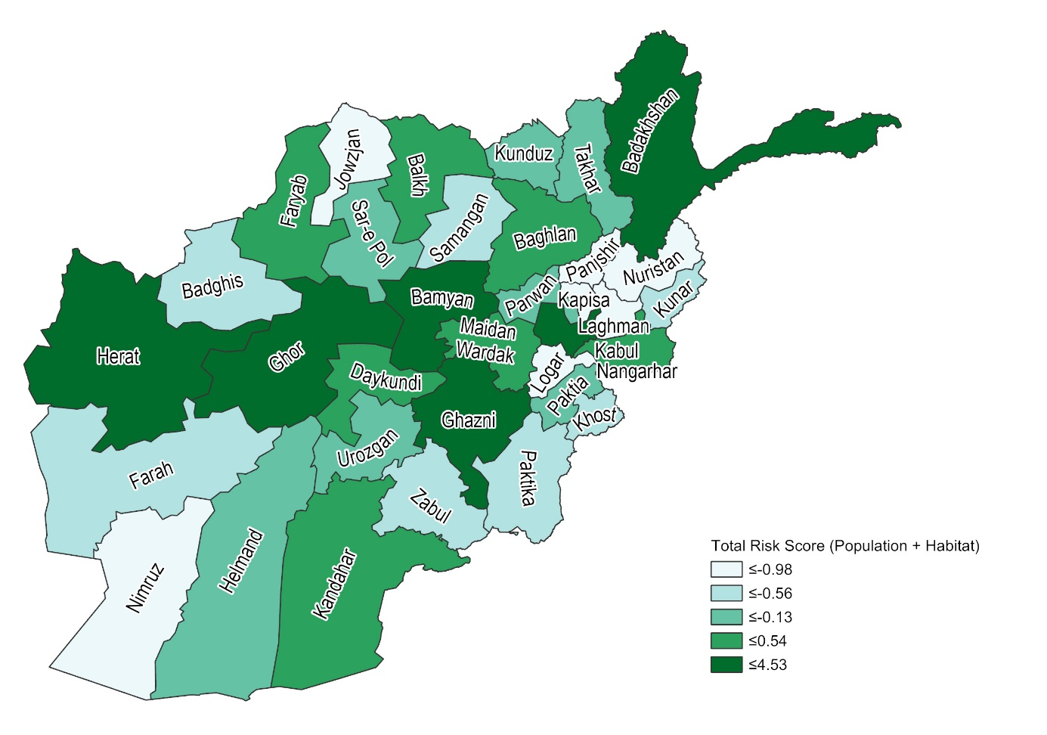

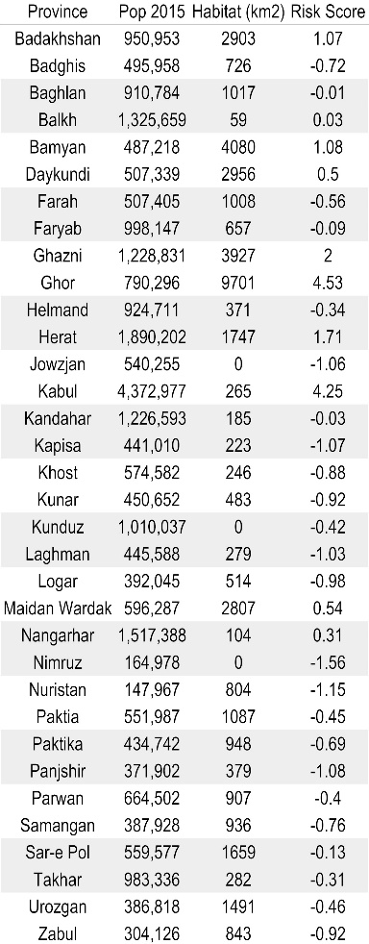

Image preprocessing was done in ENVI and NDVI was calculated for the study areas for each year. When applying the ROI made from the exported ‘Study Area’ .shp file (exported as a raster) to the spatial subset option for NDVI resulted in the mask being applied to a contiguous rectangular area that encompasses the entirety of the ROI. Since the area was not much larger than the intended mask and still covered the upper elevation portion of the image I elected to use its band statistics as the control. Impressed with the detail and speed of ENVI processing I elected to create an animated .gif of the color mapped NDVI images of the control area that I will attach along with the report.

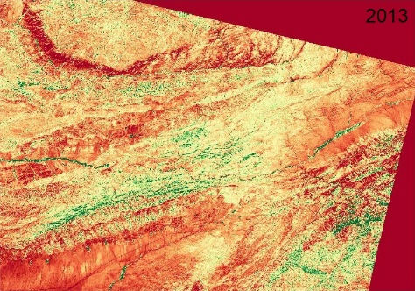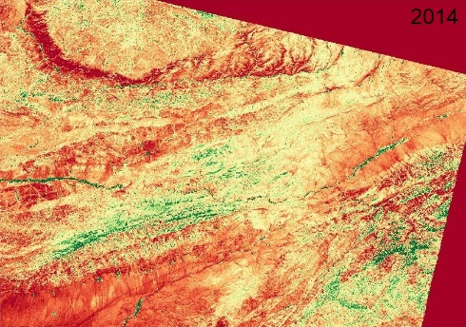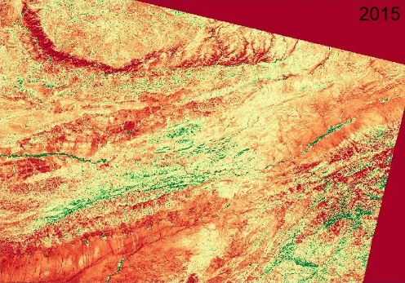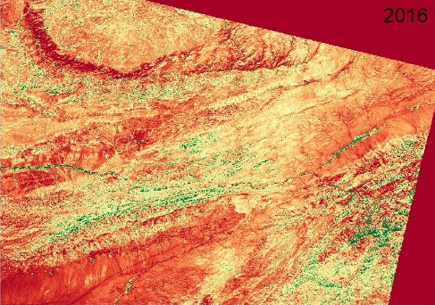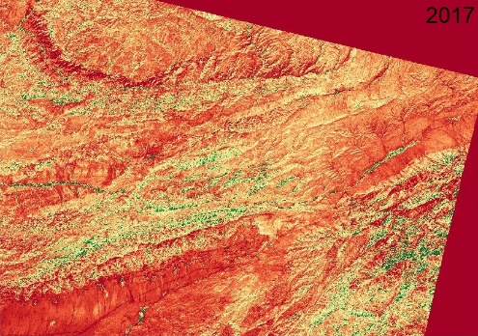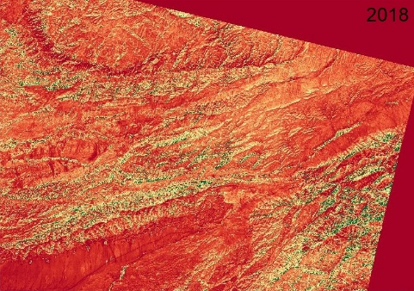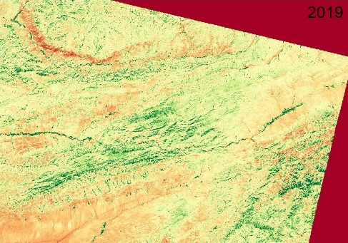

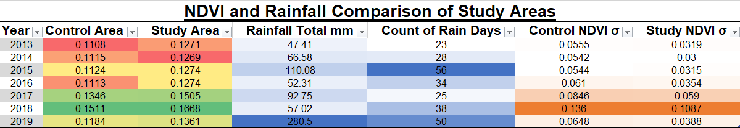

The NDVI totals for the control areas were calculated using the Band Math tool for each year. The NDVI totals for the Study area were calculated in the same way, but by applying the ROI as a mask. The above image is from an excel workbook where the totals were logged.

The results and the following charts show that there is no real difference between the biomass of the control and study areas that would support discernable patterns of ephedra harvest, nor is there any pattern of NDVI decline of areas most proximal to population centers discernable in the imagery. It is for that reason that I have to say that satellite imagery (at least at this spatial and temporal resolution) is not suitable for assessing ephedra harvesting. The spike in rainfall may be atypical to the previous years, but it may also represent a normal monsoon pattern of the local hydrology. The inclusion of historic data could improve the variance data informing the model.

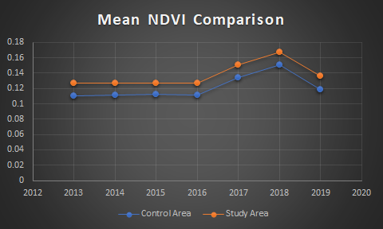

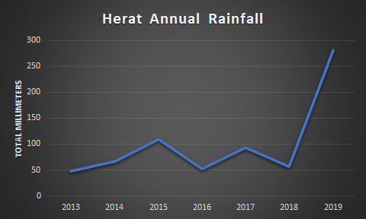

Undeterred by the outcome I experimented with ways to improve the mask. My first though was to limit the size of the mask—which was based on a fishnet/raster with 1km pixels—by instead using the classification options to find the most likely and least noisy areas within the mask. I did this in two ways,

First I used an unsupervised classification of the mask with the NDVI and postprocessed 2013 layer to attempt to find the least lush and most sunny areas of the image where ephedra would most thrive. I believe the use of a ROI of the Full-Sun Gravel and Rock classes would give more meaningful results in any subsequent study.

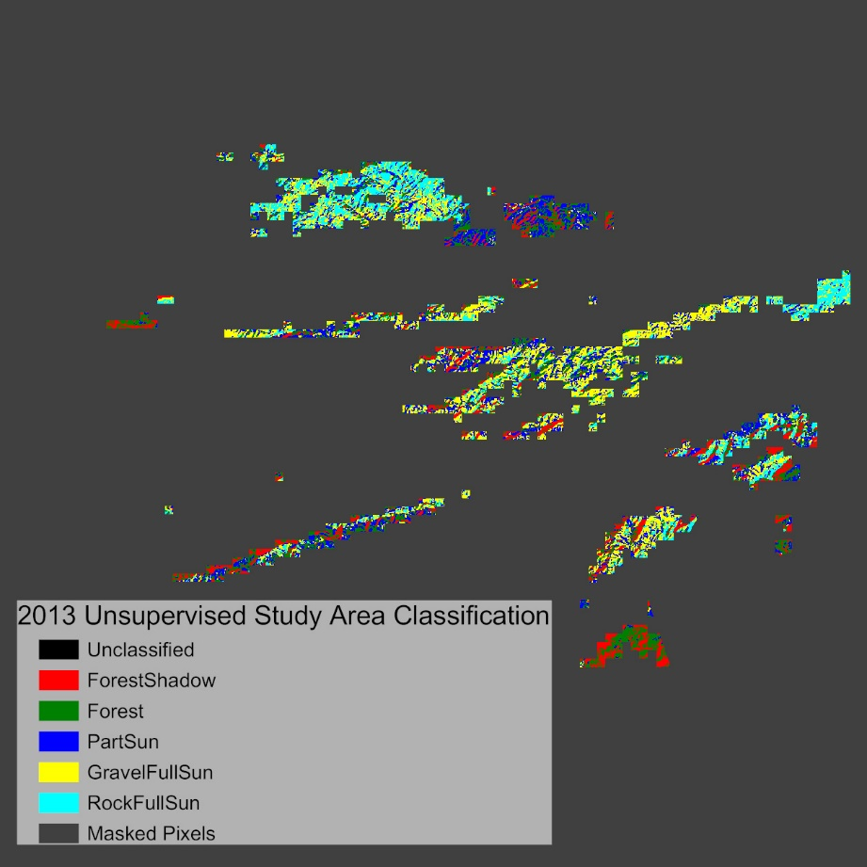

Second, considering how variations in snow cover and rainfall may throw off the NDVI totals in any year I used a 2 class Supervised classification to limit the noise that is unavoidable in low resolution imagery. I would speculate that an ROI of the two classes identified with the unclassified classification, and with any pixels found to be associated with stream vegetation or snow identified with the supervised classification subtracted from them (for each year) would produce a NDVI outputs with higher variance, and that may begin to get at identifying patterns and/or quantities of ephedra harvest

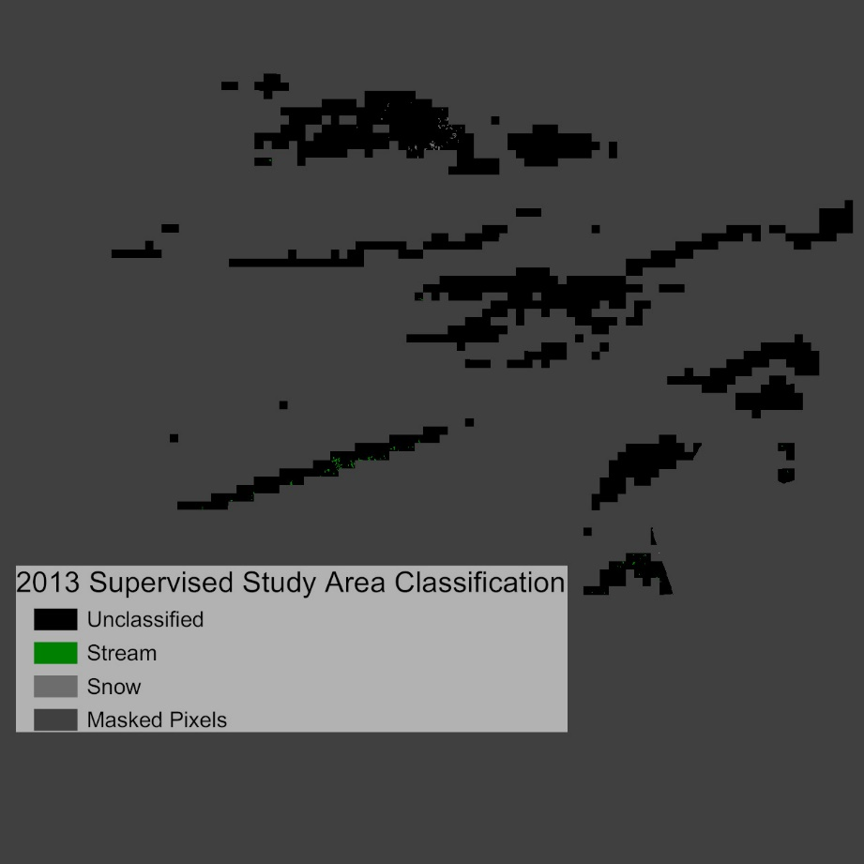

Conclusion

The analysis based on the NDVI totals does not support the hypothesis that ephedra harvest is discernible in Landsat imagery for the available temporal resolution or in the low-resolution mask. A more accurate DEM, better used of classification, and possibly, the substitution of a typical NDVI for one tailored to more drought tolerant vegetation would improve the validity of the results. My experience using EVNI software was phenomenal. The classifications that I exported to ArcGIS could not be symbolized, but everything done within the app was done relatively fast, done reliably (which is not always true in ArcGIS), and done in detail beyond my expectations. I would love to repeat the study (or something similar) with the optimize workflow with higher resolution imagery.

Bibliography

Imagery:

Landsat-8 OLI. Path: 157 Row: 37 ‘Level-1GeoTiff Data Product’. Acquired 1 October 2013. Accessed December 2019, <https://landlook.usgs.gov/viewer.html>

Landsat-8 OLI. Path: 157 Row: 37 ‘Level-1GeoTiff Data Product’. Acquired 18 October 2019 Accessed December 2019, <https://landlook.usgs.gov/viewer.html>

Landsat-8 OLI. Path: 157 Row: 37 ‘Level-1GeoTiff Data Product’. Acquired 18 October 2014. Accessed May 2020, <https://landlook.usgs.gov/viewer.html>

Landsat-8 OLI. Path: 157 Row: 37 ‘Level-1GeoTiff Data Product’. Acquired 7 October 2015. Accessed May 2020, <https://landlook.usgs.gov/viewer.html>

Landsat-8 OLI. Path: 157 Row: 37 ‘Level-1GeoTiff Data Product’. Acquired 9 October 2016. Accessed May 2020, <https://landlook.usgs.gov/viewer.html>

Landsat-8 OLI. Path: 157 Row: 37 ‘Level-1GeoTiff Data Product’. Acquired 15 September 2017. Accessed May 2020, <https://landlook.usgs.gov/viewer.html>

Landsat-8 OLI. Path: 157 Row: 37 ‘Level-1GeoTiff Data Product’. Acquired 26 October 2018. Accessed May 2020, <https://landlook.usgs.gov/viewer.html>

Web and Print

Mansfield, David, et al. “Despite claims to the contrary, US air raids against Afghanistan’s drugs labs have had little to no impact.” London School of Economics American Politics and Policy Center, Article 25 April 2019. Accessed December 2019, http://bit.ly/2L0pTAD

Mansfield, David, et al. “Long Read: The unknown unknowns of Afghanistan’s new wave of methamphetamine production” London School of Economics American Politics and Policy Center, Article 30 September 2019. Accessed December 2019, <http://bit.ly/2lMw8wc>

“Meth in the Madness: Afghan Drug Barons are Branching Out into Methamphetamines” The Economist Print Edition. Asia, Islamabad. 5 September 2019. Accessed December 2019, <https://www.economist.com/asia/2019/09/05/afghan-drug-barons-are-branching-out-into-methamphetamines>

Power, Mike. “Plant-Based Meth Is the Next Frontier of Afghanistan’s Drug Trade.” Vice Online 2 October 2019. Accessed December 2019, <https://www.vice.com/en_us/article/8xwv83/drug-lords-have-figured-out-how-to-make-meth-from-plants>

White, Sean. “Breaking Organic” GISG 130 Project Power Point. 10 December 2019

White, Sean. “Breaking Organic: Tracking the Rise of Ephedra-Based Meth in Afghanistan” GISG 130 Final Project Report. 10 December 2019.

