FX2N-232-BD communication board FX2N-232-BD _startup 2004-09

Function

The RS232C communication board FX_{2N}-232-BD connects to the FX_{2N} programmable controller to realize full duplex serial data communication with another RS232C serial interface such as a PC, bar code reader, printer etc..

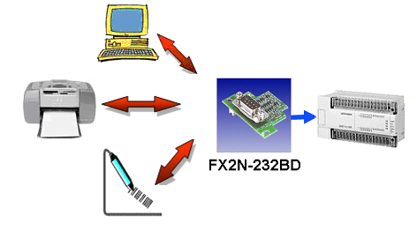

Concerning this Start Up document

This Start-Up document should not be considered as a complete manual. It is an aid
to be able to start up a normal application quickly and easily. For further information
we refer to the following manuals.

- FX_{2N} -232-BD Communication board User’s Guide (Art. Number. 069136)
- FX Communications User’s manual (Art. Number: 070143)

This document and other start-up documents can be found on the “Download” section from our website www.mitsubishi-automation.com.

For further question contact automation.hotline@meg.mee.com or dial our Hotline +49 180 - 5000 - 765

1 Function 1
2 Concerning this Start Up document 1
3 Wiring 3
4 Communication setup 4
4.1 Communication format (D8120) 5
4.2 Send request (M8122) 6
4.3 Receive completion (M8123) 6
4.4 Time-out evaluation (M8129) 6
4.5 Time-out evaluation time (D8129) 6
4.6 Data header and terminator characters (D8124, D8125) 6
5 Program Examples 7
5.1 Program 1 that receives an ASCII string of variable data length 7
5.1.1 Initialization of FX2N-232-BD 7
5.1.2 Receive variable data length 8
5.2 Program 2 that receives an ASCII string of variable data length 9
5.2.1 Initialization of FX2N-232-BD 10
5.2.2 Receive variable data length 10
5.3 Program 3 that sends an ASCII string 11
5.3.1 Initialization of FX2N-232-BD 11
5.3.2 Send ASCII string 12
5.4 Program 4 that sends and receives an ASCII string 14
5.4.1 Initialization of FX2N-232-BD 14
5.4.2 Send ASCII string 15
6 Hyper Terminal 17
6.1 Configuring the HyperTerminal 17
6.2 Sending variable ASCII character via HyperTerminal 19
Appendix 1 – ASCII characters table 20

Wiring

The pin layout of the FX_{2N}-232-BD communication board RS232C connector is shown below.

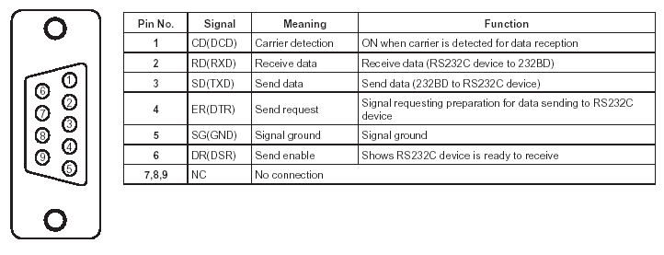

The signal wiring of the RS232C equipment varies depending on the RS232C specifications connected. A wiring example is shown below:

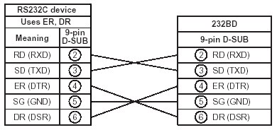

For more connection types please refer to the manuals specified in section 2 of this document.

Communication setup

The RS232C serial interface of the FX_{2N}-232-BD communication board is configured via a set of special auxiliary relays and data registers. The RS instruction is used to send and receive data.
In the tables below are mentioned the special auxiliary relays and data registers relevant to our applications. For detailed information about all the special data registers and auxiliary relays please refer to the documentation for FX Communication.
Special auxiliary relays
Special auxiliary relays | Function
M8122 | Data transmission flag (RS instruction)
M8123 | Finished receiving data (RS instruction)
M8124 | Carrier detection flag (RS instruction)
M8129 | Time-out evaluation (RS instruction)
M8161 | Selection of 8 bit operations for applied instructions ASC, RS, ASCI, HEX, CCD (RS instruction)

Special data registers
Special data registers | Function
D8120 | Communication format (RS instruction, computer link)
D8124 | Data header <initial value: STX> (RS instruction)
D8125 | Data terminator <initial value: ETX> (RS instruction)
D8129 | Time-out evaluation time (RS instruction, computer link)

Communication format (D8120)
The D8120 special data register is used to set the communication parameters for the RS232C serial communication interface of the FX_{2N}-232-BD communication board.

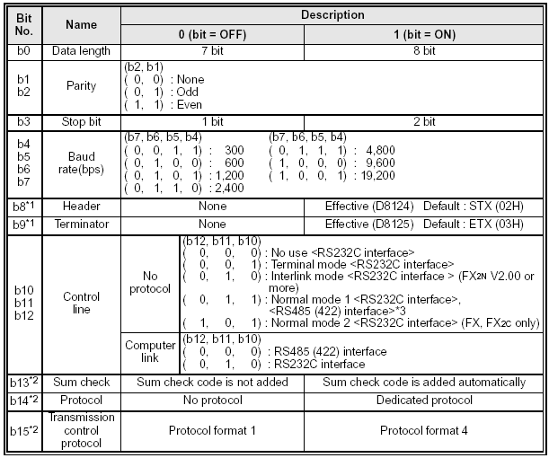

*1 - Make sure to set to “0” when computer link is used
*2 - Make sure to set to “0” when no protocol communication is used

Setting the communication format using the D8120 data register is effective only at the time the RS instruction is executed, and therefore if changed after execution, it is not actually accepted.
When modifying the communication format in the D8120 data register, make sure to turn off the power to the programmable controller, then turn it on again for the changes to take effect.
A program example on how to set up communication parameters using the D8120 data register is shown below :
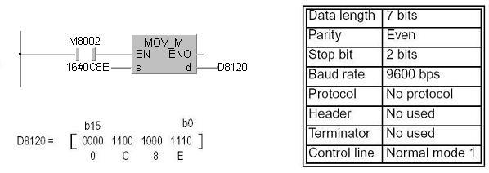
When calculating communication parameters always remember that bit 0 of the register is in the rightmost location.

Send request (M8122)
When the M8122 auxiliary relay is set by a pulse instruction in the receive wait status or the receive completion status the data is sent as specified in the RS instruction. When send is completed, M8122 is automatically reset.

Receive completion (M8123)
The M8123 auxiliary relay signals that a receive operation has been completed according to the RS instruction. When the receive completion flag is set the received data should be transferred to another save destination.
M8123 is not automatically reset. It must be manually reset to be able to receive data again.

Time-out evaluation (M8129)
If the receive operation is not restarted within the time specified by D8129 special data register after the receive data is interrupted on the midway, it is regarded as time-out, M8129 is turned on and receive is completed.
M8129 is not automatically reset. Reset it using a sequence program.

Time-out evaluation time (D8129)
The value set in the D8129 data register is multiplied by “10 ms” and is regarded as the time-out evaluation time as shown in the previous section.
When “0” is set to D8129, the evaluation time is regarded as “100 ms”.

Data header and terminator characters (D8124, D8125)
The data header can be modified in the D8124 data register. The default value is STX (02H) character.
The data terminator can be modifier in the D8125 data register. The default value is ETX (03H) character.
A table of all ASCII characters is presented in Appendix 1.

Program Examples

Program 1 that receives an ASCII string of variable data length

The ASCII String of variable data length received from a “Barcode Reader” will be ended with the terminator <CR> <LF>. In this application the communication settings are 9600 baud, 8 bits data length, no parity and 1 stop bit.

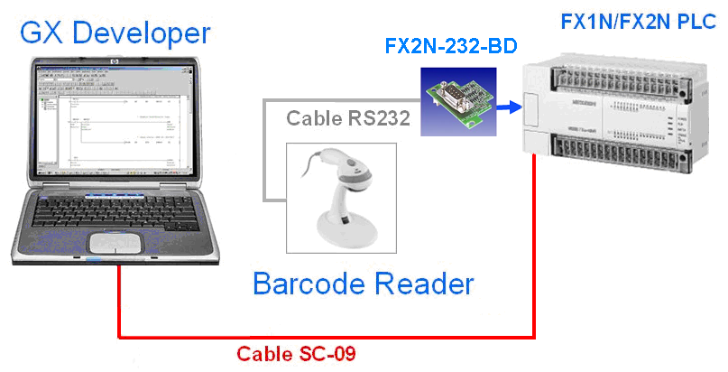
In our example the received ASCII string looks like below:

Barcode Reader ( <CR> <LF> added automatically)
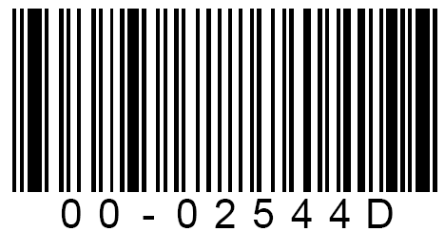
+ <CR> <LF>

Initialization of FX2N-232-BD
First the data transfer mode must be set to 8 bit and the FX2N-232-BD serial interface must be configured with the adequate communication format.

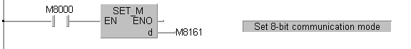

The value HEX 0481 will be loaded in the D8120 data register of the PLC. We use ASCII “No protocol” communication and we don’t use any header or terminator characters. Communication parameters are 8 bit data length, no parity, 1 stop bit, 9600 bps and terminal mode control line (used for send only or receive only).

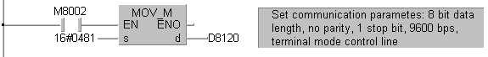

Receive variable data length
The RS instruction is used to send and receive serial data using the RS232C port. The communication is set to receive only and sets of up to 16 characters can be received through the serial connection at a time. The characters received are then stored to memory starting from register D100 onwards.
Note !!! : Sending to the PLC more characters than the receive limit specified in the RS instruction (16 in our example) can lead to unexpected results. If the application can receive more characters than the limit you should use the header and terminator characters (STX,ETX).

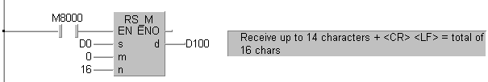

Once the data is received it is advisable to be saved to another memory location (here D30). The M8123 receive ready flag does not automatically reset so after the data is saved the flag is manually reset so another set of characters can be received.

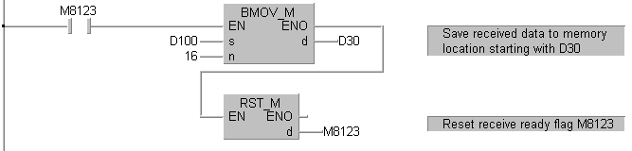

Program 2 that receives an ASCII string of variable data length
The ASCII String of variable data length received from the “HyperTerminal” will be saved in the PLC memory. In this application the communication settings are 9600 baud, 8 bits data length, no parity and 1 stop bit.
The FX_{2N}-232-BD communication board has no buffer to receive data to. Due to this fact, when typing characters in the “HyperTerminal”, after one character has been typed and sent, the PLC considers that the communication has been interrupted. If the communication is not restated during a time-out evaluation time the PLC receive session is considered complete. The default time-out evaluation time is set to 100 ms, meaning that after the PLC considers the communication as interrupted (after typing one character, or two characters at very high speed), the user must resume typing in less than 100 ms. It is impossible for a user to maintain such a typing speed. The solution is to modify the time-out evaluation time to a value acceptable for the user (in this example is set to 5 sec).
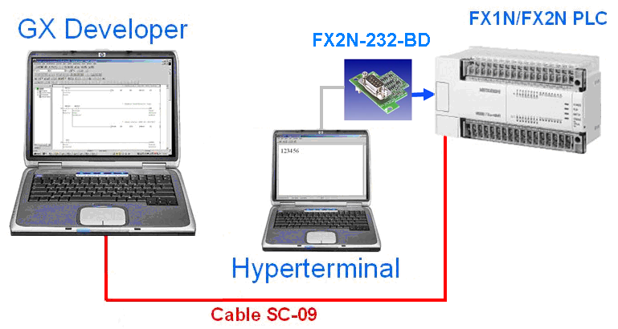

Hyper Terminal ( <CR> <LF> added by “Enter” button on your computer)

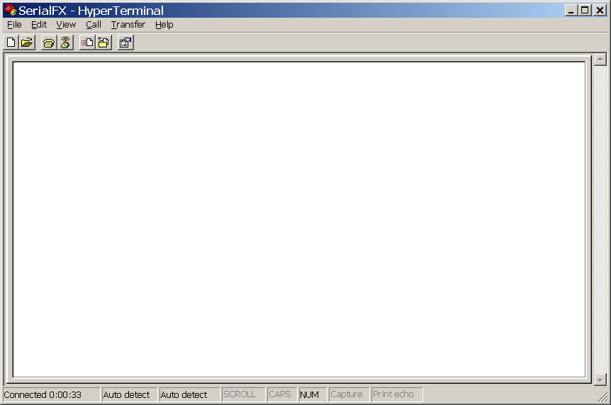
0 0 – 0 2 5 4 4 D
+ <CR> <LF>

Initialization of FX2N-232-BD
First the data transfer mode must be set to 8 bit and the FX2N-232-BD serial interface must be configured with the adequate communication format.

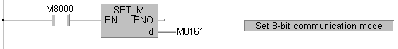
The value HEX 0481 will be loaded in the D8120 data register of the PLC. We use ASCII “No protocol” communication and we don’t use any header or terminator characters. Communication parameters are 8 bit data length, no parity, 1 stop bit, 9600 bps and terminal mode control line (used for send only or receive only).

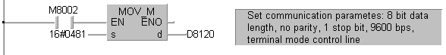
The time-out evaluation time is set to a value of 5 seconds during which the user can type up to 16 characters in the “HyperTerminal” application which are received in the PLC.
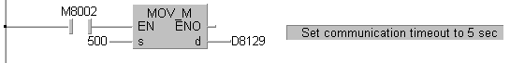

Receive variable data length
The RS instruction is used to send and receive serial data using the RS232C port. The communication is set to receive only and sets of up to 16 characters can be received through the serial connection during an interval of 5 seconds. The characters received are then stored to memory starting from register D100 onwards.
Note !!! : Sending to the PLC more characters than the receive limit specified in the RS instruction (16 in our example) can lead to unexpected results. If the application can receive more characters than the limit you should use the header and terminator characters (STX,ETX).
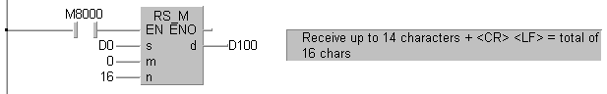
Once the data is received it is advisable to be saved to another memory location (here D30). The M8123 receive ready flag does not automatically reset so after the data is saved the flag is manually reset so another set of characters can be received.

Program 3 that sends an ASCII string
The ASCII String “FX2N-232BD” is stored in the PLC and sent to the “HyperTerminal”. In this application the communication settings are 9600 baud, 8 bits data length, even parity and 1 stop bit.

Initialization of FX2N-232-BD
First the data transfer mode must be set to 8 bit and the FX2N-232-BD serial interface must be configured with the adequate communication format.

The value HEX 0487 will be loaded in the D8120 data register of the PLC. We use ASCII “No protocol” communication and we don’t use any header or terminator characters. Communication parameters are 8 bit data length, even parity, 1 stop bit, 9600 bps and terminal mode control line (used for send only or receive only).

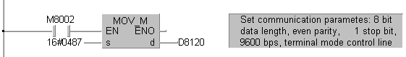

Send ASCII string
The RS instruction is used to send and receive serial data using the RS232C port. The communication is set to send only and it sends a string of up to 12 ASCII characters through the serial connection. The characters sent are displayed in the “HyperTerminal” application.

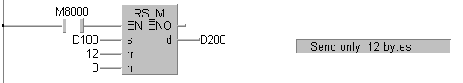

The characters that compose the string are converted to the hexadecimal ASCII code and loaded in the PLC memory. The set of ASCII characters with their corresponding hexadecimal code and keyboard code is shown in Appendix 1 of this document.

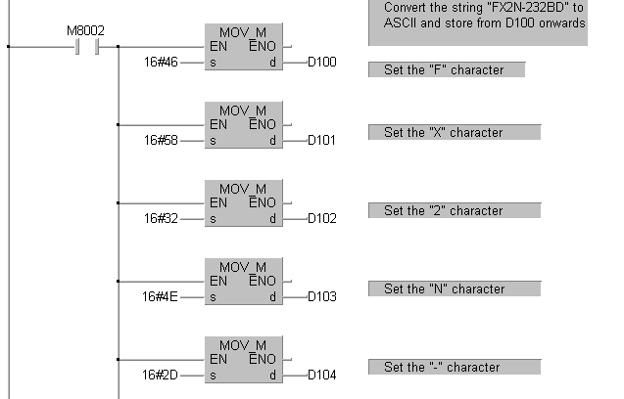

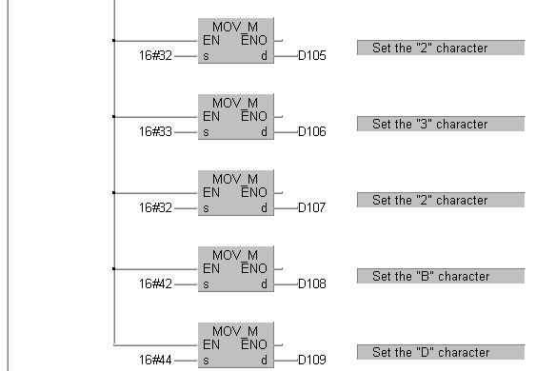

The <CR> + <LF> characters are added at the end of the string.
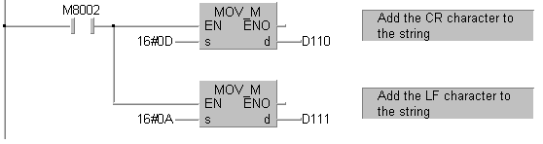
The ASCII string is sent through the serial communication line by setting the M8122 auxiliary relay. When the X1 input is activated it sets the M8122 flag on the rising edge of a pulse signal.
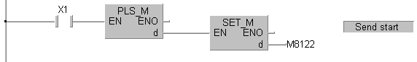

Program 4 that sends and receives an ASCII string
In this program example we connect two FX1N/FX2N PLC systems with a serial communication line using the FX1N/FX2N-232-BD communication board. The ASCII String “FX2N-232BD” is stored in each PLC. Each PLC sends and receives a string. In this application the communication settings are 9600 baud, 8 bits data length, even parity and 2 stop bits, “ASCII No protocol” communication and we use the control characters (header character - STX, terminator character - ETX).
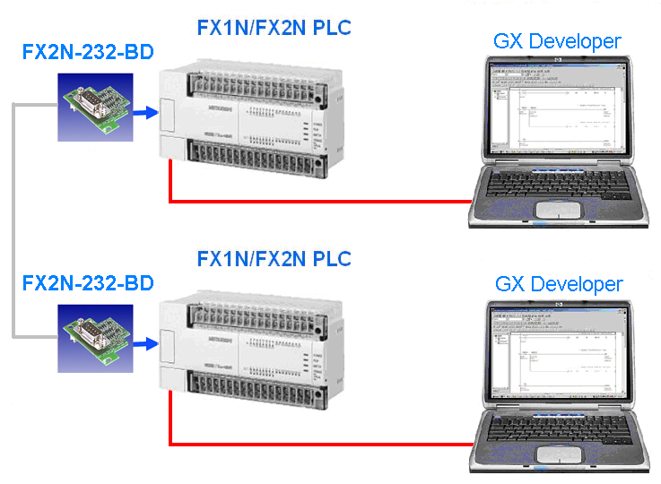

Initialization of FX2N-232-BD
First the data transfer mode must be set to 8 bit and the FX2N-232-BD serial interface must be configured with the adequate communication format.

The value HEX 038F will be loaded in the D8120 data register of the PLC. We use ASCII “No protocol” communication and we use the header and terminator characters (STX, ETX). Communication parameters are 8 bit data length, even parity, 2 stop bits, 9600 bps.

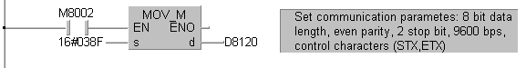

Send ASCII string
The RS instruction is used to send and receive serial data using the RS232C port. The communication is set to send and receive and it sends a string of up to 10 ASCII characters through the serial connection and receives also 10 ASCII characters.

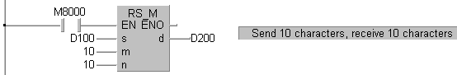

The characters that compose the string are converted to the hexadecimal ASCII code and loaded in the PLC memory. The set of ASCII characters with their corresponding hexadecimal code and keyboard code is shown in Appendix 1 of this document.

The ASCII string is sent through the serial communication line by setting the M8122 auxiliary relay. When the X1 input is activated it sets the M8122 flag on the rising edge of a pulse signal.

Once the data is received it is advisable to be saved to another memory location (here D30). The M8123 receive ready flag does not automatically reset so after the data is saved the flag is manually reset so another set of characters can be received.
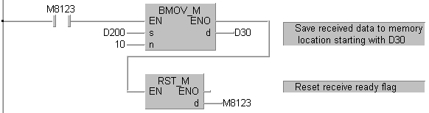
Due to the fact that we use the control characters (STX,ETX), if we would send a string with a length greater than 10 characters the PLC will receive only the first 10 characters and ignores the rest.

Hyper Terminal
HyperTerminal is a communication application that comes with all Windows versions. The application can be used for both way communication (send/receive) via computer serial port.

Configuring the HyperTerminal

- Start the HyperTerminal application by choosing the options Programs-Accessories-Communications-HyperTerminal from the Start menu in Windows.
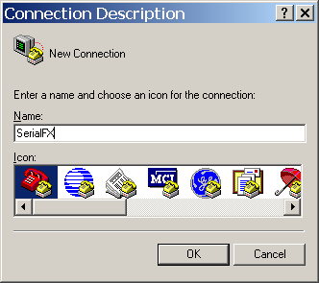

- Choose your interface COM2.
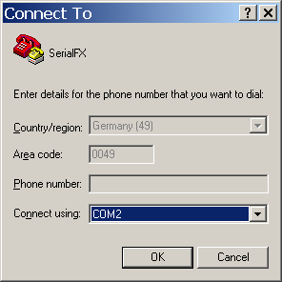

- Select this settings
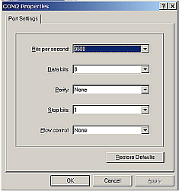

- Select properties
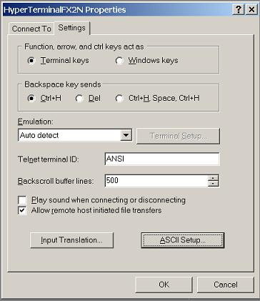

- To see the inserted ASCII character on the screen and to activate (CR,LF) for the Enter button please define:

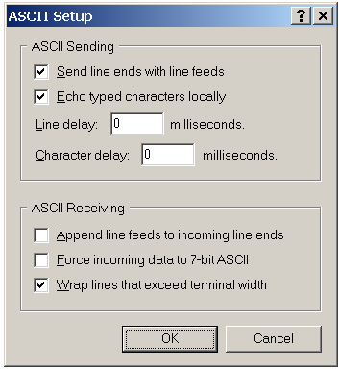

Sending variable ASCII character via HyperTerminal

- Insert “0 0 – 0 2 5 4 4 D “ and press “ENTER”.

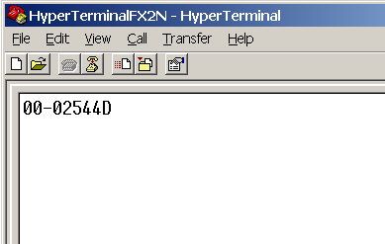

- If there was no error you will find this data in up device D100

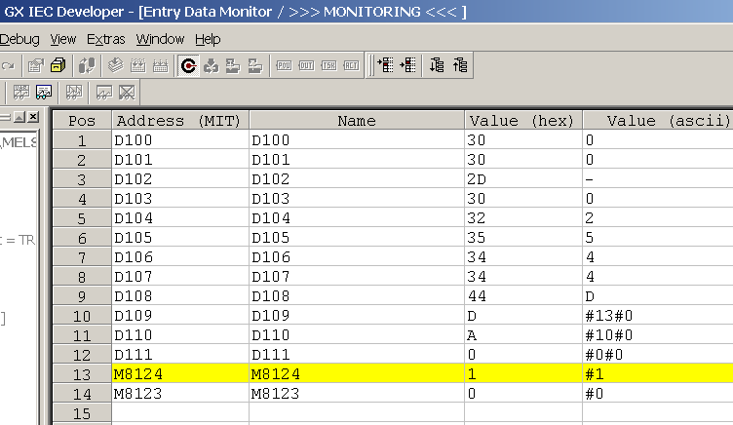

Appendix 1 – ASCII characters table

The table contains the set of ASCII characters with their corresponding keyboard code, decimal and hexadecimal character codes.

