lab5: Create Subclasses by Inheriting

实验五：使用继承方法创建子类

课程名称：Java语言程序设计

实验教学学时：2学时

年级/班级：

学生人数：

专业：软件工程

一、实验目的

Objective
In this lab you will create two subclasses of the Account class in the Banking project: SavingsAccount and CheckingAccount. You will override the withdraw method for checking accounts and use super to invoke a parent constructor.

二、实验原理或预习内容

参看教材《Java语言程序设计-基础篇》第9，10(P329, 10.10.3, 10.10.4 String split)，11(P353, 11.3 super)，12（P411,12-15 ReadData.java; P409, 12-13 WriteData.java; P420, 12.13 ）章

三、实验环境

（1）Internet网络环境，PC机

（2）文本编辑器，Java Standard Edition Development Kit 8及以上版本

四、实验内容
（1）实验提交：
编写bat文件（可参考搭建环境实验的bat文件，应包含
set path
set classpath
javac TestBanking.java
java TestBanking
pause
5行指令），可直接点击运行。将源程序、编译后class文件、bat文件及相关文件目录放到行指令），可直接点击运行。将源程序、编译后class文件、bat文件及相关文件目录放到"2-学号-姓名-班级"文件夹中（2为实验号,如提交多个版本请在班级后添加“-v#”，#代表版本号）并压缩，在规定的时间上传到教学在线。
- input.txt文件中缩写含义
c：checking account;
o：overdraftProtection;
share：共享同一账号
s: saving account;
i:interesting.
w: withdraw;
d: deposit
可能包含n个客户，每个客户可能拥有（1～m）个账户（m>=1）
- 完成下面Directions中各个类的任务

Directions
Start by changing your working directory to /step5 on your computer.

Implementing the Account Subclasses
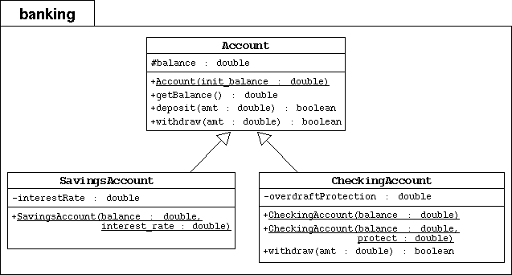

To the banking package, you will add the SavingsAccount and CheckingAccount subclasses as modeled by the UML diagram above.
- Create the banking directory. Copy the previous Banking project files in this package directory.

Modify the Account Class
- In the UML diagram the Account class has changed: The balance attribute is now protected (indicated by the # character instead of the - character).
- Change the access mode of the balance attribute to protected.

The Savings Account Subclass
- Implement the SavingsAccount class as modeled in the above UML diagram.
- The SavingsAccount class must extend the Account class.
- It must include an interestRate attribute with type double.
- It must include a public constructor that takes two parameters: balance and interest_rate. This constructor must pass the balance parameter to the parent constructor by calling super(balance).

The Checking Account Subclass
- Implement the CheckingAccount class as modeled in the above UML diagram.
- The CheckingAccount class must extend the Account class.
- It must include an overdraftProtection attribute with type double to record the actual value , and a overdraftLimit attribute with type double to record overdraft limit.
- It must include one public constructor that takes one parameter: balance. This constructor must pass the balance parameter to the parent constructor by calling super(balance).
- It must include another public constructor that takes two parameters: balance and protect. This constructor must pass the balance parameter to the parent constructor by calling super(balance) and set the overdraftProtection attribute.
- The CheckingAccount class must override the withdraw method. It must perform the following check: if the current balance is adequate to cover the amount to withdraw, then proceed as usual. If not and if there is overdraft protection, then attempt to cover the difference (balance - amount) by value of the overdraftProtection. If the amount needed to cover the overdraft is greater than the current level of protection, then the whole transaction must fail with the checking balance unaffected.
- It must include one public method getOverdraftProtection that return value of the overdraftProtection.

Modify the Bank Class
- Add the getCustomer method. This method returns the customer associated with firstName and lastName parameters.

TestBanking
- 任务1：Create bank customers and their accounts from account section of step5input.txt
- 任务2：Demonstrate behavior of various account types according to transactions section of step5input.txt
- 任务3：将控制台输出写入step5output.txt

五、实验结果及测试

Testing
In the main step5 directory, compile and execute the TestBanking program. The output should be（控制台输出及写入step5output.txt内容如下）:

Creating the customer Jane Smith.
Creating her Savings Account with a 500.00 balance and 3% interest.
Creating the customer Owen Bryant.
Creating his Checking Account with a 500.00 balance and no overdraft protection.
Creating the customer Tim Soley.
Creating his Checking Account with a 500.00 balance and 500.00 in overdraft protection.
Creating the customer Maria Soley.
Maria shares her Checking Account with her husband Tim.

Retrieving the customer Jane Smith with her savings account.
Withdraw 150.00: true
Deposit 22.50: true
Withdraw 47.62: true
Withdraw 400.00: false
Customer [Simms, Jane] has a balance of 324.88

Retrieving the customer Owen Bryant with his checking account with no overdraft protection.
Withdraw 150.00: true
Deposit 22.50: true
Withdraw 47.62: true
Withdraw 400.00: false
Customer [Bryant, Owen] has a balance of 324.88

Retrieving the customer Tim Soley with his checking account that has overdraft protection.
Withdraw 150.00: true
Deposit 22.50: true
Withdraw 47.62: true
Now the overdraft protection of checking account is ###.##(print the actual value here)
Withdraw 400.00: true
Customer [Soley, Tim] has a balance of 0.0

Retrieving the customer Maria Soley with her joint checking account with husband Tim.
Deposit 150.00: true
Withdraw 750.00: false
Customer [Soley, Maria] has a balance of 150.0
Notice that Jane's savings account and Owen's checking account fundamentaly behave as a plain-old bank account. But Tim & Maria's joint checking account has 500.00 worth of overdraft protection. Tim's transactions dip into that protection and therefore his ending balance is 0.00. His account's overdraft protection level is 424.88. Finally, Maria deposits 150.00 into this joint account; raising the balance from 0.00 to 150.00. Then she tries withdraw 750.00, which fails because neither the balance nor the overdraft protection can cover that requested amount.

