Seminary 2 – Industrial Management

|  |  |  |  |  |
| --- | --- | --- | --- | --- |
| **Symbol** | **a (days)** | **m (days)** | **b (days)** | **dF (Mean Duration)** |
| A | 5,00 | 7,00 | 10,00 | 7.00 |
| B | 15,00 | 20,00 | 30,00 | 20.00 |
| C | 7,00 | 10,00 | 20,00 | 11,17 |
| D | 12,00 | 20,00 | 40,00 | 21.33 |
| E | 15,00 | 21,00 | 30,00 | 21.00 |
| F | 70,00 | 90,00 | 120,00 | 90.00 |
| G | 6,00 | 10,00 | 15,00 | 10,17 |
| H | 100,00 | 105,00 | 120,00 | 106.67 |
| I | 0,00 | 0,00 | 0,00 | 0.00 |
| J | 0,00 | 0,00 | 0,00 | 0.00 |
| K | 60,00 | 70,00 | 90,00 | 71.67 |
| L | 10,00 | 20,00 | 30,00 | 20.00 |
| M | 5,00 | 8,00 | 14,00 | 8,17 |
| N | 8,00 | 12,00 | 20,00 | 12.00 |
| O | 8,00 | 10,00 | 15,00 | 10,17 |
| P | 5,00 | 5,00 | 5,00 | 5.00 |

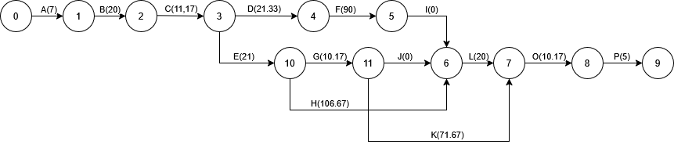

1. Critical Path: A -> B -> C -> D -> F -> G -> J -> K -> L -> O -> P

| **Nr** | **Symbol** | **a** | **m** | **b** | **Mean Duration (𝑑̄)** | **Variance (σ²)** |
| --- | --- | --- | --- | --- | --- | --- |
| 1 | A | 5 | 7 | 10 | (5 + 4×7 + 10)/6 = 7.0 | ((10−5)/6)² = 0.694 ≈ 0.69 |
| 2 | B | 15 | 20 | 30 | (15 + 4×20 + 30)/6 = 20.0 | ((30−15)/6)² = 6.25 |
| 3 | C | 7 | 10 | 20 | (7 + 4×10 + 20)/6 = 11.17 | ((20−7)/6)² ≈ 4.69 |
| 4 | D | 12 | 20 | 40 | (12 + 4×20 + 40)/6 = 21.33 | ((40−12)/6)² ≈ 22.22 |
| 5 | E | 15 | 21 | 30 | (15 + 4×21 + 30)/6 = 21.5 | ((30−15)/6)² = 6.25 |
| 6 | F | 70 | 90 | 120 | (70 + 4×90 + 120)/6 = 91.67 | ((120−70)/6)² ≈ 69.44 |
| 7 | G | 6 | 10 | 15 | (6 + 4×10 + 15)/6 = 10.17 | ((15−6)/6)² = 2.25 |
| 8 | H | 100 | 105 | 120 | (100 + 4×105 + 120)/6 = 106.67 | ((120−100)/6)² ≈ 11.11 |
| 9 | I | - | - | - | - (Fictitious) | 0 |
| 10 | J | - | - | - | - (Fictitious) | 0 |
| 11 | K | 60 | 70 | 90 | (60 + 4×70 + 90)/6 = 71.67 | ((90−60)/6)² = 25.0 |
| 12 | L | 10 | 20 | 30 | (10 + 4×20 + 30)/6 = 20.0 | ((30−10)/6)² = 11.11 |
| 13 | M | 5 | 8 | 14 | (5 + 4×8 + 14)/6 = 8.5 | ((14−5)/6)² ≈ 2.25 |
| 14 | N | 8 | 12 | 20 | (8 + 4×12 + 20)/6 = 12.67 | ((20−8)/6)² ≈ 4.0 |
| 15 | O | 8 | 10 | 15 | (8 + 4×10 + 15)/6 = 10.17 | ((15−8)/6)² = 1.36 |
| 16 | P | 5 | 5 | 5 | 5.0 (deterministic) | 0.0 |

4.

