1. Login screen – Correct logo to MojaMind. Remove welcome to creative resilience journey.
2. Terms and conditions – read more need to update.
3. After accept terms should go to Welcome screen start
4. Survey Demo doesn’t have any details. Need to update
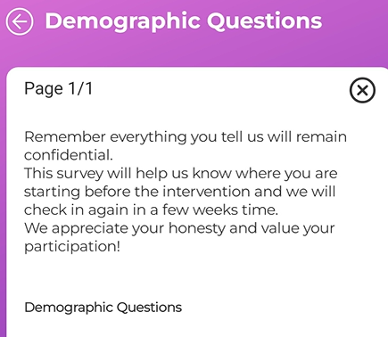
- Survey – add all grades
5. Main screen too busy
6. Welcome to creative resilience, cant color to be changed.
7. Risk score on survey
8. post survey shouldn’t be open until activities are completed
9. Chat group only admin to broadcast, individual only to admin
10. art activities show incorrect wording for 7 and 8
11. Digital art studio cant save, looks like size.
12. Need to complete the other art activities so if you can unlock

