

IONITY GLOBAL
(Pty) Ltd

WISP — Aura Wisp
Ionity Software Release
WISP 1.0.0 — Release Notes & Technical Overview
Active-window and active-screen aura overlay · Windows · macOS · Linux

ION-REL-WISP-2026-001 | Version 1.0 | 18 October 2026
PUBLIC

www.ionity.today | ai@ionity.today

Document Control
Field | Value
Document ID | ION-REL-WISP-2026-001
Product | WISP — Aura Wisp, version 1.0.0 (tag v1.0.0)
Date | 18 October 2026 (SAST, UTC+2)
Classification | PUBLIC
Author | Johan Wilhelm van Antwerp — Ionity (Pty) Ltd, formerly Antwerp Designs, AEDI
Governance | Policy 986 AED · Licence AED 900 · CC BY-NC-SA 4.0 where stated
Source | https://github.com/Ionity-Global-Pty-Ltd/WISP (public)
Download page | https://ionity.digital/#wisp

1. Executive Summary
WISP — Aura Wisp is a small tray application that draws a glowing, colour-changeable aura around the active window and a soft edge light around the active screen. When the user switches windows, the aura is pulled across on a spring while a comet of light — the wisp — flies ahead and lands in a burst of sparks. The overlay is fully click-through: it never takes focus, never intercepts the mouse and does not appear in the taskbar, Alt-Tab or Mission Control.
Version 1.0.0 ships for Windows 10/11 (installer for x64 and ARM64, plus a portable .exe), macOS (Apple Silicon and Intel) and Linux (AppImage, .deb, .rpm). Source code is published as an open repository under CC BY-NC-SA 4.0, governed by Policy 986 AED.
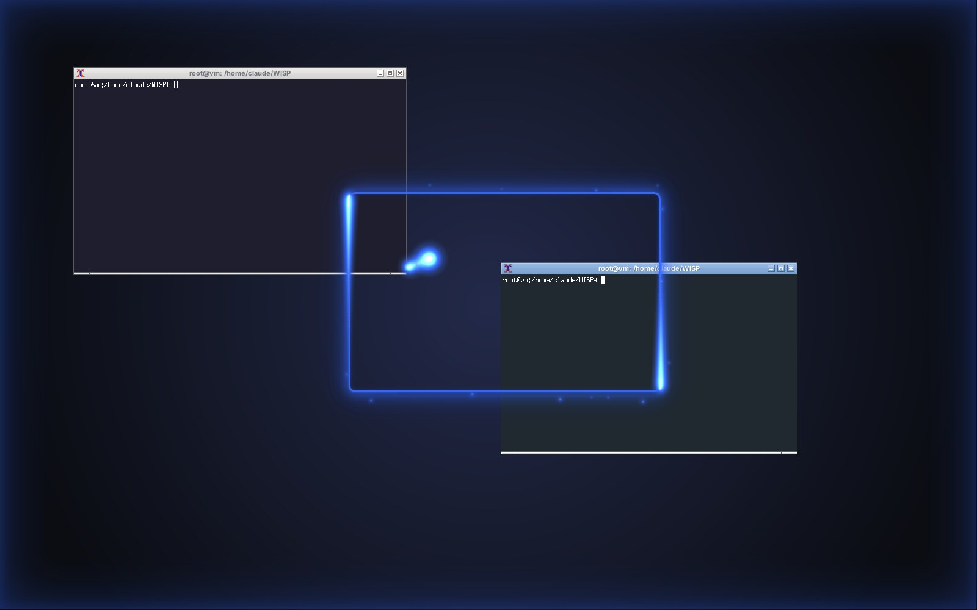
Figure 1 — The puller: the aura glides from the previous window to the newly focused one.

1.1 Why WISP
Large and multi-monitor desktops make it easy to lose track of which window has the keyboard. WISP answers that at a glance: the focused window glows, the focused screen breathes light from its edges, and every change of focus is visible as motion. It serves presenters, streamers, multi-monitor engineers and users who benefit from a stronger focus indicator for accessibility.

2. Features
• Active window aura — a crisp line plus soft halo hugging the visible window edge (DWM frame bounds on Windows, CoreGraphics bounds on macOS, EWMH frame extents on Linux).
• Active screen aura — the display holding focus is lit from its edges; ideal for multi-monitor setups.
• Puller — spring-animated glide between windows, comet flight and arrival sparks.
• Wisps — motes of light orbiting the frame; the Flow style runs two comets around the edge.
• Colours — Ionity Blue (default), Ionity Cyan, Ionity Teal, Ionity Purple, Global Orange, Emerald, Crimson, Rose, Gold, Moonlight, Ionity Flow (brand gradient), Spectrum (rainbow) and any custom colour. The tray icon repaints itself in the chosen colour.
• Styles — Aura (steady), Pulse (breathing), Flow (running light), Wire (crisp outline).
• Tuning — thickness, glow, intensity, screen-aura strength, speed, gap, corner radius (auto-matches Windows 11 and macOS corners), frame-rate cap.
• Behaviour — hides over full-screen games, video and presentations; global hotkeys Ctrl+Alt+W (pause) and Ctrl+Alt+Shift+W (next colour); start with the computer; portable mode stores settings beside the .exe.
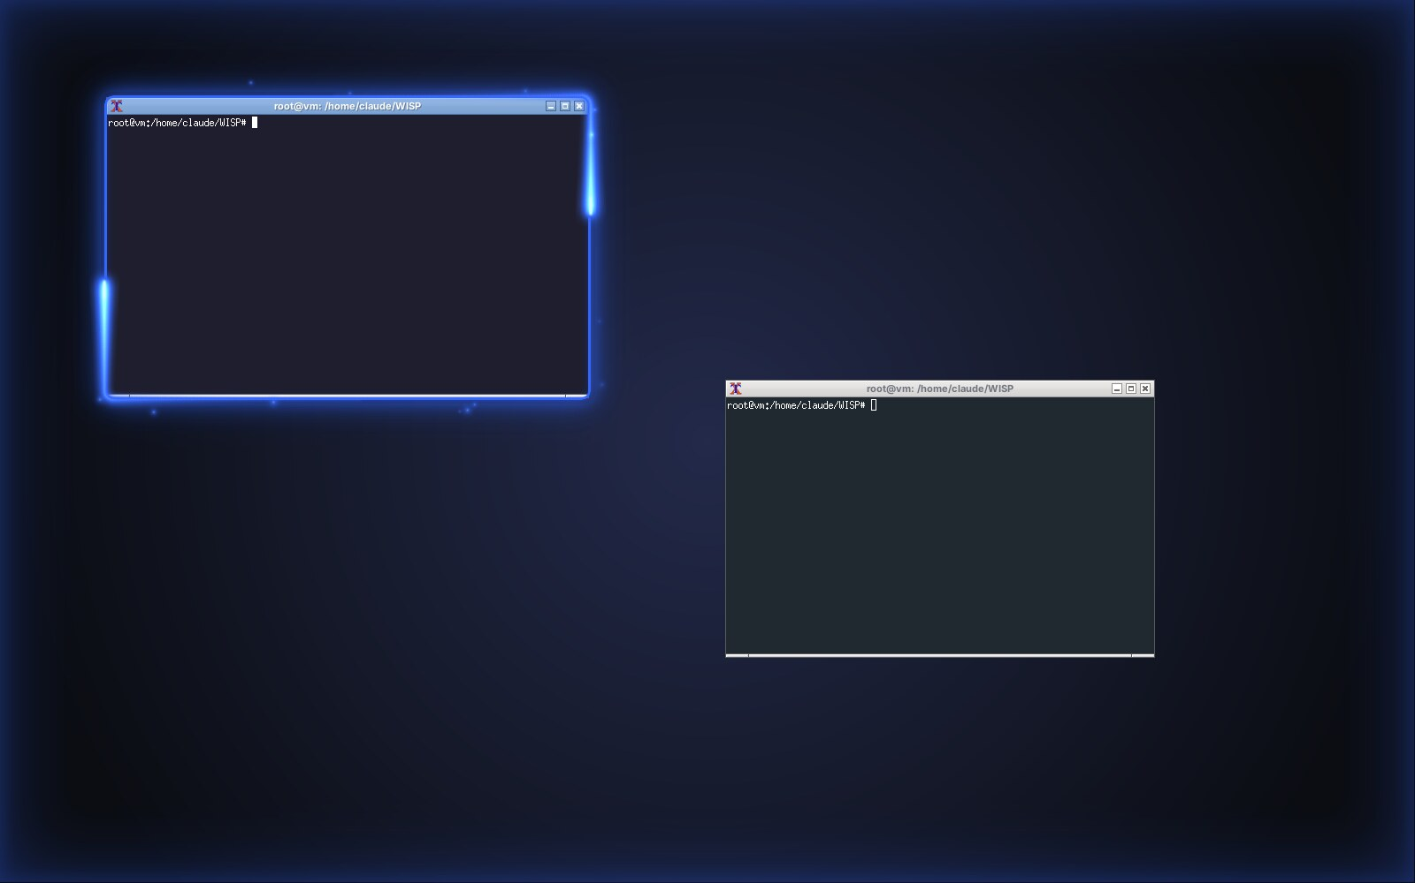
Figure 2 — Flow style in Ionity Blue with the active-screen aura.

3. Downloads
All packages are attached to the GitHub release v1.0.0 (https://github.com/Ionity-Global-Pty-Ltd/WISP/releases/tag/v1.0.0) together with SHA256.txt, and are linked from https://ionity.digital/#wisp.
Platform | File | Size | Notes
Windows 10/11 x64 | WISP-Setup-1.0.0-x64.exe | 91 MB | Installer, per-user, no admin
Windows 11 ARM64 | WISP-Setup-1.0.0-arm64.exe | 86 MB | Installer
Windows portable | WISP-Portable-1.0.0-x64.exe | 90 MB | No install; settings in WISP-data beside the .exe
macOS Apple Silicon | WISP-1.0.0-arm64.dmg | 107 MB | Also WISP-1.0.0-arm64-mac.zip
macOS Intel | WISP-1.0.0-x64.dmg | 112 MB | Also WISP-1.0.0-mac.zip
Linux (any distro) | WISP-1.0.0-x86_64.AppImage | 112 MB | chmod +x, then run
Debian / Ubuntu | wisp_1.0.0_amd64.deb | 87 MB | sudo apt install ./wisp_1.0.0_amd64.deb
Fedora / RHEL / openSUSE | wisp-1.0.0.x86_64.rpm | 78 MB | sudo dnf install ./wisp-1.0.0.x86_64.rpm

Builds are not yet code-signed. Windows SmartScreen: choose More info → Run anyway. macOS Gatekeeper: right-click → Open the first time. Verify every file against SHA256.txt.

4. Technical Design

4.1 Architecture
WISP is an Electron application with a tray-only main process. A platform tracker samples the foreground window every 33–40 ms; an engine turns the sample into a state (window rectangle, active display, full-screen flag) and sends it only when it changes to one transparent, click-through overlay window per display. Each overlay draws its share of the aura in global desktop coordinates, so an aura spanning two monitors — or a comet crossing between them — lines up exactly.
The steady frame is pure CSS (line + box-shadow glow), which costs the GPU nothing at rest. Motion — the spring, comets, wisps and sparks — is drawn on a canvas only while something moves, with a configurable frame-rate cap. The spring integrator runs in fixed sub-steps so it stays stable even when frames are slow.

4.2 Active-window trackers
Platform | Source of the active window | Notes
Windows 10/11 | GetForegroundWindow + DwmGetWindowAttribute(DWMWA_EXTENDED_FRAME_BOUNDS) through koffi (no native build) | Per-monitor DPI conversion; skips desktop, taskbar, Start, Task View and cloaked windows
macOS 11+ | CoreGraphics window list + NSWorkspace frontmost app, streamed by one long-lived JXA process | Reads bounds only — no Screen Recording or Accessibility permission required
Linux | libX11 _NET_ACTIVE_WINDOW, _NET_FRAME_EXTENTS, _GTK_FRAME_EXTENTS through koffi | X11 / XWayland; X errors are trapped; pure Wayland falls back to a pointer-following screen aura

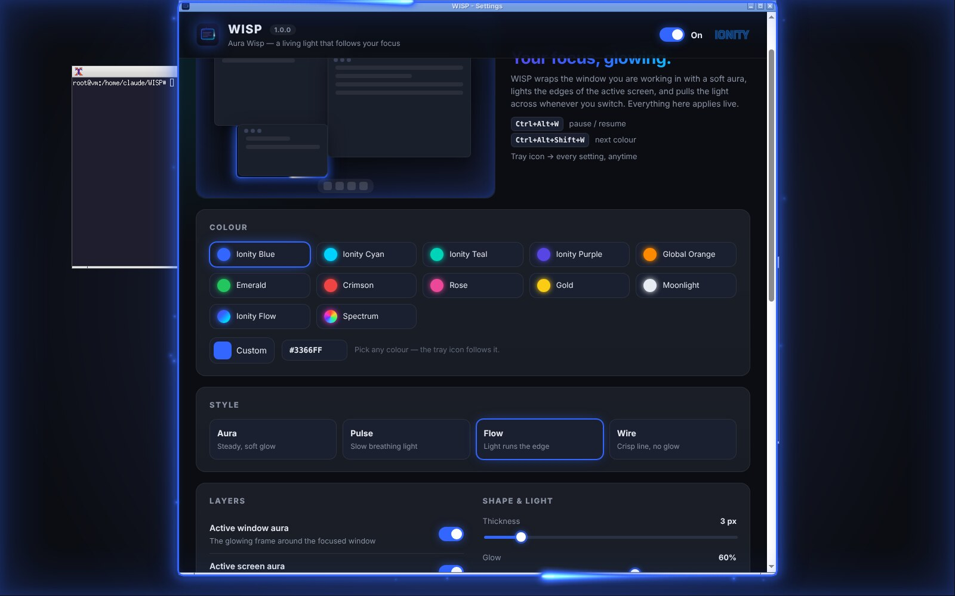
Figure 3 — Settings window: colours, styles, layers and tuning apply live.

5. Quality & Verification
Check | Environment | Result
Syntax check, geometry unit tests | Node 22 (CI) and local | Pass
Windows tracker | Windows 11 build 26200, three displays (live PC) | Pass — maximised window on a negative-coordinate monitor tracked with DWM bounds
Windows overlay | Same PC, dev run | Pass — aura and flow comets drawn, three overlays created
Tracker on runners | GitHub Actions: windows-latest, macos-latest, ubuntu-latest | Pass on all three
Overlay rendering, puller, styles | Linux X11 virtual desktop with compositor (Xvfb + openbox + xcompmgr) | Pass — screenshots in this document
Packaged build boots | Linux AppImage / unpacked build | Pass — koffi loads from app.asar.unpacked
Smoke test | CI: boots WISP on a virtual desktop for 15 s | Pass

6. Installation & Use
• Windows — run the installer (or the portable .exe). WISP appears in the notification area; click the icon for settings, double-click to pause.
• macOS — open the .dmg and drag WISP to Applications; right-click → Open the first time. WISP lives in the menu bar (no Dock icon).
• Linux — run the AppImage or install the .deb / .rpm; WISP appears in the system tray (a tray/StatusNotifier host is required on GNOME).
• Tray menu — colour, style, glow, thickness, layers (window aura, screen aura, wisps, puller), hide over full-screen, settings, start with my computer, quit.
• Command line — --preset=ionity-cyan, --color=#00D2FF, --style=pulse, --paused, --hidden.

7. Privacy, Security & Known Limitations

7.1 Privacy and security
• WISP reads window positions only; titles are never stored and no pixels are captured.
• WISP makes no network requests and collects no telemetry. Settings are a local JSON file.
• Overlay and settings pages run sandboxed with context isolation and a strict Content-Security-Policy; only https links open, in the system browser.

7.2 Known limitations
• Packages are unsigned until code-signing certificates are added to the repository secrets (the pipeline already supports them).
• Pure Wayland sessions do not expose other applications’ windows; the window aura needs X11 or XWayland. A compositor is required for transparency on Linux.
• Windows may keep its own top-most system surfaces (e.g. some UAC prompts, secure desktop) above any overlay by design.
• macOS tracking was verified on GitHub’s macOS runner; field feedback from macOS users is welcome via GitHub issues.

8. Governance & Licence
© 2018–2026 Antwerp Designs | Ionity (Pty) Ltd — All Rights Reserved — TM2. Source code is released under Creative Commons Attribution-NonCommercial-ShareAlike 4.0, governed by Policy 986 AED. Commercial use requires an AED 900 Hardware & Software licence (ai@ionity.today). Ionity, AEDI and Antwerp Designs names and marks are not licensed for reuse.
Contact: info@ionity.today · ai@ionity.today · +27 646 999 877 · https://www.ionity.today · https://ionity.digital · reference https://www.ionity.co.za
Building Tomorrow, Today. · Anything is Possible with God.

