**Project Three**

Ikechukwu Onuoha

Southern New Hampshire University

CS-360-H7055 Mobile Architect & Programming 23EW2

Dr. Ashley Godbold (MS, DCS)

December 11, 2023

**Inventory App Launch Plan**

**App Overview**

The Inventory App was designed targeted at both small and large-scale operations. It aims to provide real-time inventory updates, enabling optimal stock level maintenance and preventing stock imbalances. Key users include warehouse operatives and managers, each with tailored interfaces and functionalities to suit their roles. The app's ability to adapt to different business sizes and requirements highlights its versatility. It's not just a tool for managing inventory but a comprehensive solution that can evolve with a business, supporting them as they grow and their needs become more complex. This adaptability makes it an attractive option for a wide range of businesses, looking to modernize their warehouse operations.

**Technical Review Summary**

The app is designed to be user-friendly and adaptable, ensuring it meets the needs of different sizes of warehouse operations. Its innovative approach to inventory management will likely lead to significant cost savings and improved operational efficiency for its users. Activity classes correctly manage lifecycle events and user interactions, while Adapter classes efficiently handle data display and binding. There is an opportunity to enhance the app's performance optimization. This could involve refining the database queries for faster data retrieval, optimizing image and data caching strategies, and ensuring that the app's responsiveness remains consistent across various device types and operating systems.

**App’s Interface**

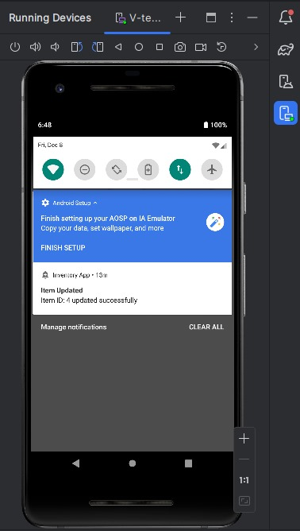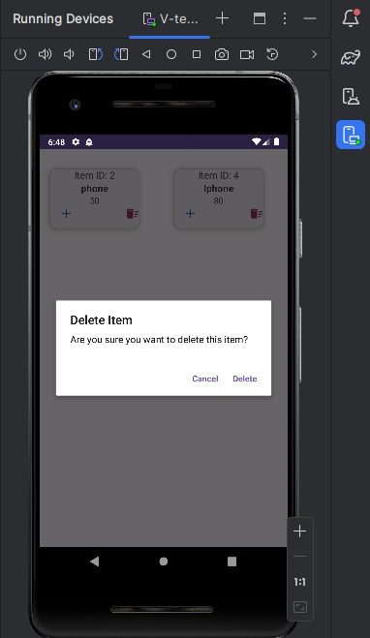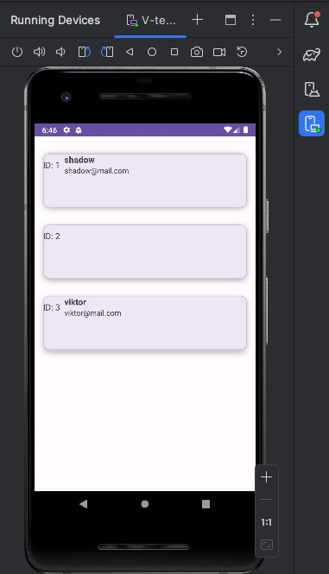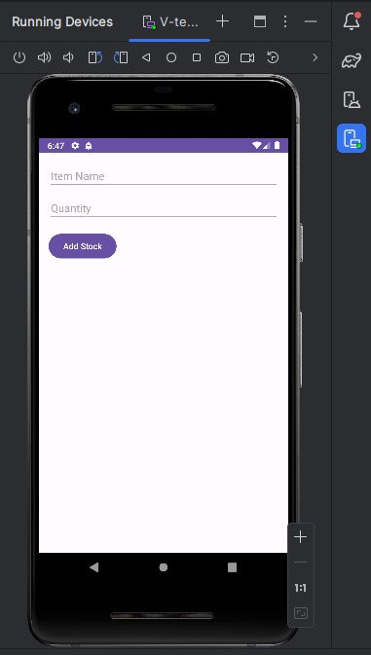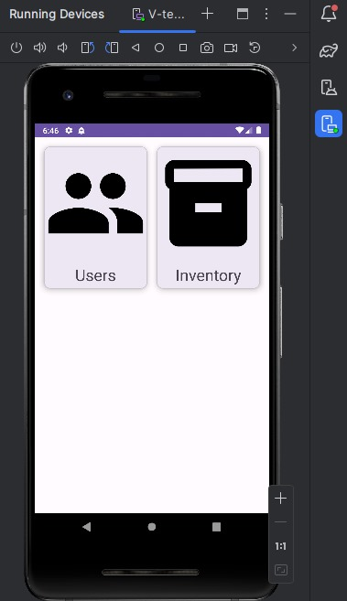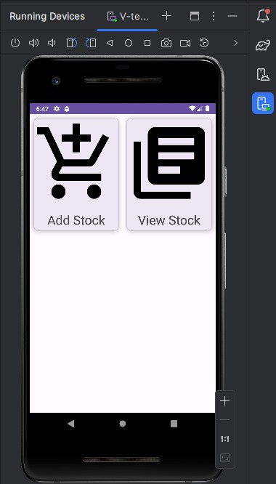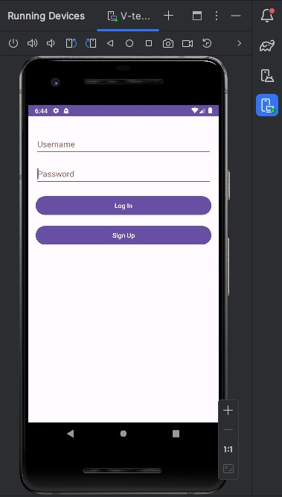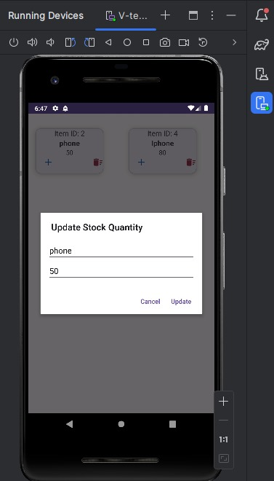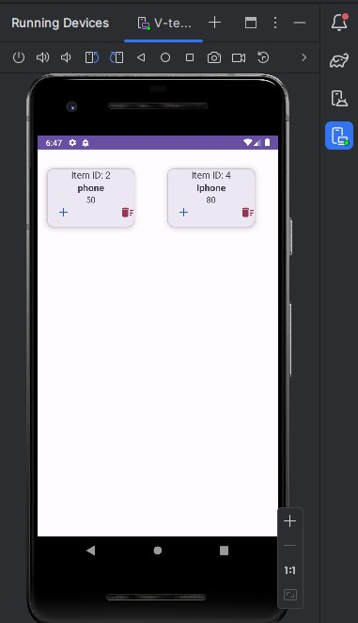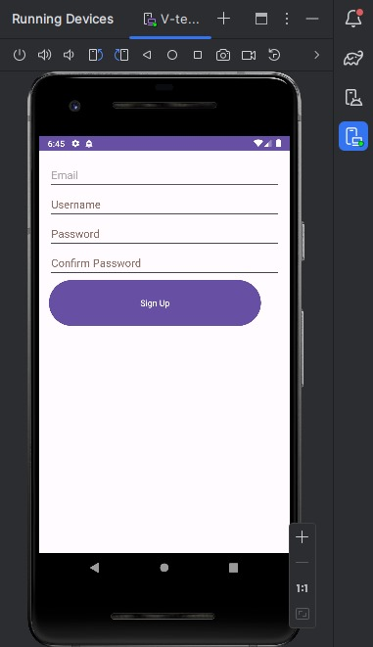

**Functionality**

The app offers a range of functionalities tailored to different user roles. The app caters to Warehouse Operatives and Managers. For Warehouse Operatives, features like 'Add Stock' and 'Remove Stock' are easily accessible, while Warehouse Managers have access to more comprehensive tools like inventory analysis and user permission management. The user interface, inspired by Material Design, is both intuitive and aesthetically pleasing, promoting an efficient user experience. Operatives will have a user-friendly interface for daily inventory tasks, while Managers will access features for strategic planning. The app offers customized interfaces for each user type, ensuring usability and efficiency in their respective roles.

Operatives will benefit from features like quick stock adjustments and easy-to-navigate interfaces, reducing the time spent on inventory management. Managers will access in-depth analytics and reporting tools, facilitating strategic decision-making and effective oversight of warehouse operations. The app ensures that each user interface is customized to fit the distinct needs of these roles

The interface is not only functional but also visually appealing, which is a significant factor in user adoption and satisfaction. The use of vibrant colors, clear typography, and intuitive navigation contributes to a positive user experience. Future UI enhancements could include personalization options, allowing users to customize the interface according to their preferences, which would make the app even more user-friendly and engaging.

**Launch Readiness**

The app appears to be in a good state for launch, with core functionalities implemented and tested. Prior to launch, a final round of testing should be conducted, focusing on edge cases and stress testing to ensure stability and performance under various conditions. The launch phase is also an excellent opportunity for marketing and user education. Developing comprehensive guides, tutorials, and promotional materials will be essential in introducing the app to the target market. Engaging with potential users through webinars, workshops, and one-on-one sessions can help in gathering valuable feedback and establishing a strong user base. This user-centric approach to launch will not only aid in smoother adoption but also help in building a loyal customer base.

**Future Enhancements**

Post-launch, the app could be enhanced with additional features like advanced analytics for trend forecasting, integration with external ERP systems, and enhanced security measures like two-factor authentication for user accounts. Creating a user community where warehouse managers and operatives can share insights, best practices, and feedback would not only enhance the app's value but also foster a sense of community. This could lead to the development of new features and improvements driven by real user experiences and needs, further solidifying the app's position as a vital tool in the inventory management domain

**Market Impact and User Benefits**

The Inventory App is to make a significant impact in the market, particularly in the domain of warehouse and inventory management. By leveraging digital tools and technologies, the app addresses key challenges faced by businesses in managing their inventory, such as reducing errors, optimizing stock levels, and improving overall operational efficiency. The benefits for users are manifold. For warehouse operatives, the app simplifies daily tasks, making stock management more efficient and less prone to errors. For managers, it provides valuable insights into inventory trends, enabling better decision-making and strategic planning. The app's scalability ensures that it is suitable for businesses of all sizes, from small local warehouses to large multinational distribution centers. Its impact extends beyond operational efficiency. By optimizing inventory management, businesses can reduce waste, lower costs, and increase their competitiveness in the market. The app also has the potential to contribute to sustainability efforts by aiding in the efficient use of resources. The Inventory App is not just a tool but a strategic asset that can transform the way businesses handle inventory management, leading to more sustainable, efficient, and profitable operations.