MORSE

A = .-

B = -...

C = -.-.

D = -..

E = .

F = ..-.

G = --.

H = ....

I = ..

J = .---

K = -.-

L = .-..

M = --

N = -.

O = ---

P = .--.

Q = --.-

R = .-.

S = ...

T = -

U = ..-

V = ...-

W = .--

X = -..-

Y = -.--

Z = --..

0 = -----

1 = .----

2 = ..---

3 = ...--

4 = ....-

5 = .....

6 = -....

7 = --...

8 = ---..

9 = ----.

, = --..--

. = .-.-.-

? = ..--..

; = -.-.-.

: = ---...

/ = -..-.

- = -....-

( = -.--.

) = -.--.-

_ = ..--.-

@ = .--.-.

! = -.-.--

& = .-...

= = -...-

+ = .-.-.

$ = ...-..-

SPACE = /

CESAR

A = D

B = E

C = F

D = G

E = H

F = I

G = J

H = K

I = L

J = M

K = N

L = O

M = P

N = Q

O = R

P = S

Q = T

R = U

S = V

T = W

U = X

V = Y

W = Z

X = A

Y = B

Z = C

HEX

SPACE = 20

! = 21

" = 22

# = 23

$ = 24

% = 25

& = 26

' = 27

( = 28

) = 29

* = 2a

+ = 2b

, = 2c

- = 2d

. = 2e

/ = 2f

0 = 30

1 = 31

2 = 32

3 = 33

4 = 34

5 = 35

6 = 36

7 = 37

8 = 38

9 = 39

: = 3a

; = 3b

< = 3c

= = 3d

> = 3e

? = 3f

@ = 40

A = 41

B = 42

C = 43

D = 44

E = 45

F = 46

G = 47

H = 48

I = 49

J = 4a

K = 4b

L = 4c

M = 4d

N = 4e

O = 4f

P = 50

Q = 51

R = 52

S = 53

T = 54

U = 55

V = 56

W = 57

X = 58

Y = 59

Z = 5a

[ = 5b

\ = 5c

] = 5d

^ = 5e

_ = 5f

` = 60

a = 61

b = 62

c = 63

d = 64

e = 65

f = 66

g = 67

h = 68

i = 69

j = 6a

k = 6b

l = 6c

m = 6d

n = 6e

o = 6f

p = 70

q = 71

r = 72

s = 73

t = 74

u = 75

v = 76

w = 77

x = 78

y = 79

z = 7a

{ = 7b

| = 7c

} = 7d

~ = 7e

BINARY

= 00100000

! = 00100001

" = 00100010

# = 00100011

$ = 00100100

% = 00100101

& = 00100110

' = 00100111

( = 00101000

) = 00101001

* = 00101010

+ = 00101011

, = 00101100

- = 00101101

. = 00101110

/ = 00101111

0 = 00110000

1 = 00110001

2 = 00110010

3 = 00110011

4 = 00110100

5 = 00110101

6 = 00110110

7 = 00110111

8 = 00111000

9 = 00111001

: = 00111010

; = 00111011

< = 00111100

= = 00111101

> = 00111110

? = 00111111

@ = 01000000

A = 01000001

B = 01000010

C = 01000011

D = 01000100

E = 01000101

F = 01000110

G = 01000111

H = 01001000

I = 01001001

J = 01001010

K = 01001011

L = 01001100

M = 01001101

N = 01001110

O = 01001111

P = 01010000

Q = 01010001

R = 01010010

S = 01010011

T = 01010100

U = 01010101

V = 01010110

W = 01010111

X = 01011000

Y = 01011001

Z = 01011010

[ = 01011011

\ = 01011100

] = 01011101

^ = 01011110

_ = 01011111

` = 01100000

a = 01100001

b = 01100010

c = 01100011

d = 01100100

e = 01100101

f = 01100110

g = 01100111

h = 01101000

i = 01101001

j = 01101010

k = 01101011

l = 01101100

m = 01101101

n = 01101110

o = 01101111

p = 01110000

q = 01110001

r = 01110010

s = 01110011

t = 01110100

u = 01110101

v = 01110110

w = 01110111

x = 01111000

y = 01111001

z = 01111010

{ = 01111011

| = 01111100

} = 01111101

~ = 01111110

VIGENERE

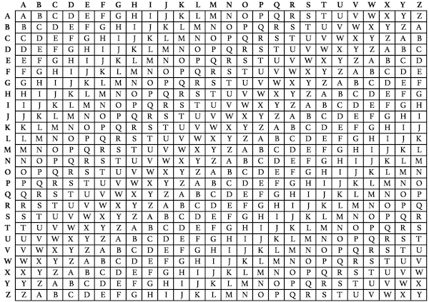

ATBASH

A = Z

B = Y

C = X

D = W

E = V

F = U

G = T

H = S

I = R

J = Q

K = P

L = O

M = N

N = M

O = L

P = K

Q = J

R = I

S = H

T = G

U = F

V = E

W = D

X = C

Y = B

Z = A