**Project Description**

**Supervisors:**

Ib Havn

Erland Ketil Larsen

Kasper Knop Rasmussen

Knud Erik Rasmussen

Lars Bech Sørensen

**Students:**Josipa Babic – 266757

Eduard Nicolae Costea -266078

Diyar Hussein Hussein – 266352

Kenneth Ulrik Petersen – 269379

Angel Iliyanov Petrov – 266489

Remedios Pastor Molines – 266100

Ionel-Cristinel Putinica – 266123

Erika Monica- Szasz- 280201

Christian Schou Sørensen – 267142

Mihai Tirtara - 266097

**SEP4**

**4th semester**

**26.02.2019**

Contents

**1.** **Background description** 3

**2.** **Definition of purpose** 4

**3.** **Problem Statement** 5

**4.** **Delimitation** 5

**5.** **Choice of models and methods** 5

**6.** **Time schedule** 6

**7.** **Risk assessment** 7

**8.** **Sources of Information** 8

1. **Background description**

Indoor plants can be a great addition to homes because they present a multitude of benefits such as improving air quality by removing carbon dioxide while providing extra oxygen and the exposure to them reduces stress levels, boosts mental health, calms anxiety and lowers blood pressure. Also, they improve productivity and concentration, which is great for people who work from home and need a boost to focus on the work at hand. Plus, they help regulate humidity and increase levels of positivity. It is equally important to mention that plants can help diversify bacteria in our bodies to fight infections and allergies which is very crucial for city dwellers who are less likely to be exposed to nature daily, therefore their immunity can be influenced negatively without the presence of indoor greenery (Tobebright, 2018).

Having discussed about all the positive sides of owning indoor plants, there are some downsides as well. For people who live in apartments the responsibility of keeping a plant alive might not be such an easy task. Also, when they leave their apartment for a longer period of time, their green space needs to be taken care of and that can also represent a problem. There are some constraints such as limited space and lack of natural light which can limit the lifetime of many plants, making maintenance feel overwhelming (Tonelli & Kelsey, 2018). If the indoor garden is on a somewhat wider scale, the care taking routine of plants requires even more devoted time and attention. Unfortunately, these aspects may determine many people to give up the plants they own or prevent them from buying new ones. In this situation, a solution to increase the lifespan of plants and make their caretaking effortless is necessary.

When deciding to own plants, people should first consider what kinds of plants work best with their lifestyle and environment. Luckily, there is a wide variety of plants to choose from starting with low-maintenance ones such as cactuses, to high-maintenance tropical plants. But even the most low-maintenance ones still require some level of attention (Mindbodygreen, 2018). For this purpose, monitoring the external conditions of the plant such as the air humidity and temperature could play a key factor in providing it with the right care that includes tasks such as watering the plant and turning up the heat.

1. **Definition of purpose**

The purpose of this project is to design a product that will make the maintanace of indoor plants a simpler task.

1. **Problem Statement**

This project will focus on answering the following question: How can technology make maintenance of plants easier?

Questions to be answered are the following:

* What are the conditions that mostly affect the growth of plants?
* What is the relevant information that the system will provide to the user regarding the situation of the plants?
* How can information about different plants be gathered and used to make maintenance of plants more accessible?
* How will the information be presented to the user?

1. **Delimitation**

* System will not present the information in any other way, apart from the use of a mobile application.
* System will not monitor conditions apart from those mentioned in the background descriptions. Examples include pressure, soil PH levels and wind speed.
* System will not provide other information except the measured conditions.

1. **Choice of models and methods**

|  |  |  |
| --- | --- | --- |
| **What?** | **Why?** | **Which?** |
| How are the conditions going to be measured? | The team must know what hardware to use for the IOT part of the project. | Sensors: Humidity and tempereture |
| How will data be managed in the system? | The project needs to generate statistics based on data for business intelligence in the company. | Extract, transform and load data into a data warehouse. |
| How will work be distributed among team members? | The project consists of three different parts and the development team has 10 members, so work must be partitioned. | SCRUM and AUP |
| How will the user interact with the product? | The project consists of different parts and hardware types and it must be established what platform the customer should interact with. | Mobile application |

1. **Time schedule**

Modifications and additions to the Design can always appear, and so, as a result, the group has planned to spend extra time into Implementation and Testing. Keeping in mind that one ECTS is equivalent to 27,5 hours of work, every group member will put roughly 140 hours of work in this project, the combined amount of work for the project summing up to about 1400 hours.

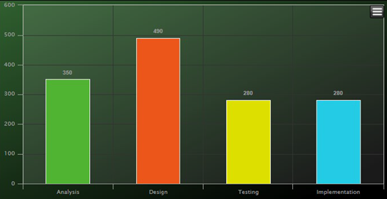A visual representation on the amount of hours to be spent on the phases of the project.

Timeline of project period:

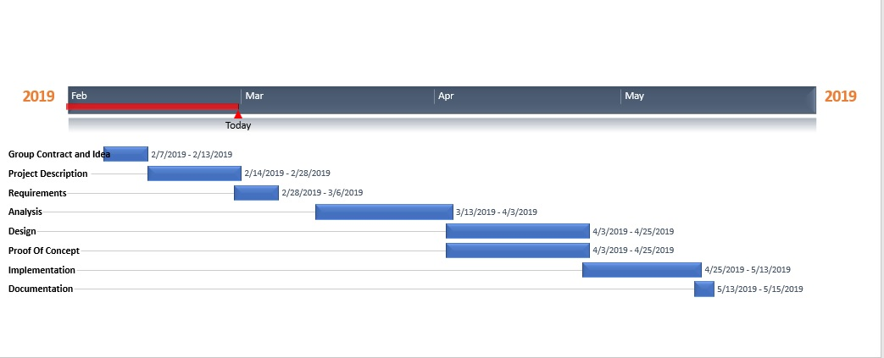

1. **Risk assessment**

|  |  |  |  |  |  |  |  |
| --- | --- | --- | --- | --- | --- | --- | --- |
| Risk | Description | Likelihood (Scale 1-10) | Severity (Scale 1-10) | Product of likelihood and severity | Risk mitigation | Identifiers | Responsible |
| 1 | Delay | 4 | 5 | 10 | Check schedule regularly, make sure the time is enough | Missing the  deadlines for the scrum sprints | Remedios |
| 2 | Illness | 2 | 4 | 4 | Make sure both physical and mental condition are favorable | Missing meetings and slowing the development of the project | Christian |
| 3 | Lack of necessary professional knowledge | 4 | 3 | 6 | Search online for information or seek help from the supervisors. | Facing difficulties when designing and implementing the project. | Ionel |
| 4 | Failure of hardware | 2 | 5 | 5 | Proper using and well maintaining of the equipment | Faulty sensors,boards etc. | Kenneth |
| 5 | Loss of information | 2 | 5 | 5 | Use clouding services such as GitHub and Google Drive to store all project work | Missing information, code, documents, etc.. | Mihai |
| 6 | Failure of Database | 2 | 4 | 4 | Use of backup for databases | Unable to retrieve or load information from the database | Josipa |
| 7 | Synchronization between teams | 4 | 5 | 10 | Constant communication between groups | The project development is slowed | Erika |
| 8 | Group member not participating or not commited | 6 | 6 | 6 | Give warnings in case of such events | The project development is slowed, the team is de-motivated | Angel |

1. **Sources of Information**

(2018, June 21). Retrieved from Tobebright:   
<https://tobebright.com/the-importance-of-indoor-plants-in-an-apartment/>

Tonelli, L., & Kelsey, K. (2018, August 21). Retrieved from Elledecor: <https://www.elledecor.com/life-culture/fun-at-home/news/g3284/best-indoor-plants-for-apartments/>

Emma Loewe (December 14, 2018). Retrieved from mindbodygreen:

<https://www.mindbodygreen.com/articles/how-to-make-sure-your-plants-dont-die-when-youre-away-for-holidays>