**Version Control & File Sharing Management**

Because of the scale of the project, the need for version control management became very obvious from the beginning of the project. Numerous other websites and applications have also been used for file sharing and communication within the group, as to better organize meetings and remote work.

**Version Control**

For version control, the team decided to use three secondary repositories, where each sub-group will submit their work regarding coding, and a main repository, where the team submitted in the first stages of the project documentation, and later, all the software was put together in this repository. GitHub, as the industry’s standard was used by the group to create and manage their repositories. GitHub was used as the hosting service for all the group’s files, offering all of the distributed version control and source control management functionality of Git, as well as adding its own featured. It provided access control and several collaboration features such as bug tracking, feature requests, task management, and a wiki for the project. As for the backend of version control, Git Bash and GitKraken have been used as the main tools to track changes in the computer files and coordinating the work on those files among the group’s members.

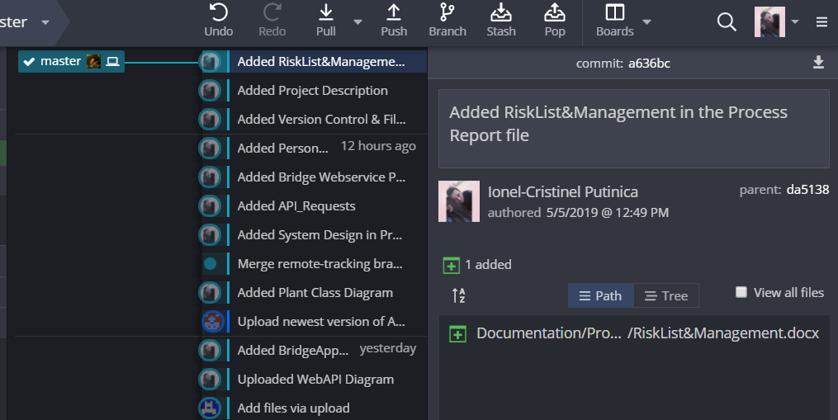

Dashboard of the main repository in the early stages of the documentation

**File Sharing Management**

Different tools were used for sharing files between members of the group, the main one being Slack, a cloud-based software, based on team collaboration tools and services, where the team uploaded different parts of documentation, such as writing or diagrams. Other tools have also been used such as Dropbox and Google Drive, and, on a small scale Facebook as well.

**Communication and Planning**

As far as communication and planning went, the main tools that the team has made use of were Slack and Facebook, because of the ease that they offer regarding this services.