Android User Interface, Interactions and Design Choices

From the early stages of the project, the main focuses regarding the User Interface were to make every layout of every single activity in the Android Application simple, intuitive and eye-catching. In the Design phase, the Android group designed sketches of the layouts.

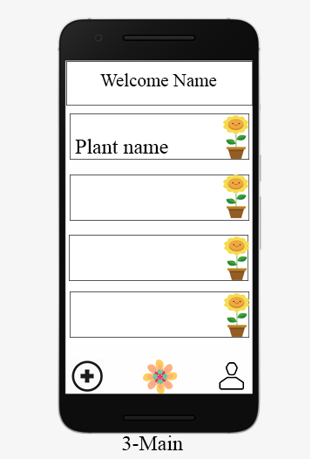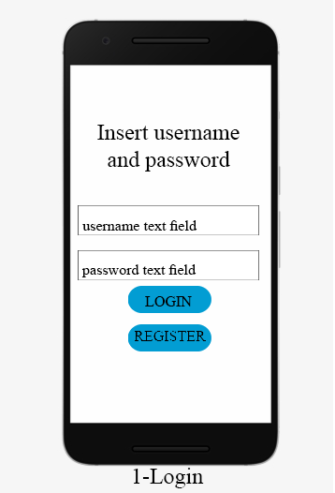

As it can be seen from the above represented sketches, the layouts have been designed to be as simple and straight forward as possible. Along with the layouts sketches, the group designed an interaction diagram for all the layouts, which has the sole purpose of giving a better understanding of how the flow of events in the application works.

As it can be seen from the interaction diagram, there are 8 activities that the application uses: **Login**, **Register**, the **Main activity**, **Account Settings**, **Modify Account**, **Create Plant Profile**, **View Plant Profile** and **Modify Plant Profile**.

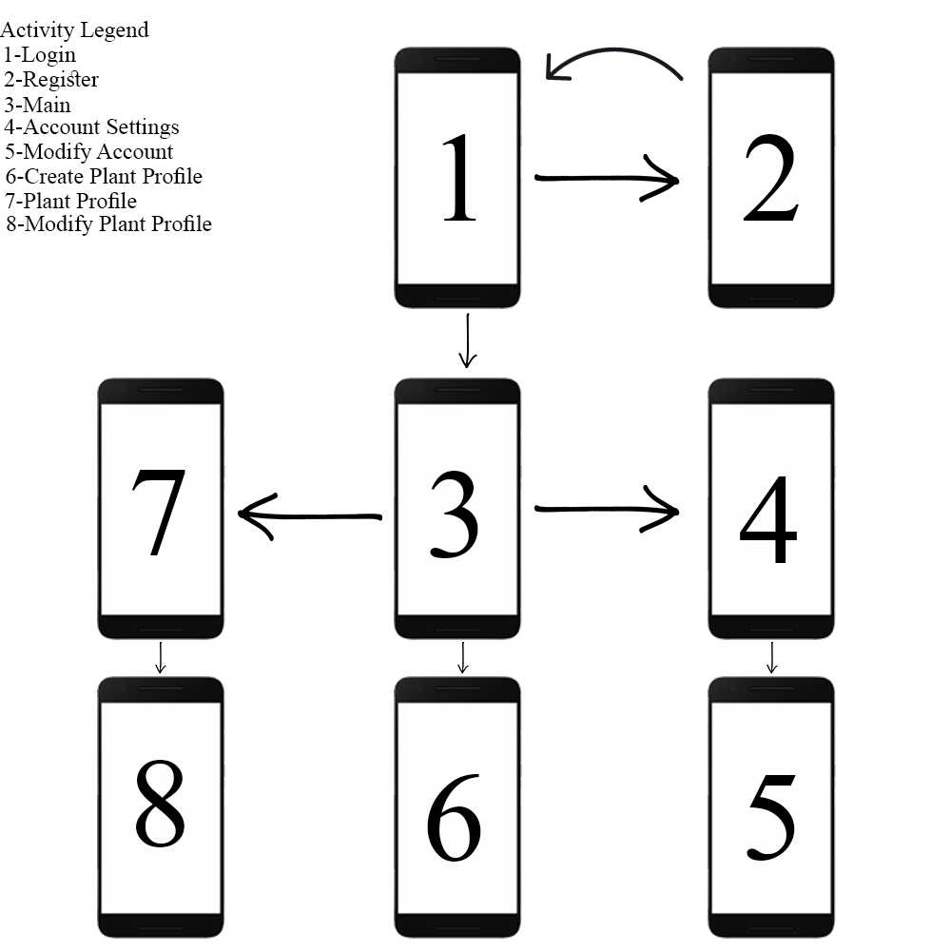

# **Login Activity**

The **Login activity** is the one that the user is prompted with when first opening the application. From this activity, the user has two options:

1. Input his login details of a previously created account and then press the “Login” button, from which he will be sent to the **Main Activity**

2. Press on the “Register” button, getting sent to the **Register activity** where he is able to create a new account

# **Register Activity**

The **Register activity** is oversimplified and it allows the user to input four text fields with his account details: username, email, name and password, after which the user presses the “Register” button which prompts him back to the **Login activity.**

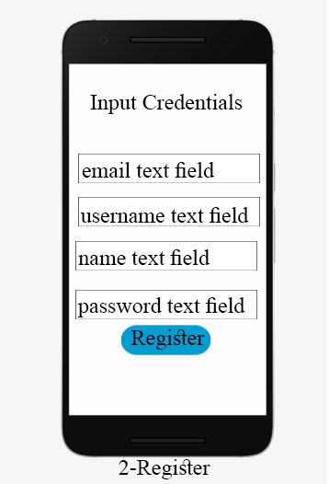

# **Main Activity**

The **Main activity** displays a custom welcome message for the user, based on his name that he inputted when he created his account, and below that it displays a list with plants. This activity also features a bottom navigation bar, which is also present in all the other activities, apart from the **Login** and the **Register** ones, with 3 options:

* The button on the right sends the user to the **Account Settings activity**
* The option in the middle has the purpose of sending the user to the **Main activity**
* The option in the left redirects the user to the **Create Plant Profile activity**

One last thing the user can do from the **Main activity** is to click on one of the existing plant profiles, which sends the user to the **View Plant Profile activity**

# **Account Settings Activity**

In the **Account Settings activity**, the username, email and name of the user are displayed on top, along with an “Edit credentials” button, which, if pressed, sends the user to the **Modify Account activity**. This activity encloses a “Delete Profile” button, which will delete all the data of the user from the database, including the login details.

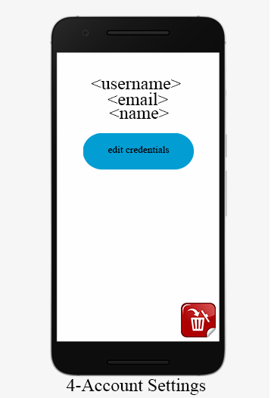

# **Modify Account Activity**

In the **Modify Account activity**, the user has 4 text fields where he can input his new details, in the case he wishes to change any, and then a save button, that, if pressed, saves and updates all the new data in the database.

# **Create Plant Profile**

In the **Create Plant Profile activity**, the user is given to option to create a plant. He has to input a name for the Plant, and, in addition to this, he can select a predefined plant template (which defines the ranges of the temperature, humidity and carbon dioxide) from a drop down list.

# **View Plant Profile**

In the **View Plant Profile activity**, the application displays the name of the plant, the current external temperature, the humidity level and also the CO2 level. There is also a “Modify Plant Profile” button, that the user can press, which sends him to the **Modify Plant profile Activity**. This activity also features a “Water Plant” button that can be pressed to remotely water the plant. Lastly, a delete button also appears in the bottom of the activity, which can be pressed to delete all the data regarding that certain plant from the database and remove it from the system.

# **Modify Plant Profile**

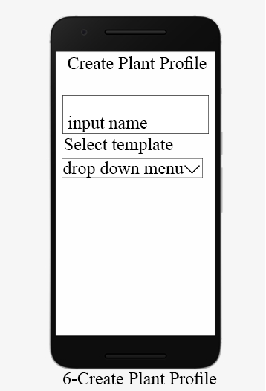 In the **Modify Plant Profile activity**, there are multiple text fields, where the user is able to change the temperature range, the CO2 level, the humidity level, the amount of water and the watering interval. For the changes to apply to the database, the user has to press the “Save Button”.

