Q1: Multiple answer questions
In a (3,3) trivial secret sharing based on the XOR the three shares are 0110, 1110, 1000. What is the secret?
Why Shamir Secret Sharing requires prime fields? | - To guarantee forward secrecy  - To guarantee unconditional security  - To guarantee reconstruction of secret  - To guarantee linearity
Given g and h public values, arithmetics modulo prime, e(G,G) a bilinear pairing, and s a secret, which of these constructions is a Pedersen commitment for the secret s? | - Commit(r,s) = g^{rs}  - Commit(r,s) = e(g^{r},h^{s})  - Commit(r,s) = h^{r}g^{s}  - None of the above
In an El Gamal encryption using a 1024 bit prime modulus, the size of the ciphertext is | - 1024 bit  - 2048 bit  - 4096 bit  - Variable, depends on the size of the plaintext
Being a an EC point, e(G,G) a bilinear pairing, g a generator of G, and b, c numerical coefficients, simplify the following expression:
e(a × g^{b}, g^{c})
How is the private key SK of an user named “bob” constructed in the Boneh-Franklin’s Identity Based Encryption scheme? (notation: s, g^s = PKG key pair, H() = hash function which maps a string into an EC point) | - SK = g^H(bob)  - SK = H(bob^s)  - SK = bob^s  - SK = H(bob)^s

Q2: For the Pedersen Verifiable Secret Sharing scheme describe: i) how shares are assigned to each party, ii) how a party’s share, once revealed, can be verified

Q3: Consider the Elliptic curve y² = x³ + x +-1 defined over the modular integer field Z₅.
- find all the points EC(Z₅)
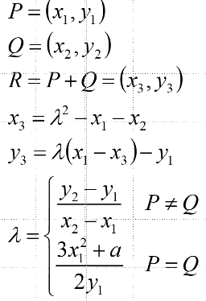

- State what is the order of the corresponding group

- Compute [4](0,2) using the minimum number of operations
[HELP: possibly useful mnemonic hints reported here on the right;
MUST-DO: show step-by-step detailed computations]

Q4: In ECDSA, we decide to sign two messages m1 and m2 using as nonces r1=[k]P and r2=[2k]P. Is this harmful? And if this is the case, demonstrate why.

Q5: Assume arithmetic modulus 101. A Linear secret sharing scheme involving 3 parties is described by the following access control matrix:
A: 1 1 1
B: 0 1 -1
C: 0 0 1
A. Assume that the following shares are revealed:
A 88
B 12
C 51
What is the secret? (explain how you arrived to the result, otherwise the answer is not considered valid)

Q6. A same message M is RSA-encrypted using two different public keys e1 = 3 and e2 = 11, but same RSA modulus n=319. The two resulting ciphertexts are: c1=10 and c2=142. Decrypt the message applying the Common Modulus Attack (show the detailed computations required).
Mod 319 inverses that might be useful to speed up computation: 10⁻¹ = 32; 142⁻¹ = 164

