Databases(lab6).

2.

a. combine each row of dealer table with each row of client table

select *  
from dealer  
 cross join client;

b. find all dealers along with client name, city, grade, sell number, date, and amount

select d.name, c.name, c.city, c.priority, s.id, s.date, s.amount  
  
from client c  
 inner join dealer d on d.id = c.dealer_id  
 inner join sell s on c.id = s.client_id;

c. select d.name, d.location, c.city  
from dealer d  
 inner join client c on d.location = c.city;

d. find sell id, amount, client name, city those sells where sell amount exists between 100 and 500

select distinct on (s.id) s.id, s.amount, c.name, c.city  
from client c  
 inner join sell s on s.amount between 100 and 500;

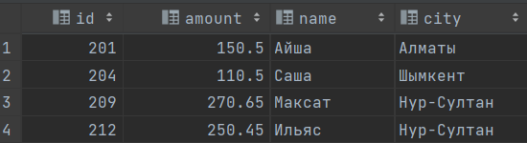

select s.id, s.amount, c.name, c.city  
from client c, sell s where s.client_id = c.id and s.amount between 100 and 500;

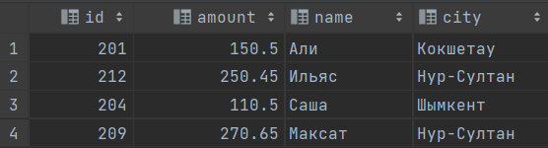

e. find dealers who works either for one or more client or not yet join under any of the clients

select d.id, d.name, *count*(d.id)  
from dealer d join client c on d.id = c.dealer_id  
group by (d.id, d.name)  
having *count*(d.id) = 1 or *count*(d.id) > 3 or *count*(d.id) = 0;

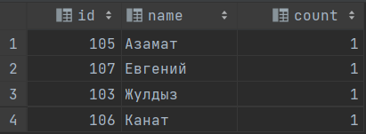

f. find the dealers and the clients he service, return client name, city, dealer name, commission.

select c.name, c.city, d.name, d.charge  
from dealer d  
 join client c on c.dealer_id = d.id;

g. find client name, client city, dealer, commission those dealers who received a commission from the sell more than 12%

select c.name, c.city, d.name, d.charge  
from client c  
 join dealer d on c.dealer_id = d.id  
where d.charge > 0.12;

h. make a report with client name, city, sell id, sell date, sell amount, dealer name and commission to find that either any of the existing clients haven’t made a purchase(sell) or made one or more purchase(sell) by their dealer or by own.

select c.name, c.city, s.id, s.date, s.amount, d.name, d.charge  
from client c  
 left outer join dealer d on c.dealer_id = d.id  
 left outer join sell s on s.client_id = c.id;

1. find dealers who either work for one or more clients. The client may have made, either one or more purchases, or purchase amount above 2000 and must have a grade, or he may not have made any purchase to the associated dealer. Print client name, client grade, dealer name, sell id, sell amount

select c.name, c.priority, d.name, s.id, s.amount  
from client c  
 right outer join dealer d on c.dealer_id = d.id  
 left outer join sell s on s.client_id = c.id  
where s.amount > 2000  
 and c.priority is not null;

2.

a. count the number of unique clients, compute average and total purchase amount of client orders by each date.

create view unicavgdate as select *count*(distinct s.client_id), *avg*(s.amount), *sum*(s.amount)  
from sell s  
group by s.date;

b. find top 5 dates with the greatest total sell amount.

create view top5 as select s.date, *sum*(s.amount) from sell s group by (s.date)  
order by *sum*(s.amount) limit 5;

c. count the number of sales, compute average and total amount of all sales of each dealer.

create view dealereport as select *count*(s.amount), *avg*(s.amount), *sum*(s.amount) from sell s  
group by (s.dealer_id);

d. compute how much all dealers earned from charge(total sell amount * charge) in each location

create view locationreport as select dealer, *sum*(amount * dealer.charge) from sell s join dealer on s.dealer_id = dealer_id  
group by dealer;

e. compute number of sales, average and total amount of all sales dealers made in each location

create view locationreport2 as  
select d.location, *count*(s.amount), *avg*(s.amount), *sum*(s.amount)  
from sell s  
 join dealer d on d.id = s.dealer_id  
group by d.location;

f. compute number of sales, average and total amount of expenses in each city clients made.

create view expenses as  
select c.city, *count*(s.amount), *avg*(s.amount * (1 + d.charge)), *sum*(s.amount * (1 + d.charge))  
from client c  
 join sell s on c.id = s.client_id  
 join dealer d on c.dealer_id = d.id  
group by c.city;

g. find cities where total expenses more than total amount of sales in location

create view citiesAmount as  
select c.city, *sum*(s.amount * (1 + d.charge)) as sumsity, *sum*(s.amount) as sumlocation  
from client c join dealer d on c.dealer_id = d.id join sell s on c.id = s.client_id and c.city = d.location  
group by c.city;