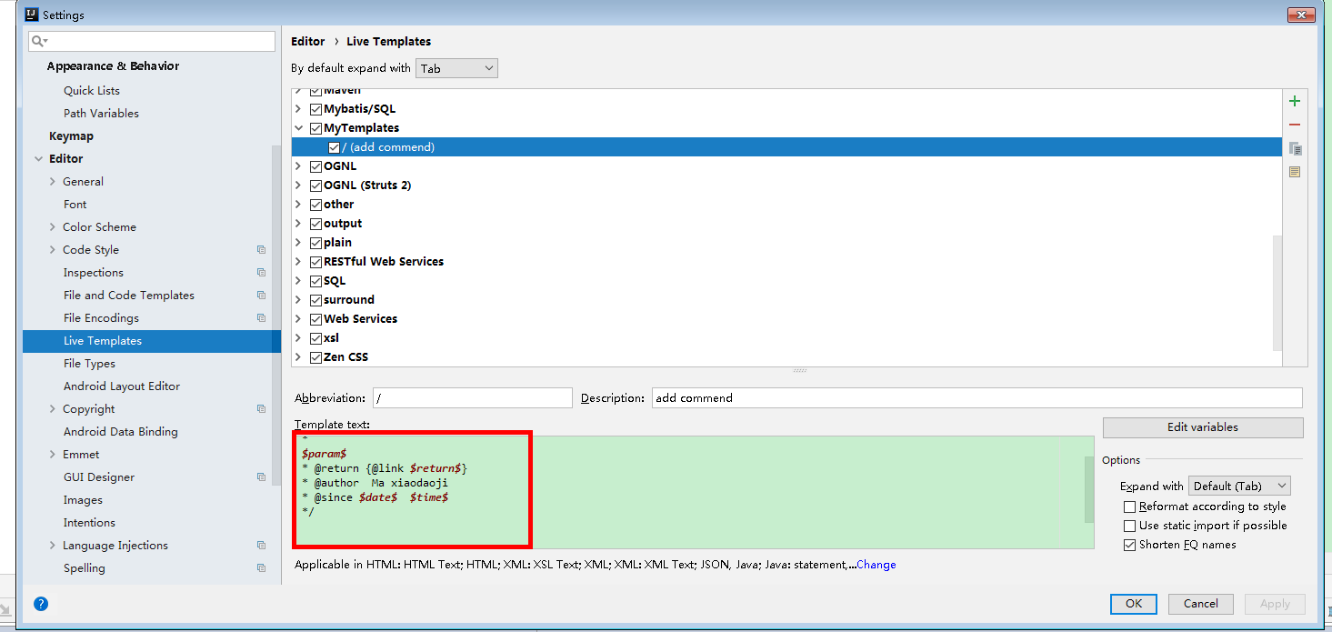

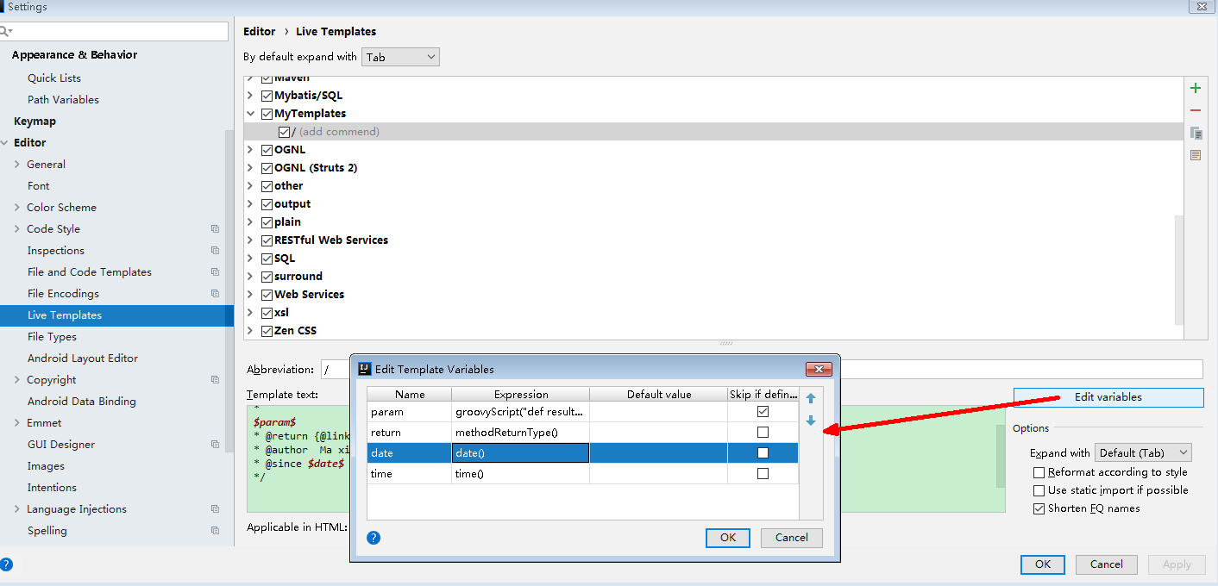

*  
 * @Description  
 *$param$* * @Return *$return$* * @Author zhangbin  
 * @Since *$date$ $time$* */

param：

groovyScript("def result=''; def params=\"${_1}\".replaceAll('[\\\\[|\\\\]|\\\\s]', '').split(',').toList(); for(i = 0; i < params.size(); i++) {result+='* @param ' + params[i] + ((i < params.size() - 1) ? '\\n ' : '')}; return result", methodParameters())

return: methodReturnType()

date : date()

time: time()

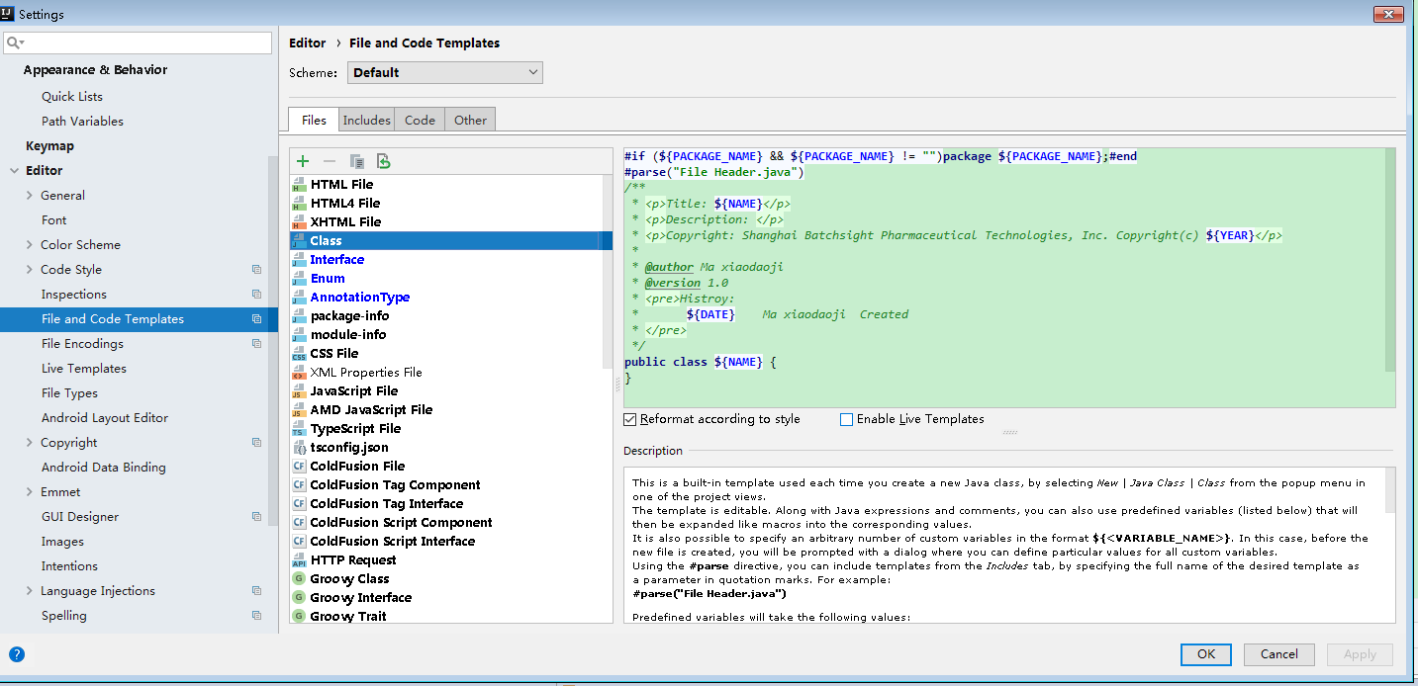

CLASS:

**#if** (**${PACKAGE_NAME}** && **${PACKAGE_NAME}** != **""**)package **${PACKAGE_NAME}**;**#end  
#parse**(**"File Header.java"**)  
/**  
 * <p>Title: **${NAME}**</p>  
 * <p>Description: </p>  
 * <p>Copyright: Code By Ion, Inc. Copyright(c) **${YEAR}**</p>  
 *  
 * @author Zhangbin  
 * @version 1.0  
 * <pre>Histroy:  
 * **${DATE}** Zhangbin Created  
 * </pre>  
 */  
public class **${NAME}** {  
}