Fast adaptive compressive sensing based compression
Iordan · 2026-10-22

Summary
We compress an image in three moves: shrink it to half its width and height, split the shrunk image into regions of similar content, and keep only a small random selection of pixels, with a different rate for each region (more where there is detail). Rebuilding the full image from those few pixels is slow on a CPU, so we moved the heavy steps to a graphics card (GPU). Rebuilding a 12-megapixel photo now takes 7.0 s instead of 42.4 s, with exactly the same quality (32.66 dB PSNR, a standard measure of how close the result is to the original). We also found that a neural network (Swin2SR) is not needed for good quality: it adds only 0.05 dB and costs about 6 s more. What matters most is how strongly the method is tied to its starting guess; loosening that tie gained 0.25 dB on average over six photos.

1 Introduction
Compressive sensing means rebuilding a signal from far fewer measurements than it has values, by using the fact that images are simple in the right representation. Here we study the segmented path of our system. The image is first shrunk 2x in each direction, so only a quarter of the pixels remain. The shrunk image is then split into regions of similar content (by k-means clustering), and each region gets its own sampling rate: flat regions keep few pixels, detailed regions keep more. Compression comes from storing only the kept pixels; everything else is reconstructed, and the result is enlarged 2x back to full size.
This paper does three things: (1) it speeds up every heavy step of the reconstruction on the GPU and measures what each change gained; (2) it shows that the refinement step (ADMM) already gives most of the quality gain without a neural network; (3) it shows that the main quality setting is how strongly ADMM sticks to its starting guess.
A side effect of this sampling method: the kept pixel values can be stored as ordinary plain values, while their positions in the image are not stored at all and are regenerated from a key. Without the key the values cannot be put back in the right places, so the same format also has potential for encryption.

2 How the image is rebuilt
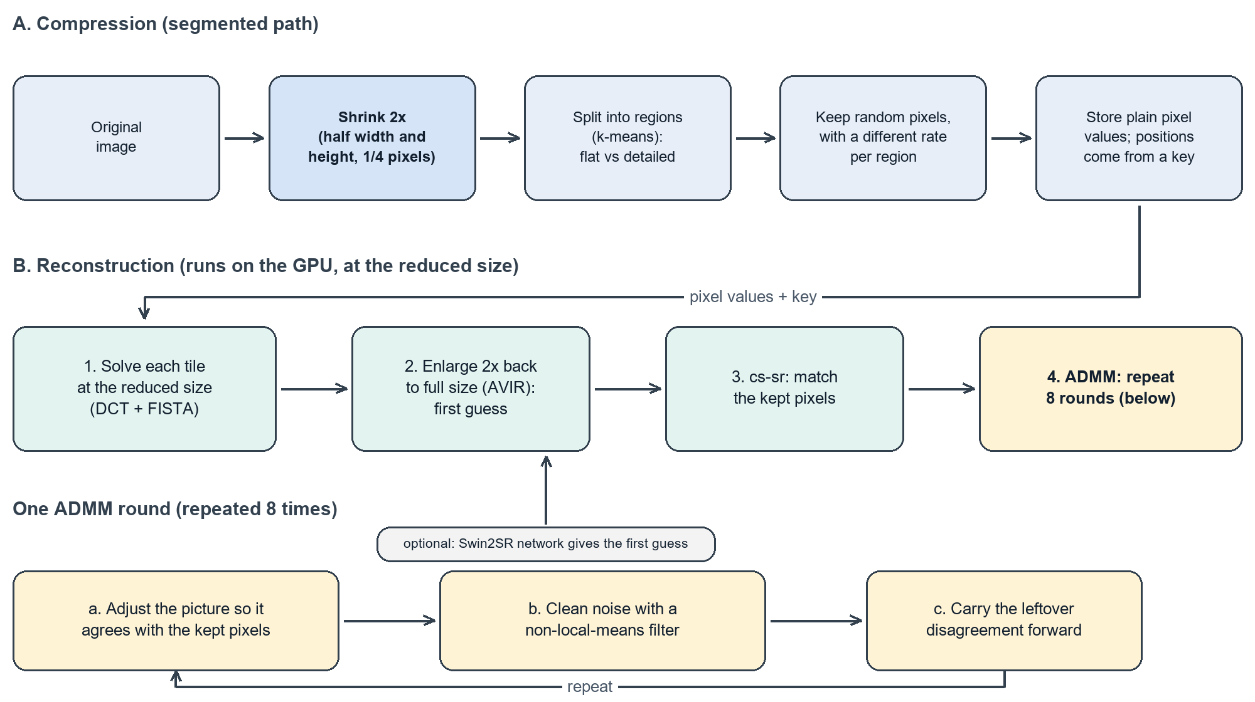
Figure 1. The segmented path: (A) the image is shrunk 2x, split into regions and sampled with a different rate per region; (B) reconstruction solves at the reduced size, enlarges 2x back to full size, and refines with repeated ADMM rounds. The grey network box is optional.
Step 1 – small pieces. Working at the shrunk size, the image is cut into overlapping tiles. For each tile we find the smoothest picture that matches the pixels we kept. This gives a rough version of the tile at the reduced size.
Step 2 – enlarge back to full size. Each rough tile is made twice as big in each direction with a standard resizing method (AVIR). This is a good first guess, but it is only a guess: it is blurry and does not know about the kept pixels.
Step 3 – correct the guess (cs-sr with ADMM). We repeat 8 times: (a) adjust the picture so that it agrees with the pixels we really kept; (b) clean up noise with a non-local-means filter, which averages similar-looking patches; (c) keep track of the remaining disagreement and feed it into the next round. A single setting, called ρ (rho), decides how strongly the picture is pulled back towards the previous guess; a small ρ lets the real pixels win. Colour is taken from the enlarged tile unchanged.
Optional – neural network. Instead of the plain enlargement, a small neural network (Swin2SR) can produce the first guess. We use it only on tiles that cross a boundary between regions.

3 What we changed to use the GPU
All data of a step stays on the GPU while that step runs, and tiles of different sizes are processed together in one go. Changes 1–3 explain the speed-up in Table 1; changes 4–5 concern only the optional network.
- Solve all tiles at once. The CPU solved tiles one after another, each using its neighbour's result. We dropped that dependency, so thousands of tiles can be solved together: 4096 tiles × 3 colour channels take 1.3 s instead of 29 s of CPU work. Then the tiles are processed in one flat parallel loop with no waiting between groups.
- Faster maths on tiles. The transform applied to every tile was rewritten as a blocked matrix multiplication that keeps data in the GPU's fast local memory. It needs 4 GPU programs per iteration instead of 7. Loading data ahead of time was important; the first version was slower on small batches.
- Same noise filter as OpenCV. We rewrote the non-local-means filter for the GPU so that it matches the OpenCV result: only 2 of 139,920 test pixels differ, by one grey level.
- Simplified neural network. The exported network has 19,113 small operations, mostly bookkeeping about shapes. Fixing the sizes and pre-computing this bookkeeping leaves 2,018, which is 2.6× faster per tile with the same output.
- Faster start-up. Not creating an unused network session, preparing the real one in the background and saving it on disk removes 6.2 s of waiting at the beginning.

4 Results
Test: a 4032×3024 photo (IMG_3690, 3969 tiles) through the segmented path (shrunk 2x, four regions, sampling ratio 0.9), automatic settings, on a Ryzen 9 7900 CPU and a Radeon RX 7900 XT GPU. Unless stated, no neural network is used. Quality is PSNR against the original at full size; ‘edge PSNR’ looks only at the 10% of pixels with the sharpest edges.
Table 1. Reconstruction time, ADMM only (no neural network).
Step | Time | Faster by
CPU only | 42.4 s | 1.0×
+ ADMM on GPU (basic kernels) | 19.7 s | 2.2×
+ blocked matrix kernels | 12.5 s | 3.4×
+ tile solve on GPU | 12.7 s | 3.3×
+ one flat loop over all tiles | 7.0 s | 6.1×
The quality is the same in every row (32.66 dB). Moving the tile solve to the GPU does not save time by itself, but it is what allows the flat loop. It no longer reuses neighbour results, so GPU and CPU images differ very slightly (56 dB PSNR between them, in a run with the network). With the neural network switched on, the GPU needs about 13 s. In an earlier setup with a manual 64×64 grid, network plus ADMM went from 168 s on the CPU to 13.8 s on the GPU, mainly thanks to the simplified network and the faster start-up.
Table 2. What each reconstruction step adds (GPU, automatic settings, no network).
Step | PSNR (dB) | Edge PSNR (dB) | Time (s)
Plain enlargement (AVIR) | 31.21 | 23.65 | 2.9
+ cs-sr | 32.05 | 24.31 | 5.5
+ ADMM | 32.66 | 25.07 | 7.0
ADMM works without the network: adding the network on top gives 32.71 dB in 13.0 s, so leaving it out costs only 0.05 dB and saves 6.0 s. How tightly ADMM holds on to its first guess matters more. On six photos and two sampling ratios, lowering ρ from 0.1 to 0.01 gained 0.25 dB on average at ratio 0.9 (0.10 dB at ratio 0.5); per image the change ranged from −0.08 to +0.69 dB. Very strong ties are harmful: ρ = 3 gives 27.7 dB, worse than the plain enlargement. Raising ρ and weakening the filter during the 8 rounds adds a little more (+0.32 dB on average), while rescaling the tracked disagreement when ρ changes hurts (−0.12 dB). At the borders between image regions (the outer 8 px, 12% of the image) every method loses about 1.5 dB and we saw no visible ringing; the network gains only 0.06 dB there.

5 Discussion and limits
The network helps little because ADMM already lets the real pixels override the first guess. With a weak tie (ρ = 0.01) the results with and without it are almost equal (33.36 and 33.35 dB). The network draws crisper stripes in fine feather texture, but sometimes with the wrong pattern, which lowered local quality by up to 2.6 dB in one crop. Shrinking the image first is also not always worse than coding it at full size: at about 1.2 million kept samples both reach about 31 dB, and full size wins beyond that (35.4 dB at 2.3 million samples).
Limits. The speed tests use one photo and one file layout (colour stored as BGR, four regions, no 4:2:0 colour compression). The ρ test covers six photos; two of them (from DIV2K) behave differently and have unusually low quality, which we have not investigated. We did not compare CPU and GPU versions of the ρ schedule. No GPU hardware counters were available, so statements about kernel efficiency rest on timers. A half-precision network was 1.5× faster alone, but not in the full pipeline, so full precision stays the default.

6 Conclusion and next steps
A GPU version of the pipeline rebuilds a 12 MP image in 7.0 s instead of 42.4 s, without changing the CPU path (168 s to 13.8 s with the network, in an earlier setup). The quality lever is how strongly ADMM is tied to its first guess, not the neural network. Next: choose ρ automatically for each image and ratio, support 4:2:0 colour files and full-resolution mode on the GPU, and try a small learned corrector trained on the pipeline's own errors.

References
- E. J. Candès, J. Romberg, T. Tao, "Robust uncertainty principles: exact signal reconstruction from highly incomplete frequency information," IEEE Trans. Inf. Theory 52(2), 2006.
- A. Beck, M. Teboulle, "A fast iterative shrinkage-thresholding algorithm for linear inverse problems," SIAM J. Imaging Sci. 2(1), 2009.
- S. Boyd et al., "Distributed optimization and statistical learning via the alternating direction method of multipliers," Found. Trends Mach. Learn. 3(1), 2011.
- S. V. Venkatakrishnan, C. A. Bouman, B. Wohlberg, "Plug-and-play priors for model based reconstruction," IEEE GlobalSIP, 2013.
- K. Zhang et al., "Plug-and-play image restoration with deep denoiser prior," IEEE TPAMI, 2021.
- A. Buades, B. Coll, J.-M. Morel, "A non-local algorithm for image denoising," CVPR, 2005.
- M. V. Conde, U.-J. Choi, M. Burchi, R. Timofte, "Swin2SR: SwinV2 transformer for compressed image super-resolution and restoration," ECCV Workshops, 2022.

