Fast adaptive compressive sensing based compression
Iordan · 2026-10-22

Abstract
We present a compression scheme based on compressive sensing and a GPU reconstruction pipeline for it. The image is downsampled 2× in each direction, segmented by k-means, and a key-selected random subset of the remaining pixels is kept, at a different rate per segment. Reconstruction solves each tile at the reduced resolution by reweighted-L1 FISTA over an orthonormal DCT basis, upscales it 2× with AVIR, and refines the luma with a measurement-consistent ADMM loop that uses a non-local-means denoiser. Batching all tiles on a consumer GPU (HIP) reduces reconstruction of a 12 MP image from 42.4 s to 7.0 s with identical PSNR (32.66 dB). Lowering the ADMM penalty ρ from 0.1 to 0.01 improves PSNR by 0.25 dB on average over six photographs.

1 Introduction
Compressive sensing (CS) recovers a signal from far fewer measurements than samples by exploiting sparsity in a transform basis [1]. We study the segmented path of our codec. The image is first shrunk 2× per axis, leaving a quarter of the pixels. The shrunk image is partitioned into regions of similar content by k-means clustering, and each region gets its own sampling rate: flat regions keep few pixels and detailed regions keep more. Only the kept pixel values are stored; everything else is reconstructed, and the result is enlarged 2× back to full size. A side effect of this sampling method is that the kept values can be stored as plain values, while their positions are not stored at all and are regenerated from a key; without the key the values cannot be put back in the right places, so the same format also has potential for encryption.
Reconstruction is an inverse problem that costs minutes per 12 MP image on a CPU. Our contributions are: (i) a batched GPU implementation of every heavy stage, with the measured effect of each optimization; (ii) an ablation of the reconstruction stages; (iii) an analysis of the ADMM anchor strength, which turns out to be the dominant quality parameter.

2 Method
Figure 1 shows the pipeline. Reconstruction works per tile: the shrunk image is cut into overlapping tiles of about 48×56 px, each using only the kept samples that fall inside it.
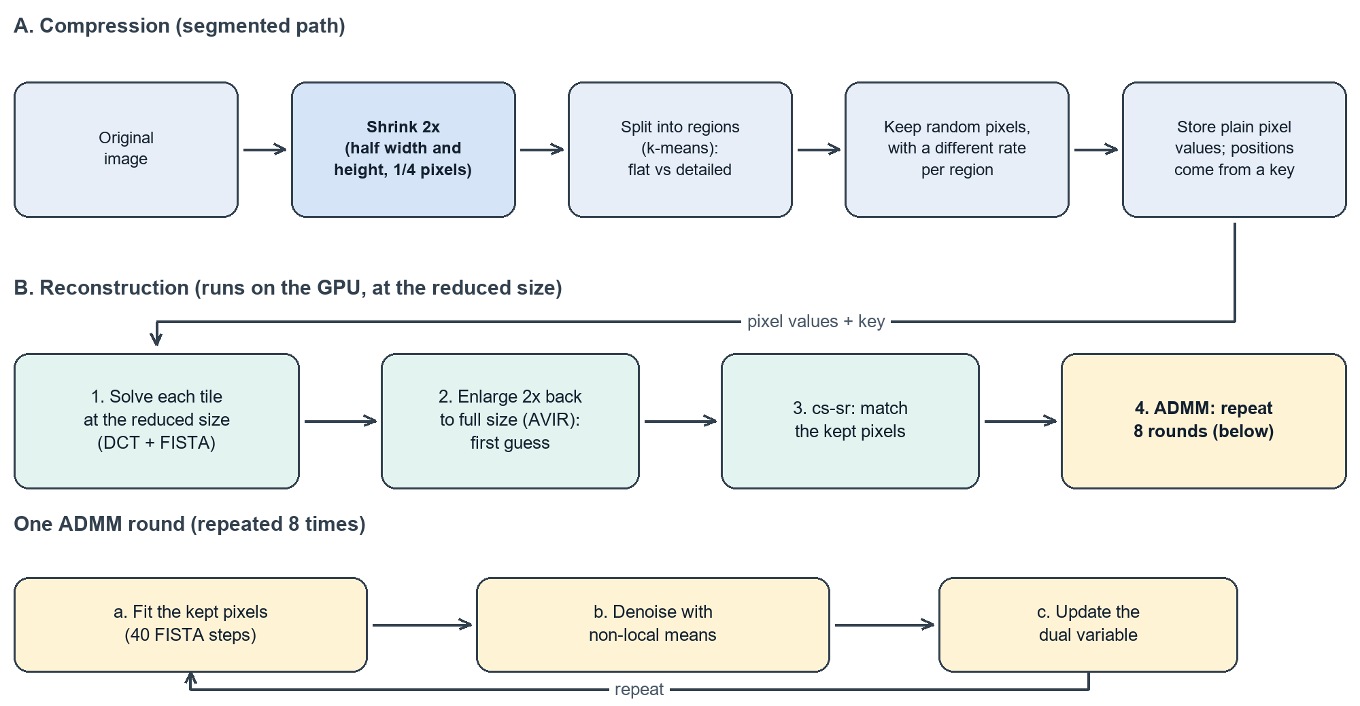
Figure 1. The segmented path: (A) the image is shrunk 2×, split into regions and sampled with a different rate per region; (B) reconstruction solves at the reduced size, enlarges 2× back to full size, and refines with repeated ADMM rounds.
Low-resolution solve. For each tile we look for the DCT coefficient vector with the smallest weighted L1 norm whose inverse transform agrees with the kept samples. The orthonormal 2-D DCT makes the sensing matrix a row-selection of an orthogonal matrix, and the problem is solved by reweighted-L1 FISTA [2], which alternates a gradient step on the data term, soft-thresholding with per-coefficient weights, and Nesterov momentum.
Enlargement with AVIR. AVIR is Aleksey Vaneev's image resizing library, a high-quality windowed-sinc (Lanczos-type) interpolator. It is a purely linear resampler: it knows nothing about which pixels were actually measured. Its output x₀ is therefore a good but blurry initial estimate, which the next stage corrects.
cs-sr and ADMM. The luma plane x of x₀ is refined against the measurements. A measured value is modelled as the mean of a 2×2 block of the high-resolution image, observed only at the sampled reduced-resolution cells. Writing the data term as the squared residual of this 2×2 averaging on the sampled cells, one ADMM round [3, 4] (a) minimizes the data term plus a quadratic anchor of weight ρ and an L1 term around the current denoised estimate, in the DCT domain, with 40 FISTA steps; (b) replaces the denoised estimate by a non-local-means [5] filtering of the result plus the scaled dual variable; and (c) updates the dual variable by the difference between the two. We run 8 rounds starting from x₀, with ρ = 0.1 by default. The denoiser runs on 8-bit luma with strength h = 1.6σ̂, where σ̂ is an Immerkaer noise estimate of the tile, clamped to [3, 30]. Chroma is left at its AVIR value.

3 GPU implementation
All state of a stage stays on the device for the whole loop, and tiles of different sizes share one launch (one thread-block row per tile, per-tile DCT tables). Items 1–3 below account for the speed-up in Table 1.
- Batched low-resolution solve and flat tile loop. The CPU solver warm-starts each tile from its neighbours and therefore needs a wavefront of diagonals with a barrier after each. Dropping the warm start makes the tiles independent: 4096 tiles × 3 channels are solved in 1.3 s on a 64×64 grid instead of 29 CPU-thread-seconds, and the wavefront is replaced by one flat parallel loop in which every worker takes the next tile and submits its ADMM work to a batching broker.
- Tiled DCT as batched GEMM. The dense per-tile DCTs run as an LDS-tiled GEMM (32×32 blocks, 4×4 register tiles) whose epilogues fuse the 2×2 residual and the soft-threshold/momentum step, giving 4 kernels per FISTA step instead of 7. Issuing all global loads of a K-chunk together was essential: the first version was slower at small batches.
- OpenCV-exact NLM kernel. Integer 7×7 patch distances, fixed-point weights and reflect-101 borders reproduce OpenCV's fastNlMeansDenoising: 2 of 139,920 test pixels differ, by one grey level.

4 Experiments and results
Setup: Ryzen 9 7900 CPU, Radeon RX 7900 XT GPU, a 4032×3024 photograph (IMG_3690, 3969 tiles), segmented path (shrunk 2×, four segments, sampling ratio 0.9), automatic settings. Quality is PSNR against the full-size original; edge PSNR uses the 10% of pixels with the largest gradient.
Table 1. Reconstruction time.
Step | Time | Speed-up
CPU only | 42.4 s | 1.0×
+ GPU ADMM, naive DCT kernels (CPU low-res solve, wavefront) | 19.7 s | 2.2×
+ tiled DCT GEMM kernels | 12.5 s | 3.4×
+ GPU low-res solve | 12.7 s | 3.3×
+ flat tile loop | 7.0 s | 6.1×
The reconstruction quality is the same in every row (32.66 dB). Moving the low-resolution solve to the GPU alone does not help (12.7 vs 12.5 s) but is what makes the flat loop possible. Without the warm start the GPU and CPU outputs differ slightly; the CPU path is unchanged.
Table 2. Effect of each reconstruction stage (GPU, automatic settings).
Stage | PSNR (dB) | Edge PSNR (dB) | Time (s)
AVIR upscaling only | 31.21 | 23.65 | 2.9
+ cs-sr | 32.05 | 24.31 | 5.5
+ ADMM | 32.66 | 25.07 | 7.0
Anchor strength. Over six photographs and two sampling ratios, lowering ρ from 0.1 to 0.01 improves PSNR by 0.25 dB on average at ratio 0.9 (+0.10 dB at 0.5), from −0.08 to +0.69 dB per image; strong anchors are harmful (ρ = 3 gives 27.7 dB, below plain AVIR). A schedule that raises ρ and lowers the NLM strength over the rounds adds a little more (+0.32 dB on average at ratio 0.9, up to +0.92 dB on one image), whereas rescaling the dual variable when ρ changes hurts (−0.12 dB). Seams. Within 8 px of segment boundaries (12% of the image) every stage loses about 1.5 dB relative to the interior, and we saw no ringing.

5 Discussion and limitations
The result that ρ matters more than the quality of the starting estimate follows from the model: a weak anchor lets the measured samples overrule x₀, so AVIR's blur is corrected where samples exist, while a strong anchor keeps the solution close to x₀ and cancels the benefit. The downscale-then-upscale pipeline is also not simply worse than full-resolution coding: at about 1.2 M sample slots both reach about 31 dB, and full resolution wins beyond that (35.4 dB at 2.3 M slots), because the 2× reduction makes the same samples three times denser on the grid being solved.
Limitations. The timing study uses one photograph and one container type (BGR, four segments, no 4:2:0 chroma). The ρ sweep covers six photographs, two of which (DIV2K) behave differently and have unusually low PSNR that we did not investigate. We did not compare CPU and GPU versions of the ρ schedule. No hardware GPU counters were available on this platform, so statements about kernel efficiency rest on event timings. Chroma is not refined.

6 Conclusion and future work
A batched GPU pipeline reconstructs a 12 MP image in 7.0 s instead of 42.4 s without changing the CPU path, and shows that the ADMM anchor strength is the main quality lever. Future work: calibrating ρ automatically across images and ratios; extending the GPU path to 4:2:0 containers and full-resolution mode; and a lightweight machine-learning enhancement pass, trained specifically on images compressed with this method, that would learn to correct the codec's own characteristic reconstruction errors (for example the seam losses and the blur left in textured regions).

References
- E. J. Candès, J. Romberg, T. Tao, "Robust uncertainty principles: exact signal reconstruction from highly incomplete frequency information," IEEE Trans. Inf. Theory 52(2), 2006.
- A. Beck, M. Teboulle, "A fast iterative shrinkage-thresholding algorithm for linear inverse problems," SIAM J. Imaging Sci. 2(1), 2009.
- S. Boyd et al., "Distributed optimization and statistical learning via the alternating direction method of multipliers," Found. Trends Mach. Learn. 3(1), 2011.
- S. V. Venkatakrishnan, C. A. Bouman, B. Wohlberg, "Plug-and-play priors for model based reconstruction," IEEE GlobalSIP, 2013.
- A. Buades, B. Coll, J.-M. Morel, "A non-local algorithm for image denoising," CVPR, 2005.

