**Table Template:**

**Table 1**

|  |  |  |  |  |
| --- | --- | --- | --- | --- |
| Classifier | Accuracy (%) | True-positive rate (TPR) | True-negative rate (TNR) | F1 Score |
|  |  |  |  |  |
|  |  |  |  |  |

**Table 1**

|  |  |  |  |  |
| --- | --- | --- | --- | --- |
| Classifier | Accuracy (%) | True-positive rate (TPR) | True-negative rate (TNR) | F1 Score |
|  |  |  |  |  |

**Data Visualization:**

Correlation Matrix

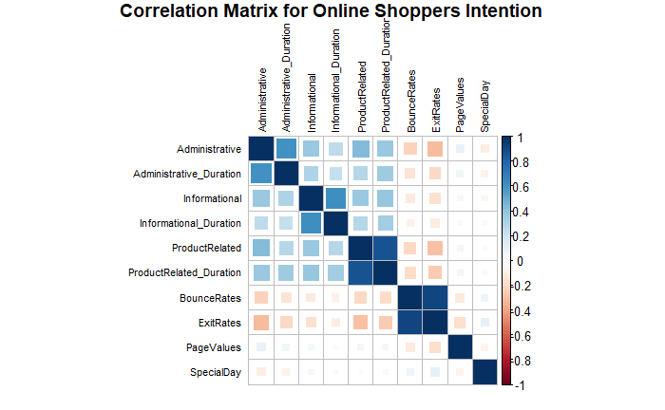

Correlation of 2 features:

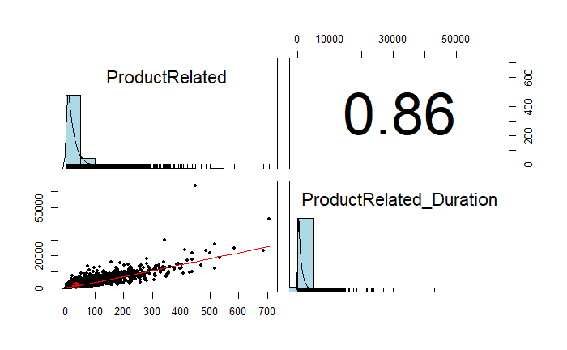

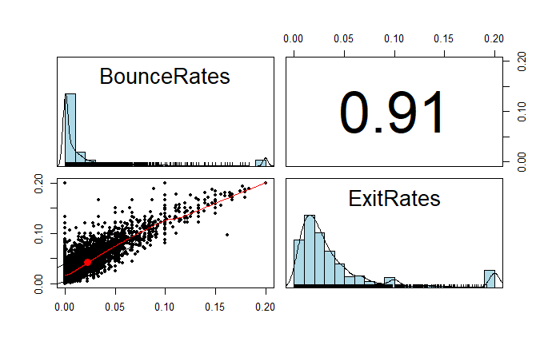

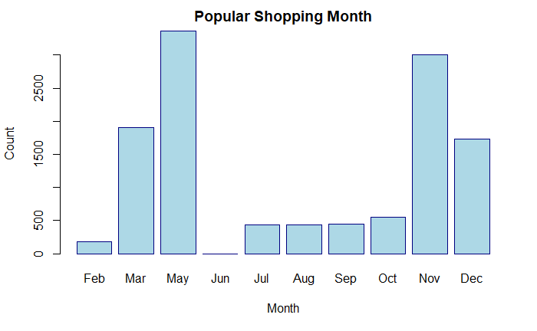

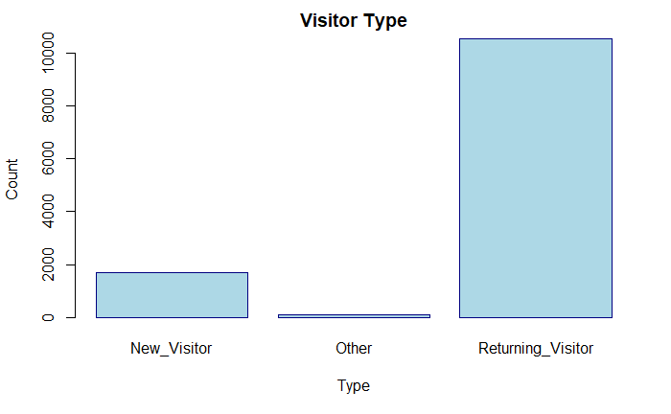

**Without Sampling:**

SVM:

vanilla:

**SVM vanilla**

|  |  |  |  |  |
| --- | --- | --- | --- | --- |
| Classifier | Accuracy (%) | True-positive rate (TPR) | True-negative rate (TNR) | F1 Score |
| Original paper | 88.3 | 0.42 | 0.97 | 0.52 |
| Reproduced | 88.7 | 0.79 | 0.90 | 0.51 |

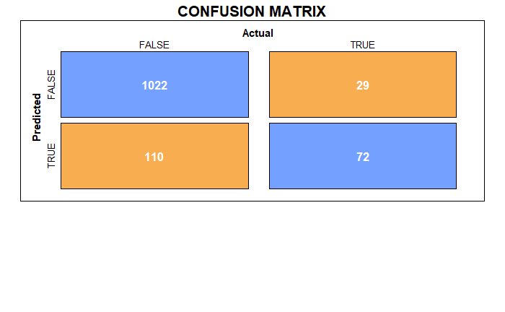

rbf kernel:

**SVM rbf**

|  |  |  |  |  |
| --- | --- | --- | --- | --- |
| Classifier | Accuracy (%) | True-positive rate (TPR) | True-negative rate (TNR) | F1 Score |
| Original paper | 86.14 | 0.46 | 0.92 | 0.53 |
| Reproduced | 89.1 | 0.69 | 0.91 | 0.57 |

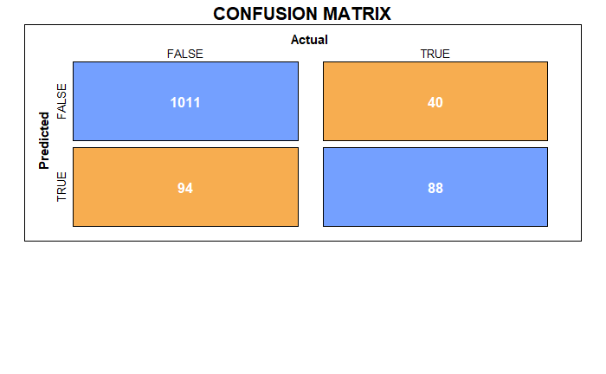

Bayes:

**Bayes**

|  |  |  |  |  |
| --- | --- | --- | --- | --- |
| Classifier | Accuracy (%) | True-positive rate (TPR) | True-negative rate (TNR) | F1 Score |
| Proposed | 81.8 | 0.43 | 0.95 | 0.54 |

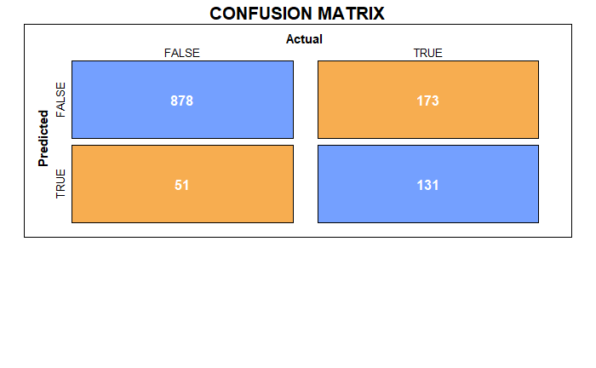

Adaboost:

**Adaboost**

|  |  |  |  |  |
| --- | --- | --- | --- | --- |
| Classifier | Accuracy (%) | True-positive rate (TPR) | True-negative rate (TNR) | F1 Score |
| Proposed | 89.1 | 0.65 | 0.93 | 0.61 |

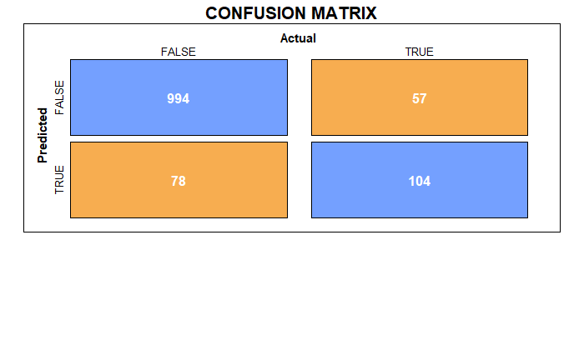

LDA:

**LDA**

|  |  |  |  |  |
| --- | --- | --- | --- | --- |
| Classifier | Accuracy (%) | True-positive rate (TPR) | True-negative rate (TNR) | F1 Score |
| Proposed | 88.8 | 0.74 | 0.90 | 0.49 |

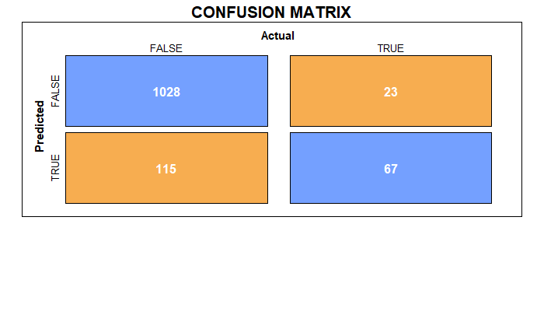

Random Forest:

**Random Forest**

|  |  |  |  |  |
| --- | --- | --- | --- | --- |
| Classifier | Accuracy (%) | True-positive rate (TPR) | True-negative rate (TNR) | F1 Score |
| Original paper | 89.5 | 0.57 | 0.96 | 0.58 |
| Reproduced | 89.5 | 0.66 | 0.93 | 0.63 |

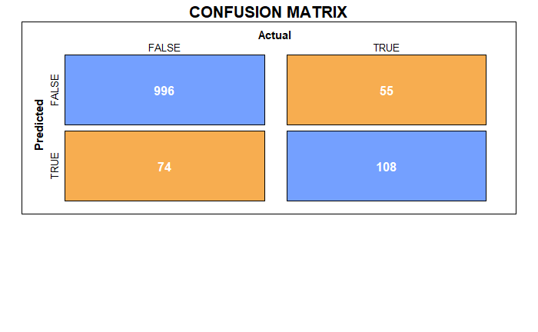

KNN:

**KNN**

|  |  |  |  |  |
| --- | --- | --- | --- | --- |
| Classifier | Accuracy (%) | True-positive rate (TPR) | True-negative rate (TNR) | F1 Score |
| Proposed | 87.4 | 0.6 | 0.91 | 0.64 |

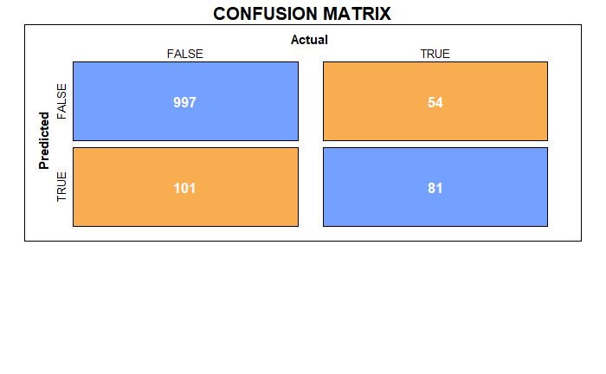

Decision Tree

without pruning:

**Decision Tree**

|  |  |  |  |  |
| --- | --- | --- | --- | --- |
| Classifier | Accuracy (%) | True-positive rate (TPR) | True-negative rate (TNR) | F1 Score |
| Proposed | 88.5 | 0.59 | 0.94 | 0.61 |

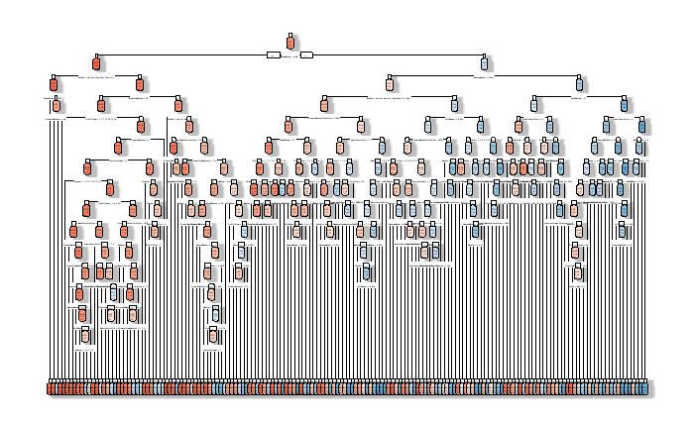

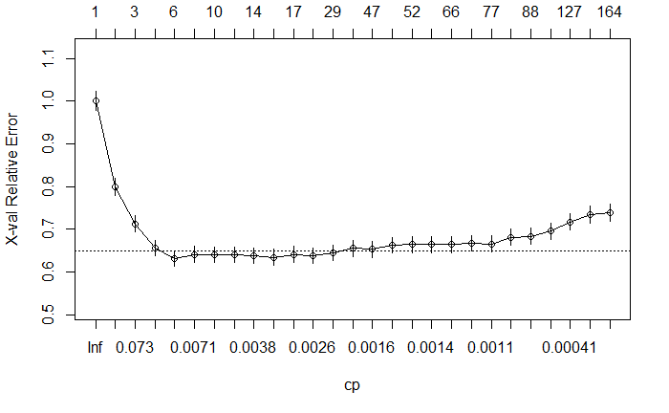

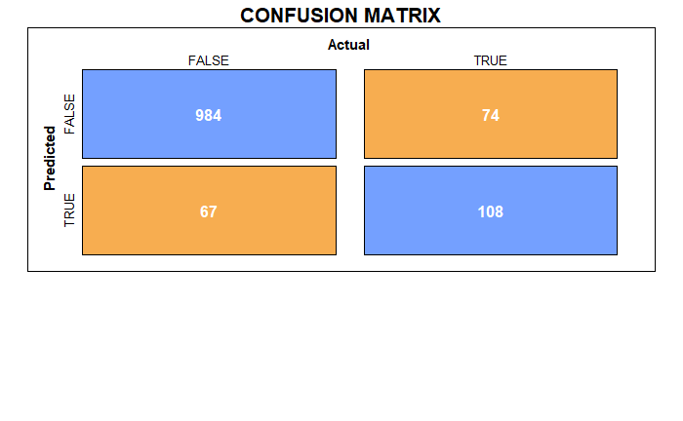

with pruning:

**Decision Tree**

|  |  |  |  |  |
| --- | --- | --- | --- | --- |
| Classifier | Accuracy (%) | True-positive rate (TPR) | True-negative rate (TNR) | F1 Score |
| Proposed | 89.8 | 0.63 | 0.94 | 0.65 |

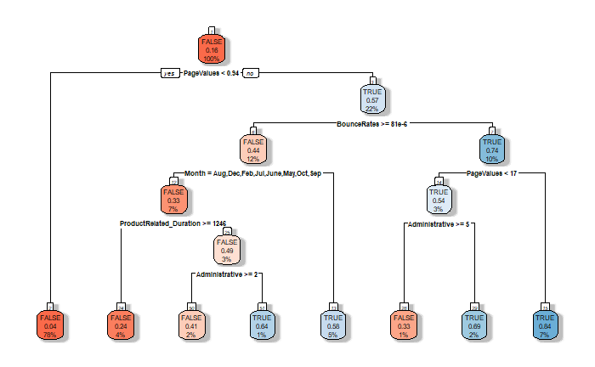

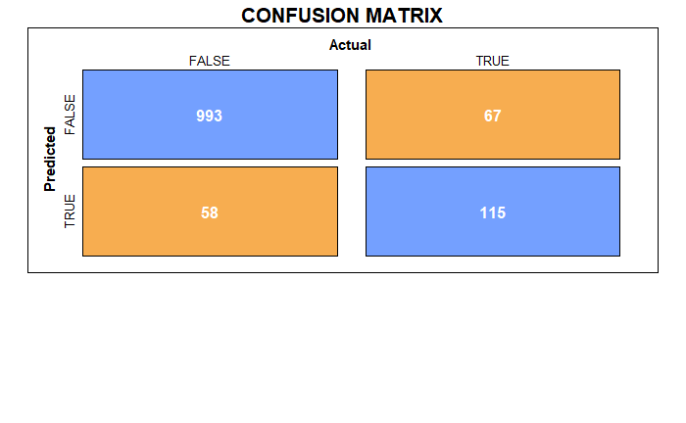

Multiple Layer Perceptron:

**MLP(# of hidden layers: 40)**

|  |  |  |  |  |
| --- | --- | --- | --- | --- |
| Classifier | Accuracy (%) | True-positive rate (TPR) | True-negative rate (TNR) | F1 Score |
| Original paper | 87.1 | 0.54 | 0.93 | 0.56 |
| Reproduced | 86.7 | 0.19 | 0.98 | 0.30 |

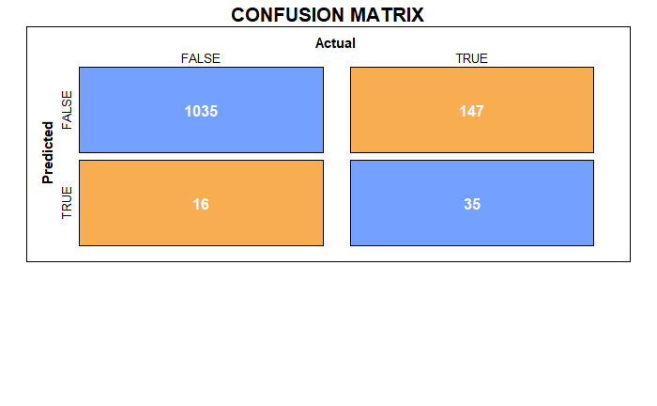

Deep Neural Net:

**Neural Net**

|  |  |
| --- | --- |
| Classifier | Accuracy (%) |
| Proposed | 90.2 |

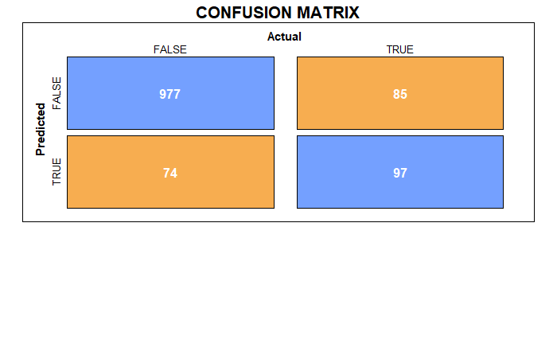

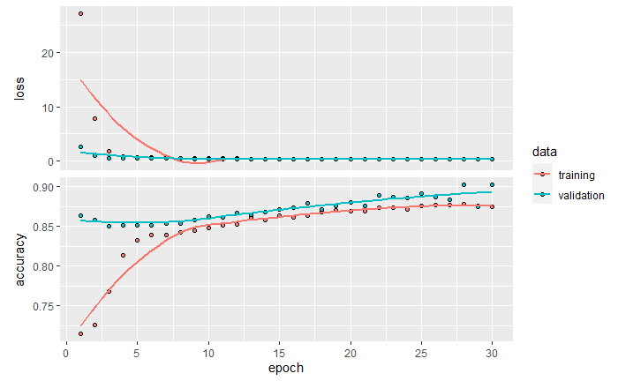

K-means:

Bagging:

With Oversampling:

SVM:

vanilla:

**SVM vanilla**

|  |  |  |  |  |
| --- | --- | --- | --- | --- |
| Classifier | Accuracy (%) | True-positive rate (TPR) | True-negative rate (TNR) | F1 Score |
| Original paper | 84.3 | 0.75 | 0.93 | 0.82 |
| Reproduced | 87.5 | 0.54 | 0.95 | 0.63 |

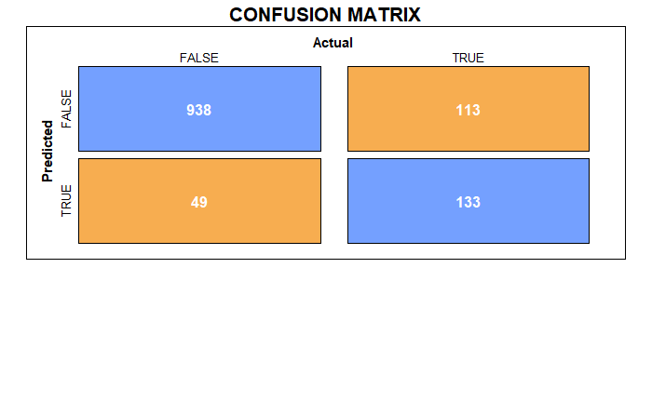

rbf kernel:

**SVM rbf**

|  |  |  |  |  |
| --- | --- | --- | --- | --- |
| Classifier | Accuracy (%) | True-positive rate (TPR) | True-negative rate (TNR) | F1 Score |
| Original paper | 84.9 | 0.75 | 0.94 | 0.82 |
| Reproduced | 86.1 | 0.52 | 0.95 | 0.61 |

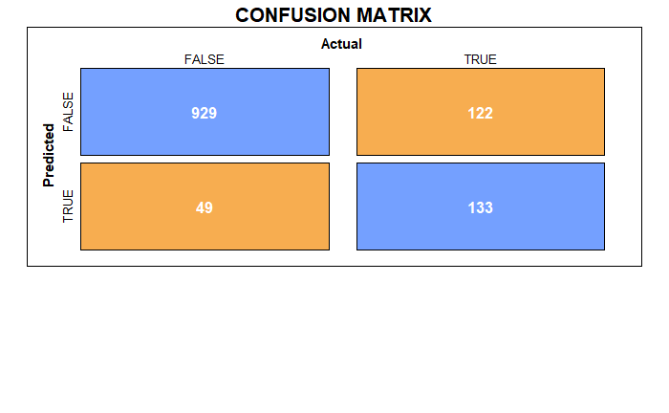

Bayes:

**Bayes**

|  |  |  |  |  |
| --- | --- | --- | --- | --- |
| Classifier | Accuracy (%) | True-positive rate (TPR) | True-negative rate (TNR) | F1 Score |
| Proposed | 64.2 | 0.29 | 0.98 | 0.42 |

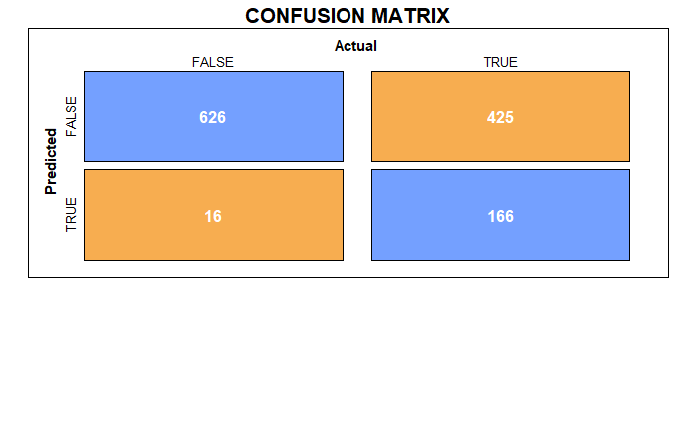

Adaboost:

**Adaboost**

|  |  |  |  |  |
| --- | --- | --- | --- | --- |
| Classifier | Accuracy (%) | True-positive rate (TPR) | True-negative rate (TNR) | F1 Score |
| Proposed | 89.1 | 0.65 | 0.93 | 0.61 |



LDA:

**LDA**

|  |  |  |  |  |
| --- | --- | --- | --- | --- |
| Classifier | Accuracy (%) | True-positive rate (TPR) | True-negative rate (TNR) | F1 Score |
| Proposed | 77.9 | 0.38 | 0.95 | 0.51 |

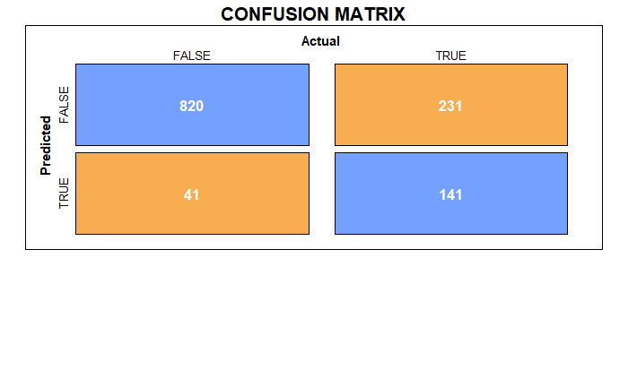

Random Forest:

**Random Forest**

|  |  |  |  |  |
| --- | --- | --- | --- | --- |
| Classifier | Accuracy (%) | True-positive rate (TPR) | True-negative rate (TNR) | F1 Score |
| Original paper | 82.3 | 0.74 | 0.90 | 0.81 |
| Reproduced | 89.9 | 0.67 | 0.94 | 0.66 |

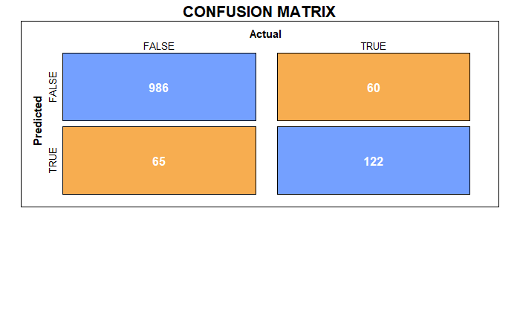

KNN:

**KNN**

|  |  |  |  |  |
| --- | --- | --- | --- | --- |
| Classifier | Accuracy (%) | True-positive rate (TPR) | True-negative rate (TNR) | F1 Score |
| Proposed | 84.2 | 0.47 | 0.92 | 0.62 |

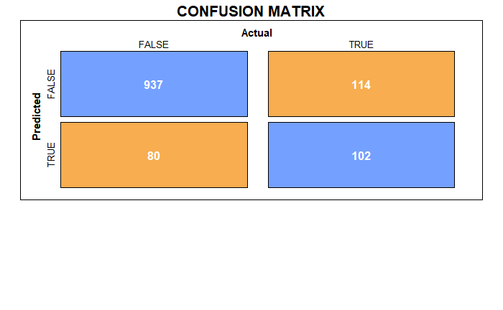

Decision Tree

without pruning:

**Decision Tree**

|  |  |  |  |  |
| --- | --- | --- | --- | --- |
| Classifier | Accuracy (%) | True-positive rate (TPR) | True-negative rate (TNR) | F1 Score |
| Proposed | 84.8 | 0.68 | 0.88 | 0.56 |

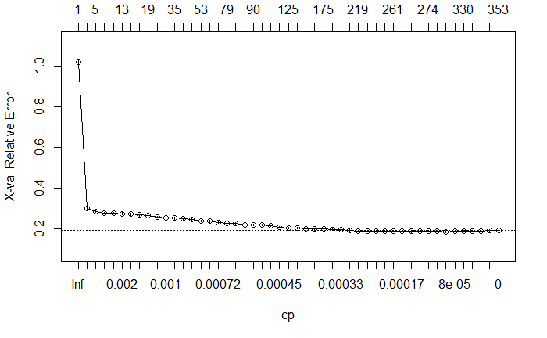

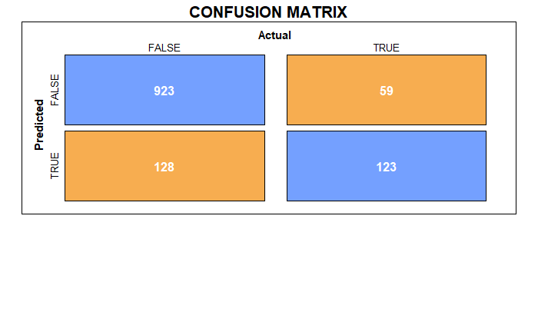

with pruning:

**Decision Tree**

|  |  |  |  |  |
| --- | --- | --- | --- | --- |
| Classifier | Accuracy (%) | True-positive rate (TPR) | True-negative rate (TNR) | F1 Score |
| Proposed | 84.8 | 0.85 | 0.83 | 0.61 |

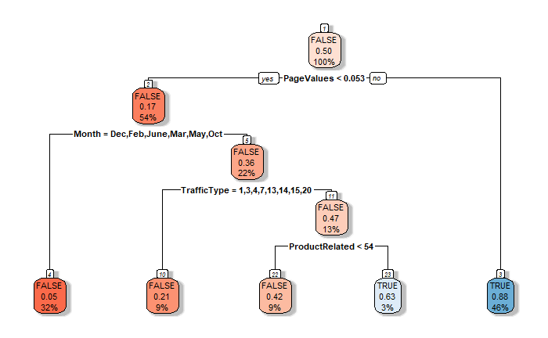

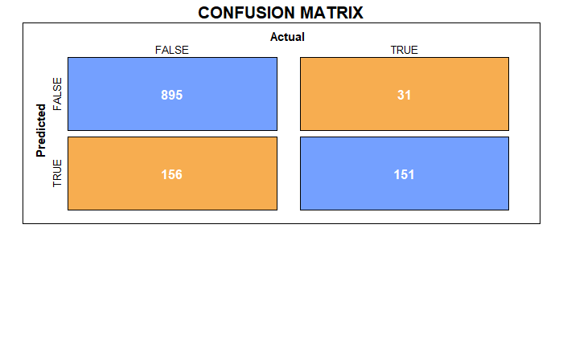

Multiple Layer Perceptron:

**MLP(# of hidden layers: 40)**

|  |  |  |  |  |
| --- | --- | --- | --- | --- |
| Classifier | Accuracy (%) | True-positive rate (TPR) | True-negative rate (TNR) | F1 Score |
| Original paper | 82.2 | 0.82 | 0.83 | 0.82 |
| Reproduced | 88.4 | 0.53 | 0.94 | 0.58 |

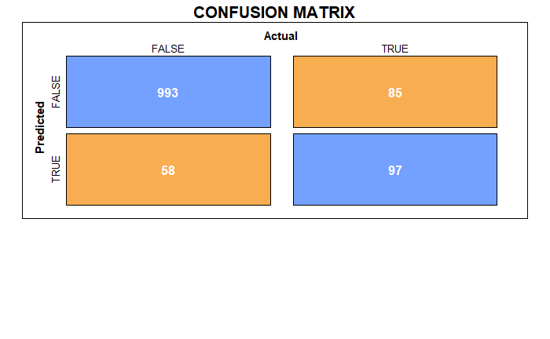

Deep Neural Net:

**Neural Net**

|  |  |
| --- | --- |
| Classifier | Accuracy (%) |
| Proposed | 87.3 |

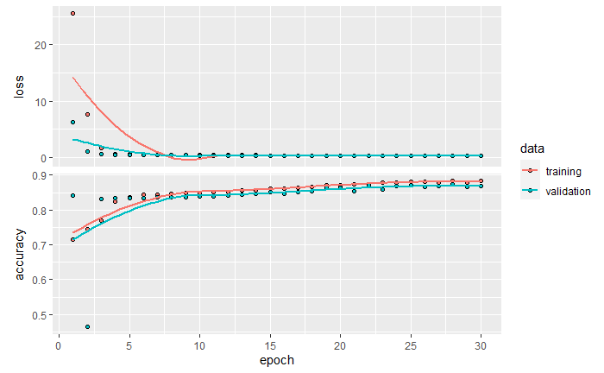

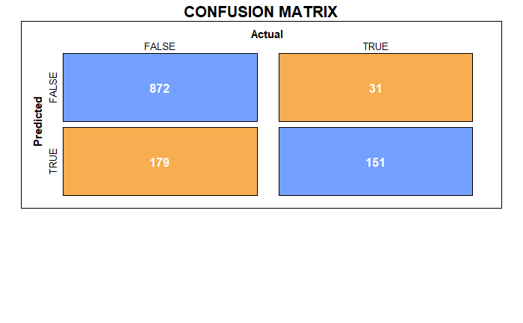

K-means:

Bagging: