

FUNCTIONAL REQUIREMENTS SPECIFICATION
Lock-in Handling
Renewal notice suppression for lock-in and Scheme 2 accounts, the 60-day lock-in review report, and cancellation of notices for past-due, fraud, terminated and disputed loan accounts

Client | Toyota Insurance Services Philippines Corporation (TISPH)
Document | TISPH-FRS-SCHM-03
Requirement | TIS-BRD-SCHM-03
Version | 1.0
Date | 9 October 2026
Status | Issued for TISPH review
Classification | Confidential

Prepared by iorta TechNXT for TISPH 
This document is confidential to Toyota Insurance Services Philippines Corporation and iorta TechNXT.
Document Control
Version | Date | Author | Reviewer | Approver | Change
1.0 | 9 Oct 2026 | iorta TechNXT Business Analysis | iorta TechNXT Project Manager | TIS Sales (pending) | First issue for review

Distribution List
Name / Unit | Role | Organisation | Purpose
TIS Sales (business owner) | Approver | TISPH | Review and sign-off
Sales Admin and account coordinators | Business user | TISPH | Lock-in review and decision FRs
Operations | Business user | TISPH | Renewal run, notices and TFS loan status upload FRs
Compliance | Business user | TISPH | Fraud and legal dispute status FRs
DTID - Project Management Team | Project owner | TISPH | Traceability against the BRD
Project team | Delivery | iorta TechNXT | Build, test and UAT preparation

Contents
1 Overview 5
1.1 The requirement 5
1.2 Scope 5
1.3 Definitions and acronyms 6
1.4 How to read the functional requirements 6
1.5 What changes in BrokerVerse 7
2 Lock-in process flow 8
2.1 Flow A - Renewal run with the notice gate 8
2.2 Flow B - TFS loan status and cancellation of notices 9
2.3 Flow C - 60-day review and decision 10
2.4 Notice treatment by account type 11
3 Personas and roles 12
3.1 Personas 12
3.2 New permissions 12
3.3 Default grants 12
4 Functional requirements 13
4.1 Lock-in on the policy 13
FR-LCK-001 Record the lock-in on the policy when it is issued 13
FR-LCK-002 Change or end a lock-in by hand, with approval 14
FR-LCK-003 Track the lock-in year and review date of each term and carry them to the renewal 15
FR-LCK-004 Show the lock-in and the loan status on Policy detail 16
4.2 Notice gate on the renewal run 17
FR-LCK-010 Decide the notice treatment of each renewal (notice gate) 17
FR-LCK-011 Produce no automatic notice or reminder for a suppressed or held renewal 18
FR-LCK-012 Exclude suppressed and held policies from Renewal Batch notices and manual sending 19
FR-LCK-013 Show the notice treatment on the renewal screens 20
FR-LCK-014 Replace the staff reminder of a lock-in account with the lock-in review task 21
4.3 TFS loan status and cancellation of notices 22
FR-LCK-020 Upload the TFS account status file 22
FR-LCK-021 Set a loan status by hand (fraud, legal dispute, corrections) 23
FR-LCK-022 Cancel queued notices and hold further notices when the loan status blocks them 24
FR-LCK-023 Lift the hold when the loan is current again; closed loans 25
4.4 The 60-day review report 26
FR-LCK-030 List lock-in and Scheme 2 accounts 60 days before expiry (job Lock-in review) 26
FR-LCK-031 Work the accounts on the Lock-in Review screen 27
FR-LCK-032 Produce the Lock-in / Scheme 2 expiry report (Excel extract) 27
4.5 Review decision and approval 28
FR-LCK-040 Record the review decision 28
FR-LCK-041 Approve a release or a not-for-renewal decision 29
4.6 Audit and access 30
FR-LCK-050 Keep a complete audit trail of lock-ins, loan statuses, notice treatments and decisions 30
FR-LCK-051 Control access to the lock-in functions 31
5 Workflow and status model 32
5.1 Lock-in record 32
5.2 Review item 32
5.3 Notice treatment of a renewal 32
5.4 Renewal batch notice status 33
6 Interfaces 34
6.1 TFS loan status mapping 34
7 Configuration items 35
7.1 Settings 35
7.2 Scheduled jobs 35
7.3 Lists of values 36
7.4 Masters and records maintained by the business 36
8 Traceability 37
8.1 BRD clause to FR 37
8.2 Related BRD requirements 37
8.3 FR to test cases 37
9 Navigation 39
9.1 Screens of SCHM-03 39
9.2 Menu by base role 39
10 Screen specifications 40
10.1 Lock-in Review (new) 40
10.2 Lock-in review dialog (new) 41
10.3 Upload loan status (new) 42
10.4 Policy detail - Lock-in & loan panel (changed) 43
10.5 Renewal Queue (changed) 45
10.6 Lock-in / Scheme 2 expiry report (changed) 46
10.7 Report columns 47
10.8 Schedules (changed) 48
11 End-to-end walkthroughs 49
11.1 WT-A Scheme 1 ARA account renewed under lock-in 49
11.2 WT-B Past-due loan: notices cancelled and resumed 49
11.3 WT-C Exceptions 50
12 Messages catalogue 51
12.1 Policy detail - Lock-in & loan 51
12.2 Renewal Queue and Renewal Batch 51
12.3 Lock-in Review - Loan status upload 52
12.4 Lock-in Review 52
12.5 Lock-in Review - Review dialog 52
13 Upload screens 53
13.1 TFS account status template 53
14 Sign-off and change control 54
14.1 What is signed 54
14.2 Change after sign-off 54
14.3 Signatures 54
Appendix A Lock-in year and review date examples 55

1 Overview

1.1 The requirement
TIS-BRD-SCHM-03 Lock-In Handling (Customization, Phase 1, CR-05). Scheme lock-in periods are honoured platform-wide: renewal notices are suppressed for accounts in lock-in (and Scheme 2 Motor), a 60-days-before-expiry review report covers lock-in and Scheme 2 accounts, lock-in review dates are tracked on the policy, and notices cancel where the loan account is past due, fraudulent, terminated or under legal dispute.

Many TISPH Motor accounts are financed by Toyota Financial Services (TFS) and are renewed under an agreement made when the car was bought. A Scheme 1 client signs an Auto Renewal Agreement (ARA): the first year is free and TISPH renews the cover for the next four years at premiums agreed in advance. A Scheme 2 client pays the insurance for the whole loan term inside the monthly amortization. A promotion may also lock its rate for up to three years. In all these cases the client must not receive the standard "your policy is about to expire, please renew" notices at 90, 60 and 30 days: the renewal is already agreed.
This FRS makes BrokerVerse know which policies are in a lock-in, for how long and in which year, and makes every renewal notice path respect it. Sixty days before expiry the lock-in and Scheme 2 accounts are listed for review, with the TFS loan status, so that Sales Admin can confirm the renewal or stop it. Where TFS reports a loan as past due, fraudulent, terminated or in legal dispute, notices that were waiting to go out are cancelled and no further notice is sent until the account is reviewed.
Screens that change or are new are shown as to-be mock-ups drawn on the real BrokerVerse screens with the Toyota Insurance Services look.

1.2 Scope
In scope
- A lock-in record on the policy: source (promotion, Scheme 1 ARA, Scheme 2), period, lock-in year of each term, next review date, TFS loan account and loan status; carried to each renewal term; shown on Policy detail in a new Lock-in & loan panel.
- A notice gate applied to every renewal notice path of the base renewal module: the Renewal notices job, the Renewal Batch queue, Send notice and Send reminder on the Renewal Queue, and the automatic customer reminders at 90, 60 and 30 days.
- Suppression of notices for accounts whose next term is inside a lock-in, and for Scheme 2 Motor accounts.
- A TFS loan status on the policy, loaded by an Excel upload of the TFS account status file or set by hand, and the cancellation of notices when the status is Past due, Fraud, Early terminated, Terminated or Legal dispute.
- A new Lock-in Review screen under Operations > Renewals with the review decision (Renew under lock-in, Hold, Release to standard renewal, Not for renewal) and its approval.
- The 60-day review report "Lock-in / Scheme 2 Expiry": Excel extract from Lock-in Review and a report criteria on Reports > Operational Reports > Renewal.
- A new scheduled job Lock-in review, new settings, permissions and audit.
Out of scope
- How a lock-in policy is first issued (Scheme 1 and 2 direct issuance on loan documents, TIS-BRD-SCHM-01) and the scheme terms and rates (Scheme Master, TIS-BRD-SCHM-02). This FRS reads the scheme, ARA period and loan account those items put on the policy.
- The promotion itself and its lock-in years (PROD-15, setting promotions.max_lockin_years) and the pricing of a renewal at the lock-in rates. This FRS decides when a renewal is inside the lock-in; the rate comes from PROD-15 or the Scheme Master.
- The content and cadence of the standard renewal notices (90 / 60 / 30 days, e-mail template) and the Renewal Notice Listing: they are base configuration of the renewal module.
- An online interface with TFS. The TFS account status arrives as a file and is uploaded.
- Credit Life and other non-Motor renewals, except where a non-Motor policy carries a TFS loan account (the loan status rule then applies to its notices too).

1.3 Definitions and acronyms
Table 1: Definitions
Term | Meaning in this FRS
Lock-in | An agreement that the policy is renewed for a set number of policy years on terms fixed in advance, without the client being asked to renew. Recorded on the policy as a lock-in record.
Lock-in source | Where the lock-in comes from: Promotion (a PROD-15 promotion with a lock-in period), Scheme 1 ARA (Auto Renewal Agreement signed for the free first-year scheme) or Scheme 2 (insurance financed for the whole loan term).
Lock-in period | From the lock-in start date (inception of the first locked term) for N policy years. Lock-in end date = start date plus N years minus one day. Example: start 13/12/2024, 5 years, end 12/12/2029.
Lock-in year | The policy year of a term inside the lock-in, shown as "n of N". The term 13/12/2025 to 12/12/2026 of the example is year 2 of 5.
Lock-in renewal | A renewal whose new term starts on or before the lock-in end date. Its notices are suppressed. The renewal of the last lock-in year is not a lock-in renewal: the client then gets the standard notices.
Scheme 2 Motor account | A Motor policy issued under Scheme 2 whose TFS loan is not Closed. Its notices are always suppressed (setting lockin.suppress_scheme2_motor).
Notice gate | The check every renewal notice path calls before a notice or reminder to the client is queued or sent. It returns Send, Suppressed (Lock-in or Scheme 2) or Held (loan status).
Suppressed | Notices are not produced because the renewal is already agreed (lock-in or Scheme 2). Not an error; nothing is sent and nothing is queued.
Held | Notices are stopped because the TFS loan status blocks them. Queued notices are cancelled. The hold lifts when the status returns to Current or when a reviewer releases the account.
TFS loan account | The 10-digit TFS loan account number of the financed vehicle (for example 8005096389), the reference account number of the TFS lead.
Loan status | The status of the TFS loan: Current, Past due, Fraud, Early terminated, Terminated, Legal dispute or Closed, with the date TFS reported it.
Blocking loan status | A loan status that holds notices: Past due, Fraud, Early terminated, Terminated, Legal dispute (setting lockin.blocking_loan_statuses).
Review date | Expiry date of the current term minus 60 days (setting lockin.review_days_before_expiry). On that date the account is listed for review.
ARA / TFS | Auto Renewal Agreement / Toyota Financial Services Philippines.

1.4 How to read the functional requirements
Each FR in chapter 4 has the same parts:
- A header table with the BRD trace, the actor, the priority, the fit and the screens that implement it.
- Description, preconditions, main flow and alternate and exception flows.
- Business rules. Configurable rules are kept on Master > System > Configuration or Schedules (chapter 7). Fixed rules change only through a change request.
- Validations and messages: the check and the message the user sees, word for word, with its ID in chapter 12. As everywhere in BrokerVerse, a message is plain English and is shown under the field it belongs to, or as a toast.
- Audit and numbered acceptance criteria, the basis of the test cases TC-LCK-nnn-n.
Note. Dates, loan accounts and names in the examples are sample data. The 60-day review window, the blocking loan statuses and the TFS status codes are delivered as configuration and are confirmed by TISPH during build.

1.5 What changes in BrokerVerse
BrokerVerse has a full renewal module but no idea of a lock-in or of a loan behind the policy. The table lists what SCHM-03 reuses, what it changes and what it adds.
Table 2: BrokerVerse today and SCHM-03
BrokerVerse today | What SCHM-03 does
Job Renewal pipeline (daily 05:30) enrols active policies expiring within renewals.pipeline_days (90) as renewals in status Pending (pipeline). | Changed. Each renewal it creates or refreshes gets its notice treatment from the notice gate: Send, Suppressed: Lock-in, Suppressed: Scheme 2 or Held: loan status.
Job Renewal notices (daily 06:00) creates "Renewal due in n days" reminders at the days of limits.renewal_notice_days (90, 60, 30 for TISPH). Customer notices First, Second and Final (renewals.notice_stages) are sent from a Renewal Batch, from the Renewal Queue or automatically at each mark. | Changed. No notice or customer reminder is produced for a suppressed or held renewal. For a lock-in account the staff reminder is replaced by the lock-in review task.
Renewal Batch: policies picked by criteria; notices queued (NotSent, Queued, Sent, Failed) and sent by the job Renewal notice queue every minute. | Changed. Suppressed and held policies are listed with the new notice status Suppressed or Held and cannot be selected. A queued notice whose policy becomes held is set to Cancelled before it is sent.
Renewal Queue: status tags (Pending, First Notice Sent ...) and actions Send notice, Send reminder. | Changed. New tags Suppressed: Lock-in, Suppressed: Scheme 2 and Held: loan status; the notice and reminder actions are disabled for those rows.
Policy detail: Policy Details, Insured Details, Payment, Documents & Billing. No loan or lock-in data. | Changed. New panel Lock-in & loan with Change lock-in and Set loan status.
Reports > Operational Reports > Renewal (Renewal Retention) with criteria, Preview and Generate (CSV, Excel, PDF). | Changed. New report criteria Lock-in / Scheme 2 expiry (60 days).
Master > System > Schedules, Configuration, Audit Trail; My Work > Approvals; maker-checker rule "the approver must be different from the user who created ...". | Reused. New job Lock-in review, new lockin.* settings, approval items of kind Lock-in review.
No lock-in record, no loan status, no review of lock-in accounts. | New. Lock-in record, loan status with TFS upload, Lock-in Review screen with decisions and approval, 60-day report.

2 Lock-in process flow
Three flow charts show the lock-in end to end: Flow A is the daily renewal run with the notice gate, Flow B is the TFS loan status update and the cancellation of notices, and Flow C is the 60-day review and its decision. Black rounded boxes are start and end points, diamonds are decisions, red boxes are exceptions, grey boxes are done by the system and boxes with a heavy border are the successful outcome.

2.1 Flow A - Renewal run with the notice gate
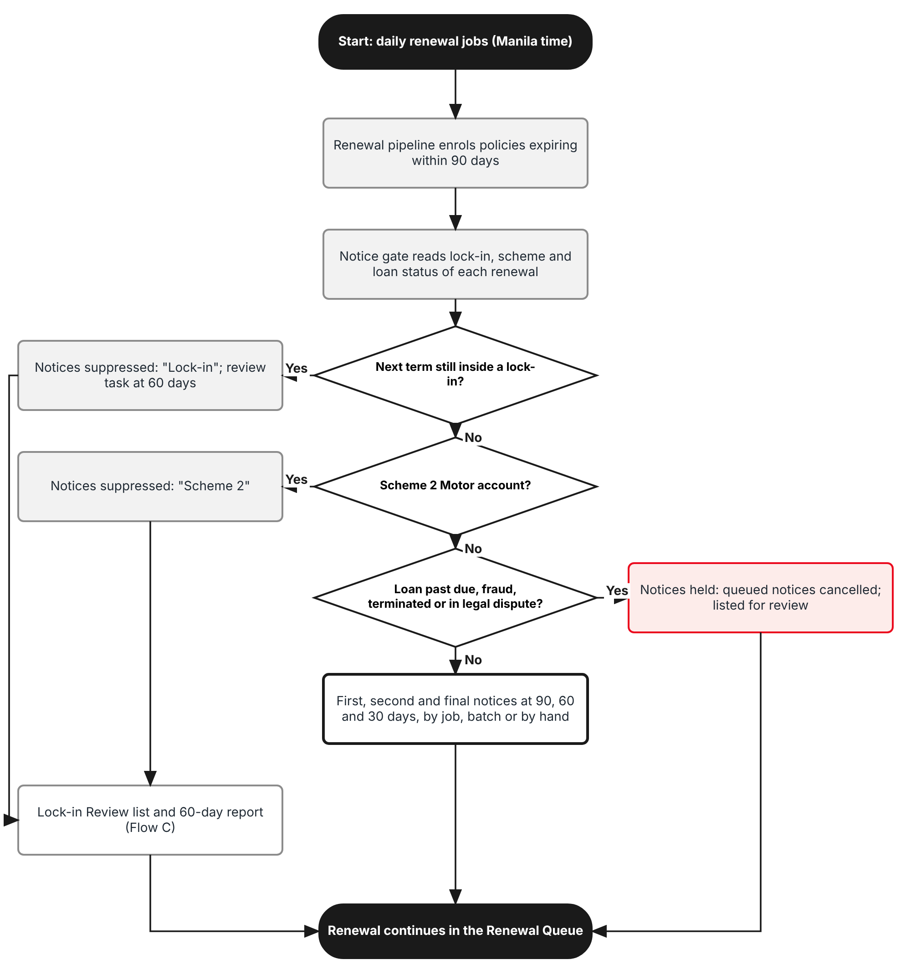
Figure 1: Flow A - Renewal run with the notice gate
Table 3: Flow A steps
Step | Who (role) | What happens | FR
A1 | System (job Lock-in review, 05:15) | Sets the lock-in year and review date of each locked term and lists the accounts that reach their review date. | FR-LCK-003, 030
A2 | System (job Renewal pipeline, 05:30) | Enrols policies expiring within 90 days as renewals in status Pending. | FR-LCK-010
A3 | System | The notice gate gives each renewal its notice treatment. A renewal whose next term starts on or before the lock-in end date is Suppressed: Lock-in. | FR-LCK-010
A4 | System | A Scheme 2 Motor account whose loan is not Closed is Suppressed: Scheme 2. | FR-LCK-010
A5 | System | A renewal whose TFS loan status is blocking is Held: loan status; its queued notices are cancelled. | FR-LCK-022
A6 | System / Operations | Other renewals get the First, Second and Final notices at 90, 60 and 30 days through the job, a Renewal Batch or the Renewal Queue. Every path calls the gate again just before sending. | FR-LCK-011, 012
A7 | Sales Admin | Suppressed and held accounts are worked on Lock-in Review (Flow C). | FR-LCK-031

2.2 Flow B - TFS loan status and cancellation of notices
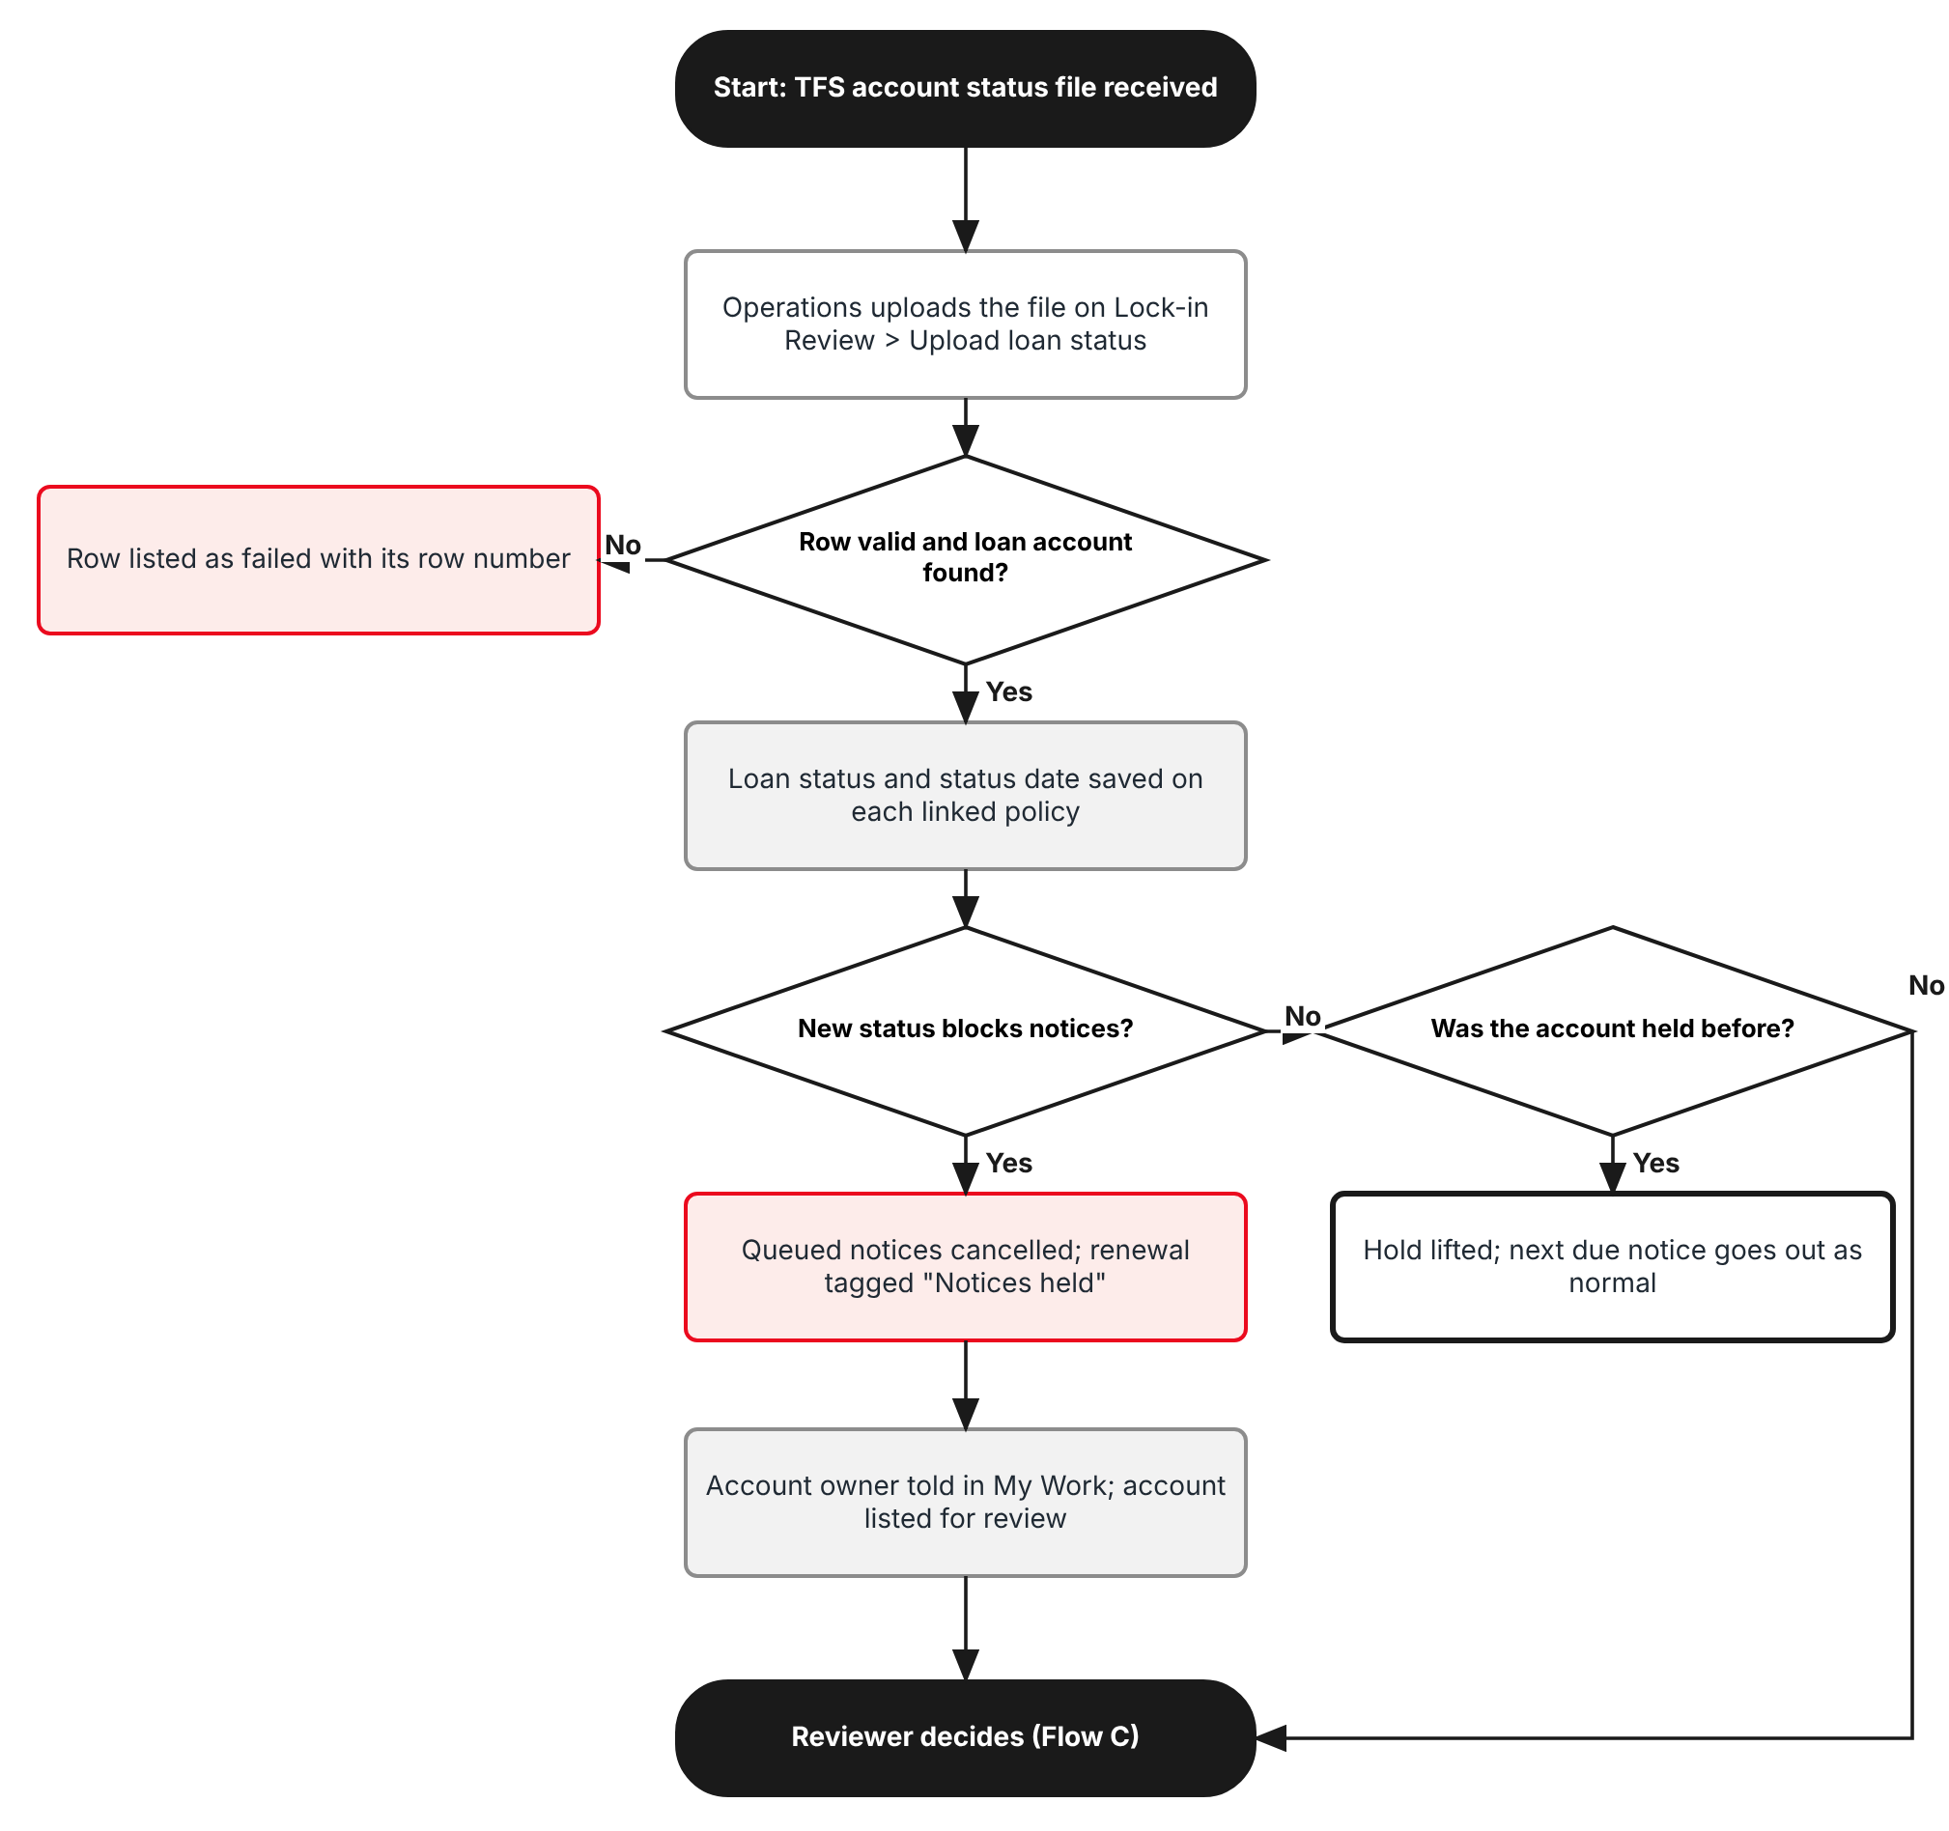
Figure 2: Flow B - TFS loan status update and cancellation of notices
Table 4: Flow B steps
Step | Who (role) | What happens | FR
B1 | Operations (write:loan-status) | Downloads the template and uploads the TFS account status file on Lock-in Review > Upload loan status. | FR-LCK-020
B2 | System | Loads the file row by row. A row with a bad loan account, status or date, or with no linked policy, is listed as failed. | FR-LCK-020
B3 | System | Saves the loan status and status date on every active policy with that loan account. An older status date does not overwrite a newer one. | FR-LCK-020
B4 | System | A new blocking status holds the notices: queued batch notices and queued notice e-mails are cancelled and the renewal is tagged Held: loan status. | FR-LCK-022
B5 | System | The account owner gets a My Work item; the account appears on the Notices held tab of Lock-in Review. | FR-LCK-022
B6 | System | A status back to Current lifts the hold; the next notice due goes out on the next run. | FR-LCK-023
B7 | Compliance Officer / Operations | Fraud and Legal dispute may also be set by hand on the policy (Set loan status). | FR-LCK-021

2.3 Flow C - 60-day review and decision
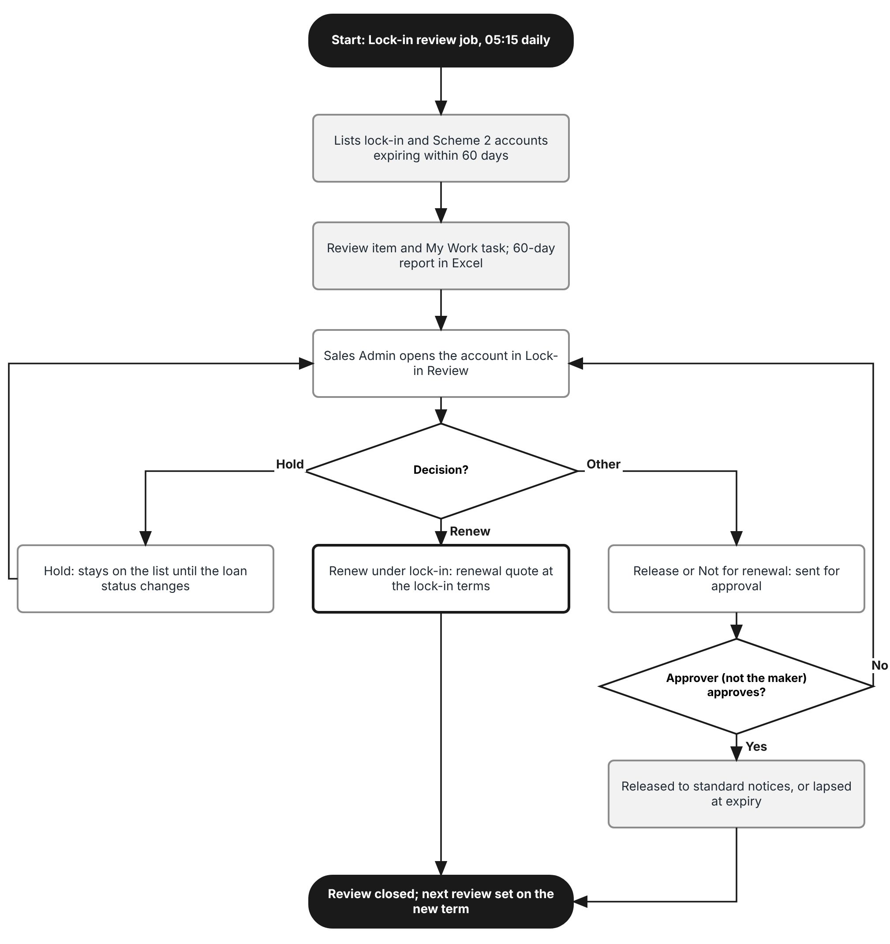
Figure 3: Flow C - 60-day review of lock-in and Scheme 2 accounts
Table 5: Flow C steps
Step | Who (role) | What happens | FR
C1 | System (job Lock-in review) | Lists lock-in and Scheme 2 accounts whose review date has come (60 days before expiry), raises a review item and a My Work task for the account owner, and files the day's 60-day report. | FR-LCK-030, 032
C2 | Sales Admin (write:lock-in) | Opens the account on Lock-in Review, checks the lock-in year, claims and the TFS loan status. | FR-LCK-031
C3 | Sales Admin | Renew under lock-in: the renewal continues in the Renewal Queue at the lock-in terms; no notice is sent. | FR-LCK-040
C4 | Sales Admin | Hold: the account stays on the list with a re-review date at most 30 days ahead and before expiry. | FR-LCK-040
C5 | Sales Admin | Release to standard renewal or Not for renewal: sent for approval to a user with approve:lock-in. | FR-LCK-040
C6 | Approver (approve:lock-in) | Approves or returns from My Work > Approvals. The maker can never approve it. Released accounts get the standard notices; Not for renewal lapses the renewal. | FR-LCK-041
C7 | System | When the renewal is completed the lock-in record moves to the new term with the next lock-in year and review date. | FR-LCK-003

2.4 Notice treatment by account type
Table 6: Notice treatment
Account | Notices at 90 / 60 / 30 days | Listed for the 60-day review | Where set
Promotion lock-in, next term inside the lock-in | Suppressed: Lock-in | Yes | PROD-15 promotion lock-in period, at conversion
Promotion lock-in, last lock-in year | Sent (standard) | Yes, as "Lock-in ends" | Same
Scheme 1 ARA, next term inside the ARA period | Suppressed: Lock-in | Yes | SCHM-01 issuance with the ARA period
Scheme 2 Motor, loan not Closed | Suppressed: Scheme 2 | Yes | SCHM-01 issuance, scheme of SCHM-02
Any policy with a TFS loan account whose loan status is blocking | Held: loan status; queued notices cancelled | Yes when in lock-in or Scheme 2; all on the Notices held tab | TFS status upload or Set loan status
Any other policy | Sent (standard) | No | -

3 Personas and roles

3.1 Personas
BrokerVerse ships eight roles (Master > Users and Access > Role). TISPH personas map to them as below; TISPH can add its own roles (for example Sales Head) and grant them the permissions of section 3.2.
Table 7: Personas and BrokerVerse roles
TISPH persona | BrokerVerse role | What they do with lock-in accounts
Sales Admin / account coordinator | Sales & Marketing (Account Executive) - sales; Processing Team - processing | Review lock-in and Scheme 2 accounts at 60 days, record decisions, renew under lock-in
Sales Head (approver) | Accounting Manager - accounting-manager, or a TISPH role with approve:lock-in | Approve or return Release, Not for renewal and lock-in changes
Operations (renewals desk) | Operations (Client Servicing) - operations | Upload the TFS account status file, run Renewal Batches, follow held accounts
Compliance | Compliance Officer (AML/CFT) - compliance-officer | Set Fraud and Legal dispute on a loan; read the review list and the Audit Trail
Finance | Accounting - accounting | Read the lock-in panel and the report (Scheme 2 billing to TFS)
System Administrator | System Administrator (Super Admin Access) - system-admin | Roles, permissions, lockin.* settings, the Lock-in review job

3.2 New permissions
New permissions follow the BrokerVerse pattern read:<module> / write:<module> / approve:<module> and are granted on Master > Users and Access > Role Permissions. The user who records a decision or requests a lock-in change can never approve it, even when holding approve:lock-in.
Table 8: New permissions
Permission | Allows
read:lock-in | Open Operations > Renewals > Lock-in Review, the Lock-in & loan panel of Policy detail and the Lock-in / Scheme 2 expiry report; Export to Excel
write:lock-in | Record review decisions; request a lock-in change on a policy (Change lock-in)
approve:lock-in | Approve or return Release to standard renewal, Not for renewal and lock-in changes (never one you requested)
write:loan-status | Upload the TFS account status file; Set loan status on a policy

3.3 Default grants
Table 9: Default grants (Y = granted)
Permission | system-admin | processing | sales | operations | accounting | accounting-manager | compliance-officer
read:lock-in | Y | Y | Y | Y | Y | Y | Y
write:lock-in | Y | Y | Y | - | - | - | -
approve:lock-in | Y | - | - | - | - | Y | -
write:loan-status | Y | - | - | Y | - | - | Y

4 Functional requirements
Twenty FRs implement SCHM-03. They follow the process: the lock-in on the policy (4.1), the notice gate on the renewal run (4.2), the TFS loan status and the cancellation of notices (4.3), the 60-day review report (4.4), the review decision (4.5), and audit and access (4.6).

4.1 Lock-in on the policy

FR-LCK-001 Record the lock-in on the policy when it is issued
BRD trace | SCHM-03 "Scheme lock-in periods are honoured platform-wide"; SCHM-01; PROD-15 | Actor | System
Priority | Must have | Fit | Customization
Screens | Operations > Policy > Policy detail (Lock-in & loan panel); Create Quote conversion (PROD-15); Scheme issuance (SCHM-01)

Description
Every policy can carry one lock-in record. It is written by the system when the policy is booked, from what the issuing path already knows: a quotation converted with a PROD-15 promotion that has a Lock-in period; a Scheme 1 policy issued with an Auto Renewal Agreement (SCHM-01); a Scheme 2 policy issued under a scheme of the Scheme Master (SCHM-02).
The record holds: Lock-in source (Promotion, Scheme 1 ARA, Scheme 2), Reference (promotion code and version, or scheme number), Lock-in start date (inception of the first locked term), Lock-in years (N), Lock-in end date, TFS loan account, Lock-in status (Active, Ended, Released, Not renewed, Cancelled) and the term values of FR-LCK-003. The TFS loan account comes from the TFS reference account number of the prospect (TFS lead import) or of the scheme issuance and is kept on the policy even without a lock-in, so that the loan status rule (4.3) can apply.
Preconditions
- The policy is booked (status active or issued) and its product is a Motor product, or it has a TFS loan account.
Main flow
- The policy is booked by conversion of a quotation, by scheme issuance or by renewal.
- The system reads the lock-in data of the source: promotion Lock-in period (1 to promotions.max_lockin_years, default 3), ARA period, or Scheme 2 loan term in years.
- It computes the end date = start date + N years - 1 day and writes the lock-in record with status Active.
- It writes the TFS loan account, when known, with loan status Current until the first TFS status is loaded.
Alternate and exception flows
- A policy booked without lock-in data gets no lock-in record. One can be added later by Change lock-in (FR-LCK-002).
- A Scheme 1 policy issued without the ARA period: the record is created with Lock-in years blank and the policy appears on the In lock-in tab with a warning until the years are set (FR-LCK-002).
Business rules
Rule | Statement | Kind | Maintained in
R1 | One lock-in record per policy chain; a renewal term inherits the record of the term it renews (FR-LCK-003). | Fixed | -
R2 | Lock-in years: 1 to 10. Promotion lock-in at most promotions.max_lockin_years (PROD-15). Scheme 1 ARA: free first year plus the ARA renewal years (5 for the current ARA: 1 free + 4). Scheme 2: loan term in whole years. | Fixed | -
R3 | TFS loan account: exactly 10 digits. | Fixed | -
R4 | Lock-in start date = inception of the first locked term. A promotion lock-in starts on the inception of the policy that carried the promotion. | Fixed | -

Validations and messages
Check | Message shown | ID
Loan account format | The TFS loan account must have 10 digits | MSG-LCK-001
Lock-in years missing | Lock-in years are missing for <policy number>; set them with Change lock-in | MSG-LCK-002

Audit
- Written to Master > System > Audit Trail (entity lock-in) with the user, time, before and after values and remark.
Acceptance criteria
- A policy converted on 13/12/2025 from a quotation with PRM-VIOS-LOCK3 (lock-in 3 years) gets a lock-in record Promotion, start 13/12/2025, end 12/12/2028, year 1 of 3, status Active.
- A Scheme 1 policy with an ARA of 1 + 4 years and inception 13/12/2024 shows lock-in end 12/12/2029.
- A Scheme 2 policy for a 4-year loan shows Lock-in source Scheme 2, Lock-in years 4.
- A loan account of 9 digits is refused with "The TFS loan account must have 10 digits".
- A policy without promotion lock-in or scheme has no lock-in record and its renewal notices are not suppressed.

FR-LCK-002 Change or end a lock-in by hand, with approval
BRD trace | SCHM-03; SEC-03 maker-checker | Actor | Sales Admin (write:lock-in); approver (approve:lock-in)
Priority | Must have | Fit | Customization
Screens | Operations > Policy > Policy detail (Lock-in & loan panel) > Change lock-in; My Work > Approvals (kind Lock-in change)

Description
Change lock-in on the Lock-in & loan panel lets an authorised user add a lock-in to a policy that has none (for example an account already under ARA when BrokerVerse goes live), correct the years or start date, or end a lock-in early. The change is a request: it does not apply until a user with approve:lock-in other than the requester approves it in My Work > Approvals.
The dialog shows the current values and the new values, the effect on the current term (lock-in year, next review date, notice treatment) and requires a reason.
Preconditions
- The policy is active or issued. No other lock-in change is pending for the policy.
Main flow
- The user clicks Change lock-in and chooses Add, Correct or End lock-in.
- The user enters source, reference, start date, years and TFS loan account (Add, Correct) or the end reason (End), and a remark.
- The system shows the resulting lock-in year, end date and notice treatment and saves the request as Pending approval.
- The approver approves (the record changes and the notice gate is re-run for the open renewal) or returns it with a remark.
Business rules
Rule | Statement | Kind | Maintained in
R1 | An approved lock-in record is never edited in place; each change keeps the old values in the history tab. | Fixed | -
R2 | End lock-in reasons: Client request, Vehicle sold, Loan closed, Scheme withdrawn, Data correction, Other (remark required). | Configurable | Lists of values (7.3)
R3 | The requester can never approve the request. | Fixed | -

Validations and messages
Check | Message shown | ID
Start date after inception of the current term | The lock-in cannot start after the current term starts (<inception date>) | MSG-LCK-003
Years out of range | Lock-in years must be between 1 and 10 | MSG-LCK-004
End date before current term | With these values the lock-in ends before the current term; use End lock-in instead | MSG-LCK-005
Reason blank | Enter the reason for the change | MSG-LCK-006
Pending change exists | A lock-in change for <policy number> is already waiting for approval | MSG-LCK-007
Self-approval | You requested this change; another user must approve it | MSG-LCK-008
Request saved | Lock-in change sent for approval | MSG-LCK-009
Approved | Lock-in change approved | MSG-LCK-010

Audit
- Written to Master > System > Audit Trail (entity lock-in) with the user, time, before and after values and remark.
Acceptance criteria
- User A requests Add lock-in Scheme 1 ARA, start 13/12/2024, 5 years on POL-2026-90004; the panel shows "Pending approval" and nothing changes until user B approves.
- After approval the panel shows year 2 of 5, end 12/12/2029, next review date 13/10/2026 and Renewal notices Suppressed: Lock-in.
- User A cannot approve the request even with approve:lock-in.
- Ending the lock-in with reason Vehicle sold sets Lock-in status Ended and the open renewal's notice treatment to Send.
- Lock-in years 12 is refused with "Lock-in years must be between 1 and 10".

FR-LCK-003 Track the lock-in year and review date of each term and carry them to the renewal
BRD trace | SCHM-03 "lock-in review dates are tracked on the policy" | Actor | System (job Lock-in review; renewal completion)
Priority | Must have | Fit | Customization
Screens | Operations > Policy > Policy detail (Lock-in & loan panel); Master > System > Schedules (job Lock-in review)

Description
For every term of a policy with an Active lock-in the system keeps the lock-in year ("n of N"), the next review date (expiry date minus lockin.review_days_before_expiry, default 60 days), the last review (date, decision, user) and whether the next term is inside the lock-in (inception of the next term on or before the lock-in end date).
When a renewal is completed (base Complete renewal: a new policy term is created and the old one is marked Renewed), the lock-in record moves to the new term: the lock-in year goes up by one and the review date is recomputed from the new expiry. When the renewed term is the last lock-in year, the record keeps status Active for that term and ends (status Ended) when the term expires or is renewed outside the lock-in.
The daily job Lock-in review recomputes these values, so that a change of expiry by endorsement, a lock-in change or a setting change is reflected the next morning.
Main flow
- The renewal of a lock-in policy is completed.
- The system links the lock-in record to the new term, sets lock-in year n+1 and the new review date.
- The daily job checks every Active record and sets Ended where the last lock-in term has expired.
Business rules
Rule | Statement | Kind | Maintained in
R1 | Lock-in year of a term = whole years between the lock-in start date and the term inception + 1. | Fixed | -
R2 | Review date = expiry date - lockin.review_days_before_expiry (default 60). When it falls on a weekend or public holiday of the working calendar it moves to the working day before. | Configurable | Master > System > Configuration
R3 | A policy cancelled before expiry sets the lock-in status Cancelled; no review is raised for it. | Fixed | -

Audit
- Written to Master > System > Audit Trail (entity lock-in) with the user, time, before and after values and remark.
Acceptance criteria
- Term 13/12/2025 - 12/12/2026 of a lock-in starting 13/12/2024 for 5 years shows year 2 of 5 and next review date 13/10/2026.
- After the renewal is completed, the new term 13/12/2026 - 12/12/2027 shows year 3 of 5 and review date 13/10/2027.
- For a term expiring 21/02/2027 the review date 23/12/2026 is kept; for one expiring 22/02/2027 the review date 24/12/2026 (holiday) moves to 23/12/2026.
- A 3-year promotion lock-in in its year 3 shows "Next term inside lock-in: No" and status Ended after its expiry.

FR-LCK-004 Show the lock-in and the loan status on Policy detail
BRD trace | SCHM-03 "lock-in review dates are tracked on the policy" | Actor | Any user with read:lock-in
Priority | Must have | Fit | Customization
Screens | Operations > Policy > Policy detail (Lock-in & loan panel)

Description
A new panel Lock-in & loan is added to Policy detail, under the Policy Details card, for every policy that has a lock-in record or a TFS loan account. It shows Lock-in source, Lock-in period, Lock-in year of this term, Next review date, Renewal notices (the current notice treatment), Last review, TFS loan account, Loan status with its date and source (upload batch or user), and Lock-in status. Buttons Change lock-in (write:lock-in) and Set loan status (write:loan-status) open the dialogs of FR-LCK-002 and FR-LCK-021. A History link lists every change of lock-in, loan status and notice treatment.
The same values are shown read-only on the Renewal Queue policy dialog (tab Lock-in) and on the Lock-in Review dialog.
Business rules
Rule | Statement | Kind | Maintained in
R1 | The panel is hidden for policies with neither a lock-in record nor a TFS loan account. | Fixed | -
R2 | A loan status older than lockin.loan_status_stale_days (default 45) is shown with the warning tag "Status older than 45 days". | Configurable | Master > System > Configuration

Validations and messages
Check | Message shown | ID
Stale loan status | The TFS loan status of <loan account> was last reported on <date> | MSG-LCK-011

Audit
- Viewing is not audited; changes are audited by FR-LCK-002 and FR-LCK-021.
Acceptance criteria
- POL-2026-90004 shows Scheme 1 ARA (SCH-01), 13/12/2024 - 12/12/2029 (5 years), year 2 of 5, next review 13/10/2026, Suppressed: Lock-in, loan 8005123456 Current as of 08/10/2026.
- A user without write:lock-in does not see Change lock-in.
- A loan status dated 15/08/2026 shown on 09/10/2026 carries the warning "Status older than 45 days".

4.2 Notice gate on the renewal run

FR-LCK-010 Decide the notice treatment of each renewal (notice gate)
BRD trace | SCHM-03 "renewal notices are suppressed for accounts in lock-in (and Scheme 2 Motor)"; RENEW-02 | Actor | System
Priority | Must have | Fit | Customization
Screens | Renewal pipeline and Renewal notices jobs; Renewal Batch; Renewal Queue

Description
A single server function, the notice gate, decides for a renewal (or a policy before it is enrolled) whether a notice or reminder to the client may be produced. Every path of chapter 4.2 calls it; no path decides on its own. It returns one treatment, checked in this order:
(1) Held: loan status when the policy has a TFS loan account whose loan status is blocking and no approved release (FR-LCK-022). (2) Suppressed: Lock-in when the lock-in record is Active and the next term starts on or before the lock-in end date. (3) Suppressed: Scheme 2 when the lock-in source is Scheme 2, the product is Motor, the loan status is not Closed and lockin.suppress_scheme2_motor is true. (4) Send otherwise, and always when a Release to standard renewal has been approved for the term (FR-LCK-041).
The treatment is stored on the renewal record with the reason and the time it was set, and is recomputed by the Renewal pipeline job every morning and immediately after any change of lock-in, loan status or review decision.
Main flow
- The Renewal pipeline job (05:30) enrols policies expiring within 90 days and calls the gate for each new or open renewal.
- The gate stores the treatment on the renewal.
- Each notice path reads the stored treatment and calls the gate again just before it queues or sends.
Business rules
Rule | Statement | Kind | Maintained in
R1 | Held has priority over Suppressed: a lock-in account with a past-due loan is shown as Held. | Fixed | -
R2 | Scheme 2 suppression on Motor products only (product line motor). | Configurable | lockin.suppress_scheme2_motor
R3 | The gate covers notices and reminders to the client only. Staff reminders, the renewal itself, quotation, approval and completion are not blocked. | Fixed | -

Audit
- Each change of treatment is written to the renewal activity log (base renewal activities) as "Notice treatment: <treatment> (<reason>)" and to the Audit Trail.
Acceptance criteria
- A renewal of POL-2026-90004 (lock-in to 12/12/2029, expiry 12/12/2026) is stored as Suppressed: Lock-in.
- A renewal of a 3-year promotion lock-in in its year 3 is stored as Send.
- A Scheme 2 Motor renewal with loan Current is Suppressed: Scheme 2; with loan Closed it is Send.
- A lock-in renewal whose loan becomes Past due is shown as Held: loan status.
- After a Release to standard renewal is approved the treatment is Send even though the lock-in runs to 2029.

FR-LCK-011 Produce no automatic notice or reminder for a suppressed or held renewal
BRD trace | SCHM-03; RENEW-02 "automatic customer reminders at each mark excluding lock-in and Scheme 2 Motor accounts" | Actor | System (jobs Renewal notices, Renewal notice queue)
Priority | Must have | Fit | Customization
Screens | Master > System > Schedules (Renewal notices daily 06:00; Renewal notice queue every minute)

Description
The job Renewal notices creates, at each day of limits.renewal_notice_days (90, 60 and 30 for TISPH), the staff reminder "Renewal due in n days" and, under TIS-BRD-RENEW-02, the customer notice of that mark (First, Second, Final). Before each one it calls the notice gate. For a Suppressed or Held renewal no customer notice and no customer reminder is queued, and the stage is recorded on the renewal as "skipped: <treatment>" so that the history shows why nothing went out.
For a Suppressed: Lock-in or Suppressed: Scheme 2 renewal the staff reminder "Renewal due in n days" is not created either: the account is handled through the lock-in review task (FR-LCK-030). For a Held renewal the staff reminder is still created, titled "Renewal due in n days - notices held (<loan status>)".
The job Renewal notice queue, which sends queued notices every minute, calls the gate again for each item and cancels the item instead of sending it when the treatment is no longer Send (FR-LCK-022).
Business rules
Rule | Statement | Kind | Maintained in
R1 | Customer notices skipped for suppression are never sent later for the same term, even if the lock-in is changed afterwards; a released account starts from the next notice due (FR-LCK-041). | Fixed | -
R2 | Mark days: limits.renewal_notice_days = [90, 60, 30]. | Configurable | Master > System > Configuration

Audit
- Renewal activity "First Notice skipped: Suppressed: Lock-in" (or Held: loan status) with the time of the job run.
Acceptance criteria
- On 13/09/2026 (90 days before 12/12/2026) no First Notice and no reminder e-mail is queued for POL-2026-90004; the renewal history shows "First Notice skipped: Suppressed: Lock-in".
- On the same day a non-lock-in policy expiring 12/12/2026 gets its First Notice.
- A Held renewal gets the staff reminder "Renewal due in 30 days - notices held (Past due)" and no customer notice.
- A notice queued at 05:59 for a policy that is held at 06:01 is cancelled by the Renewal notice queue job, not sent.

FR-LCK-012 Exclude suppressed and held policies from Renewal Batch notices and manual sending
BRD trace | SCHM-03; RENEW-01; SCHM-01 "renewal notices exclude past-due, missed-payment and early-terminated loan accounts" | Actor | Operations (write:renewals)
Priority | Must have | Fit | Customization
Screens | Operations > Renewals > Renewal Batch; Renewal Queue (Send notice, Send reminder)

Description
Renewal Batch. When a batch is created by criteria or from a list, suppressed and held policies are still added to the batch so that Operations sees them, but with the new notice status Suppressed or Held (next to NotSent, Queued, Sent, Failed), their selection box disabled and the reason in the row. Send notices on the batch queues only selected NotSent policies whose gate result is Send. The batch summary counts Suppressed and Held separately.
Renewal Queue. The actions Send notice and Send reminder are disabled for a suppressed or held renewal, with the reason as tooltip. A call to the same functions through the API is refused with the messages below.
Preconditions
- The user has write:renewals.
Main flow
- Operations creates a batch for expiries 01/11/2026 to 30/11/2026.
- The system lists 214 policies: 171 NotSent, 39 Suppressed, 4 Held.
- Operations selects the NotSent policies and clicks Send notices; 171 notices are queued.
Business rules
Rule | Statement | Kind | Maintained in
R1 | Suppressed and Held policies cannot be selected in a batch and cannot receive a notice or reminder from the Renewal Queue. | Fixed | -
R2 | A policy that becomes held after it was queued is set to Cancelled by the queue job (FR-LCK-022). | Fixed | -

Validations and messages
Check | Message shown | ID
Send on suppressed | No notice is sent for <policy number>: the renewal is inside its lock-in (until <lock-in end date>) | MSG-LCK-012
Send on Scheme 2 | No notice is sent for <policy number>: Scheme 2 accounts do not receive renewal notices | MSG-LCK-013
Send on held | Notices for <policy number> are held: TFS loan <loan account> is <loan status> since <status date> | MSG-LCK-014
Batch summary | <n> notices queued; <s> suppressed and <h> held policies were not selected | MSG-LCK-015

Audit
- Batch creation and sending are logged as in the base renewal batch; the Suppressed and Held rows keep their reason.
Acceptance criteria
- A batch for 01/11/2026 - 30/11/2026 lists POL-2025-90034 (lock-in) with notice status Suppressed and no selection box.
- Send notices on that batch queues only NotSent policies; the toast reads "171 notices queued; 39 suppressed and 4 held policies were not selected".
- On the Renewal Queue the Send notice icon of a Suppressed: Lock-in row is disabled.
- Calling Send notice for a held renewal through the API returns the held message and sends nothing.

FR-LCK-013 Show the notice treatment on the renewal screens
BRD trace | SCHM-03 | Actor | Any user with read:renewals
Priority | Must have | Fit | Customization
Screens | Operations > Renewals > Renewal Queue, Renewal Policy, Renewal Batch; Renewal Queue policy dialog

Description
The Status column of the Renewal Queue shows the tags Suppressed: Lock-in and Suppressed: Scheme 2 (blue) and Held: loan status (red) instead of Pending or the notice stage, while the renewal is open. The Status filter gets the three values. The Renewal Policy list shows the same tag under Renewal state. The policy dialog of the Renewal Queue gets a fourth tab Lock-in with the values of the Lock-in & loan panel.
The queue export (Excel icon) adds the columns Notice treatment, Lock-in, Lock-in year, Loan status.
Business rules
Rule | Statement | Kind | Maintained in
R1 | After the renewal is quoted the status tag returns to the base status (Quote Sent, Pending Approval ...) and the treatment is shown as a second tag. | Fixed | -

Audit
- Written to Master > System > Audit Trail with the user, time, before and after values and remark.
Acceptance criteria
- POL-2025-90021 in lock-in shows "Suppressed: Lock-in" in the Status column and the Status filter value Suppressed: Lock-in lists it.
- A held renewal shows "Held: loan status" in red.
- The Excel export of the Renewal Queue contains the column Notice treatment.

FR-LCK-014 Replace the staff reminder of a lock-in account with the lock-in review task
BRD trace | SCHM-03 "a 60-days-before-expiry review report" | Actor | System
Priority | Must have | Fit | Customization
Screens | My Work (task kind Lock-in review); Notifications

Description
Instead of the three "Renewal due in n days" reminders, the owner of a suppressed lock-in or Scheme 2 account gets one My Work task Lock-in review due on the review date (60 days before expiry), created by the Lock-in review job (FR-LCK-030). The task opens the account on Lock-in Review and closes itself when a decision other than Hold is recorded. A Hold creates a new task on the re-review date.
When the policy has no owner the task goes to the users of the roles in lockin.review_roles (default processing).
Business rules
Rule | Statement | Kind | Maintained in
R1 | One open lock-in review task per policy term. | Fixed | -
R2 | Task roles when there is no owner: lockin.review_roles = ["processing"]. | Configurable | Master > System > Configuration

Audit
- Written to Master > System > Audit Trail with the user, time, before and after values and remark.
Acceptance criteria
- On 13/10/2026 the owner of POL-2026-90004 has the task "Lock-in review due: POL-2026-90004, expires 12/12/2026" in My Work.
- Recording Renew under lock-in closes the task.
- Recording Hold with re-review 23/10/2026 creates a new task on 23/10/2026.

4.3 TFS loan status and cancellation of notices

FR-LCK-020 Upload the TFS account status file
BRD trace | SCHM-03 "notices cancel where the loan account is past due, fraudulent, terminated or under legal dispute"; INTG-03; BULK-01 | Actor | Operations (write:loan-status)
Priority | Must have | Fit | Customization
Screens | Operations > Renewals > Lock-in Review > Upload loan status; tab Loan status uploads

Description
TFS sends TISPH the list of financed accounts with their loan status (the Scheme 2 renewal list comes from TFSPH with the status of the accounts). Operations loads it with Upload loan status on Lock-in Review, following the base upload pattern: Template downloads the three-sheet Excel template (Data, Columns, Instructions; required headers in dark red); the file is loaded row by row; the result line reads "Processed n rows: c loaded, f failed" with the failed rows listed by row number and an error file to download.
For each valid row the system finds every active, issued or expired-in-grace policy with that TFS loan account and saves the loan status, the status date, the days past due and the upload batch. The tab Loan status uploads lists each batch with File, Status date, Rows, Updated, Not changed, Failed, Notices held and Holds lifted. The TFS status codes are mapped to BrokerVerse loan statuses as in chapter 6.
Preconditions
- The user has write:loan-status. The file is the TFS account status file in the template layout (chapter 13).
Main flow
- The user opens Lock-in Review > Loan status uploads and clicks Upload loan status.
- The user picks the .xlsx file and confirms; the system checks the columns.
- The system loads each row, updates the linked policies and runs the notice gate for their open renewals.
- The result line and the batch row are shown; failed rows can be downloaded.
Alternate and exception flows
- A row whose status date is older than the status already on the policy is counted as Not changed.
- A row for a loan account linked to no policy is failed with its row number.
- A re-upload of the same file gives only Not changed rows.
Business rules
Rule | Statement | Kind | Maintained in
R1 | .xlsx only, first sheet Data, at most lockin.upload_max_rows rows (default 5,000). | Configurable | Master > System > Configuration
R2 | Status date cannot be in the future; a newer status date wins, the same date replaces. | Fixed | -
R3 | A Fraud or Legal dispute set by hand (FR-LCK-021) is not overwritten by the file; the row is counted as Not changed and listed with the reason. | Fixed | -
R4 | A blocking status sets notices to Held (FR-LCK-022); a return to Current lifts the hold (FR-LCK-023). | Fixed | -

Validations and messages
Check | Message shown | ID
File type | Upload an Excel (.xlsx) file | MSG-LCK-016
Missing columns | The file must have the columns LOAN_ACCOUNT_NO, LOAN_STATUS and STATUS_DATE | MSG-LCK-017
Too many rows | A file can hold at most <max> rows | MSG-LCK-018
Loan account format (row) | Row <n>: loan account <value> must have 10 digits | MSG-LCK-019
Unknown status (row) | Row <n>: loan status <value> is not a known TFS status | MSG-LCK-020
Future date (row) | Row <n>: the status date cannot be in the future | MSG-LCK-021
No linked policy (row) | Row <n>: no policy is linked to loan account <value> | MSG-LCK-022
Result | Processed <n> rows: <c> loaded, <f> failed | MSG-LCK-023

Audit
- Written to Master > System > Audit Trail (entity loan-status (one entry per policy changed, with the upload batch)) with the user, time, before and after values and remark.
Acceptance criteria
- Uploading TFS_ACCT_STATUS_20261008.xlsx with 1,284 rows of which 8 invalid shows "Processed 1,284 rows: 1,276 loaded, 8 failed" and the batch LS-2026-00041.
- Row 17 with loan account 80051163 is failed with "Row 17: loan account 80051163 must have 10 digits".
- A row for 8003828889 with PAST DUE dated 30/09/2026 sets the loan status of POL-2025-90036 to Past due, status date 30/09/2026.
- A row dated 24/09/2026 for a policy whose status is dated 30/09/2026 is counted as Not changed.
- A .csv file is refused with "Upload an Excel (.xlsx) file".

FR-LCK-021 Set a loan status by hand (fraud, legal dispute, corrections)
BRD trace | SCHM-03 "fraudulent ... or under legal dispute" | Actor | Compliance Officer, Operations (write:loan-status)
Priority | Must have | Fit | Customization
Screens | Operations > Policy > Policy detail (Lock-in & loan panel) > Set loan status

Description
Fraud and legal disputes are often known to TISPH before TFS reports them. Set loan status on the Lock-in & loan panel lets a user with write:loan-status set the loan status of the policy's TFS loan account, with a status date and a mandatory remark. The status applies to every policy with the same loan account. A status set by hand is marked "manual" and is not overwritten by the TFS file until a user with write:loan-status clears it (sets Current or the TFS value).
Preconditions
- The policy has a TFS loan account.
Business rules
Rule | Statement | Kind | Maintained in
R1 | Manual statuses: any loan status; Fraud and Legal dispute are the expected use. | Fixed | -
R2 | Remark required, at least 10 characters. | Fixed | -

Validations and messages
Check | Message shown | ID
Remark blank | Enter the reason for the loan status (at least 10 characters) | MSG-LCK-024
Status date in the future | The status date cannot be in the future | MSG-LCK-025
Saved | Loan status of <loan account> set to <status>; notices are <treatment> | MSG-LCK-026

Audit
- Written to Master > System > Audit Trail (entity loan-status) with the user, time, before and after values and remark.
Acceptance criteria
- The Compliance Officer sets Fraud on loan 8005649469 with remark "Fraud case FC-2026-014 reported by TFS Legal"; both policies with that loan account show Fraud (manual) and Held: loan status.
- The next TFS file with CURRENT for 8005649469 does not change the status; the upload lists the row as Not changed (manual status).
- A user without write:loan-status does not see Set loan status.

FR-LCK-022 Cancel queued notices and hold further notices when the loan status blocks them
BRD trace | SCHM-03 "notices cancel where the loan account is past due, fraudulent, terminated or under legal dispute"; SCHM-01 | Actor | System
Priority | Must have | Fit | Customization
Screens | Renewal Batch; Renewal Queue; Master > System > E-mail Outbox; My Work

Description
When a policy's loan status becomes blocking (Past due, Fraud, Early terminated, Terminated, Legal dispute; setting lockin.blocking_loan_statuses), by upload or by hand, the system at once: (1) sets every Queued renewal batch notice of the policy to the new notice status Cancelled with the reason; (2) cancels the queued, not yet delivered renewal notice and reminder e-mails of the renewal in the E-mail Outbox; (3) sets the renewal's notice treatment to Held: loan status so that no further notice or reminder is produced; (4) creates a My Work item for the account owner "Renewal notices held: <policy number>, TFS loan <status>"; (5) lists the account on the Notices held tab of Lock-in Review.
Notices already delivered cannot be recalled; the renewal history shows which notices were sent before the hold and which were cancelled.
Business rules
Rule | Statement | Kind | Maintained in
R1 | "Missed payment" in the TFS file is treated as Past due. | Configurable | TFS status mapping (chapter 6)
R2 | The hold applies to every policy with the loan account, Motor or not, lock-in or not. | Fixed | -
R3 | A hold does not stop the renewal: it can still be quoted, approved and completed by a user, or lapsed. | Fixed | -

Validations and messages
Check | Message shown | ID
Notice cancelled | <n> queued renewal notices cancelled: TFS loan <loan account> is <loan status> | MSG-LCK-027

Audit
- Each cancelled notice and e-mail is logged in the renewal activities ("Second Notice cancelled: loan Past due") and in the Audit Trail.
Acceptance criteria
- Policy POL-2025-90050 (expiry 20/11/2026) has a reminder e-mail queued; the upload of 09/10/2026 sets its loan to Past due; the e-mail is cancelled and the renewal shows Held: loan status.
- A batch notice in status Queued for that policy becomes Cancelled with the reason "Loan Past due since 05/10/2026".
- The Final Notice due on 21/10/2026 is not produced while the hold lasts.
- The account owner has the My Work item "Renewal notices held: POL-2025-90050, TFS loan Past due".
- A Credit Life policy with the same loan account is held too.

FR-LCK-023 Lift the hold when the loan is current again; closed loans
BRD trace | SCHM-03; RENEW-02 | Actor | System
Priority | Must have | Fit | Customization
Screens | Operations > Renewals > Lock-in Review; Renewal Queue

Description
When the loan status of a held policy returns to Current (by upload or by hand) the hold is lifted: the gate is re-run, and for a non-lock-in account the treatment returns to Send. Cancelled notices are not re-sent; the next notice due goes out on the next Renewal notices run (with renewals.enforce_notice_order true, the first notice not yet sent). The owner gets a My Work item "Renewal notices resumed".
A loan reported Closed (fully paid) is not blocking. For a Scheme 2 account it ends the Scheme 2 suppression from the next term; for a Scheme 1 ARA or promotion lock-in it does not change the lock-in.
Business rules
Rule | Statement | Kind | Maintained in
R1 | A hold on a lock-in or Scheme 2 account that is lifted returns the account to its suppression (it was suppressed before the hold). | Fixed | -
R2 | A hold lifted after the expiry date leaves the renewal in its base grace or lapse handling. | Fixed | -

Validations and messages
Check | Message shown | ID
Hold lifted | Renewal notices for <policy number> resumed: TFS loan <loan account> is Current | MSG-LCK-028

Audit
- Written to Master > System > Audit Trail with the user, time, before and after values and remark.
Acceptance criteria
- The TFS file of 22/10/2026 reports 8001122334 Current; POL-2025-90050 returns to Send and its Final Notice is sent on 23/10/2026.
- A lock-in account whose loan returns to Current goes back to Suppressed: Lock-in.
- A Scheme 2 Motor account reported Closed on 15/10/2026 keeps Suppressed: Scheme 2 for the current renewal and gets standard notices from the next term.

4.4 The 60-day review report

FR-LCK-030 List lock-in and Scheme 2 accounts 60 days before expiry (job Lock-in review)
BRD trace | SCHM-03 "a 60-days-before-expiry review report covers lock-in and Scheme 2 accounts"; RPT-SLS-05 | Actor | System (job Lock-in review, daily 05:15)
Priority | Must have | Fit | Customization
Screens | Master > System > Schedules; Operations > Renewals > Lock-in Review; My Work

Description
A new scheduled job Lock-in review runs daily at 05:15 Manila time (before Renewal pipeline at 05:30 and Renewal notices at 06:00). It: (1) recomputes the lock-in year and review date of every Active record (FR-LCK-003); (2) creates a review item with status Review due for every lock-in or Scheme 2 policy whose review date is today or has passed and which has no review item for the current term; (3) creates the My Work task of FR-LCK-014; (4) brings back Hold items whose re-review date is today; (5) files the day's Lock-in / Scheme 2 expiry extract (FR-LCK-032) as a generated report.
Accounts in their last lock-in year are listed with status Lock-in ends: no decision is needed; they receive the standard notices.
Business rules
Rule | Statement | Kind | Maintained in
R1 | Review window: expiry within lockin.review_days_before_expiry days (60) from the run date. | Configurable | Master > System > Configuration
R2 | Accounts covered: lock-in status Active (all sources) and Scheme 2 Motor accounts with loan not Closed; held non-lock-in accounts are listed on the Notices held tab only. | Fixed | -
R3 | The job runs once across instances, like the other base jobs, and can be run on demand from Schedules. | Fixed | Master > System > Schedules

Audit
- Job run with counts (records updated, review items created, holds due, report id) in the Schedules run history.
Acceptance criteria
- The run of 13/10/2026 creates the review item of POL-2026-90004 (expiry 12/12/2026) with status Review due.
- The run of 09/10/2026 lists POL-2025-90044 (PRM-HEV-LOCK2, year 2 of 2) with status Lock-in ends.
- A Hold with re-review 23/10/2026 returns to Review due on the run of 23/10/2026.
- A second run on the same day creates no duplicate review item.

FR-LCK-031 Work the accounts on the Lock-in Review screen
BRD trace | SCHM-03 "review report"; RPT-SLS-05 "with loan status shown so past-due and early-terminated accounts can be excluded" | Actor | Sales Admin, Operations (read:lock-in)
Priority | Must have | Fit | Customization
Screens | Operations > Renewals > Lock-in Review

Description
A new menu item Lock-in Review is added under Operations > Renewals, after Renewal Queue (route /renewal/lock-in-review). It follows the layout of the base list pages: title, breadcrumb Operations > Renewals, a short description, buttons Export to Excel and Upload loan status, and a table with tabs: Due for review (accounts within the 60-day window, any review status), Notices held, Pending approval, In lock-in (all Active lock-in and Scheme 2 accounts) and Loan status uploads.
Filters: As of date (default today), Days to expiry (default 0 - 60), Lock-in source, Insurer, Loan status, Review status, and a search on policy number, insured or loan account. Columns: Policy number, Insured, TFS loan account, Lock-in, Year, Expiry, Review date, Loan status, Review status, and the action Review that opens the review dialog (FR-LCK-040).
Business rules
Rule | Statement | Kind | Maintained in
R1 | Default sort: review date, then expiry date; 20 rows per page (base default). | Fixed | -
R2 | Users see the accounts of their data scope (base record scope by branch and owner). | Fixed | -

Audit
- Written to Master > System > Audit Trail with the user, time, before and after values and remark.
Acceptance criteria
- On 09/10/2026 the Due for review tab lists the six lock-in and Scheme 2 accounts expiring by 08/12/2026, each with its review status.
- Filter Loan status = Past due lists POL-2025-90036.
- Searching 8003828889 finds POL-2025-90036.
- A user without read:lock-in does not see the menu item.

FR-LCK-032 Produce the Lock-in / Scheme 2 expiry report (Excel extract)
BRD trace | SCHM-03 "60-days-before-expiry review report"; RPT-SLS-05; RPT-SLS-04 field set | Actor | Sales Admin, Operations (read:lock-in, read:renewal-reports)
Priority | Must have | Fit | Customization
Screens | Operations > Renewals > Lock-in Review > Export to Excel; Reports > Operational Reports > Renewal (criteria Lock-in / Scheme 2 expiry)

Description
The 60-day review report lists the lock-in and Scheme 2 accounts expiring within the chosen window with their loan status, so that past-due and early-terminated accounts are seen before renewal is issued. It is produced three ways from the same query: Export to Excel on Lock-in Review (current filters), the report criteria Lock-in / Scheme 2 expiry (60 days) on Reports > Operational Reports > Renewal (Preview, Generate in CSV, Excel or PDF) and the daily file of the Lock-in review job.
Parameters: As of date, Days to expiry (from - to, default 0 - 60), Lock-in source, Loan status, Review status, Account coordinator, Insurer, Product. The columns follow the renewal calling template used by the TIS Sales team plus the lock-in and loan fields (table below). The Excel file carries the Toyota Insurance Services logo of the brand pack, the parameters and the run time on its first rows.
Business rules
Rule | Statement | Kind | Maintained in
R1 | Days to expiry is counted from the As of date. | Fixed | -
R2 | Rows sorted by expiry date, then policy number. | Fixed | -

Validations and messages
Check | Message shown | ID
No rows | No lock-in or Scheme 2 account expires within <from> to <to> days of <as of date> | MSG-LCK-029
Window too wide | Days to expiry can be at most 365 | MSG-LCK-030

Audit
- Report generation is logged as for every base report (user, parameters, time).
Acceptance criteria
- Generate with As of 09/10/2026, Days 0 - 60, Excel gives one row per listed account with the columns of Table "Report columns".
- The row of POL-2025-90036 shows Loan status Past due, status date 30/09/2026, Notice treatment Held: loan status.
- Export to Excel on Lock-in Review with filter Lock-in source = Scheme 2 gives only Scheme 2 rows.
- The daily job of 13/10/2026 files the extract "Lock-in / Scheme 2 expiry 13/10/2026", listed in the run history.

4.5 Review decision and approval

FR-LCK-040 Record the review decision
BRD trace | SCHM-03; RENEW-01 "not-for-renewal handling" | Actor | Sales Admin (write:lock-in)
Priority | Must have | Fit | Customization
Screens | Operations > Renewals > Lock-in Review > Review (dialog, tabs Review, Lock-in, Loan status history, Notices, History)

Description
Review opens a dialog on the account: the Account section (policy and expiry with days left, unit and insurer, lock-in source, year and end, review date, TFS loan account and status, current notice treatment) and the Decision section. The other tabs show the lock-in record, the loan status history, the notices sent, skipped and cancelled for the term, and the history of decisions.
Decisions: Renew under lock-in (the renewal continues at the lock-in terms; the review item closes and the renewal opens in the Renewal Queue for quotation through the base renewal quote wizard); Hold (with a re-review date, at most lockin.hold_max_days (30) ahead and before the expiry date); Release to standard renewal (the account leaves the lock-in from this renewal and gets the standard notices) and Not for renewal (the renewal will not be offered). Release and Not for renewal need approval (FR-LCK-041). Every decision needs a reason from the list and a remark.
Preconditions
- The review item is Review due, On hold or Returned.
Main flow
- The user opens the account and reads the lock-in and loan data.
- The user chooses the decision, the reason, the re-review date (Hold) and the remark.
- The user clicks Save decision; the system checks the rules and sets the review status.
Business rules
Rule | Statement | Kind | Maintained in
R1 | Renew under lock-in is not allowed while the loan status is blocking; the user chooses Hold, Release or Not for renewal. | Fixed | -
R2 | Reasons: Renew under lock-in - Lock-in confirmed. Hold - Loan past due, Awaiting TFS status, Client contact pending, Other. Release - Client request, Loan closed, Scheme withdrawn, Other. Not for renewal - Loan early terminated, Loan terminated, Fraud, Legal dispute, Vehicle sold, Total loss, Other. | Configurable | Lists of values (7.3)
R3 | Remark required, at least 10 characters. | Fixed | -

Validations and messages
Check | Message shown | ID
Renew while loan blocking | The TFS loan is <loan status>; choose Hold, Release or Not for renewal | MSG-LCK-031
Re-review date | The re-review date must be within <n> days and before the expiry date <expiry date> | MSG-LCK-032
Reason blank | Select the reason | MSG-LCK-033
Remark short | Enter a remark of at least 10 characters | MSG-LCK-034
Saved | Decision saved: <decision> | MSG-LCK-035
Sent for approval | Decision sent for approval: <decision> | MSG-LCK-036

Audit
- Written to Master > System > Audit Trail (entity lock-in-review) with the user, time, before and after values and remark.
Acceptance criteria
- Renew under lock-in on POL-2026-90004 sets the review status Renew under lock-in, closes the task and keeps notices Suppressed: Lock-in.
- Renew under lock-in on POL-2025-90036 (loan Past due) is refused with "The TFS loan is Past due; choose Hold, Release or Not for renewal".
- Hold with re-review 23/10/2026 on 09/10/2026 is accepted; 15/11/2026 is refused (more than 30 days).
- Not for renewal on POL-2025-90041 with reason Loan early terminated sets Pending approval.

FR-LCK-041 Approve a release or a not-for-renewal decision
BRD trace | SCHM-03; SEC-03 maker-checker | Actor | Sales Head / Accounting Manager (approve:lock-in)
Priority | Must have | Fit | Customization
Screens | My Work > Approvals (kind Lock-in review); Operations > Renewals > Lock-in Review > Pending approval

Description
A Release or Not for renewal decision raises an item in My Work > Approvals of the users with approve:lock-in (kind Lock-in review, policy number, decision, next action "Approve or return the decision"), as the base approvals do. The approver opens the review dialog read-only and clicks Approve or Return (remark required). The maker can never approve.
On approval of Release to standard renewal: the lock-in status becomes Released from the current expiry, the notice gate returns Send, and the next notice due goes out on the next Renewal notices run. On approval of Not for renewal: the open renewal is lapsed with the reason "Not for renewal: <reason>" (base Lapse), the lock-in status becomes Not renewed and no notice is sent. On Return the item goes back to the Review due tab with the remark.
Business rules
Rule | Statement | Kind | Maintained in
R1 | Approval needed: lockin.release_maker_checker (default true). | Configurable | Master > System > Configuration
R2 | An approval opened after the expiry date can still be approved; a Release then follows the base grace-period renewal. | Fixed | -

Validations and messages
Check | Message shown | ID
Self-approval | You recorded this decision; another user must approve it | MSG-LCK-037
Return without remark | Enter the reason for returning the decision | MSG-LCK-038
Approved | Decision approved: <decision> | MSG-LCK-039
Returned | Decision returned to <user> | MSG-LCK-040

Audit
- Written to Master > System > Audit Trail (entity lock-in-review) with the user, time, before and after values and remark.
Acceptance criteria
- Not for renewal on POL-2025-90041 recorded by user A appears in My Work > Approvals of an Accounting Manager and cannot be approved by user A.
- After approval the renewal of POL-2025-90041 is Lapsed with reason "Not for renewal: Loan early terminated" and the lock-in status is Not renewed.
- Approving a Release on 09/10/2026 for a policy expiring 02/12/2026 sends the First Notice on the Renewal notices run of 10/10/2026.
- Return without a remark is refused.

4.6 Audit and access

FR-LCK-050 Keep a complete audit trail of lock-ins, loan statuses, notice treatments and decisions
BRD trace | SEC-01; SCHM-03 | Actor | System
Priority | Must have | Fit | Customization
Screens | Master > System > Audit Trail; History tabs of the panel and the review dialog

Description
Every create and change of a lock-in record, every loan status change (with the upload batch or the user), every notice treatment change, every notice skipped or cancelled, and every review decision and approval is written to the base Audit Trail with user, time, before and after values and remark. New entity types: lock-in, loan-status, lock-in-review. The History tabs read the same entries.
Business rules
Rule | Statement | Kind | Maintained in
R1 | Audit entries are kept for the retention period of the base Audit Trail. | Fixed | Master > System > Configuration

Audit
- Written to Master > System > Audit Trail with the user, time, before and after values and remark.
Acceptance criteria
- The Audit Trail filtered on entity lock-in-review and policy POL-2025-90041 shows the decision, the approval and the lapse.
- The loan status history of 8003828889 lists each upload batch that changed it.

FR-LCK-051 Control access to the lock-in functions
BRD trace | SEC-01, SEC-03 | Actor | System Administrator
Priority | Must have | Fit | Customization
Screens | Master > Users and Access > Role Permissions; menu grants

Description
The four new permissions (section 3.2) are added to the permission list and granted by default as in section 3.3. The menu item Lock-in Review is shown with read:lock-in. The server checks the permission on every call, not only the screen (base requirePermission).
Validations and messages
Check | Message shown | ID
No permission | You do not have permission to <action> | MSG-LCK-041

Audit
- Written to Master > System > Audit Trail with the user, time, before and after values and remark.
Acceptance criteria
- A Sales user can record a Hold but not approve a Release.
- An Accounting user can open Lock-in Review but sees no Upload loan status and no Review decision buttons.
- A call to the upload API without write:loan-status is refused with "You do not have permission to upload the loan status".

5 Workflow and status model

5.1 Lock-in record
Table 10: Lock-in record statuses
From | Action / event | To | Who | Condition
(none) | Policy booked with promotion lock-in, Scheme 1 ARA or Scheme 2 | Active | System | FR-LCK-001
(none) / Active | Change lock-in requested | Active with change Pending approval | write:lock-in | No other change pending
Pending change | Approve / Return | Changed / unchanged | approve:lock-in, not the requester | Remark on return
Active | Renewal completed inside the lock-in | Active (next year) | System | Year n+1, new review date
Active | Last lock-in term expired or renewed outside the lock-in | Ended | Job Lock-in review / renewal completion | -
Active | End lock-in approved | Ended | approve:lock-in | Reason required
Active | Release to standard renewal approved | Released | approve:lock-in | From the current expiry
Active | Not for renewal approved | Not renewed | approve:lock-in | Renewal lapsed
Active | Policy cancelled | Cancelled | System | Base Policy Cancellation

5.2 Review item
Table 11: Review item statuses
From | Action / event | To | Who | Condition
(none) | Review date reached (job Lock-in review) | Review due | System | Next term inside the lock-in, or Scheme 2
(none) | Review date reached, last lock-in year | Lock-in ends | System | Information only; closes at expiry
Review due | Renew under lock-in | Renew under lock-in (closed) | write:lock-in | Loan status not blocking
Review due | Hold | On hold | write:lock-in | Re-review date within 30 days and before expiry
On hold | Re-review date reached | Review due | Job Lock-in review | -
Review due / On hold | Release or Not for renewal | Pending approval | write:lock-in | Item in My Work > Approvals
Pending approval | Approve | Released / Not for renewal (closed) | approve:lock-in, not the maker | -
Pending approval | Return | Returned (listed as Review due) | approve:lock-in, not the maker | Remark required

5.3 Notice treatment of a renewal
The base renewal statuses are Pending (pipeline), First Notice Sent, Second Notice Sent, Final Notice Sent, Quote Sent, Pending Approval, Approved, Renewed and Lapsed. The notice treatment is a second attribute of the open renewal; it does not replace these statuses.
Table 12: Notice treatments
Treatment | Set when | Effect | Ends when
Send | No lock-in, last lock-in year, Release approved, hold lifted | Standard notices and reminders at 90 / 60 / 30 days | -
Suppressed: Lock-in | Next term starts on or before the lock-in end date | No customer notice or reminder; no staff "Renewal due" reminder; review task at 60 days | Release approved, lock-in ended or changed
Suppressed: Scheme 2 | Scheme 2 Motor and loan not Closed | Same as Suppressed: Lock-in | Loan Closed (from the next term), Release approved
Held: loan status | Loan status blocking | Queued notices cancelled; no further notice; staff reminder marked "notices held" | Loan back to Current or Closed; Not for renewal approved

5.4 Renewal batch notice status
The base batch notice statuses NotSent, Queued, Sent and Failed get three new values: Suppressed and Held (policy listed but not selectable) and Cancelled (a queued notice stopped because the loan status became blocking before it was sent).

6 Interfaces
SCHM-03 has one file in and one file out. Both are Excel files handled through BrokerVerse screens; there is no system-to-system link with TFS in this phase.
Table 13: Interfaces
Interface | Direction | Content | Frequency and handling
TFS account status file | Inbound (upload) | Loan account number, loan status, status date, days past due, maturity date, scheme; one row per financed account (layout in chapter 13) | At least weekly, uploaded by Operations on Lock-in Review > Upload loan status (FR-LCK-020)
Lock-in / Scheme 2 expiry report | Outbound (download) | Lock-in and Scheme 2 accounts within the review window with unit, premium, lock-in and loan data (FR-LCK-032) | Daily file of the Lock-in review job; on demand from Lock-in Review and Reports

6.1 TFS loan status mapping
Table 14: TFS status mapping (configurable, setting lockin.tfs_status_map)
TFS value in LOAN_STATUS | BrokerVerse loan status | Blocks notices
CURRENT, ACTIVE | Current | No
PAST DUE, MISSED PAYMENT, DELINQUENT | Past due | Yes
FRAUD | Fraud | Yes
PRE-TERMINATED, EARLY TERMINATED | Early terminated | Yes
TERMINATED, REPOSSESSED | Terminated | Yes
LEGAL, LITIGATION, LEGAL DISPUTE | Legal dispute | Yes
CLOSED, FULLY PAID, MATURED | Closed | No

7 Configuration items

7.1 Settings
New settings use the dotted keys of BrokerVerse and are maintained on Master > System > Configuration, area Policies, Endorsements & Renewals.
Table 15: Settings
Key | Meaning | Default
lockin.review_days_before_expiry | Days before expiry when a lock-in or Scheme 2 account is listed for review | 60
lockin.suppress_scheme2_motor | Suppress the notices of Scheme 2 Motor accounts whose loan is not Closed | true
lockin.blocking_loan_statuses | Loan statuses that hold notices | Past due, Fraud, Early terminated, Terminated, Legal dispute
lockin.tfs_status_map | TFS status codes to loan statuses (6.1) | Table 6.1
lockin.hold_max_days | Longest Hold before the account is reviewed again | 30
lockin.loan_status_stale_days | Age after which a loan status is flagged as old | 45
lockin.upload_max_rows | Rows per TFS status upload | 5000
lockin.release_maker_checker | Release and Not for renewal need approval | true
lockin.review_roles | Roles that get the review task when the policy has no owner | ["processing"]
limits.renewal_notice_days (existing) | Days before expiry of the renewal reminders and notices | [90, 60, 30] for TISPH
renewals.pipeline_days (existing) | Policies expiring within this many days enter the renewal pipeline | 90
renewals.notice_stages, renewals.enforce_notice_order (existing) | First, Second, Final notice; notices in order | As delivered
promotions.max_lockin_years (PROD-15) | Longest promotion lock-in | 3

7.2 Scheduled jobs
Table 16: Scheduled jobs (Master > System > Schedules)
Job | When | What it does
Lock-in review (new) | Daily 05:15 Manila time | Lock-in years and review dates; review items and tasks; holds due; daily 60-day report (FR-LCK-003, 030)
Renewal pipeline (existing, changed) | Daily 05:30 | Enrols renewals and stores the notice treatment of each (FR-LCK-010)
Renewal notices (existing, changed) | Daily 06:00 | Reminders and notices at 90 / 60 / 30 days, skipping suppressed and held renewals (FR-LCK-011)
Renewal notice queue (existing, changed) | Every minute | Sends queued notices; cancels those whose renewal is now held (FR-LCK-022)

7.3 Lists of values
Table 17: Lists of values
List | Values
Lock-in source (new) | Promotion; Scheme 1 ARA; Scheme 2
Lock-in status (new) | Active; Ended; Released; Not renewed; Cancelled
Loan status (new) | Current; Past due; Fraud; Early terminated; Terminated; Legal dispute; Closed
Notice treatment (new) | Send; Suppressed: Lock-in; Suppressed: Scheme 2; Held: loan status
Review status (new) | Review due; Lock-in ends; On hold; Pending approval; Returned; Renew under lock-in; Released; Not for renewal
Review decision reasons (new) | As in FR-LCK-040
End lock-in reasons (new) | Client request; Vehicle sold; Loan closed; Scheme withdrawn; Data correction; Other
Batch notice status (existing, extended) | NotSent; Queued; Sent; Failed; Suppressed; Held; Cancelled

7.4 Masters and records maintained by the business
Table 18: Records
Record | Owner | Approval
Lock-in record on the policy (new) | System; Sales Admin for changes | approve:lock-in in My Work > Approvals
Loan status on the policy (new) | Operations (upload); Compliance (manual) | None; audited
Review item (new) | Sales Admin | approve:lock-in for Release and Not for renewal
Scheme Master (SCHM-02), Promotions (PROD-15) | Processing Team | As in their FRS

8 Traceability

8.1 BRD clause to FR
Table 19: SCHM-03 clauses
Clause of TIS-BRD-SCHM-03 | FR | BrokerVerse screen
Scheme lock-in periods are honoured platform-wide | FR-LCK-001, 002, 010 | Policy detail; every renewal notice path
renewal notices are suppressed for accounts in lock-in | FR-LCK-010, 011, 012, 013 | Schedules; Renewal Batch; Renewal Queue
(and Scheme 2 Motor) | FR-LCK-010 | Renewal Queue (Suppressed: Scheme 2)
a 60-days-before-expiry review report covers lock-in and Scheme 2 accounts | FR-LCK-030, 031, 032 | Lock-in Review; Reports > Operational Reports > Renewal
lock-in review dates are tracked on the policy | FR-LCK-003, 004, 014 | Policy detail > Lock-in & loan; My Work
notices cancel where the loan account is past due | FR-LCK-020, 022, 023 | Lock-in Review > Upload loan status; Renewal Batch
fraudulent | FR-LCK-021, 022 | Policy detail > Set loan status
terminated | FR-LCK-020, 022, 040 | Lock-in Review
or under legal dispute | FR-LCK-021, 022 | Policy detail > Set loan status
Review before renewal issuance (with RPT-SLS-05) | FR-LCK-040, 041 | Lock-in Review; My Work > Approvals

8.2 Related BRD requirements
Table 20: Related requirements
BRD ref. | Relation to SCHM-03 | FR
RENEW-01 | Renewal run and work queue; not-for-renewal handling | FR-LCK-010, 040, 041
RENEW-02 | Notices at 90 / 60 / 30 days excluding lock-in and Scheme 2 Motor | FR-LCK-011, 012
RENEW-03 | Motor renewal at the quotation step (lock-in terms) | FR-LCK-040
RENEW-05 | Working calendar for the review date | FR-LCK-003
SCHM-01 | Scheme 1 and 2 issuance; notices exclude past-due, missed-payment and early-terminated loans | FR-LCK-001, 012, 022
SCHM-02 | Scheme Master (scheme number, terms) | FR-LCK-001
PROD-15 | Promotion lock-in period | FR-LCK-001, 003
RPT-SLS-05 | Lock-in / Scheme 2 Expiry Report (delivered by FR-LCK-032) | FR-LCK-030, 032
RPT-SLS-04 | Renewal notice listing field set reused for the report columns | FR-LCK-032
LEAD-01, INTG-03 | TFS lead import (loan account) and TFS account lists by file | FR-LCK-001, 020
BULK-01 | Excel-only uploads with validation | FR-LCK-020
SEC-01, SEC-03 | Access and segregation of duties | FR-LCK-002, 041, 051

8.3 FR to test cases
Table 21: Test cases per FR (one per acceptance criterion)
FR | Title | Test cases
FR-LCK-001 | Record the lock-in on the policy when it is issued | TC-LCK-001-1 to -5
FR-LCK-002 | Change or end a lock-in by hand, with approval | TC-LCK-002-1 to -5
FR-LCK-003 | Track the lock-in year and review date of each term and carry them to the renewal | TC-LCK-003-1 to -4
FR-LCK-004 | Show the lock-in and the loan status on Policy detail | TC-LCK-004-1 to -3
FR-LCK-010 | Decide the notice treatment of each renewal (notice gate) | TC-LCK-010-1 to -5
FR-LCK-011 | Produce no automatic notice or reminder for a suppressed or held renewal | TC-LCK-011-1 to -4
FR-LCK-012 | Exclude suppressed and held policies from Renewal Batch notices and manual sending | TC-LCK-012-1 to -4
FR-LCK-013 | Show the notice treatment on the renewal screens | TC-LCK-013-1 to -3
FR-LCK-014 | Replace the staff reminder of a lock-in account with the lock-in review task | TC-LCK-014-1 to -3
FR-LCK-020 | Upload the TFS account status file | TC-LCK-020-1 to -5
FR-LCK-021 | Set a loan status by hand (fraud, legal dispute, corrections) | TC-LCK-021-1 to -3
FR-LCK-022 | Cancel queued notices and hold further notices when the loan status blocks them | TC-LCK-022-1 to -5
FR-LCK-023 | Lift the hold when the loan is current again; closed loans | TC-LCK-023-1 to -3
FR-LCK-030 | List lock-in and Scheme 2 accounts 60 days before expiry (job Lock-in review) | TC-LCK-030-1 to -4
FR-LCK-031 | Work the accounts on the Lock-in Review screen | TC-LCK-031-1 to -4
FR-LCK-032 | Produce the Lock-in / Scheme 2 expiry report (Excel extract) | TC-LCK-032-1 to -4
FR-LCK-040 | Record the review decision | TC-LCK-040-1 to -4
FR-LCK-041 | Approve a release or a not-for-renewal decision | TC-LCK-041-1 to -4
FR-LCK-050 | Keep a complete audit trail of lock-ins, loan statuses, notice treatments and decisions | TC-LCK-050-1 to -2
FR-LCK-051 | Control access to the lock-in functions | TC-LCK-051-1 to -3

9 Navigation

9.1 Screens of SCHM-03
Table 22: Screens
Screen | Menu path and route | Type
Lock-in Review (tabs Due for review, Notices held, Pending approval, In lock-in, Loan status uploads) | Operations > Renewals > Lock-in Review, after Renewal Queue - /renewal/lock-in-review | New
Lock-in review dialog (tabs Review, Lock-in, Loan status history, Notices, History) | Lock-in Review > Review; My Work task; My Work > Approvals item | New
Upload loan status | Lock-in Review > Upload loan status, or tab Loan status uploads | New (base upload pattern)
Policy detail - Lock-in & loan panel, Change lock-in and Set loan status dialogs | Operations > Policy > policy - /agent/policydetail/:id | Changed
Renewal Queue (status tags, disabled notice actions, Lock-in tab of the policy dialog) | Operations > Renewals > Renewal Queue - /renewal/queue | Changed
Renewal Batch (notice status Suppressed, Held, Cancelled) | Operations > Renewals > Renewal Batch - /agent/renewal-batch | Changed
Renewal Policy (renewal state tag) | Operations > Renewals > Renewal Policy - /agent/expired-policies | Changed
Lock-in / Scheme 2 expiry report | Reports > Operational Reports > Renewal - /reports/operationalreports/renewal, Report Criteria | Changed (new criteria)
My Work > Approvals; My Work tasks | My Work - /my-work | Existing; new item kinds
Schedules; Configuration; Audit Trail | Master > System > Schedules / Configuration / Audit Trail | Existing; new job, keys and entities
Role Permissions | Master > Users and Access > Role Permissions | Existing; new permissions

9.2 Menu by base role
Table 23: Menu by base role
Base role | Menu entries for lock-in handling
Sales & Marketing, Processing Team | Operations > Renewals > Lock-in Review (review and decide); Renewal Queue; Policy (panel, Change lock-in); My Work tasks
Accounting Manager | My Work > Approvals (Release, Not for renewal, lock-in changes); Lock-in Review (view)
Operations | Lock-in Review (Upload loan status, view); Renewal Batch; Renewal Queue; Policy (Set loan status)
Compliance Officer | Policy (Set loan status); Lock-in Review (view); Audit Trail
Accounting | Lock-in Review and Policy panel (view); Reports > Renewal
System Administrator | All of the above; Role Permissions, Configuration, Schedules

10 Screen specifications
One specification per screen. Pictures marked "to-be design mock-up" are the real BrokerVerse screens with the SCHM-03 changes drawn in, using the Toyota Insurance Services brand pack; the other pictures show BrokerVerse as it runs today. The numbered red markers match the No. column of the field table. Messages are listed in chapter 12.

10.1 Lock-in Review (new)
Type | New screen, laid out like the base list pages (Dealer Programmes)
Purpose | Work the lock-in and Scheme 2 accounts 60 days before expiry, the held accounts and the TFS loan status uploads.
Who can open it | read:lock-in (view); write:lock-in (decisions); write:loan-status (upload)
Navigation | Operations > Renewals > Lock-in Review
FRs | FR-LCK-030, 031, 032, 040

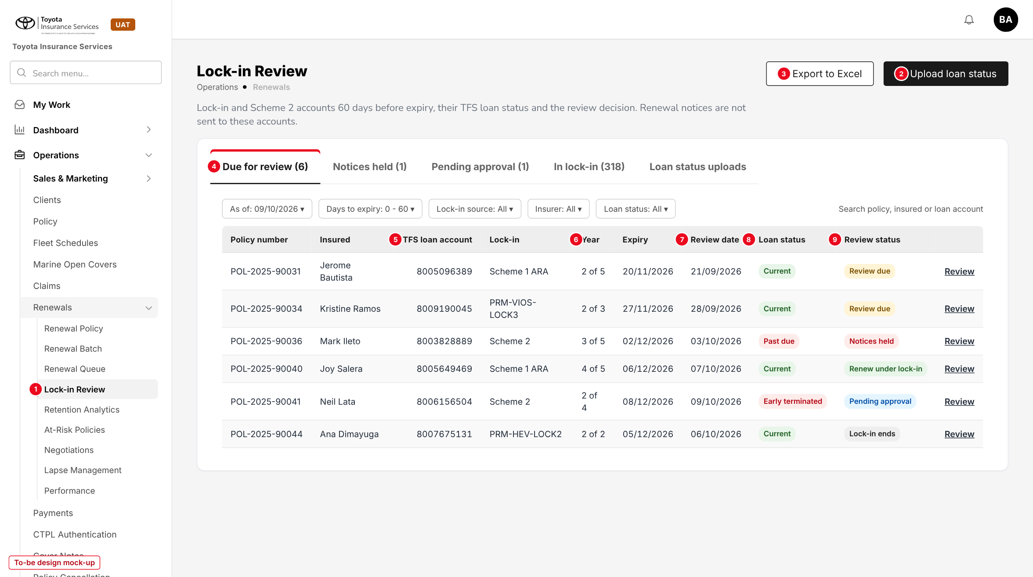
Figure 4: Lock-in Review, tab Due for review (to-be design mock-up, sample data)
No. | Field (label on screen) | Type | Mand. | Source / list | Default | Rule and message
1 | Lock-in Review (side bar) | Menu item | - | Menu grant "Renewals > Lock-in Review" | - | Shown with read:lock-in
2 | Upload loan status | Button | - | - | - | write:loan-status; opens the upload (10.3)
3 | Export to Excel | Button | - | - | - | The 60-day report with the current filters (FR-LCK-032)
4 | Due for review / Notices held / Pending approval / In lock-in / Loan status uploads | Tabs | - | Review status, notice treatment | Due for review | Each tab shows its count
- | As of, Days to expiry, Lock-in source, Insurer, Loan status; search | Filters | - | - | Today; 0 - 60; All | MSG-LCK-030
5 | TFS loan account | Column | - | Policy | - | 10 digits
6 | Year | Column | - | Lock-in record | - | "n of N" for the current term
7 | Review date | Column | - | Expiry - 60 days | - | Working day before when on a holiday
8 | Loan status | Tag | - | TFS file or manual | - | Red when blocking
9 | Review status | Tag | - | Review item | - | Review due, Lock-in ends, On hold, Pending approval, Returned, Renew under lock-in, Released, Not for renewal
- | Review | Link | - | - | - | Opens the dialog of 10.2

Button | Who sees it | Enabled when | What happens | Result
Review (row) | read:lock-in | Always | Opens the review dialog; decision part only with write:lock-in | -
Export to Excel | read:lock-in | List not empty | Downloads the 60-day report with the filters | -
Upload loan status | write:loan-status | Always | Opens the upload tab | -

10.2 Lock-in review dialog (new)
Type | New dialog, built from the base dialog pattern (Add programme)
Purpose | See the account and record the review decision.
Who can open it | read:lock-in (view); write:lock-in (decide); approve:lock-in (approve from My Work)
Navigation | - Lock-in Review > Review  - My Work task Lock-in review due  - My Work > Approvals item
FRs | FR-LCK-040, 041

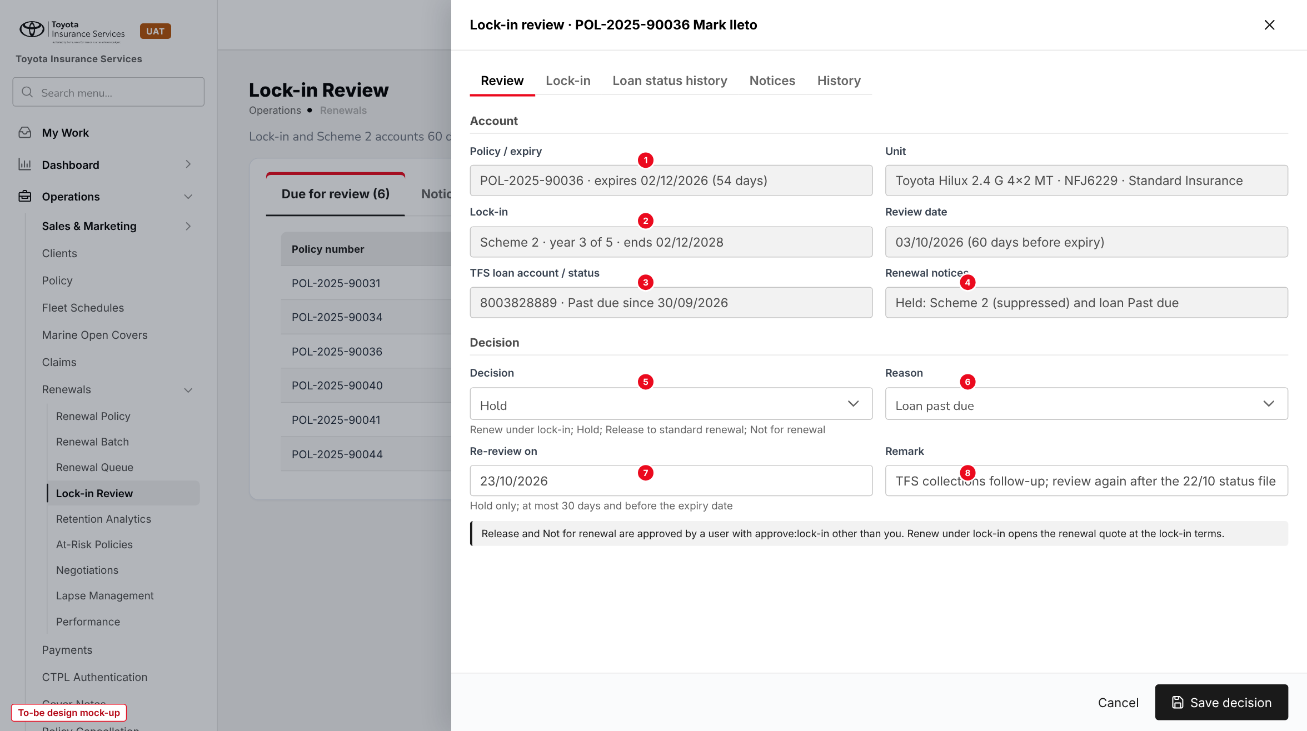
Figure 5: Lock-in review dialog with a Hold decision (to-be design mock-up)
No. | Field (label on screen) | Type | Mand. | Source / list | Default | Rule and message
1 | Policy / expiry | Display | - | Policy | - | With days left
- | Unit; Review date | Display | - | Policy risk details; lock-in record | - | -
2 | Lock-in | Display | - | Lock-in record | - | Source, year n of N, end date
3 | TFS loan account / status | Display | - | Loan status | - | With status date
4 | Renewal notices | Display | - | Notice treatment | - | -
5 | Decision | List | Y | Renew under lock-in; Hold; Release to standard renewal; Not for renewal | - | MSG-LCK-031
6 | Reason | List | Y | Reasons of the decision (7.3) | - | MSG-LCK-033
7 | Re-review on | Date | Hold | - | Today + 14 | MSG-LCK-032
8 | Remark | Text 500 | Y | - | - | MSG-LCK-034

Button | Who sees it | Enabled when | What happens | Result
Save decision | write:lock-in | Item Review due, On hold or Returned | Saves; Release and Not for renewal go to approval | Renew under lock-in / On hold / Pending approval
Approve (from My Work > Approvals) | approve:lock-in, not the maker | Pending approval | Applies the decision (FR-LCK-041) | Released / Not for renewal
Return | approve:lock-in, not the maker | Pending approval | Remark required | Returned

10.3 Upload loan status (new)
Type | New tab, base upload pattern (Dealer Sales Upload)
Purpose | Load the TFS account status file and see past uploads.
Who can open it | write:loan-status (upload); read:lock-in (view)
Navigation | - Lock-in Review > Loan status uploads  - Lock-in Review > Upload loan status
FRs | FR-LCK-020, 022, 023

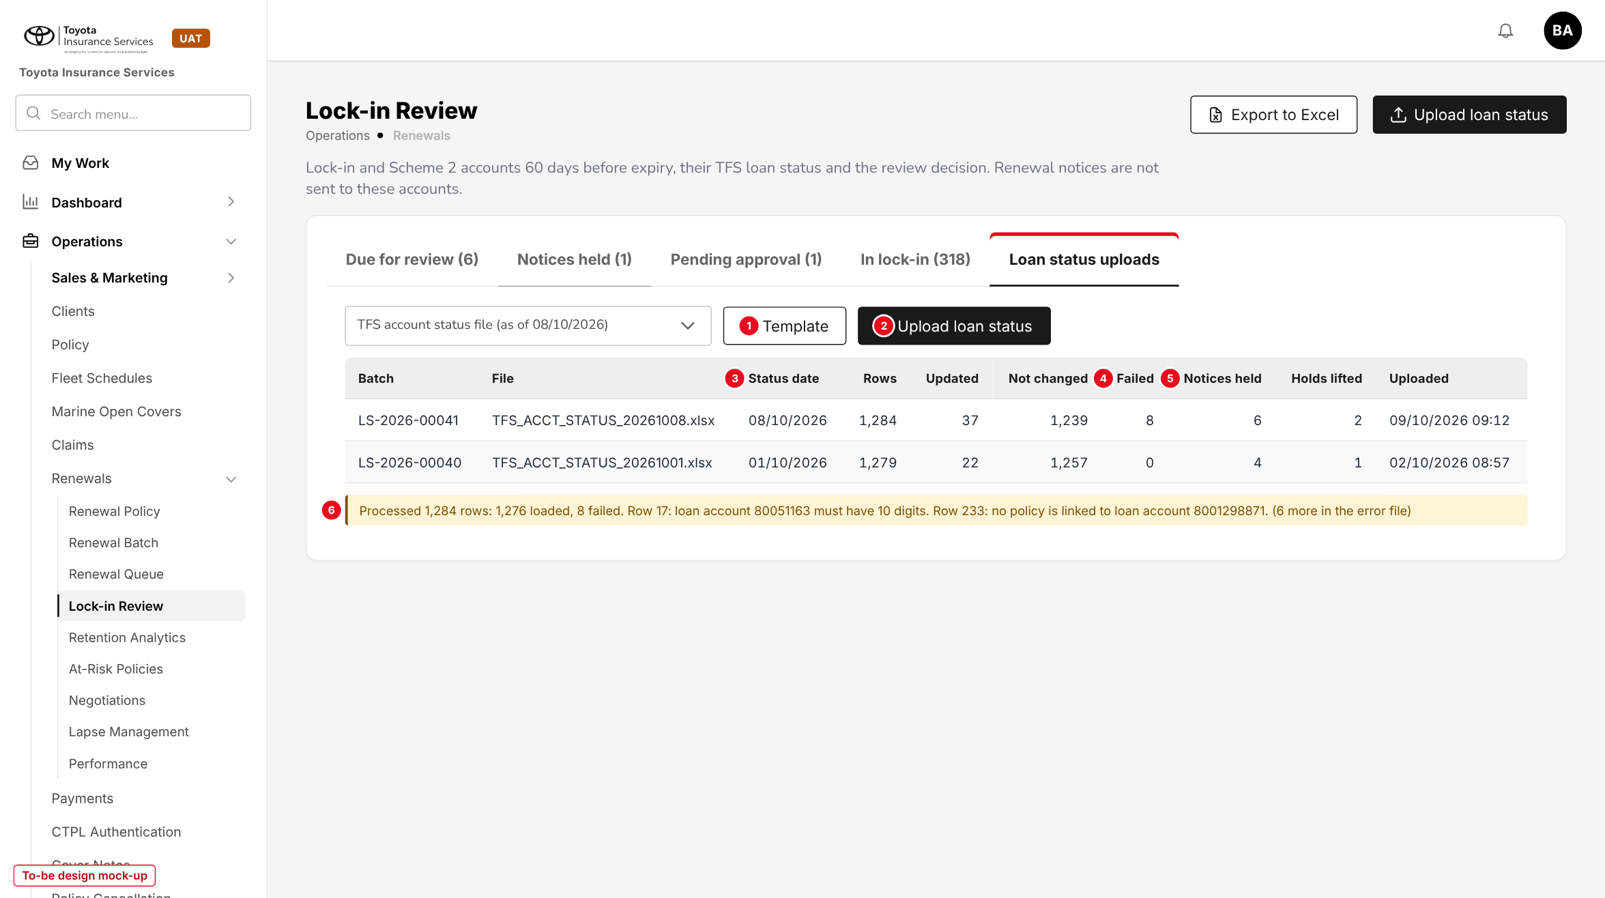
Figure 6: Loan status uploads with a result line (to-be design mock-up)
No. | Field (label on screen) | Type | Mand. | Source / list | Default | Rule and message
1 | Template | Button | - | - | - | Three-sheet Excel template (chapter 13)
2 | Upload loan status | Button | - | - | - | .xlsx only. MSG-LCK-016, MSG-LCK-017, MSG-LCK-018
3 | Status date | Column | - | Latest STATUS_DATE of the file | - | -
4 | Failed | Column | - | Rows not loaded | - | MSG-LCK-019, MSG-LCK-020, MSG-LCK-021, MSG-LCK-022
5 | Notices held / Holds lifted | Columns | - | Policies whose treatment changed | - | MSG-LCK-027, MSG-LCK-028
6 | Result line | Text | - | - | - | MSG-LCK-023

10.4 Policy detail - Lock-in & loan panel (changed)
Type | Existing screen, new panel and two dialogs
Purpose | Show the lock-in, its review dates and the loan status on the policy; change them.
Who can open it | read:lock-in (view); write:lock-in (Change lock-in); write:loan-status (Set loan status)
Navigation | Operations > Policy > policy
FRs | FR-LCK-001 to 004, 021

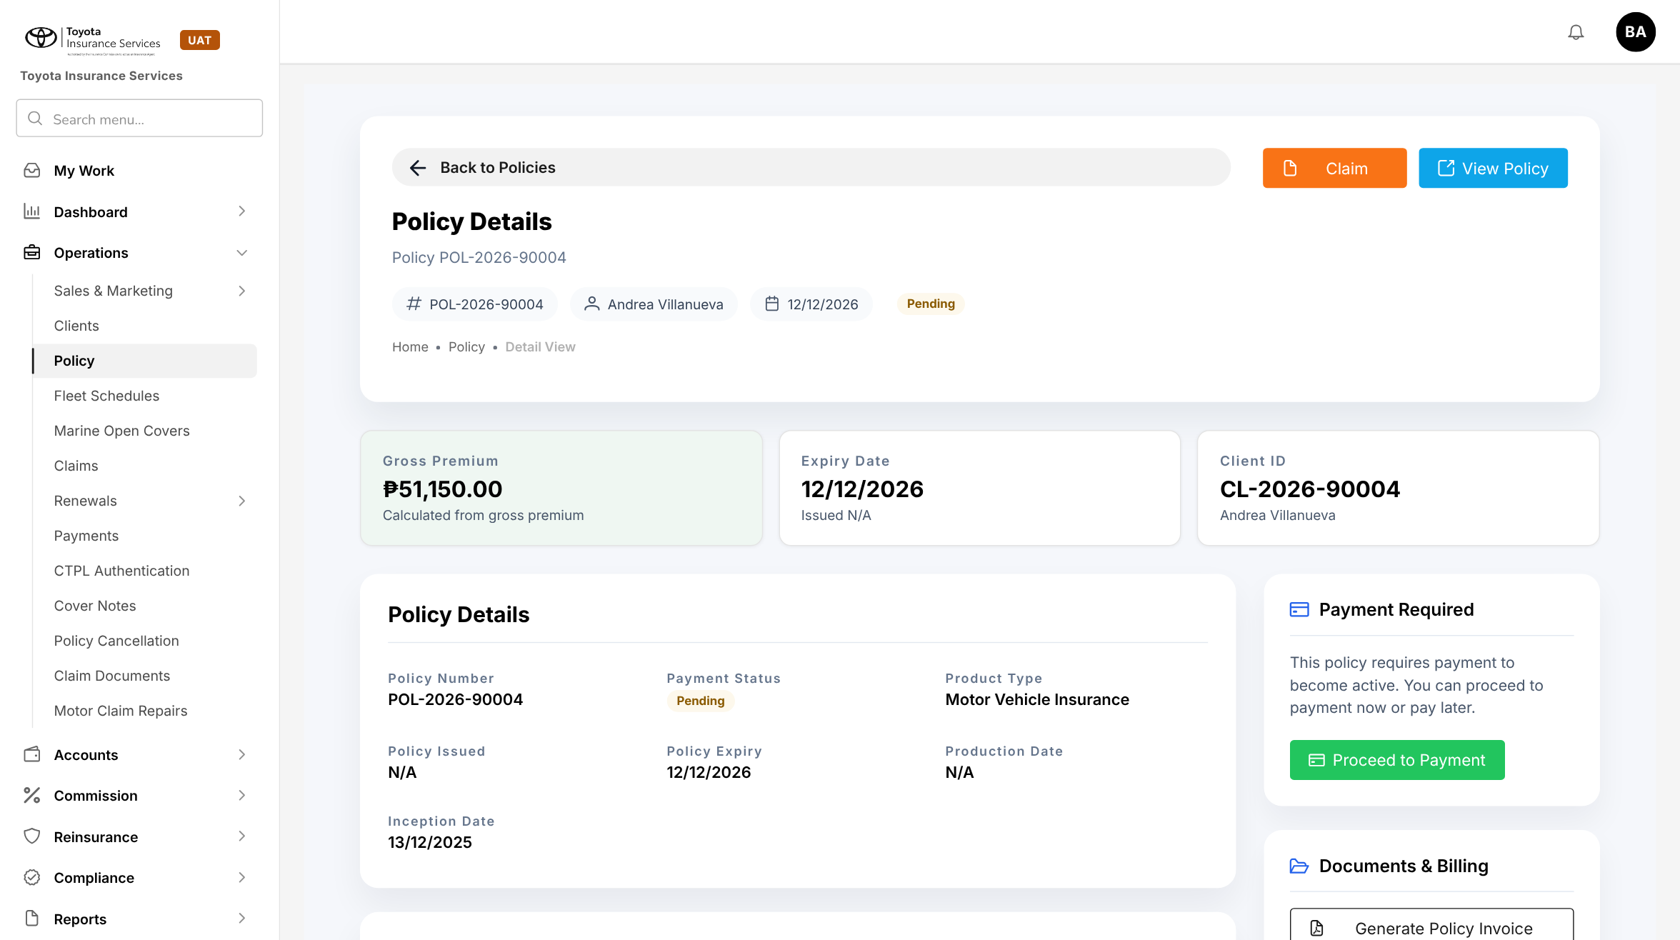
Figure 7: BrokerVerse today: Policy detail of POL-2026-90004
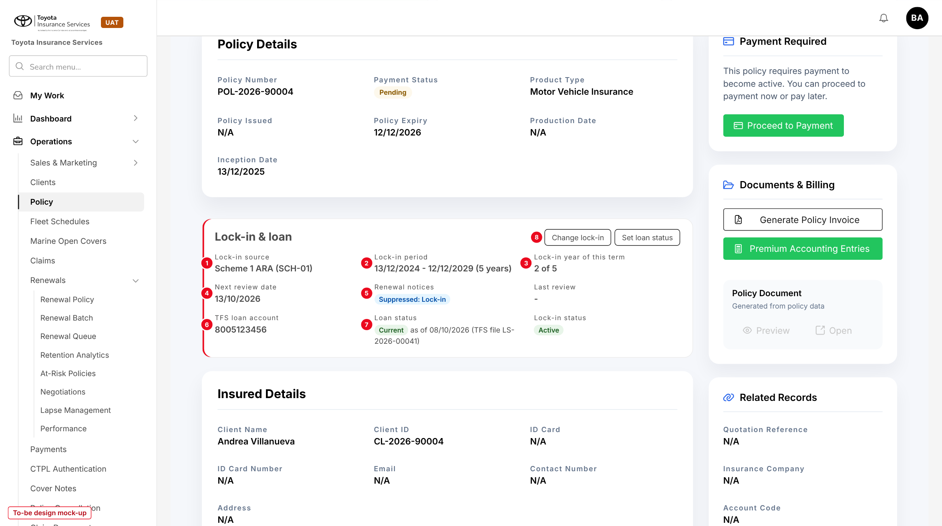
Figure 8: Policy detail with the Lock-in & loan panel (to-be design mock-up)
No. | Field (label on screen) | Type | Mand. | Source / list | Default | Rule and message
1 | Lock-in source | Display | - | Lock-in record | - | With the scheme number or promotion code
2 | Lock-in period | Display | - | Start, end, years | - | MSG-LCK-002
3 | Lock-in year of this term | Display | - | Computed | - | "n of N"
4 | Next review date | Display | - | Expiry - 60 days | - | -
5 | Renewal notices | Tag | - | Notice treatment | - | -
6 | TFS loan account | Display | - | Policy | - | MSG-LCK-001
7 | Loan status | Tag | - | TFS file or manual | - | MSG-LCK-011
8 | Change lock-in / Set loan status | Buttons | - | - | - | MSG-LCK-003, MSG-LCK-004, MSG-LCK-005, MSG-LCK-006, MSG-LCK-007; MSG-LCK-024, MSG-LCK-025

Button | Who sees it | Enabled when | What happens | Result
Change lock-in | write:lock-in | No change pending | Add, correct or end the lock-in; sent for approval | Pending approval
Set loan status | write:loan-status | Policy has a TFS loan account | Sets the status of the loan account with date and remark | Notice treatment recomputed
History | read:lock-in | Always | Lists lock-in, loan status and treatment changes | -

10.5 Renewal Queue (changed)
Type | Existing screen, new status tags and disabled actions
Purpose | Show which renewals get no notices and why.
Who can open it | read:renewals; write:renewals for the actions
Navigation | Operations > Renewals > Renewal Queue
FRs | FR-LCK-012, 013

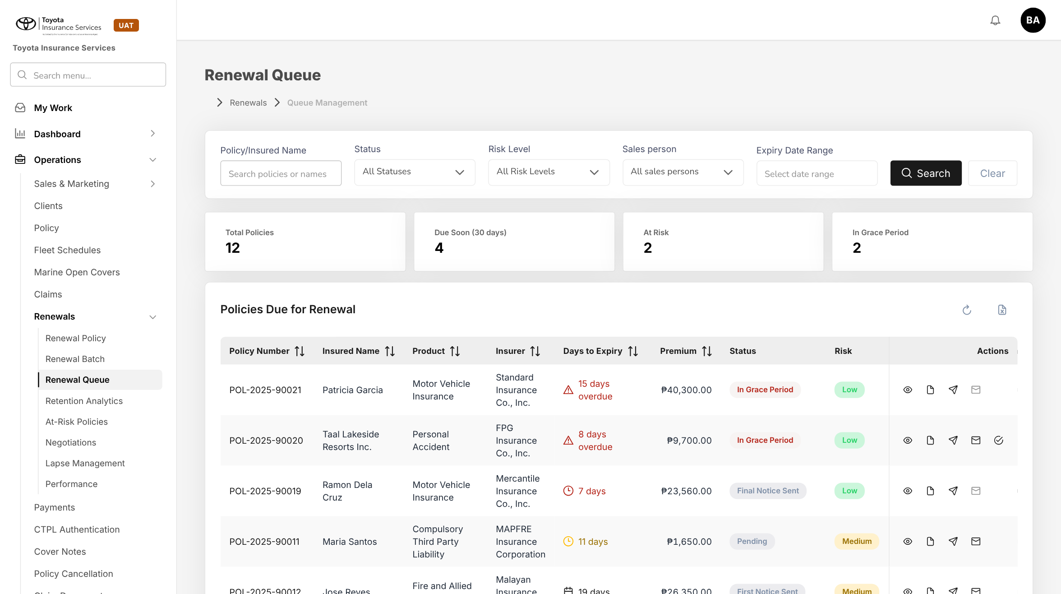
Figure 9: BrokerVerse today: Renewal Queue with the base status tags
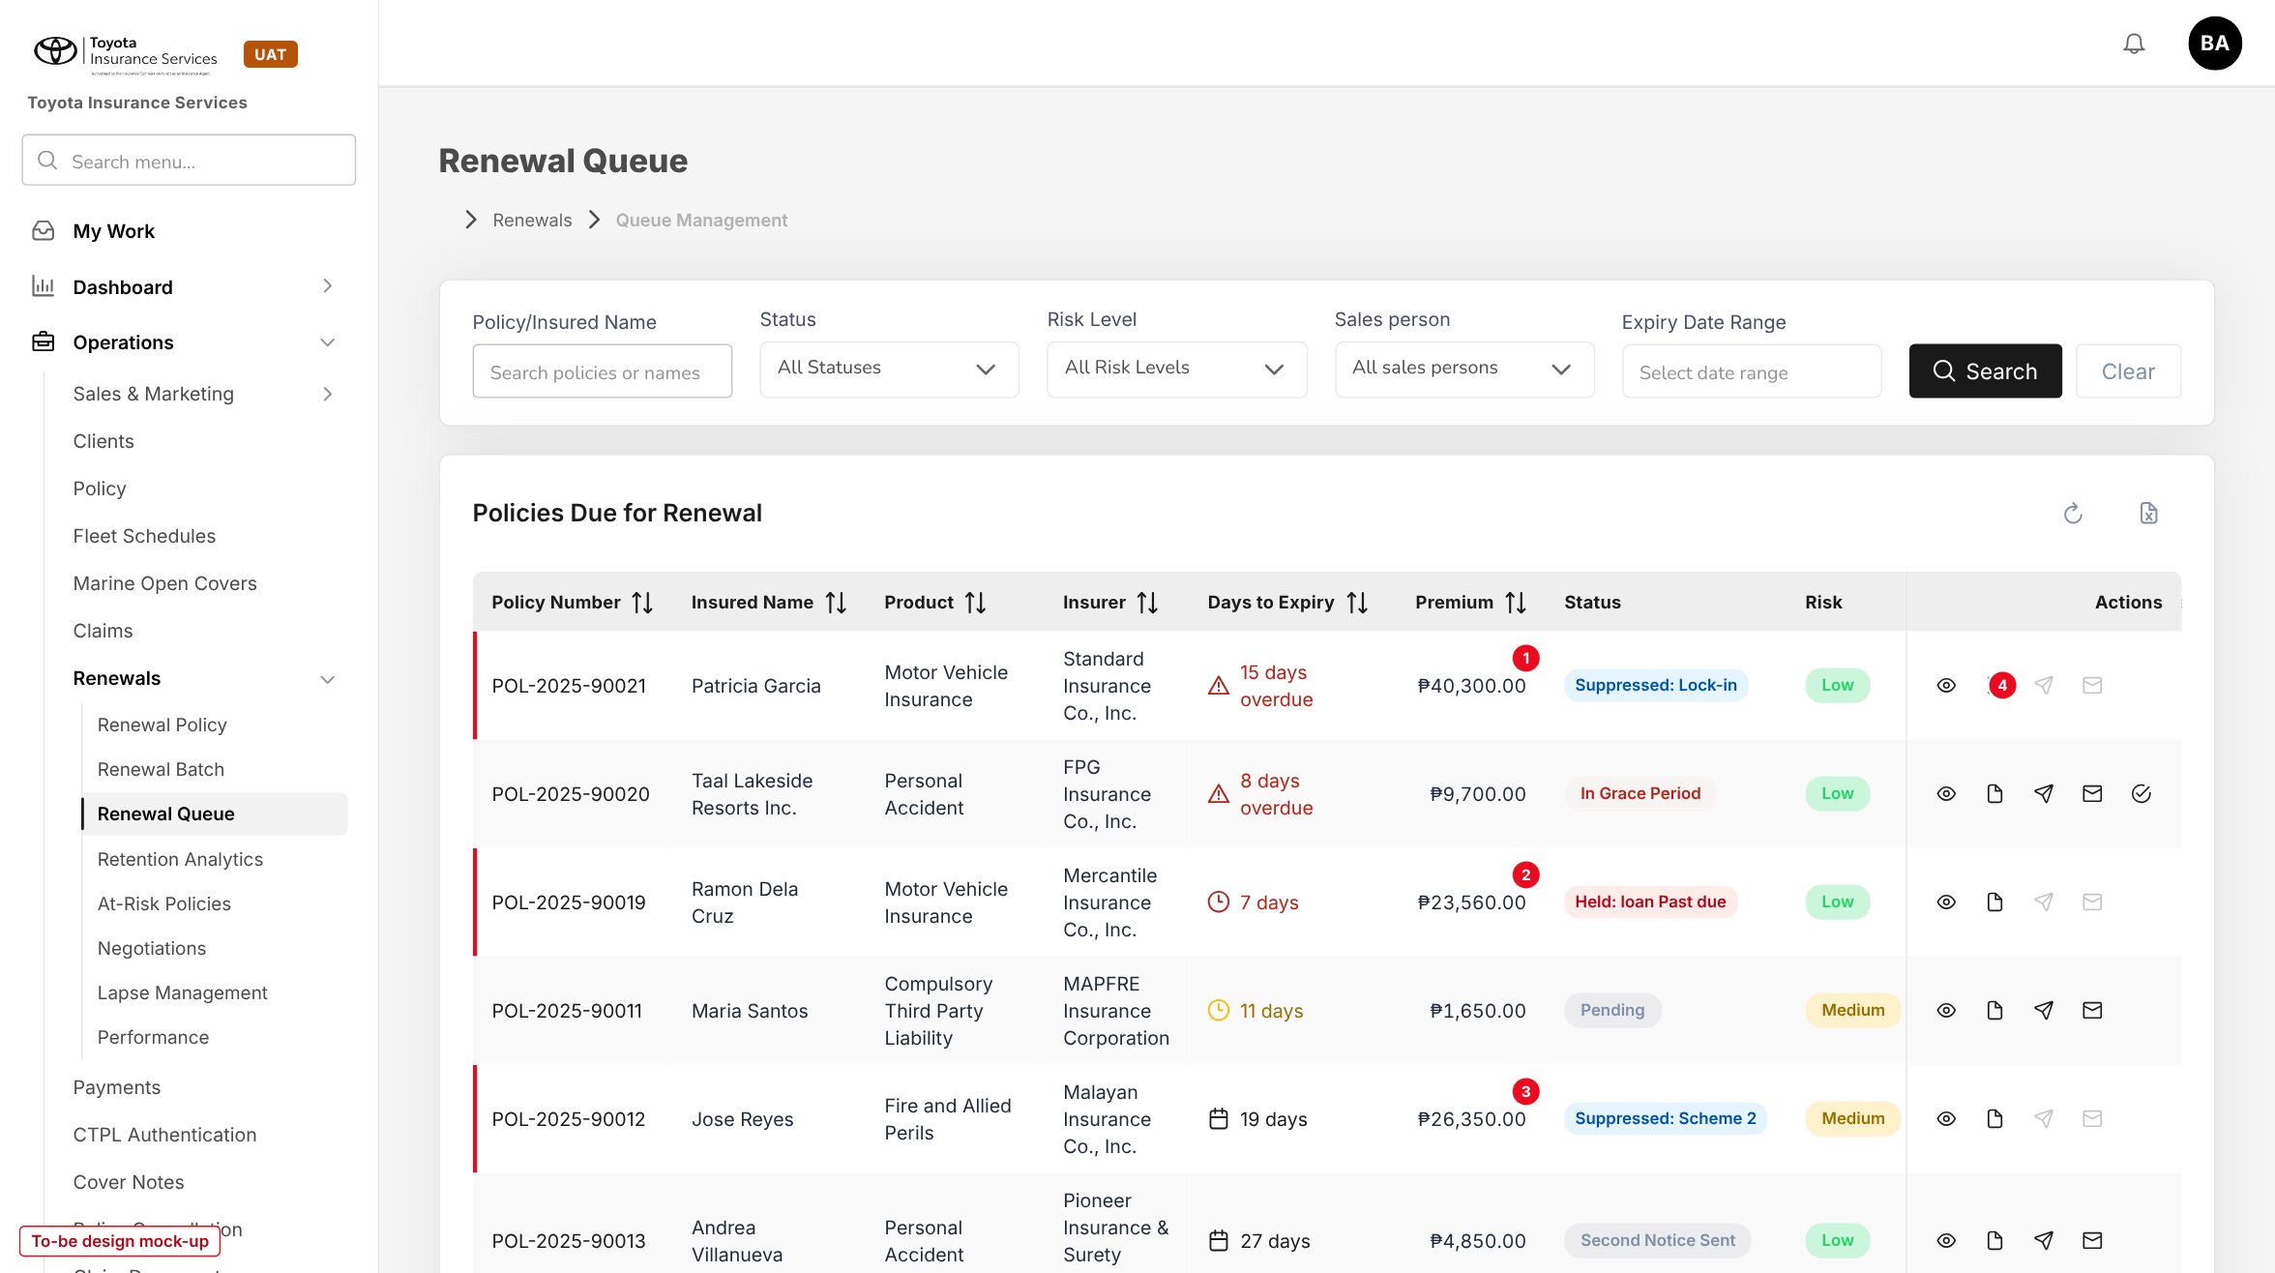
Figure 10: Renewal Queue with the notice treatment tags (to-be design mock-up)
No. | Field (label on screen) | Type | Mand. | Source / list | Default | Rule and message
1 | Status: Suppressed: Lock-in | Tag | - | Notice treatment | - | Blue; replaces Pending or the notice stage
2 | Status: Held: loan status | Tag | - | Notice treatment | - | Red
3 | Status: Suppressed: Scheme 2 | Tag | - | Notice treatment | - | Blue
4 | Send notice / Send reminder (existing) | Icons | - | - | - | Disabled for suppressed and held rows. MSG-LCK-012, MSG-LCK-013, MSG-LCK-014
- | Status filter (existing) | List | - | Base statuses + the three treatments | All Statuses | -

The Renewal Batch shows the same treatments in its notice status column (Suppressed, Held) with the selection box disabled, and Cancelled for notices stopped by a hold; Send notices returns the summary MSG-LCK-015.

10.6 Lock-in / Scheme 2 expiry report (changed)
Type | Existing report screen, new report criteria
Purpose | Produce the 60-day review report on demand.
Who can open it | read:renewal-reports and read:lock-in
Navigation | Reports > Operational Reports > Renewal > Report Criteria Lock-in / Scheme 2 expiry (60 days)
FRs | FR-LCK-032

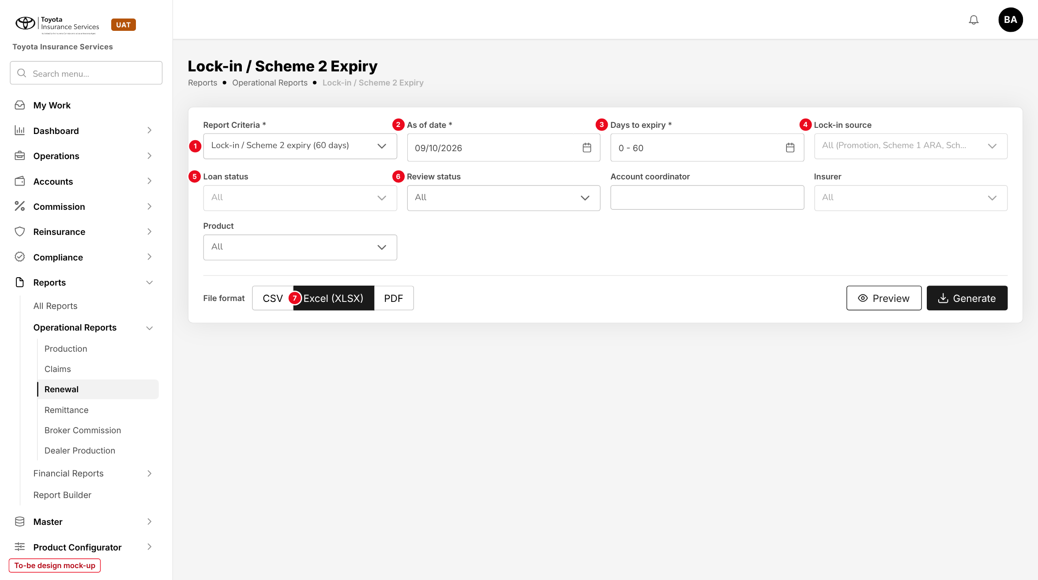
Figure 11: Report criteria for the 60-day report (to-be design mock-up)
No. | Field (label on screen) | Type | Mand. | Source / list | Default | Rule and message
1 | Report Criteria | List | Y | Base renewal criteria + Lock-in / Scheme 2 expiry (60 days) | Overall | The fields below change with the criteria
2 | As of date | Date | Y | - | Today | -
3 | Days to expiry | Range | Y | - | 0 - 60 | MSG-LCK-030
4 | Lock-in source | Multi-select | N | 7.3 | All | -
5 | Loan status | Multi-select | N | 7.3 | All | -
6 | Review status | Multi-select | N | 7.3 | All | -
- | Account coordinator, Insurer, Product | Lists | N | Users, Insurance Company, Product | All | -
7 | File format (existing) | Toggle | Y | CSV, Excel (XLSX), PDF | Excel | MSG-LCK-029

10.7 Report columns
Table 24: Report columns
Column | Source
As of date; Account coordinator | Parameters; policy owner
Policy number; Insurer; Product; Inception; Expiry; Days to expiry | Policy
Assured name; E-mail address; Contact number | Client
Unit model; Plate number; Chassis number; Engine number; Color | Policy risk details (Motor)
FMV (sum insured); Current total premium | Policy
TFS loan account; Loan status; Loan status date; Days past due | Loan status
Lock-in source; Reference; Lock-in year (n of N); Lock-in end date; Review date | Lock-in record
Notice treatment; Notices sent / skipped / cancelled this term | Renewal
Review status; Decision; Decided by; Decided on; Remark | Review item

10.8 Schedules (changed)
Type | Existing screen, new job and changed descriptions
Purpose | Run and follow the lock-in job and the changed renewal jobs.
Who can open it | System Administrator
Navigation | Master > System > Schedules
FRs | FR-LCK-003, 010, 011, 030

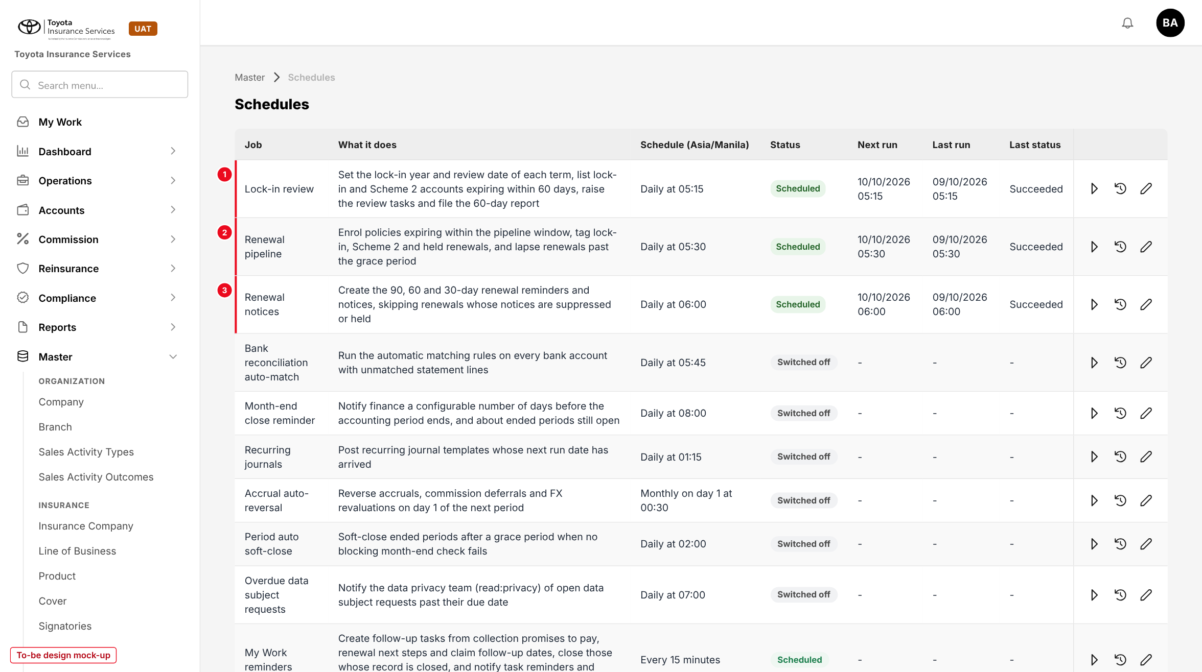
Figure 12: Schedules with the job Lock-in review (1) and the changed renewal jobs (2, 3) (to-be design mock-up)

11 End-to-end walkthroughs
The walkthroughs follow sample accounts through BrokerVerse, persona by persona, from 13/09/2026 to 23/10/2026. They are the script of the SCHM-03 SIT and UAT sessions.

11.1 WT-A Scheme 1 ARA account renewed under lock-in
Table 25: WT-A
Step | Who | Does | Sees / result
1 | System | POL-2026-90004, Andrea Villanueva, Toyota Vios 1.3 XLE CVT, term 13/12/2025 - 12/12/2026, Scheme 1 ARA from 13/12/2024 for 5 years, loan 8005123456 | Lock-in & loan panel: year 2 of 5, next review 13/10/2026, Suppressed: Lock-in
2 | System (Renewal pipeline and Renewal notices, 13/09/2026) | Policy enters the pipeline at 90 days | Renewal in the queue with tag Suppressed: Lock-in; no First Notice, history "First Notice skipped: Suppressed: Lock-in"
3 | Operations | Renewal Batch for expiries in December 2026 | POL-2026-90004 listed with notice status Suppressed, not selectable
4 | System (Lock-in review, 13/10/2026) | Review date reached | Review item Review due; My Work task to the owner; row in the 60-day report
5 | Sales Admin | Lock-in Review > Review: loan Current as of 08/10/2026, no claims; Renew under lock-in, remark "ARA year 3 confirmed" | "Decision saved: Renew under lock-in"; task closed
6 | Sales Admin / Processing | Renewal Queue > renewal quote at the ARA year-3 terms; approved and completed (base maker-checker) | New term 13/12/2026 - 12/12/2027 with lock-in year 3 of 5, review date 13/10/2027

11.2 WT-B Past-due loan: notices cancelled and resumed
Table 26: WT-B
Step | Who | Does | Sees / result
1 | System | POL-2025-90050, Carmela Dizon, no lock-in, loan 8001122334, expiry 20/11/2026 | First Notice sent 22/08/2026, Second Notice 21/09/2026
2 | Operations | Uploads TFS_ACCT_STATUS_20261008.xlsx on 09/10/2026; row 8001122334 PAST DUE dated 05/10/2026 | "Processed 1,284 rows: 1,276 loaded, 8 failed"; batch LS-2026-00041 with Notices held 6
3 | System | Notice gate | Queued reminder e-mail cancelled; renewal tagged Held: loan status; My Work item to the owner
4 | System (Renewal notices, 21/10/2026) | Final Notice mark | No Final Notice; staff reminder "Renewal due in 30 days - notices held (Past due)"
5 | Operations | Uploads the file of 22/10/2026: 8001122334 CURRENT | "Renewal notices for POL-2025-90050 resumed: TFS loan 8001122334 is Current"
6 | System (Renewal notices, 23/10/2026) | Next notice due | Final Notice sent; the renewal continues as normal

11.3 WT-C Exceptions
Table 27: WT-C
Case | Who | Does | Sees / result
C1 Scheme 2, loan past due | Sales Admin | POL-2025-90036, Mark Ileto, Scheme 2 year 3 of 5, loan Past due since 30/09/2026: tries Renew under lock-in | "The TFS loan is Past due; choose Hold, Release or Not for renewal"; records Hold to 23/10/2026
C2 Early terminated loan | Sales Admin, Accounting Manager | POL-2025-90041, Neil Lata: Not for renewal, reason Loan early terminated; approved by the Accounting Manager | Renewal lapsed "Not for renewal: Loan early terminated"; lock-in Not renewed
C3 Self-approval | Sales Admin with approve:lock-in | Tries to approve own Not for renewal | "You recorded this decision; another user must approve it"
C4 Last lock-in year | System | POL-2025-90044, PRM-HEV-LOCK2 year 2 of 2 | Listed as Lock-in ends; standard notices at 90 / 60 / 30 days
C5 Fraud set by hand | Compliance Officer | Sets Fraud on loan 8005649469 with remark | Both policies of the loan Held; next TFS file CURRENT does not overwrite the manual status
C6 Manual send | Operations | Send notice on a Suppressed: Lock-in row through the API | "No notice is sent for POL-2025-90034: the renewal is inside its lock-in (until 27/11/2027)"

12 Messages catalogue
Every message a user can see for this requirement, grouped by the screen that shows it. 41 messages: 7 confirmation, 11 error, 5 information, 16 validation, 2 warning. A validation or error is shown under the field it belongs to; a confirmation is a short toast. Text in angle brackets is filled in by the system.

12.1 Policy detail - Lock-in & loan
ID | Field | Message | Type | What the user does
MSG-LCK-001 | TFS loan account | The TFS loan account must have 10 digits | Validation | Correct the loan account
MSG-LCK-002 | Lock-in years | Lock-in years are missing for <policy number>; set them with Change lock-in | Warning | Request a lock-in change
MSG-LCK-003 | Lock-in start date | The lock-in cannot start after the current term starts (<inception date>) | Validation | Enter an earlier start date
MSG-LCK-004 | Lock-in years | Lock-in years must be between 1 and 10 | Validation | Correct the years
MSG-LCK-005 | Lock-in years | With these values the lock-in ends before the current term; use End lock-in instead | Validation | Choose End lock-in
MSG-LCK-006 | Remark | Enter the reason for the change | Validation | Enter a remark
MSG-LCK-007 | - | A lock-in change for <policy number> is already waiting for approval | Error | Wait for the approval or ask the approver to return it
MSG-LCK-008 | - | You requested this change; another user must approve it | Error | Ask another approver
MSG-LCK-009 | - | Lock-in change sent for approval | Confirmation | -
MSG-LCK-010 | - | Lock-in change approved | Confirmation | -
MSG-LCK-011 | Loan status | The TFS loan status of <loan account> was last reported on <date> | Warning | Upload the latest TFS account status file
MSG-LCK-024 | Remark | Enter the reason for the loan status (at least 10 characters) | Validation | Enter a remark
MSG-LCK-025 | Status date | The status date cannot be in the future | Validation | Correct the date
MSG-LCK-026 | - | Loan status of <loan account> set to <status>; notices are <treatment> | Confirmation | -

12.2 Renewal Queue and Renewal Batch
ID | Field | Message | Type | What the user does
MSG-LCK-012 | Send notice | No notice is sent for <policy number>: the renewal is inside its lock-in (until <lock-in end date>) | Error | None; review it on Lock-in Review
MSG-LCK-013 | Send notice | No notice is sent for <policy number>: Scheme 2 accounts do not receive renewal notices | Error | None
MSG-LCK-014 | Send notice | Notices for <policy number> are held: TFS loan <loan account> is <loan status> since <status date> | Error | Review the account on Lock-in Review
MSG-LCK-015 | - | <n> notices queued; <s> suppressed and <h> held policies were not selected | Information | -
MSG-LCK-027 | - | <n> queued renewal notices cancelled: TFS loan <loan account> is <loan status> | Information | -
MSG-LCK-028 | - | Renewal notices for <policy number> resumed: TFS loan <loan account> is Current | Information | -

12.3 Lock-in Review - Loan status upload
ID | Field | Message | Type | What the user does
MSG-LCK-016 | File | Upload an Excel (.xlsx) file | Validation | Save the file as .xlsx
MSG-LCK-017 | File | The file must have the columns LOAN_ACCOUNT_NO, LOAN_STATUS and STATUS_DATE | Validation | Use the template
MSG-LCK-018 | File | A file can hold at most <max> rows | Validation | Split the file
MSG-LCK-019 | LOAN_ACCOUNT_NO | Row <n>: loan account <value> must have 10 digits | Error | Correct the row and upload again
MSG-LCK-020 | LOAN_STATUS | Row <n>: loan status <value> is not a known TFS status | Error | Correct the row or ask for the mapping to be added
MSG-LCK-021 | STATUS_DATE | Row <n>: the status date cannot be in the future | Error | Correct the row
MSG-LCK-022 | LOAN_ACCOUNT_NO | Row <n>: no policy is linked to loan account <value> | Error | Check the loan account on the policy
MSG-LCK-023 | - | Processed <n> rows: <c> loaded, <f> failed | Information | Download the failed rows if any

12.4 Lock-in Review
ID | Field | Message | Type | What the user does
MSG-LCK-029 | - | No lock-in or Scheme 2 account expires within <from> to <to> days of <as of date> | Information | Change the parameters
MSG-LCK-030 | Days to expiry | Days to expiry can be at most 365 | Validation | Narrow the window
MSG-LCK-041 | - | You do not have permission to <action> | Error | Ask the System Administrator

12.5 Lock-in Review - Review dialog
ID | Field | Message | Type | What the user does
MSG-LCK-031 | Decision | The TFS loan is <loan status>; choose Hold, Release or Not for renewal | Validation | Choose another decision
MSG-LCK-032 | Re-review on | The re-review date must be within <n> days and before the expiry date <expiry date> | Validation | Choose an earlier date
MSG-LCK-033 | Reason | Select the reason | Validation | Select a reason
MSG-LCK-034 | Remark | Enter a remark of at least 10 characters | Validation | Enter a remark
MSG-LCK-035 | - | Decision saved: <decision> | Confirmation | -
MSG-LCK-036 | - | Decision sent for approval: <decision> | Confirmation | -
MSG-LCK-037 | - | You recorded this decision; another user must approve it | Error | Ask another approver
MSG-LCK-038 | Remark | Enter the reason for returning the decision | Validation | Enter a remark
MSG-LCK-039 | - | Decision approved: <decision> | Confirmation | -
MSG-LCK-040 | - | Decision returned to <user> | Confirmation | -

13 Upload screens

13.1 TFS account status template
Built like the other base templates (Template button): an Excel file with the sheets Data (one row per loan account; required headers in dark red), Columns (each column with its format and an example) and Instructions. Rows are loaded one by one; a failed row does not stop the others.
Table 28: Template columns
Column | Mand. | Format | Rule
LOAN_ACCOUNT_NO | Y | 10 digits | Must be the TFS loan account of at least one policy
LOAN_STATUS | Y | Text | A TFS value of Table "TFS status mapping"
STATUS_DATE | Y | DD/MM/YYYY | Not in the future; older than the date on the policy = Not changed
DAYS_PAST_DUE | N | Whole number | Shown on the report
LOAN_MATURITY_DATE | N | DD/MM/YYYY | Shown on the report
SCHEME | N | SCHEME 1 / SCHEME 2 | Checked against the lock-in source; a mismatch is a warning on the row
POLICY_NUMBER | N | Text | When filled, the row updates that policy only
BORROWER_NAME | N | Text | For reading only
REMARKS | N | Text 250 | Kept with the status

Limits: .xlsx only, first sheet Data, at most 5,000 rows (lockin.upload_max_rows). The result line reads "Processed n rows: c loaded, f failed" with "Row n: message" for each failed row and a download of the failed rows.

14 Sign-off and change control

14.1 What is signed
TISPH signs this FRS for TIS-BRD-SCHM-03 as built on BrokerVerse: the process flows (chapter 2), the functional requirements (chapter 4), the workflow (chapter 5), the interfaces (chapter 6), and the screens, report, messages and upload (chapters 9 to 13). Values marked default are configuration and are not frozen.

14.2 Change after sign-off
A change to anything signed is raised through the change control route of BRD section 8. The project team assesses its effect on BrokerVerse and on SCHM-01 and SCHM-02 in the same CR-05, and on PROD-15, and issues a new version of this FRS for delta sign-off. When the screens are built, the to-be mock-ups are replaced with screenshots of the TISPH UAT environment.

14.3 Signatures
Table 29: Sign-off
Role | Name | Unit | Signature | Date
Business owner |  | TIS Sales
Business reviewer |  | TISPH Operations
Business reviewer |  | TISPH Compliance
Project Manager |  | TISPH DTID
Delivery lead |  | iorta TechNXT

Appendix A Lock-in year and review date examples
Review date = expiry date - 60 days, moved to the working day before when it falls on a weekend or holiday. "Next term inside" decides whether the notices are suppressed.
Table 30: Lock-in examples
Account | Lock-in | Current term | Year | Lock-in end | Next term inside | Review date | Notices
POL-2026-90004 Scheme 1 ARA | 13/12/2024, 5 years | 13/12/2025 - 12/12/2026 | 2 of 5 | 12/12/2029 | Yes | 13/10/2026 | Suppressed: Lock-in
POL-2025-90034 PRM-VIOS-LOCK3 | 28/11/2024, 3 years | 28/11/2025 - 27/11/2026 | 2 of 3 | 27/11/2027 | Yes | 28/09/2026 | Suppressed: Lock-in
POL-2025-90044 PRM-HEV-LOCK2 | 06/12/2024, 2 years | 06/12/2025 - 05/12/2026 | 2 of 2 | 05/12/2026 | No | 06/10/2026 | Send (Lock-in ends)
POL-2025-90036 Scheme 2 | 03/12/2023, 5 years | 03/12/2025 - 02/12/2026 | 3 of 5 | 02/12/2028 | Yes | 03/10/2026 | Held: loan status (Past due)
Term expiring 22/02/2027 | - | 23/02/2026 - 22/02/2027 | - | - | - | 23/12/2026 (24/12 holiday) | -

