

Prepared by – iorta TechNXT
Version - 1.0
Date - 04 October 2026
Dependency Map and Critical Path

BrokerVerse OOTB implementation, by broker size
TABLE OF CONTENTS

1. Document Control 3
2. Acronyms 3
3. Introduction 4
3.1 Purpose 4
3.2 How the figures are produced 4
3.3 Terms 5
3.4 Version history 5
3.5 Related documents 5
4. The dependency map 6
4.1 Phases and gates 6
4.2 Three kinds of gate 7
5. Client inputs 8
5.1 What the broker provides 8
5.2 The kits the inputs go into 9
6. Partner certifications 10
6.1 Partners and fallbacks 10
6.2 When each partner must be live 11
7. Regulatory registrations 13
7.1 What the broker registers, and what it unlocks 13
8. Environments, pipeline and keys 15
8.1 Set-up order 15
8.2 Encryption key custody 17
9. Critical path by size 19
9.1 How to read the charts 19
9.2 Small broker (8 weeks) 19
9.3 Medium broker (12 weeks) 20
9.4 Large broker (20 weeks) 20
9.5 Enterprise broker (26 weeks) 21
10. Lead times 22
11. What slips if a dependency slips 23
11.1 Dependencies that hold the go-live 23
11.2 What else moves with it 24
11.3 Feature-only dependencies 24
12. Managing the dependencies 26
13. Document Sign-Off 27

1. Document Control

Date | Version | Author & Business Unit Info | Reviewed By & Business Unit Info | Approved By & Business Unit Info | Change History
04 October 2026 | 1.0.1 | iorta TechNXT |  |  | Version 1.0.1: Client brand packs: basis is the client's contract with iorta TechNXT (management decision of 04 October 2026). Version 1.0: Initial issue: dependencies, lead times, critical path by size and the effect of each late dependency

2. Acronyms

Acronym / Symbol | Definition / Meaning
OOTB | Out of the box
AMLC | Anti-Money Laundering Council
ATP | Authority to Print
BIR | Bureau of Internal Revenue
CAS | Computerized Accounting System
COC | Certificate of cover
CTPL | Compulsory Third Party Liability
CTR | Covered transaction report
DPO | Data protection officer
EIS | Electronic Invoicing System
GNG | Go/no-go
IC | Insurance Commission
LTO | Land Transportation Office
NPC | National Privacy Commission
PEP | Politically exposed person
PM | Project manager
RAID | Risks, assumptions, issues and dependencies
SIT | System integration test
STR | Suspicious transaction report
UAT | User acceptance test

3. Introduction

3.1 Purpose
This document shows what a BrokerVerse OOTB implementation depends on, in what order, and what moves when a dependency is late. It is written for the iorta TechNXT head of delivery and project managers, and for the broker's sponsor and project manager. It answers four questions:
- Which client inputs, partner certifications, regulatory registrations and environment steps does each phase need?
- Which chain of tasks decides the go-live date for a small, medium, large and enterprise broker?
- How long does each outside party usually take (lead time), and by when must it start?
- If a dependency slips, does the go-live move, or only one feature, and by how much?

3.2 How the figures are produced
Every figure in this document comes from one plan model kept with the documentation tools (docs/package/tools/delivery/plan_model.py). The model holds each task with its duration by size, its owner party (iorta TechNXT, broker or partner), its predecessors and what it holds back. A forward and backward pass over the links gives the dates, the float of each task and the critical path. The same model builds the companion workbook BrokerVerse_Implementation_Plan.xlsx (one task-level Gantt per size, the milestones, every link and the RACI) and the diagrams of this document, so the three never disagree.
Durations and lead times are planning assumptions of iorta TechNXT for an out-of-the-box implementation. Lead times of regulators and partners are outside the control of both parties. The steering committee re-baselines the plan at mobilisation, once the broker has said which registrations it already holds and which partners it uses.

3.3 Terms
Term | Meaning
Day, week | Working days (5 a week). Week 1 starts on the kick-off date. Go-live is the first day of the go-live week
Float to go-live | Working days a task can finish late before the go-live date moves. 0 means the task is on the critical path
Holds the go-live | The go/no-go cannot pass while the dependency is open
Feature only | The go-live does not wait; the feature is switched on later and a fallback, described in this document, is used meanwhile
Lead time | Elapsed time an outside party needs from a complete request to the result

3.4 Version history
Version | Date | Change
1.0 | 04 October 2026 | Initial issue: dependency diagrams, client inputs, partner certifications, regulatory registrations, environments and keys, critical path by size, lead times, effect of a late dependency
1.0.1 | 04 October 2026 | Client brand packs: basis is the client's contract with iorta TechNXT (management decision of 04 October 2026)

3.5 Related documents
Document | Use
BrokerVerse Implementation Approach and Plan | Method, phases, timelines by size, roles, governance
BrokerVerse_Implementation_Plan.xlsx | Task-level plan by size: durations, owners, predecessors, dates, float, critical path; RACI
BrokerVerse_RAID_Log_Template.xlsx | Pre-filled risks, assumptions, issues and dependencies; the dependencies of this document are its D items
BrokerVerse Environment Strategy and Production Rollout | Environment sets, pipeline, cutover runbook T-30 to T+30
BrokerVerse Data Migration and Cutover Plan | Mock loads, reconciliation, go/no-go criteria
Implementation Statement of Work; Customer Responsibilities and RACI Annex | The contractual form of the client dependencies and their effect when late

4. The dependency map

4.1 Phases and gates
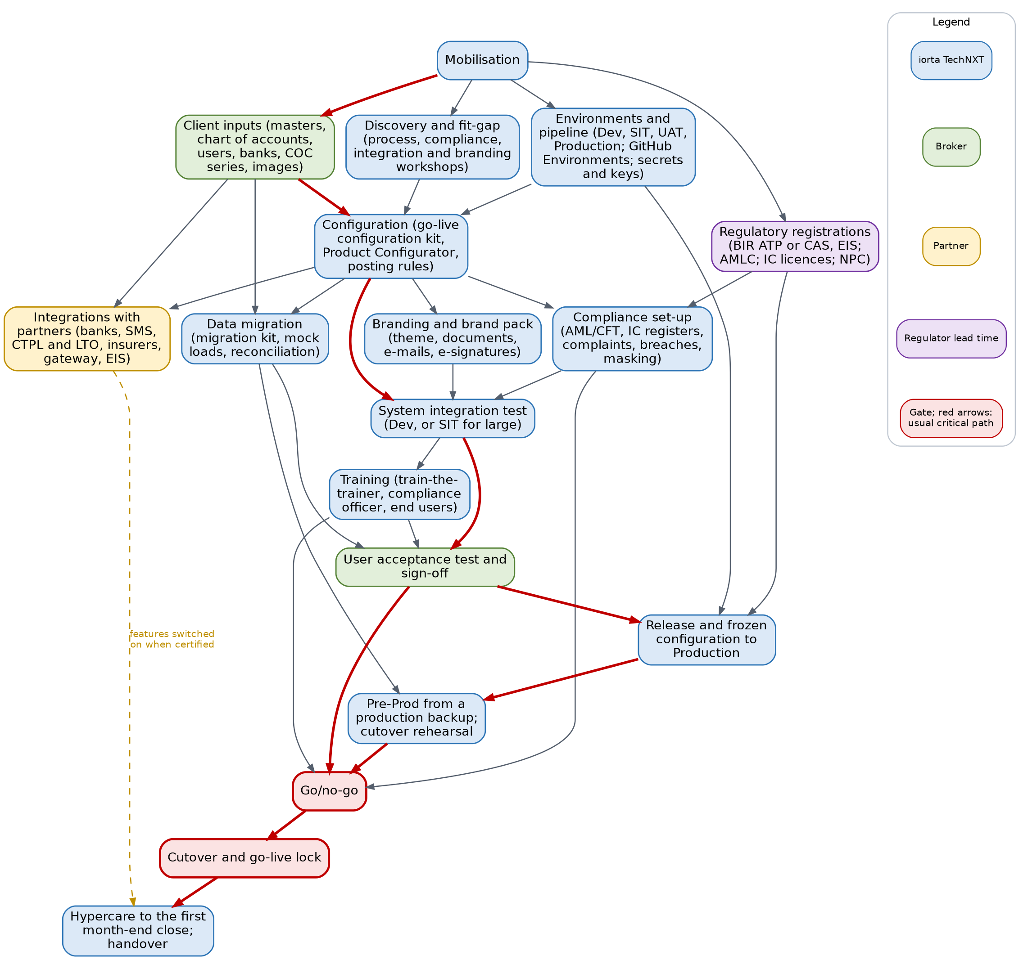
Dependency map of the phases. Red arrows: the usual critical path; dashed: features switched on when the partner has certified them
Reading the map:
- Mobilisation releases four streams in week 1: the client inputs (the configuration kit and the data request), discovery, the environments and the regulatory registrations. Registrations with a regulator start on day one because their lead times are the longest and are not in the project's hands.
- Configuration needs all three of discovery decisions, client inputs and a working Dev (or SIT) environment with the pipeline. It is the hinge of the plan: compliance set-up, branding, integrations and the mock loads all start from a loaded configuration kit.
- System integration test needs configuration, compliance set-up and branding finished. UAT needs SIT exit, trained key users and a reconciled mock load.
- Release to Production needs UAT under way, the production environment and the BIR invoice registration (ATP or CAS), because the invoice serial range is part of the frozen configuration.
- Go/no-go brings everything together: UAT sign-off, the reconciled rehearsal, trained users, compliance set-up (screening lists, AMLC reporting) and the NPC registration.
- Integrations with partners mostly do not hold the go-live: each has a fallback, and the feature is switched on when the partner has certified it (chapter Partner certifications).

4.2 Three kinds of gate
Gate | What happens when the dependency is late | Examples
Holds the go-live | The go/no-go fails; the go-live date moves by the delay less the float | Configuration kit inputs, UAT, rehearsal, ATP or CAS, AMLC registration, screening lists, NPC registration
Feature only | The go-live holds; the feature stays in test mode or switched off and the fallback is used | Bank payment files, SMS, insurer APIs, payment gateway, EIS, CTPL authentication (manual code entry), client brand pack
Hypercare exit | Hypercare is extended | First month-end close outside the hypercare window

5. Client inputs

5.1 What the broker provides
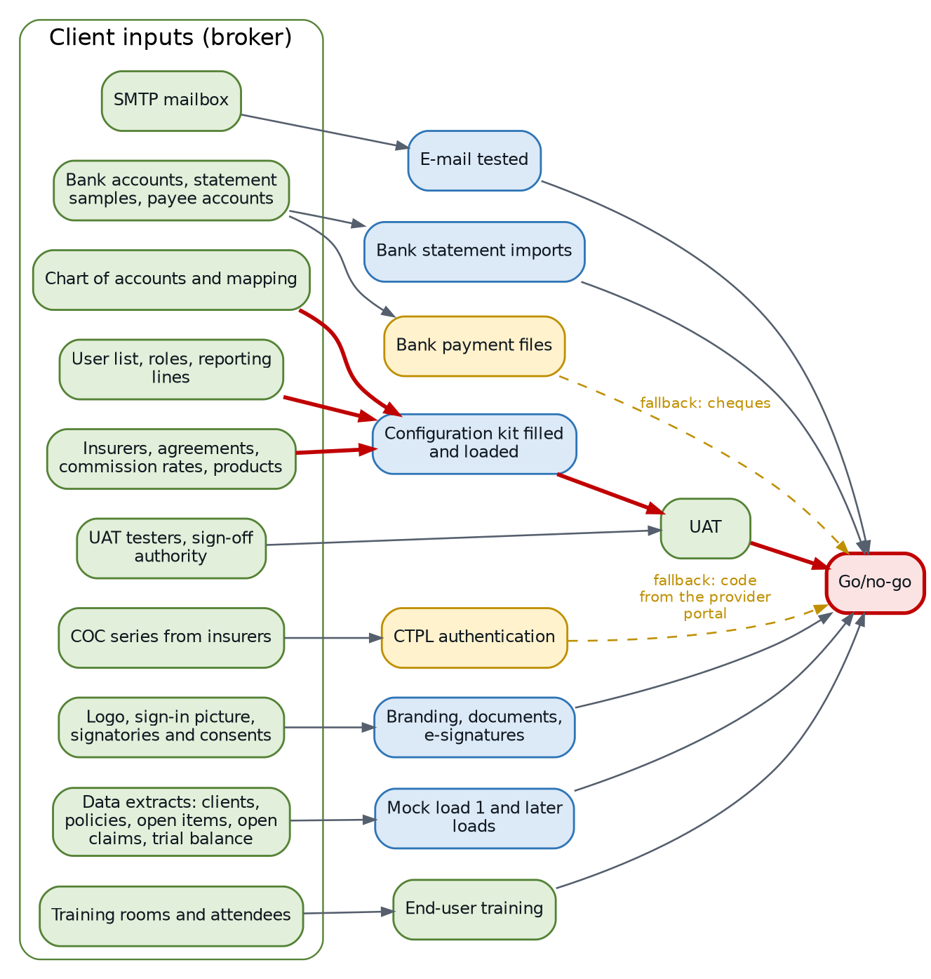
Client inputs and what each feeds. Red: on the critical path for every size
ID | Input | Owner (broker) | Needed by: Small / Medium / Large / Enterprise | Feeds
M4 | Named team: PM, key users, Accounting Manager, System Administrator, compliance officer, DPO | Sponsor | W1 for every size | Workshops, decisions
I1 | Insurer list and agreements, commission and referrer rates, product list | Key users | W1 / W2 / W3 / W4 | Configuration kit
I2 | Chart of accounts and the accountant's mapping decisions | Accounting Manager | W1 / W2 / W3 / W4 | Configuration kit
I3 | User list with roles, branches and reporting lines (My Work > My Team follows the reporting line) | System Administrator | W1 / W2 / W3 / W3 | Configuration kit, Users sheet
I4 | SMTP mailbox and credentials | IT head | W1 / W2 / W2 / W2 | E-mail test
I5 | Bank accounts, one statement export per account, bank contacts, payee bank accounts | Accounting | W2 / W2 / W3 / W3 | Statement formats, bank payment files
I6 | Partner contracts and credentials (SMS provider, CTPL authentication provider, payment gateway, insurer API access) | IT head and sponsor | W2 / W3 / W4 / W6 | Partner certifications
I7 | COC number series of each insurer | Operations | W2 / W2 / W3 / W3 | COC Series sheet, CTPL authentication
I8 | Logo, sign-in picture, signatories with their e-signature consent | Marketing, signatories | W1 / W2 / W2 / W3 | Branding, documents
G1 | Extracts of clients, in-force policies, open items, open claims and the trial balance, cleansed | Data owners | W2 / W3 / W5 / W6 | Mock load 1
I9 | Training rooms, devices, attendance list | PM | Before end-user training | Training
I10 | UAT testers and sign-off authority | PM | Before UAT | UAT

The insurer, product and commission data (I1) and the chart of accounts with its mapping (I2) are on the critical path for every size: the configuration kit cannot be completed without them, and everything after configuration waits for it. The user list (I3) has one to three days of float only.

5.2 The kits the inputs go into
The broker fills two workbooks downloaded from Master > Go-Live Data Load:
- the configuration kit (company, settings, PSGC regions, provinces, cities and barangays, branches, departments, hierarchy, designations, users, currencies, chart of accounts, banks, bank accounts, signatories, insurers, lines of business, products, covers, vehicles, suppliers, asset classes, short-period rates, cancellation reasons, claim document checklist, repair shops, commission rates, premium taxes, LGU rates, authority limits, numbering, payee bank accounts, COC series);
- the migration kit (clients, in-force policies, open items, open claims, opening balances), refused until the cutover date golive.cutover_date is set.
Each upload is validated as a trial run, the errors come back as an errors workbook, and a corrected file is loaded again without duplicates. A late or poor input therefore shows quickly as rows in error, which the project manager reports weekly.

6. Partner certifications

6.1 Partners and fallbacks
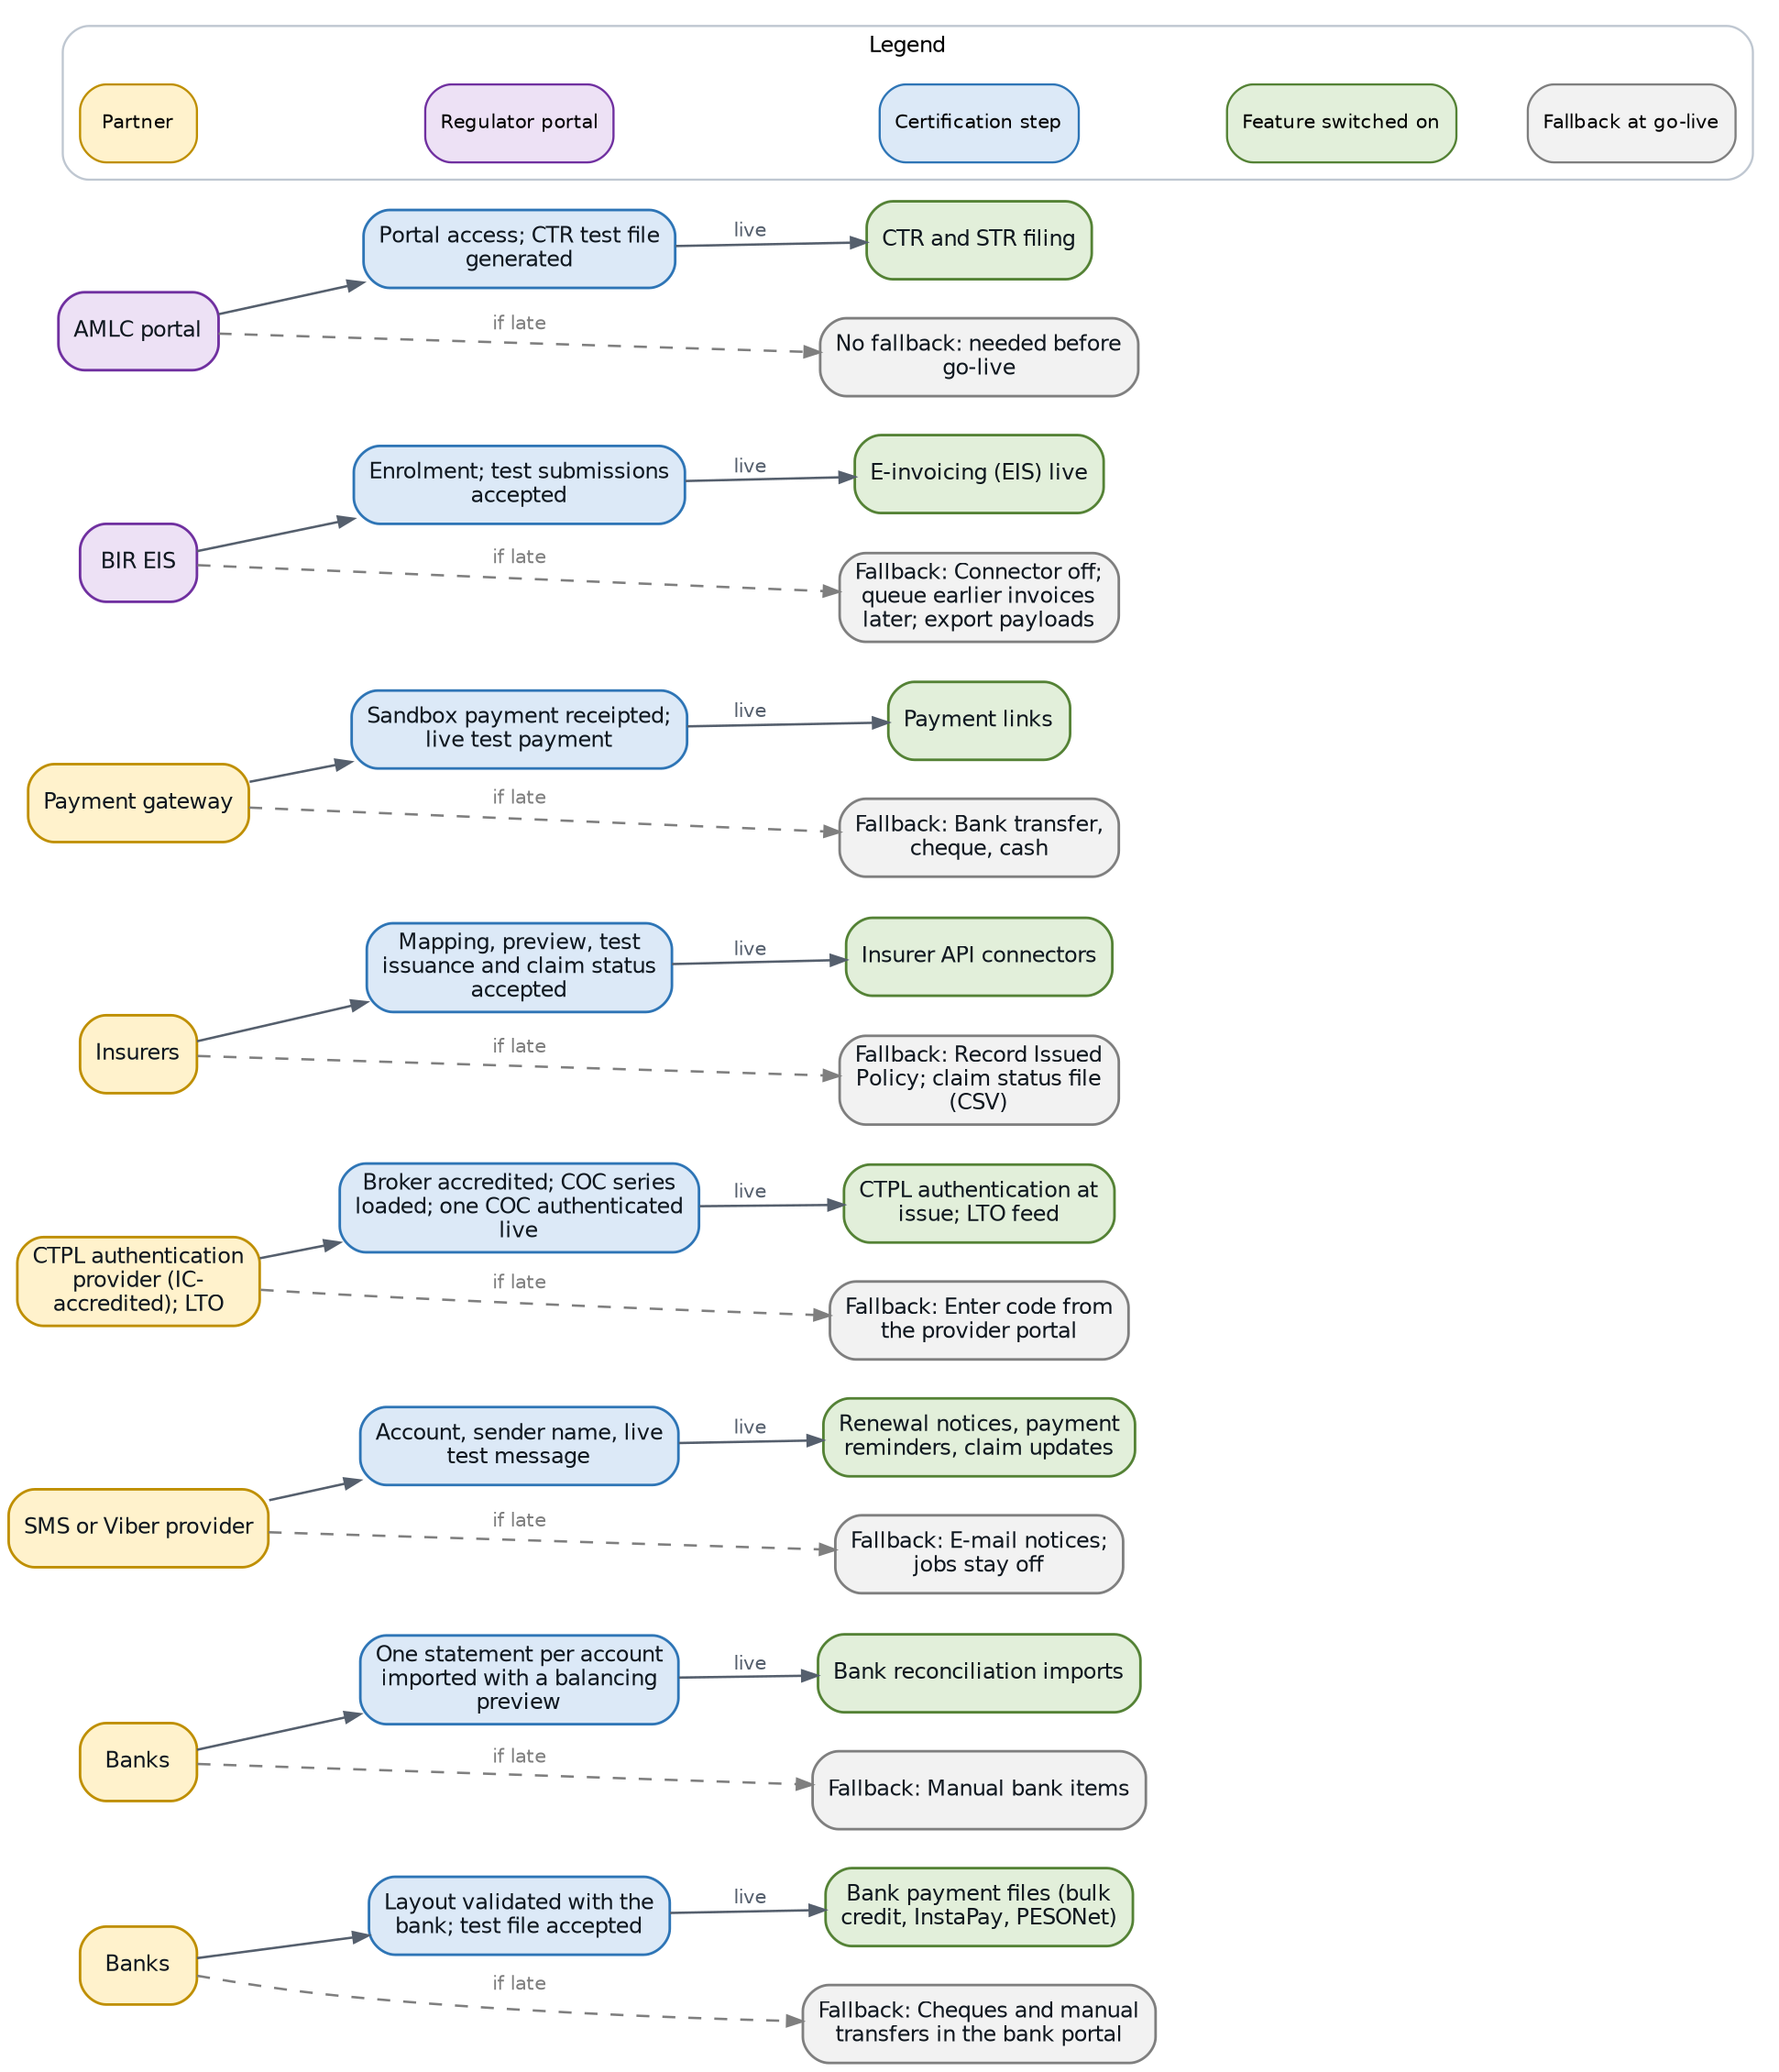
Partner certifications: what each partner certifies, the feature it switches on and the fallback while it is not certified
BrokerVerse delivers each connector in test mode (Master > System Configuration > Integrations): the whole process can be tried before the partner contract is signed. What is certified with each partner is done during onboarding with that partner; the system cannot certify it alone.
Partner | Certified during the project | Owner | Lead time assumption (S / M / L / E) | Fallback at go-live
Banks (payment files) | Each starter layout validated against the bank's current specification; a test file accepted by the bank | Bank, with Accounting | 10 / 15 / 20 / 25 days | Cheques and manual transfers in the bank portal
Banks (statements) | One statement per account imported with a balancing preview | Accounting, with iorta TechNXT | 3 / 4 / 6 / 8 days | Manual bank items
SMS or Viber provider | Account, sender name, live test message | Provider, with the IT head | 5 / 8 / 10 / 10 days | E-mail notices; SMS jobs stay switched off
CTPL authentication provider (IC-accredited); LTO | Broker accredited; COC series loaded; one COC authenticated live; LTO feed when the provider does not send it | Provider, with Operations | 8 / 10 / 15 / 15 days | Enter code from the provider portal on Operations > CTPL Authentication
Insurers | Mapping per insurer, preview, test issuance and claim status accepted | Each insurer, with the Processing Team | 10 / 15 / 20 / 25 days | Record Issued Policy; claim status file (CSV)
Payment gateway | Sandbox payment receipted; one live test payment | Gateway, with Accounting | 3 / 5 / 5 / 5 days | Bank transfer, cheque, cash
BIR EIS | Enrolment; test submissions accepted | Accounting Manager | 30 days for every size | Connector off; Queue earlier invoices once live; Export payloads for a manual upload
AMLC portal | Portal access; a CTR test file generated | Compliance officer | 15 / 20 / 20 / 20 days | None: needed before go-live

6.2 When each partner must be live
With the planned durations, every partner certification finishes before go-live except the EIS, which waits for the BIR enrolment and is switched on in the first hypercare week. The margin is the number of working days the certification can slip before the go-live starts with the fallback.
ID | Dependency | Small | Medium | Large | Enterprise
I6 | Partner contracts and credentials | W1 to W2, 20 days before go-live | W1 to W3, 31 days before go-live | W2 to W4, 50 days before go-live | W2 to W6, 74 days before go-live
I7 | COC series | W1 to W2, 24 days before go-live | W1 to W2, 36 days before go-live | W1 to W3, 59 days before go-live | W1 to W3, 89 days before go-live
N3 | Bank payment files certified | W3 to W5, 8 days before go-live | W4 to W7, 11 days before go-live | W6 to W10, 21 days before go-live | W8 to W13, 39 days before go-live
N4 | SMS or Viber live | W3 to W4, 13 days before go-live | W4 to W6, 18 days before go-live | W6 to W8, 31 days before go-live | W8 to W10, 54 days before go-live
N5 | CTPL authentication live | W3 to W4, 10 days before go-live | W4 to W6, 16 days before go-live | W6 to W9, 26 days before go-live | W8 to W11, 49 days before go-live
N6 | Insurer API connectors | W3 to W5, 6 days before go-live | W5 to W8, 9 days before go-live | W7 to W11, 19 days before go-live | W8 to W13, 37 days before go-live
N7 | Payment gateway live | W3, 15 days before go-live | W4 to W5, 21 days before go-live | W6 to W7, 36 days before go-live | W8 to W9, 59 days before go-live
N8 | EIS connector in test mode | W4, 10 days before go-live | W7, 14 days before go-live | W10, 21 days before go-live | W13, 37 days before go-live
N9 | EIS connector live | W7, in the go-live week | W10, in the go-live week | W15, in the go-live week | W21, in the go-live week

CTPL authentication is the partner dependency with the most effect on daily work: every motor policy with CTPL needs an authenticated COC before release. If the provider is not live at go-live, the go/no-go records the decision to use Enter code from the provider portal for every COC, and Operations staff the extra work until the connector is live.

7. Regulatory registrations

7.1 What the broker registers, and what it unlocks
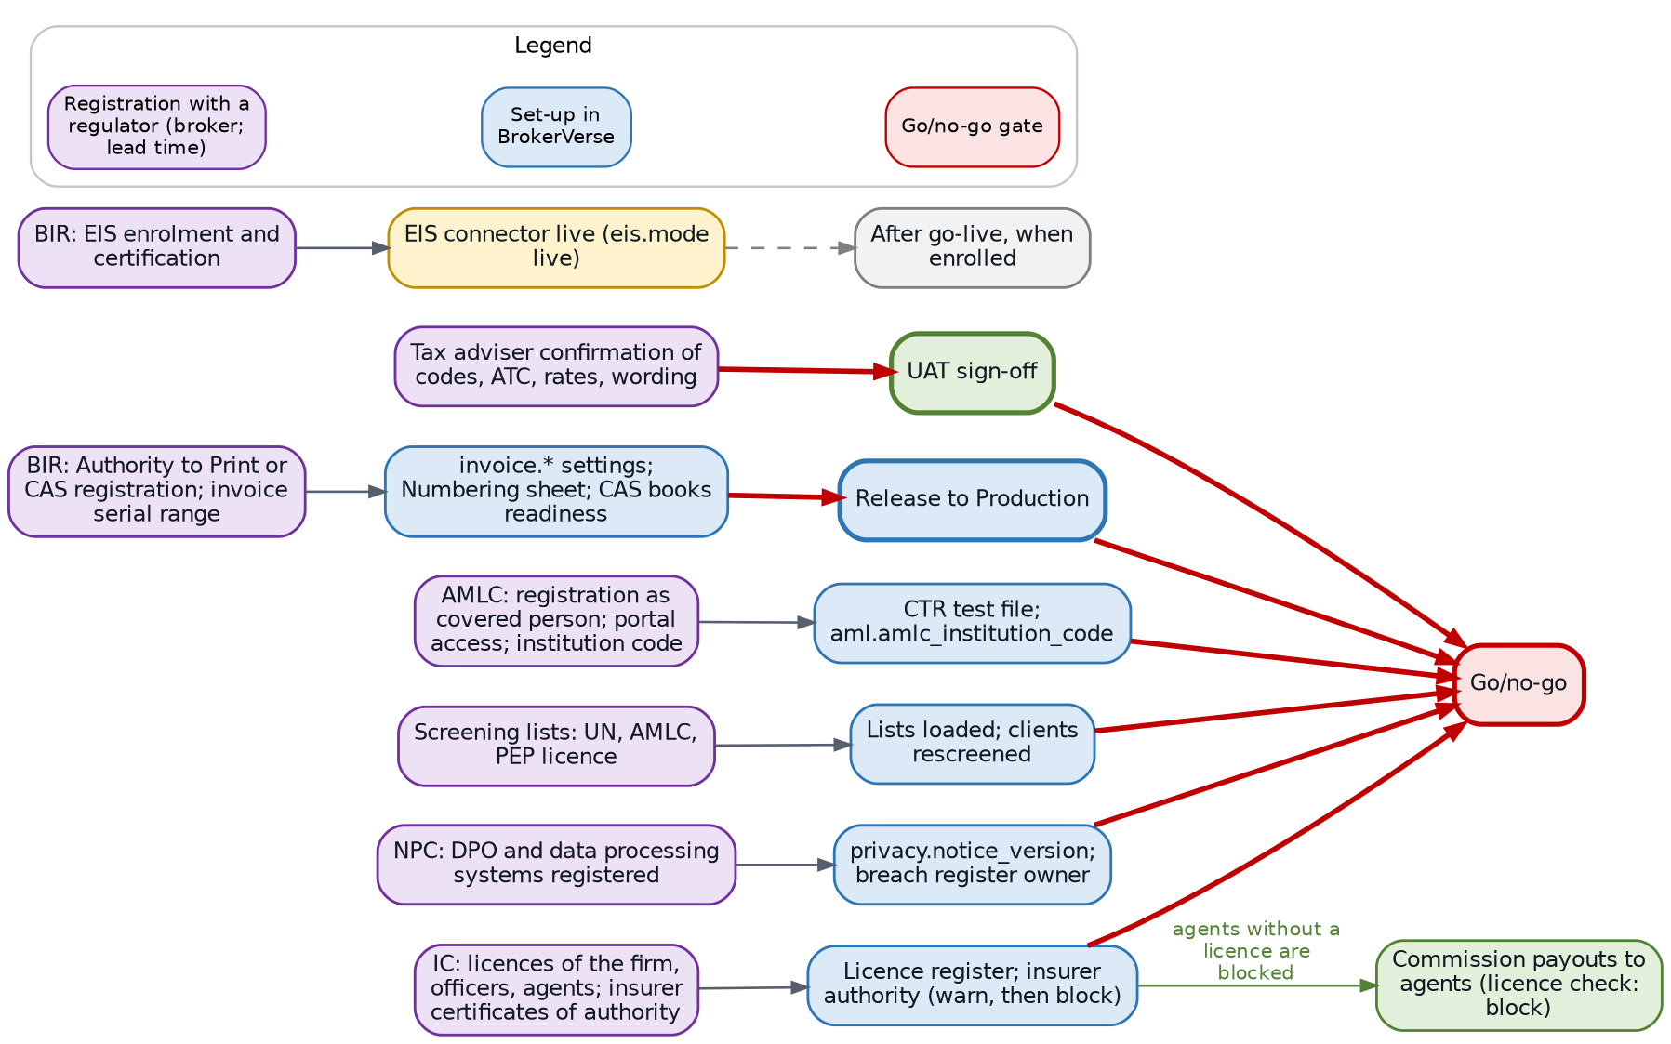
Regulatory registrations: the broker's registration with each regulator, its set-up in BrokerVerse and the gate it opens
The registrations are the broker's own obligations; iorta TechNXT plans around them and sets the system up from their results. A registration the broker already holds takes no lead time: it is confirmed at mobilisation and the task is closed.
ID | Registration | Owner | Lead time assumption (S / M / L / E) | Set-up in BrokerVerse | Gate
R1 | BIR: Authority to Print or CAS registration; registered serial range of the sales invoices; last numbers used | Accounting Manager with the tax adviser | 20 / 25 / 30 / 30 days | invoice.atp_number or invoice.cas_permit_number, invoice.serial_from, invoice.serial_to; Numbering sheet; CAS Books and Documents readiness (cas.permit_number) | Release to Production
R2 | BIR: EIS enrolment and certification, when the broker is covered | Accounting Manager | 30 days | eis.enabled, eis.mode, endpoint, accreditation id; credential variable names | Feature only
R3 | AMLC: registration as covered person, portal access, institution code | Compliance officer | 15 / 20 / 20 / 20 days | aml.amlc_institution_code, aml.amlc_transaction_codes; CTR test file | Go/no-go
R4 | IC: licences of the firm, officers, licensed individuals and agents; certificates of authority of the insurers | Compliance officer | 5 / 8 / 10 / 12 days | Compliance > Licence Register, Fit and Proper; insurer IC Certificate of Authority No. and validity | Compliance set-up; go/no-go
R5 | NPC: registration of the DPO and the data processing systems; privacy notice version | DPO | 20 / 25 / 30 / 30 days | privacy.notice_version; breach register owner | Go/no-go
R6 | Tax adviser confirmation of tax codes, ATC, rates, invoice and receipt wording, VAT treatment of commission | Tax adviser | 5 / 5 / 8 / 10 days | Taxation, bir.*, invoice.*, receipts.document_title | UAT sign-off
R7 | Screening lists: UN and AMLC lists obtained; PEP list licence from a provider when used | Compliance officer | 10 / 12 / 15 / 15 days | Compliance > Screening Lists (no list content is delivered with BrokerVerse); aml.screening_provider | Go/no-go
R8 | Contract reference covering the use of the client's marks on the engagement file (client brand pack only) | Sponsor | 3 / 5 / 5 / 5 days | Theme and Branding > Brand packs | Feature only

Points that matter to the plan:
- ATP or CAS (R1) is the regulatory item with the least float for a small broker: 2 working days. A broker that must register a new CAS or obtain a new ATP should start on the kick-off day, or the go-live moves.
- Screening lists (R7) must be loaded and every client screened before go-live: onboarding, policy issue and payouts check the lists, and a High-risk or matched client gets no policy. The UN and AMLC lists are public; a PEP list is licensed from a provider.
- IC licence data (R4) drives the commission payout check: with compliance.referrer_licence_check set to block (delivered), commission to an agent without a licence in force is refused. Load the licences before the first commission run after go-live.
- Insurer certificates of authority are checked at request for quotation, firm order and issue. Start with compliance.insurer_authority_check at warn (delivered) and switch to block once every insurer's certificate is entered.

8. Environments, pipeline and keys

8.1 Set-up order
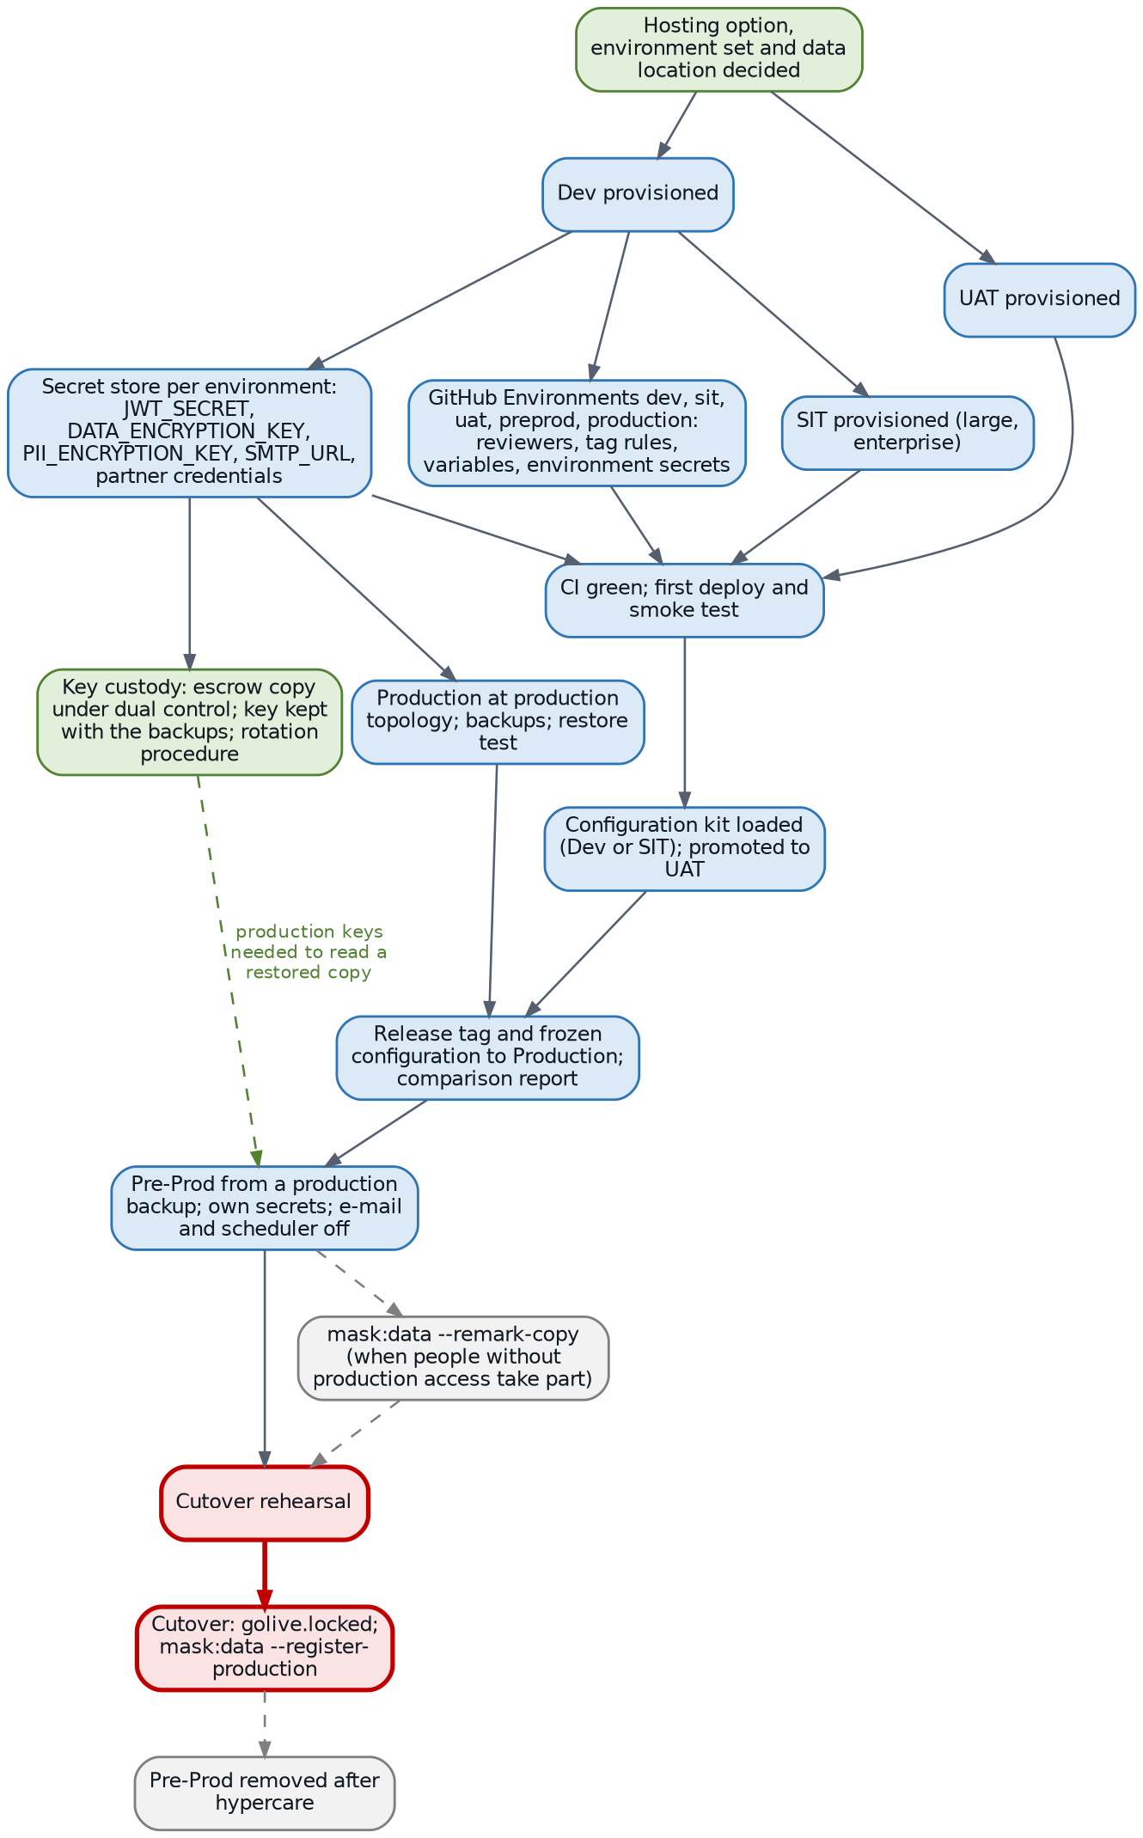
Environments, pipeline and encryption keys from the hosting decision to the removal of Pre-Prod
Environment set | Small and medium | Large | Enterprise
Standing environments | Dev, UAT, Production | Dev, SIT, UAT, Production with high availability | As large, with a cross-region copy of the backups
Where SIT runs | Dev (synthetic data only) | SIT | SIT
Mock loads | UAT | SIT, then UAT | SIT, then UAT
Pre-Prod | Temporary: created from a production backup for the rehearsal, removed after hypercare | Same | Same

ID | Step | Owner | Depends on | Float (S / M / L / E days)
M5 | Hosting option, environment set and data location decided; transfer of personal data outside the Philippines decided and documented | Broker sponsor and IT head | Kick-off | 4 / 8 / 12 / 17
E1, E2, E3 | Dev, SIT (large, enterprise) and UAT provisioned | iorta TechNXT DevOps lead | M5 | 4 to 6 / 8 to 10 / 12 to 16 / 17 to 21
E4 | GitHub Environments dev, sit, uat, preprod, production: required reviewers (two on production, prevent self-review), tag rules, variables (DEPLOY_ENABLED, targets, addresses) and environment secrets (deploy keys, known hosts, bucket and distribution ids) | iorta TechNXT DevOps lead | Dev | 4 / 8 / 13 / 19
E5 | Application secrets in the secret store of each environment: JWT_SECRET, DATA_ENCRYPTION_KEY, PII_ENCRYPTION_KEY (each at least 32 characters and different), SMTP_URL, partner credentials | iorta TechNXT DevOps lead with the broker IT head | Dev | 5 / 9 / 14 / 20
E6 | First deployment through the pipeline (CI green, deploy, smoke test) to Dev, SIT and UAT | iorta TechNXT DevOps lead | E3, E4, E5 | 4 / 8 / 12 / 17
E7 | Production at production topology, backups, monitoring, restore test | iorta TechNXT DevOps lead | E5 | 13 / 23 / 42 / 67
X2 | Pre-Prod from a production backup: own secrets, e-mail off, scheduler stopped; masked first when people without production access take part | iorta TechNXT DevOps lead; masking approved by the broker DPO | Release to Production | 1 / 2 / 2 / 10
X5 | Cutover: golive.locked switched on; npm run mask:data -- --register-production run once in Production | Broker System Administrator; iorta TechNXT DevOps lead | Go/no-go | 0

8.2 Encryption key custody
PII_ENCRYPTION_KEY encrypts TIN, government ID numbers and bank account numbers at rest; DATA_ENCRYPTION_KEY encrypts two-step verification secrets. A database backup cannot be read without the key it was written with. The key custody record is therefore a dependency of the first deployment, not a formality:
- Each environment has its own keys; Production keys are generated in the production secret store and never leave it except as the escrow copy.
- The escrow copy is kept under dual control (one person of the broker, one of iorta TechNXT, or as the hosting contract states), with the backups it opens.
- Pre-Prod restored from a production backup needs the production keys to read the copy. After masking, the copy is rotated to its own key with the rotation procedure of deploy/REFERENCE.md (npm run pii:rotate).
- A rotation keeps the previous key (PII_ENCRYPTION_KEY_PREVIOUS) until the dry run reports nothing left, and the old key is kept with the backups taken before the rotation.
If the custody record is not agreed, the first deployment can still go ahead in Dev with a development key, but Production is not provisioned (E7 depends on E5).

9. Critical path by size

9.1 How to read the charts
Each chart shows the chain of tasks with no float to the go-live, in rows of five from left to right. Blue boxes are iorta TechNXT tasks, green boxes broker tasks, red boxes the gates. A label on an arrow is a start-to-start link with its lag in working days (for example, SIT starts a number of days after on-screen configuration has started, not after it has finished).
The critical path is the same chain for every size, which is the main message for the project manager:
Client data for the configuration kit (insurers, rates, products, chart of accounts) > configuration kit filled and loaded > on-screen configuration > system integration test > promotion to UAT > UAT > cutover rehearsal > go/no-go > cutover > go-live.
Discovery workshops, environments and the regulatory registrations run beside it with some float; the size decides how much.

9.2 Small broker (8 weeks)
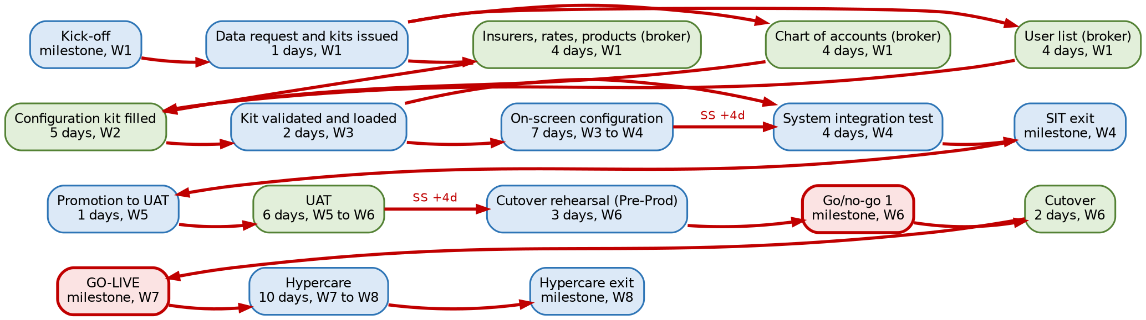
Critical path of a small broker
Item | Detail
Critical path | Kick-off (W1) > data request and kits issued (W1) > insurers, rates, products; chart of accounts; user list (W1) > configuration kit filled (W2) > kit loaded (W3) > on-screen configuration (W3 to W4) > SIT (W4) > SIT exit (W4) > promotion to UAT (W5) > UAT (W5 to W6) > cutover rehearsal (W6) > go/no-go (W6) > cutover (W6) > go-live (W7)
Near-critical (float 1 to 5 days) | Configuration complete, release to Production, Pre-Prod, UAT sign-off, train-the-trainer and end-user training 1 day; process workshops and BIR ATP or CAS 2 days; mock load 2 3 days; hosting decision, Dev, GitHub Environments, first deployment and compliance set-up 4 days; secrets and keys, fit-gap sign-off and branding 5 days
What it means | The small plan has almost no slack: 17 tasks are within one week of the critical path. Any input late by more than a week moves the go-live. Start the ATP or CAS request on the kick-off day

9.3 Medium broker (12 weeks)
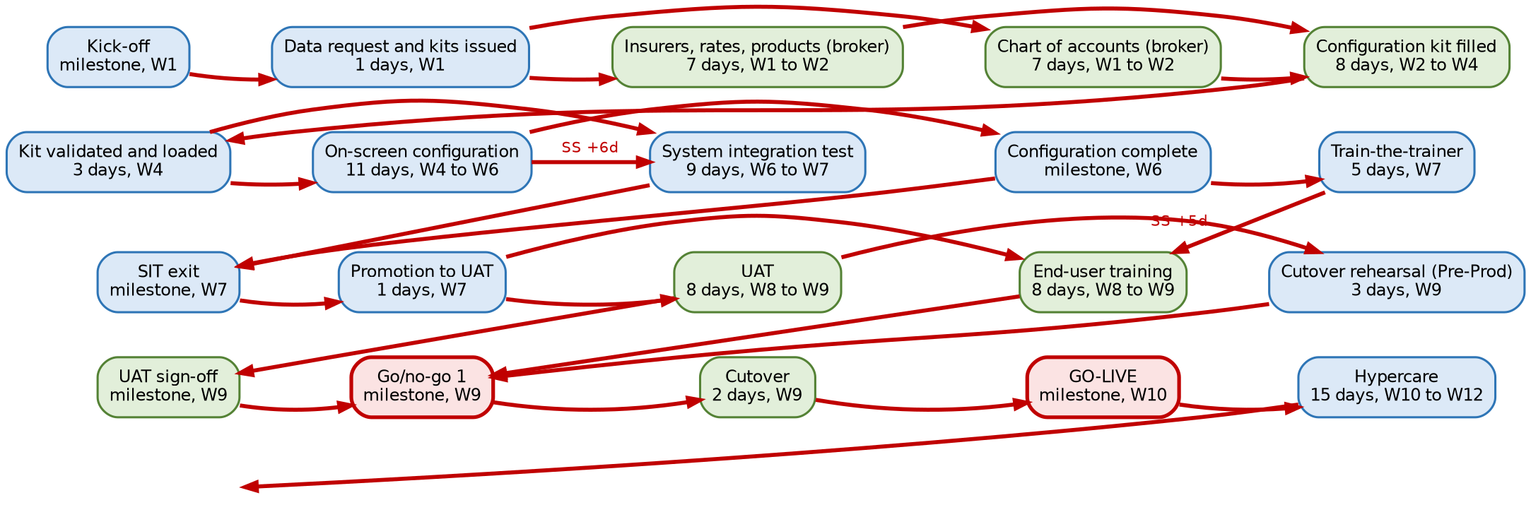
Critical path of a medium broker
Item | Detail
Critical path | Kick-off (W1) > data request and kits issued (W1) > insurers, rates, products and chart of accounts (W1 to W2) > configuration kit filled (W2 to W4) > kit loaded (W4) > on-screen configuration (W4 to W6) > SIT (W6 to W7) > SIT exit (W7) > promotion to UAT (W7) > UAT (W8 to W9) > cutover rehearsal (W9) > go/no-go (W9) > cutover (W9) > go-live (W10). A second critical chain runs through configuration complete (W6) > train-the-trainer (W7) > end-user training (W8 to W9)
Near-critical (float 1 to 5 days) | User list 1 day; release to Production and Pre-Prod 2 days; process workshops 3 days; compliance set-up 5 days
What it means | Training is as critical as testing: key users who are not released for train-the-trainer in week 7 move the go-live

9.4 Large broker (20 weeks)
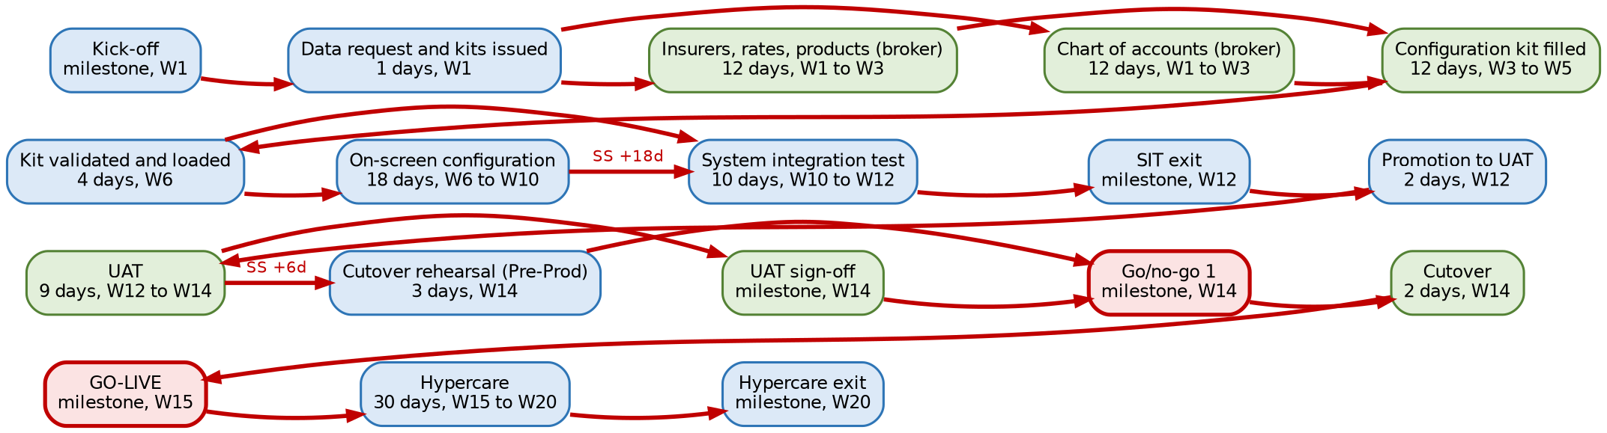
Critical path of a large broker
Item | Detail
Critical path | Kick-off (W1) > data request and kits issued (W1) > insurers, rates, products and chart of accounts (W1 to W3) > configuration kit filled (W3 to W5) > kit loaded in SIT (W6) > on-screen configuration (W6 to W10) > SIT (W10 to W12) > SIT exit (W12) > promotion to UAT (W12) > UAT (W12 to W14) > cutover rehearsal (W14) > go/no-go (W14) > cutover (W14) > go-live (W15)
Near-critical (float 1 to 5 days) | End-user training 1 day; user list, release to Production, Pre-Prod and mock load 3 2 days; configuration complete and train-the-trainer 5 days
What it means | Mock load 3 in UAT has 2 days of float: a poor second mock load in SIT moves the go-live. Branch training must finish in week 14

9.5 Enterprise broker (26 weeks)
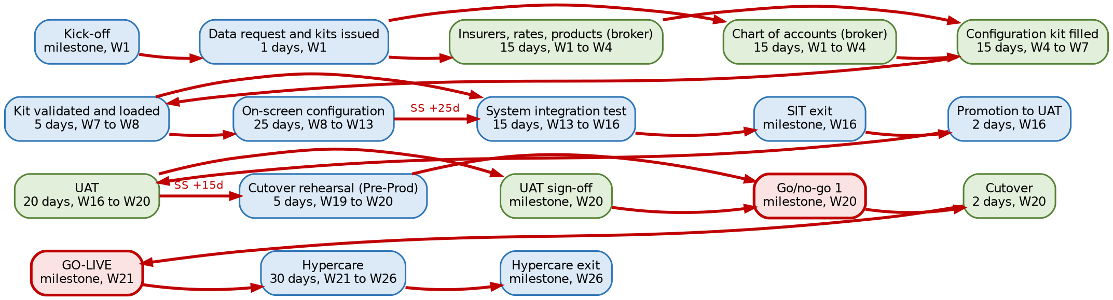
Critical path of an enterprise broker
Item | Detail
Critical path | Kick-off (W1) > data request and kits issued (W1) > insurers, rates, products and chart of accounts (W1 to W4) > configuration kit filled (W4 to W7) > kit loaded in SIT (W7 to W8) > on-screen configuration (W8 to W13) > SIT (W13 to W16) > SIT exit (W16) > promotion to UAT (W16) > UAT (W16 to W20) > cutover rehearsal (W19 to W20) > go/no-go (W20) > cutover (W20) > go-live (W21)
Near-critical (float 1 to 5 days) | User list 3 days; mock loads 3 and 4 and end-user training 5 days
What it means | The registrations have weeks of float; the risk sits in the volume of the configuration (more lines of business, insurers and products) and in four mock loads before the rehearsal

10. Lead times
ID | Item | Owner | Small | Medium | Large | Enterprise
R1 | BIR ATP or CAS, invoice serials | Broker Accounting Manager with the tax adviser | 20 days | 25 days | 30 days | 30 days
R2 | BIR EIS enrolment | Broker Accounting Manager | 30 days | 30 days | 30 days | 30 days
R3 | AMLC registration | Broker compliance officer | 15 days | 20 days | 20 days | 20 days
R4 | IC licence data | Broker compliance officer | 5 days | 8 days | 10 days | 12 days
R5 | NPC registration | Broker DPO | 20 days | 25 days | 30 days | 30 days
R6 | Tax adviser confirmation | Broker tax adviser | 5 days | 5 days | 8 days | 10 days
R7 | Screening lists and licence | Broker compliance officer | 10 days | 12 days | 15 days | 15 days
R8 | Contract reference for client marks | Broker sponsor | 3 days | 5 days | 5 days | 5 days
I6 | Partner contracts and credentials | Broker IT head and sponsor | 8 days | 10 days | 15 days | 20 days
N3 | Bank payment files certified | Bank, with Accounting and iorta TechNXT | 10 days | 15 days | 20 days | 25 days
N4 | SMS or Viber live | SMS provider, with the broker IT head | 5 days | 8 days | 10 days | 10 days
N5 | CTPL authentication live | IC-accredited authentication provider, with Operations | 8 days | 10 days | 15 days | 15 days
N6 | Insurer API connectors | Insurers, with the Processing Team | 10 days | 15 days | 20 days | 25 days
N7 | Payment gateway live | Payment gateway, with Accounting | 3 days | 5 days | 5 days | 5 days
E7 | Production provisioned | iorta TechNXT DevOps lead | 5 days | 8 days | 10 days | 12 days
G1 | Extraction and cleansing | Broker data owners | 8 days | 12 days | 20 days | 25 days

The lead times of the BIR, the AMLC, the NPC and the IC are assumptions, not commitments of those agencies. Ask the broker at mobilisation which registrations it already holds, which are in progress and their reference numbers, and record each one as a dependency in the RAID log with its expected date.

11. What slips if a dependency slips

11.1 Dependencies that hold the go-live
The table gives the float to go-live in working days. A dependency that finishes N days late moves the go-live by N less its float (never less than zero). A float of 0 moves the go-live day for day.
ID | Dependency | Small | Medium | Large | Enterprise
M4 | Broker team named | 10 | 14 | 24 | 30
M5 | Hosting and environment set decided | 4 | 8 | 12 | 17
E1 | Dev provisioned | 4 | 8 | 12 | 17
E2 | SIT provisioned | n/a | n/a | 12 | 17
E3 | UAT provisioned | 6 | 10 | 16 | 21
E4 | GitHub Environments set up | 4 | 8 | 13 | 19
E5 | Secrets and encryption keys | 5 | 9 | 14 | 20
E6 | First pipeline deployment | 4 | 8 | 12 | 17
E7 | Production provisioned | 13 | 23 | 42 | 67
D1 | Process workshops | 2 | 3 | 7 | 6
D2 | Compliance workshop | 10 | 15 | 24 | 30
I1 | Insurers, rates, products | 0 (critical) | 0 (critical) | 0 (critical) | 0 (critical)
I2 | Chart of accounts | 0 (critical) | 0 (critical) | 0 (critical) | 0 (critical)
I3 | User list and reporting lines | 0 (critical) | 1 | 2 | 3
I4 | SMTP mailbox | 23 | 36 | 60 | 90
I5 | Bank accounts and statement samples | 19 | 30 | 51 | 77
I8 | Logo, pictures, signatories | 12 | 18 | 38 | 54
I9 | Training rooms and attendees | 17 | 28 | 52 | 75
I10 | UAT testers named | 18 | 31 | 53 | 72
R1 | BIR ATP or CAS, invoice serials | 2 | 12 | 31 | 58
R3 | AMLC registration | 12 | 22 | 46 | 76
R4 | IC licence data | 10 | 14 | 31 | 48
R5 | NPC registration | 8 | 18 | 38 | 68
R6 | Tax adviser confirmation | 8 | 14 | 23 | 42
R7 | Screening lists and licence | 15 | 26 | 47 | 76
C1 | Configuration kit filled | 0 (critical) | 0 (critical) | 0 (critical) | 0 (critical)
C2 | Configuration kit loaded | 0 (critical) | 0 (critical) | 0 (critical) | 0 (critical)
C3 | On-screen configuration | 0 (critical) | 0 (critical) | 0 (critical) | 0 (critical)
K1 | Compliance set-up | 4 | 5 | 15 | 27
K2 | Screening lists loaded | 11 | 17 | 30 | 51
K3 | AMLC report file test | 11 | 17 | 29 | 50
B1 | Branding and brand pack | 5 | 7 | 18 | 31
N1 | E-mail tested | 21 | 34 | 53 | 82
N2 | Bank statement imports | 13 | 20 | 33 | 54
G1 | Extraction and cleansing | 10 | 20 | 31 | 47
G2 | Mapping to the migration kit | 12 | 22 | 35 | 52
G3 | Mock load 1 | 6 | 13 | 23 | 37
G4 | Mock load 2 | 3 | 7 | 10 | 17
G5 | Mock load 3 | n/a | n/a | 2 | 5
G6 | Mock load 4 | n/a | n/a | n/a | 5
L1 | Train-the-trainer | 1 | 0 (critical) | 5 | 12
L2 | Compliance officer and DPO training | 11 | 17 | 29 | 50
L3 | End-user training | 1 | 0 (critical) | 1 | 5
T1 | System integration test | 0 (critical) | 0 (critical) | 0 (critical) | 0 (critical)
T4 | UAT | 0 (critical) | 0 (critical) | 0 (critical) | 0 (critical)
X1 | Release to Production | 1 | 2 | 2 | 10
X3 | Cutover rehearsal | 0 (critical) | 0 (critical) | 0 (critical) | 0 (critical)

11.2 What else moves with it
Dependency late | Tasks that move with it | Effect beyond the date
Insurers, rates, products; chart of accounts (I1, I2) | Configuration kit, every task after configuration | Day for day on the go-live; the mock loads cannot reconcile commission and the ledger without them
User list (I3) | Configuration kit load; training users | My Work > My Team and the approval routing follow the reporting line: a late or wrong hierarchy shows in UAT as misrouted approvals
Discovery decisions (D1) | Fit-gap sign-off; on-screen configuration | Rework of the Product Configurator if acceptance rules or rating factors change after build
Hosting decision, environments, keys (M5, E1 to E6) | Configuration kit load, then the critical path | Without the key custody record Production is not provisioned
BIR ATP or CAS (R1) | Release to Production, Pre-Prod, rehearsal | Invoices and receipts cannot be issued from BrokerVerse at go-live; a go-live with manual invoices under the old ATP needs the tax adviser's written agreement
AMLC registration (R3) | AMLC report file test, go/no-go | Covered transactions cannot be filed within 5 working days (aml.ctr_due_working_days)
Screening lists (R7, K2) | Go/no-go | Clients are not screened at onboarding and issue; the compliance officer cannot sign the go/no-go
IC licence data (R4) | Compliance set-up | Commission payouts to agents are refused (licence check block) until the licences are entered
NPC registration (R5) | Go/no-go | The broker processes personal data in a new system without its registration updated; the DPO decides
Tax adviser confirmation (R6) | UAT sign-off | VAT, withholding and invoice wording are not accepted; the BIR forms of the first month are at risk
Mock loads (G3 to G6) | Later mock loads, rehearsal | Data quality found late; the rehearsal is the last chance to reconcile
Training (L1, L3) | Go/no-go | Users without an assessment do not receive production access
UAT (T4) | Sign-off, go/no-go, payment milestone | Day for day; the UAT sign-off payment milestone moves with it

11.3 Feature-only dependencies
Dependency late | The go-live holds; meanwhile | Switched on when
Bank payment files (N3) | Cheques and manual transfers in the bank portal | The bank accepts the test file
SMS or Viber (N4) | E-mail notices; jobs sms-renewal-notices and sms-payment-reminders stay off | The connector is live and a test message is sent
CTPL authentication (N5) | Enter code from the provider portal for each COC | One COC is authenticated live
Insurer APIs (N6) | Record Issued Policy; claim status file | Each insurer accepts the test requests; insurer by insurer
Payment gateway (N7) | Bank transfer, cheque, cash | A live test payment is receipted
BIR EIS (R2, N8, N9) | Connector off; invoices issued and kept | Enrolment; then Queue earlier invoices sends the invoices issued since go-live
Client brand pack (R8, B2) | The broker's own theme or the delivered preset | The contract reference covering the client's marks is on the engagement file

12. Managing the dependencies
- At mobilisation, the project manager walks this map with the broker: which registrations are held, which partners are contracted, who owns each input. Every dependency becomes a D line of the RAID log with its owner, needed-by week and state.
- Every week, the status report lists the dependencies due in the next two weeks and those At risk or Late. A dependency with float of 5 days or less is reported even when on track.
- Escalation: a dependency on the critical path late by 3 working days, or any dependency late by more than its float, goes to the steering committee with the effect on the go-live from the tables above.
- Re-baseline: when a dependency moves the go-live, the steering committee agrees the new date; the plan workbook is rebuilt from the model with the new durations, and the change is recorded under the change control of the Statement of Work.
- At go/no-go, the feature-only dependencies still open are listed with their fallback and the date the feature is expected; the go-live communication tells users which fallback they use.

13. Document Sign-Off

Serial Number | Description | Owner | Status
1 | No open items at the time of issue | iorta TechNXT

Sign Off Date | Signature | Approved By | Department & Project Role



