

FUNCTIONAL REQUIREMENTS SPECIFICATION
PDC Lifecycle - Logging and Tracking
Acceptance and encoding of post-dated cheques against the instalment plan, forwarding to the Insurance Partner for warehousing, confirmation and cancellation tracking, ageing, and the acknowledgement receipt on actual collection

Client | Toyota Insurance Services Philippines Corporation (TISPH)
Document | TISPH-FRS-COLL-05
Requirement | TIS-BRD-COLL-05
Version | 1.0
Date | 9 October 2026
Status | Issued for TISPH review
Classification | Confidential

Prepared by iorta TechNXT for TISPH 
This document is confidential to Toyota Insurance Services Philippines Corporation and iorta TechNXT.
Document Control
Version | Date | Author | Reviewer | Approver | Change
1.0 | 9 Oct 2026 | iorta TechNXT Business Analysis | iorta TechNXT Project Manager | - | First issue for review

Distribution List
Name / Unit | Role | Organisation | Purpose
Cash Control Department (business owner) | Approver | TISPH | Review and sign-off
Finance and General Accounting | Business user | TISPH | AR, posting and instalment FRs
TISPH Operations | Business user | TISPH | Policy, instalment plan and client follow-up
DTID - Project Management Team | Project owner | TISPH | Traceability against the BRD
Project team | Delivery | iorta TechNXT | Build, test and UAT preparation

Contents
1 Overview 5
1.1 The requirement 5
1.2 Scope 5
1.3 Definitions and acronyms 6
1.4 How to read the functional requirements 6
1.5 What changes in BrokerVerse 7
2 PDC process flow 8
2.1 Flow A - Accept, encode and forward 8
2.2 Flow B - Maturity, collection and AR 10
2.3 Flow C - Cancel, pull out and replace 11
2.4 What the log tracks 12
3 Personas and roles 13
3.1 Personas 13
3.2 New permissions 13
3.3 Default grants 13
4 Functional requirements 15
4.1 Acceptance and encoding 15
FR-PDC-001 Encode a set of PDCs against the instalment plan of a bill 15
FR-PDC-002 Capture the cheque details and refuse duplicates 16
FR-PDC-003 Keep the PDC set and close it when every cheque is settled 18
FR-PDC-004 Set the payee: forward to the Insurance Partner or retain at TISPH 18
4.2 Forwarding to the Insurance Partner 19
FR-PDC-010 Forward cheques to the Insurance Partner with a transmittal 19
FR-PDC-011 Record the Insurance Partner's receipt of the cheques (warehousing) 20
FR-PDC-012 Follow up cheques the Insurance Partner has not confirmed 21
4.3 Tracking log 22
FR-PDC-020 Show the PDC tracking log with status tabs, filters and export 22
FR-PDC-021 Age cheques not yet confirmed against the instalment schedule 22
FR-PDC-022 Keep the history of every cheque 23
4.4 Maturity advices 23
FR-PDC-030 Record the Insurance Partner's advice that a cheque cleared 23
FR-PDC-031 Show cheques awaiting the partner's advice 24
FR-PDC-032 Record a cheque the Insurance Partner reports as bounced 25
4.5 Cancellation, replacement and return 26
FR-PDC-040 Request, approve and complete the cancellation of a cheque 26
FR-PDC-041 Replace a cancelled or bounced cheque 27
FR-PDC-042 Return cheques to the client 28
4.6 AR on actual collection 28
FR-PDC-050 Raise the acknowledgement receipt when a cheque is collected 28
FR-PDC-051 Post the journal on the AR date only 29
4.7 Access 30
FR-PDC-060 Control access to the PDC functions 30
5 Workflow and status model 31
5.1 Post-dated cheque 31
5.2 PDC set 31
5.3 Transmittal 32
5.4 Cheque, instalment and AR 32
6 Configuration items 33
6.1 Settings 33
6.2 Scheduled jobs 33
6.3 Lists of values 33
6.4 Numbering and posting 34
6.5 Masters used 34
7 Traceability 35
7.1 BRD clause to FR 35
7.2 Related BRD requirements 35
7.3 FR to test cases 35
8 Navigation 37
8.1 Screens of COLL-05 37
8.2 Menu by base role 37
9 Screen specifications 38
9.1 PDC tracking log (changed) 38
9.2 Encode PDCs (new) 40
9.3 Forward to Insurance Partner (new) 42
9.4 Partner received (new) 42
9.5 Cheque detail with History (new) 43
9.6 Partner cleared (new) 44
9.7 Request cancellation and approval (new) 45
10 End-to-end walkthroughs 47
10.1 WT-A Accept, encode and forward 47
10.2 WT-B Collection and AR 47
10.3 WT-C Cancellation with pull-out and replacement 48
10.4 WT-D Bounced cheque 48
11 Messages catalogue 49
11.1 Encode PDCs 49
11.2 Forward to Insurance Partner 49
11.3 Record collection 50
11.4 Cheque actions 50
11.5 Cancellation 51
12 Sign-off and change control 52
12.1 What is signed 52
12.2 Change after sign-off 52
12.3 Signatures 52

1 Overview

1.1 The requirement
TIS-BRD-COLL-05 PDC Lifecycle & Ageing (Customization, Phase 1, CR-07). Post-dated cheques processed by payee (forwarded or retained), tracked by due date against the instalment schedule with ageing buckets (current, 1-30, 31-60, 61-90, 90+); acknowledgement letter on PDC receipt, official AR on actual collection. TISPH remark: PDC to proceed with one bank, subject to CCD's recommendation on the best option.

Clients who pay a Motor premium by instalments hand TISPH a set of post-dated cheques (PDCs), one for each instalment. TISPH does not deposit these cheques itself. The Cash Control Department (CCD) accepts them, records them, and forwards them to the Insurance Partner that issued the policy. The Insurance Partner keeps the cheques (warehousing) and deposits each one on its date. TISPH must still know, at any time, where every cheque is, which instalment it pays, whether the Insurance Partner has it, whether it cleared or bounced, and which cheques were cancelled or replaced and why.
This FRS turns that into a log in BrokerVerse. It builds on the existing Post-Dated Cheques register under Accounts and limits the build to logging and tracking: encoding a set of cheques against the instalment plan, the forwarding transmittal, the Insurance Partner's confirmations, cancellation and pull-out, ageing of cheques not yet confirmed, and the acknowledgement receipt (AR) raised when a cheque is actually collected. No journal is posted when a cheque is received; the journal follows the AR.
Screens that change or are new are shown as to-be mock-ups drawn on the real BrokerVerse screens with the Toyota Insurance Services look.

1.2 Scope
In scope
- Changes to Accounts > Post-Dated Cheques: the register becomes the PDC tracking log with payee, Insurance Partner, custody, instalment, confirmation and ageing columns, status tabs and filters.
- A new Encode PDCs dialog: one set of cheques for one policy bill, one cheque per instalment of the plan saved on Accounts > Credit Control > Instalment Plans.
- A new Forward to Insurance Partner action with a transmittal number, and the Insurance Partner's receipt confirmation (warehousing).
- Recording of the Insurance Partner's maturity advice: Cleared (collection recorded and AR raised) or Bounced (reason, client told, replacement).
- Cancellation with a reason from a list, approved by a second user, with a pull-out from the Insurance Partner when it holds the cheque; Replace and Return to client.
- Ageing of cheques past their date and not yet confirmed (current, 1-30, 31-60, 61-90, over 90 days), a daily follow-up job, and the change history of each cheque.
- Cheques payable to TISPH (retained) keep the existing deposit, clear and bounce actions of the register, on the one TISPH collection bank account.
Out of scope
- The CCD print-outs and reports that read this data (acknowledgement print of the cheques received, PDC Encoded Summary, PDC Cancelled Summary, PDC Maturing Report, PDC History Log): specified separately with the Cash Control reports.
- Setting up the instalment plan itself (existing Instalment Plans screen) and the payment types of the plan (PDC instalment split, credit card and auto-debit instalments).
- Bank reconciliation of cheques deposited by TISPH, and the upload of payments made directly to the insurer: separate requirements in the same module.
- Any file or system link with the Insurance Partners. Their advices arrive by e-mail or paper and CCD records them on screen.

1.3 Definitions and acronyms
Table 1: Definitions
Term | Meaning in this FRS
PDC | Post-dated cheque: a cheque dated later than the day TISPH receives it, given to pay one instalment of a premium bill.
PDC set | All cheques a client hands over in one go for one policy bill. Numbered PS-YYYY-NNNNN. One set covers one instalment plan.
Insurance Partner | The insurer that issued the policy (Master > Insurance > Insurance Company), for example Standard Insurance Co., Inc.
Payee | Whom the cheque is made out to: the Insurance Partner (cheque forwarded) or TISPH (cheque retained).
Warehousing | Safekeeping of the cheques by the Insurance Partner until each cheque date. A cheque is Warehoused once the partner confirms it has it.
Transmittal | The record of the cheques sent to one Insurance Partner in one batch. Numbered PT-YYYY-NNNNN.
Custody | Where the cheque physically is: TIS vault (with the folder), the Insurance Partner, or returned to the client.
Maturity advice | The Insurance Partner's word that a cheque cleared or bounced, with its reference (partner OR or deposit reference).
Pull-out | Asking the Insurance Partner to send back a cheque it holds, for cancellation or replacement.
AR | Acknowledgement Receipt: the receipt BrokerVerse raises through Accounts > Receipts when a cheque is actually collected. It is never raised when the cheque is received.
Ageing bucket | Days since the cheque date for a cheque not yet confirmed: Current (date not reached), 1-30, 31-60, 61-90, Over 90.
BRSTN | Bank Routing Symbol Transit Number of the drawee bank branch (9 digits), printed on the cheque.
CCD / FGA | Cash Control Department / Finance and General Accounting of TISPH.

1.4 How to read the functional requirements
Each FR in chapter 4 has the same parts:
- A header table with the BRD trace, the actor, the priority, the fit and the screens that implement it.
- Description, preconditions, main flow and alternate and exception flows.
- Business rules. Configurable rules are kept on Master > System > Configuration or on a list of values (chapter 6). Fixed rules change only through a change request.
- Validations and messages: the check and the message the user sees, word for word, with its ID in chapter 11. As everywhere in BrokerVerse, a message is plain English and is shown under the field it belongs to, or as a toast.
- Audit and numbered acceptance criteria, the basis of the test cases TC-PDC-nnn-n.
Note. Values marked "default" and the names, cheque numbers and amounts in the examples are illustrative until TISPH confirms them. Clients, policies, insurers and banks in the examples are the sample data of the BrokerVerse UAT environment.

1.5 What changes in BrokerVerse
BrokerVerse already has a register of post-dated cheques built for a broker that deposits its own cheques. COLL-05 keeps it and adds what TISPH needs to track cheques it hands to the Insurance Partners.
Table 2: BrokerVerse today and COLL-05
BrokerVerse today | What COLL-05 does
Accounts > Post-Dated Cheques: Register cheque (one cheque against a bill or policy: drawee bank, cheque no., date, amount, Kept in, remarks). Statuses On hand, Deposited, Cleared, Bounced, Replaced, Returned, Cancelled. Permission read:receipts / write:receipts. | Changed. The register becomes the PDC tracking log. New fields payee, Insurance Partner, instalment, branch, account number, BRSTN, custody; new statuses Forwarded, Warehoused, Cancellation pending; new permissions read:pdc, write:pdc, approve:pdc.
Register cheque takes one cheque at a time; it does not know the instalment plan. | New. Encode PDCs: one set of cheques for a bill, generated from the instalment plan, one row per instalment.
Deposit creates and posts the official receipt (posting rule receipt.apply); Cleared and Bounced follow the bank. Daily job "Post-dated cheques due" lists cheques to deposit. | Kept for cheques payable to TISPH. New for forwarded cheques: Forward, Partner received, Partner cleared (records the collection and raises the AR) and Partner bounced; job "PDC follow-up".
Cancel voids a registration made in error, with a free-text reason, by the same user, only while the cheque is on hand. | Changed. Cancellation needs a reason from a list and a second user's approval; a cheque held by the Insurance Partner needs a pull-out first.
Accounts > Credit Control > Instalment Plans: plan per bill, outstanding instalments aged in buckets 1-30, 31-60, 61-90, over 90 (setting limits.receivable_ageing_buckets). | Reused. The plan gives the rows of a set; the same buckets age the cheques.
Accounts > Receipts: receipt numbered from the receipt series, title from receipts.document_title; Audit Trail on every change. | Reused. The AR on collection is a receipt; a new posting rule pdc.partner_collected books cheques the partner collected. The History tab of a cheque reads the Audit Trail.

2 PDC process flow
Three flow charts show the life of a PDC: Flow A accepts, encodes and forwards the cheques, Flow B follows each cheque at its date up to the AR, and Flow C cancels or replaces a cheque. Black rounded boxes are start and end points, diamonds are decisions, red boxes are exceptions, grey boxes are done by the system and boxes with a heavy border are the successful outcome.

2.1 Flow A - Accept, encode and forward
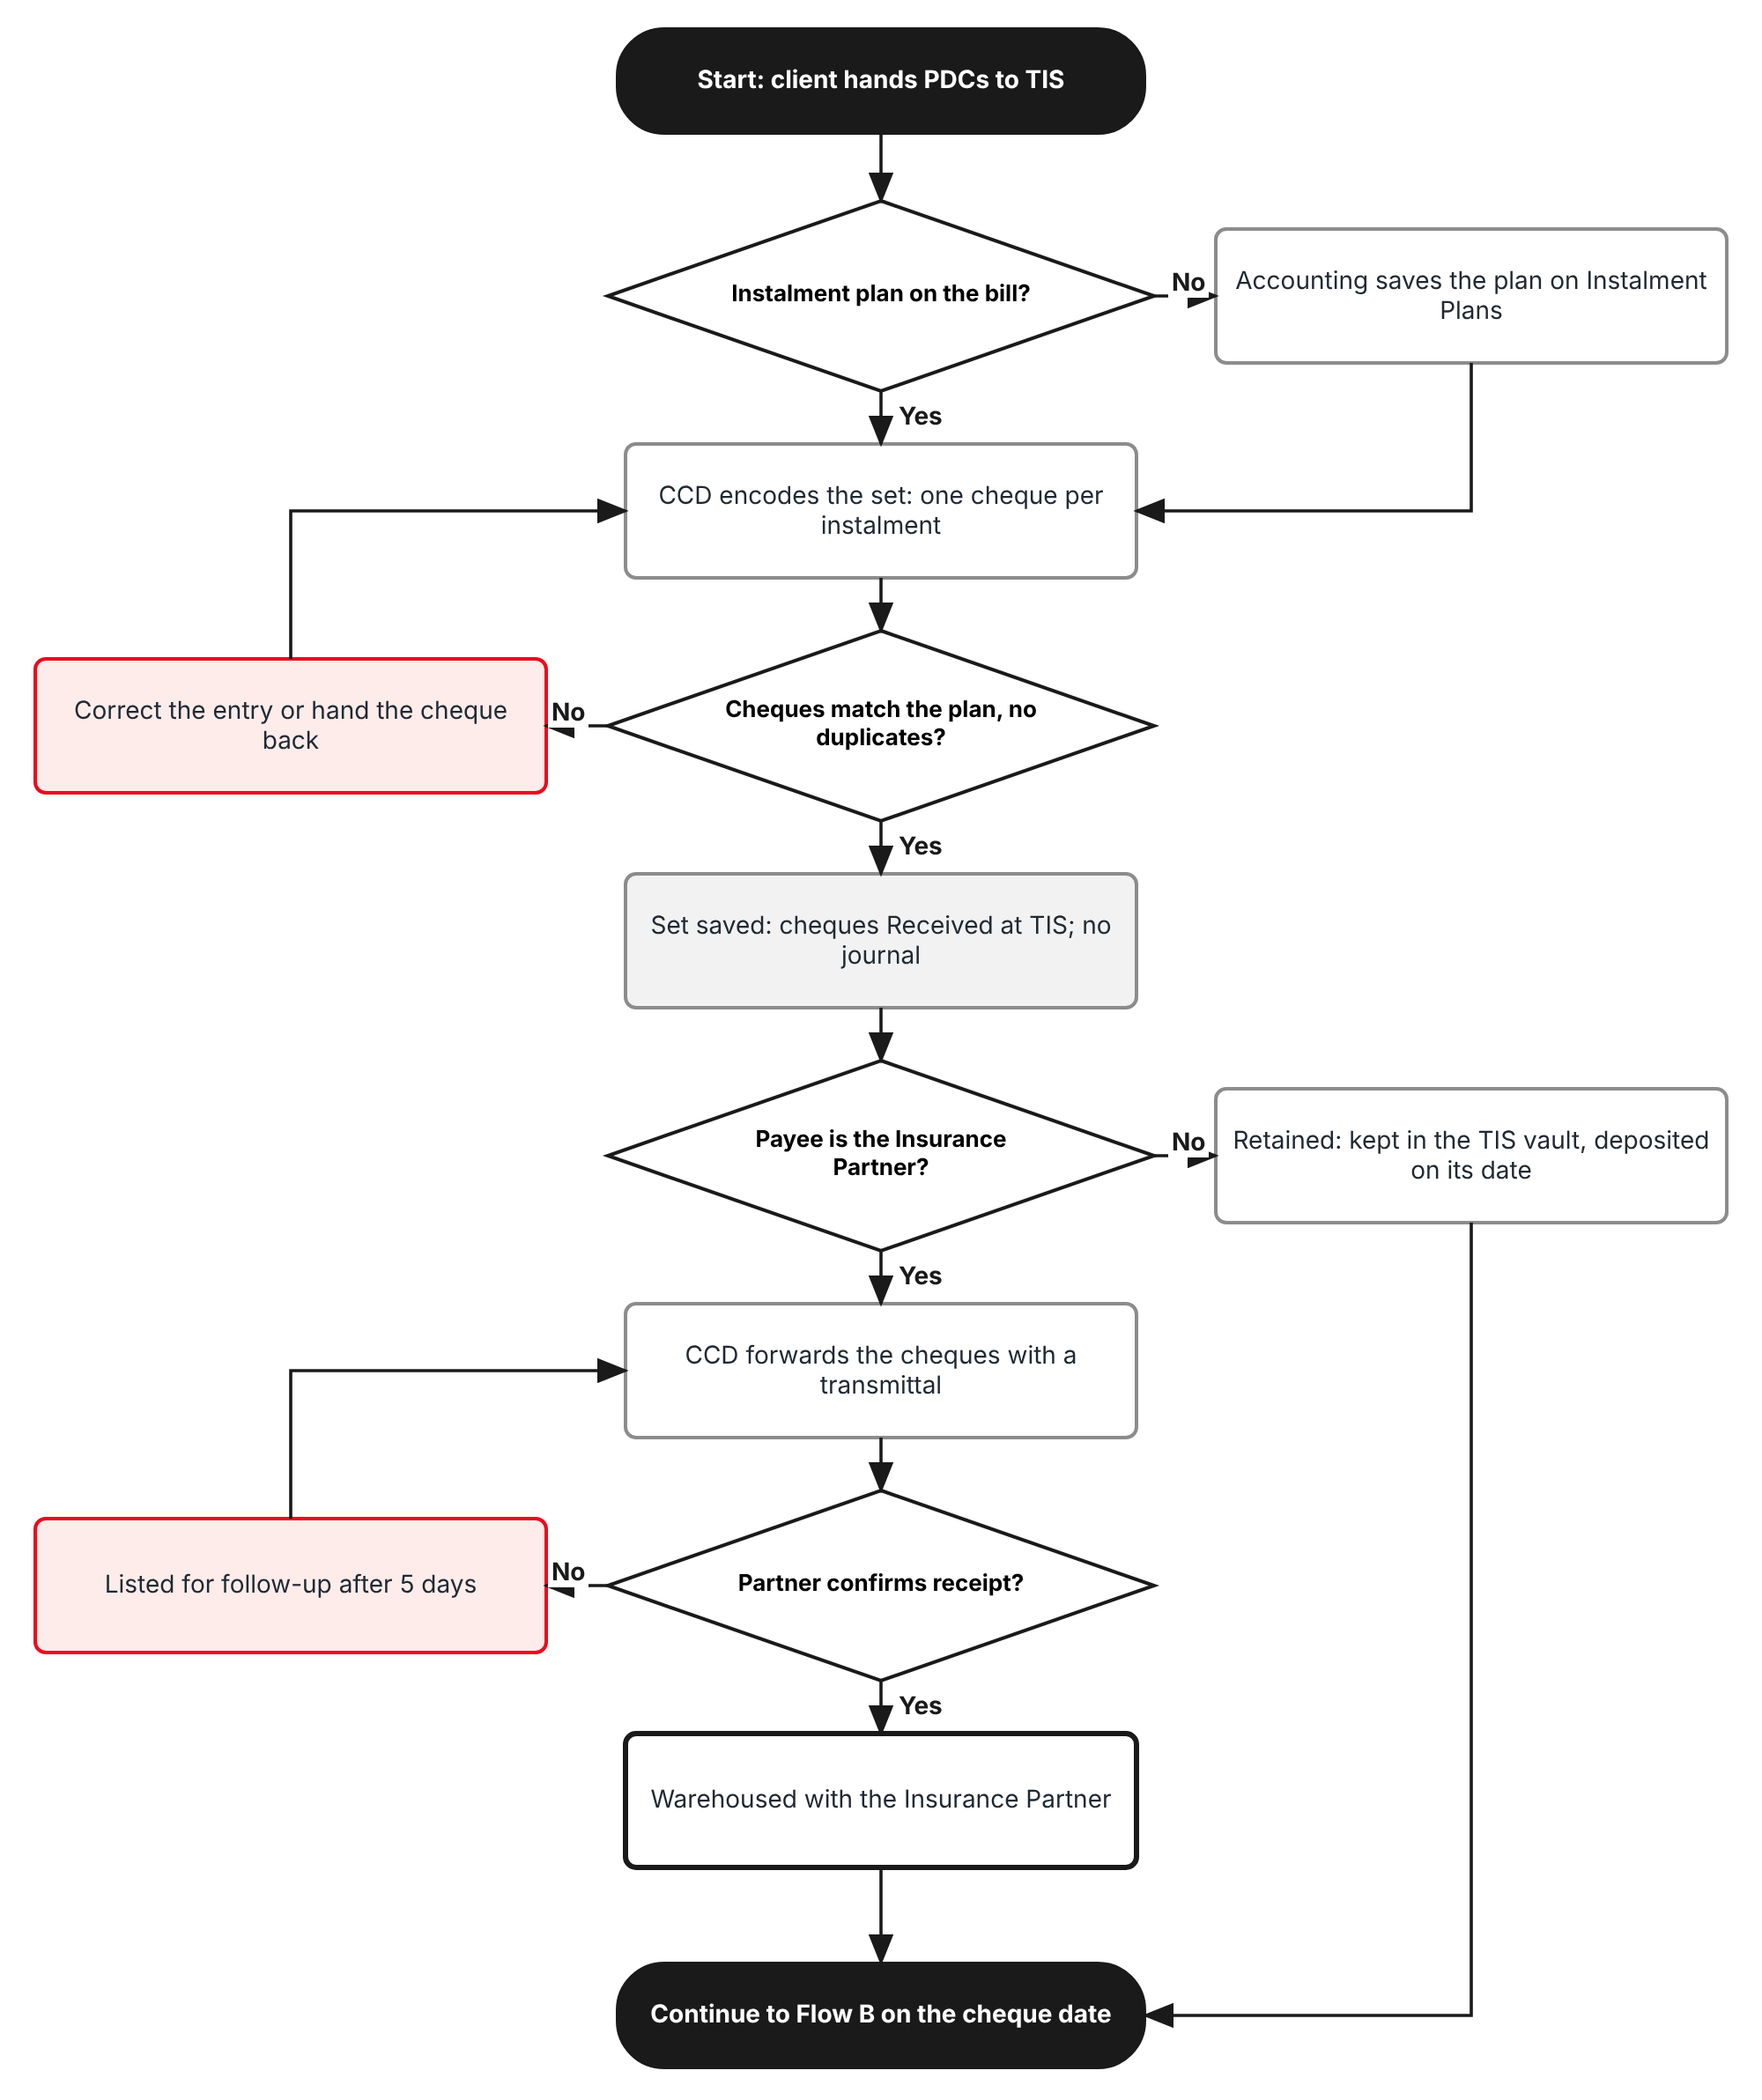
Figure 1: Flow A - Accept, encode and forward the cheques
Table 3: Flow A steps
Step | Who (role) | What happens | FR
A1 | Accounting | Checks that the bill has an instalment plan on Accounts > Credit Control > Instalment Plans; saves one if not. | FR-PDC-001
A2 | CCD officer (Accounting) | Accounts > Post-Dated Cheques > Encode PDCs: policy, bill and payee; the dialog lists one row per instalment with its due date and amount. | FR-PDC-001
A3 | CCD officer | Enters for each row the drawee bank, branch, account number, BRSTN, cheque number and cheque date; amount comes from the instalment. | FR-PDC-002
A4 | System | Checks the cheques against the plan and against cheques already encoded. Saves the set PS-YYYY-NNNNN; each cheque is Received at TIS. No journal. | FR-PDC-002, 003
A5 | CCD officer | Cheques payable to TISPH stay in the TIS vault and follow the deposit flow of the register. | FR-PDC-004
A6 | CCD officer | Selects the cheques for one Insurance Partner and clicks Forward to Insurance Partner: transmittal PT-YYYY-NNNNN, cheques Forwarded. | FR-PDC-010
A7 | CCD officer | Records the partner's receipt (date, received by, partner reference): cheques Warehoused. | FR-PDC-011
A8 | System | Job "PDC follow-up" lists Forwarded cheques not confirmed after pdc.forward_ack_days (5). | FR-PDC-012

2.2 Flow B - Maturity, collection and AR
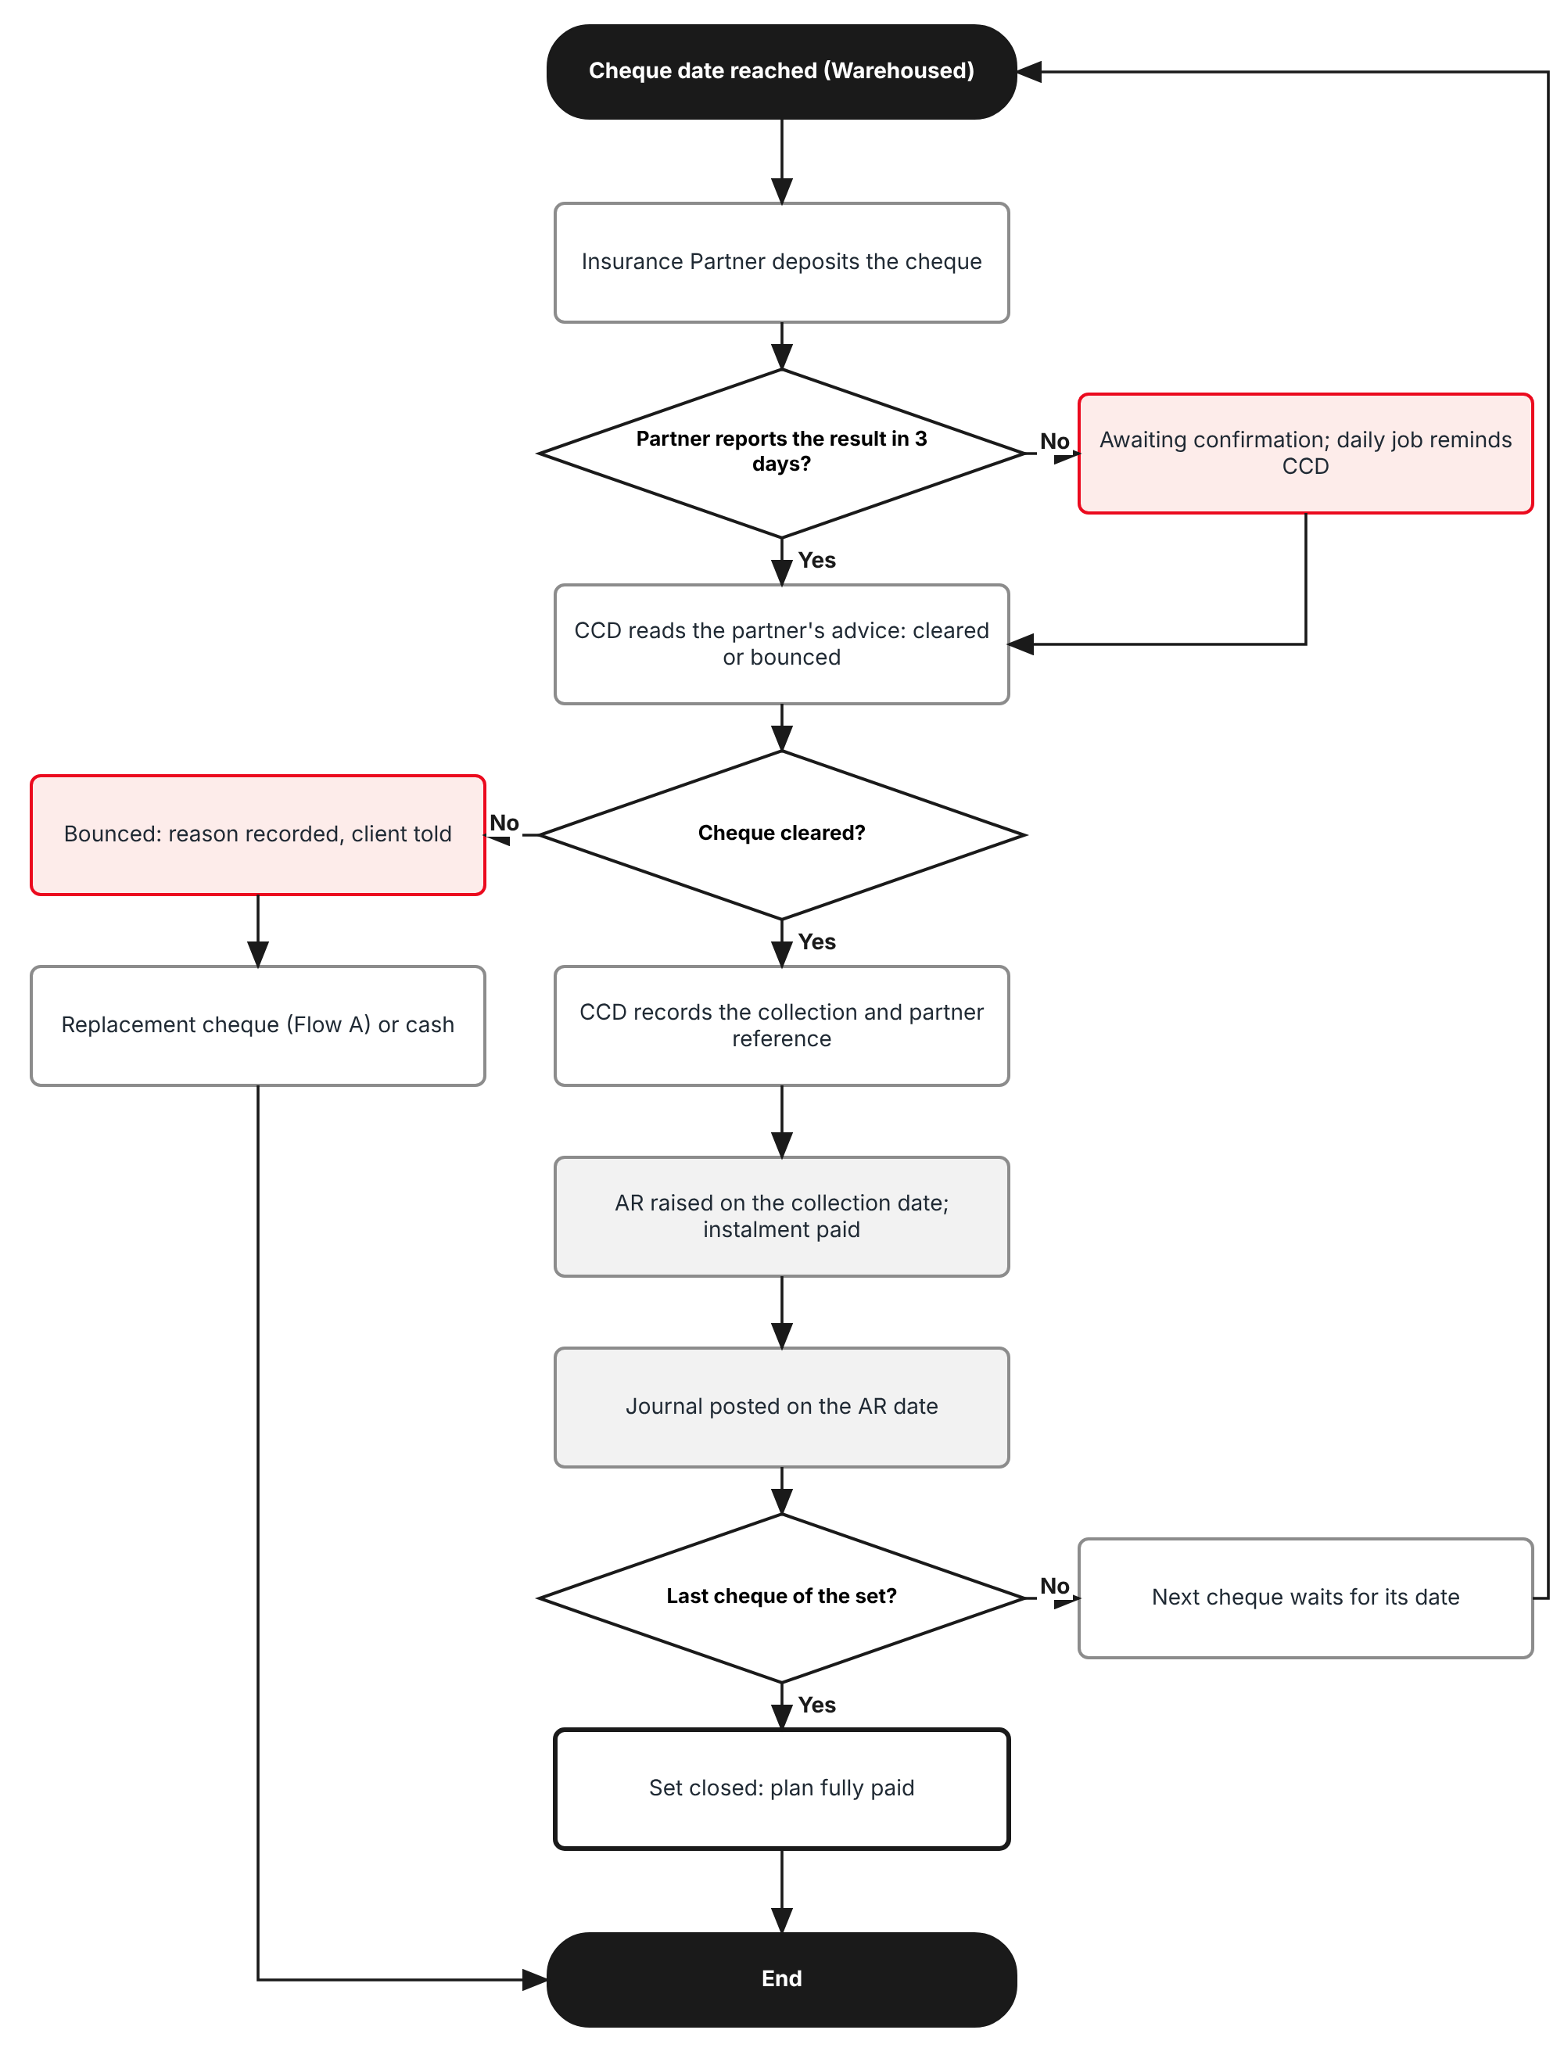
Figure 2: Flow B - Maturity advice, collection and AR
Table 4: Flow B steps
Step | Who (role) | What happens | FR
B1 | Insurance Partner | Deposits the cheque on its date and tells TISPH whether it cleared or bounced. | -
B2 | System | A Warehoused cheque past its date without an advice is shown as Awaiting confirmation and aged; after pdc.confirmation_grace_days (3) the job reminds CCD. | FR-PDC-021, 031
B3 | CCD officer | Partner cleared: enters the collection date and the partner reference. The cheque becomes Cleared. | FR-PDC-030
B4 | System | Raises the AR through Accounts > Receipts on the collection date, applies it to the bill (instalment paid) and posts the journal. | FR-PDC-050, 051
B5 | CCD officer | Partner bounced: enters the reason. Any AR of the cheque is cancelled, the instalment is open again and the client is told. | FR-PDC-032
B6 | CCD officer | Encodes the replacement cheque in the same set (Flow A) or the client pays the instalment another way. | FR-PDC-041
B7 | System | When every cheque of the set is Cleared, Cancelled or Replaced, the set is Closed. | FR-PDC-003

2.3 Flow C - Cancel, pull out and replace
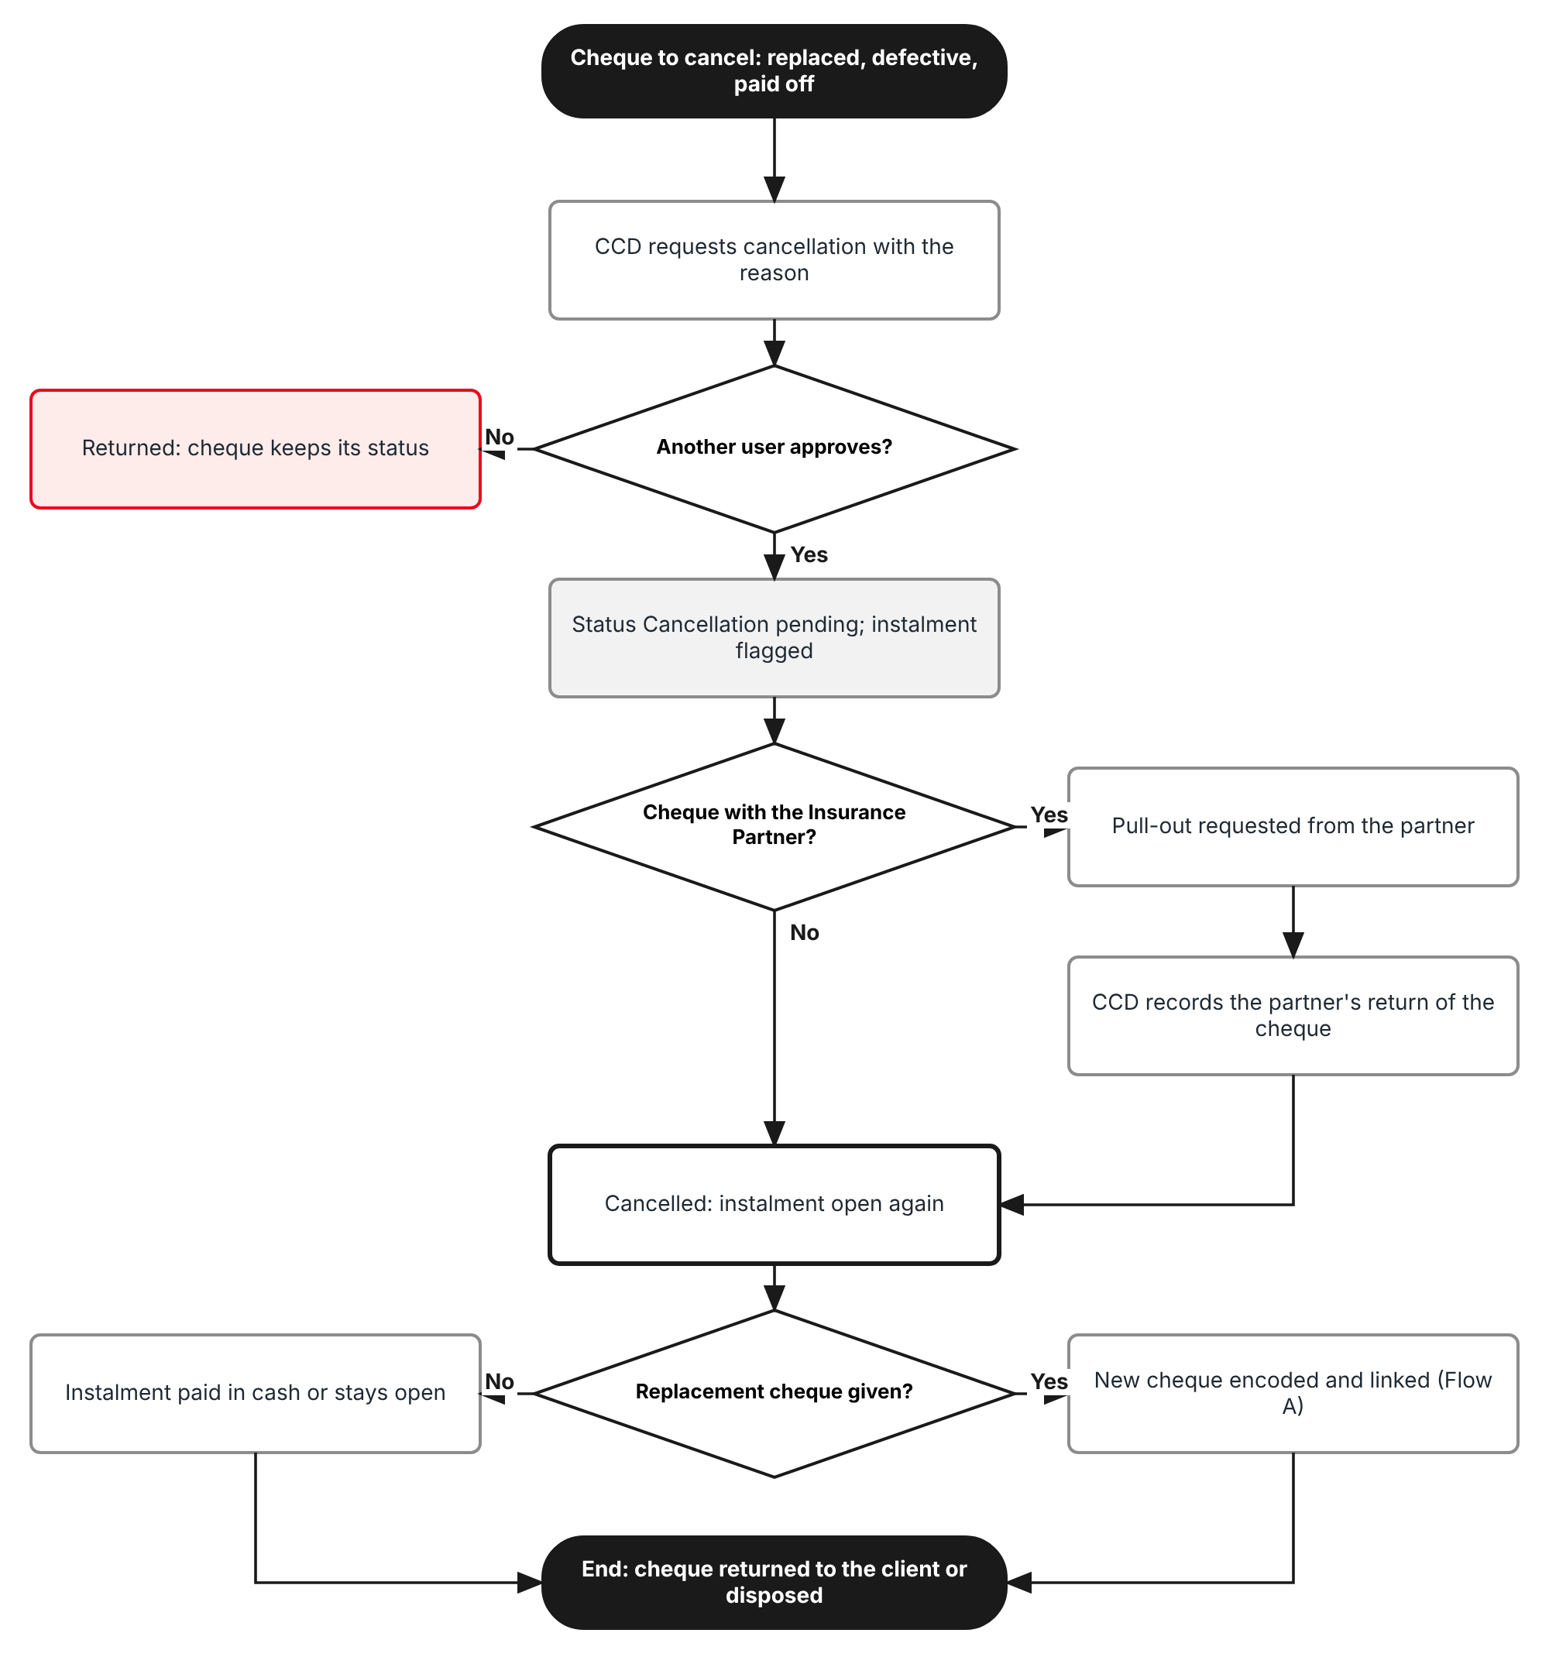
Figure 3: Flow C - Cancel, pull out and replace a cheque
Table 5: Flow C steps
Step | Who (role) | What happens | FR
C1 | CCD officer | Requests cancellation of a cheque with a reason from the list (Cash replacement, Cheque replacement, Technical defect, Policy cancelled, Account paid off, Encoded in error). | FR-PDC-040
C2 | CCD head (approve:pdc) | Approves or returns the request from My Work > Approvals. The requester can never approve it. | FR-PDC-040
C3 | System | The cheque is Cancellation pending. If the Insurance Partner holds it, a pull-out is listed on the next transmittal to that partner. | FR-PDC-040
C4 | CCD officer | Records the partner's return of the cheque. The cheque becomes Cancelled and its instalment is open again. | FR-PDC-040
C5 | CCD officer | Encodes the replacement cheque linked to the cancelled one, or hands the cancelled cheque back to the client (Returned). | FR-PDC-041, 042

2.4 What the log tracks
Table 6: PDC dimensions
Dimension | Values | Where in BrokerVerse
Payee | Insurance Partner (forwarded, default); TISPH (retained) | Encode PDCs > Payee
Insurance Partner | The insurer of the policy | Master > Insurance > Insurance Company; policy
Custody | TIS vault (folder); Insurance Partner; Returned to client | Post-Dated Cheques > Custody
Instalment | Instalment number and due date of the plan | Accounts > Credit Control > Instalment Plans
Drawee bank | Bank of the client's cheque, with branch, account number and BRSTN | Master > Finance > Bank
Collection bank (retained cheques) | One TISPH bank account | Setting pdc.default_deposit_account
Ageing | Current, 1-30, 31-60, 61-90, Over 90 days after the cheque date | Setting limits.receivable_ageing_buckets

3 Personas and roles

3.1 Personas
BrokerVerse ships eight roles (Master > Users and Access > Role). TISPH personas map to them as below; TISPH can add its own role (for example Cash Control) and grant it the permissions of section 3.2.
Table 7: Personas and BrokerVerse roles
TISPH persona | BrokerVerse role | What they do with PDCs
CCD officer (maker) | Accounting - accounting (or a TISPH Cash Control role) | Encodes sets, forwards cheques, records the partner's receipt and maturity advices, requests cancellations, records collections
CCD head (checker) | Accounting Manager - accounting-manager | Approves or returns cancellation requests; reviews the log and the ageing
FGA | Accounting - accounting | Sees the AR and the journal; sets up instalment plans
TISPH Operations | Operations (Client Servicing) - operations | Reads the log to answer client questions; tells CCD about policy cancellations
Auditor | Compliance Officer (AML/CFT) - compliance-officer | Read-only access to the log, history and Audit Trail
System Administrator | System Administrator (Super Admin Access) - system-admin | Roles, permissions, configuration keys, lists of values, schedules

3.2 New permissions
New permissions follow the BrokerVerse pattern read:<module> / write:<module> / approve:<module> and are granted on Master > Users and Access > Role Permissions. They replace read:receipts and write:receipts on the Post-Dated Cheques screen; every role that has those two today is granted the new ones, so nobody loses access. Recording a collection also needs write:receipts, because it raises a receipt.
Table 8: New permissions
Permission | Allows
read:pdc | Open Accounts > Post-Dated Cheques, a set, a transmittal and the history of a cheque; Export
write:pdc | Encode sets, edit a cheque still Received at TIS, forward, record partner receipt and maturity advices, request cancellation, record a pull-out, replace, return
approve:pdc | Approve or return a cancellation request (never one you requested)

3.3 Default grants
Table 9: Default grants (Y = granted)
Permission | system-admin | accounting | accounting-manager | operations | compliance-officer | sales | processing
read:pdc | Y | Y | Y | Y | Y | - | -
write:pdc | Y | Y | Y | - | - | - | -
approve:pdc | Y | - | Y | - | - | - | -

Segregation of duties. The Accounting Manager role includes the Accounting role, so a CCD head can also encode. The user who requested a cancellation can never approve it, even when the same user holds approve:pdc (maker-checker rule of BrokerVerse).

4 Functional requirements
Nineteen FRs implement COLL-05. They follow the life of a cheque: acceptance and encoding (4.1), forwarding to the Insurance Partner (4.2), the tracking log (4.3), maturity advices (4.4), cancellation, replacement and return (4.5), the AR on collection (4.6), and access (4.7).

4.1 Acceptance and encoding

FR-PDC-001 Encode a set of PDCs against the instalment plan of a bill
BRD trace | COLL-05 "tracked by due date against the instalment schedule"; COLL-01 (PDC instalments up to 12 months) | Actor | CCD officer (write:pdc)
Priority | Must have | Fit | Customization
Screens | Accounts > Post-Dated Cheques > Encode PDCs (new side panel, replaces Register cheque as the main button)

Description
A new button Encode PDCs opens a side panel in the layout of the existing Register cheque panel. The CCD officer enters the Policy number; the panel shows the client, the Insurance Partner and the open bills of the policy. The officer picks the Bill. When the bill has an active plan on Accounts > Credit Control > Instalment Plans, the panel lists one row per unpaid instalment with its number, due date and amount, and the officer fills in the cheque of each row (FR-PDC-002).
A client normally gives all cheques of a plan at once, so one save creates one PDC set (PS-YYYY-NNNNN) and one PDC record (PDC-YYYY-NNNNN, existing series) per row. A row can be left out when the client pays that instalment another way (for example the first month in cash); it is then not part of the set. The Received date defaults to today and the Received by to the user.
A bill without a plan can still take a single cheque, as today: the panel shows one row for the bill balance. This is the case of a full payment by one dated-ahead cheque.
Preconditions
- The user has write:pdc.
- The policy is issued, broker billed, and has an open bill.
Main flow
- The user opens Accounts > Post-Dated Cheques and clicks Encode PDCs.
- The user enters the policy number; the panel fills Client, Insurance Partner and the list of open bills.
- The user selects the bill. The rows of the unpaid instalments appear with Instalment, Due date and Amount read-only.
- The user sets Payee (Insurance Partner by default, FR-PDC-004), Custody (TIS vault folder) and fills each row (FR-PDC-002).
- The user clicks Save set. The server checks every row, creates the set and its cheques in status Received at TIS and shows "Set <PS number> saved with <n> cheques, <amount>".
Alternate and exception flows
- Copy bank details down: the bank, branch, account number and BRSTN of row 1 are copied to the other rows; cheque numbers run on from the first (0045121, 0045122 ...). The user can change any row.
- Remove row: the instalment is left out of the set; at least one row must stay.
- Add to an existing set: from a set with a cancelled or bounced cheque, Encode PDCs opens on that set with the open instalments only (used for replacements, FR-PDC-041).
Business rules
Rule | Statement | Kind | Maintained in
R1 | One set per bill per acceptance; one cheque per instalment. A plan of up to 12 monthly instalments gives up to 12 rows (pdc.max_cheques_per_set, default 12). | Configurable | Master > System > Configuration
R2 | The amount of a row is the outstanding amount of its instalment and is read-only. A bill without a plan takes one cheque of at most the bill balance. | Fixed | -
R3 | The cheques of a bill that are Received, Forwarded, Warehoused or Deposited cannot add up to more than the bill balance (existing rule of the register). | Fixed | -
R4 | Nothing is posted when a set is saved. The journal follows the AR (FR-PDC-050, 051). | Fixed | -

Validations and messages
Check | Message shown | ID
Policy not found | Policy <policy> not found | MSG-PDC-001
Direct-billed policy | Policy <policy> is direct billed: the client pays the insurer, not TISPH | MSG-PDC-002
No open bill | Policy <policy> has no open bill to pay | MSG-PDC-003
No row left | Keep at least one cheque in the set | MSG-PDC-004
Too many rows | A set can hold at most <n> cheques | MSG-PDC-005
Above the balance | Bill <bill> has <amount> left after the cheques already encoded; this set is <amount> | MSG-PDC-006
Saved | Set <set> saved with <n> cheques, <amount> | MSG-PDC-007

Audit
- Written to Master > System > Audit Trail (entity post_dated_cheque) with the user, time, before and after values and remark; shown on the History tab of the cheque (FR-PDC-022).
Acceptance criteria
- For POL-2026-90004 (Andrea Villanueva, Standard Insurance Co., Inc.) with a plan of 4 monthly instalments of 12,787.50 due 15/10/2026 to 15/01/2027, Encode PDCs shows 4 rows with those dates and amounts.
- Saving the 4 rows creates set PS-2026-00031 and cheques PDC-2026-00121 to PDC-2026-00124, all Received at TIS, and posts no journal.
- Removing row 1 (paid in cash) saves a set of 3 cheques for 38,362.50.
- A direct-billed policy is refused with "Policy <policy> is direct billed: the client pays the insurer, not TISPH".
- A bill without a plan shows one row for its balance.

FR-PDC-002 Capture the cheque details and refuse duplicates
BRD trace | COLL-05 "post-dated cheques ... tracked" | Actor | CCD officer (write:pdc)
Priority | Must have | Fit | Customization
Screens | Accounts > Post-Dated Cheques > Encode PDCs (rows); cheque detail > Edit

Description
Each row holds the details CCD keeps for a cheque today: Drawee bank (Master > Finance > Bank, for example BPI, Metrobank, Security Bank; or typed when not in the list, as today), Branch, Account number, BRSTN, Cheque number, Cheque date and the read-only Amount. The server checks every row before anything is saved; a row in error is marked and its message shown under the field.
A cheque still Received at TIS can be corrected from its detail (Edit); once forwarded, only the remarks and custody folder can change. Every change is kept in the history of the cheque.
Business rules
Rule | Statement | Kind | Maintained in
R1 | Cheque number: digits only, 6 to 10 characters. The same bank and cheque number cannot be encoded twice unless the first one is Cancelled (existing unique rule of the register). | Fixed | -
R2 | BRSTN: 9 digits. Optional, but required when pdc.brstn_required is true (default false). | Configurable | Master > System > Configuration
R3 | Cheque date: later than the received date (a PDC), and within pdc.date_tolerance_days (default 5) of the instalment due date. A cheque dated today or earlier is not a PDC: it is receipted as a normal cheque payment. | Configurable | Master > System > Configuration
R4 | Cheque dates of a set run in the order of the instalments; two rows cannot carry the same cheque number. | Fixed | -

Validations and messages
Check | Message shown | ID
Bank blank | Row <n>: choose the drawee bank | MSG-PDC-008
Cheque number format | Row <n>: cheque number must be 6 to 10 digits | MSG-PDC-009
Duplicate in the set | Row <n>: cheque <cheque> is already on row <m> | MSG-PDC-010
Duplicate in the log | Row <n>: cheque <cheque> of <bank> is already encoded as <pdc> | MSG-PDC-011
BRSTN format | Row <n>: BRSTN must be 9 digits | MSG-PDC-012
Not post-dated | Row <n>: the cheque is dated <date>, not after the received date. Receipt it as a cheque payment | MSG-PDC-013
Date far from the instalment | Row <n>: cheque date <date> is more than <d> days from the instalment due date <due> | MSG-PDC-014
Edit after forwarding | Cheque <pdc> is <status>; only the remarks and custody folder can be changed | MSG-PDC-015

Audit
- Written to Master > System > Audit Trail (entity post_dated_cheque) with the user, time, before and after values and remark; shown on the History tab of the cheque (FR-PDC-022).
Acceptance criteria
- Row 2 with cheque number 45121 (5 digits) is refused with "Row 2: cheque number must be 6 to 10 digits".
- Cheque 0045121 of BPI already encoded as PDC-2026-00121 is refused on a new set.
- A row dated 25/11/2026 for an instalment due 15/11/2026 is refused (tolerance 5 days).
- A cheque Forwarded cannot have its amount or date edited.

FR-PDC-003 Keep the PDC set and close it when every cheque is settled
BRD trace | COLL-05 "tracked ... against the instalment schedule" | Actor | System; CCD officer
Priority | Must have | Fit | Customization
Screens | Accounts > Post-Dated Cheques > set detail (opened from the Set column)

Description
The set groups the cheques of one acceptance: client, policy, bill, Insurance Partner, payee, received date, received by, number of cheques, total, first and last cheque date (the end of term), and the status of each cheque. It is the data the acknowledgement print reads.
A set is Open while any cheque is Received, Forwarded, Warehoused, Deposited, Bounced or Cancellation pending, and becomes Closed when every cheque is Cleared, Cancelled, Replaced or Returned. A set whose cheques were all cancelled before forwarding is Cancelled.
Business rules
Rule | Statement | Kind | Maintained in
R1 | Set statuses: Open, Closed, Cancelled (chapter 5). | Fixed | -
R2 | The set shows, per instalment, the cheque that pays it now (after replacements) and the cheques it replaced. | Fixed | -

Audit
- Written to Master > System > Audit Trail (entity post_dated_cheque) with the user, time, before and after values and remark; shown on the History tab of the cheque (FR-PDC-022).
Acceptance criteria
- PS-2026-00031 is Open while PDC-2026-00124 (due 15/01/2027) is Warehoused.
- When the 4th cheque is Cleared the set becomes Closed.
- Opening the set shows instalment 2 paid by replacement PDC-2026-00140, with PDC-2026-00122 Cancelled (Cheque replacement) under it.

FR-PDC-004 Set the payee: forward to the Insurance Partner or retain at TISPH
BRD trace | COLL-05 "processed by payee (forwarded or retained)"; TISPH remark "one bank"; COLL-01 (TIS-direct vs Insurance-Company-direct) | Actor | CCD officer (write:pdc)
Priority | Must have | Fit | Customization
Screens | Accounts > Post-Dated Cheques > Encode PDCs > Payee

Description
Payee says whom the cheques are made out to. Insurance Partner (default, setting pdc.default_payee) means the cheques are forwarded to the insurer of the policy for warehousing (FR-PDC-010). TISPH means the cheques are retained in the TIS vault and deposited by TISPH on their date with the existing Deposit, Cleared and Bounced actions of the register, on the one TISPH collection bank account (setting pdc.default_deposit_account).
The payee is set for the whole set and shown on each cheque. The Insurance Partner is always the insurer of the policy and cannot be changed.
Business rules
Rule | Statement | Kind | Maintained in
R1 | Payee values: Insurance Partner; TISPH. Default pdc.default_payee = insurance-partner. | Configurable | Master > System > Configuration
R2 | Retained cheques are deposited only to the account in pdc.default_deposit_account (one bank). The Deposit panel shows it read-only. | Configurable | Master > System > Configuration
R3 | Forward to Insurance Partner is offered only for payee Insurance Partner; Deposit only for payee TISPH. | Fixed | -

Validations and messages
Check | Message shown | ID
No collection account for TISPH | No TISPH collection bank account is set (pdc.default_deposit_account) | MSG-PDC-016

Audit
- Written to Master > System > Audit Trail (entity post_dated_cheque) with the user, time, before and after values and remark; shown on the History tab of the cheque (FR-PDC-022).
Acceptance criteria
- A set saved with the default payee shows Payee Insurance Partner, Standard Insurance Co., Inc. on each cheque and offers Forward, not Deposit.
- A set with payee TISPH offers Deposit; the deposit account is the account of pdc.default_deposit_account and cannot be changed.

4.2 Forwarding to the Insurance Partner

FR-PDC-010 Forward cheques to the Insurance Partner with a transmittal
BRD trace | COLL-05 "forwarded"; CR-07 note "forwarded to the Insurance Partners for warehousing" | Actor | CCD officer (write:pdc)
Priority | Must have | Fit | Customization
Screens | Accounts > Post-Dated Cheques > tab At TIS > select > Forward to Insurance Partner (new side panel)

Description
On the At TIS tab the officer ticks the cheques to send and clicks Forward to Insurance Partner. The panel lists the ticked cheques with their totals and asks for the Forwarded date (default today), Sent by (courier, messenger or hand carry), the Courier reference and remarks. On Forward the server creates one transmittal (PT-YYYY-NNNNN) for the partner and sets the cheques to Forwarded with custody "In transit to <partner>".
The transmittal also carries the pull-out requests open for that partner (FR-PDC-040), so the partner sees in one list what it receives and what it must send back. Export to Excel on the transmittal gives the list to send with the cheques, in the base export format.
Preconditions
- The cheques are Received at TIS with payee Insurance Partner.
Business rules
Rule | Statement | Kind | Maintained in
R1 | One transmittal goes to one Insurance Partner; cheques of several partners cannot be ticked together. | Fixed | -
R2 | A cheque can be on only one open transmittal. | Fixed | -
R3 | Transmittal statuses: Sent, Partly received, Received (chapter 5). | Fixed | -

Validations and messages
Check | Message shown | ID
Nothing ticked | Tick the cheques to forward | MSG-PDC-017
Several partners | The ticked cheques belong to <n> Insurance Partners. Forward one partner at a time | MSG-PDC-018
Wrong status or payee | Cheque <pdc> is <status> with payee <payee>; only cheques Received at TIS with payee Insurance Partner are forwarded | MSG-PDC-019
Forwarded date in the future | Forwarded date cannot be in the future | MSG-PDC-020
Forwarded | <n> cheques forwarded to <partner> on transmittal <transmittal> | MSG-PDC-021

Audit
- Written to Master > System > Audit Trail (entity post_dated_cheque) with the user, time, before and after values and remark; shown on the History tab of the cheque (FR-PDC-022).
Acceptance criteria
- Forwarding PDC-2026-00121 to 00124 on 12/10/2026 creates PT-2026-00008 for Standard Insurance Co., Inc., total 51,150.00, and sets the 4 cheques to Forwarded.
- Ticking a cheque of Standard and one of Pioneer is refused.
- The transmittal export lists the 4 cheques with client, policy, bank, cheque no., date and amount, and any open pull-out for Standard.

FR-PDC-011 Record the Insurance Partner's receipt of the cheques (warehousing)
BRD trace | COLL-05; CR-07 note "confirmation tracking" | Actor | CCD officer (write:pdc)
Priority | Must have | Fit | Customization
Screens | Accounts > Post-Dated Cheques > transmittal detail > Partner received

Description
When the Insurance Partner acknowledges the transmittal (signed copy or e-mail), the officer opens the transmittal and clicks Partner received: Received on, Received by (name at the partner), Partner reference and, optionally, the scanned acknowledgement (base document upload). All cheques of the transmittal, or only the ticked ones, become Warehoused with custody "<partner>".
A cheque the partner says it did not receive stays Forwarded and is listed by the follow-up job (FR-PDC-012).
Business rules
Rule | Statement | Kind | Maintained in
R1 | Received on cannot be before the forwarded date nor in the future. | Fixed | -
R2 | The transmittal becomes Received when all its cheques are Warehoused, otherwise Partly received. | Fixed | -

Validations and messages
Check | Message shown | ID
Received date order | Received on cannot be before the forwarded date <date> | MSG-PDC-022
Received by blank | Enter who received the cheques at the Insurance Partner | MSG-PDC-023
Recorded | <n> cheques of transmittal <transmittal> are warehoused with <partner> | MSG-PDC-024

Audit
- Written to Master > System > Audit Trail (entity post_dated_cheque) with the user, time, before and after values and remark; shown on the History tab of the cheque (FR-PDC-022).
Acceptance criteria
- Partner received on 14/10/2026 by J. Dizon, reference SICI-TR-1045, sets the 4 cheques of PT-2026-00008 to Warehoused and the transmittal to Received.
- Receiving 3 of 4 cheques leaves PT-2026-00008 Partly received and the 4th cheque Forwarded.

FR-PDC-012 Follow up cheques the Insurance Partner has not confirmed
BRD trace | COLL-05; CR-07 note "confirmation tracking" | Actor | System (daily job); CCD officer
Priority | Must have | Fit | Customization
Screens | Master > System > Schedules (job "PDC follow-up"); Accounts > Post-Dated Cheques > tab Follow-up

Description
A new job PDC follow-up (daily 06:35 Manila time, one run across instances like the other base jobs) finds: cheques Forwarded more than pdc.forward_ack_days (default 5) days ago without the partner's receipt; Warehoused cheques more than pdc.confirmation_grace_days (default 3) days past their date without a maturity advice; and Cancellation pending cheques waiting for a pull-out more than pdc.forward_ack_days days. It sends one notification to users with write:pdc ("<n> post-dated cheques need follow-up") linking to the tab Follow-up, which lists the cheques with the reason and the Insurance Partner.
The existing job "Post-dated cheques due" keeps reminding about retained cheques due for deposit only.
Business rules
Rule | Statement | Kind | Maintained in
R1 | pdc.forward_ack_days default 5; pdc.confirmation_grace_days default 3. Calendar days. | Configurable | Master > System > Configuration
R2 | No notification is sent when nothing needs follow-up. | Fixed | -

Audit
- Written to Master > System > Audit Trail (entity post_dated_cheque) with the user, time, before and after values and remark; shown on the History tab of the cheque (FR-PDC-022).
Acceptance criteria
- A cheque forwarded on 12/10/2026 and not received by the partner appears in Follow-up on 18/10/2026 with the reason "Forwarded 6 days ago, receipt not confirmed".
- A Warehoused cheque dated 15/11/2026 without an advice appears on 19/11/2026 with "4 days past date, no maturity advice".
- The job of a day with nothing to follow up sends no notification.

4.3 Tracking log

FR-PDC-020 Show the PDC tracking log with status tabs, filters and export
BRD trace | COLL-05 "tracked by due date"; CR-07 note "logging and tracking" | Actor | Any user with read:pdc
Priority | Must have | Fit | Customization
Screens | Accounts > Post-Dated Cheques (list, changed)

Description
The register page keeps its title and place in the menu. Its summary line shows At TIS, With partners, Due this week, Awaiting confirmation and Bounced, with counts and amounts. The tabs filter by status: All open, At TIS, With partners (Forwarded and Warehoused), Awaiting confirmation, Follow-up, Bounced, Cancellation pending and Closed, each with its count; the existing Deposit due tab stays for retained cheques.
Each row shows PDC no., Set, Client, Policy, Instalment (n of m), Insurance Partner, Drawee bank, Cheque no., Cheque date, Amount, Custody, Status, Ageing and AR. Filters: Insurance Partner, payee, cheque date from / to, received date from / to, status and the search box (PDC, set, cheque, client, policy or bill). Export to Excel downloads the filtered rows with every field of the cheque.
Business rules
Rule | Statement | Kind | Maintained in
R1 | Default sort: cheque date ascending, then PDC no.; 20 rows per page (base default). | Fixed | -
R2 | Due this week: cheques not yet Cleared whose date falls within 7 days from today. | Fixed | -

Audit
- Written to Master > System > Audit Trail (entity post_dated_cheque) with the user, time, before and after values and remark; shown on the History tab of the cheque (FR-PDC-022).
Acceptance criteria
- The With partners tab lists the 4 cheques of PS-2026-00031 once forwarded, with custody Standard Insurance Co., Inc.
- Filter Insurance Partner = Pioneer Insurance & Surety Corp. and cheque date 01/11/2026 to 30/11/2026 lists only Pioneer cheques of November.
- Export to Excel gives the same rows as the screen, with bank, branch, account number and BRSTN.

FR-PDC-021 Age cheques not yet confirmed against the instalment schedule
BRD trace | COLL-05 "ageing buckets (current, 1-30, 31-60, 61-90, 90+)" | Actor | System
Priority | Must have | Fit | Customization
Screens | Accounts > Post-Dated Cheques (Ageing column and the ageing line above the table)

Description
Each cheque that is not Cleared, Cancelled, Replaced or Returned gets an Ageing value from the days since its cheque date: Current when the date is not reached, then 1-30, 31-60, 61-90 and Over 90, the buckets BrokerVerse already uses for instalments and receivables. A line above the table shows the amount in each bucket for the rows on screen.
Because each cheque is linked to its instalment, the ageing of the cheque and of the instalment on Instalment Plans tell the same story: a Warehoused cheque 40 days past its date without an advice is in 31-60, and its instalment is 40 days past due.
Business rules
Rule | Statement | Kind | Maintained in
R1 | Bucket limits from limits.receivable_ageing_buckets (existing, 30 / 60 / 90). | Configurable | Master > System > Configuration
R2 | Ageing is computed on the screen date and is not stored. | Fixed | -

Audit
- Written to Master > System > Audit Trail (entity post_dated_cheque) with the user, time, before and after values and remark; shown on the History tab of the cheque (FR-PDC-022).
Acceptance criteria
- On 09/10/2026 a cheque dated 15/10/2026 shows Current.
- On 20/12/2026 a Warehoused cheque dated 15/11/2026 without an advice shows 31-60.
- A Cleared cheque shows no ageing.

FR-PDC-022 Keep the history of every cheque
BRD trace | COLL-05 tracking log; BRD section 5.14 audit | Actor | System
Priority | Must have | Fit | Customization
Screens | Accounts > Post-Dated Cheques > cheque detail > History tab; Master > System > Audit Trail

Description
Every create, edit, forward, partner receipt, maturity advice, cancellation request and decision, pull-out, replacement, return, collection and AR on a cheque is written to the Audit Trail as for any base record. The History tab of a cheque lists them newest first: Field, Date and time, User code, User name, Previous value, New value and Remark (for example PDC status, Warehoused to Cancellation pending, remark "Cheque replacement").
Audit
- Written to Master > System > Audit Trail (entity post_dated_cheque) with the user, time, before and after values and remark; shown on the History tab of the cheque (FR-PDC-022).
Acceptance criteria
- The History of PDC-2026-00122 lists its encoding, forwarding, warehousing, the cancellation request with reason Cheque replacement, its approval and the pull-out return, each with user and time.
- Changing the custody folder from "Vault A-12" to "Vault A-14" shows both values in the History.

4.4 Maturity advices

FR-PDC-030 Record the Insurance Partner's advice that a cheque cleared
BRD trace | COLL-05 "official AR on actual collection"; CR-07 note "confirmation tracking, AR on receipt" | Actor | CCD officer (write:pdc and write:receipts)
Priority | Must have | Fit | Customization
Screens | Accounts > Post-Dated Cheques > row action Partner cleared (side panel); tab Awaiting confirmation

Description
When the Insurance Partner confirms that a cheque cleared, the officer clicks Partner cleared on the row: Collection date (the date the partner's bank cleared the cheque), Partner reference (the partner's official receipt or deposit reference) and remarks. On save the cheque becomes Cleared and the AR is raised at once (FR-PDC-050).
The officer can tick several Warehoused cheques of the same partner and the same collection date and record them together; one AR is raised per cheque.
Preconditions
- The cheque is Warehoused (or Forwarded, when the partner's receipt was never recorded) and its date is reached.
Business rules
Rule | Statement | Kind | Maintained in
R1 | Collection date: on or after the cheque date, not in the future, and in an open accounting period (Period Management). | Fixed | -
R2 | A cheque Forwarded but never recorded as received is warehoused and cleared in one step, and the History says so. | Fixed | -

Validations and messages
Check | Message shown | ID
Before the cheque date | Collection date cannot be before the cheque date <date> | MSG-PDC-025
Future date | Collection date cannot be in the future | MSG-PDC-026
Closed period | The period of <date> is closed | MSG-PDC-027
Reference blank | Enter the Insurance Partner's reference | MSG-PDC-028
Wrong status | Cheque <pdc> is <status>; only a cheque with the Insurance Partner is cleared here | MSG-PDC-029
Cleared | Cheque <pdc> cleared; AR <ar> raised | MSG-PDC-030

Audit
- Written to Master > System > Audit Trail (entity post_dated_cheque) with the user, time, before and after values and remark; shown on the History tab of the cheque (FR-PDC-022).
Acceptance criteria
- Partner cleared on PDC-2026-00121 with collection date 16/10/2026 and partner reference 7781204 sets it to Cleared and raises AR OR-2026-00213 for 12,787.50.
- A collection date of 14/10/2026 for a cheque dated 15/10/2026 is refused.
- Ticking 3 Warehoused Standard cheques cleared on 15/11/2026 raises 3 ARs.

FR-PDC-031 Show cheques awaiting the partner's advice
BRD trace | CR-07 note "confirmation tracking" | Actor | System
Priority | Must have | Fit | Customization
Screens | Accounts > Post-Dated Cheques > tab Awaiting confirmation

Description
The tab Awaiting confirmation lists Warehoused and Forwarded cheques whose date has passed and for which no advice is recorded, with the Insurance Partner, the days past the date and the ageing. It is the CCD's daily worklist for chasing the partners; the follow-up job (FR-PDC-012) adds the ones past the grace period to Follow-up.
Audit
- Written to Master > System > Audit Trail (entity post_dated_cheque) with the user, time, before and after values and remark; shown on the History tab of the cheque (FR-PDC-022).
Acceptance criteria
- On 16/11/2026 PDC-2026-00122 (dated 15/11/2026, Warehoused) is listed with 1 day past date.
- It leaves the tab when Partner cleared or Partner bounced is recorded.

FR-PDC-032 Record a cheque the Insurance Partner reports as bounced
BRD trace | COLL-05; COLL-06 "partner-collected bounces are reported back by the partner" | Actor | CCD officer (write:pdc)
Priority | Must have | Fit | Customization
Screens | Accounts > Post-Dated Cheques > row action Partner bounced (side panel)

Description
When the partner reports a bounce, the officer clicks Partner bounced: Bounced on, Reason (list: DAIF - drawn against insufficient funds, Account closed, Stop payment, Signature differs, Stale or post-dated, Other) and remarks. The cheque becomes Bounced; its instalment is open again. If an AR was already raised (the partner first said cleared), the AR is cancelled with the base receipt cancellation (journal reversed, bill open again).
As for bounced cheques today, users with write:pdc are notified and the client is e-mailed with the template pdc_bounced when pdc.notify_client_on_bounce is on. The bounced cheque is then replaced (FR-PDC-041) or the instalment is paid another way.
Business rules
Rule | Statement | Kind | Maintained in
R1 | Bounce reasons: list of values (chapter 6). | Configurable | List of values
R2 | The base bounce charge field is not used for forwarded cheques: the partner charges the client directly. | Fixed | -

Validations and messages
Check | Message shown | ID
Reason blank | Choose the reason given by the Insurance Partner | MSG-PDC-031
Wrong status | Cheque <pdc> is <status>; only a cheque with the Insurance Partner or cleared can bounce | MSG-PDC-032
Bounced | Cheque <pdc> marked bounced | MSG-PDC-033

Audit
- Written to Master > System > Audit Trail (entity post_dated_cheque) with the user, time, before and after values and remark; shown on the History tab of the cheque (FR-PDC-022).
Acceptance criteria
- Partner bounced on PDC-2026-00123 with reason DAIF sets it to Bounced, opens instalment 3 again and e-mails Andrea Villanueva.
- A bounce on a cheque already Cleared cancels its AR and the bill balance goes up by 12,787.50.

4.5 Cancellation, replacement and return

FR-PDC-040 Request, approve and complete the cancellation of a cheque
BRD trace | COLL-05; CR-07 note "cancellation and confirmation tracking"; SEC-03 maker-checker | Actor | CCD officer (write:pdc); CCD head (approve:pdc)
Priority | Must have | Fit | Customization
Screens | Accounts > Post-Dated Cheques > row action Request cancellation; My Work > Approvals (item kind "PDC cancellation"); transmittal > Partner returned

Description
A cheque that is Received at TIS, Forwarded, Warehoused or Bounced can be cancelled. The officer clicks Request cancellation, chooses the Reason (Cash replacement, Cheque replacement, Technical defect - no signature, Technical defect - other, Policy cancelled, Account paid off, Encoded in error) and adds remarks. The cheque becomes Cancellation pending and an item is raised in My Work > Approvals for users with approve:pdc.
The approver Approves or Returns the request (remark required to return). A returned request puts the cheque back in its earlier status. On approval: a cheque at TIS or Bounced becomes Cancelled at once; a cheque Forwarded or Warehoused stays Cancellation pending with "Pull-out requested from <partner>", is listed on the next transmittal to that partner, and becomes Cancelled when the officer records Partner returned (date and partner reference). A cancelled cheque's instalment is open again.
Preconditions
- The cheque has no AR (a Cleared cheque is not cancelled; a collection recorded in error is reversed with the base receipt cancellation first).
Business rules
Rule | Statement | Kind | Maintained in
R1 | The requester can never approve the request. | Fixed | -
R2 | Cancellation reasons: list of values (chapter 6); "Cheque replacement" and "Cash replacement" ask whether a replacement follows (FR-PDC-041). | Configurable | List of values
R3 | Cancelled date and Cancelled by are the approval date and approver for a cheque at TIS, and the pull-out date and recording user for a cheque with the partner. | Fixed | -

Validations and messages
Check | Message shown | ID
Reason blank | Choose the reason for the cancellation | MSG-PDC-034
Cheque with an AR | Cheque <pdc> has AR <ar>. Cancel the AR on Accounts > Receipts first | MSG-PDC-035
Already pending | A cancellation of cheque <pdc> is already pending | MSG-PDC-036
Self-approval | Maker-checker: the approver must be different from the user who requested the cancellation | MSG-PDC-037
Return remark | Remark is required | MSG-PDC-038
Pull-out date | Returned on cannot be before the request was approved | MSG-PDC-039
Requested | Cancellation of cheque <pdc> sent for approval | MSG-PDC-040
Approved, pull-out needed | Cancellation approved. Pull-out requested from <partner> | MSG-PDC-041
Cancelled | Cheque <pdc> cancelled | MSG-PDC-042

Audit
- Written to Master > System > Audit Trail (entity post_dated_cheque) with the user, time, before and after values and remark; shown on the History tab of the cheque (FR-PDC-022).
Acceptance criteria
- A request on PDC-2026-00122 (Warehoused, Standard) with reason Cheque replacement is Cancellation pending; the requester cannot approve it.
- After approval by the CCD head the cheque shows "Pull-out requested from Standard Insurance Co., Inc." and is listed on the next transmittal to Standard.
- Partner returned on 05/11/2026 sets PDC-2026-00122 to Cancelled with Cancelled by the recording user and opens instalment 2 again.
- A request on a cheque Received at TIS becomes Cancelled on approval without a pull-out.
- A request on a Cleared cheque is refused.

FR-PDC-041 Replace a cancelled or bounced cheque
BRD trace | COLL-05; existing Replace of the register | Actor | CCD officer (write:pdc)
Priority | Must have | Fit | Customization
Screens | Accounts > Post-Dated Cheques > row action Replace; Encode PDCs on an existing set

Description
Replace on a Bounced cheque, or on a cheque cancelled with reason Cheque replacement, opens Encode PDCs on the same set with the open instalment of that cheque. The new cheque is linked both ways (Replaces / Replaced by) as in the base register, takes the payee of the set and goes through forwarding again. The old cheque becomes Replaced when it was Bounced; a cancelled cheque stays Cancelled with the link.
For Cash replacement the officer records nothing here: the instalment is paid on Accounts > Receipts and the log shows the cheque Cancelled with that reason.
Business rules
Rule | Statement | Kind | Maintained in
R1 | A replacement pays the same instalment; its amount is the instalment's outstanding amount. | Fixed | -

Validations and messages
Check | Message shown | ID
Not replaceable | Cheque <pdc> is <status>; only a bounced cheque or a cheque cancelled for a cheque replacement is replaced | MSG-PDC-043
Replaced | Replacement cheque <pdc> encoded in set <set> | MSG-PDC-044

Audit
- Written to Master > System > Audit Trail (entity post_dated_cheque) with the user, time, before and after values and remark; shown on the History tab of the cheque (FR-PDC-022).
Acceptance criteria
- Replacing PDC-2026-00122 creates PDC-2026-00140 in PS-2026-00031 for instalment 2, 12,787.50, Received at TIS, with the link shown on both cheques.
- Replacing the bounced PDC-2026-00123 sets it to Replaced.

FR-PDC-042 Return cheques to the client
BRD trace | COLL-05; existing Return of the register | Actor | CCD officer (write:pdc)
Priority | Must have | Fit | Customization
Screens | Accounts > Post-Dated Cheques > row action Return to client

Description
A Cancelled cheque back in TIS custody, or a cheque Received at TIS that is no longer needed (policy cancelled, account paid off), is handed back to the client with Return to client: date, returned to (name) and remarks. The cheque becomes Returned and its custody "Returned to client". Unclaimed cancelled cheques stay in the TIS vault until returned.
Validations and messages
Check | Message shown | ID
Not at TIS | Cheque <pdc> is with <custody>; only a cheque in the TIS vault can be returned to the client | MSG-PDC-045
Returned | Cheque <pdc> returned to the client | MSG-PDC-046

Audit
- Written to Master > System > Audit Trail (entity post_dated_cheque) with the user, time, before and after values and remark; shown on the History tab of the cheque (FR-PDC-022).
Acceptance criteria
- PDC-2026-00122, Cancelled and back from Standard, is returned to Andrea Villanueva on 08/11/2026 and shows Returned.
- Return on a Warehoused cheque is refused.

4.6 AR on actual collection

FR-PDC-050 Raise the acknowledgement receipt when a cheque is collected
BRD trace | COLL-05 "official AR on actual collection"; AR "issued on actual collection, not on receipt of a PDC"; COLL-03 | Actor | System
Priority | Must have | Fit | Customization
Screens | Accounts > Post-Dated Cheques (AR column); Accounts > Receipts; Operations > Policy (payment status)

Description
An AR is raised only when the money is actually collected: for a forwarded cheque when Partner cleared is recorded (FR-PDC-030), for a retained cheque when it is deposited (existing Deposit action). It is a receipt of Accounts > Receipts created through the receipts module, against the bill of the cheque: Receipt Mode Cheque, reference "Cheque <cheque no.> <bank>", receipt date = collection date (or deposit date), amount = cheque amount, remarks "PDC <pdc> of set <set>, instalment <n>".
For a forwarded cheque the receipt also carries Collected by: <Insurance Partner> and the partner reference. The receipt is applied to the bill and, through the plan, to the instalment of the cheque; the policy payment status follows as for any receipt (Partial, then Completed on the last instalment), and the referrer's commission becomes eligible when the premium is fully collected, as today.
The receipt is numbered from the receipt series of Master > Document Numbering and printed with the title of receipts.document_title, set to "Acknowledgement Receipt" for TISPH. The cheque row shows the AR number with a link to the receipt.
Business rules
Rule | Statement | Kind | Maintained in
R1 | One AR per cheque; never on encoding, forwarding or warehousing. | Fixed | -
R2 | AR number format and series: as TISPH sets it on Master > Document Numbering for the receipt series. | Configurable | Master > Document Numbering
R3 | receipts.document_title = "Acknowledgement Receipt". | Configurable | Master > System > Configuration

Audit
- Written to Master > System > Audit Trail (entity post_dated_cheque) with the user, time, before and after values and remark; shown on the History tab of the cheque (FR-PDC-022).
Acceptance criteria
- Partner cleared on PDC-2026-00121 raises AR OR-2026-00213 dated 16/10/2026, Receipt Mode Cheque, reference "Cheque 0045121 BPI", 12,787.50, Collected by Standard Insurance Co., Inc., applied to instalment 1.
- POL-2026-90004 payment status becomes Partial after the first AR and Completed after the fourth.
- Encoding and forwarding the set raise no AR and no receipt.

FR-PDC-051 Post the journal on the AR date only
BRD trace | COLL-05 "official AR on actual collection"; RPT-CCD-07 (no journal entries on receipt of a PDC; journal on posting of the AR when the PDC becomes due) | Actor | System
Priority | Must have | Fit | Customization
Screens | Master > Finance > Posting Rules (new rule pdc.partner_collected); Accounts > Receipts > journal of the receipt

Description
No journal is posted when a set is encoded, forwarded or warehoused, nor when a cancellation is approved. The journal is posted with the AR, on its date.
For a retained cheque the existing rule receipt.apply applies: Dr Cash in Bank (the TISPH collection account) / Cr Premiums Receivable. For a forwarded cheque the money is in the Insurance Partner's bank, so a new posting rule pdc.partner_collected (PDC collected by the Insurance Partner) applies: Dr Premium Payable to the Insurance Partner / Cr Premiums Receivable. The premium is then not remitted again by TISPH; TISPH's commission on it stays due from the partner as today.
Like every posting rule, the new rule is versioned and approved on Master > Finance > Configuration Approvals before it is used.
Business rules
Rule | Statement | Kind | Maintained in
R1 | Posting rule pdc.partner_collected: GL accounts from Master > Finance account set-up of the insurer; narration "Premium collected by <partner> - <policy> PDC <cheque no.>". | Configurable | Master > Finance > Posting Rules
R2 | Cancelling an AR reverses its journal (base receipt cancellation). | Fixed | -

Audit
- Written to Master > System > Audit Trail (entity post_dated_cheque) with the user, time, before and after values and remark; shown on the History tab of the cheque (FR-PDC-022).
Acceptance criteria
- The AR of PDC-2026-00121 posts Dr Premium Payable - Standard Insurance Co., Inc. 12,787.50 / Cr Premiums Receivable 12,787.50 on 16/10/2026.
- A retained cheque deposited on 15/10/2026 posts Dr Cash in Bank (TISPH collection account) / Cr Premiums Receivable on 15/10/2026.
- Saving and forwarding PS-2026-00031 creates no journal.

4.7 Access

FR-PDC-060 Control access to the PDC functions
BRD trace | SEC-01, SEC-02, SEC-03 | Actor | System Administrator
Priority | Must have | Fit | Customization
Screens | Master > Users and Access > Role Permissions; side bar menu grant "Accounts > Post-Dated Cheques"

Description
The permissions of section 3.2 are added to the permission list and granted as in section 3.3. The menu item Post-Dated Cheques is shown to roles with read:pdc; the action buttons are shown to roles with write:pdc; Approve and Return on cancellation items to roles with approve:pdc. The server checks the same permissions on every call.
Audit
- Written to Master > System > Audit Trail (entity post_dated_cheque) with the user, time, before and after values and remark; shown on the History tab of the cheque (FR-PDC-022).
Acceptance criteria
- A Sales user does not see Post-Dated Cheques in the side bar.
- An Operations user sees the log without Encode PDCs or any row action.
- Only an approve:pdc user other than the requester sees Approve on a PDC cancellation item.

5 Workflow and status model

5.1 Post-dated cheque
The base statuses on-hand, deposited, cleared, bounced, replaced, returned and cancelled are kept; on-hand is shown as "Received at TIS". Forwarded, Warehoused and Cancellation pending are new.
Table 10: Post-dated cheque statuses
From | Action / event | To | Who | Condition
(new) | Save set (Encode PDCs) | Received at TIS | write:pdc | Every row valid; custody TIS vault
Received at TIS | Forward to Insurance Partner | Forwarded | write:pdc | Payee Insurance Partner; transmittal created
Forwarded | Partner received | Warehoused | write:pdc | Received on >= forwarded date
Forwarded, Warehoused | Partner cleared | Cleared | write:pdc + write:receipts | Collection date >= cheque date; AR raised
Forwarded, Warehoused, Cleared | Partner bounced | Bounced | write:pdc | Reason; AR cancelled if any
Received at TIS (payee TISPH) | Deposit (existing) | Deposited | write:pdc | On or after the cheque date; AR raised
Deposited | Cleared / Bounced (existing) | Cleared / Bounced | write:pdc | Bank answer
Received at TIS, Forwarded, Warehoused, Bounced | Request cancellation | Cancellation pending | write:pdc | Reason; no AR; item in My Work > Approvals
Cancellation pending | Return (approver) | Earlier status | approve:pdc, not the requester | Remark required
Cancellation pending (at TIS or Bounced) | Approve | Cancelled | approve:pdc, not the requester | -
Cancellation pending (with the partner) | Approve | Cancellation pending, pull-out requested | approve:pdc, not the requester | Listed on the next transmittal to the partner
Cancellation pending, pull-out requested | Partner returned | Cancelled | write:pdc | Returned on >= approval date
Bounced | Replace | Replaced | write:pdc | New cheque in the same set
Received at TIS, Cancelled (in TIS custody) | Return to client | Returned | write:pdc | Cheque in the TIS vault

5.2 PDC set
Table 11: PDC set statuses
Status | When
Open | At least one cheque is Received at TIS, Forwarded, Warehoused, Deposited, Bounced or Cancellation pending
Closed | Every cheque is Cleared, Cancelled, Replaced or Returned, and at least one is Cleared
Cancelled | Every cheque is Cancelled or Returned and none was Cleared

5.3 Transmittal
Table 12: Transmittal statuses
Status | When
Sent | Created by Forward to Insurance Partner; no cheque recorded as received
Partly received | Some cheques Warehoused, others still Forwarded
Received | All cheques of the transmittal Warehoused (or later statuses)

5.4 Cheque, instalment and AR
Table 13: Cheque events and the instalment
Cheque event | Effect on the instalment and the books
Encoded, forwarded, warehoused | Instalment unchanged and still open; no receipt, no journal
Cleared (partner) or deposited (TISPH) | AR raised and applied to the instalment; journal posted on the AR date (FR-PDC-050, 051)
Bounced | AR cancelled if one was raised; instalment open again; client told (FR-PDC-032)
Cancelled | Instalment open again, waiting for a replacement or another payment (FR-PDC-040)
Replaced | The new cheque pays the same instalment (FR-PDC-041)

6 Configuration items

6.1 Settings
New settings use the dotted keys of BrokerVerse and are kept on Master > System > Configuration, group receipts like the existing pdc keys.
Table 14: Settings
Key | Meaning | Default
pdc.default_payee (new) | Payee proposed on Encode PDCs: insurance-partner or tisph | insurance-partner
pdc.max_cheques_per_set (new) | Most cheques in one set | 12
pdc.date_tolerance_days (new) | Days a cheque date may differ from the instalment due date | 5
pdc.brstn_required (new) | BRSTN required on every cheque | false
pdc.forward_ack_days (new) | Days after forwarding (or pull-out approval) before follow-up | 5
pdc.confirmation_grace_days (new) | Days after the cheque date before a missing maturity advice is followed up | 3
pdc.default_deposit_account (existing) | The one TISPH collection bank account for retained cheques | TISPH to name
pdc.due_window_days (existing) | Retained cheques shown on Deposit due | 3
pdc.notify_client_on_bounce (existing) | E-mail the client when a cheque bounces | true
limits.receivable_ageing_buckets (existing) | Ageing bucket limits | 30, 60, 90, 120
receipts.document_title (existing) | Title printed on receipts | Acknowledgement Receipt

6.2 Scheduled jobs
Table 15: Scheduled jobs (Master > System > Schedules)
Job | When | What it does
PDC follow-up (new) | Daily 06:35 Manila time | Lists forwarded cheques not received by the partner, matured cheques without an advice and pull-outs not returned; notifies write:pdc users (FR-PDC-012)
Post-dated cheques due (existing, pdc-deposit-due) | Daily 06:25 | Retained cheques due for deposit only

6.3 Lists of values
Table 16: Lists of values
List | Values
Payee (new) | Insurance Partner; TISPH
Custody (new) | TIS vault (with folder); In transit to <partner>; <Insurance Partner>; Returned to client
Cancellation reason (new) | Cash replacement; Cheque replacement; Technical defect - no signature; Technical defect - other; Policy cancelled; Account paid off; Encoded in error
Bounce reason (new) | DAIF - drawn against insufficient funds; Account closed; Stop payment; Signature differs; Stale or post-dated; Other
Sent by (new) | Courier; Messenger; Hand carry
PDC status (changed) | Received at TIS; Forwarded; Warehoused; Deposited; Cleared; Bounced; Replaced; Cancellation pending; Cancelled; Returned

6.4 Numbering and posting
Table 17: Numbering and posting
Item | Where | Value
PDC set number (new series pdc_set) | Master > Document Numbering | PS-YYYY-NNNNN
Transmittal number (new series pdc_transmittal) | Master > Document Numbering | PT-YYYY-NNNNN
PDC number (existing series pdc) | Master > Document Numbering | PDC-YYYY-NNNNN
AR number (existing receipt series) | Master > Document Numbering | Format to be set by TISPH
Posting rule pdc.partner_collected (new) | Master > Finance > Posting Rules; approved on Configuration Approvals | Dr Premium Payable to the Insurance Partner / Cr Premiums Receivable

6.5 Masters used
Table 18: Masters
Master | Use | Owner
Bank (Master > Finance > Bank) | Drawee banks of the cheques | System Administrator
Insurance Company (Master > Insurance Management) | Insurance Partner of each cheque, partner contact for transmittals | Operations
Instalment Plans (Accounts > Credit Control) | Rows of a set, instalment due dates and amounts | Accounting

7 Traceability

7.1 BRD clause to FR
Table 19: COLL-05 clauses
Clause of TIS-BRD-COLL-05 | FR | BrokerVerse screen
Post-dated cheques processed by payee | FR-PDC-004 | Encode PDCs > Payee
(forwarded | FR-PDC-010, 011, 012 | Forward to Insurance Partner; transmittal
or retained) | FR-PDC-004 | Existing Deposit, Cleared, Bounced
tracked by due date | FR-PDC-020, 031 | Post-Dated Cheques tabs and filters
against the instalment schedule | FR-PDC-001, 003 | Encode PDCs; set detail; Instalment Plans
with ageing buckets (current, 1-30, 31-60, 61-90, 90+) | FR-PDC-021 | Ageing column and line
acknowledgement letter on PDC receipt | FR-PDC-001, 003 (data); print specified with the CCD reports | Set detail
official AR on actual collection | FR-PDC-030, 050, 051 | Partner cleared; Accounts > Receipts
TISPH remark: PDC with one bank | FR-PDC-004 | pdc.default_deposit_account
CR-07: forwarded to the Insurance Partners for warehousing | FR-PDC-010, 011 | Forward; Partner received
CR-07: cancellation and confirmation tracking | FR-PDC-012, 030, 031, 032, 040 | Tabs Awaiting confirmation, Follow-up, Cancellation pending
CR-07: tracking log | FR-PDC-020, 022 | Post-Dated Cheques; History tab

7.2 Related BRD requirements
Table 20: Related requirements
BRD ref. | Relation to COLL-05 | FR
COLL-01 | Cash and PDC payment modes; PDC instalments up to 12 months; TIS-direct vs insurer-direct | FR-PDC-001, 004, 051
COLL-02 | PDC instalment payment type (plan amounts) | FR-PDC-001
COLL-03 | Receipting and the customer payment record | FR-PDC-050
COLL-06 | Bounced cheques; partner-collected bounces reported by the partner | FR-PDC-032
COLL-09 | Bank reconciliation of retained cheques deposited by TISPH | FR-PDC-004
RPT-CCD-03 to 07 | CCD prints and reports read the data of this FRS | FR-PDC-001, 003, 020, 022, 040
SEC-01, SEC-03 | Access and maker-checker | FR-PDC-040, 060

7.3 FR to test cases
Table 21: Test cases per FR (one per acceptance criterion)
FR | Title | Test cases
FR-PDC-001 | Encode a set of PDCs against the instalment plan of a bill | TC-PDC-001-1 to -5
FR-PDC-002 | Capture the cheque details and refuse duplicates | TC-PDC-002-1 to -4
FR-PDC-003 | Keep the PDC set and close it when every cheque is settled | TC-PDC-003-1 to -3
FR-PDC-004 | Set the payee: forward to the Insurance Partner or retain at TISPH | TC-PDC-004-1 to -2
FR-PDC-010 | Forward cheques to the Insurance Partner with a transmittal | TC-PDC-010-1 to -3
FR-PDC-011 | Record the Insurance Partner's receipt of the cheques (warehousing) | TC-PDC-011-1 to -2
FR-PDC-012 | Follow up cheques the Insurance Partner has not confirmed | TC-PDC-012-1 to -3
FR-PDC-020 | Show the PDC tracking log with status tabs, filters and export | TC-PDC-020-1 to -3
FR-PDC-021 | Age cheques not yet confirmed against the instalment schedule | TC-PDC-021-1 to -3
FR-PDC-022 | Keep the history of every cheque | TC-PDC-022-1 to -2
FR-PDC-030 | Record the Insurance Partner's advice that a cheque cleared | TC-PDC-030-1 to -3
FR-PDC-031 | Show cheques awaiting the partner's advice | TC-PDC-031-1 to -2
FR-PDC-032 | Record a cheque the Insurance Partner reports as bounced | TC-PDC-032-1 to -2
FR-PDC-040 | Request, approve and complete the cancellation of a cheque | TC-PDC-040-1 to -5
FR-PDC-041 | Replace a cancelled or bounced cheque | TC-PDC-041-1 to -2
FR-PDC-042 | Return cheques to the client | TC-PDC-042-1 to -2
FR-PDC-050 | Raise the acknowledgement receipt when a cheque is collected | TC-PDC-050-1 to -3
FR-PDC-051 | Post the journal on the AR date only | TC-PDC-051-1 to -3
FR-PDC-060 | Control access to the PDC functions | TC-PDC-060-1 to -3

8 Navigation

8.1 Screens of COLL-05
Table 22: Screens
Screen | Menu path and route | Type
Post-Dated Cheques (PDC tracking log) | Accounts > Post-Dated Cheques - /accounts/post-dated-cheques | Changed (columns, tabs, filters, actions)
Encode PDCs (side panel) | Post-Dated Cheques > Encode PDCs | New (replaces Register cheque as the main button)
Forward to Insurance Partner (side panel); transmittal detail | Post-Dated Cheques > tab At TIS > Forward to Insurance Partner; Transmittal column | New
Cheque detail (tabs Cheque, Set, History) | Post-Dated Cheques > PDC no. | New (the base screen has no detail)
Partner received, Partner cleared, Partner bounced, Request cancellation, Partner returned, Replace, Return to client (side panels) | Row actions of the log and of the cheque detail | New / changed (base Bounced, Replace, Return reused)
My Work > Approvals | My Work - /my-work, category Approvals | Existing; new item kind PDC cancellation
Instalment Plans | Accounts > Credit Control > Instalment Plans - /accounts/credit-control/instalments | Existing; source of the set rows
Receipts | Accounts > Receipts - /accounts/receipts | Existing; shows the AR with Collected by
Posting Rules; Configuration Approvals | Master > Finance > Posting Rules / Configuration Approvals | Existing; new rule pdc.partner_collected
Configuration; Schedules; Document Numbering; Audit Trail | Master > System | Existing; new keys, job, series and entity

8.2 Menu by base role
Table 23: Menu by base role
Base role | What the role sees
Accounting (CCD officer) | Post-Dated Cheques with all actions except Approve; Receipts; Instalment Plans
Accounting Manager (CCD head) | As Accounting, plus PDC cancellation items in My Work > Approvals
Operations | Post-Dated Cheques (view only)
Compliance Officer | Post-Dated Cheques (view only); Audit Trail
System Administrator | All of the above; Role Permissions, Configuration, Schedules, Document Numbering, Posting Rules

9 Screen specifications
One specification per screen. Pictures marked "to-be design mock-up" are the real BrokerVerse Post-Dated Cheques screen with the COLL-05 changes drawn in, using the Toyota Insurance Services brand pack; the other pictures show BrokerVerse as it runs today. The numbered red markers match the No. column of the field table. Messages are listed in chapter 11.

9.1 PDC tracking log (changed)
Type | Existing screen, new columns, tabs and actions
Purpose | Find any cheque, see where it is and what is owed on it, and start encoding, forwarding and the other actions.
Who can open it | read:pdc (view); write:pdc (actions)
Navigation | Accounts > Post-Dated Cheques
FRs | FR-PDC-012, 020, 021, 031

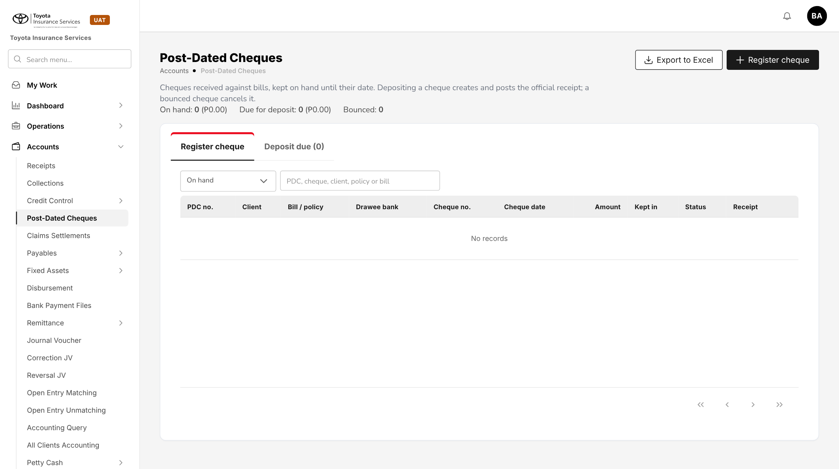
Figure 4: BrokerVerse today: Accounts > Post-Dated Cheques
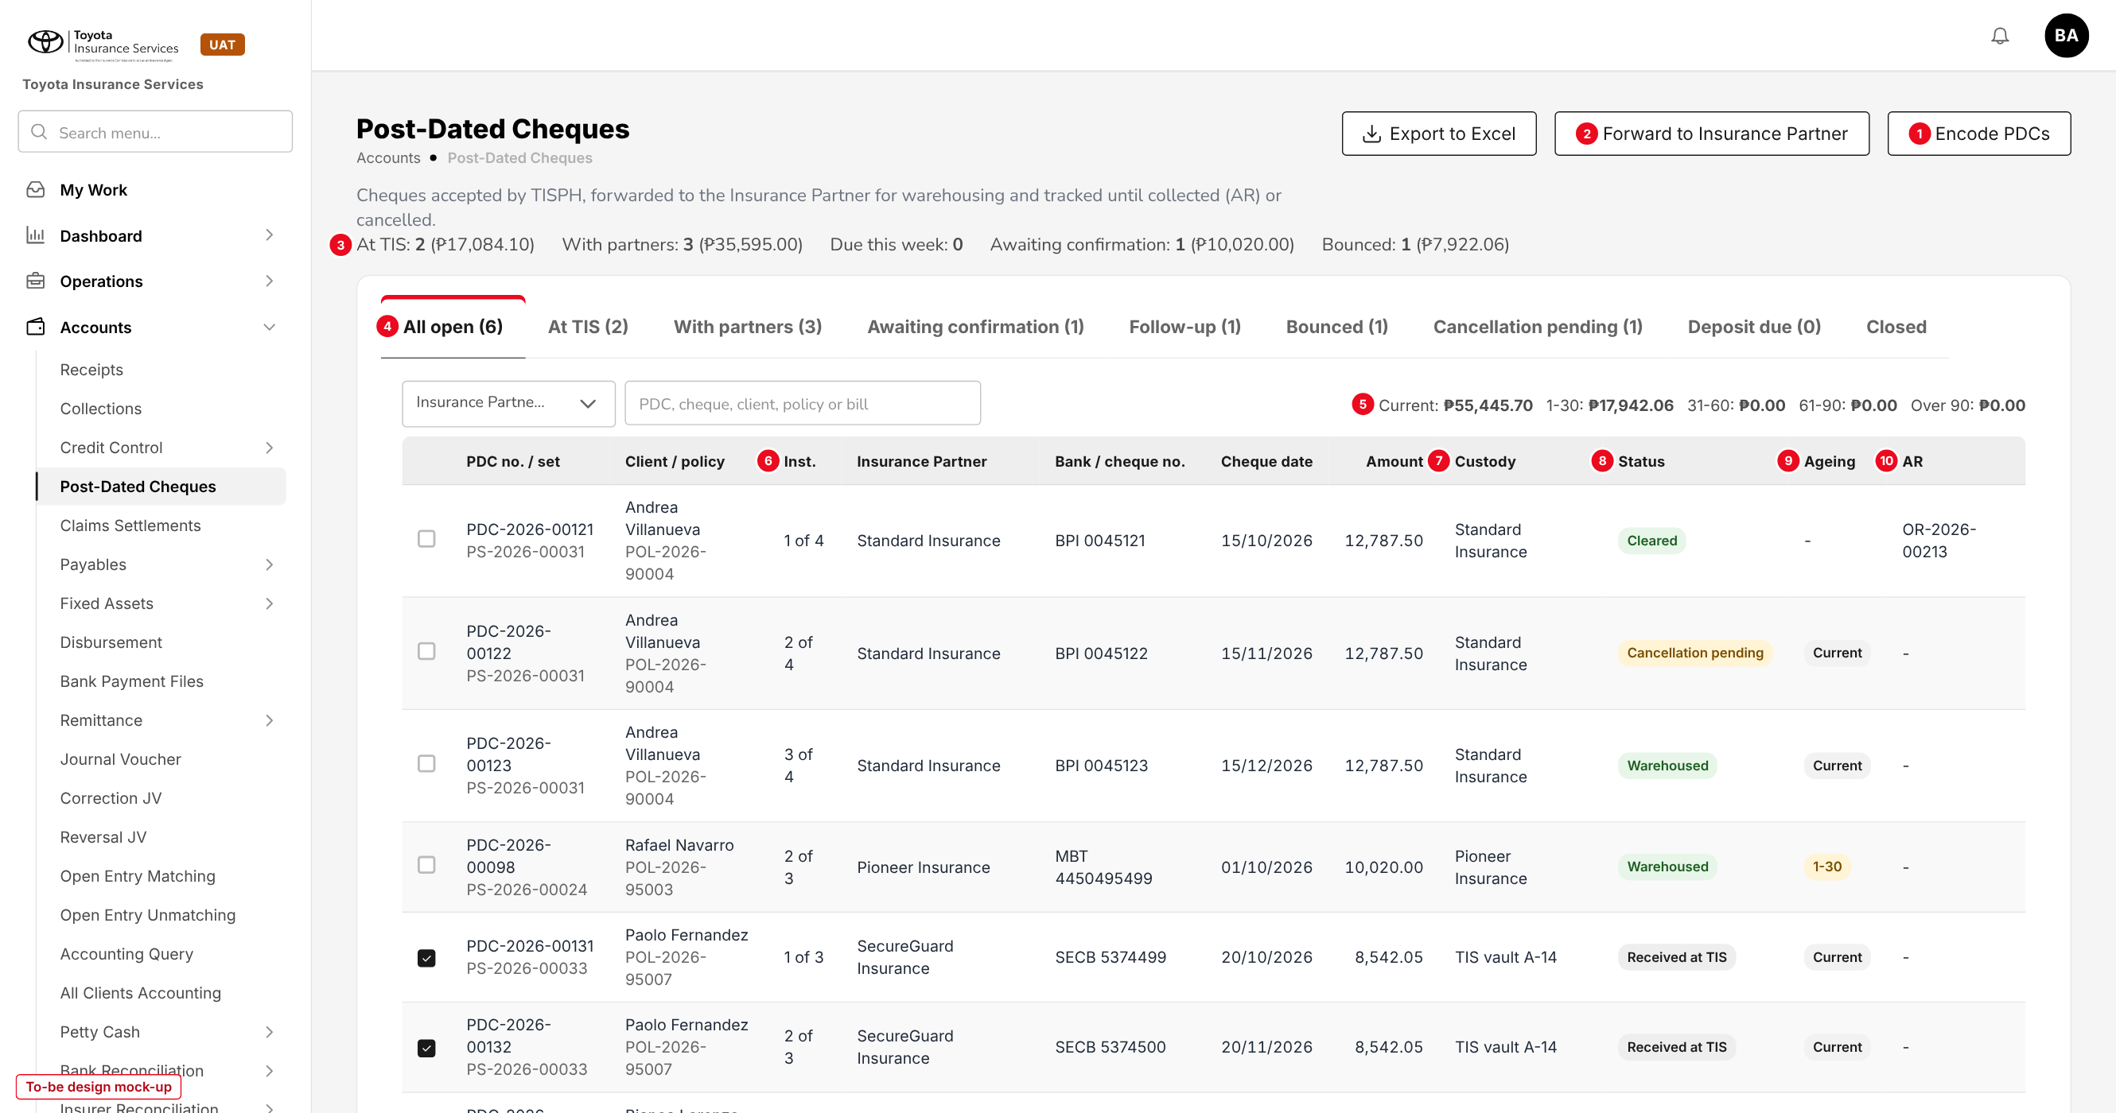
Figure 5: PDC tracking log (to-be design mock-up)
No. | Field (label on screen) | Type | Mand. | Source / list | Default | Rule and message
1 | Encode PDCs | Button | - | - | - | write:pdc; opens 9.2
2 | Forward to Insurance Partner | Button | - | - | - | write:pdc; enabled when ticked cheques are Received at TIS for one partner; opens 9.3
3 | Summary line | Display | - | Computed | - | At TIS, With partners, Due this week, Awaiting confirmation, Bounced: count and amount
4 | Tabs | Tabs | - | PDC status | All open | All open, At TIS, With partners, Awaiting confirmation, Follow-up, Bounced, Cancellation pending, Deposit due, Closed
- | Insurance Partner, Cheque date, Search | Filters | N | Insurance Company; dates; text | All | Search: PDC, set, cheque, client, policy or bill
5 | Ageing line | Display | - | limits.receivable_ageing_buckets | - | Amounts of the rows on screen per bucket
- | PDC no. / set, Client / policy | Columns | - | Cheque, set, policy | - | PDC no. opens 9.5; set no. opens the set tab
6 | Inst. | Column | - | Instalment plan | - | "n of m"
- | Insurance Partner, Bank / cheque no., Cheque date, Amount | Columns | - | Cheque | - | -
7 | Custody | Column | - | Custody list | - | TIS vault folder, partner, in transit, returned
8 | Status | Column | - | PDC status | - | Status tag
9 | Ageing | Column | - | Computed | - | Current, 1-30, 31-60, 61-90, Over 90; blank when settled
10 | AR | Column | - | Accounts > Receipts | - | Link to the AR once collected

Button | Who sees it | Enabled when | What happens | Result
Encode PDCs | write:pdc | Always | Opens the Encode PDCs panel | Set and cheques Received at TIS
Forward to Insurance Partner | write:pdc | Ticked cheques Received at TIS, payee partner, one partner | Opens the forward panel | Forwarded
Export to Excel | read:pdc | List not empty | Filtered rows with every cheque field | -
Partner received (row / transmittal) | write:pdc | Forwarded | Date, received by, partner reference | Warehoused
Partner cleared (row) | write:pdc + write:receipts | Forwarded or Warehoused, date reached | Opens 9.6; raises the AR | Cleared
Partner bounced (row) | write:pdc | Forwarded, Warehoused or Cleared | Reason; AR cancelled if any; client told | Bounced
Deposit / Cleared / Bounced (row, existing) | write:pdc | Payee TISPH | Base deposit flow; AR on deposit | Deposited / Cleared / Bounced
Request cancellation (row) | write:pdc | Received at TIS, Forwarded, Warehoused or Bounced; no AR | Opens 9.7 | Cancellation pending
Replace (row) | write:pdc | Bounced, or Cancelled for cheque replacement | Encode PDCs on the same set | Replaced / new cheque
Return to client (row) | write:pdc | In the TIS vault | Date, returned to, remarks | Returned

9.2 Encode PDCs (new)
Type | New side panel, laid out like Register cheque
Purpose | Encode the cheques of one bill, one per instalment.
Who can open it | write:pdc
Navigation | Post-Dated Cheques > Encode PDCs
FRs | FR-PDC-001, 002, 004

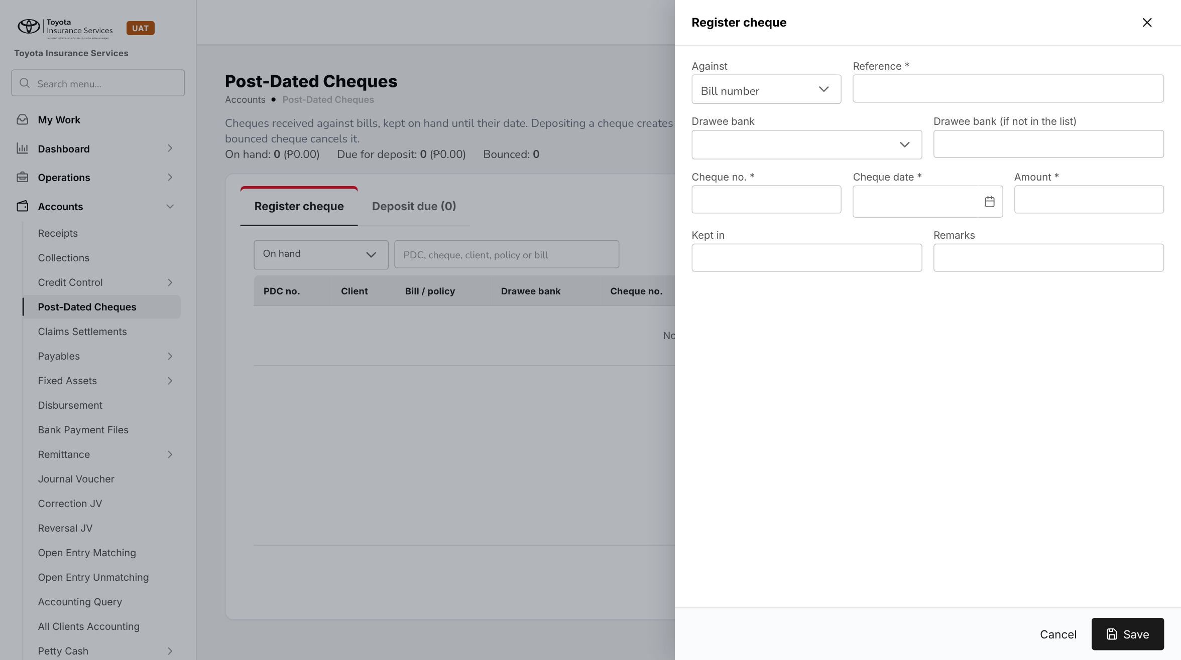
Figure 6: BrokerVerse today: Register cheque (one cheque at a time)
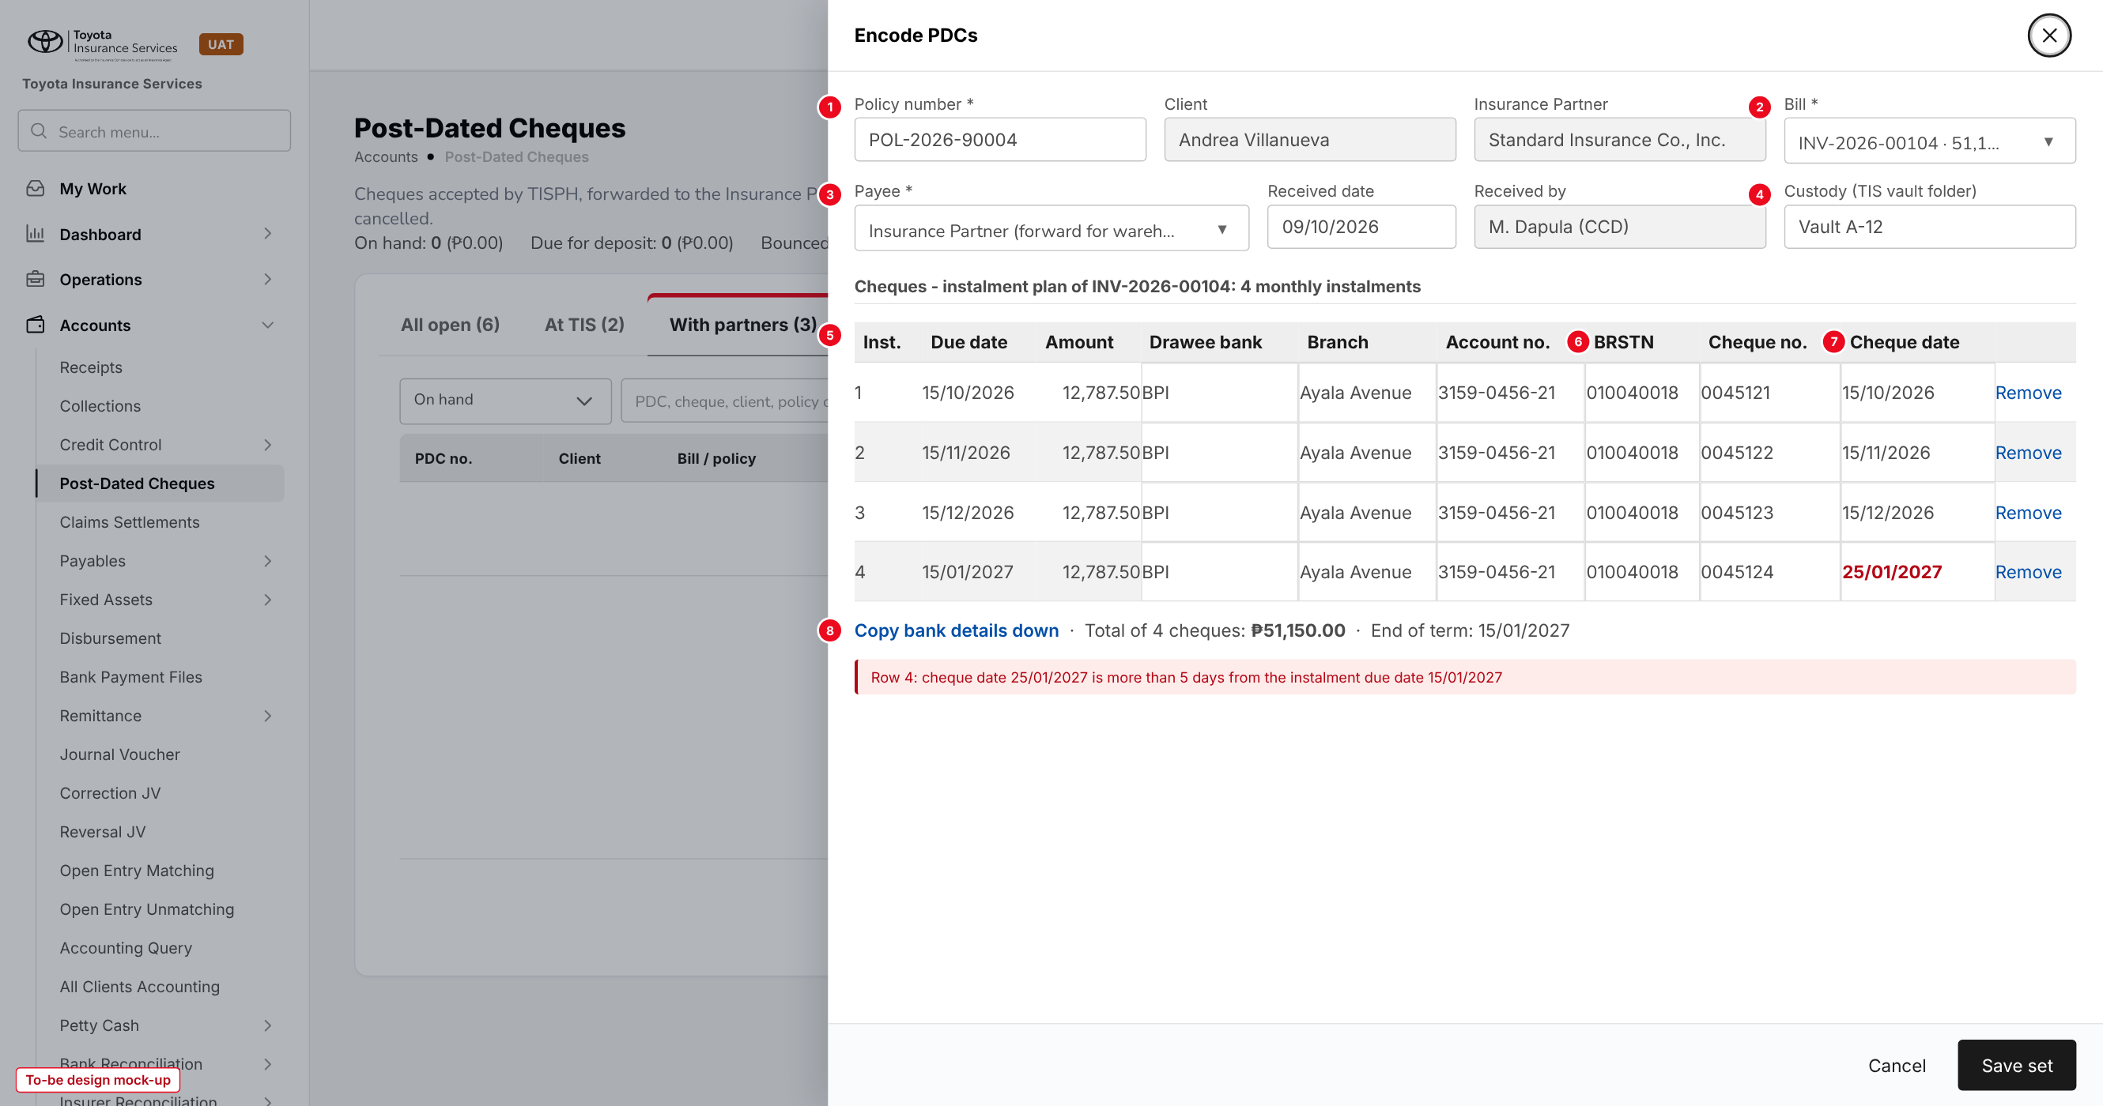
Figure 7: Encode PDCs with a row in error (to-be design mock-up)
No. | Field (label on screen) | Type | Mand. | Source / list | Default | Rule and message
1 | Policy number * | Text | Y | Policies | - | Issued, broker billed, open bill. Fills Client and Insurance Partner (read-only)
2 | Bill * | List | Y | Open bills of the policy | First open bill | Its plan gives the rows
3 | Payee * | List | Y | Insurance Partner; TISPH | pdc.default_payee | TISPH needs pdc.default_deposit_account
- | Received date / Received by | Date / Display | Y | - | Today / user | Not in the future
4 | Custody (TIS vault folder) | Text 60 | N | - | - | Where the cheques are kept until forwarded
5 | Rows: Inst., Due date, Amount | Display | - | Instalment plan | - | One row per unpaid instalment; amount read-only
- | Drawee bank, Branch, Account no. | List / Text | Y / N / N | Master > Finance > Bank | - | Bank typed when not in the list
6 | BRSTN | Text 9 | N | - | - | 9 digits; required when pdc.brstn_required
- | Cheque no. | Text | Y | - | Runs on from row 1 | 6-10 digits; unique per bank
7 | Cheque date | Date | Y | - | Due date of the row | After the received date; within pdc.date_tolerance_days of the due date
8 | Copy bank details down; totals | Link / Display | - | - | - | Copies row 1 bank details; shows total and end of term

Button | Who sees it | Enabled when | What happens | Result
Remove (row) | write:pdc | More than one row | Leaves the instalment out of the set | -
Cancel | All | Always | Closes without saving after confirmation | -
Save set | write:pdc | At least one row | Checks every row; creates the set and cheques | Received at TIS

9.3 Forward to Insurance Partner (new)
Type | New side panel
Purpose | Send cheques to one Insurance Partner with a transmittal, with the pull-outs open for that partner.
Who can open it | write:pdc
Navigation | Post-Dated Cheques > tab At TIS > tick > Forward to Insurance Partner
FRs | FR-PDC-010, 040

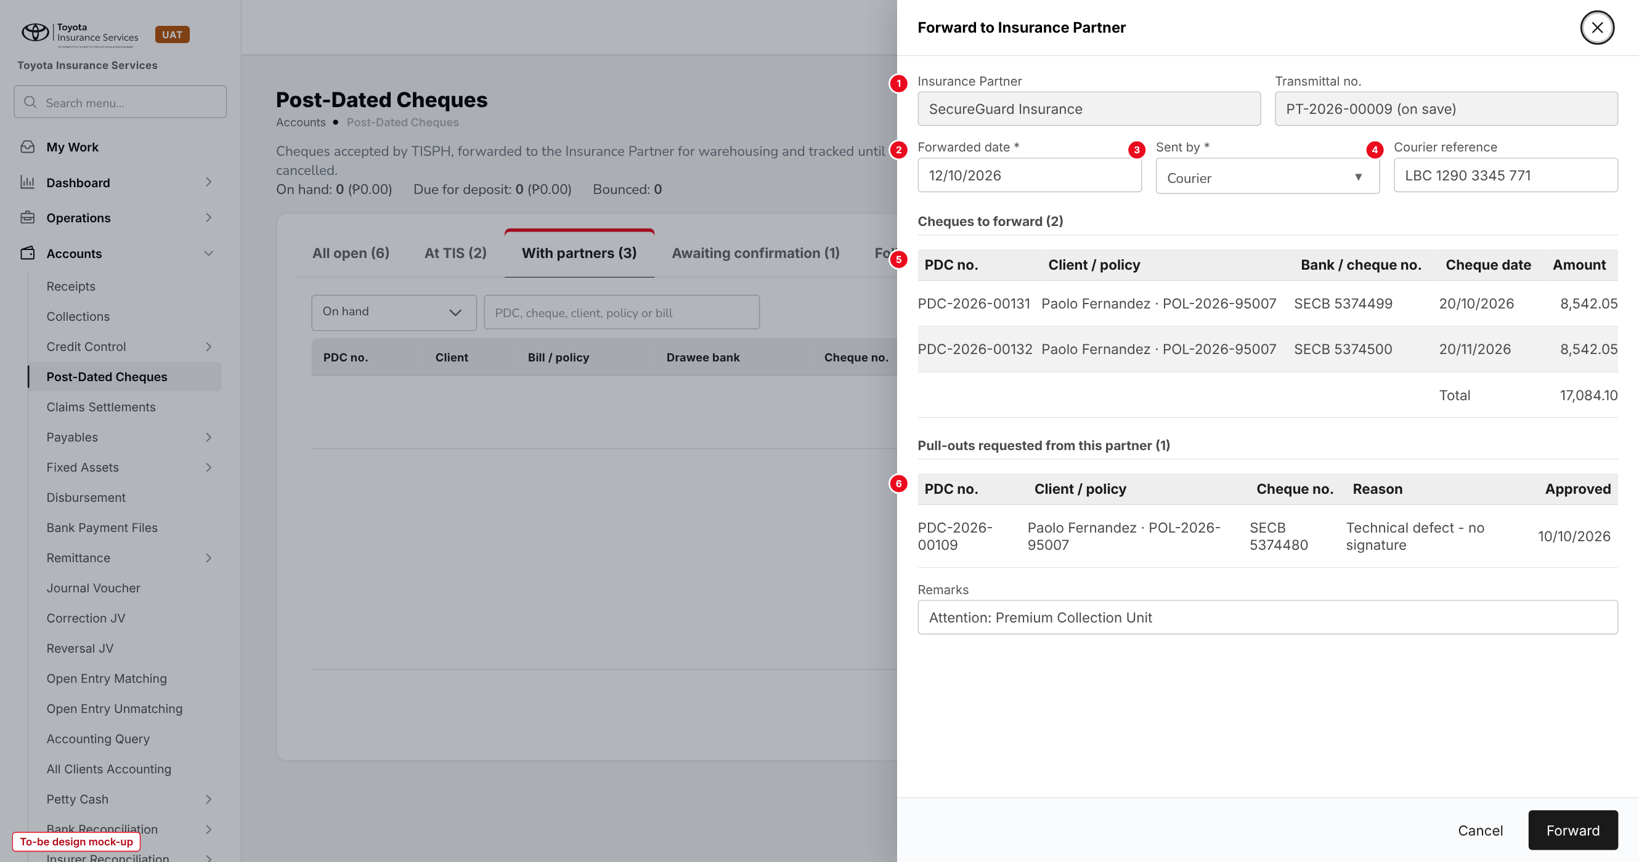
Figure 8: Forward to Insurance Partner (to-be design mock-up)
No. | Field (label on screen) | Type | Mand. | Source / list | Default | Rule and message
1 | Insurance Partner / Transmittal no. | Display | - | Ticked cheques; series pdc_transmittal | - | One partner per transmittal
2 | Forwarded date * | Date | Y | - | Today | Not in the future
3 | Sent by * | List | Y | Courier; Messenger; Hand carry | - | -
4 | Courier reference | Text 60 | N | - | - | -
5 | Cheques to forward | Table | - | Ticked cheques | - | With total
6 | Pull-outs requested from this partner | Table | - | Approved cancellations of cheques the partner holds | - | Read-only; carried on the transmittal

The transmittal detail (opened from the transmittal number) shows the same lists with the status Sent, Partly received or Received, the buttons Partner received (FR-PDC-011) and Partner returned for pull-outs (FR-PDC-040), and Export to Excel.

9.4 Partner received (new)
Type | New side panel
Purpose | Record that the Insurance Partner has the cheques (warehousing).
Who can open it | write:pdc
Navigation | - Transmittal detail > Partner received  - Row action Partner received
FRs | FR-PDC-011

No. | Field (label on screen) | Type | Mand. | Source / list | Default | Rule and message
1 | Received on * | Date | Y | - | Today | Not before the forwarded date; not in the future
2 | Received by * | Text 80 | Y | - | - | Name at the partner
3 | Partner reference | Text 60 | N | - | - | -
4 | Acknowledgement copy | File | N | Base document upload | - | PDF or image
5 | Cheques | Tick list | Y | Cheques of the transmittal still Forwarded | All ticked | Unticked cheques stay Forwarded

9.5 Cheque detail with History (new)
Type | New side panel with tabs Cheque, Set, History
Purpose | See every field of a cheque, its set and every change made to it.
Who can open it | read:pdc
Navigation | Post-Dated Cheques > PDC no.
FRs | FR-PDC-003, 022, 040, 041

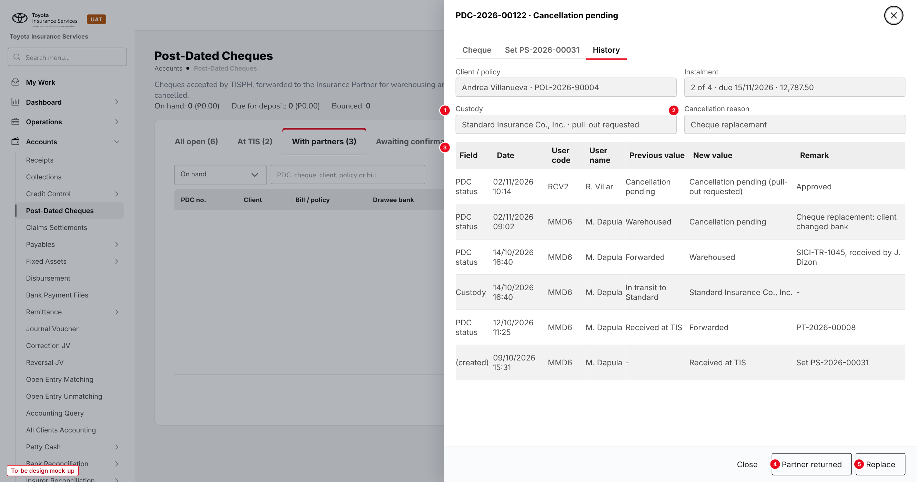
Figure 9: Cheque detail, History tab, of a cheque waiting for its pull-out (to-be design mock-up)
No. | Field (label on screen) | Type | Mand. | Source / list | Default | Rule and message
- | Cheque tab | Display | - | Cheque | - | All fields of 9.2 plus payee, Insurance Partner, transmittal, partner references, collection date, AR, bounce and cancellation details, links Replaces / Replaced by
- | Set tab | Display | - | PDC set | - | Set fields and the cheques of each instalment (FR-PDC-003)
1 | Custody | Display | - | Custody list | - | With "pull-out requested" while waiting
2 | Cancellation reason | Display | - | Cancellation reason list | - | Shown when a cancellation exists
3 | History | Table | - | Audit Trail | - | Field, Date, User code, User name, Previous value, New value, Remark; newest first
4 | Partner returned | Button | - | - | - | Cancellation pending with pull-out; asks Returned on and partner reference
5 | Replace | Button | - | - | - | Bounced, or Cancelled for cheque replacement

9.6 Partner cleared (new)
Type | New side panel
Purpose | Record the collection advised by the Insurance Partner and raise the AR.
Who can open it | write:pdc and write:receipts
Navigation | - Row action Partner cleared  - Tab Awaiting confirmation > tick > Partner cleared
FRs | FR-PDC-030, 050, 051

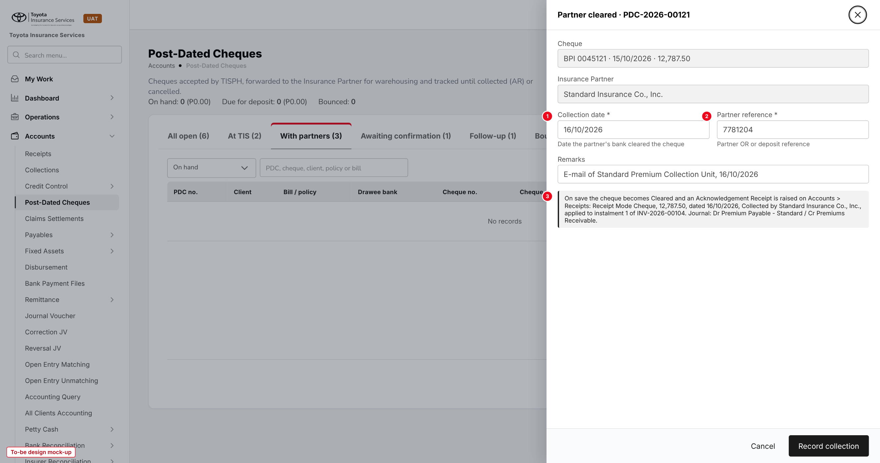
Figure 10: Partner cleared (to-be design mock-up)
No. | Field (label on screen) | Type | Mand. | Source / list | Default | Rule and message
1 | Collection date * | Date | Y | - | Today | On or after the cheque date; not in the future; open period
2 | Partner reference * | Text 60 | Y | - | - | Partner OR or deposit reference
- | Remarks | Text 500 | N | - | - | -
3 | What happens on save | Information | - | - | - | AR, application to the instalment and journal (FR-PDC-050, 051)

Partner bounced uses the same panel with Bounced on, Reason (bounce reason list) and remarks instead of the collection fields (FR-PDC-032).

9.7 Request cancellation and approval (new)
Type | New side panel; existing My Work > Approvals with a new item kind
Purpose | Cancel a cheque with a reason, approved by a second user, with a pull-out when the partner holds it.
Who can open it | write:pdc (request); approve:pdc, not the requester (approve)
Navigation | - Row action Request cancellation  - My Work > My Items > Approvals, kind PDC cancellation
FRs | FR-PDC-040, 041

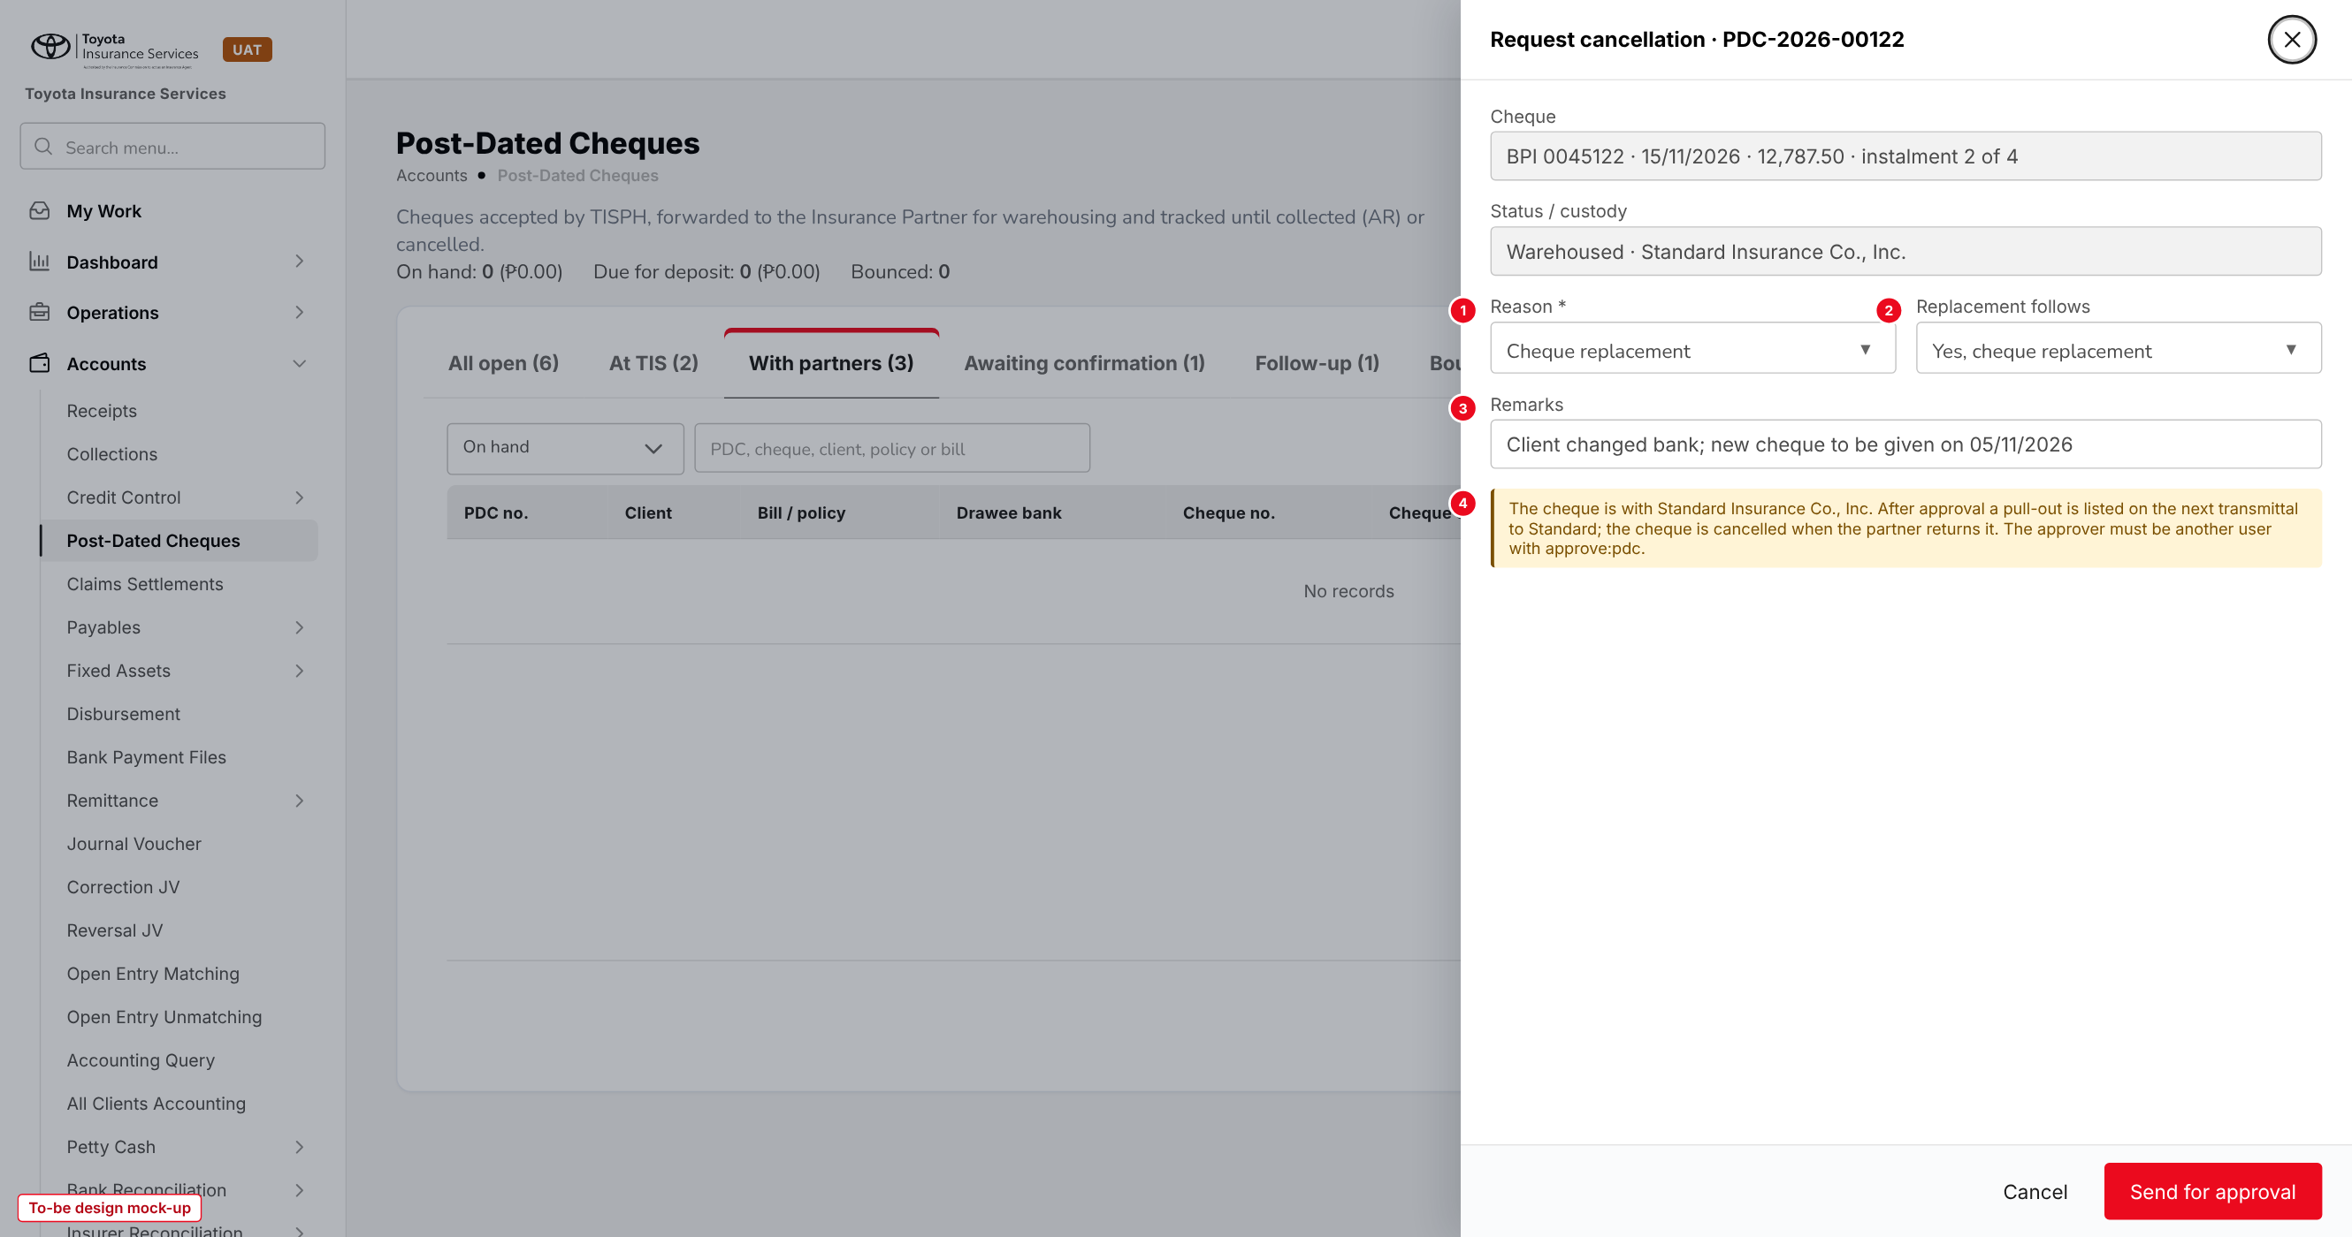
Figure 11: Request cancellation of a cheque held by the Insurance Partner (to-be design mock-up)
No. | Field (label on screen) | Type | Mand. | Source / list | Default | Rule and message
1 | Reason * | List | Y | Cancellation reason list | - | -
2 | Replacement follows | List | N | Yes, cheque replacement; Yes, cash; No | From the reason | Used by Replace and the set status
3 | Remarks | Text 500 | N | - | - | -
4 | Pull-out note | Information | - | Custody | - | Shown when the partner holds the cheque

Button | Who sees it | Enabled when | What happens | Result
Send for approval | write:pdc | Reason chosen; no AR on the cheque | Raises the item in My Work > Approvals | Cancellation pending
Approve (My Work) | approve:pdc, not the requester | Item open | Cancels, or requests the pull-out | Cancelled / Cancellation pending (pull-out)
Return (My Work) | approve:pdc, not the requester | Item open; remark entered | Puts the cheque back in its earlier status | Earlier status

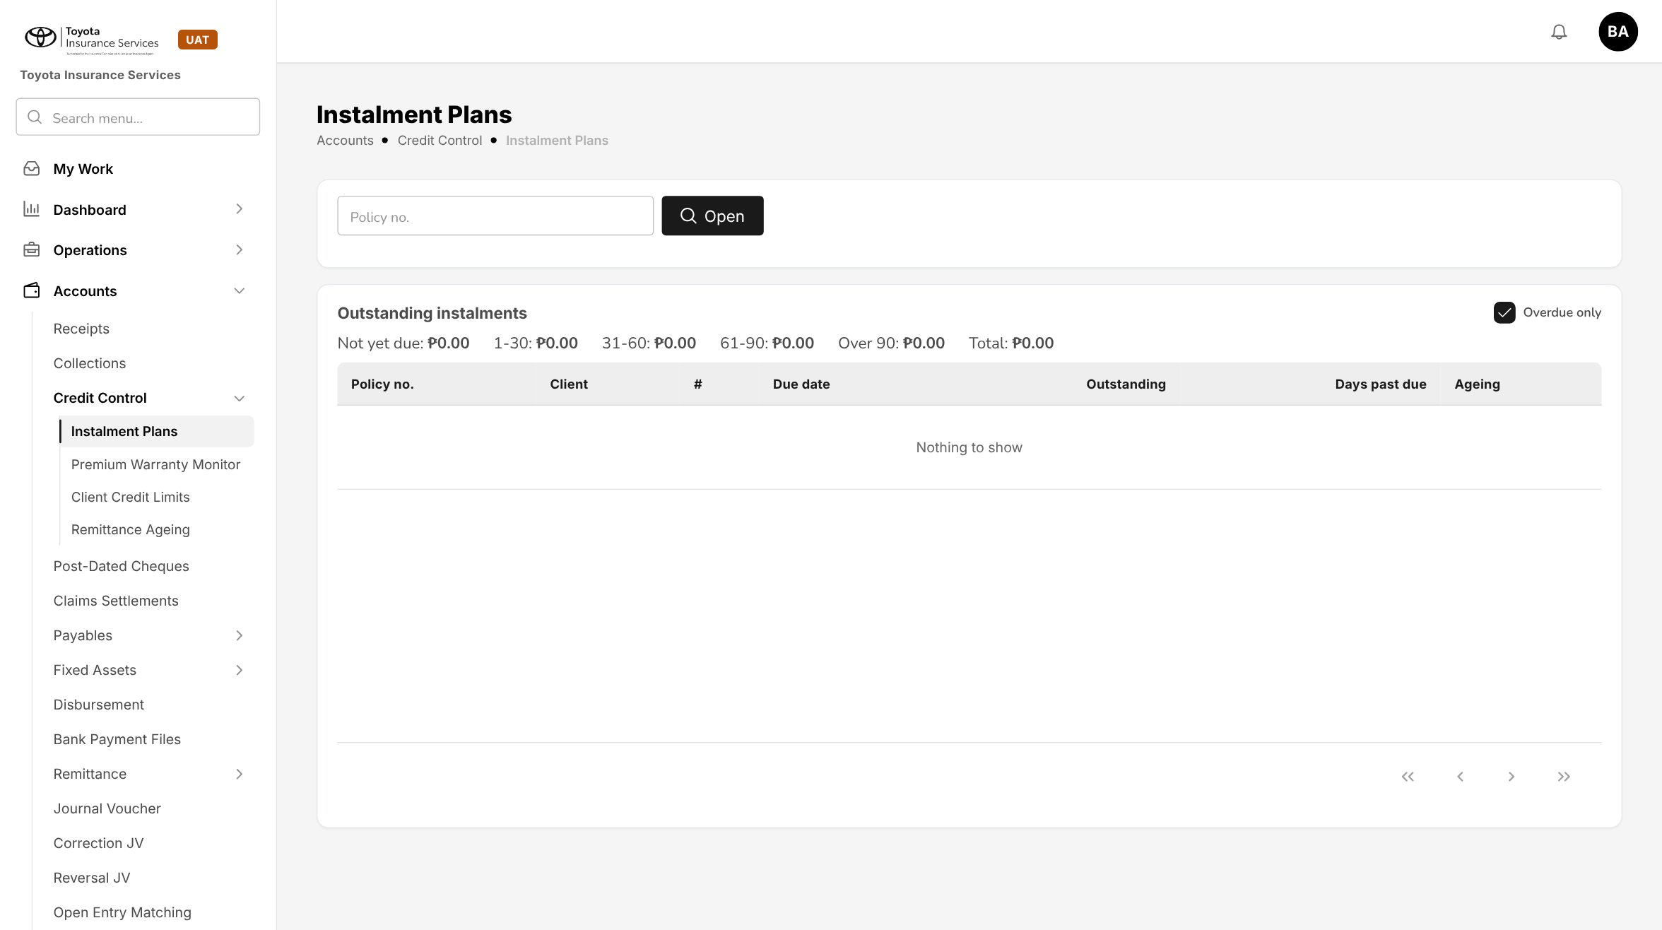
Figure 12: BrokerVerse today: Accounts > Credit Control > Instalment Plans, the source of the set rows and the ageing buckets

10 End-to-end walkthroughs
The walkthroughs follow one client through BrokerVerse using the UAT sample data: Andrea Villanueva, policy POL-2026-90004 with Standard Insurance Co., Inc., premium 51,150.00 in 4 monthly instalments of 12,787.50 due on the 15th from October 2026, paid by BPI cheques 0045121 to 0045124. They are the script of the COLL-05 SIT and UAT sessions.

10.1 WT-A Accept, encode and forward
Table 24: WT-A
Step | Who | Does | Sees / result
1 | Accounting | Instalment Plans: opens POL-2026-90004 and checks the plan of INV-2026-00104 | 4 instalments of 12,787.50 due 15/10/2026 to 15/01/2027
2 | CCD officer | On 09/10/2026, Post-Dated Cheques > Encode PDCs: POL-2026-90004, bill INV-2026-00104, payee Insurance Partner, custody Vault A-12 | 4 rows with due dates and amounts
3 | CCD officer | Row 1: BPI, Ayala Avenue, 3159-0456-21, BRSTN 010040018, 0045121, 15/10/2026; Copy bank details down | Rows 2-4 filled, cheques 0045122 to 0045124
4 | CCD officer | Types 25/01/2027 on row 4 by mistake and saves | "Row 4: cheque date 25/01/2027 is more than 5 days from the instalment due date 15/01/2027"
5 | CCD officer | Corrects to 15/01/2027 and saves | "Set PS-2026-00031 saved with 4 cheques, 51,150.00"; PDC-2026-00121 to 00124 Received at TIS; no journal
6 | CCD officer | On 12/10/2026, tab At TIS: ticks the 4 cheques, Forward to Insurance Partner, Courier | "4 cheques forwarded to Standard Insurance Co., Inc. on transmittal PT-2026-00008"
7 | CCD officer | On 14/10/2026, PT-2026-00008 > Partner received: J. Dizon, SICI-TR-1045 | 4 cheques Warehoused; transmittal Received

10.2 WT-B Collection and AR
Table 25: WT-B
Step | Who | Does | Sees / result
1 | System | 16/10/2026 Awaiting confirmation tab | PDC-2026-00121 listed, 1 day past date, ageing 1-30
2 | CCD officer | Partner cleared on PDC-2026-00121: collection date 16/10/2026, reference 7781204 | "Cheque PDC-2026-00121 cleared; AR OR-2026-00213 raised"
3 | FGA | Accounts > Receipts > OR-2026-00213 | Acknowledgement Receipt, Cheque 0045121 BPI, 12,787.50, Collected by Standard; journal Dr Premium Payable - Standard / Cr Premiums Receivable
4 | Operations | Policy POL-2026-90004 | Payment status Partial; instalment 1 paid
5 | System | Job PDC follow-up on 19/11/2026 | PDC-2026-00122 not advised 4 days after its date: listed in Follow-up, CCD notified

10.3 WT-C Cancellation with pull-out and replacement
Table 26: WT-C
Step | Who | Does | Sees / result
1 | CCD officer | On 02/11/2026 the client changes bank: Request cancellation on PDC-2026-00122, reason Cheque replacement | "Cancellation of cheque PDC-2026-00122 sent for approval"; Cancellation pending
2 | CCD officer | Tries to approve the item in My Work > Approvals | "Maker-checker: the approver must be different from the user who requested the cancellation"
3 | CCD head | Approves | "Cancellation approved. Pull-out requested from Standard Insurance Co., Inc."
4 | CCD officer | Forwards the next Standard transmittal PT-2026-00011 | The pull-out of PDC-2026-00122 is listed on it
5 | CCD officer | On 05/11/2026 records Partner returned | PDC-2026-00122 Cancelled; instalment 2 open again
6 | CCD officer | Replace: Metrobank cheque 2000000113 dated 15/11/2026 | PDC-2026-00140 in PS-2026-00031, Received at TIS, linked to PDC-2026-00122; forwarded with the next transmittal
7 | CCD officer | Return to client on 08/11/2026 | PDC-2026-00122 Returned

10.4 WT-D Bounced cheque
Table 27: WT-D
Step | Who | Does | Sees / result
1 | CCD officer | On 17/12/2026 Standard reports PDC-2026-00123 returned DAIF: Partner bounced, reason DAIF | "Cheque PDC-2026-00123 marked bounced"; instalment 3 open; client e-mailed
2 | CCD officer | The client pays instalment 3 in cash at TISPH | Receipt on Accounts > Receipts; PDC-2026-00123 stays Bounced
3 | CCD officer | Request cancellation of PDC-2026-00123, reason Cash replacement; approved | Cancelled; set still Open until PDC-2026-00124 clears
4 | CCD officer | Partner cleared on PDC-2026-00124 on 15/01/2027 | AR raised; set PS-2026-00031 Closed; policy payment status Completed

11 Messages catalogue
Every message a user can see for this requirement, grouped by the screen that shows it. 46 messages: 9 confirmation, 18 error, 1 information, 18 validation. A validation or error is shown under the field it belongs to; a confirmation is a short toast. Text in angle brackets is filled in by the system.

11.1 Encode PDCs
ID | Field | Message | Type | What the user does
MSG-PDC-001 | policyNumber | Policy <policy> not found | Validation | Check the policy number.
MSG-PDC-002 | policyNumber | Policy <policy> is direct billed: the client pays the insurer, not TISPH | Error | Do not encode the cheques here; the insurer receives them directly.
MSG-PDC-003 | billId | Policy <policy> has no open bill to pay | Error | Check the policy payment status.
MSG-PDC-004 | rows | Keep at least one cheque in the set | Validation | Add back a row or cancel.
MSG-PDC-005 | rows | A set can hold at most <n> cheques | Validation | Split the plan or check pdc.max_cheques_per_set.
MSG-PDC-006 | rows | Bill <bill> has <amount> left after the cheques already encoded; this set is <amount> | Error | Remove the rows already covered by other cheques.
MSG-PDC-007 | - | Set <set> saved with <n> cheques, <amount> | Confirmation | No action.
MSG-PDC-008 | rows[n].bankId | Row <n>: choose the drawee bank | Validation | Choose the bank or type its name.
MSG-PDC-009 | rows[n].chequeNumber | Row <n>: cheque number must be 6 to 10 digits | Validation | Correct the cheque number.
MSG-PDC-010 | rows[n].chequeNumber | Row <n>: cheque <cheque> is already on row <m> | Validation | Correct one of the two rows.
MSG-PDC-011 | rows[n].chequeNumber | Row <n>: cheque <cheque> of <bank> is already encoded as <pdc> | Error | Check the cheque; cancel the old record first if it was entered in error.
MSG-PDC-012 | rows[n].brstn | Row <n>: BRSTN must be 9 digits | Validation | Correct the BRSTN.
MSG-PDC-013 | rows[n].chequeDate | Row <n>: the cheque is dated <date>, not after the received date. Receipt it as a cheque payment | Error | Remove the row and record the payment on Accounts > Receipts.
MSG-PDC-014 | rows[n].chequeDate | Row <n>: cheque date <date> is more than <d> days from the instalment due date <due> | Error | Check the date with the client, or change the plan first.
MSG-PDC-015 | - | Cheque <pdc> is <status>; only the remarks and custody folder can be changed | Error | Request a cancellation and replacement instead.
MSG-PDC-016 | payee | No TISPH collection bank account is set (pdc.default_deposit_account) | Error | Ask the System Administrator to set the account, or choose payee Insurance Partner.

11.2 Forward to Insurance Partner
ID | Field | Message | Type | What the user does
MSG-PDC-017 | - | Tick the cheques to forward | Validation | Tick at least one cheque.
MSG-PDC-018 | - | The ticked cheques belong to <n> Insurance Partners. Forward one partner at a time | Error | Filter on one Insurance Partner.
MSG-PDC-019 | - | Cheque <pdc> is <status> with payee <payee>; only cheques Received at TIS with payee Insurance Partner are forwarded | Error | Untick the cheque.
MSG-PDC-020 | forwardedOn | Forwarded date cannot be in the future | Validation | Enter today or an earlier date.
MSG-PDC-021 | - | <n> cheques forwarded to <partner> on transmittal <transmittal> | Confirmation | No action.
MSG-PDC-022 | receivedOn | Received on cannot be before the forwarded date <date> | Validation | Correct the date.
MSG-PDC-023 | receivedBy | Enter who received the cheques at the Insurance Partner | Validation | Enter the name.
MSG-PDC-024 | - | <n> cheques of transmittal <transmittal> are warehoused with <partner> | Confirmation | No action.

11.3 Record collection
ID | Field | Message | Type | What the user does
MSG-PDC-025 | collectedOn | Collection date cannot be before the cheque date <date> | Validation | Correct the date.
MSG-PDC-026 | collectedOn | Collection date cannot be in the future | Validation | Enter today or an earlier date.
MSG-PDC-027 | collectedOn | The period of <date> is closed | Error | Ask Accounting to reopen the period or use a date in the open period.
MSG-PDC-028 | partnerReference | Enter the Insurance Partner's reference | Validation | Enter the OR or deposit reference.
MSG-PDC-029 | - | Cheque <pdc> is <status>; only a cheque with the Insurance Partner is cleared here | Error | Use the action that matches the status.
MSG-PDC-030 | - | Cheque <pdc> cleared; AR <ar> raised | Confirmation | No action.

11.4 Cheque actions
ID | Field | Message | Type | What the user does
MSG-PDC-031 | reason | Choose the reason given by the Insurance Partner | Validation | Choose a reason.
MSG-PDC-032 | - | Cheque <pdc> is <status>; only a cheque with the Insurance Partner or cleared can bounce | Error | Check the status.
MSG-PDC-033 | - | Cheque <pdc> marked bounced | Confirmation | Ask the client for a replacement.
MSG-PDC-043 | - | Cheque <pdc> is <status>; only a bounced cheque or a cheque cancelled for a cheque replacement is replaced | Error | Check the status.
MSG-PDC-044 | - | Replacement cheque <pdc> encoded in set <set> | Confirmation | Forward it with the next transmittal.
MSG-PDC-045 | - | Cheque <pdc> is with <custody>; only a cheque in the TIS vault can be returned to the client | Error | Pull it out from the Insurance Partner first.
MSG-PDC-046 | - | Cheque <pdc> returned to the client | Confirmation | No action.

11.5 Cancellation
ID | Field | Message | Type | What the user does
MSG-PDC-034 | reason | Choose the reason for the cancellation | Validation | Choose a reason.
MSG-PDC-035 | - | Cheque <pdc> has AR <ar>. Cancel the AR on Accounts > Receipts first | Error | Cancel the receipt, then request the cancellation.
MSG-PDC-036 | - | A cancellation of cheque <pdc> is already pending | Error | Wait for the decision.
MSG-PDC-037 | - | Maker-checker: the approver must be different from the user who requested the cancellation | Error | Leave it to another approver.
MSG-PDC-038 | remark | Remark is required | Validation | Enter the reason for returning the request.
MSG-PDC-039 | returnedOn | Returned on cannot be before the request was approved | Validation | Correct the date.
MSG-PDC-040 | - | Cancellation of cheque <pdc> sent for approval | Confirmation | No action. The item is in My Work > Approvals.
MSG-PDC-041 | - | Cancellation approved. Pull-out requested from <partner> | Information | Send the pull-out with the next transmittal and record the return.
MSG-PDC-042 | - | Cheque <pdc> cancelled | Confirmation | No action.

12 Sign-off and change control

12.1 What is signed
TISPH signs this FRS for TIS-BRD-COLL-05 as built on BrokerVerse: the process flows (chapter 2), the functional requirements (chapter 4), the workflow (chapter 5), and the screens and messages (chapters 8 to 11). Values marked default are configuration and are not frozen.

12.2 Change after sign-off
A change to anything signed is raised through the change control route of BRD section 8. The project team assesses its effect on BrokerVerse and on the Cash Control reports that read this data, and issues a new version of this FRS for delta sign-off. When the screens are built, the to-be mock-ups are replaced with screenshots of the TISPH UAT environment.

12.3 Signatures
Table 28: Sign-off
Role | Name | Unit | Signature | Date
Business owner |  | TISPH Cash Control Department
Business reviewer |  | TISPH FGA
Business reviewer |  | TISPH Operations
Project Manager |  | TISPH DTID
Delivery lead |  | iorta TechNXT

