

FUNCTIONAL REQUIREMENTS SPECIFICATION
Issuing vs Remitting Commission in Remittance and Billing
Commission on Own Damage and Acts of Nature from the issuing, TIS remitting and insurer net rates; instalment policies held until fully paid; weekly remittance run and twice-monthly billing run with their schedules

Client | Toyota Insurance Services Philippines Corporation (TISPH)
Document | TISPH-FRS-COMM-06
Requirement | TIS-BRD-COMM-06
Version | 1.0
Date | 9 October 2026
Status | Issued for TISPH review
Classification | Confidential

Prepared by iorta TechNXT for TISPH 
This document is confidential to Toyota Insurance Services Philippines Corporation and iorta TechNXT.
Document Control
Version | Date | Author | Reviewer | Approver | Change
1.0 | 9 Oct 2026 | iorta TechNXT Business Analysis | iorta TechNXT Project Manager | TISPH FGA (pending) | First issue for review

Distribution List
Name / Unit | Role | Organisation | Purpose
Finance and General Accounting (business owner) | Approver | TISPH | Review and sign-off
Accounting | Business user | TISPH | Remittance and billing runs, approvals
TIS Operations | Business user | TISPH | Commission masterlist, billing statement schedules
TIS Sales | Business user | TISPH | Agent, TFS team member and referral shares
DTID - Project Management Team | Project owner | TISPH | Traceability against the BRD
Project team | Delivery | iorta TechNXT | Build, test and UAT preparation

Contents
1 Overview 5
1.1 The requirement 5
1.2 Scope 5
1.3 Definitions and acronyms 6
1.4 How to read the functional requirements 6
1.5 What changes in BrokerVerse 7
2 Process flow 8
2.1 Flow A - Commission of a policy at booking 8
2.2 Flow B - Weekly remittance run 9
2.3 Flow C - Billing run 10
2.4 Products, rates and channels covered 11
3 Personas and roles 12
3.1 Personas 12
3.2 Permissions 12
3.3 Default grants 12
4 Functional requirements 13
4.1 Commission of a policy 13
FR-RMT-001 Take the rates of a policy from the commission rules register at booking 13
FR-RMT-002 Compute the insurer remitting amount and the gross commission per peril 14
FR-RMT-003 Compute the variance share of agents, TFS team members and referrals 15
FR-RMT-004 Use the rates of a promotion and of a changed issuing rate 16
FR-RMT-005 Show and recompute the commission breakdown of a policy 17
FR-RMT-006 Cancelled policies and return premium 18
4.2 Weekly remittance run 18
FR-RMT-010 Run the remittance every Monday for the previous Monday to Friday 18
FR-RMT-011 Remit only fully paid policies with proof of payment 19
FR-RMT-012 Hold instalment and part-paid policies until fully paid 20
FR-RMT-013 Build the remittance lines and the amount due to the insurer 21
FR-RMT-014 Approve the remittance and pay the insurer 21
FR-RMT-015 Produce the remittance schedule 22
4.3 Billing run 23
FR-RMT-020 Run the billing on the 15th and the 26th 23
FR-RMT-021 Compute the billing statement: commission, VAT, EWT and net amount payable 24
FR-RMT-022 Approve, issue and send the billing statement 24
FR-RMT-023 Settle the billing statement by retention or by collection 25
4.4 Agent and referrer share, settlement basis 26
FR-RMT-030 Pay the variance share only when the policy is fully paid and remitted 26
FR-RMT-031 Maintain the settlement basis per product line and insurer 27
4.5 Audit and access 27
FR-RMT-040 Keep a complete audit trail 27
FR-RMT-041 Control access to the remittance and billing functions 27
5 Workflow and status model 29
5.1 Policy in the remittance run 29
5.2 Remittance 29
5.3 Billing statement 29
5.4 Variance share line 30
6 Interfaces 31
6.1 Remittance schedule and billing statement schedule (Motor, net basis) 31
6.2 Billing statement schedule (non-Motor, gross basis) 31
7 Configuration items 32
7.1 Settings 32
7.2 Scheduled jobs 32
7.3 Lists of values 33
7.4 Masters and series 33
8 Traceability 34
8.1 BRD clause to FR 34
8.2 Related BRD requirements 34
8.3 FR to test cases 34
9 Navigation 36
9.1 Screens of COMM-06 36
9.2 Menu by base role 36
10 Screen specifications 37
10.1 Scheduling - Edit schedule (changed) 37
10.2 Automated Processing (changed) 38
10.3 Remittance Details - Policies and Schedule tabs (changed) 39
10.4 Remittance Details - Held tab (new) 40
10.5 Insurer Billing (new) 41
10.6 Agents/Referrer Accounts (changed) 43
10.7 Policy detail - Commission breakdown (new panel) 44
10.8 Schedules (existing) 45
11 End-to-end walkthroughs 46
11.1 WT-A Weekly remittance 46
11.2 WT-B Billing on the 15th 46
11.3 WT-C Instalment policy and exceptions 47
12 Messages catalogue 48
12.1 Policy - Commission breakdown 48
12.2 Remittance - Scheduling 48
12.3 Remittance - Run 48
12.4 Remittance - Approval 48
12.5 Insurer Billing - Run 49
12.6 Insurer Billing - Statement 49
12.7 Commission - Variance share 49
12.8 Insurer Billing - Settlement basis 49
13 Sign-off and change control 50
13.1 What is signed 50
13.2 Change after sign-off 50
13.3 Signatures 50
Appendix A Commission calculation examples 51
A.1 Toyota Fortuner 2.4 G 4x2 AT, Malayan, PC-Other than Sedan, NEW, OD 1,200,000, agent referral 51
A.2 Toyota Vios 1.3 XLE CVT, Malayan, PC-Sedan Regular, RENEW, OD 640,000, walk-in 51
A.3 Billing statement BS-2026-00031 (Malayan, Motor, net basis, 15/10/2026) 52
A.4 Fortuner with promotion PRM-FORTUNER26 (PROD-15) 52
A.5 Instalment policy (Toyota Innova 2.8 E AT, OD 720,000, agent referral) 52

1 Overview

1.1 The requirement
TIS-BRD-COMM-06 Issuing vs. Remitting Rates (Customization, Phase 1, CR-08). For external agents, TFS team members and referrals: issuing rate 2.0%, net TIS remitting rate 1.70% (0.3% variance), calculated on Own Damage and Acts of Nature perils only, applied to new business and renewal alike; commission on installment policies pays only once the full premium settles. Delivered as the issuing-vs-remitting commission calculation in the weekly remittance and billing runs; the rules register comes from PROD-16.

TISPH works with three rates on the Motor perils Own Damage (with Theft) and Acts of Nature. The client pays the issuing rate (2.00% on Own Damage). Business brought by an external agent, a TFS team member or a referrer is remitted to TISPH at the TIS remitting rate (1.70%), so the 0.30 point variance is the share of that agent or referrer. TISPH then remits to the insurer at the insurer's net rate (for example 0.95% for a new SUV with Malayan), and the rest is TISPH's commission. Bodily Injury, Property Damage and Auto Passenger Personal Accident earn a flat commission (25%) and carry no variance.
This FRS puts that calculation into BrokerVerse where the money moves: at booking (the commission breakdown of the policy), in the weekly remittance run that pays the insurers, and in the billing run on the 15th and the 26th that bills the insurers for TISPH's commission. Instalment policies are held out of the remittance, the billing and the agent payout until the last instalment is paid. The rates themselves are kept on the commission rules register of PROD-16; this FRS reads them and does not specify that register.
Screens that change or are new are shown as to-be mock-ups drawn on the real BrokerVerse screens with the Toyota Insurance Services look.

1.2 Scope
In scope
- The commission calculation of a Motor policy per peril: insurer remitting amount, gross commission, variance share of the agent, TFS team member or referrer, and TISPH's retained commission, for new business and renewal.
- The weekly remittance run on Accounts > Remittance: every Monday, policies fully paid from the previous Monday to Friday, per insurer and grouped by product line, with proof of payment, on maker-checker.
- The instalment hold: a policy that is not fully paid is not remitted, not billed and its variance share is not paid until the last instalment is paid.
- The billing run on the 15th and the 26th: the billing statement to each insurer with its schedule (commission, VAT, EWT, net amount payable), on maker-checker, and its settlement by retention (net basis) or by collection (gross basis).
- Two outputs named by the item: the remittance schedule sent with each remittance and the billing statement with its billing statement schedule.
- Changes to Accounts > Remittance (Scheduling, Automated Processing, Tracking), a new Accounts > Remittance > Insurer Billing screen, Commission > Agents/Referrer Accounts, and two jobs on Master > System > Schedules.
Out of scope
- The commission rules register (rates per product, insurer, channel, with sharing splits and edit limits): TIS-BRD-PROD-16. This FRS only reads it.
- Dealer and other sharing schemes of PROD-16, and the telesales incentive (TIS-BRD-COMM-08).
- Endorsement commission supplied by the insurer as an upload (TIS-BRD-COMM-07), and the service invoice layout (TIS-BRD-COMM-03); this FRS only says when the service invoice is due.
- The Net Remittance (fully paid / partially paid), commission sharing and Statement of Account reports: delivered with the reports set and fed by the data this FRS stores.
- Promotions (TIS-BRD-PROD-15): this FRS uses the promo remitting rates that PROD-15 stores on the policy.

1.3 Definitions and acronyms
Table 1: Definitions
Term | Meaning in this FRS
Issuing rate | The rate charged to the client on a peril: Own Damage coverage Rate and Acts of Nature Rate on Create Quote > Step 3 Coverage Details. Standard 2.00% and 0.50% (setting premium.default_rates).
TIS remitting rate | The rate at which business from an external agent, a TFS team member or a referrer is remitted to TISPH. Own Damage 1.70%; Acts of Nature 0.40% (illustrative). Kept on the PROD-16 register.
Variance | Issuing rate minus TIS remitting rate on Own Damage and Acts of Nature (0.30 and 0.10 points). Variance x sum insured is the variance share of the agent, TFS team member or referrer.
Insurer net rate | The rate at which TISPH remits a peril to the insurer, per insurer, motor type and business type (NEW / RENEW), e.g. Malayan, PC-Other than Sedan, NEW: Own Damage / Theft 0.95%, Acts of Nature 0.25%. Kept on the PROD-16 register.
Commission % (other perils) | Flat commission on Bodily Injury, Property Damage and Auto Passenger Personal Accident (25%), and on non-Motor products (per insurer and product). Kept on the PROD-16 register.
Insurer remitting | What the insurer receives for the premium: sum insured x insurer net rate for Own Damage and Acts of Nature; premium x (1 - commission %) for the other perils.
Gross commission | NET Premium minus insurer remitting. It includes the variance share.
TISPH retained commission | Gross commission minus the variance share (and minus any PROD-16 sharing).
Settlement basis | Net: TISPH keeps its commission, plus VAT and less EWT, out of the premium it remits (Motor). Gross: TISPH remits the full premium and bills and collects its commission (non-Motor).
Fully paid | Every receivable of the policy has a zero balance. The date of the receipt that cleared the last balance is the "fully paid on" date.
Held | A policy with a payment in the window that is not fully paid (instalment or part payment). It is shown on the run but not remitted.
Motor type | PC-Sedan Regular; PC-Electric Vehicles; PC-Other than Sedan (SUV / AUV / MPV / Pick-up / Van); CV-Light; LTO (Aircon Bus, UV Express, TNVS); MC-Regular (below 400 cc); MC-High-End (400 cc and above).
VAT / EWT | Output VAT 12% on TISPH's commission / Expanded withholding tax the insurer withholds on the commission (15% by default; rate from the tax code of setting tax.commission_ewt_code).
OD / AON / BI / PD / APPA / CTPL | Own Damage (with Theft) / Acts of Nature / Bodily Injury / Property Damage / Auto Passenger Personal Accident / Compulsory Third Party Liability.
TFS / FGA | Toyota Financial Services Philippines / TISPH Finance and General Accounting.

1.4 How to read the functional requirements
Each FR in chapter 4 has the same parts:
- A header table with the BRD trace, the actor, the priority, the fit and the screens that implement it.
- Description, preconditions, main flow and alternate and exception flows.
- Business rules. Configurable rules are maintained on a master or on Master > System > Configuration (chapter 7). Fixed rules change only through a change request.
- Validations and messages: the check and the message the user sees, word for word, with its ID in chapter 12. As everywhere in BrokerVerse, a message is plain English and is shown under the field it belongs to, or as a toast.
- Audit and numbered acceptance criteria, the basis of the test cases TC-RMT-nnn-n.
Note. The insurer net rates, the TIS remitting rate on Acts of Nature, the EWT rate and the amounts in the examples are illustrative until TISPH confirms them. Premium figures come from the BrokerVerse premium engine (Create Quote > Calculate) on sample data; Appendix A shows every calculation.

1.5 What changes in BrokerVerse
BrokerVerse already remits premium to insurers, bills commission, pays agents and runs schedules. The table lists what COMM-06 changes and adds.
Table 2: BrokerVerse today and COMM-06
BrokerVerse today | What COMM-06 does
Commission of a policy = NET Premium x one rate from Master > Finance > Commission Rate Matrix (default 15%), most specific row of insurer, product and line of business. | Changed. For Motor, commission is computed per peril: Own Damage and Acts of Nature from issuing and insurer net rates on the sum insured; other perils at their commission %. Rates come from the PROD-16 register.
Comsub to referrers (Commission > Agents/Referrer Accounts) = fixed amount + NET Premium x %; lines Accrued, Eligible (premium fully collected, commission.require_full_payment), Approved, Paid. | Changed. For agents, TFS team members and referrals the comsub is the variance share on Own Damage and Acts of Nature only. The Accrued, Eligible, Approved, Paid cycle is kept.
Accounts > Remittance > Scheduling: a schedule names insurers, a cut-off in days, a frequency and a next run date; the Remittance schedules job (switched off) runs it. Eligible policies include unpaid ones. | Changed. New schedule fields: payment window, grouping by product line, fully paid only, proof of payment. TISPH schedule TIS-WEEKLY runs every Monday; the job is switched on.
Remittance Details (Tracking) shows Policy No, Premium, Commission, Status. | Changed. Lines show fully paid date, total premium, insurer remitting, commission, VAT, EWT and due to insurer; new tabs Held and Schedule.
Broker-billed settlement pays the insurer the premium net of commission and VAT on it, plus EWT. Direct Bill Processing raises commission debit notes (DN-) for policies the client paid to the insurer. | Reused for the net basis. New gross basis (full premium remitted) for non-Motor; new Insurer Billing screen with billing statements BS- on the 15th and the 26th, built like Direct Bill Processing.
Master > System > Schedules: job Remittance schedules (daily 06:15, switched off). | Changed / new. Remittance schedules switched on; new jobs Insurer billing run and Instalment hold check.

2 Process flow
Three flow charts show the item end to end: Flow A computes the commission when the policy is booked, Flow B is the weekly remittance run and Flow C is the billing run. Black rounded boxes are start and end points, diamonds are decisions, red boxes are exceptions, grey boxes are done by the system and boxes with a heavy border are the successful outcome.

2.1 Flow A - Commission of a policy at booking
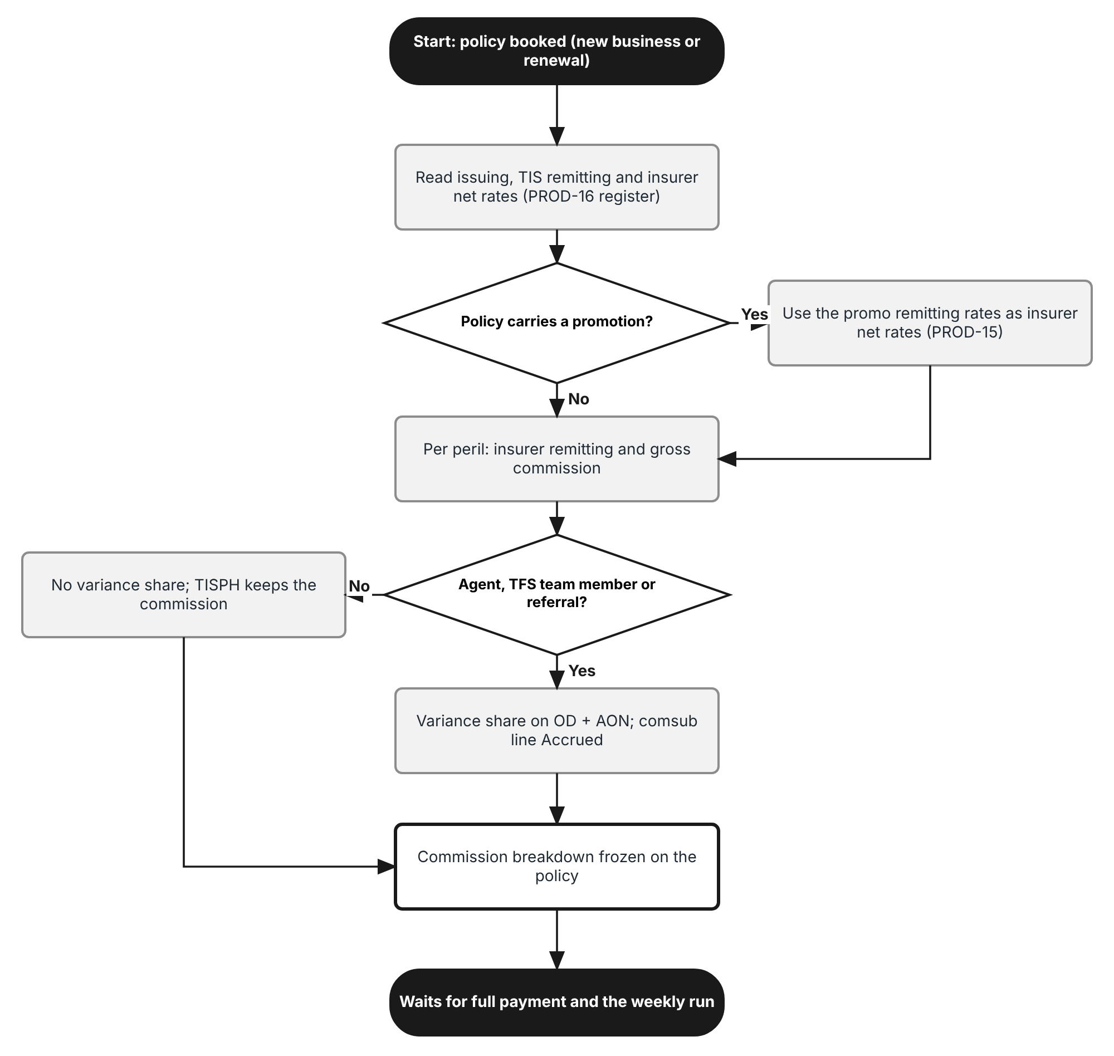
Figure 1: Flow A - Commission of a policy at booking
Table 3: Flow A steps
Step | Who (role) | What happens | FR
A1 | Processing Team | Books the policy (conversion of the quotation or renewal). The policy carries the insurer, product, motor type, business type (NEW / RENEW), sum insured, issuing rates and referrer. | FR-RMT-001
A2 | System | Reads the insurer net rates, the TIS remitting rates and the commission % of the other perils from the PROD-16 register, in force on the inception date. | FR-RMT-001
A3 | System | For a policy with a PROD-15 promotion, the promo remitting rates replace the insurer net rates. | FR-RMT-004
A4 | System | Computes per peril the insurer remitting amount and the gross commission. | FR-RMT-002
A5 | System | When the referrer is an external agent, a TFS team member or a referral, computes the variance share on Own Damage and Acts of Nature and accrues it on the referrer's account. | FR-RMT-003
A6 | System | Freezes the commission breakdown on the policy. | FR-RMT-005

2.2 Flow B - Weekly remittance run
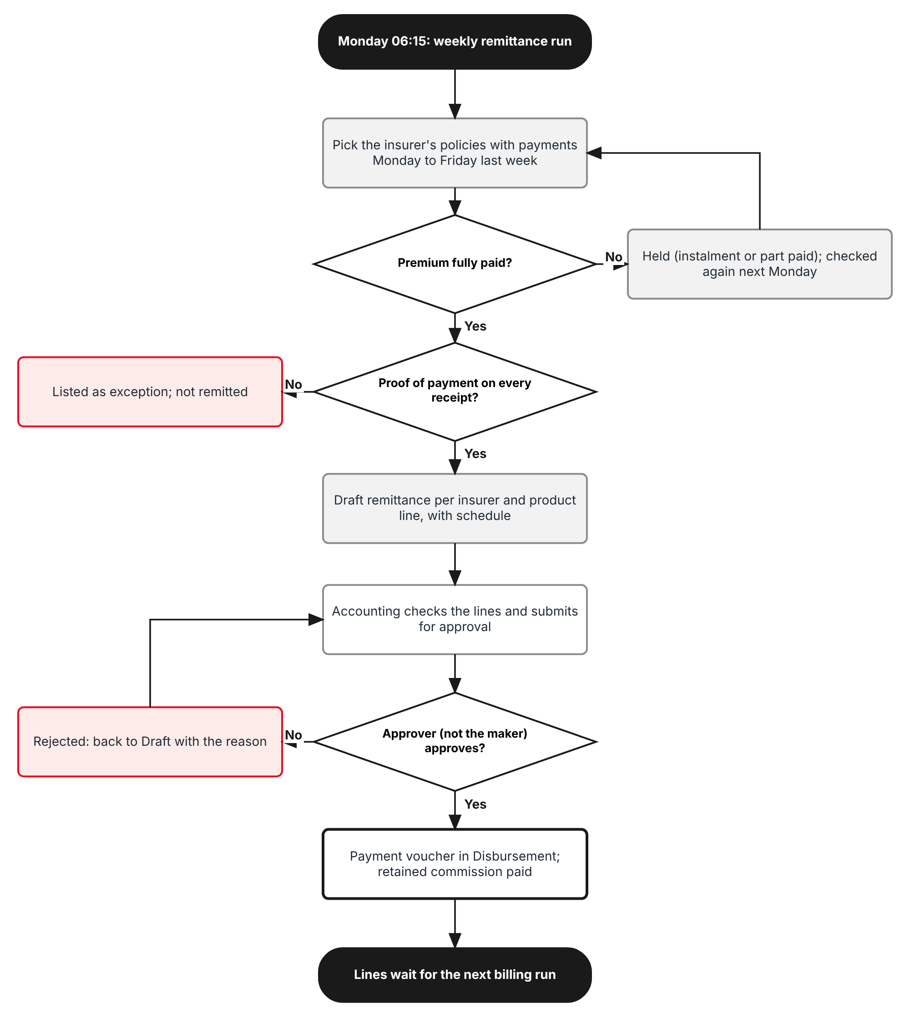
Figure 2: Flow B - Weekly remittance run
Table 4: Flow B steps
Step | Who (role) | What happens | FR
B1 | System | Monday 06:15, job Remittance schedules runs TIS-WEEKLY: policies of each insurer with a payment from the previous Monday to Friday. | FR-RMT-010
B2 | System | A policy that is not fully paid is Held and checked again next Monday. | FR-RMT-012
B3 | System | A fully paid policy with a receipt that has no proof of payment is listed as an exception. | FR-RMT-011
B4 | System | Creates one Draft remittance per insurer and product line with the per-policy lines and the remittance schedule. | FR-RMT-013, 015
B5 | Accounting | Checks the lines on Accounts > Remittance > Tracking and submits. | FR-RMT-014
B6 | Accounting Manager | Approves (not the maker, within the Authority Matrix limit for remittance). A payment voucher is raised in Disbursement; TISPH's retained commission is marked paid. | FR-RMT-014

2.3 Flow C - Billing run
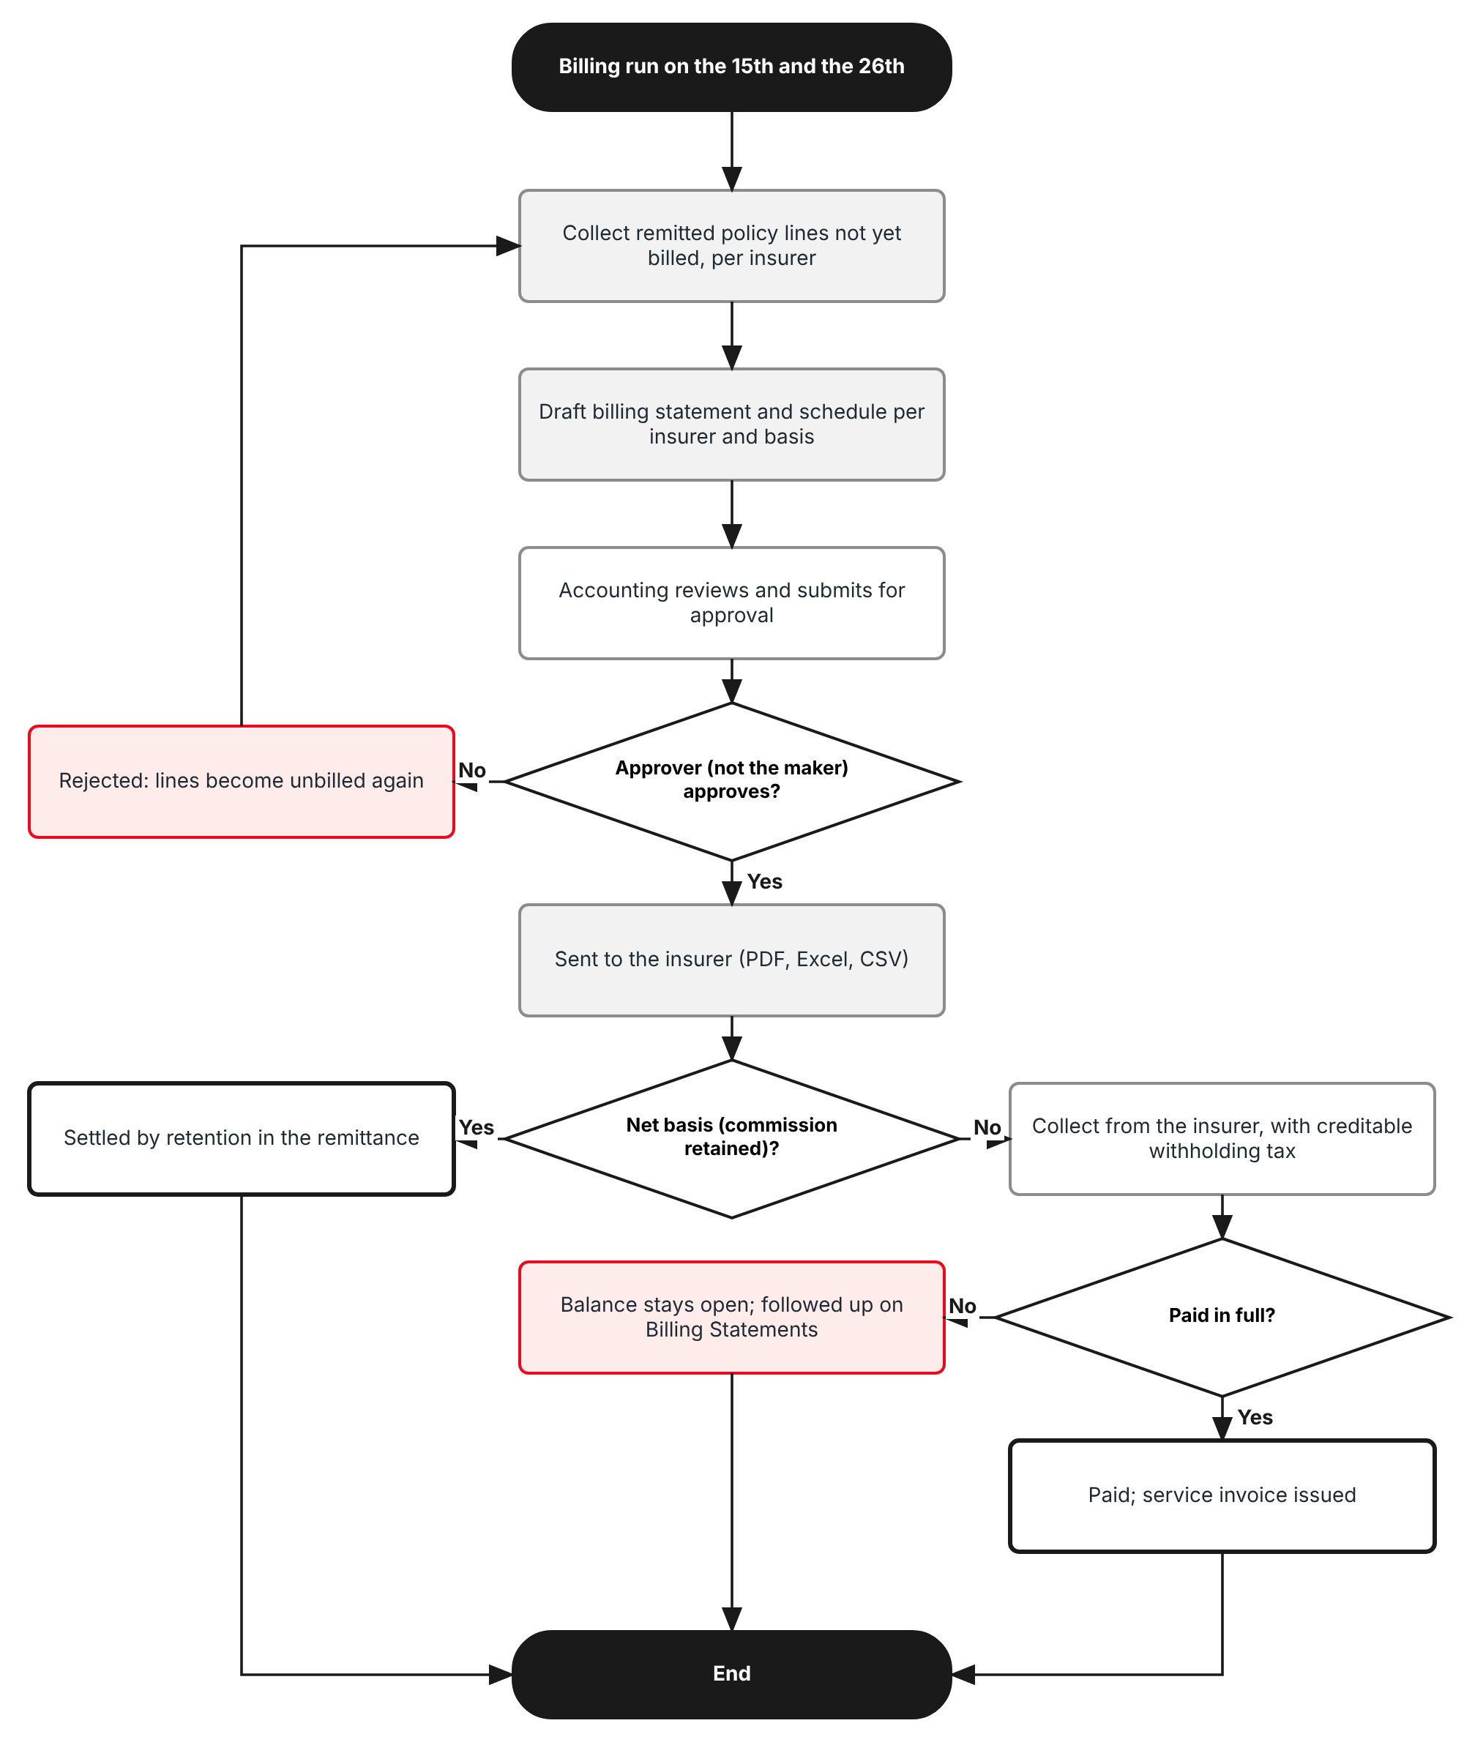
Figure 3: Flow C - Billing run on the 15th and the 26th
Table 5: Flow C steps
Step | Who (role) | What happens | FR
C1 | System | On the 15th and the 26th (the working day before when it is a non-working day), job Insurer billing run collects the remitted policy lines not yet billed. | FR-RMT-020
C2 | System | Drafts one billing statement and schedule per insurer, product line and settlement basis: commission, VAT, EWT, net amount payable, due date + 15 days. | FR-RMT-021
C3 | Accounting / Accounting Manager | Accounting submits; the Accounting Manager approves (not the maker) or rejects; the statement is sent to the insurer as PDF, Excel and CSV. | FR-RMT-022
C4 | System / Accounting | Net basis: settled by the retention in the remittance. Gross basis: Accounting records the insurer's payment with creditable withholding tax; when paid in full the service invoice is due. | FR-RMT-023

2.4 Products, rates and channels covered
Table 6: Dimensions
Dimension | Values | Where in BrokerVerse
Products | Motor - Private Car, Commercial Vehicle, Motorcycle (variance and per-peril commission). Personal Accident, Credit Life, Marine (flat commission %, gross basis) | Master > Insurance > Product; product line of the policy
Perils with a variance | Own Damage (with Theft) and Acts of Nature only | Coverage Details rates; PROD-16 register
Perils at commission % | Bodily Injury, Property Damage, Auto Passenger Personal Accident (25%); CTPL earns no commission | PROD-16 register
Channels with a variance share | External agent (referrer type Agent / Sub-agent), TFS team member (new referrer type), referral (referrer type External) | Commission > Agents/Referrer Accounts
Business type | New business and renewal alike | Policy (renewal of an earlier policy = RENEW)
Insurers | AXA, Standard, Malayan, Stronghold, Pioneer, MAAGAP and any other panel insurer | Master > Insurance > Insurance Company

3 Personas and roles

3.1 Personas
BrokerVerse ships eight roles (Master > Users and Access > Role). TISPH personas map to them as below.
Table 7: Personas and BrokerVerse roles
TISPH persona | BrokerVerse role | What they do in COMM-06
FGA accountant (maker) | Accounting - accounting | Checks and submits remittances and billing statements; records insurer payments; generates agent payouts
FGA head (checker) | Accounting Manager - accounting-manager | Approves or rejects remittances, billing statements and agent payouts
TIS Operations | Processing Team - processing | Books policies (the commission breakdown is computed then); answers held and exception lines
Cash Control | Operations - operations | Records receipts and proof of payment; clears PDCs, which releases held policies
External agent, TFS team member, referrer | Referrer on Commission > Agents/Referrer Accounts (no system role) | Receives the variance share
System Administrator | System Administrator - system-admin | Settings, schedules, permissions
Auditor | Compliance Officer - compliance-officer | Read-only access to remittances, billing statements and the Audit Trail

3.2 Permissions
Remittance screens keep the base permissions read:remittance and write:remittance; the approval of a remittance keeps the Authority Matrix limit of transaction type remittance. One permission is new, following the pattern read:<module> / write:<module> / approve:<module>. The maker of a remittance, billing statement or payout can never approve it, even with both permissions: the approver must be different from the user who created or submitted it.
Table 8: Permissions
Permission | Allows
read:remittance (existing) | Open Accounts > Remittance screens, including the new Insurer Billing screen and the Held tab
write:remittance (existing) | Edit schedules, run them, submit remittances; generate, submit, send and cancel billing statements; record insurer payments
approve:insurer-billing (new) | Approve or reject a billing statement (never one you generated or submitted)
read:commission / write:commission (existing) | See and act on variance share lines on Commission > Agents/Referrer Accounts

3.3 Default grants
Table 9: Default grants (Y = granted; the base grants of read:commission and write:commission are unchanged)
Permission | system-admin | processing | operations | accounting | accounting-manager | compliance-officer
read:remittance | Y | Y | - | Y | Y | Y
write:remittance | Y | - | - | Y | Y | -
approve:insurer-billing | Y | - | - | - | Y | -

4 Functional requirements
Twenty FRs implement COMM-06. They follow the money: the commission of a policy (4.1), the weekly remittance run (4.2), the billing run (4.3), the share of agents, TFS team members and referrers and the settlement basis (4.4), and audit and access (4.5).

4.1 Commission of a policy

FR-RMT-001 Take the rates of a policy from the commission rules register at booking
BRD trace | COMM-06 "issuing rate 2.0%, net TIS remitting rate 1.70%"; PROD-16; PROD-04 | Actor | System
Priority | Must have | Fit | Customization
Screens | Policy detail > Commission breakdown (new read-only panel on the policy); commission rules register (PROD-16)

Description
When a Motor policy is booked (conversion of a quotation, issuance, or renewal), BrokerVerse looks up the rates of each peril on the PROD-16 commission rules register, for the policy's insurer, product, motor type, business type (NEW for a first policy, RENEW for a renewal) and channel, in force on the inception date.
Four rates are taken: the issuing rate of Own Damage and Acts of Nature (from the policy itself: Own Damage coverage Rate and Acts of Nature Rate of Coverage Details), the insurer net rate of Own Damage and Acts of Nature, the TIS remitting rate of Own Damage and Acts of Nature, and the commission % of the other perils (Bodily Injury, Property Damage, Auto Passenger Personal Accident). For a non-Motor policy only the commission % of the product is taken.
The rates are copied onto the policy (rate snapshot) and are never read again for that policy: a later change of the register does not change a booked policy, its remittance or its billing.
Preconditions
- The insurer, product and motor type of the policy are on the PROD-16 register with rates in force on the inception date.
Main flow
- The Processing Team books the policy.
- The server derives the motor type from the product and vehicle type of the policy, and the business type from its renewal link.
- The server reads the rates and stores the rate snapshot with the register row id.
- The commission is computed (FR-RMT-002, 003) and shown on the Commission breakdown panel (FR-RMT-005).
Alternate and exception flows
- No row on the register: the policy is booked, the commission breakdown shows "Rates missing" and the policy cannot go on a remittance until the rates are added on the register and Recompute is used (FR-RMT-005).
- Issuing rate below the insurer net rate: the policy is booked with a warning; the commission of that peril is negative and shows in red.
Business rules
Rule | Statement | Kind | Maintained in
R1 | Rates are looked up on the inception date of the policy, not on the booking date. | Fixed | -
R2 | Business type RENEW when the policy renews an earlier TISPH policy; otherwise NEW. The same rate structure applies to both; only the insurer net rate may differ. | Fixed | PROD-16 register
R3 | The rate snapshot is kept for the life of the policy, including endorsements and cancellation. | Fixed | -
R4 | The Commission Rate Matrix (Master > Finance) is no longer used for Motor policies once COMM-06 is switched on (setting commission.peril_based_motor = true). It stays in use for products not on the register. | Configurable | Master > System > Configuration

Validations and messages
Check | Message shown | ID
No rate on the register | No commission rates found for <insurer>, <motor type>, <NEW / RENEW> on <inception date>. Add them on the commission rules register, then recompute. | MSG-RMT-001
Issuing below insurer net | The issuing rate of <peril> (<rate>%) is below the insurer net rate (<rate>%). The commission on this peril is negative. | MSG-RMT-002

Audit
- Written to Master > System > Audit Trail with the user, time, before and after values and remark.
Acceptance criteria
- A Fortuner policy with Malayan, PC-Other than Sedan, NEW, inception 01/10/2026 stores issuing 2.00 / 0.50, insurer net 0.95 / 0.25, TIS remitting 1.70 / 0.40 and 25% for BI, PD and APPA.
- A Vios renewal with Malayan, PC-Sedan Regular stores insurer net 1.10 / 0.25 (RENEW row).
- Changing the Malayan Own Damage net rate on the register after booking does not change the stored snapshot of the Fortuner policy.
- A policy whose motor type has no row shows "No commission rates found ..." and is not offered to a remittance run.

FR-RMT-002 Compute the insurer remitting amount and the gross commission per peril
BRD trace | COMM-06 "calculated on Own Damage and Acts of Nature perils only"; COMM-03 "net remittance computed on the scheduled net remitting rate" | Actor | System
Priority | Must have | Fit | Customization
Screens | Policy detail > Commission breakdown; Accounts > Remittance > Tracking > Remittance Details > Policies

Description
For each peril of a Motor policy the server computes what goes to the insurer and what stays with TISPH, in the three sections TISPH uses on its billing statement schedule (Premium, Remitting, Commission).
Own Damage and Acts of Nature: insurer remitting = sum insured of the peril x insurer net rate; commission = peril premium - insurer remitting. Bodily Injury, Property Damage and Auto Passenger Personal Accident: commission = peril premium x commission %; insurer remitting = peril premium - commission. Roadside assistance and other charges with no commission % are remitted in full. CTPL earns no commission and is remitted in full with the premium taxes.
The gross commission of the policy is the sum of the peril commissions; it equals NET Premium minus total insurer remitting. It replaces the base commission (NET Premium x matrix rate) on the policy, the receivable and the remittance line.
Business rules
Rule | Statement | Kind | Maintained in
R1 | Each peril amount is rounded to 2 decimals before it is summed. | Fixed | -
R2 | Sum insured of Own Damage and of Acts of Nature is the Own Damage coverage amount of Coverage Details (Acts of Nature follows Own Damage). | Fixed | -
R3 | Non-Motor: commission = premium x commission % of the product and insurer; there is no per-peril split. | Fixed | PROD-16 register

Audit
- Written to Master > System > Audit Trail with the user, time, before and after values and remark.
Acceptance criteria
- Fortuner, OD 1,200,000: OD premium 24,000.00, remitting 11,400.00, commission 12,600.00; AON 6,000.00 / 3,000.00 / 3,000.00; BI and PD 1,000.00 / 750.00 / 250.00 each; APPA 125.00 / 93.75 / 31.25; gross commission 16,131.25 = 32,125.00 - 15,993.75.
- Vios renewal, OD 640,000: gross commission 7,891.25 (Appendix A.2).
- CTPL 610.40 is remitted in full and is not in the commission.
- A Personal Accident policy of 18,206.79 with AXA at 25% has commission 4,551.70.

FR-RMT-003 Compute the variance share of agents, TFS team members and referrals
BRD trace | COMM-06 "For external agents, TFS team members and referrals ... (0.3% variance)"; COMM-05 | Actor | System
Priority | Must have | Fit | Customization
Screens | Policy detail > Commission breakdown; Commission > Agents/Referrer Accounts

Description
When the policy's referrer (Step 1 Referrer of the quotation, kept on the policy) is an external agent, a TFS team member or a referral, the server computes the variance share on Own Damage and Acts of Nature only: sum insured x (issuing rate - TIS remitting rate), per peril. It is the same for new business and renewal.
The variance share is accrued as a comsub line on the referrer's account on Commission > Agents/Referrer Accounts, with the basis shown ("OD 2.00 - 1.70 / AON 0.50 - 0.40"). Withholding tax follows the referrer's tax code as in the base (Individual 5%, Company 10%). TISPH's retained commission is the gross commission minus the variance share (and minus any PROD-16 sharing).
Bodily Injury, Property Damage, APPA and CTPL never carry a variance share. A walk-in or direct policy, a dealer policy and a telesales policy have no variance share (dealer sharing is PROD-16, telesales incentive is COMM-08).
Preconditions
- The referrer exists on Commission > Agents/Referrer Accounts with a type of Agent, Sub-agent, TFS team member or External.
Business rules
Rule | Statement | Kind | Maintained in
R1 | Channels with a variance share: setting commission.variance_channels (default agent, sub-agent, tfs-team-member, external). | Configurable | Master > System > Configuration
R2 | Perils with a variance share: setting commission.variance_perils (default OD, AON). Fixed to these two by the requirement; the setting exists so that TISPH can confirm Acts of Nature. | Configurable | Master > System > Configuration
R3 | A negative variance on a peril (issuing below TIS remitting) gives a share of 0.00 on that peril. | Fixed | -
R4 | The variance share cannot exceed the gross commission of the policy; when it would, it is capped and a warning is shown. | Fixed | -
R5 | New referrer type "TFS team member" is added to the referrer type list. | Fixed | Lists of values (7.3)

Validations and messages
Check | Message shown | ID
Share above commission | The variance share (<amount>) is above the gross commission of the policy (<amount>). It has been capped at the gross commission. | MSG-RMT-003
Referrer without type | The referrer <name> has no type. Set Agent, Sub-agent, TFS team member or External before the policy is booked. | MSG-RMT-004

Audit
- Written to Master > System > Audit Trail with the user, time, before and after values and remark.
Acceptance criteria
- Fortuner referred by Ramon Bautista (Agent): variance share 1,200,000 x 0.30% + 1,200,000 x 0.10% = 4,800.00; WHT 5% 240.00; net 4,560.00; TISPH retained commission 11,331.25.
- The same Fortuner sold to a walk-in client has no comsub line and TISPH retains 16,131.25.
- A renewal referred by a TFS team member gets the same 0.30 point variance as a new policy.
- The comsub line shows basis "OD 2.00 - 1.70 / AON 0.50 - 0.40" and status Accrued.

FR-RMT-004 Use the rates of a promotion and of a changed issuing rate
BRD trace | COMM-06; PROD-15 "flexible issuing and remitting rates"; PROD-16 | Actor | System
Priority | Must have | Fit | Customization
Screens | Policy detail > Commission breakdown

Description
A policy that carries a PROD-15 promotion keeps the promo rates as its issuing rates and the promo line's Remit OD % and Remit AON % as its insurer net rates. The gross commission is computed with them as in FR-RMT-002.
For the variance share the TIS remitting rate is set so that the agent keeps the same variance in points as on the standard rate (setting commission.promo_variance_basis = same_points): TIS remitting = promo issuing rate - standard variance, but never below the promo insurer net rate. With register_rate the register's TIS remitting rate is used and a negative variance gives 0.00.
When an authorised user changed the Own Damage rate on Coverage Details (PROD-15 Change promo rate, or the base Override), the rate on the policy is the issuing rate; the insurer net rate does not change.
Business rules
Rule | Statement | Kind | Maintained in
R1 | Promo variance basis: same_points | register_rate (default same_points). | Configurable | Master > System > Configuration
R2 | TISPH retained commission may be 0.00 on a promo policy; it is never negative: the variance share is capped (FR-RMT-003). | Fixed | -

Audit
- Written to Master > System > Audit Trail with the user, time, before and after values and remark.
Acceptance criteria
- Fortuner with PRM-FORTUNER26 (OD 1.50 / AON 0.40, remit 1.30 / 0.30): gross commission 4,131.25.
- With same_points the agent's share is 2,400.00 + 1,200.00 = 3,600.00 and TISPH retains 531.25.
- With register_rate the agent's share is 0.00 (1.50 is below 1.70) and TISPH retains 4,131.25.

FR-RMT-005 Show and recompute the commission breakdown of a policy
BRD trace | COMM-06; COMM-02 (no manual adjustment) | Actor | Accounting; Processing Team
Priority | Must have | Fit | Customization
Screens | Policy detail > Commission breakdown

Description
The policy detail gets a read-only Commission breakdown panel: per peril the sum insured, premium, issuing rate, insurer net rate, insurer remitting, commission, TIS remitting rate and variance share; then gross commission, variance share, TISPH retained commission, settlement basis, and the remittance and billing statement that carry the policy.
There is no manual adjustment of commission (COMM-02): the only action is Recompute, for a user with write:remittance, while the policy is on no approved remittance. Recompute reads the register again on the inception date and replaces the snapshot.
Business rules
Rule | Statement | Kind | Maintained in
R1 | Recompute is refused once the policy is on an approved remittance. | Fixed | -

Validations and messages
Check | Message shown | ID
Recompute after remittance | The commission of <policy> cannot be recomputed: it is on approved remittance <REM no.>. | MSG-RMT-005
Recomputed | Commission recomputed: <old amount> to <new amount>. | MSG-RMT-006

Audit
- Written to Master > System > Audit Trail with the user, time, before and after values and remark.
Acceptance criteria
- The Fortuner policy shows OD and AON lines with insurer net 0.95 and 0.25 and a variance share of 4,800.00.
- Recompute on a policy of REM-2026-00021 after approval shows "The commission of POL-2026-95021 cannot be recomputed ...".
- After the missing rates are added, Recompute shows "Commission recomputed: 0.00 to 7,891.25."

FR-RMT-006 Cancelled policies and return premium
BRD trace | COMM-06; COMM-04; Module 11 Cancellation | Actor | System; Operations
Priority | Must have | Fit | Customization
Screens | Operations > Policy Cancellation; Accounts > Remittance > Tracking; Commission > Agents/Referrer Accounts

Description
A policy cancelled before it is remitted is dropped from every remittance and billing run: no commission receivable is raised, and its Accrued or Eligible variance share lines are reversed.
A policy cancelled after it was remitted follows the base cancellation: the return premium is credited by the insurer (Accounts > Remittance insurer credits, netted on the next remittance), the commission is taken back at the policy's rates in proportion to the premium returned, and a variance share already paid is clawed back (Receivable from Agents).
Audit
- Written to Master > System > Audit Trail with the user, time, before and after values and remark.
Acceptance criteria
- A Fortuner policy cancelled flat on 09/10/2026 before the run of 12/10/2026 is not on REM-2026-00021 and its 4,800.00 line is Reversed.
- A pro-rata cancellation after remittance creates an insurer credit and a clawback of the paid share in the same proportion.

4.2 Weekly remittance run

FR-RMT-010 Run the remittance every Monday for the previous Monday to Friday
BRD trace | COMM-01 "generates every Monday covering the prior Monday-Friday, remitted per insurer and grouped by product line" | Actor | System; Accounting
Priority | Must have | Fit | Customization
Screens | Accounts > Remittance > Scheduling (Edit schedule); Accounts > Remittance > Automated Processing; Master > System > Schedules

Description
The base remittance schedule gets four new fields: Payment window (Previous Monday to Friday), Group remittances by (Insurer and product line), Remit only fully paid policies and Proof of payment required. TISPH uses one schedule, TIS-WEEKLY, frequency Weekly, next run on a Monday, for all active insurers.
The base job Remittance schedules (Master > System > Schedules, daily 06:15 Asia/Manila) is switched on. On Monday it runs TIS-WEEKLY: for each insurer it takes the policies whose premium became fully paid in the window (the 11:59 PM day-end cut applies to the Friday) and creates one Draft remittance per insurer and product line (Motor, Personal Accident, Credit Life, Marine).
Automated Processing shows the run per insurer and product line with the count of fully paid, held and exception policies and the amount due to the insurer. Accounting can also use Run now on Scheduling for a missed run; the window is then the Monday to Friday before the run date.
Preconditions
- Schedule TIS-WEEKLY is Active and the job Remittance schedules is switched on.
Business rules
Rule | Statement | Kind | Maintained in
R1 | Window: from Monday 00:00 to Friday 23:59 of the week before the run date, on the fully paid date of the policy. | Configurable | Accounts > Remittance > Scheduling > Payment window
R2 | One remittance per insurer and product line; a product line with nothing to remit creates no remittance. | Configurable | Accounts > Remittance > Scheduling > Group remittances by
R3 | A policy already on a remittance that is not rejected or cancelled is never picked again. | Fixed | -
R4 | A fully paid policy not picked in its week (late receipt entry) is picked by the next run: the window looks back to the start of the earliest unremitted fully paid date (setting remittance.catch_up_days, default 60). | Configurable | Master > System > Configuration

Validations and messages
Check | Message shown | ID
Window without weekly frequency | A Monday to Friday payment window needs a Weekly frequency and a next run on a Monday. | MSG-RMT-007
Run done | Weekly run done: <n> remittance(s) created, <h> policies held, <e> exceptions. | MSG-RMT-008

Audit
- Written to Master > System > Audit Trail with the user, time, before and after values and remark.
Acceptance criteria
- On Monday 12/10/2026 06:15 the job creates REM-2026-00021 for Malayan Motor with the two policies fully paid on 06/10 and 08/10/2026.
- A policy fully paid on Saturday 10/10/2026 is remitted on 19/10/2026, not on 12/10/2026.
- AXA Personal Accident and Malayan Motor fully paid in the same week give two separate remittances.
- Saving TIS-WEEKLY with frequency Monthly and payment window Previous Monday to Friday is refused.

FR-RMT-011 Remit only fully paid policies with proof of payment
BRD trace | COMM-01 "unpaid policies are excluded and proof of payment is mandatory" | Actor | System
Priority | Must have | Fit | Customization
Screens | Accounts > Remittance > Automated Processing; Accounts > Remittance > Tracking; Accounts > Remittance > Exception Management

Description
A policy goes on a remittance only when it is fully paid and every receipt or verified payment of the policy carries a proof of payment (the file attached to the receipt or to the payment captured on the policy).
A fully paid policy with a receipt without proof is listed as an exception (type "No proof of payment") on Accounts > Remittance > Exception Management, assigned to Cash Control. When the proof is attached the exception is resolved and the policy is picked by the next run.
Business rules
Rule | Statement | Kind | Maintained in
R1 | Proof required: setting remittance.proof_of_payment_required (default true). | Configurable | Accounts > Remittance > Scheduling > Proof of payment required
R2 | Direct-bill policies (client paid the insurer) are never remitted, as in the base. | Fixed | -

Validations and messages
Check | Message shown | ID
Receipt without proof | Receipt <OR no.> of <policy> has no proof of payment. The policy is not remitted until the proof is attached. | MSG-RMT-009

Audit
- Written to Master > System > Audit Trail with the user, time, before and after values and remark.
Acceptance criteria
- A policy fully paid on 07/10/2026 by a receipt without proof is not on REM-2026-00021 and appears on Exception Management.
- After the proof is attached on 13/10/2026 the policy is on the run of 19/10/2026.

FR-RMT-012 Hold instalment and part-paid policies until fully paid
BRD trace | COMM-06 "commission on installment policies pays only once the full premium settles"; COMM-01 | Actor | System
Priority | Must have | Fit | Customization
Screens | Accounts > Remittance > Tracking > Remittance Details > Held; Accounts > Remittance > Automated Processing; Commission > Agents/Referrer Accounts

Description
A policy with a payment in the window that is not fully paid (a Credit-mode Motor policy paid by PDC instalments: one dated cheque and three PDCs, or a part payment) is Held. It is shown on the run and on the Held tab of the insurer's remittance with the payment plan, total premium, paid to date, balance and next due date, but it is not remitted, not billed and its variance share stays Accrued.
The daily job Instalment hold check looks at the held policies; when the last instalment clears, the policy is released: it is picked by the next weekly run (with the clearing date as fully paid date) and its variance share becomes Eligible.
Business rules
Rule | Statement | Kind | Maintained in
R1 | Held policies are never remitted in part; the remittance carries the full premium once. | Fixed | -
R2 | A bounced PDC keeps the policy held; the balance includes the bounced amount. | Fixed | -
R3 | Hold applies to every product line; in practice only Credit-mode Motor uses instalments. | Fixed | -

Audit
- Written to Master > System > Audit Trail with the user, time, before and after values and remark.
Acceptance criteria
- POL-2026-95034 (Innova, 25,817.34 in 4 instalments, 2 cleared) is on the Held tab with paid to date 12,908.68, balance 12,908.66, next due 03/11/2026.
- When the last PDC of 03/12/2026 clears, the policy is on the run of 07/12/2026 and its 2,880.00 share becomes Eligible.
- The held policy is on no billing statement until it is remitted.

FR-RMT-013 Build the remittance lines and the amount due to the insurer
BRD trace | COMM-03, COMM-04 "retained commission/service fee marks as paid"; COMM-06 | Actor | System
Priority | Must have | Fit | Customization
Screens | Accounts > Remittance > Tracking > Remittance Details > Policies

Description
Each line of a remittance carries the policy, client and vehicle, business type, fully paid date, total premium (NET Premium, VAT, DST, LGT, CTPL, other charges), insurer remitting, commission, VAT on the commission, EWT on the commission and the amount due to the insurer. The header totals them.
Net basis (Motor): due to insurer = total premium - commission - VAT on commission + EWT on commission. This is the base broker-billed rule; COMM-06 only supplies the commission. Gross basis (non-Motor): due to insurer = total premium; the commission is billed (FR-RMT-021).
Business rules
Rule | Statement | Kind | Maintained in
R1 | VAT on commission = commission x VAT rate of tax code tax.commission_vat_code (12%). EWT = commission x rate of tax code tax.commission_ewt_code (15% by default). | Configurable | Master > Finance > Taxation; Master > System > Configuration
R2 | Settlement basis per product line and insurer (FR-RMT-031). | Configurable | Accounts > Remittance > Insurer Billing > Settlement Basis

Audit
- Written to Master > System > Audit Trail with the user, time, before and after values and remark.
Acceptance criteria
- REM-2026-00021 (Malayan, Motor, net): total premium 64,159.68, commission 24,022.50, VAT 2,882.70, EWT 3,603.38, due to insurer 40,857.86.
- The AXA Personal Accident remittance (gross) is due 18,807.35, the full premium.

FR-RMT-014 Approve the remittance and pay the insurer
BRD trace | COMM-01 "Remittance runs on maker-checker"; COMM-04 | Actor | Accounting (maker); Accounting Manager (checker)
Priority | Must have | Fit | Customization
Screens | Accounts > Remittance > Tracking; Accounts > Remittance > Approval Workflow; My Work > Approvals; Accounts > Disbursement

Description
The base approval applies: Accounting checks the Draft and submits it; the approval item goes to Accounts > Remittance > Approval Workflow and My Work > Approvals; an approver whose Authority Matrix limit for transaction type remittance covers the amount, and who is not the maker or submitter, approves or rejects with a reason.
On approval the insurer payment voucher for the amount due is raised in Accounts > Disbursement (cheque or fund transfer through Metrobank), the lines become Remitted, the retained commission of net-basis lines is marked paid, and the variance share lines of the policies become Eligible.
Validations and messages
Check | Message shown | ID
Approver is maker | Maker-checker: REM-<no.> must be approved by a different user. | MSG-RMT-010
Above limit | The amount of <amount> is above your approval authority for remittance. | MSG-RMT-011
Reject without reason | Enter the reason for rejecting the remittance. | MSG-RMT-012
Approved | Remittance approved. Payment voucher <PV no.> raised for <amount>. | MSG-RMT-013

Audit
- Written to Master > System > Audit Trail with the user, time, before and after values and remark.
Acceptance criteria
- The maker of REM-2026-00021 cannot approve it.
- Approval by the Accounting Manager raises a voucher of 40,857.86 and makes the 4,800.00 share of POL-2026-95021 Eligible.
- A rejected remittance returns to Draft; its policies are picked again by the next run if it is cancelled.

FR-RMT-015 Produce the remittance schedule
BRD trace | COMM-01; COMM-03 "net remittance computed on the scheduled net remitting rate" | Actor | System; Accounting
Priority | Must have | Fit | Customization
Screens | Accounts > Remittance > Tracking > Remittance Details > Schedule; Accounts > Remittance > Statements

Description
Each remittance has a remittance schedule: one row per policy in the layout of the TISPH billing statement schedule, with the sections Premium, Remitting and Commission per peril (OD/TH, AON, PD, BI, PA). It is downloadable as Excel and PDF from the Schedule tab and is attached to the e-mail of the remittance to the insurer (base Statements, template "Remittance schedule"). Columns are listed in chapter 6.
Audit
- Written to Master > System > Audit Trail with the user, time, before and after values and remark.
Acceptance criteria
- The schedule of REM-2026-00021 has 2 rows and totals Remitting 26,227.50 and Commission 24,022.50.
- The Excel opens with the TISPH header "TOYOTA INSURANCE SERVICES PHILIPPINES CORPORATION" and the coverage week.

4.3 Billing run

FR-RMT-020 Run the billing on the 15th and the 26th
BRD trace | COMM-01 "Billing runs every 15th day and 26th day of the month"; COMM-03 | Actor | System
Priority | Must have | Fit | Customization
Screens | Accounts > Remittance > Insurer Billing > Billing Run; Master > System > Schedules

Description
The new job Insurer billing run runs at 07:00 on the 15th and the 26th of each month. When that day is a Saturday, Sunday or a day on the holiday list, it runs on the working day before.
It takes every remittance line that is Remitted (remittance approved up to the day before the run) and not yet billed, and drafts one billing statement per insurer, product line and settlement basis. Accounting can also run it from Billing Run with a billing date and insurer.
Business rules
Rule | Statement | Kind | Maintained in
R1 | Run days: setting insurer_billing.run_days (default 15, 26). | Configurable | Master > System > Configuration
R2 | Non-working day: insurer_billing.non_working_day = previous | next (default previous). | Configurable | Master > System > Configuration
R3 | A line is on one billing statement only, unless the statement is rejected or cancelled. | Fixed | -

Validations and messages
Check | Message shown | ID
Nothing to bill | Nothing to bill for <insurer> up to <date>. | MSG-RMT-014
Run done | Billing run done: <n> billing statement(s) drafted. | MSG-RMT-015

Audit
- Written to Master > System > Audit Trail with the user, time, before and after values and remark.
Acceptance criteria
- The run of 15/10/2026 drafts BS-2026-00031 for Malayan Motor with the 2 lines of REM-2026-00021 approved on 13/10/2026.
- In a month where the 26th is a Saturday the run takes place on Friday the 25th.
- A line on BS-2026-00031 is not on the run of 26/10/2026.

FR-RMT-021 Compute the billing statement: commission, VAT, EWT and net amount payable
BRD trace | COMM-03 "customer name and TIN, automatic output VAT and EWT computation, net payable and nature of transaction" | Actor | System
Priority | Must have | Fit | Customization
Screens | Accounts > Remittance > Insurer Billing > Billing Statements > Billing statement

Description
A billing statement has the TISPH layout: header with TISPH address and VAT REG TIN, Billing No. (BS-YYYY-nnnnn), Date, Insurance Partner, IP TIN, address and Period Covered; one particulars line per product line ("Motor Car Insurance Commission", "<n> booked account/s") with Due Date, Gross Amount, VAT, Net of VAT, EWT and Net Amount Payable; Total Amount Due; the notes on the service invoice and BIR Form 2307; and TISPH's remittance information.
Gross Amount = commission + VAT on commission. VAT = Gross Amount / 1.12 x 0.12. Net of VAT = commission. EWT = Net of VAT x EWT rate. Net Amount Payable = Gross Amount - EWT. Due Date = billing date + 15 days. The billing statement schedule lists the policy lines behind it (chapter 6).
Business rules
Rule | Statement | Kind | Maintained in
R1 | Amounts are summed from the remittance lines; VAT and EWT per line are rounded to 2 decimals, then totalled. | Fixed | -
R2 | Due days: insurer_billing.due_days (default 15). | Configurable | Master > System > Configuration
R3 | Particulars text per product line: insurer_billing.particulars. | Configurable | Master > System > Configuration
R4 | The insurer's TIN and address come from Master > Insurance > Insurance Company; a statement cannot be approved without the TIN. | Fixed | -

Validations and messages
Check | Message shown | ID
Insurer without TIN | Insurance Company <name> has no TIN. Add it on Master > Insurance > Insurance Company before you approve. | MSG-RMT-016

Audit
- Written to Master > System > Audit Trail with the user, time, before and after values and remark.
Acceptance criteria
- BS-2026-00031: Gross Amount 26,905.20, VAT 2,882.70, Net of VAT 24,022.50, EWT 3,603.38, Net Amount Payable 23,301.82, Due Date 30/10/2026, "2 booked account/s".
- BS-2026-00033 (AXA, Personal Accident, gross): Gross Amount 5,097.90, EWT 682.76, Net Amount Payable 4,415.14.

FR-RMT-022 Approve, issue and send the billing statement
BRD trace | COMM-03 "generated in PDF/Excel/CSV"; SEC-03 | Actor | Accounting (maker); Accounting Manager (approve:insurer-billing)
Priority | Must have | Fit | Customization
Screens | Accounts > Remittance > Insurer Billing > Billing Statements; My Work > Approvals

Description
Accounting opens the Draft, checks the schedule and submits it. The Accounting Manager approves or rejects it from Billing Statements or My Work > Approvals; the approver must be different from the user who generated or submitted it. A rejected statement goes back to Draft with the reason; Cancel releases its lines for the next run.
An approved statement is issued: PDF (TISPH letterhead), Excel and CSV are produced, and Send e-mails them with the schedule to the insurer's billing contact.
Validations and messages
Check | Message shown | ID
Approver is maker | Maker-checker: <BS no.> must be approved by a different user. | MSG-RMT-017
Reject without reason | Enter the reason for rejecting the billing statement. | MSG-RMT-018
Approved | Billing statement <BS no.> approved. | MSG-RMT-019
Sent | Billing statement <BS no.> sent to <e-mail>. | MSG-RMT-020
No billing e-mail | Insurance Company <name> has no billing e-mail. Add it on the insurer master or download the files. | MSG-RMT-021

Audit
- Written to Master > System > Audit Trail with the user, time, before and after values and remark.
Acceptance criteria
- The user who submitted BS-2026-00031 cannot approve it.
- After approval, PDF, Excel and CSV of BS-2026-00031 can be downloaded and Send queues an e-mail with the three files.
- Cancel of an approved statement without collection returns its lines to unbilled.

FR-RMT-023 Settle the billing statement by retention or by collection
BRD trace | COMM-03 "paid commission/service fees update on collection, and a service invoice ... once the insurer pays"; COMM-04 | Actor | System; Accounting
Priority | Must have | Fit | Customization
Screens | Accounts > Remittance > Insurer Billing > Billing Statements > Record payment

Description
Net basis: the commission was kept out of the remittance, so the statement is set to Settled by retention when it is approved, with the remittance numbers as reference. It is still sent: the insurer uses it for its books and to issue BIR Form 2307 for the EWT.
Gross basis: Accounting records the insurer's payment with Record payment (date, amount, bank reference, creditable withholding tax), as for the base collection of a commission debit note (Dr Cash in Bank, Dr Creditable Withholding Tax, Cr Commission Receivable). Part payments are allowed; the statement is Partially collected until the balance is zero, then Paid. A statement past its due date with a balance shows as Overdue.
When a statement is Settled by retention or Paid, its service invoice is due (COMM-03).
Validations and messages
Check | Message shown | ID
Payment above balance | The payment of <amount> is more than the balance of <amount>. | MSG-RMT-022
Payment recorded | Payment of <amount> recorded on <BS no.>. Balance <amount>. | MSG-RMT-023

Audit
- Written to Master > System > Audit Trail with the user, time, before and after values and remark.
Acceptance criteria
- BS-2026-00031 becomes Settled by retention on approval, reference REM-2026-00021.
- A payment of 4,415.14 with EWT 682.76 on BS-2026-00033 makes it Paid.
- A payment of 2,000.00 leaves BS-2026-00033 Partially collected with balance 2,415.14.

4.4 Agent and referrer share, settlement basis

FR-RMT-030 Pay the variance share only when the policy is fully paid and remitted
BRD trace | COMM-06 "commission on installment policies pays only once the full premium settles"; COMM-05 | Actor | System; Accounting; Accounting Manager
Priority | Must have | Fit | Customization
Screens | Commission > Agents/Referrer Accounts

Description
A variance share line stays Accrued until its policy is fully paid and on an approved remittance; it then becomes Eligible. The base payout cycle follows: Approve (maker-checker, accrual journal), Generate payout (payment voucher in Disbursement), Paid.
On the referrer account the lines show the basis of the variance; held lines show "Accrued - held until fully paid" with the open balance of the policy.
Business rules
Rule | Statement | Kind | Maintained in
R1 | Eligibility needs both full payment and an approved remittance (setting commission.require_full_payment stays true). | Fixed | -

Validations and messages
Check | Message shown | ID
Mark eligible too early | No Accrued lines have fully collected and remitted premium yet. | MSG-RMT-024

Audit
- Written to Master > System > Audit Trail with the user, time, before and after values and remark.
Acceptance criteria
- The 2,880.00 share of POL-2026-95034 stays Accrued while 12,908.66 is open.
- The 4,800.00 share of POL-2026-95021 becomes Eligible when REM-2026-00021 is approved, then Approved and Paid through the base payout.

FR-RMT-031 Maintain the settlement basis per product line and insurer
BRD trace | COMM-03; COMM-04 | Actor | Accounting Manager
Priority | Must have | Fit | Customization
Screens | Accounts > Remittance > Insurer Billing > Settlement Basis

Description
The Settlement Basis tab lists per product line the basis Net or Gross, with optional exceptions per insurer. Default: Motor Net; Personal Accident, Credit Life and Marine Gross. A change applies to policies remitted after the change and is approved on Master > Finance > Configuration Approvals.
Validations and messages
Check | Message shown | ID
Change with open lines | There are remitted lines not yet billed for <insurer>, <product line>. The new basis applies to the next remittances only. | MSG-RMT-025

Audit
- Written to Master > System > Audit Trail with the user, time, before and after values and remark.
Acceptance criteria
- Motor is Net and Personal Accident is Gross after go-live.
- An exception "AXA - Motor: Gross" applies only after it is approved on Configuration Approvals.

4.5 Audit and access

FR-RMT-040 Keep a complete audit trail
BRD trace | BRD section 5.14; SEC-03 | Actor | System
Priority | Must have | Fit | Customization
Screens | Master > System > Audit Trail; Accounts > Remittance > History

Description
Rate snapshots, recomputes, schedule changes, every run (job or Run now) with its counts, holds and releases, exceptions, remittance and billing statement submissions, approvals, rejections, sends, payments and cancellations are written to the Audit Trail (entities policy_commission, remittance, remittance_schedule, insurer_billing) with user, time, before and after values and remark.
Audit
- Written to Master > System > Audit Trail with the user, time, before and after values and remark.
Acceptance criteria
- The Audit Trail of BS-2026-00031 shows generate (system), submit, approve and send with users and times.
- The release of POL-2026-95034 from hold is logged with the clearing receipt.

FR-RMT-041 Control access to the remittance and billing functions
BRD trace | SEC-01, SEC-02, SEC-03 | Actor | System Administrator
Priority | Must have | Fit | Customization
Screens | Master > Users and Access > Role Permissions; side bar menu grants

Description
approve:insurer-billing is added to the permission list and granted as in section 3.3. The menu item Insurer Billing is added after Direct Bill Processing under Accounts > Remittance and shown to roles with read:remittance.
Audit
- Written to Master > System > Audit Trail with the user, time, before and after values and remark.
Acceptance criteria
- A user without read:remittance does not see Insurer Billing.
- An accounting user without approve:insurer-billing sees no Approve button on a billing statement.

5 Workflow and status model

5.1 Policy in the remittance run
Table 10: Remittance status of a policy
From | Event | To | Who | Condition
(booked) | Commission breakdown computed | Unpaid | System | Rates found (else "Rates missing")
Unpaid | Payment received, balance left | Held | System (weekly run) | Payment in the window, not fully paid
Unpaid, Held | Last balance cleared, proof on every receipt | Ready | System | Fully paid date set
Unpaid, Held | Last balance cleared, a receipt without proof | Exception | System | Exception "No proof of payment" opened
Exception | Proof attached | Ready | Cash Control | Exception resolved
Ready | Weekly run | On remittance (Draft) | Job Remittance schedules | Fully paid date in the window or catch-up
On remittance | Remittance approved | Remitted | Accounting Manager | Not the maker; within limit
On remittance | Remittance rejected and cancelled | Ready | Accounting | Picked by the next run
Remitted | Billing run | Billed | Job Insurer billing run | Line on a billing statement
Any before Remitted | Policy cancelled | Dropped | Operations | No commission receivable; shares reversed

5.2 Remittance
The base statuses are kept: Draft -> Pending Approval -> Approved -> Completed (settled), with Rejected (back to Draft) and Cancelled. COMM-06 adds nothing to them; it adds the held and exception lists next to them.

5.3 Billing statement
Table 11: Billing statement statuses
From | Action / event | To | Who | Condition
(new) | Billing run or Run now | Draft | System / write:remittance | Remitted lines not yet billed
Draft | Submit | Pending approval | write:remittance | Insurer TIN present
Pending approval | Reject | Draft | approve:insurer-billing, not the maker | Reason required
Pending approval | Approve (net basis) | Settled by retention | approve:insurer-billing, not the maker | Remittances of the lines approved
Pending approval | Approve (gross basis) | Approved | approve:insurer-billing, not the maker | -
Approved | Send | Sent | write:remittance | Billing e-mail on the insurer
Approved, Sent | Record payment, balance left | Partially collected | write:remittance | -
Approved, Sent, Partially collected | Balance zero | Paid | System | Service invoice due
Draft, Approved, Sent | Cancel | Cancelled | write:remittance | No payment recorded; lines unbilled again

Overdue is not a status: it is shown on Approved, Sent and Partially collected statements whose due date has passed.

5.4 Variance share line
Base comsub statuses: Accrued (at booking) -> Eligible (fully paid and remitted, FR-RMT-030) -> Approved (maker-checker) -> Paid (payout voucher). Reversed when the policy is cancelled before payment; a paid line is clawed back.

6 Interfaces
The item names two runs; their outputs to the insurers are the interfaces of this FRS. Both are produced by BrokerVerse; nothing is received.
Table 12: Outputs
Output | Direction | Format | When | To
Remittance schedule | Outbound | Excel, PDF | With each approved remittance (weekly) | Insurer, with the payment advice
Billing statement | Outbound | PDF (letterhead), Excel, CSV | 15th and 26th, after approval | Insurer billing contact
Billing statement schedule | Outbound | Excel, CSV (attached to the statement) | With the billing statement | Insurer billing contact

6.1 Remittance schedule and billing statement schedule (Motor, net basis)
Header: "Billing Statement Schedule", TOYOTA INSURANCE SERVICES PHILIPPINES CORPORATION, Coverage Date (the payment week for a remittance, the month for a billing statement), Billing Date. One row per policy, then totals. Section headings PREMIUM, REMITTING and COMMISSION.
Table 13: Motor schedule columns
Column | Section | Content
ISSUED DATE, CLIENT NAME, CAR MODEL, INSURANCE COMPANY, POLICY NO. | - | From the policy
BUSINESS TYPE / MOTOR TYPE | - | NEW or RENEW; motor type (e.g. PC-Other than Sedan)
INCEPTION DATE FROM, SI | - | Inception date; Own Damage sum insured
OD/TH, AON, PD, BI, PA | Premium | Peril premiums
PREMIUM AMOUNT, VAT, DST, LGT, ROADSIDE ASSISTANCE, TOTAL PREMIUM | Premium | NET Premium, taxes, charges, total
OD/TH, AON, PD, BI, PA, TOTAL REMITTING | Remitting | Insurer remitting per peril (FR-RMT-002)
OD/TH, AON, PD, BI, PA | Commission | Commission per peril
GROSS AMOUNT, VAT, NET OF VAT, EWT, NET AMOUNT PAYABLE | Commission | Commission, VAT on it, commission + VAT, EWT, commission + VAT - EWT
VARIANCE SHARE, REFERRER (internal copy only) | - | Not on the insurer's copy

6.2 Billing statement schedule (non-Motor, gross basis)
Table 14: Non-Motor schedule columns
Column | Content
ISSUED DATE, CLIENT NAME, PRODUCT TYPE, INSURANCE COMPANY, POLICY NO., INCEPTION DATE FROM, SI | From the policy
PREMIUM AMOUNT, VAT, DST, LGT, OTHERS, TOTAL PREMIUM | Premium section
GROSS AMOUNT, VAT, NET OF VAT, EWT, NET AMOUNT PAYABLE | Commission section: premium x commission %, VAT, total, EWT, payable

Both schedules end with "Note: This is a system-generated invoice and is valid without physical signature." The billing statement itself is described in FR-RMT-021.

7 Configuration items

7.1 Settings
New settings use the dotted keys of BrokerVerse and are maintained on Master > System > Configuration.
Table 15: Settings
Key | Meaning | Default
commission.peril_based_motor | Per-peril commission for Motor from the PROD-16 register | true
commission.variance_channels | Referrer types that get the variance share | agent, sub-agent, tfs-team-member, external
commission.variance_perils | Perils with a variance | OD, AON
commission.promo_variance_basis | Variance on a promo policy: same_points or register_rate | same_points
commission.require_full_payment (existing) | Comsub Eligible only when fully paid | true
remittance.proof_of_payment_required | Receipts need a proof of payment to be remitted | true
remittance.catch_up_days | How far back the weekly run picks fully paid policies missed earlier | 60
remittance.settlement_basis | Net or Gross per product line, with insurer exceptions | Motor net; others gross
insurer_billing.run_days | Billing run days | 15, 26
insurer_billing.non_working_day | Run on the previous or next working day | previous
insurer_billing.due_days | Days from billing date to due date | 15
insurer_billing.particulars | Particulars text per product line | Motor Car Insurance Commission, ...
insurer_billing.remittance_info | TISPH bank details printed on the statement | TISPH Metrobank account
insurer_billing.email_subject / _body | E-mail text of Send | Billing statement <BS no.>
tax.commission_vat_code / tax.commission_ewt_code (existing) | Tax codes for VAT and EWT on commission | 12% / rate of the code

7.2 Scheduled jobs
Table 16: Scheduled jobs (Master > System > Schedules)
Job | When (Asia/Manila) | What it does
Remittance schedules (existing, switched on) | Daily 06:15 | Runs due remittance schedules; TIS-WEEKLY is due every Monday
Insurer billing run (new) | Day 15 and 26 at 07:00; working day before on a non-working day | Drafts billing statements and schedules (FR-RMT-020)
Instalment hold check (new) | Daily 05:50 | Releases held policies whose last instalment cleared; makes their shares Eligible after remittance

7.3 Lists of values
Table 17: Lists of values
List | Values
Referrer type (changed) | Agent; Sub-agent; External; TFS team member (new)
Settlement basis (new) | Net; Gross
Payment window (new) | Previous Monday to Friday; Cut-off days (base)
Group remittances by (new) | Insurer; Insurer and product line
Product line | Motor; Personal Accident; Credit Life; Marine
Billing statement status (new) | Draft; Pending approval; Approved; Sent; Partially collected; Paid; Settled by retention; Cancelled
Remittance exception type (added) | No proof of payment

7.4 Masters and series
Table 18: Masters and series
Item | Owner | Note
Commission rules register (PROD-16) | FGA / TIS Operations | Issuing, TIS remitting and insurer net rates, commission %
Remittance schedule TIS-WEEKLY | Accounting | Accounts > Remittance > Scheduling
Insurance Company: TIN, address, billing e-mail | System Administrator | Required on the billing statement
Document numbering series insurer_billing (new) | System Administrator | BS-YYYY-nnnnn (Master > System > Document Numbering)
Statement template "Remittance schedule" (new) | Accounting | Remittance Master, remittance-statement-template
Authority Matrix, transaction remittance (existing) | System Administrator | Approval limits of remittances

8 Traceability

8.1 BRD clause to FR
Table 19: COMM-06 clauses
Clause of TIS-BRD-COMM-06 | FR | BrokerVerse screen
For external agents, TFS team members and referrals | FR-RMT-003 | Agents/Referrer Accounts
issuing rate 2.0% | FR-RMT-001, 002 | Policy > Commission breakdown
net TIS remitting rate 1.70% (0.3% variance) | FR-RMT-001, 003, 004 | Policy > Commission breakdown; Agents/Referrer Accounts
calculated on Own Damage and Acts of Nature perils only | FR-RMT-002, 003 | Policy > Commission breakdown
applied to new business and renewal alike | FR-RMT-001, 003 | Policy > Commission breakdown
commission on installment policies pays only once the full premium settles | FR-RMT-012, 030 | Remittance Details > Held; Agents/Referrer Accounts
calculation in the weekly remittance run | FR-RMT-010 to 015 | Scheduling; Automated Processing; Tracking
calculation in the billing run | FR-RMT-020 to 023 | Insurer Billing
rules register comes from PROD-16 | FR-RMT-001 | PROD-16 register

8.2 Related BRD requirements
Table 20: Related requirements
BRD ref. | Relation to COMM-06 | FR
COMM-01 | Weekly remittance Monday, Monday to Friday, per insurer and product line, proof of payment, maker-checker; billing days | FR-RMT-010, 011, 014, 020
COMM-02 | No manual commission adjustment | FR-RMT-005
COMM-03 | Billing statement PDF/Excel/CSV, VAT, EWT, net payable; service invoice when paid | FR-RMT-021 to 023
COMM-04 | Net remittance; retained commission marked paid | FR-RMT-013, 014, 023
COMM-05 | Agent / dealer share deducted from the full commission | FR-RMT-003, 030
COMM-07 | Endorsement commission from the insurer | Out of scope
PROD-15, PROD-16 | Promo rates; commission rules register | FR-RMT-001, 004
PROD-17, COLL-05 | Instalments; PDCs | FR-RMT-012
GL-03, GL-04 | Pro-forma entries; closes 26th / 29th | FR-RMT-014, 023
SEC-01, SEC-03 | Access; segregation of duties | FR-RMT-014, 022, 041

8.3 FR to test cases
Table 21: Test cases per FR (one per acceptance criterion)
FR | Title | Test cases
FR-RMT-001 | Take the rates of a policy from the commission rules register at booking | TC-RMT-001-1 to -4
FR-RMT-002 | Compute the insurer remitting amount and the gross commission per peril | TC-RMT-002-1 to -4
FR-RMT-003 | Compute the variance share of agents, TFS team members and referrals | TC-RMT-003-1 to -4
FR-RMT-004 | Use the rates of a promotion and of a changed issuing rate | TC-RMT-004-1 to -3
FR-RMT-005 | Show and recompute the commission breakdown of a policy | TC-RMT-005-1 to -3
FR-RMT-006 | Cancelled policies and return premium | TC-RMT-006-1 to -2
FR-RMT-010 | Run the remittance every Monday for the previous Monday to Friday | TC-RMT-010-1 to -4
FR-RMT-011 | Remit only fully paid policies with proof of payment | TC-RMT-011-1 to -2
FR-RMT-012 | Hold instalment and part-paid policies until fully paid | TC-RMT-012-1 to -3
FR-RMT-013 | Build the remittance lines and the amount due to the insurer | TC-RMT-013-1 to -2
FR-RMT-014 | Approve the remittance and pay the insurer | TC-RMT-014-1 to -3
FR-RMT-015 | Produce the remittance schedule | TC-RMT-015-1 to -2
FR-RMT-020 | Run the billing on the 15th and the 26th | TC-RMT-020-1 to -3
FR-RMT-021 | Compute the billing statement: commission, VAT, EWT and net amount payable | TC-RMT-021-1 to -2
FR-RMT-022 | Approve, issue and send the billing statement | TC-RMT-022-1 to -3
FR-RMT-023 | Settle the billing statement by retention or by collection | TC-RMT-023-1 to -3
FR-RMT-030 | Pay the variance share only when the policy is fully paid and remitted | TC-RMT-030-1 to -2
FR-RMT-031 | Maintain the settlement basis per product line and insurer | TC-RMT-031-1 to -2
FR-RMT-040 | Keep a complete audit trail | TC-RMT-040-1 to -2
FR-RMT-041 | Control access to the remittance and billing functions | TC-RMT-041-1 to -2

9 Navigation

9.1 Screens of COMM-06
Table 22: Screens
Screen | Menu path and route | Type
Scheduling > Edit schedule | Accounts > Remittance > Scheduling - /finance/remittance/scheduling | Changed (four new fields)
Automated Processing | Accounts > Remittance > Automated Processing - /finance/remittance/automated/execute | Changed (run by insurer and product line)
Remittance Details (Policies, Held, Schedule tabs) | Accounts > Remittance > Tracking > View - /finance/remittance/tracking/status | Changed
Exception Management | Accounts > Remittance > Exception Management - /finance/remittance/exceptions | Existing; new type No proof of payment
Approval Workflow; My Work > Approvals | /finance/remittance/approval; /my-work | Existing; billing statement items added
Insurer Billing (Billing Run, Billing Statements, Settlement Basis) | Accounts > Remittance > Insurer Billing, after Direct Bill Processing - /finance/remittance/insurer-billing | New
Policy detail > Commission breakdown | Operations > Policy > policy | New panel
Agents/Referrer Accounts | Commission > Agents/Referrer Accounts - /commission/referrer-accounts | Changed (basis column, held lines)
Schedules | Master > System > Schedules - /master/configuration/schedules | Existing; one job switched on, two new jobs
Configuration; Role Permissions; Audit Trail | Master > System; Master > Users and Access | Existing; new keys and permission

9.2 Menu by base role
Table 23: Menu by base role
Base role | Menu entries for COMM-06
Accounting | Accounts > Remittance: Scheduling, Automated Processing, Tracking, Exception Management, Insurer Billing; Commission > Agents/Referrer Accounts
Accounting Manager | The same, plus approvals in Approval Workflow, My Work > Approvals and Insurer Billing
Processing Team | Policy detail > Commission breakdown (view); Tracking (view)
Operations | Receipts and Post-Dated Cheques (proof of payment, PDC clearing that releases held policies)
System Administrator | All of the above; Configuration, Schedules, Role Permissions
Compliance Officer | Tracking, Insurer Billing (view); Audit Trail

10 Screen specifications
One specification per screen. Pictures marked "to-be design mock-up" are the real BrokerVerse screens with the COMM-06 changes drawn in, using the Toyota Insurance Services brand pack; the other pictures show BrokerVerse as it runs today. The numbered red markers match the No. column of the field table. Messages are listed in chapter 12.

10.1 Scheduling - Edit schedule (changed)
Type | Existing drawer, four new fields
Purpose | Set the TISPH weekly remittance: Monday run, previous Monday to Friday, per insurer and product line, fully paid only, proof of payment.
Who can open it | write:remittance (edit); read:remittance (view)
Navigation | Accounts > Remittance > Scheduling > row TIS-WEEKLY > Edit
FRs | FR-RMT-010, 011, 012

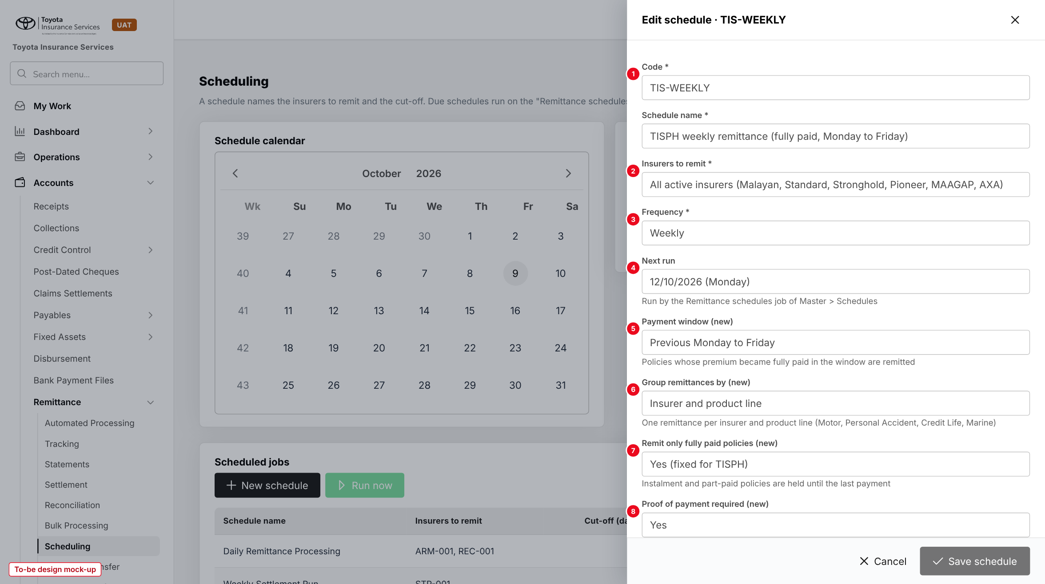
Figure 4: Edit schedule TIS-WEEKLY with the new fields 5 to 8 (to-be design mock-up)
No. | Field (label on screen) | Type | Mand. | Source / list | Default | Rule and message
1 | Code * | Text | Y | - | - | Unique (base)
2 | Insurers to remit * | Multi-select | Y | Master > Insurance > Insurance Company | All active | Base
3 | Frequency * | List | Y | Daily; Weekly; Monthly; Quarterly | Weekly | Weekly needed for the Monday to Friday window. MSG-RMT-007
4 | Next run | Date | N | - | Next Monday | Run by job Remittance schedules
5 | Payment window (new) | List | Y | Previous Monday to Friday; Cut-off days | Previous Monday to Friday | Replaces Cut-off (days) when set
6 | Group remittances by (new) | List | Y | Insurer; Insurer and product line | Insurer and product line | -
7 | Remit only fully paid policies (new) | Display | - | - | Yes | Fixed for TISPH; part-paid policies are held
8 | Proof of payment required (new) | Toggle | - | remittance.proof_of_payment_required | Yes | -

10.2 Automated Processing (changed)
Type | Existing screen, table regrouped
Purpose | See the weekly run per insurer and product line before and after it creates the drafts.
Who can open it | read:remittance; write:remittance to process
Navigation | Accounts > Remittance > Automated Processing
FRs | FR-RMT-010 to 013

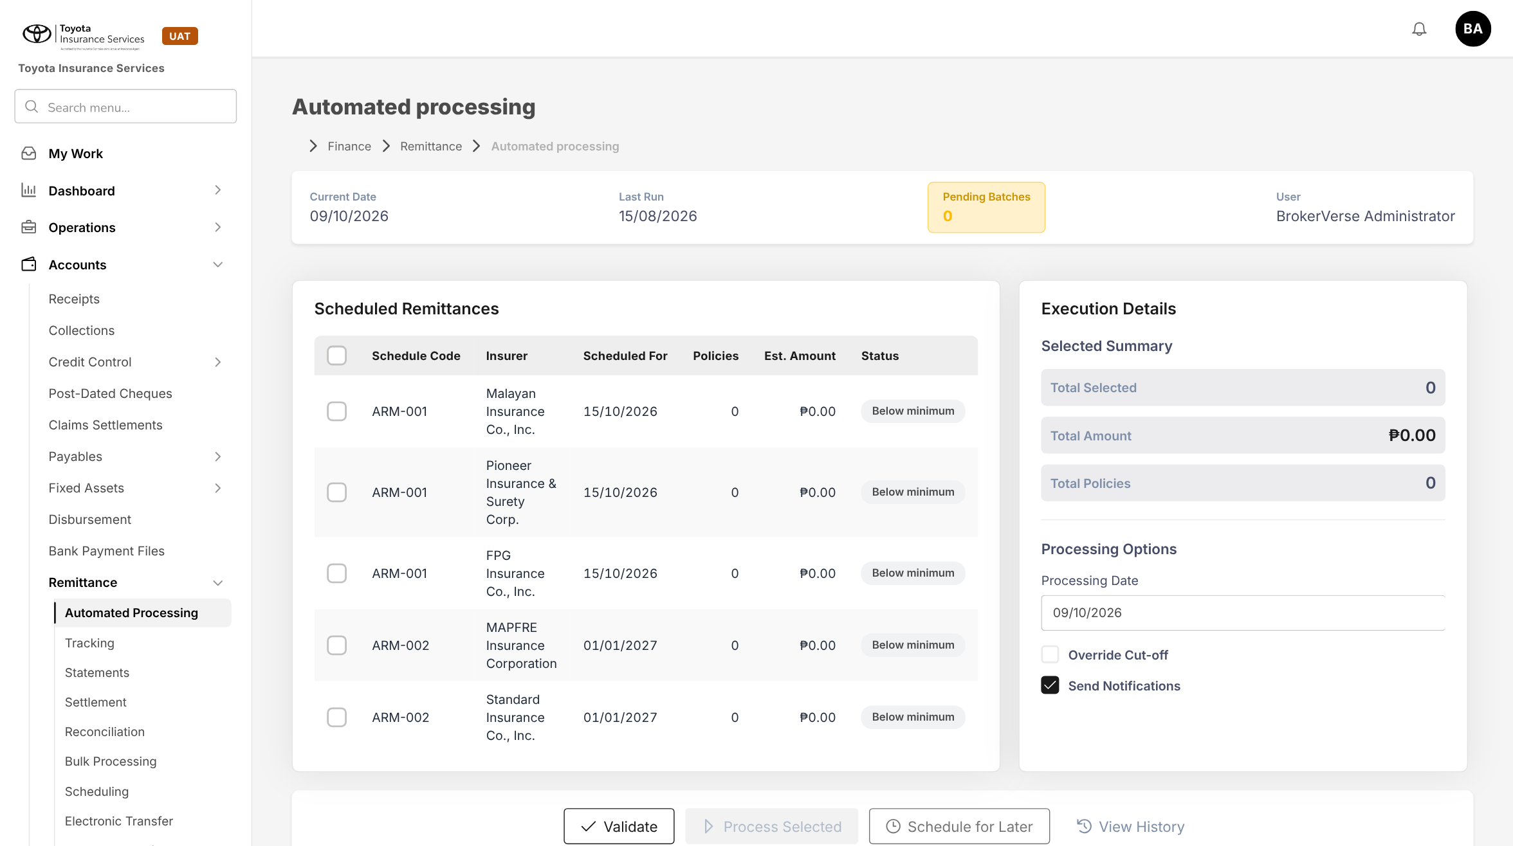
Figure 5: BrokerVerse today: Automated processing lists schedule candidates per insurer only
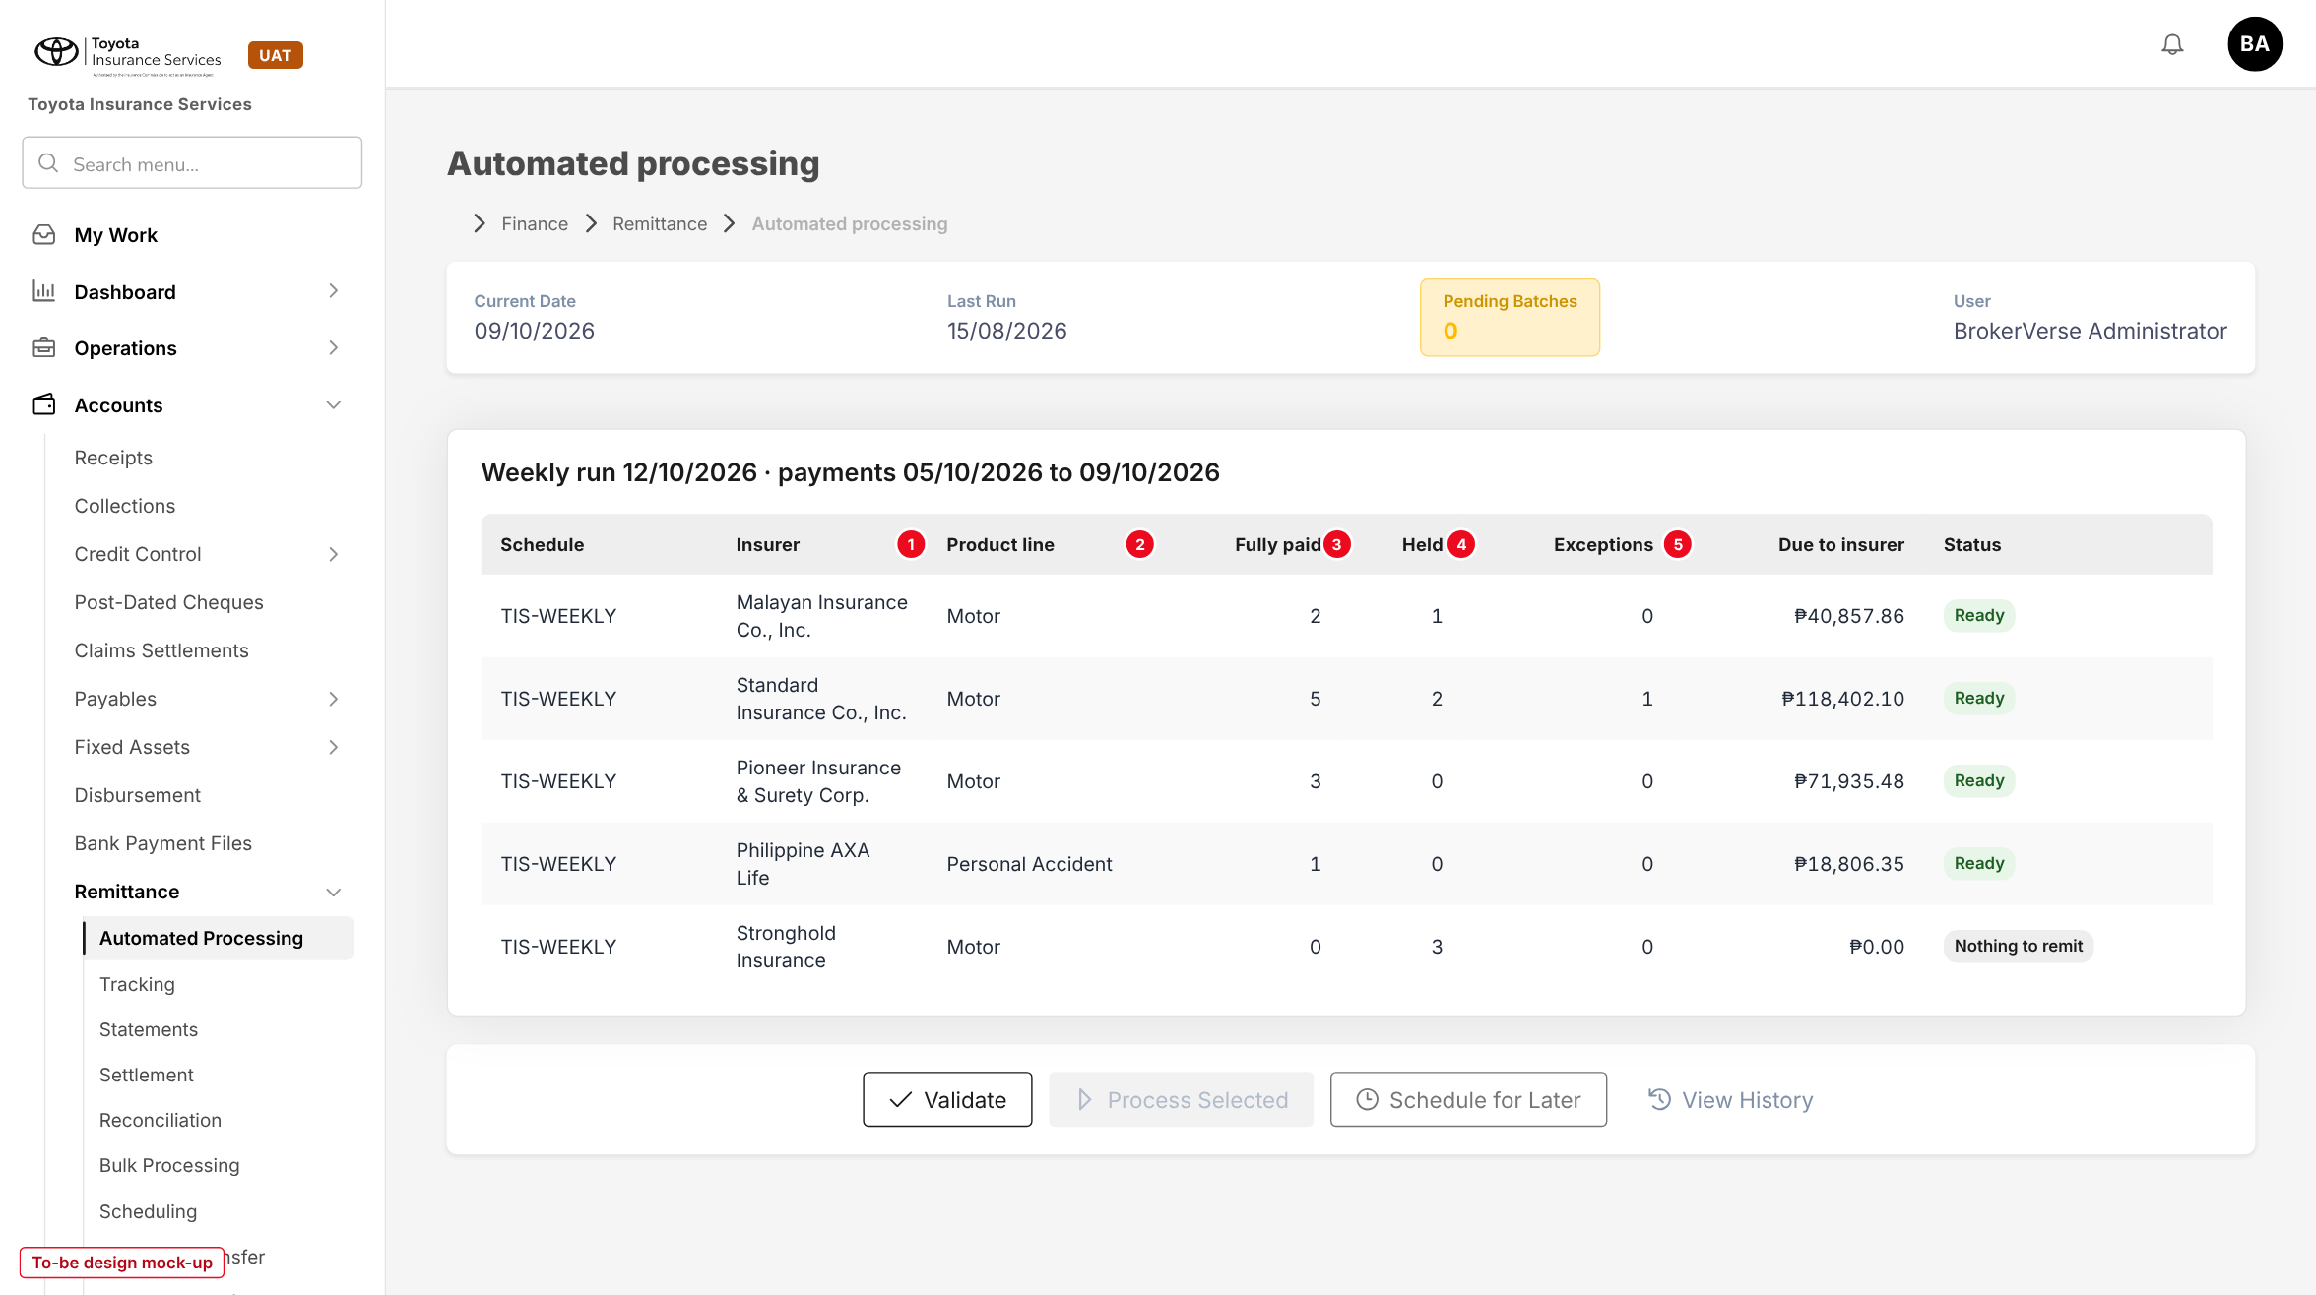
Figure 6: Automated processing with the weekly run per insurer and product line (to-be design mock-up)
No. | Field (label on screen) | Type | Mand. | Source / list | Default | Rule and message
1 | Product line (new column) | Column | - | Product of the policies | - | One row per insurer and product line
2 | Fully paid | Column | - | Policies fully paid in the window with proof | - | Go on the draft
3 | Held | Column | - | Policies with a payment, not fully paid | - | Opens the held list
4 | Exceptions | Column | - | Fully paid without proof of payment | - | Opens Exception Management
5 | Due to insurer | Column | - | FR-RMT-013 | - | Was Est. Amount (premium - commission)

Button | Who sees it | Enabled when | What happens | Result
Validate (existing) | write:remittance | Rows selected | Checks rates, proof and full payment | -
Process Selected (existing) | write:remittance | Rows Ready | Creates the Draft remittances | Draft

10.3 Remittance Details - Policies and Schedule tabs (changed)
Type | Existing drawer, new columns and tabs
Purpose | Check every line of a remittance with its commission split before submitting or approving it.
Who can open it | read:remittance; write:remittance to submit; Authority Matrix to approve
Navigation | Accounts > Remittance > Tracking > View (eye)
FRs | FR-RMT-013, 014, 015

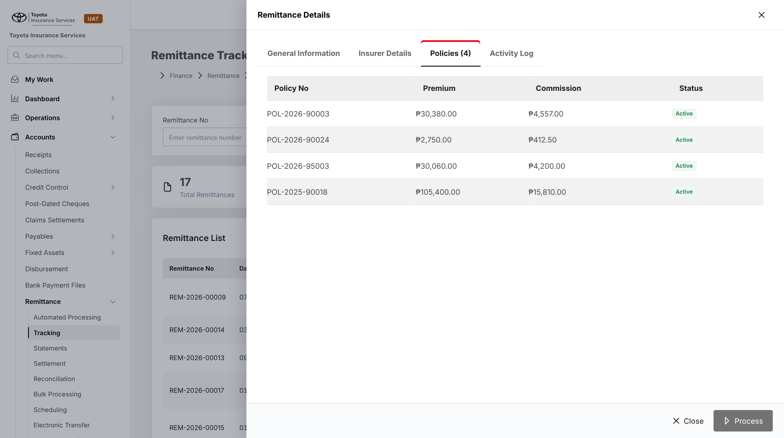
Figure 7: BrokerVerse today: Remittance Details > Policies shows premium and one commission figure
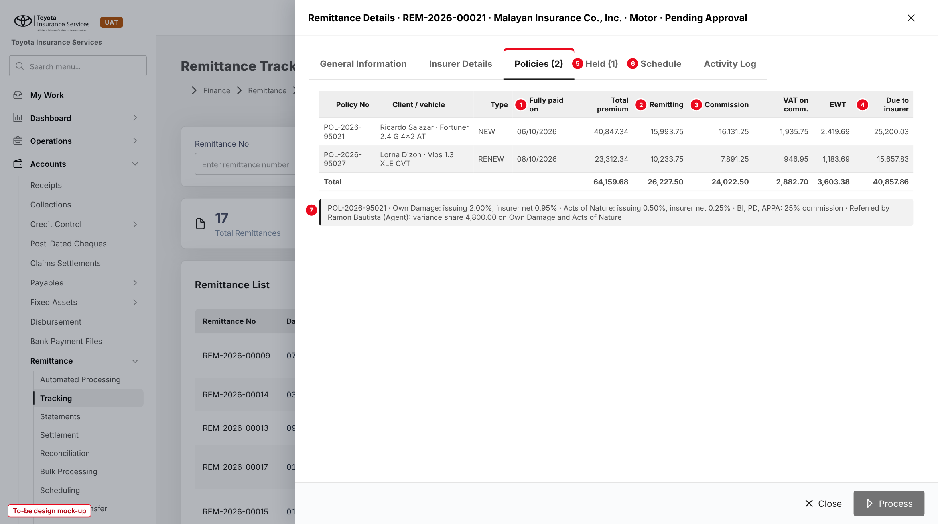
Figure 8: Remittance Details > Policies with the commission split (to-be design mock-up)
No. | Field (label on screen) | Type | Mand. | Source / list | Default | Rule and message
1 | Fully paid on | Column | - | Receipt that cleared the balance | - | -
- | Total premium | Column | - | NET Premium + taxes + CTPL + charges | - | -
2 | Remitting | Column | - | FR-RMT-002 | - | Insurer remitting
3 | Commission | Column | - | FR-RMT-002 | - | Gross commission
- | VAT on comm., EWT | Columns | - | Tax codes | - | Net basis only
4 | Due to insurer | Column | - | FR-RMT-013 | - | -
5 | Held (n) (new tab) | Tab | - | - | - | Section 10.4
6 | Schedule (new tab) | Tab | - | - | - | Excel / PDF download of the remittance schedule (chapter 6)
7 | Rate line | Text | - | Rate snapshot | - | Shown for the selected row: rates and variance share

Button | Who sees it | Enabled when | What happens | Result
Process / Submit (existing) | write:remittance | Draft | Sends for approval | Pending Approval
Approve / Reject (existing) | Authority Matrix remittance, not the maker | Pending Approval | Approve raises the payment voucher; reject needs a reason | Approved / Draft
Download schedule (new) | read:remittance | Always | Excel or PDF | -

10.4 Remittance Details - Held tab (new)
Type | New tab
Purpose | See the policies of the insurer and product line that had a payment but are not fully paid.
Who can open it | read:remittance
Navigation | Remittance Details > Held
FRs | FR-RMT-012

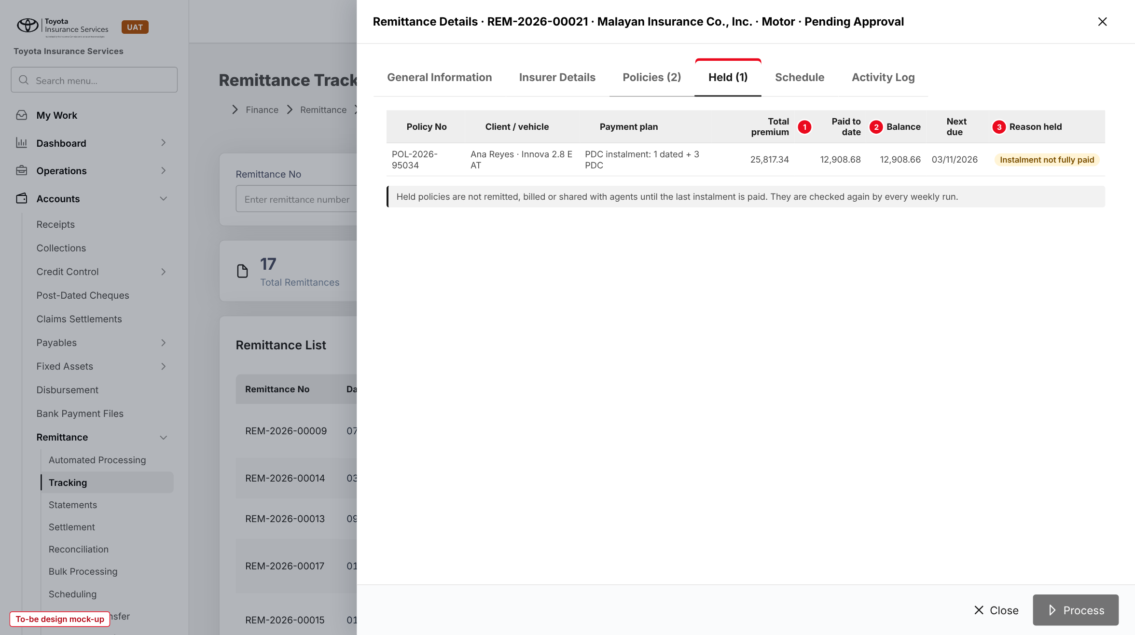
Figure 9: Held tab with an instalment policy (to-be design mock-up)
No. | Field (label on screen) | Type | Mand. | Source / list | Default | Rule and message
- | Policy No, Client / vehicle, Payment plan, Total premium | Columns | - | Policy, instalment plan | - | -
1 | Paid to date | Column | - | Receipts | - | -
2 | Balance | Column | - | Receivables | - | -
- | Next due | Column | - | Instalment plan / PDC date | - | -
3 | Reason held | Tag | - | Instalment not fully paid; Part paid; PDC bounced | - | -

10.5 Insurer Billing (new)
Type | New screen, built from Direct Bill Processing
Purpose | Run, check, approve, send and settle the billing statements to insurers.
Who can open it | read:remittance (view); write:remittance (run, submit, send, record payment); approve:insurer-billing (approve, reject)
Navigation | Accounts > Remittance > Insurer Billing
FRs | FR-RMT-020 to 023, 031

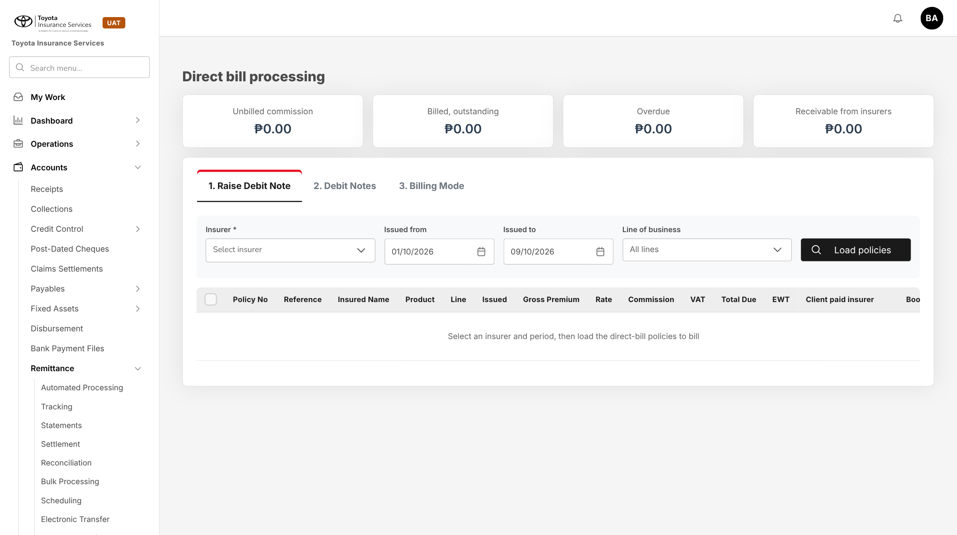
Figure 10: BrokerVerse today: Direct bill processing, the pattern of the new screen
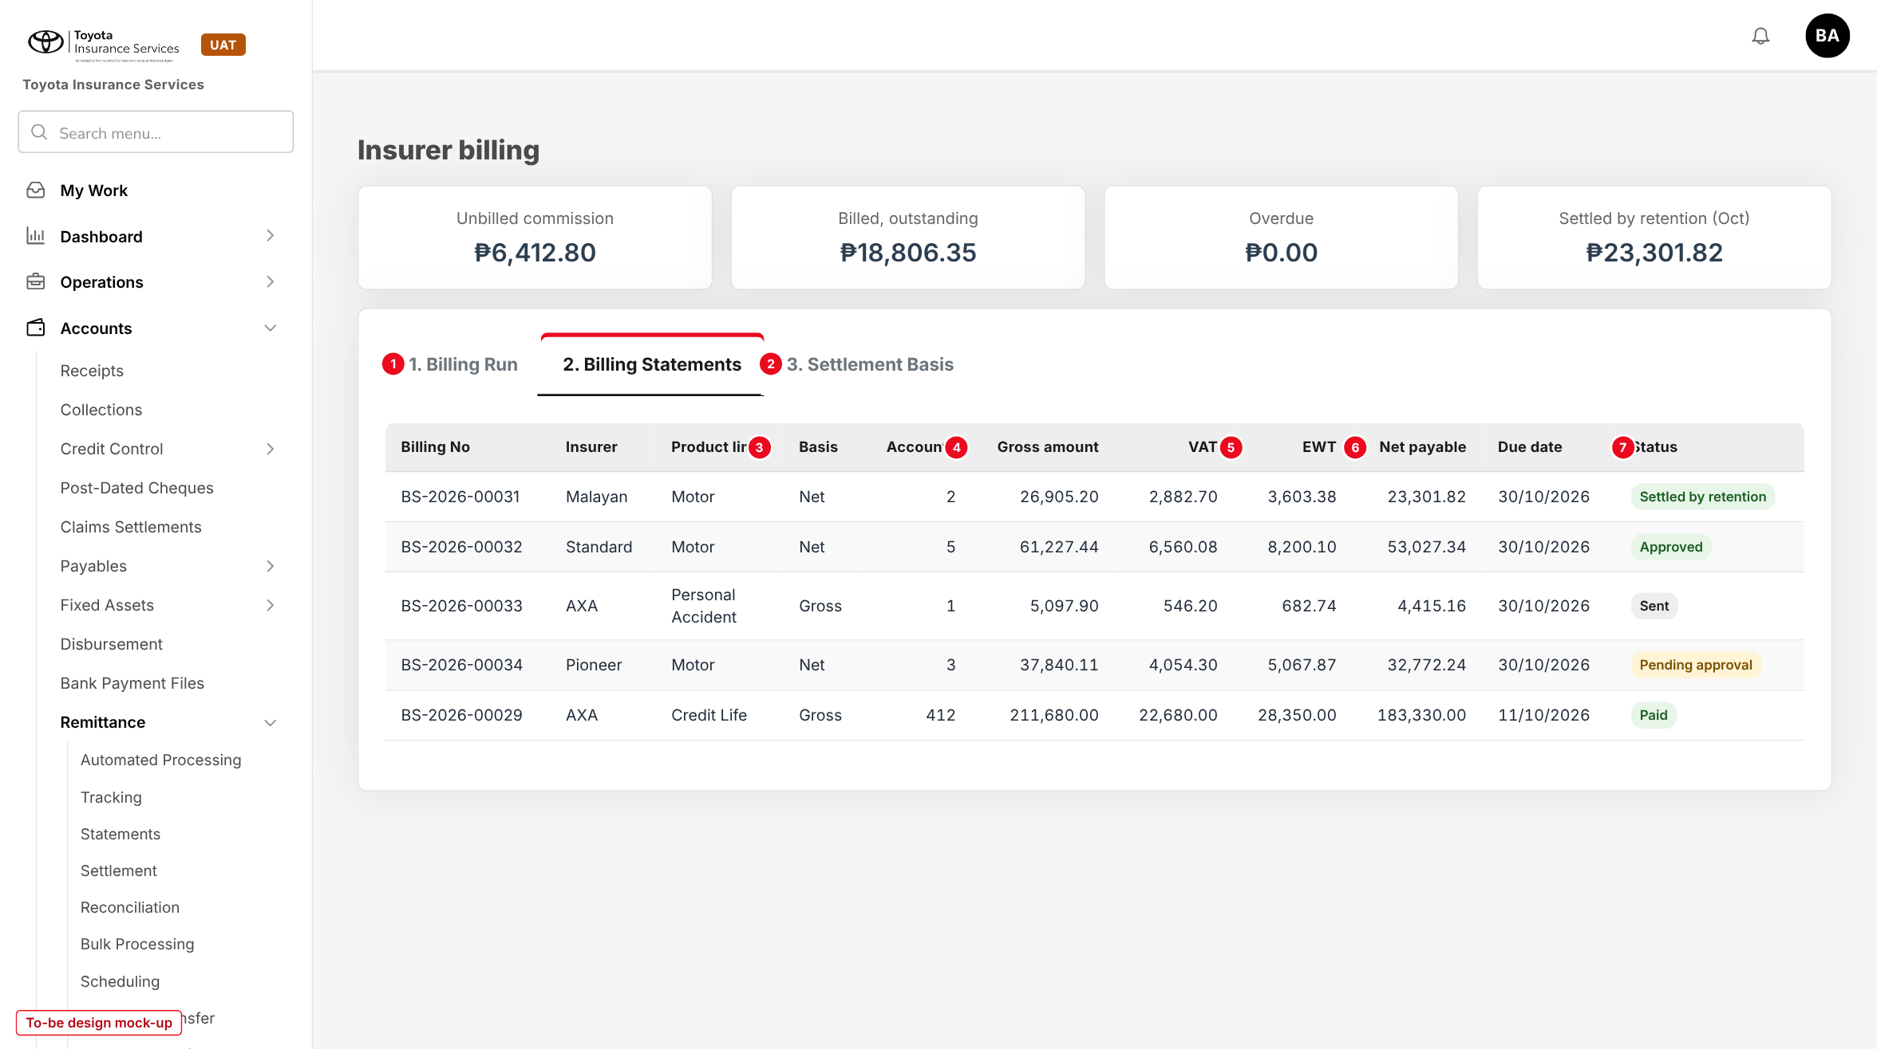
Figure 11: Insurer billing, Billing Statements tab (to-be design mock-up)
No. | Field (label on screen) | Type | Mand. | Source / list | Default | Rule and message
- | Unbilled commission, Billed outstanding, Overdue, Settled by retention | Tiles | - | Billing statements | - | Same tiles as Direct bill processing
1 | 1. Billing Run | Tab | - | - | - | Billing date, insurer, product line, Load lines, Generate (FR-RMT-020)
2 | 3. Settlement Basis | Tab | - | remittance.settlement_basis | Motor Net; others Gross | Changes approved on Configuration Approvals (FR-RMT-031)
- | Billing No, Insurer, Product line, Accounts | Columns | - | - | - | Billing No opens the statement and its schedule
3 | Basis | Column | - | Net; Gross | - | -
4 | Gross amount, VAT | Columns | - | FR-RMT-021 | - | -
5 | EWT | Column | - | FR-RMT-021 | - | -
6 | Net payable, Due date | Columns | - | FR-RMT-021 | Billing date + 15 | -
7 | Status | Tag | - | Statuses of 5.3 | - | Overdue shown in red after the due date

Button | Who sees it | Enabled when | What happens | Result
Generate | write:remittance | Lines loaded | Drafts statements as the job does | Draft
Submit | write:remittance | Draft | Checks the insurer TIN | Pending approval
Approve / Reject | approve:insurer-billing, not the maker | Pending approval | Reject needs a reason | Approved or Settled by retention / Draft
Download PDF / Excel / CSV | read:remittance | Approved or later | Statement and schedule | -
Send | write:remittance | Approved or later | E-mails the three files | Sent
Record payment | write:remittance | Gross basis, balance > 0 | Date, amount, reference, CWT | Partially collected / Paid
Cancel | write:remittance | No payment recorded | Reason required; lines unbilled again | Cancelled

10.6 Agents/Referrer Accounts (changed)
Type | Existing screen, new column and held lines
Purpose | Show the variance share of each policy and keep held lines out of the payout.
Who can open it | read:commission; write:commission to approve and pay
Navigation | Commission > Agents/Referrer Accounts > referrer
FRs | FR-RMT-003, 030

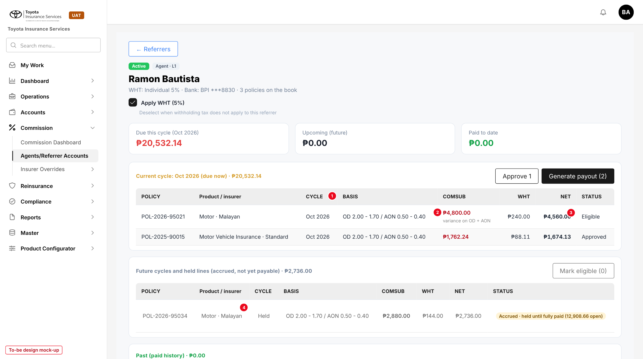
Figure 12: Referrer account with the variance basis and a held line (to-be design mock-up)
No. | Field (label on screen) | Type | Mand. | Source / list | Default | Rule and message
1 | BASIS (new column) | Column | - | Rate snapshot | - | "OD 2.00 - 1.70 / AON 0.50 - 0.40"
2 | COMSUB | Column | - | FR-RMT-003 | - | Variance share; "variance on OD + AON"
3 | STATUS | Column | - | Accrued; Eligible; Approved; Paid | - | Eligible only after full payment and remittance. MSG-RMT-024
4 | Held line | Row | - | FR-RMT-012 | - | Cycle "Held", open balance in the status

10.7 Policy detail - Commission breakdown (new panel)
Type | New read-only panel on the policy, laid out like the PROD-15 Promotion panel
Purpose | Show how the commission of the policy was computed.
Who can open it | read:policies with read:commission; Recompute with write:remittance
Navigation | Operations > Policy > policy > Commission breakdown
FRs | FR-RMT-001 to 006

No. | Field (label on screen) | Type | Mand. | Source / list | Default | Rule and message
- | Peril | Row | - | OD/TH, AON, BI, PD, APPA, CTPL | - | -
- | Sum insured, Premium | Columns | - | Policy | - | -
- | Issuing rate, Insurer net rate, TIS remitting rate, Commission % | Columns | - | Rate snapshot | - | From PROD-16 / PROD-15
- | Insurer remitting, Commission, Variance share | Columns | - | FR-RMT-002, 003 | - | Negative values in red
- | Gross commission, Variance share, TISPH retained | Totals | - | - | - | -
- | Settlement basis, Remittance, Billing statement | Links | - | - | - | -

Button | Who sees it | Enabled when | What happens | Result
Recompute | write:remittance | Policy on no approved remittance | Reads the register again | New snapshot

10.8 Schedules (existing)
Type | Existing screen, one job switched on, two new jobs
Purpose | Run the weekly remittance, the billing and the hold check on time.
Who can open it | System Administrator
Navigation | Master > System > Schedules
FRs | FR-RMT-010, 012, 020

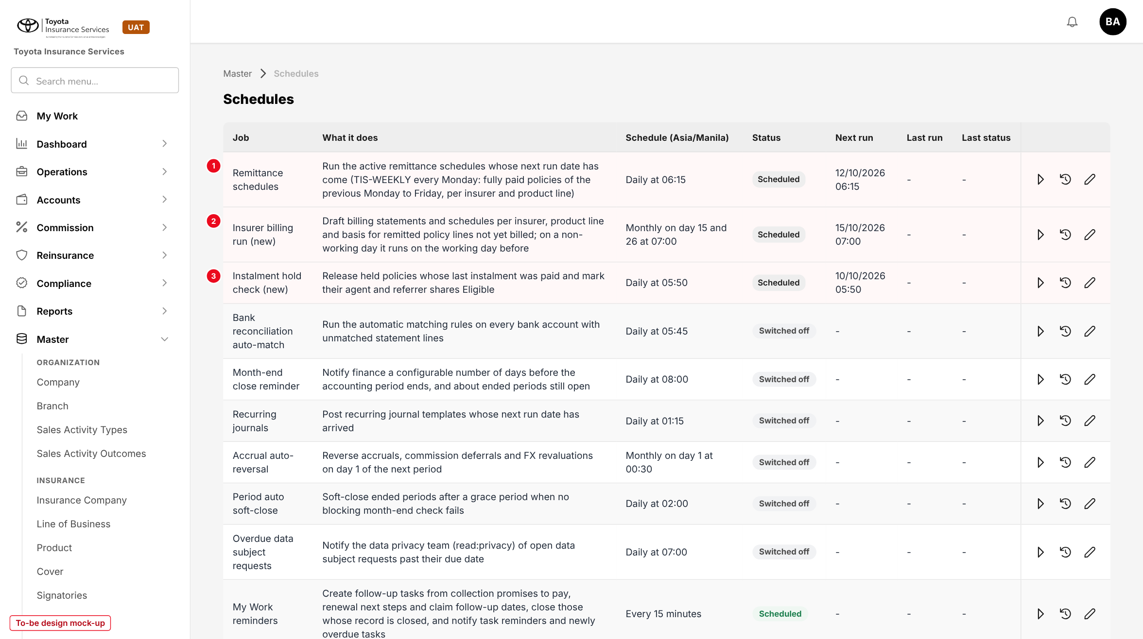
Figure 13: Schedules with the remittance and billing jobs (to-be design mock-up)
No. | Field (label on screen) | Type | Mand. | Source / list | Default | Rule and message
1 | Remittance schedules | Job | - | Existing | Daily 06:15, switched on | Runs TIS-WEEKLY on Mondays
2 | Insurer billing run (new) | Job | - | - | Day 15 and 26 at 07:00 | FR-RMT-020
3 | Instalment hold check (new) | Job | - | - | Daily 05:50 | FR-RMT-012

11 End-to-end walkthroughs
The walkthroughs follow sample policies through BrokerVerse: Ricardo Salazar's Fortuner referred by agent Ramon Bautista, Lorna Dizon's Vios renewal (walk-in) and Ana Reyes's Innova on PDC instalments, all with Malayan Insurance. They are the script of the SIT and UAT sessions.

11.1 WT-A Weekly remittance
Table 24: WT-A
Step | Who | Does | Sees / result
1 | Processing Team | Books POL-2026-95021 (Fortuner, OD 1,200,000, referrer Ramon Bautista) | Commission breakdown: gross 16,131.25; variance share 4,800.00 Accrued; TISPH retained 11,331.25
2 | Operations | Records the client's full payment of 40,847.34 on 06/10/2026 with the deposit slip as proof | Policy fully paid on 06/10/2026
3 | System | Monday 12/10/2026 06:15, job Remittance schedules runs TIS-WEEKLY | "Weekly run done: 1 remittance(s) created, 1 policies held, 0 exceptions." for Malayan Motor
4 | Accounting | Opens REM-2026-00021 on Tracking; checks Policies and Held; downloads the schedule; submits | 2 lines, due to insurer 40,857.86; Held: POL-2026-95034
5 | Accounting Manager | Approves on 13/10/2026 | "Remittance approved. Payment voucher PV-... raised for 40,857.86."; share of POL-2026-95021 Eligible
6 | Accounting / Accounting Manager | Approves and pays Ramon Bautista's share on Agents/Referrer Accounts | 4,800.00 less WHT 240.00 = 4,560.00 paid

11.2 WT-B Billing on the 15th
Table 25: WT-B
Step | Who | Does | Sees / result
1 | System | Thursday 15/10/2026 07:00, job Insurer billing run | BS-2026-00031 Draft: Malayan, Motor, Net, 2 booked accounts
2 | Accounting | Opens BS-2026-00031, checks the schedule, submits | Gross Amount 26,905.20; VAT 2,882.70; Net of VAT 24,022.50; EWT 3,603.38; Net Amount Payable 23,301.82; Due 30/10/2026
3 | Accounting Manager | Approves | Settled by retention, reference REM-2026-00021
4 | Accounting | Send | "Billing statement BS-2026-00031 sent to ..."; Malayan returns BIR Form 2307 for 3,603.38
5 | Accounting | AXA Personal Accident BS-2026-00033 (gross): Record payment 4,415.14, CWT 682.76 on 23/10/2026 | Paid; service invoice due

11.3 WT-C Instalment policy and exceptions
Table 26: WT-C
Case | Who | Does | Sees / result
C1 Instalment | System | Runs of 12/10 and 09/11/2026 on POL-2026-95034 (2 then 3 of 4 instalments paid) | Held; share 2,880.00 Accrued
C2 Last PDC | Operations / System | PDC of 03/12/2026 clears; run of 07/12/2026 | Policy on the Malayan Motor remittance; share Eligible after approval
C3 No proof | Operations | Receipt entered without proof for a policy fully paid on 07/10/2026 | Exception "No proof of payment"; not on REM-2026-00021
C4 Maker approves | Accounting | Tries to approve the remittance he submitted | "Maker-checker: REM-2026-00021 must be approved by a different user."
C5 Cancelled before remittance | Operations | Flat cancellation of a policy before the Monday run | Not remitted; share Reversed; no commission receivable
C6 Promo policy | System | Fortuner with PRM-FORTUNER26, referred by Ramon Bautista | Gross commission 4,131.25; share 3,600.00; TISPH retained 531.25

12 Messages catalogue
Every message a user can see for this requirement, grouped by the screen that shows it. 25 messages: 7 confirmation, 5 error, 1 information, 7 validation, 5 warning. A validation or error is shown under the field it belongs to; a confirmation is a short toast. Text in angle brackets is filled in by the system.

12.1 Policy - Commission breakdown
ID | Field | Message | Type | What the user does
MSG-RMT-001 | commissionBreakdown | No commission rates found for <insurer>, <motor type>, <NEW / RENEW> on <inception date>. Add them on the commission rules register, then recompute. | Warning | Ask the register owner to add the rates; then click Recompute
MSG-RMT-002 | commissionBreakdown | The issuing rate of <peril> (<rate>%) is below the insurer net rate (<rate>%). The commission on this peril is negative. | Warning | Check the rates with Sales before the policy is remitted
MSG-RMT-003 | varianceShare | The variance share (<amount>) is above the gross commission of the policy (<amount>). It has been capped at the gross commission. | Warning | Check the rates of the policy with Sales
MSG-RMT-004 | referrer | The referrer <name> has no type. Set Agent, Sub-agent, TFS team member or External before the policy is booked. | Validation | Edit the referrer on Agents/Referrer Accounts
MSG-RMT-005 | recompute | The commission of <policy> cannot be recomputed: it is on approved remittance <REM no.>. | Error | Correct the difference through Accounts > Insurer Reconciliation
MSG-RMT-006 | recompute | Commission recomputed: <old amount> to <new amount>. | Confirmation | -

12.2 Remittance - Scheduling
ID | Field | Message | Type | What the user does
MSG-RMT-007 | paymentWindow | A Monday to Friday payment window needs a Weekly frequency and a next run on a Monday. | Validation | Set Frequency to Weekly and pick a Monday
MSG-RMT-008 | run | Weekly run done: <n> remittance(s) created, <h> policies held, <e> exceptions. | Confirmation | Open Tracking to check the drafts

12.3 Remittance - Run
ID | Field | Message | Type | What the user does
MSG-RMT-009 | proofOfPayment | Receipt <OR no.> of <policy> has no proof of payment. The policy is not remitted until the proof is attached. | Warning | Attach the proof to the receipt

12.4 Remittance - Approval
ID | Field | Message | Type | What the user does
MSG-RMT-010 | approval | Maker-checker: REM-<no.> must be approved by a different user. | Error | Ask another approver
MSG-RMT-011 | approval | The amount of <amount> is above your approval authority for remittance. | Error | Ask an approver with a higher limit
MSG-RMT-012 | comments | Enter the reason for rejecting the remittance. | Validation | Type the reason
MSG-RMT-013 | approval | Remittance approved. Payment voucher <PV no.> raised for <amount>. | Confirmation | -

12.5 Insurer Billing - Run
ID | Field | Message | Type | What the user does
MSG-RMT-014 | run | Nothing to bill for <insurer> up to <date>. | Information | -
MSG-RMT-015 | run | Billing run done: <n> billing statement(s) drafted. | Confirmation | Check the drafts on Billing Statements

12.6 Insurer Billing - Statement
ID | Field | Message | Type | What the user does
MSG-RMT-016 | insurerTin | Insurance Company <name> has no TIN. Add it on Master > Insurance > Insurance Company before you approve. | Validation | Add the TIN on the insurer master
MSG-RMT-017 | approval | Maker-checker: <BS no.> must be approved by a different user. | Error | Ask another approver
MSG-RMT-018 | reason | Enter the reason for rejecting the billing statement. | Validation | Type the reason
MSG-RMT-019 | approval | Billing statement <BS no.> approved. | Confirmation | -
MSG-RMT-020 | send | Billing statement <BS no.> sent to <e-mail>. | Confirmation | -
MSG-RMT-021 | send | Insurance Company <name> has no billing e-mail. Add it on the insurer master or download the files. | Validation | Add the e-mail or download
MSG-RMT-022 | amount | The payment of <amount> is more than the balance of <amount>. | Validation | Correct the amount
MSG-RMT-023 | amount | Payment of <amount> recorded on <BS no.>. Balance <amount>. | Confirmation | -

12.7 Commission - Variance share
ID | Field | Message | Type | What the user does
MSG-RMT-024 | markEligible | No Accrued lines have fully collected and remitted premium yet. | Error | Wait for the policy to be fully paid and remitted

12.8 Insurer Billing - Settlement basis
ID | Field | Message | Type | What the user does
MSG-RMT-025 | basis | There are remitted lines not yet billed for <insurer>, <product line>. The new basis applies to the next remittances only. | Warning | -

13 Sign-off and change control

13.1 What is signed
TISPH signs this FRS for TIS-BRD-COMM-06 as built on BrokerVerse: the process flows (chapter 2), the functional requirements (chapter 4), the workflow (chapter 5), the outputs (chapter 6) and the screens and messages (chapters 9 to 12). Values marked default are configuration and are not frozen.

13.2 Change after sign-off
A change to anything signed is raised through the change control route of BRD section 8. The project team assesses its effect on BrokerVerse and on PROD-15, PROD-16 and COMM-08, and issues a new version of this FRS for delta sign-off. When the screens are built, the to-be mock-ups are replaced with screenshots of the TISPH UAT environment.

13.3 Signatures
Table 27: Sign-off
Role | Name | Unit | Signature | Date
Business owner |  | TISPH FGA
Business reviewer |  | TIS Operations
Business reviewer |  | TIS Sales
Project Manager |  | TISPH DTID
Delivery lead |  | iorta TechNXT

Appendix A Commission calculation examples
Premiums are from the base premium engine on the PROD-15 Fortuner example: VAT 12%, DST 12.5%, LGT 0.75%, CTPL from the Insurance Commission tariff. Insurer net rates are Malayan's current net rates; the TIS remitting rate on Acts of Nature, the 25% on other perils and the 15% EWT are illustrative until confirmed.

A.1 Toyota Fortuner 2.4 G 4x2 AT, Malayan, PC-Other than Sedan, NEW, OD 1,200,000, agent referral
Table 28: Fortuner: premium, remitting and commission per peril
Peril | Premium (issuing) | Insurer remitting | Commission
Own Damage / Theft (2.00% / net 0.95%) | 24,000.00 | 11,400.00 | 12,600.00
Acts of Nature (0.50% / net 0.25%) | 6,000.00 | 3,000.00 | 3,000.00
Bodily Injury 100,000 (25%) | 1,000.00 | 750.00 | 250.00
Property Damage 100,000 (25%) | 1,000.00 | 750.00 | 250.00
APPA 25,000 x 5 seats (25%) | 125.00 | 93.75 | 31.25
NET Premium / total | 32,125.00 | 15,993.75 | 16,131.25

Table 29: Fortuner: remittance and shares
Line | Amount
Value Added Tax 12% / Documentary Stamp Tax 12.5% / Local Gov't Tax 0.75% | 3,855.00 / 4,016.00 / 240.94
CTPL | 610.40
Total premium collected | 40,847.34
Commission (gross) | 16,131.25
VAT on commission 12% | 1,935.75
EWT on commission 15% | 2,419.69
Kept by TISPH: commission + VAT - EWT | 15,647.31
Due to Malayan: 40,847.34 - 15,647.31 | 25,200.03
Variance share: 1,200,000 x (2.00 - 1.70)% + 1,200,000 x (0.50 - 0.40)% | 3,600.00 + 1,200.00 = 4,800.00
Withholding tax on the share (Individual 5%) / net to Ramon Bautista | 240.00 / 4,560.00
TISPH retained commission: 16,131.25 - 4,800.00 | 11,331.25

A.2 Toyota Vios 1.3 XLE CVT, Malayan, PC-Sedan Regular, RENEW, OD 640,000, walk-in
Table 30: Vios renewal per peril
Peril | Premium (issuing) | Insurer remitting | Commission
Own Damage / Theft (2.00% / net 1.10%) | 12,800.00 | 7,040.00 | 5,760.00
Acts of Nature (0.50% / net 0.25%) | 3,200.00 | 1,600.00 | 1,600.00
Bodily Injury, Property Damage (25%) | 2,000.00 | 1,500.00 | 500.00
APPA (25%) | 125.00 | 93.75 | 31.25
NET Premium / total | 18,125.00 | 10,233.75 | 7,891.25

Total premium 23,312.34 (VAT 2,175.00, DST 2,266.00, LGT 135.94, CTPL 610.40). VAT on commission 946.95, EWT 1,183.69, kept by TISPH 7,654.51, due to Malayan 15,657.83. No variance share: TISPH retains 7,891.25.

A.3 Billing statement BS-2026-00031 (Malayan, Motor, net basis, 15/10/2026)
Table 31: Billing statement, due 30/10/2026
Particulars | Gross Amount | VAT | Net of VAT | EWT | Net Amount Payable
POL-2026-95021 Fortuner | 18,067.00 | 1,935.75 | 16,131.25 | 2,419.69 | 15,647.31
POL-2026-95027 Vios | 8,838.20 | 946.95 | 7,891.25 | 1,183.69 | 7,654.51
Motor Car Insurance Commission, 2 booked account/s | 26,905.20 | 2,882.70 | 24,022.50 | 3,603.38 | 23,301.82

Check: VAT = 26,905.20 / 1.12 x 0.12 = 2,882.70; EWT = 24,022.50 x 15% = 3,603.38; Net Amount Payable = 26,905.20 - 3,603.38 = 23,301.82. On the net basis this amount was kept from REM-2026-00021, so the statement is Settled by retention.

A.4 Fortuner with promotion PRM-FORTUNER26 (PROD-15)
Table 32: Promo policy per peril
Peril | Premium (promo issuing) | Insurer remitting (promo remit) | Commission
Own Damage (1.50% / 1.30%) | 18,000.00 | 15,600.00 | 2,400.00
Acts of Nature (0.40% / 0.30%) | 4,800.00 | 3,600.00 | 1,200.00
BI, PD, APPA (25%) | 2,125.00 | 1,593.75 | 531.25
NET Premium / total | 24,925.00 | 20,793.75 | 4,131.25

Variance with same_points: Own Damage TIS remitting = 1.50 - 0.30 = 1.20, raised to the promo remit 1.30, share 1,200,000 x 0.20% = 2,400.00; Acts of Nature 0.40 - 0.10 = 0.30, share 1,200.00. Agent 3,600.00, TISPH retained 531.25. With register_rate the agent gets 0.00 and TISPH 4,131.25. Total premium 31,829.34; due to Malayan 31,829.34 - (4,131.25 + 495.75 - 619.69) = 27,822.03.

A.5 Instalment policy (Toyota Innova 2.8 E AT, OD 720,000, agent referral)
NET Premium 20,125.00, total premium 25,817.34, paid as one dated cheque and three PDCs of 6,454.34, 6,454.34, 6,454.34 and 6,454.32 (03/09, 03/10, 03/11 and 03/12/2026). Gross commission 9,891.25; variance share 720,000 x 0.30% + 720,000 x 0.10% = 2,880.00 (WHT 144.00, net 2,736.00); TISPH retained 7,011.25. The policy is Held on the runs of 12/10 and 09/11/2026 and remitted on 07/12/2026; the share is paid after that remittance is approved.

