

FUNCTIONAL REQUIREMENTS SPECIFICATION
Telesales Incentive
Monthly incentive for telesales callers on Motor policies: 15-policy trigger, ANC tier table, production-excess table, new business and renewal amounts, approval and payment

Client | Toyota Insurance Services Philippines Corporation (TISPH)
Document | TISPH-FRS-COMM-08
Requirement | TIS-BRD-COMM-08
Version | 1.0
Date | 9 October 2026
Status | Issued for TISPH review
Classification | Confidential

Prepared by iorta TechNXT for TISPH 
This document is confidential to Toyota Insurance Services Philippines Corporation and iorta TechNXT.
Document Control
Version | Date | Author | Reviewer | Approver | Change
1.0 | 9 Oct 2026 | iorta TechNXT Business Analysis | iorta TechNXT Project Manager | - | First issue for review

Distribution List
Name / Unit | Role | Organisation | Purpose
TIS Sales - Sales Head (business owner) | Approver | TISPH | Review and sign-off
TIS Team Leaders (telesales) | Business user | TISPH | Call-out leads, callers and monthly review
Finance and General Accounting | Business user | TISPH | Net commission, accrual and payment FRs
TISPH Management | Approver of incentives | TISPH | Validation and approval of the monthly incentive
DTID - Project Management Team | Project owner | TISPH | Traceability against the BRD
Project team | Delivery | iorta TechNXT | Build, test and UAT preparation

Contents
1 Overview 5
1.1 The requirement 5
1.2 Scope 5
1.3 Definitions and acronyms 6
1.4 How to read the functional requirements 6
1.5 What changes in BrokerVerse 7
2 Telesales incentive process flow 8
2.1 Flow A - Set up and approve the program 8
2.2 Flow B - From call-out lead to eligible policy 9
2.3 Flow C - Calculate, approve and pay the month 10
2.4 What the incentive covers 11
3 Personas and roles 12
3.1 Personas 12
3.2 Permissions 12
3.3 Default grants 12
4 Functional requirements 14
4.1 Telesales program 14
FR-TSI-001 Set up a Telesales incentive program 14
FR-TSI-002 Keep the ANC tier table with new-business and renewal amounts 15
FR-TSI-003 Keep the production-excess table 17
FR-TSI-004 Keep the callers of the program and disqualify a caller 18
FR-TSI-005 Version and approve program changes by month 19
4.2 Call-out leads 21
FR-TSI-010 Endorse prospects as call-out leads 21
FR-TSI-011 Attribute a policy to a caller 22
4.3 Policies that count 23
FR-TSI-020 Decide when a telesales policy is eligible and in which month 23
FR-TSI-021 Classify a policy as new business or renewal 24
FR-TSI-022 Store the net commission of a policy and compute the ANC 25
4.4 Monthly calculation 25
FR-TSI-030 Run the monthly telesales calculation 25
FR-TSI-031 Apply the minimum-policy trigger 27
FR-TSI-032 Find the level and compute the base incentive 27
FR-TSI-033 Compute the additional incentive for production in excess 28
FR-TSI-034 Deduct withholding tax and give the total 29
FR-TSI-035 Exclude a policy and apply a disqualification 29
FR-TSI-036 Recover the incentive of a policy cancelled or refunded after payout 30
FR-TSI-037 Adjust a caller line with a reason 31
4.5 Approval, payment and statement 31
FR-TSI-040 Submit and approve the batch by TISPH Management 31
FR-TSI-041 Accrue and pay the incentive 32
FR-TSI-042 Show the caller statement and export the batch 33
FR-TSI-043 Keep an audit trail of the incentive 33
5 Workflow and status model 35
5.1 Telesales program version 35
5.2 Caller 35
5.3 Call-out endorsement of a prospect 35
5.4 Telesales policy (incentive status) 35
5.5 Calculation batch 36
6 Configuration items 37
6.1 Settings 37
6.2 Scheduled job 37
6.3 Lists of values 37
6.4 Masters and posting rules 38
7 Traceability 39
7.1 BRD clause to FR 39
7.2 Related BRD requirements 39
7.3 FR to test cases 39
8 Navigation 41
8.1 Screens of COMM-08 41
8.2 Menu by role 41
9 Screen specifications 42
9.1 Incentive Program Master (changed) 42
9.2 Edit Incentive Program - Basic Information (changed) 42
9.3 Edit Incentive Program - Callers tab (new) 44
9.4 Edit Incentive Program - Incentive Structure (changed) 45
9.5 Configuration Approvals (existing) 46
9.6 Lead Assignment (changed) 47
9.7 New Incentive Calculation (existing) 48
9.8 Calculation Details - Agent Details (changed) 48
9.9 Calculation Details - Policies tab (new) 50
9.10 Incentive Statement (changed) 51
10 End-to-end walkthroughs 52
10.1 WT-A Set up the program and change the minimum 52
10.2 WT-B Call-out lead to counted policy 52
10.3 WT-C Close September 2026 53
10.4 WT-D Exceptions 53
11 Messages catalogue 54
11.1 Incentive Program - Basic Information 54
11.2 Incentive Program - Incentive Structure 54
11.3 Incentive Program - Callers 55
11.4 Lead Assignment 55
11.5 Calculation 55
11.6 Calculation - Policies 55
11.7 Calculation - Approval 56
12 Sign-off and change control 57
12.1 What is signed 57
12.2 Change after sign-off 57
12.3 Signatures 57
Appendix A Worked incentive calculations 58
A.1 Program tables 58
A.2 Net commission of one policy and the ANC 58
A.3 September 2026 batch, all callers 59
A.4 Additional incentive of Errin Dizon (104 policies, banded) 59
A.5 Banded or highest band only 60
A.6 Recovery and tax of Anna Cruz 60

1 Overview

1.1 The requirement
TIS-BRD-COMM-08 Telesales Incentive (Customization, Phase 1, CR-08). Telesales incentive on Motor policies only, triggered at a minimum of 15 policies, with a tiering table by volume and a separate table for production in excess of target; full rate on new business, reduced at renewal. The number of target policies must be editable based on the agreement with management.

TISPH works its base of clients with expired Motor insurance through telesales callers. The callers are staff of the accredited insurance partners, stationed at the TISPH office and working in BrokerVerse. TISPH pays them a monthly incentive under a program approved by its Executive Committee, effective for production from 1 April 2026. Today the incentive is worked out in Excel from the sales masterfile. This FRS moves the whole computation into BrokerVerse: the caller qualifies with at least 15 issued and fully paid policies in the month, the amount per policy comes from a tier table on the caller's average net commission (ANC), extra amounts are paid for every block of policies above 30, 50, 75 and 100, a renewal earns a lower amount than new business, and TISPH Management approves the result before Accounting pays it.
Only policies that come from official call-out leads endorsed by a TIS Team Leader count, and only once the premium is fully paid and the insurer has settled the commission. A cancelled or refunded policy that was already paid out is recovered in the next month. All tables and the 15-policy minimum are kept on the program and can be changed, with approval, from any month onward.
Screens that change or are new are shown as to-be mock-ups drawn on the real BrokerVerse screens with the Toyota Insurance Services look.

1.2 Scope
In scope
- A new program type Telesales on Master > Finance > Incentive Programs, with the minimum number of policies, the Motor products, the withholding tax %, a Callers tab and an Incentive Structure tab holding the ANC tier table (new business and renewal amounts) and the production-excess table. Changes are versioned by month and approved on Configuration Approvals.
- Call-out endorsement on Operations > Sales & Marketing > Lead Assignment: a Team Leader marks the prospects given to a caller as official call-out leads.
- The rules that decide which policies count: Motor, call-out lead, owned by the caller, issued, fully paid, commission settled, not cancelled or refunded; new business or renewal; the net commission and ANC.
- The monthly calculation on Accounts > Incentive > Calculations (by hand or by the scheduled job): 15-policy trigger, tier, base incentive, additional incentive, withholding tax, exclusions, disqualification and recovery.
- Approval by TISPH Management (maker-checker), accrual and payment through the existing incentive batch, the caller's Incentive Statement and the Excel export of a batch.
Out of scope
- The incentive for referrals by TFSPH team members (10% of the net commission of the referred policy). It is a referral share and is set up with the referral sharing schemes of PROD-16 and paid through Commission.
- Incentives on non-Motor lines, and the other incentive program types of BrokerVerse (Target Based, Commission Based, Hybrid, Contest), which keep working as today.
- Reports: the Agent Policy Conversion Report with tier level and incentives (RPT-SLS-03) and the sales dashboards read the results of this FRS but are specified with the reports.
- How the issuing and remitting rates give TISPH's commission on a policy (PROD-16, COMM-06). This FRS uses the commission those items produce.
- Lead upload and talkbot filtering (LEAD-09) and the lead assignment rules themselves (LEAD-06), except for the call-out endorsement added here.

1.3 Definitions and acronyms
Table 1: Definitions
Term | Meaning in this FRS
Caller | A telesales agent of an accredited insurance partner who works TISPH call-out leads. In BrokerVerse a caller is a user with the Sales & Marketing role listed on the Callers tab of the Telesales program.
Insurance partner | The insurer the caller works for (Master > Insurance > Insurance Company). A caller has one insurance partner at a time.
Team Leader | The TIS Team Leader who hands out call-out lists and endorses them. A Sales & Marketing user with the new permission write:callout-endorsement.
Call-out lead | A prospect assigned to a caller and endorsed by the caller's Team Leader on Lead Assignment before the quotation is created.
Telesales policy | A Motor policy whose quotation was created by a caller on a call-out lead endorsed for that caller.
Eligible date | The later of the date the premium became fully paid (payment status Completed) and the date the insurer settled the commission of the policy.
Production month | The calendar month of the eligible date. A policy is counted in its production month and only once.
Counted policy | A telesales policy whose eligible date falls in the month, that is not cancelled, refunded or excluded.
Net commission | The commission TISPH keeps on the policy after the insurer's net premium and after any share paid to a referrer or agent, before VAT, in PHP.
ANC | Average net commission: total net commission of the caller's counted policies of the month divided by their number, rounded to 2 decimals.
Level | The row of the ANC tier table whose range holds the caller's ANC (Level 1 from PHP 2,500.00 to Level 5 from PHP 10,000.00).
Base incentive | New-business policies x new-business amount of the level + renewal policies x renewal amount of the level.
Additional incentive | The volume incentive from the production-excess table: a fixed amount for every block of counted policies above 30, 50, 75 and 100.
NB / Renewal | New business: any telesales policy that does not renew a policy placed by TISPH. Renewal: a policy that renews a TISPH policy (Renewals module).
Recovery | A negative line in a later month for a policy that was paid out and then cancelled or refunded.
Calculation batch | The existing incentive batch (CALC-YYYY-NNNNN) of Accounts > Incentive > Calculations that holds one line per caller for a month.
WHT | Withholding tax deducted from the incentive (5.00% by default).

1.4 How to read the functional requirements
Each FR in chapter 4 has the same parts:
- A header table with the BRD trace, the actor, the priority, the fit and the screens that implement it.
- Description, preconditions, main flow and alternate and exception flows.
- Business rules. Configurable rules are kept on the Telesales program or on Master > System > Configuration (chapter 6). Fixed rules change only through a change request.
- Validations and messages: the check and the message the user sees, word for word, with its ID in chapter 11. As everywhere in BrokerVerse, a message is plain English and is shown under the field it belongs to, or as a toast.
- Audit and numbered acceptance criteria, the basis of the test cases TC-TSI-nnn-n.
Note. The tier amounts for new business and the production-excess table are the approved program values. The renewal amounts, the net commission figures and the callers in the examples are illustrative until TISPH confirms them.

1.5 What changes in BrokerVerse
BrokerVerse already has incentive programs, monthly calculation batches with maker-checker approval, accrual and payment postings, and an incentive statement per sales person. It cannot express the telesales program: it pays on a target %, a premium or a policy count, not on a tier of average commission, and it counts every policy of the owner. The table lists what COMM-08 reuses, changes and adds.
Table 2: BrokerVerse today and COMM-08
BrokerVerse today | What COMM-08 does
Master > Finance > Incentive Programs: Create Incentive Program with tabs Basic Information, Target Configuration and Incentive Structure; types Target Based, Commission Based, Hybrid, Contest; metrics Premium Volume, Policy Count, Renewal Rate, Conversion; a tier list of achievement level, type and value. Edited in place, no approval. | Changed. New type Telesales and metric Average Net Commission (ANC). For this type the dialog has the tabs Basic Information, Callers, Incentive Structure (ANC tier table and production-excess table) and History. Changes create a version by month, approved on Configuration Approvals.
Achievement counts the owner's policies by inception date that are not cancelled, paid or not. | Changed for Telesales. Only telesales policies count, in the month of their eligible date (fully paid and commission settled), once.
Accounts > Incentive > Calculations: New Calculation (period, programs, review); Calculation Details with Overview, Agent Details and Execution Log; Adjust with a reason; Submit for Approval; Approve / Reject by another user; Mark as paid. Batch number CALC-YYYY-NNNNN. | Reused and changed. Telesales columns on Agent Details, a new Policies tab with Exclude / Include again, recovery lines, Export to Excel; approval of telesales batches needs approve:incentive.
Operations > Sales & Marketing > Lead Assignment: Team View, Reassignment Queue, Assignment Rules, Reassign with a reason, Assignment history. | Changed. Endorse as call-out lead and Withdraw endorsement for Team Leaders; Call-out lead column; call-out rules.
Accounts > Incentive > Statement and My Programs. | Changed. Telesales line with policies, ANC, level, base, additional, recovery and tax.
Settings incentive.eligible_roles, incentive.program_types, incentive.metric_map; posting rules incentive.accrual and incentive.payout; Master > System > Schedules. | Reused. New values and keys; new job Telesales incentive calculation; withholding tax line on the accrual.

2 Telesales incentive process flow
Three flow charts show the incentive end to end: Flow A sets up the program, Flow B takes a call-out lead to an eligible policy, Flow C calculates, approves and pays the month. Black rounded boxes are start and end points, diamonds are decisions, red boxes are exceptions, grey boxes are done by the system and boxes with a heavy border are the successful outcome.

2.1 Flow A - Set up and approve the program
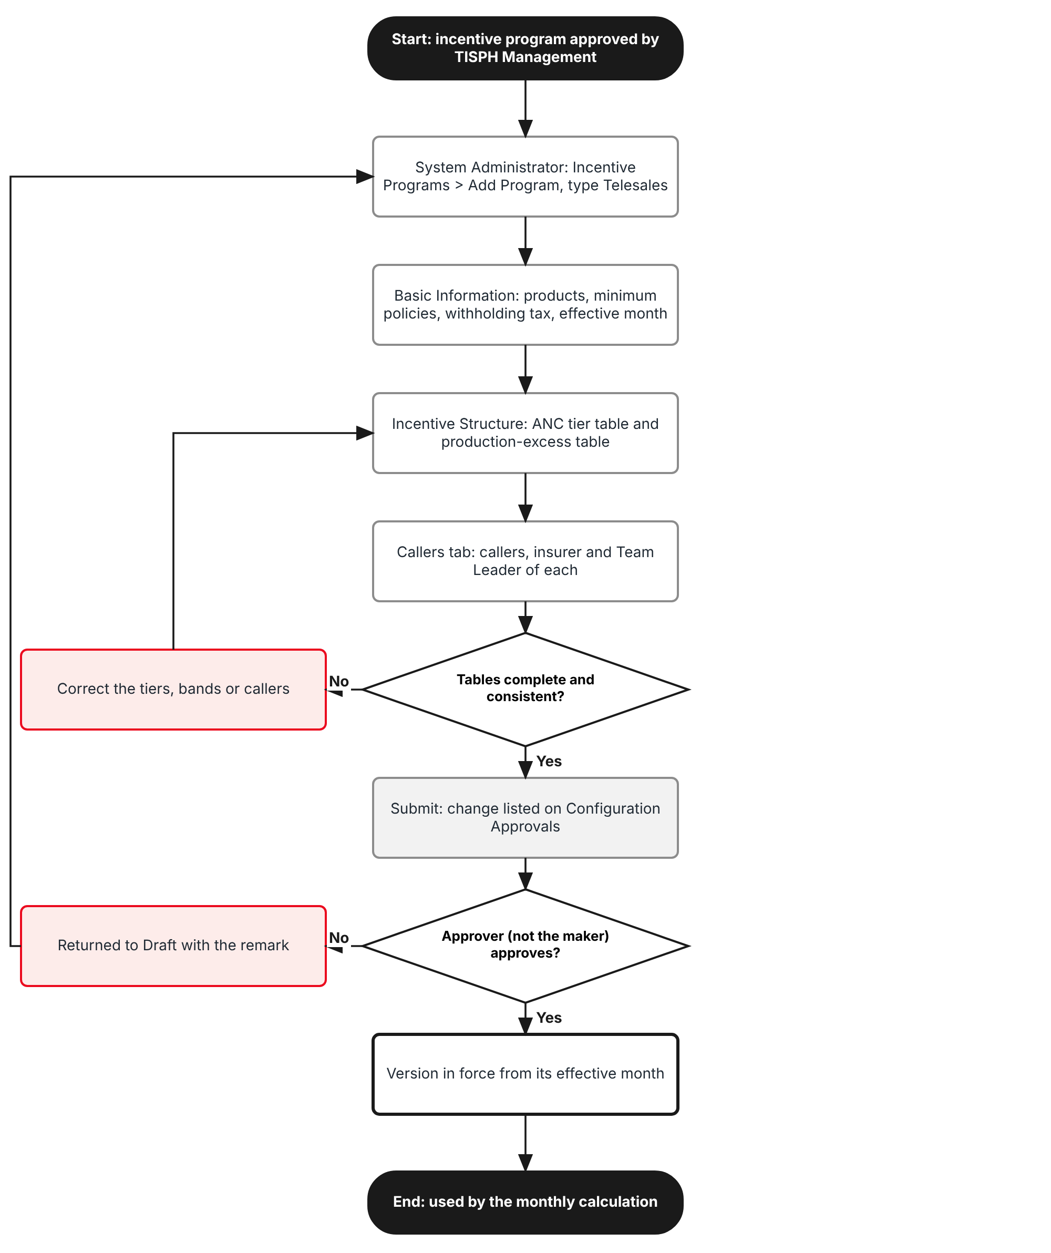
Figure 1: Flow A - Set up and approve the Telesales program
Table 3: Flow A steps
Step | Who (role) | What happens | FR
A1 | System Administrator | Master > Finance > Incentive Programs > Add Program with Program Type Telesales; Basic Information: products, minimum policies (15), withholding tax %, effective month. | FR-TSI-001
A2 | System Administrator | Incentive Structure: ANC tier table with new-business and renewal amounts; production-excess table. | FR-TSI-002, 003
A3 | System Administrator | Callers tab: each caller with insurance partner, Team Leader and dates. | FR-TSI-004
A4 | System | Checks the tables; Submit for approval lists the change on Master > Finance > Configuration Approvals. | FR-TSI-005
A5 | Accounting Manager or Sales Head (approve:incentive) | Approves or returns the version. The maker can never approve it. The version is in force from its effective month. | FR-TSI-005

2.2 Flow B - From call-out lead to eligible policy
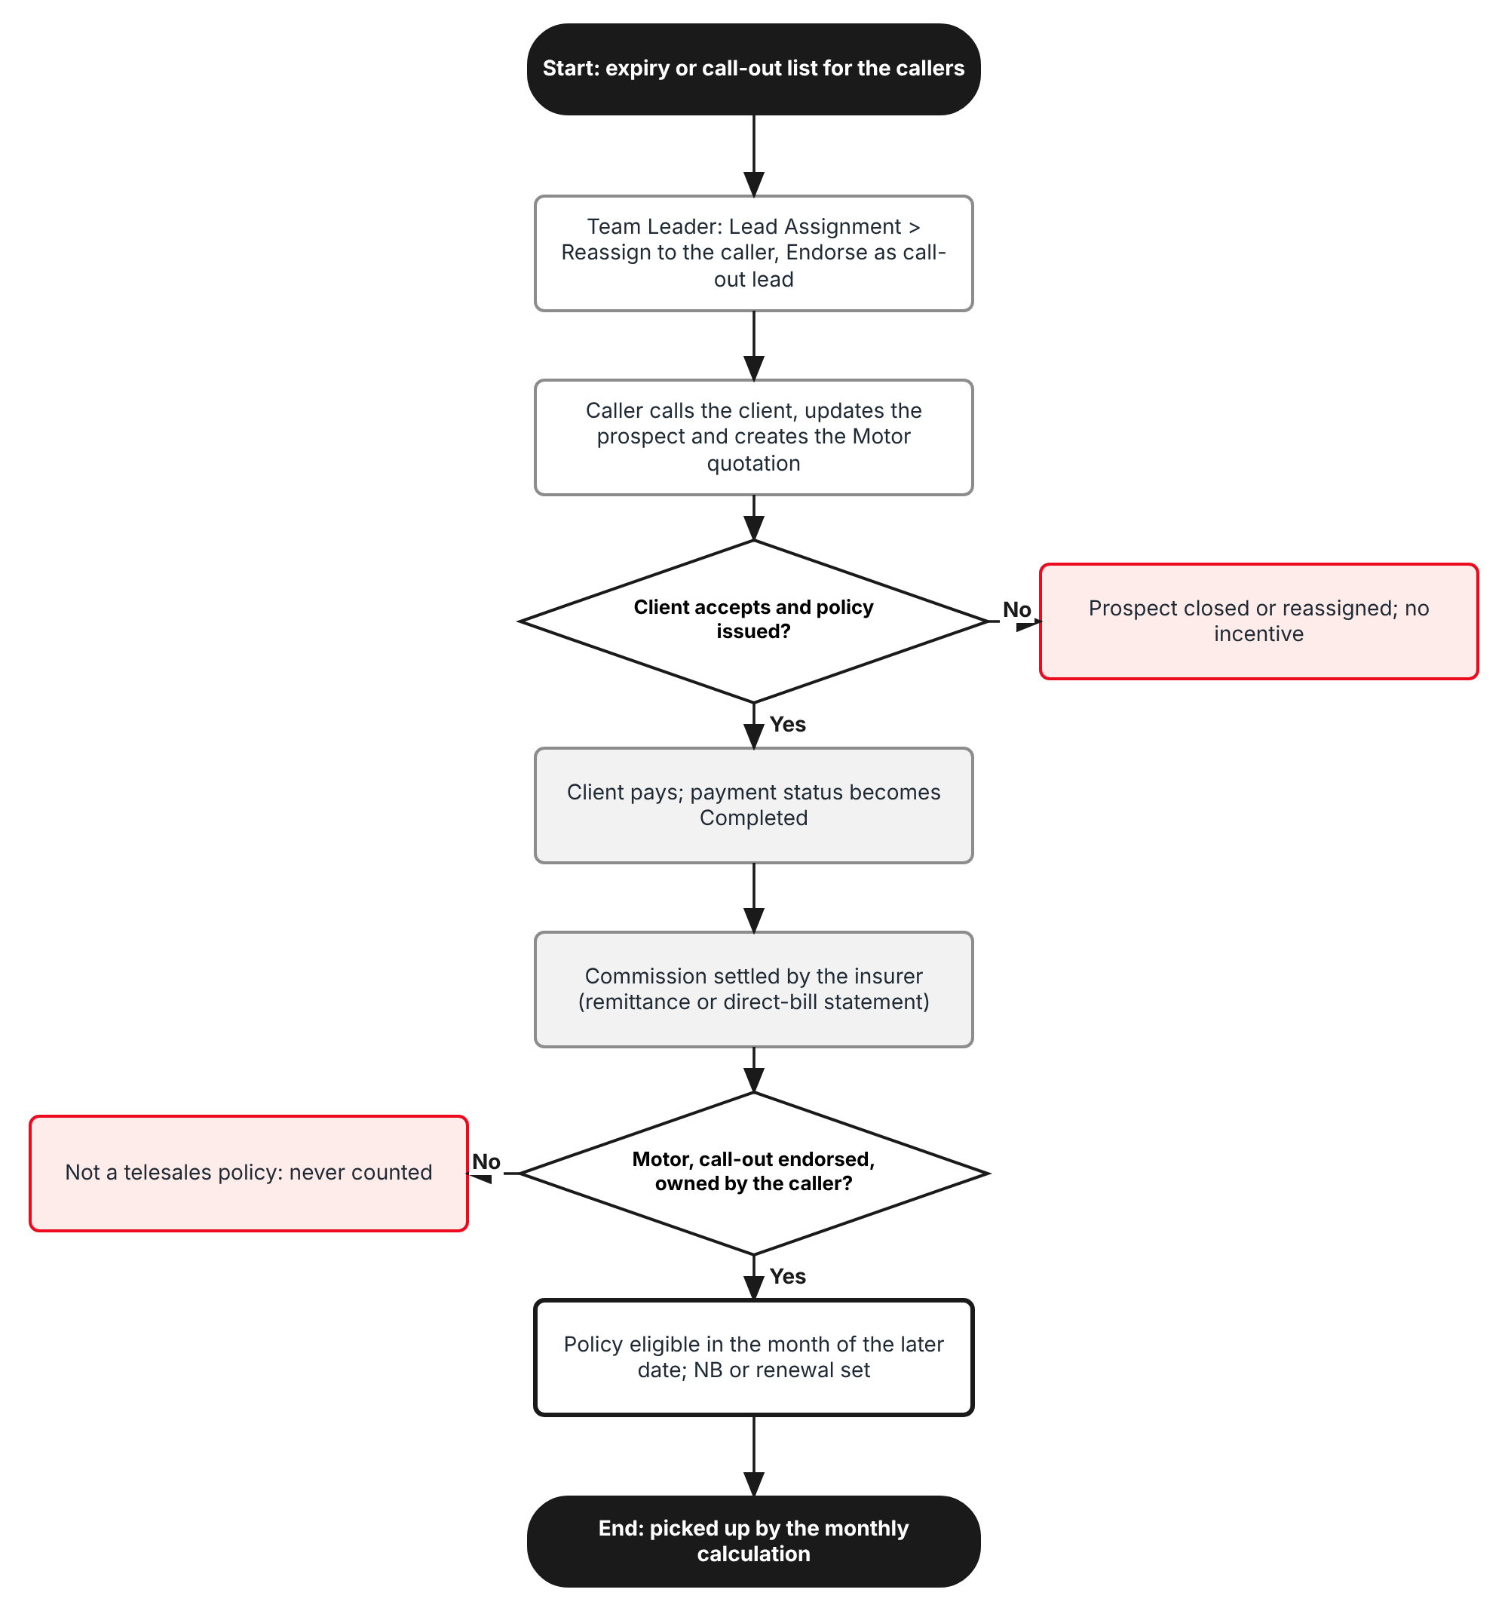
Figure 2: Flow B - From call-out lead to eligible policy
Table 4: Flow B steps
Step | Who (role) | What happens | FR
B1 | Team Leader | Lead Assignment: reassigns the prospects of the call-out list to the caller and clicks Endorse as call-out lead (or uses a call-out assignment rule). | FR-TSI-010
B2 | Caller (Sales & Marketing) | Calls the client, updates the prospect and creates the Motor quotation in the prospect (Create Quote). | FR-TSI-011
B3 | Processing Team, client | Quotation accepted, converted and the policy issued with the insurance partner. | FR-TSI-011
B4 | Accounting | Client payment confirmed: payment status Completed. Commission settled on the remittance or the insurer's direct-bill statement. | FR-TSI-020
B5 | System | Sets the eligible date and production month, classifies NB or renewal and stores the net commission. | FR-TSI-020 to 022

2.3 Flow C - Calculate, approve and pay the month
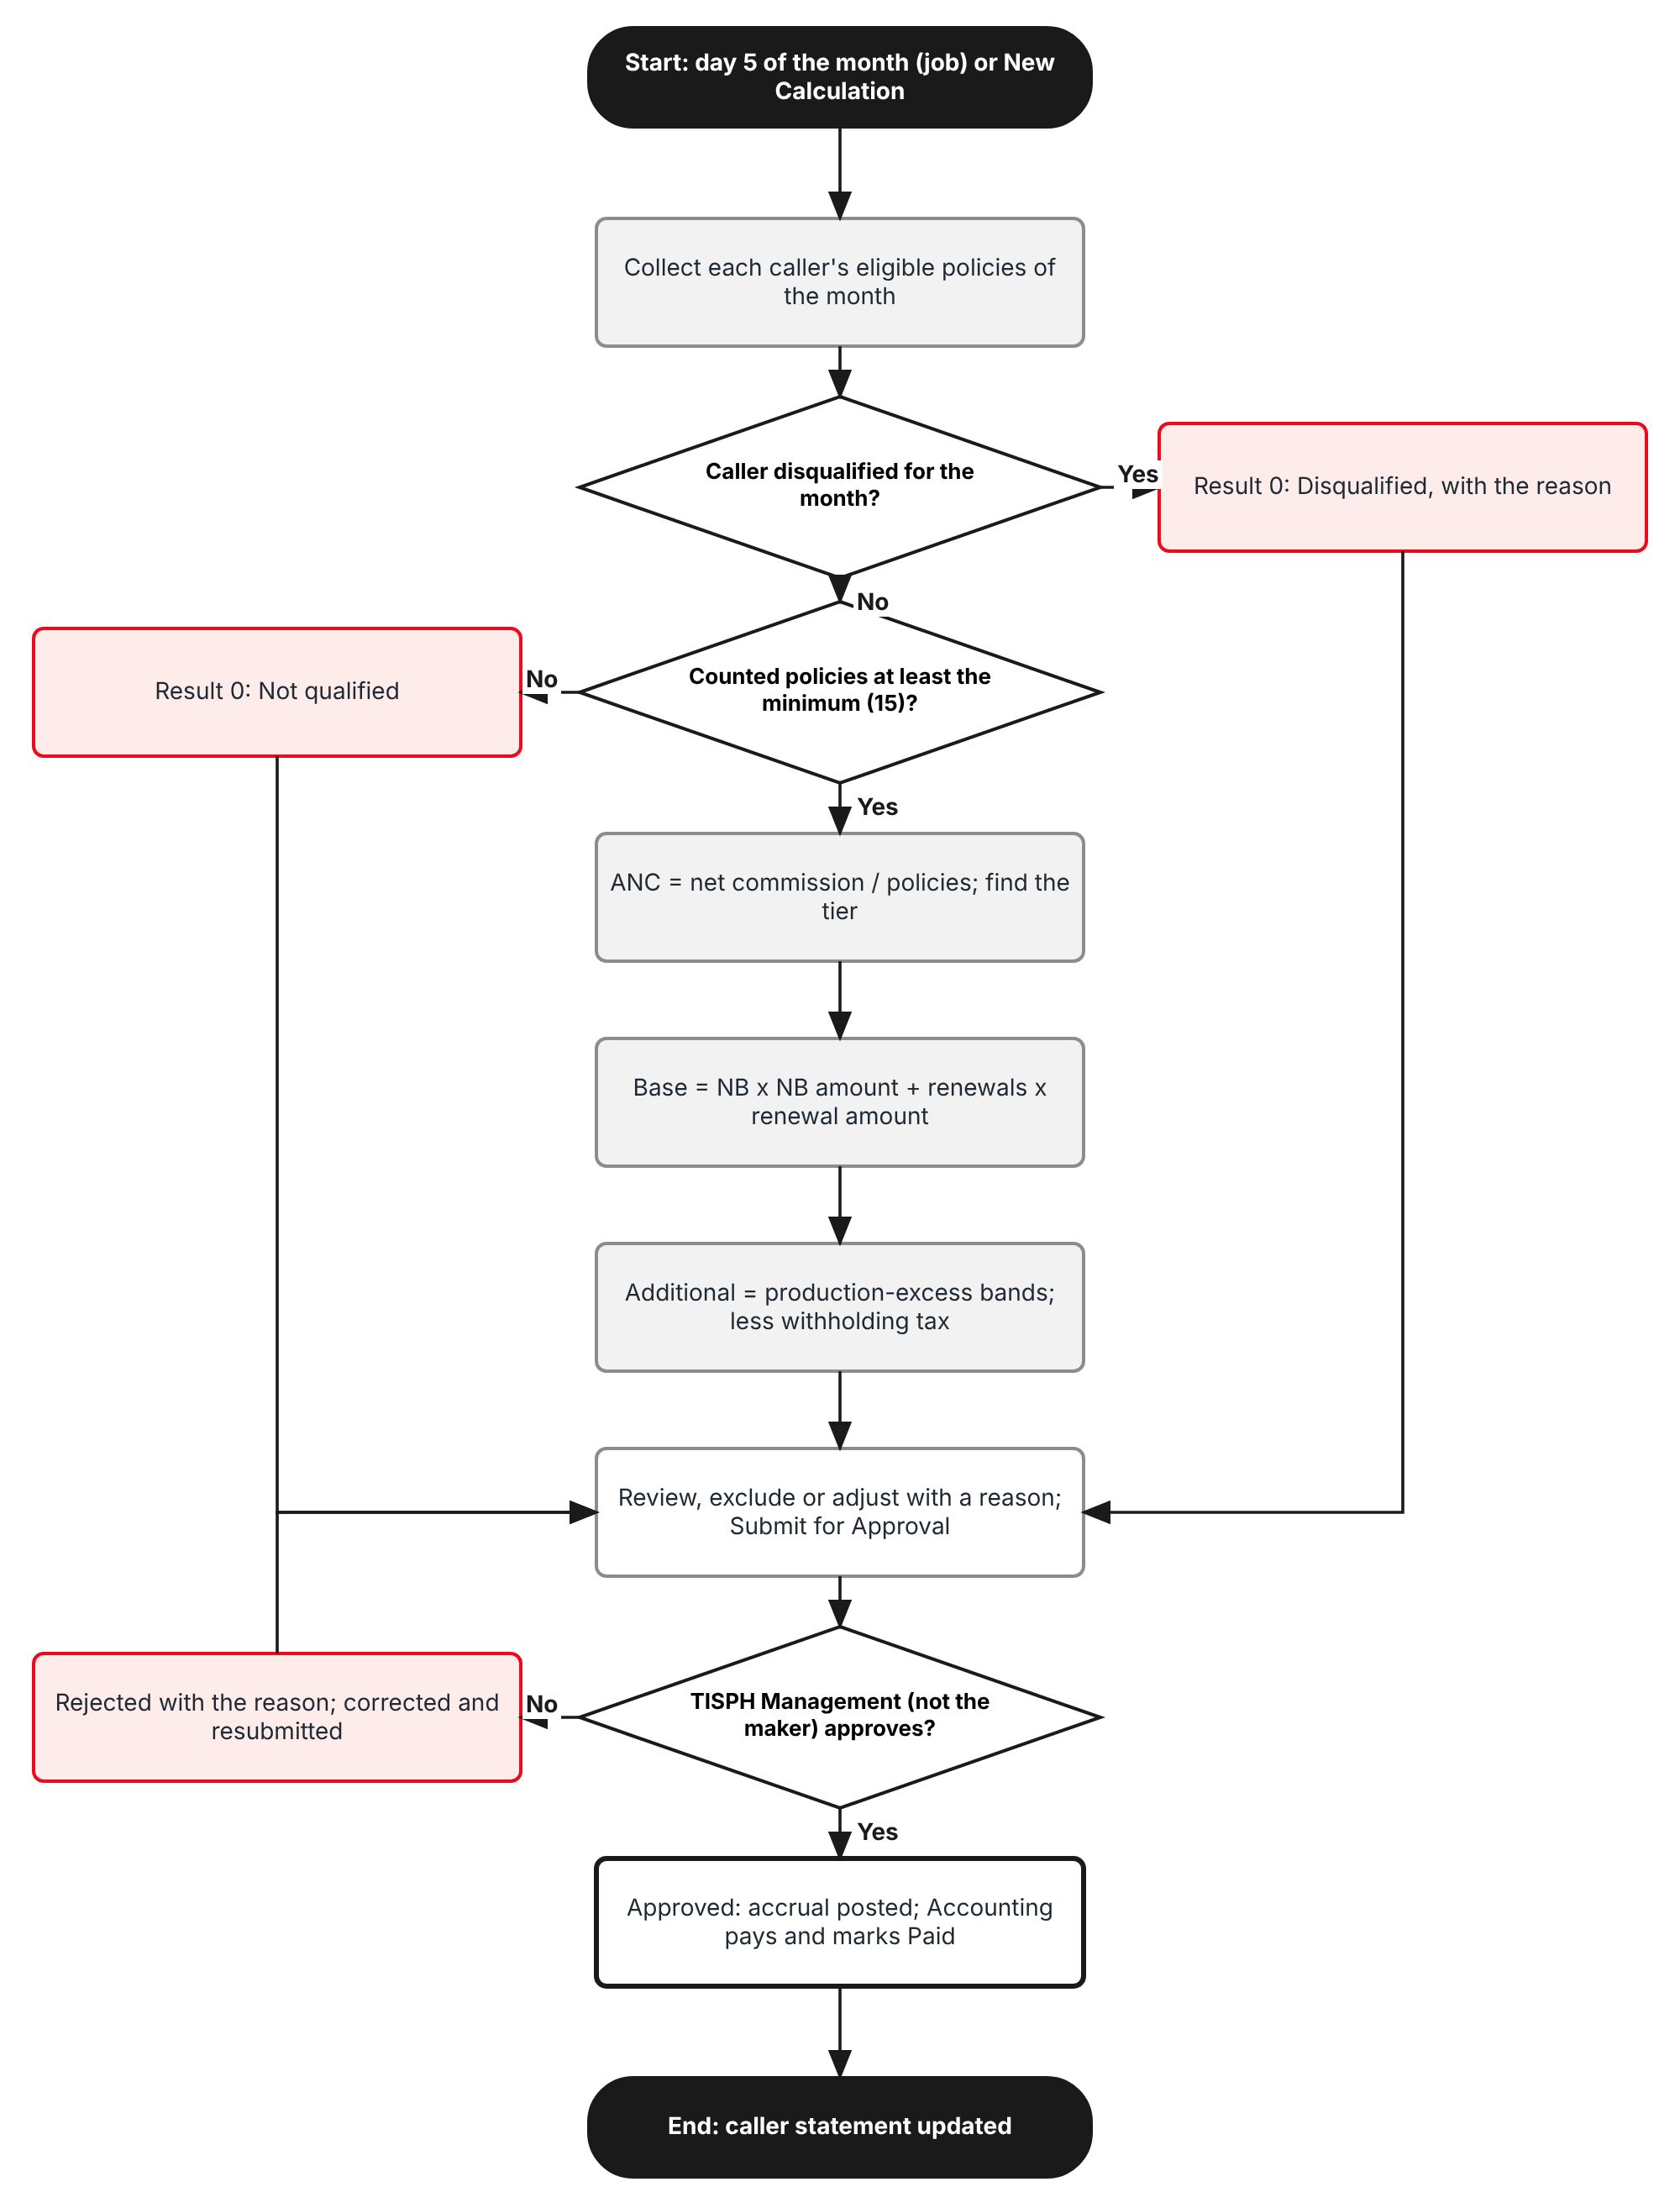
Figure 3: Flow C - Monthly calculation, approval and payment
Table 5: Flow C steps
Step | Who (role) | What happens | FR
C1 | System / Accounting | On day 5 the job Telesales incentive calculation creates the batch of the previous month; Accounting may also use New Calculation. | FR-TSI-030
C2 | System | Per caller: disqualification check, 15-policy trigger, ANC and level, base incentive, additional incentive, recovery lines, withholding tax. | FR-TSI-031 to 036
C3 | Accounting, Team Leader | Review the Policies tab, exclude a policy with a reason, adjust a line with a reason; Submit for Approval. | FR-TSI-035, 037, 040
C4 | TISPH Management (approve:incentive) | Approves or rejects the batch from My Work > Approvals or Accounts > Incentive > Approvals. Approval posts the accrual. | FR-TSI-040
C5 | Accounting | Pays the callers and marks the batch Paid; statements and the Excel export show the result. | FR-TSI-041, 042

2.4 What the incentive covers
Table 6: Telesales incentive dimensions
Dimension | Values | Where in BrokerVerse
Products | Motor - Private Car, Motor - Commercial Vehicle, Motor - Motorcycle | Master > Insurance > Product; Basic Information > Products
People | Callers of the accredited insurance partners; TIS Team Leaders; TISPH Management | Master > Users and Access; Callers tab
Policies | Telesales policies, new business and renewal, issued, fully paid, commission settled | Operations > Policy; Accounts > Remittance
Period | Calendar month of the eligible date; from 1 April 2026 production | Accounts > Incentive > Calculations
Amounts | Base per policy by ANC level, additional per block above 30 / 50 / 75 / 100, withholding tax 5% | Incentive Structure tab

3 Personas and roles

3.1 Personas
BrokerVerse ships eight roles (Master > Users and Access > Role). TISPH personas map to them as below. TISPH adds two roles of its own, Telesales Team Leader and Sales Head, built on Sales & Marketing with the extra permissions of section 3.2.
Table 7: Personas and BrokerVerse roles
TISPH persona | BrokerVerse role | What they do with the incentive
Telesales caller (insurance partner staff) | Sales & Marketing (Account Executive) - sales | Works call-out prospects, quotes; sees own My Programs and Incentive Statement
TIS Team Leader | Telesales Team Leader (TISPH role on sales + write:callout-endorsement) | Hands out and endorses call-out leads; reviews the month's policies of the team
TISPH Management, e.g. Sales Head | Sales Head (TISPH role with approve:incentive) or Accounting Manager - accounting-manager | Approves program versions and monthly batches; disqualifies callers
Accounting | Accounting - accounting | Runs and submits the calculation, excludes and adjusts with reasons, pays and marks Paid
System Administrator | System Administrator - system-admin | Keeps the Telesales program, callers and settings; roles and schedules
Auditor | Compliance Officer - compliance-officer | Read-only access to programs, batches and the Audit Trail

3.2 Permissions
Permissions follow the BrokerVerse pattern read:<module> / write:<module> / approve:<module> and are granted on Master > Users and Access > Role Permissions.
Table 8: Permissions used by COMM-08
Permission | New / existing | Allows
read:incentive | Existing | Open Accounts > Incentive screens for any sales person; Export to Excel
write:incentive | Existing | New Calculation, Recalculate, Exclude / Include again, Adjust, Submit for Approval, Mark as paid
approve:incentive | New | Approve or reject telesales batches and Telesales program versions; Disqualify and Reinstate callers (never one's own work)
write:masters | Existing | Add and edit incentive programs, including the Telesales program and its callers
write:callout-endorsement | New | Endorse as call-out lead and Withdraw endorsement on Lead Assignment; save call-out assignment rules
read:profile | Existing | A caller sees his or her own My Programs and Incentive Statement

3.3 Default grants
Table 9: Default grants (Y = granted; TL = Telesales Team Leader)
Permission | system-admin | sales | TL (TISPH) | Sales Head (TISPH) | accounting | accounting-manager | compliance-officer
read:incentive | Y | - | Y | Y | Y | Y | Y
write:incentive | Y | - | - | - | Y | Y | -
approve:incentive | Y | - | - | Y | - | Y | -
write:masters | Y | - | - | - | - | - | -
write:callout-endorsement | Y | - | Y | Y | - | - | -
read:profile | Y | Y | Y | Y | Y | Y | Y

Segregation of duties. The user who created or submitted a calculation batch, or who saved a program version, can never approve it, even with approve:incentive (maker-checker rule, TIS-BRD-SEC-03). A caller never holds read:incentive, so a caller sees only his or her own results.

4 Functional requirements
Twenty-two FRs implement COMM-08. They follow the process: the Telesales program (4.1), call-out leads (4.2), the policies that count (4.3), the monthly calculation (4.4), and approval, payment and statement (4.5).

4.1 Telesales program

FR-TSI-001 Set up a Telesales incentive program
BRD trace | COMM-08 "Telesales incentive on Motor policies only, triggered at a minimum of 15 policies"; remark "number of target policies editable" | Actor | System Administrator (write:masters)
Priority | Must have | Fit | Customization
Screens | Master > Finance > Incentive Programs > Add Program / Edit, Basic Information tab

Description
The existing Create Incentive Program dialog gets a new Program Type Telesales. When it is chosen, Target Metric is fixed to Average Net Commission (ANC), Calculation Frequency to Monthly and Applicable To to Telesales caller, and the dialog shows the tabs Basic Information, Callers (FR-TSI-004), Incentive Structure (FR-TSI-002, 003) and History (FR-TSI-005) in place of Target Configuration.
Basic Information adds four fields for this type: Products (Motor products only), Minimum policies to qualify (default 15), Withholding tax % (default 5.00) and Effective from (month). The minimum is a field of the program, not a fixed rule, so that TISPH can change the target when management agrees a new one; the change takes effect from a chosen month through a new version (FR-TSI-005).
The program code follows the base numbering (INC-YYYY-NNN) unless the user types one, for example TSI-2026-001. Only one Telesales program can be in force in a month.
Preconditions
- The user has write:masters.
- The Motor products exist on Master > Insurance > Product.
Main flow
- The user opens Master > Finance > Incentive Programs and clicks Add Program.
- On Basic Information the user enters Program Name, chooses Program Type Telesales, selects the Products, and enters Minimum policies to qualify, Withholding tax %, Effective from (month) and Start Date.
- The user completes the Callers and Incentive Structure tabs and clicks Save draft. The program is saved in Draft, version 1.
- The user clicks Submit for approval (FR-TSI-005).
Alternate and exception flows
- Edit an active program: Edit opens version n+1 in Draft with a copy of the version in force; the version in force keeps working until the new one is approved and its month starts.
- Deactivate: the existing Active toggle sets the program Inactive from the next month that has no batch; months already calculated are not touched.
Business rules
Rule | Statement | Kind | Maintained in
R1 | Program Type Telesales fixes Target Metric ANC, Calculation Frequency Monthly and Applicable To Telesales caller. | Fixed | -
R2 | Products: one or more Motor products; a policy of another product never counts. | Configurable per program | Basic Information
R3 | Minimum policies to qualify: whole number from 1 to 999; default 15. | Configurable per version | Basic Information
R4 | Withholding tax %: 0.00 to 100.00; default 5.00 (incentive.telesales.default_wht_pct). | Configurable per version | Basic Information; Master > System > Configuration
R5 | Effective from (month) is the first day of a month and cannot be earlier than the first month without a calculation batch. | Fixed | -
R6 | Only one Telesales program version is in force in a given month. | Fixed | -

Validations and messages
Check | Message shown | ID
Program name blank | Program name is required | MSG-TSI-001
No product | Select at least one Motor product | MSG-TSI-002
Product not Motor | Telesales programs apply to Motor products only | MSG-TSI-003
Minimum not a whole number in range | Minimum policies to qualify must be a whole number from 1 to 999 | MSG-TSI-004
Tax out of range | Withholding tax % must be between 0.00 and 100.00 | MSG-TSI-005
Effective month not the first day | Effective from must be the first day of a month | MSG-TSI-006
Effective month already calculated | Incentives for <month> are already calculated; choose <next month> or later | MSG-TSI-007
Second program in the same month | Telesales program <code> is already in force for <month> | MSG-TSI-008
Saved | Program saved | MSG-TSI-009

Audit
- Written to Master > System > Audit Trail with the user, time, before and after values and remark.
Acceptance criteria
- A program saved with Program Type Telesales shows Target Metric Average Net Commission (ANC), Calculation Frequency Monthly and Applicable To Telesales caller, all read-only.
- Minimum policies to qualify defaults to 15 and Withholding tax % to 5.00.
- Selecting Personal Accident - Individual as a product is refused with "Telesales programs apply to Motor products only".
- With the September 2026 batch calculated, Effective from 01/09/2026 is refused and 01/10/2026 is accepted.
- A second Telesales program for October 2026 is refused while TSI-2026-001 is in force for that month.

FR-TSI-002 Keep the ANC tier table with new-business and renewal amounts
BRD trace | COMM-08 "tiering table"; "full rate on new business, reduced at renewal" | Actor | System Administrator (write:masters)
Priority | Must have | Fit | Customization
Screens | Master > Finance > Incentive Programs > Edit > Incentive Structure tab, ANC tier table

Description
The Incentive Structure tab of a Telesales program holds the ANC tier table. Each row is a level with ANC from, ANC to and two amounts per policy: New business (PHP) and Renewal (PHP). The caller's ANC of the month selects one level; every counted policy then earns the amount of that level for its kind (FR-TSI-032).
The approved program sets five levels: PHP 2,500 to 3,999 pays PHP 300 per policy, 4,000 to 5,999 pays 500, 6,000 to 7,999 pays 700, 8,000 to 9,999 pays 900, 10,000 and above pays 1,100. These are the new-business amounts. Renewal amounts are lower, as the requirement asks; their values are set by TISPH (illustrated at half the new-business amount in this FRS).
Preconditions
- The program is in Draft.
Main flow
- The user opens the Incentive Structure tab and clicks Add level for each level.
- The user enters ANC from, New business amount and Renewal amount. ANC to is filled from the next level (next ANC from - 0.01); the last level reads "and above".
- On save the server checks the table and shows the result under it.
Alternate and exception flows
- Remove a level: the levels are renumbered and the ANC to of the level before is refilled.
- ANC below Level 1: a caller whose ANC is below the lowest ANC from has no level and no base incentive (FR-TSI-032).
Business rules
Rule | Statement | Kind | Maintained in
R1 | Levels are numbered 1 to n in increasing ANC from; at most 10 levels. | Fixed | -
R2 | ANC from of level 1 is more than 0; each next ANC from is higher than the one before; ranges have no gap and no overlap; the last level has no upper limit. | Fixed | -
R3 | A level applies when ANC >= its ANC from and ANC < the next level's ANC from. | Fixed | -
R4 | New business amount > 0. Renewal amount >= 0 and not higher than the new-business amount of the same level. | Fixed | -
R5 | Default table (new business): 2,500.00 / 300; 4,000.00 / 500; 6,000.00 / 700; 8,000.00 / 900; 10,000.00 / 1,100. | Configurable per version | Incentive Structure
R6 | Amounts are in PHP with 2 decimals. | Fixed | -

Validations and messages
Check | Message shown | ID
No level | Add at least one ANC level | MSG-TSI-010
ANC from not increasing | Level <n>: ANC from must be higher than level <n-1> | MSG-TSI-011
Amount missing or zero | Level <n>: the new-business amount must be more than 0 | MSG-TSI-012
Renewal above new business | Level <n>: the renewal amount cannot be higher than the new-business amount | MSG-TSI-013
Renewal equal to new business | Level <n>: renewal pays the same as new business | MSG-TSI-014
More than 10 levels | A tier table can have at most 10 levels | MSG-TSI-015

Audit
- Written to Master > System > Audit Trail with the user, time, before and after values and remark.
Acceptance criteria
- The default table shows five levels with ANC to 3,999.99, 5,999.99, 7,999.99, 9,999.99 and "and above".
- Level 3 with ANC from 6,000.00, new business 700.00 and renewal 350.00 is accepted.
- Renewal 800.00 on level 3 (new business 700.00) is refused with "Level 3: the renewal amount cannot be higher than the new-business amount".
- ANC from 3,500.00 on level 2 when level 1 starts at 4,000.00 is refused.
- An ANC of exactly 4,000.00 falls in level 2; 3,999.99 falls in level 1.

FR-TSI-003 Keep the production-excess table
BRD trace | COMM-08 "a separate table for production in excess of target" | Actor | System Administrator (write:masters)
Priority | Must have | Fit | Customization
Screens | Master > Finance > Incentive Programs > Edit > Incentive Structure tab, Production-excess table

Description
Below the tier table the tab holds the production-excess table: bands of counted policies with In excess of, Up to (filled from the next band), Every and Additional incentive (PHP). The approved program pays PHP 2,000 for every 5 policies in excess of 30, PHP 3,000 for every 5 in excess of 50, PHP 4,000 for every 2 in excess of 75 and PHP 5,000 for every 2 in excess of 100.
Each band counts only the policies between its threshold and the next one, and pays one amount per full block (banded method, FR-TSI-033). The alternative method "highest band only", which pays only the highest band reached on the policies above its threshold, can be chosen with the setting incentive.telesales.excess_method.
Preconditions
- The program is in Draft.
Main flow
- The user clicks Add band and enters In excess of, Every and Additional incentive.
- Up to is filled from the next band; the last band reads "no limit".
- On save the server checks the bands.
Alternate and exception flows
- No bands: allowed; no additional incentive is paid.
Business rules
Rule | Statement | Kind | Maintained in
R1 | Bands are in increasing In excess of; at most 10 bands. | Fixed | -
R2 | The first In excess of is not lower than the minimum policies to qualify (15). | Fixed | -
R3 | Every is a whole number of 1 or more; Additional incentive > 0, in PHP. | Fixed | -
R4 | Default bands: 30 / every 5 / 2,000; 50 / every 5 / 3,000; 75 / every 2 / 4,000; 100 / every 2 / 5,000. | Configurable per version | Incentive Structure
R5 | Method: banded (default) or highest band only. | Configurable | Master > System > Configuration: incentive.telesales.excess_method

Validations and messages
Check | Message shown | ID
Thresholds not increasing | Band <n>: In excess of must be higher than band <n-1> | MSG-TSI-016
First threshold below the minimum | The first band must start at or above the minimum of <min> policies | MSG-TSI-017
Block size | Band <n>: Every must be a whole number of 1 or more | MSG-TSI-018
Amount | Band <n>: the additional incentive must be more than 0 | MSG-TSI-019

Audit
- Written to Master > System > Audit Trail with the user, time, before and after values and remark.
Acceptance criteria
- The default table shows four bands with Up to 50, 75, 100 and "no limit".
- A band In excess of 10 with minimum policies 15 is refused with "The first band must start at or above the minimum of 15 policies".
- Every 0 is refused.
- With the default table and the banded method, 58 counted policies give PHP 11,000.00 (FR-TSI-033).

FR-TSI-004 Keep the callers of the program and disqualify a caller
BRD trace | COMM-08 | Actor | System Administrator (write:masters); TISPH Management (approve:incentive) for Disqualify and Reinstate
Priority | Must have | Fit | Customization
Screens | Master > Finance > Incentive Programs > Edit > Callers tab

Description
The Callers tab lists who takes part: Caller (a BrokerVerse user), Code (the user's employee code), Insurance partner, Team Leader, From, To and Status. Only users whose role is in incentive.eligible_roles (Sales & Marketing) can be added, as for every base incentive program.
Disqualify records that TISPH Management has disqualified a caller for misrepresentation, account grabbing or unauthorized reassignment. From the month of its date the caller earns nothing (FR-TSI-035) until Reinstate.
Preconditions
- The callers exist as active users with the Sales & Marketing role on Master > Users and Access.
Main flow
- The user clicks Add caller, picks the user, the insurance partner, the Team Leader and the From date, and saves.
- To disqualify, a user with approve:incentive clicks Disqualify on the row, enters the date, the reason and a remark, and confirms.
- To end participation, the user enters the To date.
Alternate and exception flows
- Caller moves to another insurance partner: the row is ended and a new row is added from the next day; policies follow the row in force on the quotation date.
- Team Leader leaves: the System Administrator changes the Team Leader on the rows; past endorsements stay valid.
Business rules
Rule | Statement | Kind | Maintained in
R1 | A user has at most one active caller row at a time. | Fixed | -
R2 | Team Leader must hold write:callout-endorsement. | Fixed | -
R3 | Disqualify and Reinstate need approve:incentive; a remark is required. Reasons: Misrepresentation, Account grabbing, Unauthorized reassignment, Other. | Fixed | List of values (6.3)
R4 | Disqualification applies from the month of its date; batches already Approved or Paid are not changed. | Fixed | -
R5 | Caller rows are part of the program version but a disqualification takes effect without a new version (it is approved by its own maker-checker: the user who disqualifies cannot reinstate the same row). | Fixed | -

Validations and messages
Check | Message shown | ID
User not eligible | <user> does not have a role that takes part in incentives | MSG-TSI-020
Caller twice | <user> is already an active caller from <date> | MSG-TSI-021
Team Leader without the permission | <user> cannot endorse call-out leads | MSG-TSI-022
No reason | A reason and a remark are required to disqualify a caller | MSG-TSI-023
Disqualified | <caller> is disqualified from <date> | MSG-TSI-024

Audit
- Written to Master > System > Audit Trail with the user, time, before and after values and remark.
Acceptance criteria
- Adding Geralyn Ramos (Sales & Marketing) with Apex Assurance and Team Leader Marco Villanueva from 01/04/2026 lists her as Active.
- Adding a user with only the Accounting role is refused.
- Disqualifying Jose Bautista from 01/08/2026 for account grabbing gives him PHP 0.00 in the August 2026 batch with the result "Disqualified".
- The user who disqualified a caller cannot reinstate the same caller.

FR-TSI-005 Version and approve program changes by month
BRD trace | COMM-08 remark "target editable based on the agreement with management"; SEC-03 | Actor | System Administrator (maker); Accounting Manager or Sales Head (approve:incentive, checker)
Priority | Must have | Fit | Customization
Screens | Master > Finance > Incentive Programs > Edit, History tab; Master > Finance > Configuration Approvals

Description
A Telesales program is money-relevant master data, so each change is a version with an Effective from (month) and is approved before it is used. Submit for approval lists the change on Master > Finance > Configuration Approvals, with the old and new values of every field and table row. The History tab lists all versions with their months, maker, approver and change reason.
Each month is calculated with the version in force on the first day of that month. A version can never start in a month that already has a batch that is not Rejected, so a past month is never recalculated under new rules.
Preconditions
- The program has a version in Draft.
Main flow
- The maker edits the program, enters the Change reason and clicks Submit for approval.
- The change is listed on Configuration Approvals; users with approve:incentive are notified.
- The checker opens the change, compares old and new values and clicks Approve or Return with a remark.
- On approval the version is Approved and is in force from its effective month; the version before is Superseded from that month.
Alternate and exception flows
- Recall: the maker can take back a version not yet actioned.
- Returned: the version goes back to Draft with the remark.
Business rules
Rule | Statement | Kind | Maintained in
R1 | Maker-checker: the approver is not the user who saved or submitted the version. | Fixed | -
R2 | Change reason is required from version 2. | Fixed | -
R3 | Only one version can be in Draft or Pending approval at a time. | Fixed | -
R4 | A version in force is never edited; a change always creates the next version. | Fixed | -

Validations and messages
Check | Message shown | ID
No change reason | Change reason is required | MSG-TSI-025
Version already open | Version <n> of <code> is already in Draft or Pending approval | MSG-TSI-026
Maker approves | The approver must be different from the user who created this version | MSG-TSI-027
Submitted | Program version submitted for approval | MSG-TSI-028

Audit
- Written to Master > System > Audit Trail with the user, time, before and after values and remark.
Acceptance criteria
- Version 2 of TSI-2026-001 with minimum 18 policies from 01/11/2026, approved on 15/10/2026, is used for November 2026; October 2026 is still calculated with 15.
- The System Administrator who submitted version 2 cannot approve it.
- History lists version 1 (01/04/2026, Superseded from 01/11/2026) and version 2 (01/11/2026, Approved).
- A returned version is back in Draft with the checker's remark.

4.2 Call-out leads

FR-TSI-010 Endorse prospects as call-out leads
BRD trace | COMM-08; LEAD-06 | Actor | Team Leader (write:callout-endorsement)
Priority | Must have | Fit | Customization
Screens | Operations > Sales & Marketing > Lead Assignment > Team View and Reassignment Queue (Endorse as call-out lead, Withdraw endorsement, Call-out lead column); Assignment Rules (Call-out rule)

Description
A Team Leader hands each caller a call-out list. On Lead Assignment the Team Leader ticks the prospects already given to a caller of his or her team (or reassigns them to the caller with the existing Reassign) and clicks the new button Endorse as call-out lead. The prospect then shows "Endorsed <date> by <Team Leader>" in the new Call-out lead column, and the endorsement is written to the prospect's Assignment history.
For large lists the Team Leader can tick Call-out rule on an assignment rule (Assignment Rules tab): every prospect the rule assigns to one of the listed callers is endorsed at assignment. The Team View shows a Call-out count per team member.
Preconditions
- The prospects are assigned to callers of the active Telesales program whose Team Leader is the signed-in user.
Main flow
- The Team Leader opens Lead Assignment > Team View and filters on a caller.
- The Team Leader ticks the prospects and clicks Endorse as call-out lead.
- The server records the endorsement for each prospect and shows "<n> prospects endorsed as call-out leads".
Alternate and exception flows
- Withdraw endorsement: allowed while no quotation exists on the prospect; a reason is required.
- Reassign an endorsed prospect: when the Team Leader reassigns it to another caller of the team, the endorsement moves to the new caller; when anyone else reassigns it, the endorsement ends and the history says why.
- Prospect of another team: skipped and listed with the reason.
Business rules
Rule | Statement | Kind | Maintained in
R1 | Only the caller's Team Leader (or a user with approve:incentive) can endorse or withdraw. | Fixed | -
R2 | The endorsement must exist before the quotation is created; an endorsement after the quotation date does not make the policy count. | Fixed | -
R3 | An endorsement is valid for incentive.telesales.callout_validity_days (default 90) days; a quotation created later does not count. | Configurable | Master > System > Configuration
R4 | Call-out rules can be saved only by users with write:callout-endorsement. | Fixed | -

Validations and messages
Check | Message shown | ID
Prospect not with a caller | <prospect> is not assigned to a caller of your team | MSG-TSI-029
Quotation exists on withdraw | <prospect> already has quotation <number>; the endorsement cannot be withdrawn | MSG-TSI-030
Endorsed | <n> prospects endorsed as call-out leads | MSG-TSI-031

Audit
- Written to Master > System > Audit Trail with the user, time, before and after values and remark.
Acceptance criteria
- Marco Villanueva endorses LD-2026-95102 assigned to Geralyn Ramos; the Call-out lead column reads "Endorsed 22/09/2026 by Marco Villanueva" and the Assignment history has the entry.
- A Sales & Marketing user without write:callout-endorsement does not see the button.
- Withdrawing the endorsement of a prospect with a quotation is refused.
- A prospect reassigned to another caller by a non-Team Leader loses its endorsement.
- A call-out rule assigning Motor renewals of Apex Assurance to Geralyn Ramos endorses each prospect it assigns.

FR-TSI-011 Attribute a policy to a caller
BRD trace | COMM-08 | Actor | System
Priority | Must have | Fit | Customization
Screens | Operations > Policy; Accounts > Incentive > Calculations > Calculation Details > Policies tab

Description
A policy is a telesales policy of a caller when the caller created its quotation as account executive of the prospect, the prospect carried a valid call-out endorsement for that caller when the quotation was created, and the policy is placed with the caller's insurance partner. The link is set when the policy is issued and shown on the policy (Related Records: "Telesales: <caller>, call-out endorsed <date>").
Preconditions
- The policy is issued from a quotation created in a prospect.
Main flow
- On issue, the server reads the quotation's creator and date, the prospect's owner and endorsements and the caller rows of the program.
- If all conditions are met, the policy is linked to the caller.
- Otherwise the policy is not a telesales policy and is never counted.
Alternate and exception flows
- Quotation created by someone else (for example the Processing Team for the caller): the policy counts for the caller only if the prospect owner at quotation date is the caller and the endorsement is valid.
- Policy with another insurer: not counted when incentive.telesales.same_insurer_only is true (default).
Business rules
Rule | Statement | Kind | Maintained in
R1 | Conditions: caller is the prospect owner on the quotation date; endorsement for that caller dated on or before the quotation date and within its validity; caller row active on that date; policy insurer = caller's insurance partner (setting). | Fixed / Configurable | Master > System > Configuration: incentive.telesales.same_insurer_only
R2 | A policy is linked to one caller at most. | Fixed | -
R3 | Renewal quotations from the Renewal Queue count when the renewal prospect was endorsed for the caller in the same way. | Fixed | -

Audit
- Written to Master > System > Audit Trail with the user, time, before and after values and remark.
Acceptance criteria
- A policy quoted on 23/09/2026 by Geralyn Ramos on LD-2026-95102, endorsed on 22/09/2026, with Apex Assurance, is linked to her.
- The same policy quoted on 21/09/2026 (before the endorsement) is not linked.
- A policy of her prospect placed with Pioneer is not linked while same_insurer_only is true.

4.3 Policies that count

FR-TSI-020 Decide when a telesales policy is eligible and in which month
BRD trace | COMM-08; COMM-01, COMM-04 | Actor | System
Priority | Must have | Fit | Customization
Screens | Accounts > Incentive > Calculations > Calculation Details > Policies tab; Operations > Policy

Description
A telesales policy becomes eligible when both are true: the premium is fully paid (payment status Completed) and the insurer has settled the commission (the policy is on an approved remittance where TISPH kept its commission, or on a settled direct-bill statement of the insurer). The eligible date is the later of the two dates. The policy is counted in the batch of the month of its eligible date, its production month, and never again.
A policy that is Cancelled, or whose payment status is Refunded, before its eligible date never becomes eligible. Instalment policies become eligible only when the last instalment is paid. Endorsements do not add a policy.
Preconditions
- The policy is a telesales policy (FR-TSI-011) of a Motor product of the program.
Main flow
- When the receipt that completes the premium is posted, or the remittance or direct-bill statement with the policy is settled, the server checks both conditions.
- When both are met it stores the eligible date and the incentive status Eligible.
- The next calculation of that month picks the policy up.
Alternate and exception flows
- Commission settled after the month's batch was calculated: the eligible date is the settlement date, so the policy falls in the month of settlement.
- Eligible date before the program start (01/04/2026): not counted.
Business rules
Rule | Statement | Kind | Maintained in
R1 | Eligible date = later of full-payment date and commission-settlement date. | Fixed | -
R2 | Policy statuses Active, Expired or Renewed can count; Cancelled and Lapsed cannot; payment status must be Completed. | Fixed | -
R3 | A policy is counted in one batch only. | Fixed | -

Audit
- Written to Master > System > Audit Trail with the user, time, before and after values and remark.
Acceptance criteria
- A policy fully paid on 12/09/2026 with commission settled on 21/09/2026 is eligible on 21/09/2026 and counted in September 2026.
- A policy fully paid on 25/09/2026 with commission settled on 06/10/2026 is counted in October 2026.
- A policy with payment status Partial is listed as "Not fully paid" and not counted.
- A policy cancelled on 10/09/2026 before full payment is never counted.

FR-TSI-021 Classify a policy as new business or renewal
BRD trace | COMM-08 "full rate on new business, reduced at renewal" | Actor | System
Priority | Must have | Fit | Customization
Screens | Accounts > Incentive > Calculations > Calculation Details > Policies tab (NB / Ren.)

Description
Each telesales policy is Renewal when it renews a policy placed by TISPH (it was created from Operations > Renewals and points to the policy it renews). Every other telesales policy is New business, including clients whose last policy was with another insurer or another broker, and clients whose TISPH policy expired without renewal.
Preconditions
- The policy is a telesales policy.
Main flow
- On issue the server sets NB or Renewal from the renewal link of the policy.
- The value is shown on the Policies tab and drives the amount per policy (FR-TSI-032).
Business rules
Rule | Statement | Kind | Maintained in
R1 | Renewal = the policy has a renewed-from policy in BrokerVerse. Otherwise New business. | Fixed | -
R2 | Migrated policies (Data Migration) keep their renewal link so that their renewals are classified the same way. | Fixed | -

Audit
- Written to Master > System > Audit Trail with the user, time, before and after values and remark.
Acceptance criteria
- POL-2026-004655, renewed from a TISPH policy expiring 31/08/2026, is Renewal.
- A client of the expiry list whose last policy was with another insurer is New business.
- A renewal is paid the renewal amount of the caller's level and a new-business policy the new-business amount.

FR-TSI-022 Store the net commission of a policy and compute the ANC
BRD trace | COMM-08; COMM-05, COMM-06 | Actor | System
Priority | Must have | Fit | Customization
Screens | Accounts > Incentive > Calculations > Calculation Details > Policies tab (Net commission), Agent Details tab (ANC)

Description
The net commission of a policy is the commission TISPH keeps: the commission on the remittance or direct-bill line of the policy, less any share paid to a referrer or agent on that policy (Commission), before VAT. It is stored at the eligible date. The issuing and remitting rates that give this commission belong to PROD-16 and COMM-06.
The ANC of a caller for a month is the sum of the net commission of the caller's counted policies divided by their number, rounded half up to 2 decimals. Excluded policies and recovery lines are not part of it.
Preconditions
- The policy is eligible.
Main flow
- At the eligible date the server stores the net commission of the policy.
- In the calculation it adds the net commission of the counted policies and divides by their number.
Business rules
Rule | Statement | Kind | Maintained in
R1 | Net commission = commission retained on the policy - referrer / agent share, before VAT, PHP 2 decimals. | Fixed | -
R2 | ANC = round(sum of net commission / counted policies, 2), half up. | Fixed | -
R3 | A later commission change by endorsement does not change the stored figure. | Fixed | -

Audit
- Written to Master > System > Audit Trail with the user, time, before and after values and remark.
Acceptance criteria
- 16 counted policies with total net commission 62,481.60 give an ANC of 3,905.10.
- A policy with commission 5,600.00 and a referrer share of 560.00 has a net commission of 5,040.00.
- An excluded policy is left out of both the sum and the count.

4.4 Monthly calculation

FR-TSI-030 Run the monthly telesales calculation
BRD trace | COMM-08 "dedicated incentive computation" | Actor | Accounting (write:incentive); System (scheduled job)
Priority | Must have | Fit | Customization
Screens | Accounts > Incentive > Calculations > New Calculation; Calculation Details; Master > System > Schedules

Description
The calculation uses the existing incentive batch. On day 5 of each month at 06:00 Manila time the new job Telesales incentive calculation creates the batch of the previous month for the Telesales program in force, with status Calculated, and notifies the users with write:incentive. Accounting can also run it from New Calculation (Period, then Program TSI-2026-001, then Review & Submit).
The batch has one line per caller of the program who was active in the month, even with no policy, and lists every telesales policy considered on the new Policies tab with its status: Counted, Excluded, Waiting for commission, Not fully paid, Cancelled or Recovery.
Preconditions
- The month has ended.
- The program has an Approved version in force on the first day of the month.
Main flow
- The job or the user starts the calculation for the month.
- The server collects the eligible telesales policies of the month and the recovery lines (FR-TSI-036).
- For each caller it applies FR-TSI-031 to 034 and writes the line.
- The batch is saved as Calculated with the message "Calculation complete".
Alternate and exception flows
- Recalculate: while the batch is Calculated or Rejected, Accounting can recalculate it; exclusions and adjustments with reasons are kept.
- Month already calculated: refused unless the batch was Rejected (base rule).
- Job runs when the month already has a batch: the job does nothing and writes a line to its log.
Business rules
Rule | Statement | Kind | Maintained in
R1 | One batch per program and month. | Fixed | -
R2 | The batch uses the program version in force on the first day of the month. | Fixed | -
R3 | Job day and time: incentive.telesales.run_day (default 5) at 06:00. | Configurable | Master > System > Configuration; Master > System > Schedules

Validations and messages
Check | Message shown | ID
Month not ended | The month of <month> has not ended yet | MSG-TSI-032
Already calculated | <program> is already calculated for <month> (batch <status>) | MSG-TSI-033
No version in force | <program> has no approved version for <month> | MSG-TSI-034
Done | Calculation complete | MSG-TSI-035

Audit
- Written to Master > System > Audit Trail with the user, time, before and after values and remark.
Acceptance criteria
- On 05/10/2026 at 06:00 the job creates CALC-2026-00011 for September 2026 with six caller lines and status Calculated.
- New Calculation for October 2026 on 20/10/2026 is refused with "The month of October 2026 has not ended yet".
- A second calculation of September 2026 is refused while CALC-2026-00011 is Calculated.
- Recalculate keeps an exclusion entered before it.

FR-TSI-031 Apply the minimum-policy trigger
BRD trace | COMM-08 "triggered at a minimum of 15 policies" | Actor | System
Priority | Must have | Fit | Customization
Screens | Accounts > Incentive > Calculations > Calculation Details > Agent Details tab (Result)

Description
A caller qualifies for the month when the number of counted policies (new business plus renewal) is at least the Minimum policies to qualify of the version in force (15). A caller below the minimum gets no incentive at all for the month: no base and no additional incentive. The policies of that month are still used up; they are not carried to the next month.
Main flow
- The server counts the caller's counted policies.
- If the count is below the minimum the line is set to "Not qualified (n < minimum)" with all amounts 0.00.
Business rules
Rule | Statement | Kind | Maintained in
R1 | Qualified when counted policies >= minimum policies of the version. | Configurable per version | Basic Information
R2 | No partial incentive below the minimum; policies are not carried forward. | Fixed | -
R3 | Recovery lines still apply to a caller who is not qualified (FR-TSI-036). | Fixed | -

Audit
- Written to Master > System > Audit Trail with the user, time, before and after values and remark.
Acceptance criteria
- Novy Castillo with 14 counted policies in September 2026 shows "Not qualified (14 < 15)" and PHP 0.00.
- Anna Cruz with 16 counted policies qualifies.
- With version 2 (minimum 18) in force from November 2026, 16 policies in November do not qualify.

FR-TSI-032 Find the level and compute the base incentive
BRD trace | COMM-08 "tiering table", "full rate on new business, reduced at renewal" | Actor | System
Priority | Must have | Fit | Customization
Screens | Accounts > Incentive > Calculations > Calculation Details > Agent Details tab (ANC, Level, Base)

Description
For a qualified caller the server finds the level whose ANC range holds the caller's ANC and computes Base = new-business policies x new-business amount + renewal policies x renewal amount of that level. A caller whose ANC is below Level 1 has no level and a base of 0.00.
Business rules
Rule | Statement | Kind | Maintained in
R1 | Level: ANC >= ANC from of the level and < ANC from of the next level. | Fixed | -
R2 | Base = NB count x NB amount + renewal count x renewal amount. | Fixed | -
R3 | ANC below Level 1: result "Below level 1", base 0.00. | Fixed | -

Audit
- Written to Master > System > Audit Trail with the user, time, before and after values and remark.
Acceptance criteria
- Geralyn Ramos: 31 NB and 6 renewals, ANC 6,412.50, Level 3: base 31 x 700 + 6 x 350 = PHP 23,800.00.
- Errin Dizon: 90 NB and 14 renewals, ANC 10,250.00, Level 5: base PHP 106,700.00.
- Vincent Lim: 22 policies, ANC 2,180.00: "Below level 1", base 0.00.

FR-TSI-033 Compute the additional incentive for production in excess
BRD trace | COMM-08 "a separate table for production in excess of target" | Actor | System
Priority | Must have | Fit | Customization
Screens | Accounts > Incentive > Calculations > Calculation Details > Agent Details tab (Additional)

Description
For a qualified caller the server applies the production-excess table to the number N of counted policies. With the banded method each band k counts the policies above its threshold up to the next threshold, min(N, next) - threshold, and pays its amount for every full block: floor(policies in band / every) x amount. The bands are added up.
With the method highest band only, only the highest band whose threshold N exceeds is used: floor((N - threshold) / every) x amount.
Business rules
Rule | Statement | Kind | Maintained in
R1 | Banded: sum over bands of floor(max(0, min(N, next threshold) - threshold) / every) x amount. | Fixed | -
R2 | Highest band only: floor((N - threshold of the highest band reached) / every) x amount. | Fixed | -
R3 | Method from incentive.telesales.excess_method (default banded). | Configurable | Master > System > Configuration
R4 | The additional incentive is paid to a qualified caller even when the ANC is below Level 1. | Fixed | -

Audit
- Written to Master > System > Audit Trail with the user, time, before and after values and remark.
Acceptance criteria
- 37 policies: 7 above 30, 1 block of 5: PHP 2,000.00.
- 58 policies, banded: 20 in band 1 = 4 x 2,000 and 8 in band 2 = 1 x 3,000: PHP 11,000.00. Highest band only: PHP 3,000.00.
- 104 policies, banded: 8,000 + 15,000 + 48,000 + 10,000 = PHP 81,000.00.
- 30 policies: PHP 0.00.

FR-TSI-034 Deduct withholding tax and give the total
BRD trace | COMM-08 | Actor | System
Priority | Must have | Fit | Customization
Screens | Accounts > Incentive > Calculations > Calculation Details > Agent Details tab (Tax, Total)

Description
The line total is computed as Gross = base + additional + recovery + adjustments, Tax = Gross x withholding tax % (when Gross is positive) and Total = Gross - Tax. The callers are not TISPH employees, so the tax is the withholding tax of the version (5.00%). The batch total is the sum of the line totals.
Business rules
Rule | Statement | Kind | Maintained in
R1 | Tax = round(max(Gross, 0) x WHT %, 2), half up. | Fixed | -
R2 | Total never below 0.00; a negative Gross is carried to the next month as a recovery line. | Fixed | -
R3 | Amounts in PHP, 2 decimals. | Fixed | -

Audit
- Written to Master > System > Audit Trail with the user, time, before and after values and remark.
Acceptance criteria
- Cristina Navarro: gross 48,600 + 11,000 = 59,600.00; tax 2,980.00; total PHP 56,620.00.
- Anna Cruz: gross 4,200.00 - 300.00 = 3,900.00; tax 195.00; total PHP 3,705.00.
- The September 2026 batch total is PHP 263,150.00.

FR-TSI-035 Exclude a policy and apply a disqualification
BRD trace | COMM-08; LEAD-06 | Actor | Accounting (write:incentive), on the Team Leader's review
Priority | Must have | Fit | Customization
Screens | Accounts > Incentive > Calculations > Calculation Details > Policies tab (Exclude, Include again)

Description
While a batch is Calculated or Rejected, Accounting can Exclude a counted policy with a reason (Misrepresentation, Account grabbing, Unauthorized reassignment, Duplicate, Other) and a remark, for example after the Team Leader's review. The caller's line is recalculated at once: count, ANC, level, base, additional and tax. Include again undoes it.
A caller disqualified for the month (FR-TSI-004) gets a line with the result "Disqualified" and 0.00; the policies are listed with that status.
Business rules
Rule | Statement | Kind | Maintained in
R1 | Reason and remark are required to exclude. | Fixed | -
R2 | An excluded policy is never counted in a later month. | Fixed | -
R3 | Exclusion is not possible once the batch is Pending Approval, Approved or Paid. | Fixed | -

Validations and messages
Check | Message shown | ID
No reason | A reason and a remark are required to exclude a policy | MSG-TSI-036
Batch locked | Batch <id> is <status>; policies can no longer be excluded | MSG-TSI-037
Excluded | Policy <number> excluded; <caller> recalculated | MSG-TSI-038

Audit
- Written to Master > System > Audit Trail with the user, time, before and after values and remark.
Acceptance criteria
- Excluding one of Geralyn Ramos's 37 policies (account grabbing) recalculates her line on 36 policies: the additional incentive stays PHP 2,000.00 (6 above 30) and, for a new-business policy with the level unchanged, the base drops by 700.00.
- Excluding without a remark is refused.
- Exclude is not offered on an Approved batch.

FR-TSI-036 Recover the incentive of a policy cancelled or refunded after payout
BRD trace | COMM-08 | Actor | System
Priority | Must have | Fit | Customization
Screens | Accounts > Incentive > Calculations > Calculation Details > Policies tab (Recovery)

Description
When a policy counted in an Approved or Paid batch is later cancelled or refunded, the next calculation of the caller adds a recovery line: minus the amount per policy at which it was paid (the NB or renewal amount of the caller's level in that month). The ANC, level and additional incentive of the past month are not recomputed.
Business rules
Rule | Statement | Kind | Maintained in
R1 | Recovery = - amount per policy paid for that policy in its month. | Fixed | -
R2 | A recovery is taken once, in the first batch calculated after the cancellation or refund date. | Fixed | -
R3 | A recovery larger than the caller's gross is carried to the next month; a caller no longer active is listed as "Recovery outstanding" for Accounting to settle outside the batch. | Fixed | -

Audit
- Written to Master > System > Audit Trail with the user, time, before and after values and remark.
Acceptance criteria
- POL-2026-004338, counted for Anna Cruz in August 2026 at Level 1 new business (PHP 300) and cancelled on 18/09/2026, gives a recovery of -300.00 in September 2026.
- A policy cancelled while its own batch is still Calculated is simply dropped from that batch on Recalculate.
- A recovery of -1,100.00 for a caller with a gross of 0.00 is carried to the next month.

FR-TSI-037 Adjust a caller line with a reason
BRD trace | COMM-08; COMM-02 | Actor | Accounting (write:incentive)
Priority | Must have | Fit | Customization
Screens | Accounts > Incentive > Calculations > Calculation Details > Agent Details tab (Adjust)

Description
The existing Adjust of a batch line is kept for telesales: an amount (positive or negative) and a reason per line, before submission. The adjustment is part of the Gross, so withholding tax applies to it. It is shown on the line, in the export and on the caller's statement.
Business rules
Rule | Statement | Kind | Maintained in
R1 | Reason required; batch must be Calculated or Rejected (base rule). | Fixed | -
R2 | Adjustments are kept on Recalculate. | Fixed | -

Validations and messages
Check | Message shown | ID
No reason | A reason is required for each adjustment | MSG-TSI-039

Audit
- Written to Master > System > Audit Trail with the user, time, before and after values and remark.
Acceptance criteria
- An adjustment of +500.00 "Late commission settlement, agreed by Sales Head" on Geralyn Ramos raises her gross to 26,300.00, tax 1,315.00, total 24,985.00.
- An adjustment without a reason is refused.

4.5 Approval, payment and statement

FR-TSI-040 Submit and approve the batch by TISPH Management
BRD trace | COMM-08; SEC-03 | Actor | Accounting (submit); Sales Head or Accounting Manager (approve:incentive)
Priority | Must have | Fit | Customization
Screens | Accounts > Incentive > Calculations (Submit for Approval); Accounts > Incentive > Approvals; My Work > Approvals

Description
Submit for Approval sets the batch to Pending Approval and raises an item in My Work > Approvals for the users with approve:incentive. For telesales batches the approver needs approve:incentive (in BrokerVerse today write:incentive is enough). The approver opens Calculation Details, checks the Agent Details and Policies tabs and clicks Approve or Reject with a reason.
Approval sets the batch and its lines to Approved and posts the accrual (posting rule incentive.accrual, now with the withholding tax line, chapter 6).
Business rules
Rule | Statement | Kind | Maintained in
R1 | Approver is neither the creator nor the submitter of the batch (base rule). | Fixed | -
R2 | Telesales batches need approve:incentive to approve or reject. | Fixed | -
R3 | Reject needs a reason; a rejected batch can be recalculated and resubmitted. | Fixed | -

Validations and messages
Check | Message shown | ID
No permission | Only users with the right to approve incentives can approve a telesales batch | MSG-TSI-040
Maker approves | The approver must be different from the user who created or submitted this batch | MSG-TSI-041
Approved | Batch approved | MSG-TSI-042

Audit
- Written to Master > System > Audit Trail with the user, time, before and after values and remark.
Acceptance criteria
- An Accounting user with write:incentive only cannot approve CALC-2026-00011.
- The Sales Head approves it; the batch is Approved and the accrual journal of PHP 277,000.00 gross is posted.
- A rejected batch shows the reason and can be recalculated.

FR-TSI-041 Accrue and pay the incentive
BRD trace | COMM-08 | Actor | Accounting (write:incentive)
Priority | Must have | Fit | Customization
Screens | Accounts > Incentive > Calculations > Mark as paid; Accounts > Disbursement

Description
Approval posts the accrual: Dr incentive expense (gross), Cr withholding tax payable (tax), Cr incentive payable (total). Accounting pays the callers through the existing disbursement and then uses Mark as paid with the payment date and reference; the payout posting (incentive.payout) clears the incentive payable. Payment is made to the caller, or to the insurance partner when TISPH and the partner agree so; the payee is chosen on the voucher.
Business rules
Rule | Statement | Kind | Maintained in
R1 | Only Approved batches can be marked paid (base rule). | Fixed | -
R2 | Accrual split gross / tax / total is new for telesales batches. | Fixed | Master > Finance > Posting Rules: incentive.accrual

Audit
- Written to Master > System > Audit Trail with the user, time, before and after values and remark.
Acceptance criteria
- Approval of CALC-2026-00011 posts Dr 277,000.00 / Cr 13,850.00 / Cr 263,150.00.
- Mark as paid with PV-2026-00412 on 15/10/2026 sets the batch to Paid and posts the payout of 263,150.00.

FR-TSI-042 Show the caller statement and export the batch
BRD trace | COMM-08; RPT-SLS-03 | Actor | Caller (read:profile); Accounting and Team Leaders (read:incentive)
Priority | Must have | Fit | Customization
Screens | Accounts > Incentive > Statement; My Programs; Calculation Details > Export to Excel

Description
The Incentive Statement shows, for a Telesales program, one Program Breakdown row with counted policies (NB / renewal), ANC, level, base, additional, recovery and adjustment, tax and earned amount. My Programs shows the caller's month to date: policies counted so far, ANC to date, the level it would give and the policies still needed to reach the minimum and the next band.
Export to Excel on Calculation Details gives one sheet per batch with the columns Caller Name, No. Issued & Paid Policies, NB, Renewal, Average Net Commission (ANC), Tier Level (Amount), Incentive Level, Base Incentives, Additional, Recovery / Adjustment, Tax, Total Incentive and Remarks, and a second sheet with the policies.
Business rules
Rule | Statement | Kind | Maintained in
R1 | A caller sees only his or her own statement and progress. | Fixed | -
R2 | Figures before approval are marked "Not approved". | Fixed | -

Audit
- Written to Master > System > Audit Trail with the user, time, before and after values and remark.
Acceptance criteria
- Anna Cruz sees September 2026: 16 (12 / 4), ANC 3,905.10, Level 1, base 4,200.00, recovery -300.00, tax 195.00, earned 3,705.00.
- On 20/10/2026 My Programs shows her 11 policies counted so far and "4 more to qualify".
- Export to Excel of CALC-2026-00011 has six caller rows and the policy sheet.

FR-TSI-043 Keep an audit trail of the incentive
BRD trace | COMM-08; SEC-01, SEC-03 | Actor | System
Priority | Must have | Fit | Customization
Screens | Master > System > Audit Trail

Description
Every change of a Telesales program version, caller row, disqualification, call-out endorsement, exclusion, adjustment, submission, approval, rejection and payment is written to the Audit Trail with the user, time, before and after values and the reason. The Execution Log tab of a batch lists the steps of the calculation and the job run.
Business rules
Rule | Statement | Kind | Maintained in
R1 | Audit entities: incentive_program, incentive_caller, callout_endorsement, incentive_calculation, incentive_policy. | Fixed | -

Audit
- This FR is the audit trail itself.
Acceptance criteria
- The exclusion of a policy shows in the Audit Trail with the reason and the user.
- The Execution Log of CALC-2026-00011 shows the job start, 268 policies read and 6 lines written.

5 Workflow and status model

5.1 Telesales program version
Table 10: Program version statuses
From | Action / event | To | Who | Condition
(new) | Save draft | Draft | write:masters | Mandatory fields of Basic Information
Draft | Submit for approval | Pending approval | write:masters | Tables valid; listed on Configuration Approvals
Pending approval | Recall | Draft | Maker | Not yet actioned
Pending approval | Return | Draft | approve:incentive, not the maker | Remark required
Pending approval | Approve | Approved | approve:incentive, not the maker | Effective month has no batch
Approved | Effective month starts | In force | System | -
In force | Next version starts | Superseded | System | History only
In force | Deactivate | Inactive | write:masters | From the next month without a batch

5.2 Caller
Table 11: Caller statuses
From | Action / event | To | Who
(new) | Add caller | Active | write:masters
Active | Disqualify (date, reason, remark) | Disqualified | approve:incentive
Disqualified | Reinstate (remark) | Active | approve:incentive, not the user who disqualified
Active, Disqualified | To date passed | Ended | System

5.3 Call-out endorsement of a prospect
Table 12: Call-out endorsement statuses
From | Action / event | To | Who
(none) | Endorse as call-out lead, or call-out rule | Endorsed | Team Leader (write:callout-endorsement)
Endorsed | Withdraw endorsement (no quotation yet) | Withdrawn | Team Leader
Endorsed | Reassigned by the Team Leader to another caller of the team | Endorsed (new caller) | Team Leader
Endorsed | Reassigned by anyone else | Ended | System
Endorsed | Validity days passed without a quotation | Expired | System

5.4 Telesales policy (incentive status)
Table 13: Incentive status of a telesales policy
Status | Meaning | Next
Not fully paid | Telesales policy, premium not fully paid | Waiting for commission or Eligible
Waiting for commission | Fully paid, commission not yet settled by the insurer | Eligible
Eligible | Both dates reached; production month set | Counted on the next calculation of that month
Counted | In a batch of its production month | Recovery if cancelled or refunded after approval
Excluded | Removed from a batch with a reason | Included again while the batch is Calculated or Rejected
Cancelled | Cancelled or refunded before being counted | Final
Recovery | Cancelled or refunded after its batch was approved; recovery line taken | Final

5.5 Calculation batch
The base statuses of the incentive batch are kept: Calculated -> Pending Approval -> Approved -> Paid, with Rejected from Pending Approval back to Calculated on recalculation. For a telesales batch, Approve and Reject need approve:incentive. Each caller line carries a result: Qualified, Not qualified, Below level 1 or Disqualified.

6 Configuration items

6.1 Settings
New settings use the dotted keys of BrokerVerse and are kept on Master > System > Configuration, area Commission & Incentives.
Table 14: Settings
Key | Meaning | Default
incentive.telesales.excess_method | How the production-excess table is applied: banded or highest_band | banded
incentive.telesales.run_day | Day of the month on which the job calculates the previous month | 5
incentive.telesales.callout_validity_days | Days a call-out endorsement stays valid for a new quotation | 90
incentive.telesales.same_insurer_only | Count only policies placed with the caller's insurance partner | true
incentive.telesales.default_min_policies | Minimum policies proposed on a new Telesales program | 15
incentive.telesales.default_wht_pct | Withholding tax % proposed on a new Telesales program | 5.00
incentive.program_types (existing) | Program types; Telesales added | Target Based, Commission Based, Hybrid, Contest, Telesales
incentive.metric_map (existing) | Target metrics; Average Net Commission (ANC) added | -
incentive.eligible_roles (existing) | Roles that take part in incentives | sales

6.2 Scheduled job
Table 15: Scheduled job (Master > System > Schedules)
Job | When | What it does
Telesales incentive calculation (new) | Monthly, day 5 at 06:00 Manila time | Creates the Calculated batch of the previous month for the Telesales program in force; notifies write:incentive users; does nothing if the month has a batch

6.3 Lists of values
Table 16: Lists of values
List | Values
Program type (existing, new value) | Telesales
Target metric (existing, new value) | Average Net Commission (ANC)
Applicable to (existing, new value) | Telesales caller
Disqualification reason (new) | Misrepresentation; Account grabbing; Unauthorized reassignment; Other
Exclusion reason (new) | Misrepresentation; Account grabbing; Unauthorized reassignment; Duplicate; Other
Caller line result (new) | Qualified; Not qualified; Below level 1; Disqualified
Policy incentive status (new) | Not fully paid; Waiting for commission; Eligible; Counted; Excluded; Cancelled; Recovery

6.4 Masters and posting rules
Table 17: Masters and posting rules
Item | Owner | Approval
Telesales program, its versions, tier and excess tables (Master > Finance > Incentive Programs) | System Administrator | approve:incentive on Configuration Approvals
Callers tab | System Administrator; Disqualify / Reinstate by TISPH Management | Disqualify and Reinstate by two different users
Posting rule incentive.accrual (existing, changed): Dr Incentive expense (gross) / Cr Withholding tax payable (tax) / Cr Incentive payable (total) | Accounting Manager | Configuration Approvals (base)
Posting rule incentive.payout (existing) | Accounting Manager | Unchanged

7 Traceability

7.1 BRD clause to FR
Table 18: COMM-08 clauses
Clause of TIS-BRD-COMM-08 | FR | BrokerVerse screen
Telesales incentive | FR-TSI-001, 030 | Incentive Programs (type Telesales); Calculations
on Motor policies only | FR-TSI-001, 020 | Basic Information > Products
triggered at a minimum of 15 policies | FR-TSI-001, 031 | Basic Information > Minimum policies to qualify
with a tiering table | FR-TSI-002, 032 | Incentive Structure > ANC tier table
a separate table for production in excess of target | FR-TSI-003, 033 | Incentive Structure > Production-excess table
full rate on new business, reduced at renewal | FR-TSI-002, 021, 032 | ANC tier table (New business / Renewal)
number of target policies editable based on the agreement with management | FR-TSI-001, 005 | Basic Information; History; Configuration Approvals
dedicated incentive computation per the approved program | FR-TSI-010, 011, 020 to 022, 030 to 043 | Lead Assignment; Calculations; Approvals; Statement

7.2 Related BRD requirements
Table 19: Related requirements
BRD ref. | Relation to COMM-08 | FR
LEAD-06 | Assignment of accounts to callers; reassignment | FR-TSI-010, 011
LEAD-07, LEAD-09 | Lead status updates; talkbot-confirmed lists fed to callers | FR-TSI-010
RENEW-01 | Renewals by source of production (callers) | FR-TSI-021
COMM-01, COMM-04 | Remittance and net remittance: commission settlement | FR-TSI-020
COMM-05, COMM-06, PROD-16 | Agent / referrer share; issuing vs remitting commission | FR-TSI-022
COMM-02 | Adjustments with approval | FR-TSI-037
MAS-07 | Channels and sources of business; telesales incentive set-up | FR-TSI-002, 003
RPT-02, RPT-SLS-03 | Policy conversion per agent with tier level and incentives | FR-TSI-042
SEC-01, SEC-03 | Access and segregation of duties | FR-TSI-005, 040, 043

7.3 FR to test cases
Table 20: Test cases per FR (one per acceptance criterion)
FR | Title | Test cases
FR-TSI-001 | Set up a Telesales incentive program | TC-TSI-001-1 to -5
FR-TSI-002 | Keep the ANC tier table with new-business and renewal amounts | TC-TSI-002-1 to -5
FR-TSI-003 | Keep the production-excess table | TC-TSI-003-1 to -4
FR-TSI-004 | Keep the callers of the program and disqualify a caller | TC-TSI-004-1 to -4
FR-TSI-005 | Version and approve program changes by month | TC-TSI-005-1 to -4
FR-TSI-010 | Endorse prospects as call-out leads | TC-TSI-010-1 to -5
FR-TSI-011 | Attribute a policy to a caller | TC-TSI-011-1 to -3
FR-TSI-020 | Decide when a telesales policy is eligible and in which month | TC-TSI-020-1 to -4
FR-TSI-021 | Classify a policy as new business or renewal | TC-TSI-021-1 to -3
FR-TSI-022 | Store the net commission of a policy and compute the ANC | TC-TSI-022-1 to -3
FR-TSI-030 | Run the monthly telesales calculation | TC-TSI-030-1 to -4
FR-TSI-031 | Apply the minimum-policy trigger | TC-TSI-031-1 to -3
FR-TSI-032 | Find the level and compute the base incentive | TC-TSI-032-1 to -3
FR-TSI-033 | Compute the additional incentive for production in excess | TC-TSI-033-1 to -4
FR-TSI-034 | Deduct withholding tax and give the total | TC-TSI-034-1 to -3
FR-TSI-035 | Exclude a policy and apply a disqualification | TC-TSI-035-1 to -3
FR-TSI-036 | Recover the incentive of a policy cancelled or refunded after payout | TC-TSI-036-1 to -3
FR-TSI-037 | Adjust a caller line with a reason | TC-TSI-037-1 to -2
FR-TSI-040 | Submit and approve the batch by TISPH Management | TC-TSI-040-1 to -3
FR-TSI-041 | Accrue and pay the incentive | TC-TSI-041-1 to -2
FR-TSI-042 | Show the caller statement and export the batch | TC-TSI-042-1 to -3
FR-TSI-043 | Keep an audit trail of the incentive | TC-TSI-043-1 to -2

8 Navigation

8.1 Screens of COMM-08
Table 21: Screens
Screen | Menu path and route | Type
Incentive Program Master (list) | Master > Finance > Incentive Programs - /master/incentive/programs/view | Changed (type filter Telesales, columns)
Create / Edit Incentive Program: Basic Information, Callers, Incentive Structure, History | Incentive Programs > Add Program or Edit | Changed (Basic Information, Incentive Structure); New (Callers, History)
Configuration Approvals | Master > Finance > Configuration Approvals - /master/finance/configuration-approvals | Existing; lists Telesales program versions
Lead Assignment | Operations > Sales & Marketing > Lead Assignment - /sales/lead-assignment | Changed (call-out endorsement)
Incentive Calculations; New Incentive Calculation | Accounts > Incentive > Calculations - /incentive/calculations | Existing
Calculation Details: Overview, Agent Details, Policies, Execution Log | Calculations > row > view | Changed (Agent Details columns, Export to Excel); New (Policies tab)
Incentive Approvals; My Work > Approvals | Accounts > Incentive > Approvals - /incentive/approvals; My Work | Existing; approve:incentive for telesales batches
Incentive Statement; My Programs | Accounts > Incentive > Statement / My Programs | Changed (telesales breakdown)
Role Permissions; Configuration; Schedules; Audit Trail | Master > Users and Access > Role Permissions; Master > System > Configuration / Schedules / Audit Trail | Existing; new permissions, keys and job

8.2 Menu by role
Table 22: Menu by role
Role | Menu entries for the telesales incentive
Sales & Marketing (caller) | Prospects and Create Quote (call-out prospects); Accounts > Incentive > My Programs and Statement (own figures)
Telesales Team Leader (TISPH role) | Lead Assignment (endorse); Accounts > Incentive > Calculations and Statement (view, team review)
Sales Head (TISPH role) | My Work > Approvals and Accounts > Incentive > Approvals (telesales batches); Configuration Approvals (program versions); Callers tab (Disqualify / Reinstate)
Accounting | Accounts > Incentive > Calculations (run, exclude, adjust, submit, Mark as paid); Disbursement
Accounting Manager | Same approvals as the Sales Head; Posting Rules
System Administrator | Master > Finance > Incentive Programs; Role Permissions; Configuration; Schedules
Compliance Officer | Incentive screens (view); Audit Trail

9 Screen specifications
One specification per screen. Pictures marked "to-be design mock-up" are the real BrokerVerse screens with the COMM-08 changes drawn in, using the Toyota Insurance Services brand pack; the other pictures show BrokerVerse as it runs today. The numbered red markers match the No. column of the field table. Messages are listed in chapter 11.

9.1 Incentive Program Master (changed)
Type | Existing list, new type and columns
Purpose | Find the Telesales program, its version and minimum; start a new program.
Who can open it | write:masters (maintain); read:incentive (view)
Navigation | Master > Finance > Incentive Programs
FRs | FR-TSI-001, 005

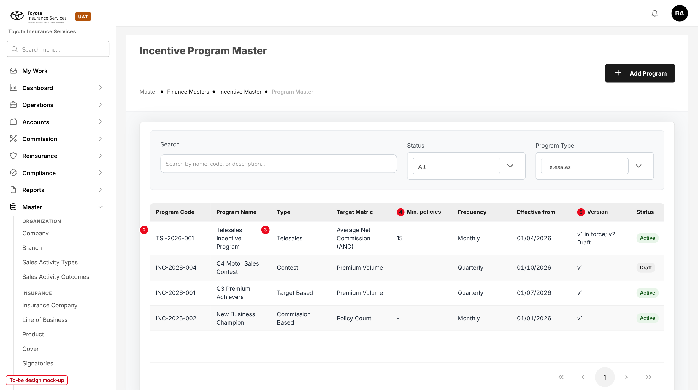
Figure 4: Incentive Program Master with the Telesales program (to-be design mock-up)
No. | Field (label on screen) | Type | Mand. | Source / list | Default | Rule and message
1 | Add Program (existing) | Button | - | - | - | write:masters
2 | Program Code | Column | - | Program | - | Opens the program
3 | Type / Program Type filter | Column, list | - | incentive.program_types | All | Telesales added
4 | Min. policies | Column | - | Version in force | - | New; "-" for other types
5 | Version | Column | - | Program versions | - | New; e.g. "v1 in force; v2 Draft"
- | Effective from | Column | - | Version in force | - | Replaces Start Date for Telesales

9.2 Edit Incentive Program - Basic Information (changed)
Type | Existing dialog, new fields for type Telesales
Purpose | Type, products, minimum, withholding tax and month of a Telesales program version.
Who can open it | write:masters
Navigation | Incentive Programs > Add Program or Edit
FRs | FR-TSI-001, 005

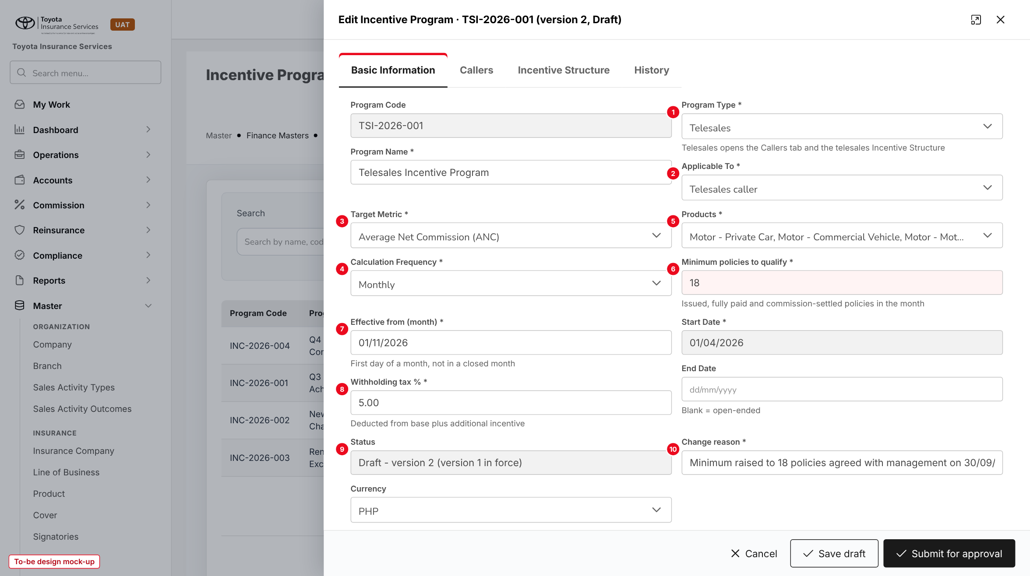
Figure 5: Basic Information of a Telesales program, version 2 raising the minimum to 18 (to-be design mock-up)
No. | Field (label on screen) | Type | Mand. | Source / list | Default | Rule and message
1 | Program Type * | List | Y | incentive.program_types | - | Telesales changes the tabs. MSG-TSI-008
2 | Applicable To * | Display | - | - | Telesales caller | Fixed for Telesales
3 | Target Metric * | Display | - | - | Average Net Commission (ANC) | Fixed for Telesales
4 | Calculation Frequency * | Display | - | - | Monthly | Fixed for Telesales
5 | Products * | Multi-select | Y | Master > Insurance > Product (Motor) | The three Motor products | MSG-TSI-002, 003
6 | Minimum policies to qualify * | Number | Y | - | 15 | 1 to 999. MSG-TSI-004
7 | Effective from (month) * | Date | Y | - | Next month without a batch | First day of a month. MSG-TSI-006, 007
8 | Withholding tax % * | Percent, 2 dec. | Y | - | 5.00 | MSG-TSI-005
9 | Status | Display | - | Program version | Draft - version n | -
10 | Change reason * | Text | From v2 | - | - | MSG-TSI-025
- | Program Code, Program Name, Description, Start Date, End Date, Currency (existing) | Mixed | Y / N | - | - | MSG-TSI-001

Button | Who sees it | Enabled when | What happens | Result
Save draft | write:masters | Draft | Validates and saves the version | Draft
Submit for approval | write:masters | Draft without errors | Lists the change on Configuration Approvals | Pending approval
Cancel | All | Always | Closes without saving after confirmation | -

9.3 Edit Incentive Program - Callers tab (new)
Type | New tab
Purpose | Who takes part, for which insurance partner and Team Leader; disqualification.
Who can open it | write:masters; approve:incentive for Disqualify / Reinstate
Navigation | Incentive Programs > Edit > Callers
FRs | FR-TSI-004

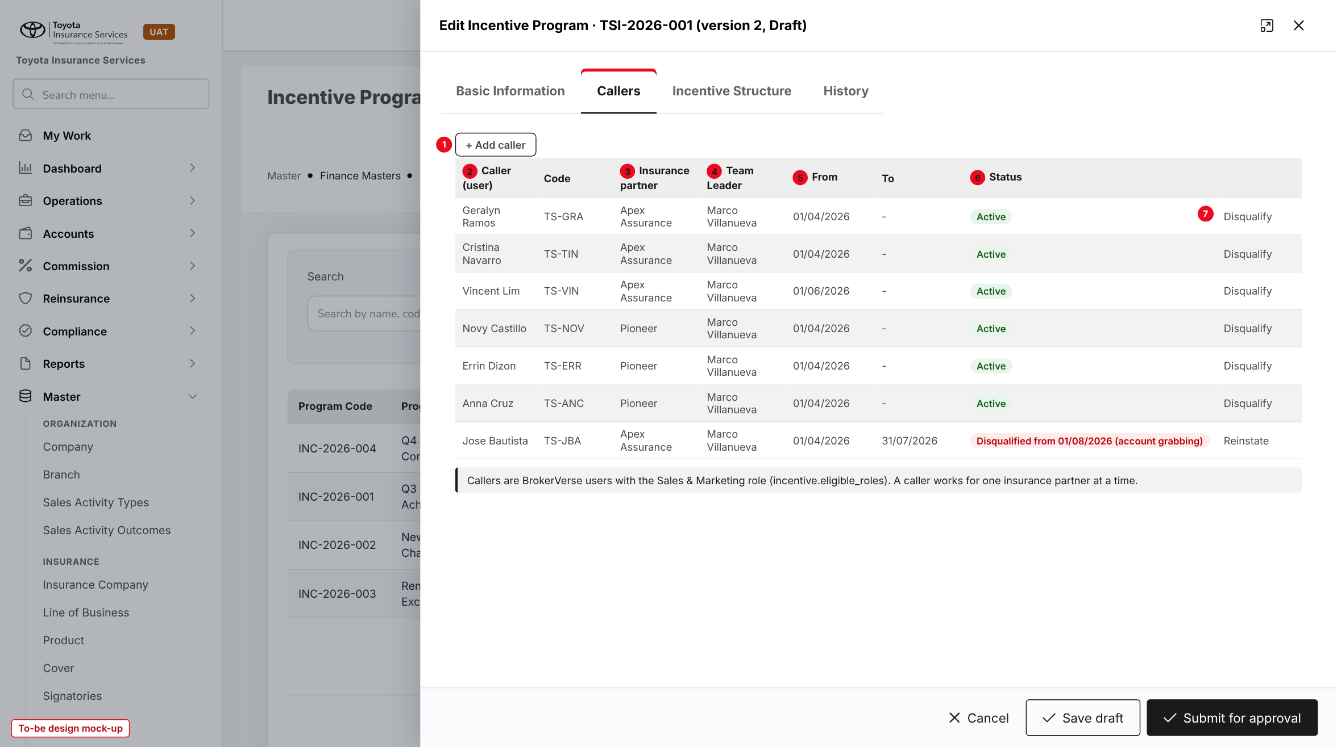
Figure 6: Callers tab (to-be design mock-up)
No. | Field (label on screen) | Type | Mand. | Source / list | Default | Rule and message
1 | Add caller | Button | - | - | - | Adds a row
2 | Caller (user) | List | Y | Active users with a role in incentive.eligible_roles | - | MSG-TSI-020, 021
- | Code | Display | - | User employee code | - | -
3 | Insurance partner | List | Y | Master > Insurance > Insurance Company | - | -
4 | Team Leader | List | Y | Users with write:callout-endorsement | - | MSG-TSI-022
5 | From / To | Date | Y / N | - | Today / blank | -
6 | Status | Tag | - | Active; Disqualified; Ended | - | Disqualified shows date and reason
7 | Disqualify / Reinstate | Row action | - | Disqualification reason list | - | approve:incentive; remark required. MSG-TSI-023, 024

9.4 Edit Incentive Program - Incentive Structure (changed)
Type | Existing tab, new content for Telesales
Purpose | ANC tier table and production-excess table of the version.
Who can open it | write:masters
Navigation | Incentive Programs > Edit > Incentive Structure
FRs | FR-TSI-002, 003

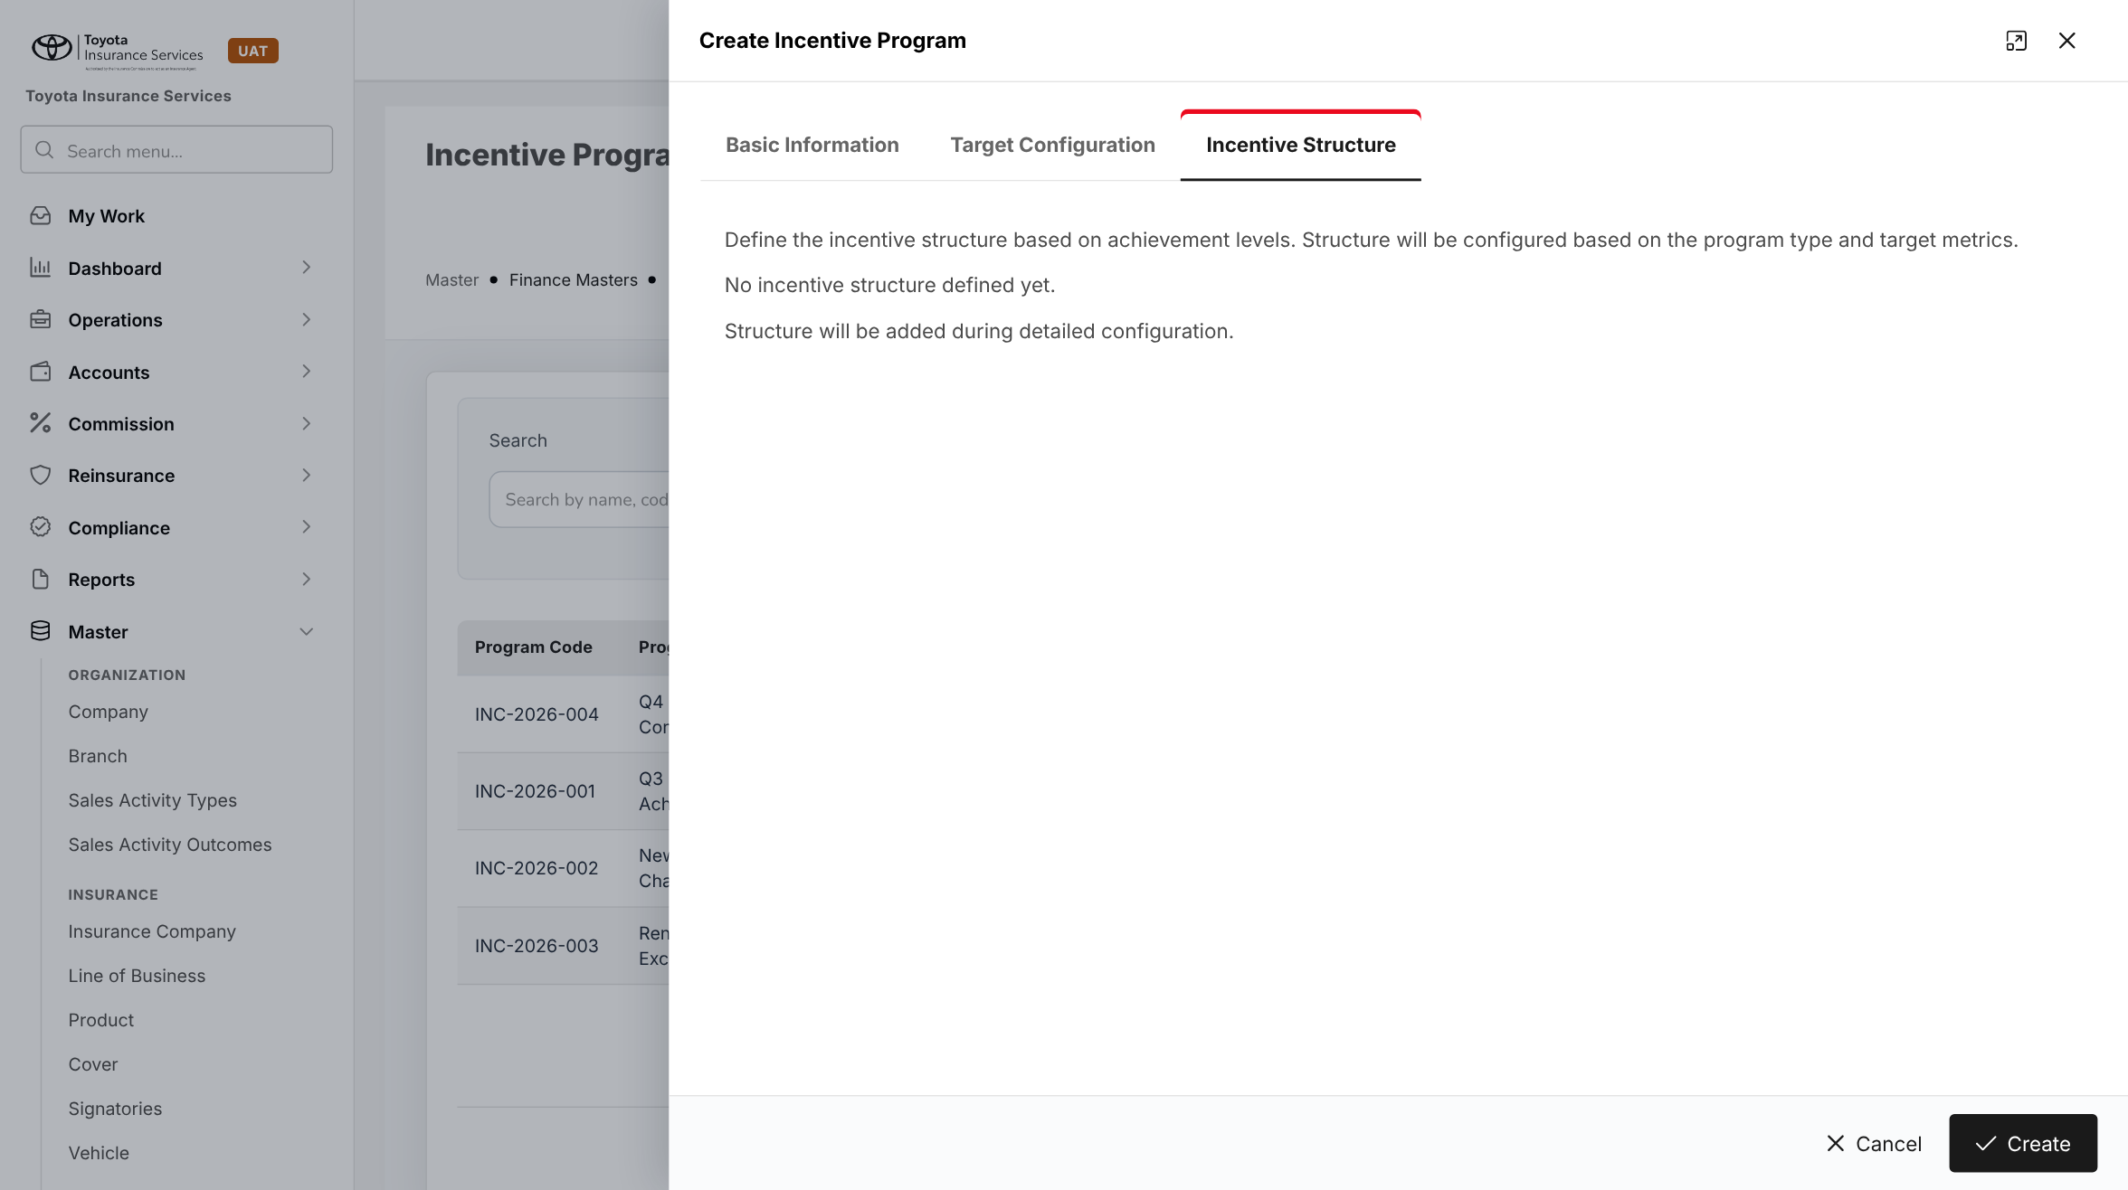
Figure 7: BrokerVerse today: the Incentive Structure tab of a new program
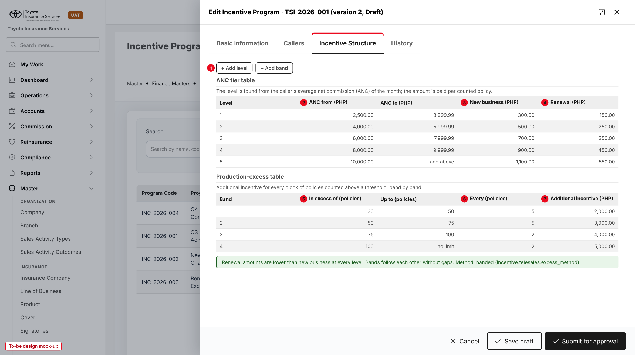
Figure 8: Incentive Structure of the Telesales program (to-be design mock-up; renewal amounts illustrative)
No. | Field (label on screen) | Type | Mand. | Source / list | Default | Rule and message
1 | Add level / Add band | Buttons | - | - | - | Up to 10 levels and 10 bands
- | Level | Display | - | Computed | 1..n | -
2 | ANC from (PHP) | Amount | Y | - | 2,500.00 / 4,000.00 / 6,000.00 / 8,000.00 / 10,000.00 | Increasing. MSG-TSI-010, 011, 015
- | ANC to (PHP) | Display | - | Next ANC from - 0.01 | - | Last level "and above"
3 | New business (PHP) | Amount | Y | - | 300 / 500 / 700 / 900 / 1,100 | > 0. MSG-TSI-012
4 | Renewal (PHP) | Amount | Y | - | Set by TISPH | <= new business. MSG-TSI-013, 014
5 | In excess of (policies) | Number | Y | - | 30 / 50 / 75 / 100 | Increasing, >= minimum. MSG-TSI-016, 017
- | Up to (policies) | Display | - | Next threshold | - | Last band "no limit"
6 | Every (policies) | Number | Y | - | 5 / 5 / 2 / 2 | >= 1. MSG-TSI-018
7 | Additional incentive (PHP) | Amount | Y | - | 2,000 / 3,000 / 4,000 / 5,000 | > 0. MSG-TSI-019

9.5 Configuration Approvals (existing)
Type | Existing screen, new item kind
Purpose | Approve or return a Telesales program version.
Who can open it | approve:incentive, not the maker
Navigation | Master > Finance > Configuration Approvals
FRs | FR-TSI-005

A Telesales program version appears as an item "Incentive program TSI-2026-001 version 2" with the maker, the date, the change reason and the old and new values of each changed field, tier and band. Approve and Return work as for posting rule changes; Return needs a remark.

9.6 Lead Assignment (changed)
Type | Existing screen, new buttons and columns
Purpose | Endorse the prospects of a call-out list for the callers of the team.
Who can open it | write:callout-endorsement for the buttons; every lead-assignment user sees the column
Navigation | Operations > Sales & Marketing > Lead Assignment
FRs | FR-TSI-010

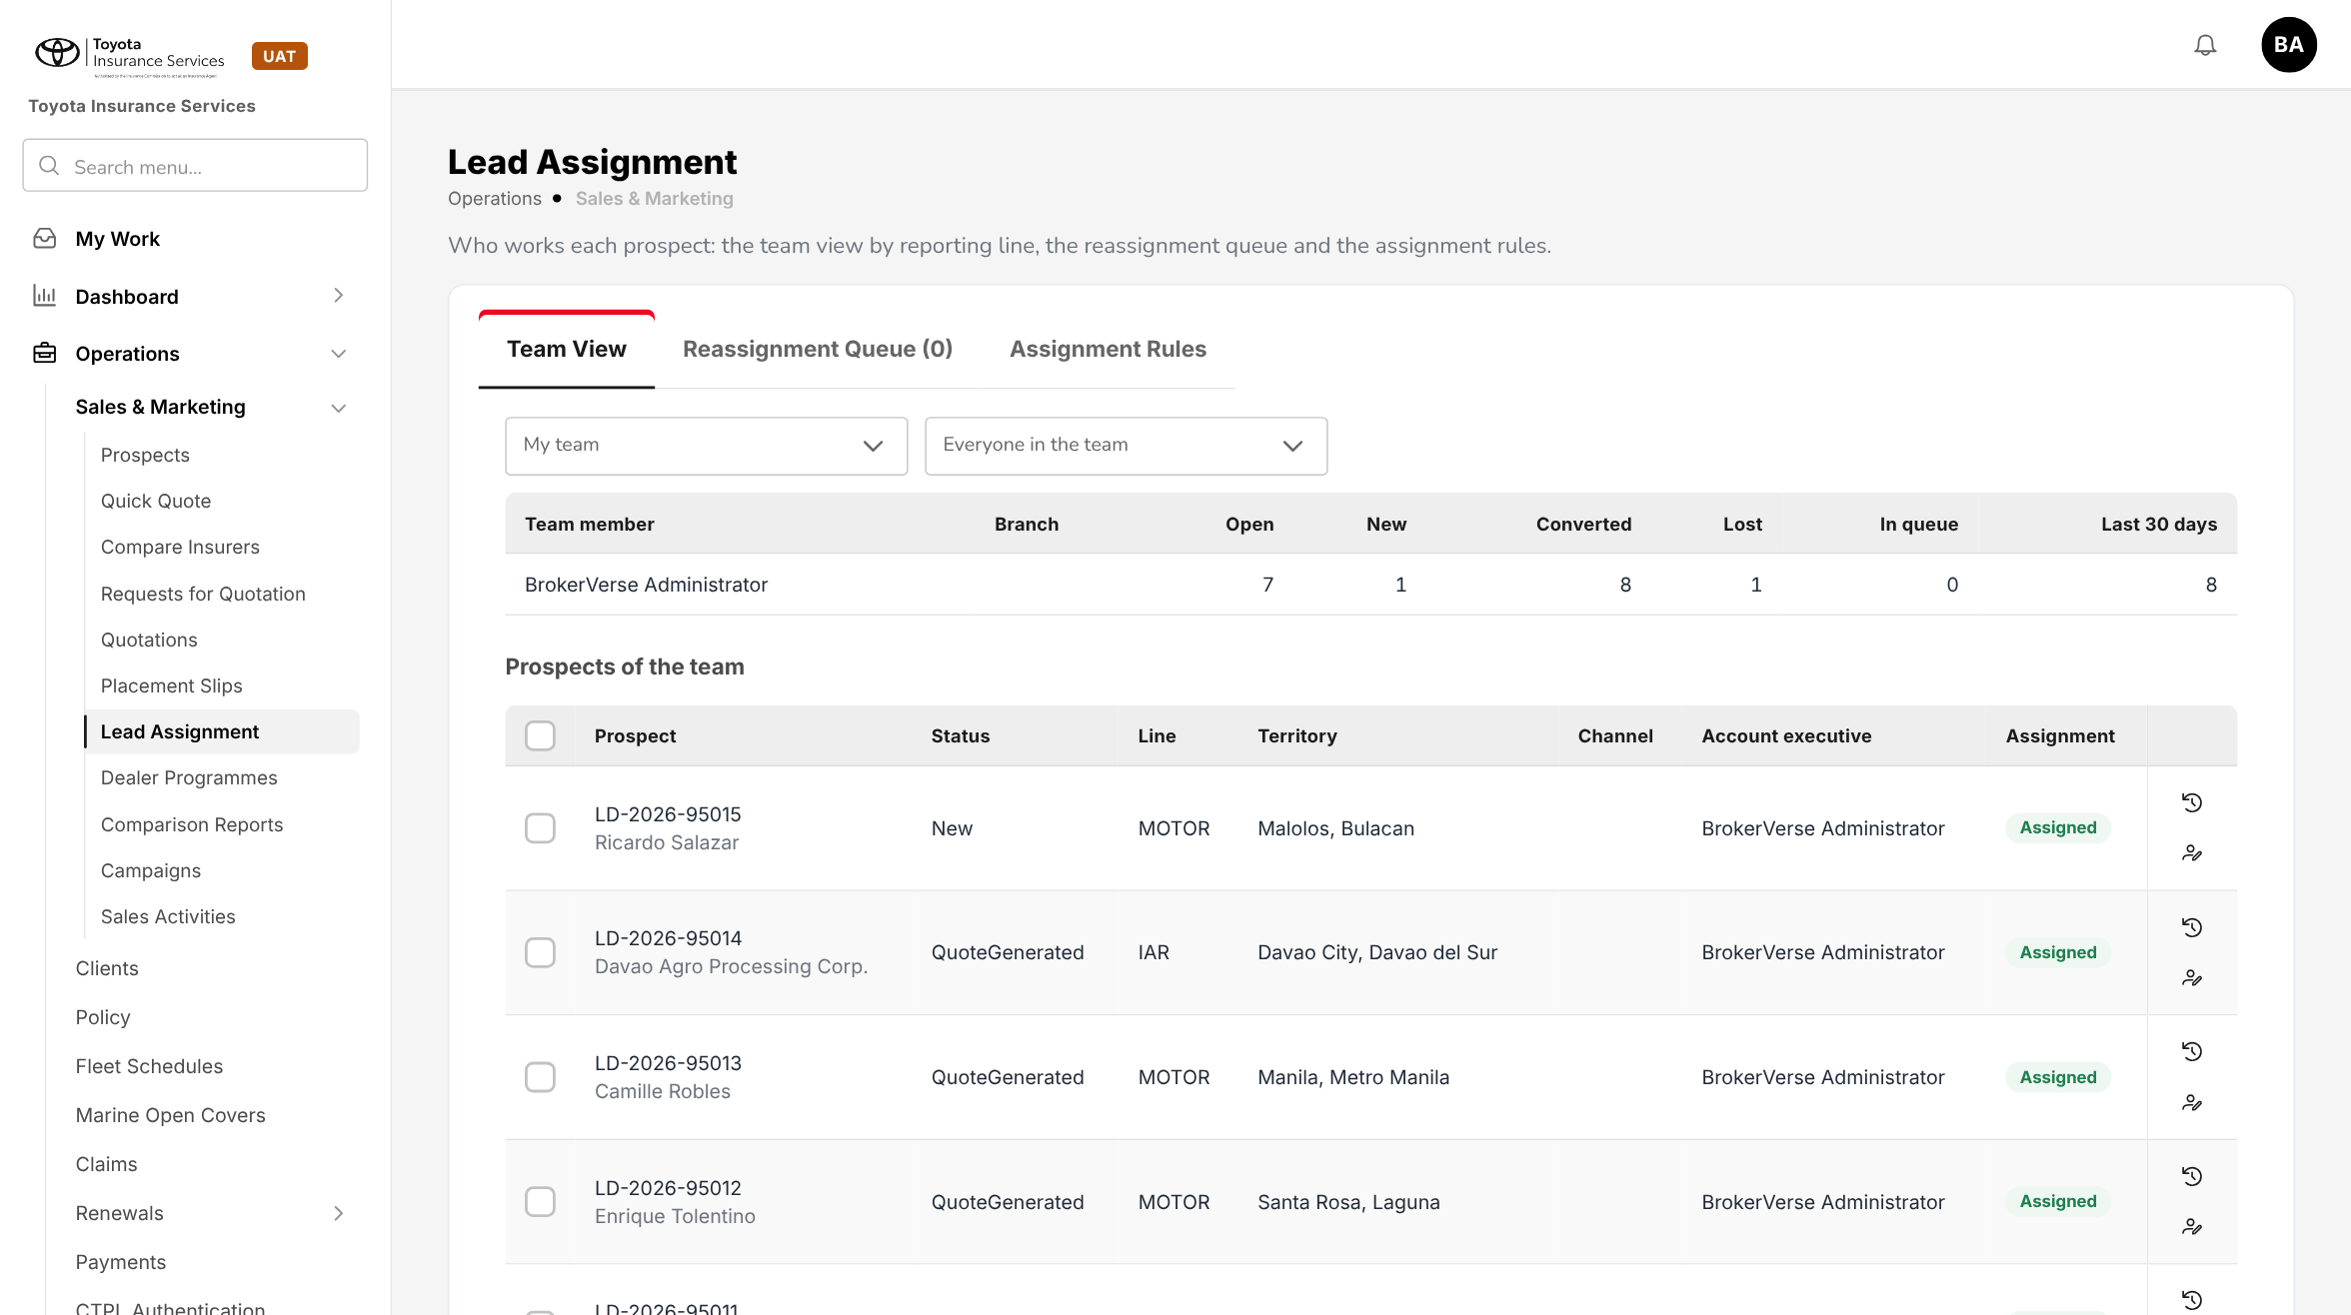
Figure 9: BrokerVerse today: Lead Assignment, Team View
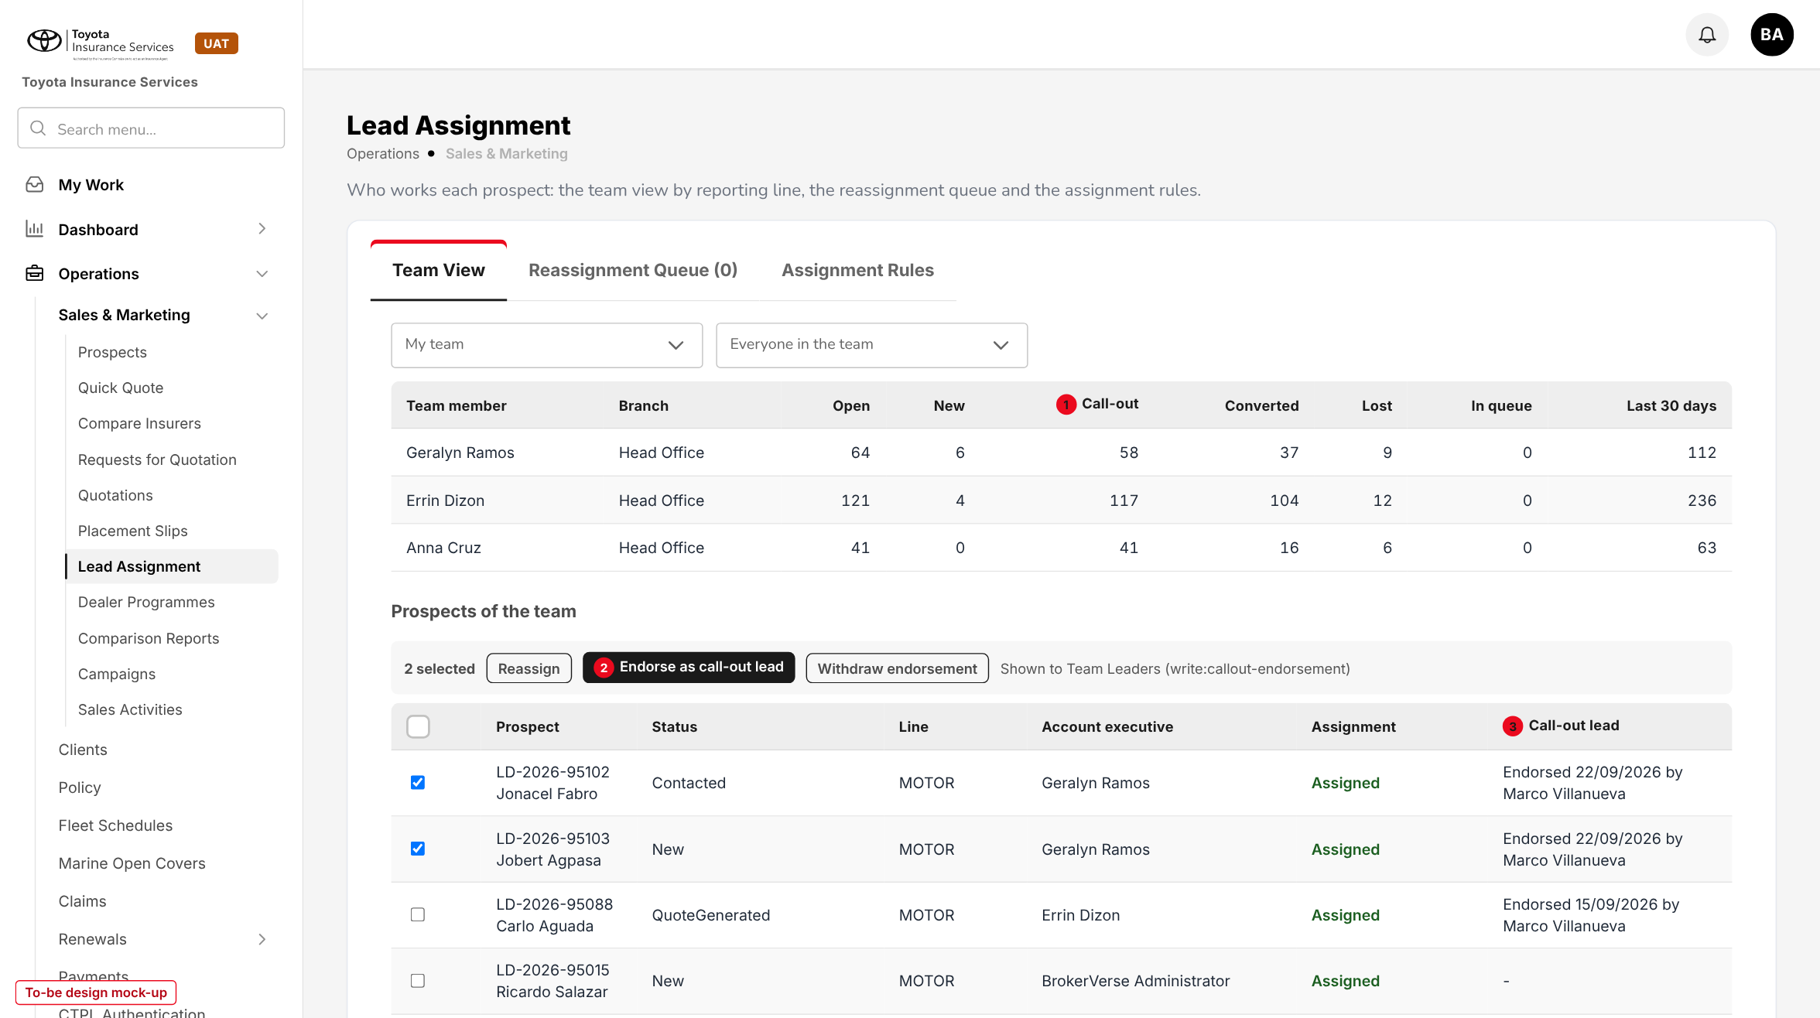
Figure 10: Lead Assignment with call-out endorsement (to-be design mock-up)
No. | Field (label on screen) | Type | Mand. | Source / list | Default | Rule and message
1 | Call-out (Team View) | Column | - | Endorsed open prospects | - | New count per team member
2 | Endorse as call-out lead / Withdraw endorsement | Buttons | - | - | - | On ticked prospects. MSG-TSI-029 to 031
3 | Call-out lead | Column | - | Endorsement | - | "Endorsed <date> by <Team Leader>" or "-"
- | Call-out rule (Assignment Rules > Add rule) | Tick box | N | - | Off | Endorses each prospect the rule assigns to a listed caller

9.7 New Incentive Calculation (existing)
Type | Existing dialog
Purpose | Run the telesales calculation of a month by hand.
Who can open it | write:incentive
Navigation | Accounts > Incentive > Calculations > New Calculation
FRs | FR-TSI-030

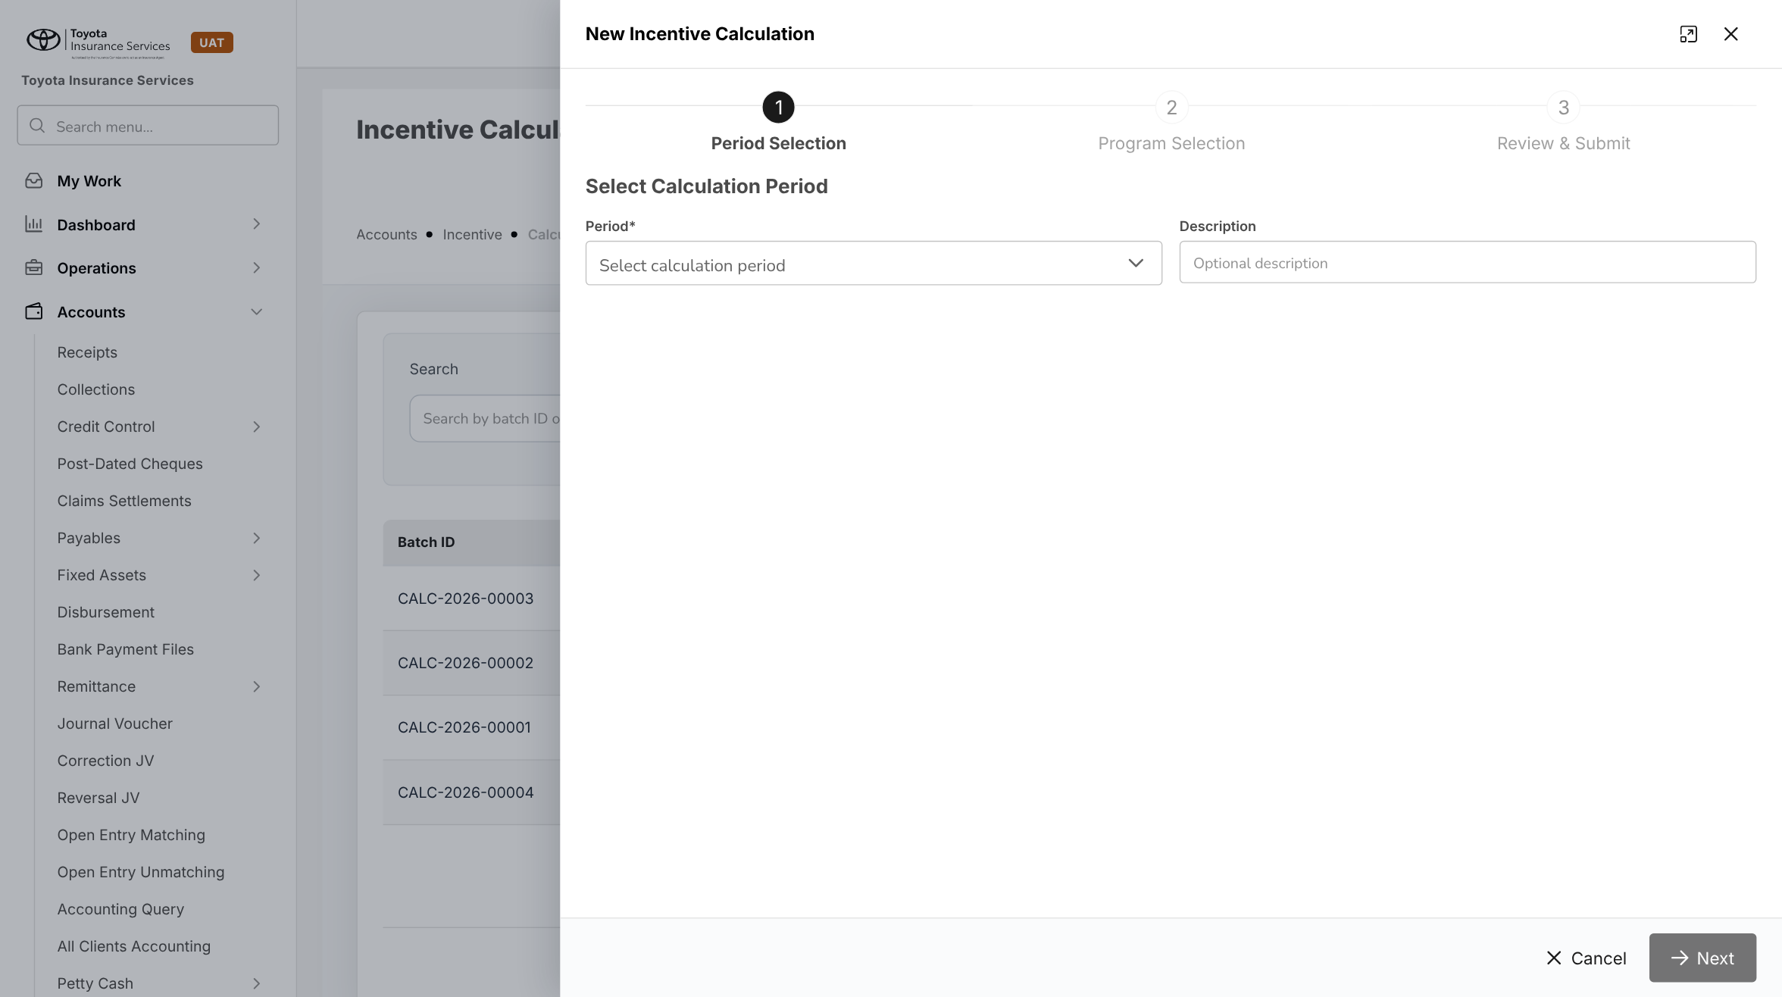
Figure 11: BrokerVerse today: New Incentive Calculation, step 1 Period Selection
Step 1 Period Selection takes the month (only ended months are offered for a Telesales program); step 2 Program Selection offers TSI-2026-001; step 3 Review & Submit shows the callers and totals before the batch is saved. Messages MSG-TSI-032 to 035.

9.8 Calculation Details - Agent Details (changed)
Type | Existing dialog, telesales columns
Purpose | Check each caller's result and the batch total.
Who can open it | read:incentive; actions with write:incentive and approve:incentive
Navigation | Accounts > Incentive > Calculations > row > view
FRs | FR-TSI-031 to 034, 037, 040, 042

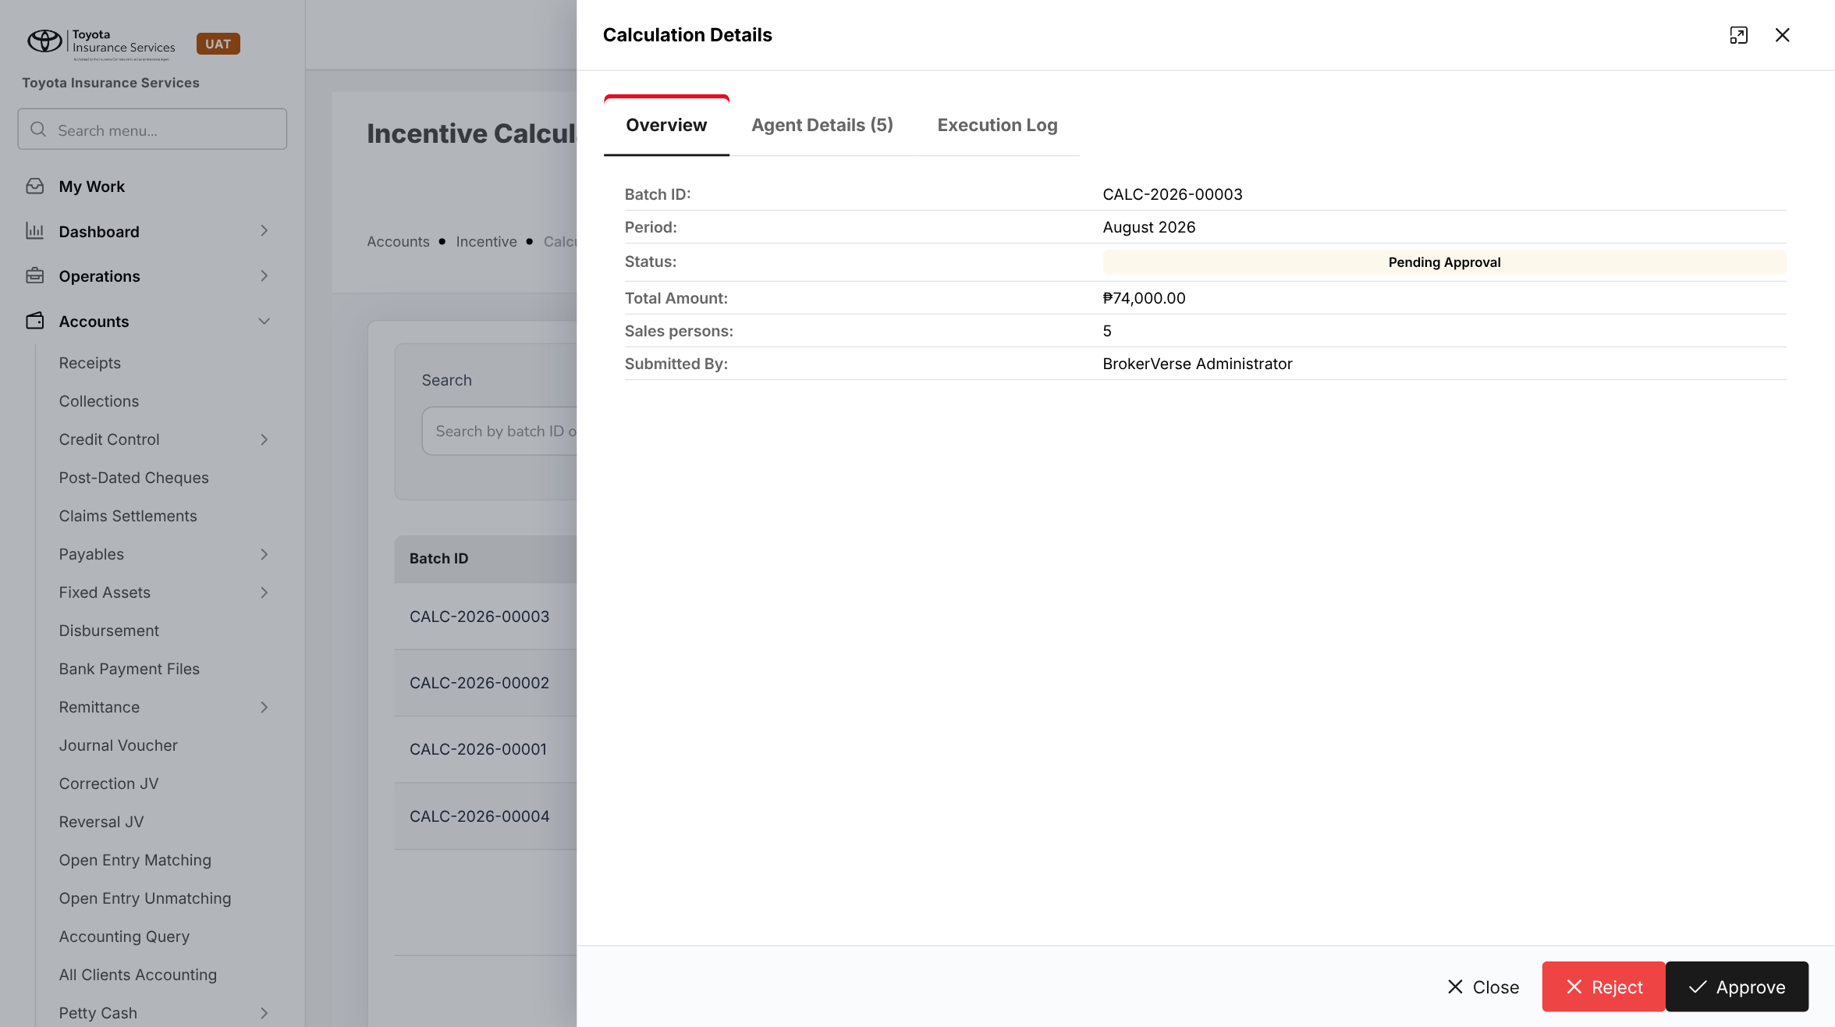
Figure 12: BrokerVerse today: Calculation Details, Overview
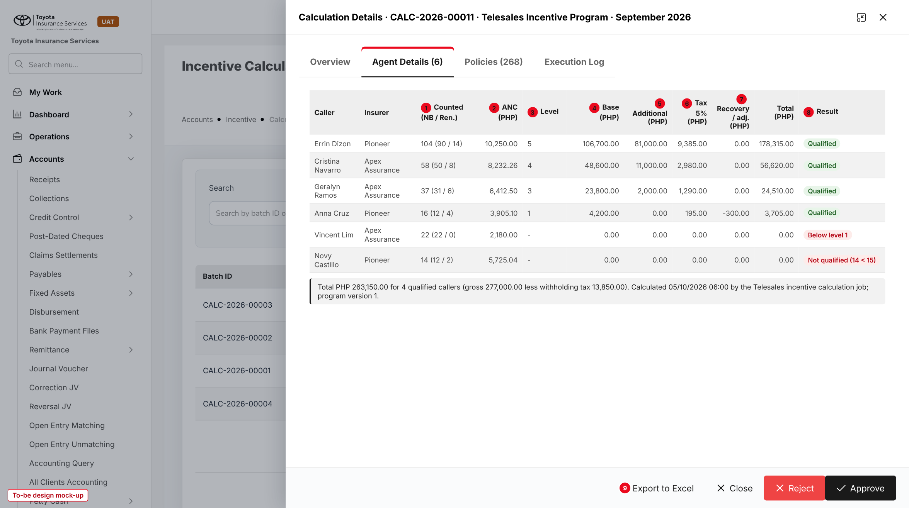
Figure 13: Agent Details of the September 2026 telesales batch (to-be design mock-up)
No. | Field (label on screen) | Type | Mand. | Source / list | Default | Rule and message
1 | Counted (NB / Ren.) | Display | - | Policies tab | - | FR-TSI-031
2 | ANC (PHP) | Display | - | Computed | - | FR-TSI-022
3 | Level | Display | - | ANC tier table | - | "-" below Level 1
4 | Base (PHP) | Display | - | Computed | - | FR-TSI-032
5 | Additional (PHP) | Display | - | Production-excess table | - | FR-TSI-033
6 | Tax 5% (PHP) | Display | - | Version WHT % | - | FR-TSI-034
7 | Recovery / adj. (PHP) | Display; Adjust | - | Recovery lines and adjustments | - | Adjust needs a reason. MSG-TSI-039
8 | Result | Tag | - | Caller line result | - | Qualified; Not qualified; Below level 1; Disqualified
9 | Export to Excel | Button | - | - | - | FR-TSI-042

Button | Who sees it | Enabled when | What happens | Result
Recalculate | write:incentive | Calculated, Rejected | Reads the policies again; keeps exclusions and adjustments | Calculated
Submit for Approval (existing) | write:incentive | Calculated | Raises the approval item | Pending Approval
Approve / Reject (existing) | approve:incentive, not the maker | Pending Approval | Approve posts the accrual; Reject needs a reason | Approved / Rejected
Mark as paid (existing) | write:incentive | Approved | Payment date and reference; posts the payout | Paid

9.9 Calculation Details - Policies tab (new)
Type | New tab
Purpose | See every telesales policy considered for the month, with its dates and status; exclude a policy.
Who can open it | read:incentive; Exclude with write:incentive
Navigation | Calculation Details > Policies
FRs | FR-TSI-011, 020 to 022, 035, 036

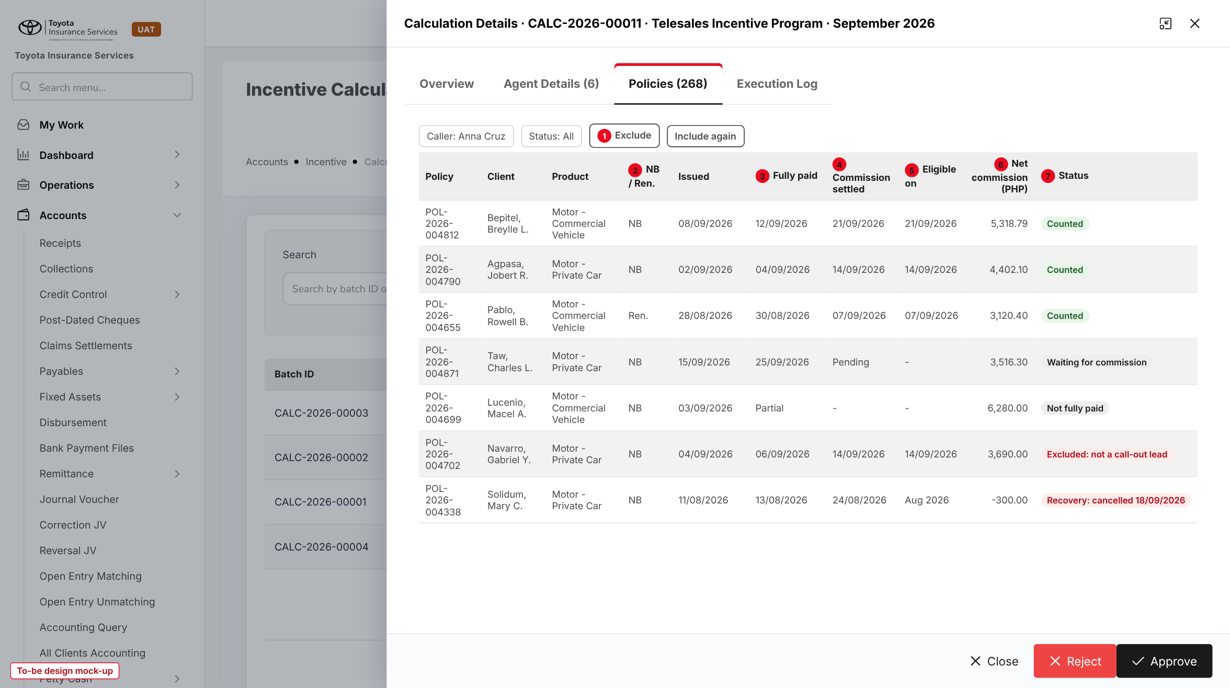
Figure 14: Policies tab filtered on one caller (to-be design mock-up)
No. | Field (label on screen) | Type | Mand. | Source / list | Default | Rule and message
1 | Exclude / Include again | Buttons | - | Exclusion reason list | - | Reason and remark. MSG-TSI-036 to 038
- | Caller, Status | Filters | - | - | All | -
2 | NB / Ren. | Display | - | FR-TSI-021 | - | -
3 | Fully paid | Date | - | Receipts | - | "Partial" while not fully paid
4 | Commission settled | Date | - | Remittance or direct-bill statement | - | "Pending" while not settled
5 | Eligible on | Date | - | Later of the two dates | - | Month of a recovery line for recoveries
6 | Net commission (PHP) | Amount | - | FR-TSI-022 | - | Negative amount on a recovery line
7 | Status | Tag | - | Policy incentive status | - | -

9.10 Incentive Statement (changed)
Type | Existing screen, telesales breakdown
Purpose | The caller's result per month.
Who can open it | read:profile (own); read:incentive (any caller)
Navigation | Accounts > Incentive > Statement
FRs | FR-TSI-042

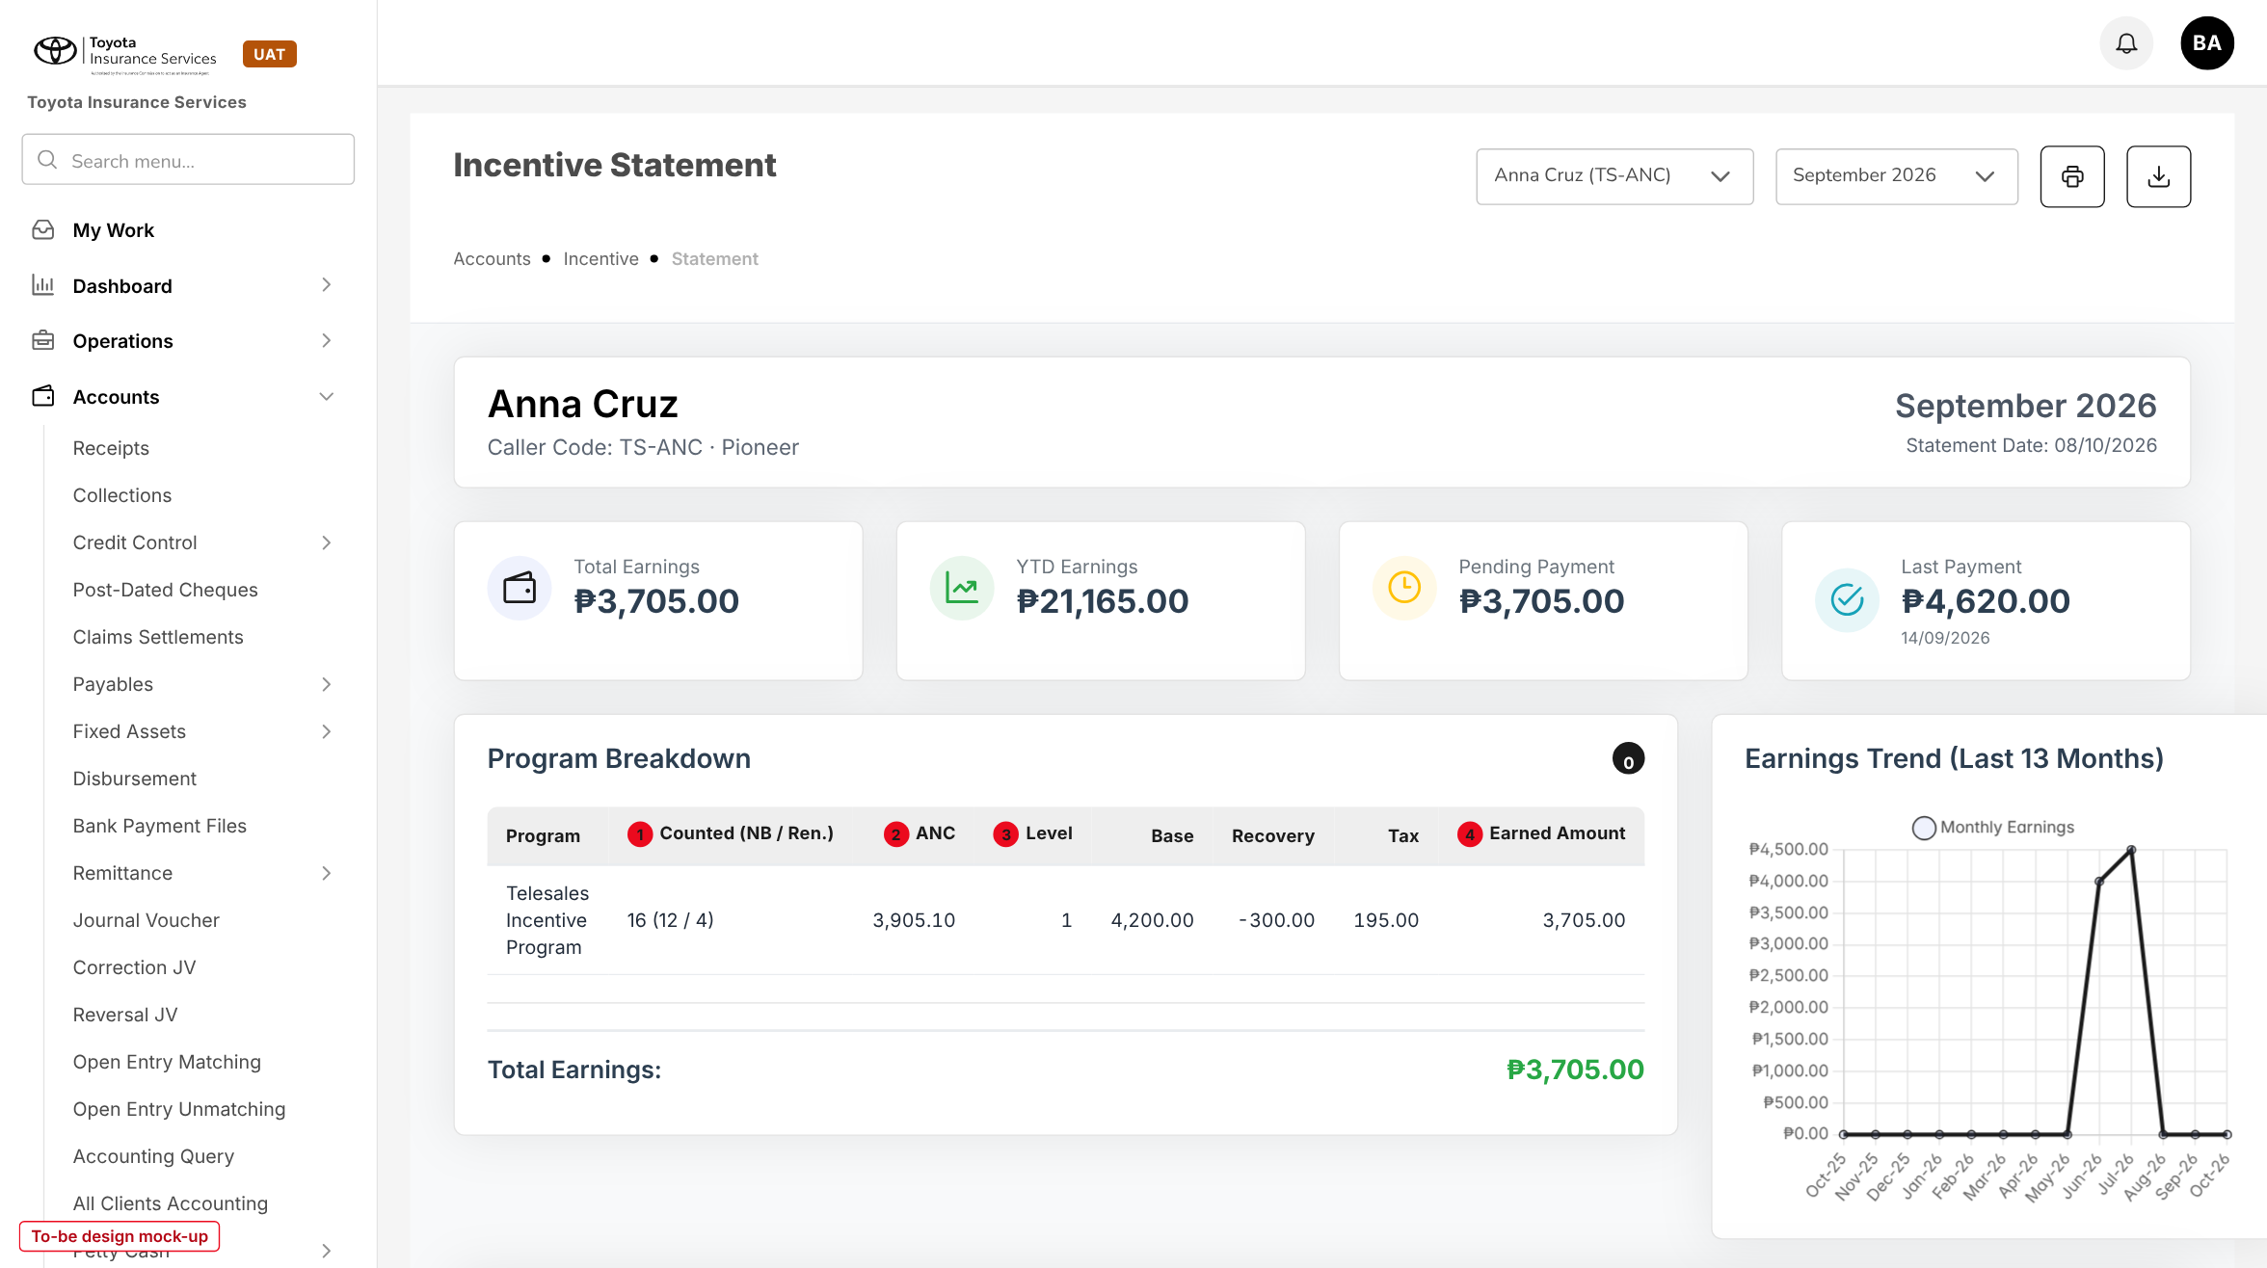
Figure 15: Incentive Statement of a caller for September 2026 (to-be design mock-up)
No. | Field (label on screen) | Type | Mand. | Source / list | Default | Rule and message
1 | Counted (NB / Ren.) | Display | - | Batch line | - | -
2 | ANC | Display | - | Batch line | - | -
3 | Level | Display | - | Batch line | - | -
- | Base, Recovery, Tax | Display | - | Batch line | - | Additional and adjustment shown when not zero
4 | Earned Amount | Display | - | Batch line total | - | "Not approved" before approval

10 End-to-end walkthroughs
The walkthroughs follow the September 2026 month through BrokerVerse, persona by persona, on sample data (program TSI-2026-001; Team Leader Marco Villanueva; callers of Apex Assurance and Pioneer). They are the script of the COMM-08 SIT and UAT sessions. Appendix A shows the arithmetic.

10.1 WT-A Set up the program and change the minimum
Table 23: WT-A
Step | Who | Does | Sees / result
1 | System Administrator | Incentive Programs > Add Program: TSI-2026-001 "Telesales Incentive Program", Telesales, Motor products, minimum 15, WHT 5.00, effective 01/04/2026 | "Program saved"; Draft v1
2 | System Administrator | Incentive Structure: five levels and four bands as in A.1; Callers: six callers with Team Leader Marco Villanueva | Tables valid
3 | System Administrator | Submit for approval | Listed on Configuration Approvals
4 | Accounting Manager | Approves | v1 in force from April 2026
5 | System Administrator | On 14/10/2026 edits: minimum 18 from 01/11/2026, reason "agreed with management on 30/09/2026"; submits | v2 Pending approval; v1 still in force
6 | Sales Head | Approves v2 on 15/10/2026 | v2 Approved; used from November 2026

10.2 WT-B Call-out lead to counted policy
Table 24: WT-B
Step | Who | Does | Sees / result
1 | Team Leader | Lead Assignment: reassigns LD-2026-95102 Jonacel Fabro to Geralyn Ramos and clicks Endorse as call-out lead on 22/09/2026 | "1 prospects endorsed as call-out leads"; Call-out lead column filled
2 | Geralyn Ramos | Calls the client; Create Quote on 23/09/2026 with Apex Assurance, Motor - Commercial Vehicle (Toyota Hiace Commuter Deluxe) | Quotation created on the endorsed prospect
3 | Processing Team | Converts the accepted quotation; policy issued 28/09/2026 | Policy shows "Telesales: Geralyn Ramos, call-out endorsed 22/09/2026"; New business
4 | Accounting | Posts the receipt that completes the premium on 30/09/2026 | Incentive status Waiting for commission
5 | Accounting | Weekly remittance with the policy approved on 05/10/2026 | Eligible on 05/10/2026; net commission stored
6 | System | October 2026 calculation on 05/11/2026 | Counted for Geralyn Ramos in October, not in September

10.3 WT-C Close September 2026
Table 25: WT-C
Step | Who | Does | Sees / result
1 | System | Job Telesales incentive calculation on 05/10/2026 06:00 | CALC-2026-00011, Calculated, six caller lines, 268 policies considered, 251 counted
2 | Team Leader, Accounting | Review the Policies tab; one policy of Gabriel Navarro shows "Excluded: not a call-out lead" (never endorsed) | No change needed
3 | Accounting | Submit for Approval | Pending Approval; item in My Work > Approvals
4 | Sales Head | Approves on 07/10/2026 | Approved; accrual Dr 277,000.00 / Cr WHT 13,850.00 / Cr payable 263,150.00
5 | Accounting | Pays and marks Paid with PV-2026-00412 on 15/10/2026 | Paid; statements updated
6 | Anna Cruz | Opens Incentive Statement, September 2026 | 16 (12 / 4), ANC 3,905.10, Level 1, earned 3,705.00

10.4 WT-D Exceptions
Table 26: WT-D
Case | Who | Does | Sees / result
D1 Below the minimum | System | Novy Castillo has 14 counted policies | "Not qualified (14 < 15)", PHP 0.00
D2 Below Level 1 | System | Vincent Lim has 22 policies with ANC 2,180.00 | "Below level 1", base 0.00, no additional (22 < 30)
D3 Disqualified caller | Sales Head | Disqualified Jose Bautista from 01/08/2026 (account grabbing) | August 2026 line "Disqualified", PHP 0.00
D4 Late commission | System | Policy fully paid 25/09/2026, commission settled 06/10/2026 | Counted in October 2026
D5 Recovery | System | POL-2026-004338 of Anna Cruz, paid in August, cancelled 18/09/2026 | Recovery -300.00 in September 2026
D6 Endorsement too late | Team Leader | Endorses a prospect after its quotation was created | Policy not linked to the caller; never counted

11 Messages catalogue
Every message a user can see for this requirement, grouped by the screen that shows it. 42 messages: 7 confirmation, 18 error, 16 validation, 1 warning. A validation or error is shown under the field it belongs to; a confirmation is a short toast. Text in angle brackets is filled in by the system.

11.1 Incentive Program - Basic Information
ID | Field | Message | Type | What the user does
MSG-TSI-001 | programName | Program name is required | Validation | Enter a name.
MSG-TSI-002 | products | Select at least one Motor product | Validation | Select the Motor products.
MSG-TSI-003 | products | Telesales programs apply to Motor products only | Error | Remove the product that is not Motor.
MSG-TSI-004 | minPolicies | Minimum policies to qualify must be a whole number from 1 to 999 | Validation | Correct the number.
MSG-TSI-005 | whtPct | Withholding tax % must be between 0.00 and 100.00 | Validation | Correct the rate.
MSG-TSI-006 | effectiveFrom | Effective from must be the first day of a month | Validation | Choose the first day of the month.
MSG-TSI-007 | effectiveFrom | Incentives for <month> are already calculated; choose <next month> or later | Error | Choose a later month, or have the batch rejected first.
MSG-TSI-008 | programType | Telesales program <code> is already in force for <month> | Error | Amend that program instead of adding a new one.
MSG-TSI-009 | - | Program saved | Confirmation | No action.
MSG-TSI-025 | changeReason | Change reason is required | Validation | Enter why the program changes.
MSG-TSI-026 | - | Version <n> of <code> is already in Draft or Pending approval | Error | Finish or recall that version first.
MSG-TSI-027 | - | The approver must be different from the user who created this version | Error | Ask another approver.
MSG-TSI-028 | - | Program version submitted for approval | Confirmation | No action.

11.2 Incentive Program - Incentive Structure
ID | Field | Message | Type | What the user does
MSG-TSI-010 | tiers | Add at least one ANC level | Validation | Add the levels.
MSG-TSI-011 | tiers[n].ancFrom | Level <n>: ANC from must be higher than level <n-1> | Validation | Correct the ANC from.
MSG-TSI-012 | tiers[n].nbAmount | Level <n>: the new-business amount must be more than 0 | Validation | Enter the amount.
MSG-TSI-013 | tiers[n].renewalAmount | Level <n>: the renewal amount cannot be higher than the new-business amount | Error | Lower the renewal amount.
MSG-TSI-014 | tiers[n].renewalAmount | Level <n>: renewal pays the same as new business | Warning | Confirm that renewals are not reduced at this level, or lower the amount.
MSG-TSI-015 | tiers | A tier table can have at most 10 levels | Validation | Merge levels.
MSG-TSI-016 | bands[n].over | Band <n>: In excess of must be higher than band <n-1> | Validation | Correct the threshold.
MSG-TSI-017 | bands[0].over | The first band must start at or above the minimum of <min> policies | Error | Raise the threshold or lower the minimum.
MSG-TSI-018 | bands[n].every | Band <n>: Every must be a whole number of 1 or more | Validation | Correct the block size.
MSG-TSI-019 | bands[n].amount | Band <n>: the additional incentive must be more than 0 | Validation | Enter the amount.

11.3 Incentive Program - Callers
ID | Field | Message | Type | What the user does
MSG-TSI-020 | callers[n].userId | <user> does not have a role that takes part in incentives | Error | Give the user the Sales & Marketing role, or pick another user.
MSG-TSI-021 | callers[n].userId | <user> is already an active caller from <date> | Error | End the existing row first.
MSG-TSI-022 | callers[n].teamLeaderId | <user> cannot endorse call-out leads | Error | Choose a Team Leader with write:callout-endorsement.
MSG-TSI-023 | reason | A reason and a remark are required to disqualify a caller | Validation | Enter both.
MSG-TSI-024 | - | <caller> is disqualified from <date> | Confirmation | No action.

11.4 Lead Assignment
ID | Field | Message | Type | What the user does
MSG-TSI-029 | - | <prospect> is not assigned to a caller of your team | Error | Reassign it to a caller first.
MSG-TSI-030 | - | <prospect> already has quotation <number>; the endorsement cannot be withdrawn | Error | Leave it, or exclude the policy later with a reason.
MSG-TSI-031 | - | <n> prospects endorsed as call-out leads | Confirmation | No action.

11.5 Calculation
ID | Field | Message | Type | What the user does
MSG-TSI-032 | period | The month of <month> has not ended yet | Error | Wait for the month end.
MSG-TSI-033 | period | <program> is already calculated for <month> (batch <status>) | Error | Open the existing batch.
MSG-TSI-034 | selectedPrograms | <program> has no approved version for <month> | Error | Approve a version first.
MSG-TSI-035 | - | Calculation complete | Confirmation | No action.
MSG-TSI-039 | lines | A reason is required for each adjustment | Validation | Enter the reason.

11.6 Calculation - Policies
ID | Field | Message | Type | What the user does
MSG-TSI-036 | reason | A reason and a remark are required to exclude a policy | Validation | Enter both.
MSG-TSI-037 | - | Batch <id> is <status>; policies can no longer be excluded | Error | Ask the approver to reject the batch first.
MSG-TSI-038 | - | Policy <number> excluded; <caller> recalculated | Confirmation | No action.

11.7 Calculation - Approval
ID | Field | Message | Type | What the user does
MSG-TSI-040 | - | Only users with the right to approve incentives can approve a telesales batch | Error | Ask the Sales Head or the Accounting Manager.
MSG-TSI-041 | - | The approver must be different from the user who created or submitted this batch | Error | Ask another approver.
MSG-TSI-042 | - | Batch approved | Confirmation | No action.

12 Sign-off and change control

12.1 What is signed
TISPH signs this FRS for TIS-BRD-COMM-08 as built on BrokerVerse: the process flows (chapter 2), the functional requirements (chapter 4), the workflow (chapter 5), the configuration (chapter 6), and the screens and messages (chapters 8 to 11). Values marked default, the renewal amounts and the minimum number of policies are configuration and are not frozen.

12.2 Change after sign-off
A change to anything signed is raised through the change control route of BRD section 8. The project team assesses its effect on BrokerVerse and on COMM-06 in the same CR-08 and on PROD-16, and issues a new version of this FRS for delta sign-off. A change of the program values themselves (tiers, bands, minimum, renewal amounts) needs no change request: it is a new program version approved in BrokerVerse (FR-TSI-005). When the screens are built, the to-be mock-ups are replaced with screenshots of the TISPH UAT environment.

12.3 Signatures
Table 27: Sign-off
Role | Name | Unit | Signature | Date
Business owner |  | TIS Sales (Sales Head)
Business reviewer |  | TISPH Finance and General Accounting
Business reviewer |  | TIS Team Leaders
Project Manager |  | TISPH DTID
Delivery lead |  | iorta TechNXT

Appendix A Worked incentive calculations
The examples use the approved new-business tier amounts and production-excess table, renewal amounts at half the new-business amount (illustrative), withholding tax 5.00% and the banded method unless stated. Amounts are in PHP.

A.1 Program tables
Table 28: ANC tier table
Level | ANC from | ANC to | New business per policy | Renewal per policy (illustrative)
1 | 2,500.00 | 3,999.99 | 300.00 | 150.00
2 | 4,000.00 | 5,999.99 | 500.00 | 250.00
3 | 6,000.00 | 7,999.99 | 700.00 | 350.00
4 | 8,000.00 | 9,999.99 | 900.00 | 450.00
5 | 10,000.00 | and above | 1,100.00 | 550.00

Table 29: Production-excess table
Band | In excess of | Up to | Every | Additional incentive
1 | 30 | 50 | 5 policies | 2,000.00
2 | 50 | 75 | 5 policies | 3,000.00
3 | 75 | 100 | 2 policies | 4,000.00
4 | 100 | no limit | 2 policies | 5,000.00

A.2 Net commission of one policy and the ANC
Net commission of a Toyota Vios 1.3 XLE CVT with a fair market value of 664,848.00, Own Damage charged at 2.00% and remitted at 1.30%, Acts of Nature charged at 0.50% and remitted at 0.40% (illustrative rates; the rates themselves come from PROD-16 and COMM-06), no referrer share:
Table 30: Net commission example
Line | Amount
Own Damage: 664,848.00 x (2.00% - 1.30%) | 4,653.94
Acts of Nature: 664,848.00 x (0.50% - 0.40%) | 664.85
Referrer / agent share | 0.00
Net commission of the policy | 5,318.79

Anna Cruz has 16 counted policies in September 2026 with a total net commission of 62,481.60. ANC = 62,481.60 / 16 = 3,905.10, which is in Level 1 (2,500.00 to 3,999.99).

A.3 September 2026 batch, all callers
Table 31: September 2026 telesales batch
Caller | Counted (NB / Ren.) | ANC | Level | Base | Additional | Recovery | Gross | Tax 5% | Total
Errin Dizon | 104 (90 / 14) | 10,250.00 | 5 | 106,700.00 | 81,000.00 | 0.00 | 187,700.00 | 9,385.00 | 178,315.00
Cristina Navarro | 58 (50 / 8) | 8,232.26 | 4 | 48,600.00 | 11,000.00 | 0.00 | 59,600.00 | 2,980.00 | 56,620.00
Geralyn Ramos | 37 (31 / 6) | 6,412.50 | 3 | 23,800.00 | 2,000.00 | 0.00 | 25,800.00 | 1,290.00 | 24,510.00
Anna Cruz | 16 (12 / 4) | 3,905.10 | 1 | 4,200.00 | 0.00 | -300.00 | 3,900.00 | 195.00 | 3,705.00
Vincent Lim | 22 (22 / 0) | 2,180.00 | - | 0.00 | 0.00 | 0.00 | 0.00 | 0.00 | 0.00
Novy Castillo | 14 (12 / 2) | 5,725.04 | - | 0.00 | 0.00 | 0.00 | 0.00 | 0.00 | 0.00
Batch CALC-2026-00011 | 251 |  |  | 183,300.00 | 94,000.00 | -300.00 | 277,000.00 | 13,850.00 | 263,150.00

Base of each qualified caller: Errin Dizon 90 x 1,100 + 14 x 550 = 99,000 + 7,700 = 106,700.00; Cristina Navarro 50 x 900 + 8 x 450 = 45,000 + 3,600 = 48,600.00; Geralyn Ramos 31 x 700 + 6 x 350 = 21,700 + 2,100 = 23,800.00; Anna Cruz 12 x 300 + 4 x 150 = 3,600 + 600 = 4,200.00. Vincent Lim qualifies on count but his ANC is below Level 1; Novy Castillo is below the minimum of 15 and gets nothing, although his ANC is in Level 2.

A.4 Additional incentive of Errin Dizon (104 policies, banded)
Table 32: Banded production excess, 104 policies
Band | Policies in the band | Full blocks | Amount
1: above 30 up to 50 | 20 | 20 / 5 = 4 | 4 x 2,000 = 8,000.00
2: above 50 up to 75 | 25 | 25 / 5 = 5 | 5 x 3,000 = 15,000.00
3: above 75 up to 100 | 25 | 25 / 2 = 12 (1 left over) | 12 x 4,000 = 48,000.00
4: above 100 | 4 | 4 / 2 = 2 | 2 x 5,000 = 10,000.00
Additional incentive | 74 |  | 81,000.00

A.5 Banded or highest band only
The setting incentive.telesales.excess_method decides how the bands are read. With "highest band only" a caller can earn less after selling more (52 policies pay nothing while 50 pay 8,000.00). The banded method has no such drop and is the default.
Table 33: Additional incentive by method
Counted policies | Banded | Highest band only
35 | 2,000.00 | 2,000.00
50 | 8,000.00 | 8,000.00
52 | 8,000.00 | 0.00
58 | 11,000.00 | 3,000.00
76 | 23,000.00 | 0.00
104 | 81,000.00 | 10,000.00

A.6 Recovery and tax of Anna Cruz
Table 34: Anna Cruz, September 2026
Line | Amount
Base: 12 x 300.00 + 4 x 150.00 | 4,200.00
Additional (16 policies, below 30) | 0.00
Recovery: POL-2026-004338 paid in August at Level 1 new business, cancelled 18/09/2026 | -300.00
Gross | 3,900.00
Withholding tax 5.00% of 3,900.00 | -195.00
Total incentive | 3,705.00

