

FUNCTIONAL REQUIREMENTS SPECIFICATION
Talkbot Call Results and Renewal Filter
Talkbot call list for Motor renewals, upload of the Talkbot call results, and filtering of the Talkbot-confirmed accounts into bulk renewal quoting

Client | Toyota Insurance Services Philippines Corporation (TISPH)
Document | TISPH-FRS-LEAD-09
Requirement | TIS-BRD-LEAD-09
Version | 1.0
Date | 9 October 2026
Status | Issued for TISPH review
Classification | Confidential

Prepared by iorta TechNXT for TISPH 
This document is confidential to Toyota Insurance Services Philippines Corporation and iorta TechNXT.
Document Control
Version | Date | Author | Reviewer | Approver | Change
1.0 | 9 Oct 2026 | iorta TechNXT Business Analysis | iorta TechNXT Project Manager | - | First issue for review

Distribution List
Name / Unit | Role | Organisation | Purpose
TIS Sales (business owner) | Approver | TISPH | Review and sign-off
Sales Admin / Telesales | Business user | TISPH | Call lists and result upload
Processing Team | Business user | TISPH | Renewal batch and renewal quotes
Operations | Business user | TISPH | Renewal follow-up and issuance
DTID - Project Management Team | Project owner | TISPH | Traceability against the BRD
Project team | Delivery | iorta TechNXT | Build, test and UAT preparation

Contents
1 Overview 5
1.1 The requirement 5
1.2 Scope 5
1.3 Definitions and acronyms 6
1.4 How to read the functional requirements 6
1.5 What changes in BrokerVerse 7
2 Process flow 8
2.1 Flow A - Prepare and send the call list 8
2.2 Flow B - Load the Talkbot results 9
2.3 Flow C - Filter into bulk renewal quoting 10
2.4 What the item covers 10
3 Personas and roles 11
3.1 Personas 11
3.2 New permissions 11
3.3 Default grants 11
4 Functional requirements 13
4.1 Talkbot call list 13
FR-TBT-001 Create a Talkbot call list from Motor policies due for renewal 13
FR-TBT-002 Apply the eligibility rules and exclusions of the call list 14
FR-TBT-003 Download the call list in the Talkbot Contact Import layout 16
FR-TBT-004 Mark the call list as sent to Talkbot 17
FR-TBT-005 Prepare the call list of the day with a scheduled job 18
FR-TBT-006 Close or cancel a call list 19
4.2 Talkbot call results 19
FR-TBT-010 Upload the Talkbot call records file 19
FR-TBT-011 Match each call record to its call list line 21
FR-TBT-012 Derive the Talkbot outcome of each account 22
FR-TBT-013 Record the Talkbot call on the renewal timeline 23
FR-TBT-014 Record or correct a Talkbot outcome by hand 24
FR-TBT-015 Put accounts not reached on the next call list 25
4.3 Filter into bulk renewal quoting 25
FR-TBT-020 Create a renewal batch from the Talkbot-confirmed accounts 25
FR-TBT-021 Select policies by Talkbot outcome on Create Batch Renewal 26
FR-TBT-022 Generate Renewal Quotes only for Talkbot-confirmed Motor policies 27
FR-TBT-023 Show the Talkbot outcome on Renewal Queue 28
4.4 Access and audit 28
FR-TBT-030 Control access to call lists and client contact data 28
FR-TBT-031 Audit the call lists, files and outcomes 29
5 Workflow and status model 30
5.1 Call list 30
5.2 Call list line 30
5.3 Renewal batch policy 31
6 Interfaces 32
6.1 I-1 Talkbot Contact Import (outbound) 32
6.2 I-2 Talkbot Call Records (inbound) 32
7 Configuration items 34
7.1 Settings 34
7.2 Scheduled job 34
7.3 Lists of values and numbering 34
8 Traceability 36
8.1 BRD clause to FR 36
8.2 Related BRD requirements 36
8.3 FR to test cases 36
9 Navigation 38
9.1 Screens of LEAD-09 38
9.2 Menu by base role 38
10 Screen specifications 39
10.1 Talkbot Calls (new) 39
10.2 New Talkbot call list (new dialog) 40
10.3 Call list detail (new) 41
10.4 Upload Talkbot results (new dialog) 42
10.5 Renewal Batch - Create Batch Renewal (changed) 43
10.6 Renewal Queue (changed) 45
11 End-to-end walkthroughs 47
11.1 WT-A Prepare and send the call list 47
11.2 WT-B Load the results 47
11.3 WT-C Bulk renewal quoting 48
12 Messages catalogue 49
12.1 New call list 49
12.2 Call list 49
12.3 Upload Talkbot results 49
12.4 Renewal Batch 50
13 Upload screens 51
13.1 Talkbot call results template 51
13.2 Call list file 51
14 Sign-off and change control 52
14.1 What is signed 52
14.2 Change after sign-off 52
14.3 Signatures 52

1 Overview

1.1 The requirement
TIS-BRD-LEAD-09 Talkbot Capture (Renewals) (Customization, Phase 1, CR-02). Talkbot (AI outbound calling) runs outside BrokerVerse for renewal business; successful reminder lists upload into the system (reference no., name, call ID, contact no., result: willing to renew / uncontacted / missed call), contacting accounts 3 days before renewal. Talkbot-confirmed accounts are filtered so bulk renewal quoting runs only for those policies. Upload template exists as a sample; the filter feeds the bulk renewal run.

TIS Sales uses Talkbot, an AI calling service, to call Motor clients whose policy is about to expire and ask whether they will renew. Talkbot is not connected to BrokerVerse. Today the call list is prepared by hand in the Talkbot customer template and the call results come back as an Excel export that nobody can match to a policy without manual work. Renewal quotes are then prepared for accounts that may never have agreed to renew.
This FRS closes that loop inside BrokerVerse. BrokerVerse prepares the call list in the exact layout the Talkbot platform imports, takes back the Talkbot call results file, works out one outcome per account (for example Willing to renew, Missed call or Uncontacted), writes the call on the renewal timeline and then lets the Processing Team send only the Talkbot-confirmed policies into the existing Renewal Batch run that generates the renewal quotes. Renewal reminders to the client remain the e-mail notices of the renewal cadence; Talkbot is an extra calling channel, not a reminder sent by BrokerVerse.
Screens that change or are new are shown as to-be mock-ups drawn on the real BrokerVerse screens with the Toyota Insurance Services look.

1.2 Scope
In scope
- A new Talkbot Calls screen under Operations > Renewals: create a call list of Motor policies due for renewal, download it in the Talkbot Contact Import layout, mark it as sent with the Talkbot task name, and close or cancel it.
- Upload of the Talkbot call results file (the Call Records export of the Talkbot platform), with matching of each call to its policy, one derived Talkbot outcome per account and a manual outcome for calls captured outside the file.
- The Talkbot call on the renewal timeline (Renewal Queue > View, Negotiations) and a Talkbot outcome column and filter on Renewal Queue.
- The filter into bulk renewal quoting: a renewal batch created from the confirmed accounts of a call list, a Talkbot outcome criterion on Create Batch Renewal, and a rule on Generate Renewal Quotes so that a batch quotes only Talkbot-confirmed Motor policies.
- An optional daily job that prepares the call list of the day, the settings, permissions and audit trail.
Out of scope
- Any system link to the Talkbot platform. Files are moved by the user; no API, SFTP or webhook.
- Talkbot scripts, dialogue design and the Talkbot service contract.
- Renewal notices and e-mail reminders (90 / 60 / 30 days): unchanged. The suppression of notices for lock-in and Scheme 2 accounts is specified in TIS-BRD-SCHM-03; this FRS only reuses that flag to leave those accounts out of the call list.
- Non-Motor renewals (Credit Life, Personal Accident, Fire). Talkbot is used for Motor renewals only.
- Renewal rating itself (re-rating on current FMV or 10% depreciation): the existing renewal rating is reused as it is.

1.3 Definitions and acronyms
Table 1: Definitions
Term | Meaning in this FRS
Talkbot | The AI outbound calling service TIS Sales uses for Motor renewals. It runs outside BrokerVerse.
Call list | A BrokerVerse record (number TCL-YYYY-nnnnn) holding the accounts to be called by Talkbot in one campaign, one line per expiring policy.
Contact Import file | The call list file in the layout the Talkbot platform imports (sheet Contact Import, 12 columns, required headers in red). The outbound interface.
Talkbot task name | The name of the campaign on the Talkbot platform, for example "TIS_MV - OCT 07, 2026". Recorded on the call list when it is sent.
Call records file | The Call Records export of the Talkbot platform: one row per call attempt, 67 columns, of which BrokerVerse reads 13. The inbound interface.
Call attempt | One row of the call records file. Talkbot calls the same account several times: in the sample campaign 500 accounts gave 1,529 attempts.
Talkbot outcome | The single result BrokerVerse derives for an account from all its attempts: Willing to renew, Not willing to renew, Already renewed, Call back, Wrong contact, Uncontacted, Missed call, or Not called.
Talkbot-confirmed | An account whose Talkbot outcome is Willing to renew, set within the last 30 days (talkbot.confirmation_valid_days).
Renewal batch | The existing record of Operations > Renewals > Renewal Batch (number RB-YYYY-nnnnn) that groups policies to send renewal notices or to generate renewal quotes in the background.
Generate Renewal Quotes | The existing batch run that opens the renewal of each selected policy and prepares its re-rated renewal quote (number RQ-YYYY-nnnnn). This is the "bulk renewal quoting" of the BRD.
Renewal timeline | The activity history of a renewal shown on Renewal Queue > View and on Negotiations.
Lock-in / Scheme 2 | Accounts whose renewal is handled under a lock-in promo or the TFS Scheme 2 arrangement (TIS-BRD-SCHM-03). Left out of call lists.
TFS / FMV | Toyota Financial Services Philippines / Fair Market Value.

1.4 How to read the functional requirements
Each FR in chapter 4 has the same parts:
- A header table with the BRD trace, the actor, the priority, the fit and the screens that implement it.
- Description, preconditions, main flow and alternate and exception flows.
- Business rules. Configurable rules are maintained on Master > System > Configuration (chapter 7). Fixed rules change only through a change request.
- Validations and messages: the check and the message the user sees, word for word, with its ID in chapter 12. As everywhere in BrokerVerse, a message is plain English and is shown under the field it belongs to, or as a toast.
- Audit and numbered acceptance criteria, the basis of the test cases TC-TBT-nnn-n.
Note. Counts in the examples come from a sample Talkbot campaign of 500 accounts and 1,529 call attempts. Names, policy numbers and mobile numbers in the examples and mock-ups are fictitious. Values marked "default" are configuration until TISPH confirms them.

1.5 What changes in BrokerVerse
BrokerVerse has no Talkbot feature today. The table lists what LEAD-09 reuses, what it changes and what it adds.
Table 2: BrokerVerse today and LEAD-09
BrokerVerse today | What LEAD-09 does
Operations > Renewals > Renewal Policy (page Expired & Expiring Policies) lists policies by expiry with their renewal state (Due for renewal, In grace period, Lapsed, renewable, Renewal in progress, Renewed). | Reused. The same list of renewable policies feeds the call list, with the same renewal states.
Renewal Batch (page Batch Renewal): Create Batch Renewal with Expiry Date From / To, Insurance Company, Product Type, Min / Max Premium, Client Name, Payment Status; Generate policy list; batches of up to 500 policies (renewals.batch_max_policies); notices and renewal quotes queued as background jobs. | Changed. Two new criteria (Talkbot outcome, Talkbot call list), a Talkbot outcome column, and Generate Renewal Quotes limited to Talkbot-confirmed Motor policies.
Generate Renewal Quotes on a batch: opens the renewal (RN-...) and prepares the re-rated quote (RQ-...) for each selected policy; result per policy Quoted or Failed. | Changed. A policy that is not Talkbot-confirmed is skipped with the reason "Not confirmed by Talkbot".
Renewal Queue: filters Policy/Insured Name, Status, Risk Level, Sales person, Expiry Date Range; renewal timeline with notices, quotes and contacts (activity types such as Reminder, Quote Generated). | Changed. Talkbot outcome filter and column; a new activity type Talkbot Call on the timeline.
Upload pattern: Download template, .xlsx upload loaded row by row, "Processed n rows: c created, f failed" with the failed rows listed. | Reused for the Talkbot results upload.
No call list, no Talkbot file, no Talkbot outcome. | New. Talkbot Calls screen, call list record, Contact Import download, results upload, outcome rules, daily job.

2 Process flow
Three flow charts show the item end to end: Flow A prepares and sends the call list, Flow B loads the Talkbot results and sets the outcome of each account, and Flow C sends the confirmed accounts into bulk renewal quoting. Black rounded boxes are start and end points, diamonds are decisions, red boxes are exceptions, grey boxes are done by the system and boxes with a heavy border are the successful outcome.

2.1 Flow A - Prepare and send the call list
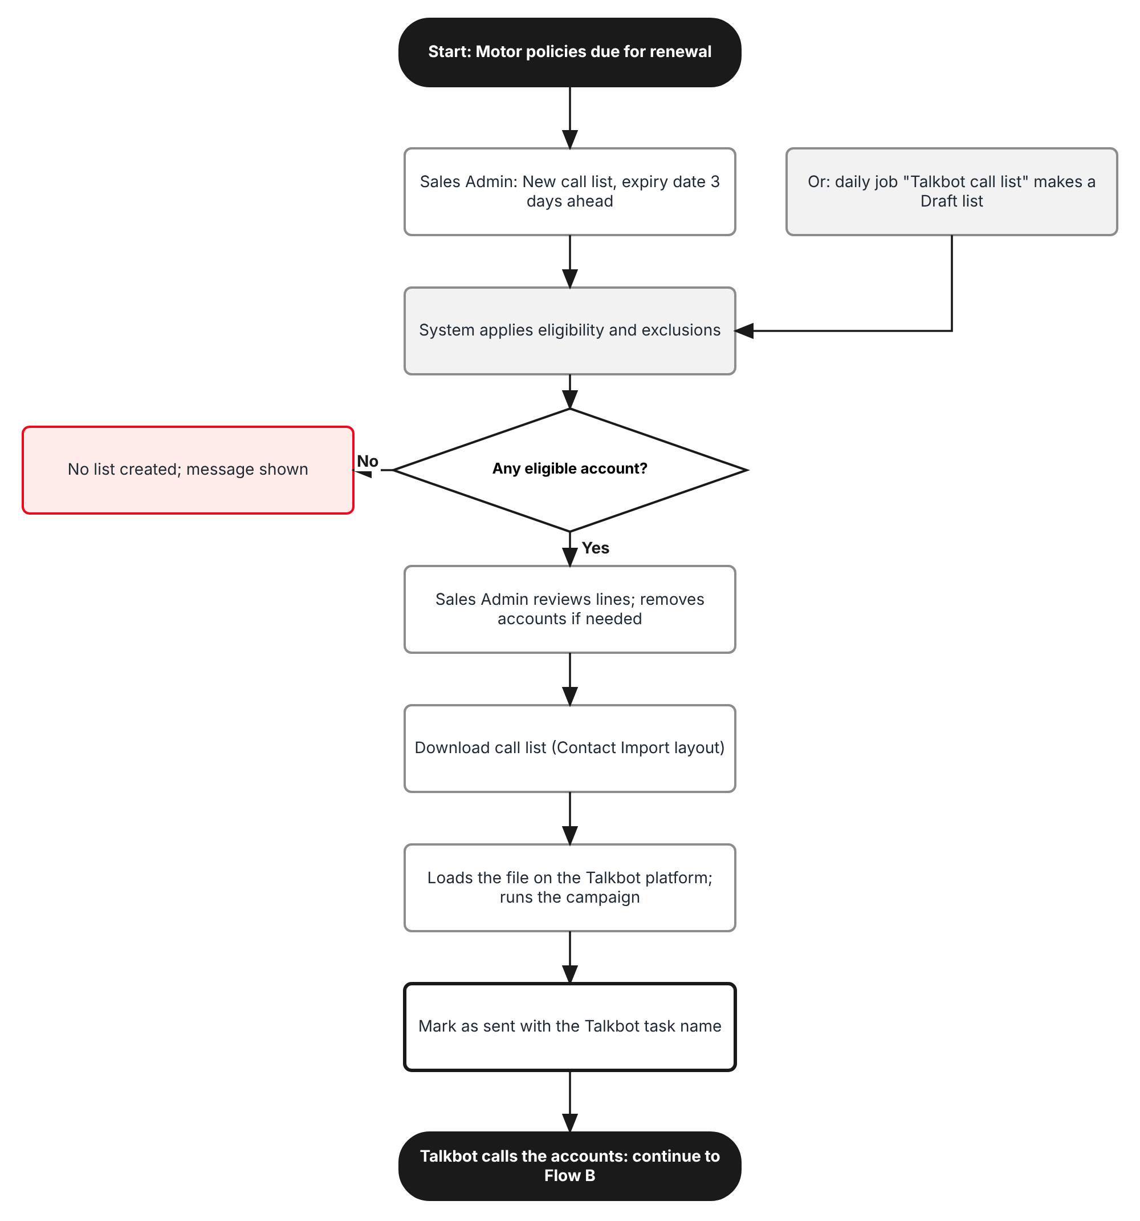
Figure 1: Flow A - Prepare and send the Talkbot call list
Table 3: Flow A steps
Step | Who (role) | What happens | FR
A1 | Sales Admin (Sales & Marketing) | Operations > Renewals > Talkbot Calls > New call list. Expiry date defaults to 3 days from today; optionally adds expired policies still renewable and accounts not reached on an earlier list. | FR-TBT-001
A2 | System | Daily at 06:10 the job "Talkbot call list" can create the same list as a Draft (switched off by default). | FR-TBT-005
A3 | System | Applies the eligibility rules: Motor, renewable, mobile number present, not lock-in or Scheme 2, not already renewed or confirmed. Shows what was left out. | FR-TBT-002
A4 | Sales Admin | Reviews the lines and removes accounts that must not be called (for example a complaint in progress). | FR-TBT-001
A5 | Sales Admin | Download call list: the Contact Import file with Contact ID, Phone, Customer_PERSON_NAME, Expiration_DATE, Sum_Insured_AMOUNT, Premium_AMOUNT and the other template columns. | FR-TBT-003
A6 | Sales Admin | Loads the file on the Talkbot platform and starts the campaign; then marks the list Sent to Talkbot with the task name. | FR-TBT-004

2.2 Flow B - Load the Talkbot results
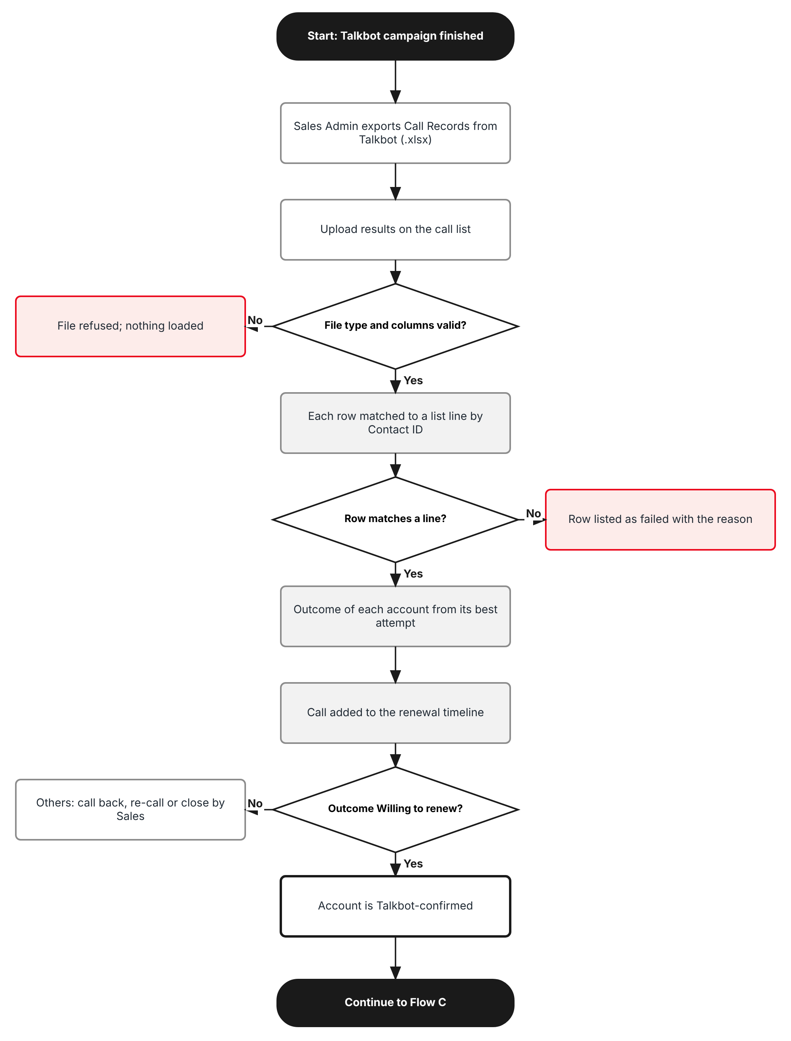
Figure 2: Flow B - Upload the Talkbot call results
Table 4: Flow B steps
Step | Who (role) | What happens | FR
B1 | Sales Admin | Exports the Call Records of the campaign from the Talkbot platform (.xlsx). | -
B2 | Sales Admin | Talkbot Calls > call list > Upload results. The file type and the 13 columns BrokerVerse reads are checked first. | FR-TBT-010
B3 | System | Matches each row to a line of the list by Contact ID (the policy number), else by Contact Number. Unmatched or repeated rows are listed as failed. | FR-TBT-011
B4 | System | Derives the Talkbot outcome of each account from all its attempts using the outcome rules. | FR-TBT-012
B5 | System | Writes a Talkbot Call activity on the renewal timeline of the policy. | FR-TBT-013
B6 | Sales Admin / Sales | Corrects or records an outcome by hand when the client called back or confirmed through another channel. | FR-TBT-014
B7 | Sales Admin | Puts accounts not reached (Missed call, Uncontacted) on the next call list. | FR-TBT-015

2.3 Flow C - Filter into bulk renewal quoting
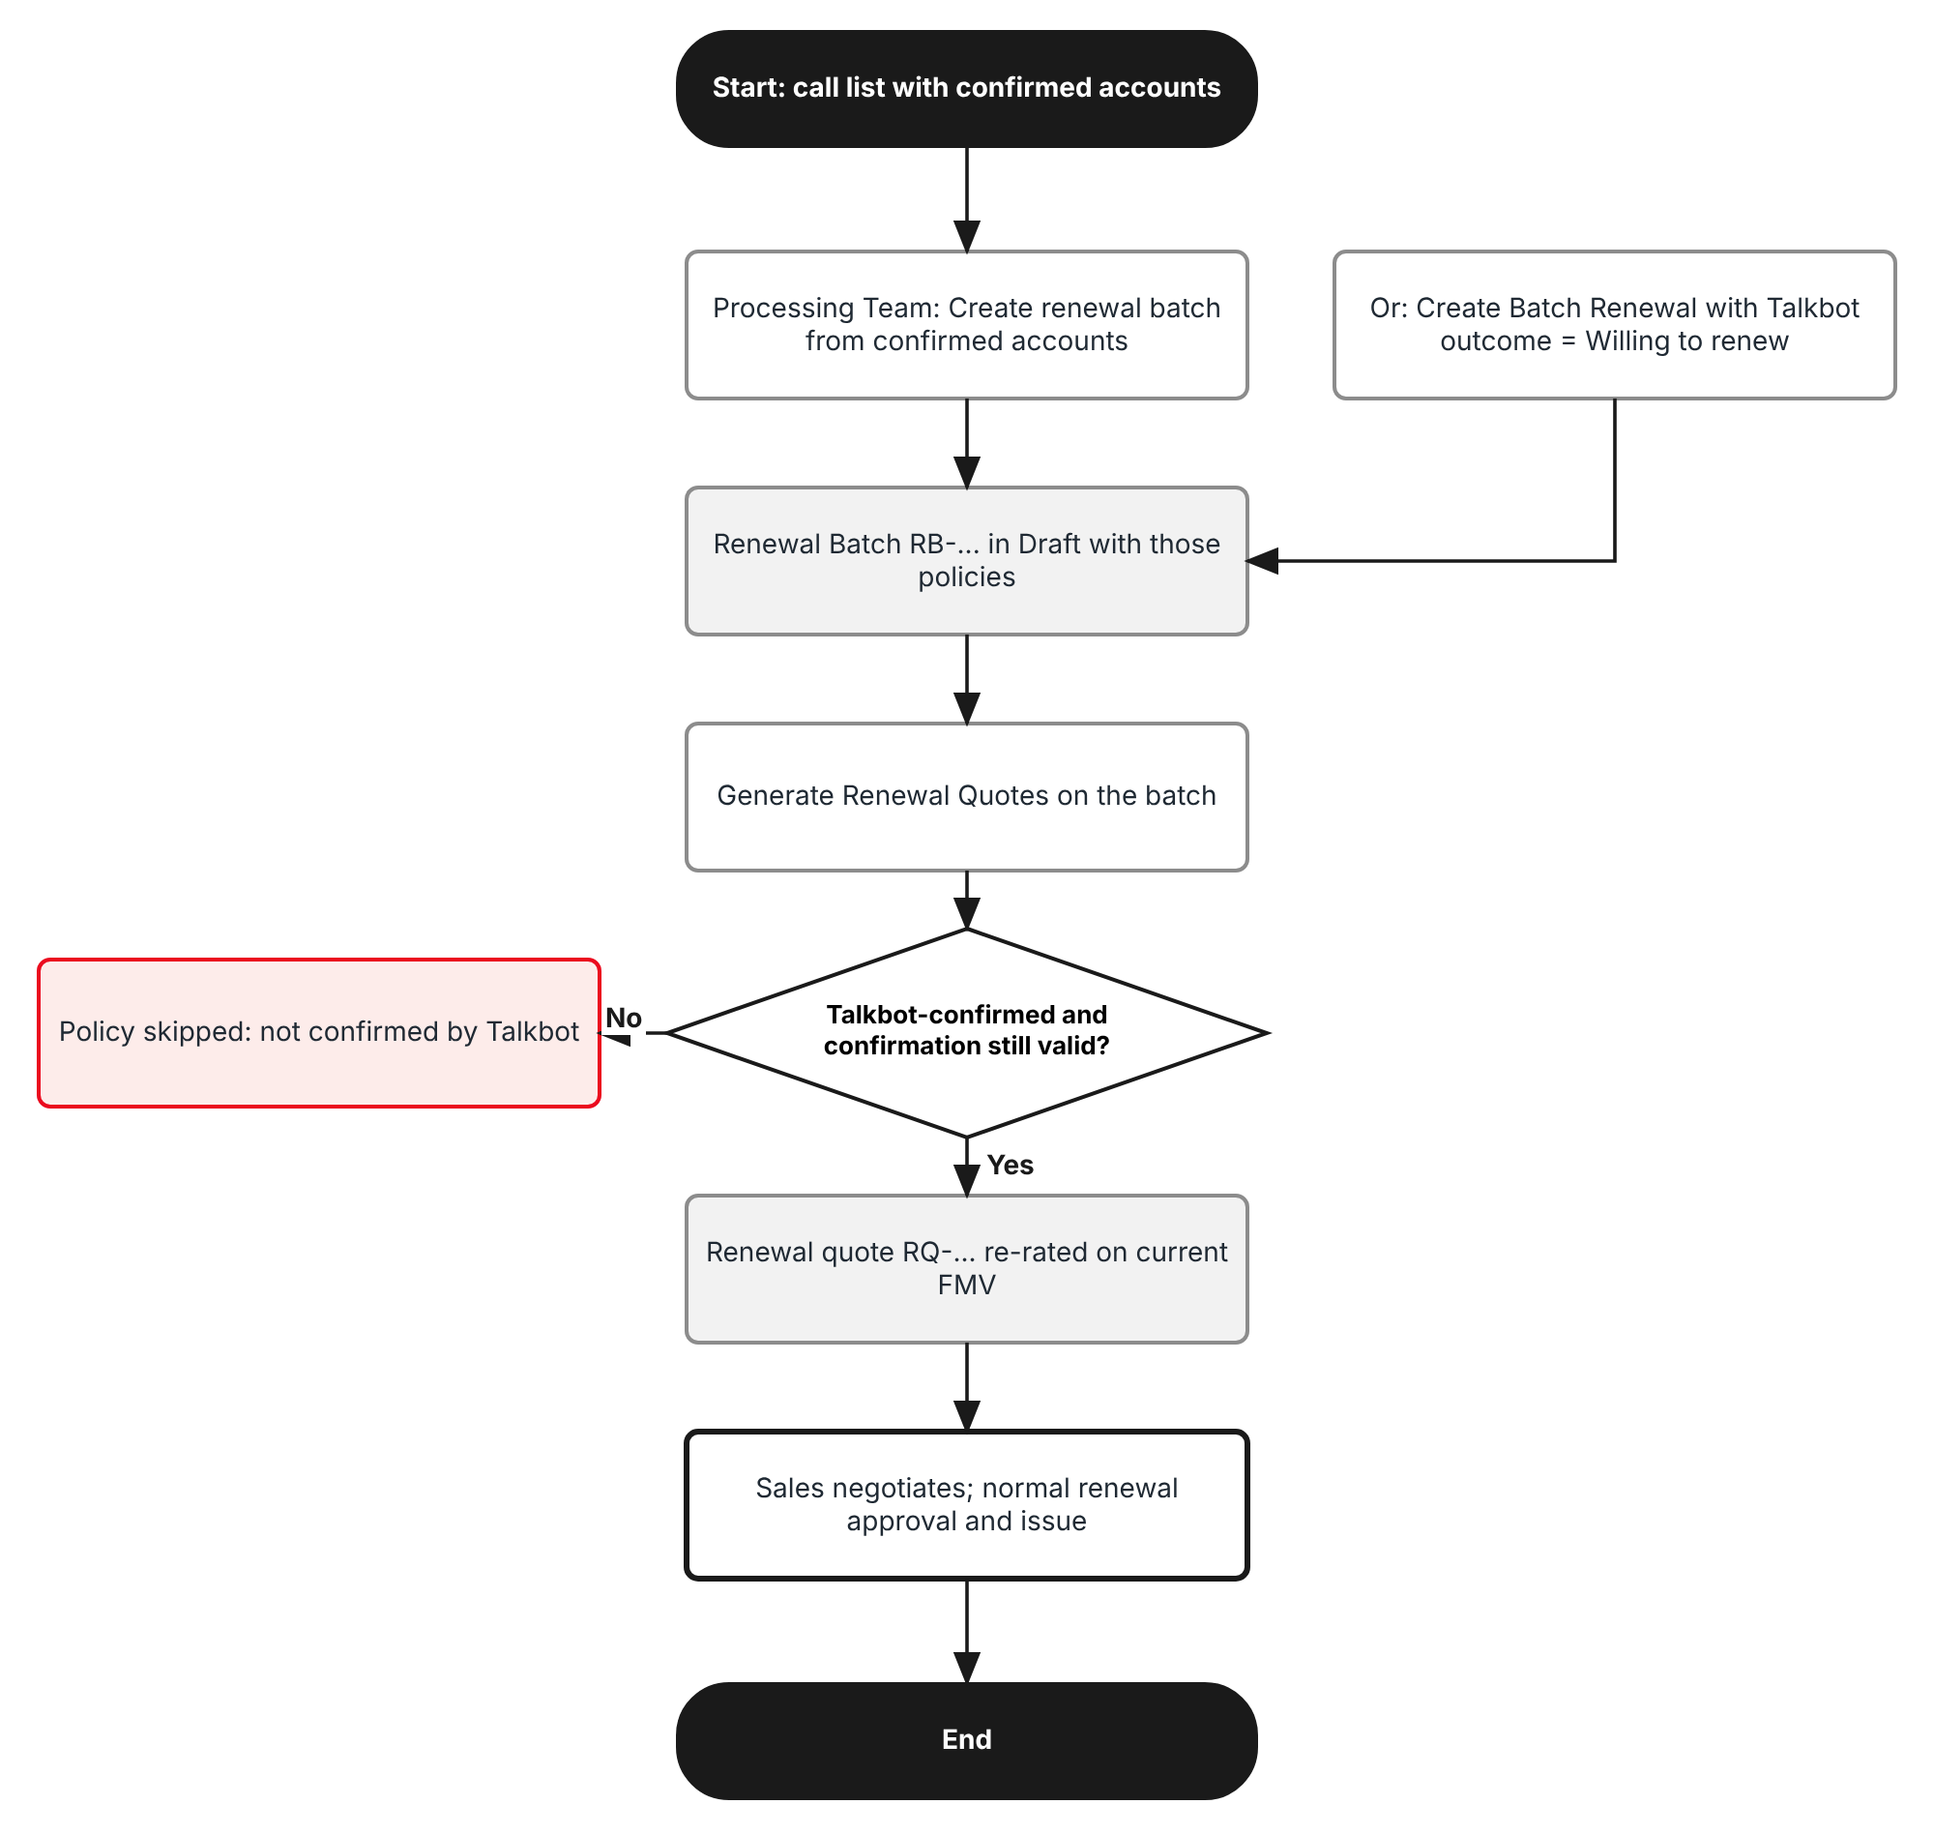
Figure 3: Flow C - Talkbot-confirmed accounts into the renewal batch
Table 5: Flow C steps
Step | Who (role) | What happens | FR
C1 | Processing Team | On the call list, Create renewal batch: a Renewal Batch in Draft with only the Talkbot-confirmed policies still renewable. | FR-TBT-020
C2 | Processing Team | Or: Renewal Batch > Create Batch Renewal with Talkbot outcome Willing to renew (and optionally one call list). | FR-TBT-021
C3 | Processing Team | Generate Renewal Quotes on the batch. Each policy is checked again: a policy that is not Talkbot-confirmed, or whose confirmation is older than 30 days, is skipped with the reason. | FR-TBT-022
C4 | System | Each confirmed policy gets its renewal (RN-...) and re-rated renewal quote (RQ-...); the call list line shows the quote number. | FR-TBT-022
C5 | Sales & Marketing | Follows up on Renewal Queue and Negotiations with the Talkbot outcome in view; renewal approval and issuance are unchanged. | FR-TBT-023

2.4 What the item covers
Table 6: Dimensions
Dimension | Values | Where in BrokerVerse
Products | Motor products only (product line motor): Private Car, Commercial Vehicle, Motorcycle | Master > Insurance > Product
Policies | Renewable policies: Due for renewal, and, when chosen, In grace period or Lapsed, renewable | Operations > Renewals > Renewal Policy
Insurers | All panel insurers; the renewal stays with the expiring insurer | Master > Insurance > Insurance Company
Source of business | TFS accounts, dealer, direct and agent business | Policy source / Distribution Channels
Files | Outbound Contact Import file; inbound Call Records file | Chapter 6

3 Personas and roles

3.1 Personas
BrokerVerse ships eight roles (Master > Users and Access > Role). TISPH personas map to them as below.
Table 7: Personas and BrokerVerse roles
TISPH persona | BrokerVerse role | What they do with Talkbot
Sales Admin / Telesales coordinator | Sales & Marketing (Account Executive) - sales | Creates call lists, downloads the Contact Import file, uploads the results, records outcomes
Sales officer / Telesales agent | Sales & Marketing - sales | Sees the Talkbot outcome on Renewal Queue; calls back accounts with Call back; records a manual outcome
Renewal processor | Processing Team (Placement & Policy Processing) - processing | Creates the renewal batch from the confirmed accounts and runs Generate Renewal Quotes
Operations | Operations (Client Servicing) - operations | Same as the renewal processor; renewal issuance
System Administrator | System Administrator - system-admin | Permissions, settings, the outcome rules and the daily job
Auditor | Compliance Officer (AML/CFT) - compliance-officer | Read-only access to call lists and the Audit Trail

3.2 New permissions
New permissions follow the BrokerVerse pattern read:<module> / write:<module> and are granted on Master > Users and Access > Role Permissions. Creating a renewal batch and running Generate Renewal Quotes keep the existing write:renewals.
Table 8: New permissions
Permission | Allows
read:talkbot-calls | Open Operations > Renewals > Talkbot Calls and its call lists; see the Talkbot outcome on Renewal Queue and Renewal Batch
write:talkbot-calls | Create, edit, download, mark as sent, close and cancel call lists; upload results; record or correct an outcome

3.3 Default grants
Table 9: Default grants (Y = granted)
Permission | system-admin | sales | processing | operations | compliance-officer | claims, accounting, accounting-manager
read:talkbot-calls | Y | Y | Y | Y | Y | -
write:talkbot-calls | Y | Y | - | Y | - | -
read:renewals (existing) | Y | Y | Y | Y | - | -
write:renewals (existing) | Y | Y | Y | Y | - | -

Record scope. A user whose role is record-scoped (an agent) sees only the call list lines of policies in their own book, as for the Renewal Policy list. The Contact Import file holds client mobile numbers and e-mail hints, so the download is limited to write:talkbot-calls and every download is logged.

4 Functional requirements
Seventeen FRs implement LEAD-09. They follow the process: the call list (4.1), the Talkbot results (4.2), the filter into bulk renewal quoting (4.3), and access and audit (4.4).

4.1 Talkbot call list

FR-TBT-001 Create a Talkbot call list from Motor policies due for renewal
BRD trace | LEAD-09 "contacting accounts 3 days before renewal"; RENEW-01 | Actor | Sales Admin (write:talkbot-calls)
Priority | Must have | Fit | Customization
Screens | Operations > Renewals > Talkbot Calls (new menu item after Renewal Batch, route /renewal/talkbot): list and New call list dialog

Description
A new menu item Talkbot Calls is added under Operations > Renewals, after Renewal Batch. It is laid out like Renewal Batch: page title, the buttons Upload results and New call list, and a table of call lists with their number, Talkbot task name, expiry date, number of accounts, number Willing to renew, number not yet called, the renewal batch created from it and the status.
New call list opens a dialog built from Create Batch Renewal. The user picks the expiry dates of the policies to call, the insurer, the source of business and the sales person, and may add expired policies that are still renewable and the accounts not reached on an earlier list. Create call list reads the same list of renewable policies as Renewal Policy, applies the eligibility rules of FR-TBT-002 and creates the call list in Draft with number TCL-YYYY-nnnnn and one line per policy.
Talkbot calls an account 3 days before its renewal date. Expiry Date From and Expiry Date To therefore default to today plus 3 days (talkbot.days_before_expiry). On the last working day before a weekend or public holiday, Expiry Date To is extended to cover the expiry dates of the days nobody works, so no account is missed.
Preconditions
- The user has write:talkbot-calls.
- The policies have an expiry date, a client and a Motor product.
Main flow
- The user opens Operations > Renewals > Talkbot Calls and clicks New call list.
- The dialog shows Expiry Date From and To (default today + 3 days), Insurance Company (All), Product Type (Motor Vehicle Insurance, fixed), Include expired policies still renewable (No), Re-call accounts not reached on (blank), Sales person (All) and Source of business (All).
- As the user changes a criterion the dialog shows how many accounts can be called and how many are left out, by reason.
- The user clicks Create call list. The server creates the list in Draft and shows "Call list TCL-2026-00016 created with 41 accounts".
- The call list opens. The user can remove a line (reason required) before the list is sent.
Alternate and exception flows
- No eligible account: no list is created; the message says so.
- More than talkbot.max_accounts (default 2,000) accounts: the user narrows the dates or the insurer.
- A line removed by mistake can be put back while the list is in Draft.
Business rules
Rule | Statement | Kind | Maintained in
R1 | Only Motor products (product line motor) are offered; Product Type is fixed. | Fixed | -
R2 | Default expiry date = today + talkbot.days_before_expiry days (default 3); extended over the following non-working days of the working calendar. | Configurable | Master > System > Configuration
R3 | Include expired policies still renewable adds policies In grace period and Lapsed, renewable (renewals.grace_period_days 30, renewals.lapsed_renewal_days 90). | Configurable | Master > System > Configuration
R4 | One line per policy. A client with two expiring policies gets two lines (two Contact IDs). | Fixed | -
R5 | A call list holds at most talkbot.max_accounts accounts (default 2,000). | Configurable | Master > System > Configuration
R6 | Number format TCL-YYYY-nnnnn from Document Numbering (new document type Talkbot Call List). | Configurable | Master > System > Document Numbering

Validations and messages
Check | Message shown | ID
Expiry Date To before From | Expiry Date To cannot be before Expiry Date From | MSG-TBT-001
No account eligible | No Motor policy due for renewal matches these criteria. Widen the expiry dates or clear a filter. | MSG-TBT-002
Too many accounts | The call list would hold <n> accounts; a call list can hold at most <max>. Narrow the dates or choose an insurer. | MSG-TBT-003
Created | Call list <number> created with <n> accounts | MSG-TBT-004
Remove a line without reason | Enter the reason for removing this account from the call list | MSG-TBT-005

Audit
- Written to Master > System > Audit Trail with the user, time, before and after values and remark.
Acceptance criteria
- On Wednesday 07/10/2026 New call list proposes Expiry Date From and To 10/10/2026; on Friday 09/10/2026 it proposes 12/10/2026 to 14/10/2026, covering the expiries of Saturday and Sunday.
- With Expiry Date From and To 12/10/2026 and 45 Motor policies due, 4 of them not eligible, the list is created as Draft with 41 lines and the message "Call list TCL-2026-00016 created with 41 accounts".
- Product Type shows Motor Vehicle Insurance and cannot be changed; a Fire policy expiring on the same day is not on the list.
- With Include expired policies still renewable = Yes, a Motor policy that expired 20 days ago and has no renewal in progress is added; one that expired 130 days ago (past grace and lapsed window) is not.
- Removing a line without a reason is refused; with the reason "Complaint in progress" the line shows Removed and is not in the download.

FR-TBT-002 Apply the eligibility rules and exclusions of the call list
BRD trace | LEAD-09; RENEW-02 (lock-in and Scheme 2 excluded from reminders); SCHM-03 | Actor | System
Priority | Must have | Fit | Customization
Screens | Operations > Renewals > Talkbot Calls > New call list; Operations > Renewals > Talkbot Calls > call list

Description
Only accounts Talkbot can usefully call are put on a list. The rules are applied when the list is created and again when it is downloaded, so a policy renewed or cancelled in between is dropped from the file.
The dialog and the list header show the accounts left out with their reason, so the Sales Admin can fix the client record (for example add a missing mobile number) and create the list again.
Preconditions
- A call list is being created or downloaded.
Main flow
- The server reads the renewable policies of the criteria (same source as Renewal Policy).
- It leaves out each policy that fails a rule below and counts it by reason.
- It keeps the others as lines.
Business rules
Rule | Statement | Kind | Maintained in
R1 | Renewal state must be Due for renewal (or In grace period / Lapsed, renewable when chosen). Renewed, Cancelled and closed (Lapsed) policies are left out. | Fixed | -
R2 | A policy with a renewal already Quote Sent, Pending Approval or Approved is left out: it is already being quoted. | Fixed | -
R3 | The client must have a mobile number of 11 digits starting with 09 (or +639 / 639, converted). Otherwise reason "No mobile number". | Fixed | Clients
R4 | Lock-in and Scheme 2 accounts flagged by SCHM-03 are left out (reason "Lock-in or Scheme 2"). | Fixed | SCHM-03 flag on the policy
R5 | A policy already on another call list in Draft or Sent to Talkbot, or Talkbot-confirmed within talkbot.confirmation_valid_days (default 30), is left out (reason "Already on call list <number>"). | Configurable | Master > System > Configuration
R6 | A policy whose client asked not to be called (client marketing consent off) is left out (reason "Do not call"). | Fixed | Clients > consent
R7 | A policy that has been on talkbot.max_lists_per_policy lists (default 3) without being reached is left out (reason "Called <n> times"). | Configurable | Master > System > Configuration

Validations and messages
Check | Message shown | ID
Accounts left out | <n> accounts left out: <count> <reason>, ... | MSG-TBT-006
Policy no longer eligible at download | <n> accounts are no longer eligible and are left out of the file: <policy numbers> | MSG-TBT-007

Audit
- Written to Master > System > Audit Trail with the user, time, before and after values and remark.
Acceptance criteria
- A Motor policy whose client has no mobile number is left out with reason "No mobile number" and counted in the dialog.
- A client mobile number +639171234567 is written to the list as 09171234567.
- A policy flagged lock-in by SCHM-03 is left out with reason "Lock-in or Scheme 2".
- A policy confirmed Willing to renew on TCL-2026-00015 five days ago is left out of a new list with reason "Already on call list TCL-2026-00015".
- A policy renewed after the list was created is dropped at download with the warning naming its policy number.

FR-TBT-003 Download the call list in the Talkbot Contact Import layout
BRD trace | LEAD-09 "Upload template exists as a sample" | Actor | Sales Admin (write:talkbot-calls)
Priority | Must have | Fit | Customization
Screens | Operations > Renewals > Talkbot Calls > call list > Download call list

Description
Download call list produces the file the Talkbot platform imports, in the layout of the Talkbot customer template: one sheet Contact Import, row 1 the Talkbot notes, row 2 the 12 headers (required headers in red), one row per line from row 3. Columns and their source are in chapter 6.
Contact ID carries the policy number. It is the key that comes back in the call records file and links each call to its policy. Talkbot reads the client e-mail only as a hint (first letter, last letter and domain) so that the bot can confirm it without reading it out in full.
Preconditions
- The call list is in Draft or Sent to Talkbot.
- The user has write:talkbot-calls.
Main flow
- The user clicks Download call list.
- The server applies the rules of FR-TBT-002 again and builds the file from the remaining lines.
- The browser saves TCL-2026-00014_Contact_Import.xlsx.
- The list records the download (user, time, number of rows).
Alternate and exception flows
- A list in Results loaded, Closed or Cancelled cannot be downloaded again; the button is hidden.
Business rules
Rule | Statement | Kind | Maintained in
R1 | Contact ID = policy number; Phone = client mobile, 11 digits; Customer_PERSON_NAME and Name = client display name in capitals. | Fixed | -
R2 | Expiration_DATE = policy expiry date as YYYY-MM-DD. | Fixed | -
R3 | Sum_Insured_AMOUNT and Premium_AMOUNT = the renewal sum insured and the indicative renewal gross premium from the existing renewal rating (current FMV or 10% depreciation), rounded to whole pesos; nothing is saved on the renewal. | Fixed | Renewal rating
R4 | First_letter / Last_letter / Domain_EMAIL = first and last character of the e-mail name and "@" + domain; "-" in all three when there is no e-mail. | Fixed | -
R5 | CAR_MODEL = "<Model Year> TOYOTA <Vehicle Model> <Model Variant>" from the policy vehicle, for example "2024 TOYOTA Vios 1.3 XLE CVT". | Fixed | -
R6 | Insurance Status = EXPIRING INSURANCE (expiry today or later) or EXPIRED INSURANCE (expiry passed). | Fixed | -
R7 | A cell is cut to 200 characters (Talkbot limit). The file is not password protected. | Fixed | -
R8 | File type .xlsx (talkbot.export_format; .xls if the Talkbot platform requires it). | Configurable | Master > System > Configuration

Validations and messages
Check | Message shown | ID
No line left | There is no account left to call on this list | MSG-TBT-008
Downloaded | Call list downloaded: <n> accounts | MSG-TBT-009

Audit
- Written to Master > System > Audit Trail with the user, time, before and after values and remark.
Acceptance criteria
- The file has a sheet Contact Import with the 12 headers on row 2 in the order Contact ID, Phone, Customer_PERSON_NAME, Expiration_DATE, Sum_Insured_AMOUNT, Premium_AMOUNT, First_letter, Last_letter, Domain_EMAIL, CAR_MODEL, Name, Insurance Status; Phone to CAR_MODEL in red.
- For client e-mail andrea.villanueva@gmail.com the row has First_letter a, Last_letter a, Domain_EMAIL @gmail.com.
- A policy expired on 25/09/2026 has Insurance Status EXPIRED INSURANCE; one expiring 10/10/2026 has EXPIRING INSURANCE.
- A 2023 Raize 1.0 Turbo CVT with expiring sum insured 895,860 has Sum_Insured_AMOUNT 806274 (10% depreciation).
- The download is written to the Audit Trail with the number of rows.

FR-TBT-004 Mark the call list as sent to Talkbot
BRD trace | LEAD-09 | Actor | Sales Admin (write:talkbot-calls)
Priority | Must have | Fit | Customization
Screens | Operations > Renewals > Talkbot Calls > call list > Mark as sent

Description
After loading the file on the Talkbot platform the user clicks Mark as sent and types the Talkbot task name. The list becomes Sent to Talkbot and its lines can no longer be added or removed. The task name is checked against the Task Name of the call records file at upload (FR-TBT-010).
Preconditions
- The list is in Draft and has been downloaded at least once.
Main flow
- The user clicks Mark as sent.
- The dialog proposes the task name from talkbot.task_name_pattern (default "TIS_MV - MMM DD, YYYY" with today's date, for example "TIS_MV - OCT 07, 2026"); the user confirms or changes it.
- The server sets Sent to Talkbot with the date, user and task name.
Business rules
Rule | Statement | Kind | Maintained in
R1 | Task name required, at most 100 characters. | Fixed | -
R2 | Default task name pattern talkbot.task_name_pattern. | Configurable | Master > System > Configuration

Validations and messages
Check | Message shown | ID
Not downloaded | Download the call list before you mark it as sent | MSG-TBT-010
Task name blank | Enter the Talkbot task name | MSG-TBT-011
Sent | Call list <number> marked as sent to Talkbot | MSG-TBT-012

Audit
- Written to Master > System > Audit Trail with the user, time, before and after values and remark.
Acceptance criteria
- Mark as sent on a list never downloaded is refused with "Download the call list before you mark it as sent".
- On 07/10/2026 the proposed task name is "TIS_MV - OCT 07, 2026".
- After Mark as sent the list shows Sent to Talkbot and Remove line is no longer offered.

FR-TBT-005 Prepare the call list of the day with a scheduled job
BRD trace | LEAD-09 "contacting accounts 3 days before renewal" | Actor | System (job "Talkbot call list")
Priority | Must have | Fit | Customization
Screens | Master > System > Schedules (job "Talkbot call list"); Operations > Renewals > Talkbot Calls

Description
A new scheduled job Talkbot call list (Master > System > Schedules, working days at 06:10 Manila time, after the renewal pipeline at 05:30) creates a Draft call list with the default criteria of FR-TBT-001: expiry date today + 3 days (extended over the coming non-working days), all insurers, without expired policies. It is delivered switched off; TIS Sales switches it on when the daily routine is agreed.
The job never downloads or sends a list: the Sales Admin reviews it and continues from FR-TBT-003.
Main flow
- The job runs on working days only.
- It creates the list as FR-TBT-001 would, with Created by "System".
- If no account is eligible it creates nothing and records "0 accounts" in the job history.
Business rules
Rule | Statement | Kind | Maintained in
R1 | Runs once a day, skipped on weekends and public holidays of the working calendar. | Configurable | Master > System > Schedules
R2 | Delivered switched off. | Configurable | Master > System > Schedules

Audit
- Written to Master > System > Audit Trail with the user, time, before and after values and remark.
Acceptance criteria
- With the job on, on Wednesday 07/10/2026 at 06:10 a Draft list is created for policies expiring Saturday 10/10/2026.
- On Friday 09/10/2026 the list covers expiries 12/10/2026 to 14/10/2026; on Saturday and Sunday the job does not run.
- A day with no eligible policy creates no list and the job history shows 0 accounts.

FR-TBT-006 Close or cancel a call list
BRD trace | LEAD-09 | Actor | Sales Admin (write:talkbot-calls)
Priority | Must have | Fit | Customization
Screens | Operations > Renewals > Talkbot Calls > call list > Close list / Cancel list

Description
A list in Draft or Sent to Talkbot can be cancelled (remark required), for example when the campaign was not run. A list in Results loaded is closed when the Sales Admin has finished with it; it is also closed automatically talkbot.auto_close_days (default 30) days after the results were loaded. A closed or cancelled list is read-only. Its outcomes stay on the policies and the renewal timeline.
Business rules
Rule | Statement | Kind | Maintained in
R1 | Cancel: Draft or Sent to Talkbot; remark required. Close: Results loaded. | Fixed | -
R2 | Automatic close after talkbot.auto_close_days days (default 30). | Configurable | Master > System > Configuration

Validations and messages
Check | Message shown | ID
Cancel without remark | Enter the reason for cancelling the call list | MSG-TBT-013
Cancelled | Call list <number> cancelled | MSG-TBT-014
Closed | Call list <number> closed | MSG-TBT-015

Audit
- Written to Master > System > Audit Trail with the user, time, before and after values and remark.
Acceptance criteria
- A Sent to Talkbot list cancelled with remark "Campaign not run" shows Cancelled and its policies can go on a new list.
- A list whose results were loaded 30 days ago is Closed by the system.
- Upload results is not offered on a Closed list.

4.2 Talkbot call results

FR-TBT-010 Upload the Talkbot call records file
BRD trace | LEAD-09 "successful reminder lists upload into the system (reference no., name, call ID, contact no., result)"; BULK-01 | Actor | Sales Admin (write:talkbot-calls)
Priority | Must have | Fit | Customization
Screens | Operations > Renewals > Talkbot Calls > call list > Upload results; Operations > Renewals > Talkbot Calls > Upload results

Description
Upload results opens the upload dialog of the base pattern. The user picks the call list (preset when opened from a list), sees its Talkbot task name and uploads the Call Records export exactly as it comes from the Talkbot platform. Download template gives the three-sheet template (Data, Columns, Instructions) with the 13 columns BrokerVerse reads; the Talkbot export can be uploaded as it is because the other columns are ignored.
The upload runs in the background like the renewal batch jobs and the dialog shows the result line "Processed n rows: c loaded, f failed" with the failed rows by row number, and the count of accounts per outcome.
Preconditions
- The call list is Sent to Talkbot or Results loaded (a second file adds attempts, for example a second calling day).
Main flow
- The user clicks Upload results, chooses the file and clicks Upload.
- The server checks the file type and that the 13 columns are present (header row 1, any order, names compared without case).
- It checks that Task Name matches the task name of the list; if not, the user confirms or cancels.
- Rows are loaded one by one (FR-TBT-011) and outcomes derived (FR-TBT-012).
- The list becomes Results loaded and the dialog shows the result.
Alternate and exception flows
- Same file uploaded twice: rows whose Call ID is already loaded fail with "already loaded"; nothing is counted twice.
- Wrong task name: warning; the user may continue (for example when the task was renamed on the platform).
Business rules
Rule | Statement | Kind | Maintained in
R1 | .xlsx only (BULK-01); first sheet read; at most talkbot.max_upload_rows rows (default 20,000). | Configurable | Master > System > Configuration
R2 | Columns read: Task Name, Contact ID, Call ID, Contact Name, Contact Number, Result, Call Time, Call Duration, Tags, Call Drop-off Point, Call Status, Call Result, Date of Callback. Others are ignored. | Fixed | -
R3 | Call Time format DD/MM/YYYY HH:MM:SS (Manila time); Date of Callback YYYY-MM-DD. | Fixed | -
R4 | The file is kept with the call list (Documents) for talkbot.file_retention_days (default 365). | Configurable | Master > System > Configuration

Validations and messages
Check | Message shown | ID
File type | Upload the Talkbot Call Records file as Excel (.xlsx) | MSG-TBT-016
Missing column | The file has no column <name>. Upload the Call Records export of the Talkbot platform. | MSG-TBT-017
Too many rows | The file has <n> rows; at most <max> rows can be loaded at once | MSG-TBT-018
Task name differs | The file is for Talkbot task <file task> but the call list was sent as <list task>. Load it anyway? | MSG-TBT-019
List not sent | Mark the call list as sent to Talkbot before you upload results | MSG-TBT-020
Result | Processed <n> rows: <c> loaded, <f> failed | MSG-TBT-021

Audit
- Written to Master > System > Audit Trail with the user, time, before and after values and remark.
Acceptance criteria
- Uploading the sample export (1,529 rows, 67 columns) on a list of 500 accounts gives "Processed 1,529 rows: 1,529 loaded, 0 failed" and the outcome counts of FR-TBT-012.
- A .csv file is refused with "Upload the Talkbot Call Records file as Excel (.xlsx)".
- A file without the column Call Result is refused and nothing is loaded.
- A file with Task Name "TIS_MV - AUG 27, 2026" on a list sent as "TIS_MV - OCT 07, 2026" shows the warning; on Cancel nothing is loaded.
- Uploading the same file a second time fails every row with "Call ID <id> was already loaded" and the outcomes do not change.

FR-TBT-011 Match each call record to its call list line
BRD trace | LEAD-09 "reference no., name, call ID, contact no." | Actor | System
Priority | Must have | Fit | Customization
Screens | Operations > Renewals > Talkbot Calls > call list > Upload results

Description
Each row of the file is one call attempt. It is matched to a line of the chosen list by Contact ID (the policy number written in the Contact Import file). When Contact ID is blank or unknown, the row is matched by Contact Number if exactly one line of the list has that mobile number. A matched row is stored as a call attempt of the line with its Call ID, call time, duration, Result, Call Status, Call Result, Call Drop-off Point, Date of Callback and Tags.
A row that cannot be matched, or whose Call ID is already stored, fails with its reason and does not stop the other rows.
Main flow
- For each row: find the line by Contact ID, else by Contact Number.
- Check Call ID is new.
- Store the attempt and recount the line.
Business rules
Rule | Statement | Kind | Maintained in
R1 | Key: Contact ID = policy number; fallback Contact Number (11 digits, unique on the list). | Fixed | -
R2 | Call ID unique across all call lists. | Fixed | -
R3 | Contact Name is stored but not used for matching. | Fixed | -

Validations and messages
Check | Message shown | ID
Not on the list | Row <n>: Contact ID <id> is not on call list <number> | MSG-TBT-022
Duplicate call | Row <n>: Call ID <id> was already loaded | MSG-TBT-023
Bad call time | Row <n>: Call Time <value> is not a valid date and time | MSG-TBT-024
Ambiguous number | Row <n>: Contact Number <number> belongs to more than one account on the list | MSG-TBT-025

Audit
- Written to Master > System > Audit Trail with the user, time, before and after values and remark.
Acceptance criteria
- A row with Contact ID POL-2025-41187 is stored on the line of policy POL-2025-41187.
- A row with blank Contact ID and Contact Number 09173047105, held by one line only, is matched to that line.
- A row with Contact ID POL-2025-40998, not on the list, fails with "Row 214: Contact ID POL-2025-40998 is not on call list TCL-2026-00014".
- Call Time 31/09/2026 10:02:11 fails as not a valid date and time.
- A line called 4 times shows Calls 4 and the last call time.

FR-TBT-012 Derive the Talkbot outcome of each account
BRD trace | LEAD-09 "result: willing to renew / uncontacted / missed call" | Actor | System
Priority | Must have | Fit | Customization
Screens | Operations > Renewals > Talkbot Calls > call list (column Talkbot outcome)

Description
After each upload BrokerVerse works out one Talkbot outcome per line from all its attempts. Each attempt is classified with the outcome rules below, which read the Talkbot columns Call Status, Call Result, Date of Callback and Result. The line takes the attempt that ranks highest, so a client who missed three calls and said "Will Renew" on the fourth is Willing to renew. The detail column shows the Talkbot value behind the outcome (for example "Will Renew (Closing)" or "Missed Call(19)").
Willing to renew is the Talkbot-confirmed outcome that feeds bulk renewal quoting (4.3). The three outcomes named in the BRD map as follows: willing to renew = Willing to renew; uncontacted = Uncontacted (the line connected but the client gave no answer) and Wrong contact; missed call = Missed call.
Main flow
- Classify every attempt of the line with the rules, in rank order; the first rule that fits gives the attempt outcome.
- Take the best-ranked attempt outcome as the line outcome; keep the attempt it came from.
- A line with no attempt stays Not called.
Business rules
Rule | Statement | Kind | Maintained in
R1 | Rank 1 Already renewed: Call Status = Already Renewed. | Configurable | talkbot.outcome_rules
R2 | Rank 2 Willing to renew: Call Result = Will Renew. | Configurable | talkbot.outcome_rules
R3 | Rank 3 Not willing to renew: Call Result = Will not Renew or Not Interested, or Call Status = Stop Calling/Already Called. | Configurable | talkbot.outcome_rules
R4 | Rank 4 Wrong contact: Call Status = Wrong PIC or Wrong Number/Deny Car Loan. | Configurable | talkbot.outcome_rules
R5 | Rank 5 Call back: any other Call Result (Undecided, Unspecified) or Call Status (Busy, Just text/email me, Speak with an Agent, Insurance Quotation Request, Email Already Provided, Ask Insurance Claims), or a Date of Callback. | Configurable | talkbot.outcome_rules
R6 | Rank 6 Uncontacted: Result Connected(200) or Connected(202) with no Call Status or Call Result (the client dropped at Greeting or Purpose). | Configurable | talkbot.outcome_rules
R7 | Rank 7 Wrong contact: Result Invalid Number(1) or Out of Service(5), when no attempt connected. | Configurable | talkbot.outcome_rules
R8 | Rank 8 Missed call: any other Result (Missed Call(19), Missed Call(903), Busy(486), Answering Machine(201), Network Outage(2), Line Blind Spot(480/483)). | Configurable | talkbot.outcome_rules
R9 | A manual outcome (FR-TBT-014) always overrides the derived one until a later upload brings a higher-ranked attempt. | Fixed | -

Audit
- Written to Master > System > Audit Trail with the user, time, before and after values and remark.
Acceptance criteria
- On the sample campaign the 500 accounts get: Willing to renew 37, Not willing to renew 21, Already renewed 14, Call back 41, Wrong contact 48, Uncontacted 78, Missed call 261.
- A line with attempts Missed Call(19), Missed Call(19), Will Renew (Closing) is Willing to renew with detail "Will Renew (Closing)".
- A line with attempts Missed Call(19), Out of Service(5), Out of Service(5) is Wrong contact.
- A line with attempts Missed Call(19), Connected(202) dropped at Greeting is Uncontacted.
- A line with Call Result Undecided and Date of Callback 2026-10-12 is Call back with detail "Undecided, call back 12/10/2026".
- Changing talkbot.outcome_rules (after approval on Configuration Approvals) re-derives the outcomes of lists not yet Closed.

FR-TBT-013 Record the Talkbot call on the renewal timeline
BRD trace | LEAD-09; RENEW-01 (renewal dispositions with remarks) | Actor | System
Priority | Must have | Fit | Customization
Screens | Renewal Queue > View (timeline); Negotiations > Timeline

Description
When a line gets or changes its outcome, BrokerVerse opens the renewal of the policy if there is none (status Pending, as the renewal pipeline does) and adds one activity of the new type Talkbot Call to its timeline: method Phone, the outcome, the call list number, the task name, the number of attempts and the Talkbot detail. The renewal Attempts count goes up by one per call list, not per attempt.
For Call back with a Date of Callback, the activity carries Next Action "Call the client back" and Follow-up Date = Date of Callback, so it shows on Negotiations like any other follow-up.
Business rules
Rule | Statement | Kind | Maintained in
R1 | One Talkbot Call activity per line per upload that changes the outcome. | Fixed | -
R2 | Activity type Talkbot Call added to the list of update types. | Fixed | -

Audit
- Written to Master > System > Audit Trail with the user, time, before and after values and remark.
Acceptance criteria
- After the upload, the renewal of POL-2025-41187 shows "Talkbot Call - Willing to renew - TCL-2026-00014 (TIS_MV - OCT 07, 2026), 3 attempts".
- For a Call back with Date of Callback 2026-10-12 the activity shows Follow-up Date 12/10/2026 on Negotiations.
- A second upload that does not change the outcome adds no activity.

FR-TBT-014 Record or correct a Talkbot outcome by hand
BRD trace | LEAD-09 "result" | Actor | Sales Admin, Sales officer (write:talkbot-calls)
Priority | Must have | Fit | Customization
Screens | Operations > Renewals > Talkbot Calls > call list > Record outcome

Description
Record outcome on a line sets its outcome by hand, for example when the client called TIS back after a missed call, or when the Talkbot recording shows the result was misread. The user picks the outcome, the date and a remark. The line shows "Manual" next to the outcome and the renewal timeline gets a Talkbot Call activity with the user's name.
Preconditions
- The list is Sent to Talkbot or Results loaded.
Business rules
Rule | Statement | Kind | Maintained in
R1 | Remark required. Any outcome except Not called can be set. | Fixed | -
R2 | A manual Willing to renew counts as Talkbot-confirmed from its date. | Fixed | -

Validations and messages
Check | Message shown | ID
No remark | Enter a remark for the outcome you record | MSG-TBT-026
Saved | Outcome recorded for policy <policy number> | MSG-TBT-027

Audit
- Written to Master > System > Audit Trail with the user, time, before and after values and remark.
Acceptance criteria
- A Missed call line set to Willing to renew with remark "Client called the hotline 08/10/2026" shows Willing to renew (Manual) and can go into a renewal batch.
- Saving without a remark is refused.
- The Audit Trail shows the old and the new outcome.

FR-TBT-015 Put accounts not reached on the next call list
BRD trace | LEAD-09 | Actor | Sales Admin (write:talkbot-calls)
Priority | Must have | Fit | Customization
Screens | Operations > Renewals > Talkbot Calls > New call list > Re-call accounts not reached on

Description
In the New call list dialog the field Re-call accounts not reached on picks an earlier list. Its lines with outcome Missed call or Uncontacted (and, when ticked, Call back) are added to the new list if they are still eligible, so Talkbot can try again before the policy expires.
Business rules
Rule | Statement | Kind | Maintained in
R1 | Only Missed call and Uncontacted by default; Call back on request. | Fixed | -
R2 | A policy is called on at most talkbot.max_lists_per_policy lists (default 3). | Configurable | Master > System > Configuration

Audit
- Written to Master > System > Audit Trail with the user, time, before and after values and remark.
Acceptance criteria
- Re-calling TCL-2026-00014 adds its 339 Missed call and Uncontacted accounts that are still renewable to the new list.
- A policy already on 3 lists is not added and is counted as "Called 3 times".

4.3 Filter into bulk renewal quoting

FR-TBT-020 Create a renewal batch from the Talkbot-confirmed accounts
BRD trace | LEAD-09 "Talkbot-confirmed accounts are filtered so bulk renewal quoting runs only for those policies" | Actor | Processing Team, Operations, Sales Admin (write:renewals)
Priority | Must have | Fit | Customization
Screens | Operations > Renewals > Talkbot Calls > call list > Create renewal batch; Operations > Renewals > Renewal Batch

Description
Create renewal batch on a call list creates a renewal batch in Draft (number RB-YYYY-nnnnn, same record as Create Batch on Renewal Batch) holding only the lines that are Talkbot-confirmed and still renewable, all selected. The batch criteria record the call list number. The call list shows the batch number in its Renewal batch column and each line shows "In batch RB-...".
The batch then follows the existing Renewal Batch process: Generate Renewal Quotes (FR-TBT-022) and, if wanted, Send Renewal Notices.
Preconditions
- The list has at least one Willing to renew line not yet in a batch.
- The user has write:renewals.
Main flow
- The user clicks Create renewal batch.
- The server collects the confirmed lines not yet in a batch and still renewable.
- It creates the batch (at most renewals.batch_max_policies = 500 policies; more lines give several batches) and shows "Renewal batch RB-2026-90014 created with 37 policies".
Business rules
Rule | Statement | Kind | Maintained in
R1 | Only Willing to renew lines confirmed within talkbot.confirmation_valid_days (default 30). | Configurable | Master > System > Configuration
R2 | A policy with a renewal already Quote Sent or later is not added (it is already quoted). | Fixed | -
R3 | At most 500 policies per batch (renewals.batch_max_policies, existing). | Configurable | Master > System > Configuration

Validations and messages
Check | Message shown | ID
Nothing to batch | No Talkbot-confirmed account on this list is waiting for a renewal batch | MSG-TBT-028
Batch created | Renewal batch <batch number> created with <n> policies | MSG-TBT-029

Audit
- Written to Master > System > Audit Trail with the user, time, before and after values and remark.
Acceptance criteria
- On TCL-2026-00014 with 37 Willing to renew lines, Create renewal batch creates RB-2026-90014 with 37 selected policies.
- Clicking it again shows "No Talkbot-confirmed account on this list is waiting for a renewal batch".
- A confirmed policy renewed in the meantime is not added.

FR-TBT-021 Select policies by Talkbot outcome on Create Batch Renewal
BRD trace | LEAD-09 "filtered so bulk renewal quoting runs only for those policies" | Actor | Processing Team (write:renewals)
Priority | Must have | Fit | Customization
Screens | Operations > Renewals > Renewal Batch > Create Batch > Create Batch Renewal (changed)

Description
Create Batch Renewal gets two new criteria: Talkbot outcome (All, Willing to renew, Not willing to renew, Already renewed, Call back, Wrong contact, Uncontacted, Missed call, Not called) and Talkbot call list (All or one list). The policy list of Generate policy list gets two columns, Talkbot outcome and Confirmed on.
For Motor, Talkbot outcome defaults to Willing to renew when talkbot.bulk_quote_filter is on, so a batch built for quoting starts from the confirmed accounts.
Business rules
Rule | Statement | Kind | Maintained in
R1 | Default Talkbot outcome Willing to renew for Product Type Motor when talkbot.bulk_quote_filter = true; All otherwise. | Configurable | Master > System > Configuration
R2 | The existing criteria and the 500-policy limit are unchanged. | Fixed | -

Audit
- Written to Master > System > Audit Trail with the user, time, before and after values and remark.
Acceptance criteria
- Create Batch Renewal for Motor shows Talkbot outcome = Willing to renew by default.
- Expiry 10/10/2026, Motor, Talkbot outcome Willing to renew, call list TCL-2026-00014 lists the 37 confirmed policies with Confirmed on 07/10/2026.
- With Talkbot outcome All, policies without any Talkbot call show "-" in the column.

FR-TBT-022 Generate Renewal Quotes only for Talkbot-confirmed Motor policies
BRD trace | LEAD-09 "bulk renewal quoting runs only for those policies"; RENEW-03 | Actor | System (batch job); Processing Team (write:renewals)
Priority | Must have | Fit | Customization
Screens | Operations > Renewals > Renewal Batch > batch > Generate Renewal Quotes

Description
Generate Renewal Quotes on a renewal batch (the existing background run that opens each renewal and prepares its re-rated renewal quote) checks each selected Motor policy before quoting it. A policy that is not Talkbot-confirmed, or whose confirmation is older than talkbot.confirmation_valid_days, is not quoted: its quote status is set to Skipped with the reason "Not confirmed by Talkbot". The other policies are quoted as today (Quoted, quote number RQ-..., renewal premium).
The rule applies to the bulk run only. A single policy can still be renewed from Renewal Policy > Renew by a user, Talkbot or not, because the client may have confirmed by e-mail or at the dealer. Non-Motor policies are not affected.
Main flow
- The user selects policies in the batch and clicks Generate Renewal Quotes; the job is queued.
- For each policy the job checks the product line and the Talkbot confirmation.
- Confirmed: renewal opened (RN-...) and quote prepared (RQ-...), status Quoted; the call list line shows "Quoted RQ-...".
- Not confirmed: status Skipped with the reason; nothing is created.
- The batch shows Quoted, Skipped and Failed counts; Generate Report includes the reason.
Business rules
Rule | Statement | Kind | Maintained in
R1 | Filter on when talkbot.bulk_quote_filter = true (default true). | Configurable | Master > System > Configuration
R2 | Applies to Motor policies only; other lines are quoted as today. | Fixed | -
R3 | Confirmation valid for talkbot.confirmation_valid_days (default 30) from the outcome date. | Configurable | Master > System > Configuration
R4 | Skipped policies can be quoted later by the same button once confirmed. | Fixed | -

Validations and messages
Check | Message shown | ID
Not confirmed | Not confirmed by Talkbot | MSG-TBT-030
Confirmation too old | Talkbot confirmation of <date> is older than <n> days | MSG-TBT-031
Queued | Renewal quotes queued: <q> policies, <s> skipped as not confirmed by Talkbot | MSG-TBT-032

Audit
- Written to Master > System > Audit Trail with the user, time, before and after values and remark.
Acceptance criteria
- A batch of 40 Motor policies, 37 confirmed, gives 37 Quoted and 3 Skipped "Not confirmed by Talkbot".
- A policy confirmed on 01/09/2026 is skipped on 09/10/2026 with "Talkbot confirmation of 01/09/2026 is older than 30 days".
- A Fire policy in the same batch is quoted without a Talkbot check.
- With talkbot.bulk_quote_filter = false every selected policy is quoted as BrokerVerse does today.
- After the run the call list line of POL-2025-41187 shows "Quoted RQ-2026-90031".

FR-TBT-023 Show the Talkbot outcome on Renewal Queue
BRD trace | LEAD-09; RENEW-01 | Actor | Sales & Marketing, Processing Team (read:talkbot-calls)
Priority | Must have | Fit | Customization
Screens | Operations > Renewals > Renewal Queue (changed)

Description
Renewal Queue gets a Talkbot outcome filter (next to Status) and a Talkbot column with the latest outcome, its call list and date, or the number of calls for a Missed call. Sales uses it to call back the Call back accounts and to chase the confirmed ones whose quote is out. The column is hidden for users without read:talkbot-calls.
Audit
- Written to Master > System > Audit Trail with the user, time, before and after values and remark.
Acceptance criteria
- Filtering Renewal Queue on Call back lists the accounts with that outcome, with their callback date under the tag.
- POL-2025-41187 shows Willing to renew, TCL-2026-00014, 07/10.
- A user without read:talkbot-calls does not see the filter or the column.

4.4 Access and audit

FR-TBT-030 Control access to call lists and client contact data
BRD trace | SEC-01; Data Privacy Act | Actor | System Administrator
Priority | Must have | Fit | Customization
Screens | Master > Users and Access > Role Permissions; Operations > Renewals > Talkbot Calls

Description
read:talkbot-calls opens Talkbot Calls; write:talkbot-calls is needed for every change, the download and the upload. Record scope applies: a record-scoped user sees only lines of policies in their book. Mobile numbers are shown masked on screen (0917 *** 7105); the full number is only in the downloaded file.
Validations and messages
Check | Message shown | ID
No right | You do not have access to Talkbot call lists | MSG-TBT-033

Audit
- Written to Master > System > Audit Trail with the user, time, before and after values and remark.
Acceptance criteria
- A Claims user does not see Talkbot Calls in the menu and gets the message on the route /renewal/talkbot.
- A Processing Team user can open a list and create a renewal batch but does not see Download call list or Upload results.
- Mobile numbers are masked on screen and complete in the file.

FR-TBT-031 Audit the call lists, files and outcomes
BRD trace | SEC-03; BULK-01 "stamped as a batch for traceability" | Actor | System
Priority | Must have | Fit | Customization
Screens | Master > System > Audit Trail; Operations > Renewals > Talkbot Calls

Description
Every create, line removal, download, mark as sent, upload, manual outcome, close and cancel is written to the Audit Trail with the user, time, before and after values and remark. Each upload is stamped with an upload number and keeps its file, so every outcome can be traced to the Call ID and the file it came from.
Audit
- Entities talkbot-call-list and talkbot-call-line on Master > System > Audit Trail.
Acceptance criteria
- The Audit Trail of TCL-2026-00014 shows the creation, the download (500 rows), Mark as sent, the upload (1,529 rows) and the batch creation.
- Opening a line shows its attempts with Call ID and the upload they came from.
- The uploaded file can be downloaded again from the list for 365 days.

5 Workflow and status model

5.1 Call list
Table 10: Call list statuses
From | Action / event | To | Who | Condition
(new) | Create call list, or daily job | Draft | write:talkbot-calls; job "Talkbot call list" | At least one eligible account
Draft | Remove / restore a line | Draft | write:talkbot-calls | Reason required to remove
Draft | Download call list | Draft | write:talkbot-calls | At least one line left
Draft | Mark as sent | Sent to Talkbot | write:talkbot-calls | Downloaded at least once; task name entered
Sent to Talkbot | Upload results | Results loaded | write:talkbot-calls | At least one row loaded
Results loaded | Upload results (another file) | Results loaded | write:talkbot-calls | New Call IDs only
Results loaded | Close list, or 30 days after the last upload | Closed | write:talkbot-calls; system | -
Draft, Sent to Talkbot | Cancel list | Cancelled | write:talkbot-calls | Remark required

5.2 Call list line
Each line has a Talkbot outcome and a renewal status.
Table 11: Talkbot outcomes
Talkbot outcome | Set by | Talkbot-confirmed | Next step
Not called | Line created; no attempt loaded | No | Wait for the results, or re-call
Willing to renew | Rule rank 2, or manual | Yes, for 30 days | Renewal batch and renewal quote
Not willing to renew | Rule rank 3, or manual | No | Sales follow-up or lapse handling (Lapse Management)
Already renewed | Rule rank 1, or manual | No | Sales checks where the client renewed; the policy may lapse
Call back | Rule rank 5, or manual | No | Sales calls back on the callback date
Wrong contact | Rule ranks 4 and 7, or manual | No | Correct the mobile number on the client
Uncontacted | Rule rank 6, or manual | No | Re-call on the next list
Missed call | Rule rank 8, or manual | No | Re-call on the next list

Table 12: Renewal status of a line
Renewal status of the line | Meaning
- | Not in a renewal batch
In batch RB-... | Added to a renewal batch (FR-TBT-020 or 021)
Quoted RQ-... | Renewal quote prepared by Generate Renewal Quotes
Skipped | Not quoted by the batch run: not confirmed, or confirmation too old (FR-TBT-022)
Removed | Taken off the list before sending, with the reason

5.3 Renewal batch policy
The existing quote status of a batch policy (NotQuoted, Queued, Quoted, Failed) gets one new value, Skipped, with the reason in the Error column of Generate Report. A skipped policy can be queued again. The batch status (Draft, Processing, Completed, Cancelled) and the notice status (NotSent, Queued, Sent, Failed) are unchanged.

6 Interfaces
Both files are moved by the user between BrokerVerse and the Talkbot platform. There is no system connection.
Table 13: Interfaces
Interface | Direction | File | Frequency | Owner
I-1 Talkbot Contact Import | Outbound (download) | TCL-YYYY-nnnnn_Contact_Import.xlsx, sheet Contact Import | Per call list, usually daily | Sales Admin
I-2 Talkbot Call Records | Inbound (upload) | Call Records export of the Talkbot platform (.xlsx), first sheet, e.g. CallRecords_07-10-2026 | Per campaign, after the calling day(s) | Sales Admin

6.1 I-1 Talkbot Contact Import (outbound)
Same layout as the Talkbot customer template: row 1 holds the Talkbot notes (required headers in red, file not password protected, at most 200 characters per cell), row 2 the headers, data from row 3. Required on the Talkbot side: Phone to CAR_MODEL.
Table 14: I-1 columns
Column | Talkbot req. | BrokerVerse source | Example
Contact ID | N | Policy number (the key returned in I-2) | POL-2025-41187
Phone | Y | Client mobile number, 11 digits | 09173047105
Customer_PERSON_NAME | Y | Client display name, capitals | ANDREA M. VILLANUEVA
Expiration_DATE | Y | Policy expiry date, YYYY-MM-DD | 2026-10-10
Sum_Insured_AMOUNT | Y | Renewal sum insured from the renewal rating, whole pesos | 806274
Premium_AMOUNT | Y | Indicative renewal gross premium from the renewal rating, whole pesos | 22610
First_letter | Y | First character of the e-mail name, "-" if no e-mail | a
Last_letter | Y | Last character of the e-mail name, "-" if no e-mail | a
Domain_EMAIL | Y | "@" + e-mail domain, "-" if no e-mail | @gmail.com
CAR_MODEL | Y | Model Year + TOYOTA + Vehicle Model + Model Variant | 2023 TOYOTA Raize 1.0 Turbo CVT
Name | N | Client display name, capitals | ANDREA M. VILLANUEVA
Insurance Status | N | EXPIRING INSURANCE or EXPIRED INSURANCE | EXPIRING INSURANCE

6.2 I-2 Talkbot Call Records (inbound)
The Talkbot export has 67 columns and one row per call attempt. BrokerVerse reads the 13 columns below and ignores the others (collection, verification and inbound columns used by other Talkbot campaigns).
Table 15: I-2 columns read
Column | Use in BrokerVerse | Values seen
Task Name | Checked against the task name of the call list | TIS_MV - OCT 07, 2026
Contact ID | Match key: policy number | POL-2025-41187
Call ID | Unique id of the attempt; repeats rejected | 3422766876
Contact Name | Stored | ANDREA M. VILLANUEVA
Contact Number | Fallback match key | 09173047105
Result | Outcome ranks 6 to 8 | Missed Call(19), Missed Call(903), Busy(486), Connected(200), Connected(202), Out of Service(5), Answering Machine(201), Invalid Number(1), Network Outage(2), Line Blind Spot(480), Line Blind Spot(483)
Call Time | Attempt date and time | 07/10/2026 14:52:10
Call Duration | Seconds, stored | 0 to 300
Tags | Stored as the detail of the attempt | Call Drop-off Point:Closing;Call Result:Will Renew
Call Drop-off Point | Detail | Greeting, Purpose, Proceed Premium Amount, Closing, Will Renew - Confirm Email
Call Status | Outcome ranks 1, 3, 4, 5 | Already Renewed, Wrong PIC, Wrong Number/Deny Car Loan, Busy, Stop Calling/Already Called, Just text/email me, Speak with an Agent, Insurance Quotation Request, Email Already Provided, Ask Insurance Claims
Call Result | Outcome ranks 2, 3, 5 | Will Renew, Will not Renew, Not Interested, Undecided, Unspecified
Date of Callback | Follow-up date of a Call back | 2026-10-12

Sample campaign. A Talkbot campaign of 500 accounts produced 1,529 attempts: 116 accounts were called once, 58 twice, 29 three times, 282 four times and 15 five or six times. Only 213 attempts connected; 78 attempts carry a Call Result.

7 Configuration items

7.1 Settings
New settings use the dotted keys of BrokerVerse and are maintained on Master > System > Configuration. Changes to talkbot.outcome_rules and talkbot.bulk_quote_filter are approved on Master > Finance > Configuration Approvals.
Table 16: Settings
Key | Meaning | Default
talkbot.days_before_expiry | Days between the call list date and the expiry date of the accounts | 3
talkbot.max_accounts | Accounts per call list | 2000
talkbot.max_lists_per_policy | Call lists a policy can be on without being reached | 3
talkbot.confirmation_valid_days | Days a Willing to renew outcome stays Talkbot-confirmed | 30
talkbot.task_name_pattern | Proposed Talkbot task name | TIS_MV - MMM DD, YYYY
talkbot.export_format | File type of the Contact Import file | xlsx
talkbot.max_upload_rows | Rows per call records upload | 20000
talkbot.outcome_rules | Outcome rules and their rank (chapter 4, FR-TBT-012) | As in FR-TBT-012
talkbot.bulk_quote_filter | Generate Renewal Quotes quotes only Talkbot-confirmed Motor policies | true
talkbot.auto_close_days | Days after the last upload before a list closes | 30
talkbot.file_retention_days | Days an uploaded file is kept | 365
renewals.batch_max_policies (existing) | Policies per renewal batch | 500
renewals.grace_period_days / renewals.lapsed_renewal_days (existing) | Renewable window after expiry | 30 / 90

7.2 Scheduled job
Table 17: Scheduled jobs (Master > System > Schedules)
Job | When | What it does
Talkbot call list (new, delivered off) | Working days 06:10 Manila time | Creates the Draft call list of the day (FR-TBT-005)
Talkbot call list close (new) | Daily 01:50 | Closes lists 30 days after their last upload (FR-TBT-006)
Renewal pipeline (existing) | Daily 05:30 | Puts policies expiring within 90 days into the renewal pipeline
Renewal notice queue (existing) | Every minute | Runs the queued renewal batch jobs, including Generate Renewal Quotes

7.3 Lists of values and numbering
Table 18: Lists of values
List | Values
Talkbot outcome (new) | Not called; Willing to renew; Not willing to renew; Already renewed; Call back; Wrong contact; Uncontacted; Missed call
Call list status (new) | Draft; Sent to Talkbot; Results loaded; Closed; Cancelled
Line removal reason (new) | Complaint in progress; Client asked not to be called; Renewing elsewhere; Duplicate account; Other
Renewal activity type (existing list, new value) | Talkbot Call
Batch quote status (existing list, new value) | Skipped
Document type (Master > System > Document Numbering) | Talkbot Call List, prefix TCL, yearly sequence: TCL-2026-00014

8 Traceability

8.1 BRD clause to FR
Table 19: LEAD-09 clauses
Clause of TIS-BRD-LEAD-09 | FR | BrokerVerse screen
Talkbot runs outside BrokerVerse for renewal business | FR-TBT-003, 010 | Talkbot Calls; interfaces I-1 and I-2
successful reminder lists upload into the system | FR-TBT-010, 011 | Talkbot Calls > Upload results
reference no., name, call ID, contact no. | FR-TBT-011 | Call list line and attempts
result: willing to renew / uncontacted / missed call | FR-TBT-012, 014 | Call list (Talkbot outcome)
contacting accounts 3 days before renewal | FR-TBT-001, 002, 005 | New call list; job Talkbot call list
Talkbot-confirmed accounts are filtered | FR-TBT-020, 021 | Call list > Create renewal batch; Create Batch Renewal
bulk renewal quoting runs only for those policies | FR-TBT-022 | Renewal Batch > Generate Renewal Quotes
Upload template exists as a sample | FR-TBT-003, 010 | Contact Import download; results template
(outcome visible to the renewal follow-up) | FR-TBT-013, 023 | Renewal timeline; Renewal Queue

8.2 Related BRD requirements
Table 20: Related requirements
BRD ref. | Relation to LEAD-09 | FR
RENEW-01 | Renewal runs and work queue by source of production | FR-TBT-001, 023
RENEW-02 | Notice cadence; lock-in and Scheme 2 excluded from reminders | FR-TBT-002
RENEW-03 | Motor renewal re-rated on FMV or 10% depreciation | FR-TBT-003, 022
RENEW-05 | Working calendar | FR-TBT-001, 005
SCHM-03 | Lock-in and Scheme 2 flags | FR-TBT-002
BULK-01 | Excel only; batch stamp for traceability | FR-TBT-010, 031
LEAD-07 | 3-day uncontacted alert (same CR-02) | -
SEC-01, SEC-03 | Access and audit | FR-TBT-030, 031

8.3 FR to test cases
Table 21: Test cases per FR (one per acceptance criterion)
FR | Title | Test cases
FR-TBT-001 | Create a Talkbot call list from Motor policies due for renewal | TC-TBT-001-1 to -5
FR-TBT-002 | Apply the eligibility rules and exclusions of the call list | TC-TBT-002-1 to -5
FR-TBT-003 | Download the call list in the Talkbot Contact Import layout | TC-TBT-003-1 to -5
FR-TBT-004 | Mark the call list as sent to Talkbot | TC-TBT-004-1 to -3
FR-TBT-005 | Prepare the call list of the day with a scheduled job | TC-TBT-005-1 to -3
FR-TBT-006 | Close or cancel a call list | TC-TBT-006-1 to -3
FR-TBT-010 | Upload the Talkbot call records file | TC-TBT-010-1 to -5
FR-TBT-011 | Match each call record to its call list line | TC-TBT-011-1 to -5
FR-TBT-012 | Derive the Talkbot outcome of each account | TC-TBT-012-1 to -6
FR-TBT-013 | Record the Talkbot call on the renewal timeline | TC-TBT-013-1 to -3
FR-TBT-014 | Record or correct a Talkbot outcome by hand | TC-TBT-014-1 to -3
FR-TBT-015 | Put accounts not reached on the next call list | TC-TBT-015-1 to -2
FR-TBT-020 | Create a renewal batch from the Talkbot-confirmed accounts | TC-TBT-020-1 to -3
FR-TBT-021 | Select policies by Talkbot outcome on Create Batch Renewal | TC-TBT-021-1 to -3
FR-TBT-022 | Generate Renewal Quotes only for Talkbot-confirmed Motor policies | TC-TBT-022-1 to -5
FR-TBT-023 | Show the Talkbot outcome on Renewal Queue | TC-TBT-023-1 to -3
FR-TBT-030 | Control access to call lists and client contact data | TC-TBT-030-1 to -3
FR-TBT-031 | Audit the call lists, files and outcomes | TC-TBT-031-1 to -3

9 Navigation

9.1 Screens of LEAD-09
Table 22: Screens
Screen | Menu path and route | Type
Talkbot Calls (list of call lists) | Operations > Renewals > Talkbot Calls, after Renewal Batch - /renewal/talkbot | New
New Talkbot call list (dialog) | Talkbot Calls > New call list | New, built from Create Batch Renewal
Call list detail | Talkbot Calls > call list number - /renewal/talkbot/:id | New
Upload Talkbot results (dialog) | Talkbot Calls > Upload results, or the same button on a call list | New (base upload pattern)
Record outcome (dialog) | Call list > line > Record outcome | New
Renewal Batch (page Batch Renewal), Create Batch Renewal | Operations > Renewals > Renewal Batch - /agent/renewal-batch | Changed (criteria, column, Skipped)
Renewal Queue | Operations > Renewals > Renewal Queue - /renewal/queue | Changed (filter, column)
Renewal timeline | Renewal Queue > View; Operations > Renewals > Negotiations | Changed (Talkbot Call activity)
Role Permissions; Configuration; Schedules; Document Numbering; Audit Trail | Master > Users and Access; Master > System | Existing; new permissions, keys, jobs, document type

9.2 Menu by base role
Table 23: Menu by base role
Base role | Menu entries for LEAD-09
Sales & Marketing | Renewals > Talkbot Calls (maintain); Renewal Queue (Talkbot filter and column); Renewal Batch
Processing Team | Renewals > Talkbot Calls (view, Create renewal batch); Renewal Batch (Generate Renewal Quotes)
Operations | Renewals > Talkbot Calls (maintain); Renewal Batch; Renewal Queue
System Administrator | All of the above; Role Permissions, Configuration, Schedules, Document Numbering
Compliance Officer | Renewals > Talkbot Calls (view); Audit Trail

10 Screen specifications
One specification per screen. Pictures marked "to-be design mock-up" are the real BrokerVerse screens with the LEAD-09 changes drawn in, using the Toyota Insurance Services brand pack; the other pictures show BrokerVerse as it runs today. The numbered red markers match the No. column of the field table. Messages are listed in chapter 12.

10.1 Talkbot Calls (new)
Type | New screen, laid out like Renewal Batch
Purpose | Find a call list, see its status and results, and start a new list or an upload.
Who can open it | read:talkbot-calls
Navigation | Operations > Renewals > Talkbot Calls
FRs | FR-TBT-001, 006, 010

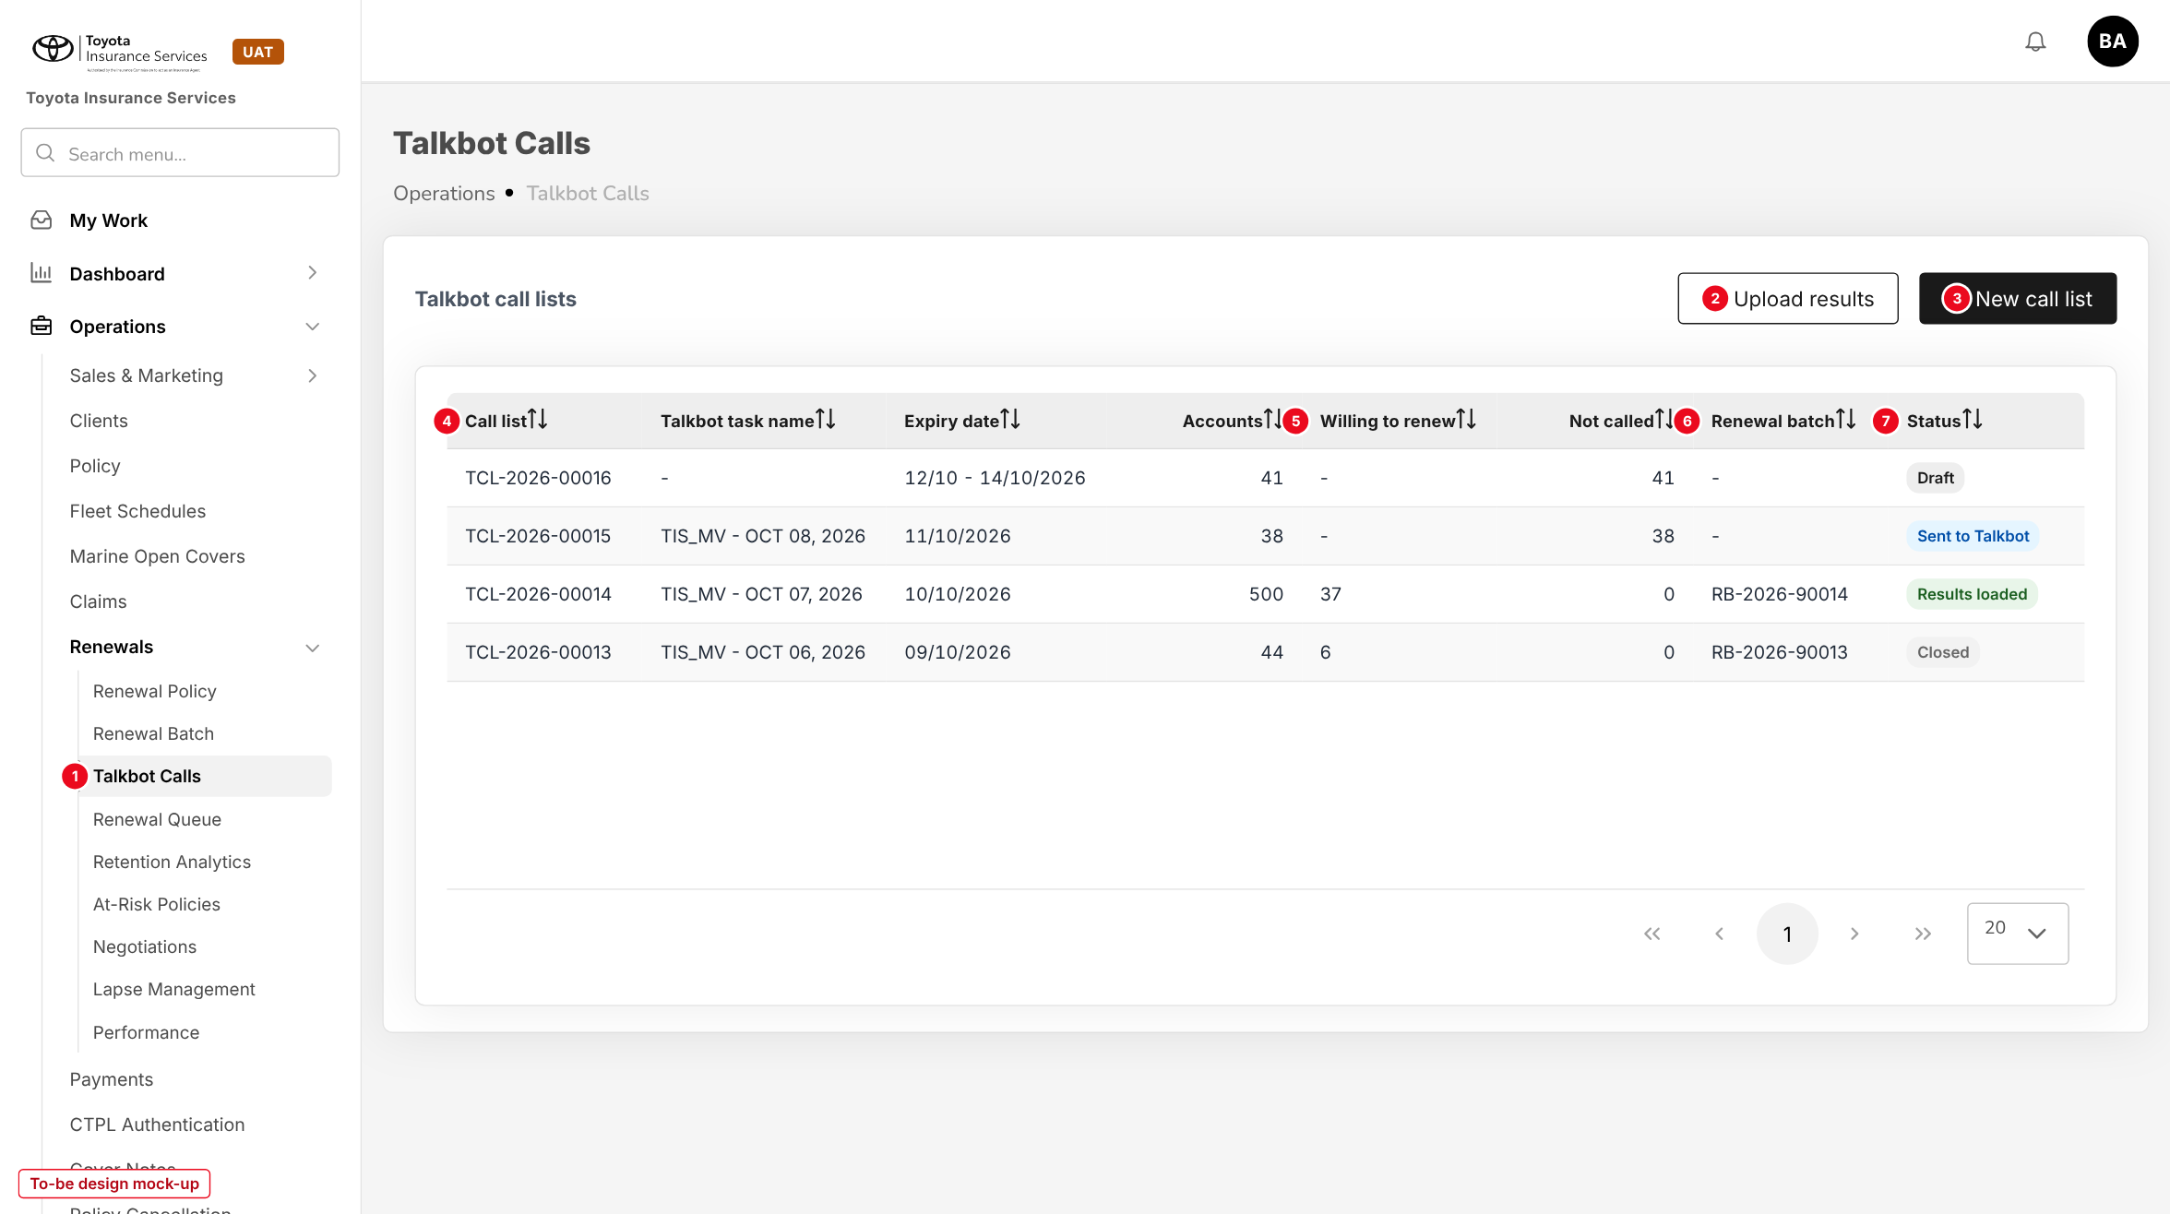
Figure 4: Talkbot Calls (to-be design mock-up)
No. | Field (label on screen) | Type | Mand. | Source / list | Default | Rule and message
1 | Talkbot Calls (side bar) | Menu item | - | After Renewal Batch | - | Shown with read:talkbot-calls
2 | Upload results | Button | - | - | - | write:talkbot-calls; opens 10.4 with a call list to pick
3 | New call list | Button | - | - | - | write:talkbot-calls; opens 10.2
4 | Call list | Column | - | TCL-YYYY-nnnnn | - | Opens 10.3; newest first
- | Talkbot task name, Expiry date, Accounts | Columns | - | Call list | - | -
5 | Willing to renew / Not called | Columns | - | Line outcomes | - | Counts
6 | Renewal batch | Column | - | Renewal Batch | - | Opens the batch
7 | Status | Tag | - | Draft; Sent to Talkbot; Results loaded; Closed; Cancelled | - | -

10.2 New Talkbot call list (new dialog)
Type | New dialog, built from Create Batch Renewal
Purpose | Choose the accounts Talkbot will call and create the list.
Who can open it | write:talkbot-calls
Navigation | Talkbot Calls > New call list
FRs | FR-TBT-001, 002, 015

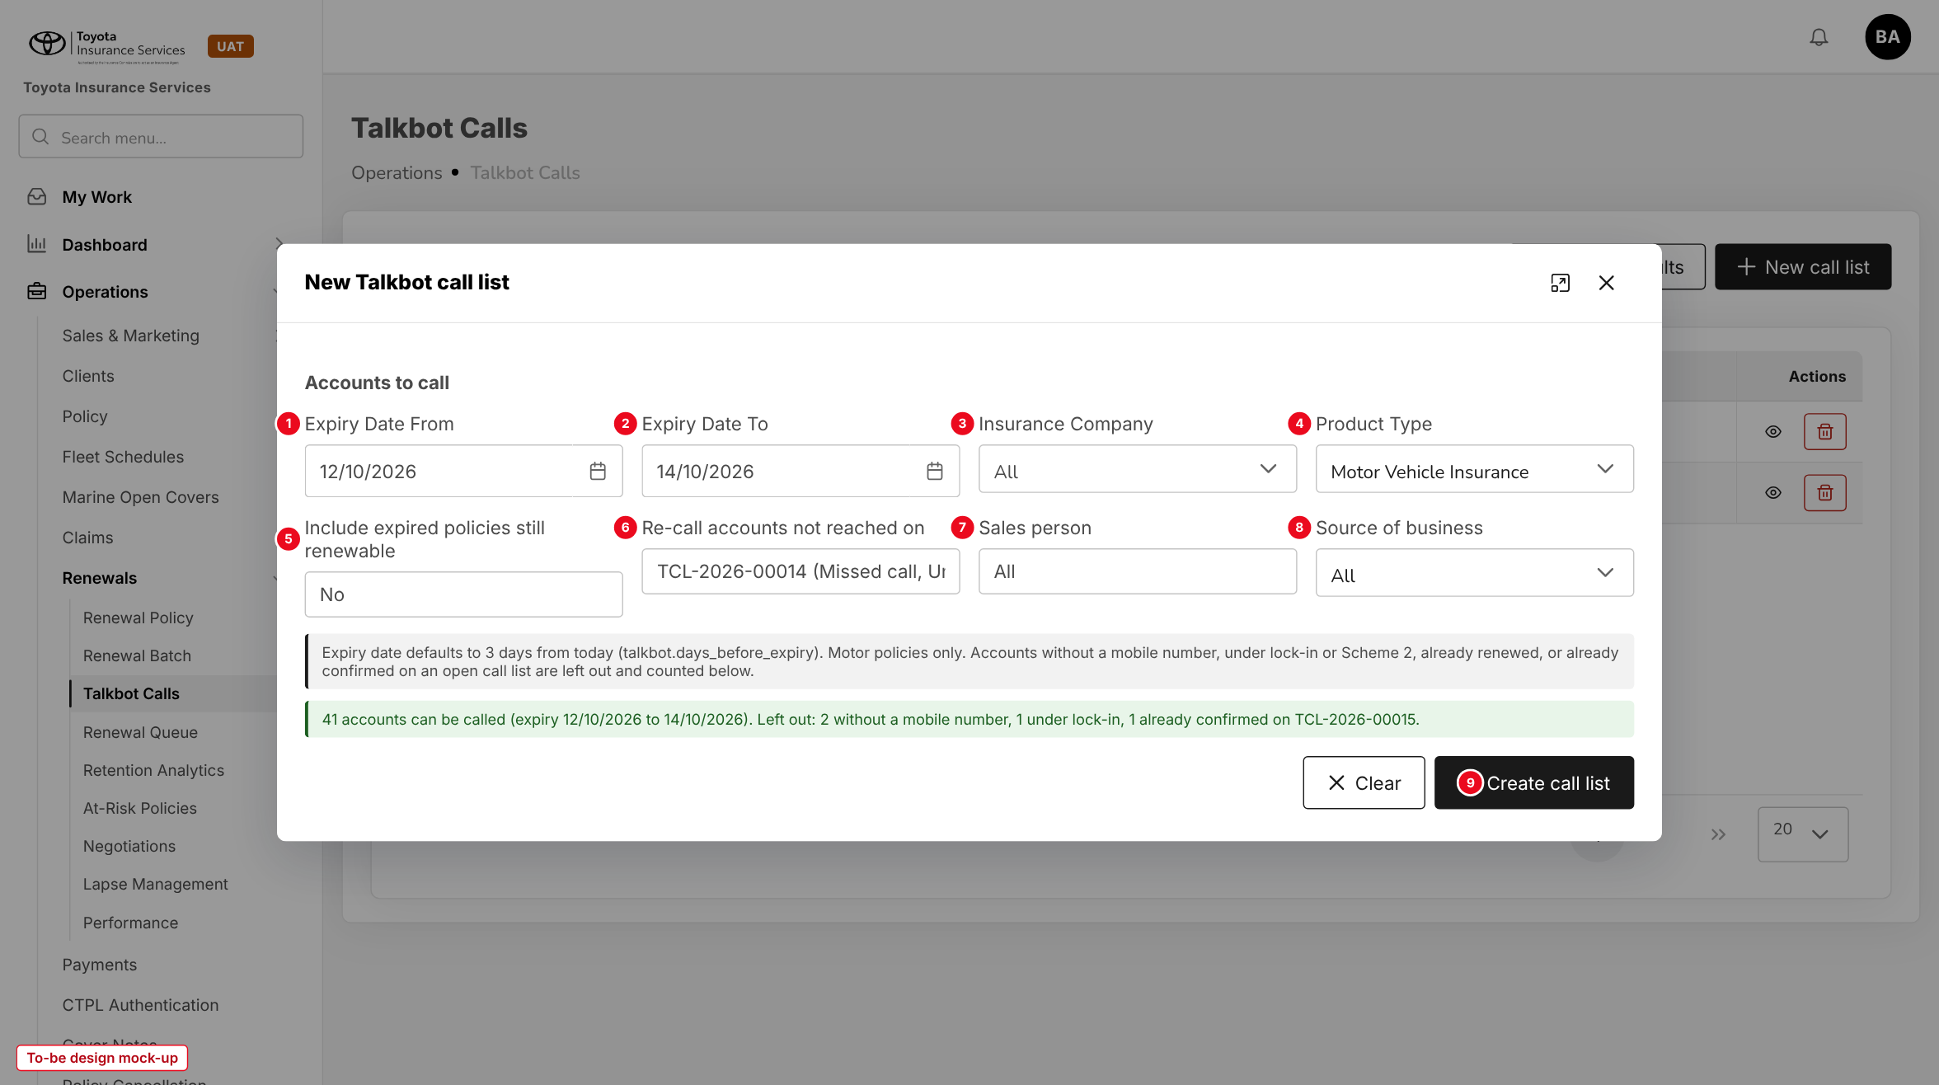
Figure 5: New Talkbot call list (to-be design mock-up)
No. | Field (label on screen) | Type | Mand. | Source / list | Default | Rule and message
1 | Expiry Date From | Date | Y | - | Today + 3 days | MSG-TBT-001
2 | Expiry Date To | Date | Y | - | Today + 3 days, extended over non-working days | >= From
3 | Insurance Company | List | N | Master > Insurance > Insurance Company | All | -
4 | Product Type | Display | - | - | Motor Vehicle Insurance | Fixed
5 | Include expired policies still renewable | Yes / No | N | - | No | Adds In grace period and Lapsed, renewable
6 | Re-call accounts not reached on | List | N | Call lists with results | Blank | Adds Missed call and Uncontacted lines (FR-TBT-015)
7 | Sales person | List | N | Users | All | -
8 | Source of business | List | N | TFS; Dealer; Direct; Agent / referrer | All | -
- | Count line | Text | - | Computed | - | Eligible and left-out accounts by reason. MSG-TBT-002, 003, 006
9 | Create call list | Button | - | - | - | MSG-TBT-004

10.3 Call list detail (new)
Type | New screen
Purpose | Work one call list: download, mark as sent, upload, record outcomes and create the renewal batch.
Who can open it | read:talkbot-calls (view); write:talkbot-calls (change); write:renewals (Create renewal batch)
Navigation | Talkbot Calls > call list number
FRs | FR-TBT-003, 004, 006, 012, 014, 020

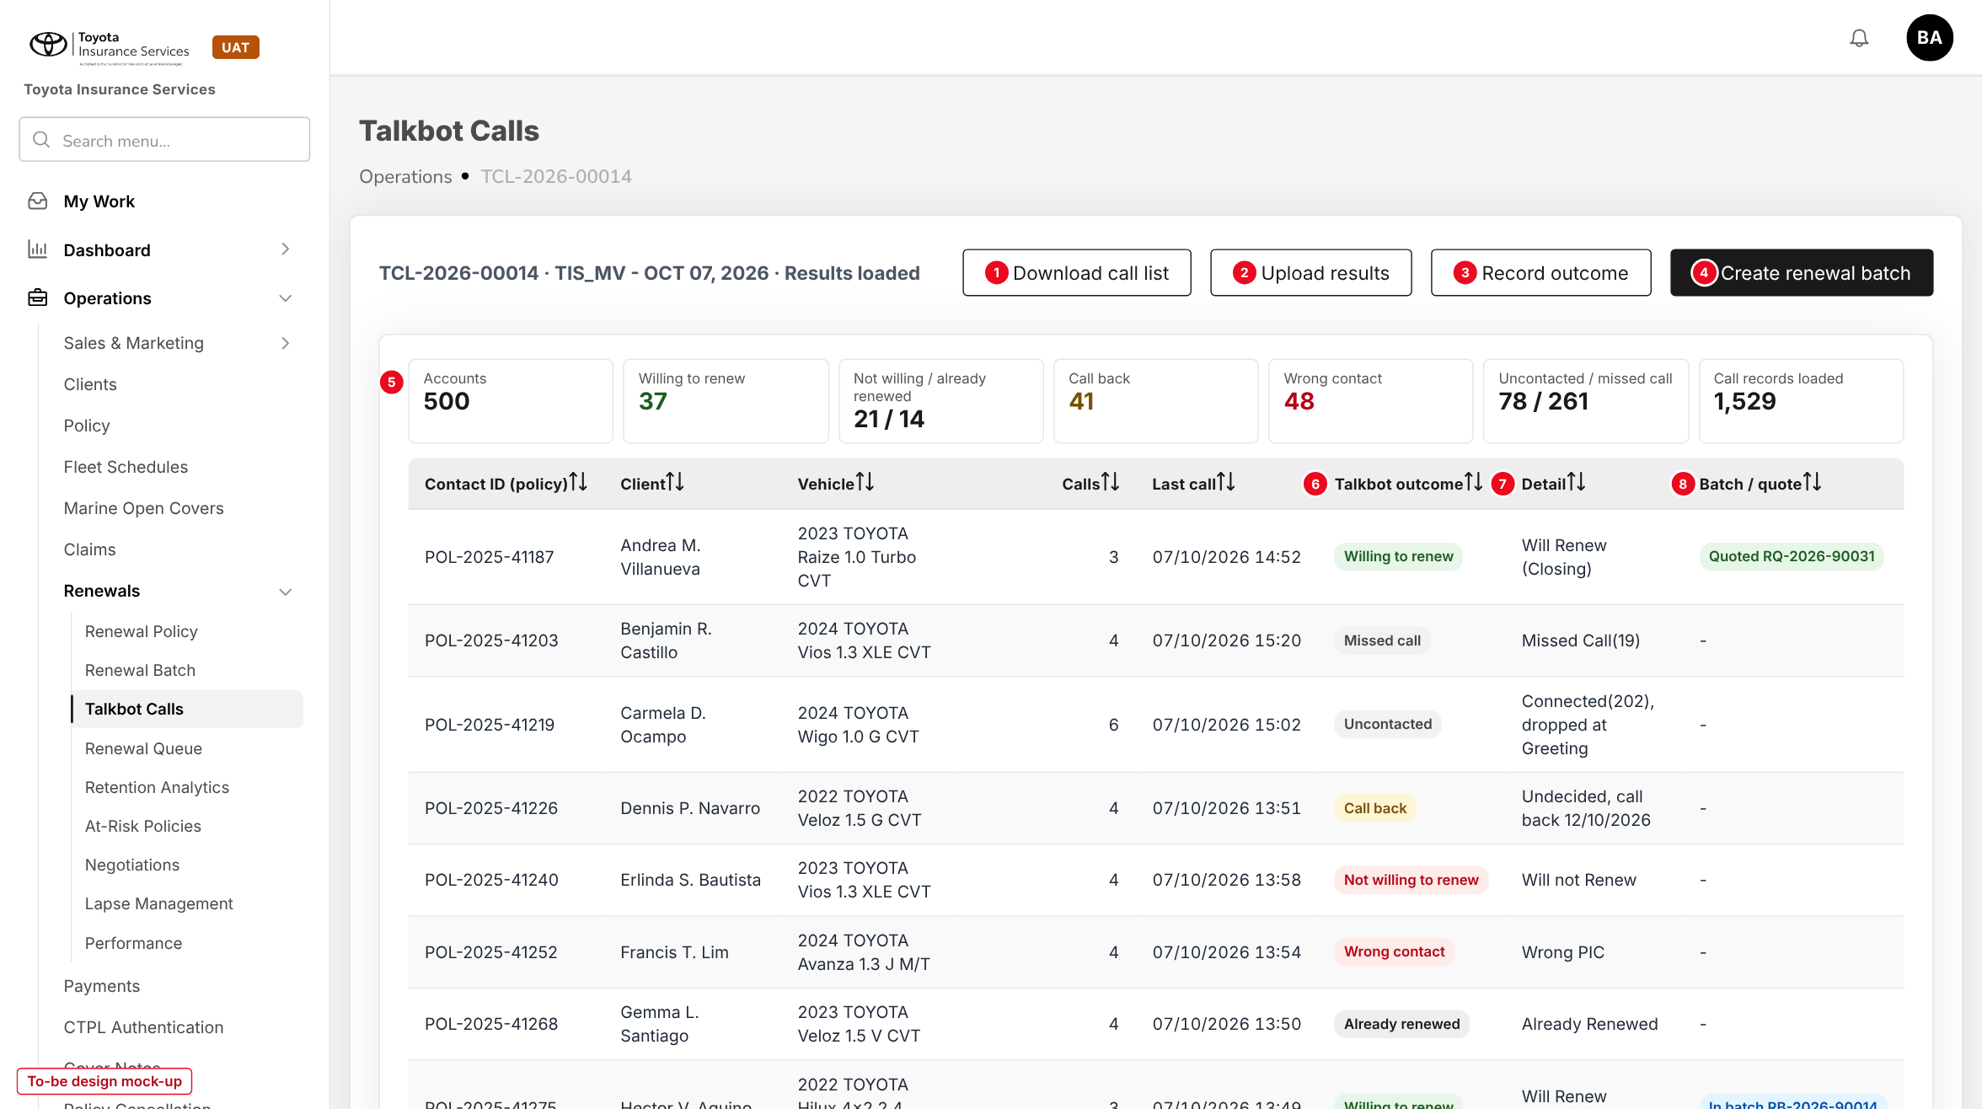
Figure 6: Call list TCL-2026-00014 with its results (to-be design mock-up)
No. | Field (label on screen) | Type | Mand. | Source / list | Default | Rule and message
1 | Download call list | Button | - | - | - | Draft or Sent to Talkbot. MSG-TBT-008, 009
2 | Upload results | Button | - | - | - | Sent to Talkbot or Results loaded; opens 10.4
3 | Record outcome | Button | - | - | - | On the selected line; outcome, date, remark. MSG-TBT-026, 027
4 | Create renewal batch | Button | - | - | - | write:renewals. MSG-TBT-028, 029
5 | Summary cards | Display | - | Line outcomes | - | Accounts, each outcome, call records loaded
- | Contact ID (policy), Client, Vehicle, Calls, Last call | Columns | - | Line and attempts | - | Mobile number masked on screen
6 | Talkbot outcome | Tag | - | FR-TBT-012 | Not called | "(Manual)" when recorded by hand
7 | Detail | Text | - | Talkbot values of the deciding attempt | - | e.g. "Will Renew (Closing)"
8 | Batch / quote | Tag | - | Renewal batch | - | In batch RB-...; Quoted RQ-...; Skipped; Removed

Button | Who sees it | Enabled when | What happens | Result
Download call list | write:talkbot-calls | Draft, Sent to Talkbot | Builds the Contact Import file (chapter 6) | Status unchanged
Mark as sent | write:talkbot-calls | Draft, downloaded | Asks for the Talkbot task name | Sent to Talkbot
Upload results | write:talkbot-calls | Sent to Talkbot, Results loaded | Opens the upload dialog | Results loaded
Record outcome | write:talkbot-calls | Sent to Talkbot, Results loaded | Sets the outcome of a line with a remark | Outcome (Manual)
Remove line | write:talkbot-calls | Draft | Reason required | Line Removed
Create renewal batch | write:renewals | Confirmed lines not in a batch | Creates the renewal batch | Lines In batch
Close list / Cancel list | write:talkbot-calls | Results loaded / Draft or Sent | Remark required to cancel | Closed / Cancelled

10.4 Upload Talkbot results (new dialog)
Type | New dialog, base upload pattern
Purpose | Load the Talkbot Call Records file of a call list.
Who can open it | write:talkbot-calls
Navigation | Talkbot Calls > Upload results; call list > Upload results
FRs | FR-TBT-010, 011, 012

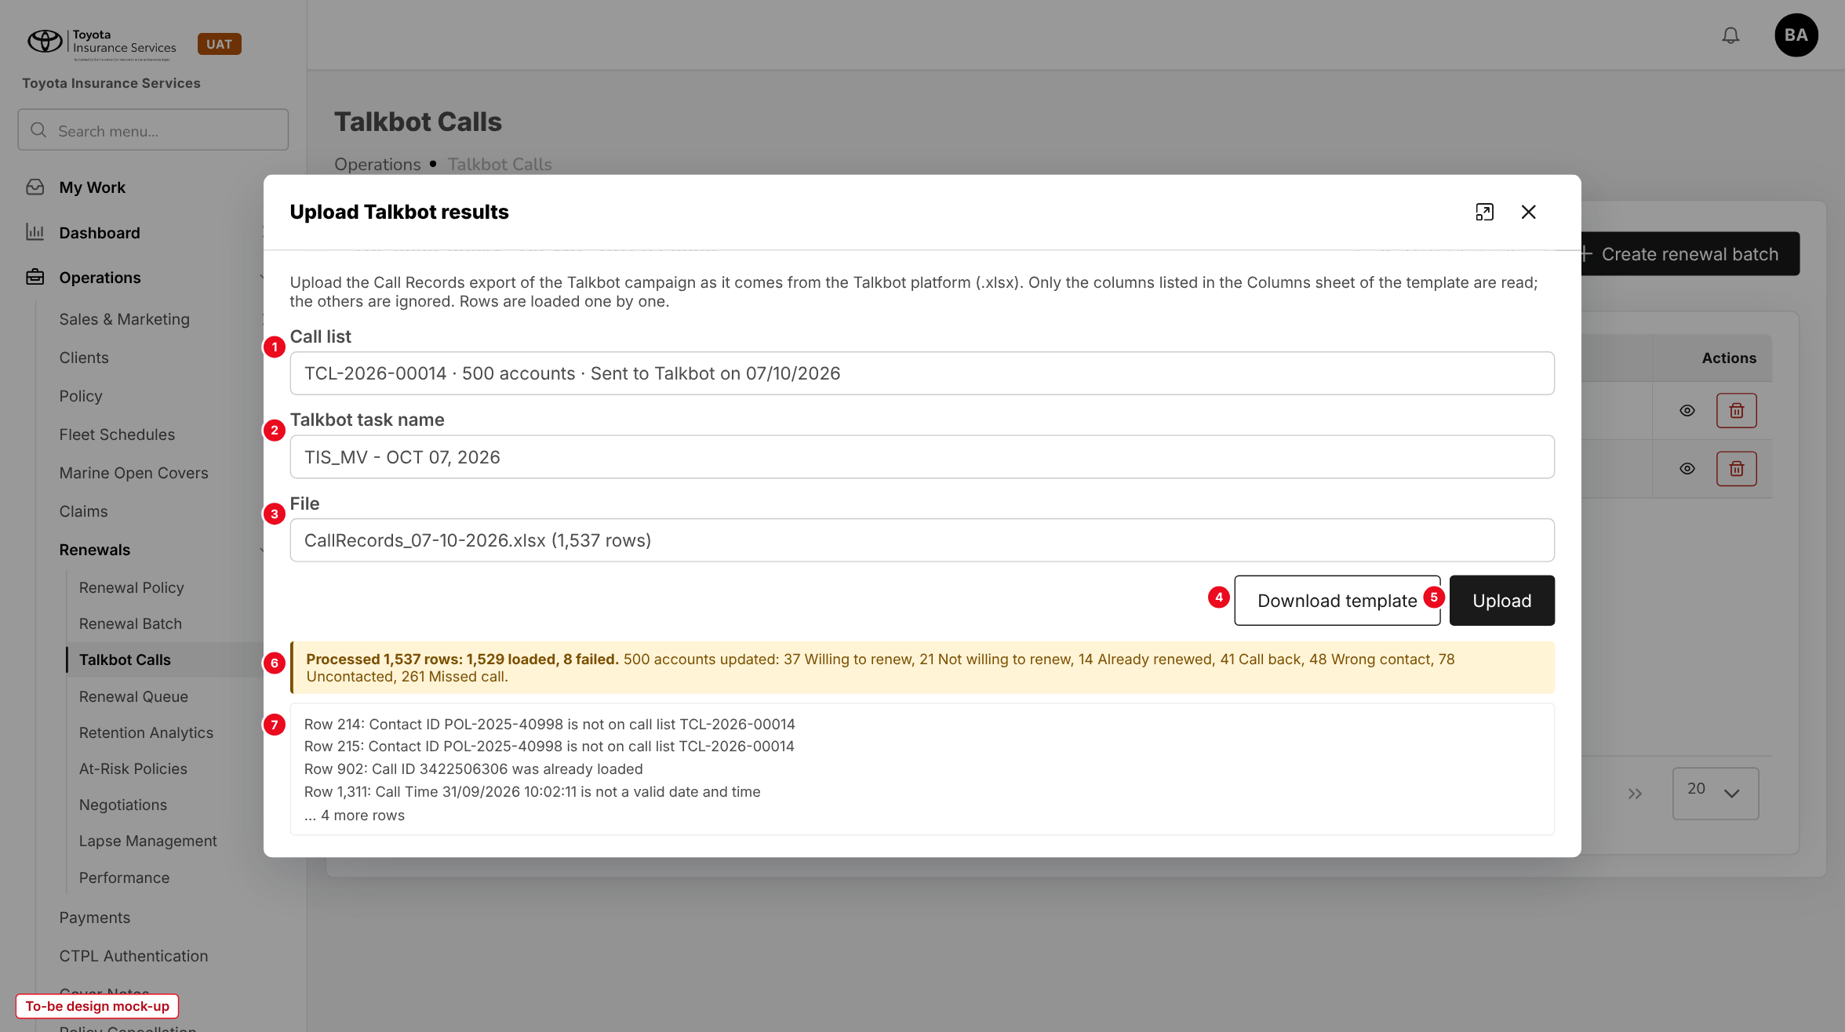
Figure 7: Upload Talkbot results with the result line and failed rows (to-be design mock-up)
No. | Field (label on screen) | Type | Mand. | Source / list | Default | Rule and message
1 | Call list | List | Y | Lists Sent to Talkbot or Results loaded | The open list | MSG-TBT-020
2 | Talkbot task name | Display | - | Call list | - | Compared with Task Name of the file. MSG-TBT-019
3 | File | File | Y | .xlsx | - | MSG-TBT-016 to 018
4 | Download template | Button | - | - | - | Data, Columns, Instructions sheets (chapter 13)
5 | Upload | Button | - | - | - | Enabled when a file is chosen
6 | Result line | Text | - | - | - | MSG-TBT-021 and the outcome counts
7 | Failed rows | Text | - | - | - | Row number and reason. MSG-TBT-022 to 025

10.5 Renewal Batch - Create Batch Renewal (changed)
Type | Existing dialog, two new criteria and columns, new quote status
Purpose | Build a renewal batch from the Talkbot-confirmed policies and generate their renewal quotes.
Who can open it | write:renewals
Navigation | Operations > Renewals > Renewal Batch > Create Batch
FRs | FR-TBT-021, 022

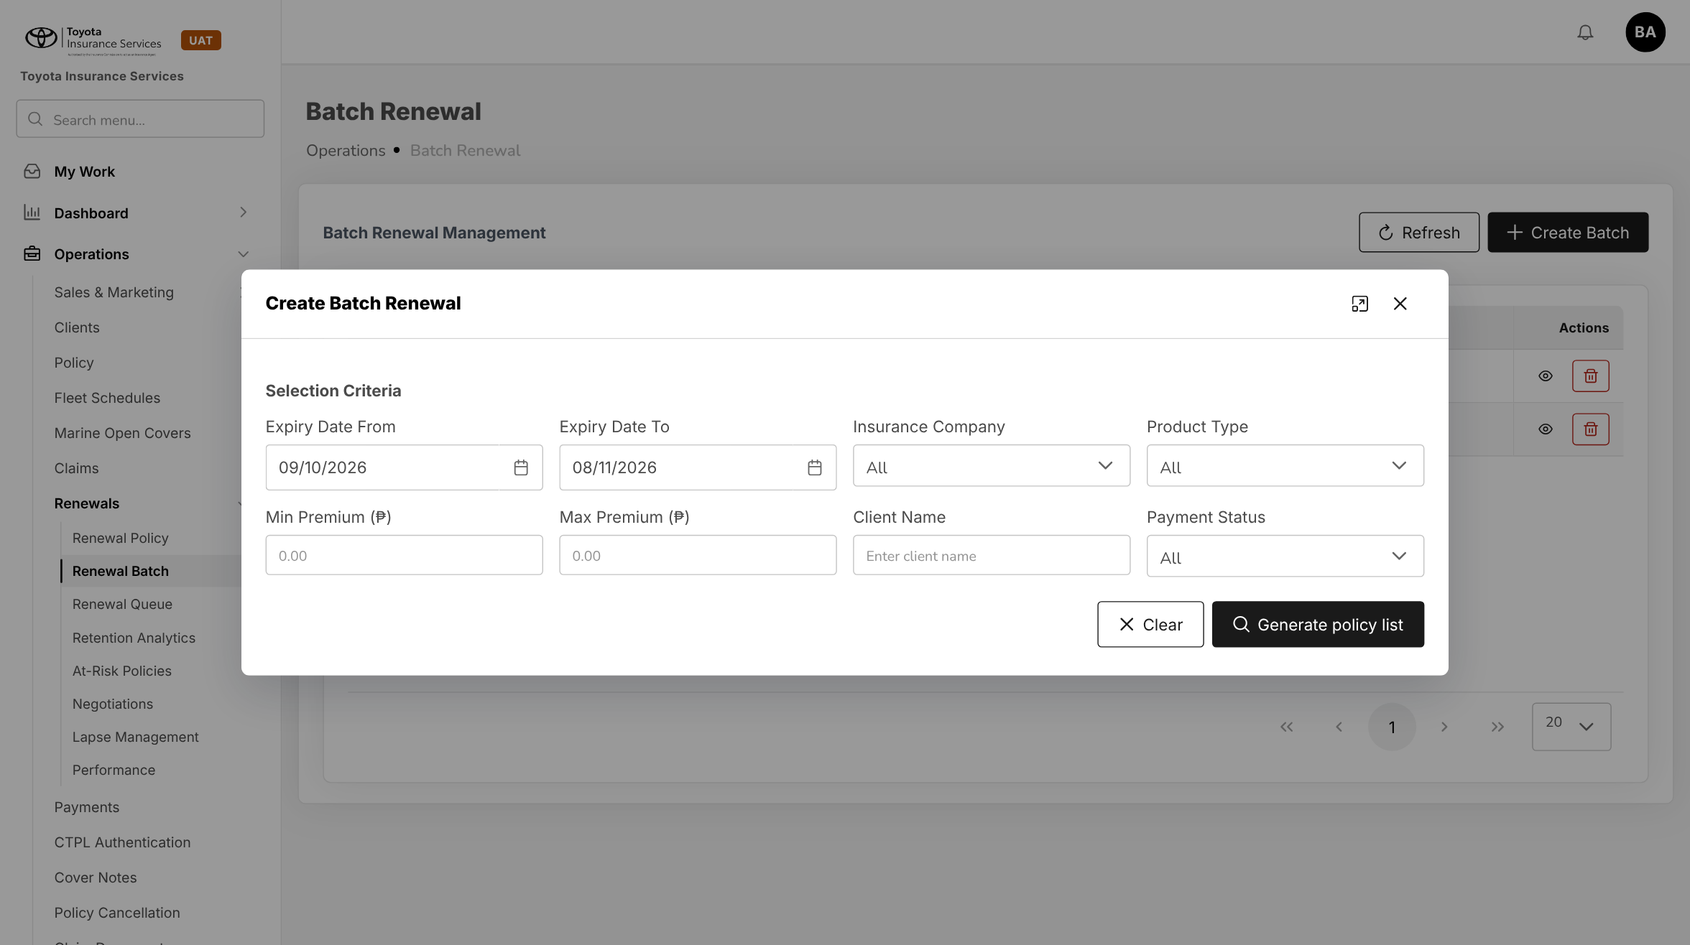
Figure 8: BrokerVerse today: Create Batch Renewal
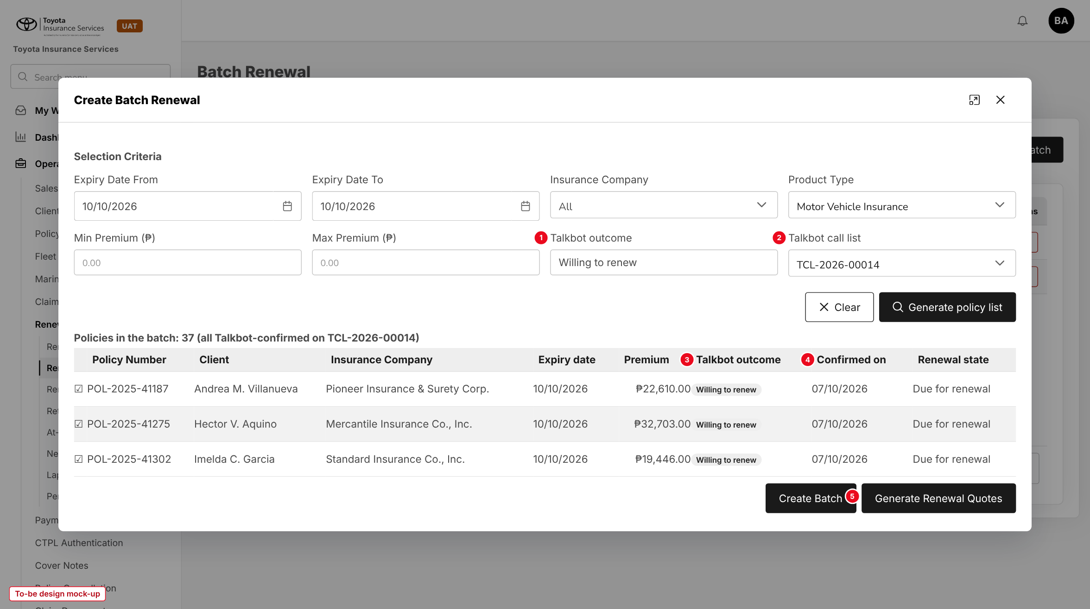
Figure 9: Create Batch Renewal with the Talkbot criteria and the confirmed policies (to-be design mock-up)
No. | Field (label on screen) | Type | Mand. | Source / list | Default | Rule and message
1 | Talkbot outcome | List | N | Talkbot outcome list (7.3) and All | Willing to renew for Motor | New criterion
2 | Talkbot call list | List | N | Call lists | All | New criterion
- | Expiry Date From / To, Insurance Company, Product Type, Min / Max Premium, Client Name, Payment Status (existing) | - | - | - | - | Unchanged (Client Name and Payment Status are hidden in the mock-up for space only)
3 | Talkbot outcome | Column | - | Line outcome | - | New column of the policy list
4 | Confirmed on | Column | - | Outcome date | - | New column
5 | Generate Renewal Quotes | Button | - | - | - | Quotes confirmed Motor policies; others Skipped. MSG-TBT-030 to 032

10.6 Renewal Queue (changed)
Type | Existing screen, new filter and column
Purpose | Follow up renewals with the Talkbot outcome in view.
Who can open it | read:renewals; the Talkbot parts need read:talkbot-calls
Navigation | Operations > Renewals > Renewal Queue
FRs | FR-TBT-013, 023

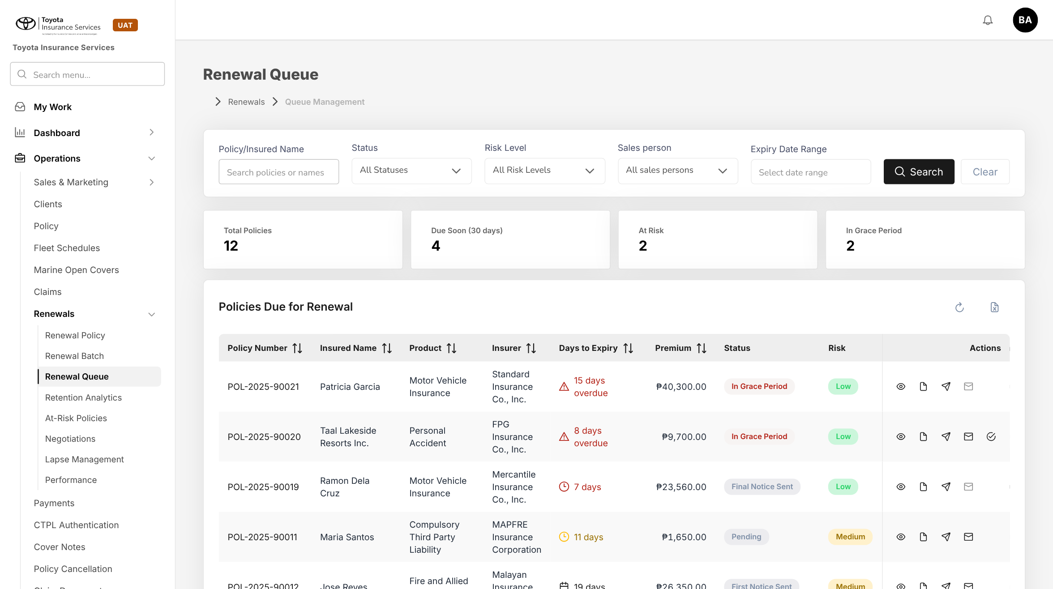
Figure 10: BrokerVerse today: Renewal Queue
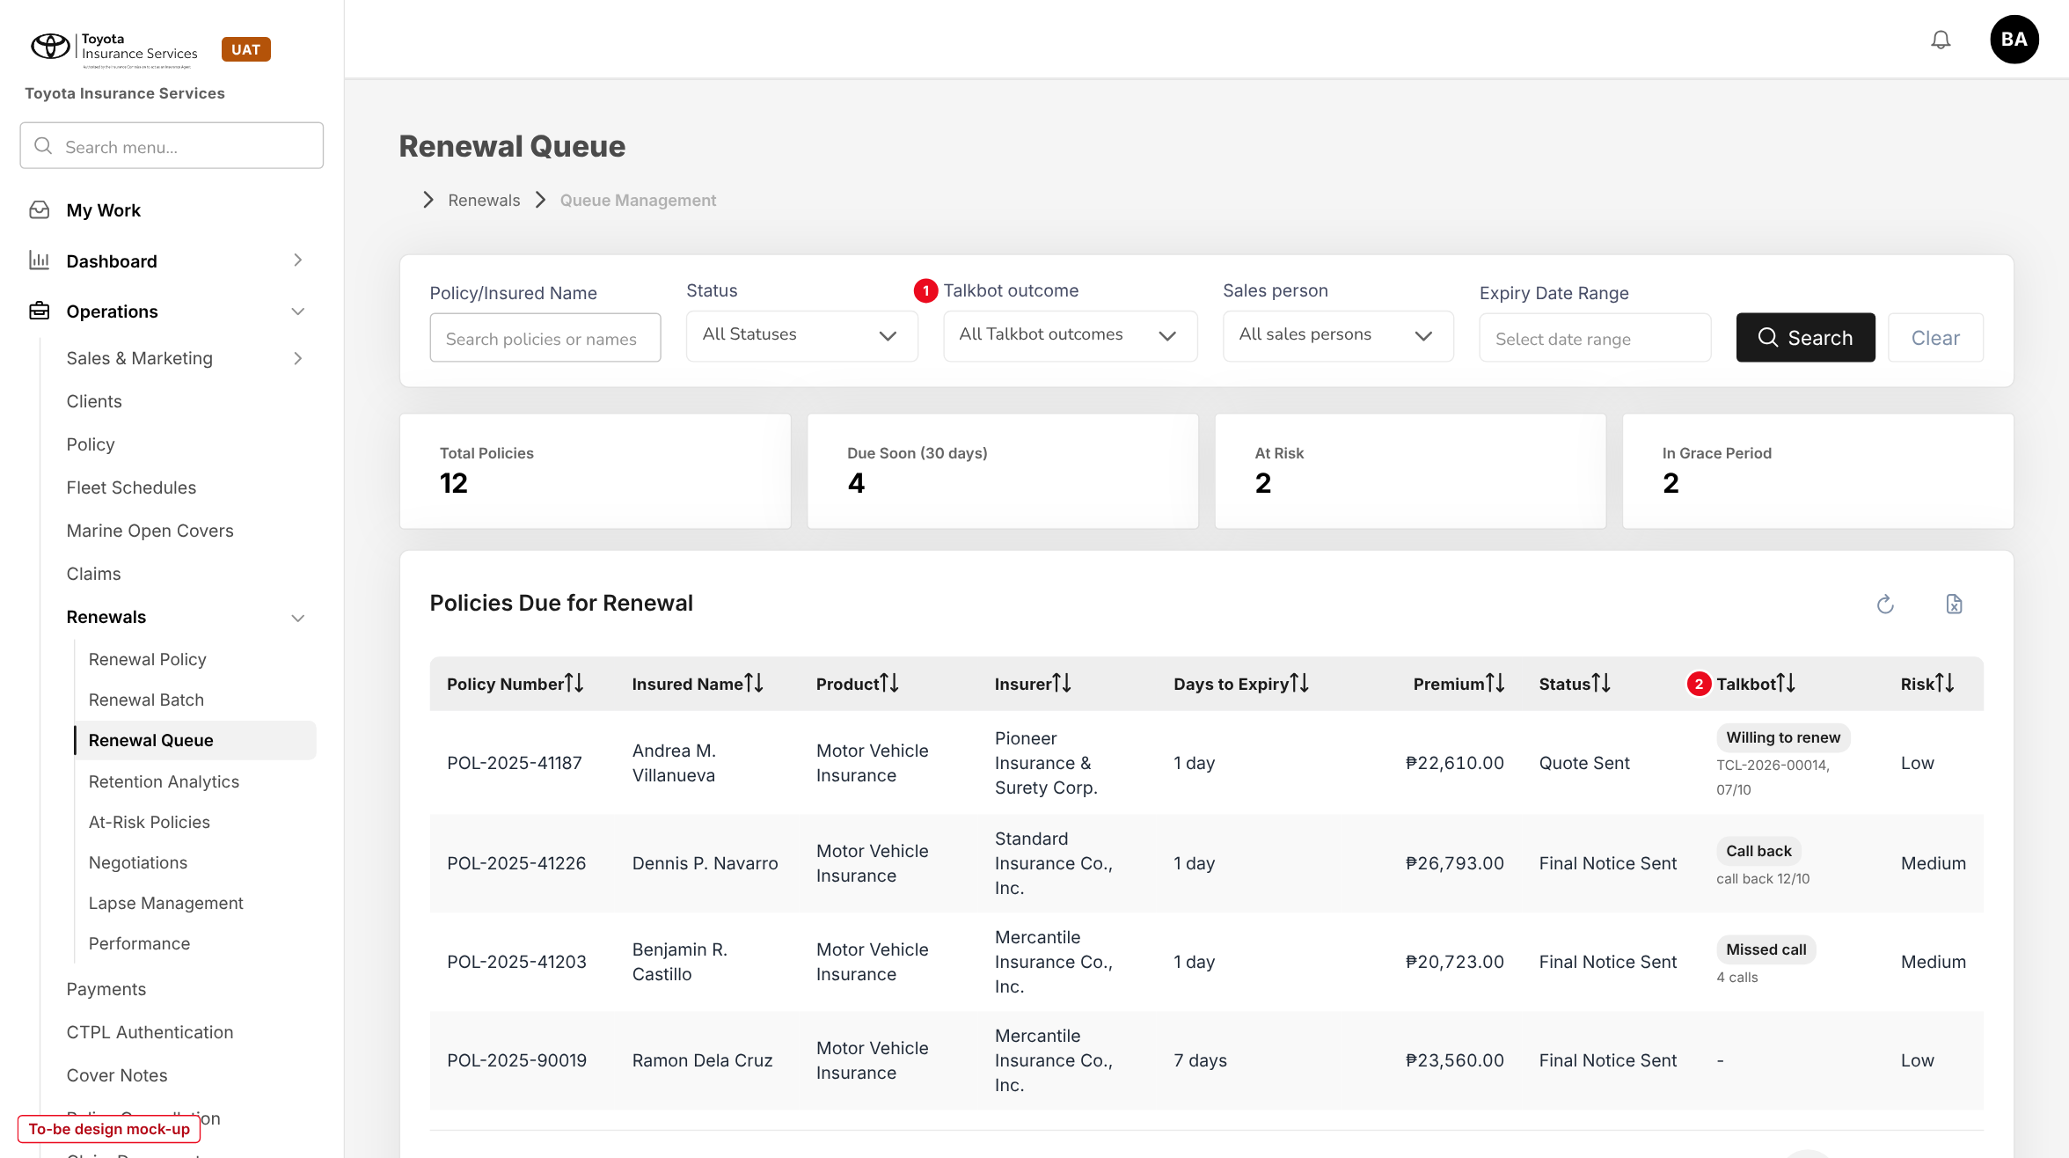
Figure 11: Renewal Queue with the Talkbot outcome filter (1) and column (2) (to-be design mock-up)
No. | Field (label on screen) | Type | Mand. | Source / list | Default | Rule and message
1 | Talkbot outcome | List | N | Talkbot outcome list | All Talkbot outcomes | Filter; takes the place of Risk Level in the mock-up, Risk Level stays
2 | Talkbot | Column | - | Latest line outcome | - | Outcome tag, call list and date, callback date or number of calls

11 End-to-end walkthroughs
The walkthroughs follow one campaign through BrokerVerse using the counts of the sample Talkbot campaign (500 accounts, 1,529 attempts) with fictitious clients. They are the script of the LEAD-09 SIT and UAT sessions.

11.1 WT-A Prepare and send the call list
Table 24: WT-A
Step | Who | Does | Sees / result
1 | Sales Admin | Wednesday 07/10/2026: Talkbot Calls > New call list; Expiry 10/10/2026, Include expired policies still renewable = Yes | "500 accounts can be called. Left out: 6 without a mobile number, 2 under lock-in, 3 already on TCL-2026-00013"
2 | Sales Admin | Create call list | "Call list TCL-2026-00014 created with 500 accounts"; Draft
3 | Sales Admin | Removes POL-2025-41330, reason Complaint in progress, then restores it after checking | Line Removed, then back
4 | Sales Admin | Download call list | TCL-2026-00014_Contact_Import.xlsx, 500 rows; row of POL-2025-41187: 09173047105, ANDREA M. VILLANUEVA, 2026-10-10, 806274, 22610, a, a, @gmail.com, 2023 TOYOTA Raize 1.0 Turbo CVT
5 | Sales Admin | Loads the file on the Talkbot platform, starts task "TIS_MV - OCT 07, 2026", then Mark as sent | "Call list TCL-2026-00014 marked as sent to Talkbot"

11.2 WT-B Load the results
Table 25: WT-B
Step | Who | Does | Sees / result
1 | Sales Admin | Exports CallRecords_07-10-2026.xlsx from Talkbot; call list > Upload results | Task name matches
2 | System | Loads the rows | "Processed 1,529 rows: 1,529 loaded, 0 failed"
3 | System | Derives the outcomes | Willing to renew 37, Not willing to renew 21, Already renewed 14, Call back 41, Wrong contact 48, Uncontacted 78, Missed call 261
4 | System | Timeline of POL-2025-41187 | Talkbot Call - Willing to renew - TCL-2026-00014, 3 attempts
5 | Sales officer | Renewal Queue filtered on Call back; calls Dennis P. Navarro on 12/10/2026, who sold the vehicle; Record outcome Not willing to renew, remark "Vehicle sold" | Not willing to renew (Manual); still 37 confirmed
6 | Sales Admin | Next day: New call list with Re-call accounts not reached on TCL-2026-00014 | Missed call and Uncontacted accounts still renewable added

11.3 WT-C Bulk renewal quoting
Table 26: WT-C
Step | Who | Does | Sees / result
1 | Processing Team | Call list TCL-2026-00014 > Create renewal batch | "Renewal batch RB-2026-90014 created with 37 policies"
2 | Processing Team | Adds 2 more Motor policies expiring 10/10/2026 to a second batch from Create Batch Renewal with Talkbot outcome All, and runs Generate Renewal Quotes | "Renewal quotes queued: 0 policies, 2 skipped as not confirmed by Talkbot"
3 | Processing Team | Generate Renewal Quotes on RB-2026-90014 | 37 Quoted (RQ-2026-90031 to RQ-2026-90067), 0 Skipped, 0 Failed
4 | System | Call list lines | Quoted RQ-2026-90031 on POL-2025-41187
5 | Sales & Marketing | Sends the renewal quotations and follows up on Negotiations; renewal approval and issuance as today | Renewed policies show Renewed on Renewal Policy

12 Messages catalogue
Every message a user can see for this requirement, grouped by the screen that shows it. 33 messages: 8 confirmation, 8 error, 6 information, 9 validation, 2 warning. A validation or error is shown under the field it belongs to; a confirmation is a short toast. Text in angle brackets is filled in by the system.

12.1 New call list
ID | Field | Message | Type | What the user does
MSG-TBT-001 | Expiry Date To | Expiry Date To cannot be before Expiry Date From | Validation | Correct the dates
MSG-TBT-002 | - | No Motor policy due for renewal matches these criteria. Widen the expiry dates or clear a filter. | Information | Change the criteria
MSG-TBT-003 | - | The call list would hold <n> accounts; a call list can hold at most <max>. Narrow the dates or choose an insurer. | Validation | Narrow the criteria
MSG-TBT-004 | - | Call list <number> created with <n> accounts | Confirmation | -
MSG-TBT-005 | Reason | Enter the reason for removing this account from the call list | Validation | Enter a reason
MSG-TBT-006 | - | <n> accounts left out: <count> <reason>, ... | Information | Fix the client data if needed
MSG-TBT-007 | - | <n> accounts are no longer eligible and are left out of the file: <policy numbers> | Warning | Check the lines marked Removed

12.2 Call list
ID | Field | Message | Type | What the user does
MSG-TBT-008 | - | There is no account left to call on this list | Error | Cancel the list
MSG-TBT-009 | - | Call list downloaded: <n> accounts | Confirmation | Load the file on the Talkbot platform
MSG-TBT-010 | - | Download the call list before you mark it as sent | Validation | Download the list
MSG-TBT-011 | Talkbot task name | Enter the Talkbot task name | Validation | Enter the name
MSG-TBT-012 | - | Call list <number> marked as sent to Talkbot | Confirmation | -
MSG-TBT-013 | Remark | Enter the reason for cancelling the call list | Validation | Enter a remark
MSG-TBT-014 | - | Call list <number> cancelled | Confirmation | -
MSG-TBT-015 | - | Call list <number> closed | Confirmation | -
MSG-TBT-026 | Remark | Enter a remark for the outcome you record | Validation | Enter a remark
MSG-TBT-027 | - | Outcome recorded for policy <policy number> | Confirmation | -
MSG-TBT-033 | - | You do not have access to Talkbot call lists | Error | Ask the System Administrator

12.3 Upload Talkbot results
ID | Field | Message | Type | What the user does
MSG-TBT-016 | File | Upload the Talkbot Call Records file as Excel (.xlsx) | Validation | Export the file again as .xlsx
MSG-TBT-017 | File | The file has no column <name>. Upload the Call Records export of the Talkbot platform. | Error | Use the right export
MSG-TBT-018 | File | The file has <n> rows; at most <max> rows can be loaded at once | Error | Split the file
MSG-TBT-019 | Talkbot task name | The file is for Talkbot task <file task> but the call list was sent as <list task>. Load it anyway? | Warning | Confirm or cancel
MSG-TBT-020 | - | Mark the call list as sent to Talkbot before you upload results | Validation | Mark the list as sent
MSG-TBT-021 | - | Processed <n> rows: <c> loaded, <f> failed | Information | Check the failed rows
MSG-TBT-022 | Contact ID | Row <n>: Contact ID <id> is not on call list <number> | Error | Check the file belongs to this list
MSG-TBT-023 | Call ID | Row <n>: Call ID <id> was already loaded | Error | None; the row is ignored
MSG-TBT-024 | Call Time | Row <n>: Call Time <value> is not a valid date and time | Error | Correct the row and upload it again
MSG-TBT-025 | Contact Number | Row <n>: Contact Number <number> belongs to more than one account on the list | Error | Record the outcome by hand

12.4 Renewal Batch
ID | Field | Message | Type | What the user does
MSG-TBT-028 | - | No Talkbot-confirmed account on this list is waiting for a renewal batch | Information | -
MSG-TBT-029 | - | Renewal batch <batch number> created with <n> policies | Confirmation | Open the batch and generate the renewal quotes
MSG-TBT-030 | Quote status | Not confirmed by Talkbot | Information | Call the client or record the outcome
MSG-TBT-031 | Quote status | Talkbot confirmation of <date> is older than <n> days | Information | Put the account on a new call list
MSG-TBT-032 | - | Renewal quotes queued: <q> policies, <s> skipped as not confirmed by Talkbot | Confirmation | Refresh to see the progress

13 Upload screens

13.1 Talkbot call results template
Built like the other base templates (Download template): an Excel file with the sheets Data (header row with the 13 columns; required headers in dark red), Columns (each column with its format and an example) and Instructions. The Talkbot Call Records export can be uploaded as it is: its other 54 columns are ignored. Rows are loaded one by one; a failed row does not stop the others.
Table 27: Template columns
Column | Mand. | Format | Rule
Task Name | Y | Text | Same for all rows; compared with the task name of the call list
Contact ID | Y* | Text | Policy number on the call list (*Contact Number used when blank)
Call ID | Y | Text | Unique; a Call ID already loaded fails
Contact Name | N | Text | Stored only
Contact Number | Y | 11 digits | Fallback key when Contact ID is blank
Result | Y | Text | Talkbot telephony result, e.g. Missed Call(19), Connected(202)
Call Time | Y | DD/MM/YYYY HH:MM:SS | Manila time
Call Duration | N | Whole seconds | -
Tags | N | Text | Stored as detail
Call Drop-off Point | N | Text | Stored as detail
Call Status | N | Text | Values in chapter 6
Call Result | N | Text | Will Renew, Will not Renew, Not Interested, Undecided, Unspecified
Date of Callback | N | YYYY-MM-DD | Follow-up date of a Call back

Limits: .xlsx only, first sheet, at most 20,000 rows (talkbot.max_upload_rows). The result line reads "Processed n rows: c loaded, f failed" with "Row n: message" for each failed row.

13.2 Call list file
The Contact Import file is produced by BrokerVerse, not uploaded. Its columns are in section 6.1.

14 Sign-off and change control

14.1 What is signed
TISPH signs this FRS for TIS-BRD-LEAD-09 as built on BrokerVerse: the process flows (chapter 2), the functional requirements (chapter 4), the workflow (chapter 5), the interfaces (chapter 6), and the screens, messages and uploads (chapters 9 to 13). Values marked default are configuration and are not frozen.

14.2 Change after sign-off
A change to anything signed is raised through the change control route of BRD section 8. The project team assesses its effect on BrokerVerse and on LEAD-07 in the same CR-02, and on SCHM-03 for the lock-in and Scheme 2 exclusions, and issues a new version of this FRS for delta sign-off. A change of the Talkbot file layouts by the Talkbot provider is handled the same way. When the screens are built, the to-be mock-ups are replaced with screenshots of the TISPH UAT environment.

14.3 Signatures
Table 28: Sign-off
Role | Name | Unit | Signature | Date
Business owner |  | TIS Sales
Business reviewer |  | TISPH Operations
Project Manager |  | TISPH DTID
Delivery lead |  | iorta TechNXT

