

FUNCTIONAL REQUIREMENTS SPECIFICATION
Commission Rules and Sharing Schemes
Issuing rate against net remitting rate on the commission rules register, sharing schemes for agents, TFS team members, referrals and dealers, and share changes within minimum and maximum limits by user right

Client | Toyota Insurance Services Philippines Corporation (TISPH)
Document | TISPH-FRS-PROD-16
Requirement | TIS-BRD-PROD-16
Version | 1.0
Date | 9 October 2026
Status | Issued for TISPH review
Classification | Confidential

Prepared by iorta TechNXT for TISPH 
This document is confidential to Toyota Insurance Services Philippines Corporation and iorta TechNXT.
Document Control
Version | Date | Author | Reviewer | Approver | Change
1.0 | 9 Oct 2026 | iorta TechNXT Business Analysis | iorta TechNXT Project Manager | TIS FGA (pending) | First issue for review

Distribution List
Name / Unit | Role | Organisation | Purpose
TIS Finance and General Accounting (business owner) | Approver | TISPH | Review and sign-off
TIS Sales | Business user | TISPH | Sharing schemes and quotation FRs
Sales Admin | Business user | TISPH | Referrers, channels and quotation FRs
Operations | Business user | TISPH | Conversion, endorsement and renewal FRs
DTID - Project Management Team | Project owner | TISPH | Traceability against the BRD
Project team | Delivery | iorta TechNXT | Build, test and UAT preparation

Contents
1 Overview 5
1.1 The requirement 5
1.2 Scope 5
1.3 Definitions and acronyms 6
1.4 How to read the functional requirements 6
1.5 What changes in BrokerVerse 7
2 Process flow 8
2.1 Flow A - Keep the commission rules 8
2.2 Flow B - Set up and assign a sharing scheme 9
2.3 Flow C - Quotation to policy 10
2.4 Dimensions covered 11
3 Personas and roles 12
3.1 Personas 12
3.2 New permissions 12
3.3 Default grants 12
4 Functional requirements 14
4.1 Commission rules register 14
FR-CMR-001 Keep commission rules by insurer, product, channel, motor type, policy type and band 14
FR-CMR-002 Hold the issuing rate and the insurer remitting rate per peril 15
FR-CMR-003 Approve rule changes on Configuration Approvals and keep the history 17
FR-CMR-004 Find the rule that applies to a placement 18
FR-CMR-005 Load commission rules from Excel 19
FR-CMR-006 Use the promotion rates and promo remitting rates of PROD-15 20
4.2 Sharing schemes 21
FR-CMR-010 Set up a sharing scheme 21
FR-CMR-011 Define split lines with share basis, default, minimum and maximum 23
FR-CMR-012 Share along an agent hierarchy 24
FR-CMR-013 Approve, suspend and end a sharing scheme 25
FR-CMR-014 Assign schemes to referrers and Distribution Channels, with an override inside the limits 26
FR-CMR-015 Choose the scheme for a quotation or policy 27
4.3 Quotation and policy 27
FR-CMR-020 Fill the issuing rates on Create Quote from the rule 27
FR-CMR-021 Show commission and sharing on Order Summary 28
FR-CMR-022 Change a share inside the limits by user right 29
FR-CMR-023 Freeze the commission basis at conversion to policy 30
FR-CMR-024 Keep the commission basis on endorsement, cancellation and renewal 31
FR-CMR-025 Commission lines of referrers follow the scheme 31
4.4 Audit and access 32
FR-CMR-030 Keep a complete audit trail of rules, schemes and shares 32
FR-CMR-031 Control access to rules, schemes and share changes 32
5 Workflow and status model 34
5.1 Commission rule 34
5.2 Sharing scheme 34
5.3 Scheme assignment 34
5.4 Commission basis on the quotation and the policy 35
6 Interfaces 36
7 Configuration items 37
7.1 Settings 37
7.2 Scheduled job 37
7.3 Lists of values 37
7.4 Masters maintained by the business 38
8 Traceability 39
8.1 BRD clause to FR 39
8.2 Related BRD requirements 39
8.3 FR to test cases 40
9 Navigation 41
9.1 Screens of PROD-16 41
9.2 Menu by base role 41
10 Screen specifications 42
10.1 Commission Rate Matrix (changed) 42
10.2 Add / Edit commission rule - Rule tab (changed) 44
10.3 Add / Edit commission rule - Peril rates tab (new) 45
10.4 Test rate (changed) 46
10.5 Configuration Approvals (existing screen) 46
10.6 Sharing Schemes list (new) 47
10.7 Add / Edit sharing scheme (new) 48
10.8 Scheme on a channel and on a referrer (changed) 49
10.9 Create Quote - Step 5 Order Summary (changed) 50
10.10 Referrer account line drawer (changed) 51
10.11 Upload rules (new) 52
11 End-to-end walkthroughs 53
11.1 WT-A Load an insurer net rate schedule 53
11.2 WT-B Agent business 53
11.3 WT-C Dealer business 53
11.4 WT-D Exceptions 54
12 Messages catalogue 55
12.1 Commission Rate Matrix 55
12.2 Upload rules 56
12.3 Sharing Schemes 56
12.4 Scheme assignment (referrers and channels) 56
12.5 Create Quote and policy 57
12.6 Agents/Referrer Accounts 57
13 Upload screens 58
13.1 Commission rules template 58
14 Sign-off and change control 59
14.1 What is signed 59
14.2 Change after sign-off 59
14.3 Signatures 59
Appendix A Commission examples 60
A.1 Agent business - Standard Insurance, Vios, Own Damage sum insured PHP 800,000 60
A.2 Dealer business - same policy through Makati Motors (DLR-STD, override 45%) 60
A.3 Agent business on a promotion - Fortuner, Own Damage sum insured PHP 1,200,000, PRM-FORTUNER26 60

1 Overview

1.1 The requirement
TIS-BRD-PROD-16 Commission & Sharing Schemes (Customization, Phase 1, CR-01). Commission rules per product, insurer and channel with bands and overrides (issuing rate vs. net remitting rate), plus sharing schemes for agent, dealer and referral/incentive splits, editable within configured min/max limits by user rights. Delivery basis: dual-rate model on the commission rules register with sharing splits and min/max edit rights.

On a Motor policy TISPH works with three rates on Own Damage and Acts of Nature. The client pays the issuing rate on the sum insured (Own Damage 2.00%). TISPH remits a lower net rate to the insurer (for example Own Damage 1.30%); each insurer has its own net rates, by type of vehicle and by new business or renewal. The difference is the commission of TISPH. When the business comes from an external agent, a TFS team member or a referral, it is remitted to TISPH at the TIS remitting rate (Own Damage 1.70%), so the 0.30 point variance is their share. Dealers and other partners can be given a share of the commission under an agreed scheme.
This FRS turns that into data in BrokerVerse. The Commission Rate Matrix becomes the commission rules register: each rule holds, per peril, the issuing rate, the TIS remitting rate and the insurer net rate, or a commission % for the perils paid as a share of premium. A new Sharing Schemes screen holds the splits, each with a default, a minimum and a maximum. The quotation shows the brokerage and the share, a user with the right can change the share within the limits, and the policy keeps the rule and the scheme it was issued with. The billing and remittance runs then use them (COMM-06).
Screens that change or are new are shown as to-be mock-ups drawn on the real BrokerVerse screens with the Toyota Insurance Services look.

1.2 Scope
In scope
- The Commission Rate Matrix (Master > Finance) as the commission rules register: new keys (channel type, motor type, sum insured band), a rate basis per rule, per-peril issuing, TIS remitting and insurer net rates, approval on Configuration Approvals, history, Excel upload and an extended Test rate.
- A new Sharing Schemes screen (Commission > Sharing Schemes): party types, split lines with share basis, default, minimum and maximum, agent hierarchy splits, approval, suspension and end.
- Assignment of a scheme, with an override inside the limits, to a referrer (Commission > Agents/Referrer Accounts) and to a Distribution Channel (Master > Insurance > Distribution Channels).
- On Create Quote: issuing rates filled from the rule, and a Commission & sharing panel on Step 5 Order Summary where an authorised user can change the share within the limits.
- The commission basis frozen on the policy at conversion, and its treatment on endorsement, cancellation and renewal; the scheme and its limits on the commission lines of Agents/Referrer Accounts.
- Interaction with the promotion rates and promo remitting rates of PROD-15.
Out of scope
- The calculation of commission and of the shares in the weekly remittance and billing runs, including the instalment hold until fully paid: COMM-06.
- The telesales incentive (15-policy trigger, tiers, production excess): COMM-08.
- Endorsement commission supplied by the insurer as an upload: COMM-07. This FRS only says which scheme splits it.
- Reports on commission sharing: not part of this requirement.
- Overriding, profit and contingent commission from insurers (Commission > Insurer Overrides): unchanged.

1.3 Definitions and acronyms
Table 1: Definitions
Term | Meaning in this FRS
Commission rule | One row of Master > Finance > Commission Rate Matrix: insurer, product or line of business, policy type, channel type, motor type and sum insured band, with its peril rates and effective dates.
Issuing rate | The rate charged to the client on the sum insured of a peril, for example Own Damage / Theft 2.00% and Acts of Nature 0.50%. It is the default of Own Damage coverage Rate and Acts of Nature Rate on Create Quote.
TIS remitting rate | The rate at which business from an external agent, a TFS team member or a referral is remitted to TISPH, for example Own Damage / Theft 1.70% and Acts of Nature 0.40%.
Insurer net rate | The net rate TISPH remits to the insurer on the sum insured of a peril (net IP remitting rate), for example Own Damage / Theft 1.30% and Acts of Nature 0.30%.
Commission (brokerage) | The commission of TISPH on a policy before any sharing. On an issuing-vs-remitting peril: (issuing rate - insurer net rate) x sum insured of the peril. On a %-of-premium peril: commission % x premium of the peril.
Variance | Issuing rate - TIS remitting rate, in rate points (Own Damage 0.30, Acts of Nature 0.10). Variance x sum insured is the share of the external agent, TFS team member or referral.
Sharing scheme | A record on Commission > Sharing Schemes that says who receives part of the commission, on which basis and within which limits.
Split line | One line of a scheme: who is paid (the referrer, the parent agent, the dealer), the share basis, the perils, and the default, minimum and maximum.
Share basis | Variance to the TIS remitting rate; % of commission; % of net premium; Fixed amount per policy (PHP).
Party type | The kind of party a scheme is for: Agent, Sub-agent, TFS team member, Referral, Dealer, Affinity partner, External.
Override | A share value set for one referrer, one channel or one quotation, different from the scheme default but inside its minimum and maximum.
Commission basis | The rule, peril rates, scheme, split values and amounts kept on a quotation and frozen on the policy at conversion.
Motor type | Commission class of the vehicle: PC-Sedan Regular; PC-Electric Vehicles; PC-Other than Sedan (SUV / AUV / MPV / Pick-up / Van); CV-Light; LTO (Aircon Bus, UV Express, TNVS); MC-Regular (below 400 cc); MC-High-End (400 cc and above).
Channel type | Financing bank, Dealer, Affinity partner, Agent / referrer or Direct, derived from the Distribution Channel or the referrer of the quotation (the same list as PROD-15).
OD / AON / BI / PD / APPA / CTPL | Own Damage (with Theft) / Acts of Nature / Bodily Injury / Property Damage / Auto Passenger Personal Accident / Compulsory Third Party Liability.
TFS / IP | Toyota Financial Services Philippines / Insurance Partner (insurer).

1.4 How to read the functional requirements
Each FR in chapter 4 has the same parts:
- A header table with the BRD trace, the actor, the priority, the fit and the screens that implement it.
- Description, preconditions, main flow and alternate and exception flows.
- Business rules. Configurable rules are maintained on a master or on Master > System > Configuration (chapter 7). Fixed rules change only through a change request.
- Validations and messages: the check and the message the user sees, word for word, with its ID in chapter 12. As everywhere in BrokerVerse, a message is plain English and is shown under the field it belongs to, or as a toast.
- Audit and numbered acceptance criteria, the basis of the test cases TC-CMR-nnn-n.
Note. Rates, shares and limits in the examples are illustrative until TISPH confirms the net rate schedules of each insurer and the agent, dealer and referral sharing schedule. Premium figures follow the BrokerVerse premium engine (NET Premium, VAT 12%, DST, LGT 0.75%, CTPL).

1.5 What changes in BrokerVerse
BrokerVerse already computes brokerage and referrer commission (comsub) from a single rate. The table lists what PROD-16 reuses, changes and adds.
Table 2: BrokerVerse today and PROD-16
BrokerVerse today | What PROD-16 does
Master > Finance > Commission Rate Matrix: one brokerage rate (% of net premium) per insurer, product, line of business and policy type, with effective dates. Precedence insurer + product, insurer + line, insurer, product, line; then the insurer default rate and commission.default_rate (15%). Saved directly by write:masters; rows can be deleted. | Changed into the commission rules register. New keys channel type, motor type and sum insured band; rate basis Issuing vs remitting (per peril) next to % of net premium; per-peril issuing, TIS remitting and insurer net rates; changes approved on Configuration Approvals; no delete of a used rule; Upload rules; Test rate returns the rule and the scheme.
Create Quote > Step 3 Coverage Details: Own Damage coverage Rate 2.00% and Acts of Nature Rate 0.50% from setting premium.default_rates. | Changed. The issuing rates of the rule are the defaults; the setting stays as the fallback. A promotion (PROD-15) still replaces them.
Commission referral details on the quotation default to "Direct"; comsub = fixed amount + % of net premium, rate by referrer level (L1 8%, L2 5%, commission.comsub_rate_by_level); no limits on the rate. | Changed. New Commission & sharing panel on Step 5 Order Summary; share from the scheme; change only with write:commission-share and inside the minimum and maximum.
Commission > Agents/Referrer Accounts: referrers of type Agent, Sub-agent or External, level L1 / L2, lines Accrued, Eligible, Approved, Paid; "Change rate" on a line before approval with no limit. | Changed. Party type and sharing scheme on the referrer; lines carry the scheme and its limits; Change rate kept inside them.
Master > Insurance > Distribution Channels: Referrer and Comsub % per channel. | Changed. Comsub % replaced by Sharing scheme and Share override (%), approved on Configuration Approvals.
Master > Insurance > Vehicle: Brand, Model, Variant; no commission class. | Changed. New column Motor type at model level.
No sharing scheme, no issuing-vs-remitting split, no minimum or maximum on shares. | New. Sharing Schemes screen and the commission basis on quotations and policies, read by the COMM-06 runs.

2 Process flow
Three flow charts show the item end to end: Flow A keeps the commission rules, Flow B sets up and assigns a sharing scheme, Flow C applies both on a quotation and a policy. Black rounded boxes are start and end points, diamonds are decisions, red boxes are exceptions, grey boxes are done by the system and boxes with a heavy border are the successful outcome.

2.1 Flow A - Keep the commission rules
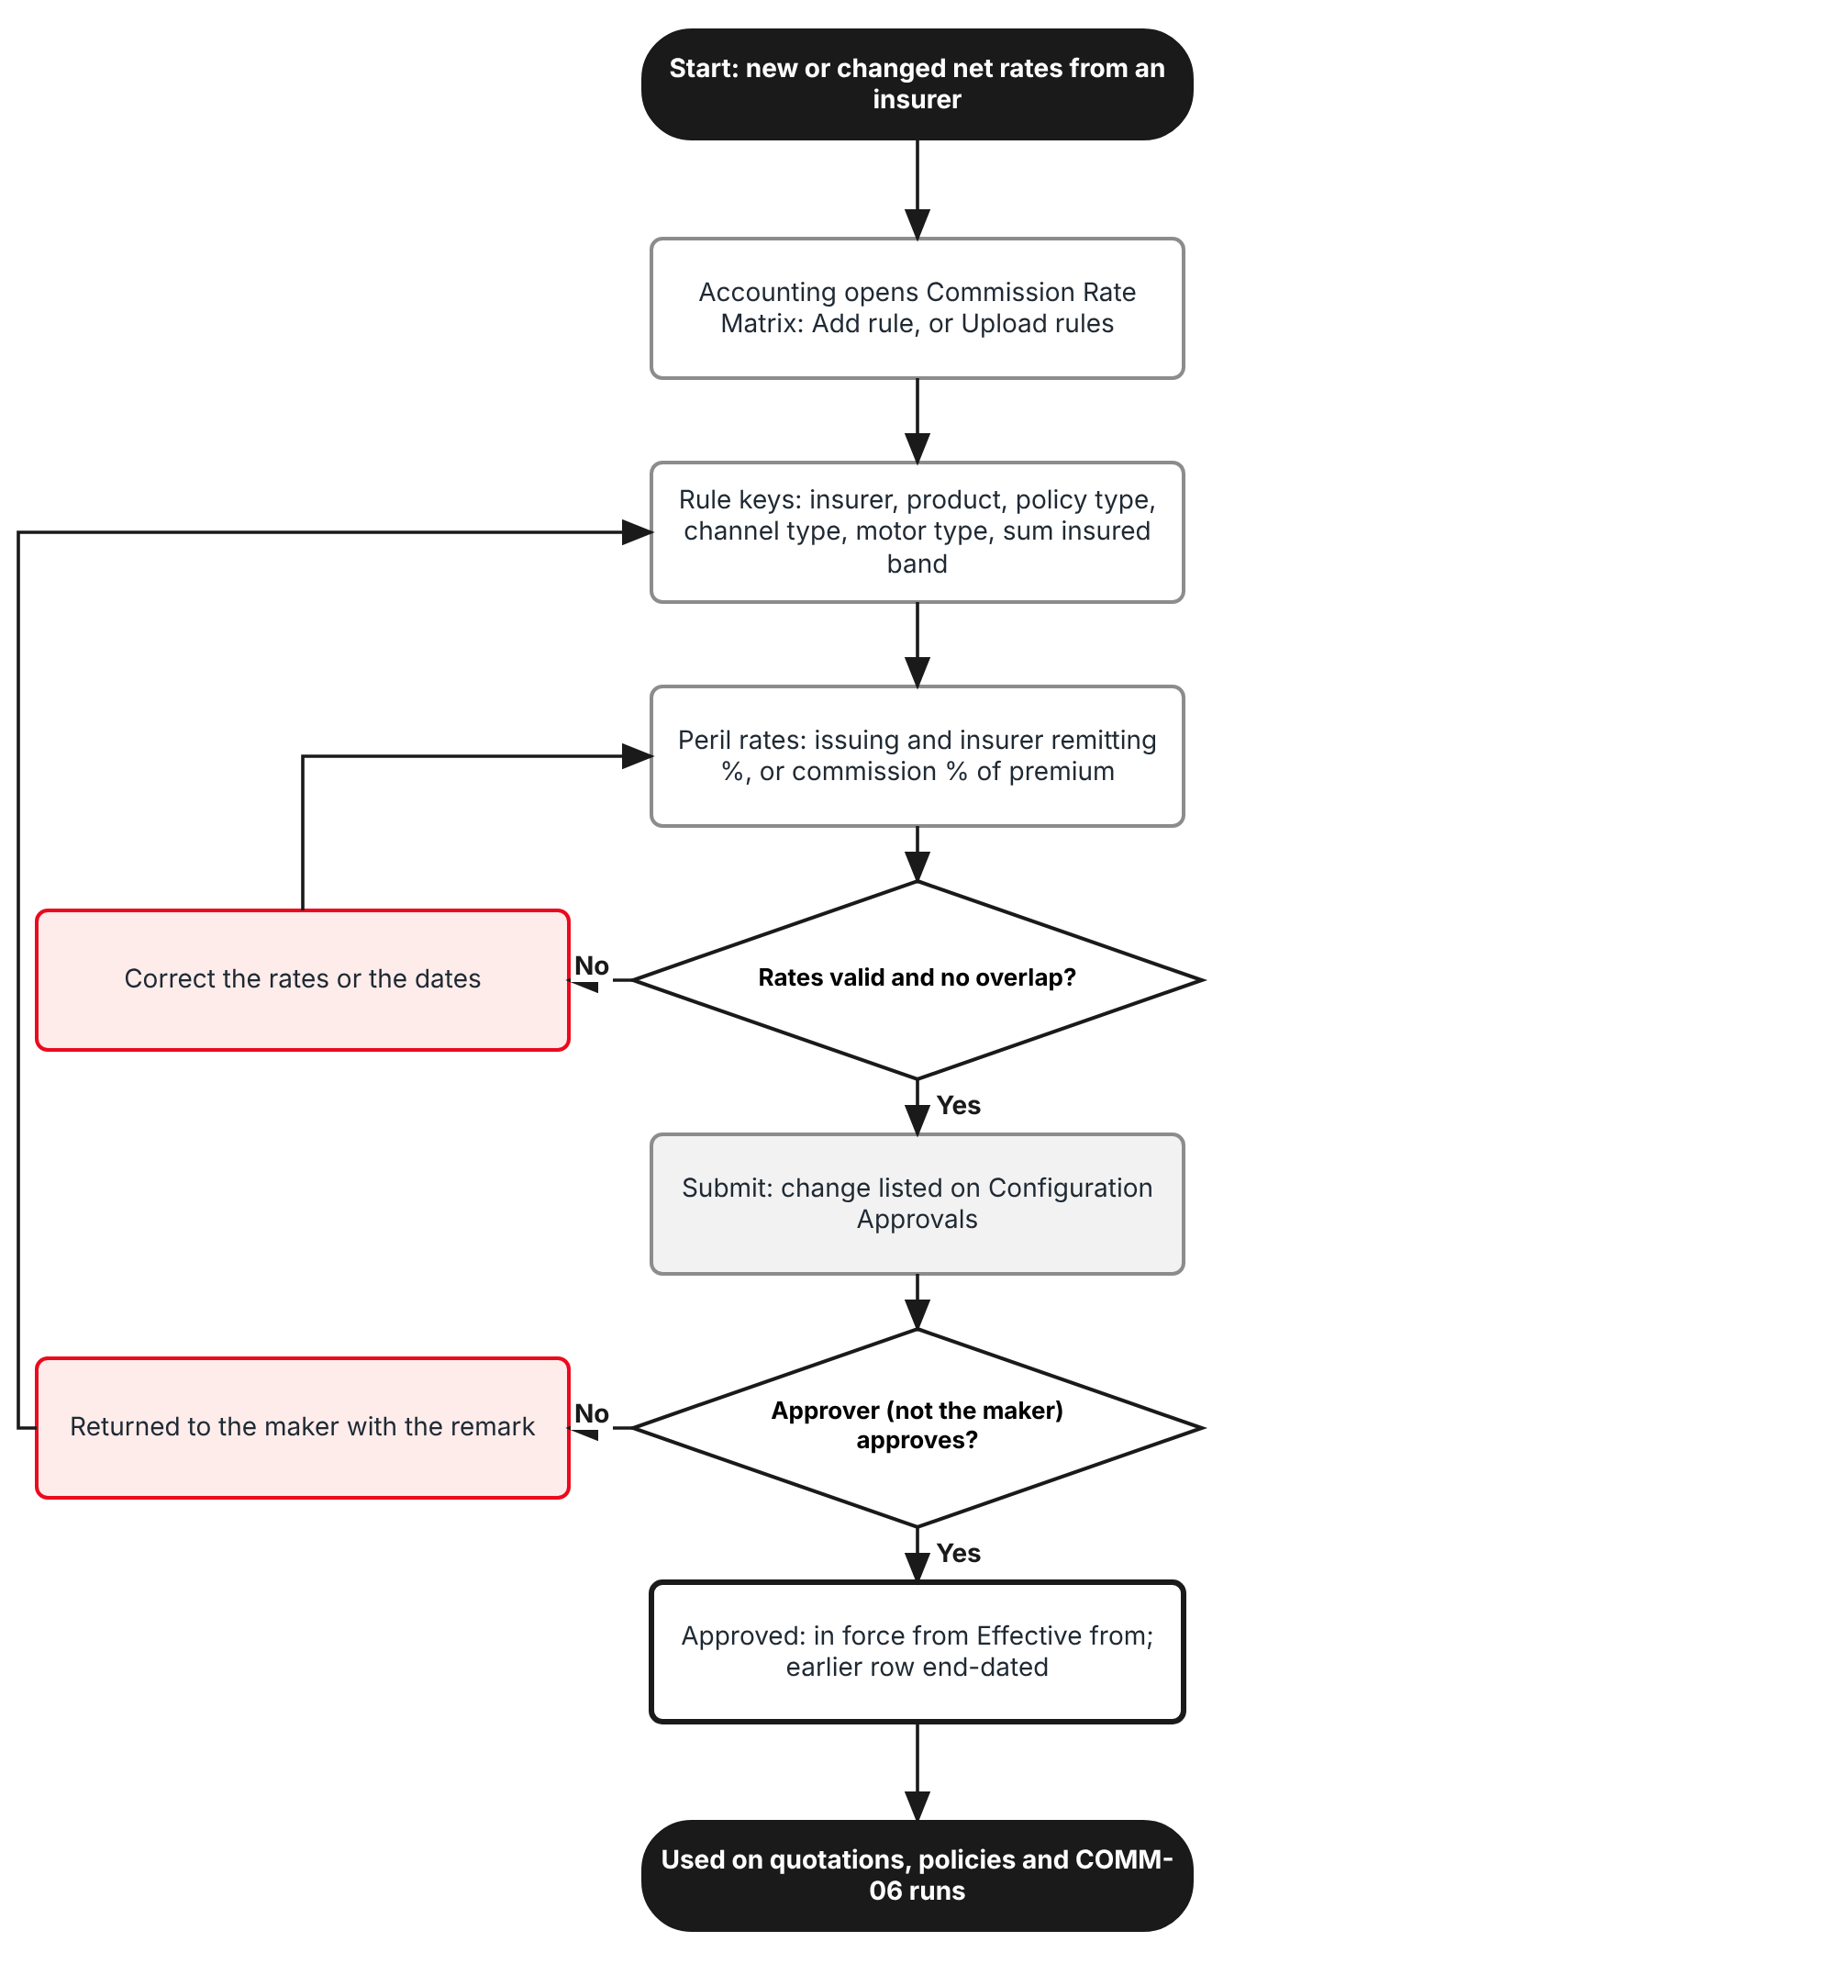
Figure 1: Flow A - Add or change a commission rule
Table 3: Flow A steps
Step | Who (role) | What happens | FR
A1 | Accounting | Receives a new or changed net rate schedule from an insurer and opens Master > Finance > Commission Rate Matrix. | FR-CMR-001
A2 | Accounting | Add rule: insurer, product, policy type, channel type, motor type, sum insured band, effective dates; or Upload rules for many rules at once. | FR-CMR-001, 005
A3 | Accounting | Peril rates tab: issuing, TIS remitting and insurer net rate for Own Damage / Theft and Acts of Nature; commission % of premium for Bodily Injury, Property Damage and APPA. | FR-CMR-002
A4 | System | Checks the rates and that no other rule has the same keys and dates. An error is corrected before submit. | FR-CMR-002, 003
A5 | Accounting Manager (approve:commission-rules) | Approves or returns the change on Master > Finance > Configuration Approvals. The maker can never approve it. | FR-CMR-003
A6 | System | The approved rule is in force from its Effective from; the rule it replaces is end-dated the day before. | FR-CMR-003

2.2 Flow B - Set up and assign a sharing scheme
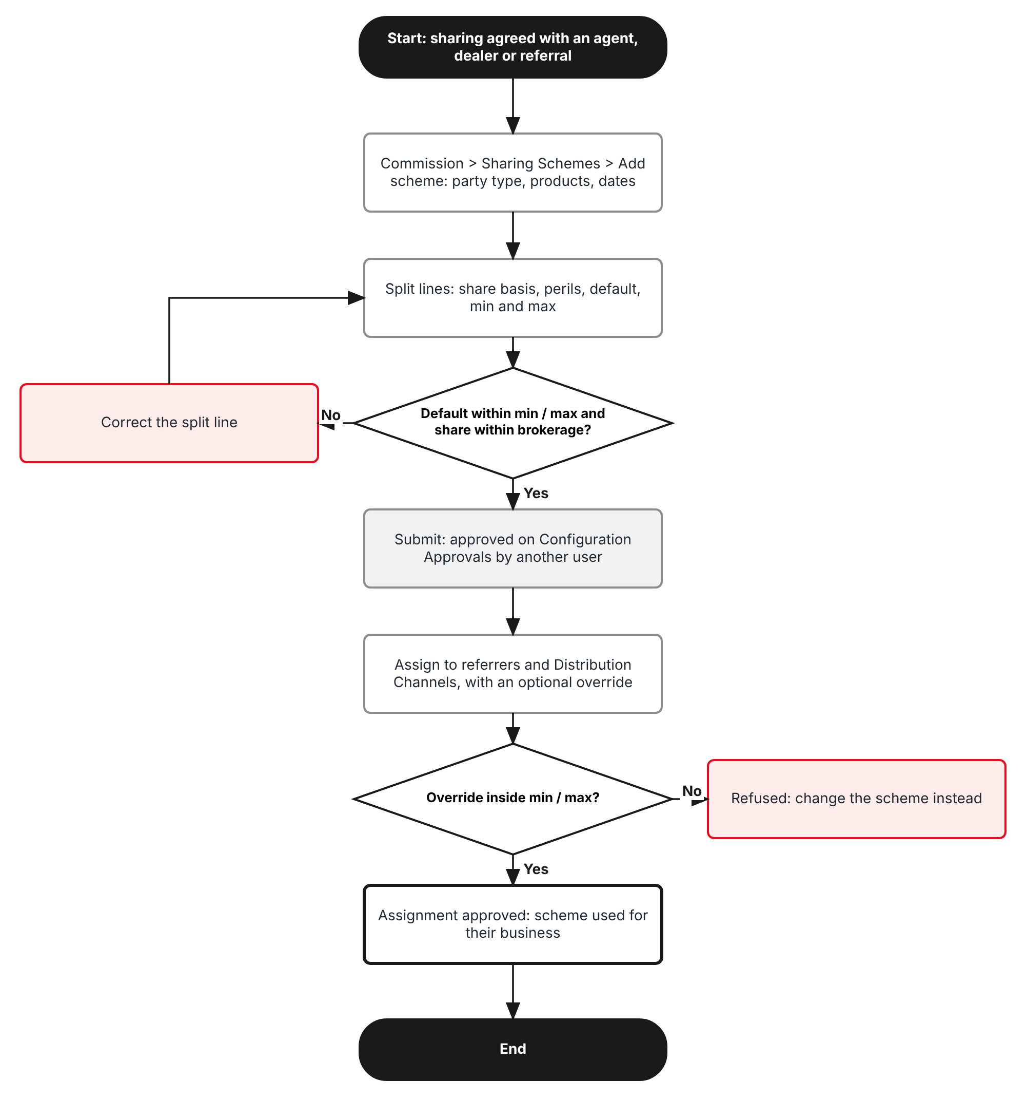
Figure 2: Flow B - Set up a sharing scheme and assign it
Table 4: Flow B steps
Step | Who (role) | What happens | FR
B1 | Accounting | Commission > Sharing Schemes > Add scheme: code, name, party type, products, insurers, policy type, dates, pay-when-fully-paid flag. | FR-CMR-010
B2 | Accounting | Split lines: who is paid, share basis, perils, default, minimum, maximum; for an agent with a sub-agent, one line per level. | FR-CMR-011, 012
B3 | System | Checks min <= default <= max and that the maximum share cannot exceed the commission. | FR-CMR-011
B4 | Accounting Manager | Approves the scheme on Configuration Approvals. | FR-CMR-013
B5 | Accounting | Assigns the scheme to referrers and Distribution Channels, with an optional override inside the limits; the assignment is approved the same way. | FR-CMR-014

2.3 Flow C - Quotation to policy
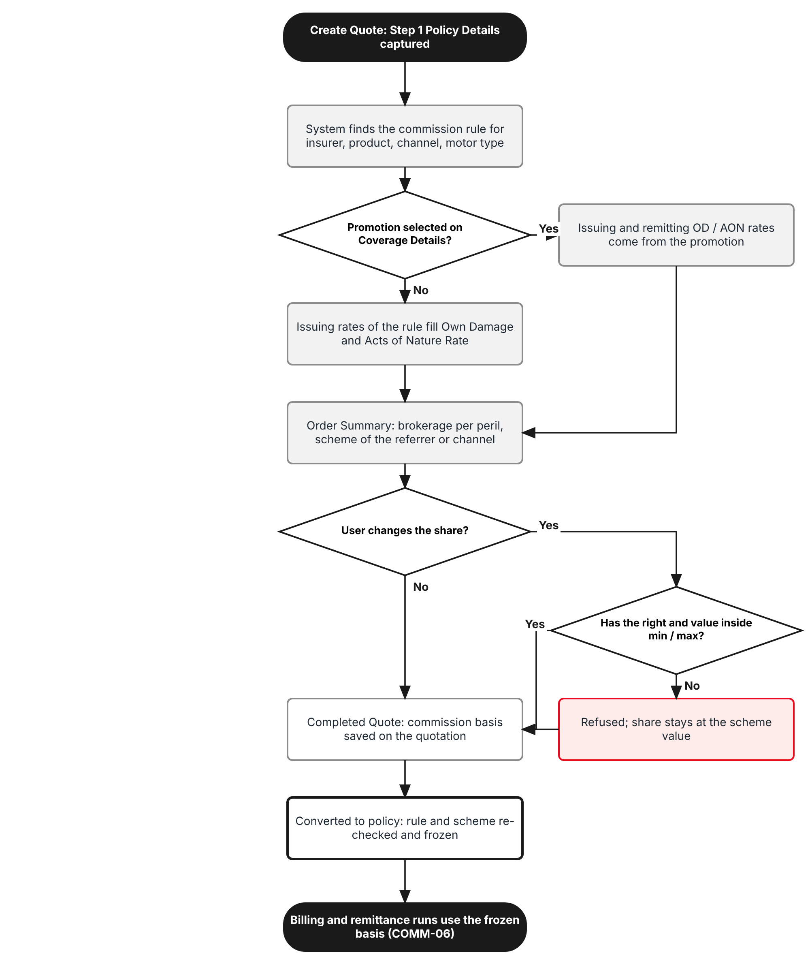
Figure 3: Flow C - Commission rule and sharing scheme on a quotation and a policy
Table 5: Flow C steps
Step | Who (role) | What happens | FR
C1 | System | After Step 1 Policy Details, finds the rule for the insurer, product, policy type, channel type, motor type and sum insured. | FR-CMR-004
C2 | System | Without a promotion, fills Own Damage coverage Rate and Acts of Nature Rate on Coverage Details with the issuing rates of the rule. With a promotion, the promo rates apply and the promo remitting rates stand in for the insurer net rates (PROD-15). | FR-CMR-006, 020
C3 | System | Step 5 Order Summary shows the three rates and the commission per peril, the scheme of the referrer or channel, the share and what TISPH keeps. | FR-CMR-015, 021
C4 | Sales (write:commission-share) | May change the share inside the minimum and maximum, with a reason. Other users cannot change it. | FR-CMR-022
C5 | Processing Team | Converts the quotation to policy: the rule and scheme are checked again and frozen on the policy. | FR-CMR-023
C6 | System | The billing and remittance runs and the commission lines use the frozen basis (COMM-06). Endorsement, cancellation and renewal follow FR-CMR-024. | FR-CMR-024, 025

2.4 Dimensions covered
Table 6: Dimensions
Dimension | Values | Where in BrokerVerse
Insurers | Panel insurers, each with its own net rates (for example Standard, Malayan, Pioneer, Apex Assurance) | Master > Insurance > Insurance Company
Products | Motor - Private Car, Motor - Commercial Vehicle, Motor - Motorcycle with issuing vs remitting; other lines (Fire, PA, Credit Life, Parcel) with % of net premium | Master > Insurance > Product; Line of Business
Channel types | Financing bank, Dealer, Affinity partner, Agent / referrer, Direct | Master > Insurance > Distribution Channels; Step 1 Referrer
Bands | Motor type (7 classes) and an optional sum insured band | Master > Insurance > Vehicle (Motor type); Step 1 Fair market value
Policy type | New business, Renewal, Any | Quotation origin (renewal run or new)
Perils | Own Damage / Theft and Acts of Nature at issuing, TIS remitting and insurer net rates; Bodily Injury, Property Damage, APPA at % of premium; CTPL and Roadside Assistance without commission | Step 3 Coverage Details
Parties sharing | Agent, Sub-agent, TFS team member, Referral, Dealer, Affinity partner, External | Commission > Agents/Referrer Accounts; Distribution Channels

3 Personas and roles

3.1 Personas
BrokerVerse ships eight roles (Master > Users and Access > Role). TISPH personas map to them as below; TISPH can add its own roles (for example Sales Head) and grant them the permissions of section 3.2.
Table 7: Personas and BrokerVerse roles
TISPH persona | BrokerVerse role | What they do with commission rules and schemes
Finance commission officer (maker) | Accounting - accounting | Keeps commission rules and sharing schemes, assigns schemes, uploads net rate schedules
Finance head (checker) | Accounting Manager - accounting-manager | Approves or returns rules, schemes and assignments on Configuration Approvals; suspends and ends schemes
Sales officer / Sales Head | Sales & Marketing - sales | Sees the share on Order Summary; listed users change it inside the limits
Sales Admin / Operations | Processing Team - processing; Operations - operations | Keep referrers and channels; convert quotations; endorsements and cancellations
System Administrator | System Administrator - system-admin | Roles, permissions, configuration keys, schedules
Auditor | Compliance Officer - compliance-officer | Read-only access to rules, schemes and the Audit Trail

3.2 New permissions
New permissions follow the BrokerVerse pattern read:<module> / write:<module> / approve:<module> and are granted on Master > Users and Access > Role Permissions. The existing read:commission and write:commission keep their meaning on Commission > Agents/Referrer Accounts.
Table 8: New permissions
Permission | Allows
read:commission-rules | Open the Commission Rate Matrix and Test rate; see the commission and what TISPH keeps on Order Summary and on the policy
write:commission-rules | Add, amend, end and upload commission rules (sent to Configuration Approvals)
approve:commission-rules | Approve or return rule changes (never one you made)
read:sharing-schemes | Open Commission > Sharing Schemes; see the share on Order Summary
write:sharing-schemes | Add, amend and assign schemes; set overrides on referrers and channels
approve:sharing-schemes | Approve or return schemes and assignments; suspend, resume and end schemes
write:commission-share | Change the share on a quotation or on an unapproved commission line, inside the minimum and maximum of the scheme

3.3 Default grants
Table 9: Default grants (Y = granted)
Permission | system-admin | processing | sales | operations | accounting | accounting-manager | compliance-officer
read:commission-rules | Y | Y | - | - | Y | Y | Y
write:commission-rules | Y | - | - | - | Y | - | -
approve:commission-rules | Y | - | - | - | - | Y | -
read:sharing-schemes | Y | Y | Y | Y | Y | Y | Y
write:sharing-schemes | Y | - | - | - | Y | - | -
approve:sharing-schemes | Y | - | - | - | - | Y | -
write:commission-share | Y | - | Listed users | - | Y | Y | -

Segregation of duties. The maker of a rule, scheme or assignment can never approve it, even when the same user holds both permissions (maker-checker rule, TIS-BRD-SEC-03). write:commission-share is never granted to a role used by external agents or referrers. Users without read:commission-rules see the share of the referrer but not the commission or what TISPH keeps.

4 Functional requirements
Twenty FRs implement PROD-16. They follow the process: the commission rules register (4.1), sharing schemes (4.2), the quotation and the policy (4.3), and audit and access (4.4).

4.1 Commission rules register

FR-CMR-001 Keep commission rules by insurer, product, channel, motor type, policy type and band
BRD trace | PROD-16 "Commission rules per product, insurer and channel with bands"; PROD-04; MAS-07; MAS-09 | Actor | Accounting (write:commission-rules)
Priority | Must have | Fit | Customization
Screens | Master > Finance > Commission Rate Matrix (route /master/finance/commission-rate-matrix): list, Add rule / Edit rule dialog, Rule tab

Description
The existing Commission Rate Matrix becomes the commission rules register. The button Add rate becomes Add rule and the dialog gets three tabs: Rule, Peril rates (FR-CMR-002) and History. The keys of today stay (Insurer, Product, Line of business, Policy type, Effective from, Effective to, Remarks) and three keys are added: Channel type, Motor type and a Sum insured band (from / to).
A rule also has a Rate basis: Issuing vs remitting (per peril) for Motor products, or % of net premium for the other lines, which is how the matrix works today (for example Fire 25%, Credit Life 20%, Parcel 32.5%). The Active switch of today is replaced by the approval status of FR-CMR-003.
Motor type is a new column of Master > Insurance > Vehicle at model level (for example Vios = PC-Sedan Regular, Fortuner = PC-Other than Sedan, bZ4X = PC-Electric Vehicles). The quotation takes it from the Vehicle Model of Step 1. A rule with Motor type Any applies to every vehicle.
Preconditions
- The user has write:commission-rules.
- Insurers, products, lines of business and Motor types exist on their masters.
Main flow
- The user opens Master > Finance > Commission Rate Matrix and clicks Add rule.
- On the Rule tab the user picks Insurer (or Any insurer), Product (or Any product), Line of business (or Any), Policy type (New business, Renewal, Any), Channel type (or Any), Motor type (or Any), and optionally Sum insured from / to.
- The user picks the Rate basis, Effective from, Effective to (blank = open-ended) and Remarks.
- The user fills the Peril rates tab (FR-CMR-002) and clicks Submit for approval (FR-CMR-003).
Alternate and exception flows
- Copy (row action): opens a new rule with the same keys and rates and a blank Effective from; used when an insurer sends a new schedule.
- End (row action): sets Effective to on an approved rule; sent for approval like any change.
- A rule that was never approved can be withdrawn by its maker. An approved rule cannot be deleted, because quotations and policies point to it.
Business rules
Rule | Statement | Kind | Maintained in
R1 | At least one of Insurer, Product and Line of business is set (as today). | Fixed | -
R2 | Motor type and Sum insured band are offered only for Motor products or the Motor line; Rate basis Issuing vs remitting is offered only for them. | Fixed | -
R3 | Two approved or pending rules with the same keys (insurer, product, line, policy type, channel type, motor type, band) cannot overlap in dates. | Fixed | -
R4 | Sum insured bands of rules with the same other keys cannot overlap. Sum insured to is inclusive. | Fixed | -
R5 | Effective from cannot be before today when the rule is submitted; rules are never backdated. | Fixed | -
R6 | Lines of business that use Issuing vs remitting: commission.dual_rate_lines (default Motor). | Configurable | Master > System > Configuration

Validations and messages
Check | Message shown | ID
No key chosen | Choose an insurer, a product or a line of business | MSG-CMR-001
Overlap | Another rule for Standard Insurance Co., Inc. - Motor - Private Car - PC-Sedan Regular - New business is in force on these dates | MSG-CMR-002
Band overlap | The sum insured band overlaps band <from> - <to> of another rule with the same keys | MSG-CMR-003
Band order | Sum insured to must be higher than sum insured from | MSG-CMR-004
Backdated | Effective from cannot be before today | MSG-CMR-005
Dates order | Effective to must be on or after effective from | MSG-CMR-006
Basis not allowed | Issuing vs remitting is used for Motor products only | MSG-CMR-007
Delete of an approved rule | This rule is used by quotations or policies and cannot be deleted. Use End instead. | MSG-CMR-008

Audit
- Written to Master > System > Audit Trail with the user, time, before and after values and remark.
Acceptance criteria
- A rule Standard Insurance Co., Inc. - Motor - Private Car - New business - Any channel - PC-Sedan Regular from 01/11/2026 is listed with status Pending approval after submit.
- A second rule with the same keys from 01/12/2026 while the first is open-ended is refused with the overlap message.
- A Fire rule cannot be given Rate basis Issuing vs remitting or a Motor type.
- Delete is not offered on an approved rule; End is.
- A Vios quotation picks Motor type PC-Sedan Regular from Master > Insurance > Vehicle.

FR-CMR-002 Hold the issuing rate and the insurer remitting rate per peril
BRD trace | PROD-16 "(issuing rate vs. net remitting rate)"; delivery basis "dual-rate model"; PROD-04; PROD-13; COMM-06 | Actor | Accounting (write:commission-rules)
Priority | Must have | Fit | Customization
Screens | Master > Finance > Commission Rate Matrix > Add / Edit rule > Peril rates tab

Description
For a rule with Rate basis Issuing vs remitting, the Peril rates tab lists the perils of the Motor product (from Product Configurator > Coverage Builder). For each peril the user sets its basis and rates:
Issuing vs remitting (default for Own Damage / Theft and Acts of Nature): three rates in % of the sum insured with up to 4 decimals. Issuing % is what the client pays; TIS remitting % is the rate at which business from an external agent, a TFS team member or a referral is remitted to TISPH; Insurer net % is the net rate TISPH remits to the insurer. The tab shows Commission % = issuing - insurer net and Variance = issuing - TIS remitting, read-only. % of peril premium (default for Bodily Injury, Property Damage and Auto Passenger Personal Accident): Commission % of the premium of the peril, for example 25%. None: no commission (default for Roadside Assistance). CTPL never earns commission under a rule.
For a rule with Rate basis % of net premium the tab shows one rate, as the matrix does today. The column Promo reads "PROD-15 promo net rate" on Own Damage / Theft and Acts of Nature, to show that a promotion replaces the issuing and insurer net rates (FR-CMR-006).
These three rates and the commission % of the other perils are what the billing and remittance runs read, frozen on the policy (COMM-06).
Preconditions
- The Rule tab is filled.
Main flow
- The user opens the Peril rates tab; the perils of the product are listed with their default basis.
- The user enters Issuing %, TIS remitting % and Insurer net % for Own Damage / Theft and Acts of Nature, and Commission % for the %-of-premium perils.
- The system shows Commission % and Variance for each issuing-vs-remitting peril.
- The user submits the rule.
Alternate and exception flows
- The issuing rate of a rule may be left blank: the setting premium.default_rates (Own Damage 2.00%, Acts of Nature 0.50%) is then the issuing default, and the commission is worked out on the rate used on the quotation.
Business rules
Rule | Statement | Kind | Maintained in
R1 | Rates are 0 to 100 with up to 4 decimals. | Fixed | -
R2 | Insurer net % <= TIS remitting % <= Issuing % on each peril; an insurer net rate equal to the issuing rate gives a warning (no commission on that peril). | Fixed | -
R3 | Every issuing-vs-remitting peril needs an insurer net rate and a TIS remitting rate. Defaults of TIS remitting: Own Damage / Theft 1.70%, Acts of Nature 0.40% (commission.default_tis_remitting_rates). | Configurable | Master > System > Configuration
R4 | Default basis per peril: Own Damage / Theft and Acts of Nature Issuing vs remitting; Bodily Injury, Property Damage, APPA % of peril premium at 25%; others None. Defaults per product: commission.peril_defaults. | Configurable | Master > System > Configuration

Validations and messages
Check | Message shown | ID
Rate out of range | Enter a rate from 0 to 100 with up to 4 decimals | MSG-CMR-009
Net rate blank | Enter the insurer net rate of <peril> | MSG-CMR-010
TIS rate blank | Enter the TIS remitting rate of <peril> | MSG-CMR-011
Rates out of order | <peril>: the rates must be insurer net <= TIS remitting <= issuing | MSG-CMR-012
No commission | <peril>: issuing and insurer net rates are equal, so TISPH earns no commission on this peril | MSG-CMR-013
Commission % out of range | Enter a commission from 0 to 100% | MSG-CMR-014

Audit
- Written to Master > System > Audit Trail with the user, time, before and after values and remark.
Acceptance criteria
- Own Damage / Theft issuing 2.0000, TIS remitting 1.7000 and insurer net 1.3000 shows Commission 0.7000 and Variance 0.3000; Acts of Nature 0.5000, 0.4000 and 0.3000 shows 0.2000 and 0.1000.
- Insurer net 1.8000 with TIS remitting 1.7000 is refused; TIS remitting 2.1000 with issuing 2.0000 is refused.
- Bodily Injury, Property Damage and APPA default to % of peril premium at 25.00; Roadside Assistance to None.
- CTPL is not listed on the Peril rates tab.
- A Fire rule with Rate basis % of net premium shows one rate field, as today.

FR-CMR-003 Approve rule changes on Configuration Approvals and keep the history
BRD trace | PROD-03 maker-checker on registers; SEC-03; PROD-16 | Actor | Accounting (maker); Accounting Manager (approve:commission-rules)
Priority | Must have | Fit | Customization
Screens | Master > Finance > Commission Rate Matrix; Master > Finance > Configuration Approvals; Edit rule > History tab

Description
Today a matrix row is saved at once. With PROD-16, every new rule, amendment or end of a rule is a change request listed on Master > Finance > Configuration Approvals (Change "Commission rule - new", "- amend" or "- end"; Of = the keys; Before and Requested = the rates and dates). A user with approve:commission-rules other than the maker approves or returns it, as for posting rules today.
An approved rule is not edited in place. Amend creates a new version with a later Effective from; on approval the previous version gets Effective to = new Effective from - 1 day. The History tab lists every version with its rates, maker, approver and dates. Quotations and policies keep the version they were priced with.
Main flow
- The maker clicks Submit for approval; the rule shows Pending approval and the change is listed on Configuration Approvals with the message "Commission rule sent for approval".
- The approver opens Configuration Approvals, reads Before and Requested, and clicks Approve or Return (remark required).
- On approval the rule is Approved and in force from Effective from; the replaced version is end-dated.
Alternate and exception flows
- The maker withdraws a pending change before it is actioned.
- An approval after the Effective from of the change is refused; the approver returns it and the maker resubmits with a new date.
Business rules
Rule | Statement | Kind | Maintained in
R1 | The maker (creator or last editor) can never approve or return the change. | Fixed | -
R2 | One pending change per rule at a time. | Fixed | -
R3 | Approvers: users with approve:commission-rules (default system-admin and accounting-manager). | Configurable | Master > Users and Access > Role Permissions

Validations and messages
Check | Message shown | ID
Self-approval | The approver must be different from the user who created or changed this rule | MSG-CMR-015
Return without remark | Enter a remark to return the change | MSG-CMR-016
Date passed | The effective-from date of this change has passed. Return it so that the maker can set a new date. | MSG-CMR-017
Second pending change | This rule already has a change waiting for approval | MSG-CMR-018
Submitted | Commission rule sent for approval | MSG-CMR-019
Approved | Commission rule approved | MSG-CMR-020
Returned | Commission rule returned to the maker | MSG-CMR-021

Audit
- Written to Master > System > Audit Trail with the user, time, before and after values and remark.
Acceptance criteria
- A rule submitted by user A cannot be approved by user A.
- Amending the Renewal rule of Standard (remitting Own Damage 1.10 to 1.05 from 01/01/2027) leaves 1.10 in force until 31/12/2026 after approval.
- Return without a remark is refused.
- The History tab of the rule lists version 1 and version 2 with maker, approver and dates.
- A quotation priced on 15/12/2026 with version 1 keeps version 1 after version 2 is approved.

FR-CMR-004 Find the rule that applies to a placement
BRD trace | PROD-16 "rules per product, insurer and channel with bands and overrides"; PROD-04 | Actor | System; Accounting (Test rate)
Priority | Must have | Fit | Customization
Screens | Master > Finance > Commission Rate Matrix > Test rate; Create Quote (FR-CMR-020)

Description
BrokerVerse already picks the most specific active matrix row on the policy date. PROD-16 keeps that logic and adds the new keys. The order is: insurer + product + motor type; insurer + product; insurer + line of business; insurer; product; line of business. Within the same level, an exact channel type beats Any, an exact policy type beats Any, a matching sum insured band beats no band, then the latest Effective from wins.
Without a matching approved rule the base fallback stays: the commission rate of the insurer (Master > Generals > Insurance Company), then commission.default_rate (15%), both as % of net premium. For a Motor quotation the fallback is flagged on Order Summary so that Accounting can add the missing rule.
The Test rate panel gets the fields Channel type, Motor type and Sum insured, and its result shows the rule applied, its level, the peril rates and the sharing scheme that would apply (FR-CMR-015).
Main flow
- The system collects insurer, product, line, policy type, channel type (PROD-15 derivation), motor type, sum insured of Own Damage and the date.
- It selects the approved rule by the order above and returns it with its level.
- Test rate shows the same result for the values typed by the user.
Business rules
Rule | Statement | Kind | Maintained in
R1 | Only Approved rules in force on the date are used; Pending approval rules never apply. | Fixed | -
R2 | The date is the quotation date on a quotation and the inception date at conversion. | Fixed | -
R3 | Channel type of a quotation: the type of its Distribution Channel; when there is none, Agent / referrer when a referrer is set, otherwise Direct. | Fixed | Master > Insurance > Distribution Channels

Validations and messages
Check | Message shown | ID
No Motor rule | No commission rule for <insurer> - <product> - <motor type>. The insurer default rate of <rate>% of net premium is used. | MSG-CMR-022

Audit
- Written to Master > System > Audit Trail with the user, time, before and after values and remark.
Acceptance criteria
- With a Standard + Private Car + PC-Sedan Regular rule and a Standard + Private Car rule, a Vios quotation uses the first one (level insurer + product + motor type).
- With a channel type Dealer rule and an Any rule for the same keys, a quotation from Makati Motors Alabang uses the Dealer rule.
- A Pending approval rule is never used.
- Test rate for Standard, Motor - Private Car, Agent / referrer, New business shows the rule, its three rates per peril and scheme EXT-AGENT-STD.
- Without any Motor rule for Malayan Motorcycle, the quotation shows the warning and uses the insurer default rate.

FR-CMR-005 Load commission rules from Excel
BRD trace | PROD-16; PROD-13 "rate card register ... maintained as data" | Actor | Accounting (write:commission-rules)
Priority | Must have | Fit | Customization
Screens | Master > Finance > Commission Rate Matrix > Upload rules

Description
Net rate schedules come from the insurers as spreadsheets with one row per motor type, business type and peril. Upload rules loads them with the BrokerVerse upload pattern: Download template gives the Excel file with the sheets Data, Columns and Instructions (required headers in dark red); the file is read row by row and the result reads "Processed n rows: c created, f failed", with the failed rows listed by row number.
Each row is one peril of a rule (chapter 13). Rows with the same keys and dates form one rule. Every rule created by an upload is a change request on Configuration Approvals, as for a rule added on screen; the approver can approve all changes of one upload together.
Main flow
- The user clicks Upload rules, downloads the template and fills it.
- The user uploads the .xlsx file.
- The system checks each row with the rules of FR-CMR-001 and 002, groups rows into rules, and creates the change requests.
- The result line and the failed rows are shown.
Business rules
Rule | Statement | Kind | Maintained in
R1 | .xlsx only; first sheet Data; at most commission.rules_max_rows rows (default 2,000). | Configurable | Master > System > Configuration
R2 | A rule whose peril rows are not all valid is not created; its rows are listed as failed. | Fixed | -

Validations and messages
Check | Message shown | ID
File type | Upload an Excel (.xlsx) file | MSG-CMR-023
Columns | The file does not have the template columns. Download the template and copy your rows into it. | MSG-CMR-024
Row error | Row <n>: <message> | MSG-CMR-025
Result | Processed <n> rows: <c> created, <f> failed | MSG-CMR-026

Audit
- Written to Master > System > Audit Trail with the user, time, before and after values and remark.
Acceptance criteria
- An upload of 28 rows (7 motor types x 2 business types x 2 perils) for Malayan creates 14 rules in Pending approval.
- A row with insurer net 2.50 and issuing 2.00 fails with its row number; the other peril row of the same rule is also listed as failed.
- A .csv file is refused.
- The approver can approve the 14 changes of the upload together.

FR-CMR-006 Use the promotion rates and promo remitting rates of PROD-15
BRD trace | PROD-15 "flexible issuing and remitting rates"; PROD-16; COMM-06 | Actor | System
Priority | Must have | Fit | Customization
Screens | Create Quote > Step 3 Coverage Details (Promotion section of PROD-15); Create Quote > Step 5 Order Summary

Description
When a promotion is selected on Coverage Details (PROD-15), its Promo OD % and Promo AON % are the issuing rates and its Remit OD % and Remit AON % stand in for the insurer net rates of the rule on Own Damage / Theft and Acts of Nature. The %-of-premium perils keep the commission % of the rule.
A rate changed by an authorised user down to Min OD % (PROD-15) is the issuing rate used for the commission. The TIS remitting rate on a promo policy follows the setting commission.promo_variance_basis of COMM-06: same_points (default) keeps the standard variance in points, so TIS remitting = promo issuing rate - standard variance, but never below the promo net rate; register_rate keeps the TIS remitting rate of the rule, and a negative variance gives no share.
Business rules
Rule | Statement | Kind | Maintained in
R1 | Promo remitting rates stand in for the insurer net rates of the rule on the two promo perils. | Fixed | -
R2 | TIS remitting rate on a promo policy: commission.promo_variance_basis (same_points or register_rate). | Configurable | Master > System > Configuration
R3 | No share is ever higher than the commission of its peril. | Fixed | -

Validations and messages
Check | Message shown | ID
TIS rate raised | On <peril> the TIS remitting rate is raised to the promo net rate of <rate>%, so the share is PHP <amount> | MSG-CMR-027

Audit
- Written to Master > System > Audit Trail with the user, time, before and after values and remark.
Acceptance criteria
- With PRM-FORTUNER26 (Promo OD 1.50, AON 0.40, Remit 1.30 / 0.30) on a sum insured of PHP 1,200,000, the commission is PHP 2,400.00 on Own Damage and PHP 1,200.00 on Acts of Nature.
- The Bodily Injury commission of the same policy stays at 25% of its premium.
- With same_points an agent gets Own Damage 1.50 - 0.30 = 1.20, raised to 1.30: share PHP 2,400.00; Acts of Nature 0.40 - 0.10 = 0.30: share PHP 1,200.00.
- With register_rate the same agent gets no share (issuing below the TIS remitting rate of 1.70 and 0.40).

4.2 Sharing schemes

FR-CMR-010 Set up a sharing scheme
BRD trace | PROD-16 "sharing schemes for agent, dealer and referral/incentive splits"; COMM-05; SCHM-02 | Actor | Accounting (write:sharing-schemes)
Priority | Must have | Fit | Customization
Screens | Commission > Sharing Schemes (new menu item after Agents/Referrer Accounts, route /commission/sharing-schemes): list and Add scheme dialog, General tab

Description
A new menu item Sharing Schemes is added under Commission, after Agents/Referrer Accounts. The list shows code, name, party type, products, share basis, default, minimum - maximum, assignments, effective dates and status. Add scheme opens a dialog with the tabs General, Split lines (FR-CMR-011), Assignments (FR-CMR-014) and History.
On the General tab the user enters Code, Name, Party type (one or more of Agent, Sub-agent, TFS team member, Referral, Dealer, Affinity partner, External), Products, Insurers (or all), Policy type (New business, Renewal, or both), Effective from / to and the tick box Pay only when the premium is fully paid (on by default; the hold itself is applied by COMM-06).
Typical schemes: EXT-AGENT-STD for external agents, TFS team members and referrals (the variance between the issuing rate and the TIS remitting rate of the rule, on Own Damage and Acts of Nature only, so they quote at 2.00% and leave 1.70% to TISPH); DLR-STD for dealers (a % of the Own Damage and Acts of Nature commission); FIRE-AGT for Fire agents (5% of net premium).
Preconditions
- The user has write:sharing-schemes.
Main flow
- The user opens Commission > Sharing Schemes and clicks Add scheme.
- The user fills the General tab and the split lines.
- The user clicks Save draft ("Sharing scheme saved") and later Submit for approval (FR-CMR-013).
Alternate and exception flows
- Copy (row action) opens a new Draft with the same lines and a blank code.
Business rules
Rule | Statement | Kind | Maintained in
R1 | Code: capital letters, digits and hyphens, 3 to 20 characters, unique; read-only after the first save. | Fixed | -
R2 | A scheme without split lines cannot be submitted. | Fixed | -
R3 | A scheme is used only for policies of its products, insurers and policy types, on dates within its period. | Fixed | -
R4 | Telesales incentives are not sharing schemes; they follow COMM-08. | Fixed | -

Validations and messages
Check | Message shown | ID
Code blank | Enter the scheme code | MSG-CMR-028
Code format | Use capital letters, digits and hyphens, 3 to 20 characters | MSG-CMR-029
Code used | Scheme code <code> is already used | MSG-CMR-030
Party type blank | Choose at least one party type | MSG-CMR-031
Product blank | Choose at least one product | MSG-CMR-032
Saved | Sharing scheme saved | MSG-CMR-033

Audit
- Written to Master > System > Audit Trail with the user, time, before and after values and remark.
Acceptance criteria
- A scheme DLR-STD "Dealer standard share", party type Dealer, Motor - Private Car and Motor - Commercial Vehicle, from 01/12/2026, is saved as Draft.
- A second scheme with code dlr-std is refused.
- Submit without a split line is refused (FR-CMR-011).
- Sharing Schemes appears in the Commission menu for users with read:sharing-schemes.

FR-CMR-011 Define split lines with share basis, default, minimum and maximum
BRD trace | PROD-16 "splits, editable within configured min/max limits"; delivery basis "sharing splits and min/max edit rights"; COMM-05; COMM-06 | Actor | Accounting (write:sharing-schemes)
Priority | Must have | Fit | Customization
Screens | Commission > Sharing Schemes > Add / Edit scheme > Split lines tab

Description
A split line says who is paid and how much. Paid to: the referrer of the policy, the parent of the referrer (FR-CMR-012), or the dealer or partner of the channel. Share basis: Variance to the TIS remitting rate (issuing - TIS remitting of the rule, in points on the sum insured of the chosen perils), % of commission (of the chosen perils), % of net premium, or Fixed amount per policy (PHP). Perils: Own Damage / Theft and Acts of Nature by default; Bodily Injury, Property Damage and APPA carry no agent share. Default, Min and Max: the value used, and the range inside which an authorised user may change it. For the variance basis the default is the variance of the rule and the maximum is that variance unless a lower one is set. Who may change it: write:commission-share by default.
The tab shows a worked example on a sample policy so that the maker sees the amounts. The share is always taken from the commission: what TISPH keeps is the commission less all shares (COMM-05). Changing a variance on a quotation changes the TIS remitting rate frozen on that policy (variance 0.20 = TIS remitting 1.80).
Main flow
- The user clicks Add line and fills Paid to, Share basis, Perils, Default, Min and Max.
- The system checks the line and shows the example.
- The user saves.
Business rules
Rule | Statement | Kind | Maintained in
R1 | Min <= Default <= Max. | Fixed | -
R2 | A variance never takes the TIS remitting rate below the insurer net rate of the peril. | Fixed | -
R3 | % of commission: 0 to 100 in total over all lines of the scheme. | Fixed | -
R4 | The sum of all shares on a policy can never exceed its commission; an excess is cut from the last line and flagged. | Fixed | -
R5 | TIS remitting rate used on the policy = issuing rate - variance. | Fixed | -

Validations and messages
Check | Message shown | ID
Default outside range | The default must be between the minimum and the maximum | MSG-CMR-034
Min above max | The minimum cannot be higher than the maximum | MSG-CMR-035
Total above 100% | The shares of this scheme add up to more than 100% of the commission | MSG-CMR-036
Variance above commission | A variance of <max> points is higher than the commission of <peril> on <n> rules in force | MSG-CMR-037
No line | Add at least one split line | MSG-CMR-038

Audit
- Written to Master > System > Audit Trail with the user, time, before and after values and remark.
Acceptance criteria
- EXT-AGENT-STD: Variance to the TIS remitting rate on Own Damage / Theft and Acts of Nature, default from the rule, min 0.00 is accepted; on the Standard rule it shows 0.30 and 0.10 points (TIS remitting 1.70% and 0.40%).
- DLR-STD: % of commission on Own Damage and Acts of Nature, default 40, min 30, max 50 is accepted.
- A default of 55 with a max of 50 is refused.
- On the sample policy of PHP 800,000 with Standard, DLR-STD shows a dealer share of PHP 2,880.00 and TISPH keeps PHP 4,320.00 of the commission on these perils.

FR-CMR-012 Share along an agent hierarchy
BRD trace | PROD-16 "agent ... splits"; agent commission hierarchy | Actor | Accounting (write:sharing-schemes)
Priority | Must have | Fit | Customization
Screens | Commission > Sharing Schemes > Split lines tab; Commission > Agents/Referrer Accounts (Parent referrer)

Description
BrokerVerse already links a sub-agent to a parent referrer and keeps levels L1 and L2. A scheme can split the share along that chain: line 1 Paid to the referrer of the policy, line 2 Paid to the parent of the referrer. For example AGT-L1L2: sub-agent 0.20 and parent agent 0.10 points on the Own Damage sum insured, together the 0.30 variance; the Acts of Nature variance goes to the sub-agent.
When the referrer of the policy has no parent, the parent line is not paid and its value stays with TISPH, unless the line is marked "Add to the referrer when there is no parent".
Business rules
Rule | Statement | Kind | Maintained in
R1 | At most commission.max_chain_levels levels (default 2). | Configurable | Master > System > Configuration
R2 | The chain shares together stay inside the variance of the rule (FR-CMR-011). | Fixed | -

Validations and messages
Check | Message shown | ID
Too many levels | A scheme can share along at most <n> levels | MSG-CMR-039

Audit
- Written to Master > System > Audit Trail with the user, time, before and after values and remark.
Acceptance criteria
- A policy of sub-agent Liza Garcia (L2, parent Ramon Bautista) under AGT-L1L2 gives Liza 0.20 and Ramon 0.10 points of the Own Damage sum insured.
- The same scheme on a policy of Ramon Bautista (no parent) pays Ramon 0.20 points; the 0.10 stays with TISPH.
- A third chain line is refused with the default setting.

FR-CMR-013 Approve, suspend and end a sharing scheme
BRD trace | PROD-03; SEC-03; PROD-16 | Actor | Accounting (maker); Accounting Manager (approve:sharing-schemes)
Priority | Must have | Fit | Customization
Screens | Commission > Sharing Schemes; Master > Finance > Configuration Approvals

Description
A scheme, and each amendment of it, is approved on Master > Finance > Configuration Approvals (Change "Sharing scheme - new" or "- amend") by a user with approve:sharing-schemes other than the maker. Approval sets it to Active (or Scheduled when Effective from is later). An amendment is a new version; the old version becomes Superseded on the day the new one starts.
An approver can Suspend an active scheme (no new quotation uses it; policies already priced keep it), Resume it, or End it (Effective to = today). A daily job activates Scheduled schemes and ends schemes whose Effective to has passed.
Main flow
- The maker clicks Submit for approval: status Pending approval.
- The approver approves or returns it on Configuration Approvals.
- For a suspension or end, the approver uses the row actions of Sharing Schemes and enters a remark.
Business rules
Rule | Statement | Kind | Maintained in
R1 | The maker can never approve or return the scheme. | Fixed | -
R2 | A scheme assigned to referrers or channels cannot be ended without a replacement scheme or confirmation that their business is no longer shared. | Fixed | -

Validations and messages
Check | Message shown | ID
Self-approval | The approver must be different from the user who created or changed this scheme | MSG-CMR-040
End with assignments | This scheme is assigned to <n> referrers and channels. Choose the scheme that replaces it, or confirm that their business is no longer shared. | MSG-CMR-041
Remark blank | Enter a remark | MSG-CMR-042
Approved | Sharing scheme approved | MSG-CMR-043
Suspended | Sharing scheme suspended | MSG-CMR-044

Audit
- Written to Master > System > Audit Trail with the user, time, before and after values and remark.
Acceptance criteria
- DLR-STD submitted by user A cannot be approved by user A.
- Approved on 20/11/2026 with Effective from 01/12/2026, DLR-STD is Scheduled, and Active after the job of 01/12/2026.
- A suspended scheme is not offered on a new quotation; a quotation priced before keeps it.
- Ending EXT-AGENT-STD asks for a replacement scheme for its 6 referrers.

FR-CMR-014 Assign schemes to referrers and Distribution Channels, with an override inside the limits
BRD trace | PROD-16 "overrides", "editable within configured min/max limits by user rights"; PROD-04 "per agent"; MAS-07 | Actor | Accounting (write:sharing-schemes); approver
Priority | Must have | Fit | Customization
Screens | Commission > Agents/Referrer Accounts (referrer form); Master > Insurance > Distribution Channels (Edit channel); Commission > Sharing Schemes > Assignments tab

Description
The referrer form gets Party type (Agent, Sub-agent, TFS team member, Referral, External) and Sharing scheme. The Edit channel dialog of Distribution Channels keeps Referrer and replaces Comsub % with Sharing scheme and Share override (%). Both can carry an override of the default of a split line, for one referrer or one channel, inside the minimum and maximum of the scheme.
An assignment or an override is approved on Configuration Approvals (Change "Sharing scheme - assign"); until then the previous scheme applies. The Assignments tab of the scheme lists every referrer and channel using it, with the override. The existing Comsub % values of channels are moved to an override of a migration scheme at go-live.
Business rules
Rule | Statement | Kind | Maintained in
R1 | The party type of the referrer or channel must be a party type of the scheme (dealer group and dealer branch = Dealer; affinity partner = Affinity partner). | Fixed | -
R2 | An override is inside the minimum and maximum of the split line. | Fixed | -
R3 | A dealer branch without its own scheme uses the scheme of its dealer group. | Fixed | Master > Insurance > Distribution Channels

Validations and messages
Check | Message shown | ID
Party type mismatch | Scheme <code> is not for party type <type> | MSG-CMR-045
Override outside range | The override must be between <min> and <max> | MSG-CMR-046
Assignment sent | Scheme assignment sent for approval | MSG-CMR-047

Audit
- Written to Master > System > Audit Trail with the user, time, before and after values and remark.
Acceptance criteria
- Makati Motors Group (dealer group) with DLR-STD and override 45% is listed on Configuration Approvals; after approval its branches Makati Motors Alabang and Makati Motors Makati use DLR-STD at 45%.
- An override of 55% on DLR-STD (max 50) is refused.
- Assigning DLR-STD to agent Andres Mendoza is refused (party type Agent).
- The Assignments tab of DLR-STD lists Makati Motors Group with 45%.

FR-CMR-015 Choose the scheme for a quotation or policy
BRD trace | PROD-16; COMM-05; COMM-06 | Actor | System
Priority | Must have | Fit | Customization
Screens | Create Quote > Step 5 Order Summary; Master > Finance > Commission Rate Matrix > Test rate

Description
For a quotation the system takes, in order: the scheme of the referrer on Step 1 (with its override); else the scheme of the Distribution Channel of the prospect, or of its dealer group (with its override); else no sharing (Direct). A policy can carry one referrer share and one channel share when both exist and the channel scheme is marked "Combine with the referrer share"; otherwise the referrer scheme wins.
When neither the referrer nor the channel has a scheme but the referrer has a level, the base rate by level (commission.comsub_rate_by_level: L1 8%, L2 5% of net premium) is used as today and flagged on Order Summary as "No sharing scheme".
Business rules
Rule | Statement | Kind | Maintained in
R1 | Only Active schemes in force on the quotation date whose products, insurers and policy type match are used. | Fixed | -
R2 | A suspended or ended scheme is not chosen for a new quotation. | Fixed | -

Validations and messages
Check | Message shown | ID
No scheme | No sharing scheme for <referrer>. The rate of level <level> (<rate>% of net premium) is used. | MSG-CMR-048

Audit
- Written to Master > System > Audit Trail with the user, time, before and after values and remark.
Acceptance criteria
- A quotation with referrer Andres Mendoza (EXT-AGENT-STD) uses EXT-AGENT-STD.
- A quotation for a prospect of Makati Motors Alabang without referrer uses DLR-STD at 45% (from the group).
- A referrer without a scheme gets the level rate and the warning.

4.3 Quotation and policy

FR-CMR-020 Fill the issuing rates on Create Quote from the rule
BRD trace | PROD-16 "issuing rate"; PROD-04 "default issuing rate ... maintainable at product level and per agent"; PROD-12 | Actor | System
Priority | Must have | Fit | Customization
Screens | Create Quote > Step 3 Coverage Details (Own Damage coverage Rate, Acts of Nature Rate)

Description
When Coverage Details opens, Own Damage coverage Rate and Acts of Nature Rate are filled with the issuing rates of the rule found for the quotation (FR-CMR-004), instead of the fixed defaults of setting premium.default_rates. Without a rule, or when the rule has no issuing rate, the setting stays the default (2.00% and 0.50%).
Who may change these rates does not change: the existing Override and the rights of PROD-12 (about 20 internal users, never agents) and PROD-15 (promo rates) apply. The commission is always worked out on the rate actually used.
Business rules
Rule | Statement | Kind | Maintained in
R1 | A selected promotion replaces the rule issuing rates (PROD-15). | Fixed | -
R2 | A change of insurer, product, vehicle model or referrer on Step 1 finds the rule again and refills the rates that were not overridden. | Fixed | -

Validations and messages
Check | Message shown | ID
Rule rates applied | Issuing rates of the commission rule applied: Own Damage <od>%, Acts of Nature <aon>% | MSG-CMR-049

Audit
- Written to Master > System > Audit Trail with the user, time, before and after values and remark.
Acceptance criteria
- A Standard quotation for a Vios with a rule issuing 2.00 / 0.50 opens Coverage Details with 2 and 0.5.
- A Malayan rule with issuing 1.80 on Own Damage fills 1.8.
- A quotation without a matching rule shows the setting defaults 2 and 0.5.
- Changing the insurer on Step 1 from Standard to Malayan refills the rates.

FR-CMR-021 Show commission and sharing on Order Summary
BRD trace | PROD-16 "issuing rate vs. net remitting rate ... sharing schemes"; COMM-05 | Actor | Sales & Marketing; System
Priority | Must have | Fit | Customization
Screens | Create Quote > Step 5 Order Summary (new Commission & sharing panel)

Description
Step 5 Order Summary gets a Commission & sharing panel under the premium lines. It shows the rule applied; per peril the issuing rate, the TIS remitting rate, the insurer net rate and the commission in PHP; the total commission; the referrer or channel and its scheme; each share with its basis, value and limits; and what TISPH keeps.
Users without read:commission-rules see only the referrer, the scheme and the share. The amounts are recomputed on the server when the quotation is calculated, as for the premium; the panel is a preview of what the billing and remittance runs will compute (COMM-06).
Business rules
Rule | Statement | Kind | Maintained in
R1 | Commission per issuing-vs-remitting peril = (issuing % - insurer net %) x sum insured of the peril, rounded to 2 decimals. | Fixed | -
R2 | Commission per %-of-premium peril = commission % x premium of the peril. | Fixed | -
R3 | Variance share per peril = (issuing % - TIS remitting %) x sum insured, only for external agents, TFS team members and referrals. | Fixed | -
R4 | Discount on Order Summary does not change the commission shown; its funding follows COMM-06. | Fixed | -

Audit
- Written to Master > System > Audit Trail with the user, time, before and after values and remark.
Acceptance criteria
- A Standard Vios quotation with an Own Damage sum insured of PHP 800,000 shows commission PHP 5,600.00 (Own Damage), PHP 1,600.00 (Acts of Nature) and PHP 531.25 (BI, PD, APPA), total PHP 7,731.25.
- With referrer Andres Mendoza (EXT-AGENT-STD) it shows a variance share of PHP 2,400.00 + PHP 800.00 = PHP 3,200.00 and TISPH keeps PHP 4,531.25.
- A sales user without read:commission-rules sees the share of PHP 3,200.00 but not the commission.
- A premium changed in the browser is refused as today; the panel shows the server figures.

FR-CMR-022 Change a share inside the limits by user right
BRD trace | PROD-16 "editable within configured min/max limits by user rights"; delivery basis "min/max edit rights" | Actor | Users with write:commission-share
Priority | Must have | Fit | Customization
Screens | Create Quote > Step 5 Order Summary > Commission & sharing panel

Description
The value of each split line is editable on the panel only for users with write:commission-share and only between the minimum and maximum of the line (or of the override range). A reason from the list Change reason is required. Other users see the value read-only.
The changed value is kept on the quotation with the user, time and reason, and is used when the quotation is converted. It does not change the scheme or the override of the referrer.
Main flow
- The user types a new value in the share field.
- The system checks the right and the range, asks for the reason, and recomputes the share and what TISPH keeps.
Business rules
Rule | Statement | Kind | Maintained in
R1 | Change reasons: Negotiated with agent; Dealer agreement; Management approval; Correction; Other (with text). | Configurable | Lists of values
R2 | A reason is required: commission.share_change_reason_required (default true). | Configurable | Master > System > Configuration

Validations and messages
Check | Message shown | ID
No right | Only users with the right to change commission shares can change this value | MSG-CMR-050
Above max | The share must be between <min> and <max> for scheme <code> | MSG-CMR-051
Reason blank | Choose the reason for the change | MSG-CMR-052

Audit
- Written to Master > System > Audit Trail with the user, time, before and after values and remark.
Acceptance criteria
- A sales user without write:commission-share cannot edit the variance of 0.30.
- An authorised user changes the Own Damage variance to 0.20 with reason Negotiated with agent; the share becomes PHP 1,600.00 + PHP 800.00 = PHP 2,400.00 and the TIS remitting rate of the quotation 1.80%.
- A variance of 0.35 (max 0.30) is refused.
- The change is shown on the quotation detail with the user and reason.

FR-CMR-023 Freeze the commission basis at conversion to policy
BRD trace | PROD-16; COMM-06; ISSUE-01 | Actor | Processing Team; System
Priority | Must have | Fit | Customization
Screens | Quotations > Convert to policy; Operations > Policy (Commission panel, read-only)

Description
When a CustomerAccepted quotation is converted, the rule and scheme are found again for the inception date. If they are the same versions, the basis of the quotation is copied to the policy. If a newer rule or scheme version is in force, or the sum insured changed, the basis is recomputed and the user is told. The policy then holds a frozen commission basis: rule version, the issuing, TIS remitting and insurer net rate of each peril, the commission % of the other perils, scheme version, split values (with any change of FR-CMR-022) and amounts.
The billing and remittance runs and the commission lines of referrers read this basis (COMM-06). The policy detail shows it read-only in a Commission panel.
Business rules
Rule | Statement | Kind | Maintained in
R1 | A frozen basis changes only through FR-CMR-024. | Fixed | -
R2 | A share value changed on the quotation is kept if it is still inside the limits of the scheme version in force; otherwise the default is used and the user is told. | Fixed | -

Validations and messages
Check | Message shown | ID
Basis recomputed | The commission rule or scheme changed since the quotation. Commission recomputed: PHP <amount>, shares PHP <amount>. | MSG-CMR-053

Audit
- Written to Master > System > Audit Trail with the user, time, before and after values and remark.
Acceptance criteria
- A quotation priced with rule version 1 and converted after version 2 starts is recomputed with version 2 and shows the warning.
- The policy detail shows the rule, the scheme and the amounts read-only.
- A changed variance of 0.20 is kept on the policy.

FR-CMR-024 Keep the commission basis on endorsement, cancellation and renewal
BRD trace | PROD-16; COMM-06; COMM-07; RENEW-03 | Actor | Operations; System
Priority | Must have | Fit | Customization
Screens | Operations > Endorsements; Policy Cancellation; Renewals

Description
Endorsement: the commission of an endorsement comes from the insurer (COMM-07). The frozen scheme of the policy splits it with the same split values. Cancellation: no commission receivable is generated for a cancelled policy (COMM-06); the basis is marked Cancelled and its shares are reversed by the existing return-premium clawback of commission lines. Renewal: the renewal quotation finds the rule (policy type Renewal) and the scheme in force at renewal, as a new quotation does; a lock-in promotion (PROD-15, SCHM-03) keeps its rates.
Business rules
Rule | Statement | Kind | Maintained in
R1 | A renewal never copies the shares of the expiring policy. | Fixed | -

Audit
- Written to Master > System > Audit Trail with the user, time, before and after values and remark.
Acceptance criteria
- An endorsement commission of PHP 1,000.00 supplied by the insurer on a policy with DLR-STD at 45% gives the dealer PHP 450.00.
- A policy cancelled from inception has its basis marked Cancelled and its Accrued lines reversed.
- The renewal of a Standard Vios uses the Renewal rule (remitting Own Damage 1.10).

FR-CMR-025 Commission lines of referrers follow the scheme
BRD trace | PROD-16 "editable within configured min/max limits by user rights"; COMM-05 | Actor | Accounting (write:commission, write:commission-share)
Priority | Must have | Fit | Customization
Screens | Commission > Agents/Referrer Accounts > referrer > line drawer

Description
The commission lines of a referrer (Accrued, Eligible, Approved, Paid) show the scheme, the split line, the basis and the limits from the frozen basis. The existing Change rate on an Accrued or Eligible line is kept but needs write:commission-share and stays inside the minimum and maximum, with a reason. The amount of each line in each cycle is computed by the runs of COMM-06.
Validations and messages
Check | Message shown | ID
Change outside range | The share must be between <min> and <max> for scheme <code> | MSG-CMR-054

Audit
- Written to Master > System > Audit Trail with the user, time, before and after values and remark.
Acceptance criteria
- The line of policy POL-2026-00412 of Andres Mendoza shows EXT-AGENT-STD, variance Own Damage 0.30 (0.00 - 0.30) and Acts of Nature 0.10 (0.00 - 0.10).
- Change rate to 0.40 is refused.
- Change rate on an Approved line is refused as today.

4.4 Audit and access

FR-CMR-030 Keep a complete audit trail of rules, schemes and shares
BRD trace | SEC-01; SEC-03; PROD-16 | Actor | System
Priority | Must have | Fit | Customization
Screens | Master > System > Audit Trail (entities commission_rule, sharing_scheme, scheme_assignment, commission_basis)

Description
Every create, amend, end, upload, approval, return, suspension, assignment, override, share change on a quotation or line, and recomputation at conversion is written to the Audit Trail with the user, time, before and after values and the remark or reason.
Audit
- Entities commission_rule, sharing_scheme, scheme_assignment and commission_basis on Master > System > Audit Trail.
Acceptance criteria
- Approving a rule writes the approver, time and the rates before and after.
- A share change on Order Summary writes the old and new value and the reason.
- The Audit Trail can be filtered on entity sharing_scheme.

FR-CMR-031 Control access to rules, schemes and share changes
BRD trace | PROD-16 "by user rights"; SEC-01 | Actor | System Administrator
Priority | Must have | Fit | Customization
Screens | Master > Users and Access > Role Permissions; side bar

Description
The permissions of section 3.2 are added to Role Permissions with the default grants of section 3.3. The menu items Commission Rate Matrix and Sharing Schemes are shown only with their read permission. The API refuses a call without the permission, as for every BrokerVerse module.
Validations and messages
Check | Message shown | ID
No permission | You do not have permission to do this | MSG-CMR-055

Audit
- Written to Master > System > Audit Trail with the user, time, before and after values and remark.
Acceptance criteria
- A sales user does not see Commission Rate Matrix in the Master menu.
- An accounting user can add a rule but cannot approve it without approve:commission-rules.
- An agent portal user never sees the commission or what TISPH keeps.

5 Workflow and status model

5.1 Commission rule
Table 10: Commission rule statuses
From | Action / event | To | Who | Condition
(new) | Submit for approval (screen or upload) | Pending approval | write:commission-rules | Checks of FR-CMR-001 and 002 pass; change listed on Configuration Approvals
Pending approval | Withdraw | (deleted) | Maker | Not yet actioned
Pending approval | Return | Returned | approve:commission-rules, not the maker | Remark required
Returned | Edit and submit | Pending approval | Maker | -
Pending approval | Approve | Approved | approve:commission-rules, not the maker | Effective from not passed; in force from Effective from
Approved | Amend (new version approved) | Approved, end-dated | System | Effective to = new Effective from - 1 day
Approved | End (approved) | Approved, end-dated | approve:commission-rules | -
Approved | Effective to passed | Ended | Job "Commission rules and schemes" | History only; quotations and policies keep their version

5.2 Sharing scheme
Table 11: Sharing scheme statuses
From | Action / event | To | Who | Condition
(new) | Save draft | Draft | write:sharing-schemes | Mandatory fields of the General tab
Draft | Submit for approval | Pending approval | write:sharing-schemes | At least one valid split line
Pending approval | Return | Draft | approve:sharing-schemes, not the maker | Remark required
Pending approval | Approve | Scheduled / Active | approve:sharing-schemes, not the maker | Scheduled when Effective from is later than today
Scheduled | Effective from reached | Active | Job "Commission rules and schemes" | -
Active | Suspend / Resume | Suspended / Active | approve:sharing-schemes | Remark required
Active, Suspended | End, or Effective to passed | Ended | approve:sharing-schemes; job | Replacement or confirmation when assigned
Active (old version) | New version starts | Superseded | System | History only

5.3 Scheme assignment
Pending approval (on Configuration Approvals) -> Approved (used from the approval date) -> Ended (replaced by another assignment or the scheme ends). A returned assignment leaves the previous one in force.

5.4 Commission basis on the quotation and the policy
Table 12: Commission basis along the quotation and the policy
Quotation / policy event | Commission basis
Step 1 Policy Details changed | Rule and scheme found again; issuing rates refilled where not overridden (FR-CMR-004, 020)
Calculate / Order Summary | Provisional basis: commission and shares worked out on the server (FR-CMR-021)
Share changed by an authorised user | Provisional basis keeps the new value, user and reason (FR-CMR-022)
Completed Quote, Approved, CustomerAccepted | Provisional basis kept on the quotation
Expired, Dropped, Rejected | Basis discarded with the quotation
ConvertedToPolicy | Frozen basis on the policy; recomputed when a newer rule or scheme is in force (FR-CMR-023)
Endorsement | Insurer commission split with the frozen scheme (FR-CMR-024)
Policy Cancellation | Basis Cancelled; shares reversed (FR-CMR-024)
Renewal | New provisional basis on the renewal quotation (FR-CMR-024)

6 Interfaces
PROD-16 has one file interface: the upload of commission rules. The frozen commission basis is read inside BrokerVerse by the billing and remittance runs (COMM-06) and is not a file.
Table 13: Interfaces
Interface | Direction | Data | Note
Upload rules (Commission Rate Matrix) | Inbound (Excel upload) | Insurer net rate schedules with the issuing and TIS remitting rates: one row per rule key and peril | Template in chapter 13; every rule goes to Configuration Approvals
Configuration workbook, sheet Commission Rates (existing data load) | Inbound (go-live load) | Same columns as the upload template | Used once at go-live to load the rules of all panel insurers

7 Configuration items

7.1 Settings
New settings use the dotted keys of BrokerVerse and are maintained on Master > System > Configuration.
Table 14: Settings
Key | Meaning | Default
commission.dual_rate_lines | Lines of business that use issuing vs remitting rates | ["motor"]
commission.peril_defaults | Default basis and commission % per peril on a new rule | OD, AON: issuing vs remitting; BI, PD, APPA: 25%
commission.rules_max_rows | Rows per upload of rules | 2000
commission.max_chain_levels | Levels a scheme can share along | 2
commission.share_change_reason_required | Reason needed to change a share | true
commission.default_tis_remitting_rates | TIS remitting rates proposed on a new Motor rule | OD 1.70, AON 0.40
commission.promo_variance_basis (COMM-06) | TIS remitting rate on a promo policy: same_points or register_rate | same_points
commission.default_rate (existing) | Fallback commission, % of net premium | 0.15
commission.comsub_rate_by_level (existing) | Share when a referrer has no scheme | L1 0.08, L2 0.05
premium.default_rates (existing) | Issuing rates when no rule gives one | OD 2.00, AON 0.50

7.2 Scheduled job
Table 15: Scheduled jobs (Master > System > Schedules)
Job | When | What it does
Commission rules and schemes (new) | Daily 00:10 Manila time | Ends rules and schemes whose Effective to has passed; activates Scheduled schemes; supersedes old scheme versions

7.3 Lists of values
Table 16: Lists of values
List | Values
Motor type (new) | PC-Sedan Regular; PC-Electric Vehicles; PC-Other than Sedan (SUV / AUV / MPV / Pick-up / Van); CV-Light; LTO (Aircon Bus, UV Express, TNVS); MC-Regular (below 400 cc); MC-High-End (400 cc and above)
Rate basis of a rule (new) | Issuing vs remitting (per peril); % of net premium
Peril basis (new) | Issuing vs remitting; % of peril premium; None
Share basis (new) | Variance to the TIS remitting rate; % of commission; % of net premium; Fixed amount per policy
Party type (new; extends referrer type) | Agent; Sub-agent; TFS team member; Referral; Dealer; Affinity partner; External
Paid to (new) | Referrer of the policy; Parent of the referrer; Dealer / partner of the channel
Change reason (new) | Negotiated with agent; Dealer agreement; Management approval; Correction; Other
Channel type (from PROD-15) | Financing bank; Dealer; Affinity partner; Agent / referrer; Direct

7.4 Masters maintained by the business
Table 17: Masters
Master | Owner | Approval
Commission Rate Matrix (changed) | Accounting | approve:commission-rules on Configuration Approvals
Sharing Schemes (new) | Accounting | approve:sharing-schemes on Configuration Approvals
Agents/Referrer Accounts, Distribution Channels (scheme and override) | Accounting; Sales Admin | approve:sharing-schemes on Configuration Approvals
Vehicle (new column Motor type) | Operations | Unchanged

8 Traceability

8.1 BRD clause to FR
Table 18: PROD-16 clauses
Clause of TIS-BRD-PROD-16 | FR | BrokerVerse screen
Commission rules per product, insurer and channel | FR-CMR-001, 004 | Commission Rate Matrix
with bands | FR-CMR-001, 004 | Commission Rate Matrix (Motor type, Sum insured band)
and overrides | FR-CMR-014, 022, 025 | Agents/Referrer Accounts; Distribution Channels; Order Summary
(issuing rate vs. net remitting rate) | FR-CMR-002, 006, 020, 021 | Commission Rate Matrix > Peril rates; Coverage Details; Order Summary
sharing schemes for agent, dealer and referral | FR-CMR-010, 011, 012, 015 | Sharing Schemes
/incentive splits | FR-CMR-011 | Sharing Schemes > Split lines (telesales incentive itself: COMM-08)
editable within configured min/max limits | FR-CMR-011, 014, 022, 025 | Split lines; overrides; Order Summary; line drawer
by user rights | FR-CMR-022, 031 | Role Permissions (write:commission-share)
Delivery basis: dual-rate model on the commission rules register | FR-CMR-002, 003, 005 | Commission Rate Matrix; Configuration Approvals
Delivery basis: sharing splits and min/max edit rights | FR-CMR-011, 022 | Sharing Schemes; Order Summary

8.2 Related BRD requirements
Table 19: Related requirements
BRD ref. | Relation to PROD-16 | FR
PROD-03 | Registers on maker-checker | FR-CMR-003, 013
PROD-04, PROD-13 | Default issuing and remitting rate per product and per agent; rate cards as data | FR-CMR-002, 005, 020
PROD-12 | Rate override rights (unchanged) | FR-CMR-020
PROD-15 | Promo issuing and remitting rates | FR-CMR-006
COMM-02 | No manual commission adjustment: rates come from the register | FR-CMR-002
COMM-05 | Agent / dealer share deducted from the full commission | FR-CMR-011, 015, 021
COMM-06 | Reads the issuing, TIS remitting and insurer net rates frozen on the policy; calculation in the billing and remittance runs, instalment hold | FR-CMR-002, 006, 023, 025
COMM-07 | Endorsement commission from the insurer | FR-CMR-024
COMM-08 | Telesales incentive (separate) | -
SCHM-02 | Commission % and dealer % of a scheme on the Scheme Master | FR-CMR-010
MAS-07, MAS-09 | Distribution channels; vehicles | FR-CMR-001, 014
SEC-01, SEC-03 | Access and segregation of duties | FR-CMR-003, 013, 031

8.3 FR to test cases
Table 20: Test cases per FR (one per acceptance criterion)
FR | Title | Test cases
FR-CMR-001 | Keep commission rules by insurer, product, channel, motor type, policy type and band | TC-CMR-001-1 to -5
FR-CMR-002 | Hold the issuing rate and the insurer remitting rate per peril | TC-CMR-002-1 to -5
FR-CMR-003 | Approve rule changes on Configuration Approvals and keep the history | TC-CMR-003-1 to -5
FR-CMR-004 | Find the rule that applies to a placement | TC-CMR-004-1 to -5
FR-CMR-005 | Load commission rules from Excel | TC-CMR-005-1 to -4
FR-CMR-006 | Use the promotion rates and promo remitting rates of PROD-15 | TC-CMR-006-1 to -4
FR-CMR-010 | Set up a sharing scheme | TC-CMR-010-1 to -4
FR-CMR-011 | Define split lines with share basis, default, minimum and maximum | TC-CMR-011-1 to -4
FR-CMR-012 | Share along an agent hierarchy | TC-CMR-012-1 to -3
FR-CMR-013 | Approve, suspend and end a sharing scheme | TC-CMR-013-1 to -4
FR-CMR-014 | Assign schemes to referrers and Distribution Channels, with an override inside the limits | TC-CMR-014-1 to -4
FR-CMR-015 | Choose the scheme for a quotation or policy | TC-CMR-015-1 to -3
FR-CMR-020 | Fill the issuing rates on Create Quote from the rule | TC-CMR-020-1 to -4
FR-CMR-021 | Show commission and sharing on Order Summary | TC-CMR-021-1 to -4
FR-CMR-022 | Change a share inside the limits by user right | TC-CMR-022-1 to -4
FR-CMR-023 | Freeze the commission basis at conversion to policy | TC-CMR-023-1 to -3
FR-CMR-024 | Keep the commission basis on endorsement, cancellation and renewal | TC-CMR-024-1 to -3
FR-CMR-025 | Commission lines of referrers follow the scheme | TC-CMR-025-1 to -3
FR-CMR-030 | Keep a complete audit trail of rules, schemes and shares | TC-CMR-030-1 to -3
FR-CMR-031 | Control access to rules, schemes and share changes | TC-CMR-031-1 to -3

9 Navigation

9.1 Screens of PROD-16
Table 21: Screens
Screen | Menu path and route | Type
Commission Rate Matrix (list, Add / Edit rule with tabs Rule, Peril rates, History; Test rate) | Master > Finance > Commission Rate Matrix - /master/finance/commission-rate-matrix | Changed
Upload rules | Commission Rate Matrix > Upload rules | New (base upload pattern)
Configuration Approvals | Master > Finance > Configuration Approvals - /master/finance/configuration-approvals | Existing; lists rule, scheme and assignment changes
Sharing Schemes (list, Add / Edit scheme with tabs General, Split lines, Assignments, History) | Commission > Sharing Schemes, after Agents/Referrer Accounts - /commission/sharing-schemes | New
Agents/Referrer Accounts (referrer form, line drawer) | Commission > Agents/Referrer Accounts - /commission/referrer-accounts | Changed (Party type, Sharing scheme, limits on Change rate)
Distribution Channels (Edit channel) | Master > Insurance > Distribution Channels - /master/insurance/channels | Changed (Sharing scheme, Share override replace Comsub %)
Vehicle | Master > Insurance > Vehicle | Changed (Motor type column)
Create Quote > Step 3 Coverage Details | /agent/createquote/coveragedetails/coveragecreate/:id | Changed (issuing rates from the rule)
Create Quote > Step 5 Order Summary | /agent/createquote/ordersummary/:id | Changed (Commission & sharing panel)
Policy detail | Operations > Policy | Changed (read-only Commission panel)
Role Permissions; Configuration; Schedules; Audit Trail | Master > Users and Access; Master > System | Existing; new permissions, keys, job and entities

9.2 Menu by base role
Table 22: Menu by base role
Base role | Menu entries for commission rules and schemes
Accounting | Master > Finance > Commission Rate Matrix (maintain); Commission > Sharing Schemes (maintain); Agents/Referrer Accounts
Accounting Manager | Master > Finance > Configuration Approvals (rules, schemes, assignments); Commission Rate Matrix and Sharing Schemes (view, Suspend / Resume / End)
Sales & Marketing | Prospects > Create Quote (Commission & sharing panel, share only); Sharing Schemes (view)
Processing Team, Operations | Quotations, Policy (Commission panel); Distribution Channels; Sharing Schemes (view)
System Administrator | All of the above; Role Permissions, Configuration, Schedules
Compliance Officer | Commission Rate Matrix and Sharing Schemes (view); Audit Trail

10 Screen specifications
One specification per screen. Pictures marked "to-be design mock-up" are the real BrokerVerse screens with the PROD-16 changes drawn in, using the Toyota Insurance Services brand pack; the other pictures show BrokerVerse as it runs today. The numbered red markers match the No. column of the field table. Messages are listed in chapter 12.

10.1 Commission Rate Matrix (changed)
Type | Existing screen, new columns and buttons
Purpose | Find a commission rule, see its rates and status, and start a new rule or an upload.
Who can open it | read:commission-rules
Navigation | Master > Finance > Commission Rate Matrix
FRs | FR-CMR-001 to 005

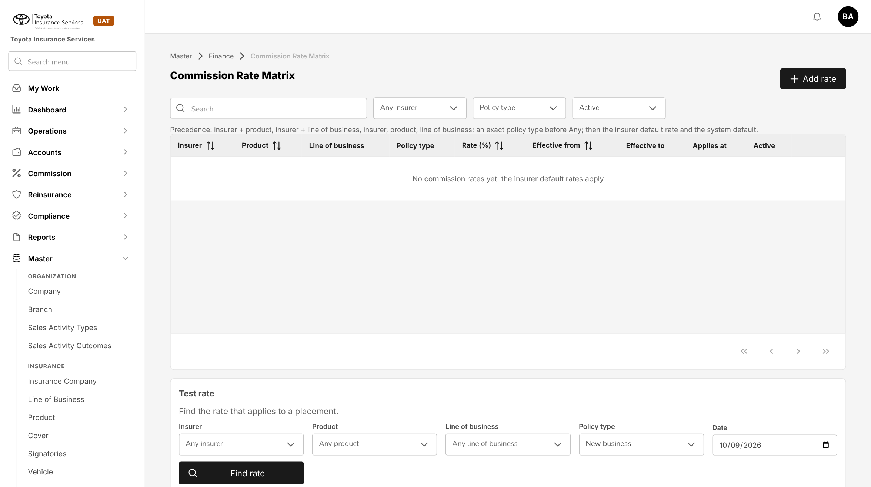
Figure 4: BrokerVerse today: Commission Rate Matrix with one rate per row
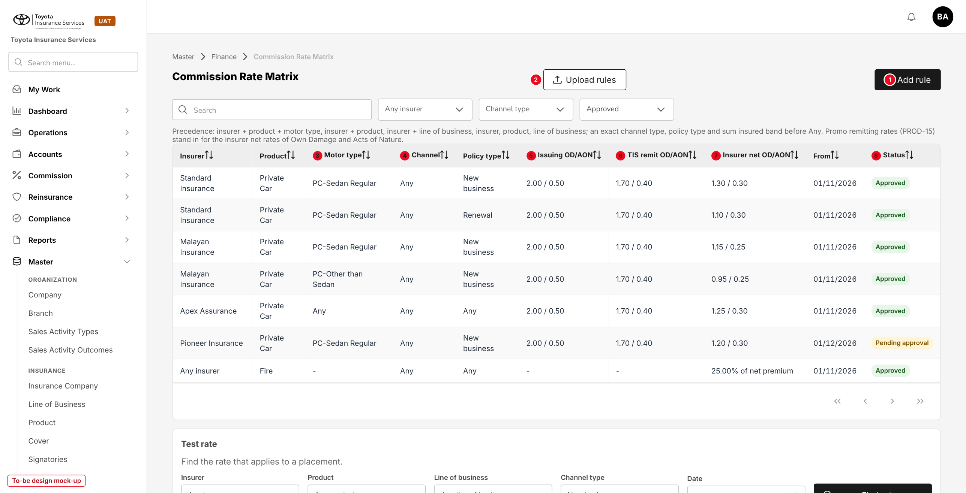
Figure 5: Commission Rate Matrix as the commission rules register (to-be design mock-up, illustrative rates)
No. | Field (label on screen) | Type | Mand. | Source / list | Default | Rule and message
1 | Add rule (was Add rate) | Button | - | - | - | write:commission-rules; opens 10.2
2 | Upload rules | Button | - | - | - | write:commission-rules; chapter 13
- | Search, Any insurer, Channel type, Status filters | Filters | - | - | Approved | Replace the Policy type and Active filters of today
- | Insurer, Product, Policy type | Columns | - | Rule keys | - | As today
3 | Motor type | Column | - | Motor type list | Any | New key
4 | Channel | Column | - | Channel type list | Any | New key
5 | Issuing OD/AON | Column | - | Peril rates | - | Issuing % of Own Damage / Theft and Acts of Nature
6 | TIS remit OD/AON | Column | - | Peril rates | - | TIS remitting %
7 | Insurer net OD/AON | Column | - | Peril rates | - | Insurer net %; for a % of net premium rule the rate
8 | Status | Column | - | Pending approval; Approved; Returned; Ended | - | Replaces Active

Button | Who sees it | Enabled when | What happens | Result
Add rule | write:commission-rules | Always | Opens an empty rule | Pending approval on submit
Upload rules | write:commission-rules | Always | Opens the upload | Pending approval per rule
Copy (row) | write:commission-rules | Any rule | New rule with the same keys and rates, blank Effective from | -
Amend (row) | write:commission-rules | Approved | New version with a later Effective from | Pending approval
End (row) | write:commission-rules | Approved, open-ended | Sets Effective to | Pending approval
Withdraw (row) | Maker | Pending approval | Removes the change | -

10.2 Add / Edit commission rule - Rule tab (changed)
Type | Existing dialog, new fields and tabs
Purpose | Keys, rate basis and dates of a rule.
Who can open it | write:commission-rules (edit); read:commission-rules (view)
Navigation | Commission Rate Matrix > Add rule, or a row
FRs | FR-CMR-001, 003

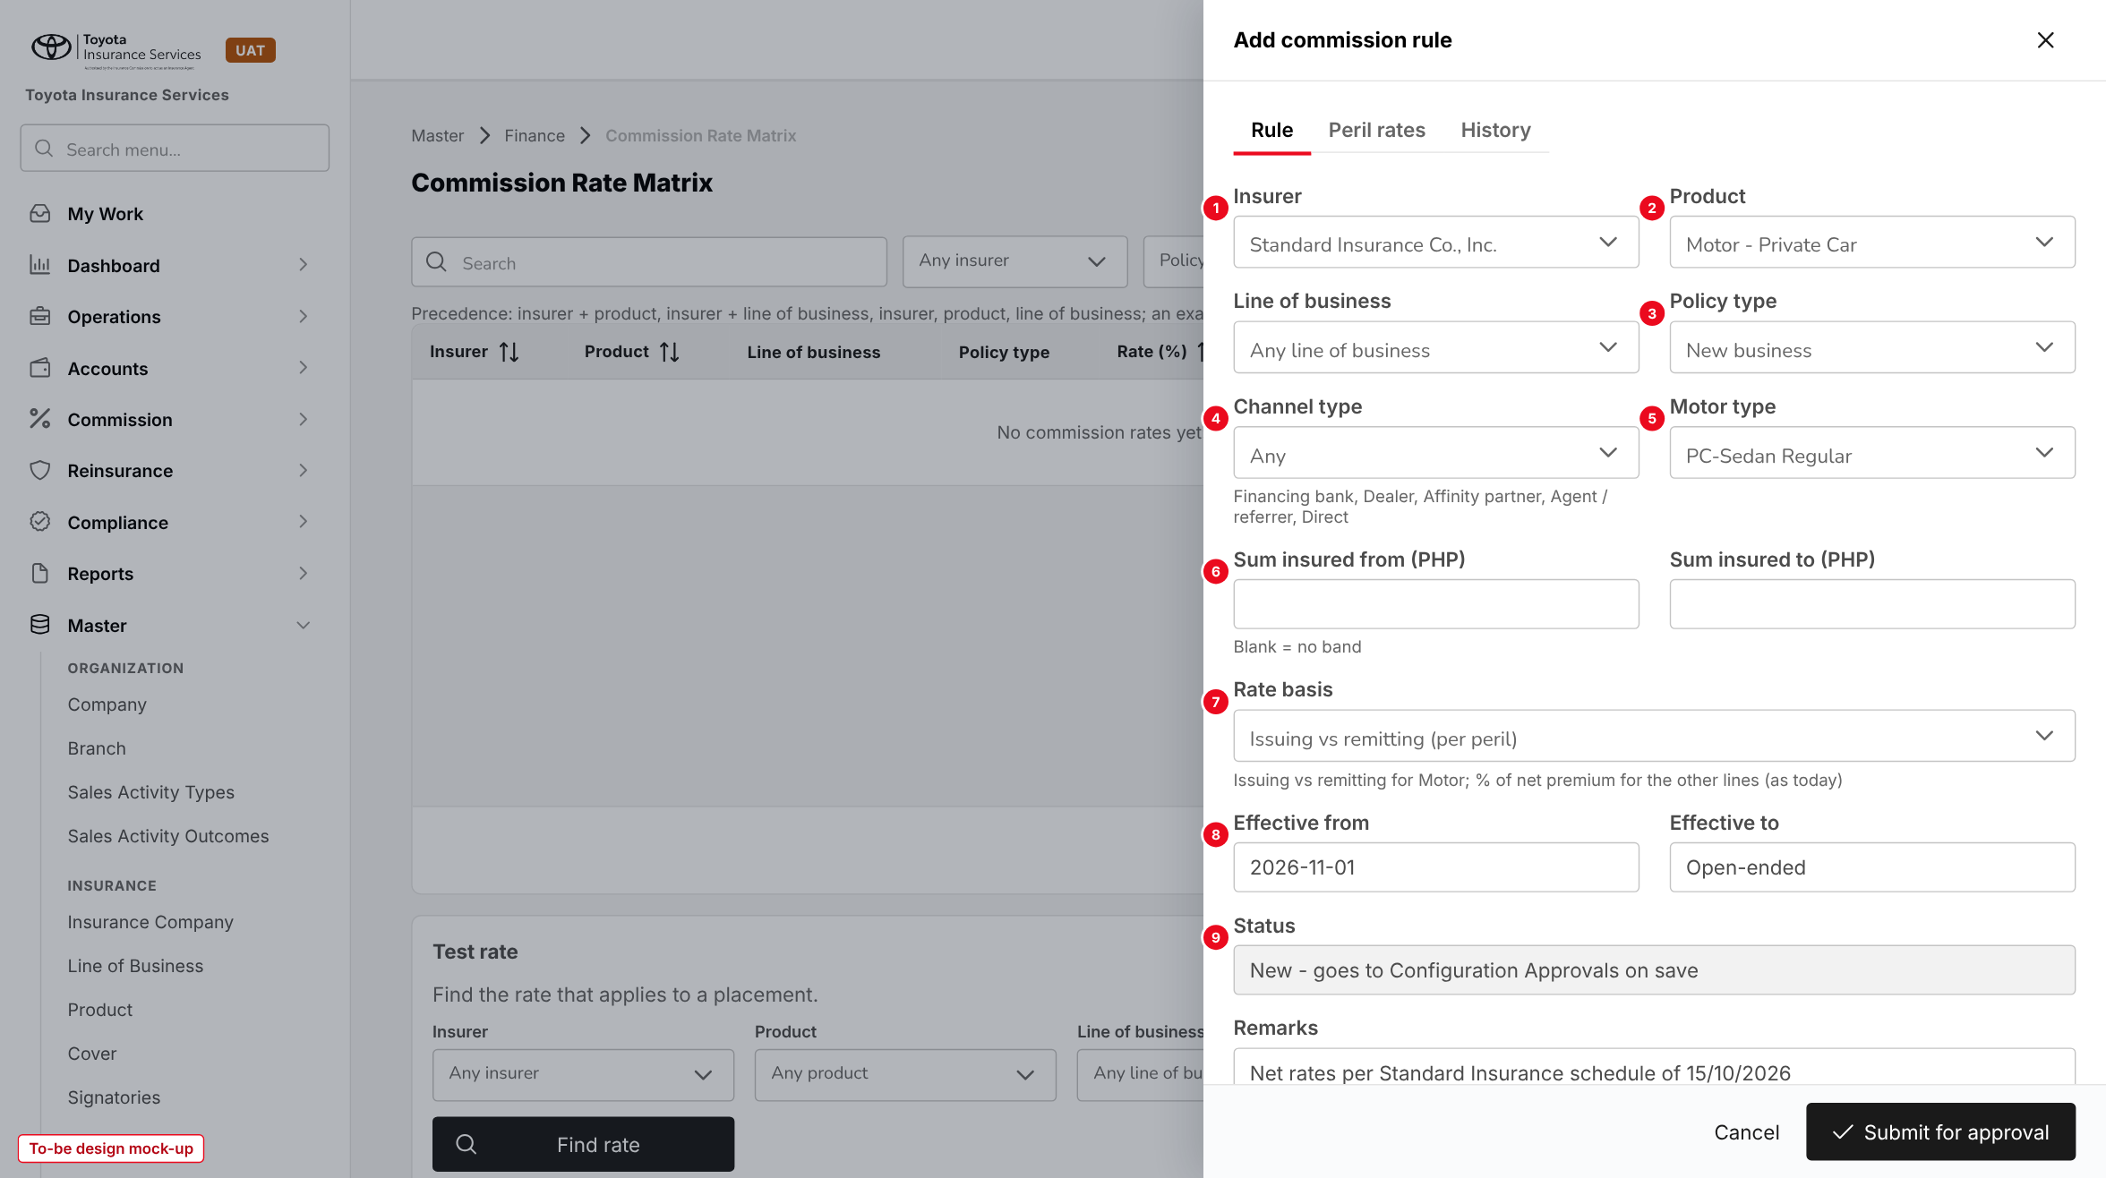
Figure 6: Add commission rule, Rule tab (to-be design mock-up)
No. | Field (label on screen) | Type | Mand. | Source / list | Default | Rule and message
1 | Insurer | List | N* | Master > Insurance > Insurance Company | Any insurer | *One of Insurer, Product, Line of business
2 | Product | List | N* | Master > Insurance > Product | Any product | -
- | Line of business | List | N* | Line of Business master | Any | As today
3 | Policy type | List | Y | New business; Renewal; Any | Any | -
4 | Channel type | List | Y | Channel type list | Any | New
5 | Motor type | List | Y | Motor type list | Any | Motor only
6 | Sum insured from / to (PHP) | Amount | N | - | Blank | No overlap; to > from
7 | Rate basis | List | Y | Issuing vs remitting (per peril); % of net premium | By line (commission.dual_rate_lines) | Issuing vs remitting for Motor only
8 | Effective from / Effective to | Date | Y / N | - | Today / open-ended | Not backdated; no overlap
9 | Status | Display | - | Rule status | - | -
- | Remarks | Text 500 | N | - | - | As today

Button | Who sees it | Enabled when | What happens | Result
Cancel | All | Always | Closes without saving | -
Submit for approval (was Save) | write:commission-rules | No validation error | Sends the change to Configuration Approvals | Pending approval

10.3 Add / Edit commission rule - Peril rates tab (new)
Type | New tab
Purpose | Issuing, TIS remitting and insurer net rates, or commission %, per peril.
Who can open it | write:commission-rules
Navigation | Add / Edit rule > Peril rates
FRs | FR-CMR-002, 006

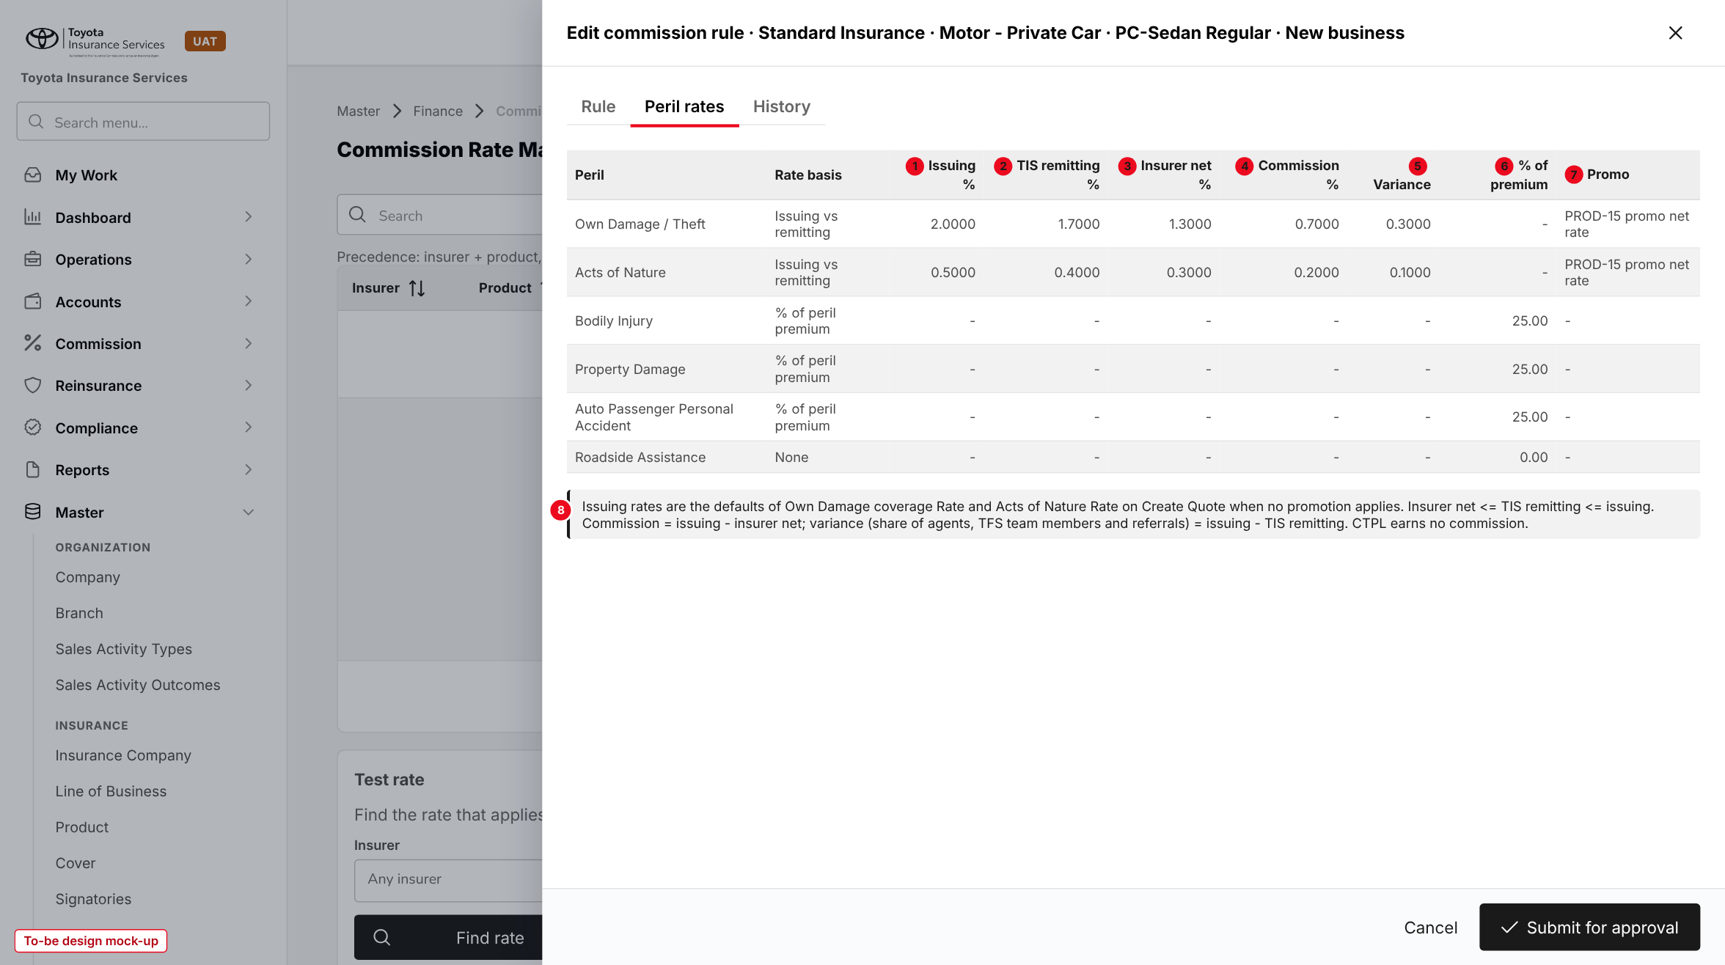
Figure 7: Peril rates of a Motor rule (to-be design mock-up, illustrative rates)
No. | Field (label on screen) | Type | Mand. | Source / list | Default | Rule and message
- | Peril | Display | - | Coverage Builder of the product | - | CTPL not listed
- | Rate basis | List | Y | Issuing vs remitting; % of peril premium; None | commission.peril_defaults | -
1 | Issuing % | Rate, 4 dec. | N | - | - | 0-100; blank = premium.default_rates
2 | TIS remitting % | Rate, 4 dec. | Y | - | OD 1.70, AON 0.40 | <= Issuing %
3 | Insurer net % | Rate, 4 dec. | Y | Insurer schedule | - | <= TIS remitting %
4 | Commission % | Display | - | Issuing - insurer net | - | -
5 | Variance | Display | - | Issuing - TIS remitting | - | Share of agents, TFS team members, referrals
6 | % of premium | Percent | Y | - | 25.00 | For % of peril premium
7 | Promo | Display | - | PROD-15 | - | Promo net rate on the promo perils
8 | Information line | Text | - | - | - | -

10.4 Test rate (changed)
Type | Existing panel, new fields and result
Purpose | Find the rule and the scheme that apply to a placement.
Who can open it | read:commission-rules
Navigation | Commission Rate Matrix, bottom of the page
FRs | FR-CMR-004, 015

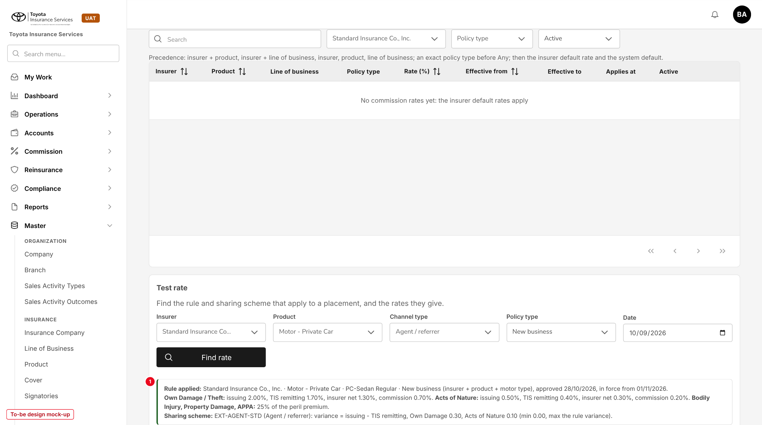
Figure 8: Test rate with the rule and scheme found (1) (to-be design mock-up)
Fields: Insurer, Product, Line of business, Policy type and Date as today; new Channel type, Motor type and Sum insured. Find rate shows the rule applied with its level, the three rates per peril, and the sharing scheme.

10.5 Configuration Approvals (existing screen)
Type | Existing screen, new change kinds
Purpose | Approve or return changes to rules, schemes and assignments.
Who can open it | approve:commission-rules; approve:sharing-schemes
Navigation | Master > Finance > Configuration Approvals
FRs | FR-CMR-003, 013, 014

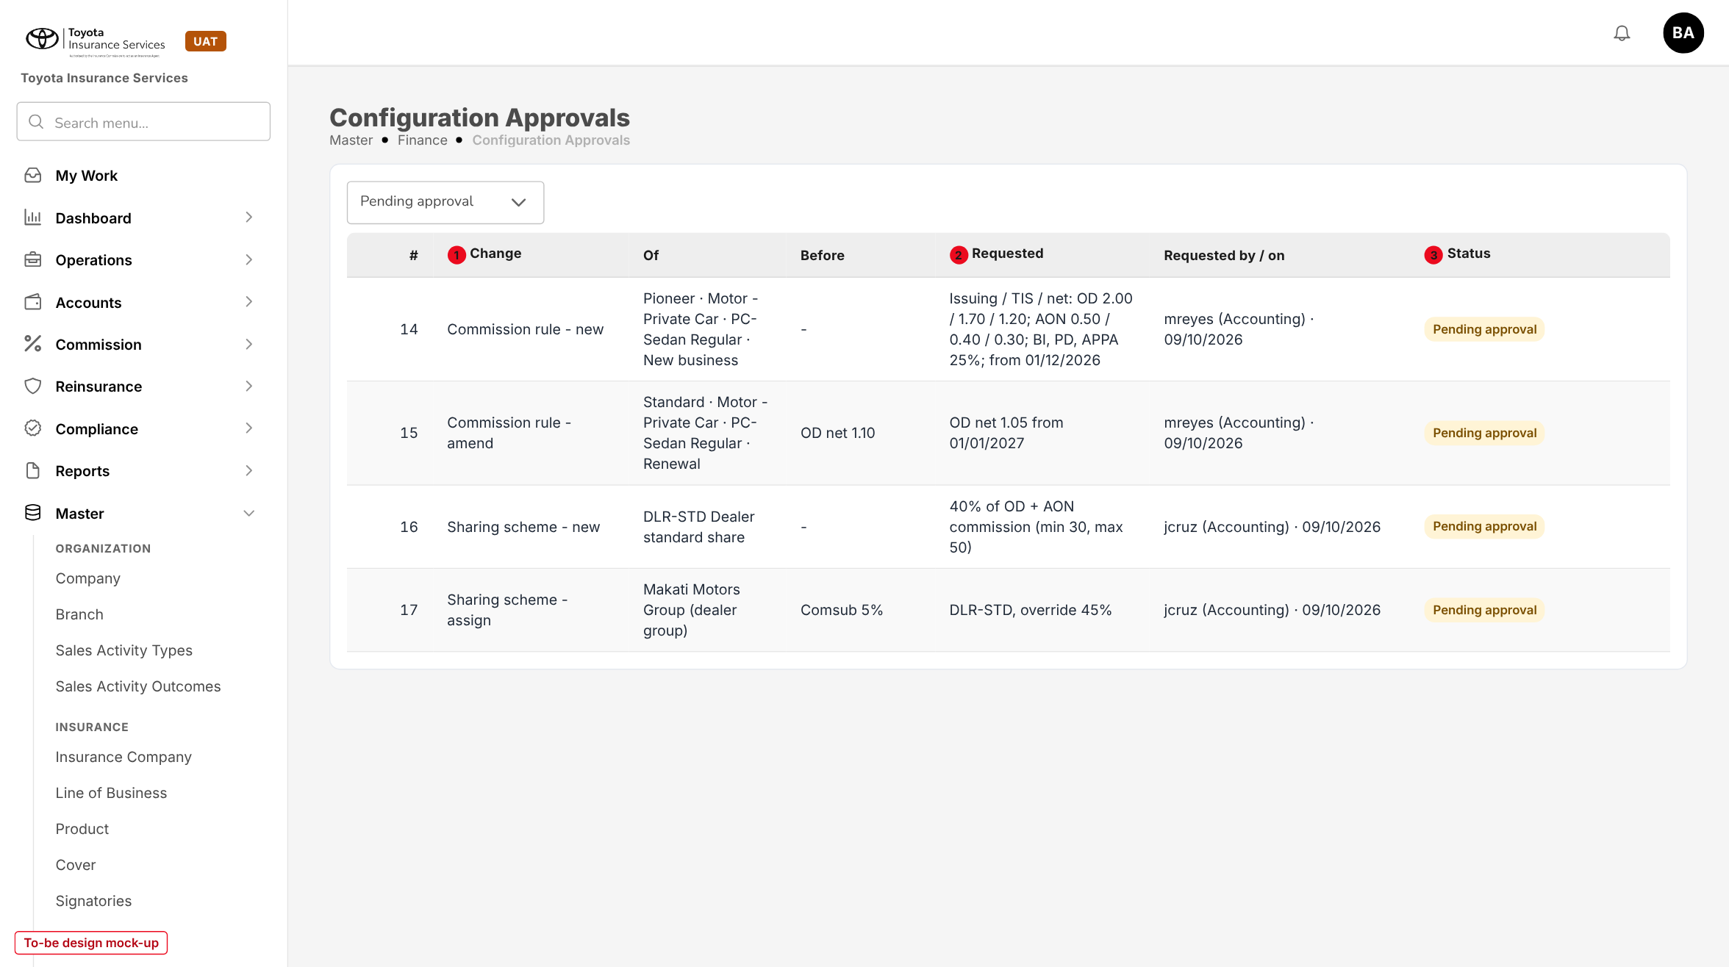
Figure 9: Configuration Approvals with commission rule and sharing scheme changes (to-be design mock-up)
No. | Field (label on screen) | Type | Mand. | Source / list | Default | Rule and message
1 | Change | Column | - | Commission rule - new / amend / end; Sharing scheme - new / amend / assign | - | -
2 | Requested | Column | - | Requested rates, shares or dates | - | Before shows the values in force
3 | Status | Column | - | Pending approval; Approved; Returned | - | -

Button | Who sees it | Enabled when | What happens | Result
Approve | approve permission, not the maker | Pending approval; Effective from not passed | Applies the change | Approved
Return | approve permission, not the maker | Pending approval | Remark required | Returned

10.6 Sharing Schemes list (new)
Type | New screen, laid out like Agents/Referrer Accounts
Purpose | Find a scheme, see its basis, limits and use, and start a new scheme.
Who can open it | read:sharing-schemes
Navigation | Commission > Sharing Schemes
FRs | FR-CMR-010 to 014

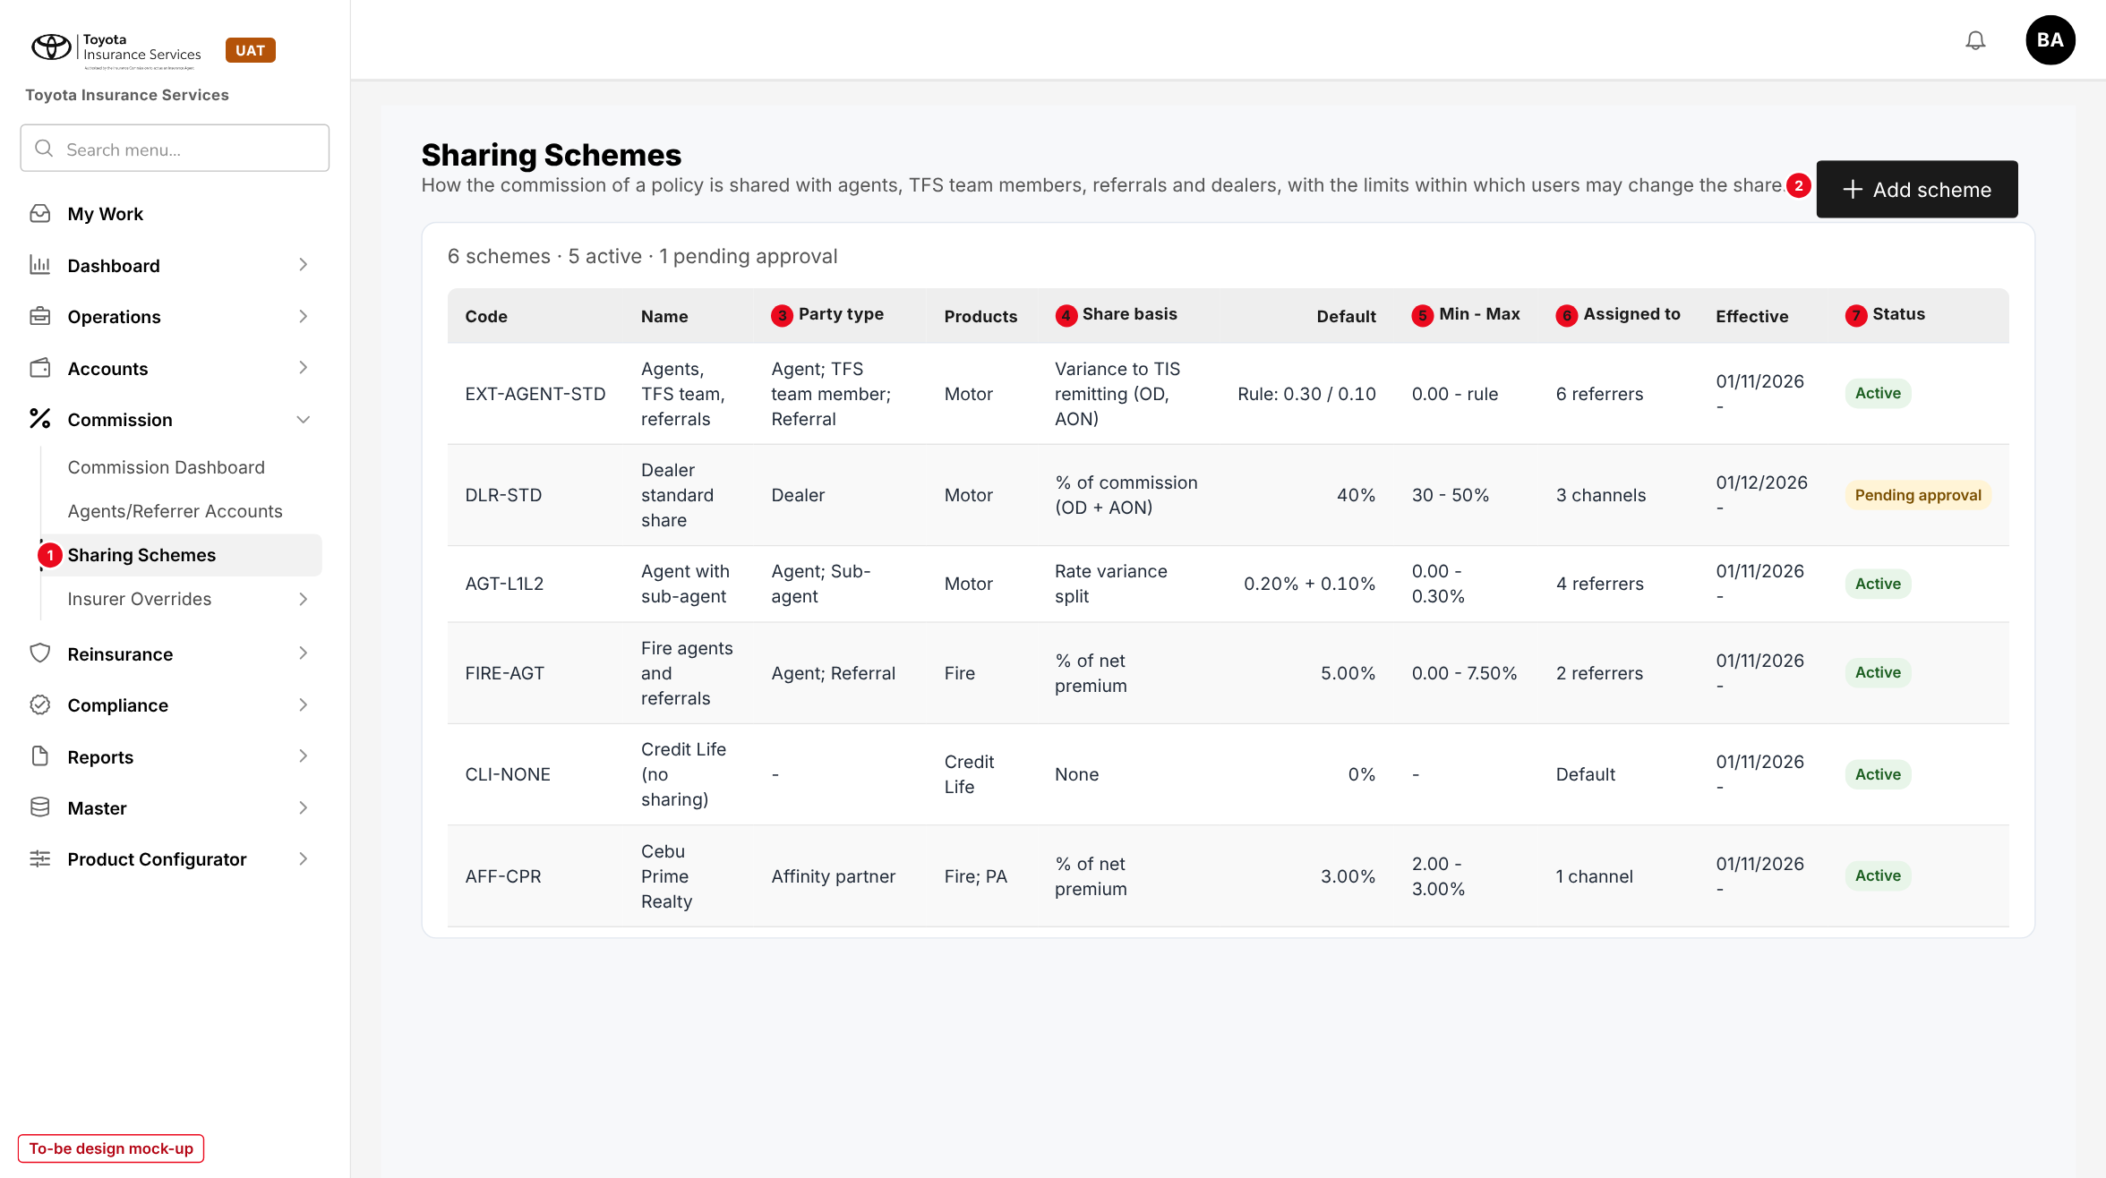
Figure 10: Sharing Schemes (to-be design mock-up, illustrative schemes)
No. | Field (label on screen) | Type | Mand. | Source / list | Default | Rule and message
1 | Sharing Schemes (side bar) | Menu item | - | - | - | Shown with read:sharing-schemes
2 | Add scheme | Button | - | - | - | write:sharing-schemes; opens 10.7
- | Code, Name, Products, Default, Effective | Columns | - | Scheme | - | -
3 | Party type | Column | - | Party type list | - | -
4 | Share basis | Column | - | Share basis list | - | Of the first split line
5 | Min - Max | Column | - | Split line | - | -
6 | Assigned to | Column | - | Assignments | - | Opens the Assignments tab
7 | Status | Column | - | Scheme status | - | -

Button | Who sees it | Enabled when | What happens | Result
Add scheme | write:sharing-schemes | Always | Opens an empty scheme | Draft
Copy / Amend (row) | write:sharing-schemes | Any / Active | New Draft or new version | Draft
Suspend / Resume / End (row) | approve:sharing-schemes | Active / Suspended | Remark; replacement when assigned | Suspended / Active / Ended

10.7 Add / Edit sharing scheme (new)
Type | New dialog, built from the Add programme dialog
Purpose | Identity, applicability and split lines of a scheme.
Who can open it | write:sharing-schemes
Navigation | Sharing Schemes > Add scheme, or a code
FRs | FR-CMR-010, 011, 012

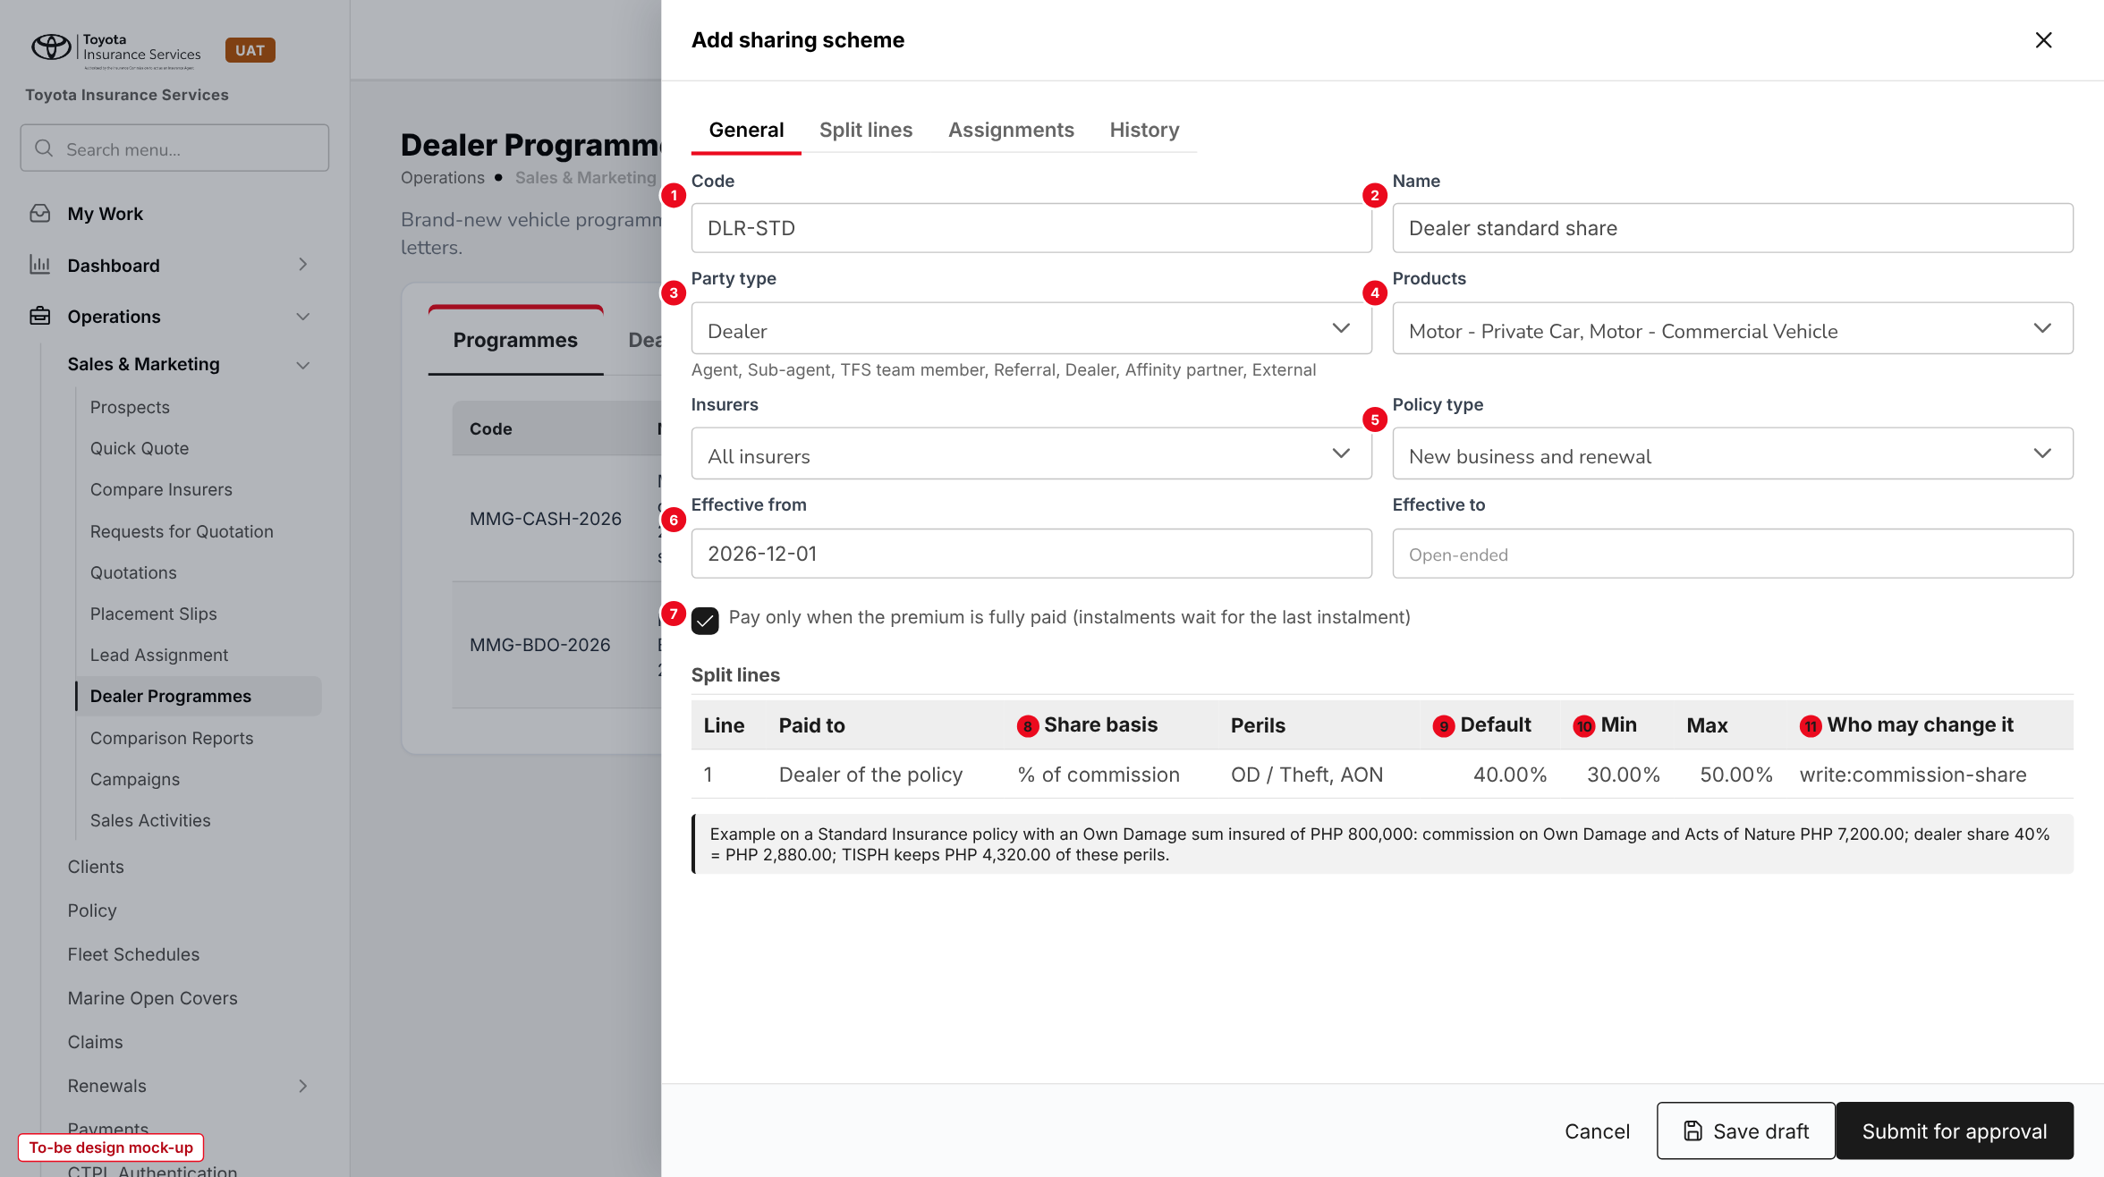
Figure 11: Add sharing scheme with its split line (to-be design mock-up)
No. | Field (label on screen) | Type | Mand. | Source / list | Default | Rule and message
1 | Code | Text | Y | - | - | A-Z, 0-9, hyphen, 3-20; unique
2 | Name | Text 120 | Y | - | - | -
3 | Party type | Multi-select | Y | Party type list | - | -
4 | Products | Multi-select | Y | Master > Insurance > Product | - | -
- | Insurers | Multi-select | N | Insurance Company | All insurers | -
5 | Policy type | List | Y | New business; Renewal; New business and renewal | Both | -
6 | Effective from / to | Date | Y / N | - | - | Not backdated
7 | Pay only when the premium is fully paid | Tick box | - | - | On | Applied by COMM-06
- | Paid to, Perils | List | Y | Paid to list; perils of the products | Referrer; OD + AON | -
8 | Share basis | List | Y | Share basis list | - | -
9 | Default | Number | Y | - | - | Min <= Default <= Max
10 | Min / Max | Number | Y | - | - | Max within the commission
11 | Who may change it | List | Y | Permissions | write:commission-share | -

Button | Who sees it | Enabled when | What happens | Result
Save draft | write:sharing-schemes | Draft | Validates and saves | Draft
Submit for approval | write:sharing-schemes | Draft with a valid line | Sends to Configuration Approvals | Pending approval

10.8 Scheme on a channel and on a referrer (changed)
Type | Existing dialogs, new fields
Purpose | Assign a scheme and an override.
Who can open it | write:sharing-schemes (scheme fields); write:channels / write:commission (other fields as today)
Navigation | - Master > Insurance > Distribution Channels > Edit channel  - Commission > Agents/Referrer Accounts > referrer
FRs | FR-CMR-014

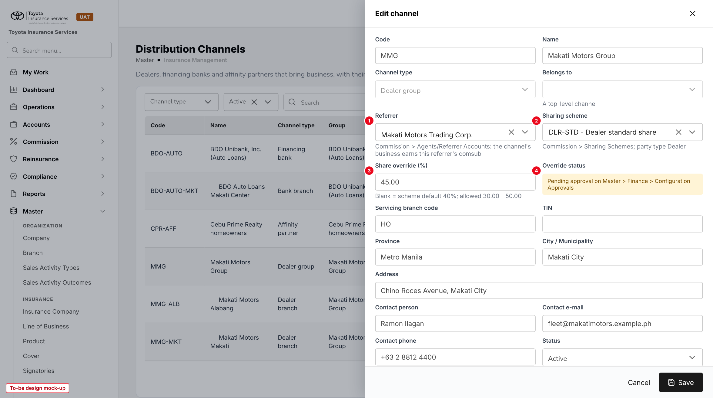
Figure 12: Edit channel with Sharing scheme and Share override (to-be design mock-up)
No. | Field (label on screen) | Type | Mand. | Source / list | Default | Rule and message
1 | Referrer (existing) | List | N | Agents/Referrer Accounts | - | As today
2 | Sharing scheme (replaces Comsub %) | List | N | Active schemes of the party type | Scheme of the dealer group | MSG on party type mismatch
3 | Share override (%) | Number | N | - | Blank = scheme default | Inside min - max
4 | Override status | Display | - | Assignment status | - | -

The referrer form of Agents/Referrer Accounts gets the same two fields, plus Party type; the list gets a Scheme column.

10.9 Create Quote - Step 5 Order Summary (changed)
Type | Existing screen, new panel
Purpose | Show the commission and the shares of the quotation and let an authorised user change a share inside the limits.
Who can open it | write:quotations; read:commission-rules for the brokerage; write:commission-share to change a share
Navigation | Create Quote > Next from Accessories
FRs | FR-CMR-021, 022

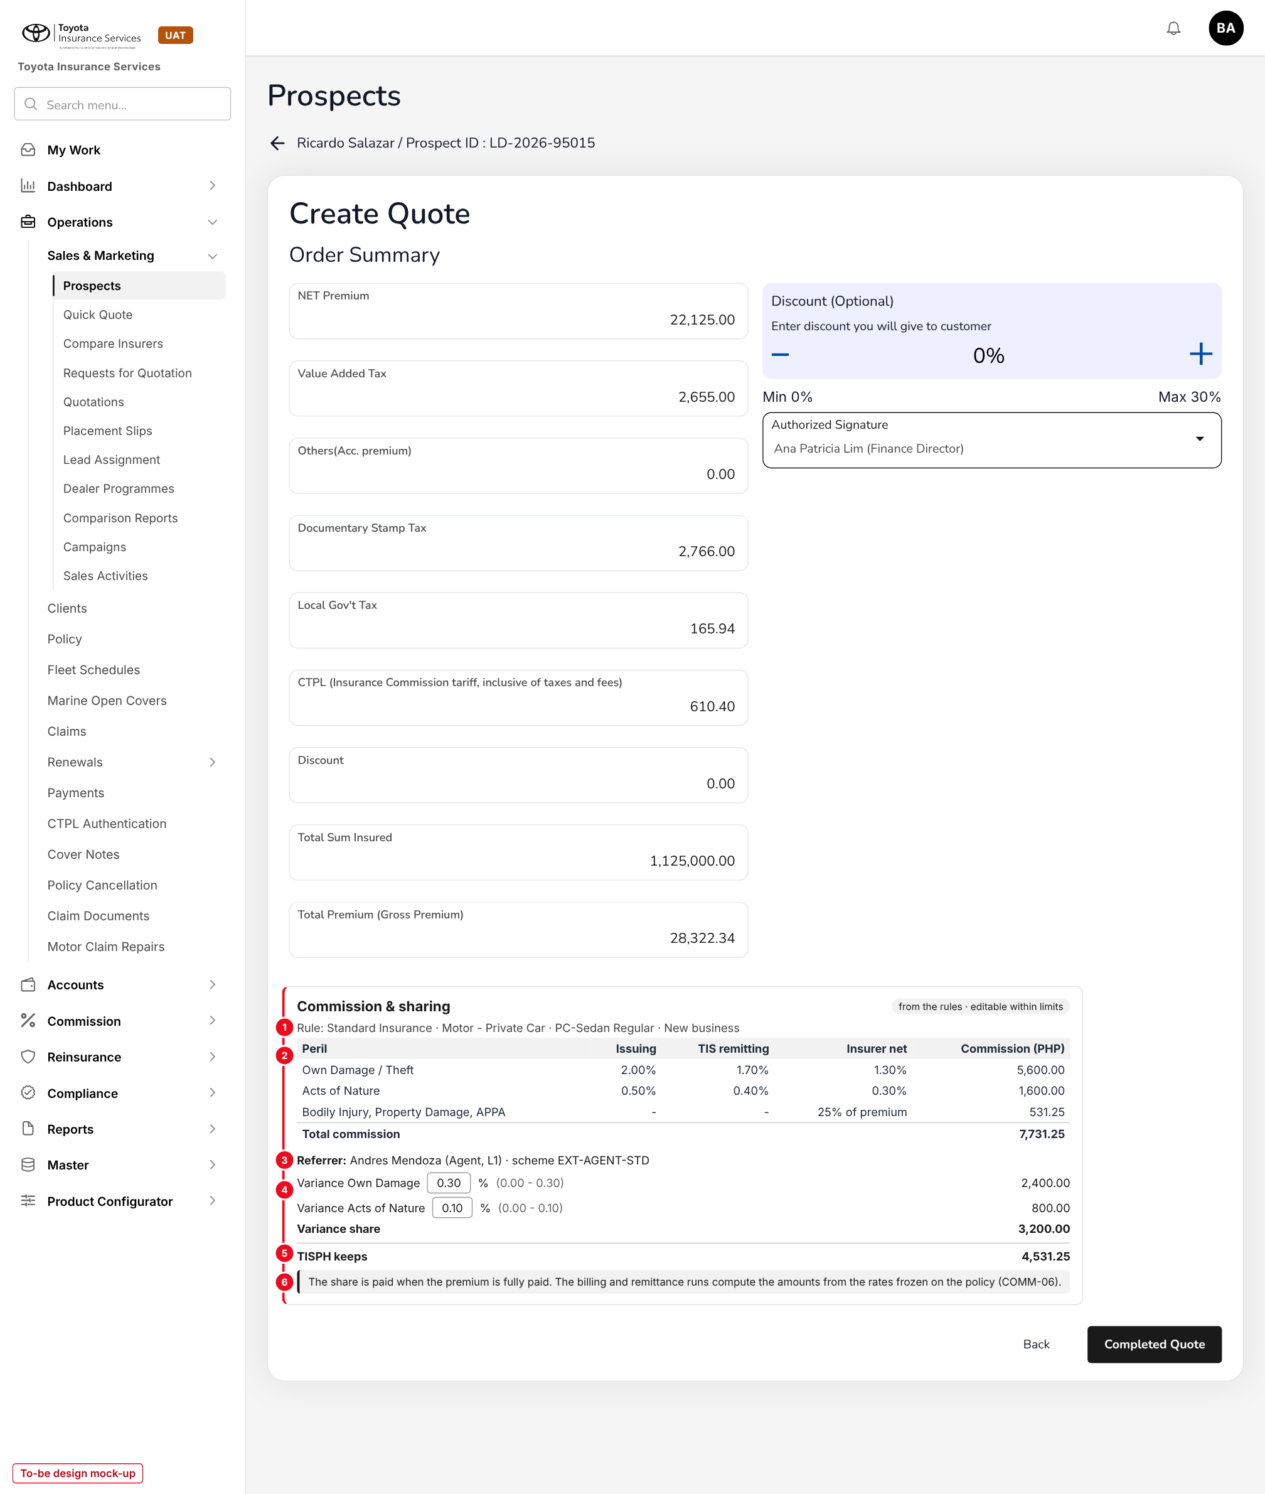
Figure 13: Order Summary with the Commission & sharing panel (to-be design mock-up, sample of Appendix A.1)
No. | Field (label on screen) | Type | Mand. | Source / list | Default | Rule and message
1 | Rule | Display | - | Commission rule | - | Warning when the fallback rate is used
2 | Peril table: Issuing, TIS remitting, Insurer net, Commission | Display | - | Peril rates and premium engine | - | Hidden without read:commission-rules
3 | Referrer and scheme | Display | - | Step 1 Referrer; channel | - | -
4 | Variance Own Damage / Acts of Nature | Number | - | Split line | Rule variance or override | Editable with write:commission-share, inside min - max; reason
5 | TISPH keeps | Display | - | Computed | - | Hidden without read:commission-rules
6 | Information line | Text | - | - | - | -

10.10 Referrer account line drawer (changed)
Type | Existing drawer
Purpose | See the scheme of a commission line and change it inside the limits.
Who can open it | read:commission; write:commission-share to change
Navigation | Commission > Agents/Referrer Accounts > referrer > line
FRs | FR-CMR-025

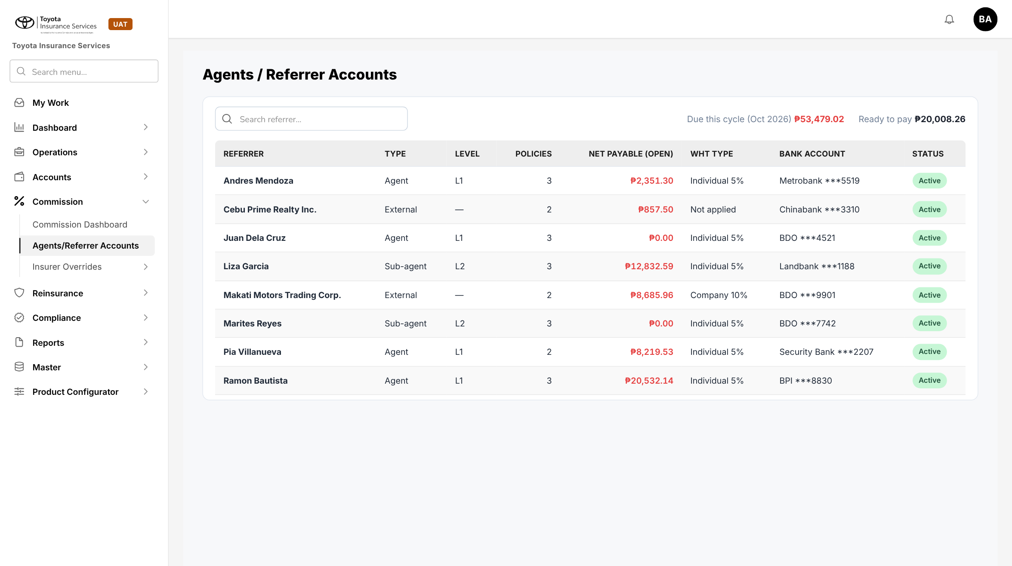
Figure 14: BrokerVerse today: Agents/Referrer Accounts
The drawer adds Scheme, Split line, Share basis and Min - Max under the comsub line. Change rate is enabled only with write:commission-share on an Accrued or Eligible line and refuses a value outside the range.

10.11 Upload rules (new)
Type | New, base upload pattern
Purpose | Load insurer net rate schedules.
Who can open it | write:commission-rules
Navigation | Commission Rate Matrix > Upload rules
FRs | FR-CMR-005

The user downloads the template, uploads the .xlsx and reads the result line ("Processed n rows: c created, f failed") with the failed rows listed by row number, as in the other BrokerVerse uploads. The template is in chapter 13.

11 End-to-end walkthroughs
The walkthroughs follow sample cases persona by persona (prospect Ricardo Salazar, LD-2026-95015; Standard Insurance Co., Inc.; Toyota Vios 1.3 XLE CVT; Own Damage sum insured PHP 800,000; Bodily Injury and Property Damage PHP 100,000; APPA PHP 25,000 x 5). They are the script of the PROD-16 SIT and UAT sessions; the amounts are worked out in Appendix A.

11.1 WT-A Load an insurer net rate schedule
Table 23: WT-A
Step | Who | Does | Sees / result
1 | Accounting | Commission Rate Matrix > Upload rules with the Standard schedule: 14 rules (7 motor types x new / renewal), 2 issuing-vs-remitting perils each, from 01/11/2026 | "Processed 28 rows: 14 created, 0 failed"; 14 rules Pending approval
2 | Accounting | Opens the PC-Sedan Regular - New business rule, Peril rates tab | Issuing / TIS remitting / insurer net: OD 2.0000 / 1.7000 / 1.3000; AON 0.5000 / 0.4000 / 0.3000; BI, PD, APPA 25%
3 | Accounting Manager | Configuration Approvals: approves the 14 changes | "Commission rule approved"; status Approved
4 | Accounting | Test rate: Standard, Motor - Private Car, Agent / referrer, New business | Rule at level insurer + product + motor type; TIS remitting 1.70 / 0.40; scheme EXT-AGENT-STD

11.2 WT-B Agent business
Table 24: WT-B
Step | Who | Does | Sees / result
1 | Sales & Marketing | Create Quote; Step 1: Standard Insurance, Comprehensive, Vios 1.3 XLE CVT, 2026, Referrer Andres Mendoza | Motor type PC-Sedan Regular; channel type Agent / referrer
2 | Sales & Marketing | Coverage Details: Own Damage coverage 800000, Acts of Nature, BI, PD, APPA; Calculate | Rates 2 and 0.5 from the rule; NET Premium 22,125.00
3 | Sales & Marketing | Order Summary | Total Premium 28,322.34; share PHP 3,200.00 (variance 0.30 and 0.10); commission hidden for this user
4 | Sales Head (write:commission-share) | Changes the variance to 0.20, reason Negotiated with agent | Share PHP 2,400.00; TIS remitting 1.80% on Own Damage; TISPH keeps PHP 5,331.25
5 | Processing Team | Converts the accepted quotation | Basis frozen on the policy with variance 0.20
6 | Accounting | Agents/Referrer Accounts > Andres Mendoza | Line with EXT-AGENT-STD 0.20 / 0.10; amount and cycle from the COMM-06 runs

11.3 WT-C Dealer business
Table 25: WT-C
Step | Who | Does | Sees / result
1 | Accounting | Sharing Schemes: DLR-STD, Dealer, 40% of OD + AON commission (30 - 50); submit | Pending approval; approved by the Accounting Manager
2 | Accounting | Distribution Channels > Makati Motors Group: Sharing scheme DLR-STD, override 45 | Assignment approved; branches inherit it
3 | Sales & Marketing | Quotation for a Makati Motors Alabang prospect, same Vios, no referrer | Rule for channel type Dealer, or Any; dealer share 45% x 7,200.00 = PHP 3,240.00; TISPH keeps PHP 4,491.25
4 | Operations | Endorsement later: insurer commission PHP 1,000.00 (COMM-07) | Dealer PHP 450.00

11.4 WT-D Exceptions
Table 26: WT-D
Case | Who | Does | Sees / result
D1 Share above max | Sales Head | Variance 0.35 on EXT-AGENT-STD | "The share must be between 0.00 and 0.30 for scheme EXT-AGENT-STD"
D2 No right | Sales & Marketing | Tries to edit the share | "Only users with the right to change commission shares can change this value"
D3 Promo policy | System | Agent quotation with PRM-FORTUNER26 | same_points: share PHP 3,600.00, Own Damage TIS remitting raised to 1.30 (Appendix A.3)
D4 No rule | System | Malayan Motorcycle quotation, no Motor rule | Insurer default rate used, warning
D5 Self-approval | Accounting Manager | Approves a rule she amended | "The approver must be different from the user who created or changed this rule"

12 Messages catalogue
Every message a user can see for this requirement, grouped by the screen that shows it. 55 messages: 7 confirmation, 8 error, 3 information, 31 validation, 6 warning. A validation or error is shown under the field it belongs to; a confirmation is a short toast. Text in angle brackets is filled in by the system.

12.1 Commission Rate Matrix
ID | Field | Message | Type | What the user does
MSG-CMR-001 | Insurer | Choose an insurer, a product or a line of business | Validation | Pick at least one key
MSG-CMR-002 | Effective from | Another rule for Standard Insurance Co., Inc. - Motor - Private Car - PC-Sedan Regular - New business is in force on these dates | Validation | Change the dates or amend the other rule
MSG-CMR-003 | Sum insured from | The sum insured band overlaps band <from> - <to> of another rule with the same keys | Validation | Change the band
MSG-CMR-004 | Sum insured to | Sum insured to must be higher than sum insured from | Validation | Correct the band
MSG-CMR-005 | Effective from | Effective from cannot be before today | Validation | Use today or a later date
MSG-CMR-006 | Effective to | Effective to must be on or after effective from | Validation | Correct the dates
MSG-CMR-007 | Rate basis | Issuing vs remitting is used for Motor products only | Validation | Choose % of net premium
MSG-CMR-008 | - | This rule is used by quotations or policies and cannot be deleted. Use End instead. | Error | End the rule
MSG-CMR-009 | Issuing % | Enter a rate from 0 to 100 with up to 4 decimals | Validation | Correct the rate
MSG-CMR-010 | Insurer net % | Enter the insurer net rate of <peril> | Validation | Enter the net rate of the insurer
MSG-CMR-011 | TIS remitting % | Enter the TIS remitting rate of <peril> | Validation | Enter the rate agents remit to TISPH
MSG-CMR-012 | TIS remitting % | <peril>: the rates must be insurer net <= TIS remitting <= issuing | Validation | Correct one of the rates
MSG-CMR-013 | Insurer net % | <peril>: issuing and insurer net rates are equal, so TISPH earns no commission on this peril | Warning | Check the schedule of the insurer
MSG-CMR-014 | Commission % | Enter a commission from 0 to 100% | Validation | Correct the rate
MSG-CMR-015 | - | The approver must be different from the user who created or changed this rule | Error | Ask another approver
MSG-CMR-016 | Remark | Enter a remark to return the change | Validation | Type the reason
MSG-CMR-017 | - | The effective-from date of this change has passed. Return it so that the maker can set a new date. | Error | Return the change
MSG-CMR-018 | - | This rule already has a change waiting for approval | Error | Wait for the decision or withdraw it
MSG-CMR-019 | - | Commission rule sent for approval | Confirmation | -
MSG-CMR-020 | - | Commission rule approved | Confirmation | -
MSG-CMR-021 | - | Commission rule returned to the maker | Confirmation | -
MSG-CMR-022 | - | No commission rule for <insurer> - <product> - <motor type>. The insurer default rate of <rate>% of net premium is used. | Warning | Accounting adds the rule
MSG-CMR-027 | Share | On <peril> the TIS remitting rate is raised to the promo net rate of <rate>%, so the share is PHP <amount> | Information | -
MSG-CMR-055 | - | You do not have permission to do this | Error | Ask the System Administrator

12.2 Upload rules
ID | Field | Message | Type | What the user does
MSG-CMR-023 | File | Upload an Excel (.xlsx) file | Validation | Save the file as .xlsx
MSG-CMR-024 | File | The file does not have the template columns. Download the template and copy your rows into it. | Error | Use the template
MSG-CMR-025 | File | Row <n>: <message> | Validation | Correct the row and upload it again
MSG-CMR-026 | - | Processed <n> rows: <c> created, <f> failed | Information | Check the failed rows

12.3 Sharing Schemes
ID | Field | Message | Type | What the user does
MSG-CMR-028 | Code | Enter the scheme code | Validation | Type a code
MSG-CMR-029 | Code | Use capital letters, digits and hyphens, 3 to 20 characters | Validation | Correct the code
MSG-CMR-030 | Code | Scheme code <code> is already used | Validation | Choose another code
MSG-CMR-031 | Party type | Choose at least one party type | Validation | Pick a party type
MSG-CMR-032 | Products | Choose at least one product | Validation | Pick a product
MSG-CMR-033 | - | Sharing scheme saved | Confirmation | -
MSG-CMR-034 | Default | The default must be between the minimum and the maximum | Validation | Correct the values
MSG-CMR-035 | Min | The minimum cannot be higher than the maximum | Validation | Correct the values
MSG-CMR-036 | Max | The shares of this scheme add up to more than 100% of the commission | Validation | Lower a share
MSG-CMR-037 | Max | A variance of <max> points is higher than the commission of <peril> on <n> rules in force | Warning | Check the rules or lower the maximum
MSG-CMR-038 | Split lines | Add at least one split line | Validation | Add a line
MSG-CMR-039 | Paid to | A scheme can share along at most <n> levels | Validation | Remove a level
MSG-CMR-040 | - | The approver must be different from the user who created or changed this scheme | Error | Ask another approver
MSG-CMR-041 | - | This scheme is assigned to <n> referrers and channels. Choose the scheme that replaces it, or confirm that their business is no longer shared. | Warning | Pick a replacement or confirm
MSG-CMR-042 | Remark | Enter a remark | Validation | Type the reason
MSG-CMR-043 | - | Sharing scheme approved | Confirmation | -
MSG-CMR-044 | - | Sharing scheme suspended | Confirmation | -

12.4 Scheme assignment (referrers and channels)
ID | Field | Message | Type | What the user does
MSG-CMR-045 | Sharing scheme | Scheme <code> is not for party type <type> | Validation | Choose a scheme for this party type
MSG-CMR-046 | Share override (%) | The override must be between <min> and <max> | Validation | Enter a value inside the range
MSG-CMR-047 | - | Scheme assignment sent for approval | Confirmation | -

12.5 Create Quote and policy
ID | Field | Message | Type | What the user does
MSG-CMR-048 | - | No sharing scheme for <referrer>. The rate of level <level> (<rate>% of net premium) is used. | Warning | Assign a scheme to the referrer
MSG-CMR-049 | - | Issuing rates of the commission rule applied: Own Damage <od>%, Acts of Nature <aon>% | Information | -
MSG-CMR-050 | Share | Only users with the right to change commission shares can change this value | Error | Ask an authorised user
MSG-CMR-051 | Share | The share must be between <min> and <max> for scheme <code> | Validation | Enter a value inside the range
MSG-CMR-052 | Reason | Choose the reason for the change | Validation | Pick a reason
MSG-CMR-053 | - | The commission rule or scheme changed since the quotation. Commission recomputed: PHP <amount>, shares PHP <amount>. | Warning | Check the panel before saving

12.6 Agents/Referrer Accounts
ID | Field | Message | Type | What the user does
MSG-CMR-054 | Rate | The share must be between <min> and <max> for scheme <code> | Validation | Enter a value inside the range

13 Upload screens

13.1 Commission rules template
Built like the other BrokerVerse templates (Download template): an Excel file with the sheets Data (one row per peril of a rule; required headers in dark red), Columns (each column with its format and an example) and Instructions. Rows with the same keys and dates form one rule. Rows are loaded one by one; a failed rule does not stop the others.
Table 27: Template columns
Column | Mand. | Format | Rule
INSURER | N* | Text | Name or code on Master > Insurance > Insurance Company; *one of INSURER, PRODUCT, LINE_OF_BUSINESS
PRODUCT / LINE_OF_BUSINESS | N* | Text | Code on the Product / Line of Business master
POLICY_TYPE | Y | Text | NEW, RENEWAL or ANY
CHANNEL_TYPE | N | Text | Financing bank, Dealer, Affinity partner, Agent / referrer, Direct; blank = Any
MOTOR_TYPE | N | Text | A value of the Motor type list; blank = Any
SI_FROM / SI_TO | N | Amount | SI_TO > SI_FROM
RATE_BASIS | Y | Text | ISSUING_VS_REMITTING or PCT_NET_PREMIUM
PERIL | Cond. | Text | Peril code (OD, AON, BI, PD, APPA); blank for PCT_NET_PREMIUM
ISSUING_RATE | N | Decimal 4 | % of sum insured; blank = premium.default_rates
TIS_REMITTING_RATE | Cond. | Decimal 4 | Required for an issuing-vs-remitting peril; <= ISSUING_RATE
INSURER_NET_RATE | Cond. | Decimal 4 | Required for an issuing-vs-remitting peril; <= TIS_REMITTING_RATE
COMMISSION_PCT | Cond. | Decimal 2 | For a %-of-premium peril or a PCT_NET_PREMIUM rule
EFFECTIVE_FROM / EFFECTIVE_TO | Y / N | DD/MM/YYYY | Not before today; no overlap
REMARKS | N | Text 500 | -

Limits: .xlsx only, first sheet Data, at most 2,000 rows (commission.rules_max_rows). The result line reads "Processed n rows: c created, f failed" with "Row n: message" for each failed row.

14 Sign-off and change control

14.1 What is signed
TISPH signs this FRS for TIS-BRD-PROD-16 as built on BrokerVerse: the process flows (chapter 2), the functional requirements (chapter 4), the workflow (chapter 5), and the screens, messages and upload (chapters 9 to 13). Values marked default, and the rates and shares in the examples, are configuration and are not frozen.

14.2 Change after sign-off
A change to anything signed is raised through the change control route of BRD section 8. The project team assesses its effect on BrokerVerse and on PROD-15 in the same CR-01 and on COMM-06 in CR-08, and issues a new version of this FRS for delta sign-off. When the screens are built, the to-be mock-ups are replaced with screenshots of the TISPH UAT environment.

14.3 Signatures
Table 28: Sign-off
Role | Name | Unit | Signature | Date
Business owner |  | TIS Finance and General Accounting
Business reviewer |  | TIS Sales
Business reviewer |  | TISPH Operations
Project Manager |  | TISPH DTID
Delivery lead |  | iorta TechNXT

Appendix A Commission examples
Premium figures follow the BrokerVerse premium engine: VAT 12%, DST PHP 0.50 per PHP 4.00 of net premium, LGT 0.75%, CTPL from the Insurance Commission tariff. Rates and shares are illustrative. The amounts paid in each cycle are computed by the runs of COMM-06.

A.1 Agent business - Standard Insurance, Vios, Own Damage sum insured PHP 800,000
Table 29: Agent business
Peril | Premium (issuing) | TIS remitting | Insurer net | Commission | Variance share
Own Damage / Theft (2.00 / 1.70 / 1.30%) | 16,000.00 | 13,600.00 | 10,400.00 | 5,600.00 | 2,400.00
Acts of Nature (0.50 / 0.40 / 0.30%) | 4,000.00 | 3,200.00 | 2,400.00 | 1,600.00 | 800.00
Bodily Injury 100,000 (25%) | 1,000.00 | - | 750.00 | 250.00 | -
Property Damage 100,000 (25%) | 1,000.00 | - | 750.00 | 250.00 | -
APPA 25,000 x 5 (25%) | 125.00 | - | 93.75 | 31.25 | -
NET Premium / total | 22,125.00 | - | 14,393.75 | 7,731.25 | 3,200.00
VAT 12% / DST / LGT 0.75% / CTPL | 2,655.00 / 2,766.00 / 165.94 / 610.40 | - | - | - | -
Total Premium (Gross Premium) | 28,322.34 | - | - | - | -
TISPH keeps (7,731.25 - 3,200.00) | - | - | - | 4,531.25 | -

A.2 Dealer business - same policy through Makati Motors (DLR-STD, override 45%)
Table 30: Dealer business
Line | Amount
Commission on Own Damage and Acts of Nature (5,600.00 + 1,600.00) | 7,200.00
Dealer share 45% of 7,200.00 | 3,240.00
Commission on BI, PD, APPA (not shared by DLR-STD) | 531.25
TISPH keeps (7,731.25 - 3,240.00) | 4,491.25

A.3 Agent business on a promotion - Fortuner, Own Damage sum insured PHP 1,200,000, PRM-FORTUNER26
Table 31: Promotion with an agent
Peril | Issuing | Promo net (insurer) | Commission | TIS remitting (same_points) | Variance share
Own Damage / Theft | 1.50% = 18,000.00 | 1.30% = 15,600.00 | 2,400.00 | 1.50 - 0.30 = 1.20, raised to 1.30 | 2,400.00
Acts of Nature | 0.40% = 4,800.00 | 0.30% = 3,600.00 | 1,200.00 | 0.40 - 0.10 = 0.30 | 1,200.00
BI, PD, APPA (25% of 2,125.00) | 2,125.00 | 1,593.75 | 531.25 | - | -
Total | 24,925.00 | 20,793.75 | 4,131.25 | - | 3,600.00

With same_points TISPH keeps PHP 531.25. With register_rate the agent gets no share (TIS remitting 1.70 and 0.40 are above the promo issuing rates) and TISPH keeps PHP 4,131.25.

