

FUNCTIONAL REQUIREMENTS SPECIFICATION
Scheme 1 & 2 Issuance
Direct issuance of Scheme 1 and Scheme 2 Motor policies on the TFSPH loan documents, without a quotation, behind a KYC and document checklist, with renewal notices withheld from past-due, missed-payment and early-terminated loan accounts

Client | Toyota Insurance Services Philippines Corporation (TISPH)
Document | TISPH-FRS-SCHM-01
Requirement | TIS-BRD-SCHM-01
Version | 1.0
Date | 9 October 2026
Status | Issued for TISPH review
Classification | Confidential

Prepared by iorta TechNXT for TISPH 
This document is confidential to Toyota Insurance Services Philippines Corporation and iorta TechNXT.
Document Control
Version | Date | Author | Reviewer | Approver | Change
1.0 | 9 Oct 2026 | iorta TechNXT Business Analysis | iorta TechNXT Project Manager | - | First issue for review

Distribution List
Name / Unit | Role | Organisation | Purpose
TIS Sales (business owner) | Approver | TISPH | Review and sign-off
Sales Admin | Business user | TISPH | Scheme applications, checklist and loan uploads
Operations | Business user | TISPH | Placement, policy issuance and renewal notice FRs
Finance and General Accounting | Business user | TISPH | Billing of the dealer and TFSPH
DTID - Project Management Team | Project owner | TISPH | Traceability against the BRD
Project team | Delivery | iorta TechNXT | Build, test and UAT preparation

Contents
1 Overview 5
1.1 The requirement 5
1.2 Scope 5
1.3 Definitions and acronyms 6
1.4 How to read the functional requirements 6
1.5 What changes in BrokerVerse 7
2 Process flow 8
2.1 Flow A - Application and document checklist 8
2.2 Flow B - Placement and policy issuance 10
2.3 Schemes and documents covered 11
3 Personas and roles 12
3.1 Personas 12
3.2 New permissions 13
3.3 Default grants 13
4 Functional requirements 14
4.1 Scheme application 14
FR-SIS-001 Create a scheme application from the loan documents 14
FR-SIS-002 Load the day's loan bookings by upload 16
FR-SIS-003 Check the application against the scheme 17
FR-SIS-004 Price the application from the scheme, without a quotation 18
FR-SIS-005 Record the Auto Renewal Agreement of Scheme 1 19
4.2 Document checklist 20
FR-SIS-010 Maintain the Scheme Document Checklist master 20
FR-SIS-011 Build the checklist on the application and receive the documents 22
FR-SIS-012 Apply the KYC rules by source 23
FR-SIS-013 Waive a missing document under maker-checker 24
FR-SIS-014 Hold the application until the checklist is complete 25
4.3 Placement and issuance 26
FR-SIS-020 Send the application to the insurer as a direct placement 26
FR-SIS-021 Record the insurer's answer and issue the policy 28
FR-SIS-022 Bill the year-1 premium to the dealer or TFSPH 29
FR-SIS-023 Carry the application data to the policy 30
FR-SIS-024 Cancel an application 31
4.4 Lock-in record and renewal notices 32
FR-SIS-030 Create the lock-in record of a scheme policy at issuance 32
4.5 Access and audit 33
FR-SIS-040 Control access and keep the audit trail 33
5 Workflow and status model 34
5.1 Scheme application 34
5.2 Checklist item 34
5.3 Policy issued from an application 35
6 Interfaces 36
7 Configuration items 37
7.1 Settings 37
7.2 Document numbering 37
7.3 Lists of values 37
7.4 Scheme Document Checklist as delivered 38
8 Traceability 39
8.1 BRD clause to FR 39
8.2 Related BRD requirements 39
8.3 FR to test cases 40
9 Navigation 41
9.1 Screens of SCHM-01 41
9.2 Menu by base role 41
10 Screen specifications 42
10.1 Scheme Issuance - Applications (new) 42
10.2 New scheme application (new) 43
10.3 Scheme application page (new) 45
10.4 Scheme Document Checklist (new) 47
10.5 Placement Slips (existing screen) 48
10.6 Policy detail - Scheme panel (changed) 48
11 End-to-end walkthroughs 50
11.1 WT-A Scheme 1 application to policy 50
11.2 WT-B Scheme 2 by upload, with an insurer decline 50
11.3 WT-C Exceptions 51
12 Messages catalogue 52
12.1 Scheme application 52
12.2 Loan Bookings Upload 53
12.3 Scheme Document Checklist 53
12.4 Application > Document checklist 53
12.5 Send to insurer 54
12.6 Issue policy 54
13 Upload screens 55
13.1 Loan bookings template 55
14 Sign-off and change control 56
14.1 What is signed 56
14.2 Change after sign-off 56
14.3 Signatures 56
Appendix A Premium schedule examples 57
A.1 Scheme 1 (S1-STD-2026) - Toyota Vios 1.3 XLE CVT, invoice price 1,015,000.00, 60-month loan 57
A.2 Scheme 2 (S2-STD-2026) - Toyota Fortuner 2.4 G 4x2 AT, invoice price 1,800,000.00, year 1 57

1 Overview

1.1 The requirement
TIS-BRD-SCHM-01 Scheme 1 & 2 (Customization, Phase 1, CR-05). Two dealer schemes are mapped as bundled products (Motor only; all dealers eligible for Scheme 1: 1 year free insurance with the remaining term ARA and renewal notice; Scheme 2: whole-term free insurance included in the M.A.). No quotation: issuance happens directly on receipt of loan documents with KYC and supporting documents against an upload checklist; renewal notices exclude past-due, missed-payment and early-terminated loan accounts.

Under the Toyota bundling programme the motor insurance premium is part of the customer's car loan with Toyota Financial Services Philippines (TFSPH). In Scheme 1 the first year is free to the customer (the dealer pays it) and the customer signs an Auto Renewal Agreement (ARA) that renews the cover every year for the rest of the loan term at premiums set in advance. In Scheme 2 the premiums of the whole loan term are built into the monthly amortisation, so the customer never pays a renewal premium separately.
For both schemes TISPH does not quote. The policy is placed with the insurer as soon as TFSPH has booked the loan and the loan documents, the KYC and the supporting documents are in. This FRS adds a Scheme Issuance screen to BrokerVerse for that path: an application per loan account, priced from the scheme, a document checklist that must be complete before the risk goes to the insurer, the direct placement and the policy. At issuance it records the TFSPH loan account and the lock-in on the policy, so that the renewal notice gate of SCHM-03 keeps notices away from past-due, missed-payment and early-terminated loan accounts. Screens that are new or change are shown as to-be mock-ups drawn on the real BrokerVerse screens with the Toyota Insurance Services look.

1.2 Scope
In scope
- A new Scheme Issuance screen under Operations > Sales & Marketing: scheme applications created one by one or from a TFSPH loan bookings upload, priced from the scheme without a quotation, with the ARA of Scheme 1 and the premium schedule of the loan term.
- A new master Scheme Document Checklist under Master > Insurance, and the checklist on each application: loan documents, KYC by source (TFSPH KYC confirmation or full KYC) and supporting documents, with upload, receipt and waiver under maker-checker.
- The checklist gate: an application goes to the insurer only when every required item is received or waived and the base KYC and vehicle check passes.
- Issuance through the existing Placement Slips (direct placement without a quotation) and the existing policy issuance, with the scheme and loan data on the policy and the year-1 premium billed to the dealer (Scheme 1) or TFSPH (Scheme 2).
- For each issued policy, the lock-in record of SCHM-03 (source Scheme 1 ARA or Scheme 2, period, TFS loan account), through which SCHM-03 applies the renewal-notice exclusions.
- Permissions, audit trail and the new settings.
Out of scope
- The Scheme Master itself (Scheme No., products and perils, rates by peril, make and model range, term and year-by-year sum insured, commission % and dealer commission %), the scheme rating and the Scheme panel on the policy: TIS-BRD-SCHM-02. This FRS calls them.
- Lock-in handling and the renewal notice gate: the TFS loan status upload, suppression of notices for lock-in and Scheme 2 accounts, notices held for past-due, terminated and other blocked loan accounts, the lock-in review and the 60-day review report: TIS-BRD-SCHM-03. This FRS only creates the lock-in record SCHM-03 works on.
- The issuing-vs-remitting commission and the dealer sharing of the commission (PROD-16, COMM-06), and the monthly billing of TFSPH.
- Renewal pricing and the renewal policy of later years; Credit Life and other lines bundled with the loan.

1.3 Definitions and acronyms
Table 1: Definitions
Term | Meaning in this FRS
Scheme | A record of the Scheme Master (SCHM-02), identified by its Scheme No. (for example S1-STD-2026), with its scheme type, products, perils, rates by peril, vehicle lines, term and year-by-year sum insured, effective dates and commission %.
Scheme type | Scheme 1 (free first year, then annual renewal under the ARA) or Scheme 2 (whole-term insurance included in the monthly amortisation).
Scheme application | A new record on Operations > Sales & Marketing > Scheme Issuance, one per loan account, numbered SAP-yyyy-nnnnn. It replaces the quotation for scheme business.
ARA | Auto Renewal Agreement: the deed signed by a Scheme 1 borrower authorising TISPH to renew the cover every year for the rest of the loan term, at indicative premiums, through the chosen payment mode.
M.A. | Monthly amortisation of the TFSPH loan.
Premium schedule | The sum insured and gross premium of each policy year of the loan term, computed when the application is priced. Year 1 is the policy issued by this FRS; later years are indicative.
Loan documents | The documents of a booked loan: TFSPH loan booking advice, vehicle sales invoice, delivery receipt, chattel mortgage or disclosure statement, and for Scheme 1 the signed ARA.
KYC source | TFSPH KYC confirmation (TFSPH validated the customer at loan approval; KYC is not collected again) or Full KYC (the borrower's IDs are collected and attached).
Checklist item | One document an application needs, copied from the Scheme Document Checklist, with the status Pending, Received, Waiver requested or Waived.
TFS loan account | The 10-digit TFSPH loan account number of the financed vehicle, for example 8005123456. It identifies the application and is carried to the policy and its lock-in record.
Lock-in record | The SCHM-03 record on the policy: lock-in source (Promotion, Scheme 1 ARA, Scheme 2), start, years, end, TFS loan account and loan status. The SCHM-03 notice gate decides from it whether a renewal notice is sent, suppressed or held.
TFSPH / TISPH | Toyota Financial Services Philippines Corporation (the financing bank and mortgagee) / Toyota Insurance Services Philippines Corporation (the broker).
ADA / PDC / OTC | Automatic Debit Arrangement / Post-dated cheque / Over-the-counter payment.

1.4 How to read the functional requirements
Each FR in chapter 4 has the same parts:
- A header table with the BRD trace, the actor, the priority, the fit and the screens that implement it.
- Description, preconditions, main flow and alternate and exception flows.
- Business rules. Configurable rules are maintained on a master or on Master > System > Configuration (chapter 7). Fixed rules change only through a change request.
- Validations and messages: the check and the message the user sees, word for word, with its ID in chapter 12. As everywhere in BrokerVerse, a message is plain English and is shown under the field it belongs to, or as a toast.
- Audit and numbered acceptance criteria, the basis of the test cases TC-SIS-nnn-n.
Note. Scheme codes, rates, the checklist content and the amounts in the examples are illustrative until TISPH confirms the scheme details. The premium figures are computed by the BrokerVerse premium engine on sample data with an Own Damage rate of 2.00% and an Acts of Nature rate of 0.50%.

1.5 What changes in BrokerVerse
BrokerVerse already issues brand-new vehicle business without a quotation for a dealer programme, and already places a risk with a named insurer without a quotation slip. SCHM-01 joins these into a loan-driven path with a document gate.
Table 2: BrokerVerse today and SCHM-01
BrokerVerse today | What SCHM-01 does
Motor business starts at Create Quote; the placement journey (setting placement.journey) requires a quotation slip for Motor Comprehensive, so New direct placement is refused for Motor. | Changed. A scheme application may be placed without a quotation. No other Motor business can skip the quotation.
Dealer Programmes (Operations > Sales & Marketing): the Dealer Sales upload creates the prospect, a quotation and, in issue mode "Policy issued", the policy, billing the dealer or bank for the free first year. | Reused as the pattern for Scheme Issuance: list page, upload tab, dealer and financing bank from Distribution Channels, free first year billed to the dealer. Dealer Programmes stay as they are.
Placement Slips: New direct placement, Send to insurer(s), Confirm (bind) with the insurer's policy number, Issue policy. Statuses Draft, SentToInsurer, Bound, Declined, Cancelled, PolicyIssued. | Reused. Send to insurer on a scheme application creates the direct placement (source Scheme) with the checklist documents attached; the policy is issued from it.
Convert to policy checks the KYC and vehicle identifiers of setting policy.kyc_required_fields (ID type, ID number, ID card image, chassis, engine, plate or MV file number). | Reused at Send to insurer. The TFSPH KYC confirmation stands for the ID card image and the conduction sticker for the plate of a new vehicle.
Claim Documents (Operations) and the Claim Document Checklist master: documents copied from a master by line and claim type, Received / Waive, upload, a claim goes to the insurer once every required document is in. | Reused as the pattern for the scheme checklist; a new master Scheme Document Checklist; waivers need a second user.
Renewals: Renewal Queue and Renewal Batch send First, Second and Final Notices to every account; no loan account or lock-in on a policy. | Changed through SCHM-03. Each scheme policy gets its TFS loan account and lock-in record at issuance; the SCHM-03 notice gate then suppresses or holds its notices.
No scheme, ARA or premium schedule on a policy. | New. The SCHM-02 Scheme panel of the policy also shows the application, the ARA, the KYC source and the waived documents.

2 Process flow
Two flow charts show the scheme business end to end: Flow A creates the application and completes the checklist, Flow B places the risk, issues the policy and hands its lock-in to SCHM-03. Black rounded boxes are start and end points, diamonds are decisions, red boxes are exceptions, grey boxes are done by the system and boxes with a heavy border are the successful outcome.

2.1 Flow A - Application and document checklist
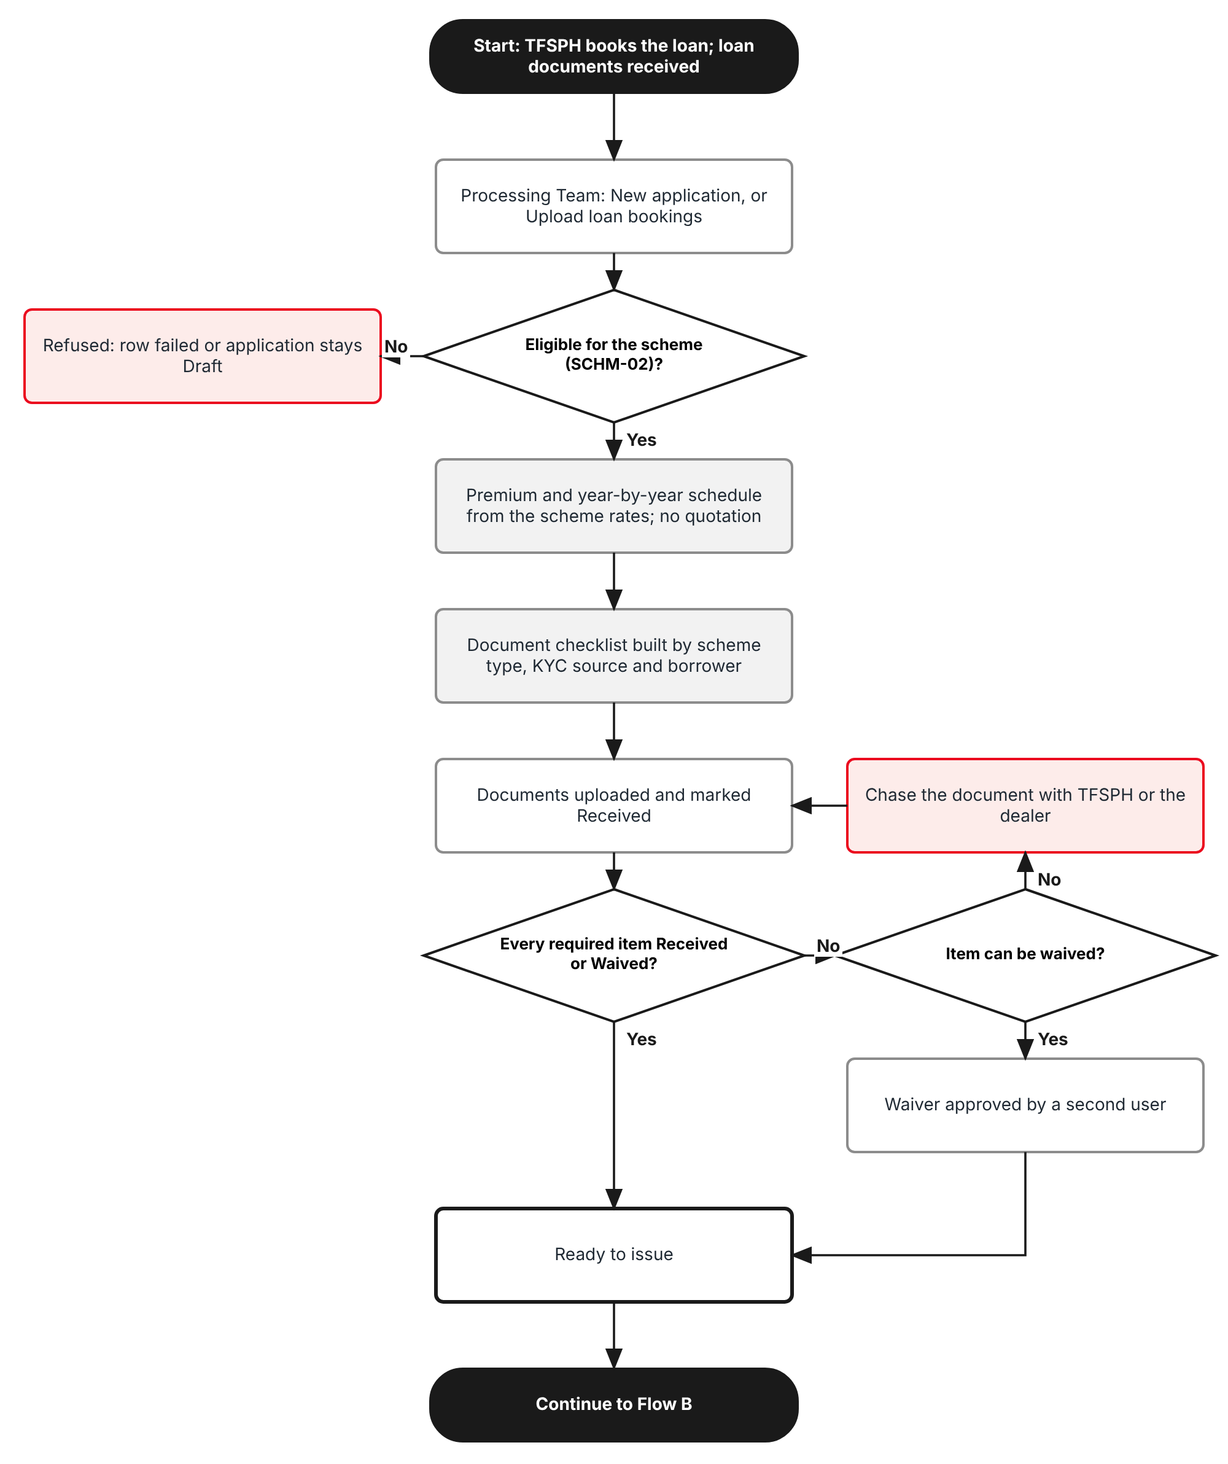
Figure 1: Flow A - Application and document checklist
Table 3: Flow A steps
Step | Who (role) | What happens | FR
A1 | Processing Team | Receives the loan documents of a booked TFSPH loan and opens Scheme Issuance > New application, or loads the day's bookings with Upload loan bookings. | FR-SIS-001, 002
A2 | System | Checks the application against the scheme (SCHM-02): active on the release date, Motor Comprehensive, make and model in range, brand-new vehicle, dealer and financing bank, no duplicate loan account or chassis. | FR-SIS-003
A3 | System | Prices year 1 with the scheme rates through the premium engine and computes the premium schedule of the loan term. No quotation is created. | FR-SIS-004
A4 | Processing Team | Scheme 1: records the ARA (signed on, payment mode); the ARA period runs to the end of the loan term. | FR-SIS-005
A5 | System | Copies the applicable documents from the Scheme Document Checklist by scheme type, KYC source and borrower conditions. | FR-SIS-010, 011, 012
A6 | Processing Team | Uploads each document or marks it Received. A missing document that may be waived goes to a second user for approval. | FR-SIS-011, 013
A7 | System | When every required item is Received or Waived, the application becomes Ready to issue. | FR-SIS-014

2.2 Flow B - Placement and policy issuance
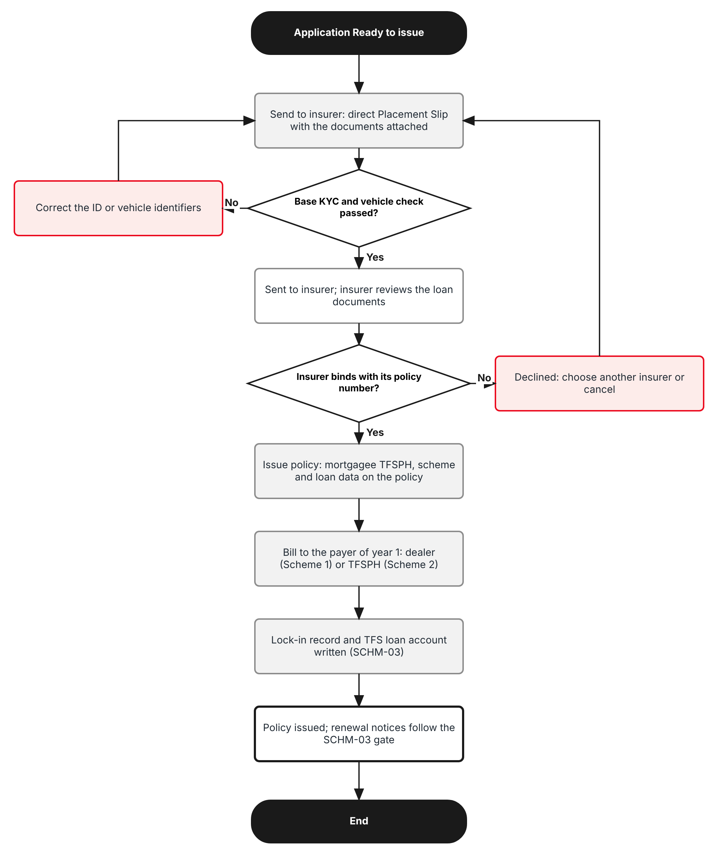
Figure 2: Flow B - Placement and policy issuance
Table 4: Flow B steps
Step | Who (role) | What happens | FR
B1 | Processing Team | Clicks Send to insurer. The system runs the base KYC and vehicle check, creates the direct Placement Slip (source Scheme) and e-mails the placement order with the checklist documents. | FR-SIS-020
B2 | Processing Team | Records the insurer's confirmation and policy number on the Placement Slip (Confirm), or its decline. | FR-SIS-021
B3 | Processing Team (write:policies) | Issues the policy: inception on the vehicle release date, TFSPH as mortgagee, scheme and loan data copied to the policy. | FR-SIS-021, 023
B4 | System | Bills the year-1 premium to the dealer (Scheme 1) or TFSPH (Scheme 2) and accrues the commission. | FR-SIS-022
B5 | System | Creates the SCHM-03 lock-in record: Scheme 1 ARA for 5 years (1 free + 4) or Scheme 2 for the loan term, with the TFS loan account. From then the SCHM-03 notice gate decides every renewal notice. | FR-SIS-030

2.3 Schemes and documents covered
Table 5: Dimensions covered
Dimension | Values | Where in BrokerVerse
Scheme types | Scheme 1 (free first year paid by the dealer, then ARA renewals); Scheme 2 (whole term included in the M.A., paid by TFSPH) | Scheme Master (SCHM-02); Scheme Issuance
Products | Motor - Private Car and Motor - Commercial Vehicle, Insurance Policy Type Comprehensive, brand-new vehicles | Master > Insurance > Product; Vehicle
Dealers | All Toyota dealers (Scheme 1); dealers named on the scheme (Scheme 2) | Master > Insurance > Distribution Channels (dealer group, dealer branch)
Financing bank | TFSPH (and its branches) as lender and mortgagee | Distribution Channels (financing bank, bank branch)
KYC sources | TFSPH KYC confirmation; Full KYC | Scheme Document Checklist; application

3 Personas and roles

3.1 Personas
BrokerVerse ships eight roles (Master > Users and Access > Role). TISPH personas map to them as below; TISPH can add its own roles (for example Sales Admin Head) and grant them the permissions of section 3.2.
Table 6: Personas and BrokerVerse roles
TISPH persona | BrokerVerse role | What they do with scheme business
Sales Admin / issuance officer (maker) | Processing Team (Placement & Policy Processing) - processing | Creates and uploads applications, collects the documents, sends to the insurer, issues the policy
Checker, e.g. Sales Admin Head | Accounting Manager - accounting-manager (or a TISPH role with approve:scheme-issuance) | Approves or rejects waivers of checklist items; cancels an application already sent to the insurer
Sales officer | Sales & Marketing (Account Executive) - sales | Views applications and their status for dealer follow-up
Renewals | Operations (Client Servicing) - operations | Works the renewals of scheme policies under the SCHM-03 notice gate
Finance | Accounting - accounting | Collects the year-1 premium from the dealer or TFSPH
System Administrator | System Administrator (Super Admin Access) - system-admin | Roles, permissions, configuration keys, the checklist master
Auditor | Compliance Officer (AML/CFT) - compliance-officer | Read-only access to applications, checklists and the Audit Trail

3.2 New permissions
New permissions follow the BrokerVerse pattern read:<module> / write:<module> / approve:<module> and are granted on Master > Users and Access > Role Permissions. Issuing the policy still needs the existing write:policies; maintaining the checklist master needs the existing write:masters. A waiver is always approved by a user other than the one who requested it, even when one user holds both permissions (maker-checker, TIS-BRD-SEC-03).
Table 7: New permissions
Permission | Allows
read:scheme-issuance | Open Operations > Sales & Marketing > Scheme Issuance, its applications, checklists and upload history; Export
write:scheme-issuance | Create, edit and upload applications; upload and receive documents; request waivers; Send to insurer; cancel an application not yet sent
approve:scheme-issuance | Approve or reject a waiver (never one you requested); cancel an application already sent to the insurer

3.3 Default grants
Table 8: Default grants (Y = granted)
Permission | system-admin | processing | sales | operations | accounting | accounting-manager | compliance-officer
read:scheme-issuance | Y | Y | Y | Y | Y | Y | Y
write:scheme-issuance | Y | Y | - | - | - | - | -
approve:scheme-issuance | Y | - | - | - | - | Y | -

4 Functional requirements
Seventeen FRs implement SCHM-01. They follow the process: the scheme application (4.1), the document checklist (4.2), placement and issuance (4.3), the lock-in record that carries the renewal-notice exclusions (4.4), and access and audit (4.5).

4.1 Scheme application

FR-SIS-001 Create a scheme application from the loan documents
BRD trace | SCHM-01 "issuance happens directly on receipt of loan documents"; LEAD-01; KYC-01 | Actor | Processing Team (write:scheme-issuance)
Priority | Must have | Fit | Customization
Screens | Operations > Sales & Marketing > Scheme Issuance (new menu item after Scheme Master, route /sales/scheme-issuance): New application; application page

Description
A new menu item Scheme Issuance is added under Operations > Sales & Marketing, after Scheme Master (SCHM-02). It follows the layout of Dealer Programmes: page title, breadcrumb, a short description, the buttons Upload loan bookings and New application, and the tabs Applications and Loan Bookings Upload.
New application opens a side dialog in four sections: Scheme and loan (scheme, loan account number, financing bank, loan booking date, loan term in months, vehicle release date), Borrower and KYC (an existing client or a new borrower with name, birthday, nationality, mobile number, e-mail and address; KYC source), Vehicle and dealer (dealer, vehicle brand, model, variant and year model from Master > Insurance > Vehicle, chassis, engine, conduction sticker, colour, invoice price, insurer) and, for Scheme 1, the Auto Renewal Agreement (FR-SIS-005). Save checks the scheme rules (FR-SIS-003), prices the application (FR-SIS-004), builds the checklist (FR-SIS-011) and gives the number SAP-yyyy-nnnnn (Master > System > Document Numbering, new entry scheme_application, prefix SAP).
A new borrower becomes a client of Operations > Clients only when the policy is issued, as in the Dealer Sales upload; until then the borrower is kept on the application. No prospect and no quotation are created.
Preconditions
- The user has write:scheme-issuance.
- At least one Active scheme exists in the Scheme Master (SCHM-02).
- The dealer and TFSPH exist on Master > Insurance > Distribution Channels.
Main flow
- The user opens Scheme Issuance and clicks New application.
- The user selects the Scheme; the scheme type (Scheme 1 or Scheme 2) is shown and the ARA section appears for Scheme 1.
- The user enters the loan, borrower, vehicle and dealer data from the loan documents and selects the insurer.
- The user clicks Save. The application is saved as Draft when a mandatory field is missing, otherwise as Documents pending, with the message "Application SAP-2026-90012 saved".
- The application page opens with the summary, the premium schedule and the checklist.
Alternate and exception flows
- Edit: an application in Draft, Documents pending or Ready to issue can be edited; a change to the scheme, KYC source, borrower nationality or birthday, or ARA payment mode rebuilds the checklist (items already Received stay Received).
- Existing client: when the borrower is picked from Operations > Clients, the name, birthday and contact data come from the client and the client's KYC documents already on file are offered for the checklist.
Business rules
Rule | Statement | Kind | Maintained in
R1 | TFS loan account: exactly 10 digits, as in SCHM-03; unique among applications that are not Cancelled. | Fixed | -
R2 | The financing bank is a financing bank or bank branch channel of TFSPH (setting schemes.financing_banks). | Configurable | Master > System > Configuration
R3 | Policy years = loan term in months / 12, rounded up, at most the term of the scheme (SCHM-02). Loan term 12 to 84 months. | Fixed | Scheme Master
R4 | The vehicle release date is the inception date of the year-1 policy (setting schemes.inception_basis, release_date or booking_date). It cannot be more than schemes.max_backdating_days (default 30) before today, nor in the future. | Configurable | Master > System > Configuration
R5 | The insurer is one of the insurers of the scheme (SCHM-02); when the scheme names one insurer it is filled in and read-only. | Fixed | Scheme Master

Validations and messages
Check | Message shown | ID
Scheme blank | Scheme is required | MSG-SIS-001
Loan account format | The TFS loan account must have 10 digits | MSG-SIS-002
Loan account used | Loan account <number> is already on application <application> | MSG-SIS-003
Loan term out of range | Loan term must be between 12 and 84 months | MSG-SIS-004
Release date backdated | The vehicle release date cannot be more than <n> days before today | MSG-SIS-005
Release date in the future | The vehicle release date cannot be in the future | MSG-SIS-006
Financing bank not TFSPH | The financing bank must be TFSPH or one of its branches | MSG-SIS-007
Saved | Application <application> saved | MSG-SIS-008

Audit
- Written to Master > System > Audit Trail with the user, time, before and after values and remark.
Acceptance criteria
- An application for loan 8005123456, scheme S1-STD-2026, Toyota Vios 1.3 XLE CVT 2026, invoice price 1,015,000.00, release date 07/10/2026 is saved as SAP-2026-90012 in Documents pending.
- A second application for loan 8005123456 is refused with "Loan account 8005123456 is already on application SAP-2026-90012".
- A loan term of 96 months is refused; 60 months gives 5 policy years.
- A release date 45 days before today is refused with the backdating message when schemes.max_backdating_days is 30.
- No quotation and no prospect exist for SAP-2026-90012 after the save.

FR-SIS-002 Load the day's loan bookings by upload
BRD trace | SCHM-01; LEAD-01 (TFS account detail set); BULK-01 | Actor | Processing Team (write:scheme-issuance)
Priority | Must have | Fit | Customization
Screens | Operations > Sales & Marketing > Scheme Issuance > Upload loan bookings; tab Loan Bookings Upload

Description
TFSPH sends the loans booked under the schemes as an Excel list. Upload loan bookings loads it with the BrokerVerse upload pattern: Template downloads a three-sheet workbook (Data, Columns, Instructions; required headers in dark red), the user uploads the filled .xlsx and each row is processed on its own, as in the Dealer Sales upload of Dealer Programmes.
Each valid row creates one scheme application with the same checks as FR-SIS-001 and FR-SIS-003, priced (FR-SIS-004) and with its checklist (FR-SIS-011). The KYC confirmation fields of the row (ID type and number presented at loan approval) are stored for the base KYC check. Documents are not in the file: they are uploaded on each application. The result reads "Processed n rows: c created, f failed" with the failed rows by row number; the batch (numbered SB-yyyy-nnnnn) is listed on the Loan Bookings Upload tab with its counts.
Preconditions
- The user has write:scheme-issuance.
Main flow
- The user clicks Template and fills one row per loan (chapter 13.1).
- The user clicks Upload loan bookings and chooses the file.
- The server reads the Data sheet row by row; a row with an error is listed and does not stop the others.
- The result line and the batch appear on the tab; the created applications are on the Applications tab in Documents pending.
Alternate and exception flows
- A row for a loan account already on an application fails with the duplicate message; the existing application is not changed.
- A file with more rows than schemes.max_rows is refused as a whole.
Business rules
Rule | Statement | Kind | Maintained in
R1 | .xlsx only, first sheet Data, at most schemes.max_rows rows (default 2,000). | Configurable | Master > System > Configuration
R2 | Columns are matched by header, case-insensitive, with the aliases listed on the Columns sheet. | Fixed | -
R3 | A batch is kept with its file name, rows, created, failed and the user; failed rows can be corrected and loaded again in a new file. | Fixed | -

Validations and messages
Check | Message shown | ID
File type | Upload an Excel (.xlsx) file | MSG-SIS-009
Missing column | The file does not match the template: column <column> is missing | MSG-SIS-010
Too many rows | The file has <n> rows; at most <max> rows can be uploaded at once | MSG-SIS-011
Row error | Row <n>: <message> | MSG-SIS-012
Result | Processed <n> rows: <c> created, <f> failed | MSG-SIS-013

Audit
- Written to Master > System > Audit Trail with the user, time, before and after values and remark.
Acceptance criteria
- An upload of 25 rows with 2 rows lacking the chassis number shows "Processed 25 rows: 23 created, 2 failed" and lists rows 7 and 19.
- The 23 applications are in Documents pending with their checklists, priced from their schemes.
- A .csv file is refused with "Upload an Excel (.xlsx) file".
- A row whose loan account is already on SAP-2026-90012 fails and SAP-2026-90012 is unchanged.
- The batch SB-2026-90003 is listed with 25 rows, 23 created and 2 failed.

FR-SIS-003 Check the application against the scheme
BRD trace | SCHM-01 "Motor only; all dealers eligible for Scheme 1"; SCHM-02; KYC-03 | Actor | System
Priority | Must have | Fit | Customization
Screens | Operations > Sales & Marketing > Scheme Issuance > New application, application page; Loan Bookings Upload

Description
On every save and upload row the server checks the application against the scheme record of the Scheme Master (SCHM-02). An application that fails a check stays in Draft (screen) or fails (upload) with the reason; it cannot reach Documents pending.
The brand-new rule is the one of PROD-15: Model Year not older than the policy year minus 1 and a chassis number on no earlier policy. Scheme business is always brand-new business.
Main flow
- The server reads the scheme: status, effective from / to, products, make and model range, dealers and insurers.
- It checks the vehicle, dealer, insurer and dates against them.
- It checks the chassis number against Operations > Policy and other applications.
- It returns every failed check at once, each under its field.
Business rules
Rule | Statement | Kind | Maintained in
R1 | The scheme is Active on the vehicle release date (SCHM-02 effective from / to). | Fixed | Scheme Master
R2 | Scheme 1 is open to every active dealer group and dealer branch channel; Scheme 2 only to the dealers listed on the scheme. | Fixed | Scheme Master; Distribution Channels
R3 | The vehicle brand and model are inside the make and model range of the scheme. | Fixed | Scheme Master
R4 | Product Motor, Insurance Policy Type Comprehensive; vehicle class from the variant (private_cars, commercial vehicles). | Fixed | -
R5 | The chassis number is on no policy and no other application that is not Cancelled. | Fixed | -

Validations and messages
Check | Message shown | ID
Scheme inactive | Scheme <scheme> is not active on <date> | MSG-SIS-014
Dealer not on scheme | Dealer <dealer> is not part of scheme <scheme> | MSG-SIS-015
Vehicle out of range | <brand> <model> is outside the make and model range of scheme <scheme> | MSG-SIS-016
Not brand new | Scheme business is for brand-new vehicles only: Model Year <year> is too old | MSG-SIS-017
Chassis used | Chassis number <chassis> is already on <policy or application> | MSG-SIS-018

Audit
- Written to Master > System > Audit Trail with the user, time, before and after values and remark.
Acceptance criteria
- A 2024 model year on a 2026 policy is refused with the brand-new message.
- A Scheme 2 application for a dealer not listed on S2-STD-2026 is refused; the same dealer is accepted on S1-STD-2026.
- A Toyota Hiace outside the model range of S1-STD-2026 is refused.
- A release date after the effective to of S1-STD-2026 is refused with "Scheme S1-STD-2026 is not active on <date>".
- An upload row whose chassis is on policy POL-2026-90031 fails with the chassis message.

FR-SIS-004 Price the application from the scheme, without a quotation
BRD trace | SCHM-01 "No quotation"; SCHM-02 rate by peril; QUOT-02; PROD-11 | Actor | System
Priority | Must have | Fit | Customization
Screens | Operations > Sales & Marketing > Scheme Issuance > application page, Premium schedule section

Description
Instead of a quotation, the application is priced by the scheme rating of SCHM-02 (FR-SCM-020 finds the scheme version and vehicle line from the Scheme No., dealer, insurer, vehicle, sum insured and inception date; FR-SCM-021 prices every peril of the scheme and adds VAT 12%, DST 12.5%, LGT 0.75% and CTPL from the tariff of the vehicle class, with 3-year CTPL for a brand-new vehicle). The year-1 sum insured is the invoice price. No discount applies.
The premium schedule lists, for each policy year, the sum insured (year-1 sum insured x the % of that year in the scheme schedule, FR-SCM-006) and the gross premium the scheme rating gives for it. CTPL due after the 3-year CTPL is added at renewal and is not in the schedule. The schedule of Scheme 1 is the indicative premium table printed in the ARA; the schedule of Scheme 2 is what TFSPH builds into the M.A.
The commission and the dealer share are computed from the scheme (FR-SCM-030, 031).
Main flow
- On save the server calls the scheme rating for year 1 and for each later year.
- It stores the breakdown (NET, VAT, DST, LGT, CTPL, gross, commission) of year 1 and the schedule.
- The application page shows them; any change to the vehicle, invoice price, scheme or loan term re-prices the application.
Alternate and exception flows
- The scheme has no rate for a peril it lists: the application cannot be priced and stays in Draft.
Business rules
Rule | Statement | Kind | Maintained in
R1 | Rates come only from the scheme; there is no Override on a scheme application. | Fixed | Scheme Master
R2 | Sum insured of each later year: the % of year 1 set in the scheme schedule (SCHM-02). | Fixed | Scheme Master
R3 | Re-pricing stops when the application is Sent to insurer; the issued policy carries the premium sent to the insurer. | Fixed | -

Validations and messages
Check | Message shown | ID
Rate missing | Scheme <scheme> has no rate for <peril> | MSG-SIS-019
Priced | Premium computed from scheme <scheme>: year 1 gross premium <amount> | MSG-SIS-020

Audit
- Written to Master > System > Audit Trail with the user, time, before and after values and remark.
Acceptance criteria
- SAP-2026-90012 under S1-STD-2026 (invoice price 1,015,000.00, OD 2.00%, AON 0.50%, BI and PD 100,000, 3-year CTPL; schedule 100%, 90%, 81%, 72.9%, 65.61%) shows NET premium 27,375.00, VAT 3,285.00, DST 3,422.00, LGT 205.31, CTPL 1,660.40 and gross premium 35,947.71.
- Its schedule shows years 2 to 5 at sums insured 913,500.00, 822,150.00, 739,935.00 and 665,941.50 and gross premiums 31,109.28, 28,248.85, 25,674.43 and 23,357.72.
- Changing the invoice price to 1,050,000.00 re-prices year 1 and the schedule.
- The rate fields cannot be edited on the application.
- After Send to insurer, a change to the invoice price is refused (FR-SIS-020).

FR-SIS-005 Record the Auto Renewal Agreement of Scheme 1
BRD trace | SCHM-01 "Scheme 1: 1 year free insurance with the remaining term ARA"; SCHM-03 | Actor | Processing Team (write:scheme-issuance)
Priority | Must have | Fit | Customization
Screens | Operations > Sales & Marketing > Scheme Issuance > New application, section Auto Renewal Agreement; application page

Description
For Scheme 1 the borrower signs the Deed of Undertaking on Automatic Renewal Agreement for the free first-year motor insurance. The application records the date it was signed and the payment mode of the renewal premiums: Automatic Debit Arrangement (ADA, the account of the TFSPH loan payments), Post-dated cheques, Online banking / OTC / QR, or Credit card. The auto-renewal period follows the deed: the four policy years after the free first year, so the Scheme 1 lock-in is 5 years in all (1 free + 4).
The ARA data and the premium schedule are copied to the policy at issuance (FR-SIS-023) and the ARA period becomes the lock-in record of SCHM-03 (FR-SIS-030).
For Scheme 2 there is no ARA: the payment mode is fixed to "Included in the monthly amortisation" and the section is hidden.
Preconditions
- The scheme of the application is Scheme 1.
Main flow
- The user enters ARA signed on and selects the ARA payment mode.
- The system shows the auto-renewal period and the schedule premiums of years 2 onward.
- The signed ARA is an item of the checklist (FR-SIS-011); for payment mode ADA the ADA enrolment form is added.
Business rules
Rule | Statement | Kind | Maintained in
R1 | ARA signed on: not after the vehicle release date and not before the loan booking date minus 30 days. | Fixed | -
R2 | ARA payment modes: ADA; Post-dated cheques; Online banking / OTC / QR; Credit card. | Configurable | List of values (7.3)
R3 | The ARA cannot be removed from a Scheme 1 application; a borrower who refuses the ARA is not Scheme 1 business. | Fixed | -

Validations and messages
Check | Message shown | ID
ARA date blank (Scheme 1) | ARA signed on is required for Scheme 1 | MSG-SIS-021
ARA date out of range | ARA signed on must be between <from> and the vehicle release date | MSG-SIS-022
Payment mode blank | ARA payment mode is required for Scheme 1 | MSG-SIS-023

Audit
- Written to Master > System > Audit Trail with the user, time, before and after values and remark.
Acceptance criteria
- A Scheme 1 application with a 60-month loan shows an auto-renewal period of 4 years, years 2 to 5, and a lock-in of 5 years.
- Saving a Scheme 1 application without ARA signed on keeps it in Draft with "ARA signed on is required for Scheme 1".
- Selecting payment mode ADA adds the item "ADA enrolment form" to the checklist; changing it to Credit card removes it.
- A Scheme 2 application has no ARA section and shows the payment mode "Included in the monthly amortisation".
- A Scheme 1 policy released on 07/10/2026 gets a lock-in from 07/10/2026 to 06/10/2031 (FR-SIS-030).

4.2 Document checklist

FR-SIS-010 Maintain the Scheme Document Checklist master
BRD trace | SCHM-01 "KYC and supporting documents against an upload checklist"; KYC-04 | Actor | System Administrator or Processing Team (write:masters)
Priority | Must have | Fit | Customization
Screens | Master > Insurance > Scheme Document Checklist (new, after Claim Document Checklist, route /master/insurance/scheme-document-checklist)

Description
A new master Scheme Document Checklist is added to Master > Insurance, built like the Claim Document Checklist master (a generic master of Master > Insurance with Add, edit and deactivate). Each record is one document an application may need, with: Code, Scheme type (Scheme 1, Scheme 2 or * for both), KYC source (TFSPH, Full KYC or *), Condition (Always, Non-Filipino borrower, Borrower 21 or younger, ARA payment by ADA), Document, KYC item (Yes / No), Required (Yes / No), Can be waived (Yes / No) and Sort order.
BrokerVerse is delivered with the twelve records of section 7.4, drawn from the loan documents of the bundling programme and the TFSPH list of acceptable IDs. TISPH maintains them; a change applies to applications saved afterwards and to open applications when their checklist is rebuilt.
Preconditions
- The user has write:masters.
Main flow
- The user opens Master > Insurance > Scheme Document Checklist and clicks Add.
- The user fills the fields and saves.
- The record is listed Active; Deactivate removes it from new checklists.
Business rules
Rule | Statement | Kind | Maintained in
R1 | A KYC item can never be waived: Can be waived is forced to No when KYC item is Yes. | Fixed | -
R2 | Code unique; Scheme type, KYC source and Condition from their lists. | Fixed | -
R3 | Deactivating a record does not remove it from applications that already carry it. | Fixed | -

Validations and messages
Check | Message shown | ID
Code used | Code <code> is already used | MSG-SIS-024
Document blank | Document is required | MSG-SIS-025
KYC waivable | A KYC item cannot be waived | MSG-SIS-026

Audit
- Written to Master > System > Audit Trail with the user, time, before and after values and remark.
Acceptance criteria
- The master lists the twelve delivered records with their scheme type, KYC source and condition.
- A record with KYC item Yes and Can be waived Yes is refused with "A KYC item cannot be waived".
- A new record "Insurance endorsement letter to TFSPH", Scheme type *, Required Yes appears on applications saved afterwards.
- Deactivating SCH-PHOTOS removes it from new applications; SAP-2026-90012 keeps it.
- Every change is listed on Master > System > Audit Trail.

FR-SIS-011 Build the checklist on the application and receive the documents
BRD trace | SCHM-01 "against an upload checklist"; KYC-04 "KYC is more on electronic documentation" | Actor | Processing Team (write:scheme-issuance)
Priority | Must have | Fit | Customization
Screens | Operations > Sales & Marketing > Scheme Issuance > application page, Document checklist

Description
When the application is first saved the server copies onto it every active record of the Scheme Document Checklist whose scheme type, KYC source and condition match the application, in sort order, as on Claim Documents. Each item shows Document, Required, KYC, Status, Received / waived (date and user, or the waiver) and Actions.
Upload stores a file (types of setting uploads.allowed_types: PDF, JPEG, PNG and the other base types) against the item and marks it Received with today's date. Received marks an item received without a file, for a paper original kept on file; it needs a remark. Add document adds an item that is not on the master (for example a letter the insurer asks for); it is optional unless the user ticks Required. The header of the application shows "n required document(s) missing" until the gate is passed.
Preconditions
- The application is saved (not Draft, not Cancelled, not Policy issued).
Main flow
- The user opens the application.
- For each item the user clicks Upload and picks the file, or Received with a remark.
- The item becomes Received; the count of missing documents is updated.
- When the last required item is in, FR-SIS-014 moves the application to Ready to issue.
Alternate and exception flows
- Reopen: a Received item can be set back to Pending (for example a blurred scan) with a remark; an application in Ready to issue goes back to Documents pending.
- Rebuild after a change of scheme, KYC source, borrower or payment mode: new items are added, items that no longer apply are removed when Pending and kept as optional when Received.
Business rules
Rule | Statement | Kind | Maintained in
R1 | File size at most schemes.max_document_mb (default 10 MB); file type decided by its content, not its name (base upload rule, setting uploads.allowed_types). | Configurable | Master > System > Configuration
R2 | A KYC item marked Received without a file is not allowed: KYC is kept electronically. | Fixed | -
R3 | Files are stored against the application and copied to the policy's Documents at issuance. | Fixed | -

Validations and messages
Check | Message shown | ID
File type | This file type is not accepted. Upload a PDF, JPEG or PNG file | MSG-SIS-027
Received without remark | Remark is required when no file is uploaded | MSG-SIS-028
KYC without file | A KYC document must be uploaded | MSG-SIS-029
Uploaded | <document> received | MSG-SIS-030

Audit
- Written to Master > System > Audit Trail with the user, time, before and after values and remark.
Acceptance criteria
- A Scheme 1 application with KYC source TFSPH, Filipino borrower aged 34 and ARA payment by ADA gets the items SCH-LOAN, SCH-INVOICE, SCH-DR, SCH-MORTGAGE, SCH1-ARA, SCH1-ADA, KYC-TFS, KYC-TFS-ID and SCH-PHOTOS.
- Uploading booking-8005123456.pdf on "Loan booking advice from TFSPH" sets it Received with today's date.
- Marking "TFSPH KYC confirmation" Received without a file is refused with "A KYC document must be uploaded".
- Reopening a Received item of a Ready to issue application returns it to Documents pending.
- Changing the KYC source to Full KYC removes the Pending item KYC-TFS and adds KYC-ID.

FR-SIS-012 Apply the KYC rules by source
BRD trace | KYC-02 "TFS-sourced deals rely on pre-validated KYC"; KYC-04; SCHM-01 "with KYC" | Actor | System; Processing Team
Priority | Must have | Fit | Customization
Screens | Operations > Sales & Marketing > Scheme Issuance > application page, Borrower and KYC section and Document checklist

Description
A loan booked by TFSPH comes with the KYC TFSPH did at loan approval, so KYC is not collected again: the application needs the TFSPH KYC confirmation (customer name, birthday, mobile number or e-mail, and the ID presented, with its type and number). This is KYC source TFSPH, the default for every bank of schemes.kyc_confirmation_banks.
When TFSPH cannot confirm the KYC, the user sets KYC source Full KYC: the borrower presents one primary ID or two secondary IDs from the TFSPH list of acceptable IDs (setting policy.kyc_id_types, updated to that list in section 7.1), scanned and attached. For both sources a non-Filipino borrower adds SRRV or ACR / ICR, and a borrower aged 21 or younger adds the birth certificate.
The ID type and number recorded here feed the base KYC check at Send to insurer (FR-SIS-020).
Main flow
- The user selects the KYC source and enters ID type and ID number (from the confirmation, or from the ID presented).
- The system adds the KYC items of the source and of the borrower's conditions to the checklist.
- The user uploads the KYC documents.
Business rules
Rule | Statement | Kind | Maintained in
R1 | Primary IDs: PhilID, LTO Driver's License, Passport, UMID, SSS, PRC, IBP, Senior Citizen, Postal ID, OWWA, MARINA, GSIS e-card, ACR / ICR, government office and GOCC ID, OFW ID. Secondary IDs: Police clearance, NBI clearance, PhilHealth ID, Pag-IBIG Loyalty Card Plus, DSWD certification, Seaman's Book, Barangay certification (with photo), company ID of a BSP / SEC / IC regulated company, NCWDP or PWD ID. | Configurable | policy.kyc_id_types
R2 | Full KYC: at least one primary ID, or two different secondary IDs. | Fixed | -
R3 | Borrower age is computed on the release date from the birthday. | Fixed | -

Validations and messages
Check | Message shown | ID
ID type blank | ID type is required | MSG-SIS-031
ID not accepted | ID type "<type>" is not an accepted ID | MSG-SIS-032
Secondary IDs | Full KYC needs one primary ID or two different secondary IDs | MSG-SIS-033
Birthday blank | Birthday is required | MSG-SIS-034

Audit
- Written to Master > System > Audit Trail with the user, time, before and after values and remark.
Acceptance criteria
- A TFSPH-booked loan defaults to KYC source TFSPH and needs the TFSPH KYC confirmation, not an ID scan.
- With Full KYC and a single NBI clearance, Send to insurer is refused with the two-secondary-IDs message.
- A Japanese borrower gets the item "SRRV or ACR / ICR".
- A borrower born on 01/03/2006 (aged 20 on 07/10/2026) gets the item "Birth certificate".
- ID type "Voter's ID" is refused when it is not in policy.kyc_id_types.

FR-SIS-013 Waive a missing document under maker-checker
BRD trace | SEC-03 maker-checker; SCHM-01 checklist gate | Actor | Processing Team (request); Accounting Manager or TISPH checker (approve:scheme-issuance)
Priority | Must have | Fit | Customization
Screens | Operations > Sales & Marketing > Scheme Issuance > application page, Document checklist (Waive, Approve, Reject); My Work > Approvals (item kind "Checklist waiver")

Description
A required item whose master record says Can be waived may be waived when the document will come later or does not apply, for example a chattel mortgage still being registered. The maker clicks Waive and enters the reason; the item becomes Waiver requested and an item appears in My Work > Approvals of the users with approve:scheme-issuance (kind Checklist waiver, the application, the document and the reason).
A checker other than the requester Approves (item Waived, counts as in for the gate) or Rejects with a remark (item back to Pending). A waived document can still be uploaded later; it then becomes Received.
Preconditions
- The item is Pending and Can be waived on its master record.
Main flow
- The maker clicks Waive and enters the reason.
- The item becomes Waiver requested; the approval item is raised.
- The checker opens it from My Work > Approvals or the application and approves or rejects it.
Business rules
Rule | Statement | Kind | Maintained in
R1 | KYC items, the loan booking advice, the sales invoice and the signed ARA cannot be waived (Can be waived No on the delivered records). | Configurable | Scheme Document Checklist
R2 | The checker must be different from the user who requested the waiver. | Fixed | -
R3 | A waived item is listed on the policy's Scheme panel with the reason, so Operations can follow it up. | Fixed | -

Validations and messages
Check | Message shown | ID
Not waivable | <document> cannot be waived | MSG-SIS-035
Reason blank | Reason is required | MSG-SIS-036
Self-approval | Maker-checker: the approver must be different from the user who requested the waiver | MSG-SIS-037
Waiver approved | Waiver of <document> approved | MSG-SIS-038
Waiver rejected | Waiver of <document> rejected | MSG-SIS-039

Audit
- Written to Master > System > Audit Trail with the user, time, before and after values and remark.
Acceptance criteria
- A waiver of "Chattel mortgage naming TFSPH as mortgagee" requested by J. Santos appears in My Work > Approvals of an Accounting Manager.
- J. Santos cannot approve it, even with approve:scheme-issuance.
- Waive is not offered on "TFSPH KYC confirmation".
- An approved waiver counts as in: an application whose other items are Received becomes Ready to issue.
- Rejecting with the remark "Registration done, ask TFSPH for the copy" sets the item back to Pending.

FR-SIS-014 Hold the application until the checklist is complete
BRD trace | SCHM-01 "checklist gate"; QUOT-08 Motor issuance checklist | Actor | System
Priority | Must have | Fit | Customization
Screens | Operations > Sales & Marketing > Scheme Issuance > application page (status, Send to insurer)

Description
The checklist is the gate of the scheme path. An application is Ready to issue only when it passed the scheme checks (FR-SIS-003), is priced (FR-SIS-004) and every Required item of its checklist is Received or Waived. Until then it is Documents pending and Send to insurer is disabled with the missing documents listed in its tooltip.
The gate is checked again by the server at Send to insurer, so the API cannot bypass it.
Main flow
- After each checklist change the server counts the required items not Received or Waived.
- At zero it sets Ready to issue; above zero it sets Documents pending.
Business rules
Rule | Statement | Kind | Maintained in
R1 | Optional items never block the gate. | Fixed | -
R2 | A Waiver requested item still blocks the gate until it is approved. | Fixed | -

Validations and messages
Check | Message shown | ID
Gate not passed | The application cannot go to the insurer: <n> required document(s) missing (<list>) | MSG-SIS-040
Ready | All required documents are in. The application is ready to issue | MSG-SIS-041

Audit
- Written to Master > System > Audit Trail with the user, time, before and after values and remark.
Acceptance criteria
- SAP-2026-90012 with the delivery receipt Pending and the chattel mortgage Waiver requested shows "2 required document(s) missing" and Send to insurer is disabled.
- Approving the waiver and uploading the delivery receipt sets Ready to issue.
- A Pending optional item (vehicle photos) does not block Ready to issue.
- Calling Send to insurer through the API on a Documents pending application is refused with the gate message.
- Reopening an item sets the application back to Documents pending.

4.3 Placement and issuance

FR-SIS-020 Send the application to the insurer as a direct placement
BRD trace | SCHM-01 "No quotation: issuance happens directly"; ISSUE-01; QUOT-01; KYC-02, KYC-03 | Actor | Processing Team (write:scheme-issuance)
Priority | Must have | Fit | Customization
Screens | Operations > Sales & Marketing > Scheme Issuance > application page, Send to insurer; Operations > Sales & Marketing > Placement Slips

Description
Send to insurer on a Ready to issue application creates a Placement Slip with source Scheme for the insurer of the application, 100% share, with the year-1 premium, the vehicle, the period and the TFSPH mortgagee clause, and sends it with the existing placement order e-mail (template email.template.placement_order). With schemes.attach_documents_to_placement on (default) the checklist files are attached. The application becomes Sent to insurer and shows the Placement Slip number.
Before the slip is created the server runs the base KYC and vehicle check of convert-to-policy (setting policy.kyc_required_fields, for MOTOR: ID type, ID number, ID card image, chassis number, engine number, plate or MV file number). For scheme applications the uploaded TFSPH KYC confirmation (or the ID scan under Full KYC) is the ID card image, and the conduction sticker stands for the plate number of a vehicle not yet registered.
The placement journey of BrokerVerse requires a quotation slip for Motor Comprehensive. A Placement Slip of source Scheme is exempt from that rule; New direct placement on Placement Slips stays refused for Motor.
Preconditions
- The application is Ready to issue.
- The insurer is authorised (Insurer Authority of the IC compliance module), as for any placement.
Main flow
- The user clicks Send to insurer and confirms.
- The server checks the gate (FR-SIS-014) and the KYC and vehicle identifiers.
- The server creates the Placement Slip (source Scheme), queues the e-mail to the insurer and sets the application to Sent to insurer.
- The application and the Placement Slip link to each other.
Alternate and exception flows
- The insurer has no e-mail address: the slip is created in Draft and the user sends it from Placement Slips after the address is added.
Business rules
Rule | Statement | Kind | Maintained in
R1 | Only a Placement Slip created from a scheme application may skip the quotation for Motor. | Fixed | placement.journey
R2 | After Send to insurer the application data and the checklist are read-only; a correction means cancelling the slip (FR-SIS-024). | Fixed | -
R3 | Attach the checklist files to the placement e-mail: schemes.attach_documents_to_placement (default true). | Configurable | Master > System > Configuration

Validations and messages
Check | Message shown | ID
KYC missing | Policy cannot be issued without the customer's KYC and vehicle identifiers. Missing: <items> | MSG-SIS-042
Insurer not authorised | Insurer <insurer> is not authorised for Motor | MSG-SIS-043
Sent | Application <application> sent to <insurer> on placement slip <slip> | MSG-SIS-044

Audit
- Written to Master > System > Audit Trail with the user, time, before and after values and remark.
Acceptance criteria
- Send to insurer on SAP-2026-90011 creates PS-2026-90007 with source Scheme, Malayan Insurance 100%, gross premium 60,527.90, and sets the application to Sent to insurer.
- The placement e-mail to the insurer carries the checklist files as attachments.
- With the ID number blank, Send to insurer is refused with "Missing: ID number".
- A new vehicle with conduction sticker A1B234 and no plate passes the vehicle check.
- New direct placement for Motor on Placement Slips is still refused by the placement journey.

FR-SIS-021 Record the insurer's answer and issue the policy
BRD trace | ISSUE-01 "the policy activates only on Insurer issued"; ISSUE-02 | Actor | Processing Team (write:quotations to confirm; write:policies to issue)
Priority | Must have | Fit | Customization
Screens | Operations > Sales & Marketing > Placement Slips > slip (Confirm, Decline, Issue policy); Scheme Issuance application page

Description
The insurer's answer is recorded on the Placement Slip as for any placement: Confirm with the insurer's policy number (status Bound) or Decline with the reason. When bound, Issue policy (on the slip or on the application) issues the policy through the base issuance routine.
The policy is issued with: the borrower as client (created from the application when new), inception on the vehicle release date and expiry 12 months later, the insurer's policy number, sum insured and premium of year 1, TFSPH as mortgagee with its mortgagee clause from Distribution Channels, the loan amount, and source Scheme. The application becomes Policy issued with the policy number; the checklist files are copied to the policy's Documents.
A decline sets the application to Declined by insurer: the user picks another insurer of the scheme (the application is re-priced and back to Ready to issue) or cancels it.
Preconditions
- The application is Sent to insurer.
Main flow
- The insurer confirms; the user records the policy number on the Placement Slip (Bound).
- The user clicks Issue policy.
- The base routine creates the policy, the bill (FR-SIS-022) and the commission accrual, and runs the AML/CFT screening of the client.
- The application shows Policy issued and the policy number.
Alternate and exception flows
- AML/CFT screening refuses the issue (sanctions or PEP match not cleared): the policy is not issued and the application stays Sent to insurer until Compliance decides.
Business rules
Rule | Statement | Kind | Maintained in
R1 | Inception = vehicle release date; term 12 months (policies.default_term_months). | Fixed | -
R2 | The insurer's policy number is required on Confirm and unique, as for any policy. | Fixed | -

Validations and messages
Check | Message shown | ID
Not bound | The policy can be issued only after the insurer has confirmed the placement | MSG-SIS-045
Decline reason | Reason is required | MSG-SIS-036
Issued | Policy <policy> issued for application <application> | MSG-SIS-046

Audit
- Written to Master > System > Audit Trail with the user, time, before and after values and remark.
Acceptance criteria
- Confirming PS-2026-90007 with Malayan policy number PC-MLY-2026-004512 and issuing gives a policy with inception 07/10/2026, expiry 07/10/2027 and mortgagee TFSPH.
- The application SAP-2026-90011 shows Policy issued with the policy number.
- The checklist files appear under the policy's Documents.
- Issue policy is disabled while the slip is Sent to insurer.
- A decline by Pioneer sets the application to Declined by insurer; choosing Malayan re-prices it and returns it to Ready to issue.

FR-SIS-022 Bill the year-1 premium to the dealer or TFSPH
BRD trace | SCHM-01 "Scheme 1: 1 year free insurance; Scheme 2: whole-term free insurance included in the M.A." | Actor | System
Priority | Must have | Fit | Customization
Screens | Policy detail > Billing; Accounts > Receipts (bill to the payer)

Description
The customer pays nothing at issuance. For Scheme 1 the year-1 premium is billed to the party the scheme names in Year 1 paid by (SCHM-02, default the dealer): in full to the dealer of the application, through the dealer's billing client, exactly as Dealer Programmes do for a free first year. For Scheme 2 it is billed in full to TFSPH through its billing client. The bill number is on the policy; the policy carries the payer.
Direct-billed insurers (billing mode direct) follow the base rule: no premium bill, only the commission due from the insurer. Later years are billed at renewal according to the ARA payment mode (Scheme 1) or to TFSPH (Scheme 2); that billing is not part of this FRS.
Main flow
- At Issue policy the routine reads the scheme type.
- It raises one bill to the payer for the gross premium with the breakdown of NET, VAT, DST, LGT and CTPL.
- It accrues the commission at the scheme commission % (SCHM-02).
Business rules
Rule | Statement | Kind | Maintained in
R1 | Scheme 1 year 1: payer = dealer billing client, 100% (or the client when the scheme says Year 1 paid by client). Scheme 2: payer = TFSPH billing client, 100%. | Fixed | Scheme Master
R2 | The payer cannot be changed on the application. | Fixed | -

Validations and messages
Check | Message shown | ID
No billing client | <party> has no billing client: add it on Distribution Channels before issuing | MSG-SIS-047

Audit
- Written to Master > System > Audit Trail with the user, time, before and after values and remark.
Acceptance criteria
- The year-1 bill of the Scheme 1 policy of SAP-2026-90012 is 35,947.71 to Makati Motors Group; the borrower has no bill.
- The year-1 bill of the Scheme 2 policy of SAP-2026-90011 is 60,527.90 to TFSPH.
- For a direct-billed insurer no premium bill is raised and the commission receivable is created.
- The commission is accrued at the commission % of the scheme.
- A dealer channel without billing client blocks Issue policy with the billing-client message.

FR-SIS-023 Carry the application data to the policy
BRD trace | SCHM-01; KYC-05; SCHM-02 (Scheme panel) | Actor | System; all users with read:policies
Priority | Must have | Fit | Customization
Screens | Operations > Policy > policy detail, Scheme panel (SCHM-02) and Documents; Policy list filter Scheme

Description
A scheme policy keeps its scheme, version, line, rates, schedule and commission in the read-only Scheme panel of SCHM-02 (FR-SCM-023). SCHM-01 adds to that panel what only the issuance knows: the application number (a link to the application, read-only), the loan booking date and loan term, the KYC source, the ARA signed on date and payment mode (Scheme 1), and the waived checklist items with their reasons and approvers. The checklist files are copied to the policy's Documents.
The Policy list gets a filter Scheme (All / Scheme 1 / Scheme 2 / None). The TFS loan account, the lock-in and the loan status are shown in the Lock-in & loan panel of SCHM-03.
Main flow
- At Issue policy the routine copies the application data to the policy.
- The user opens the policy on Operations > Policy and sees the data in the Scheme panel.
Business rules
Rule | Statement | Kind | Maintained in
R1 | The application data on the policy cannot be edited; a correction is an endorsement. | Fixed | -

Audit
- Written to Master > System > Audit Trail with the user, time, before and after values and remark.
Acceptance criteria
- The policy of SAP-2026-90012 shows application SAP-2026-90012, loan booked 05/10/2026, 60 months, KYC source TFSPH, ARA signed 05/10/2026, ADA.
- The application number opens SAP-2026-90012 read-only.
- Filtering Policy by Scheme 2 lists only Scheme 2 policies.
- A waived chattel mortgage is listed with its reason and approver.
- The eight checklist files of SAP-2026-90012 are under the policy's Documents.

FR-SIS-024 Cancel an application
BRD trace | SCHM-01 | Actor | Processing Team (before sending); approve:scheme-issuance (after sending)
Priority | Must have | Fit | Customization
Screens | Operations > Sales & Marketing > Scheme Issuance > application page, Cancel application

Description
An application that will not become a policy (loan cancelled, wrong scheme, duplicate) is cancelled with a reason. Before Send to insurer the maker can cancel it. Once Sent to insurer, only a user with approve:scheme-issuance can cancel it; the Placement Slip is cancelled with it and the insurer is told with the base cancellation e-mail. A Policy issued application cannot be cancelled: the policy follows Policy Cancellation.
Main flow
- The user clicks Cancel application and enters the reason.
- The application becomes Cancelled; its loan account and chassis number are free for a new application.
Business rules
Rule | Statement | Kind | Maintained in
R1 | Cancellation reasons: Loan not released; Wrong scheme; Duplicate; Customer withdrew; Other. | Configurable | List of values (7.3)

Validations and messages
Check | Message shown | ID
Reason blank | Reason is required | MSG-SIS-036
Sent, no right | The application was sent to the insurer: only an approver can cancel it | MSG-SIS-048
Policy issued | Application <application> has policy <policy>: use Policy Cancellation | MSG-SIS-049
Cancelled | Application <application> cancelled | MSG-SIS-050

Audit
- Written to Master > System > Audit Trail with the user, time, before and after values and remark.
Acceptance criteria
- The maker cancels SAP-2026-90007 in Documents pending with reason Loan not released; it shows Cancelled.
- A new application for the same loan account is then accepted.
- A processing user cannot cancel a Sent to insurer application; an Accounting Manager can, and its Placement Slip becomes Cancelled.
- Cancel application is not offered on a Policy issued application.
- The cancellation and its reason are on the Audit Trail.

4.4 Lock-in record and renewal notices

FR-SIS-030 Create the lock-in record of a scheme policy at issuance
BRD trace | SCHM-01 "renewal notices exclude past-due, missed-payment and early-terminated loan accounts"; "Scheme 1 ... remaining term ARA and renewal notice"; SCHM-03 | Actor | System
Priority | Must have | Fit | Customization
Screens | Issue policy (Scheme Issuance or Placement Slips); Policy detail, Lock-in & loan panel (SCHM-03)

Description
SCHM-01 does not run a notice rule of its own. When a scheme policy is issued, the issuance writes the lock-in record of SCHM-03 (FR-LCK-001) with what the application knows: lock-in source Scheme 1 ARA or Scheme 2, reference = the Scheme No., start = the policy inception, lock-in years = 5 for Scheme 1 ARA (1 free year + 4 ARA years) or the loan term in whole years for Scheme 2, and the TFS loan account of the application. The loan status starts as Current until the first TFS status upload of SCHM-03.
From then on the SCHM-03 notice gate (FR-LCK-010 to 012) decides every renewal notice of the policy: Suppressed: Lock-in within the ARA period, Suppressed: Scheme 2, and Held: loan status when TFSPH reports the loan past due, terminated early or in another blocking status, which keeps notices away from past-due, missed-payment and early-terminated accounts. The renewal notice of a Scheme 1 policy that is sent quotes the premium of the coming year from the schedule.
Preconditions
- The policy is issued from a scheme application (FR-SIS-021).
Main flow
- Issue policy completes.
- The routine writes the lock-in record with source, reference, start, years and end, and the TFS loan account.
- The Lock-in & loan panel of the policy shows the record.
Business rules
Rule | Statement | Kind | Maintained in
R1 | Lock-in end = start + lock-in years - 1 day (SCHM-03 rule). | Fixed | SCHM-03
R2 | The lock-in record is written in the same transaction as the policy: no scheme policy exists without its lock-in record and loan account. | Fixed | -

Validations and messages
Check | Message shown | ID
Lock-in written | Lock-in <source> recorded on policy <policy> until <end date> | MSG-SIS-051

Audit
- Written to Master > System > Audit Trail with the user, time, before and after values and remark.
Acceptance criteria
- The Scheme 1 policy of SAP-2026-90012, inception 07/10/2026, gets a lock-in record Scheme 1 ARA, S1-STD-2026, 07/10/2026 to 06/10/2031, 5 years, loan 8005123456.
- The Scheme 2 policy of SAP-2026-90011 (48-month loan) gets a lock-in record Scheme 2 of 4 years with loan 8005123311.
- Both policies show loan status Current until the first TFS status upload.
- After SCHM-03 loads loan 8005123456 as Past due, the renewal notice of that policy is Held: loan status, with no SCHM-01 action.
- A policy issued from Create Quote gets no lock-in record from this FR.

4.5 Access and audit

FR-SIS-040 Control access and keep the audit trail
BRD trace | SEC-01, SEC-03; SCHM-01 | Actor | System Administrator
Priority | Must have | Fit | Customization
Screens | Master > Users and Access > Role Permissions; Master > System > Audit Trail

Description
The three new permissions of chapter 3 control Scheme Issuance; the menu item is shown with read:scheme-issuance. Every create, change, upload, checklist action, waiver decision, Send to insurer, issue and cancellation is written to Master > System > Audit Trail with the user, time, before and after values and remark, under the new entities scheme_application and scheme_checklist_item.
The quotation exemption is narrow: only the Scheme path may place Motor business without a quotation. Dealer Programmes, Create Quote, Placement Slips and the Policies Bulk Upload keep their rules.
Business rules
Rule | Statement | Kind | Maintained in
R1 | Menu Scheme Issuance needs read:scheme-issuance; actions need the permission of chapter 3. | Fixed | Role Permissions

Validations and messages
Check | Message shown | ID
No right | You do not have permission to <action> | MSG-SIS-052

Audit
- Written to Master > System > Audit Trail with the user, time, before and after values and remark.
Acceptance criteria
- A sales user sees Scheme Issuance read-only; New application is hidden.
- A compliance user can open an application and its checklist but sees no action button.
- The Audit Trail lists the waiver request and approval of SAP-2026-90012 with both users.
- A change of invoice price shows before and after values on the Audit Trail.
- A Motor direct placement started from Placement Slips is still refused.

5 Workflow and status model

5.1 Scheme application
Table 9: Scheme application statuses
From | Action / event | To | Who | Condition
(new) | Save with a mandatory field or scheme check failing | Draft | write:scheme-issuance | Reason shown under the fields
(new), Draft | Save / upload row with all checks passed | Documents pending | write:scheme-issuance | Priced; checklist built
Documents pending | Last required item Received or Waived | Ready to issue | System | Gate passed (FR-SIS-014)
Ready to issue | Item reopened, or a change adds a required item | Documents pending | System | -
Ready to issue | Send to insurer | Sent to insurer | write:scheme-issuance | KYC and vehicle check passed; Placement Slip created
Sent to insurer | Insurer declines (Placement Slip Declined) | Declined by insurer | Processing Team | Reason recorded
Declined by insurer | Another insurer selected | Ready to issue | write:scheme-issuance | Re-priced
Sent to insurer | Issue policy after the insurer's confirmation | Policy issued | write:policies | Placement Slip Bound
Draft, Documents pending, Ready to issue, Declined by insurer | Cancel application | Cancelled | write:scheme-issuance | Reason required
Sent to insurer | Cancel application | Cancelled | approve:scheme-issuance | Placement Slip cancelled with it

5.2 Checklist item
Table 10: Checklist item statuses
From | Action | To | Who | Condition
(copied) | Application saved | Pending | System | Record matches scheme type, KYC source and condition
Pending | Upload, or Received with remark | Received | write:scheme-issuance | KYC items need a file
Pending | Waive with reason | Waiver requested | write:scheme-issuance | Can be waived on the master
Waiver requested | Approve | Waived | approve:scheme-issuance, not the requester | -
Waiver requested | Reject with remark | Pending | approve:scheme-issuance, not the requester | -
Waived | Upload | Received | write:scheme-issuance | -
Received | Reopen with remark | Pending | write:scheme-issuance | Application not yet sent

5.3 Policy issued from an application
The policy follows the base policy statuses. At issuance it gets the SCHM-03 lock-in record (Scheme 1 ARA or Scheme 2) with the TFS loan account; the lock-in and loan statuses, and their effect on renewal notices, follow SCHM-03.

6 Interfaces
Table 11: Interfaces
Interface | Direction | Data | Note
TFSPH loan bookings (Upload loan bookings) | Inbound (upload) | Loan account, scheme, booking and release dates, term, borrower and KYC confirmation fields, vehicle, dealer, invoice price, ARA | Template in chapter 13.1; daily or as booked
Placement order to the insurer | Outbound (e-mail) | Placement Slip PDF with the scheme, vehicle, period, premium and mortgagee; checklist files attached | Existing template email.template.placement_order
Insurer confirmation | Inbound (keyed) | Insurer policy number, or decline reason | Recorded on Placement Slips (Confirm / Decline)

7 Configuration items

7.1 Settings
New settings use the dotted keys of BrokerVerse and are maintained on Master > System > Configuration.
Table 12: Settings
Key | Meaning | Default
schemes.financing_banks | Distribution channel codes allowed as the financing bank of a scheme application | ["TFSPH"]
schemes.kyc_confirmation_banks | Banks whose KYC confirmation replaces full KYC (KYC source TFSPH) | ["TFSPH"]
schemes.inception_basis | Inception of the year-1 policy: release_date or booking_date | release_date
schemes.max_backdating_days | How far the release date may be before today | 30
schemes.max_rows | Rows per loan bookings upload | 2000
schemes.max_document_mb | Largest checklist file | 10
schemes.attach_documents_to_placement | Attach the checklist files to the placement e-mail | true
policy.kyc_id_types (existing) | Accepted IDs, set to the TFSPH list of primary and secondary IDs (FR-SIS-012) | Base list, to be replaced
policy.kyc_required_fields (existing) | KYC and vehicle identifiers checked at Send to insurer | MOTOR as delivered

7.2 Document numbering
Table 13: Document numbering
Item | Where | What
scheme_application (new) | Master > System > Document Numbering | SAP-yyyy-nnnnn
scheme_booking_batch (new) | Master > System > Document Numbering | SB-yyyy-nnnnn

7.3 Lists of values
Table 14: Lists of values
List | Values
Application status (new) | Draft; Documents pending; Ready to issue; Sent to insurer; Declined by insurer; Policy issued; Cancelled
Checklist item status (new) | Pending; Received; Waiver requested; Waived
KYC source (new) | TFSPH KYC confirmation; Full KYC
Checklist condition (new) | Always; Non-Filipino borrower; Borrower 21 or younger; ARA payment by ADA
ARA payment mode (new) | Automatic Debit Arrangement (ADA); Post-dated cheques; Online banking / OTC / QR; Credit card; Included in the monthly amortisation (Scheme 2 only)
Application cancellation reason (new) | Loan not released; Wrong scheme; Duplicate; Customer withdrew; Other
Placement Slip source (existing, new value) | Scheme

7.4 Scheme Document Checklist as delivered
Table 15: Delivered checklist records
Code | Scheme type | KYC source | Condition | Document | KYC | Req. | Waive
SCH-LOAN | * | * | Always | Loan booking advice from TFSPH | No | Yes | No
SCH-INVOICE | * | * | Always | Vehicle sales invoice | No | Yes | No
SCH-DR | * | * | Always | Delivery receipt with chassis, engine and conduction sticker numbers | No | Yes | Yes
SCH-MORTGAGE | * | * | Always | Chattel mortgage or disclosure statement naming TFSPH as mortgagee | No | Yes | Yes
SCH1-ARA | Scheme 1 | * | Always | Deed of undertaking on the Auto Renewal Agreement (ARA), signed | No | Yes | No
SCH1-ADA | Scheme 1 | * | ARA payment by ADA | ADA enrolment form | No | Yes | Yes
KYC-TFS | * | TFSPH | Always | TFSPH KYC confirmation (name, birthday, mobile or e-mail, ID presented) | Yes | Yes | No
KYC-TFS-ID | * | TFSPH | Always | Copy of the ID presented at loan approval | Yes | No | -
KYC-ID | * | Full KYC | Always | One primary ID, or two secondary IDs, of the borrower | Yes | Yes | No
KYC-FOREIGN | * | * | Non-Filipino borrower | SRRV or ACR / ICR | Yes | Yes | No
KYC-MINOR | * | * | Borrower 21 or younger | Birth certificate | Yes | Yes | No
SCH-PHOTOS | * | * | Always | Photos of the vehicle (4 sides) | No | No | -

8 Traceability

8.1 BRD clause to FR
Table 16: SCHM-01 clauses
Clause of TIS-BRD-SCHM-01 | FR | BrokerVerse screen
Two dealer schemes mapped as bundled products | FR-SIS-001, 003 | Scheme Issuance; Scheme Master (SCHM-02)
Motor only | FR-SIS-003 | Scheme Issuance
all dealers eligible for Scheme 1 | FR-SIS-003 | Distribution Channels
Scheme 1: 1 year free insurance | FR-SIS-004, 022 | Application; Policy billing (dealer)
with the remaining term ARA | FR-SIS-005, 023 | Application ARA section; policy Scheme panel
and renewal notice | FR-SIS-030 | Schedule premium of the coming year; SCHM-03 notice gate
Scheme 2: whole-term free insurance included in the M.A. | FR-SIS-004, 005, 022 | Premium schedule; billing to TFSPH
No quotation: issuance happens directly | FR-SIS-004, 020, 040 | Application; Placement Slips (source Scheme)
on receipt of loan documents | FR-SIS-001, 002, 011 | New application; Loan Bookings Upload; checklist
with KYC and supporting documents | FR-SIS-011, 012 | Checklist; Borrower and KYC
against an upload checklist | FR-SIS-010, 011, 013, 014 | Scheme Document Checklist; application checklist
renewal notices exclude past-due, missed-payment and early-terminated loan accounts | FR-SIS-030 (applied by SCHM-03) | Lock-in record and TFS loan account on the policy; SCHM-03 notice gate

8.2 Related BRD requirements
Table 17: Related requirements
BRD ref. | Relation to SCHM-01 | FR
SCHM-02 | Scheme Master, scheme rating (FR-SCM-020, 021), schedule, Scheme panel, commission | FR-SIS-003, 004, 022, 023
SCHM-03 | Lock-in record, TFS loan status upload, notice gate, 60-day review report | FR-SIS-005, 030
PROD-15 | Brand-new rule | FR-SIS-003
PROD-16, COMM-06 | Commission and dealer sharing | FR-SIS-004, 022
KYC-01 to KYC-05 | Client master, KYC by source, vehicle verification, checklist | FR-SIS-011, 012, 020
QUOT-01, QUOT-08 | Quotation mandatory for Motor; Motor issuance checklist | FR-SIS-014, 020
ISSUE-01, ISSUE-02 | Broker-mediated issuance; insurer policy recorded | FR-SIS-020, 021
LEAD-01, BULK-01 | TFS account data set; Excel uploads | FR-SIS-002
RENEW-01, RENEW-02 | Renewal work queue; notice cadence and exclusions (through SCHM-03) | FR-SIS-030
RPT-SLS-05 | Lock-in / Scheme 2 expiry report lists the accounts this FRS puts in lock-in | FR-SIS-030
SEC-01, SEC-03 | Access; maker-checker | FR-SIS-013, 040

8.3 FR to test cases
Table 18: Test cases per FR (one per acceptance criterion)
FR | Title | Test cases
FR-SIS-001 | Create a scheme application from the loan documents | TC-SIS-001-1 to -5
FR-SIS-002 | Load the day's loan bookings by upload | TC-SIS-002-1 to -5
FR-SIS-003 | Check the application against the scheme | TC-SIS-003-1 to -5
FR-SIS-004 | Price the application from the scheme, without a quotation | TC-SIS-004-1 to -5
FR-SIS-005 | Record the Auto Renewal Agreement of Scheme 1 | TC-SIS-005-1 to -5
FR-SIS-010 | Maintain the Scheme Document Checklist master | TC-SIS-010-1 to -5
FR-SIS-011 | Build the checklist on the application and receive the documents | TC-SIS-011-1 to -5
FR-SIS-012 | Apply the KYC rules by source | TC-SIS-012-1 to -5
FR-SIS-013 | Waive a missing document under maker-checker | TC-SIS-013-1 to -5
FR-SIS-014 | Hold the application until the checklist is complete | TC-SIS-014-1 to -5
FR-SIS-020 | Send the application to the insurer as a direct placement | TC-SIS-020-1 to -5
FR-SIS-021 | Record the insurer's answer and issue the policy | TC-SIS-021-1 to -5
FR-SIS-022 | Bill the year-1 premium to the dealer or TFSPH | TC-SIS-022-1 to -5
FR-SIS-023 | Carry the application data to the policy | TC-SIS-023-1 to -5
FR-SIS-024 | Cancel an application | TC-SIS-024-1 to -5
FR-SIS-030 | Create the lock-in record of a scheme policy at issuance | TC-SIS-030-1 to -5
FR-SIS-040 | Control access and keep the audit trail | TC-SIS-040-1 to -5

9 Navigation

9.1 Screens of SCHM-01
Table 19: Screens
Screen | Menu path and route | Type
Scheme Issuance (tabs Applications, Loan Bookings Upload) | Operations > Sales & Marketing > Scheme Issuance, after Scheme Master - /sales/scheme-issuance | New
New scheme application (side dialog) | Scheme Issuance > New application | New
Scheme application page (summary, premium schedule, checklist) | Scheme Issuance > application number - /sales/scheme-issuance/:id | New
Scheme Document Checklist | Master > Insurance > Scheme Document Checklist, after Claim Document Checklist - /master/insurance/scheme-document-checklist | New (generic master)
Placement Slips | Operations > Sales & Marketing > Placement Slips - /placement/placement-slips | Existing; new source Scheme
Policy detail, Policy list | Operations > Policy - /agent/policy | Changed (application data in the SCHM-02 Scheme panel, Scheme filter)
My Work > Approvals | My Work - /my-work, category Approvals | Existing; new item kind Checklist waiver
Role Permissions; Configuration; Document Numbering; Audit Trail | Master > Users and Access; Master > System | Existing; new permissions, keys, numbering and entities

9.2 Menu by base role
Table 20: Menu by base role
Base role | Menu entries for scheme business
Processing Team | Scheme Issuance (maintain, uploads); Placement Slips; Policy; Master > Insurance > Scheme Document Checklist (with write:masters)
Accounting Manager | My Work > Approvals (checklist waivers); Scheme Issuance (view, cancel after sending)
Sales & Marketing | Scheme Issuance (view)
Operations | Scheme Issuance and Policy (view)
Accounting | Receipts and bills of dealers and TFSPH; Scheme Issuance (view)
System Administrator | All of the above; Role Permissions, Configuration, Document Numbering
Compliance Officer | Scheme Issuance and the checklist master (view); Audit Trail

10 Screen specifications
One specification per screen. Pictures marked "to-be design mock-up" are the real BrokerVerse screens with the SCHM-01 changes drawn in, using the Toyota Insurance Services brand pack; the other pictures show BrokerVerse as it runs today. The numbered red markers match the No. column of the field table. Messages are listed in chapter 12.

10.1 Scheme Issuance - Applications (new)
Type | New screen, laid out like Dealer Programmes
Purpose | Find a scheme application, see its scheme, checklist progress and status, and start a new application or an upload.
Who can open it | read:scheme-issuance (all base roles by default)
Navigation | Operations > Sales & Marketing > Scheme Issuance
FRs | FR-SIS-001, 002, 014

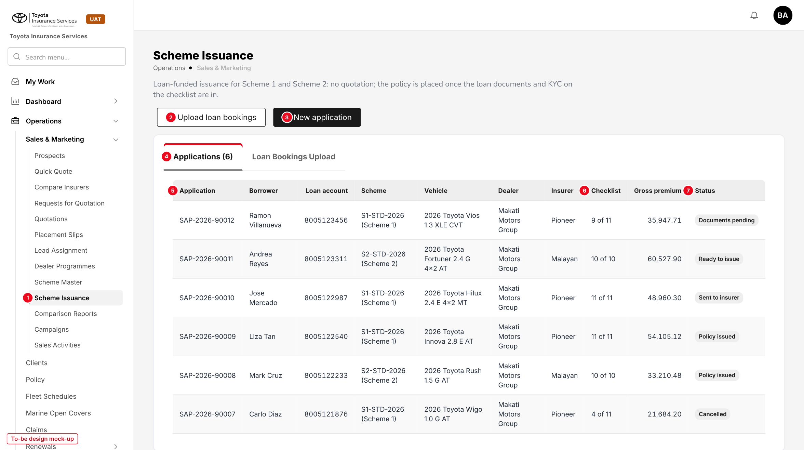
Figure 3: Scheme Issuance, Applications tab (to-be design mock-up)
No. | Field (label on screen) | Type | Mand. | Source / list | Default | Rule and message
1 | Scheme Issuance (side bar) | Menu item | - | Menu grant "Sales & Marketing > Scheme Issuance" | - | Shown with read:scheme-issuance
2 | Upload loan bookings | Button | - | - | - | write:scheme-issuance; FR-SIS-002
3 | New application | Button | - | - | - | write:scheme-issuance; opens 10.2
4 | Applications / Loan Bookings Upload | Tabs | - | - | Applications | Applications shows its count; status filter All / Draft / Documents pending / Ready to issue / Sent to insurer / Policy issued / Cancelled
5 | Application | Column | - | SAP-yyyy-nnnnn | - | Opens the application page (10.3); newest first
- | Borrower, Loan account, Scheme, Vehicle, Dealer, Insurer, Gross premium | Columns | - | Application | - | Gross premium of year 1
6 | Checklist | Column | - | Computed | - | "Required items in of required items", e.g. 9 of 11
7 | Status | Column | - | Application status (7.3) | - | Status tag

Button | Who sees it | Enabled when | What happens | Result
New application | write:scheme-issuance | Always | Opens the side dialog | Draft or Documents pending
Upload loan bookings | write:scheme-issuance | Always | File picker; rows processed one by one | Applications in Documents pending
Export | read:scheme-issuance | List not empty | Excel of the listed applications with their checklist counts | -

The Loan Bookings Upload tab follows the Dealer Sales Upload tab of Dealer Programmes, shown below as it runs today: Template, Upload, and the list of batches (batch, file, created, failed, status, uploaded) with the failed rows of each batch.
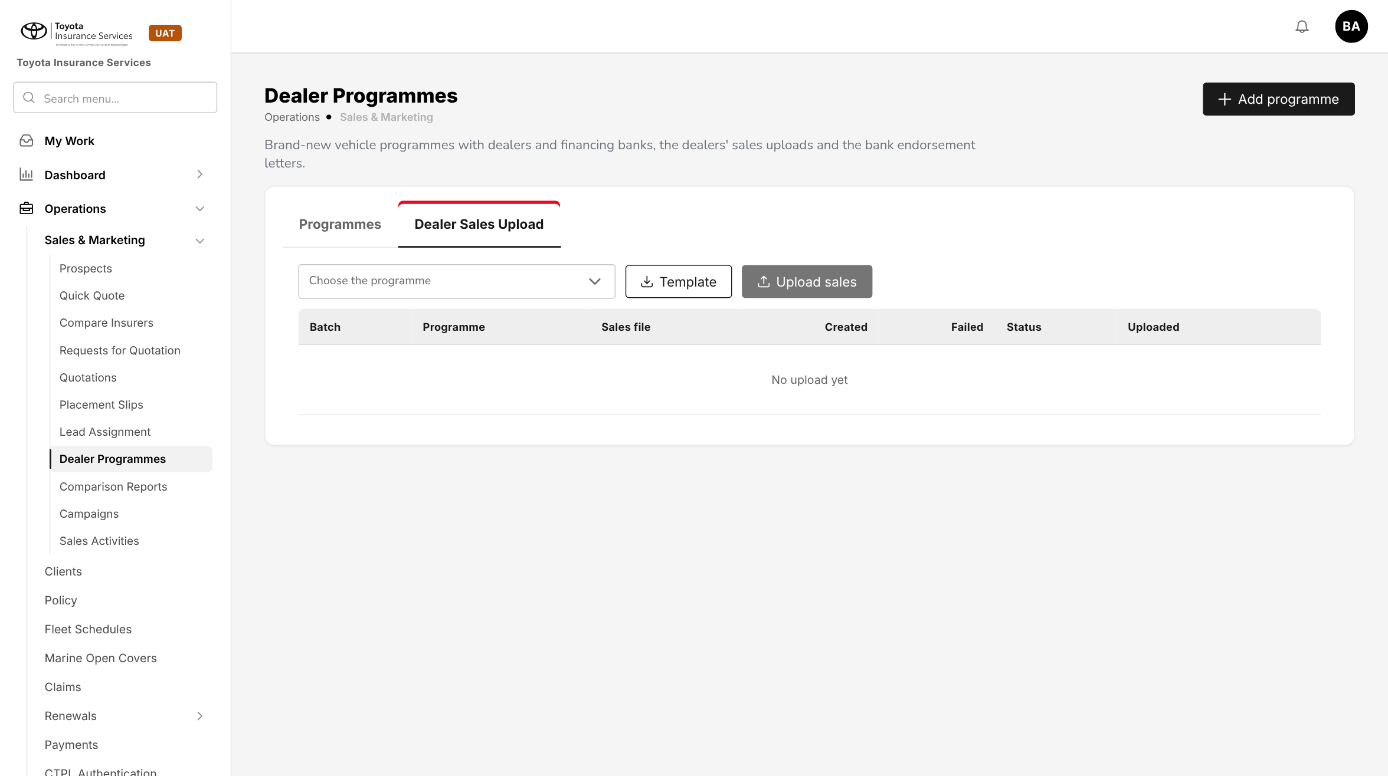
Figure 4: BrokerVerse today: Dealer Programmes > Dealer Sales Upload, the pattern of the Loan Bookings Upload tab

10.2 New scheme application (new)
Type | New side dialog, built from the Add programme dialog of Dealer Programmes
Purpose | Capture the loan, borrower, KYC source, vehicle, dealer, insurer and ARA of one loan account.
Who can open it | write:scheme-issuance
Navigation | Scheme Issuance > New application; Edit on the application page
FRs | FR-SIS-001, 003, 004, 005, 012

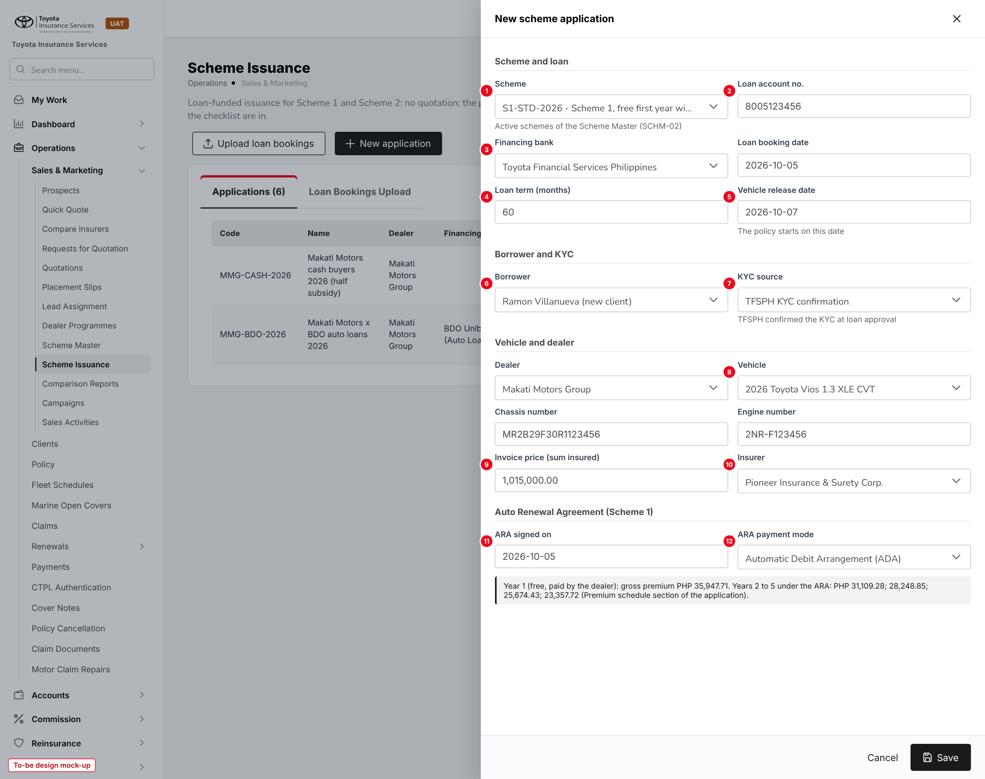
Figure 5: New scheme application (to-be design mock-up)
No. | Field (label on screen) | Type | Mand. | Source / list | Default | Rule and message
1 | Scheme | List | Y | Active schemes (SCHM-02) | - | Shows the scheme type; MSG for scheme checks (FR-SIS-003)
2 | Loan account no. | Text | Y | - | - | 10 digits, unique
3 | Financing bank | List | Y | Distribution Channels in schemes.financing_banks | TFSPH | -
- | Loan booking date | Date | Y | - | - | Not in the future
4 | Loan term (months) | Number | Y | - | - | 12 to 84; gives the policy years
5 | Vehicle release date | Date | Y | - | - | Inception of year 1; backdating limit
6 | Borrower | Client picker or new | Y | Operations > Clients | - | New: name, birthday, nationality, mobile, e-mail, address
7 | KYC source | List | Y | TFSPH KYC confirmation; Full KYC | TFSPH for TFSPH loans | ID type and ID number below it (FR-SIS-012)
- | Dealer | List | Y | Dealer group / dealer branch channels | - | Scheme 2: dealers of the scheme only
8 | Vehicle | Chained lists | Y | Master > Insurance > Vehicle | - | Brand, model, variant, year model; in the scheme range
- | Chassis number, Engine number, Conduction sticker, Colour | Text | Y / Y / N / N | - | - | Chassis unique
9 | Invoice price (sum insured) | Amount | Y | - | - | More than 0; re-prices
10 | Insurer | List | Y | Insurers of the scheme | The scheme's insurer when only one | -
11 | ARA signed on | Date | Y (Scheme 1) | - | - | FR-SIS-005
12 | ARA payment mode | List | Y (Scheme 1) | ARA payment modes (7.3) | - | ADA adds the ADA enrolment form

Button | Who sees it | Enabled when | What happens | Result
Cancel | All | Always | Closes without saving after confirmation | -
Save | write:scheme-issuance | Always | Checks, prices, builds the checklist | Draft or Documents pending

10.3 Scheme application page (new)
Type | New page, laid out like Claim Documents (list on the left, record on the right)
Purpose | See the application, its premium and premium schedule, complete the checklist, request waivers and send the application to the insurer.
Who can open it | read:scheme-issuance (view); write:scheme-issuance (act); approve:scheme-issuance (waivers)
Navigation | Scheme Issuance > application number
FRs | FR-SIS-004, 011 to 014, 020, 021, 024

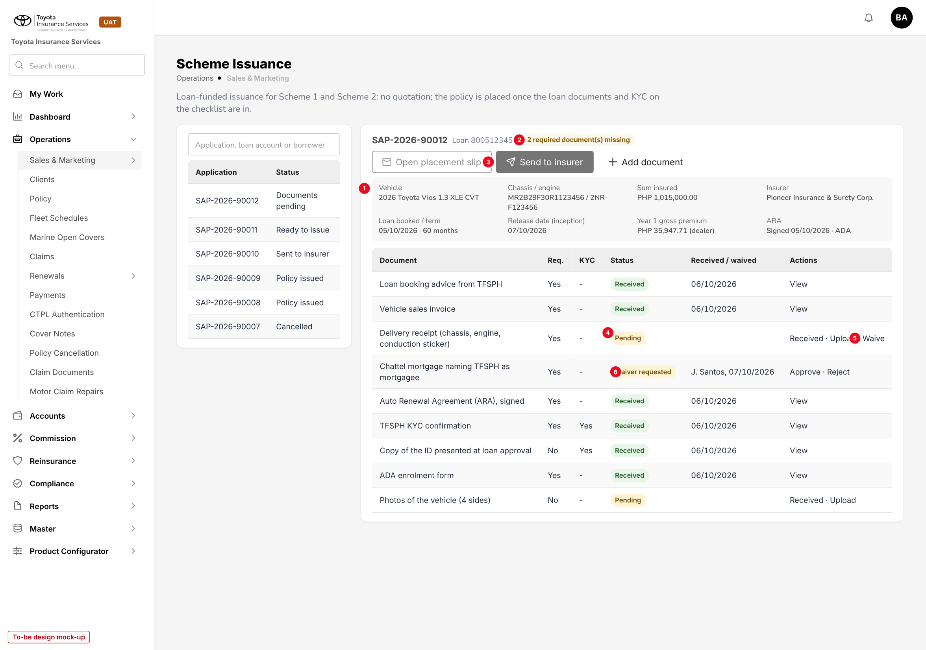
Figure 6: Scheme application SAP-2026-90012 with its document checklist (to-be design mock-up)
No. | Field (label on screen) | Type | Mand. | Source / list | Default | Rule and message
1 | Summary | Display | - | Application | - | Vehicle, chassis / engine, sum insured, insurer, loan booked / term, release date, year-1 gross premium and payer, ARA. A Premium schedule section below lists each policy year
2 | Missing documents | Tag | - | Computed | - | "n required document(s) missing" until the gate is passed
3 | Send to insurer | Button | - | - | - | Enabled in Ready to issue; tooltip lists the missing documents
- | Open placement slip | Button | - | - | - | Enabled once Sent to insurer
- | Document, Req., KYC | Columns | - | Checklist item | - | From the master (or Add document)
4 | Status | Tag | - | Pending; Received; Waiver requested; Waived | Pending | -
- | Received / waived | Display | - | - | - | Date and user, or the waiver requester and date
5 | Actions: Received, Upload, Waive, View, Reopen | Links | - | - | - | Waive only when the master allows it
6 | Waiver requested: Approve, Reject | Links | - | - | - | approve:scheme-issuance, not the requester

Button | Who sees it | Enabled when | What happens | Result
Edit | write:scheme-issuance | Draft, Documents pending, Ready to issue, Declined by insurer | Opens 10.2 with the data | Re-priced; checklist rebuilt
Add document | write:scheme-issuance | Before Sent to insurer | Adds an item, optional unless ticked Required | -
Send to insurer | write:scheme-issuance | Ready to issue | KYC and vehicle check, Placement Slip (source Scheme), e-mail with the files | Sent to insurer
Issue policy | write:policies | Placement Slip Bound | Base issuance routine; bill to dealer or TFSPH | Policy issued
Change insurer | write:scheme-issuance | Declined by insurer | Select another insurer of the scheme; re-priced | Ready to issue
Cancel application | write:scheme-issuance; approve:scheme-issuance once sent | Not Policy issued | Reason required; Placement Slip cancelled when there is one | Cancelled

10.4 Scheme Document Checklist (new)
Type | New generic master, laid out like Claim Document Checklist
Purpose | The documents a scheme application needs by scheme type, KYC source and condition.
Who can open it | read:masters (view); write:masters (maintain)
Navigation | Master > Insurance > Scheme Document Checklist
FRs | FR-SIS-010

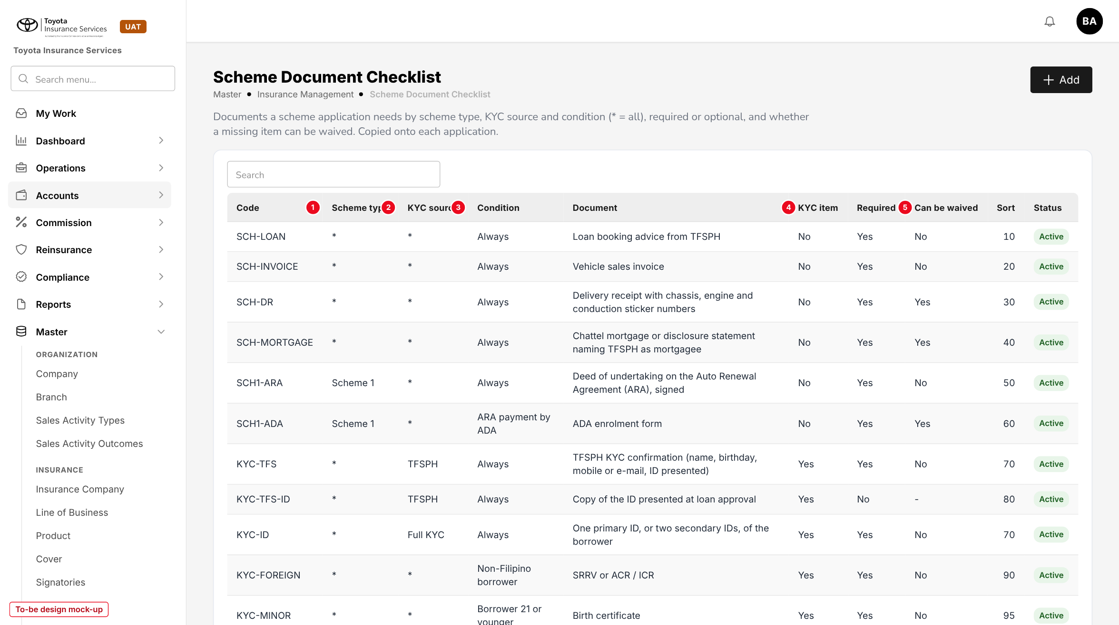
Figure 7: Scheme Document Checklist with the delivered records (to-be design mock-up)
No. | Field (label on screen) | Type | Mand. | Source / list | Default | Rule and message
- | Code | Text | Y | - | - | Unique
1 | Scheme type | List | Y | Scheme 1; Scheme 2; * (both) | * | -
2 | KYC source | List | Y | TFSPH; Full KYC; * | * | -
3 | Condition | List | Y | Checklist condition (7.3) | Always | -
- | Document | Text | Y | - | - | Name shown on the application
4 | KYC item | Yes / No | Y | - | No | KYC items need a file and cannot be waived
- | Required | Yes / No | Y | - | Yes | Optional items do not block the gate
5 | Can be waived | Yes / No | Y | - | No | Forced to No for a KYC item
- | Sort order, Status | Number, tag | N | - | 100, Active | Deactivate removes it from new checklists

10.5 Placement Slips (existing screen)
Type | Existing screen, new source Scheme
Purpose | Follow the placements of scheme applications with the insurers, record their confirmation and issue the policy.
Who can open it | read:quotations; write:quotations to confirm; write:policies to issue
Navigation | Operations > Sales & Marketing > Placement Slips
FRs | FR-SIS-020, 021

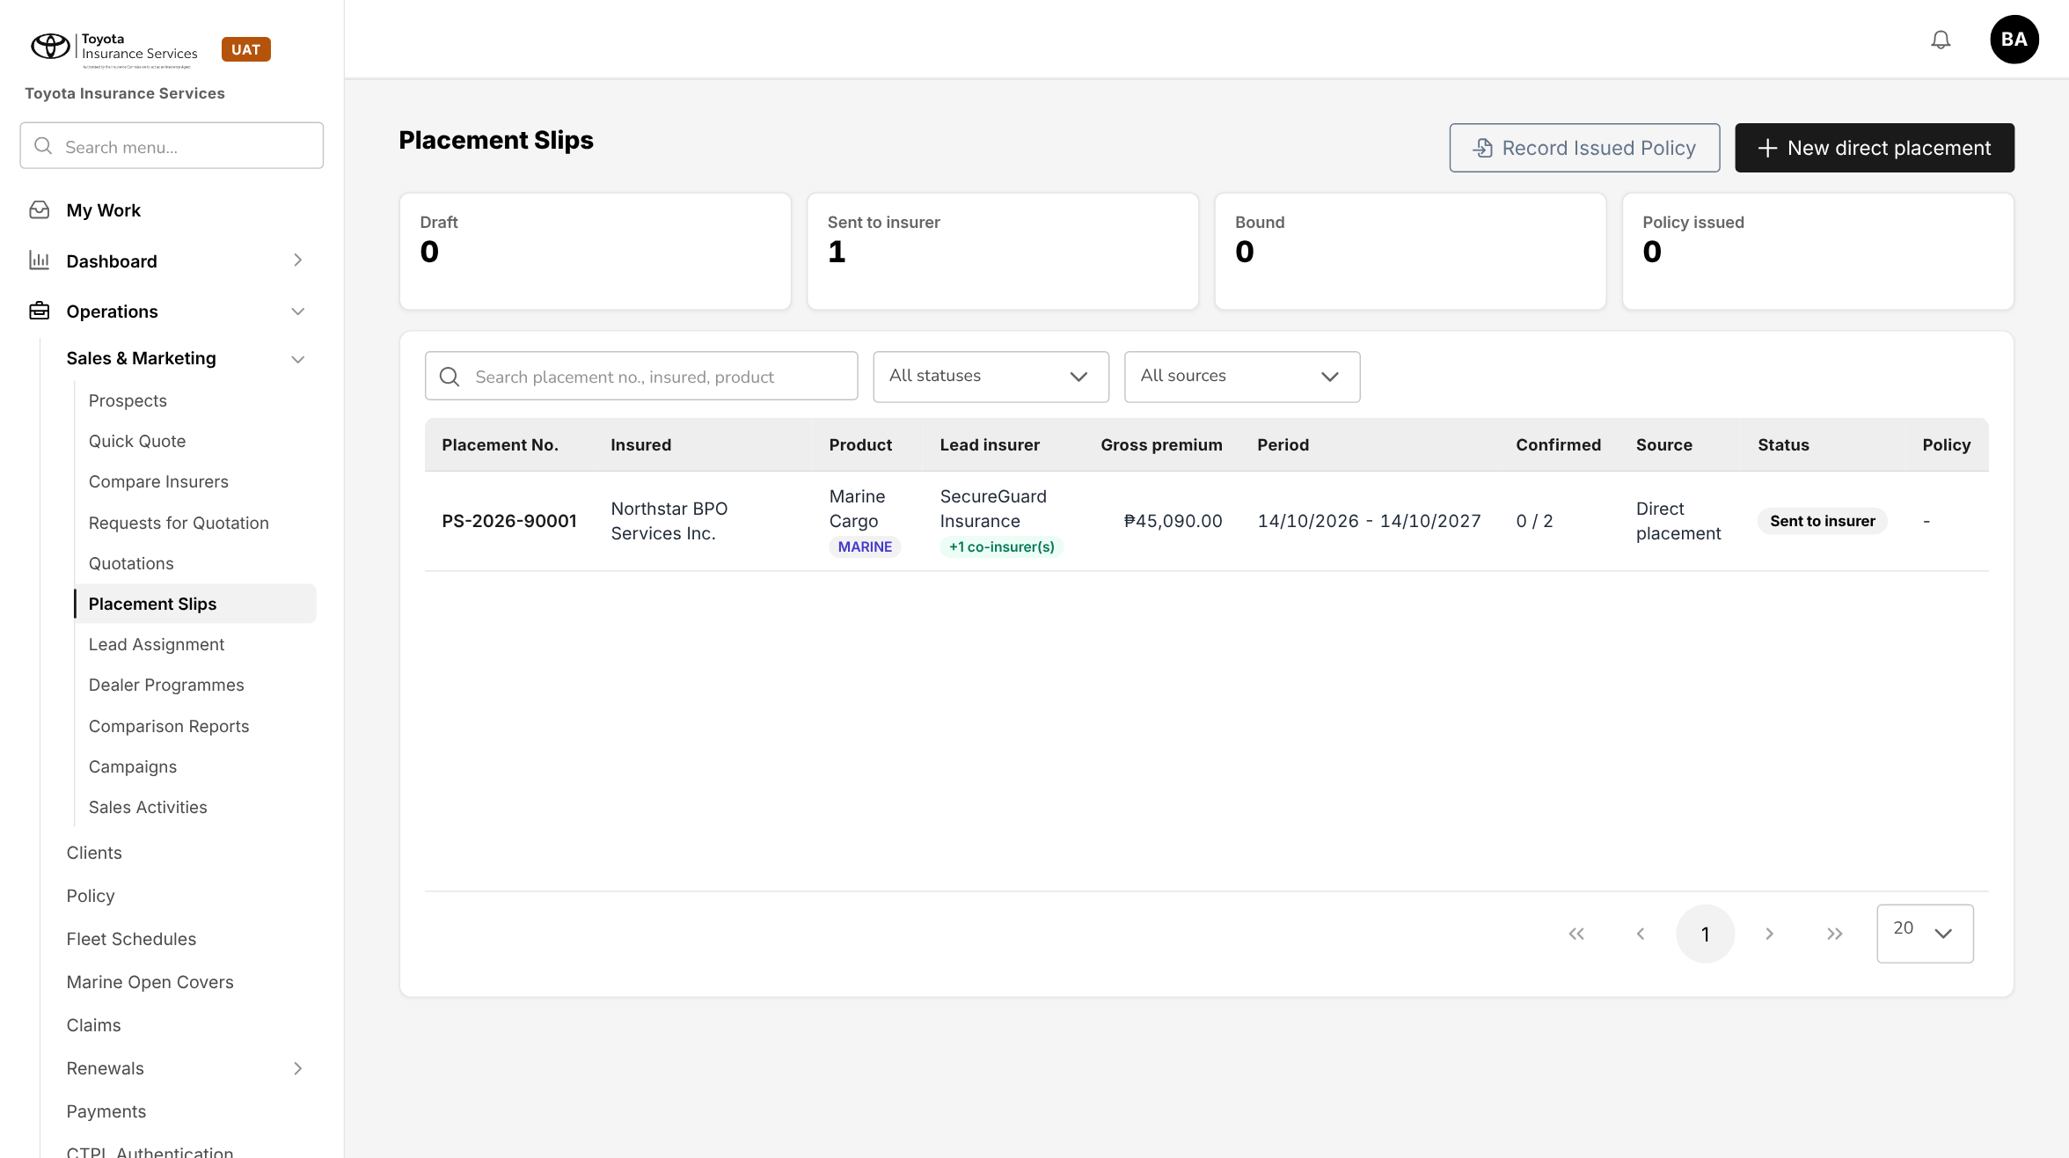
Figure 8: BrokerVerse today: Placement Slips. Scheme placements appear here with Source "Scheme" and the application number
No new field: the Source filter gets the value Scheme and a scheme slip shows a link back to its application. Confirm, Decline, Cancel and Issue policy work as today; Issue policy on a scheme slip applies FR-SIS-021 and FR-SIS-022.

10.6 Policy detail - Scheme panel (changed)
Type | Existing screen; the Scheme panel of SCHM-02 gets the application data
Purpose | Show on the policy what the issuance knew: application, loan, KYC source, ARA and waived documents.
Who can open it | read:policies
Navigation | Operations > Policy > policy
FRs | FR-SIS-023, 030

No. | Field (label on screen) | Type | Mand. | Source / list | Default | Rule and message
- | Application | Link | - | Application | - | Opens the application read-only
- | Loan booking date, Loan term | Display | - | Application | - | -
- | KYC source | Display | - | Application | - | TFSPH KYC confirmation or Full KYC
- | ARA signed on, ARA payment mode | Display | - | Application | - | Scheme 1 only
- | Waived documents | List | - | Checklist | - | Document, reason, approver

Scheme No., version, rates, schedule and commission stay as SCHM-02 shows them. The TFS loan account, lock-in and loan status are in the Lock-in & loan panel of SCHM-03.

11 End-to-end walkthroughs
The walkthroughs follow sample cases through BrokerVerse, persona by persona (dealer Makati Motors Group, financing bank TFSPH, insurers Pioneer Insurance & Surety Corp. and Malayan Insurance Co., Inc.). They are the script of the SCHM-01 SIT and UAT sessions; premium figures come from the base premium engine.

11.1 WT-A Scheme 1 application to policy
Table 21: WT-A
Step | Who | Does | Sees / result
1 | Processing Team | Scheme Issuance > New application: S1-STD-2026, loan 8005123456, TFSPH, booked 05/10/2026, 60 months, release 07/10/2026; borrower Ramon Villanueva (new), KYC source TFSPH, PhilID; Toyota Vios 1.3 XLE CVT 2026, chassis MR2B29F30R1123456, invoice price 1,015,000.00; Pioneer; ARA signed 05/10/2026, ADA | "Application SAP-2026-90012 saved"; Documents pending; year-1 gross premium 35,947.71; schedule years 2 to 5
2 | Processing Team | Uploads the booking advice, sales invoice, ARA, ADA form, TFSPH KYC confirmation and ID copy | Items Received; "2 required document(s) missing"
3 | Processing Team | Requests a waiver of the chattel mortgage: "Registration in progress at LTO" | Waiver requested; item in My Work > Approvals
4 | Accounting Manager | Approves the waiver | Waived; 1 missing
5 | Processing Team | Uploads the delivery receipt | Ready to issue
6 | Processing Team | Send to insurer | Placement Slip PS-2026-90008 (source Scheme) e-mailed to Pioneer with 8 files; Sent to insurer
7 | Processing Team | Placement Slips > PS-2026-90008 > Confirm with Pioneer policy PC-PIS-2026-118203; Issue policy | Policy issued, 07/10/2026 to 07/10/2027, mortgagee TFSPH; bill 35,947.71 to Makati Motors Group; lock-in Scheme 1 ARA 07/10/2026 to 06/10/2031 with loan 8005123456

11.2 WT-B Scheme 2 by upload, with an insurer decline
Table 22: WT-B
Step | Who | Does | Sees / result
1 | Processing Team | Upload loan bookings with 25 rows, one of them Andrea Reyes, loan 8005123311, S2-STD-2026, Toyota Fortuner 2.4 G 4x2 AT 2026, invoice price 1,800,000.00 | "Processed 25 rows: 23 created, 2 failed"; SAP-2026-90011 in Documents pending; year-1 gross premium 60,527.90
2 | Processing Team | Uploads the six required documents of SAP-2026-90011 (no ARA for Scheme 2) | Ready to issue
3 | Processing Team | Send to insurer (Pioneer) | Sent to insurer
4 | Processing Team | Records Pioneer's decline "Fortuner capacity full for October" | Declined by insurer
5 | Processing Team | Change insurer to Malayan; Send to insurer | Re-priced at the scheme rates; new Placement Slip PS-2026-90009
6 | Processing Team | Confirm with Malayan policy PC-MLY-2026-004512; Issue policy | Policy issued; bill 60,527.90 to TFSPH; no customer bill; lock-in Scheme 2 for the loan term with loan 8005123311

11.3 WT-C Exceptions
Table 23: WT-C
Case | Who | Does | Sees / result
C1 Missing KYC | Processing Team | Tries to mark the TFSPH KYC confirmation Received without a file | "A KYC document must be uploaded"
C2 Self-approval | Processing Team with approve:scheme-issuance | Approves the waiver he requested | Refused (maker-checker)
C3 Duplicate loan | Processing Team | New application for loan 8005123456 | "Loan account 8005123456 is already on application SAP-2026-90012"
C4 Gate | Processing Team | Send to insurer on SAP-2026-90012 with the delivery receipt Pending | Button disabled; API refuses with the gate message
C5 Not brand new | Processing Team | Upload row with a 2024 Model Year | Row failed with the brand-new message
C6 Past-due loan after issuance | Operations (SCHM-03) | TFS status upload reports loan 8005123456 Past due | Renewal notices of the policy Held: loan status by SCHM-03; nothing to do in Scheme Issuance

12 Messages catalogue
Every message a user can see for this requirement, grouped by the screen that shows it. 52 messages: 8 confirmation, 26 error, 3 information, 15 validation. A validation or error is shown under the field it belongs to; a confirmation is a short toast. Text in angle brackets is filled in by the system.

12.1 Scheme application
ID | Field | Message | Type | What the user does
MSG-SIS-001 | schemeId | Scheme is required | Validation | Select the scheme of the loan.
MSG-SIS-002 | loanAccountNo | The TFS loan account must have 10 digits | Validation | Correct the number from the booking advice.
MSG-SIS-003 | loanAccountNo | Loan account <number> is already on application <application> | Error | Open that application instead.
MSG-SIS-004 | loanTermMonths | Loan term must be between 12 and 84 months | Validation | Correct the loan term.
MSG-SIS-005 | releaseDate | The vehicle release date cannot be more than <n> days before today | Error | Check the date; ask the Sales Admin Head to raise the limit if the release is correct.
MSG-SIS-006 | releaseDate | The vehicle release date cannot be in the future | Validation | Correct the date.
MSG-SIS-007 | bankChannelId | The financing bank must be TFSPH or one of its branches | Error | Select TFSPH.
MSG-SIS-008 | - | Application <application> saved | Confirmation | No action.
MSG-SIS-014 | schemeId | Scheme <scheme> is not active on <date> | Error | Select the scheme in force on the release date.
MSG-SIS-015 | dealerChannelId | Dealer <dealer> is not part of scheme <scheme> | Error | Check the scheme with Sales; Scheme 2 is limited to its dealers.
MSG-SIS-016 | vehicleModel | <brand> <model> is outside the make and model range of scheme <scheme> | Error | Check the vehicle or the scheme.
MSG-SIS-017 | modelYear | Scheme business is for brand-new vehicles only: Model Year <year> is too old | Error | Correct the Model Year.
MSG-SIS-018 | chassisNumber | Chassis number <chassis> is already on <policy or application> | Error | Check the chassis number on the sales invoice.
MSG-SIS-019 | schemeId | Scheme <scheme> has no rate for <peril> | Error | Ask the scheme owner to complete the Scheme Master.
MSG-SIS-020 | - | Premium computed from scheme <scheme>: year 1 gross premium <amount> | Information | No action.
MSG-SIS-021 | araSignedOn | ARA signed on is required for Scheme 1 | Validation | Enter the date on the signed deed.
MSG-SIS-022 | araSignedOn | ARA signed on must be between <from> and the vehicle release date | Validation | Correct the date.
MSG-SIS-023 | araPaymentMode | ARA payment mode is required for Scheme 1 | Validation | Select the payment mode ticked on the deed.
MSG-SIS-048 | - | The application was sent to the insurer: only an approver can cancel it | Error | Ask an approver.
MSG-SIS-049 | - | Application <application> has policy <policy>: use Policy Cancellation | Error | Cancel the policy instead.
MSG-SIS-050 | - | Application <application> cancelled | Confirmation | No action.
MSG-SIS-052 | - | You do not have permission to <action> | Error | Ask the System Administrator.

12.2 Loan Bookings Upload
ID | Field | Message | Type | What the user does
MSG-SIS-009 | file | Upload an Excel (.xlsx) file | Validation | Save the file as .xlsx and upload it again.
MSG-SIS-010 | file | The file does not match the template: column <column> is missing | Error | Download the template and copy the rows into its Data sheet.
MSG-SIS-011 | file | The file has <n> rows; at most <max> rows can be uploaded at once | Error | Split the file (schemes.max_rows).
MSG-SIS-012 | - | Row <n>: <message> | Error | Correct the row and upload the corrected rows.
MSG-SIS-013 | - | Processed <n> rows: <c> created, <f> failed | Confirmation | Check the failed rows listed under the message.

12.3 Scheme Document Checklist
ID | Field | Message | Type | What the user does
MSG-SIS-024 | code | Code <code> is already used | Error | Use another code.
MSG-SIS-025 | documentName | Document is required | Validation | Enter the document name.
MSG-SIS-026 | canBeWaived | A KYC item cannot be waived | Validation | Leave Can be waived at No.

12.4 Application > Document checklist
ID | Field | Message | Type | What the user does
MSG-SIS-027 | file | This file type is not accepted. Upload a PDF, JPEG or PNG file | Validation | Scan the document as PDF or image.
MSG-SIS-028 | remark | Remark is required when no file is uploaded | Validation | Say where the original is kept.
MSG-SIS-029 | file | A KYC document must be uploaded | Error | Upload the scan of the document.
MSG-SIS-030 | - | <document> received | Confirmation | No action.
MSG-SIS-031 | idType | ID type is required | Validation | Select the ID presented.
MSG-SIS-032 | idType | ID type "<type>" is not an accepted ID | Error | Ask for an ID on the TFSPH list.
MSG-SIS-033 | idType | Full KYC needs one primary ID or two different secondary IDs | Error | Add a second secondary ID or a primary ID.
MSG-SIS-034 | birthday | Birthday is required | Validation | Enter the birthday from the KYC.
MSG-SIS-035 | - | <document> cannot be waived | Error | Obtain the document.
MSG-SIS-036 | reason | Reason is required | Validation | Enter why the document is missing.
MSG-SIS-037 | - | Maker-checker: the approver must be different from the user who requested the waiver | Error | Leave it to another approver.
MSG-SIS-038 | - | Waiver of <document> approved | Confirmation | No action.
MSG-SIS-039 | - | Waiver of <document> rejected | Confirmation | No action. The item is Pending again.
MSG-SIS-040 | - | The application cannot go to the insurer: <n> required document(s) missing (<list>) | Error | Upload or waive the documents listed.
MSG-SIS-041 | - | All required documents are in. The application is ready to issue | Information | Click Send to insurer.

12.5 Send to insurer
ID | Field | Message | Type | What the user does
MSG-SIS-042 | kyc | Policy cannot be issued without the customer's KYC and vehicle identifiers. Missing: <items> | Error | Complete the identifiers on the application.
MSG-SIS-043 | insuranceCompanyId | Insurer <insurer> is not authorised for Motor | Error | Choose another insurer of the scheme.
MSG-SIS-044 | - | Application <application> sent to <insurer> on placement slip <slip> | Confirmation | No action. Record the insurer's answer on the Placement Slip.

12.6 Issue policy
ID | Field | Message | Type | What the user does
MSG-SIS-045 | - | The policy can be issued only after the insurer has confirmed the placement | Error | Record the insurer's confirmation first.
MSG-SIS-046 | - | Policy <policy> issued for application <application> | Confirmation | No action.
MSG-SIS-047 | - | <party> has no billing client: add it on Distribution Channels before issuing | Error | Ask the System Administrator to complete the channel.
MSG-SIS-051 | - | Lock-in <source> recorded on policy <policy> until <end date> | Information | No action.

13 Upload screens

13.1 Loan bookings template
Built like the other base templates (Template button): an Excel file with the sheets Data (one row per loan; required headers in dark red), Columns (each column with its format and an example) and Instructions. Rows are loaded one by one; a failed row does not stop the others.
Limits: .xlsx only, first sheet Data, at most 2,000 rows (schemes.max_rows). The result line reads "Processed n rows: c created, f failed" with "Row n: message" for each failed row.
Table 24: Loan bookings template columns
Column | Mand. | Format | Rule
Scheme Code | Y | Text | An Active scheme of the Scheme Master
Loan Account No. | Y | 10 digits | TFS loan account, unique among open applications
Financing Bank Code | N | Text | TFSPH or a TFSPH branch channel; TFSPH when empty
Loan Booking Date / Vehicle Release Date | Y | YYYY-MM-DD | Release not in the future, within the backdating limit
Loan Term (months) | Y | Whole number | 12 to 84
Borrower First Name / Last Name / Company Name | Y (one) | Text | As in the Dealer Sales template
Birthday / Nationality / Mobile / Email / Address / City / Province | Birthday Y | Date, text | Drives the KYC conditions
KYC Source / ID Type / ID Number | ID Y | List, text | KYC source TFSPH when empty; ID presented at loan approval, type in policy.kyc_id_types
Dealer Branch Code | Y | Text | Dealer group or branch channel
Make / Model / Variant / Year Model / Color | Make, Model, Year Y | Text, YYYY | In the scheme range; brand new
Chassis Number / Engine Number / Conduction Sticker / Plate Number | Chassis, Engine Y | Text | Chassis unique
Invoice Price | Y | Amount | More than 0
Insurer | N | Name or code | An insurer of the scheme; the scheme's when it has one
ARA Signed On / ARA Payment Mode | Y for Scheme 1 | Date, list | FR-SIS-005

14 Sign-off and change control

14.1 What is signed
TISPH signs this FRS for TIS-BRD-SCHM-01 as built on BrokerVerse: the process flows (chapter 2), the functional requirements (chapter 4), the workflow (chapter 5), and the screens, messages and uploads (chapters 9 to 13). Values marked default and the delivered checklist records are configuration and are not frozen.

14.2 Change after sign-off
A change to anything signed is raised through the change control route of BRD section 8. The project team assesses its effect on BrokerVerse and on SCHM-02 and SCHM-03 in the same CR-05, and issues a new version of this FRS for delta sign-off. When the screens are built, the to-be mock-ups are replaced with screenshots of the TISPH UAT environment.

14.3 Signatures
Table 25: Sign-off
Role | Name | Unit | Signature | Date
Business owner |  | TIS Sales
Business reviewer |  | TISPH Sales Admin
Business reviewer |  | TISPH Operations
Project Manager |  | TISPH DTID
Delivery lead |  | iorta TechNXT

Appendix A Premium schedule examples
All figures are computed by the base premium engine (POST quotations/calculate-premium, the same tax and CTPL engine the scheme rating of SCHM-02 uses) for an illustrative scheme S1-STD-2026 with Own Damage 2.00%, Acts of Nature 0.50%, Bodily Injury and Property Damage 100,000 each, VAT 12%, DST 12.5% and LGT 0.75%, and the 3-year CTPL of a private car in year 1. Rates are illustrative until the Scheme Master holds the agreed rates.

A.1 Scheme 1 (S1-STD-2026) - Toyota Vios 1.3 XLE CVT, invoice price 1,015,000.00, 60-month loan
Table 26: Scheme 1 premium schedule
Line | Year 1 | Year 2 | Year 3 | Year 4 | Year 5
Sum insured (scheme schedule 100 / 90 / 81 / 72.9 / 65.61%) | 1,015,000.00 | 913,500.00 | 822,150.00 | 739,935.00 | 665,941.50
Own Damage / Theft 2.00% | 20,300.00 | 18,270.00 | 16,443.00 | 14,798.70 | 13,318.83
Acts of Nature 0.50% | 5,075.00 | 4,567.50 | 4,110.75 | 3,699.68 | 3,329.71
Bodily Injury + Property Damage | 2,000.00 | 2,000.00 | 2,000.00 | 2,000.00 | 2,000.00
NET Premium | 27,375.00 | 24,837.50 | 22,553.75 | 20,498.38 | 18,648.54
VAT / DST / LGT | 3,285.00 / 3,422.00 / 205.31 | 2,980.50 / 3,105.00 / 186.28 | 2,706.45 / 2,819.50 / 169.15 | 2,459.81 / 2,562.50 / 153.74 | 2,237.82 / 2,331.50 / 139.86
CTPL | 1,660.40 (3 years) | - | - | At renewal | At renewal
Gross premium | 35,947.71 | 31,109.28 | 28,248.85 | 25,674.43 | 23,357.72
Paid by | Dealer (free first year) | Customer, ARA (ADA) | Customer, ARA (ADA) | Customer, ARA (ADA) | Customer, ARA (ADA)

A.2 Scheme 2 (S2-STD-2026) - Toyota Fortuner 2.4 G 4x2 AT, invoice price 1,800,000.00, year 1
Table 27: Scheme 2 year 1
Line | Amount
Own Damage / Theft 2.00% | 36,000.00
Acts of Nature 0.50% | 9,000.00
Bodily Injury + Property Damage | 2,000.00
NET Premium | 47,000.00
VAT / DST / LGT | 5,640.00 / 5,875.00 / 352.50
CTPL (3 years) | 1,660.40
Gross premium, billed to TFSPH | 60,527.90

For Scheme 2 the later years are computed the same way and give TFSPH the insurance cost it adds to the monthly amortisation; the customer is never billed.

