

FUNCTIONAL REQUIREMENTS SPECIFICATION
Scheme Master
Register of the Toyota bundling schemes: products and perils, rate by peril, vehicle make and model range, commission and dealer commission %, term schedule, and the scheme rating used at issuance and renewal

Client | Toyota Insurance Services Philippines Corporation (TISPH)
Document | TISPH-FRS-SCHM-02
Requirement | TIS-BRD-SCHM-02
Version | 1.0
Date | 9 October 2026
Status | Issued for TISPH review
Classification | Confidential

Prepared by iorta TechNXT for TISPH 
This document is confidential to Toyota Insurance Services Philippines Corporation and iorta TechNXT.
Document Control
Version | Date | Author | Reviewer | Approver | Change
1.0 | 9 Oct 2026 | iorta TechNXT Business Analysis | iorta TechNXT Project Manager | - | First issue for review

Distribution List
Name / Unit | Role | Organisation | Purpose
TIS Sales (business owner) | Approver | TISPH | Review and sign-off; scheme parameters
Sales Admin | Business user | TISPH | Scheme set-up FRs and screens
Operations | Business user | TISPH | Scheme rating at issuance and renewal
Finance and General Accounting | Business user | TISPH | Commission and dealer commission FRs
DTID - Project Management Team | Project owner | TISPH | Traceability against the BRD
Project team | Delivery | iorta TechNXT | Build, test and UAT preparation

Contents
1 Overview 5
1.1 The requirement 5
1.2 Scope 5
1.3 Definitions and acronyms 6
1.4 How to read the functional requirements 6
1.5 What changes in BrokerVerse 7
2 Scheme process flow 8
2.1 Flow A - Set up and approve a scheme 8
2.2 Flow B - Scheme rating at issuance and renewal 10
2.3 Flow C - Life of an approved scheme 11
2.4 What a scheme covers 11
3 Personas and roles 13
3.1 Personas 13
3.2 New permissions 13
3.3 Default grants 13
4 Functional requirements 15
4.1 Scheme Master register 15
FR-SCM-001 Add a scheme with its number, type, description and effective dates 15
FR-SCM-002 Set the products and perils of a scheme and the rate of each peril 17
FR-SCM-003 Define the vehicle make and model range of a scheme 18
FR-SCM-004 Upload the vehicle lines of a scheme from Excel 20
FR-SCM-005 Set the commission % and the dealer commission % of a scheme 21
FR-SCM-006 Set the term and the year-by-year sum insured schedule of a scheme 22
FR-SCM-007 Search, view and export schemes 23
4.2 Approval and life cycle 24
FR-SCM-010 Submit, approve or return a scheme (maker-checker) 24
FR-SCM-011 Run the scheme life cycle: scheduled, active, suspended, expired, withdrawn 25
FR-SCM-012 Amend an approved scheme as a new version 26
4.3 Scheme rating 27
FR-SCM-020 Find the scheme version and vehicle line of a loan 27
FR-SCM-021 Price a scheme policy by peril 28
FR-SCM-022 Preview the premiums of a scheme for a sample vehicle 29
FR-SCM-023 Keep the scheme on the policy and rate the renewal years within the term 30
FR-SCM-024 Endorse and cancel a scheme policy 31
4.4 Commission and dealer commission 32
FR-SCM-030 Compute the commission of a scheme policy from the scheme 32
FR-SCM-031 Credit the dealer share of the commission to the dealer of the loan 32
4.5 Audit and access 33
FR-SCM-040 Audit and control access to schemes 33
5 Workflow and status model 35
5.1 Scheme 35
5.2 Scheme on the policy 35
6 Interfaces 36
7 Configuration items 37
7.1 Settings 37
7.2 Scheduled job 37
7.3 Lists of values 37
7.4 Masters 37
7.5 Scheme parameters to load 38
8 Traceability 39
8.1 BRD clause to FR 39
8.2 Related BRD requirements 39
8.3 FR to test cases 39
9 Navigation 41
9.1 Screens of SCHM-02 41
9.2 Menu by base role 41
10 Screen specifications 42
10.1 Scheme Master list (new) 42
10.2 Add / Edit scheme - General tab (new) 44
10.3 Add / Edit scheme - Products & perils tab (new) 45
10.4 Add / Edit scheme - Vehicles tab (new) 46
10.5 Add / Edit scheme - Commission & term tab (new) 47
10.6 Premium preview (new) 48
10.7 Scheme approval in My Work (existing screen) 49
10.8 Policy detail - Scheme panel (changed) 50
10.9 Upload vehicle lines (new) 51
11 End-to-end walkthroughs 52
11.1 WT-A Set up and approve Scheme 1 standard 2027 52
11.2 WT-B Issue and renew a Scheme 1 policy 52
11.3 WT-C Exceptions 53
12 Messages catalogue 54
12.1 Scheme Master - General tab 54
12.2 Scheme Master - Products & perils tab 54
12.3 Scheme Master - Vehicles tab 54
12.4 Upload vehicle lines 55
12.5 Scheme Master - Commission & term tab 55
12.6 Scheme approval and life cycle 55
12.7 Scheme rating (issuance and renewal) 56
13 Upload screens 57
13.1 Scheme vehicle lines template 57
14 Sign-off and change control 58
14.1 What is signed 58
14.2 Change after sign-off 58
14.3 Signatures 58
Appendix A Scheme premium examples 59
A.1 Scheme 1 standard (S1-STD-2027): OD 2.00%, AON 0.50% 59
A.2 Scheme 2 standard (S2-STD-2027): OD 1.80%, AON 0.40% 59
A.3 Commission and dealer share (Commission 25.00%, Dealer 85.00%) 60
A.4 The same split in rate terms 60

1 Overview

1.1 The requirement
TIS-BRD-SCHM-02 Scheme Master (Customization, Phase 1, CR-05). Scheme Master capturing scheme number, description, applicable products and perils, effective from/to, rate by peril, vehicle make/model range, commission % and dealer commission %.

TISPH sells Motor insurance bundled with Toyota Financial Services (TFS) car loans. Two schemes exist today. Under Scheme 1 (lock-in, Auto Renewal Agreement) the first year is free and the premiums of the later years are fixed in advance and renewed automatically. Under Scheme 2 (guaranteed renewal) the premiums of the whole loan term are built into the monthly amortization. In both, the rate depends on the scheme, the commission is shared with the dealer, and the vehicles covered are Toyota makes and models financed by TFS.
This FRS adds the Scheme Master register to BrokerVerse and the scheme rating that prices a scheme policy from it. A scheme is set up once with its products, perils and rate by peril, its vehicle lines, its commission % and dealer commission % and its year-by-year sum insured schedule; it is approved by a second user and then used, without a quotation, when a scheme policy is issued and each time it renews within the term. The issuance path itself (loan documents, KYC and checklist) is TIS-BRD-SCHM-01; notice suppression and the lock-in review are TIS-BRD-SCHM-03.
Scheme parameters still owed by TISPH. TISPH has not yet provided the full details of Scheme 1 and Scheme 2. The rates, vehicle lines, commission %, dealer commission %, term and sum insured schedule in this FRS are illustrative values chosen to show how the register and the rating work; they are marked "illustrative" and are loaded with the real values once TISPH provides them (section 7.5). The screens and rules do not depend on the values.

1.2 Scope
In scope
- A new Scheme Master screen under Operations > Sales & Marketing: create, approve (maker-checker), version, suspend, resume and withdraw schemes, with tabs General, Products & perils, Vehicles, Commission & term and History.
- Vehicle lines by make and model range on screen or by Excel upload (Upload vehicle lines).
- The scheme rating: finding the scheme and vehicle line of a loan and pricing the policy by peril for year 1 and each renewal year within the term, with a Premium preview on the Scheme Master.
- Commission of a scheme policy from the scheme (Commission %) and the dealer's share of it (Dealer commission %).
- The scheme, its version and its rates kept on the policy; audit trail and permissions.
Out of scope
- The direct-issuance path of scheme policies on loan documents with the KYC and document checklist, and its renewal-notice exclusions: TIS-BRD-SCHM-01. This FRS gives SCHM-01 the scheme rating it calls.
- Renewal-notice suppression for lock-in and Scheme 2 accounts, the 60-day review and the cancellation of notices: TIS-BRD-SCHM-03. This FRS gives SCHM-03 the term and schedule it reads.
- Promotions (PROD-15) and the issuing-vs-remitting rules register (PROD-16): not used on scheme policies, see FR-SCM-021 and FR-SCM-030.
- Dealer Programmes, Package Bundles and Insurer Rate Tables: unchanged.
- Payment of the dealer commission to the dealer and the billing of TFS: existing Commission and billing processes.

1.3 Definitions and acronyms
Table 1: Definitions
Term | Meaning in this FRS
Scheme | A record of Operations > Sales & Marketing > Scheme Master: the terms under which TISPH insures vehicles financed by TFS under a bundling scheme.
Scheme No. | The unique code of a scheme typed by the user, for example S1-STD-2027. It is printed on the policy and the loan documents refer to it.
Scheme type | Scheme 1 - Lock-in (Auto Renewal Agreement): free first year, later years renewed automatically at predetermined premiums. Scheme 2 - Guaranteed renewal: the premiums of the whole term are financed in the monthly amortization.
Peril | A cover of the Motor product as listed in Product Configurator > Coverage Builder: Own Damage, Theft, Acts of Nature, Excess Bodily Injury, Property Damage, Auto Personal Accident, Roadside Assistance, Personal Accident of the Driver, Compulsory Third Party Liability.
Rate by peril | The price of each peril in the scheme: a % of the sum insured, a fixed premium for a limit, or a % of a limit per seat. CTPL always follows the Insurance Commission tariff.
Vehicle line | One row of the Vehicles tab: a make, one model or all models, one variant or all variants, a year model range, a sum insured range and the vehicle class, with optional line rates for Own Damage and Acts of Nature.
Commission % | The commission of a scheme policy as a % of its NET Premium. It replaces the Commission Rate Matrix rate for scheme policies.
Dealer commission % | The share of the commission paid to the dealer of the loan, as a % of the commission. TISPH keeps the rest as its service fee.
Term | Number of policy years the scheme covers: year 1 plus the renewal years.
Sum insured schedule | The sum insured of each policy year as a % of the year 1 sum insured.
Scheme rating | The server routine that prices a scheme policy for a given policy year from the scheme version on the policy.
ARA / M.A. / ADA | Auto Renewal Agreement / monthly amortization of the loan / Automatic Debit Arrangement.
TFS | Toyota Financial Services Philippines Corporation, set up in Distribution Channels as a financing bank.
OD / AON / CTPL / APPA | Own Damage / Acts of Nature / Compulsory Third Party Liability / Auto Passenger Personal Accident (Auto Personal Accident cover).
NET Premium | The sum of the peril premiums before VAT, DST and LGT, as on the Order Summary of Create Quote.

1.4 How to read the functional requirements
Each FR in chapter 4 has the same parts:
- A header table with the BRD trace, the actor, the priority, the fit and the screens that implement it.
- Description, preconditions, main flow and alternate and exception flows.
- Business rules. Configurable rules are maintained on the Scheme Master or on Master > System > Configuration (chapter 7). Fixed rules change only through a change request.
- Validations and messages: the check and the message the user sees, word for word, with its ID in chapter 12. As everywhere in BrokerVerse, a message is plain English and is shown under the field it belongs to, or as a toast.
- Audit and numbered acceptance criteria, the basis of the test cases TC-SCM-nnn-n.
Note. The premium figures in the examples are computed by the BrokerVerse premium engine (the same routine as Calculate on Create Quote) on sample data: VAT 12%, DST 12.5%, LGT 0.75% from Premium Taxes & LGU Rates and CTPL from the tariff of the Motor template MOT-003-2025. The scheme values themselves are illustrative.

1.5 What changes in BrokerVerse
BrokerVerse has no scheme register today. The table lists what SCHM-02 reuses, what it changes and what it adds.
Table 2: BrokerVerse today and SCHM-02
BrokerVerse today | What SCHM-02 does
Dealer Programmes (Operations > Sales & Marketing): brand-new vehicle programmes with one dealer, one financing bank and one insurer, Own damage rate %, Acts of nature rate %, Excess bodily injury, Property damage, CTPL term, free first year and subsidy. No peril table, no vehicle lines, no term schedule, no approval. | Reused as the pattern. Scheme Master sits next to it with the same list and side dialog. Dealer Programmes itself is unchanged.
Product Configurator > Coverage Builder of the Motor template (MOT-003-2025, Motor Insurance Basic Plan): covers OD, THEFT and CTPL mandatory; AOG, VTPL-BI, VTPL-PD, APA, RSA and Personal Accident of the Driver optional. | Reused. The perils of a scheme are the covers of the product's template; mandatory covers are always in the scheme.
Premium engine (Create Quote > Calculate): cover premium = sum insured x rate / 100; Own Damage 2.00% and Acts of Nature 0.50% by default (setting premium.default_rates); taxes from Premium Taxes & LGU Rates; CTPL from the tariff (private car 610.40, 3-year 1,660.40). | Reused. The scheme rating feeds the engine with the scheme rates instead of the defaults or typed rates.
Commission = NET Premium x the Commission Rate Matrix rate (Master > Finance), else the insurer rate, else commission.default_rate (15%); comsub to referrers from Commission. | Changed for scheme policies. The scheme Commission % replaces the matrix; the dealer share is credited to the dealer of the loan.
Master > Insurance > Vehicle (brand, model, variant, with upload); Distribution Channels (dealer group, dealer branch, financing bank, bank branch); Insurance Company. | Reused. Makes and models for the vehicle lines; TFS and the dealers for the scheme.
Package Bundles and Insurer Rate Tables (multi-line packages, one rate per insurer and product). | Not used. A scheme is a single Motor product over a loan term.
Maker-checker on registers, approvals in My Work > Approvals; Master > System > Schedules; Audit Trail. | Reused for scheme approval, the Scheme status job and the audit.
No scheme register, no year-by-year schedule, no dealer commission share. | New. Scheme Master, scheme rating, Premium preview, Upload vehicle lines.

2 Scheme process flow
Three flow charts cover the scheme: Flow A sets up and approves a scheme, Flow B is the scheme rating used when a scheme policy is issued or renews, and Flow C is the life of an approved scheme. Black rounded boxes are start and end points, diamonds are decisions, red boxes are exceptions, grey boxes are done by the system and boxes with a heavy border are the successful outcome.

2.1 Flow A - Set up and approve a scheme
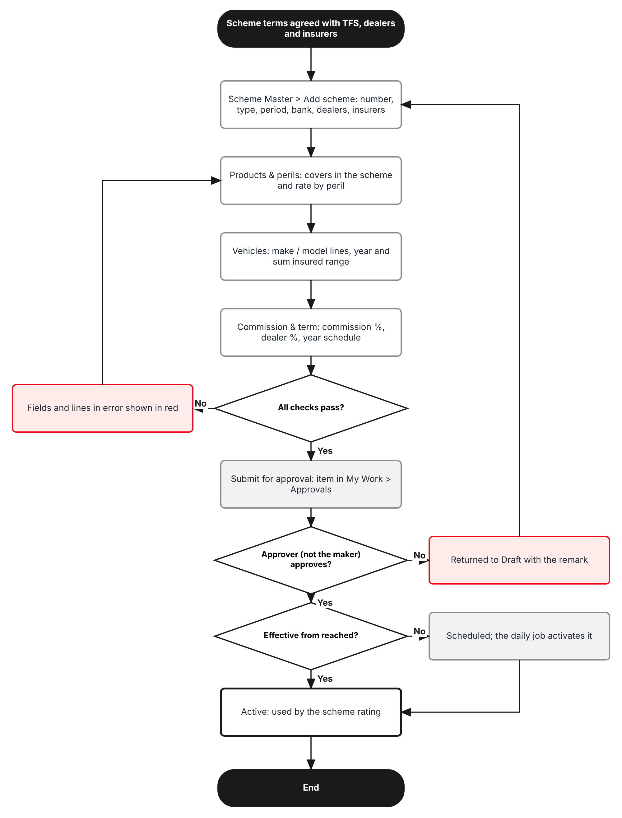
Figure 1: Flow A - Set up and approve a scheme
Table 3: Flow A steps
Step | Who (role) | What happens | FR
A1 | Sales Admin (Processing Team) | Operations > Sales & Marketing > Scheme Master > Add scheme: Scheme No., scheme type, description, effective from and to, financing bank, dealers and insurers. | FR-SCM-001
A2 | Sales Admin | Products & perils tab: product, vehicle classes, the perils in the scheme and the rate of each. | FR-SCM-002
A3 | Sales Admin | Vehicles tab: one line per make and model range with year model and sum insured range; or Upload vehicle lines. | FR-SCM-003, 004
A4 | Sales Admin | Commission & term tab: Commission %, Dealer commission %, term and sum insured schedule. Premium preview checks the result on a sample vehicle. | FR-SCM-005, 006, 022
A5 | System | Checks every field and line. A scheme with an error cannot be submitted. | FR-SCM-010
A6 | Accounting Manager or TISPH Sales Head (approve:schemes) | Approves or returns the scheme from My Work > Approvals. The maker can never approve it. | FR-SCM-010
A7 | System | Sets the scheme to Scheduled or Active; the daily Scheme status job activates and expires schemes. | FR-SCM-011

2.2 Flow B - Scheme rating at issuance and renewal
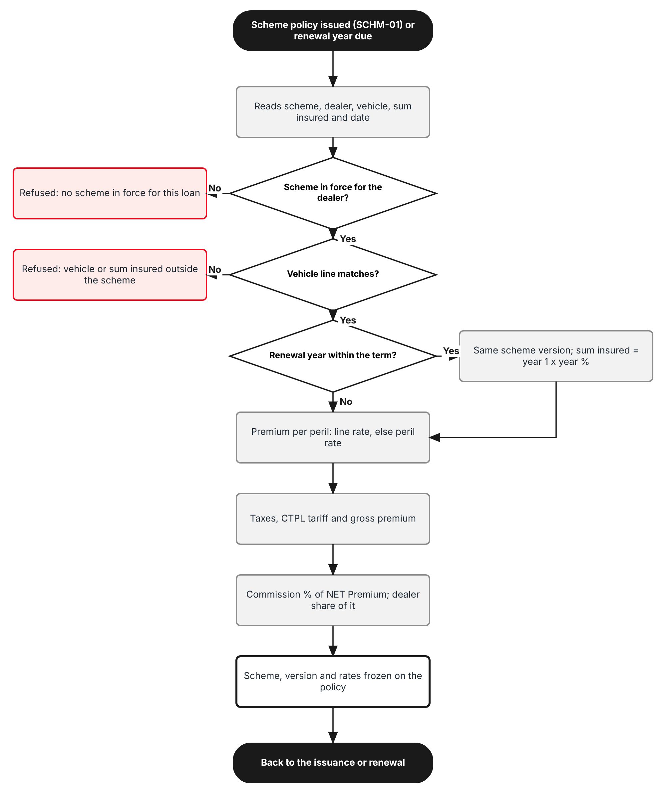
Figure 2: Flow B - Scheme rating
Table 4: Flow B steps
Step | Who (role) | What happens | FR
B1 | Operations (SCHM-01) or System (renewal) | A scheme policy is issued from the loan documents, or a renewal year of a scheme policy falls due. The calling process passes the Scheme No., dealer, vehicle, sum insured, insurer and inception date. | FR-SCM-020
B2 | System | Finds the scheme version in force on the inception date for the dealer and the vehicle line that matches make, model, variant, year model and sum insured. No match: the issuance is refused with the reason. | FR-SCM-020
B3 | System | For a renewal year within the term: keeps the scheme version of the policy and sets the sum insured from the schedule. | FR-SCM-023
B4 | System | Prices each peril at the line or peril rate, adds VAT, DST, LGT and the CTPL tariff and gives the gross premium. | FR-SCM-021
B5 | System | Computes the commission from the scheme Commission % and the dealer share from the Dealer commission %. | FR-SCM-030, 031
B6 | System | Keeps the scheme, version, line and rates on the policy, then hands back to the issuance or renewal. | FR-SCM-023

2.3 Flow C - Life of an approved scheme
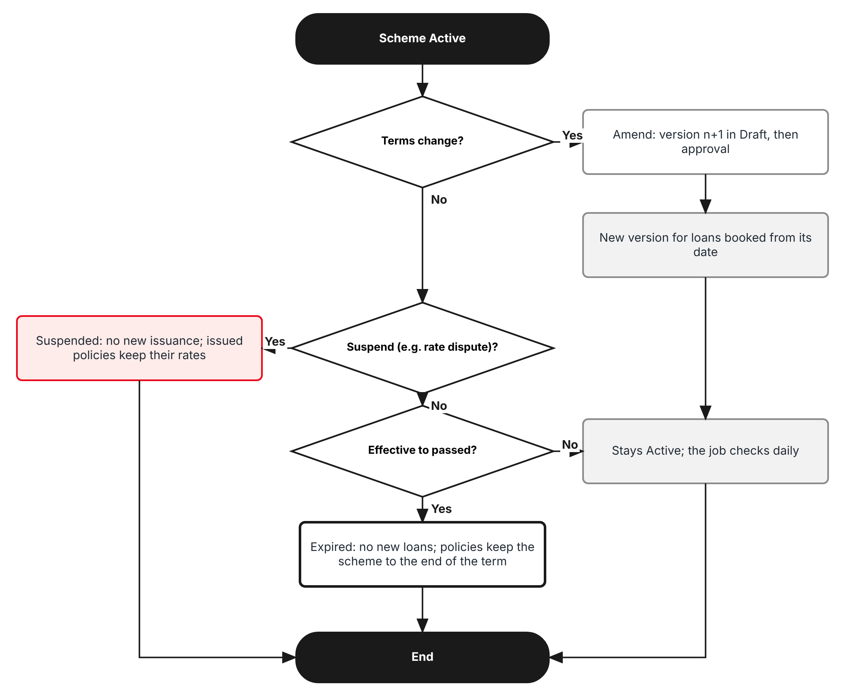
Figure 3: Flow C - Amend, suspend and expire
Table 5: Flow C steps
Step | Who (role) | What happens | FR
C1 | Sales Admin; approver | A change of terms is made as a new version (Amend) and approved like a new scheme. The new version applies to loans booked from its effective date. | FR-SCM-012
C2 | Approver | Suspend stops new issuance on the scheme, for example while a rate is disputed with an insurer; Resume restarts it. Policies already issued keep their scheme. | FR-SCM-011
C3 | System | After Effective to the scheme is Expired: no new loans, but issued policies keep the scheme and its schedule to the end of their term. | FR-SCM-011, 023

2.4 What a scheme covers
Table 6: Scheme dimensions
Dimension | Values | Where in BrokerVerse
Scheme types | Scheme 1 - Lock-in (Auto Renewal Agreement); Scheme 2 - Guaranteed renewal | Scheme Master > General
Products | Motor products only, Insurance Policy Type Comprehensive | Master > Insurance > Product; Product Configurator template
Vehicle classes | Insurance Commission vehicle classes of the Motor tariff, e.g. Private cars; Light / medium trucks | Motor template MOT-003-2025
Perils | Own Damage / Theft, Acts of Nature, Excess Bodily Injury, Property Damage, Auto Personal Accident, Roadside Assistance, Personal Accident of the Driver; CTPL by tariff | Product Configurator > Coverage Builder
Vehicles | Make, model, variant, year model range and sum insured range | Master > Insurance > Vehicle
Parties | TFS (financing bank), all or selected dealers (dealer groups and branches), panel insurers | Master > Insurance > Distribution Channels; Insurance Company
Money | Commission % of NET Premium; Dealer commission % of the commission | Scheme Master > Commission & term
Time | Effective from / to (loan booking); term of 1 to 5 years with the sum insured % of each year | Scheme Master > General, Commission & term

3 Personas and roles

3.1 Personas
TISPH personas map to the eight base roles (Master > Users and Access > Role); TISPH can add its own roles, such as Sales Head, with the permissions of 3.2.
Table 7: Personas and BrokerVerse roles
TISPH persona | BrokerVerse role | What they do with schemes
Sales Admin (maker) | Processing Team (Placement & Policy Processing) - processing | Maintains schemes, perils, rates, vehicle lines, commission and schedule; uploads vehicle lines; submits for approval
Scheme approver (checker), e.g. Sales Head | Accounting Manager - accounting-manager (or a TISPH role with approve:schemes) | Approves or returns schemes; suspends, resumes and withdraws them
Operations | Operations (Client Servicing) - operations; Processing Team | Issues and renews scheme policies through SCHM-01; sees the scheme on the policy
Sales / Telesales | Sales & Marketing (Account Executive) - sales | Views schemes to answer dealers and clients; Premium preview
Finance | Accounting - accounting | Commission and dealer commission of scheme policies
System Administrator | System Administrator (Super Admin Access) - system-admin | Roles, permissions, configuration keys, schedules
Auditor | Compliance Officer (AML/CFT) - compliance-officer | Read-only access to schemes and the Audit Trail

3.2 New permissions
Granted on Master > Users and Access > Role Permissions. The scheme rating needs no permission of its own: it runs under the issuance or renewal that calls it (write:policies, write:renewals).
Table 8: New permissions
Permission | Allows
read:schemes | Open Operations > Sales & Marketing > Scheme Master and its records; Premium preview; Export
write:schemes | Add, edit, copy, amend and submit schemes; Upload vehicle lines
approve:schemes | Approve, return, suspend, resume and withdraw schemes (never one you made or changed)

3.3 Default grants
Table 9: Default grants (Y = granted)
Permission | system-admin | processing | sales | operations | accounting | accounting-manager | compliance-officer
read:schemes | Y | Y | Y | Y | Y | Y | Y
write:schemes | Y | Y | - | - | - | - | -
approve:schemes | Y | - | - | - | - | Y | -

Segregation of duties. The maker of a scheme or scheme version can never approve it, even when holding approve:schemes. Scheme rates cannot be overridden on a policy.

4 Functional requirements
Eighteen FRs implement SCHM-02. They follow the life of a scheme: the Scheme Master register (4.1), approval and life cycle (4.2), the scheme rating (4.3), commission and dealer commission (4.4), and audit and access (4.5).

4.1 Scheme Master register

FR-SCM-001 Add a scheme with its number, type, description and effective dates
BRD trace | SCHM-02 "scheme number, description ... effective from/to" | Actor | Sales Admin - Processing Team (write:schemes)
Priority | Must have | Fit | Customization
Screens | Operations > Sales & Marketing > Scheme Master (new menu item after Dealer Programmes, route /sales/schemes): list and Add scheme dialog, General tab

Description
A new menu item Scheme Master is added under Operations > Sales & Marketing, after Dealer Programmes, with the same layout: page title, breadcrumb Operations > Sales & Marketing, a short description, the buttons Upload vehicle lines and Add scheme, status tabs and a table of schemes.
Add scheme opens the side dialog used by Add programme, with five tabs: General, Products & perils (FR-SCM-002), Vehicles (FR-SCM-003), Commission & term (FR-SCM-005, 006) and History. On the General tab the user enters the Scheme No., Scheme type, Description, Effective from and Effective to, the Financing bank, the Dealers and the Insurers. The first Save draft creates the scheme as Draft, version 1.
The Scheme No. is typed by the user because TFS, the dealers and the loan documents refer to the scheme by its number (for example S1-STD-2027). The effective dates apply to the inception date of the first policy year, which is the loan booking date: a scheme effective 01/01/2027 to 31/12/2027 rates loans booked in 2027, and its policies keep it for their whole term (FR-SCM-023).
Preconditions
- The user has write:schemes.
- TFS is set up in Master > Insurance > Distribution Channels as a financing bank; the dealers as dealer groups or dealer branches; the insurers in Insurance Company.
Main flow
- The user opens Operations > Sales & Marketing > Scheme Master and clicks Add scheme.
- On the General tab the user enters Scheme No., Scheme type, Description, Effective from, Effective to, Financing bank, Dealers (All dealers or a selection), Insurers and Notes.
- The user clicks Save draft. The server checks the fields, sets status Draft, version 1, and shows "Scheme saved".
- The user continues with the other tabs.
Alternate and exception flows
- Copy (row action): a new Draft opens with every tab copied and a blank Scheme No. and dates; used to start the next year's scheme or a dealer-specific scheme.
- Cancel: the dialog closes without saving after confirmation.
- Delete: a Draft version 1 never submitted can be deleted by its maker; any other scheme can only be withdrawn.
Business rules
Rule | Statement | Kind | Maintained in
R1 | Scheme No.: capital letters, digits and hyphens, 3 to 20 characters, unique without regard to case; read-only after the first save. | Fixed | -
R2 | Scheme type: Scheme 1 - Lock-in (Auto Renewal Agreement) or Scheme 2 - Guaranteed renewal. It sets the defaults of the Commission & term tab and cannot be changed after approval. | Fixed | -
R3 | Effective from cannot be before today when the scheme is submitted or approved; schemes are never backdated. Effective to is on or after Effective from, at most schemes.max_period_months (default 24) later. | Configurable | Master > System > Configuration
R4 | Financing bank: one active Distribution Channel of type financing bank (TFS). Its name is the mortgagee of the scheme policies. | Fixed | Master > Insurance > Distribution Channels
R5 | Dealers: All dealers, or one or more active dealer groups or dealer branches; a dealer group includes its branches. | Fixed | Master > Insurance > Distribution Channels
R6 | Insurers: one or more active insurers of the panel; the insurer of each policy is chosen among them at issuance (SCHM-01). | Fixed | Master > Insurance > Insurance Company

Validations and messages
Check | Message shown | ID
Scheme No. blank | Enter the Scheme No. | MSG-SCM-001
Scheme No. format | Use capital letters, digits and hyphens (3 to 20 characters) | MSG-SCM-002
Scheme No. used | Scheme No. <number> is already used | MSG-SCM-003
Scheme type blank | Choose the scheme type | MSG-SCM-004
Description blank | Enter a description of the scheme | MSG-SCM-005
Effective to before from | Effective to must be on or after Effective from | MSG-SCM-006
Effective from in the past | A scheme cannot start before today | MSG-SCM-007
Period too long | A scheme can run for at most <n> months | MSG-SCM-008
Bank not a financing bank | The financing bank must be an active financing bank of Distribution Channels | MSG-SCM-009
No dealer | Choose All dealers or at least one dealer | MSG-SCM-010
No insurer | Choose at least one insurer | MSG-SCM-011
Saved | Scheme saved | MSG-SCM-012

Audit
- Written to Master > System > Audit Trail with the user, time, before and after values and remark.
Acceptance criteria
- A scheme saved with Scheme No. S1-STD-2027, type Scheme 1, effective 01/01/2027 to 31/12/2027, financing bank Toyota Financial Services Philippines, All dealers and insurers Malayan and Pioneer is listed as Draft, version v1.
- Saving another scheme with s1-std-2027 is refused with "Scheme No. S1-STD-2027 is already used".
- Effective from of yesterday is refused; a period of 25 months is refused.
- Choosing BDO Auto Loans Makati Center (a bank branch) as financing bank is refused.
- Copy of S1-STD-2027 opens a Draft with the same perils, lines and commission and a blank Scheme No.

FR-SCM-002 Set the products and perils of a scheme and the rate of each peril
BRD trace | SCHM-02 "applicable products and perils ... rate by peril" | Actor | Sales Admin (write:schemes)
Priority | Must have | Fit | Customization
Screens | Operations > Sales & Marketing > Scheme Master > Add / Edit scheme > Products & perils tab

Description
The Products & perils tab says what the scheme insures and at what price. The user picks the Product (Motor products only) and the Vehicle classes of the Motor tariff the scheme accepts (for example Private cars; Light / medium trucks). Insurance Policy Type is Comprehensive and read-only.
Below, the tab lists every cover of the product's template from Product Configurator > Coverage Builder (Motor Insurance Basic Plan in BrokerVerse today): Own Damage and Theft (one line, as on Coverage Details), Acts of Nature, Excess Bodily Injury, Property Damage, Auto Personal Accident, Roadside Assistance, Personal Accident of the Driver and CTPL. For each the user sets In the scheme (Included or Not covered) and the rate in the rate basis of the cover. The column Standard today shows the base rate for comparison (Own Damage 2.00% and Acts of Nature 0.50% from premium.default_rates).
A scheme rate replaces the default or typed rate when a scheme policy is priced (FR-SCM-021). Discount Caps of PROD-15 do not apply to scheme rates: the approval of the scheme is the control.
Preconditions
- The scheme is in Draft.
- The product has a template with covers in Product Configurator > Coverage Builder.
Main flow
- The user opens the Products & perils tab and picks the Product and the Vehicle classes.
- The peril table is filled from the template's covers; mandatory covers (Own Damage, Theft, CTPL) are set to Included and cannot be removed.
- For each optional peril the user sets Included or Not covered.
- For each included peril the user enters the rate (and the limit where the basis needs one).
- Optionally the user sets a fixed Own Damage / Theft deductible; blank keeps the product template deductible.
- On save the server checks the rates and limits.
Alternate and exception flows
- A cover added to the template after the scheme was approved is not in the scheme; it appears as Not covered in the next version.
- A peril rate above the standard rate gives a warning, not an error.
Business rules
Rule | Statement | Kind | Maintained in
R1 | Rate basis by peril: Own Damage / Theft and Acts of Nature: % of the sum insured, up to 4 decimals. Excess Bodily Injury and Property Damage: a limit from the coverages master and its fixed premium. Auto Personal Accident: a limit per seat and a % of the limit, times the seats of the vehicle. Roadside Assistance: fixed premium per vehicle. Personal Accident of the Driver: a limit and a % of it. | Fixed | -
R2 | CTPL is always priced from the Insurance Commission tariff of the vehicle class; it has no scheme rate. Year 1 of a brand-new vehicle takes the 3-year CTPL (private car 1,660.40) when schemes.year1_three_year_ctpl is true; the policy years it covers carry no CTPL. | Configurable | Master > System > Configuration
R3 | Rates are more than 0 and at most 100; fixed premiums are more than 0. | Fixed | -
R4 | Illustrative values for testing, to be confirmed by TISPH: Scheme 1 standard OD / Theft 2.00%, AON 0.50%, Excess Bodily Injury 100,000 at 1,000.00, Property Damage 100,000 at 1,000.00, APPA 25,000 per seat at 0.10%, Roadside Assistance not covered. Scheme 2 standard: OD / Theft 1.80%, AON 0.40%, others the same. | Configurable | Scheme Master
R5 | No discount of any kind applies on top of a scheme rate (PROD-15 promotions and the Discount (Optional) of the Order Summary are not offered on scheme policies). | Fixed | -

Validations and messages
Check | Message shown | ID
No product | Choose the product of the scheme | MSG-SCM-013
Product not Motor | Schemes apply to Motor products only | MSG-SCM-014
No vehicle class | Choose at least one vehicle class | MSG-SCM-015
Included peril without rate | <peril>: enter the rate of an included peril | MSG-SCM-016
Rate out of range | <peril>: the rate must be more than 0 and at most 100 | MSG-SCM-017
Limit missing | <peril>: choose the limit | MSG-SCM-018
Mandatory peril removed | <peril> is a mandatory cover of the product and stays in the scheme | MSG-SCM-019
Rate above standard | <peril>: the scheme rate of <rate>% is above the standard rate of <standard>% | MSG-SCM-020

Audit
- Written to Master > System > Audit Trail with the user, time, before and after values and remark.
Acceptance criteria
- With product Motor Vehicle Insurance the peril table lists Own Damage / Theft, Acts of Nature, Excess Bodily Injury, Property Damage, Auto Personal Accident, Roadside Assistance, Personal Accident of the Driver and CTPL.
- Own Damage / Theft and CTPL cannot be set to Not covered.
- Acts of Nature Included without a rate is refused with "Acts of Nature: enter the rate of an included peril".
- An Own Damage rate of 2.2000 is saved with the warning "Own Damage / Theft: the scheme rate of 2.2000% is above the standard rate of 2.00%".
- CTPL shows "Tariff" and cannot be edited.

FR-SCM-003 Define the vehicle make and model range of a scheme
BRD trace | SCHM-02 "vehicle make/model range" | Actor | Sales Admin (write:schemes)
Priority | Must have | Fit | Customization
Screens | Operations > Sales & Marketing > Scheme Master > Add / Edit scheme > Vehicles tab

Description
The Vehicles tab lists the vehicles the scheme accepts. A vehicle line is a Make and either one Model or All models, and either one Variant or All variants, taken from Master > Insurance > Vehicle (the same brand, model and variant lists as Step 1 of Create Quote). Each line has a Year model range, a Sum insured range in PHP and the Vehicle class that sets its CTPL tariff.
A line can carry its own OD % and AON % when TISPH agrees a different rate for a model, for example a higher Own Damage rate for Wigo. Blank means the peril rates of the Products & perils tab. The Check column shows OK or the error of the line.
When the rating looks for the line of a vehicle (FR-SCM-020) the most specific line wins: a variant line before a model line, a model line before an All models line.
Preconditions
- The scheme is in Draft and its Products & perils tab is saved.
- The makes, models and variants are active on Master > Insurance > Vehicle.
Main flow
- The user clicks Add vehicle line.
- The user picks Make, Model (or All models) and Variant (or All variants), enters Year model from and to, Sum insured from and to and picks the Vehicle class.
- Optionally the user enters OD % and AON % for the line.
- The server checks the line and shows OK or the error in Check.
- The user repeats for each line, or uses Upload (FR-SCM-004), and saves.
Alternate and exception flows
- A make, model or variant later made inactive on the Vehicle master: the line stays, shows a warning and matches no new vehicle.
Business rules
Rule | Statement | Kind | Maintained in
R1 | Two lines of the same level (variant, model or all models) may not overlap on the same make, model, variant and year model. | Fixed | -
R2 | Year model to >= Year model from; Sum insured to > Sum insured from; both ranges are inclusive. | Fixed | -
R3 | The vehicle class of a line must be one of the Vehicle classes of the Products & perils tab. | Fixed | -
R4 | Line OD % and AON % follow the rate rules of FR-SCM-002. | Fixed | -
R5 | At least one line is needed to submit the scheme. | Fixed | -

Validations and messages
Check | Message shown | ID
No line on submit | Add at least one vehicle line | MSG-SCM-021
Make, model or variant inactive | Line <n>: <vehicle> is not active on the Vehicle master | MSG-SCM-022
Overlapping lines | Line <n>: <vehicle>, year model <year> is already covered by line <m> | MSG-SCM-023
Year model order | Line <n>: Year model to must be on or after Year model from | MSG-SCM-024
Sum insured order | Line <n>: Sum insured to must be higher than Sum insured from | MSG-SCM-025
Class not in the scheme | Line <n>: <class> is not a vehicle class of the scheme | MSG-SCM-026
Line rate out of range | Line <n>: the rate must be more than 0 and at most 100 | MSG-SCM-027

Audit
- Written to Master > System > Audit Trail with the user, time, before and after values and remark.
Acceptance criteria
- A line Toyota, Vios, All variants, 2026-2027, 500,000-1,300,000, Private cars without line rates is saved with Check OK.
- A line Toyota, Fortuner, 2.4 G 4x2 AT, 2027-2028 next to a line for the same variant 2026-2027 is refused with "Line 6: Toyota Fortuner 2.4 G 4x2 AT, year model 2027 is already covered by line 3".
- A line Toyota, Fortuner, All variants, 2026-2027 next to the variant line 2.4 G 4x2 AT is accepted; a Fortuner 2.4 G 4x2 AT is rated on the variant line.
- A line with Sum insured from 1,300,000 and to 500,000 is refused.
- Submit for approval of a scheme without lines is refused with "Add at least one vehicle line".

FR-SCM-004 Upload the vehicle lines of a scheme from Excel
BRD trace | SCHM-02 "vehicle make/model range"; BULK-01 (.xlsx only) | Actor | Sales Admin (write:schemes)
Priority | Must have | Fit | Customization
Screens | Operations > Sales & Marketing > Scheme Master > Upload vehicle lines; Vehicles tab > Download template / Upload

Description
Toyota schemes cover many models, so the lines can be loaded from Excel. Download template gives the three-sheet template of BrokerVerse (Data, Columns, Instructions; required headers in dark red; columns in chapter 13). The user picks the Draft scheme and the mode, Add (adds the rows to the existing lines) or Replace (the rows replace every line), and uploads the file.
Rows are checked and loaded one by one with the rules of FR-SCM-003; a failed row does not stop the others. The result line reads "Processed n rows: c created, f failed" and each failed row is listed as "Row n: message".
Preconditions
- The scheme is in Draft; its Products & perils tab is saved.
Main flow
- The user opens Upload vehicle lines (or Upload on the Vehicles tab), picks the scheme and the mode.
- The user downloads the template, fills it and uploads the .xlsx.
- The server loads the valid rows and shows the result line with the failed rows.
Business rules
Rule | Statement | Kind | Maintained in
R1 | Only .xlsx; first sheet Data; at most schemes.max_rows rows (default 2,000). | Configurable | Master > System > Configuration
R2 | Replace only applies when at least one row is valid; otherwise the lines are unchanged. | Fixed | -

Validations and messages
Check | Message shown | ID
Not .xlsx | Upload an Excel (.xlsx) file | MSG-SCM-028
Missing column | Column <header> is missing from the Data sheet | MSG-SCM-029
Too many rows | The file has <n> rows; the limit is <max> | MSG-SCM-030
Scheme not Draft | Lines can be uploaded only to a Draft scheme | MSG-SCM-031
Row error | Row <n>: <message> | MSG-SCM-032
Result | Processed <n> rows: <c> created, <f> failed | MSG-SCM-033

Audit
- Written to Master > System > Audit Trail with the user, time, before and after values and remark.
Acceptance criteria
- An upload of 14 rows with 2 invalid rows to S1-STD-2027 in mode Add shows "Processed 14 rows: 12 created, 2 failed" and lists the two rows.
- A .csv file is refused with "Upload an Excel (.xlsx) file".
- Upload in mode Replace with 14 valid rows leaves exactly 14 lines.
- Upload to an Active scheme is refused.

FR-SCM-005 Set the commission % and the dealer commission % of a scheme
BRD trace | SCHM-02 "commission % and dealer commission %"; COMM-05 | Actor | Sales Admin (write:schemes)
Priority | Must have | Fit | Customization
Screens | Operations > Sales & Marketing > Scheme Master > Add / Edit scheme > Commission & term tab

Description
The Commission & term tab holds the two percentages of the BRD. Commission % is the commission of a scheme policy as a % of its NET Premium; it replaces the Commission Rate Matrix for scheme policies (FR-SCM-030). Dealer commission % is the share of that commission paid to the dealer of the loan; TISPH keeps the rest as its service fee (FR-SCM-031).
Under the fields the tab shows the equivalent rates on Own Damage so that Sales can check them against what was agreed in rate terms: with Own Damage at 2.00% and Commission 25.00%, the commission is 0.50% of the sum insured and the rate remitted to the insurer 1.50%; with Dealer commission 85.00% the dealer receives 0.425% and TISPH 0.075%.
Preconditions
- The scheme is in Draft.
Main flow
- The user enters Commission % and Dealer commission % (2 decimals).
- The server shows the equivalent rates and the TISPH share (100 - Dealer commission %).
Business rules
Rule | Statement | Kind | Maintained in
R1 | 0 <= Commission % <= 100; 0 <= Dealer commission % <= 100; both mandatory to submit. | Fixed | -
R2 | The commission is computed on the NET Premium of every peril of the scheme; CTPL is not commissioned (as in BrokerVerse today). | Fixed | -
R3 | Illustrative values for testing, to be confirmed by TISPH: Commission 25.00% and Dealer commission 85.00% (TISPH 15.00%) for both standard schemes. | Configurable | Scheme Master

Validations and messages
Check | Message shown | ID
Commission blank | Enter the commission % | MSG-SCM-034
Commission out of range | The commission % must be between 0 and 100 | MSG-SCM-035
Dealer % blank | Enter the dealer commission % | MSG-SCM-036
Dealer % out of range | The dealer commission % must be between 0 and 100 | MSG-SCM-037

Audit
- Written to Master > System > Audit Trail with the user, time, before and after values and remark.
Acceptance criteria
- Commission 25.00% and Dealer commission 85.00% show "TISPH keeps 15.00%" and the equivalent rates 0.50% (commission), 1.50% (remitting), 0.425% (dealer), 0.075% (TISPH) on Own Damage at 2.00%.
- Dealer commission 120 is refused.
- Submit for approval with a blank Commission % is refused.

FR-SCM-006 Set the term and the year-by-year sum insured schedule of a scheme
BRD trace | SCHM-02 rating hook; SCHM-01 (Scheme 1 one year free and the remaining term ARA; Scheme 2 whole term in the M.A.); SCHM-03 (lock-in) | Actor | Sales Admin (write:schemes)
Priority | Must have | Fit | Customization
Screens | Operations > Sales & Marketing > Scheme Master > Add / Edit scheme > Commission & term tab

Description
A scheme premium is known in advance for every year of the loan. The Term (years) says how many policy years the scheme covers, and the schedule gives the sum insured of each year as a % of year 1. The scheme rating uses it to price each renewal year (FR-SCM-023); SCHM-01 prints the resulting premiums in the Auto Renewal Agreement and SCHM-03 reads the term to know when the lock-in ends.
The schedule also says who pays each year. For Scheme 1 year 1 is paid by the dealer (free first year) or by the client, and years 2 onwards by the client through TFS (ADA) as auto renewals. For Scheme 2 every year is paid by the client through TFS within the monthly amortization.
Preconditions
- The scheme is in Draft.
Main flow
- The user enters Term (years) and, for Scheme 1, Year 1 paid by.
- The schedule shows one row per year with Sum insured % of year 1 (year 1 fixed at 100.00), an example sum insured, who pays and the kind of renewal.
- The user enters the % of each later year.
Business rules
Rule | Statement | Kind | Maintained in
R1 | Term: 1 to schemes.max_term_years (default 5) years. Scheme 1 default 5 (year 1 plus four auto-renewal years); Scheme 2 default 5 (the usual TFS loan term). | Configurable | Master > System > Configuration; Scheme Master
R2 | Year 1 is 100.00%; each later year is more than 0 and not higher than the year before. | Fixed | -
R3 | Illustrative schedule for testing, to be confirmed by TISPH: 100, 90, 80, 70, 60%. | Configurable | Scheme Master
R4 | The premiums the schedule gives are indicative; a renewal may still be adjusted for claims history or a change of use through the renewal (FR-SCM-023). | Fixed | -

Validations and messages
Check | Message shown | ID
Term out of range | The term must be between 1 and <max> years | MSG-SCM-038
Year % missing | Year <n>: enter the sum insured % | MSG-SCM-039
Year % increases | Year <n>: the sum insured % cannot be higher than year <n-1> | MSG-SCM-040

Audit
- Written to Master > System > Audit Trail with the user, time, before and after values and remark.
Acceptance criteria
- A Scheme 1 with term 5 and schedule 100, 90, 80, 70, 60 shows for a year 1 sum insured of 1,000,000.00 the sums 1,000,000.00, 900,000.00, 800,000.00, 700,000.00 and 600,000.00.
- Year 3 at 95% after year 2 at 90% is refused.
- A term of 6 years is refused with "The term must be between 1 and 5 years".
- For a Scheme 2 every year shows "Client through TFS (M.A.)" in Who pays.

FR-SCM-007 Search, view and export schemes
BRD trace | SCHM-02 | Actor | Any user with read:schemes
Priority | Must have | Fit | Customization
Screens | Operations > Sales & Marketing > Scheme Master list

Description
The list shows each scheme with Scheme No., Description, Scheme type, Dealers, Financing bank, Effective, Vehicle lines (count), Comm. % / Dealer %, Version and Status, in the base table style. Tabs filter by status with their counts (All, Active, Scheduled, Pending approval, Draft, Expired / withdrawn). The search box covers Scheme No. and description; filters cover scheme type, dealer, insurer and "in force on date". Export downloads the schemes, their perils and their lines in Excel with the Toyota Insurance Services logo of the brand pack.
Opening a scheme shows every tab read-only, with the History tab listing each version with its maker, approver, dates and remark.
Business rules
Rule | Statement | Kind | Maintained in
R1 | Default sort: Active first, then Effective from descending; 20 rows per page (base default). | Fixed | -

Audit
- Written to Master > System > Audit Trail with the user, time, before and after values and remark.
Acceptance criteria
- Filter "in force on date" 15/03/2027 lists the schemes whose effective period covers that date and whose status is Active or Scheduled.
- Export gives one sheet of schemes, one of perils and one of vehicle lines with the same filters.
- The History tab of S1-STD-2026 lists v1 (Superseded) and v2 (Active) with their approvers.

4.2 Approval and life cycle

FR-SCM-010 Submit, approve or return a scheme (maker-checker)
BRD trace | SCHM-02; PROD-03 maker-checker on registers; SEC-03 | Actor | Sales Admin (maker); Accounting Manager or TISPH Sales Head (approve:schemes)
Priority | Must have | Fit | Customization
Screens | Operations > Sales & Marketing > Scheme Master; My Work > Approvals (item kind "Scheme")

Description
A scheme, and every new version of it, is approved by a user with approve:schemes other than its maker before it can rate a policy. Submit for approval runs every check of FR-SCM-001 to 006; a scheme with an error cannot be submitted.
Submitting raises an item in My Work > Approvals of the users with approve:schemes (kind Scheme, the Scheme No. and version, next action "Approve or return the scheme"). Opening it shows the scheme read-only; for a new version the changed fields, perils and lines are highlighted. Approve sets the scheme to Scheduled (Effective from in the future) or Active (Effective from today). Return sends it back to Draft with the remark.
Preconditions
- The scheme is in Draft and passes all checks.
Main flow
- The maker clicks Submit for approval: status Pending approval, the record becomes read-only and the approval item appears in My Work > Approvals.
- An approver opens the item.
- The approver clicks Approve (optional remark) or Return (remark required).
- On approval the server sets Scheduled or Active and records the approver and time.
Alternate and exception flows
- The item is opened after Effective from has passed: Approve is refused and the approver returns it so that the maker moves the date.
- The maker recalls a submitted scheme before it is actioned: it goes back to Draft.
Business rules
Rule | Statement | Kind | Maintained in
R1 | The maker (creator or last editor of the version) can never approve or return it. | Fixed | -
R2 | One version of a scheme can be in Draft or Pending approval at a time. | Fixed | -
R3 | Approvers: users with approve:schemes (default system-admin and accounting-manager; TISPH grants it to its Sales Head role). | Configurable | Master > Users and Access > Role Permissions

Validations and messages
Check | Message shown | ID
Self-approval | You made or changed this scheme, so another user must approve it | MSG-SCM-041
Return without remark | Enter the reason for returning the scheme | MSG-SCM-042
Effective from passed | Effective from <date> has passed; return the scheme so the maker can move the date | MSG-SCM-043
Second pending version | Version <n> of this scheme is already being changed or approved | MSG-SCM-044
Submitted | Scheme submitted for approval | MSG-SCM-045
Approved | Scheme approved | MSG-SCM-046
Returned | Scheme returned to the maker | MSG-SCM-047

Audit
- Written to Master > System > Audit Trail with the user, time, before and after values and remark.
Acceptance criteria
- A scheme submitted by user A cannot be approved by user A, even when A holds approve:schemes.
- Approving on 15/12/2026 a scheme effective 01/01/2027 sets it to Scheduled; approving one effective today sets it to Active.
- Return without a remark is refused; with a remark the scheme returns to Draft.
- After submit, the item S1-MMG-2027 v1 appears in My Work > Approvals of an Accounting Manager.

FR-SCM-011 Run the scheme life cycle: scheduled, active, suspended, expired, withdrawn
BRD trace | SCHM-02 "effective from/to" | Actor | System (daily job); approver (approve:schemes)
Priority | Must have | Fit | Customization
Screens | Operations > Sales & Marketing > Scheme Master (row actions Suspend, Resume, Withdraw); Master > System > Schedules (job "Scheme status")

Description
A new scheduled job Scheme status (Master > System > Schedules, daily at 00:10 Manila time, one run across instances like the other base jobs) moves Scheduled schemes whose Effective from is today to Active, and Active or Suspended schemes whose Effective to has passed to Expired.
An approver can Suspend an Active scheme, for example while a rate is disputed with an insurer, Resume it, or Withdraw it (Effective to set to today). Only an Active scheme rates a new loan. A policy already issued on a scheme keeps it for its whole term, whatever happens to the scheme later (FR-SCM-023).
Main flow
- The job reads every Scheduled, Active and Suspended scheme and changes the status where the date rule is met.
- For a manual action the approver opens the row actions, chooses Suspend, Resume or Withdraw, enters the remark and confirms; the number of scheme policies in force is shown first.
Business rules
Rule | Statement | Kind | Maintained in
R1 | Statuses: Draft, Pending approval, Scheduled, Active, Suspended, Expired, Withdrawn; an older version becomes Superseded (chapter 5). | Fixed | -

Validations and messages
Check | Message shown | ID
Remark blank | Enter the reason | MSG-SCM-048
Policies in force | <n> policies are in force on this scheme; they keep it to the end of their term | MSG-SCM-049
Suspended | Scheme suspended | MSG-SCM-050
Resumed | Scheme resumed | MSG-SCM-051
Withdrawn | Scheme withdrawn | MSG-SCM-052

Audit
- Written to Master > System > Audit Trail with the user, time, before and after values and remark.
Acceptance criteria
- A Scheduled scheme effective 01/01/2027 is Active after the job of 01/01/2027.
- An Active scheme ending 31/12/2027 is Expired after the job of 01/01/2028.
- A suspended scheme rates no new loan; a renewal year of a policy issued on it is still rated.
- Withdraw sets Effective to to today and the status to Withdrawn.

FR-SCM-012 Amend an approved scheme as a new version
BRD trace | SCHM-02; PROD-01 versioned configuration | Actor | Sales Admin; approver
Priority | Must have | Fit | Customization
Screens | Operations > Sales & Marketing > Scheme Master > row action Amend

Description
An approved scheme is never edited in place. Amend creates version n+1 in Draft, copied from the current version, in the same way as new template versions in the Product Configurator. The current version stays in force until the new one is approved. The new version has its own Effective from (not before its approval date); from that date it rates new loans and the old version becomes Superseded for new business.
Policies issued on the old version keep it, with its rates, commission and schedule, for their whole term. This is what makes the premiums of the Auto Renewal Agreement and of the financed premium reliable.
Preconditions
- The scheme is Scheduled, Active or Suspended. No other version is in Draft or Pending approval.
Main flow
- The user clicks Amend; a Draft version opens.
- The user changes the description, effective dates, dealers, insurers, perils, rates, lines, commission or schedule and submits; approval follows FR-SCM-010.
Alternate and exception flows
- The user discards the Draft version: the current version is unchanged.
Business rules
Rule | Statement | Kind | Maintained in
R1 | The Scheme No. and the scheme type cannot be amended. | Fixed | -
R2 | A policy is never moved to a newer version of its scheme. | Fixed | -

Validations and messages
Check | Message shown | ID
Edit of an approved version | An approved scheme cannot be changed; use Amend to create a new version | MSG-SCM-053

Audit
- Written to Master > System > Audit Trail with the user, time, before and after values and remark.
Acceptance criteria
- Amending S1-STD-2026 v2 creates v3 Draft; v2 stays Active until v3 is approved.
- A loan booked after v3 is in force is rated on v3; the renewal years of a policy issued on v2 are still rated on v2.
- The approval of v3 highlights the perils and lines that differ from v2.

4.3 Scheme rating

FR-SCM-020 Find the scheme version and vehicle line of a loan
BRD trace | SCHM-02 rating hook; SCHM-01 | Actor | System, called by the scheme issuance (SCHM-01) and the renewal
Priority | Must have | Fit | Customization
Screens | Server routine (new) used by the SCHM-01 issuance screens and the renewal run; Scheme Master > Premium preview

Description
The scheme rating is a new server routine of BrokerVerse, next to the premium engine of Create Quote. The caller passes the Scheme No. (from the loan documents), the dealer of the loan, the insurer, the vehicle (make, model, variant, year model, vehicle class, seats), the sum insured of year 1 and the inception date of year 1.
The routine finds the version of the scheme in force on the inception date and checks that the dealer is one of its dealers and the insurer one of its insurers. It then finds the vehicle line: same make, the most specific matching line (variant, then model, then All models), year model within the range and sum insured within the range. When no Scheme No. is given, the caller may pass the scheme type: a scheme naming the dealer is used before an All dealers scheme of the same type.
Preconditions
- The scheme is Active (or the policy is already on the scheme, for a renewal year).
Main flow
- The caller passes the loan data.
- The routine finds the scheme version and checks dealer, insurer and product.
- The routine finds the vehicle line.
- The routine returns the scheme, version and line to price (FR-SCM-021), or the reason it cannot.
Business rules
Rule | Statement | Kind | Maintained in
R1 | Precedence of lines: variant line, then model line, then All models line. | Fixed | -
R2 | Precedence of schemes of the same type in force on a date: a scheme naming the dealer (branch before group) before an All dealers scheme. | Fixed | -
R3 | A Suspended, Expired or Withdrawn scheme rates no new loan. | Fixed | -

Validations and messages
Check | Message shown | ID
No scheme in force | Scheme <number> is not in force on <date> | MSG-SCM-054
Dealer not in the scheme | <dealer> is not a dealer of scheme <number> | MSG-SCM-055
Insurer not in the scheme | <insurer> is not an insurer of scheme <number> | MSG-SCM-056
No vehicle line | <vehicle> <year> is not covered by scheme <number> | MSG-SCM-057
Sum insured out of range | The sum insured of <amount> is outside the range <from> - <to> of scheme <number> for <vehicle> | MSG-SCM-058

Audit
- Written to Master > System > Audit Trail with the user, time, before and after values and remark.
Acceptance criteria
- A Toyota Vios 1.3 XLE CVT 2026 with sum insured 1,000,000.00 from Makati Motors Makati on 05/01/2027 under S1-STD-2027 finds line 1 (Vios, All variants).
- A Fortuner 2.4 G 4x2 AT 2026 finds the variant line 3 rather than an All variants Fortuner line.
- A Vios with sum insured 1,400,000.00 is refused with the range 500,000 - 1,300,000.
- On 05/01/2027 a loan from Makati Motors under scheme type Scheme 1 without a number is rated on S1-MMG-2027, not on S1-STD-2027.
- A loan booked on 05/01/2027 under S1-STD-2026 (Effective to 31/12/2026) is refused.

FR-SCM-021 Price a scheme policy by peril
BRD trace | SCHM-02 "rate by peril"; PROD-10, PROD-11 (taxes) | Actor | System
Priority | Must have | Fit | Customization
Screens | Server routine (new); SCHM-01 issuance screens; Policy detail; Scheme Master > Premium preview

Description
With the scheme version, the line and the policy year, the routine prices every included peril: Own Damage / Theft and Acts of Nature at the line rate, else the peril rate, times the sum insured of the year; Excess Bodily Injury, Property Damage and Roadside Assistance at their fixed premium; Auto Personal Accident at the limit per seat x seats x rate. The NET Premium is the sum.
VAT, DST and LGT come from the premium tax and charge engine (Master > Finance > Premium Taxes & LGU Rates), CTPL from the tariff of the vehicle class, exactly as for a quotation, so a scheme premium and a Create Quote premium at the same rates are the same to the centavo. The gross premium is NET Premium + VAT + DST + LGT + CTPL. No discount applies.
The result is the premium breakdown of the policy (same fields as Order Summary: NET Premium, Value Added Tax, Documentary Stamp Tax, Local Gov't Tax, CTPL, Total Premium) plus the scheme, version, line and rates used.
Main flow
- The routine reads the peril rates of the version and the line rates.
- It computes the premium of each included peril for the sum insured of the year.
- It calls the tax and charge engine and the CTPL tariff.
- It returns the breakdown.
Business rules
Rule | Statement | Kind | Maintained in
R1 | Rounding as in the base engine: each premium to 2 decimals; DST as the tax engine computes it. | Fixed | -
R2 | A peril set to Not covered has no premium and no sum insured on the policy. | Fixed | -
R3 | PROD-15 promotions are not offered and the Discount (Optional) is fixed at 0 on a scheme policy. | Fixed | -

Validations and messages
Check | Message shown | ID
Peril without rate (old data) | Scheme <number> version <v> has no rate for <peril>; the scheme must be amended | MSG-SCM-059

Audit
- Written to Master > System > Audit Trail with the user, time, before and after values and remark.
Acceptance criteria
- A Vios 1,000,000.00 under S1-STD-2027 (OD 2.00%, AON 0.50%, BI and PD 100,000 at 1,000.00, APPA 25,000 x 5 at 0.10%) in year 1 gives OD 20,000.00, AON 5,000.00, NET Premium 27,125.00, VAT 3,255.00, DST 3,391.00, LGT 203.44, 3-year CTPL 1,660.40 and gross premium 35,634.84 (Appendix A.1).
- The same vehicle under S2-STD-2027 (OD 1.80%, AON 0.40%) gives NET Premium 24,125.00 and gross premium 31,877.34 (Appendix A.2).
- A Wigo on line 2 is priced at the line OD rate 2.20%, not the peril rate 2.00%.
- A scheme with Roadside Assistance Not covered gives no Roadside Assistance premium.

FR-SCM-022 Preview the premiums of a scheme for a sample vehicle
BRD trace | SCHM-02 | Actor | Any user with read:schemes
Priority | Must have | Fit | Customization
Screens | Operations > Sales & Marketing > Scheme Master > Add / Edit scheme > Premium preview

Description
Premium preview on the scheme dialog runs the scheme rating on a vehicle and year 1 sum insured the user enters and shows, for every year of the term, the sum insured, the premium of the main perils, the NET Premium, the taxes, CTPL, the gross premium, the commission and the dealer share. Nothing is saved. It works on a Draft scheme, so Sales can check the figures before submitting, and on any approved version.
Main flow
- The user clicks Premium preview.
- The user picks a vehicle (make, model, variant, year model), enters the sum insured of year 1 and the insurer.
- The table shows years 1 to term.
Validations and messages
Check | Message shown | ID
Vehicle not covered | <vehicle> <year> is not covered by scheme <number> | MSG-SCM-057

Audit
- Written to Master > System > Audit Trail with the user, time, before and after values and remark.
Acceptance criteria
- Premium preview of S1-STD-2027 for a Vios 1.3 XLE CVT 2026 at 1,000,000.00 shows gross premiums 35,634.84, 30,843.19, 27,711.94, 25,191.09 and 22,059.84 for years 1 to 5.
- The preview of a Draft scheme saves nothing and creates no audit entry.

FR-SCM-023 Keep the scheme on the policy and rate the renewal years within the term
BRD trace | SCHM-02 rating hook; SCHM-01; SCHM-03; RENEW-03 | Actor | System
Priority | Must have | Fit | Customization
Screens | Policy detail (new read-only Scheme panel); renewal run; SCHM-01 issuance

Description
When a scheme policy is issued, the policy keeps the Scheme No., version, vehicle line, peril rates, Commission %, Dealer commission %, term, schedule and year 1 sum insured. The Policy detail shows them in a read-only Scheme panel with the policy year (for example "Year 2 of 5").
Each renewal of the policy within the term is rated by the scheme rating on the same version, with the sum insured of the year from the schedule (year 1 sum insured x the year %), instead of the base Motor renewal that re-rates on the current fair market value. The renewal keeps the scheme panel with the next policy year. After the last year of the term the policy renews as a normal Motor policy.
Which notices are sent or suppressed for these renewals and the 60-day lock-in review are SCHM-03; the document flow of the renewal for Scheme 1 (ARA) and Scheme 2 is SCHM-01.
Alternate and exception flows
- Adjustment: the scheme premiums are indicative. When the renewal premium must change because of claims history or a change to business use, the renewal is changed through the existing renewal screens with a reason; the scheme panel then shows the scheme premium and the adjusted premium.
- Scheme suspended or expired: renewal years of issued policies are still rated on their version.
Business rules
Rule | Statement | Kind | Maintained in
R1 | A policy never changes scheme or version during its term. | Fixed | -
R2 | Renewal sum insured of year n = year 1 sum insured x schedule % of year n, rounded to 2 decimals. | Fixed | -

Validations and messages
Check | Message shown | ID
Renewal adjusted | The renewal premium differs from the scheme premium of <amount> for year <n>; enter the reason | MSG-SCM-060

Audit
- Written to Master > System > Audit Trail with the user, time, before and after values and remark.
Acceptance criteria
- A policy issued under S1-STD-2027 v1 shows the Scheme panel "S1-STD-2027 v1, line 1, Year 1 of 5".
- Its year 2 renewal is priced on v1 at sum insured 900,000.00: NET Premium 24,625.00, gross premium 30,843.19 (no CTPL, covered by the 3-year CTPL).
- After S1-STD-2027 v2 is approved with OD 1.90%, the year 3 renewal of the policy is still priced at 2.00%.
- The renewal after year 5 is a normal Motor renewal on the current fair market value.

FR-SCM-024 Endorse and cancel a scheme policy
BRD trace | SCHM-02; ENDT-01 to 03 | Actor | Operations
Priority | Must have | Fit | Customization
Screens | Operations > Policy > Endorsements; Operations > Policy Cancellation (existing)

Description
A financial endorsement of a scheme policy (for example an accessory added to the sum insured) is priced pro rata at the peril rates kept on the policy, through the existing endorsement screens. A cancellation follows the existing Policy Cancellation, with its refund rules. The commission and the dealer share are reversed in the same proportion as the premium (FR-SCM-030, 031).
Replacing the insured vehicle by another one takes the new vehicle out of the scheme: the endorsement shows a warning and the new vehicle is priced at the standard rates.
Validations and messages
Check | Message shown | ID
Vehicle replaced | The new vehicle is not covered by scheme <number>; it is priced at the standard rates | MSG-SCM-061

Audit
- Written to Master > System > Audit Trail with the user, time, before and after values and remark.
Acceptance criteria
- An endorsement adding 50,000.00 to the sum insured on day 183 of year 1 of a S1-STD-2027 policy is priced at 2.00% and 0.50% pro rata.
- A flat cancellation reverses the whole commission and dealer share of the year.
- Replacing the vehicle shows the warning and prices the new vehicle at Own Damage 2.00%.

4.4 Commission and dealer commission

FR-SCM-030 Compute the commission of a scheme policy from the scheme
BRD trace | SCHM-02 "commission %"; COMM-05, COMM-06; PROD-16 | Actor | System; Accounting
Priority | Must have | Fit | Customization
Screens | Policy detail (Scheme panel); Commission; Remittance (existing)

Description
For a scheme policy, commission = NET Premium x the Commission % kept on the policy. It replaces the base look-up (Commission Rate Matrix, then the insurer rate, then commission.default_rate); the commission line of the policy carries the source "scheme" with the Scheme No. and version, in the same place where the matrix rule is shown today. The premium due to the insurer is the premium less this commission, as in the base remittance.
The issuing-vs-remitting rules register of PROD-16 does not apply to scheme policies: the scheme carries its own commission. When an insurer has agreed a lower internal remitting rate for scheme business, the extra TISPH income is computed by the issuing-vs-remitting calculation of COMM-06 from that insurer rate; it does not change the scheme commission or the dealer share.
Business rules
Rule | Statement | Kind | Maintained in
R1 | Commission is computed on the premium of every policy year and of every financial endorsement, and reversed on cancellation in proportion. | Fixed | -
R2 | The Commission % is the one kept on the policy, never the current scheme version. | Fixed | -

Audit
- Written to Master > System > Audit Trail with the user, time, before and after values and remark.
Acceptance criteria
- A year 1 S1-STD-2027 policy with NET Premium 27,125.00 has commission 6,781.25 with source "scheme S1-STD-2027 v1".
- A Commission Rate Matrix row for the same insurer and product at 20% does not change it.
- The year 2 renewal (NET Premium 24,625.00) has commission 6,156.25.

FR-SCM-031 Credit the dealer share of the commission to the dealer of the loan
BRD trace | SCHM-02 "dealer commission %"; COMM-05 | Actor | System; Accounting
Priority | Must have | Fit | Customization
Screens | Commission > Referrer Accounts (existing); Policy detail (Scheme panel)

Description
The dealer share = commission x Dealer commission %, rounded to 2 decimals; TISPH keeps the commission less the dealer share. The dealer share is credited to the dealer of the loan (the dealer branch of Distribution Channels, or its dealer group when the branch has no referrer account) as a referrer commission line, in the same way as the comsub to referrers of BrokerVerse, and is paid through the existing Commission process.
The Scheme panel of the policy shows Commission, Dealer share and TISPH share for the year.
Business rules
Rule | Statement | Kind | Maintained in
R1 | The dealer share follows the commission: same timing, same reversal on cancellation. | Fixed | -
R2 | A dealer without a referrer account cannot be paid; the line is held with the reason until Accounting sets the account up. | Fixed | Commission > Referrer Accounts

Validations and messages
Check | Message shown | ID
Dealer without account | <dealer> has no referrer account; the dealer share of <amount> is held | MSG-SCM-062

Audit
- Written to Master > System > Audit Trail with the user, time, before and after values and remark.
Acceptance criteria
- Commission 6,781.25 with Dealer commission 85.00% gives a dealer share of 5,764.06 to Makati Motors Makati and 1,017.19 to TISPH.
- A flat cancellation reverses the 5,764.06.
- For a dealer without referrer account the line is held and Accounting sees the warning.

4.5 Audit and access

FR-SCM-040 Audit and control access to schemes
BRD trace | SCHM-02; SEC-01, SEC-03 | Actor | System; System Administrator
Priority | Must have | Fit | Customization
Screens | Master > System > Audit Trail; Master > Users and Access > Role Permissions (existing)

Description
Every save, submit, approval, return, suspension, resumption, withdrawal, amendment and upload of a scheme is written to the Audit Trail (entity "scheme") with the user, time, before and after values and remark, like the other registers. The scheme rating writes the scheme, version and line to the policy record, so the audit of the policy shows where its premium came from.
Screens, buttons and API calls follow the permissions of section 3.2; a user without read:schemes does not see the menu item.
Audit
- Written to Master > System > Audit Trail, entity "scheme", with the user, time, before and after values and remark.
Acceptance criteria
- Changing the Own Damage rate of a Draft from 2.00 to 2.20 writes an audit entry with both values.
- A Sales & Marketing user sees Scheme Master read-only; Add scheme is hidden.
- A user without read:schemes does not see the menu item and gets "You do not have permission" from the API.

5 Workflow and status model

5.1 Scheme
Table 10: Scheme statuses
From | Action / event | To | Who | Condition
(new) | Save draft | Draft | write:schemes | Mandatory fields of the General tab
Draft | Submit for approval | Pending approval | write:schemes | All checks pass; item raised in My Work > Approvals
Pending approval | Recall | Draft | Maker | Not yet actioned
Pending approval | Return | Draft | approve:schemes, not the maker | Remark required
Pending approval | Approve | Scheduled | approve:schemes, not the maker | Effective from in the future
Pending approval | Approve | Active | approve:schemes, not the maker | Effective from is today
Scheduled | Effective from reached | Active | Job "Scheme status" 00:10 | -
Active | Effective to passed | Expired | Job | -
Active | Suspend | Suspended | approve:schemes | Remark required
Suspended | Resume | Active | approve:schemes | Effective to not passed
Suspended | Effective to passed | Expired | Job | -
Draft, Scheduled, Active, Suspended | Withdraw | Withdrawn | approve:schemes | Remark required; Effective to = today
Scheduled, Active, Suspended | Amend | New version in Draft | write:schemes | No other version pending; the current version stays in force
Active (old version) | New version in force | Superseded | System | Rates no new loan; keeps rating the renewal years of its policies

Only an Active version rates a new loan. Every version that has policies in force, whatever its status, keeps rating the renewal years of those policies until the end of their term.

5.2 Scheme on the policy
Table 11: Scheme along the policy
Policy event | Effect of the scheme
Issuance (SCHM-01) | Scheme and line found, premium by peril, commission and dealer share; scheme kept on the policy, Year 1 of n (FR-SCM-020, 021, 023, 030, 031)
Renewal within the term | Same version; sum insured from the schedule; Year k of n (FR-SCM-023)
Renewal adjusted for claims or use | Reason required; scheme premium and adjusted premium both shown (FR-SCM-023)
Financial endorsement | Pro rata at the policy's scheme rates; commission and dealer share follow (FR-SCM-024)
Vehicle replaced | New vehicle out of the scheme, standard rates (FR-SCM-024)
Cancellation | Existing refund rules; commission and dealer share reversed in proportion (FR-SCM-024, 031)
End of the term | Next renewal is a normal Motor renewal on the current fair market value (FR-SCM-023)

6 Interfaces
SCHM-02 has one inbound file and one outbound file, both in the base Excel format. The scheme rating is called inside BrokerVerse by SCHM-01 and the renewal run; it has no external interface.
Table 12: Interfaces
Interface | Direction | Scheme data | Note
Upload vehicle lines | Inbound (.xlsx upload) | Vehicle lines of a Draft scheme | Template in chapter 13
Master > Insurance > Vehicle upload (existing) | Inbound (.xlsx upload) | Makes, models and variants behind the lines | Loaded from the TISPH make and model master before the schemes
Export (Scheme Master list) | Outbound (.xlsx) | Schemes, perils and vehicle lines | For TFS, the dealers and the insurers

7 Configuration items

7.1 Settings
New settings use the dotted keys of BrokerVerse and are maintained on Master > System > Configuration.
Table 13: Settings
Key | Meaning | Default
schemes.max_period_months | Longest effective period of a scheme version | 24
schemes.max_term_years | Longest term of a scheme | 5
schemes.max_rows | Rows per vehicle lines upload | 2000
schemes.year1_three_year_ctpl | Year 1 of a scheme policy takes the 3-year CTPL of a brand-new vehicle | true
schemes.warn_rate_above_standard | Warn when a scheme rate is above the standard rate | true
premium.default_rates (existing) | Standard Own Damage and Acts of Nature rates, shown for comparison | OD 2.00, AON 0.50
motor.pricing_template_code (existing) | Motor template giving the covers and the CTPL tariff | MOT-003-2025

7.2 Scheduled job
Table 14: Scheduled jobs (Master > System > Schedules)
Job | When | What it does
Scheme status (new) | Daily 00:10 Manila time | Scheduled to Active on Effective from; Active / Suspended to Expired after Effective to

7.3 Lists of values
Table 15: Lists of values
List | Values
Scheme type (new) | Scheme 1 - Lock-in (Auto Renewal Agreement); Scheme 2 - Guaranteed renewal
Scheme status (new) | Draft; Pending approval; Scheduled; Active; Suspended; Expired; Withdrawn; Superseded
In the scheme (new) | Included; Not covered
Rate basis (new) | % of sum insured; Fixed premium per limit; % of limit x seats; Fixed premium per vehicle; Insurance Commission tariff
Year 1 paid by (new) | Dealer (free first year); Client through TFS (ADA); Client through TFS (M.A.)
Upload mode (new) | Add; Replace

7.4 Masters
Table 16: Masters
Master | Owner | Approval
Scheme Master (new) | Sales Admin (Processing Team) | approve:schemes in My Work > Approvals
Vehicle, Distribution Channels, Insurance Company, Product (existing) | Operations / System Administrator | Unchanged
Coverage Builder of the Motor template (existing) | Processing Team | Product Configurator versioning
Referrer accounts of the dealers (existing) | Accounting | Unchanged

7.5 Scheme parameters to load
The schemes are loaded on the Scheme Master with the values TISPH provides. Until then the build and the tests use the illustrative values below.
Table 17: Scheme parameters
Parameter | Scheme 1 standard (illustrative) | Scheme 2 standard (illustrative) | Status
Scheme No. / type | S1-STD-2027 / Scheme 1 - Lock-in (ARA) | S2-STD-2027 / Scheme 2 - Guaranteed renewal | To be provided by TISPH
Effective, financing bank, dealers | 01/01/2027 - 31/12/2027, TFS, All dealers | 01/01/2027 - 31/12/2027, TFS, All dealers | To be provided by TISPH
Insurers | Panel insurers for scheme business | Panel insurers for scheme business | To be provided by TISPH
Product, vehicle classes | Motor; Private cars, Light / medium trucks | Motor; Private cars, Light / medium trucks | To be provided by TISPH
OD / Theft, AON | 2.00%, 0.50% | 1.80%, 0.40% | To be provided by TISPH
BI, PD, APPA, Roadside | 100,000 at 1,000.00; 100,000 at 1,000.00; 25,000 per seat at 0.10%; not covered | Same as Scheme 1 | To be provided by TISPH
Vehicle lines | Toyota models of the TFS portfolio with year and sum insured ranges | Same | To be provided by TISPH
Commission % / Dealer commission % | 25.00% / 85.00% | 25.00% / 85.00% | To be provided by TISPH
Term / schedule | 5 years; 100, 90, 80, 70, 60%; year 1 paid by the dealer | 5 years; 100, 90, 80, 70, 60%; all years in the M.A. | To be provided by TISPH
Dealer-specific schemes | Where a dealer has its own Scheme 1 rate (e.g. S1-MMG-2027) | - | To be provided by TISPH

8 Traceability

8.1 BRD clause to FR
Table 18: SCHM-02 clauses
Clause of TIS-BRD-SCHM-02 | FR | BrokerVerse screen
Scheme Master | FR-SCM-001, 007, 010 to 012 | Scheme Master (new)
scheme number, description | FR-SCM-001, 007 | Scheme Master > General
applicable products and perils | FR-SCM-002 | Scheme Master > Products & perils
effective from / to | FR-SCM-001, 011, 012, 020 | Scheme Master > General; Schedules
rate by peril | FR-SCM-002, 021 | Scheme Master > Products & perils; scheme rating
vehicle make / model range | FR-SCM-003, 004, 020 | Scheme Master > Vehicles; Upload vehicle lines
commission % | FR-SCM-005, 030 | Scheme Master > Commission & term; Commission
dealer commission % | FR-SCM-005, 031 | Scheme Master > Commission & term; Commission > Referrer Accounts
New register + rating hook (CR-05 note) | FR-SCM-020 to 024 | Scheme rating; Policy detail; Premium preview

8.2 Related BRD requirements
Table 19: Related requirements
BRD ref. | Relation to SCHM-02 | FR
SCHM-01 | Scheme issuance on loan documents calls the scheme rating; ARA premiums from the schedule | FR-SCM-006, 020, 021, 023
SCHM-03 | Lock-in handling reads the scheme term and the policy year | FR-SCM-006, 023
PROD-01, PROD-03 | Versioned registers on maker-checker | FR-SCM-010, 012
PROD-10, PROD-11 | Excess; taxes | FR-SCM-002, 021
PROD-15 | Promotions not offered on scheme policies | FR-SCM-002, 021
PROD-16, COMM-05, COMM-06 | Issuing vs remitting rate and sharing; scheme commission takes precedence | FR-SCM-030, 031
MAS-04, MAS-07, MAS-09 | Insurers, channels, vehicles | FR-SCM-001, 003
RENEW-03 | Motor renewal re-rated on fair market value, except within a scheme term | FR-SCM-023
ENDT-01 to 03; module 11 | Endorsement and cancellation | FR-SCM-024
BULK-01 | Excel (.xlsx) uploads only | FR-SCM-004
SEC-01, SEC-03 | Access and segregation of duties | FR-SCM-010, 040

8.3 FR to test cases
Table 20: Test cases per FR (one per acceptance criterion)
FR | Title | Test cases
FR-SCM-001 | Add a scheme with its number, type, description and effective dates | TC-SCM-001-1 to -5
FR-SCM-002 | Set the products and perils of a scheme and the rate of each peril | TC-SCM-002-1 to -5
FR-SCM-003 | Define the vehicle make and model range of a scheme | TC-SCM-003-1 to -5
FR-SCM-004 | Upload the vehicle lines of a scheme from Excel | TC-SCM-004-1 to -4
FR-SCM-005 | Set the commission % and the dealer commission % of a scheme | TC-SCM-005-1 to -3
FR-SCM-006 | Set the term and the year-by-year sum insured schedule of a scheme | TC-SCM-006-1 to -4
FR-SCM-007 | Search, view and export schemes | TC-SCM-007-1 to -3
FR-SCM-010 | Submit, approve or return a scheme (maker-checker) | TC-SCM-010-1 to -4
FR-SCM-011 | Run the scheme life cycle: scheduled, active, suspended, expired, withdrawn | TC-SCM-011-1 to -4
FR-SCM-012 | Amend an approved scheme as a new version | TC-SCM-012-1 to -3
FR-SCM-020 | Find the scheme version and vehicle line of a loan | TC-SCM-020-1 to -5
FR-SCM-021 | Price a scheme policy by peril | TC-SCM-021-1 to -4
FR-SCM-022 | Preview the premiums of a scheme for a sample vehicle | TC-SCM-022-1 to -2
FR-SCM-023 | Keep the scheme on the policy and rate the renewal years within the term | TC-SCM-023-1 to -4
FR-SCM-024 | Endorse and cancel a scheme policy | TC-SCM-024-1 to -3
FR-SCM-030 | Compute the commission of a scheme policy from the scheme | TC-SCM-030-1 to -3
FR-SCM-031 | Credit the dealer share of the commission to the dealer of the loan | TC-SCM-031-1 to -3
FR-SCM-040 | Audit and control access to schemes | TC-SCM-040-1 to -3

9 Navigation

9.1 Screens of SCHM-02
Table 21: Screens
Screen | Menu path and route | Type
Scheme Master (list, Add / Edit scheme dialog with tabs General, Products & perils, Vehicles, Commission & term, History) | Operations > Sales & Marketing > Scheme Master, after Dealer Programmes - /sales/schemes | New
Premium preview | Scheme Master > Add / Edit scheme > Premium preview | New
Upload vehicle lines | Scheme Master > Upload vehicle lines, or Upload on the Vehicles tab | New (base upload pattern)
My Work > Approvals | My Work - /my-work, category Approvals | Existing; new item kind Scheme
Policy detail | Operations > Policy - /agent/policy | Changed (read-only Scheme panel)
Commission > Referrer Accounts | Commission > Referrer Accounts - /commission/referrer-accounts | Existing; dealer share lines
Role Permissions | Master > Users and Access > Role Permissions | Existing; new permissions
Configuration; Schedules; Audit Trail | Master > System > Configuration / Schedules / Audit Trail | Existing; new keys, job and entity

9.2 Menu by base role
Table 22: Menu by base role
Base role | Menu entries for schemes
Processing Team | Operations > Sales & Marketing > Scheme Master (maintain, upload)
Accounting Manager | My Work > Approvals (schemes); Scheme Master (view, Suspend / Resume / Withdraw)
Sales & Marketing | Scheme Master (view, Premium preview)
Operations | Scheme Master (view); Policy detail (Scheme panel); scheme issuance (SCHM-01)
Accounting | Scheme Master (view); Commission, Referrer Accounts
System Administrator | All of the above; Role Permissions, Configuration, Schedules
Compliance Officer | Scheme Master (view); Audit Trail

10 Screen specifications
One specification per screen. Pictures marked "to-be design mock-up" are the real BrokerVerse screens with the SCHM-02 changes drawn in, using the Toyota Insurance Services brand pack; the other pictures show BrokerVerse as it runs today. The numbered red markers match the No. column of the field table. Messages are listed in chapter 12. All scheme values in the pictures are illustrative.

10.1 Scheme Master list (new)
Type | New screen, laid out like Dealer Programmes
Purpose | Find a scheme, see its status, period, lines and commission, and start a new scheme or an upload.
Who can open it | read:schemes (all base roles by default)
Navigation | Operations > Sales & Marketing > Scheme Master
FRs | FR-SCM-001, 007, 011

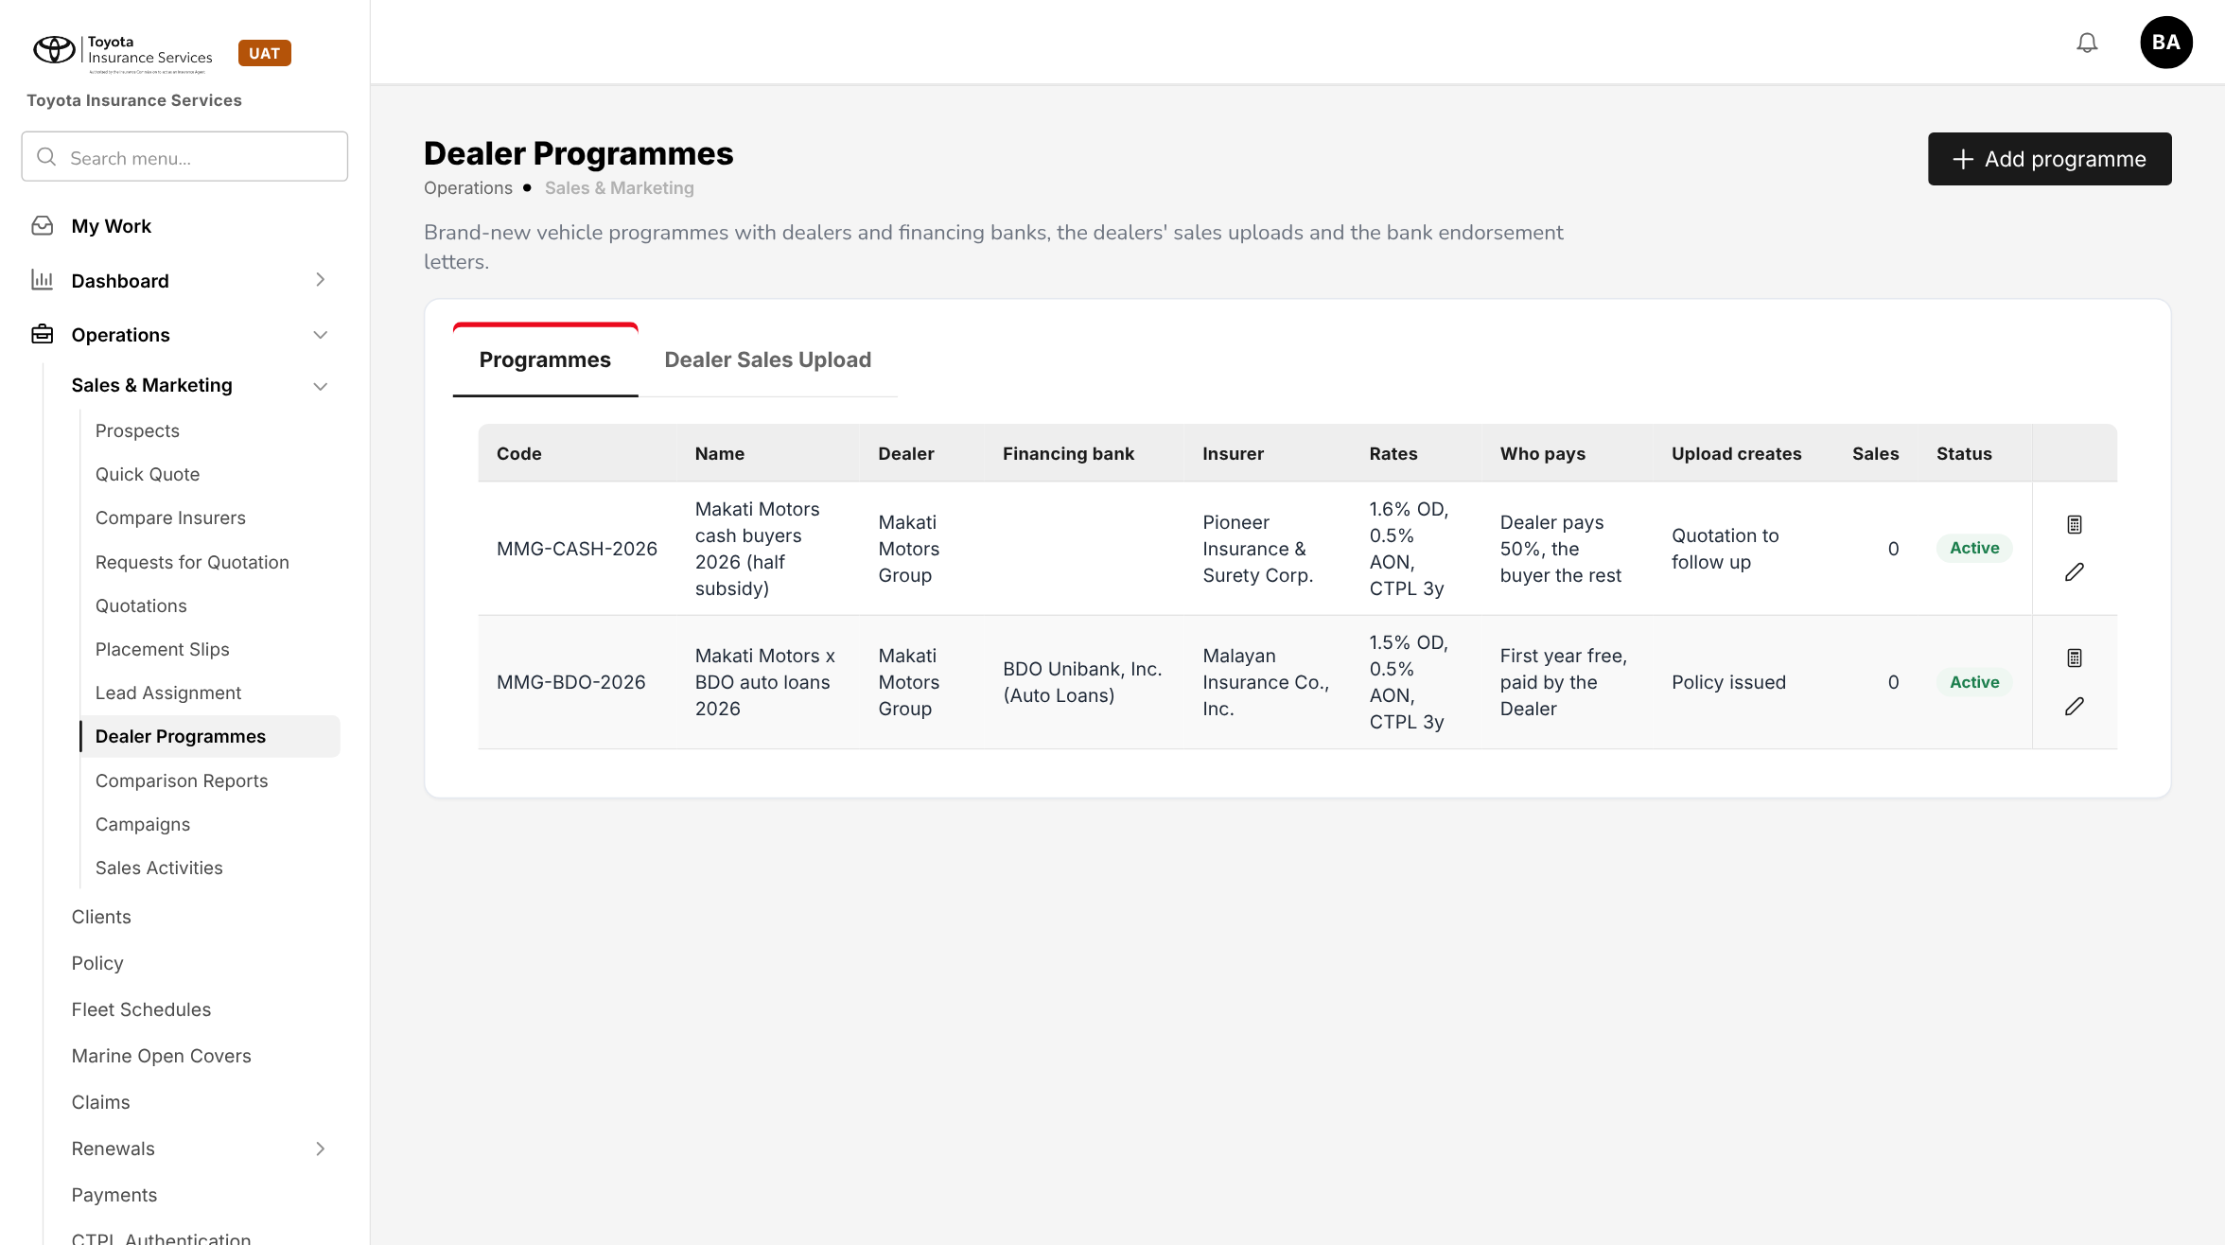
Figure 4: BrokerVerse today: Dealer Programmes, the screen the Scheme Master is laid out on
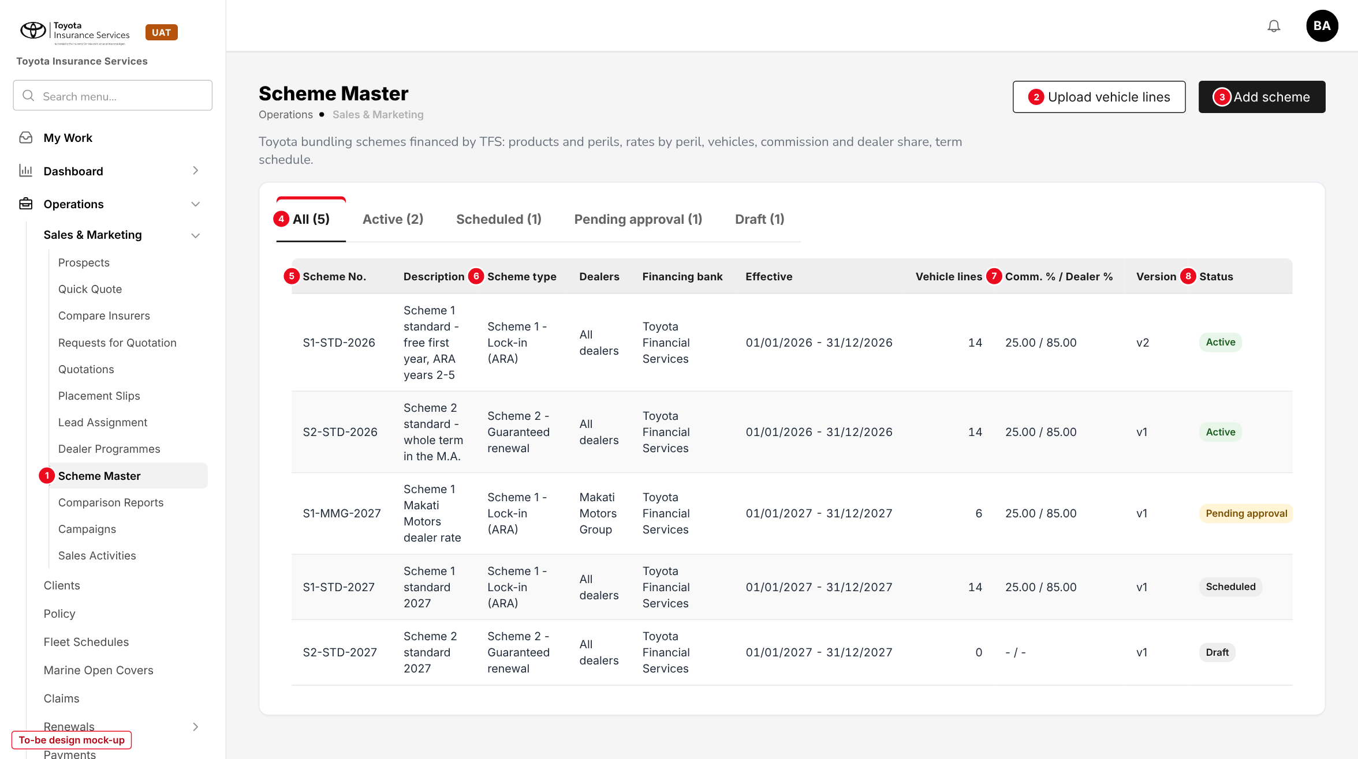
Figure 5: Scheme Master list (to-be design mock-up)
No. | Field (label on screen) | Type | Mand. | Source / list | Default | Rule and message
1 | Scheme Master (side bar) | Menu item | - | Menu grant "Sales & Marketing > Scheme Master" | - | Shown with read:schemes
2 | Upload vehicle lines | Button | - | - | - | write:schemes; chapter 13
3 | Add scheme | Button | - | - | - | write:schemes; opens the dialog of 10.2
4 | All / Active / Scheduled / Pending approval / Draft | Tabs | - | Scheme status | All | Each tab shows its count; an Expired / withdrawn tab appears when there are any
5 | Scheme No. | Column | - | Scheme | - | Opens the scheme
6 | Scheme type | Column | - | Scheme type list | - | -
- | Description, Dealers, Financing bank, Effective, Vehicle lines, Version | Columns | - | Scheme | - | -
7 | Comm. % / Dealer % | Column | - | Commission & term tab | - | "- / -" while not set
8 | Status | Column | - | Scheme status | - | Status tag

Button | Who sees it | Enabled when | What happens | Result
Add scheme | write:schemes | Always | Opens an empty Add scheme dialog | Draft (on Save draft)
Upload vehicle lines | write:schemes | A Draft scheme exists | Opens the upload | -
Export | read:schemes | List not empty | Excel of schemes, perils and lines | -
Copy (row) | write:schemes | Any scheme | New Draft copied, blank Scheme No. and dates | Draft
Amend (row) | write:schemes | Scheduled, Active, Suspended | Creates version n+1 | Draft (new version)
Suspend / Resume / Withdraw (row) | approve:schemes | Active / Suspended / any but Expired | Remark; shows the policies in force | Suspended / Active / Withdrawn

10.2 Add / Edit scheme - General tab (new)
Type | New dialog, built from the Add programme dialog of Dealer Programmes
Purpose | Identity, type, period and parties of a scheme.
Who can open it | write:schemes (edit); read:schemes (view)
Navigation | Scheme Master > Add scheme, or a Scheme No. in the list
FRs | FR-SCM-001, 010, 012

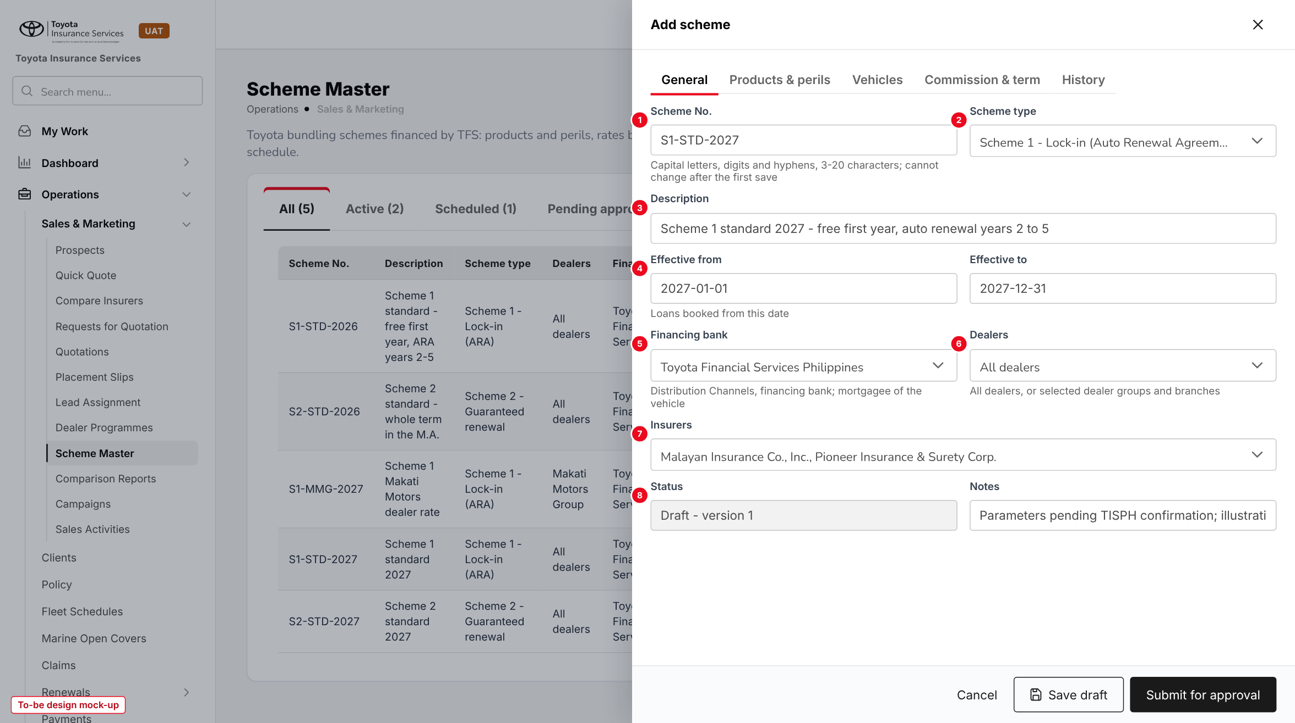
Figure 6: Add scheme, General tab (to-be design mock-up)
No. | Field (label on screen) | Type | Mand. | Source / list | Default | Rule and message
1 | Scheme No. | Text | Y | - | - | A-Z, 0-9, hyphen, 3-20; unique; read-only after the first save
2 | Scheme type | List | Y | Scheme type (7.3) | - | Not editable after approval
3 | Description | Text 200 | Y | - | - | -
4 | Effective from / Effective to | Date | Y | - | - | From >= today; to >= from; <= 24 months
5 | Financing bank | List | Y | Distribution Channels, type financing bank | Toyota Financial Services Philippines | -
6 | Dealers | Multi-select | Y | All dealers; dealer groups and branches | All dealers | -
7 | Insurers | Multi-select | Y | Master > Insurance > Insurance Company | - | At least one
8 | Status | Display | - | Scheme status | Draft - version 1 | -
- | Notes | Text | N | - | - | -

Button | Who sees it | Enabled when | What happens | Result
Cancel | All | Always | Closes without saving after confirmation | -
Premium preview | read:schemes | Products & perils and one line saved | Opens 10.6 | -
Save draft | write:schemes | Draft | Checks and saves; "Scheme saved" | Draft
Submit for approval | write:schemes | Draft without errors | All checks; item in My Work > Approvals | Pending approval

10.3 Add / Edit scheme - Products & perils tab (new)
Type | New tab
Purpose | Product, vehicle classes and the rate of each peril.
Who can open it | write:schemes
Navigation | Add / Edit scheme > Products & perils
FRs | FR-SCM-002

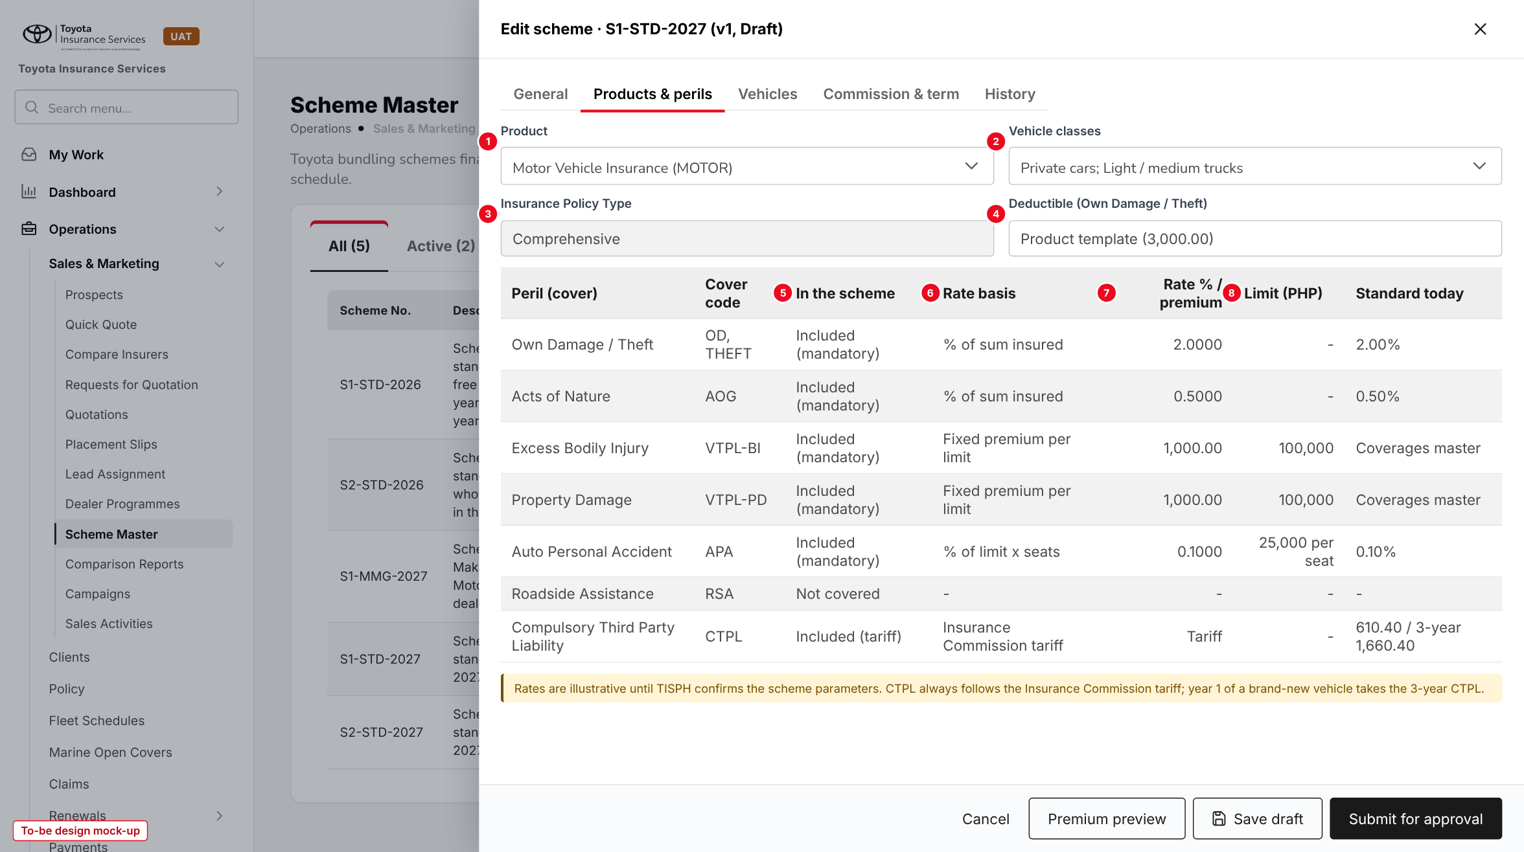
Figure 7: Products & perils tab (to-be design mock-up, illustrative rates)
No. | Field (label on screen) | Type | Mand. | Source / list | Default | Rule and message
1 | Product | List | Y | Master > Insurance > Product (Motor) | - | Motor only
2 | Vehicle classes | Multi-select | Y | Vehicle classes of the Motor tariff | Private cars | -
3 | Insurance Policy Type | Display | - | - | Comprehensive | Fixed
4 | Deductible (Own Damage / Theft) | Amount | N | - | Product template | Blank keeps the template deductible (3,000.00)
- | Peril (cover), Cover code | Display | - | Coverage Builder of the template | - | One row per cover
5 | In the scheme | List | Y | Included; Not covered | Mandatory covers Included | Mandatory covers cannot be removed
6 | Rate basis | Display | - | Fixed per cover | - | See FR-SCM-002 R1
7 | Rate % / premium | Rate 4 dec. or amount | Y if included | - | - | > 0, <= 100; warning above standard
8 | Limit (PHP) | List | Y for BI, PD, APPA, PA driver | Coverages master; APPA limits 25,000 to 200,000 | - | -
- | Standard today | Display | - | premium.default_rates; coverages master; tariff | - | For comparison

10.4 Add / Edit scheme - Vehicles tab (new)
Type | New tab
Purpose | The make and model range of the scheme, with optional line rates.
Who can open it | write:schemes
Navigation | Add / Edit scheme > Vehicles
FRs | FR-SCM-003, 004

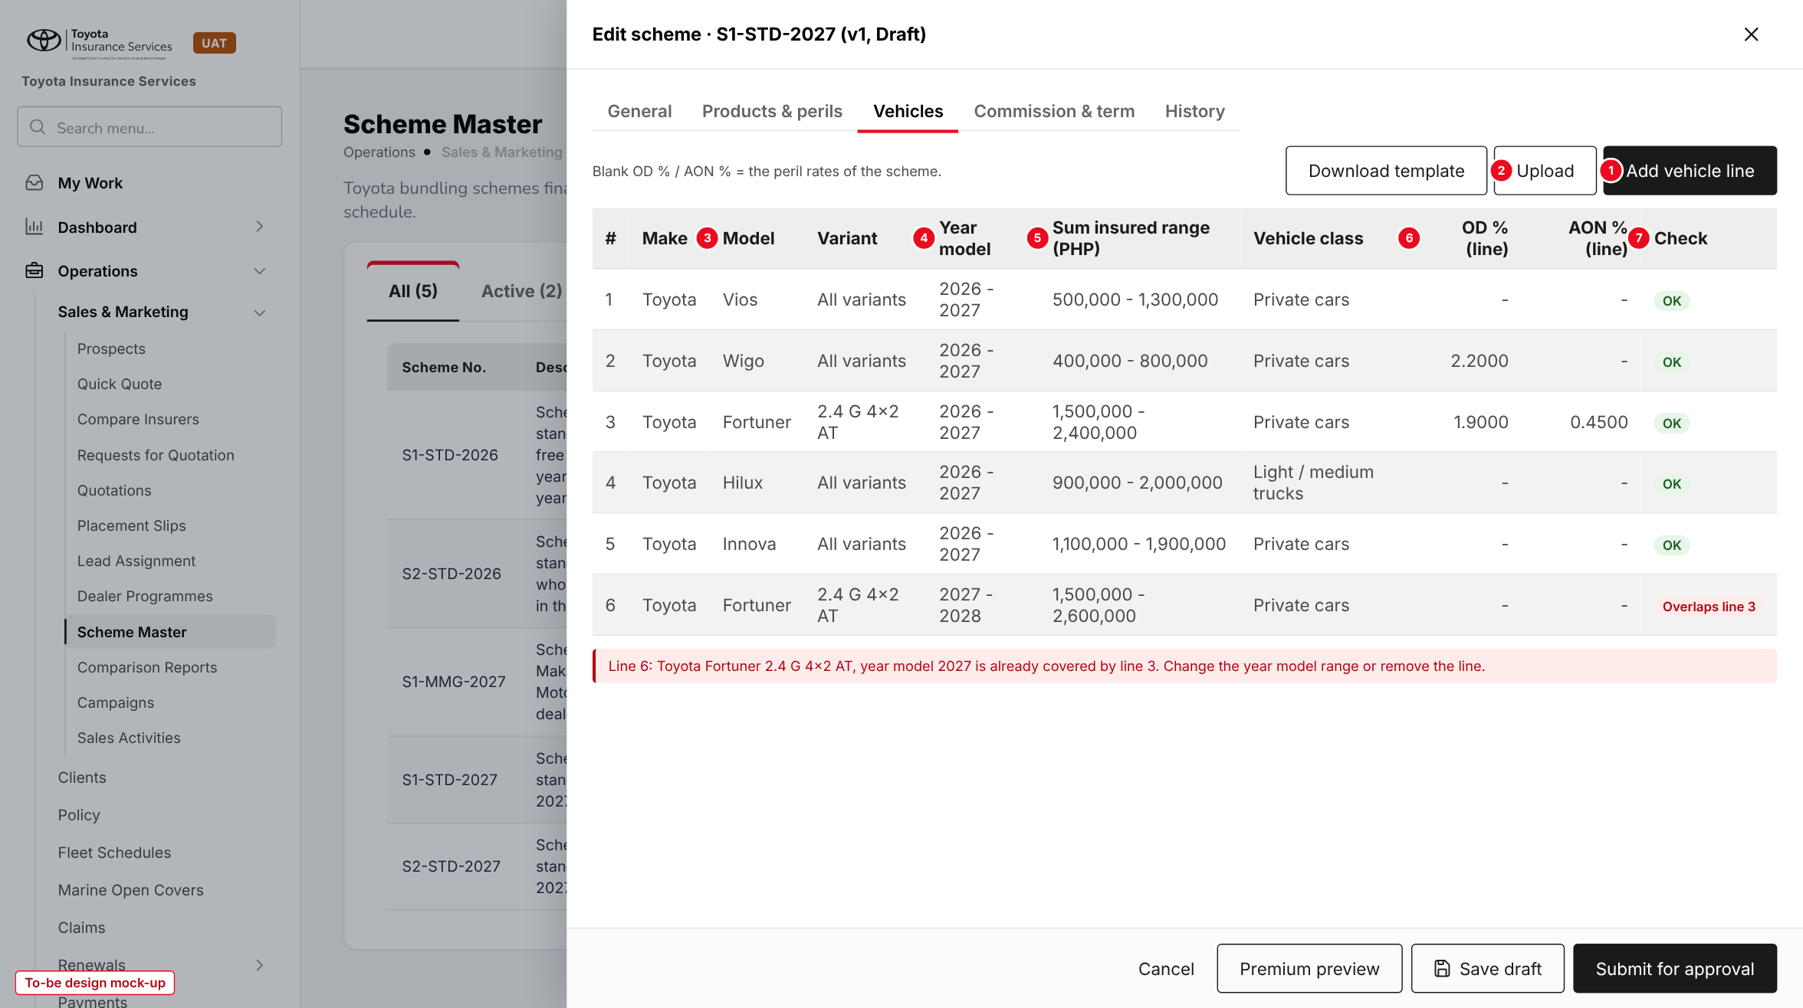
Figure 8: Vehicles tab with an overlapping line (to-be design mock-up)
No. | Field (label on screen) | Type | Mand. | Source / list | Default | Rule and message
1 | Add vehicle line | Button | - | - | - | Adds a line
2 | Download template / Upload | Buttons | - | - | - | Chapter 13
- | Make | List | Y | Master > Insurance > Vehicle (brand) | - | Active
3 | Model / Variant | Lists | Y | Vehicle master, chained; All models / All variants | All variants | Active
4 | Year model (from - to) | Year | Y | - | Current year to +1 | To >= from; no overlap
5 | Sum insured range (PHP) | Amount | Y | - | - | To > from
- | Vehicle class | List | Y | Classes of the scheme | First class of the scheme | -
6 | OD % (line) / AON % (line) | Rate 4 dec. | N | - | Blank = peril rate | > 0, <= 100
7 | Check | Tag | - | Computed | - | OK or the error of the line

10.5 Add / Edit scheme - Commission & term tab (new)
Type | New tab
Purpose | Commission %, dealer commission %, term and sum insured schedule.
Who can open it | write:schemes
Navigation | Add / Edit scheme > Commission & term
FRs | FR-SCM-005, 006

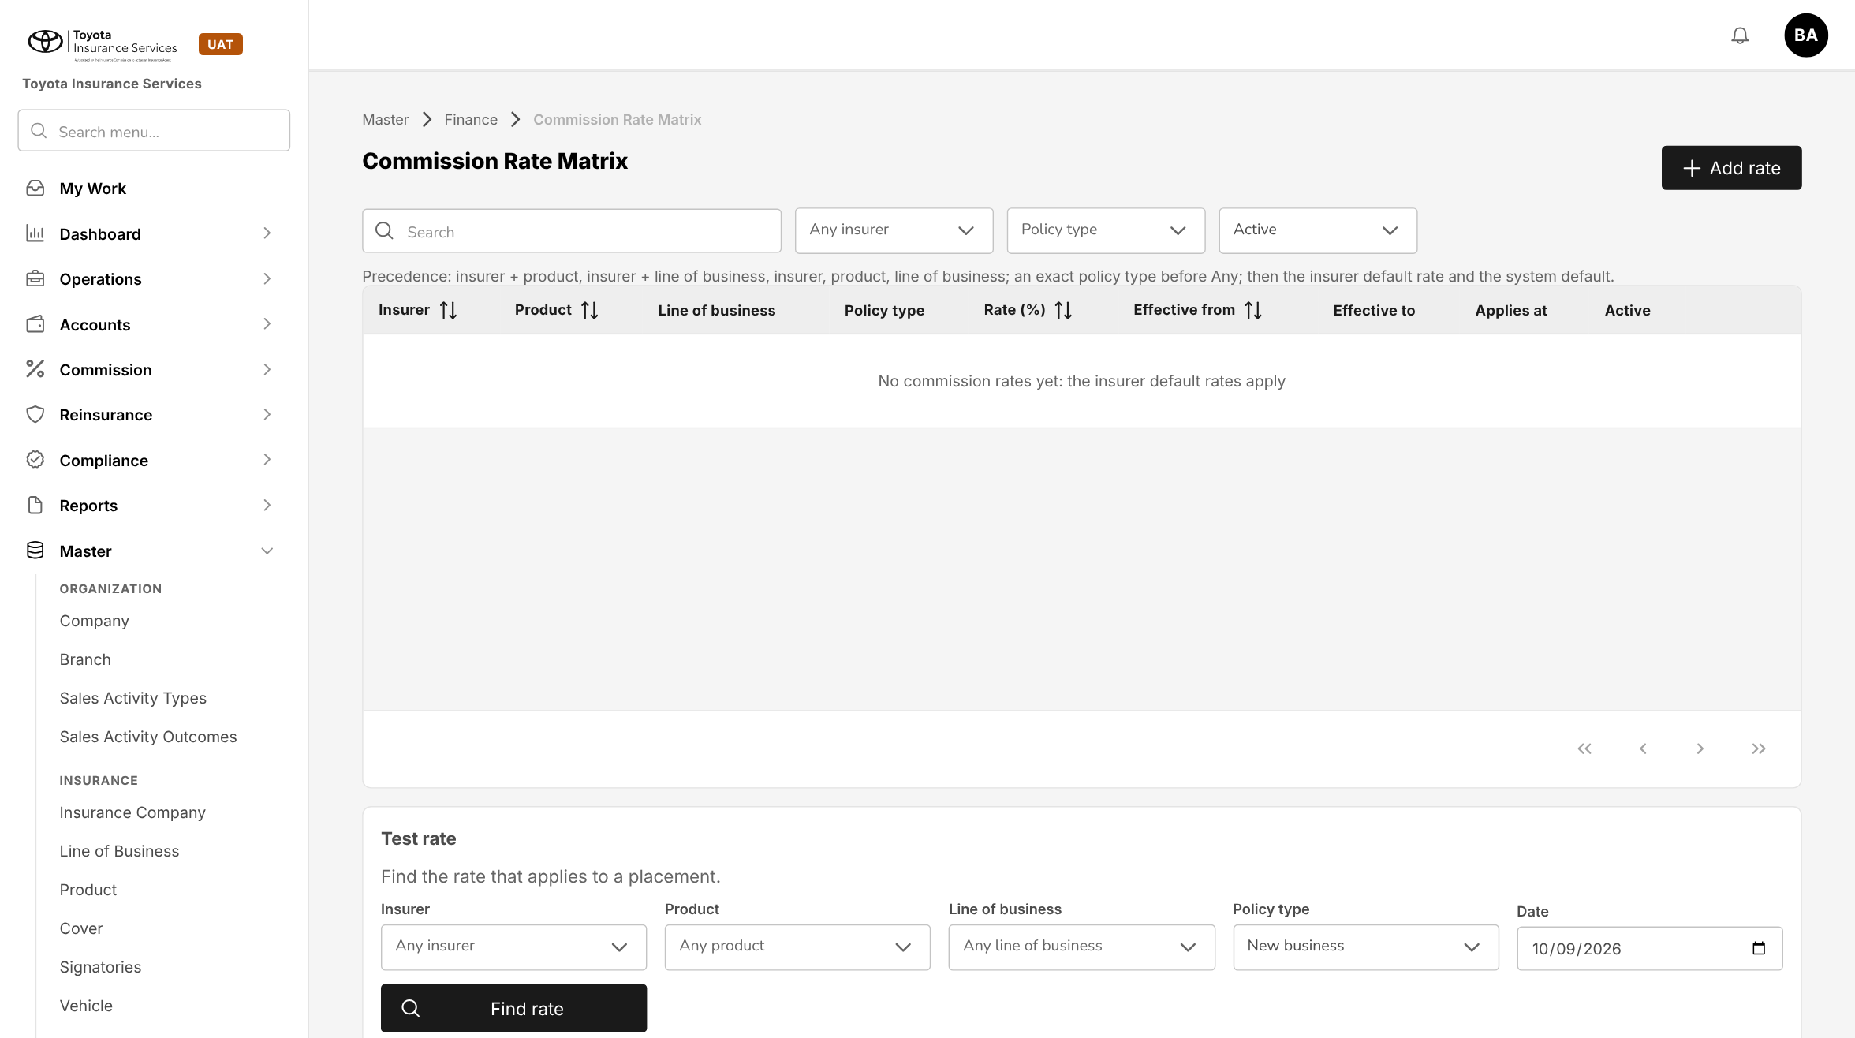
Figure 9: BrokerVerse today: Master > Finance > Commission Rate Matrix, where the commission of a policy comes from
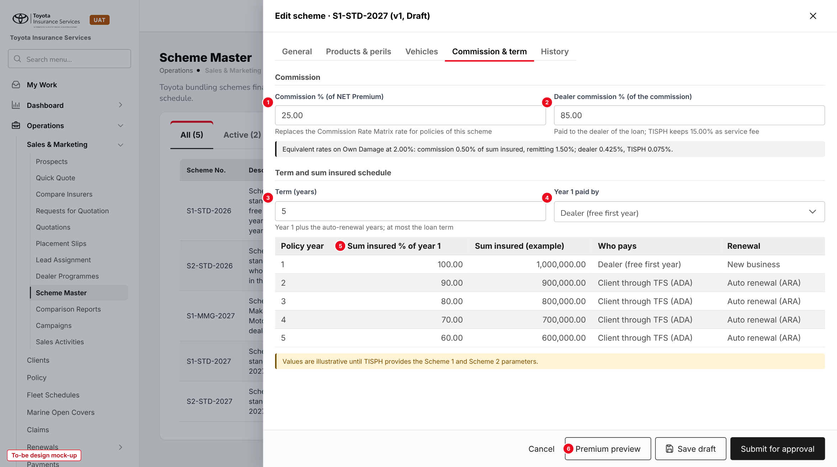
Figure 10: Commission & term tab (to-be design mock-up, illustrative values)
No. | Field (label on screen) | Type | Mand. | Source / list | Default | Rule and message
1 | Commission % (of NET Premium) | Percent 2 dec. | Y | - | - | 0-100
2 | Dealer commission % (of the commission) | Percent 2 dec. | Y | - | - | 0-100; TISPH share shown
- | Equivalent rates line | Text | - | Computed on the Own Damage rate | - | -
3 | Term (years) | Number | Y | - | 5 | 1 to schemes.max_term_years
4 | Year 1 paid by | List | Y (Scheme 1) | Year 1 paid by (7.3) | Dealer (free first year) | Scheme 2: Client through TFS (M.A.), fixed
5 | Sum insured % of year 1 | Percent 2 dec. | Y | - | Year 1 = 100.00 | Not higher than the year before
- | Sum insured (example), Who pays, Renewal | Display | - | Computed | - | -
6 | Premium preview | Button | - | - | - | Opens 10.6

10.6 Premium preview (new)
Type | New dialog over the scheme
Purpose | The premiums, commission and dealer share of each year of the term for a sample vehicle; nothing is saved.
Who can open it | read:schemes
Navigation | Add / Edit scheme > Premium preview
FRs | FR-SCM-021, 022

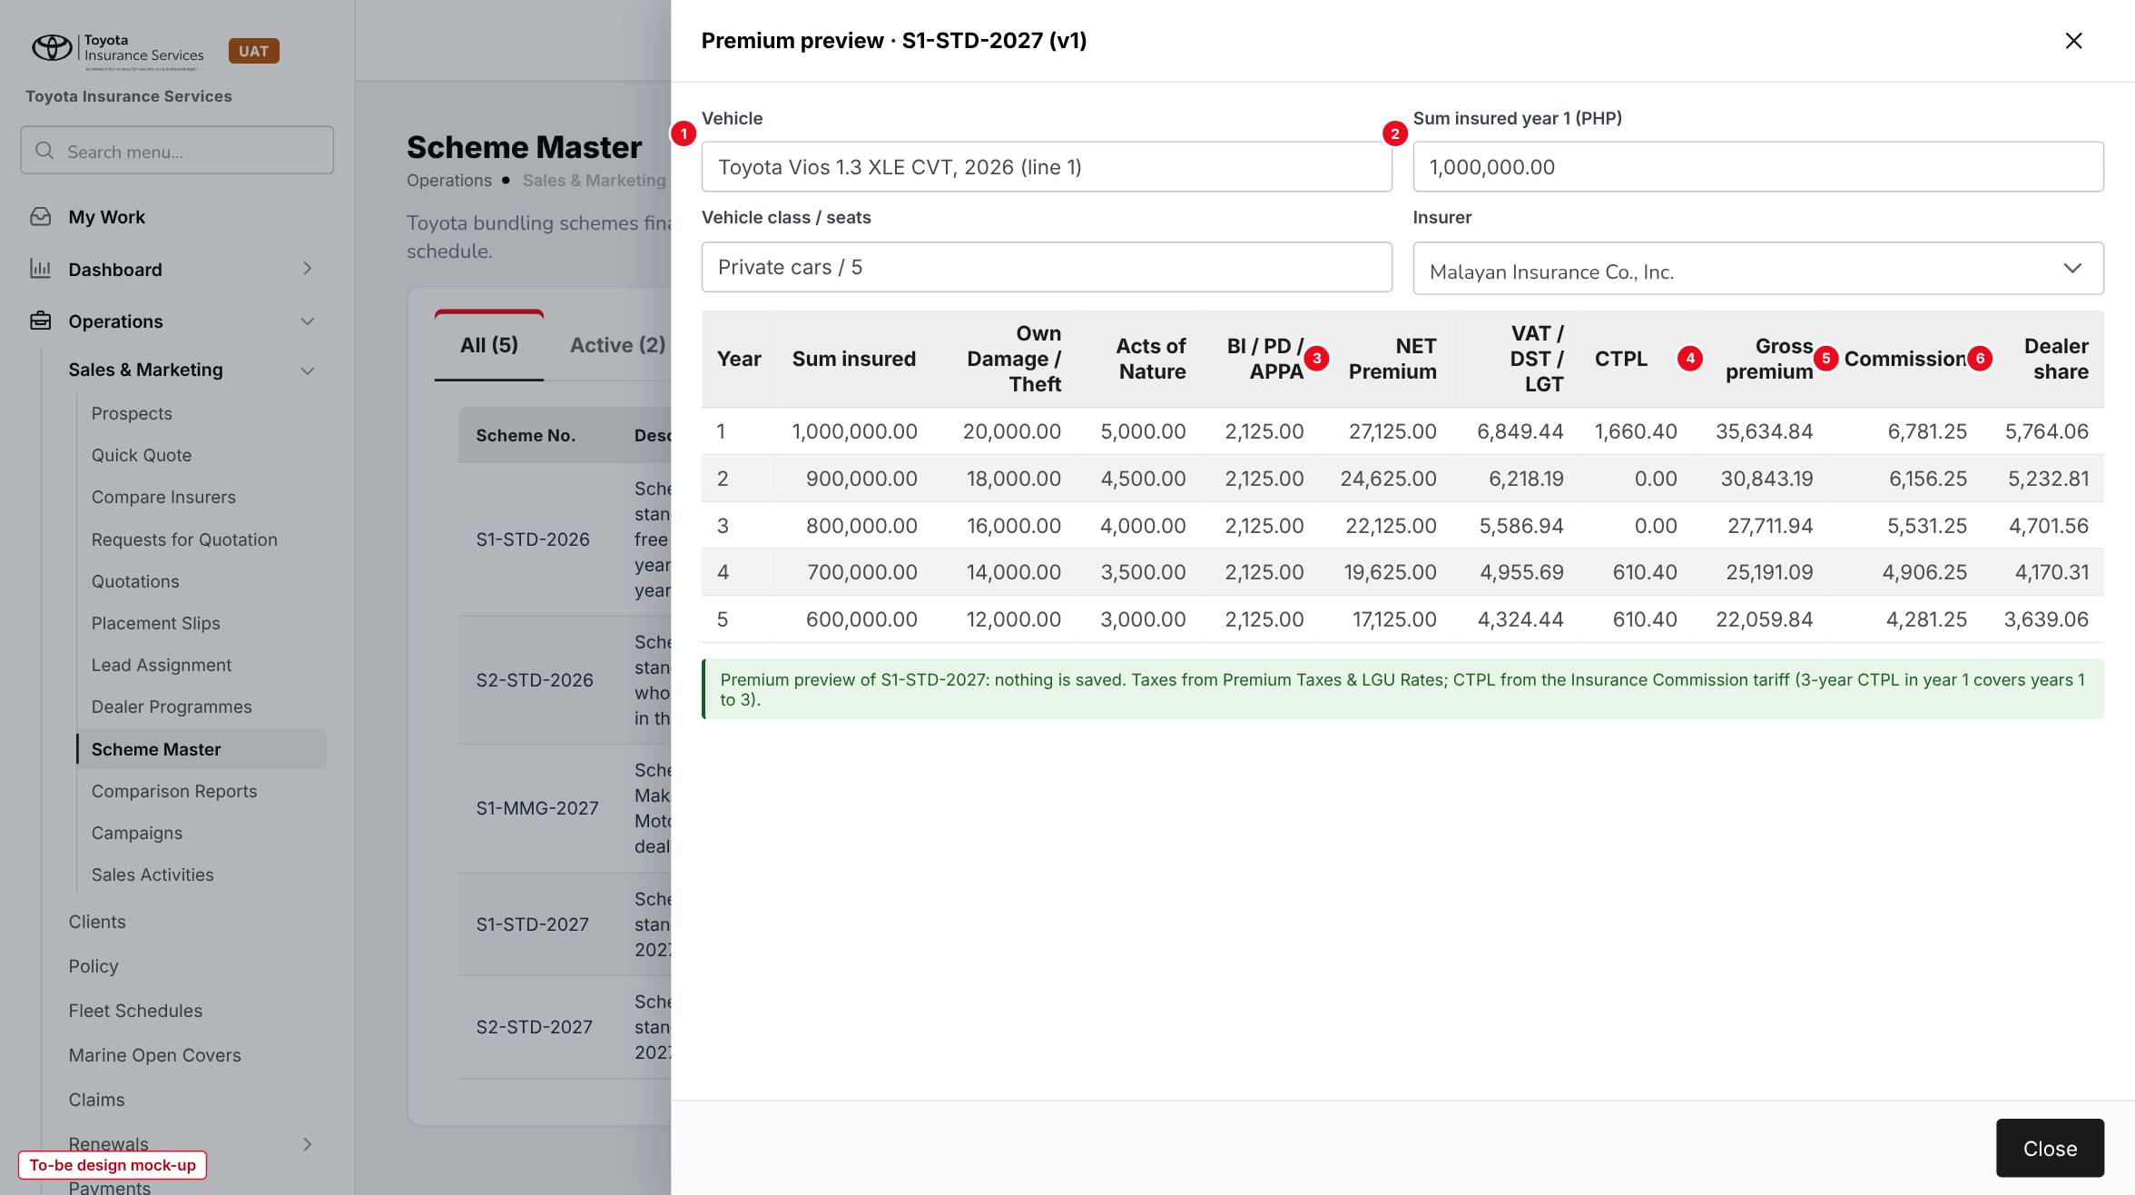
Figure 11: Premium preview of S1-STD-2027 for a Vios at 1,000,000.00 (to-be design mock-up; figures from the premium engine)
No. | Field (label on screen) | Type | Mand. | Source / list | Default | Rule and message
1 | Vehicle | Lists | Y | Vehicle master; line of the scheme | - | Must match a line
2 | Sum insured year 1 (PHP) | Amount | Y | - | - | Within the line range
- | Vehicle class / seats, Insurer | List | Y | Line; insurers of the scheme | From the line | -
3 | BI / PD / APPA | Display | - | Scheme rating | - | Fixed perils together
4 | CTPL | Display | - | Tariff | - | 3-year CTPL in year 1; 0.00 in the years it covers
5 | Gross premium | Display | - | Scheme rating | - | NET + VAT + DST + LGT + CTPL
6 | Commission / Dealer share | Display | - | Commission & term | - | -

10.7 Scheme approval in My Work (existing screen)
Type | Existing screen, new item kind
Purpose | Approve or return a scheme or a scheme version.
Who can open it | approve:schemes
Navigation | My Work > My Items > Approvals
FRs | FR-SCM-010

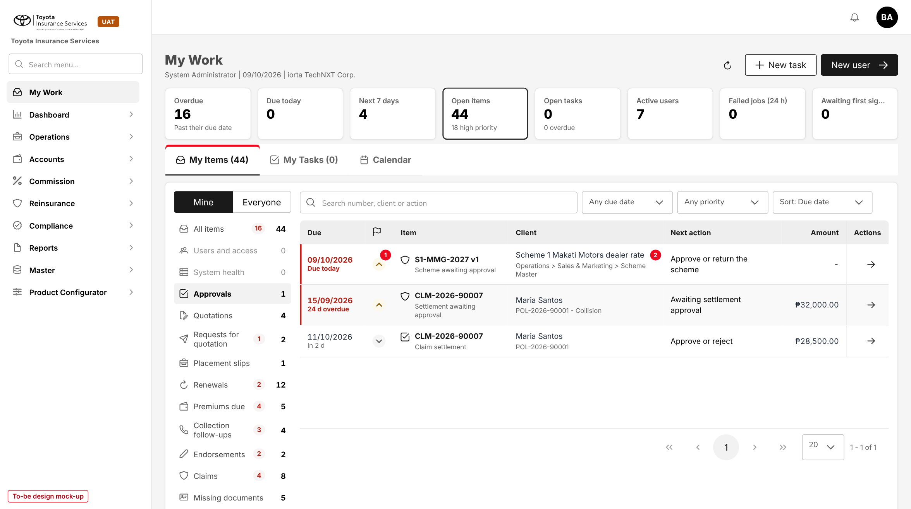
Figure 12: My Work > Approvals with a scheme item (1) and its next action (2) (to-be design mock-up)
Button | Who sees it | Enabled when | What happens | Result
Approve | approve:schemes, not the maker | Pending approval; Effective from not passed | Records the approver; sets Scheduled or Active | Scheduled / Active
Return | approve:schemes, not the maker | Pending approval | Remark required | Draft

10.8 Policy detail - Scheme panel (changed)
Type | Existing screen, new read-only panel
Purpose | Show where the premium and commission of a scheme policy come from.
Who can open it | read:policies
Navigation | Operations > Policy > policy number
FRs | FR-SCM-023, 030, 031

No. | Field (label on screen) | Type | Mand. | Source / list | Default | Rule and message
- | Scheme | Display | - | Policy | - | Scheme No., version, type, e.g. "S1-STD-2027 v1, Scheme 1"
- | Vehicle line | Display | - | Policy | - | Line number and description
- | Policy year | Display | - | Policy | - | "Year 2 of 5"
- | Sum insured of the year / year 1 | Display | - | Policy | - | -
- | Peril rates | Display | - | Policy | - | Rates used
- | Commission, Dealer share, TISPH share | Display | - | Commission | - | Amounts of the year
- | Scheme premium / adjusted premium | Display | - | Renewal | - | Only when the renewal was adjusted

10.9 Upload vehicle lines (new)
Type | New, base upload pattern
Purpose | Load many vehicle lines from Excel.
Who can open it | write:schemes
Navigation | - Scheme Master > Upload vehicle lines  - Vehicles tab > Upload
FRs | FR-SCM-004

The user picks the Draft scheme, chooses Add or Replace, downloads the template, uploads the .xlsx and reads the result line ("Processed n rows: c created, f failed") with the failed rows listed by row number, as in the Dealer Sales Upload of Dealer Programmes. The template is in chapter 13.

11 End-to-end walkthroughs
The walkthroughs follow schemes and one loan through BrokerVerse with sample data (Makati Motors Makati, Toyota Vios 1.3 XLE CVT 2026, Malayan Insurance). They are the script of the SCHM-02 SIT and UAT sessions; premium figures come from the base premium engine and the scheme values are illustrative.

11.1 WT-A Set up and approve Scheme 1 standard 2027
Table 23: WT-A
Step | Who | Does | Sees / result
1 | Sales Admin | Scheme Master > Add scheme: S1-STD-2027, Scheme 1, "Scheme 1 standard 2027", 01/01/2027 - 31/12/2027, TFS, All dealers, Malayan and Pioneer; Save draft | "Scheme saved"; Draft v1
2 | Sales Admin | Products & perils: Motor Vehicle Insurance; Private cars and Light / medium trucks; OD / Theft 2.0000, AON 0.5000, BI and PD 100,000 at 1,000.00, APPA 25,000 at 0.1000, Roadside Not covered | Saved; CTPL shows Tariff
3 | Sales Admin | Upload vehicle lines (Add) with 14 Toyota lines | "Processed 14 rows: 14 created, 0 failed"
4 | Sales Admin | Commission & term: 25.00 / 85.00; term 5; schedule 100, 90, 80, 70, 60; Year 1 paid by Dealer | TISPH keeps 15.00%; equivalent 0.50% / 1.50% on OD
5 | Sales Admin | Premium preview: Vios 1.3 XLE CVT 2026, 1,000,000.00, Malayan | Gross 35,634.84 / 30,843.19 / 27,711.94 / 25,191.09 / 22,059.84
6 | Sales Admin | Submit for approval | "Scheme submitted for approval"; item in My Work > Approvals
7 | Accounting Manager | My Work > Approvals > S1-STD-2027 > Approve on 15/12/2026 | "Scheme approved"; Scheduled
8 | System | Scheme status job on 01/01/2027 | Active

11.2 WT-B Issue and renew a Scheme 1 policy
Table 24: WT-B
Step | Who | Does | Sees / result
1 | Operations | Issues the scheme policy on the loan documents (SCHM-01) on 05/01/2027: Scheme No. S1-STD-2027, dealer Makati Motors Makati, Malayan, Toyota Vios 1.3 XLE CVT 2026, sum insured 1,000,000.00 | Scheme rating finds line 1 (Vios, All variants)
2 | System | Prices year 1 | NET Premium 27,125.00; VAT 3,255.00; DST 3,391.00; LGT 203.44; 3-year CTPL 1,660.40; gross 35,634.84
3 | System | Commission and dealer share | Commission 6,781.25 (source scheme S1-STD-2027 v1); Makati Motors Makati 5,764.06; TISPH 1,017.19
4 | Operations | Opens the policy | Scheme panel "S1-STD-2027 v1, line 1, Year 1 of 5"
5 | Sales Admin / approver | Amends the scheme in June 2027 to OD 1.90% (v2), approved | New loans rated at 1.90%
6 | System | Year 2 renewal of the policy on 05/01/2028 | Rated on v1 at sum insured 900,000.00: NET 24,625.00, gross 30,843.19, commission 6,156.25, dealer 5,232.81
7 | System | Renewal after year 5 (2032) | Normal Motor renewal on the current fair market value

11.3 WT-C Exceptions
Table 25: WT-C
Case | Who | Does | Sees / result
C1 Vehicle outside the range | Operations | Issues a Vios with sum insured 1,400,000.00 under S1-STD-2027 | "The sum insured of 1,400,000.00 is outside the range 500,000 - 1,300,000 of scheme S1-STD-2027 for Toyota Vios"
C2 Scheme not in force | Operations | Issues a loan booked 05/01/2027 under S1-STD-2026 | "Scheme S1-STD-2026 is not in force on 05/01/2027"
C3 Self-approval | Sales Admin with approve:schemes | Approves the scheme they submitted | "You made or changed this scheme, so another user must approve it"
C4 Overlapping lines | Sales Admin | Adds Fortuner 2.4 G 4x2 AT 2027-2028 next to 2026-2027 | "Line 6: Toyota Fortuner 2.4 G 4x2 AT, year model 2027 is already covered by line 3"
C5 Dealer-specific scheme | Operations | Issues a Scheme 1 loan of Makati Motors without a Scheme No. in 2027 | Rated on S1-MMG-2027 (dealer scheme) rather than S1-STD-2027
C6 Renewal adjusted | Operations | Year 3 renewal after two claims, premium raised | Reason required; panel shows scheme premium 27,711.94 and the adjusted premium

12 Messages catalogue
Every message a user can see for this requirement, grouped by the screen that shows it. 62 messages: 7 confirmation, 12 error, 1 information, 37 validation, 5 warning. A validation or error is shown under the field it belongs to; a confirmation is a short toast. Text in angle brackets is filled in by the system.

12.1 Scheme Master - General tab
ID | Field | Message | Type | What the user does
MSG-SCM-001 | Scheme No. | Enter the Scheme No. | Validation | Types the number
MSG-SCM-002 | Scheme No. | Use capital letters, digits and hyphens (3 to 20 characters) | Validation | Corrects the number
MSG-SCM-003 | Scheme No. | Scheme No. <number> is already used | Validation | Chooses another number
MSG-SCM-004 | Scheme type | Choose the scheme type | Validation | Picks Scheme 1 or Scheme 2
MSG-SCM-005 | Description | Enter a description of the scheme | Validation | Types it
MSG-SCM-006 | Effective to | Effective to must be on or after Effective from | Validation | Corrects the date
MSG-SCM-007 | Effective from | A scheme cannot start before today | Validation | Moves the date
MSG-SCM-008 | Effective to | A scheme can run for at most <n> months | Validation | Shortens the period
MSG-SCM-009 | Financing bank | The financing bank must be an active financing bank of Distribution Channels | Validation | Picks TFS
MSG-SCM-010 | Dealers | Choose All dealers or at least one dealer | Validation | Picks the dealers
MSG-SCM-011 | Insurers | Choose at least one insurer | Validation | Picks the insurers
MSG-SCM-012 | - | Scheme saved | Confirmation | -

12.2 Scheme Master - Products & perils tab
ID | Field | Message | Type | What the user does
MSG-SCM-013 | Product | Choose the product of the scheme | Validation | Picks the product
MSG-SCM-014 | Product | Schemes apply to Motor products only | Validation | Picks a Motor product
MSG-SCM-015 | Vehicle classes | Choose at least one vehicle class | Validation | Picks the classes
MSG-SCM-016 | Rate % / premium | <peril>: enter the rate of an included peril | Validation | Types the rate
MSG-SCM-017 | Rate % / premium | <peril>: the rate must be more than 0 and at most 100 | Validation | Corrects the rate
MSG-SCM-018 | Limit (PHP) | <peril>: choose the limit | Validation | Picks the limit
MSG-SCM-019 | In the scheme | <peril> is a mandatory cover of the product and stays in the scheme | Error | -
MSG-SCM-020 | Rate % / premium | <peril>: the scheme rate of <rate>% is above the standard rate of <standard>% | Warning | Confirms or lowers the rate

12.3 Scheme Master - Vehicles tab
ID | Field | Message | Type | What the user does
MSG-SCM-021 | Vehicles | Add at least one vehicle line | Validation | Adds a line
MSG-SCM-022 | Make / Model / Variant | Line <n>: <vehicle> is not active on the Vehicle master | Validation | Picks an active entry
MSG-SCM-023 | Check | Line <n>: <vehicle>, year model <year> is already covered by line <m> | Validation | Changes the range or removes the line
MSG-SCM-024 | Year model | Line <n>: Year model to must be on or after Year model from | Validation | Corrects the years
MSG-SCM-025 | Sum insured range | Line <n>: Sum insured to must be higher than Sum insured from | Validation | Corrects the range
MSG-SCM-026 | Vehicle class | Line <n>: <class> is not a vehicle class of the scheme | Validation | Picks a class of the scheme
MSG-SCM-027 | OD % (line) | Line <n>: the rate must be more than 0 and at most 100 | Validation | Corrects the rate

12.4 Upload vehicle lines
ID | Field | Message | Type | What the user does
MSG-SCM-028 | File | Upload an Excel (.xlsx) file | Validation | Saves the file as .xlsx
MSG-SCM-029 | File | Column <header> is missing from the Data sheet | Validation | Uses the template
MSG-SCM-030 | File | The file has <n> rows; the limit is <max> | Validation | Splits the file
MSG-SCM-031 | Scheme | Lines can be uploaded only to a Draft scheme | Validation | Amends the scheme first
MSG-SCM-032 | - | Row <n>: <message> | Error | Corrects the row and uploads it again
MSG-SCM-033 | - | Processed <n> rows: <c> created, <f> failed | Information | -

12.5 Scheme Master - Commission & term tab
ID | Field | Message | Type | What the user does
MSG-SCM-034 | Commission % | Enter the commission % | Validation | Types it
MSG-SCM-035 | Commission % | The commission % must be between 0 and 100 | Validation | Corrects it
MSG-SCM-036 | Dealer commission % | Enter the dealer commission % | Validation | Types it
MSG-SCM-037 | Dealer commission % | The dealer commission % must be between 0 and 100 | Validation | Corrects it
MSG-SCM-038 | Term (years) | The term must be between 1 and <max> years | Validation | Corrects the term
MSG-SCM-039 | Sum insured % of year 1 | Year <n>: enter the sum insured % | Validation | Types the %
MSG-SCM-040 | Sum insured % of year 1 | Year <n>: the sum insured % cannot be higher than year <n-1> | Validation | Corrects the %

12.6 Scheme approval and life cycle
ID | Field | Message | Type | What the user does
MSG-SCM-041 | - | You made or changed this scheme, so another user must approve it | Error | Asks another approver
MSG-SCM-042 | Remark | Enter the reason for returning the scheme | Validation | Types the remark
MSG-SCM-043 | - | Effective from <date> has passed; return the scheme so the maker can move the date | Error | Returns the scheme
MSG-SCM-044 | - | Version <n> of this scheme is already being changed or approved | Error | Completes that version first
MSG-SCM-045 | - | Scheme submitted for approval | Confirmation | -
MSG-SCM-046 | - | Scheme approved | Confirmation | -
MSG-SCM-047 | - | Scheme returned to the maker | Confirmation | -
MSG-SCM-048 | Remark | Enter the reason | Validation | Types the remark
MSG-SCM-049 | - | <n> policies are in force on this scheme; they keep it to the end of their term | Warning | Confirms
MSG-SCM-050 | - | Scheme suspended | Confirmation | -
MSG-SCM-051 | - | Scheme resumed | Confirmation | -
MSG-SCM-052 | - | Scheme withdrawn | Confirmation | -
MSG-SCM-053 | - | An approved scheme cannot be changed; use Amend to create a new version | Error | Clicks Amend

12.7 Scheme rating (issuance and renewal)
ID | Field | Message | Type | What the user does
MSG-SCM-054 | Scheme No. | Scheme <number> is not in force on <date> | Error | Checks the Scheme No. on the loan documents
MSG-SCM-055 | Dealer | <dealer> is not a dealer of scheme <number> | Error | Checks the dealer of the loan
MSG-SCM-056 | Insurer | <insurer> is not an insurer of scheme <number> | Error | Picks an insurer of the scheme
MSG-SCM-057 | Vehicle | <vehicle> <year> is not covered by scheme <number> | Error | Checks the vehicle or uses the standard issuance
MSG-SCM-058 | Sum insured | The sum insured of <amount> is outside the range <from> - <to> of scheme <number> for <vehicle> | Error | Checks the vehicle price
MSG-SCM-059 | - | Scheme <number> version <v> has no rate for <peril>; the scheme must be amended | Error | Asks the Sales Admin to amend the scheme
MSG-SCM-060 | Total Premium | The renewal premium differs from the scheme premium of <amount> for year <n>; enter the reason | Warning | Types the reason
MSG-SCM-061 | - | The new vehicle is not covered by scheme <number>; it is priced at the standard rates | Warning | Confirms the endorsement
MSG-SCM-062 | - | <dealer> has no referrer account; the dealer share of <amount> is held | Warning | Accounting sets up the referrer account

13 Upload screens

13.1 Scheme vehicle lines template
Built like the other base templates (Download template): an Excel file with the sheets Data (one row per vehicle line; required headers in dark red), Columns (each column with its format and an example) and Instructions. Rows are loaded one by one; a failed row does not stop the others.
Table 26: Template columns
Column | Mand. | Format | Rule | Example
SCHEME_NO | Y | Text | A Draft scheme | S1-STD-2027
MAKE | Y | Text | Active brand of Master > Insurance > Vehicle | Toyota
MODEL | N | Text | Active model of the make; blank or ALL = all models | Vios
VARIANT | N | Text | Active variant of the model; blank or ALL = all variants | ALL
YEAR_FROM / YEAR_TO | Y | YYYY | YEAR_TO >= YEAR_FROM | 2026 / 2027
SI_FROM / SI_TO | Y | Amount | SI_TO > SI_FROM | 500000 / 1300000
VEHICLE_CLASS | Y | Code | A vehicle class of the scheme | private_cars
OD_RATE / AON_RATE | N | Decimal 4 | Line rates; blank = peril rate; > 0, <= 100 | 2.2000 /

Mode Add or Replace is chosen on the screen. Limits: .xlsx only, first sheet Data, at most 2,000 rows (schemes.max_rows). The result line reads "Processed n rows: c created, f failed" with "Row n: message" for each failed row; the row messages are those of FR-SCM-003.

14 Sign-off and change control

14.1 What is signed
TISPH signs this FRS for TIS-BRD-SCHM-02 as built on BrokerVerse: the process flows (chapter 2), the functional requirements (chapter 4), the workflow (chapter 5), and the screens, messages and upload (chapters 9 to 13). The scheme values (rates, lines, commission %, dealer commission %, term and schedule) are configuration loaded on the Scheme Master and are not frozen by this sign-off.

14.2 Change after sign-off
A change to anything signed is raised through the change control route of BRD section 8. The project team assesses its effect on BrokerVerse and on SCHM-01 and SCHM-03 in the same CR-05, and issues a new version of this FRS for delta sign-off. When the screens are built, the to-be mock-ups are replaced with screenshots of the TISPH UAT environment.

14.3 Signatures
Table 27: Sign-off
Role | Name | Unit | Signature | Date
Business owner |  | TIS Sales
Business reviewer |  | TISPH Operations
Business reviewer |  | TISPH FGA
Project Manager |  | TISPH DTID
Delivery lead |  | iorta TechNXT

Appendix A Scheme premium examples
All figures are computed by the base premium engine (the same routine as Calculate on Create Quote) on the base sample data: VAT 12%, DST 12.5%, LGT 0.75% from Premium Taxes & LGU Rates, CTPL from the tariff of the Motor template (private car 610.40; 3-year 1,660.40). Vehicle Toyota Vios 1.3 XLE CVT 2026, private car, 5 seats, sum insured year 1 1,000,000.00, schedule 100, 90, 80, 70, 60%. Excess Bodily Injury 100,000 (1,000.00), Property Damage 100,000 (1,000.00) and APPA 25,000 x 5 seats at 0.10% (125.00) every year. Scheme values are illustrative.

A.1 Scheme 1 standard (S1-STD-2027): OD 2.00%, AON 0.50%
Table 28: Scheme 1 premiums by year
Year | Sum insured | Own Damage / Theft | Acts of Nature | NET Premium | VAT | DST | LGT | CTPL | Gross premium
1 | 1,000,000.00 | 20,000.00 | 5,000.00 | 27,125.00 | 3,255.00 | 3,391.00 | 203.44 | 1,660.40 | 35,634.84
2 | 900,000.00 | 18,000.00 | 4,500.00 | 24,625.00 | 2,955.00 | 3,078.50 | 184.69 | 0.00 | 30,843.19
3 | 800,000.00 | 16,000.00 | 4,000.00 | 22,125.00 | 2,655.00 | 2,766.00 | 165.94 | 0.00 | 27,711.94
4 | 700,000.00 | 14,000.00 | 3,500.00 | 19,625.00 | 2,355.00 | 2,453.50 | 147.19 | 610.40 | 25,191.09
5 | 600,000.00 | 12,000.00 | 3,000.00 | 17,125.00 | 2,055.00 | 2,141.00 | 128.44 | 610.40 | 22,059.84
Term |  |  |  | 110,625.00 |  |  |  | 2,881.20 | 141,440.90

Year 1 is paid by the dealer (free first year); years 2 to 5 are the auto-renewal premiums of the Auto Renewal Agreement, collected from the client through TFS. The 3-year CTPL of year 1 covers years 1 to 3.

A.2 Scheme 2 standard (S2-STD-2027): OD 1.80%, AON 0.40%
Table 29: Scheme 2 premiums by year
Year | Sum insured | Own Damage / Theft | Acts of Nature | NET Premium | VAT | DST | LGT | CTPL | Gross premium
1 | 1,000,000.00 | 18,000.00 | 4,000.00 | 24,125.00 | 2,895.00 | 3,016.00 | 180.94 | 1,660.40 | 31,877.34
2 | 900,000.00 | 16,200.00 | 3,600.00 | 21,925.00 | 2,631.00 | 2,741.00 | 164.44 | 0.00 | 27,461.44
3 | 800,000.00 | 14,400.00 | 3,200.00 | 19,725.00 | 2,367.00 | 2,466.00 | 147.94 | 0.00 | 24,705.94
4 | 700,000.00 | 12,600.00 | 2,800.00 | 17,525.00 | 2,103.00 | 2,191.00 | 131.44 | 610.40 | 22,560.84
5 | 600,000.00 | 10,800.00 | 2,400.00 | 15,325.00 | 1,839.00 | 1,916.00 | 114.94 | 610.40 | 19,805.34
Term |  |  |  | 98,625.00 |  |  |  | 2,881.20 | 126,410.90

Under Scheme 2 the term total of 126,410.90 is financed by TFS and spread over the monthly amortization; TISPH bills TFS for each policy year.

A.3 Commission and dealer share (Commission 25.00%, Dealer 85.00%)
Table 30: Commission and dealer share by year
Year | S1 NET Premium | S1 commission | S1 dealer | S1 TISPH | S2 NET Premium | S2 commission | S2 dealer | S2 TISPH
1 | 27,125.00 | 6,781.25 | 5,764.06 | 1,017.19 | 24,125.00 | 6,031.25 | 5,126.56 | 904.69
2 | 24,625.00 | 6,156.25 | 5,232.81 | 923.44 | 21,925.00 | 5,481.25 | 4,659.06 | 822.19
3 | 22,125.00 | 5,531.25 | 4,701.56 | 829.69 | 19,725.00 | 4,931.25 | 4,191.56 | 739.69
4 | 19,625.00 | 4,906.25 | 4,170.31 | 735.94 | 17,525.00 | 4,381.25 | 3,724.06 | 657.19
5 | 17,125.00 | 4,281.25 | 3,639.06 | 642.19 | 15,325.00 | 3,831.25 | 3,256.56 | 574.69
Term | 110,625.00 | 27,656.25 | 23,507.80 | 4,148.45 | 98,625.00 | 24,656.25 | 20,957.80 | 3,698.45

A.4 The same split in rate terms
On Own Damage at 2.00% the Commission of 25.00% equals 0.50% of the sum insured, so 1.50% is remitted to the insurer; the dealer receives 85% of 0.50% = 0.425% and TISPH 0.075%. This is the issuing rate 2.0% less remitting rate 1.5% = commission 0.5%, shared 85% dealer and 15% TISPH, that Sales uses today. The Commission % is applied to the whole NET Premium, so Acts of Nature, Bodily Injury, Property Damage and APPA are commissioned at the same 25.00%.

