

FUNCTIONAL REQUIREMENTS SPECIFICATION
Promotions - Promo Master
TIS-BRD-PROD-15 Promotions: promo master, vehicle-level promo rates for new vehicles, issuing and remitting rates, discount caps per product and channel
BrokerVerse TISPH - iNXT BrokerVerse

Client | Toyota Insurance Services Philippines Corporation (TISPH)
Document | TISPH-FRS-PROD-15
Version | 1.0
Date | 8 October 2026
BRD baseline | BrokerVerse TISPH BRD v2.2 (signed), Module 02 Product Configurator & Rating, CR-01
Status | Issued for TISPH review
Classification | Confidential

Prepared by iorta TechNXT for TISPH 
This document is confidential to Toyota Insurance Services Philippines Corporation and iorta TechNXT.
Document Control
Version | Date | Author | Reviewer | Approver | Change
0.9 | 6 Oct 2026 | iorta TechNXT Business Analysis | iorta TechNXT Solution Architect | - | Internal draft from BRD v2.2 (PROD-15 and related items), the CR-01 delivery basis and the Gap Analysis MOM Sessions 1-9
1.0 | 8 October 2026 | iorta TechNXT Business Analysis | iorta TechNXT Project Manager | TIS Sales (pending) | Issued for TISPH review after first-level review: scope limited to the promo CR; process flow charts added; reports, notifications, documents and the related chapters removed

Distribution List
Name / Unit | Role | Organisation | Purpose
TIS Sales (business owner of PROD-15) | Approver | TISPH | Review and sign-off
Sales Admin | Business user | TISPH | Review of promo set-up and quotation FRs
Operations | Business user | TISPH | Review of placement, issuance, endorsement and renewal FRs
Finance and General Accounting | Business user | TISPH | Review of the remittance and commission FRs
DTID - Project Management Team | Project owner | TISPH | Traceability against the BRD
Project team | Delivery | iorta TechNXT | Build, test and UAT preparation

Contents
1 Introduction 5
1.1 Purpose 5
1.2 Scope 5
1.3 References 6
1.4 Definitions and acronyms 6
1.5 How to read the functional requirements 7
2 Promo process flow 8
2.1 Flow A - Set up and approve a promo 8
2.2 Flow B - Apply a promo on a Motor quotation 10
2.3 Flow C - Convert to policy and book 11
2.4 Flow D - Policy with a promo after booking 12
2.5 Products, channels and perils covered 13
3 Personas and roles 14
3.1 Personas 14
3.2 Permissions 14
3.3 Permissions matrix 14
4 Functional requirements 16
4.1 Promo Master 16
FR-PRM-001 Create a promo with its code, description and period 16
FR-PRM-002 Define where a promo applies: products, insurers, channels and conditions 18
FR-PRM-003 Map vehicle variants and their promo issuing and remitting rates 19
FR-PRM-004 Submit, approve or return a promo (maker-checker) 21
FR-PRM-005 Run the promo life cycle: scheduled, active, suspended, expired, withdrawn 22
FR-PRM-006 Amend an approved promo as a new version 24
FR-PRM-007 Search, view and export promos 25
4.2 Discount caps 25
FR-PRM-010 Maintain discount caps per product and channel 25
FR-PRM-011 Check every promo line against the caps at set-up 27
4.3 New vehicles only 28
FR-PRM-020 Decide whether a vehicle is eligible for promos 28
4.4 Risk block and rating 29
FR-PRM-021 Select the promo on the risk block and fetch its mapped rates 29
FR-PRM-022 Compute the premium with the promo and the discount on gross premium 31
FR-PRM-023 Apply the caps, the flexible issuing rate and the approval route at rating 32
FR-PRM-024 Re-validate the promo on new quotation versions, extension, approval and conversion 33
FR-PRM-025 Apply promos on fleet and bulk quotations 34
4.5 Policy life cycle after the quotation 35
FR-PRM-030 Carry the promo to placement, issuance and booking 35
FR-PRM-031 Remit at the promo remitting rate and compute commission and sharing 35
FR-PRM-032 Process endorsements on a policy with a promo 36
FR-PRM-033 Cancel a policy with a promo 37
FR-PRM-034 Renew a policy that carried a promo 37
4.6 Audit and access 38
FR-PRM-040 Keep a complete audit trail of promos, caps and their use 38
FR-PRM-041 Control access to promo functions 38
5 Workflow and status model 40
5.1 Promo (PROMO) 40
5.2 Discount cap (DISCOUNT_CAP) 40
5.3 Promo on a quotation and policy 40
6 Interfaces 42
7 Configuration items 43
7.1 Parameters 43
7.2 Lists of values 43
7.3 Masters maintained by the business 43
8 Traceability 44
8.1 BRD clause to FR 44
8.2 Related BRD requirements 44
8.3 FR to test cases 45
9 Navigation 46
9.1 Screens of PROD-15 46
9.2 Menu by persona 46
10 Screen specifications 47
10.1 SCR-PRM-01 Promo Master list 47
10.2 SCR-PRM-02 Promo Master record 48
10.3 SCR-PRM-03 Promo approval 50
10.4 SCR-PRM-04 Discount Caps 50
10.5 SCR-PRM-05 Upload Variant Mapping 51
10.6 SCR-QOT-MTR Motor risk block - Promotion section 52
11 End-to-end walkthroughs 54
11.1 WT-A Launch a promo 54
11.2 WT-B Quote, issue and remit a vehicle with a promo 54
11.3 WT-C Exceptions 55
11.4 WT-D Gross premium discount promo 55
12 Messages catalogue 56
12.1 SCR-PRM-02 Promo Master record 56
12.2 SCR-PRM-03 Promo approval 57
12.3 SCR-PRM-02 Lifecycle dialogs 58
12.4 SCR-PRM-05 Upload Variant Mapping 58
12.5 SCR-PRM-04 Discount Caps 58
12.6 SCR-QOT-MTR Motor risk block 59
12.7 Endorsement screen 60
13 Upload screens 61
13.1 Promo Variant Mapping template 61
14 Sign-off and change control 62
14.1 What is signed 62
14.2 Change after sign-off 62
14.3 Signatures 62
Appendix A Premium computation examples 63
A.1 Promo rate - Veloz 1.5 V CVT, FMV 1,200,000, TFS 63
A.2 Gross premium discount - Hilux, FMV 1,800,000, 10% 63
A.3 Why the rate discount is the worst case 63

1 Introduction

1.1 Purpose
This Functional Requirements Specification (FRS) describes how BrokerVerse TISPH delivers BRD requirement TIS-BRD-PROD-15 Promotions, end to end: from setting up a promotion and its discount caps, through selecting the promotion on the Motor risk block of a quotation, to the premium, approval, placement, issuance, remittance, commission, endorsement, cancellation and renewal of a policy that carries a promotion.
It is written for the business owners who sign it off (TIS Sales, Operations and FGA), for the iorta TechNXT build and test teams, and for User Acceptance Testing. Every functional requirement (FR) traces back to the signed BRD v2.2 and forward to its screens, messages and acceptance criteria.
The BRD requirement reads as below. It was first raised in Gap Analysis Session 2 (18 August 2026), where TISPH Sales confirmed the same wording, and the promo customisation was logged as action item 36 for iorta TechNXT.
TIS-BRD-PROD-15 Promotions (Customization, Phase 1, CR-01). Promo Master (code, description, period start/end, applicable vehicle variants, rates) applying at vehicle level, for new vehicles only, with flexible issuing and remitting rates; the risk block selects the promo and auto-fetches the mapped rate; discounts capped min/max per product and channel, applied to gross premium.

1.2 Scope
In scope
- Promo Master: create, maintain, approve (maker-checker), version, suspend, resume and withdraw promotions with code, description, period, products, insurers, channels, vehicle condition, quota, lock-in and combinability.
- Vehicle variant mapping per promotion (make, model, variant, year model range, FMV range, insurer) with promo issuing rate, minimum issuing rate and promo remitting rate, or a gross premium discount %, entered on screen or uploaded from Excel.
- Discount Caps master: minimum and maximum discount % per product and channel, the minimum issuing rate (rate floor) and the approval threshold, with effectivity and maker-checker.
- Validation of every promo line against the caps when the promo is set up, and again at rating.
- Motor risk block: eligibility check (brand-new vehicle, product, insurer, channel, variant, year model, FMV, period, quota), selection of the promo, automatic fetch of the mapped rates, flexible rate change by authorised users within the promo floor, discount computed on gross premium and capped.
- Approval routing of quotations whose discount is above the approval threshold, re-validation on new quotation versions, extension and conversion to policy.
- Downstream effects: placement, policy booking, net remittance at the promo remitting rate, commission spread and sharing, endorsements, cancellations and renewals (lock-in).
- Audit trail and access rights for every promo function.
Out of scope
- Promotions on non-Motor lines (Personal Accident, Credit Life, Parcel / Courier).
- Promo reports and promo notifications: not part of the PROD-15 requirement.
- Bundled dealer schemes (Scheme 1 and Scheme 2), covered by TIS-BRD-SCHM-01 and SCHM-02. This FRS only defines how a promo and a scheme interact (not combinable by default).
- Generic discounts and loadings (TIS-BRD-PROD-09) and the No-Claims Bonus (PROD-14), except for the combinability rule.
- Marketing campaign management, vouchers, customer-facing promo codes and loyalty points.
- Insurer system integration: promo data reaches the insurer on the placement file.

1.3 References
Table 1: Reference documents
Ref. | Document | Version / date | Use in this FRS
R1 | BrokerVerse TISPH Business Requirement Document, Final Consolidated Baseline (signed) | v2.2, 29 Sep 2026 | Requirement baseline; PROD-15 and related requirements
R2 | BRD section 7.1 Phase 1 customizations - Promo engine (PROD-15), complexity L | v2.2 | Delivery basis: new master, rating hook, vehicle-variant mapping, cap validation
R3 | BRD section 8.2 Change request register - CR-01 Motor rating controls, promotions and dual-rate commission | v2.2 | Change request covering PROD-12, PROD-15, PROD-16
R4 | BIBS FRS BRD-01 New Business (sample FRS template) | v2.0, 27 Sep 2026 | Structure and conventions of this FRS
R5 | PIRA APRIL 2026 (FMV checker).xlsx (TISPH remark on MAS-09) | Apr 2026 | Vehicle variants and FMV behind the variant mapping
R6 | TISPH Gap Analysis / BSM - Consolidated Minutes of Meeting, Sessions 1-9 (17-28 Aug 2026) | Draft for TISPH review | Confirmed decisions behind this FRS: Session 2 (promotions, rating, promo excess), Sessions 4 and 7 (issuing vs remitting rate), Session 6 (lock-in)
R7 | iNXT BrokerVerse user manual - Product Configurator, Quotation and Rating | Platform baseline | Standard screens, rating engine and maker-checker behaviour extended here

1.4 Definitions and acronyms
Table 2: Definitions and acronyms
Term | Meaning in this FRS
Promo | A promotion held on the Promo Master: a time-bound reduced rate or discount offered on new vehicles of selected variants, products, insurers and channels.
Promo line | One row of the variant mapping of a promo: a vehicle variant (with year model, FMV range and insurer) and its promo rates or discount %.
Standard issuing rate | The rate charged to the customer without a promo: the Motor default issuing rate of 2.00% on Own Damage / Theft and Acts of Nature (PROD-12), or the rate card of the insurer (PROD-13).
Standard remitting rate | The net rate TISPH remits to the insurer without a promo: 1.70% (COMM-06), from the commission rules (PROD-16).
Promo issuing rate | The reduced rate charged to the customer on the promo perils when the promo is selected.
Minimum issuing rate (line) | The lowest issuing rate an authorised user may apply on a promo line ("flexible issuing rate"). Equal to the promo issuing rate when no flexibility is given.
Promo remitting rate | The net rate remitted to the insurer on the promo perils when the promo is used, as agreed with the insurer ("flexible remitting rate").
Rate spread | Issuing rate minus remitting rate on the promo perils x FMV: the TISPH commission before sharing (COMM-06).
Gross premium | Basic premium (Own Damage / Theft, Acts of Nature, VTPL-BI, VTPL-PD and other covers) plus DST, VAT and LGT.
Discount (promo) | Standard gross premium minus gross premium with the promo. Shown in PHP and as a % of the standard gross premium.
Rate discount % | (standard issuing rate - minimum issuing rate of the line) / standard issuing rate x 100. The worst-case discount used to check a promo line against the caps when it is set up.
Discount cap | Minimum and maximum discount % allowed for a product through a channel, with the minimum issuing rate (floor) and the approval threshold.
Brand-new vehicle | A vehicle whose condition is Brand New, whose year model is not older than the inception year minus the tolerance (default 1) and that has no previous policy on record (section 4.3).
Lock-in promo | A promo whose rate is kept on renewal for a set number of years (TIS-BRD-SCHM-03).
AON / OD / TH | Acts of Nature / Own Damage / Theft (Motor perils).
DST / VAT / LGT | Documentary Stamp Tax / Value Added Tax / Local Government Tax.
FMV / SRP | Fair Market Value / Suggested Retail Price.
TFS / TFSPH | Toyota Financial Services Philippines.
VTPL-BI / VTPL-PD | Voluntary Third Party Liability - Bodily Injury / Property Damage.
FGA | Finance and General Accounting Department.

1.5 How to read the functional requirements
Each FR in chapter 4 has the same parts:
- A header table with the BRD trace, the actor, the priority, the fit (BRD fitment: Available, Configuration or Customization), and the screens that implement it.
- Description, preconditions, main flow and alternate and exception flows.
- Business rules. Configurable rules are maintained by the Product Administrator, the Business Administrator or the System Administrator in BrokerVerse (parameter, list of values or master, chapter 7). Fixed rules are part of the system and change only through a change request.
- Validations and messages: the check, the message the user sees and its code. Text in angle brackets (<code>) is filled in by the system. The complete list is in chapter 12.
- Audit and numbered acceptance criteria. The acceptance criteria are the basis of the PROD-15 test cases (TC-PRM-nnn-n, where nnn is the FR number and n the criterion).
Note. Values marked "default" (rates, caps, thresholds, days, list entries) and all amounts in the examples are illustrative values delivered with the build or used for testing. They are configuration, so a different TISPH value does not need a new build. Insurer names in examples are placeholders (Insurer A, B, C).

Table 3: Priorities
Priority | Meaning
Must have | Required for Phase 1 go-live (all PROD-15 FRs; CR-01 priority Must)
Should have | Required for Phase 1 but a manual workaround exists for go-live

2 Promo process flow
Four flow charts show the promo end to end: Flow A sets up and approves a promo, Flow B applies it on a Motor quotation, Flow C converts the quotation and books the policy, and Flow D covers the policy after booking. Rounded blue boxes are start and end points, yellow diamonds are decisions, red boxes are exceptions, shaded boxes are done by the system and green boxes are the successful outcome.

2.1 Flow A - Set up and approve a promo
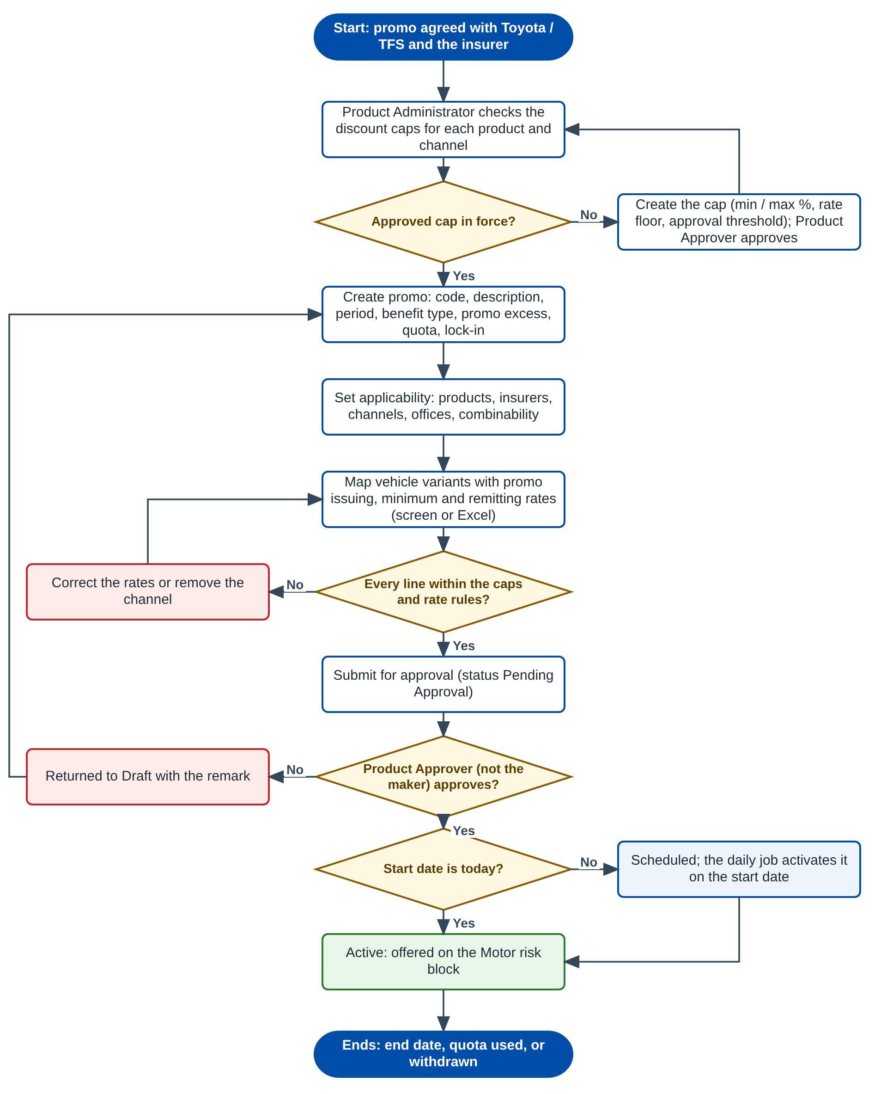
Figure 1: Flow A - Set up and approve a promo
Table 4: Flow A steps
Step | Who | What happens | FR
A1 | Product Administrator | Checks that an approved discount cap exists for each product and channel the promo will use. If not, creates the cap (minimum and maximum discount %, rate floor, approval threshold) and a Product Approver approves it. | FR-PRM-010
A2 | Product Administrator | Creates the promo: code, description, period, benefit type, promo excess, quota and lock-in. | FR-PRM-001
A3 | Product Administrator | Sets where it applies: products, insurers, channels, offices, combinability with schemes and discounts. | FR-PRM-002
A4 | Product Administrator | Maps the vehicle variants with their promo issuing, minimum issuing and remitting rates, on screen or by Excel upload. | FR-PRM-003
A5 | System | Checks every line against the caps and the rate rules. A failing line must be corrected (or the channel removed) before the promo can be submitted. | FR-PRM-011
A6 | Product Approver | Approves or returns the promo. The maker can never approve it. | FR-PRM-004
A7 | System | Sets the promo to Scheduled or Active; the daily job activates scheduled promos and expires ended ones. | FR-PRM-005

2.2 Flow B - Apply a promo on a Motor quotation
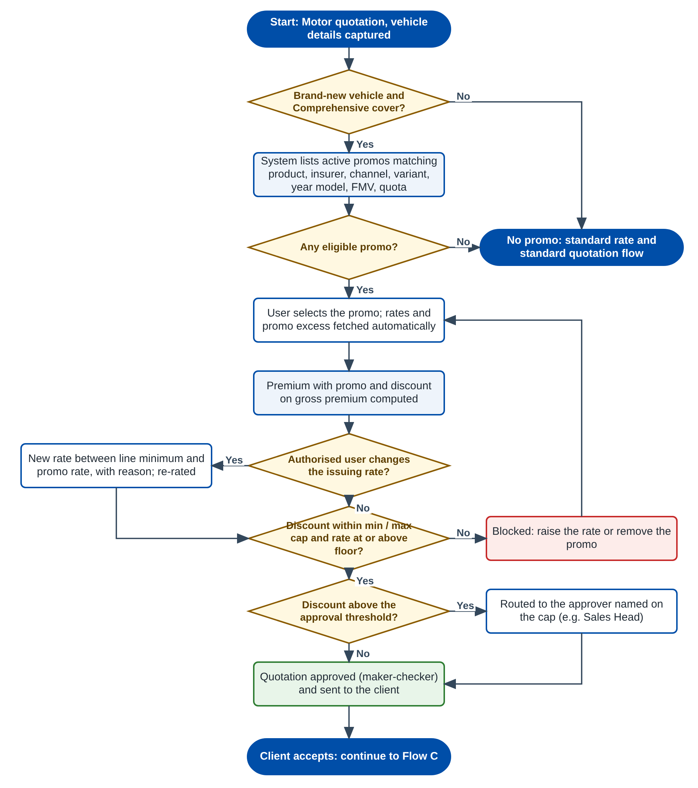
Figure 2: Flow B - Apply a promo on a Motor quotation
Table 5: Flow B steps
Step | Who | What happens | FR
B1 | System | Checks that the vehicle is brand new and the cover is Comprehensive, then lists the active promos that match the product, insurer, channel, variant, year model, FMV and quota. | FR-PRM-020
B2 | Sales / Agent | Selects a promo. The mapped rates and the promo excess are fetched automatically. | FR-PRM-021
B3 | System | Computes the premium with the promo and the discount on gross premium, side by side with the standard premium. | FR-PRM-022
B4 | Authorised Sales user | May lower the issuing rate down to the line minimum, with a reason. Agents cannot change rates. | FR-PRM-023
B5 | System | Blocks a discount outside the min / max cap or a rate below the floor; routes a discount above the threshold to the approver named on the cap. | FR-PRM-023
B6 | Quotation Approver | Approves the quotation; it is sent to the client. | FR-PRM-024

2.3 Flow C - Convert to policy and book
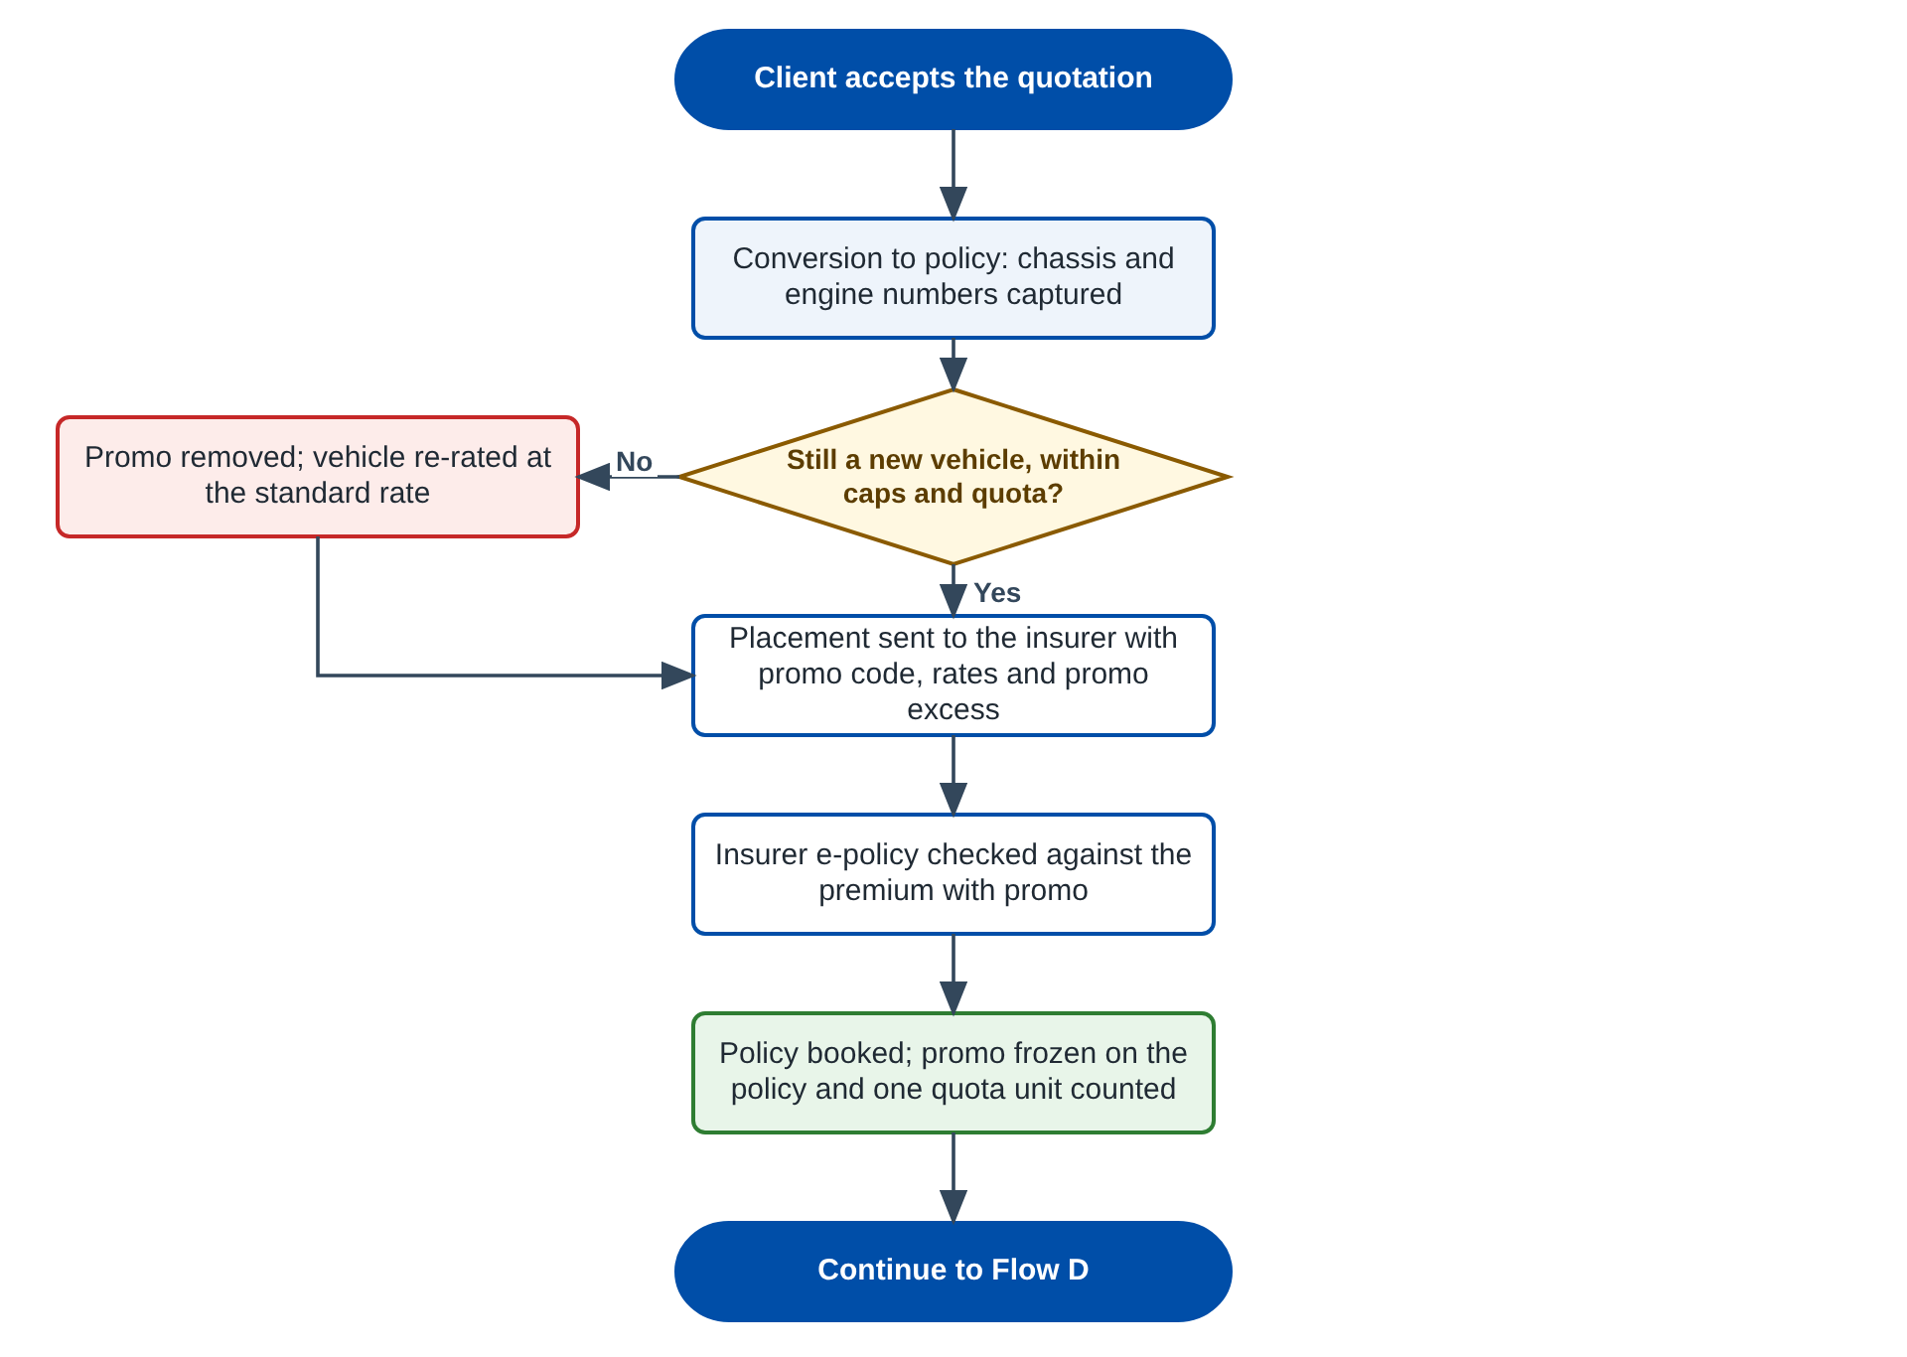
Figure 3: Flow C - Convert the quotation and book the policy
Table 6: Flow C steps
Step | Who | What happens | FR
C1 | Operations | Converts the accepted quotation. The new-vehicle rule (now with the chassis number), the caps and the quota are checked again; if the promo no longer applies it is removed and the vehicle re-rated. | FR-PRM-024
C2 | Operations | Sends the placement with the promo code, promo rates and promo excess, checks the insurer e-policy against the premium with promo and books the policy. | FR-PRM-030
C3 | System | Freezes the promo on the policy and counts one quota unit. | FR-PRM-030

2.4 Flow D - Policy with a promo after booking
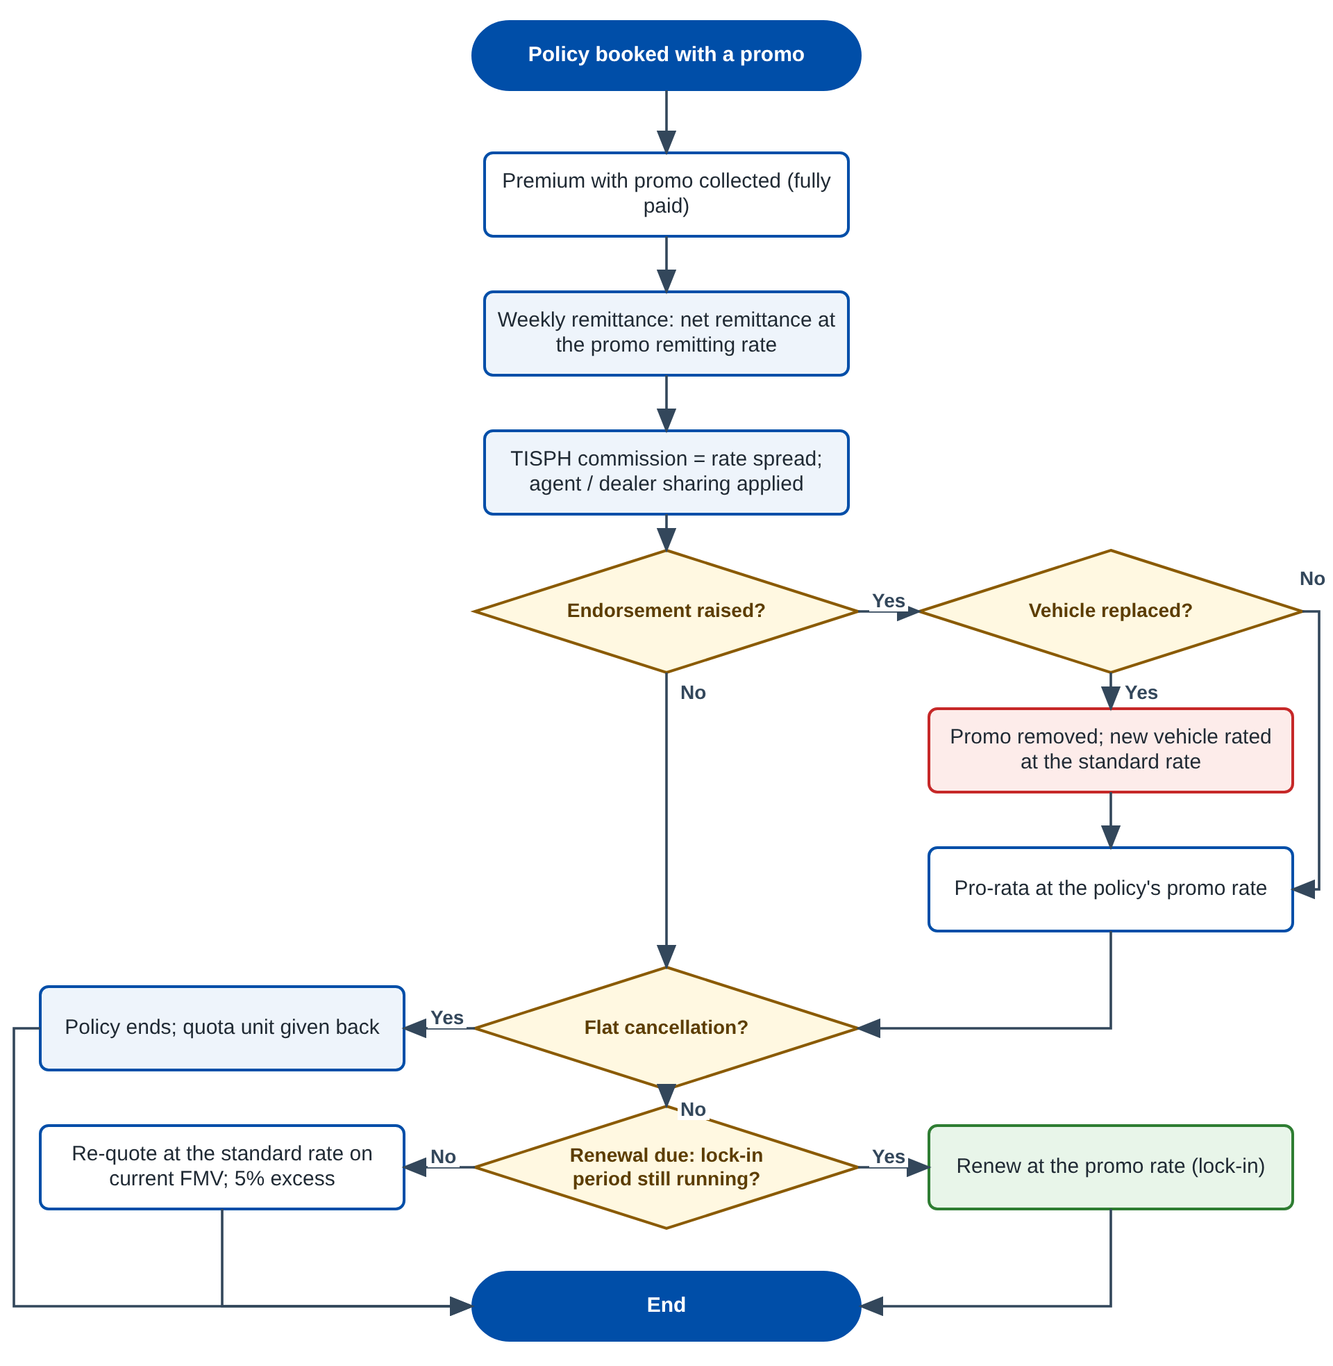
Figure 4: Flow D - Remittance, endorsement, cancellation and renewal
Table 7: Flow D steps
Step | Who | What happens | FR
D1 | FGA | Remits at the promo remitting rate; the rate spread is the TISPH commission on which agent / dealer sharing applies. | FR-PRM-031
D2 | Operations | Financial endorsements use the policy's promo rate pro-rata; replacing the vehicle removes the promo. | FR-PRM-032
D3 | Operations | A flat cancellation gives the quota unit back. | FR-PRM-033
D4 | System | Renewal is re-quoted at the standard rate, unless the promo has a lock-in that is still running. | FR-PRM-034

2.5 Products, channels and perils covered
Table 8: Promo dimensions
Dimension | Values | Source
Products | Motor - Private Car, Motor - Commercial Vehicle, Motor - Motorcycle (Comprehensive cover only) | PROD-03 Product Master
Insurers | Panel insurers; one insurer per quotation (direct placement, MOM Session 2) | MAS-04 Insurer Panel
Channels | TFS, Toyota dealer network, Direct, Online, Referral, Agent | MAS-07 Channels & Source of Business
Vehicles | Make / model / variant from the Vehicle Master; brand-new only | MAS-09 Vehicle Master
Perils a promo rate applies to | Own Damage / Theft and Acts of Nature; VTPL-BI, VTPL-PD and Auto PA stay at their rate-card premium | PROD-12, COMM-06
Business types | New business (first-year policy); renewal only under a lock-in promo | PROD-15, SCHM-03
Excess | Fixed promo excess replaces the 5% excess: Private Car PHP 2,000, Commercial Vehicle PHP 3,000 | MOM Session 2; PROD-10

3 Personas and roles

3.1 Personas
Table 9: Personas
Persona | Unit | What they do with promos
Product Administrator | TIS Sales / Product (Configuration Studio maker) | Maintains promos, variant mappings and discount caps; submits them for approval; monitors usage
Product Approver | TIS Sales Head / Product Head | Approves or returns promos and caps; suspends, resumes and withdraws promos
Sales Officer / Telesales (internal) | TIS Sales | Selects promos on quotations; authorised users (rate override list, about 20 users) may use the flexible rate range
Agent / TFS team member / Referral (external) | Agents and dealers | Selects promos on quotations; cannot change any rate (PROD-12)
Quotation Approver | Sales Supervisor / Sales Head | Approves quotations; quotations above the approval threshold go to the role named on the cap
Operations (Policy Issuance) | Operations | Converts quotations to policies, sends placements, books policies, processes endorsements and cancellations
FGA | Finance | Net remittance at the promo remitting rate, commission and sharing
System Administrator | DTID - IT App Support | Parameters, roles and permissions
Auditor | Internal Audit / Compliance | Read-only access to promos, caps and their history

3.2 Permissions
Table 10: Permissions
Permission | Allows
PROMO_VIEW | Open the Promo Master list and records, export the list
PROMO_MAINTAIN | Create, edit, amend and submit promos; upload variant mappings
PROMO_APPROVE | Approve or return promos submitted by another user
PROMO_LIFECYCLE | Suspend, resume and withdraw active or scheduled promos
DISCOUNT_CAP_MAINTAIN | Create, end-date and submit discount caps
DISCOUNT_CAP_APPROVE | Approve or return discount caps submitted by another user
PROMO_SELECT | Select or remove a promo on the Motor risk block
PROMO_RATE_OVERRIDE | Change the issuing rate of a selected promo within the line minimum (flexible issuing rate)

3.3 Permissions matrix
Table 11: Permissions by persona (Y = granted by default)
Permission | Prod. Admin | Prod. Approver | Sales (int.) | Agent (ext.) | Quote Approver | Ops | FGA | Sys. Admin | Auditor
PROMO_VIEW | Y | Y | Y | - | Y | Y | Y | Y | Y
PROMO_MAINTAIN | Y | - | - | - | - | - | - | - | -
PROMO_APPROVE | - | Y | - | - | - | - | - | - | -
PROMO_LIFECYCLE | - | Y | - | - | - | - | - | - | -
DISCOUNT_CAP_MAINTAIN | Y | - | - | - | - | - | - | - | -
DISCOUNT_CAP_APPROVE | - | Y | - | - | - | - | - | - | -
PROMO_SELECT | - | - | Y | Y | Y | Y | - | - | -
PROMO_RATE_OVERRIDE | - | - | Listed users | - | Y | - | - | - | -

Segregation of duties. The maker of a promo or cap can never approve it, even if the same user holds both permissions (TIS-BRD-SEC-03). The System Administrator grants permissions through the role profiles of TIS-BRD-SEC-01; the defaults above are configuration.

4 Functional requirements
Twenty-two FRs implement PROD-15. They are grouped by the part of the process they serve: the Promo Master (4.1), the discount caps (4.2), the eligibility rule for new vehicles (4.3), the Motor risk block and rating (4.4), the policy life cycle after the quotation (4.5) and audit and access (4.6).

4.1 Promo Master

FR-PRM-001 Create a promo with its code, description and period
BRD trace | PROD-15 (p.23) "Promo Master (code, description, period start/end ...)"; PROD-01; MOM Session 2 | Actor | Product Administrator
Priority | Must have | Fit | Customization
Screens | SCR-PRM-01 Promo Master list; SCR-PRM-02 Promo Master record - General tab

Description
The Product Administrator creates a promo on the Promo Master. The General tab holds the identity and the period of the promo; the Applicability tab (FR-PRM-002) and the Vehicle Variants & Rates tab (FR-PRM-003) complete it. A new promo is saved as Draft, version 1 and can be saved as often as needed before it is submitted (FR-PRM-004).
The promo code is entered by the user (for example PRM-VELOZ26) because Sales and the insurers refer to promos by their campaign name; it is unique across all versions and statuses and cannot be changed after the first save. The period is inclusive: a promo with period 01-Oct-2026 to 31-Dec-2026 is offered on quotations created from 01-Oct-2026 00:00 to 31-Dec-2026 23:59 (Philippine time).
Preconditions
- The user has PROMO_MAINTAIN.
- At least one Motor product, insurer and channel exist on their masters.
Main flow
- The user opens Product Configurator > Promo Master and clicks + New Promo.
- The user enters the promo code, description, period start and end, the promo benefit type (Promo rate or Gross premium discount %), the fixed promo excess per product, the optional unit quota, lock-in period and remarks.
- The user clicks Save Draft. The system validates the fields, assigns version 1 and status Draft, and shows "Promo <code> v<n> saved as draft".
- The user continues with the Applicability and Vehicle Variants & Rates tabs.
Alternate and exception flows
- Copy promo: from the list the user opens any promo and clicks Copy; the system creates a new Draft with all tabs copied, a blank code and blank period.
- Cancel: unsaved changes are discarded after confirmation.
- Delete draft: a Draft version 1 that was never submitted can be deleted by its maker; any other version cannot be deleted (only withdrawn).
Business rules
Rule | Statement | Kind | Maintained in
R1 | Promo code: capital letters, digits and hyphens, 3 to 20 characters, unique across all promos. Not editable after the first save. | Fixed | -
R2 | Period start must be today or later when the promo is submitted and approved; promos are never retroactive. | Fixed | -
R3 | Period length at most PRM_MAX_PERIOD_MONTHS (default 12 months). A lock-in promo still has a normal sales period; the lock-in applies to renewals. | Configurable | Parameter PRM_MAX_PERIOD_MONTHS
R4 | Promo benefit type: Promo rate (replaces the issuing rate on the promo perils) or Gross premium discount % (a % taken off the gross premium). One type per promo. | Configurable list | LOV PROMO_BENEFIT_TYPE
R5 | Unit quota (optional): the number of vehicles that may be booked with the promo. Blank = no quota. | Configurable per promo | Promo Master
R6 | Promo excess: a fixed excess amount per product replaces the 5% compulsory excess while the promo applies. Defaults from Gap Analysis Session 2: Private Car PHP 2,000, Commercial Vehicle PHP 3,000; Motorcycle keeps the 5% excess unless an amount is entered. | Configurable per promo | Promo Master (General tab)
R7 | Lock-in period (optional): 1 to PRM_MAX_LOCKIN_YEARS (default 3) years. When set, renewals within the lock-in keep the promo rate (FR-PRM-034). | Configurable per promo | Promo Master; parameter PRM_MAX_LOCKIN_YEARS

Validations and messages
Check | Message shown | Code
Code blank | Enter the promo code | PROMO_CODE_REQUIRED
Code format | The promo code may contain only capital letters, numbers and hyphens, up to 20 characters | PROMO_CODE_FORMAT
Code already used | Promo code <code> already exists | PROMO_CODE_DUPLICATE
Description blank | Enter the promo description | PROMO_DESC_REQUIRED
End before start | The period end must be on or after the period start | PROMO_PERIOD_INVALID
Start before today | The period start cannot be before today | PROMO_START_IN_PAST
Period too long | A promo period cannot be longer than <n> months | PROMO_PERIOD_TOO_LONG
Quota not a positive whole number | The unit quota must be a whole number of 1 or more | PROMO_QUOTA_INVALID
Lock-in out of range | The lock-in period must be between 1 and <n> years | PROMO_LOCKIN_RANGE

Audit
- Every create, update and status change is written to the audit trail with the user, timestamp, before and after values and remark (FR-PRM-040).
Acceptance criteria
- A promo saved with code PRM-VELOZ26, period 01-Oct-2026 to 31-Dec-2026 and type Promo rate is listed as Draft v1.
- Saving a second promo with code PRM-VELOZ26 is refused with PROMO_CODE_DUPLICATE.
- A period start of yesterday is refused with PROMO_START_IN_PAST; a period of 13 months is refused with PROMO_PERIOD_TOO_LONG.
- The code field is read-only after the first save.
- Copy of PRM-VELOZ26 creates a Draft with the same applicability and variant lines and a blank code and period.

FR-PRM-002 Define where a promo applies: products, insurers, channels and conditions
BRD trace | PROD-15 "discounts capped min/max per product and channel"; MAS-04, MAS-07; SCHM-01; PROD-09 | Actor | Product Administrator
Priority | Must have | Fit | Customization
Screens | SCR-PRM-02 Promo Master record - Applicability tab

Description
The Applicability tab says to whom and on what a promo is offered. Each dimension is a multi-select on its master; the risk block offers the promo only when every dimension matches the quotation (FR-PRM-020).
Vehicle condition is fixed to Brand New for every promo: the BRD restricts promos to new vehicles. The promo also says whether it can be combined with a dealer scheme (SCHM-01) and with a generic discount (PROD-09); both default to No.
Preconditions
- The promo is in Draft.
Main flow
- The user opens the Applicability tab.
- The user selects the products (Motor - Private Car, Commercial Vehicle, Motorcycle), the insurers and the channels.
- Optionally the user restricts the promo to offices / branches (blank = all offices).
- The user sets Combinable with scheme and Combinable with additional discount (default No) and the perils the promo rate applies to (default Own Damage / Theft and Acts of Nature).
- The user saves. For each product x channel selected, the system checks that an approved discount cap exists for the promo period (FR-PRM-011).
Alternate and exception flows
- If a channel has no approved cap, the promo can be saved as Draft but cannot be submitted (PROMO_CAP_NOT_DEFINED).
- Removing an insurer that is named on a variant line removes the insurer from that line after confirmation; a line left with no insurer applies to all insurers of the promo.
Business rules
Rule | Statement | Kind | Maintained in
R1 | Products must be Motor products with Comprehensive cover. TPL-only policies never carry a promo. | Fixed | -
R2 | Vehicle condition is Brand New and business type is New Business. Not editable. | Fixed | -
R3 | Promo perils default to Own Damage / Theft and Acts of Nature, in line with the issuing-vs-remitting perils of COMM-06. | Configurable | Promo Master; LOV MOTOR_PERILS
R4 | A promo with Combinable with scheme = No is not offered on a vehicle under Scheme 1 or Scheme 2. | Configurable per promo | Promo Master
R5 | A promo with Combinable with additional discount = No blocks a generic discount (PROD-09) on the same vehicle; when Yes, promo and generic discount together must stay within the maximum cap. | Configurable per promo | Promo Master
R6 | Offices blank = all offices. | Fixed | -

Validations and messages
Check | Message shown | Code
No product | Select at least one product | PROMO_PRODUCT_REQUIRED
Non-Motor product | Promos apply to Motor products only | PROMO_PRODUCT_NOT_MOTOR
No insurer | Select at least one insurer | PROMO_INSURER_REQUIRED
No channel | Select at least one channel | PROMO_CHANNEL_REQUIRED
Product x channel without approved cap (on submit) | No approved discount cap is set up for <product> through <channel> | PROMO_CAP_NOT_DEFINED

Audit
- Every create, update and status change is written to the audit trail with the user, timestamp, before and after values and remark (FR-PRM-040).
Acceptance criteria
- A promo for Motor - Private Car, Insurer A and B, channels TFS and Direct is offered only on quotations matching all three.
- Selecting Personal Accident is refused with PROMO_PRODUCT_NOT_MOTOR.
- With channel Online selected and no Online cap, submit is refused with PROMO_CAP_NOT_DEFINED.
- The Vehicle condition shows Brand New and cannot be changed.
- A promo with Combinable with scheme = No is not listed on a Scheme 1 vehicle.

FR-PRM-003 Map vehicle variants and their promo issuing and remitting rates
BRD trace | PROD-15 "applicable vehicle variants, rates ... flexible issuing and remitting rates"; MAS-09; PROD-04; COMM-06; BULK-01 | Actor | Product Administrator
Priority | Must have | Fit | Customization
Screens | SCR-PRM-02 - Vehicle Variants & Rates tab; SCR-PRM-05 Upload Variant Mapping

Description
The variant mapping lists the vehicles a promo applies to and the rates of each. A line is one variant of the Vehicle Master with a year model range, an optional FMV range and an optional insurer (blank = every insurer of the promo). Different variants of the same model can carry different rates.
For a Promo rate promo each line holds three rates on the promo perils: the promo issuing rate (charged to the customer), the minimum issuing rate (the lowest rate an authorised user may apply - the "flexible issuing rate"; equal to the promo rate when there is no flexibility) and the promo remitting rate (the net rate agreed with the insurer - the "flexible remitting rate"). For a Gross premium discount % promo each line holds the discount % (and an optional maximum %, for flexibility) and the remitting rate stays the standard one unless a promo remitting rate is entered.
For every line the system shows the reference standard issuing and remitting rates of the product and insurer (PROD-12, PROD-13, PROD-16), computes the rate discount % and shows the cap check result per channel (FR-PRM-011).
Preconditions
- The promo is in Draft. Applicability is saved.
- The variants are active on the Vehicle Master (MAS-09).
Main flow
- The user opens the Vehicle Variants & Rates tab and clicks + Add variant.
- The user picks make, model and variant from the Vehicle Master (type-ahead), enters the year model from / to, the FMV from / to (optional) and the insurer (optional).
- The user enters the promo issuing rate, minimum issuing rate and promo remitting rate (or the discount %).
- The system computes the rate discount % and the cap check per channel and shows them on the line.
- The user repeats for each variant, or uploads the mapping from Excel (FR-PRM-003 alternate flow), and saves.
Alternate and exception flows
- Upload: the user clicks Upload, downloads the Promo Variant Mapping template (chapter 13), fills it and uploads it. Valid rows are added to the Draft (or replace all lines, if the user chooses Replace); rejected rows are listed in a result file with the row number and message. Only .xlsx is accepted (BULK-01).
- Apply to all variants of a model: the user picks a model and "All variants"; the system creates one line per active variant with the same rates, which the user can then edit.
- Variant later inactivated on the Vehicle Master: the line stays on the promo but is not offered; the promo record shows a warning icon on the line.
Business rules
Rule | Statement | Kind | Maintained in
R1 | Rates are percentages with up to 4 decimals, more than 0 and at most 100. | Fixed | -
R2 | Promo remitting rate <= promo issuing rate; minimum issuing rate <= promo issuing rate; minimum issuing rate >= promo remitting rate. | Fixed | -
R3 | Rate discount % = (standard issuing rate - minimum issuing rate) / standard issuing rate x 100, rounded to 2 decimals. For a discount % promo it is the maximum discount % of the line. | Fixed | -
R4 | Two lines may not overlap on the same variant, year model and insurer. | Fixed | -
R5 | A promo issuing rate equal to or higher than the standard rate gives a warning, not an error (the promo may exist only for its remitting rate). | Fixed | -
R6 | Upload: .xlsx only, at most PRM_UPLOAD_MAX_ROWS rows (default 2,000). | Configurable | Parameter PRM_UPLOAD_MAX_ROWS

Validations and messages
Check | Message shown | Code
No line | Add at least one vehicle variant | PROMO_VARIANT_REQUIRED
Variant inactive | Variant <variant> is inactive in the Vehicle Master | PROMO_VARIANT_INACTIVE
Overlapping lines | Variant <variant> is listed more than once for overlapping year models and insurers | PROMO_VARIANT_DUPLICATE
Year range | Line <n>: the year model to must be on or after the year model from | PROMO_YEAR_RANGE_INVALID
FMV range | Line <n>: the FMV to must be higher than the FMV from | PROMO_FMV_RANGE_INVALID
Rate blank | Enter the promo issuing and remitting rates of line <n> | PROMO_RATE_REQUIRED
Rate out of range | Line <n>: rates must be more than 0% and at most 100%, with up to 4 decimals | PROMO_RATE_RANGE
Remitting above issuing | Line <n>: the promo remitting rate cannot be higher than the promo issuing rate | PROMO_REMIT_ABOVE_ISSUE
Minimum above promo rate | Line <n>: the minimum issuing rate cannot be higher than the promo issuing rate | PROMO_MIN_ABOVE_ISSUE
Promo rate not below standard | Line <n>: the promo issuing rate is not lower than the standard issuing rate of <rate>% | PROMO_ISSUE_NOT_BELOW_STANDARD
Discount % blank | Line <n>: enter the gross premium discount % | PROMO_DISCOUNT_PCT_REQUIRED
Upload file type | Upload an Excel (.xlsx) file | UPLOAD_FILE_TYPE
Upload template | The file does not match the Promo Variant Mapping template: <column> is missing | UPLOAD_TEMPLATE_INVALID
Upload row | Row <n>: <message> | UPLOAD_ROW_ERROR

Audit
- Every create, update and status change is written to the audit trail with the user, timestamp, before and after values and remark (FR-PRM-040).
Acceptance criteria
- A line Toyota Veloz 1.5 V CVT, 2026-2027, promo issuing 1.50, minimum 1.50, remitting 1.30 shows a rate discount of 25.00% against a standard rate of 2.00%.
- A remitting rate of 1.60 with an issuing rate of 1.50 is refused with PROMO_REMIT_ABOVE_ISSUE.
- Two lines for Veloz 1.5 V CVT with year models 2026-2027 and 2027-2028 for the same insurer are refused with PROMO_VARIANT_DUPLICATE.
- An upload of 10 rows with 2 invalid rows loads 8 lines and returns a result file with the 2 rows and their messages.
- A .csv upload is refused with UPLOAD_FILE_TYPE.

FR-PRM-004 Submit, approve or return a promo (maker-checker)
BRD trace | PROD-03 maker-checker on registers; SEC-03; PROD-15 | Actor | Product Administrator (maker), Product Approver (checker)
Priority | Must have | Fit | Customization
Screens | SCR-PRM-02; SCR-PRM-03 Promo approval (My Approvals)

Description
A promo, and every new version of it, needs approval by a Product Approver other than its maker before it can be offered. On submit the system runs all validations of FR-PRM-001 to 003 and the cap check of FR-PRM-011; a promo with any error cannot be submitted.
On approval the promo becomes Scheduled when its start date is in the future, or Active when the start date is today. A returned promo goes back to Draft with the approver's remark.
Preconditions
- The promo is in Draft and has passed all validations.
Main flow
- The maker clicks Submit for Approval. The status becomes Pending Approval and the record is read-only.
- The approver opens the item from My Approvals. SCR-PRM-03 shows the promo, its lines with the cap check, and for an amended version the differences with the previous version highlighted.
- The approver clicks Approve (optional remark) or Return (remark mandatory).
- On approval the system sets Scheduled or Active and records the approver and time.
Alternate and exception flows
- The approval page is opened after the start date has passed: Approve is refused (PROMO_APPROVE_START_PASSED); the approver returns the promo so the maker can correct the period.
- The maker recalls a submitted promo before it is approved: the status goes back to Draft.
Business rules
Rule | Statement | Kind | Maintained in
R1 | The maker (creator or last editor of the version) can never approve or return it. | Fixed | -
R2 | Only one version of a promo can be in Draft or Pending Approval at a time. | Fixed | -
R3 | Approval routing: any user with PROMO_APPROVE. An optional second level (for example promos with a rate discount above 20%) can be added in the workflow configuration. | Configurable | Configuration Studio - workflow PROMO_APPROVAL

Validations and messages
Check | Message shown | Code
Self-approval | You cannot approve or return a promo you created or amended | PROMO_SELF_APPROVAL
Return without remark | Enter the reason for returning the promo | PROMO_RETURN_REMARK
Start date passed | The period start <date> has passed. Return the promo so the maker can correct the period | PROMO_APPROVE_START_PASSED
Pending version exists | Promo <code> already has version <n> in Draft or Pending Approval | PROMO_PENDING_VERSION_EXISTS

Audit
- Every create, update and status change is written to the audit trail with the user, timestamp, before and after values and remark (FR-PRM-040).
Acceptance criteria
- A promo submitted by user A cannot be approved by user A (PROMO_SELF_APPROVAL), even when A holds PROMO_APPROVE.
- Approving on 25-Sep-2026 a promo starting 01-Oct-2026 sets it to Scheduled; approving a promo starting today sets it to Active.
- Return without a remark is refused; with a remark the promo goes back to Draft.
- A promo with a line above the maximum cap cannot be submitted.

FR-PRM-005 Run the promo life cycle: scheduled, active, suspended, expired, withdrawn
BRD trace | PROD-15 "period start/end" | Actor | System (daily job); Product Approver
Priority | Must have | Fit | Customization
Screens | SCR-PRM-01; SCR-PRM-02 lifecycle dialogs

Description
A daily job at 00:05 moves Scheduled promos whose start date is today to Active and Active promos whose end date has passed to Expired. A promo whose quota is fully used also moves to Expired. The Product Approver can suspend an active promo (for example while a rate is renegotiated with the insurer), resume it, or withdraw it (the end date becomes today).
Only Active promos are offered on the risk block. A quotation that already carries a promo keeps it until the quotation validity ends, even if the promo is later suspended, withdrawn or expired (FR-PRM-024).
Preconditions
- The promo is approved (Scheduled or Active).
Main flow
- The daily job evaluates every Scheduled and Active promo and changes the status where the date or quota rule is met.
- For a manual action the approver opens the promo, clicks Suspend, Resume or Withdraw, enters the reason and confirms. When open quotations carry the promo the system warns with their number (PROMO_OPEN_QUOTES).
Alternate and exception flows
- Withdraw on a Scheduled promo: the promo becomes Withdrawn and is never offered.
- Resume after the end date: not possible; the promo is Expired.
Business rules
Rule | Statement | Kind | Maintained in
R1 | Status set: Draft, Pending Approval, Scheduled, Active, Suspended, Expired, Withdrawn (chapter 5). | Fixed | -
R2 | A promo counts one unit for each vehicle booked as a policy with the promo; cancelled-from-inception policies give the unit back. | Fixed | -
R3 | Open quotations keep the promo after suspension, withdrawal or expiry until the end of their 30-day validity (QUOT-04). | Configurable | Parameter PRM_HONOUR_ON_QUOTE_VALIDITY (default Yes)

Validations and messages
Check | Message shown | Code
Reason blank | Enter the reason | PROMO_ACTION_REMARK
Open quotations exist | <n> open quotation(s) carry this promo. They keep it until their validity ends | PROMO_OPEN_QUOTES

Audit
- Every create, update and status change is written to the audit trail with the user, timestamp, before and after values and remark (FR-PRM-040).
Acceptance criteria
- A Scheduled promo with start date 01-Oct-2026 is Active after the job of 01-Oct-2026.
- An Active promo with end date 31-Dec-2026 is Expired after the job of 01-Jan-2027.
- A promo with quota 500 becomes Expired when the 500th policy with the promo is booked.
- A suspended promo is not listed on the risk block of a new quotation; a quotation rated with it before the suspension keeps it.
- Withdraw sets the end date to today and the status to Withdrawn.

FR-PRM-006 Amend an approved promo as a new version
BRD trace | PROD-01 versioned configuration; PROD-15 | Actor | Product Administrator, Product Approver
Priority | Must have | Fit | Customization
Screens | SCR-PRM-02

Description
An approved promo is never edited in place. Amend creates version n+1 in Draft, copied from the current version. The current version stays in force until the new one is approved; on approval the new version replaces it from the approval time (or from its own start date if later).
Quotations already rated keep the version they used. A new version of a quotation (QUOT-04) re-fetches the current version and shows PROMO_VERSION_CHANGED when the rates changed.
Preconditions
- The promo is Scheduled, Active or Suspended. No other version is in Draft or Pending Approval.
Main flow
- The user clicks Amend. The system creates the Draft version and opens it.
- The user changes the end date, applicability, lines or rates and submits; approval follows FR-PRM-004.
- On approval the previous version becomes Superseded (history only).
Alternate and exception flows
- The user discards the Draft version: the current version is unchanged.
Business rules
Rule | Statement | Kind | Maintained in
R1 | The code and the benefit type cannot be amended; the start date can be amended only while the promo is Scheduled. | Fixed | -
R2 | The period end may be shortened or extended (within the maximum period). | Fixed | -
R3 | The unit count carries over across versions of the same promo. | Fixed | -

Validations and messages
Check | Message shown | Code
Edit of an approved version | Promo <code> is <status> and cannot be changed. Use Amend to create a new version | PROMO_NOT_EDITABLE
Second pending version | Promo <code> already has version <n> in Draft or Pending Approval | PROMO_PENDING_VERSION_EXISTS

Audit
- Every create, update and status change is written to the audit trail with the user, timestamp, before and after values and remark (FR-PRM-040).
Acceptance criteria
- Amending PRM-VELOZ26 v1 creates v2 Draft; v1 stays Active and offered until v2 is approved.
- After v2 is approved, a new quotation uses v2 rates; a quotation rated on v1 still shows v1.
- The approval page of v2 highlights the lines and fields that differ from v1.

FR-PRM-007 Search, view and export promos
BRD trace | PROD-15 | Actor | Any user with PROMO_VIEW
Priority | Must have | Fit | Customization
Screens | SCR-PRM-01

Description
The Promo Master list shows every promo with code, description, products, insurers, channels, period, number of variant lines, current version, status and units used / quota. Tabs filter by status; filters cover code or description, product, insurer, channel, status and "active on date". The list exports to Excel with the lines of each promo.
Main flow
- The user opens Promo Master, sets filters and clicks Search.
- The user opens a promo; the Approval & History tab lists every version with maker, approver, dates and remarks.
- The user clicks Export to download the list and lines (.xlsx).
Business rules
Rule | Statement | Kind | Maintained in
R1 | Default sort: status (Active first), then start date descending; 25 rows per page. | Fixed | -

Audit
- Every create, update and status change is written to the audit trail with the user, timestamp, before and after values and remark (FR-PRM-040).
Acceptance criteria
- Filter "active on date" 15-Nov-2026 lists only promos whose period covers that date and whose status is Active or Scheduled.
- Export produces one sheet of promos and one sheet of lines with the same filters.

4.2 Discount caps

FR-PRM-010 Maintain discount caps per product and channel
BRD trace | PROD-15 "discounts capped min/max per product and channel"; PROD-09 (TISPH remark: approval hierarchy based on minimum issuing rate) | Actor | Product Administrator (maker), Product Approver (checker)
Priority | Must have | Fit | Customization
Screens | SCR-PRM-04 Discount Caps

Description
The Discount Caps master holds, per product x channel and effective period: the minimum discount % and maximum discount % a promo may give on the gross premium, the minimum issuing rate % (the rate floor below which no promo or override may go) and the approval threshold % with the approver role for quotations whose discount is above the threshold.
Caps are dated: a change is a new cap record with a new effective from date, approved by a checker. The cap in force on the quotation date applies at rating.
Preconditions
- Products and channels exist.
Main flow
- The user opens Discount Caps and clicks + New Cap.
- The user enters product, channel, min %, max %, minimum issuing rate, approval threshold and approver role, effective from (and optional effective to).
- The system validates and lists the active promo lines that would fall outside the new cap (CAP_AFFECTS_PROMOS).
- The user submits; a Product Approver approves or returns it (maker-checker).
Alternate and exception flows
- End-dating a cap: the user enters an effective to date on an approved cap; this also needs approval.
- No cap for a product x channel: no promo can be submitted or used for it.
Business rules
Rule | Statement | Kind | Maintained in
R1 | 0 <= min % <= max % <= 100; min % <= threshold <= max %. | Fixed | -
R2 | Only one approved cap per product x channel may cover any date. | Fixed | -
R3 | Default caps delivered for testing (to be confirmed by TIS Sales): Private Car - TFS 0-25%, floor 1.40%, threshold 15%; Dealer 0-20%, floor 1.50%, threshold 10%; Direct 0-25%, floor 1.40%; Referral 0-15%, floor 1.60%; Online 0-10%, floor 1.70%. | Configurable | Discount Caps master
R4 | A new cap applies to ratings from its effective date; promo lines outside it are not offered from that date. | Fixed | -

Validations and messages
Check | Message shown | Code
Mandatory fields | Enter the product, channel, minimum and maximum discount, minimum issuing rate and effective from date | CAP_REQUIRED_FIELDS
Range | Discount caps must be between 0% and 100% | CAP_RANGE
Min above max | The minimum discount cannot be higher than the maximum discount | CAP_MIN_ABOVE_MAX
Threshold | The approval threshold must be between the minimum and the maximum discount | CAP_THRESHOLD_RANGE
Overlap | An approved cap for <product> through <channel> already covers <date> | CAP_OVERLAP
Backdated | The effective from date cannot be before today | CAP_FROM_IN_PAST
Self-approval | You cannot approve a cap you created or changed | CAP_SELF_APPROVAL
Impact on promos | <n> line(s) of active promos would be outside the new cap: <list>. These lines will not be offered from <date> | CAP_AFFECTS_PROMOS

Audit
- Every create, update and status change is written to the audit trail with the user, timestamp, before and after values and remark (FR-PRM-040).
Acceptance criteria
- A cap Private Car - TFS 0-25%, floor 1.40%, threshold 15% -> Sales Head is saved, approved by another user and listed as Approved.
- A cap with min 30% and max 25% is refused with CAP_MIN_ABOVE_MAX.
- A second approved cap for Private Car - TFS covering the same date is refused with CAP_OVERLAP.
- Lowering the TFS maximum to 20% warns that PRM-VELOZ26 lines 1 and 2 (25%) will not be offered from the effective date.

FR-PRM-011 Check every promo line against the caps at set-up
BRD trace | PROD-15; BRD 7.1 "cap validation" | Actor | System
Priority | Must have | Fit | Customization
Screens | SCR-PRM-02; SCR-PRM-03

Description
On save (as information) and on submit (as a blocking check) the system checks each promo line against the cap of every product x channel of the promo, using the cap in force on the promo start date (and on any later cap effective date within the period). It uses the rate discount % - the worst case for the line - so that a promo that passes set-up cannot exceed the cap at rating for any FMV.
Main flow
- For each line and each product x channel the system reads the cap.
- It checks: minimum issuing rate of the line >= cap floor; rate discount % <= cap max; rate discount % >= cap min.
- It shows a Within cap / Above max / Below min / Below floor tag per line and channel and the message for each failure.
Business rules
Rule | Statement | Kind | Maintained in
R1 | Rate discount % is an upper bound of the discount on gross premium: VTPL and other covers at full premium only dilute the % (Appendix A.3). | Fixed | -
R2 | For a Gross premium discount % promo the line maximum discount % is checked directly against the cap. | Fixed | -

Validations and messages
Check | Message shown | Code
Above max | Line <n>: the rate discount of <x>% is above the maximum discount of <max>% for <product> through <channel> | PROMO_CAP_MAX_EXCEEDED
Below min | Line <n>: the rate discount of <x>% is below the minimum discount of <min>% for <product> through <channel> | PROMO_CAP_MIN_NOT_MET
Below floor | Line <n>: the rate of <r>% is below the minimum issuing rate of <floor>% for <product> through <channel> | PROMO_BELOW_MIN_ISSUING
No cap | No approved discount cap is set up for <product> through <channel> | PROMO_CAP_NOT_DEFINED

Audit
- Every create, update and status change is written to the audit trail with the user, timestamp, before and after values and remark (FR-PRM-040).
Acceptance criteria
- Line Veloz 1.5 E CVT with minimum issuing 1.40% (rate discount 30%) on a promo open to TFS (max 25%) shows Above max 25.00% (TFS) and blocks submit.
- The same line on a promo open to Direct only, with floor 1.40% and max 25%, still fails (30% > 25%).
- A line with minimum issuing rate 1.45% against a Dealer floor of 1.50% fails with PROMO_BELOW_MIN_ISSUING.

4.3 New vehicles only

FR-PRM-020 Decide whether a vehicle is eligible for promos
BRD trace | PROD-15 "applying at vehicle level, for new vehicles only"; LEAD-01 (TFS feed); KYC-03 | Actor | System
Priority | Must have | Fit | Customization
Screens | SCR-QOT-MTR Motor risk block

Description
Eligibility is decided per vehicle (risk item). A vehicle is brand new when all three conditions hold: (1) Vehicle condition = Brand New; (2) year model >= inception year - PRM_NEW_VEHICLE_YEAR_TOLERANCE (default 1), so a 2026 or 2027 model is new for a policy starting in 2026 or 2027; (3) business type New Business and no earlier policy on record for the same chassis number.
For a brand-new vehicle the system then lists the promos that are Active on the quotation date and match the product, cover (Comprehensive), insurer, channel, office, variant, year model and FMV of the vehicle, whose quota is not used up and which are combinable with any scheme or discount on the vehicle.
Preconditions
- The vehicle details are captured: variant, year model, condition, FMV, chassis number (or TBA).
Main flow
- The user enters or changes the vehicle details, cover, insurer or channel.
- The system evaluates the brand-new rule and calls the eligibility service.
- The risk block shows the number of eligible promos and fills the Promo list (FR-PRM-021). If none, it shows PROMO_NONE_ELIGIBLE and the Promo field is disabled.
Alternate and exception flows
- TFS-fed leads: vehicle condition, year model and SRP come from the TFS account feed (LEAD-01) and are read-only on the quotation.
- Chassis number TBA at quotation: condition (3) is re-checked at conversion to policy, when the chassis number is mandatory (ISSUE-02).
- A renewal quotation never lists promos, except the lock-in promo carried by the policy (FR-PRM-034).
Business rules
Rule | Statement | Kind | Maintained in
R1 | Brand-new rule as above; tolerance PRM_NEW_VEHICLE_YEAR_TOLERANCE (default 1 year). | Configurable | Parameter
R2 | Vehicle condition list: Brand New, Used / Second-hand, Repossessed (ROPA). | Configurable | LOV VEHICLE_CONDITION
R3 | The quotation date (creation of version 1) decides whether the promo period covers the quotation. | Fixed | -

Validations and messages
Check | Message shown | Code
Not brand new and promo selected | Promos apply to brand-new vehicles only | PROMO_NOT_NEW_VEHICLE
Cover not Comprehensive | Promos apply to Comprehensive cover only | PROMO_COVER_NOT_COMPREHENSIVE
No promo | No promo is open to this vehicle | PROMO_NONE_ELIGIBLE

Audit
- Every create, update and status change is written to the audit trail with the user, timestamp, before and after values and remark (FR-PRM-040).
Acceptance criteria
- A 2026 Veloz 1.5 V CVT, Brand New, FMV 1,200,000, TFS, Insurer A, on 08-Oct-2026 lists PRM-VELOZ26.
- The same vehicle with condition Used lists no promo and shows PROMO_NONE_ELIGIBLE.
- A 2024 model marked Brand New for a 2026 inception is not eligible (tolerance 1 year).
- A chassis number already on an earlier policy makes the vehicle ineligible at conversion; the promo is removed with PROMO_REMOVED_RERATED.

4.4 Risk block and rating

FR-PRM-021 Select the promo on the risk block and fetch its mapped rates
BRD trace | PROD-15 "the risk block selects the promo and auto-fetches the mapped rate"; PROD-07; QUOT-02 | Actor | Sales Officer, Agent, Quotation Approver
Priority | Must have | Fit | Customization
Screens | SCR-QOT-MTR Motor risk block - Promotion section

Description
The Motor risk block has a Promotion section under the vehicle details. The Promo field lists the eligible promos as "code - description (version)". When the user selects one, the system finds the promo line that matches the variant, year model, FMV and insurer and fetches its rates automatically: promo issuing rate, promo remitting rate and minimum issuing rate (or discount %). The fields are read-only for users without PROMO_RATE_OVERRIDE. The promo end date and the discount are shown next to them.
Selecting, changing or removing the promo re-rates the vehicle immediately. In a quotation with several vehicles (fleet), each vehicle has its own Promotion section; promos are never applied at policy level.
Preconditions
- The vehicle is eligible (FR-PRM-020). The user has PROMO_SELECT.
Main flow
- The user opens the Promo list and selects a promo.
- The system fetches the line rates, shows PROMO_RATE_FETCHED and re-rates (FR-PRM-022).
- The system checks the caps and shows the discount and, if above the threshold, the approval route (FR-PRM-023).
- The user saves the quotation.
Alternate and exception flows
- Only one promo eligible and PRM_AUTO_SELECT_SINGLE = Yes: the promo is pre-selected; the user can remove it.
- The user selects "No promo": rates go back to the standard rates.
- The lead was captured with source "Promo" (LEAD-04) and a promo code: that promo is pre-selected when eligible.
Business rules
Rule | Statement | Kind | Maintained in
R1 | One promo per vehicle; promos never stack. | Fixed | -
R2 | When several promos are eligible the list is sorted by lowest promo issuing rate; the user chooses. | Fixed | -
R3 | Auto-select of a single eligible promo PRM_AUTO_SELECT_SINGLE (default No). | Configurable | Parameter
R4 | The promo code, version, line and the fetched rates are stored on the risk item and carried to every later version and to the policy. | Fixed | -

Validations and messages
Check | Message shown | Code
Promo no longer matches after a vehicle change | Promo <code> is not open to this vehicle, product, insurer or channel | PROMO_NOT_ELIGIBLE
FMV outside the line range | The FMV of <fmv> is outside the range of promo <code> for this variant | PROMO_FMV_OUT_OF_RANGE
Promo suspended | Promo <code> is suspended and cannot be selected | PROMO_SUSPENDED_QUOTE
Quota reached | Promo <code> has reached its quota of <n> units | PROMO_QUOTA_REACHED
Not combinable | Promo <code> cannot be combined with <scheme or discount> | PROMO_NOT_COMBINABLE
Rates fetched | Rates of promo <code> v<n> applied: issuing <r>%, remitting <r>% | PROMO_RATE_FETCHED

Audit
- Every create, update and status change is written to the audit trail with the user, timestamp, before and after values and remark (FR-PRM-040).
Acceptance criteria
- Selecting PRM-VELOZ26 on a Veloz 1.5 V CVT fills promo issuing 1.50, remitting 1.30 and valid until 31-Dec-2026 and re-rates the vehicle.
- Changing the variant to a variant without a line removes the promo with PROMO_REMOVED_RERATED.
- In a two-vehicle quotation, vehicle 1 carries PRM-VELOZ26 and vehicle 2 no promo; each is rated separately.
- An agent sees the rates read-only.

FR-PRM-022 Compute the premium with the promo and the discount on gross premium
BRD trace | PROD-15 "applied to gross premium"; PROD-10, PROD-11, PROD-12; COMM-06; MOM Session 2 (promo excess) | Actor | System
Priority | Must have | Fit | Customization
Screens | SCR-QOT-MTR - Premium breakdown

Description
The rating engine computes two premiums for every vehicle with a promo: the standard premium (standard issuing rate) and the premium with promo. Both are shown side by side in the premium breakdown. The customer pays the premium with promo.
Promo rate promo: promo peril premium = FMV x promo issuing rate (or the overridden rate); other covers at their rate-card premium; basic premium = sum of covers; DST 12.5%, VAT 12% and LGT (rate of the locality) on the basic premium; gross premium = basic premium + taxes. Discount = standard gross premium - gross premium with promo; discount % = discount / standard gross premium x 100.
Gross premium discount % promo: the premium is computed at the standard rate; discount = standard gross premium x discount %; amount payable = standard gross premium - discount. Taxes are not recomputed.
Excess: while a promo applies, the compulsory excess of the vehicle is the fixed promo excess of the product (Private Car PHP 2,000, Commercial Vehicle PHP 3,000 by default) instead of 5% of the sum insured. Removing the promo brings back the 5% excess. EBI and PD limits are not affected (default PHP 200,000, up to PHP 1,000,000 per PROD-10).
The remitting side is computed at the same time: net remittance on the promo perils = FMV x promo remitting rate, and the rate spread (TISPH commission before sharing) = FMV x (issuing rate - remitting rate) (FR-PRM-031). Appendix A gives worked examples.
Preconditions
- A promo is selected; the FMV and covers are captured.
Main flow
- The engine computes the standard premium.
- The engine computes the premium with promo and the discount.
- The engine stores both breakdowns with the quotation version.
Business rules
Rule | Statement | Kind | Maintained in
R1 | Amounts in PHP rounded to 2 decimals at each tax line (half up). Discount % rounded to 2 decimals. | Fixed | -
R2 | Tax rates DST 12.5%, VAT 12%, LGT per locality are maintained on Charges & Taxes (PROD-11); the same rules apply with or without promo. | Configurable | Charges & Taxes
R3 | Pro-rata and short-period bases (PROD-06) apply to the promo premium in the same way as to the standard premium. | Fixed | -
R4 | FMV depreciation (10% default) and FMV edits (PROD-12) are applied before the promo rate. | Fixed | -

Audit
- Every create, update and status change is written to the audit trail with the user, timestamp, before and after values and remark (FR-PRM-040).
Acceptance criteria
- Veloz 1.5 V CVT, FMV 1,200,000, VTPL-BI 600.00, VTPL-PD 1,200.00, LGT 0.75%: standard gross premium 32,314.50; with PRM-VELOZ26 (1.50%) gross premium 24,799.50; discount 7,515.00 = 23.26%.
- Hilux, FMV 1,800,000, 10% gross premium discount: standard gross 47,908.13, discount 4,790.81, payable 43,117.32 (Appendix A.2).
- Removing the promo shows only the standard breakdown.
- With the promo the excess of the Veloz (Private Car) shows PHP 2,000.00 instead of PHP 60,000.00 (5% of 1,200,000); without it, 5% applies again.

FR-PRM-023 Apply the caps, the flexible issuing rate and the approval route at rating
BRD trace | PROD-15 "flexible issuing ... rates", "discounts capped min/max per product and channel"; PROD-09 remark; PROD-12 (override restricted to about 20 users, locked for agents); SEC-01 approval limits | Actor | Sales Officer (authorised), System, Quotation Approver
Priority | Must have | Fit | Customization
Screens | SCR-QOT-MTR

Description
After every rating the system checks the discount of the vehicle against the cap of the product and channel of the quotation in force on the quotation date: discount % <= max, discount % >= min, issuing rate >= cap floor. A discount above the max or a rate below the floor blocks the quotation; it cannot be submitted.
Flexible issuing rate: a user with PROMO_RATE_OVERRIDE may lower the issuing rate of the selected promo down to the minimum issuing rate of the line (never below), with a mandatory reason. The rate can never be raised above the promo rate while the promo is selected (the user removes the promo instead). The remitting rate is never editable on the quotation.
Approval route: when the discount % is above the approval threshold of the cap, the quotation is routed on submit to the approver role named on the cap (for example Sales Head) instead of the normal quotation approver, in line with the approval limits per persona (SEC-01).
Main flow
- The authorised user clicks the pencil next to the promo issuing rate, enters the new rate and the reason.
- The system checks the line minimum and re-rates.
- The system checks the caps and shows PROMO_APPROVAL_ROUTED when the threshold is passed.
- On submit the quotation goes to the approver role; the approval page shows the promo, the standard and promo premiums, the discount and the override reason.
Alternate and exception flows
- Agent or user without PROMO_RATE_OVERRIDE clicks the rate: PROMO_RATE_LOCKED.
- A combinable generic discount (PROD-09) is also entered: the cap check uses the total discount.
Business rules
Rule | Statement | Kind | Maintained in
R1 | Cap check at rating uses the actual discount % on gross premium (not the rate discount %). | Fixed | -
R2 | Overrides are allowed only between the line minimum issuing rate and the promo issuing rate. | Fixed | -
R3 | Approval threshold and approver role per product x channel are on the cap (FR-PRM-010). | Configurable | Discount Caps master

Validations and messages
Check | Message shown | Code
Rate locked | Only authorised users can change the promo rate | PROMO_RATE_LOCKED
Below line minimum | The issuing rate cannot be lower than <min>% for this promo | PROMO_RATE_BELOW_MIN
Above promo rate | The issuing rate cannot be higher than the promo rate of <r>%. Remove the promo to use the standard rate | PROMO_RATE_ABOVE_PROMO
Reason blank | Enter the reason for changing the promo rate | PROMO_OVERRIDE_REASON
Above max cap | The discount of <x>% is above the maximum of <max>% for <product> through <channel> | PROMO_CAP_EXCEEDED_QUOTE
Below min cap | The discount of <x>% is below the minimum of <min>% for <product> through <channel> | PROMO_CAP_MIN_QUOTE
Approval routed | The discount of <x>% is above <t>%. The quotation will go to <role> for approval | PROMO_APPROVAL_ROUTED

Audit
- The override (old rate, new rate, reason, user) is stored on the risk item and in the audit trail.
Acceptance criteria
- On line Veloz 1.5 E MT (promo 1.60%, minimum 1.55%) an authorised user can set 1.55%; 1.50% is refused with PROMO_RATE_BELOW_MIN.
- An agent cannot change the rate (PROMO_RATE_LOCKED).
- A TFS quotation with a discount of 23.26% (threshold 15%) goes to the Sales Head on submit.
- After the TFS max cap is lowered to 20%, a new rating of the Veloz example (23.26%) is refused with PROMO_CAP_EXCEEDED_QUOTE.

FR-PRM-024 Re-validate the promo on new quotation versions, extension, approval and conversion
BRD trace | QUOT-03, QUOT-04 (versions, 30-day validity, one extension); ISSUE-02 | Actor | System
Priority | Must have | Fit | Customization
Screens | SCR-QOT-MTR; quotation approval; conversion to policy

Description
A promo selected on a quotation is checked again at every later step. The rule is: the promo is honoured for the life of the quotation version it was rated on (30 days); a new version, an extension or the conversion re-check it.
Main flow
- New version (v2, v3): the system re-runs eligibility with the current promo version. If the promo is still Active the line rates of the current promo version are fetched (PROMO_VERSION_CHANGED when they differ). If not, the promo is removed and the vehicle re-rated (PROMO_REMOVED_RERATED).
- Approval: the approver sees the promo; approval is allowed even if the promo expired after the version was rated.
- Extension (one 30-day extension): when the promo has ended, extending removes the promo after confirmation (PROMO_EXTENSION_ENDED).
- Conversion to policy: the system re-checks the brand-new rule (chassis number now mandatory), the caps and the quota. The promo is kept if the quotation is within its validity, even if the promo period has ended.
Business rules
Rule | Statement | Kind | Maintained in
R1 | Promo honoured on extension after the promo end: PRM_HONOUR_ON_EXTENSION (default No). | Configurable | Parameter
R2 | Quota is checked and reserved at conversion; the unit is counted at booking. | Fixed | -

Validations and messages
Check | Message shown | Code
Version changed | Promo <code> changed since the last version of this quotation (v<old> to v<new>). The new version uses v<new> | PROMO_VERSION_CHANGED
Promo removed | Promo <code> was removed and the vehicle was re-rated at the standard rate | PROMO_REMOVED_RERATED
Extension after end | Promo <code> ended on <date>. Extending the quotation removes the promo and re-rates it at the standard rate | PROMO_EXTENSION_ENDED
Expired on new version | Promo <code> ended on <date>. Remove it or select another promo | PROMO_EXPIRED

Audit
- Every create, update and status change is written to the audit trail with the user, timestamp, before and after values and remark (FR-PRM-040).
Acceptance criteria
- A quotation rated on 30-Dec-2026 with PRM-VELOZ26 can be converted on 20-Jan-2027 within its validity, with the promo.
- A v2 created on 05-Jan-2027 removes the expired promo and re-rates at 2.00%.
- Extending on 30-Jan-2027 warns PROMO_EXTENSION_ENDED and re-rates at the standard rate.

FR-PRM-025 Apply promos on fleet and bulk quotations
BRD trace | PROD-15 "applying at vehicle level"; BULK-01; LEAD-02 (TFS fleet accounts) | Actor | Sales Officer
Priority | Must have | Fit | Customization
Screens | Bulk / fleet quotation upload; SCR-QOT-MTR

Description
The fleet / bulk quotation template gets an optional column Promo Code. For each vehicle row the system runs the eligibility check and, when the code is eligible, fetches the line rates; otherwise the row is rated at the standard rate and the result file explains why. When the column is blank and exactly one promo is eligible, PRM_AUTO_SELECT_SINGLE decides.
Main flow
- The user uploads the fleet file with Promo Code per row.
- The system rates each vehicle; rows with an ineligible promo get the message of FR-PRM-021 in the result file.
- The fleet quotation shows the promo per vehicle and the total discount.
Business rules
Rule | Statement | Kind | Maintained in
R1 | Each vehicle row is checked independently; one ineligible row does not reject the file. | Fixed | -

Audit
- Every create, update and status change is written to the audit trail with the user, timestamp, before and after values and remark (FR-PRM-040).
Acceptance criteria
- A fleet file of 3 Veloz and 2 Hilux with code PRM-VELOZ26 on all rows applies the promo to the 3 Veloz and rates the 2 Hilux at standard, with the reason in the result file.

4.5 Policy life cycle after the quotation

FR-PRM-030 Carry the promo to placement, issuance and booking
BRD trace | ISSUE-01, ISSUE-02 (encode-back of premium and commission) | Actor | Operations
Priority | Must have | Fit | Customization
Screens | Placement; e-policy check; policy record (Promo panel)

Description
Booking an accepted quotation raises the placement; the promo code, version and rates go with the risk item. When the insurer's e-policy comes back, the encode-back check compares the insurer premium with the premium with promo; a difference above the tolerance of the e-policy check stops booking as for any other policy. The booked policy shows a read-only Promo panel and counts one unit against the promo quota.
Business rules
Rule | Statement | Kind | Maintained in
R1 | The policy keeps the promo version and rates for its whole term. | Fixed | -

Audit
- Every create, update and status change is written to the audit trail with the user, timestamp, before and after values and remark (FR-PRM-040).
Acceptance criteria
- The booked policy shows PRM-VELOZ26 v2, 1.50 / 1.30, discount 7,515.00, and the promo units used increase by 1.
- An e-policy at the standard premium is flagged as a mismatch at the check against the slip.

FR-PRM-031 Remit at the promo remitting rate and compute commission and sharing
BRD trace | PROD-15 "flexible ... remitting rates"; PROD-16; COMM-04, COMM-05, COMM-06 | Actor | System; FGA
Priority | Must have | Fit | Customization
Screens | Remittance run; commission

Description
For a policy with a promo, the weekly remittance run (fully paid policies only) uses the promo remitting rate on the promo perils instead of the standard remitting rate: net remittance = gross premium collected - rate spread, where rate spread = FMV x (promo issuing rate or overridden rate - promo remitting rate). The rate spread is the TISPH commission on which the agent / dealer / referral sharing of PROD-16 applies (COMM-05).
For a Gross premium discount % promo with the standard remitting rate, the insurer receives the standard net remittance and the discount reduces the TISPH commission (default).
Business rules
Rule | Statement | Kind | Maintained in
R1 | Promo remitting rate applies only to the perils of the promo; other covers keep their remitting basis. | Fixed | -
R2 | Commission on instalment policies is paid only once the full premium is settled, and no commission receivable is raised for a cancelled policy (COMM-06; MOM Session 4). | Fixed | -
R3 | Remittance runs every Monday for the fully paid policies of the previous Monday to Friday, per insurer and product line, under maker-checker (MOM Session 4). Promo policies follow the same run. | Fixed | -
R4 | Funding of a gross premium discount: PRM_GROSS_DISCOUNT_FUNDING = TISPH commission (default) | insurer (reduced remitting rate). | Configurable | Parameter

Audit
- Every create, update and status change is written to the audit trail with the user, timestamp, before and after values and remark (FR-PRM-040).
Acceptance criteria
- Veloz example: gross premium 24,799.50; rate spread 1,200,000 x 0.20% = 2,400.00; net remittance 22,399.50 (standard would be 3,600.00 and 28,714.50).
- Hilux 10% example: net remittance 42,508.13; TISPH commission 5,400.00 - 4,790.81 = 609.19.

FR-PRM-032 Process endorsements on a policy with a promo
BRD trace | ENDT-01, ENDT-02, ENDT-03 | Actor | Operations
Priority | Must have | Fit | Customization
Screens | Endorsement screen

Description
Financial endorsements on a promo policy recompute the premium pro-rata over the unexpired days at the policy's promo rate (for example an FMV increase for accessories). A change of vehicle (replacement unit) removes the promo: the new vehicle is rated at the standard rate unless it is itself eligible, and the user is warned (PROMO_ENDORSE_VEHICLE_CHANGE). Non-financial endorsements do not touch the promo.
Business rules
Rule | Statement | Kind | Maintained in
R1 | A promo is never added to a policy by endorsement. | Fixed | -

Validations and messages
Check | Message shown | Code
Vehicle change | Changing the vehicle removes promo <code>; the premium of the new vehicle is rated at the standard rate | PROMO_ENDORSE_VEHICLE_CHANGE

Audit
- Every create, update and status change is written to the audit trail with the user, timestamp, before and after values and remark (FR-PRM-040).
Acceptance criteria
- An FMV increase of 100,000 with 180 days unexpired is rated at 1.50% pro-rata: 100,000 x 1.50% x 180/365 = 739.73 before taxes.
- Replacing the vehicle warns and rates the new vehicle at 2.00%.

FR-PRM-033 Cancel a policy with a promo
BRD trace | CANC module 11; FR-PRM-005 (quota) | Actor | Operations
Priority | Must have | Fit | Customization
Screens | Cancellation

Description
Cancellation follows the normal rules; the return premium is computed on the premium with promo actually charged. A cancellation from inception (flat cancellation) gives the promo unit back to the quota; any other cancellation does not.
Audit
- Every create, update and status change is written to the audit trail with the user, timestamp, before and after values and remark (FR-PRM-040).
Acceptance criteria
- A flat cancellation reduces the units used of the promo by 1.
- A mid-term cancellation returns premium pro-rata on 24,799.50, not on the standard premium.

FR-PRM-034 Renew a policy that carried a promo
BRD trace | RENEW-02, RENEW-03; SCHM-03 (lock-in) | Actor | System; Renewals
Priority | Must have | Fit | Customization
Screens | Renewal work queue; renewal quotation

Description
Promos are for new vehicles, so a renewal is re-quoted at the standard rate on the current FMV (RENEW-03); the renewal quotation shows "Promo <code> ended with the first policy year".
For a lock-in promo (lock-in period set) the renewal within the lock-in keeps the promo rates of the version on the original policy; it is treated as a lock-in account under SCHM-03. After the lock-in, the standard rate applies.
Business rules
Rule | Statement | Kind | Maintained in
R1 | Lock-in year count starts with the first policy year; year n is in lock-in when n <= lock-in years. | Fixed | -
R2 | The caps in force at renewal still apply; if the promo rate now breaches them, the renewal is routed to the Product Approver. | Fixed | -

Audit
- Every create, update and status change is written to the audit trail with the user, timestamp, before and after values and remark (FR-PRM-040).
Acceptance criteria
- A Veloz policy without lock-in renews at 2.00%.
- A Raize policy under PRM-RAIZE-LOCK3 (3 years) renews in years 2 and 3 at the promo rate; year 4 renews at 2.00%.

4.6 Audit and access

FR-PRM-040 Keep a complete audit trail of promos, caps and their use
BRD trace | BRD section 5.14; SEC-03 | Actor | System
Priority | Must have | Fit | Customization
Screens | SCR-PRM-02 Approval & History tab; audit log

Description
The audit trail records every create, update, submit, approve, return, suspend, resume, withdraw, amend and upload on promos and caps, every promo selection, removal and rate override on quotations, with the user, timestamp, before and after values and remark. Logs are kept for at least 12 months online.
Audit
- Every create, update and status change is written to the audit trail with the user, timestamp, before and after values and remark (FR-PRM-040).
Acceptance criteria
- The history of PRM-VELOZ26 lists v1 creation, approval, the amendment to v2 and its approval with users and times.
- A rate override on a quotation is shown in the audit log with old and new rate and reason.

FR-PRM-041 Control access to promo functions
BRD trace | SEC-01, SEC-02, SEC-03; PROD-12 | Actor | System Administrator
Priority | Must have | Fit | Customization
Screens | User and role administration

Description
The permissions of section 3.2 are added to the role catalogue and mapped to the personas as in section 3.3. The PROMO_RATE_OVERRIDE list is the same controlled list of internal users as the Motor rate override of PROD-12.
Audit
- Every create, update and status change is written to the audit trail with the user, timestamp, before and after values and remark (FR-PRM-040).
Acceptance criteria
- A user without PROMO_VIEW does not see the Promo Master menu.
- An external agent role cannot be granted PROMO_RATE_OVERRIDE (the role administration refuses it).

5 Workflow and status model

5.1 Promo (PROMO)
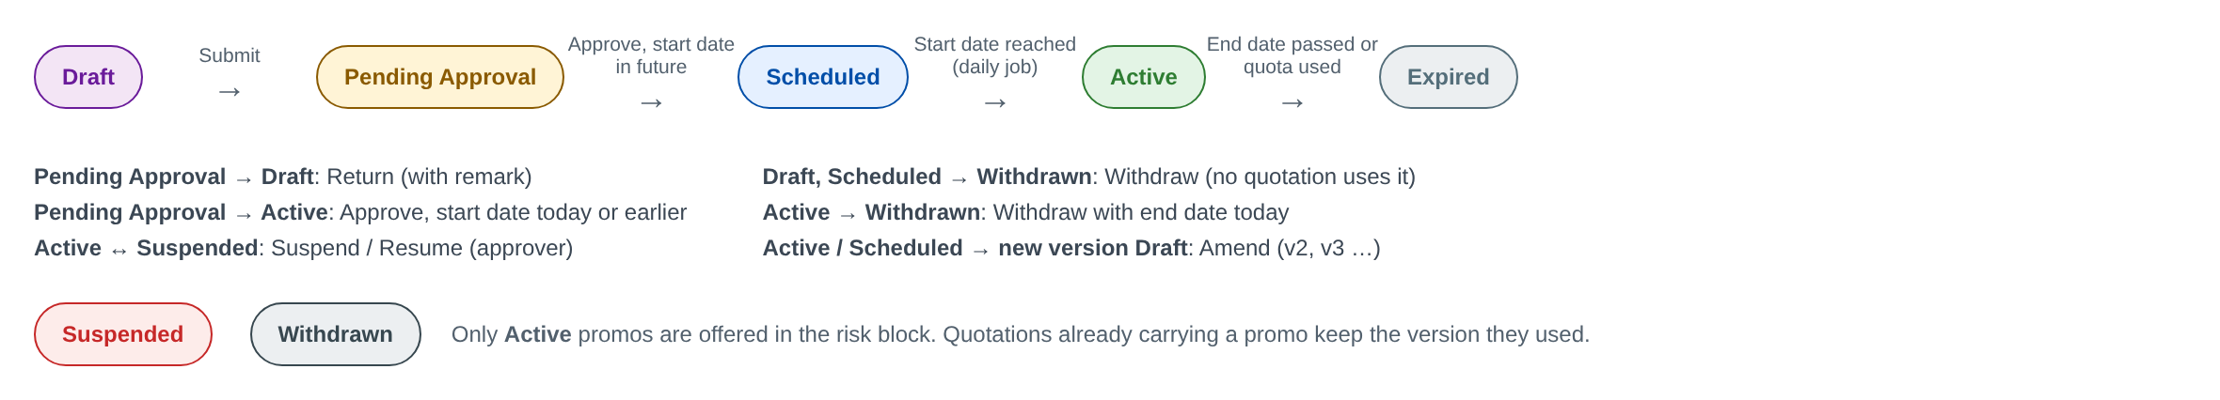
Figure 5: Promo status model
Table 12: Promo status transitions
From | Action / event | To | Who | Condition
(new) | Save Draft | Draft | Product Administrator | Mandatory fields of the General tab
Draft | Submit for Approval | Pending Approval | Product Administrator | All validations pass, including the cap check
Pending Approval | Recall | Draft | Maker | Not yet actioned by an approver
Pending Approval | Return | Draft | Product Approver | Remark mandatory; approver is not the maker
Pending Approval | Approve | Scheduled | Product Approver | Start date in the future
Pending Approval | Approve | Active | Product Approver | Start date is today
Scheduled | Start date reached | Active | System (daily job 00:05) | -
Active | End date passed, or quota used up | Expired | System (daily job, or at booking for quota) | -
Active | Suspend | Suspended | Product Approver | Reason mandatory
Suspended | Resume | Active | Product Approver | End date not passed
Suspended | End date passed | Expired | System | -
Draft, Scheduled, Active, Suspended | Withdraw | Withdrawn | Product Approver | Reason mandatory; end date set to today
Scheduled, Active, Suspended | Amend | New version in Draft | Product Administrator | No other version pending; current version stays in force
Active (old version) | New version approved | Superseded | System | History only

5.2 Discount cap (DISCOUNT_CAP)
Draft -> Pending Approval -> Approved (in force from the effective from date) -> Ended (effective to date passed). A returned cap goes back to Draft. Approved caps are never edited; a change is a new cap with a later effective date, and the old one is end-dated in the same request.

5.3 Promo on a quotation and policy
Table 13: Promo along the policy life cycle
Quotation / policy event | Effect on the promo of each vehicle
Vehicle captured or changed | Eligibility re-run; promo kept, swapped or removed (FR-PRM-020, 021)
Quotation saved / submitted | Cap and threshold checked; route to the cap approver if above the threshold (FR-PRM-023)
Quotation approved and sent | Promo, discount and promo excess shown on the quotation
New quotation version | Promo re-fetched from the current promo version or removed (FR-PRM-024)
Extension | Promo kept if still active; otherwise removed after confirmation (FR-PRM-024)
Lapse / spoil after 30 days | Nothing counted against the promo
Conversion to policy | Brand-new rule, caps and quota re-checked; quota unit reserved (FR-PRM-024)
Policy booked | Unit counted; promo frozen on the policy (FR-PRM-030)
Endorsement | Promo rate used pro-rata; vehicle change removes it (FR-PRM-032)
Flat cancellation | Unit given back (FR-PRM-033)
Renewal | Standard rate, or promo rate within a lock-in (FR-PRM-034)

6 Interfaces
Table 14: Interfaces
Interface | Direction | Promo data | Note
TFS account feed (LEAD-01) | Inbound | Vehicle make / model / variant, year model, vehicle condition (new / used), SRP | Vehicle condition is needed for the brand-new rule
Vehicle Master import (MAS-09) | Inbound (upload) | Variants behind the promo lines | Source: PIRA FMV checker workbook
Placement file / e-mail to the insurer (ISSUE-01) | Outbound | Promo code, promo issuing and remitting rates, promo excess | File-based
Insurer e-policy encode-back (ISSUE-02) | Inbound | Premium and commission as issued | Compared with the premium with promo

7 Configuration items

7.1 Parameters
Table 15: Parameters
Parameter | Meaning | Default | Owner
PRM_MAX_PERIOD_MONTHS | Longest promo period | 12 | Product Administrator
PRM_MAX_LOCKIN_YEARS | Longest lock-in period | 3 | Product Administrator
PRM_NEW_VEHICLE_YEAR_TOLERANCE | Year model tolerance of the brand-new rule | 1 | Product Administrator
PRM_AUTO_SELECT_SINGLE | Pre-select the promo when only one is eligible | No | Product Administrator
PRM_HONOUR_ON_QUOTE_VALIDITY | Keep the promo on an open quotation after the promo ends | Yes | Product Administrator
PRM_HONOUR_ON_EXTENSION | Keep the promo when an ended promo's quotation is extended | No | Product Administrator
PRM_UPLOAD_MAX_ROWS | Rows per variant upload | 2,000 | System Administrator
PRM_GROSS_DISCOUNT_FUNDING | Who bears a gross premium discount | TISPH commission | FGA
PRM_STATUS_JOB_TIME | Time of the daily status job | 00:05 | System Administrator

7.2 Lists of values
Table 16: Lists of values
List | Values
PROMO_BENEFIT_TYPE | Promo rate; Gross premium discount %
PROMO_STATUS | Draft; Pending Approval; Scheduled; Active; Suspended; Expired; Withdrawn; Superseded
VEHICLE_CONDITION | Brand New; Used / Second-hand; Repossessed (ROPA)
PROMO_SUSPEND_REASON | Rate renegotiation with insurer; Budget reached; Campaign paused by Toyota / TFS; Error in set-up; Other
PROMO_RETURN_REASON | Rates not as agreed; Wrong variants; Wrong period; Cap breach; Other
PROMO_OVERRIDE_REASON | Dealer negotiation; Fleet account; Competitive match; Management approval; Other

7.3 Masters maintained by the business
Table 17: Masters
Master | Owner | Approval
Promo Master (promos, variant lines, rates, excess, quota, lock-in) | Product Administrator | Product Approver
Discount Caps (min / max %, floor, threshold, approver role) | Product Administrator | Product Approver
Vehicle Master (MAS-09) | Operations | Per MAS-09
Standard issuing and remitting rates (PROD-12, 13, 16) | Product Administrator / FGA | Per CR-01

8 Traceability

8.1 BRD clause to FR
Table 18: PROD-15 clauses
Clause of TIS-BRD-PROD-15 | FR | Screens
Promo Master (code, description) | FR-PRM-001, 007 | SCR-PRM-01, 02
period start / end | FR-PRM-001, 005, 024 | SCR-PRM-02
applicable vehicle variants | FR-PRM-003 | SCR-PRM-02, 05
rates | FR-PRM-003, 022 | SCR-PRM-02; SCR-QOT-MTR
applying at vehicle level | FR-PRM-020, 021, 025 | SCR-QOT-MTR
for new vehicles only | FR-PRM-020 | SCR-QOT-MTR
flexible issuing and remitting rates | FR-PRM-003, 023, 031 | SCR-PRM-02; SCR-QOT-MTR
the risk block selects the promo | FR-PRM-021 | SCR-QOT-MTR
and auto-fetches the mapped rate | FR-PRM-021 | SCR-QOT-MTR
discounts capped min / max per product and channel | FR-PRM-010, 011, 023 | SCR-PRM-04; SCR-QOT-MTR
applied to gross premium | FR-PRM-022 | SCR-QOT-MTR
MOM Session 2: fixed excess when a promo applies | FR-PRM-001, 022 | SCR-PRM-02; SCR-QOT-MTR

8.2 Related BRD requirements
Table 19: Related requirements
BRD ref. | Relation to PROD-15 | FR
PROD-03, PROD-01 | Registers on maker-checker, versioned configuration | FR-PRM-004, 006
PROD-04, PROD-13 | Standard issuing and remitting rates per product, insurer and agent | FR-PRM-003
PROD-09 | Generic discounts with min / max caps; approval hierarchy on minimum issuing rate | FR-PRM-002, 010, 023
PROD-10 | Excess; fixed promo excess | FR-PRM-022
PROD-11 | Taxes on premium | FR-PRM-022
PROD-12 | FMV rating, 2.0% default; override for about 20 internal users, locked for agents | FR-PRM-022, 023, 041
PROD-16, COMM-05, COMM-06 | Issuing vs remitting rate; sharing | FR-PRM-031
MAS-04, MAS-07, MAS-09 | Insurers, channels, vehicles | FR-PRM-002, 003
LEAD-01, LEAD-04 | TFS feed vehicle data; promo as a lead source | FR-PRM-020, 021
QUOT-02, QUOT-03, QUOT-04 | Rating, approval, versions and validity | FR-PRM-021 to 024
ISSUE-01, ISSUE-02 | Placement and encode-back | FR-PRM-030
ENDT-01 to 03, module 11 | Endorsement and cancellation | FR-PRM-032, 033
RENEW-03, SCHM-03 | Renewal and lock-in | FR-PRM-034
SCHM-01 | Combinability with dealer schemes | FR-PRM-002
SEC-01, SEC-03 | Access and segregation of duties | FR-PRM-004, 041

8.3 FR to test cases
Table 20: Test cases per FR (one per acceptance criterion)
FR | Title | Test cases
FR-PRM-001 | Create a promo with its code, description and period | TC-PRM-001-1 to -5
FR-PRM-002 | Define where a promo applies: products, insurers, channels and conditions | TC-PRM-002-1 to -5
FR-PRM-003 | Map vehicle variants and their promo issuing and remitting rates | TC-PRM-003-1 to -5
FR-PRM-004 | Submit, approve or return a promo (maker-checker) | TC-PRM-004-1 to -4
FR-PRM-005 | Run the promo life cycle: scheduled, active, suspended, expired, withdrawn | TC-PRM-005-1 to -5
FR-PRM-006 | Amend an approved promo as a new version | TC-PRM-006-1 to -3
FR-PRM-007 | Search, view and export promos | TC-PRM-007-1 to -2
FR-PRM-010 | Maintain discount caps per product and channel | TC-PRM-010-1 to -4
FR-PRM-011 | Check every promo line against the caps at set-up | TC-PRM-011-1 to -3
FR-PRM-020 | Decide whether a vehicle is eligible for promos | TC-PRM-020-1 to -4
FR-PRM-021 | Select the promo on the risk block and fetch its mapped rates | TC-PRM-021-1 to -4
FR-PRM-022 | Compute the premium with the promo and the discount on gross premium | TC-PRM-022-1 to -4
FR-PRM-023 | Apply the caps, the flexible issuing rate and the approval route at rating | TC-PRM-023-1 to -4
FR-PRM-024 | Re-validate the promo on new quotation versions, extension, approval and conversion | TC-PRM-024-1 to -3
FR-PRM-025 | Apply promos on fleet and bulk quotations | TC-PRM-025-1 to -1
FR-PRM-030 | Carry the promo to placement, issuance and booking | TC-PRM-030-1 to -2
FR-PRM-031 | Remit at the promo remitting rate and compute commission and sharing | TC-PRM-031-1 to -2
FR-PRM-032 | Process endorsements on a policy with a promo | TC-PRM-032-1 to -2
FR-PRM-033 | Cancel a policy with a promo | TC-PRM-033-1 to -2
FR-PRM-034 | Renew a policy that carried a promo | TC-PRM-034-1 to -2
FR-PRM-040 | Keep a complete audit trail of promos, caps and their use | TC-PRM-040-1 to -2
FR-PRM-041 | Control access to promo functions | TC-PRM-041-1 to -2

9 Navigation

9.1 Screens of PROD-15
Table 21: Screens
Code | Screen | Menu path | Type
SCR-PRM-01 | Promo Master list | Product Configurator > Promo Master | New
SCR-PRM-02 | Promo Master record (General, Applicability, Vehicle Variants & Rates, Approval & History) | Promo Master > open or + New Promo | New
SCR-PRM-03 | Promo approval | My Approvals > Promo | New (standard approval page)
SCR-PRM-04 | Discount Caps list and record | Product Configurator > Discount Caps | New
SCR-PRM-05 | Upload Variant Mapping | Promo Master > Upload Variant Mapping, or the Upload button of the Vehicle Variants & Rates tab | New (standard upload page)
SCR-QOT-MTR | Motor quotation risk block - Promotion section and premium breakdown | Sales > Quotations > Motor quotation > Vehicle | Change to an existing screen

9.2 Menu by persona
Table 22: Menu by persona
Persona | Menu entries for promos
Product Administrator | Product Configurator > Promo Master, Discount Caps
Product Approver | My Approvals (promos and caps); Product Configurator > Promo Master, Discount Caps (view and lifecycle actions)
Sales Officer / Telesales | Sales > Quotations (Promotion section); Product Configurator > Promo Master (view)
Agent / TFS team member / Referral | Sales > Quotations (Promotion section, select only)
Quotation Approver | My Approvals (quotations with promo); Promo Master (view)
Operations | Quotations, Policies, Endorsements (Promo panel); Promo Master (view)
FGA | Remittance and commission (promo remitting rate shown per policy)
Auditor | Promo Master and Discount Caps (view); audit log

10 Screen specifications
One specification per screen. The pictures are design mock-ups made for this FRS; the screens will follow the BrokerVerse standards, and the as-built screenshots replace them in the as-built refresh of this document. The numbered markers on each picture match the No. column of the field table.

10.1 SCR-PRM-01 Promo Master list
Purpose | Find a promo, see its status, period and usage at a glance, and start a new promo or an upload.
Who can open it | Product Administrator, Product Approver, Sales, Quotation Approver, Operations, FGA, Auditor (PROMO_VIEW)
Navigation | - Product Configurator > Promo Master  - Links from a quotation or policy Promo panel
FRs | FR-PRM-001, 005, 007

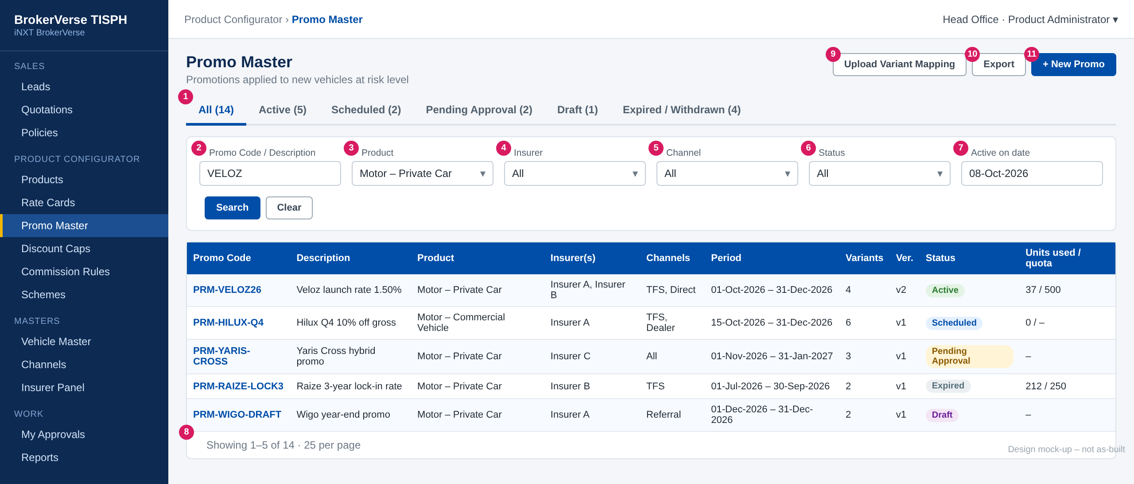
Figure 6: SCR-PRM-01 Promo Master list (design mock-up)
No. | Section | Field | Type | Mand. | Source / list | Default | Validation and message
1 | Tabs | All / Active / Scheduled / Pending Approval / Draft / Expired-Withdrawn | Tab | - | PROMO_STATUS | All | Each tab filters on status; the count is shown
2 | Filters | Promo Code / Description | Text | N | - | Blank | Contains search
3 | Filters | Product | List | N | Products (Motor) | All
4 | Filters | Insurer | List | N | Insurer Panel | All
5 | Filters | Channel | List | N | Channels | All
6 | Filters | Status | List | N | PROMO_STATUS | All
7 | Filters | Active on date | Date | N | - | Blank | Promos whose period covers the date
8 | List | Columns: code, description, product, insurers, channels, period, variants, version, status, units used / quota | Table | - | Promo Master | - | Code opens SCR-PRM-02; 25 rows per page
9-11 | Header | Upload Variant Mapping, Export, + New Promo | Button | - | - | - | See actions

Button | Who sees it | Enabled when | What happens | Result
+ New Promo | PROMO_MAINTAIN | Always | Opens an empty SCR-PRM-02 | Draft (on save)
Upload Variant Mapping | PROMO_MAINTAIN | Always | Opens SCR-PRM-05 | -
Export | PROMO_VIEW | List not empty | Downloads promos and lines (.xlsx) | -
Copy (row menu) | PROMO_MAINTAIN | Any promo | New Draft copied, blank code and period | Draft

10.2 SCR-PRM-02 Promo Master record
Purpose | Create, maintain, submit and amend a promo; see its versions and history.
Who can open it | Edit: Product Administrator (PROMO_MAINTAIN). Lifecycle actions: Product Approver (PROMO_LIFECYCLE). View: PROMO_VIEW
Navigation | Promo Master > code link or + New Promo
FRs | FR-PRM-001 to 006, 011

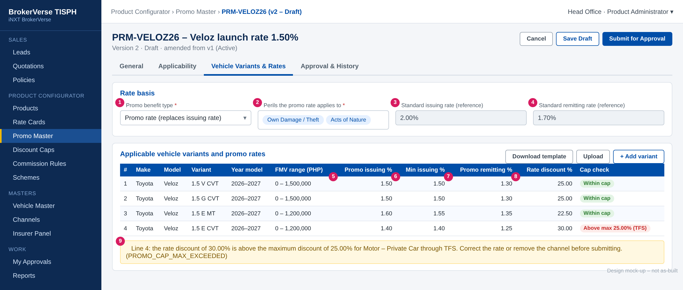
Figure 7: SCR-PRM-02 Vehicle Variants & Rates tab with a line above the cap (design mock-up)
General tab
No. | Section | Field | Type | Mand. | Source / list | Default | Validation and message
- | General | Promo Code | Text | Y | - | - | A-Z, 0-9, hyphen; 3-20; unique; read-only after first save. PROMO_CODE_FORMAT / PROMO_CODE_DUPLICATE
- | General | Description | Text 100 | Y | - | - | PROMO_DESC_REQUIRED
- | General | Period Start / Period End | Date | Y | - | - | End >= start; start >= today; <= 12 months. PROMO_PERIOD_INVALID / PROMO_START_IN_PAST / PROMO_PERIOD_TOO_LONG
1 | General | Promo benefit type | List | Y | PROMO_BENEFIT_TYPE | Promo rate | Not editable after approval
- | General | Promo excess - Private Car / Commercial Vehicle / Motorcycle | Amount | N | - | 2,000 / 3,000 / blank | Blank = 5% excess applies
- | General | Unit quota | Number | N | - | Blank | Whole number >= 1. PROMO_QUOTA_INVALID
- | General | Lock-in period (years) | Number | N | - | Blank | 1-3. PROMO_LOCKIN_RANGE
- | General | Remarks | Text 500 | N | - | -

Applicability tab
No. | Section | Field | Type | Mand. | Source / list | Default | Validation and message
- | Applicability | Products | Multi-select | Y | Products (Motor, Comprehensive) | - | PROMO_PRODUCT_REQUIRED / PROMO_PRODUCT_NOT_MOTOR
- | Applicability | Insurers | Multi-select | Y | Insurer Panel | - | PROMO_INSURER_REQUIRED
- | Applicability | Channels | Multi-select | Y | Channels | - | PROMO_CHANNEL_REQUIRED; cap must exist (on submit)
- | Applicability | Offices | Multi-select | N | Offices & Branches | All
- | Applicability | Vehicle condition | Display | - | - | Brand New | Fixed
2 | Applicability | Perils the promo rate applies to | Multi-select | Y | MOTOR_PERILS | OD / Theft, AON
- | Applicability | Combinable with scheme / with additional discount | Yes / No | Y | - | No / No

Vehicle Variants & Rates tab (one row per line)
No. | Section | Field | Type | Mand. | Source / list | Default | Validation and message
3, 4 | Rate basis | Standard issuing / remitting rate | Display | - | Rate card, commission rules | 2.00 / 1.70 | Reference only
- | Line | Make / Model / Variant | Type-ahead | Y | Vehicle Master | - | Active variant. PROMO_VARIANT_INACTIVE
- | Line | Year model from / to | Year | Y | - | Current year / +1 | PROMO_YEAR_RANGE_INVALID
- | Line | FMV from / to | Amount | N | - | Blank | PROMO_FMV_RANGE_INVALID
- | Line | Insurer | List | N | Insurers of the promo | All | No overlap. PROMO_VARIANT_DUPLICATE
5 | Line | Promo issuing % | Rate 4 dec. | Cond. | - | - | Promo rate type. PROMO_RATE_REQUIRED / PROMO_RATE_RANGE / PROMO_ISSUE_NOT_BELOW_STANDARD
6 | Line | Min issuing % | Rate 4 dec. | Cond. | - | = promo issuing | PROMO_MIN_ABOVE_ISSUE
7 | Line | Promo remitting % | Rate 4 dec. | Cond. | - | - | PROMO_REMIT_ABOVE_ISSUE
- | Line | Discount % / Max discount % | Rate 2 dec. | Cond. | - | - | Discount type. PROMO_DISCOUNT_PCT_REQUIRED
8 | Line | Rate discount % | Display | - | Computed | - | (standard - min issuing) / standard x 100
- | Line | Cap check | Tag | - | Computed per channel | - | Within cap / Above max / Below min / Below floor
9 | Messages | Cap check message | Banner | - | - | - | PROMO_CAP_MAX_EXCEEDED / PROMO_CAP_MIN_NOT_MET / PROMO_BELOW_MIN_ISSUING

Button | Who sees it | Enabled when | What happens | Result
Save Draft | PROMO_MAINTAIN | Draft | Validates fields and saves | Draft
Submit for Approval | PROMO_MAINTAIN | Draft, no errors | Full validation and cap check | Pending Approval
Recall | Maker | Pending Approval | Takes the version back | Draft
Amend | PROMO_MAINTAIN | Scheduled, Active, Suspended | Creates version n+1 | Draft (new version)
Suspend / Resume | PROMO_LIFECYCLE | Active / Suspended | Reason dialog; warning on open quotations | Suspended / Active
Withdraw | PROMO_LIFECYCLE | Draft, Scheduled, Active, Suspended | Reason dialog; end date = today | Withdrawn
Delete | Maker | Draft v1 never submitted | Deletes the promo | -

10.3 SCR-PRM-03 Promo approval
Purpose | Review a submitted promo or amendment and approve or return it.
Who can open it | Product Approver (PROMO_APPROVE), never the maker
Navigation | My Approvals > Promo
FRs | FR-PRM-004, 006, 011

The standard BrokerVerse approval page, showing the promo tabs read-only. For an amendment, every changed field and line is highlighted with its old value. The cap check of each line is shown again.
Button | Who sees it | Enabled when | What happens | Result
Approve | PROMO_APPROVE, not maker | Pending Approval; start date not passed | Records approver; sets Scheduled or Active | Scheduled / Active
Return | PROMO_APPROVE, not maker | Pending Approval | Remark mandatory | Draft

10.4 SCR-PRM-04 Discount Caps
Purpose | Maintain the min / max discount, the rate floor and the approval threshold per product and channel.
Who can open it | Product Administrator (maintain), Product Approver (approve), PROMO_VIEW (view)
Navigation | Product Configurator > Discount Caps
FRs | FR-PRM-010, 011, 023

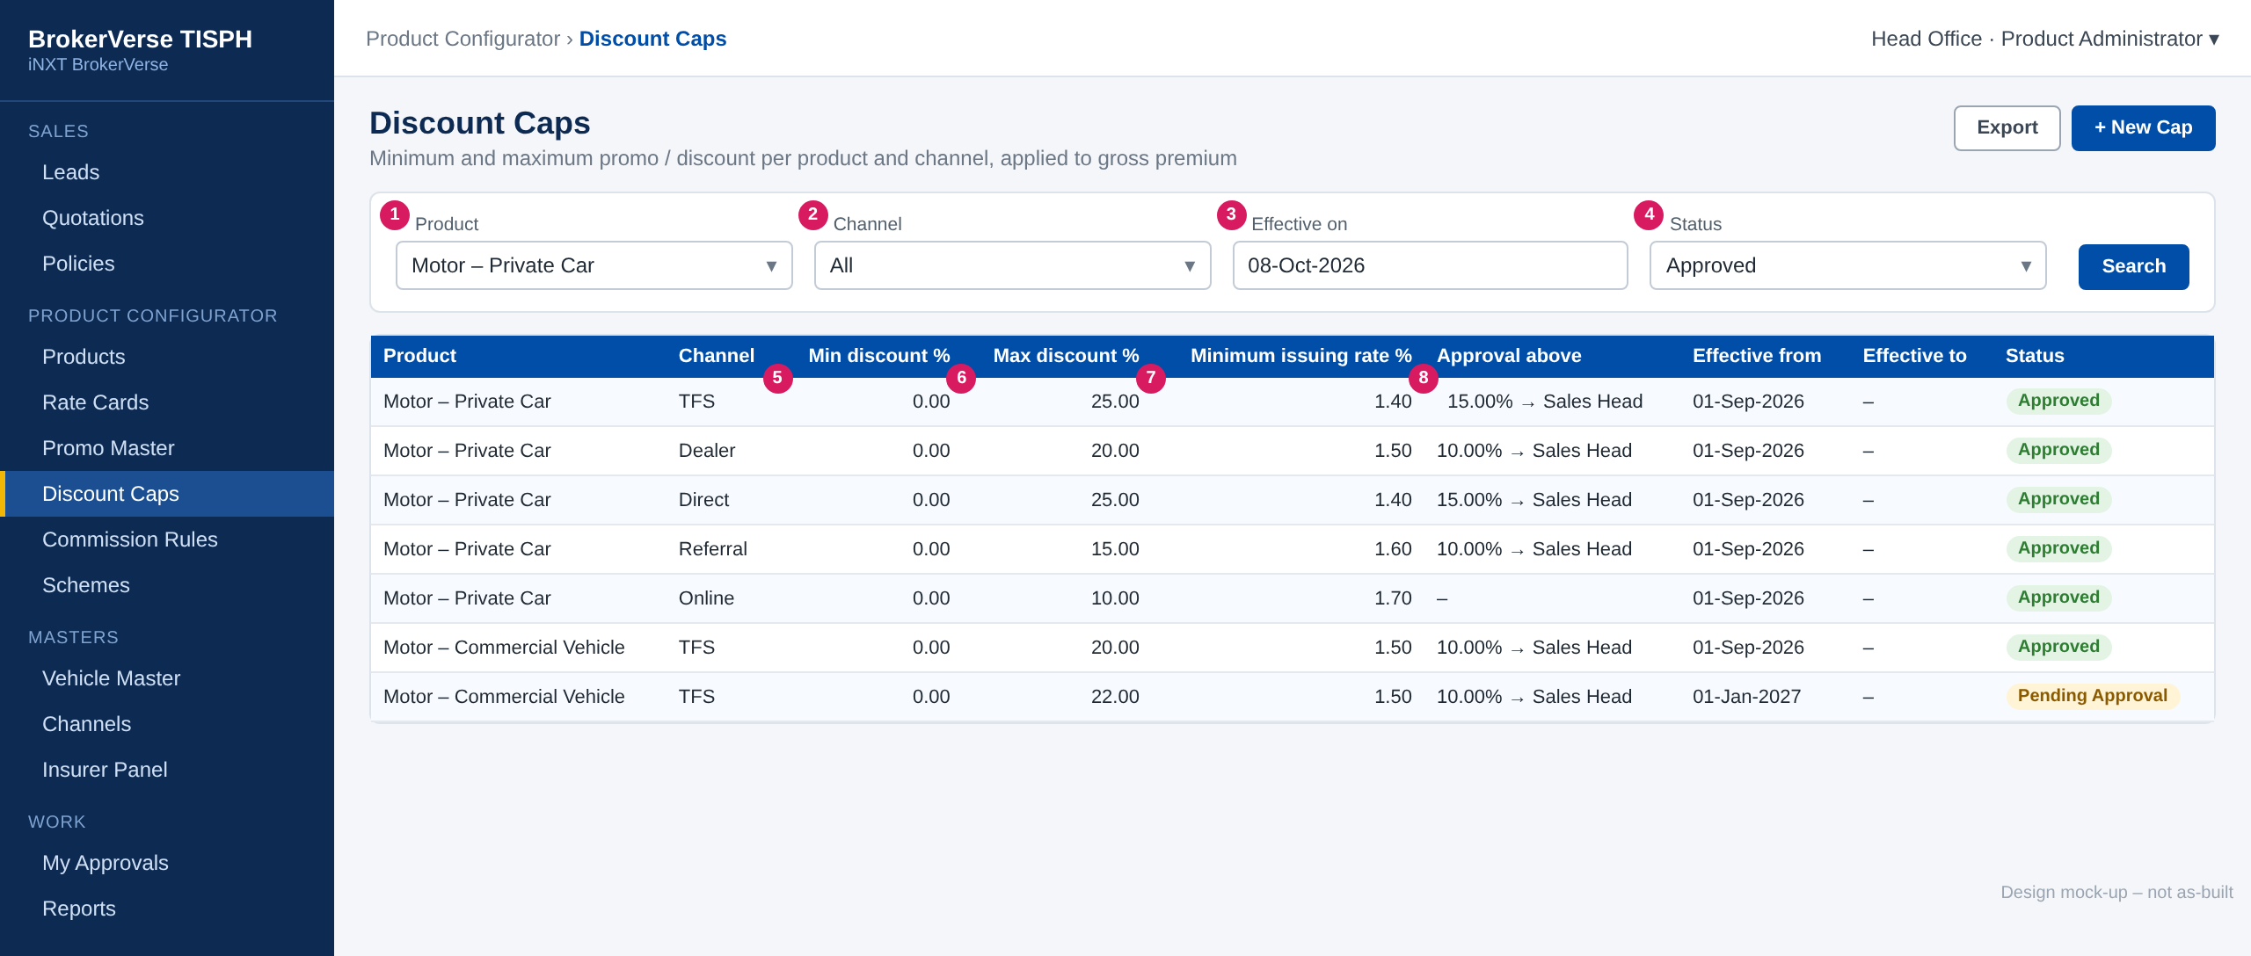
Figure 8: SCR-PRM-04 Discount Caps (design mock-up, illustrative values)
No. | Section | Field | Type | Mand. | Source / list | Default | Validation and message
1 | Filters | Product | List | N | Products | All
2 | Filters | Channel | List | N | Channels | All
3 | Filters | Effective on | Date | N | - | Today
4 | Filters | Status | List | N | Draft, Pending, Approved, Ended | Approved
5 | Record | Min discount % | Rate 2 dec. | Y | - | 0.00 | CAP_RANGE / CAP_MIN_ABOVE_MAX
6 | Record | Max discount % | Rate 2 dec. | Y | - | - | CAP_RANGE
7 | Record | Minimum issuing rate % | Rate 4 dec. | Y | - | - | CAP_REQUIRED_FIELDS
8 | Record | Approval threshold % and approver role | Rate + list | N | Roles | - | CAP_THRESHOLD_RANGE
- | Record | Effective from / to | Date | Y / N | - | Today | CAP_FROM_IN_PAST / CAP_OVERLAP

Button | Who sees it | Enabled when | What happens | Result
+ New Cap | DISCOUNT_CAP_MAINTAIN | Always | Opens the cap form; shows promos affected | Pending Approval (on submit)
Approve / Return | DISCOUNT_CAP_APPROVE, not maker | Pending Approval | Approves or returns | Approved / Draft
End-date | DISCOUNT_CAP_MAINTAIN | Approved | Sets the effective to date (needs approval) | Pending Approval

10.5 SCR-PRM-05 Upload Variant Mapping
Purpose | Load many promo lines at once from Excel.
Who can open it | Product Administrator (PROMO_MAINTAIN)
Navigation | - Promo Master > Upload Variant Mapping  - Vehicle Variants & Rates tab > Upload
FRs | FR-PRM-003

Standard BrokerVerse upload page: the user picks the promo (Draft only), chooses Add or Replace, downloads the template, uploads the .xlsx and receives the result file. The template is in chapter 13.

10.6 SCR-QOT-MTR Motor risk block - Promotion section
Purpose | Select a promo for the vehicle, see the fetched rates, the discount, the promo excess and the premium side by side.
Who can open it | Sales, Agents (select only), Quotation Approver, Operations (PROMO_SELECT)
Navigation | Sales > Quotations > Motor quotation > Vehicle n
FRs | FR-PRM-020 to 025

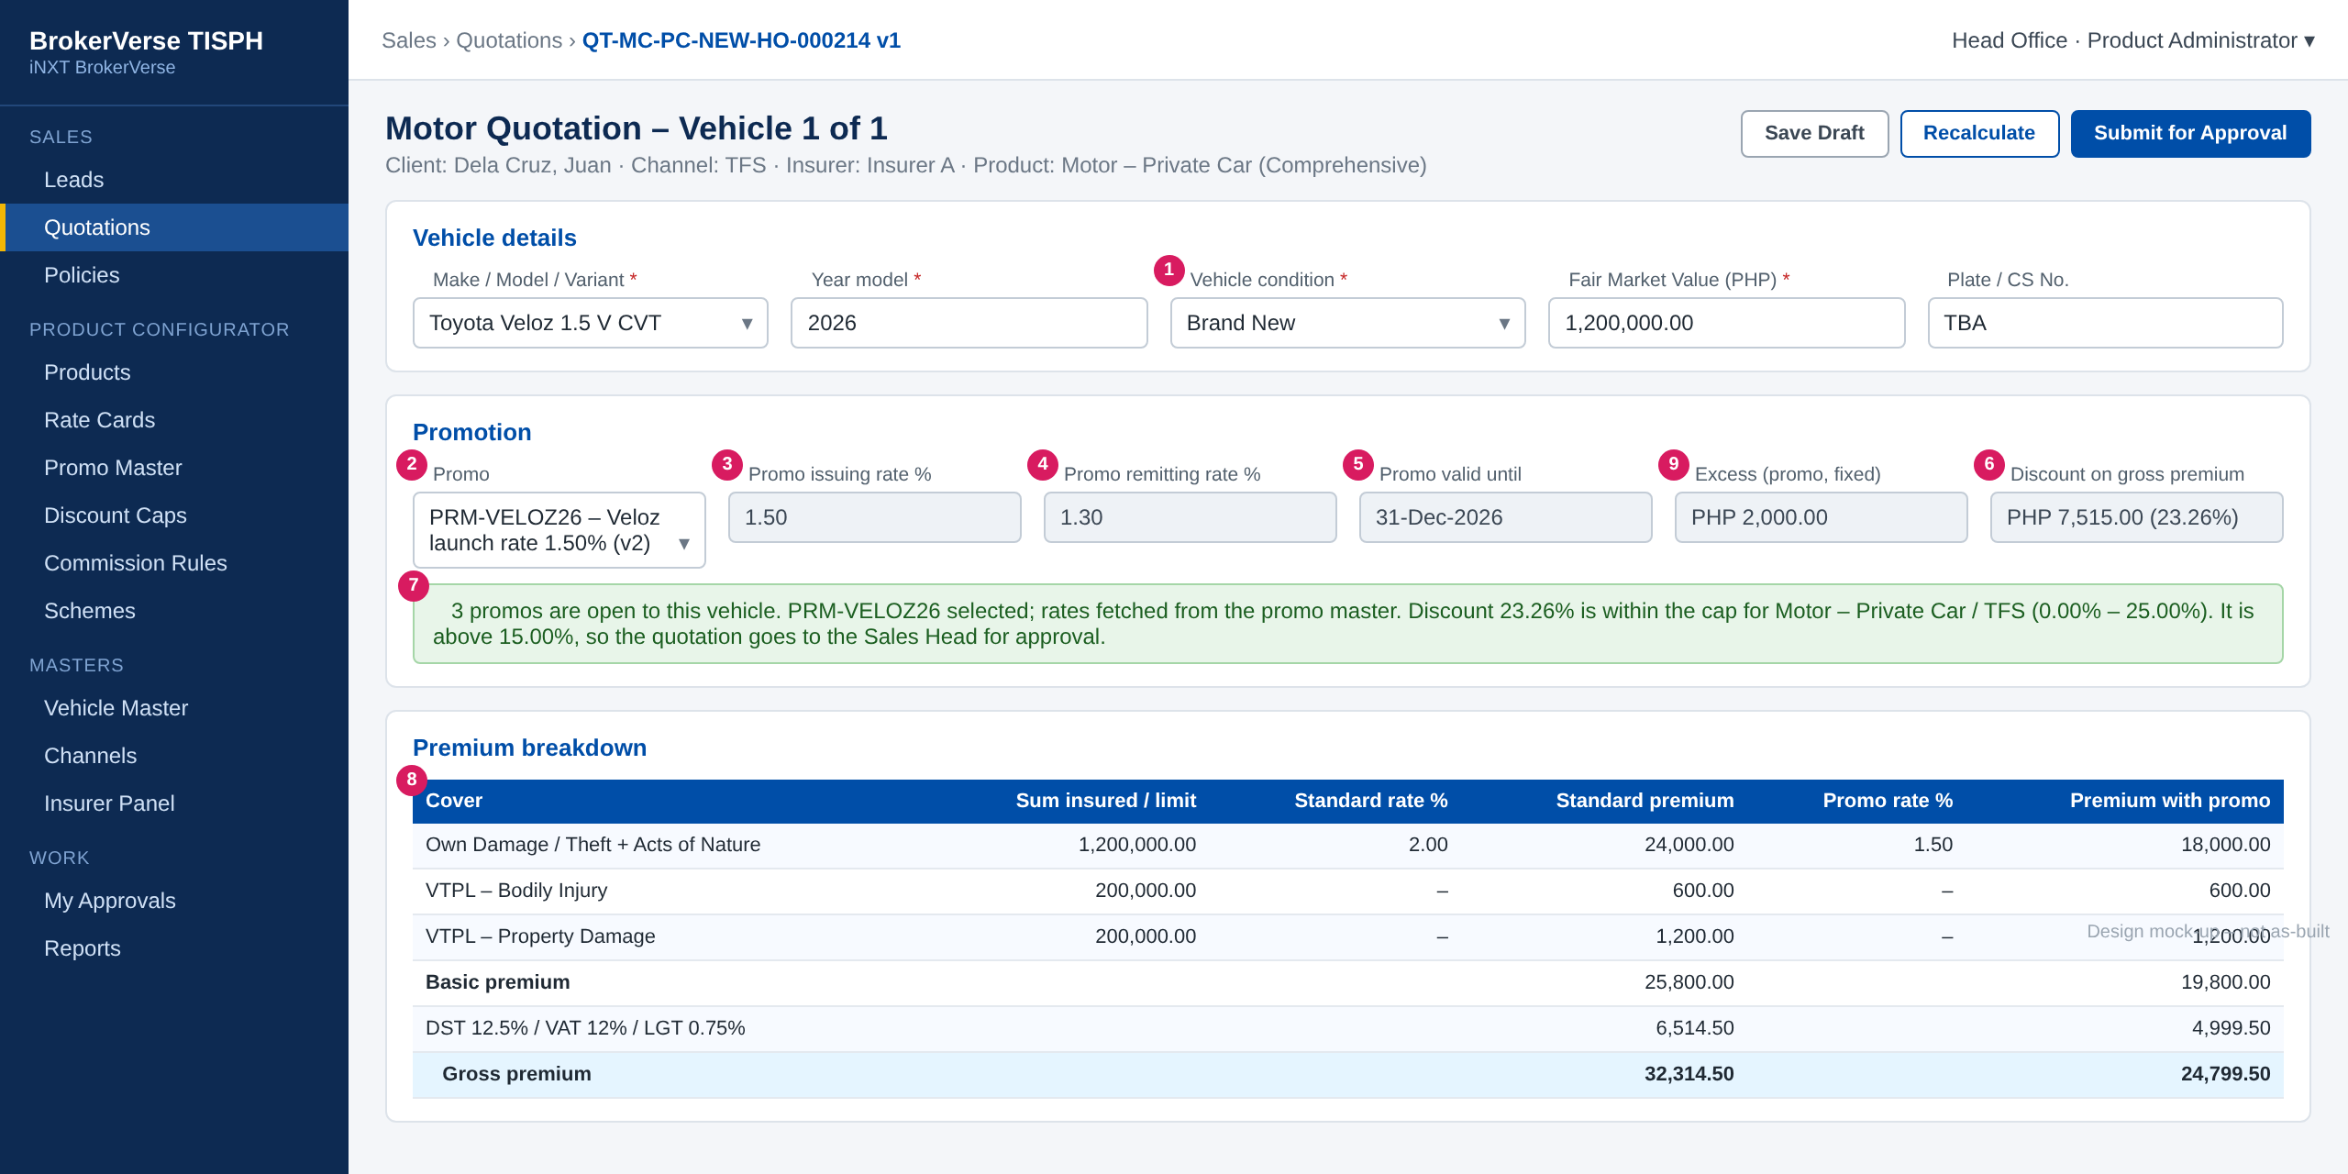
Figure 9: SCR-QOT-MTR Promotion section and premium breakdown (design mock-up)
No. | Section | Field | Type | Mand. | Source / list | Default | Validation and message
1 | Vehicle | Vehicle condition | List | Y | VEHICLE_CONDITION | From TFS feed | Read-only for TFS leads
2 | Promotion | Promo | List | N | Eligible active promos | Blank (or single, if parameter) | PROMO_NOT_ELIGIBLE / PROMO_NOT_NEW_VEHICLE / PROMO_QUOTA_REACHED / PROMO_NOT_COMBINABLE
3 | Promotion | Promo issuing rate % | Rate | - | Promo line | Fetched | Editable with PROMO_RATE_OVERRIDE only, between line minimum and promo rate. PROMO_RATE_LOCKED / PROMO_RATE_BELOW_MIN
4 | Promotion | Promo remitting rate % | Display | - | Promo line | Fetched | Hidden from external agents
5 | Promotion | Promo valid until | Display | - | Promo | -
9 | Promotion | Excess (promo, fixed) | Display | - | Promo General tab | PC 2,000 / CV 3,000 | Replaces 5% excess
6 | Promotion | Discount on gross premium | Display | - | Computed | - | PROMO_CAP_EXCEEDED_QUOTE / PROMO_CAP_MIN_QUOTE
7 | Promotion | Status banner | Banner | - | - | - | PROMO_RATE_FETCHED / PROMO_APPROVAL_ROUTED
8 | Premium | Breakdown: standard vs with promo | Table | - | Rating engine | -
- | Promotion | Override reason | List + text | Cond. | PROMO_OVERRIDE_REASON | - | Mandatory when the rate is changed

Button | Who sees it | Enabled when | What happens | Result
Recalculate | PROMO_SELECT | Draft quotation | Re-rates with the selected promo | -
Submit for Approval | Quotation maker | No blocking error | Routes to the cap approver role if above the threshold | Pending Approval

11 End-to-end walkthroughs
The walkthroughs follow one case through the screens, persona by persona. They use the illustrative data of the examples and are the script of the PROD-15 SIT and UAT sessions.

11.1 WT-A Launch a promo
Table 23: WT-A steps
Step | Who | Does | Sees / result
1 | Product Administrator | Checks Discount Caps for Private Car - TFS and Direct | TFS 0-25%, floor 1.40%, threshold 15% -> Sales Head; Direct 0-25%
2 | Product Administrator | Creates PRM-VELOZ26 "Veloz launch rate 1.50%", 01-Oct to 31-Dec-2026, Promo rate, excess PC 2,000, quota 500 | Draft v1 saved
3 | Product Administrator | Applicability: Private Car; Insurer A and B; TFS and Direct | Saved; caps found
4 | Product Administrator | Uploads 4 Veloz variant lines | 4 lines loaded; line 4 (1.40%) flagged Above max 25.00% (TFS)
5 | Product Administrator | Changes line 4 to 1.50 / 1.50 / 1.30 and submits | Pending Approval
6 | Product Approver | Opens My Approvals, reviews and approves on 25-Sep-2026 | Scheduled
7 | System | Daily job on 01-Oct-2026 | Active; offered on the risk block

11.2 WT-B Quote, issue and remit a vehicle with a promo
Table 24: WT-B steps
Step | Who | Does | Sees / result
1 | Sales Officer | Opens the TFS lead of Juan Dela Cruz and creates a Motor quotation with Insurer A | Vehicle from TFS: Veloz 1.5 V CVT, 2026, Brand New, FMV 1,200,000
2 | Sales Officer | Opens the Promo list | PRM-VELOZ26 and two other promos listed
3 | Sales Officer | Selects PRM-VELOZ26 | Rates 1.50 / 1.30 fetched; excess 2,000; standard 32,314.50, with promo 24,799.50; discount 7,515.00 (23.26%); routed to Sales Head
4 | Sales Officer | Submits | Pending approval with the Sales Head (discount above 15%)
5 | Sales Head | Approves | Quotation sent to the client with the promo and discount
6 | Operations | Records acceptance and converts to policy with chassis and engine numbers | Brand-new rule passed; quota unit reserved
7 | Operations | Sends the placement file; receives and checks the e-policy; books | Policy shows PRM-VELOZ26 v1; units used +1; premium 24,799.50
8 | FGA | Runs the Monday remittance | Net remittance 22,399.50; rate spread 2,400.00; sharing per PROD-16

11.3 WT-C Exceptions
Table 25: WT-C exception cases
Case | Who | Does | Sees / result
C1 Used vehicle | Sales Officer | Quotes a 2024 Fortuner, condition Used | PROMO_NONE_ELIGIBLE; Promo field disabled
C2 Agent tries to change rate | External agent | Clicks the promo issuing rate | PROMO_RATE_LOCKED
C3 Flexible rate | Authorised Sales Officer | On Veloz 1.5 E MT (promo 1.60%, min 1.55%) enters 1.50%, then 1.55% with reason "Fleet account" | PROMO_RATE_BELOW_MIN, then accepted and logged
C4 Extension after promo end | Sales Officer | Extends a 20-Dec-2026 quotation on 19-Jan-2027 | PROMO_EXTENSION_ENDED; re-rated at 2.00% on confirmation
C5 Vehicle replaced by endorsement | Operations | Replaces the insured unit | PROMO_ENDORSE_VEHICLE_CHANGE; new unit at 2.00%
C6 Renewal | System | Renewal run 90 days before expiry of the Veloz policy | Renewal quotation at 2.00% on current FMV; 5% excess
C7 Cap lowered | Product Administrator | Submits TFS max 20% from 01-Dec-2026 | CAP_AFFECTS_PROMOS lists PRM-VELOZ26 lines; after approval new ratings above 20% are refused

11.4 WT-D Gross premium discount promo
Table 26: WT-D steps
Step | Who | Does | Sees / result
1 | Product Administrator | Sets up PRM-HILUX-Q4: Commercial Vehicle, TFS and Dealer, Gross premium discount 10%, excess CV 3,000 | Line max 10% within both caps; approved
2 | Sales Officer | Quotes a new Hilux, FMV 1,800,000, through TFS | Standard gross 47,908.13; discount 4,790.81; payable 43,117.32
3 | FGA | Remits after payment | Net remittance 42,508.13 (standard); TISPH commission 5,400.00 - 4,790.81 = 609.19 (default funding)

12 Messages catalogue
Every message a user can see for PROD-15, grouped by the screen or dialog that shows it. 77 messages: 9 confirmation, 35 error, 3 information, 23 validation, 7 warning. Text in angle brackets is filled in by the system. Server messages also show the code as the Reference.

12.1 SCR-PRM-02 Promo Master record
ID | Code (Reference) | Message | Type | What the user does
MSG-PRM-001 | PROMO_CODE_REQUIRED | Enter the promo code | Validation | Enter a code.
MSG-PRM-002 | PROMO_CODE_FORMAT | The promo code may contain only capital letters, numbers and hyphens, up to 20 characters | Validation | Correct the code.
MSG-PRM-003 | PROMO_CODE_DUPLICATE | Promo code <code> already exists | Error | Use another code, or amend the existing promo.
MSG-PRM-004 | PROMO_DESC_REQUIRED | Enter the promo description | Validation | Enter a description.
MSG-PRM-005 | PROMO_PERIOD_INVALID | The period end must be on or after the period start | Validation | Correct the dates.
MSG-PRM-006 | PROMO_START_IN_PAST | The period start cannot be before today | Error | Enter today or a later date. Promos are never retroactive.
MSG-PRM-007 | PROMO_PERIOD_TOO_LONG | A promo period cannot be longer than <n> months | Error | Shorten the period or ask the System Administrator to review the parameter.
MSG-PRM-008 | PROMO_PRODUCT_REQUIRED | Select at least one product | Validation | Select the Motor product(s).
MSG-PRM-009 | PROMO_PRODUCT_NOT_MOTOR | Promos apply to Motor products only | Error | Remove the non-Motor product.
MSG-PRM-010 | PROMO_INSURER_REQUIRED | Select at least one insurer | Validation | Select the insurer(s) that agreed the promo rates.
MSG-PRM-011 | PROMO_CHANNEL_REQUIRED | Select at least one channel | Validation | Select the channel(s).
MSG-PRM-012 | PROMO_VARIANT_REQUIRED | Add at least one vehicle variant | Validation | Add a variant line or upload the mapping.
MSG-PRM-013 | PROMO_VARIANT_INACTIVE | Variant <variant> is inactive in the Vehicle Master | Error | Remove the line or ask for the variant to be re-activated.
MSG-PRM-014 | PROMO_VARIANT_DUPLICATE | Variant <variant> is listed more than once for overlapping year models and insurers | Error | Merge or correct the lines.
MSG-PRM-015 | PROMO_YEAR_RANGE_INVALID | Line <n>: the year model to must be on or after the year model from | Validation | Correct the year models.
MSG-PRM-016 | PROMO_FMV_RANGE_INVALID | Line <n>: the FMV to must be higher than the FMV from | Validation | Correct the FMV range.
MSG-PRM-017 | PROMO_RATE_REQUIRED | Enter the promo issuing and remitting rates of line <n> | Validation | Enter both rates.
MSG-PRM-018 | PROMO_RATE_RANGE | Line <n>: rates must be more than 0% and at most 100%, with up to 4 decimals | Validation | Correct the rate.
MSG-PRM-019 | PROMO_REMIT_ABOVE_ISSUE | Line <n>: the promo remitting rate cannot be higher than the promo issuing rate | Error | Correct the remitting rate with the insurer-agreed value.
MSG-PRM-020 | PROMO_MIN_ABOVE_ISSUE | Line <n>: the minimum issuing rate cannot be higher than the promo issuing rate | Error | Lower the minimum issuing rate or leave it equal to the promo rate.
MSG-PRM-021 | PROMO_ISSUE_NOT_BELOW_STANDARD | Line <n>: the promo issuing rate is not lower than the standard issuing rate of <rate>% | Warning | Check the rate; the promo gives no discount on this line.
MSG-PRM-022 | PROMO_DISCOUNT_PCT_REQUIRED | Line <n>: enter the gross premium discount % | Validation | Enter the discount.
MSG-PRM-023 | PROMO_CAP_NOT_DEFINED | No approved discount cap is set up for <product> through <channel> | Error | Ask the Product Administrator to set up the cap, or remove the channel.
MSG-PRM-024 | PROMO_CAP_MAX_EXCEEDED | Line <n>: the rate discount of <x>% is above the maximum discount of <max>% for <product> through <channel> | Error | Correct the rate or remove the channel before submitting.
MSG-PRM-025 | PROMO_CAP_MIN_NOT_MET | Line <n>: the rate discount of <x>% is below the minimum discount of <min>% for <product> through <channel> | Error | Correct the rate or remove the channel.
MSG-PRM-026 | PROMO_BELOW_MIN_ISSUING | Line <n>: the rate of <r>% is below the minimum issuing rate of <floor>% for <product> through <channel> | Error | Raise the rate to the floor or above.
MSG-PRM-027 | PROMO_QUOTA_INVALID | The unit quota must be a whole number of 1 or more | Validation | Correct the quota or leave it blank for no quota.
MSG-PRM-028 | PROMO_LOCKIN_RANGE | The lock-in period must be between 1 and <n> years | Validation | Correct the lock-in period.
MSG-PRM-029 | PROMO_NOT_EDITABLE | Promo <code> is <status> and cannot be changed. Use Amend to create a new version | Error | Click Amend.
MSG-PRM-030 | PROMO_PENDING_VERSION_EXISTS | Promo <code> already has version <n> in Draft or Pending Approval | Error | Open and finish that version first.
MSG-PRM-031 | PROMO_SAVED | Promo <code> v<n> saved as draft | Confirmation | No action.
MSG-PRM-032 | PROMO_SUBMITTED | Promo <code> v<n> submitted for approval | Confirmation | No action.

12.2 SCR-PRM-03 Promo approval
ID | Code (Reference) | Message | Type | What the user does
MSG-PRM-033 | PROMO_SELF_APPROVAL | You cannot approve or return a promo you created or amended | Error | Leave it to another approver.
MSG-PRM-034 | PROMO_RETURN_REMARK | Enter the reason for returning the promo | Validation | Enter a remark.
MSG-PRM-035 | PROMO_APPROVE_START_PASSED | The period start <date> has passed. Return the promo so the maker can correct the period | Error | Return the promo.
MSG-PRM-036 | PROMO_APPROVED | Promo <code> v<n> approved. Status: <status> | Confirmation | No action.
MSG-PRM-037 | PROMO_RETURNED | Promo <code> v<n> returned to <maker> | Confirmation | No action.

12.3 SCR-PRM-02 Lifecycle dialogs
ID | Code (Reference) | Message | Type | What the user does
MSG-PRM-038 | PROMO_ACTION_REMARK | Enter the reason | Validation | Enter a remark.
MSG-PRM-039 | PROMO_SUSPENDED | Promo <code> suspended. It is no longer offered in the risk block | Confirmation | No action.
MSG-PRM-040 | PROMO_RESUMED | Promo <code> resumed | Confirmation | No action.
MSG-PRM-041 | PROMO_WITHDRAWN | Promo <code> withdrawn with end date <date> | Confirmation | No action.
MSG-PRM-042 | PROMO_OPEN_QUOTES | <n> open quotation(s) carry this promo. They keep it until their validity ends | Warning | Confirm, or cancel and review the quotations first.

12.4 SCR-PRM-05 Upload Variant Mapping
ID | Code (Reference) | Message | Type | What the user does
MSG-PRM-043 | UPLOAD_FILE_TYPE | Upload an Excel (.xlsx) file | Validation | Save the file as .xlsx and upload again.
MSG-PRM-044 | UPLOAD_TEMPLATE_INVALID | The file does not match the Promo Variant Mapping template: <column> is missing | Error | Download the template and copy the rows into it.
MSG-PRM-045 | UPLOAD_MAX_ROWS | The file has more than <max> rows | Error | Split the file.
MSG-PRM-046 | UPLOAD_ROW_ERROR | Row <n>: <message> | Error | Correct the row in the result file and upload the corrected rows.
MSG-PRM-047 | UPLOAD_DONE | <n> line(s) loaded, <m> rejected. Download the result file for the rejected rows | Confirmation | Download the result file when rows were rejected.

12.5 SCR-PRM-04 Discount Caps
ID | Code (Reference) | Message | Type | What the user does
MSG-PRM-048 | CAP_REQUIRED_FIELDS | Enter the product, channel, minimum and maximum discount, minimum issuing rate and effective from date | Validation | Complete the fields.
MSG-PRM-049 | CAP_RANGE | Discount caps must be between 0% and 100% | Validation | Correct the value.
MSG-PRM-050 | CAP_MIN_ABOVE_MAX | The minimum discount cannot be higher than the maximum discount | Validation | Correct the values.
MSG-PRM-051 | CAP_THRESHOLD_RANGE | The approval threshold must be between the minimum and the maximum discount | Validation | Correct the threshold.
MSG-PRM-052 | CAP_OVERLAP | An approved cap for <product> through <channel> already covers <date> | Error | End-date the existing cap first, or start the new cap after it.
MSG-PRM-053 | CAP_FROM_IN_PAST | The effective from date cannot be before today | Error | Enter today or a later date.
MSG-PRM-054 | CAP_SELF_APPROVAL | You cannot approve a cap you created or changed | Error | Leave it to another approver.
MSG-PRM-055 | CAP_AFFECTS_PROMOS | <n> line(s) of active promos would be outside the new cap: <list>. These lines will not be offered from <date> | Warning | Confirm, or amend the promos first.
MSG-PRM-056 | CAP_SAVED | Discount cap for <product> through <channel> submitted for approval | Confirmation | No action.

12.6 SCR-QOT-MTR Motor risk block
ID | Code (Reference) | Message | Type | What the user does
MSG-PRM-057 | PROMO_NONE_ELIGIBLE | No promo is open to this vehicle | Information | No action. The vehicle is rated at the standard rate.
MSG-PRM-058 | PROMO_NOT_NEW_VEHICLE | Promos apply to brand-new vehicles only | Error | Remove the promo, or correct the vehicle condition and year model if they are wrong.
MSG-PRM-059 | PROMO_COVER_NOT_COMPREHENSIVE | Promos apply to Comprehensive cover only | Error | Remove the promo or change the cover.
MSG-PRM-060 | PROMO_NOT_ELIGIBLE | Promo <code> is not open to this vehicle, product, insurer or channel | Error | Select another promo or none.
MSG-PRM-061 | PROMO_FMV_OUT_OF_RANGE | The FMV of <fmv> is outside the range of promo <code> for this variant | Error | Select another promo or none.
MSG-PRM-062 | PROMO_EXPIRED | Promo <code> ended on <date>. Remove it or select another promo | Error | Remove the promo; the vehicle is re-rated at the standard rate.
MSG-PRM-063 | PROMO_SUSPENDED_QUOTE | Promo <code> is suspended and cannot be selected | Error | Select another promo or none.
MSG-PRM-064 | PROMO_QUOTA_REACHED | Promo <code> has reached its quota of <n> units | Error | Select another promo or none.
MSG-PRM-065 | PROMO_NOT_COMBINABLE | Promo <code> cannot be combined with <scheme or discount> | Error | Remove the scheme or additional discount, or the promo.
MSG-PRM-066 | PROMO_RATE_FETCHED | Rates of promo <code> v<n> applied: issuing <r>%, remitting <r>% | Information | No action.
MSG-PRM-067 | PROMO_RATE_LOCKED | Only authorised users can change the promo rate | Error | Ask an authorised user.
MSG-PRM-068 | PROMO_RATE_BELOW_MIN | The issuing rate cannot be lower than <min>% for this promo | Error | Enter the minimum rate or above.
MSG-PRM-069 | PROMO_RATE_ABOVE_PROMO | The issuing rate cannot be higher than the promo rate of <r>%. Remove the promo to use the standard rate | Error | Correct the rate or remove the promo.
MSG-PRM-070 | PROMO_OVERRIDE_REASON | Enter the reason for changing the promo rate | Validation | Enter a reason.
MSG-PRM-071 | PROMO_CAP_EXCEEDED_QUOTE | The discount of <x>% is above the maximum of <max>% for <product> through <channel> | Error | Raise the rate or remove the promo.
MSG-PRM-072 | PROMO_CAP_MIN_QUOTE | The discount of <x>% is below the minimum of <min>% for <product> through <channel> | Error | Remove the promo.
MSG-PRM-073 | PROMO_APPROVAL_ROUTED | The discount of <x>% is above <t>%. The quotation will go to <role> for approval | Information | No action. Submit the quotation.
MSG-PRM-074 | PROMO_VERSION_CHANGED | Promo <code> changed since the last version of this quotation (v<old> to v<new>). The new version uses v<new> | Warning | Check the premium before submitting.
MSG-PRM-075 | PROMO_REMOVED_RERATED | Promo <code> was removed and the vehicle was re-rated at the standard rate | Warning | Check the premium; inform the client if the quotation was already sent.
MSG-PRM-076 | PROMO_EXTENSION_ENDED | Promo <code> ended on <date>. Extending the quotation removes the promo and re-rates it at the standard rate | Warning | Confirm the extension or leave the quotation to lapse.

12.7 Endorsement screen
ID | Code (Reference) | Message | Type | What the user does
MSG-PRM-077 | PROMO_ENDORSE_VEHICLE_CHANGE | Changing the vehicle removes promo <code>; the premium of the new vehicle is rated at the standard rate | Warning | Confirm, or cancel the change.

13 Upload screens

13.1 Promo Variant Mapping template
Table 27: Upload template columns
Column | Mand. | Format | Rule
PROMO_CODE | Y | Text | Existing promo in Draft
MAKE / MODEL / VARIANT | Y | Text | Must match an active Vehicle Master entry
YEAR_FROM / YEAR_TO | Y | YYYY | YEAR_TO >= YEAR_FROM
FMV_FROM / FMV_TO | N | Amount | FMV_TO > FMV_FROM
INSURER_CODE | N | Text | One of the promo insurers; blank = all
PROMO_ISSUING_RATE | Cond. | Decimal 4 | Promo rate type
MIN_ISSUING_RATE | N | Decimal 4 | Blank = promo issuing rate
PROMO_REMITTING_RATE | Cond. | Decimal 4 | <= issuing rate
DISCOUNT_PCT / MAX_DISCOUNT_PCT | Cond. | Decimal 2 | Discount type

Rules: .xlsx only, first sheet, header row exactly as above, at most 2,000 rows. Each row is validated with the messages of FR-PRM-003; the result file repeats the rejected rows with a RESULT column.

14 Sign-off and change control

14.1 What is signed
TISPH signs this FRS for TIS-BRD-PROD-15: the process flows (chapter 2), the functional requirements (chapter 4), the workflow (chapter 5), and the screens, messages and upload (chapters 9 to 13). Values marked default are configuration and are not frozen.

14.2 Change after sign-off
A change to anything signed is raised through the change control route of BRD section 8. The project team assesses its effect, including on PROD-12 and PROD-16 in the same CR-01, and a new version of this FRS is issued for delta sign-off.

14.3 Signatures
Table 28: Sign-off
Role | Name | Unit | Signature | Date
Business owner |  | TIS Sales
Business reviewer |  | TISPH Operations
Business reviewer |  | TISPH FGA
Project Manager |  | TISPH DTID
Delivery lead |  | iorta TechNXT

Appendix A Premium computation examples
All rates, limits and amounts are illustrative. DST 12.5%, VAT 12% and LGT 0.75% on the basic premium; each tax rounded to 2 decimals.

A.1 Promo rate - Veloz 1.5 V CVT, FMV 1,200,000, TFS
Table 29: Promo rate example
Item | Standard (2.00%) | With PRM-VELOZ26 (1.50%)
OD / Theft + AON (FMV x rate) | 24,000.00 | 18,000.00
VTPL-BI (limit 200,000) | 600.00 | 600.00
VTPL-PD (limit 200,000) | 1,200.00 | 1,200.00
Basic premium | 25,800.00 | 19,800.00
DST 12.5% | 3,225.00 | 2,475.00
VAT 12% | 3,096.00 | 2,376.00
LGT 0.75% | 193.50 | 148.50
Gross premium | 32,314.50 | 24,799.50
Discount on gross premium | - | 7,515.00 (23.26%)
Excess | 60,000.00 (5% of FMV) | 2,000.00 (promo, Private Car)
Remitting rate on OD / Theft + AON | 1.70% | 1.30%
Rate spread (TISPH commission before sharing) | 3,600.00 | 2,400.00
Net remittance to insurer | 28,714.50 | 22,399.50

A.2 Gross premium discount - Hilux, FMV 1,800,000, 10%
Table 30: Gross premium discount example
Item | Amount
OD / Theft + AON 2.00% | 36,000.00
VTPL-BI / VTPL-PD | 750.00 / 1,500.00
Basic premium | 38,250.00
DST / VAT / LGT | 4,781.25 / 4,590.00 / 286.88
Standard gross premium | 47,908.13
Discount 10% of gross premium | 4,790.81
Payable by the customer | 43,117.32
Net remittance (standard 1.70%, spread 5,400.00) | 42,508.13
TISPH commission after discount (default funding) | 609.19

A.3 Why the rate discount is the worst case
The rate discount of a line is (2.00 - 1.50) / 2.00 = 25.00%. The discount on gross premium in A.1 is only 23.26%, because VTPL-BI and VTPL-PD are charged in full and taxes apply in proportion. The discount on gross premium can therefore never be higher than the rate discount, so a line that passes the cap at set-up cannot breach it at rating, unless the cap itself is lowered later (FR-PRM-023 checks that case).

