
BrokerVerse OOTB
Insurance broking platform by iorta TechNXT
Solution Architecture · Document 07 of 11
High Availability and Resiliency

Product | BrokerVerse OOTB
Document | 07 High Availability and Resiliency
Version | 1.1
Date | 29 September 2026
Prepared by | iorta TechNXT
Classification | Confidential: for the client, iorta TechNXT and authorised partners
Prepared by iorta TechNXT

Document control
Document | BrokerVerse OOTB Solution Architecture: 07 High Availability and Resiliency
Document ID | BV-SA-07
Version | 1.1
Status | Issued for review
Date | 29 September 2026
Prepared by | iorta TechNXT
Source baseline | BrokerVerse source repository, branch brokerverse-platform (backend/, brokerverse/, deploy/, docker-compose.yml, .github/workflows, docs/)
Version history
Version | Date | Author | Change
1.0 | 29 September 2026 | iorta TechNXT | Initial issue
1.1 | 29 September 2026 | iorta TechNXT | Updated to the current system: placement journey, co-insurance, posting rules, period end and BIR tax, bank reconciliation, document numbering, commission rate matrix, single PDF engine, uploads and go-live imports, housekeeping, business time zone, broker roles, deployment on the BrokerVerse URL
Review and approval
Role | Name | Signature | Date
Solution architect
DevOps / infrastructure lead
Information security
Business owner
Conventions
- Statements of fact are derived from the code, configuration and database of the baseline above (file paths are given relative to the repository). Figures measured on the local test system are labelled test data or indicative.
- Targets, sizes, retention periods and thresholds that are not facts of the code are labelled Recommended / to be confirmed by the business and DevOps.
- Items marked Gap are defects or missing capabilities found while preparing this document.

Contents
1 Introduction 4
1.1 Purpose and scope 4
2 Application properties that enable high availability 5
2.1 Stateless API 5
2.2 Health endpoints 5
2.3 Start-up and graceful shutdown 5
2.4 Scheduled jobs on several instances 5
2.5 Transactions, retries and idempotency 6
3 Recommended highly available deployment 7
4 Single points of failure and mitigations 8
5 Known limitations 9
6 Related documents 10
7 Glossary 11

1 Introduction

1.1 Purpose and scope
This document describes how BrokerVerse OOTB stays available when components fail: the properties of the application that allow redundancy (stateless API, health endpoints, graceful shutdown, single execution of scheduled jobs and migrations, settings that follow changes on every instance), the recommended highly available deployment in AWS, the single points of failure and their mitigations, and the known limitations. Recovery objectives are in document 08, backups and restores in document 09.
Recommended / to be confirmed by the business and DevOps: deploy/README.md deploys the backend as a container behind an HTTPS load balancer, with PostgreSQL 16 and a persistent upload volume, and allows several instances. The topology in chapter 3 (two or more API instances across two Availability Zones, Multi-AZ RDS, EFS) is the recommended production form of that deployment; the number of instances, Multi-AZ and the file system choice are to be confirmed by DevOps.

2 Application properties that enable high availability

2.1 Stateless API
The API keeps no user session in memory. Every request carries its access token, and all state is in PostgreSQL (records, refresh tokens, token versions, job runs, outbox) or in the file store (UPLOAD_DIR). Any instance can serve any request, so instances can be added, removed or replaced behind a load balancer without sticky sessions. Two things are held per process: the settings cache, which checks the table version every 5 seconds and so follows changes made through other instances, and the rate-limit counters (chapter 5).

2.2 Health endpoints
Endpoint | Use | Behaviour (backend/src/lib/health.js)
GET /api/health | Readiness: load balancer target health, Docker HEALTHCHECK | 200 { status: "ok", ready: true, database: { reachable, latencyMs }, pendingMigrations: 0, uptimeSeconds } when start-up (migrations and seed) has finished, PostgreSQL answers SELECT 1 within HEALTH_DB_TIMEOUT_MS (2,000 ms) and no migration is pending; otherwise 503 with status starting or unavailable. Also 503 as soon as shutdown begins, so traffic drains.
GET /api/health/live | Liveness: container restart probe | 200 while the process serves HTTP; no database check, so a database outage does not cause restart loops
GET /api/version | Monitoring | Name, version, commit (GIT_COMMIT), start time, uptime, Node version, environment, database reachability, pending migrations

The health endpoints need no sign-in, are not rate limited and are not written to the access log.

2.3 Start-up and graceful shutdown
1. The server checks the production configuration and exits with a clear log line if it is unsafe.
2. It marks itself not ready and takes the migration advisory lock. If another instance holds it, it waits (up to MIGRATION_LOCK_TIMEOUT_MS, 10 minutes by default) and then finds nothing left to apply. It applies pending migrations and the idempotent seed, starts HTTP and the scheduler, and marks itself ready.
3. On SIGTERM or SIGINT (task stop, rolling deployment, scale-in) it marks itself not ready (readiness 503), stops the scheduler, stops accepting new connections, lets requests in flight finish, closes idle keep-alive connections and the database pool, and exits. A forced exit happens after SHUTDOWN_TIMEOUT_MS (25 s by default).
Recommended / to be confirmed by the business and DevOps: Set the container stop timeout to 30 s (above the 25 s shutdown timeout) and the load balancer deregistration delay to 30 s, so requests in flight complete during deployments.

2.4 Scheduled jobs on several instances
Every job run takes a PostgreSQL session advisory lock keyed on the job code (pg_try_advisory_lock) on a dedicated connection; an instance that cannot take the lock skips the run. A scheduled run is also skipped if another instance already started a scheduled run of the same job in the same minute. The scheduler can therefore run on all instances (SCHEDULER_ENABLED=true) without double execution, and the jobs keep running as long as one instance with the scheduler is up. Advisory locks are released automatically when the holding connection or instance dies. Every instance reads the cron expressions in the business time zone (Asia/Manila) and reloads the schedules within 30 seconds of a change made through any instance.

2.5 Transactions, retries and idempotency
Aspect | Behaviour
Atomic business operations | Multi-table operations (policy issue with bill, co-insurance split, journals, collection item and commission; receipts and applications; vouchers; debit notes; remittance decisions; close runs) run in one database transaction (withTransaction). A failure rolls back everything, including the document number, so a retry does not leave half-created documents.
Concurrency guards | Rows are locked FOR UPDATE where a double action would do harm (converting a quotation, issuing a policy, taking a document number); unique indexes prevent duplicates (one open renewal per policy, one pending approval per entity, one active close run per period, one lead co-insurer, unique document numbers, one bank statement per file hash).
Reruns | A month-end close run executed again first reverses its own earlier journals; the go-live opening balance load for the same date replaces the earlier load.
Client retries | The front end retries a request once after refreshing an expired access token. Other failed requests are not retried automatically; the user repeats the action. POST requests carry no idempotency keys, so a save that timed out but succeeded can be repeated by the user; the uniqueness rules above prevent the most harmful duplicates.
E-mail | Queued in the database and sent by the outbox job with up to 5 attempts; an SMTP outage delays e-mail but does not fail a business transaction.
Renewal notice queue | job_queue items are retried by the renewal-queue job; stale items are picked up again.
Database failover | During an RDS Multi-AZ failover (typically 60 to 120 s) open connections fail; requests in that window return 500 or 503 and the pool reconnects afterwards. Readiness answers 503 while the database is unreachable, but the liveness probe keeps the containers running.

3 Recommended highly available deployment
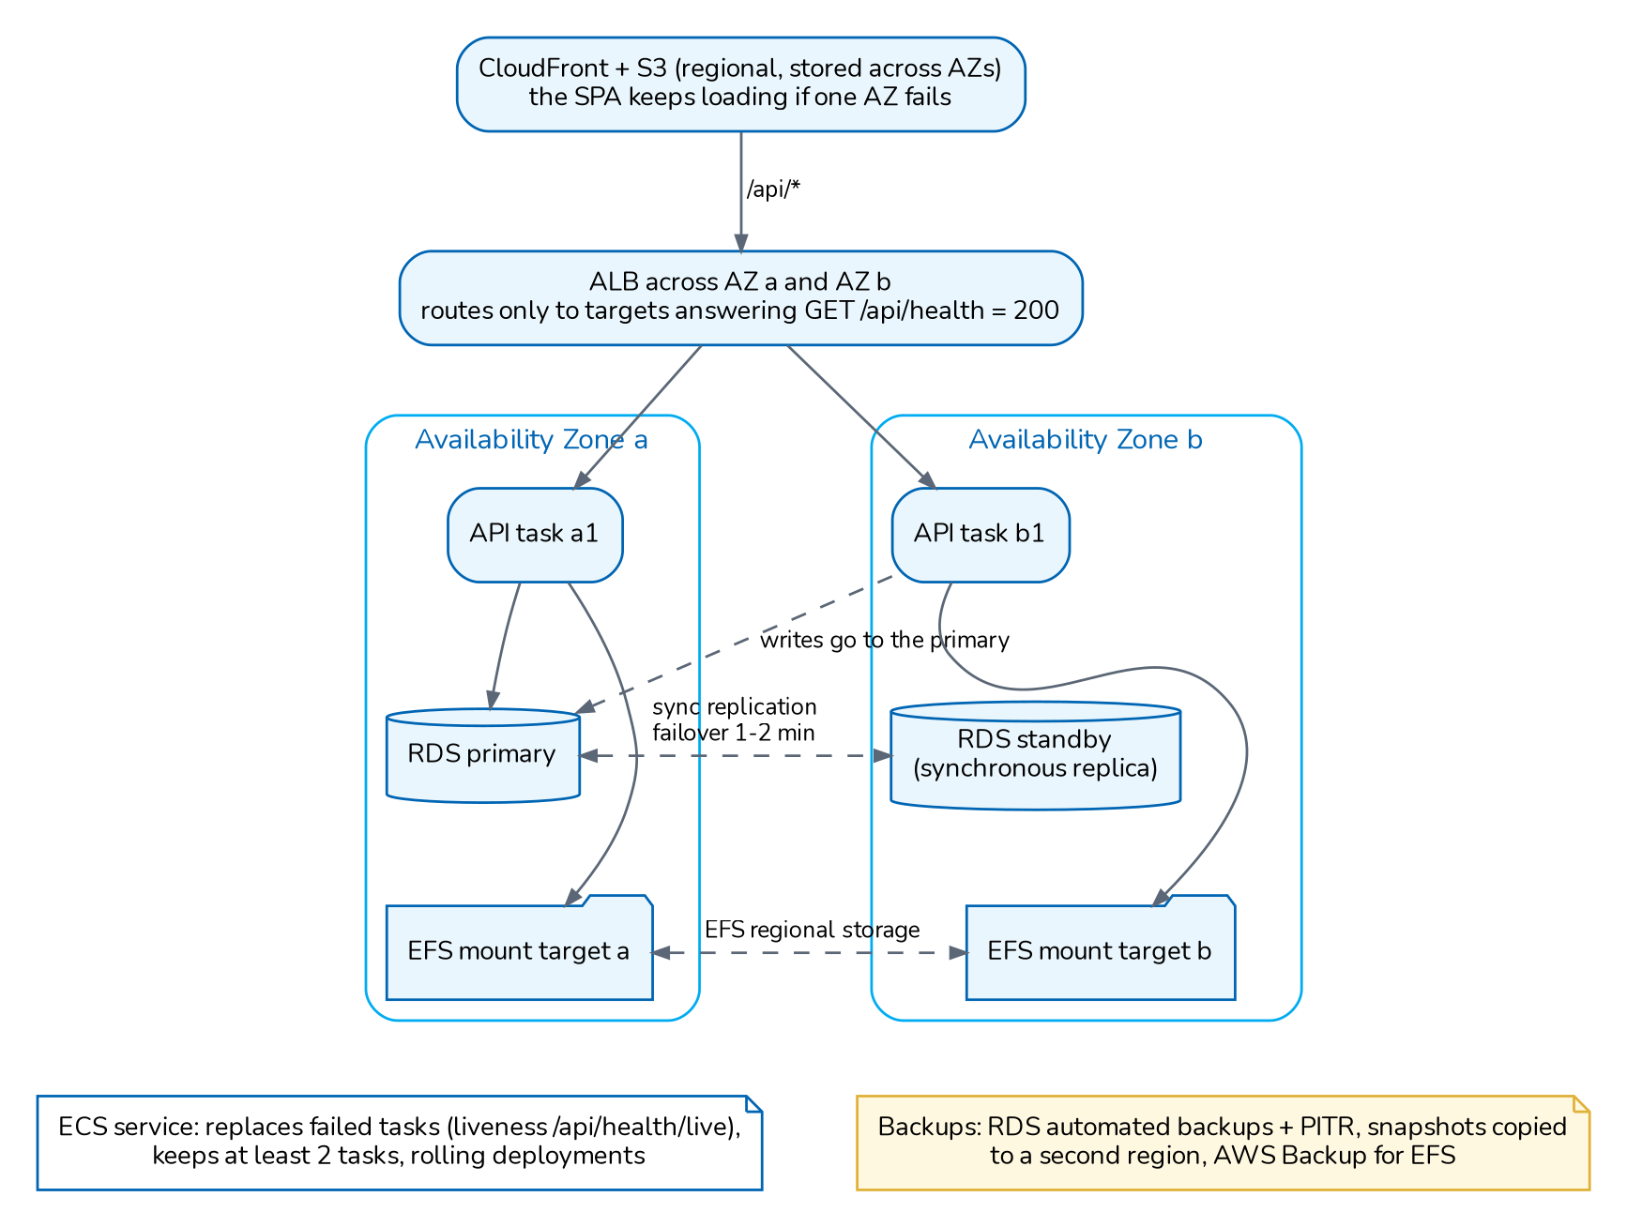
Figure 1. High-availability topology and failure domains (recommended)
Tier | Redundancy | Behaviour on failure
DNS and edge | DNS of the BrokerVerse URL, CloudFront (global edge), optional WAF | Managed by AWS; no single instance
Front end | S3 (regional, stores objects across Availability Zones) with versioning | The SPA stays available during API outages; screens show errors until the API returns
Load balancer | Application Load Balancer across two Availability Zones | Managed; routes only to healthy targets (/api/health)
API | At least two containers spread over two Availability Zones; rolling deployment with minimum healthy 100%, maximum 200% | A failed container is replaced automatically (liveness); if a zone fails, the containers in the other zone keep serving and replacements start there
Database | RDS PostgreSQL Multi-AZ (synchronous standby) | Automatic failover to the standby in the other zone, same endpoint name; the application reconnects
File store | EFS (regional storage class, mount targets in each zone) | Files remain available from the other zone
Secrets | Secrets Manager or SSM (regional) | Read at container start
E-mail | Office 365 | Outbox retries; e-mail is delayed, not lost

4 Single points of failure and mitigations
Single point of failure | In the baseline | Mitigation
Database | One PostgreSQL instance unless Multi-AZ is chosen | RDS Multi-AZ in production; point-in-time recovery and snapshots (document 09)
File store | A persistent volume mounted into the container; a local volume serves one instance only | EFS mounted by all instances; AWS Backup
Single API instance | The checklist starts with one instance; Docker Compose runs one | At least two instances in two zones once the first start has applied the migrations
Migrations at start | A failed migration stops every starting instance; the release is not rolled back automatically | Run one instance first for releases with migrations; test migrations on a UAT copy of production; keep the previous image and a pre-deployment snapshot for rollback
Secrets | Losing DATA_ENCRYPTION_KEY makes two-factor secrets unreadable; changing JWT_SECRET signs everyone out | Secret store with versioning; sealed copy of the keys kept with the backups (document 09)
Region | Single region ap-southeast-1 | Cross-region snapshot and file backup copies; documented regional recovery (document 08)
E-mail provider | One Office 365 mailbox in SMTP_URL | Outbox retries; another provider can be set by changing SMTP_URL and the sender setting
Front-end pipeline | Deployment by GitHub Actions to one bucket | S3 versioning allows a rollback to the previous build; the workflow can be re-run on a previous commit

5 Known limitations
Limitation | Impact and recommendation
Per-instance rate limiting | Sign-in and API rate limits are kept in memory per process. With N instances the effective limit is N times the configured value, and counters reset when an instance restarts. Recommended: move the counters to a shared store (PostgreSQL or ElastiCache Redis) or enforce limits with AWS WAF rate-based rules.
Long-running requests | Large report files, bulk prints and imports run inside the web request on the event loop; meanwhile the instance serves other requests slowly (document 06).
Local file storage API | Files are on a shared file system, not in S3; EFS gives multi-zone durability. Replacing the storage functions with S3 would remove the file system dependency (later change).
No automatic retry of failed jobs | A failed job run is recorded (job_runs.status = failed) and logged at error level; it runs again at its next schedule. There is no immediate retry; alerting is set up from the log (document 11).

6 Related documents
This document is one of eleven that together form the BrokerVerse OOTB Solution Architecture. They are maintained and issued together (source and build: docs/architecture/README.md).
No. | Document | File
01 | Solution Component Diagram and Application Architecture | 01_BrokerVerse_Solution_Component_Diagram_Application_Architecture.pdf
02 | Database Design | 02_BrokerVerse_Database_Design.pdf
03 | Database Inventory | 03_BrokerVerse_Database_Inventory.pdf
04 | Technology Stack | 04_BrokerVerse_Technology_Stack.pdf
05 | Shared Service Components | 05_BrokerVerse_Shared_Service_Components.pdf
06 | Capacity and Performance | 06_BrokerVerse_Capacity_and_Performance.pdf
07 | High Availability and Resiliency (this document) | 07_BrokerVerse_High_Availability_and_Resiliency.pdf
08 | RTO and RPO | 08_BrokerVerse_RTO_and_RPO.pdf
09 | Backup and Recovery | 09_BrokerVerse_Backup_and_Recovery.pdf
10 | Data Archival, Housekeeping and Restoration | 10_BrokerVerse_Data_Archival_Housekeeping_and_Restoration.pdf
11 | Monitoring | 11_BrokerVerse_Monitoring.pdf

7 Glossary
Terms and abbreviations used in this document.
Term | Meaning
Advisory lock | PostgreSQL application-level lock (pg_try_advisory_lock, pg_advisory_lock) used so a job runs on one API instance at a time and only one instance applies migrations.
API | Application programming interface; here the BrokerVerse REST API under /api served by the Node.js backend.
AZ | Availability Zone: an isolated data-centre group inside an AWS region.
CloudFront | AWS content delivery network that serves the single-page application and can route /api to the backend.
Co-insurance | Placement of one risk with several insurers, one of them the lead, each taking a share; premium, commission and claims are split by share.
Cron | Time-based schedule expression (minute hour day month weekday) used by the scheduled jobs.
EFS | Elastic File System (AWS): shared, multi-AZ network file system proposed for the upload directory.
Housekeeping | Daily job that deletes operational rows (job runs, sent e-mails, sign-in history, expired tokens, read notifications) after the retention days in System Settings.
JWT | JSON Web Token: signed token carrying the user id, roles, permissions and token version.
Migration | Numbered SQL file in backend/src/db/migrations applied once, in order, on API start.
Month-end close | Run (MEC-) that posts the accruals, recurring journals and valuations of a period, checks the checklist and, once approved, closes the period.
Multi-AZ | Deployment with a synchronous standby in a second Availability Zone and automatic failover (RDS).
Office 365 | Microsoft 365 mail service; BrokerVerse sends e-mail through smtp.office365.com with the mailbox in SMTP_URL.
RDS | Amazon Relational Database Service, the managed PostgreSQL target.
Receivable / bill | Premium bill (INV-) raised when a policy, endorsement or renewal is issued.
Remittance | Payment of collected premium, net of commission, from the broker to the insurer.
RPO | Recovery point objective: the maximum acceptable data loss, measured in time.
RTO | Recovery time objective: the maximum acceptable time to restore service.
S3 | Amazon Simple Storage Service: object storage hosting the SPA build (and proposed archive store).
Seed | Idempotent data load run on every API start: reference data always, sample data only when SEED_SAMPLE_DATA is on.
SMTP | Simple Mail Transfer Protocol; the API sends e-mail through the server in SMTP_URL.
SPA | Single-page application: the React front end served as static files.
UAT | User acceptance testing environment.
WAF | Web Application Firewall.

