

FUNCTIONAL REQUIREMENTS SPECIFICATION
Promotions - Promo Master
TIS-BRD-PROD-15 Promotions: promo master, vehicle-level promo rates for new vehicles, issuing and remitting rates, discount caps per product and channel
Built on the BrokerVerse base version (branch brokerverse-platform, v1.0.0) with the Toyota Insurance Services brand pack

Client | Toyota Insurance Services Philippines Corporation (TISPH)
Document | TISPH-FRS-PROD-15
Version | 1.1
Date | 9 October 2026
BRD baseline | BrokerVerse TISPH BRD v2.2 (signed), Module 02 Product Configurator & Rating, CR-01
Base version | BrokerVerse, repository BDOI-OOTB, branch brokerverse-platform (v1.0.0), UAT web-production-17476.up.railway.app
Status | Issued for TISPH review
Classification | Confidential

Prepared by iorta TechNXT for TISPH 
This document is confidential to Toyota Insurance Services Philippines Corporation and iorta TechNXT.
Document Control
Version | Date | Author | Reviewer | Approver | Change
0.9 | 6 Oct 2026 | iorta TechNXT Business Analysis | iorta TechNXT Solution Architect | - | Internal draft from BRD v2.2 (PROD-15 and related items), the CR-01 delivery basis and the Gap Analysis MOM Sessions 1-9
1.0 | 8 Oct 2026 | iorta TechNXT Business Analysis | iorta TechNXT Project Manager | - | Issued for first-level review; revised after it: scope limited to the promo CR, flow charts added, reports, notifications and documents removed
1.1 | 9 October 2026 | iorta TechNXT Business Analysis | iorta TechNXT Project Manager | TIS Sales (pending) | Rebased on the BrokerVerse base version: real menus, fields, statuses, roles, permissions and premium engine; real and to-be screenshots with the Toyota Insurance Services brand pack; document in the iorta TechNXT FRS template

Distribution List
Name / Unit | Role | Organisation | Purpose
TIS Sales (business owner of PROD-15) | Approver | TISPH | Review and sign-off
Sales Admin | Business user | TISPH | Review of promo set-up and quotation FRs
Operations | Business user | TISPH | Review of placement, issuance, endorsement and renewal FRs
Finance and General Accounting | Business user | TISPH | Review of the remittance and commission FRs
DTID - Project Management Team | Project owner | TISPH | Traceability against the BRD
Project team | Delivery | iorta TechNXT | Build, test and UAT preparation

Contents
1 Introduction 5
1.1 Purpose 5
1.2 Scope 5
1.3 References 6
1.4 Definitions and acronyms 6
1.5 How to read the functional requirements 7
1.6 The base version and what PROD-15 changes 7
2 Promo process flow 10
2.1 Flow A - Set up and approve a promo 10
2.2 Flow B - Apply a promo on Create Quote 12
2.3 Flow C - Convert to policy 14
2.4 Flow D - Policy with a promo after booking 15
2.5 Products, channels and perils covered 16
3 Personas and roles 17
3.1 Personas 17
3.2 New permissions 17
3.3 Default grants 18
4 Functional requirements 19
4.1 Promotions screen 19
FR-PRM-001 Add a promotion with its code, name and period 19
FR-PRM-002 Set where a promotion applies: products, insurers, channel types and combinability 21
FR-PRM-003 Map vehicle variants and their promo and remitting rates 22
FR-PRM-004 Submit, approve or return a promotion (maker-checker) 24
FR-PRM-005 Run the life cycle: scheduled, active, suspended, expired, withdrawn 26
FR-PRM-006 Amend an approved promotion as a new version 27
FR-PRM-007 Search, view and export promotions 28
4.2 Discount Caps screen 28
FR-PRM-010 Maintain discount caps per product and channel type 28
FR-PRM-011 Check every promotion line against the caps at set-up 30
4.3 Brand-new vehicles only 31
FR-PRM-020 Capture the vehicle condition and decide whether promotions are offered 31
4.4 Create Quote 32
FR-PRM-021 Select the promotion on Coverage Details and fill its rates 32
FR-PRM-022 Price the quotation with the promotion and show the discount 34
FR-PRM-023 Apply the caps, the flexible rate and the authority limit 35
FR-PRM-024 Check the promotion again on edit, approval, expiry and conversion 36
FR-PRM-025 Apply promotions on bulk-uploaded quotations 37
4.5 Policy after the quotation 38
FR-PRM-030 Carry the promotion to the Placement Slip and the policy 38
FR-PRM-031 Use the promo remitting rates for remittance and commission 39
FR-PRM-032 Endorse a policy with a promotion 39
FR-PRM-033 Cancel a policy with a promotion 40
FR-PRM-034 Renew a policy that carried a promotion 40
4.6 Audit and access 41
FR-PRM-040 Keep a complete audit trail of promotions, caps and their use 41
FR-PRM-041 Control access to the promotion functions 41
5 Workflow and status model 43
5.1 Promotion 43
5.2 Discount cap 43
5.3 Promotion along the quotation and policy 43
6 Interfaces 45
7 Configuration items 46
7.1 Settings 46
7.2 Scheduled job 46
7.3 Lists of values 46
7.4 Masters maintained by the business 46
8 Traceability 48
8.1 BRD clause to FR 48
8.2 Related BRD requirements 48
8.3 FR to test cases 49
9 Navigation 50
9.1 Screens of PROD-15 50
9.2 Menu by base role 50
10 Screen specifications 52
10.1 Promotions list (new) 52
10.2 Add / Edit promotion - General tab (new) 53
10.3 Add / Edit promotion - Applicability tab (new) 54
10.4 Add / Edit promotion - Vehicle variants & rates tab (new) 55
10.5 Promotion approval in My Work (existing screen) 56
10.6 Discount Caps (new) 57
10.7 Create Quote - Step 1 Policy Details (changed) 58
10.8 Create Quote - Step 3 Coverage Details (changed) 60
10.9 Create Quote - Step 5 Order Summary (changed) 62
10.10 Upload variant mapping (new) 63
11 End-to-end walkthroughs 65
11.1 WT-A Launch a promotion 65
11.2 WT-B Quote, approve and convert with a promotion 65
11.3 WT-C Exceptions 66
12 Messages catalogue 67
12.1 Add / Edit promotion 67
12.2 Vehicle variants & rates 68
12.3 Upload variant mapping 68
12.4 Promotion approval 69
12.5 Suspend / Resume / Withdraw 69
12.6 Discount Caps 69
12.7 Create Quote > Policy Details 70
12.8 Create Quote > Coverage Details 70
12.9 Create Quote > Order Summary 71
12.10 Convert to policy 71
12.11 Endorsement 71
13 Upload screens 72
13.1 Promotion variant mapping template 72
13.2 Quotations Bulk Upload - new columns 72
14 Sign-off and change control 73
14.1 What is signed 73
14.2 Change after sign-off 73
14.3 Signatures 73
Appendix A Premium computation examples 74
A.1 Promo rate - Toyota Fortuner 2.4 G 4x2 AT, Own Damage coverage 1,200,000 74
A.2 Gross premium discount - Toyota Hilux 2.4 E 4x2 MT, Own Damage coverage 1,800,000, 10% 74
A.3 Why the rate discount is the worst case 75

1 Introduction

1.1 Purpose
This Functional Requirements Specification (FRS) describes how TIS-BRD-PROD-15 Promotions is built on the BrokerVerse base version that iorta TechNXT uses for TISPH. It covers the promo end to end: setting up a promotion and its discount caps, selecting it on a Motor quotation, the premium, approval, conversion to policy, remittance and commission, endorsement, cancellation and renewal.
Every screen, menu path, field label, status and permission named here is either taken from the base version as it runs today, or is marked as new or changed. Screens that do not exist yet are shown as to-be mock-ups drawn on the real base screens with the Toyota Insurance Services brand pack, so the business sees them as they will look.
The BRD requirement reads as below. TISPH Sales confirmed it in Gap Analysis Session 2 (18 August 2026), and the promo customisation was logged as action item 36 for iorta TechNXT.
TIS-BRD-PROD-15 Promotions (Customization, Phase 1, CR-01). Promo Master (code, description, period start/end, applicable vehicle variants, rates) applying at vehicle level, for new vehicles only, with flexible issuing and remitting rates; the risk block selects the promo and auto-fetches the mapped rate; discounts capped min/max per product and channel, applied to gross premium.

1.2 Scope
In scope
- A new Promotions screen under Operations > Sales & Marketing: create, approve (maker-checker), version, suspend, resume and withdraw promotions, with their vehicle variants and rates, on screen or by Excel upload.
- A new Discount Caps screen under Master > Finance: minimum and maximum discount % and the lowest Own Damage rate per product and channel type, approved on Configuration Approvals.
- Changes to Create Quote: a Vehicle condition field on Step 1 Policy Details, a Promotion section on Step 3 Coverage Details, and promo-aware discount limits on Step 5 Order Summary.
- Use of the existing Authority Matrix limit "Quotation discount" so that a discount above the user's limit is approved in My Work > Approvals.
- Restriction of the existing Override button on Coverage Details for promo rates to authorised users.
- The promo on the quotation detail, the policy, the Placement Slip, endorsements, cancellations and renewals; audit trail and permissions.
Out of scope
- Promotions on non-Motor lines (Personal Accident, Credit Life, Parcel / Courier).
- Promo reports and promo notifications: not part of the PROD-15 requirement.
- Dealer Programmes (the existing screen for dealer and bank programmes with a subsidy): unchanged; this FRS only says how a promotion and a programme interact.
- The issuing-vs-remitting rate model of commission (TIS-BRD-PROD-16 / COMM-06) and generic discounts (PROD-09): delivered in the same CR-01 but specified in their own FRS. This FRS stores the promo remitting rates they use.

1.3 References
Table 1: Reference documents
Ref. | Document | Version / date | Use in this FRS
R1 | BrokerVerse TISPH Business Requirement Document, Final Consolidated Baseline (signed) | v2.2, 29 Sep 2026 | Requirement baseline; PROD-15 and related requirements
R2 | BRD section 7.1 Phase 1 customizations and 8.2 Change request register (CR-01) | v2.2 | Delivery basis: new master, rating hook, vehicle-variant mapping, cap validation
R3 | BrokerVerse base version: repository BDOI-OOTB, branch brokerverse-platform (release v1.0.0), deployed at web-production-17476.up.railway.app | Build of 4 Oct 2026 | Screens, menus, fields, statuses, roles, permissions and premium engine this FRS builds on
R4 | BrokerVerse User Manual (docs/package/source/user-manual.md of R3) | v1.0.0 | Create a motor quotation; Quotations; Dealer Programmes; Authority Matrix; Configuration Approvals
R5 | Toyota Insurance Services brand pack (backend/assets/brand-packs/toyota-insurance-services of R3) | v1.0.0 | Colours, font and logo of the screens
R6 | TISPH Gap Analysis / BSM - Consolidated Minutes of Meeting, Sessions 1-9 (17-28 Aug 2026) | Draft for TISPH review | Session 2 (promotions, rating, promo excess), Sessions 4 and 7 (issuing vs remitting rate), Session 6 (lock-in)
R7 | BIBS FRS BRD-01 New Business (sample FRS) | v2.0, 27 Sep 2026 | Structure and conventions of this FRS

1.4 Definitions and acronyms
Table 2: Definitions
Term | Meaning in this FRS
Promotion (promo) | A record on Operations > Sales & Marketing > Promotions: a time-bound reduced rate or discount offered on brand-new vehicles of selected variants, products, insurers and channel types.
Promo line | One row of the Vehicle variants & rates tab: a variant of Master > Insurance > Vehicle (with year model range, FMV range and insurer) and its rates.
Standard rates | The rates Create Quote uses without a promo: Own Damage coverage Rate 2.00% and Acts of Nature Rate 0.50% (setting premium.default_rates), or the rates typed by the user.
Promo OD % / Promo AON % | The reduced Own Damage and Acts of Nature rates charged to the client while the promo applies (the "flexible issuing rate").
Min OD % | The lowest Own Damage rate an authorised user may apply on a promo line. Equal to Promo OD % when no flexibility is given.
Remit OD % / Remit AON % | The net rates agreed with the insurer for the promo (the "flexible remitting rate"), used by the issuing-vs-remitting commission of PROD-16.
Rate discount % | ((standard OD + standard AON) - (Min OD + Promo AON)) / (standard OD + standard AON) x 100. The worst-case discount of a line, checked against the caps when the promo is set up.
Discountable premium | NET Premium + Value Added Tax + Documentary Stamp Tax + Local Gov't Tax + Others, i.e. the gross premium without CTPL. The base version never discounts CTPL.
Promo discount | Gross premium at the standard rates minus gross premium with the promo. Shown in PHP and as a % of the standard discountable premium.
Discount cap | Minimum and maximum discount % (promo plus Order Summary discount) and the lowest OD rate allowed for a product through a channel type (Master > Finance > Discount Caps).
Channel type | The type of the Distribution Channel the quotation comes from: Financing bank (e.g. TFS), Dealer, Affinity partner, Agent / referrer, or Direct.
Brand New | Vehicle condition on Step 1 Policy Details. A vehicle is brand new when its condition is Brand New, its Model Year is not older than the policy year minus 1, and its chassis number is on no earlier policy.
Lock-in promo | A promo whose rates are kept on renewal for a set number of years (TIS-BRD-SCHM-03).
OD / AON / CTPL / APPA | Own Damage / Acts of Nature / Compulsory Third Party Liability / Auto Passenger Personal Accident.
FMV / TFS | Fair Market Value / Toyota Financial Services Philippines.

1.5 How to read the functional requirements
Each FR in chapter 4 has the same parts:
- A header table with the BRD trace, the actor, the priority, the fit and the screens of the base version that implement it.
- Description, preconditions, main flow and alternate and exception flows.
- Business rules. Configurable rules are maintained on a master or on Master > System > Configuration (chapter 7). Fixed rules change only through a change request.
- Validations and messages: the check and the message the user sees, word for word, with its ID in chapter 12. As everywhere in the base version, a message is plain English and is shown under the field it belongs to, or as a toast.
- Audit and numbered acceptance criteria, the basis of the test cases TC-PRM-nnn-n.
Note. Values marked "default" and the rates, caps and amounts in the examples are illustrative until TISPH confirms them. The premium figures in the examples are computed by the base version's own premium engine (Create Quote > Calculate) on the sample data of the base version.

1.6 The base version and what PROD-15 changes
TISPH builds on the BrokerVerse base version (R3), shown here with the Toyota Insurance Services brand pack enabled (Master > System > System Settings > Theme and Branding > Brand packs). The base version has no promotion feature. The table lists what PROD-15 reuses, what it changes and what it adds.
Table 3: Base version and PROD-15
Base version today | What PROD-15 does
Create Quote wizard (5 steps). Step 3 Coverage Details holds Own Damage coverage Rate (2.00%) and Acts of Nature Rate (0.50%); the Override button makes rates editable for any user. | Changed. New Promotion section on Step 3 fills the rates from the promo; changing a promo rate needs the new permission write:promotion-rates (PROD-12: about 20 internal users, never agents).
Step 1 Policy Details has Vehicle Brand, Vehicle Model, Model Variant and Model Year but no vehicle condition. A "Brand-new vehicle: 3-year CTPL" tick box exists on Step 3. | Changed. New field Vehicle condition (Brand New / Used / Repossessed) on Step 1. The 3-year CTPL tick box is offered only for Brand New.
Step 5 Order Summary: Discount (Optional) with fixed limits "Min 0%" and "Max 30%" in the screen. | Changed. The limits come from Discount Caps for the product and channel type, net of the promo discount. A Promotion line shows the promo discount.
Authority Matrix transaction "Quotation discount" (Sales 10%, Operations 10%, Processing 15%, Accounting Manager 25%) is recorded but not checked when a quotation is approved. | Changed. PROD-15 checks it: a quotation whose total discount is above the maker's limit is approved in My Work > Approvals by a user whose limit covers it.
Dealer Programmes (Operations > Sales & Marketing): brand-new vehicle programmes with a dealer or bank, OD and AON rates, subsidy; applied only through the Dealer Sales upload. No variant mapping, no approval. | Reused as the pattern for the Promotions screen. A promo and a Dealer Programme are not combined by default.
Master > Insurance > Vehicle (Brand, Model, Variant), Distribution Channels (dealer group, dealer branch, financing bank, bank branch, affinity partner), Commission Rate Matrix, Configuration Approvals, My Work > Approvals. | Reused. Variants for promo lines; channel types for caps; the approval screens for promos and caps.
No promotion master, no discount caps, no issuing-vs-remitting rate split. | New. Promotions and Discount Caps screens; promo remitting rates stored for PROD-16.

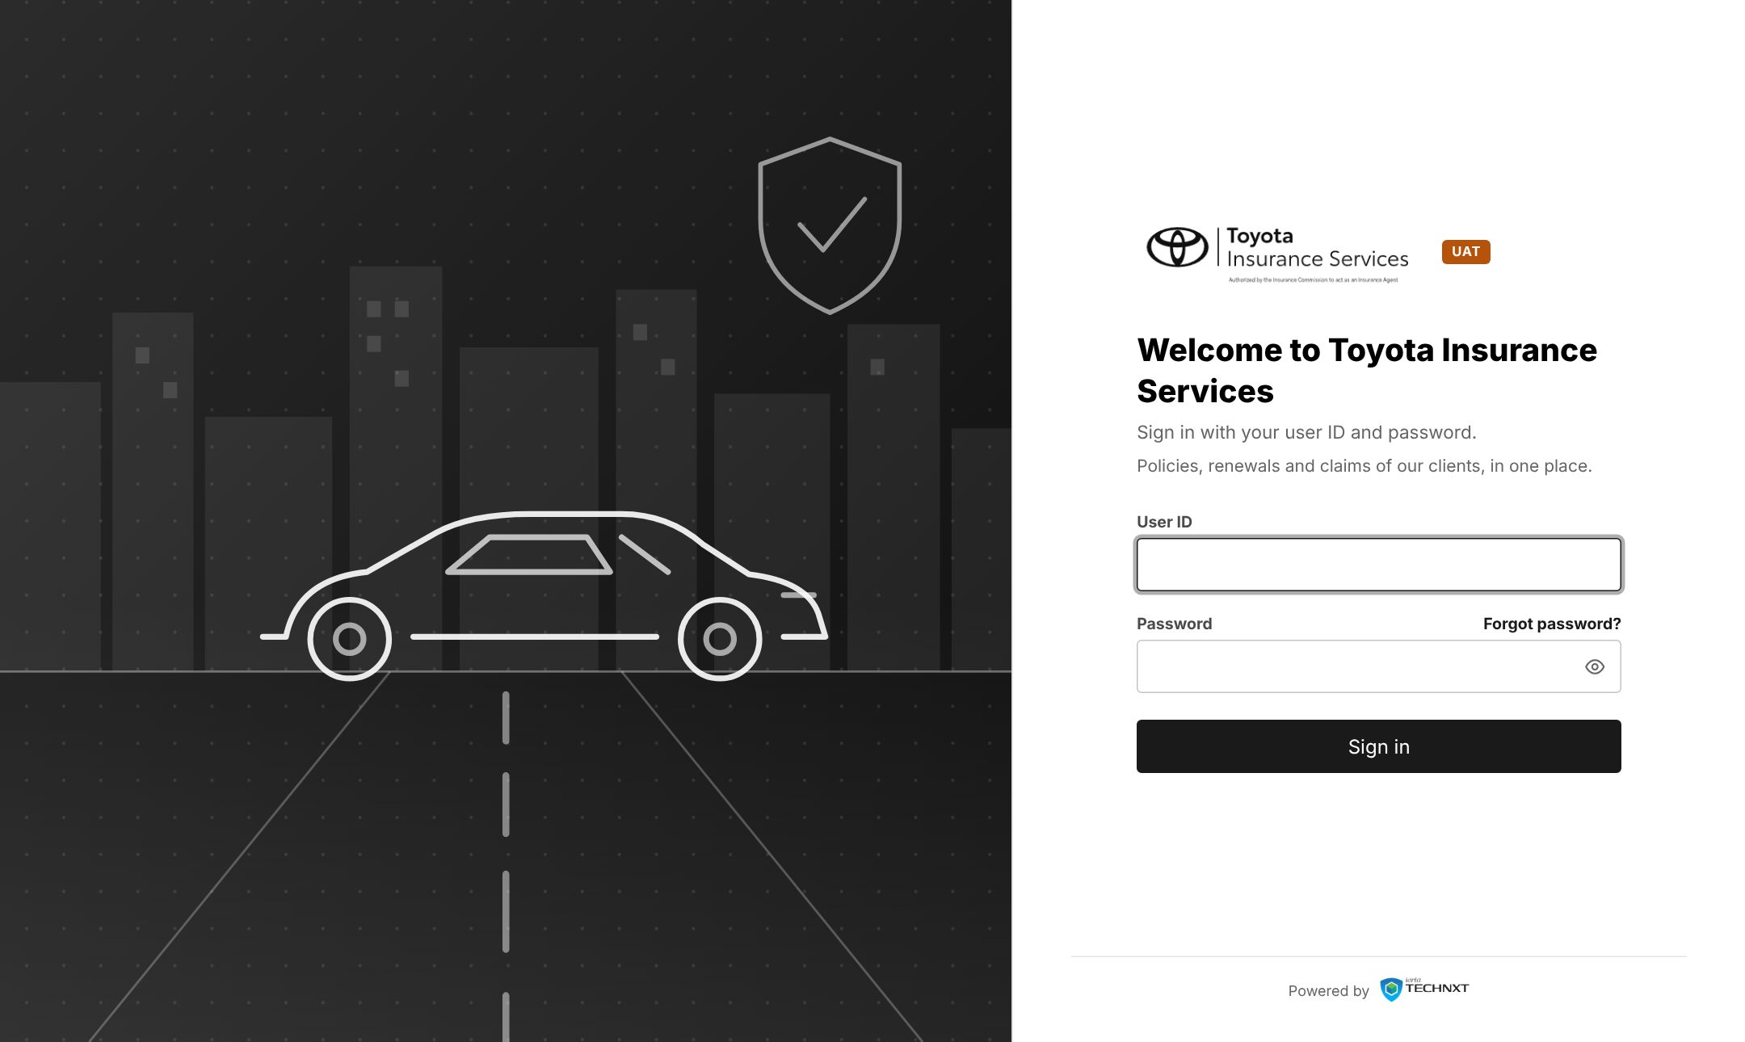
Figure 1: Base version: sign-in page with the Toyota Insurance Services brand pack
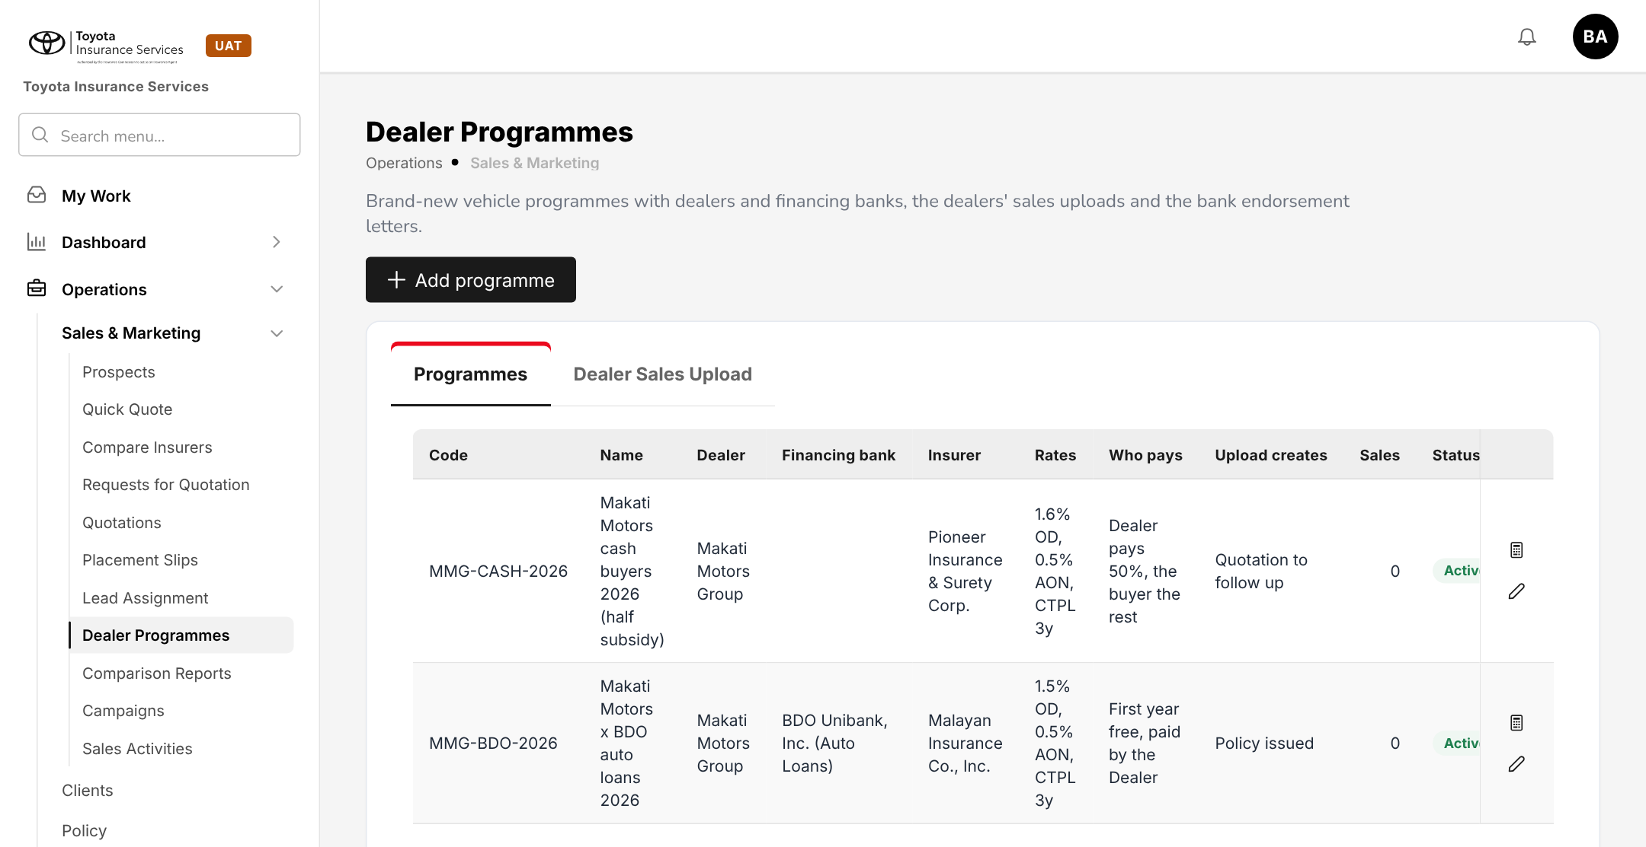
Figure 2: Base version: Operations > Sales & Marketing > Dealer Programmes (pattern for Promotions)
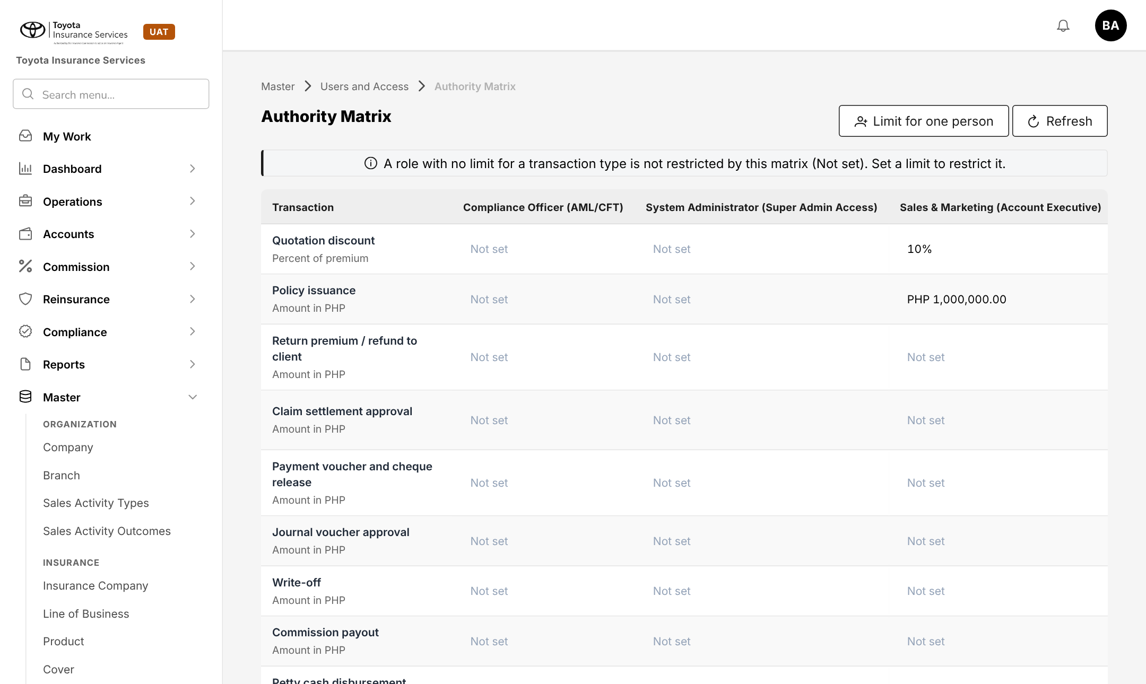
Figure 3: Base version: Master > Users and Access > Authority Matrix, row "Quotation discount"

2 Promo process flow
Four flow charts show the promo end to end on the base version: Flow A sets up and approves a promo, Flow B applies it on Create Quote, Flow C converts the quotation and books the policy, and Flow D covers the policy after booking. Black rounded boxes are start and end points, diamonds are decisions, red boxes are exceptions, grey boxes are done by the system and boxes with a heavy border are the successful outcome.

2.1 Flow A - Set up and approve a promo
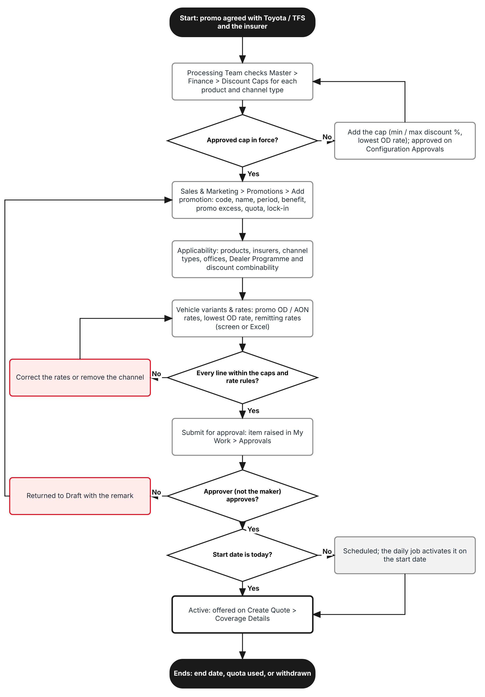
Figure 4: Flow A - Set up and approve a promo
Table 4: Flow A steps
Step | Who (base role) | What happens | FR
A1 | Processing Team | Checks Master > Finance > Discount Caps for each product and channel type the promo will use. If a cap is missing, adds it; an Accounting Manager approves it on Configuration Approvals. | FR-PRM-010
A2 | Processing Team | Operations > Sales & Marketing > Promotions > Add promotion: code, name, period, benefit, promo excess, quota and lock-in. | FR-PRM-001
A3 | Processing Team | Applicability tab: products, insurers, channel types, offices, combinability with Dealer Programmes and with the Order Summary discount. | FR-PRM-002
A4 | Processing Team | Vehicle variants & rates tab: one line per variant with Promo OD %, Min OD %, Promo AON %, Remit OD %, Remit AON %; or Upload. | FR-PRM-003
A5 | System | Checks each line against the caps and the rate rules. A failing line must be corrected (or the channel type removed) before Submit for approval. | FR-PRM-011
A6 | Accounting Manager (approve:promotions) | Approves or returns the promo from My Work > Approvals. The maker can never approve it. | FR-PRM-004
A7 | System | Sets the promo to Scheduled or Active; the daily "Promotion status" job (Master > System > Schedules) activates and expires promos. | FR-PRM-005

2.2 Flow B - Apply a promo on Create Quote
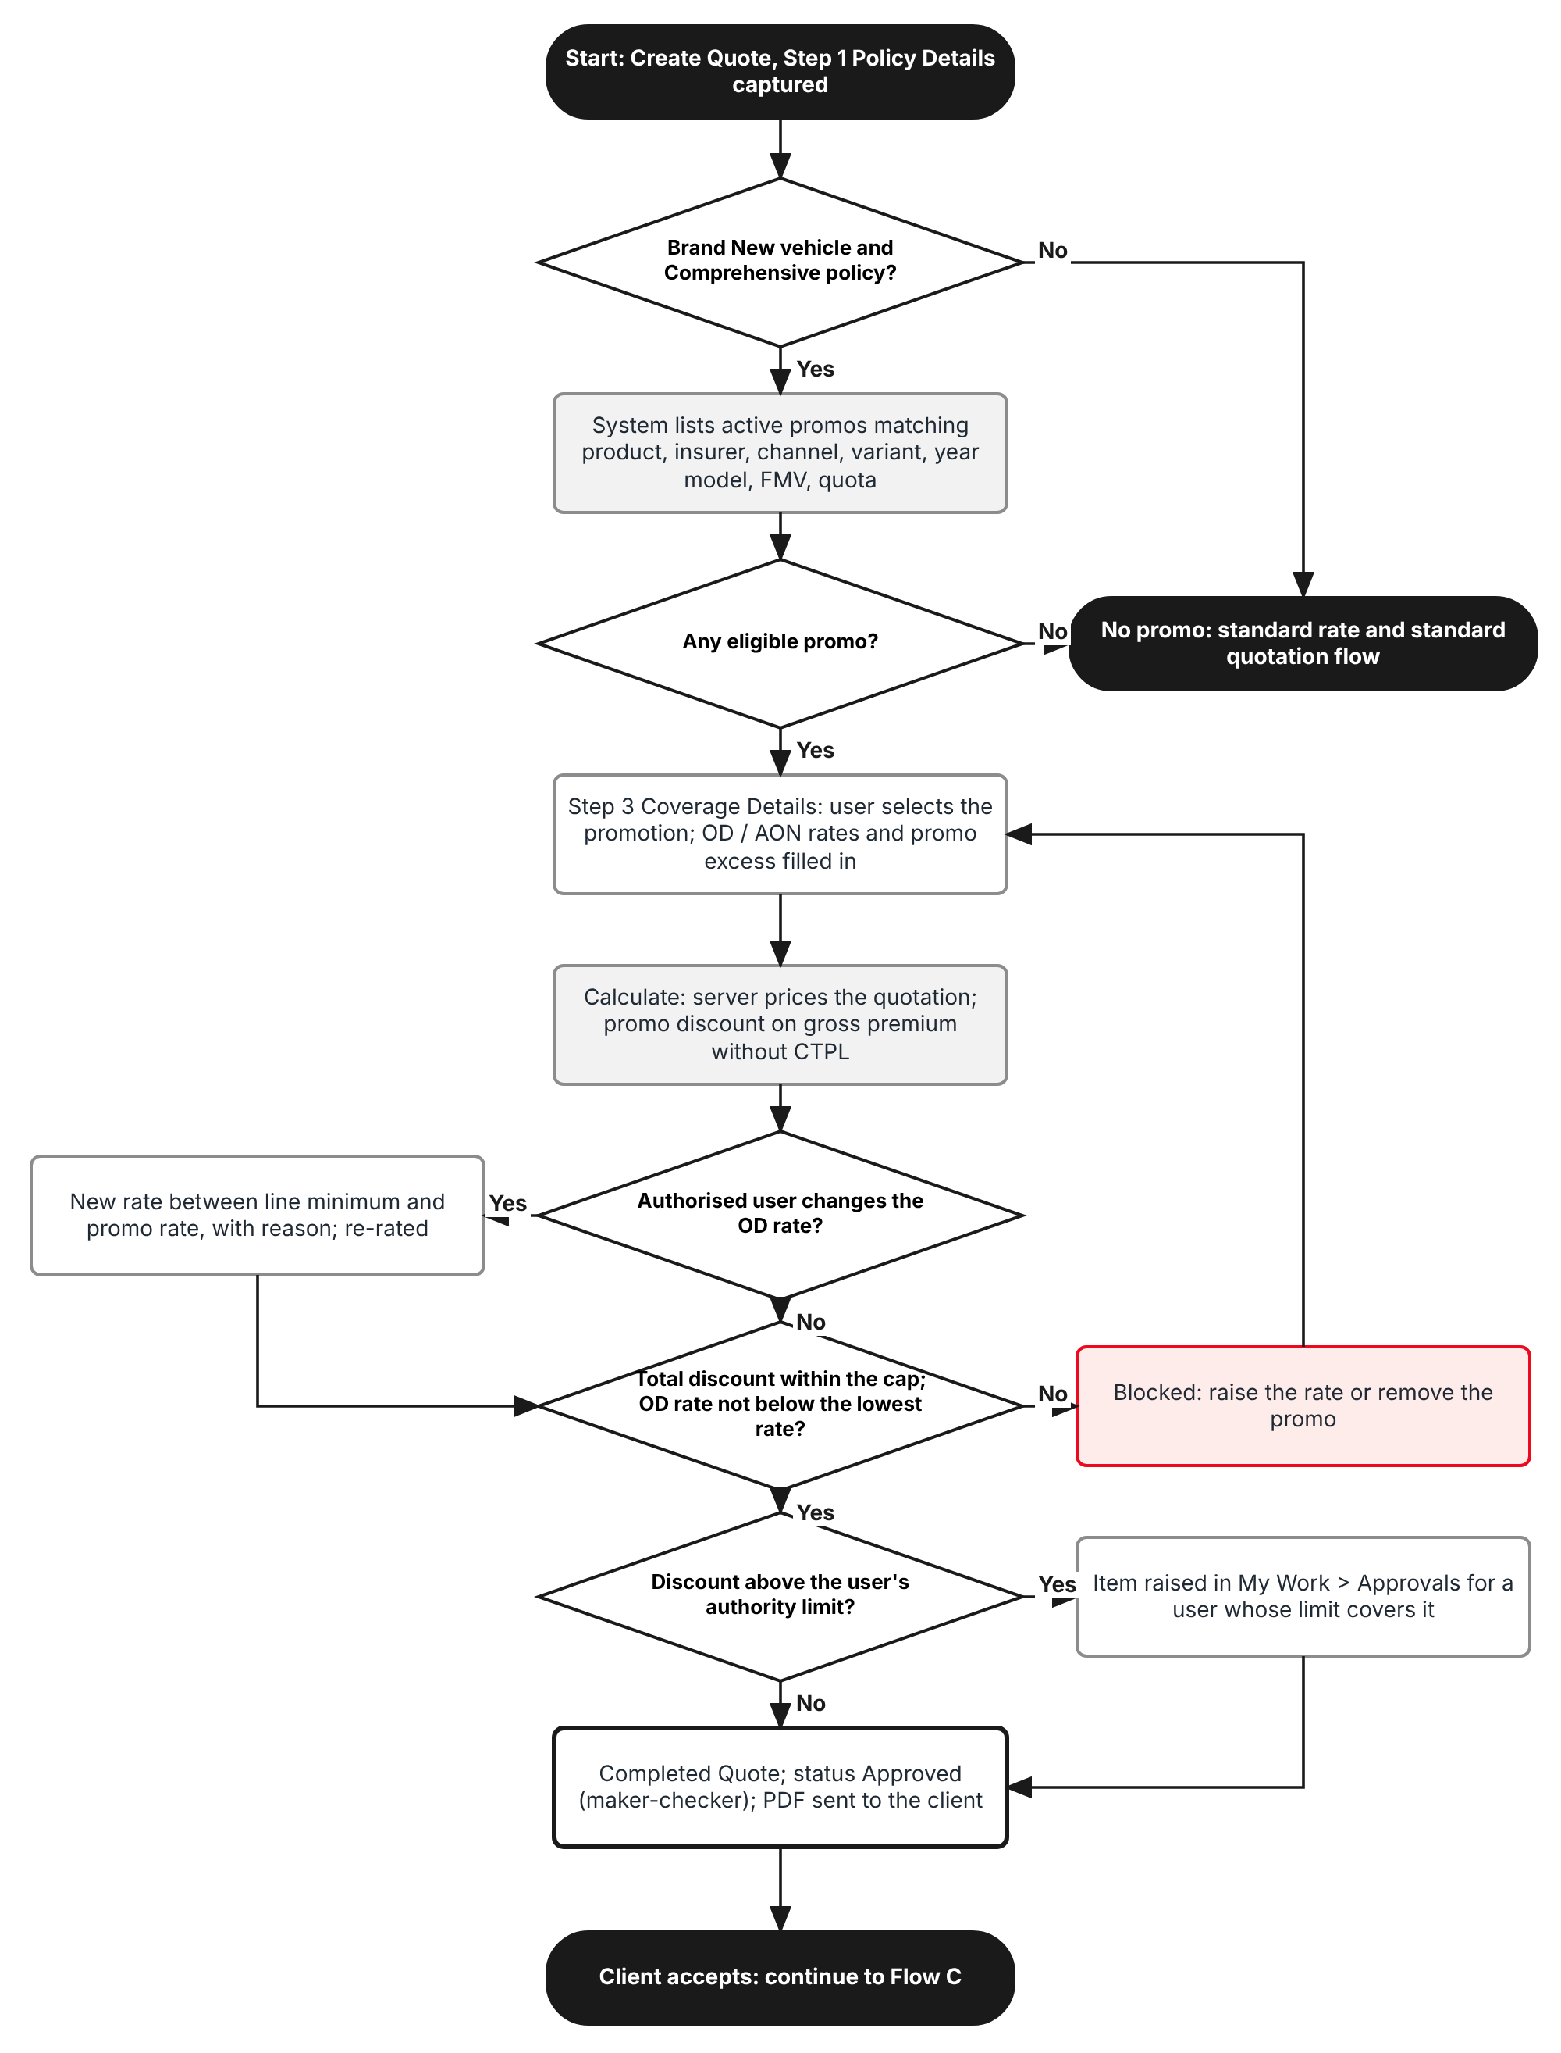
Figure 5: Flow B - Apply a promo on a Motor quotation
Table 5: Flow B steps
Step | Who (base role) | What happens | FR
B1 | Sales & Marketing | Step 1 Policy Details: Insurance Company Name, Insurance Policy Type Comprehensive, Vehicle Brand / Model / Model Variant / Model Year and the new Vehicle condition Brand New. | FR-PRM-020
B2 | System | Step 3 Coverage Details lists the active promos that match the product, insurer, channel type, variant, year model, FMV and quota. | FR-PRM-020
B3 | Sales & Marketing | Selects a promo in the Promotion section. Own Damage coverage Rate and Acts of Nature Rate are filled from the promo; the promo excess is shown. | FR-PRM-021
B4 | System | Calculate: the server prices the quotation with the promo rates and shows the promo discount on the gross premium without CTPL. | FR-PRM-022
B5 | Authorised user | May lower the OD rate down to Min OD % with a reason (write:promotion-rates). Others cannot change promo rates. | FR-PRM-023
B6 | System | Step 5 Order Summary: the discount limits come from the cap, net of the promo. A total discount above the cap or a rate below the lowest OD rate is refused. | FR-PRM-023
B7 | System / approver | Completed Quote: if the total discount is above the maker's Authority Matrix limit, an item is raised in My Work > Approvals; otherwise the normal maker-checker approval applies. | FR-PRM-024

2.3 Flow C - Convert to policy
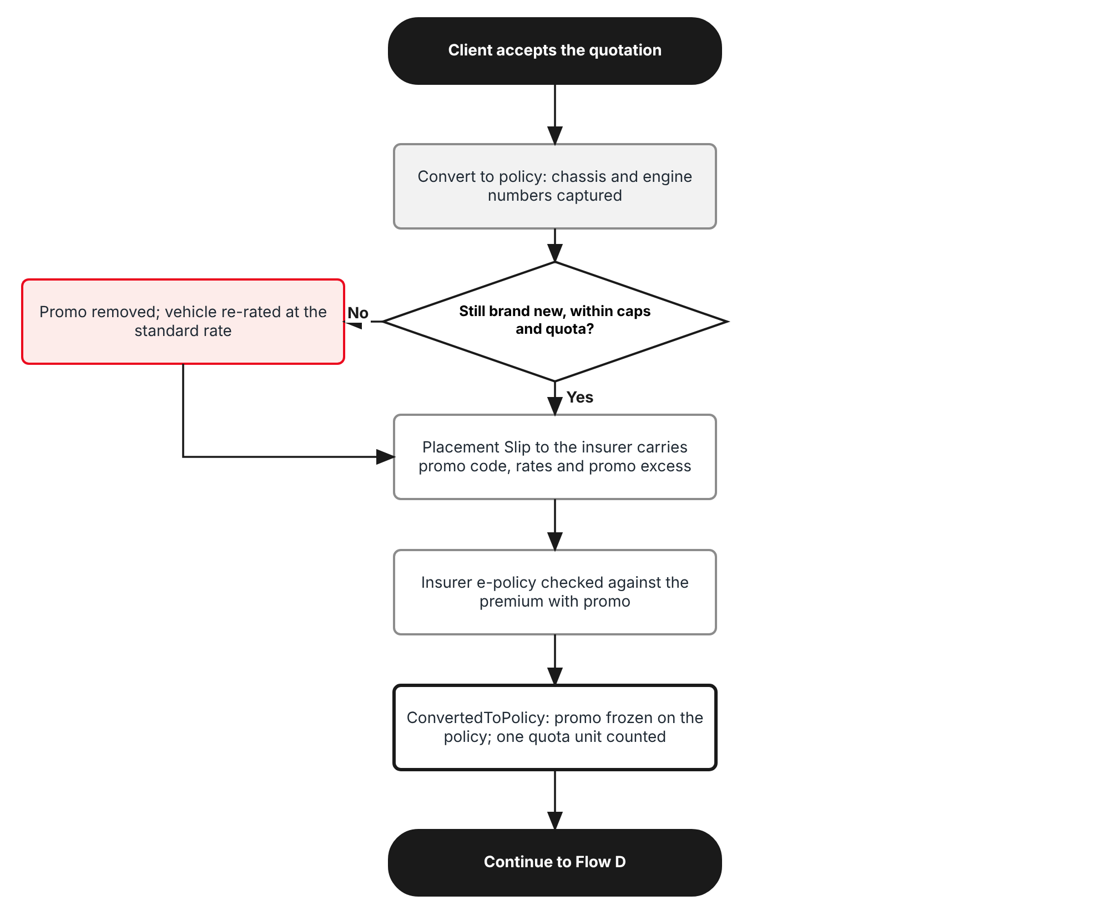
Figure 6: Flow C - Convert the quotation and book the policy
Table 6: Flow C steps
Step | Who (base role) | What happens | FR
C1 | Processing Team | Converts the CustomerAccepted quotation. With the chassis number now captured, the brand-new rule, the caps and the quota are checked again; a promo that no longer applies is removed and the premium recomputed. | FR-PRM-024
C2 | Processing Team | The Placement Slip to the insurer carries the promo code, promo rates and promo excess; the insurer's policy is checked against the premium with promo. | FR-PRM-030
C3 | System | ConvertedToPolicy: the promo is frozen on the policy and one quota unit is counted. | FR-PRM-030

2.4 Flow D - Policy with a promo after booking
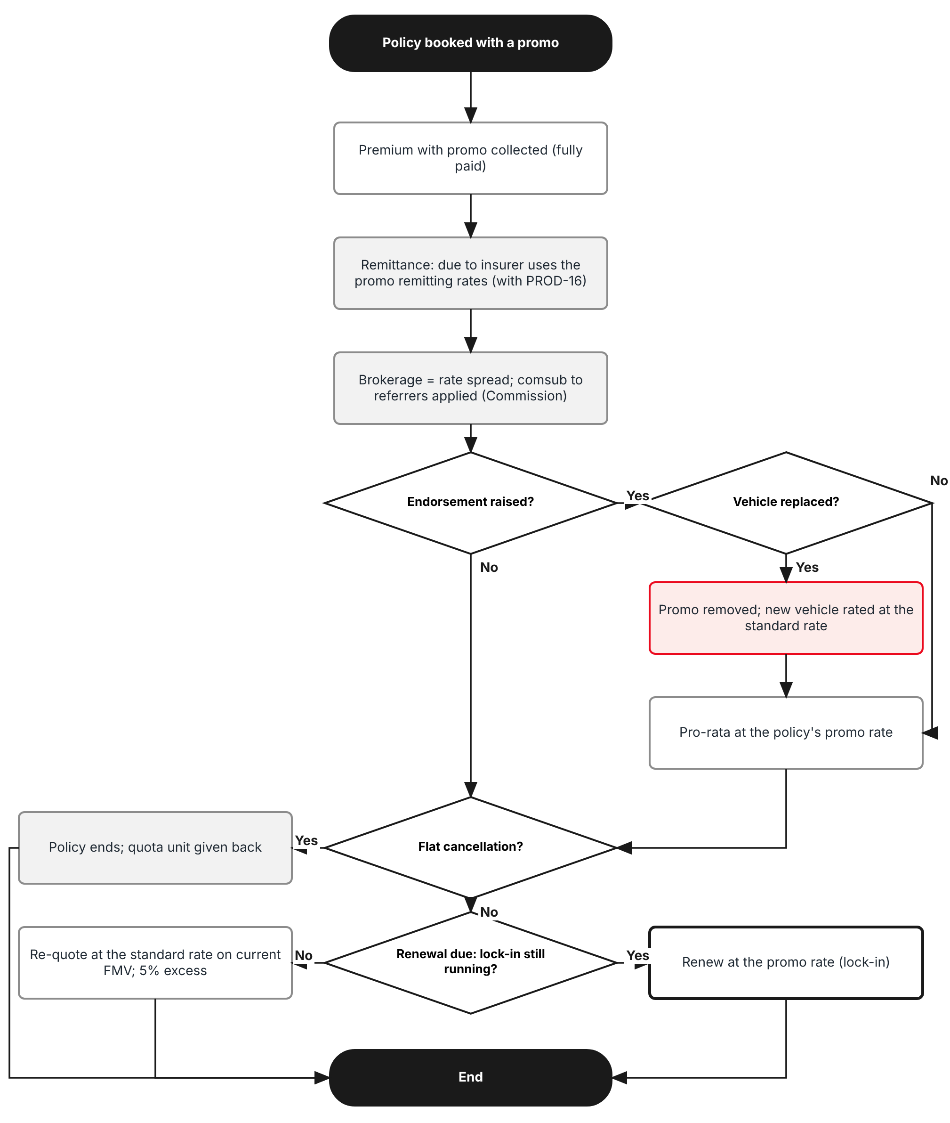
Figure 7: Flow D - Remittance, endorsement, cancellation and renewal
Table 7: Flow D steps
Step | Who (base role) | What happens | FR
D1 | Accounting | Remittance and commission use the promo remitting rates through the issuing-vs-remitting model of PROD-16; comsub to referrers follows Commission. | FR-PRM-031
D2 | Operations | Financial endorsements use the policy's promo rates pro-rata; replacing the vehicle removes the promo. | FR-PRM-032
D3 | Operations | Policy Cancellation from inception gives the quota unit back. | FR-PRM-033
D4 | System | Renewal is priced at the standard rates on current FMV, unless the promo has a lock-in that is still running. | FR-PRM-034

2.5 Products, channels and perils covered
Table 8: Promo dimensions
Dimension | Values | Where in the base version
Products | Motor - Private Car, Motor - Commercial Vehicle, Motor - Motorcycle; Insurance Policy Type Comprehensive only | Master > Insurance > Product; Step 1 Insurance Policy Type
Insurers | Panel insurers; one insurer per quotation (direct placement, MOM Session 2) | Master > Insurance > Insurance Company; Step 1 Insurance Company Name
Channel types | Financing bank (TFS), Dealer, Affinity partner, Agent / referrer, Direct | Master > Insurance > Distribution Channels; Step 1 Referrer
Vehicles | Brand / Model / Variant, brand-new only | Master > Insurance > Vehicle; Step 1 Vehicle Brand, Vehicle Model, Model Variant
Perils the promo rate replaces | Own Damage (with Theft) and Acts of Nature; Bodily Injury, Property Damage, APPA, Roadside Assistance and CTPL keep their premiums | Step 3 Own Damage coverage Rate, Acts of Nature Rate
Excess | Fixed promo excess replaces the Own Damage / Theft deductible: Private Car PHP 2,000, Commercial Vehicle PHP 3,000 (MOM Session 2) | Product Configurator > Coverage Builder deductibles (OD PHP 3,000 in the sample template)

3 Personas and roles

3.1 Personas
The base version ships eight roles (Master > Users and Access > Role). TISPH personas map to them as below; TISPH can add its own roles (for example Sales Head) and grant them the permissions of section 3.2.
Table 9: Personas and base roles
TISPH persona | Base role | What they do with promos
Product / Sales administrator (maker) | Processing Team (Placement & Policy Processing) - processing | Maintains promotions, variant lines and discount caps; submits them for approval
Product approver (checker), e.g. Sales Head | Accounting Manager - accounting-manager (or a TISPH role with approve:promotions) | Approves or returns promotions and discount caps; suspends, resumes and withdraws promotions
Sales officer / Telesales | Sales & Marketing (Account Executive) - sales | Selects promotions on Create Quote; listed users may change promo rates down to Min OD %
Quotation approver | Any role whose Authority Matrix "Quotation discount" limit covers the discount | Approves quotations with a discount above the maker's limit from My Work > Approvals
Operations | Operations (Client Servicing) - operations; Processing Team | Converts quotations, Placement Slips, endorsements and cancellations
Finance | Accounting - accounting | Remittance and commission
System Administrator | System Administrator (Super Admin Access) - system-admin | Roles, permissions, configuration keys, schedules
Auditor | Compliance Officer (AML/CFT) - compliance-officer | Read-only access to promotions, caps and the Audit Trail

3.2 New permissions
New permissions follow the base pattern read:<module> / write:<module> / approve:<module> and are granted on Master > Users and Access > Role Permissions. Selecting a promo on a quotation needs no new permission: it is part of write:quotations.
Table 10: New permissions
Permission | Allows
read:promotions | Open Operations > Sales & Marketing > Promotions and its records; Export
write:promotions | Add, edit, amend, submit and upload promotions
approve:promotions | Approve, return, suspend, resume and withdraw promotions (never one you made or changed)
read:discount-caps | Open Master > Finance > Discount Caps
write:discount-caps | Add and end-date caps (sent to Configuration Approvals)
approve:discount-caps | Approve or return cap changes on Configuration Approvals
write:promotion-rates | Change Own Damage coverage Rate of a selected promo, down to Min OD % (flexible issuing rate)

3.3 Default grants
Table 11: Default grants (Y = granted)
Permission | system-admin | processing | sales | operations | accounting | accounting-manager | compliance-officer
read:promotions | Y | Y | Y | Y | Y | Y | Y
write:promotions | Y | Y | - | - | - | - | -
approve:promotions | Y | - | - | - | - | Y | -
read:discount-caps | Y | Y | Y | Y | Y | Y | Y
write:discount-caps | Y | Y | - | - | - | - | -
approve:discount-caps | Y | - | - | - | - | Y | -
write:promotion-rates | Y | - | Listed users | - | - | - | -

Segregation of duties. The maker of a promotion or cap can never approve it, even when the same user holds both permissions (base maker-checker rule, TIS-BRD-SEC-03). write:promotion-rates is granted only to the roles of the internal users TISPH names (about 20, PROD-12), never to a role used by external agents.

4 Functional requirements
Twenty-two FRs implement PROD-15 on the base version. They follow the process: the Promotions screen (4.1), the Discount Caps screen (4.2), the brand-new rule (4.3), Create Quote (4.4), the policy after the quotation (4.5), and audit and access (4.6).

4.1 Promotions screen

FR-PRM-001 Add a promotion with its code, name and period
BRD trace | PROD-15 "Promo Master (code, description, period start/end ...)"; MOM Session 2 | Actor | Processing Team (write:promotions)
Priority | Must have | Fit | Customization
Screens | Operations > Sales & Marketing > Promotions (new menu item after Dealer Programmes, route /sales/promotions): list and Add promotion dialog, General tab

Description
A new menu item Promotions is added under Operations > Sales & Marketing, after Dealer Programmes. It follows the layout of Dealer Programmes: page title, breadcrumb Operations > Sales & Marketing, a short description, the buttons Upload variant mapping and Add promotion, and a table of promotions.
Add promotion opens a dialog with four tabs: General, Applicability (FR-PRM-002), Vehicle variants & rates (FR-PRM-003) and History. On the General tab the user enters the code, name, period, promo benefit, promo excess, unit quota and lock-in. The first Save draft creates the promotion as Draft, version 1, with the message "Promotion saved".
The code is typed by the user (for example PRM-FORTUNER26), because Sales and the insurers refer to promos by their campaign name. As for Dealer Programmes, it is unique without regard to case and cannot be changed after the first save. The period is inclusive and follows the base date format (Effective from / Effective to): a promo from 01/10/2026 to 31/12/2026 is offered on quotations created from 01/10/2026 00:00 to 31/12/2026 23:59 Manila time.
Preconditions
- The user has write:promotions.
- The Motor products, insurers and Distribution Channels exist on their masters.
Main flow
- The user opens Operations > Sales & Marketing > Promotions and clicks Add promotion.
- On the General tab the user enters Code, Name, Period from, Period to, Promo benefit (Promo rate or Gross premium discount %), the promo excess per product, Unit quota (optional), Lock-in period (optional) and Notes.
- The user clicks Save draft. The server validates the fields, sets status Draft, version 1, and shows "Promotion saved".
- The user continues with the Applicability and Vehicle variants & rates tabs.
Alternate and exception flows
- Copy: from the row actions of the list the user copies a promotion; a new Draft opens with all tabs copied and a blank code and period.
- Cancel: the dialog closes without saving after confirmation.
- Delete: a Draft version 1 that was never submitted can be deleted by its maker; any other promotion can only be withdrawn.
Business rules
Rule | Statement | Kind | Maintained in
R1 | Code: capital letters, digits and hyphens, 3 to 20 characters, unique (case-insensitive). Read-only after the first save. | Fixed | -
R2 | The period cannot start before today when the promotion is submitted or approved; promotions are never backdated. | Fixed | -
R3 | Period length at most promotions.max_period_months (default 12). | Configurable | Master > System > Configuration
R4 | Promo benefit: Promo rate (the promo replaces the Own Damage and Acts of Nature rates) or Gross premium discount % (a % taken off the discountable premium). One benefit per promotion. | Fixed | -
R5 | Promo excess per product replaces the Own Damage / Theft deductible while the promo applies. Defaults from MOM Session 2: Private Car PHP 2,000, Commercial Vehicle PHP 3,000; blank keeps the deductible of the product template. | Configurable per promotion | Promotions > General
R6 | Unit quota: number of vehicles that may be converted to policy with the promo. Blank = no quota. | Configurable per promotion | Promotions > General
R7 | Lock-in period: 1 to promotions.max_lockin_years (default 3) years; renewals within the lock-in keep the promo rates (FR-PRM-034). | Configurable | Promotions > General; Master > System > Configuration

Validations and messages
Check | Message shown | ID
Code blank | Code is required | MSG-PRM-001
Code format | Code may contain only capital letters, digits and hyphens (3 to 20 characters) | MSG-PRM-002
Code used | Promotion code <code> is already used | MSG-PRM-003
Name blank | Name is required | MSG-PRM-004
Period to before from | effectiveTo is before effectiveFrom | MSG-PRM-005
Period from in the past | The period cannot start before today | MSG-PRM-006
Period too long | A promotion period cannot be longer than <n> months | MSG-PRM-007
Quota not a whole number | Unit quota must be a whole number of 1 or more | MSG-PRM-012
Lock-in out of range | Lock-in period must be between 1 and <n> years | MSG-PRM-013

Audit
- Written to Master > System > Audit Trail with the user, time, before and after values and remark (FR-PRM-040).
Acceptance criteria
- A promotion saved with Code PRM-FORTUNER26, Name "Fortuner launch rate", period 01/10/2026 to 31/12/2026 and Promo benefit Promo rate is listed as Draft, version v1.
- Saving another promotion with code prm-fortuner26 is refused with "Promotion code PRM-FORTUNER26 is already used".
- A Period from of yesterday is refused; a period of 13 months is refused.
- The Code field is read-only after the first save.
- Copy of PRM-FORTUNER26 opens a Draft with the same applicability and lines and a blank code and period.

FR-PRM-002 Set where a promotion applies: products, insurers, channel types and combinability
BRD trace | PROD-15 "discounts capped min/max per product and channel"; MAS-04, MAS-07; SCHM-01; PROD-09 | Actor | Processing Team (write:promotions)
Priority | Must have | Fit | Customization
Screens | Operations > Sales & Marketing > Promotions > Add / Edit promotion > Applicability tab

Description
The Applicability tab says on which quotations the promo is offered. Each field is a multi-select on a base master; Create Quote offers the promo only when every field matches the quotation (FR-PRM-020).
Vehicle condition is fixed to Brand New: the BRD restricts promos to new vehicles. Two tick boxes say whether the promo can be combined with a Dealer Programme and with an Order Summary discount; both are off by default.
Preconditions
- The promotion is in Draft.
Main flow
- The user opens the Applicability tab.
- The user selects Products (Master > Insurance > Product, Motor only), Insurers (Master > Insurance > Insurance Company) and Channel types (Financing bank, Dealer, Affinity partner, Agent / referrer, Direct).
- Optionally the user selects Offices (Master > Branch); blank means every office.
- The user sets the perils the promo rate replaces (default Own Damage / Theft and Acts of Nature) and the two combinability tick boxes.
- On save the server checks that an approved discount cap exists for each product and channel type (FR-PRM-011) and shows the result under the fields.
Alternate and exception flows
- A product and channel type without an approved cap can be saved in Draft but blocks Submit for approval.
- Removing an insurer named on a variant line clears the insurer of that line after confirmation (the line then applies to every insurer of the promo).
Business rules
Rule | Statement | Kind | Maintained in
R1 | Products must be Motor products; the promo is offered only when Insurance Policy Type is Comprehensive. | Fixed | -
R2 | Vehicle condition Brand New is fixed and shown read-only. | Fixed | -
R3 | Channel type of a quotation: the type of the Distribution Channel of the prospect (dealer group or dealer branch = Dealer; financing bank or bank branch = Financing bank; affinity partner = Affinity partner); when there is none, Agent / referrer when Step 1 Referrer is filled, otherwise Direct. TFS is set up as a financing bank. | Fixed | Master > Insurance > Distribution Channels
R4 | Promo perils default to Own Damage / Theft and Acts of Nature (the perils of the issuing-vs-remitting rates, COMM-06). | Configurable per promotion | Promotions > Applicability
R5 | Combinable with a Dealer Programme off: the promo is not offered on a quotation created from a Dealer Sales upload (which carries a programme). | Configurable per promotion | Promotions > Applicability
R6 | Combinable with an Order Summary discount off: the Discount (Optional) of Step 5 is fixed at 0% when the promo is selected. When on, promo and discount together must stay within the cap. | Configurable per promotion | Promotions > Applicability

Validations and messages
Check | Message shown | ID
No product | Select at least one product | MSG-PRM-008
Product not Motor | Promotions apply to Motor products only | MSG-PRM-009
No insurer | Select at least one insurer | MSG-PRM-010
No channel type | Select at least one channel type | MSG-PRM-011
Cap missing (on submit) | No approved discount cap for <product> through <channel type> | MSG-PRM-029

Audit
- Written to Master > System > Audit Trail with the user, time, before and after values and remark (FR-PRM-040).
Acceptance criteria
- A promotion for Motor - Private Car, Apex Assurance and Pioneer, channel types Financing bank and Dealer is offered only on quotations that match all three.
- Selecting a non-Motor product is refused with "Promotions apply to Motor products only".
- With channel type Direct selected and no Direct cap for the product, Submit for approval is refused with "No approved discount cap for Motor - Private Car through Direct".
- Vehicle condition shows Brand New and cannot be changed.
- With "Can be combined with a Dealer Programme" off, the promo is not offered on a quotation created by the Dealer Sales upload.

FR-PRM-003 Map vehicle variants and their promo and remitting rates
BRD trace | PROD-15 "applicable vehicle variants, rates ... flexible issuing and remitting rates"; MAS-09; PROD-04; COMM-06; BULK-01 | Actor | Processing Team (write:promotions)
Priority | Must have | Fit | Customization
Screens | Operations > Sales & Marketing > Promotions > Add / Edit promotion > Vehicle variants & rates tab; Upload variant mapping

Description
The Vehicle variants & rates tab lists the vehicles of the promo. A line is one variant of Master > Insurance > Vehicle (Brand > Model > Variant, the same chained lists as Step 1 of Create Quote), a year model range, an optional FMV range and an optional insurer (blank = every insurer of the promo). Each variant can carry its own rates.
For a Promo rate promotion a line holds five rates, in % with up to 4 decimals, mirroring the two rated perils of Coverage Details: Promo OD % and Promo AON % (charged to the client), Min OD % (the lowest Own Damage rate an authorised user may apply; the "flexible issuing rate") and Remit OD % and Remit AON % (the net rates agreed with the insurer; the "flexible remitting rate"). For a Gross premium discount % promotion a line holds the discount % (and an optional maximum %) and the remitting rates.
Above the table the tab shows the standard rates for reference (Own Damage 2.00%, Acts of Nature 0.50% from setting premium.default_rates; remitting rates from PROD-16). For each line the server computes the rate discount % and shows the cap check per channel type (FR-PRM-011).
Preconditions
- The promotion is in Draft and its Applicability is saved.
- The variants are active on Master > Insurance > Vehicle.
Main flow
- The user opens the tab and clicks Add variant.
- The user picks Brand, Model and Variant, enters Year model from / to, FMV from / to (optional) and Insurer (optional).
- The user enters Promo OD %, Min OD %, Promo AON %, Remit OD % and Remit AON % (or the discount %).
- The server computes Rate discount % and the Cap check of the line and shows them.
- The user repeats for each variant, or uses Upload (chapter 13), and saves.
Alternate and exception flows
- Upload: Download template gives the three-sheet Excel template of the base version (Data, Columns, Instructions; required headers in dark red). Rows are loaded one by one: valid rows are added (or replace all lines when Replace is chosen), failed rows are listed under the message with their row number.
- All variants of a model: picking a model and "All variants" creates one line per active variant with the same rates.
- Variant later made inactive on the Vehicle master: the line stays but is not offered; the line shows a warning.
Business rules
Rule | Statement | Kind | Maintained in
R1 | Rates are more than 0 and at most 100, with up to 4 decimals. | Fixed | -
R2 | Remit OD % <= Promo OD %; Remit AON % <= Promo AON %; Min OD % <= Promo OD %; Min OD % >= Remit OD %. | Fixed | -
R3 | Rate discount % = ((standard OD + standard AON) - (Min OD + Promo AON)) / (standard OD + standard AON) x 100, rounded to 2 decimals. For a discount % promotion: the line maximum %. | Fixed | -
R4 | Two lines may not overlap on the same variant, year model and insurer. | Fixed | -
R5 | A line whose promo rates are not lower than the standard rates gives a warning, not an error (the promo may exist for its remitting rates or excess only). | Fixed | -
R6 | Upload: .xlsx only, at most promotions.max_rows rows (default 2,000), row by row. | Configurable | Master > System > Configuration

Validations and messages
Check | Message shown | ID
No line | Add at least one vehicle variant | MSG-PRM-018
Variant inactive | Variant <variant> is inactive on Master > Insurance > Vehicle | MSG-PRM-019
Overlapping lines | Variant <variant> is listed twice for overlapping year models and insurers | MSG-PRM-020
Year model order | Line <n>: year model to is before year model from | MSG-PRM-021
FMV order | Line <n>: FMV to must be higher than FMV from | MSG-PRM-022
Rate blank | Line <n>: Promo OD %, Promo AON %, Remit OD % and Remit AON % are required | MSG-PRM-023
Rate out of range | Line <n>: rates must be more than 0 and at most 100, with up to 4 decimals | MSG-PRM-024
Remitting above promo | Line <n>: a remitting rate cannot be higher than the promo rate of the same peril | MSG-PRM-025
Min OD above Promo OD | Line <n>: Min OD % cannot be higher than Promo OD % | MSG-PRM-026
Not below standard | Line <n>: the promo rates are not lower than the standard rates (OD <r>%, AON <r>%) | MSG-PRM-027
Discount % blank | Line <n>: discount % is required | MSG-PRM-028
Upload file type | Upload an Excel (.xlsx) file | MSG-PRM-033
Upload columns | The file does not match the template: column <column> is missing | MSG-PRM-034
Upload row | Row <n>: <message> | MSG-PRM-036
Upload result | Processed <n> rows: <c> loaded, <f> failed | MSG-PRM-037

Audit
- Written to Master > System > Audit Trail with the user, time, before and after values and remark (FR-PRM-040).
Acceptance criteria
- A line Toyota Fortuner 2.4 G 4x2 AT, 2026-2027, Promo OD 1.50, Min OD 1.50, Promo AON 0.40, Remit OD 1.30, Remit AON 0.30 shows Rate discount 24.00% against standard rates of 2.00% and 0.50%.
- Remit OD 1.60 with Promo OD 1.50 is refused with "Line 1: a remitting rate cannot be higher than the promo rate of the same peril".
- Two lines for Fortuner 2.4 G 4x2 AT with year models 2026-2027 and 2027-2028 for the same insurer are refused.
- An upload of 10 rows with 2 invalid rows shows "Processed 10 rows: 8 loaded, 2 failed" and lists the two rows.
- A .csv upload is refused with "Upload an Excel (.xlsx) file".

FR-PRM-004 Submit, approve or return a promotion (maker-checker)
BRD trace | PROD-03 maker-checker on registers; SEC-03; PROD-15 | Actor | Processing Team (maker); Accounting Manager or TISPH approver (approve:promotions)
Priority | Must have | Fit | Customization
Screens | Operations > Sales & Marketing > Promotions; My Work > Approvals (item kind "Promotion")

Description
A promotion, and every new version of it, is approved by a user with approve:promotions other than its maker before it is offered, following the base maker-checker rule ("the approver must be different from the user who created ..."). Submit for approval runs all checks of FR-PRM-001 to 003 and the cap check of FR-PRM-011; a promotion with an error cannot be submitted.
Submitting raises an item in My Work > Approvals of the users with approve:promotions (kind Promotion, the promo code and version, next action "Approve or return the promotion"). Opening it shows the promotion read-only with, for an amendment, the changed fields and lines highlighted. Approve sets the promotion to Scheduled (start date in the future) or Active (start date today); Return sends it back to Draft with the remark.
Preconditions
- The promotion is in Draft and passes all checks.
Main flow
- The maker clicks Submit for approval: status Pending approval, the record becomes read-only, the message "Promotion submitted for approval" is shown and the approval item appears in My Work > Approvals.
- An approver opens the item from My Work > Approvals.
- The approver clicks Approve (optional remark) or Return (remark required).
- On approval the server sets Scheduled or Active and records the approver and time.
Alternate and exception flows
- The item is opened after the period start has passed: Approve is refused; the approver returns it.
- The maker recalls a submitted promotion before it is actioned: it goes back to Draft.
Business rules
Rule | Statement | Kind | Maintained in
R1 | The maker (creator or last editor of the version) can never approve or return it. | Fixed | -
R2 | One version of a promotion can be in Draft or Pending approval at a time. | Fixed | -
R3 | Approvers: users with approve:promotions (default system-admin and accounting-manager; TISPH grants it to its Sales Head role). | Configurable | Master > Users and Access > Role Permissions

Validations and messages
Check | Message shown | ID
Self-approval | Maker-checker: the approver must be different from the user who created or changed the promotion | MSG-PRM-038
Return without remark | Remark is required | MSG-PRM-039
Start date passed | The period start <date> has passed. Return the promotion so the maker can correct the period | MSG-PRM-040
Second pending version | Promotion <code> already has version <n> in Draft or Pending approval | MSG-PRM-015
Submitted | Promotion submitted for approval | MSG-PRM-017
Approved | Promotion approved | MSG-PRM-041
Returned | Promotion returned | MSG-PRM-042

Audit
- Written to Master > System > Audit Trail with the user, time, before and after values and remark (FR-PRM-040).
Acceptance criteria
- A promotion submitted by user A cannot be approved by user A, even when A holds approve:promotions.
- Approving on 25/09/2026 a promotion starting 01/10/2026 sets it to Scheduled; approving one starting today sets it to Active.
- Return without a remark is refused; with a remark the promotion returns to Draft.
- A promotion with a line above the maximum cap cannot be submitted.
- After submit, the item PRM-FORTUNER26 appears in My Work > Approvals of an Accounting Manager.

FR-PRM-005 Run the life cycle: scheduled, active, suspended, expired, withdrawn
BRD trace | PROD-15 "period start/end" | Actor | System (daily job); approver (approve:promotions)
Priority | Must have | Fit | Customization
Screens | Operations > Sales & Marketing > Promotions (row actions Suspend, Resume, Withdraw); Master > System > Schedules (job "Promotion status")

Description
A new scheduled job Promotion status (Master > System > Schedules, daily at 00:05 Manila time, one run across instances like the other base jobs) moves Scheduled promotions whose start date is today to Active, and Active or Suspended promotions whose end date has passed to Expired. A promotion whose quota is fully used becomes Expired when the last unit is counted.
An approver can Suspend an active promotion (for example while a rate is renegotiated with the insurer), Resume it, or Withdraw it (end date set to today). Only Active promotions are offered on Create Quote. A quotation that already carries a promo keeps it until its 30-day validity ends (setting limits.quote_validity_days), even if the promotion is later suspended, withdrawn or expired.
Main flow
- The job evaluates every Scheduled, Active and Suspended promotion and changes the status where the date or quota rule is met.
- For a manual action the approver opens the row actions, chooses Suspend, Resume or Withdraw, enters the remark and confirms; when open quotations carry the promo, the number is shown first.
Business rules
Rule | Statement | Kind | Maintained in
R1 | Statuses: Draft, Pending approval, Scheduled, Active, Suspended, Expired, Withdrawn; an older version becomes Superseded (chapter 5). | Fixed | -
R2 | One quota unit is counted when a quotation with the promo is converted to policy; a cancellation from inception gives it back. | Fixed | -
R3 | Open quotations keep the promo until the end of their validity: promotions.keep_on_open_quotes (default true). | Configurable | Master > System > Configuration

Validations and messages
Check | Message shown | ID
Remark blank | Remark is required | MSG-PRM-043
Open quotations exist | <n> open quotation(s) carry this promotion. They keep it until their validity ends | MSG-PRM-044
Suspended | Promotion suspended | MSG-PRM-045
Resumed | Promotion resumed | MSG-PRM-046
Withdrawn | Promotion withdrawn | MSG-PRM-047

Audit
- Written to Master > System > Audit Trail with the user, time, before and after values and remark (FR-PRM-040).
Acceptance criteria
- A Scheduled promotion starting 01/10/2026 is Active after the job of 01/10/2026.
- An Active promotion ending 31/12/2026 is Expired after the job of 01/01/2027.
- A promotion with quota 500 becomes Expired when the 500th policy with it is converted.
- A suspended promotion is not offered on a new quotation; a quotation priced with it before the suspension keeps it.
- Withdraw sets the end date to today and the status to Withdrawn.

FR-PRM-006 Amend an approved promotion as a new version
BRD trace | PROD-01 versioned configuration; PROD-15 | Actor | Processing Team; approver
Priority | Must have | Fit | Customization
Screens | Operations > Sales & Marketing > Promotions > row action Amend

Description
An approved promotion is never edited in place. Amend creates version n+1 in Draft, copied from the current version (the same idea as product template versions in the Product Configurator). The current version stays in force until the new one is approved; on approval the new version applies from the approval time (or from its own start date if later) and the old one becomes Superseded.
A quotation priced on the old version keeps it. When a Draft quotation is edited and priced again, the current version is used and the user is warned if the rates changed.
Preconditions
- The promotion is Scheduled, Active or Suspended. No other version is in Draft or Pending approval.
Main flow
- The user clicks Amend; a Draft version opens.
- The user changes the end date, applicability, lines or rates and submits; approval follows FR-PRM-004.
Alternate and exception flows
- The user discards the Draft version: the current version is unchanged.
Business rules
Rule | Statement | Kind | Maintained in
R1 | The code and the promo benefit cannot be amended; the start date only while the promotion is Scheduled. | Fixed | -
R2 | The units counted carry over across versions. | Fixed | -

Validations and messages
Check | Message shown | ID
Edit of an approved version | Promotion <code> is <status> and cannot be changed. Use Amend to create a new version | MSG-PRM-014
Second pending version | Promotion <code> already has version <n> in Draft or Pending approval | MSG-PRM-015
Rates changed on re-pricing | Promotion <code> changed since this quotation was priced (v<old> to v<new>). The new rates are used | MSG-PRM-072

Audit
- Written to Master > System > Audit Trail with the user, time, before and after values and remark (FR-PRM-040).
Acceptance criteria
- Amending PRM-FORTUNER26 v1 creates v2 Draft; v1 stays Active until v2 is approved.
- After v2 is approved, a new quotation uses v2 rates; a quotation priced on v1 still shows v1.
- The approval of v2 highlights the fields and lines that differ from v1.

FR-PRM-007 Search, view and export promotions
BRD trace | PROD-15 | Actor | Any user with read:promotions
Priority | Must have | Fit | Customization
Screens | Operations > Sales & Marketing > Promotions list

Description
The list shows each promotion with Code, Name, Product, Insurers, Channels, Period, Variants (number of lines), Version, Units / quota and Status, in the base table style. Tabs filter by status: All, Active, Scheduled, Pending approval, Draft, Expired / withdrawn, each with its count. The search box and filters cover code or name, product, insurer, channel type and "active on date". Export downloads the list and the lines in Excel, with the Toyota Insurance Services logo and banner of the brand pack.
Business rules
Rule | Statement | Kind | Maintained in
R1 | Default sort: Active first, then start date descending; 20 rows per page (base default). | Fixed | -

Audit
- Written to Master > System > Audit Trail with the user, time, before and after values and remark (FR-PRM-040).
Acceptance criteria
- Filter "active on date" 15/11/2026 lists only promotions whose period covers that date and whose status is Active or Scheduled.
- Export gives one sheet of promotions and one sheet of lines with the same filters.

4.2 Discount Caps screen

FR-PRM-010 Maintain discount caps per product and channel type
BRD trace | PROD-15 "discounts capped min/max per product and channel"; PROD-09 (TISPH remark: approval hierarchy based on minimum issuing rate) | Actor | Processing Team (write:discount-caps); Accounting Manager (approve:discount-caps)
Priority | Must have | Fit | Customization
Screens | Master > Finance > Discount Caps (new, after Commission Rate Matrix, route /master/finance/discount-caps); Master > Finance > Configuration Approvals

Description
A new screen Discount Caps is added under Master > Finance, after Commission Rate Matrix, in the same layout (search, filters, Add button, table with Effective from / Effective to). A cap holds, per product and channel type and effective period: Min discount %, Max discount % (of the discountable premium, promo and Order Summary discount together) and Lowest OD rate % (the floor below which no promo line or rate change may go).
Like posting rules, a new cap or a change is not live until it is approved on Master > Finance > Configuration Approvals by a user with approve:discount-caps (the item also appears in My Work > Approvals as a configuration change). Approved caps are not edited; a change is a new cap with a later Effective from, and the old cap is end-dated in the same request.
Who may approve a quotation with a given discount is not set on the cap: it is the existing Authority Matrix limit "Quotation discount" of each role (FR-PRM-023).
Preconditions
- The products exist on Master > Insurance > Product.
Main flow
- The user opens Master > Finance > Discount Caps and clicks Add cap.
- The user enters Product, Channel type, Min discount %, Max discount %, Lowest OD rate %, Effective from and (optional) Effective to.
- The server checks the values and lists the active promotion lines that would fall outside the new cap.
- The user saves; the cap appears on Configuration Approvals as Pending approval; an approver approves or returns it.
Alternate and exception flows
- End-dating a cap: the user enters Effective to on an approved cap; this also needs approval.
Business rules
Rule | Statement | Kind | Maintained in
R1 | 0 <= Min discount % <= Max discount % <= 100. | Fixed | -
R2 | Only one approved cap per product and channel type may cover a date (the no-overlap rule of the Commission Rate Matrix). | Fixed | -
R3 | Values delivered for testing, to be confirmed by TIS Sales (MOM action item 4): Private Car - Financing bank 0-25%, lowest OD 1.40%; Dealer 0-20%, 1.50%; Direct 0-25%, 1.40%; Agent / referrer 0-15%, 1.60%; Commercial Vehicle - Financing bank 0-20%, 1.50%; Dealer 0-15%, 1.60%. | Configurable | Master > Finance > Discount Caps
R4 | A new cap applies to quotations priced from its Effective from; promo lines outside it are not offered from that date. | Fixed | -

Validations and messages
Check | Message shown | ID
Mandatory fields | Product, channel type, min discount %, max discount %, lowest OD rate % and effective from are required | MSG-PRM-048
Range | Discount % must be between 0 and 100 | MSG-PRM-049
Min above max | Min discount % cannot be higher than max discount % | MSG-PRM-050
Overlap | An approved cap for <product> through <channel type> already covers <date> | MSG-PRM-051
Backdated | effectiveFrom cannot be before today | MSG-PRM-052
Impact on promotions | <n> line(s) of active promotions would be outside the new cap: <list>. They will not be offered from <date> | MSG-PRM-053
Saved | Discount cap submitted for approval | MSG-PRM-054
Self-approval | Maker-checker: the approver must be different from the user who created the change | MSG-PRM-055

Audit
- Written to Master > System > Audit Trail with the user, time, before and after values and remark (FR-PRM-040).
Acceptance criteria
- A cap Motor - Private Car, Financing bank, 0-25%, lowest OD 1.40% is listed as Pending approval and becomes Approved after another user approves it on Configuration Approvals.
- Min 30% with Max 25% is refused.
- A second approved cap for Private Car - Financing bank covering the same date is refused.
- Lowering the Financing bank maximum to 20% warns that PRM-FORTUNER26 line 1 (24.00%) will not be offered from the effective date.

FR-PRM-011 Check every promotion line against the caps at set-up
BRD trace | PROD-15; BRD 7.1 "cap validation" | Actor | System
Priority | Must have | Fit | Customization
Screens | Operations > Sales & Marketing > Promotions > Vehicle variants & rates tab (Cap check column); My Work > Approvals

Description
On save (as information) and on Submit for approval (as a blocking check), the server checks each line against the cap of every product and channel type of the promotion, using the cap in force on the promo start date and on any later cap Effective from within the period. It uses the rate discount %, the worst case of the line, so that a promo that passes here cannot exceed the cap at pricing for any FMV.
Main flow
- For each line and each product and channel type the server reads the approved cap.
- It checks: Min OD % >= Lowest OD rate %; rate discount % <= Max discount %; rate discount % >= Min discount %.
- It shows Within cap, Above max, Below min or Below lowest OD rate in the Cap check column, with the message.
Business rules
Rule | Statement | Kind | Maintained in
R1 | The rate discount % is never lower than the discount on the gross premium: Bodily Injury, Property Damage, APPA and the taxes on them are charged in full (Appendix A.3). | Fixed | -

Validations and messages
Check | Message shown | ID
Above max | Line <n>: the rate discount of <x>% is above the maximum discount of <max>% for <product> through <channel type> | MSG-PRM-030
Below min | Line <n>: the rate discount of <x>% is below the minimum discount of <min>% for <product> through <channel type> | MSG-PRM-031
Below lowest OD rate | Line <n>: Min OD % of <r>% is below the lowest OD rate of <floor>% for <product> through <channel type> | MSG-PRM-032
No cap | No approved discount cap for <product> through <channel type> | MSG-PRM-029

Audit
- Written to Master > System > Audit Trail with the user, time, before and after values and remark (FR-PRM-040).
Acceptance criteria
- Line Vios 1.5 G MT with Min OD 1.40% and Promo AON 0.40% (rate discount 28.00%) on a promotion open to Financing bank (max 25%) shows "Above max 25.00% (Financing bank)" and blocks Submit for approval.
- A line with Min OD 1.45% on a promotion open to Dealer (lowest OD 1.50%) shows Below lowest OD rate.

4.3 Brand-new vehicles only

FR-PRM-020 Capture the vehicle condition and decide whether promotions are offered
BRD trace | PROD-15 "applying at vehicle level, for new vehicles only"; LEAD-01; KYC-03 | Actor | Sales & Marketing; System
Priority | Must have | Fit | Customization
Screens | Create Quote > Step 1 Policy Details (new field Vehicle condition); Step 3 Coverage Details

Description
A new required field Vehicle condition (Brand New, Used, Repossessed) is added to Insurance Vehicle Details on Step 1, next to Vehicle Color. For prospects from the TFS feed it is filled from the feed and read-only. The existing tick box "Brand-new vehicle: 3-year CTPL (LTO 3-year registration)" on Step 3 is offered only when the condition is Brand New.
A vehicle is brand new when: (1) Vehicle condition = Brand New; (2) Model Year >= the year of the policy start minus promotions.new_vehicle_year_tolerance (default 1); and (3) its chassis number is on no earlier policy (checked when the chassis number is captured at conversion, FR-PRM-024).
For a brand-new vehicle on a Comprehensive quotation, Step 3 lists the promotions that are Active on the quotation date and match the product, Insurance Company Name, channel type, office, Model Variant, Model Year and fair market value (risk detail "Fair market value of the vehicle" of Step 1), whose quota is not used up and which can be combined with the Dealer Programme of the quotation, if any.
Preconditions
- Step 1 Policy Details is complete.
Main flow
- The user fills Step 1, including Vehicle condition, and clicks Next.
- On Step 3 the server evaluates the brand-new rule and the promotions open to the vehicle.
- The Promotion section shows how many promotions are open and fills the Promotion list; when none is open it shows "No promotion is open to this vehicle" and the list is disabled.
Alternate and exception flows
- Quotations created by the Dealer Sales upload of Dealer Programmes already carry brandNew; Vehicle condition is set to Brand New for them.
- A renewal quotation never lists promotions, except the lock-in promo of the policy (FR-PRM-034).
Business rules
Rule | Statement | Kind | Maintained in
R1 | Brand-new rule as above; tolerance promotions.new_vehicle_year_tolerance (default 1 year). | Configurable | Master > System > Configuration
R2 | Vehicle condition values: Brand New, Used, Repossessed. | Configurable | List of values of Create Quote
R3 | The quotation creation date decides whether the promo period covers the quotation. | Fixed | -

Validations and messages
Check | Message shown | ID
Vehicle condition blank | Vehicle condition is required | MSG-PRM-056
No promotion open | No promotion is open to this vehicle | MSG-PRM-057
Promo on a vehicle that is not new | Promotions apply to brand-new vehicles only | MSG-PRM-058
Policy type not Comprehensive | Promotions apply to Comprehensive policies only | MSG-PRM-059

Audit
- Written to Master > System > Audit Trail with the user, time, before and after values and remark (FR-PRM-040).
Acceptance criteria
- A 2026 Toyota Fortuner 2.4 G 4x2 AT, Brand New, FMV 1,200,000, Apex Assurance, channel type Financing bank, quoted on 09/10/2026 lists PRM-FORTUNER26.
- The same vehicle with Vehicle condition Used lists no promotion.
- A 2024 Model Year marked Brand New for a 2026 policy is not offered promotions (tolerance 1 year).
- The 3-year CTPL tick box is not offered when Vehicle condition is Used.

4.4 Create Quote

FR-PRM-021 Select the promotion on Coverage Details and fill its rates
BRD trace | PROD-15 "the risk block selects the promo and auto-fetches the mapped rate"; PROD-07; QUOT-02 | Actor | Sales & Marketing (write:quotations)
Priority | Must have | Fit | Customization
Screens | Create Quote > Step 3 Coverage Details (new Promotion section under the heading Coverage Details)

Description
A new Promotion section is added at the top of Coverage Details. It holds: Promotion (list of the open promotions as "code - name (version)"), Vehicle condition (from Policy Details), Promo valid until and Promo excess (Own Damage / Theft), with an information line.
When the user selects a promotion, the server finds the line that matches the Model Variant, Model Year, fair market value and insurer and fills Own Damage coverage Rate with Promo OD % and Acts of Nature Rate with Promo AON %; Acts of Nature is ticked. The promo remitting rates are stored with the quotation but not shown on the screen. Calculate then prices the quotation (FR-PRM-022). Selecting "No promotion" puts the standard rates back.
Promos apply per vehicle: each quotation (and each vehicle of a fleet upload, FR-PRM-025) carries its own promo.
Preconditions
- The vehicle is brand new and the policy Comprehensive (FR-PRM-020).
Main flow
- The user opens the Promotion list on Coverage Details and selects a promotion.
- The rates and the promo excess are filled; the information line shows "Rates of promotion <code> v<n> applied ...".
- The user clicks Calculate; the premium and the promo discount are shown.
- The user continues to Accessories and Order Summary.
Alternate and exception flows
- Only one promotion open and promotions.auto_select_single = true: it is pre-selected; the user can remove it.
- The prospect came from the lead source "Promos" (LEAD-04) with a promo code: that promotion is pre-selected when open.
- The user changes Step 1 (variant, year, insurer) afterwards: the promotion is checked again and removed with a warning when it no longer applies.
Business rules
Rule | Statement | Kind | Maintained in
R1 | One promotion per quotation; promotions never stack. | Fixed | -
R2 | With several promotions open the list is sorted by the lowest Promo OD %; the user chooses. | Fixed | -
R3 | Pre-selection of a single open promotion: promotions.auto_select_single (default false). | Configurable | Master > System > Configuration
R4 | The promotion code, version, line and rates are stored with the quotation and carried to the policy. | Fixed | -

Validations and messages
Check | Message shown | ID
Promotion no longer matches | Promotion <code> is not open to this vehicle, product, insurer or channel | MSG-PRM-060
FMV outside the line | The fair market value of <fmv> is outside the range of promotion <code> for this variant | MSG-PRM-061
Promotion ended | Promotion <code> ended on <date> | MSG-PRM-062
Promotion suspended | Promotion <code> is suspended | MSG-PRM-063
Quota used | Promotion <code> has used its quota of <n> units | MSG-PRM-064
Dealer Programme on the quotation | Promotion <code> cannot be combined with Dealer Programme <programme> | MSG-PRM-065
Rates filled | Rates of promotion <code> v<n> applied: Own Damage <r>%, Acts of Nature <r>% | MSG-PRM-066
Promotion removed | Promotion <code> was removed and the vehicle was priced at the standard rates | MSG-PRM-071

Audit
- Written to Master > System > Audit Trail with the user, time, before and after values and remark (FR-PRM-040).
Acceptance criteria
- Selecting PRM-FORTUNER26 on the Fortuner quotation sets Own Damage coverage Rate 1.5 and Acts of Nature Rate 0.4 and shows Promo valid until 31/12/2026 and Promo excess 2,000.00.
- Changing Model Variant on Step 1 to a variant without a line removes the promotion with a warning.
- An agent sees the filled rates read-only.

FR-PRM-022 Price the quotation with the promotion and show the discount
BRD trace | PROD-15 "applied to gross premium"; PROD-10, PROD-11, PROD-12; MOM Session 2 (promo excess) | Actor | System (premium engine)
Priority | Must have | Fit | Customization
Screens | Create Quote > Step 3 Coverage Details (Calculate, Total Gross Premium); Step 5 Order Summary

Description
The base premium engine prices every quotation on the server ("a premium changed in the browser is refused"). With a Promo rate promotion it is called with the promo rates: Own Damage premium = Own Damage coverage x Promo OD %; Acts of Nature premium = Own Damage coverage x Promo AON %; Bodily Injury, Property Damage, APPA, Roadside Assistance and CTPL as usual. NET Premium is the sum of the covers; Value Added Tax 12%, Documentary Stamp Tax 12.5% and Local Gov't Tax 0.75% come from Master > Finance > Premium Taxes & LGU Rates as for any quotation; Total Premium (Gross Premium) = NET Premium + VAT + DST + LGT + Others + CTPL - Discount.
The engine also prices the same quotation at the standard rates and stores both. The promo discount = gross at the standard rates - gross with the promo; its % is taken of the standard discountable premium (gross without CTPL). Order Summary shows it on a new line "Promotion <code> (already in the premium)".
With a Gross premium discount % promotion the quotation is priced at the standard rates and the promo discount % is applied to the discountable premium, in the existing Discount line of the engine; CTPL is never discounted (base rule).
While a promo applies, the Own Damage / Theft deductible shown on the quotation and the policy is the promo excess of the product instead of the deductible of the product template.
Business rules
Rule | Statement | Kind | Maintained in
R1 | Amounts in PHP rounded to 2 decimals as the base engine does; DST per unit as set on Premium Taxes & LGU Rates. Discount % rounded to 2 decimals. | Fixed | -
R2 | FMV depreciation and FMV edits (PROD-12) and the rating factors of Product Configurator > Rating Engine apply before the promo discount is measured, in the same way at both rates. | Fixed | -
R3 | Commission Rate Matrix and comsub work on the NET Premium with promo; the promo remitting rates are used by PROD-16 (FR-PRM-031). | Fixed | -

Audit
- Written to Master > System > Audit Trail with the user, time, before and after values and remark (FR-PRM-040).
Acceptance criteria
- Fortuner 2.4 G 4x2 AT, Own Damage coverage 1,200,000, Acts of Nature ticked, Bodily Injury 100,000, Property Damage 100,000, APPA 25,000 x 5 seats, CTPL 1 year: at the standard rates NET Premium 32,125.00 and Total Premium 40,847.34; with PRM-FORTUNER26 NET Premium 24,925.00, VAT 2,991.00, DST 3,116.00, LGT 186.94, CTPL 610.40 and Total Premium 31,829.34; promo discount 9,018.00 = 22.41%.
- Hilux 2.4 E 4x2 MT, Own Damage coverage 1,800,000 with PRM-HILUX-Q4 (10% of gross): standard Total Premium 58,867.50, Discount 5,886.75, Total Premium 52,980.75 (Appendix A.2).
- With the promo the Own Damage / Theft deductible shows 2,000.00 instead of the template deductible; without it the template deductible applies again.

FR-PRM-023 Apply the caps, the flexible rate and the authority limit
BRD trace | PROD-15 "flexible issuing ... rates", "discounts capped min/max per product and channel"; PROD-09 remark; PROD-12 (override about 20 users, locked for agents); SEC-01 approval limits | Actor | Authorised user (write:promotion-rates); System; quotation approver
Priority | Must have | Fit | Customization
Screens | Create Quote > Step 3 Coverage Details (Override); Step 5 Order Summary (Discount (Optional)); Master > Users and Access > Authority Matrix; My Work > Approvals

Description
Flexible rate. In the base version the Override button on Coverage Details makes the rates editable for anyone. When a promotion is selected, the button reads Change promo rate and is shown only to users with write:promotion-rates. They may lower Own Damage coverage Rate down to Min OD % of the line, never below and never above Promo OD %, and must give a reason. Remitting rates are never editable on the quotation.
Caps. On Order Summary, the fixed "Min 0%" / "Max 30%" of Discount (Optional) is replaced by the cap of the product and channel type in force on the quotation date, net of the promo: the user can add at most Max discount % - promo discount %. When the promotion cannot be combined with an Order Summary discount, the field stays at 0%. On every Calculate and on Completed Quote the server checks: total discount % (promo + Order Summary) between Min and Max discount %, and Own Damage coverage Rate >= Lowest OD rate %. A breach blocks Completed Quote.
Authority. The base Authority Matrix already holds a "Quotation discount" limit per role (defaults Sales 10%, Operations 10%, Processing 15%, Accounting Manager 25%) that the base version does not enforce. PROD-15 enforces it: when the total discount % is above the maker's limit, Completed Quote raises an item in My Work > Approvals for users whose limit covers it, and the quotation reaches Approved only when one of them approves it (maker-checker still applies).
Main flow
- An authorised user clicks Change promo rate, enters the new Own Damage coverage Rate and the reason, and clicks Calculate.
- The server checks the line minimum, prices the quotation and checks the caps.
- On Order Summary the user may add a discount within the remaining range shown as Min / Max.
- On Completed Quote the server compares the total discount with the maker's authority limit and routes the approval.
Alternate and exception flows
- A user without write:promotion-rates sees the promo rates read-only.
- A Gross premium discount % promotion: the promo % and the Order Summary % add up against the cap.
Business rules
Rule | Statement | Kind | Maintained in
R1 | Cap check at pricing uses the actual discount % of the discountable premium, not the rate discount %. | Fixed | -
R2 | Rate change only between Min OD % and Promo OD % of the line, with a reason from the list Dealer negotiation, Fleet account, Competitive match, Management approval, Other. | Fixed | -
R3 | Approval limits per role: Authority Matrix, transaction "Quotation discount" (percent of premium). | Configurable | Master > Users and Access > Authority Matrix

Validations and messages
Check | Message shown | ID
Rate locked | Only users with the right to change promotion rates can change this rate | MSG-PRM-067
Below line minimum | Own Damage coverage Rate cannot be lower than <min>% for this promotion | MSG-PRM-068
Above promo rate | Own Damage coverage Rate cannot be higher than the promotion rate of <r>%. Remove the promotion to use the standard rate | MSG-PRM-069
Reason blank | Reason for the rate change is required | MSG-PRM-070
Above max cap | The discount of <x>% is above the maximum of <max>% for <product> through <channel type> | MSG-PRM-073
Below min cap | The discount of <x>% is below the minimum of <min>% for <product> through <channel type> | MSG-PRM-074
Discount not allowed with promo | Promotion <code> cannot be combined with an Order Summary discount | MSG-PRM-075
Above authority limit | The discount of <x>% is above your quotation discount limit of <l>%. The quotation goes to My Work > Approvals | MSG-PRM-076

Audit
- The rate change (old rate, new rate, reason, user) is stored with the quotation and in the Audit Trail.
Acceptance criteria
- On Vios 1.3 XLE CVT (Promo OD 1.60, Min OD 1.55) a user with write:promotion-rates can set 1.55; 1.50 is refused with "Own Damage coverage Rate cannot be lower than 1.55% for this promotion".
- A Sales user without write:promotion-rates cannot change the promo rate.
- With PRM-FORTUNER26 (promo discount 22.41%) and the Financing bank cap of 25%, Order Summary shows Min 0% and Max 2.59%; 3% is refused.
- A Sales user (limit 10%) completing the Fortuner quotation (22.41%) raises an item in My Work > Approvals; an Accounting Manager (limit 25%) approves it.

FR-PRM-024 Check the promotion again on edit, approval, expiry and conversion
BRD trace | QUOT-03, QUOT-04 (30-day validity); ISSUE-02 | Actor | System
Priority | Must have | Fit | Customization
Screens | Create Quote; Quotations; quotation detail (/agent/quotedetailview); Convert to policy

Description
Base quotations have no versions: an edit re-prices the same quotation. The promo is honoured for the 30-day validity of the quotation and is checked again at each later step.
Main flow
- Edit of a Draft or PendingCustomer quotation: the server re-runs the eligibility with the current promotion version; if it is still Active the current line rates are used (warning when they changed); if not, the promo is removed and the quotation re-priced.
- Approval (status Approved): allowed even if the promotion expired after the quotation was priced.
- Expired (job at 00:30 after limits.quote_validity_days): nothing is counted against the promotion.
- Convert to policy (CustomerAccepted to ConvertedToPolicy): with the chassis number now captured the server checks that the chassis is on no earlier policy, the caps and the quota. If all pass, the promo is kept even if its period has ended; if not, it is removed, the premium re-computed and the user warned.
Business rules
Rule | Statement | Kind | Maintained in
R1 | A quotation keeps its promo until its validity ends (promotions.keep_on_open_quotes). | Configurable | Master > System > Configuration
R2 | The quota is checked and the unit counted at conversion. | Fixed | -

Validations and messages
Check | Message shown | ID
Rates changed | Promotion <code> changed since this quotation was priced (v<old> to v<new>). The new rates are used | MSG-PRM-072
Promo removed | Promotion <code> was removed and the vehicle was priced at the standard rates | MSG-PRM-071
Promo ended | Promotion <code> ended on <date> | MSG-PRM-062
Chassis on an earlier policy | Chassis number <chassis> is already on policy <policy>: the vehicle is not brand new | MSG-PRM-077

Audit
- Written to Master > System > Audit Trail with the user, time, before and after values and remark (FR-PRM-040).
Acceptance criteria
- A quotation priced on 30/12/2026 with PRM-FORTUNER26 and accepted by the client can be converted on 20/01/2027 with the promo.
- Editing that quotation on 05/01/2027 (still Draft) removes the expired promo and re-prices at the standard rates.
- A chassis number already on policy POL-2025-00012 removes the promo at conversion with a warning.

FR-PRM-025 Apply promotions on bulk-uploaded quotations
BRD trace | PROD-15 "applying at vehicle level"; BULK-01; LEAD-02 (TFS fleet accounts) | Actor | Sales & Marketing
Priority | Must have | Fit | Customization
Screens | Operations > Sales & Marketing > Quotations > Bulk Upload

Description
The base Bulk Upload of Quotations (CSV / XLSX, one quotation per row) gets two optional columns, VEHICLE_CONDITION and PROMO_CODE. For each row the server runs the eligibility and, when the code is open to the vehicle, applies the line rates; otherwise the row is created at the standard rates and the reason is listed with the row number in the upload result ("Processed n rows: c created, f failed").
Business rules
Rule | Statement | Kind | Maintained in
R1 | Each row is checked on its own; one ineligible promo does not fail the file. | Fixed | -

Audit
- Written to Master > System > Audit Trail with the user, time, before and after values and remark (FR-PRM-040).
Acceptance criteria
- A file of 3 Fortuner and 2 Hilux rows with PRM-FORTUNER26 on all rows applies the promo to the Fortuner rows and lists the 2 Hilux rows as priced at the standard rates.

4.5 Policy after the quotation

FR-PRM-030 Carry the promotion to the Placement Slip and the policy
BRD trace | ISSUE-01, ISSUE-02 | Actor | Processing Team
Priority | Must have | Fit | Customization
Screens | Operations > Sales & Marketing > Placement Slips; Operations > Policy (policy detail)

Description
The promotion code, version, rates and promo excess go with the quotation to the Placement Slip sent to the insurer and to the policy created at conversion. When the insurer's policy is received back, the premium is checked against the premium with promo as for any policy. The policy detail shows a read-only Promotion panel (code, version, Promo OD %, Promo AON %, promo discount, promo excess) and one quota unit is counted.
Business rules
Rule | Statement | Kind | Maintained in
R1 | The policy keeps the promotion version and rates for its whole term. | Fixed | -

Audit
- Written to Master > System > Audit Trail with the user, time, before and after values and remark (FR-PRM-040).
Acceptance criteria
- The policy converted from the Fortuner quotation shows PRM-FORTUNER26 v2, 1.50% / 0.40%, discount 9,018.00 and excess 2,000.00; the units of the promotion increase by 1.
- An insurer policy at the standard premium is flagged as a difference when it is checked.

FR-PRM-031 Use the promo remitting rates for remittance and commission
BRD trace | PROD-15 "flexible ... remitting rates"; PROD-16; COMM-04, COMM-05, COMM-06 | Actor | System; Accounting
Priority | Must have | Fit | Customization
Screens | Commission; Master > Finance > Remittance Master; Accounts

Description
In the base version the amount due to the insurer is the gross premium less the brokerage (NET Premium x commission rate from the Commission Rate Matrix, default 15%), and comsub to referrers is taken from the brokerage. There is no issuing-vs-remitting split yet: it is added by PROD-16 in the same CR-01.
For a policy with a promotion, PROD-16 uses the promo remitting rates stored by this FRS instead of the standard remitting rates: brokerage on the promo perils = Own Damage coverage x (Promo OD % - Remit OD %) + Own Damage coverage x (Promo AON % - Remit AON %). For a Gross premium discount % promotion without its own remitting rates, the insurer receives the standard amount and the discount is borne by the brokerage (setting promotions.gross_discount_funding = commission).
Business rules
Rule | Statement | Kind | Maintained in
R1 | Commission on instalment policies is paid only when the premium is fully settled, and no commission receivable is raised for a cancelled policy (COMM-06; MOM Session 4). | Fixed | -
R2 | Who bears a gross premium discount: promotions.gross_discount_funding (commission | insurer). | Configurable | Master > System > Configuration

Audit
- Written to Master > System > Audit Trail with the user, time, before and after values and remark (FR-PRM-040).
Acceptance criteria
- Fortuner example: brokerage on the promo perils = 1,200,000 x (1.50% - 1.30%) + 1,200,000 x (0.40% - 0.30%) = 3,600.00, against 4,800.00 at the standard rates (OD 2.00/1.70, AON 0.50/0.40).
- Hilux 10% example: the insurer receives the standard amount and the brokerage is reduced by 5,886.75.

FR-PRM-032 Endorse a policy with a promotion
BRD trace | ENDT-01, ENDT-02, ENDT-03 | Actor | Operations
Priority | Must have | Fit | Customization
Screens | Endorsements (policy detail > Endorse)

Description
The base endorsement prices with the same engine, keeping the policy's CTPL and APPA. For a policy with a promotion, a financial endorsement (for example an FMV increase for accessories) is priced pro-rata at the policy's promo rates. Replacing the insured vehicle removes the promo: the new vehicle is priced at the standard rates unless it is itself eligible. Non-financial endorsements do not touch the promo.
Business rules
Rule | Statement | Kind | Maintained in
R1 | A promotion is never added to a policy by endorsement. | Fixed | -

Validations and messages
Check | Message shown | ID
Vehicle replaced | Changing the vehicle removes promotion <code>; the new vehicle is priced at the standard rates | MSG-PRM-078

Audit
- Written to Master > System > Audit Trail with the user, time, before and after values and remark (FR-PRM-040).
Acceptance criteria
- An FMV increase of 100,000 with 180 days unexpired is priced at 1.50%: 100,000 x 1.50% x 180/365 = 739.73 before taxes.
- Replacing the vehicle warns and prices the new vehicle at 2.00% / 0.50%.

FR-PRM-033 Cancel a policy with a promotion
BRD trace | Module 11 Cancellation; FR-PRM-005 (quota) | Actor | Operations
Priority | Must have | Fit | Customization
Screens | Operations > Policy Cancellation

Description
Cancellation follows the base rules (method from Master > Insurance > Cancellation Reasons: flat, pro-rata, short-period from Short-Period Rates, or manual; commission taken back at the policy's rate). The return premium is computed on the premium with promo actually charged. A cancellation from inception (flat) gives the quota unit back.
Audit
- Written to Master > System > Audit Trail with the user, time, before and after values and remark (FR-PRM-040).
Acceptance criteria
- A flat cancellation reduces the units of the promotion by 1.
- A pro-rata cancellation returns premium on 31,829.34, not on the standard premium.

FR-PRM-034 Renew a policy that carried a promotion
BRD trace | RENEW-02, RENEW-03; SCHM-03 (lock-in) | Actor | System; Renewals
Priority | Must have | Fit | Customization
Screens | Operations > Renewals (renewal queue and renewal quotation)

Description
Promotions are for new vehicles, so the renewal is priced at the standard rates on current FMV, as the base renewal queue does; the renewal quotation shows "Promotion <code> applied to the first policy year only".
For a lock-in promotion the renewal within the lock-in keeps the promo rates of the version on the original policy, and the policy is treated as a lock-in account (TIS-BRD-SCHM-03). After the lock-in the standard rates apply.
Business rules
Rule | Statement | Kind | Maintained in
R1 | Year n of the policy is in lock-in when n <= Lock-in period. | Fixed | -
R2 | The caps in force at renewal still apply; a lock-in rate that now breaches them goes to My Work > Approvals. | Fixed | -

Audit
- Written to Master > System > Audit Trail with the user, time, before and after values and remark (FR-PRM-040).
Acceptance criteria
- A Fortuner policy without lock-in renews at 2.00% / 0.50%.
- A Vios policy under PRM-VIOS-LOCK3 (3 years) renews in years 2 and 3 at the promo rates; year 4 at the standard rates.

4.6 Audit and access

FR-PRM-040 Keep a complete audit trail of promotions, caps and their use
BRD trace | BRD section 5.14; SEC-03 | Actor | System
Priority | Must have | Fit | Customization
Screens | Master > System > Audit Trail; Promotions > History tab

Description
As for every base change, each create, update, submit, approve, return, suspend, resume, withdraw, amend and upload of a promotion (entity promotion) or cap (entity discount-cap), and each promo selection, removal and rate change on a quotation, is written to the Audit Trail with the user, time, before and after values and remark. The History tab of a promotion lists its versions with maker, approver, dates and remarks.
Audit
- Written to Master > System > Audit Trail with the user, time, before and after values and remark (FR-PRM-040).
Acceptance criteria
- The History of PRM-FORTUNER26 lists v1 creation and approval, the amendment to v2 and its approval, with users and times.
- A promo rate change on a quotation appears in the Audit Trail with the old and new rate and the reason.

FR-PRM-041 Control access to the promotion functions
BRD trace | SEC-01, SEC-02, SEC-03; PROD-12 | Actor | System Administrator
Priority | Must have | Fit | Customization
Screens | Master > Users and Access > Role Permissions, User Access Matrix; side bar menu grants

Description
The permissions of section 3.2 are added to the permission list and granted as in section 3.3. The menu items Promotions and Discount Caps are added to the menu grants ("Sales & Marketing > Promotions", "Finance > Discount Caps") and shown only to roles with the read permission.
Audit
- Written to Master > System > Audit Trail with the user, time, before and after values and remark (FR-PRM-040).
Acceptance criteria
- A user without read:promotions does not see Promotions in the side bar.
- Only roles granted write:promotion-rates see Change promo rate on Coverage Details.

5 Workflow and status model

5.1 Promotion
Table 12: Promotion statuses
From | Action / event | To | Who | Condition
(new) | Save draft | Draft | write:promotions | Mandatory fields of the General tab
Draft | Submit for approval | Pending approval | write:promotions | All checks pass, including the cap check; item raised in My Work > Approvals
Pending approval | Recall | Draft | Maker | Not yet actioned
Pending approval | Return | Draft | approve:promotions, not the maker | Remark required
Pending approval | Approve | Scheduled | approve:promotions, not the maker | Start date in the future
Pending approval | Approve | Active | approve:promotions, not the maker | Start date is today
Scheduled | Start date reached | Active | Job "Promotion status" 00:05 | -
Active | End date passed, or quota used up | Expired | Job, or at conversion for the quota | -
Active | Suspend | Suspended | approve:promotions | Remark required
Suspended | Resume | Active | approve:promotions | End date not passed
Suspended | End date passed | Expired | Job | -
Draft, Scheduled, Active, Suspended | Withdraw | Withdrawn | approve:promotions | Remark required; end date = today
Scheduled, Active, Suspended | Amend | New version in Draft | write:promotions | No other version pending; the current version stays in force
Active (old version) | New version approved | Superseded | System | History only

5.2 Discount cap
Pending approval (on Configuration Approvals) -> Approved (in force from Effective from) -> Ended (Effective to passed). A returned change goes back to the maker. Approved caps are not edited; a change is a new cap with a later Effective from.

5.3 Promotion along the quotation and policy
The base quotation statuses are Draft, PendingCustomer, CustomerAccepted, SubmittedToInsurer, Approved, ConvertedToPolicy, Rejected, Dropped and Expired (Operations > Sales & Marketing > Quotations).
Table 13: Promotion along the quotation and policy
Quotation / policy event | Effect on the promotion
Step 1 Policy Details changed | Eligibility re-run on Step 3; promo kept, changed or removed (FR-PRM-020, 021)
Calculate on Step 3 / Order Summary | Priced at the promo and standard rates; caps checked (FR-PRM-022, 023)
Completed Quote | Authority Matrix limit checked; My Work > Approvals item when above the maker's limit (FR-PRM-023)
Edit of a Draft / PendingCustomer quotation | Promo re-checked against the current version; removed when no longer open (FR-PRM-024)
Approved | Allowed even if the promotion expired after pricing
Expired (validity 30 days) | Nothing counted against the promotion
ConvertedToPolicy | Chassis, caps and quota re-checked; unit counted; promo frozen on the policy (FR-PRM-024, 030)
Endorsement | Promo rates used pro-rata; vehicle replacement removes the promo (FR-PRM-032)
Policy Cancellation from inception | Unit given back (FR-PRM-033)
Renewal | Standard rates, or promo rates within a lock-in (FR-PRM-034)

6 Interfaces
Table 14: Interfaces
Interface | Direction | Promotion data | Note
TFS account feed (LEAD-01) into Prospects | Inbound | Vehicle brand / model / variant, model year, vehicle condition (new / used) | Fills Vehicle condition on Step 1 for TFS prospects
Master > Insurance > Vehicle upload | Inbound (upload) | Variants behind the promo lines | Source: TISPH PIRA FMV checker workbook
Placement Slip to the insurer (ISSUE-01) | Outbound | Promo code, Promo OD %, Promo AON %, promo excess | File / e-mail as for any Placement Slip
Insurer policy received back (ISSUE-02) | Inbound | Premium and commission as issued | Compared with the premium with promo

7 Configuration items

7.1 Settings
New settings use the dotted keys of the base version and are maintained on Master > System > Configuration.
Table 15: Settings
Key | Meaning | Default
promotions.max_period_months | Longest promotion period | 12
promotions.max_lockin_years | Longest lock-in period | 3
promotions.new_vehicle_year_tolerance | Model Year tolerance of the brand-new rule | 1
promotions.auto_select_single | Pre-select the promotion when only one is open | false
promotions.keep_on_open_quotes | Keep the promo on an open quotation after the promotion ends | true
promotions.max_rows | Rows per variant upload | 2000
promotions.gross_discount_funding | Who bears a gross premium discount: commission or insurer | commission
limits.quote_validity_days (existing) | Quotation validity | 30
premium.default_rates (existing) | Standard Own Damage and Acts of Nature rates | OD 2.00, AON 0.50

7.2 Scheduled job
Table 16: Scheduled jobs (Master > System > Schedules)
Job | When | What it does
Promotion status (new) | Daily 00:05 Manila time | Scheduled to Active on the start date; Active / Suspended to Expired after the end date
Quotation expiry (existing) | Daily 00:30 | Quotations past their validity become Expired

7.3 Lists of values
Table 17: Lists of values
List | Values
Vehicle condition (new) | Brand New; Used; Repossessed
Promo benefit (new) | Promo rate; Gross premium discount %
Promotion status (new) | Draft; Pending approval; Scheduled; Active; Suspended; Expired; Withdrawn; Superseded
Channel type (new, derived) | Financing bank; Dealer; Affinity partner; Agent / referrer; Direct
Rate change reason (new) | Dealer negotiation; Fleet account; Competitive match; Management approval; Other

7.4 Masters maintained by the business
Table 18: Masters
Master | Owner | Approval
Promotions (new) | Processing Team | approve:promotions in My Work > Approvals
Discount Caps (new) | Processing Team | approve:discount-caps in Configuration Approvals
Authority Matrix, row Quotation discount (existing) | System Administrator | Per base version
Vehicle, Distribution Channels, Product, Insurance Company (existing) | Operations / System Administrator | Per base version

8 Traceability

8.1 BRD clause to FR
Table 19: PROD-15 clauses
Clause of TIS-BRD-PROD-15 | FR | Base version screen
Promo Master (code, description) | FR-PRM-001, 007 | Promotions (new)
period start / end | FR-PRM-001, 005, 024 | Promotions; Schedules
applicable vehicle variants | FR-PRM-003 | Promotions > Vehicle variants & rates; Master > Insurance > Vehicle
rates | FR-PRM-003, 022 | Promotions; Create Quote > Coverage Details
applying at vehicle level | FR-PRM-020, 021, 025 | Create Quote; Quotations > Bulk Upload
for new vehicles only | FR-PRM-020, 024 | Create Quote > Policy Details (Vehicle condition)
flexible issuing and remitting rates | FR-PRM-003, 023, 031 | Promotions; Coverage Details (Change promo rate); Commission
the risk block selects the promo | FR-PRM-021 | Coverage Details > Promotion
and auto-fetches the mapped rate | FR-PRM-021 | Coverage Details > Own Damage coverage Rate, Acts of Nature Rate
discounts capped min / max per product and channel | FR-PRM-010, 011, 023 | Master > Finance > Discount Caps; Order Summary
applied to gross premium | FR-PRM-022 | Coverage Details > Total Gross Premium; Order Summary
MOM Session 2: fixed excess when a promo applies | FR-PRM-001, 022 | Promotions > General; Coverage Details

8.2 Related BRD requirements
Table 20: Related requirements
BRD ref. | Relation to PROD-15 | FR
PROD-01, PROD-03 | Versioned registers on maker-checker | FR-PRM-004, 006
PROD-04, PROD-13 | Standard issuing and remitting rates | FR-PRM-003
PROD-09 | Discounts with min / max caps; approval hierarchy | FR-PRM-002, 010, 023
PROD-10, PROD-11 | Excess; taxes | FR-PRM-022
PROD-12 | FMV rating; rate override for about 20 internal users, locked for agents | FR-PRM-022, 023, 041
PROD-16, COMM-05, COMM-06 | Issuing vs remitting rate; sharing | FR-PRM-031
MAS-04, MAS-07, MAS-09 | Insurers, channels, vehicles | FR-PRM-002, 003
LEAD-01, LEAD-04 | TFS feed; promo as a lead source | FR-PRM-020, 021
QUOT-02, QUOT-03, QUOT-04 | Pricing, approval, validity | FR-PRM-021 to 024
ISSUE-01, ISSUE-02 | Placement and policy | FR-PRM-030
ENDT-01 to 03; module 11 | Endorsement and cancellation | FR-PRM-032, 033
RENEW-03, SCHM-03 | Renewal and lock-in | FR-PRM-034
SCHM-01 | Combinability with dealer schemes (Dealer Programmes) | FR-PRM-002
SEC-01, SEC-03 | Access and segregation of duties | FR-PRM-004, 041

8.3 FR to test cases
Table 21: Test cases per FR (one per acceptance criterion)
FR | Title | Test cases
FR-PRM-001 | Add a promotion with its code, name and period | TC-PRM-001-1 to -5
FR-PRM-002 | Set where a promotion applies: products, insurers, channel types and combinability | TC-PRM-002-1 to -5
FR-PRM-003 | Map vehicle variants and their promo and remitting rates | TC-PRM-003-1 to -5
FR-PRM-004 | Submit, approve or return a promotion (maker-checker) | TC-PRM-004-1 to -5
FR-PRM-005 | Run the life cycle: scheduled, active, suspended, expired, withdrawn | TC-PRM-005-1 to -5
FR-PRM-006 | Amend an approved promotion as a new version | TC-PRM-006-1 to -3
FR-PRM-007 | Search, view and export promotions | TC-PRM-007-1 to -2
FR-PRM-010 | Maintain discount caps per product and channel type | TC-PRM-010-1 to -4
FR-PRM-011 | Check every promotion line against the caps at set-up | TC-PRM-011-1 to -2
FR-PRM-020 | Capture the vehicle condition and decide whether promotions are offered | TC-PRM-020-1 to -4
FR-PRM-021 | Select the promotion on Coverage Details and fill its rates | TC-PRM-021-1 to -3
FR-PRM-022 | Price the quotation with the promotion and show the discount | TC-PRM-022-1 to -3
FR-PRM-023 | Apply the caps, the flexible rate and the authority limit | TC-PRM-023-1 to -4
FR-PRM-024 | Check the promotion again on edit, approval, expiry and conversion | TC-PRM-024-1 to -3
FR-PRM-025 | Apply promotions on bulk-uploaded quotations | TC-PRM-025-1 to -1
FR-PRM-030 | Carry the promotion to the Placement Slip and the policy | TC-PRM-030-1 to -2
FR-PRM-031 | Use the promo remitting rates for remittance and commission | TC-PRM-031-1 to -2
FR-PRM-032 | Endorse a policy with a promotion | TC-PRM-032-1 to -2
FR-PRM-033 | Cancel a policy with a promotion | TC-PRM-033-1 to -2
FR-PRM-034 | Renew a policy that carried a promotion | TC-PRM-034-1 to -2
FR-PRM-040 | Keep a complete audit trail of promotions, caps and their use | TC-PRM-040-1 to -2
FR-PRM-041 | Control access to the promotion functions | TC-PRM-041-1 to -2

9 Navigation

9.1 Screens of PROD-15
Table 22: Screens
Screen | Menu path and route | Type
Promotions (list, Add / Edit promotion dialog with tabs General, Applicability, Vehicle variants & rates, History) | Operations > Sales & Marketing > Promotions, after Dealer Programmes - /sales/promotions | New
Upload variant mapping | Promotions > Upload variant mapping, or the Upload button of the Vehicle variants & rates tab | New (base upload pattern)
Discount Caps | Master > Finance > Discount Caps, after Commission Rate Matrix - /master/finance/discount-caps | New
Configuration Approvals | Master > Finance > Configuration Approvals - /master/finance/configuration-approvals | Existing; lists cap changes
My Work > Approvals | My Work - /my-work, category Approvals | Existing; promotion and quotation-discount items
Create Quote > Step 1 Policy Details | Prospects > prospect > Create Quote - /agent/createquote/policydetails/createquote/:id | Changed (Vehicle condition)
Create Quote > Step 3 Coverage Details | /agent/createquote/coveragedetails/coveragecreate/:id | Changed (Promotion section, Change promo rate)
Create Quote > Step 5 Order Summary | /agent/createquote/ordersummary/:id | Changed (Promotion line, discount limits)
Quotations > Bulk Upload | Operations > Sales & Marketing > Quotations - /agent/Quotation | Changed (VEHICLE_CONDITION, PROMO_CODE columns)
Quotation detail, Policy detail | /agent/quotedetailview/:id; Operations > Policy | Changed (read-only Promotion panel)
Authority Matrix | Master > Users and Access > Authority Matrix | Existing; "Quotation discount" now enforced
Role Permissions | Master > Users and Access > Role Permissions | Existing; new permissions
Configuration; Schedules; Audit Trail | Master > System > Configuration / Schedules / Audit Trail | Existing; new keys, job and entities

9.2 Menu by base role
Table 23: Menu by base role
Base role | Menu entries for promotions
Processing Team | Operations > Sales & Marketing > Promotions (maintain); Master > Finance > Discount Caps (maintain)
Accounting Manager | My Work > Approvals (promotions, quotation discounts up to 25%); Master > Finance > Configuration Approvals (caps); Promotions and Discount Caps (view, Suspend / Resume / Withdraw)
Sales & Marketing | Prospects > Create Quote (Promotion section); Quotations; Promotions (view)
Operations | Quotations, Policy, Endorsements, Policy Cancellation (Promotion panel); Promotions (view)
Accounting | Commission, Remittance; Promotions (view)
System Administrator | All of the above; Role Permissions, Authority Matrix, Configuration, Schedules
Compliance Officer | Promotions and Discount Caps (view); Audit Trail

10 Screen specifications
One specification per screen. Pictures marked "to-be design mock-up on the base version" are the real base screens with the PROD-15 changes drawn in, using the Toyota Insurance Services brand pack; the other pictures are the base version as it runs today. The numbered red markers match the No. column of the field table. Messages are listed in chapter 12.

10.1 Promotions list (new)
Type | New screen, laid out like Dealer Programmes
Purpose | Find a promotion, see its status, period and usage, and start a new promotion or an upload.
Who can open it | read:promotions (all base roles by default)
Navigation | Operations > Sales & Marketing > Promotions
FRs | FR-PRM-001, 005, 007

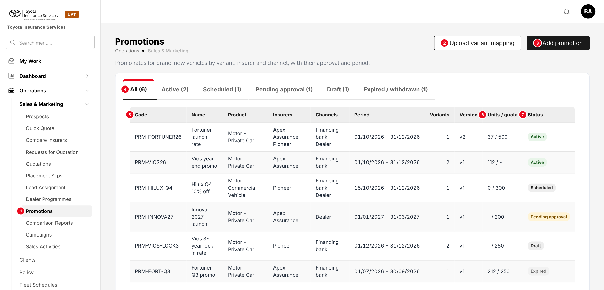
Figure 8: Promotions list (to-be design mock-up on the base version)
No. | Field (label on screen) | Type | Mand. | Source / list | Default | Rule and message
1 | Promotions (side bar) | Menu item | - | Menu grant "Sales & Marketing > Promotions" | - | Shown with read:promotions
2 | Upload variant mapping | Button | - | - | - | write:promotions; opens the upload (chapter 13)
3 | Add promotion | Button | - | - | - | write:promotions; opens the dialog of 10.2
4 | All / Active / Scheduled / Pending approval / Draft / Expired / withdrawn | Tabs | - | Promotion status | All | Each tab filters on status and shows its count
5 | Code | Column | - | Promotion | - | Opens the promotion; sorted Active first, then start date descending
- | Name, Product, Insurers, Channels, Period, Variants, Version | Columns | - | Promotion | - | -
6 | Units / quota | Column | - | Count of policies converted | - | "-" when no quota
7 | Status | Column | - | Promotion status | - | Status tag

Button | Who sees it | Enabled when | What happens | Result
Add promotion | write:promotions | Always | Opens an empty Add promotion dialog | Draft (on Save draft)
Upload variant mapping | write:promotions | Always | Opens the upload for a Draft promotion | -
Export | read:promotions | List not empty | Excel of promotions and lines, with the brand pack logo | -
Copy (row) | write:promotions | Any promotion | New Draft copied, blank code and period | Draft
Amend (row) | write:promotions | Scheduled, Active, Suspended | Creates version n+1 | Draft (new version)
Suspend / Resume / Withdraw (row) | approve:promotions | Active / Suspended / any but Expired | Remark dialog; warning when open quotations carry it | Suspended / Active / Withdrawn

10.2 Add / Edit promotion - General tab (new)
Type | New dialog, built from the Add programme dialog of Dealer Programmes
Purpose | Identity, period, benefit, promo excess and limits of a promotion.
Who can open it | write:promotions (edit); read:promotions (view)
Navigation | Promotions > Add promotion, or a code in the list
FRs | FR-PRM-001, 004, 006

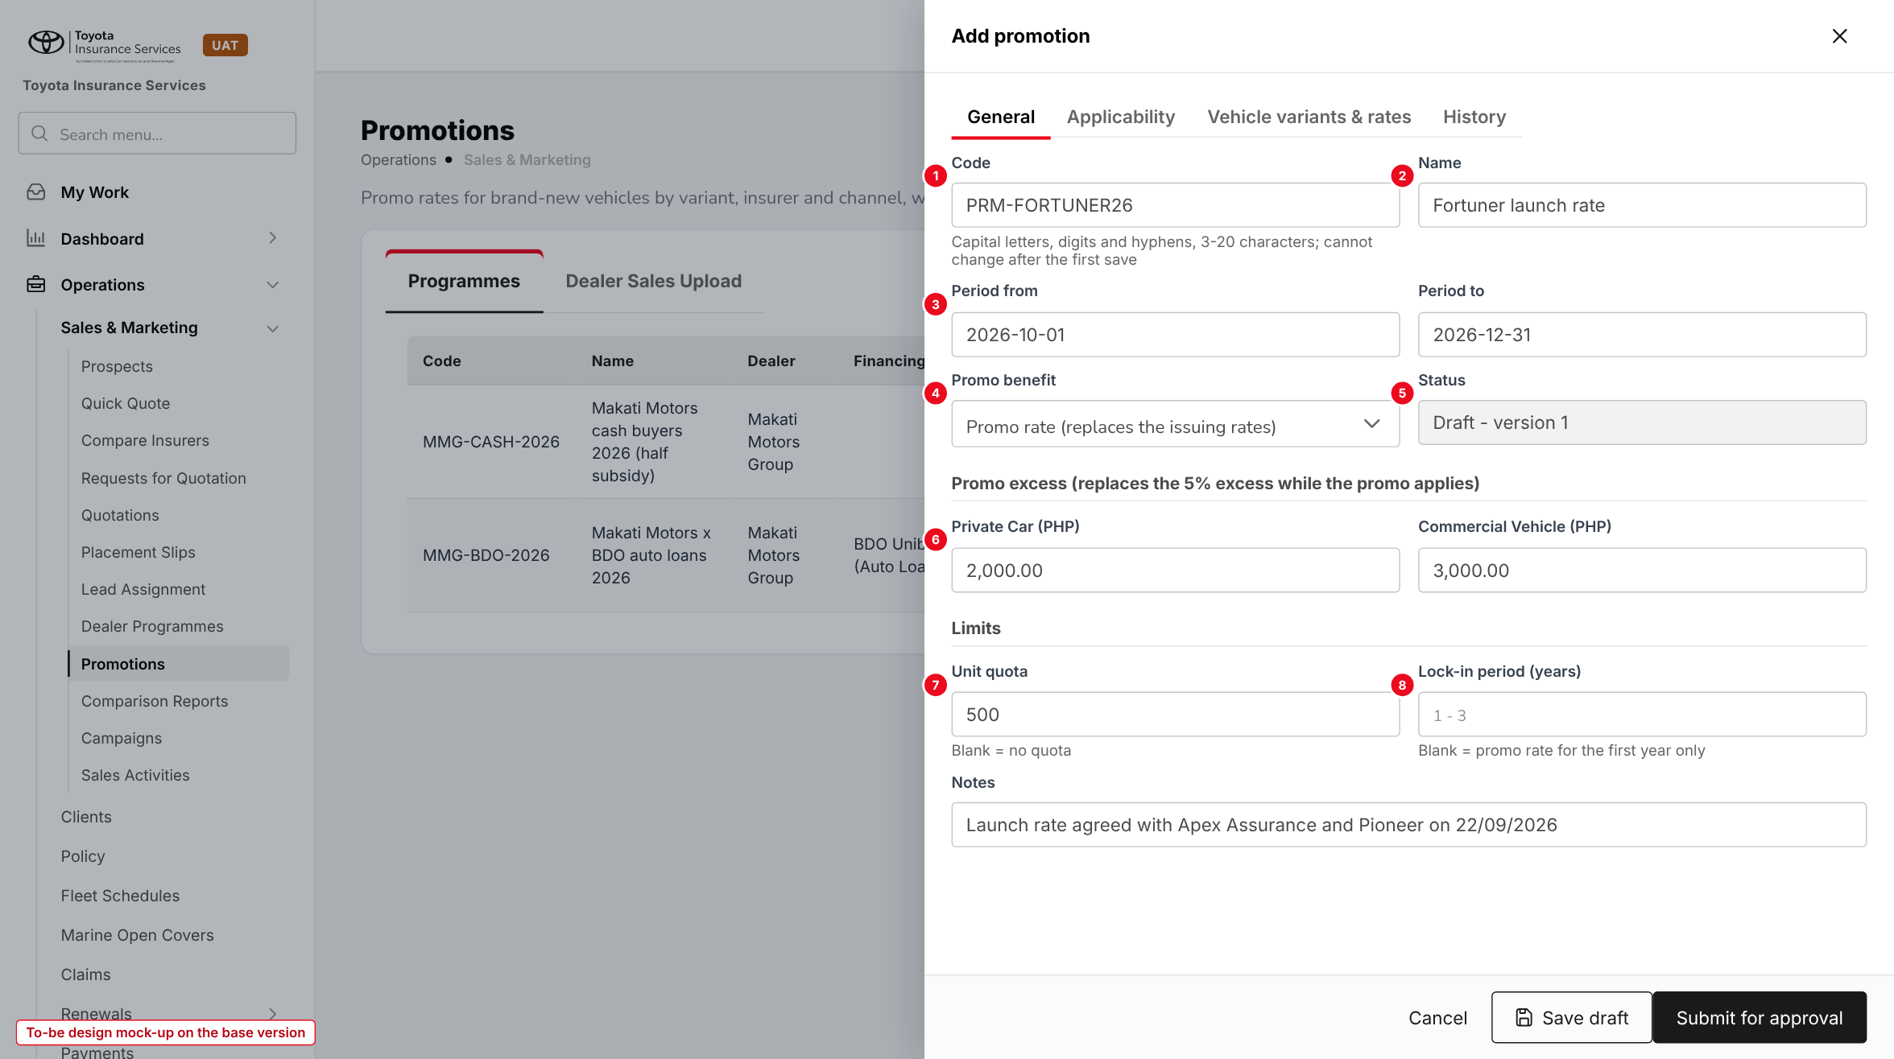
Figure 9: Add promotion, General tab (to-be design mock-up on the base version)
No. | Field (label on screen) | Type | Mand. | Source / list | Default | Rule and message
1 | Code | Text | Y | - | - | A-Z, 0-9, hyphen, 3-20; unique; read-only after the first save. MSG-PRM-001 to 003
2 | Name | Text 120 | Y | - | - | MSG-PRM-004
3 | Period from / Period to | Date | Y | - | - | From >= today; to >= from; <= 12 months. MSG-PRM-005 to 007
4 | Promo benefit | List | Y | Promo rate; Gross premium discount % | Promo rate | Not editable after approval
5 | Status | Display | - | Promotion status | Draft - version 1 | -
6 | Private Car / Commercial Vehicle (PHP) | Amount | N | - | 2,000.00 / 3,000.00 | Promo excess; blank keeps the template deductible
7 | Unit quota | Number | N | - | Blank | Whole number >= 1. MSG-PRM-012
8 | Lock-in period (years) | Number | N | - | Blank | 1-3. MSG-PRM-013
- | Notes | Text | N | - | - | -

Button | Who sees it | Enabled when | What happens | Result
Cancel | All | Always | Closes without saving after confirmation | -
Save draft | write:promotions | Draft | Validates and saves; "Promotion saved" | Draft
Submit for approval | write:promotions | Draft without errors | All checks and cap check; item in My Work > Approvals | Pending approval

10.3 Add / Edit promotion - Applicability tab (new)
Type | New tab
Purpose | Where the promotion applies.
Who can open it | write:promotions
Navigation | Add / Edit promotion > Applicability
FRs | FR-PRM-002, 011

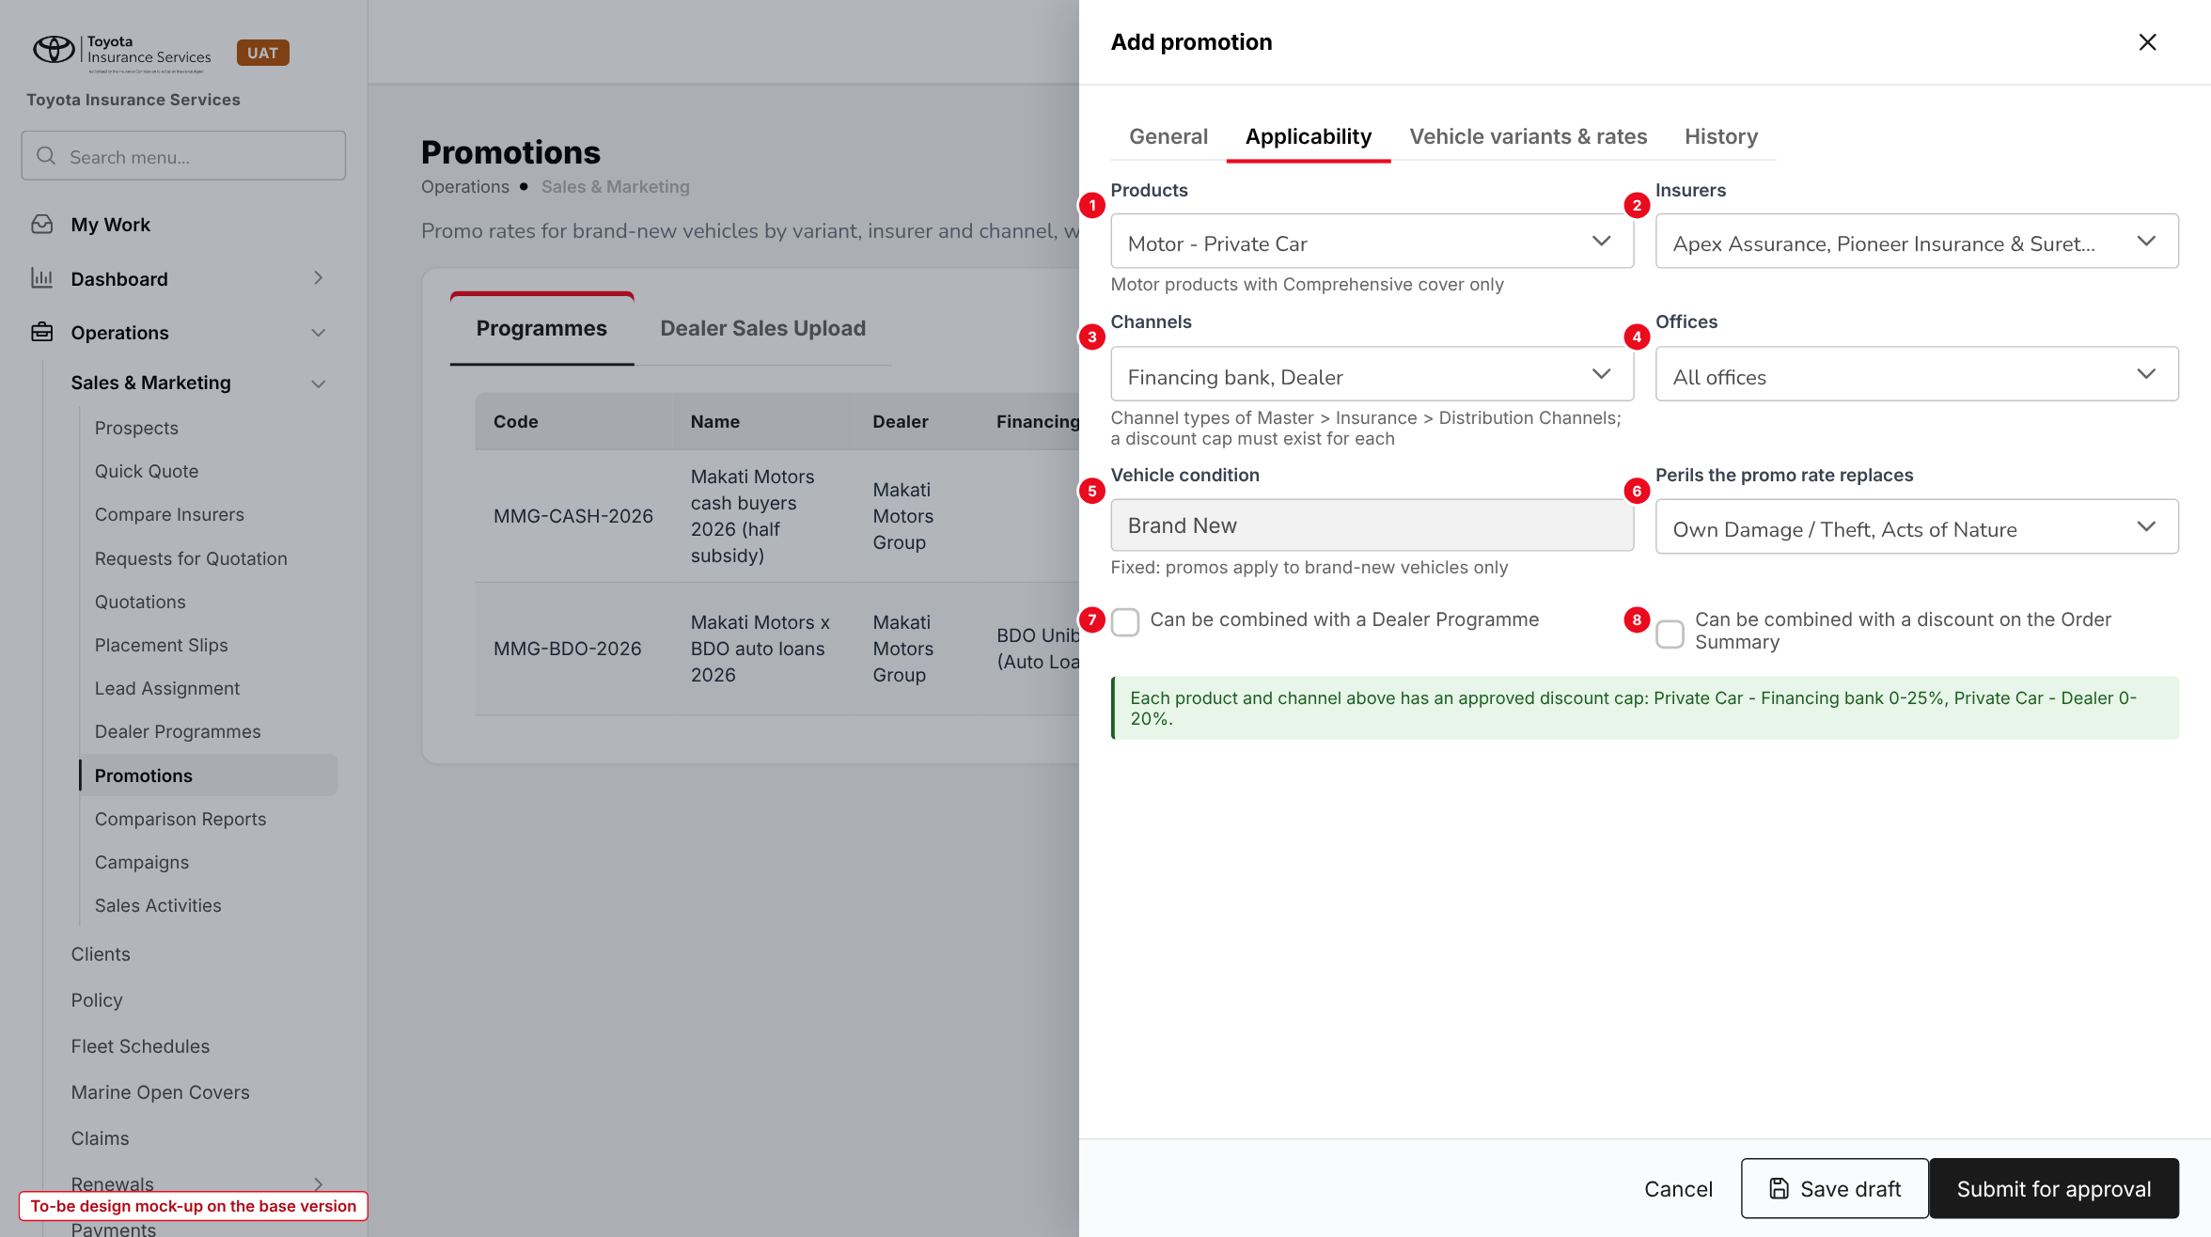
Figure 10: Applicability tab (to-be design mock-up on the base version)
No. | Field (label on screen) | Type | Mand. | Source / list | Default | Rule and message
1 | Products | Multi-select | Y | Master > Insurance > Product (Motor) | - | MSG-PRM-008, 009
2 | Insurers | Multi-select | Y | Master > Insurance > Insurance Company | - | MSG-PRM-010
3 | Channels | Multi-select | Y | Channel type list (7.3) | - | An approved cap must exist for each product and channel type. MSG-PRM-011, 029
4 | Offices | Multi-select | N | Master > Branch | All offices | -
5 | Vehicle condition | Display | - | - | Brand New | Fixed
6 | Perils the promo rate replaces | Multi-select | Y | Own Damage / Theft, Acts of Nature | Both | -
7 | Can be combined with a Dealer Programme | Tick box | - | - | Off | -
8 | Can be combined with a discount on the Order Summary | Tick box | - | - | Off | When off, Discount (Optional) stays at 0%

10.4 Add / Edit promotion - Vehicle variants & rates tab (new)
Type | New tab
Purpose | The vehicles of the promotion and their promo and remitting rates, with the cap check of each line.
Who can open it | write:promotions
Navigation | Add / Edit promotion > Vehicle variants & rates
FRs | FR-PRM-003, 011

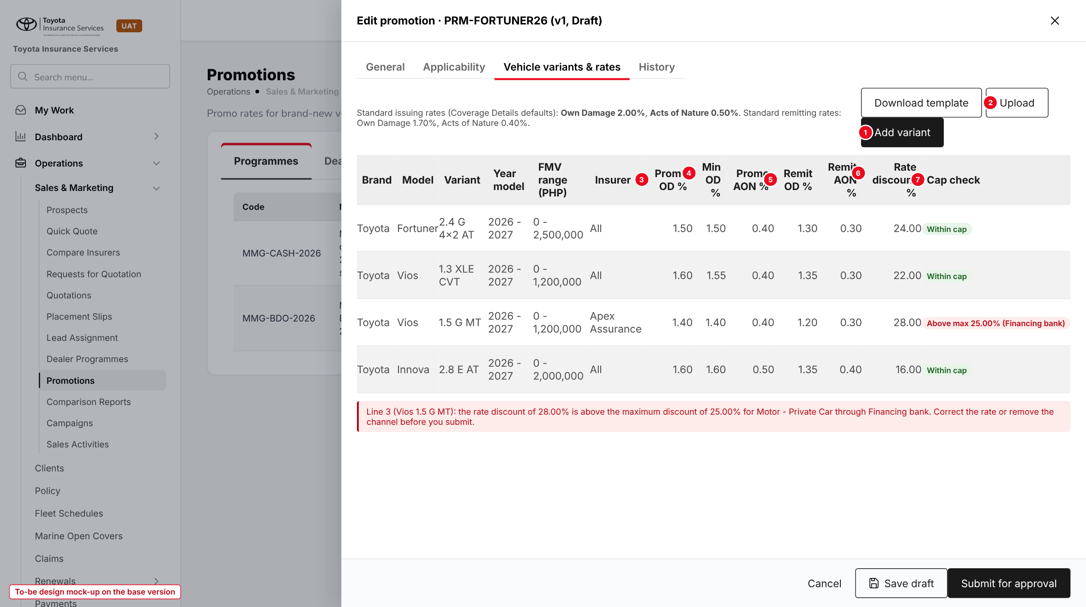
Figure 11: Vehicle variants & rates tab with a line above the cap (to-be design mock-up on the base version)
No. | Field (label on screen) | Type | Mand. | Source / list | Default | Rule and message
1 | Add variant | Button | - | - | - | Adds a line
2 | Download template / Upload | Buttons | - | - | - | Chapter 13
- | Brand, Model, Variant | Chained lists | Y | Master > Insurance > Vehicle | - | Active variant. MSG-PRM-019
- | Year model (from - to) | Year | Y | - | Current year to +1 | MSG-PRM-021
- | FMV range (PHP) | Amount | N | - | Blank | MSG-PRM-022
- | Insurer | List | N | Insurers of the promotion | All | No overlap. MSG-PRM-020
3 | Promo OD % / Promo AON % | Rate, 4 dec. | Y | - | - | MSG-PRM-023, 024, 027
4 | Min OD % | Rate, 4 dec. | Y | - | = Promo OD % | <= Promo OD %, >= Remit OD %. MSG-PRM-026
5 | Remit OD % / Remit AON % | Rate, 4 dec. | Y | - | - | <= promo rate of the peril. MSG-PRM-025
6 | Rate discount % | Display | - | Computed | - | ((2.00 + 0.50) - (Min OD + Promo AON)) / 2.50 x 100
7 | Cap check | Tag | - | Computed per channel type | - | Within cap / Above max / Below min / Below lowest OD rate. MSG-PRM-030 to 032

10.5 Promotion approval in My Work (existing screen)
Type | Existing screen, new item kinds
Purpose | Approve or return a promotion; approve a quotation whose discount is above the maker's limit.
Who can open it | approve:promotions; users whose Authority Matrix "Quotation discount" limit covers the discount
Navigation | My Work > My Items > Approvals
FRs | FR-PRM-004, 023

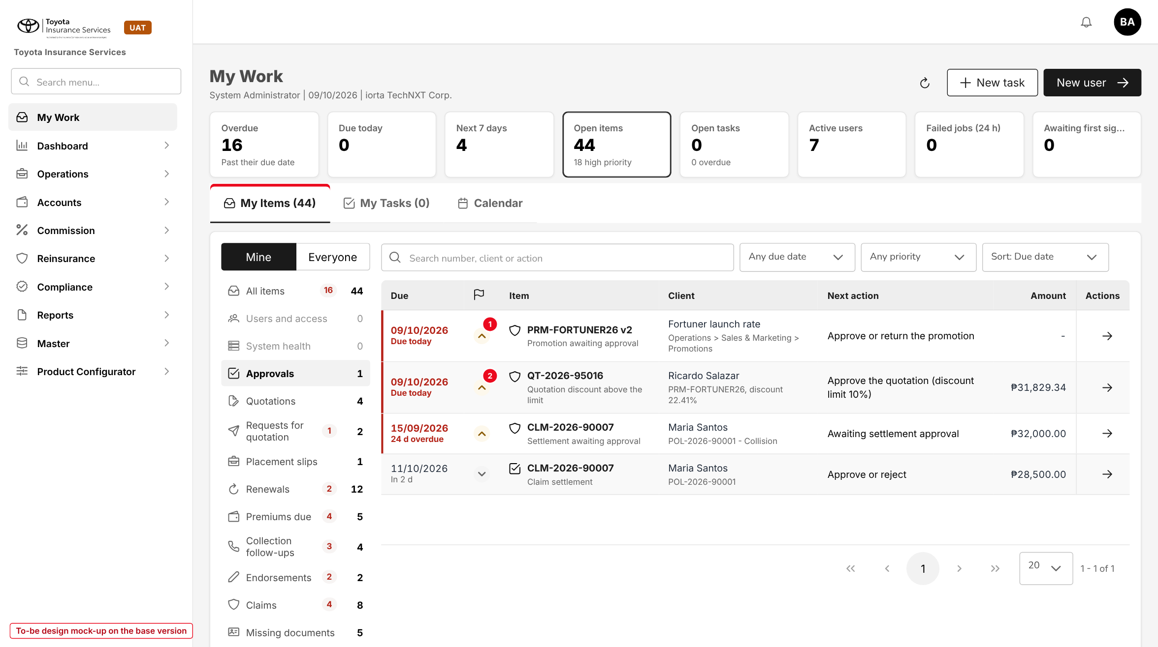
Figure 12: My Work > Approvals with a promotion item (1) and a quotation-discount item (2) (to-be design mock-up on the base version)
Button | Who sees it | Enabled when | What happens | Result
Approve | approve:promotions, not the maker | Pending approval; start date not passed | Records the approver; sets Scheduled or Active | Scheduled / Active
Return | approve:promotions, not the maker | Pending approval | Remark required | Draft
Approve (quotation) | Limit >= total discount, not the maker | Quotation awaiting discount approval | Normal quotation approval | Approved

10.6 Discount Caps (new)
Type | New screen, laid out like Commission Rate Matrix
Purpose | Min / max discount and the lowest Own Damage rate per product and channel type.
Who can open it | read:discount-caps (view); write:discount-caps (maintain); approve:discount-caps on Configuration Approvals
Navigation | Master > Finance > Discount Caps
FRs | FR-PRM-010, 011, 023

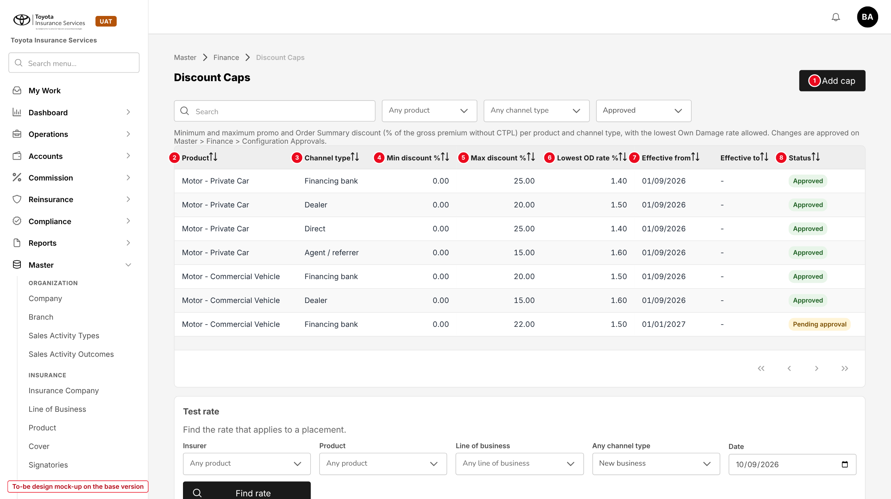
Figure 13: Discount Caps (to-be design mock-up on the base version, illustrative values)
No. | Field (label on screen) | Type | Mand. | Source / list | Default | Rule and message
1 | Add cap | Button | - | - | - | write:discount-caps; change sent to Configuration Approvals
2 | Product | List | Y | Master > Insurance > Product (Motor) | - | MSG-PRM-048
3 | Channel type | List | Y | Channel type list (7.3) | - | -
4 | Min discount % | Percent, 2 dec. | Y | - | 0.00 | 0-100, <= max. MSG-PRM-049, 050
5 | Max discount % | Percent, 2 dec. | Y | - | - | 0-100
6 | Lowest OD rate % | Rate, 4 dec. | Y | - | - | Floor for Min OD % and rate changes
7 | Effective from / Effective to | Date | Y / N | - | Today | No overlap; not backdated. MSG-PRM-051, 052
8 | Status | Tag | - | Pending approval; Approved; Ended | - | -

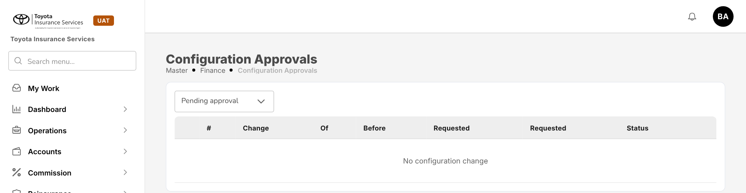
Figure 14: Base version: Master > Finance > Configuration Approvals, where cap changes are approved

10.7 Create Quote - Step 1 Policy Details (changed)
Type | Existing screen, one new field
Purpose | Capture the vehicle condition that decides whether promotions are offered.
Who can open it | write:quotations
Navigation | Prospects > prospect > Create Quote
FRs | FR-PRM-020

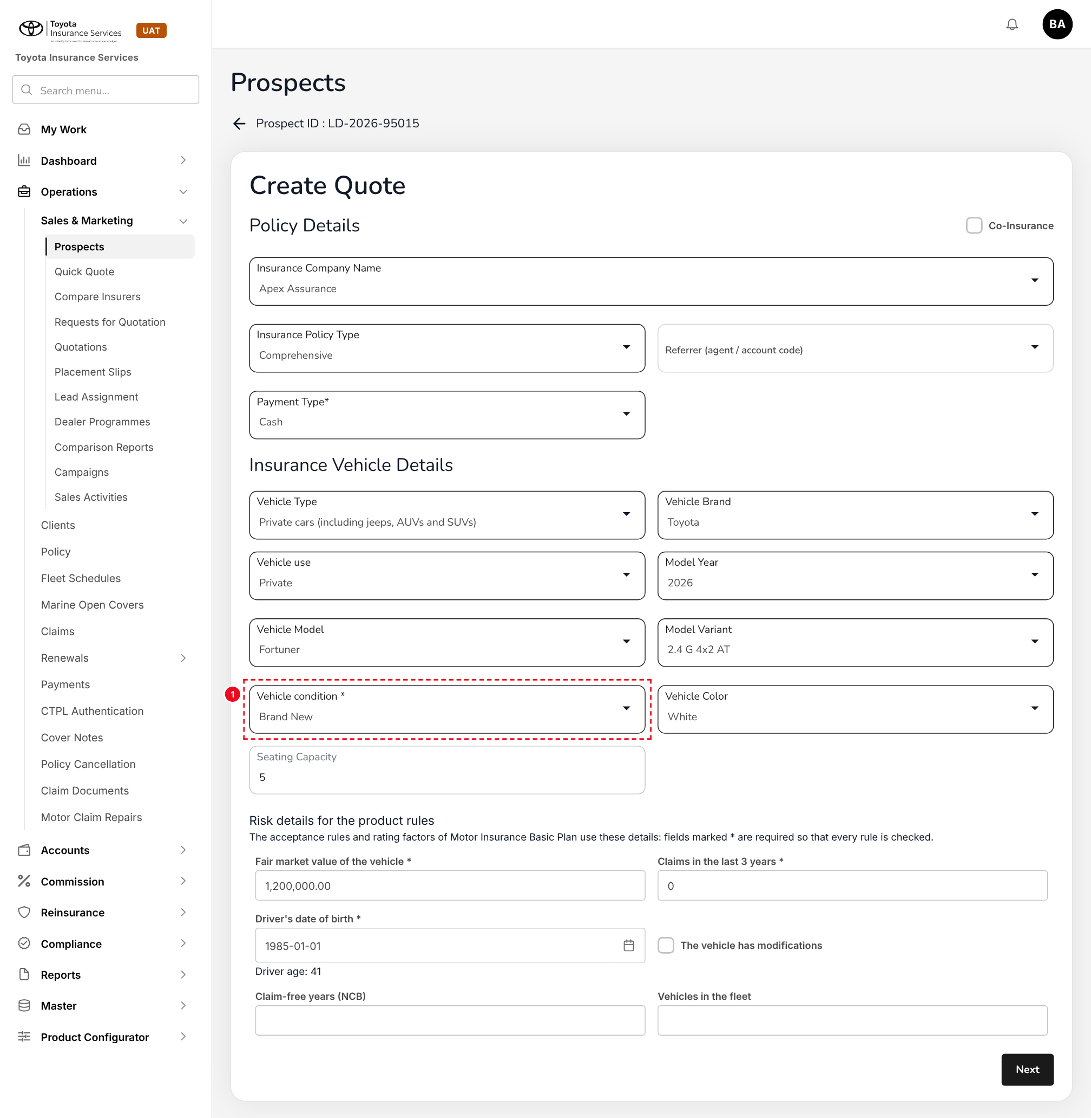
Figure 15: Step 1 Policy Details with the new field Vehicle condition (1) (to-be design mock-up on the base version)
No. | Field (label on screen) | Type | Mand. | Source / list | Default | Rule and message
1 | Vehicle condition * | List | Y | Brand New; Used; Repossessed | From the TFS feed for TFS prospects | MSG-PRM-056
- | Vehicle Brand, Vehicle Model, Model Variant, Model Year (existing) | Lists | Y | Master > Insurance > Vehicle | - | Used to find the promo line
- | Fair market value of the vehicle * (existing risk detail) | Amount | Y | - | - | Checked against the FMV range of the line

10.8 Create Quote - Step 3 Coverage Details (changed)
Type | Existing screen, new Promotion section; Override restricted
Purpose | Select the promotion, fill its rates and see the premium with promo.
Who can open it | write:quotations; write:promotion-rates for Change promo rate
Navigation | Create Quote > Next from Plan Recommendations
FRs | FR-PRM-020 to 023

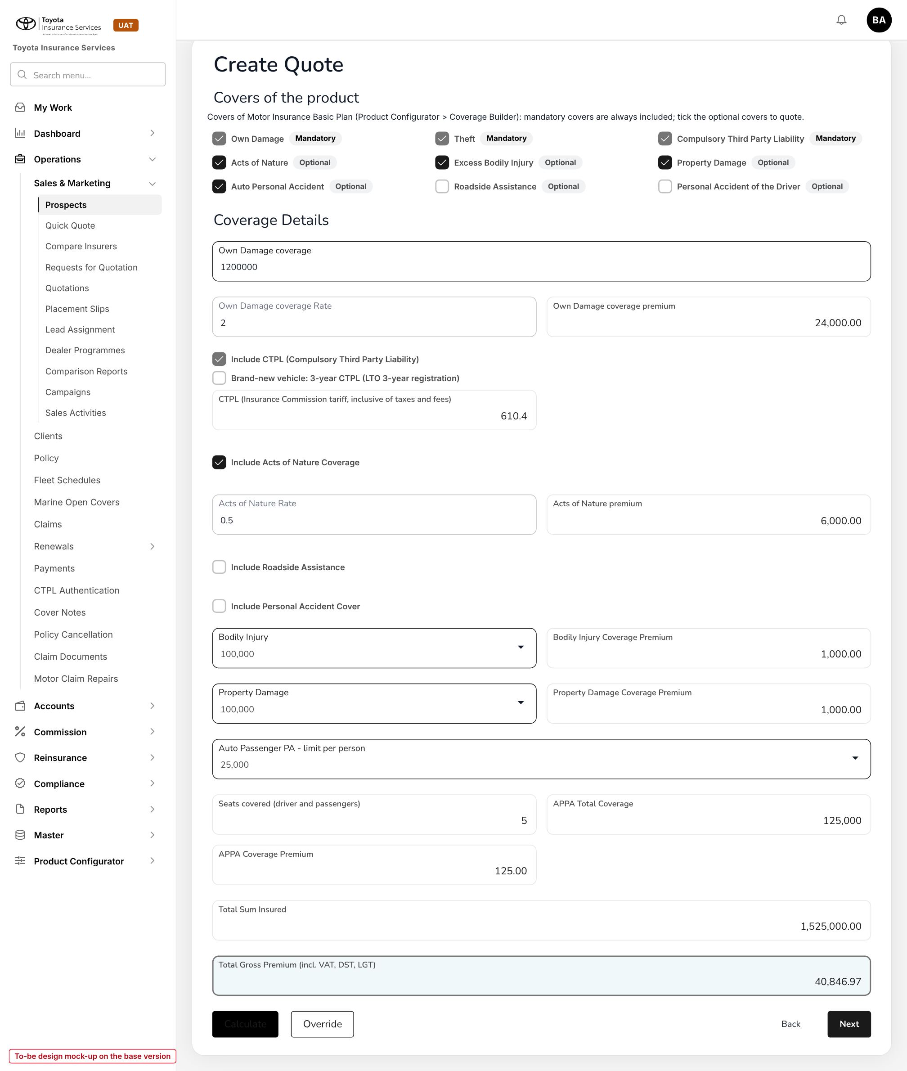
Figure 16: Base version today: Coverage Details at the standard rates (Own Damage 2, Acts of Nature 0.5)
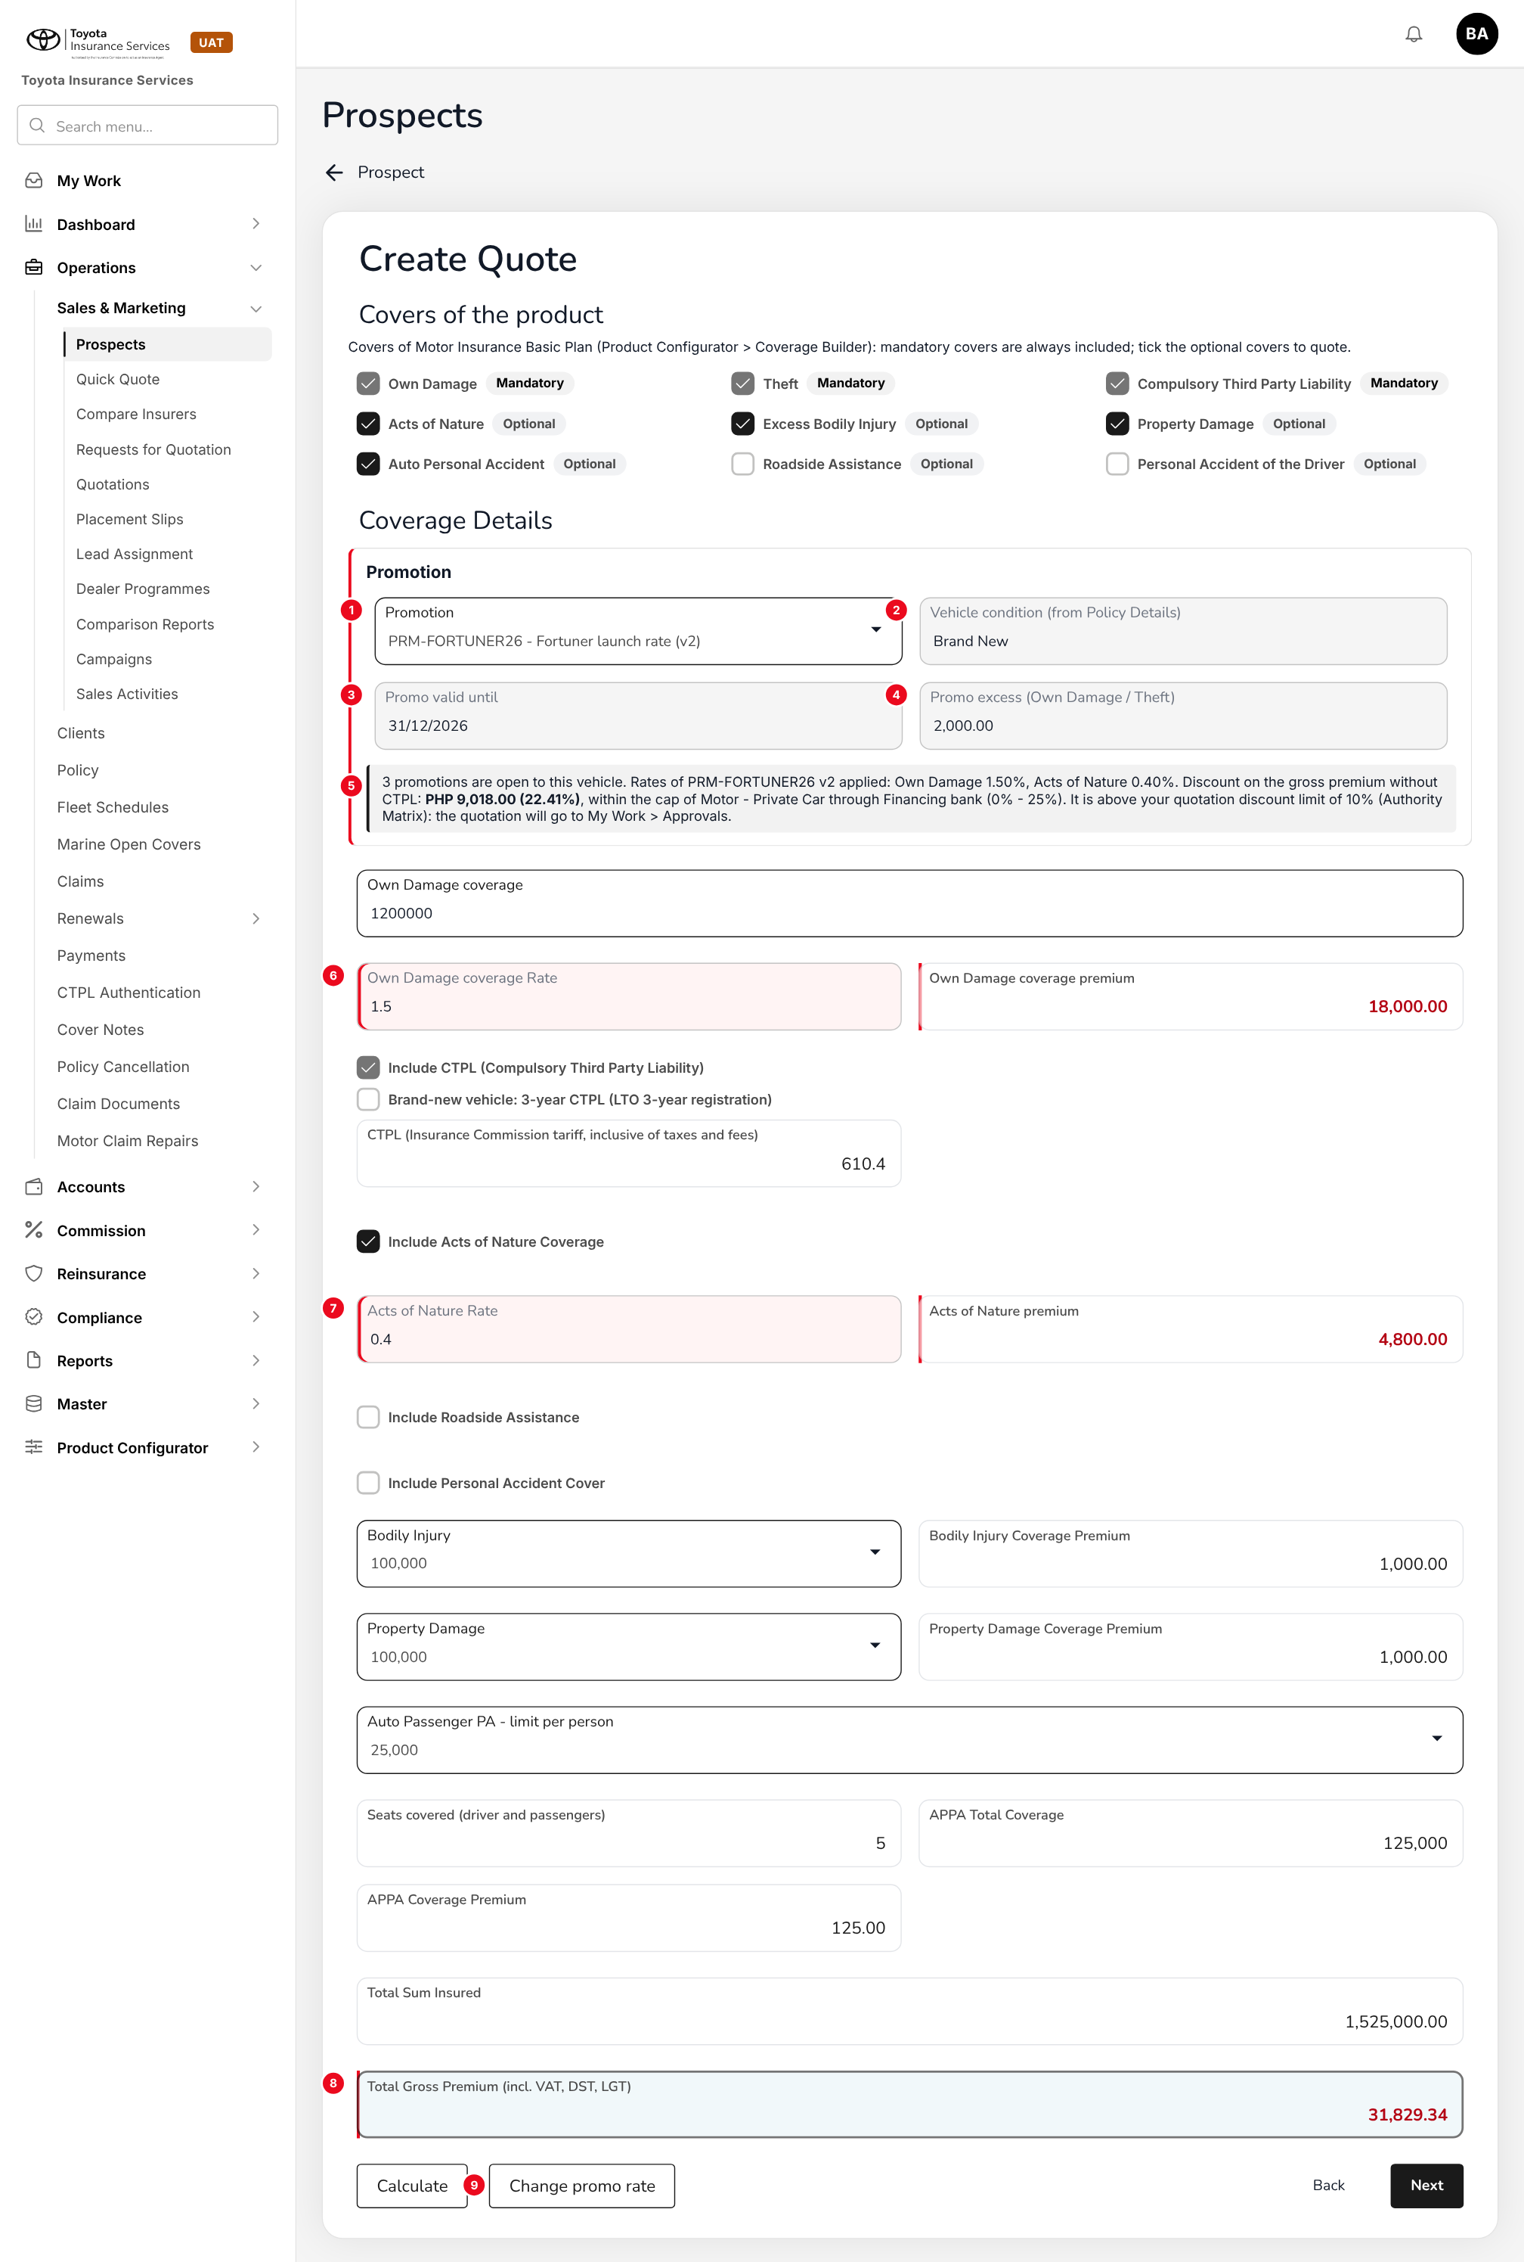
Figure 17: Coverage Details with the Promotion section and promo rates (to-be design mock-up on the base version)
No. | Field (label on screen) | Type | Mand. | Source / list | Default | Rule and message
1 | Promotion | List | N | Open promotions (FR-PRM-020) | Blank (or the only one, if configured) | MSG-PRM-057 to 065
2 | Vehicle condition (from Policy Details) | Display | - | Step 1 | - | -
3 | Promo valid until | Display | - | Promotion | - | -
4 | Promo excess (Own Damage / Theft) | Display | - | Promotion > General | - | Replaces the template deductible
5 | Information line | Text | - | - | - | Rates applied, discount, cap and authority result. MSG-PRM-066, 076
6 | Own Damage coverage Rate (existing) | Rate | Y | Promo OD % | 2 without promo | Read-only with a promo except for write:promotion-rates. MSG-PRM-067 to 070
7 | Acts of Nature Rate (existing) | Rate | Y | Promo AON % | 0.5 without promo | Read-only with a promo
8 | Total Gross Premium (incl. VAT, DST, LGT) (existing) | Display | - | Premium engine | - | Premium with promo
9 | Change promo rate (was Override) | Button | - | - | - | Only with write:promotion-rates when a promo is selected; reason required

10.9 Create Quote - Step 5 Order Summary (changed)
Type | Existing screen, new line and limits
Purpose | Show the promo discount and keep the Order Summary discount within the cap.
Who can open it | write:quotations
Navigation | Create Quote > Next from Accessories
FRs | FR-PRM-022, 023

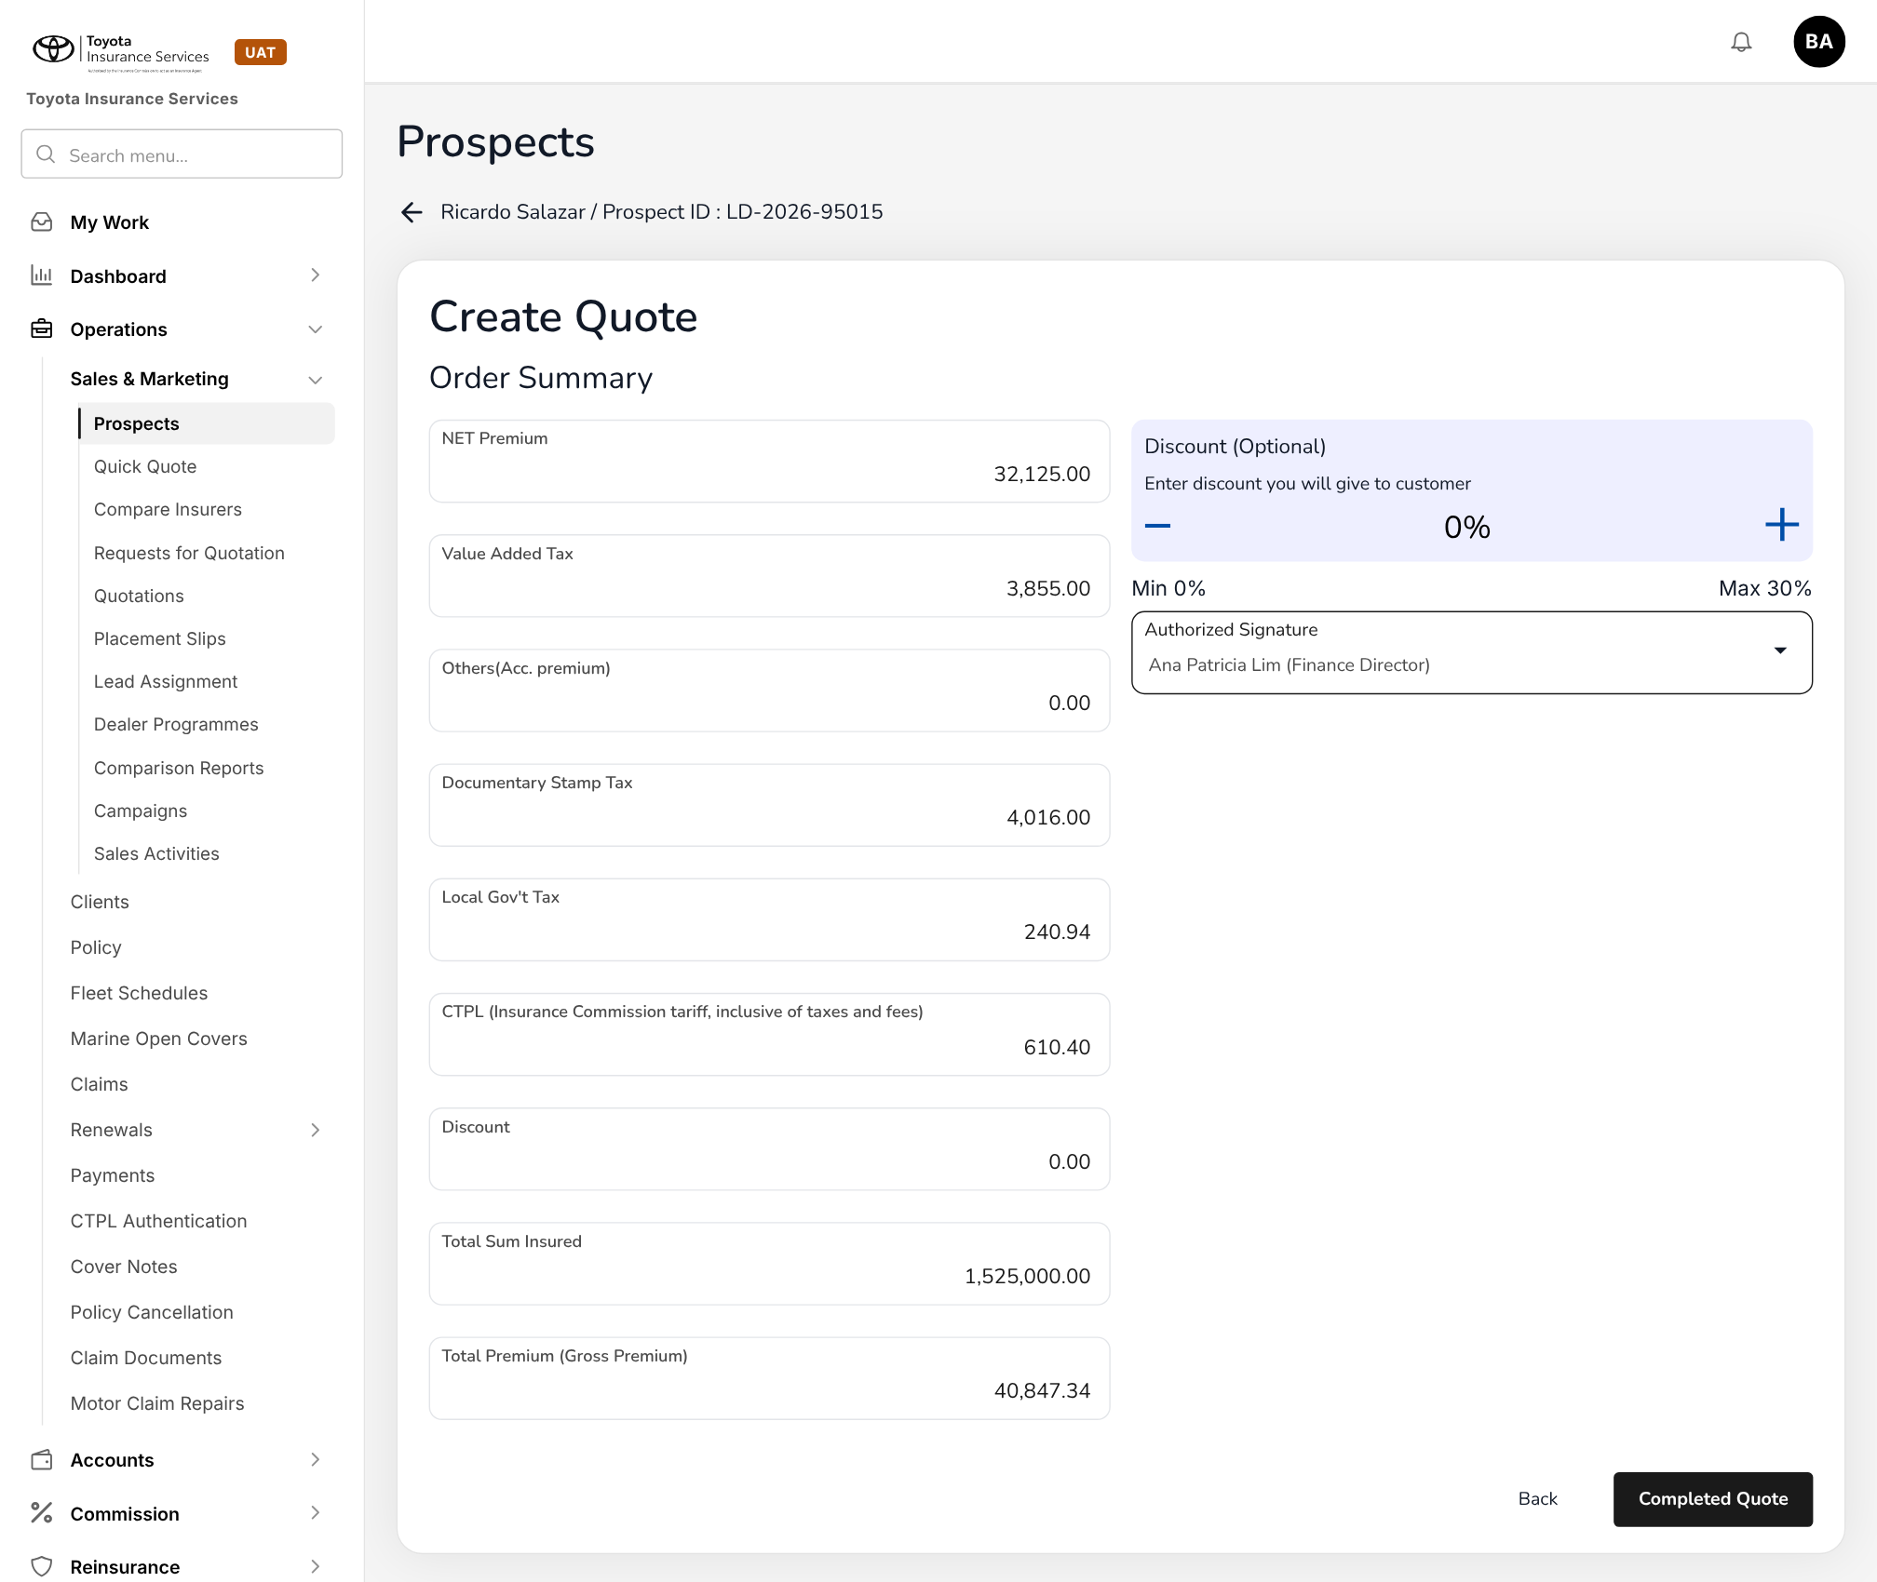
Figure 18: Base version today: Order Summary with Discount (Optional) limited to Min 0% / Max 30%
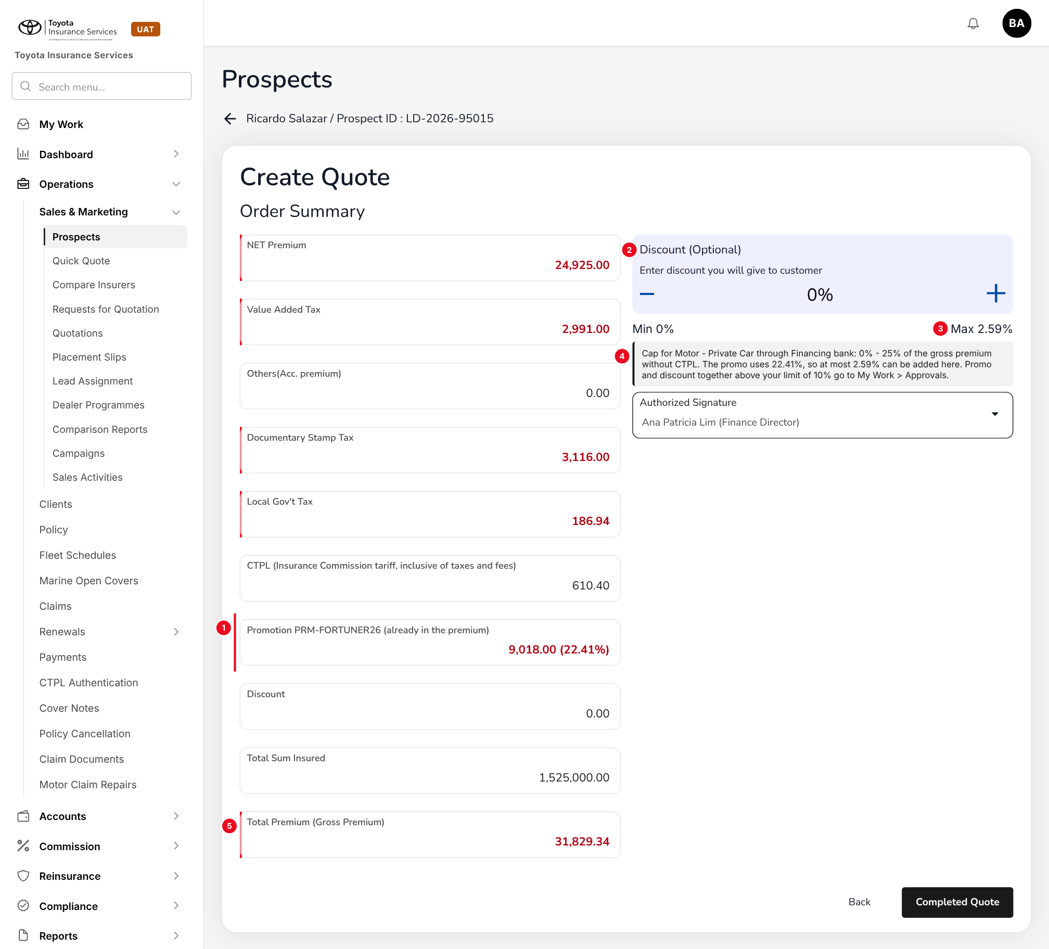
Figure 19: Order Summary with the Promotion line and the cap limits (to-be design mock-up on the base version)
No. | Field (label on screen) | Type | Mand. | Source / list | Default | Rule and message
1 | Promotion <code> (already in the premium) | Display | - | Premium engine | - | Promo discount in PHP and % of the discountable premium
2 | Discount (Optional) (existing) | Percent | N | - | 0% | Fixed at 0% when the promo is not combinable. MSG-PRM-075
3 | Min / Max (existing labels) | Display | - | Discount Caps minus the promo discount | Was Min 0% / Max 30% | MSG-PRM-073, 074
4 | Cap and authority line | Text | - | - | - | MSG-PRM-076
5 | Total Premium (Gross Premium) (existing) | Display | - | Premium engine | - | -

Button | Who sees it | Enabled when | What happens | Result
Completed Quote (existing) | write:quotations | No blocking error | Saves the quotation; above the maker's authority limit an approval item is raised in My Work > Approvals | Draft / PendingCustomer as today; Approved only after the approval

10.10 Upload variant mapping (new)
Type | New, base upload pattern
Purpose | Load many promotion lines from Excel.
Who can open it | write:promotions
Navigation | - Promotions > Upload variant mapping  - Vehicle variants & rates tab > Upload
FRs | FR-PRM-003

The user picks the Draft promotion, chooses Add or Replace, downloads the template, uploads the .xlsx and reads the result line ("Processed n rows: c loaded, f failed") with the failed rows listed by row number, as in the Dealer Sales Upload of Dealer Programmes. The template is in chapter 13.

11 End-to-end walkthroughs
The walkthroughs follow one case through the base version, persona by persona, using the sample data of the base version (prospect Ricardo Salazar, LD-2026-95015; Apex Assurance; Toyota Fortuner 2.4 G 4x2 AT). They are the script of the PROD-15 SIT and UAT sessions; premium figures come from the base premium engine.

11.1 WT-A Launch a promotion
Table 24: WT-A
Step | Who | Does | Sees / result
1 | Processing Team | Master > Finance > Discount Caps: checks Private Car - Financing bank and Dealer | Financing bank 0-25%, lowest OD 1.40%; Dealer 0-20%, 1.50% (Approved)
2 | Processing Team | Promotions > Add promotion: PRM-FORTUNER26 "Fortuner launch rate", 01/10/2026 - 31/12/2026, Promo rate, excess PC 2,000, quota 500 | "Promotion saved"; Draft v1
3 | Processing Team | Applicability: Motor - Private Car; Apex Assurance, Pioneer; Financing bank, Dealer | Caps found for both channel types
4 | Processing Team | Vehicle variants & rates: Fortuner 2.4 G 4x2 AT, 1.50 / 1.50 / 0.40 / 1.30 / 0.30 | Rate discount 24.00%; Within cap for Financing bank (25%); Above max for Dealer (20%)
5 | Processing Team | Removes Dealer from Applicability and submits | "Promotion submitted for approval"; item in My Work > Approvals
6 | Accounting Manager | My Work > Approvals > PRM-FORTUNER26 > Approve on 25/09/2026 | "Promotion approved"; Scheduled
7 | System | Promotion status job on 01/10/2026 | Active

11.2 WT-B Quote, approve and convert with a promotion
Table 25: WT-B
Step | Who | Does | Sees / result
1 | Sales & Marketing | Prospects > LD-2026-95015 > Create Quote; Step 1: Apex Assurance, Comprehensive, Cash, Private cars, Toyota Fortuner 2.4 G 4x2 AT, 2026, Vehicle condition Brand New, FMV 1,200,000.00 | Next to Plan Recommendations, then Coverage Details
2 | Sales & Marketing | Coverage Details: selects PRM-FORTUNER26 in Promotion; Own Damage coverage 1200000; Acts of Nature, Bodily Injury 100,000, Property Damage 100,000, APPA 25,000 x 5; Calculate | Rates 1.5 and 0.4 filled; premium 18,000.00 and 4,800.00; Total Gross Premium 31,829.34
3 | Sales & Marketing | Order Summary | NET Premium 24,925.00; VAT 2,991.00; DST 3,116.00; LGT 186.94; CTPL 610.40; Promotion 9,018.00 (22.41%); Discount (Optional) Min 0% / Max 2.59%; Total Premium 31,829.34
4 | Sales & Marketing | Completed Quote | Quotation saved; discount 22.41% is above the Sales limit of 10%: item in My Work > Approvals
5 | Accounting Manager | Approves the quotation (limit 25%) | Approved; PDF sent to the client with the promo
6 | Client | Accepts through the approval link | CustomerAccepted
7 | Processing Team | Converts to policy with chassis and engine numbers; Placement Slip to Apex Assurance | Chassis on no earlier policy; ConvertedToPolicy; units of PRM-FORTUNER26 +1
8 | Accounting | Remittance and commission after payment | Brokerage on the promo perils 3,600.00 (with PROD-16)

11.3 WT-C Exceptions
Table 26: WT-C
Case | Who | Does | Sees / result
C1 Used vehicle | Sales & Marketing | Vehicle condition Used on Step 1 | "No promotion is open to this vehicle"
C2 Rate change without the right | Sales & Marketing | Tries to edit Own Damage coverage Rate with a promo | "Only users with the right to change promotion rates can change this rate"
C3 Flexible rate | Authorised user | Vios 1.3 XLE CVT (Promo OD 1.60, Min OD 1.55): enters 1.50, then 1.55 with reason Fleet account | 1.50 refused; 1.55 accepted and logged
C4 Discount above the cap | Sales & Marketing | Adds 3% on Order Summary after the 22.41% promo (cap 25%) | "The discount of 25.41% is above the maximum of 25.00% ..."
C5 Promo ended before an edit | Sales & Marketing | Edits on 05/01/2027 a Draft quotation priced in December | Promo removed; re-priced at the standard rates; warning
C6 Vehicle replaced | Operations | Endorsement replacing the insured vehicle | Warning; new vehicle at the standard rates
C7 Renewal | System | Renewal of the Fortuner policy | Standard rates on current FMV

12 Messages catalogue
Every message a user can see for PROD-15, grouped by the screen or dialog that shows it. 78 messages: 9 confirmation, 36 error, 3 information, 23 validation, 7 warning. As in the base version, a validation or error is returned as { message, errors: [{ path, message }] } and shown under the field of the path; confirmations are toasts in short past tense. Text in angle brackets is filled in by the system.

12.1 Add / Edit promotion
ID | Field (path) | Message | Type | What the user does
MSG-PRM-001 | code | Code is required | Validation | Enter a code.
MSG-PRM-002 | code | Code may contain only capital letters, digits and hyphens (3 to 20 characters) | Validation | Correct the code.
MSG-PRM-003 | code | Promotion code <code> is already used | Error | Use another code, or amend the existing promotion.
MSG-PRM-004 | name | Name is required | Validation | Enter a name.
MSG-PRM-005 | effectiveTo | effectiveTo is before effectiveFrom | Validation | Correct the dates.
MSG-PRM-006 | effectiveFrom | The period cannot start before today | Error | Enter today or a later date. Promotions are never backdated.
MSG-PRM-007 | effectiveTo | A promotion period cannot be longer than <n> months | Error | Shorten the period (Master > System > Configuration: promotions.max_period_months).
MSG-PRM-008 | productIds | Select at least one product | Validation | Select the Motor product(s).
MSG-PRM-009 | productIds | Promotions apply to Motor products only | Error | Remove the product that is not Motor.
MSG-PRM-010 | insuranceCompanyIds | Select at least one insurer | Validation | Select the insurers that agreed the promo rates.
MSG-PRM-011 | channelTypes | Select at least one channel type | Validation | Select the channel types.
MSG-PRM-012 | unitQuota | Unit quota must be a whole number of 1 or more | Validation | Correct the quota or leave it blank.
MSG-PRM-013 | lockInYears | Lock-in period must be between 1 and <n> years | Validation | Correct the lock-in period or leave it blank.
MSG-PRM-014 | - | Promotion <code> is <status> and cannot be changed. Use Amend to create a new version | Error | Click Amend.
MSG-PRM-015 | - | Promotion <code> already has version <n> in Draft or Pending approval | Error | Finish or discard that version first.
MSG-PRM-016 | - | Promotion saved | Confirmation | No action.
MSG-PRM-017 | - | Promotion submitted for approval | Confirmation | No action. The item is in My Work > Approvals.

12.2 Vehicle variants & rates
ID | Field (path) | Message | Type | What the user does
MSG-PRM-018 | lines | Add at least one vehicle variant | Validation | Add a line or upload the mapping.
MSG-PRM-019 | lines[n].variantId | Variant <variant> is inactive on Master > Insurance > Vehicle | Error | Remove the line or ask for the variant to be re-activated.
MSG-PRM-020 | lines[n] | Variant <variant> is listed twice for overlapping year models and insurers | Error | Merge or correct the lines.
MSG-PRM-021 | lines[n].yearTo | Line <n>: year model to is before year model from | Validation | Correct the year models.
MSG-PRM-022 | lines[n].fmvTo | Line <n>: FMV to must be higher than FMV from | Validation | Correct the FMV range.
MSG-PRM-023 | lines[n].ownDamageRate | Line <n>: Promo OD %, Promo AON %, Remit OD % and Remit AON % are required | Validation | Enter the four rates.
MSG-PRM-024 | lines[n] | Line <n>: rates must be more than 0 and at most 100, with up to 4 decimals | Validation | Correct the rate.
MSG-PRM-025 | lines[n].remitOwnDamageRate | Line <n>: a remitting rate cannot be higher than the promo rate of the same peril | Error | Enter the remitting rate agreed with the insurer.
MSG-PRM-026 | lines[n].minOwnDamageRate | Line <n>: Min OD % cannot be higher than Promo OD % | Error | Lower Min OD % or set it equal to Promo OD %.
MSG-PRM-027 | lines[n] | Line <n>: the promo rates are not lower than the standard rates (OD <r>%, AON <r>%) | Warning | Check the rates; this line gives no discount.
MSG-PRM-028 | lines[n].discountPercent | Line <n>: discount % is required | Validation | Enter the discount.
MSG-PRM-029 | channelTypes | No approved discount cap for <product> through <channel type> | Error | Add the cap on Master > Finance > Discount Caps, or remove the channel type.
MSG-PRM-030 | lines[n] | Line <n>: the rate discount of <x>% is above the maximum discount of <max>% for <product> through <channel type> | Error | Correct the rate or remove the channel type before you submit.
MSG-PRM-031 | lines[n] | Line <n>: the rate discount of <x>% is below the minimum discount of <min>% for <product> through <channel type> | Error | Correct the rate or remove the channel type.
MSG-PRM-032 | lines[n].minOwnDamageRate | Line <n>: Min OD % of <r>% is below the lowest OD rate of <floor>% for <product> through <channel type> | Error | Raise Min OD % to the lowest rate or above.

12.3 Upload variant mapping
ID | Field (path) | Message | Type | What the user does
MSG-PRM-033 | file | Upload an Excel (.xlsx) file | Validation | Save the file as .xlsx and upload it again.
MSG-PRM-034 | file | The file does not match the template: column <column> is missing | Error | Download the template and copy the rows into its Data sheet.
MSG-PRM-035 | file | The file has more than <max> rows | Error | Split the file (promotions.max_rows).
MSG-PRM-036 | - | Row <n>: <message> | Error | Correct the row and upload the corrected rows.
MSG-PRM-037 | - | Processed <n> rows: <c> loaded, <f> failed | Confirmation | Check the failed rows listed under the message.

12.4 Promotion approval
ID | Field (path) | Message | Type | What the user does
MSG-PRM-038 | - | Maker-checker: the approver must be different from the user who created or changed the promotion | Error | Leave it to another approver.
MSG-PRM-039 | remark | Remark is required | Validation | Enter the reason for returning the promotion.
MSG-PRM-040 | - | The period start <date> has passed. Return the promotion so the maker can correct the period | Error | Return the promotion.
MSG-PRM-041 | - | Promotion approved | Confirmation | No action.
MSG-PRM-042 | - | Promotion returned | Confirmation | No action.

12.5 Suspend / Resume / Withdraw
ID | Field (path) | Message | Type | What the user does
MSG-PRM-043 | remark | Remark is required | Validation | Enter the reason.
MSG-PRM-044 | - | <n> open quotation(s) carry this promotion. They keep it until their validity ends | Warning | Confirm, or cancel and review the quotations first.
MSG-PRM-045 | - | Promotion suspended | Confirmation | No action.
MSG-PRM-046 | - | Promotion resumed | Confirmation | No action.
MSG-PRM-047 | - | Promotion withdrawn | Confirmation | No action.

12.6 Discount Caps
ID | Field (path) | Message | Type | What the user does
MSG-PRM-048 | - | Product, channel type, min discount %, max discount %, lowest OD rate % and effective from are required | Validation | Complete the fields.
MSG-PRM-049 | maxPercent | Discount % must be between 0 and 100 | Validation | Correct the value.
MSG-PRM-050 | minPercent | Min discount % cannot be higher than max discount % | Validation | Correct the values.
MSG-PRM-051 | effectiveFrom | An approved cap for <product> through <channel type> already covers <date> | Error | End-date the existing cap first, or start the new cap after it.
MSG-PRM-052 | effectiveFrom | effectiveFrom cannot be before today | Error | Enter today or a later date.
MSG-PRM-053 | - | <n> line(s) of active promotions would be outside the new cap: <list>. They will not be offered from <date> | Warning | Confirm, or amend the promotions first.
MSG-PRM-054 | - | Discount cap submitted for approval | Confirmation | No action. It is approved on Master > Finance > Configuration Approvals.
MSG-PRM-055 | - | Maker-checker: the approver must be different from the user who created the change | Error | Leave it to another approver.

12.7 Create Quote > Policy Details
ID | Field (path) | Message | Type | What the user does
MSG-PRM-056 | vehicleCondition | Vehicle condition is required | Validation | Select Brand New, Used or Repossessed.

12.8 Create Quote > Coverage Details
ID | Field (path) | Message | Type | What the user does
MSG-PRM-057 | - | No promotion is open to this vehicle | Information | No action. The vehicle is priced at the standard rates.
MSG-PRM-058 | promotionId | Promotions apply to brand-new vehicles only | Error | Remove the promotion, or correct Vehicle condition and Model Year on Policy Details.
MSG-PRM-059 | promotionId | Promotions apply to Comprehensive policies only | Error | Remove the promotion or change Insurance Policy Type.
MSG-PRM-060 | promotionId | Promotion <code> is not open to this vehicle, product, insurer or channel | Error | Select another promotion or none.
MSG-PRM-061 | promotionId | The fair market value of <fmv> is outside the range of promotion <code> for this variant | Error | Select another promotion or none.
MSG-PRM-062 | promotionId | Promotion <code> ended on <date> | Error | Remove it; the vehicle is priced at the standard rates.
MSG-PRM-063 | promotionId | Promotion <code> is suspended | Error | Select another promotion or none.
MSG-PRM-064 | promotionId | Promotion <code> has used its quota of <n> units | Error | Select another promotion or none.
MSG-PRM-065 | promotionId | Promotion <code> cannot be combined with Dealer Programme <programme> | Error | Use the Dealer Programme or the promotion, not both.
MSG-PRM-066 | - | Rates of promotion <code> v<n> applied: Own Damage <r>%, Acts of Nature <r>% | Information | No action.
MSG-PRM-067 | lossAndDamageCoverageRate | Only users with the right to change promotion rates can change this rate | Error | Ask an authorised user.
MSG-PRM-068 | lossAndDamageCoverageRate | Own Damage coverage Rate cannot be lower than <min>% for this promotion | Error | Enter the minimum or above.
MSG-PRM-069 | lossAndDamageCoverageRate | Own Damage coverage Rate cannot be higher than the promotion rate of <r>%. Remove the promotion to use the standard rate | Error | Correct the rate or remove the promotion.
MSG-PRM-070 | rateChangeReason | Reason for the rate change is required | Validation | Select or enter a reason.
MSG-PRM-071 | - | Promotion <code> was removed and the vehicle was priced at the standard rates | Warning | Check the premium; tell the client if the quotation was already sent.
MSG-PRM-072 | - | Promotion <code> changed since this quotation was priced (v<old> to v<new>). The new rates are used | Warning | Check the premium before Completed Quote.

12.9 Create Quote > Order Summary
ID | Field (path) | Message | Type | What the user does
MSG-PRM-073 | discount | The discount of <x>% is above the maximum of <max>% for <product> through <channel type> | Error | Lower the Order Summary discount, raise the rate or remove the promotion.
MSG-PRM-074 | discount | The discount of <x>% is below the minimum of <min>% for <product> through <channel type> | Error | Remove the promotion.
MSG-PRM-075 | discount | Promotion <code> cannot be combined with an Order Summary discount | Error | Set the discount to 0%.
MSG-PRM-076 | - | The discount of <x>% is above your quotation discount limit of <l>%. The quotation goes to My Work > Approvals | Information | No action. An approver whose limit covers it approves the quotation.

12.10 Convert to policy
ID | Field (path) | Message | Type | What the user does
MSG-PRM-077 | chassisNumber | Chassis number <chassis> is already on policy <policy>: the vehicle is not brand new | Warning | The promotion is removed and the premium recomputed; confirm with the client.

12.11 Endorsement
ID | Field (path) | Message | Type | What the user does
MSG-PRM-078 | - | Changing the vehicle removes promotion <code>; the new vehicle is priced at the standard rates | Warning | Confirm, or cancel the change.

13 Upload screens

13.1 Promotion variant mapping template
Built like the other base templates (Download template): an Excel file with the sheets Data (one row per line; required headers in dark red), Columns (each column with its format and an example) and Instructions. Rows are loaded one by one; a failed row does not stop the others.
Table 27: Template columns
Column | Mand. | Format | Rule
PROMOTION_CODE | Y | Text | A Draft promotion
BRAND / MODEL / VARIANT | Y | Text | Must match an active entry of Master > Insurance > Vehicle
YEAR_FROM / YEAR_TO | Y | YYYY | YEAR_TO >= YEAR_FROM
FMV_FROM / FMV_TO | N | Amount | FMV_TO > FMV_FROM
INSURER | N | Text | An insurer of the promotion; blank = all
PROMO_OD_RATE / PROMO_AON_RATE | Y | Decimal 4 | Promo rate benefit
MIN_OD_RATE | N | Decimal 4 | Blank = PROMO_OD_RATE
REMIT_OD_RATE / REMIT_AON_RATE | Y | Decimal 4 | <= the promo rate of the peril
DISCOUNT_PCT / MAX_DISCOUNT_PCT | Cond. | Decimal 2 | Gross premium discount % benefit

Limits: .xlsx only, first sheet Data, at most 2,000 rows (promotions.max_rows). The result line reads "Processed n rows: c loaded, f failed" with "Row n: message" for each failed row.

13.2 Quotations Bulk Upload - new columns
Table 28: New Bulk Upload columns
Column | Mand. | Rule
VEHICLE_CONDITION | N | Brand New, Used or Repossessed; blank = Used
PROMO_CODE | N | An Active promotion open to the row's vehicle; otherwise the row is priced at the standard rates and the reason is listed

14 Sign-off and change control

14.1 What is signed
TISPH signs this FRS for TIS-BRD-PROD-15 as built on the BrokerVerse base version named in R3: the process flows (chapter 2), the functional requirements (chapter 4), the workflow (chapter 5), and the screens, messages and uploads (chapters 9 to 13). Values marked default are configuration and are not frozen.

14.2 Change after sign-off
A change to anything signed is raised through the change control route of BRD section 8. The project team assesses its effect on the base version and on PROD-12 and PROD-16 in the same CR-01, and issues a new version of this FRS for delta sign-off. When the screens are built, the to-be mock-ups are replaced with screenshots of the TISPH UAT environment.

14.3 Signatures
Table 29: Sign-off
Role | Name | Unit | Signature | Date
Business owner |  | TIS Sales
Business reviewer |  | TISPH Operations
Business reviewer |  | TISPH FGA
Project Manager |  | TISPH DTID
Delivery lead |  | iorta TechNXT

Appendix A Premium computation examples
All figures are computed by the base premium engine (POST quotations/calculate-premium, the same call as Calculate on Coverage Details) on the base sample data: VAT 12%, DST 12.5%, LGT 0.75% from Premium Taxes & LGU Rates, CTPL from the Insurance Commission tariff of the Motor template. Rates and caps are illustrative.

A.1 Promo rate - Toyota Fortuner 2.4 G 4x2 AT, Own Damage coverage 1,200,000
Table 30: Promo rate example
Line (Coverage Details / Order Summary) | Standard (OD 2.00%, AON 0.50%) | PRM-FORTUNER26 (OD 1.50%, AON 0.40%)
Own Damage coverage premium | 24,000.00 | 18,000.00
Acts of Nature premium | 6,000.00 | 4,800.00
Bodily Injury Coverage Premium (100,000) | 1,000.00 | 1,000.00
Property Damage Coverage Premium (100,000) | 1,000.00 | 1,000.00
APPA Coverage Premium (25,000 x 5 seats) | 125.00 | 125.00
NET Premium | 32,125.00 | 24,925.00
Value Added Tax 12% | 3,855.00 | 2,991.00
Documentary Stamp Tax 12.5% | 4,016.00 | 3,116.00
Local Gov't Tax 0.75% | 240.94 | 186.94
Discountable premium (without CTPL) | 40,236.94 | 31,218.94
CTPL (Insurance Commission tariff) | 610.40 | 610.40
Total Premium (Gross Premium) | 40,847.34 | 31,829.34
Promo discount | - | 9,018.00 (22.41% of 40,236.94)
Own Damage / Theft deductible | Template (3,000.00) | 2,000.00 (promo excess)
Brokerage on OD + AON with PROD-16 (remitting OD 1.70 / 1.30, AON 0.40 / 0.30) | 4,800.00 | 3,600.00

A.2 Gross premium discount - Toyota Hilux 2.4 E 4x2 MT, Own Damage coverage 1,800,000, 10%
Table 31: Gross premium discount example
Line | Amount
Own Damage coverage premium (2.00%) | 36,000.00
Acts of Nature premium (0.50%) | 9,000.00
Bodily Injury / Property Damage (100,000 each) | 1,000.00 / 1,000.00
NET Premium | 47,000.00
Value Added Tax / Documentary Stamp Tax / Local Gov't Tax | 5,640.00 / 5,875.00 / 352.50
Total Premium before discount (no CTPL in this example) | 58,867.50
Discount 10% of the discountable premium | 5,886.75
Total Premium (Gross Premium) | 52,980.75

A.3 Why the rate discount is the worst case
The rate discount of the Fortuner line is ((2.00 + 0.50) - (1.50 + 0.40)) / 2.50 = 24.00%. The discount on the discountable premium in A.1 is only 22.41%, because Bodily Injury, Property Damage and APPA are charged in full and the taxes follow the NET Premium. The discount at pricing can therefore never be higher than the rate discount, so a line that passes the cap at set-up cannot breach it when a quotation is priced, unless the cap itself is lowered later (FR-PRM-023 checks that case).

