

Prepared by – iorta TechNXT
Version - 1.1
Date - 04 October 2026
Architecture, Infrastructure, Security and Data Privacy

BrokerVerse OOTB
TABLE OF CONTENTS

1. Document Control 4
2. Acronyms 4
3. Introduction 6
3.1 Purpose 6
3.2 Sources and conventions 6
3.3 Related documents 7
4. Solution overview and logical architecture 8
4.1 What BrokerVerse does 8
4.2 Architecture at a glance 8
4.3 Logical components 9
4.4 Business modules 9
4.5 Integrations 10
5. Technology stack and versions 13
5.1 Runtime and platform 13
5.2 Backend dependencies 13
5.3 Front-end dependencies 13
6. Deployment architecture options 15
6.1 Common building blocks 15
6.2 Environment layout 15
6.3 Network zones 16
6.4 Option A: customer cloud on AWS (Singapore) 16
6.5 Option B: Microsoft Azure (Southeast Asia) 18
6.6 Option C: local partner or on-premise data centre in the Philippines 18
6.7 Sizing by broker size 19
6.8 Indicative monthly cost 19
7. CI/CD and release management 21
7.1 Workflows in the repository 21
7.2 Release process 21
7.3 Environment configuration and secrets 22
7.4 Database migrations on start 23
8. High availability, backup and recovery 24
8.1 Resilience properties of the application 24
8.2 Recovery objectives 25
8.3 Backup 25
8.4 Archival and housekeeping 26
8.5 Monitoring and alerting 27
9. Security architecture 29
9.1 Identity and authentication 29
9.2 Authorisation, maker-checker and segregation of duties 29
9.3 Application security controls (OWASP Top 10, 2021) 30
9.4 Encryption 31
9.5 Audit trail and logging 32
9.6 Vulnerability management 32
9.7 Penetration testing approach 33
9.8 Secure development lifecycle 33
10. Data privacy 34
10.1 Legal framework 34
10.2 Roles under the DPA 34
10.3 Personal data held in BrokerVerse 34
10.4 Lawful basis and consent 35
10.5 Data subject rights 36
10.6 Retention and disposal 36
10.7 Security of personal data 37
10.8 Cross-border transfer 37
10.9 Breach management 37
11. Insurance Commission and records 38
12. Compliance checklist 39
13. Document Sign-Off 41

1. Document Control

Date | Version | Author & Business Unit Info | Reviewed By & Business Unit Info | Approved By & Business Unit Info | Change History
04 October 2026 | 1.1.1 | iorta TechNXT |  |  | Version 1.1.1: release figures aligned (packages B and G merged on 04 October 2026; backend suite of 104 test files). Version 1.1: new modules (AML/CFT, BIR, operations and accounting, distribution, My Work, go-live workbench), integration framework and its connectors, encryption of personal identifiers at rest and masking by role, runtime theming and e-signatures, release pipeline, IC and NPC compliance registers

2. Acronyms

Acronym / Symbol | Definition / Meaning
OOTB | Out of the box
IC | Insurance Commission
NPC | National Privacy Commission
DPA | Data Privacy Act of 2012 (Republic Act 10173)
IRR | Implementing Rules and Regulations
DPO | Data Protection Officer
PIC | Personal information controller
PIP | Personal information processor
SPA | Single-page application
API | Application programming interface
RDS | Amazon Relational Database Service
EFS | Amazon Elastic File System
WAF | Web application firewall
CDN | Content delivery network
RTO | Recovery time objective
RPO | Recovery point objective
PITR | Point-in-time recovery
TOTP | Time-based one-time password
JWT | JSON Web Token
SoD | Segregation of duties
BIR | Bureau of Internal Revenue
DR | Disaster recovery
DEV | Development environment
SIT | System integration test
PRE-PROD | Pre-production environment
PROD | Production environment
UAT | User acceptance testing
AML | Anti-money laundering
CFT | Countering the financing of terrorism
AMLC | Anti-Money Laundering Council
EIS | Electronic Invoicing System
CTPL | Compulsory third party liability
COC | Certificate of cover
LTO | Land Transportation Office
PII | Personally identifiable information
OIDC | OpenID Connect
CAB | Change advisory board

3. Introduction

3.1 Purpose
This document describes how BrokerVerse OOTB is built, how it can be hosted for a Philippine non-life insurance broker, how it is secured and how it supports the broker's obligations under the Data Privacy Act of 2012. It is written for the broker's management, IT, compliance and data protection officer, and for the support team that takes over the system.

3.2 Sources and conventions
The facts in this document come from the source code and configuration of branch brokerverse-platform on 04 October 2026 (backend in backend/, front end in brokerverse/), including the two packages merged into it that day (package B: Insurance Commission and data privacy compliance, with encryption and masking of personal data; package G: sales activities, quote covers and risk fields, supplier BIR Form 2307 and fixed asset disposal), the deployment package in deploy/ (including deploy/RELEASE_PIPELINE.md), the GitHub workflows in .github/workflows/, docker-compose.yml, the onboarding guides in docs/onboarding/ and the eleven Solution Architecture documents in docs/architecture/ (version 1.2, 04 October 2026). Where a statement depends on package B or G it says so.
- Statements without a label describe what the system does today.
- Recommended marks a design choice, a size, a threshold or a procedure that iorta TechNXT advises but that is not built into the code or the deployment package. It must be confirmed by the broker and the hosting team.
- Indicative marks a cost or size estimate. Indicative figures are planning ranges, not quotations.
- Gap marks a point where the current build or pipeline falls short of good practice and needs action before or after go-live.
This document gives the regulatory context in general terms. It is not legal advice; the broker's compliance officer and DPO confirm how each rule applies to the broker.

3.3 Related documents
Document | Content
01 Solution Component Diagram and Application Architecture | Components, request pipeline, modules, integrations
02 and 03 Database Design and Inventory | Tables, keys, retention classes
04 Technology Stack | Versions, licences, lifecycle notes
05 Shared Service Components | Authentication, settings, audit, numbering, PDF engine
06 to 11 | Capacity, high availability, RTO and RPO, backup, archival, monitoring
deploy/README.md, deploy/REFERENCE.md | Deployment checklist, environment variables, start-up rules
docs/onboarding/ | Getting started, go-live data set-up and workbench, smoke test and reset, data masking, branding and signatures, UAT scripts, support and escalation
deploy/RELEASE_PIPELINE.md | Build once and promote, environments, approvals, migrations policy, rollback, hotfix
Technical Reference, Data Dictionary | Module catalogue, engines, code review; tables, columns and personal data classification

4. Solution overview and logical architecture

4.1 What BrokerVerse does
BrokerVerse OOTB is the operating system of a non-life insurance broker. It covers the full broking cycle: leads and lead assignment, distribution channels and dealer programmes, quotations driven by the Product Configurator, broker slips to several insurers, comparison reports, placement and co-insurance, cover notes, policy issue, fleet schedules, marine open covers, endorsements and computed cancellations, claims with document checklists and motor repairs, renewals, billing with instalment invoices, receipts and post-dated cheques, collections and credit control, remittance to insurers, direct bill, commission, override commission and incentives, reinsurance including facultative placement, accounts payable and fixed assets, bank and insurer statement reconciliation, period-end close, BIR returns, sales invoices and the CAS books, AML/CFT compliance, Insurance Commission and data privacy registers (package B), marketing campaigns, My Work, reports, the report builder and dashboards. Referrers and sub-agents do not sign in; their business is entered by Sales & Marketing.

4.2 Architecture at a glance
Aspect | BrokerVerse OOTB
Style | Three-tier web application: SPA, stateless REST API, relational database. The API is a modular monolith.
Presentation tier | React 18 SPA (PrimeReact, Redux Toolkit), served as static files from object storage and a CDN, or from an nginx container
Application tier | Node.js 22 with Express 4. 70 module folders under /api (73 with packages B and G), 1,291 registered routes (1,356), two health endpoints, a built-in scheduler of 32 jobs (35) in Asia/Manila time, an integration framework with an outbox and retries
Data tier | PostgreSQL 16, database time zone Asia/Manila, 139 migration files (149) applied on start under an advisory lock; 250 tables (260)
File store | Persistent volume at UPLOAD_DIR (documents, ID images, photos, generated reports)
Security | JWT sessions with refresh-token rotation, role and permission checks on every route, maker-checker, authority matrix, SoD rules, access reviews, TOTP two-factor, audit log with source; with package B field encryption of personal identifiers and masking by role
Branding | Runtime theme (colours, logo, sign-in picture) applied to screens, documents, reports and e-mails without a rebuild; e-signatures mapped to documents

Route, module and migration counts were taken from the code on 04 October 2026; the figures in brackets include packages B and G. The diagrams come from the architecture set, version 1.2.

4.3 Logical components
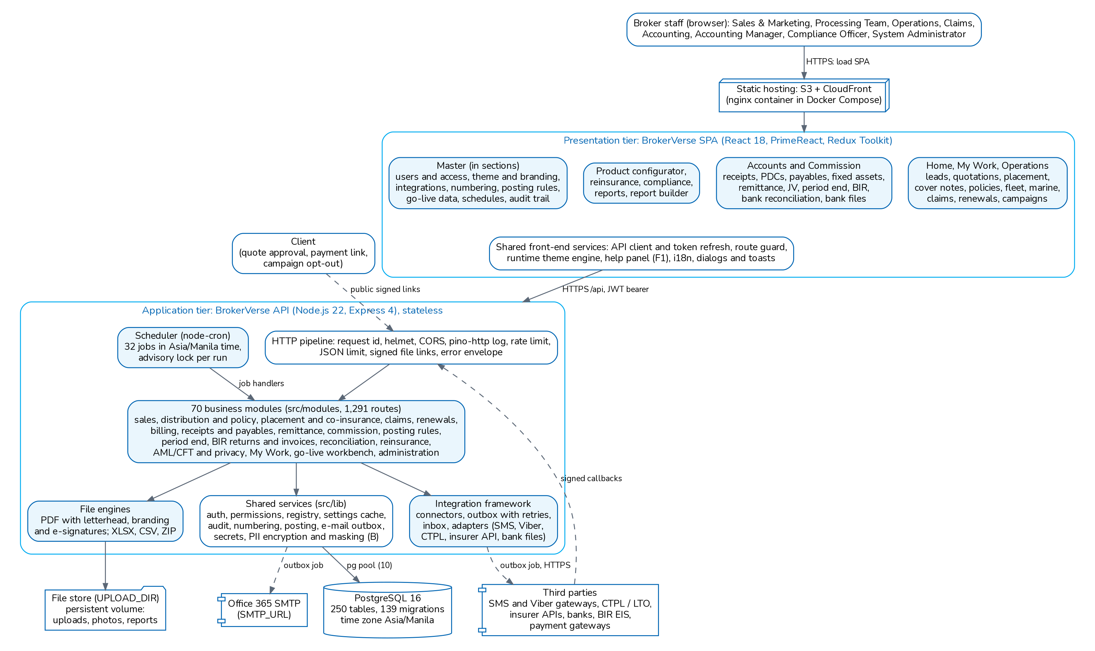
Logical component view of BrokerVerse OOTB (architecture document 01)
Layer | Components
Users | Broker staff in a browser; clients through public links (quotation approval, payment checkout)
Edge | DNS, TLS, CDN or reverse proxy, WAF (recommended)
Presentation | SPA: Home, My Work, Operations, Accounts, Commission, Reinsurance, Compliance, Reports, Master (in sections), Product Configurator, Dashboards; help panel (F1) with the user manual section of each screen; runtime theme
HTTP pipeline | Request id, security headers (helmet), CORS, access log with redaction, rate limit, JSON size limit, signed file links, one error envelope
Business modules | backend/src/modules: each module owns its routes, services and tables
Shared services | backend/src/lib: authentication, permissions, settings cache, audit, numbering, e-mail outbox, secrets, personal data encryption and masking (package B), PDF and Excel engines, letterhead and branding
Integration framework | backend/src/modules/integrations: connectors (test or live), outbox with retries, inbox, adapters for SMS, Viber, CTPL and LTO, insurer APIs and bank files; fake provider for test mode
Scheduler | node-cron jobs with a PostgreSQL advisory lock per run, so each run executes once across instances
Data | PostgreSQL 16 and the file store

4.4 Business modules
Area | Backend modules
Sales and operations | leads, clients, addresses, quotations, packages, premium-charges, placement, comparison-reports, cover-notes, policies, endorsements, cancellations, documents; sales-activities (package G)
Distribution and specialty lines | channels, motor-programmes, fleet, marine, campaigns
Claims and renewals | claims, claim-documents, motor-claims, claim-payments, renewals
Billing and collection | receipts, collections, credit-control, pdc, payments, payment-gateway
Insurer accounts | remittance, insurer-reconciliation, commission, commission-rates, insurer-overrides, incentive, reinsurance
Accounting and tax | accounting, posting-rules, journal-vouchers, disbursements, payables, fixed-assets, period-end, bank-reconciliation, bir
Compliance | aml, privacy; ic-compliance and data-breaches (package B)
Integrations | integrations (framework, messaging, CTPL, insurer connectors, bank payment files)
Configuration | product-configurator, masters, ops-masters, document-numbering, settings, system-settings, schedules, branding, e-signatures, data-load
Administration and security | auth, users, access-control, my-work, notifications, uploads, search, audit, dashboard, reports, report-builder, system

The Technical Reference describes each module (purpose, routes, tables, jobs, posting events, settings).

4.5 Integrations
Integration | Direction | How it works
E-mail (SMTP) | Outbound | Messages are queued in email_outbox; the email-outbox job sends up to 50 per run every 5 minutes through SMTP_URL (Office 365, port 587, STARTTLS), up to 5 attempts. Off until "Send e-mails" is switched on in Master > Configuration.
Payment gateways | Inbound and outbound | Payment links (PL- numbers) for a quotation, a package quotation or a policy's open premium. Providers: SANDBOX (training and UAT), PayMongo (Checkout Session) and Dragonpay (Payment Switch). Webhooks are signature-checked, logged in payment_events and idempotent; a paid link creates the official receipt and can issue a package policy.
Insurers | Outbound files and e-mail; API through the integration framework | Broker slips, placement orders, remittance statements, commission debit notes as PDF, CSV or XLSX. Insurer API connectors (insurer_rest adapter with a mapping per insurer) send the policy issuance request and receive claim status updates; delivered in test mode until certified with each insurer.
SMS and Viber | Outbound | Message templates per event (renewal notices, payment reminders, claim updates) sent through an SMS gateway connector (Semaphore, Globe Labs or a generic HTTP gateway) or Viber business messages, via the integration outbox; jobs sms-renewal-notices and sms-payment-reminders are delivered off
CTPL authentication and LTO | Outbound and inbound | COC numbers allocated from the insurer's series and authenticated with the CTPL provider (ctpl_http), optional LTO feed (lto_http); asynchronous results arrive on the signed inbound endpoint
BIR Electronic Invoicing System | Outbound | Every sales invoice and its cancellation queued as an e-invoice payload (eis_submissions); job eis-outbox delivered off until the broker's EIS accreditation
AML screening provider | Outbound | Optional commercial screening provider through aml_provider_requests (job aml-provider-retry, off); the built-in screening uses the lists loaded in Compliance > Screening Lists
BI extract | Outbound files | Job bi-extract (off) writes one CSV per curated dataset to bi.extract_folder for the broker's BI tool
Insurer statements | Inbound files | CSV or XLSX statements of account read with an insurer statement format (column mapping per insurer) for Accounts > Insurer Reconciliation.
Bank statements | Inbound files | CSV or XLSX statements read with a bank statement format; BDO, BPI, Metrobank and a generic layout ship as standard.
Electronic transfers and bank payment files | Outbound files, inbound status files | Payment vouchers are batched per bank account and written in the bank's bulk credit, InstaPay or PESONet layout (Accounts > Bank Payment Files, layouts in Master > Finance > Bank File Layouts); the bank's status file marks each line paid or rejected and posts the payment. No direct bank API.
Reinsurers | Outbound files | Bordereaux and reconciliation files as CSV
Uploads and go-live imports | Inbound files | 10 MB per file, 50 MB decompressed, 20,000 rows; templates in docs/package/05_Delivery/Upload_Templates
Document generation | Internal | One PDF engine (lib/pdf) with the letterhead of the primary company in the Company master; XLSX, CSV and ZIP writers. No third-party document library.
Client quotation approval | Inbound (public) | Signed link valid for quotations.approval_link_ttl_hours (168 hours)

Recommended: Before PayMongo or Dragonpay are switched to live, obtain the merchant accounts and test against the providers' own sandboxes. The automated tests cover the SANDBOX provider and signed test payloads only. Gateway fees are recorded on the link but not journalised.

5. Technology stack and versions
Versions are the exact versions resolved in backend/package-lock.json and brokerverse/package-lock.json on 03 October 2026.

5.1 Runtime and platform
Component | Version | Use
Node.js | 22 (node:22-alpine; engines >=22) | API runtime and build
PostgreSQL | 16 (postgres:16-alpine in Compose, postgres:16 in CI) | System of record, extension pgcrypto
nginx | 1.27-alpine | Web container (Compose); reverse proxy on the EC2 host
PM2 | Latest from npm at deployment | Process manager on the EC2 deployment (deploy/ec2/ecosystem.config.cjs)
Docker and Docker Compose | Compose file without a version key | Single-server, test and trial installations
GitHub Actions | checkout, setup-node, upload and download-artifact, configure-aws-credentials v4; appleboy/ssh-action 1.2.0 | CI and deployment

5.2 Backend dependencies
Package | Version | Purpose
express | 4.22.3 | HTTP server and routing
pg | 8.23.0 | PostgreSQL client, pool of 10 connections
zod | 3.25.76 | Request validation
pino / pino-http | 9.14.0 / 10.5.0 | JSON logs with redaction
helmet | 8.3.0 | Security headers
cors | 2.8.6 | Cross-origin policy
jsonwebtoken | 9.0.3 | Access, refresh and link tokens (HS256)
bcryptjs | 2.4.3 | Password hashing
multer | 1.4.5-lts.2 | Multipart uploads in memory with limits
nodemailer | 10.0.12 | SMTP delivery
node-cron | 4.6.0 | Job schedules
dotenv | 16.6.1 | .env loading
vitest / supertest | 2.1.9 / 7.3.0 | Integration tests against PostgreSQL
eslint | 9.39.5 | Lint

5.3 Front-end dependencies
Package | Version | Purpose
react, react-dom | 18.2.0 | UI library
react-scripts / @craco/craco | 5.0.1 / 7.1.0 | Build tool chain
primereact, primeflex, primeicons | 10.3.1, 3.3.1, 6.0.1 | Components, layout, icons
@reduxjs/toolkit, react-redux | 2.0.1, 9.0.4 | Application state
react-router-dom | 6.30.6 | Routing
axios | 1.20.0 | HTTP client with token refresh
formik | 2.4.5 | Forms
i18next, react-i18next | 25.8.13, 16.5.4 | English (complete), Thai (partial)
chart.js, @fullcalendar | 4.5.1, 6.1.x | Charts and calendars
@fontsource/nunito | 5.3.0 | Bundled font, no external font service

The backend has 13 direct runtime dependencies. PDF, XLSX, ZIP, CSV (with formula-injection guarding), TOTP, AES-256-GCM encryption, HMAC link signing and rate limiting are part of the code base. All direct dependencies use permissive licences (MIT, MIT-0, ISC, BSD-2-Clause, Apache-2.0, OFL-1.1).

6. Deployment architecture options

6.1 Common building blocks
Whatever the hosting option, BrokerVerse needs the same components.
Component | Requirement
Web hosting | Static files of the SPA (npm run build, the same build for every environment), with a fallback of every path to index.html; /env-config.js per environment (API address, environment name) and /api forwarded to the backend
API runtime | Container from backend/Dockerfile (runs as user node, port 8000, health check /api/health) or Node.js 22 under a process manager
Database | PostgreSQL 16, empty database and a login that may create tables; time zone Asia/Manila; TLS on the connection
File store | Persistent volume at UPLOAD_DIR, shared between instances when there is more than one
Secrets | JWT_SECRET, DATA_ENCRYPTION_KEY, PII_ENCRYPTION_KEY (package B), ADMIN_PASSWORD, DATABASE_URL, SMTP_URL, payment gateway keys, integration connector credentials (variables named in each connector), in a secret store
TLS | HTTPS at the CDN, load balancer or reverse proxy
Outbound | SMTP (port 587) and, when used, the payment gateways, SMS and Viber gateways, the CTPL provider and LTO feed, insurer APIs, the BIR EIS and a screening provider over HTTPS; the addresses are the connector endpoints set by an administrator
Inbound public paths | Quotation approval, payment checkout and gateway webhooks under /api/public/..., signed integration callbacks (/api/public/integrations/inbound/:connector), campaign opt-out links, the branding of the sign-in page

6.2 Environment layout
Decision (product owner, 04 October 2026): the environment set follows the broker size. Small and medium brokers have DEV, UAT and PROD: integration is done in DEV and the release is pushed to UAT for testing, then to PROD. Large brokers have DEV, SIT, UAT and PROD, with SIT and UAT separate. PRE-PROD is temporary for every size.
Environment | Purpose | Data | Recommended form
DEV | Development and integration by iorta TechNXT; for small and medium brokers also configuration and the system integration test | Sample and synthetic data (SEED_SAMPLE_DATA=true, backend/scripts/uat-scenario.js); never client data | Small single-zone environment: one API instance, small managed PostgreSQL without standby
SIT (large broker) | System integration test, configuration build and first mock loads | Synthetic data; client data during mock loads | Single-zone environment, medium size
UAT | Business acceptance, training, mock loads, performance test | Mock-load data from the broker's extracts | Same components as PROD at a smaller size, single zone (small size for small and medium brokers, medium size for large)
PRE-PROD (temporary) | Cutover rehearsal before go-live; rehearsal of each major release | Restored from a PROD backup; masked when used by people without production access | Same topology and size as PROD; removed after use
PROD | Live operations | Reference data only, then go-live imports | Two API instances and managed PostgreSQL sized by tier (sizing below); high availability with a standby database required for large brokers
DR | Recovery after a regional or site disaster | Restored from cross-region or off-site backups | Pilot light or warm standby (chapter on resilience); included for the Enterprise size

Recommended: Never copy production personal data into DEV, SIT or UAT. A PRE-PROD restored from a production backup is masked with the data masking tool before anyone without production access uses it (npm run mask:data, docs/onboarding/DATA_MASKING.md: it refuses on a database marked production, --remark-copy re-marks a restored copy, --register-production records where production lives). Each environment has its own secrets; DATA_ENCRYPTION_KEY, JWT_SECRET and PII_ENCRYPTION_KEY differ between environments (a restored copy is masked with production's personal data key, then rotated to its own). The environment marker system.environment and the label next to the logo (ENVIRONMENT_NAME) show which environment a user is in.

6.3 Network zones
Zone | Contents | Allowed traffic
Public edge | DNS, CDN, WAF, public load balancer or reverse proxy | HTTPS 443 from the internet
Application zone (private) | API instances | From the load balancer only, on the API port; outbound to SMTP, the payment gateways and the enabled integration endpoints only (allow-list)
Data zone (private) | PostgreSQL, file store | PostgreSQL 5432 and NFS from the application zone only
Management zone | Bastion or session manager, CI/CD runner access | Administrator access with multi-factor sign-in, logged

6.4 Option A: customer cloud on AWS (Singapore)
This is the reference deployment of deploy/README.md and architecture documents 01 and 07. The region is ap-southeast-1 (Singapore).
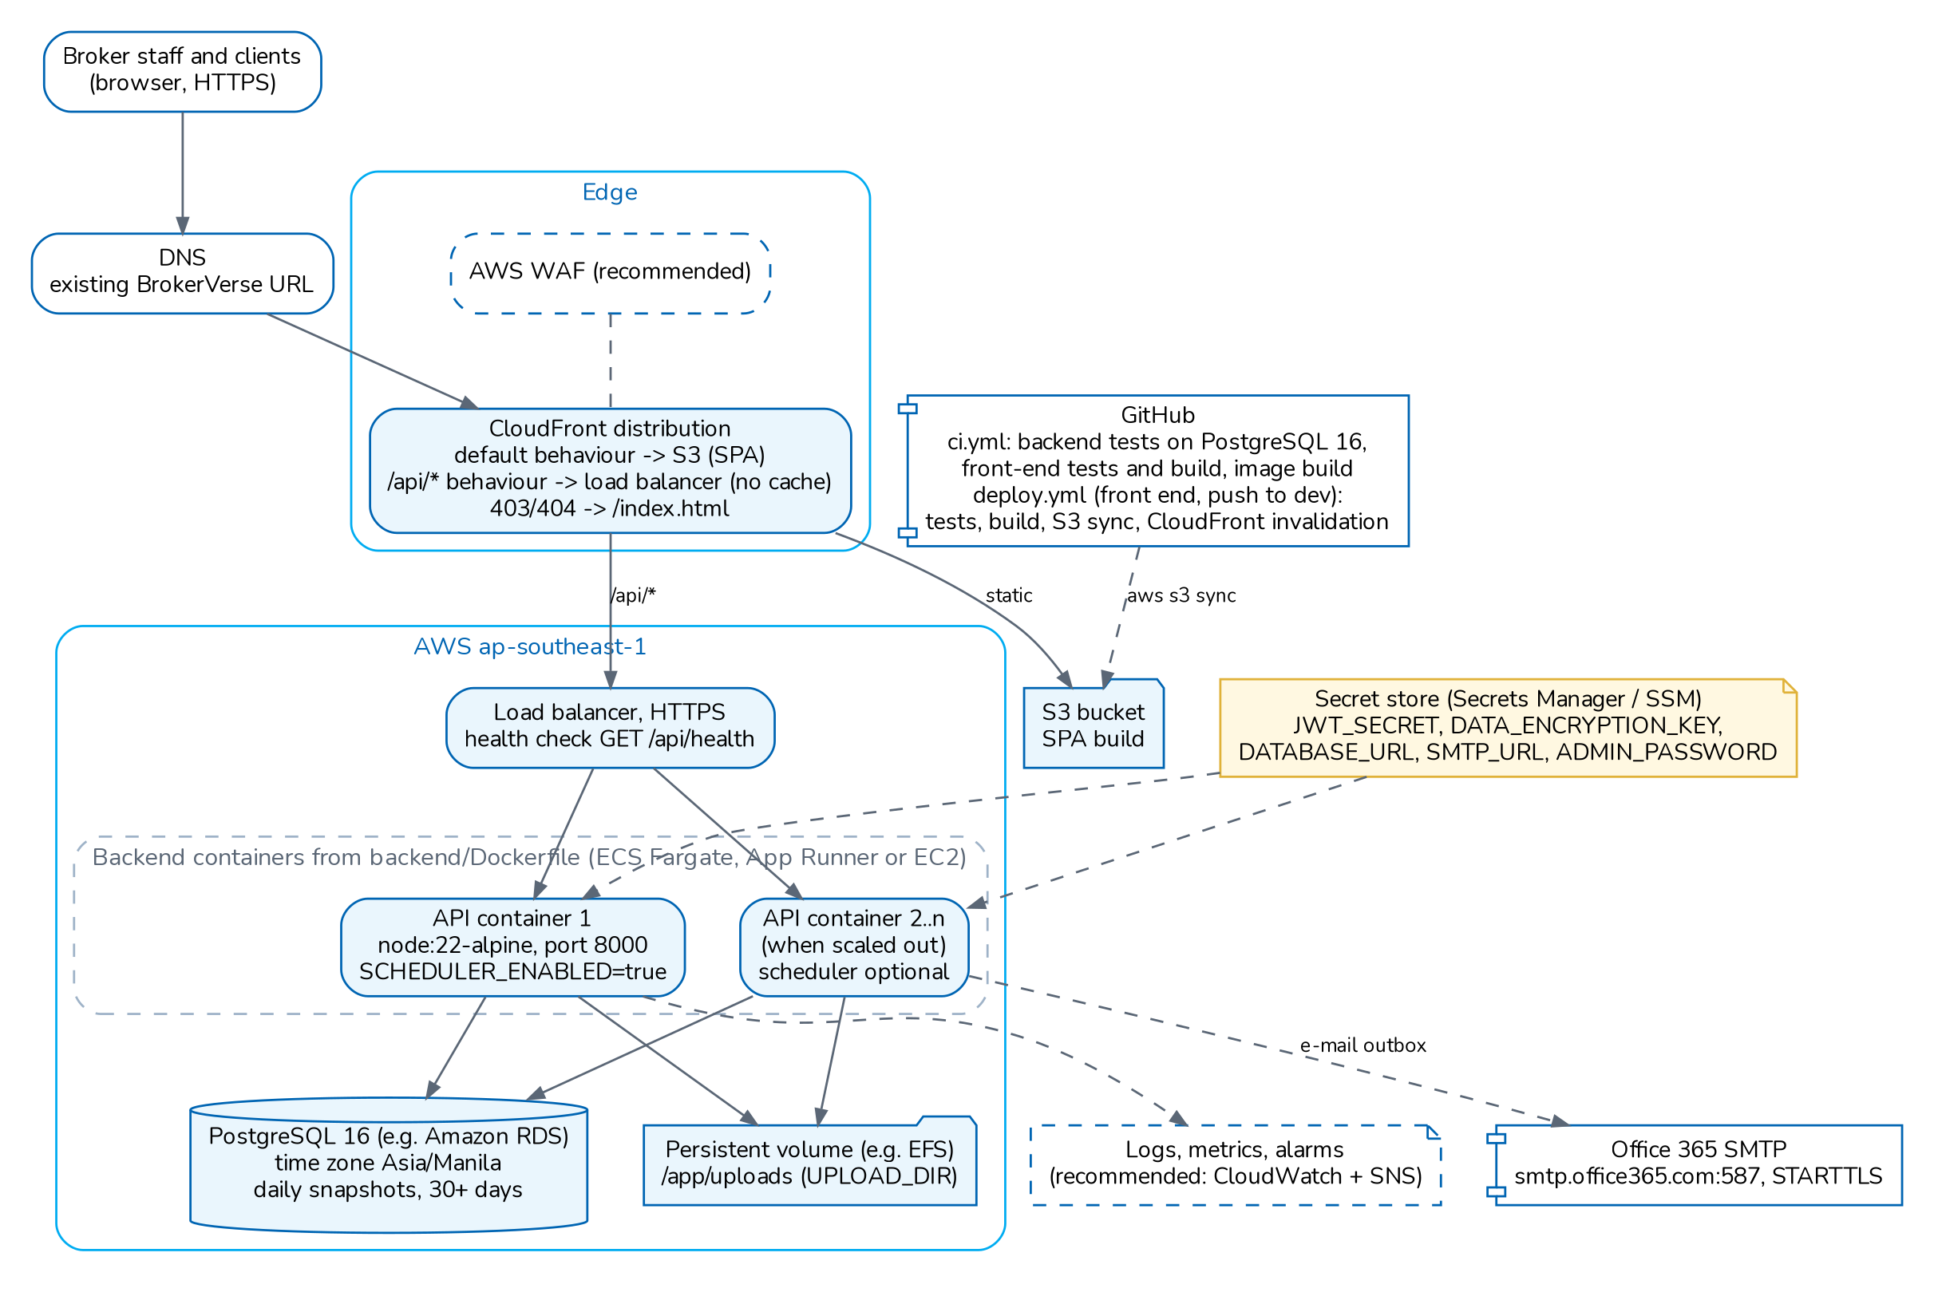
Production deployment on AWS ap-southeast-1 (architecture document 01)
Component | AWS service
Web hosting and CDN | Amazon S3 bucket and CloudFront; custom error responses 403 and 404 return /index.html
API address | Same-domain option: CloudFront behaviour /api/* to the load balancer, no caching
API | ECS Fargate (recommended), App Runner or EC2, behind an Application Load Balancer with HTTPS (ACM certificate)
Database | Amazon RDS for PostgreSQL 16, Multi-AZ, encrypted with KMS, sslmode=require
File store | Amazon EFS mounted at /app/uploads, encrypted at rest
Backups | RDS automated backups (35 days, PITR), AWS Backup plans for RDS and EFS, cross-region copies
Secrets | AWS Secrets Manager or SSM Parameter Store
Monitoring | CloudWatch Logs, metrics, alarms, Synthetics; SNS for notifications
WAF | AWS WAF on CloudFront with managed rule groups and rate-based rules
Image registry | Amazon ECR, replicated to the recovery region

Philippine data residency. The Data Privacy Act does not require personal data to be stored in the Philippines; it makes the broker accountable for personal data transferred abroad (DPA section 21). Hosting in Singapore is therefore a cross-border transfer that the broker documents and covers by contract (chapter on data privacy). AWS has a Local Zone in Manila with a limited set of services (compute and block storage); managed RDS, EFS and the other services above run in the Singapore parent region. A broker that must keep the system of record in the Philippines uses option C, or confirms with AWS which services are available in Manila at the time of the decision.

6.4.1 Current demo deployment
The repository also deploys a demo system: the release pipeline (.github/workflows/deploy.yml, environment dev) publishes the front end to S3 and CloudFront and switches the API on one EC2 host with PM2 (deploy/ec2/release.sh). The API runs as one PM2 process (fork mode, restart above 700 MB) on port 8001 behind an nginx site that only forwards /api/. This is a single-instance set-up with no redundancy; it is suitable for demonstration and UAT, not as the production form of option A.

6.5 Option B: Microsoft Azure (Southeast Asia)
The Azure region Southeast Asia is in Singapore, so the data residency position is the same as for option A. The application needs no code change on Azure: it uses a container, PostgreSQL and a mounted file system.
Component | Azure service (recommended mapping)
Web hosting and CDN | Azure Storage static website with Azure Front Door (CDN and routing of /api/*)
WAF | Azure Front Door WAF policy
API | Azure Container Apps or App Service for Containers, two or more replicas across availability zones
Database | Azure Database for PostgreSQL Flexible Server 16, zone-redundant high availability
File store | Azure Files (SMB or NFS share) mounted at /app/uploads
Backups | Flexible Server automated backups with PITR (up to 35 days), geo-redundant backup storage; Azure Backup for Azure Files
Secrets | Azure Key Vault, referenced by the container app
Monitoring | Azure Monitor, Log Analytics, Application Insights availability tests
Registry | Azure Container Registry
Network | Virtual network with separate subnets for the application and the database (private access)

Recommended: The GitHub workflows in the repository target AWS. For Azure, the deployment steps (registry push, container app revision, static website upload, Front Door purge) must be added to the pipeline. Set the database time zone to Asia/Manila (server parameter timezone) or add the time zone option to DATABASE_URL, as done for Railway.

6.6 Option C: local partner or on-premise data centre in the Philippines
For a broker that wants the data held in the Philippines, BrokerVerse runs on virtual machines in a local data centre or with a Philippine hosting partner. The Docker Compose file and the EC2 scripts show both ways to run it without cloud managed services.
Component | On-premise or partner form
Web hosting | nginx serving the SPA build (the web image of Docker Compose), behind the TLS reverse proxy
Reverse proxy and WAF | Two nginx or HAProxy nodes with a virtual IP, TLS certificate; WAF appliance or ModSecurity with the OWASP Core Rule Set
API | Two VMs running the API container (or Node.js 22 with PM2)
Database | PostgreSQL 16 primary and streaming-replica standby on separate hosts; failover with Patroni or a manual runbook
File store | NFS share on redundant storage (or a clustered file system) mounted on both API VMs
Backups | Daily pg_dump -Fc and WAL archiving (pgBackRest or WAL-G) to a backup server; daily archive of the upload share; an off-site copy in a second Philippine site
Secrets | HashiCorp Vault, or an encrypted environment file readable only by the service account, with an escrow copy under dual control
Monitoring | Prometheus and Grafana or Zabbix, log shipping to a central log server or SIEM, external uptime check
DR | Second data centre in another Philippine city with replicated backups

Recommended: Ask the partner for evidence of physical security, power and cooling redundancy, and an ISO/IEC 27001 certificate or equivalent. Agree in the contract who patches the operating system, PostgreSQL and the reverse proxy.

6.7 Sizing by broker size
The sizes below extend the recommendation of architecture document 06 (200 named users, 80 concurrent, 50,000 policies a year: two API instances of 1 vCPU and 2 GB, database of 2 vCPU and 8 GB Multi-AZ). They apply to PROD and must be confirmed with the UAT performance test.
Recommended / Indicative: Assumptions per broker size: small up to 25 named users and about 5,000 policies a year; medium 26 to 100 users and about 20,000 policies; large 101 to 300 users and about 60,000 policies. Uploaded documents average 2 MB per policy. Replace these with the broker's own forecast.
Item | Small (up to 25 users) | Medium (26 to 100) | Large (101 to 300)
API instances | 2 x 1 vCPU, 2 GB | 2 x 1 vCPU, 2 GB | 3 to 4 x 2 vCPU, 4 GB
Database | 2 vCPU, 4 GB, standby | 2 vCPU, 8 GB, standby | 4 vCPU, 16 GB, standby
Database storage | 50 GB | 100 GB | 250 GB
File store (year 1) | 25 GB | 60 GB | 150 GB
Backup storage | 100 GB | 250 GB | 600 GB
Concurrent users at peak | 10 | 40 | 120

6.8 Indicative monthly cost
Indicative: Hosting prices when iorta TechNXT hosts, from the commercials and pricing workbook (Infrastructure sheet) and the Rate Card: estimates of on-demand list prices at PHP 62.75 to USD 1.00 plus a 20% margin for exchange rate movement and operations, excluding VAT. Reserved capacity or savings plans reduce the cloud cost by roughly 20% to 40%. Obtain a quotation from the provider or partner before ordering.
Environment (AWS Singapore, PHP a month) | Small | Medium | Large | Enterprise
DEV | 11,000.00 | 11,000.00 | 11,000.00 | 11,000.00
SIT | Not used | Not used | 23,000.00 | 23,000.00
UAT | 11,000.00 | 11,000.00 | 23,000.00 | 23,000.00
PROD | 21,000.00 | 47,000.00 | 86,000.00 | 199,000.00 (with cross-region backups)
Standing set | 43,000.00 | 69,000.00 | 143,000.00 | 256,000.00
PRE-PROD, per month of use | 21,000.00 | 47,000.00 | 86,000.00 | 169,000.00

Standing set, other options (PHP a month) | Small | Medium | Large | Enterprise
B: Azure Southeast Asia | 46,000.00 | 73,000.00 | 150,000.00 | 269,000.00
C: Philippine partner | 42,000.00 | 67,000.00 | 135,000.00 | 242,000.00

DR option | Indicative share of the PROD cost
DR as pilot light (backups and images in the second region or site, nothing running) | 5% to 10%
DR as warm standby (small database replica and one API instance running) | 30% to 50%

The largest cost items are the database with its standby, the load balancer or reverse proxy, the WAF and the log volume. The file store and the backups grow with the number of uploaded documents. PRE-PROD is billed only for the months it exists: the workbook budgets 2 months around go-live and 1 month per major release.

7. CI/CD and release management

7.1 Workflows in the repository
Workflow | Trigger | What it does
.github/workflows/ci.yml (CI) | Every pull request and push; tags v*.*.* | Backend: npm ci, npm run lint, npm test against a postgres:16 service. Front end: npm ci --legacy-peer-deps, npm run lint, craco test, one environment-neutral build. Dependency audit (production dependencies, high and critical fail). Artefacts web-<sha> and backend-<sha>. Then deploys: brokerverse-platform to dev, vX.Y.Z-rc.N to UAT, vX.Y.Z to Production (GitHub Environments with approvals).
.github/workflows/deploy.yml (Deploy) | Called by CI, or by hand to promote a commit or tag | Same artefacts in every environment: pre-deploy backup (Pre-Prod, Production), migrations then seeds, API switch on the EC2 host (deploy/ec2/release.sh), front end to S3 + CloudFront with /env-config.js, smoke test, automatic rollback. Skipped with a notice when the environment is not configured.
.github/workflows/rollback.yml (Rollback) | By hand | Switches an environment back to an earlier build, without migrations
brokerverse/.github/workflows/deploy.yml | Push or pull request, when the front end is its own repository | Front-end lint, tests and environment-neutral build; /env-config.js from repository variables; the publish job runs only for a push to dev

Details, approvals and the GitHub settings: deploy/RELEASE_PIPELINE.md. The earlier git-checkout script deploy/ec2/deploy.sh (checks out the branch, npm ci --omit=dev, creates the database if missing, installs the nginx site after nginx -t, starts the API under PM2 and waits for /api/health) remains for manual use.
Gap: The deploy workflow accepts an IAM role through GitHub OIDC (AWS_ROLE_ARN) but falls back to long-lived AWS access keys, and reaches the EC2 host with an SSH key stored per environment. Recommended: use the OIDC role in every environment, limited to the bucket and the distribution; for container platforms push the versioned backend image (backend/Dockerfile, build arguments GIT_COMMIT, BUILD_TIME, GIT_REF) to a registry and scan it.
Note: In brokerverse/.github/workflows/deploy.yml the publish job requires the branch dev while the trigger is brokerverse-platform; as written it tests and builds but does not publish. Align the branch names when the front end is moved to its own repository.

7.2 Release process
The release pipeline (deploy/RELEASE_PIPELINE.md) builds once and promotes the same artefacts:
- Merge to brokerverse-platform through a reviewed pull request with the four required checks green; dev deploys automatically.
- Tag a release candidate vX.Y.Z-rc.N: UAT deploys after the iorta TechNXT delivery lead approves (SIT by hand for a large broker). Run the UAT scripts for the changed areas and obtain business sign-off.
- For a major release or go-live, deploy the release tag to a PRE-PROD restored from a PROD backup (masked where required), rehearse, run the environment comparison against PROD, then remove PRE-PROD.
- Tag the release vX.Y.Z: PROD deploys after two reviewers approve (DevOps lead and the broker's release approver or CAB), inside the maintenance window.
- Every deployment takes a verified pre-deploy backup (always for PRE-PROD and PROD), migrates forward only, switches the API, publishes the front end, runs the smoke test and rolls the application back by itself when the switch or the smoke test fails.
- rollback.yml switches an environment back to an earlier build; a database restore is a CAB decision.

7.3 Environment configuration and secrets
Variable | Use | Rule enforced at production start
NODE_ENV | production turns on the start-up checks
DATABASE_URL | PostgreSQL connection, sslmode=require on managed databases
JWT_SECRET | Signs sessions, file links and approval tokens | Required, not a placeholder, at least 32 characters
DATA_ENCRYPTION_KEY | Encrypts TOTP secrets, keys reset-code hashes | Required, at least 32 characters, different from JWT_SECRET
PII_ENCRYPTION_KEY (package B) | Encrypts TIN, government ID and bank account numbers at rest and keys their blind indexes | Required, at least 32 characters, different from JWT_SECRET and DATA_ENCRYPTION_KEY
PII_ENCRYPTION_KEY_PREVIOUS (package B) | Set only during a key rotation (npm run pii:rotate)
APP_ENVIRONMENT | Environment of the deployment (dev, sit, uat, preprod, production)
ADMIN_PASSWORD | First password of the BrokerVerse administrator | Must meet the password policy
CORS_ORIGINS | Allowed web origins | * refused
PUBLIC_BASE_URL | Public API address for links | localhost refused
UPLOAD_DIR | File store path
SMTP_URL | Mail account
SEED_SAMPLE_DATA | Demo data on or off (off by default in production)
SCHEDULER_ENABLED | Runs scheduled jobs on this instance
<prefix>_SECRET_KEY, <prefix>_WEBHOOK_SECRET, <prefix>_MERCHANT_ID, <prefix>_PASSWORD | Payment gateway credentials, read only from the environment | A gateway cannot go live without them
Variables named in each integration connector (credential_env) and in eis.client_id_env, eis.client_secret_env, eis.signing_key_env | Credentials of SMS, Viber, CTPL, LTO, insurer APIs, bank file drop and the BIR EIS | A connector cannot be switched to live while a variable is missing

If a rule fails, the API logs Refusing to start in production: ... with the reason and exits. Secrets are never stored in the repository; deploy/backend.env.example holds placeholders only.

7.4 Database migrations on start
- The server checks the production configuration.
- It reports not ready (/api/health answers 503) and takes a PostgreSQL advisory lock. Other instances starting at the same time wait (up to 10 minutes).
- It applies each pending migration in its own transaction and records it in schema_migrations, then runs the idempotent seed (roles, permissions, settings, chart of accounts, product templates, jobs, masters, administrator).
- It starts HTTP and the scheduler and reports ready.
Migrations only add to the schema (project convention), so the previous release normally runs on the newer schema. A failed migration stops the start-up; the release is not rolled back automatically. Recommended: test every migration in DEV, SIT (large broker) and UAT, and for a major release in PRE-PROD, and keep a pre-release snapshot.

8. High availability, backup and recovery

8.1 Resilience properties of the application
Property | Effect
Stateless API | Any instance serves any request; no sticky sessions
Readiness and liveness | /api/health checks the database (2,000 ms timeout) and pending migrations; /api/health/live checks the process only
Graceful shutdown | On SIGTERM: not ready, scheduler stopped, requests drained, forced exit after 25 s
Jobs on several instances | Advisory lock per run; a job runs once even with several schedulers
One transaction per business operation | A failure rolls back the whole operation including the document number
E-mail outbox | SMTP outages delay e-mail without failing transactions
Integration outbox | Messages to third parties are queued in the business transaction and sent with retries and exponential backoff; a provider outage never fails or blocks a policy issue; stuck messages are queued again

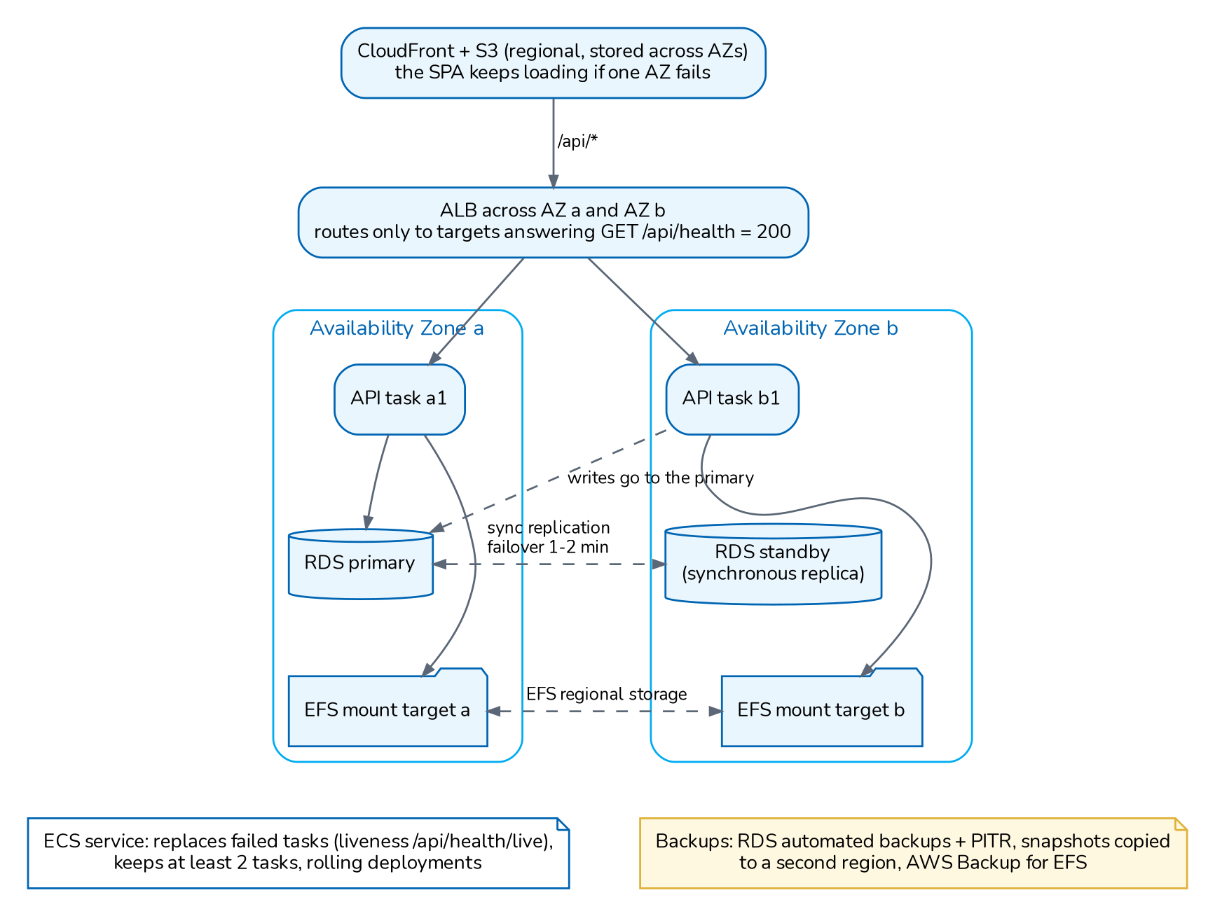
High-availability topology (architecture document 07, recommended)
Recommended production topology: at least two API instances in two availability zones, rolling deployment with 100% minimum healthy, managed PostgreSQL with a synchronous standby, a shared file store across zones, container stop timeout 30 s and load balancer deregistration delay 30 s.
Single point of failure | Mitigation
Database | Standby with automatic failover; PITR
File store | Shared, zone-redundant store with daily backup
Single API instance | Two or more instances
Secrets | Versioned secret store and sealed escrow copy of DATA_ENCRYPTION_KEY, PII_ENCRYPTION_KEY and JWT_SECRET
Region or site | Cross-region or off-site copies and a documented recovery

Known limitation: Rate limits are counted per API process, so with N instances the effective limit is N times the setting. Recommended: enforce rate limits at the WAF as well.

8.2 Recovery objectives
Recommended: The objectives below are the proposal of architecture document 08. Nothing in the code sets an RTO or RPO; the broker confirms them.
Scenario | RPO | RTO
API instance failure | 0 | under 5 minutes
Availability zone failure | 0 | under 15 minutes
Database instance failure (with standby) | 0 | under 15 minutes
Logical corruption or wrong mass change | 15 minutes or less (5 achievable with PITR) | 4 hours or less
Loss of uploaded files | 24 hours or less | 4 hours or less
Regional outage | 24 hours or less | 24 hours or less (warm standby: 8 hours)
Front end deleted | 0 | under 1 hour
Loss of secrets | not applicable | under 1 hour

Service tiers: Tier 1 core transactions in PostgreSQL; Tier 2 documents in the file store; Tier 3 derived data (notifications, outbox, generated reports); Tier 4 code and configuration as code, rebuilt from Git.

8.3 Backup
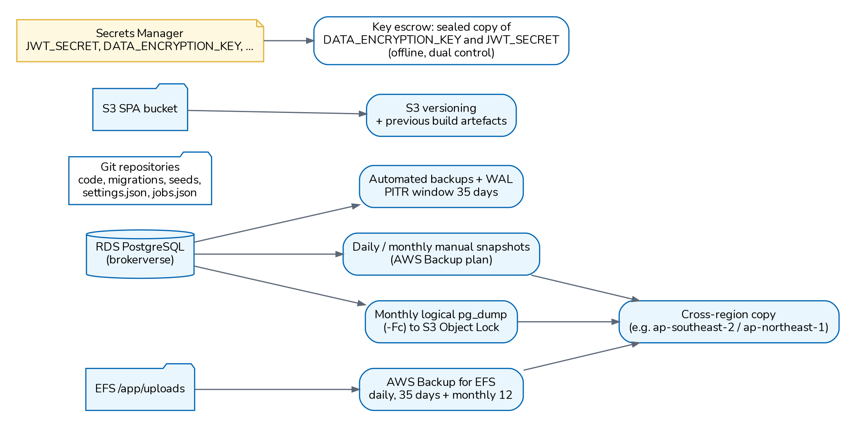
Backup and recovery data flows (architecture document 09, recommended)
deploy/README.md requires daily automated database snapshots kept at least 30 days, a backup of the upload volume and of DATA_ENCRYPTION_KEY (and, with package B, PII_ENCRYPTION_KEY, without which the encrypted identifiers in a backup cannot be read), and one restore test before go-live. The release pipeline takes a verified pg_dump before every deployment to PRE-PROD and PROD (release.sh backup, newest ten kept, copy to BACKUP_S3_URI); these are restore points for a release, not the backup plan. Document 09 recommends:
Backup | Retention (recommended)
Automated database backups with PITR, window 02:00 to 03:00 Manila time | 35 days
Daily and monthly snapshots; monthly copy to a second region | Daily 35 days, monthly 12 months, yearly 10 years for year-end records
Snapshot before each release with migrations, before go-live imports and before each year-end close | At least 30 days
Monthly logical dump (pg_dump -Fc) to write-once storage | 12 months
File store daily, weekly copy to the second region | Daily 35 days, monthly 12 months
Front-end bucket versioning | 90 days
Container images | Last 10 releases

Restore procedures for PITR, snapshots, dumps, files, the front end, secrets and release rollback are in document 09. Recommended restore tests: PITR quarterly and before go-live; dump restore twice a year; file restore quarterly; secret escrow check yearly; full DR exercise yearly as a tabletop and every two years in full.

8.4 Archival and housekeeping
The daily housekeeping job (02:45 Manila time) deletes operational rows past the periods set in System Settings > Housekeeping, in batches of 5,000.
Data | Default retention
job_runs | 90 days
email_outbox sent / failed | 180 / 730 days
login_history | 365 days
refresh_tokens expired or revoked | 30 days
password_resets | 7 days
Read notifications | 180 days
Completed job_queue items | 30 days
Generated reports (reports.retention_days) | 90 days
audit_log | Kept (0); never purged below 2,557 days (seven years) if a period is set

Business and financial records are kept; financial documents are cancelled or reversed, not deleted. The dormant-users job (01:45 daily) deactivates accounts without a sign-in for access.dormant_days (90 days).
Gap: Housekeeping does not yet purge the operational tables added with the new modules: integration_outbox and integration_attempts, integration_inbox, eis_submissions, aml_provider_requests and the rows of loaded go-live workbooks (data_load_rows). Recommended: add retention rules for them before volumes grow (for example 180 days for sent messages and attempts, 730 days for failed ones, 90 days for workbook rows after the load), keeping AML records for aml.record_retention_years.
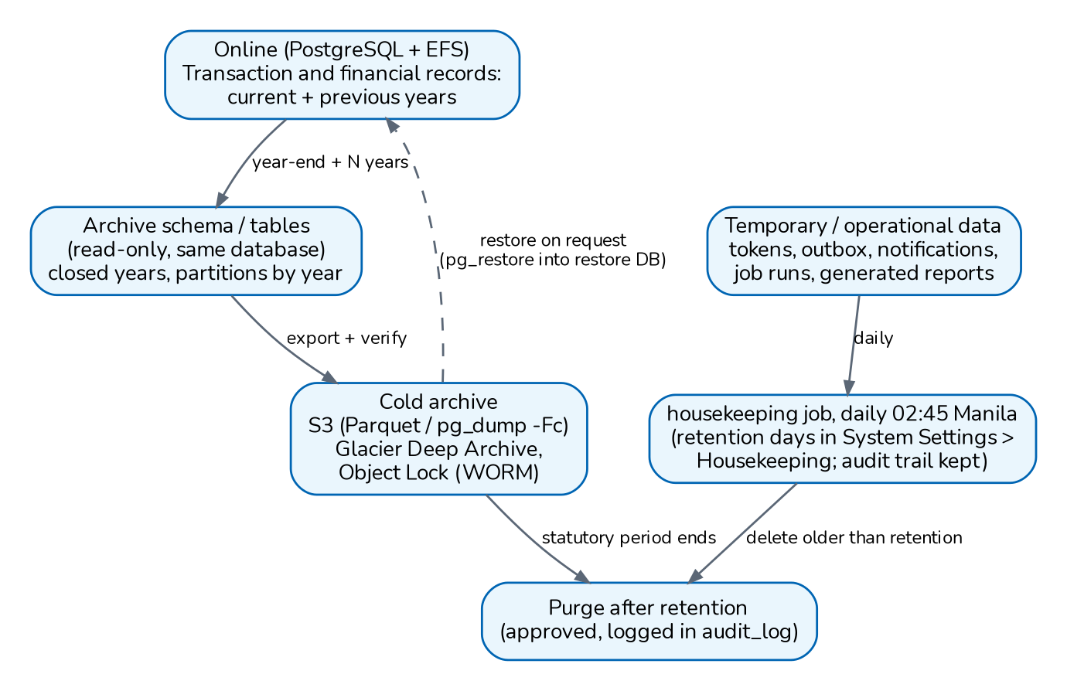
Data lifecycle: online, archive, purge (architecture document 10, recommended)
Recommended: Document 10 proposes keeping financial and policy records 10 years after the financial year end or policy expiry, unconverted leads and quotations 3 years then anonymised or deleted, and an annual export of closed years to write-once archive storage. The application anonymises the personal data of a client or prospect on request (Master > Data Privacy > Data Subject Requests, Anonymise, with a dry run first); it refuses while the records must still be kept (privacy.retention_years, 10 years after the last policy expiry). There is no archive function: the annual export of closed years is a database procedure run by the hosting team under change control.

8.5 Monitoring and alerting
The application produces JSON logs on standard output (pino) with a request id on every line and response, redaction of authorization headers, passwords, tokens and signatures, the health and version endpoints, and operational tables (job_runs, email_outbox, login_history, audit_log, generated_reports). The deployment package contains no monitoring configuration.
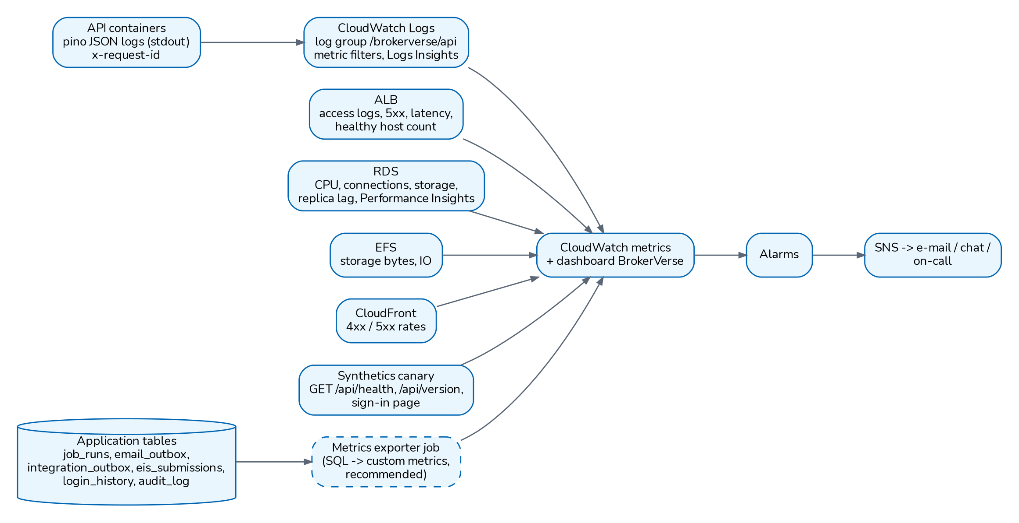
Monitoring and alerting (architecture document 11, recommended)
Alarm (recommended) | Threshold | Severity
Synthetic health check | 2 consecutive failures, check every 5 minutes | P1
No healthy API instance | 1 minute | P1
HTTP 5xx | over 2% for 5 minutes | P1
p95 response time | over 2 s for 10 minutes | P2
API CPU / memory | over 80% for 15 min / over 85% for 10 min | P2
Database CPU, free storage, connections | over 80% / under 20% / over 80% of maximum | P2
Scheduled job failed or not run | any failure of a daily job; over 26 hours since success | P2
Integration messages failed or stuck | any message failed, or messages queued over 30 minutes (integration monitor, integration_outbox) | P2
BIR EIS submission rejected or failed | any (eis_submissions) | P2
AML monitoring or breach deadline jobs not run | over 26 hours since success | P2
Failed sign-ins | over 50 in 5 minutes | P2
Refresh-token reuse | any | P3
Backup failure or PITR older than 15 minutes | any | P2
Certificate expiry | under 30 days | P3

Severity P1 is a 24 x 7 response, P2 the same business day and P3 the next business day, to be aligned with the support agreement in docs/onboarding/SUPPORT_AND_ESCALATION.md.

9. Security architecture

9.1 Identity and authentication
Control | Implementation
Accounts | Named users only; no shared or agent sign-in. Users are created in Master > User Management or from a CSV with scripts/provision-users.js; each must change the initial password at first sign-in.
Password storage | bcrypt (cost 10); reset codes stored only as keyed HMAC hashes
Password policy | Minimum 8 characters, upper and lower case, digit and symbol, history of 5, maximum age 90 days (security.password_*)
Lockout | Account locked after 5 wrong passwords (limits.max_login_attempts); 10 attempts per 5 minutes per IP and per username (security.login_rate_limit)
Two-factor | TOTP (RFC 6238); secrets encrypted with AES-256-GCM; compulsory for the roles in security.require_2fa_roles (empty by default)
Sessions | Access token 30 minutes, refresh token 30 days rotated on each use; reuse of a rotated token revokes the token family and is logged
Revocation | Password change or reset, deactivation, role or permission change raise the token version and end sessions at once; Master > User Management can end every session of a user
Idle sign-out | 30 minutes (limits.session_idle_minutes) with a one-minute warning
Sign-in history | Every attempt in login_history with result, reason, IP and user agent

Recommended: Before go-live set security.require_2fa_roles to at least system-admin, accounting and accounting-manager, as the deployment checklist suggests.
Known limitation: Tokens are kept in the browser's local storage (accepted for go-live in deploy/README.md section 9). A change to an httpOnly refresh cookie is planned. Two-factor enrolment shows the key and a link, not a QR code.

9.2 Authorisation, maker-checker and segregation of duties
Permissions are read:<module>, write:<module> and approve:<area> codes (98 with packages B and G), plus view:pii for full personal identifiers (package B), checked by the server on every route (requirePermission, requireRole); the route registry adds the sign-in check to every route that is not explicitly public. The front end also hides menus by role (deny by default).
Role (seeded) | Main access
System Administrator (system-admin) | Every permission; configuration, users and roles
Sales & Marketing (sales) | Leads, clients, quotations, policies, endorsements, renewals, reports
Processing Team (processing) | Broker slips and placement, policies, endorsements, renewals, reinsurance, products
Operations (operations) | Leads, clients, quotations, policies, endorsements, renewals
Claims (claims) | Claims; read clients and policies
Accounting (accounting) | Receipts, collections, disbursements, commission, remittance, incentive, journals, period end, bank reconciliation
Accounting Manager (accounting-manager) | Inherits Accounting; approves period close, bank and insurer reconciliations, credit control, payables, posting rule changes
Compliance Officer (compliance-officer) | AML/CFT: customer risk rating and EDD approval, screening decisions, transaction monitoring, AML cases and AMLC reports; read of clients, policies, claims and payments

With package B, Sales, Operations and Accounting hold view:pii and see full TIN, ID, mobile, e-mail, bank account and birth date values; Processing and Claims see them masked unless the broker grants it. Operations also keeps the Insurance Commission registers and the complaints register; Claims works complaints.
Control | Implementation
Administrator protection | Only a System Administrator can grant that role or change an administrator; nobody can change their own roles or status
Record scope | Roles listed in security.scoped_roles see only their own records and clients (empty by default)
Maker-checker | A different user approves journal vouchers, payment vouchers and cheques, commission payouts, remittances and settlements, debit notes, claim settlements, incentive calculations, treaties, petty cash, period closes, reconciliations, quotation and renewal approvals, authority limits and posting rule changes (finance.maker_checker_enabled)
Authority matrix | Approval limits per transaction type and role or user (Master > User Management > Authority Matrix); a new limit applies only after another administrator approves it; default limits in PHP are seeded and replaced by the board-approved signing authority
Delegation of authority | Time-bound delegation of approval authority (leave, travel), revocable (Master > User Management > Delegations)
Segregation of duties | Rules on pairs of roles, checked when roles are assigned (access.sod_enforced). Seeded: placement and payment, placement and payment approval, claims and payment (block); sales and collection, sales and claims (warn)
Access reviews | Recertification campaigns over every active user; "revoke" deactivates the account and signs it out (Master > User Management > Access Reviews)
Access reports | User Access Matrix and Role Permissions, downloadable as XLSX or CSV
Period control | Postings refused in closed or locked periods; soft-closed periods only with approve:period-end

9.3 Application security controls (OWASP Top 10, 2021)
OWASP risk | Controls in BrokerVerse
A01 Broken access control | Authentication by default on every route; permission check per route; record scope; maker-checker; signed, expiring file links (30 minutes); masking of personal identifiers by role (package B)
A02 Cryptographic failures | TLS in transit; bcrypt passwords; AES-256-GCM for TOTP secrets; AES-256-CBC with an HMAC-SHA256 tag for personal identifiers (package B); HMAC-SHA256 for links, reset codes and webhooks; JWT limited to HS256
A03 Injection | Parameterised SQL only, dynamic identifiers from white lists; zod validation; CSV formula-injection guarding
A04 Insecure design | Maker-checker, authority limits, SoD, one transaction per operation, idempotent payment webhooks with amount check
A05 Security misconfiguration | Production start refuses unsafe secrets, CORS_ORIGINS=* and localhost URLs; helmet headers; x-powered-by off; sample data off in production
A06 Vulnerable components | Lock files with npm ci; npm audit at review (see vulnerability management)
A07 Identification and authentication failures | Password policy, lockout, rate limits, TOTP, refresh-token rotation with reuse detection, idle sign-out
A08 Software and data integrity failures | Webhook signatures verified on the raw body; uploads checked by file signature; lock files; reviewed pull requests (recommended)
A09 Security logging and monitoring failures | Audit log, sign-in history, request ids, redacted JSON logs; alarms recommended in the monitoring chapter
A10 Server-side request forgery | The API calls only configured provider addresses (SMTP, payment gateways, integration connector endpoints set by an administrator with write:integrations); no address taken from a request is fetched

Further controls: uploads limited by type (uploads.allowed_types, checked by file signature), size (10 MB, 10 files) and decompressed size (50 MB); stored files served with nosniff and a sandbox content security policy, and anything other than images and PDF as a download; 5xx responses return a generic message with the request id.

9.4 Encryption
Data | In transit | At rest
Browser to edge | HTTPS (CDN, load balancer or reverse proxy)
Edge to API | HTTPS or private network
API to database | TLS (sslmode=require) | Storage encryption of the managed database (KMS or provider key), recommended on every option
API to SMTP | STARTTLS on port 587
File store |  | Storage encryption of EFS, Azure Files or the partner's storage (recommended)
Backups |  | Encrypted snapshots and write-once storage (recommended)
TOTP secrets |  | AES-256-GCM, key derived from DATA_ENCRYPTION_KEY
TIN, government ID and bank account numbers (package B) |  | AES-256-CBC with an HMAC-SHA256 tag, keys derived from PII_ENCRYPTION_KEY, encrypted by database triggers on every write; blind indexes for exact search
Integration credentials |  | Not stored: the connector keeps only the names of the environment variables
Password reset codes |  | HMAC-SHA256 keyed from DATA_ENCRYPTION_KEY
Sandbox gateway webhook secret |  | Derived from DATA_ENCRYPTION_KEY when no secret is set
Passwords |  | bcrypt hash

DATA_ENCRYPTION_KEY is not used to encrypt client records or uploaded documents. Losing it makes two-factor secrets unreadable (administrators reset two-factor and users enrol again); no business data is lost. With package B, TIN, government ID and bank account numbers of clients, prospects, referrers and payees, the identifier keys inside quotation, placement and policy documents and the same values in the audit trail are encrypted with PII_ENCRYPTION_KEY; losing that key makes those identifiers unreadable in the database and in every backup. Other client data and uploaded documents rely on storage encryption of the database, file store and backups.
Key rotation (package B). Set the new key in PII_ENCRYPTION_KEY and the old one in PII_ENCRYPTION_KEY_PREVIOUS, restart, run npm run pii:rotate (dry run) and npm run pii:rotate -- --execute, then remove the previous key when nothing is left on it. Keep the old key with the backups taken before the rotation.
Masking by role (package B). Users without view:pii receive personal identifiers partially masked in every screen, export and report file (privacy.masking_enabled). With privacy.pii_reveal_mode set to on-request, even holders see masked values until they switch on "Show full identifiers", and each answer given in full is recorded in the audit trail. Before package B, these values are shown to every user who can open the record.
Recommended: Keep DATA_ENCRYPTION_KEY, PII_ENCRYPTION_KEY and JWT_SECRET in the secret store with versioning and an escrow copy under dual control. Turn on storage encryption for the database, file store and backups in every option; on premises use encrypted volumes (LUKS or the storage array's encryption).

9.5 Audit trail and logging
Record | Content
audit_log | User, entity, record id, action, before and after JSON, IP, time and source (screen, API or job), written by every mutating handler; kept by default; shown as business events with old and new values per field
Field-level and status history | claim_field_changes, claim_history, period status, bank reconciliation history, remittance approvals
login_history | Sign-in attempts, two-factor results, token reuse
payment_events | Every gateway notification with signature result
integration_attempts, integration_inbox | Every call to a third party and every message received, with result
Application log | JSON on standard output with request id; secrets redacted

Master > System Configuration > Audit Trail filters by record type, record, user, action and date and exports to Excel or CSV; the History panel of a record shows its own events. Recommended reviews (document 11): monthly access reviews of administrators and new or dormant users; weekly review of changes to settings, posting rules, number series, tax codes and the Company master; monthly review of maker-checker exceptions; weekly review of security events. Ship application logs to central storage kept at least one year.

9.6 Vulnerability management
Item | Status
Backend dependencies | npm audit reported no advisories on 29 September 2026 (document 04); CI runs npm audit --omit=dev --audit-level=high on every pull request and fails on a high or critical advisory in a production dependency
Front-end dependencies | 71 advisories at the review, almost all build-time dependencies of react-scripts 5.0.1; Create React App is no longer maintained. Move to Vite is the planned remedy.
Unused packages | js-cookie, react-pro-sidebar, web-vitals to be removed
Base images | node:22-alpine, nginx:1.27-alpine, postgres:16-alpine

Recommended: Add an image scan (for example Trivy or the registry's scanner) to the CI audit job; enable GitHub Dependabot alerts and secret scanning; patch critical findings within 14 days and high within 30 days; patch the operating system, PostgreSQL and nginx monthly.

9.7 Penetration testing approach
Recommended: No penetration test report is part of the repository. Commission an independent test before go-live and yearly, and after major changes.
Step | Content
Scope | Web application and API on UAT with production configuration, public paths (approval, payment checkout, webhooks), the hosting perimeter
Method | OWASP Web Security Testing Guide and OWASP API Security Top 10; authenticated tests with one user per role
Focus | Access control between roles and scoped users, maker-checker bypass, file link signatures, upload handling, token handling, rate limits, webhook forgery
Rules | Written authorisation by the broker and the hosting provider; test data only; no production personal data
Follow-up | Findings rated, fixed and retested; summary kept as evidence for the NPC and auditors

9.8 Secure development lifecycle
Practice | Current state
Code review | Pull requests run ci.yml (lint, the backend suite of 104 test files against PostgreSQL 16, front-end lint, tests and build, dependency audit); branch protection requires one approving review and the four checks; the Technical Reference gives the reviewer's checklist
Tests | Backend integration tests with vitest and supertest on a real database; front-end tests with Jest
Lint rules | no-console outside scripts, no-unused-vars and eqeqeq as errors
Secure defaults | Production start-up checks; sample data off in production; routes authenticated unless declared public
API inventory | npm run export:api writes OpenAPI, Postman and Excel lists of every route and its permission
Secrets | Never in the repository; placeholders in deploy/*.env.example
Data classification | Every table classified for the transaction reset and every personal column in the personal data catalogue; tests fail otherwise

Recommended: Image scanning; a short threat review for changes to authentication, payments, integrations and personal data.

10. Data privacy

10.1 Legal framework
Instrument | Relevance
Data Privacy Act of 2012 (Republic Act 10173) | Principles of transparency, legitimate purpose and proportionality; lawful criteria for processing; rights of data subjects; security of personal data; accountability for transfers
Implementing Rules and Regulations of the DPA (2016) | Detailed duties of controllers and processors, organisational, physical and technical security measures, outsourcing and subcontracting
NPC Circular 16-03, Personal Data Breach Management | Breach response team, notification to the NPC and to affected data subjects within 72 hours of knowledge, breach records and annual report
NPC Circular 2022-04 | Registration of personal data processing systems and of the DPO with the NPC
Other NPC circulars and advisories | Security of personal data, consent, privacy impact assessment and administrative fines; the DPO confirms the current issuances

10.2 Roles under the DPA
Party | Role | Main duties
The broker | Personal information controller | Decides the purposes and means; appoints the DPO; registers with the NPC where required; answers data subjects; notifies breaches
iorta TechNXT | Personal information processor (when it hosts, supports or accesses production data) | Processes only on the broker's documented instructions; confidentiality; security; assists with rights requests and breaches
Cloud provider or hosting partner | Sub-processor | Infrastructure security under its contract
Insurers, reinsurers, payment gateways | Separate controllers or processors for their own processing | Covered by the broker's agreements with them

Recommended: Sign a Data Processing Agreement between the broker and iorta TechNXT covering the subject matter and duration, the instructions, confidentiality, security measures (this document), sub-processors (the hosting provider), assistance with rights requests and breaches (notice to the broker without undue delay so the 72-hour deadline can be met), return or deletion of data at the end of the contract, and audit rights.

10.3 Personal data held in BrokerVerse
Data subject | Data | Where
Leads and prospects | Name, company, e-mail, phone, birth date, gender, address | leads
Clients (insured persons and companies) | Name, e-mail, phone, TIN, birth date, gender, address, credit limit | clients
Insured risks | Vehicle plate, chassis and engine numbers; property locations | Quotations, policies
KYC | Government ID type and number (PhilSys ID, UMID, passport, driver's licence and others in policy.kyc_id_types), ID image | Policies, uploaded documents
Claimants and payees | Loss details, description, settlement amounts, payee and bank details, claim documents and photos | claims, claim cash, documents
Payments | Payment references, amounts, gateway notifications (no card numbers: card entry happens on the gateway's page) | policy_payments, payment_events
Referrers and sub-agents | Name, bank account, withholding tax data | Referrer master
Staff users | Name, username, e-mail, roles, sign-in history with IP and browser, signature image | users, login_history, e_signatures
Juridical clients' signatories and beneficial owners | Names, IDs, ownership share, board resolutions, due diligence documents | client_signatories, client_beneficial_owners, client_kyc_documents
AML/CFT | Risk rating, screening matches, transaction alerts, case notes, CTR and STR files | aml_* tables (Compliance Officer only)
Campaign recipients | Name, e-mail, consent checked, opt-out | campaign_recipients
Complainants and breach records (package B) | Complainant name and contact, complaint details; breach description and affected data subjects | complaints, personal_data_breaches

Government-issued identifiers and some claim information (for example injury details in a personal accident claim) are sensitive personal information under the DPA and need the stricter protection the DPA requires. The system holds no structured beneficiary register for policies; named beneficiaries, where captured, sit in policy details or documents.

10.4 Lawful basis and consent
Purpose | Usual basis under the DPA (to be confirmed by the DPO)
Quotation, placement, policy issue, endorsements, claims, renewals | Necessary for a contract with the data subject or steps at their request
Accounting, tax records, BIR forms, IC examination | Compliance with a legal obligation
KYC identification | Legal obligation and the insurers' underwriting requirements
Marketing to leads, win-back campaigns, marketing campaigns | Consent, or legitimate interest where the DPO concludes it applies; the campaign module sends only to parties with a marketing consent and every e-mail carries an opt-out link
AML/CFT customer due diligence, screening, covered and suspicious transaction reports | Compliance with a legal obligation (AMLA and its rules)

Consent is recorded per client or prospect and per purpose (processing, that is the privacy notice acknowledged; marketing; sharing with insurers and reinsurers) on the Data privacy tab of the client and on the prospect view, with the channel, the evidence and the notice version in force (privacy.notice_version). A withdrawal is stamped on the consent it ends; records are never deleted. Master > Data Privacy > Consent Register lists every consent across clients and prospects.
Recommended: the broker keeps the wording of its privacy notice in its own forms and proposal documents, raises privacy.notice_version when the notice changes, and checks the marketing consent before a campaign.

10.5 Data subject rights
Right (DPA section 16 and following) | How it is handled with BrokerVerse
To be informed | Broker's privacy notice; acknowledgement recorded as the processing consent with the notice version
Access | Export personal data (JSON or Excel) from the data subject request; client view with its policies; documents in the document viewers
Rectification | Edit the client or lead (Operations screens); every change is in the audit log
Object and withdraw consent | Withdraw the consent on the client or prospect; the request is logged with type Objection or Withdraw consent
Erasure or blocking | Anonymise from the data subject request (dry run first); refused while policy, claim and accounting records must be kept (privacy.retention_years). Leads can also be deleted (soft delete). Amounts, numbers and dates stay for the books.
Data portability | Export personal data in JSON or Excel
Damages and complaints | Broker's DPO and complaints procedure

Master > Data Privacy > Data Subject Requests is the register of requests: number from the DSR series, requester, type (Access, Rectification, Erasure or blocking, Objection, Data portability, Withdraw consent), date received and a due date privacy.request_due_days (15 calendar days) later, status, assignee, outcome and the exports and anonymisation done for it. The privacy-requests-due job (07:00 daily, delivered switched off) notifies the holders of read:privacy of open requests past their due date.
Recommended: the DPO confirms the response period and switches on the privacy-requests-due job at go-live (Master > Schedules).

10.6 Retention and disposal
Retention follows the recommendation of architecture document 10 until the compliance officer confirms it: financial and policy records 10 years, audit trail 10 years, unconverted leads and quotations 3 years then anonymised or deleted, security logs 2 years. Housekeeping already removes temporary data automatically (see the archival chapter). Disposal of media follows the hosting provider's certified destruction; on premises, use secure wipe or physical destruction with a certificate.

10.7 Security of personal data
The organisational, physical and technical measures required by the DPA and its IRR map to this document as follows.
Measure | Where addressed
Organisational: DPO, policies, training, contracts with processors | Broker; Data Processing Agreement (recommended)
Physical: data centre controls | Cloud provider or partner certifications
Technical: access control, encryption, audit, monitoring, backup, vulnerability management | Security architecture and resilience chapters

10.8 Cross-border transfer
When BrokerVerse is hosted in Singapore (options A and B), personal data is stored and processed outside the Philippines. The DPA allows this; the broker remains responsible and must use contractual or other reasonable means to give comparable protection. Recommended: record the transfer in the broker's privacy notice and processing records, rely on the provider's data processing terms and certifications, keep encryption keys under the broker's account, and document the decision in a privacy impact assessment. Option C keeps the data in the Philippines.

10.9 Breach management
Step | Practice with BrokerVerse
Detect | Alarms on failed sign-ins, token reuse, 5xx spikes; audit and sign-in history; WAF logs
Contain | End user sessions (Master > Generals > User Management), deactivate accounts, rotate JWT_SECRET to sign everyone out, block addresses at the WAF
Assess | Use the audit log, login_history and request ids to find which records were affected; with package B record the assessment against the NPC criteria in Compliance > Data Privacy (NPC) > Breach Register
Notify | The broker's DPO notifies the NPC and affected data subjects within 72 hours of knowledge where NPC Circular 16-03 requires it; with package B the Breach Register tracks the 72-hour deadline (privacy.breach_notify_hours) and the privacy-breach-deadlines job reminds the team; iorta TechNXT informs the broker without undue delay
Record | Incident and breach records kept for the annual report to the NPC (package B: annual security incident report from the Breach Register)

11. Insurance Commission and records
The Amended Insurance Code (Republic Act 10607) and the circulars of the Insurance Commission require licensed brokers to keep complete and accurate books and records of the business they transact, to keep premiums received for insurers apart from their own funds and remit them on time, and to make their records available for examination by the Commission. The IC also expects regulated entities to manage information technology and cyber risk. BrokerVerse supports these expectations as follows; the compliance officer confirms the applicable circulars.
Expectation | Support in BrokerVerse
Complete records of policies placed, premiums, commissions | Policy, billing, receipt, remittance and commission registers with journals from posting rules
Premiums held for insurers and remitted | Premium trust bank account in the masters; remittance with multi-level approval; remittance ageing on the insurer's terms
Records available for examination | Reports in XLSX, CSV and PDF; audit trail; retention as recommended above
Reconciliation with insurers | Insurer statement reconciliation with approval and adjustment journals
Control over changes and approvals | Maker-checker, authority matrix, SoD, period locks
Licensed persons and payouts (package B) | Licence register of the firm, officers and referrers with expiry reminders; payouts to a referrer with a lapsed licence are blocked (compliance.referrer_licence_check); fit and proper records
Placement only with authorised insurers (package B) | Insurer certificate of authority checked at placement and policy issue (compliance.insurer_authority_check)
IC annual statement and production report (package B) | GL accounts mapped to the statement lines; production by line of business and insurer
Complaints handling, RA 11765 (package B) | Complaints register with acknowledgement and resolution deadlines, escalation and the regulator reference
AML/CFT | Customer due diligence and onboarding before the first policy, beneficial owners, risk rating and EDD, screening, covered and suspicious transaction monitoring, cases and AMLC report files
IT resilience and security | Backup, recovery objectives, monitoring and security controls in this document

12. Compliance checklist
Control | How BrokerVerse meets it | Customer responsibility
Named user accounts | Users created per person; initial password changed at first sign-in | Request, approve and remove access through a joiner-mover-leaver process
Strong passwords and lockout | Policy of 8 characters with four classes, 5-password history, 90-day age, lockout after 5 failures | Review the settings before go-live
Two-factor authentication | TOTP built in, compulsory per role | Set security.require_2fa_roles; reset two-factor when a phone is lost
Least privilege | Eight roles with read, write and approve permissions; deny by default; personal identifiers masked without view:pii (package B) | Assign roles by job; keep few System Administrators; decide who holds view:pii
Segregation of duties | SoD rules checked on role assignment; maker-checker | Approve the rule set; act on conflicts in the User Access Matrix
Approval limits | Authority matrix with approved limits and delegations | Replace default limits with the board-approved signing authority
Access recertification | Access Reviews; dormant accounts deactivated after 90 days | Run a review at least twice a year (recommended)
Audit trail | audit_log with before and after values, kept by default | Review sensitive changes; set the retention period
Encryption in transit | HTTPS; TLS to the database; STARTTLS to SMTP | Provide certificates; refuse plain HTTP
Encryption at rest | TOTP secrets encrypted; passwords hashed; TIN, ID and bank account numbers encrypted (package B) | Turn on storage encryption for database, files and backups
Secrets management | Production start refuses weak or missing secrets | Store secrets in a vault; escrow DATA_ENCRYPTION_KEY and PII_ENCRYPTION_KEY; rotate the personal data key on schedule
Backup and restore | Transactional database; health checks after restore | Configure backups; test restores quarterly
High availability | Stateless API, single job execution, graceful shutdown | Run two instances and a database standby
Monitoring | Health and version endpoints, JSON logs, operational tables | Set up dashboards, alarms and on-call
Vulnerability management | Lock files; backend audit clean at review | Scan in CI; patch OS and middleware; yearly penetration test
Change management | Pull request CI with required checks; one artefact promoted with approvals per environment; pre-deploy backup; forward-only migrations; automatic rollback | Name the release approvers and CAB; UAT sign-off
Non-production data | Data masking tool; environment marker; go-live lock | Mask every copy of production before people without production access use it
DPO and registration | Not a system function | Appoint the DPO; register with the NPC where required
Privacy notice and consent | Consent per purpose with notice version; Consent Register | Issue the notice; record consent; act on withdrawals
Data subject rights | Data Subject Requests register with due dates; export; anonymisation | Log every request; respond within the agreed period
Retention and disposal | Housekeeping of temporary data; financial records kept; anonymisation after the retention period | Approve retention periods; run archival
Cross-border transfer | Hosting choice of Singapore or the Philippines | Document the transfer; sign the provider's data processing terms
Data processing agreement | iorta TechNXT acts on instructions | Sign the agreement with iorta TechNXT and the hosting partner
Breach notification | Logs and audit data to assess a breach; Breach Register with the 72-hour tracker (package B) | Breach response team; notify NPC and data subjects within 72 hours
AML/CFT | AML module and the Compliance Officer role | Appoint the compliance officer; approve the risk factors and thresholds; file CTRs and STRs with the AMLC
Complaints (RA 11765) | Complaints register (package B) | Set the deadlines and the escalation; report to the IC as required
Insurer and IC records | Registers, reconciliations, reports | Keep records available for IC examination
Payment card data | Card details entered on the gateway's page only | Use gateways that hold the card industry certification

13. Document Sign-Off

Serial Number | Description | Owner | Status
1 | No open items at the time of issue | iorta TechNXT

Sign Off Date | Signature | Approved By | Department & Project Role



