 | Product brochure  Out-of-the-box (OOTB) edition

INSURANCE BROKING PLATFORM FOR THE PHILIPPINES
iNXT BrokerVerse
Placement, policy servicing, broker accounting and BIR working papers in one system, built for Philippine non-life insurance brokers.
From the first quotation to the month-end close: every slip, policy, receipt, remittance and journal in one place, with maker-checker on the money and an audit trail on every change.

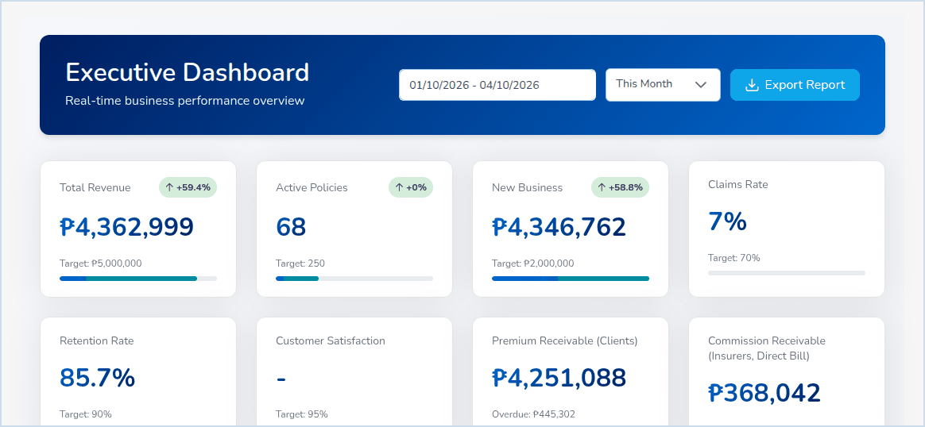
Executive Dashboard: premium, policies, new business, claims, retention and receivables against target.

854  APIs |  | 39  reports |  | 16  scheduled jobs |  | 7  personas |  | 497  test cases
Figures of the OOTB release test of 03 and 04 October 2026: 480 of the 497 test cases passed, a 23-step policy life cycle passed end to end, and every role was checked on all 173 menu screens.

WHY BROKERS CHANGE SYSTEMS
Where a broker’s time goes today
A Philippine non-life broker earns its commission on placement and service, yet much of the day goes to re-keying the same risk, premium and share into e-mails, spreadsheets and ledgers. These are the five gaps we hear most, and what BrokerVerse does about each of them.
TODAY |  | WITH BROKERVERSE
Manual placement  Broker slips go out by e-mail, offers come back as PDFs, and the chosen shares are typed again into the quotation, the policy and the bill. |  | Request for Quotation sends one slip to every insurer approached, records each offer or decline, ranks the offers and carries the chosen lead and co-insurer shares into the Placement Slip and the policy.
Spreadsheets for remittance  Premium collected for each insurer is worked out by hand, net of commission and per co-insurer share, month after month. |  | Automated Processing builds the remittance per insurer from collected premium, net of commission and by share, with approval levels by amount, a settlement voucher and Remittance Ageing on each insurer’s terms.
BIR compliance effort  VAT, withholding tax and alphalists are rebuilt from the books at each deadline, and Forms 2307 are tracked in folders. |  | Taxes are split when the policy is billed. VAT Summary, SAWT, QAP and SLSP come out of the ledger in the BIR column order, and BIR Form 2307 is issued and received with its own number series.
Slow renewals  Expiring policies are found late, notices depend on someone remembering, and lapses are noticed after the fact. |  | Every policy enters the renewal pipeline 90 days before expiry, notices go out at 60, 30 and 15 days, at-risk policies are scored, and lapses after the 30-day grace period are tracked for win-back.
Audit gaps  Approvals happen by e-mail or signature, changes leave no trace, and the books stay open after the month is reported. |  | Maker-checker on quotations, vouchers, remittances, settlements and closes, with notifications to the approvers; an audit trail with before and after values; 52 number series; periods that soft-close, close and lock.

One record, many teams. A risk entered once by Sales & Marketing is the same record the Processing Team places, Operations services, Claims settles and Accounting bills, receipts, remits and closes. Each step leaves a numbered document and a journal from its posting rule.

THE PLATFORM
One system, end to end
BrokerVerse covers the whole broking cycle and the accounting of a broker. The flow below is the path every piece of business takes; the modules that follow are all part of the OOTB edition.
Prospect | Request for  Quotation | Quotation | Placement  Slip | Policy | Bill and  official receipt | Remittance | Commission | Close and  BIR
Endorsements, claims and renewals run on the issued policy. Collections, reconciliation and period end run on the money that follows.
01 Sales and quotation  Prospects with bulk upload, Quick Quote and Compare Insurers for packaged products, and a five-step motor quotation with CTPL and Auto Passenger PA. The server re-prices every quotation from the configured rates. The client approves online through a signed link. |  | 02 Placement with insurers  Request for Quotation (broker slip) to several insurers, offers and declines recorded, Compare offers with the best offer and market capacity. Placement Slip firm order with each insurer’s confirmation; shares total 100% with one lead.
03 Policy issuance and servicing  Issue from a bound Placement Slip, from an accepted quotation, or with Record Issued Policy. The client, the bill and the commission are created at issue. Motor issue requires government ID, chassis, motor and plate or MV file number. |  | 04 Endorsements  Personal details, motor details and coverage changes, extensions and cancellations (full, partial, pro-rata). Coverage changes are priced again; additional premium is billed and return premium is credited and netted on the insurer’s next remittance.
05 Claims  Claim registration with the Preliminary Loss Advice to the insurer, adjuster follow-up, settlement by maker and approval by a second Claims user, co-insurer shares, claims paid through the broker, claim letters on the letterhead. |  | 06 Renewals  Renewal pipeline 90 days ahead, notices at 60, 30 and 15 days, renewal batches of up to 500 policies, Renewal Queue, At-Risk Policies, Negotiations, Lapse Management with win-back campaigns, Retention Analytics.
07 Billing and official receipts  Premium invoices on issue, endorsement and renewal. Official receipts from the OR series, posted only by Accounting after verifying the payment. Receipt and invoice PDFs e-mailed to the client. Payment links through PayMongo or Dragonpay. |  | 08 Collections and credit control  Collections with ageing (current, 1-30, 31-60, 61-90, over 90 days) and daily reminders. Instalment Plans, Premium Warranty Monitor, Client Credit Limits and Remittance Ageing under Credit Control.

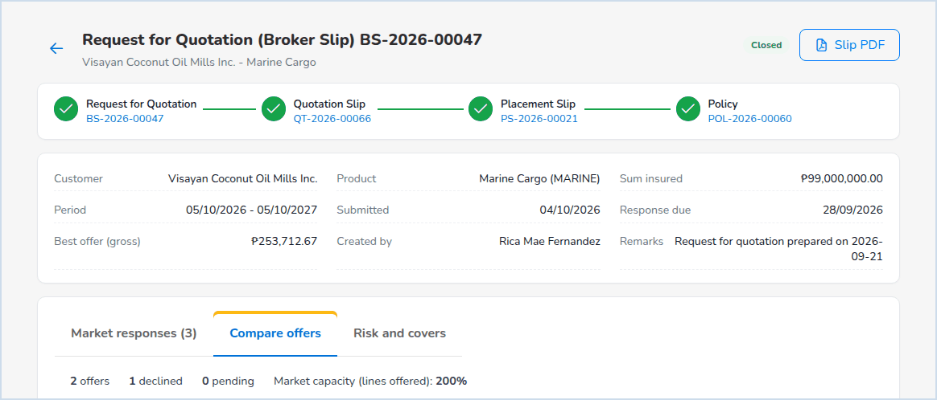
Request for Quotation BS-2026-00047, tab Compare offers: offers ranked by gross premium, best offer marked, lead and shares chosen for the Placement Slip.

THE PLATFORM, CONTINUED
09 Remittance and direct bill  Remittance per insurer and per co-insurer share, approval levels by amount (PHP 100,000 and PHP 1,000,000), settlement and insurer payment voucher. Direct bill: commission debit notes with 12% VAT, collection net of 10% EWT. |  | 10 Commission  Commission Rate Matrix by insurer, product, line and policy type. Accrued at issue, payable to referrers when the premium is fully collected, paid by voucher less withholding tax, clawed back on return premium.
11 General ledger and period end  Posting rules turn each business event into a balanced journal. Journal, Correction and Reversal JV with approval, Recurring Journals, Month-End Close with checklist, Year-End Close and Financial Statements. |  | 12 Bank and insurer reconciliation  Bank statements imported in BDO, BPI, Metrobank or generic layout, six matching rules, adjustments, stale cheques, reconciliation approved by the Accounting Manager. Insurer statements imported with a differences report.
13 BIR tax  BIR Form 2307 issued by the broker and received from insurers and clients, VAT Summary, SAWT, QAP, SLSP Sales and SLSP Purchases. Tax codes carry rate, BIR ATC and GL account. |  | 14 Reinsurance  Treaties (quota share, surplus, excess of loss, stop loss) with approval, cession tracking and bordereaux, claims recovery, reinsurer statement reconciliation and treaty analytics.
15 Incentives  Incentive programmes for account executives on premium, policy count, renewal rate or conversion. Calculations approved by a second Accounting user, statements per person, accrual and payment through posting rules. |  | 16 Reports and dashboards  39 catalogue reports on screen, in Excel, CSV or PDF on the company letterhead, with scheduled delivery by e-mail. Executive, Sales, Processing, Claims and Commission dashboards with live figures.
17 Security and control  Seven roles checked by the server on every request, two-step verification, lockout and password policy, Authority Matrix, Delegations, Segregation of Duties, Access Reviews and an Audit Trail with before and after values. |  | 18 Data privacy  Consent Register per purpose, Data Subject Requests register with due dates, personal data export for access and portability, and anonymisation once the retention period of the records has passed.

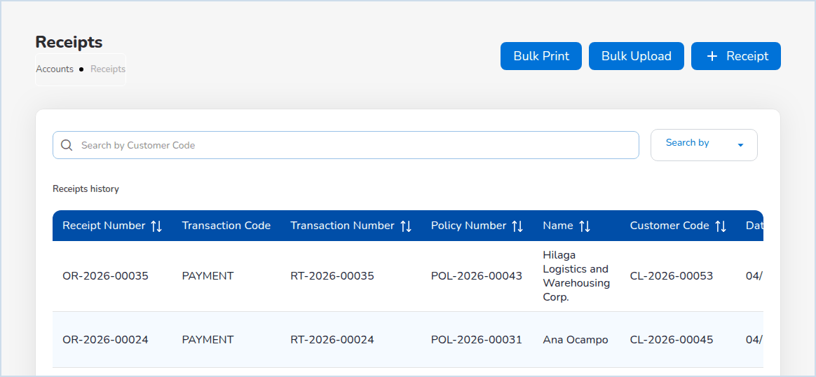  Accounts > Receipts: official receipts against open bills. |  | 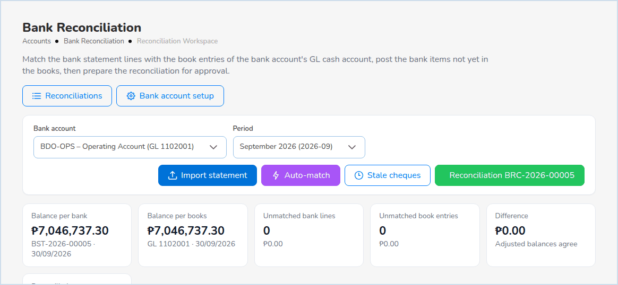  Bank Reconciliation: balance per bank and per books agree.

NEW IN THIS RELEASE
Approval notifications  Every maker-checker flow tells the people who can approve it, and the maker hears of the approval or rejection with the reason. |  | Documents by e-mail  Official receipts and premium invoices e-mailed to the client with the PDF attached; debit notes and policy schedules attached too. |  | Data privacy registers  Consent Register and Data Subject Requests under Master > Data Privacy, with personal data export and anonymisation.

SEVEN PERSONAS
Built around the people who do the work
Each user signs in with a personal ID and sees only the menus of the role. The server applies the same permissions on every request, and the person who enters a transaction cannot approve it.
Sales & Marketing  Account executives | Prospects, quick quotes and motor quotations sent for online approval; own pipeline, premium and commission on the Sales Dashboard; renewal follow-up.
Processing Team  Placement and policy processing | Request for Quotation to the market, offer comparison, Placement Slips, policy issue, endorsements, renewal approvals, motor tariff and products, reinsurance.
Operations  Client servicing | Clients and their policies in one view, endorsement requests, payment capture for verification, Open Items worklist of expiring policies and pending payments.
Claims  Claims officers | Claims Dashboard, registration with the insurer notice, adjuster follow-up, settlement with a second approver, claim letters, reinsurance recoveries.
Accounting  Finance team | Receipts, collections, remittance, direct bill, commission payouts, vouchers, journals, bank reconciliation, month-end preparation, BIR reports and Form 2307.
Accounting Manager  Finance approver | Approves month-end and year-end close and bank reconciliations, reopens periods, posts into soft-closed periods, reviews the close status.
System Administrator  IT and set-up | Users and roles, company and letterhead, insurers and credit terms, number series, posting rules, configuration, schedules and the audit trail.

PHILIPPINE RULES BUILT IN
Configured for the Philippine market from day one
CTPL and motor  ■ CTPL 1-year and 3-year tariff per vehicle class in the motor template  ■ CTPL inclusive of taxes and never discounted  ■ Auto Passenger PA priced per seat  ■ Certificate number and authentication code on the policy |  | Taxes on premium  ■ DST 12.5%, LGT 0.75%, VAT 12%, FST 2% on fire and IAR  ■ Taxes per line of business and LGU rates per city  ■ Premium taxes booked to their own accounts, due to insurers  ■ Return premium reverses the taxes |  | BIR outputs  ■ BIR Form 2307 issued and received, CWT series  ■ VAT Summary for the VAT return  ■ SAWT, QAP, SLSP Sales and Purchases in BIR column order  ■ EWT codes with ATC, for example WI139, WC139, WI515
Insurance Commission records  ■ Registers of slips, placements, policies, claims and renewals  ■ Premium due to insurers kept apart from commission income  ■ Remittance terms per insurer and Remittance Ageing  ■ Reports in Excel, CSV and PDF for examination |  | Data Privacy Act  ■ Consent per purpose with notice version and channel  ■ Data subject requests numbered DSR- with due dates  ■ Personal data export and anonymisation with retention rules  ■ Role-based access, audit trail, signed document links |  | Local formats  ■ PHP amounts and Asia/Manila business time  ■ TIN, 4-digit ZIP code, Philippine mobile numbers  ■ PhilSys ID, UMID, passport and other KYC IDs  ■ Bank statement layouts for BDO, BPI and Metrobank

DEPLOYMENT
Hosted where your data should live
The same build runs in the cloud or in a Philippine data centre: a web application, a stateless API, PostgreSQL 16 and a file store. Each option is sized to the broker and confirmed by a performance test in UAT.
■ Reference deployment  ■ CloudFront, load balancer, containers  ■ RDS PostgreSQL Multi-AZ, encrypted  ■ Automated backups with point-in-time restore |  | ■ No code change needed  ■ Front Door with WAF  ■ Container Apps, PostgreSQL Flexible Server  ■ Zone-redundant high availability |  | ■ Data held in the Philippines  ■ Managed virtual machines  ■ PostgreSQL with streaming standby  ■ Off-site copy in a second site |  | ■ Docker or Node.js with PM2  ■ nginx reverse proxy and TLS  ■ Backups with WAL archiving  ■ Broker IT runs the platform
  AWS
  Singapore region
  Microsoft Azure
  Southeast Asia region
  Local partner
  Philippine data centre
  On-premise
  Broker’s own servers
The Data Privacy Act does not require data to stay in the Philippines but keeps the broker accountable for data held abroad. Brokers who want the system of record in the country choose a local partner or on-premise hosting.
PostgreSQL 16  database of record |  | Node.js 22  stateless API |  | React 18  browser application, no install |  | Asia/Manila  business time zone

IMPLEMENTATION
Live in 8, 12 or 16 to 20 weeks
Configure, do not customise. BrokerVerse is fitted to the broker through master data and settings: insurers and credit terms, products and the motor tariff, commission, tax codes, chart of accounts, posting rules, number series and approvals. Hypercare lasts until the first month-end close is done.
8 weeks  Small broker  One office, up to 25 users, up to 10 insurers, up to 5,000 in-force policies.  Go-live at the start of week 7; hypercare weeks 7 and 8. |  | 12 weeks  Medium broker  Up to 3 offices, 26 to 75 users, up to 25 insurers, up to 25,000 in-force policies.  Go-live at the start of week 10; hypercare weeks 10 to 12. |  | 16-20 weeks  Large broker  More than 3 offices and 75 users, many insurers, more than 25,000 in-force policies.  Go-live at the start of week 15 (20-week plan); hypercare to week 20.

Mobilise | Discover | Set-up | Configure | Migrate data | Train | SIT | UAT | Cutover | Go-live | Hypercare

What OOTB means
The broker uses the delivered screens, workflows, reports and printed documents. Customisation of screens, reports or documents and new integrations (insurer systems, core banking, bank payment files, SMS, BIR eFPS or eBIRForms) are outside the OOTB scope and are handled as change requests, estimated and priced before any work starts.

PRODUCTION SUPPORT
Support that knows the product
After hypercare, iorta TechNXT supports BrokerVerse through one service desk. The broker’s key users and System Administrator handle the first line; iorta TechNXT handles analysis, fixes and releases.
L1 | Broker key users and System Administrator | How-to questions, users and passwords, settings and master data, logging the ticket with the evidence.
L2 | iorta TechNXT application support | Triage, reproduction, analysis with request IDs and the audit trail, configuration and data corrections under change control, workarounds.
L3 | iorta TechNXT engineering | Code defects, performance, infrastructure, security incidents, root-cause analysis, fixes and releases.

Service levels (standard proposal)  Standard support 8:00 to 18:00 Philippine time, Monday to Friday; 24 x 7 cover for P1 available as an option. Final targets are fixed in the support agreement. |  | How changes are handled  ■ Monthly planned releases, tested first in the test environment  ■ Database snapshot before every release; rollback by image tag  ■ Configuration changes recorded in the audit trail with old and new values  ■ Posting rule changes proposed by one user and approved by another  ■ Problem records and root-cause analysis for every P1  ■ Monthly service review with ticket and target figures
  Severity | First response | Restore or workaround
  P1 Critical | 30 minutes | 4 service hours
  P2 High | 2 service hours | 2 business days
  P3 Medium | 1 business day | 5 business days
  P4 Low | 2 business days | Planned

WHY IORTA TECHNXT
A finished product, documented and tested
  Built for Philippine broking
  CTPL tariff, premium taxes, BIR working papers, IC records and the Data Privacy Act are part of the product, not a project.
  Tested before you see it
  497 test cases, a 634-test business rule regression on PostgreSQL and a full UAT cycle of 371 business steps from set-up to month-end close.
  Documented for your team
  A 199-page user manual, seven role decks, a reports book, architecture, compliance matrix, data migration, training and support documents.
  Configuration over code
  Settings, masters, posting rules and the Product Configurator change the system. Upgrades stay simple because the code is the same for every broker.
  Accounting that closes
  Every event posts through a posting rule; maker-checker, period locks, bank reconciliation and month-end checklist give the auditors their trail.
  Open and portable
  React, Node.js and PostgreSQL with permissively licensed components; 854 APIs documented in OpenAPI; runs on AWS, Azure or your own servers.

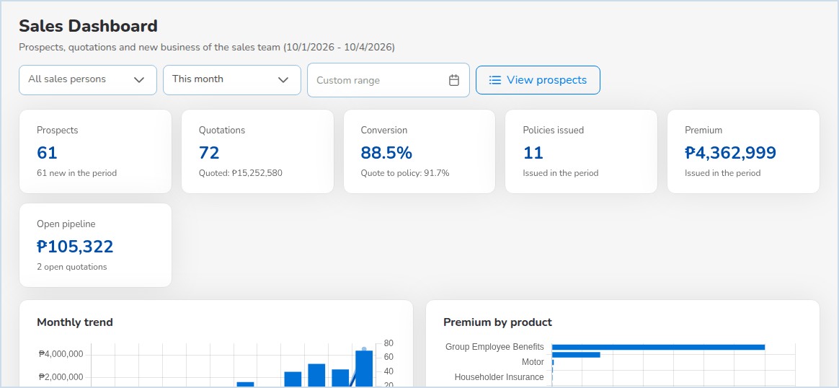
Sales Dashboard: prospects, quotations, conversion, policies issued and premium for the sales team.

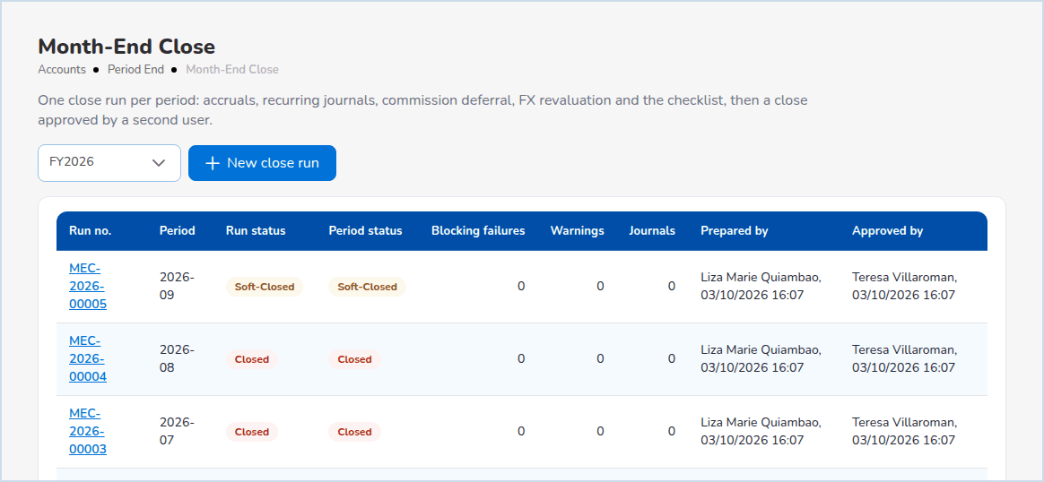  Month-End Close: one run per period, approved by a second user. |  | 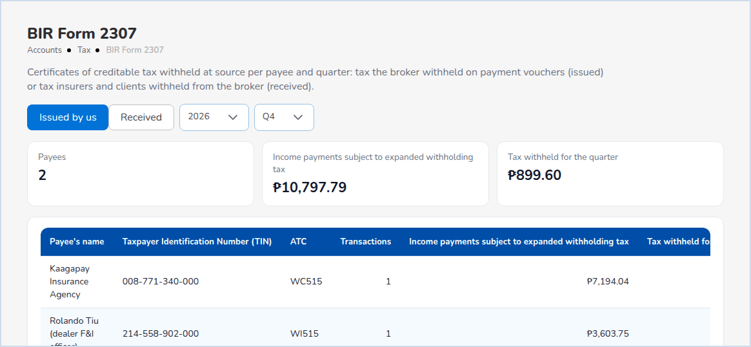  BIR Form 2307 per payee and quarter, issued and received.

SEE IT WITH YOUR OWN DATA
Book a walk-through of BrokerVerse
We run your own example, a motor policy or a co-insured fire risk, from quotation to official receipt, remittance and month-end close, on the delivered system.
iorta TechNXT  Address [address]  Telephone [phone]  E-mail [e-mail]  Website [website] | Contact person  [name, designation]  Commercial models  Subscription per user per month, or perpetual licence with annual maintenance. Hosting quoted separately.

iNXT BrokerVerse, OOTB edition, version 1.0. Product facts and figures are taken from the system and its release test of 03 October 2026. Timelines, service levels and prices are confirmed in the proposal and the agreements. BrokerVerse produces records and working papers; filings with the BIR, the Insurance Commission and the National Privacy Commission remain with the broker.

