

FUNCTIONAL REQUIREMENTS SPECIFICATION
Parcel / Courier - Open Policy and Declarations
Certificate per customer under the AXA open policy, daily declarations, the monthly AXA declaration file and reports, billing, full premium remitted to AXA and commission; Marine Cargo inland declarations on the same mechanism

Client | Toyota Insurance Services Philippines Corporation (TISPH)
Document | TISPH-FRS-PJRN-09
Requirement | TIS-BRD-PJRN-09
Version | 1.0
Date | 9 October 2026
Status | Issued for TISPH review
Classification | Confidential

Prepared by iorta TechNXT for TISPH 
This document is confidential to Toyota Insurance Services Philippines Corporation and iorta TechNXT.
Document Control
Version | Date | Author | Reviewer | Approver | Change
1.0 | 9 Oct 2026 | iorta TechNXT Business Analysis | iorta TechNXT Project Manager | - | First issue for review

Distribution List
Name / Unit | Role | Organisation | Purpose
TIS Sales (business owner) | Approver | TISPH | Review and sign-off
Sales Admin | Business user | TISPH | Daily parcel upload and certificate FRs
Operations | Business user | TISPH | Open policy, declarations and AXA file FRs
Finance and General Accounting | Business user | TISPH | Billing, remittance and commission FRs
DTID - Project Management Team | Project owner | TISPH | Traceability against the BRD
Project team | Delivery | iorta TechNXT | Build, test and UAT preparation

Contents
1 Overview 5
1.1 The requirement 5
1.2 Scope 5
1.3 Definitions and acronyms 6
1.4 How to read the functional requirements 6
1.5 What changes in BrokerVerse 7
2 Process flow 8
2.1 Flow A - Set up the open policy 8
2.2 Flow B - Parcels of a day 9
2.3 Flow C - Month end with AXA 10
2.4 Flow D - Marine Cargo inland 11
2.5 Open policies covered 12
3 Personas and roles 13
3.1 Personas 13
3.2 Permissions 13
3.3 Default grants 13
4 Functional requirements 14
4.1 Open policy set-up 14
FR-PCL-001 Choose the open cover type and set up a Parcel / Courier open cover 14
FR-PCL-002 Define the covers on each parcel certificate 15
FR-PCL-003 Set the charge per certificate, the remittance basis and the declaration settings 17
FR-PCL-004 Activate the open cover and issue the open policy 18
FR-PCL-005 Endorse the open policy (endorsements apply to the open policy only) 19
4.2 Parcel certificates 20
FR-PCL-010 Upload the TFS daily parcel list 20
FR-PCL-011 Add one parcel on screen 21
FR-PCL-012 Check each parcel: data, period, duplicates 22
FR-PCL-013 Produce the certificate of insurance for each customer 23
FR-PCL-014 Cancel a certificate, or reverse it after declaration 24
4.3 Declarations and the AXA declaration file 25
FR-PCL-020 Keep a daily declaration per open cover and close it each night 25
FR-PCL-021 Take late parcels into the next open day 26
FR-PCL-022 Build the monthly declaration from the daily declarations 26
FR-PCL-023 Generate the AXA declaration file 28
FR-PCL-024 Send the declaration to AXA and record AXA's acceptance 28
4.4 Marine Cargo inland declarations 29
FR-PCL-030 Upload the client's daily shipments on a Marine Cargo open cover 29
FR-PCL-031 Send the monthly cargo declaration to the insurer by bulk file 30
4.5 Billing, remittance and commission 31
FR-PCL-040 Bill the monthly declaration to TFS 31
FR-PCL-041 Remit the full premium to AXA (gross remittance) 31
FR-PCL-042 Bill and collect AXA's commission 32
4.6 Declaration reports to AXA 33
FR-PCL-050 Declaration summary report 33
FR-PCL-051 Parcel certificate register 33
4.7 Audit and access 34
FR-PCL-060 Keep the audit trail of open covers, certificates and declarations 34
FR-PCL-061 Control access to the parcel and declaration functions 34
5 Workflow and status model 35
5.1 Open cover 35
5.2 Open policy endorsement 35
5.3 Parcel certificate 35
5.4 Daily declaration 35
5.5 Monthly declaration and its file 35
6 Interfaces 37
6.1 Files in and out 37
6.2 AXA declaration file (AXA parcel layout) 37
6.3 Cargo declaration file (Cargo layout) 38
7 Configuration items 39
7.1 Settings 39
7.2 Scheduled jobs 39
7.3 Lists of values 40
7.4 Masters, number series and posting rule 40
8 Traceability 41
8.1 BRD clause to FR 41
8.2 Related BRD requirements 41
8.3 FR to test cases 41
9 Navigation 43
9.1 Screens of PJRN-09 43
9.2 Menu by base role 43
10 Screen specifications 44
10.1 Marine Open Covers list (changed) 44
10.2 New open cover - Parcel / Courier (changed) 45
10.3 Open cover - Covers tab (new) 47
10.4 Open cover - Certificates tab (changed) 48
10.5 Upload parcels (new) 49
10.6 Parcel certificate of insurance (new document) 50
10.7 Open cover - Daily declarations tab (new) 51
10.8 Open cover - Monthly declarations tab (changed) 52
10.9 Endorse open policy (new) 53
10.10 Direct Bill Processing (existing) 54
11 End-to-end walkthroughs 55
11.1 WT-A Set up the AXA parcel open policy 55
11.2 WT-B Parcels of 9 October 2026 55
11.3 WT-C September 2026 month end 55
11.4 WT-D Marine Cargo inland 56
11.5 WT-E Exceptions 56
12 Messages catalogue 57
12.1 Open cover set-up and endorsement 57
12.2 Parcel certificates 57
12.3 Declarations and the AXA file 58
12.4 Marine Cargo inland 59
12.5 Billing, remittance and commission 59
13 Upload screens 60
13.1 Parcel upload template (TFS parcel list) 60
13.2 Cargo shipment upload template 60
14 Sign-off and change control 61
14.1 What is signed 61
14.2 Values TISPH confirms before build 61
14.3 Change after sign-off 61
14.4 Signatures 61
Appendix A Per-parcel premium workings 62
A.1 One parcel as set up in this FRS (charge 500, premium 62, commission 3%) 62
A.2 The two other readings to be confirmed 62
A.3 Taxes inside the flat premium 63
A.4 September 2026 - 1,240 parcels 63
A.5 Marine Cargo inland - October 2026 shipments 63

1 Overview

1.1 The requirement
TIS-BRD-PJRN-09 Parcel / Courier (Customization, Phase 1, CR-18). Parcel/Courier business sent by TFS through TISPH is insured with the partner insurer (AXA): a certificate per customer under an Open Policy with a daily Declaration; flat PHP 2,500 charge to the customer with a default flat PHP 500 premium inclusive of taxes and charges; 3% commission from AXA with the full premium remitted to AXA; declaration file and reports to AXA per agreed format. Marine Cargo (inland) moves into Phase 1 with this item: an open policy with declarations made daily and sent to the insurer monthly by bulk upload; endorsements apply to the open policy only.

When a TFS loan is booked, TFS sends the original loan collateral documents (certificate of registration, deed of sale) to the customer by LBC Express. The customer pays TFS a flat charge for the delivery: PHP 2,500 for rush and PHP 2,000 for regular delivery. PHP 500 of it is for insurance. The parcel is insured under the AXA Marine Open Policy MN-HO-26-000631-00, in which TFS is the assured, and the customer also gets Personal Accident cover from AXA. TISPH places the business: it issues one certificate per customer, declares the parcels of each day under the open policy, sends AXA the declaration file and reports, bills TFS, remits the full premium to AXA and collects its commission from AXA.
BrokerVerse already runs marine cargo open covers (Operations > Marine Open Covers): a contract with rates per conveyance, a certificate per shipment and a monthly or quarterly declaration billed on the open policy. This FRS adds a Parcel / Courier type of open cover with a flat premium per certificate, a daily declaration on every open cover, the AXA declaration file and reports, the upload of the TFS parcel list and of cargo shipments, and the gross remittance of the premium with the commission billed back to AXA. Marine Cargo inland uses the same daily and monthly declaration mechanism. Changed and new screens are shown as to-be mock-ups drawn on the real BrokerVerse screens with the Toyota Insurance Services look.

1.2 Scope
In scope
- A new open cover type on Operations > Marine Open Covers: Parcel / Courier (flat covers on each certificate) next to the existing Marine Cargo type (rate and limit per conveyance).
- The covers on each parcel certificate (Marine (parcel) and Personal Accident, with sum insured, premium inclusive of taxes, commission % and AXA policy number), the charge per certificate billed to TFS, the remittance basis and the declaration settings.
- Upload of the TFS daily parcel list and Add parcel: one certificate per customer, checks on period, duplicates and mandatory data; the certificate of insurance PDF e-mailed or printed; cancellation and reversal.
- A daily declaration on every open cover, closed each night by a scheduled job, with late parcels taken into the next open day.
- The monthly declaration built from the daily declarations, the taxes kept inside the flat premium, the AXA declaration file, sending it to AXA and recording AXA's acceptance.
- The declaration reports to AXA: the Declaration summary and the Parcel certificate register.
- Marine Cargo inland: upload of the client's daily shipments and the monthly declaration file to the insurer on the same mechanism.
- Endorsement of the open policy with maker-checker approval (endorsements apply to the open policy only).
- Billing of the monthly declaration to TFS, remittance of the full premium to AXA and the commission debit note to AXA.
- Permissions, audit trail, settings, scheduled jobs and number series.
Out of scope
- The courier fee, the notary fee and the rest of the flat charge collected by TFS from the customer: BrokerVerse records the delivery type and the charge for reference only.
- Marine Cargo standalone (one shipment by land, sea or air, extension only) and Marine Hull: not part of this item.
- Claims on a parcel or on the Personal Accident cover: handled with the existing Claims module against the open policy.
- A direct system link with AXA or with LBC Express: the declaration goes to AXA as a file by e-mail; the TFS parcel list comes as a file.
- Other reports: only the declaration file and the two declaration reports named by the item are specified.

1.3 Definitions and acronyms
Table 1: Definitions
Term | Meaning in this FRS
Open policy (open cover) | A policy for a period under which every shipment or parcel that fits its terms is insured when it is declared. In BrokerVerse an open cover record on Operations > Marine Open Covers (MOC-YYYY-NNNNN) issues one open policy (POL-) without a bill.
Open cover type | Marine Cargo: premium = insured value x rate of the conveyance, at least the minimum premium (existing). Parcel / Courier: a flat premium for each cover on the certificate (new).
Parcel | One LBC Express delivery of a customer's loan collateral documents from TFS head office to the customer's declared residence.
Certificate (parcel) | The certificate of insurance issued to one customer for one parcel (PCC-YYYY-NNNNNN), listing the covers, sums insured and AXA policy numbers.
Cover on the certificate | Marine (parcel): sum insured PHP 10,000, premium PHP 12. Personal Accident: sum insured PHP 50,000, premium PHP 50. Premiums are inclusive of taxes and stamps.
Charge per certificate | The amount TISPH bills TFS for each certificate: default PHP 500. When it is higher than the premium, the difference is TISPH's service fee.
Flat charge to the customer | What TFS collects from the customer for the delivery: PHP 2,500 rush, PHP 2,000 regular (courier fee, notary and insurance). Recorded for reference.
Daily declaration | The certificates (or cargo shipments) of one day under one open cover (MDD-YYYY-NNNNNN). Open during the day, closed by the job "Daily declaration close".
Late item | A certificate whose parcel date falls on a day already closed. It joins the open daily declaration and is flagged late.
Monthly declaration | The existing declaration record (MDC-YYYY-NNNNN) that gathers the daily declarations of a month. It is submitted, sent to the insurer and billed.
AXA declaration file | The Excel file sent to AXA for a monthly declaration: one row per certificate and cover, a summary and a control sheet.
Reversal | A negative line on a later declaration for a certificate cancelled after its declaration was submitted.
Remittance basis | Net: premium remitted net of the commission (BrokerVerse today). Gross: full premium remitted, commission billed to the insurer afterwards (this FRS, for AXA).
TFS / AXA / LBC | Toyota Financial Services Philippines / AXA Philippines Life and General Insurance Corporation / LBC Express, the courier.
PA / SI / VAT / DST / LGT | Personal Accident / sum insured / Value Added Tax / Documentary Stamp Tax / Local Government Tax.

1.4 How to read the functional requirements
Each FR in chapter 4 has the same parts:
- A header table with the BRD trace, the actor, the priority, the fit and the screens that implement it.
- Description, preconditions, main flow and alternate and exception flows.
- Business rules. Configurable rules are kept on the open cover or on Master > System > Configuration (chapter 7). Fixed rules change only through a change request.
- Validations and messages: the check and the message the user sees, word for word, with its ID in chapter 12. As everywhere in BrokerVerse, a message is plain English and is shown under the field it belongs to, or as a toast.
- Audit and numbered acceptance criteria, the basis of the test cases TC-PCL-nnn-n.
Note. The covers, premiums, charge and commission rates in the examples are the values known today. The breakdown of the PHP 2,500 charge, the commission rate (3% or 30%) and the AXA file format are still to be confirmed by TISPH (chapter 14 and Appendix A). They are configuration on the open cover, so a confirmed value changes no FR.

1.5 What changes in BrokerVerse
The table lists what PJRN-09 reuses, what it changes and what it adds.
Table 2: BrokerVerse today and PJRN-09
BrokerVerse today | What PJRN-09 does
Operations > Marine Open Covers: open cover with client, insurer, period, goods, voyages, clauses, rate % and limit per conveyance (Sea, Air, Land), mark-up, minimum premium per certificate, declarations monthly or quarterly. Activate issues the open policy without a bill. | Changed. New field Open cover type (Marine Cargo / Parcel / Courier). For Parcel / Courier: covers on each certificate with flat premiums, charge per certificate, remittance basis, daily declaration and declaration file settings.
Certificates tab: Issue certificate and Shipment without certificate, one at a time; premium = insured value x rate; Print and Cancel certificate. | Changed. Upload parcels (TFS list) and Add parcel for a Parcel cover; Upload shipments for a cargo cover; the parcel certificate PDF e-mailed or printed; reversal after declaration.
Declarations tab: New declaration per month (or quarter), Recompute, Submit, Bill, Print "Declaration of Shipments"; premium taxes of the MARINE line added on top of the premium. | Changed. Daily declarations (new tab) feed the monthly declaration, opened by a job. For a flat premium inclusive of taxes the taxes are shown inside the premium. New buttons: AXA declaration file, Send to AXA, Record AXA acceptance, Declaration summary, Certificate register.
Edit of an active open cover changes period end, clauses and rates in place. | Changed. An active open cover is changed by Endorse open policy (numbered, effective date, approved by a second user). Certificates are never endorsed.
Billing a declaration raises the bill on the open policy; the settlement remits the collected premium net of commission (net remitting). | Changed. Bill amount = certificates x charge per certificate; remittance basis Gross remits the full premium to AXA and moves the commission to Direct Bill Processing for a debit note to AXA.
Accounts > Remittance > Direct Bill Processing: commission debit notes (DN-) to insurers, collections with EWT. | Reused for the AXA commission.
Master > Insurance > Product (MARINE, PA), Insurance Company (AXA is not in the delivered list), Master > System > Configuration, Schedules, Document Numbering, E-mail Outbox. | Reused. New product PARCEL and insurer AXA are configuration; new settings, two jobs and three number series.

2 Process flow
Four flow charts show the item end to end: Flow A sets up the open policy, Flow B issues the certificates of a day and closes the daily declaration, Flow C runs the month end with AXA and Flow D applies the same mechanism to Marine Cargo inland. Black rounded boxes are start and end points, diamonds are decisions, red boxes are exceptions, grey boxes are done by the system and boxes with a heavy border are the successful outcome.

2.1 Flow A - Set up the open policy
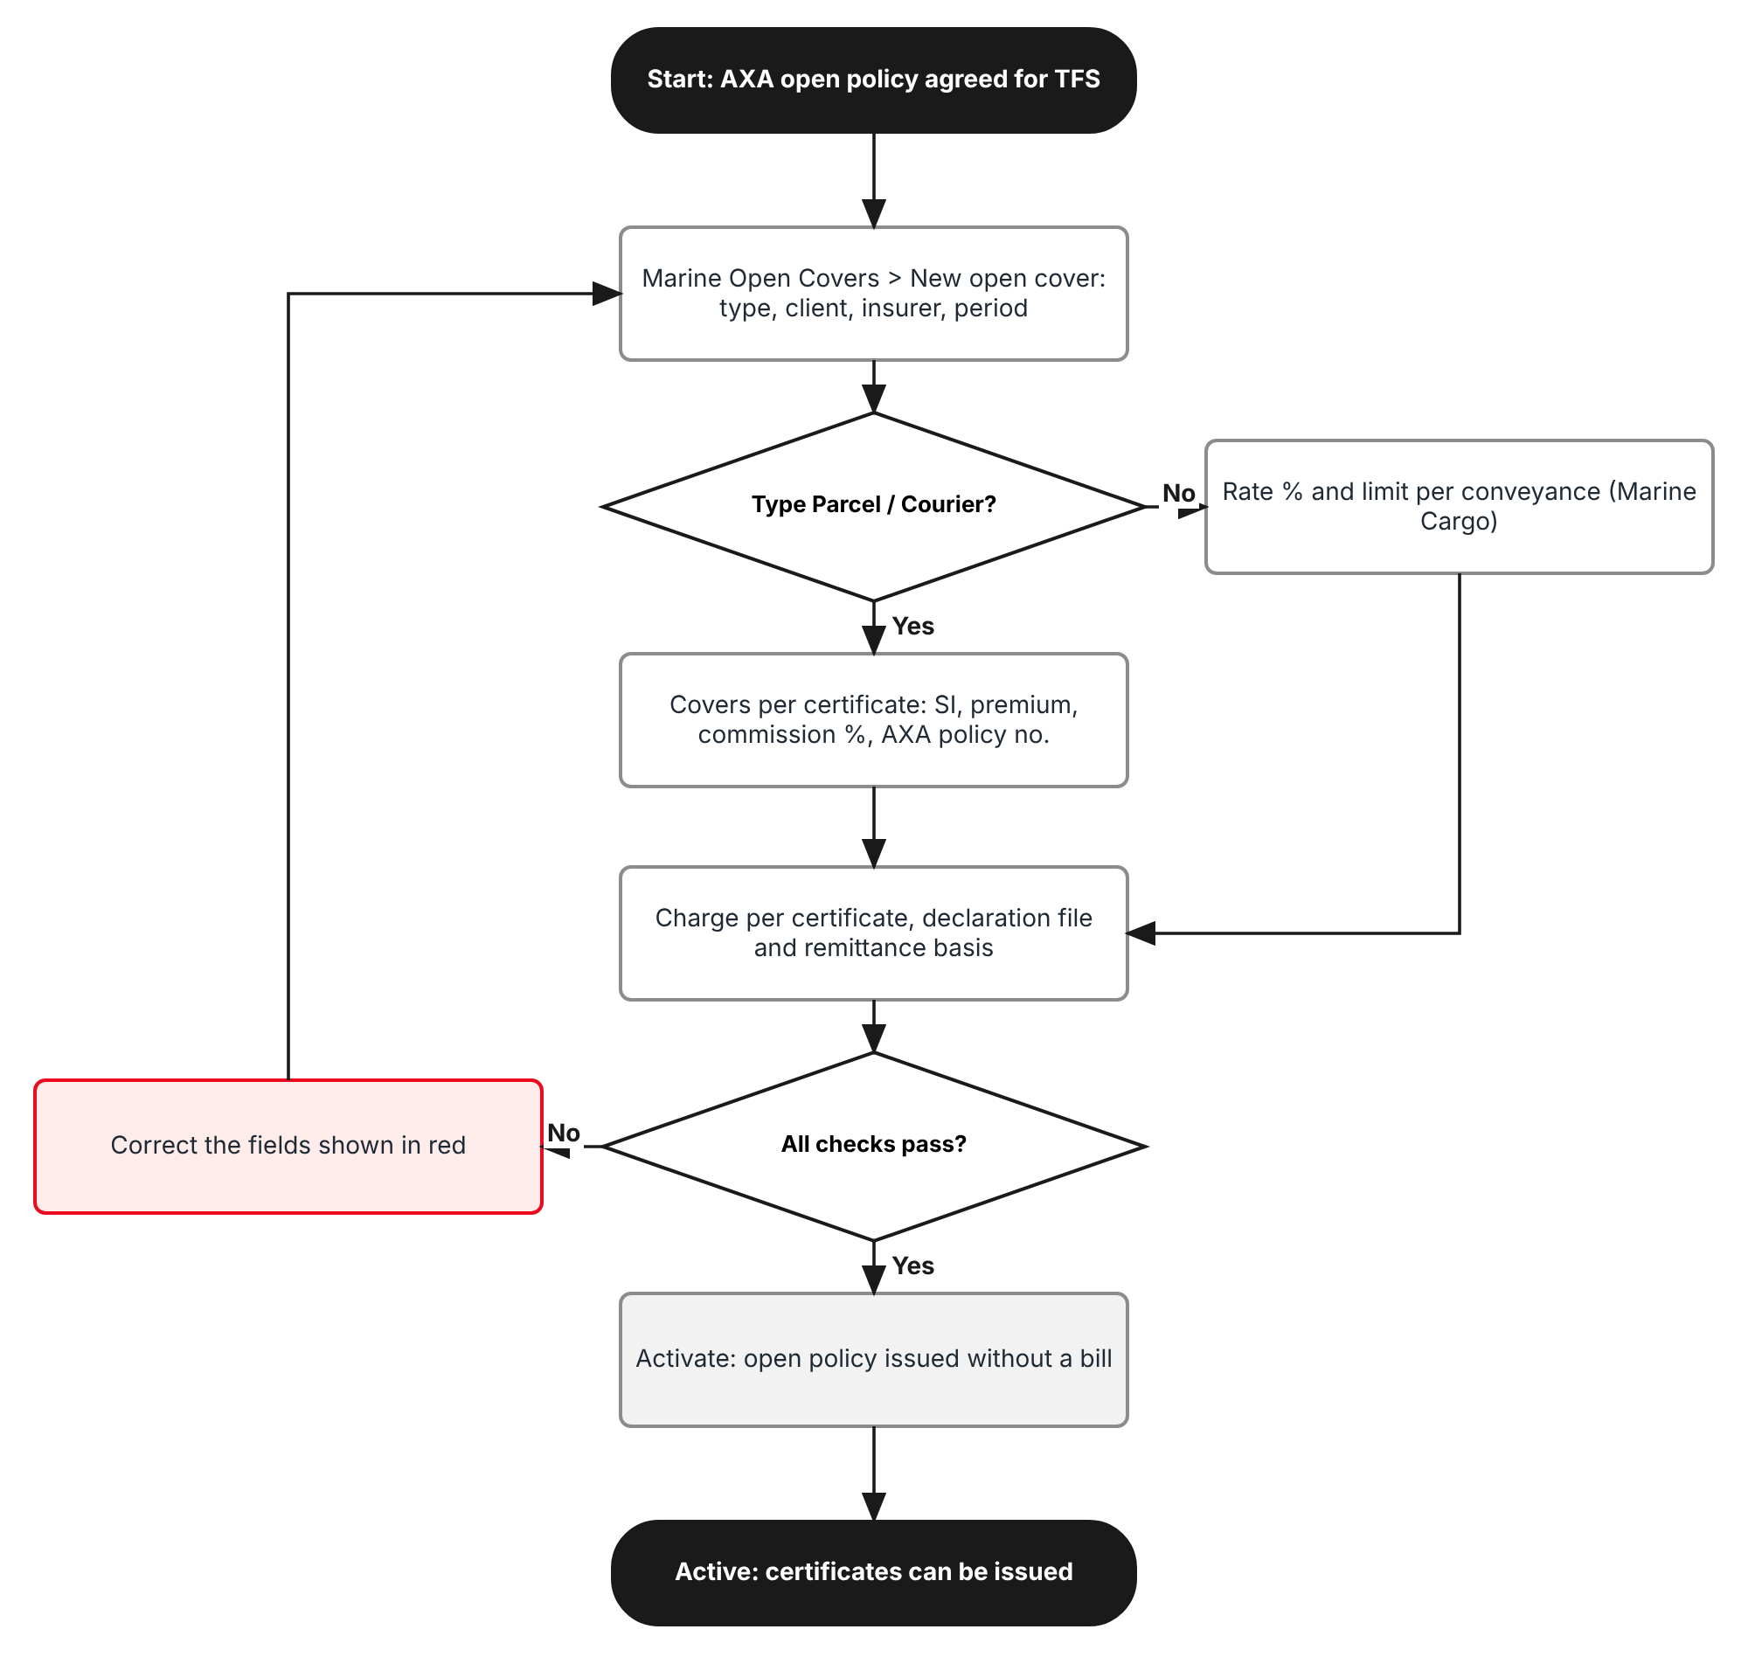
Figure 1: Flow A - Set up the open policy
Table 3: Flow A steps
Step | Who (role) | What happens | FR
A1 | Operations | Operations > Marine Open Covers > New open cover: Open cover type Parcel / Courier, product PARCEL, client Toyota Financial Services Philippines, insurer AXA, period 01/08/2026 to 01/08/2027, AXA open policy number. | FR-PCL-001
A2 | Operations | Covers on each certificate: Marine (parcel) SI 10,000 premium 12; Personal Accident SI 50,000 premium 50; commission % and AXA policy number of each. | FR-PCL-002
A3 | Operations | Charge per certificate 500, remittance basis Gross, daily declaration on, declaration file monthly with the AXA parcel layout and the AXA e-mail. | FR-PCL-003
A4 | System | Checks the fields; Save creates the open cover in Draft. | FR-PCL-001 to 003
A5 | Operations | Activate: the open policy is issued without a bill; the cover is Active. | FR-PCL-004
A6 | Operations; approver | Any later change is an endorsement of the open policy, approved by a second user. | FR-PCL-005

2.2 Flow B - Parcels of a day
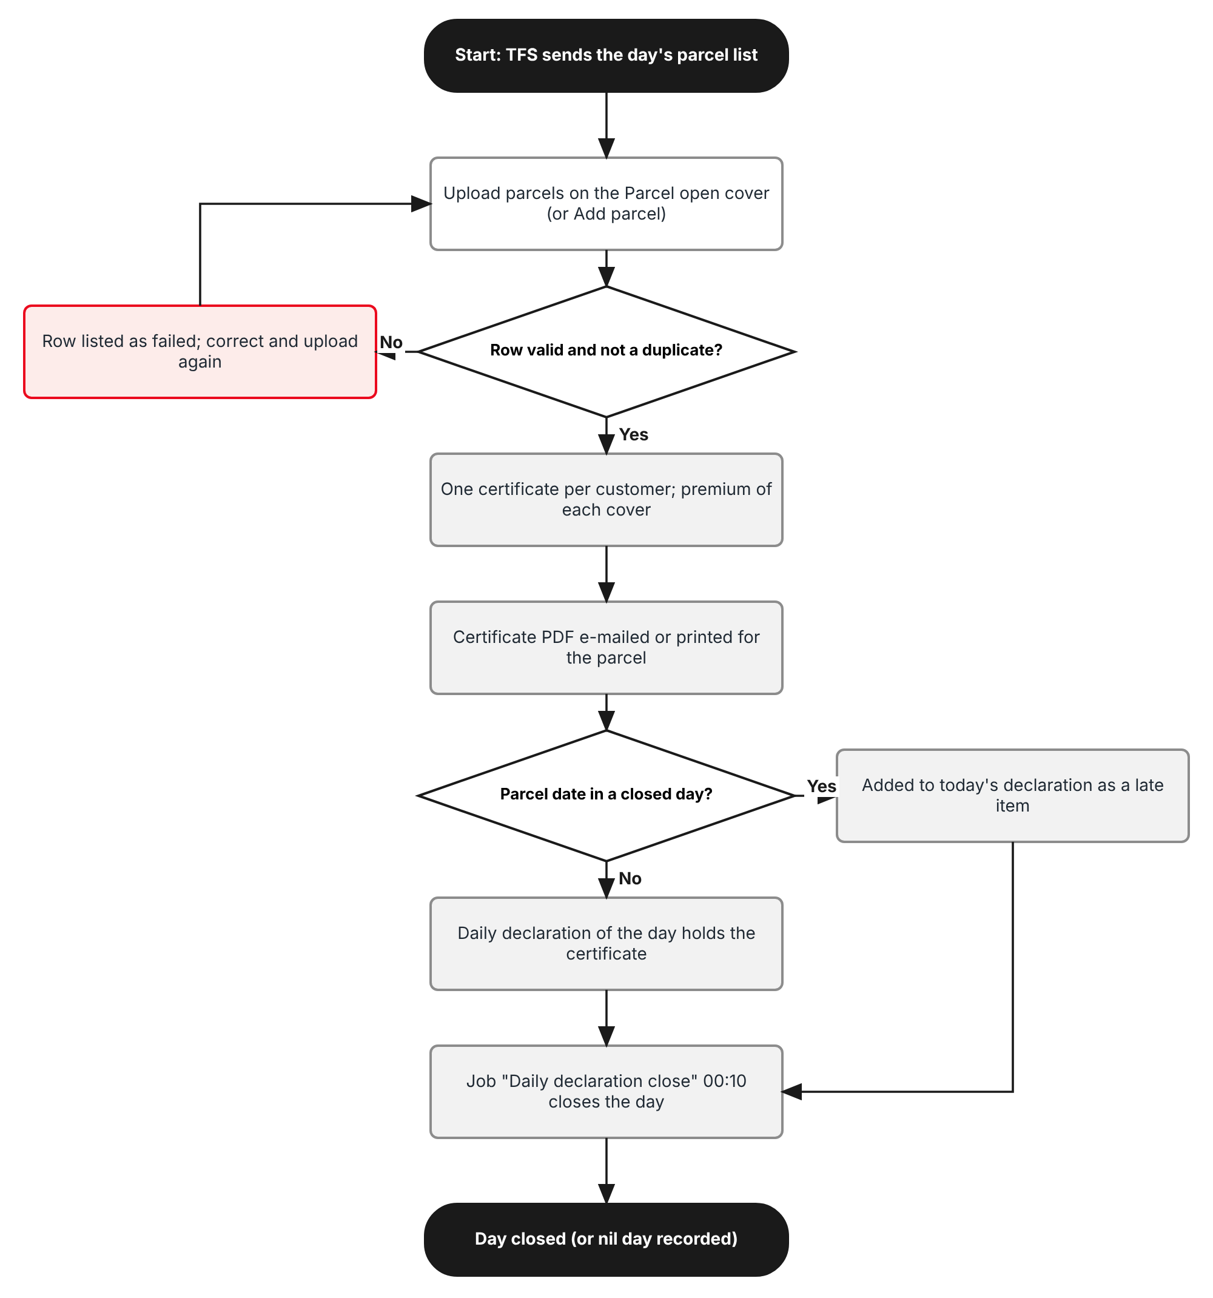
Figure 2: Flow B - Parcels of a day and the daily declaration
Table 4: Flow B steps
Step | Who (role) | What happens | FR
B1 | Sales Admin | Receives the TFS parcel list of the day and uses Upload parcels on the Parcel open cover (or Add parcel for one). | FR-PCL-010, 011
B2 | System | Checks each row: mandatory data, parcel date within the period, waybill not used, loan account not on a recent certificate. Failed rows are listed with their row number. | FR-PCL-012
B3 | System | Creates one certificate per customer with the premium of each cover; the PDF is e-mailed to the customer or printed with the parcel. | FR-PCL-013
B4 | System | Puts the certificate on the daily declaration of its parcel date; a parcel of a closed day goes to the open day as a late item. | FR-PCL-020, 021
B5 | System | Job "Daily declaration close" (00:10) closes the day; a day without parcels is a nil day. | FR-PCL-020
B6 | Sales Admin | Cancels a certificate issued in error; after declaration it is reversed on the next month. | FR-PCL-014

2.3 Flow C - Month end with AXA
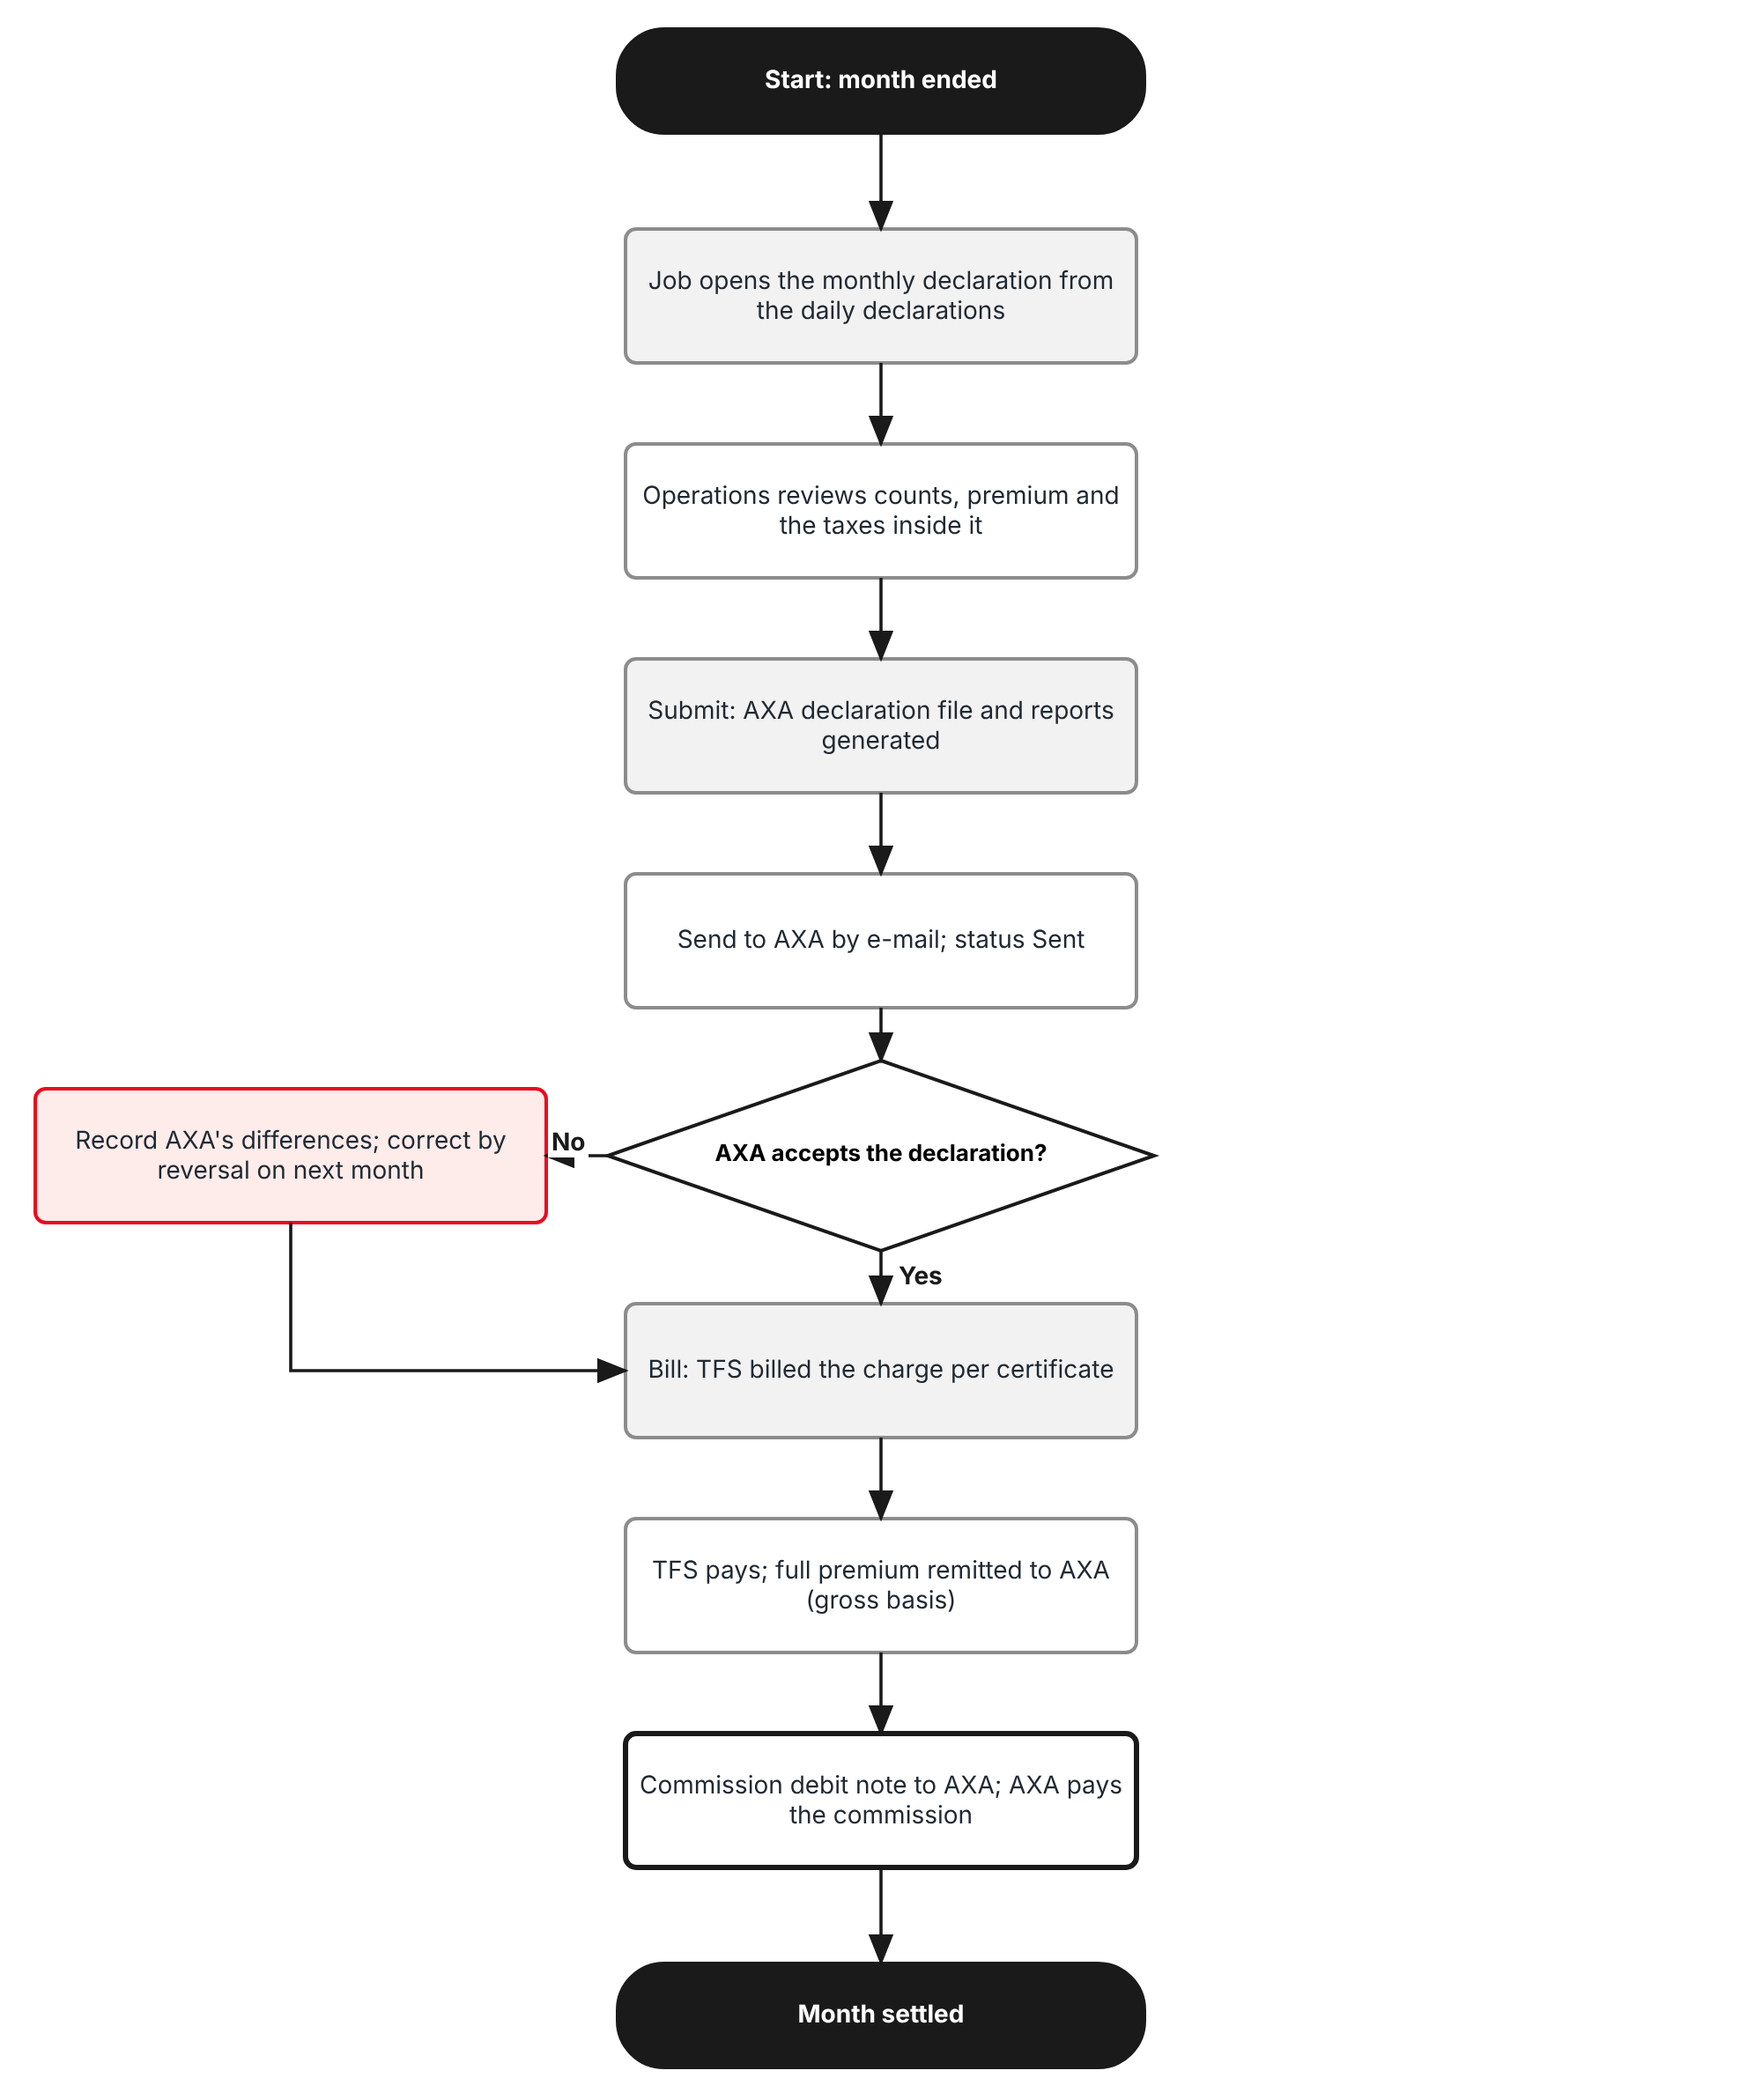
Figure 3: Flow C - Monthly declaration, AXA file, billing, remittance and commission
Table 5: Flow C steps
Step | Who (role) | What happens | FR
C1 | System | On the 1st at 01:00 the job opens the monthly declaration of the previous month with its daily declarations. | FR-PCL-022
C2 | Operations | Reviews the counts, premium per cover and the taxes inside the premium; Submit generates the AXA declaration file and the reports. | FR-PCL-022, 023, 050, 051
C3 | Operations | Send to AXA: e-mail with the file and the reports. Records AXA's acceptance or its differences. | FR-PCL-024
C4 | Operations | Bill: TFS is billed the charge per certificate for the month. | FR-PCL-040
C5 | Accounting | When TFS pays, the settlement remits the full premium to AXA. | FR-PCL-041
C6 | Accounting | Raises the commission debit note to AXA on Direct Bill Processing and records AXA's payment. | FR-PCL-042

2.4 Flow D - Marine Cargo inland
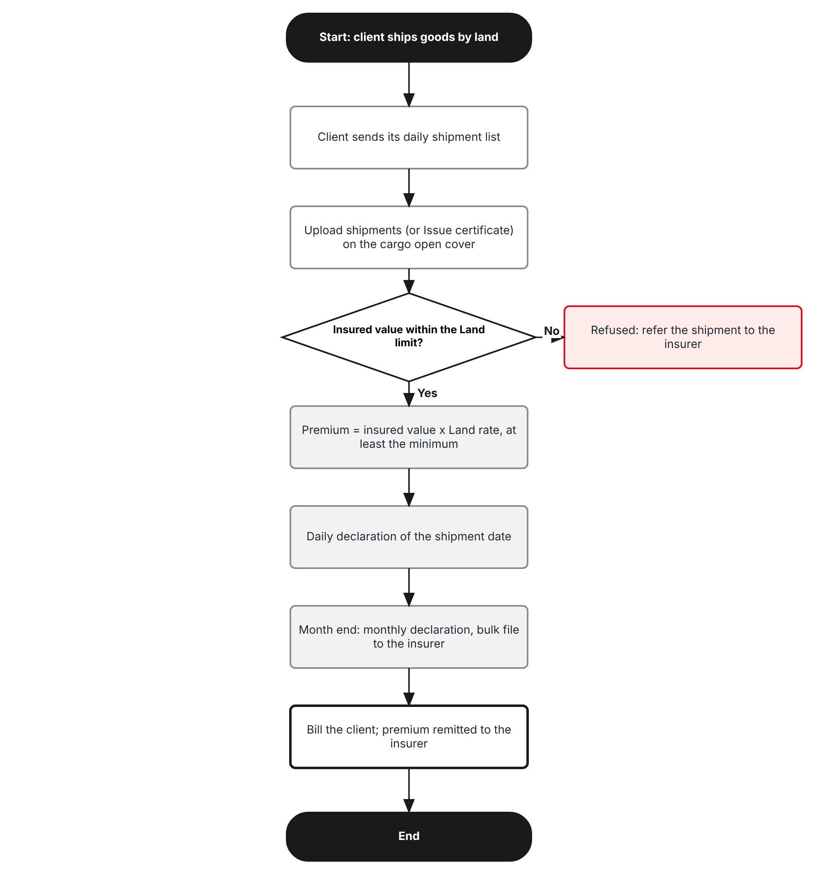
Figure 4: Flow D - Marine Cargo inland declarations
Table 6: Flow D steps
Step | Who (role) | What happens | FR
D1 | Operations | Uploads the client's daily shipment list on the cargo open cover (or Issue certificate for one shipment). | FR-PCL-030
D2 | System | Prices each shipment at the Land rate, at least the minimum premium; refuses a shipment above the Land limit. | FR-PCL-030
D3 | System | Shipments join the daily declaration of their date; the job closes each day. | FR-PCL-020
D4 | Operations | At month end submits the monthly declaration; the bulk file goes to the insurer; the client is billed and the premium remitted as today. | FR-PCL-031

2.5 Open policies covered
Table 7: Open policies covered
Dimension | Parcel / Courier | Marine Cargo inland
Client (assured) | Toyota Financial Services Philippines | Any client with an inland cargo open policy
Insurer | AXA (Marine Open Policy MN-HO-26-000631-00; PA policy number to be advised) | Any panel insurer
Product | PARCEL (new, line Marine) | MARINE (existing)
Unit insured | One parcel = one customer = one certificate | One shipment
Premium | Flat per cover, inclusive of taxes: Marine (parcel) 12, PA 50 | Insured value x Land rate %, at least the minimum; taxes added
Declaration | Daily; file to AXA monthly | Daily; bulk file to the insurer monthly
Billed to | TFS: charge per certificate (500) | The client: premium and taxes
Remittance basis | Gross (full premium to AXA; commission billed back) | Net (as today) or Gross, per open cover

3 Personas and roles

3.1 Personas
TISPH personas map to the BrokerVerse roles (Master > Users and Access > Role) as below.
Table 8: Personas and BrokerVerse roles
TISPH persona | BrokerVerse role | What they do in this item
TIS Sales Admin (parcel desk) | Sales & Marketing - sales | Uploads the TFS parcel list each day; adds, cancels and prints certificates
Operations officer | Operations - operations; Processing Team - processing | Sets up and endorses open covers, uploads cargo shipments, submits, sends and bills declarations
Approver | Accounting Manager - accounting-manager | Approves open policy endorsements and reversals of declared certificates (never their own)
Finance | Accounting - accounting | Collection from TFS, remittance to AXA, commission debit note to AXA
Claims; auditor | Claims - claims; Compliance Officer - compliance-officer | Read the certificates and declarations; the auditor also the Audit Trail
System Administrator | System Administrator - system-admin | Roles, permissions, settings, jobs, number series

3.2 Permissions
Two permissions are added to the existing read:marine and write:marine, on the pattern read:/write:/approve:<module>, granted on Master > Users and Access > Role Permissions. The approver of an endorsement or a reversal is never the user who requested it (maker-checker).
Table 9: Permissions
Permission | Allows
read:marine (existing) | Open Operations > Marine Open Covers, its certificates and declarations; print certificates and reports
write:marine (existing) | Set up and activate open covers, request endorsements, upload cargo shipments, submit, send and bill declarations
write:parcel-certificates (new) | Upload parcels, Add parcel, cancel a certificate not yet declared, print the certificates of the day
approve:marine (new) | Approve or return an open policy endorsement and the reversal of a declared certificate (never one you requested)

3.3 Default grants
Table 10: Default grants (Y = granted)
Permission | system-admin | processing | operations | sales | accounting | accounting-manager | claims | compliance-officer
read:marine | Y | Y | Y | Y | Y | Y (new) | Y | Y (new)
write:marine | Y | Y | Y | - | - | - | - | -
write:parcel-certificates | Y | Y | Y | Y | - | - | - | -
approve:marine | Y | - | - | - | - | Y | - | -

4 Functional requirements
Twenty-four FRs implement PJRN-09. They follow the process: the open policy set-up (4.1), the parcel certificates (4.2), the declarations and the AXA file (4.3), Marine Cargo inland (4.4), billing, remittance and commission (4.5), the declaration reports to AXA (4.6), and audit and access (4.7).

4.1 Open policy set-up

FR-PCL-001 Choose the open cover type and set up a Parcel / Courier open cover
BRD trace | PJRN-09 "insured with the partner insurer (AXA) ... under an Open Policy" | Actor | Operations, Processing Team (write:marine)
Priority | Must have | Fit | Customization
Screens | Operations > Marine Open Covers (route /operations/open-covers): New open cover

Description
A new required field Open cover type is added at the top of New open cover with two values: Marine Cargo (the existing contract with a rate % and a limit per conveyance) and Parcel / Courier (new). The type decides which fields the panel shows and cannot be changed after the first save.
For Parcel / Courier the panel asks for the Product (default PARCEL, a new product of line Marine on Master > Insurance > Product), the Client (Toyota Financial Services Philippines, the assured of the AXA open policy), the Insurer (AXA Philippines Life and General Insurance Corporation, added on Master > Insurance > Insurance Company), Period from and Period to (the AXA policy period, 01/08/2026 to 01/08/2027), Goods insured (loan collateral documents sent by LBC Express), Insurer's reference (the AXA open policy number MN-HO-26-000631-00) and Clauses. The conveyance rates, mark-up and minimum premium of the cargo type are not shown; the covers of FR-PCL-002 and the settings of FR-PCL-003 take their place.
Save creates the open cover in Draft with the next number of the existing series (MOC-YYYY-NNNNN) and the message "Open cover MOC-2026-00001 created", as today.
Preconditions
- The user has write:marine.
- AXA is active on Master > Insurance > Insurance Company and product PARCEL on Master > Insurance > Product.
Main flow
- The user opens Operations > Marine Open Covers and clicks New open cover.
- The user chooses Open cover type Parcel / Courier; the panel shows the parcel fields.
- The user enters the client, insurer, period, goods, insurer's reference and clauses, then the covers (FR-PCL-002) and the settings (FR-PCL-003).
- The user clicks Save; the server checks all fields and creates the open cover in Draft.
Alternate and exception flows
- Marine Cargo: the panel is the existing one, with the new declaration fields of FR-PCL-003.
- Overlap: a second Parcel open cover for the same client and insurer whose period overlaps an active one is refused; the next year's cover can be prepared in Draft with a period starting after the current one.
Business rules
Rule | Statement | Kind | Maintained in
R1 | Open cover type is required and read-only after the first save. | Fixed | -
R2 | A Parcel / Courier open cover needs the Insurer's reference (the insurer's open policy number), at least one cover and a charge per certificate. | Fixed | -
R3 | Only one active Parcel / Courier open cover per client and insurer may cover a date. | Fixed | -
R4 | The certificate wording printed on the parcel certificate comes from parcel.certificate_wording; the clauses of the open cover are printed by reference. | Configurable | Master > System > Configuration

Validations and messages
Check | Message shown | ID
Type blank | Choose the open cover type | MSG-PCL-001
Type changed after save | The open cover type cannot change after the open cover is saved | MSG-PCL-002
Insurer's reference blank (parcel) | Enter the insurer's open policy number | MSG-PCL-003
Overlapping parcel cover | Open cover <number> already covers <client> with <insurer> on <date> | MSG-PCL-004
Created | Open cover <number> created | MSG-PCL-005

Audit
- Written to Master > System > Audit Trail with the user, time, before and after values and remark.
Acceptance criteria
- A Parcel / Courier open cover for TFS with AXA, 01/08/2026 to 01/08/2027, reference MN-HO-26-000631-00 is saved as MOC-2026-00001 in Draft.
- The parcel panel does not show the Sea, Air and Land rates, the mark-up or the minimum premium.
- Saving without the insurer's reference is refused with "Enter the insurer's open policy number".
- A second active parcel cover for TFS and AXA covering 15/09/2026 is refused.
- The Open cover type of a saved cover is read-only.

FR-PCL-002 Define the covers on each parcel certificate
BRD trace | PJRN-09 "a certificate per customer ... default flat PHP 500 premium inclusive of taxes" | Actor | Operations (write:marine)
Priority | Must have | Fit | Customization
Screens | Operations > Marine Open Covers > New open cover (section Covers on each certificate); Open cover > Covers tab

Description
A Parcel / Courier open cover lists the covers every certificate carries. Each cover line holds: Cover name, Line (Marine or Personal Accident, from Master > Insurance > Line of Business), Insurer policy no. (the AXA policy under which the cover is declared), Sum insured, Premium per certificate (flat, inclusive of taxes and stamps), Commission % and Cover days (Transit for the parcel cover; a number of days from the parcel date for Personal Accident).
The delivered set-up for TFS has two lines: Marine (parcel), sum insured PHP 10,000, premium PHP 12.00, policy MN-HO-26-000631-00, Truck Risk Clause with Robbery and Hijacking; and Personal Accident, sum insured PHP 50,000, premium PHP 50.00, policy number to be advised by AXA, 365 days. The premium per certificate is therefore PHP 62.00. The Covers tab of the open cover shows the lines with the premium net of taxes for information (Appendix A.3).
Preconditions
- The open cover is of type Parcel / Courier and is in Draft, or an endorsement is being prepared (FR-PCL-005).
Main flow
- The user clicks Add cover in the section Covers on each certificate.
- The user enters the cover, line, insurer policy no., sum insured, premium, commission % and cover days.
- The server checks the line and shows the premium per certificate (sum of the cover premiums).
Business rules
Rule | Statement | Kind | Maintained in
R1 | At least one cover; at most parcel.max_covers (default 5) covers; a cover name is used once. | Configurable | Master > System > Configuration
R2 | Sum insured and premium are more than 0, with 2 decimals; commission % between 0 and 100, up to 2 decimals. | Fixed | -
R3 | Premiums are inclusive of taxes: BrokerVerse adds no tax on top; it shows the taxes inside the premium with the rates of the line on Premium Taxes & LGU Rates (FR-PCL-022). | Fixed | -
R4 | The limit of liability per parcel is the sum insured of the Marine cover (PHP 10,000), in excess of what is recoverable from the courier. | Fixed | -
R5 | Personal Accident cover days: default 365 from the parcel date (to be confirmed by TIS Sales). | Configurable per open cover | Open cover > Covers

Validations and messages
Check | Message shown | ID
No cover | Add at least one cover to the open cover | MSG-PCL-006
Duplicate cover name | Cover <name> is listed twice | MSG-PCL-007
Sum insured or premium not above 0 | Enter a sum insured and a premium greater than zero | MSG-PCL-008
Commission % out of range | The commission must be between 0% and 100% | MSG-PCL-009
Line not Marine or Personal Accident | A parcel cover must be on the Marine or Personal Accident line | MSG-PCL-010

Audit
- Written to Master > System > Audit Trail with the user, time, before and after values and remark.
Acceptance criteria
- With the two delivered lines the premium per certificate shows 62.00.
- A cover with premium 0.00 is refused.
- A commission % of 130 is refused.
- The Covers tab shows the Marine (parcel) line with premium 12.00 and net of taxes 9.58 at VAT 12%, DST 12.5% and LGT 0.75%.

FR-PCL-003 Set the charge per certificate, the remittance basis and the declaration settings
BRD trace | PJRN-09 "flat PHP 2,500 charge ... full premium remitted to AXA ... daily Declaration ... declaration file"; Marine Cargo inland "declarations daily, sent monthly by bulk upload" | Actor | Operations (write:marine)
Priority | Must have | Fit | Customization
Screens | Operations > Marine Open Covers > New open cover; Open cover > Contract tab

Description
New fields on the open cover:
Charge per certificate billed to the client (Parcel / Courier only; default PHP 500.00 from parcel.default_charge). The panel shows the premium per certificate and, when the charge is higher, the difference as TISPH service fee (PHP 438.00 with the delivered covers). Delivery types list the flat charge TFS collects from the customer, for reference: Rush PHP 2,500.00 and Regular PHP 2,000.00.
Remittance basis: Net (premium remitted net of commission, as BrokerVerse does today) or Gross (full premium remitted, commission billed to the insurer afterwards, FR-PCL-041 and 042). Default Gross for Parcel / Courier, Net for Marine Cargo.
Daily declaration (on / off; default on for both types) and Declaration file to the insurer: frequency (Monthly or Daily), File layout (AXA parcel layout, Cargo layout) and Declaration file e-mail to. The existing field Declarations (monthly or quarterly) stays for Marine Cargo; a Parcel cover always declares monthly.
Preconditions
- The user has write:marine; the open cover is in Draft (or an endorsement is prepared).
Main flow
- The user enters the charge per certificate and the delivery types (parcel only).
- The user chooses the remittance basis, daily declaration, file frequency, file layout and e-mail.
- The server checks the values on Save.
Business rules
Rule | Statement | Kind | Maintained in
R1 | Charge per certificate >= premium per certificate. Equal means no service fee. | Fixed | -
R2 | Delivery types: list of values Rush, Regular (parcel.delivery_types) with the flat charge of each; not used in any computation. | Configurable | Master > System > Configuration
R3 | Declaration file e-mail is required when the file frequency is set; it must be a valid e-mail address. | Fixed | -
R4 | File layouts are defined in marine.declaration_file_layouts (chapter 6). The delivered AXA parcel layout is a starting point to be validated with AXA. | Configurable | Master > System > Configuration

Validations and messages
Check | Message shown | ID
Charge below premium | The charge per certificate cannot be lower than the premium per certificate (<premium>) | MSG-PCL-011
E-mail missing or invalid | Enter the e-mail address the declaration file is sent to | MSG-PCL-012
Layout unknown | Choose a declaration file layout | MSG-PCL-013

Audit
- Written to Master > System > Audit Trail with the user, time, before and after values and remark.
Acceptance criteria
- Charge 500.00 with premium 62.00 shows a service fee of 438.00.
- Charge 50.00 with premium 62.00 is refused.
- A new Parcel open cover defaults to Gross, daily declaration on, file Monthly with the AXA parcel layout.
- A new Marine Cargo open cover defaults to Net and daily declaration on.

FR-PCL-004 Activate the open cover and issue the open policy
BRD trace | PJRN-09 "Open Policy" | Actor | Operations (write:marine)
Priority | Must have | Fit | Customization
Screens | Operations > Marine Open Covers > Open cover > Activate

Description
Activate works as today: the open policy is issued without a bill (POL-YYYY-NNNNN) with product PARCEL, the insurer's reference and the period; the premium is billed through the declarations. For a Parcel cover the policy's risk details list the covers, sums insured and premiums per certificate, and the policy carries the remittance basis of the open cover so that remittance and commission follow FR-PCL-041 and 042.
Preconditions
- The open cover is in Draft and passes the checks of FR-PCL-001 to 003.
Main flow
- The user clicks Activate and confirms.
- The server issues the open policy and sets the open cover to Active with the message "Open cover activated".
Business rules
Rule | Statement | Kind | Maintained in
R1 | Certificates can be issued only on an Active open cover, within its period. | Fixed | -

Validations and messages
Check | Message shown | ID
Activated | Open cover activated | MSG-PCL-014

Audit
- Written to Master > System > Audit Trail with the user, time, before and after values and remark.
Acceptance criteria
- Activating MOC-2026-00001 issues POL-2026-00151 with a premium of 0.00 and no bill; the cover is Active.
- The policy shows the Marine (parcel) and Personal Accident covers in its risk details.

FR-PCL-005 Endorse the open policy (endorsements apply to the open policy only)
BRD trace | Marine Cargo inland "Endorsements apply to the Open Policy only"; PJRN-09 | Actor | Operations (write:marine); Accounting Manager (approve:marine)
Priority | Must have | Fit | Customization
Screens | Operations > Marine Open Covers > Open cover > Endorse open policy; Endorsements tab; My Work > Approvals (kind "Open policy endorsement")

Description
An active open cover is no longer edited in place. Endorse open policy opens a copy of the contract in which the user changes the period end, clauses, insurer's reference, conveyance rates and limits (cargo), covers, charge per certificate, remittance basis or declaration settings, and enters the Effective from date and a Reason. Submitting raises an item in My Work > Approvals for users with approve:marine; the approver is never the user who submitted it.
On approval the endorsement takes the next number of a new series (MOE-YYYY-NNNNN) and applies to certificates whose parcel or shipment date is on or after the effective date. Certificates already issued keep their terms. A certificate itself is never endorsed: an error on a certificate is corrected by cancelling it and issuing a new one (FR-PCL-014). An extension of the period end also moves the expiry date of the open policy, as today.
Preconditions
- The open cover is Active. No other endorsement of it is pending.
Main flow
- The user clicks Endorse open policy, changes the fields and enters Effective from and Reason.
- The user clicks Submit for approval; status Pending approval; item in My Work > Approvals.
- The approver opens the item, sees the changed fields highlighted and clicks Approve or Return (remark required).
- On approval the server applies the change from the effective date and lists the endorsement on the Endorsements tab.
Alternate and exception flows
- Return: the endorsement goes back to the maker with the remark.
- Effective date in a submitted month: refused; the change can only apply from the first day after the last submitted monthly declaration.
Business rules
Rule | Statement | Kind | Maintained in
R1 | The client, insurer, open cover type and period start cannot be endorsed. | Fixed | -
R2 | Effective from: within the period and after the last day of the last submitted monthly declaration. | Fixed | -
R3 | The approver must be different from the user who submitted the endorsement. | Fixed | -

Validations and messages
Check | Message shown | ID
Reason blank | Enter the reason for the endorsement | MSG-PCL-015
Effective date in a declared month | The endorsement can apply from <date> at the earliest: the month before is already declared | MSG-PCL-016
Pending endorsement exists | Endorsement <number> of this open cover is still pending approval | MSG-PCL-017
Self-approval | The approver must be different from the user who submitted the endorsement | MSG-PCL-018
Approved | Endorsement <number> approved, effective <date> | MSG-PCL-019

Audit
- Written to Master > System > Audit Trail with the user, time, before and after values and remark.
Acceptance criteria
- An endorsement raising the PA premium to 55.00 effective 01/11/2026 applies to certificates dated 01/11/2026 or later; October certificates keep 50.00.
- An endorsement effective 15/09/2026 is refused when the September declaration is already submitted.
- The user who submitted the endorsement cannot approve it.
- The approved endorsement is listed as MOE-2026-00001 on the Endorsements tab with its reason, maker and approver.

4.2 Parcel certificates

FR-PCL-010 Upload the TFS daily parcel list
BRD trace | PJRN-09 "business sent by TFS through TISPH ... a certificate per customer" | Actor | Sales Admin (write:parcel-certificates)
Priority | Must have | Fit | Customization
Screens | Operations > Marine Open Covers > Open cover > Certificates tab > Upload parcels

Description
TFS sends TISPH the list of the parcels it hands to LBC Express each day. On an active Parcel / Courier open cover, Upload parcels follows the BrokerVerse upload pattern: the user enters the Parcel date (default today), clicks Download template (Excel with the sheets Data, Columns and Instructions; required headers in dark red), fills or pastes the TFS list, chooses the file and clicks Upload.
Rows are loaded one by one. For each valid row the server creates one certificate (FR-PCL-013) with the premium of each cover of the open cover and puts it on the daily declaration of its parcel date (FR-PCL-020). A failed row does not stop the others. The result reads "Processed n rows: c created, f failed" with "Row n: message" for each failed row and each warning. The template is in chapter 13.
Preconditions
- The open cover is Active and of type Parcel / Courier.
- The user has write:parcel-certificates.
Main flow
- The user opens the open cover, Certificates tab, and clicks Upload parcels.
- The user checks the parcel date, chooses the .xlsx file and clicks Upload.
- The server checks each row (FR-PCL-012) and creates the certificates of the valid rows.
- The result line is shown; certificates appear in the list; the certificates are queued for e-mail or printing.
Alternate and exception flows
- Row without PARCEL_DATE: the parcel date entered in the dialog is used.
- Same file uploaded twice: every row fails on the waybill check; nothing is created twice.
Business rules
Rule | Statement | Kind | Maintained in
R1 | .xlsx only, at most parcel.max_upload_rows rows (default 2,000), at most 10 MB as for every BrokerVerse bulk upload. | Configurable | Master > System > Configuration
R2 | One row = one parcel = one customer = one certificate. | Fixed | -
R3 | The upload is written to the Audit Trail with the file name, the counts and the user. | Fixed | -

Validations and messages
Check | Message shown | ID
File type | Upload an Excel (.xlsx) file | MSG-PCL-020
Required columns missing | The file has no column <column>: download the template again | MSG-PCL-021
Too many rows | The file has <n> rows; at most <max> rows can be uploaded at once | MSG-PCL-022
Open cover not active or not parcel | Parcels can only be uploaded on an active Parcel / Courier open cover | MSG-PCL-023
Result | Processed <n> rows: <c> created, <f> failed | MSG-PCL-024

Audit
- Written to Master > System > Audit Trail with the user, time, before and after values and remark.
Acceptance criteria
- An upload of 43 rows with one waybill already used shows "Processed 43 rows: 42 created, 1 failed" and "Row 17: Waybill 143298765012 is already on certificate PCC-2026-002062".
- The 42 certificates are listed with parcel date 09/10/2026 and premium 62.00 each, on daily declaration MDD-2026-000070.
- A .pdf or .csv file is refused with "Upload an Excel (.xlsx) file".
- Upload parcels is not shown on a Marine Cargo open cover.
- Uploading the same file again creates no certificate.

FR-PCL-011 Add one parcel on screen
BRD trace | PJRN-09 "a certificate per customer" | Actor | Sales Admin (write:parcel-certificates)
Priority | Must have | Fit | Customization
Screens | Operations > Marine Open Covers > Open cover > Certificates tab > Add parcel

Description
Add parcel replaces Issue certificate on a Parcel / Courier open cover. The dialog has the fields of one template row: Parcel date, Customer name, TFS loan account, Delivery address (line, barangay, city or municipality, province, ZIP code), Mobile number, E-mail, Documents sent (certificate of registration, deed of sale, other), Courier (default LBC Express), Waybill no. and Delivery type (Rush, Regular). The covers and the premium are shown read-only from the open cover. Save issues the certificate with the message "Certificate PCC-2026-002063 issued".
Preconditions
- The open cover is Active and of type Parcel / Courier.
Main flow
- The user clicks Add parcel, enters the fields and clicks Save.
- The server runs the checks of FR-PCL-012 and issues the certificate.
Business rules
Rule | Statement | Kind | Maintained in
R1 | The same checks apply as for an uploaded row. | Fixed | -

Validations and messages
Check | Message shown | ID
Issued | Certificate <number> issued | MSG-PCL-025

Audit
- Written to Master > System > Audit Trail with the user, time, before and after values and remark.
Acceptance criteria
- A parcel added for Carlo Bautista with parcel date 08/10/2026 on 09/10/2026 is issued as PCC-2026-002063 and joins MDD-2026-000070 as a late item.
- The premium shown is 62.00 and cannot be changed.

FR-PCL-012 Check each parcel: data, period, duplicates
BRD trace | PJRN-09; open policy terms (limit per parcel, geographical limit) | Actor | System
Priority | Must have | Fit | Customization
Screens | Operations > Marine Open Covers > Open cover > Certificates tab > Upload parcels, Add parcel

Description
Every parcel, uploaded or added, passes the same checks before a certificate is issued. Errors stop the row; warnings let the certificate be issued and are listed in the result and on the certificate as a flag.
Business rules
Rule | Statement | Kind | Maintained in
R1 | Required: customer name, TFS loan account, delivery address with city or municipality and province, documents sent, waybill no., delivery type. | Fixed | -
R2 | Parcel date within the open cover period, not after today, and not more than parcel.max_backdate_days (default 30) days before today. An older parcel is referred to AXA outside BrokerVerse. | Configurable | Master > System > Configuration
R3 | Waybill no. unique among the certificates of the open cover that are not cancelled (error). | Fixed | -
R4 | Same TFS loan account on another certificate in the last parcel.duplicate_days days (default 7): warning, the certificate is issued and flagged "Possible duplicate". | Configurable | Master > System > Configuration
R5 | Delivery address in the Philippines only (geographical limit of the open policy); the province must be on the address master. | Fixed | Philippine geography master
R6 | E-mail, when given, must be valid; mobile number in the +63 format of BrokerVerse. | Fixed | -

Validations and messages
Check | Message shown | ID
Required field blank | <Field> is required | MSG-PCL-026
Parcel date outside the period | The parcel date must fall within <from> to <to> | MSG-PCL-027
Parcel date in the future | The parcel date cannot be after today | MSG-PCL-028
Parcel date too old | The parcel date is more than <n> days old: refer the parcel to AXA | MSG-PCL-029
Waybill used | Waybill <no> is already on certificate <number> | MSG-PCL-030
Loan account recently insured | Loan account <account> already has certificate <number> of <date>: issued and flagged as a possible duplicate | MSG-PCL-031
Province unknown | Province <name> is not on the address list | MSG-PCL-032
Invalid e-mail | Enter a valid e-mail address | MSG-PCL-033

Audit
- Written to Master > System > Audit Trail with the user, time, before and after values and remark.
Acceptance criteria
- A parcel dated 02/08/2027 on MOC-2026-00001 is refused (period ends 01/08/2027).
- A parcel dated tomorrow is refused.
- A second parcel for loan account 0701-2026-118842 within 7 days is issued with the possible-duplicate warning.
- A row without a waybill no. is refused with "Waybill no. is required".

FR-PCL-013 Produce the certificate of insurance for each customer
BRD trace | PJRN-09 "a certificate per customer" | Actor | System; Sales Admin
Priority | Must have | Fit | Customization
Screens | Operations > Marine Open Covers > Open cover > Certificates tab (Print, Print certificates of the day); E-mail Outbox

Description
Each certificate takes the next number of a new series PCC-YYYY-NNNNNN (Master > System > Document Numbering, yearly reset) and is printed as a one-page PDF on the TISPH letterhead: customer and delivery address, TFS loan account, documents sent, courier and waybill, parcel date, the covers with the AXA policy number, sum insured and period, the parties (AXA as insurer, TFS as assured of the open policy, TISPH as broker), the limit of liability and the wording of parcel.certificate_wording, and the signature block for the insurer.
When the customer has an e-mail address and parcel.email_certificate is on, the certificate is queued in the E-mail Outbox as a password-protected PDF (password rule parcel.certificate_password, default the last six digits of the TFS loan account). Print certificates of the day gives one PDF with the certificates of a parcel date that were not e-mailed, to go with the parcels.
Business rules
Rule | Statement | Kind | Maintained in
R1 | The certificate shows the terms of the open cover in force on the parcel date (after endorsements). | Fixed | -
R2 | A cancelled certificate prints with a CANCELLED watermark and no signature, as every BrokerVerse document. | Fixed | -
R3 | E-mail subject and body: parcel.certificate_email_subject and parcel.certificate_email_body. | Configurable | Master > System > Configuration

Validations and messages
Check | Message shown | ID
No certificates to print | All certificates of <date> were e-mailed: nothing to print | MSG-PCL-034

Audit
- Written to Master > System > Audit Trail with the user, time, before and after values and remark.
Acceptance criteria
- Certificate PCC-2026-002062 prints Maria Clara Reyes, loan account 0701-2026-118842, waybill 143298765012, Marine (parcel) 10,000.00 under MN-HO-26-000631-00 and Personal Accident 50,000.00 from 09/10/2026 to 08/10/2027.
- For a customer with an e-mail address the certificate is queued in the E-mail Outbox with a password-protected PDF.
- Print certificates of the day for 09/10/2026 gives one PDF with the 3 certificates without e-mail.

FR-PCL-014 Cancel a certificate, or reverse it after declaration
BRD trace | PJRN-09; open policy "endorsements apply to the Open Policy only" | Actor | Sales Admin (write:parcel-certificates); Accounting Manager (approve:marine)
Priority | Must have | Fit | Customization
Screens | Operations > Marine Open Covers > Open cover > Certificates tab > Cancel certificate

Description
A certificate issued in error (wrong customer, parcel not sent) is cancelled with a reason, as today, while its monthly declaration is not yet submitted: it leaves its daily declaration and carries no premium.
After the monthly declaration is submitted the certificate can only be reversed: the request needs approval by a user with approve:marine; on approval the certificate becomes Reversed and a negative line (status REVERSAL in the AXA file) is put on the next open monthly declaration, so the premium, the charge billed and the commission are returned there.
Business rules
Rule | Statement | Kind | Maintained in
R1 | A certificate is never changed after issue; a correction is a cancellation (or reversal) and a new certificate. | Fixed | -
R2 | Reason required; list of values Parcel not sent; Wrong customer details; Duplicate; Other. | Configurable | Master > System > Configuration
R3 | A reversal is allowed up to parcel.reversal_max_days (default 60) after the parcel date. | Configurable | Master > System > Configuration

Validations and messages
Check | Message shown | ID
Reason blank | Enter the reason for the cancellation | MSG-PCL-035
Declared certificate cancelled | Certificate <number> is on submitted declaration <decl>: request a reversal | MSG-PCL-036
Reversal too late | Certificate <number> is more than <n> days old and can no longer be reversed | MSG-PCL-037
Cancelled | Certificate <number> cancelled | MSG-PCL-038
Reversal approved | Certificate <number> reversed on declaration <decl> | MSG-PCL-039

Audit
- Written to Master > System > Audit Trail with the user, time, before and after values and remark.
Acceptance criteria
- Cancelling PCC-2026-002004 on 08/10/2026 removes 62.00 from MDD-2026-000069.
- A September certificate cancelled on 05/10/2026 after MDC-2026-00002 was submitted needs approval and appears as a REVERSAL line of -62.00 on the October declaration.
- Cancel without a reason is refused.

4.3 Declarations and the AXA declaration file

FR-PCL-020 Keep a daily declaration per open cover and close it each night
BRD trace | PJRN-09 "Open Policy with a daily Declaration"; Marine Cargo inland "declarations occur daily" | Actor | System (job "Daily declaration close")
Priority | Must have | Fit | Customization
Screens | Operations > Marine Open Covers > Open cover > Daily declarations tab (new); Master > System > Schedules

Description
Every active open cover with Daily declaration on has one daily declaration per calendar day (MDD-YYYY-NNNNNN), created with the first certificate of the day or by the job. It lists the certificates (or cargo shipments) of the day with their count, sum insured and premium, and the late items of earlier days.
A new job Daily declaration close (Master > System > Schedules, daily at 00:10 Manila time) closes the declarations of the previous day. A day without certificates is recorded as Nil, so that every day of the period is declared. A closed day cannot receive new certificates (FR-PCL-021).
Main flow
- The first certificate of a day creates the daily declaration of its parcel date (status Open).
- The job runs at 00:10 and sets the declarations of the previous day to Closed, or Nil when empty.
- When the monthly declaration is submitted, its daily declarations become Declared.
Business rules
Rule | Statement | Kind | Maintained in
R1 | One daily declaration per open cover and calendar day. | Fixed | -
R2 | Cut-off: the end of the day (parcel.daily_cutoff_time, default 23:59) in Manila time. | Configurable | Master > System > Configuration
R3 | Run now on Master > System > Schedules closes the days already ended; it never closes today. | Fixed | -

Validations and messages
Check | Message shown | ID
Closed | Daily declarations closed: <n> closed, <m> nil | MSG-PCL-040

Audit
- Written to Master > System > Audit Trail with the user, time, before and after values and remark.
Acceptance criteria
- After the job of 09/10/2026 00:10, MDD-2026-000069 (08/10/2026, 49 certificates, 3,038.00) is Closed.
- Sunday 04/10/2026 without parcels is MDD-2026-000065, Nil.
- A Marine Cargo open cover with daily declaration on gets its own daily declarations for its shipments.

FR-PCL-021 Take late parcels into the next open day
BRD trace | PJRN-09 "daily Declaration" | Actor | System
Priority | Must have | Fit | Customization
Screens | Operations > Marine Open Covers > Open cover > Certificates tab; Daily declarations tab

Description
A certificate whose parcel date falls on a closed day keeps its parcel date but joins the open daily declaration of today with the flag Late. The Late items column of the daily declaration counts them, and the AXA file shows both the parcel date and the declaration date. A parcel date in a month whose monthly declaration is already submitted joins the next open month in the same way.
Business rules
Rule | Statement | Kind | Maintained in
R1 | Late items are declared once, on the day they are entered. | Fixed | -

Validations and messages
Check | Message shown | ID
Late item | Parcel date <date> is already closed: the certificate is declared today as a late item | MSG-PCL-041

Audit
- Written to Master > System > Audit Trail with the user, time, before and after values and remark.
Acceptance criteria
- PCC-2026-002063 with parcel date 08/10/2026 entered on 09/10/2026 is on MDD-2026-000070 with Late items 1.
- A September parcel entered on 02/10/2026 after the September declaration was submitted is on the October declaration as a late item.

FR-PCL-022 Build the monthly declaration from the daily declarations
BRD trace | PJRN-09 "default flat PHP 500 premium inclusive of taxes"; Marine Cargo inland "sent to the insurance partner monthly" | Actor | System (job "Monthly declaration open"); Operations (write:marine)
Priority | Must have | Fit | Customization
Screens | Operations > Marine Open Covers > Open cover > Monthly declarations tab (was Declarations)

Description
A new job Monthly declaration open (01:00 on the 1st of each month) opens the existing monthly declaration (MDC-YYYY-NNNNN, status Draft) of the previous month for each active open cover, and attaches the closed daily declarations, the late items and the reversals of that month. New declaration stays available for a period the job did not open.
For a Parcel cover the declaration shows one line per cover: certificates, sum insured, premium, and the net premium and taxes inside the premium. Because the premium is inclusive of taxes, BrokerVerse does not add VAT, DST and LGT on top as it does for cargo: it computes net = premium / (1 + VAT % + DST % + LGT %) with the rates of the line on Premium Taxes & LGU Rates, rounds each tax to 2 decimals and lets the LGT take the rounding difference (Appendix A.3). The totals show the charge billed to TFS and the commission due from AXA. Recompute, Delete and Submit work as today.
Preconditions
- All daily declarations of the month are Closed or Nil.
Main flow
- The job opens MDC-2026-00002 for September 2026 on 01/10/2026 01:00.
- Operations reviews the lines and clicks Recompute if late items were added since.
- Operations clicks Submit; the declaration and its daily declarations become Submitted / Declared and the AXA file is generated (FR-PCL-023).
Business rules
Rule | Statement | Kind | Maintained in
R1 | A Parcel open cover declares monthly; a cargo cover keeps its monthly or quarterly frequency. | Fixed | -
R2 | Submit is refused while a daily declaration of the period is still Open. | Fixed | -
R3 | Taxes inside the flat premium are computed on the declaration total per cover, not per certificate. | Fixed | -
R4 | Declarations are due marine.declaration_due_days (default 15) days after the month ends (existing). | Configurable | Master > System > Configuration

Validations and messages
Check | Message shown | ID
Open day in the period | The daily declaration of <date> is still open | MSG-PCL-042
Submitted | Declaration <number> submitted | MSG-PCL-043
Nil month | Nil declaration recorded | MSG-PCL-044

Audit
- Written to Master > System > Audit Trail with the user, time, before and after values and remark.
Acceptance criteria
- MDC-2026-00002 (September 2026) holds 30 daily declarations and 1,240 certificates: premium 76,880.00 of which net 61,381.24, VAT 7,365.75, DST 7,672.66, LGT 460.35.
- The Marine (parcel) line shows 14,880.00 with net 11,880.24, and no tax is added to the 76,880.00.
- Submit on 01/10/2026 at 00:05, before the job closed 30/09/2026, is refused.
- For a cargo open cover the taxes are added on top of the premium, as today.

FR-PCL-023 Generate the AXA declaration file
BRD trace | PJRN-09 "declaration file ... to AXA per agreed format" | Actor | System; Operations (write:marine)
Priority | Must have | Fit | Customization
Screens | Operations > Marine Open Covers > Open cover > Monthly declarations tab > AXA declaration file

Description
On Submit the server writes the declaration file of the open cover's layout and stores it on the declaration; AXA declaration file downloads it. With the AXA parcel layout it is an Excel workbook with three sheets: Declaration (one row per certificate and cover, including reversals), Summary (count, sum insured, premium, net premium and taxes per cover) and Control (open policy, period, number of rows, total premium, file creation time and user). The columns, file name and checks are in chapter 6.
A file can be generated again while the declaration is not Accepted; each version is kept with its time and user. With file frequency Daily, the same layout is also written for each closed daily declaration.
Business rules
Rule | Statement | Kind | Maintained in
R1 | The file is generated from the submitted declaration only; it never contains certificates of another declaration. | Fixed | -
R2 | Total premium on the Control sheet = sum of the Declaration sheet = premium of the declaration. | Fixed | -
R3 | File name pattern from the layout, for example AXA_MN-HO-26-000631-00_202609_MDC-2026-00002.xlsx. | Configurable | marine.declaration_file_layouts

Validations and messages
Check | Message shown | ID
Totals do not agree | The file total <a> differs from the declaration premium <b>: the file was not written | MSG-PCL-045
Declaration not submitted | Submit the declaration before generating the file | MSG-PCL-046
File written | Declaration file <file name> written | MSG-PCL-047

Audit
- Written to Master > System > Audit Trail with the user, time, before and after values and remark.
Acceptance criteria
- Submitting MDC-2026-00002 writes AXA_MN-HO-26-000631-00_202609_MDC-2026-00002.xlsx with 2,480 Declaration rows (1,240 certificates x 2 covers) and a Control total of 76,880.00.
- A reversal of -62.00 appears as two REVERSAL rows of -12.00 and -50.00.
- Generating the file again keeps both versions on the declaration.

FR-PCL-024 Send the declaration to AXA and record AXA's acceptance
BRD trace | PJRN-09 "declaration file and reports to AXA" | Actor | Operations (write:marine)
Priority | Must have | Fit | Customization
Screens | Operations > Marine Open Covers > Open cover > Monthly declarations tab > Send to AXA, Record AXA acceptance; E-mail Outbox

Description
Send to AXA queues an e-mail in the E-mail Outbox to the Declaration file e-mail of the open cover, with the declaration file, the Declaration summary (FR-PCL-050) and the Parcel certificate register (FR-PCL-051) attached; subject and body from marine.declaration_email_subject and marine.declaration_email_body. The file status becomes Sent with the time.
Record AXA acceptance records AXA's answer: date, AXA reference and the result Accepted or Accepted with differences (number of rows and premium AXA accepted, remark). Differences are corrected by cancellations, reversals or late items on the next month.
Business rules
Rule | Statement | Kind | Maintained in
R1 | File status: Not generated, Generated, Sent, Accepted, Accepted with differences. | Fixed | -
R2 | Attachments above email.max_attachment_mb (10 MB) are sent as a download link instead. | Configurable | Master > System > Configuration
R3 | Billing does not wait for AXA's acceptance. | Fixed | -

Validations and messages
Check | Message shown | ID
No e-mail on the cover | Enter the declaration file e-mail on the open cover first | MSG-PCL-048
Sent | Declaration <number> queued for e-mail to <address> | MSG-PCL-049
Acceptance without reference | Enter AXA's reference for the declaration | MSG-PCL-050
Accepted | AXA acceptance recorded | MSG-PCL-051

Audit
- Written to Master > System > Audit Trail with the user, time, before and after values and remark.
Acceptance criteria
- Send to AXA on MDC-2026-00002 queues one e-mail with three attachments and sets the file status Sent.
- Recording "Accepted with differences", 1,239 certificates, 76,818.00, remark "PCC-2026-001102 not received" sets the status and keeps the remark.

4.4 Marine Cargo inland declarations

FR-PCL-030 Upload the client's daily shipments on a Marine Cargo open cover
BRD trace | Marine Cargo inland "declarations occur daily" | Actor | Operations (write:marine)
Priority | Must have | Fit | Customization
Screens | Operations > Marine Open Covers > Open cover (Marine Cargo) > Certificates tab > Upload shipments

Description
A cargo client sends the list of its land shipments each day. Upload shipments on an active Marine Cargo open cover loads it with the base upload pattern (template in chapter 13). Each valid row is priced exactly like Issue certificate today: insured value = invoice value plus the mark-up, premium = insured value x rate of the conveyance, at least the minimum premium; a shipment above the limit of its conveyance is refused for referral to the insurer. Each row creates a declared item (or a certificate when the column CERTIFICATE is Y) and joins the daily declaration of its shipment date.
Business rules
Rule | Statement | Kind | Maintained in
R1 | For an inland cover the conveyance is Land; the mark-up is usually 0%. | Configurable per open cover | Open cover > Contract
R2 | The checks of Issue certificate apply to each row: period, conveyance rated on the cover, limit, voyage from and to. | Fixed | -

Validations and messages
Check | Message shown | ID
Above the limit | Row <n>: insured value <v> exceeds the Land limit per conveyance <l>: refer the shipment to the insurer | MSG-PCL-052
Conveyance not rated | Row <n>: the open cover has no rate for <conveyance> | MSG-PCL-053

Audit
- Written to Master > System > Audit Trail with the user, time, before and after values and remark.
Acceptance criteria
- Three shipments of 850,000, 240,000 and 1,600,000 at Land 0.15% with minimum 500 are priced 1,275.00, 500.00 and 2,400.00.
- A shipment of 3,200,000 with a Land limit of 3,000,000 is refused with the referral message.
- The uploaded shipments appear on the daily declaration of their shipment date.

FR-PCL-031 Send the monthly cargo declaration to the insurer by bulk file
BRD trace | Marine Cargo inland "sent to the insurance partner monthly via bulk upload" | Actor | Operations (write:marine)
Priority | Must have | Fit | Customization
Screens | Operations > Marine Open Covers > Open cover (Marine Cargo) > Monthly declarations tab

Description
The cargo open cover uses the same monthly declaration, file and sending as the parcel cover (FR-PCL-022 to 024) with the Cargo layout: one row per shipment with date, conveyance, voyage, delivery receipt, goods, consignee, invoice value, mark-up, insured value, rate and premium. The premium taxes are added on top as today, and billing to the client and remittance follow the open cover's remittance basis (Net by default).
Business rules
Rule | Statement | Kind | Maintained in
R1 | The insurer uploads the file into its own system; BrokerVerse sends it by e-mail and records the acceptance. | Fixed | -

Audit
- Written to Master > System > Audit Trail with the user, time, before and after values and remark.
Acceptance criteria
- The October declaration of MOC-2026-00002 with the three shipments shows premium 4,175.00, VAT 501.00, DST 521.88, LGT 31.31, total 5,229.19, and its file has 3 rows.
- The client is billed 5,229.19 when the declaration is billed.

4.5 Billing, remittance and commission

FR-PCL-040 Bill the monthly declaration to TFS
BRD trace | PJRN-09 "flat PHP 2,500 charge to the customer with a default flat PHP 500 premium" | Actor | Operations (write:marine)
Priority | Must have | Fit | Customization
Screens | Operations > Marine Open Covers > Open cover > Monthly declarations tab > Bill

Description
Bill raises the bill on the open policy as today (premium receivable, booking journal, collection item), with the amount of the parcel cover: certificates x charge per certificate (reversals counted negative). The bill breakdown carries the premium per cover with its net premium and taxes, the commission per cover and the service fee (charge minus premium). The bill goes to TFS, the client of the open cover.
The service fee is booked through a new posting rule parcel.service_fee (Cr Parcel service fee income, GL account given by Finance) and its VAT treatment follows parcel.service_fee_vat (inclusive or exempt, to be confirmed by Finance). When the charge equals the premium no service fee is booked.
Preconditions
- The monthly declaration is Submitted.
Business rules
Rule | Statement | Kind | Maintained in
R1 | Bill amount = net certificates of the declaration x the charge per certificate in force on each parcel date. | Fixed | -
R2 | A nil declaration has nothing to bill (existing). | Fixed | -

Validations and messages
Check | Message shown | ID
Billed | Bill <number> raised | MSG-PCL-054

Audit
- Written to Master > System > Audit Trail with the user, time, before and after values and remark.
Acceptance criteria
- Billing MDC-2026-00002 raises a bill of 620,000.00 to Toyota Financial Services Philippines: premium 76,880.00 and service fee 543,120.00.
- With charge = premium = 500.00, 1,240 certificates give a bill of 620,000.00 with no service fee.

FR-PCL-041 Remit the full premium to AXA (gross remittance)
BRD trace | PJRN-09 "full premium remitted to AXA" | Actor | Accounting (write:remittance)
Priority | Must have | Fit | Customization
Screens | Accounts > Remittance > Settlement; Disbursement (payment voucher)

Description
Today a settlement remits the premium collected net of the commission and its VAT. For a policy whose remittance basis is Gross, the settlement remits the full premium collected, including the taxes inside it; the commission is not deducted. The service fee is never remitted. The commission of the policy is moved to the unbilled commission of Direct Bill Processing (FR-PCL-042).
Business rules
Rule | Statement | Kind | Maintained in
R1 | Gross basis: amount due to the insurer = premium collected (net premium + taxes). Net basis: unchanged. | Fixed | -
R2 | The premium is remitted when TFS has paid the bill; part payments are remitted pro rata, as today. | Fixed | -

Audit
- Written to Master > System > Audit Trail with the user, time, before and after values and remark.
Acceptance criteria
- After TFS pays 620,000.00, the settlement for AXA lists POL-2026-00151 with 76,880.00 due and the payment voucher is 76,880.00.
- A Marine Cargo policy on Net basis is remitted net of commission as today.

FR-PCL-042 Bill and collect AXA's commission
BRD trace | PJRN-09 "3% commission from AXA" | Actor | Accounting (write:remittance)
Priority | Must have | Fit | Customization
Screens | Accounts > Remittance > Direct Bill Processing (Raise Debit Note, Debit Notes)

Description
When the declaration is billed, the commission of each cover (premium of the cover x its commission %) is booked as commission receivable from AXA and appears as unbilled commission on Direct Bill Processing, like a direct-bill policy. Finance raises the commission debit note (DN-) to AXA for the period, a second user approves it, it is e-mailed to AXA and AXA's payment is recorded with the creditable withholding tax, all as today.
Business rules
Rule | Statement | Kind | Maintained in
R1 | Commission per cover = premium per cover in the declaration x commission % of the cover, on the premium inclusive of taxes (parcel.commission_base = gross) or on the net premium (net). | Configurable | Master > System > Configuration
R2 | Commission rate: 3% per cover as delivered; the alternative of 30% must be confirmed by TISPH before go-live. | Configurable per open cover | Open cover > Covers

Validations and messages
Check | Message shown | ID
Debit note raised | Debit note <number> raised for <insurer> | MSG-PCL-055

Audit
- Written to Master > System > Audit Trail with the user, time, before and after values and remark.
Acceptance criteria
- September commission at 3% on the gross premium: Marine (parcel) 446.40, Personal Accident 1,860.00, total 2,306.40, listed as unbilled for AXA.
- A debit note for September to AXA shows 2,306.40 plus the VAT on it per the direct-bill settings.
To confirm. Two commission rates from AXA have been given: 3%, and 30% per cover (PHP 3.60 + PHP 15.00 = PHP 18.60 per parcel). Whether the PHP 500 per parcel is all premium, or PHP 62 premium plus PHP 438 TISPH service fee, is also still open. Both are open cover settings; Appendix A shows the figures for each reading.

4.6 Declaration reports to AXA

FR-PCL-050 Declaration summary report
BRD trace | PJRN-09 "reports to AXA per agreed format" | Actor | Operations (read:marine)
Priority | Must have | Fit | Customization
Screens | Operations > Marine Open Covers > Open cover > Monthly declarations tab > Declaration summary

Description
The existing "Declaration of Shipments" PDF is extended into the Declaration summary for a Parcel cover: header (open cover, AXA open policy, assured, insurer, period, declaration number, status); one table per cover with certificates, sum insured, premium, net premium, VAT, DST, LGT and commission; a table of the daily declarations of the month (date, certificates, late items, premium; nil days shown); the reversals; and the totals with the charge billed to TFS. It is attached to the e-mail to AXA (FR-PCL-024).
Audit
- Written to Master > System > Audit Trail with the user, time, before and after values and remark.
Acceptance criteria
- The September summary lists 30 daily declarations, 1,240 certificates and 76,880.00, matching the declaration and the Control sheet of the file.
- Nil days are listed with 0 certificates.

FR-PCL-051 Parcel certificate register
BRD trace | PJRN-09 "reports to AXA per agreed format" | Actor | Operations, Sales Admin (read:marine)
Priority | Must have | Fit | Customization
Screens | Operations > Marine Open Covers > Open cover > Monthly declarations tab > Certificate register; Certificates tab > Export

Description
The Parcel certificate register is an Excel list of the certificates of a declaration (or of a date range on the Certificates tab): certificate, parcel date, declaration date, customer, loan account, city and province, waybill, delivery type, flat charge, covers, sum insured, premium, status (Issued, Declared, Cancelled, Reversed), late and possible-duplicate flags. It goes to AXA with the declaration and serves TIS Sales to check the TFS lists.
Audit
- Written to Master > System > Audit Trail with the user, time, before and after values and remark.
Acceptance criteria
- The register of MDC-2026-00002 has 1,240 rows, one per certificate, with premium 62.00 each.
- Filtering the Certificates tab on 01/10/2026 to 09/10/2026 and Export gives the October certificates to date.

4.7 Audit and access

FR-PCL-060 Keep the audit trail of open covers, certificates and declarations
BRD trace | BRD section 5.14 (audit) | Actor | System
Priority | Must have | Fit | Customization
Screens | Master > System > Audit Trail

Description
As for the existing entities open_cover, marine_certificate and marine_declaration, every create, activate, endorse, approve, return, upload, issue, cancel, reverse, print, daily close, submit, file generation, send, acceptance and bill is written to the Audit Trail with the user, time, before and after values and remark. New entities: open_cover_endorsement and daily_declaration.
Audit
- Written to Master > System > Audit Trail with the user, time, before and after values and remark.
Acceptance criteria
- The upload of 09/10/2026 appears in the Audit Trail with the file name, 43 rows, 42 created, 1 failed and the user.
- The reversal of a certificate shows the requester, the approver and the declaration it went to.

FR-PCL-061 Control access to the parcel and declaration functions
BRD trace | SEC-01, SEC-03 | Actor | System Administrator
Priority | Must have | Fit | Customization
Screens | Master > Users and Access > Role Permissions

Description
The permissions write:parcel-certificates and approve:marine are added and granted as in section 3.3. Upload parcels, Add parcel, Cancel certificate and Print certificates of the day need write:parcel-certificates; set-up, endorsement requests, uploads of cargo shipments and declarations need write:marine; approvals need approve:marine.
Audit
- Written to Master > System > Audit Trail with the user, time, before and after values and remark.
Acceptance criteria
- A Sales user sees Upload parcels and Add parcel but not Bill or Endorse open policy.
- An Accounting Manager can approve an endorsement requested by an Operations user.

5 Workflow and status model

5.1 Open cover
The statuses of the open cover are unchanged: Draft, Active, Expired, Cancelled. Activate (Draft to Active) issues the open policy; the policy expiry job sets Expired after the period; Cancel cover needs every monthly declaration billed or deleted. While Active, a change goes through an endorsement (5.2).

5.2 Open policy endorsement
Table 11: Endorsement statuses
From | Action / event | To | Who | Condition
(new) | Submit for approval | Pending approval | write:marine | Effective from after the last submitted month; reason given
Pending approval | Recall | (deleted) | Maker | Not yet actioned
Pending approval | Return | Returned | approve:marine, not the maker | Remark required
Pending approval | Approve | Approved | approve:marine, not the maker | Applies from Effective from; number MOE- given

5.3 Parcel certificate
Table 12: Certificate statuses
From | Action / event | To | Who | Condition
(new) | Upload parcels / Add parcel | Issued | write:parcel-certificates | Checks of FR-PCL-012 pass
Issued | Cancel certificate | Cancelled | write:parcel-certificates | Monthly declaration not submitted; reason
Issued | Monthly declaration submitted | Declared | System | -
Declared | Reversal approved | Reversed | approve:marine, not the requester | Within parcel.reversal_max_days; negative line on the next declaration

5.4 Daily declaration
Table 13: Daily declaration statuses
From | Action / event | To | Who
(new) | First certificate of the day, or the job for an empty day | Open | System
Open | Job "Daily declaration close" after the cut-off, with certificates | Closed | System
Open | Job "Daily declaration close" after the cut-off, no certificate | Nil | System
Closed, Nil | Monthly declaration submitted | Declared | System

5.5 Monthly declaration and its file
The declaration statuses stay Draft, Submitted, Billed and Nil. The new file status follows the file sent to the insurer.
Table 14: Monthly declaration and file status
Declaration status | File status | What happened
Draft | Not generated | Opened by the job or New declaration; Recompute and Delete allowed
Submitted | Generated | Submit wrote the declaration file and the two reports
Submitted or Billed | Sent | Send to AXA queued the e-mail with the attachments
Submitted or Billed | Accepted / Accepted with differences | AXA's answer recorded with its reference
Billed | (any) | Bill raised to TFS; remittance and commission follow
Nil | Generated, Sent | A nil month is still sent to the insurer

6 Interfaces

6.1 Files in and out
Table 15: Interfaces
Interface | Direction | Content | When
TFS parcel list | In (upload) | One row per parcel: customer, loan account, address, documents, waybill, delivery type (chapter 13.1) | Daily
Parcel certificate | Out (e-mail, print) | PDF per customer, password-protected when e-mailed | At issue
AXA declaration file | Out (e-mail to AXA) | Excel, AXA parcel layout (6.2) | Monthly (or daily per open cover)
Declaration summary, certificate register | Out (e-mail to AXA) | PDF and Excel (FR-PCL-050, 051) | With the file
Cargo shipment list | In (upload) | One row per shipment (chapter 13.2) | Daily
Cargo declaration file | Out (e-mail to the insurer) | Excel, Cargo layout (6.3) | Monthly
Commission debit note | Out (e-mail to AXA) | Existing DN- PDF of Direct Bill Processing | Monthly

6.2 AXA declaration file (AXA parcel layout)
Excel workbook, file name {insurerCode}_{policyNo}_{period:YYYYMM}_{declarationNo}.xlsx. Sheet Declaration: one row per certificate and cover; amounts with 2 decimals and no thousands separator; dates YYYY-MM-DD; names in capitals as LAST, FIRST. The layout below is the delivered starting point: TISPH still has to agree the final format with AXA, and the change is made in marine.declaration_file_layouts without a code change.
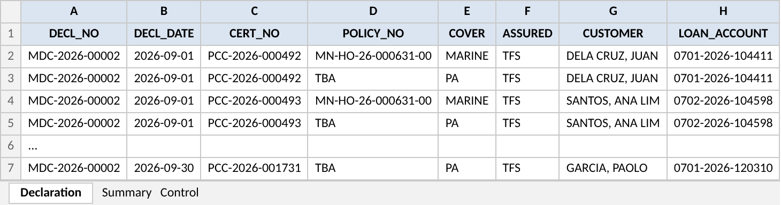
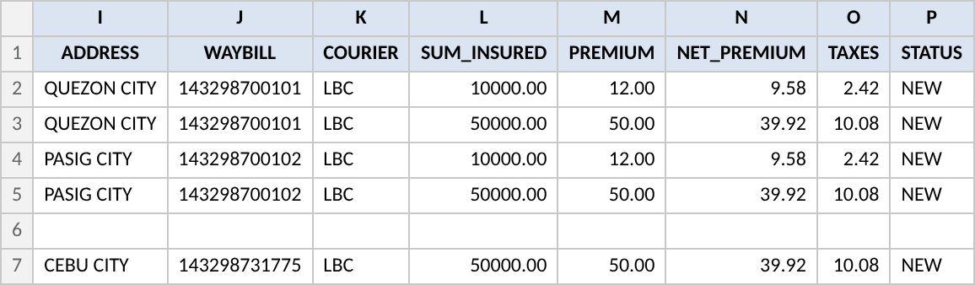
Figure 5: AXA declaration file, Declaration sheet: columns A to H (top) and I to P (bottom), sample rows (to-be)
Table 16: Declaration sheet columns
Column | Content | Source in BrokerVerse
DECL_NO / DECL_DATE | Monthly declaration number; date of the daily declaration the row is on | Monthly and daily declaration
CERT_NO | Certificate number PCC- | Certificate
POLICY_NO / COVER | AXA policy number of the cover; MARINE or PA | Open cover > Covers
ASSURED | TFS | Client of the open cover (short name)
CUSTOMER / LOAN_ACCOUNT / ADDRESS | Customer name, TFS loan account, city or municipality and province | Certificate
WAYBILL / COURIER | LBC waybill number; courier code | Certificate
PARCEL_DATE / LATE | Parcel date; Y when declared late | Certificate (not shown in the sample)
SUM_INSURED / PREMIUM | Sum insured and premium of the cover; negative on a reversal | Certificate cover
NET_PREMIUM / TAXES | Premium net of taxes and the taxes inside it, per row for information | Computed (Appendix A.3)
STATUS | NEW or REVERSAL | Certificate

Sheet Summary: per cover the certificates, sum insured, premium, net premium, VAT, DST, LGT and commission, with a total row; it equals the declaration. Sheet Control: open policy, period, rows, total premium, created at and by. The file is not written when the totals differ (FR-PCL-023).

6.3 Cargo declaration file (Cargo layout)
Table 17: Cargo layout columns
Column | Content
DECL_NO, DECL_DATE, CERT_NO, POLICY_NO | As in 6.2; CERT_NO is the MIC- number of the certificate or declared item
SHIPMENT_DATE, CONVEYANCE, VOYAGE_FROM, VOYAGE_TO | Shipment data
DELIVERY_RECEIPT, TRUCK_PLATE, GOODS, CONSIGNEE | Shipment data
INVOICE_VALUE, MARKUP_PCT, INSURED_VALUE, RATE_PCT, PREMIUM | Pricing of the shipment
STATUS | NEW or REVERSAL

7 Configuration items

7.1 Settings
New settings use the dotted keys of BrokerVerse and are maintained on Master > System > Configuration.
Table 18: Settings
Key | Meaning | Default
parcel.default_charge | Charge per certificate proposed on a new Parcel open cover | 500.00
parcel.delivery_types | Delivery types and the flat charge TFS collects (reference) | Rush 2,500.00; Regular 2,000.00
parcel.max_covers | Covers on one certificate | 5
parcel.max_upload_rows | Rows per parcel or shipment upload | 2000
parcel.max_backdate_days | Oldest parcel date accepted | 30
parcel.duplicate_days | Days within which the same loan account gives a warning | 7
parcel.reversal_max_days | Days after the parcel date a declared certificate can be reversed | 60
parcel.daily_cutoff_time | End of the declaration day | 23:59
parcel.certificate_wording | Wording printed on the parcel certificate | Limit, valuation and notice text
parcel.email_certificate | E-mail the certificate to the customer | true
parcel.certificate_password | Password rule of the e-mailed PDF | Last 6 digits of the loan account
parcel.certificate_email_subject / _body | E-mail text to the customer | Your parcel insurance certificate <number>
parcel.commission_base | Commission on the premium with taxes (gross) or net of taxes (net) | gross
parcel.service_fee_vat | VAT treatment of the service fee: inclusive or exempt | inclusive (to be confirmed)
marine.declaration_file_layouts | Declaration file layouts (columns, sheets, file name) | AXA parcel layout; Cargo layout
marine.declaration_email_subject / _body | E-mail text to the insurer | Declaration <number> - <policy> - <period>
marine.declaration_due_days (existing) | Days after the period by which the declaration is due | 15
marine.certificate_wording (existing) | Wording of the cargo certificate | -

7.2 Scheduled jobs
Table 19: Scheduled jobs (Master > System > Schedules)
Job | When | What it does
Daily declaration close (new) | Daily 00:10 Manila time | Closes the daily declarations of the previous day; empty days become Nil
Monthly declaration open (new) | 1st of the month 01:00 | Opens the monthly declaration of the previous month for each active open cover and attaches its daily declarations
E-mail outbox (existing) | Every 5 minutes | Sends the certificates and the declaration e-mails
Policy expiry (existing) | Daily 00:15 | Expires the open policy and the open cover after the period

7.3 Lists of values
Table 20: Lists of values
List | Values
Open cover type (new) | Marine Cargo; Parcel / Courier
Remittance basis (new) | Net; Gross
Declaration file frequency (new) | Monthly; Daily
Delivery type (new) | Rush; Regular
Documents sent (new) | Certificate of registration; Deed of sale; Other
Certificate cancellation reason (new) | Parcel not sent; Wrong customer details; Duplicate; Other
Certificate status (changed) | Issued; Declared; Cancelled; Reversed (new)
Daily declaration status (new) | Open; Closed; Nil; Declared
Declaration file status (new) | Not generated; Generated; Sent; Accepted; Accepted with differences

7.4 Masters, number series and posting rule
Table 21: Masters, series and posting rule
Item | Set up | Where
Insurer AXA Philippines Life and General Insurance Corporation | New record, with the declaration and commission e-mails | Master > Insurance > Insurance Company
Product PARCEL - Parcel / Courier, line Marine | New record | Master > Insurance > Product
Client Toyota Financial Services Philippines | Existing or new corporate client | Clients
Series parcel_certificate PCC-{YYYY}-{SEQ}, 6 digits, yearly | New | Master > System > Document Numbering
Series daily_declaration MDD-{YYYY}-{SEQ}, 6 digits, yearly | New | Master > System > Document Numbering
Series open_cover_endorsement MOE-{YYYY}-{SEQ}, 5 digits, yearly | New | Master > System > Document Numbering
Posting rule parcel.service_fee | New; GL account from Finance | Master > Finance > Posting Rules
Premium Taxes & LGU Rates for lines Marine and Personal Accident | Existing; rates used to show the taxes inside the premium | Master > Finance

8 Traceability

8.1 BRD clause to FR
Table 22: PJRN-09 clauses
Clause | FR | BrokerVerse screen
Parcel/Courier business sent by TFS through TISPH | FR-PCL-001, 010 | Marine Open Covers; Upload parcels
insured with the partner insurer (AXA) | FR-PCL-001, 002 | New open cover; Covers tab
a certificate per customer | FR-PCL-010 to 014 | Certificates tab; certificate PDF
under an Open Policy | FR-PCL-001, 004, 005 | New open cover; Activate; Endorse open policy
with a daily Declaration | FR-PCL-020, 021 | Daily declarations tab; job Daily declaration close
flat PHP 2,500 charge to the customer | FR-PCL-003 | New open cover (delivery types)
default flat PHP 500 premium inclusive of taxes and charges | FR-PCL-002, 003, 022, 040 | Covers; Monthly declarations; Bill
3% commission from AXA | FR-PCL-042 | Direct Bill Processing
full premium remitted to AXA | FR-PCL-041 | Remittance > Settlement
declaration file to AXA per agreed format | FR-PCL-023, 024 | Monthly declarations tab; E-mail Outbox
reports to AXA per agreed format | FR-PCL-050, 051 | Declaration summary; Certificate register
Marine Cargo inland: declarations occur daily | FR-PCL-020, 030 | Upload shipments; Daily declarations tab
sent to the insurance partner monthly via bulk upload | FR-PCL-031 | Monthly declarations tab (Cargo layout)
Endorsements apply to the Open Policy only | FR-PCL-005, 014 | Endorse open policy

8.2 Related BRD requirements
Table 23: Related requirements
BRD ref. | Relation to PJRN-09 | FR
PJRN-02 | Certificate of cover as a password-protected PDF to the customer's e-mail (same pattern) | FR-PCL-013
MAS-04 | Insurer master (AXA) | FR-PCL-001
ISSUE-01, ISSUE-02 | The insurer issues the cover; the open policy is recorded and billed through declarations | FR-PCL-004
COMM-04 | Remittance per insurance company, here on the gross basis for AXA | FR-PCL-041, 042
BULK-01 | Bulk upload in Excel (.xlsx) only, row by row | FR-PCL-010, 030
SEC-01, SEC-03 | Access and segregation of duties | FR-PCL-005, 014, 061

8.3 FR to test cases
Table 24: Test cases per FR (one per acceptance criterion)
FR | Title | Test cases
FR-PCL-001 | Choose the open cover type and set up a Parcel / Courier open cover | TC-PCL-001-1 to -5
FR-PCL-002 | Define the covers on each parcel certificate | TC-PCL-002-1 to -4
FR-PCL-003 | Set the charge per certificate, the remittance basis and the declaration settings | TC-PCL-003-1 to -4
FR-PCL-004 | Activate the open cover and issue the open policy | TC-PCL-004-1 to -2
FR-PCL-005 | Endorse the open policy (endorsements apply to the open policy only) | TC-PCL-005-1 to -4
FR-PCL-010 | Upload the TFS daily parcel list | TC-PCL-010-1 to -5
FR-PCL-011 | Add one parcel on screen | TC-PCL-011-1 to -2
FR-PCL-012 | Check each parcel: data, period, duplicates | TC-PCL-012-1 to -4
FR-PCL-013 | Produce the certificate of insurance for each customer | TC-PCL-013-1 to -3
FR-PCL-014 | Cancel a certificate, or reverse it after declaration | TC-PCL-014-1 to -3
FR-PCL-020 | Keep a daily declaration per open cover and close it each night | TC-PCL-020-1 to -3
FR-PCL-021 | Take late parcels into the next open day | TC-PCL-021-1 to -2
FR-PCL-022 | Build the monthly declaration from the daily declarations | TC-PCL-022-1 to -4
FR-PCL-023 | Generate the AXA declaration file | TC-PCL-023-1 to -3
FR-PCL-024 | Send the declaration to AXA and record AXA's acceptance | TC-PCL-024-1 to -2
FR-PCL-030 | Upload the client's daily shipments on a Marine Cargo open cover | TC-PCL-030-1 to -3
FR-PCL-031 | Send the monthly cargo declaration to the insurer by bulk file | TC-PCL-031-1 to -2
FR-PCL-040 | Bill the monthly declaration to TFS | TC-PCL-040-1 to -2
FR-PCL-041 | Remit the full premium to AXA (gross remittance) | TC-PCL-041-1 to -2
FR-PCL-042 | Bill and collect AXA's commission | TC-PCL-042-1 to -2
FR-PCL-050 | Declaration summary report | TC-PCL-050-1 to -2
FR-PCL-051 | Parcel certificate register | TC-PCL-051-1 to -2
FR-PCL-060 | Keep the audit trail of open covers, certificates and declarations | TC-PCL-060-1 to -2
FR-PCL-061 | Control access to the parcel and declaration functions | TC-PCL-061-1 to -2

9 Navigation

9.1 Screens of PJRN-09
Table 25: Screens
Screen | Menu path and route | Type
Marine Open Covers (list) | Operations > Marine Open Covers - /operations/open-covers | Changed (Type column, wider subtitle)
New open cover | Marine Open Covers > New open cover | Changed (Open cover type, covers, charge, declaration settings)
Open cover: Contract, Covers, Certificates, Daily declarations, Monthly declarations, Endorsements tabs | /operations/open-covers/:id | Changed (Covers, Daily declarations and Endorsements tabs new)
Upload parcels; Add parcel | Open cover > Certificates tab | New (base upload pattern)
Upload shipments | Open cover (Marine Cargo) > Certificates tab | New (base upload pattern)
Endorse open policy | Open cover > Endorse open policy | New
Parcel certificate PDF | Certificates tab > Print; E-mail Outbox | New document
My Work > Approvals | My Work - /my-work, category Approvals | Existing; endorsement and reversal items
Settlement; Direct Bill Processing | Accounts > Remittance > Settlement / Direct Bill Processing | Changed (gross basis) / Existing
Configuration; Schedules; Document Numbering; Audit Trail | Master > System | Existing; new keys, jobs, series and entities
Insurance Company; Product | Master > Insurance | Existing; AXA and PARCEL records

9.2 Menu by base role
Table 26: Menu by base role
Base role | Menu entries for this item
Sales & Marketing | Operations > Marine Open Covers (view; Upload parcels, Add parcel, Cancel certificate, Print)
Operations, Processing Team | Operations > Marine Open Covers (all actions except approvals)
Accounting Manager | My Work > Approvals (endorsements, reversals); Marine Open Covers (view)
Accounting | Marine Open Covers (view); Accounts > Remittance > Settlement, Direct Bill Processing
Claims, Compliance Officer | Marine Open Covers (view); Audit Trail for the Compliance Officer
System Administrator | All of the above; Configuration, Schedules, Document Numbering, Role Permissions

10 Screen specifications
One specification per screen. Pictures marked "to-be design mock-up" are the real BrokerVerse screens with the PJRN-09 changes drawn in, using the Toyota Insurance Services brand pack; the other pictures show BrokerVerse as it runs today. The numbered red markers sit just left of the element they point to and match the No. column of the field table. Messages are listed in chapter 12.

10.1 Marine Open Covers list (changed)
Type | Existing screen, new column
Purpose | Find an open cover of either type and see its period, covers, certificates and billed premium.
Who can open it | read:marine
Navigation | Operations > Marine Open Covers
FRs | FR-PCL-001, 004

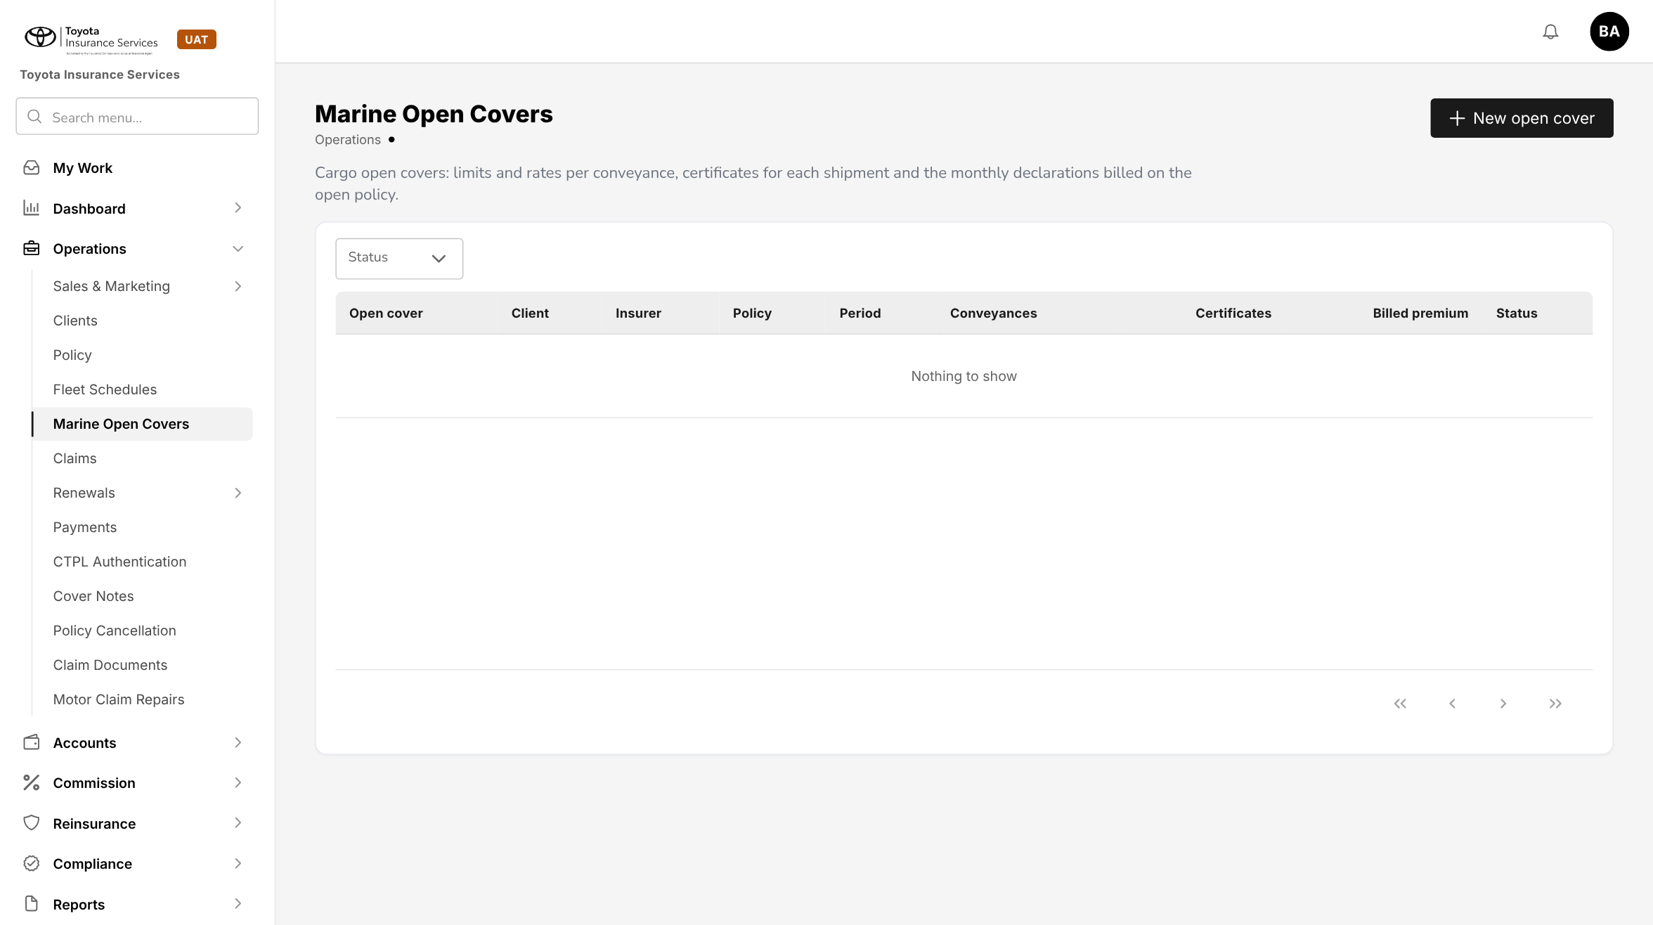
Figure 6: BrokerVerse today: Operations > Marine Open Covers
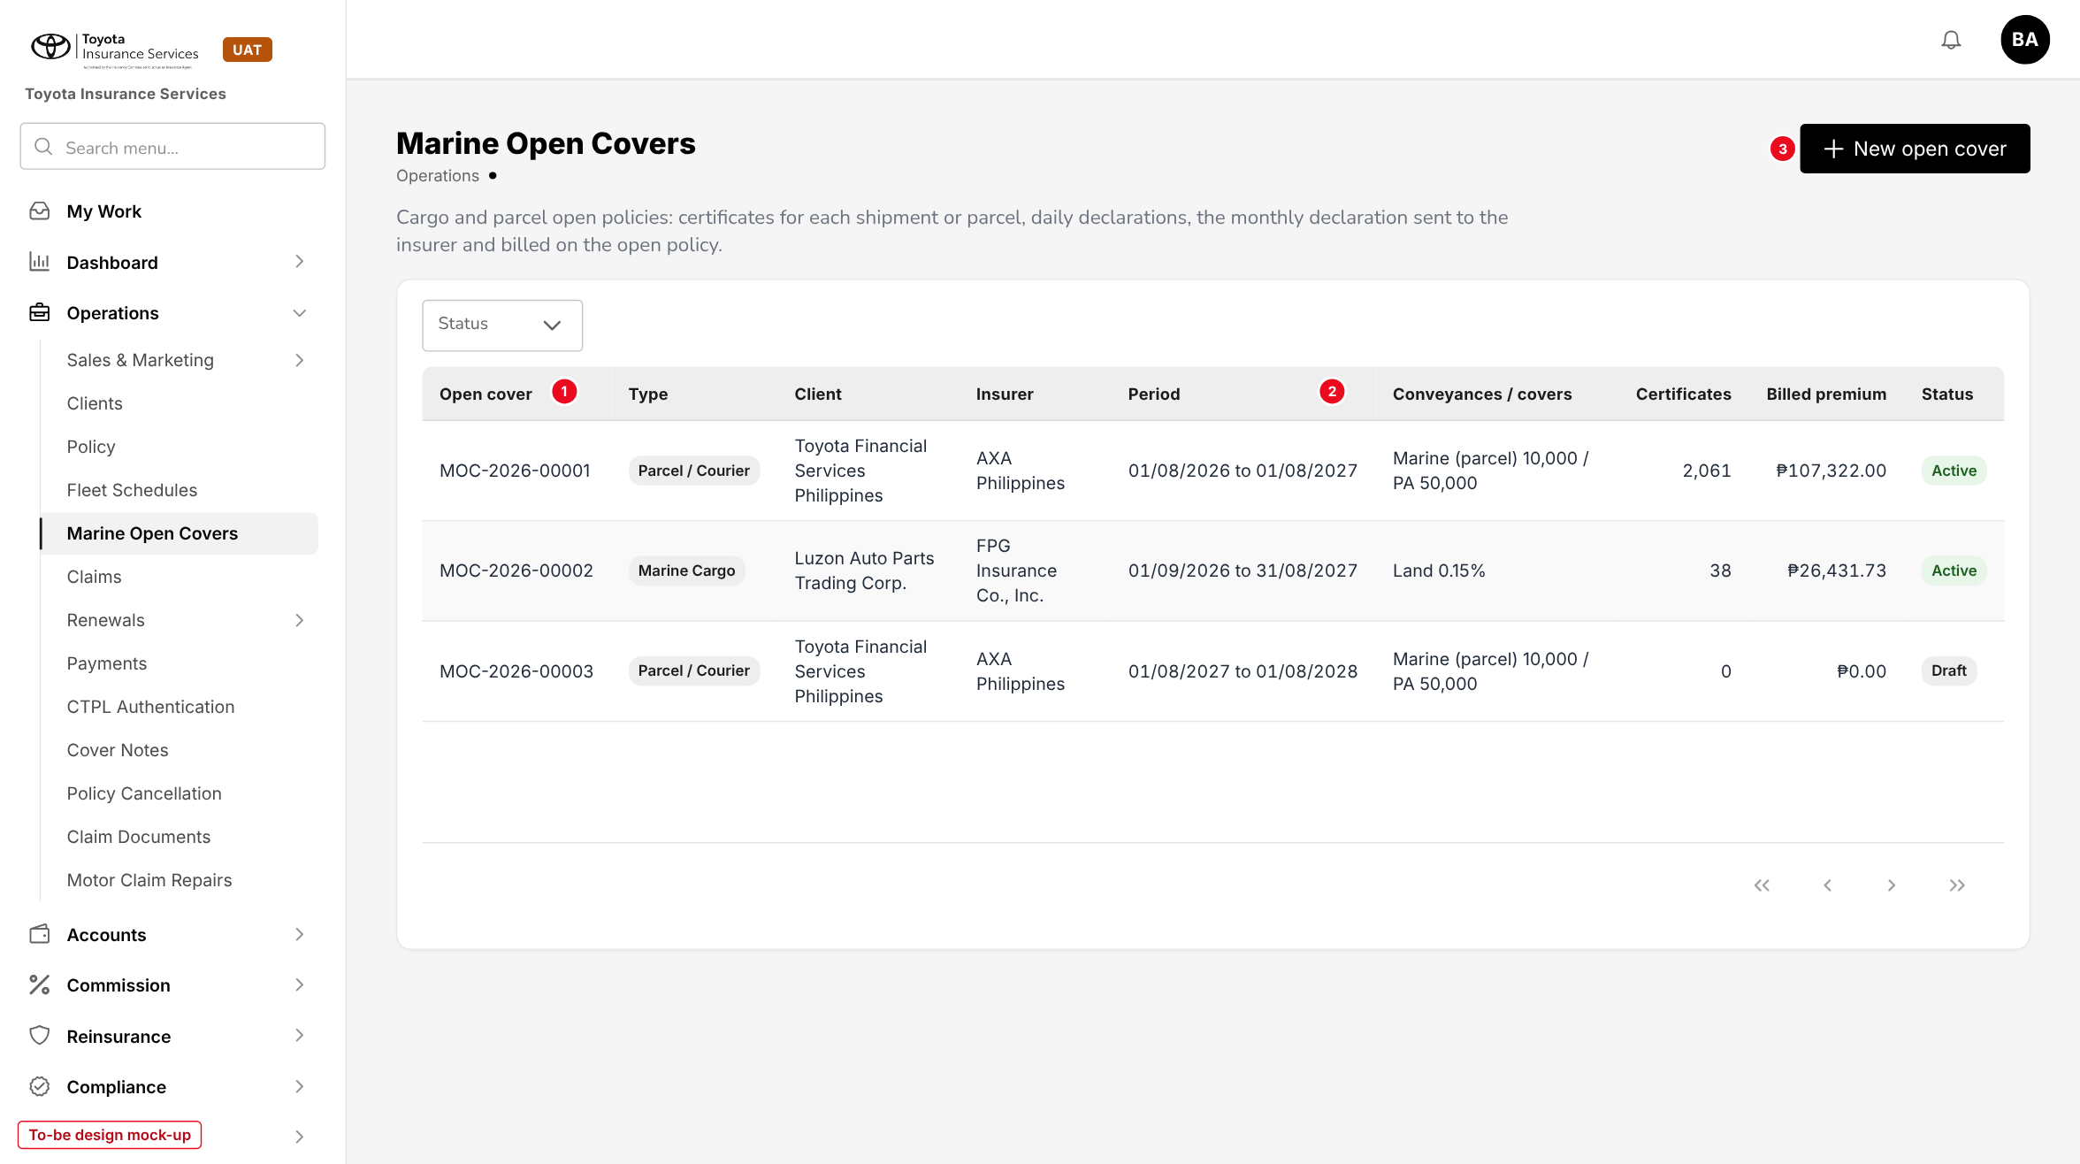
Figure 7: Marine Open Covers with the Type column (to-be design mock-up)
No. | Field (label on screen) | Type | Mand. | Source / list | Default | Rule and message
1 | Type | Column | - | Open cover type | - | Marine Cargo or Parcel / Courier tag; also a filter next to Status
2 | Conveyances / covers | Column | - | Open cover | - | Cargo: conveyance and rate; parcel: covers and sums insured
3 | New open cover | Button | - | - | - | write:marine; opens 10.2
- | Open cover, Client, Insurer, Period, Certificates, Billed premium, Status | Columns | - | Existing | - | -

10.2 New open cover - Parcel / Courier (changed)
Type | Existing side panel; fields depend on the type
Purpose | Set up the AXA parcel open policy for TFS.
Who can open it | write:marine
Navigation | Marine Open Covers > New open cover
FRs | FR-PCL-001 to 003

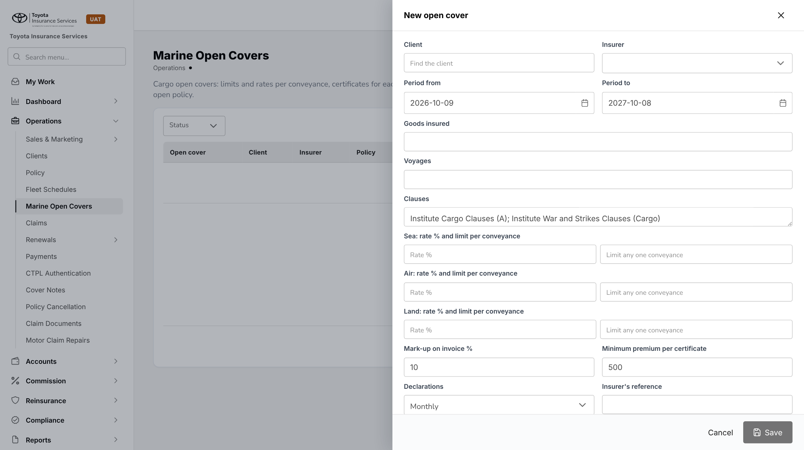
Figure 8: BrokerVerse today: New open cover (cargo fields)
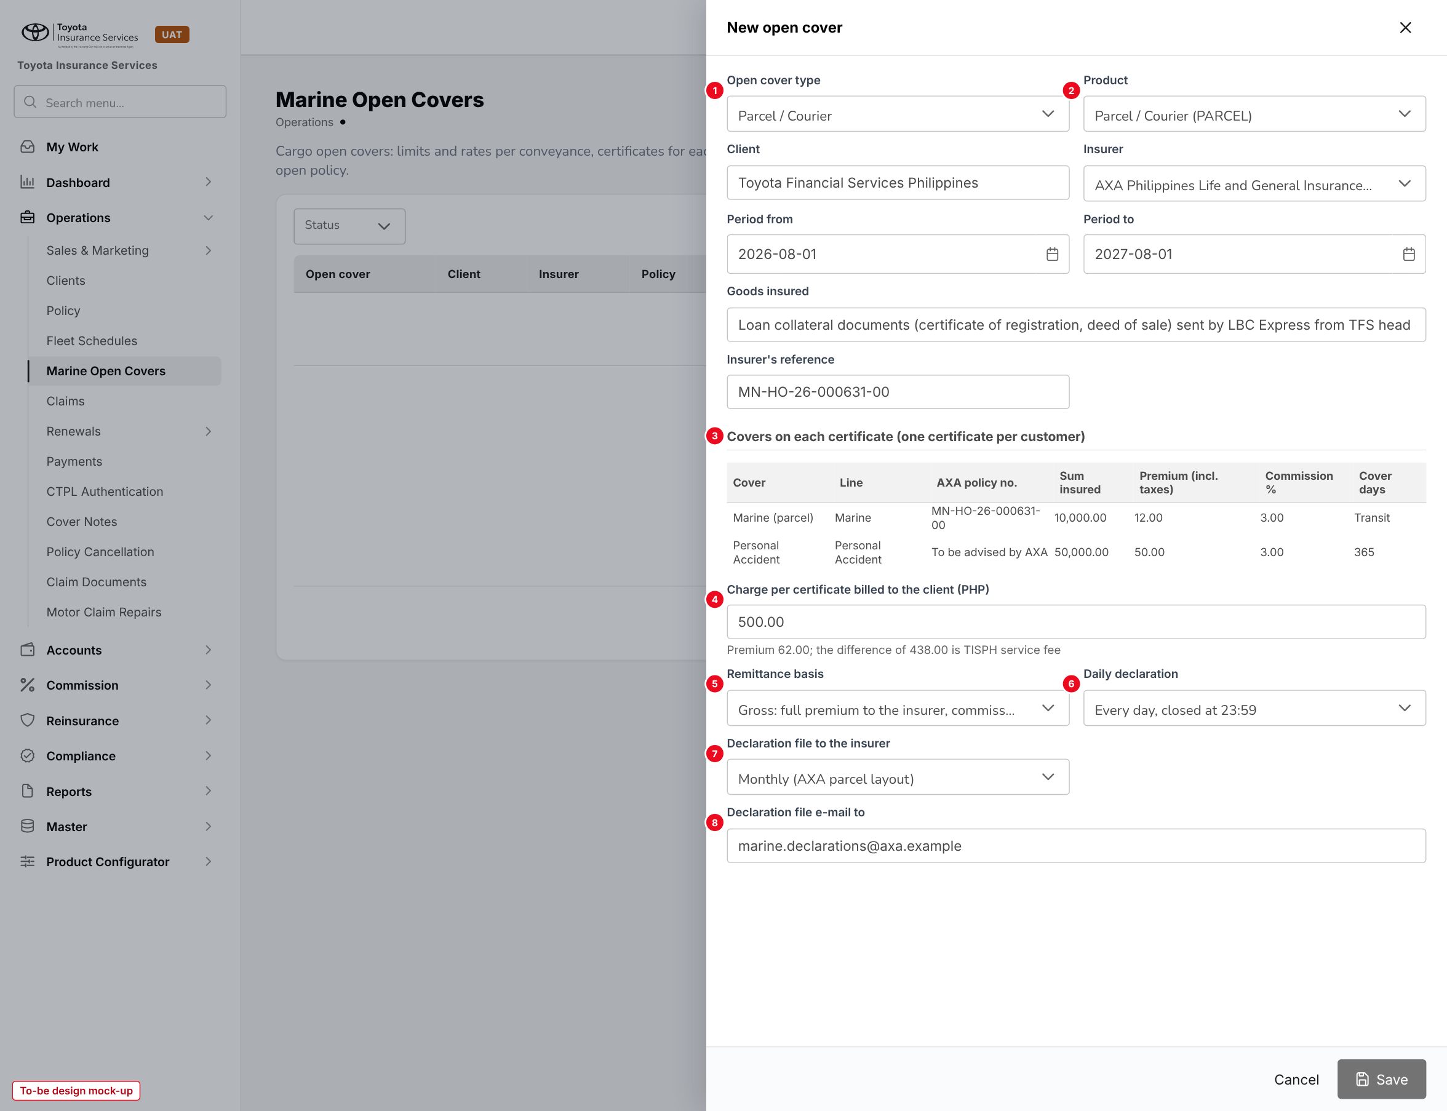
Figure 9: New open cover for a Parcel / Courier cover (to-be design mock-up)
No. | Field (label on screen) | Type | Mand. | Source / list | Default | Rule and message
1 | Open cover type | List | Y | Marine Cargo; Parcel / Courier | - | Read-only after save. MSG-PCL-001, MSG-PCL-002
2 | Product | List | Y | Master > Insurance > Product | PARCEL | -
- | Client, Insurer, Period from, Period to, Goods insured (existing) | Various | Y | Clients; Insurance Company | - | MSG-PCL-004
- | Insurer's reference (existing) | Text | Y for parcel | - | - | MSG-PCL-003
3 | Covers on each certificate | Table | Y | Cover, Line, AXA policy no., Sum insured, Premium, Commission %, Cover days | Marine (parcel); Personal Accident | MSG-PCL-006, MSG-PCL-007, MSG-PCL-008, MSG-PCL-009, MSG-PCL-010
4 | Charge per certificate billed to the client (PHP) | Amount | Y | - | 500.00 | Shows the service fee. MSG-PCL-011
5 | Remittance basis | List | Y | Net; Gross | Gross (parcel) | -
6 | Daily declaration | List | Y | On (closed at the cut-off); Off | On | -
7 | Declaration file to the insurer | Lists | Y | Frequency; File layout | Monthly; AXA parcel layout | MSG-PCL-013
8 | Declaration file e-mail to | E-mail | Y | - | - | MSG-PCL-012
- | Delivery types (Rush 2,500 / Regular 2,000) | Table | N | parcel.delivery_types | As configured | Reference only (below the charge, not shown in the picture)

Button | Who sees it | Enabled when | What happens | Result
Save | write:marine | Always | Checks all fields; creates the open cover | Draft
Activate (open cover page) | write:marine | Draft without errors | Issues the open policy without a bill | Active

10.3 Open cover - Covers tab (new)
Type | New tab on the open cover page
Purpose | Show the covers every parcel certificate carries and the money per certificate.
Who can open it | read:marine
Navigation | Marine Open Covers > open cover > Covers
FRs | FR-PCL-002, 003

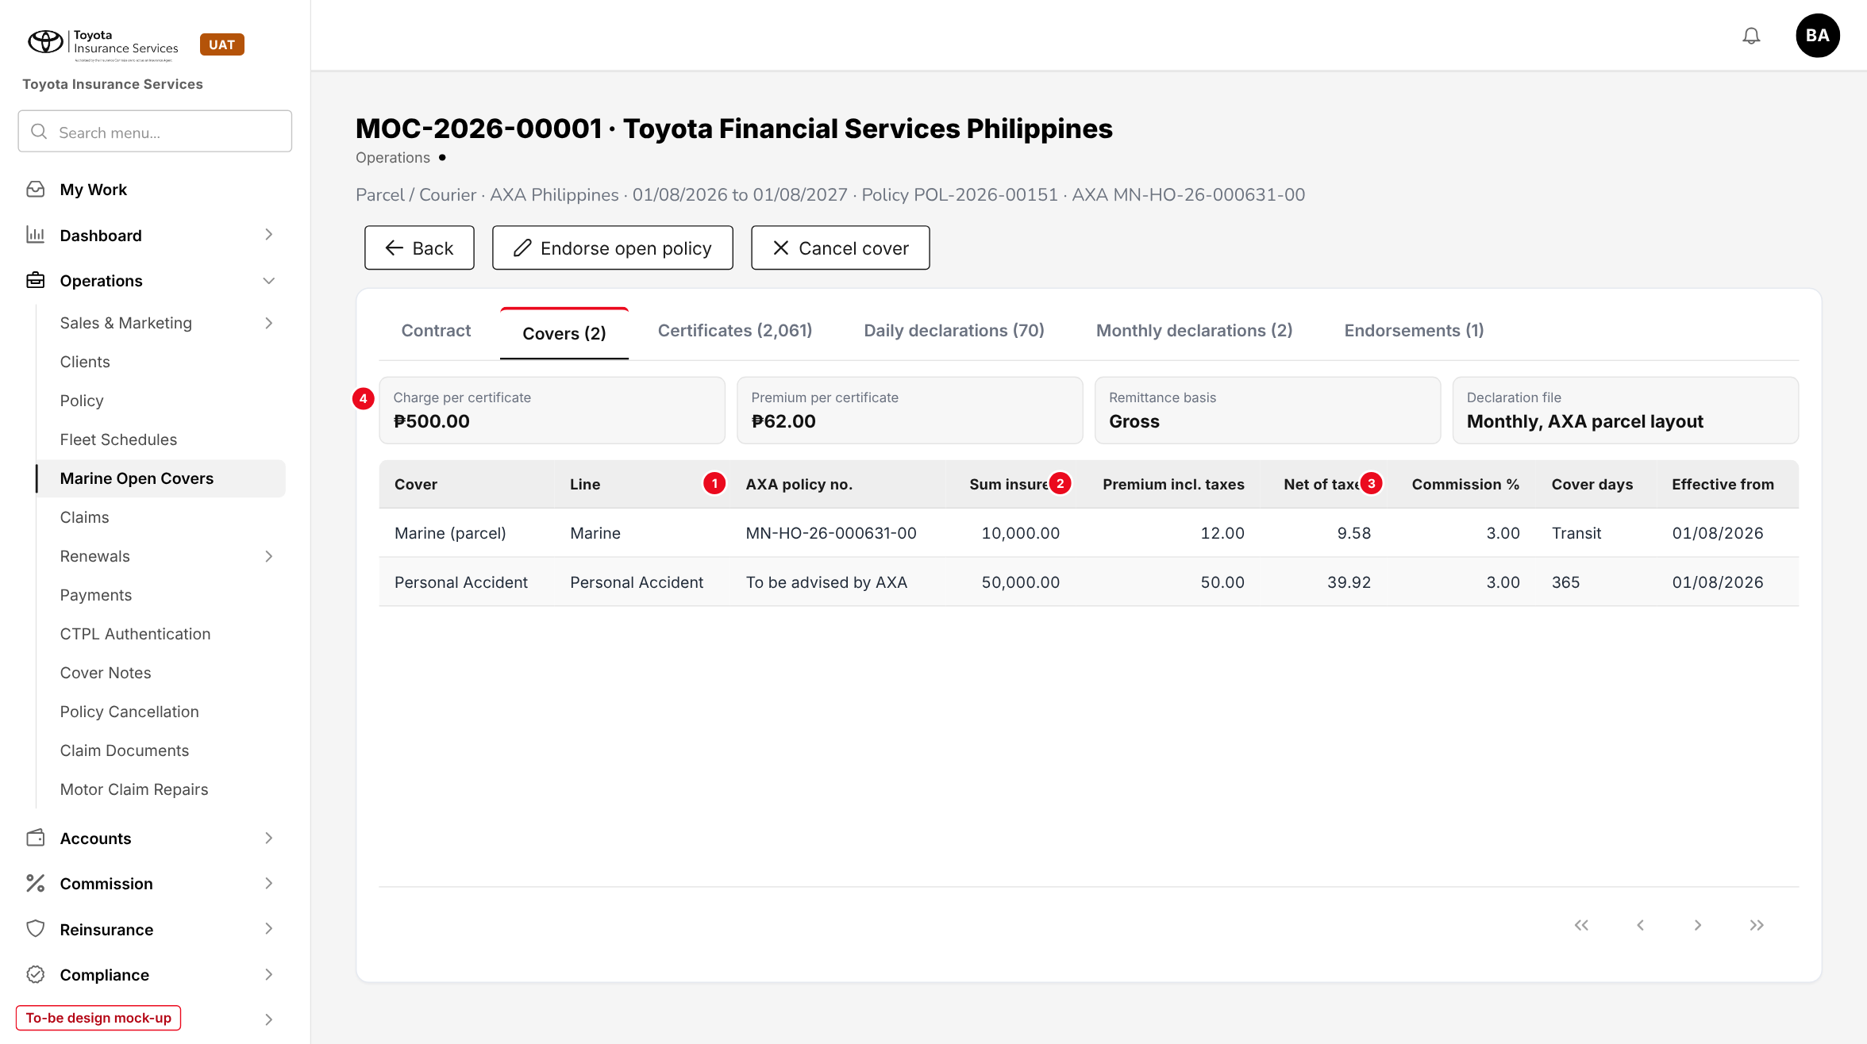
Figure 10: Covers tab of the TFS parcel open cover (to-be design mock-up)
No. | Field (label on screen) | Type | Mand. | Source / list | Default | Rule and message
1 | AXA policy no. | Display | - | Open cover > Covers | - | Printed on the certificate and the AXA file
2 | Sum insured / Premium incl. taxes | Display | - | Open cover > Covers | - | Premium inclusive of taxes and stamps
3 | Net of taxes / Commission % | Display | - | Computed; open cover | - | Net = premium / (1 + VAT + DST + LGT)
4 | Charge, premium per certificate, remittance basis, declaration file | Cards | - | Open cover | - | Changed only by endorsement

10.4 Open cover - Certificates tab (changed)
Type | Existing tab, new buttons and columns for a parcel cover
Purpose | Issue, find, print and cancel parcel certificates.
Who can open it | read:marine; write:parcel-certificates for the buttons
Navigation | Marine Open Covers > open cover > Certificates
FRs | FR-PCL-010 to 014, 021

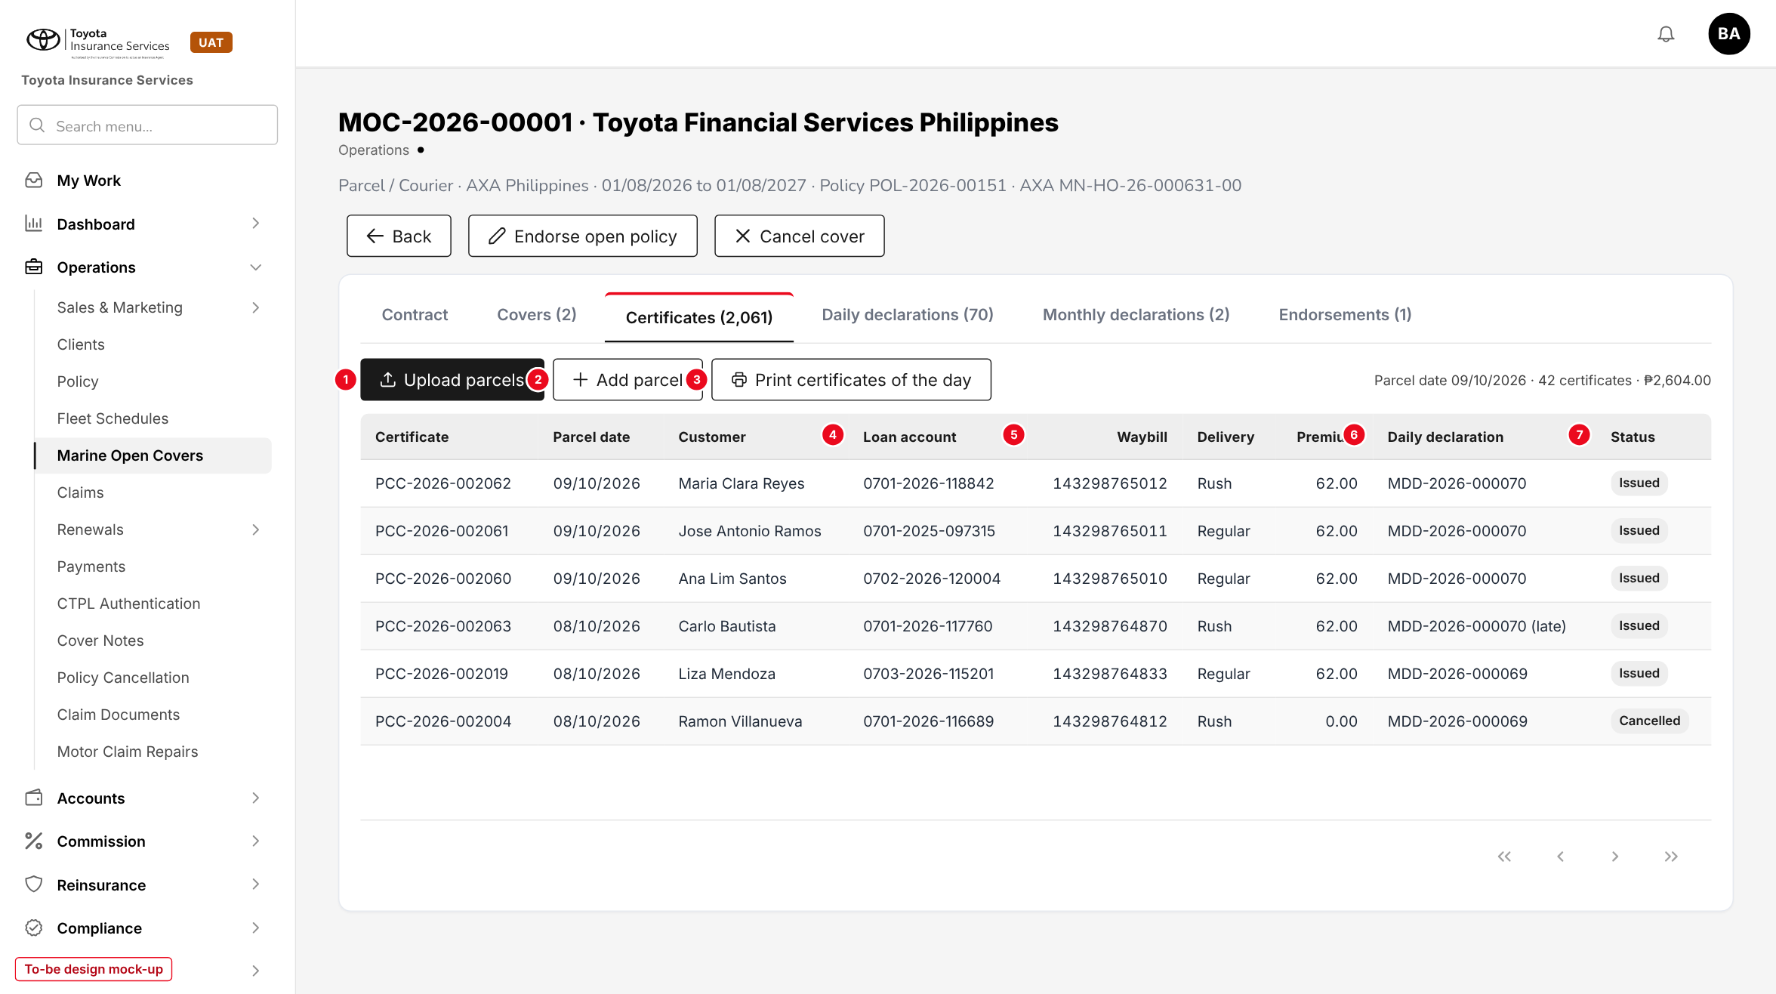
Figure 11: Certificates tab of a parcel open cover (to-be design mock-up)
No. | Field (label on screen) | Type | Mand. | Source / list | Default | Rule and message
1 | Upload parcels | Button | - | - | - | Opens 10.5
2 | Add parcel | Button | - | - | - | Dialog with the fields of one template row (chapter 13.1). MSG-PCL-025
3 | Print certificates of the day | Button | - | Parcel date | Today | MSG-PCL-034
4 | Customer / Loan account | Columns | - | Certificate | - | Search box finds a name, loan account, waybill or certificate
5 | Waybill / Delivery | Columns | - | Certificate | - | -
6 | Premium / Daily declaration | Columns | - | Certificate | - | "(late)" for a late item
7 | Status | Tag | - | Issued; Declared; Cancelled; Reversed | - | Row actions Print, Cancel certificate, Reverse certificate

Button | Who sees it | Enabled when | What happens | Result
Cancel certificate (row) | write:parcel-certificates | Issued, month not submitted | Reason dialog; leaves the daily declaration | Cancelled
Reverse certificate (row) | write:parcel-certificates | Declared | Reason; item in My Work > Approvals | Reversed after approval
Export | read:marine | List not empty | Certificate register for the filter (FR-PCL-051) | -

10.5 Upload parcels (new)
Type | New dialog, base upload pattern
Purpose | Load the TFS parcel list of a day.
Who can open it | write:parcel-certificates
Navigation | Open cover > Certificates > Upload parcels
FRs | FR-PCL-010, 012

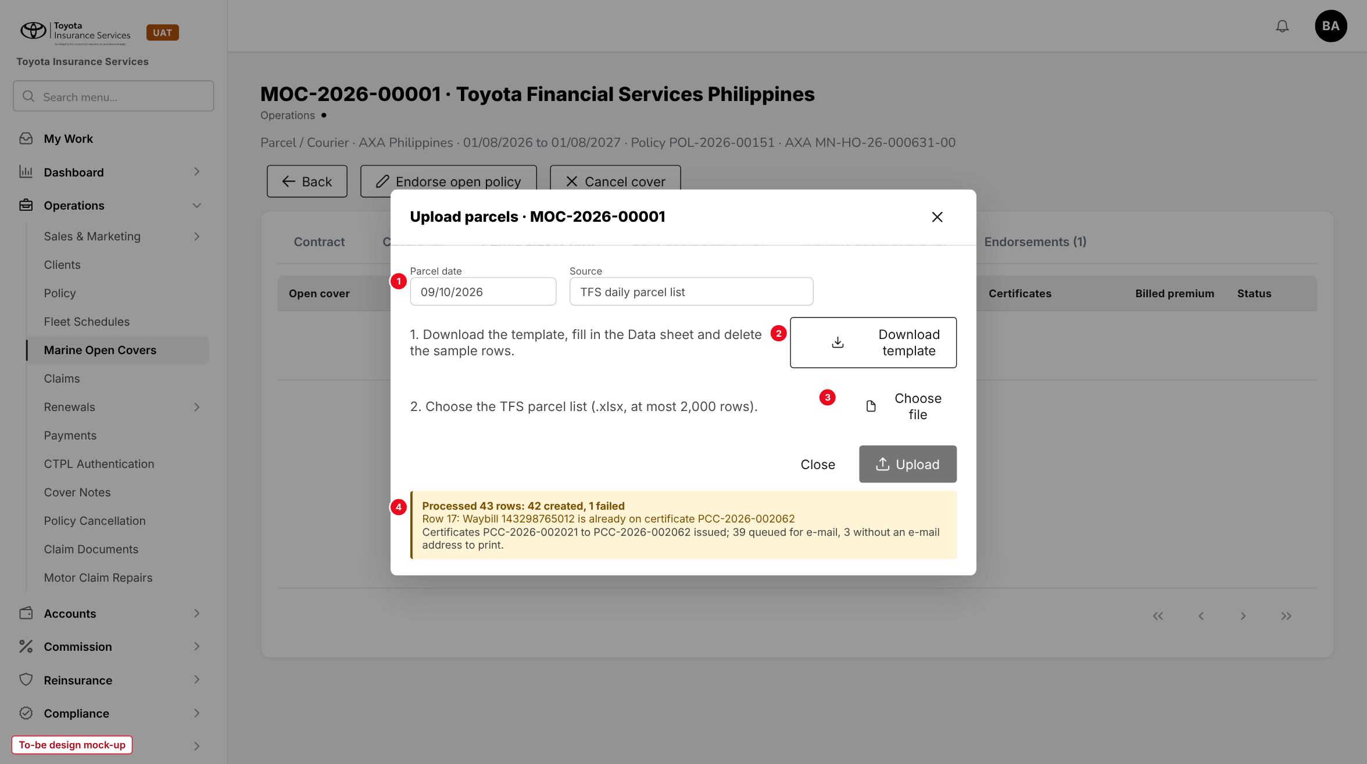
Figure 12: Upload parcels with the result of a 43-row file (to-be design mock-up)
No. | Field (label on screen) | Type | Mand. | Source / list | Default | Rule and message
1 | Parcel date / Source | Date / Display | Y | - | Today / TFS daily parcel list | Used for rows without PARCEL_DATE
2 | Download template | Button | - | - | - | Data, Columns and Instructions sheets (13.1)
3 | Choose file | File | Y | - | - | .xlsx, at most 2,000 rows. MSG-PCL-020, MSG-PCL-021, MSG-PCL-022
4 | Result | Message | - | - | - | MSG-PCL-024; one line per failed row or warning

Upload shipments on a Marine Cargo open cover is the same dialog with the template of chapter 13.2 and the Shipment date in place of the Parcel date.

10.6 Parcel certificate of insurance (new document)
Type | New PDF, one page, TISPH letterhead
Purpose | The certificate each customer receives.
Who can open it | Printed by read:marine; e-mailed by the system
Navigation | Certificates tab > Print; Print certificates of the day; E-mail Outbox
FRs | FR-PCL-013

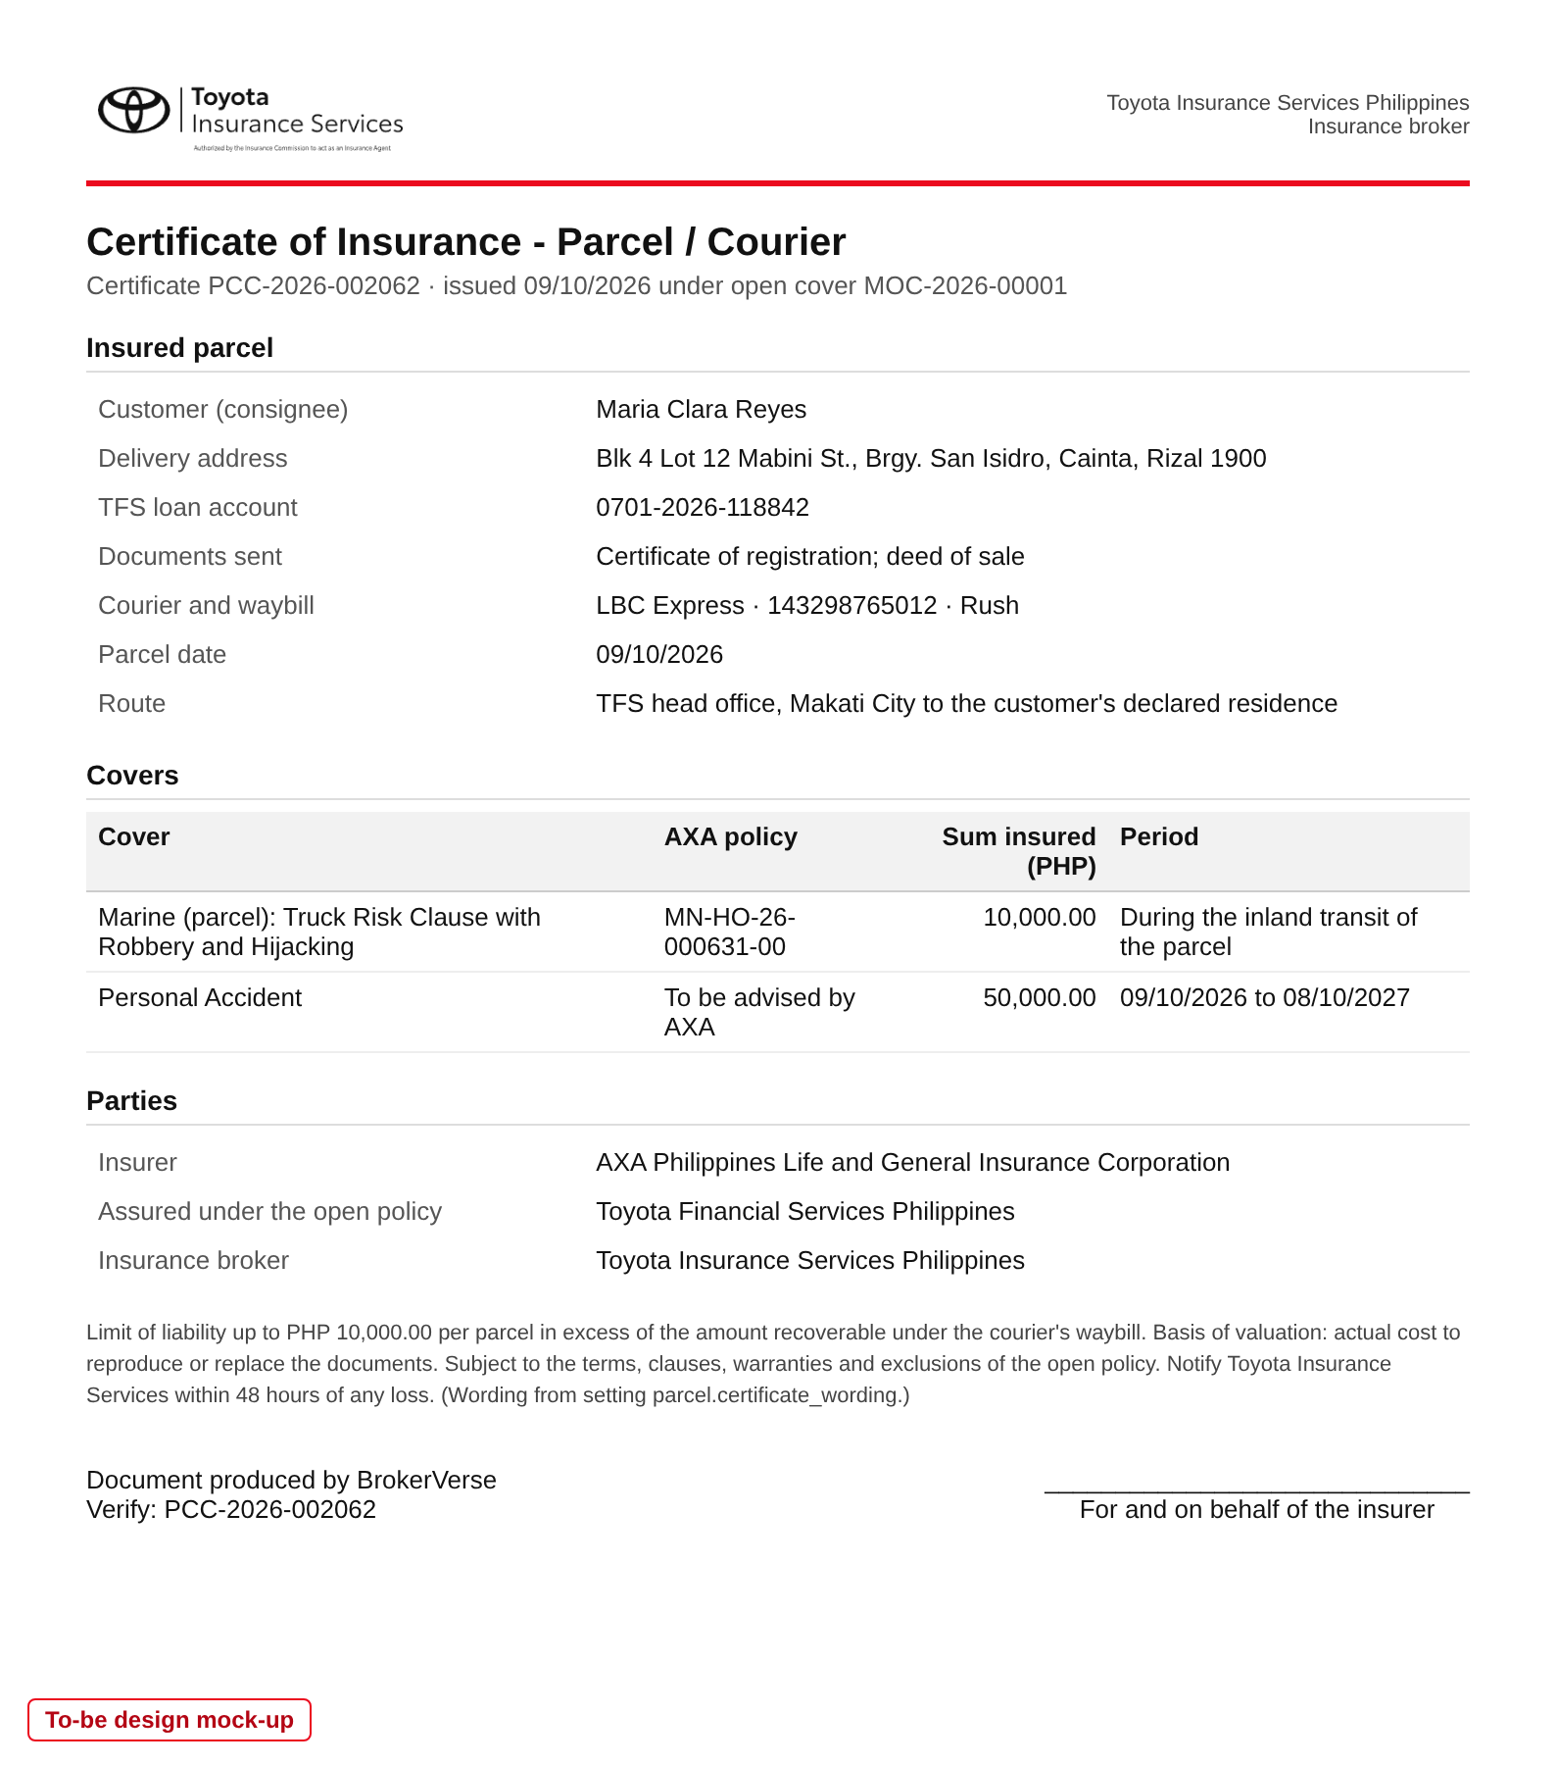
Figure 13: Parcel certificate PCC-2026-002062 (to-be design mock-up)

10.7 Open cover - Daily declarations tab (new)
Type | New tab
Purpose | See each day declared under the open cover.
Who can open it | read:marine
Navigation | Marine Open Covers > open cover > Daily declarations
FRs | FR-PCL-020, 021

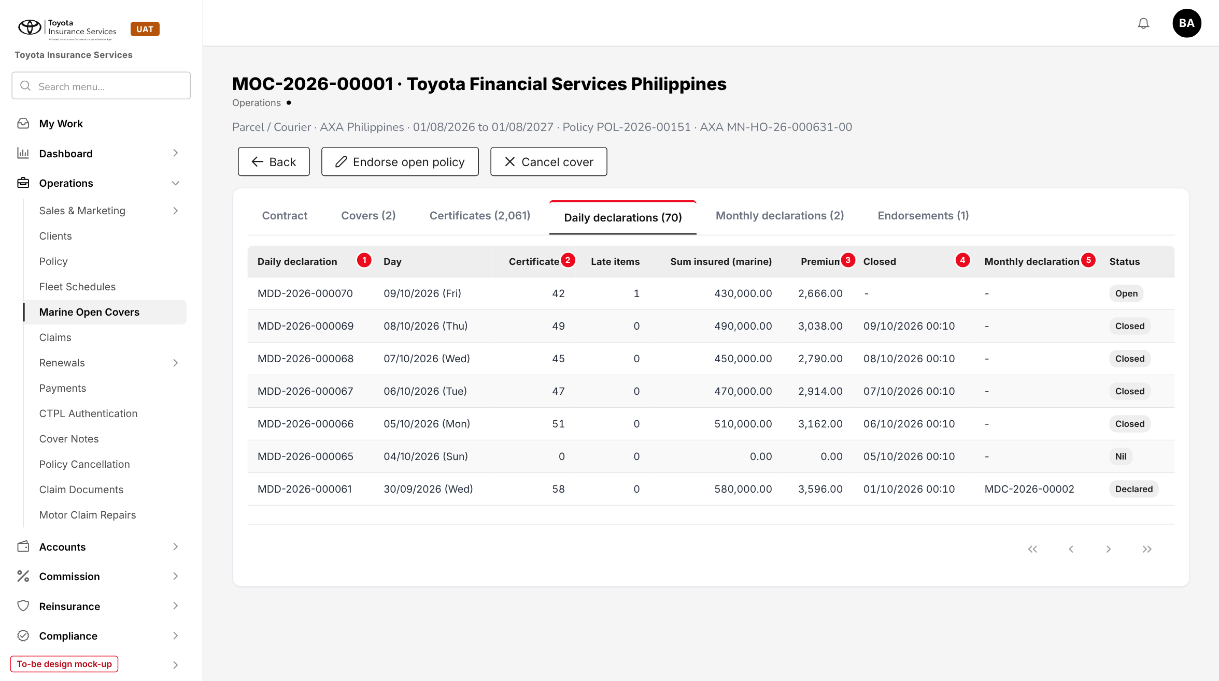
Figure 14: Daily declarations tab (to-be design mock-up)
No. | Field (label on screen) | Type | Mand. | Source / list | Default | Rule and message
1 | Day | Column | - | Daily declaration | - | Opening a row lists its certificates
2 | Late items | Column | - | Count of late certificates | - | FR-PCL-021
3 | Closed | Column | - | Job run time | - | "-" while Open
4 | Monthly declaration | Column | - | MDC- number | - | Filled when the month is submitted
5 | Status | Tag | - | Open; Closed; Nil; Declared | - | MSG-PCL-040

10.8 Open cover - Monthly declarations tab (changed)
Type | Existing Declarations tab, renamed, new buttons and lines per cover
Purpose | Submit the month, send the file and reports to AXA, record AXA's answer and bill TFS.
Who can open it | read:marine; write:marine for the actions
Navigation | Marine Open Covers > open cover > Monthly declarations > a declaration
FRs | FR-PCL-022 to 024, 040, 050, 051

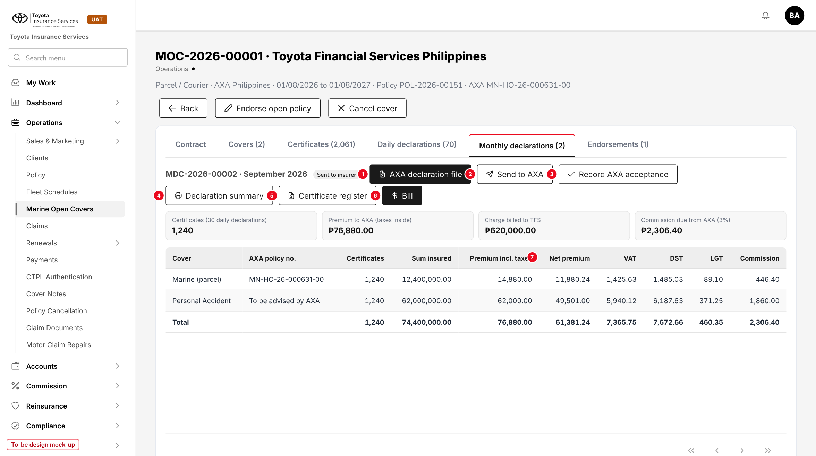
Figure 15: Monthly declaration MDC-2026-00002 of September 2026 (to-be design mock-up)
No. | Field (label on screen) | Type | Mand. | Source / list | Default | Rule and message
1 | AXA declaration file | Button | - | - | - | Downloads the last version. MSG-PCL-045, MSG-PCL-046, MSG-PCL-047
2 | Send to AXA | Button | - | Open cover e-mail | - | MSG-PCL-048, MSG-PCL-049
3 | Record AXA acceptance | Button | - | - | - | Date, AXA reference, result, accepted rows and premium, remark. MSG-PCL-050, MSG-PCL-051
4 | Declaration summary | Button | - | - | - | PDF, FR-PCL-050
5 | Certificate register | Button | - | - | - | Excel, FR-PCL-051
6 | Bill | Button | - | - | - | Submitted only. MSG-PCL-054
7 | Premium incl. taxes / Net premium / VAT / DST / LGT / Commission | Columns | - | Computed per cover | - | Taxes shown inside the premium (A.3)
- | Recompute, Delete, Submit (existing) | Buttons | - | - | - | MSG-PCL-042, MSG-PCL-043

10.9 Endorse open policy (new)
Type | New side panel, same fields as New open cover
Purpose | Change an active open cover from a date, with approval.
Who can open it | write:marine (request); approve:marine (approve in My Work > Approvals)
Navigation | Open cover > Endorse open policy
FRs | FR-PCL-005

The panel shows the fields of 10.2 filled with the current values; the client, insurer, type and period start are read-only. Two fields are added at the top: Effective from (date, required) and Reason (text, required). Changed fields are highlighted for the approver. Buttons: Cancel, Submit for approval.
Button | Who sees it | Enabled when | What happens | Result
Submit for approval | write:marine | No pending endorsement; effective date valid | Item in My Work > Approvals | Pending approval
Approve / Return (My Work) | approve:marine, not the maker | Pending approval | Applies the change from the effective date / back to the maker with a remark | Approved / Returned

10.10 Direct Bill Processing (existing)
Type | Existing screen
Purpose | Raise and collect the commission debit note to AXA.
Who can open it | read:remittance; write:remittance
Navigation | Accounts > Remittance > Direct Bill Processing
FRs | FR-PCL-042

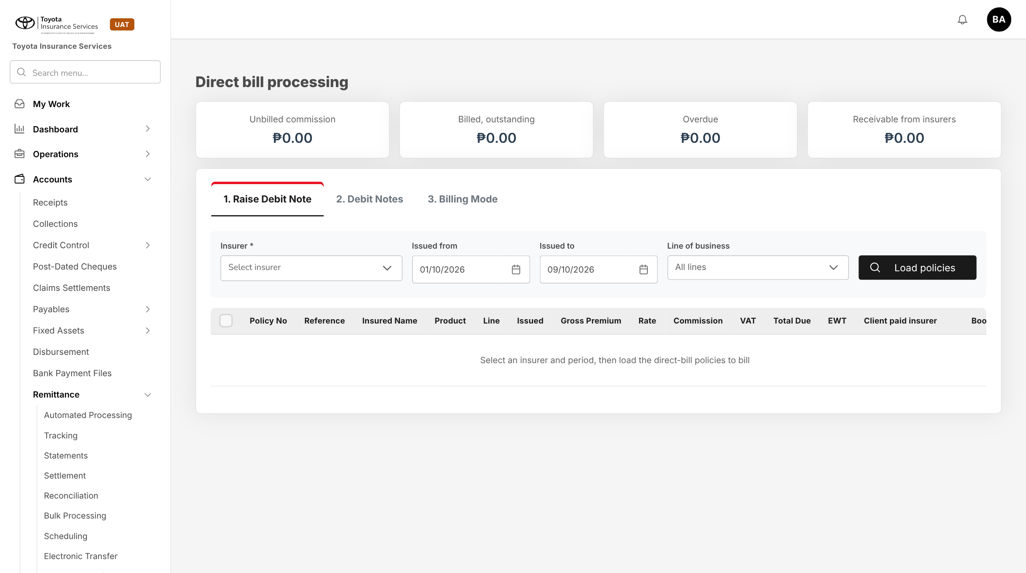
Figure 16: BrokerVerse today: Direct Bill Processing, where the AXA commission is billed
Unchanged. The parcel open policy appears under Raise Debit Note for insurer AXA with the commission of each billed declaration.

11 End-to-end walkthroughs
The walkthroughs follow the TFS parcel business through BrokerVerse with sample data, plus one Marine Cargo inland case. They are the script of the SIT and UAT sessions for this item.

11.1 WT-A Set up the AXA parcel open policy
Table 27: WT-A
Step | Who | Does | Sees / result
1 | System Administrator | Adds AXA on Master > Insurance > Insurance Company and product PARCEL | Both Active
2 | Operations | New open cover: Parcel / Courier, PARCEL, TFS, AXA, 01/08/2026 to 01/08/2027, reference MN-HO-26-000631-00 | Parcel fields shown
3 | Operations | Covers: Marine (parcel) 10,000 / 12.00 / 3%; Personal Accident 50,000 / 50.00 / 3% / 365 days | Premium per certificate 62.00
4 | Operations | Charge 500.00; Gross; daily declaration on; Monthly, AXA parcel layout, AXA e-mail; Save | "Open cover MOC-2026-00001 created"; service fee 438.00
5 | Operations | Activate | POL-2026-00151 issued without a bill; Active

11.2 WT-B Parcels of 9 October 2026
Table 28: WT-B
Step | Who | Does | Sees / result
1 | Sales Admin | Upload parcels, parcel date 09/10/2026, TFS file of 43 rows | "Processed 43 rows: 42 created, 1 failed"; row 17 waybill already used
2 | System | Issues PCC-2026-002021 to PCC-2026-002062 | 39 queued for e-mail, 3 to print; MDD-2026-000070 holds 42 certificates, 2,604.00
3 | Sales Admin | Print certificates of the day | One PDF with the 3 certificates without e-mail
4 | Sales Admin | Add parcel: Carlo Bautista, parcel date 08/10/2026 (missed yesterday) | PCC-2026-002063, late item on MDD-2026-000070 (43 certificates, 2,666.00)
5 | System | Job Daily declaration close on 10/10/2026 00:10 | MDD-2026-000070 Closed

11.3 WT-C September 2026 month end
Table 29: WT-C
Step | Who | Does | Sees / result
1 | System | Monthly declaration open job, 01/10/2026 01:00 | MDC-2026-00002 Draft, 30 daily declarations, 1,240 certificates
2 | Operations | Reviews and clicks Submit | Premium 76,880.00 (net 61,381.24, taxes 15,498.76); file AXA_MN-HO-26-000631-00_202609_MDC-2026-00002.xlsx with 2,480 rows
3 | Operations | Send to AXA | E-mail queued with the file, summary and register; file status Sent
4 | Operations | Bill | Bill of 620,000.00 to TFS: premium 76,880.00, service fee 543,120.00
5 | Operations | Records AXA's acceptance on 08/10/2026 | Accepted, AXA reference recorded
6 | Accounting | TFS pays 620,000.00; settlement for AXA | Payment voucher 76,880.00 to AXA (gross)
7 | Accounting | Direct Bill Processing: debit note for September | Commission 2,306.40 to AXA at 3%; approved by a second user; e-mailed

11.4 WT-D Marine Cargo inland
Table 30: WT-D
Step | Who | Does | Sees / result
1 | Operations | Open cover MOC-2026-00002, Luzon Auto Parts Trading Corp., FPG, Land 0.15%, limit 3,000,000, minimum 500, mark-up 0% | Active, daily declaration on, Cargo layout, Net
2 | Operations | Upload shipments of 05/10/2026: 850,000; 240,000; 1,600,000; 3,200,000 | 3 created (1,275.00; 500.00; 2,400.00), 1 failed above the Land limit
3 | System | Daily close and, on 01/11/2026, the October declaration | Premium 4,175.00 + VAT 501.00 + DST 521.88 + LGT 31.31 = 5,229.19
4 | Operations | Submit, Send, Bill | Cargo file with 3 rows to FPG; client billed 5,229.19; remitted net of commission

11.5 WT-E Exceptions
Table 31: WT-E
Case | Who | Does | Sees / result
E1 Duplicate waybill | Sales Admin | Uploads a row with a used waybill | Row refused with the certificate number
E2 Possible duplicate | Sales Admin | Second parcel to the same loan account within 7 days | Issued with the warning; flagged on the register
E3 Cancel | Sales Admin | Cancels PCC-2026-002004 (parcel not sent) on 08/10/2026 | Cancelled; MDD-2026-000069 reduced by 62.00
E4 Reversal | Sales Admin; Accounting Manager | Reverses a September certificate on 05/10/2026 | After approval: REVERSAL rows -12.00 and -50.00 on the October declaration; charge -500.00 on the October bill
E5 Endorsement | Operations; Accounting Manager | PA premium to 55.00 from 01/11/2026 | MOE-2026-00001; October certificates keep 50.00
E6 Too old | Sales Admin | Parcel dated 01/09/2026 entered on 09/10/2026 | Refused: more than 30 days old, refer to AXA

12 Messages catalogue
Every message a user can see for this requirement, grouped by the screen that shows it. 55 messages: 12 confirmation, 10 error, 4 information, 27 validation, 2 warning. A validation or error is shown under the field it belongs to; a confirmation is a short toast. Text in angle brackets is filled in by the system.

12.1 Open cover set-up and endorsement
ID | Field | Message | Type | What the user does
MSG-PCL-001 | openCoverType | Choose the open cover type | Validation | Choose Marine Cargo or Parcel / Courier
MSG-PCL-002 | openCoverType | The open cover type cannot change after the open cover is saved | Error | Create a new open cover of the other type
MSG-PCL-003 | insurerReference | Enter the insurer's open policy number | Validation | Copy it from the insurer's policy schedule
MSG-PCL-004 | periodFrom | Open cover <number> already covers <client> with <insurer> on <date> | Validation | Start the new period after the end of the current cover
MSG-PCL-005 | - | Open cover <number> created | Confirmation | -
MSG-PCL-006 | covers | Add at least one cover to the open cover | Validation | Add the Marine (parcel) cover
MSG-PCL-007 | covers.n.name | Cover <name> is listed twice | Validation | Remove or rename the second line
MSG-PCL-008 | covers.n.premium | Enter a sum insured and a premium greater than zero | Validation | Correct the amount
MSG-PCL-009 | covers.n.commissionPercent | The commission must be between 0% and 100% | Validation | Correct the rate
MSG-PCL-010 | covers.n.line | A parcel cover must be on the Marine or Personal Accident line | Validation | Choose one of the two lines
MSG-PCL-011 | chargePerCertificate | The charge per certificate cannot be lower than the premium per certificate (<premium>) | Validation | Raise the charge or lower a cover premium
MSG-PCL-012 | declarationEmail | Enter the e-mail address the declaration file is sent to | Validation | Enter the insurer's declaration mailbox
MSG-PCL-013 | fileLayout | Choose a declaration file layout | Validation | Choose AXA parcel layout or Cargo layout
MSG-PCL-014 | - | Open cover activated | Confirmation | -
MSG-PCL-015 | reason | Enter the reason for the endorsement | Validation | Enter the reason
MSG-PCL-016 | effectiveFrom | The endorsement can apply from <date> at the earliest: the month before is already declared | Validation | Choose a later effective date
MSG-PCL-017 | - | Endorsement <number> of this open cover is still pending approval | Error | Wait for the decision or recall it
MSG-PCL-018 | - | The approver must be different from the user who submitted the endorsement | Error | Ask another approver
MSG-PCL-019 | - | Endorsement <number> approved, effective <date> | Confirmation | -

12.2 Parcel certificates
ID | Field | Message | Type | What the user does
MSG-PCL-020 | file | Upload an Excel (.xlsx) file | Validation | Save the list as .xlsx
MSG-PCL-021 | file | The file has no column <column>: download the template again | Validation | Use the current template
MSG-PCL-022 | file | The file has <n> rows; at most <max> rows can be uploaded at once | Validation | Split the file
MSG-PCL-023 | - | Parcels can only be uploaded on an active Parcel / Courier open cover | Error | Open the active parcel cover
MSG-PCL-024 | - | Processed <n> rows: <c> created, <f> failed | Information | Correct the failed rows and upload them again
MSG-PCL-025 | - | Certificate <number> issued | Confirmation | -
MSG-PCL-026 | <column> | <Field> is required | Validation | Fill in the field
MSG-PCL-027 | parcelDate | The parcel date must fall within <from> to <to> | Validation | Check the date or use the cover of that period
MSG-PCL-028 | parcelDate | The parcel date cannot be after today | Validation | Correct the date
MSG-PCL-029 | parcelDate | The parcel date is more than <n> days old: refer the parcel to AXA | Validation | Ask AXA to accept the late declaration
MSG-PCL-030 | waybillNo | Waybill <no> is already on certificate <number> | Validation | Remove the duplicate row
MSG-PCL-031 | loanAccount | Loan account <account> already has certificate <number> of <date>: issued and flagged as a possible duplicate | Warning | Check with TFS; cancel one if it is a duplicate
MSG-PCL-032 | province | Province <name> is not on the address list | Validation | Use the province name of the address list
MSG-PCL-033 | email | Enter a valid e-mail address | Validation | Correct or clear the e-mail
MSG-PCL-034 | - | All certificates of <date> were e-mailed: nothing to print | Information | -
MSG-PCL-035 | reason | Enter the reason for the cancellation | Validation | Choose the reason
MSG-PCL-036 | - | Certificate <number> is on submitted declaration <decl>: request a reversal | Error | Use Reverse certificate
MSG-PCL-037 | - | Certificate <number> is more than <n> days old and can no longer be reversed | Error | Refer the case to AXA
MSG-PCL-038 | - | Certificate <number> cancelled | Confirmation | -
MSG-PCL-039 | - | Certificate <number> reversed on declaration <decl> | Confirmation | -

12.3 Declarations and the AXA file
ID | Field | Message | Type | What the user does
MSG-PCL-040 | - | Daily declarations closed: <n> closed, <m> nil | Information | -
MSG-PCL-041 | parcelDate | Parcel date <date> is already closed: the certificate is declared today as a late item | Warning | -
MSG-PCL-042 | - | The daily declaration of <date> is still open | Error | Wait for the job or run it on Schedules
MSG-PCL-043 | - | Declaration <number> submitted | Confirmation | -
MSG-PCL-044 | - | Nil declaration recorded | Information | -
MSG-PCL-045 | - | The file total <a> differs from the declaration premium <b>: the file was not written | Error | Recompute the declaration and submit again
MSG-PCL-046 | - | Submit the declaration before generating the file | Error | Submit the declaration
MSG-PCL-047 | - | Declaration file <file name> written | Confirmation | -
MSG-PCL-048 | - | Enter the declaration file e-mail on the open cover first | Error | Endorse the open cover with the e-mail
MSG-PCL-049 | - | Declaration <number> queued for e-mail to <address> | Confirmation | -
MSG-PCL-050 | insurerReference | Enter AXA's reference for the declaration | Validation | Copy the reference from AXA's reply
MSG-PCL-051 | - | AXA acceptance recorded | Confirmation | -

12.4 Marine Cargo inland
ID | Field | Message | Type | What the user does
MSG-PCL-052 | invoiceValue | Row <n>: insured value <v> exceeds the Land limit per conveyance <l>: refer the shipment to the insurer | Validation | Refer the shipment and declare it after the insurer agrees
MSG-PCL-053 | conveyance | Row <n>: the open cover has no rate for <conveyance> | Validation | Correct the conveyance

12.5 Billing, remittance and commission
ID | Field | Message | Type | What the user does
MSG-PCL-054 | - | Bill <number> raised | Confirmation | -
MSG-PCL-055 | - | Debit note <number> raised for <insurer> | Confirmation | -

13 Upload screens

13.1 Parcel upload template (TFS parcel list)
Built like the other base templates (Download template): an Excel file with the sheets Data (one row per parcel; required headers in dark red), Columns (each column with its format and an example) and Instructions. .xlsx only, at most 2,000 rows. Rows are loaded one by one; a failed row does not stop the others.
Table 32: Parcel template columns
Column | Mand. | Format | Rule
PARCEL_DATE | N | DD/MM/YYYY | Blank = the date entered in the dialog; within the period, not future, at most 30 days old
CUSTOMER_NAME | Y | Text 120 | As on the loan
LOAN_ACCOUNT | Y | Text 30 | TFS loan account; same account within 7 days gives a warning
ADDRESS_LINE / BARANGAY | Y / N | Text | Delivery address
CITY_MUNICIPALITY / PROVINCE / ZIP | Y / Y / N | Text | Province on the address list
MOBILE / EMAIL | N | +63 number / e-mail | E-mail used to send the certificate
DOCUMENTS | Y | List | Certificate of registration; Deed of sale; Other (several separated by ;)
COURIER | N | Text | Blank = LBC Express
WAYBILL_NO | Y | Text 30 | Unique on the open cover
DELIVERY_TYPE | Y | List | Rush or Regular

Result line: "Processed n rows: c created, f failed", with "Row n: message" for each failed row and each warning.

13.2 Cargo shipment upload template
Table 33: Cargo template columns
Column | Mand. | Format | Rule
SHIPMENT_DATE | Y | DD/MM/YYYY | Within the period
CONVEYANCE | Y | List | A conveyance rated on the open cover (Land for inland)
VOYAGE_FROM / VOYAGE_TO | Y | Text 200 | -
DELIVERY_RECEIPT / TRUCK_PLATE | N | Text | Waybill or delivery receipt; plate of the truck
GOODS / PACKING / CONSIGNEE | N | Text | Blank goods = goods of the open cover
INVOICE_VALUE | Y | Amount | > 0; insured value within the limit of the conveyance
MARKUP_PCT | N | Decimal 2 | Blank = mark-up of the open cover
CERTIFICATE | N | Y / N | Y issues a certificate; blank or N enters a declared item

14 Sign-off and change control

14.1 What is signed
TISPH signs this FRS for TIS-BRD-PJRN-09, with Marine Cargo inland, as built on BrokerVerse: the process flows (chapter 2), the functional requirements (chapter 4), the workflow (chapter 5), the interfaces (chapter 6) and the screens, messages and uploads (chapters 9 to 13). Values marked default are configuration and are not frozen.

14.2 Values TISPH confirms before build
Table 34: Values to confirm
Item | Value in this FRS | Confirmed by
What the PHP 500 per parcel is | Premium 62.00 (Marine 12.00 + PA 50.00) and TISPH service fee 438.00; alternative: all 500.00 is premium | TIS Sales, Finance
Commission rate from AXA | 3% per cover; 30% per cover has also been given | TIS Sales with AXA
Commission base | On the premium inclusive of taxes | Finance
Breakdown of the PHP 2,500 / 2,000 charge and the insurance part for regular delivery | Insurance 500.00 for both delivery types | TIS Sales
AXA declaration file format and the reports | Delivered layout of chapter 6 and FR-PCL-050, 051 | TIS Sales with AXA
AXA policy number and term of the Personal Accident cover | To be advised; 365 days from the parcel date | TIS Sales with AXA
Declaration file frequency | Monthly, as in the AXA open policy (daily declaration inside BrokerVerse) | TIS Sales with AXA
VAT on the service fee and its GL account | Inclusive; account from Finance | Finance
Certificate password rule | Last 6 digits of the loan account | TIS Sales

14.3 Change after sign-off
A change to anything signed is raised through the change control route of BRD section 8. The project team assesses its effect on BrokerVerse and issues a new version of this FRS for delta sign-off. When the screens are built, the to-be mock-ups are replaced with screenshots of the TISPH UAT environment.

14.4 Signatures
Table 35: Sign-off
Role | Name | Unit | Signature | Date
Business owner |  | TIS Sales
Business reviewer |  | TISPH Operations
Business reviewer |  | TISPH FGA
Project Manager |  | TISPH DTID
Delivery lead |  | iorta TechNXT

Appendix A Per-parcel premium workings
Amounts in PHP. Taxes are shown with VAT 12%, DST 12.5% and LGT 0.75% of the net premium, the rates of the base sample on Premium Taxes & LGU Rates; the rates set for the Marine and Personal Accident lines apply in production.

A.1 One parcel as set up in this FRS (charge 500, premium 62, commission 3%)
Table 36: Per parcel, 3% commission
Line | Marine (parcel) | Personal Accident | Total
Sum insured | 10,000.00 | 50,000.00 | -
Premium inclusive of taxes (remitted to AXA) | 12.00 | 50.00 | 62.00
Commission 3% of the premium (due from AXA) | 0.36 | 1.50 | 1.86
Charge billed to TFS | - | - | 500.00
TISPH service fee (charge - premium) | - | - | 438.00
TISPH income per parcel (service fee + commission) |  |  | 439.86
Flat charge TFS collects from the customer (reference) | - | - | Rush 2,500.00 / Regular 2,000.00

A.2 The two other readings to be confirmed
Table 37: Readings to be confirmed by TISPH
Reading | Premium to AXA | Commission | Service fee | TISPH income per parcel
Premium 62.00 and service fee, commission 30% | 62.00 | 3.60 + 15.00 = 18.60 | 438.00 | 456.60
PHP 500 is all premium, commission 3% | 500.00 | 15.00 | 0.00 | 15.00
This FRS (A.1): premium 62.00, commission 3% | 62.00 | 1.86 | 438.00 | 439.86

Conflict to confirm. The 3% and the 30% commission cannot both be right, and reading the PHP 500 as all premium gives AXA eight times the premium of the 62.00 reading. Each reading is set by the cover premiums, the charge per certificate and the commission % of the open cover, so the build does not wait for the answer, but billing to TFS and the AXA file depend on it.

A.3 Taxes inside the flat premium
Net premium = premium / (1 + 0.12 + 0.125 + 0.0075) = premium / 1.2525, rounded to 2 decimals; VAT and DST are 12% and 12.5% of the net premium, rounded; LGT takes the rest so that the parts add up to the premium.
Table 38: Tax back-out per certificate and per declaration
Line | Marine (parcel) 12.00 | Personal Accident 50.00 | September Marine 14,880.00 | September PA 62,000.00
Net premium | 9.58 | 39.92 | 11,880.24 | 49,501.00
VAT 12% | 1.15 | 4.79 | 1,425.63 | 5,940.12
DST 12.5% | 1.20 | 4.99 | 1,485.03 | 6,187.63
LGT (rest) | 0.07 | 0.30 | 89.10 | 371.25
Premium | 12.00 | 50.00 | 14,880.00 | 62,000.00

The declaration totals are computed on the totals per cover, not by adding the per-certificate figures: 1,240 x 9.58 = 11,879.20, while 14,880.00 / 1.2525 = 11,880.24.

A.4 September 2026 - 1,240 parcels
Table 39: September 2026 declaration
Line | Amount
Certificates (30 daily declarations, no reversal) | 1,240
Premium Marine (parcel) 1,240 x 12.00 | 14,880.00
Premium Personal Accident 1,240 x 50.00 | 62,000.00
Premium remitted to AXA | 76,880.00
Bill to TFS 1,240 x 500.00 | 620,000.00
Service fee 620,000.00 - 76,880.00 | 543,120.00
Commission due from AXA at 3% (446.40 + 1,860.00) | 2,306.40
Commission at 30% if confirmed (4,464.00 + 18,600.00) | 23,064.00

A.5 Marine Cargo inland - October 2026 shipments
Table 40: Cargo declaration example
Shipment | Insured value | Land rate 0.15% | Premium (minimum 500)
05/10/2026 auto parts to Batangas | 850,000.00 | 1,275.00 | 1,275.00
05/10/2026 tyres to Pampanga | 240,000.00 | 360.00 | 500.00
05/10/2026 engines to Laguna | 1,600,000.00 | 2,400.00 | 2,400.00
Premium | 2,690,000.00 |  | 4,175.00
VAT 12% / DST 12.5% / LGT 0.75% (added on top) |  |  | 501.00 / 521.88 / 31.31
Billed to the client |  |  | 5,229.19

