
BrokerVerse OOTB
Insurance broking platform by iorta TechNXT
Solution Architecture · Document 01 of 11
Solution Component Diagram and Application Architecture

Product | BrokerVerse OOTB
Document | 01 Solution Component Diagram and Application Architecture
Version | 1.1
Date | 29 September 2026
Prepared by | iorta TechNXT
Classification | Confidential: for the client, iorta TechNXT and authorised partners
Prepared by iorta TechNXT

Document control
Document | BrokerVerse OOTB Solution Architecture: 01 Solution Component Diagram and Application Architecture
Document ID | BV-SA-01
Version | 1.1
Status | Issued for review
Date | 29 September 2026
Prepared by | iorta TechNXT
Source baseline | BrokerVerse source repository, branch brokerverse-platform (backend/, brokerverse/, deploy/, docker-compose.yml, .github/workflows, docs/)
Version history
Version | Date | Author | Change
1.0 | 29 September 2026 | iorta TechNXT | Initial issue
1.1 | 29 September 2026 | iorta TechNXT | Updated to the current system: placement journey, co-insurance, posting rules, period end and BIR tax, bank reconciliation, document numbering, commission rate matrix, single PDF engine, uploads and go-live imports, housekeeping, business time zone, broker roles, deployment on the BrokerVerse URL
Review and approval
Role | Name | Signature | Date
Solution architect
DevOps / infrastructure lead
Information security
Business owner
Conventions
- Statements of fact are derived from the code, configuration and database of the baseline above (file paths are given relative to the repository). Figures measured on the local test system are labelled test data or indicative.
- Targets, sizes, retention periods and thresholds that are not facts of the code are labelled Recommended / to be confirmed by the business and DevOps.
- Items marked Gap are defects or missing capabilities found while preparing this document.

Contents
1 Introduction 4
1.1 Purpose and scope 4
1.2 Architecture at a glance 4
2 Solution component diagram 5
2.1 Logical components 6
2.2 Front-end application structure 7
3 Deployment view 9
3.1 Production deployment on the existing BrokerVerse URL 9
3.2 Docker Compose 11
4 Request processing 13
4.1 API request pipeline 13
4.2 Authentication and session flow 15
5 Module map 17
5.1 Backend modules 17
5.2 Front-end areas and backend modules 19
6 Integration points 20
7 Security architecture summary 21
7.1 Roles and permissions 21
7.2 Controls 21
8 Key business flows 23
8.1 Lead, placement, policy and billing 23
8.2 Receipt, commission and remittance 24
8.3 Direct bill 25
8.4 Claims 26
8.5 Renewal 27
8.6 Period end 27
8.7 Scheduled jobs 27
9 Architecture decisions and constraints 29
10 Related documents 30
11 Glossary 31

1 Introduction

1.1 Purpose and scope
This document describes the application architecture of BrokerVerse OOTB, the insurance broking platform of iorta TechNXT for brokers in the Philippines. It covers the logical components, the deployment, how a request is processed and secured, how the functional modules map to the front end and the backend, the external integrations and the main business flows. It is the entry point to the Solution Architecture set. Documents 02 to 11 give the detail on the database, the technology, the shared services and operations.
The description is taken from the code and configuration of the baseline named in the document control section: the React front end in brokerverse/, the Node.js API in backend/, docker-compose.yml, the deployment package in deploy/ (README.md and REFERENCE.md) and the GitHub workflows .github/workflows/ci.yml and brokerverse/.github/workflows/deploy.yml.

1.2 Architecture at a glance
Aspect | BrokerVerse OOTB
Style | Three-tier web application: single-page application (SPA), stateless REST API and a relational database. The server is a modular monolith.
Presentation tier | React 18 SPA built with Create React App and craco, PrimeReact components and Redux Toolkit. Served as static files from S3 and CloudFront on the existing BrokerVerse URL (nginx in the Docker Compose option).
Application tier | Node.js 22 (ES modules) with Express 4. 38 module folders mounted under /api with 717 registered routes, plus two health endpoints. A built-in scheduler runs 15 jobs in the business time zone (Asia/Manila).
Data tier | PostgreSQL 16 with the database time zone set to Asia/Manila: 138 tables from 58 migration files, applied on start under an advisory lock. Files on a persistent volume (UPLOAD_DIR).
Integration | Office 365 SMTP for outbound e-mail through an outbox table; public quote approval link for clients; spreadsheet uploads and go-live imports with 39 published templates; OpenAPI, Postman and Excel API documentation generated from the route registry.
Security | JWT access tokens (30 minutes) with rotating refresh tokens (30 days), token version revocation, role and permission checks on every route, role inheritance, maker-checker approvals, audit log, TOTP two-factor sign-in, HMAC-signed file links.
Deployment | AWS ap-southeast-1 on the existing BrokerVerse URL: the front end through its GitHub workflow to S3 and CloudFront; the backend container from backend/Dockerfile behind HTTPS; PostgreSQL 16; a persistent upload volume; secrets in a secret store. Docker Compose serves a single server or a test system.

2 Solution component diagram

2.1 Logical components
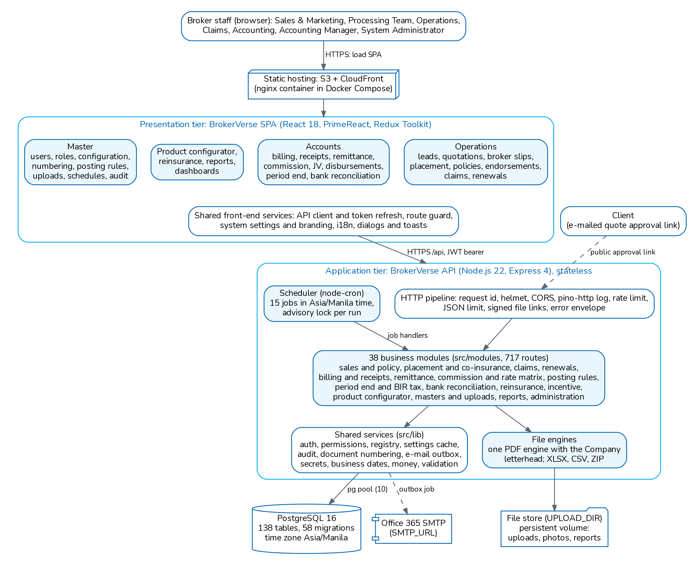
Figure 1. Logical component view of BrokerVerse OOTB
Component | Responsibility
Browser SPA | All user screens: operations (leads to renewals, including broker slips and placement slips), accounts (billing, receipts, remittance, commission, journals, period end, bank reconciliation, tax), product configurator, reinsurance, reports, dashboards, masters and administration. It holds the session tokens, renews them automatically and hides the menus a role may not open.
Static hosting | Serves the compiled SPA (HTML, JavaScript, CSS, images). There is no server-side rendering; every data call goes to /api.
HTTP pipeline | Request handling in backend/src/app.js: request id, security headers (helmet), CORS, structured access log with redaction, global rate limit, JSON size limit, signing of file URLs in responses, one error envelope.
Business modules | 38 folders in backend/src/modules. Each has a router.js that declares its endpoints through the route registry, and services that hold the business rules and SQL. They are loaded automatically at start. The larger modules (accounting, placement, period-end, bank-reconciliation, remittance, reports, document-numbering) have their own README.
Shared services | backend/src/lib: authentication, permissions, settings cache, audit, document numbering, e-mail outbox, secrets and signed links, business dates, money rounding, validation, rate limits, health, the PDF engine and the letterhead (document 05).
Scheduler | backend/src/jobs/scheduler.js: node-cron schedules the enabled rows of scheduled_jobs in the time zone general.timezone. Each run takes a PostgreSQL advisory lock so it runs once across instances, and is recorded in job_runs. Schedule changes reach every instance within 30 seconds.
File engines | One PDF engine (lib/pdf) for every document and report, with the letterhead of the primary company of the Company master; XLSX, CSV and ZIP writers in lib/. No third-party document library.
PostgreSQL | System of record for business, financial, configuration, security and log data (documents 02 and 03).
File store | UPLOAD_DIR (/app/uploads in the container): uploaded documents and photos, generated reports and statements, registered in the documents table.
SMTP server | Office 365 (smtp.office365.com, port 587, STARTTLS) delivers the e-mail queued in email_outbox: quote approval links, broker slip requests and placement orders to insurers, password reset codes, renewal and collection reminders, report schedules and remittance statements.

2.2 Front-end application structure
The SPA (brokerverse/src, 848 JavaScript and JSX files) is organised by functional area:
Folder | Content
agentModule/ | Operations screens: leads, quotation wizard, policy, endorsements, claims, renewals, collections, open items, payments, the Sales Dashboard and the customer quote approval page. The folder name is historical; there is no agent sign-in.
module/ | Back-office areas: Administration, BankReconciliation, ClaimsModule, Commission, CorrectionJV, ExecutiveDashboard, FinanceMastersModule, GeneralMasters, Incentive, JournalVoucher, PaymentVoucher, PeriodEnd, PettyCashManagement, Placement, ProductConfigurator, Receipts, Reinsurance, Remittance, Renewal, Reports, Reversals, SystemSettings, UnderwritingModule, accounts
services/ | 43 API client services (one per backend area, for example placementService.js, periodEndService.js, bankReconciliationService.js, importService.js)
routes/ | MainRoute.js (416 routes) and ProtectedRoute (route guard)
redux/, context/, hooks/ | Redux Toolkit store (reset on sign-out), notification context, currency formatting hook
utility/, utils/ | Shared helpers: HTTP interceptor and session refresh, menu permissions, dialogs and toasts, date, number and phone formatting, idle time-out, system settings, a logger that is silent in production
components/ | Reusable UI: layout, header, side bar, file upload, dialogs, toasts, status badges, stepper, notification drop-down
locales/, i18n.js | i18next resources: English (en.json, complete) and Thai (th.json, partial). Filipino is listed in the settings but has no translation file.

3 Deployment view

3.1 Production deployment on the existing BrokerVerse URL
deploy/README.md is the checklist the iorta TechNXT DevOps team follows to connect the source to the existing BrokerVerse URL; deploy/REFERENCE.md gives every environment variable, the seed data, the scheduled jobs, the health checks and the production start-up rules. Figure 2 shows the result. The AWS service names in dashed boxes and the "e.g." choices are options the checklist leaves open.
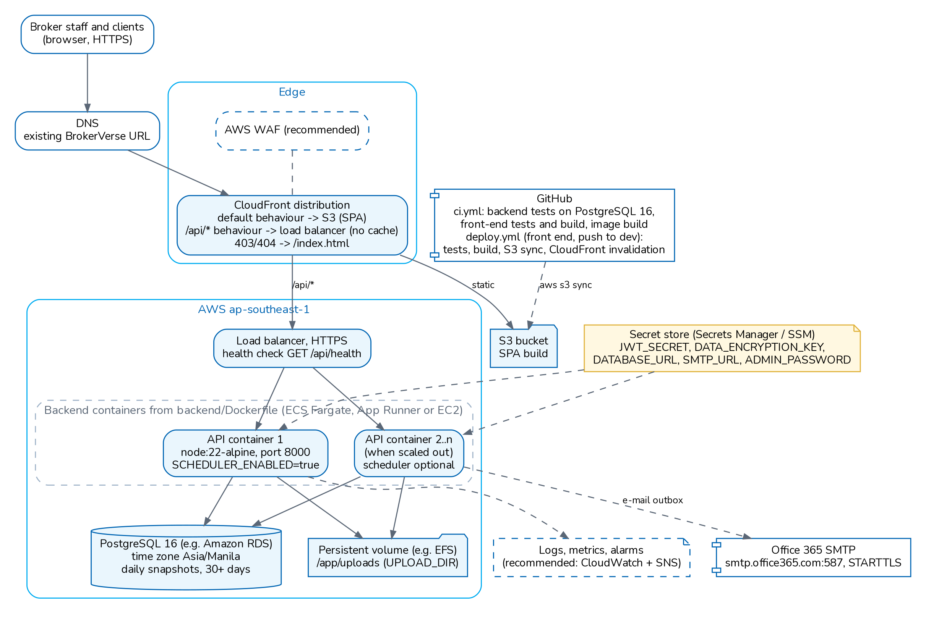
Figure 2. Production deployment on the existing BrokerVerse URL (AWS ap-southeast-1)
Layer | Fact from the baseline | To be confirmed by DevOps
Front-end build and hosting | brokerverse/.github/workflows/deploy.yml: on a push to dev, Node 22, npm ci, front-end tests, a check that the repository variable REACT_APP_BASE_URL is set, build, aws s3 sync build/ s3://$S3_BUCKET --delete, CloudFront invalidation /*, region ap-southeast-1. A failing test stops the deployment. | GitHub OIDC role instead of long-lived access keys; S3 versioning for roll-back
API address | Same-domain option recommended: CloudFront behaviour /api/* to the backend load balancer, all methods and headers, no caching. Separate domain possible with CORS_ORIGINS. | Choice of option
CloudFront errors | Custom error responses 403 and 404 return /index.html with status 200, so deep links work.
API runtime | backend/Dockerfile: node:22-alpine, npm ci --omit=dev, runs as user node, port 8000, HEALTHCHECK on /api/health. Behind a load balancer with HTTPS. | ECS Fargate, App Runner or EC2; number of instances
Database | PostgreSQL 16, created empty with a login that may create tables; database time zone Asia/Manila. The API migrates and seeds it on start. ?sslmode=require on RDS. | Amazon RDS class, Multi-AZ, backup retention (at least 30 days in the checklist)
Files | A persistent volume at UPLOAD_DIR (/app/uploads) is required; a container without it loses documents on restart. | EFS or another shared volume when more than one instance runs
E-mail | Office 365: SMTP_URL=smtp://connect%40iortatechnxt.com:<password>@smtp.office365.com:587, sender BrokerVerse <connect@iortatechnxt.com>; Authenticated SMTP turned on for the mailbox. E-mail is off until "Send e-mails" is switched on in Master > Configuration. | App password if the tenant enforces multi-factor sign-in
Secrets | JWT_SECRET, DATA_ENCRYPTION_KEY, ADMIN_PASSWORD, DATABASE_URL, SMTP_URL in a secret store (AWS Secrets Manager, SSM Parameter Store or the GitHub environment), never in a repository. The production start refuses unsafe values. | Secrets Manager or SSM
Repository CI | .github/workflows/ci.yml on every push to brokerverse-platform or main and on pull requests: backend lint and tests against PostgreSQL 16, front-end tests and production build, backend image build. | Image registry and backend release pipeline

3.2 Docker Compose
docker-compose.yml runs the system on one server, a test system or for a trial. It has three services. db runs postgres:16-alpine with a pg_isready health check and the volume db-data. api is built from backend/, runs with NODE_ENV=production by default, refuses to start without JWT_SECRET, DATA_ENCRYPTION_KEY, ADMIN_PASSWORD, CORS_ORIGINS and PUBLIC_BASE_URL, and keeps files in the volume uploads. web is built from brokerverse/ (nginx 1.27) and publishes port 8080; it serves the SPA and forwards /api/ to the API container. A TLS proxy must be placed in front of port 8080.
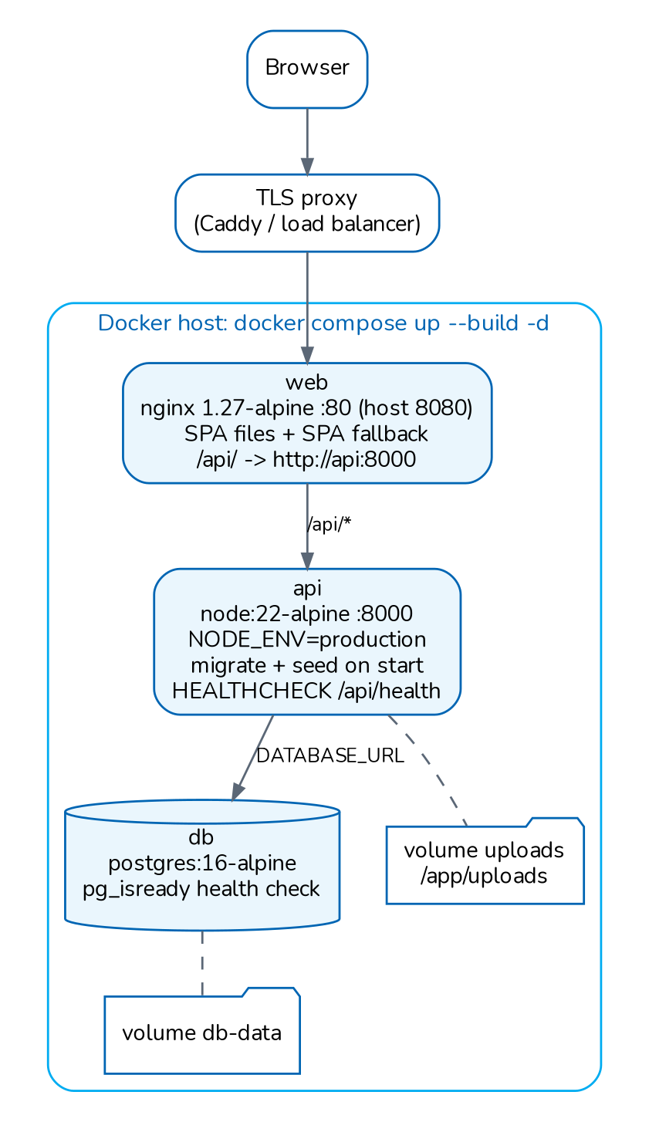
Figure 3. Docker Compose deployment (docker-compose.yml)

4 Request processing

4.1 API request pipeline
Every request passes the same middleware chain before it reaches a handler. The route registry (backend/src/lib/registry.js) places requireAuth first on every route that is not declared auth: false, so an endpoint cannot be left open by mistake. 14 routes are public by design: sign-in, the two-factor step, refresh, logout, forgot and reset password, the password policy, the public system settings (two routes), the version, the customer quote approval, a file download with a signed link (two routes) and a generated report download with a signed token.
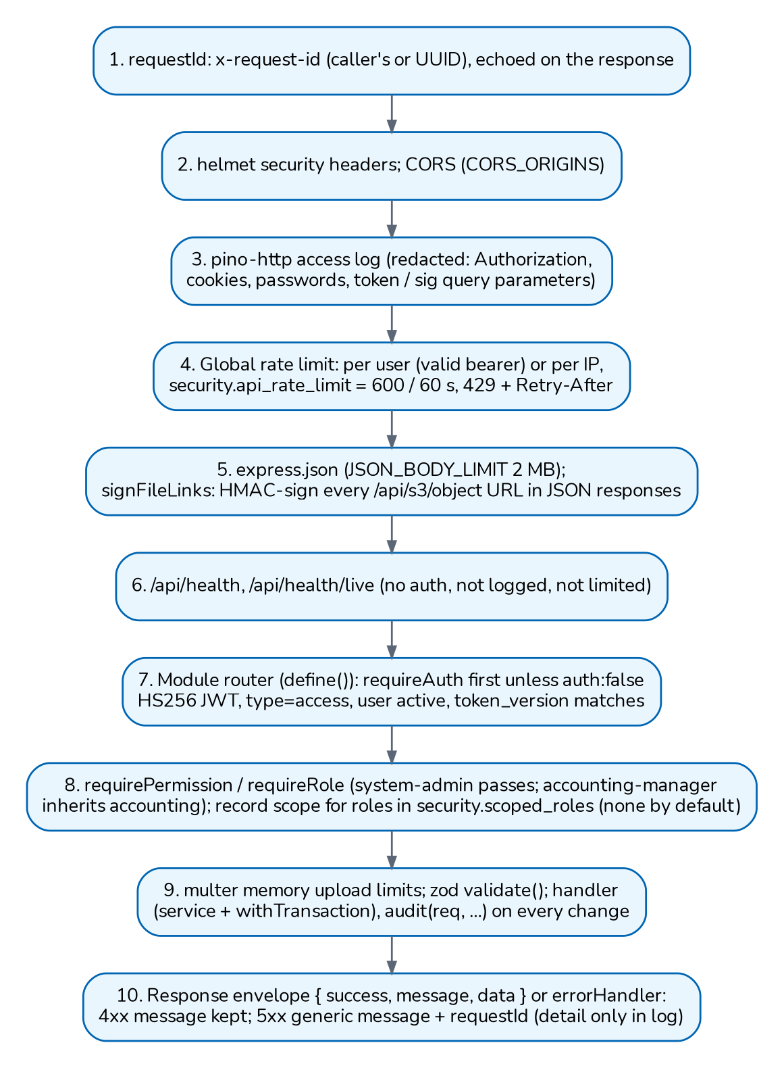
Figure 4. Request pipeline of the BrokerVerse API

4.2 Authentication and session flow
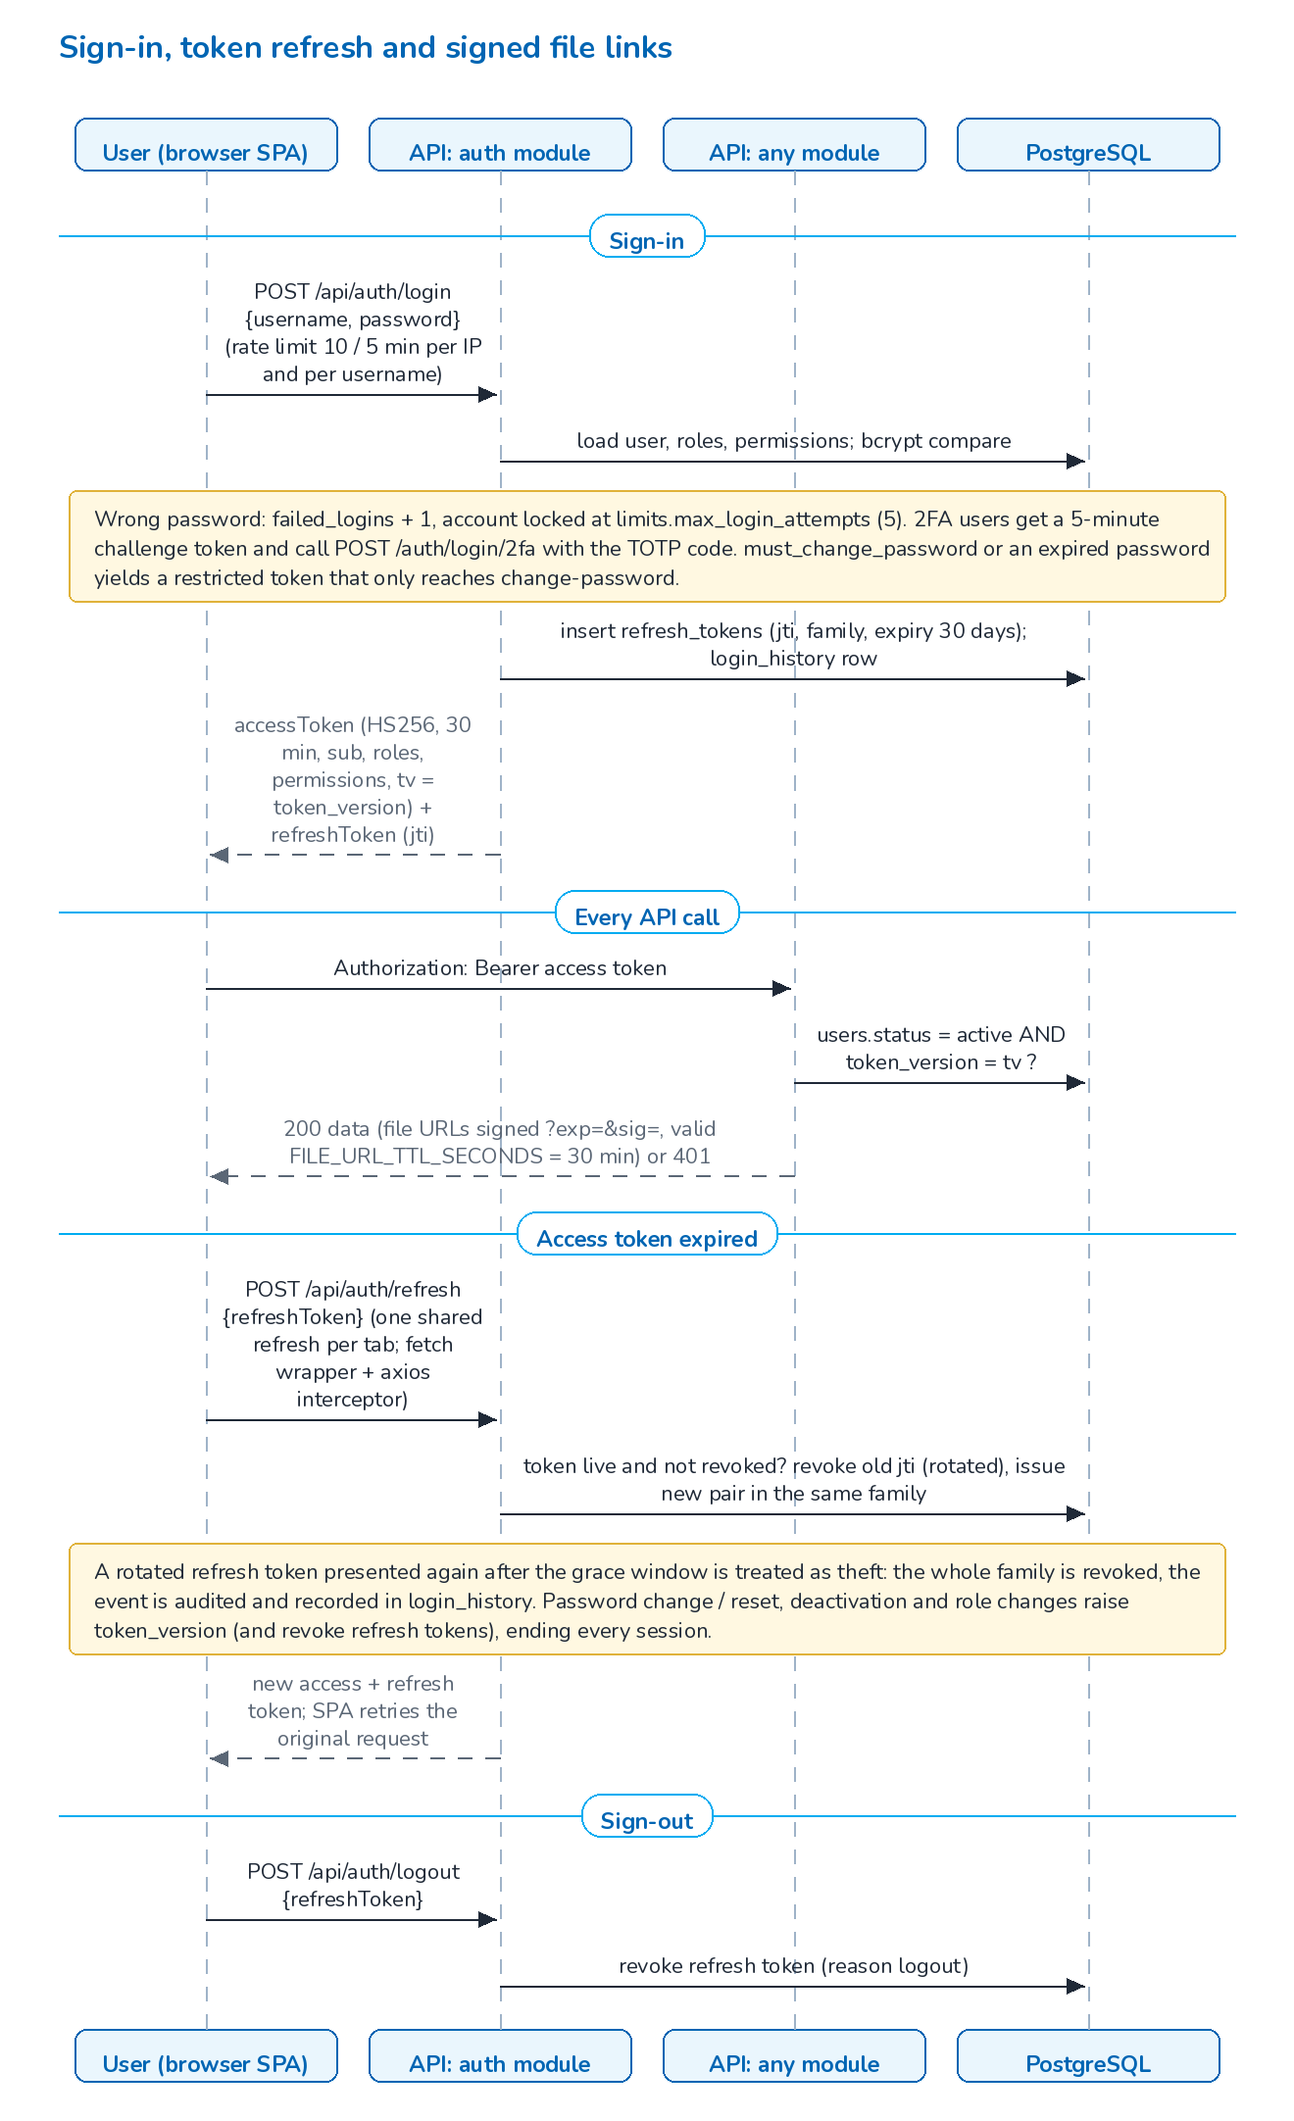
Figure 5. Sign-in, refresh-token rotation and signed file links
Mechanism | Implementation
Access token | JWT, HS256 only, lifetime JWT_ACCESS_TTL_SECONDS (default 1,800 s). Claims: user id, username, effective roles, permissions, type=access, tv (token version) and an optional restrict (enrol2fa, pwchange).
Per-request check | authenticate() verifies the signature and type, then reads users.status and users.token_version. An inactive user or a changed token version ends the session at once (HTTP 401).
Refresh token | JWT with a jti recorded in refresh_tokens (lifetime JWT_REFRESH_TTL_SECONDS, default 30 days), rotated on every use. Reuse of a rotated token after the grace window revokes the whole token family and is audited.
Revocation | Password change or reset, administrator reset, deactivation and role or permission changes raise token_version and revoke refresh tokens.
Sign-in protection | Limit of 10 attempts per 5 minutes per IP and per username (security.login_rate_limit); account locked after limits.max_login_attempts (5) wrong passwords; every attempt recorded in login_history.
Password policy | Minimum length 8, upper and lower case, digit and symbol, history of 5, maximum age 90 days (security.password_*). A must-change or expired password gets a restricted token. Users created by an administrator or by scripts/provision-users.js must change the initial password at the first sign-in.
Two-factor | TOTP (RFC 6238) in lib/totp.js; secrets encrypted at rest with AES-256-GCM under DATA_ENCRYPTION_KEY. Roles that must use it are set in security.require_2fa_roles (empty by default; the checklist suggests system-admin, accounting and accounting-manager).
Front end | Tokens kept in localStorage. utility/sessionRefresh.js wraps fetch and utility/interceptor.js wraps axios with one shared refresh. Idle sign-out after limits.session_idle_minutes (30) with a one-minute warning.
File links | Stored documents are served by GET /api/s3/object/<key> only with a bearer token or an HMAC-signed link (?exp=&sig=) valid for FILE_URL_TTL_SECONDS (1,800 s). The API signs every object URL in JSON responses on the way out.

Limitation: Tokens are stored in the browser's local storage; this is accepted for go-live (deploy/README.md, section 9). A change to an httpOnly, SameSite refresh cookie needs a backend change. The global and sign-in rate limits are counted per API process, so with several instances the effective limit is multiplied by the number of instances.

5 Module map

5.1 Backend modules
The API is a modular monolith. Each module owns its routes, services and tables and shares the database and the lib/ services. Module routers are loaded in folder order (the system module first) and mounted under /api. Some modules mount extra prefixes: placement serves /broker-slips and /placements, posting-rules also serves /account-determination, payments serves /open-items and /petty-cash.
Module (backend/src/modules) | Routes | Responsibility
auth | 15 | Sign-in, two-factor challenge and enrolment, refresh, logout, change, forgot and reset password, profile
users | 16 | Users and roles (User Management), role permissions and inheritance, sessions, sign-in history
leads | 11 | Leads and prospects, statistics, lead report, lead upload
clients | 6 | Clients and customer codes (/clients, /customers)
addresses | 5 | Provinces, cities, districts and postal codes
quotations | 38 | Quotation wizard, motor tariff, premium calculation, customer approval link, submission to the insurer, conversion to policy, quotation masters, e-mail
placement | 26 | Broker slips to several insurers, insurer offers and comparison, placement slips, binding per co-insurer, policy issue and "Record Issued Policy"; the journey per product type (placement.journey)
policies | 12 | Policy list and detail, KYC, payment capture for accounting confirmation, policy documents, policy upload
endorsements | 8 | Endorsements and cancellations with re-pricing, return premium and billing
documents | 5 | Server-rendered PDFs (quotation, policy schedule, receipt) and upload template downloads
claims | 16 | Claim registration with acceptance check, lifecycle, settlement with maker-checker, settlement cash from insurers to the claimant, documents and letters, claims reports
renewals | 42 | Renewal pipeline, renewal quotes, notices, batches and queue, workspace, analytics, win-back campaigns
receipts | 16 | Official receipts, application to bills, billing statements, receivables, open items import for go-live
collections | 9 | Collection items, follow-up actions, due-date reminders, KPIs
accounting | 27 | Journal engine, ledgers per client and policy, open-item matching and write-off, trial balance, chart of accounts and its upload
posting-rules | 14 | Posting rules per business event with versions and simulation; Account Determination (the GL account of each account role)
journal-vouchers | 8 | Journal vouchers with maker-checker, correction and reversal
period-end | 45 | Fiscal years, period status, month-end and year-end close, recurring and accrual journals, financial statements, tax codes, BIR Form 2307, go-live opening balances
bank-reconciliation | 38 | Statement formats and import, matching rules and workspace, adjustments, stale cheques, monthly reconciliation with approval
disbursements | 15 | Payment vouchers, invoice lists, cheques, commission and insurer payouts
payments | 29 | Open items, payments and petty cash (funds, requests, disbursements, receipts, replenishment)
commission | 19 | Commission accrual, eligibility, approval, payout and clawback; referrer accounts and dashboard
commission-rates | 7 | Commission rate matrix per insurer, product, line and policy type with effective dates
remittance | 86 | Remittances to insurers, bills, settlements, multi-level approvals and delegations, statements, refunds due from insurers, direct bill (debit notes, collections)
reinsurance | 38 | Reinsurers, treaties, cessions, recoveries, bordereaux, reconciliation, analytics
incentive | 22 | Incentive programmes, calculation batches with maker-checker, results, reports
product-configurator | 72 | Product templates, components, rating, rules, risk mapping, versions
masters | 13 | Generic master data screens driven by master_types, master uploads
document-numbering | 5 | Document number series: prefix, pattern, width, reset rule and next number
reports | 13 | Report catalogue, on-screen run, file generation (CSV, XLSX, PDF), schedules
dashboard, search | 6 | Executive, sales, processing and claims dashboards; global search
notifications | 8 | In-app notifications and unread count
uploads | 11 | File upload, signed download, existence check, delete (/s3, /upload)
settings, system-settings | 11 | Configuration keys by group, audit trail query; branding and system settings (public read for the sign-in page)
schedules | 4 | Scheduled jobs: list, run history, edit, run now
system | 1 | GET /api/version: build and runtime information

Route counts come from the route registry through collectRoutes() in backend/src/tools/export-api.js, the same list that npm run export:api writes to backend/docs/api/openapi.json: 717 operations (331 GET, 277 POST, 74 PUT, 28 DELETE, 7 PATCH).

5.2 Front-end areas and backend modules
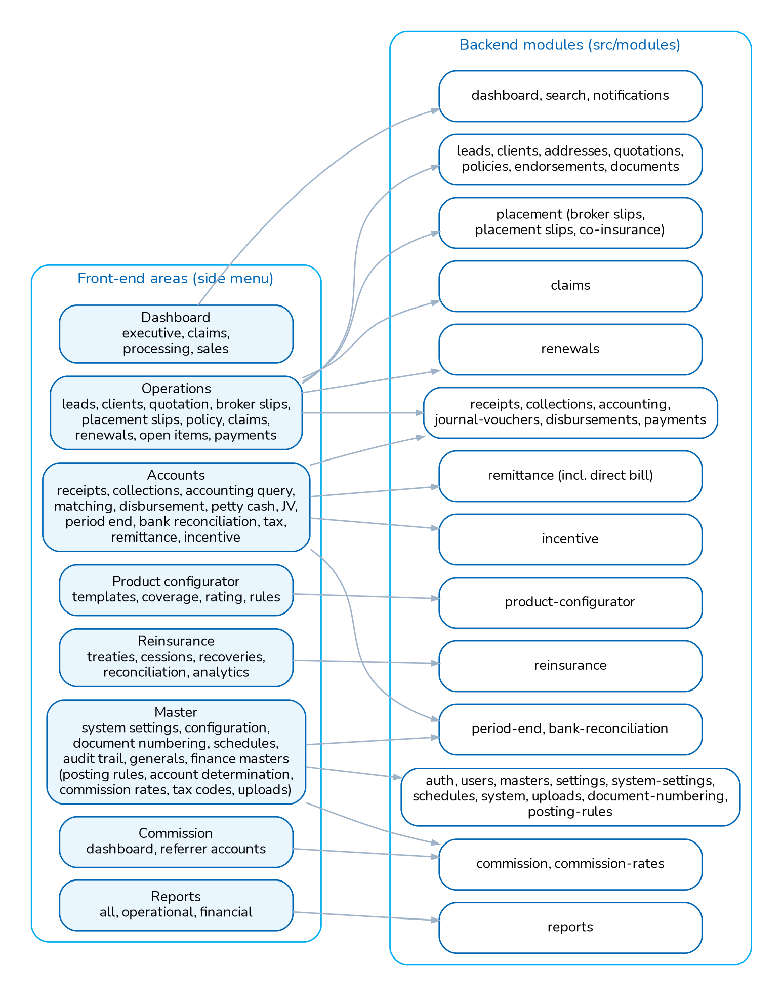
Figure 6. Front-end areas (menus) and the backend modules they use

6 Integration points
Integration | Direction | Description
SMTP e-mail | Outbound | lib/mailer.js queues messages in email_outbox. The email-outbox job (every 5 minutes) sends up to 50 queued messages per run through nodemailer and SMTP_URL when notification.email_enabled is true; up to 5 attempts, then failed. Sender: notification.from_address (BrokerVerse <connect@iortatechnxt.com>; Office 365 refuses any other sender for that mailbox).
Client quote approval | Inbound (public) | The approval e-mail carries a signed token (quotations.approval_link_ttl_hours, 168 h). POST /api/quotations/approve-by-customer previews or accepts; only the latest token of a quotation is valid.
Insurers | Outbound (e-mail, files) | Broker slip requests for quotation, placement orders to the lead insurer and co-insurers, remittance statements and bills, commission debit notes; PDF, CSV and XLSX files. Insurer answers are keyed as offers. There is no insurer API integration.
Reinsurers | Outbound (files) | Bordereaux and reconciliation files generated as CSV.
Uploads and go-live imports | Inbound (files) | Masters, chart of accounts, leads, quotations, policies, receipts, payment vouchers, opening balances, open items, bank statements and remittance bulk files through importUpload(): one file of at most IMPORT_MAX_MB (10 MB), decompressed size capped at IMPORT_MAX_INFLATED_MB (50 MB) and IMPORT_MAX_ROWS (20,000) rows. The 39 templates in docs/templates are generated from the importers' own column lists and checked by backend/test/upload-templates.test.js.
Bank statements | Inbound (files) | CSV or XLSX statements read with a statement format (layouts of three Philippine banks and a generic layout ship as standard) for bank reconciliation.
User provisioning | Operations | scripts/provision-users.js creates named users from a CSV kept outside the repository (dry run unless CONFIRM_PROVISION=yes).
Payment gateway | Not integrated | Policy payments are captured by staff with proof of payment (policy_payments) and confirmed by Accounting.
API documentation | Developer | npm run export:api writes backend/docs/api/openapi.json, a Postman collection and environment, and BrokerVerse_API_Touchpoints.xlsx and .csv from the route registry.
Monitoring | Operations | GET /api/health (readiness), GET /api/health/live (liveness), GET /api/version (build, commit from GIT_COMMIT, database reachability, pending migrations); JSON logs on stdout (document 11).

7 Security architecture summary

7.1 Roles and permissions
Permissions are codes read:<module> and write:<module> for 27 modules, plus approve:period-end and approve:bank-reconciliation: 56 permission rows. Seven roles are seeded (backend/src/db/seed.js and migration 0140_broker_roles.sql). A role can inherit another role (roles.inherits); the effective roles of a user are resolved by the database function user_effective_roles(). Administrators can create further roles and change grants in User Management.
Role | Access (seeded grants)
System Administrator (Super Admin Access), system-admin | Every permission; configuration, users and roles. Only a System Administrator can grant this role or change an administrator account, and nobody can change their own roles or status.
Sales & Marketing (Account Executive), sales | Leads, clients, quotations, policies, endorsements, renewals, reports, notifications; read products, masters and claims
Processing Team (Placement & Policy Processing), processing | Broker slips and placement (quotation permissions), policies, endorsements, renewals, reinsurance, product templates, clients, reports; read leads, masters and claims
Operations (Client Servicing), operations | Leads, clients, quotations, policies, endorsements, renewals, reports; read claims, masters and products
Claims, claims | Claims, reports; read clients, policies and masters
Accounting, accounting | Receipts, collections, disbursements, commission, remittance, incentive, journal vouchers, period end, bank reconciliation, reports; read clients, policies, claims, masters and schedules
Accounting Manager, accounting-manager | Inherits Accounting, plus approve:period-end and approve:bank-reconciliation: approves month-end and year-end closes and bank reconciliations, posts into soft-closed periods and reopens periods

There is no agent sign-in. Referrers and sub-agents are a master (commission_referrers): Sales & Marketing enter their business and Accounting pays them. The server enforces permissions on every route (requirePermission, requireRole); the front end also hides menus and blocks routes by role (utils/menuPermissions.js, deny by default, and routes/ProtectedRoute). Receipts are an Accounting function (segregation of duties).

7.2 Controls
Control | Implementation
Record scope | Users whose roles are all listed in security.scoped_roles see and act only on records they own or that belong to their clients (lib/scope.js); another user's record answers 404. The setting is empty in the seed, so no role is scoped.
Maker-checker | A different user must approve: journal vouchers, payment vouchers and cheques, commission payouts, remittances and settlements (multi-level with delegation), commission debit notes, claim settlements, incentive calculations, reinsurance treaties, petty cash requests, month-end and year-end closes, bank reconciliations, quotation and renewal approvals (lib/makerChecker.js, switch finance.maker_checker_enabled).
Period control | Every journal passes assertPostingAllowed: open periods accept all postings, soft-closed periods only postings by approve:period-end, closed and locked periods none. A trigger on journal_vouchers checks balance and period again at posting.
Audit | lib/audit.js writes audit_log (user, entity, id, action, before and after JSON, IP) from every mutating handler; claims keep a field-level trail (claim_field_changes); period and reconciliation status changes have their own history tables; sign-ins are in login_history.
Input validation | zod schemas on request bodies and parameters where declared; parameterised SQL only, with dynamic identifiers taken from white lists.
Uploads | Type checked against uploads.allowed_types by file signature and the detected type stored; per-file size UPLOAD_MAX_MB (10 MB) and UPLOAD_MAX_FILES (10); files served with nosniff and a sandbox CSP, and anything other than images and PDF as a download.
Transport and headers | TLS at the load balancer and CloudFront; helmet headers on the API; nginx adds X-Content-Type-Options, X-Frame-Options and Referrer-Policy in the Compose option; CORS limited to CORS_ORIGINS (* refused in production).
Secrets | Production start refuses a missing, placeholder or short (under 32 characters) JWT_SECRET or DATA_ENCRYPTION_KEY, equal keys, CORS_ORIGINS=* or a localhost PUBLIC_BASE_URL. Reset codes are stored only as HMAC hashes.
Logging | pino JSON logs with redaction of authorization headers, cookies, passwords, refresh tokens and token or signature query parameters; 5xx responses return a generic message with the request id.

8 Key business flows

8.1 Lead, placement, policy and billing
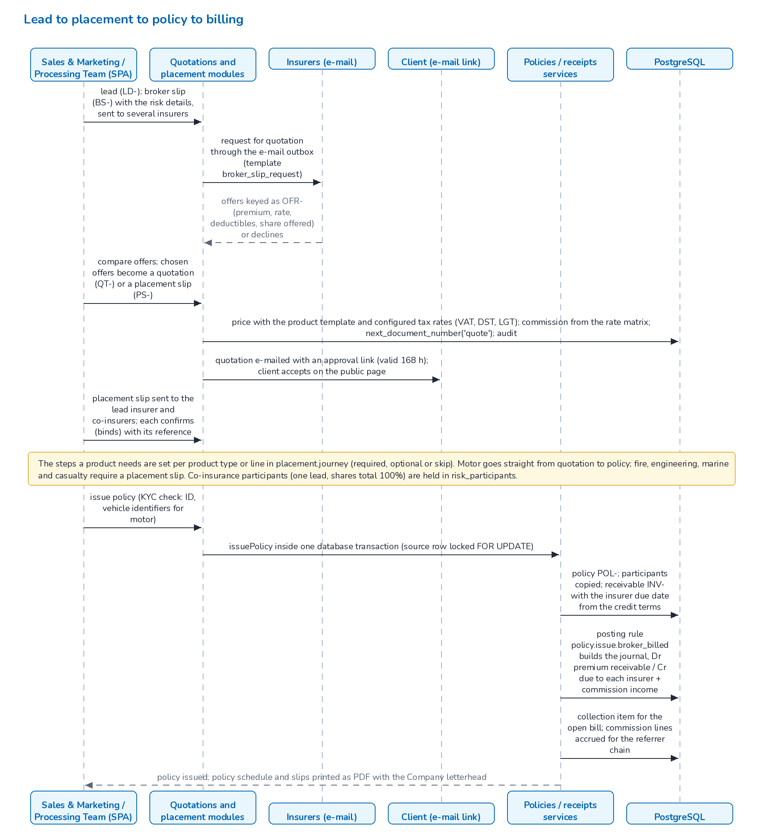
Figure 7. Lead to placement to policy to billing

8.2 Receipt, commission and remittance
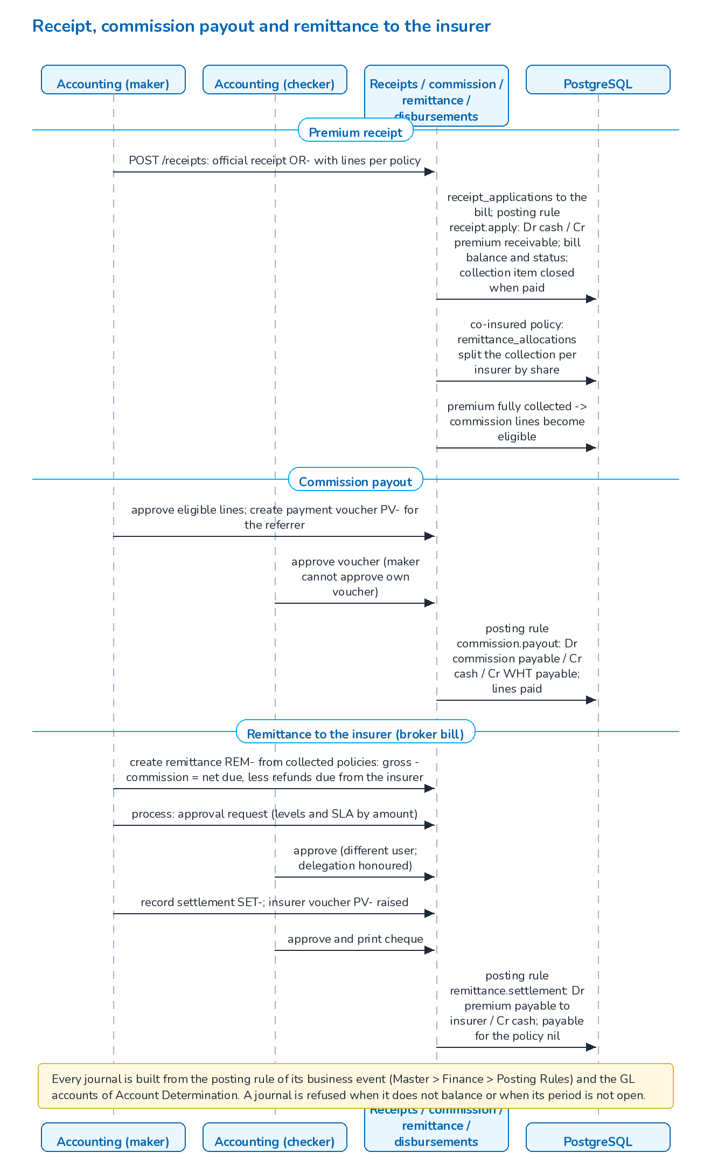
Figure 8. Receipt, commission payout and remittance to the insurer

8.3 Direct bill
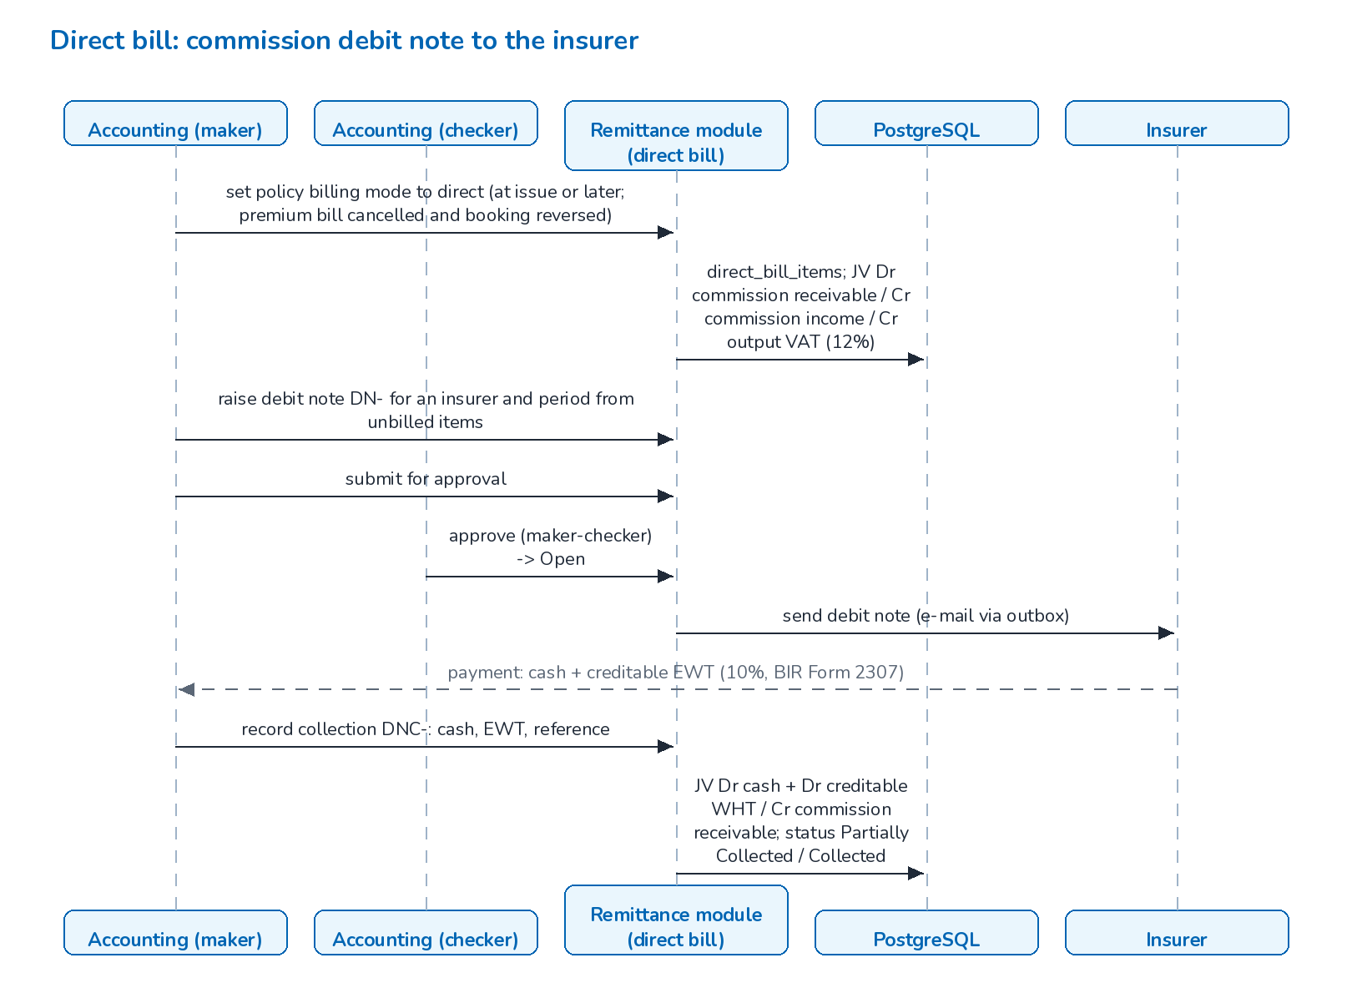
Figure 9. Direct bill: commission debit note to the insurer

8.4 Claims
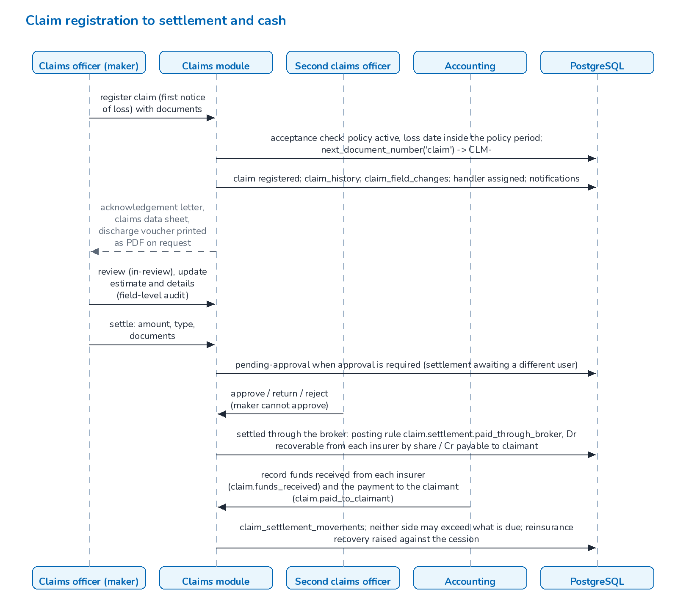
Figure 10. Claim registration to settlement and cash

8.5 Renewal
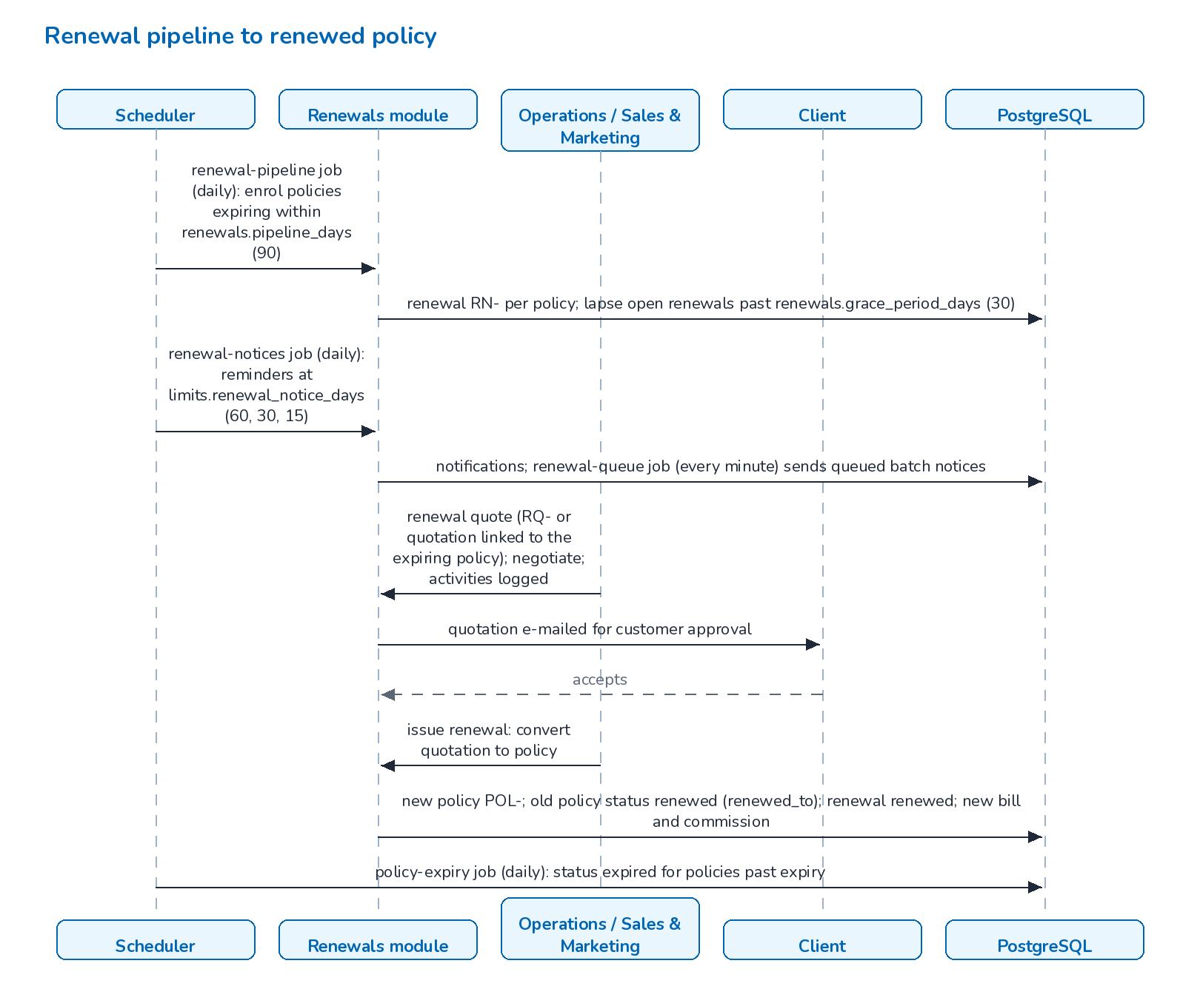
Figure 11. Renewal pipeline to renewed policy

8.6 Period end
Accounting prepares the month-end close for a period (run MEC-): accrual and recurring journals, unearned commission deferral, FX revaluation and the checklist. The manual checklist items are signed and the run is submitted. When accounting.period_close_requires_approval is on, an Accounting Manager approves and the period becomes closed. Executing a run again first reverses its own earlier journals, so a rerun gives the same ledger. The year-end close (run YEC-) needs twelve closed periods; it posts the closing entries in period 13, carries the balance-sheet balances into opening_balances of the next year, locks the year and creates the next one. At go-live, the old system's trial balance is loaded into opening_balances and the open premium receivables as open items, with the templates in docs/templates.

8.7 Scheduled jobs
All cron expressions are read in the business time zone (general.timezone, Asia/Manila), whatever the time zone of the server clock. The seed and the migrations create 15 jobs; 10 are enabled by default.
Job (scheduled_jobs.code) | Cron | Enabled | Work
policy-expiry | 15 0 * * * | yes | Mark policies past their expiry date as expired
quote-expiry | 30 0 * * * | yes | Expire quotations older than limits.quote_validity_days
housekeeping | 45 2 * * * | yes | Delete operational rows past their retention period (System Settings > Housekeeping; the audit trail is kept)
daily-reports | 0 5 * * * | yes | Generate the daily reports; purge generated reports older than reports.retention_days (90)
renewal-pipeline | 30 5 * * * | yes | Enrol policies expiring within the pipeline window; lapse renewals past the grace period
renewal-notices | 0 6 * * * | yes | Renewal reminders at the configured notice days
receivable-ageing | 0 7 * * * | yes | Recompute the age and ageing bucket of open bills
collection-reminders | 0 8 * * * | yes | E-mail and notify clients with premiums falling due
email-outbox | */5 * * * * | yes | Deliver queued e-mails
renewal-queue | * * * * * | yes | Send queued renewal batch notices, retry stale queue items
accrual-reversal | 30 0 1 * * | no | Reverse last month's accrual journals on day 1
recurring-journals | 15 1 * * * | no | Create the journals of recurring templates that are due
period-auto-soft-close | 0 2 * * * | no | Soft-close periods after the grace days
bank-auto-match | 45 5 * * * | no | Run the automatic bank matching rules
month-end-reminder | 0 8 * * * | no | Remind Accounting of the coming month-end

Report schedules created under Reports > Schedules add further jobs (report-<id>, handler scheduledReport). The period-end and bank-matching jobs are disabled by default; Accounting switches them on in Master > Schedules when the business is ready.

9 Architecture decisions and constraints
Decision | Rationale and consequence
Modular monolith | One deployable API keeps an operation (policy, bill, journal, commission) in one database transaction. Modules can be split later along the folder boundaries.
Stateless API | Sessions are tokens; state is in PostgreSQL and the file store, so instances can be added behind a load balancer (document 07). The settings cache is per instance but checks the table version every 5 seconds, so a change reaches every instance within seconds. Rate-limit counters stay per instance.
Migrations and seed on start | Every instance takes an advisory lock, applies pending migrations (each in its own transaction) and the idempotent seed before it reports ready. Instances that start together wait for the first one. A failed migration blocks start-up (documents 07 and 09).
Posting rules as data | Every system journal is built from the posting rule of its business event and the account roles of Account Determination. Accounting can change the GL treatment without a code change; each rule version has an effective date.
Configuration over code | 351 settings in app_settings (tax rates, account roles, limits, templates, security policy, retention periods), 52 document number series and the commission rate matrix are edited in the application.
One PDF engine, no third-party document libraries | PDF, XLSX, CSV and ZIP writers are part of the code base. Every PDF carries the letterhead of the primary company of the Company master, so the broker's own details print on every document and report once the master is updated.
Business time zone | Business dates, document number years, column defaults and job schedules use general.timezone (Asia/Manila); the database time zone is also set to Asia/Manila. Instants are stored in timestamptz.
Local file store behind an S3-style API | uploads/storage.js keeps an S3-like key space on disk. With more than one instance the volume must be shared (for example EFS) so every instance sees the same files.

10 Related documents
This document is one of eleven that together form the BrokerVerse OOTB Solution Architecture. They are maintained and issued together (source and build: docs/architecture/README.md).
No. | Document | File
01 | Solution Component Diagram and Application Architecture (this document) | 01_BrokerVerse_Solution_Component_Diagram_Application_Architecture.pdf
02 | Database Design | 02_BrokerVerse_Database_Design.pdf
03 | Database Inventory | 03_BrokerVerse_Database_Inventory.pdf
04 | Technology Stack | 04_BrokerVerse_Technology_Stack.pdf
05 | Shared Service Components | 05_BrokerVerse_Shared_Service_Components.pdf
06 | Capacity and Performance | 06_BrokerVerse_Capacity_and_Performance.pdf
07 | High Availability and Resiliency | 07_BrokerVerse_High_Availability_and_Resiliency.pdf
08 | RTO and RPO | 08_BrokerVerse_RTO_and_RPO.pdf
09 | Backup and Recovery | 09_BrokerVerse_Backup_and_Recovery.pdf
10 | Data Archival, Housekeeping and Restoration | 10_BrokerVerse_Data_Archival_Housekeeping_and_Restoration.pdf
11 | Monitoring | 11_BrokerVerse_Monitoring.pdf

11 Glossary
Terms and abbreviations used in this document.
Term | Meaning
Account determination | Settings accounting.account.<role> that give the GL account of each account role (cash in bank, premium receivable, due to insurer, commission income ...) used by the posting rules.
Advisory lock | PostgreSQL application-level lock (pg_try_advisory_lock, pg_advisory_lock) used so a job runs on one API instance at a time and only one instance applies migrations.
API | Application programming interface; here the BrokerVerse REST API under /api served by the Node.js backend.
Audit log / audit trail | Table audit_log: who changed which record, when, from which IP, with the before and after values.
AZ | Availability Zone: an isolated data-centre group inside an AWS region.
BIR | Bureau of Internal Revenue (Philippines): tax authority whose rules drive record keeping and withholding tax certificates.
BIR Form 2307 | Certificate of creditable tax withheld at source, issued by the payor to the payee each quarter.
Broker slip | Request for quotation (BS-) that the broker sends to several insurers for one client risk; the answers are recorded as insurer offers.
CloudFront | AWS content delivery network that serves the single-page application and can route /api to the backend.
Company master | Master record of the broker company; the primary company is the letterhead printed on every document and report.
CORS | Cross-Origin Resource Sharing: browser rule set that the API restricts to the configured web origins (CORS_ORIGINS).
CRA / craco | Create React App (react-scripts) build tool chain, customised with craco (Create React App Configuration Override).
Cron | Time-based schedule expression (minute hour day month weekday) used by the scheduled jobs.
CSP | Content Security Policy: HTTP header restricting what a page may load or run.
Debit note (DN) | Commission debit note raised by the broker to an insurer for direct-billed policies.
Direct bill | Billing mode in which the insurer collects the premium and the broker bills the insurer for its commission.
ECS / Fargate | Elastic Container Service (AWS) and its serverless compute mode for running the API containers.
EFS | Elastic File System (AWS): shared, multi-AZ network file system proposed for the upload directory.
HMAC | Keyed-hash message authentication code; signs file links and hashes one-time codes.
Housekeeping | Daily job that deletes operational rows (job runs, sent e-mails, sign-in history, expired tokens, read notifications) after the retention days in System Settings.
HS256 | HMAC-SHA256 JSON Web Token signature algorithm, the only one the API accepts.
JWT | JSON Web Token: signed token carrying the user id, roles, permissions and token version.
KYC | Know your customer: identification data required before a policy is issued.
Maker-checker | Control in which a record created or submitted by one user must be approved by a different user.
Migration | Numbered SQL file in backend/src/db/migrations applied once, in order, on API start.
Month-end close | Run (MEC-) that posts the accruals, recurring journals and valuations of a period, checks the checklist and, once approved, closes the period.
Multi-AZ | Deployment with a synchronous standby in a second Availability Zone and automatic failover (RDS).
nginx | Web server used in the web container to serve the SPA and forward /api to the API container.
Office 365 | Microsoft 365 mail service; BrokerVerse sends e-mail through smtp.office365.com with the mailbox in SMTP_URL.
Posting rule | Versioned definition of the journal lines for one business event (policy issued, receipt applied ...); every system journal is built from it.
RDS | Amazon Relational Database Service, the managed PostgreSQL target.
Receivable / bill | Premium bill (INV-) raised when a policy, endorsement or renewal is issued.
Record scope | Rule that users holding only roles listed in security.scoped_roles see only their own records (lib/scope.js); no role is scoped by default.
Refresh token | Long-lived token (30 days) exchanged for a new access token; rotated on every use.
Remittance | Payment of collected premium, net of commission, from the broker to the insurer.
RPO | Recovery point objective: the maximum acceptable data loss, measured in time.
RTO | Recovery time objective: the maximum acceptable time to restore service.
S3 | Amazon Simple Storage Service: object storage hosting the SPA build (and proposed archive store).
Seed | Idempotent data load run on every API start: reference data always, sample data only when SEED_SAMPLE_DATA is on.
SMTP | Simple Mail Transfer Protocol; the API sends e-mail through the server in SMTP_URL.
SPA | Single-page application: the React front end served as static files.
TLS | Transport Layer Security (HTTPS).
Token version | users.token_version, carried in every access token; raising it ends all sessions of the user.
TOTP / 2FA | Time-based one-time password (RFC 6238) used for two-factor authentication.
Year-end close | Run (YEC-) that posts the closing entries in period 13, carries the balances into the next year and locks the year.
zod | TypeScript-first schema validation library used to validate request bodies and parameters.

