
BrokerVerse OOTB
Insurance broking platform by iorta TechNXT
Solution Architecture · Document 10 of 11
Data Archival, Housekeeping and Restoration

Product | BrokerVerse OOTB
Document | 10 Data Archival, Housekeeping and Restoration
Version | 1.1
Date | 29 September 2026
Prepared by | iorta TechNXT
Classification | Confidential: for the client, iorta TechNXT and authorised partners
Prepared by iorta TechNXT

Document control
Document | BrokerVerse OOTB Solution Architecture: 10 Data Archival, Housekeeping and Restoration
Document ID | BV-SA-10
Version | 1.1
Status | Issued for review
Date | 29 September 2026
Prepared by | iorta TechNXT
Source baseline | BrokerVerse source repository, branch brokerverse-platform (backend/, brokerverse/, deploy/, docker-compose.yml, .github/workflows, docs/)
Version history
Version | Date | Author | Change
1.0 | 29 September 2026 | iorta TechNXT | Initial issue
1.1 | 29 September 2026 | iorta TechNXT | Updated to the current system: placement journey, co-insurance, posting rules, period end and BIR tax, bank reconciliation, document numbering, commission rate matrix, single PDF engine, uploads and go-live imports, housekeeping, business time zone, broker roles, deployment on the BrokerVerse URL
Review and approval
Role | Name | Signature | Date
Solution architect
DevOps / infrastructure lead
Information security
Business owner
Conventions
- Statements of fact are derived from the code, configuration and database of the baseline above (file paths are given relative to the repository). Figures measured on the local test system are labelled test data or indicative.
- Targets, sizes, retention periods and thresholds that are not facts of the code are labelled Recommended / to be confirmed by the business and DevOps.
- Items marked Gap are defects or missing capabilities found while preparing this document.

Contents
1 Introduction 4
1.1 Purpose and scope 4
2 What grows 5
3 Retention policy 6
3.1 Regulatory context 6
3.2 Recommended retention periods 6
4 Housekeeping 8
4.1 Housekeeping job 8
4.2 Other housekeeping 8
4.3 Recommended additions 8
5 Archival 9
5.1 Approach 9
5.2 Restoration from archive 10
6 Sample-data purge before go-live 11
7 Related documents 12
8 Glossary 13

1 Introduction

1.1 Purpose and scope
This document describes how BrokerVerse OOTB data grows, the housekeeping the system performs, the recommended retention periods, the approach to archiving old records out of the online database, how archived data is restored on request, and how the sample-data purge script is used before go-live.
Recommended / to be confirmed by the business and DevOps: Retention periods in this document are proposals. The compliance officer must confirm them against the rules that apply to the broker, in particular the record-keeping rules of the Bureau of Internal Revenue (BIR) and the Insurance Commission (IC), and the Data Privacy Act of 2012 (personal data kept no longer than needed for the declared purposes). This document gives the regulatory context in general terms only; it is not legal advice.

2 What grows
Data | Growth driver | Handling in the baseline
Business and financial records (about 100 tables: leads to journals, placement, period end, bank reconciliation) | Every quotation, policy, receipt, voucher, claim, statement line | Kept indefinitely; financial documents are cancelled or reversed, not deleted; draft quotations can be deleted; leads, quotations and bank statements have deleted_at
audit_log | Every change, sign-in related event, job run started by a user, report generation | Kept; purged only if housekeeping.audit_log_days is set, never below seven years
login_history | Every password, two-factor and refresh attempt | Purged by housekeeping after 365 days
job_runs | About 1,736 rows a day: renewal-queue every minute (1,440), email-outbox every 5 minutes (288), 8 enabled daily jobs | Purged by housekeeping after 90 days
notifications | Reminders, approvals, renewal and collection notices | Read notifications purged after 180 days; users can delete them in the bell menu
email_outbox | Every e-mail (full HTML body kept) | Sent messages purged after 180 days, failed ones after 730 days
refresh_tokens | Every sign-in and every refresh (rotation) | Expired or revoked rows purged 30 days after expiry or revocation
password_resets | Forgot-password requests | Used or expired codes purged after 7 days
password_history | Password changes | Trimmed to the last security.password_history_count (5) per user by lib/password.js
job_queue | Renewal batch notices | Completed items purged after 30 days
generated_reports and report files | Scheduled daily reports and user-generated reports | Rows and files older than reports.retention_days (90) deleted by the daily-reports job
Uploaded files (UPLOAD_DIR) | Documents, photos, statements, bordereaux, exports | No lifecycle; deleted only through the delete endpoint (uploader, module writer or administrator)
Status housekeeping | Policies past expiry, quotations past validity, renewals past grace | Jobs policy-expiry, quote-expiry, renewal-pipeline change the status (no deletion)

Note: In production, files without a database record (orphans) can arise from failed uploads (a key is reserved before the file is written) and from restores done at different times for the database and the files. A periodic reconciliation report is recommended (chapter 4).

3 Retention policy

3.1 Regulatory context
- BIR: books of accounts and their supporting documents (official receipts, invoices, vouchers, journals, withholding tax certificates such as BIR Form 2307) must be kept for the period set by the revenue regulations, currently up to ten years from the date of the last entry (Revenue Regulations No. 17-2013 as amended), and be available for examination.
- Insurance Commission: insurance brokers must keep complete records of the business transacted (policies placed, premiums received and remitted, commissions) available for examination, for the period required by the Insurance Code and IC circulars.
- Data Privacy Act of 2012 (Republic Act 10173): personal data of leads, clients and claimants may be kept only as long as needed for the purpose or as required by law, then disposed of securely; access and retention must be documented.

3.2 Recommended retention periods
Class / data (Recommended / to be confirmed by compliance) | Tables | Online (PostgreSQL) | Total, incl. archive
Financial records | receivables and credits, receipts and applications, journal vouchers and lines, entry matches, disbursements, invoice lists, cheques, petty cash, commissions and adjustments, remittances, allocations and refunds, debit notes and collections, direct-bill items, claim settlement cash, bank statements, matches and reconciliations, close runs, year-end runs, opening balances, BIR 2307 certificates, reinsurance recoveries and reconciliations, incentive calculations and results, policy payments | Current year + 2 closed years | 10 years after the end of the financial year
Policy and claim records | clients, quotations (converted), broker slips, offers, placements, co-insurance participants, policies, endorsements, claims with history, renewals, cessions, treaties, bordereaux, documents | Life of the policy or claim + 2 years | 10 years after policy expiry or claim closure
Leads and quotations not converted | leads, quotes (not converted), broker slips without placement, renewal quotes, win-back campaigns | 2 years | 3 years, then anonymise or delete (privacy)
Audit trail | audit_log, claim_field_changes, claim_history, collection_actions, renewal_activities, renewal_notices, remittance_approvals, period_status_history, bank_reconciliation_history | 2 years | 10 years (supports the financial records)
Security logs | login_history, password_resets | 1 year | 2 years
Operational logs | job_runs | 90 days | 1 year (aggregated)
Temporary data | refresh_tokens (expired or revoked), email_outbox (sent), notifications (read), job_queue (done), generated_reports | 30 to 180 days | Same (no archive)
Reference and configuration | settings, masters, posting rules, number series, tax codes, product templates, roles, report catalogue | While in use | Versions kept through the audit log
Uploaded files | UPLOAD_DIR | As the owning record | As the owning record

4 Housekeeping

4.1 Housekeeping job
The scheduled job housekeeping (daily at 02:45 Manila time, jobs/housekeeping.js) deletes operational rows past their retention period. Each period is a setting in System Settings > Housekeeping (days; 0 keeps the rows forever). Deletes run in batches of 5,000 rows so a large backlog never holds long locks, and the job output lists the rows deleted per table and the tables kept.
Setting | Rule | Default days | Supporting index
housekeeping.job_runs_days | job_runs started before the cut-off | 90 | job_runs (job_id, started_at)
housekeeping.email_outbox_sent_days | email_outbox with status sent | 180 | email_outbox (status, created_at)
housekeeping.email_outbox_failed_days | email_outbox with status failed | 730 | email_outbox (status, created_at)
housekeeping.login_history_days | login_history | 365 | login_history (at DESC)
housekeeping.refresh_tokens_days | refresh_tokens expired or revoked before the cut-off | 30 | primary key and user index
housekeeping.password_resets_days | password_resets used or expired before the cut-off | 7 | primary key
housekeeping.notifications_read_days | read notifications | 180 | notifications (user_id, is_read, created_at)
housekeeping.job_queue_done_days | job_queue items with status completed | 30 | primary key
housekeeping.audit_log_days | audit_log older than the cut-off, never less than 2,557 days (seven years) | 0 (kept) | audit_log (at)

4.2 Other housekeeping
Job or rule | Schedule (Manila time) | Effect
daily-reports | 05:00 | Generates the daily reports and deletes generated reports and their files older than reports.retention_days
policy-expiry | 00:15 | Status expired for policies past expiry
quote-expiry | 00:30 | Status expired for quotations older than limits.quote_validity_days
renewal-pipeline | 05:30 | Lapses renewals past renewals.grace_period_days
Password change | on change | Keeps only the last N password hashes

4.3 Recommended additions
Recommended / to be confirmed by the business and DevOps: Archive login_history and, once the compliance period is agreed, audit_log before housekeeping deletes them (chapter 5). Add a weekly report of files in UPLOAD_DIR without a documents or generated_reports row, and of rows whose file is missing; do not delete automatically.

5 Archival

5.1 Approach
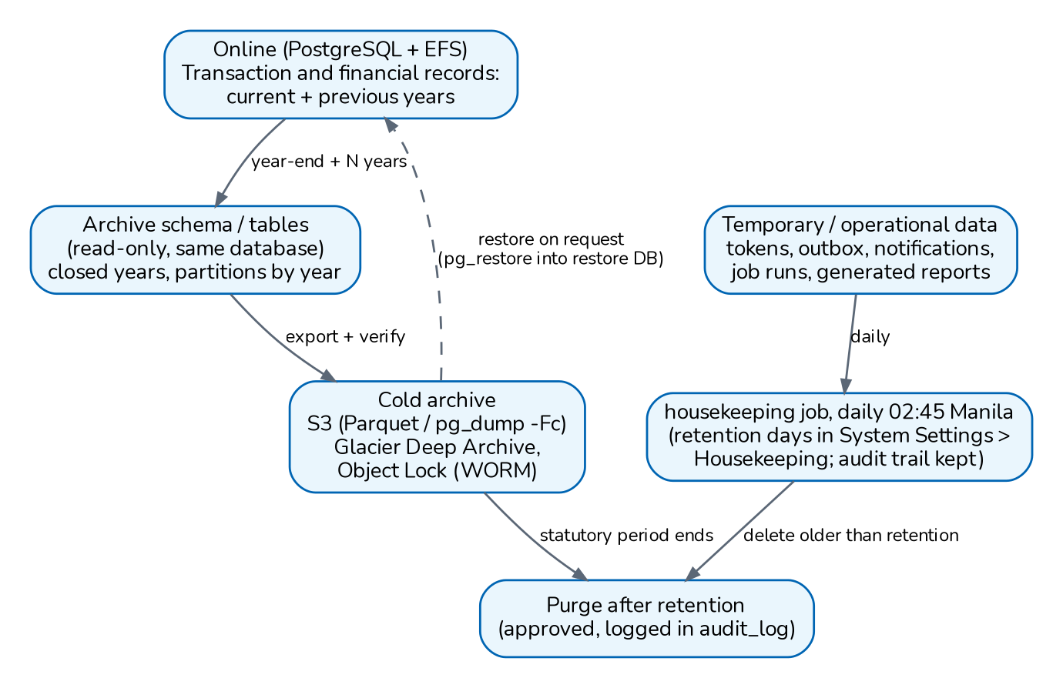
Figure 1. Data lifecycle: online, archive, purge (recommended)
Stage | Approach (Recommended / to be confirmed by the business and DevOps)
Online | Operational data stays in the main tables for the online period above; reports and screens work unchanged.
Archive in the database | For the high-volume tables (audit_log, login_history, later journal_lines and bank_statement_lines), convert to tables partitioned by year (declarative partitioning on at or jv_date) when the volume justifies it (for example above 10 million rows); old partitions can then be detached, exported and dropped in seconds without long deletes. Until then, move rows older than the online period into archive.<table> tables with the same structure in a separate schema, in batches.
Cold archive | Once a year, after the financial year is closed (year-end run) and audited: export the closed year (per table, filtered by date or by policy or financial year) with COPY ... TO as CSV or Parquet, or as a pg_dump -Fc of the archive schema, to an S3 bucket with Object Lock (compliance mode) and a lifecycle to S3 Glacier Deep Archive. Record a manifest (tables, row counts, checksums, date range, migration level from schema_migrations). Copy the files of the archived records from the file store to the same bucket under their storage keys.
Purge | Only after the export is verified (row counts and checksums) and approved by the data owner: delete the archived rows from the online database and record the purge in audit_log. Financial records are purged only after the statutory period.
Referential integrity | Archive whole business units together (a policy with its quotation, placement, bills, receipts, journals, commissions, claims and documents) or keep the referenced parent rows online; foreign keys (NO ACTION) prevent deleting a parent that is still referenced. Opening balances of later years keep the ledger totals correct after old journals are archived.

The document-number counters (sequences) stay online; old periods are small.

5.2 Restoration from archive
1. The data owner requests the records (for example a policy file of a given year for an audit or a claim dispute); the request is approved and logged.
2. DevOps restores the archive object from Glacier (standard retrieval up to 12 hours, bulk up to 48 hours for Deep Archive).
3. The data is loaded into a separate restore database, never into production: pg_restore of the archive dump, or CREATE TABLE and COPY ... FROM of the CSV or Parquet files, at the migration level recorded in the manifest.
4. The requester gets read access through a read-only database login or a report extract; the files come from the restored S3 objects.
5. The restore database is deleted once the purpose is fulfilled; the access is recorded.
If records must come back into production (for example a reopened claim), load them with the same ids after a review of the dependent rows. Ids are random text or serial values and do not collide with new records, and the document-number counters are not affected.

6 Sample-data purge before go-live
backend/scripts/purge-sample-data.js (npm run purge:sample) removes demo data from a database that was started with SEED_SAMPLE_DATA on (for example a UAT database promoted to production). It is a one-off go-live tool, not a housekeeping job.
Aspect | Behaviour
Safety | Refuses to run without CONFIRM_PURGE=yes; dry run by default (row counts per table); --execute deletes, in one transaction (any error rolls everything back). Stop the API instances first.
Removes | All rows of the transaction tables (leads to journals, broker slips, offers, placements and co-insurance participants, claims, renewals, fiscal years, opening balances, close runs, recurring journals, bank statements and reconciliations, BIR 2307 certificates, notifications, documents and generated-report records, job history, e-mail outbox, document-number counters), the sample master rows by natural key (fictional insurers, demo branches, signatories, referrers, reinsurers, incentive programmes, demo master records such as bank accounts and commission rates) and the six sample users. With --keep-users=a,b, every user except BrokerVerse and those listed.
Keeps | Reference data (settings, roles, permissions, scheduled jobs, masters, chart of accounts, posting rules, number series, tax codes, product templates, report catalogue) and the audit trail (the purge is recorded in it); --purge-audit also empties audit_log and login_history.
Files | Uploaded files of removed records stay in UPLOAD_DIR; clear the directory if nothing real was uploaded.
Afterwards | Set SEED_SAMPLE_DATA=false (or remove it) before starting the API, otherwise the sample data is seeded again. Then load the go-live data: masters, users, opening balances and open items (docs/onboarding/GO_LIVE_DATA_SETUP.md and the templates in docs/templates).

Procedure (deploy/README.md, section 7): take a snapshot; stop the API; CONFIRM_PURGE=yes npm run purge:sample and review the counts; CONFIRM_PURGE=yes npm run purge:sample -- --execute [--keep-users=...]; set SEED_SAMPLE_DATA=false; start the API; check that Leads, Clients and Policies are empty.

7 Related documents
This document is one of eleven that together form the BrokerVerse OOTB Solution Architecture. They are maintained and issued together (source and build: docs/architecture/README.md).
No. | Document | File
01 | Solution Component Diagram and Application Architecture | 01_BrokerVerse_Solution_Component_Diagram_Application_Architecture.pdf
02 | Database Design | 02_BrokerVerse_Database_Design.pdf
03 | Database Inventory | 03_BrokerVerse_Database_Inventory.pdf
04 | Technology Stack | 04_BrokerVerse_Technology_Stack.pdf
05 | Shared Service Components | 05_BrokerVerse_Shared_Service_Components.pdf
06 | Capacity and Performance | 06_BrokerVerse_Capacity_and_Performance.pdf
07 | High Availability and Resiliency | 07_BrokerVerse_High_Availability_and_Resiliency.pdf
08 | RTO and RPO | 08_BrokerVerse_RTO_and_RPO.pdf
09 | Backup and Recovery | 09_BrokerVerse_Backup_and_Recovery.pdf
10 | Data Archival, Housekeeping and Restoration (this document) | 10_BrokerVerse_Data_Archival_Housekeeping_and_Restoration.pdf
11 | Monitoring | 11_BrokerVerse_Monitoring.pdf

8 Glossary
Terms and abbreviations used in this document.
Term | Meaning
API | Application programming interface; here the BrokerVerse REST API under /api served by the Node.js backend.
Audit log / audit trail | Table audit_log: who changed which record, when, from which IP, with the before and after values.
BIR | Bureau of Internal Revenue (Philippines): tax authority whose rules drive record keeping and withholding tax certificates.
BIR Form 2307 | Certificate of creditable tax withheld at source, issued by the payor to the payee each quarter.
Co-insurance | Placement of one risk with several insurers, one of them the lead, each taking a share; premium, commission and claims are split by share.
Housekeeping | Daily job that deletes operational rows (job runs, sent e-mails, sign-in history, expired tokens, read notifications) after the retention days in System Settings.
IC | Insurance Commission (Philippines): regulator of insurers and brokers.
Migration | Numbered SQL file in backend/src/db/migrations applied once, in order, on API start.
Receivable / bill | Premium bill (INV-) raised when a policy, endorsement or renewal is issued.
Remittance | Payment of collected premium, net of commission, from the broker to the insurer.
RPO | Recovery point objective: the maximum acceptable data loss, measured in time.
RTO | Recovery time objective: the maximum acceptable time to restore service.
S3 | Amazon Simple Storage Service: object storage hosting the SPA build (and proposed archive store).
Seed | Idempotent data load run on every API start: reference data always, sample data only when SEED_SAMPLE_DATA is on.
UAT | User acceptance testing environment.

