
BrokerVerse OOTB
Insurance broking platform by iorta TechNXT
Solution Architecture · Document 02 of 11
Database Design

Product | BrokerVerse OOTB
Document | 02 Database Design
Version | 1.2
Date | 04 October 2026
Prepared by | iorta TechNXT
Classification | Confidential: for the client, iorta TechNXT and authorised partners
Prepared by iorta TechNXT

Document control
Document | BrokerVerse OOTB Solution Architecture: 02 Database Design
Document ID | BV-SA-02
Version | 1.2
Status | Issued for review
Date | 04 October 2026
Prepared by | iorta TechNXT
Source baseline | BrokerVerse source repository, branch brokerverse-platform (backend/, brokerverse/, deploy/, docker-compose.yml, .github/workflows, docs/)
Version history
Version | Date | Author | Change
1.0 | 29 September 2026 | iorta TechNXT | Initial issue
1.1 | 29 September 2026 | iorta TechNXT | Updated to the current system: placement journey, co-insurance, posting rules, period end and BIR tax, bank reconciliation, document numbering, commission rate matrix, single PDF engine, uploads and go-live imports, housekeeping, business time zone, broker roles, deployment on the BrokerVerse URL
1.2 | 04 October 2026 | iorta TechNXT | New modules (AML/CFT, BIR, payables and fixed assets, distribution, fleet and marine, My Work, go-live workbench), integration framework, encryption and masking of personal data, branding and e-signatures, release pipeline; database at migration 0322 (reference data), new ER diagrams
Review and approval
Role | Name | Signature | Date
Solution architect
DevOps / infrastructure lead
Information security
Business owner
Conventions
- Statements of fact are derived from the code, configuration and database of the baseline above (file paths are given relative to the repository). Figures measured on the local test system are labelled test data or indicative.
- Targets, sizes, retention periods and thresholds that are not facts of the code are labelled Recommended / to be confirmed by the business and DevOps.
- Items marked Gap are defects or missing capabilities found while preparing this document.

Contents
1 Introduction 6
1.1 Purpose and scope 6
1.2 Database platform 6
2 Schema overview by domain 8
3 Design conventions 10
3.1 Keys 10
3.2 Column types 10
3.3 JSONB document columns 11
3.4 Document numbering 11
3.5 Audit, history and soft delete 13
3.6 Ledger integrity 13
3.7 Constraints and indexes 13
4 Entity-relationship diagrams 15
4.1 Sales and policy 16
4.2 Placement and co-insurance 17
4.3 Renewals 18
4.4 Billing, receipts and collections 19
4.5 General ledger and posting rules 20
4.6 Period end and tax 21
4.7 Bank reconciliation 22
4.8 Disbursements and petty cash 23
4.9 Commission and incentive 24
4.10 Claims 25
4.11 Remittance and direct bill 26
4.12 Reinsurance 27
4.13 Configuration, security and platform 28
4.14 Reference masters and product configurator 30
4.15 Distribution and marketing 32
4.16 Fleet, marine open cover, claim documents and motor repairs 33
4.17 Payables, fixed assets, BIR and override commission 34
4.18 Compliance 35
4.19 Integrations 36
5 Migrations 37
6 Seed data 38
7 Time zone, date and amount handling 39
8 Related documents 40
9 Glossary 41

1 Introduction

1.1 Purpose and scope
This document describes the logical and physical design of the BrokerVerse OOTB database: the schema by business domain, the entity-relationship structure of each domain, the keys, the JSONB document columns, document numbering, audit and soft-delete conventions, the posting rules and period controls that protect the ledger, the migration and seed approach, and the handling of time zones, dates and amounts. The table-by-table inventory with sizes, row counts and retention classes is document 03.
Sources: backend/src/db/migrations/*.sql (139 files, 8,360 lines, plus the 10 migrations of packages B and G being merged), backend/src/db/seeds, backend/src/db/pool.js, migrate.js, seed.js, backend/src/lib/dates.js, money.js, numbering.js, and the catalogue of a PostgreSQL 16 database created for this issue on 04 October 2026: migrated with the migrations of the branch and of packages B and G and seeded with the reference data only (snapshot in docs/architecture/tools/data/db_snapshot.json).

1.2 Database platform
Item | Value (local test database)
PostgreSQL version | 16.13 (Ubuntu 16.13-0ubuntu0.24.04.1)
Database size | 28.6 MB (test data)
Server time zone | Asia/Manila
Tables (schema public) | 260
Columns by type | text 2595, timestamp with time zone 590, numeric 493, integer 293, date 220, jsonb 166, bigint 116, boolean 93, ARRAY 22, time without time zone 1
Indexes | 901 (440 unique incl. 260 primary keys, 71 partial, 1 GIN)
Foreign keys | 468 (60 without a supporting index)
Identity sequences (serial / identity columns) | 125
Document-number counters (table sequences) | 0 counters for -
Extensions | pgcrypto 1.3, plpgsql 1.0
Application functions | accounting_period_lock_guard, backfill_risk_participants, cities_default_region, document_numbering_mirror_prefix, format_document_number, gl_accounts_defaults, jv_check_posting, next_document_number, next_number, numbering_business_date, numbering_fiscal_year, numbering_optional_token, numbering_period_key, numbering_prefix, numbering_start_number, pe_balance_before, ph_place_key, pii_blind_index, pii_decrypt, pii_encrypt, pii_json_key, pii_jsonb_needs, pii_protect_columns, pii_protect_jsonb, pii_setting, pii_store, policies_channel_inherit, quotes_channel_inherit, quotes_link_product, receipt_applications_collected_on, rp_insurer_id, rp_parts_from_doc, rp_share, rp_write_split, rpt_age_bucket, set_updated_at, user_effective_roles
Triggers | accounting_period_lock_guard_trg (accounting_periods), audit_log_pii (audit_log), bir_2307_certificates_pii (bir_2307_certificates), cities_region (cities), clients_pii (clients), commission_rates_updated (commission_rates), commission_referrers_pii (commission_referrers), document_numbering_mirror (document_numbering), document_numbering_updated (document_numbering), gl_accounts_defaults_trg (gl_accounts), insurer_rate_tables_updated (insurer_rate_tables), jv_check_posting_trg (journal_vouchers), leads_pii (leads), lgu_tax_rates_updated (lgu_tax_rates), package_bundles_updated (package_bundles), package_quotes_updated (package_quotes), package_sections_updated (package_sections), payment_gateways_updated (payment_gateways), payment_links_updated (payment_links), placements_pii (placements), policies_channel_inherit (policies), policies_pii (policies), premium_charge_rules_updated (premium_charge_rules), quotes_channel_inherit (quotes), quotes_link_product (quotes), quotes_pii (quotes), receipt_applications_collected_on (receipt_applications), regions_updated (regions), roles_updated (roles), users_updated (users)
Views / materialised views | bank_account_links, bank_book_lines
Migrations applied | 149 (0001_core.sql to 0322_quote_covers_and_risk_fields.sql)
Application settings (app_settings) | 659 keys in 64 groups
Scheduled jobs (scheduled_jobs) | 35
Snapshot taken | 2026-10-04T09:13:21+00:00

One database and one schema (public) hold all data. The application connects with a single login through DATABASE_URL (node-postgres pool, maximum 10 connections per API process). The login needs the right to create tables because the API applies its own migrations on start. The database time zone is set to Asia/Manila (ALTER DATABASE ... SET timezone, or the RDS parameter group), as deploy/README.md requires. Only the pgcrypto extension is used, for gen_random_bytes() in primary-key defaults.

2 Schema overview by domain
The 260 tables fall into 25 domains (250 tables without packages B and G). Row counts and sizes are those of the reference data a new database starts with; transaction tables are empty.
Domain | Tables | Rows (reference data) | Size KB | Tables
Security and identity | 15 | 434 | 736 | access_review_items, access_reviews, authority_limits, authority_transaction_types, login_history, password_history, password_resets, permissions, refresh_tokens, role_permissions, roles, sod_rules, user_delegations, user_roles, users
Platform services | 16 | 1,461 | 1,440 | agent_events, app_settings, audit_log, document_numbering, document_signature_slots, documents, e_signatures, email_outbox, job_queue, job_runs, master_records, master_types, notifications, scheduled_jobs, schema_migrations, sequences
Reference masters | 17 | 5,475 | 2,136 | banks, branches, cities, countries, coverages, currencies, districts, insurance_companies, policy_types, postal_codes, products, regions, signatories, states, vehicle_brands, vehicle_models, vehicle_variants
Product configurator | 9 | 91 | 496 | insurer_rate_tables, lgu_tax_rates, package_bundle_sections, package_bundles, premium_charge_rules, product_components, product_risk_mappings, product_risk_sections, product_templates
Sales and policy | 14 | 3 | 936 | clients, cover_notes, endorsements, leads, package_endorsements, package_quotes, package_sections, payment_events, payment_gateways, payment_links, policies, policy_payments, quote_customer_responses, quotes
Placement and co-insurance | 4 | 0 | 264 | broker_slips, insurer_offers, placements, risk_participants
Claims | 6 | 0 | 224 | claim_document_items, claim_document_reminders, claim_field_changes, claim_history, claim_settlement_movements, claims
Renewals | 7 | 0 | 224 | renewal_activities, renewal_batch_policies, renewal_batches, renewal_notices, renewal_quotes, renewals, winback_campaigns
Billing, receipts and collections | 15 | 4 | 648 | client_credit_exceptions, collection_actions, collection_items, post_dated_cheques, premium_instalment_plans, premium_instalments, premium_warranty_actions, premium_warranty_extensions, receipt_applications, receipt_lines, receipts, receivable_credits, receivable_participants, receivables, write_off_reasons
General ledger and posting rules | 8 | 361 | 512 | accounting_config_changes, accounting_periods, entry_matches, gl_accounts, journal_lines, journal_vouchers, posting_rule_lines, posting_rules
Period end and tax | 12 | 39 | 392 | bir_2307_certificates, fiscal_years, opening_balances, period_close_checklist, period_close_entries, period_close_run_checks, period_close_runs, period_status_history, recurring_journal_runs, recurring_journals, tax_codes, year_end_runs
Bank reconciliation | 9 | 17 | 304 | bank_match_rules, bank_rec_match_items, bank_rec_matches, bank_reconciliation_history, bank_reconciliations, bank_statement_formats, bank_statement_lines, bank_statements, bank_transaction_types
Disbursements and petty cash | 9 | 0 | 408 | checkbooks, disbursements, invoice_lists, petty_cash_disbursements, petty_cash_funds, petty_cash_receipts, petty_cash_replenishments, petty_cash_request_lines, petty_cash_requests
Commission | 8 | 0 | 272 | commission_adjustments, commission_rates, commission_referrers, commissions, override_agreement_tiers, override_agreements, override_computations, override_settlements
Remittance and direct bill | 16 | 1 | 648 | commission_debit_note_collections, commission_debit_note_lines, commission_debit_notes, direct_bill_client_payments, direct_bill_items, insurer_refund_credits, insurer_statement_formats, insurer_statement_lines, insurer_statement_resolutions, insurer_statements, remittance_allocations, remittance_approvals, remittance_delegations, remittance_items, remittance_lines, remittances
Reinsurance | 10 | 0 | 376 | cessions, fac_placement_shares, fac_placements, fac_settlements, reinsurance_bordereaux, reinsurance_exceptions, reinsurance_reconciliations, reinsurance_recoveries, reinsurance_treaties, reinsurers
Incentive | 3 | 0 | 80 | incentive_calculations, incentive_programs, incentive_results
Reporting | 5 | 40 | 240 | bi_extract_runs, generated_reports, report_builder_reports, report_definitions, report_schedules
Distribution and marketing | 13 | 0 | 520 | campaign_recipients, campaign_segments, campaign_templates, campaigns, channel_billing_accounts, comparison_reports, dealer_sales, dealer_sales_batches, distribution_channels, lead_assignment_history, lead_assignment_rules, motor_programmes, sales_activities
Fleet, marine and motor claims | 8 | 0 | 344 | claim_loas, claim_repair_estimates, claim_vehicle_releases, fleet_schedules, fleet_vehicles, open_cover_certificates, open_cover_declarations, open_covers
Payables and fixed assets | 7 | 0 | 248 | fixed_asset_depreciation, fixed_asset_disposals, fixed_assets, supplier_invoice_lines, supplier_invoices, supplier_payment_allocations, supplier_payments
BIR returns and invoicing | 6 | 0 | 184 | bir_return_filings, cas_book_prints, eis_submissions, sales_invoice_lines, sales_invoice_payments, sales_invoices
Compliance: AML, Insurance Commission and data privacy | 27 | 80 | 1,040 | aml_alerts, aml_cases, aml_edd_reviews, aml_list_entries, aml_list_versions, aml_provider_requests, aml_report_items, aml_reports, aml_risk_assessments, aml_risk_factors, aml_rules, aml_screening_hits, aml_screening_lists, aml_screenings, client_beneficial_owners, client_kyc_documents, client_signatories, complaint_reminders, complaints, compliance_fit_proper, compliance_licence_reminders, compliance_licences, data_subject_requests, ic_statement_lines, personal_data_breach_reminders, personal_data_breaches, privacy_consents
Integrations | 12 | 19 | 416 | bank_file_layouts, bank_payment_batch_lines, bank_payment_batches, coc_series, ctpl_authentications, insurer_api_mappings, integration_attempts, integration_connectors, integration_inbox, integration_outbox, message_templates, payee_bank_accounts
Go-live data load and work management | 4 | 0 | 152 | data_load_batches, data_load_comparisons, data_load_rows, work_tasks
Total | 260 | 8,025 | 13,240

3 Design conventions

3.1 Keys
Convention | Detail
Business records | 103 tables use a text primary key made of a readable prefix and random hexadecimal characters generated by the database, for example policies.id DEFAULT 'pol_' || encode(gen_random_bytes(8), 'hex'). Prefixes include ld_ lead, cl_ client, qt_ quotation, bs_ broker slip, ofr_ insurer offer, plc_ placement, pol_ policy, end_ endorsement, clm_ claim, rnw_ renewal, or_ receipt, jv_ journal voucher, pv_ payment voucher, rm_ remittance, dn_ debit note, brc_ bank reconciliation, yec_ year-end run, usr_ user and doc_ document. The ids cannot be guessed and do not collide across tables.
Reference, line and log tables | 125 tables use integer or bigint serial keys: masters (countries, banks, insurers, products), lines and logs that grow fast (journal_lines, audit_log, login_history, job_runs, claim_history, risk_participants, bank_rec_match_items, period_status_history).
Natural and composite keys | 32 tables: app_settings(key), gl_accounts(code), master_types(code), report_definitions(code), accounting_periods(period), fiscal_years(code), tax_codes(code), bank_statement_formats(code), bank_transaction_types(code), bank_match_rules(code), period_close_checklist(code), opening_balances(fiscal_year, account_code), receivable_participants(receivable_id, insurance_company_id), refresh_tokens(jti), schema_migrations(name), sequences(name, period), role_permissions, user_roles and others.
Business numbers | Readable document numbers (QT-2026-00001, POL-2026-00001, OR-2026-00019, BS-, PS-, MEC-, BRC-) are separate unique columns (quote_number, policy_number, receipt_number, slip_number, run_number...), never primary keys. Most detail endpoints accept either the id or the number.
Foreign keys | 468 foreign keys: 369 NO ACTION (a referenced record cannot be deleted while in use), 77 CASCADE (children with no meaning without their parent: journal lines, receipt lines, match items, claim history, renewal notices, role grants, refresh tokens, notifications) and 22 SET NULL.

3.2 Column types
Data | Type and handling
Amounts | numeric (490 columns), typically numeric(14,2); converted to JavaScript numbers by the pool type parser; all rounding through round2() in lib/money.js (half away from zero, the same rule as PostgreSQL round(numeric, 2)). Shares are numeric(7,4).
Business dates | date (217 columns: inception, expiry, due, loss, receipt, voucher, statement and period dates), returned to the application as YYYY-MM-DD strings so no time-zone shift can occur. Date columns that default to today take numbering_business_date(), the date in general.timezone.
Instants | timestamptz (590 columns, for example created_at, approved_at, sent_at); there are no timestamp without time zone columns.
Flexible parts | jsonb (166 columns in 103 tables), see below.
Codes and statuses | text with validation in the application (zod, service rules) and 390 CHECK constraints; statuses are lower-case codes mapped to display labels.

3.3 JSONB document columns
JSONB is used where the structure varies by product, screen or configuration. Columns that are searched, joined, totalled or reported on stay relational.
Table | JSONB columns and use
quotes, broker_slips, placements | Wizard inputs and selected covers, the full document (doc) with premium breakdown and customer data, risk details and requested covers
policies | details (risk and party details, renewal link), doc (policy document data carried from the quotation or placement)
insurer_offers | taxes, deductibles, terms of an insurer's answer
claims | details, driver, third_party, policy_info, adjuster, settlement
endorsements | changes (field changes and re-pricing), endorsement_type_ids, completion
renewals, renewal_quotes | Coverage details, accessories, order summary, limits, premium breakdown, taxes and rating
product_templates, product_components | config, features, insurers, tags; component data (covers, rating tables, rules, the motor CTPL tariff)
master_records, master_types | data of generic masters (GIN index master_records_data_idx, jsonb_path_ops); fields and unique_keys of each master screen
app_settings | value: every configuration value
audit_log | before_data, after_data of every audited change
period end and bank reconciliation | period_close_runs.steps, period_close_run_checks.detail, recurring_journals.lines, year_end_runs.checks, bir_2307_certificates.lines, bank_statement_formats.columns, bank_match_rules.params, bank_reconciliations.snapshot
finance and reinsurance | remittances.data, remittance_items.data, remittance_approvals.history, insurer_refund_credits.split, reinsurance_treaties.terms, incentive_programs.structure
operations | scheduled_jobs.params, job_runs.output, job_queue.payload, generated_reports.params, report_definitions.parameters

3.4 Document numbering
Every document number comes from a series in the Document Numbering master (document_numbering, 85 series, Master > Document Numbering). nextDocumentNumber(code, { db }) in lib/numbering.js calls the SQL function next_document_number(code, branch, lob, date). The function locks the counter row of the series and period in sequences until the caller's transaction ends, so two users never get the same number and a rolled-back save gives its number back. format_document_number() applies the pattern: tokens {PREFIX} {YYYY} {YY} {MM} {FY} {BRANCH} {LOB} {SEQ}; all seeded series use {PREFIX}-{YYYY}-{SEQ}. A prefix must be unique among active series (index document_numbering_active_prefix); migration 0246 lets a series start a period at the old system's next number at go-live. The reset rule of a series is yearly, fiscal_yearly, monthly or never; the counter period is 2026, FY2027, 2026-09 or ALL. The year is taken from the business date in general.timezone, so a document created at 00:30 Manila time on 1 January gets the new year. The next number of a series can only be moved forward (for example to continue from the legacy system at go-live). A trigger copies each prefix into the read-only setting numbering.<code>.prefix.
Series (code) | Prefix | Reset | Series (code) | Prefix | Reset
acknowledgement_receipt | AR | yearly | marine_certificate | MIC | yearly
adjustment | ADJ | yearly | marine_declaration | MDC | yearly
aml_alert | AMA | yearly | open_cover | MOC | yearly
aml_case | AMC | yearly | override_computation | OVC | yearly
aml_edd | EDD | yearly | package_policy | PKG | yearly
aml_report | AMR | yearly | package_quote | PQ | yearly
bank_payment_batch | BPB | yearly | payment_link | PL | yearly
bank_reconciliation | BRC | yearly | pdc | PDC | yearly
bank_statement | BST | yearly | period_close | MEC | yearly
bank_txn | BNK | yearly | petty_cash | PC | yearly
bir_2307 | CWT | yearly | petty_cash_fund | PCF | never
bordereau | BDX | yearly | petty_cash_receipt | PCRC | yearly
broker_slip | BS | yearly | petty_cash_request | PCR | yearly
campaign | WB | yearly | placement | PS | yearly
cession | CES | yearly | policy | POL | yearly
claim | CLM | yearly | product_template | TPL | yearly
claim_loa | LOA | yearly | quote | QT | yearly
claim_payment_voucher | CPV | yearly | receipt | OR | yearly
client | CL | yearly | receipt_txn | RT | yearly
commission_debit_note | DN | yearly | recurring_journal | RJV | yearly
commission_master | COM | never | reinsurer | RE | yearly
comparison_report | CMP | yearly | remittance | REM | yearly
complaint | CPX | yearly | remittance_batch | BLK | yearly
cover_note | CVN | yearly | remittance_bill | BIL | yearly
data_breach | PDB | yearly | remittance_exception | EXC | yearly
data_subject_request | DSR | yearly | remittance_notice | NTF | yearly
dealer_sales_batch | DSB | yearly | remittance_report | RPT | yearly
disbursement_txn | DT | yearly | remittance_schedule | SCH | yearly
dn_collection | DNC | yearly | renewal | RN | yearly
employee | EMP | never | renewal_batch | RB | yearly
endorsement | END | yearly | renewal_quote | RQ | yearly
fac_slip | FAC | yearly | ri_reconciliation | REC | yearly
fixed_asset | FA | yearly | ri_recovery | RCL | yearly
fleet_schedule | FLT | yearly | sales_invoice | SI | never
incentive_calc | CALC | yearly | settlement | SET | yearly
incentive_program | INC | yearly | statement | STMT | yearly
insurer_offer | OFR | yearly | supplier_invoice | APV | yearly
insurer_statement | ISR | yearly | supplier_payment | SPV | yearly
invoice | INV | yearly | transfer | TRF | yearly
invoice_list | IL | yearly | treaty | TRT | yearly
invoice_payment | PAR | yearly | voucher | PV | yearly
journal | JV | yearly | year_end_close | YEC | yearly
lead | LD | yearly

3.5 Audit, history and soft delete
Convention | Detail
Row stamps | created_at (192 tables), updated_at (148), created_by (157), updated_by (107). updated_at is set by the application; triggers maintain it on users, roles, commission_rates and document_numbering (set_updated_at()).
Audit log | audit_log(id, at, user_id, username, entity, entity_id, action, before_data, after_data, ip, source) (source, migration 0247: screen, API or job), written by lib/audit.js from every create, update, approval, posting, run and sign-in related event; indexed on (entity, entity_id), (at) and (username).
Domain histories | claim_history, claim_field_changes, renewal_activities, renewal_notices, collection_actions, remittance_approvals.history, period_status_history, bank_reconciliation_history, login_history, password_history, job_runs.
Soft delete | leads, quotes and bank_statements carry deleted_at; masters and product components use a status of deleted (unique indexes are partial: WHERE status <> 'deleted'). Financial documents are never deleted but cancelled or reversed (receipts.cancelled_at, journal reversal and correction vouchers, bir_2307_certificates.cancelled_at). A draft quotation is the only business record deleted physically.

3.6 Ledger integrity
Control | Detail
Posting rules | Every system journal is built by postEvent() from the posting rule of its business event (43 events with an active rule, for example policy.issue.broker_billed, ap.invoice, fa.depreciation, sales_invoice.issue, override_commission.accrual, receipt.apply, remittance.settlement, claim.funds_received, commission.clawback). A rule has versions with an effective date (posting_rules) and lines (posting_rule_lines) that name either a GL account or an account role. Account roles resolve to GL accounts through the settings accounting.account.<role> (Account Determination). A line marked per participant is split across the co-insurers by share, with the rounding remainder on the lead.
Balance and period trigger | Trigger jv_check_posting refuses to post a journal voucher with fewer than two lines, unbalanced, with a zero total, or in a period that does not accept postings.
Period status | accounting_periods holds periods 1 to 12 and the adjustment period 13 of each fiscal year with the status open, soft_closed, closed or locked. Trigger accounting_period_lock_guard refuses to reopen a period locked by the year-end close. Every change is written to period_status_history.
Opening balances | The year-end close writes the balance-sheet balances into opening_balances of the next year; the go-live import writes the old system's trial balance there (source go-live:<date>). Reports read them through pe_balance_before(); no opening journal is posted.
Co-insurance | risk_participants holds the participants of a broker slip, quotation, placement or policy (one lead, shares total 100%, index risk_participants_one_lead); receivable_participants and remittance_allocations split bills and collections per insurer.
Account defaults | Trigger gl_accounts_defaults derives the normal balance of an account from its type.

3.7 Constraints and indexes
The schema has 901 indexes: 260 primary keys, 180 further unique indexes (business numbers, natural keys and partial uniqueness such as one open renewal per policy, one pending approval per entity, one active close run per period, one lead co-insurer per record), 71 partial indexes and one GIN index. Case-insensitive uniqueness uses expression indexes on lower(...).
Migration 0146_foreign_key_indexes.sql indexed the foreign keys of every table that grows (transactions, documents, lines and logs) and added the operational log indexes job_runs (job_id, started_at), email_outbox (status, created_at), audit_log (at) and audit_log (username). The list was produced by backend/scripts/fk-index-report.js. 60 of the 468 foreign keys have no index whose first column is the foreign-key column; they are on small master and set-up tables (vehicle models, states, policy types, product components) or are maker-checker stamp columns (approved_by, rejected_by), left out on purpose. They are listed in document 03.

4 Entity-relationship diagrams
The diagrams are generated from the database catalogue. Each box lists the primary key (PK), up to two unique keys (UK), the foreign keys (FK; a red asterisk marks an FK without a supporting index) and the JSONB columns ({ }). Dashed boxes are tables of another domain. References to users (creator, owner, approver) are listed as columns but drawn only in the security diagram.

4.1 Sales and policy
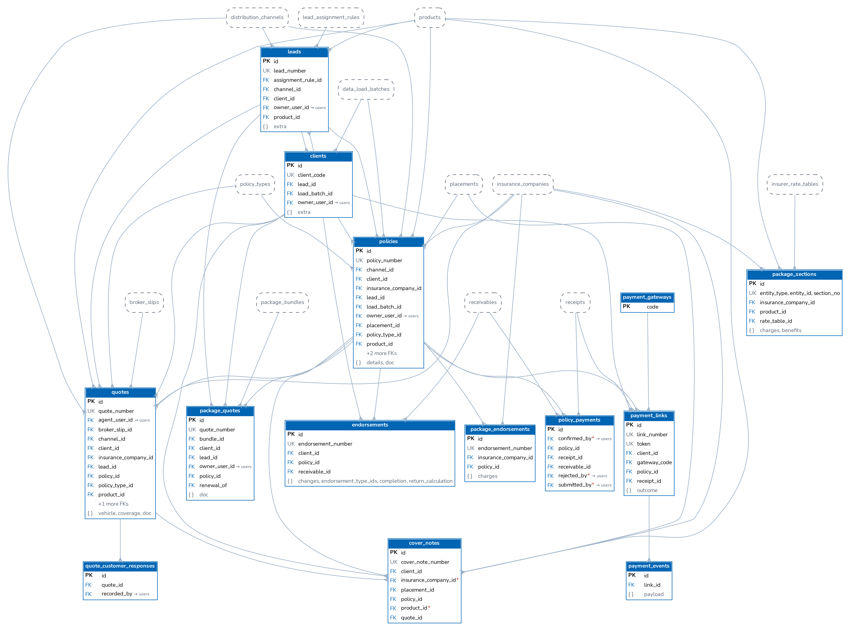
Figure 1. Sales and policy: leads, clients, quotations, policies, endorsements, payment captures
A lead becomes a client when a quotation is converted (clients.lead_id is unique when set). A quotation references the lead or client, product, policy type, insurer and signatory; conversion creates the policy (policies.quote_id, quotes.policy_id). A renewed policy points to its predecessor (policies.renewed_from, renewed_to). Endorsements belong to a policy and may raise their own bill (endorsements.receivable_id). policy_payments holds payments captured by front-office staff until Accounting confirms them and issues a receipt.

4.2 Placement and co-insurance
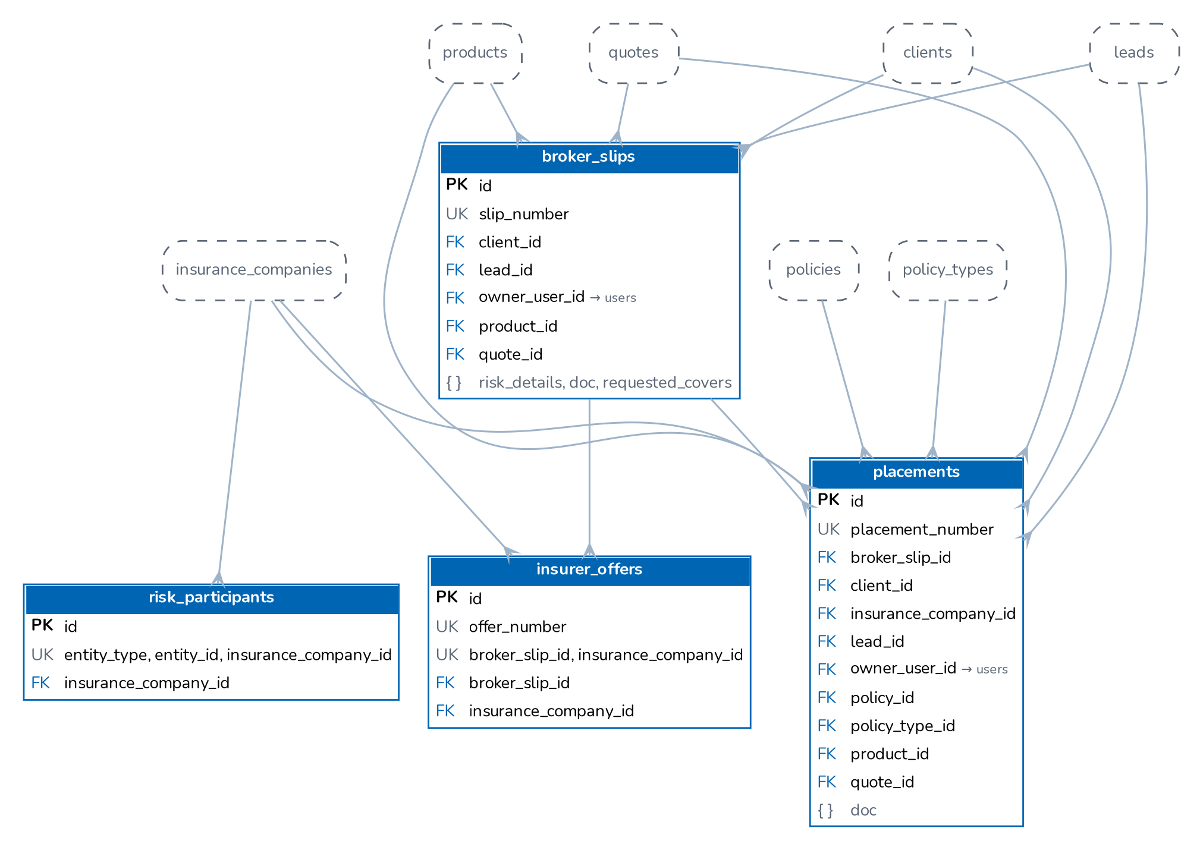
Figure 2. Placement: broker slips, insurer offers, placement slips and co-insurance participants
A broker slip is created from a lead or client and sent to several insurers; each answer is an insurer_offers row (premium, rate, taxes, deductibles, validity, share offered) or a decline. The chosen offers become a quotation or a placement slip (placements.broker_slip_id, placements.quote_id). A placement is sent to the lead insurer and the co-insurers; each participant binds with its own reference and the policy is issued when all have bound (placements.policy_id). risk_participants is shared by all four record types through entity_type and entity_id.

4.3 Renewals
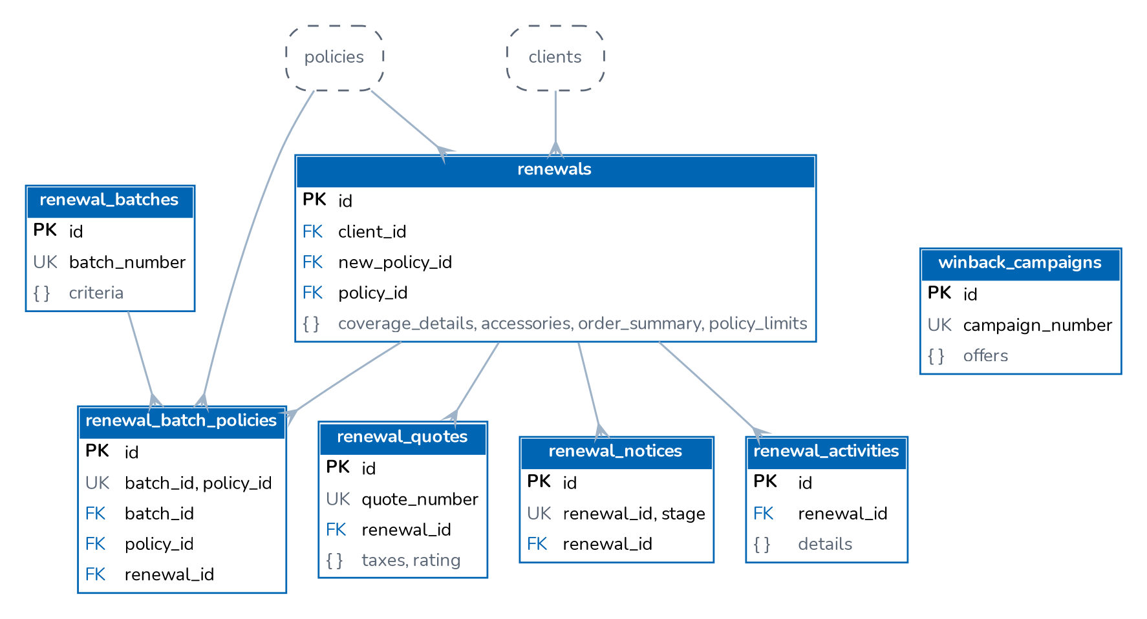
Figure 3. Renewals: renewal cases, quotes, notices, activities, batches, win-back campaigns

4.4 Billing, receipts and collections
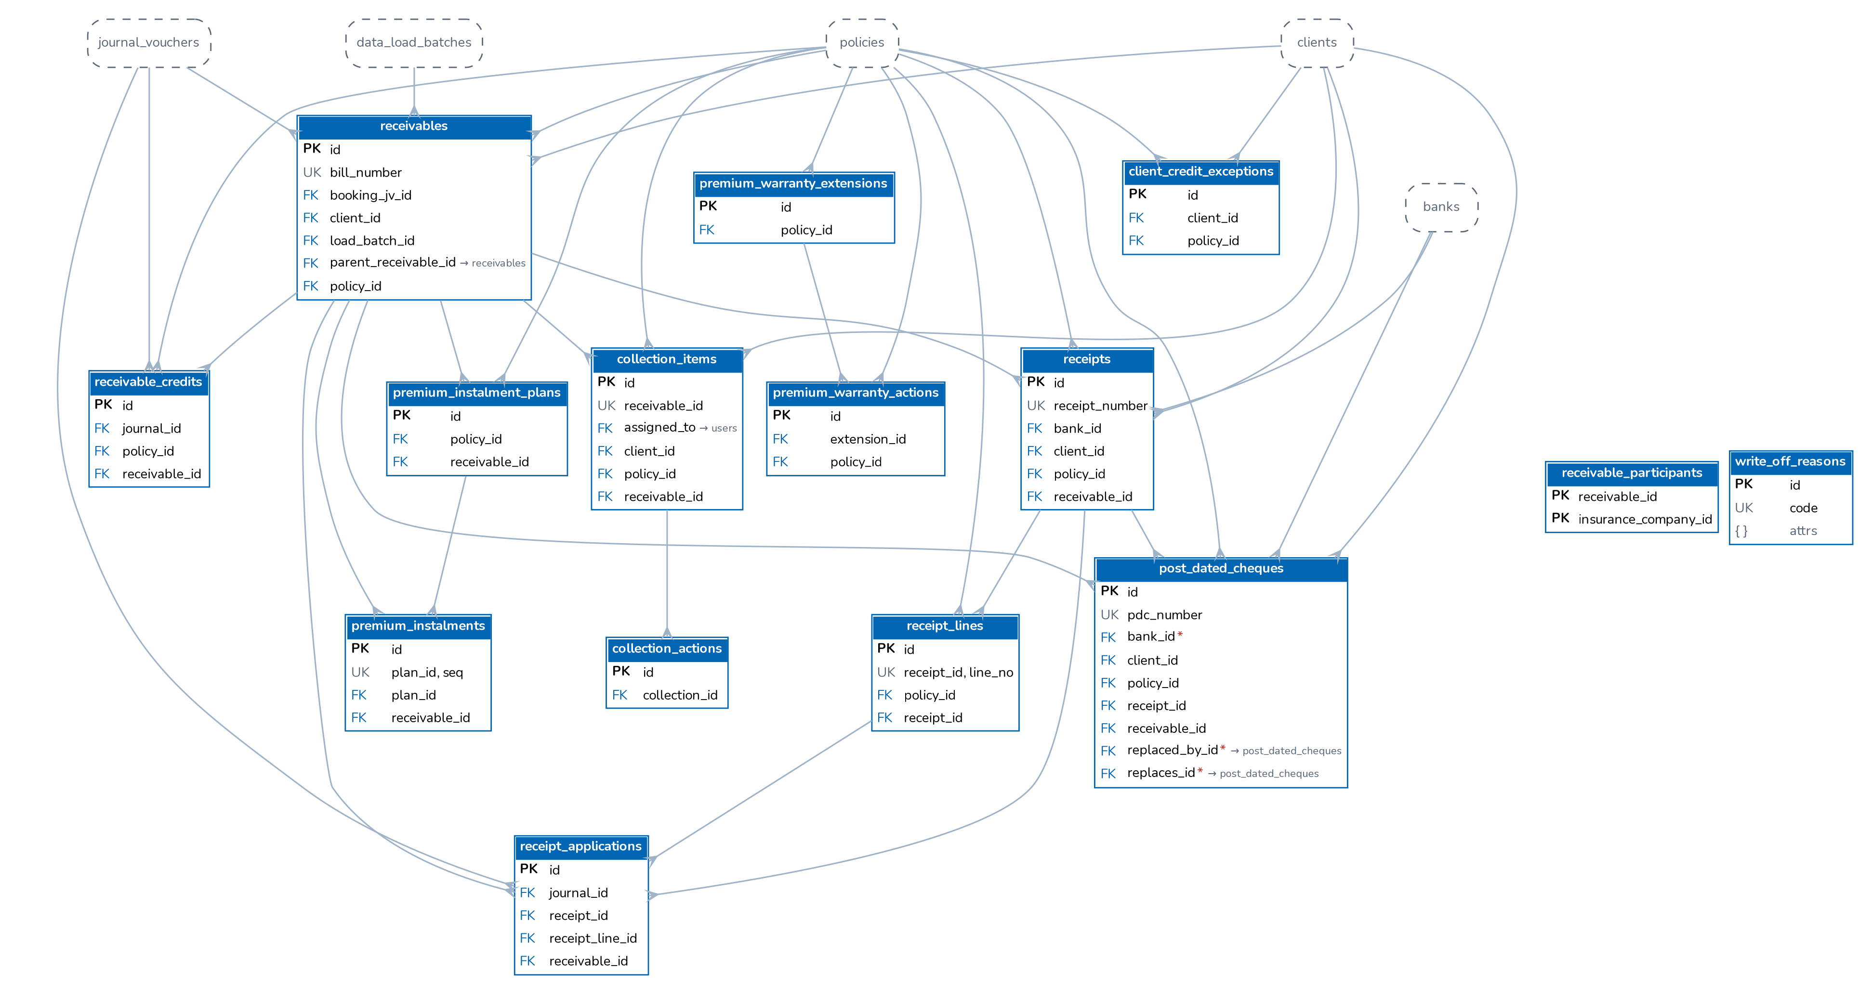
Figure 4. Billing, receipts, credits, co-insurance split and collections
A policy, endorsement or renewal raises a receivable (bill) with its booking journal (receivables.booking_jv_id). A receipt has lines per policy, and receipt applications allocate the lines to bills and link the posting journal. Return premium and cancellations reduce a bill through receivable_credits. Collection items track the follow-up of open bills; write-offs use the reasons and GL accounts of write_off_reasons.

4.5 General ledger and posting rules
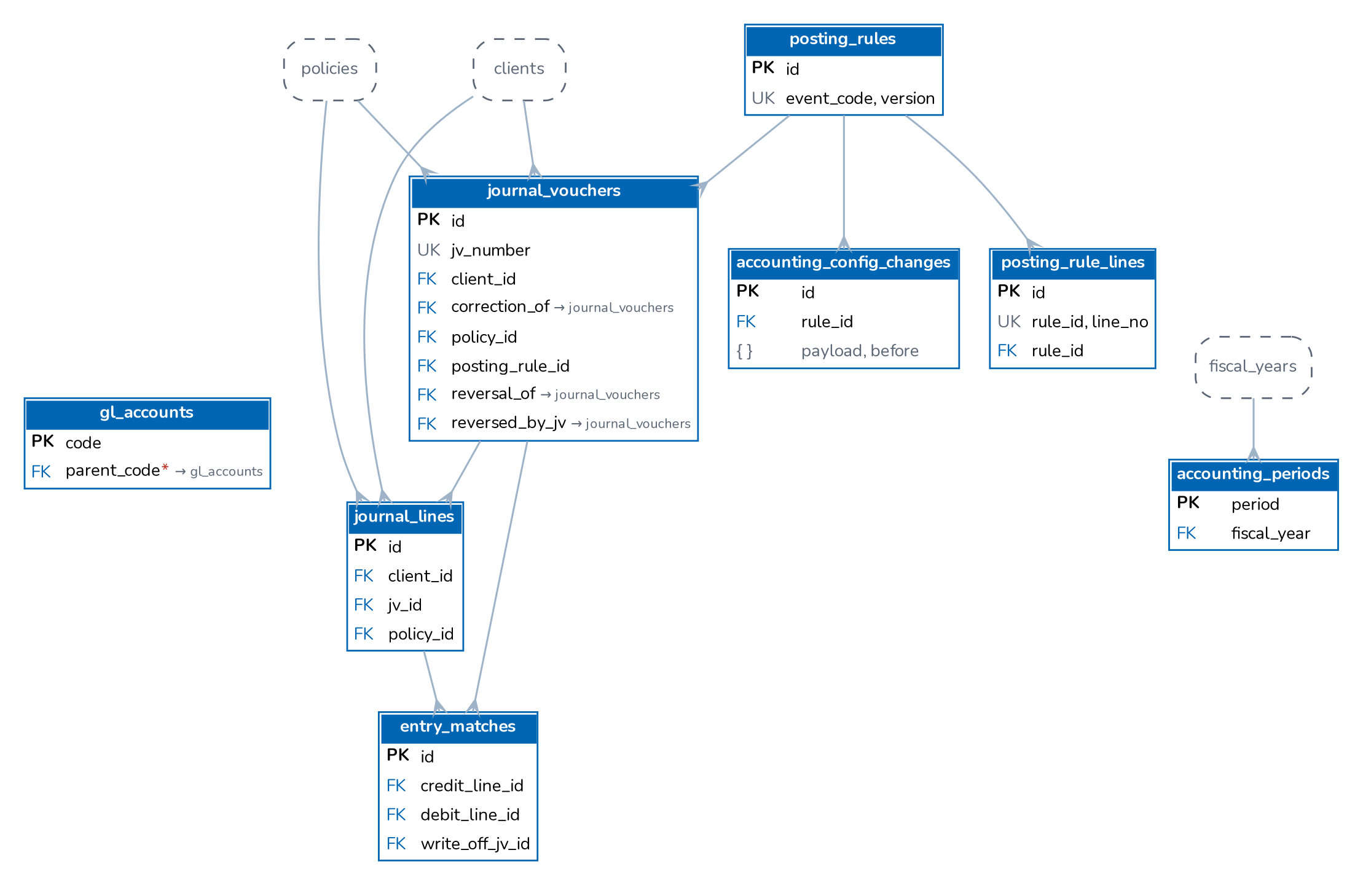
Figure 5. General ledger: chart of accounts, journals, periods, matching and posting rules
Journal vouchers hold balanced journal lines coded to the chart of accounts (gl_accounts). Open-item accounts are reconciled by entry_matches (debit line to credit line). Journals point back to their source document through journal_vouchers.reference_type and reference_id.

4.6 Period end and tax
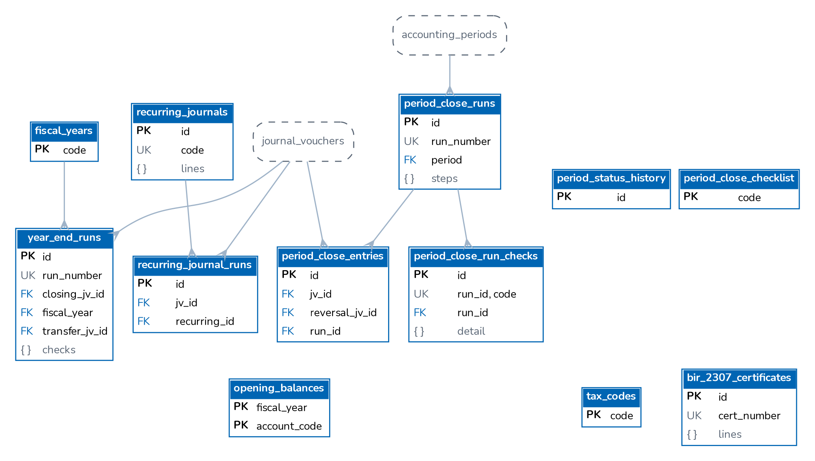
Figure 6. Period end: fiscal years, close runs, recurring journals, year-end, tax codes and BIR 2307

4.7 Bank reconciliation
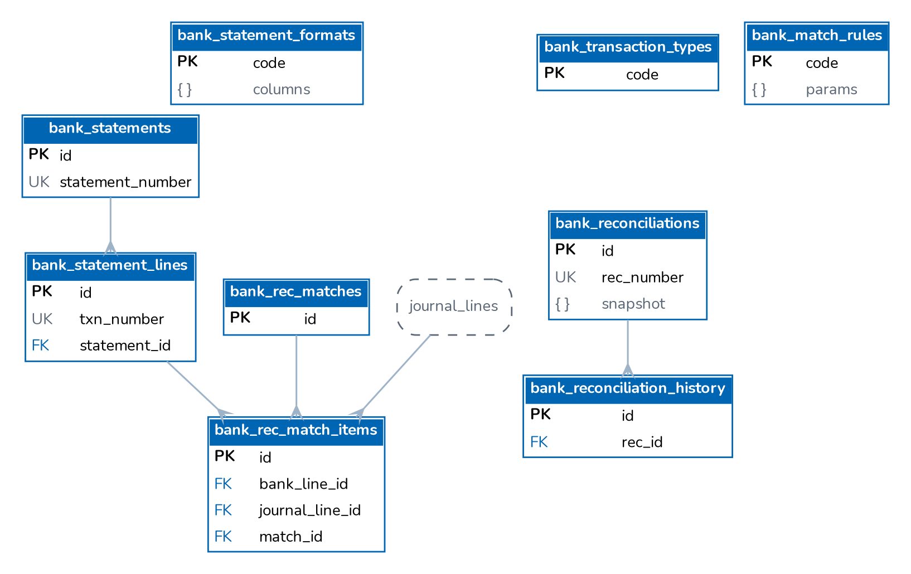
Figure 7. Bank reconciliation: statement formats, statements and lines, matches, reconciliations
A bank statement is imported with a statement format into bank_statements and bank_statement_lines (a line hash refuses duplicates). Matches link bank lines to cash-account journal lines (bank_rec_match_items with a side). A monthly reconciliation (bank_reconciliations) stores the statement figures and, once approved, locks the matches cleared up to the period end. The bank account itself is a master record linked to a GL cash account.

4.8 Disbursements and petty cash
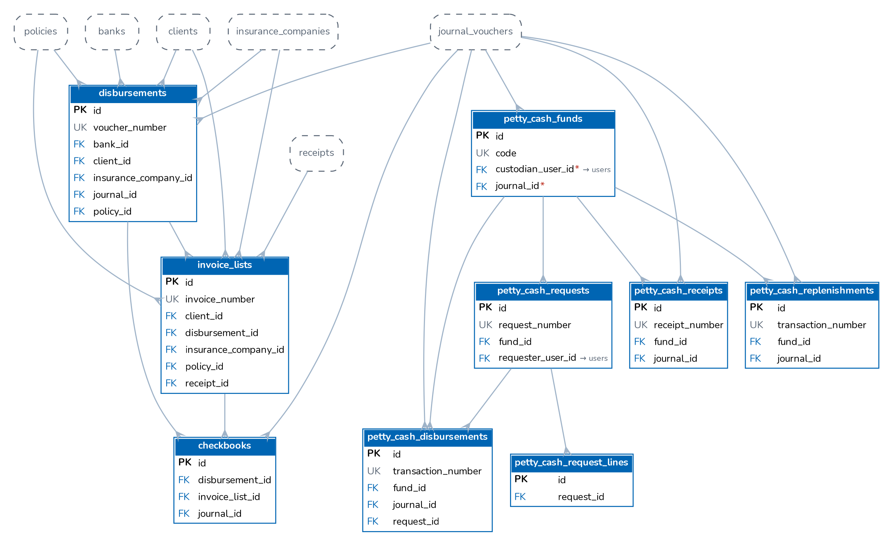
Figure 8. Disbursements (payment vouchers, invoice lists, cheques) and petty cash

4.9 Commission and incentive
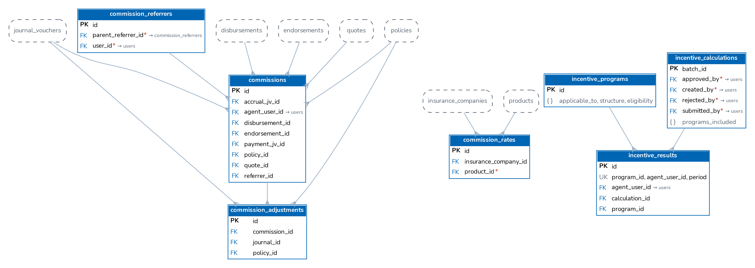
Figure 9. Commission lines, adjustments, the rate matrix, referrers and incentive programmes
Commission lines are created per policy, endorsement and referrer in the referral chain (commissions_policy_referrer_uq), link to the accrual and payment journals and to the payment voucher that paid them. commission_adjustments records the reversal or clawback when premium is returned. The rate of a new policy comes from commission_rates (insurer, product, line, policy type, effective dates), else the insurer's default rate. Referrers form a hierarchy (parent_referrer_id); they do not sign in.

4.10 Claims
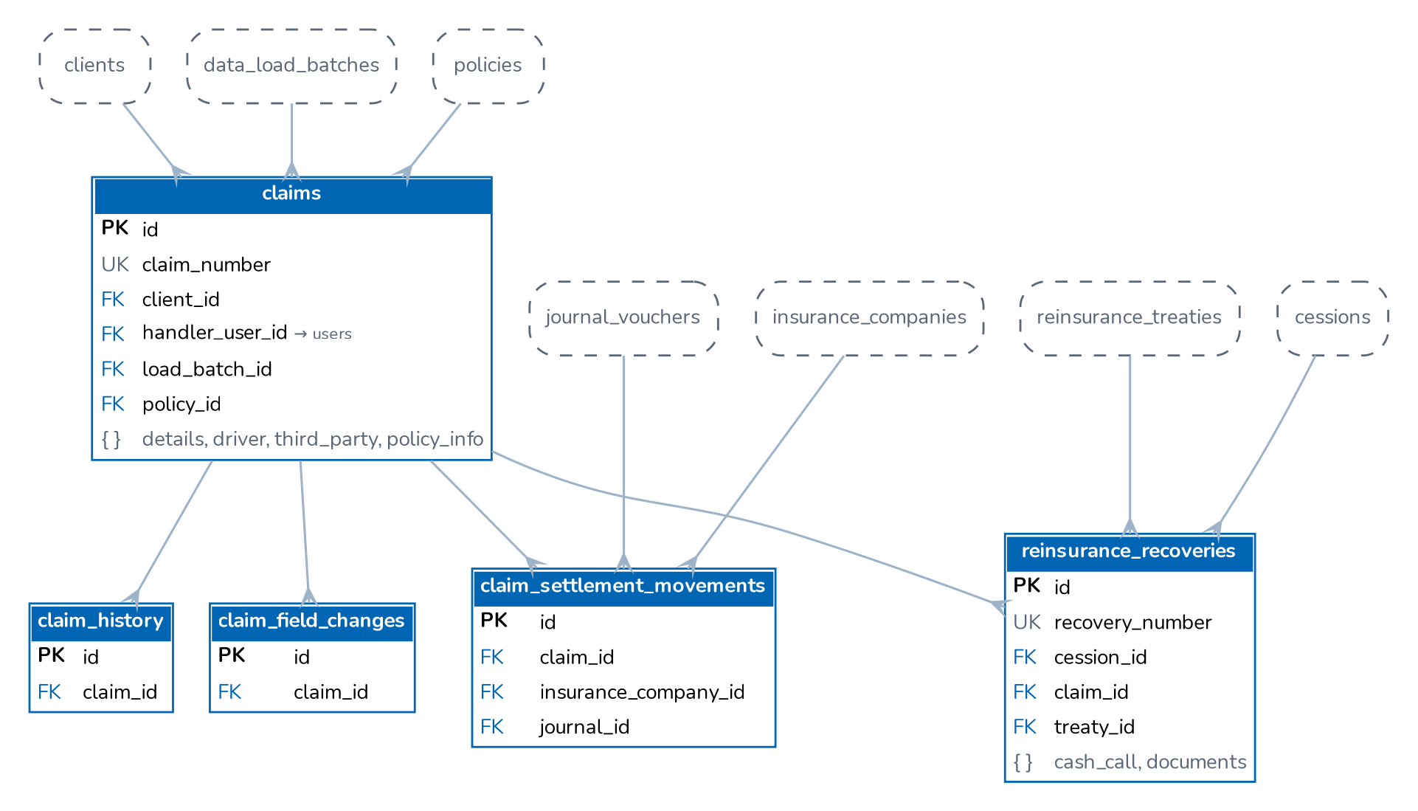
Figure 10. Claims, claim history, field-level changes, settlement cash and reinsurance recoveries

4.11 Remittance and direct bill
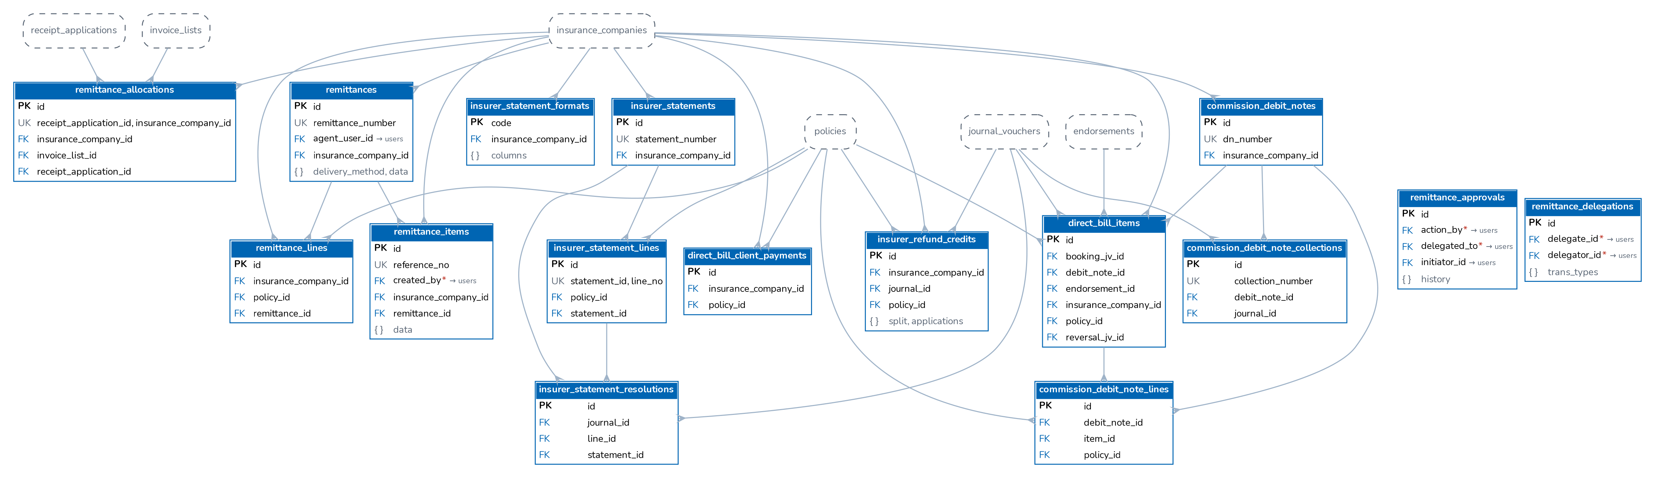
Figure 11. Remittances to insurers, co-insurance allocations, insurer refunds and direct-bill debit notes
Broker-billed premium is remitted to insurers through remittances with remittance_lines per policy; settlements, adjustments and exceptions are remittance_items; remittance_approvals is a multi-level approval register (entity, levels, SLA, history). For a co-insured policy remittance_allocations splits each collection by insurer share. insurer_refund_credits holds refunds due from an insurer on returned premium already remitted; they are netted against the next remittance. Direct-billed policies produce direct_bill_items (commission receivable) billed to the insurer on commission_debit_notes and settled by commission_debit_note_collections.

4.12 Reinsurance
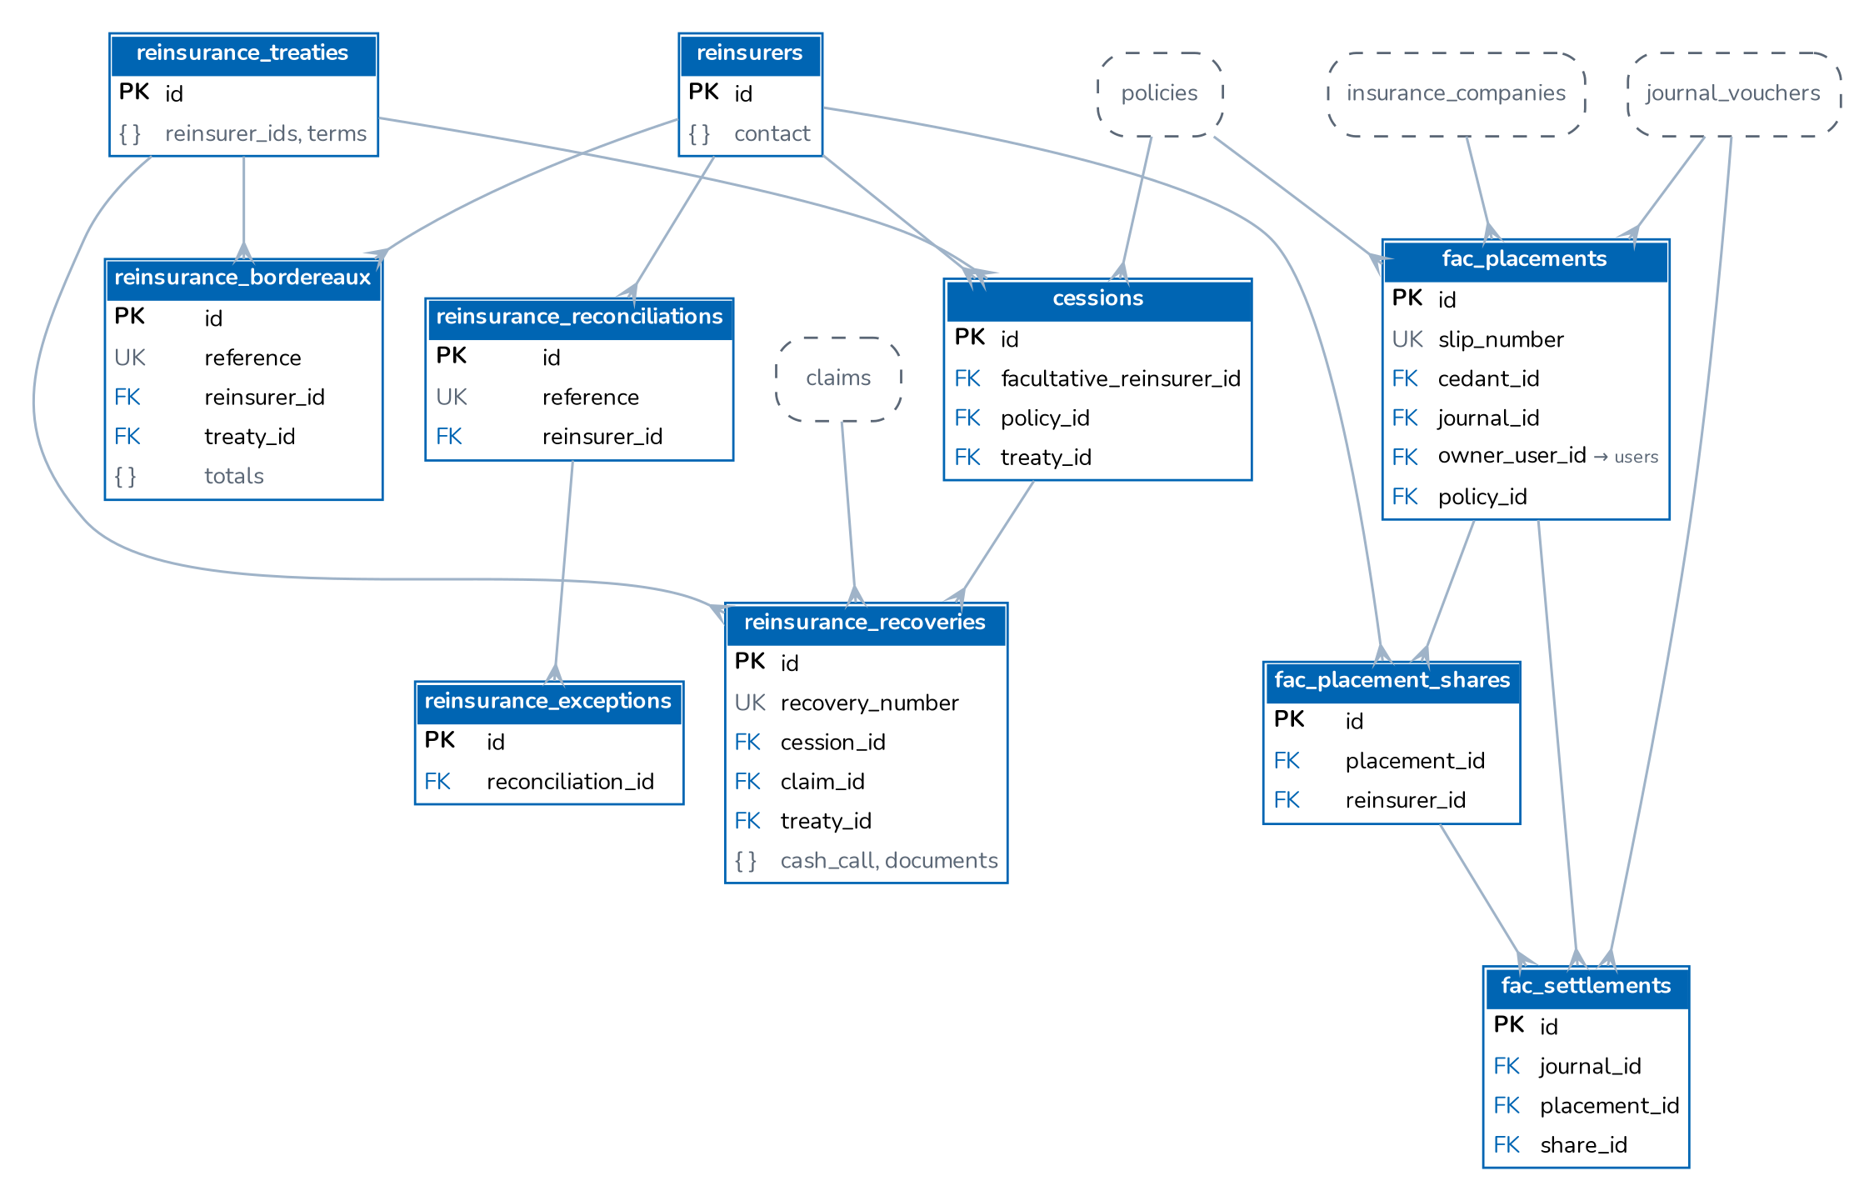
Figure 12. Reinsurers, treaties, cessions, recoveries, bordereaux and reconciliations

4.13 Configuration, security and platform
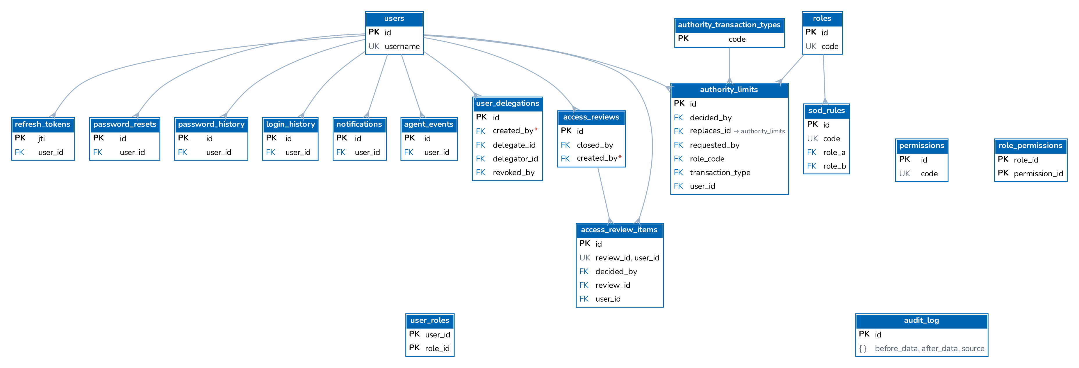
Figure 13. Security and identity tables
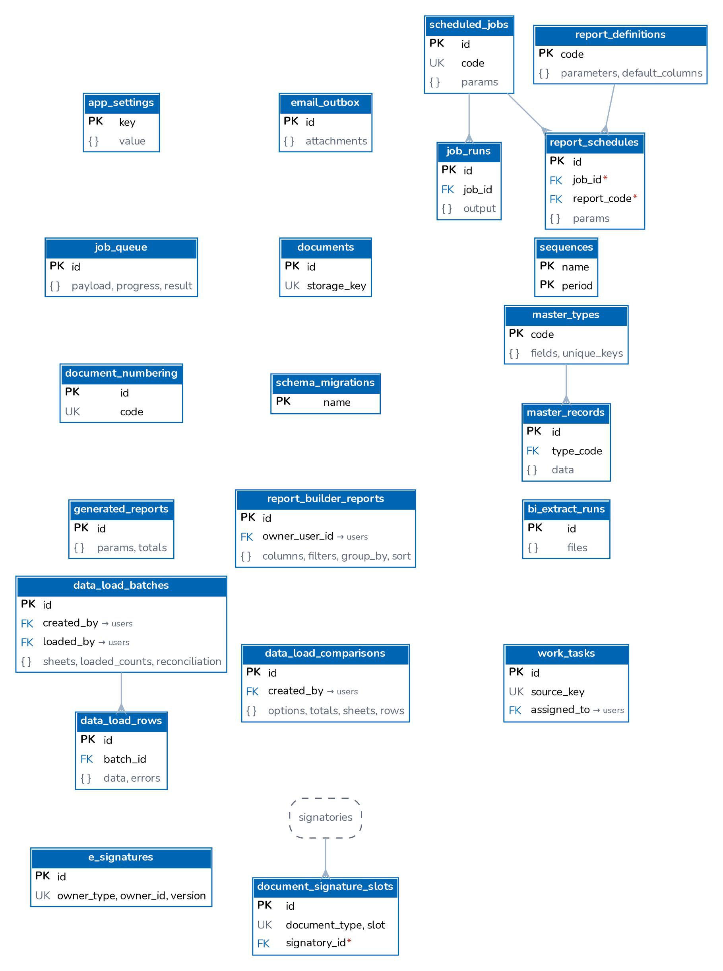
Figure 14. Configuration and platform services tables

4.14 Reference masters and product configurator
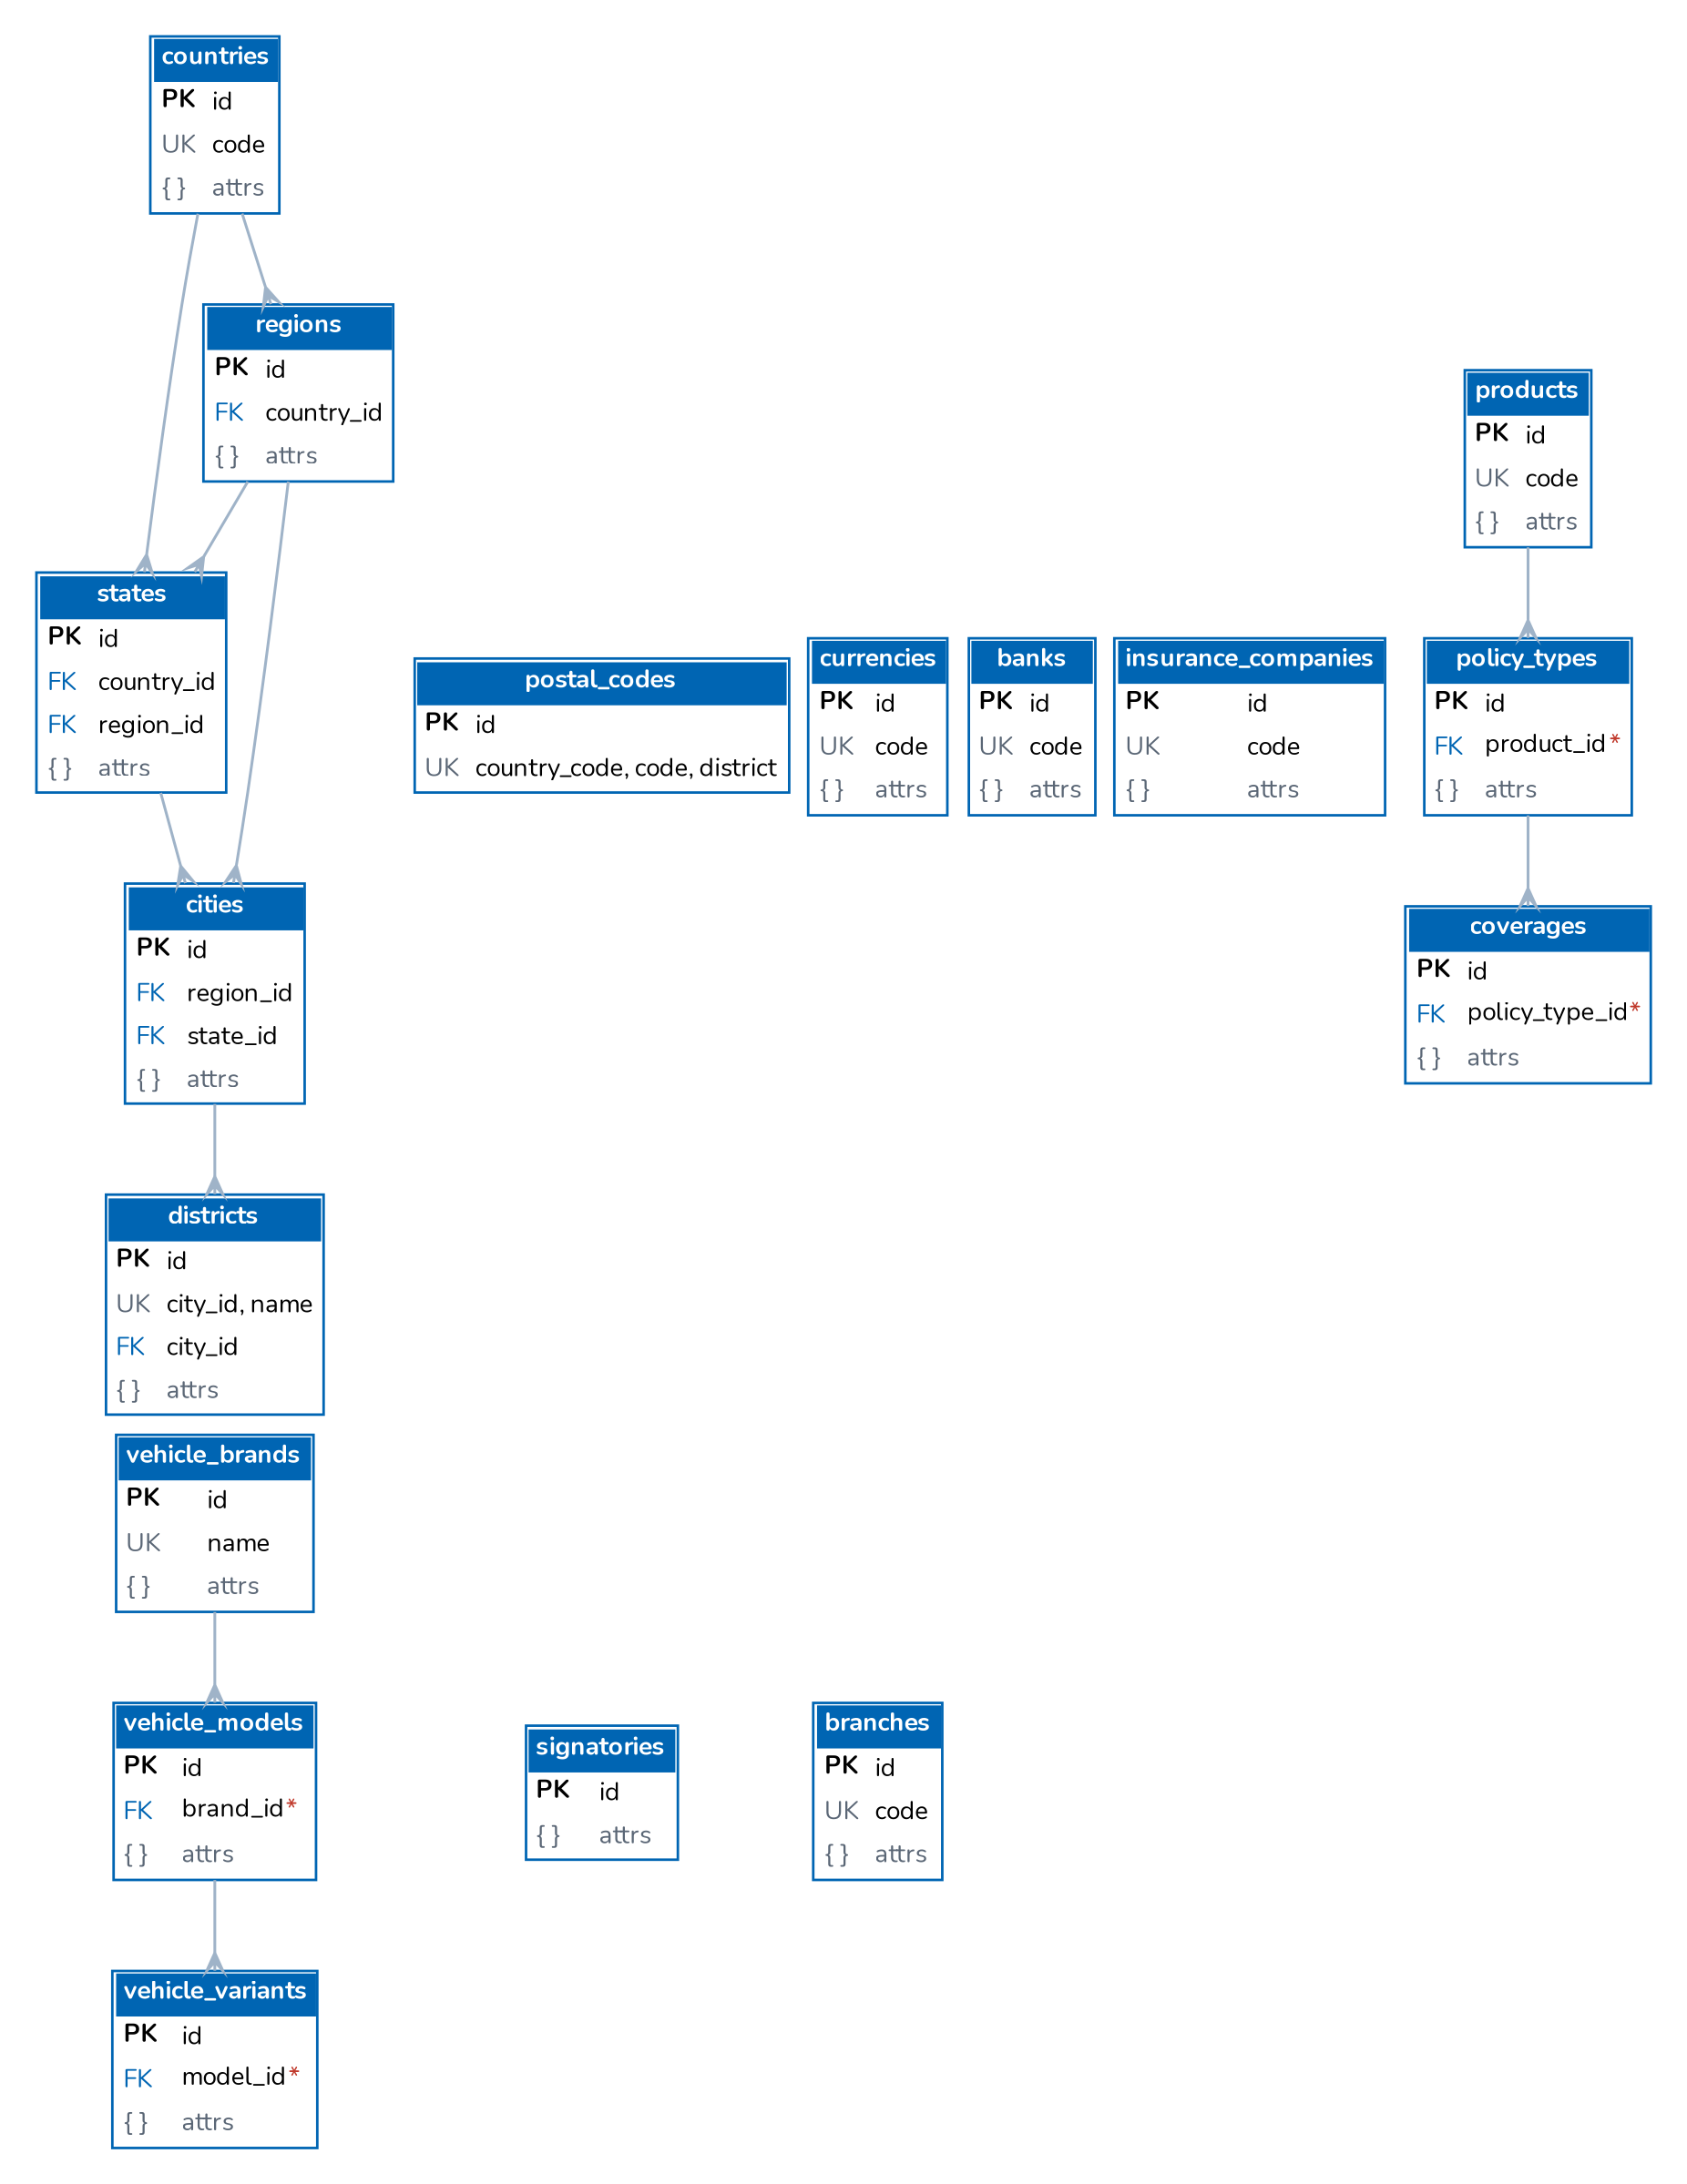
Figure 15. Reference masters
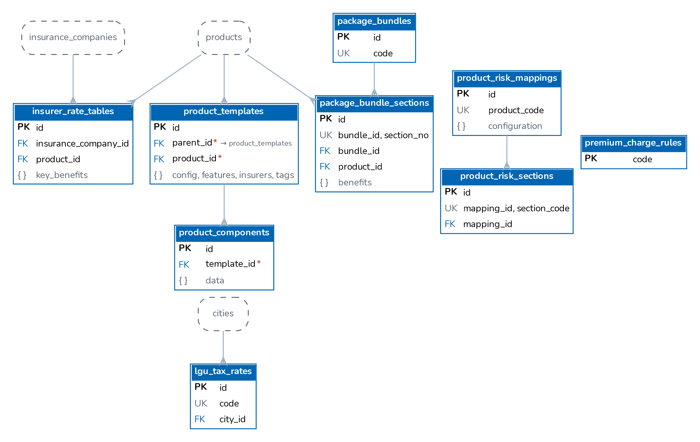
Figure 16. Product configurator and pricing

4.15 Distribution and marketing
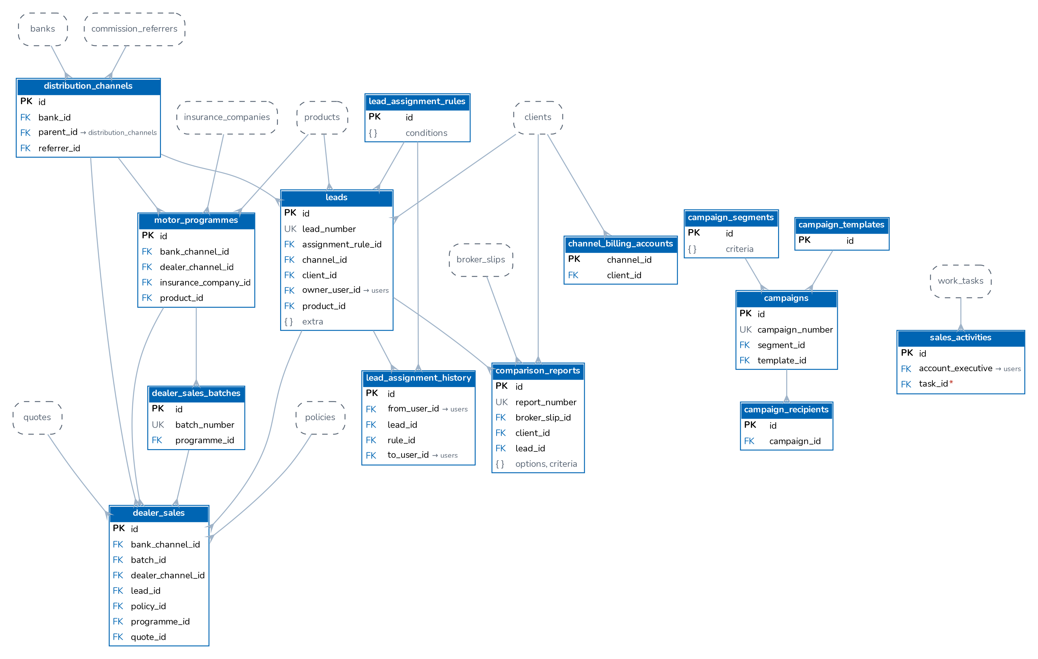
Figure 17. Distribution and marketing: lead assignment, channels, dealer programmes, comparison reports, campaigns, sales activities
Lead assignment rules route a new prospect; every assignment is kept in lead_assignment_history. distribution_channels is one hierarchy of dealer groups and branches, financing banks and affinity partners (parent_id); dealer programmes (motor_programmes) set the terms of the cars a dealer sells and uploaded dealer_sales become quotations or policies. Campaigns send to a segment through a template; campaign_recipients records consent, result and opt-out. sales_activities (package G) logs calls and visits and creates follow-up tasks in work_tasks.

4.16 Fleet, marine open cover, claim documents and motor repairs
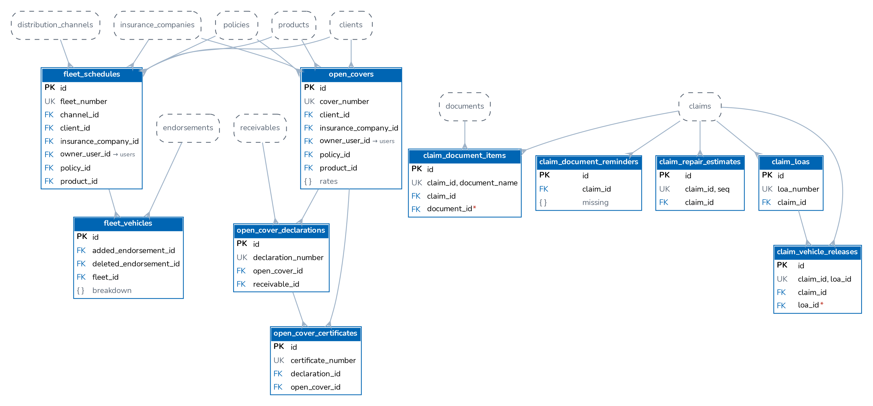
Figure 18. Fleet schedules, marine open covers, claim document checklist and motor repair records

4.17 Payables, fixed assets, BIR and override commission
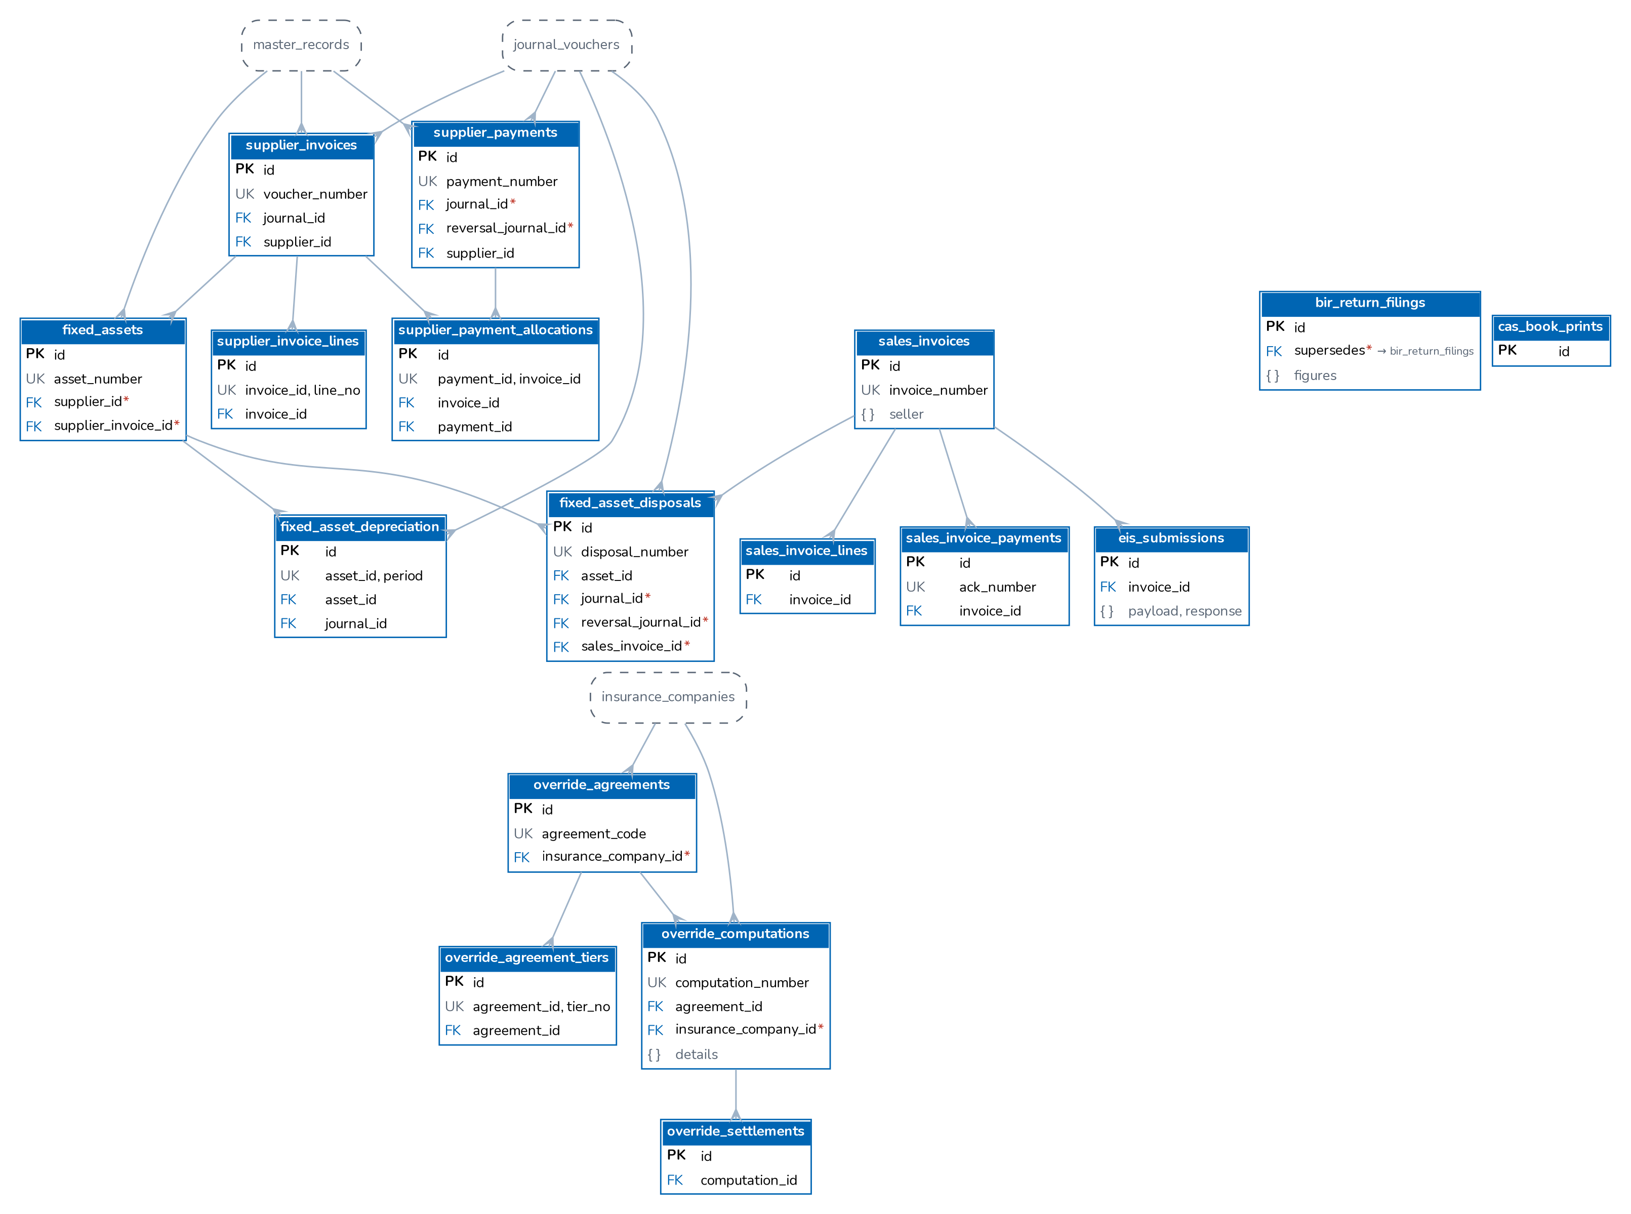
Figure 19. Accounts payable, fixed assets, BIR return filings, sales invoices and EIS, override commission
Supplier invoices post on approval (ap.invoice) and payments through supplier_payment_allocations (ap.payment); assets depreciate monthly (fa.depreciation) and are disposed of with a gain or loss (fa.disposal, package G). The BIR returns are computed from the ledger and recorded in bir_return_filings; every sales invoice is queued in eis_submissions. Override commission agreements, computations and settlements accrue and settle insurer overriding commission.

4.18 Compliance
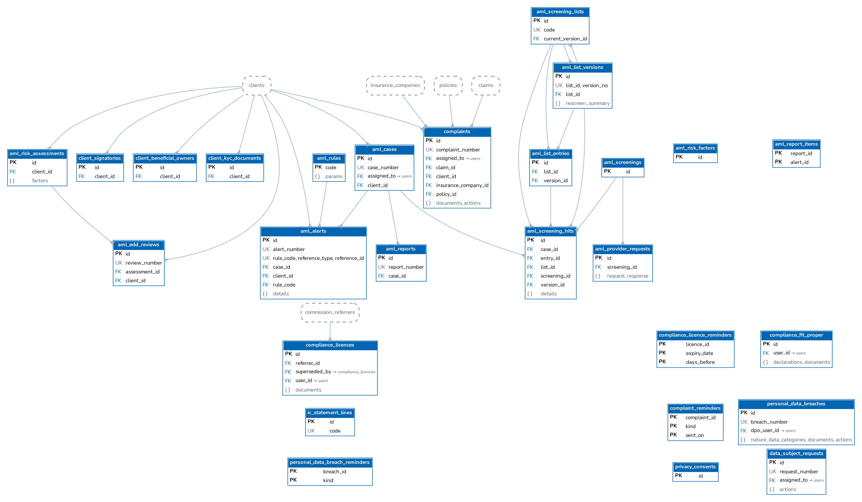
Figure 20. AML/CFT, Insurance Commission registers, complaints, breaches and data privacy
The AML tables hang off clients: KYC records of juridical clients, risk assessments and EDD reviews, screenings and their hits against the screening lists, alerts raised by monitoring rules, cases and AMLC report files. Package B adds the licence register, fit and proper records, the IC statement mapping, the complaints register and the breach register. With package B, TIN, ID and bank account numbers are encrypted in the database by the triggers pii_protect_columns and pii_protect_json with blind indexes (*_bidx) for exact search (document 05).

4.19 Integrations
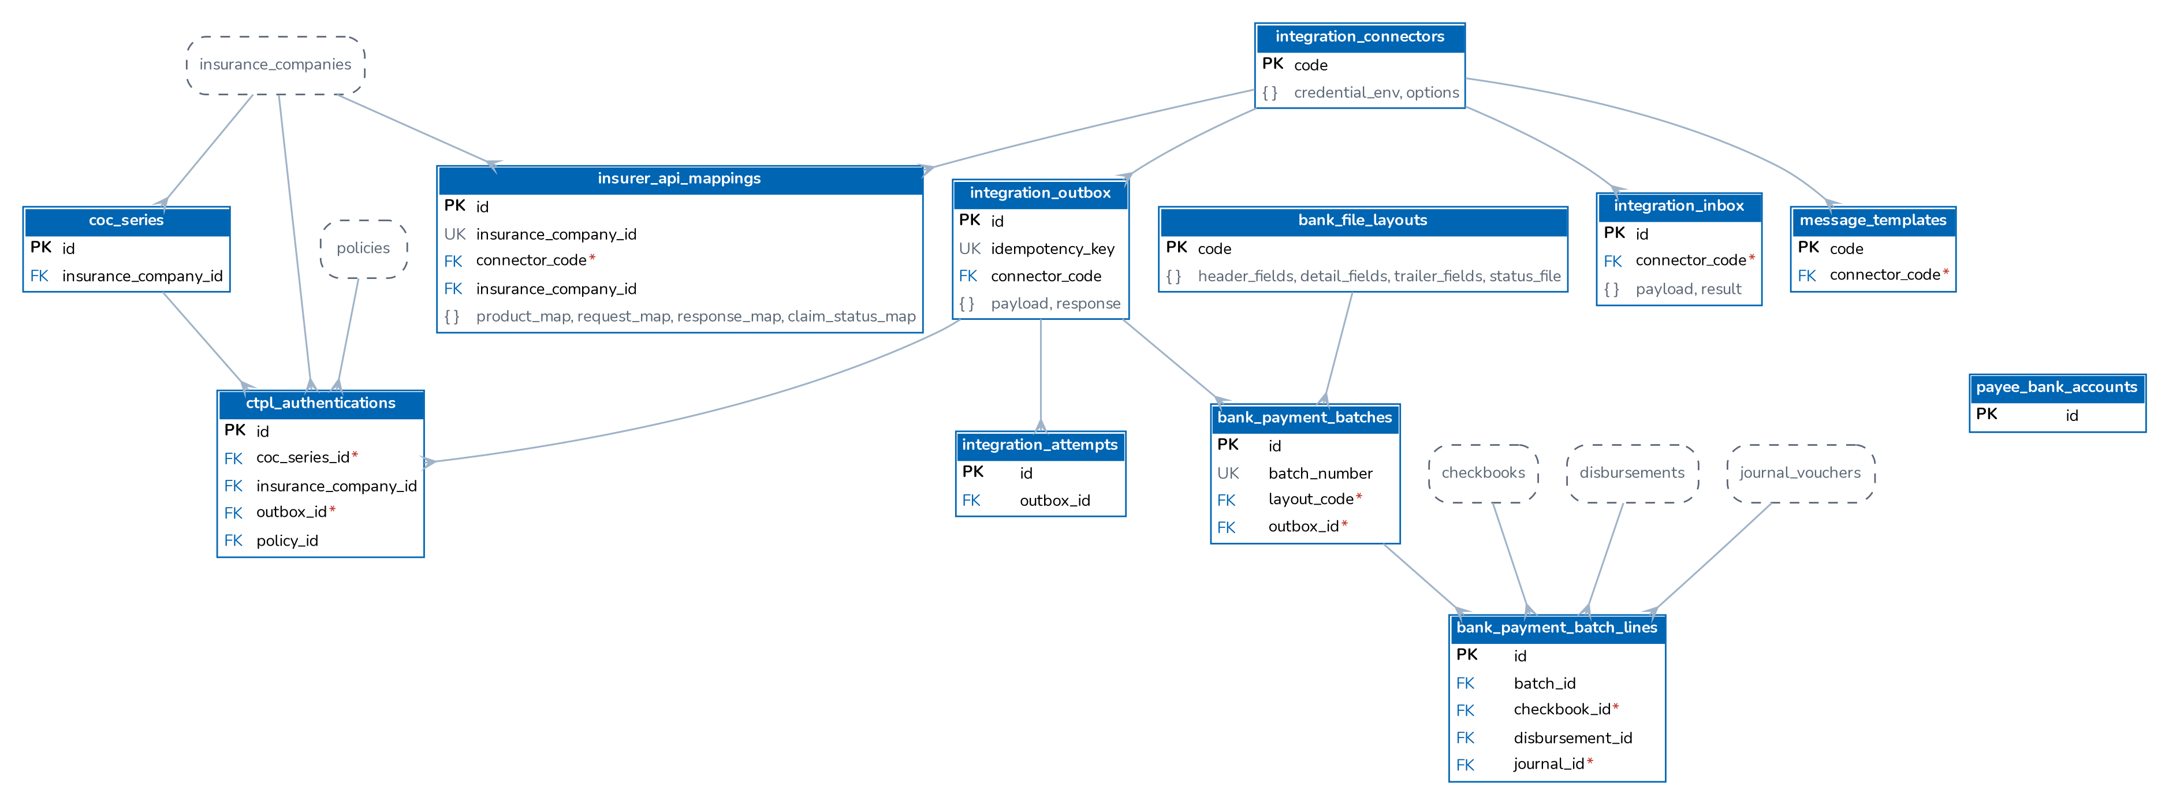
Figure 21. Integration framework: connectors, outbox, attempts, inbox, messaging, CTPL, insurer mappings and bank payment files
Every message to a third party is a row of integration_outbox written in the business transaction; integration_attempts keeps each try and integration_inbox each message received. Connectors keep only the names of the environment variables that hold their credentials.

5 Migrations
Aspect | Implementation (backend/src/db/migrate.js)
Format | Plain SQL files NNNN_name.sql in backend/src/db/migrations, applied in file-name order: 0001-0004 core, masters, operations, finance; 0010-0021 sales, claims, renewals; 0030-0034 ledger, receipts, disbursements, commission, petty cash; 0040-0050 configuration, product configurator, remittance, reinsurance, incentive, reports; 0060-0097 security and later changes; 0110-0113 branding and the Company letterhead; 0115-0117 role inheritance and bank reconciliation; 0120-0127 co-insurance, document numbering, commission rates, insurer credit terms, placement; 0130-0136 posting rules, period end, tax codes; 0140-0152 broker roles, business-date defaults, foreign-key indexes, accounting follow-ups, go-live imports and the e-mail sender.
Tracking | Table schema_migrations(name, applied_at); a file is applied once.
Execution | On every API start (server.js), before the seed. The migrate step first takes the advisory lock hashtext('brokerverse.migrate'), hashtext('schema_migrations'); instances that start together wait (up to MIGRATION_LOCK_TIMEOUT_MS, 10 minutes) and then find nothing to do. Each pending file runs in its own transaction with its schema_migrations row; on error the transaction is rolled back and the API does not start. npm run migrate runs the same code; npm run db:reset drops and recreates the schema (development only).
Idempotency | Files use CREATE TABLE IF NOT EXISTS, ADD COLUMN IF NOT EXISTS, CREATE INDEX IF NOT EXISTS, ON CONFLICT DO NOTHING and guarded updates, so they are safe on a database that already holds data. An applied file is never edited; fixes go forward in a new file.
Readiness | GET /api/health answers 503 until no migration is pending, so a load balancer does not route to an instance with an older schema.
Direction | Forward only. Migrations only add; rolling back data means restoring a snapshot (document 09).

Recommended / to be confirmed by the business and DevOps: Keep destructive changes (column drops, type changes) in a separate release after the code that no longer uses them is live. Start one instance first when a release contains migrations (deploy/REFERENCE.md, Upgrading).

6 Seed data
backend/src/db/seed.js runs on every start after the migrations and with npm run seed. Every step is idempotent: rows are inserted by natural key or fixed id, so administrator edits are kept.
1. In code: the roles, permissions and grants, and the administrator BrokerVerse (password from ADMIN_PASSWORD; without it a random password is generated, logged once and must be changed at the first sign-in).
2. seeds/settings.json (configuration keys, inserted only if missing) and seeds/jobs.json (the scheduled jobs; the period-end and bank-matching jobs come from migrations).
3. Encryption of any two-factor secret still stored in clear (upgrade path).
4. The SQL files seeds/*.sql (reference data, always) and seeds/sample/*.sql (sample data, only when SEED_SAMPLE_DATA is on), interleaved by file name so a sample file runs after the reference file it depends on.
Class | Content
Reference | Settings (659 keys in 64 groups); 8 roles and 98 permissions; Philippine geography from the PSGC of the 2nd quarter 2026 (regions, provinces, cities and municipalities with ZIP codes; barangays as an optional load), banks, ID types, salutations, holidays and the IC insurer list (seeds/12_ph_geography.sql, 69_ph_practice_masters.sql); currencies, banks, insurers, products and policy types; vehicle makes, models and variants; covers; head office branch; the Company master with the letterhead company; master screen registry and reference master records; chart of accounts (129 accounts in this database) with main and sub account masters; posting rules for 43 events and Account Determination; 85 document number series; tax codes (VAT, expanded withholding with ATC, DST, LGT); the month-end checklist; bank statement formats (three Philippine bank layouts and a generic one); product templates with the motor and CTPL tariff; report catalogue (40 reports); direct-bill and security configuration; BIR forms, operations and accounting rules, AML risk factors and rules, integration connectors in test mode (seeds/72_, 73_, 75_).
Sample | Fictional leads, clients, quotations, broker slips and placements, policies, endorsements, claims, renewals, bills, receipts, collections, disbursements, petty cash, commissions and referrers, remittances, reinsurance, incentives, journal vouchers, bank statements, demo branches, signatories and master records, and six sample users (five Sales & Marketing users and one Accounting approver).

SEED_SAMPLE_DATA accepts true or false (1 or 0, yes or no, on or off); unset, it is on in development and test and off with NODE_ENV=production. A database seeded with sample data is cleaned with npm run purge:sample (document 10).

7 Time zone, date and amount handling
Topic | Design
Storage | Instants in timestamptz (stored in UTC); calendar dates in date. The database time zone is Asia/Manila; the containers run in UTC.
Business date | lib/dates.js: "today" is the calendar date in general.timezone (seeded Asia/Manila), not the server's UTC date. businessDate(), calendarPeriod(), the report engine, document numbering and the column defaults (numbering_business_date(), migration 0145) use the configured zone, so between 00:00 and 08:00 Manila time the system never uses yesterday's date.
Job times | The scheduler reads cron expressions in general.timezone: 0 6 * * * runs at 06:00 Manila time.
Display | The front end formats dates with general.date_format (DD/MM/YYYY) and amounts with the configured currency and locale (en-PH grouping); the server uses formatMoney() and the PDF engine the same settings.
Money | numeric in the database, rounding by round2(); taxes (VAT 12%, DST 12.5%, LGT 0.75%, expanded withholding by ATC) and commission rates come from settings, the tax codes and the rate matrix.

Note: Amounts are converted from numeric to JavaScript double-precision numbers. This is exact for amounts of up to about 90 trillion with two decimals, far above broking volumes, provided every arithmetic result is rounded with round2(), which the ledger and document code does.

8 Related documents
This document is one of eleven that together form the BrokerVerse OOTB Solution Architecture. They are maintained and issued together (source and build: docs/architecture/README.md).
No. | Document | File
01 | Solution Component Diagram and Application Architecture | 01_BrokerVerse_Solution_Component_Diagram_Application_Architecture.pdf
02 | Database Design (this document) | 02_BrokerVerse_Database_Design.pdf
03 | Database Inventory | 03_BrokerVerse_Database_Inventory.pdf
04 | Technology Stack | 04_BrokerVerse_Technology_Stack.pdf
05 | Shared Service Components | 05_BrokerVerse_Shared_Service_Components.pdf
06 | Capacity and Performance | 06_BrokerVerse_Capacity_and_Performance.pdf
07 | High Availability and Resiliency | 07_BrokerVerse_High_Availability_and_Resiliency.pdf
08 | RTO and RPO | 08_BrokerVerse_RTO_and_RPO.pdf
09 | Backup and Recovery | 09_BrokerVerse_Backup_and_Recovery.pdf
10 | Data Archival, Housekeeping and Restoration | 10_BrokerVerse_Data_Archival_Housekeeping_and_Restoration.pdf
11 | Monitoring | 11_BrokerVerse_Monitoring.pdf

9 Glossary
Terms and abbreviations used in this document.
Term | Meaning
Account determination | Settings accounting.account.<role> that give the GL account of each account role (cash in bank, premium receivable, due to insurer, commission income ...) used by the posting rules.
Advisory lock | PostgreSQL application-level lock (pg_try_advisory_lock, pg_advisory_lock) used so a job runs on one API instance at a time and only one instance applies migrations.
API | Application programming interface; here the BrokerVerse REST API under /api served by the Node.js backend.
ATC | Alphanumeric tax code of the BIR for a type of withholding, printed on BIR Form 2307.
Audit log / audit trail | Table audit_log: who changed which record, when, from which IP, with the before and after values.
BIR | Bureau of Internal Revenue (Philippines): tax authority whose rules drive record keeping and withholding tax certificates.
Bordereau | Periodic list of ceded premiums or claims sent to a reinsurer.
Broker slip | Request for quotation (BS-) that the broker sends to several insurers for one client risk; the answers are recorded as insurer offers.
Cession | The share of a policy's risk and premium passed to a reinsurer under a treaty or facultatively.
Co-insurance | Placement of one risk with several insurers, one of them the lead, each taking a share; premium, commission and claims are split by share.
Company master | Master record of the broker company; the primary company is the letterhead printed on every document and report.
Cron | Time-based schedule expression (minute hour day month weekday) used by the scheduled jobs.
CTPL | Compulsory Third Party Liability motor insurance (Philippines).
Debit note (DN) | Commission debit note raised by the broker to an insurer for direct-billed policies.
Direct bill | Billing mode in which the insurer collects the premium and the broker bills the insurer for its commission.
DST | Documentary Stamp Tax (Philippines), part of the gross premium.
Endorsement | Change to an issued policy (details, cover, premium or cancellation).
Fiscal year | Accounting year (FY2026) with twelve periods and an adjustment period 13 used by the year-end close.
FK | Foreign key: column that references the primary key of another table.
GIN | Generalised inverted index (PostgreSQL), used for JSONB searches.
Housekeeping | Daily job that deletes operational rows (job runs, sent e-mails, sign-in history, expired tokens, read notifications) after the retention days in System Settings.
IC | Insurance Commission (Philippines): regulator of insurers and brokers.
JSONB | PostgreSQL binary JSON column type, used for flexible document parts of records.
JV | Journal voucher: balanced set of debit and credit ledger lines.
KYC | Know your customer: identification data required before a policy is issued.
LGT | Local Government Tax (Philippines), part of the gross premium.
Maker-checker | Control in which a record created or submitted by one user must be approved by a different user.
Migration | Numbered SQL file in backend/src/db/migrations applied once, in order, on API start.
OR | Official receipt issued for premium received.
PK | Primary key: column(s) that uniquely identify a row.
Placement slip | Firm order (PS-) sent to the lead insurer and co-insurers; each participant binds before the policy is issued.
Posting rule | Versioned definition of the journal lines for one business event (policy issued, receipt applied ...); every system journal is built from it.
PV | Payment voucher (disbursement) to an insurer, referrer, client or supplier.
RDS | Amazon Relational Database Service, the managed PostgreSQL target.
Receivable / bill | Premium bill (INV-) raised when a policy, endorsement or renewal is issued.
Remittance | Payment of collected premium, net of commission, from the broker to the insurer.
RPO | Recovery point objective: the maximum acceptable data loss, measured in time.
RTO | Recovery time objective: the maximum acceptable time to restore service.
Seed | Idempotent data load run on every API start: reference data always, sample data only when SEED_SAMPLE_DATA is on.
SLA | Service level agreement / target time, e.g. for remittance approvals.
Treaty | Reinsurance contract under which risks are ceded automatically within agreed limits.
VAT | Value-added tax (12 % in the Philippines).
Year-end close | Run (YEC-) that posts the closing entries in period 13, carries the balances into the next year and locks the year.
zod | TypeScript-first schema validation library used to validate request bodies and parameters.

