

INFRASTRUCTURE ARCHITECTURE
Infrastructure Architecture
Hosting, network zones, sizing, data services, high availability, backup, monitoring and the component baseline of BIBS
BIBS – BDOI Broker System
Client | BDO Insurance and Reinsurance Brokers, Inc.
Document | BIBS-ARC-03
Version | 1.0
Date | 08 October 2026
Status | Issued for BDOI review
Classification | Confidential

Prepared by iorta TechNXT for BDOI 
iNXT BrokerVerse. This document is confidential to BDO Insurance and Reinsurance Brokers, Inc. and iorta TechNXT.
Document Control
Version | Date | Author | Reviewer | Approver | Change
1.0 | 08 Oct 2026 | iorta TechNXT Solution Architect | iorta TechNXT DevOps Engineer; iorta TechNXT Tech Lead | BDO IT Cloud and Digital Operations Engineering (pending) | First issue, aligned with the IER workbook v20 and the component baseline of 8 October 2026

Distribution List
Name / Unit | Role | Organisation | Purpose
Cloud and Digital Operations Engineering (IER owner) | Approver | BDO Unibank IT | Hosting, sizing, IER restatement
Enterprise Architecture | Reviewer | BDOI IT | Infrastructure baseline
Information Security Office | Reviewer | BDOI IT | Zones, trust boundaries, encryption, keys
Network team | Reviewer | BDO Unibank IT | Connectivity, private routes, address ranges
IT Operations and DBA | Reviewer | BDOI IT | Backups, DR, monitoring
Project team | Delivery | iorta TechNXT | Environments and operations support

Contents

1 Introduction 4
1.1 Purpose and audience 4
1.2 Scope 4
1.3 Sources 4
1.4 Conventions 4
2 Hosting model 4
3 Environments 5
4 Network zones and trust boundaries 6
5 Compute and storage sizing 7
5.1 IER figures and the proposed BIBS sizing 7
5.2 How the sizes were derived 8
6 Data services 9
6.1 PostgreSQL 16: high availability and backups 9
6.2 Valkey 8 9
6.3 Apache Kafka 3.9 (KRaft) 10
6.4 Object and file storage (Amazon S3) 10
7 High availability and disaster recovery 11
8 Monitoring 12
9 Security infrastructure 13
10 Component baseline 13
11 Responsibilities 14
12 Decisions and open points for BDOI 15
Glossary 15

1 Introduction

1.1 Purpose and audience
This document describes the infrastructure that runs BIBS, for BDO IT Cloud and Digital Operations Engineering (owner of the IER workbook), the network team, the Information Security Office, the DBAs and IT Operations. It states the hosting model, the network zones and trust boundaries, the sizing of each environment derived from the IER workbook, the data services and their high availability and backups, disaster recovery, monitoring, and the component baseline with licences and support horizons.

1.2 Scope
All six environments (DEV, SIT, UAT, Pre-Prod, PROD, DR) on AWS, the EKS clusters at node level, PostgreSQL 16, Valkey 8, Apache Kafka 3.9 (KRaft), Amazon S3, keys and secrets, connectivity to the BDO network and Apigee X, and the monitoring stack. Kubernetes resources inside the clusters are in the Deployment Architecture.

1.3 Sources
Table 1: Sources
Ref | Document | Used for
S1 | IER workbook v20: HW and SW Requirements, Kubernetes sheets (DEV, SIT, UAT, PROD Y1-Y5), environment sheets, assumptions, VDI requirements | Sizing, hours, growth, recovery objectives
S2 | Programme Alignment pack v1.0, chapter 6 (IER against BIBS) and questions IQ25 to IQ35 | Changes to the IER, open questions
S3 | Document storage decision record (approved 26-Sep-2026) | Buckets, keys, Object Lock, replication, malware scanning
S4 | Application architecture option decision (26-Sep-2026) | Edge, encryption in transit, network policies
S5 | Client decisions of 8-Oct-2026 | Component baseline (Valkey, Kafka 3.9, Gateway API)
S6 | BIBS deployment guide, runbook, platform cache and events architecture | Database roles, backups, Valkey and Kafka behaviour
S7 | Umbrella Core Replacement BRD p.42-46 and the hosting appendix | Users, volumes, retention, backup, data residency

1.4 Conventions
Open points of this document are numbered IA-01 to IA-10 (chapter 12). Sizes are vCPU and GiB; storage in GB as in the IER.

2 Hosting model
BIBS runs in BDOI's AWS organisation in the Asia Pacific (Singapore) region, ap-southeast-1, on managed services (ADR-18). Philippine data stays in the approved regions; access is restricted to personnel in the Philippines (hosting appendix).
Table 2: Hosting model
Layer | Service | Notes
Containers | Amazon EKS, managed node groups across three availability zones | Kubernetes version supported by EKS; upgraded within its 14-month standard support
Relational data | Amazon RDS for PostgreSQL 16 | Single-AZ in DEV, SIT, UAT; Multi-AZ in Pre-Prod and PROD; cross-region read replica for DR
Cache and shared state | Amazon ElastiCache for Valkey 8 | Cluster mode disabled; primary and replica in Pre-Prod and PROD
Event streaming | Amazon MSK, Apache Kafka 3.9 in KRaft mode | 2 brokers in DEV, SIT, UAT; 3 brokers in Pre-Prod, PROD and DR
Files | Amazon S3, four buckets per environment | SSE-KMS, Object Lock, GuardDuty Malware Protection, cross-region replication from PROD
Keys and secrets | AWS KMS (customer-managed keys owned by BDOI), AWS Secrets Manager, AWS Private CA | One key per environment and bucket class; multi-Region keys for DR
Edge | Route 53 private zone, AWS WAF, internal Application Load Balancer through the Gateway API | No public exposure
Images | Amazon ECR with image scanning and replication to the DR region | Immutable tags
Management | Bastion through AWS Systems Manager (no inbound ports), pipeline runner, VDI for the project team | 15 VDI users (IER)
Monitoring | Dynatrace (BDO standard of the IER cluster sheets), Amazon CloudWatch, AWS CloudTrail | Tool choice IQ30

Account structure (proposed, IA-01). One AWS account for non-production (DEV, SIT, UAT), one for Pre-Prod and one for production, with the DR region in the production account; each account with its own KMS keys and Secrets Manager, so that production keys and data are never reachable from a test environment.
Responsibilities. AWS operates the managed services; BDO IT Cloud and Digital Operations provisions and operates the accounts, networks, clusters and data services (infrastructure as code, IA-02); iorta TechNXT provides the application, its manifests, the sizing and the runbooks, and supports operations.

3 Environments
Table 3: Environments
Environment | Purpose | Data | Hours | Availability | Owner
DEV | Development and integration of changes by the project team | Seed data (SIT/UAT users) | 12 x 5 | Single-AZ | iorta TechNXT
SIT | System integration test per drop; trial migrations 1 and 2 | Seed data and masked trial-migration data | 12 x 5, extended for batch and trial migrations | Single-AZ | iorta TechNXT, BDOI IT for the interfaces
UAT | User acceptance test end to end; trial migration 3 and the re-load | Masked migrated data | 12 x 5, extended for month-end cycles | Single-AZ | BDOI business owners
Pre-Prod | Performance and penetration tests, dress rehearsal of the cut-over | Production-sized, masked | 12 x 5, extended for tests and rehearsal | Multi-AZ | BDOI IT
PROD | Production | Production data | 24 x 7 | Multi-AZ, three availability zones | BDOI IT operations
DR | Warm standby of production in the DR region | Replica of production | 12 x 7 standby; 24 x 7 after failover | Multi-AZ after failover | BDOI IT operations

The 12 x 5 hours of the IER apply to the EKS nodes and RDS instances of the non-production environments; MSK and ElastiCache cannot be stopped and run 24 x 7. Extended hours are booked for batch and month-end test cycles, trial migrations (weekend loads) and the dress rehearsal; the night jobs are moved into the working window by configuration (IQ27, DA-07). Training uses a separate database on the UAT cluster with seed data (IA-09).

4 Network zones and trust boundaries
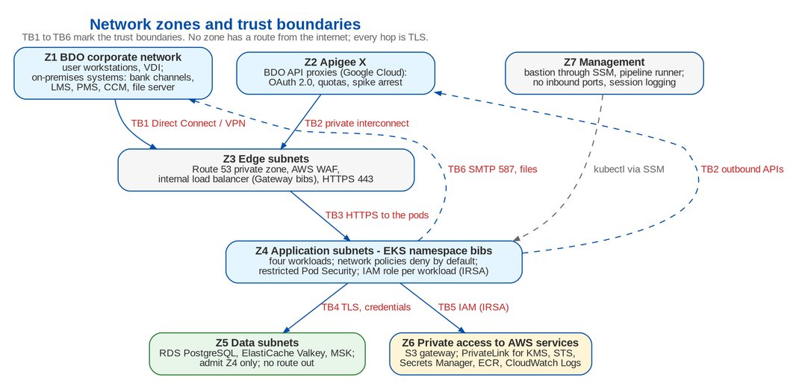
Figure 1: Network zones and trust boundaries
Table 4: Network zones
Zone | Contains | Controls
Z1 BDO corporate network | User workstations, VDI, BDO on-premises systems (bank channels, LMS, PMS, CCM, file server) | BDO perimeter; Direct Connect or VPN to AWS
Z2 Apigee X | BDO API proxies in Google Cloud | OAuth 2.0 client credentials, quotas, spike arrest, analytics; private interconnect to AWS (HA VPN or Interconnect and Direct Connect through the BDO backbone)
Z3 Edge subnets | Route 53 private zone, internal load balancer with AWS WAF | HTTPS 443 only; source ranges limited to Z1 and Z2
Z4 Application subnets | EKS worker nodes, namespace bibs | Network policies deny by default; security groups for pods; restricted Pod Security; IRSA
Z5 Data subnets | RDS, ElastiCache, MSK | Security groups admit Z4 only; no route out; TLS required
Z6 Private access to AWS services | S3 gateway; PrivateLink interfaces for KMS, STS, Secrets Manager, ECR and CloudWatch Logs | Bucket policies deny non-TLS requests and access from outside the VPC
Z7 Management | Bastion through SSM, pipeline runner | No inbound ports; session logging; MFA

Table 5: Trust boundaries
Boundary | Between | Controls at the boundary
TB1 | Users (Z1) and the edge (Z3) | TLS 1.2+ with the BDO certificate; AWS WAF managed rules and rate rule; EIAM sign-in, TOTP for privileged users; 15-minute access tokens
TB2 | Apigee X (Z2) and BIBS | Private route only; WAF admits the integration prefix only from the Apigee ranges; BIBS validates the Apigee token (issuer, audience, scopes per API); outbound calls to BDO systems also through Apigee
TB3 | Edge (Z3) and the pods (Z4) | HTTPS to the pods with certificates from AWS Private CA; network policy admits only the load balancer subnets
TB4 | Pods (Z4) and data services (Z5) | TLS verify-full to RDS, TLS and AUTH to Valkey, SASL_SSL to MSK; least-privilege database login; credentials from Secrets Manager
TB5 | Pods (Z4) and AWS services (Z6) | IAM role per workload (IRSA), least privilege per bucket and key; KMS key policies held by BDOI security
TB6 | Pods (Z4) and BDO on-premises systems (Z1) | Through Apigee X (APIs) or the CCM relay (SMTP 587 with STARTTLS); files through the S3 buckets with malware scanning

There is no inbound route from the internet to any zone and no outbound internet access from the pods: images come from ECR and AWS services through PrivateLink. Subnet ranges, the Direct Connect or VPN route and the Apigee source ranges are BDO network values (Deployment Architecture, chapter 7).

5 Compute and storage sizing

5.1 IER figures and the proposed BIBS sizing
The IER sized about ten microservices. BIBS runs four workloads from two images (ADR-01, ADR-15), so the Kubernetes rows are restated; the data services keep the IER sizes adjusted to the component baseline. Growth is 15 % a year over 60 months (IER).
Table 6: IER requests against the proposed sizing
Item | IER workbook v20 | Proposed for BIBS
EKS worker nodes PROD Y1 | 3 x m5.4xlarge (16 vCPU, 64 GiB) for ten bv-* services; Y5 6 nodes | 3 to 6 x m5.2xlarge (8 vCPU, 32 GiB), one or more per zone; Y5 4 to 8 nodes (DA-05)
EKS worker nodes UAT | 2 x m5.4xlarge | 3 x m5.xlarge, one per zone
EKS worker nodes DEV, SIT | 2 nodes each | 2 x m5.xlarge (SIT up to 3)
Persistent volumes | EFS "Total PV" of 21,800 GB (DEV) to 87,200 GB (PROD Y5) | None: pods are stateless, files are in S3; the EFS totals came from a formula error (maximum replicas x CPU limit)
PostgreSQL PROD | 16 vCPU, 128 GB, 2,000 GB, Multi-AZ | Same; storage autoscaling on; re-sized once Trial migration 2 measures the migrated volume without file content (IA-04)
PostgreSQL Pre-Prod / UAT / SIT / DEV | 8, 64, 1,000 Multi-AZ / 8, 32, 500 / 4, 16, 200 / 4, 16, 200 | Same
Cache and streaming PROD | ElastiCache for Redis 7 (cluster) + MSK 3 brokers (Kafka 3.6), 8 vCPU, 32 GB, 1,000 GB | ElastiCache for Valkey 8, cache.r7g.large primary and replica, cluster mode disabled; MSK Kafka 3.9 KRaft, 3 x kafka.m5.large, 100 GB per broker
DR | Cross-region read replica 16 vCPU, 128 GB, 2,000 GB; cache and streaming 3 brokers | Read replica as IER; Valkey and MSK created at failover; EKS standby with 2 nodes
Bastion and runner | 4 vCPU, 16 GB, 200 GB, RHEL 9 | Same (SSM, kubectl, kustomize)
VDI | 15 users: 8 developers (24 months), 4 testers (18), 3 production support (60) | Same; software list Temurin 21, Maven 3.9, Node 22 (Node 24 from April 2027), no Angular, no JDK 17 (IQ28)

Table 7: Proposed Kubernetes sizing per environment
Environment | bibs-web pods (min / max) | bibs-jobs pods | bibs-integration pods | bibs-frontend pods (min / max) | Worker nodes
DEV | 1 / 2 | 1 | 1 | 1 / 2 | 2 x m5.xlarge (4 vCPU, 16 GiB)
SIT | 2 / 3 | 2 | 1 | 2 / 2 | 2 to 3 x m5.xlarge (4 vCPU, 16 GiB)
UAT | 2 / 4 | 2 | 2 | 2 / 4 | 3 x m5.xlarge (4 vCPU, 16 GiB), one per zone
Pre-Prod | 3 / 10 | 2 | 2 | 2 / 4 | 3 to 6 x m5.2xlarge (8 vCPU, 32 GiB)
PROD Y1 | 3 / 10 | 2 | 2 | 2 / 4 | 3 to 6 x m5.2xlarge (8 vCPU, 32 GiB), one or more per zone
PROD Y5 | 4 / 12 | 2 | 2 | 2 / 4 | 4 to 8 x m5.2xlarge (15 % growth a year, proved by the performance test)
DR standby | 1 / 10 | 0 | 0 | 1 / 4 | 2 x m5.2xlarge, scaled to the PROD node count at failover

Table 8: Data services per environment
Environment | PostgreSQL | Valkey | Kafka | S3
DEV | RDS PostgreSQL 16, Single-AZ, 4 vCPU, 16 GiB, 200 GB gp3 | ElastiCache for Valkey 8, one node cache.t4g.medium | MSK Kafka 3.9 KRaft, 2 brokers kafka.t3.small, replication factor 2 | Four buckets, SSE-KMS
SIT | RDS PostgreSQL 16, Single-AZ, 4 vCPU, 16 GiB, 200 GB gp3 | ElastiCache for Valkey 8, one node cache.t4g.medium | MSK Kafka 3.9 KRaft, 2 brokers kafka.t3.small, replication factor 2 | Four buckets, SSE-KMS
UAT | RDS PostgreSQL 16, Single-AZ, 8 vCPU, 32 GiB, 500 GB gp3 | ElastiCache for Valkey 8, primary and replica cache.t4g.medium | MSK Kafka 3.9 KRaft, 2 brokers kafka.m5.large, replication factor 2 | Four buckets, SSE-KMS
Pre-Prod | RDS PostgreSQL 16, Multi-AZ, 8 vCPU, 64 GiB, 1,000 GB gp3 | ElastiCache for Valkey 8, primary and replica cache.r7g.large, Multi-AZ | MSK Kafka 3.9 KRaft, 3 brokers kafka.m5.large, replication factor 3 | Four buckets, SSE-KMS, Object Lock
PROD | RDS PostgreSQL 16, Multi-AZ, 16 vCPU, 128 GiB, 2,000 GB gp3 (re-sized once the document content is in S3) | ElastiCache for Valkey 8, primary and replica cache.r7g.large, Multi-AZ, cluster mode disabled | MSK Kafka 3.9 KRaft, 3 brokers kafka.m5.large, replication factor 3, minimum in-sync replicas 2 | Four buckets, SSE-KMS, Object Lock, cross-region replication
DR | RDS cross-region read replica, 16 vCPU, 128 GiB, 2,000 GB; promoted at failover | ElastiCache for Valkey 8 created at failover (caches refill) | MSK Kafka 3.9 created at failover; undelivered events resent from the outbox | Replica buckets (replication time control 15 minutes)

5.2 How the sizes were derived
• Users and load. 429 concurrent sessions at peak (SA-02), screens p95 under 2 seconds; the peak hours are 08:00-10:00 and 15:00-17:00 and the month-end (BRD-6, BRD-3). bibs-web scales from 3 to 10 pods of 1 to 2 vCPU; the performance test on Pre-Prod (November - December 2027) confirms the figures.
• Volumes. 21,200 new-business and 25,800 renewal transactions a month, 144,400 CSF interactions a year, 15 % growth a year. Kafka carries ten topics of three partitions; at these volumes 100 GB per broker holds more than the 7-day retention.
• Database. One database for all modules; file content is in S3, so the database holds records, journals, ledger entries, audit trail and file metadata only.
• Files. The S3 volume is set by the existing document volumes copied before go-live and the yearly growth; the estimate is made from the legacy file inventory (IA-05).

6 Data services

6.1 PostgreSQL 16: high availability and backups
Table 9: PostgreSQL 16 on Amazon RDS
Aspect | Set-up
Availability | Multi-AZ in Pre-Prod and PROD: synchronous standby in a second zone, automatic failover in about one to two minutes; the application reconnects through its pool
Encryption | At rest with the BDOI customer-managed KMS key of the environment; in transit required (force-SSL parameter on, clients verify-full with the RDS CA bundle)
Logins and roles | Schema owner login (migrations at start-up only); runtime group role without login holding row access only; application login, member of the runtime role, used by the connection pools. The runtime login cannot change the schema, truncate tables or disable the immutability triggers of the audit trail and the ledger
Point-in-time recovery | Automated backups with continuous transaction-log archiving, retention 35 days; restore to any second within the window
Snapshots | AWS Backup plan: every 4 hours kept 35 days; daily kept 35 days; monthly kept 7 years in a vault with Vault Lock, copied to the DR region; a manual snapshot before every PROD release
DR replica | Cross-region read replica in the DR region (asynchronous, lag normally seconds); promoted at failover
Restore tests | Quarterly restore of the latest snapshot into Pre-Prod with reconciliation of ledger totals; yearly DR failover test
Monitoring | Performance Insights; CloudWatch alarms on CPU, free memory, free storage, connections, replica lag and deadlocks
Maintenance | Minor versions applied in the 00:00-04:00 window after Pre-Prod; the major version reviewed at the annual technology review (PostgreSQL 16 community support until 09-Nov-2028)

The backup policy meets the umbrella BRD (every 4 hours, kept 5 years) and the register proposal of 7 years; the retention of the business records themselves follows the retention rules of BIBS (5 years online, 15 offline).

6.2 Valkey 8
Table 10: Valkey 8 on Amazon ElastiCache
Aspect | Set-up
Use | Reference-data cache (lists of values, parameters, role permissions, data scope, product versions, organisation units), cluster-wide job locks with fencing tokens, token deny-list after sign-out, sign-in counters and rate limits
Topology | Cluster mode disabled (one shard), primary and replica in two zones with automatic failover in Pre-Prod and PROD; single node in DEV and SIT
Security | In-transit encryption and AUTH token (or an RBAC user); at-rest encryption with the BDOI KMS key; security group admits the EKS subnets only
Data loss tolerance | No persistence needed: caches refill from the database, locks expire within their 2-minute lease, the deny-list falls back to the session log in PostgreSQL
Eviction | volatile-lru (proposed): every key carries a time to live (caches, locks, deny-list, counters)
Key prefix | Set per environment by configuration, so a shared cache can never mix environments

6.3 Apache Kafka 3.9 (KRaft)
Table 11: Apache Kafka 3.9 on Amazon MSK
Aspect | Set-up
Mode | KRaft (no ZooKeeper), Kafka 3.9
Brokers | 3 x kafka.m5.large across three zones in Pre-Prod, PROD and DR; 2 brokers in DEV, SIT and UAT
Topics | Ten topics bibs.<domain>.<event>.v1 and their dead-letter topics, created by the application with 3 partitions; replication factor 3 and minimum in-sync replicas 2 (replication factor 2 on two brokers); automatic topic creation off on brokers and clients
Retention | 7 days on the event topics and 30 days on the dead-letter topics (proposed, IA-06); the outbox and the event archive in PostgreSQL are the long-term record
Security | SASL_SSL with SCRAM-SHA-512 (credentials in Secrets Manager) or IAM authentication; plaintext listeners disabled; encryption at rest with the BDOI KMS key
Producer and consumers | Producer with acknowledgements from all in-sync replicas and idempotency; consumer groups bibs-mail-dispatch, bibs-event-archive and bibs-dead-letter-recorder, plus the ECM archive connector
Monitoring | Under-replicated partitions, offline partitions, consumer lag per group, broker disk use

6.4 Object and file storage (Amazon S3)
Table 12: S3 buckets per environment
Bucket | Content | Lifecycle and protection
bibs-<env>-documents | Attachments, generated documents (slips, invoices, ORs, SOAs, vouchers, letters, STRs), Word and PDF renditions | Versioning; Standard, then Standard-IA after 90 days, Glacier Instant Retrieval after 1 year; Object Lock in governance mode with legal hold; deletion by the BIBS retention rules
bibs-<env>-reports | Report runs, scheduled files, batch ZIP files | Expiry per the report archive setting (default 400 days)
bibs-<env>-inbound | Bulk uploads, bank and insurer files, watchlist feeds | Incoming and quarantine prefixes; GuardDuty Malware Protection; kept 90 days
bibs-<env>-migration | Migration extracts and staging files | Expiry after 5 days; migration role only

All buckets: public access blocked at account and bucket level; SSE-KMS with the BDOI key of the bucket class and bucket keys; bucket policies deny unencrypted uploads, non-TLS access and other regions; object keys carry no personal data (company, record type, year, month, random identifier); CloudTrail data events and server access logs kept for audit. PROD documents and reports buckets replicate to the DR region with replication time control (15 minutes). Amazon EFS is not used.

7 High availability and disaster recovery
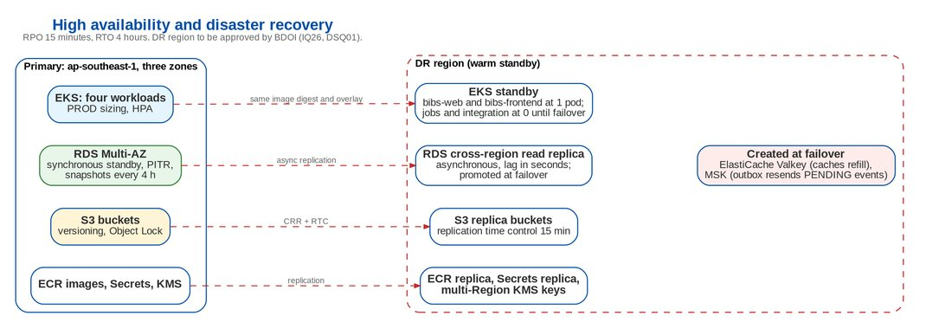
Figure 2: High availability and disaster recovery
Table 13: Availability and recovery per component
Component | Within the region | DR region | Recovery point
bibs-web, bibs-frontend | 3 zones, at least 2 pods, autoscaling | Standby at 1 pod each; scaled to PROD at failover | Stateless
bibs-jobs, bibs-integration | 2 pods across zones; job lock | 0 pods until failover (so jobs and consumers never run twice) | Stateless
PostgreSQL | Multi-AZ synchronous standby | Cross-region read replica, promoted | Seconds of replica lag; at most 15 minutes
Valkey | Primary and replica, automatic failover | Created at failover | Not needed (caches refill)
Kafka | 3 brokers, replication factor 3 | Created at failover | Undelivered events resent from the outbox
S3 | 11 nines durability, versioning | Replica buckets, replication time control | 15 minutes
Images, secrets, keys | ECR, Secrets Manager, KMS | ECR replication, secret replicas, multi-Region keys | Current

Failover plan (targets). The RTO of 4 hours is met by the following steps, rehearsed in the yearly DR test:
Table 14: DR failover steps and target times
Target time | Step | Owner
T + 0:30 | Incident assessed; failover decided by the DR owner | BDOI IT Operations
T + 0:45 | RDS replica promoted to primary in the DR region | DBA
T + 1:30 | ElastiCache for Valkey and MSK created from the infrastructure templates; secrets updated with their addresses | BDO IT Cloud
T + 2:00 | DR overlay applied: workloads scaled to the PROD sizing; jobs and integration started | Release team
T + 2:15 | Route 53 record of the BIBS host name switched to the DR load balancer; Apigee targets switched | BDO network and API teams
T + 3:00 | Smoke test and business verification by key users; outbox resends pending events | iorta TechNXT support, BDOI key users
T + 4:00 | RTO limit | DR owner

The DR region and its cross-border basis must be approved by BDOI before the DR environment is provisioned (IA-03, IQ26, DSQ01).

8 Monitoring
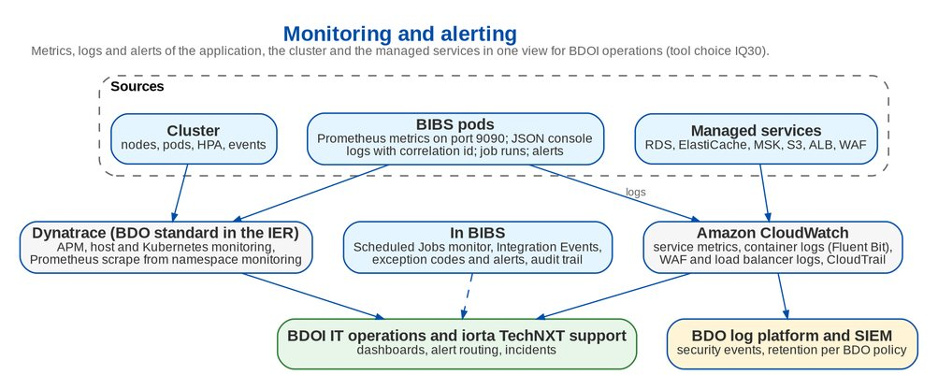
Figure 3: Monitoring and alerting
• Metrics. Each backend pod exposes Prometheus metrics on the management port 9090, reachable only from the monitoring namespace: JVM, HTTP latency and status by operation, connection pool, journals posted, security store failures. The IER cluster sheets place Dynatrace in every cluster; Dynatrace scrapes the Prometheus metrics and adds APM traces, host and Kubernetes monitoring. CloudWatch holds the managed-service metrics.
• Logs. One line per event on the console with ISO timestamps and the correlation identifier; line breaks neutralised against log forging. Container logs go to CloudWatch Logs (Fluent Bit) and on to the BDO log platform and SIEM; load balancer, WAF and CloudTrail logs too. Retention: 90 days searchable, then archived for one year (IA-07).
• In the application. The Scheduled Jobs monitor (run history, skipped and failed runs), the Integration Events screen (outbox, archive, dead letters), exception codes and alerts with notifications, the audit trail.
Table 15: Alert catalogue (proposed thresholds)
Alert | Condition | Severity | Routed to
Service unavailable | Any served workload with no ready pod, or load balancer 5xx above 2 % for 5 minutes | Critical | IT Operations, on call
Slow screens | p95 latency of user operations above 2 seconds for 10 minutes | High | IT Operations, iorta support
Security store failure | Any increase of the security store failure counter (deny-list, session log or rate counters unreadable) | Critical | IT Operations, Security
Job failure | JOB_FAILURE alert raised by BIBS, or a job skipped on every pod longer than its run time | High | Job owner unit, iorta support
Outbox backlog | Pending events older than 15 minutes, or any failed outbox row | High | iorta support
Dead letters | A new dead letter | Medium | iorta support
Database | CPU above 80 % for 15 minutes; free storage under 20 %; replica lag above 5 minutes (RPO risk) | High | DBA
Valkey | Memory above 80 %; failover event | Medium | IT Operations
Kafka | Under-replicated partitions above 0 for 5 minutes; consumer lag above 1,000 records | High | IT Operations
Capacity | bibs-web at its maximum replicas for 15 minutes; node CPU above 80 % | Medium | IT Operations
Certificates | Any certificate expiring in less than 14 days | High | Release team
Malware | A quarantined file (FILE_QUARANTINED) | High | Security, uploader
Backups | A failed AWS Backup job or snapshot copy | High | DBA

9 Security infrastructure
Table 16: Security services
Service | Use
AWS KMS | Customer-managed keys created and administered by BDOI security in BDOI's account: per environment for RDS, ElastiCache, MSK and Secrets Manager; per environment and bucket class for S3; multi-Region keys for DR; rotation per BDOI policy (annual by default); imported key material possible without a change in BIBS
AWS Secrets Manager | Database logins, signing and encryption keys of the application, Valkey and Kafka credentials, SMTP and OIDC client secrets; rotation policy per secret
AWS Private CA | In-cluster TLS certificates through cert-manager
IAM and IRSA | One role per backend workload; bucket- and key-level least privilege; no long-lived keys
AWS WAF | Managed rule groups, rate rule, Apigee-only rule (Deployment Architecture, chapter 5)
Amazon GuardDuty | Malware Protection for S3 on the inbound bucket and the upload prefix of the documents bucket; threat detection for the accounts and EKS
AWS CloudTrail | Management and S3 data events, kept for audit
CrowdStrike Falcon | Host protection (EDR) on the worker nodes (IER cluster sheets)

10 Component baseline
Table 17: Component baseline with licences and support horizon (8 October 2026)
Component | Version baseline | Licence | Function | Support horizon
PostgreSQL | 16.x | PostgreSQL Licence | Relational data store (Amazon RDS for PostgreSQL 16) | Community support of the major version until 09-Nov-2028
Valkey | 8.x | BSD-3-Clause | Reference-data cache, job locks, token deny-list, shared counters (Amazon ElastiCache for Valkey) | Follows the Valkey release policy and the ElastiCache engine calendar; checked at each annual technology review
Apache Kafka | 3.9 (KRaft) | Apache 2.0 | Event streaming with the transactional outbox (Amazon MSK) | Last 3.x line; the move to Kafka 4.x (KRaft only) is planned at the first annual technology review after go-live
OpenJDK (Eclipse Temurin) | 21 LTS | GPLv2 with Classpath Exception | Application runtime of the backend | Adoptium LTS support at least until Dec-2029
Spring Boot | 3.5.x | Apache 2.0 | Application framework of the backend | Open-source and commercial support windows differ; the support route is an open point (SA-07)
React with TypeScript and Vite | React 19.x, TypeScript 6, Vite 8 | MIT | Web user interface (single-page application) | Follows the current major version
Node (JavaScript runtime) | 22 LTS | MIT | Compiles and packages the web user interface in the pipeline; not a production runtime | End of life 30-Apr-2027: move to Node 24 LTS before UAT (SA-08)
nginx (unprivileged image) | 1.30 | BSD-2-Clause | Serves the web user interface over TLS | Until the next stable line; image refreshed with each release
Kubernetes (Amazon EKS) | Version supported by EKS | Apache 2.0 | Container orchestration | Standard support of each version for 14 months after its EKS release
Kubernetes Gateway API controller | Gateway API v1 (standard channel); AWS Load Balancer Controller 2.14 or later | Apache 2.0 | Edge routing (Gateway, HTTPRoute) to the internal load balancer | Per release of the controller; checked at each annual technology review

Table 18: Further platform libraries and tools
Library or tool | Version | Licence | Use
Spring Security | With Spring Boot 3.5 | Apache 2.0 | Authentication, OIDC and SAML 2.0 sign-in, method security
Hibernate ORM and Spring Data JPA | With Spring Boot 3.5 | LGPL 2.1 (Hibernate), Apache 2.0 | Persistence of the domain model
Schema migration library (Community edition) | With Spring Boot 3.5 | Apache 2.0 | Versioned, forward-only schema changes applied at start-up
Spring for Apache Kafka | With Spring Boot 3.5 | Apache 2.0 | Kafka producer of the outbox relay and the consumers
Spring Data Redis with Lettuce | With Spring Boot 3.5 | Apache 2.0 / MIT | Valkey client (same protocol)
springdoc-openapi | 2.8 | Apache 2.0 | OpenAPI 3 description of the user interface operations (developer environments only)
OpenPDF and Apache POI | OpenPDF 2.0, POI 5.4 | LGPL / MPL (OpenPDF), Apache 2.0 (POI) | PDF, Excel and Word renditions of documents and reports
AWS SDK for Java v2 | Current 2.x | Apache 2.0 | S3 file store with SSE-KMS, presigned links
TanStack Query, React Router, Recharts | Pinned in the web client | MIT | Web client data access, navigation, charts
cert-manager with the AWS Private CA issuer | Current release | Apache 2.0 | In-cluster certificates, rotated automatically

The baseline is reviewed every year and before go-live (first review 31-Jan-2027, second in October 2027 before the ORR): each support date is checked against the upstream or AWS pages, components that reach their support end within the next twelve months are planned for upgrade, and this table is re-issued. Every component is under a licence that allows commercial use without a fee; none is source-available (ADR-04).

11 Responsibilities
Table 19: Infrastructure responsibilities (R responsible, A accountable, C consulted, I informed)
Activity | BDO IT Cloud and Digital Operations | BDO network | BDOI Information Security | BDOI IT Operations and DBA | iorta TechNXT
AWS accounts, VPCs, subnets | A, R | C | C | I | C
Direct Connect, VPN, Apigee private route | C | A, R | C | I | I
EKS clusters and add-ons | A, R | I | C | I | C
RDS, ElastiCache, MSK, S3 provisioning | A, R | I | C | C | C
KMS keys and key policies | C | I | A, R | I | I
Backups and restore tests | C | I | I | A, R | C
DR test | R | R | C | A | R
Monitoring and alert routing | R | I | C | A | C
Sizing and annual technology review | C | I | C | C | R (A: BDOI Enterprise Architecture)

12 Decisions and open points for BDOI
Table 20: Decisions and open points for BDOI
ID | Topic | Our proposal | Owner | Needed by
IA-01 | AWS account structure | Three accounts: non-production (DEV, SIT, UAT), Pre-Prod, production with DR; separate keys and secrets per account | BDO IT Cloud | 30-Nov-2026
IA-02 | Infrastructure as code | Terraform modules owned by BDO IT Cloud for accounts, networks, EKS, RDS, ElastiCache, MSK, S3, KMS; iorta TechNXT reviews the BIBS-specific values | BDO IT Cloud | 18-Dec-2026
IA-03 | DR region | Name the DR region and approve its cross-border basis; warm standby as in chapter 7; yearly DR test (IQ26, DSQ01) | BDOI Risk and Compliance, BDO IT Cloud | 16-Oct-2026
IA-04 | PROD database size | Keep the IER 2,000 GB with storage autoscaling; re-size after Trial migration 2 measures the volume without file content | DBA | 31-Jul-2027
IA-05 | S3 volume estimate | Estimate from the legacy file inventory before the copy of the existing files; add the yearly growth | BDOI IT with iorta TechNXT | 31-Mar-2027
IA-06 | Kafka retention | 7 days on event topics, 30 days on dead-letter topics | BDOI IT Operations | 30-Nov-2026
IA-07 | Log retention | 90 days searchable in CloudWatch, one year archived, security events in the BDO SIEM per BDO policy | Information Security Office | 30-Nov-2026
IA-08 | Monitoring tool | Dynatrace for APM, hosts and Kubernetes (scraping the BIBS Prometheus metrics), CloudWatch for managed services and logs (IQ30) | BDO IT Cloud | 30-Nov-2026
IA-09 | Training environment | A separate database with seed data on the UAT cluster, refreshed per training wave | BDOI Training lead | 30-Jun-2027
IA-10 | IER restatement | BDO IT updates the IER: Kubernetes sheets with the sizing of chapter 5, Pre-Prod and DR sheets, ElastiCache for Valkey and MSK 3.9 rows, no EFS, S3 and KMS rows (IQ25, IQ33, IQ34) | BDO IT Cloud and Digital Operations Engineering | 30-Nov-2026

Glossary
Term | Meaning
AZ | Availability zone
CRR | S3 cross-region replication
DR | Disaster recovery
EKS | Amazon Elastic Kubernetes Service
IER | Infrastructure Estimation and Recommendation workbook
KMS | AWS Key Management Service
KRaft | Kafka Raft metadata mode
MSK | Amazon Managed Streaming for Apache Kafka
PITR | Point-in-time recovery
RDS | Amazon Relational Database Service
RTC | S3 replication time control
SIEM | Security information and event management
SSM | AWS Systems Manager
VDI | Virtual desktop infrastructure

