

FUNCTIONAL REQUIREMENTS SPECIFICATION
Accounting, Disbursement and ACSL
BRD-5 Accounting (FRBS), Disbursement, Marketing Refund and Cash-Advance Requests, Accounting Controls and Subsidiary Ledger (ACSL), with Addendum 1, the Workshop Addendum and the walkthrough minutes of 4 May 2026 (WS Addendum v04152026)
BIBS – BDOI Broker System
Client | BDO Insurance and Reinsurance Brokers, Inc.
Document | BIBS-FRS-BRD-05
Version | 2.1
Date | 8 October 2026
Status | Issued for BDOI business sign-off
Classification | Confidential

Prepared by iorta TechNXT for BDOI 
iNXT BrokerVerse. This document is confidential to BDO Insurance and Reinsurance Brokers, Inc. and iorta TechNXT.
Document Control
Version | Date | Author | Reviewer | Approver | Change
0.9 | 18 Sep 2026 | iorta TechNXT Business Analysis | iorta TechNXT Solution Architect |  | Internal draft from the BRD-5 baseline
1.0 | 25 Sep 2026 | iorta TechNXT Business Analysis | iorta TechNXT Project Manager | BDOI Comptrollership Head (pending) | First issue for BDOI review in two volumes with a cover note (Volume 1 FRBS and administration; Volume 2 Disbursement, Payment Requests and ACSL)
2.0 | 2 Oct 2026 | iorta TechNXT Business Analysis | iorta TechNXT Project Manager | BDOI business units (sign-off) | Business sign-off pack: the two volumes and the cover note in one document, chapters 1-11 combined by topic with FR, BRD and test IDs kept; navigation by persona, 51 screen specifications with screenshots, five walkthroughs, messages, notifications, document outputs, upload templates, cross-BRD contract, sign-off and change control (chapters 12-20); proposed business rules and clarifications for confirmation of both volumes, extended with the screen presentation items (chapter 21); screen standards (appendix). Issued 2-Oct-2026
2.1 | 08 Oct 2026 | iorta TechNXT Business Analysis | iorta TechNXT Project Manager | BDOI business units (sign-off) | Re-based on the Accounting, Disbursement and ACSL WS Addendum v04152026 (268 pages: the minutes of the walkthrough of the Workshop Addendum with IT on 4-May-2026 in front of the unchanged BRD-5 pack); user-story view and storyboard index added. The minutes record FRBS 3.1.1, 3.1.2, DIS 3.29.0, 3.29.1, 3.30.0-3.30.2, 2.2.8 and ACSL 2.9.1, 2.9.2 as walked through without questions. CPC2 follows the incentive tag stored on the booked transaction (FR-DS-090, 092); the early-incentive service invoice is issued per remittance batch with one line per qualified transaction, its granularity and trigger proposed for confirmation (FR-DS-091); DIS 2.17.1 shown as outside BIBS in the coverage summary; every BRD page citation follows the new file (one page added in front); clarifications CLR-DS-16 to CLR-DS-18 added. Issued 08-Oct-2026

Distribution List
Name / Unit | Role | Organisation | Purpose
Ronald Allan E. De Leon, VP, Head - Comptrollership | Approver | BDOI | Review and sign-off
Iris S. Marquez, Product Owner - Comptrollership - FRBS and ACSL | Approver | BDOI | Review and sign-off for FRBS and ACSL
Rodrigo R. Dela Cruz, Product Owner - Comptrollership - Disbursement | Approver | BDOI | Review and sign-off for Disbursement
Perjelyn Joy R. Gutierrez, Product Owner - Comptrollership and Operations | Approver | BDOI | Review and sign-off for the Operations hand-offs
Shellah Marie C. Miranda, AVP, Product Owner - Marketing, Processing and Collections | Approver | BDOI | Review and sign-off for the Marketing refund and cash-advance requests
Roderick L. Lim, FVP, Head - Institutional Banking, SM and BDO Accounts | Approver | BDOI | Review and sign-off for Marketing
Freddie A. Atanque and Jennifer T. Lugtu, Product Owners - Comptrollership - ACSL | Reviewer | BDOI | Review of the ACSL, Disbursement and Accounting screens and rows
Ma. Fides Rivera, Marketing Business Services and System Support (MBS) | Input provider | BDOI | Review of the non-functional requirements and the Marketing request screens
Information Technology Group | Reviewer | BDOI | Review of interfaces, jobs, access and the Technical Specification
Dan Ace R. Cauton, Program Manager, Roda Lyn D. Gallardo and Zean C. Ibay, Business Analysts, ESG - Business Project Services | BRD owner | BDO Unibank ESG | Traceability check against the BRD
Project team | Delivery | iorta TechNXT | Delivery, test and UAT preparation

Contents

1 Introduction 12
1.1 Purpose 12
1.2 Scope 12
1.3 Structure of this FRS 13
1.4 References 14
1.5 Definitions and acronyms 14
1.6 How to read the functional requirements 15
2 Business context and process overview 17
2.1 Business context 17
2.1.1 Accounting (FRBS) 17
2.1.2 Disbursement, Payment Requests and ACSL 17
2.2 Process overview 18
2.2.1 Accounting (FRBS) 18
2.2.2 Disbursement, Payment Requests and ACSL 19
3 Personas and roles 21
3.1 Personas 21
3.2 Permissions 22
3.3 Permissions matrix 23
3.3.1 Accounting and administration 23
3.3.2 Disbursement, Payment Requests and ACSL 24
4 Functional requirements 26
4.1 Access and session 26
FR-AC-001 Access Accounting and administration with a user profile 26
FR-AC-002 Warn before the idle time-out and before the forced log-out 27
4.2 Chart of accounts and revaluation rate 28
FR-AC-010 Enter the monthly revaluation rate 28
FR-AC-011 Set up, view and edit the chart of accounts 29
FR-AC-012 Upload the chart of accounts 30
FR-AC-013 Generate account numbers and roll child accounts up to their parent 32
FR-AC-014 Search accounts by name, short code or number 33
4.3 Reports on demand 34
FR-AC-020 Select, run, view and copy reports on demand 34
FR-AC-021 Filter every column of a report 35
FR-AC-022 Download or print several reports at once 35
FR-AC-023 Set the print options of a report 36
4.4 Posting and manual entries 37
FR-AC-030 Post every financial transaction to the GL and the sub-ledger 37
FR-AC-031 Assign manual entries for posting and work the assigned list 38
FR-AC-032 Prepare manual entries 39
FR-AC-033 Reverse accruals automatically on their reversal date 41
FR-AC-034 Validate entries and refuse errors 42
FR-AC-035 Confirm the transaction details before sending them on 43
FR-AC-036 Post or return entries, one or several at a time, with remarks 43
FR-AC-037 Edit accounting entries 44
4.5 Closing and revaluation 45
FR-AC-040 Schedule and run the month-end close of the GL books 45
FR-AC-041 Close the year and verify that the nominal accounts are zero 47
FR-AC-042 Close the broking books automatically at month end 48
FR-AC-043 Revalue USD balances at the revaluation rate 49
4.6 Bank reconciliation 50
FR-AC-050 Upload bank files and reconcile automatically 50
FR-AC-051 Report the unmatched transactions 51
4.7 Service fee 52
FR-AC-052 Compute, approve and pay the service fee 52
FR-AC-053 Record the liquidation report and tag released or liquidated 54
4.8 Cost centres and incentive income 55
FR-AC-054 Derive and enforce the cost centre of every entry 55
FR-AC-055 Account for early incentives as Other Income 56
4.9 Report pack 57
FR-AC-060 Generate the FRBS report pack 57
FR-AC-061 Run and maintain configurable account schedules 58
FR-AC-062 Produce the Mancom, production, GAP, cash-flow and expense reports 60
FR-AC-063 Produce the BIR returns, alphalists, SAWT and books of accounts 60
4.10 Business and system administration 61
FR-AC-070 Maintain lists of values with approval 61
FR-AC-071 Manage users and role profiles through approved requests 63
FR-AC-072 Approve, decline or return administration requests 64
4.11 Disbursement 65
4.11.1 Access 65
FR-DS-001 Access Disbursement, Payment Requests and ACSL with a user profile 65
4.11.2 Payee maintenance 66
FR-DS-010 Maintain payees with authorisation 66
FR-DS-011 Classify payees and choose the modes of payment 68
FR-DS-012 Receive payee maintenance requests 69
FR-DS-013 Delete or deactivate payees 70
FR-DS-014 View all payees and migrate the existing payees 70
4.11.3 Request intake 71
FR-DS-020 Receive system-triggered payment requests 71
FR-DS-021 Classify requests by disbursement type 73
FR-DS-022 Match the payee and report requests without payee 73
FR-DS-023 Encode requests received by e-mail 74
FR-DS-024 Upload requests and view the fall-out 75
FR-DS-025 Work the Disbursement Workbench 76
4.11.4 Processing 77
FR-DS-030 Create the disbursement voucher 77
FR-DS-031 Create and edit the proforma entry 78
FR-DS-032 Allocate expenses by cost centre 79
FR-DS-033 Process the payment by one of the seven modes 80
FR-DS-034 Process an Authority to Debit 81
FR-DS-035 Process Manager's Checks, Demand Drafts, Credit Tickets and Telegraphic Transfers 82
FR-DS-036 Submit the DV for review 83
FR-DS-037 Maintain the employee and cost-centre master and report the headcount 83
4.11.5 Review, approval and cancellation 85
FR-DS-040 Review, return and submit DVs for approval 85
FR-DS-041 Approve and post one or several DVs 85
FR-DS-042 Reject a DV 86
FR-DS-043 Cancel a DV In Process or For review 87
FR-DS-044 Cancel an approved DV and regularise the accounting 88
FR-DS-045 Regularise the accounting of every DV and list what is not regularised 89
4.11.6 Instrument statuses and tagging 90
FR-DS-050 Tag instrument statuses 90
FR-DS-051 Edit an instrument status with approval 91
FR-DS-052 Tag statuses automatically 92
FR-DS-053 Upload deposited-checks and credited-accounts files 93
FR-DS-054 Stale checks after 180 days and re-issue them 93
FR-DS-055 Post the entries of negotiated and stale checks 94
FR-DS-056 Tag the Official Receipt or Acknowledgement Receipt 95
FR-DS-057 Tag creditable withholding tax received or released 96
FR-DS-058 Generate BIR Form 2307 for suppliers 97
4.11.7 End of day, funding and masters 98
FR-DS-060 Run the end of day of Disbursement 98
FR-DS-061 Produce the Direct Credit Transaction File 99
FR-DS-062 Print checks and vouchers 100
FR-DS-063 E-mail the payment confirmations and the remittance schedule 100
FR-DS-064 Fund the main BDOIR account with a verifier and two approvers 101
FR-DS-070 Maintain the check series 102
FR-DS-071 Maintain the BDOIR bank accounts and their status 103
4.11.8 Disbursement reports 104
FR-DS-080 Run Disbursement reports on demand 104
FR-DS-081 Generate the end-of-day reports 105
FR-DS-082 Run the real-time Disbursement reports 106
FR-DS-083 Report payees and upload fall-outs 106
4.11.9 Incentives and the invoice family 107
FR-DS-090 Compute CPC2 incentives per remittance 107
FR-DS-091 Issue the service invoice of the early incentive automatically 108
FR-DS-092 Report CPC2 incentives 109
FR-DS-093 Link related transactions to one invoice number 110
4.12 Payment Requests (Marketing) 112
FR-PQ-001 Receive refund and cash-advance requests in Requests Home 112
FR-PQ-002 Access the unapplied payment reports 113
FR-PQ-003 Fill in the Refund Request Form 113
FR-PQ-004 Fill in the Request for Payment of a cash advance 115
FR-PQ-005 Assign, re-assign and return requests 116
FR-PQ-006 Validate the refund of a cancelled policy with ACSL and Cashiering 117
FR-PQ-007 Upload and view supporting documents 118
FR-PQ-008 Submit, review and endorse requests 119
FR-PQ-009 Approve or decline refunds, cash advances and check cancellations 120
FR-PQ-010 Cancel a request before approval 121
FR-PQ-011 Request the cancellation of a disbursed check 121
FR-PQ-012 Track the status of requests and extract them 122
FR-PQ-013 Receive the disbursement confirmation 123
FR-PQ-014 Prevent duplicate refunds by AR number 124
FR-PQ-015 Send approved requests to Disbursement and to HR 124
FR-PQ-016 Record the client's payout account on approval 125
FR-PQ-017 Liquidate a cash advance 126
4.13 ACSL 128
4.13.1 Input files and reports 128
FR-AS-001 Generate the input files and run ACSL reports on demand 128
4.13.2 Insurer SOA reconciliation 129
FR-AS-002 Upload insurer statements of account 129
FR-AS-003 Reconcile the SOA against the booked transactions by invoice number 130
FR-AS-004 Reconcile GL and SL balances by GL code 131
FR-AS-005 Produce aging and schedule reports per account family 132
4.13.3 Investigation and cases 133
FR-AS-010 Investigate accounts and receive account analysis requests 133
FR-AS-011 Give the result of the investigation to the requester 134
FR-AS-012 Apply AR refunds and request sub-ledger payment reversals 135
FR-AS-013 Coordinate short or over payments with the Account Officer 136
4.13.4 Correction entries 136
FR-AS-020 Assign and re-assign correction entries 136
FR-AS-021 Prepare a correction entry and route it for review 137
FR-AS-022 Review and endorse the correction 139
FR-AS-023 Approve, decline or return the correction with a comment 139
FR-AS-024 Post corrections automatically on approval 140
FR-AS-025 Deduct from the remittance on insurer confirmation 141
FR-AS-026 Track related transactions per invoice and insurer 143
5 Workflows, statuses and accounting events 144
5.1 Manual journal 144
5.2 GL close and broking-books cut-off 145
5.3 Service-fee run (FRBS_SERVICE_FEE) 146
5.4 Access requests 146
5.5 Accounting events of BRD-5 147
5.6 Disbursement voucher (DISB_VOUCHER) 148
5.7 Payment instruments 149
5.8 End of day 149
5.9 Account funding (DISB_FUNDING) 150
5.10 Payee (DISB_PAYEE) 151
5.11 Payment Requests 152
5.12 ACSL cases and corrections 154
5.13 Remittance deduction (REM_DEDUCTION) 156
5.14 Accounting events of Disbursement, Payment Requests and ACSL 156
6 Reports and documents 157
6.1 Accounting reports 157
6.2 Report pack (Appendix A) 158
6.3 Documents 159
6.4 Disbursement, Payment Request and ACSL reports 160
7 Interfaces and integration 161
8 Non-functional requirements 163
9 Configuration items owned by the business and the System Administrator 164
9.1 Parameters 164
9.2 Jobs 164
9.3 Lists of values 165
9.4 Alerts 166
9.5 Masters and rules maintained by the business 166
10 Assumptions, dependencies and open questions 167
10.1 Assumptions 167
10.2 Dependencies 167
10.3 Open questions 168
11 Traceability 170
11.1 FRBS (Accounting) 170
11.2 Business and system administration (BASAU) 172
11.3 Disbursement (DIS) 173
11.4 Payment Requests (MKT) 175
11.5 ACSL 176
11.6 Coverage summary 178
12 Navigation 179
12.1 Screens of Accounting, Disbursement and ACSL 179
12.2 Screen flow 182
12.3 Menu by persona 184
12.3.1 GL Officer (FRBS) 184
12.3.2 GL Team Lead 184
12.3.3 GL Section Head 185
12.3.4 Accountant (bank reconciliation) 186
12.3.5 Comptrollership administrator (masters and rules) 187
12.3.6 Disbursement Processor 187
12.3.7 Disbursement Team Leader 188
12.3.8 Disbursement Approver 188
12.3.9 Marketing Processor (AO) 189
12.3.10 Marketing Reviewer 189
12.3.11 Marketing Approver 190
12.3.12 Human Resources Approver 190
12.3.13 ACSL Processor 191
12.3.14 ACSL Team Leader 191
12.3.15 ACSL Head (approver) 192
12.3.16 Comptrollership (read access) 192
12.3.17 Business Administrator 193
12.3.18 System Administrator 194
12.3.19 Auditor 195
12.4 Common screen elements 196
13 Screen specifications 199
13.1 General ledger, chart of accounts and rates 199
13.1.1 SCR-AC-01 Journals 199
13.1.2 SCR-AC-02 New Journal and Edit Journal 203
13.1.3 SCR-AC-03 Journal 208
13.1.4 SCR-AC-04 Account Inquiry 212
13.1.5 SCR-AC-05 Party Statement 214
13.1.6 SCR-AC-06 Chart of Accounts 216
13.1.7 SCR-AC-07 Chart Upload 221
13.1.8 SCR-AC-08 Currencies & Rates 225
13.1.9 SCR-AC-09 Cost-Centre Rules 227
13.2 Closing, revaluation and bank reconciliation 230
13.2.1 SCR-AC-10 Financial Periods 230
13.2.2 SCR-AC-11 GL Close & Cut-Off 232
13.2.3 SCR-AC-12 Period-End & Year-End 237
13.2.4 SCR-AC-13 FX Revaluation 241
13.2.5 SCR-AC-14 Bank Statement Layouts 244
13.2.6 SCR-AC-15 Bank Statements 246
13.2.7 SCR-AC-16 Bank Reconciliation 248
13.3 Reports, report pack and service fee 252
13.3.1 SCR-AC-17 Report Centre 252
13.3.2 SCR-AC-18 Report 255
13.3.3 SCR-AC-19 Report Pack 259
13.3.4 SCR-AC-20 Account Schedules 261
13.3.5 SCR-AC-21 Service Fee Runs 266
13.3.6 SCR-AC-22 Service Fee Run 268
13.3.7 SCR-AC-23 Service Fee Rates 272
13.3.8 SCR-AC-24 BIR Forms & Books 275
13.4 Disbursement 277
13.4.1 SCR-AC-25 Disbursement Workbench 277
13.4.2 SCR-AC-26 Encode Payment Request 282
13.4.3 SCR-AC-27 Disbursement Voucher 285
13.4.4 SCR-AC-28 Payees 294
13.4.5 SCR-AC-29 Payee 297
13.4.6 SCR-AC-30 Disbursement Uploads 301
13.4.7 SCR-AC-31 Disbursement End of Day 303
13.4.8 SCR-AC-32 Account Funding 305
13.4.9 SCR-AC-33 Funding Request 307
13.4.10 SCR-AC-34 Bank Accounts and Checks 310
13.4.11 SCR-AC-35 Employees 312
13.4.12 SCR-AC-36 Certificates Received 314
13.4.13 SCR-AC-37 BIR Form 2307 316
13.4.14 SCR-AC-38 Disbursement Reports 319
13.5 Refund and cash-advance requests 322
13.5.1 SCR-AC-39 Requests Home 322
13.5.2 SCR-AC-40 New Refund Request 325
13.5.3 SCR-AC-41 New Cash Advance 329
13.5.4 SCR-AC-42 Cancel a Check 330
13.5.5 SCR-AC-43 Request 332
13.5.6 SCR-AC-44 Liquidation Accounts 337
13.6 Accounting Controls and Subsidiary Ledger (ACSL) 339
13.6.1 SCR-AC-45 ACSL Cases 339
13.6.2 SCR-AC-46 ACSL Case 342
13.6.3 SCR-AC-47 Correction Entries 346
13.6.4 SCR-AC-48 Correction Entry 348
13.6.5 SCR-AC-49 Insurer SOA Reconciliation 352
13.6.6 SCR-AC-50 Insurer SOA 355
13.6.7 SCR-AC-51 GL-SL Reconciliation 358
14 End-to-end walkthroughs 361
14.1 WT-A A manual accrual from the voucher to its posting and automatic reversal 361
14.2 WT-B A client refund from the Refund Request Form to the payment 368
14.3 WT-C An insurer's statement of account reconciled and a wrong posting corrected 380
14.4 WT-D Month end: the revaluation rate, the revaluation, the GL close and the service fee 393
14.5 WT-E Controls and the messages the user sees 400
15 Messages catalogue 407
16 Notifications catalogue 429
17 Document outputs 431
17.1 DO-01 Disbursement voucher 431
17.2 DO-02 Authority to Debit (bank form) 432
17.3 DO-03 Direct Credit Transaction File (DCTF) 433
17.4 DO-04 Refund Request Form (RRF) 435
17.5 DO-05 BIR Form 2307 (certificate of creditable tax withheld at source) 436
17.6 DO-06 Insurer SOA reconciliation report 437
18 Upload screens 439
18.1 Chart of accounts upload (COA_ACCOUNTS) 439
18.2 BOB Approvals (Online Banking) (DISB_BOB_APPROVED) 440
18.3 Deposited Checks (Negotiated) (DISB_CHECKS_NEGOTIATED) 440
18.4 Credited Accounts (Credit to Account) (DISB_CTA_CREDITED) 440
18.5 Payee Migration (DISB_PAYEE_MIGRATION) 440
18.6 Disbursement Requests (DISB_REQUESTS) 441
19 Cross-BRD dependencies and interface contract 442
20 Sign-off and change control 444
20.1 What is signed 444
20.2 How the review is recorded 444
20.3 What signing freezes 445
20.4 Change after sign-off 445
20.5 Proposed rules for confirmation 445
20.6 Signatures 446
21 Proposed business rules and clarifications for confirmation 447
22 Appendix: User-story view 451
23 Appendix: Storyboard index 466
24 Appendix: Screen standards 469

1 Introduction

1.1 Purpose
This Functional Requirements Specification (FRS) states how BIBS (BDOI Broker System, on iNXT BrokerVerse) meets the requirements of BRD-5 for BDO Insurance and Reinsurance Brokers, Inc. (BDOI): Accounting (the Financial Reporting and Budget Section, FRBS, the GL team of Comptrollership), Disbursement, the Marketing refund and cash-advance requests, Accounting Controls and Subsidiary Ledger (ACSL), and the business and system administration of the BRD. It turns each BRD requirement into functional requirements with actors, flows, rules, validations, screens, fields, notifications, audit and acceptance criteria.
BDOI uses this document to confirm that the system behaves as the business expects. The project team uses it to test and to prepare user acceptance testing (UAT). Every functional requirement (FR) cites the BRD requirement it meets and the BRD page. The FRs describe the proposed behaviour of the screens. Where the proposed rule or screen differs from the BRD text, or needs a decision of BDOI, the FR says so in a note and chapter 21 lists each such point for confirmation. Chapters 12 to 19 give the business view of the system: the navigation, the specification of every screen with its screenshots, the walkthroughs, the messages, notifications, documents, uploads and the contract with the other BRDs; chapter 20 describes the sign-off. The appendices give the user-story view of every BRD requirement (chapter 22), the storyboard index of the walkthroughs (chapter 23) and the screen standards (chapter 24).
This version 2.1 follows the BRD as BDOI issued it on 8 October 2026: the Accounting, Disbursement and ACSL WS Addendum v04152026, which puts the minutes of the walkthrough of the Workshop Addendum with IT on 4 May 2026 in front of the unchanged BRD-5 pack. The minutes clarify the CPC2 incentive and the service invoices of incentives; this FRS applies them.

1.2 Scope
BRD-5 is one BRD with four source documents: Accounting (FRBS), Disbursement, Marketing refund and cash-advance requests (Payment Requests) and ACSL, plus business and system administration. The FRS is organised by unit.
Table 1: Scope of this FRS
Area | In scope | Source
Access | Access from BDO devices, log-in with a profile, idle and log-out warnings for every unit of the BRD | FRBS 1.1.0-1.1.3; DIS, MKT, ACSL 1.1.0-1.1.3; BASAU 1.1.0-1.1.3
Chart of accounts and rates | Chart set-up, upload, account numbering, search by short code, monthly revaluation rate | FRBS 2.2.0, 2.3.0-2.3.5, 3.6.0
Reports on demand | Report selection, date range, column filters, batches of reports, print options | FRBS 2.4.0-2.4.10
Posting and manual entries | Posting to GL and sub-ledger, assignment, validation, negative-balance control, bulk posting, return, accrual auto-reversal | FRBS 2.5.0-2.5.10, 2.8.0-2.8.5, 2.9.0, 3.1.0, 3.6.0b
Closing | Scheduled month-end GL close, broking-books cut-off, year-end close and verification, USD revaluation | FRBS 2.6.0-2.7.1, 3.4.0-3.5.0
Bank reconciliation | Bank file upload, check-number matching, unmatched report | FRBS 3.3.0-3.3.3
Service fee | Service-fee runs, payout, release and liquidation tags | FRBS 2.10.0-2.10.2
Cost centres and incentive income | Cost-centre derivation rules; early incentives as Other Income | FRBS 3.1.1, 3.1.2
Report pack | Appendix A report families - end of day, GARD, subsidiaries, schedules and aging, Mancom, service fee, government | FRBS 3.2.0; Appendix A
Business and system administration | Lists of values with approval, user and role management through requests, approvals and returns | BASAU 2.2.0-2.6.3
Payees | Payee master, classes, modes of payment, payee requests, deletion rules, migration | DIS 2.2.0-2.2.8
Request intake | System-triggered requests, classification, payee matching, e-mailed requests, uploads, the workbench | DIS 2.4.x-2.6.x, 3.25.x
Processing | Disbursement voucher, proforma entry, seven payment modes, ATD, MC / DD, CT / TT, expense allocation by cost centre, employee master | DIS 2.7.x, 3.30.x
Review, approval, cancellation | Review, return, approval and posting, rejection, cancellation before and after approval, regularisation | DIS 2.9.0, 2.13.0-2.21.0, 3.27.0
Status and tagging | Instrument statuses, status edits, uploads of bank files, stale and negotiated checks, OR / AR and CWT tags, BIR 2307 | DIS 2.8.x, 2.10.x-2.12.0, 2.22.0, 3.26.x, 3.27.1
End of day and funding | End of day, DCTF, checks, forms, confirmations, account funding, check series, bank accounts | DIS 2.7.12, 2.16.x, 2.17.x, 2.23.x, 2.24.x
Disbursement reports | On-demand, end-of-day and real-time reports, fall-out, CPC2 report | DIS 2.3.x, 3.28.x, 3.29.0
Incentives and invoice family | CPC2 and the early-incentive service invoice; one invoice number for related transactions | DIS 3.27.2, 3.29.1, 3.29.2
Payment Requests | Refund Request Form, cash-advance RFP, validation, review, approval, HR approval, check cancellation, CA / SA, status, liquidation | MKT 1.2.0-2.26.0; Appendix D
ACSL | Input files, insurer SOA upload and reconciliation, GL-SL reconciliation, reports, investigation, AR refund application, payment reversal, correction entries, remittance deduction, invoice family | ACSL 2.2.0-2.16.0, 2.9.1, 2.9.2

Out of scope: payroll outputs of Appendix A VII (HDMF, SSS, PhilHealth, 1601-C, 1604-C), because BIBS has no payroll (AQ06); the log-in to BDO Business Online Banking (DIS 2.17.1), which is outside BIBS and marked OUT in the BRD baseline. BDO Business Online Banking, eFPS / eBIRForms filing, the transmission of GARD reports to BDO Unibank and the bank channels (TPD / ACA, branch processing) are external channels; BIBS produces the files, forms and reports and records the results.

1.3 Structure of this FRS
BRD-5 has 277 requirement IDs. Version 1.0 was issued in two volumes with a cover note; this version 2.0 combines them into one document so that the business sign-off set has one FRS with the screens of every unit. The FR numbers of both volumes are kept: FR-AC for Accounting and administration (FRBS 60, BASAU 25), FR-DS for Disbursement (DIS 111), FR-PQ for Payment Requests (MKT 36) and FR-AS for ACSL (ACSL 45). Chapters 1 to 11 keep the content of the volumes, combined by topic; chapter 4 has one section per area.

1.4 References
Table 2: Reference documents
Ref. | Document | Version / date
R0 | Accounting, Disbursement and ACSL WS Addendum v04152026, page 1: minutes of the Financial Reporting, Disbursement and ACSL BRD Addendum walkthrough with IT ("the minutes") | 4-May-2026, sent 5-May-2026; no action items
R1 | Accounting, Disbursement and ACSL BRD (main BRD), pages 41-154 of the BRD-5 pack; signed scan pp.155-268 | v1.0, 23-Jul-2025; approved Jul to Oct 2025
R2 | Addendum 1 "Accounting, Disbursement and ACSL - Addendum", pages 29-40 (signed copy pp.17-28) | v1.0, 18-Dec-2025; signed 13-Jan-2026
R3 | Addendum 2 "Financial Reporting, Disbursement and ACSL - Addendum (Workshop)", pages 2-16 (scanned) | v1.0, 10-Apr-2026; signed 8 to 15-Apr-2026
R4 | BDOI Accounting, Disbursement and ACSL (BRD-5) requirements baseline | current
R6 | Cross-BRD decisions and answered questions | current
R8 | BRD-2 Operations FRS (receipts, remittance, commission, remittance deductions) | v2.0
R9 | BRD-4 Collections FRS (collector requests to Cashiering) | v2.1
R10 | BRD-11 User Access Maintenance FRS (users, roles and access requests) | v2.0

Page references ("p.52") are pages of the WS Addendum v04152026 PDF of 268 pages issued on 8 October 2026: page 1 holds the minutes (R0) and pages 2-268 are the earlier BRD-5 pack unchanged, so page n of the earlier pack is page n+1. "Minutes p.1" cites R0. "Add.1" is Addendum 1 (pp.29-40) and "Add.2" is the Workshop Addendum (pp.2-16). The BRD numbers the access rows of each unit "BRD 1.1.0-1.1.3"; this FRS writes them FRBS, DIS, MKT, ACSL and BASAU 1.1.0-1.1.3. The second row numbered FRBS 3.6.0 (item q, p.67) is written FRBS 3.6.0b. Duplicate numbers renamed by Addendum 1 are used in their new form (DIS 2.17.4, DIS 2.24.2, ACSL 2.5.5); the second row printed "DIS 3.30.1" (headcount report) is written DIS 3.30.2.

1.5 Definitions and acronyms
Term | Meaning
ACA | Automatic credit arrangement processed by BDO TPD from the DCTF
ACSL | Accounting Controls and Subsidiary Ledger unit of Comptrollership
AO | Account Officer (Marketing)
AQnn | Open question on BRD-5 raised by the project team (section 10.3)
AR | Acknowledgement Receipt
ATC | Alphanumeric tax code of the BIR
ATD | Authority to Debit the BDOIR main account
BASAU | Requirement ID prefix of the business and system administration rows of BRD-5
BIR | Bureau of Internal Revenue
BOB | BDO Business Online Banking
BOOK rate | Exchange rate at which USD Operations documents are booked
Broking books | The postings of the broking and Operations modules (booking, receipts, remittance, adjustment, commission, disbursement), closed by the system at month end
CA / SA | Current or savings account of a client at BDO, used for refunds
CLOSING rate | Month-end exchange rate used to revalue USD balances; the BRD's monthly revaluation rate
Cost centre | Responsibility centre of an expense or income line (dimension of the journal line)
CPC2 | Incentive earned by BDOI on packaged Fire and Motor products, agreed with the insurers, on top of the regular commission
CT / TT | Credit Ticket / Telegraphic Transfer
CTA | Credit to account
CWT | Creditable withholding tax (BIR Form 2307)
DCTF | Direct Credit Transaction File sent to TPD for ACA processing
DTIP | Due to insurer (premium payable)
DV | Disbursement voucher (DV-yyyy-n)
EOD | End of day of Disbursement
EWT | Expanded withholding tax withheld at payment
FRBS | Financial Reporting and Budget Section (the GL team of Comptrollership); also the requirement ID prefix of the Accounting rows
GARD | BDO Unibank reporting format for subsidiaries (Appendix A II)
GL | General ledger
GL books | The general ledger closed by FRBS on a chosen date after the broking books
Instrument | The payment document of an approved DV (check, ATD, CTA extraction, MC / DD, CT / TT, online banking)
Mancom | Management committee reports (Appendix A V)
MC / DD | Manager's check / demand draft
OR | Official Receipt
Payee request | A request to create or change a payee (from a refund request, from Disbursement or from a payment request whose payee is not found)
Proforma entry | The accounting entry proposed by the rules before approval
RFP | Request for Payment (cash advance); RFP-yyyy-n
Root invoice | The original invoice number shared by an invoice's endorsements and cancellations
RRF | Refund Request Form; RRF-yyyy-n
SAWT | Summary Alphalist of Withholding Taxes
Schedule engine | Configurable account-schedule report of BIBS (report GL-SCHEDULE)
Service fee | Referrers' share of fully paid commission (Appendix A VI, p.145)
Short code | Unique short key of a GL account used for entry and search
SL | Sub-ledger (open items per party)
SOA | Statement of account sent by an insurer
TPD | BDO Transaction Processing Department
UPP | Unapplied payment

1.6 How to read the functional requirements
Each FR in section 4 has the same parts:
• A header table with the BRD trace (requirement ID and page), the actor, the BRD priority and the screens where the user performs it.
• Description, preconditions, main flow and alternate and exception flows.
• Business rules. Configurable rules are maintained by the business or the System Administrator in BIBS (parameter, list of values or master record, section 9). Fixed rules are part of the system and change only through a change request.
• Validations and messages: the check, the message the user sees and its code. The code is the one BIBS returns for a business rule. A "-" marks a screen or platform check; its message has no business code. Text in angle brackets (<account>) is replaced by the value.
• Screens and fields: label, type, whether mandatory ("Cond." = mandatory when the condition in the Validation column applies), the source list and the validation.
• Notifications, audit and numbered acceptance criteria, the basis of the BRD-5 test cases.
Every BRD-5 row carries the priority Must have in the BRD. Where a function waits for BDOI data, its rules name the question it waits for (for example AQ24); the FR describes the proposed default until the answer.
Note. The real chart of accounts, the accounting rules, the report layouts and several rates are BDOI data that have not been given (AQ01-AQ07, AQ20, AQ26). BIBS holds them as configuration with seed values, so a BDOI answer does not need a change to the system.

Note. Bank channel layouts, form layouts, the payee migration file, the real accounting entries and several lists are BDOI data not given yet (AQ02, AQ09-AQ19, AQ21-AQ25). BIBS holds them as configuration or draft templates, so an answer does not need a change to the system.

2 Business context and process overview

2.1 Business context

2.1.1 Accounting (FRBS)
BDOI is a broker. Its money is of two kinds: trust money (premium collected for insurers and remitted net of commission) and its own income (commission, service fee, profit share, incentives). BRD-1 and BRD-2 cover the front of the cycle - booking, receipts, application, remittance, adjustments and commission receivables. BRD-5 covers the back office of Comptrollership. In BIBS the general ledger is internal: every module posts through the accounting engine, and FRBS closes, reconciles and reports on the same ledger.
Table 3: Current and envisioned Accounting process (BRD p.45-47)
# | Current process (before) | Envisioned process in BIBS (after)
1 | Input reports and the closing of the broking books depend on IT support | FRBS runs every report on demand; the broking books close automatically at month end
2 | Output reports are prepared by hand | The report pack (Appendix A) is generated from the ledger and exported to Excel and PDF
3 | Reconciliation is manual | Bank files are uploaded and matched automatically on check number and amount
4 | The system cannot prevent unbalanced transactions | Every journal is validated before submission and posting; unbalanced journals are refused
5 | Some transactions need manual entries | Every financial event of BIBS posts through rules; manual entries are assigned, reviewed and posted in the system

2.1.2 Disbursement, Payment Requests and ACSL
Disbursement pays what the other units of BDOI request - remittances to insurers, client refunds, suppliers, government agencies, employees, service fees and incentive pass-ons. Marketing raises client refunds and employee cash advances. ACSL controls the sub-ledgers - it reconciles the insurer statements and the GL with the sub-ledgers, investigates accounts and corrects wrong postings. In BIBS all three work inside the application: a business module asks for a payment through the Operations disbursement gateway, the Disbursement module pays it and reports the status back, and every approval posts to the BIBS ledger.
Table 4: Current and envisioned process (BRD p.46-49)
# | Current process (before) | Envisioned process in BIBS (after)
1 | Some requests arrive on paper or by e-mail | Requests arrive from the BIBS modules, by upload or by encoding; each gets a request number
2 | Not all payment methods are in the system | The seven modes of payment are in BIBS with their instrument statuses
3 | Disbursement and CWT status tagging are manual | Statuses are set by print, extraction, uploads and jobs; users can still edit them with approval
4 | Communication and approvals happen outside the system | Review and approval are workflows with four eyes; the source unit is notified
5 | Payee maintenance covers only credit to account and check | The payee master covers every class and mode of payment
6 | Most Disbursement reports are manual | End-of-day and real-time reports are generated
7 | Marketing refund and cash-advance requests are e-mailed and signed on paper | Requests are raised, validated, reviewed and approved in BIBS and routed to Disbursement automatically
8 | ACSL input reports need IT; corrections are posted by a separate unit; cancellations get a new invoice number | Reports are on demand; corrections post on approval; related transactions are linked by the root invoice number

2.2 Process overview

2.2.1 Accounting (FRBS)
The table lists the monthly cycle of the GL team, and Figure 1 shows it by actor.
Table 5: Process steps
# | Step | Owner | What happens in BIBS | BRD
1 | Daily posting | System (all modules) | Business events post to the GL and sub-ledger through the accounting rules; cost centres are derived | FRBS 2.5.0, 3.1.0, 3.1.1
2 | Manual entries | GL Officer, then GL TL / Head | Manual, adjustment and accrual journals are prepared, assigned, validated, confirmed and posted | FRBS 2.5.1-2.5.10, 2.8.x, 2.9.0
3 | Accrual reversal | System | Accruals with a "reverse on" date are reversed on that date | FRBS 2.8.1
4 | Bank reconciliation | GL Officer | Bank files are uploaded; items are matched on check number and amount; unmatched items are reported | FRBS 3.3.x
5 | Broking-books cut-off | System | On the last day of the month at 23:00 the broking modules stop posting into the month | FRBS 3.4.0-3.4.1
6 | Revaluation rate and revaluation | GL Head; GL TL | The month-end CLOSING rate is entered; USD balances are revalued | FRBS 2.2.0, 3.5.0
7 | Month-end GL close | GL TL (scheduled) | On the scheduled date the checklist runs and the previous month closes | FRBS 2.6.0-2.6.1
8 | Service fee | GL Officer, GL TL | The service fee of the month is computed, approved, paid through Disbursement and tagged | FRBS 2.10.x
9 | Reports | GL team | End-of-day, GARD, subsidiaries, schedules, Mancom, service fee and government reports | FRBS 2.4.x, 3.2.0
10 | Year-end close | GL TL | The year closes on or before 15 April and is verified | FRBS 2.7.0-2.7.1

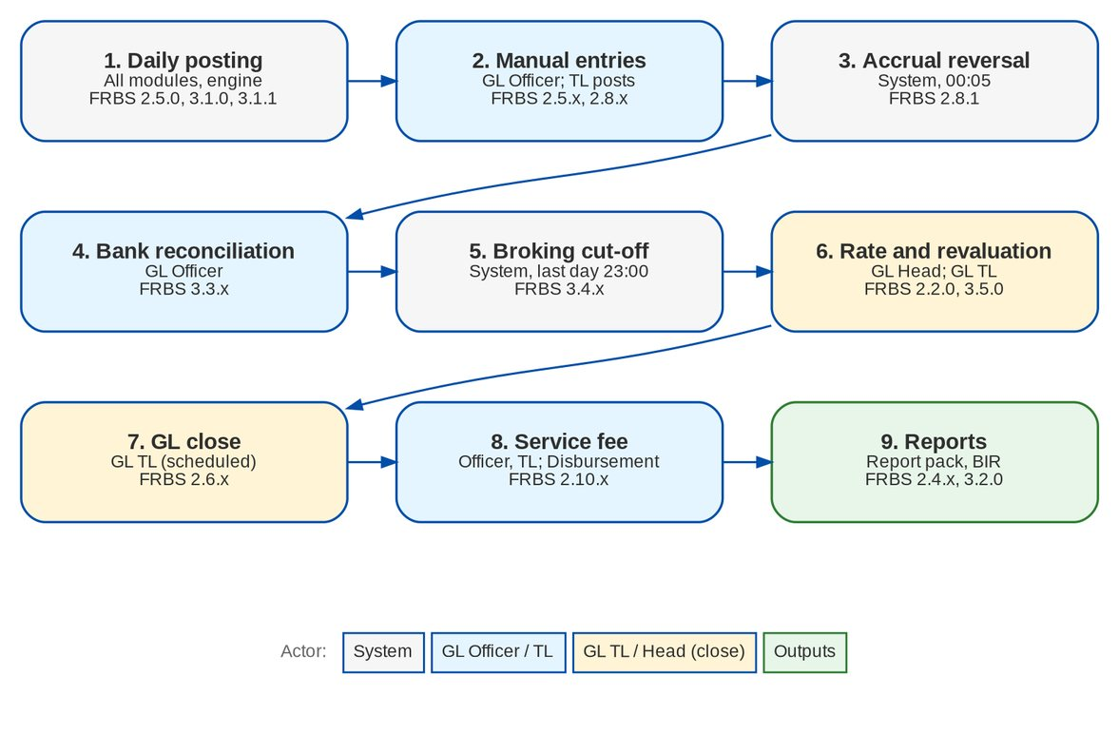
Figure 1: Monthly accounting cycle by actor (FRBS 2.2.0-3.6.0)

2.2.2 Disbursement, Payment Requests and ACSL
Table 6: Process steps
# | Step | Owner | What happens in BIBS | BRD
1 | Request | Source module; Marketing; Disbursement | A payment request arrives from a module or Payment Requests, by upload or by encoding; it is classified and its payee matched | DIS 2.4-2.6, 3.25; MKT 2.24.0
2 | Disbursement voucher | Processor | The DV is created with its proforma entry, mode, paying account and allocation | DIS 2.7.x
3 | Review | Team Leader | The TL reviews and submits for approval, or returns | DIS 2.13.0-2.15.0
4 | Approval and posting | Approver | The approver approves (single or bulk); the entry posts and the instrument is created | DIS 2.19.0
5 | End of day | TL / Approver | Checks, DCTF, forms and reports of the day; confirmations to payees | DIS 2.16.x, 2.7.12
6 | Instrument follow-up | Processor; System | Released, e-mailed, debited, credited, negotiated, stale | DIS 2.8.x, 3.26.x
7 | Tagging | Processor | OR / AR and CWT tags; BIR 2307 | DIS 2.10.0-2.12.0
8 | Status to the source | System | The source module is told of every DV stage and payment | DIS 3.25.0; MKT 1.20.0
9 | ACSL control | ACSL | SOA and GL-SL reconciliation; cases; correction entries | ACSL 2.x

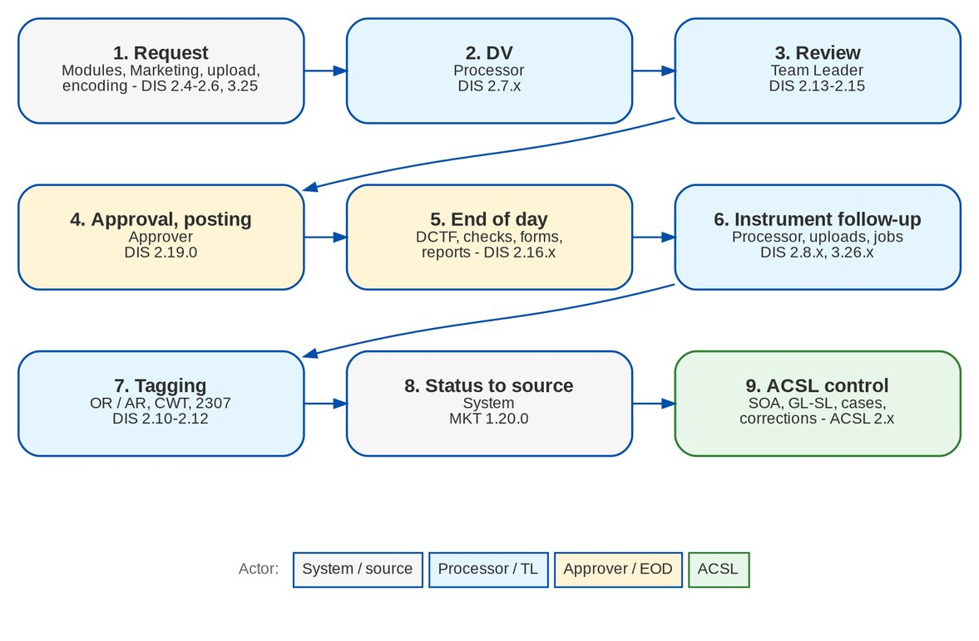
Figure 2: Payment request to payment, with the Payment Request and ACSL flows

3 Personas and roles

3.1 Personas
Table 7: Personas and BIBS roles
Persona | BIBS role | Responsibilities | BRD
GL Officer (FRBS Processor) | FRBS_PROCESSOR | Prepares manual entries; monitors the service fee; runs and exports the report pack and government reports | p.67-68 matrix (p.182)
GL Team Lead | FRBS_TL | Assigns and posts entries; schedules and runs the month-end and year-end closes; maintains and uploads the chart; approves the service fee | p.67-68 matrix
GL Team Head / Section Head | FRBS_HEAD | As the TL, plus the monthly revaluation rate, authorisation of masters and reversal of journals | p.67-68 matrix
Business Administrator | BUSINESS_ADMIN | Maintains lists of values; requests user and role changes | BASAU 2.2.x (p.129)
System Administrator | SYSADMIN | Manages users and role profiles through approved requests | BASAU 2.3.x (p.130)
Approver (administration) | Holder of ACCESS_APPROVE or MASTER_AUTHORIZE | Approves, declines or returns LOV and user-management requests | BASAU 2.5.x-2.6.x (p.131-132)
Comptrollership, Auditor | COMPTROLLERSHIP, AUDITOR | Read access to journals, reports and closing | -
Disbursement Processor | DISBURSEMENT | Encodes and uploads requests, processes DVs, tags instruments, OR / AR and CWT | DIS 2.4-2.12
Disbursement Team Leader | DISB_TL | As the processor, plus review, payee maintenance, funding request and verification, end of day, status-edit approval | DIS 2.13-2.17
Disbursement Approver | DISB_APPROVER | Approves, rejects and cancels approved DVs; authorises payees; approves funding; maintains bank accounts and check series | DIS 2.17-2.24
Marketing Processor (AO) | PRQ_PROCESSOR, MKT_AO | Raises refund, cash-advance and check-cancellation requests | MKT 1.2-1.14
Marketing Reviewer | PRQ_REVIEWER, MKT_TL | Assigns, reviews and endorses requests | MKT 1.9, 1.15
Marketing Approver | PRQ_APPROVER | Approves or returns requests | MKT 1.16
Human Resources | HR_APPROVER | Approves cash advances after Marketing | MKT 1.16.2
ACSL Processor | ACSL_PROCESSOR | Uploads SOAs, investigates, applies refunds, requests reversals, prepares corrections | ACSL 2.2-2.9
ACSL Team Leader | ACSL_TL | Assigns cases and corrections, reviews corrections, confirms remittance deductions | ACSL 2.7-2.10, 2.9.2
ACSL Head (Approver) | ACSL_HEAD | Approves corrections | ACSL 2.11-2.12
Cashier | CASHIER (Operations) | Validates refunds of cancelled policies; approves payment reversals | MKT 1.11.0; ACSL 2.6.1
Comptrollership administrator | FIN_ADMIN, BUSINESS_ADMIN | Employee and cost-centre master; liquidation accounts | DIS 3.30.1

The role grants are the project's reading of the scanned role matrix (p.182): only the Section Head inputs the revaluation rate; only the Team Lead closes the month and the year; Processors make manual entries and monitor the service fee. BDOI confirms the matrix through AQ28. Several roles per user are allowed (decision D5 of R6). The Disbursement, Payment Request and ACSL grants follow the matrices of pp.217-218, 228 and 241.

3.2 Permissions
Table 8: Permissions
Permission | Action class | Allows
JOURNAL_VIEW | VIEW | Journals, account inquiry, party statements
JOURNAL_CREATE | CREATE / AMEND | Create, edit, submit and cancel manual, adjustment and accrual journals
JOURNAL_ASSIGN | AMEND | Assign or re-assign submitted journals to a poster (FRBS 2.5.1)
JOURNAL_AUTHORIZE | APPROVE | Post (approve) or return journals, in bulk (FRBS 2.5.6-2.5.7)
JOURNAL_REVERSE | APPROVE | Reverse a posted journal
REVALUATION_RATE_MAINTAIN | AMEND | Enter the monthly revaluation rate (FRBS 2.2.0)
COA_UPLOAD | CREATE | Upload the chart of accounts (FRBS 2.3.1)
MASTER_MAINTAIN / MASTER_AUTHORIZE | AMEND / APPROVE | Maintain and authorise masters (chart, schedule definitions, LOVs)
PERIOD_MANAGE, PERIOD_END_RUN | AMEND | Open and close periods, run revaluation and year-end
GL_CLOSE_SCHEDULE | AMEND | Schedule, withdraw or run the GL close; broking-books cut-off (FRBS 2.6.0, 3.4.x)
FRBS_REPORT_VIEW, FRBS_REPORT_EXPORT | VIEW | Report pack and account schedules; commentary
SERVICE_FEE_MANAGE, SERVICE_FEE_APPROVE, SERVICE_FEE_TAG | CREATE / APPROVE / AMEND | Service-fee runs, approval and tags (FRBS 2.10.x)
TAX_VIEW | VIEW | BIR forms, books and alphalists
ACCOUNTING_RULE_MANAGE | AMEND | Accounting rules and cost-centre rules (FRBS 3.1.1)
EMPLOYEE_MAINTAIN | AMEND | Employee and cost-centre master (DIS 3.30.1)
LOV_MANAGE | AMEND | Lists of values (BASAU 2.2.x)
ACCESS_REQUEST, ACCESS_APPROVE | CREATE / APPROVE | User and role requests and their decisions (BASAU 2.3.x-2.6.x)
DISB_VIEW | VIEW | Disbursement screens (read)
DISB_PROCESS | CREATE / AMEND | Encode requests, process DVs, instrument actions, cancel In Process
DISB_UPLOAD | CREATE | Request, status and payee-migration uploads
DISB_TAG | AMEND | OR / AR and CWT tags; record certificates received
DISB_REVIEW | APPROVE | Review, return, submit for approval, cancel For review
DISB_APPROVE | APPROVE | Approve, reject, return; cancel approved DVs
DISB_STATUS_APPROVE | APPROVE | Approve instrument status edits
DISB_PAYEE_MAINTAIN / DISB_PAYEE_AUTHORIZE / DISB_PAYEE_VIEW_FULL | CREATE, AMEND / APPROVE / VIEW | Payee master; full account numbers
DISB_EOD | AMEND | End of day and confirmations
DISB_FUNDING_REQUEST / VERIFY / APPROVE | CREATE / APPROVE / APPROVE | Account funding
DISB_REPORT_VIEW / DISB_REPORT_EXPORT | VIEW | Disbursement reports
MASTER_MAINTAIN | AMEND | Bank accounts and check series
EMPLOYEE_MAINTAIN | AMEND | Employee and cost-centre master
PRQ_VIEW / PRQ_CREATE / PRQ_ASSIGN / PRQ_REVIEW / PRQ_APPROVE / PRQ_HR_APPROVE | VIEW / CREATE / AMEND / APPROVE | Payment Requests
ACSL_VIEW / ACSL_UPLOAD / ACSL_PROCESS / ACSL_APPLY / ACSL_ASSIGN / ACSL_REVIEW / ACSL_APPROVE | VIEW / CREATE / AMEND / APPROVE | ACSL
ACSL_REPORT_VIEW / ACSL_REPORT_EXPORT | VIEW | ACSL reports
REMIT_DEDUCTION_CONFIRM | APPROVE | Confirm a remittance deduction

3.3 Permissions matrix

3.3.1 Accounting and administration
Table 9: Role-to-permission matrix for Accounting (proposal until AQ28)
Permission | GL Officer | GL TL | GL Head | Bus. Admin | Sys. Admin | Compt. | Auditor
JOURNAL_VIEW | Y | Y | Y |  |  | Y
JOURNAL_CREATE | Y | Y
JOURNAL_ASSIGN |  | Y | Y
JOURNAL_AUTHORIZE |  | Y | Y
JOURNAL_REVERSE |  |  | Y
REVALUATION_RATE_MAINTAIN |  |  | Y
COA_UPLOAD, MASTER_MAINTAIN |  | Y
MASTER_AUTHORIZE |  |  | Y
PERIOD_MANAGE, PERIOD_END_RUN, GL_CLOSE_SCHEDULE |  | Y | Y
FRBS_REPORT_VIEW | Y | Y | Y |  |  | Y | Y
FRBS_REPORT_EXPORT, TAX_VIEW | Y | Y | Y
SERVICE_FEE_MANAGE, SERVICE_FEE_TAG | Y | Y
SERVICE_FEE_APPROVE |  | Y | Y
LOV_MANAGE |  |  |  | Y
ACCESS_REQUEST |  |  |  | Y | Y

ACCESS_APPROVE is held by the access approvers named by BDOI; ACCOUNTING_RULE_MANAGE and EMPLOYEE_MAINTAIN by the Comptrollership administrators. The table shows the proposed grants.

3.3.2 Disbursement, Payment Requests and ACSL
Table 10: Role-to-permission matrix (proposal until AQ28)
Permission | Disb. Proc. | Disb. TL | Disb. Appr. | MKT Proc. | MKT Rev. | MKT Appr. | HR | ACSL Proc. | ACSL TL | ACSL Head
DISB_VIEW | Y | Y | Y
DISB_PROCESS | Y | Y
DISB_UPLOAD, DISB_TAG | Y | Y
DISB_REVIEW |  | Y
DISB_APPROVE |  |  | Y
DISB_STATUS_APPROVE |  | Y
DISB_PAYEE_MAINTAIN |  | Y
DISB_PAYEE_AUTHORIZE |  |  | Y
DISB_PAYEE_VIEW_FULL |  | Y | Y
DISB_EOD |  | Y | Y
DISB_FUNDING_REQUEST, _VERIFY |  | Y
DISB_FUNDING_APPROVE |  |  | Y
MASTER_MAINTAIN (banks, checks) |  |  | Y
DISB_REPORT_VIEW, _EXPORT | Y | Y | Y
PRQ_VIEW |  |  |  | Y | Y | Y | Y
PRQ_CREATE |  |  |  | Y | Y
PRQ_ASSIGN, PRQ_REVIEW |  |  |  |  | Y
PRQ_APPROVE |  |  |  |  |  | Y
PRQ_HR_APPROVE |  |  |  |  |  |  | Y
ACSL_VIEW, ACSL_REPORT_VIEW |  |  |  |  |  |  |  | Y | Y | Y
ACSL_UPLOAD, _PROCESS, _APPLY, _REPORT_EXPORT |  |  |  |  |  |  |  | Y | Y
ACSL_ASSIGN, ACSL_REVIEW, REMIT_DEDUCTION_CONFIRM |  |  |  |  |  |  |  |  | Y
ACSL_APPROVE |  |  |  |  |  |  |  |  |  | Y

MKT_AO holds PRQ_CREATE and PRQ_VIEW; MKT_TL holds PRQ_VIEW, PRQ_ASSIGN and PRQ_REVIEW. COMPTROLLERSHIP, SYSADMIN and AUDITOR have read access (DISB_VIEW, ACSL_VIEW and the report views; SYSADMIN and AUDITOR also PRQ_VIEW).
Segregation of duties enforced by the system: a journal is never posted by the user who submitted it; a submitted journal is never assigned to its submitter; a service-fee run is never approved by its preparer; an access request is never decided by its submitter; a record is never authorised by its maker; a DV is never checked by its processor or approved by its processor or checker; a funding request is verified by a user other than the maker and approved by two further users; a payee is never authorised by its maker; a status edit is never approved by its requester; a Payment Request is never endorsed or approved by the user who raised or last moved it; a liquidation is checked by someone other than the employee; an ACSL correction is reviewed by someone other than its preparer and approved by someone other than its maker.

4 Functional requirements

4.1 Access and session

FR-AC-001 Access Accounting and administration with a user profile
BRD trace | FRBS 1.1.0 (p.51), FRBS 1.1.1 (p.51), BASAU 1.1.0 (p.128), BASAU 1.1.1 (p.128) | Actor | FRBS users; Business and System Administrators
Priority | Must have | Screens | Login; Home; menu groups Finance, Planning and Closing, Setup and Administration

Description
Users reach BIBS from any BDO-issued device with a browser; the screens are responsive. Each user logs in with their own profile, and the menu shows only the screens their roles allow (section 3).
Preconditions
• The user has an active BIBS account with an Accounting or administration role.
Main flow
1. The user opens BIBS and enters the user ID and password.
2. BIBS checks the credentials and the account status.
3. BIBS opens the home page with the menu of the user's roles.
Alternate and exception flows
• Wrong credentials. The log-in is refused and counted; after LOGIN_MAX_FAILED_ATTEMPTS the account locks.
Business rules
Rule | Statement | Kind | Maintained in
R1 | Log-in, lock-out and session rules are those of BRD-1 (BRNB.040). | Configurable | Session parameters
R2 | BDO single sign-on / Active Directory is not part of this phase (Q42). | Fixed | -

Validations and messages
Check | Message shown | Code
User ID or password wrong | Invalid user name or password | AUTHENTICATION_FAILED
Account locked (the same message as a wrong password; the lock shows to the System Administrator on Users) | Invalid user name or password | AUTHENTICATION_FAILED

Notifications
• None.
Audit
• Every successful and failed log-in is recorded with user, time and source address.
Acceptance criteria
1. A GL Officer logs in from a BDO laptop and a BDO mobile device and sees Journals, Report Pack and Service Fee Runs.
2. A GL Officer does not see Chart Upload or GL Close & Cut-Off.

FR-AC-002 Warn before the idle time-out and before the forced log-out
BRD trace | FRBS 1.1.2 (p.51), FRBS 1.1.3 (p.51), BASAU 1.1.2 (p.129), BASAU 1.1.3 (p.129) | Actor | System
Priority | Must have | Screens | All screens (session dialog)

Description
After 15 minutes without activity BIBS shows an inactivity warning; the user continues or is logged out. 30 minutes before the end of the session BIBS warns that the system will log the user out. Both times are parameters.
Preconditions
• The user is logged in.
Main flow
1. The user is inactive for SESSION_IDLE_WARNING_MINUTES.
2. BIBS shows the inactivity warning with the choice to stay logged in.
3. Before the session ends, BIBS shows the log-out warning SESSION_EXPIRY_WARNING_MINUTES ahead.
Business rules
Rule | Statement | Kind | Maintained in
R1 | Inactivity warning after 15 minutes (SESSION_IDLE_WARNING_MINUTES). | Configurable | Parameter
R2 | Log-out warning 30 minutes before the forced log-out (SESSION_EXPIRY_WARNING_MINUTES). | Configurable | Parameter

Notifications
• On-screen warnings only.
Audit
• Log-outs by time-out are recorded.
Acceptance criteria
1. After 15 minutes of inactivity the warning appears.
2. The log-out warning appears 30 minutes before the session ends.

4.2 Chart of accounts and revaluation rate

FR-AC-010 Enter the monthly revaluation rate
BRD trace | FRBS 2.2.0 (p.52), FRBS 3.6.0 (p.66) | Actor | GL Team Head / Section Head
Priority | Must have | Screens | Setup > Currencies & Rates (card Monthly revaluation rates)

Description
The Section Head enters, once a month, the revaluation rate of each foreign currency for the month end. BIBS keeps it as the CLOSING rate of that date; the FX revaluation (FR-AC-043) uses it.
When OPS_BOOK_RATE_SOURCE is CLOSING_PREV_MONTH, the job BOOK_RATE_FROM_CLOSING copies the rates of the month that ends as the BOOK rates of the next month, never overwriting a BOOK rate already entered. "Copy to BOOK" does it on demand.
Preconditions
• The user has REVALUATION_RATE_MAINTAIN.
Main flow
1. The Section Head opens Currencies & Rates, card Monthly revaluation rates.
2. The Section Head enters the month and the rate per currency and saves.
3. BIBS stores the CLOSING rate at the month end.
4. At 00:30 on the first day of the next month the job copies it as that month's BOOK rate.
Business rules
Rule | Statement | Kind | Maintained in
R1 | The revaluation rate is the CLOSING rate of the month end. | Fixed | -
R2 | BOOK rate of month M = CLOSING rate of the end of M-1 when OPS_BOOK_RATE_SOURCE = CLOSING_PREV_MONTH; MANUAL keeps BOOK rates by hand (AQ03, OQ08). | Configurable | Parameter OPS_BOOK_RATE_SOURCE
R3 | Rates are positive; the currency must be active. | Fixed | -

Validations and messages
Check | Message shown | Code
Rate not positive | Exchange rate must be positive | INVALID_RATE
Inactive currency | Currency <code> is not active | INACTIVE_CURRENCY

Screens and fields: Monthly revaluation rates
Field | Type | Mand. | Source / LOV | Validation
Month | Month | Yes | - | yyyy-MM
Currency | List | Yes | Active currencies | Not the base currency
Rate | Number | Yes | - | > 0; up to 8 decimals

Notifications
• None.
Audit
• Rates are recorded with user and time; the copy job records its run.
Acceptance criteria
1. The Section Head enters USD 58.1234 for August; it appears as the CLOSING rate of 31 August and as the BOOK rate from 1 September.
2. A GL Officer cannot enter a revaluation rate.
Difference from the BRD. The BRD asks only for a monthly rate. BIBS also proposes it as the BOOK rate of the next month for Operations receipts, which BDOI confirms through AQ03 / OQ08. The parameter switches this off.

FR-AC-011 Set up, view and edit the chart of accounts
BRD trace | FRBS 2.3.0 (p.52), FRBS 2.3.4 (p.54), FRBS 2.3.5 (p.54), FRBS 3.6.0 (p.66) | Actor | GL Team Lead (maintain); GL Team Head (authorise)
Priority | Must have | Screens | General Ledger > Chart of Accounts

Description
FRBS keeps the chart of accounts in BIBS - levels (group, main, sub, micro), class, category, parent, postable flag, control account and sub-ledger type, currencies, cost-centre requirement, revaluation flag, negative-balance policy, short code, branch and role restrictions, freeze and close. New and changed accounts are maker-checker. Users view the details of any account.
Preconditions
• The maker has MASTER_MAINTAIN; the authoriser MASTER_AUTHORIZE.
Main flow
1. The TL opens Chart of Accounts and creates or edits an account.
2. BIBS checks the hierarchy (class of the parent, allowed level) and saves it pending authorisation.
3. The Head authorises it; it becomes usable for postings.
Business rules
Rule | Statement | Kind | Maintained in
R1 | A child account has the class of its parent; sub and micro accounts need a parent. | Fixed | -
R2 | An account with postings cannot become a heading. | Fixed | -
R3 | BDOI's own chart is loaded at go-live by upload (FR-AC-012); the seed chart is a placeholder (AQ01). | Configurable | Chart of accounts

Validations and messages
Check | Message shown | Code
Parent class differs | Child account class must match parent <code> | CLASS_MISMATCH
Level not allowed under the parent | A <level> account cannot be placed under a <level> | INVALID_TIER
Sub or micro without parent | Sub and Micro GL accounts require a parent account | PARENT_REQUIRED
Parent with postings | Account <code> already has postings and cannot become a heading | PARENT_HAS_POSTINGS
Authoriser is the maker | A record cannot be authorized by the user who maintained it | MAKER_CHECKER_VIOLATION

Screens and fields: Chart of Accounts (account)
Field | Type | Mand. | Source / LOV | Validation
Account code | Text | Cond. | - | Unique; proposed by numbering when blank (FR-AC-013)
Name | Text | Yes | - | -
Short code | Text | No | - | Unique per company (FR-AC-014)
Parent | Look-up | Cond. | Chart | Required for sub and micro
Class / Level / Category | List | Yes | Account classes and levels | Class of the parent
Postable, Control account, Sub-ledger type | Check box / List | No | - | -
Cost centre required, Revaluation required | Check box | No | - | -
Negative balance policy | List | No | ALLOW, WARN, BLOCK | Default ALLOW (FR-AC-034)

Notifications
• Pending accounts appear in My Approvals.
Audit
• Every change is audited with before and after values.
Acceptance criteria
1. A new account under 1210 with a different class is refused.
2. A new account is not usable in a journal until another user authorises it.

FR-AC-012 Upload the chart of accounts
BRD trace | FRBS 2.3.1 (p.52) | Actor | GL Team Lead (COA_UPLOAD); GL Team Head (authorise)
Priority | Must have | Screens | General Ledger > Chart Upload (Upload Chart, Upload History)

Description
FRBS uploads an XLSX, CSV or ODS file of parent and child accounts. BIBS validates every row (parent, class, level, category, postable, control, sub-ledger type, currency, flags), shows the valid and invalid rows, and on commit creates the accounts pending authorisation, parents before children. A parent may be an existing account or an earlier row of the file. The error report lists every refused row with its reason.
Preconditions
• The user has COA_UPLOAD.
Main flow
1. The TL downloads the template and fills it.
2. The TL uploads the file; BIBS validates each row and shows the counts.
3. The TL commits the valid rows; BIBS creates the accounts pending authorisation.
4. The Head authorises them.
Alternate and exception flows
• Invalid rows. The TL downloads the row report, corrects the file and uploads again, or commits only the valid rows.
• Cancel. The TL cancels an upload that was not committed.
Business rules
Rule | Statement | Kind | Maintained in
R1 | Every uploaded account is created PENDING_AUTHORIZATION. | Fixed | -
R2 | A blank code takes the next number of the parent's numbering scheme (FR-AC-013). | Fixed | -

Validations and messages
Check | Message shown | Code
Class of a row differs from its parent | Child account class must match parent <code> | CLASS_MISMATCH
Short code already used | Short code <code> is already used by account <account> | SHORT_CODE_TAKEN
No numbering scheme for a blank code | Enter the account code: no numbering scheme under <parent> | NO_NUMBERING
File not readable or wrong type | Upload a .csv or .xlsx file | -

Screens and fields: Chart Upload
Field | Type | Mand. | Source / LOV | Validation
Chart file | File | Yes | - | XLSX, CSV or ODS

Notifications
• Pending accounts appear in My Approvals of the authorisers.
Audit
• The upload keeps its file, rows, outcomes and the user who committed it.
Acceptance criteria
1. The sample file of 8 accounts under the groups 1900 and 2900 loads without errors and the accounts wait for authorisation.
2. A row whose parent is missing is reported with its reason and not created.

FR-AC-013 Generate account numbers and roll child accounts up to their parent
BRD trace | FRBS 2.3.2 (p.53) | Actor | GL Team Lead; System
Priority | Must have | Screens | General Ledger > Chart of Accounts (Numbering Schemes)

Description
FRBS defines a numbering scheme per parent account (separator none, "." or "-", and a width of 1 to 6 digits). When an account is created or uploaded with a blank code, BIBS gives it the next free number under its parent; numbers already used under the prefix are never reused. Every child is linked to its parent, and the statements and schedules roll child balances up to the parent.
Preconditions
• The user has MASTER_MAINTAIN.
Main flow
1. The TL sets the numbering scheme of a parent.
2. The TL creates a child account with a blank code.
3. BIBS proposes and assigns the next number.
Business rules
Rule | Statement | Kind | Maintained in
R1 | Numbers are unique and never reused under a parent. | Fixed | -
R2 | Balances of child accounts roll up to every parent level in the statements. | Fixed | -

Validations and messages
Check | Message shown | Code
Invalid scheme | Separator must be none, '.' or '-' and width 1 to 6 digits | INVALID_NUMBERING
Top-level account without code | Enter the account code of a top-level account | ACCOUNT_CODE_REQUIRED
No free number left | No free <width>-digit number under <parent> | NUMBERING_EXHAUSTED

Screens and fields: Numbering scheme
Field | Type | Mand. | Source / LOV | Validation
Parent account | Look-up | Yes | Chart | Heading account
Separator | List | Yes | none, '.', '-' | -
Width | Number | Yes | - | 1-6

Notifications
• None.
Audit
• Scheme changes are audited.
Acceptance criteria
1. With the scheme "." and width 2 under 1900, a new blank-coded child becomes 1900.01, the next 1900.02.
2. The balance of 1900.01 is included in 1900 on the trial balance.
Difference from the BRD. FRBS 2.3.2 says the account number is system-generated. BIBS generates it when the code is blank and a scheme exists; FRBS may still key a code. BDOI's numbering convention is part of AQ01.

FR-AC-014 Search accounts by name, short code or number
BRD trace | FRBS 2.3.3 (p.53) | Actor | FRBS users
Priority | Must have | Screens | Chart of Accounts (search); journal lines (account entry)

Description
Each account may have a short code, unique per company regardless of case. The chart search finds accounts by code, name or short code, and a journal line accepts the short code in place of the account code (FR-AC-032).
Preconditions
• The user has JOURNAL_VIEW or MASTER_VIEW.
Main flow
1. The user types a name, short code or number in the search.
2. BIBS lists the matching accounts.
Business rules
Rule | Statement | Kind | Maintained in
R1 | Short codes are unique per company, case-insensitive. | Fixed | -

Validations and messages
Check | Message shown | Code
Short code already used | Short code <code> is already used by account <account> | SHORT_CODE_TAKEN
Unknown key on a journal line | Unknown GL account <key> | UNKNOWN_ACCOUNT

Notifications
• None.
Audit
• Read only.
Acceptance criteria
1. Searching "PRPHP" returns the account whose short code is PRPHP.
2. A second account cannot take a short code already used.

4.3 Reports on demand

FR-AC-020 Select, run, view and copy reports on demand
BRD trace | FRBS 2.4.0 (p.54), FRBS 2.4.1 (p.54), FRBS 2.4.2 (p.54), FRBS 2.4.3 (p.55), FRBS 2.4.6 (p.55), FRBS 2.4.8 (p.56), FRBS 2.4.10 (p.56) | Actor | FRBS users
Priority | Must have | Screens | Report Centre; Report; Accounting Reports > Report Pack

Description
FRBS users run any report they are allowed to see at any time, without IT. They choose the report from the catalogue by category, enter its parameters (date range or as-of date, company, branch), view the result on screen, preview the PDF and export to XLSX, ODS, PDF or CSV. The on-screen table can be selected and copied into Excel or Word.
Preconditions
• The user has the view permission of the report (for example FRBS_REPORT_VIEW).
Main flow
1. The user opens the Report Centre or the Report Pack and selects a report.
2. The user enters the parameters and clicks Run.
3. BIBS shows the result.
4. The user previews or exports it.
Business rules
Rule | Statement | Kind | Maintained in
R1 | Exports and runs are archived with parameters, user and time. | Fixed | -

Validations and messages
Check | Message shown | Code
Mandatory parameter missing | Parameter <name> is required | MISSING_PARAMETER
Invalid parameters | <errors> | INVALID_REPORT_PARAMETERS

Screens and fields: Report parameters (typical)
Field | Type | Mand. | Source / LOV | Validation
Company | List | Yes | Companies of the user | -
From / To or As of | Date | Yes | - | Defaults per report (for example start of month, today)
Branch | List | No | Branches | -

Notifications
• None.
Audit
• Each run and export is in the report archive.
Acceptance criteria
1. A GL Officer runs the trial balance for August and exports it to XLSX and ODS.
2. The on-screen result can be copied and pasted into Excel.

FR-AC-021 Filter every column of a report
BRD trace | FRBS 2.4.4 (p.55) | Actor | FRBS users
Priority | Must have | Screens | Report (column filter row)

Description
The report viewer has a filter row under the column headings. The user filters the loaded rows by any column; an export applies the same filters to the detail rows and notes them on the file.
Preconditions
• A report result is on screen.
Main flow
1. The user types a filter value in a column.
2. BIBS shows only the matching rows.
3. The user exports; the file holds the filtered rows and states the filter.
Business rules
Rule | Statement | Kind | Maintained in
R1 | Filters apply to detail rows; totals are recomputed on the filtered rows. | Fixed | -

Notifications
• None.
Audit
• The filter is part of the archived parameters.
Acceptance criteria
1. Filtering the Account column of a trial balance on "1210" shows only the 1210 accounts; the export holds the same rows.

FR-AC-022 Download or print several reports at once
BRD trace | FRBS 2.4.5 (p.55), FRBS 2.4.7 (p.55) | Actor | FRBS users
Priority | Must have | Screens | Report Centre > Report Batch

Description
A report batch runs several reports with shared parameters and returns one ZIP of files in a chosen format, or one merged PDF for printing. Each report checks its own permission; a report that fails is listed and the others are produced (status COMPLETED, PARTIAL or FAILED). Only the creator sees a batch.
Preconditions
• The user may run each report of the batch.
Main flow
1. The user opens Report Batch and selects the reports.
2. The user enters the shared parameters and the output (ZIP of XLSX / ODS / PDF / CSV, or merged PDF).
3. BIBS runs the reports and offers the file.
Business rules
Rule | Statement | Kind | Maintained in
R1 | A batch has at least one report and at most the platform maximum. | Fixed | -
R2 | Batches run in the request; each report in its own transaction. | Fixed | -

Validations and messages
Check | Message shown | Code
No report or too many | Select between 1 and <max> reports | REPORT_BATCH_SIZE
No file produced | Batch <no> produced no file | REPORT_BATCH_EMPTY

Notifications
• None.
Audit
• The batch and each report run are archived.
Acceptance criteria
1. Selecting the trial balance, the income statement and the statement of condition for August returns one ZIP with three files.
2. The merged PDF option returns one PDF with the three reports in order.

FR-AC-023 Set the print options of a report
BRD trace | FRBS 2.4.9 (p.56) | Actor | FRBS users
Priority | Must have | Screens | Report (Export dialog); Report Batch

Description
Before printing, the user chooses the paper size, the orientation and whether to fit the columns to the page width. The header and footer repeat on every page.
Preconditions
• A report result is on screen.
Main flow
1. The user chooses PDF and the print options.
2. BIBS renders the PDF with those options.
Business rules
Rule | Statement | Kind | Maintained in
R1 | Paper A4, Letter or Legal; portrait or landscape; fit to width on or off. | Fixed | -

Screens and fields: PDF print options
Field | Type | Mand. | Source / LOV | Validation
Paper | List | No | A4, Letter, Legal | -
Orientation | List | No | Portrait, Landscape | -
Fit to width | Check box | No | - | -

Notifications
• None.
Audit
• The options are recorded with the export.
Acceptance criteria
1. A wide report printed landscape, fit to width, shows all its columns on one page width.

4.4 Posting and manual entries

FR-AC-030 Post every financial transaction to the GL and the sub-ledger
BRD trace | FRBS 2.5.0 (p.56), FRBS 3.1.0 (p.63) | Actor | System
Priority | Must have | Screens | Journals; Account Inquiry; Party Statement; Accounting Engine (event log)

Description
Every BIBS module that has a financial effect publishes a business event (booking, receipt, remittance, adjustment, commission, disbursement, service fee, correction). The accounting engine creates the journal lines from the rules maintained by Comptrollership, posts them together with the event, and records or matches the open items of the parties in the sub-ledger. GL accounts are never chosen in code.
Preconditions
• An active accounting rule exists for the event type.
Main flow
1. A module publishes an event with its amounts and account roles.
2. The engine resolves the rule, fills the cost centres (FR-AC-054) and creates balanced lines.
3. The engine posts the journal and the sub-ledger items.
Alternate and exception flows
• No rule or missing account role. The event is recorded FAILED in the event log for re-processing; the alert of the module is raised.
• Broking books closed. Events of the broking modules for a closed month are refused (FR-AC-042).
Business rules
Rule | Statement | Kind | Maintained in
R1 | Posting rules are configuration maintained by Comptrollership; the real rules replace the seed rules (AQ02, OQ07). | Configurable | Accounting rules
R2 | A posted journal is immutable; corrections are reversals and new entries. | Fixed | -

Validations and messages
Check | Message shown | Code
No rule for the event | No active accounting rule for event <type> (line of business <lob>, currency <ccy>) | NO_ACCOUNTING_RULE
Account role not supplied | Event <type> must supply an account for role <role> | MISSING_ACCOUNT_ROLE
Event without amounts | Event <type> has no amounts to account for | EMPTY_ACCOUNTING_EVENT

Notifications
• Alerts of the publishing module on failure.
Audit
• The event log keeps each event, its source reference and its journal.
Acceptance criteria
1. An approved remittance batch posts its journal and clears the insurer's open items.
2. An event without a rule is FAILED in the event log and can be re-processed after the rule is added.

FR-AC-031 Assign manual entries for posting and work the assigned list
BRD trace | FRBS 2.5.1 (p.57), FRBS 2.5.2 (p.57), FRBS 2.5.3 (p.57) | Actor | GL Team Lead / Head (assign); poster
Priority | Must have | Screens | General Ledger > Journals (Assign, Assigned to me); Journal

Description
A TL or Head assigns submitted journals to a poster, or re-assigns them. Each poster filters Journals on "Assigned to me", selects an entry and views its lines, dimensions, attachments and history before posting.
Preconditions
• The assigner has JOURNAL_ASSIGN; the assignee holds JOURNAL_AUTHORIZE.
Main flow
1. The TL selects submitted journals and clicks Assign.
2. The TL chooses the poster.
3. The poster opens Journals, filter "Assigned to me", and opens an entry.
Business rules
Rule | Statement | Kind | Maintained in
R1 | The assignee must be allowed to authorise journals and must not be the submitter. | Fixed | -

Validations and messages
Check | Message shown | Code
Assignee cannot authorise | <user> is not allowed to authorize journals | ASSIGNEE_NOT_AUTHORIZER
Assignee is the submitter | <journal> cannot be assigned to the user who submitted it | ASSIGNEE_IS_MAKER

Screens and fields: Assign journals
Field | Type | Mand. | Source / LOV | Validation
Assign to | List | Yes | Users with JOURNAL_AUTHORIZE | Not the submitter

Notifications
• The assignee sees the entries in Assigned to me.
Audit
• Assigned by, assigned to and time are stored on the journal.
Acceptance criteria
1. A journal submitted by glofficer cannot be assigned to glofficer.
2. After assignment to gltl, the journal appears in gltl's Assigned to me.

FR-AC-032 Prepare manual entries
BRD trace | FRBS 2.8.0 (p.60), FRBS 2.8.1 (p.61), FRBS 2.8.2 (p.61), FRBS 2.8.5 (p.62) | Actor | GL Officer; GL Team Lead
Priority | Must have | Screens | General Ledger > New Journal; Edit Journal

Description
The GL Officer prepares a MANUAL, ADJUSTMENT or ACCRUAL journal - journal type, value date, reference, narration, optional "reverse on" date, and lines with the account (by code or short code; the name fills in), debit or credit, description, cost centre and other dimensions. The journal is saved as a draft and submitted for review and posting. Journals can also be uploaded from a file or generated from recurring templates.
Preconditions
• The user has JOURNAL_CREATE; the value date is in an open period.
Main flow
1. The officer clicks New Journal and fills the header and the lines.
2. The officer saves the draft; BIBS numbers it.
3. The officer submits it; BIBS validates it (FR-AC-034) and asks for confirmation (FR-AC-035).
4. The journal becomes PENDING_APPROVAL.
Alternate and exception flows
• Accrual with reversal. A "reverse on" date after the value date is set; the reversal posts automatically (FR-AC-033).
Business rules
Rule | Statement | Kind | Maintained in
R1 | Only MANUAL, ADJUSTMENT or ACCRUAL journals are entered manually. | Fixed | -
R2 | Only the maker changes a draft or returned journal. | Fixed | -
R3 | The reversal date must follow the value date and applies to manual journals only. | Fixed | -

Validations and messages
Check | Message shown | Code
Wrong journal type | Only MANUAL, ADJUSTMENT or ACCRUAL journals can be entered manually | INVALID_JOURNAL_TYPE
Not the maker | Only the maker (<user>) can change this journal | NOT_MAKER
Reversal date not after value date | The reversal date must be after the value date <date> | REVERSAL_DATE_INVALID
Unknown account or short code | Unknown GL account <key> | UNKNOWN_ACCOUNT

Screens and fields: New Journal
Field | Type | Mand. | Source / LOV | Validation
Journal type | List | Yes | MANUAL, ADJUSTMENT, ACCRUAL | -
Value date | Date | Yes | - | Open period; back- and forward-dating limits
Reference | Text | No | - | -
Narration | Text | Yes | - | -
Reverse on | Date | No | - | After the value date
Line - account or short code | Look-up | Yes | Chart of accounts | Postable; manual posting allowed
Line - debit / credit | Amount | Yes | - | One side per line; > 0
Line - description | Text | No | - | -
Line - cost centre and dimensions | List | Cond. | Dimensions | Required when the account requires a cost centre

Notifications
• The journal appears in the approval inbox of the posters.
Audit
• Create, save, submit, cancel and every change are recorded with user and time.
Acceptance criteria
1. An accrual entered with the short code of the account shows the account name and saves as a draft.
2. Submitting sends it to PENDING_APPROVAL after confirmation.

FR-AC-033 Reverse accruals automatically on their reversal date
BRD trace | FRBS 2.8.1 (p.61) | Actor | System
Priority | Must have | Screens | Journals (REVERSAL journals); Scheduled Jobs

Description
Every day at 00:05 Manila the job JOURNAL_AUTO_REVERSAL posts, for each posted manual journal whose "reverse on" date has come, a REVERSAL system journal that mirrors it, linked to the original. Each reversal posts in its own transaction.
Preconditions
• A posted manual journal has a reverse-on date of today or earlier and is not reversed.
Main flow
1. The job selects the journals due for reversal.
2. BIBS posts the reversal journal with the key JV:<batch>:AUTOREV.
3. The original shows its reversal.
Business rules
Rule | Statement | Kind | Maintained in
R1 | One reversal per journal; a repeat does not create a second one. | Fixed | -
R2 | Schedule daily 00:05 Manila. | Configurable | Job schedule (System Administrator)

Validations and messages
Check | Message shown | Code
Journal already reversed | Journal <no> is already reversed | ALREADY_REVERSED
Reversal already pending | A reversal of <no> already exists | REVERSAL_PENDING

Notifications
• None; failures appear in the job run history.
Audit
• The reversal journal carries the source AUTOREV and the link to the original.
Acceptance criteria
1. An accrual posted on 31 August with reverse-on 1 September is reversed by a system journal dated 1 September.
Difference from the BRD. FRBS 2.8.1 asks for the reversal in the GL and the SL. Manual journals record no sub-ledger open items in BIBS, so only the GL is reversed.

FR-AC-034 Validate entries and refuse errors
BRD trace | FRBS 2.5.4 (p.57), FRBS 2.5.5 (p.58), FRBS 2.8.4 (p.62), FRBS 3.6.0b (p.67) | Actor | System
Priority | Must have | Screens | New Journal; Journal; confirmation dialog

Description
BIBS validates every manual journal on submission and again on posting. It refuses a journal that has no debit or no credit line, is not balanced, posts to a non-postable, frozen or closed account, uses a currency or branch the account does not allow, is dated outside the permitted window, or would leave a BLOCK account with a negative balance. WARN accounts give a warning that the user sees before confirming. All errors are listed together.
Preconditions
• A journal is submitted or approved.
Main flow
1. The user submits or approves a journal.
2. BIBS runs the checks and the negative-balance check on the balance after posting.
3. BIBS refuses the journal with every error, or shows the warnings for confirmation.
Business rules
Rule | Statement | Kind | Maintained in
R1 | Each account has a negative-balance policy ALLOW, WARN or BLOCK; the natural side comes from the account class. | Configurable | Chart of accounts (FR-AC-011)
R2 | The accounts that may never be negative are to be named by BDOI (AQ30). | Configurable | Chart of accounts

Validations and messages
Check | Message shown | Code
Unbalanced journal | Journal is not balanced - debit <x> vs credit <y> | UNBALANCED_JOURNAL
Any line error | <list of errors> | JOURNAL_INVALID
Negative balance on a BLOCK account | Account <code> would have a negative (<side>) balance of <amount> | JOURNAL_INVALID
Negative balance on a WARN account | Account <code> would have a negative (<side>) balance of <amount> | - (warning)
Value date outside the window | Value date <date> is earlier / later than the permitted <n> back- / forward-dated days | JOURNAL_INVALID

Notifications
• Messages on screen.
Audit
• Refusals are not posted; warnings accepted are recorded with the confirmation.
Acceptance criteria
1. A journal with debits of 1,000.00 and credits of 900.00 is refused as unbalanced.
2. A journal that would make a BLOCK cash account negative is refused; on a WARN account it shows a warning and can be confirmed.
Difference from the BRD. FRBS 2.5.4 asks to prevent posting with a negative balance on every account. BIBS lets FRBS choose per account (ALLOW, WARN, BLOCK), because many GL accounts legitimately change sides.

FR-AC-035 Confirm the transaction details before sending them on
BRD trace | FRBS 2.5.10 (p.59), FRBS 2.8.3 (p.61) | Actor | GL Officer; poster
Priority | Must have | Screens | Confirm posting dialog (Journals)

Description
Before a journal is submitted or posted, BIBS shows a confirmation dialog with the totals, the number of lines, the dates and any warnings. The user confirms or goes back.
Preconditions
• The user clicks Submit or Post.
Main flow
1. BIBS shows the confirmation dialog.
2. The user confirms; BIBS submits or posts.
Alternate and exception flows
• Cancel. The journal stays as it was.
Business rules
Rule | Statement | Kind | Maintained in
R1 | The dialog is shown for every submission and posting. | Fixed | -

Notifications
• None.
Audit
• The confirmed action is audited.
Acceptance criteria
1. Submitting a journal shows its debit and credit totals and line count before it is sent.

FR-AC-036 Post or return entries, one or several at a time, with remarks
BRD trace | FRBS 2.5.6 (p.58), FRBS 2.5.7 (p.58), FRBS 2.5.8 (p.58), FRBS 2.5.9 (p.58) | Actor | GL Team Lead / Head (JOURNAL_AUTHORIZE)
Priority | Must have | Screens | Journals (bulk posting); Journal (Post, Return to Maker); My Approvals

Description
The poster posts a single journal or selects several and posts them together. Each journal is validated and posted in its own transaction with every control; the result lists the successes and the refusals. The poster returns a journal to its maker with remarks ("Return to Maker"); the maker corrects and resubmits it.
Preconditions
• The user has JOURNAL_AUTHORIZE and did not submit the journal.
Main flow
1. The poster selects the journals and clicks Post.
2. BIBS validates and posts each journal; the results are listed.
Alternate and exception flows
• Return. The poster enters the remarks and clicks Return to Maker; the journal is REJECTED and editable by its maker.
• Limit. A journal above the poster's authorisation limit is refused.
Business rules
Rule | Statement | Kind | Maintained in
R1 | A journal is never posted by its submitter. | Fixed | -
R2 | Posting limits per user apply. | Configurable | User authorisation limits

Validations and messages
Check | Message shown | Code
Poster is the submitter | A journal cannot be authorized by the user who submitted it | MAKER_CHECKER_VIOLATION
Above the limit | Journal total <amount> exceeds your authorization limit <limit> | AUTHORIZATION_LIMIT_EXCEEDED
Wrong status | Cannot <action> journal <no> in status <status> | INVALID_JOURNAL_STATUS
Return without remarks | Enter the reason | -

Screens and fields: Return to Maker
Field | Type | Mand. | Source / LOV | Validation
Remarks | Long text | Yes | - | -

Notifications
• The maker sees a returned journal in the journal list with its remarks.
Audit
• Posting and return are recorded with user, time and remarks.
Acceptance criteria
1. Posting 10 selected journals of which one is unbalanced posts 9 and reports the refused one.
2. A returned journal shows the remarks and can be edited and resubmitted by its maker.

FR-AC-037 Edit accounting entries
BRD trace | FRBS 2.9.0 (p.62) | Actor | GL Officer (maker)
Priority | Must have | Screens | Edit Journal; Journal (Reverse)

Description
Draft and returned journals are edited by their maker. A posted journal is never edited; it is corrected by reversal and a new entry, or through an ACSL correction entry (FR-AS-021).
Preconditions
• The journal is DRAFT or REJECTED (edit); POSTED (reverse, JOURNAL_REVERSE).
Main flow
1. The maker opens the journal and edits it.
2. The maker submits it again.
Alternate and exception flows
• Posted. The Head reverses the journal with a reason; the maker prepares a new one.
Business rules
Rule | Statement | Kind | Maintained in
R1 | Posted journals are immutable. | Fixed | -

Validations and messages
Check | Message shown | Code
Edit a posted journal | Cannot edit journal <no> in status POSTED | INVALID_JOURNAL_STATUS

Notifications
• None.
Audit
• Every change and the reversal are audited.
Acceptance criteria
1. A returned journal is edited and resubmitted by its maker.
2. A posted journal has no Edit action.

4.5 Closing and revaluation

FR-AC-040 Schedule and run the month-end close of the GL books
BRD trace | FRBS 2.6.0 (p.59; Add.1 p.36), FRBS 2.6.1 (p.59) | Actor | GL Team Lead / Head (GL_CLOSE_SCHEDULE); System
Priority | Must have | Screens | Planning & Closing > GL Close & Cut-Off (Month-End Close)

Description
FRBS schedules the close of the previous month's GL books on a date and time of its choice in the current month (Addendum 1). BIBS proposes the 2nd banking day of the month at 17:00 Manila, skipping company holidays. Every 15 minutes the job GL_PERIOD_CLOSE runs the closes that are due - the period-end checklist, then the period close. A refused close is recorded on the schedule with the blocking items and raises GL_CLOSE_FAILED. FRBS can also close at once.
With CLOSE_ONLY_PREVIOUS_MONTH on, only the month before the close date may be closed.
Preconditions
• The user has GL_CLOSE_SCHEDULE; the period is open and has no scheduled close.
Main flow
1. The TL opens GL Close & Cut-Off and clicks Schedule Close.
2. BIBS proposes the date and time; the TL confirms or changes them.
3. At the time, the job runs the checklist and closes the period.
Alternate and exception flows
• Checklist fails. The close is FAILED with the blocking items; GL_CLOSE_FAILED is raised; the TL fixes the items and schedules again.
• Withdraw. The TL withdraws a scheduled close.
Business rules
Rule | Statement | Kind | Maintained in
R1 | Only the previous month may be closed (CLOSE_ONLY_PREVIOUS_MONTH = true). | Configurable | Parameter CLOSE_ONLY_PREVIOUS_MONTH
R2 | Proposed close - 2nd banking day of the next month, 17:00 Manila. | Fixed | -
R3 | The checklist covers pending journals, reconciliations, FX revaluation and the trial balance. | Fixed | -

Validations and messages
Check | Message shown | Code
Not the previous month | On <date> only the period of <month> may be closed, not <period> | CLOSE_ONLY_PREVIOUS_MONTH
Already scheduled | <period> already has a scheduled close | CLOSE_ALREADY_SCHEDULED
Period not closable | <period> is <status> | PERIOD_NOT_CLOSABLE
Checklist blocking items | <blocking items> | GL_CLOSE_CHECKLIST
Schedule not active | The scheduled close is already <status> | CLOSE_SCHEDULE_NOT_ACTIVE

Screens and fields: Schedule Close
Field | Type | Mand. | Source / LOV | Validation
Period | List | Yes | Open periods | Previous month
Close on (date) | Date | Yes | - | dd-MMM-yyyy; with the time, in the future; default 2nd banking day
Close on (time) | Time | Yes | - | HH:mm, next to the date; default 17:00

Notifications
• Alert GL_CLOSE_FAILED when a scheduled close fails.
Audit
• Schedule, withdrawal, run and result are recorded with user and time.
Acceptance criteria
1. On 1 October, scheduling the close of August is refused; September is accepted.
2. A close with unposted journals fails and raises GL_CLOSE_FAILED with the list.

FR-AC-041 Close the year and verify that the nominal accounts are zero
BRD trace | FRBS 2.7.0 (p.60), FRBS 2.7.1 (p.60) | Actor | GL Team Lead
Priority | Must have | Screens | Planning & Closing > Period-End & Year-End (Year-End panel)

Description
The TL closes the fiscal year by 15 April of the next year. The year-end close zeroes the income and expense accounts into retained earnings and opens the next year. BIBS then verifies the close - the nominal balance as of the year end and the trial-balance difference must both be zero - and stores and shows the result. The alert YEAR_END_CLOSE_DUE is raised 15 days before the deadline while the year is open.
Preconditions
• Every period of the year is closed; the user has PERIOD_END_RUN.
Main flow
1. The TL runs the year-end checklist and previews the closing entries.
2. The TL closes the year.
3. BIBS posts the closing journal and verifies the result.
Alternate and exception flows
• Verify again. After late adjustments the TL runs the verification again.
Business rules
Rule | Statement | Kind | Maintained in
R1 | Deadline 15 April (YEAR_END_CLOSE_DEADLINE = 04-15); alert 15 days before. | Configurable | Parameter YEAR_END_CLOSE_DEADLINE; alert YEAR_END_CLOSE_DUE
R2 | Periods of a closed year cannot be reopened. | Fixed | -

Validations and messages
Check | Message shown | Code
Open periods | All periods of fiscal year <year> must be closed first | YEAR_PERIODS_OPEN
Checklist fails | <failures> | YEAR_END_CHECKLIST_FAILED
Already closed | Fiscal year <year> is already closed | YEAR_ALREADY_CLOSED
Verify a year not closed | The fiscal year has no year-end close to verify | YEAR_NOT_CLOSED

Notifications
• Alert YEAR_END_CLOSE_DUE before the deadline.
Audit
• The close, the closing journal and the verification (values, time) are stored.
Acceptance criteria
1. After the close of 2025, the verification shows nominal balance 0.00 and trial-balance difference 0.00.
2. On 1 April 2026 with 2025 still open, YEAR_END_CLOSE_DUE is raised.

FR-AC-042 Close the broking books automatically at month end
BRD trace | FRBS 3.4.0 (p.65), FRBS 3.4.1 (p.66) | Actor | System; GL Team Lead (reopen)
Priority | Must have | Screens | Planning & Closing > GL Close & Cut-Off (Broking Books Cut-Off)

Description
On the last day of each month at 23:00 Manila the job BROKING_BOOKS_CLOSE closes the broking books of the month. From then on the accounting engine refuses events of the broking source modules (booking, Operations, cashiering, remittance, adjustment, commission, disbursement) dated in that month, without any change to those modules. The GL itself stays open for FRBS adjustments until the GL close (FR-AC-040).
The screen shows the status of the cut-off and the pending broking items. A TL can close at once or reopen the books with a reason.
Preconditions
• The month is open.
Main flow
1. At 23:00 on the last day the job closes the broking books.
2. A later broking event dated in the month is refused with BOOKS_CLOSED.
3. FRBS posts its adjustments and then closes the GL books.
Alternate and exception flows
• Reopen. The TL reopens the broking books with a reason (for example a late remittance) and closes them again.
Business rules
Rule | Statement | Kind | Maintained in
R1 | Close time BROKING_CLOSE_TIME = 23:00 Manila on the last day of the month. | Configurable | Parameter BROKING_CLOSE_TIME
R2 | The broking source modules are listed in BROKING_SOURCE_MODULES. | Configurable | Parameter BROKING_SOURCE_MODULES
R3 | The pending list shows the items that the broking modules report as pending for the month. | Fixed | -

Validations and messages
Check | Message shown | Code
Broking event in a closed month | The broking books of <period> are closed | BOOKS_CLOSED
Reopen without reason | Enter the reason for reopening the books | REASON_REQUIRED

Screens and fields: Reopen broking books
Field | Type | Mand. | Source / LOV | Validation
Reason | Text | Yes | - | -

Notifications
• Alert GL_CLOSE_FAILED if the automatic close fails.
Audit
• Close and reopen are recorded with user, time and reason.
Acceptance criteria
1. After 23:00 on 30 September, a remittance posting dated 30 September is refused; a GL adjustment dated 30 September is accepted.
2. A reopened month accepts broking postings until it is closed again.
Difference from the BRD. The agreed close time and whether a closed month may be reopened are open (AQ04); 23:00 and reopen-with-reason are the proposed defaults (chapter 12, CLR-AC-07).

FR-AC-043 Revalue USD balances at the revaluation rate
BRD trace | FRBS 3.5.0 (p.66) | Actor | GL Team Lead (PERIOD_END_RUN)
Priority | Must have | Screens | Planning & Closing > FX Revaluation

Description
At month end the TL previews and runs the FX revaluation. BIBS revalues the balances of the accounts flagged "revaluation required" (USD receivables, payables, cash and bank) per account, branch and currency at the CLOSING rate of FR-AC-010, posts the difference to the unrealised FX gain or loss, and reverses it automatically on the first day of the next period. Open items are revalued for information. The register report GL-FXREV lists the revaluation.
Preconditions
• The CLOSING rate of the month end exists.
Main flow
1. The TL opens FX Revaluation, chooses the period and previews.
2. The TL runs the revaluation; BIBS posts the entries and their reversal.
Business rules
Rule | Statement | Kind | Maintained in
R1 | Revaluation is once per period, with automatic reversal. | Fixed | -
R2 | The accounts revalued are those flagged revaluation required. | Configurable | Chart of accounts
R3 | Daily revaluation (BRD - previous date versus current date) only if BDOI confirms (AQ03). | Fixed | -

Validations and messages
Check | Message shown | Code
No CLOSING rate | No CLOSING rate for <currencies> | RATE_NOT_FOUND
Period of another company | Period belongs to another company | PERIOD_OTHER_COMPANY

Notifications
• None.
Audit
• The revaluation run, its journal and its reversal are recorded.
Acceptance criteria
1. A USD receivable of 1,000.00 booked at 56.00 and revalued at 58.00 gives an unrealised gain of 2,000.00, reversed on the first day of the next month.

4.6 Bank reconciliation

FR-AC-050 Upload bank files and reconcile automatically
BRD trace | FRBS 3.3.0 (p.64), FRBS 3.3.1 (p.64), FRBS 3.3.2 (p.65) | Actor | GL Officer; System
Priority | Must have | Screens | Receivables > Bank Statements; Bank Reconciliation; Setup > Bank Statement Layouts

Description
FRBS keeps a statement layout per bank account (the columns of the bank's file). The GL Officer uploads the bank's cash-in-bank file (XLSX, ODS or CSV); BIBS maps it to the standard statement, imports it and runs the automatic matching at once.
The first matching pass pairs a book entry and a bank line that carry the same check number (in the reference or narration) and the same amount, on any date. The other rules then match the remaining lines on amount within a date window. The officer reviews the matches, matches or unmatches by hand, and finalises the reconciliation.
Preconditions
• The layout of the bank account exists; the user has the bank-reconciliation permission.
Main flow
1. The officer opens Bank Statements and uploads the file for the bank account.
2. BIBS imports the lines and auto-matches them.
3. The officer reviews the workbench, adjusts matches and finalises.
Alternate and exception flows
• Lines without a check number. They are matched by amount and date, or by hand (AQ08).
Business rules
Rule | Statement | Kind | Maintained in
R1 | Rule CHECK_NO_AND_AMOUNT runs first - same check number and same amount. | Fixed | -
R2 | Bank file layouts are configuration per bank account (AQ08). | Configurable | Bank Statement Layouts

Validations and messages
Check | Message shown | Code
Row with a bad date or amount | Row <n> - invalid date / amount '<value>' | INVALID_STATEMENT
Layout without amount columns | Map either a signed amount column or both debit and credit columns | LAYOUT_AMOUNTS
Invalid date pattern in the layout | Invalid date pattern <pattern> | LAYOUT_DATE_PATTERN
Line already reconciled | Statement line <n> is already reconciled | LINE_ALREADY_MATCHED

Screens and fields: Bank Statement Layout
Field | Type | Mand. | Source / LOV | Validation
Bank account (GL) | List | Yes | Bank accounts | -
Column mapping (date, description, reference, debit and credit or signed amount, balance) | Text | Yes | - | Column names of the file
Date pattern | Text | No | - | Valid date pattern

Notifications
• None.
Audit
• Imports, matches, unmatches and finalisation are recorded with user and time.
Acceptance criteria
1. A bank file with check 000123 for 15,000.00 matches the book payment of check 000123 for 15,000.00 though the dates differ.
2. After finalisation the reconciliation statement shows no unexplained difference.

FR-AC-051 Report the unmatched transactions
BRD trace | FRBS 3.3.3 (p.65) | Actor | GL Officer
Priority | Must have | Screens | Report Centre; Bank Reconciliation

Description
The reports list the book entries not matched to the bank, the bank lines not matched to the books, and the bank reconciliation statement (balance per bank, per books, reconciling items). They export to Excel and PDF.
Preconditions
• A statement is imported.
Main flow
1. The officer runs the unmatched reports for the bank account and date.
Business rules
Rule | Statement | Kind | Maintained in
R1 | Unmatched items are those without a match at the report date. | Fixed | -

Notifications
• None.
Audit
• Report runs are archived.
Acceptance criteria
1. A deposit in transit appears on the unmatched book report and on the reconciliation statement.

4.7 Service fee

FR-AC-052 Compute, approve and pay the service fee
BRD trace | FRBS 2.10.0 (p.62); Appendix A VI (p.145) | Actor | GL Officer (compute, submit); GL Team Lead / Head (approve)
Priority | Must have | Screens | Accounting Reports > Service Fee Runs; Service Fee Run; Service Fee Rates

Description
The service fee is the referrers' share of the commission that BDOI has fully collected - 2.5% or 1% of the commission net of the insurer's withholding tax, per market segment (p.145). FRBS computes a run for a period - BIBS takes the invoices whose payment status became paid in the period, are not cancelled, carry commission and are in no live run, and applies the rule of their segment in force on the day paid. It groups them into one line per service-fee segment, sales unit and currency. The payee of a line is the unit's recipient, else the unit; the cost centre is the recipient's, else the unit's, else the invoice's, else the cost-centre rules.
The run is submitted and approved by another user. Approval posts the accrual (FRBS_SERVICE_FEE_ACCRUE, expense against service fee payable) per line and sends each payout to Disbursement as a request of type SERVICE_FEE (FR-DS-020).
Preconditions
• Rules exist for the segments; the user has SERVICE_FEE_MANAGE (compute) or SERVICE_FEE_APPROVE (approve).
Main flow
1. The officer opens Service Fee Runs, enters the fully-paid period and clicks Compute.
2. BIBS computes the run (SFR-yyyy-n) with its lines and invoices.
3. The officer reviews it and submits it.
4. The TL approves it; BIBS posts the accruals and sends the payouts.
Alternate and exception flows
• Recompute. A computed run is recomputed after rule changes.
• Return. The approver returns the run with a reason; it is COMPUTED again.
• Cancel. A computed run is cancelled; its invoices are freed.
• Payout returned. A payout returned or cancelled by Disbursement puts the line back for "Send Again".
Business rules
Rule | Statement | Kind | Maintained in
R1 | Proposed rules - CBG 2.5% (segments CBG, RETAIL); IBG 1% (COMBANK, CORBANK, INSTITUTIONAL); base = commission less the insurer's withholding tax. To be confirmed (AQ20). | Configurable | Service Fee Rates
R2 | An invoice is in one live run only. | Fixed | -
R3 | Fee = (commission - insurer WTAX) x rate, 2 decimals; USD lines at the BOOK rate. | Fixed | -
R4 | The approver is neither the preparer nor the submitter. | Fixed | -

Validations and messages
Check | Message shown | Code
Period invalid | Give a period that ends on or before today and after it starts | SERVICE_FEE_PERIOD
Nothing to pay | No invoice fully paid from <from> to <to> is left for a service fee | SERVICE_FEE_NOTHING
Run without invoices | Run <no> has no invoice to pay a fee on | SERVICE_FEE_EMPTY
Approver is the preparer | The run is approved by someone other than its preparer | SERVICE_FEE_FOUR_EYES
Wrong stage | Run <no> is <stage> and cannot be <action> | SERVICE_FEE_STAGE
Rule incomplete | Give the segment, the rate and the start date | SERVICE_FEE_RULE
Rate not positive | The rate is a percentage above 0 | SERVICE_FEE_RATE

Screens and fields: Service Fee Run (compute) and Service Fee Rates
Field | Type | Mand. | Source / LOV | Validation
Fully Paid From / To | Date | Yes | - | To <= today; From <= To
Rule - Service-Fee Segment | List | Yes | LOV SERVICE_FEE_SEGMENT | -
Rule - Market Segments | Multi-select | Yes | Market segments | -
Rule - Rate (%) | Number | Yes | - | > 0
Rule - Effective From / To | Date | Yes / No | - | To >= From
Recipient - Sales Unit, Payee Code, Payee Name, Cost Centre | Text / List | Yes | Sales units; payees | -

Notifications
• The approvers see submitted runs in their work list.
Audit
• Compute, submit, approve, return, cancel, the accruals and the payouts are recorded on the run.
Acceptance criteria
1. For a CBG invoice fully paid in August with commission 10,000.00 and insurer WTAX 200.00, the fee is 245.00.
2. The preparer cannot approve the run.
3. On approval, one accrual journal and one Disbursement request are created per line.

FR-AC-053 Record the liquidation report and tag released or liquidated
BRD trace | FRBS 2.10.1 (p.63), FRBS 2.10.2 (p.63) | Actor | GL Officer (SERVICE_FEE_TAG); System
Priority | Must have | Screens | Service Fee Run (lines - Release, Liquidate)

Description
When Disbursement pays a line (status PAID), BIBS tags it RELEASED on that date. The officer can also tag a line released with the credit date. When the unit sends its liquidation report, the officer uploads it on the line and tags the line LIQUIDATED with the liquidation date. The run moves to RELEASED when every paid line is released and to LIQUIDATED when every line is liquidated.
Preconditions
• The run is approved.
Main flow
1. Disbursement pays the line; BIBS tags it released.
2. The officer uploads the unit's liquidation report and enters the liquidation date.
3. BIBS tags the line liquidated; when all are, the run is LIQUIDATED.
Business rules
Rule | Statement | Kind | Maintained in
R1 | The liquidation date is not before the release date and not in the future. | Fixed | -
R2 | The liquidation report is mandatory to liquidate. | Fixed | -

Validations and messages
Check | Message shown | Code
Date in the future | Give a date that is not in the future | SERVICE_FEE_DATES
Liquidation before release | The liquidation date is before the release date <date> | SERVICE_FEE_DATES
No report attached | Attach the liquidation report of the unit | SERVICE_FEE_LIQUIDATION_REPORT
Wrong line status | Line <n> is <status> and cannot be <action> | SERVICE_FEE_LINE_STATUS

Screens and fields: Liquidate line
Field | Type | Mand. | Source / LOV | Validation
Released On | Date | Cond. | - | Manual release; not in the future
Liquidated On | Date | Yes | - | >= release date; not in the future
Liquidation Report | File | Yes | - | Attachment

Notifications
• None.
Audit
• Tags, dates and the attachment are kept on the line.
Acceptance criteria
1. A line paid by Disbursement on 5 September shows Released on 5 September.
2. Liquidating without the report is refused.

4.8 Cost centres and incentive income

FR-AC-054 Derive and enforce the cost centre of every entry
BRD trace | FRBS 3.1.1 (Add.2 p.6-7) | Actor | Comptrollership (rules); System
Priority | Must have | Screens | Setup > Cost-Centre Rules; Accounting Engine (event log); Alerts

Description
Accounts can require a cost centre. Comptrollership maintains cost-centre rules - source module, event type, sales unit, account officer - that give the cost centre of an entry. Before posting, the accounting engine fills a missing cost centre on a cost-centre-required line from the first matching rule. When none matches, the event is recorded FAILED with COST_CENTER_MISSING in the event register and the alert is raised, so the exception is logged and can be re-processed after the rule is added. Manual journals must carry the cost centre themselves.
Preconditions
• The user has ACCOUNTING_RULE_MANAGE or MASTER_MAINTAIN (rules).
Main flow
1. Comptrollership adds a rule with its criteria and cost centre.
2. An event posts to a cost-centre-required account without a cost centre.
3. The engine applies the rule and posts.
Alternate and exception flows
• No rule. The event fails with COST_CENTER_MISSING and the alert is raised.
Business rules
Rule | Statement | Kind | Maintained in
R1 | The rules are tried in order; the first match gives the cost centre. | Configurable | Cost-Centre Rules
R2 | Which rules apply to which transactions is BDOI data (AQ26). | Configurable | Cost-Centre Rules

Validations and messages
Check | Message shown | Code
Rule without cost centre | Enter the cost centre of the rule | COST_CENTER_REQUIRED
Missing cost centre at posting | <message naming the event and account> | COST_CENTER_MISSING

Screens and fields: Cost-Centre Rule
Field | Type | Mand. | Source / LOV | Validation
Source module / Event type | List | No | Modules; event types | -
Sales unit / Account officer | List | No | Sales units; users | -
Cost centre | List | Yes | Cost-centre dimension | Active
Priority | Number | Yes | - | -

Notifications
• Alert COST_CENTER_MISSING.
Audit
• Rule changes are audited; failed events stay in the register.
Acceptance criteria
1. A service-fee accrual without a cost centre takes the cost centre of the matching rule.
2. A posting that no rule covers is not posted and raises COST_CENTER_MISSING.

FR-AC-055 Account for early incentives as Other Income
BRD trace | FRBS 3.1.2 (Add.2 p.7) | Actor | Comptrollership (rules); System
Priority | Must have | Screens | Accounting rules; Chart of Accounts

Description
The early-remittance incentive posts through its own event component, separate from commission and premium, to the incentive income account (seed 4130), so the commission accounts are not touched. Comptrollership maps the component to an Other Income account of the BDOI chart. The source remittance batch is kept on the entry. CPC2 incentives use their own account (seed 4131, FR-DS-090).
Preconditions
• The Other Income account exists in the chart.
Main flow
1. A remittance batch with an early incentive is approved (BRD-2).
2. The engine posts the incentive component to the incentive income account.
Business rules
Rule | Statement | Kind | Maintained in
R1 | The incentive account is chosen by the rule, not by code. | Configurable | Accounting rules
R2 | Moving the seed account 4130 under Other Income (4700) is a chart change for FRBS, not done in the seed data (AQ01). | Configurable | Chart of accounts

Notifications
• None.
Audit
• The journal carries the source batch reference.
Acceptance criteria
1. The early incentive of a remittance batch posts to the incentive income account and not to commission income.
Related functions. The automatic service invoice with 2% withholding for early incentives (DIS 3.29.1) and the CPC2 incentive (DIS 3.29.2) are part of Remittance and described in section 4.11 (FR-DS-090, FR-DS-091).

4.9 Report pack

FR-AC-060 Generate the FRBS report pack
BRD trace | FRBS 3.2.0 (p.64); Appendix A (p.143-145) | Actor | FRBS users (FRBS_REPORT_VIEW / EXPORT)
Priority | Must have | Screens | Accounting Reports > Report Pack

Description
The Report Pack screen lists the reports of Appendix A by group - I End of Day, II GARD (bank format), III Subsidiaries Accounting, IV Schedules and Aging, V Performance / Mancom, VI Service Fee, VII Government - with 58 entries (section 6.2). Each entry opens its report runner and exports at once to Excel or PDF; the reports also run in report batches (FR-AC-022).
End-of-day reports are the statement of condition, income statement, trial balance, journal entries (day book) and subsidiary ledger; the cash receipts and cash disbursements books are day-book variants and BIR books (FR-AC-063).
Preconditions
• The user has FRBS_REPORT_VIEW.
Main flow
1. The user opens Report Pack and chooses a group and a report.
2. The user enters the parameters and runs or exports it.
Business rules
Rule | Statement | Kind | Maintained in
R1 | Layouts of the GARD, subsidiaries and Mancom reports are drafts until BDOI provides them (AQ05). | Configurable | Schedule definitions; report pack
R2 | Reports flagged Word requested are issued in PDF and Excel (chapter 12, CLR-AC-10). | Fixed | -

Notifications
• None.
Audit
• Every run and export is archived.
Acceptance criteria
1. The Report Pack lists the seven Appendix A groups with their reports.
2. The GARD Schedule of Operating Expenses exports to Excel and PDF.

FR-AC-061 Run and maintain configurable account schedules
BRD trace | FRBS 3.2.0 (p.64); Appendix A II-IV (p.143-144) | Actor | GL team (run); GL Team Lead (MASTER_MAINTAIN, definitions)
Priority | Must have | Screens | Accounting Reports > Account Schedules (run, commentary, definitions editor)

Description
Most Appendix A schedules are definitions of one engine, the report GL-SCHEDULE. A definition selects the postable accounts by code prefix or report group, groups the posted ledger by account, party, party and document, cost centre, branch or business line, in base currency or in one currency, and shows the chosen figures - opening, debits, credits, movement, closing, a comparative (previous month or year), the variance and variance %. Optional ageing spreads the balance over up to eight buckets, first in first out. An optional commentary column prints the month's comment per row.
28 definitions are provided (GARD-, SUBS-, SCH-*), all marked TO_CONFIRM. FRBS adds or changes definitions without a release and writes the monthly commentary.
Preconditions
• The user has FRBS_REPORT_VIEW (run), FRBS_REPORT_EXPORT (commentary) or MASTER_MAINTAIN (definitions).
Main flow
1. The user opens Account Schedules and chooses a schedule and the as-of date.
2. BIBS runs the definition and shows the rows.
3. The user writes the commentary of the month and exports.
Alternate and exception flows
• New schedule. The TL creates a definition with its selector, grouping, figures and ageing.
Business rules
Rule | Statement | Kind | Maintained in
R1 | Account selectors point at the seed chart until BDOI's chart is uploaded (AQ01). | Configurable | Schedule definitions
R2 | Only a balance schedule can be aged; up to 8 buckets. | Fixed | -

Validations and messages
Check | Message shown | Code
No accounts selected | List at least one account prefix or report group | SCHEDULE_ACCOUNTS
Definition incomplete | Give the name, family, selector, grouping, side and basis | SCHEDULE_INCOMPLETE
Invalid code | Use 2 to 40 upper-case letters, digits or dashes for the code | SCHEDULE_CODE
No figure chosen | Choose at least one figure | SCHEDULE_COLUMNS
Comparative without period | Choose a comparative period for the comparative figures | SCHEDULE_COMPARATIVE
Ageing on a movement schedule | Only a balance schedule can be aged | SCHEDULE_AGEING_BASIS
Comment on a schedule without commentary | Schedule <code> has no commentary column | SCHEDULE_NO_COMMENTARY
Comment too long | A comment has at most <n> characters | COMMENT_TOO_LONG

Screens and fields: Schedule definition
Field | Type | Mand. | Source / LOV | Validation
Code / Title / Family | Text / List | Yes | GARD, SUBS, SCH | Code 2-40 characters
Accounts By | List | Yes | Code prefix, Report group | -
Accounts | Text | Yes | - | At least one
Grouping | List | Yes | Account, party, party and document, cost centre, branch, business line | -
Basis | List | Yes | Balance, Movement | -
Positive Side | List | Yes | Debit, Credit | -
Currency | Text | No | - | 3-letter code
Comparative | List | No | Previous month, previous year | -
Figures, in column order | Multi-select | Yes | Opening, debits, credits, movement, closing, comparative, variance, variance % | Each once
Ageing Buckets | Text | No | - | Up to 8; balance schedules only

Notifications
• None.
Audit
• Definition changes and comments are recorded with user and time.
Acceptance criteria
1. Every provided definition runs and exports to Excel and PDF.
2. The aged schedule of premium receivable splits each balance into its buckets and the buckets add up to the balance.

FR-AC-062 Produce the Mancom, production, GAP, cash-flow and expense reports
BRD trace | FRBS 3.2.0 (p.64); Appendix A IV-V (p.144-145) | Actor | FRBS users
Priority | Must have | Screens | Accounting Reports > Report Pack (groups IV, V, VI)

Description
The reports that need broking data are part of the FRBS module - the market performance summary (premium and commission per segment and location, month, year to date, previous year to date, growth), branch production (detailed and summary), expenses per cost centre and account, the GAP report (open sub-ledger receivables and payables by time to maturity, gap and cumulative gap), the cash-flow report (opening cash and bank, receipts and payments per journal type, closing) and the service-fee summary and detail.
Preconditions
• The user has FRBS_REPORT_VIEW.
Main flow
1. The user runs the report for the period and exports it.
Business rules
Rule | Statement | Kind | Maintained in
R1 | Sales units stand in for BDO branch codes in branch production until AQ05. | Configurable | Sales organisation
R2 | Segment budgets for the market performance summary are to be provided (AQ05). | Configurable | Budget

Notifications
• None.
Audit
• Report runs are archived.
Acceptance criteria
1. The market performance summary of August shows the premium and commission of each segment with year to date and growth.
2. The GAP report totals match the open items of the sub-ledger.

FR-AC-063 Produce the BIR returns, alphalists, SAWT and books of accounts
BRD trace | FRBS 3.2.0 (p.64); Appendix A VII (p.145) | Actor | FRBS users (TAX_VIEW)
Priority | Must have | Screens | Tax & Statutory > BIR Forms & Books; Tax Returns; Certificates Received

Description
FRBS chooses a period and opens or exports each output - the VAT return 2550-Q with the relief lists, 1601-EQ and the quarterly, monthly and annual alphalists (QAP, MAP, 1604-E) from the withholding-tax worksheet, the SAWT from the register of certificates received (FR-DS-057), the 0619-F, 1603, 1702-Q (year to date) and 1702 worksheets from ledger movements of account prefixes and rates from parameters, the BIR books of accounts (general, purchase and sales journals, cash receipts and disbursements books, general ledger per account class with the balance forward) and the Insurance Commission Broker's Annual Statement of Business Operations.
Preconditions
• The user has TAX_VIEW (granted to the FRBS roles).
Main flow
1. The user opens BIR Forms & Books, chooses the period and the output.
2. The user opens it on screen or exports it to Excel or PDF.
Business rules
Rule | Statement | Kind | Maintained in
R1 | Rates - income tax TAX_RCIT_RATE 25%, fringe benefit TAX_FBT_RATE 35%. | Configurable | Parameters
R2 | The outputs are worksheets and loose-leaf books, not eFPS, DAT or CAS files; the final withholding tax account of 0619-F is not mapped (AQ07). | Fixed | -
R3 | HDMF, SSS, PhilHealth, 1601-C and 1604-C are payroll outputs and out of scope (AQ06); 2550-M only if BDOI still needs it (AQ07). | Fixed | -

Validations and messages
Check | Message shown | Code
Form without lines | Form <code> has no lines | FORM_NOT_DEFINED
Form prepared outside BIBS | This form is prepared outside BIBS and has no worksheet | NO_WORKSHEET
Period end before start | Tax period end precedes its start | INVALID_TAX_PERIOD

Notifications
• None.
Audit
• Returns filed through Tax Returns keep maker-checker; report runs are archived.
Acceptance criteria
1. The SAWT of Q3 lists every insurer certificate recorded for the quarter.
2. The Cash Disbursements book of August lists the payment journals of the month.

4.10 Business and system administration

FR-AC-070 Maintain lists of values with approval
BRD trace | BASAU 2.2.0 (p.129), BASAU 2.2.1 (p.129), BASAU 2.2.2 (p.129), BASAU 2.2.3 (p.129), BASAU 2.2.4 (p.129), BASAU 2.2.5 (p.130) | Actor | Business Administrator (LOV_MANAGE); approver (MASTER_AUTHORIZE)
Priority | Must have | Screens | Administration > Lists of Values; My Approvals

Description
The Business Administrator views every list of values, adds values, edits them and deactivates them by an effective-to date. Each value has an effective-from and effective-to date. Additions and changes wait for approval by another user and apply from their effective date. The lists of BRD-5 are in section 9.3.
Preconditions
• The user has LOV_MANAGE; the list is maintainable.
Main flow
1. The administrator opens Lists of Values and a list.
2. The administrator adds or edits a value with its effective dates.
3. The approver approves it in My Approvals; it is usable from its effective date.
Business rules
Rule | Statement | Kind | Maintained in
R1 | Lists maintained by the system cannot be changed on the screen. | Fixed | -
R2 | Values are never deleted; they end on their effective-to date. | Fixed | -

Validations and messages
Check | Message shown | Code
Effective-to before effective-from | The effective-to date is before the effective-from date | LOV_EFFECTIVITY_INVALID
System list | The list <type> is maintained by the system | LOV_NOT_MAINTAINABLE
Approver is the maker | A record cannot be authorized by the user who maintained it | MAKER_CHECKER_VIOLATION

Screens and fields: List value
Field | Type | Mand. | Source / LOV | Validation
Code | Text | Yes | - | Unique in the list
Label | Text | Yes | - | -
Sort order | Number | No | - | -
Effective from / to | Date | Yes / No | - | To >= From

Notifications
• Pending values appear in My Approvals of the approvers.
Audit
• Every change and approval is audited.
Acceptance criteria
1. A new refund reason is usable only after another user approves it.
2. A value ended yesterday is no longer offered today.

FR-AC-071 Manage users and role profiles through approved requests
BRD trace | BASAU 2.3.0 (p.130), BASAU 2.3.1 (p.130), BASAU 2.3.2 (p.130), BASAU 2.3.3 (p.130), BASAU 2.4.0 (p.131), BASAU 2.4.2 (p.131) | Actor | System Administrator / Business Administrator (ACCESS_REQUEST); approver (ACCESS_APPROVE)
Priority | Must have | Screens | Administration > Access Requests; Users; Roles & Permissions; User Access Matrix

Description
User management follows the access matrix and goes through requests - create a user with roles, change the roles of a user (the group profiles), disable a user, and change the permissions of a role. The administrator raises the request with its justification; an approver who is not the requester decides it; BIBS applies it. The request list shows every request with its status. Roles act as the group profiles; a user may hold several roles.
Preconditions
• The requester has ACCESS_REQUEST.
Main flow
1. The administrator opens Access Requests and creates a request of the needed type.
2. BIBS validates it and waits for approval.
3. The approver approves it; BIBS applies it and notifies the requester.
Business rules
Rule | Statement | Kind | Maintained in
R1 | One pending request per subject. | Fixed | -
R2 | A role-permission change applies the difference between the role at approval and the request. | Fixed | -

Validations and messages
Check | Message shown | Code
User name invalid | The user name has 3 to 50 letters, digits, dots, dashes or underscores | ACCESS_USERNAME
User exists | User <user> already exists | ACCESS_USER_EXISTS
No role | Select at least one role | ACCESS_ROLES
Unknown role or permission | Unknown role(s) / permission(s) <list> | ACCESS_UNKNOWN_ROLE, ACCESS_UNKNOWN_PERMISSION
Permission added and removed | Permission(s) both added and removed - <list> | ACCESS_PERMISSION_CONFLICT
No change | The request does not change the permissions of role <role> | ACCESS_NO_PERMISSION_CHANGE
Pending request exists | A request for <subject> is already waiting for approval | ACCESS_REQUEST_PENDING

Screens and fields: Access Request
Field | Type | Mand. | Source / LOV | Validation
Type | List | Yes | Create user, Modify roles, Disable user, Modify role permissions | -
User name / Full name | Text | Cond. | - | Create user
Roles | Multi-select | Cond. | Roles | At least one
Role and permissions to add / remove | List / Multi-select | Cond. | Roles; permissions | Modify role permissions
Justification | Text | Yes | - | -

Notifications
• The approvers are notified of a new request; the requester of the decision.
Audit
• Request, decision and applied change are recorded.
Acceptance criteria
1. A request to give glofficer the role FRBS_TL takes effect only after another user approves it.
2. The User Access Matrix shows the changed role.

FR-AC-072 Approve, decline or return administration requests
BRD trace | BASAU 2.4.1 (p.131), BASAU 2.5.0 (p.131), BASAU 2.5.1 (p.132), BASAU 2.5.2 (p.132), BASAU 2.5.3 (p.132), BASAU 2.6.0 (p.132), BASAU 2.6.1 (p.132), BASAU 2.6.2 (p.132), BASAU 2.6.3 (p.133) | Actor | Approver (ACCESS_APPROVE, MASTER_AUTHORIZE)
Priority | Must have | Screens | My Approvals; Access Requests

Description
The approver sees the pending LOV and user-management requests in My Approvals with a count, and is notified of new ones. The approver approves or declines a request with remarks, or returns it to the requester with remarks; the requester corrects and resubmits it. Several requests can be approved at once through bulk approval - each is decided on its own; a new-user request is approved on its own because its temporary password is shown once.
Preconditions
• The approver is not the requester.
Main flow
1. The approver opens My Approvals and a request.
2. The approver enters remarks and approves, declines or returns it.
3. BIBS applies the decision and notifies the requester.
Alternate and exception flows
• Return. The request becomes RETURNED; the requester resubmits it with a new justification.
• Bulk. Several requests are approved together with a result per request.
Business rules
Rule | Statement | Kind | Maintained in
R1 | A request is never decided by its submitter. | Fixed | -
R2 | Remarks are mandatory to decline or return. | Fixed | -

Validations and messages
Check | Message shown | Code
Approver is the requester | A request cannot be decided by the user who submitted it | ACCESS_FOUR_EYES
Decline without reason | Enter the reason of the rejection | ACCESS_REJECT_REASON
Return without remarks | Enter the remarks for the requester | ACCESS_RETURN_REASON
Already decided | Request <no> is already <status> | ACCESS_REQUEST_DECIDED
Resubmit by another user | Only <user> can resubmit this request | ACCESS_NOT_REQUESTER
New user in bulk | Approve <ref> on its own - the new user's temporary password is shown once | ACCESS_APPROVE_INDIVIDUALLY

Screens and fields: Decision
Field | Type | Mand. | Source / LOV | Validation
Remarks | Long text | Cond. | - | Required to decline or return

Notifications
• The requester is notified of approval, decline or return; approvers of new requests.
Audit
• Every decision is recorded with user, time and remarks.
Acceptance criteria
1. A returned request shows RETURNED with the remarks and is resubmitted by its requester.
2. The requester cannot approve their own request.
Section 4.1 covers Disbursement (FR-DS), section 4.2 Payment Requests of Marketing (FR-PQ) and section 4.3 ACSL (FR-AS).

4.11 Disbursement

4.11.1 Access

FR-DS-001 Access Disbursement, Payment Requests and ACSL with a user profile
BRD trace | DIS 1.1.0 (p.69), DIS 1.1.1 (p.70), DIS 1.1.2 (p.70), DIS 1.1.3 (p.70), MKT 1.1.0 (p.106), MKT 1.1.1 (p.106), MKT 1.1.2 (p.106), MKT 1.1.3 (p.106), ACSL 1.1.0 (p.115), ACSL 1.1.1 (p.116), ACSL 1.1.2 (p.116), ACSL 1.1.3 (p.116) | Actor | Disbursement, Marketing and ACSL users
Priority | Must have | Screens | Login; menu group Finance (Disbursement, Refund & Cash Advance Requests, ACSL)

Description
Users reach BIBS from any BDO-issued device and log in with their own profile; the menu shows only the screens their roles allow. BIBS warns after 15 minutes of inactivity (SESSION_IDLE_WARNING_MINUTES) and 30 minutes before the forced log-out (SESSION_EXPIRY_WARNING_MINUTES). The rules are those of, FR-AC-001 and FR-AC-002.
Preconditions
• The user has an active account with a Disbursement, Payment Request or ACSL role.
Main flow
1. The user logs in with the user ID and password.
2. BIBS opens the home page with the Finance menu of the user's roles.
3. When inactive, the user receives the warnings before the time-outs.
Business rules
Rule | Statement | Kind | Maintained in
R1 | Log-in, lock-out (3 attempts) and session rules of BRD-1. | Configurable | Session parameters

Validations and messages
Check | Message shown | Code
User ID or password wrong | Invalid user name or password | AUTHENTICATION_FAILED

Notifications
• On-screen warnings only.
Audit
• Every log-in attempt is recorded with user, time and source address.
Acceptance criteria
1. A Disbursement Processor sees the Disbursement Workbench and not the ACSL screens.
2. A Marketing AO sees Requests Home and New Refund Request only.
3. The inactivity warning appears after 15 minutes.

4.11.2 Payee maintenance

FR-DS-010 Maintain payees with authorisation
BRD trace | DIS 2.2.0 (p.70), DIS 2.2.3 (p.71), DIS 2.2.6 (p.72), DIS 2.2.7 (p.72) | Actor | Disbursement Team Leader (maintain); Disbursement Approver (authorise)
Priority | Must have | Screens | Payees (tabs Active, For Authorisation, Drafts, Inactive, Payee Requests); Payee

Description
Disbursement keeps a payee master - payee code, class, name, address, e-mail, TIN, default and allowed modes of payment, currency, default cost centre and remarks, with one or more bank accounts (bank, branch, account number, account name, currency, mode, primary, active). Taxes (TIN, ATC, VAT) come from the party tax profile.
A new payee is saved as a draft and submitted; the Approver authorises it and it becomes ACTIVE. A change to an active payee, a deactivation and a reactivation are authorised the same way. Account numbers are masked in lists unless the user holds DISB_PAYEE_VIEW_FULL.
Preconditions
• The maker has DISB_PAYEE_MAINTAIN; the authoriser DISB_PAYEE_AUTHORIZE.
Main flow
1. The TL clicks New Payee, enters the details and the accounts, and saves the draft.
2. The TL submits the payee for authorisation.
3. The Approver authorises it; the payee is ACTIVE and usable on DVs.
Alternate and exception flows
• Return. The Approver returns the payee to the maker with a reason.
• Change. The TL amends an active payee; the change waits for authorisation.
Business rules
Rule | Statement | Kind | Maintained in
R1 | A payee is never authorised by its maker. | Fixed | -
R2 | At least one mode of payment; the default mode is one of the allowed modes. | Fixed | -
R3 | Only ACTIVE payees are used on DVs. | Fixed | -

Validations and messages
Check | Message shown | Code
Code or company missing | Company and payee code are required | PAYEE_CODE
No mode | Select at least one mode of payment | PAYEE_MODE
Default mode not allowed | The default mode of payment must be one of the allowed modes | PAYEE_MODE
Payee not editable | Payee <code> is <stage> | PAYEE_NOT_EDITABLE
Authoriser is the maker | A payee cannot be authorised by the user who maintained it | MAKER_CHECKER_VIOLATION

Screens and fields: New Payee
Field | Type | Mand. | Source / LOV | Validation
Payee Code | Text | Yes | - | Unique; up to 30 characters
Payee Class | List | Yes | LOV PAYEE_CLASS | -
Name | Text | Yes | - | Up to 250 characters
Address / E-mail / TIN | Text | No | - | Valid e-mail
Default Mode | List | Yes | Modes of payment | One of the allowed modes
Allowed Modes | Multi-select | Yes | CTA, ATD, MC_DD, CREDIT_TICKET, TT, ONLINE_BANKING, CHECK | At least one
Currency | List | Yes | Currencies | 3-letter code
Cost Centre | List | No | Cost centres | Default for expense lines
Account - bank, branch, number, name, currency, mode, primary | Table | Cond. | - | Required for CTA / TT / online banking

Notifications
• Payees for authorisation appear in the Approver's For Authorisation tab.
Audit
• Every change, submission, authorisation and return is recorded with user and time.
Acceptance criteria
1. A payee created by disbtl is usable only after disbappr authorises it.
2. disbtl cannot authorise the payee he created.
3. A Processor sees the account number masked.

FR-DS-011 Classify payees and choose the modes of payment
BRD trace | DIS 2.2.2 (p.71), DIS 2.2.5 (p.71) | Actor | Disbursement Team Leader
Priority | Must have | Screens | Payee

Description
Each payee has a class - Supplier, Insurer, Employee, Client, Government agency or Others - and the modes of payment it may be paid by - Credit to Account, Debit BDOIR Main Account (ATD), Manager's Check or Demand Draft, Credit Ticket, Telegraphic Transfer, Online Banking and Check. The class drives the automatic classification of requests (FR-DS-021); the modes limit the DV (FR-DS-033).
Preconditions
• The user maintains the payee (FR-DS-010).
Main flow
1. The TL chooses the class and the allowed and default modes.
Business rules
Rule | Statement | Kind | Maintained in
R1 | Payee classes Supplier, Insurer, Employee, Client, Government agency, Others. | Configurable | LOV PAYEE_CLASS
R2 | Party types EMPLOYEE, GOVERNMENT and OTHER_PAYEE exist for payees that are not clients or insurers. | Fixed | -

Validations and messages
Check | Message shown | Code
Mode not allowed on a DV | Mode <mode> is not allowed for payee <code> | DV_MODE

Notifications
• None.
Audit
• As FR-DS-010.
Acceptance criteria
1. A supplier payee with modes Check and CTA cannot be paid by ATD.

FR-DS-012 Receive payee maintenance requests
BRD trace | DIS 2.2.1 (p.70) | Actor | Disbursement Team Leader
Priority | Must have | Screens | Payees (Payee Requests)

Description
Payee requests come from refund requests (payee data of the RRF), from Disbursement itself, and from system requests whose payee was not found (NO_MATCH, FR-DS-022). Each shows its source, the payee data given and its status. The TL creates or completes the payee from the request; when the payee is authorised the request is DONE and a request waiting for that payee resumes.
Preconditions
• The user has DISB_PAYEE_MAINTAIN.
Main flow
1. The TL opens Payee Requests and a request.
2. The TL creates the payee from it and submits it.
3. On authorisation the request is DONE.
Alternate and exception flows
• Close. A request not needed is closed.
Business rules
Rule | Statement | Kind | Maintained in
R1 | Sources RRF, DISBURSEMENT, NO_MATCH. | Fixed | -

Validations and messages
Check | Message shown | Code
Request closed | The payee request is <status> | PAYEE_REQUEST_CLOSED

Notifications
• Alert DISB_PAYEE_NO_MATCH for NO_MATCH requests.
Audit
• The request keeps its source, its content and the payee created.
Acceptance criteria
1. A remittance request for an insurer without payee creates a NO_MATCH payee request; authorising the payee resumes the request.

FR-DS-013 Delete or deactivate payees
BRD trace | DIS 2.2.4 (p.71) | Actor | Disbursement Team Leader; Approver
Priority | Must have | Screens | Payee (Delete, Request Deactivation)

Description
A draft payee that was never used can be deleted. A payee that is active or has been used is deactivated instead; the deactivation is authorised by the Approver and the payee can be reactivated the same way. Inactive payees are not offered on new DVs.
Preconditions
• The user has DISB_PAYEE_MAINTAIN.
Main flow
1. The TL deletes a draft payee, or requests the deactivation of an active one.
2. The Approver authorises the deactivation.
Business rules
Rule | Statement | Kind | Maintained in
R1 | Only a draft payee never used is deleted. | Fixed | -

Validations and messages
Check | Message shown | Code
Delete a used or active payee | Only a draft payee never used can be deleted; deactivate it instead | PAYEE_IN_USE

Notifications
• None.
Audit
• Deletion and deactivation are recorded.
Acceptance criteria
1. Deleting a payee paid last month is refused with PAYEE_IN_USE.
Difference from the BRD. DIS 2.2.4 asks to delete payee details. BIBS keeps every payee that was used, for audit, and deactivates it (AQ11).

FR-DS-014 View all payees and migrate the existing payees
BRD trace | DIS 2.2.8 (p.72; Add.1 p.32-33; Add.2 p.12-13) | Actor | Disbursement users; Disbursement Team Leader (migration)
Priority | Must have | Screens | Payees; Disbursement Uploads (Payee Migration); Disbursement Reports (Payee report)

Description
The Payees screen is the consolidated list of maintained payees - name, address, account number (masked unless permitted), mode of payment, disbursement type - active and inactive by tab. The payees of the current system are loaded once by the migration upload (payee code, name, class, address, e-mail, TIN, currency, allowed and default modes, bank, account number); each row is validated and the reconciliation lists loaded and refused rows. Payee data flows to the DV at processing, and every maintenance is logged.
Preconditions
• The user has DISB_VIEW (list); DISB_UPLOAD (migration).
Main flow
1. The TL downloads the migration template and fills it from the current system.
2. The TL uploads it; BIBS validates the rows and creates the payees.
3. Users view the payees by tab and export the payee report.
Business rules
Rule | Statement | Kind | Maintained in
R1 | Migrated payees carry the source MIGRATION. | Fixed | -
R2 | The migration file of the current system is to be provided (AQ11). | Configurable | Bulk handler DISB_PAYEE_MIGRATION

Validations and messages
Check | Message shown | Code
Row error | <reason per row> | -

Notifications
• None.
Audit
• The upload keeps its rows and outcomes; payee changes are audited.
Acceptance criteria
1. A migration file of 100 payees with 2 invalid rows creates 98 payees and reports 2 rows with their reasons.
2. A user without DISB_PAYEE_VIEW_FULL sees masked account numbers.

4.11.3 Request intake

FR-DS-020 Receive system-triggered payment requests
BRD trace | DIS 2.6.0 (p.76), DIS 2.6.2 (p.77), DIS 3.25.0 (p.96) | Actor | System; Disbursement Processor
Priority | Must have | Screens | Disbursement Workbench (System Requests, No Payee)

Description
BIBS modules ask for payments through the Operations disbursement gateway - remittance batches, cashiering refunds and 2307 releases, commission pass-ons, Payment Requests refunds and cash advances, service-fee payouts. Each request (DSR-yyyy-n) carries the RFP number, payee, disbursement type, amount, currency, attachments, the root invoice and the accounting references to settle.
When the payee is maintained, BIBS creates the DV at once (FR-DS-030). Refund and remittance requests go straight to the Approver (DISB_AUTO_APPROVER_ROUTING); others start In Process for the Processor.
When the payee is not maintained, the request waits under No Payee with a NO_MATCH payee request and the alert DISB_PAYEE_NO_MATCH, and resumes when the payee is authorised. With DISB_NO_PAYEE_ACTION = RETURN it is returned to its source at once.
Every DV stage and payment is reported back to the source module.
Preconditions
• The source module is configured to use the gateway.
Main flow
1. A module sends a payment request.
2. BIBS records it and matches its payee.
3. BIBS creates the DV and routes it.
Alternate and exception flows
• Duplicate. A second request with the same source reference is refused.
• No payee. The request waits or is returned (parameter).
Business rules
Rule | Statement | Kind | Maintained in
R1 | Types routed straight to the approver - REFUND, REMITTANCE. | Configurable | Parameter DISB_AUTO_APPROVER_ROUTING
R2 | No-payee behaviour HOLD (default) or RETURN. | Configurable | Parameter DISB_NO_PAYEE_ACTION
R3 | A request has a positive amount. | Fixed | -

Validations and messages
Check | Message shown | Code
Amount not positive | A payment request needs a positive amount | DISB_AMOUNT
Duplicate request | Request <ref> was already received | DISB_REQUEST_DUPLICATE
Payee not maintained | Maintain payee <code> before creating the voucher | DISB_PAYEE_NOT_MAINTAINED
Wrong request status | Request <no> is <status> and cannot be <action> | DISB_REQUEST_STATUS

Notifications
• Alert DISB_PAYEE_NO_MATCH; the source module is notified of the status.
Audit
• The request keeps its source, its content and its history.
Acceptance criteria
1. An approved remittance batch creates a remittance DV directly For Approval.
2. A refund request for a client without payee waits under No Payee and resumes when the payee is authorised.
Difference from the BRD. DIS 3.25.0 asks to auto-reject requests without a maintained payee. The proposed default keeps them waiting so the payee can be added without the source re-sending; the parameter DISB_NO_PAYEE_ACTION = RETURN gives the BRD behaviour (AQ11, AQ12).

FR-DS-021 Classify requests by disbursement type
BRD trace | DIS 3.25.1 (p.97) | Actor | System
Priority | Must have | Screens | Disbursement Workbench; DV

Description
Each request carries a disbursement type from its source or payee class - Remittance, Refund, Payment to supplier, Payment to government agencies, Payment to other bank units, Employee-related, Cash advance, Service fee, Incentive pass-on, BIR 2307 release, Other, and Re-issue of a stale check. The type drives the accounting rule of the DV, the reports and the end-of-day files.
Preconditions
• A request is received.
Main flow
1. BIBS sets the type of the request.
Business rules
Rule | Statement | Kind | Maintained in
R1 | Types of the list DISBURSEMENT_TYPE (codes of the gateway). | Configurable | LOV DISBURSEMENT_TYPE

Notifications
• None.
Audit
• The type is stored on the request and the DV.
Acceptance criteria
1. A request from a government payee is classified Payment to government agencies and appears in DSB-EOD-OTHER.

FR-DS-022 Match the payee and report requests without payee
BRD trace | DIS 3.25.2 (p.97) | Actor | System
Priority | Must have | Screens | Disbursement Workbench (No Payee); Disbursement Reports

Description
BIBS matches the payee of a request to the payee master by party code first, then by name when only one payee has that name. Requests without a match are listed in the report of unmatched payees and wait under No Payee (FR-DS-020).
Preconditions
• A request is received.
Main flow
1. BIBS looks up the payee.
2. Without a match, BIBS creates the NO_MATCH payee request and lists it.
Business rules
Rule | Statement | Kind | Maintained in
R1 | Match by party code, then by a unique name. | Fixed | -

Notifications
• Alert DISB_PAYEE_NO_MATCH.
Audit
• The match result is stored on the request.
Acceptance criteria
1. The no-match report lists the request with its source, payee code and amount.

FR-DS-023 Encode requests received by e-mail
BRD trace | DIS 2.6.1 (p.77) | Actor | Disbursement Processor
Priority | Must have | Screens | Encode Payment Request

Description
The Processor encodes a request received by e-mail - disbursement type, payee (the payee's details fill in from the master), currency, amount, purpose, RFP number, root invoice, expense account and cost centre - and attaches the documents. The request becomes a DV through the template (FR-DS-030) and flows to the checker.
Preconditions
• The user has DISB_PROCESS; the payee is maintained.
Main flow
1. The Processor opens Encode Payment Request and fills it.
2. The Processor attaches the e-mail and documents and saves.
3. BIBS creates the request and its DV In Process.
Business rules
Rule | Statement | Kind | Maintained in
R1 | Types for encoding - Remittance, Refund, Payment to supplier, Employee-related, Other. | Configurable | LOV DISBURSEMENT_TYPE

Validations and messages
Check | Message shown | Code
Amount not positive | A payment request needs a positive amount | DISB_AMOUNT
Payee not maintained | Maintain payee <code> before creating the voucher | DISB_PAYEE_NOT_MAINTAINED

Screens and fields: Encode Payment Request
Field | Type | Mand. | Source / LOV | Validation
Disbursement Type | List | Yes | LOV DISBURSEMENT_TYPE | -
Payee Code / Name | Look-up | Yes | Payee master | Active payee
Currency | List | Yes | Currencies | 3-letter code
Amount | Amount | Yes | - | > 0
Purpose | Text | Yes | - | Up to 500 characters
RFP No. / Root Invoice | Text | No | - | -
Expense Account / Cost Centre | Look-up | No | Chart; cost centres | -
Supporting Documents | Attachment | No | - | Platform file types

Notifications
• None.
Audit
• The request records its source ENCODED and the user.
Acceptance criteria
1. An encoded supplier request of 25,000.00 creates a DV In Process with the supplier's details.

FR-DS-024 Upload requests and view the fall-out
BRD trace | DIS 2.5.0 (p.76), DIS 2.5.1 (p.76) | Actor | Disbursement Processor / Team Leader (DISB_UPLOAD)
Priority | Must have | Screens | Disbursement Uploads (Payment Requests)

Description
The user uploads an XLSX, ODS or CSV file of requests - RFP no., disbursement type, amount, currency, payee code and name, purpose, root invoice, expense account, cost centre. Each row is validated; valid rows become requests with their DVs in the processing list; the fall-out lists every failed row with its reason.
Preconditions
• The user has DISB_UPLOAD.
Main flow
1. The user downloads the template, fills it and uploads it.
2. BIBS validates the rows and shows the valid and failed counts.
3. The user commits; the valid rows join the workbench.
Business rules
Rule | Statement | Kind | Maintained in
R1 | Upload columns are to be confirmed (AQ12). | Configurable | Bulk handler DISB_REQUESTS

Validations and messages
Check | Message shown | Code
Row error | <reason per row> | -

Notifications
• None.
Audit
• The upload keeps its file, rows and outcomes.
Acceptance criteria
1. An upload of 20 rows with 3 unknown payees creates 17 requests and lists 3 fall-out rows with the reason.

FR-DS-025 Work the Disbursement Workbench
BRD trace | DIS 2.4.0 (p.74), DIS 2.4.1 (p.74), DIS 2.4.2 (p.75), DIS 2.4.3 (p.75), DIS 2.4.4 (p.75), DIS 2.7.1 (p.78), DIS 2.7.2 (p.79), DIS 2.7.3 (p.79) | Actor | Disbursement users
Priority | Must have | Screens | Disbursement Workbench; Disbursement Voucher (tabs Details, Entry, Instrument, OR / AR and CWT, Documents, E-mails)

Description
The workbench lists the requests and DVs by tab - System Requests, No Payee, In Process, For Review, For Approval, Approved, Cancelled / Rejected - with filters on the date received, and filter and sort on every column. Opening a DV shows its request, payee details from the master (name, currency, mode, taxes for suppliers), the attached documents (view and download), the entry, the instrument and the history.
A DV being worked by one user is claimed by that user; others see it read only.
Preconditions
• The user has DISB_VIEW.
Main flow
1. The user opens the workbench and a tab, and filters by the received date.
2. The user opens a DV to view or process it.
Business rules
Rule | Statement | Kind | Maintained in
R1 | A DV in process belongs to the user who claimed it. | Fixed | -

Screens and fields: Disbursement Workbench (filters)
Field | Type | Mand. | Source / LOV | Validation
Received From / To | Date | No | - | To >= From
Column filters | Text | No | - | -

Notifications
• None.
Audit
• Read only; claims are recorded on the work case.
Acceptance criteria
1. Filtering on the received date lists only the requests of that range.
2. The DV shows the payee's TIN and ATC for a supplier.

4.11.4 Processing

FR-DS-030 Create the disbursement voucher
BRD trace | DIS 2.7.5 (p.80), DIS 2.7.4 (p.79) | Actor | System; Disbursement Processor
Priority | Must have | Screens | Disbursement Voucher (Details)

Description
BIBS creates the DV for a request automatically (system requests) or from the template of an encoded request, numbers it DV-yyyy-n and attaches it to the request. The Processor completes the terms - mode of payment, paying bank account, payee account, withholding tax (EWT), purpose, value date, cost centre and expense account. Missing or wrong fields are flagged and the DV cannot be submitted until they are corrected.
Preconditions
• The request has a maintained payee.
Main flow
1. BIBS creates the DV and its proforma entry (FR-DS-031).
2. The Processor fills or corrects the terms and saves.
Business rules
Rule | Statement | Kind | Maintained in
R1 | The paying account is active and in the DV currency; the payee account is active. | Fixed | -
R2 | EWT is zero or more and below the gross amount. | Fixed | -
R3 | DV number format DV-<yyyy>-n (AQ13). | Configurable | Document numbering

Validations and messages
Check | Message shown | Code
Mandatory term missing | Complete DV <no>: <missing fields> | DV_INCOMPLETE
No paying account | Select the paying bank account | DV_INCOMPLETE
Paying account currency differs | The paying account must be in <currency> | DV_BANK_CURRENCY
Payee account inactive | Select an active account of the payee | DV_PAYEE_ACCOUNT
EWT out of range | The withholding tax must be at least zero and below the gross amount | DV_EWT
DV not editable | DV <no> is <stage> and can no longer be changed | DV_NOT_EDITABLE

Screens and fields: Disbursement Voucher, Details
Field | Type | Mand. | Source / LOV | Validation
Mode of Payment | List | Yes | Allowed modes of the payee | -
Paying Account | List | Yes | Active BDOIR bank accounts | DV currency
Payee Account | List | Cond. | Active accounts of the payee | Required for CTA / TT / online banking
Withholding Tax | Amount | No | - | >= 0 and < gross
Purpose | Text | Yes | - | -
Value Date | Date | Yes | - | Open period
Cost Centre / Expense Account | Look-up | Cond. | Cost centres; chart | Required for expense types

Notifications
• None.
Audit
• DV creation and every change are recorded.
Acceptance criteria
1. An encoded request gets DV-2026-n with its terms pre-filled from the payee.
2. Submitting a DV without paying account is refused with DV_INCOMPLETE.

FR-DS-031 Create and edit the proforma entry
BRD trace | DIS 2.7.6 (p.81) | Actor | System; Disbursement Processor
Priority | Must have | Screens | Disbursement Voucher (Entry)

Description
BIBS creates the proforma entry of the DV from the accounting rule of its type (section 5.5). The Processor may edit the lines - account, side, party, cost centre, amount - before approval; each edited line is marked Edited and the Approver sees that the entry was changed. Each line is checked for posting eligibility and the entry must balance. "Rebuild from rule" discards the edits.
Preconditions
• The DV is In Process or returned.
Main flow
1. The Processor opens the Entry tab.
2. The Processor edits a line and saves.
3. BIBS validates the lines and the balance.
Alternate and exception flows
• Reset. The Processor creates the entry again from the rule.
Business rules
Rule | Statement | Kind | Maintained in
R1 | Lines start from the rule; edits are marked and shown to the Approver. | Fixed | -
R2 | Which lines may be edited and whether an edited entry needs extra approval is open (AQ13). | Fixed | -

Validations and messages
Check | Message shown | Code
Entry without lines | The proforma entry has no line | DV_ENTRY_EMPTY
Invalid or unbalanced lines | <errors> | DV_ENTRY_INVALID

Screens and fields: Entry line
Field | Type | Mand. | Source / LOV | Validation
Side | List | Yes | Debit, Credit | -
Account | Look-up | Yes | Chart of accounts | Postable; eligible
Party | Look-up | Cond. | Parties | Required for control accounts
Cost Centre | List | Cond. | Cost centres | Required for cost-centre accounts
Amount | Amount | Yes | - | > 0

Notifications
• None.
Audit
• Edited lines keep their origin (Rule, Edited, Allocation) and the user.
Acceptance criteria
1. Changing the expense account of a supplier DV marks the line Edited and the Approver sees it.
2. An unbalanced edited entry cannot be saved.

FR-DS-032 Allocate expenses by cost centre
BRD trace | DIS 2.7.10 (p.83), DIS 3.30.0 (Add.2 p.10) | Actor | Disbursement Processor
Priority | Must have | Screens | Disbursement Voucher (Entry - Apply Allocation)

Description
For supplier and employee expenses, the Processor attaches an allocation - lines of account, cost centre and amount - that makes up the expense lines of the proforma. The payee's default cost centre fills lines without one; the cost-centre rules (FR-AC-054) apply at posting. The allocation is visible in review and logged.
Preconditions
• The DV is In Process.
Main flow
1. The Processor enters or pastes the allocation lines and clicks Apply Allocation.
2. BIBS replaces the expense lines with the allocation lines (origin Allocation).
Business rules
Rule | Statement | Kind | Maintained in
R1 | The allocation adds up to the gross amount. | Fixed | -

Validations and messages
Check | Message shown | Code
Allocation total differs | The allocation must add up to the gross amount <amount> | DV_ALLOCATION_TOTAL

Screens and fields: Allocation line
Field | Type | Mand. | Source / LOV | Validation
Expense Account | Look-up | Yes | Chart | Postable
Cost Centre | List | Yes | Cost centres | Active
Amount | Amount | Yes | - | > 0

Notifications
• None.
Audit
• Allocation lines are recorded with origin Allocation.
Acceptance criteria
1. A 30,000.00 rent DV allocated 20,000.00 to HO and 10,000.00 to Cebu posts two expense lines with those cost centres.

FR-DS-033 Process the payment by one of the seven modes
BRD trace | DIS 2.7.0 (p.78) | Actor | Disbursement Processor
Priority | Must have | Screens | Disbursement Voucher (Instrument)

Description
After approval each DV has one instrument of its mode - Check (printed from the paying account's cheque book), ATD, Credit to Account (extracted in the DCTF), Manager's Check / Demand Draft, Credit Ticket, Telegraphic Transfer or Online Banking. The instrument follows the life cycle of its mode (section 5.2); its number is the check number or a number of the mode's series.
Preconditions
• The DV is approved.
Main flow
1. The Processor opens the Instrument tab and performs the next step of the mode (print, e-mail, release, confirm).
2. BIBS moves the instrument to the next status and reports it to the source.
Business rules
Rule | Statement | Kind | Maintained in
R1 | One instrument per approved DV. | Fixed | -
R2 | Transitions per mode as in section 5.2. | Fixed | -

Validations and messages
Check | Message shown | Code
DV not approved | The DV has no instrument until it is approved | DV_NOT_APPROVED
Status not allowed | <mode> <instrument> is <status> and cannot become <status> | INSTRUMENT_STATUS
Mode without form | <mode> has no printed form; it is processed by file | DISB_NO_FORM

Notifications
• The source module is notified of the instrument status.
Audit
• Every status change is an instrument event with source USER, SYSTEM, UPLOAD or JOB.
Acceptance criteria
1. A check DV prints check 000124 from the paying account's series and becomes Printed.

FR-DS-034 Process an Authority to Debit
BRD trace | DIS 2.7.7 (p.82) | Actor | Disbursement Processor
Priority | Must have | Screens | Disbursement Voucher (Instrument - Print, E-mail, Debited)

Description
For ATD, BIBS generates the ATD from the template DSB_ATD (status Printed), the Processor e-mails it to the processing branch with the debit instruction and the requester in copy (status Emailed), and records the branch's confirmation (status Debited).
Preconditions
• The DV is approved with mode ATD; the branch e-mail is in BRANCH_EMAIL.
Main flow
1. The Processor prints the ATD.
2. The Processor e-mails it to the branch.
3. On the branch confirmation the Processor marks it Debited.
Business rules
Rule | Statement | Kind | Maintained in
R1 | Branch mailboxes are the list BRANCH_EMAIL (AQ09). | Configurable | LOV BRANCH_EMAIL

Validations and messages
Check | Message shown | Code
E-mail of a non-ATD instrument | Only an authority to debit is e-mailed | DISB_NOT_ATD

Notifications
• The ATD e-mail goes to the branch with the requester in copy.
Audit
• The e-mail is logged on the DV (E-mails tab).
Acceptance criteria
1. An ATD printed, e-mailed and confirmed shows Printed, Emailed and Debited in its history.

FR-DS-035 Process Manager's Checks, Demand Drafts, Credit Tickets and Telegraphic Transfers
BRD trace | DIS 2.7.8 (p.82), DIS 2.7.9 (p.83) | Actor | Disbursement Processor
Priority | Must have | Screens | Disbursement Voucher (Instrument)

Description
For MC / DD, BIBS generates the form (template DSB_MC_DD) for sign-off and transaction at the branch (Printed); the Processor records the issued MC / DD received from the branch (Received) and its release to the payee (Released). For Credit Ticket and TT, BIBS generates the form (DSB_CREDIT_TICKET, DSB_TT) for sign-off (Printed) and the Processor records the branch's validation (Debited).
Preconditions
• The DV is approved with the mode.
Main flow
1. The Processor prints the form.
2. The Processor records the branch result.
Business rules
Rule | Statement | Kind | Maintained in
R1 | Form layouts are drafts until AQ14. | Configurable | Document templates

Validations and messages
Check | Message shown | Code
Status not allowed | <mode> <instrument> is <status> and cannot become <status> | INSTRUMENT_STATUS

Notifications
• The source module is notified of Released or Debited.
Audit
• Every status is an instrument event.
Acceptance criteria
1. A manager's check goes Printed, Received, Released; a credit ticket goes Printed, Debited.
BRD text. DIS 2.7.9 is titled "Demand Draft / Manager's Check" but describes Credit Ticket / TT steps; this FR covers both.

FR-DS-036 Submit the DV for review
BRD trace | DIS 2.7.11 (p.83) | Actor | Disbursement Processor
Priority | Must have | Screens | Disbursement Voucher (Submit)

Description
The Processor submits a complete DV; it moves to For Review (workflow DISB_VOUCHER) with the confirmation of its totals.
Preconditions
• The DV is In Process and complete.
Main flow
1. The Processor clicks Submit and confirms.
2. The DV is For Review in the TL's queue.
Business rules
Rule | Statement | Kind | Maintained in
R1 | Only a complete DV is submitted. | Fixed | -

Validations and messages
Check | Message shown | Code
Incomplete DV | Complete DV <no>: <missing fields> | DV_INCOMPLETE

Notifications
• The TLs see the DV in For Review.
Audit
• The transition is in the workflow history.
Acceptance criteria
1. A submitted DV appears in the For Review tab.

FR-DS-037 Maintain the employee and cost-centre master and report the headcount
BRD trace | DIS 3.30.1 (Add.2 p.10-11), DIS 3.30.2 (Add.2 p.11-12) | Actor | Comptrollership administrator (EMPLOYEE_MAINTAIN)
Priority | Must have | Screens | Setup > Employees; Report Centre (Headcount per Cost Centre)

Description
The employee master holds the employee number (unique), name, position, unit and branch, cost centre, hiring and separation dates and status. It gives the default cost centre of employee payees and the headcount per cost centre report, filtered by date and unit and exported to Excel and PDF.
Preconditions
• The user has EMPLOYEE_MAINTAIN.
Main flow
1. The administrator adds or edits an employee.
2. Users run the headcount report.
Business rules
Rule | Statement | Kind | Maintained in
R1 | The employee number is unique; the separation date is not before the hiring date. | Fixed | -
R2 | Whether a cost centre is per employee or per unit is open (AQ26). | Configurable | Employee master

Validations and messages
Check | Message shown | Code
Cost centre missing | Enter the employee's cost centre | COST_CENTER_REQUIRED
Separation before hiring | The separation date is before the hiring date | SEPARATION_BEFORE_HIRING
Branch of another company | The branch belongs to another company | BRANCH_OF_OTHER_COMPANY

Screens and fields: Employee
Field | Type | Mand. | Source / LOV | Validation
Employee No. | Text | Yes | - | Unique
Name / Position | Text | Yes | - | -
Branch / Unit | List | Yes | Branches; units | Active
Cost Centre | List | Yes | Cost centres | Active
Hired / Separated | Date | Yes / No | - | Separation >= hiring

Notifications
• None.
Audit
• Every change is audited.
Acceptance criteria
1. A second employee with the same number is refused.
2. The headcount report of 30 September counts the active employees per cost centre.

4.11.5 Review, approval and cancellation

FR-DS-040 Review, return and submit DVs for approval
BRD trace | DIS 2.13.0 (p.88), DIS 2.14.0 (p.89), DIS 2.15.0 (p.89) | Actor | Disbursement Team Leader (DISB_REVIEW); Approver (return)
Priority | Must have | Screens | Disbursement Workbench (For Review); Disbursement Voucher

Description
The TL reviews the DVs For Review - details, entry (edited lines marked), documents - and submits them for approval, or returns them to the Processor with a reason from the list and special instructions. The Approver may also return a DV.
Preconditions
• The DV is For Review; the TL is not its processor.
Main flow
1. The TL opens a DV For Review and checks it.
2. The TL clicks Submit for Approval.
Alternate and exception flows
• Return. The TL returns it with a reason (DISB_RETURN_REASON) and remarks; it is In Process again.
Business rules
Rule | Statement | Kind | Maintained in
R1 | The checker is never the processor. | Fixed | -

Validations and messages
Check | Message shown | Code
Checker is the processor | The processor cannot check their own voucher | DV_FOUR_EYES
Return without reason | Select a reason for '<action>' | WORKFLOW_REASON_REQUIRED

Notifications
• The Approvers see the DV For Approval; the Processor sees a returned DV with its reason.
Audit
• Review, return and remarks are in the workflow history.
Acceptance criteria
1. A DV returned with "Incomplete supporting documents" is back In Process with the reason visible.

FR-DS-041 Approve and post one or several DVs
BRD trace | DIS 2.19.0 (p.92) | Actor | Disbursement Approver (DISB_APPROVE)
Priority | Must have | Screens | Disbursement Workbench (For Approval - bulk); Disbursement Voucher (Approve)

Description
The Approver approves a single DV or selects several. Approval posts the DV entry - through the accounting rule, or the edited lines as given - creates the instrument, and reports the new status to the source (DV assigned). Each DV of a bulk approval is posted in its own transaction with a result per DV. A posting failure keeps the DV For Approval with posting status FAILED and the error.
Preconditions
• The DV is For Approval; the Approver is neither its processor nor its checker.
Main flow
1. The Approver selects the DVs and clicks Approve, with remarks.
2. BIBS posts each DV and creates its instrument.
3. BIBS lists the results.
Business rules
Rule | Statement | Kind | Maintained in
R1 | The approver of a DV is never its processor or checker. | Fixed | -
R2 | Posting at approval (AQ13 may move it to release). | Fixed | -

Validations and messages
Check | Message shown | Code
Approver is processor or checker | The approver of a voucher cannot be its processor or checker | DV_FOUR_EYES
Not for approval | DV <no> is <stage> | DV_NOT_FOR_APPROVAL
Posting failed | DV <no> could not be posted: <reason> | DV_POSTING_FAILED
Entry empty | DV <no> has no entry | DV_ENTRY_EMPTY

Notifications
• The source module is notified of the status.
Audit
• Approval, remarks, the journal number and the posting status are on the DV.
Acceptance criteria
1. Approving a refund DV posts Dr refund payable / Cr bank and creates its instrument.
2. Approving 5 DVs of which one has no rule approves 4 and leaves one For Approval with DV_POSTING_FAILED.

FR-DS-042 Reject a DV
BRD trace | DIS 2.21.0 (p.93) | Actor | Disbursement Approver
Priority | Must have | Screens | Disbursement Voucher (Reject)

Description
The Approver rejects a DV For Approval with a reason and remarks. The DV is REJECTED (final) and the request is returned to its source, which is notified.
Preconditions
• The DV is For Approval.
Main flow
1. The Approver clicks Reject, chooses the reason and writes remarks.
2. BIBS rejects the DV and returns the request.
Business rules
Rule | Statement | Kind | Maintained in
R1 | A rejected DV is final. | Fixed | -

Validations and messages
Check | Message shown | Code
Reject without reason | Select a reason for 'reject' | WORKFLOW_REASON_REQUIRED

Notifications
• The source module is notified (RETURNED).
Audit
• Reason and remarks are in the history.
Acceptance criteria
1. A rejected refund DV sends the refund request back to its preparer in Payment Requests.

FR-DS-043 Cancel a DV In Process or For review
BRD trace | DIS 2.9.0 (p.86), DIS 2.18.0 (p.92) | Actor | Disbursement Processor (In Process); Team Leader (For review)
Priority | Must have | Screens | Disbursement Workbench (search); Disbursement Voucher (Cancel)

Description
On request of the source unit, a DV In Process (Processor) or For review (TL) is cancelled with a reason from DISB_CANCEL_REASON and remarks. The user finds the DV by payee, client, amount or reference. The DV is CANCELLED and the request goes back to its source.
Preconditions
• The DV is In Process or For Review.
Main flow
1. The user searches and opens the DV.
2. The user clicks Cancel, chooses the reason and writes remarks.
Business rules
Rule | Statement | Kind | Maintained in
R1 | Cancellation reasons of the list DISB_CANCEL_REASON (to confirm, AQ15). | Configurable | LOV DISB_CANCEL_REASON

Validations and messages
Check | Message shown | Code
Cancel without reason | Select a reason for 'cancel' | WORKFLOW_REASON_REQUIRED
Request already in a voucher | Cancel or reject the voucher of <request> | DISB_REQUEST_IN_VOUCHER

Notifications
• The source module is notified (CANCELLED).
Audit
• Reason and remarks are recorded.
Acceptance criteria
1. A duplicate supplier DV In Process is cancelled with reason "Duplicate request or DV".

FR-DS-044 Cancel an approved DV and regularise the accounting
BRD trace | DIS 2.20.0 (p.93) | Actor | Disbursement Approver
Priority | Must have | Screens | Disbursement Voucher (Cancel approved DV)

Description
On request, the Approver cancels an approved DV with a reason. BIBS reverses the DV journal (DV:<no>:CANCEL; posting status REVERSED, or REVERSAL_FAILED with the error), cancels the instrument when it is not final, returns the request to its source and publishes CANCELLED. The source restores its records - Payment Requests reopens the refund; for a remittance DV, Remittance reverses the batch postings with the opposite sign (remittance, incentive, CPC2 and each deduction, which gets its amount back), puts the invoices back in review with the remittance lock, records the cancelled DV and returns the batch to Review in process for its next send cycle (re-approval sends a new request under <batch>/R<n>). When another team has locked one of the invoices since, the batch is left as it is and the remittance processors are notified. Open check-cancellation hand-offs that name the DV are closed.
Preconditions
• The DV is APPROVED; its instrument is not final (negotiated, credited, debited).
Main flow
1. The Approver opens the DV and clicks Cancel approved DV with the reason.
2. BIBS reverses the entry, cancels the instrument and notifies the source.
Alternate and exception flows
• Reversal failure. The DV shows REVERSAL_FAILED; it is listed in DSB-UNREGULARIZED and DISB_UNREGULARIZED is raised.
Business rules
Rule | Statement | Kind | Maintained in
R1 | Cancellation after release (check void versus stale) is open (AQ15). | Fixed | -

Validations and messages
Check | Message shown | Code
Instrument final | <mode> <instrument> is <status> and cannot be cancelled | INSTRUMENT_FINAL
Cancel without reason | Select a reason for 'cancel' | WORKFLOW_REASON_REQUIRED

Notifications
• The source module is notified (CANCELLED); alert DISB_UNREGULARIZED when not regularised.
Audit
• The reversal journal is linked to the DV.
Acceptance criteria
1. Cancelling an approved refund DV posts the reversal and reopens the refund request.
2. A negotiated check's DV cannot be cancelled.

FR-DS-045 Regularise the accounting of every DV and list what is not regularised
BRD trace | DIS 3.27.0 (p.100; Add.1 p.32) | Actor | System; Disbursement users
Priority | Must have | Screens | Disbursement Workbench (Unregularised); Disbursement Reports

Description
Every DV state change with an accounting effect posts in the same flow - approval, cancellation, negotiated and stale checks, re-issue. Lines stay editable only while the DV is not posted (Addendum 1). The report and the workbench list the DVs not regularised - posting FAILED or REVERSAL_FAILED, and approved DVs without their OR / AR tag.
Preconditions
• None.
Main flow
1. A DV changes stage.
2. BIBS posts the entry, or records the failure.
3. Users review the unregularised list and act.
Business rules
Rule | Statement | Kind | Maintained in
R1 | Posted entries are never edited; unposted ones are. | Fixed | -
R2 | Every approved DV counts as unregularised until tagged, until AQ17 says which DVs need an OR / AR. | Fixed | -

Validations and messages
Check | Message shown | Code
Edit a posted DV | DV <no> is <stage>; return it first | DV_NOT_EDITABLE

Notifications
• Alert DISB_UNREGULARIZED.
Audit
• Posting status and errors are on the DV.
Acceptance criteria
1. A DV whose approval posting failed appears in DSB-UNREGULARIZED with the error.

4.11.6 Instrument statuses and tagging

FR-DS-050 Tag instrument statuses
BRD trace | DIS 2.8.0 (p.84), DIS 2.8.1 (p.84), DIS 2.8.2 (p.85), DIS 2.8.3 (p.85), DIS 2.8.4 (p.86) | Actor | Disbursement Processor
Priority | Must have | Screens | Disbursement Voucher (Instrument)

Description
The Processor tags the statuses that need a person - a check Released when the payee receives it (release date, received by); an ATD Emailed and Debited after the branch confirms; a Credit Ticket or TT Debited after the branch confirms; an MC / DD Received from the branch and Released to the payee.
Preconditions
• The DV is approved and the instrument is in the previous status.
Main flow
1. The Processor opens the instrument and records the step with its date.
Business rules
Rule | Statement | Kind | Maintained in
R1 | Transitions per mode as in section 5.2. | Fixed | -

Validations and messages
Check | Message shown | Code
Status not allowed | <mode> <instrument> is <status> and cannot become <status> | INSTRUMENT_STATUS

Screens and fields: Instrument step
Field | Type | Mand. | Source / LOV | Validation
Date | Date | Yes | - | Not in the future
Released to / Received by | Text | Cond. | - | Release of a check or MC / DD

Notifications
• The source module is notified of paid statuses.
Audit
• Each tag is an instrument event (USER).
Acceptance criteria
1. A check released on 2 October shows Released with the date and the person who received it.

FR-DS-051 Edit an instrument status with approval
BRD trace | DIS 2.8.5 (p.86) | Actor | Disbursement Processor (request); Team Leader (DISB_STATUS_APPROVE)
Priority | Must have | Screens | Disbursement Voucher (Instrument - Request Status Edit); status edits list

Description
When a status was tagged wrongly, the Processor requests another status of the same mode with a reason. The TL approves it (the status changes) or rejects it. The requester never approves their own edit.
Preconditions
• No other edit of the instrument is pending.
Main flow
1. The Processor requests the new status with the reason.
2. The TL approves; BIBS applies the status.
Alternate and exception flows
• Reject. The TL rejects with a reason; the status stays.
Business rules
Rule | Statement | Kind | Maintained in
R1 | Workflow DISB_STATUS_EDIT - REQUESTED, APPLIED, REJECTED. | Fixed | -

Validations and messages
Check | Message shown | Code
Not a status of the mode | <status> is not another status of a <mode> | STATUS_EDIT_INVALID
Edit pending | A status edit of this instrument already waits for approval | STATUS_EDIT_PENDING
Instrument changed meanwhile | The instrument is now <status>; request the edit again | STATUS_EDIT_STALE
Approver is the requester | A status edit cannot be approved by its requestor | MAKER_CHECKER_VIOLATION

Screens and fields: Request Status Edit
Field | Type | Mand. | Source / LOV | Validation
New Status | List | Yes | Statuses of the mode | Another status
Reason | Text | Yes | - | -

Notifications
• The TL sees pending edits.
Audit
• The edit and its decision are recorded.
Acceptance criteria
1. A check wrongly tagged Released is set back to Printed after the TL approves the edit.

FR-DS-052 Tag statuses automatically
BRD trace | DIS 3.26.0 (p.97), DIS 3.26.3 (p.98), DIS 3.26.5 (p.99), DIS 3.26.6 (p.99), DIS 3.26.7 (p.100) | Actor | System
Priority | Must have | Screens | Disbursement Voucher (Instrument - status history)

Description
BIBS sets statuses without a person where it can - an ATD, Credit Ticket, TT or MC / DD is Printed when its form is generated; an online-banking payment is Approved when the DV is approved and Debited when the BOB approval report is uploaded (by voucher reference and amount); a credit to account is Extracted at end of day and Credited by the upload of FR-DS-053; checks are Negotiated or Stale (FR-DS-053, FR-DS-054).
Preconditions
• The DV is approved.
Main flow
1. The triggering event occurs (form generated, EOD, upload, job).
2. BIBS moves the instrument and records the source SYSTEM, UPLOAD or JOB.
Business rules
Rule | Statement | Kind | Maintained in
R1 | The BOB approval report is uploaded until a BOB interface exists (AQ09). | Fixed | -

Validations and messages
Check | Message shown | Code
Upload row with unknown DV | No DV <no> | DV_NOT_FOUND
Amount differs | Amount <amount> differs from <amount> of <instrument> | INSTRUMENT_AMOUNT
Mode differs | DV <no> is paid by <mode>, not <mode> | INSTRUMENT_MODE

Notifications
• The source module is notified of paid statuses.
Audit
• Each automatic status keeps its source and file.
Acceptance criteria
1. Printing an ATD sets it Printed; uploading the BOB report sets an online-banking payment Debited.

FR-DS-053 Upload deposited-checks and credited-accounts files
BRD trace | DIS 2.22.0 (p.94), DIS 3.26.1 (p.98), DIS 3.26.4 (p.99) | Actor | Disbursement Processor / Team Leader (DISB_UPLOAD)
Priority | Must have | Screens | Disbursement Uploads (Negotiated Checks, Credited Accounts, BOB Approvals)

Description
The user uploads the bank's files - deposited checks (check no., amount, date deposited), credited accounts (reference, amount, account no.) and BOB approvals (voucher reference, amount, BOB reference). Each row is matched to its instrument; a negotiated check is tagged Negotiated and posts its clearing entry (FR-DS-055); a credited account is tagged Credited.
Preconditions
• The user has DISB_UPLOAD.
Main flow
1. The user uploads the file.
2. BIBS validates each row and updates the instruments.
3. The upload report lists the updated and refused rows.
Business rules
Rule | Statement | Kind | Maintained in
R1 | The uploads take a minimal CSV until the bank layouts are given (AQ09). | Configurable | Bulk handlers

Validations and messages
Check | Message shown | Code
Check not found | No printed or released check <no> (<n> found) | CHECK_NOT_FOUND
Amount differs | Amount <amount> differs from <amount> of <instrument> | INSTRUMENT_AMOUNT

Notifications
• The source module is notified of paid statuses.
Audit
• The upload keeps its file and outcomes; instrument events carry the file.
Acceptance criteria
1. A deposited-checks file with check 000124 for 15,000.00 tags it Negotiated.
2. A row whose amount differs is refused with INSTRUMENT_AMOUNT.

FR-DS-054 Stale checks after 180 days and re-issue them
BRD trace | DIS 3.26.2 (p.98) | Actor | System (job DISB_CHECK_STALE); Disbursement Processor (re-issue)
Priority | Must have | Screens | Disbursement Voucher (Instrument - Re-issue); Disbursement Reports

Description
Every day at 00:20 the job tags Stale every check still Printed or Released DISB_STALE_DAYS (180) days after its print date, posts the stale entry to Miscellaneous Liability - stale checks (FR-DS-055) and raises DISB_CHECK_STALE. A stale check can be re-issued - a STALE_REISSUE request creates a new DV for the payee.
Preconditions
• The check is Printed or Released.
Main flow
1. The job finds the checks older than 180 days.
2. BIBS tags them Stale and posts the entry.
Alternate and exception flows
• Re-issue. The Processor re-issues a stale check; a new DV follows the normal flow.
Business rules
Rule | Statement | Kind | Maintained in
R1 | Stale after DISB_STALE_DAYS = 180 days from the print date (30-720). | Configurable | Parameter DISB_STALE_DAYS

Validations and messages
Check | Message shown | Code
Re-issue of a check not stale | Only a stale check is re-issued | CHECK_NOT_STALE

Notifications
• Alert DISB_CHECK_STALE.
Audit
• The stale tag is an instrument event (JOB).
Acceptance criteria
1. A check printed on 1 April and not negotiated is Stale on 28 September.

FR-DS-055 Post the entries of negotiated and stale checks
BRD trace | DIS 3.27.1 (p.101) | Actor | System
Priority | Must have | Screens | Disbursement Voucher (Instrument, Entry)

Description
With DISB_CHECK_CLEARING = ON, an approved check DV credits checks outstanding (account 2241). When the check is negotiated BIBS posts checks outstanding against the bank; when it is stale, checks outstanding against Miscellaneous Liability - stale checks of the payee. A re-issue posts the stale liability against the paying account. The entries flow to FRBS through the ledger.
Preconditions
• The check is negotiated or stale.
Main flow
1. The upload or the job changes the check status.
2. BIBS posts the event with its seed rule (section 5.5, rows 8-10).
Business rules
Rule | Statement | Kind | Maintained in
R1 | Clearing model on or off. | Configurable | Parameters DISB_CHECK_CLEARING, DISB_CHECK_CLEARING_ACCOUNT (2241)
R2 | Stale-check accounting and re-issue are to be confirmed (AQ02, AQ14). | Configurable | Accounting rules

Notifications
• None.
Audit
• The journals are linked to the instrument (CHK:<id>:NEG / STALE).
Acceptance criteria
1. Negotiating a 15,000.00 check posts Dr 2241 / Cr bank 15,000.00.

FR-DS-056 Tag the Official Receipt or Acknowledgement Receipt
BRD trace | DIS 2.10.0 (p.87), DIS 2.10.1 (p.87), DIS 2.10.2 (p.87) | Actor | Disbursement Processor (DISB_TAG)
Priority | Must have | Screens | Disbursement Voucher (OR / AR and CWT)

Description
When the payee's OR or AR arrives, the Processor finds the DV and tags the OR / AR number, its date, the date received, the amount and remarks. For remittance DVs the insurer OR uploaded in Remittance (BRD-2) is shown and does not need to be keyed again. A tagged DV leaves the unregularised list.
Preconditions
• The DV is approved.
Main flow
1. The Processor searches the DV and opens OR / AR and CWT.
2. The Processor enters the receipt and saves.
Business rules
Rule | Statement | Kind | Maintained in
R1 | Only approved DVs are tagged. | Fixed | -
R2 | Which DVs need an OR / AR back is open (AQ17). | Fixed | -

Validations and messages
Check | Message shown | Code
DV not approved | Only an approved DV is tagged; DV <no> is <stage> | DV_NOT_APPROVED

Screens and fields: OR / AR tag
Field | Type | Mand. | Source / LOV | Validation
OR / AR No. | Text | Yes | - | Up to 40 characters
Receipt Date | Date | Yes | - | -
Received On | Date | Yes | - | -
Amount | Amount | No | - | >= 0
Remarks | Text | No | - | -

Notifications
• None.
Audit
• The tag is kept with user and time.
Acceptance criteria
1. A supplier's OR 12345 tagged on its DV removes the DV from the unregularised list.

FR-DS-057 Tag creditable withholding tax received or released
BRD trace | DIS 2.11.0 (p.87), DIS 2.11.1 (p.87), DIS 2.11.2 (p.88) | Actor | Disbursement Processor (DISB_TAG)
Priority | Must have | Screens | Disbursement Voucher (OR / AR and CWT); Tax & Statutory > Certificates Received

Description
The Processor tags the CWT of a DV - Received for the certificates an insurer issues on commission and incentives, Released for the BIR 2307 BDOI gives a supplier - with the certificate number, period covered, date received or released and amount. Insurer certificates are recorded in one register (Certificates Received), which posts TAX_CWT_CERT_RECEIVED (AR-BIR on commission or incentives to AR-BIR on hand) and feeds the SAWT and the CWT report.
Preconditions
• The DV is approved (tag); the user has DISB_TAG or TAX_MANAGE (register).
Main flow
1. The Processor opens the DV's CWT tag and enters the certificate.
2. For an insurer certificate, the Processor records it in Certificates Received with its income lines.
Business rules
Rule | Statement | Kind | Maintained in
R1 | Directions RECEIVED and RELEASED. | Fixed | -
R2 | One register of received certificates for Disbursement and Commission (CMRID.015). | Fixed | -

Validations and messages
Check | Message shown | Code
Period reversed | The period covered ends before it starts | CWT_PERIOD
Certificate incomplete | Give the certificate number and the withholding agent | CERTIFICATE_INCOMPLETE
No income line | Give at least one income payment with the tax withheld | CERTIFICATE_LINES
Date received in the future | Give the date received, not in the future | CERTIFICATE_RECEIVED_ON

Screens and fields: CWT tag
Field | Type | Mand. | Source / LOV | Validation
Direction | Option | Yes | Received, Released | -
Certificate No. | Text | Yes | - | -
Period From / To | Date | Yes | - | To >= From
Received / Released On | Date | Yes | - | -
Amount | Amount | Yes | - | > 0

Notifications
• None.
Audit
• Tags and certificates are recorded; a cancelled certificate is reversed (CRT:<id>:CANCEL).
Acceptance criteria
1. Recording an insurer 2307 of 2,000.00 on commission posts Dr AR-BIR on hand / Cr AR-BIR on commission 2,000.00.

FR-DS-058 Generate BIR Form 2307 for suppliers
BRD trace | DIS 2.12.0 (p.88) | Actor | Disbursement Processor; Tax users
Priority | Must have | Screens | Tax & Statutory > BIR Form 2307

Description
BIBS fills BIR Form 2307 per payee and quarter from the withholding on the payments and saves it as PDF, one or in batch.
Preconditions
• Withholding was recorded on payments of the quarter.
Main flow
1. The user chooses the quarter and generates the certificates.
2. The user downloads the PDFs.
Business rules
Rule | Statement | Kind | Maintained in
R1 | Form 2307 covers a calendar quarter. | Fixed | -

Validations and messages
Check | Message shown | Code
Not a quarter | Form 2307 covers a calendar quarter, not <period> | NOT_A_QUARTER
Nothing to issue | No payee of <period> needs a new certificate | NO_CERTIFICATES

Notifications
• None.
Audit
• Issued certificates are registered.
Acceptance criteria
1. The 2307 of a supplier for Q3 shows the income and tax withheld of the quarter.

4.11.7 End of day, funding and masters

FR-DS-060 Run the end of day of Disbursement
BRD trace | DIS 2.16.0 (p.89), DIS 2.16.3 (p.90), DIS 2.16.4 (p.90), DIS 2.16.5 (p.90) | Actor | Disbursement Team Leader / Approver (DISB_EOD)
Priority | Must have | Screens | Disbursement End of Day (Run End of Day, Runs, outputs)

Description
For a business date, the end of day freezes the approved DVs and produces the outputs - the DCTF credit file (FR-DS-061), the check print batch (FR-DS-062), the ATD, MC / DD, Credit Ticket and TT forms, the vouchers and the end-of-day reports (FR-DS-081). Each output is downloadable from the run (EOD-yyyy-n).
Preconditions
• The user has DISB_EOD; the date has no run.
Main flow
1. The user chooses the business date and clicks Run End of Day.
2. BIBS produces the outputs and lists them with their counts.
Business rules
Rule | Statement | Kind | Maintained in
R1 | One run per business date. | Fixed | -

Validations and messages
Check | Message shown | Code
Date already run | The end of day of <date> was already processed | EOD_ALREADY_RUN

Notifications
• None; confirmations follow (FR-DS-063).
Audit
• The run keeps its outputs, counts and user.
Acceptance criteria
1. The end of day of 30 September lists the DCTF, the check batch, the forms and six reports.
2. A second run of 30 September is refused.

FR-DS-061 Produce the Direct Credit Transaction File
BRD trace | DIS 2.16.1 (p.89) | Actor | System (end of day); Disbursement Team Leader
Priority | Must have | Screens | Disbursement End of Day (DCTF output)

Description
The end of day writes the DCTF of the credit-to-account DVs - a header with the date (MMddyyyy) and the file name, and one 89-character detail per payment - 12-digit account number, 30-character payee name, 12 blanks, 20-character system reference, amount 000000000000.00, upper case (Appendix B, p.148). Each included payment becomes Extracted. The user forwards the file to TPD for ACA processing.
Preconditions
• Credit-to-account DVs are approved for the date.
Main flow
1. The end of day writes the file.
2. The user downloads it and sends it to TPD.
Business rules
Rule | Statement | Kind | Maintained in
R1 | No trailer or totals until TPD's full specification is given (AQ09). | Fixed | -

Notifications
• None.
Audit
• The file is kept with the run.
Acceptance criteria
1. A CTA of 12,500.00 to account 001234567890 appears as one 89-character line with amount 000000012500.00.

FR-DS-062 Print checks and vouchers
BRD trace | DIS 2.16.2 (p.89), DIS 2.16.6 (p.90) | Actor | Disbursement Processor / Team Leader
Priority | Must have | Screens | Disbursement End of Day (check batch, vouchers); Disbursement Voucher (Document)

Description
The end of day produces the check print batch - each check takes the next leaf of the paying account's cheque book and uses the template DSB_CHECK - and the vouchers (DSB_VOUCHER). Vouchers print one at a time or in batch with the print options of the report platform.
Preconditions
• Check DVs are approved; the paying account has an active cheque book.
Main flow
1. The user downloads the check batch and prints it.
2. The user prints the vouchers.
Business rules
Rule | Statement | Kind | Maintained in
R1 | Check and voucher layouts and signatories are drafts until AQ14. | Configurable | Document templates
R2 | CHECK_SERIES_LOW is raised when DISB_CHECK_SERIES_WARNING (20) leaves remain. | Configurable | Parameter DISB_CHECK_SERIES_WARNING

Notifications
• Alert CHECK_SERIES_LOW.
Audit
• Printed check numbers are recorded on the instruments.
Acceptance criteria
1. Three check DVs print checks 000125 to 000127 in order.

FR-DS-063 E-mail the payment confirmations and the remittance schedule
BRD trace | DIS 2.7.12 (p.84) | Actor | System; Disbursement Team Leader
Priority | Must have | Screens | Disbursement End of Day (Confirm); Disbursement Voucher (E-mails)

Description
After the end of day, BIBS e-mails to each payee of the day the payment advice (template DSB_PAYMENT_ADVICE). The confirmations of a run are sent once; the e-mails are logged on the DVs.
Preconditions
• The run is completed and not confirmed.
Main flow
1. The user clicks Confirm (or the scheduler runs it).
2. BIBS sends the advices and marks the run CONFIRMED.
Business rules
Rule | Statement | Kind | Maintained in
R1 | One confirmation per run. | Fixed | -
R2 | The remittance schedule is not attached to the insurer's advice (chapter 12, CLR-DS-15). | Fixed | -

Validations and messages
Check | Message shown | Code
Already sent | The confirmations of <run> were already sent | EOD_CONFIRMED

Notifications
• Each payee receives its payment advice.
Audit
• Each e-mail is logged.
Acceptance criteria
1. Confirming the run of 30 September sends one advice per payee paid that day.

FR-DS-064 Fund the main BDOIR account with a verifier and two approvers
BRD trace | DIS 2.17.0 (p.91), DIS 2.17.1 (p.91), DIS 2.17.2 (p.91), DIS 2.17.3 (p.91), DIS 2.17.4 (p.91; Add.1 p.34) | Actor | Disbursement Team Leader (maker, verifier); Disbursement Approvers
Priority | Must have | Screens | Account Funding; Funding Request

Description
A TL creates a funding request (FND-yyyy-n) - source and target BDOIR accounts, amount, purpose - and submits it. Another TL verifies it, and two approvers approve it in turn; either approver can decline it with remarks, and each step can return it to the maker. When the second approval is given, BIBS posts the transfer (DISB_FUND_TRANSFER). The transfer itself is done in BDO Business Online Banking; its reference is recorded on the request. The log-in to BOB is outside BIBS.
Preconditions
• The maker has DISB_FUNDING_REQUEST.
Main flow
1. The TL creates and submits the request.
2. Another TL verifies it.
3. Approver 1 and approver 2 approve it.
4. BIBS posts the transfer.
Alternate and exception flows
• Decline or return with remarks at any approval step.
Business rules
Rule | Statement | Kind | Maintained in
R1 | Verifier differs from the maker; each approver differs from the maker, the verifier and the other approver. | Fixed | -
R2 | Accounts, limits and approver order are to be confirmed (AQ10). | Configurable | Bank accounts

Validations and messages
Check | Message shown | Code
Amount not positive | The amount must be positive | FUNDING_AMOUNT
Same account | The source and target accounts must differ | FUNDING_SAME_ACCOUNT
Currencies differ | Both accounts must be in <currency> | FUNDING_CURRENCY
Maker verifies | The maker cannot verify the funding request | FUNDING_FOUR_EYES
Maker or verifier approves | The maker or verifier cannot approve the funding request | FUNDING_FOUR_EYES
Same approver twice | The second approval must be given by another approver | FUNDING_FOUR_EYES
Wrong stage | Funding request <no> is <stage> | FUNDING_NOT_EDITABLE

Screens and fields: New Funding Request
Field | Type | Mand. | Source / LOV | Validation
Source Account / Target Account | List | Yes | BDOIR bank accounts | Different; same currency
Amount | Amount | Yes | - | > 0
Purpose / Remarks | Text | Yes / No | - | -
BOB Reference | Text | No | - | -

Notifications
• Each step's owners see the request in their tab.
Audit
• Maker, verifier, approvers, remarks and the journal are recorded.
Acceptance criteria
1. disbtl creates, disbtl2 verifies, disbappr and disbappr2 approve; the transfer posts.
2. disbappr cannot give both approvals.

FR-DS-070 Maintain the check series
BRD trace | DIS 2.23.0 (p.94), DIS 2.23.1 (p.94), DIS 2.23.2 (p.94) | Actor | Disbursement Approver (MASTER_MAINTAIN)
Priority | Must have | Screens | Bank Accounts and Checks (cheque books)

Description
Each paying account has cheque books with first, last and next check numbers and a status. The Approver adds the beginning series and may correct its range only before the first check is printed; the correction keeps the previous range.
Preconditions
• The user has MASTER_MAINTAIN.
Main flow
1. The Approver adds a cheque book with its first and last numbers.
2. The Approver corrects the range before any check is used.
Business rules
Rule | Statement | Kind | Maintained in
R1 | A range is edited only before its first leaf is used. | Fixed | -

Validations and messages
Check | Message shown | Code
Range edited after use | Only an active cheque book with no leaf used can be edited | CHEQUE_BOOK_IN_USE
Range invalid | Cheque range <first>-<last> is invalid | INVALID_CHEQUE_RANGE
Range overlaps | Cheque range overlaps another book of the account | CHEQUE_RANGE_OVERLAP

Screens and fields: Cheque book
Field | Type | Mand. | Source / LOV | Validation
First Check No. / Last Check No. | Number | Yes | - | First <= Last

Notifications
• Alert CHECK_SERIES_LOW.
Audit
• Edits keep the user, time and previous range.
Acceptance criteria
1. A new series 000100-000199 is used from 000100.

FR-DS-071 Maintain the BDOIR bank accounts and their status
BRD trace | DIS 2.24.0 (p.94), DIS 2.24.1 (p.94), DIS 2.24.2 (p.95; Add.1 p.34) | Actor | Disbursement Approver
Priority | Must have | Screens | Bank Accounts and Checks

Description
The Approver maintains the BDOIR bank accounts (GL account, currency, branch, notification format) and tags them active or inactive; a status change waits for authorisation. Inactive accounts are not offered on new DVs.
Preconditions
• The user has MASTER_MAINTAIN.
Main flow
1. The Approver adds an account or requests a status change.
2. Another user authorises it.
Business rules
Rule | Statement | Kind | Maintained in
R1 | An account is usable when authorised and ACTIVE. | Fixed | -

Validations and messages
Check | Message shown | Code
Authoriser is the maker | A record cannot be authorized by the user who maintained it | MAKER_CHECKER_VIOLATION

Notifications
• Pending changes appear for authorisation.
Audit
• Every change is audited.
Acceptance criteria
1. An inactive account cannot be chosen as the paying account.

4.11.8 Disbursement reports

FR-DS-080 Run Disbursement reports on demand
BRD trace | DIS 2.3.0 (p.72), DIS 2.3.1 (p.73), DIS 2.3.2 (p.73), DIS 2.3.3 (p.73), DIS 2.3.4 (p.73), DIS 2.3.5 (p.73), DIS 2.3.6 (p.74), DIS 2.3.7 (p.74), DIS 2.3.8 (p.74), DIS 2.3.9 (p.74) | Actor | Disbursement users (DISB_REPORT_VIEW / EXPORT)
Priority | Must have | Screens | Disbursement Reports; Report Centre

Description
The Disbursement reports (section 6.1) run at any time for a date or period; the user views the details, copies them, exports to XLSX, ODS or PDF, saves the file, previews and prints with print options (paper, orientation, fit to width), as in, FR-AC-020 to FR-AC-023.
Preconditions
• The user has DISB_REPORT_VIEW.
Main flow
1. The user selects a report and the period.
2. The user views, exports or prints it.
Business rules
Rule | Statement | Kind | Maintained in
R1 | Report category Disbursement; archived. | Fixed | -

Validations and messages
Check | Message shown | Code
Mandatory parameter missing | Parameter <name> is required | MISSING_PARAMETER

Notifications
• None.
Audit
• Runs and exports are archived.
Acceptance criteria
1. The masterlist of September exports to XLSX and prints landscape.

FR-DS-081 Generate the end-of-day reports
BRD trace | DIS 3.28.0 (p.101), DIS 3.28.2 (p.102) | Actor | System (end of day)
Priority | Must have | Screens | Disbursement End of Day (outputs); Disbursement Reports

Description
The end of day generates for the date the Remittance, Refund, Summary, Payment to supplier, Employee-related and Other disbursement reports (Appendix B fields) with the DCTF, and archives them with the run.
Preconditions
• The end of day of the date has run.
Main flow
1. The end of day generates the reports.
2. Users download them from the run.
Business rules
Rule | Statement | Kind | Maintained in
R1 | Layouts follow Appendix B; withholding on remittance shows 2% and 15%. | Fixed | -

Notifications
• None.
Audit
• The reports are archived with the run.
Acceptance criteria
1. The Remittance EOD report of 30 September lists every remittance DV approved that day.

FR-DS-082 Run the real-time Disbursement reports
BRD trace | DIS 3.28.3 (p.102) | Actor | Disbursement users
Priority | Must have | Screens | Disbursement Reports

Description
For any date range - the masterlist of all disbursements; unreleased checks aged current-30 to 151-180 days with subtotals; CWT / BIR 2307 on commission (AR-BIR on commission and on incentives against the certificates, per payee and insurer, with variances); Authority to Debit; Miscellaneous Liability stale checks aged to 181 days and over; and the cash flow (amount per savings account, checks, ATD and CTA in process and for crediting, inter-office).
Preconditions
• The user has DISB_REPORT_VIEW.
Main flow
1. The user runs the report for the range.
Business rules
Rule | Statement | Kind | Maintained in
R1 | Ageing buckets as Appendix B (30-day steps). | Fixed | -

Notifications
• None.
Audit
• Runs are archived.
Acceptance criteria
1. The unreleased-checks report puts a check printed 45 days ago in 31-60.

FR-DS-083 Report payees and upload fall-outs
BRD trace | DIS 3.28.1 (p.101), DIS 3.28.4 (p.103) | Actor | Disbursement users
Priority | Must have | Screens | Disbursement Reports

Description
The payee report lists the payees with name, address, account number (masked unless permitted), mode of payment, disbursement type and source. The fall-out report lists, for a period, every refused row of the request uploads with its reason.
Preconditions
• The user has DISB_REPORT_VIEW.
Main flow
1. The user runs the report for the period.
Business rules
Rule | Statement | Kind | Maintained in
R1 | Account numbers are masked without DISB_PAYEE_VIEW_FULL. | Fixed | -

Notifications
• None.
Audit
• Runs are archived.
Acceptance criteria
1. The fall-out report of September lists the 3 refused rows of an upload with their reasons.

4.11.9 Incentives and the invoice family

FR-DS-090 Compute CPC2 incentives per remittance
BRD trace | DIS 3.29.2 (Add.2 p.9-10); Minutes of 4-May-2026 on DIS 3.29.2 (p.1) | Actor | System (remittance extraction and approval)
Priority | Must have | Screens | Remittance batch (CPC2 column and totals, Settlement tab); remittance payment request and schedule

Description
CPC2 follows the incentive tag of the booked transaction (minutes of 4 May 2026). At booking, the incentive criteria of code CPC2 maintained by TSU on the products matrix (BRD-3 PMADD07-08) tag the invoice when it qualifies, and the tag is stored on the booked invoice with the criterion code and rate (FR-PM-081). An endorsement that changes the qualification changes the tag of the transaction in New Business and Operations; CPC2 reads only the tag.
When a remittance batch is extracted, BIBS reads for each line the incentive tag of its booked invoice. A line whose booked transaction carries the CPC2 tag qualifies; CPC2 is the rate of the tag on the basic premium remitted, with output VAT at the invoice's commission VAT ratio, per remittance batch and not cumulative. A line without the tag gets no CPC2, whatever the criteria say on the extraction date. The CPC2 criteria are not those of the other incentives (minutes); their definition is still asked (AQ24).
CPC2 and its VAT are deducted from the amount payable to the insurer and shown apart from commission on the line, the batch totals, the payment request and the schedule. On approval BIBS posts OPS_REMIT_CPC2 per batch (reference RMB:<batch>:CPC2; amounts GROSS, CPC2_INCOME, OUTPUT_VAT) to CPC2 incentive income. Each line keeps the criterion code and rate for audit.
Preconditions
• The booked invoices of the batch carry their incentive tag (FR-PM-081).
Main flow
1. The remittance processor extracts the batch.
2. BIBS reads the incentive tag of each booked invoice and computes CPC2 on each line tagged CPC2.
3. On approval BIBS posts OPS_REMIT_CPC2.
Business rules
Rule | Statement | Kind | Maintained in
R1 | CPC2 applies to the lines whose booked transaction carries the CPC2 incentive tag; the rate is the one stored with the tag (minutes p.1; CLR-DS-16). | Configurable | Incentive criteria (code CPC2) applied at booking
R2 | Optional minimum gross premium per criterion. | Configurable | Criterion rule parameter minimumPremium
R3 | Base (basic premium remitted), VAT treatment and fixed-amount or rule criteria are to be confirmed (AQ24, OQ39, PQ04). | Fixed | -

Notifications
• None.
Audit
• Each line keeps the CPC2 code and rate; the journal is linked to the batch.
Acceptance criteria
1. A packaged Motor line with a basic premium remitted of 100,000.00 and a CPC2 rate of 2% shows CPC2 2,000.00 plus VAT, and the batch payable is reduced by that amount.
2. Approving the batch posts OPS_REMIT_CPC2 with the CPC2 income.
3. A line whose booked transaction lost the CPC2 tag through an endorsement gets no CPC2, although the product still matches the CPC2 criteria.

FR-DS-091 Issue the service invoice of the early incentive automatically
BRD trace | DIS 3.29.1 (Add.2 p.8-9); Minutes of 4-May-2026 on DIS 3.29.2 (p.1) | Actor | System (remittance approval, booking)
Priority | Must have | Screens | Remittance batch (Settlement tab - SI); Service invoices; Service invoice types (trigger ON_INCENTIVE)

Description
When a remittance batch with an early incentive is approved, BIBS issues once per batch a booking service invoice of type EARLY_INCENTIVE to the insurer - incentive, its VAT and withholding tax at EARLY_INCENTIVE_WTAX_RATE (2%) of the incentive, summed per line - and links it on the batch. The incentive OR carries the same withholding per line and names the service invoice. A manual issue of a service invoice type with trigger ON_INCENTIVE is refused.
The service invoice has one line per qualified transaction of the batch - the invoice, the incentive, its VAT and withholding - so that each qualified transaction stays linked to the service invoice that billed it (DIS 3.29.1). The amount of the invoice is the incentive of the batch with the applicable taxes, as the minutes of 4 May 2026 confirm. The Settlement tab of the batch lists the qualified transactions with the service invoice number, so the users see in one place every transaction that needs, or has, its service invoice.
The proposed position is one service invoice per remittance batch, issued automatically when the batch is approved, with a line per qualified transaction. The minutes also mention a screen listing the transactions that need a service invoice, generated in one click, and individual invoices per qualified transaction; the granularity and the trigger are asked for confirmation (CLR-DS-17).
Preconditions
• The batch has a qualified early incentive (BRD-2).
Main flow
1. The remittance approver approves the batch.
2. BIBS issues the service invoice and links it to the batch.
3. The incentive OR names the service invoice.
Business rules
Rule | Statement | Kind | Maintained in
R1 | Withholding tax rate 2%. | Configurable | Parameter EARLY_INCENTIVE_WTAX_RATE
R2 | One early-incentive service invoice per batch, with one line per qualified transaction; a re-sent batch does not issue a second one (minutes p.1; CLR-DS-17). | Fixed | -
R3 | The entry of the insurer's 2% withholding (Dr 1611 / Cr 2211) waits for AQ25; until then the incentive is deducted in full from the remittance. | Fixed | -

Validations and messages
Check | Message shown | Code
Manual issue of an automatic type | Service invoices of type <type> are issued automatically with the early remittance incentive | SERVICE_INVOICE_AUTOMATIC_ONLY

Notifications
• None.
Audit
• The service invoice number is kept on the batch; the invoice keeps its batch reference.
Acceptance criteria
1. An early incentive of 5,000.00 produces one service invoice with 100.00 withholding tax, linked to its batch.
2. Issuing an EARLY_INCENTIVE service invoice by hand is refused with SERVICE_INVOICE_AUTOMATIC_ONLY.
3. A batch with three qualified transactions produces one service invoice with three lines, each naming its invoice and incentive, whose amount is the incentive of the batch with its taxes.

FR-DS-092 Report CPC2 incentives
BRD trace | DIS 3.29.0 (Add.2 p.8); Minutes of 4-May-2026 on DIS 3.29.2 (p.1) | Actor | Disbursement users
Priority | Must have | Screens | Disbursement Reports (CPC2 report)

Description
Disbursement users run the CPC2 report for a period. It is based only on the incentive tag of the booked transactions (minutes of 4 May 2026) and lists, per remittance batch line of a transaction tagged CPC2, the invoice, the user, product and role, the CPC2 code and rate of the tag, the basic premium remitted, the CPC2 amount and its VAT, with totals that agree with the CPC2 income posted in the ledger (FR-DS-090). It is the report of qualified invoices of the minutes for CPC2; for the early incentive, each qualified transaction is listed with its service invoice on the batch (FR-DS-091; CLR-DS-18). The report exports to Excel and PDF and every run is logged. Its layout is confirmed with the CPC2 definition (AQ24).
Preconditions
• The user holds the Disbursement report permission.
Main flow
1. The user opens Disbursement Reports, chooses the CPC2 report and enters the period.
2. BIBS lists the lines tagged CPC2 of the remittance batches approved in the period, with the breakdown and totals.
3. The user exports the report to Excel or PDF.
Business rules
Rule | Statement | Kind | Maintained in
R1 | Layout to be agreed with the CPC2 definition (AQ24). | Configurable | Report layout
R2 | The totals agree with the CPC2 income posted for the period. | Fixed | -
R3 | A line is listed only when its booked transaction carries the CPC2 tag (minutes p.1). | Fixed | -

Validations and messages
Check | Message shown | Code
Mandatory parameter missing | Parameter <name> is required | MISSING_PARAMETER

Notifications
• None.
Audit
• Every run and export is archived.
Acceptance criteria
1. The CPC2 report of September lists every CPC2 line of the September batches and its total equals the CPC2 income posted in September.
2. A remitted transaction without the CPC2 tag is not on the report.

FR-DS-093 Link related transactions to one invoice number
BRD trace | DIS 3.27.2 (p.101) | Actor | System; Operations, Disbursement and ACSL users
Priority | Must have | Screens | Invoice Search; Invoice 360 (Invoice Family tab); booking invoice (Root Invoice chip); ACSL Case; Disbursement Voucher

Description
Booking sets the root invoice number of each invoice - the invoice itself for an original booking, the original booking for an endorsement or cancellation - and the ledger carries it. The Invoice 360 Invoice Family tab lists all invoices of the root with the family totals; remittance payment requests carry the root invoice when the batch has one family. BIR invoice numbers stay unique; the root links them.
Preconditions
• None.
Main flow
1. An endorsement or cancellation is booked.
2. Booking sets its root invoice number.
3. Users see the family on the invoice and on ACSL cases.
Business rules
Rule | Statement | Kind | Maintained in
R1 | Endorsements and cancellations get their own invoice numbers, linked to the root (AQ29). | Fixed | -

Notifications
• None.
Audit
• The root is stored on the booked invoice and the ledger invoice.
Acceptance criteria
1. The family of an invoice lists its endorsement and its cancellation with the family totals.

4.12 Payment Requests (Marketing)
Access (MKT 1.1.0-1.1.3) is FR-DS-001.

FR-PQ-001 Receive refund and cash-advance requests in Requests Home
BRD trace | MKT 1.2.0 (p.106), MKT 1.3.0 (p.107), MKT 1.4.0 (p.107), MKT 1.5.0 (p.107), MKT 1.6.0 (p.107) | Actor | Marketing Processor, Reviewer and Approver; HR
Priority | Must have | Screens | Requests Home (tabs by stage with counts); Request

Description
Marketing AOs raise refund requests to clients (RRF-yyyy-n) and employees raise cash-advance requests (RFP-yyyy-n) in BIBS. Requests Home lists them by stage with counts, searches by request number, payee, reference or DV number, and filters by kind and date. The user selects one request, or several for a bulk endorse or approve with a result per request. The request page shows the header, the accounts (RRF lines), the documents, the validations, the Disbursement status and the history.
Preconditions
• The user has PRQ_VIEW.
Main flow
1. The user opens Requests Home and a tab.
2. The user searches or filters, and opens a request or selects several.
Business rules
Rule | Statement | Kind | Maintained in
R1 | Tabs follow the stages of section 5.6. | Fixed | -

Screens and fields: Requests Home (filters)
Field | Type | Mand. | Source / LOV | Validation
Search | Text | No | - | Request no., payee, reference, DV no.
Kind | List | No | Refund, Cash advance, Check cancellation | -
Date From / To | Date | No | - | To >= From

Notifications
• None.
Audit
• Read only.
Acceptance criteria
1. The For Review tab of the reviewer shows the count and the requests waiting for him.
2. Selecting 3 requests and clicking Endorse shows one result per request.

FR-PQ-002 Access the unapplied payment reports
BRD trace | MKT 1.7.0 (p.107), MKT 1.7.1 (p.107), MKT 1.7.2 (p.108), MKT 1.7.3 (p.108) | Actor | Marketing Processor, Reviewer and Approver
Priority | Must have | Screens | Report Centre (Operations reports)

Description
The Marketing roles hold OPS_REPORT_VIEW and run the Operations reports of Cashiering on unapplied payments for a date range, download them as XLSX, save the file and print it (FR-AC-020 to FR-AC-023). A report of unapplied payments restricted to the Marketing user's segment is not proposed; its layout waits for AQ18 (chapter 12, CLR-PQ-01).
Preconditions
• The user holds OPS_REPORT_VIEW.
Main flow
1. The user opens the Report Centre, chooses the report and the date range.
2. The user views, downloads or prints it.
Business rules
Rule | Statement | Kind | Maintained in
R1 | Report access by permission; no segment filter. | Fixed | -

Validations and messages
Check | Message shown | Code
Mandatory parameter missing | Parameter <name> is required | MISSING_PARAMETER

Notifications
• None.
Audit
• Runs and exports are archived.
Acceptance criteria
1. A Marketing processor exports the unapplied-payment report of September to XLSX.
Difference from the BRD. MKT 1.7.0 expects an unapplied-payment report for Marketing. Marketing uses the Cashiering reports without a segment filter; a Marketing-specific report is added if BDOI gives its layout (AQ18).

FR-PQ-003 Fill in the Refund Request Form
BRD trace | MKT 1.10.0 (p.108; Appendix D) | Actor | Marketing Processor (AO)
Priority | Must have | Screens | New Refund Request; Request (Refund)

Description
The AO fills in the RRF - segment, reference, requesting unit, purpose, currency, mode of payment (Credit to account, Check, ATD, Inter-office, Manager's check, Demand draft), the client's account number and name for credit to account, and one line per account (1 to 50) - AR no., client code, assured name, invoice no., amount, refund reason, branch / unit, categories A and B, account name.
All lines of a request belong to one client. The payee is the client. The RRF prints as PDF from the template of Appendix D.
Preconditions
• The user has PRQ_CREATE; the ARs are in the ledger.
Main flow
1. The AO opens New Refund Request and fills the header and the lines.
2. The AO saves the draft (RRF-yyyy-n, DRAFT).
Alternate and exception flows
• Edit. A request in Draft or Preparing is changed and saved again.
Business rules
Rule | Statement | Kind | Maintained in
R1 | One client per refund request. | Fixed | -
R2 | 1 to 50 accounts per request. | Fixed | -
R3 | Refund reasons Cancelled policy, Overpayment, Double payment, Premium decrease (endorsement), Others. | Configurable | LOV REFUND_REASON
R4 | Categories A and B hold 'Others' until AQ18. | Configurable | LOVs RRF_CATEGORY_A, RRF_CATEGORY_B

Validations and messages
Check | Message shown | Code
No or too many lines | A refund request has between 1 and 50 accounts | PRQ_LINES_REQUIRED
Line incomplete | Every line needs the AR number and the assured name | PRQ_LINE_INCOMPLETE
Several clients | All accounts of a refund request belong to one client (AQ18) | PRQ_ONE_CLIENT
Invoice not in the ledger | Invoice <no> is not in the ledger | PRQ_INVOICE_UNKNOWN
Amount not positive | The amount must be positive with at most two decimals | PRQ_AMOUNT_INVALID
Currency wrong | Currency must be a 3-letter code | PRQ_CURRENCY_INVALID
Request not editable | <request> is <stage> for this action | PRQ_WRONG_STAGE

Screens and fields: New Refund Request
Field | Type | Mand. | Source / LOV | Validation
Segment / Reference / Requesting Unit | Text | No | - | Up to 40 / 80 / 60 characters
Purpose | Text | No | - | Up to 500 characters
Currency | List | No | Currencies | 3-letter code
Mode of Payment | List | Yes | LOV PRQ_PAYMENT_MODE | -
Account No. / Account Name | Text | Cond. | - | Credit to account - 10 to 16 digits
AR No. | Text | Yes | - | Unique among live requests
Client Code / Assured Name | Text | Yes | Client | One client
Invoice No. | Text | No | Ledger | Exists
Amount | Amount | Yes | - | > 0, 2 decimals
Reason | List | Yes | LOV REFUND_REASON | -
Branch / Unit; Category A; Category B | Text / List | No | LOVs RRF_CATEGORY_A, _B | -

Notifications
• None.
Audit
• The request keeps its trail (created, changed) with user and time.
Acceptance criteria
1. An RRF with lines of two clients is refused with PRQ_ONE_CLIENT.
2. An RRF of 51 lines is refused.

FR-PQ-004 Fill in the Request for Payment of a cash advance
BRD trace | MKT 1.10.0 (p.108; Appendix D) | Actor | Employee / Marketing Processor
Priority | Must have | Screens | New Cash Advance; Request (Cash advance)

Description
The employee fills in the RFP - segment, reference, requesting unit, RFP type (Cash advance, Petty cash, Others), purpose, currency, employee number and name, mode of payment, account number and name, and amount. The payee is the employee. The RFP prints as PDF from the template of Appendix D.
Preconditions
• The user has PRQ_CREATE.
Main flow
1. The employee opens New Cash Advance, fills it and saves (RFP-yyyy-n, DRAFT).
Business rules
Rule | Statement | Kind | Maintained in
R1 | RFP types Cash advance, Petty cash, Others. | Configurable | LOV PRQ_RFP_TYPE

Validations and messages
Check | Message shown | Code
Purpose missing | Give the purpose of the cash advance (Appendix D RFP) | PRQ_PURPOSE_REQUIRED
Payee missing | Give the payee code and name | PRQ_PAYEE_REQUIRED
Amount not positive | The amount must be positive with at most two decimals | PRQ_AMOUNT_INVALID

Screens and fields: New Cash Advance
Field | Type | Mand. | Source / LOV | Validation
RFP Type | List | No | LOV PRQ_RFP_TYPE | -
Purpose | Text | Yes | - | Up to 500 characters
Employee No. / Name | Text | Yes | Employee master | -
Mode of Payment | List | Yes | LOV PRQ_PAYMENT_MODE | -
Account No. / Name | Text | Cond. | - | Credit to account
Amount | Amount | Yes | - | > 0, 2 decimals

Notifications
• None.
Audit
• As FR-PQ-003.
Acceptance criteria
1. A cash advance without purpose is refused with PRQ_PURPOSE_REQUIRED.

FR-PQ-005 Assign, re-assign and return requests
BRD trace | MKT 1.8.0 (p.108), MKT 1.9.0 (p.108) | Actor | Marketing Reviewer (PRQ_ASSIGN); any handler (return)
Priority | Must have | Screens | Request (Assign, Return)

Description
The reviewer assigns a refund request to a preparer, or re-assigns it; the request moves to Preparing and appears in the preparer's work. Any handler can return a request to the previous handler with a reason and remarks (preparer, reviewer or requester, depending on the stage - section 5.6).
Preconditions
• The request is in a stage where the action is allowed.
Main flow
1. The reviewer clicks Assign, chooses the user and writes a comment.
2. The request is Preparing for that user.
Alternate and exception flows
• Return. The handler returns the request with a reason (RETURN_REASON).
Business rules
Rule | Statement | Kind | Maintained in
R1 | Returns go one step back (section 5.6). | Fixed | -

Validations and messages
Check | Message shown | Code
Return without reason | Select a reason for '<action>' | WORKFLOW_REASON_REQUIRED
Wrong stage | <request> is <stage> for this action | PRQ_WRONG_STAGE

Screens and fields: Assign
Field | Type | Mand. | Source / LOV | Validation
User | Look-up | Yes | Users with PRQ_CREATE | -
Comment | Text | No | - | Up to 500 characters

Notifications
• The assignee and the returned-to handler are notified (PRQ_REQUEST_STATUS).
Audit
• Assignments and returns are in the trail.
Acceptance criteria
1. A request re-assigned from mktao to mktao2 appears in mktao2's work.

FR-PQ-006 Validate the refund of a cancelled policy with ACSL and Cashiering
BRD trace | MKT 1.11.0 (p.109), ACSL 2.5.5 (p.118; Add.1 p.35) | Actor | Marketing Processor; ACSL Processor; Cashier
Priority | Must have | Screens | Request (Validations); ACSL Cases; Cashiering tasks

Description
When a refund line has the reason Cancelled policy, the preparer sends the request for validation. BIBS opens, per line, a validation for ACSL - a case of type Account analysis request that checks the cancelled premium and whether the insurer returned the remitted premium - and one for Cashiering - a task RVL-yyyy-n that confirms the payment was reinstated to unapplied and gives the new AR number.
When all validations are confirmed the request goes For review; when one is rejected it returns to the preparer. When a validating module is not installed the validation is handed over and its result is entered by hand.
Preconditions
• The request has a Cancelled policy line; it is Draft or Preparing.
Main flow
1. The preparer clicks Send for Validation.
2. ACSL and Cashiering record their results.
3. BIBS moves the request For review (all confirmed) or back to Preparing.
Business rules
Rule | Statement | Kind | Maintained in
R1 | One ACSL and one Cashiering validation per cancelled-policy line. | Fixed | -
R2 | The validation stage has a 48-hour SLA. | Configurable | Workflow PRQ_REFUND

Validations and messages
Check | Message shown | Code
Result already given | This validation was already <status> | PRQ_VALIDATION_DONE

Screens and fields: Validation result
Field | Type | Mand. | Source / LOV | Validation
Confirmed | Option | Yes | Confirmed, Rejected | -
New AR No. | Text | Cond. | - | Cashiering confirmation
Remarks | Text | No | - | Up to 500 characters

Notifications
• ACSL and Cashiering see the case or task; the preparer is notified of the result.
Audit
• Each validation keeps its validator, result and time.
Acceptance criteria
1. A refund of a cancelled policy goes For review only after ACSL confirms and Cashiering gives the new AR number.

FR-PQ-007 Upload and view supporting documents
BRD trace | MKT 1.12.0 (p.109), MKT 1.13.0 (p.109), MKT 2.22.0 (p.112) | Actor | Marketing users
Priority | Must have | Screens | Request (Documents)

Description
Users attach supporting documents to the request with a document type; they select one or several, view them, download one file or a ZIP of the selected files, and save them. The documents are linked to the request and their references travel with the payment request to Disbursement, where the DV shows them.
Preconditions
• The user has ATTACHMENT_MANAGE.
Main flow
1. The user uploads a file with its type.
2. The user selects files and views or downloads them.
Business rules
Rule | Statement | Kind | Maintained in
R1 | Accepted types - pdf, png, jpg, jpeg, xlsx, docx, csv, ods, odt, xls, doc, msg, eml; up to 10 MB each. | Configurable | Attachment settings

Validations and messages
Check | Message shown | Code
Type not allowed | Only these file types are allowed: <list> | ATTACHMENT_TYPE_NOT_ALLOWED

Notifications
• None.
Audit
• Files are stored with a SHA-256 checksum; every action is logged.
Acceptance criteria
1. A PDF and an XLSX attached to an RRF appear on the refund DV.
Difference from the BRD. MKT 1.12.0 lists .txt files; the platform does not accept .txt attachments. MKT 1.13.0 asks for a side-by-side preview; files open one at a time in the viewer.

FR-PQ-008 Submit, review and endorse requests
BRD trace | MKT 1.14.0 (p.110), MKT 1.15.0 (p.110) | Actor | Marketing Processor (submit); Reviewer (endorse)
Priority | Must have | Screens | Request (Submit, Endorse); Requests Home (bulk endorse)

Description
The preparer submits the request for review. The reviewer checks it and endorses it to the approver, or returns it to the preparer. The reviewer is never the user who raised or last moved the request.
Preconditions
• The request is Draft or Preparing (submit); For review (endorse).
Main flow
1. The preparer clicks Submit for Review.
2. The reviewer clicks Endorse with a comment.
Business rules
Rule | Statement | Kind | Maintained in
R1 | Four eyes - no endorsement or approval by the requester or the previous actor. | Fixed | -

Validations and messages
Check | Message shown | Code
Same user | You raised or already moved <request>: another user decides | PRQ_FOUR_EYES
Wrong stage | <request> is <stage> for this action | PRQ_WRONG_STAGE
AR already refunded | AR <no> is already refunded by request <no> | PRQ_DUPLICATE_AR

Notifications
• The next handler is notified (PRQ_REQUEST_STATUS).
Audit
• Every action is in the trail.
Acceptance criteria
1. mktao cannot endorse the request he submitted.

FR-PQ-009 Approve or decline refunds, cash advances and check cancellations
BRD trace | MKT 1.16.0 (p.110), MKT 1.16.1 (p.110), MKT 1.16.2 (p.110), MKT 1.16.3 (p.110) | Actor | Marketing Approver; HR (cash advances)
Priority | Must have | Screens | Request (Approve, Return); Requests Home (bulk approve)

Description
The approver approves a request with remarks, or returns it to the reviewer with a reason; a request is declined by returning or cancelling it with a reason. A refund goes to Disbursement on approval. A cash advance goes to HR, whose approval sends it to Disbursement; HR can return it to the Marketing approver. An approved check cancellation is sent to the Disbursement approvers (FR-PQ-011).
Preconditions
• The request is For approval (HR approval for HR).
Main flow
1. The approver opens the request and clicks Approve with remarks.
2. BIBS moves the request to its next stage (section 5.6).
Alternate and exception flows
• Return. The approver returns it with a reason (RETURN_REASON).
Business rules
Rule | Statement | Kind | Maintained in
R1 | Four eyes as FR-PQ-008. | Fixed | -
R2 | The approver of each kind and amount is to be confirmed (AQ18). | Configurable | Workflow permissions

Validations and messages
Check | Message shown | Code
Same user | You raised or already moved <request>: another user decides | PRQ_FOUR_EYES
Wrong stage | <request> is <stage> for this action | PRQ_WRONG_STAGE

Notifications
• The requester is notified (PRQ_REQUEST_STATUS).
Audit
• Approvals and remarks are in the trail.
Acceptance criteria
1. An approved cash advance is For HR approval; after HR approves it is Sent to Disbursement.

FR-PQ-010 Cancel a request before approval
BRD trace | MKT 1.17.0 (p.111) | Actor | Requester, preparer or reviewer
Priority | Must have | Screens | Request (Cancel)

Description
Before approval a request can be cancelled with a reason (VOID_REASON) and remarks - by the requester in Draft, by the preparer or reviewer in Preparing and For review. Cancelling releases the AR numbers of its lines. A check cancellation is withdrawn the same way.
Preconditions
• The request is not yet approved.
Main flow
1. The user clicks Cancel, chooses the reason and writes remarks.
Business rules
Rule | Statement | Kind | Maintained in
R1 | Approved requests are cancelled only through Disbursement. | Fixed | -

Validations and messages
Check | Message shown | Code
Reason missing | Select a reason for 'cancel' | WORKFLOW_REASON_REQUIRED

Notifications
• None.
Audit
• The reason is in the trail.
Acceptance criteria
1. A cancelled RRF frees its AR for a new request.

FR-PQ-011 Request the cancellation of a disbursed check
BRD trace | MKT 1.19.0 (p.111) | Actor | Marketing Processor; Reviewer; Approver
Priority | Must have | Screens | Cancel a Check; Request (Check cancellation)

Description
For a refund or cash advance paid by check, manager's check or demand draft, the user raises a check-cancellation request (CCR-yyyy-n) with the paid request, the check number, a reason and remarks. It is reviewed and approved like the other requests and then sent to the Disbursement approvers as the hand-off DV_CANCELLATION; the approver cancels the DV (FR-DS-044), which closes the hand-off. One live cancellation per paid request.
Preconditions
• The target request is disbursed by check with a DV.
Main flow
1. The user opens Cancel a Check, chooses the paid request and the reason.
2. Reviewer and approver act (section 5.6).
3. BIBS sends the hand-off to Disbursement.
Business rules
Rule | Statement | Kind | Maintained in
R1 | Reasons of DISB_CANCEL_REASON. | Configurable | LOV DISB_CANCEL_REASON

Validations and messages
Check | Message shown | Code
Unknown target | Request <no> is not a refund or cash advance | PRQ_TARGET_UNKNOWN
Not paid by check | <request> was not paid by check | PRQ_TARGET_NOT_CHECK
No DV yet | <request> has no disbursement voucher yet | PRQ_TARGET_NOT_DISBURSED
Cancellation pending | A cancellation of the check of <request> is already in progress | PRQ_CANCELLATION_PENDING

Screens and fields: Cancel a Check
Field | Type | Mand. | Source / LOV | Validation
Paid Request | Look-up | Yes | Disbursed requests | Paid by check
Check No. | Text | No | Instrument | -
Reason | List | Yes | LOV DISB_CANCEL_REASON | -
Remarks | Text | No | - | Up to 500 characters

Notifications
• The Disbursement approvers receive the hand-off.
Audit
• The request and the DV cancellation are linked.
Acceptance criteria
1. A check cancellation of a CTA refund is refused with PRQ_TARGET_NOT_CHECK.

FR-PQ-012 Track the status of requests and extract them
BRD trace | MKT 1.18.0 (p.111), MKT 1.18.1 (p.111), MKT 2.26.0 (p.113) | Actor | Marketing users
Priority | Must have | Screens | Requests Home; Request (History, Disbursement); Report Centre

Description
Each request shows its stage, its trail and, once sent, the DV number and Disbursement status. For a date range, the status report lists requests with their current stage and the register lists all requests with their details; both export to XLSX or ODS and print.
Preconditions
• The user has PRQ_VIEW.
Main flow
1. The user runs the report for the range and exports or prints it.
Business rules
Rule | Statement | Kind | Maintained in
R1 | Report category Payment Requests. | Fixed | -

Validations and messages
Check | Message shown | Code
Mandatory parameter missing | Parameter <name> is required | MISSING_PARAMETER

Notifications
• None.
Audit
• Runs are archived.
Acceptance criteria
1. The status report of September lists each request with its stage and DV number.

FR-PQ-013 Receive the disbursement confirmation
BRD trace | MKT 1.20.0 (p.112) | Actor | System
Priority | Must have | Screens | Request (Disbursement tab)

Description
Disbursement reports every DV status back. When the refund or cash advance is paid the request becomes Disbursed and the requester is notified. When Disbursement returns, rejects or cancels it, the request goes back to the preparer (refund) or requester (cash advance) and can be resent under a new reference (RRF.../n).
Preconditions
• The request was sent to Disbursement.
Main flow
1. Disbursement pays the DV.
2. BIBS moves the request to Disbursed and notifies the requester.
Business rules
Rule | Statement | Kind | Maintained in
R1 | Paid statuses move the request to Disbursed; returned or cancelled move it back. | Fixed | -

Notifications
• PRQ_REQUEST_STATUS to the requester.
Audit
• The Disbursement status is in the trail.
Acceptance criteria
1. A refund whose check is released shows Disbursed with the DV number.

FR-PQ-014 Prevent duplicate refunds by AR number
BRD trace | MKT 2.23.0 (p.112) | Actor | System
Priority | Must have | Screens | New Refund Request

Description
An AR number can be on one live request only. The same AR twice on a request, or an AR already on another live request, is refused. Cancelling a request frees its ARs.
Preconditions
• None.
Main flow
1. The user saves or submits a refund request.
2. BIBS checks the AR numbers.
Business rules
Rule | Statement | Kind | Maintained in
R1 | Unique live AR number. | Fixed | -

Validations and messages
Check | Message shown | Code
AR twice on the request | AR <no> appears twice on the request | PRQ_DUPLICATE_AR
AR on another request | AR <no> is already refunded by request <no> | PRQ_DUPLICATE_AR

Notifications
• None.
Audit
• -
Acceptance criteria
1. A second RRF for AR 2026-00123 is refused while the first is live.

FR-PQ-015 Send approved requests to Disbursement and to HR
BRD trace | MKT 2.24.0 (p.112) | Actor | System
Priority | Must have | Screens | Request (Disbursement tab)

Description
On final approval a refund is sent to Disbursement as a payment request of type Refund; a cash advance goes to HR first and is sent on HR approval as type Cash advance. The payment request carries the request number, payee, amount, mode, account and documents. The Disbursement flow of FR-DS-020 follows.
Preconditions
• The request is approved (and HR-approved for a cash advance).
Main flow
1. BIBS sends the request through the gateway.
2. The request is Sent to Disbursement.
Business rules
Rule | Statement | Kind | Maintained in
R1 | Refund and cash-advance DVs go straight to the Disbursement approver (DISB_AUTO_APPROVER_ROUTING contains REFUND). | Configurable | Parameter DISB_AUTO_APPROVER_ROUTING

Notifications
• None.
Audit
• The DSR reference is on the request.
Acceptance criteria
1. An approved refund appears in the Disbursement workbench with its RRF number.

FR-PQ-016 Record the client's payout account on approval
BRD trace | MKT 2.25.0 (p.113; Add.1 p.35-36), MKT 2.25.1 (p.113) | Actor | System
Priority | Must have | Screens | Client (Payout accounts); New Refund Request (payout fields)

Description
On approval of a refund, BIBS adds the client's payout details to the client record - for credit to account the payee name and BDO account number, for check the payee name. The same details are not recorded twice. The form offers the recorded accounts of the client.
Preconditions
• The refund is approved.
Main flow
1. The approver approves the refund.
2. BIBS records the payout account unless it exists.
Business rules
Rule | Statement | Kind | Maintained in
R1 | BDO account number of 10 to 16 digits until AQ19. | Configurable | Client payout rule

Validations and messages
Check | Message shown | Code
Account number wrong | A credit to account needs the BDO account number (10 to 16 digits AQ19) | PAYOUT_ACCOUNT_INVALID
Details missing | Give the payout mode and the account or check payee name | PAYOUT_INCOMPLETE

Notifications
• None.
Audit
• The client record keeps who recorded the account and from which request.
Acceptance criteria
1. The second refund of the same client to the same account does not add a second payout account.

FR-PQ-017 Liquidate a cash advance
BRD trace | MKT 1.10.0 (Appendix D) | Actor | Employee; Checker (Marketing / Comptrollership); Comptrollership administrator (accounts)
Priority | Must have | Screens | Request (Liquidation); Liquidation Accounts

Description
After a cash advance is disbursed the employee records the liquidation - job level, cost centre, remarks and up to 60 fieldwork days with the date, particulars and expenses (per diem, representation, transport, lodging, others). The checker returns it or posts it (event PRQ_CA_LIQUIDATION) - the expenses by category against the advance, with the excess returned (cash returned) or the shortage payable to the employee. The account of each expense role is set on the Liquidation Accounts screen.
Preconditions
• The cash advance is Disbursed.
Main flow
1. The employee enters the fieldwork days and submits.
2. The checker posts the liquidation.
Alternate and exception flows
• Return. The checker returns it to the employee.
Business rules
Rule | Statement | Kind | Maintained in
R1 | The checker is not the employee. | Fixed | -
R2 | Expense-role accounts are configuration (AQ02). | Configurable | Liquidation Accounts

Validations and messages
Check | Message shown | Code
Not disbursed | Only a disbursed cash advance is liquidated | PRQ_NOT_LIQUIDABLE
No day | Enter at least one fieldwork day before submitting | PRQ_LIQUIDATION_EMPTY
Day incomplete | Every fieldwork day needs its date and particulars | PRQ_LIQUIDATION_LINE
Too many days | A liquidation has up to 60 fieldwork days | PRQ_LIQUIDATION_LINES
Expense negative | Expenses are zero or positive with at most two decimals | PRQ_AMOUNT_INVALID
Account not set | Comptrollership has not set the account of <role> for liquidations (AQ02) | PRQ_LIQUIDATION_ACCOUNT_MISSING
Liquidation locked | <liquidation> is <status> | PRQ_LIQUIDATION_LOCKED
Checker is the employee | A liquidation is checked by someone other than the employee | PRQ_FOUR_EYES

Screens and fields: Liquidation (fieldwork day)
Field | Type | Mand. | Source / LOV | Validation
Date | Date | Yes | - | -
Particulars | Text | Yes | - | Up to 250 characters
Per Diem, Representation, Transport, Lodging, Others | Amount | No | - | >= 0, 2 decimals

Notifications
• None.
Audit
• The liquidation keeps its trail and journal number.
Acceptance criteria
1. Posting a liquidation of 4,500.00 against an advance of 5,000.00 posts the expenses and 500.00 cash returned against the advance of 5,000.00.

4.13 ACSL
Access (ACSL 1.1.0-1.1.3) is FR-DS-001.

4.13.1 Input files and reports

FR-AS-001 Generate the input files and run ACSL reports on demand
BRD trace | ACSL 2.2.0 (p.116), ACSL 2.3.0 (p.116), ACSL 2.3.1 (p.117), ACSL 2.3.2 (p.117), ACSL 2.3.3 (p.117), ACSL 2.3.4 (p.117), ACSL 2.3.5 (p.117), ACSL 2.3.6 (p.117), ACSL 2.14.2 (p.124) | Actor | ACSL users (ACSL_REPORT_VIEW / EXPORT)
Priority | Must have | Screens | Report Centre (category ACSL)

Description
ACSL runs its reports at any time without IT - the list of all booked accounts with their financial details for a period and GL account (the input file of the investigations, named "List of all booked accounts_<GL account name>_<period>"), the SOA reconciliation, the SOA upload log and the GL-SL reconciliation. The user views the list, selects one or several reports, views the details, and downloads, prints and saves them singly or as a batch (FR-AC-020 to FR-AC-023).
Preconditions
• The user has ACSL_REPORT_VIEW.
Main flow
1. The user chooses the reports and the period.
2. The user views, downloads, prints or saves them.
Business rules
Rule | Statement | Kind | Maintained in
R1 | Report category ACSL; runs are archived. | Fixed | -

Validations and messages
Check | Message shown | Code
Mandatory parameter missing | Parameter <name> is required | MISSING_PARAMETER

Notifications
• None.
Audit
• Runs and exports are archived.
Acceptance criteria
1. The booked-accounts list of September for premium receivable exports to XLSX with the file name of the BRD.

4.13.2 Insurer SOA reconciliation

FR-AS-002 Upload insurer statements of account
BRD trace | ACSL 2.2.1 (p.116), ACSL 2.4.0 (p.118; Add.1 p.34-35) | Actor | ACSL Processor (ACSL_UPLOAD)
Priority | Must have | Screens | Insurer SOA Reconciliation (Upload SOA; uploads list; upload log)

Description
The processor uploads the SOA of an insurer for a covered period (CSV, XLSX, ODS or TXT, up to 10 MB and 20,000 rows). BIBS reads it with the insurer's layout, or the standard layout (Invoice No, Policy No, Assured, Inception Date, Expiry Date, Gross Premium, Balance, Payments), numbers the upload SOA-yyyy-n and reconciles it (FR-AS-003).
The upload log proves each row was loaded - rows read, loaded and failed, with the reason per failed row (report ACSL-SOA-UPLOAD-LOG). The same file cannot be uploaded twice for an insurer.
Preconditions
• The user has ACSL_UPLOAD; a layout exists for the insurer or the standard layout.
Main flow
1. The processor chooses the insurer and the period and uploads the file.
2. BIBS checks the layout, loads the rows and writes the log.
3. BIBS reconciles the upload.
Business rules
Rule | Statement | Kind | Maintained in
R1 | Maximum rows per upload ACSL_SOA_MAX_ROWS = 20000. | Configurable | Parameter ACSL_SOA_MAX_ROWS
R2 | Column headers per insurer; standard layout '*' until AQ21. | Configurable | SOA layouts

Validations and messages
Check | Message shown | Code
Insurer or period missing | Give the insurer and the covered period of the statement | ACSL_SOA_PERIOD
Period reversed | The covered period ends before it starts | ACSL_SOA_PERIOD
File too large | The file must be at most 10 MB | ACSL_SOA_TOO_LARGE
Too many rows | An SOA upload has at most <max> rows | ACSL_SOA_TOO_LARGE
Duplicate file | This file was already uploaded for <insurer> as <upload> | ACSL_SOA_DUPLICATE
Headers missing | The file does not follow the layout '<name>'; missing column(s) <list> | ACSL_SOA_LAYOUT_MISMATCH
No layout | No SOA layout is configured | ACSL_SOA_NO_LAYOUT

Screens and fields: Upload SOA
Field | Type | Mand. | Source / LOV | Validation
Insurer | Look-up | Yes | Insurers | -
Period From / To | Date | Yes | - | To >= From
File | File | Yes | - | csv, xlsx, ods, txt; <= 10 MB

Notifications
• None.
Audit
• The upload keeps its file checksum (SHA-256), counts and user.
Acceptance criteria
1. An SOA of 1,200 rows with 3 rows without invoice number loads 1,197 rows and the log lists the 3 with their reason.
2. Uploading the same file again is refused with ACSL_SOA_DUPLICATE.

FR-AS-003 Reconcile the SOA against the booked transactions by invoice number
BRD trace | ACSL 2.13.0 (p.121), ACSL 2.13.1 (p.122), ACSL 2.14.0 (p.122), ACSL 2.14.1 (p.123) | Actor | System; ACSL Processor
Priority | Must have | Screens | Insurer SOA Reconciliation (upload - Results, Reconcile Again, Report)

Description
For each SOA line BIBS finds the invoice in the ledger and reports its status - Outstanding, For remittance, Remitted (batch and date), Cancelled (with the cancellation reference), Direct billed (indicator), with the 2307 amount, the SOA balance and the variances of premium and outstanding balance. Lines without invoice in BIBS are Not found. The reconciliation report is named "<insurer>_<from>_<to>" and exports to XLSX, ODS or PDF. The processor can reconcile again after the ledger changes.
Preconditions
• The upload is loaded.
Main flow
1. BIBS reconciles the lines.
2. The processor reviews the results by bucket and downloads the report.
Alternate and exception flows
• Reconcile again. The processor re-runs the reconciliation.
Business rules
Rule | Statement | Kind | Maintained in
R1 | Matching key is the invoice number. | Fixed | -
R2 | Buckets Outstanding, For remittance, Remitted, Cancelled, Direct billed; Not found. | Fixed | -

Notifications
• None.
Audit
• Each run keeps its results and time.
Acceptance criteria
1. An SOA line whose invoice was remitted in batch RB-2026-12 shows Remitted with that batch and date.
2. An SOA line with an unknown invoice is Not found.

FR-AS-004 Reconcile GL and SL balances by GL code
BRD trace | ACSL 2.13.2 (p.122) | Actor | System (job ACSL_GL_SL_RECON); ACSL users
Priority | Must have | Screens | GL-SL Reconciliation (runs, rows, control accounts)

Description
For each control account set up, BIBS compares the GL balance with its sub-ledger - the party ledger of the Operations components, or the open items of given document types - and shows the difference. The job runs every day at 20:00 and users run it on demand; a difference raises ACSL_GLSL_DIFFERENCE.
Preconditions
• Control accounts are set up (account, source, components or document types, currency).
Main flow
1. The job or the user runs the reconciliation for a date.
2. BIBS lists per account the GL balance, the SL balance and the difference.
Business rules
Rule | Statement | Kind | Maintained in
R1 | Sources PARTY_LEDGER or OPEN_ITEMS. | Fixed | -
R2 | Schedule daily at 20:00 Manila. | Configurable | Job ACSL_GL_SL_RECON

Validations and messages
Check | Message shown | Code
Setting incomplete | Give the sub-ledger, and the components (Operations ledger) or document types (open items) | ACSL_GLSL_SETTING

Screens and fields: Control account
Field | Type | Mand. | Source / LOV | Validation
GL Account | Look-up | Yes | Chart | Control account
Source | Option | Yes | Party ledger, Open items | -
Components / Document Types | Text | Cond. | - | Per source
Currency | List | No | Currencies | -

Notifications
• Alert ACSL_GLSL_DIFFERENCE.
Audit
• Runs and rows are kept.
Acceptance criteria
1. A premium receivable GL of 1,000,000.00 against an SL of 998,500.00 shows a difference of 1,500.00 and raises the alert.
Difference from the BRD. ACSL 2.13.2 includes the period-end check. The reconciliation runs nightly and on demand; a check that stops the period close on a GL-SL difference is not proposed (chapter 12, CLR-AS-04).

FR-AS-005 Produce aging and schedule reports per account family
BRD trace | ACSL 2.14.3 (p.125), ACSL 2.14.4 (p.126) | Actor | ACSL users
Priority | Must have | Screens | Report Centre (category ACSL)

Description
ACSL users run the aging report by posting date and the schedule for the covered period of each account family - AR insurer's refund, AP refund from insurer, commission receivable, payable to insurance company and premium receivable - in PHP and USD. Each report ages the open items per party in the agreed ageing slots and shows the GL balance and the SL-GL difference, which agrees with the GL-SL reconciliation (FR-AS-004). The ageing slots and layouts are confirmed by BDOI (OQ43).
Preconditions
• The user holds the ACSL report permission.
Main flow
1. The user opens the Report Centre, category ACSL, chooses the account family and enters the period and currency.
2. BIBS lists the open items per party in the ageing slots, with the totals, the GL balance and the SL-GL difference.
3. The user exports the report to Excel or PDF.
Business rules
Rule | Statement | Kind | Maintained in
R1 | Ageing slots and layouts to be confirmed (OQ43); eight slots are proposed. | Configurable | Ageing slots

Validations and messages
Check | Message shown | Code
Mandatory parameter missing | Parameter <name> is required | MISSING_PARAMETER

Notifications
• None.
Audit
• Every run and export is archived.
Acceptance criteria
1. The premium receivable aging report of September ages the open items per party, and its SL-GL difference equals that of the GL-SL reconciliation for the same date.

4.13.3 Investigation and cases

FR-AS-010 Investigate accounts and receive account analysis requests
BRD trace | ACSL 2.5.0 (p.118), ACSL 2.5.5 (p.118; Add.1 p.35), ACSL 2.5.1 (p.118), ACSL 2.5.2 (p.119), ACSL 2.5.3 (p.119) | Actor | ACSL Processor; ACSL Team Leader (assign)
Priority | Must have | Screens | ACSL Cases (tabs by stage); ACSL Case; Invoice Search; Invoice 360 (Invoice Family)

Description
ACSL works in cases (ACS-yyyy-n) of type Investigation, Account analysis request, Correction entry, AR refund payment application or Sub-ledger payment reversal. Cases come from ACSL users, from other units, and from Payment Requests (validation of a refund of a cancelled policy, FR-PQ-006).
The TL assigns a case; the processor searches the transaction in Invoice Search by invoice number, policy number, assured name, inception date range or account officer, selects it and sees it with all related transactions of the invoice family (regular booking, endorsements, cancellations, adjustments) and their collections, remittances and cases. The processor records the findings.
Preconditions
• The user has ACSL_PROCESS (ACSL_ASSIGN to assign).
Main flow
1. A case is received (RECEIVED).
2. The TL assigns it (ASSIGNED); the processor starts the investigation (INVESTIGATING).
3. The processor searches and opens the transaction and records the findings.
Alternate and exception flows
• Send back. The processor sends the case back for re-assignment with a reason.
Business rules
Rule | Statement | Kind | Maintained in
R1 | Case types of the list ACSL_CASE_TYPE. | Configurable | LOV ACSL_CASE_TYPE
R2 | Investigation SLA 72 hours. | Configurable | Workflow ACSL_CASE

Validations and messages
Check | Message shown | Code
Type or subject missing | Give the case type and subject | ACSL_CASE_INCOMPLETE
Invoice unknown | Invoice <no> is not in the ledger | ACSL_INVOICE_UNKNOWN
Wrong stage | <case> is <stage>, not <stage> | ACSL_WRONG_STAGE

Screens and fields: New Case
Field | Type | Mand. | Source / LOV | Validation
Type | List | Yes | LOV ACSL_CASE_TYPE | -
Invoice No. / AR No. | Text | No | Ledger | Exists
Subject | Text | Yes | - | Up to 250 characters
Details | Text | No | - | Up to 2000 characters

Notifications
• The ACSL team is notified of new cases; the assignee of assignments.
Audit
• The case keeps its trail and findings.
Acceptance criteria
1. Searching by assured name finds the invoice; the case shows its endorsement and cancellation.

FR-AS-011 Give the result of the investigation to the requester
BRD trace | ACSL 2.5.4 (p.119) | Actor | ACSL Processor
Priority | Must have | Screens | ACSL Case (Provide Result)

Description
The processor gives the result - Confirmed, Rejected or No action - with remarks. The case is RESULT_PROVIDED and the requester (user or module) receives it; a Payment Requests validation moves its request (FR-PQ-006).
Preconditions
• The case is INVESTIGATING.
Main flow
1. The processor clicks Provide Result, chooses the outcome and writes remarks.
Business rules
Rule | Statement | Kind | Maintained in
R1 | Outcomes CONFIRMED, REJECTED, NO_ACTION. | Fixed | -

Validations and messages
Check | Message shown | Code
Outcome missing | Give the result: confirmed, rejected or no action | ACSL_OUTCOME_INVALID

Notifications
• The requester is notified.
Audit
• The result is in the trail.
Acceptance criteria
1. Confirming the analysis request of a cancelled-policy refund marks the ACSL validation of the RRF Confirmed.

FR-AS-012 Apply AR refunds and request sub-ledger payment reversals
BRD trace | ACSL 2.6.0 (p.119), ACSL 2.6.1 (p.119) | Actor | ACSL Processor (ACSL_APPLY); Cashier (approval)
Priority | Must have | Screens | ACSL Case (Request Payment Reversal); Cashiering (payment reversals)

Description
From a case, the processor requests the reversal of a payment application in the sub-ledger - receipt number, amount and reason - to apply an AR refund or correct an application. Cashiering records it (PRV-yyyy-n), a second cashiering user approves it, the applications are reversed and the money goes back to unapplied (Dr receivable / Cr unapplied); the result returns to the case.
Preconditions
• The case has its invoice; the receipt is applied to it.
Main flow
1. The processor enters the receipt, amount and reason and requests the reversal.
2. Cashiering approves it.
3. The case shows the result.
Business rules
Rule | Statement | Kind | Maintained in
R1 | The reversal is approved by a cashiering user who is not the requester. | Fixed | -

Validations and messages
Check | Message shown | Code
Invoice or receipt missing | A payment reversal needs the case's invoice and the receipt | ACSL_REVERSAL_INCOMPLETE
Approver is the requester | The requester cannot approve the payment reversal | MAKER_CHECKER_VIOLATION

Screens and fields: Request Payment Reversal
Field | Type | Mand. | Source / LOV | Validation
Receipt No. | Text | Yes | Receipts of the invoice | -
Amount | Amount | No | - | > 0
Reason | Text | Yes | - | Up to 250 characters

Notifications
• Cashiering sees the request; the case is updated with the result.
Audit
• The request and its outcome are linked to the case.
Acceptance criteria
1. A reversal of 3,000.00 on OR 555 approved by a second cashier puts 3,000.00 back to unapplied and updates the case.

FR-AS-013 Coordinate short or over payments with the Account Officer
BRD trace | ACSL 2.6.2 (p.120) | Actor | ACSL Processor
Priority | Must have | Screens | ACSL Case (Message the AO)

Description
For a short or over payment, the processor sends a message from the case to the Account Officer of the invoice; the AO receives it as a notification and the message is kept on the case.
Preconditions
• The case's invoice has an Account Officer.
Main flow
1. The processor writes the message and sends it.
Business rules
Rule | Statement | Kind | Maintained in
R1 | The AO is the account officer of the invoice. | Fixed | -

Validations and messages
Check | Message shown | Code
No AO or empty message | The case's invoice has no Account Officer, or the message is empty | ACSL_NO_ACCOUNT_OFFICER

Screens and fields: Message the AO
Field | Type | Mand. | Source / LOV | Validation
Message | Text | Yes | - | Up to 1000 characters

Notifications
• The AO receives the message.
Audit
• The message is in the case trail.
Acceptance criteria
1. The AO of invoice 2026-0456 receives the message about a short payment of 150.00.

4.13.4 Correction entries

FR-AS-020 Assign and re-assign correction entries
BRD trace | ACSL 2.7.0 (p.120), ACSL 2.8.0 (p.120) | Actor | ACSL Team Leader (ACSL_ASSIGN)
Priority | Must have | Screens | Correction Entries (To assign); Correction

Description
A correction (COR-yyyy-n) is raised from a case (raise correction) or directly. The TL assigns it to a preparer, and can re-assign it while it is a draft; it moves to Draft in the preparer's work.
Preconditions
• The correction is To assign or Draft.
Main flow
1. The TL clicks Assign, chooses the preparer and writes a comment.
Business rules
Rule | Statement | Kind | Maintained in
R1 | Draft SLA 48 hours. | Configurable | Workflow ACSL_CORRECTION

Validations and messages
Check | Message shown | Code
Wrong stage | <correction> is <stage>, not <stage> | ACSL_WRONG_STAGE

Screens and fields: Assign
Field | Type | Mand. | Source / LOV | Validation
User | Look-up | Yes | Users with ACSL_PROCESS | -
Comment | Text | No | - | Up to 500 characters

Notifications
• The preparer is notified.
Audit
• Assignments are in the trail.
Acceptance criteria
1. A correction re-assigned to acslproc2 appears in her Draft tab.

FR-AS-021 Prepare a correction entry and route it for review
BRD trace | ACSL 2.9.0 (p.120), ACSL 2.9.1 (Add.2 p.13-14) | Actor | ACSL Processor
Priority | Must have | Screens | Correction (Lines, Propose from journal, Submit)

Description
The preparer enters the kind (Posting to a wrong GL account, Wrong amount, Reclassification, Other), the invoice, the original journal and the description, then the lines - account, side, amount, party for control accounts, invoice and ledger component, cost centre, business line and narration (up to 200 lines).
For a wrong GL account, "Propose" reads the original journal line and prepares the reversal of that line and the re-post to the right account (and party or component), both linked to the original invoice and batch. The original and the correction stay visible in the invoice family. The preparer submits a balanced correction for review.
Preconditions
• The correction is Draft and assigned to the user.
Main flow
1. The preparer enters the header and lines, or proposes them from the journal.
2. The preparer submits it.
Alternate and exception flows
• Cancel. The preparer cancels the draft with a reason.
Business rules
Rule | Statement | Kind | Maintained in
R1 | Kinds of the list ACSL_CORRECTION_KIND. | Configurable | LOV ACSL_CORRECTION_KIND
R2 | At least two lines, balanced, up to 200 lines. | Fixed | -

Validations and messages
Check | Message shown | Code
Description missing | Describe the correction | ACSL_DESCRIPTION_REQUIRED
Line without account | Every line needs a GL account | ACSL_LINE_INVALID
Side or amount wrong | Every line needs a side and a positive amount with two decimals | ACSL_LINE_INVALID
Account a heading | Account <code> is a heading | ACSL_ACCOUNT_NOT_POSTABLE
Party missing | Control account <code> needs the sub-ledger party | ACSL_PARTY_REQUIRED
Component without invoice | A ledger component (<list>) needs the invoice it corrects | ACSL_COMPONENT_INVALID
Unbalanced | A correction needs at least two lines and equal debits (<dr>) and credits (<cr>) | ACSL_CORRECTION_UNBALANCED
Too many lines | A correction has at most 200 lines | ACSL_TOO_MANY_LINES
Journal line unknown | Journal <batch> has no line <n> | ACSL_LINE_UNKNOWN

Screens and fields: Correction line
Field | Type | Mand. | Source / LOV | Validation
Account | Look-up | Yes | Chart | Postable
Side | List | Yes | Debit, Credit | -
Amount | Amount | Yes | - | > 0, 2 decimals
Party | Look-up | Cond. | Parties | Control accounts
Invoice / Component | Text / List | Cond. | Ledger | Component needs the invoice
Cost Centre / Business Line / Narration | Text | No | - | -

Notifications
• The reviewers see the correction For review.
Audit
• Lines keep their origin (Reversal, Repost) and the original batch and line.
Acceptance criteria
1. A premium posted to 4110 instead of 4120 is corrected by a proposal that reverses 4110 and re-posts to 4120, both linked to the invoice.

FR-AS-022 Review and endorse the correction
BRD trace | ACSL 2.10.0 (p.120) | Actor | ACSL Team Leader (ACSL_REVIEW)
Priority | Must have | Screens | Correction (Endorse, Return)

Description
The reviewer checks the correction and endorses it for approval with a comment, or returns it to the preparer with a reason. The reviewer is not the preparer.
Preconditions
• The correction is For review.
Main flow
1. The reviewer clicks Endorse with a comment.
Business rules
Rule | Statement | Kind | Maintained in
R1 | The reviewer is never the preparer. | Fixed | -

Validations and messages
Check | Message shown | Code
Reviewer is the preparer | A correction is reviewed by someone other than its preparer | ACSL_FOUR_EYES

Notifications
• The approvers see it For approval.
Audit
• Comments are in the trail.
Acceptance criteria
1. acsltl endorses the correction of acslproc; acslproc cannot endorse his own.

FR-AS-023 Approve, decline or return the correction with a comment
BRD trace | ACSL 2.11.0 (p.121), ACSL 2.11.1 (p.121), ACSL 2.11.2 (p.121), ACSL 2.12.0 (p.121), ACSL 2.12.1 (p.121), ACSL 2.12.2 (p.121) | Actor | ACSL Head (ACSL_APPROVE)
Priority | Must have | Screens | Correction (Approve, Return)

Description
The Head approves the correction with a comment (it posts, FR-AS-024), or returns it to the preparer with a reason and comment; a declined correction is returned and then cancelled by the preparer. Comments are saved in the trail.
Preconditions
• The correction is For approval.
Main flow
1. The Head writes a comment and clicks Approve.
Alternate and exception flows
• Return. The Head returns it with a reason (RETURN_REASON) and comment.
Business rules
Rule | Statement | Kind | Maintained in
R1 | The approver is not the maker. | Fixed | -

Validations and messages
Check | Message shown | Code
Approver is the maker | The approver of a correction is not its maker | ACSL_FOUR_EYES
Return without reason | Select a reason for 'return' | WORKFLOW_REASON_REQUIRED

Screens and fields: Approve / Return
Field | Type | Mand. | Source / LOV | Validation
Comment | Text | No | - | Up to 500 characters
Reason | List | Cond. | LOV RETURN_REASON | Return

Notifications
• The preparer is notified.
Audit
• Decisions and comments are in the trail.
Acceptance criteria
1. A returned correction is Draft again with the Head's comment.

FR-AS-024 Post corrections automatically on approval
BRD trace | ACSL 2.15.0 (p.126) | Actor | System
Priority | Must have | Screens | Correction (Journal); Journal

Description
On approval BIBS posts a system journal ACS:<no> in the journal type of the corrected batch, records and matches the open items of the lines with a party, and moves the invoice components of the Operations ledger. The journal number is shown on the correction.
Preconditions
• The correction is approved.
Main flow
1. BIBS posts the journal and updates the sub-ledgers.
Business rules
Rule | Statement | Kind | Maintained in
R1 | Posting in the open period of the approval date. | Fixed | -

Validations and messages
Check | Message shown | Code
Account unknown | Account <code> is not in the chart | ACSL_ACCOUNT_UNKNOWN
Party unknown | Party <code> of a correction line is not maintained | ACSL_PARTY_UNKNOWN

Notifications
• None.
Audit
• The journal is linked to the correction, case and invoice.
Acceptance criteria
1. An approved correction shows its journal ACS:COR-2026-5 and the invoice balance changes.

FR-AS-025 Deduct from the remittance on insurer confirmation
BRD trace | ACSL 2.9.2 (Add.2 p.14) | Actor | ACSL Processor (ACSL_PROCESS); ACSL Team Leader (REMIT_DEDUCTION_CONFIRM); System (remittance approval)
Priority | Must have | Screens | Remittance Deductions (work list); Remittance Deduction (record, batches, insurer confirmation documents); Remittance batch (Settlement tab)

Description
When an insurer confirms, with supporting documents, that an amount may be deducted from BDOI's remittance, the processor records the deduction (RDN-yyyy-n) - insurer, currency, source (AR insurer's refund, Over-remittance to the insurer, Other amount confirmed by the insurer), source reference, invoice, amount, the insurer's confirmation reference and date, remarks - attaches the documents and submits it. Another user confirms it.
When the next remittance batch of that insurer and currency is approved, BIBS consumes the confirmed deductions oldest first, capped at the amount payable (net due less the incentives), posts each part as OPS_REMIT_DEDUCTION (reference RMB:<batch>:<deduction no>) and records the application. The payment request is for the amount due after deductions; when the deductions take everything the batch is settled without a payment request. A deduction stays Confirmed while batches consume it (remaining amount shown) and becomes Applied when every batch that used it has received the insurer OR; a cancelled DV gives the amount back (FR-DS-044).
Preconditions
• The insurer's confirmation reference, date and documents are available.
Main flow
1. The processor records the deduction and submits it (DRAFT to FOR_CONFIRMATION).
2. The TL confirms it (CONFIRMED).
3. The next approved batch of the insurer consumes it; it is APPLIED once the insurer ORs of its batches are in.
Alternate and exception flows
• Return. The TL returns it to the processor with a reason.
• Cancel. A draft deduction is cancelled with a reason.
Business rules
Rule | Statement | Kind | Maintained in
R1 | Submission needs the insurer's confirmation reference and date. | Fixed | -
R2 | The confirmer is not the preparer. | Fixed | -
R3 | Consumption is capped at the amount payable of the batch; the remainder waits for the next batch. | Fixed | -
R4 | Sources AR_INSURER_REFUND, OVER_REMITTANCE, OTHER (to confirm, AQ23). | Configurable | LOV REMIT_DEDUCTION_SOURCE

Validations and messages
Check | Message shown | Code
Amount not positive | A deduction needs a positive amount | REMIT_DEDUCTION_AMOUNT
Changed after submission | Deduction <no> can only change as a draft | REMIT_DEDUCTION_STAGE
No insurer confirmation | Deduction <no> needs the insurer's confirmation reference and date before submission | REMIT_DEDUCTION_UNCONFIRMED
Confirmer is the preparer | Deduction <no> must be confirmed by another user | REMIT_DEDUCTION_FOUR_EYES

Screens and fields: Remittance Deduction
Field | Type | Mand. | Source / LOV | Validation
Insurer | Look-up | Yes | Insurers | -
Currency | List | Yes | Currencies | 3-letter code
Source | List | Yes | LOV REMIT_DEDUCTION_SOURCE | -
Source Reference | Text | Yes | - | Up to 60 characters
Invoice No. | Text | No | Ledger | -
Amount | Amount | Yes | - | > 0
Confirmation Ref. / Date | Text / Date | Yes at submission | - | Up to 100 characters
Remarks | Text | No | - | Up to 1000 characters

Notifications
• The confirmers see deductions For confirmation.
Audit
• The deduction keeps its documents, confirmation, applications per batch and journals.
Acceptance criteria
1. A confirmed deduction of 10,000.00 reduces the next remittance of the insurer by 10,000.00 and posts OPS_REMIT_DEDUCTION.
2. A deduction of 50,000.00 against a batch payable of 30,000.00 consumes 30,000.00, settles the batch without a payment request and keeps 20,000.00 remaining.
3. acsl cannot confirm the deduction he recorded.

FR-AS-026 Track related transactions per invoice and insurer
BRD trace | ACSL 2.16.0 (p.127; Add.1 p.35) | Actor | ACSL users
Priority | Must have | Screens | Invoice 360 (Invoice Family); ACSL Case

Description
As FR-DS-093, ACSL sees for an invoice and its insurer the whole family - original, endorsements, cancellations, adjustments, collections, remittances, corrections and cases - through the root invoice number.
Preconditions
• None.
Main flow
1. The user opens the invoice family from a case or Invoice 360.
Business rules
Rule | Statement | Kind | Maintained in
R1 | Endorsements and cancellations keep their own BIR invoice numbers (AQ29). | Fixed | -

Notifications
• None.
Audit
• -
Acceptance criteria
1. The family of an invoice cancelled and rebooked shows both with their cases.

5 Workflows, statuses and accounting events
Solid arrows in the figures are the main path, dashed arrows are returns, dotted arrows are system actions.

5.1 Manual journal
Figure 2 shows the statuses of a manual journal. Solid arrows are the main path, dashed arrows are returns, dotted arrows are system actions.
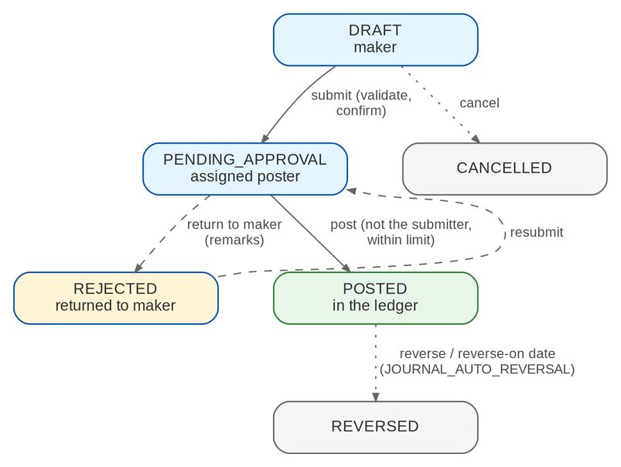
Figure 3: Statuses of a manual journal (FRBS 2.5.x, 2.8.x)
Table 11: Journal statuses
Status | Meaning | Next
DRAFT | Being prepared by the maker | Submit (PENDING_APPROVAL) or cancel
PENDING_APPROVAL | Submitted; assigned or open to posters | Post (POSTED) or return (REJECTED)
REJECTED | Returned to the maker with remarks | Edit and submit again, or cancel
POSTED | In the ledger; immutable | Reverse (REVERSED), manually or on the reverse-on date
REVERSED | Cancelled in the ledger by a linked reversal journal | -
CANCELLED | Withdrawn before posting | -

5.2 GL close and broking-books cut-off
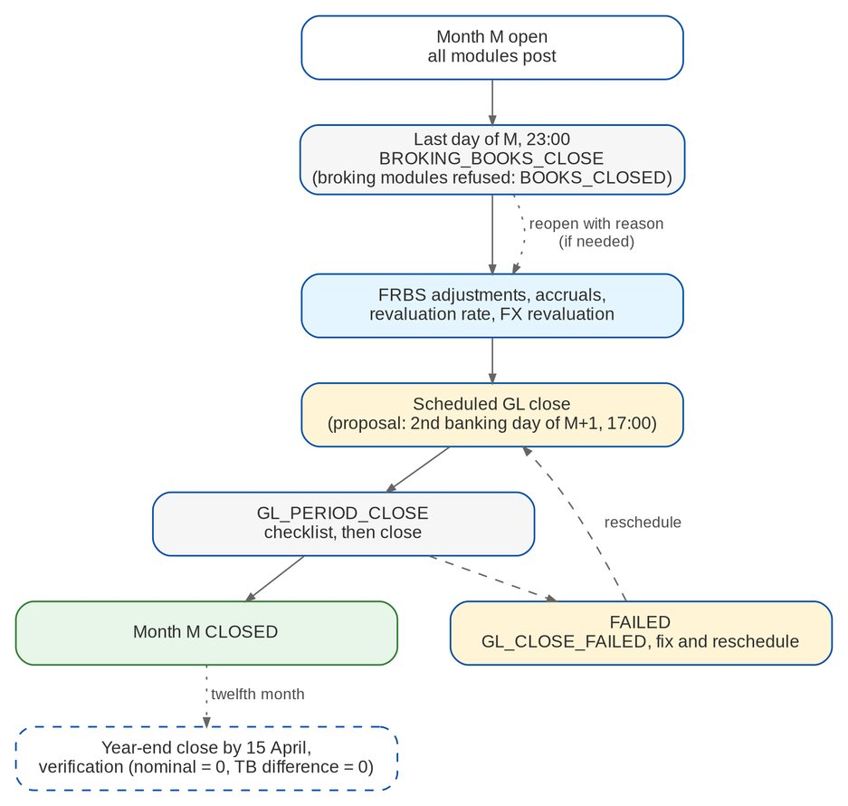
Figure 4: Month-end sequence: broking-books cut-off, adjustments, GL close (FRBS 2.6.0, 3.4.0)
Table 12: Statuses of a scheduled close
Status | Meaning | Set by
SCHEDULED | Waiting for its date and time | The TL (schedule)
COMPLETED | Checklist passed; the period is closed | Job GL_PERIOD_CLOSE
FAILED | Checklist or close refused; blocking items recorded; GL_CLOSE_FAILED raised | Job GL_PERIOD_CLOSE
CANCELLED | Withdrawn before its time | The TL

Accounting periods move FUTURE, OPEN, CLOSING, CLOSED and REOPENED; a period of a closed fiscal year cannot be reopened.

5.3 Service-fee run (FRBS_SERVICE_FEE)
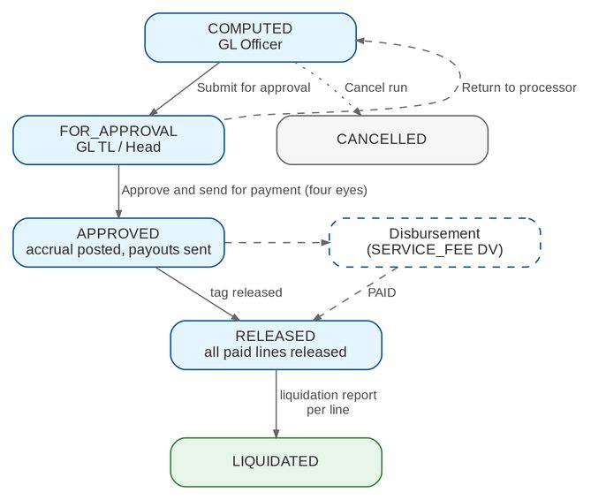
Figure 5: Workflow FRBS_SERVICE_FEE (FRBS 2.10.x)
Table 13: Transitions of FRBS_SERVICE_FEE
From | Action | To | Permission | Reason list
COMPUTED | submit | FOR_APPROVAL | SERVICE_FEE_MANAGE | -
COMPUTED | cancel | CANCELLED | SERVICE_FEE_MANAGE | VOID_REASON
FOR_APPROVAL | approve | APPROVED | SERVICE_FEE_APPROVE (not the preparer) | -
FOR_APPROVAL | return | COMPUTED | SERVICE_FEE_APPROVE | RETURN_REASON
APPROVED | release (system when all paid lines are released) | RELEASED | SERVICE_FEE_TAG | -
RELEASED | liquidate (system when all lines are liquidated) | LIQUIDATED | SERVICE_FEE_TAG | -

SLA hours: COMPUTED 48, FOR_APPROVAL 24.

5.4 Access requests
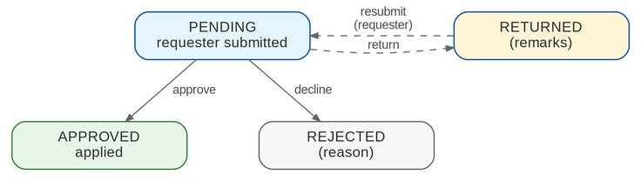
Figure 6: Access request statuses (BASAU 2.3.x-2.6.x)
Table 14: Access request statuses
Status | Meaning
PENDING | Waiting for an approver other than the requester
APPROVED | Applied to the user or role
REJECTED | Declined with a reason
RETURNED | Returned with remarks; the requester corrects and resubmits it (back to PENDING)

5.5 Accounting events of BRD-5
Every posting of BRD-5 is a business event with components and account roles; the accounts come from the rules maintained by Comptrollership. The entries below are the seed rules; the real ones are BDOI's (AQ02, OQ07).
Table 15: Accounting events and seed entries
# | Transaction | Event (source reference) | Seed entry | Note
1 | DV approved - remittance to insurer | DISB_VOUCHER REMITTANCE (DV:<no>) | Dr 2211 due to insurer for disbursement / Cr paying bank, or 2241 checks outstanding for checks | -
2 | DV approved - refund to client | DISB_VOUCHER REFUND | Dr 2216 refund payable / Cr paying account | -
3 | DV approved - refund received from insurer | DISB_VOUCHER REFUND_FROM_INSURER | Dr 2217 AP refund from insurer / Cr paying account | -
4 | DV approved - supplier, government, other bank unit | DISB_VOUCHER SUPPLIER / GOVERNMENT / OTHER_BANK_UNIT | Dr payable of the request / Cr paying account; Cr EWT payable when withheld | -
5 | DV approved - employee, cash advance | DISB_VOUCHER EMPLOYEE / CASH_ADVANCE | Dr 1604 advances to employees or the expense (cost centre) / Cr paying account | -
6 | DV approved - service fee, pass-on | DISB_VOUCHER SERVICE_FEE / PASS_ON | Dr 2250 / 2230 / Cr paying account | -
7 | Proforma edited | DISB_VOUCHER (edited lines) | The edited lines, validated and balanced | -
8 | Check negotiated | DISB_CHECK_NEGOTIATED (CHK:<id>:NEG) | Dr 2241 checks outstanding / Cr bank | -
9 | Check staled | DISB_CHECK_STALE (CHK:<id>:STALE) | Dr 2241 / Cr 2240 Miscellaneous Liability - stale checks | -
10 | Re-issue of a stale check | DISB_VOUCHER STALE_REISSUE | Dr 2240 / Cr paying account | -
11 | Approved DV cancelled | DISB_VOUCHER negative (DV:<no>:CANCEL) | Reversal of rows 1-6 | -
12 | Funding of the main account | DISB_FUND_TRANSFER (FND:<no>) | Dr target bank / Cr source bank | -
13 | Insurer certificate received | TAX_CWT_CERT_RECEIVED (CRT:<id>) | Dr 1612 AR-BIR on hand / Cr 1610 AR-BIR on commission or 1611 on incentives | -
14 | CPC2 incentive per remittance batch | OPS_REMIT_CPC2 (RMB:<batch>:CPC2) | Dr 2211 / Cr 4131 CPC2 incentive income, Cr 2504 output VAT | Base to be confirmed (AQ24)
15 | Early incentive with service invoice | OPS_REMIT_INCENTIVE + service invoice EARLY_INCENTIVE | Dr 2211 / Cr 4130 incentive income (Other Income) + output VAT | The 2% WTAX entry (Dr 1611 / Cr 2211) to be confirmed (AQ25)
16 | Remittance deduction on insurer confirmation | OPS_REMIT_DEDUCTION (RMB:<batch>:<deduction no>) | Dr 2211 / Cr 1225 AR insurer's refund | -
17 | ACSL correction | System journal ADJUSTMENT (ACS:<no>) | Reversal of the wrong line and re-post to the right account | -
18 | Service-fee accrual | FRBS_SERVICE_FEE_ACCRUE (<run>:<line>) | Dr 5614 service fee expense (cost centre) / Cr 2250 service fee payable | -
19 | Cash-advance liquidation | PRQ_CA_LIQUIDATION (LIQ:<no>) | Dr expenses by category / Cr 1604; excess or shortage | -
20 | Accrual auto-reversal | System journal REVERSAL (JV:<no>:AUTOREV) | Mirror of the accrual | -

5.6 Disbursement voucher (DISB_VOUCHER)
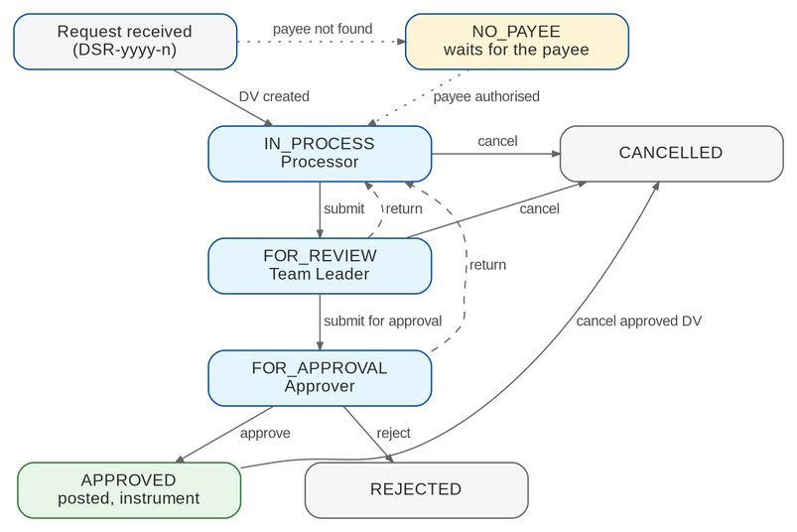
Figure 7: Workflow DISB_VOUCHER (DIS 2.6.x-2.21.0)
Table 16: Stages of a DV
Stage | Owner (permission) | SLA | Next
IN_PROCESS | Processor (DISB_PROCESS) | 24 h | Submit (FOR_REVIEW); route to the approver (refund, remittance); cancel (DISB_CANCEL_REASON)
FOR_REVIEW | Team Leader (DISB_REVIEW) | 24 h | Submit for approval; return (DISB_RETURN_REASON); cancel
FOR_APPROVAL | Approver (DISB_APPROVE) | 24 h | Approve (posting, instrument); return; reject (DISB_RETURN_REASON)
APPROVED | Processor (instrument) | - | Cancel approved DV (reversal DV:<no>:CANCEL)
REJECTED, CANCELLED | - | - | Final; the request goes back to its source

A request without a maintained payee waits as NO_PAYEE (FR-DS-020). Refund and remittance DVs are routed straight to FOR_APPROVAL (DISB_AUTO_APPROVER_ROUTING). The posting status of a DV is NOT_POSTED, POSTED, FAILED, REVERSED or REVERSAL_FAILED.

5.7 Payment instruments
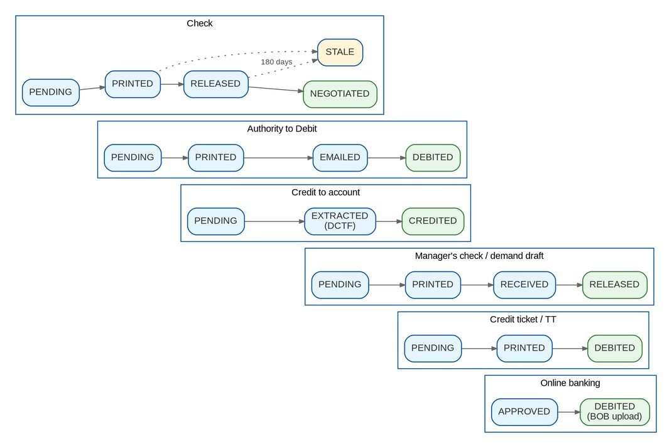
Figure 8: Instrument statuses per mode of payment (DIS 2.7.0, 2.8.x, 3.26.x)
Table 17: Instrument statuses and what sets them
Mode | Statuses | Set by
Check | PENDING, PRINTED, RELEASED, NEGOTIATED; STALE | Print; release tag; deposited-checks upload; job DISB_CHECK_STALE (180 days)
Authority to Debit | PENDING, PRINTED, EMAILED, DEBITED | Print; e-mail to the branch; branch confirmation
Credit to account | PENDING, EXTRACTED, CREDITED | End of day (DCTF); credited-accounts upload
Manager's check / demand draft | PENDING, PRINTED, RECEIVED, RELEASED | Print; received from the branch; release to the payee
Credit ticket / TT | PENDING, PRINTED, DEBITED | Print; branch validation
Online banking | APPROVED, DEBITED | DV approval; BOB approval upload

Every status except a final one (negotiated, credited, debited, released MC / DD) can become CANCELLED when the DV is cancelled. A wrong status is corrected through a status edit (workflow DISB_STATUS_EDIT - REQUESTED, APPLIED, REJECTED; FR-DS-051).

5.8 End of day
The end of day of a business date (EOD-yyyy-n) produces the outputs DCTF, CHECKS, ATD, MC_DD, CREDIT_TICKET, TT, VOUCHERS and REPORT. After the run the confirmations are sent once (FR-DS-063). A date is run once.

5.9 Account funding (DISB_FUNDING)
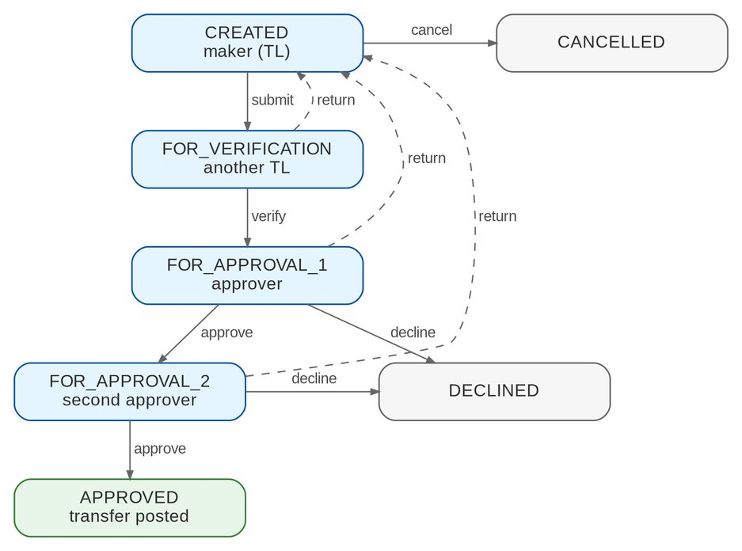
Figure 9: Workflow DISB_FUNDING (DIS 2.17.x)
The SLA of each stage is 8 hours. Returns and declines need a reason (RETURN_REASON); a cancellation needs VOID_REASON.

5.10 Payee (DISB_PAYEE)
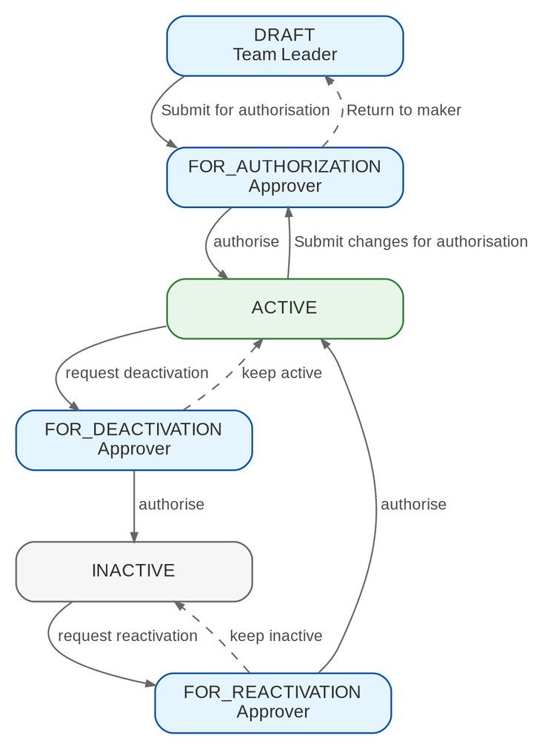
Figure 10: Workflow DISB_PAYEE (DIS 2.2.x)

5.11 Payment Requests
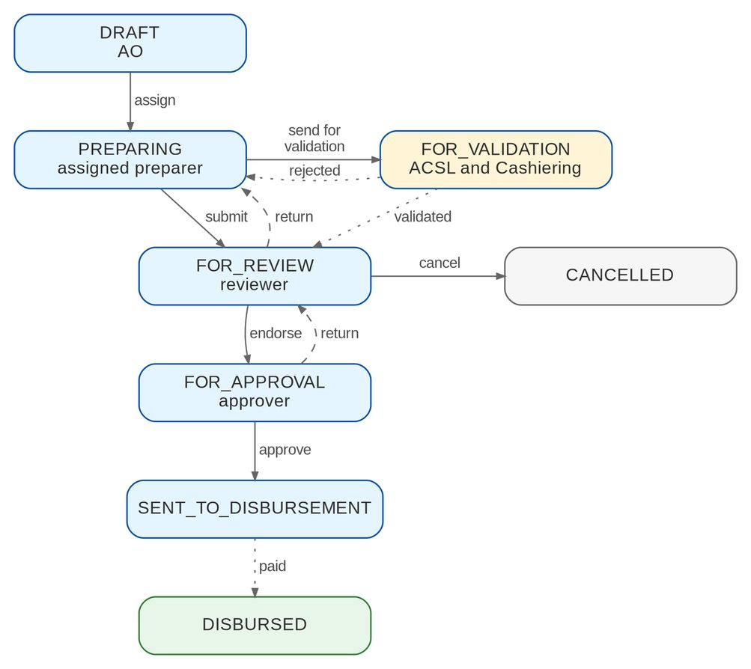
Figure 11: Workflow PRQ_REFUND (MKT 1.8.0-1.20.0)
A DRAFT refund can also be submitted, or sent for validation, without assignment. A refund returned by Disbursement goes back to PREPARING.
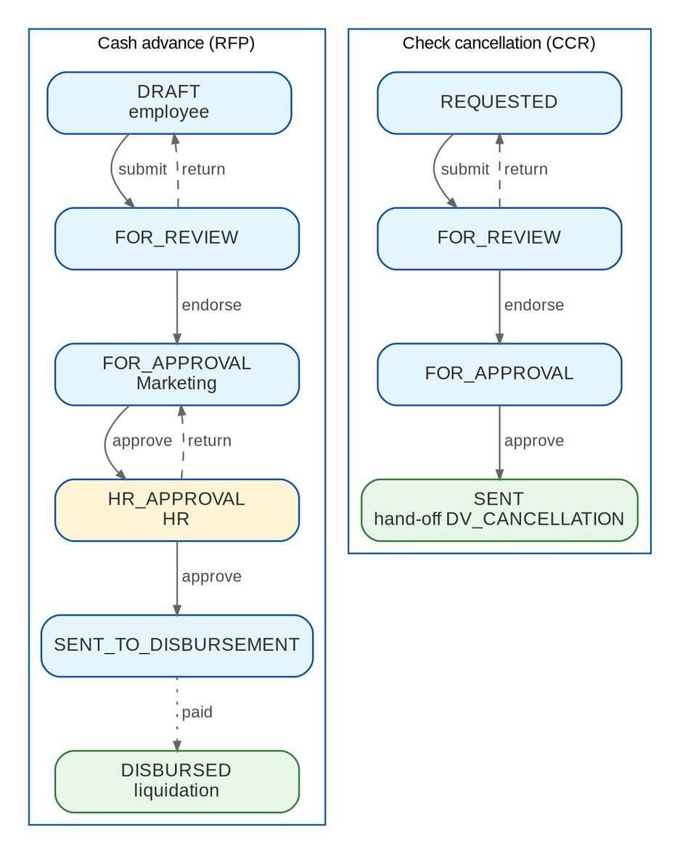
Figure 12: Workflows PRQ_CASH_ADVANCE and PRQ_CHECK_CANCEL (MKT 1.16.2, 1.16.3, 1.19.0, 2.24.0)
Table 18: Payment Request stages
Stage | Owner (permission) | Meaning
DRAFT | Requester (PRQ_CREATE) | Being prepared; editable
PREPARING | Assigned preparer (PRQ_CREATE) | Assigned, or returned by the reviewer or Disbursement (refunds)
FOR_VALIDATION | ACSL and Cashiering (48 h) | Refund of a cancelled policy being validated
FOR_REVIEW | Reviewer (PRQ_REVIEW) | Waiting for endorsement
FOR_APPROVAL | Approver (PRQ_APPROVE) | Waiting for Marketing approval
HR_APPROVAL | HR (PRQ_HR_APPROVE) | Cash advance waiting for HR
SENT_TO_DISBURSEMENT | - | Payment request sent (DSR number)
DISBURSED | - | Paid; cash advance ready for liquidation
REQUESTED, SENT | Requester; - | Check cancellation prepared; sent to Disbursement
CANCELLED | - | Cancelled or withdrawn before approval

A liquidation is DRAFT, SUBMITTED or POSTED (FR-PQ-017). A validation is OPEN, DEFERRED (handed over), CONFIRMED or REJECTED.

5.12 ACSL cases and corrections
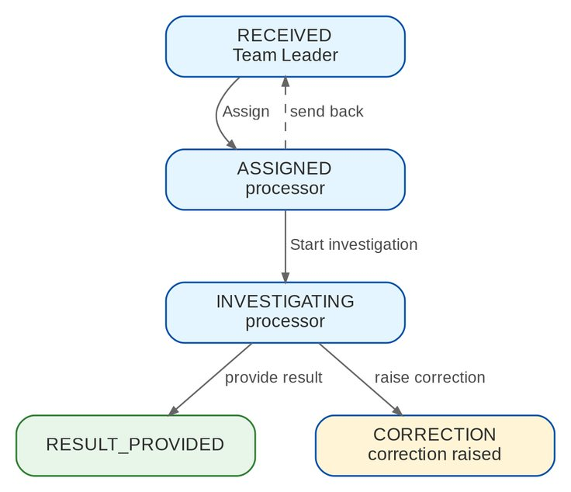
Figure 13: Workflow ACSL_CASE (ACSL 2.5.x-2.6.x)
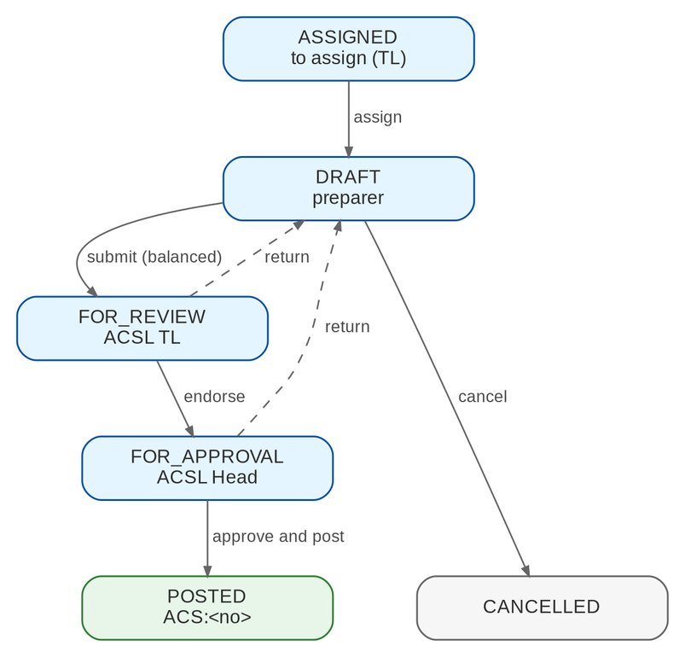
Figure 14: Workflow ACSL_CORRECTION (ACSL 2.7.0-2.15.0)
The investigation SLA is 72 hours; a correction draft 48 hours; review and approval 24 hours each.

5.13 Remittance deduction (REM_DEDUCTION)
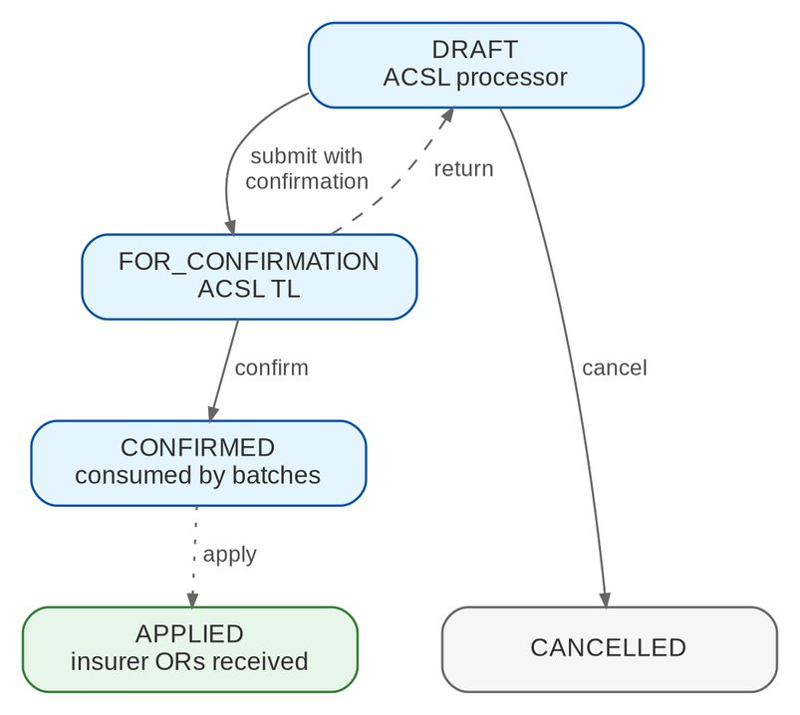
Figure 15: Workflow REM_DEDUCTION (ACSL 2.9.2)
The system action apply runs when every batch that used the deduction has received the insurer OR. A cancelled remittance DV gives the consumed amount back to the deduction.

5.14 Accounting events of Disbursement, Payment Requests and ACSL
The events and seed entries are listed in, section 5.5 (rows 1-19). The events of this volume are DISB_VOUCHER (by disbursement type), DISB_CHECK_NEGOTIATED, DISB_CHECK_STALE, DISB_FUND_TRANSFER, TAX_CWT_CERT_RECEIVED, OPS_REMIT_CPC2, OPS_REMIT_INCENTIVE, OPS_REMIT_DEDUCTION, the ACSL correction journals (ACS:<no>) and PRQ_CA_LIQUIDATION. The real entries are BDOI data (AQ02).

6 Reports and documents

6.1 Accounting reports
Table 19: Accounting reports
Code | Name | Content | BRD
FIN-MIS-BS, FIN-MIS-IE | Statement of Condition, Income Statement | Configurable statement formats with comparatives | FRBS 3.2.0 (I)
FIN-TB-MAIN | Trial Balance | Opening, movement and closing per account | FRBS 3.2.0 (I)
FIN-GL-DAYBOOK, FIN-GL-SUBLEDGER-LC | Journal Entries, Subsidiary Ledger | Posted lines per day; sub-ledger per party | FRBS 3.2.0 (I)
GL-SCHEDULE | Account schedule | Any schedule definition (FR-AC-061) | FRBS 3.2.0 (II-IV)
GL-FXREV | Revaluation Report | FX revaluation register | FRBS 3.5.0
FIN-BRS-STMT, FIN-BRS-UNREC-BOOK, FIN-BRS-UNREC-BANK | Bank reconciliation | Statement and unmatched items | FRBS 3.3.3
FRBS-MANCOM-MARKET | Market Performance Summary | Premium and commission per segment and location; month, YTD, previous YTD, growth | FRBS 3.2.0 (V)
FRBS-BRANCH-PRODUCTION, -SUM | Branch Production | Detailed and summary production per branch (sales unit) | FRBS 3.2.0 (V)
FRBS-EXPENSE-GROUPING | Expense Allocation per Cost Centre | Expenses per cost centre and account | FRBS 3.2.0 (IV)
FRBS-GAP | GAP Report | Open receivables and payables by time to maturity; gap and cumulative gap | FRBS 3.2.0 (IV)
FRBS-CASH-FLOW | Cash Flow Report | Opening cash and bank, receipts and payments per journal type, closing | FRBS 3.2.0 (IV)
FRBS-SERVICE-FEE, -DETAIL | Service Fee Report | Summary per segment; detail per invoice | FRBS 2.10.0
FRBS-SUSTAINABILITY-PROD | Sustainability Report | Yearly production per client type, region and line | Report List #169
TAX-* , IC-BROKER-ASBO | Government outputs | Section 6.2 group VII | FRBS 3.2.0 (VII)
ORG-HEADCOUNT-CC | Headcount per Cost Centre | Employees per cost centre (FR-DS-037) | DIS 3.30.2

All reports need their view permission, export to PDF, XLSX, ODS and CSV, are archived, and run in report batches.

6.2 Report pack (Appendix A)
The table is the catalogue of the Report Pack screen (58 entries). "Word" marks the reports BDOI asked for in Word, issued in PDF and Excel (chapter 12, CLR-AC-10). Layouts marked TO_CONFIRM wait for AQ05.
Table 20: Report pack entries by Appendix A group
Group | Report / definition | Title | Source | Word
I | FIN-MIS-BS | Statement of Condition | App. A I; list #1 | -
I | FIN-MIS-IE | Income Statement | App. A I; list #2 | -
I | FIN-TB-MAIN | Trial Balance | App. A I; list #3 | -
I | FIN-GL-DAYBOOK | Journal Entries | App. A I; list #4 | -
I | FIN-GL-SUBLEDGER-LC | Subsidiary Ledger | App. A I; list #5 | -
II | GARD-CASH | Schedule of Cash and Cash Equivalents | App. A II | Word
II | GARD-OPEX | Schedule of Operating Expenses | App. A II | Word
II | GARD-OTHER-INCOME | Schedule of Other Income | App. A II | Word
II | GARD-FX | Schedule of Foreign Exchange Gain / (Loss) | App. A II | Word
II | GARD-MISC-ASSETS | Schedule of Miscellaneous Assets | App. A II | Word
II | GARD-ACCRUED | Schedule of Accrued Expenses and Taxes Payable | App. A II | Word
II | GARD-VARIANCE-SIE | Variance Analysis SIE with Commentary | App. A II-45 | Word
III | SUBS-SIE-YOY | FS Analysis SIE - Year on Year | App. A III | Word
III | SUBS-SOC-MOM | FS Analysis SOC - Month on Month | App. A III | Word
III | GL-BVA | FS Analysis - Actual vs Budget | App. A III | Word
IV | SCH-COMMISSION-INCOME | Schedule of Commission Income | App. A IV; list #9 | -
IV | SCH-PR-PHP | Schedule of Receivable from Insurance Companies Clients - Peso | App. C; list #45 | -
IV | SCH-PR-USD | Schedule of Receivable from Insurance Companies Clients - USD | App. C; list #46 | -
IV | SCH-PR-2307 | Schedule of Premiums Receivable 2307 | App. A IV-32 | -
IV | SCH-COMM-RECEIVABLE | Schedule of Commission Receivables | App. A IV | -
IV | SCH-AR-BIR | Schedule of AR-BIR | App. A IV-6 to 8 | -
IV | SCH-AR-BIR-INSURER | Schedule of AR-BIR per Insurer | App. A IV | -
IV | SCH-AR-INSURER-REFUND | Schedule of AR Insurer's Refund | App. C | -
IV | SCH-AR-OFFICERS | Schedule of AR Officers and Employees | App. A IV | -
IV | SCH-PREPAID | Schedule of Prepaid Expenses | App. A IV | -
IV | SCH-FFE | Schedule of Furniture, Fixtures and Equipment | App. A IV | -
IV | SCH-PAY-INSURERS | Schedule of Payable to Insurance Companies | App. C | -
IV | SCH-AP-REFUND-INS | Schedule of A/P Refund from Insurer | App. C | -
IV | SCH-AP-OTHERS | Schedule of AP - Others Current | App. A IV-18/19 | -
IV | SCH-AP-OFFICERS | Schedule of AP - Officers and Employees | App. A IV | -
IV | SCH-STALE-CHECKS | Schedule of Stale Checks | App. B | -
IV | SCH-CHECKS-OUTSTANDING | Checks and Other Cash Items | App. A IV | -
IV | SCH-SERVICE-FEE-PAYABLE | Schedule of Service Fee Payable | App. A VI | -
IV | SCH-EXPENSE-CC | Schedule of Expenses per Cost Centre | App. A IV | -
IV | FRBS-EXPENSE-GROUPING | Expense Allocation per Cost Centre | App. A IV; list #10 | -
IV | FRBS-GAP | GAP Report | App. A IV | -
IV | FRBS-CASH-FLOW | Cash Flow Report | App. A IV | -
IV | FIN-BRS-STMT | SA / CA Reconciliation | App. A IV; list #11-12 | -
IV | GL-FXREV | Revaluation Report | App. A IV; list #14 | -
V | FRBS-MANCOM-MARKET | Market Performance Summary | App. A V; list #15 | Word
V | FRBS-BRANCH-PRODUCTION | Branch Production - Detailed | App. A V; list #16 | -
V | FRBS-BRANCH-PRODUCTION-SUM | Branch Production - Summary | App. A V; list #16 | -
V | FRBS-SUSTAINABILITY-PROD | Sustainability Report - Risk Management | List #169 | -
VI | FRBS-SERVICE-FEE | Service Fee Report - Summary | App. A VI; list #17 | -
VI | FRBS-SERVICE-FEE-DETAIL | Service Fee Report - Details | App. A VI; list #17 | -
VII | TAX-VAT-2550Q | VAT Return 2550-Q | App. A VII; list #29 | -
VII | TAX-EWT-1601EQ | Expanded Withholding Tax 1601-EQ | App. A VII | -
VII | TAX-QAP | Quarterly Alphalist of Payees | App. A VII | -
VII | TAX-MAP | Monthly Alphalist of Payees | App. A VII; list #28 | -
VII | TAX-1604E | Annual Information Return 1604-E | App. A VII | -
VII | TAX-SAWT | Summary Alphalist of Withholding Taxes | App. A VII; list #30 | -
VII | TAX-0619F | Final Withholding Tax Remittance 0619-F | App. A VII | -
VII | TAX-1603 | Fringe Benefit Tax 1603 | App. A VII | -
VII | TAX-1702Q | Quarterly Income Tax Return 1702-Q | App. A VII | -
VII | TAX-1702 | Annual Income Tax Return 1702 | App. A VII | -
VII | TAX-BOOK-GJ, -PJ, -SJ, -CRB, -CDB | Books of Accounts - General, Purchase, Sales, Cash Receipts, Cash Disbursements | App. A VII; list #18-22 | -
VII | TAX-BOOK-SL | Books of Accounts - General Ledger by Class | App. A VII; list #23-27 | -
VII | IC-BROKER-ASBO | Broker's Annual Statement of Business Operations | App. A VII; list #31 | -

Appendix A reports not in the pack: the IFRS 16 lease, DTA, ECL / NUGL and placement schedules need data BIBS does not hold (AQ05); HDMF, SSS, PhilHealth, 1601-C and 1604-C are payroll outputs (AQ06, out of scope); 2550-M waits for AQ07. Any further GL schedule of groups II-IV is a new definition of the schedule engine, without a release.

6.3 Documents
The Accounting functions produce no customer documents; the service-fee payout advice, the disbursement vouchers and the bank forms are produced by Disbursement.
Table 21: Documents produced
Template | Document
DSB_VOUCHER | Disbursement voucher
DSB_CHECK | Check
DSB_ATD, DSB_ATD_EMAIL | Authority to Debit and its e-mail to the branch
DSB_MC_DD, DSB_CREDIT_TICKET, DSB_TT | Bank forms
DSB_PAYMENT_ADVICE | Payment advice e-mailed to the payee
DCTF | Direct Credit Transaction File (text)
PRQ_RRF, PRQ_RFP, PRQ_LIQUIDATION | Refund Request Form, Request for Payment, cash-advance liquidation (Appendix D)
BIR Form 2307 | Certificate of creditable tax withheld
EARLY_INCENTIVE service invoice | Service invoice of the early incentive (booking)

6.4 Disbursement, Payment Request and ACSL reports
Table 22: Reports
Code | Name | BRD
DSB-MASTERLIST | Masterlist of Disbursements | DIS 2.3.1, 3.28.3
DSB-UNRELEASED-CHECKS | Unreleased Checks (aged to 180 days) | DIS 2.3.2, 3.28.3
DSB-CWT-COMMISSION | CWT / BIR 2307 on Commission | DIS 2.3.3, 3.28.3
DSB-ATD | Authority to Debit | DIS 2.3.4, 3.28.3
DSB-ML-STALE | Miscellaneous Liability - Stale Checks | DIS 2.3.5, 3.28.3
DSB-CASH-FLOW | Disbursement Cash Flow | DIS 2.3.6, 3.28.3
DSB-PAYEE | Payee Report | DIS 2.3.7, 3.28.1
DSB-UPLOAD-FALLOUT | Request Upload Fall-out | DIS 2.3.8, 3.28.4
DSB-PAYEE-NOMATCH | Payees Not Matched | DIS 3.25.2
DSB-UNREGULARIZED | Unregularised Transactions | DIS 2.3.9, 3.27.0
DSB-EOD-REMIT, -REFUND, -SUPPLIER, -EMPLOYEE, -OTHER, -SUMMARY | End-of-day reports | DIS 3.28.0, 3.28.2
DSB-CPC2-INCENTIVE | CPC2 incentive report | DIS 3.29.0
PRQ-STATUS | Request status | MKT 1.18.0
PRQ-REGISTER | Request register | MKT 1.18.1
ACSL-BOOKED-FIN-DETAILS | List of all booked accounts with financial details | ACSL 2.2.0, 2.14.2
ACSL-SOA-RECON | SOA reconciliation | ACSL 2.14.1
ACSL-SOA-UPLOAD-LOG | SOA upload log | ACSL 2.4.0
ACSL-GL-SL-RECON | GL-SL reconciliation | ACSL 2.13.2
ACSL aging and schedule reports | Five account families, PHP and USD | ACSL 2.14.3, 2.14.4

Reports run in the Report Centre with the options (view, export to XLSX, ODS or PDF, print, archive, batches).

7 Interfaces and integration
Figure 6 shows the interfaces of Accounting. The general ledger is inside BIBS: every module posts through the accounting engine, so there is no accounting export (OQ01).
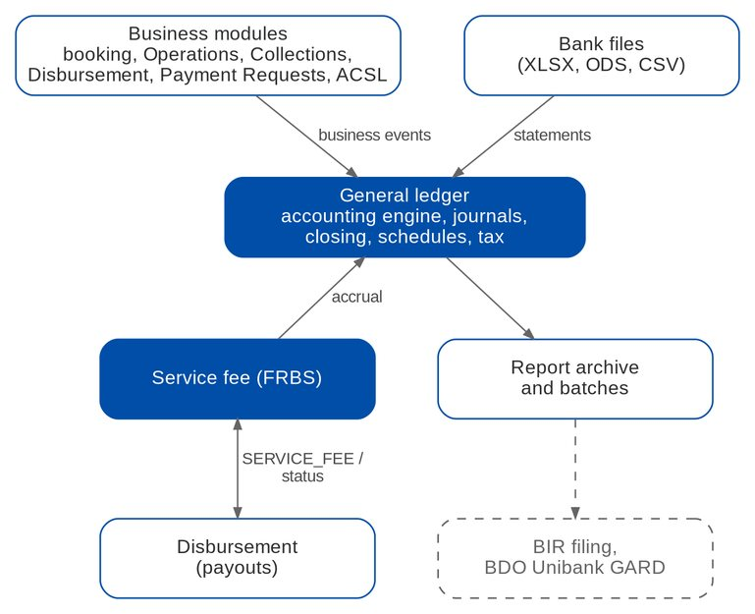
Figure 16: Interfaces of Accounting (dashed = external or on hold)
Table 23: Interfaces
Interface | Direction | Content and trigger | BRD | Scope
Business modules (booking, Operations, Collections, Disbursement, Payment Requests, ACSL, FRBS) | In | Business events posted by the accounting engine | FRBS 3.1.0 | IN SCOPE
Disbursement | Out / In | Service-fee payouts (SERVICE_FEE) and their status (PAID, RETURNED, CANCELLED) | FRBS 2.10.x | IN SCOPE
Bank files | In | Cash-in-bank statements (XLSX, ODS, CSV) per layout | FRBS 3.3.1 | IN SCOPE
Report archive and batches | Out | Report files, ZIP and merged PDF | FRBS 2.4.x | IN SCOPE
BIR (eFPS, eBIRForms, CAS) | Out | Worksheets and loose-leaf books; no electronic filing | FRBS 3.2.0 | ON HOLD
BDO Unibank (GARD) | Out | Reports exported in PDF and Excel; submission channel not defined | FRBS 3.2.0 | ON HOLD
Payroll | In | HDMF, SSS, PhilHealth, 1601-C, 1604-C | Appendix A VII | OUT
Operations disbursement gateway | In / Out | Payment requests of remittance, cashiering, commission, FRBS and Payment Requests; DV status back | DIS 2.6.0, 3.25.0; MKT 1.20.0 | IN SCOPE
Refund validation | Out / In | ACSL case and Cashiering task per cancelled-policy line; results back | MKT 1.11.0; ACSL 2.5.5 | IN SCOPE
Payment reversal | Out / In | ACSL request to Cashiering (PRV-); result back | ACSL 2.6.1 | IN SCOPE
DV cancellation hand-off | Out | Approved check cancellation to the Disbursement approvers (DV_CANCELLATION); part on hold until BDOI answers AQ15 | MKT 1.19.0 | IN SCOPE
General ledger | Out | DV, check, funding, correction, liquidation, CPC2 and deduction postings | DIS 2.19.0; ACSL 2.15.0 | IN SCOPE
TPD (ACA) | Out | DCTF text file downloaded and sent by the user | DIS 2.16.1 | IN SCOPE
Bank branches | Out / In | ATD e-mail and bank forms; confirmations recorded by the user | DIS 2.7.7-2.7.9 | IN SCOPE
Bank files | In | Deposited checks, credited accounts, BOB approvals (CSV uploads); part on hold until BDOI answers AQ09 | DIS 2.22.0, 3.26.x | IN SCOPE
BDO Business Online Banking | Out | Funding and online payments done in BOB; reference recorded | DIS 2.17.1 | OUT
Insurer SOA | In | SOA file upload per insurer and period; part on hold until BDOI answers AQ21 | ACSL 2.2.1, 2.4.0 | IN SCOPE
E-mail | Out | Payment advice, ATD, notifications | DIS 2.7.12 | IN SCOPE

8 Non-functional requirements
Table 24: Non-functional requirements (BRD p.134-140; Add.1 p.38)
Topic | BRD value | BIBS target and approach
Users | Accounting 5 (GL officer, TL, TH); Business / System Admin 7 | Within the BRD-1 sizing (145 concurrent)
Volumes | Manual adjustments about 100 a year; 6 GL closings | Small; no special tuning
Response time | Screen load 5-10 s, refresh 5 s, field display 2 s, save 5 s; reports 10-20 s first load, 10 s next | Online p95 under 3 s; heavy reports in batches
Peaks | Month end and year end; 10:00-15:00 | Close and reversal jobs outside the peak
Devices | Same performance on mobile and desktop | Responsive screens
Availability (Add.1) | 100%; use 07:00-18:00 Monday to Saturday; downtime under 24 hours; maintenance 19:00-07:00 | Same deployment as BRD-1; 100% is not a measurable SLA; one BIBS-wide NFR set is being agreed (AQ27, XQ08)
Retention (Add.1) | Reports and vouchers 5 years online, 5 years archive; daily backup kept 5 years | Retention rules of BRD-1 with a document class for vouchers and generated reports
Security and audit | Authorised users only; maker-checker | Role-based access, four-eyes rules and audit on every change (section 3)
Users | Disbursement 8; ACSL 6; Marketing 394 named, 40 concurrent | Within the BRD-1 sizing (145 concurrent)
Volumes | Remittance DVs 198 a year (+20%), refunds 246, supplier payments 293, government 9, other bank units 31, employee-related 56, CWT tagging 50; corrections 400; Marketing RFP / refund 302 | Small; no special tuning
Response time | Screen load 5-10 s, refresh 5 s, field display 2 s, save 5 s (2 s for some Disbursement and ACSL saves); reports 10-20 s first load; upload or download 3 s per file | Online p95 under 3 s; end of day, reports and SOA reconciliation run as jobs or batches
Peaks | Month end and year end; 08:00-12:00 Disbursement; 10:00-15:00 ACSL and Marketing | End of day after the peak; GL-SL reconciliation at 20:00; stale-check job at 00:20
Devices | Same performance on mobile and desktop | Responsive screens
Availability (Add.1) | 100%; 07:00-18:00 Monday to Saturday; downtime under 24 hours; maintenance 19:00-07:00; BCP under 3 days | Same deployment as BRD-1; 100% is not a measurable SLA; one BIBS-wide NFR set is being agreed (AQ27)
Retention (Add.1) | Reports and vouchers 5 years online, 5 years archive; daily backup kept 5 years | Retention rules of BRD-1 with a document class for vouchers and generated reports
Security and audit | Authorised users; maker-checker | Role-based access; four-eyes rules of section 3.3; masked account numbers; audit of every change

9 Configuration items owned by the business and the System Administrator

9.1 Parameters
Table 25: Accounting parameters
Parameter | Default | Meaning
OPS_BOOK_RATE_SOURCE | CLOSING_PREV_MONTH | BOOK rate of a month = revaluation rate of the previous month end; MANUAL keeps BOOK rates by hand
CLOSE_ONLY_PREVIOUS_MONTH | true | Month-end close only for the previous month
YEAR_END_CLOSE_DEADLINE | 04-15 | Month and day by which the previous year is closed
BROKING_CLOSE_TIME | 23:00 | Time of the broking-books close on the last day of the month
BROKING_SOURCE_MODULES | booking, Operations, cashiering, remittance, adjustment, commission, disbursement | Modules cut off by the broking-books close
SESSION_IDLE_WARNING_MINUTES | 15 | Inactivity warning
SESSION_EXPIRY_WARNING_MINUTES | 30 | Warning before the forced log-out
TAX_RCIT_RATE / TAX_FBT_RATE | 25 / 35 | Income tax and fringe benefit tax rates of the BIR worksheets
AGEING_BUCKETS | platform default | BDOI buckets 30, 90, 180, 365, 730 once BDOI confirms (OQ43)
DISB_STALE_DAYS | 180 | Days after printing when an unnegotiated check is stale (30-720)
DISB_CHECK_CLEARING | ON | Checks credit checks outstanding until negotiated
DISB_CHECK_CLEARING_ACCOUNT | 2241 | Checks outstanding account
DISB_AUTO_APPROVER_ROUTING | REFUND,REMITTANCE | Disbursement types whose DV goes straight to the approver
DISB_NO_PAYEE_ACTION | HOLD | HOLD keeps a request without payee waiting; RETURN returns it to its source
DISB_CHECK_SERIES_WARNING | 20 | Remaining checks that raise CHECK_SERIES_LOW
EARLY_INCENTIVE_WTAX_RATE | 2 | Withholding tax rate (%) of the early-incentive service invoice
ACSL_SOA_MAX_ROWS | 20000 | Maximum rows of an SOA upload

9.2 Jobs
Table 26: Accounting jobs (Manila time)
Job | Schedule | Purpose
JOURNAL_AUTO_REVERSAL | Daily 00:05 | Reverse accruals on their reverse-on date
GL_PERIOD_CLOSE | Every 15 minutes | Run the scheduled GL closes that are due
BROKING_BOOKS_CLOSE | Last day of the month 23:00 | Close the broking books
BOOK_RATE_FROM_CLOSING | First day of the month 00:30 | Copy the revaluation rates of the month that ended as the new month's BOOK rates
DISB_CHECK_STALE | Daily 00:20 | Stale the checks older than DISB_STALE_DAYS and post the entry
DISB_EOD_CONFIRMATION | After each end-of-day run (no fixed schedule) | Send the payment advices
DISB_EOD_REPORTS | After each end-of-day run (no fixed schedule) | Generate the end-of-day reports
ACSL_GL_SL_RECON | Daily 20:00 | GL-SL reconciliation of the control accounts

9.3 Lists of values
Table 27: Lists of values
List | Values provided
SERVICE_FEE_SEGMENT | CBG; IBG (Institutional Banking Group); Others (to confirm, AQ20)
RETURN_REASON, VOID_REASON | Shared platform lists (journal return, run cancellation)
Lists of Payment Requests, Disbursement and ACSL | PAYEE_CLASS, DISBURSEMENT_TYPE, DISB_CANCEL_REASON, DISB_RETURN_REASON, BRANCH_EMAIL, REFUND_REASON, RRF_CATEGORY_A / B, PRQ_PAYMENT_MODE, PRQ_RFP_TYPE, ACSL_CASE_TYPE, ACSL_CORRECTION_KIND, REMIT_DEDUCTION_SOURCE
PAYEE_CLASS | Supplier, Insurer, Employee, Client, Government agency, Others
DISBURSEMENT_TYPE | Remittance; Refund; Payment to supplier; Payment to government agencies; Payment to other bank units; Employee-related request; Cash advance; Service fee; Incentive pass-on; BIR 2307 release; Other disbursement requests; Re-issue of a stale check
DISB_CANCEL_REASON | Requested by the requesting unit; Wrong payee, account or amount; Duplicate request or DV; Check spoiled or lost; Others (AQ15)
DISB_RETURN_REASON | Payee not maintained; Incomplete supporting documents; Incorrect accounting entry; Others
BRANCH_EMAIL | Branch mailboxes for the ATD (AQ09)
REFUND_REASON | Cancelled policy; Overpayment; Double payment; Premium decrease (endorsement); Others
RRF_CATEGORY_A, RRF_CATEGORY_B | Others (to confirm, AQ18)
PRQ_PAYMENT_MODE | CTA, CHECK, ATD, INTER_OFFICE, MANAGERS_CHECK, DEMAND_DRAFT
PRQ_RFP_TYPE | Cash advance, Petty cash, Others
ACSL_CASE_TYPE | Investigation; Account analysis request; Correction entry; AR refund payment application; Sub-ledger payment reversal
ACSL_CORRECTION_KIND | Posting to a wrong GL account; Wrong amount; Reclassification; Other correction
REMIT_DEDUCTION_SOURCE | AR insurer's refund; Over-remittance to the insurer; Other amount confirmed by the insurer (AQ23)
RETURN_REASON, VOID_REASON | Shared platform lists

9.4 Alerts
Table 28: Accounting alerts
Code | Severity | When
COST_CENTER_MISSING | Medium | A posting to a cost-centre-required account found no rule
YEAR_END_CLOSE_DUE | High | The previous year is open 15 days before the deadline
GL_CLOSE_FAILED | High | A scheduled GL close or the broking-books close did not complete
DISB_PAYEE_NO_MATCH | Medium | A system request names a payee that is not maintained
DISB_UNREGULARIZED | High | A cancelled approved DV is not regularised after 2 days
DISB_CHECK_STALE | Low | A check reached DISB_STALE_DAYS
CHECK_SERIES_LOW | Medium | A cheque book reached its warning threshold
ACSL_GLSL_DIFFERENCE | High | The GL-SL reconciliation found a difference of 1.00 or more

9.5 Masters and rules maintained by the business
Table 29: Masters and rules
Item | Maintained by (authorised by) | FR
Chart of accounts, numbering schemes, short codes, negative-balance policy | GL Team Lead (GL Team Head) | FR-AC-011-014, 034
Monthly revaluation rate | GL Team Head | FR-AC-010
Accounting rules | Comptrollership (maker-checker) | FR-AC-030
Cost-centre rules | Comptrollership | FR-AC-054
Bank statement layouts | GL team | FR-AC-050
Service-fee rules and recipients | GL Team Lead / Head | FR-AC-052
Schedule definitions and commentary | GL Team Lead (MASTER_MAINTAIN); GL team | FR-AC-061
Lists of values | Business Administrator (approver) | FR-AC-070
Users, roles, permissions | System / Business Administrator (access approver) | FR-AC-071
Payees and their accounts | Disbursement TL (Approver) | FR-DS-010-014
BDOIR bank accounts, cheque books | Disbursement Approver (another user) | FR-DS-070, 071
Employees and cost centres | Comptrollership administrator | FR-DS-037
Accounting rules of the disbursement types | Comptrollership (maker-checker) | , FR-AC-030
Document templates (voucher, check, forms, RRF, RFP) | System Administrator | FR-DS-062, FR-PQ-003
Liquidation accounts | Comptrollership administrator | FR-PQ-017
SOA layouts per insurer | System Administrator (AQ21) | FR-AS-002
GL-SL control accounts | ACSL TL | FR-AS-004
CPC2 incentive criteria | TSU (BRD-3 Product Maintenance) | FR-DS-090
Lists of values | Business Administrator (approver) | , FR-AC-070

10 Assumptions, dependencies and open questions

10.1 Assumptions
Table 30: Assumptions
ID | Assumption | Related
A-AC-01 | The general ledger of BDOI is kept in BIBS; there is no accounting interface to another system | OQ01
A-AC-02 | BDOI's chart and accounting rules are loaded as configuration at go-live; the seed chart is a placeholder | AQ01, AQ02
A-AC-03 | The monthly revaluation rate is the month-end CLOSING rate and becomes the next month's BOOK rate | AQ03, OQ08
A-AC-04 | "Broking books" are the postings of the broking modules; "GL books" the whole ledger closed by FRBS | AQ04
A-AC-05 | The service fee is 2.5% (CBG) or 1% (IBG) of fully paid commission net of the insurer's withholding tax | AQ20
A-AC-06 | Payroll outputs are prepared outside BIBS | AQ06
A-DS-01 | Bank channels stay manual or file-based; BIBS has no system-to-system link to the banks | AQ09
A-DS-02 | Posting happens at DV approval, not at release | AQ13
A-DS-03 | A payee used on a DV is never deleted; it is deactivated | AQ11
A-DS-04 | Endorsements and cancellations keep their own BIR invoice numbers linked to a root invoice | AQ29
A-PQ-01 | All accounts of one refund request belong to one client | AQ18
A-PQ-02 | The cash-advance liquidation of Appendix D is in scope | AQ18
A-AS-01 | Insurer SOAs carry BDOI's invoice number as matching key | AQ21
A-AS-02 | CPC2 is computed on the basic premium remitted and deducted from the remittance | AQ24

10.2 Dependencies
Table 31: Dependencies
ID | Dependency | Needed for
D-AC-01 | BDOI provides its chart, numbering convention and accounting rules | FR-AC-011-013, 030 (AQ01, AQ02)
D-AC-02 | BDOI provides the GARD, subsidiaries and Mancom layouts and segment budgets | FR-AC-060-062 (AQ05)
D-AC-03 | BDOI provides the bank file layouts | FR-AC-050 (AQ08)
D-AC-04 | BDOI confirms the service-fee rates and recipients | FR-AC-052 (AQ20)
D-AC-05 | BDOI gives the cost-centre rules | FR-AC-054 (AQ26)
D-AC-06 | BDOI confirms PDF and Excel for the reports asked in Word | FR-AC-060 (CLR-AC-10)
D-AC-07 | The broking modules report their pending items to the cut-off | FR-AC-042
D-AC-08 | BDOI confirms Return, Resubmit and bulk approval on the administration screens | FR-AC-072 (CLR-AC-14)
D-DS-01 | BDOI gives the DCTF trailer, the credited-accounts, deposited-checks and BOB report layouts | FR-DS-052, 053, 061 (AQ09)
D-DS-02 | BDOI gives the check, voucher and bank-form layouts and signatories | FR-DS-035, 062 (AQ14)
D-DS-03 | BDOI gives the payee migration file | FR-DS-014 (AQ11)
D-DS-04 | BDOI gives the real accounting entries of each disbursement type | FR-DS-041, 055 (AQ02)
D-DS-05 | BDOI confirms the CPC2 base, VAT and criteria, and the accounting of the insurer's 2% on early incentives | FR-DS-090, 091 (AQ24, AQ25)
D-DS-06 | BDOI confirms the CPC2 report layout | FR-DS-092 (AQ24)
D-PQ-01 | BDOI gives the mandatory RRF / RFP fields, approval chains and the HR approver | FR-PQ-003, 004, 009 (AQ18)
D-AS-01 | BDOI gives the insurer SOA layouts | FR-AS-002 (AQ21)
D-AS-02 | BDOI confirms the ageing slots of the ACSL aging and schedule reports | FR-AS-005 (OQ43)

10.3 Open questions
Table 32: Open questions
ID | Question | Affects | Status
AQ01 | BDOI's chart, its mapping, numbering, short codes; PHP and USD as separate accounts? | FR-AC-011-014 | OPEN
AQ02 | Default entries of every BRD-5 transaction | FR-AC-030; section 5.5 | OPEN
AQ03 | Source of the revaluation rate; BOOK rate; daily or monthly revaluation | FR-AC-010, 043 | OPEN
AQ04 | Broking books versus GL books; agreed close time; reopening; 15 April deadline | FR-AC-040-042 | OPEN
AQ05 | Layouts of GARD, subsidiaries, Mancom; non-GL data; segment budgets | FR-AC-060-062 | PARTIAL
AQ06 | Payroll reports out of scope or imported | FR-AC-063 | OPEN
AQ07 | 2550-M; formats of MAP, SAWT, 0619-F, 1603, 1702, 1604-E; BIR books format | FR-AC-063 | OPEN
AQ08 | Bank file layouts; matching without check numbers | FR-AC-050 | OPEN
AQ20 | Service-fee definition, rates, recipients, liquidation content | FR-AC-052, 053 | OPEN
AQ26 | Cost-centre rules; cost centre per employee or per unit | FR-AC-054 | OPEN
AQ27 | NFR set (availability, hours, retention) | Section 8 | OPEN
AQ28 | Role matrices | Section 3 | PARTIAL
AQ30 | Accounts that may never be negative; warning or block | FR-AC-034 | OPEN
AQ31 | GARD submission to BDO Unibank (file or print); reciprocal accounts | FR-AC-060 | OPEN
AQ09 | Bank channel per mode; full DCTF specification; credited-accounts, deposited-checks and BOB report layouts | FR-DS-052, 053, 061 | OPEN
AQ10 | Main and source accounts of the funding; approver order; limits | FR-DS-064 | OPEN
AQ11 | Payee migration file; classes; several accounts; delete or deactivate | FR-DS-010-014 | OPEN
AQ12 | System request sources; RFP number format; upload columns | FR-DS-020, 024 | OPEN
AQ13 | DV number format; editable proforma lines; posting at approval or release; EWT at DV or invoice | FR-DS-030, 031, 041 | OPEN
AQ14 | Check, voucher and form layouts; signatories; stale-check accounting and re-issue | FR-DS-035, 054, 055, 062 | OPEN
AQ15 | Approver of status edits; cancellation after release; regularisation per source | FR-DS-044, 051; FR-PQ-011 | OPEN
AQ16 | CWT received and released; relation to the client 2307 flow; period covered | FR-DS-057 | OPEN
AQ17 | Which DVs need an OR / AR back | FR-DS-045, 056 | OPEN
AQ18 | RRF / RFP mandatory fields; approval chains; HR approver; liquidation scope; unapplied payment report | FR-PQ-002-004, 009, 017 | OPEN
AQ19 | CA / SA definition and validation | FR-PQ-016 | OPEN
AQ21 | Insurer SOA layouts; matching key; direct-billed indicator | FR-AS-002, 003 | OPEN
AQ22 | Accounts ACSL may correct; effect on sub-ledgers; approvers | FR-AS-021 | OPEN
AQ23 | What is deducted from the remittance; spanning batches; entries | FR-AS-025 | OPEN
AQ24 | CPC2 percentage, base, VAT and WTAX (with OQ39, PQ04); the minutes confirm that the CPC2 criteria differ from those of the other incentives and follow the incentive tag of the booked transaction | FR-DS-090, 092 | OPEN
AQ25 | Early-incentive SI series, recipient and timing; accounting of the 2% | FR-DS-091 | OPEN
AQ29 | Invoice number of endorsements and cancellations | FR-DS-093, FR-AS-026 | PARTIAL

AQ05 and AQ28 are partly answered by the Report List of BRD-12 and the role sections of BRD-6 to BRD-12 (R6).
AQ29 is applied as proposed (new numbers linked to a root invoice) until BDOI decides otherwise.

11 Traceability
Every BRD-5 requirement is met by at least one FR, except the login to BDO Business Online Banking (DIS 2.17.1), which is outside BIBS; FR-DS-064 records the BOB reference of the funding. The minutes of 4 May 2026 (R0) record FRBS 3.1.1, FRBS 3.1.2, DIS 3.29.0, DIS 3.29.1, DIS 3.30.0 to 3.30.2, DIS 2.2.8, ACSL 2.9.1 and ACSL 2.9.2 as walked through with IT without questions, and clarify DIS 3.29.2. The test cases are listed by test condition (TC-AC-nnn.n, TC-DS-nnn.n, TC-PQ-nnn.n, TC-AS-nnn.n); the test plan workbook lists each case.

11.1 FRBS (Accounting)
Table 33: FRBS requirement IDs to FR, screen and test cases
BRD ID | Page | FR | Screen | Test cases
FRBS 1.1.0 | p.51 | FR-AC-001 | Login; menu | TC-AC-001.1, 001.2 (4 cases)
FRBS 1.1.1 | p.51 | FR-AC-001 | Login; menu | TC-AC-001.1, 001.2 (4 cases)
FRBS 1.1.2 | p.51 | FR-AC-002 | Session dialog | TC-AC-002.1, 002.2 (4 cases)
FRBS 1.1.3 | p.51 | FR-AC-002 | Session dialog | TC-AC-002.1, 002.2 (4 cases)
FRBS 2.2.0 | p.52 | FR-AC-010 | Currencies & Rates | TC-AC-010.1, 010.2, 010.3, 010.4 (5 cases)
FRBS 2.3.0 | p.52 | FR-AC-011 | Chart of Accounts | TC-AC-011.1, 011.2, 011.3, 011.4 (7 cases)
FRBS 2.3.1 | p.52 | FR-AC-012 | Chart Upload | TC-AC-012.1, 012.2, 012.3 (7 cases)
FRBS 2.3.2 | p.53 | FR-AC-013 | Chart of Accounts (Numbering) | TC-AC-013.1, 013.2, 013.3 (5 cases)
FRBS 2.3.3 | p.53 | FR-AC-014 | Chart of Accounts; New Journal | TC-AC-014.1, 014.2 (4 cases)
FRBS 2.3.4 | p.54 | FR-AC-011 | Chart of Accounts | TC-AC-011.1, 011.2, 011.3, 011.4 (7 cases)
FRBS 2.3.5 | p.54 | FR-AC-011 | Chart of Accounts | TC-AC-011.1, 011.2, 011.3, 011.4 (7 cases)
FRBS 3.6.0 | p.66 | FR-AC-010, FR-AC-011 | Currencies & Rates; Chart of Accounts | TC-AC-010.1, 010.2, 010.3, 010.4, 011.1, 011.2, 011.3, 011.4 (12 cases)
FRBS 2.4.0 | p.54 | FR-AC-020 | Report Centre; Report Pack | TC-AC-020.1, 020.2, 020.3, 020.4 (4 cases)
FRBS 2.4.1 | p.54 | FR-AC-020 | Report Centre; Report Pack | TC-AC-020.1, 020.2, 020.3, 020.4 (4 cases)
FRBS 2.4.2 | p.54 | FR-AC-020 | Report Centre; Report Pack | TC-AC-020.1, 020.2, 020.3, 020.4 (4 cases)
FRBS 2.4.3 | p.55 | FR-AC-020 | Report Centre; Report Pack | TC-AC-020.1, 020.2, 020.3, 020.4 (4 cases)
FRBS 2.4.4 | p.55 | FR-AC-021 | Report (column filters) | TC-AC-021.1, 021.2 (2 cases)
FRBS 2.4.5 | p.55 | FR-AC-022 | Report Batch | TC-AC-022.1, 022.2, 022.3 (5 cases)
FRBS 2.4.6 | p.55 | FR-AC-020 | Report Centre; Report Pack | TC-AC-020.1, 020.2, 020.3, 020.4 (4 cases)
FRBS 2.4.7 | p.55 | FR-AC-022 | Report Batch | TC-AC-022.1, 022.2, 022.3 (5 cases)
FRBS 2.4.8 | p.56 | FR-AC-020 | Report Centre; Report Pack | TC-AC-020.1, 020.2, 020.3, 020.4 (4 cases)
FRBS 2.4.9 | p.56 | FR-AC-023 | Report (print options) | TC-AC-023.1, 023.2 (3 cases)
FRBS 2.4.10 | p.56 | FR-AC-020 | Report Centre; Report Pack | TC-AC-020.1, 020.2, 020.3, 020.4 (4 cases)
FRBS 3.2.0 | p.64 | FR-AC-060, FR-AC-061, FR-AC-062, FR-AC-063 | Report Pack; Account Schedules; BIR Forms & Books | TC-AC-060.1, 060.2, 061.1, 061.2, 061.3, 062.1, 062.2, 063.1, 063.2, 063.3 (22 cases)
FRBS 2.5.0 | p.56 | FR-AC-030 | Journals; event log | TC-AC-030.1, 030.2, 030.3 (5 cases)
FRBS 2.5.1 | p.57 | FR-AC-031 | Journals (Assign, Assigned to me) | TC-AC-031.1, 031.2 (4 cases)
FRBS 2.5.2 | p.57 | FR-AC-031 | Journals (Assign, Assigned to me) | TC-AC-031.1, 031.2 (4 cases)
FRBS 2.5.3 | p.57 | FR-AC-031 | Journals (Assign, Assigned to me) | TC-AC-031.1, 031.2 (4 cases)
FRBS 2.5.4 | p.57 | FR-AC-034 | New Journal; Journal | TC-AC-034.1, 034.2, 034.3 (6 cases)
FRBS 2.5.5 | p.58 | FR-AC-034 | New Journal; Journal | TC-AC-034.1, 034.2, 034.3 (6 cases)
FRBS 2.5.6 | p.58 | FR-AC-036 | Journals; My Approvals | TC-AC-036.1, 036.2, 036.3 (6 cases)
FRBS 2.5.7 | p.58 | FR-AC-036 | Journals; My Approvals | TC-AC-036.1, 036.2, 036.3 (6 cases)
FRBS 2.5.8 | p.58 | FR-AC-036 | Journals; My Approvals | TC-AC-036.1, 036.2, 036.3 (6 cases)
FRBS 2.5.9 | p.58 | FR-AC-036 | Journals; My Approvals | TC-AC-036.1, 036.2, 036.3 (6 cases)
FRBS 2.5.10 | p.59 | FR-AC-035 | Confirm posting dialog | TC-AC-035.1, 035.2 (3 cases)
FRBS 2.8.0 | p.60 | FR-AC-032 | New Journal | TC-AC-032.1, 032.2, 032.3, 032.4 (5 cases)
FRBS 2.8.1 | p.61 | FR-AC-032, FR-AC-033 | New Journal; Journals (REVERSAL) | TC-AC-032.1, 032.2, 032.3, 032.4, 033.1, 033.2 (8 cases)
FRBS 2.8.2 | p.61 | FR-AC-032 | New Journal | TC-AC-032.1, 032.2, 032.3, 032.4 (5 cases)
FRBS 2.8.3 | p.61 | FR-AC-035 | Confirm posting dialog | TC-AC-035.1, 035.2 (3 cases)
FRBS 2.8.4 | p.62 | FR-AC-034 | New Journal; Journal | TC-AC-034.1, 034.2, 034.3 (6 cases)
FRBS 2.8.5 | p.62 | FR-AC-032 | New Journal | TC-AC-032.1, 032.2, 032.3, 032.4 (5 cases)
FRBS 2.9.0 | p.62 | FR-AC-037 | Edit Journal | TC-AC-037.1, 037.2 (3 cases)
FRBS 3.1.0 | p.63 | FR-AC-030 | Journals; event log | TC-AC-030.1, 030.2, 030.3 (5 cases)
FRBS 3.6.0b | p.67 | FR-AC-034 | New Journal; Journal | TC-AC-034.1, 034.2, 034.3 (6 cases)
FRBS 2.6.0 | p.59; Add.1 p.36 | FR-AC-040 | GL Close & Cut-Off | TC-AC-040.1, 040.2, 040.3, 040.4 (7 cases)
FRBS 2.6.1 | p.59 | FR-AC-040 | GL Close & Cut-Off | TC-AC-040.1, 040.2, 040.3, 040.4 (7 cases)
FRBS 2.7.0 | p.60 | FR-AC-041 | Period-End & Year-End | TC-AC-041.1, 041.2, 041.3 (5 cases)
FRBS 2.7.1 | p.60 | FR-AC-041 | Period-End & Year-End | TC-AC-041.1, 041.2, 041.3 (5 cases)
FRBS 3.4.0 | p.65 | FR-AC-042 | GL Close & Cut-Off | TC-AC-042.1, 042.2, 042.3 (4 cases)
FRBS 3.4.1 | p.66 | FR-AC-042 | GL Close & Cut-Off | TC-AC-042.1, 042.2, 042.3 (4 cases)
FRBS 3.5.0 | p.66 | FR-AC-043 | FX Revaluation | TC-AC-043.1, 043.2 (4 cases)
FRBS 3.3.0 | p.64 | FR-AC-050 | Bank Statements; Bank Reconciliation; Bank Statement Layouts | TC-AC-050.1, 050.2, 050.3, 050.4 (6 cases)
FRBS 3.3.1 | p.64 | FR-AC-050 | Bank Statements; Bank Reconciliation; Bank Statement Layouts | TC-AC-050.1, 050.2, 050.3, 050.4 (6 cases)
FRBS 3.3.2 | p.65 | FR-AC-050 | Bank Statements; Bank Reconciliation; Bank Statement Layouts | TC-AC-050.1, 050.2, 050.3, 050.4 (6 cases)
FRBS 3.3.3 | p.65 | FR-AC-051 | Report Centre | TC-AC-051.1, 051.2 (2 cases)
FRBS 2.10.0 | p.62 | FR-AC-052 | Service Fee Runs; Service Fee Rates | TC-AC-052.1, 052.2, 052.3, 052.4 (10 cases)
FRBS 2.10.1 | p.63 | FR-AC-053 | Service Fee Run (lines) | TC-AC-053.1, 053.2, 053.3 (6 cases)
FRBS 2.10.2 | p.63 | FR-AC-053 | Service Fee Run (lines) | TC-AC-053.1, 053.2, 053.3 (6 cases)
FRBS 3.1.1 | Add.2 p.6-7 | FR-AC-054 | Cost-Centre Rules | TC-AC-054.1, 054.2, 054.3 (3 cases)
FRBS 3.1.2 | Add.2 p.7 | FR-AC-055 | Accounting rules | TC-AC-055.1, 055.2 (3 cases)

11.2 Business and system administration (BASAU)
Table 34: BASAU requirement IDs to FR, screen and test cases
BRD ID | Page | FR | Screen | Test cases
BASAU 1.1.0 | p.128 | FR-AC-001 | Login; menu | TC-AC-001.1, 001.2 (4 cases)
BASAU 1.1.1 | p.128 | FR-AC-001 | Login; menu | TC-AC-001.1, 001.2 (4 cases)
BASAU 1.1.2 | p.129 | FR-AC-002 | Session dialog | TC-AC-002.1, 002.2 (4 cases)
BASAU 1.1.3 | p.129 | FR-AC-002 | Session dialog | TC-AC-002.1, 002.2 (4 cases)
BASAU 2.2.0 | p.129 | FR-AC-070 | Lists of Values; My Approvals | TC-AC-070.1, 070.2, 070.3, 070.4 (5 cases)
BASAU 2.2.1 | p.129 | FR-AC-070 | Lists of Values; My Approvals | TC-AC-070.1, 070.2, 070.3, 070.4 (5 cases)
BASAU 2.2.2 | p.129 | FR-AC-070 | Lists of Values; My Approvals | TC-AC-070.1, 070.2, 070.3, 070.4 (5 cases)
BASAU 2.2.3 | p.129 | FR-AC-070 | Lists of Values; My Approvals | TC-AC-070.1, 070.2, 070.3, 070.4 (5 cases)
BASAU 2.2.4 | p.129 | FR-AC-070 | Lists of Values; My Approvals | TC-AC-070.1, 070.2, 070.3, 070.4 (5 cases)
BASAU 2.2.5 | p.130 | FR-AC-070 | Lists of Values; My Approvals | TC-AC-070.1, 070.2, 070.3, 070.4 (5 cases)
BASAU 2.3.0 | p.130 | FR-AC-071 | Access Requests; Users; Roles | TC-AC-071.1, 071.2, 071.3 (8 cases)
BASAU 2.3.1 | p.130 | FR-AC-071 | Access Requests; Users; Roles | TC-AC-071.1, 071.2, 071.3 (8 cases)
BASAU 2.3.2 | p.130 | FR-AC-071 | Access Requests; Users; Roles | TC-AC-071.1, 071.2, 071.3 (8 cases)
BASAU 2.3.3 | p.130 | FR-AC-071 | Access Requests; Users; Roles | TC-AC-071.1, 071.2, 071.3 (8 cases)
BASAU 2.4.0 | p.131 | FR-AC-071 | Access Requests; Users; Roles | TC-AC-071.1, 071.2, 071.3 (8 cases)
BASAU 2.4.1 | p.131 | FR-AC-072 | My Approvals; Access Requests | TC-AC-072.1, 072.2, 072.3, 072.4 (8 cases)
BASAU 2.4.2 | p.131 | FR-AC-071 | Access Requests; Users; Roles | TC-AC-071.1, 071.2, 071.3 (8 cases)
BASAU 2.5.0 | p.131 | FR-AC-072 | My Approvals; Access Requests | TC-AC-072.1, 072.2, 072.3, 072.4 (8 cases)
BASAU 2.5.1 | p.132 | FR-AC-072 | My Approvals; Access Requests | TC-AC-072.1, 072.2, 072.3, 072.4 (8 cases)
BASAU 2.5.2 | p.132 | FR-AC-072 | My Approvals; Access Requests | TC-AC-072.1, 072.2, 072.3, 072.4 (8 cases)
BASAU 2.5.3 | p.132 | FR-AC-072 | My Approvals; Access Requests | TC-AC-072.1, 072.2, 072.3, 072.4 (8 cases)
BASAU 2.6.0 | p.132 | FR-AC-072 | My Approvals; Access Requests | TC-AC-072.1, 072.2, 072.3, 072.4 (8 cases)
BASAU 2.6.1 | p.132 | FR-AC-072 | My Approvals; Access Requests | TC-AC-072.1, 072.2, 072.3, 072.4 (8 cases)
BASAU 2.6.2 | p.132 | FR-AC-072 | My Approvals; Access Requests | TC-AC-072.1, 072.2, 072.3, 072.4 (8 cases)
BASAU 2.6.3 | p.133 | FR-AC-072 | My Approvals; Access Requests | TC-AC-072.1, 072.2, 072.3, 072.4 (8 cases)

11.3 Disbursement (DIS)
Table 35: DIS requirement IDs to FR, screen and test cases
BRD ID | Page | FR | Screen | Test cases
DIS 1.1.0 | p.69 | FR-DS-001 | Login | TC-DS-001.1, 001.2, 001.3 (4 cases)
DIS 1.1.1 | p.70 | FR-DS-001 | Login | TC-DS-001.1, 001.2, 001.3 (4 cases)
DIS 1.1.2 | p.70 | FR-DS-001 | Login | TC-DS-001.1, 001.2, 001.3 (4 cases)
DIS 1.1.3 | p.70 | FR-DS-001 | Login | TC-DS-001.1, 001.2, 001.3 (4 cases)
DIS 2.2.0 | p.70 | FR-DS-010 | Payees | TC-DS-010.1, 010.2, 010.3, 010.4 (9 cases)
DIS 2.2.1 | p.70 | FR-DS-012 | Payees | TC-DS-012.1, 012.2 (2 cases)
DIS 2.2.2 | p.71 | FR-DS-011 | Payee | TC-DS-011.1, 011.2 (2 cases)
DIS 2.2.3 | p.71 | FR-DS-010 | Payees | TC-DS-010.1, 010.2, 010.3, 010.4 (9 cases)
DIS 2.2.4 | p.71 | FR-DS-013 | Payee | TC-DS-013.1, 013.2 (3 cases)
DIS 2.2.5 | p.71 | FR-DS-011 | Payee | TC-DS-011.1, 011.2 (2 cases)
DIS 2.2.6 | p.72 | FR-DS-010 | Payees | TC-DS-010.1, 010.2, 010.3, 010.4 (9 cases)
DIS 2.2.7 | p.72 | FR-DS-010 | Payees | TC-DS-010.1, 010.2, 010.3, 010.4 (9 cases)
DIS 2.2.8 | p.72; Add.1 p.32-33; Add.2 p.12-13 | FR-DS-014 | Payees | TC-DS-014.1, 014.2 (3 cases)
DIS 2.3.0 | p.72 | FR-DS-080 | Disbursement Reports | TC-DS-080.1, 080.2 (3 cases)
DIS 2.3.1 | p.73 | FR-DS-080 | Disbursement Reports | TC-DS-080.1, 080.2 (3 cases)
DIS 2.3.2 | p.73 | FR-DS-080 | Disbursement Reports | TC-DS-080.1, 080.2 (3 cases)
DIS 2.3.3 | p.73 | FR-DS-080 | Disbursement Reports | TC-DS-080.1, 080.2 (3 cases)
DIS 2.3.4 | p.73 | FR-DS-080 | Disbursement Reports | TC-DS-080.1, 080.2 (3 cases)
DIS 2.3.5 | p.73 | FR-DS-080 | Disbursement Reports | TC-DS-080.1, 080.2 (3 cases)
DIS 2.3.6 | p.74 | FR-DS-080 | Disbursement Reports | TC-DS-080.1, 080.2 (3 cases)
DIS 2.3.7 | p.74 | FR-DS-080 | Disbursement Reports | TC-DS-080.1, 080.2 (3 cases)
DIS 2.3.8 | p.74 | FR-DS-080 | Disbursement Reports | TC-DS-080.1, 080.2 (3 cases)
DIS 2.3.9 | p.74 | FR-DS-080 | Disbursement Reports | TC-DS-080.1, 080.2 (3 cases)
DIS 3.28.0 | p.101 | FR-DS-081 | Disbursement End of Day | TC-DS-081.1, 081.2 (2 cases)
DIS 3.28.1 | p.101 | FR-DS-083 | Disbursement Reports | TC-DS-083.1 (2 cases)
DIS 3.28.2 | p.102 | FR-DS-081 | Disbursement End of Day | TC-DS-081.1, 081.2 (2 cases)
DIS 3.28.3 | p.102 | FR-DS-082 | Disbursement Reports | TC-DS-082.1, 082.2 (4 cases)
DIS 3.28.4 | p.103 | FR-DS-083 | Disbursement Reports | TC-DS-083.1 (2 cases)
DIS 3.29.0 | Add.2 p.8 | FR-DS-092 | - | TC-DS-092.1, 092.2, 092.3 (4 cases)
DIS 3.30.2 | Add.2 p.11-12 | FR-DS-037 | Setup > Employees | TC-DS-037.1, 037.2 (6 cases)
DIS 2.4.0 | p.74 | FR-DS-025 | Disbursement Workbench | TC-DS-025.1, 025.2, 025.3 (3 cases)
DIS 2.4.1 | p.74 | FR-DS-025 | Disbursement Workbench | TC-DS-025.1, 025.2, 025.3 (3 cases)
DIS 2.4.2 | p.75 | FR-DS-025 | Disbursement Workbench | TC-DS-025.1, 025.2, 025.3 (3 cases)
DIS 2.4.3 | p.75 | FR-DS-025 | Disbursement Workbench | TC-DS-025.1, 025.2, 025.3 (3 cases)
DIS 2.4.4 | p.75 | FR-DS-025 | Disbursement Workbench | TC-DS-025.1, 025.2, 025.3 (3 cases)
DIS 2.5.0 | p.76 | FR-DS-024 | Disbursement Uploads | TC-DS-024.1, 024.2 (3 cases)
DIS 2.5.1 | p.76 | FR-DS-024 | Disbursement Uploads | TC-DS-024.1, 024.2 (3 cases)
DIS 2.6.0 | p.76 | FR-DS-020 | Disbursement Workbench | TC-DS-020.1, 020.2, 020.3 (5 cases)
DIS 2.6.1 | p.77 | FR-DS-023 | Encode Payment Request | TC-DS-023.1, 023.2 (3 cases)
DIS 2.6.2 | p.77 | FR-DS-020 | Disbursement Workbench | TC-DS-020.1, 020.2, 020.3 (5 cases)
DIS 3.25.0 | p.96 | FR-DS-020 | Disbursement Workbench | TC-DS-020.1, 020.2, 020.3 (5 cases)
DIS 3.25.1 | p.97 | FR-DS-021 | Disbursement Workbench | TC-DS-021.1, 021.2 (2 cases)
DIS 3.25.2 | p.97 | FR-DS-022 | Disbursement Workbench | TC-DS-022.1, 022.2 (3 cases)
DIS 2.7.0 | p.78 | FR-DS-033 | Disbursement Voucher | TC-DS-033.1, 033.2 (4 cases)
DIS 2.7.1 | p.78 | FR-DS-025 | Disbursement Workbench | TC-DS-025.1, 025.2, 025.3 (3 cases)
DIS 2.7.2 | p.79 | FR-DS-025 | Disbursement Workbench | TC-DS-025.1, 025.2, 025.3 (3 cases)
DIS 2.7.3 | p.79 | FR-DS-025 | Disbursement Workbench | TC-DS-025.1, 025.2, 025.3 (3 cases)
DIS 2.7.4 | p.79 | FR-DS-030 | Disbursement Voucher | TC-DS-030.1, 030.2, 030.3 (6 cases)
DIS 2.7.5 | p.80 | FR-DS-030 | Disbursement Voucher | TC-DS-030.1, 030.2, 030.3 (6 cases)
DIS 2.7.6 | p.81 | FR-DS-031 | Disbursement Voucher | TC-DS-031.1, 031.2 (4 cases)
DIS 2.7.7 | p.82 | FR-DS-034 | Disbursement Voucher | TC-DS-034.1, 034.2 (2 cases)
DIS 2.7.8 | p.82 | FR-DS-035 | Disbursement Voucher | TC-DS-035.1, 035.2 (2 cases)
DIS 2.7.9 | p.83 | FR-DS-035 | Disbursement Voucher | TC-DS-035.1, 035.2 (2 cases)
DIS 2.7.10 | p.83 | FR-DS-032 | Disbursement Voucher | TC-DS-032.1 (2 cases)
DIS 2.7.11 | p.83 | FR-DS-036 | Disbursement Voucher | TC-DS-036.1, 036.2 (2 cases)
DIS 2.7.12 | p.84 | FR-DS-063 | Disbursement End of Day | TC-DS-063.1, 063.2 (2 cases)
DIS 3.30.0 | Add.2 p.10 | FR-DS-032 | Disbursement Voucher | TC-DS-032.1 (2 cases)
DIS 3.30.1 | Add.2 p.10-11 | FR-DS-037 | Setup > Employees | TC-DS-037.1, 037.2 (6 cases)
DIS 2.8.0 | p.84 | FR-DS-050 | Disbursement Voucher | TC-DS-050.1, 050.2 (2 cases)
DIS 2.8.1 | p.84 | FR-DS-050 | Disbursement Voucher | TC-DS-050.1, 050.2 (2 cases)
DIS 2.8.2 | p.85 | FR-DS-050 | Disbursement Voucher | TC-DS-050.1, 050.2 (2 cases)
DIS 2.8.3 | p.85 | FR-DS-050 | Disbursement Voucher | TC-DS-050.1, 050.2 (2 cases)
DIS 2.8.4 | p.86 | FR-DS-050 | Disbursement Voucher | TC-DS-050.1, 050.2 (2 cases)
DIS 2.8.5 | p.86 | FR-DS-051 | Disbursement Voucher | TC-DS-051.1, 051.2 (6 cases)
DIS 2.9.0 | p.86 | FR-DS-043 | Disbursement Workbench | TC-DS-043.1, 043.2 (3 cases)
DIS 2.22.0 | p.94 | FR-DS-053 | Disbursement Uploads | TC-DS-053.1, 053.2 (4 cases)
DIS 3.26.0 | p.97 | FR-DS-052 | Disbursement Voucher | TC-DS-052.1, 052.2 (3 cases)
DIS 3.26.1 | p.98 | FR-DS-053 | Disbursement Uploads | TC-DS-053.1, 053.2 (4 cases)
DIS 3.26.2 | p.98 | FR-DS-054 | Disbursement Voucher | TC-DS-054.1, 054.2 (3 cases)
DIS 3.26.3 | p.98 | FR-DS-052 | Disbursement Voucher | TC-DS-052.1, 052.2 (3 cases)
DIS 3.26.4 | p.99 | FR-DS-053 | Disbursement Uploads | TC-DS-053.1, 053.2 (4 cases)
DIS 3.26.5 | p.99 | FR-DS-052 | Disbursement Voucher | TC-DS-052.1, 052.2 (3 cases)
DIS 3.26.6 | p.99 | FR-DS-052 | Disbursement Voucher | TC-DS-052.1, 052.2 (3 cases)
DIS 3.26.7 | p.100 | FR-DS-052 | Disbursement Voucher | TC-DS-052.1, 052.2 (3 cases)
DIS 2.10.0 | p.87 | FR-DS-056 | Disbursement Voucher | TC-DS-056.1, 056.2 (3 cases)
DIS 2.10.1 | p.87 | FR-DS-056 | Disbursement Voucher | TC-DS-056.1, 056.2 (3 cases)
DIS 2.10.2 | p.87 | FR-DS-056 | Disbursement Voucher | TC-DS-056.1, 056.2 (3 cases)
DIS 2.11.0 | p.87 | FR-DS-057 | Disbursement Voucher | TC-DS-057.1, 057.2 (6 cases)
DIS 2.11.1 | p.87 | FR-DS-057 | Disbursement Voucher | TC-DS-057.1, 057.2 (6 cases)
DIS 2.11.2 | p.88 | FR-DS-057 | Disbursement Voucher | TC-DS-057.1, 057.2 (6 cases)
DIS 2.12.0 | p.88 | FR-DS-058 | Tax & Statutory > BIR Form 2307 | TC-DS-058.1, 058.2 (3 cases)
DIS 2.13.0 | p.88 | FR-DS-040 | Disbursement Workbench | TC-DS-040.1, 040.2 (4 cases)
DIS 2.14.0 | p.89 | FR-DS-040 | Disbursement Workbench | TC-DS-040.1, 040.2 (4 cases)
DIS 2.15.0 | p.89 | FR-DS-040 | Disbursement Workbench | TC-DS-040.1, 040.2 (4 cases)
DIS 2.16.0 | p.89 | FR-DS-060 | Disbursement End of Day | TC-DS-060.1, 060.2 (2 cases)
DIS 2.16.1 | p.89 | FR-DS-061 | Disbursement End of Day | TC-DS-061.1, 061.2 (2 cases)
DIS 2.16.2 | p.89 | FR-DS-062 | Disbursement End of Day | TC-DS-062.1, 062.2 (2 cases)
DIS 2.16.3 | p.90 | FR-DS-060 | Disbursement End of Day | TC-DS-060.1, 060.2 (2 cases)
DIS 2.16.4 | p.90 | FR-DS-060 | Disbursement End of Day | TC-DS-060.1, 060.2 (2 cases)
DIS 2.16.5 | p.90 | FR-DS-060 | Disbursement End of Day | TC-DS-060.1, 060.2 (2 cases)
DIS 2.16.6 | p.90 | FR-DS-062 | Disbursement End of Day | TC-DS-062.1, 062.2 (2 cases)
DIS 2.17.0 | p.91 | FR-DS-064 | Account Funding | TC-DS-064.1, 064.2, 064.3 (7 cases)
DIS 2.17.1 | p.91 | FR-DS-064 | Out of BIBS (BDO Business Online Banking); the BOB reference is recorded on Account Funding | TC-DS-064.1, 064.2, 064.3 (7 cases)
DIS 2.17.2 | p.91 | FR-DS-064 | Account Funding | TC-DS-064.1, 064.2, 064.3 (7 cases)
DIS 2.17.3 | p.91 | FR-DS-064 | Account Funding | TC-DS-064.1, 064.2, 064.3 (7 cases)
DIS 2.17.4 | p.91; Add.1 p.34 | FR-DS-064 | Account Funding | TC-DS-064.1, 064.2, 064.3 (7 cases)
DIS 2.18.0 | p.92 | FR-DS-043 | Disbursement Workbench | TC-DS-043.1, 043.2 (3 cases)
DIS 2.19.0 | p.92 | FR-DS-041 | Disbursement Workbench | TC-DS-041.1, 041.2, 041.3 (5 cases)
DIS 2.20.0 | p.93 | FR-DS-044 | Disbursement Voucher | TC-DS-044.1, 044.2, 044.3 (4 cases)
DIS 2.21.0 | p.93 | FR-DS-042 | Disbursement Voucher | TC-DS-042.1, 042.2 (2 cases)
DIS 2.23.0 | p.94 | FR-DS-070 | Bank Accounts and Checks | TC-DS-070.1, 070.2 (4 cases)
DIS 2.23.1 | p.94 | FR-DS-070 | Bank Accounts and Checks | TC-DS-070.1, 070.2 (4 cases)
DIS 2.23.2 | p.94 | FR-DS-070 | Bank Accounts and Checks | TC-DS-070.1, 070.2 (4 cases)
DIS 2.24.0 | p.94 | FR-DS-071 | Bank Accounts and Checks | TC-DS-071.1, 071.2 (2 cases)
DIS 2.24.1 | p.94 | FR-DS-071 | Bank Accounts and Checks | TC-DS-071.1, 071.2 (2 cases)
DIS 2.24.2 | p.95; Add.1 p.34 | FR-DS-071 | Bank Accounts and Checks | TC-DS-071.1, 071.2 (2 cases)
DIS 3.27.0 | p.100; Add.1 p.32 | FR-DS-045 | Disbursement Workbench | TC-DS-045.1, 045.2 (2 cases)
DIS 3.27.1 | p.101 | FR-DS-055 | Disbursement Voucher | TC-DS-055.1, 055.2 (3 cases)
DIS 3.27.2 | p.101 | FR-DS-093 | Invoice Search | TC-DS-093.1, 093.2 (2 cases)
DIS 3.29.1 | Add.2 p.8-9 | FR-DS-091 | Remittance batch | TC-DS-091.1, 091.2, 091.3 (4 cases)
DIS 3.29.2 | Add.2 p.9-10 | FR-DS-090 | Remittance batch | TC-DS-090.1, 090.2, 090.3 (4 cases)

11.4 Payment Requests (MKT)
Table 36: MKT requirement IDs to FR, screen and test cases
BRD ID | Page | FR | Screen | Test cases
MKT 1.1.0 | p.106 | FR-DS-001 | Login | TC-DS-001.1, 001.2, 001.3 (4 cases)
MKT 1.1.1 | p.106 | FR-DS-001 | Login | TC-DS-001.1, 001.2, 001.3 (4 cases)
MKT 1.1.2 | p.106 | FR-DS-001 | Login | TC-DS-001.1, 001.2, 001.3 (4 cases)
MKT 1.1.3 | p.106 | FR-DS-001 | Login | TC-DS-001.1, 001.2, 001.3 (4 cases)
MKT 1.2.0 | p.106 | FR-PQ-001 | Requests Home | TC-PQ-001.1, 001.2, 001.3 (4 cases)
MKT 1.3.0 | p.107 | FR-PQ-001 | Requests Home | TC-PQ-001.1, 001.2, 001.3 (4 cases)
MKT 1.4.0 | p.107 | FR-PQ-001 | Requests Home | TC-PQ-001.1, 001.2, 001.3 (4 cases)
MKT 1.5.0 | p.107 | FR-PQ-001 | Requests Home | TC-PQ-001.1, 001.2, 001.3 (4 cases)
MKT 1.6.0 | p.107 | FR-PQ-001 | Requests Home | TC-PQ-001.1, 001.2, 001.3 (4 cases)
MKT 1.7.0 | p.107 | FR-PQ-002 | Report Centre | TC-PQ-002.1, 002.2 (2 cases)
MKT 1.7.1 | p.107 | FR-PQ-002 | Report Centre | TC-PQ-002.1, 002.2 (2 cases)
MKT 1.7.2 | p.108 | FR-PQ-002 | Report Centre | TC-PQ-002.1, 002.2 (2 cases)
MKT 1.7.3 | p.108 | FR-PQ-002 | Report Centre | TC-PQ-002.1, 002.2 (2 cases)
MKT 1.8.0 | p.108 | FR-PQ-005 | Request | TC-PQ-005.1, 005.2 (4 cases)
MKT 1.9.0 | p.108 | FR-PQ-005 | Request | TC-PQ-005.1, 005.2 (4 cases)
MKT 1.10.0 | p.108 | FR-PQ-003, FR-PQ-004, FR-PQ-017 | New Refund Request; New Cash Advance; Request | TC-PQ-003.1, 003.2, 003.3, 004.1, 004.2, 017.1, 017.2, 017.3 (22 cases)
MKT 1.11.0 | p.109 | FR-PQ-006 | Request | TC-PQ-006.1, 006.2, 006.3 (4 cases)
MKT 1.12.0 | p.109 | FR-PQ-007 | Request | TC-PQ-007.1, 007.2 (2 cases)
MKT 1.13.0 | p.109 | FR-PQ-007 | Request | TC-PQ-007.1, 007.2 (2 cases)
MKT 1.14.0 | p.110 | FR-PQ-008 | Request | TC-PQ-008.1, 008.2, 008.3 (4 cases)
MKT 1.15.0 | p.110 | FR-PQ-008 | Request | TC-PQ-008.1, 008.2, 008.3 (4 cases)
MKT 1.16.0 | p.110 | FR-PQ-009 | Request | TC-PQ-009.1, 009.2, 009.3 (5 cases)
MKT 1.16.1 | p.110 | FR-PQ-009 | Request | TC-PQ-009.1, 009.2, 009.3 (5 cases)
MKT 1.16.2 | p.110 | FR-PQ-009 | Request | TC-PQ-009.1, 009.2, 009.3 (5 cases)
MKT 1.16.3 | p.110 | FR-PQ-009 | Request | TC-PQ-009.1, 009.2, 009.3 (5 cases)
MKT 1.17.0 | p.111 | FR-PQ-010 | Request | TC-PQ-010.1, 010.2 (3 cases)
MKT 1.18.0 | p.111 | FR-PQ-012 | Requests Home | TC-PQ-012.1, 012.2 (3 cases)
MKT 1.18.1 | p.111 | FR-PQ-012 | Requests Home | TC-PQ-012.1, 012.2 (3 cases)
MKT 1.19.0 | p.111 | FR-PQ-011 | Cancel a Check | TC-PQ-011.1, 011.2 (5 cases)
MKT 1.20.0 | p.112 | FR-PQ-013 | Request | TC-PQ-013.1, 013.2 (3 cases)
MKT 2.22.0 | p.112 | FR-PQ-007 | Request | TC-PQ-007.1, 007.2 (2 cases)
MKT 2.23.0 | p.112 | FR-PQ-014 | New Refund Request | TC-PQ-014.1, 014.2 (3 cases)
MKT 2.24.0 | p.112 | FR-PQ-015 | Request | TC-PQ-015.1, 015.2 (2 cases)
MKT 2.25.0 | p.113; Add.1 p.35-36 | FR-PQ-016 | Client | TC-PQ-016.1, 016.2 (3 cases)
MKT 2.25.1 | p.113 | FR-PQ-016 | Client | TC-PQ-016.1, 016.2 (3 cases)
MKT 2.26.0 | p.113 | FR-PQ-012 | Requests Home | TC-PQ-012.1, 012.2 (3 cases)

11.5 ACSL
Table 37: ACSL requirement IDs to FR, screen and test cases
BRD ID | Page | FR | Screen | Test cases
ACSL 1.1.0 | p.115 | FR-DS-001 | Login | TC-DS-001.1, 001.2, 001.3 (4 cases)
ACSL 1.1.1 | p.116 | FR-DS-001 | Login | TC-DS-001.1, 001.2, 001.3 (4 cases)
ACSL 1.1.2 | p.116 | FR-DS-001 | Login | TC-DS-001.1, 001.2, 001.3 (4 cases)
ACSL 1.1.3 | p.116 | FR-DS-001 | Login | TC-DS-001.1, 001.2, 001.3 (4 cases)
ACSL 2.2.0 | p.116 | FR-AS-001 | Report Centre | TC-AS-001.1, 001.2 (3 cases)
ACSL 2.2.1 | p.116 | FR-AS-002 | Insurer SOA Reconciliation | TC-AS-002.1, 002.2, 002.3 (7 cases)
ACSL 2.3.0 | p.116 | FR-AS-001 | Report Centre | TC-AS-001.1, 001.2 (3 cases)
ACSL 2.3.1 | p.117 | FR-AS-001 | Report Centre | TC-AS-001.1, 001.2 (3 cases)
ACSL 2.3.2 | p.117 | FR-AS-001 | Report Centre | TC-AS-001.1, 001.2 (3 cases)
ACSL 2.3.3 | p.117 | FR-AS-001 | Report Centre | TC-AS-001.1, 001.2 (3 cases)
ACSL 2.3.4 | p.117 | FR-AS-001 | Report Centre | TC-AS-001.1, 001.2 (3 cases)
ACSL 2.3.5 | p.117 | FR-AS-001 | Report Centre | TC-AS-001.1, 001.2 (3 cases)
ACSL 2.3.6 | p.117 | FR-AS-001 | Report Centre | TC-AS-001.1, 001.2 (3 cases)
ACSL 2.4.0 | p.118; Add.1 p.34-35 | FR-AS-002 | Insurer SOA Reconciliation | TC-AS-002.1, 002.2, 002.3 (7 cases)
ACSL 2.13.0 | p.121 | FR-AS-003 | Insurer SOA Reconciliation | TC-AS-003.1, 003.2, 003.3 (3 cases)
ACSL 2.13.1 | p.122 | FR-AS-003 | Insurer SOA Reconciliation | TC-AS-003.1, 003.2, 003.3 (3 cases)
ACSL 2.13.2 | p.122 | FR-AS-004 | GL-SL Reconciliation | TC-AS-004.1, 004.2 (2 cases)
ACSL 2.14.0 | p.122 | FR-AS-003 | Insurer SOA Reconciliation | TC-AS-003.1, 003.2, 003.3 (3 cases)
ACSL 2.14.1 | p.123 | FR-AS-003 | Insurer SOA Reconciliation | TC-AS-003.1, 003.2, 003.3 (3 cases)
ACSL 2.14.2 | p.124 | FR-AS-001 | Report Centre | TC-AS-001.1, 001.2 (3 cases)
ACSL 2.14.3 | p.125 | FR-AS-005 | Report Centre | TC-AS-005.1, 005.2 (2 cases)
ACSL 2.14.4 | p.126 | FR-AS-005 | Report Centre | TC-AS-005.1, 005.2 (2 cases)
ACSL 2.5.0 | p.118 | FR-AS-010 | ACSL Cases | TC-AS-010.1, 010.2, 010.3 (5 cases)
ACSL 2.5.5 | p.118; Add.1 p.35 | FR-PQ-006, FR-AS-010 | Request; ACSL Cases | TC-AS-010.1, 010.2, 010.3, 006.1, 006.2, 006.3 (9 cases)
ACSL 2.5.1 | p.118 | FR-AS-010 | ACSL Cases | TC-AS-010.1, 010.2, 010.3 (5 cases)
ACSL 2.5.2 | p.119 | FR-AS-010 | ACSL Cases | TC-AS-010.1, 010.2, 010.3 (5 cases)
ACSL 2.5.3 | p.119 | FR-AS-010 | ACSL Cases | TC-AS-010.1, 010.2, 010.3 (5 cases)
ACSL 2.5.4 | p.119 | FR-AS-011 | ACSL Case | TC-AS-011.1, 011.2 (2 cases)
ACSL 2.6.0 | p.119 | FR-AS-012 | ACSL Case | TC-AS-012.1, 012.2 (3 cases)
ACSL 2.6.1 | p.119 | FR-AS-012 | ACSL Case | TC-AS-012.1, 012.2 (3 cases)
ACSL 2.6.2 | p.120 | FR-AS-013 | ACSL Case | TC-AS-013.1, 013.2 (2 cases)
ACSL 2.7.0 | p.120 | FR-AS-020 | Correction Entries | TC-AS-020.1, 020.2 (2 cases)
ACSL 2.8.0 | p.120 | FR-AS-020 | Correction Entries | TC-AS-020.1, 020.2 (2 cases)
ACSL 2.9.0 | p.120 | FR-AS-021 | Correction | TC-AS-021.1, 021.2, 021.3, 021.4 (11 cases)
ACSL 2.9.1 | Add.2 p.13-14 | FR-AS-021 | Correction | TC-AS-021.1, 021.2, 021.3, 021.4 (11 cases)
ACSL 2.9.2 | Add.2 p.14 | FR-AS-025 | Remittance Deductions | TC-AS-025.1, 025.2, 025.3 (7 cases)
ACSL 2.10.0 | p.120 | FR-AS-022 | Correction | TC-AS-022.1, 022.2 (3 cases)
ACSL 2.11.0 | p.121 | FR-AS-023 | Correction | TC-AS-023.1, 023.2 (3 cases)
ACSL 2.11.1 | p.121 | FR-AS-023 | Correction | TC-AS-023.1, 023.2 (3 cases)
ACSL 2.11.2 | p.121 | FR-AS-023 | Correction | TC-AS-023.1, 023.2 (3 cases)
ACSL 2.12.0 | p.121 | FR-AS-023 | Correction | TC-AS-023.1, 023.2 (3 cases)
ACSL 2.12.1 | p.121 | FR-AS-023 | Correction | TC-AS-023.1, 023.2 (3 cases)
ACSL 2.12.2 | p.121 | FR-AS-023 | Correction | TC-AS-023.1, 023.2 (3 cases)
ACSL 2.15.0 | p.126 | FR-AS-024 | Correction | TC-AS-024.1, 024.2 (3 cases)
ACSL 2.16.0 | p.127; Add.1 p.35 | FR-AS-026 | Invoice 360 | TC-AS-026.1, 026.2 (2 cases)

11.6 Coverage summary
Table 38: Coverage summary
Group | BRD IDs | Covered | Out
FRBS (Accounting) | 60 | 60 | 0
Business and system administration (BASAU) | 25 | 25 | 0
Disbursement (DIS) | 111 | 110 | 1
Payment Requests (MKT) | 36 | 36 | 0
ACSL | 45 | 45 | 0
Total | 277 | 276 | 1

12 Navigation
This chapter shows how each user of Accounting, Disbursement, the Marketing requests and ACSL reaches the screens. The sidebar shows a screen only when the user's role holds its permission (section 3.2), so each persona sees a different menu. The tables follow the proposed role grants.

12.1 Screens of Accounting, Disbursement and ACSL
The 51 screens specified in chapter 13, with the menu path and the roles that can open them. A screen without its own menu entry (a record, a dialog, a report) is reached from the screen before it; its path ends with that screen. The administration screens of BASAU (Lists of Values, Access Requests, Users, Roles & Permissions) are the screens of the BRD-1 and BRD-11 sets and are specified there.
Table 39: Accounting Disbursement ACSL screens
ID | Screen | Menu path | Personas
SCR-AC-01 | Journals | Finance › General Ledger › Journals | GL Officer (FRBS), GL Team Lead, GL Section Head, Accountant (bank reconciliation), Comptrollership administrator (masters and rules), ACSL Processor, ACSL Team Leader, ACSL Head (approver), Comptrollership (read access), Auditor
SCR-AC-02 | New Journal and Edit Journal | Finance › General Ledger › New Journal | GL Officer (FRBS), GL Team Lead, Accountant (bank reconciliation)
SCR-AC-03 | Journal | Finance › General Ledger › Journals › Journal | GL Officer (FRBS), GL Team Lead, GL Section Head, Accountant (bank reconciliation), Comptrollership administrator (masters and rules), ACSL Processor, ACSL Team Leader, ACSL Head (approver), Comptrollership (read access), Auditor
SCR-AC-04 | Account Inquiry | Finance › General Ledger › Account Inquiry | GL Officer (FRBS), GL Team Lead, GL Section Head, Accountant (bank reconciliation), Comptrollership administrator (masters and rules), ACSL Processor, ACSL Team Leader, ACSL Head (approver), Comptrollership (read access), Auditor
SCR-AC-05 | Party Statement | Finance › General Ledger › Party Statement | GL Officer (FRBS), GL Team Lead, GL Section Head, Accountant (bank reconciliation), Comptrollership administrator (masters and rules), ACSL Processor, ACSL Team Leader, ACSL Head (approver), Comptrollership (read access), Auditor
SCR-AC-06 | Chart of Accounts | Finance › General Ledger › Chart of Accounts | GL Officer (FRBS), GL Team Lead, GL Section Head, Accountant (bank reconciliation), Comptrollership administrator (masters and rules), Disbursement Approver, Business Administrator, System Administrator, Auditor
SCR-AC-07 | Chart Upload | Finance › General Ledger › Chart Upload | GL Team Lead
SCR-AC-08 | Currencies & Rates | Setup & Administration › Setup › Currencies & Rates | GL Officer (FRBS), GL Team Lead, GL Section Head, Accountant (bank reconciliation), Comptrollership administrator (masters and rules), Disbursement Approver, Business Administrator, System Administrator, Auditor
SCR-AC-09 | Cost-Centre Rules | Setup & Administration › Setup › Cost-Centre Rules | GL Officer (FRBS), GL Team Lead, GL Section Head, Accountant (bank reconciliation), Comptrollership administrator (masters and rules), Disbursement Approver, Business Administrator, System Administrator, Auditor
SCR-AC-10 | Financial Periods | Finance › General Ledger › Financial Periods | GL Officer (FRBS), GL Team Lead, GL Section Head, Accountant (bank reconciliation), Comptrollership administrator (masters and rules), Disbursement Approver, Business Administrator, System Administrator, Auditor
SCR-AC-11 | GL Close & Cut-Off | Finance › Planning & Closing › GL Close & Cut-Off | GL Team Lead, GL Section Head
SCR-AC-12 | Period-End & Year-End | Finance › Planning & Closing › Period-End & Year-End | GL Team Lead, GL Section Head
SCR-AC-13 | FX Revaluation | Finance › Planning & Closing › FX Revaluation | GL Team Lead, GL Section Head
SCR-AC-14 | Bank Statement Layouts | Setup & Administration › Setup › Bank Statement Layouts | Accountant (bank reconciliation)
SCR-AC-15 | Bank Statements | Finance › Receivables & Banking › Bank Statements | Accountant (bank reconciliation)
SCR-AC-16 | Bank Reconciliation | Finance › Receivables & Banking › Bank Reconciliation | Accountant (bank reconciliation)
SCR-AC-17 | Report Centre | Reports › Reports › Report Centre | GL Officer (FRBS), GL Team Lead, GL Section Head, Accountant (bank reconciliation), Comptrollership administrator (masters and rules), Disbursement Processor, Disbursement Team Leader, Disbursement Approver, Marketing Processor (AO), Marketing Reviewer, Marketing Approver, Human Resources Approver, ACSL Processor, ACSL Team Leader, ACSL Head (approver), Comptrollership (read access), Business Administrator, System Administrator, Auditor
SCR-AC-18 | Report | Reports › Reports › Report Centre › Report | GL Officer (FRBS), GL Team Lead, GL Section Head, Accountant (bank reconciliation), Comptrollership administrator (masters and rules), Disbursement Processor, Disbursement Team Leader, Disbursement Approver, Marketing Processor (AO), Marketing Reviewer, Marketing Approver, Human Resources Approver, ACSL Processor, ACSL Team Leader, ACSL Head (approver), Comptrollership (read access), Business Administrator, System Administrator, Auditor
SCR-AC-19 | Report Pack | Finance › Accounting Reports › Report Pack | GL Officer (FRBS), GL Team Lead, GL Section Head, Comptrollership (read access), System Administrator, Auditor
SCR-AC-20 | Account Schedules | Finance › Accounting Reports › Account Schedules | GL Officer (FRBS), GL Team Lead, GL Section Head, Accountant (bank reconciliation), Comptrollership administrator (masters and rules), Disbursement Approver, Comptrollership (read access), Business Administrator, System Administrator, Auditor
SCR-AC-21 | Service Fee Runs | Finance › Accounting Reports › Service Fee Runs | GL Officer (FRBS), GL Team Lead, GL Section Head, Comptrollership (read access), System Administrator, Auditor
SCR-AC-22 | Service Fee Run | Finance › Accounting Reports › Service Fee Runs › Service Fee Run | GL Officer (FRBS), GL Team Lead, GL Section Head, Comptrollership (read access), System Administrator, Auditor
SCR-AC-23 | Service Fee Rates | Finance › Accounting Reports › Service Fee Rates | GL Officer (FRBS), GL Team Lead, GL Section Head, Comptrollership (read access), System Administrator, Auditor
SCR-AC-24 | BIR Forms & Books | Finance › Tax & Statutory › BIR Forms & Books | GL Officer (FRBS), GL Team Lead, GL Section Head, Accountant (bank reconciliation), Comptrollership administrator (masters and rules), Disbursement Processor, Disbursement Team Leader, Auditor
SCR-AC-25 | Disbursement Workbench | Finance › Disbursement › Disbursement Workbench | Disbursement Processor, Disbursement Team Leader, Disbursement Approver, Comptrollership (read access), System Administrator, Auditor
SCR-AC-26 | Encode Payment Request | Encode Payment Request | Disbursement Processor, Disbursement Team Leader
SCR-AC-27 | Disbursement Voucher | Finance › Disbursement › Disbursement Workbench › Disbursement Voucher | Disbursement Processor, Disbursement Team Leader, Disbursement Approver, Comptrollership (read access), System Administrator, Auditor
SCR-AC-28 | Payees | Finance › Disbursement › Payees | Disbursement Processor, Disbursement Team Leader, Disbursement Approver, Comptrollership (read access), System Administrator, Auditor
SCR-AC-29 | Payee | Finance › Disbursement › Payees › Payee | Disbursement Processor, Disbursement Team Leader, Disbursement Approver, Comptrollership (read access), System Administrator, Auditor
SCR-AC-30 | Disbursement Uploads | Finance › Disbursement › Disbursement Uploads | Disbursement Processor, Disbursement Team Leader
SCR-AC-31 | Disbursement End of Day | Finance › Disbursement › Disbursement End of Day | Disbursement Processor, Disbursement Team Leader, Disbursement Approver, Comptrollership (read access), System Administrator, Auditor
SCR-AC-32 | Account Funding | Finance › Disbursement › Account Funding | Disbursement Processor, Disbursement Team Leader, Disbursement Approver, Comptrollership (read access), System Administrator, Auditor
SCR-AC-33 | Funding Request | Finance › Disbursement › Account Funding › Funding Request | Disbursement Processor, Disbursement Team Leader, Disbursement Approver, Comptrollership (read access), System Administrator, Auditor
SCR-AC-34 | Bank Accounts and Checks | Finance › Disbursement › Bank Accounts and Checks | Disbursement Processor, Disbursement Team Leader, Disbursement Approver, Comptrollership (read access), System Administrator, Auditor
SCR-AC-35 | Employees | Setup & Administration › Setup › Employees | GL Officer (FRBS), GL Team Lead, GL Section Head, Accountant (bank reconciliation), Comptrollership administrator (masters and rules), Disbursement Approver, Business Administrator, System Administrator, Auditor
SCR-AC-36 | Certificates Received | Finance › Tax & Statutory › Certificates Received | GL Officer (FRBS), GL Team Lead, GL Section Head, Accountant (bank reconciliation), Comptrollership administrator (masters and rules), Disbursement Processor, Disbursement Team Leader, Auditor
SCR-AC-37 | BIR Form 2307 | Finance › Tax & Statutory › BIR Form 2307 | GL Officer (FRBS), GL Team Lead, GL Section Head, Accountant (bank reconciliation), Comptrollership administrator (masters and rules), Disbursement Processor, Disbursement Team Leader, Auditor
SCR-AC-38 | Disbursement Reports | Finance › Disbursement › Disbursement Reports | Disbursement Processor, Disbursement Team Leader, Disbursement Approver, Comptrollership (read access), System Administrator, Auditor
SCR-AC-39 | Requests Home | Finance › Refund & Cash Advance Requests › Requests Home | Marketing Processor (AO), Marketing Reviewer, Marketing Approver, Human Resources Approver, System Administrator, Auditor
SCR-AC-40 | New Refund Request | Finance › Refund & Cash Advance Requests › New Refund Request | Marketing Processor (AO), Marketing Reviewer
SCR-AC-41 | New Cash Advance | Finance › Refund & Cash Advance Requests › New Cash Advance | Marketing Processor (AO), Marketing Reviewer
SCR-AC-42 | Cancel a Check | Finance › Refund & Cash Advance Requests › Cancel a Check | Marketing Processor (AO), Marketing Reviewer
SCR-AC-43 | Request | Finance › Refund & Cash Advance Requests › Requests Home › Request | Marketing Processor (AO), Marketing Reviewer, Marketing Approver, Human Resources Approver, System Administrator, Auditor
SCR-AC-44 | Liquidation Accounts | Finance › Refund & Cash Advance Requests › Liquidation Accounts | Comptrollership administrator (masters and rules), Marketing Reviewer
SCR-AC-45 | ACSL Cases | Finance › ACSL › ACSL Cases | ACSL Processor, ACSL Team Leader, ACSL Head (approver), Comptrollership (read access), System Administrator, Auditor
SCR-AC-46 | ACSL Case | Finance › ACSL › ACSL Cases › ACSL Case | ACSL Processor, ACSL Team Leader, ACSL Head (approver), Comptrollership (read access), System Administrator, Auditor
SCR-AC-47 | Correction Entries | Finance › ACSL › Correction Entries | ACSL Processor, ACSL Team Leader, ACSL Head (approver), Comptrollership (read access), System Administrator, Auditor
SCR-AC-48 | Correction Entry | Finance › ACSL › Correction Entries › Correction Entry | ACSL Processor, ACSL Team Leader, ACSL Head (approver), Comptrollership (read access), System Administrator, Auditor
SCR-AC-49 | Insurer SOA Reconciliation | Finance › ACSL › Insurer SOA Reconciliation | ACSL Processor, ACSL Team Leader, ACSL Head (approver), Comptrollership (read access), System Administrator, Auditor
SCR-AC-50 | Insurer SOA | Finance › ACSL › Insurer SOA Reconciliation › Insurer SOA | ACSL Processor, ACSL Team Leader, ACSL Head (approver), Comptrollership (read access), System Administrator, Auditor
SCR-AC-51 | GL-SL Reconciliation | Finance › ACSL › GL-SL Reconciliation | ACSL Processor, ACSL Team Leader, ACSL Head (approver), Comptrollership (read access), System Administrator, Auditor

12.2 Screen flow
How the screens link: from a list to its record, from a record action to the next screen, and from one unit's work to the next. The walkthroughs of chapter 14 follow these links with real steps.
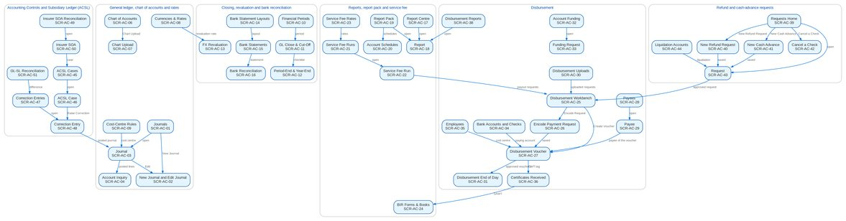
Figure 17: Screen flow of Accounting Disbursement ACSL: how the screens link (list, record, action, next screen)

12.3 Menu by persona
For each persona, the SIT and UAT user of the seed data and the sidebar that user sees, section by section. The BRD column shows which BRD owns a section; entries of other BRDs are listed so the business unit sees the whole menu of its users.

12.3.1 GL Officer (FRBS)
SIT/UAT user glofficer. 67 menu entries, 42 of them Accounting Disbursement ACSL screens; the other entries belong to the BRD shown.
Table 40: Sidebar of the GL Officer (FRBS)
Group | Section | Screens | BRD
Home | Overview | My Approvals, Dashboard | Platform
Home | New Business Dashboard | NB Dashboard | BRD-1
Home | My Work | My Work | BRD-1
Client & Policy | Booking | Booking Setup | BRD-1
Client & Policy | Product Maintenance | Products, Coverages & Clauses, Insurers, Rates & Taxes, Sales Organisation | BRD-3
Finance | Accounting Reports | Report Pack, Account Schedules, Service Fee Runs, Service Fee Rates | BRD-5
Finance | General Ledger | Journals, New Journal, Recurring Journals, Journal Upload, Account Inquiry, Party Statement, Chart of Accounts, Financial Periods | BRD-5
Finance | Receivables & Banking | Receipts, Cheques & Deposits, PDC Received, Receivables Reports | BRD-5
Finance | Payables & Cash | Supplier Invoices, Payment Vouchers, PDC Issued, Petty Cash, Bank Accounts | BRD-5
Finance | Assets & Investments | Asset Categories, Asset Register, Depreciation Run, Investment Portfolios, Investments, Accrual & Amortization, Maturities & Sales | BRD-5
Finance | Planning & Closing | Budget vs Actual | BRD-5
Finance | Tax & Statutory | Tax Calendar, VAT Worksheet, Withholding Tax, Tax Returns, BIR Form 2307, Certificates Received, BIR Forms & Books, Tax Codes & Forms, Party Tax Profiles | BRD-5
Finance | Accounting Engine | Event Types, Accounting Rules, Rule Simulator, Event Register | BRD-5
Reports | New Business Reports | New Business Reports, Production Targets | BRD-1
Reports | Reports | Report Centre | Platform
Setup & Administration | Broking Setup | Data Retention, Document Templates | BRD-1
Setup & Administration | Setup | Companies, Branches, Currencies & Rates, Dimensions, Business Partners, Employees, Cost-Centre Rules, Holiday Calendar | Platform
Setup & Administration | Help | Help Center, My Profile | Platform

12.3.2 GL Team Lead
SIT/UAT user gltl. 71 menu entries, 46 of them Accounting Disbursement ACSL screens; the other entries belong to the BRD shown.
Table 41: Sidebar of the GL Team Lead
Group | Section | Screens | BRD
Home | Overview | My Approvals, Dashboard | Platform
Home | New Business Dashboard | NB Dashboard | BRD-1
Home | My Work | My Work | BRD-1
Client & Policy | Booking | Booking Setup | BRD-1
Client & Policy | Product Maintenance | Products, Coverages & Clauses, Insurers, Rates & Taxes, Sales Organisation | BRD-3
Finance | Accounting Reports | Report Pack, Account Schedules, Service Fee Runs, Service Fee Rates | BRD-5
Finance | General Ledger | Journals, New Journal, Recurring Journals, Journal Upload, Account Inquiry, Party Statement, Chart of Accounts, Chart Upload, Financial Periods | BRD-5
Finance | Receivables & Banking | Receipts, Cheques & Deposits, PDC Received, Receivables Reports | BRD-5
Finance | Payables & Cash | Supplier Invoices, Payment Vouchers, PDC Issued, Petty Cash, Bank Accounts | BRD-5
Finance | Assets & Investments | Asset Categories, Asset Register, Depreciation Run, Investment Portfolios, Investments, Accrual & Amortization, Maturities & Sales | BRD-5
Finance | Planning & Closing | Budget vs Actual, FX Revaluation, Period-End & Year-End, GL Close & Cut-Off | BRD-5
Finance | Tax & Statutory | Tax Calendar, VAT Worksheet, Withholding Tax, Tax Returns, BIR Form 2307, Certificates Received, BIR Forms & Books, Tax Codes & Forms, Party Tax Profiles | BRD-5
Finance | Accounting Engine | Event Types, Accounting Rules, Rule Simulator, Event Register | BRD-5
Reports | New Business Reports | New Business Reports, Production Targets | BRD-1
Reports | Reports | Report Centre | Platform
Setup & Administration | Broking Setup | Data Retention, Document Templates | BRD-1
Setup & Administration | Setup | Companies, Branches, Currencies & Rates, Dimensions, Business Partners, Employees, Cost-Centre Rules, Holiday Calendar | Platform
Setup & Administration | Help | Help Center, My Profile | Platform

12.3.3 GL Section Head
SIT/UAT user glhead. 71 menu entries, 43 of them Accounting Disbursement ACSL screens; the other entries belong to the BRD shown.
Table 42: Sidebar of the GL Section Head
Group | Section | Screens | BRD
Home | Overview | My Approvals, Dashboard | Platform
Home | New Business Dashboard | NB Dashboard | BRD-1
Home | My Work | My Work | BRD-1
Client & Policy | Booking | Booking Setup | BRD-1
Client & Policy | Product Maintenance | Products, Coverages & Clauses, Insurers, Rates & Taxes, Sales Organisation | BRD-3
Finance | Collections | Escalation Rules | BRD-4
Finance | Cashiering | Receipt Series | BRD-2
Finance | Accounting Reports | Report Pack, Account Schedules, Service Fee Runs, Service Fee Rates | BRD-5
Finance | General Ledger | Journals, Recurring Journals, Account Inquiry, Party Statement, Chart of Accounts, Financial Periods | BRD-5
Finance | Receivables & Banking | Receipts, Cheques & Deposits, PDC Received, Receivables Reports | BRD-5
Finance | Payables & Cash | Supplier Invoices, Payment Vouchers, PDC Issued, Petty Cash, Bank Accounts | BRD-5
Finance | Assets & Investments | Asset Categories, Asset Register, Depreciation Run, Investment Portfolios, Investments, Accrual & Amortization, Maturities & Sales | BRD-5
Finance | Planning & Closing | Budget vs Actual, FX Revaluation, Period-End & Year-End, GL Close & Cut-Off | BRD-5
Finance | Tax & Statutory | Tax Calendar, VAT Worksheet, Withholding Tax, Tax Returns, BIR Form 2307, Certificates Received, BIR Forms & Books, Tax Codes & Forms, Party Tax Profiles | BRD-5
Finance | Accounting Engine | Event Types, Accounting Rules, Rule Simulator, Event Register | BRD-5
Reports | New Business Reports | New Business Reports, Production Targets | BRD-1
Reports | Reports | Report Centre | Platform
Setup & Administration | Broking Setup | Lists of Values, Data Retention, Document Templates | BRD-1
Setup & Administration | Setup | Companies, Branches, Currencies & Rates, Dimensions, Business Partners, Employees, Cost-Centre Rules, Holiday Calendar | Platform
Setup & Administration | Help | Help Center, My Profile | Platform

12.3.4 Accountant (bank reconciliation)
SIT/UAT user accountant. 67 menu entries, 43 of them Accounting Disbursement ACSL screens; the other entries belong to the BRD shown.
Table 43: Sidebar of the Accountant (bank reconciliation)
Group | Section | Screens | BRD
Home | Overview | My Approvals, Dashboard | Platform
Client & Policy | Booking | Booking Setup | BRD-1
Client & Policy | Product Maintenance | Products, Coverages & Clauses, Insurers, Rates & Taxes, Sales Organisation | BRD-3
Finance | Accounting Reports | Account Schedules | BRD-5
Finance | General Ledger | Journals, New Journal, Recurring Journals, Journal Upload, Account Inquiry, Party Statement, Chart of Accounts, Financial Periods | BRD-5
Finance | Receivables & Banking | Receipts, New Receipt, Cheques & Deposits, PDC Received, Bank Statements, Bank Reconciliation, Receivables Reports | BRD-5
Finance | Payables & Cash | Supplier Invoices, Payment Vouchers, PDC Issued, Petty Cash, Bank Accounts | BRD-5
Finance | Assets & Investments | Asset Categories, Asset Register, Depreciation Run, Investment Portfolios, Investments, Accrual & Amortization, Maturities & Sales | BRD-5
Finance | Planning & Closing | Budgets, Budget vs Actual | BRD-5
Finance | Tax & Statutory | Tax Calendar, VAT Worksheet, Withholding Tax, Tax Returns, BIR Form 2307, Certificates Received, BIR Forms & Books, Tax Codes & Forms, Party Tax Profiles | BRD-5
Finance | Accounting Engine | Event Types, Accounting Rules, Rule Simulator, Event Register | BRD-5
Reports | New Business Reports | New Business Reports, Production Targets | BRD-1
Reports | Reports | Report Centre | Platform
Setup & Administration | Broking Setup | Data Retention, Document Templates | BRD-1
Setup & Administration | Setup | Companies, Branches, Currencies & Rates, Dimensions, Business Partners, Employees, Cost-Centre Rules, Bank Statement Layouts, Holiday Calendar | Platform
Setup & Administration | Help | Help Center, My Profile | Platform

12.3.5 Comptrollership administrator (masters and rules)
SIT/UAT user fmanager. 65 menu entries, 39 of them Accounting Disbursement ACSL screens; the other entries belong to the BRD shown.
Table 44: Sidebar of the Comptrollership administrator (masters and rules)
Group | Section | Screens | BRD
Home | Overview | My Approvals, Dashboard, Alerts | Platform
Client & Policy | Booking | Booking Setup | BRD-1
Client & Policy | Product Maintenance | Products, Coverages & Clauses, Insurers, Rates & Taxes, Sales Organisation | BRD-3
Finance | Refund & Cash Advance Requests | Liquidation Accounts | BRD-5
Finance | Accounting Reports | Account Schedules | BRD-5
Finance | General Ledger | Journals, Recurring Journals, Account Inquiry, Party Statement, Chart of Accounts, Financial Periods | BRD-5
Finance | Receivables & Banking | Receipts, Cheques & Deposits, PDC Received, Receivables Reports | BRD-5
Finance | Payables & Cash | Supplier Invoices, Payment Vouchers, PDC Issued, Petty Cash, Bank Accounts | BRD-5
Finance | Assets & Investments | Asset Categories, Asset Register, Depreciation Run, Investment Portfolios, Investments, Accrual & Amortization, Maturities & Sales | BRD-5
Finance | Planning & Closing | Budgets, Budget vs Actual | BRD-5
Finance | Tax & Statutory | Tax Calendar, VAT Worksheet, Withholding Tax, Tax Returns, BIR Form 2307, Certificates Received, BIR Forms & Books, Tax Codes & Forms, Party Tax Profiles | BRD-5
Finance | Accounting Engine | Event Types, Accounting Rules, Rule Simulator, Event Register | BRD-5
Reports | New Business Reports | New Business Reports, Production Targets | BRD-1
Reports | Reports | Report Centre | Platform
Setup & Administration | Broking Setup | Data Retention, Document Templates | BRD-1
Setup & Administration | Setup | Companies, Branches, Currencies & Rates, Dimensions, Business Partners, Employees, Cost-Centre Rules, Holiday Calendar | Platform
Setup & Administration | Administration | Exception Codes, Product Modules | Platform / BRD-11
Setup & Administration | Help | Help Center, My Profile | Platform

12.3.6 Disbursement Processor
SIT/UAT user disb. 50 menu entries, 16 of them Accounting Disbursement ACSL screens; the other entries belong to the BRD shown.
Table 45: Sidebar of the Disbursement Processor
Group | Section | Screens | BRD
Home | Overview | My Approvals | Platform
Home | New Business Dashboard | NB Dashboard | BRD-1
Home | My Work | My Work | BRD-1
Client & Policy | Clients | Clients, KYC Reviews Due | BRD-1
Client & Policy | Accounts & Placement | Accounts, FFY Register, Direct Payment | BRD-1
Client & Policy | Placement & Booking | Placement Workbench, Placement Slips | BRD-1
Client & Policy | Policy Issuance | Issuance Workbench, Insurance Advice | BRD-1
Client & Policy | Product Maintenance | Premium Calculator | BRD-3
Operations | Operations | Operations Home, Invoice Search, Disbursement Queue, Hand-offs and Extracts, Report Archive, Notification Settings | BRD-2
Finance | Collections | Collections Home, PR Worklist, Installment Plans, Installments Due, Promises to Pay, Escalations, Billing Statements, Unapplied Payments, Requests to Cashiering, Collections Files | BRD-4
Finance | Cashiering | BIR 2307 | BRD-2
Finance | Disbursement | Disbursement Workbench, Payees, Disbursement Uploads, Disbursement End of Day, Account Funding, Bank Accounts and Checks, Disbursement Reports | BRD-5
Finance | Tax & Statutory | Tax Calendar, VAT Worksheet, Withholding Tax, Tax Returns, BIR Form 2307, Certificates Received, BIR Forms & Books, Tax Codes & Forms, Party Tax Profiles | BRD-5
Reports | New Business Reports | New Business Reports | BRD-1
Reports | Reports | Report Centre | Platform
Setup & Administration | Help | Help Center, My Profile | Platform

12.3.7 Disbursement Team Leader
SIT/UAT user disbtl. 34 menu entries, 16 of them Accounting Disbursement ACSL screens; the other entries belong to the BRD shown.
Table 46: Sidebar of the Disbursement Team Leader
Group | Section | Screens | BRD
Home | Overview | My Approvals, Dashboard | Platform
Home | New Business Dashboard | NB Dashboard | BRD-1
Home | My Work | My Work | BRD-1
Client & Policy | Clients | Clients, KYC Reviews Due | BRD-1
Client & Policy | Bulk Processing | Bulk Uploads | BRD-1
Operations | Operations | Operations Home, Invoice Search, Disbursement Queue, Hand-offs and Extracts, Report Archive, Notification Settings | BRD-2
Finance | Cashiering | BIR 2307 | BRD-2
Finance | Disbursement | Disbursement Workbench, Payees, Disbursement Uploads, Disbursement End of Day, Account Funding, Bank Accounts and Checks, Disbursement Reports | BRD-5
Finance | Tax & Statutory | Tax Calendar, VAT Worksheet, Withholding Tax, Tax Returns, BIR Form 2307, Certificates Received, BIR Forms & Books, Tax Codes & Forms, Party Tax Profiles | BRD-5
Reports | New Business Reports | New Business Reports | BRD-1
Reports | Reports | Report Centre | Platform
Setup & Administration | Help | Help Center, My Profile | Platform

12.3.8 Disbursement Approver
SIT/UAT user disbappr. 52 menu entries, 20 of them Accounting Disbursement ACSL screens; the other entries belong to the BRD shown.
Table 47: Sidebar of the Disbursement Approver
Group | Section | Screens | BRD
Home | Overview | My Approvals, Dashboard | Platform
Home | New Business Dashboard | NB Dashboard | BRD-1
Home | My Work | My Work | BRD-1
Client & Policy | Clients | Clients, KYC Reviews Due | BRD-1
Client & Policy | Booking | Booking Setup | BRD-1
Client & Policy | Product Maintenance | Products, Coverages & Clauses, Insurers, Rates & Taxes, Sales Organisation | BRD-3
Operations | Operations | Operations Home, Invoice Search, Hand-offs and Extracts, Report Archive, Notification Settings | BRD-2
Finance | Disbursement | Disbursement Workbench, Payees, Disbursement End of Day, Account Funding, Bank Accounts and Checks, Disbursement Reports | BRD-5
Finance | Accounting Reports | Account Schedules | BRD-5
Finance | General Ledger | Chart of Accounts, Financial Periods | BRD-5
Finance | Payables & Cash | Bank Accounts | BRD-5
Finance | Assets & Investments | Asset Categories, Asset Register, Depreciation Run, Investment Portfolios, Investments, Accrual & Amortization, Maturities & Sales | BRD-5
Finance | Accounting Engine | Event Types, Accounting Rules, Rule Simulator | BRD-5
Reports | New Business Reports | New Business Reports, Production Targets | BRD-1
Reports | Reports | Report Centre | Platform
Setup & Administration | Broking Setup | Data Retention, Document Templates | BRD-1
Setup & Administration | Setup | Companies, Branches, Currencies & Rates, Dimensions, Business Partners, Employees, Cost-Centre Rules, Holiday Calendar | Platform
Setup & Administration | Help | Help Center, My Profile | Platform

12.3.9 Marketing Processor (AO)
SIT/UAT user mktao. 19 menu entries, 4 of them Accounting Disbursement ACSL screens; the other entries belong to the BRD shown.
Table 48: Sidebar of the Marketing Processor (AO)
Group | Section | Screens | BRD
Home | Overview | My Approvals, Dashboard | Platform
Home | New Business Dashboard | NB Dashboard | BRD-1
Home | My Work | My Work | BRD-1
Client & Policy | Clients | Clients, KYC Reviews Due | BRD-1
Operations | Operations | Operations Home, Invoice Search, Hand-offs and Extracts, Report Archive, Notification Settings | BRD-2
Finance | Refund & Cash Advance Requests | Requests Home, New Refund Request, New Cash Advance, Cancel a Check | BRD-5
Reports | New Business Reports | New Business Reports | BRD-1
Reports | Reports | Report Centre | Platform
Setup & Administration | Help | Help Center, My Profile | Platform

12.3.10 Marketing Reviewer
SIT/UAT user mktrev. 20 menu entries, 5 of them Accounting Disbursement ACSL screens; the other entries belong to the BRD shown.
Table 49: Sidebar of the Marketing Reviewer
Group | Section | Screens | BRD
Home | Overview | My Approvals, Dashboard | Platform
Home | New Business Dashboard | NB Dashboard | BRD-1
Home | My Work | My Work | BRD-1
Client & Policy | Clients | Clients, KYC Reviews Due | BRD-1
Operations | Operations | Operations Home, Invoice Search, Hand-offs and Extracts, Report Archive, Notification Settings | BRD-2
Finance | Refund & Cash Advance Requests | Requests Home, New Refund Request, New Cash Advance, Cancel a Check, Liquidation Accounts | BRD-5
Reports | New Business Reports | New Business Reports | BRD-1
Reports | Reports | Report Centre | Platform
Setup & Administration | Help | Help Center, My Profile | Platform

12.3.11 Marketing Approver
SIT/UAT user mktappr. 16 menu entries, 1 of them Accounting Disbursement ACSL screens; the other entries belong to the BRD shown.
Table 50: Sidebar of the Marketing Approver
Group | Section | Screens | BRD
Home | Overview | My Approvals, Dashboard | Platform
Home | New Business Dashboard | NB Dashboard | BRD-1
Home | My Work | My Work | BRD-1
Client & Policy | Clients | Clients, KYC Reviews Due | BRD-1
Operations | Operations | Operations Home, Invoice Search, Hand-offs and Extracts, Report Archive, Notification Settings | BRD-2
Finance | Refund & Cash Advance Requests | Requests Home | BRD-5
Reports | New Business Reports | New Business Reports | BRD-1
Reports | Reports | Report Centre | Platform
Setup & Administration | Help | Help Center, My Profile | Platform

12.3.12 Human Resources Approver
SIT/UAT user hrappr. 9 menu entries, 1 of them Accounting Disbursement ACSL screens; the other entries belong to the BRD shown.
Table 51: Sidebar of the Human Resources Approver
Group | Section | Screens | BRD
Home | Overview | My Approvals, Dashboard | Platform
Home | New Business Dashboard | NB Dashboard | BRD-1
Home | My Work | My Work | BRD-1
Finance | Refund & Cash Advance Requests | Requests Home | BRD-5
Reports | New Business Reports | New Business Reports | BRD-1
Reports | Reports | Report Centre | Platform
Setup & Administration | Help | Help Center, My Profile | Platform

12.3.13 ACSL Processor
SIT/UAT user acsl. 43 menu entries, 16 of them Accounting Disbursement ACSL screens; the other entries belong to the BRD shown.
Table 52: Sidebar of the ACSL Processor
Group | Section | Screens | BRD
Home | Overview | My Approvals, Dashboard | Platform
Home | New Business Dashboard | NB Dashboard | BRD-1
Home | My Work | My Work | BRD-1
Client & Policy | Clients | Clients, KYC Reviews Due | BRD-1
Client & Policy | Bulk Processing | Bulk Uploads | BRD-1
Operations | Operations | Operations Home, Invoice Search, Hand-offs and Extracts, Report Archive, Notification Settings | BRD-2
Finance | Collections | Collections Home, PR Worklist, Installment Plans, Installments Due, Promises to Pay, Escalations, Billing Statements, Unapplied Payments, Requests to Cashiering, Collections Files | BRD-4
Finance | Remittance | Remittance Deductions | BRD-2
Finance | ACSL | ACSL Cases, Correction Entries, Insurer SOA Reconciliation, GL-SL Reconciliation | BRD-5
Finance | General Ledger | Journals, Recurring Journals, Account Inquiry, Party Statement | BRD-5
Finance | Receivables & Banking | Receipts, Cheques & Deposits, PDC Received | BRD-5
Finance | Payables & Cash | Supplier Invoices, Payment Vouchers, PDC Issued, Petty Cash | BRD-5
Finance | Accounting Engine | Event Register | BRD-5
Reports | New Business Reports | New Business Reports | BRD-1
Reports | Reports | Report Centre | Platform
Setup & Administration | Help | Help Center, My Profile | Platform

12.3.14 ACSL Team Leader
SIT/UAT user acsltl. 43 menu entries, 16 of them Accounting Disbursement ACSL screens; the other entries belong to the BRD shown.
Table 53: Sidebar of the ACSL Team Leader
Group | Section | Screens | BRD
Home | Overview | My Approvals, Dashboard | Platform
Home | New Business Dashboard | NB Dashboard | BRD-1
Home | My Work | My Work | BRD-1
Client & Policy | Clients | Clients, KYC Reviews Due | BRD-1
Client & Policy | Bulk Processing | Bulk Uploads | BRD-1
Operations | Operations | Operations Home, Invoice Search, Hand-offs and Extracts, Report Archive, Notification Settings | BRD-2
Finance | Collections | Collections Home, PR Worklist, Installment Plans, Installments Due, Promises to Pay, Escalations, Billing Statements, Unapplied Payments, Requests to Cashiering, Collections Files | BRD-4
Finance | Remittance | Remittance Deductions | BRD-2
Finance | ACSL | ACSL Cases, Correction Entries, Insurer SOA Reconciliation, GL-SL Reconciliation | BRD-5
Finance | General Ledger | Journals, Recurring Journals, Account Inquiry, Party Statement | BRD-5
Finance | Receivables & Banking | Receipts, Cheques & Deposits, PDC Received | BRD-5
Finance | Payables & Cash | Supplier Invoices, Payment Vouchers, PDC Issued, Petty Cash | BRD-5
Finance | Accounting Engine | Event Register | BRD-5
Reports | New Business Reports | New Business Reports | BRD-1
Reports | Reports | Report Centre | Platform
Setup & Administration | Help | Help Center, My Profile | Platform

12.3.15 ACSL Head (approver)
SIT/UAT user acslhead. 42 menu entries, 16 of them Accounting Disbursement ACSL screens; the other entries belong to the BRD shown.
Table 54: Sidebar of the ACSL Head (approver)
Group | Section | Screens | BRD
Home | Overview | My Approvals, Dashboard | Platform
Home | New Business Dashboard | NB Dashboard | BRD-1
Home | My Work | My Work | BRD-1
Client & Policy | Clients | Clients, KYC Reviews Due | BRD-1
Operations | Operations | Operations Home, Invoice Search, Hand-offs and Extracts, Report Archive, Notification Settings | BRD-2
Finance | Collections | Collections Home, PR Worklist, Installment Plans, Installments Due, Promises to Pay, Escalations, Billing Statements, Unapplied Payments, Requests to Cashiering, Collections Files | BRD-4
Finance | Remittance | Remittance Deductions | BRD-2
Finance | ACSL | ACSL Cases, Correction Entries, Insurer SOA Reconciliation, GL-SL Reconciliation | BRD-5
Finance | General Ledger | Journals, Recurring Journals, Account Inquiry, Party Statement | BRD-5
Finance | Receivables & Banking | Receipts, Cheques & Deposits, PDC Received | BRD-5
Finance | Payables & Cash | Supplier Invoices, Payment Vouchers, PDC Issued, Petty Cash | BRD-5
Finance | Accounting Engine | Event Register | BRD-5
Reports | New Business Reports | New Business Reports | BRD-1
Reports | Reports | Report Centre | Platform
Setup & Administration | Help | Help Center, My Profile | Platform

12.3.16 Comptrollership (read access)
SIT/UAT user comptrol. 71 menu entries, 26 of them Accounting Disbursement ACSL screens; the other entries belong to the BRD shown.
Table 55: Sidebar of the Comptrollership (read access)
Group | Section | Screens | BRD
Home | Overview | My Approvals | Platform
Home | New Business Dashboard | NB Dashboard | BRD-1
Home | My Work | My Work | BRD-1
Client & Policy | Clients | Clients, KYC Reviews Due | BRD-1
Client & Policy | Accounts & Placement | Accounts, FFY Register, Direct Payment | BRD-1
Client & Policy | Placement & Booking | Placement Workbench, Placement Slips | BRD-1
Client & Policy | Policy Issuance | Issuance Workbench, Insurance Advice | BRD-1
Client & Policy | Product Maintenance | Premium Calculator | BRD-3
Operations | Operations | Operations Home, Invoice Search, Hand-offs and Extracts, Report Archive, Notification Settings | BRD-2
Finance | Collections | Collections Home, PR Worklist, Installment Plans, Installments Due, Promises to Pay, Escalations, Billing Statements, Unapplied Payments, Requests to Cashiering, Collections Files | BRD-4
Finance | Remittance | Remittance Deductions | BRD-2
Finance | Commission Receivables | Commission Workbench, BIR Certificates | BRD-2
Finance | Disbursement | Disbursement Workbench, Payees, Disbursement End of Day, Account Funding, Bank Accounts and Checks, Disbursement Reports | BRD-5
Finance | ACSL | ACSL Cases, Correction Entries, Insurer SOA Reconciliation, GL-SL Reconciliation | BRD-5
Finance | Accounting Reports | Report Pack, Account Schedules, Service Fee Runs, Service Fee Rates | BRD-5
Finance | General Ledger | Journals, Recurring Journals, Account Inquiry, Party Statement | BRD-5
Finance | Receivables & Banking | Receipts, Cheques & Deposits, PDC Received | BRD-5
Finance | Payables & Cash | Supplier Invoices, Payment Vouchers, PDC Issued, Petty Cash | BRD-5
Finance | Accounting Engine | Event Register | BRD-5
Data Migration | Data Migration | Migration Home, Data Objects, Code Maps, Layouts and Rules, Batches, Reconciliation, Opening Adjustments, Cutover, Run-off and Decommissioning, Sign-off | BRD-13
Reports | New Business Reports | New Business Reports | BRD-1
Reports | Reports | Report Centre | Platform
Setup & Administration | Help | Help Center, My Profile | Platform

12.3.17 Business Administrator
SIT/UAT user badmin. 84 menu entries, 14 of them Accounting Disbursement ACSL screens; the other entries belong to the BRD shown.
Table 56: Sidebar of the Business Administrator
Group | Section | Screens | BRD
Home | Overview | My Approvals | Platform
Home | New Business Dashboard | NB Dashboard | BRD-1
Home | My Work | My Work | BRD-1
Client & Policy | Employee Benefits | EB Home, Programmes, Member Changes, Pending Items, EB Setup | BRD-8
Client & Policy | Booking | Booking Setup | BRD-1
Client & Policy | Renewal | Renewal Home, Expiry List, Renewal Setup | BRD-6
Client & Policy | Product Maintenance | Product Maintenance Home, Package Requests, Package Expiry, Products, Validation Queue, Coverages & Clauses, Incentive Criteria, Insurers, Rates & Taxes, Sales Organisation | BRD-3
Client & Policy | Bulk Processing | Bulk Uploads | BRD-1
Operations | Operations | Operations Home, Invoice Search, Hand-offs and Extracts, Interfaces, Notification Settings | BRD-2
Finance | Collections | Collections Home, PR Worklist, Installment Plans, Installments Due, Promises to Pay, Escalations, Escalation Rules, Billing Statements, Unapplied Payments, Requests to Cashiering, Collections Setup | BRD-4
Finance | Accounting Reports | Account Schedules | BRD-5
Finance | General Ledger | Chart of Accounts, Financial Periods | BRD-5
Finance | Payables & Cash | Bank Accounts | BRD-5
Finance | Assets & Investments | Asset Categories, Asset Register, Depreciation Run, Investment Portfolios, Investments, Accrual & Amortization, Maturities & Sales | BRD-5
Finance | Accounting Engine | Event Types, Accounting Rules, Rule Simulator | BRD-5
Reports | New Business Reports | New Business Reports, Production Targets | BRD-1
Reports | Reports | Report Centre | Platform
Setup & Administration | Broking Setup | Lists of Values, Data Retention, Document Templates, Outbound Messages | BRD-1
Setup & Administration | Setup | Companies, Branches, Currencies & Rates, Dimensions, Business Partners, Employees, Cost-Centre Rules, Holiday Calendar | Platform
Setup & Administration | User Access | Access Requests, Group Profile Requests, Bulk Request, User Access Matrix, Separation of Duties, User Access Reports | BRD-11
Setup & Administration | Administration | Audit Trail, System Parameters, Scheduled Jobs, Record Classes, Legal Holds, Content Migration, Product Modules, Application Info | Platform / BRD-11
Setup & Administration | Help | Help Center, My Profile | Platform

12.3.18 System Administrator
SIT/UAT user admin. 122 menu entries, 28 of them Accounting Disbursement ACSL screens; the other entries belong to the BRD shown.
Table 57: Sidebar of the System Administrator
Group | Section | Screens | BRD
Home | Overview | My Approvals, Dashboard, Alerts | Platform
Home | New Business Dashboard | NB Dashboard | BRD-1
Home | My Work | My Work | BRD-1
Client & Policy | Sanction Screening | Screening Home, Cases, Matches, Screening Runs, High-risk Clients | BRD-10
Client & Policy | Employee Benefits | EB Home, Programmes, Member Changes, Pending Items | BRD-8
Client & Policy | Booking | Booking Setup | BRD-1
Client & Policy | Product Maintenance | Product Maintenance Home, Package Requests, Products, Coverages & Clauses, Incentive Criteria, Insurers, Rates & Taxes, Sales Organisation | BRD-3
Client & Policy | Bulk Processing | Bulk Uploads | BRD-1
Operations | Operations | Operations Home, Invoice Search, Hand-offs and Extracts, Interfaces, Report Archive, Notification Settings | BRD-2
Finance | Collections | Collections Home, PR Worklist, Installment Plans, Installments Due, Promises to Pay, Escalations, Escalation Rules, Billing Statements, Unapplied Payments, Requests to Cashiering, Collections Files, Collections Setup | BRD-4
Finance | Remittance | Remittance Deductions | BRD-2
Finance | Disbursement | Disbursement Workbench, Payees, Disbursement End of Day, Account Funding, Bank Accounts and Checks, Disbursement Reports | BRD-5
Finance | Refund & Cash Advance Requests | Requests Home | BRD-5
Finance | ACSL | ACSL Cases, Correction Entries, Insurer SOA Reconciliation, GL-SL Reconciliation | BRD-5
Finance | Accounting Reports | Report Pack, Account Schedules, Service Fee Runs, Service Fee Rates | BRD-5
Finance | General Ledger | Chart of Accounts, Financial Periods | BRD-5
Finance | Payables & Cash | Bank Accounts | BRD-5
Finance | Assets & Investments | Asset Categories, Asset Register, Depreciation Run, Investment Portfolios, Investments, Accrual & Amortization, Maturities & Sales | BRD-5
Finance | Accounting Engine | Event Types, Accounting Rules, Rule Simulator | BRD-5
Claims & Insurance | Claims Handling | Claims Home, Claims Worklist, My Diary, Claims Reports | BRD-7
Data Migration | Data Migration | Migration Home, Data Objects, Code Maps, Layouts and Rules, Batches, Reconciliation, Opening Adjustments, Cutover, Run-off and Decommissioning, Sign-off | BRD-13
Reports | New Business Reports | New Business Reports, Production Targets | BRD-1
Reports | Reports | Report Centre | Platform
Setup & Administration | Broking Setup | Lists of Values, Data Retention, Document Templates, Outbound Messages | BRD-1
Setup & Administration | Compliance Setup | Watchlist | BRD-10
Setup & Administration | Setup | Companies, Branches, Currencies & Rates, Dimensions, Business Partners, Employees, Cost-Centre Rules, Holiday Calendar | Platform
Setup & Administration | User Access | Access Requests, Group Profile Requests, Bulk Request, User Access Matrix, User Access Reports | BRD-11
Setup & Administration | Administration | Users, Roles & Permissions, Second Factor, Audit Trail, System Parameters, Exception Codes, Scheduled Jobs, Integration Events, Caches, Record Classes, Legal Holds, Content Migration, Product Modules, Application Info | Platform / BRD-11
Setup & Administration | Help | Help Center, My Profile | Platform

12.3.19 Auditor
SIT/UAT user auditor. 150 menu entries, 51 of them Accounting Disbursement ACSL screens; the other entries belong to the BRD shown.
Table 58: Sidebar of the Auditor
Group | Section | Screens | BRD
Home | Overview | My Approvals, Dashboard, Alerts | Platform
Home | New Business Dashboard | NB Dashboard | BRD-1
Home | My Work | My Work | BRD-1
Client & Policy | Clients | Clients, KYC Reviews Due | BRD-1
Client & Policy | Sanction Screening | Screening Home, Cases, Matches, Screening Runs, High-risk Clients, STR | BRD-10
Client & Policy | Quotation / Proposal | Quotations, Quotation Requests | BRD-1
Client & Policy | Accounts & Placement | Accounts, FFY Register, Direct Payment | BRD-1
Client & Policy | Employee Benefits | EB Home, Programmes, Member Changes, Pending Items | BRD-8
Client & Policy | Placement & Booking | Placement Workbench, Placement Slips | BRD-1
Client & Policy | Policy Issuance | Issuance Workbench, Insurance Advice | BRD-1
Client & Policy | Booking | Booking Setup | BRD-1
Client & Policy | Renewal | Renewal Home, Expiry List | BRD-6
Client & Policy | Product Maintenance | Product Maintenance Home, Package Requests, Package Expiry, Products, Coverages & Clauses, Incentive Criteria, Insurers, Rates & Taxes, Sales Organisation, Premium Calculator | BRD-3
Operations | Operations | Operations Home, Invoice Search, Hand-offs and Extracts, Report Archive, Notification Settings | BRD-2
Finance | Collections | Collections Home, PR Worklist, Installment Plans, Installments Due, Promises to Pay, Escalations, Billing Statements, Unapplied Payments, Requests to Cashiering, Collections Files | BRD-4
Finance | Remittance | Remittance Deductions | BRD-2
Finance | Disbursement | Disbursement Workbench, Payees, Disbursement End of Day, Account Funding, Bank Accounts and Checks, Disbursement Reports | BRD-5
Finance | Refund & Cash Advance Requests | Requests Home | BRD-5
Finance | ACSL | ACSL Cases, Correction Entries, Insurer SOA Reconciliation, GL-SL Reconciliation | BRD-5
Finance | Accounting Reports | Report Pack, Account Schedules, Service Fee Runs, Service Fee Rates | BRD-5
Finance | General Ledger | Journals, Recurring Journals, Account Inquiry, Party Statement, Chart of Accounts, Financial Periods | BRD-5
Finance | Receivables & Banking | Receipts, Cheques & Deposits, PDC Received, Receivables Reports | BRD-5
Finance | Payables & Cash | Supplier Invoices, Payment Vouchers, PDC Issued, Petty Cash, Bank Accounts | BRD-5
Finance | Assets & Investments | Asset Categories, Asset Register, Depreciation Run, Investment Portfolios, Investments, Accrual & Amortization, Maturities & Sales | BRD-5
Finance | Planning & Closing | Budget vs Actual | BRD-5
Finance | Tax & Statutory | Tax Calendar, VAT Worksheet, Withholding Tax, Tax Returns, BIR Form 2307, Certificates Received, BIR Forms & Books, Tax Codes & Forms, Party Tax Profiles | BRD-5
Finance | Accounting Engine | Event Types, Accounting Rules, Rule Simulator, Event Register | BRD-5
Claims & Insurance | Claims Handling | Claims Home, Claims Worklist, My Diary, Claims Reports | BRD-7
Data Migration | Data Migration | Migration Home, Data Objects, Code Maps, Layouts and Rules, Batches, Reconciliation, Opening Adjustments, Cutover, Run-off and Decommissioning, Sign-off | BRD-13
Reports | New Business Reports | New Business Reports, Production Targets | BRD-1
Reports | Reports | Report Centre | Platform
Setup & Administration | Broking Setup | Data Retention, Document Templates, Outbound Messages | BRD-1
Setup & Administration | Compliance Setup | Watchlist | BRD-10
Setup & Administration | Setup | Companies, Branches, Currencies & Rates, Dimensions, Business Partners, Employees, Cost-Centre Rules, Holiday Calendar | Platform
Setup & Administration | User Access | Access Requests, Group Profile Requests, User Access Matrix, User Access Reports | BRD-11
Setup & Administration | Administration | Audit Trail, System Parameters, Exception Codes, Scheduled Jobs, Record Classes, Legal Holds, Content Migration, Product Modules, Application Info | Platform / BRD-11
Setup & Administration | Help | Help Center, My Profile | Platform

12.4 Common screen elements
Elements that behave the same on every screen of this set are described once here and not repeated in the screen specifications.
Table 59: Common screen elements
Element | What the user sees and does
Page header and company | Every page shows its section and title, a one-line description and its actions on the right. The company in the header decides the records shown; lists, journals, reports and files are always of that company.
Work lists | Lists show status tabs (with their counts where useful), a search box, a Filters button for the other criteria and the paged table ("Showing 1 to n of N results"). Rows alternate white and Background Blue; a long list scrolls inside its card with the header row in view. A row opens its record. Selecting rows enables the bulk actions of the tab (assign or post journals, approve vouchers, endorse or approve requests).
Record summary and reference chips | A record opens with its reference chips (voucher, request, journal, case, correction, root invoice), its status pill, its flags (Automatic, Entry Edited, Posted, Returned) and the key facts. A reference chip copies the reference.
Workflow header and history | A record with a workflow (disbursement voucher, payee, account funding, payment request, ACSL case and correction, service-fee run) shows the workflow header under the record header: a stepper of the stages in their order (passed stages ticked in blue, the current stage highlighted, the stages ahead in grey; a returned stage in amber, the last stage in green once reached), and one row with Current Stage, Since, Due (with the Overdue pill) and Assigned To, with the actions the user may take now on the right. The history table lists every step, newest first: Stage, From Stage, Action, By (the user's name; the role under it for the users who may read the roles of others: user administration, access review and audit), Date and Time, Remarks and Duration in Stage. "Workflow notice" in the action tables means the in-app notice of the move.
Maker-checker and separation of duties | Every posting and every master change needs a second user: a journal is posted by another user than its submitter; a disbursement voucher is checked and approved by other users than its processor; a funding request is verified by another user than its maker and approved by two further users; a payee, a bank account and a check series change take effect when the approver authorises them; a correction entry is reviewed and approved by other users than its preparer; a service-fee run is approved by another user than its preparer. The action is not offered to the user who may not take it, and a refusal names the rule.
Accounting entries | Every amount that BIBS posts goes through the accounting rules: the business event (a voucher approved, a check negotiated, a funding, a correction, a service-fee accrual) proposes the entry from the rule, the user sees it as Dr / Cr lines with the account, party, cost centre and amount, and the entry posts only when it balances. A voucher entry that the processor edits is marked Entry Edited for the approver. Posted entries are never changed; they are reversed by a linked entry.
Status pills and tags | Statuses are outlined pills of one size and colour per state group; a pill never wraps. Statuses show their full label; an agreed short form, with the full label in the tooltip, is used only for a label longer than 21 characters. Flags (Automatic, Entry Edited, Posting Failed, Returned) are tags.
Dates, amounts, rates and names | Dates are entered with one date picker and shown as dd-MMM-yyyy; times as dd-MMM-yyyy HH:mm in Philippine time. Amounts show two decimals and thousand separators, with the currency in the column header or before the amount; negatives in brackets. Exchange rates show six decimals and percentage rates two to four. A period is shown in lists on two lines, the start date and "to" the end date. Lists of values show their labels, insurers their names and users their names.
Uploads | Uploads (payment requests, bank confirmations, payees, the chart of accounts, bank statements, insurer statements) offer the template next to the upload; every row is checked before anything is saved and the rows read, valid and rejected are shown with their messages; only the valid rows are processed and a file uploaded before is refused.
Hand-offs between the units | Work moves inside BIBS: an approved refund, cash advance or check cancellation of Marketing becomes a payment request in the Disbursement Workbench; a remittance, a commission refund or a service fee becomes a payment request when its batch or run is approved; a cancelled voucher goes back to the request's source; an ACSL case can ask Cashiering for a payment reversal and raise a correction entry. Each hand-off keeps the reference of its source.
Notifications and help | The bell in the header shows the unread count and opens the notifications panel, grouped by day; each notice shows its title, a one-line summary, the record reference and the time, and opens its record. Mark Read, Mark All Read and View All are offered. Each user chooses the channels of the events on Notification Settings. The Help button of each page explains the screen.
Messages | Every message follows one notice standard: a white notice with a thin bar and an icon in the colour of its kind (red error, amber warning, blue information, green success), a bold short title, then the business message with one bullet per missing item. Field errors appear under the field. A refusal by a business rule shows the business message only, without codes; only an unexpected system error offers Retry and a reference for support. Success is confirmed by a short message in the same standard.
Confirmations and bulk results | Every approve, post, authorise, cancel, reverse and deactivate asks for confirmation in a dialog that names the record and the effect; actions that need a reason open a dialog with the reason and a comment. An action run on several selected records (post journals, approve vouchers, endorse or approve requests) processes each on its own and lists the outcome of each, so one failure does not stop the others.
Reports and exports | Reports open in the report runner with their parameters, column filters and the export to Excel, PDF, ODS or CSV; several reports run together as a report batch. Large exports run in the background and are published with the time from which they may be downloaded.

13 Screen specifications
One specification per screen, grouped by area: the general ledger, the chart and the rates; closing and bank reconciliation; reports, the service fee and the BIR outputs; Disbursement; the Marketing refund and cash-advance requests; ACSL. Each gives:
• Purpose, who can open it (personas and the permission), navigation (menu path and the other ways in) and the related FRs;
• the screenshots taken with seed data; the first carries numbered callouts that match the Fields table;
• the Fields table: section, label, type, length or format, mandatory, source list, default, the statuses in which the field can be changed, the validation and the message shown when it fails;
• the Actions table: button, who sees it, when it is enabled, what happens, the resulting status and the notification sent;
• the business rules, the expected outcome and the test cases of the test plan that exercise the screen.

13.1 General ledger, chart of accounts and rates

13.1.1 SCR-AC-01 Journals
Purpose | The journal vouchers of the company: search by status, batch number, value dates, inputter and assignment; follow the approval status of each voucher; assign the submitted vouchers to the user who will post them and post several vouchers at once. The GL Team Lead and the Section Head work the vouchers "Assigned to me".
Who can open it | GL Officer (FRBS), GL Team Lead, GL Section Head, Accountant (bank reconciliation), Comptrollership administrator (masters and rules), ACSL Processor, ACSL Team Leader, ACSL Head (approver), Comptrollership (read access), Auditor (permission Journal view)
Navigation | • Menu: Finance › General Ledger › Journals  • Journal › back arrow
FRs | FR-AC-030, FR-AC-031, FR-AC-033, FR-AC-036

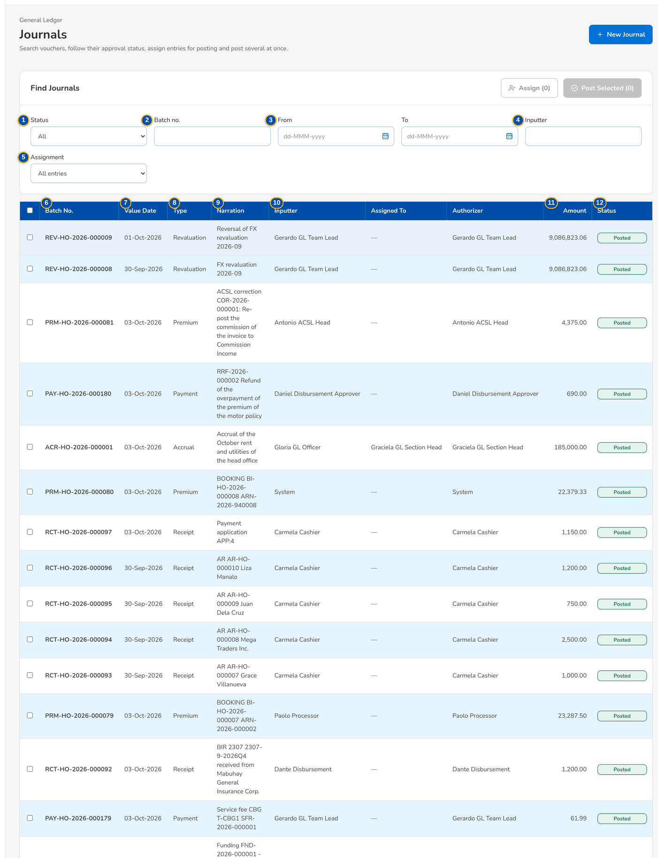
Figure 18: SCR-AC-01 Journals of the GL Team Lead: vouchers with value date, type, inputter, assignee, authorizer, amount and status
1 | Status | 6 | Batch No. | 11 | Amount
2 | Batch no. | 7 | Value Date | 12 | Status
3 | From / To | 8 | Type | 13 | Assign to
4 | Inputter | 9 | Narration | 14 | Journals to post, Total debit, Selected but not pending
5 | Assignment | 10 | Inputter / Assigned To / Authorizer

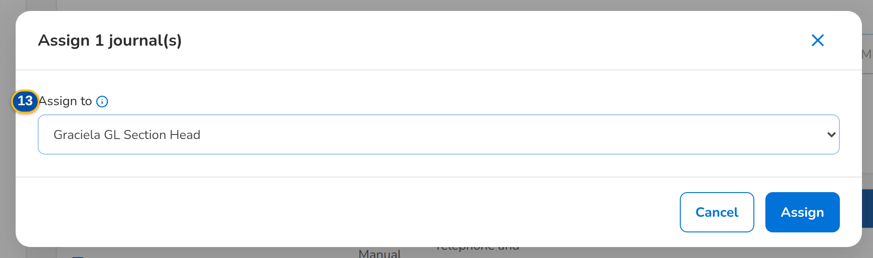
Figure 19: SCR-AC-01 Assign journal(s): the submitted voucher assigned to the user who will post it

Figure 20: SCR-AC-01 Post selected journals: the count, the total debit and the vouchers that are not pending
Fields (No. = callout number on the first screenshot)
No. | Section | Field | Type | Length / format | Mand. | Source / list | Default | Editable in | Validation | Message when it fails
1 | Filters | Status | Drop-down | All, Draft, Pending approval, Posted, Rejected, Cancelled, Reversed | N | Journal statuses | All | - | - | -
2 | Filters | Batch no. | Text | Batch number or its start | N | Journals | Blank | - | Contains | -
3 | Filters | From / To | Date | dd-MMM-yyyy, value date | N | - | Blank | - | To on or after From | -
4 | Filters | Inputter | Text | User ID of the maker | N | Users | Blank | - | Equal | -
5 | Filters | Assignment | Drop-down | All entries or Assigned to me | N | Fixed list | All entries | - | - | -
6 | List | Batch No. | Column | Batch number of the voucher | - | Journals | - | Read only | - | No journal matches these filters
7 | List | Value Date | Column | dd-MMM-yyyy | - | Journals | - | Read only | - | -
8 | List | Type | Column | Manual journal, Adjustment, Accrual, Reversal or the journal of a business event | - | Journals | - | Read only | - | -
9 | List | Narration | Column | Narration of the voucher | - | Journals | - | Read only | - | -
10 | List | Inputter / Assigned To / Authorizer | Column | Names of the maker, the assignee and the user who posted it | - | Users | - | Read only | - | -
11 | List | Amount | Column | Total debit, two decimals | - | Journals | - | Read only | - | -
12 | List | Status | Column | Draft, Pending Approval, Posted, Rejected, Cancelled, Reversed | - | Journals | - | Read only | - | -
13 | Assign journal(s) dialog | Assign to | Drop-down | The users who may post journals, or No one (clear the assignment) | N | Users with the journal authorize permission | No one | Pending approval | Not the submitter of the voucher | A journal is never assigned to its submitter
14 | Post selected journals dialog | Journals to post, Total debit, Selected but not pending | Display | Counts and the total of the selected pending vouchers | - | Selection | - | Read only | - | -

Actions
Button | Who | Enabled when | What happens | Resulting status | Notification
New Journal | GL Officer, GL Team Lead (journal create) | Always | Opens New Journal | - | -
Assign (n) | GL Team Lead, GL Section Head (journal assign) | Vouchers selected | Assigns the selected vouchers to the user chosen, or clears the assignment | Pending Approval | -
Post Selected (n) | GL Team Lead, GL Section Head (journal authorize) | Pending vouchers selected | Posts each selected voucher on its own after the confirmation; the vouchers that cannot be posted are listed under Not posted with the reason | Posted | -
Row | Every user who reads journals | Always | Opens the journal | - | -

Business rules
• A voucher is never posted by the user who submitted it, and never assigned to its submitter (FR-AC-031, FR-AC-036).
• Posting several vouchers at once posts each on its own; a voucher refused by a check stays pending with its reason (FR-AC-036).
• The vouchers of the business events (vouchers, receipts, remittances, corrections, accruals) are listed with their source; only manual vouchers are edited (FR-AC-030).
Expected outcome
The GL team finds the vouchers waiting, assigns them and posts them, one or several at a time.
Test cases: TC-AC-031.1-01, TC-AC-031.1-02, TC-AC-031.2-01, TC-AC-031.2-02, TC-AC-032.1-02, TC-AC-033.1-01, TC-AC-033.2-01, TC-AC-036.1-01, TC-AC-036.2-01, TC-AC-036.2-02, TC-AC-036.3-01, TC-AC-036.3-02, TC-AC-SCR-01.

13.1.2 SCR-AC-02 New Journal and Edit Journal
Purpose | The manual voucher of the GL team: the voucher header (journal type, branch, value date, currency, the reversal date of an accrual, reference and narration) and its Dr / Cr lines with the account (by code or short code), the cost centre and the line of business. The voucher is saved as a draft or submitted for posting after the confirmation of its totals.
Who can open it | GL Officer (FRBS), GL Team Lead, Accountant (bank reconciliation) (permission Journal create)
Navigation | • Menu: Finance › General Ledger › New Journal  • Journals › New Journal  • Journal › Edit (a draft or returned voucher of the maker)
FRs | FR-AC-014, FR-AC-032, FR-AC-033, FR-AC-034, FR-AC-035, FR-AC-037

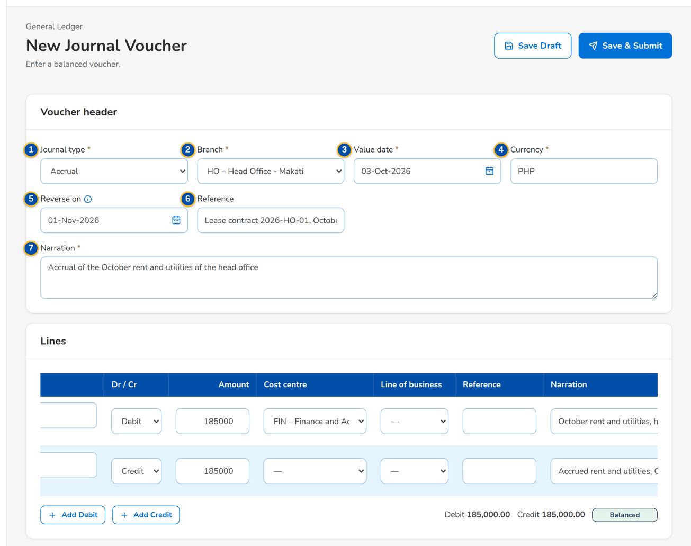
Figure 21: SCR-AC-02 New Journal Voucher: an accrual with its reversal date and two balanced lines
1 | Journal type | 5 | Reverse on | 9 | Dr / Cr / Amount
2 | Branch | 6 | Reference | 10 | Cost centre / Line of business
3 | Value date | 7 | Narration | 11 | Reference / Narration
4 | Currency | 8 | Account | 12 | Balance

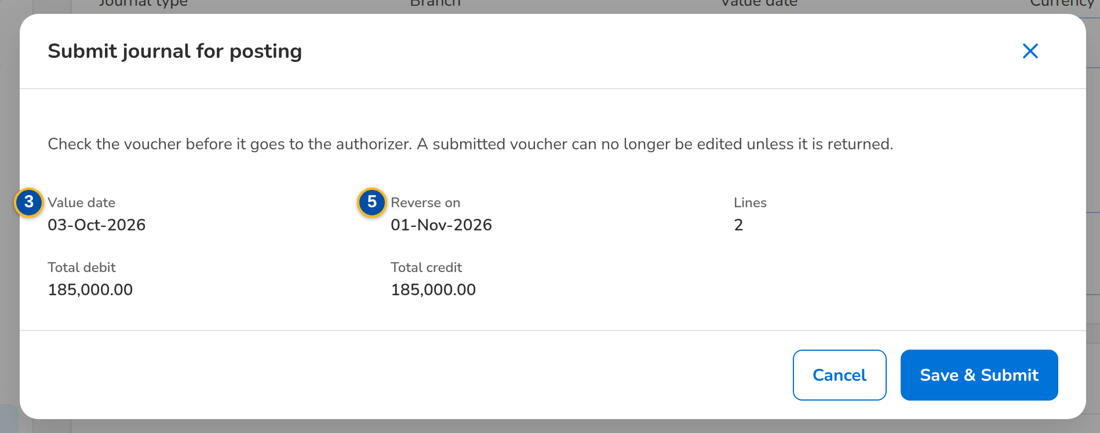
Figure 22: SCR-AC-02 Submit journal for posting: the value date, the reversal date, the lines and the totals to confirm
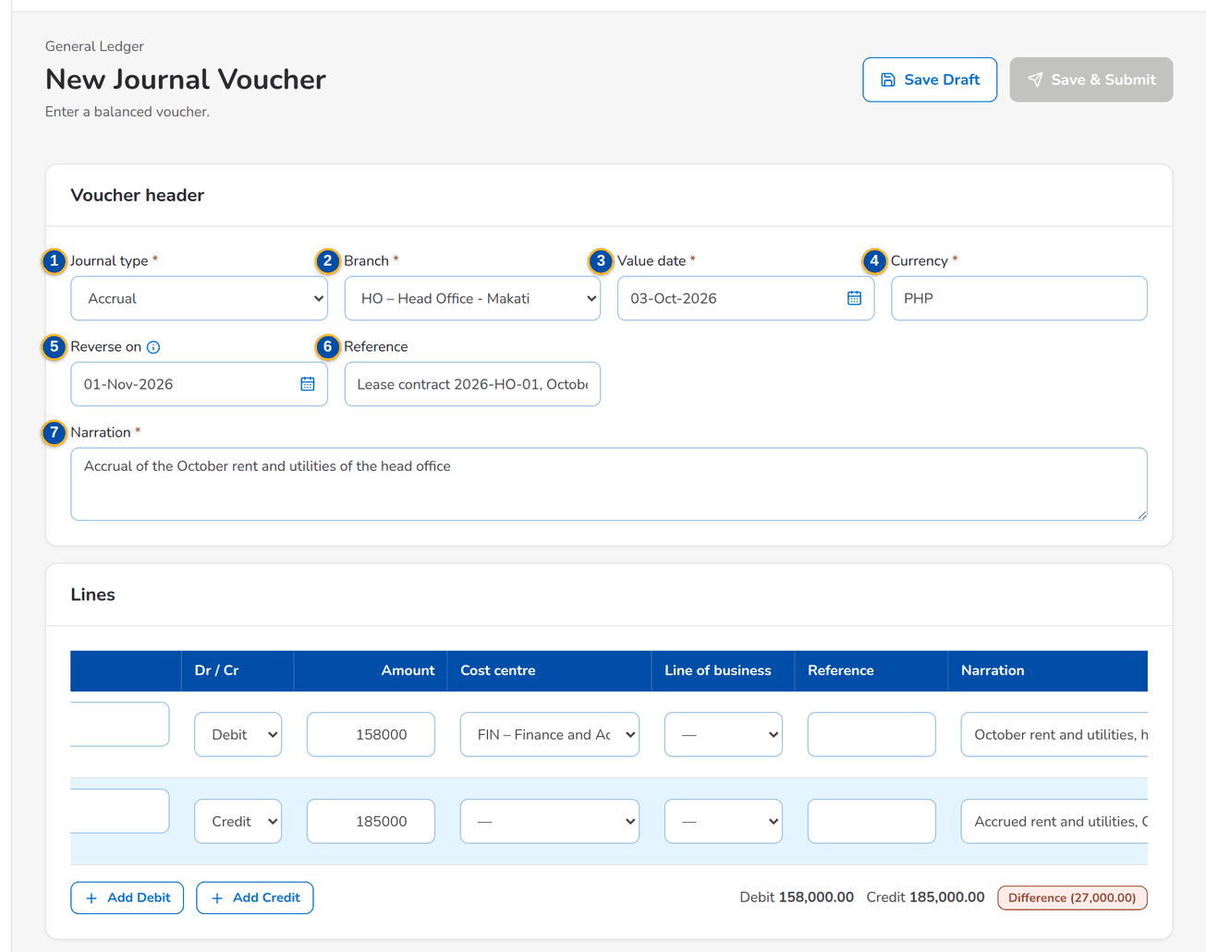
Figure 23: SCR-AC-02 An unbalanced voucher: the difference under the lines and the voucher not submitted
Fields (No. = callout number on the first screenshot)
No. | Section | Field | Type | Length / format | Mand. | Source / list | Default | Editable in | Validation | Message when it fails
1 | Voucher header | Journal type | Drop-down | Manual journal, Adjustment or Accrual | Y | Fixed list | Manual journal | Draft, Rejected | - | -
2 | Voucher header | Branch | Drop-down | Branches of the company | Y | Branches | Branch of the user | Draft, Rejected | - | -
3 | Voucher header | Value date | Date | dd-MMM-yyyy, in an open period | Y | - | Today | Draft, Rejected | Period open | The period of the value date is not open
4 | Voucher header | Currency | Drop-down | Currency of the voucher | Y | Currencies | Base currency | Draft, Rejected | - | -
5 | Voucher header | Reverse on | Date | dd-MMM-yyyy; accruals only, after the value date | Cond.: accrual | - | Blank | Draft, Rejected | After the value date | The reversal date must be after the value date
6 | Voucher header | Reference | Text | Up to 50 characters | N | - | Blank | Draft, Rejected | - | -
7 | Voucher header | Narration | Text | Up to 500 characters | Y | - | Blank | Draft, Rejected | - | Enter the narration
8 | Lines | Account | Text with list | Account code or short code; the name shows under it | Y | Postable accounts of the chart | Blank | Draft, Rejected | Active, postable, manual posting allowed, not frozen | The account does not allow manual posting
9 | Lines | Dr / Cr / Amount | Drop-down, number | Debit or Credit; amount above zero, two decimals | Y | - | Debit | Draft, Rejected | Above zero | Amounts must be greater than zero
10 | Lines | Cost centre / Line of business | Drop-down | Mandatory for the accounts that require them | Cond.: account | Cost centres, lines of business | Blank | Draft, Rejected | Present when the account requires it | Cost centre is required for this account
11 | Lines | Reference / Narration | Text | Line reference and narration | N | - | Blank | Draft, Rejected | - | -
12 | Lines | Balance | Display | Balanced, or Difference with the amount | - | Lines | - | Read only | Total debit equals total credit | Difference <amount>

Actions
Button | Who | Enabled when | What happens | Resulting status | Notification
Add Debit / Add Credit / [Remove] | Maker | Draft or returned voucher | Adds a debit or a credit line, or removes a line | - | -
Save Draft | Maker (journal create) | Always | Saves the voucher as a draft | Draft | -
Save & Submit | Maker (journal create) | The voucher balances | Opens Submit journal for posting with the totals; Submit sends it for posting | Pending Approval | -
Cancel | Maker | Always | Leaves the form without saving | - | -

Business rules
• A voucher posts only when the debits equal the credits; amounts are above zero with two decimals (FR-AC-034).
• An account is entered by its code or its short code; frozen accounts and accounts closed to manual posting are refused (FR-AC-014, FR-AC-034).
• An accrual carries its reversal date; on that date the posted voucher is reversed automatically in the GL (FR-AC-033).
• The cost centre is mandatory for the accounts that require it; the cost-centre rules propose it for the vouchers of the business events (FR-AC-054).
• A posting that makes a block account negative is refused; a warn account shows the warning to the maker and the checker (FR-AC-034).
Expected outcome
The voucher is saved, or submitted for posting by another user.
Test cases: TC-AC-014.1-02, TC-AC-014.2-02, TC-AC-032.1-01, TC-AC-032.3-01, TC-AC-032.4-01, TC-AC-034.1-01, TC-AC-034.1-02, TC-AC-034.2-01, TC-AC-034.2-02, TC-AC-034.3-01, TC-AC-034.3-02, TC-AC-035.1-01, TC-AC-035.2-01, TC-AC-037.1-01, TC-AC-042.1-02, TC-AC-SCR-02, TC-AC-MSG-02.

13.1.3 SCR-AC-03 Journal
Purpose | One journal voucher: its type, value date, totals and source; the lines with account, cost centre, line of business, currency, debit and credit; the audit of the input, submission, authorisation and posting with the assignment and the automatic reversal date; and the actions the user may take on it now.
Who can open it | GL Officer (FRBS), GL Team Lead, GL Section Head, Accountant (bank reconciliation), Comptrollership administrator (masters and rules), ACSL Processor, ACSL Team Leader, ACSL Head (approver), Comptrollership (read access), Auditor (permission Journal view)
Navigation | • Menu: Finance › General Ledger › Journals › Journal  • Journals › open a row  • Correction Entry › the posted journal
FRs | FR-AC-030, FR-AC-031, FR-AC-035, FR-AC-036, FR-AC-037, FR-AS-024

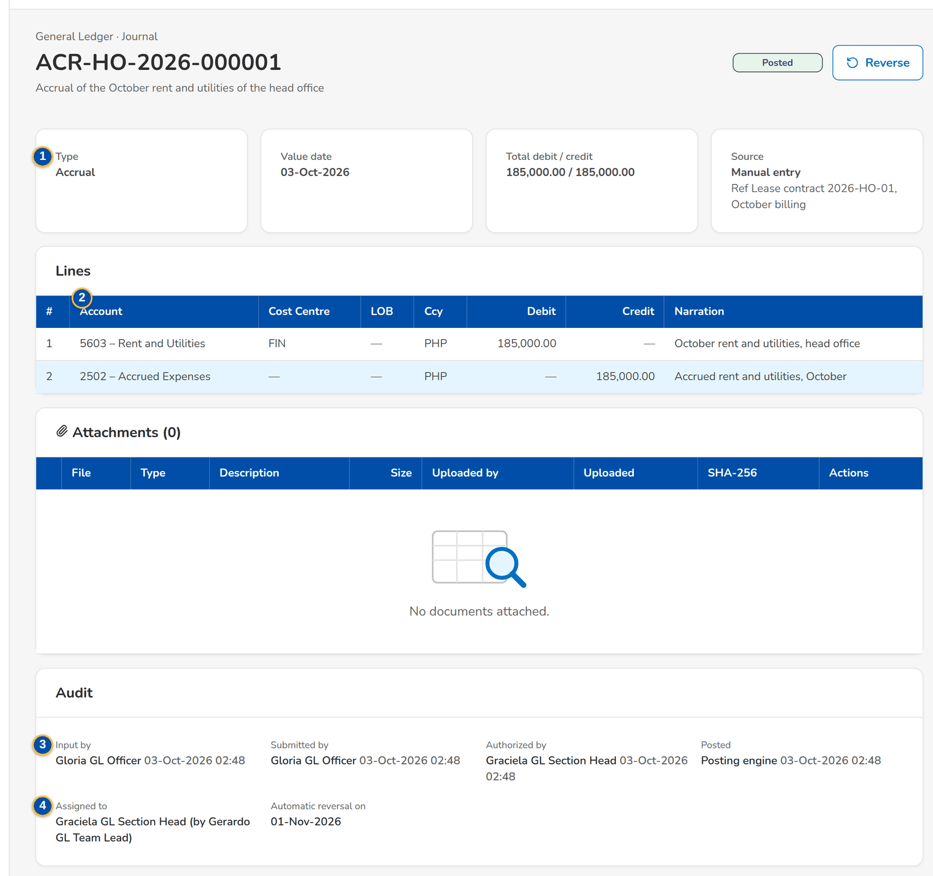
Figure 24: SCR-AC-03 A posted journal: totals, source, lines and the audit
1 | Type / Value date / Total debit / credit / Source | 3 | Input by / Submitted by / Authorized by / Posted | 5 | Reason / remarks
2 | # / Account / Cost Centre / LOB / Ccy / Debit / Credit / Narration | 4 | Assigned to / Automatic reversal on / Returned by | 6 | Reversal value date / Reason / remarks

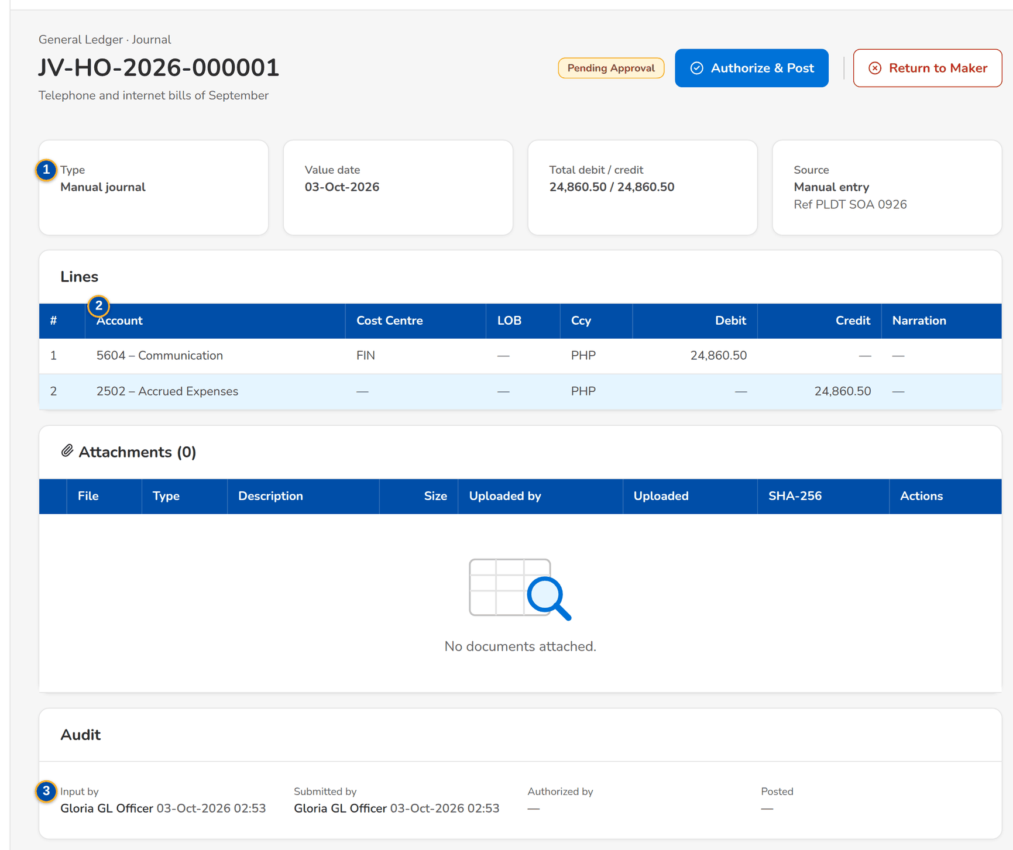
Figure 25: SCR-AC-03 A journal pending approval as the poster sees it, with Authorize & Post and Return to Maker

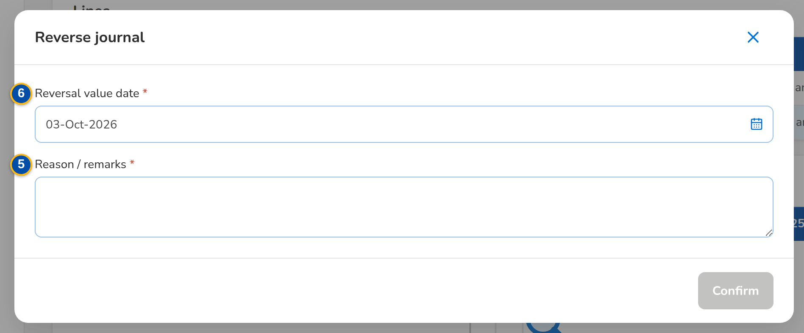
Figure 26: SCR-AC-03 Reverse journal: the reversal value date and the reason
Fields (No. = callout number on the first screenshot)
No. | Section | Field | Type | Length / format | Mand. | Source / list | Default | Editable in | Validation | Message when it fails
1 | Summary | Type / Value date / Total debit / credit / Source | Display | Journal type; dd-MMM-yyyy; two decimals; Manual entry or the business event with its reference | - | Journal | - | Read only | - | -
2 | Lines | # / Account / Cost Centre / LOB / Ccy / Debit / Credit / Narration | Column | One row per line, the account with its name | - | Journal lines | - | Read only | - | -
3 | Audit | Input by / Submitted by / Authorized by / Posted | Display | Names with date and time | - | Journal | - | Read only | - | -
4 | Audit | Assigned to / Automatic reversal on / Returned by | Display | Name of the assignee and of the assigner; reversal date; the reason of a return | - | Journal | - | Read only | - | -
5 | Return journal to its maker dialog | Reason / remarks | Text area | The reason of the return | Y | - | Blank | Pending approval | - | Enter the reason
6 | Reverse journal dialog | Reversal value date / Reason / remarks | Date, text area | dd-MMM-yyyy in an open period; the reason | Y | - | Today | Posted | Period open | Enter the reason

Actions
Button | Who | Enabled when | What happens | Resulting status | Notification
Edit / Submit / Cancel Voucher | Maker | Draft or returned voucher | Edits, submits (with the confirmation of the totals) or cancels the voucher | Pending Approval or Cancelled | -
Authorize & Post | GL Team Lead, GL Section Head (journal authorize) | Pending approval and the user is not the submitter | Posts the voucher after the confirmation | Posted | -
Return to Maker | GL Team Lead, GL Section Head (journal authorize) | Pending approval | Returns the voucher with the reason | Rejected | -
Reverse | GL Section Head (journal reverse) | Posted | Posts a linked reversal at the date given | Reversed | -
Copy | Maker (journal create) | Always | Creates a new draft with the same lines at today's date | Draft | -

Business rules
• A posted voucher is never changed; it is reversed by a linked voucher (FR-AC-037).
• The submitter may not post or return the own voucher (FR-AC-036).
• A returned voucher goes back to its maker with the remarks; the maker edits and submits it again (FR-AC-036).
Expected outcome
The voucher is posted, returned or reversed, with its audit.
Test cases: TC-AC-030.3-01, TC-AC-033.2-02, TC-AC-035.1-02, TC-AC-037.2-01, TC-AC-037.2-02, TC-AC-SCR-03, TC-AC-MSG-03.

13.1.4 SCR-AC-04 Account Inquiry
Purpose | The statement of one GL account for a range of value dates: the opening balance, the total debits and credits, the closing balance and every posted line with its batch, type, narration, reference and running balance.
Who can open it | GL Officer (FRBS), GL Team Lead, GL Section Head, Accountant (bank reconciliation), Comptrollership administrator (masters and rules), ACSL Processor, ACSL Team Leader, ACSL Head (approver), Comptrollership (read access), Auditor (permission Journal view)
Navigation | • Menu: Finance › General Ledger › Account Inquiry  • Journal › posted lines
FRs | FR-AC-030, FR-AC-014

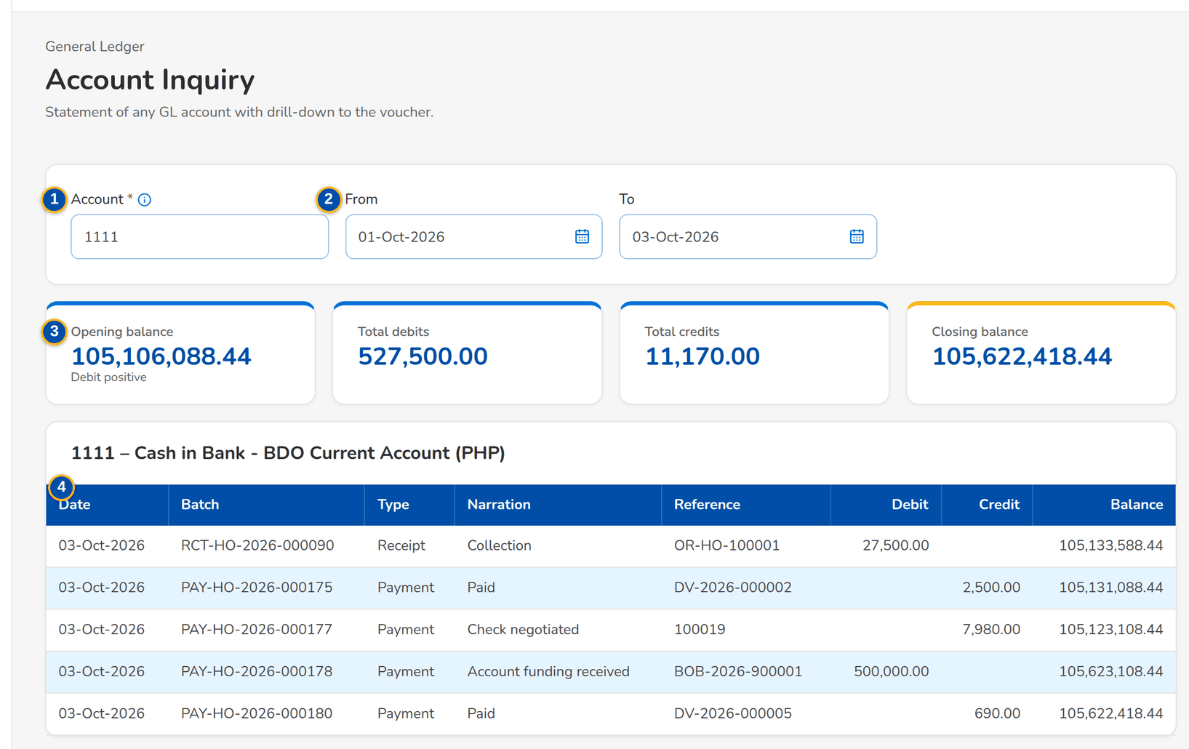
Figure 27: SCR-AC-04 Account Inquiry: the statement of a bank account with the balances and the posted lines
1 | Account | 3 | Opening balance / Total debits / Total credits / Closing balance
2 | From / To | 4 | Date / Batch / Type / Narration / Reference / Debit / Credit / Balance

Fields (No. = callout number on the first screenshot)
No. | Section | Field | Type | Length / format | Mand. | Source / list | Default | Editable in | Validation | Message when it fails
1 | Criteria | Account | Text with list | Account code or short code; the name shows under the field | Y | Chart of accounts | Blank | - | An account of the chart | Enter the account
2 | Criteria | From / To | Date | dd-MMM-yyyy | N | - | Start of the month / today | - | To on or after From | The end date is before the start date
3 | Balances | Opening balance / Total debits / Total credits / Closing balance | Total | Two decimals | - | General ledger | - | Read only | - | -
4 | Lines | Date / Batch / Type / Narration / Reference / Debit / Credit / Balance | Column | One row per posted line, oldest first | - | General ledger | - | Read only | - | No posting in the range

Actions
Button | Who | Enabled when | What happens | Resulting status | Notification
Criteria | Every user who reads journals | An account entered | Shows the statement of the account | - | -

Business rules
• Only posted lines are shown; the running balance starts from the opening balance of the range (FR-AC-030).
Expected outcome
The user sees the balance and the movements of an account.
Test cases: TC-AC-055.1-02, TC-AC-SCR-04.

13.1.5 SCR-AC-05 Party Statement
Purpose | The open items of a sub-ledger party (insurer, client, supplier, employee) with the receivable, payable and net balance, the overdue amount and the ageing by due date as of a date.
Who can open it | GL Officer (FRBS), GL Team Lead, GL Section Head, Accountant (bank reconciliation), Comptrollership administrator (masters and rules), ACSL Processor, ACSL Team Leader, ACSL Head (approver), Comptrollership (read access), Auditor (permission Journal view)
Navigation | • Menu: Finance › General Ledger › Party Statement
FRs | FR-AC-030

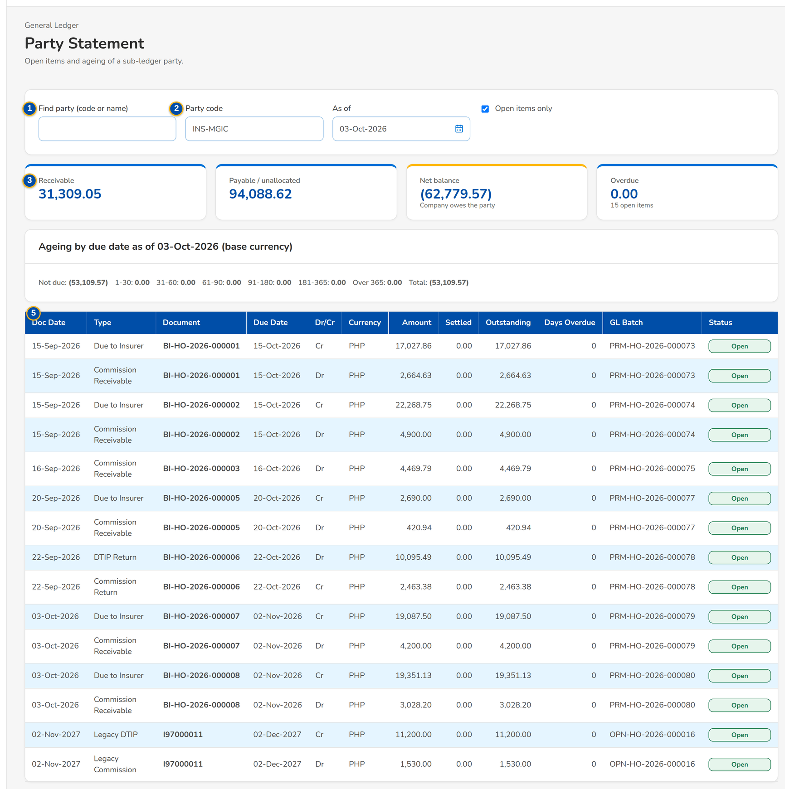
Figure 28: SCR-AC-05 Party Statement of an insurer: balances, ageing and the open items
1 | Find party (code or name) | 3 | Receivable / Payable / unallocated / Net balance / Overdue | 5 | Doc Date / Type / Document / Due Date / Dr/Cr / Currency / Amount / Settled / Outstanding / Days Overdue / GL Batch / Status
2 | Party code / As of | 4 | Ageing buckets

Fields (No. = callout number on the first screenshot)
No. | Section | Field | Type | Length / format | Mand. | Source / list | Default | Editable in | Validation | Message when it fails
1 | Criteria | Find party (code or name) | Text with list | Two letters or more; the parties found by code or name | N | Business partners | Blank | - | - | -
2 | Criteria | Party code / As of | Text, date | Party code; dd-MMM-yyyy | Y / N | Business partners | Blank / today | - | - | -
3 | Balances | Receivable / Payable / unallocated / Net balance / Overdue | Total | Two decimals in the base currency | - | Sub-ledger | - | Read only | - | -
4 | Ageing | Ageing buckets | Total | Ageing by due date as of the date, in the base currency | - | Sub-ledger | - | Read only | - | -
5 | Open items | Doc Date / Type / Document / Due Date / Dr/Cr / Currency / Amount / Settled / Outstanding / Days Overdue / GL Batch / Status | Column | One row per sub-ledger item of the party | - | Sub-ledger | - | Read only | - | No open items

Actions
Button | Who | Enabled when | What happens | Resulting status | Notification
Criteria | Every user who reads journals | A party chosen | Shows the statement of the party | - | -

Business rules
• Every posting to a control account records its sub-ledger item for the party, so the party statement agrees with the GL (FR-AC-030).
Expected outcome
The user sees what a party owes or is owed and how old it is.
Test cases: TC-AC-055.1-02, TC-AC-SCR-05.

13.1.6 SCR-AC-06 Chart of Accounts
Purpose | The chart of accounts of the company as a tree of main, sub and micro accounts: code and name, class, tier, postable or heading, sub-ledger, statement line and status. The GL Team Lead adds and changes accounts, which the Section Head authorises; frozen accounts refuse postings.
Who can open it | GL Officer (FRBS), GL Team Lead, GL Section Head, Accountant (bank reconciliation), Comptrollership administrator (masters and rules), Disbursement Approver, Business Administrator, System Administrator, Auditor (permission Master view)
Navigation | • Menu: Finance › General Ledger › Chart of Accounts  • Chart Upload › the accounts created
FRs | FR-AC-011, FR-AC-013, FR-AC-014, FR-AC-055

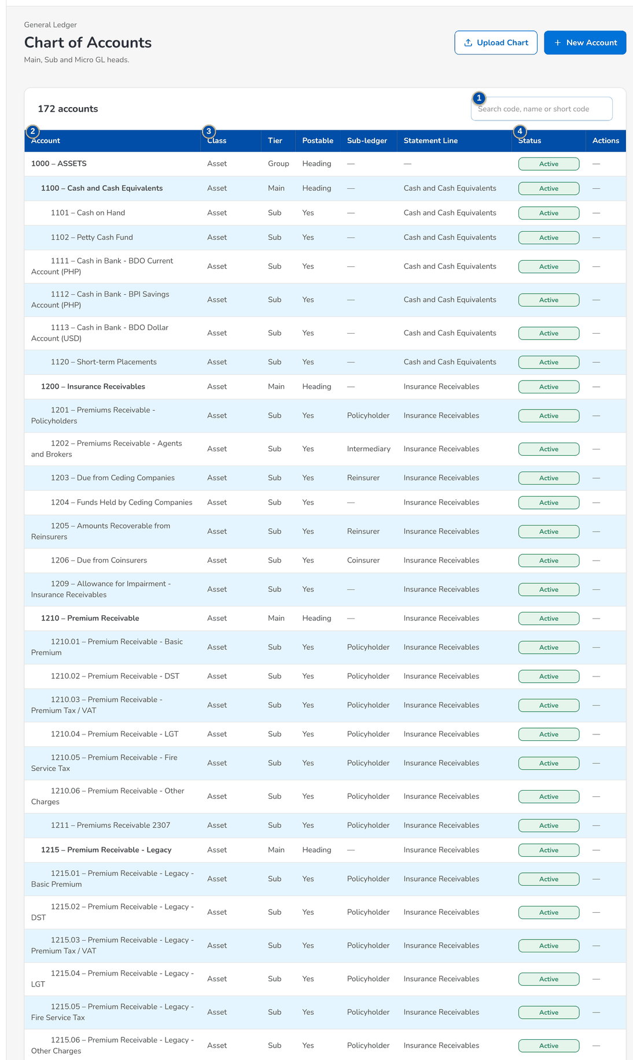
Figure 29: SCR-AC-06 Chart of Accounts: the account tree with class, tier, sub-ledger, statement line and status
1 | Search code, name or short code | 5 | Account code / Account name | 9 | Negative balance
2 | Account | 6 | Short code | 10 | Opened on / Allowed currencies
3 | Class / Tier / Postable / Sub-ledger / Statement Line | 7 | Class / Tier / Parent account | 11 | Posting controls
4 | Status | 8 | Sub-ledger / Statement line

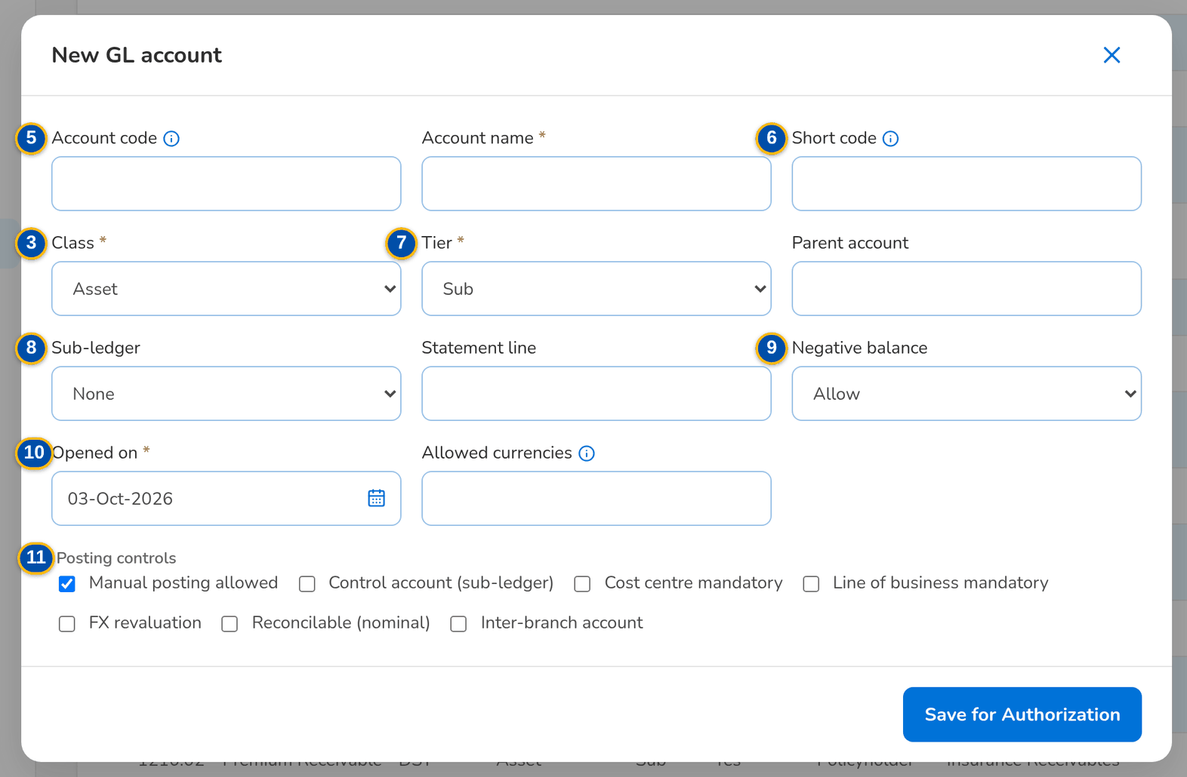
Figure 30: SCR-AC-06 New GL account: code, name, short code, class, tier, parent, sub-ledger, negative balance and the posting controls
Fields (No. = callout number on the first screenshot)
No. | Section | Field | Type | Length / format | Mand. | Source / list | Default | Editable in | Validation | Message when it fails
1 | Toolbar | Search code, name or short code | Text | Part of the code, name or short code | N | Chart of accounts | Blank | - | Contains | -
2 | List | Account | Column | Code and name, indented by tier; headings in bold | - | Chart of accounts | - | Read only | - | -
3 | List | Class / Tier / Postable / Sub-ledger / Statement Line | Column | Asset, Liability, Equity, Income or Expense; Main, Sub or Micro; Yes or Heading | - | Chart of accounts | - | Read only | - | -
4 | List | Status | Column | Pending authorization, Active, Frozen, Inactive | - | Chart of accounts | - | Read only | - | -
5 | Account form | Account code / Account name | Text | Code proposed from the numbering scheme of the parent when left blank | Y | - | Blank | Pending authorization, Active | Unique code | -
6 | Account form | Short code | Text | Unique; typed instead of the code on journal lines | N | - | Blank | Pending authorization, Active | Unique | -
7 | Account form | Class / Tier / Parent account | Drop-down | Class; Main, Sub or Micro; the parent of a sub or micro account | Y / Y / Cond.: not main | Chart of accounts | - | Pending authorization | Parent of the same class | -
8 | Account form | Sub-ledger / Statement line | Drop-down | Sub-ledger of a control account; line of the financial statements | N | Fixed lists | Blank | Pending authorization, Active | - | -
9 | Account form | Negative balance | Drop-down | Allow, Warn the maker and checker, or Block the posting | Y | Fixed list | Allow | Pending authorization, Active | - | -
10 | Account form | Opened on / Allowed currencies | Date, text | dd-MMM-yyyy; comma separated, blank for all | Y / N | - | Today / Blank | Pending authorization | - | -
11 | Account form | Posting controls | Check boxes | Manual posting allowed, Control account (sub-ledger), Cost centre mandatory, Line of business mandatory, FX revaluation, Reconcilable (nominal), Inter-branch account | N | - | - | Pending authorization, Active | - | -

Actions
Button | Who | Enabled when | What happens | Resulting status | Notification
New Account | GL Team Lead (master maintain) | Always | Opens the account form; saving sends the account for authorisation | Pending authorization | -
Row | GL Team Lead (master maintain) | Always | Opens the account to change it | - | -
Authorize | GL Section Head (master authorize) | Pending authorization and another user than the maker | Activates the account | Active | -
Freeze / Unfreeze | GL Section Head (master authorize) | Active account | Refuses or allows postings again; a freeze needs a reason | Frozen or Active | -

Business rules
• An account becomes active only when another user than its maker authorises it (FR-AC-011).
• A child account rolls up to its parent; a heading takes no posting (FR-AC-011, FR-AC-013).
• Each account has its negative-balance policy: allow, warn or block (FR-AC-034).
Expected outcome
The chart is kept by the GL team with four eyes on every change.
Test cases: TC-AC-011.1-01, TC-AC-011.1-02, TC-AC-011.2-01, TC-AC-011.2-02, TC-AC-011.2-03, TC-AC-011.3-01, TC-AC-011.4-01, TC-AC-013.3-02, TC-AC-014.1-01, TC-AC-014.2-01, TC-AC-SCR-06, TC-AC-MSG-04.

13.1.7 SCR-AC-07 Chart Upload
Purpose | Loads parent and child accounts of the chart from the template in three steps (template, upload, review of every row), keeps the history of the uploads, and sets the numbering scheme that proposes the codes of the child accounts of a parent.
Who can open it | GL Team Lead (permission Coa upload)
Navigation | • Menu: Finance › General Ledger › Chart Upload  • Chart of Accounts › Chart Upload
FRs | FR-AC-012, FR-AC-013

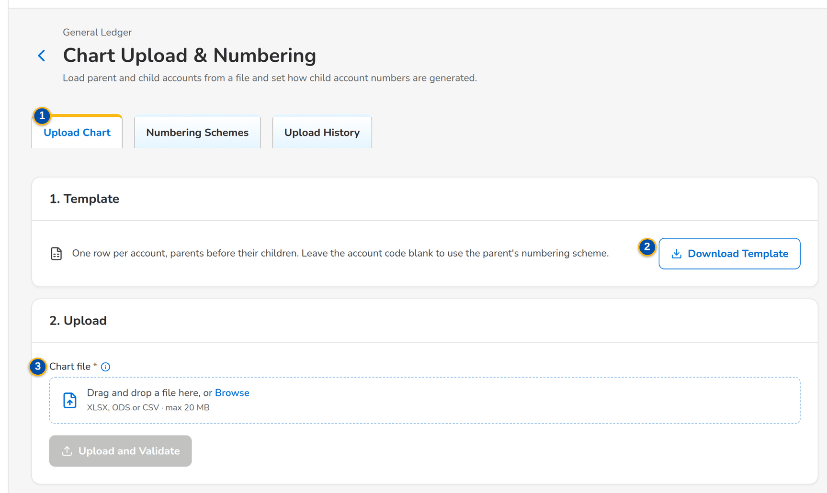
Figure 31: SCR-AC-07 Chart Upload & Numbering: the template, the upload and the uploads before
1 | Upload Chart / Numbering Schemes / Upload History | 4 | Accounts / Valid / Invalid / Created / failed | 7 | Parent account / Separator / Digits / Proposes codes
2 | Download Template | 5 | Row / Status / Account Code / Account Name / Parent / Class / Level / Messages | 8 | Upload No. / File / Uploaded / By / Created / Rows / Status
3 | Chart file | 6 | Parent Account / Separator / Digits / First Child / Status

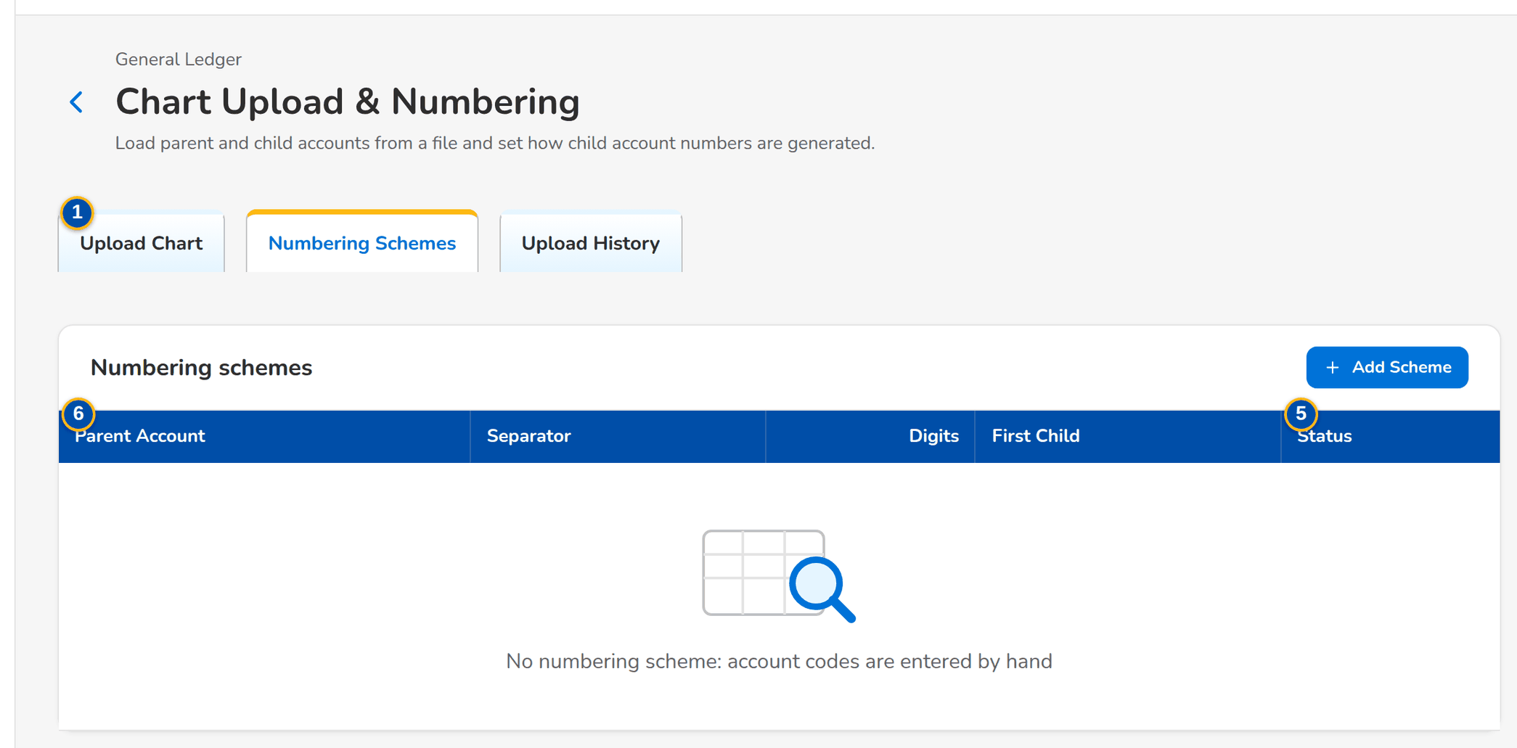
Figure 32: SCR-AC-07 Numbering Schemes: the separator and the digits of the child accounts of each parent
Fields (No. = callout number on the first screenshot)
No. | Section | Field | Type | Length / format | Mand. | Source / list | Default | Editable in | Validation | Message when it fails
1 | Tabs | Upload Chart / Numbering Schemes / Upload History | Tab | - | - | - | Upload Chart | - | - | -
2 | 1. Template | Download Template | Button | The chart template (Excel) | - | - | - | - | - | -
3 | 2. Upload | Chart file | File | Excel or CSV of the template | Y | - | - | - | Every row checked before anything is saved | -
4 | 3. Review | Accounts / Valid / Invalid / Created / failed | Total | Counts of the rows | - | Upload | - | Read only | - | -
5 | 3. Review | Row / Status / Account Code / Account Name / Parent / Class / Level / Messages | Column | One row per account of the file, with its messages | - | Upload | - | Read only | - | -
6 | Numbering schemes | Parent Account / Separator / Digits / First Child / Status | Column | The rule that proposes the codes under a parent | - | Numbering schemes | - | Read only | - | -
7 | Numbering scheme form | Parent account / Separator / Digits / Proposes codes | Text, number, check box | Parent code; separator or none; number of digits of the child part | Y / N / Y / N | Chart of accounts | - | - | Digits above zero | -
8 | Upload History | Upload No. / File / Uploaded / By / Created / Rows / Status | Column | One row per upload | - | Uploads | - | Read only | - | -

Actions
Button | Who | Enabled when | What happens | Resulting status | Notification
Download Template | GL Team Lead (chart upload) | Always | Downloads the template | - | -
Upload | GL Team Lead (chart upload) | A file chosen | Reads and checks every row | Validated | -
Create n Account(s) | GL Team Lead (chart upload) | Valid rows | Creates the valid accounts, pending authorisation | Pending authorization | -
Discard Upload | GL Team Lead (chart upload) | Before the accounts are created | Discards the upload | Discarded | -

Business rules
• Every row is checked before anything is saved; only the valid rows are created, each pending authorisation (FR-AC-012).
• A parent must exist in the chart or earlier in the file; a child's code follows the numbering scheme of its parent when left blank (FR-AC-012, FR-AC-013).
Expected outcome
The chart is loaded from the file and waits for authorisation.
Test cases: TC-AC-012.1-01, TC-AC-012.2-01, TC-AC-012.2-02, TC-AC-012.2-03, TC-AC-012.2-04, TC-AC-012.2-05, TC-AC-012.3-01, TC-AC-013.1-01, TC-AC-013.3-01, TC-AC-013.3-03, TC-AC-SCR-07, TC-AC-MSG-05.

13.1.8 SCR-AC-08 Currencies & Rates
Purpose | The currencies of the company and their exchange rates; the card Monthly revaluation rates where the GL Section Head enters the month-end rate of each foreign currency, used by the FX revaluation of the month and as the book rate of the next month.
Who can open it | GL Officer (FRBS), GL Team Lead, GL Section Head, Accountant (bank reconciliation), Comptrollership administrator (masters and rules), Disbursement Approver, Business Administrator, System Administrator, Auditor (permission Master view)
Navigation | • Menu: Setup & Administration › Setup › Currencies & Rates
FRs | FR-AC-010

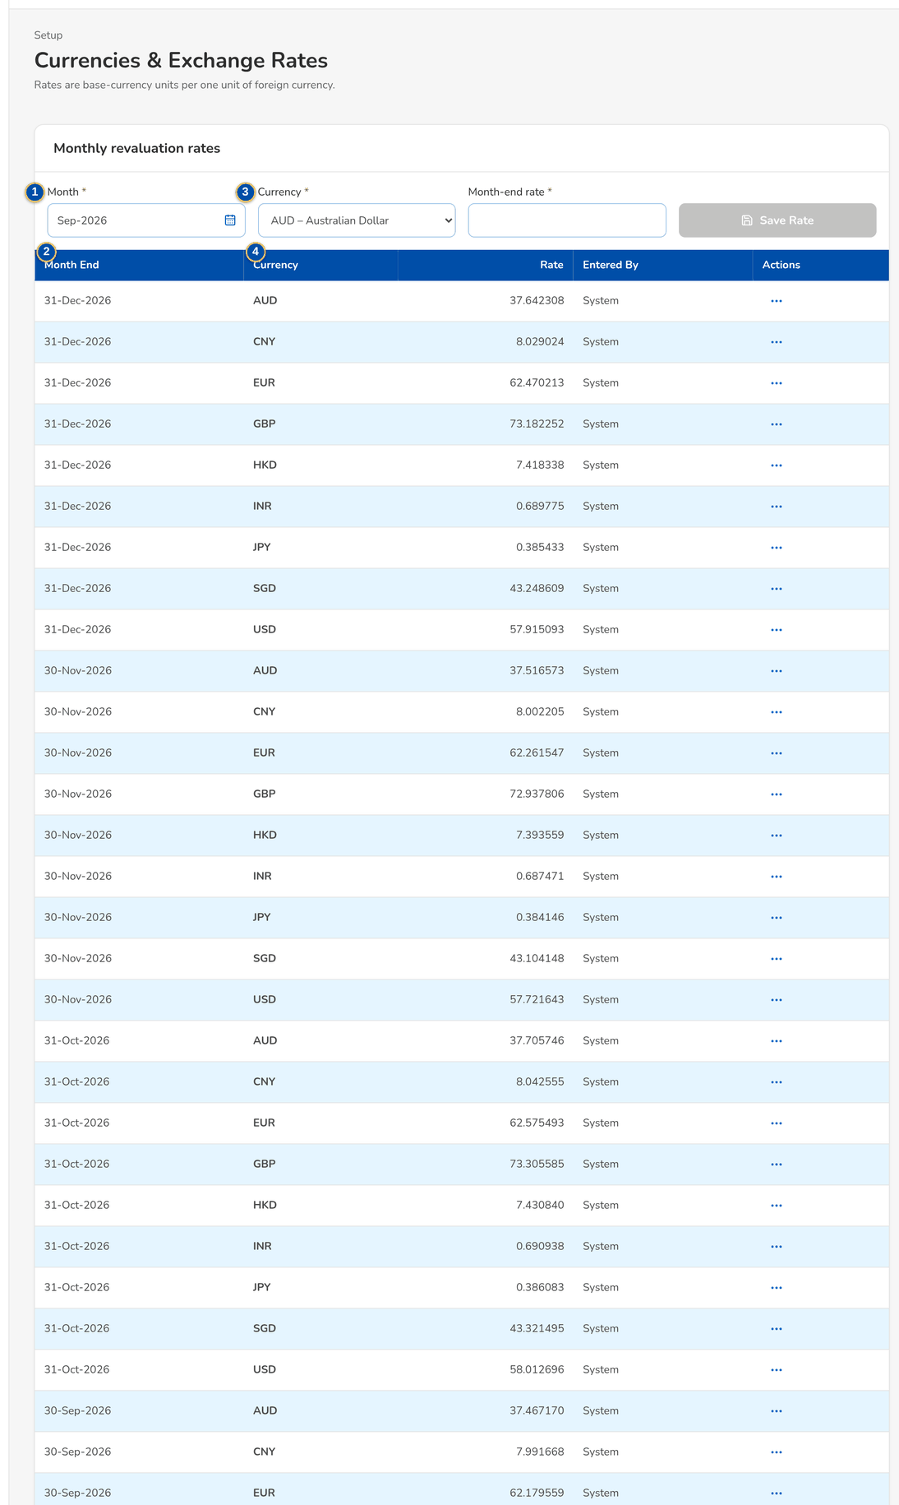
Figure 33: SCR-AC-08 Currencies & Exchange Rates with the card Monthly revaluation rates
1 | Month / Currency / Month-end rate | 3 | Currency / Rate type / Effective date / Rate
2 | Month End / Currency / Rate / Entered By | 4 | Currency / Type / Effective / Rate / Maintained by

Fields (No. = callout number on the first screenshot)
No. | Section | Field | Type | Length / format | Mand. | Source / list | Default | Editable in | Validation | Message when it fails
1 | Monthly revaluation rates | Month / Currency / Month-end rate | Drop-down, number | Month; foreign currency; rate with up to six decimals | Y | Currencies | Previous month | - | Above zero | Enter a rate above zero
2 | Monthly revaluation rates | Month End / Currency / Rate / Entered By | Column | The rates entered, newest first; the rate with six decimals | - | Exchange rates | - | Read only | - | -
3 | Maintain rate | Currency / Rate type / Effective date / Rate | Drop-down, date, number | Rate types Spot, Closing, Average, Budget, Book | Y | Currencies | - | - | Above zero | -
4 | Rates in force | Currency / Type / Effective / Rate / Maintained by | Column | The rates in force at the rate date | - | Exchange rates | - | Read only | - | -

Actions
Button | Who | Enabled when | What happens | Resulting status | Notification
Save Rate | GL Section Head (revaluation rate maintain) | Month, currency and rate entered | Saves the month-end rate of the currency | - | -
Save | Master maintain | Rate entered | Saves an exchange rate | - | -

Business rules
• Only the GL Section Head enters the monthly revaluation rate; the rate of the month end is the closing rate of the FX revaluation and the book rate of the next month (FR-AC-010, FR-AC-043).
Expected outcome
The month-end rates are in place for the revaluation.
Test cases: TC-AC-010.1-01, TC-AC-010.2-01, TC-AC-010.3-01, TC-AC-010.3-02, TC-AC-010.4-01, TC-AC-SCR-08, TC-AC-MSG-06.

13.1.9 SCR-AC-09 Cost-Centre Rules
Purpose | The standard rules that give the journal lines of the business events their cost centre: by source module, event type, GL account and party, in the order of their priority. A line of an account that requires a cost centre and that no rule covers raises the alert Cost centre missing.
Who can open it | GL Officer (FRBS), GL Team Lead, GL Section Head, Accountant (bank reconciliation), Comptrollership administrator (masters and rules), Disbursement Approver, Business Administrator, System Administrator, Auditor (permission Master view)
Navigation | • Menu: Setup & Administration › Setup › Cost-Centre Rules  • Journal › cost centre of a line
FRs | FR-AC-054

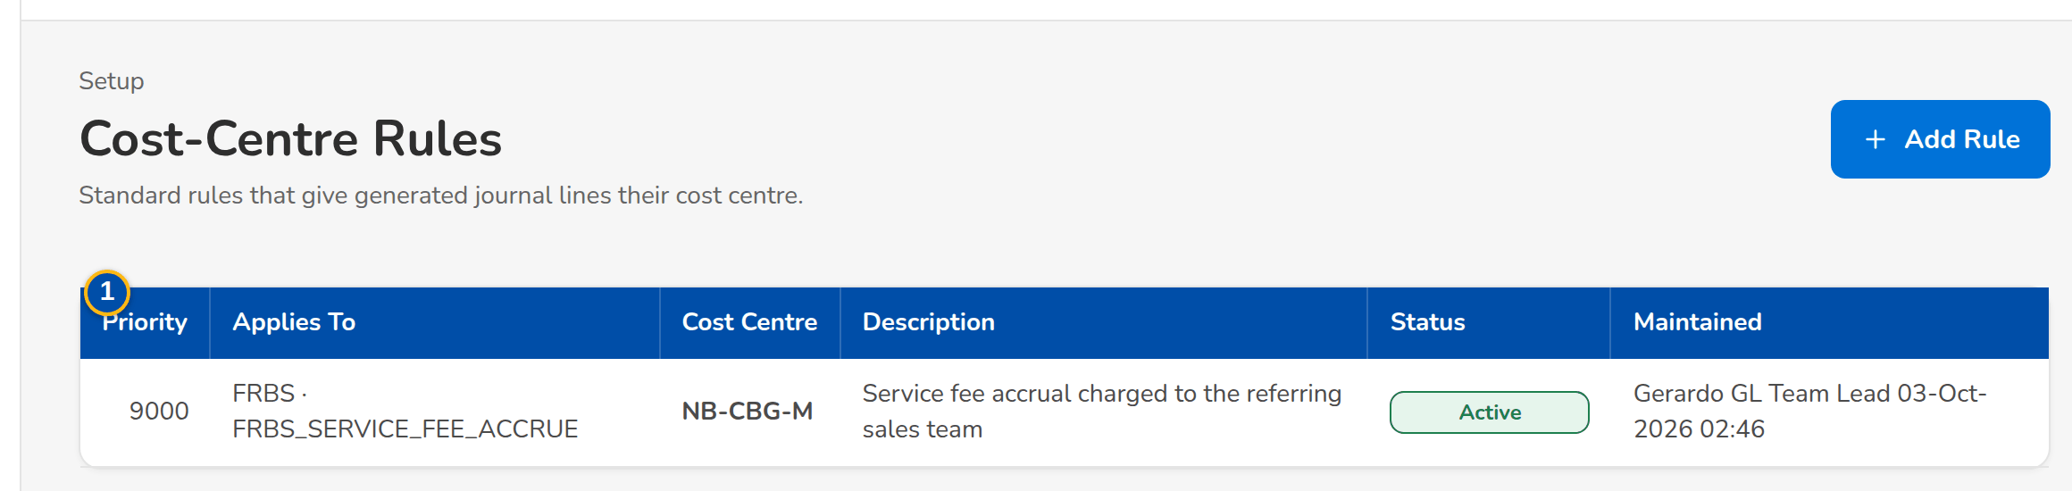
Figure 34: SCR-AC-09 Cost-Centre Rules: priority, the criteria, the cost centre and the status
1 | Priority / Applies To / Cost Centre / Description / Status / Maintained | 3 | Source module / Event type / GL account / Party code | 5 | Description / Status
2 | Priority | 4 | Cost centre

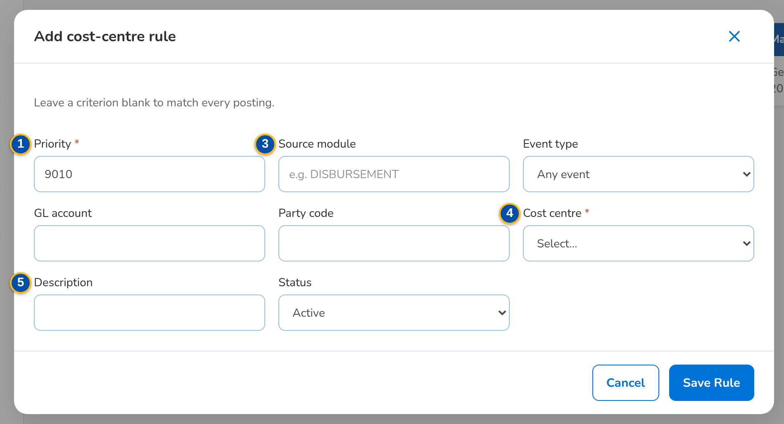
Figure 35: SCR-AC-09 Add cost-centre rule: priority, criteria and the cost centre
Fields (No. = callout number on the first screenshot)
No. | Section | Field | Type | Length / format | Mand. | Source / list | Default | Editable in | Validation | Message when it fails
1 | List | Priority / Applies To / Cost Centre / Description / Status / Maintained | Column | Lower priority first; the criteria in words | - | Cost-centre rules | - | Read only | - | No rule yet
2 | Rule form | Priority | Number | Unique; lower number wins | Y | - | Next free | - | Unique | -
3 | Rule form | Source module / Event type / GL account / Party code | Text, drop-down | Each optional; blank matches any | N | Event types, chart, business partners | Blank | - | - | -
4 | Rule form | Cost centre | Drop-down | Active cost centres | Y | Cost centres | Blank | - | - | -
5 | Rule form | Description / Status | Text, drop-down | Active or Inactive | N / Y | - | Active | - | - | -

Actions
Button | Who | Enabled when | What happens | Resulting status | Notification
Add Rule | GL Team Lead (master maintain), Comptrollership administrator (accounting rule manage) | Always | Opens the rule form | - | -
Row | Same users | Always | Opens the rule to change it | - | -

Business rules
• The first active rule whose criteria match the line, by priority, gives the cost centre; a cost centre keyed on the line is kept (FR-AC-054).
• A line of an account that requires a cost centre without one is refused and raises the alert Cost centre missing (FR-AC-054).
Expected outcome
Every journal line that needs a cost centre gets one.
Test cases: TC-AC-054.3-01, TC-AC-SCR-09.

13.2 Closing, revaluation and bank reconciliation

13.2.1 SCR-AC-10 Financial Periods
Purpose | The fiscal years and their monthly periods with the status of each period (Future, Open, Closing, Closed, Reopened), the last change and its reason; only open periods accept normal postings. The GL Team Lead opens, closes and reopens a period with a reason and creates the next fiscal year.
Who can open it | GL Officer (FRBS), GL Team Lead, GL Section Head, Accountant (bank reconciliation), Comptrollership administrator (masters and rules), Disbursement Approver, Business Administrator, System Administrator, Auditor (permission Master view)
Navigation | • Menu: Finance › General Ledger › Financial Periods
FRs | FR-AC-040, FR-AC-041

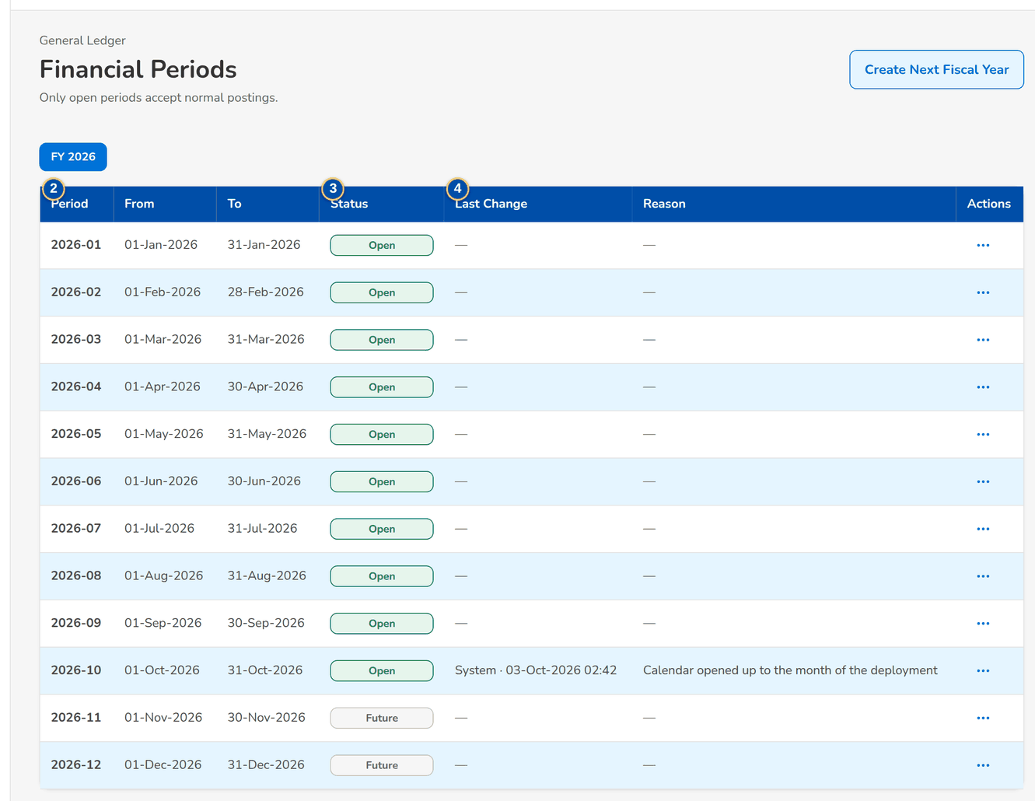
Figure 36: SCR-AC-10 Financial Periods: the periods of the fiscal year with their status, last change and reason
1 | Fiscal year | 3 | Status | 5 | Reason
2 | Period / From / To | 4 | Last Change / Reason

Fields (No. = callout number on the first screenshot)
No. | Section | Field | Type | Length / format | Mand. | Source / list | Default | Editable in | Validation | Message when it fails
1 | Fiscal year | Fiscal year | Drop-down | The fiscal years of the company | Y | Fiscal years | Current year | - | - | -
2 | Periods | Period / From / To | Column | Period name and its dates, dd-MMM-yyyy | - | Periods | - | Read only | - | -
3 | Periods | Status | Column | Future, Open, Closing, Closed, Reopened | - | Periods | - | Read only | - | -
4 | Periods | Last Change / Reason | Column | The user's name and the time of the last change; the reason given | - | Periods | - | Read only | - | -
5 | Period dialog | Reason | Text area | The reason of the change; mandatory to reopen a period | Cond.: reopen | - | Blank | - | - | Enter the reason

Actions
Button | Who | Enabled when | What happens | Resulting status | Notification
Create Next Fiscal Year | GL Team Lead (period manage) | The last year exists | Creates the next fiscal year with its periods in Future | Future | -
Open / Start closing / Close / Back to open / Reopen / Close again | GL Team Lead, GL Section Head (period manage) | As the period's status allows | Changes the status of the period after the confirmation | Open, Closing, Closed or Reopened | -

Business rules
• Only open periods accept normal postings; a closed period of a closed fiscal year cannot be reopened (FR-AC-040, FR-AC-041).
Expected outcome
The GL team controls which months accept postings.
Test cases: TC-AC-040.1-01, TC-AC-040.2-01, TC-AC-040.4-01, TC-AC-040.4-02, TC-AC-040.1-02, TC-AC-042.2-01, TC-AC-042.3-01, TC-AC-SCR-10, TC-AC-MSG-07.

13.2.2 SCR-AC-11 GL Close & Cut-Off
Purpose | The month-end close of the GL books and the cut-off of the broking books. The GL Team Lead schedules the close of the previous month on a preferred date and time; the checklist runs at that time and closes the month or records why it failed. The broking books close by themselves on the last day of the month; the tab Broking Books Cut-Off shows each period's books with who closed or reopened them.
Who can open it | GL Team Lead, GL Section Head (permission GL close schedule)
Navigation | • Menu: Finance › Planning & Closing › GL Close & Cut-Off  • Financial Periods › the period to close
FRs | FR-AC-040, FR-AC-042

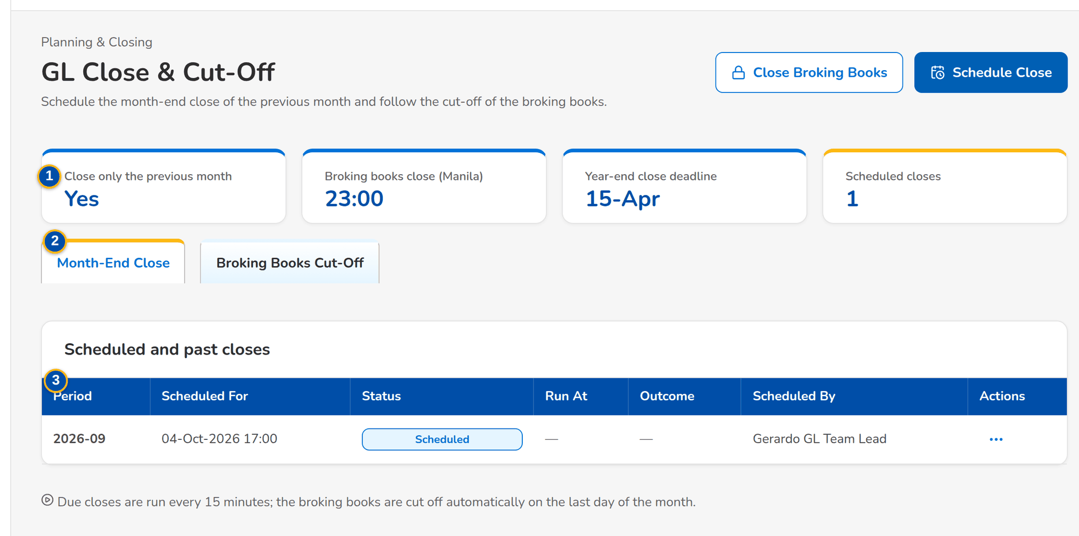
Figure 37: SCR-AC-11 GL Close & Cut-Off: the close settings and the scheduled and past closes
1 | Close only the previous month / Broking books close (Manila) / Year-end close deadline / Scheduled closes | 4 | Period / Books / Closed / Reopened / Note | 7 | Reason
2 | Month-End Close / Broking Books Cut-Off | 5 | Fiscal year / Period
3 | Period / Scheduled For / Status / Run At / Outcome / Scheduled By | 6 | Close on

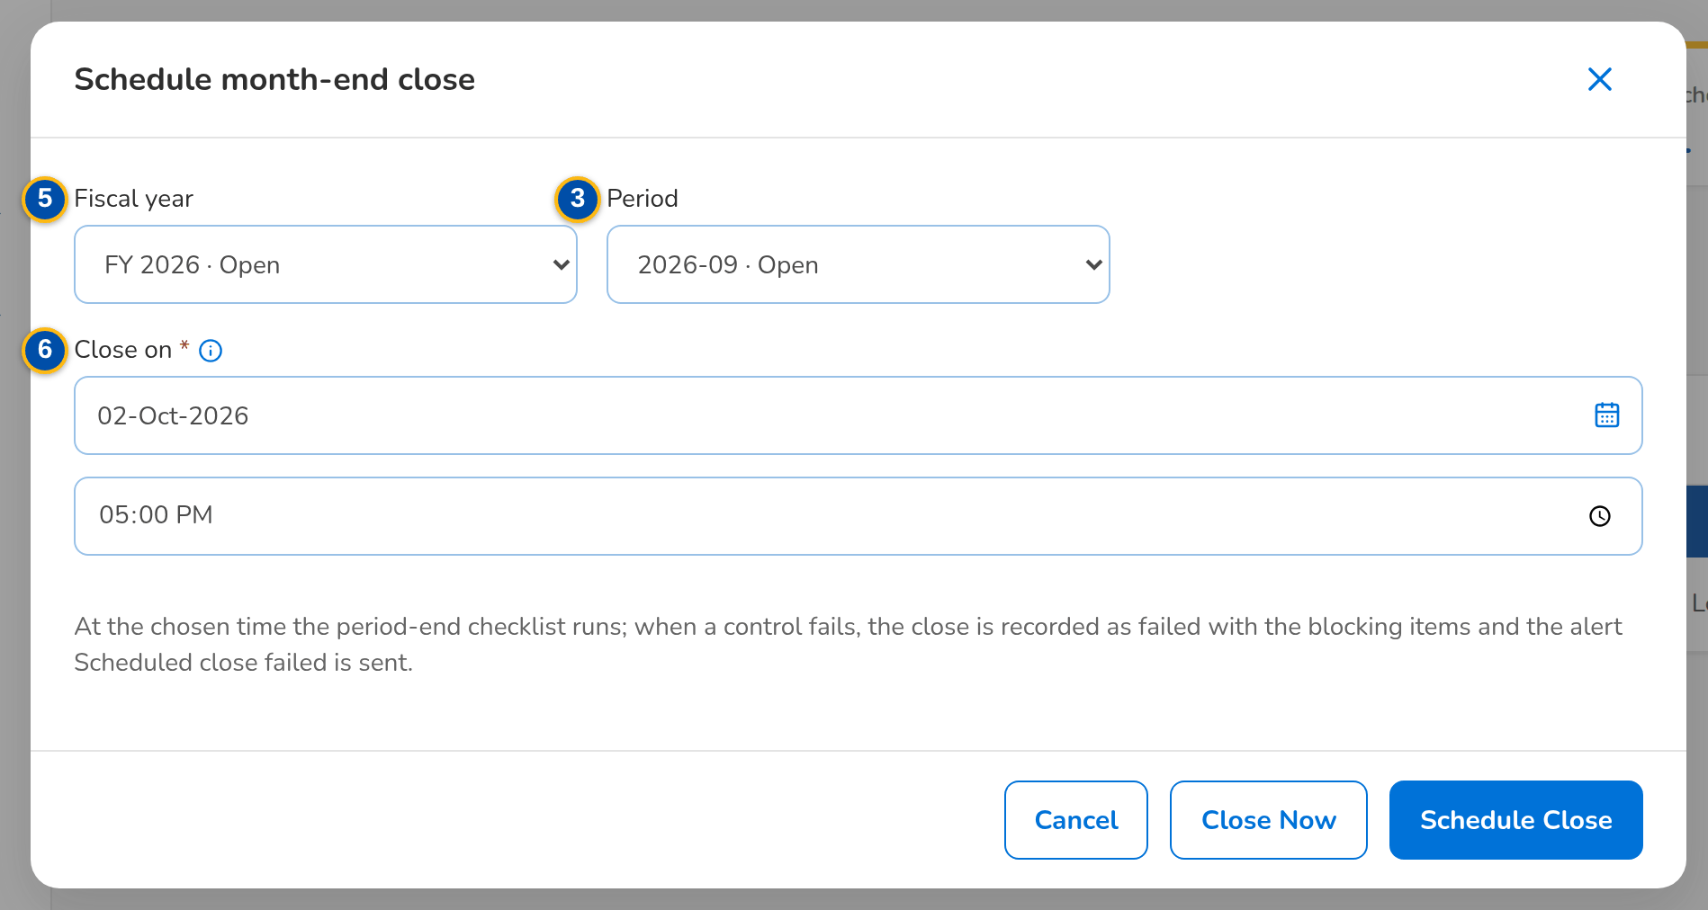
Figure 38: SCR-AC-11 Schedule month-end close: the period and the date and time of the close
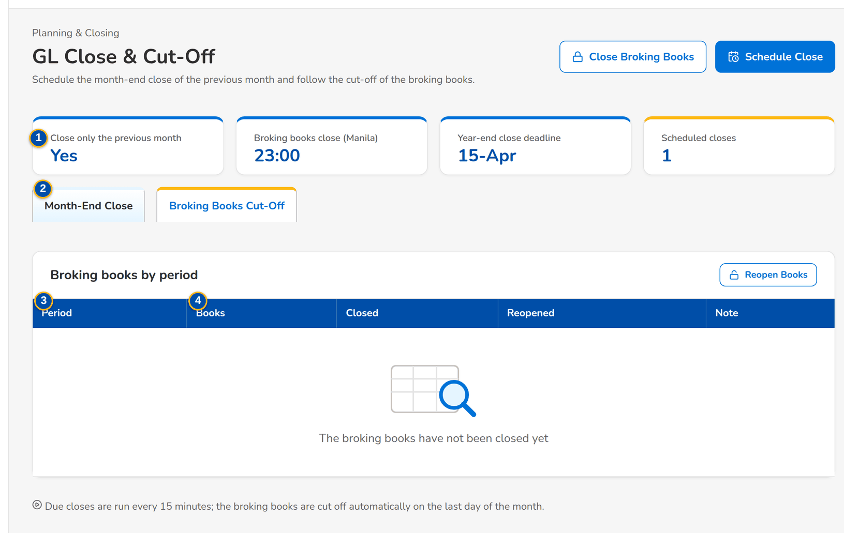
Figure 39: SCR-AC-11 Broking Books Cut-Off: the books of each period, closed and reopened
Fields (No. = callout number on the first screenshot)
No. | Section | Field | Type | Length / format | Mand. | Source / list | Default | Editable in | Validation | Message when it fails
1 | Settings | Close only the previous month / Broking books close (Manila) / Year-end close deadline / Scheduled closes | Display | The close parameters and the number of closes waiting | - | Parameters | - | Read only | - | -
2 | Tabs | Month-End Close / Broking Books Cut-Off | Tab | - | - | - | Month-End Close | - | - | -
3 | Scheduled and past closes | Period / Scheduled For / Status / Run At / Outcome / Scheduled By | Column | Scheduled, Completed, Failed or Cancelled; dates and times dd-MMM-yyyy HH:mm; the name of the scheduler | - | Close schedules | - | Read only | - | -
4 | Broking books by period | Period / Books / Closed / Reopened / Note | Column | Open or Closed; who closed or reopened them and when | - | Broking books | - | Read only | - | -
5 | Schedule month-end close dialog | Fiscal year / Period | Drop-down | The previous month by default | Y | Periods | Previous month | - | Previous month only, unless the parameter allows another | Only the previous month can be closed
6 | Schedule month-end close dialog | Close on | Date and time | dd-MMM-yyyy date and HH:mm time, in the future | Y | - | 2nd banking day of the next month, 17:00 | - | In the future | -
7 | Close or reopen the broking books dialog | Reason | Text area | Mandatory to reopen the books | Cond.: reopen | - | Blank | - | - | Enter the reason

Actions
Button | Who | Enabled when | What happens | Resulting status | Notification
Schedule Close | GL Team Lead, GL Section Head (GL close schedule) | Always | Schedules the close of the period; the job runs the checklist at that time | Scheduled | -
Withdraw | GL Team Lead, GL Section Head | A scheduled close | Withdraws the close before its time | Cancelled | -
Close Broking Books / Reopen Books | GL Team Lead, GL Section Head | Books open, or closed | Closes the broking books of a period now, or reopens them with the reason | Closed or Open | -

Business rules
• Only the previous month is closed by default; a close fails and records its blocking items when the checklist does not pass (FR-AC-040).
• The broking books close at 23:00 Manila on the last day of the month; after the cut-off the broking modules post into the next month (FR-AC-042).
Expected outcome
The previous month closes on the chosen date and the broking books are cut off on time.
Test cases: TC-AC-040.1-01, TC-AC-040.2-01, TC-AC-040.4-01, TC-AC-040.4-02, TC-AC-040.1-02, TC-AC-042.2-01, TC-AC-042.3-01, TC-AC-SCR-11, TC-AC-MSG-08.

13.2.3 SCR-AC-12 Period-End & Year-End
Purpose | The closing controls of a period and of the fiscal year with their pass or fail result. The period tab shows the closing checklist of a month with Start Soft Close and Close Period; the year tab shows the pre-close checklist, the preview of the closing entries, Close Fiscal Year and, once closed, the post-close verification that the nominal accounts are zero.
Who can open it | GL Team Lead, GL Section Head (permission Period end run)
Navigation | • Menu: Finance › Planning & Closing › Period-End & Year-End  • GL Close & Cut-Off › the checklist of a close
FRs | FR-AC-040, FR-AC-041

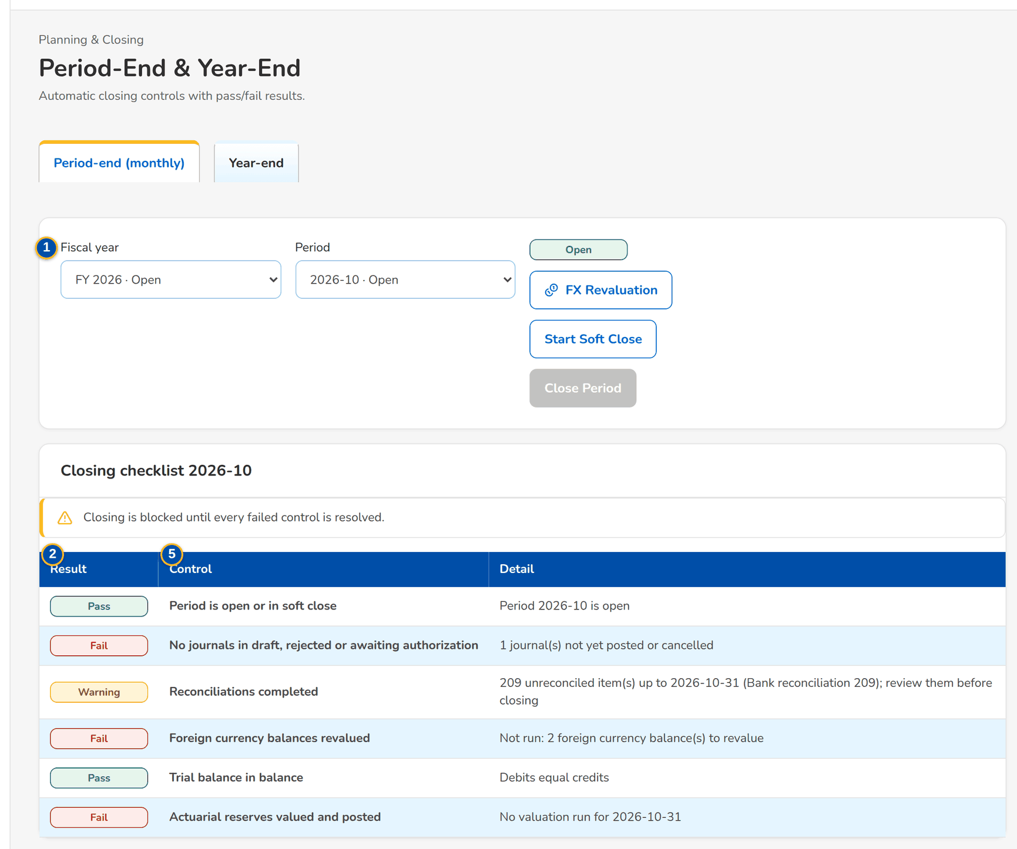
Figure 40: SCR-AC-12 Period-End: the closing checklist of the month with the result of each control
1 | Fiscal year / Period | 3 | Branch / Account / Cost Centre / Line of Business / Balance (Dr +) | 5 | Result / Control / Detail
2 | Result / Control / Detail | 4 | Closed by / Closed on / Net result / Transferred to / Closing journals

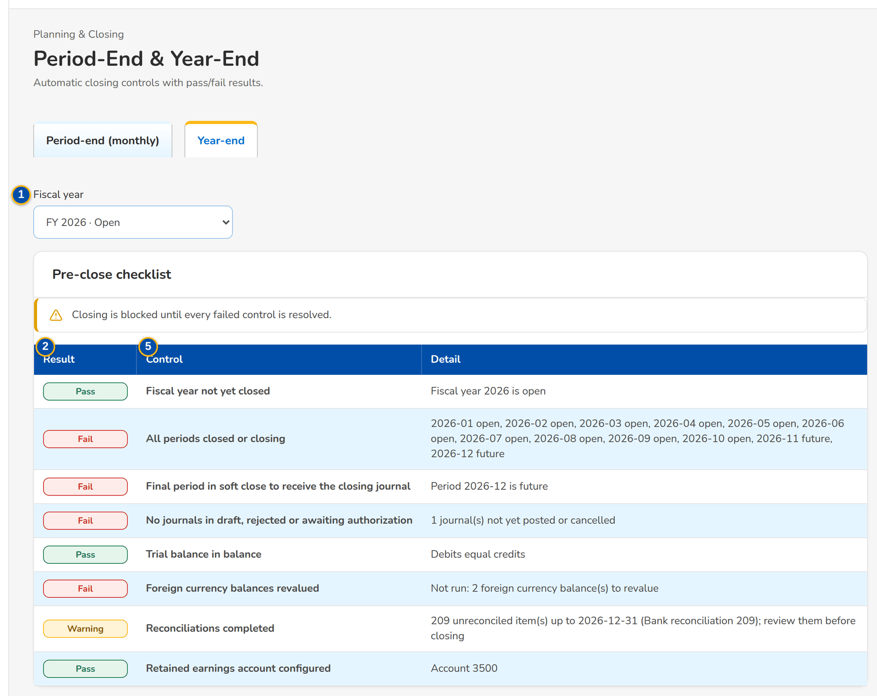
Figure 41: SCR-AC-12 Year-End: the pre-close checklist and the closing entries preview

Fields (No. = callout number on the first screenshot)
No. | Section | Field | Type | Length / format | Mand. | Source / list | Default | Editable in | Validation | Message when it fails
1 | Selectors | Fiscal year / Period | Drop-down | The fiscal year and the month | Y | Periods | Current | - | - | -
2 | Closing checklist | Result / Control / Detail | Column | Pass, Fail or Warning; the control; what it found | - | Closing controls | - | Read only | - | -
3 | Closing entries preview | Branch / Account / Cost Centre / Line of Business / Balance (Dr +) | Column | The nominal balances to close, with the net result | - | General ledger | - | Read only | - | -
4 | FY close | Closed by / Closed on / Net result / Transferred to / Closing journals | Display | Name, date and time, amount, the retained earnings account and the journals | - | Year-end close | - | Read only | - | -
5 | Post-close verification | Result / Control / Detail | Column | Nominal accounts at zero after the close | - | Closing controls | - | Read only | - | -

Actions
Button | Who | Enabled when | What happens | Resulting status | Notification
Start Soft Close / Close Period | GL Team Lead, GL Section Head (period-end run) | The checklist passes | Moves the period to Closing, then Closed | Closing or Closed | -
FX Revaluation | GL Team Lead, GL Section Head | Revaluation pending | Opens FX Revaluation for the period | - | -
Close Fiscal Year | GL Team Lead, GL Section Head (period-end run) | Pre-close checklist passed | Posts the closing entries to retained earnings after the confirmation | Closed | -
Verify Again | GL Team Lead, GL Section Head | Year closed | Runs the post-close verification again | - | -

Business rules
• The year closes on or before the year-end deadline (15 April by default); a reminder alert is raised before it (FR-AC-041).
• After the close, every nominal account of the year is verified to be zero (FR-AC-041).
Expected outcome
The month and the year close with their controls passed and verified.
Test cases: TC-AC-041.1-01, TC-AC-041.3-01, TC-AC-041.3-02, TC-AC-041.3-03, TC-AC-SCR-12, TC-AC-MSG-09.

13.2.4 SCR-AC-13 FX Revaluation
Purpose | Restates the foreign-currency balances of the revaluation accounts at the closing rate of the period: the preview of each balance with the booked and the revalued base amount and the gain or loss, the foreign-currency open items for information, the posting of the revaluation journals with their automatic reversal and the revaluation runs.
Who can open it | GL Team Lead, GL Section Head (permission Period end run)
Navigation | • Menu: Finance › Planning & Closing › FX Revaluation  • Currencies & Rates › the revaluation rate of the month  • Period-End & Year-End › FX Revaluation
FRs | FR-AC-043, FR-AC-010

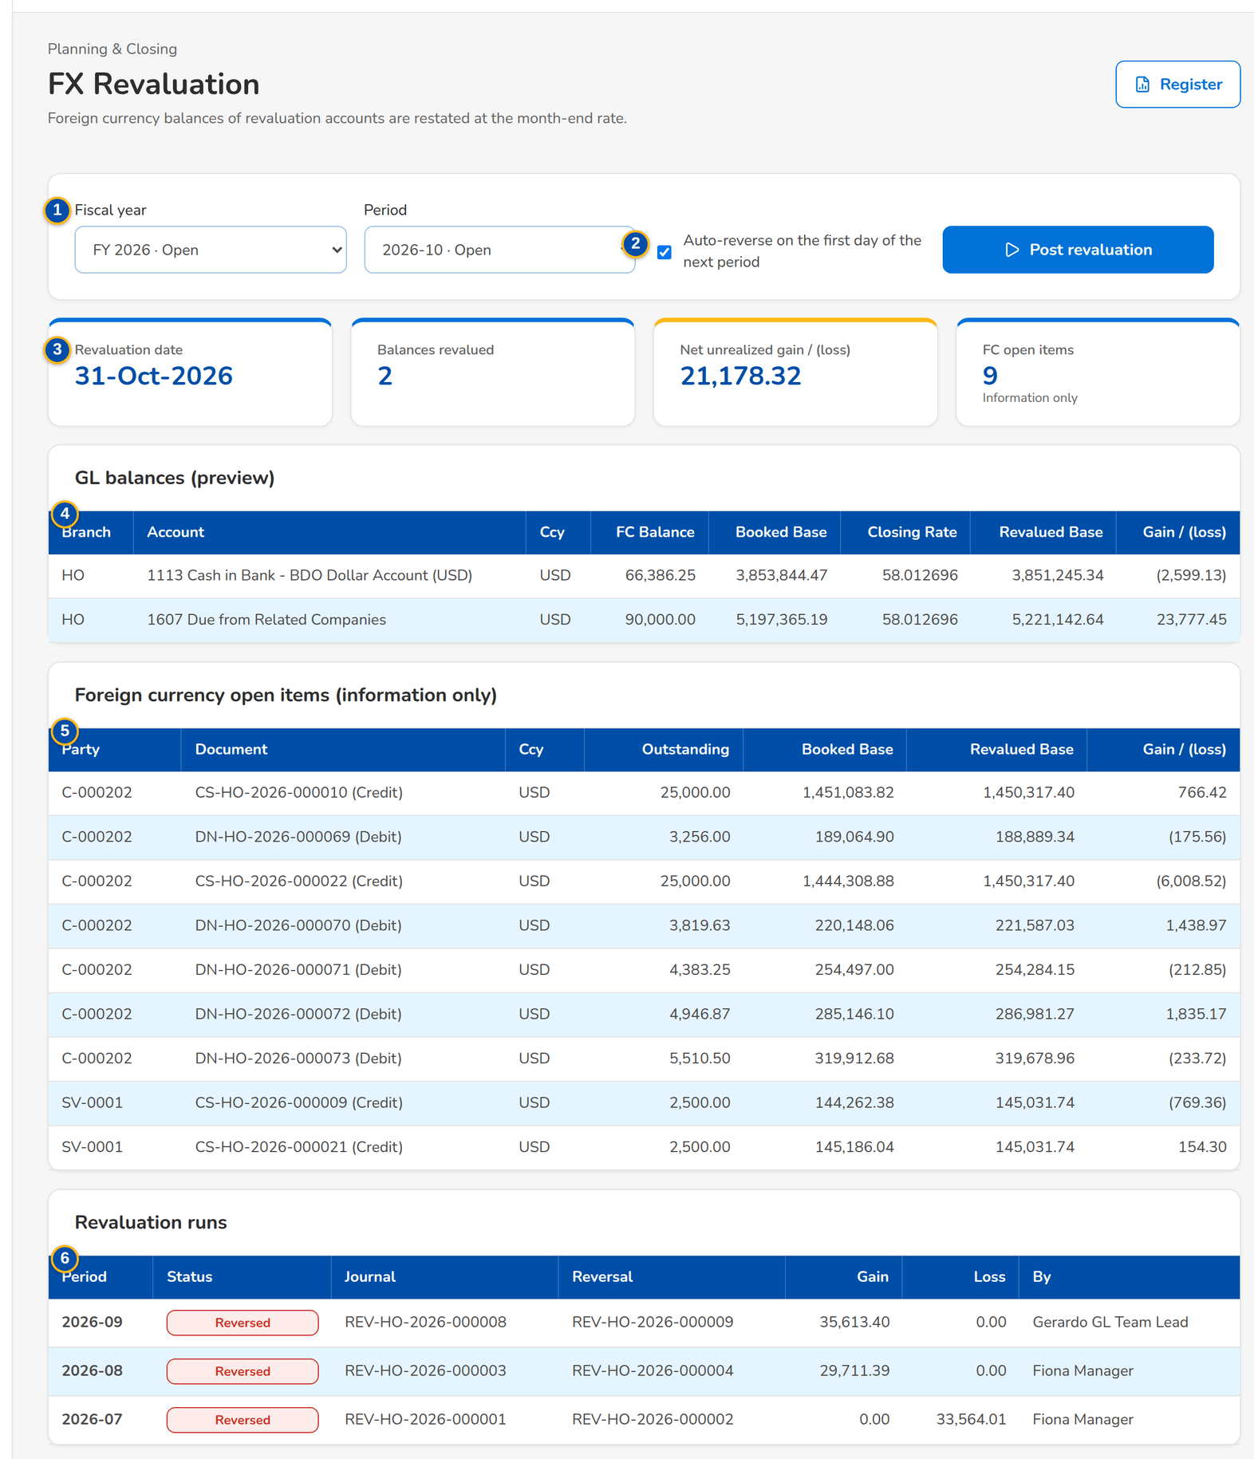
Figure 42: SCR-AC-13 FX Revaluation: the period, the preview of the balances revalued and the runs
1 | Fiscal year / Period | 3 | Revaluation date / Balances revalued / Net unrealized gain / FC open items | 5 | Party / Document / Ccy / Outstanding / Booked Base / Revalued Base / Gain / (loss)
2 | Auto-reverse on the first day of the next period | 4 | Branch / Account / Ccy / FC Balance / Booked Base / Closing Rate / Revalued Base / Gain / (loss) | 6 | Period / Status / Journal / Reversal / Gain / Loss / By

Fields (No. = callout number on the first screenshot)
No. | Section | Field | Type | Length / format | Mand. | Source / list | Default | Editable in | Validation | Message when it fails
1 | Criteria | Fiscal year / Period | Drop-down | The period to revalue | Y | Periods | Current period | - | Period open | -
2 | Criteria | Auto-reverse on the first day of the next period | Check box | Reverses the revaluation on the first day of the next period | N | - | Ticked | - | - | -
3 | Preview | Revaluation date / Balances revalued / Net unrealized gain / FC open items | Total | Date and counts; amount in the base currency | - | General ledger | - | Read only | - | No closing rate for the date
4 | GL balances (preview) | Branch / Account / Ccy / FC Balance / Booked Base / Closing Rate / Revalued Base / Gain / (loss) | Column | One row per revaluation account and currency | - | General ledger, exchange rates | - | Read only | - | -
5 | Foreign currency open items | Party / Document / Ccy / Outstanding / Booked Base / Revalued Base / Gain / (loss) | Column | Information only | - | Sub-ledger | - | Read only | - | -
6 | Revaluation runs | Period / Status / Journal / Reversal / Gain / Loss / By | Column | The runs of the company with the journal posted and its reversal | - | Revaluation runs | - | Read only | - | -

Actions
Button | Who | Enabled when | What happens | Resulting status | Notification
Post revaluation | GL Team Lead, GL Section Head (period-end run) | A closing rate exists and the period is not revalued | Posts the revaluation journals of the period after the confirmation | Posted | -
Register | Every user who opens the screen | Always | Opens the revaluation register report | - | -

Business rules
• Revaluation uses the closing rate of the month end entered by the GL Section Head; a period is revalued once (FR-AC-043).
• The revaluation is reversed on the first day of the next period when Auto-reverse is ticked (FR-AC-043).
Expected outcome
The foreign-currency balances are restated at the month-end rate.
Test cases: TC-AC-043.1-01, TC-AC-043.1-02, TC-AC-043.2-01, TC-AC-SCR-13, TC-AC-MSG-10.

13.2.5 SCR-AC-14 Bank Statement Layouts
Purpose | The layout of each bank's statement file: the columns of the date, description, check or reference number, the signed amount or the withdrawals and deposits, and the running balance, with the date pattern; and the import of a statement file through its layout, matched at once.
Who can open it | Accountant (bank reconciliation) (permission Reconciliation manage)
Navigation | • Menu: Setup & Administration › Setup › Bank Statement Layouts
FRs | FR-AC-050

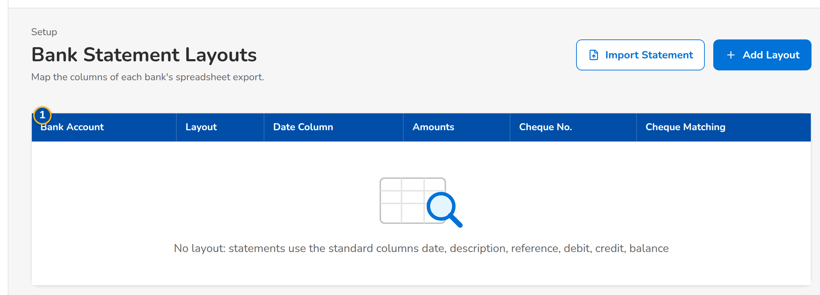
Figure 43: SCR-AC-14 Bank Statement Layouts: the layout of each bank account and its cheque matching
1 | Bank Account / Layout / Date Column / Amounts / Cheque No. / Cheque Matching | 3 | Layout name / Date column / Date pattern / Description column / Cheque / reference column | 5 | Bank account / Statement file
2 | Bank account | 4 | Signed amount column / Withdrawals column / Deposits column / Running balance column

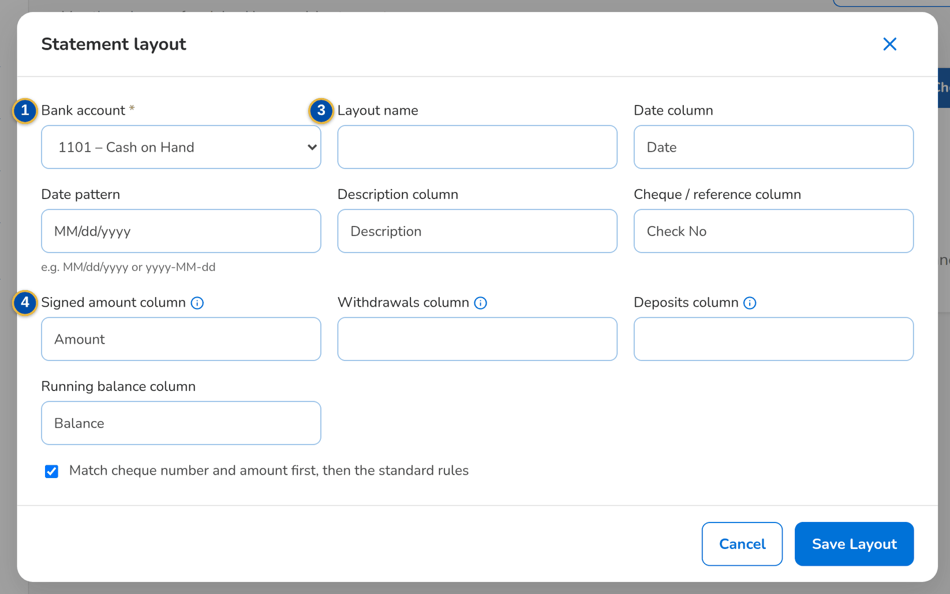
Figure 44: SCR-AC-14 Statement layout: the bank account and the columns of its file
Fields (No. = callout number on the first screenshot)
No. | Section | Field | Type | Length / format | Mand. | Source / list | Default | Editable in | Validation | Message when it fails
1 | List | Bank Account / Layout / Date Column / Amounts / Cheque No. / Cheque Matching | Column | One row per layout | - | Statement layouts | - | Read only | - | -
2 | Layout form | Bank account | Drop-down | GL bank accounts | Y | Bank accounts | Blank | - | One layout per account | Select the bank account
3 | Layout form | Layout name / Date column / Date pattern / Description column / Cheque / reference column | Text | Column names of the file; date pattern such as MM/dd/yyyy | Y / Y / Y / N / N | - | Blank | - | A valid date pattern | Invalid date pattern <pattern>
4 | Layout form | Signed amount column / Withdrawals column / Deposits column / Running balance column | Text | A signed amount, or both withdrawals and deposits | Cond. | - | Blank | - | Either a signed amount or both columns | Map either a signed amount column or both debit and credit columns
5 | Import bank statement dialog | Bank account / Statement file | Drop-down, file | The layout's account; Excel, ODS or CSV file | Y | Bank accounts | - | - | Every row read with the layout | Row <n> - invalid date / amount '<value>'

Actions
Button | Who | Enabled when | What happens | Resulting status | Notification
Add Layout / Save Layout | Accountant (bank reconciliation) | Always | Saves the layout of the bank account | - | -
Import Statement / Import and Match | Accountant (bank reconciliation) | A layout exists | Imports the bank file through the layout and runs the automatic matching | - | -

Business rules
• Each bank account has its layout; the first matching rule pairs a book entry and a bank line with the same check number and amount (FR-AC-050).
Expected outcome
The bank's files are read without manual re-keying.
Test cases: TC-AC-050.3-01, TC-AC-050.3-02, TC-AC-SCR-14, TC-AC-MSG-11.

13.2.6 SCR-AC-15 Bank Statements
Purpose | The import of a bank statement (CSV) for a GL bank account, with its reference and opening balance, and the statements imported with their period, opening, debits, credits, closing and lines; the lines of a statement show whether they are reconciled.
Who can open it | Accountant (bank reconciliation) (permission Reconciliation manage)
Navigation | • Menu: Finance › Receivables & Banking › Bank Statements  • Bank Statement Layouts › Import Statement
FRs | FR-AC-050

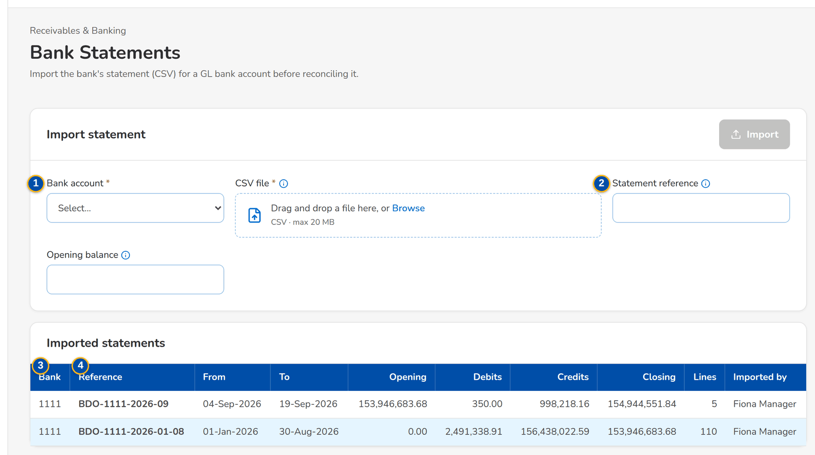
Figure 45: SCR-AC-15 Bank Statements: the import of a statement and the statements imported
1 | Bank account / CSV file | 3 | Bank / Reference / From / To / Opening / Debits / Credits / Closing / Lines / Imported by
2 | Statement reference / Opening balance | 4 | # / Value Date / Description / Reference / Debit / Credit / Balance / Reconciled

Fields (No. = callout number on the first screenshot)
No. | Section | Field | Type | Length / format | Mand. | Source / list | Default | Editable in | Validation | Message when it fails
1 | Import statement | Bank account / CSV file | Drop-down, file | GL bank account; CSV of the statement | Y | Bank accounts | - | - | - | Select the bank account
2 | Import statement | Statement reference / Opening balance | Text, number | Defaults to the file name; derived from the first line when blank | N | - | Blank | - | - | -
3 | Imported statements | Bank / Reference / From / To / Opening / Debits / Credits / Closing / Lines / Imported by | Column | One row per statement | - | Bank statements | - | Read only | - | -
4 | Statement lines | # / Value Date / Description / Reference / Debit / Credit / Balance / Reconciled | Column | The lines of the statement chosen | - | Bank statements | - | Read only | - | -

Actions
Button | Who | Enabled when | What happens | Resulting status | Notification
Import | Accountant (bank reconciliation) | Account and file chosen | Imports the statement | - | -
Row | Accountant | Always | Shows the lines of the statement | - | -

Business rules
• A statement file imported before is refused (FR-AC-050).
Expected outcome
The bank statement is in BIBS for the reconciliation.
Test cases: TC-AC-050.1-01, TC-AC-050.3-03, TC-AC-SCR-15.

13.2.7 SCR-AC-16 Bank Reconciliation
Purpose | The reconciliation of a bank account as of a statement date: the match workbench with the book entries and the bank lines not reconciled (automatic and manual matching, recent matches and unmatch), the reconciliation statement with the balance per book and per bank and the four groups of reconciling items, and the reconciliations finalised.
Who can open it | Accountant (bank reconciliation) (permission Reconciliation manage)
Navigation | • Menu: Finance › Receivables & Banking › Bank Reconciliation  • Bank Statements › the statement to reconcile
FRs | FR-AC-050, FR-AC-051

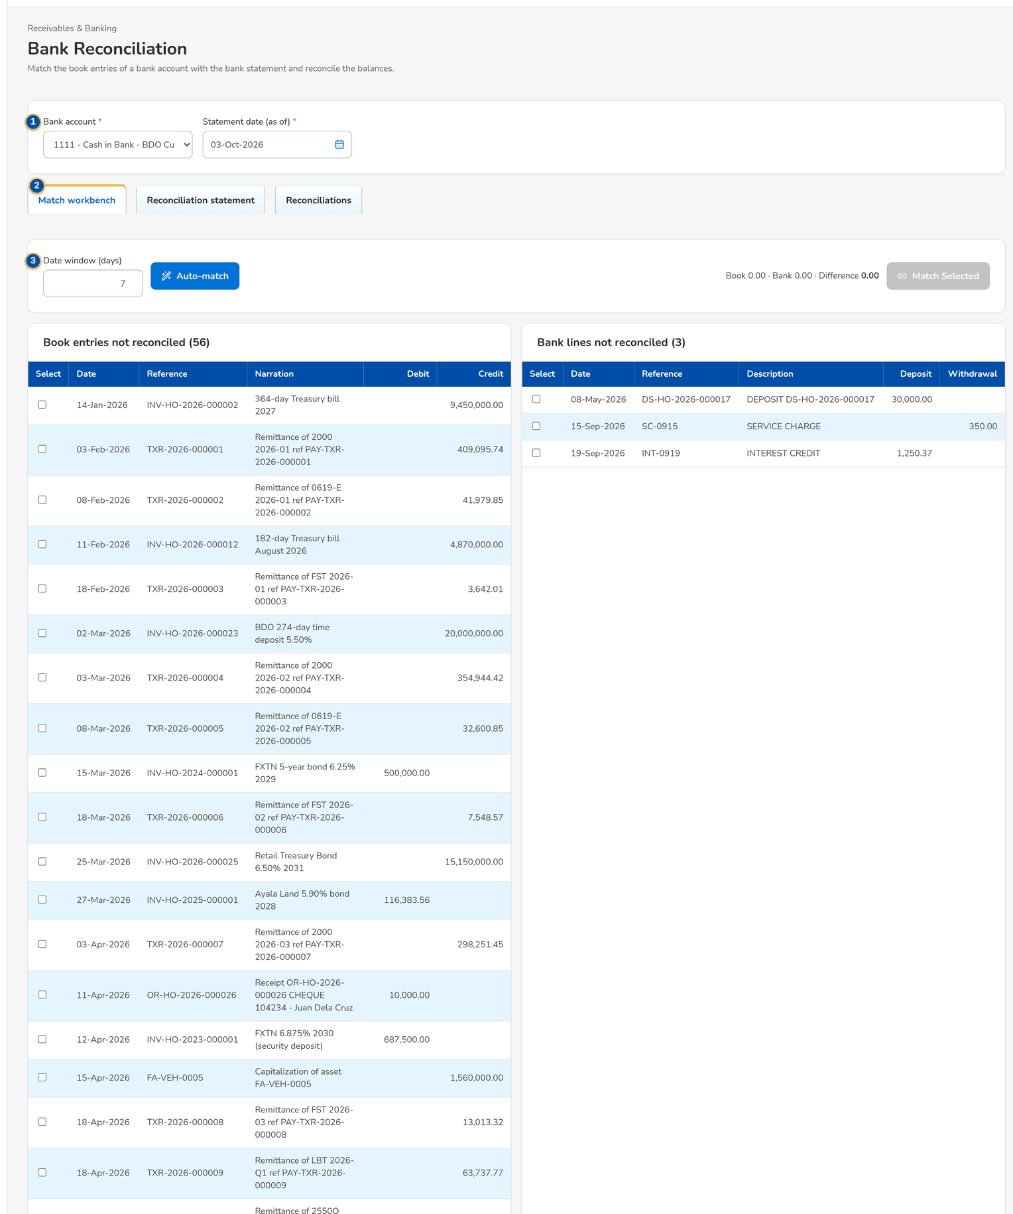
Figure 46: SCR-AC-16 Bank Reconciliation, Match workbench: book entries and bank lines not reconciled
1 | Bank account / Statement date (as of) | 4 | Book entries not reconciled | 7 | Balance as per book / Balance per bank (computed) / Balance per bank statement / Unexplained difference
2 | Match workbench / Reconciliation statement / Reconciliations | 5 | Bank lines not reconciled | 8 | Reconciling items
3 | Date window (days) | 6 | Recent matches | 9 | Bank / As of / Book Balance / Statement Balance / Difference / Status / Finalized by

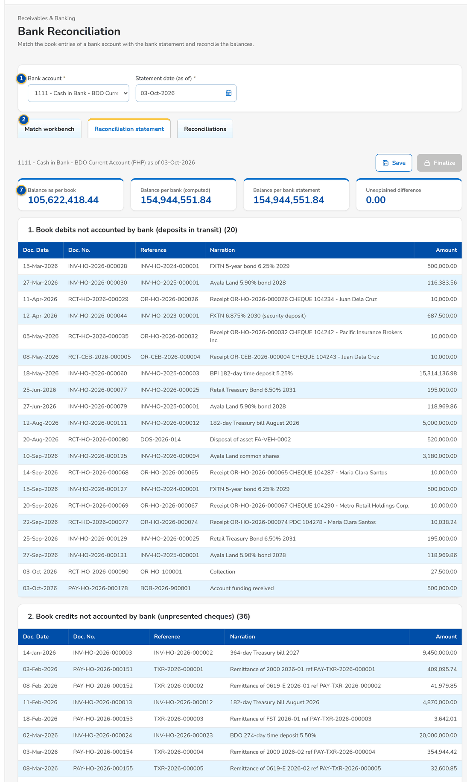
Figure 47: SCR-AC-16 Reconciliation statement: balances and the reconciling items

Fields (No. = callout number on the first screenshot)
No. | Section | Field | Type | Length / format | Mand. | Source / list | Default | Editable in | Validation | Message when it fails
1 | Criteria | Bank account / Statement date (as of) | Drop-down, date | GL bank account; dd-MMM-yyyy | Y | Bank accounts | Today | - | - | -
2 | Tabs | Match workbench / Reconciliation statement / Reconciliations | Tab | - | - | - | Match workbench | - | - | -
3 | Match workbench | Date window (days) | Number | Days around the date for the amount rules | N | - | 3 | - | - | -
4 | Match workbench | Book entries not reconciled | Column | Select / Date / Reference / Narration / Debit / Credit | - | General ledger | - | Read only | - | -
5 | Match workbench | Bank lines not reconciled | Column | Select / Date / Reference / Description / Deposit / Withdrawal | - | Bank statements | - | Read only | - | -
6 | Match workbench | Recent matches | Column | Match / Method / Date / Amount / By | - | Matches | - | Read only | - | -
7 | Reconciliation statement | Balance as per book / Balance per bank (computed) / Balance per bank statement / Unexplained difference | Total | Two decimals | - | General ledger, statement | - | Read only | - | -
8 | Reconciliation statement | Reconciling items | Column | Book debits not accounted by bank, book credits not accounted by bank, bank debits and bank credits not accounted in book | - | Matches | - | Read only | - | -
9 | Reconciliations | Bank / As of / Book Balance / Statement Balance / Difference / Status / Finalized by | Column | One row per reconciliation | - | Reconciliations | - | Read only | - | -

Actions
Button | Who | Enabled when | What happens | Resulting status | Notification
Auto-match | Accountant (bank reconciliation) | Lines not reconciled | Runs the matching rules: check number and amount first, then amount within the date window | - | -
Match Selected | Accountant | Book entries and bank lines of the same total selected | Matches them by hand | - | -
Unmatch | Accountant | A recent match | Undoes the match | - | -
Save / Finalize | Accountant | Statement prepared | Saves the reconciliation statement, then finalises it | Finalized | -

Business rules
• The first rule pairs a book entry and a bank line with the same check number and amount on any date; the other rules match on amount within the date window (FR-AC-050).
• The unmatched items are listed on the reconciliation statement and in the unmatched report (FR-AC-051).
Expected outcome
The bank account is reconciled and the differences are explained.
Test cases: TC-AC-050.2-01, TC-AC-050.4-01, TC-AC-SCR-16.

13.3 Reports, report pack and service fee

13.3.1 SCR-AC-17 Report Centre
Purpose | Every report the user may run, by category (Accounting, Disbursement, ACSL, Payment Requests, Operations and the other modules), with a search by title; Report Batch runs several reports at once with shared dates and one output, and My report batches lists the batches with their download.
Who can open it | GL Officer (FRBS), GL Team Lead, GL Section Head, Accountant (bank reconciliation), Comptrollership administrator (masters and rules), Disbursement Processor, Disbursement Team Leader, Disbursement Approver, Marketing Processor (AO), Marketing Reviewer, Marketing Approver, Human Resources Approver, ACSL Processor, ACSL Team Leader, ACSL Head (approver), Comptrollership (read access), Business Administrator, System Administrator, Auditor (permission Report view)
Navigation | • Menu: Reports › Reports › Report Centre
FRs | FR-AC-020, FR-AC-022, FR-AS-001, FR-DS-080, FR-PQ-012

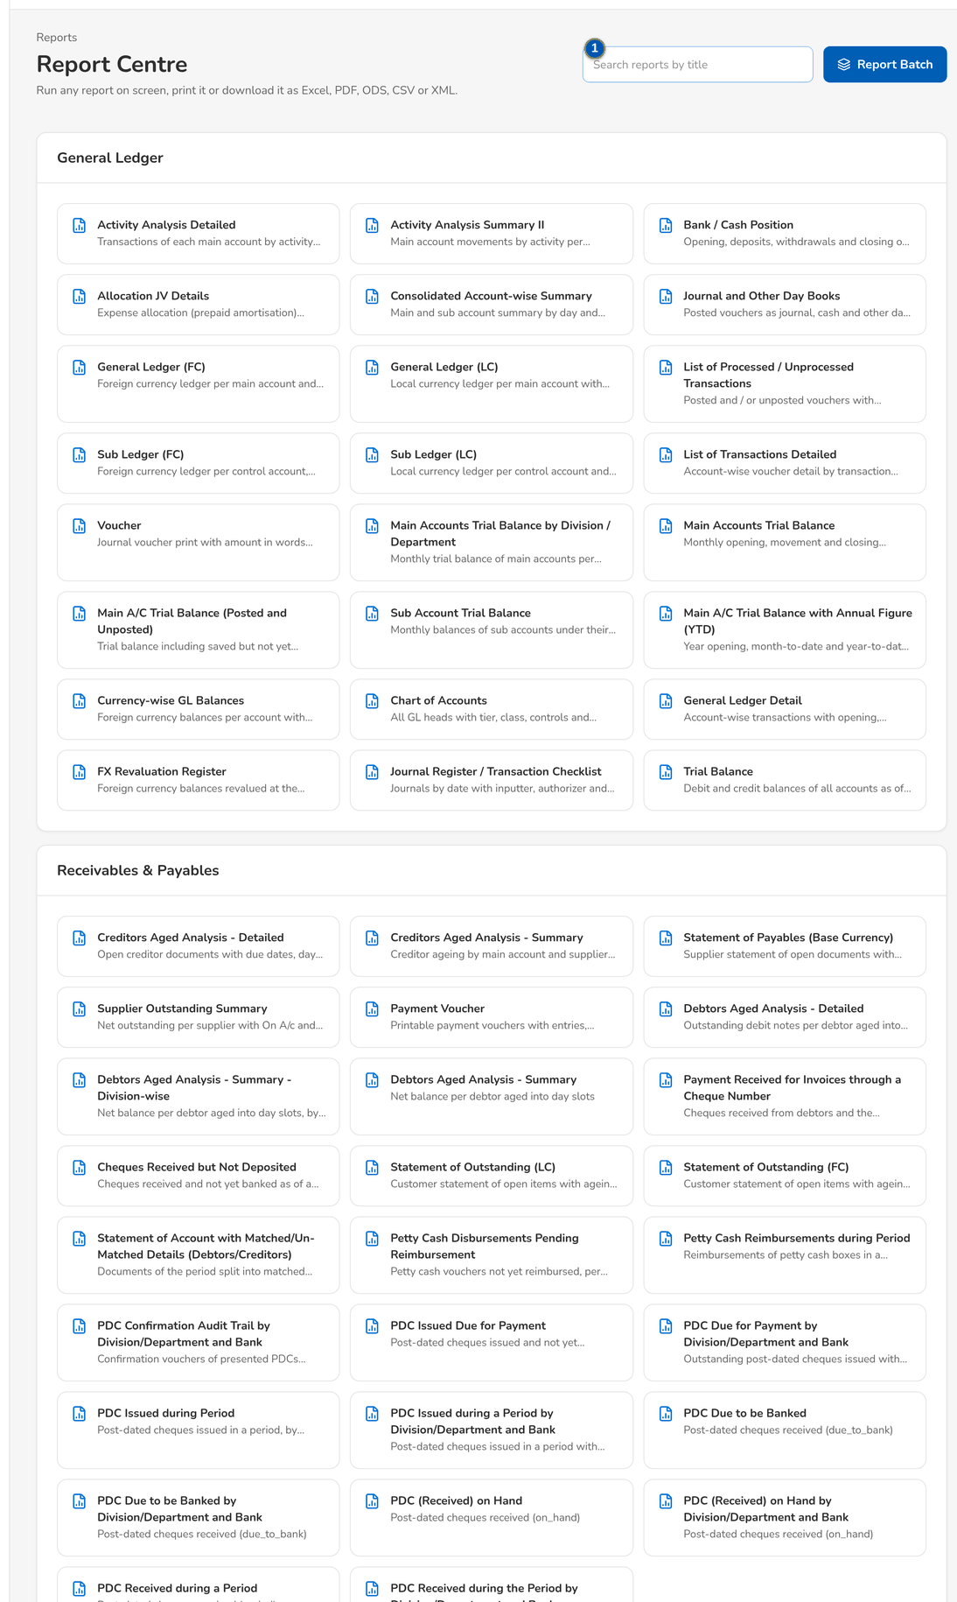
Figure 48: SCR-AC-17 Report Centre: the reports by category and My report batches
1 | Search reports by title | 4 | From / To / as of | 7 | Report / Status / Rows / Reason
2 | Report title and description | 5 | Output
3 | Batch No. / Run At / Output / Status | 6 | Search reports (n selected)

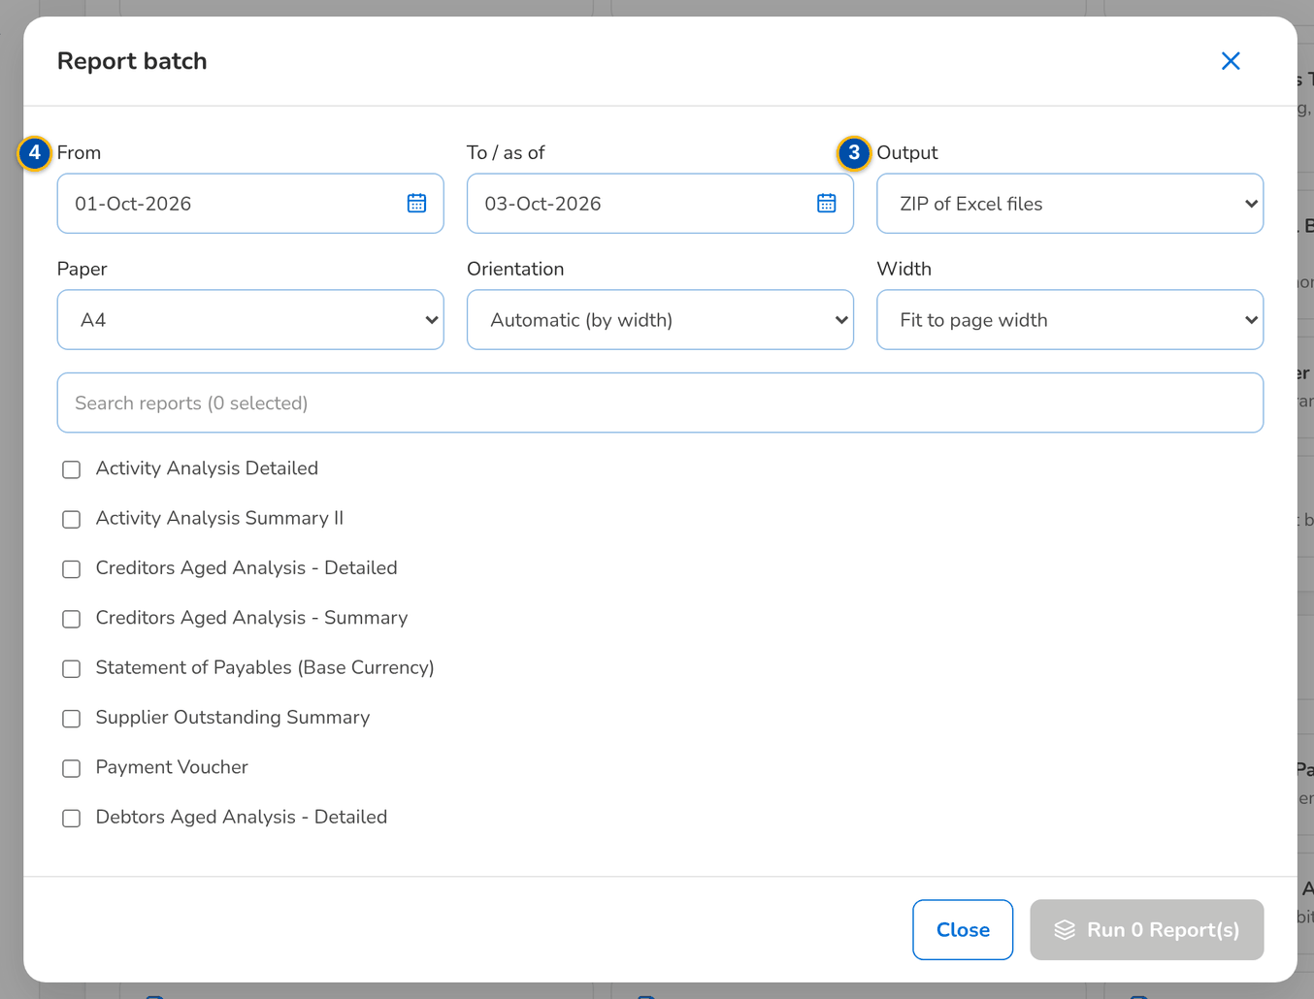
Figure 49: SCR-AC-17 Report batch: the reports chosen, the dates and the output
Fields (No. = callout number on the first screenshot)
No. | Section | Field | Type | Length / format | Mand. | Source / list | Default | Editable in | Validation | Message when it fails
1 | Toolbar | Search reports by title | Text | Part of the title | N | Report catalogue | Blank | - | Contains | -
2 | Categories | Report title and description | Link | The reports of the category the user may run | - | Report catalogue | - | Read only | - | -
3 | My report batches | Batch No. / Run At / Output / Status | Column | Batch number, date and time, output format, Queued, Running, Completed or Failed | - | Report batches | - | Read only | - | -
4 | Report batch dialog | From / To / as of | Date | dd-MMM-yyyy; shared by the reports chosen | N | - | Start of the month / today | - | - | -
5 | Report batch dialog | Output | Drop-down | One ZIP of the files, or one merged PDF | Y | Fixed list | ZIP | - | - | -
6 | Report batch dialog | Search reports (n selected) | Text, check boxes | The reports to run together | Y | Report catalogue | None | - | At least one report | -
7 | Report batch dialog | Report / Status / Rows / Reason | Column | The outcome of each report of the batch | - | Report batch | - | Read only | - | -

Actions
Button | Who | Enabled when | What happens | Resulting status | Notification
Report title | Every user who may run the report | Always | Opens the report runner | - | -
Report Batch | Report users | Always | Opens the report batch; Run runs the reports in the background | Queued | -
Download | Report users | A completed batch | Downloads the batch output | - | -

Business rules
• A user sees only the reports of the categories the role may run (FR-AC-020).
• A batch runs each report on its own; a report that fails is listed with its reason and does not stop the others (FR-AC-022).
Expected outcome
The user finds a report and runs it, alone or with others.
Test cases: TC-AC-013.2-01, TC-AC-020.1-01, TC-AC-020.4-01, TC-AC-022.1-01, TC-AC-022.1-02, TC-AC-022.2-01, TC-AC-022.3-01, TC-AC-051.1-01, TC-AC-051.2-01, TC-DS-037.1-03, TC-DS-080.2-02, TC-PQ-002.1-01, TC-PQ-002.2-01, TC-PQ-012.1-01, TC-PQ-012.2-01, TC-AS-001.1-01, TC-AS-001.1-02, TC-AS-001.2-01, TC-AS-005.1-01, TC-AS-005.2-01, TC-AC-SCR-17, TC-AC-MSG-12.

13.3.2 SCR-AC-18 Report
Purpose | The report runner of one report: its parameters (dates, company, the criteria of the report), saved variants, the result on screen with a filter on every column, the print options and the export to Excel, PDF, ODS, CSV or XML.
Who can open it | GL Officer (FRBS), GL Team Lead, GL Section Head, Accountant (bank reconciliation), Comptrollership administrator (masters and rules), Disbursement Processor, Disbursement Team Leader, Disbursement Approver, Marketing Processor (AO), Marketing Reviewer, Marketing Approver, Human Resources Approver, ACSL Processor, ACSL Team Leader, ACSL Head (approver), Comptrollership (read access), Business Administrator, System Administrator, Auditor (permission Report view)
Navigation | • Menu: Reports › Reports › Report Centre › Report  • Report Centre › a report  • Report Pack, Disbursement Reports › a report
FRs | FR-AC-020, FR-AC-021, FR-AC-023, FR-AC-051, FR-AS-005

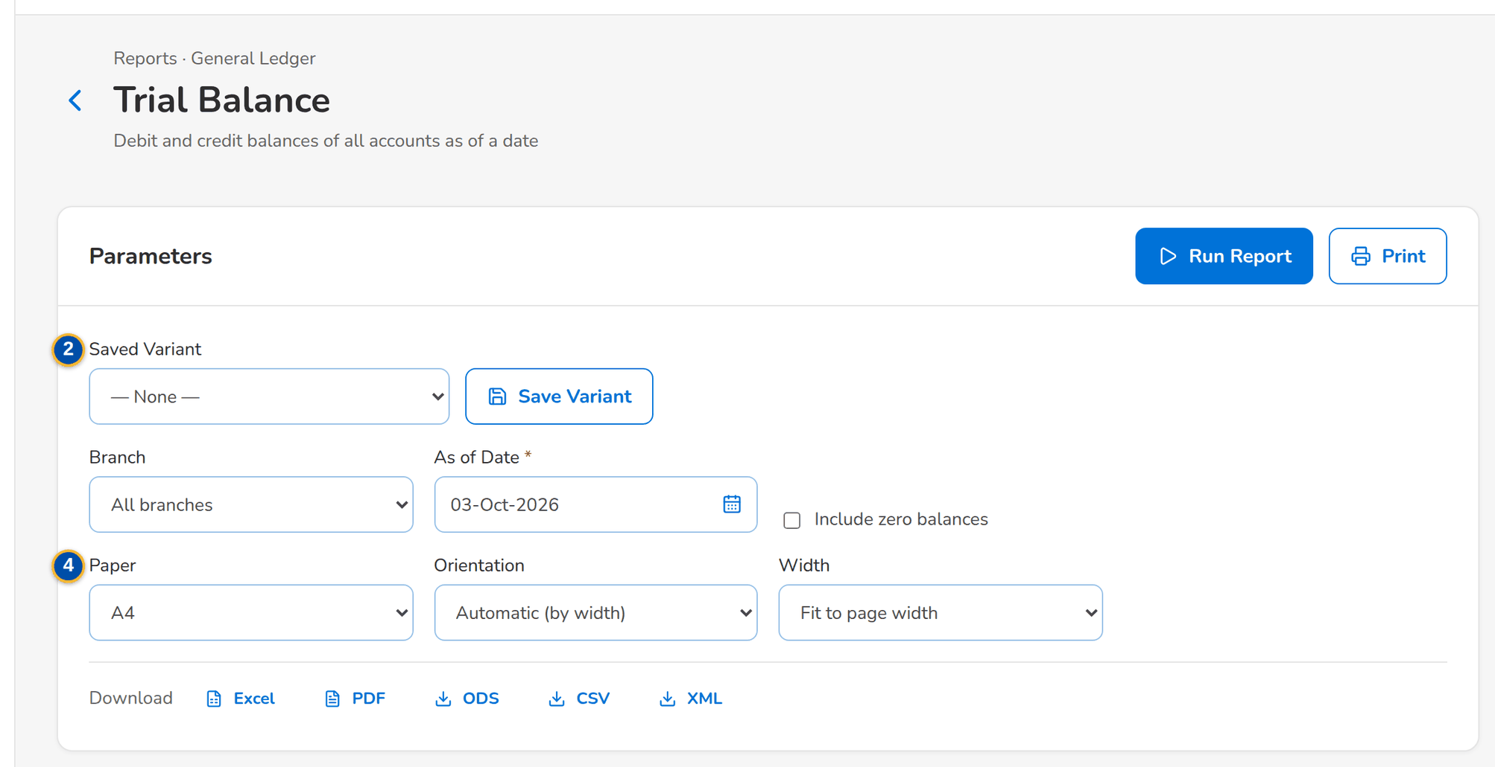
Figure 50: SCR-AC-18 A report before it is run: its parameters, the print options and the export formats
1 | Report parameters | 3 | Report columns | 5 | Variant Name / Share with every user who may run this report
2 | Saved Variant | 4 | Paper / Orientation / Width

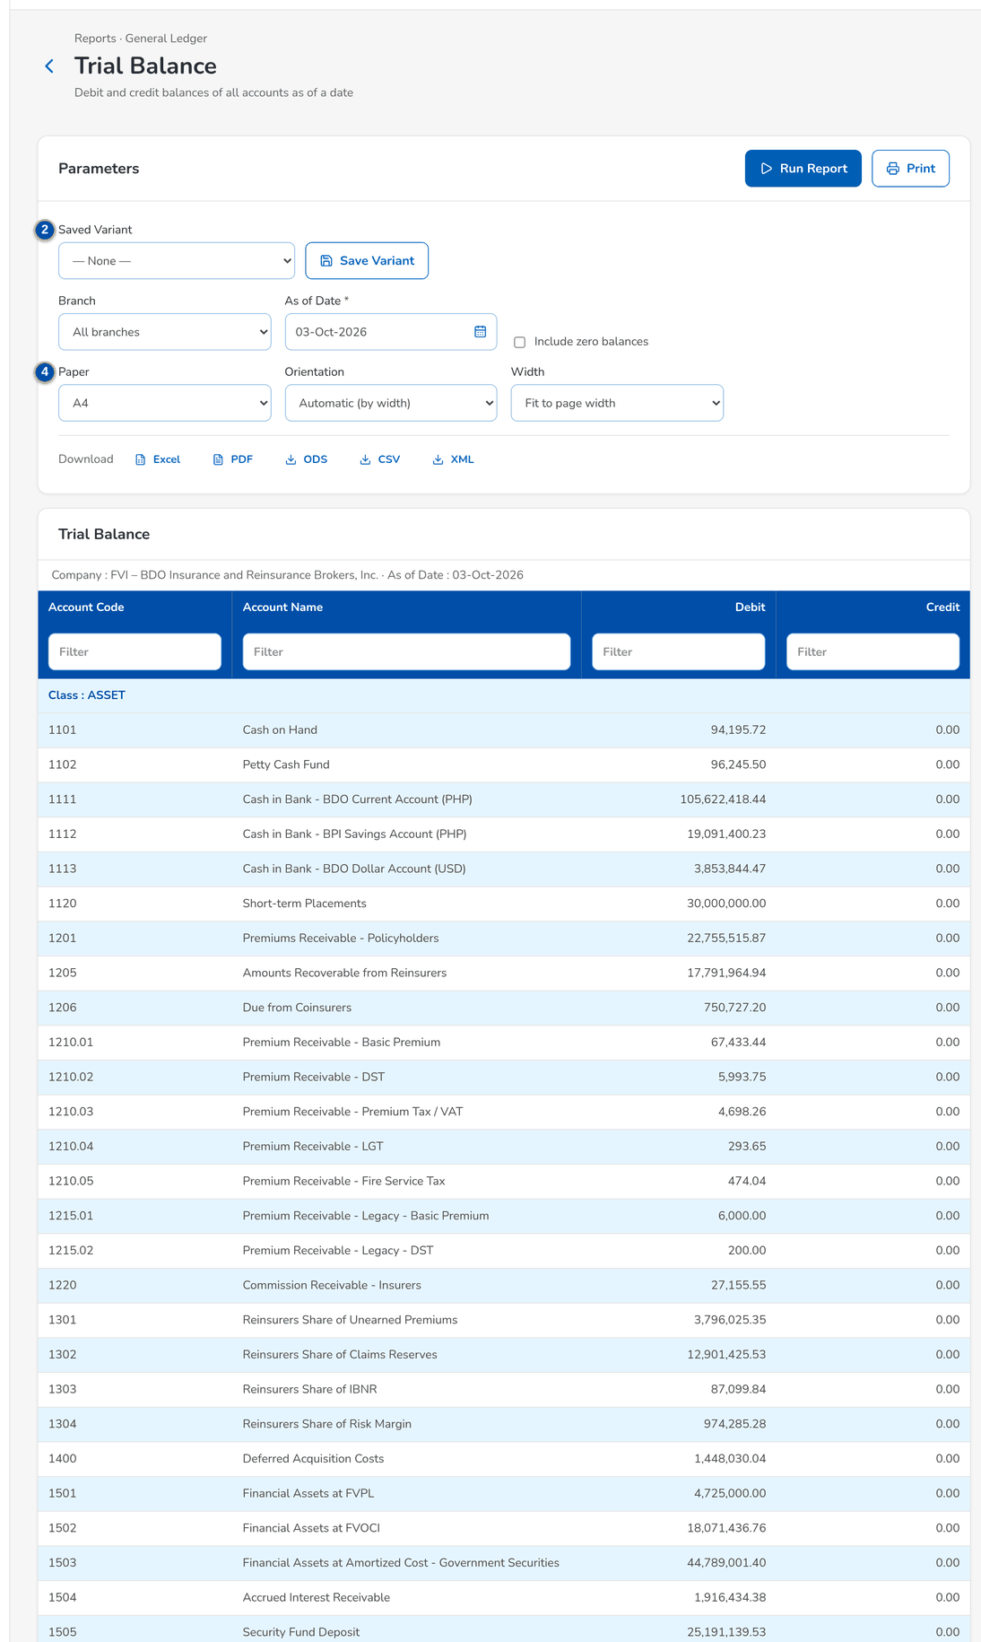
Figure 51: SCR-AC-18 The report run on screen with the column filters and the export buttons

Fields (No. = callout number on the first screenshot)
No. | Section | Field | Type | Length / format | Mand. | Source / list | Default | Editable in | Validation | Message when it fails
1 | Parameters | Report parameters | Date, drop-down, text | The parameters of the report: dates, company, branch, account, party, status | Cond.: report | Report definition | Report defaults | - | Mandatory parameters filled | -
2 | Parameters | Saved Variant | Drop-down | The variants saved by the user or shared | N | Report variants | Blank | - | - | -
3 | Result | Report columns | Column | The columns of the report with a Filter field on each | - | Report | - | Read only | Contains | -
4 | Export | Paper / Orientation / Width | Drop-down | A4, Letter or Legal; Automatic (by width), Portrait or Landscape; Fit to page width or Natural column widths | N | Fixed lists | A4, Automatic, Fit to page width | - | - | -
5 | Save Report Variant dialog | Variant Name / Share with every user who may run this report | Text, check box | Name of the variant | Y / N | - | Blank | - | - | -

Actions
Button | Who | Enabled when | What happens | Resulting status | Notification
Run Report | Report users | Mandatory parameters filled | Runs the report on screen | - | -
Print | Report users | A result | Prints the result with the print options | - | -
Export | Report users (export permission of the category) | A result | Exports the report in the format chosen | - | -
Save Variant / Delete Variant | Report users | Always | Saves or deletes the parameters as a variant | - | -

Business rules
• Every column of a report can be filtered on screen; the export takes the filtered rows (FR-AC-021).
• PDF prints take the paper, orientation and width chosen (FR-AC-023).
Expected outcome
The report is shown, filtered, printed or exported.
Test cases: TC-AC-020.2-01, TC-AC-020.3-01, TC-AC-021.1-01, TC-AC-021.2-01, TC-AC-023.1-01, TC-AC-023.1-02, TC-AC-SCR-18, TC-AC-MSG-13.

13.3.3 SCR-AC-19 Report Pack
Purpose | The Comptrollership report pack of Appendix A by group (end of day, GARD, subsidiaries, schedules and aging, Mancom, service fee, government): each report opens in the runner and exports to the formats it offers; the counts of the pack and of the Word documents requested.
Who can open it | GL Officer (FRBS), GL Team Lead, GL Section Head, Comptrollership (read access), System Administrator, Auditor (permission FRBS report view)
Navigation | • Menu: Finance › Accounting Reports › Report Pack
FRs | FR-AC-060, FR-AC-062

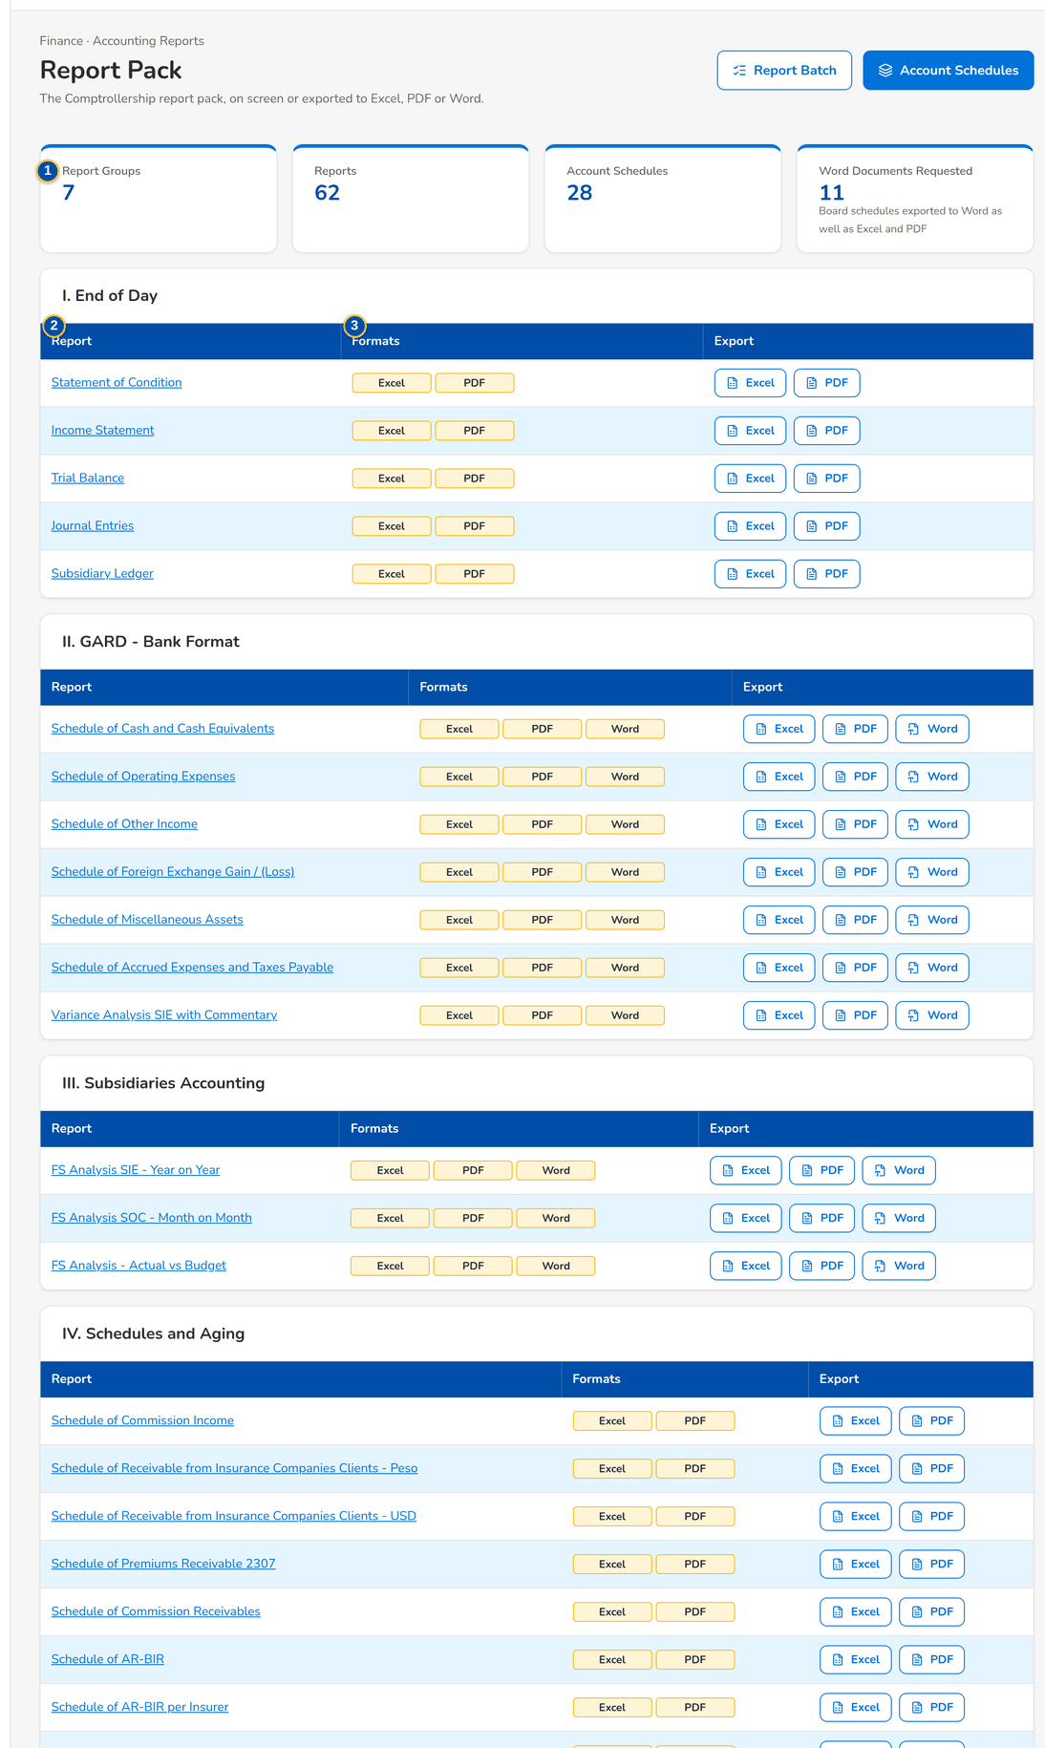
Figure 52: SCR-AC-19 Report Pack: the groups of Appendix A with their reports and formats
1 | Report Groups / Reports / Account Schedules / Word Documents Requested | 2 | Report | 3 | Formats / Export

Fields (No. = callout number on the first screenshot)
No. | Section | Field | Type | Length / format | Mand. | Source / list | Default | Editable in | Validation | Message when it fails
1 | Counts | Report Groups / Reports / Account Schedules / Word Documents Requested | Display | Counts of the pack | - | Report pack | - | Read only | - | -
2 | Group | Report | Column | Title of the report (a link when available) with its code and source under it | - | Report pack | - | Read only | - | -
3 | Group | Formats / Export | Column | The formats offered (Excel, PDF, ODS, CSV, Word requested) and the export of each | - | Report pack | - | Read only | - | -

Actions
Button | Who | Enabled when | What happens | Resulting status | Notification
Report title | FRBS users (FRBS report view) | Available | Opens the report or the account schedule | - | -
Export format | FRBS users (FRBS report export) | Available | Exports the report in the format | - | -

Business rules
• Reports whose layout BDOI has not confirmed carry the draft layout until confirmed (FR-AC-060).
Expected outcome
The GL team runs the reports of the pack from one place.
Test cases: TC-AC-060.1-01, TC-AC-060.1-02, TC-AC-060.2-01, TC-AC-062.1-01, TC-AC-062.1-02, TC-AC-062.2-01, TC-AC-062.2-02, TC-AC-SCR-19.

13.3.4 SCR-AC-20 Account Schedules
Purpose | The GARD, subsidiaries and ageing schedules of the report pack, run from their definitions: run a schedule for a date or a period with its figures and the commentary per row; the definitions list with the family, accounts, figures and layout, which the GL Team Lead maintains.
Who can open it | GL Officer (FRBS), GL Team Lead, GL Section Head, Accountant (bank reconciliation), Comptrollership administrator (masters and rules), Disbursement Approver, Comptrollership (read access), Business Administrator, System Administrator, Auditor (permission FRBS report view or Report financial or Master maintain)
Navigation | • Menu: Finance › Accounting Reports › Account Schedules  • Report Pack › a schedule
FRs | FR-AC-061

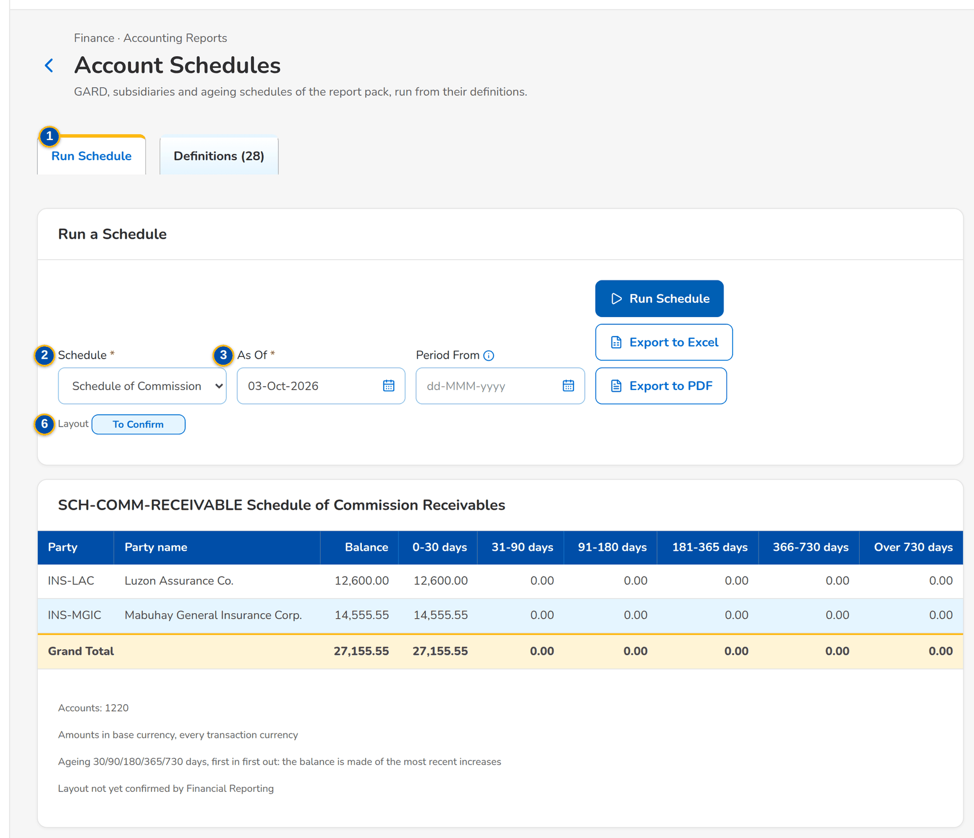
Figure 53: SCR-AC-20 Account Schedules: a schedule run for the month with its figures
1 | Run Schedule / Definitions (n) | 4 | Schedule rows and figures | 7 | Code / Title / Family / Source / Accounts By / Accounts / Rows / Currency / Positive Side / Basis / Ageing Buckets / Comparative / Layout
2 | Schedule | 5 | Row / Commentary | 8 | Figures, in column order
3 | As Of / Period From | 6 | Schedule / Family / Accounts / Figures / Layout

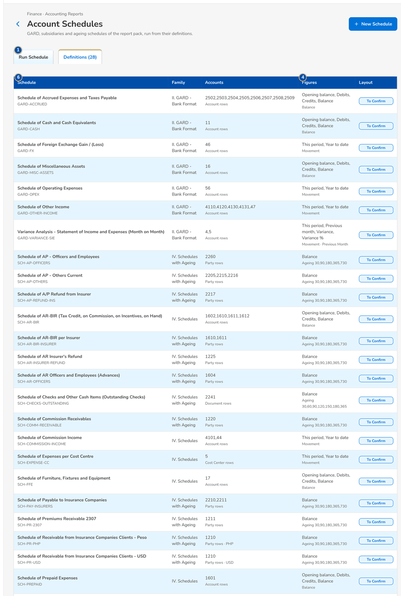
Figure 54: SCR-AC-20 Account Schedules, Definitions: family, accounts, figures and layout

Fields (No. = callout number on the first screenshot)
No. | Section | Field | Type | Length / format | Mand. | Source / list | Default | Editable in | Validation | Message when it fails
1 | Tabs | Run Schedule / Definitions (n) | Tab | - | - | - | Run Schedule | - | - | -
2 | Run a Schedule | Schedule | Drop-down | The schedules grouped by family | Y | Schedule definitions | Blank | - | - | Choose a schedule
3 | Run a Schedule | As Of / Period From | Date | dd-MMM-yyyy | Y / Cond.: comparative | - | Month end | - | - | -
4 | Result | Schedule rows and figures | Column | The rows of the schedule with the figures in column order | - | General ledger | - | Read only | - | -
5 | Commentary | Row / Commentary | Column, text | The comment of each row for the period | N | - | Blank | - | - | -
6 | Definitions | Schedule / Family / Accounts / Figures / Layout | Column | One row per definition | - | Schedule definitions | - | Read only | - | -
7 | Definition form | Code / Title / Family / Source / Accounts By / Accounts / Rows / Currency / Positive Side / Basis / Ageing Buckets / Comparative / Layout | Text, drop-down | The definition of the schedule | Y | Fixed lists, chart | - | - | - | -
8 | Definition form | Figures, in column order | Rows | The measure and the heading of each figure column | Y | Fixed list | Balance | - | At least one figure | -

Actions
Button | Who | Enabled when | What happens | Resulting status | Notification
Run Schedule | FRBS users | Schedule and date chosen | Runs the schedule | - | -
Save Comment | FRBS users | A comment typed | Saves the commentary of the row for the period | - | -
New Schedule / [Row] | GL Team Lead (master maintain) | Always | Adds or changes a definition | - | -

Business rules
• A schedule is computed from its definition on the posted ledger; its layout is configuration (FR-AC-061).
Expected outcome
The schedules of the pack are run and explained.
Test cases: TC-AC-061.1-01, TC-AC-061.2-01, TC-AC-061.3-01, TC-AC-061.3-02, TC-AC-061.3-03, TC-AC-061.3-04, TC-AC-061.3-05, TC-AC-061.3-06, TC-AC-SCR-20, TC-AC-MSG-14.

13.3.5 SCR-AC-21 Service Fee Runs
Purpose | The service-fee runs: the referrers' share of the commission fully paid in a period, by status tab (Computed, For Approval, Sent for Payment, Released, Liquidated, Cancelled); Compute Service Fee computes a new run for a period of full payment.
Who can open it | GL Officer (FRBS), GL Team Lead, GL Section Head, Comptrollership (read access), System Administrator, Auditor (permission Service fee manage or Service fee manage or Service fee approve or Service fee tag or FRBS report view)
Navigation | • Menu: Finance › Accounting Reports › Service Fee Runs  • Service Fee Rates › the runs
FRs | FR-AC-052

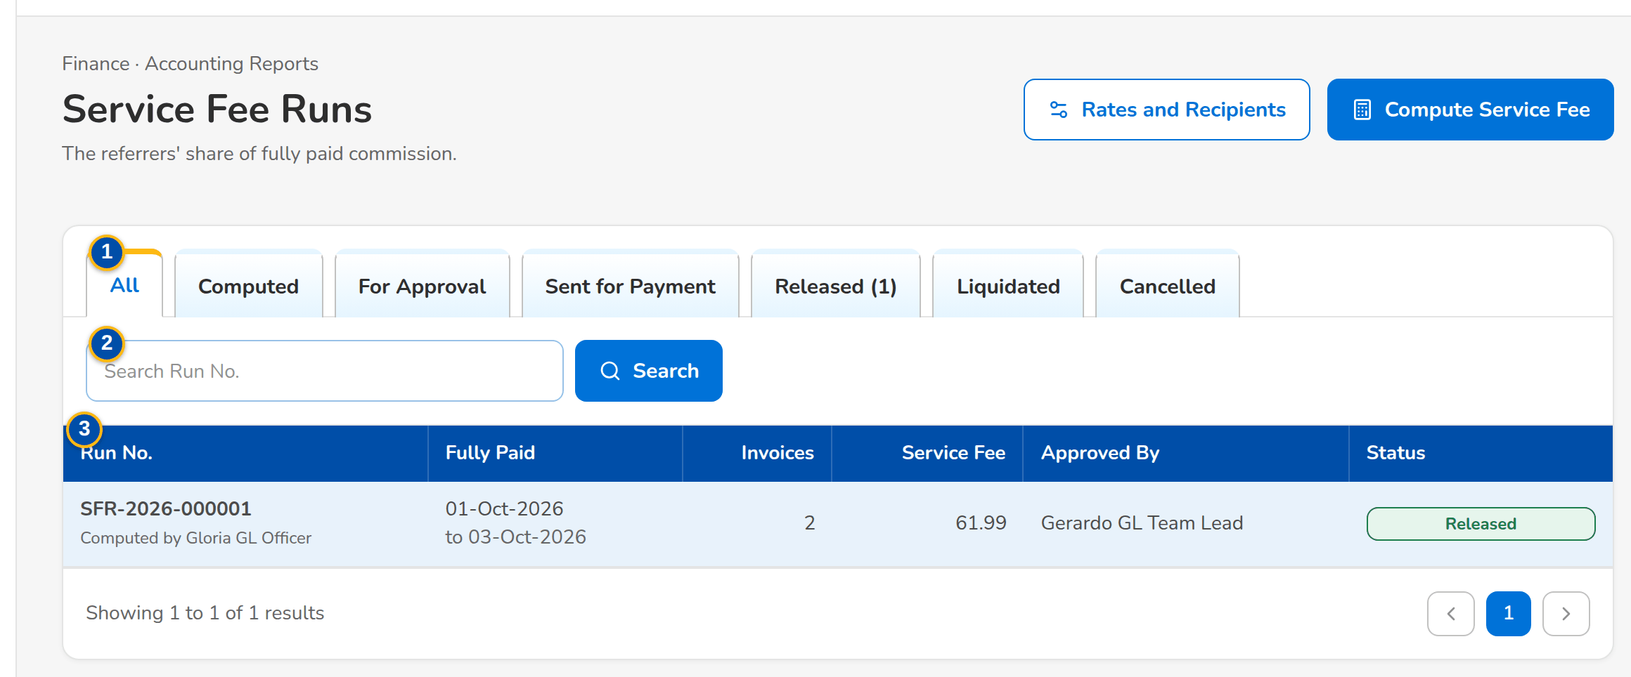
Figure 55: SCR-AC-21 Service Fee Runs: the runs with their period, invoices, service fee, approver and status
1 | All / Computed / For Approval / Sent for Payment / Released / Liquidated / Cancelled | 3 | Run No. / Fully Paid / Invoices / Service Fee / Approved By / Status
2 | Search Run No. | 4 | Fully Paid From / Fully Paid To

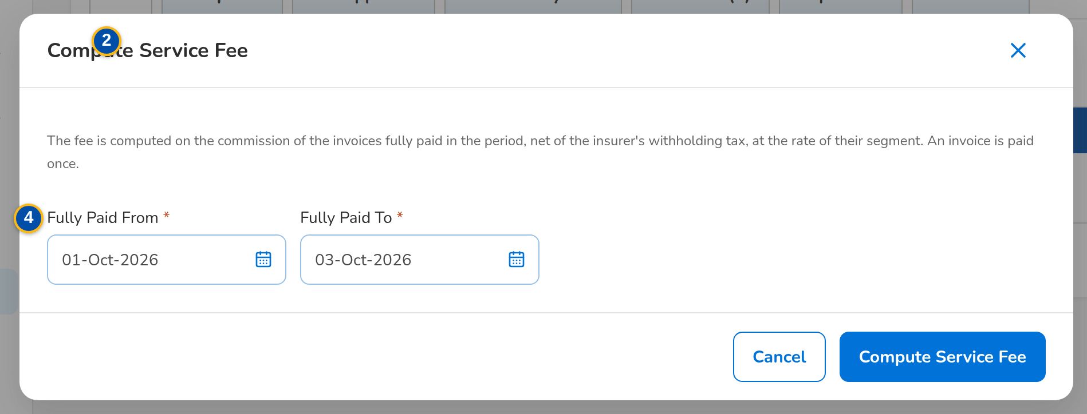
Figure 56: SCR-AC-21 Compute Service Fee: the period of full payment
Fields (No. = callout number on the first screenshot)
No. | Section | Field | Type | Length / format | Mand. | Source / list | Default | Editable in | Validation | Message when it fails
1 | Tabs | All / Computed / For Approval / Sent for Payment / Released / Liquidated / Cancelled | Tab | Counts per tab | - | Service-fee runs | All | - | - | -
2 | Toolbar | Search Run No. | Text | Run number | N | - | Blank | - | Contains | -
3 | List | Run No. / Fully Paid / Invoices / Service Fee / Approved By / Status | Column | Run number; the period of full payment on two lines; count; amount; name | - | Service-fee runs | - | Read only | - | -
4 | Compute Service Fee dialog | Fully Paid From / Fully Paid To | Date | dd-MMM-yyyy | Y | - | The previous month | - | To on or after From | -

Actions
Button | Who | Enabled when | What happens | Resulting status | Notification
Compute Service Fee | GL Officer, GL Team Lead (service fee manage) | Always | Computes the run of the invoices fully paid in the period | Computed | -
Row | FRBS users | Always | Opens the run | - | -

Business rules
• The service fee is the rate of the segment applied to the commission fully paid in the period, net of withholding tax when the rate says so (FR-AC-052).
Expected outcome
The service fee of the month is computed.
Test cases: TC-AC-052.1-01, TC-AC-052.4-01, TC-AC-052.4-02, TC-AC-SCR-21, TC-AC-MSG-15.

13.3.6 SCR-AC-22 Service Fee Run
Purpose | One service-fee run: the invoices, the service fee and who computed and approved it; the lines per recipient with the base, rate, service fee, the payout to Disbursement and the release and liquidation tags; the invoices of the run. The preparer submits it, another user approves it and sends each payout to Disbursement; the liquidation report is recorded per line.
Who can open it | GL Officer (FRBS), GL Team Lead, GL Section Head, Comptrollership (read access), System Administrator, Auditor (permission Service fee manage or Service fee manage or Service fee approve or Service fee tag or FRBS report view)
Navigation | • Menu: Finance › Accounting Reports › Service Fee Runs › Service Fee Run  • Service Fee Runs › open a row
FRs | FR-AC-052, FR-AC-053

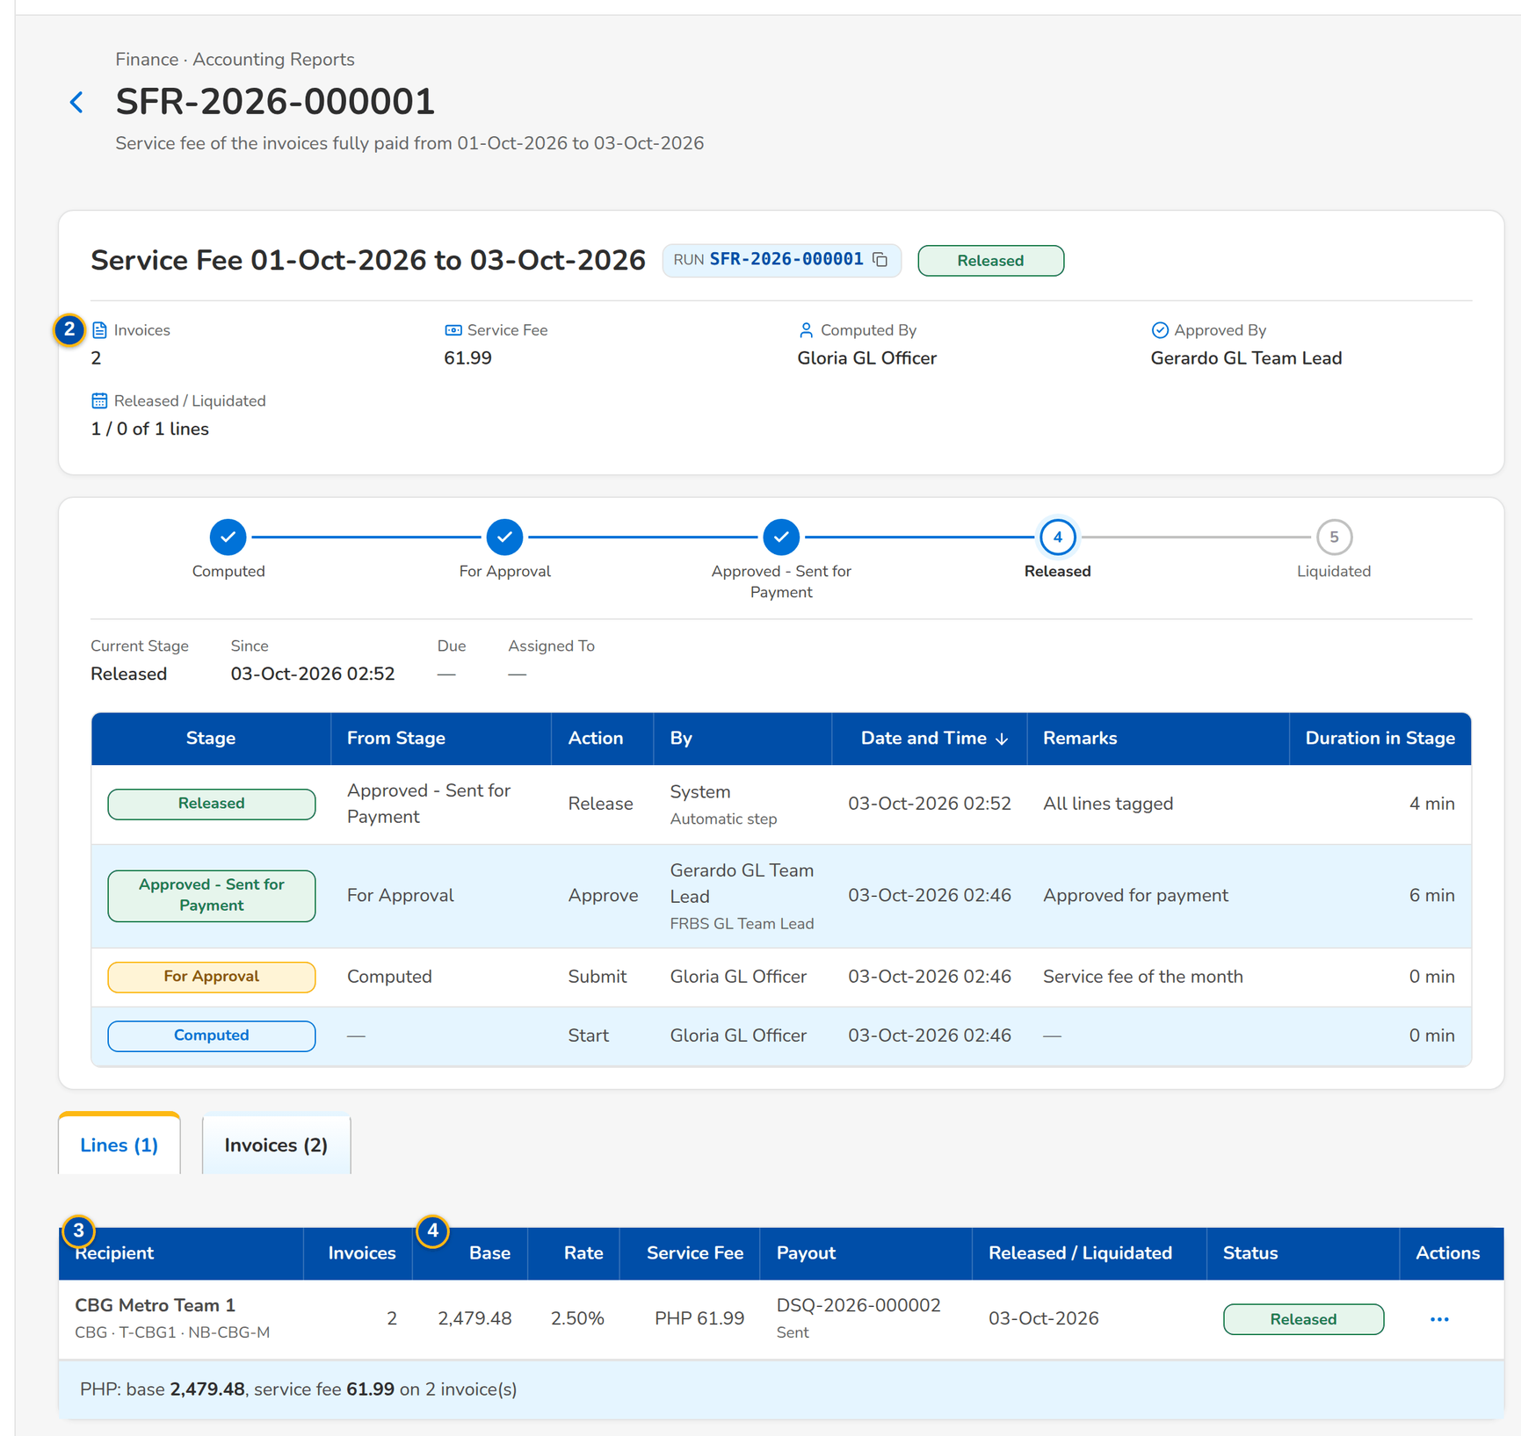
Figure 57: SCR-AC-22 A service-fee run sent for payment: the lines per recipient with the payout and the tags
1 | Run chip, status pill | 3 | Recipient / Invoices / Base / Rate / Service Fee / Payout / Released / Liquidated / Status | 5 | Released On
2 | Invoices / Service Fee / Computed By / Approved By / Released / Liquidated | 4 | Invoice / Insurer / Segment / Fully Paid / Commission / Withholding Tax / Base / Service Fee | 6 | Liquidated On / Liquidation Report / Remarks

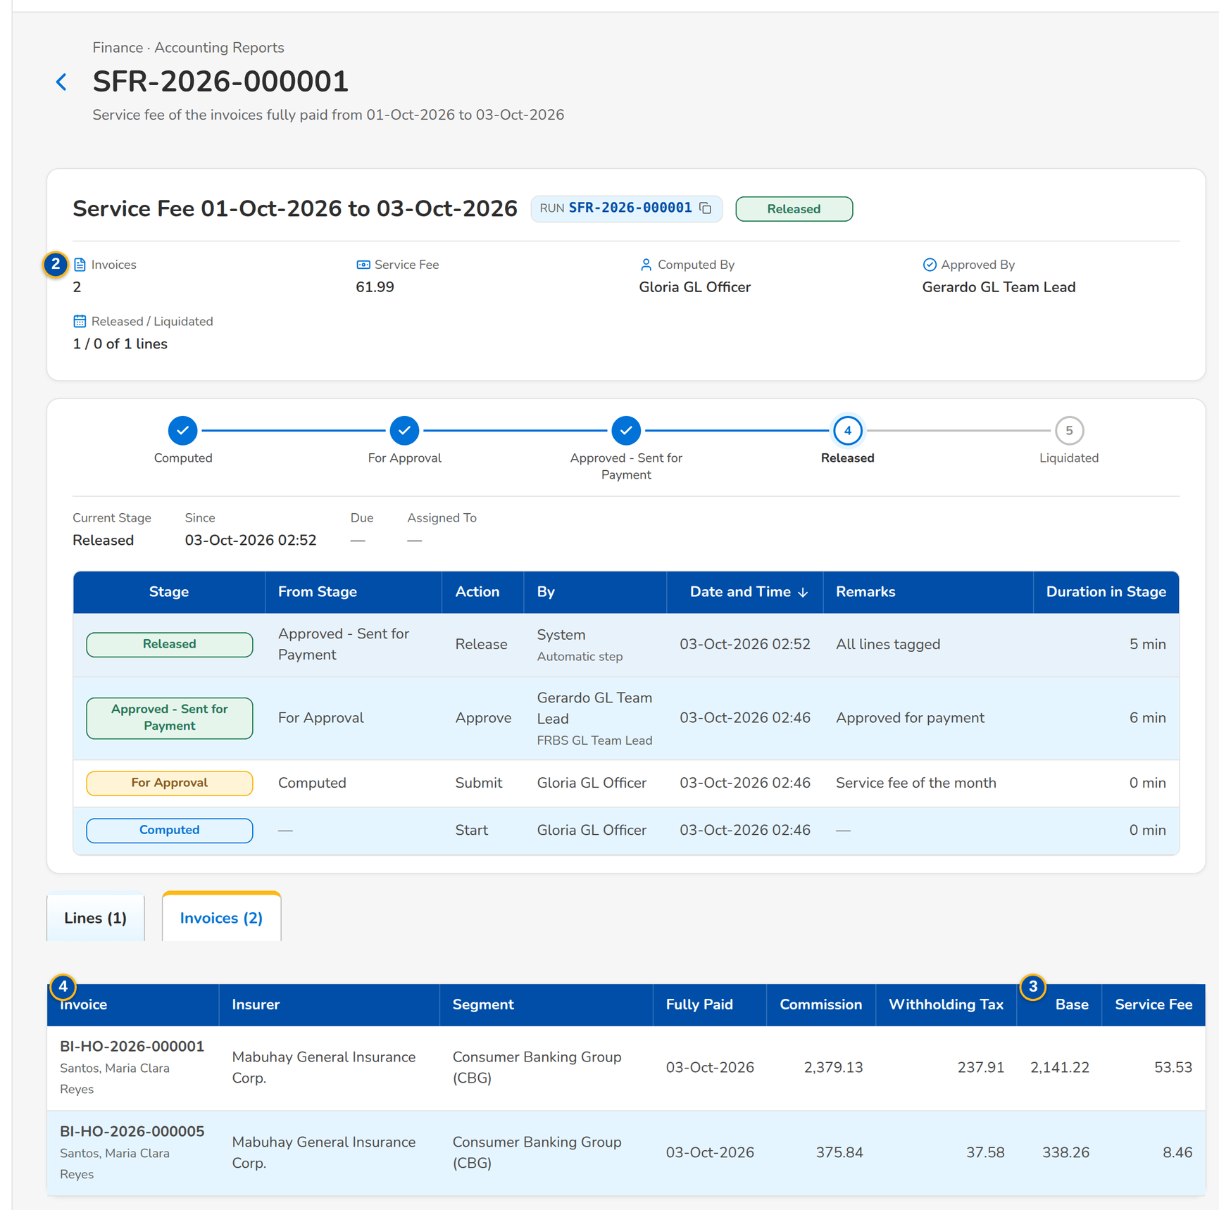
Figure 58: SCR-AC-22 The invoices of the run with the commission, withholding tax, base and service fee

Fields (No. = callout number on the first screenshot)
No. | Section | Field | Type | Length / format | Mand. | Source / list | Default | Editable in | Validation | Message when it fails
1 | Header | Run chip, status pill | Reference chip, status pill | Run number; Computed, For Approval, Sent for Payment, Released, Liquidated or Cancelled | - | Service-fee run | - | Read only | - | -
2 | Facts | Invoices / Service Fee / Computed By / Approved By / Released / Liquidated | Display | Count, amount, names, tag counts | - | Service-fee run | - | Read only | - | -
3 | Lines | Recipient / Invoices / Base / Rate / Service Fee / Payout / Released / Liquidated / Status | Column | One row per recipient; the payout request and the voucher of Disbursement; the dates tagged | - | Service-fee lines | - | Read only | - | -
4 | Invoices | Invoice / Insurer / Segment / Fully Paid / Commission / Withholding Tax / Base / Service Fee | Column | The invoices of the run; insurer by name | - | Service-fee run | - | Read only | - | -
5 | Tag Released dialog | Released On | Date | dd-MMM-yyyy, not in the future | Y | - | Today | Sent for payment | Not in the future | -
6 | Tag Liquidated dialog | Liquidated On / Liquidation Report / Remarks | Date, file, text | dd-MMM-yyyy; the liquidation report of the recipient | Y / Y / N | - | Today | Released | Not before the release | -

Actions
Button | Who | Enabled when | What happens | Resulting status | Notification
Recompute | GL Officer (service fee manage) | Computed | Computes the run again | Computed | -
Submit for Approval | Preparer (service fee manage) | Computed | Sends the run for approval with a comment | For Approval | Workflow notice
Approve and Send for Payment | GL Team Lead (service fee approve), not the preparer | For approval | Accrues every line and sends each payout to Disbursement as a payment request | Sent for Payment | Workflow notice
Tag Released / Tag Liquidated / Send Again | GL Officer, GL Team Lead (service fee tag) | As the line allows | Records the release or the liquidation of the line, or sends a payout again | Released or Liquidated | -

Business rules
• A run is approved by another user than its preparer (FR-AC-052).
• On approval each line is accrued (service fee expense with its cost centre against service fee payable) and its payout becomes a payment request in Disbursement (FR-AC-052, FR-DS-020).
• The run is Released when every paid line is released and Liquidated when every line is liquidated (FR-AC-053).
Expected outcome
The service fee is approved, paid through Disbursement and tagged.
Test cases: TC-AC-052.2-01, TC-AC-052.2-02, TC-AC-052.3-01, TC-AC-052.3-02, TC-AC-053.1-01, TC-AC-053.2-01, TC-AC-053.3-01, TC-AC-053.3-02, TC-AC-053.3-03, TC-AC-053.3-04, TC-AC-SCR-22, TC-AC-MSG-16.

13.3.7 SCR-AC-23 Service Fee Rates
Purpose | The rate of each service-fee segment with the market segments it covers, its base and effective dates, and the recipient of each sales unit with the payee and the cost centre of its payouts. The GL Team Lead maintains them; runs already computed keep their rates.
Who can open it | GL Officer (FRBS), GL Team Lead, GL Section Head, Comptrollership (read access), System Administrator, Auditor (permission Service fee approve or Service fee manage or Service fee approve or Service fee tag or FRBS report view)
Navigation | • Menu: Finance › Accounting Reports › Service Fee Rates
FRs | FR-AC-052

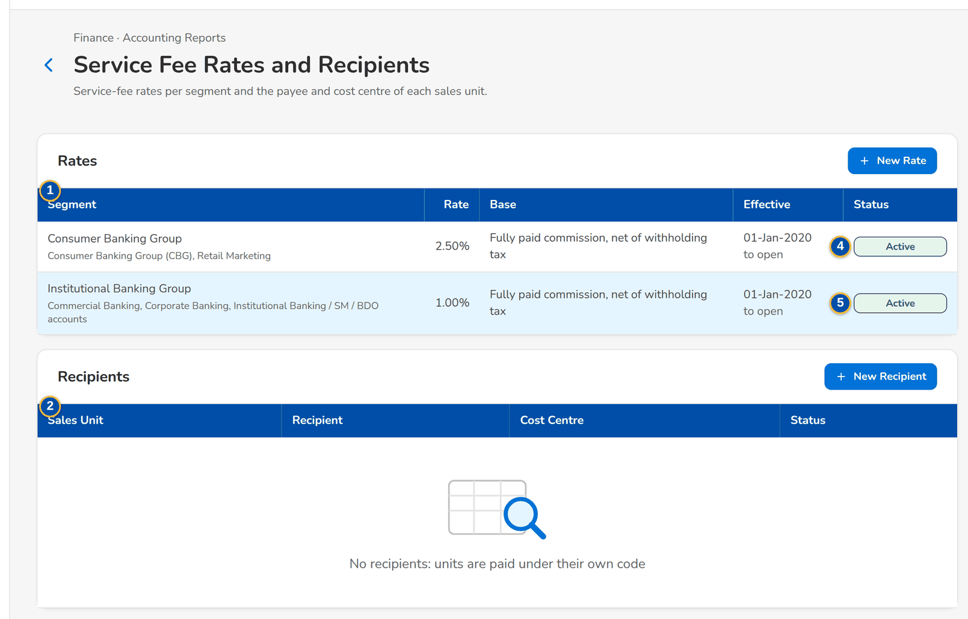
Figure 59: SCR-AC-23 Service Fee Rates and Recipients: the rates per segment and the recipients per sales unit
1 | Segment / Rate / Base / Effective / Status | 3 | Service-Fee Segment / Market Segments | 5 | Sales Unit / Payee Code / Payee Name / Cost Centre / Active
2 | Sales Unit / Recipient / Cost Centre / Status | 4 | Rate (%) / Effective From / Effective To / Commission net of withholding tax / Active

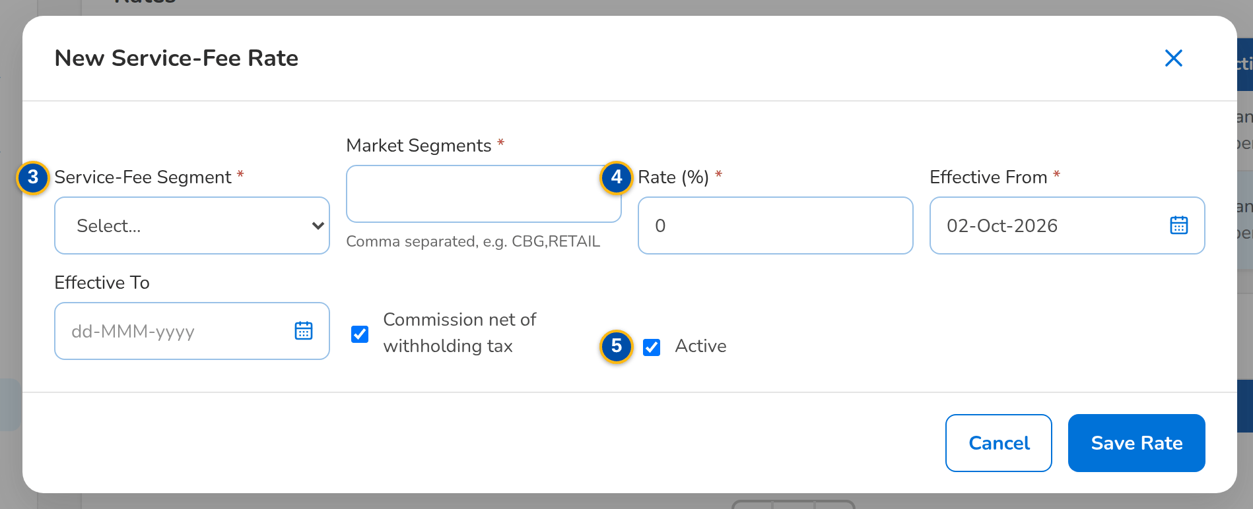
Figure 60: SCR-AC-23 New Service-Fee Rate: segment, market segments, rate and effective dates
Fields (No. = callout number on the first screenshot)
No. | Section | Field | Type | Length / format | Mand. | Source / list | Default | Editable in | Validation | Message when it fails
1 | Rates | Segment / Rate / Base / Effective / Status | Column | The segment by name with its market segments under it; rate in %; Fully paid commission, or net of withholding tax; the effective period on two lines | - | Service-fee rates | - | Read only | - | -
2 | Recipients | Sales Unit / Recipient / Cost Centre / Status | Column | The payee name with its code; the cost centre or By rule | - | Service-fee recipients | - | Read only | - | -
3 | Rate dialog | Service-Fee Segment / Market Segments | Drop-down, check boxes | The segment and the market segments it covers | Y | Service-fee segment and market segment lists | - | - | - | -
4 | Rate dialog | Rate (%) / Effective From / Effective To / Commission net of withholding tax / Active | Number, date, check box | Rate above zero; dates dd-MMM-yyyy | Y / Y / N / N / N | - | Active | - | To after From | -
5 | Recipient dialog | Sales Unit / Payee Code / Payee Name / Cost Centre / Active | Drop-down, text | The payee of the payouts of the unit; the cost centre, blank for the unit's or the rules' | Y / Y / Y / N / N | Sales organisation, payees | - | - | - | -

Actions
Button | Who | Enabled when | What happens | Resulting status | Notification
New Rate / Save Rate | GL Team Lead (service fee approve or manage) | Always | Adds or changes a rate | - | -
New Recipient / Save Recipient | GL Team Lead | Always | Adds or changes a recipient | - | -

Business rules
• A computed run keeps the rates of its computation; a new rate applies to the runs computed after it (FR-AC-052).
Expected outcome
The rates and recipients of the service fee are kept by the GL team.
Test cases: TC-AC-052.4-03, TC-AC-052.4-04, TC-AC-SCR-23, TC-AC-MSG-17.

13.3.8 SCR-AC-24 BIR Forms & Books
Purpose | The BIR returns, alphalists, books of accounts and the IC broker statement for a year, quarter or month: each output opens in the report runner and exports to Excel or PDF.
Who can open it | GL Officer (FRBS), GL Team Lead, GL Section Head, Accountant (bank reconciliation), Comptrollership administrator (masters and rules), Disbursement Processor, Disbursement Team Leader, Auditor (permission Tax view)
Navigation | • Menu: Finance › Tax & Statutory › BIR Forms & Books  • Certificates Received › SAWT
FRs | FR-AC-063

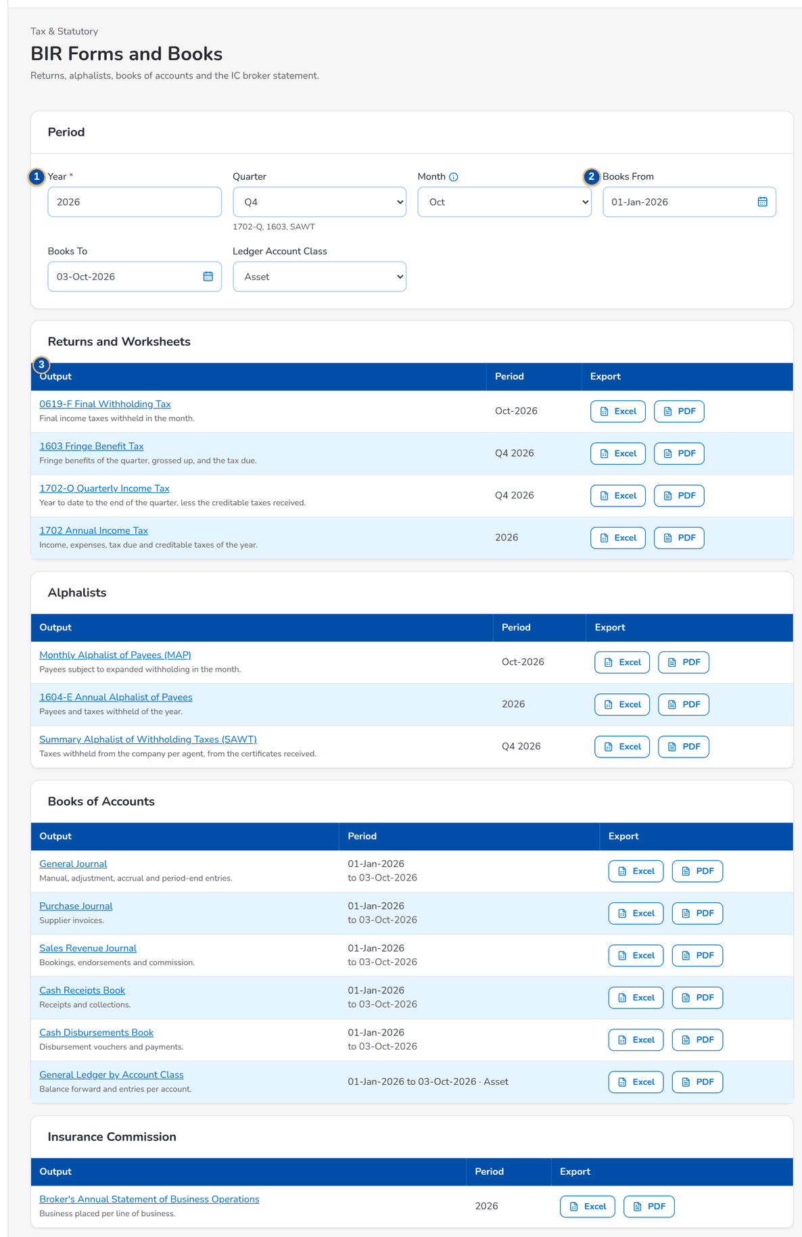
Figure 61: SCR-AC-24 BIR Forms and Books: the period and the returns, alphalists and books
1 | Year / Quarter / Month | 2 | Books From / Books To / Ledger Account Class | 3 | Output / Period / Export

Fields (No. = callout number on the first screenshot)
No. | Section | Field | Type | Length / format | Mand. | Source / list | Default | Editable in | Validation | Message when it fails
1 | Period | Year / Quarter / Month | Number, drop-down | The year; the quarter of 1702-Q, 1603 and SAWT; the month of MAP and 0619-F | Y / N / N | - | Current | - | A valid year | -
2 | Period | Books From / Books To / Ledger Account Class | Date, drop-down | The period of the books of accounts and the class of the subsidiary ledger | N | - | The year | - | - | -
3 | Outputs | Output / Period / Export | Column | The output with its form number and description; the period it covers; the export formats | - | Tax outputs | - | Read only | - | -

Actions
Button | Who | Enabled when | What happens | Resulting status | Notification
Output title | Users with tax view | Always | Opens the output in the report runner | - | -
Excel or PDF | Users with tax view | Always | Exports the output for the period | - | -

Business rules
• The returns and books are worksheets and loose-leaf books produced from the ledger; electronic filing files are not produced (FR-AC-063).
Expected outcome
The GL team prepares the BIR returns and books of the period.
Test cases: TC-AC-063.1-01, TC-AC-063.2-01, TC-AC-063.2-02, TC-AC-063.3-01, TC-AC-063.3-02, TC-AC-063.3-03, TC-AC-063.1-02, TC-AC-SCR-24.

13.4 Disbursement

13.4.1 SCR-AC-25 Disbursement Workbench
Purpose | The work of Disbursement: the counts For Approval, In Process, Waiting for Payee and Unregularised; the payment requests received from the other units (System Requests) and those waiting for their payee (No Payee); then the vouchers by stage (In Process, For Review, For Approval, Approved, Cancelled / Rejected). A request opens its details with Create Voucher and Return to Source; the approver approves the selected vouchers at once.
Who can open it | Disbursement Processor, Disbursement Team Leader, Disbursement Approver, Comptrollership (read access), System Administrator, Auditor (permission Disb view or Disb process or Disb review or Disb approve or Disb payee maintain or Disb payee authorize or Disb funding request or Disb funding verify or Disb funding approve or Disb EOD)
Navigation | • Menu: Finance › Disbursement › Disbursement Workbench  • Service Fee Run, Request › the payment request sent to Disbursement
FRs | FR-DS-020, FR-DS-021, FR-DS-022, FR-DS-025, FR-DS-040, FR-DS-041, FR-DS-045

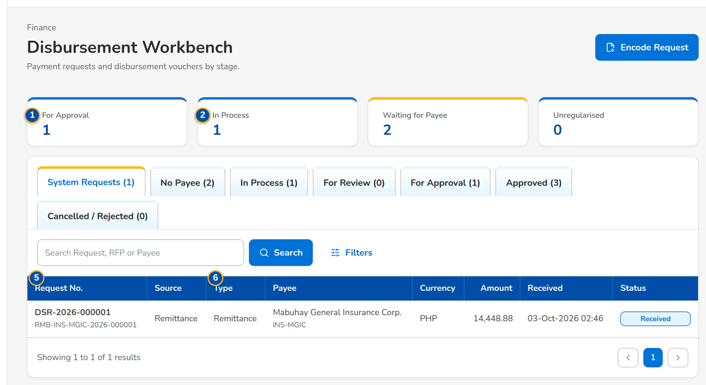
Figure 62: SCR-AC-25 Disbursement Workbench: the counts and the system requests received
1 | For Approval / In Process / Waiting for Payee / Unregularised | 4 | Disbursement Type / Received From / Received To | 7 | Source / RFP No. / Payee / Type / Amount / Purpose / Root invoice / Status
2 | System Requests / No Payee / In Process / For Review / For Approval / Approved / Cancelled / Rejected | 5 | Request No. / Source / Type / Payee / Currency / Amount / Received / Status | 8 | Reason / Comment
3 | Search Request, RFP or Payee / Search DV, Payee or Invoice | 6 | DV No. / Type / Payee / Mode / Net Amount / Currency / Flags / Status

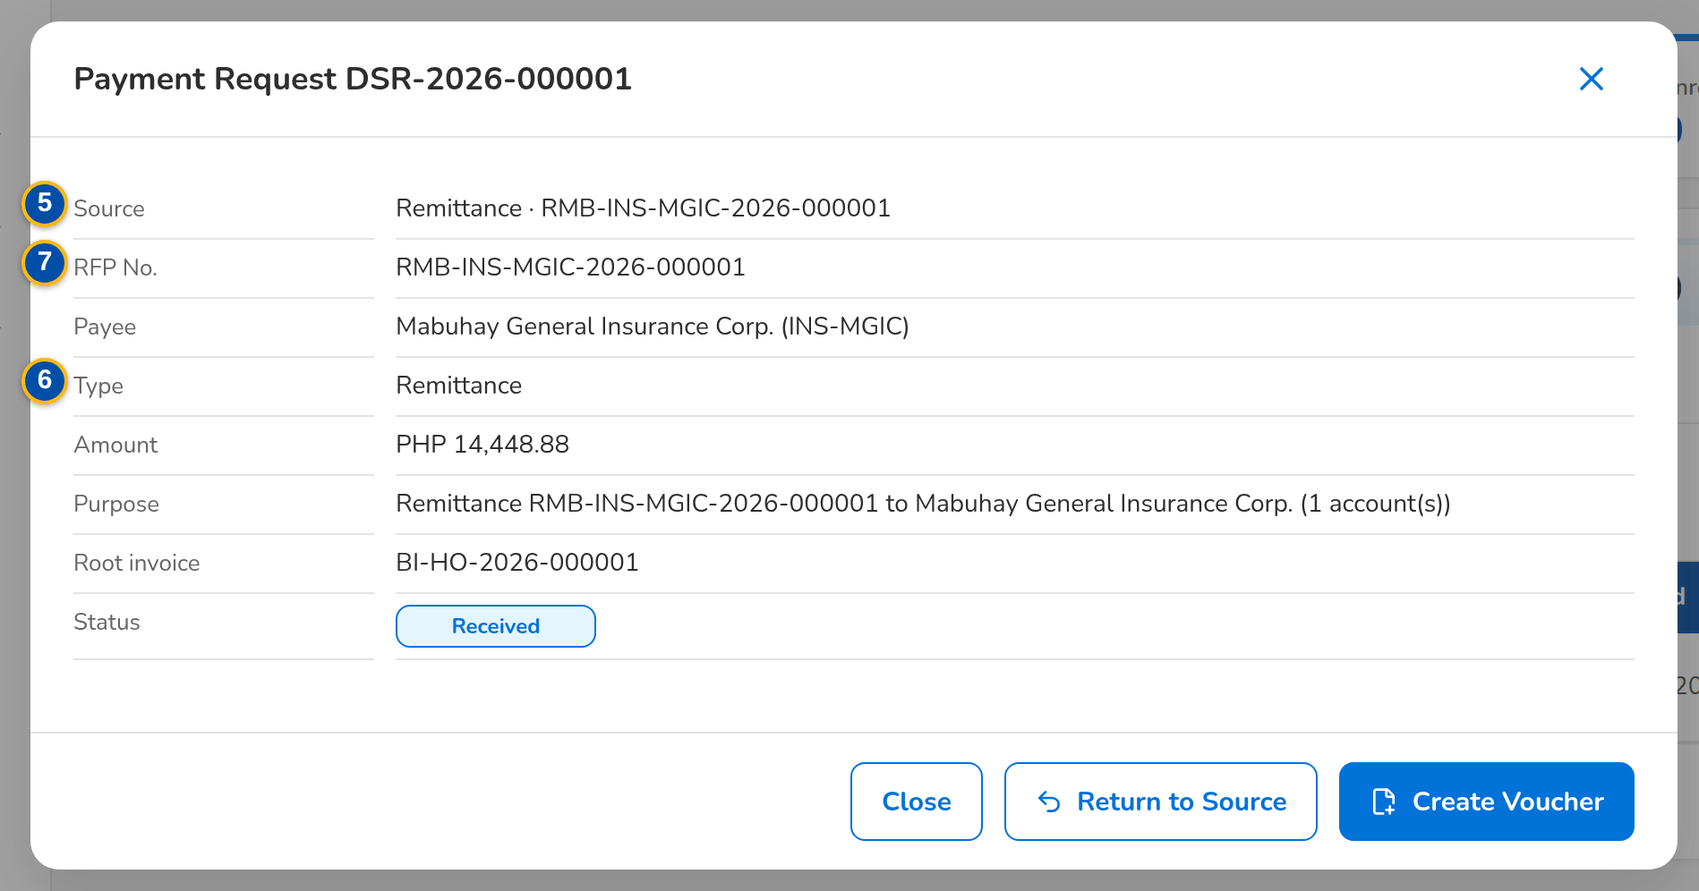
Figure 63: SCR-AC-25 Payment Request: source, payee, type, amount and purpose, with Create Voucher and Return to Source
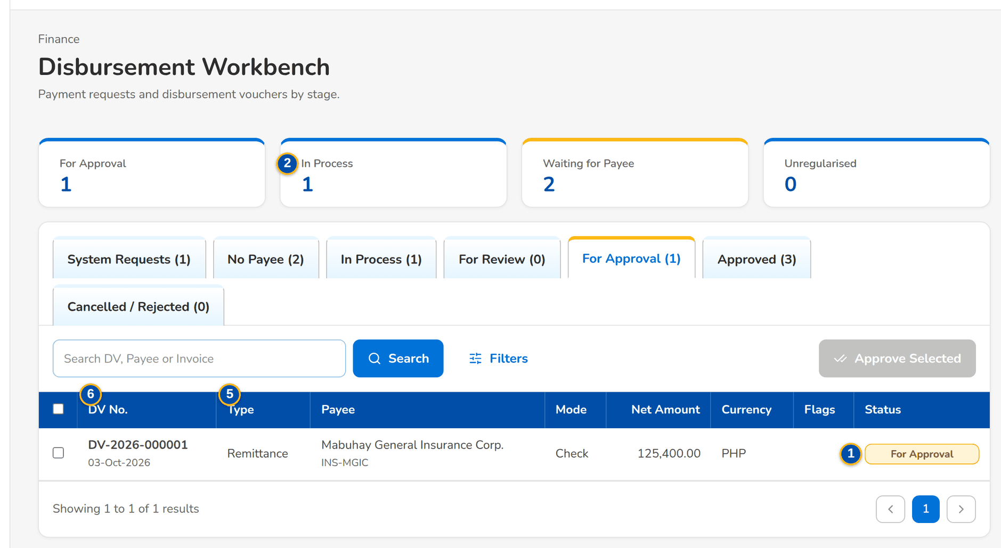
Figure 64: SCR-AC-25 For Approval: the vouchers waiting for the approver, selected for Approve Selected
Fields (No. = callout number on the first screenshot)
No. | Section | Field | Type | Length / format | Mand. | Source / list | Default | Editable in | Validation | Message when it fails
1 | Counts | For Approval / In Process / Waiting for Payee / Unregularised | Display | Live counts; Waiting for Payee and Unregularised highlighted when above zero | - | Requests and vouchers | - | Read only | - | -
2 | Tabs | System Requests / No Payee / In Process / For Review / For Approval / Approved / Cancelled / Rejected | Tab | With the count of each | - | Requests and vouchers | System Requests | - | - | -
3 | Toolbar | Search Request, RFP or Payee / Search DV, Payee or Invoice | Text | Request, RFP, DV, payee or invoice number | N | - | Blank | - | Contains | -
4 | Filters | Disbursement Type / Received From / Received To | Drop-down, date | Remittance, Refund, Payment to supplier, Government, Employee-related, Service fee, Other; dd-MMM-yyyy | N | Disbursement type list | All types | - | - | -
5 | Requests | Request No. / Source / Type / Payee / Currency / Amount / Received / Status | Column | Request number with the RFP or the source reference under it; the source unit; payee name with its code; date and time | - | Payment requests | - | Read only | - | -
6 | Vouchers | DV No. / Type / Payee / Mode / Net Amount / Currency / Flags / Status | Column | DV number with its date; the mode of payment; flags Automatic, Entry Edited, Posting Failed | - | Vouchers | - | Read only | - | -
7 | Payment Request dialog | Source / RFP No. / Payee / Type / Amount / Purpose / Root invoice / Status | Display | The request as received | - | Payment request | - | Read only | - | -
8 | Return dialog | Reason / Comment | Drop-down, text area | The return reasons of Disbursement | Y / N | Disbursement return reason list | Blank | Received, No payee | - | Choose a reason

Actions
Button | Who | Enabled when | What happens | Resulting status | Notification
Encode Request | Disbursement Processor, Team Leader (disbursement process) | Always | Opens Encode Payment Request | - | -
Create Voucher | Disbursement Processor (disbursement process) | Received request with its payee maintained | Creates the voucher with its proforma entry and opens it | In Process | -
Return to Source | Disbursement Processor | Received or No payee | Returns the request to its source unit with the reason | Returned | Workflow notice to the source
Release Documents | Disbursement Processor | A received BIR 2307 request | Releases the documents to the payee | Released | -
Approve Selected | Disbursement Approver (disbursement approve) | For Approval tab, vouchers selected | Approves and posts each selected voucher on its own after the confirmation; each failure is reported | Approved | Workflow notice
Row | Disbursement users | Always | Opens the request or the voucher | - | -

Business rules
• A request whose payee is not maintained waits under No Payee; a payee request is raised and the voucher is created once the payee is authorised (FR-DS-020, FR-DS-022).
• Requests are classified by disbursement type from their source and payee class (FR-DS-021).
• Approving several vouchers approves each on its own; a voucher that cannot be approved stays pending with its reason (FR-DS-041).
Expected outcome
Disbursement sees every request and voucher by stage and moves them on.
Test cases: TC-DS-001.3-01, TC-DS-020.1-01, TC-DS-020.2-01, TC-DS-020.3-03, TC-DS-021.1-01, TC-DS-025.1-01, TC-DS-041.2-01, TC-DS-041.3-01, TC-DS-043.1-01, TC-PQ-015.1-01, TC-PQ-015.2-01, TC-AC-SCR-25, TC-AC-MSG-18.

13.4.2 SCR-AC-26 Encode Payment Request
Purpose | A payment that does not come from another module (a request received by e-mail for a supplier, a government agency or an employee): the disbursement type, the payee, currency and amount, the RFP and invoice numbers, the expense account and cost centre and the purpose. Its voucher is created at once when the payee is maintained.
Who can open it | Disbursement Processor, Disbursement Team Leader (permission Disb process)
Navigation | • Menu: Encode Payment Request  • Disbursement Workbench › Encode Request
FRs | FR-DS-023

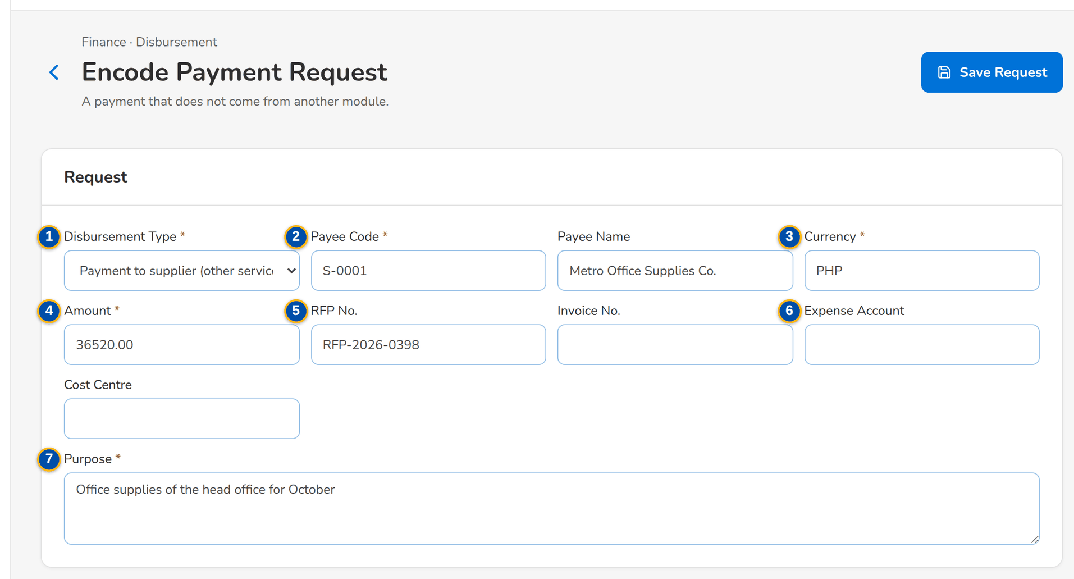
Figure 65: SCR-AC-26 Encode Payment Request: a supplier payment with its expense account and cost centre
1 | Disbursement Type | 4 | Amount | 7 | Purpose
2 | Payee Code / Payee Name | 5 | RFP No. / Invoice No.
3 | Currency | 6 | Expense Account / Cost Centre

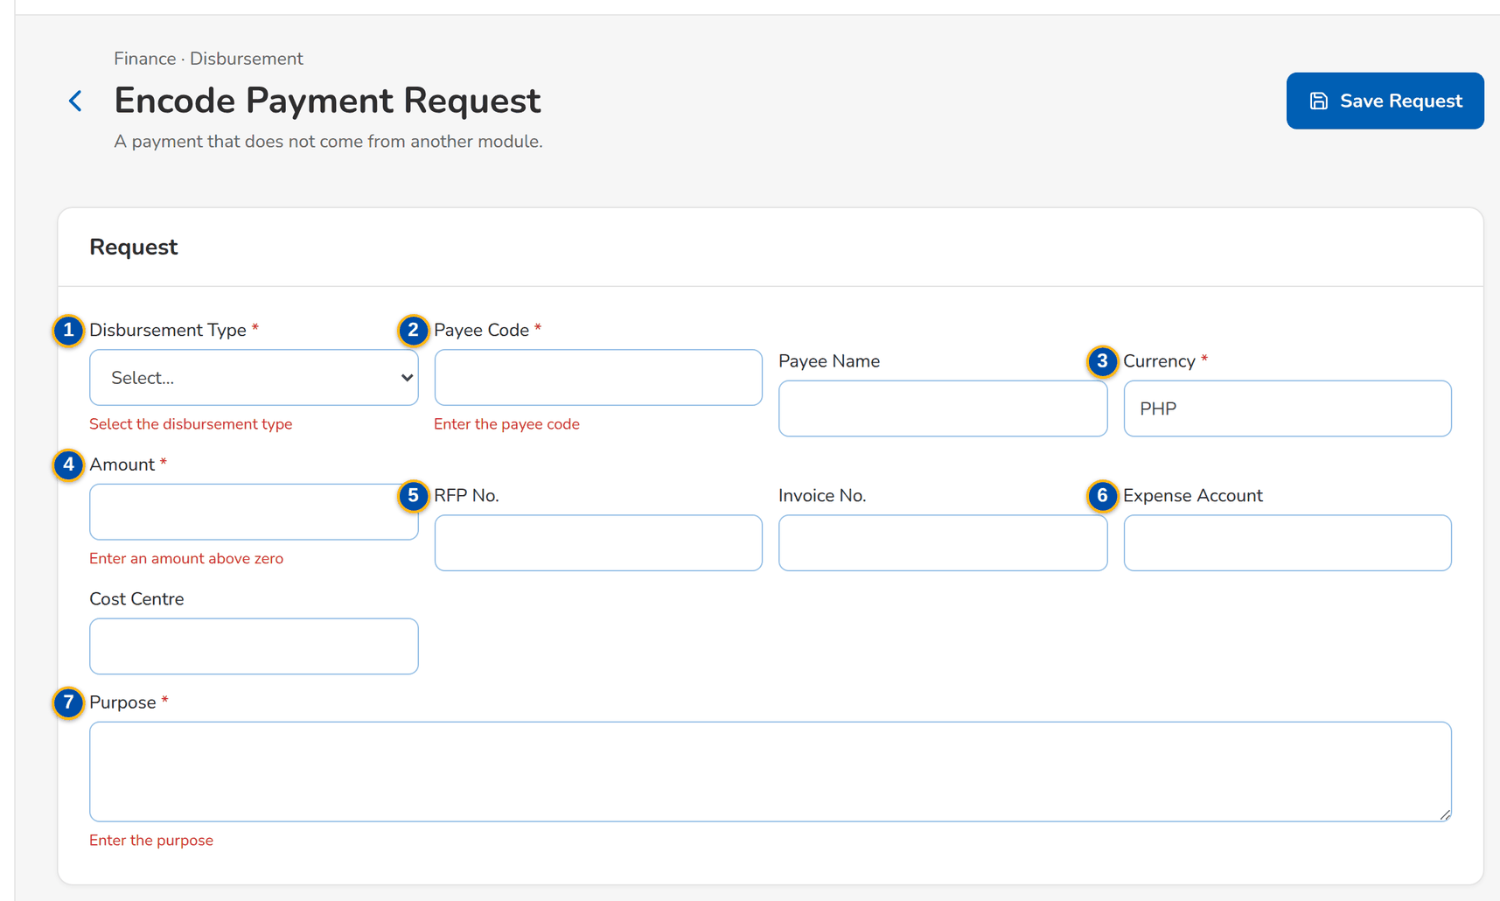
Figure 66: SCR-AC-26 The mandatory fields named under each field
Fields (No. = callout number on the first screenshot)
No. | Section | Field | Type | Length / format | Mand. | Source / list | Default | Editable in | Validation | Message when it fails
1 | Request | Disbursement Type | Drop-down | Remittance, Refund, Payment to supplier, Government, Employee-related, Other | Y | Disbursement type list | Blank | - | - | Select the disbursement type
2 | Request | Payee Code / Payee Name | Text | The code of a maintained payee; the name of a payee not yet maintained | Y / N | Payees | Blank | - | - | Enter the payee code
3 | Request | Currency | Text | Three-letter currency | Y | Currencies | Base currency | - | Three letters | Enter a 3-letter currency
4 | Request | Amount | Number | Above zero, two decimals | Y | - | Blank | - | Above zero | Enter an amount above zero
5 | Request | RFP No. / Invoice No. | Text | The Request for Payment and the invoice paid | N | - | Blank | - | - | -
6 | Request | Expense Account / Cost Centre | Text | The expense account and the cost centre of an other disbursement | Cond.: Other | Chart, cost centres | Blank | - | - | -
7 | Request | Purpose | Text area | Up to 500 characters | Y | - | Blank | - | - | Enter the purpose

Actions
Button | Who | Enabled when | What happens | Resulting status | Notification
Save Request | Disbursement Processor (disbursement process) | Mandatory fields filled | Saves the request; its voucher is created at once when the payee is maintained, else the request waits under No Payee | In Process or No payee | -

Business rules
• An encoded request gets its request number and follows the same voucher flow as a system request (FR-DS-023).
Expected outcome
The e-mailed request is in BIBS with its voucher.
Test cases: TC-DS-021.2-01, TC-DS-023.1-01, TC-DS-023.2-01, TC-DS-023.2-02, TC-AC-SCR-26, TC-AC-MSG-01.

13.4.3 SCR-AC-27 Disbursement Voucher
Purpose | One disbursement voucher (DV): the payee, type, mode, net amount and paying account; the voucher workflow (submit for review, route to the approver, submit for approval, approve and post, reject, cancel); the tabs Details (the terms), Entry (the proforma entry from the rule, editable before approval, with the expense allocation), Instrument (the payment document and its statuses), OR / AR and CWT (the tags), Documents and E-mails.
Who can open it | Disbursement Processor, Disbursement Team Leader, Disbursement Approver, Comptrollership (read access), System Administrator, Auditor (permission Disb view or Disb process or Disb review or Disb approve)
Navigation | • Menu: Finance › Disbursement › Disbursement Workbench › Disbursement Voucher  • Disbursement Workbench › Create Voucher or open a voucher  • Encode Payment Request › saved
FRs | FR-DS-025, FR-DS-030, FR-DS-031, FR-DS-032, FR-DS-033, FR-DS-034, FR-DS-035, FR-DS-036, FR-DS-040, FR-DS-041, FR-DS-042, FR-DS-043, FR-DS-044, FR-DS-050, FR-DS-051, FR-DS-052, FR-DS-054, FR-DS-055, FR-DS-056, FR-DS-057, FR-DS-062, FR-DS-063

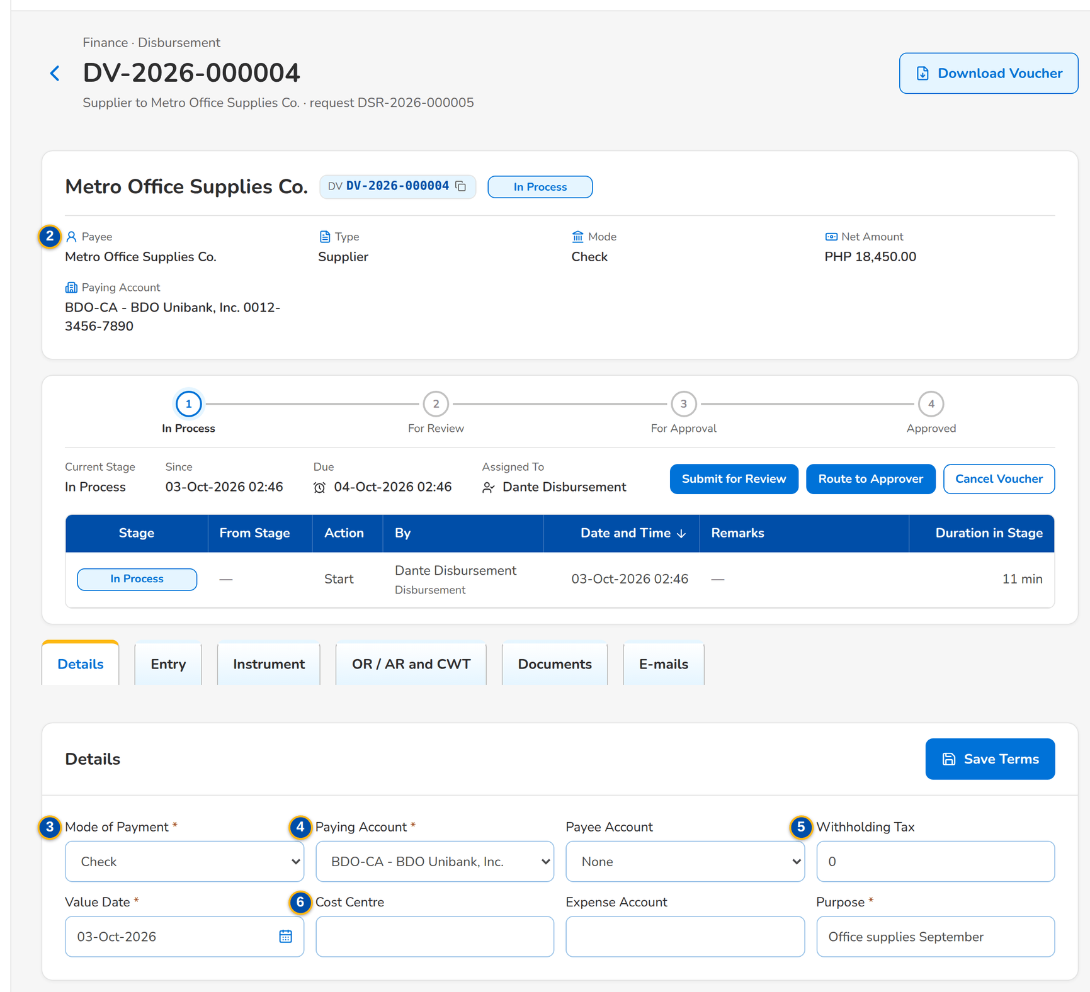
Figure 67: SCR-AC-27 A voucher in process: the header, the workflow and the terms of the Details tab
1 | DV chip, status pill, flags | 6 | Cost Centre / Expense Account / Purpose | 11 | Status History
2 | Payee / Type / Mode / Net Amount / Paying Account | 7 | Processor / checker / approver / Journal / reversal / Request | 12 | New Status / Reason
3 | Mode of Payment | 8 | Side / Account / Party / Cost Centre / Debit / Credit / Origin / Narration | 13 | Tag / Received / Released / Number / Date / Period / Received / Released On / Amount / Tagged By
4 | Paying Account / Payee Account | 9 | Account n / Cost Centre / Amount | 14 | Received / Released / OR / AR No. / Certificate No. / Receipt Date / Period From / Period To / Amount
5 | Withholding Tax / Value Date | 10 | Status / Amount / Reference / Released to

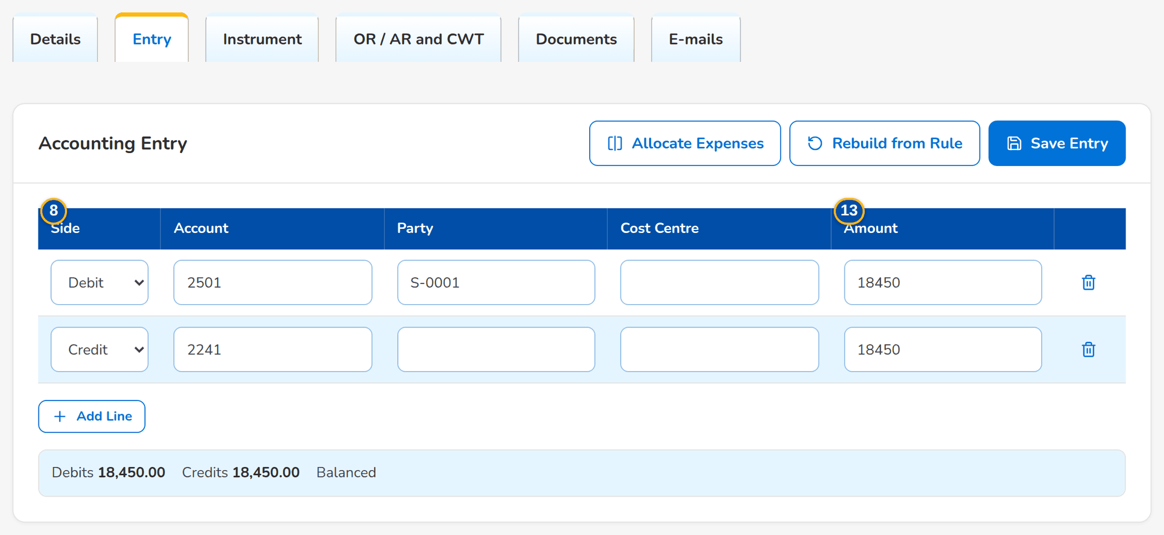
Figure 68: SCR-AC-27 Entry tab: the proforma entry from the rule, its totals and the expense allocation
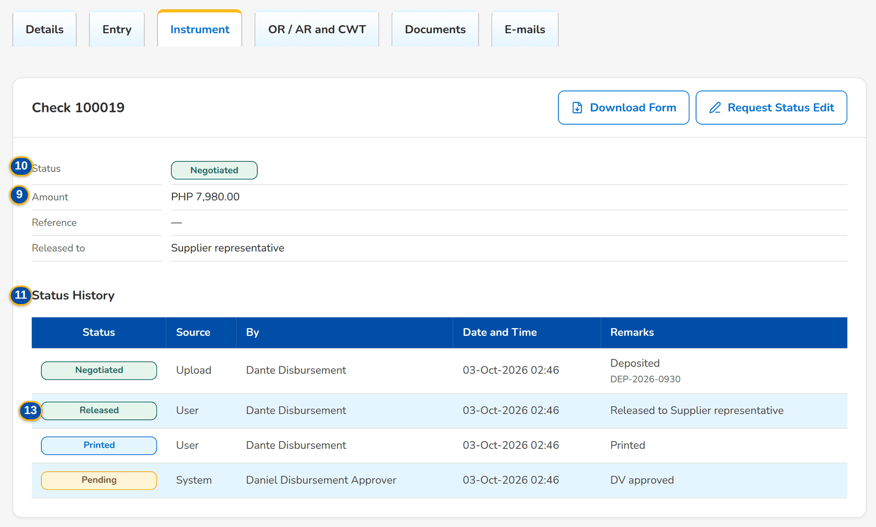
Figure 69: SCR-AC-27 Instrument tab of a check: status, amount, released to and the status history
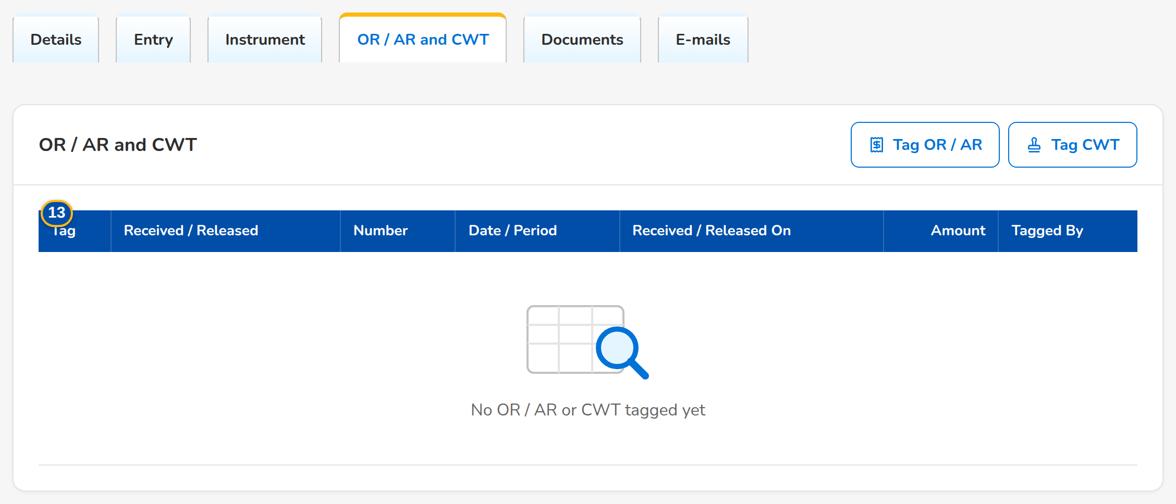
Figure 70: SCR-AC-27 OR / AR and CWT tab: the receipts and certificates tagged on the voucher
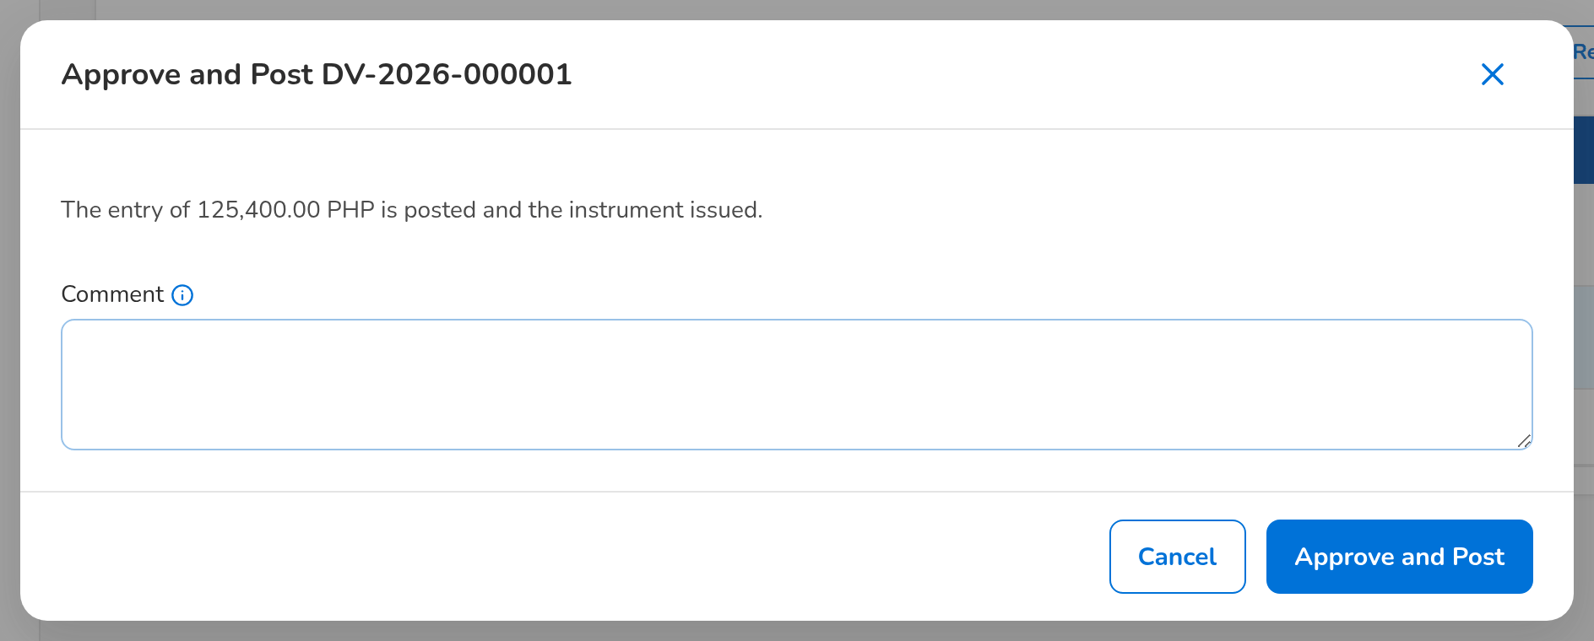
Figure 71: SCR-AC-27 Approve and Post: the entry posted and the instrument issued on confirmation
Fields (No. = callout number on the first screenshot)
No. | Section | Field | Type | Length / format | Mand. | Source / list | Default | Editable in | Validation | Message when it fails
1 | Header | DV chip, status pill, flags | Reference chip, status pill, tag | DV number; In Process, For Review, For Approval, Approved, Cancelled, Rejected; Automatic, Entry Edited, posting status | - | Voucher | - | Read only | - | -
2 | Facts | Payee / Type / Mode / Net Amount / Paying Account | Display | Payee code; disbursement type; mode of payment; currency and net amount | - | Voucher | - | Read only | - | -
3 | Details | Mode of Payment | Drop-down | The modes allowed for the payee: Credit to Account, Authority to Debit, Manager's Check / Demand Draft, Credit Ticket, Telegraphic Transfer, Online Banking, Check | Y | Payee | Default mode of the payee | In process | A mode allowed for the payee | -
4 | Details | Paying Account / Payee Account | Drop-down | Active BDOIR account in the voucher currency; the payee account credited | Y / Cond.: credit modes | Bank accounts, payee accounts | Blank | In process | - | Select the payee account credited
5 | Details | Withholding Tax / Value Date | Number, date | Zero or more, below the gross; dd-MMM-yyyy | N / Y | Payee tax profile | Today | In process | Below the gross | The withholding tax must be at least zero and below the gross
6 | Details | Cost Centre / Expense Account / Purpose | Text | Expense account mandatory for an other disbursement | N / Cond.: other / Y | Chart, cost centres | From the request | In process | - | Enter the expense account of an other disbursement
7 | Details | Processor / checker / approver / Journal / reversal / Request | Display | Names of the users; the journal posted and its reversal; the request with its source | - | Voucher | - | Read only | - | -
8 | Entry | Side / Account / Party / Cost Centre / Debit / Credit / Origin / Narration | Column | The proforma lines; From rule, or edited by the processor | - | Accounting rule | - | In process | Debits equal credits | Not balanced
9 | Allocate Expenses dialog | Account n / Cost Centre / Amount | Text, number | The rows replace the debit of the disbursement type and add up to the gross | Y / N / Y | Chart, cost centres | - | In process | Total equals the gross | -
10 | Instrument | Status / Amount / Reference / Released to | Display | The instrument of the mode with its number | - | Instrument | - | Read only | - | The instrument is issued when the voucher is approved
11 | Instrument | Status History | Column | Status / Source / By / Date and Time / Remarks | - | Instrument | - | Read only | - | -
12 | Request Status Edit dialog | New Status / Reason | Drop-down, text | The status to set and why | Y | Instrument statuses | - | Approved | - | -
13 | OR / AR and CWT | Tag / Received / Released / Number / Date / Period / Received / Released On / Amount / Tagged By | Column | The tags of the voucher | - | Tags | - | Read only | - | -
14 | Tag dialog | Received / Released / OR / AR No. / Certificate No. / Receipt Date / Period From / Period To / Amount | Drop-down, text, date, number | Received from insurer or Released to supplier | Y | - | - | Approved | - | -

Actions
Button | Who | Enabled when | What happens | Resulting status | Notification
Save Terms | Disbursement Processor | In process | Saves the terms; the entry is prepared again from the rule | In Process | -
Save Entry / Rebuild from Rule / Add Line / Allocate Expenses | Disbursement Processor | In process | Saves the edited entry (marked Entry Edited), prepares it again from the rule, or allocates the expenses by cost centre | In Process | -
Submit for Review | Disbursement Processor | In process and nothing missing | Sends the voucher to the team leader | For Review | Workflow notice
Route to Approver | Disbursement Processor | In process, refund or remittance | Sends the voucher straight to the approver | For Approval | Workflow notice
Submit for Approval | Disbursement Team Leader (disbursement review), not the processor | For review | Sends the voucher to the approver | For Approval | Workflow notice
Approve and Post | Disbursement Approver (disbursement approve), not the processor or the checker | For approval | Posts the entry and issues the instrument after the confirmation | Approved | Workflow notice to the source
Reject / Cancel Voucher | Approver; Processor or Team Leader before approval; Approver after approval | As the stage allows | Rejects or cancels with the reason; an approved voucher is reversed and its request goes back to its source | Rejected or Cancelled | Workflow notice to the source
Print / Release / Email to Branch / Confirm Debit / Receive from Branch / Re-issue Check | Disbursement Processor | As the mode and the status allow | Moves the instrument to its next status | Printed, Released, Emailed, Debited, Received or Stale re-issued | -
Request Status Edit / Approve Status Edit | Processor; Team Leader (status approve), not the requester | Approved voucher | Changes the instrument status with approval | As requested | -
Tag OR / AR / Tag CWT | Disbursement Processor (disbursement tag) | Approved voucher | Records the receipt or the certificate on the voucher | Regularised | -
Download Voucher / Download Form | Disbursement users | Always / instrument with a form | Downloads the voucher or the bank form | - | -

Business rules
• A voucher is checked and approved by other users than its processor; refund and remittance vouchers are routed straight to the approver (FR-DS-036, FR-DS-040, FR-DS-041).
• The proforma entry comes from the accounting rule of the disbursement type; edited lines are marked for the approver and the entry must balance (FR-DS-031).
• Approval posts the entry and issues the instrument of the mode; a cancelled approved voucher is reversed and its request goes back to its source for regularisation (FR-DS-041, FR-DS-044).
• An instrument status edit is approved by the team leader, not by the requester (FR-DS-051).
• A check not negotiated after 180 days becomes stale and is re-issued through a new request (FR-DS-054).
• Every approved voucher counts as unregularised until its OR / AR is tagged (FR-DS-045, FR-DS-056).
Expected outcome
The voucher is checked, approved, paid and regularised.
Test cases: TC-DS-011.2-01, TC-DS-025.2-01, TC-DS-025.3-01, TC-DS-030.1-01, TC-DS-030.2-01, TC-DS-030.2-02, TC-DS-030.2-03, TC-DS-030.3-01, TC-DS-031.1-01, TC-DS-031.1-02, TC-DS-031.2-01, TC-DS-032.1-01, TC-DS-032.1-02, TC-DS-033.1-01, TC-DS-033.2-03, TC-DS-034.1-01, TC-DS-035.1-01, TC-DS-035.2-01, TC-DS-036.1-01, TC-DS-036.2-01, TC-DS-040.1-01, TC-DS-040.1-02, TC-DS-040.1-03, TC-DS-040.2-01, TC-DS-041.1-01, TC-DS-042.1-01, TC-DS-042.2-01, TC-DS-043.2-01, TC-DS-044.1-01, TC-DS-044.3-01, TC-DS-044.3-02, TC-DS-045.2-01, TC-DS-050.1-01, TC-DS-050.2-01, TC-DS-051.1-01, TC-DS-051.1-02, TC-DS-051.2-01, TC-DS-051.2-02, TC-DS-051.2-03, TC-DS-051.2-04, TC-DS-054.1-01, TC-DS-054.2-01, TC-DS-054.2-02, TC-DS-055.1-01, TC-DS-055.1-02, TC-DS-055.2-01, TC-DS-056.1-01, TC-DS-056.1-02, TC-DS-056.2-01, TC-DS-057.1-02, TC-DS-057.2-04, TC-AC-SCR-27, TC-AC-MSG-19, TC-AC-MSG-20, TC-AC-MSG-21, TC-AC-MSG-22.

13.4.4 SCR-AC-28 Payees
Purpose | The payee master: the payees by tab (Active, For Authorisation, Drafts, Inactive) with their class, default mode, primary account and source, and the Payee Requests raised by refunds, payment requests without payee and Disbursement users, which the team leader turns into payees or closes.
Who can open it | Disbursement Processor, Disbursement Team Leader, Disbursement Approver, Comptrollership (read access), System Administrator, Auditor (permission Disb view or Disb payee maintain or Disb payee authorize)
Navigation | • Menu: Finance › Disbursement › Payees
FRs | FR-DS-010, FR-DS-012, FR-DS-014

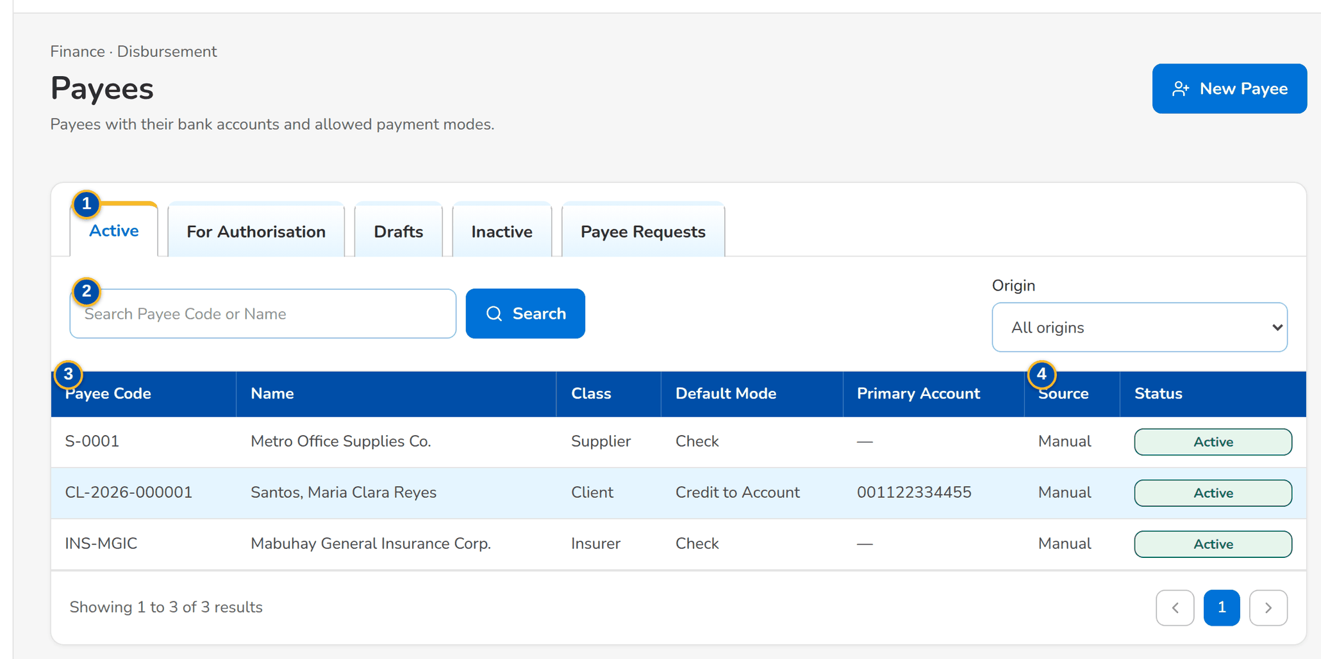
Figure 72: SCR-AC-28 Payees: the active payees with class, default mode, primary account and source
1 | Active / For Authorisation / Drafts / Inactive / Payee Requests | 3 | Payee Code / Name / Class / Default Mode / Primary Account / Source / Status
2 | Search Payee Code or Name | 4 | Source / Payee Code / Payee Name / Reference / Details / Received

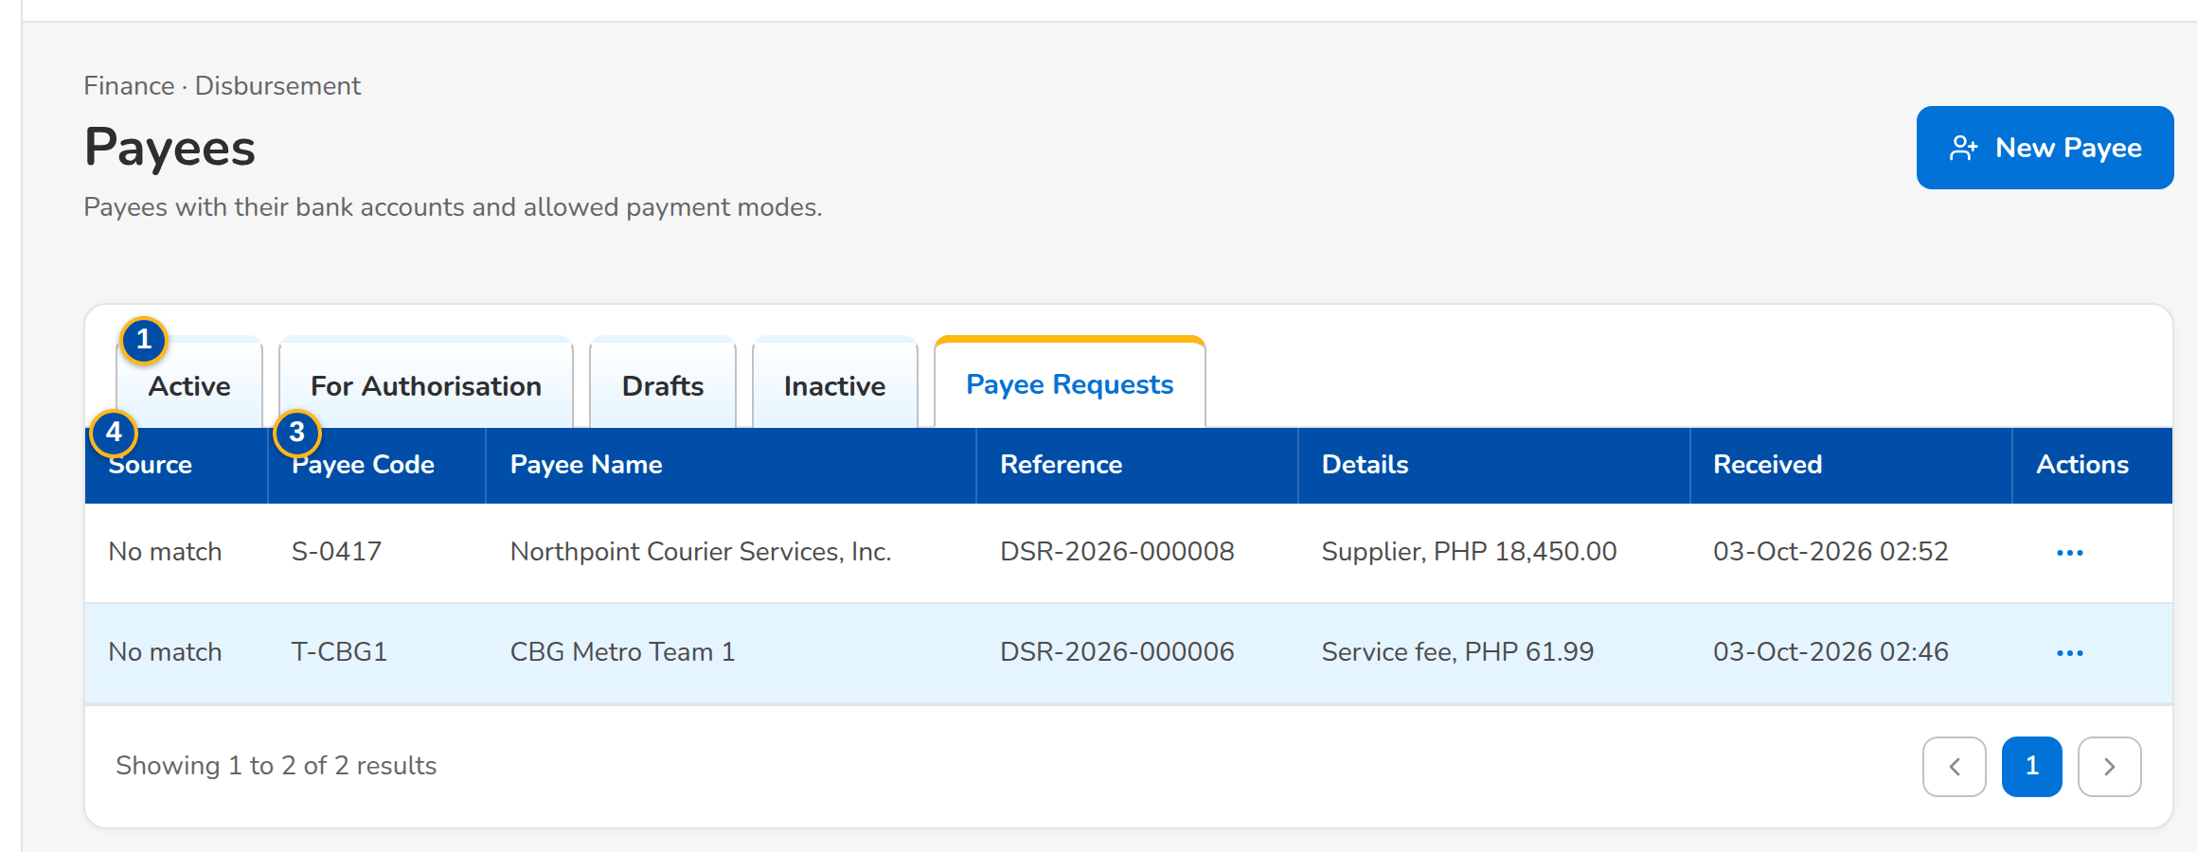
Figure 73: SCR-AC-28 Payee Requests: the requests to create a payee, with Create Payee and Close
Fields (No. = callout number on the first screenshot)
No. | Section | Field | Type | Length / format | Mand. | Source / list | Default | Editable in | Validation | Message when it fails
1 | Tabs | Active / For Authorisation / Drafts / Inactive / Payee Requests | Tab | - | - | Payees | Active | - | - | -
2 | Toolbar | Search Payee Code or Name | Text | Code or name | N | - | Blank | - | Contains | -
3 | List | Payee Code / Name / Class / Default Mode / Primary Account / Source / Status | Column | Class Supplier, Insurer, Employee, Client or Others; account masked for other units | - | Payees | - | Read only | - | -
4 | Payee Requests | Source / Payee Code / Payee Name / Reference / Details / Received | Column | Where the request comes from (a request without payee, a refund, a user) | - | Payee requests | - | Read only | - | -

Actions
Button | Who | Enabled when | What happens | Resulting status | Notification
New Payee | Disbursement Team Leader (payee maintain) | Always | Opens the new payee form | Draft | -
Create Payee / Close | Disbursement Team Leader (payee maintain) | A payee request | Opens the payee form with the request's code and name, or closes the request after the confirmation | - | -
Row | Disbursement users | Always | Opens the payee | - | -

Business rules
• A payee is used on vouchers only once the approver has authorised it; a request without a payee raises a payee request (FR-DS-010, FR-DS-012).
Expected outcome
Disbursement keeps one master of payees with every request answered.
Test cases: TC-DS-010.4-01, TC-DS-010.4-02, TC-DS-012.1-01, TC-DS-012.2-01, TC-DS-014.1-01, TC-AC-SCR-28, TC-AC-MSG-23.

13.4.5 SCR-AC-29 Payee
Purpose | One payee: code, class, name, TIN, e-mail, address, default mode, currency, default cost centre, the modes of payment allowed and remarks; its bank accounts; the payee workflow (submit, authorise, request deactivation or reactivation). A payee never used on a payment can be deleted.
Who can open it | Disbursement Processor, Disbursement Team Leader, Disbursement Approver, Comptrollership (read access), System Administrator, Auditor (permission Disb view or Disb payee maintain or Disb payee authorize)
Navigation | • Menu: Finance › Disbursement › Payees › Payee  • Payees › New Payee, Create Payee or open a row
FRs | FR-DS-010, FR-DS-011, FR-DS-013

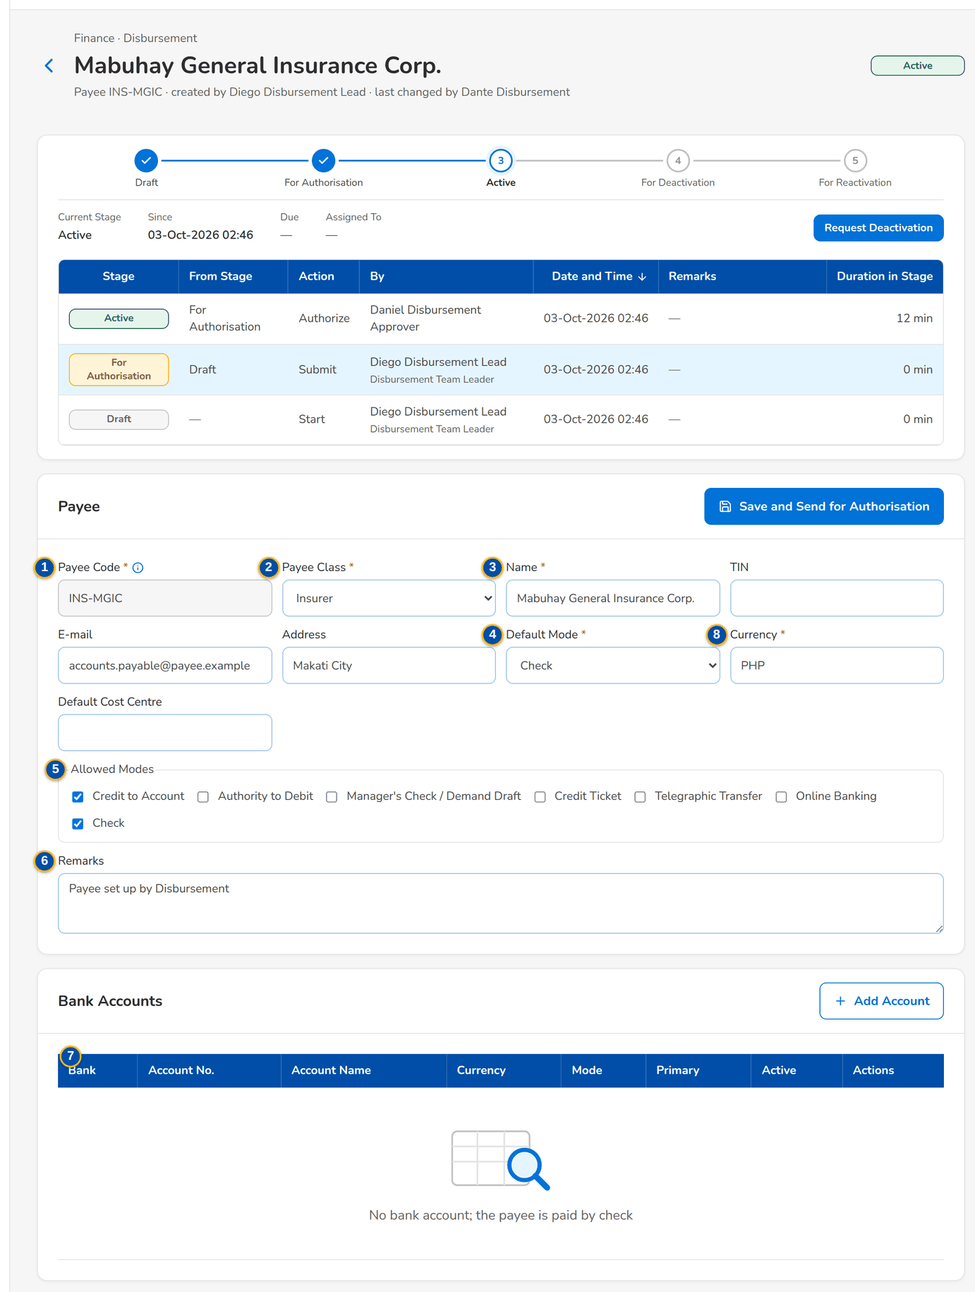
Figure 74: SCR-AC-29 An active payee: details, allowed modes and bank accounts
1 | Payee Code | 4 | Default Mode / Currency / Default Cost Centre | 7 | Bank / Account No. / Account Name / Currency / Mode / Primary / Active
2 | Payee Class | 5 | Allowed Modes | 8 | Bank / Branch / Account No. / Account Name / Currency / Mode / Primary account
3 | Name / TIN / E-mail / Address | 6 | Remarks

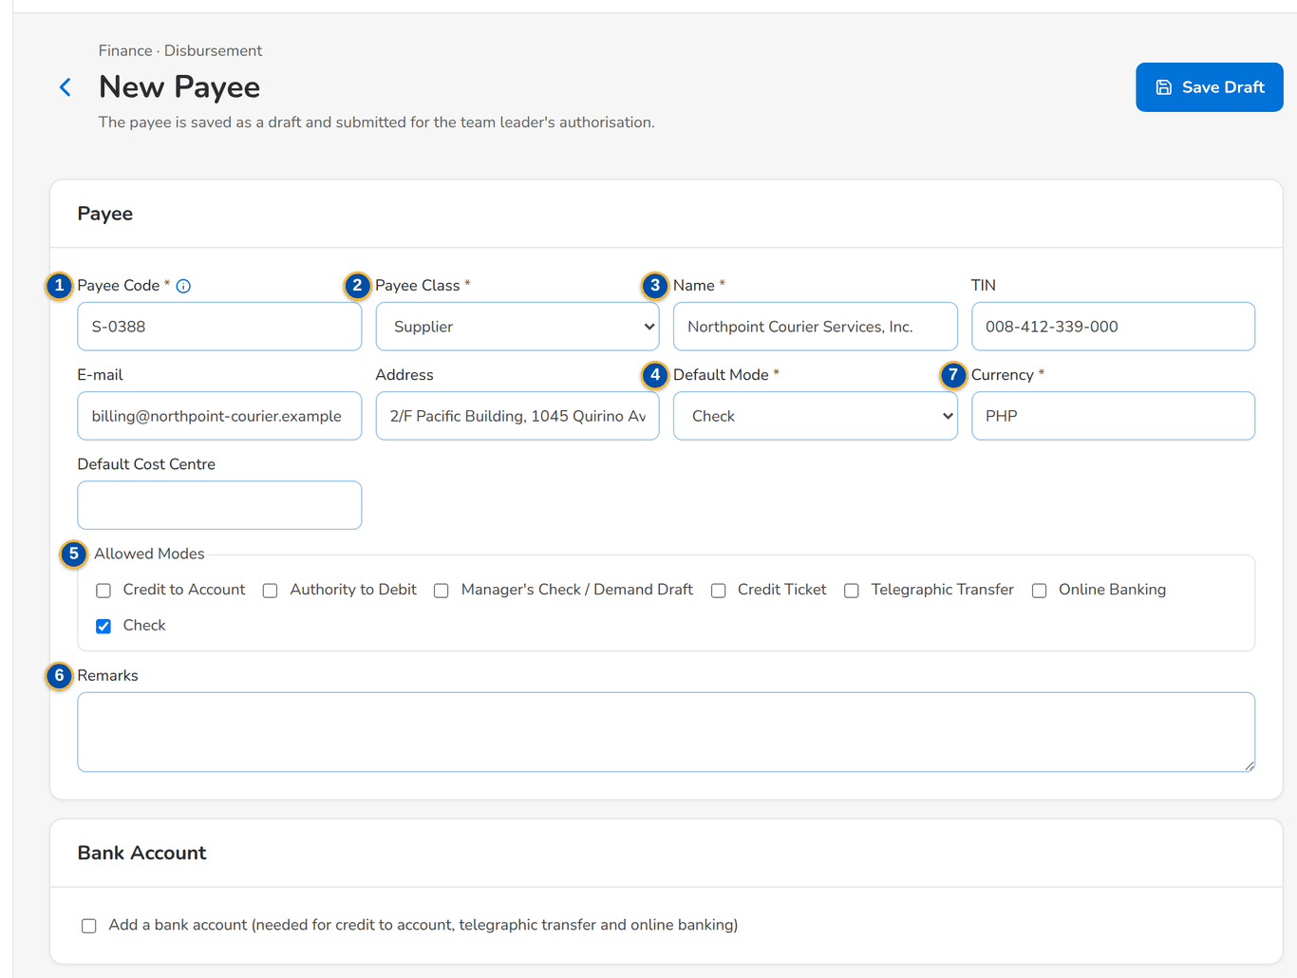
Figure 75: SCR-AC-29 New Payee: the payee saved as a draft and submitted for authorisation
Fields (No. = callout number on the first screenshot)
No. | Section | Field | Type | Length / format | Mand. | Source / list | Default | Editable in | Validation | Message when it fails
1 | Payee | Payee Code | Text | The party code of the client, insurer, supplier or employee | Y | Business partners | Blank | New | Unique | Enter the payee code
2 | Payee | Payee Class | Drop-down | Supplier, Insurer, Employee, Client, Others | Y | Payee class list | Blank | Draft, Active | - | -
3 | Payee | Name / TIN / E-mail / Address | Text | The payee details | Y / N / N / N | - | Blank | Draft, Active | A valid e-mail | -
4 | Payee | Default Mode / Currency / Default Cost Centre | Drop-down, text | The usual mode, three-letter currency, cost centre | Y / Y / N | - | Check, base currency | Draft, Active | - | -
5 | Payee | Allowed Modes | Check boxes | The seven modes of payment | Y | - | All | Draft, Active | At least one; an account for the credit modes | -
6 | Payee | Remarks | Text area | Up to 500 characters | N | - | Blank | Draft, Active | - | -
7 | Bank Accounts | Bank / Account No. / Account Name / Currency / Mode / Primary / Active | Column | The accounts of the payee; numbers masked for the users without full view | - | Payee accounts | - | Read only | - | -
8 | Add Bank Account dialog | Bank / Branch / Account No. / Account Name / Currency / Mode / Primary account | Text, drop-down, check box | The account and the mode it is used for | Y / N / Y / Y / Y / Y / N | - | - | Draft, Active | - | -

Actions
Button | Who | Enabled when | What happens | Resulting status | Notification
Save Draft / Save / Save and Send for Authorisation | Disbursement Team Leader (payee maintain) | Draft or active payee | Saves the payee; a change of an active payee goes for authorisation | Draft or For Authorization | -
Submit for Authorisation / Authorise | Team Leader; Approver (payee authorize), not the maker | As the stage allows | Sends the payee for authorisation, or authorises it | For Authorization or Active | Workflow notice
Request Deactivation / Request Reactivation | Disbursement Team Leader | Active or inactive | Asks the approver to deactivate or reactivate the payee | For Deactivation or For Reactivation | Workflow notice
Add Account / [Deactivate] | Disbursement Team Leader | Draft or active payee | Adds a bank account or deactivates one; the payee goes back for authorisation | For Authorization | -
Delete Payee | Disbursement Team Leader | The payee was never used | Deletes the payee after the confirmation | - | -

Business rules
• A payee is authorised by another user than its maker; a change of an active payee waits for authorisation (FR-DS-010).
• Only a payee never used on a payment is deleted; any other payee is deactivated with authorisation (FR-DS-013).
• The credit modes need an active bank account of the payee (FR-DS-011).
Expected outcome
The payee is ready to be paid.
Test cases: TC-DS-010.1-01, TC-DS-010.1-02, TC-DS-010.2-01, TC-DS-010.3-01, TC-DS-010.3-02, TC-DS-010.3-04, TC-DS-011.1-01, TC-DS-013.1-01, TC-DS-013.2-01, TC-DS-013.2-02, TC-AC-SCR-29, TC-AC-MSG-24.

13.4.6 SCR-AC-30 Disbursement Uploads
Purpose | The uploads of Disbursement, each validated row by row before the valid rows are committed: payment requests of other units, the negotiated checks and the credited accounts of the bank, the online banking approvals and the payee migration.
Who can open it | Disbursement Processor, Disbursement Team Leader (permission Disb upload or Disb payee maintain)
Navigation | • Menu: Finance › Disbursement › Disbursement Uploads
FRs | FR-DS-014, FR-DS-024, FR-DS-053

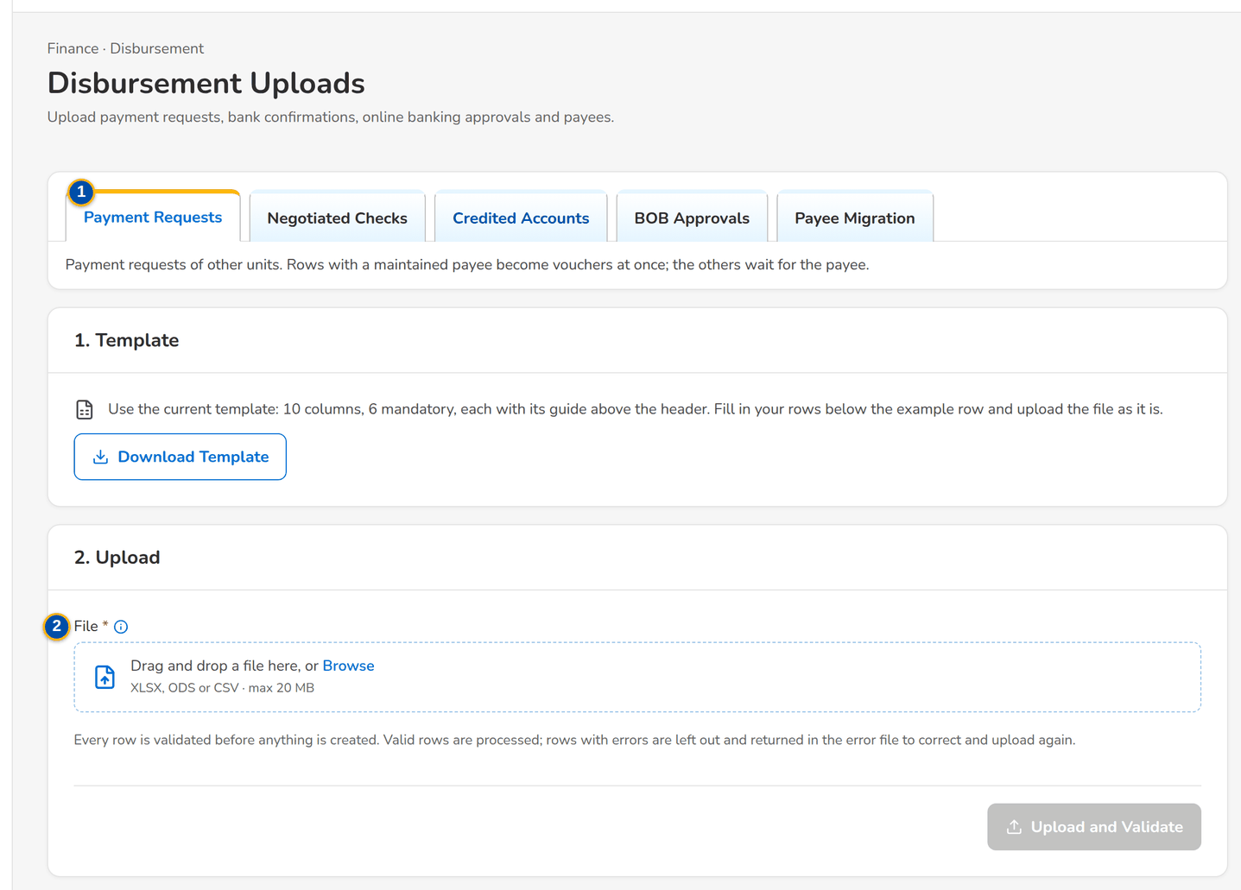
Figure 76: SCR-AC-30 Disbursement Uploads: the upload types, the template and the upload
1 | Payment Requests / Negotiated Checks / Credited Accounts / BOB Approvals / Payee Migration | 2 | File | 3 | Rows Read / Valid / Rejected

Fields (No. = callout number on the first screenshot)
No. | Section | Field | Type | Length / format | Mand. | Source / list | Default | Editable in | Validation | Message when it fails
1 | Tabs | Payment Requests / Negotiated Checks / Credited Accounts / BOB Approvals / Payee Migration | Tab | The types the user may upload, with the text of each | - | Upload types | Payment Requests | - | - | -
2 | Upload | File | File | The template of the type: Excel, CSV or TXT | Y | Upload template | - | - | Every row checked before anything is committed | -
3 | Result | Rows Read / Valid / Rejected | Total | Counts of the rows with the rows and their message | - | Upload | - | Read only | - | -

Actions
Button | Who | Enabled when | What happens | Resulting status | Notification
Download Template / Upload and Validate | Disbursement Processor, Team Leader (disbursement upload; payee maintain for the migration) | A file chosen | Checks every row; the valid rows are processed and the rejected rows listed with their message | - | -
Download Error File / Upload Corrected File / Discard Upload | Same users | After the upload | Downloads the rejected rows, uploads the corrected file linked to the first, or discards the upload | - | -

Business rules
• Uploaded requests with a maintained payee become vouchers at once; the others wait for the payee (FR-DS-024).
• A negotiated check posts its clearing entry; a credited account and a BOB approval set the instrument status (FR-DS-053).
• Migrated payees come in for authorisation (FR-DS-014).
Expected outcome
The bank files and the requests of other units are in BIBS without re-keying.
Test cases: TC-DS-014.2-01, TC-DS-014.2-02, TC-DS-024.1-01, TC-DS-024.1-02, TC-DS-024.2-01, TC-DS-052.1-01, TC-DS-052.2-01, TC-DS-052.2-02, TC-DS-053.1-01, TC-DS-053.1-02, TC-DS-053.2-01, TC-DS-053.2-02, TC-AC-SCR-30, TC-AC-MSG-25, TC-AC-MSG-38, TC-AC-MSG-39, TC-AC-MSG-40, TC-AC-MSG-41.

13.4.7 SCR-AC-31 Disbursement End of Day
Purpose | The end of day of a business date: it freezes the approved vouchers of the date and produces the checks, the Direct Credit Transaction File (DCTF), the ATD, MC / DD, credit ticket and TT forms and the end-of-day reports; the payment confirmations are then sent to the payees. The scheduler runs the same steps.
Who can open it | Disbursement Processor, Disbursement Team Leader, Disbursement Approver, Comptrollership (read access), System Administrator, Auditor (permission Disb EOD or Disb view)
Navigation | • Menu: Finance › Disbursement › Disbursement End of Day
FRs | FR-DS-060, FR-DS-061, FR-DS-062, FR-DS-063, FR-DS-081

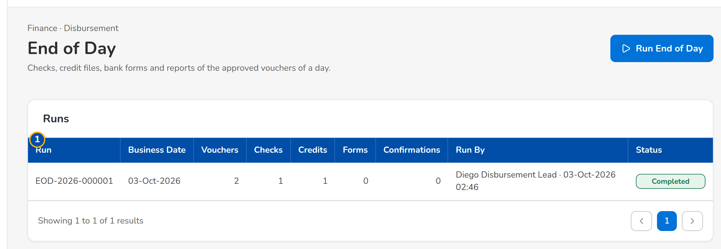
Figure 77: SCR-AC-31 End of Day: the runs with their vouchers, checks, credits, forms and confirmations, and the outputs of a run
1 | Run / Business Date / Vouchers / Checks / Credits / Forms / Confirmations / Run By / Status | 2 | Outputs | 3 | Business Date

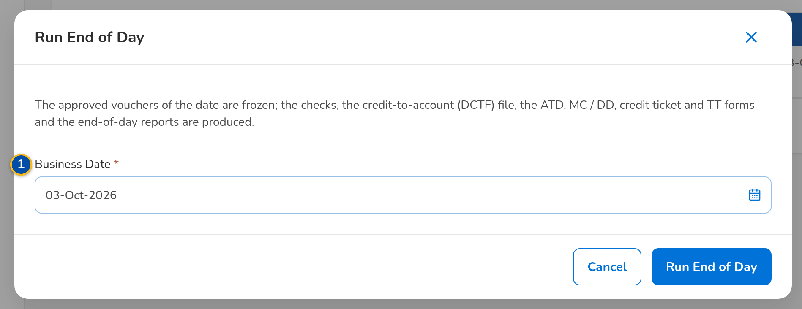
Figure 78: SCR-AC-31 Run End of Day: the business date
Fields (No. = callout number on the first screenshot)
No. | Section | Field | Type | Length / format | Mand. | Source / list | Default | Editable in | Validation | Message when it fails
1 | Runs | Run / Business Date / Vouchers / Checks / Credits / Forms / Confirmations / Run By / Status | Column | One row per run; counts; name | - | End-of-day runs | - | Read only | - | -
2 | Run | Outputs | Button | The output kind, the file name and its item count: DCTF, check batch, vouchers, forms, end-of-day reports | - | End-of-day run | - | Read only | - | -
3 | Run End of Day dialog | Business Date | Date | dd-MMM-yyyy | Y | - | Today | - | - | -

Actions
Button | Who | Enabled when | What happens | Resulting status | Notification
Run End of Day | Disbursement Team Leader, Approver (disbursement end of day) | Always | Freezes the approved vouchers of the date and produces the outputs | Completed | -
Send Confirmations | Same users | A completed run | E-mails the payment confirmations to the payees | Confirmed | Payment confirmation e-mail
Output | Disbursement users | Always | Downloads the file | - | -

Business rules
• The DCTF holds the credit-to-account payments of the date in the layout of Appendix B (FR-DS-061).
• Checks take the next leaves of the paying account's check series; the vouchers and forms are printed in batch (FR-DS-062).
Expected outcome
The day's payments are issued and the payees are told.
Test cases: TC-DS-060.1-01, TC-DS-060.2-01, TC-DS-061.1-01, TC-DS-061.2-01, TC-DS-062.1-01, TC-DS-063.1-01, TC-DS-063.2-01, TC-DS-081.1-01, TC-DS-081.2-01, TC-AC-SCR-31, TC-AC-MSG-26.

13.4.8 SCR-AC-32 Account Funding
Purpose | The transfers between BDOIR bank accounts that fund the main account, by tab (With the Maker, For Verification and Approval, Approved and Closed): a maker requests, another team leader verifies and two approvers approve.
Who can open it | Disbursement Processor, Disbursement Team Leader, Disbursement Approver, Comptrollership (read access), System Administrator, Auditor (permission Disb view or Disb funding request or Disb funding verify or Disb funding approve)
Navigation | • Menu: Finance › Disbursement › Account Funding
FRs | FR-DS-064

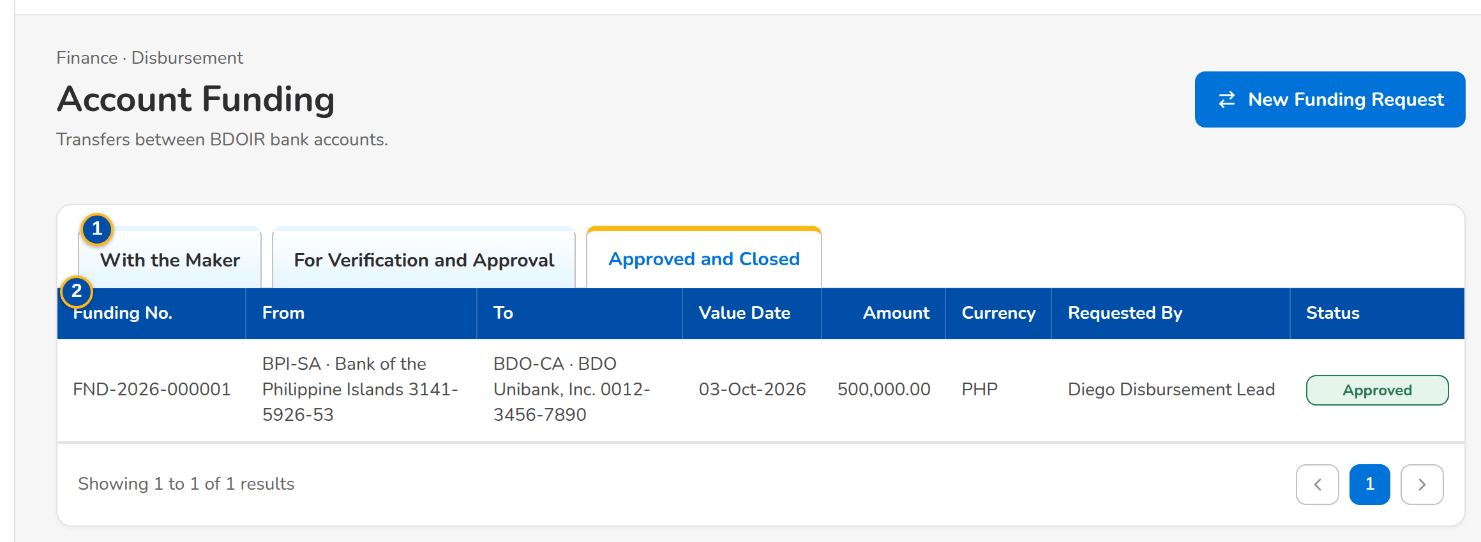
Figure 79: SCR-AC-32 Account Funding: the transfers with their accounts, value date, amount, requester and status
1 | With the Maker / For Verification and Approval / Approved and Closed | 2 | Funding No. / From / To / Value Date / Amount / Currency / Requested By / Status

Fields (No. = callout number on the first screenshot)
No. | Section | Field | Type | Length / format | Mand. | Source / list | Default | Editable in | Validation | Message when it fails
1 | Tabs | With the Maker / For Verification and Approval / Approved and Closed | Tab | - | - | Funding requests | With the Maker | - | - | -
2 | List | Funding No. / From / To / Value Date / Amount / Currency / Requested By / Status | Column | The accounts by code, bank and number; the requester's name | - | Funding requests | - | Read only | - | -

Actions
Button | Who | Enabled when | What happens | Resulting status | Notification
New Funding Request | Disbursement Team Leader (funding request) | Always | Opens a new funding request | Created | -
Row | Disbursement users | Always | Opens the funding request | - | -

Business rules
• A funding is verified by another user than its maker and approved by two further users (FR-DS-064).
Expected outcome
The main account is funded with four eyes.
Test cases: TC-DS-064.1-01, TC-DS-064.2-01, TC-DS-064.3-01, TC-DS-064.3-02, TC-DS-064.3-03, TC-DS-064.3-04, TC-DS-064.3-05, TC-AC-SCR-32.

13.4.9 SCR-AC-33 Funding Request
Purpose | One transfer between two BDOIR bank accounts: the accounts, amount, currency, value date and purpose; the funding workflow (submit, verify, first and second approval with the BOB reference); the second approval posts the transfer entry.
Who can open it | Disbursement Processor, Disbursement Team Leader, Disbursement Approver, Comptrollership (read access), System Administrator, Auditor (permission Disb view or Disb funding request or Disb funding verify or Disb funding approve)
Navigation | • Menu: Finance › Disbursement › Account Funding › Funding Request  • Account Funding › New Funding Request or open a row
FRs | FR-DS-064

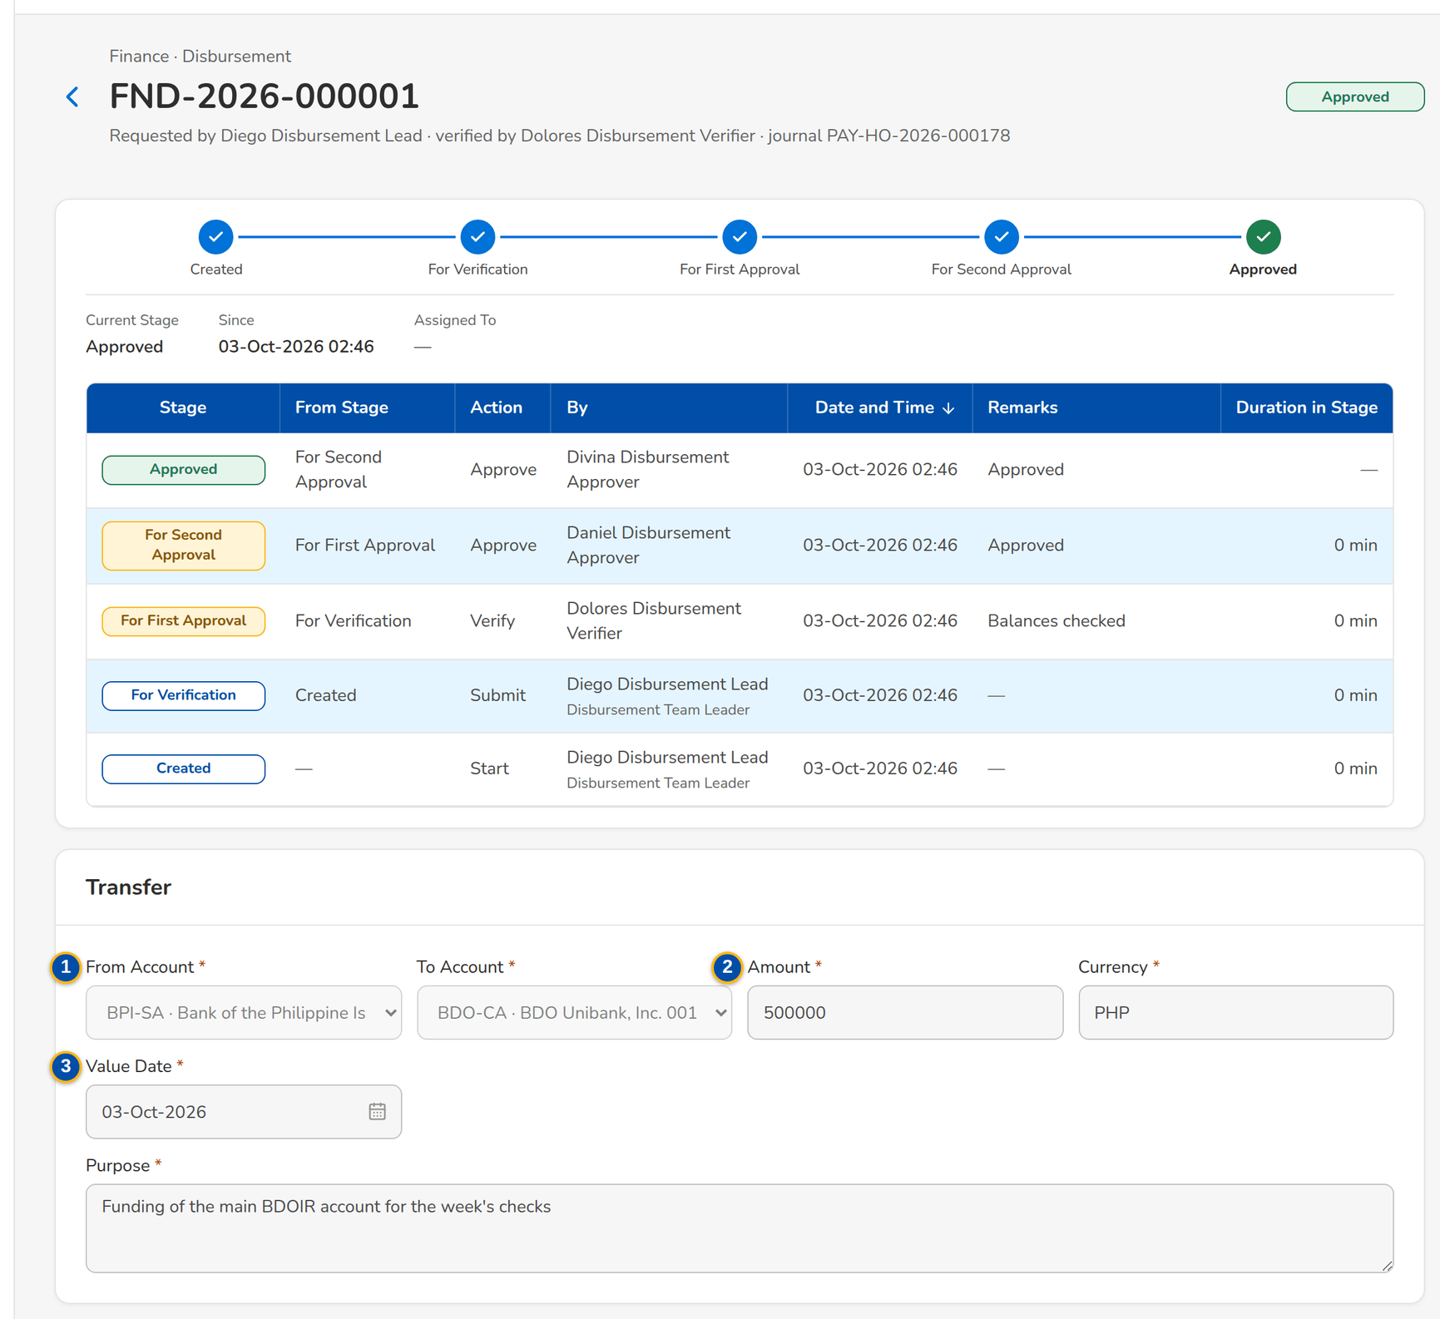
Figure 80: SCR-AC-33 An approved funding: the transfer and the workflow history of maker, verifier and two approvers
1 | From Account / To Account | 3 | Value Date / Purpose
2 | Amount / Currency | 4 | BOB Reference

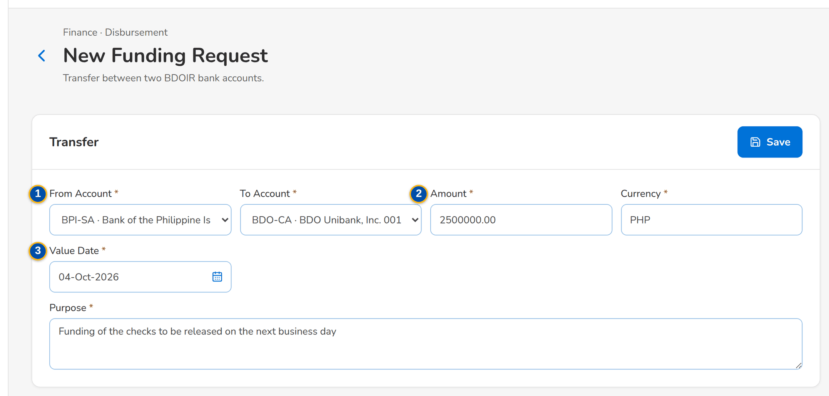
Figure 81: SCR-AC-33 New Funding Request: from and to accounts, amount, value date and purpose
Fields (No. = callout number on the first screenshot)
No. | Section | Field | Type | Length / format | Mand. | Source / list | Default | Editable in | Validation | Message when it fails
1 | Transfer | From Account / To Account | Drop-down | Active BDOIR accounts; the target other than the source | Y | Bank accounts | Blank | Created | Different accounts | Select a target account other than the source
2 | Transfer | Amount / Currency | Number, text | Above zero; the currency of the accounts | Y | - | Blank | Created | Above zero | Enter an amount above zero
3 | Transfer | Value Date / Purpose | Date, text area | dd-MMM-yyyy; the purpose | Y | - | Today | Created | - | Enter the purpose
4 | Approve dialog | BOB Reference | Text | The reference of the transaction in BDO Business Online Banking | N | - | Blank | For approval | - | -

Actions
Button | Who | Enabled when | What happens | Resulting status | Notification
Save | Disbursement Team Leader (funding request) | Created | Saves the request | Created | -
Submit / Verify / Approve | Maker; verifier (funding verify), not the maker; two approvers (funding approve), each another user | As the stage allows | Moves the request; the second approval posts the transfer entry | For Verification, For Approval 1, For Approval 2, Approved | Workflow notice

Business rules
• The verifier is not the maker, and the two approvers differ from each other and from the maker (FR-DS-064).
• The second approval posts the transfer entry between the two accounts (FR-DS-064).
Expected outcome
The transfer is approved and posted.
Test cases: TC-DS-064.1-01, TC-DS-064.2-01, TC-DS-064.3-01, TC-DS-064.3-02, TC-DS-064.3-03, TC-DS-064.3-04, TC-DS-064.3-05, TC-AC-SCR-33, TC-AC-MSG-27.

13.4.10 SCR-AC-34 Bank Accounts and Checks
Purpose | The BDOIR paying accounts with their GL account and check leaves, their active or inactive status changed by the team leader and authorised by the approver, and the check series of each account with the next check and the remaining leaves.
Who can open it | Disbursement Processor, Disbursement Team Leader, Disbursement Approver, Comptrollership (read access), System Administrator, Auditor (permission Disb view or Disb review or Disb approve)
Navigation | • Menu: Finance › Disbursement › Bank Accounts and Checks
FRs | FR-DS-070, FR-DS-071

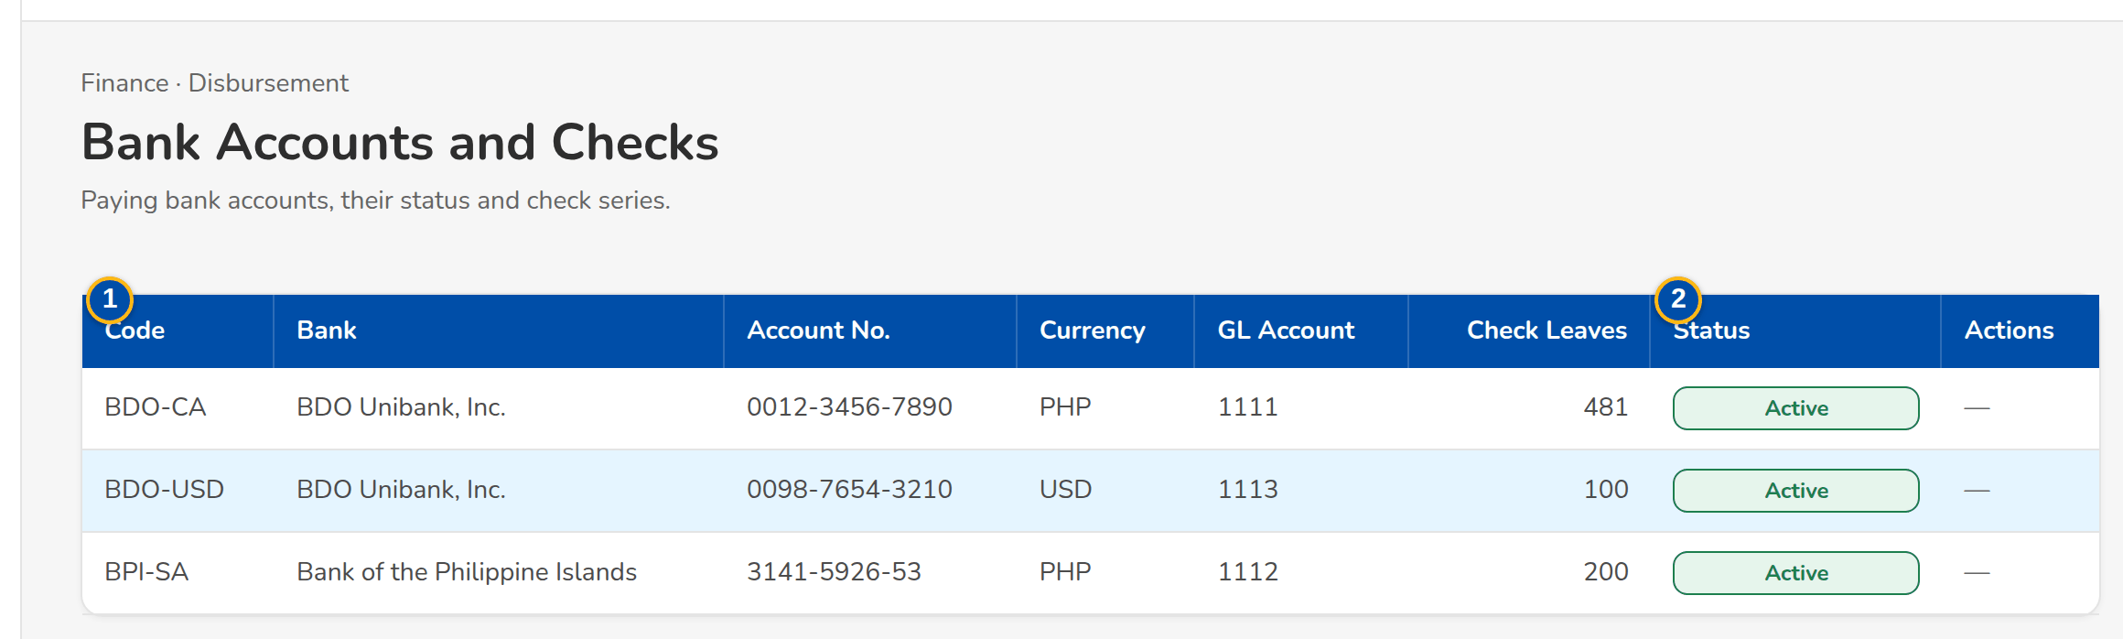
Figure 82: SCR-AC-34 Bank Accounts and Checks: the paying accounts and the check series of an account
1 | Code / Bank / Account No. / Currency / GL Account / Check Leaves / Status | 2 | Series / Next Check / Remaining / Received / Previous Range / Status | 3 | First Check No. / Last Check No.

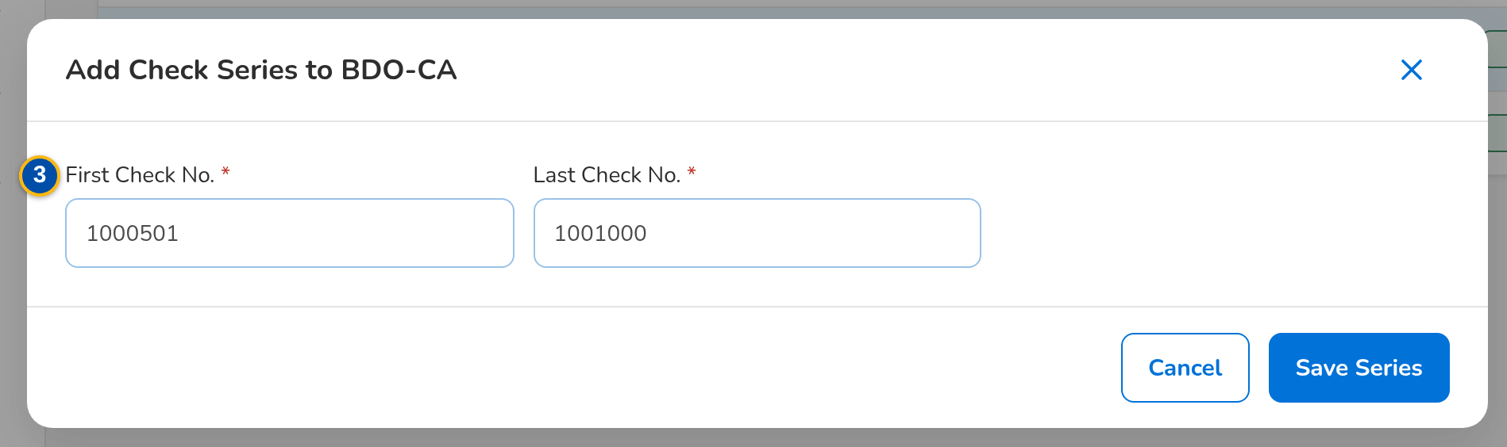
Figure 83: SCR-AC-34 Add Series: the first and last check numbers of a new check book
Fields (No. = callout number on the first screenshot)
No. | Section | Field | Type | Length / format | Mand. | Source / list | Default | Editable in | Validation | Message when it fails
1 | Accounts | Code / Bank / Account No. / Currency / GL Account / Check Leaves / Status | Column | One row per paying account; status Active, Inactive or the change waiting | - | Bank accounts | - | Read only | - | -
2 | Check Series | Series / Next Check / Remaining / Received / Previous Range / Status | Column | The check books of the account; the range before a correction with who changed it | - | Check series | - | Read only | - | No check series
3 | Series dialog | First Check No. / Last Check No. | Number | The range of the book; corrected only before its first check is printed | Y | - | - | Active, unused | Last after first | -

Actions
Button | Who | Enabled when | What happens | Resulting status | Notification
Deactivate / Activate | Disbursement Team Leader (disbursement review) | No change waiting | Sends the status change for authorisation after the confirmation | Pending authorization | -
Authorise | Disbursement Approver (disbursement approve) | A change waiting | Applies the change | Active or Inactive | -
Add Series / Save Series / Edit | Disbursement Team Leader | Always; edit while no check is used | Adds a check series or corrects its range | Active | -

Business rules
• A bank account status change takes effect when the approver authorises it (FR-DS-071).
• A series is corrected only before its first check is printed; the previous range is kept (FR-DS-070).
• An alert is raised when the leaves of a series run low (FR-DS-070).
Expected outcome
The paying accounts and their checks are kept up to date.
Test cases: TC-DS-070.1-01, TC-DS-070.2-01, TC-DS-070.2-02, TC-DS-070.2-03, TC-DS-071.1-01, TC-DS-071.2-01, TC-AC-SCR-34.

13.4.11 SCR-AC-35 Employees
Purpose | The employees with their number, branch, cost centre, position, e-mail, the payee code used for their payments, hire and separation dates; used by Disbursement to charge employee-related payments to the right cost centre and by the headcount report per cost centre.
Who can open it | GL Officer (FRBS), GL Team Lead, GL Section Head, Accountant (bank reconciliation), Comptrollership administrator (masters and rules), Disbursement Approver, Business Administrator, System Administrator, Auditor (permission Master view)
Navigation | • Menu: Setup & Administration › Setup › Employees
FRs | FR-DS-037

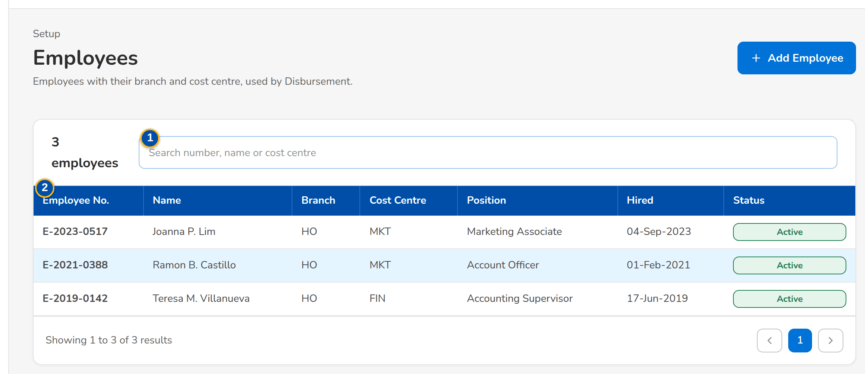
Figure 84: SCR-AC-35 Employees: number, name, branch, cost centre, position, hire date and status
1 | Search number, name or cost centre | 3 | Employee no. / Full name / Branch / Cost centre
2 | Employee No. / Name / Branch / Cost Centre / Position / Hired / Status | 4 | Position / E-mail / Payee party code / Hired on / Separated on

Fields (No. = callout number on the first screenshot)
No. | Section | Field | Type | Length / format | Mand. | Source / list | Default | Editable in | Validation | Message when it fails
1 | Toolbar | Search number, name or cost centre | Text | - | N | - | Blank | - | Contains | -
2 | List | Employee No. / Name / Branch / Cost Centre / Position / Hired / Status | Column | One row per employee | - | Employees | - | Read only | - | -
3 | Employee form | Employee no. / Full name / Branch / Cost centre | Text, drop-down | Unique number; the branch and cost centre | Y | Branches, cost centres | - | - | Unique | -
4 | Employee form | Position / E-mail / Payee party code / Hired on / Separated on | Text, date | The party of type Employee for payments; a separation date makes the employee inactive | N | Business partners | - | - | A valid e-mail | -

Actions
Button | Who | Enabled when | What happens | Resulting status | Notification
Add Employee / Save Employee | Business Administrator, Comptrollership administrator (employee maintain) | Always | Adds or changes an employee | Active or Inactive | -

Business rules
• An employee-related payment is charged to the cost centre of the employee (FR-DS-037).
Expected outcome
Every employee has the cost centre of the payments.
Test cases: TC-DS-037.1-01, TC-DS-037.1-02, TC-DS-037.2-01, TC-DS-037.2-02, TC-AC-SCR-35.

13.4.12 SCR-AC-36 Certificates Received
Purpose | The register of the BIR 2307 certificates received from the insurers on commission and incentives: the certificate number, withholding agent, period covered, income, tax withheld and the journal that recorded it; a certificate is recorded with its income payments and cancelled with a reason.
Who can open it | GL Officer (FRBS), GL Team Lead, GL Section Head, Accountant (bank reconciliation), Comptrollership administrator (masters and rules), Disbursement Processor, Disbursement Team Leader, Auditor (permission Tax view or Disb tag)
Navigation | • Menu: Finance › Tax & Statutory › Certificates Received  • Disbursement Voucher › Tag CWT
FRs | FR-DS-057

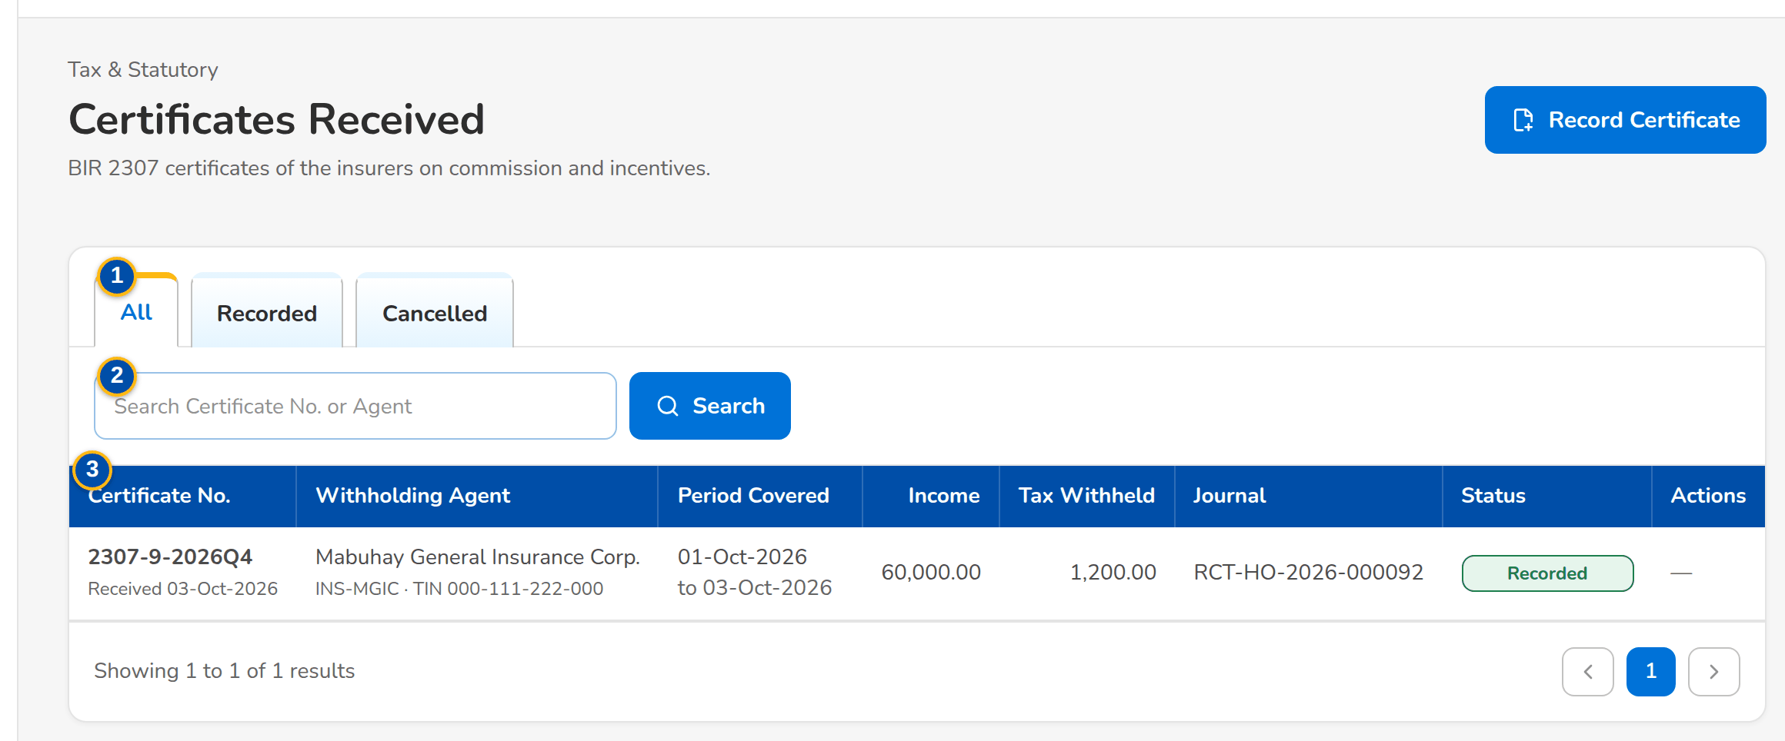
Figure 85: SCR-AC-36 Certificates Received: the BIR 2307 certificates of the insurers with the journal posted
1 | All / Recorded / Cancelled | 3 | Certificate No. / Withholding Agent / Period Covered / Income / Tax Withheld / Journal / Status | 5 | Period Covered From / Period Covered To / Date Received / Reference (DV / Remittance)
2 | Search Certificate No. or Agent | 4 | Certificate No. / Withholding Agent (Insurer Code) / Agent Name / Agent TIN | 6 | Income Payments

Fields (No. = callout number on the first screenshot)
No. | Section | Field | Type | Length / format | Mand. | Source / list | Default | Editable in | Validation | Message when it fails
1 | Tabs | All / Recorded / Cancelled | Tab | - | - | Certificates | All | - | - | -
2 | Toolbar | Search Certificate No. or Agent | Text | - | N | - | Blank | - | Contains | -
3 | List | Certificate No. / Withholding Agent / Period Covered / Income / Tax Withheld / Journal / Status | Column | The agent by name; the period on two lines | - | Certificates received | - | Read only | - | -
4 | Record Certificate Received dialog | Certificate No. / Withholding Agent (Insurer Code) / Agent Name / Agent TIN | Text | The certificate and the agent | Y | Insurers | - | - | - | -
5 | Record Certificate Received dialog | Period Covered From / Period Covered To / Date Received / Reference (DV / Remittance) | Date, text | dd-MMM-yyyy | Y / Y / Y / N | - | - | - | - | -
6 | Record Certificate Received dialog | Income Payments | Rows | Kind, ATC, income and tax withheld of each payment | Y | Tax codes | - | - | At least one row | -

Actions
Button | Who | Enabled when | What happens | Resulting status | Notification
Record Certificate | Disbursement Processor, Team Leader (disbursement tag) | Always | Records the certificate and posts its entry | Recorded | -
Cancel Certificate | Same users | Recorded | Cancels the certificate with the reason and reverses its entry | Cancelled | -

Business rules
• A certificate received posts the tax credit on hand against the tax credit on commission or incentives (FR-DS-057).
Expected outcome
The certificates of the insurers are recorded for the SAWT.
Test cases: TC-DS-057.1-01, TC-DS-057.2-01, TC-DS-057.2-02, TC-DS-057.2-03, TC-AC-SCR-36.

13.4.13 SCR-AC-37 BIR Form 2307
Purpose | The certificates of creditable tax withheld at source that BDOI issues to its payees per quarter, from the EWT worksheet: generate the batch of a quarter, download its PDF, and the certificate register with each payee.
Who can open it | GL Officer (FRBS), GL Team Lead, GL Section Head, Accountant (bank reconciliation), Comptrollership administrator (masters and rules), Disbursement Processor, Disbursement Team Leader, Auditor (permission Tax view)
Navigation | • Menu: Finance › Tax & Statutory › BIR Form 2307
FRs | FR-DS-058

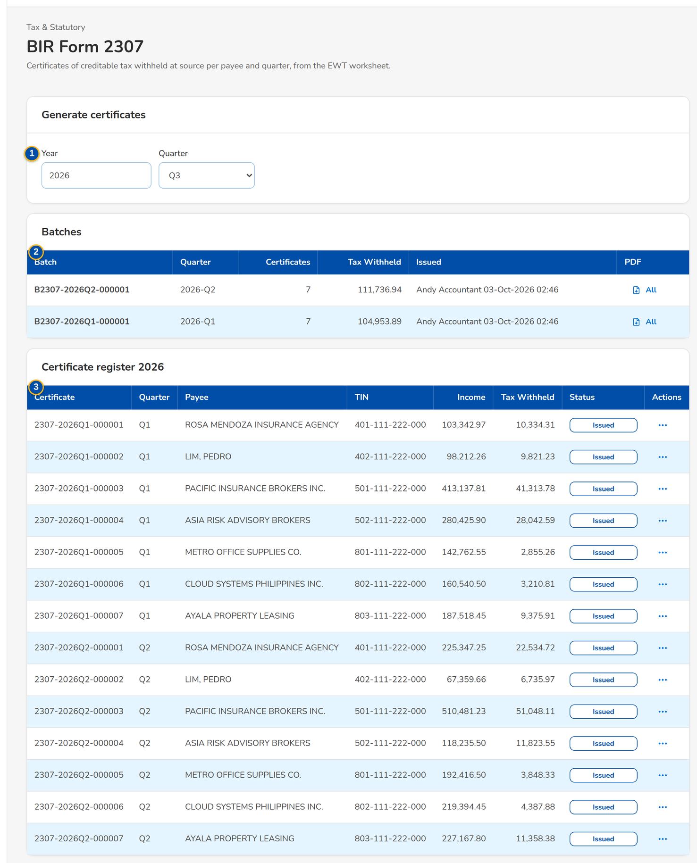
Figure 86: SCR-AC-37 BIR Form 2307: the generation of a quarter, the batches and the certificate register
1 | Year / Quarter | 2 | Batch / Quarter / Certificates / Tax Withheld / Issued / PDF | 3 | Certificate / Quarter / Payee / TIN / Income / Tax Withheld / Status

Fields (No. = callout number on the first screenshot)
No. | Section | Field | Type | Length / format | Mand. | Source / list | Default | Editable in | Validation | Message when it fails
1 | Generate certificates | Year / Quarter | Number, drop-down | The quarter to generate | Y | - | Current quarter | - | - | -
2 | Batches | Batch / Quarter / Certificates / Tax Withheld / Issued / PDF | Column | One row per batch with its PDF | - | Certificate batches | - | Read only | - | -
3 | Certificate register | Certificate / Quarter / Payee / TIN / Income / Tax Withheld / Status | Column | One row per certificate | - | Certificates | - | Read only | - | -

Actions
Button | Who | Enabled when | What happens | Resulting status | Notification
Generate Batch | Users with tax view | Always | Generates the certificates of the quarter | Issued | -
PDF / Cancel | Same users | Issued certificate | Downloads the PDF, or cancels the certificate after the confirmation | Cancelled | -

Business rules
• One certificate per payee and quarter, filled from the withholding tax of the payments (FR-DS-058).
Expected outcome
The 2307 certificates of the quarter are issued to the suppliers.
Test cases: TC-DS-058.1-01, TC-DS-058.2-01, TC-DS-058.2-02, TC-AC-SCR-37.

13.4.14 SCR-AC-38 Disbursement Reports
Purpose | The reports of Disbursement by group (Payments, Control, End of Day); each opens in the report runner with its exports.
Who can open it | Disbursement Processor, Disbursement Team Leader, Disbursement Approver, Comptrollership (read access), System Administrator, Auditor (permission Disb report view or Disb view)
Navigation | • Menu: Finance › Disbursement › Disbursement Reports
FRs | FR-DS-080, FR-DS-081, FR-DS-082, FR-DS-083, FR-DS-092

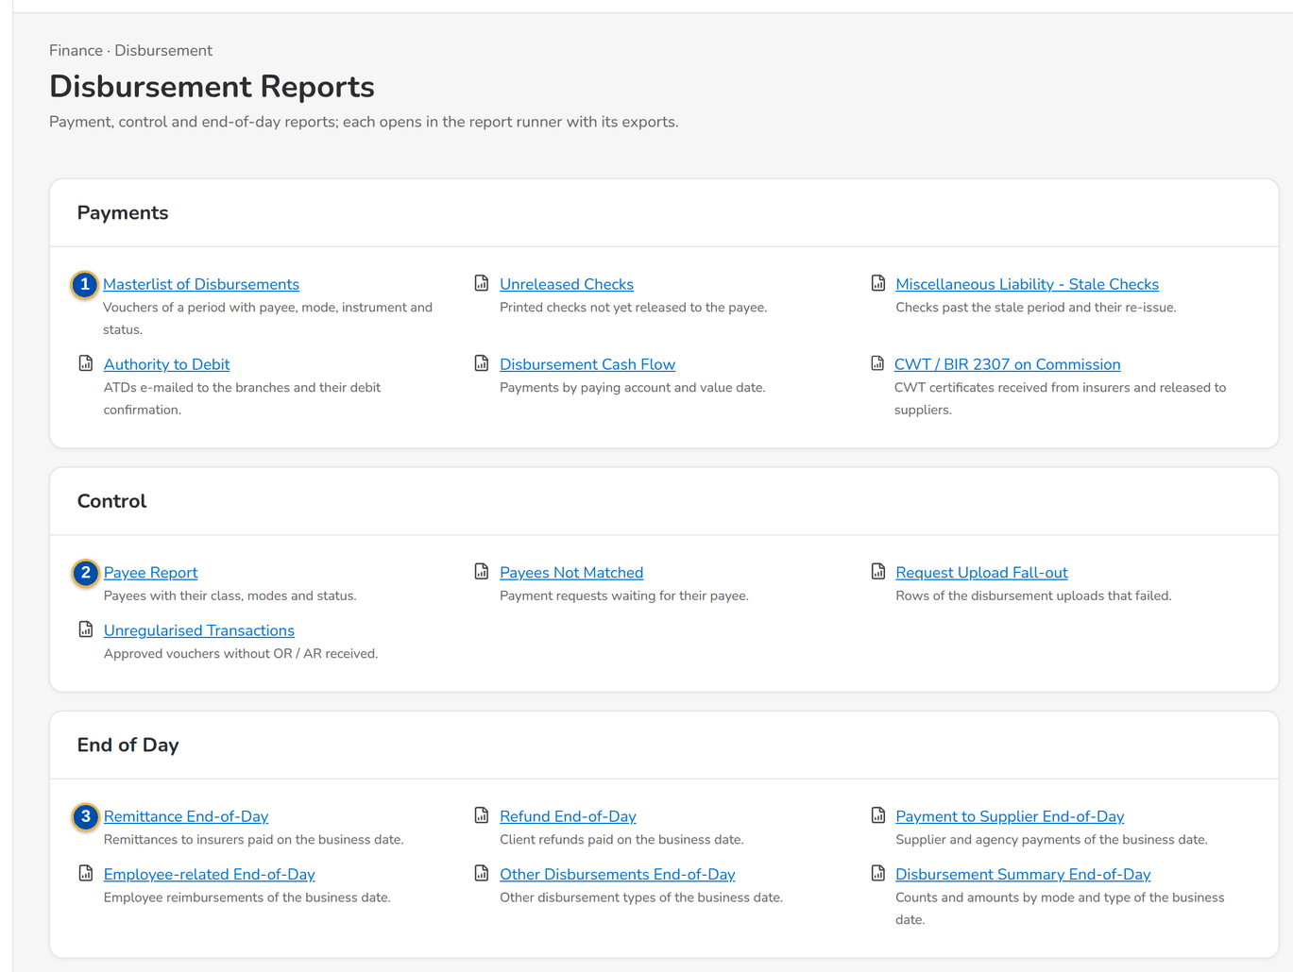
Figure 87: SCR-AC-38 Disbursement Reports: the payment, control and end-of-day reports
1 | Masterlist of Disbursements / Unreleased Checks / Miscellaneous Liability - Stale Checks / Authority to Debit / Disbursement Cash Flow / CWT / BIR 2307 on Commission | 2 | Payee Report / Payees Not Matched / Request Upload Fall-out / Unregularised Transactions | 3 | Remittance End-of-Day / Refund End-of-Day / Payment to Supplier End-of-Day / Employee-related End-of-Day / Other Disbursements End-of-Day / Disbursement Summary End-of-Day

Fields (No. = callout number on the first screenshot)
No. | Section | Field | Type | Length / format | Mand. | Source / list | Default | Editable in | Validation | Message when it fails
1 | Payments | Masterlist of Disbursements / Unreleased Checks / Miscellaneous Liability - Stale Checks / Authority to Debit / Disbursement Cash Flow / CWT / BIR 2307 on Commission | Link | Each with its description | - | Reports | - | Read only | - | -
2 | Control | Payee Report / Payees Not Matched / Request Upload Fall-out / Unregularised Transactions | Link | Each with its description | - | Reports | - | Read only | - | -
3 | End of Day | Remittance End-of-Day / Refund End-of-Day / Payment to Supplier End-of-Day / Employee-related End-of-Day / Other Disbursements End-of-Day / Disbursement Summary End-of-Day | Link | Each with its description | - | Reports | - | Read only | - | -

Actions
Button | Who | Enabled when | What happens | Resulting status | Notification
Report | Disbursement users (disbursement report view) | Always | Opens the report in the runner | - | -

Business rules
• The end-of-day reports are also produced by each end-of-day run (FR-DS-081).
• The CPC2 incentive report is run from the Report Centre, category Disbursement; it lists only the remitted lines whose booked transaction carries the CPC2 incentive tag (FR-DS-092).
Expected outcome
Disbursement runs its reports from one place.
Test cases: TC-DS-022.1-01, TC-DS-022.2-01, TC-DS-022.2-02, TC-DS-045.1-01, TC-DS-080.1-01, TC-DS-080.2-01, TC-DS-082.1-01, TC-DS-082.1-02, TC-DS-082.1-03, TC-DS-082.2-01, TC-DS-083.1-01, TC-DS-083.1-02, TC-DS-092.2-01, TC-DS-092.2-02, TC-DS-092.3-01, TC-AC-SCR-38.

13.5 Refund and cash-advance requests

13.5.1 SCR-AC-39 Requests Home
Purpose | The Marketing requests by stage (Draft, Preparing, For Validation, For Review, For Approval, For HR Approval, With Disbursement, Disbursed, Cancelled) with their counts: client refunds (RRF), employee cash advances (RFP) and the cancellations of disbursed checks. The reviewer endorses and the approvers approve the selected requests at once.
Who can open it | Marketing Processor (AO), Marketing Reviewer, Marketing Approver, Human Resources Approver, System Administrator, Auditor (permission Prq view or Prq create or Prq review or Prq approve or Prq hr approve)
Navigation | • Menu: Finance › Refund & Cash Advance Requests › Requests Home
FRs | FR-PQ-001, FR-PQ-008, FR-PQ-009, FR-PQ-012

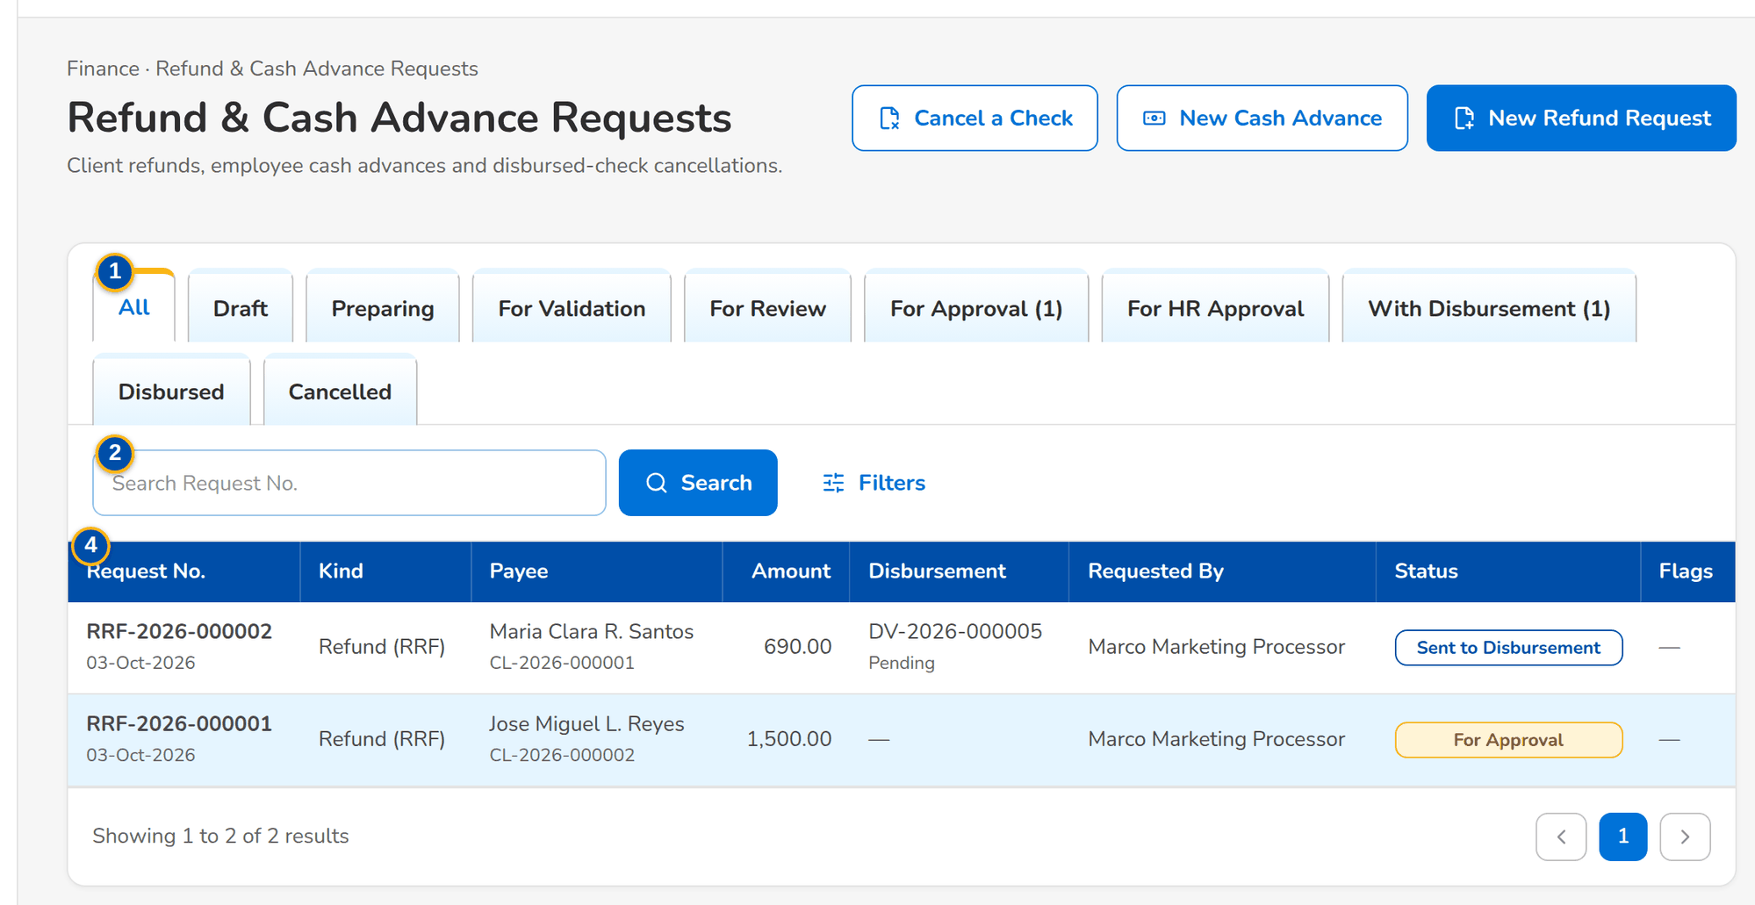
Figure 88: SCR-AC-39 Refund & Cash Advance Requests: the requests by stage with kind, payee, amount, disbursement and status
1 | All / Draft / Preparing / For Validation / For Review / For Approval / For HR Approval / With Disbursement / Disbursed / Cancelled | 3 | Kind / Request Date From / Request Date To | 5 | Outcome of each request
2 | Search Request No. | 4 | Request No. / Kind / Payee / Amount / Disbursement / Requested By / Status / Flags

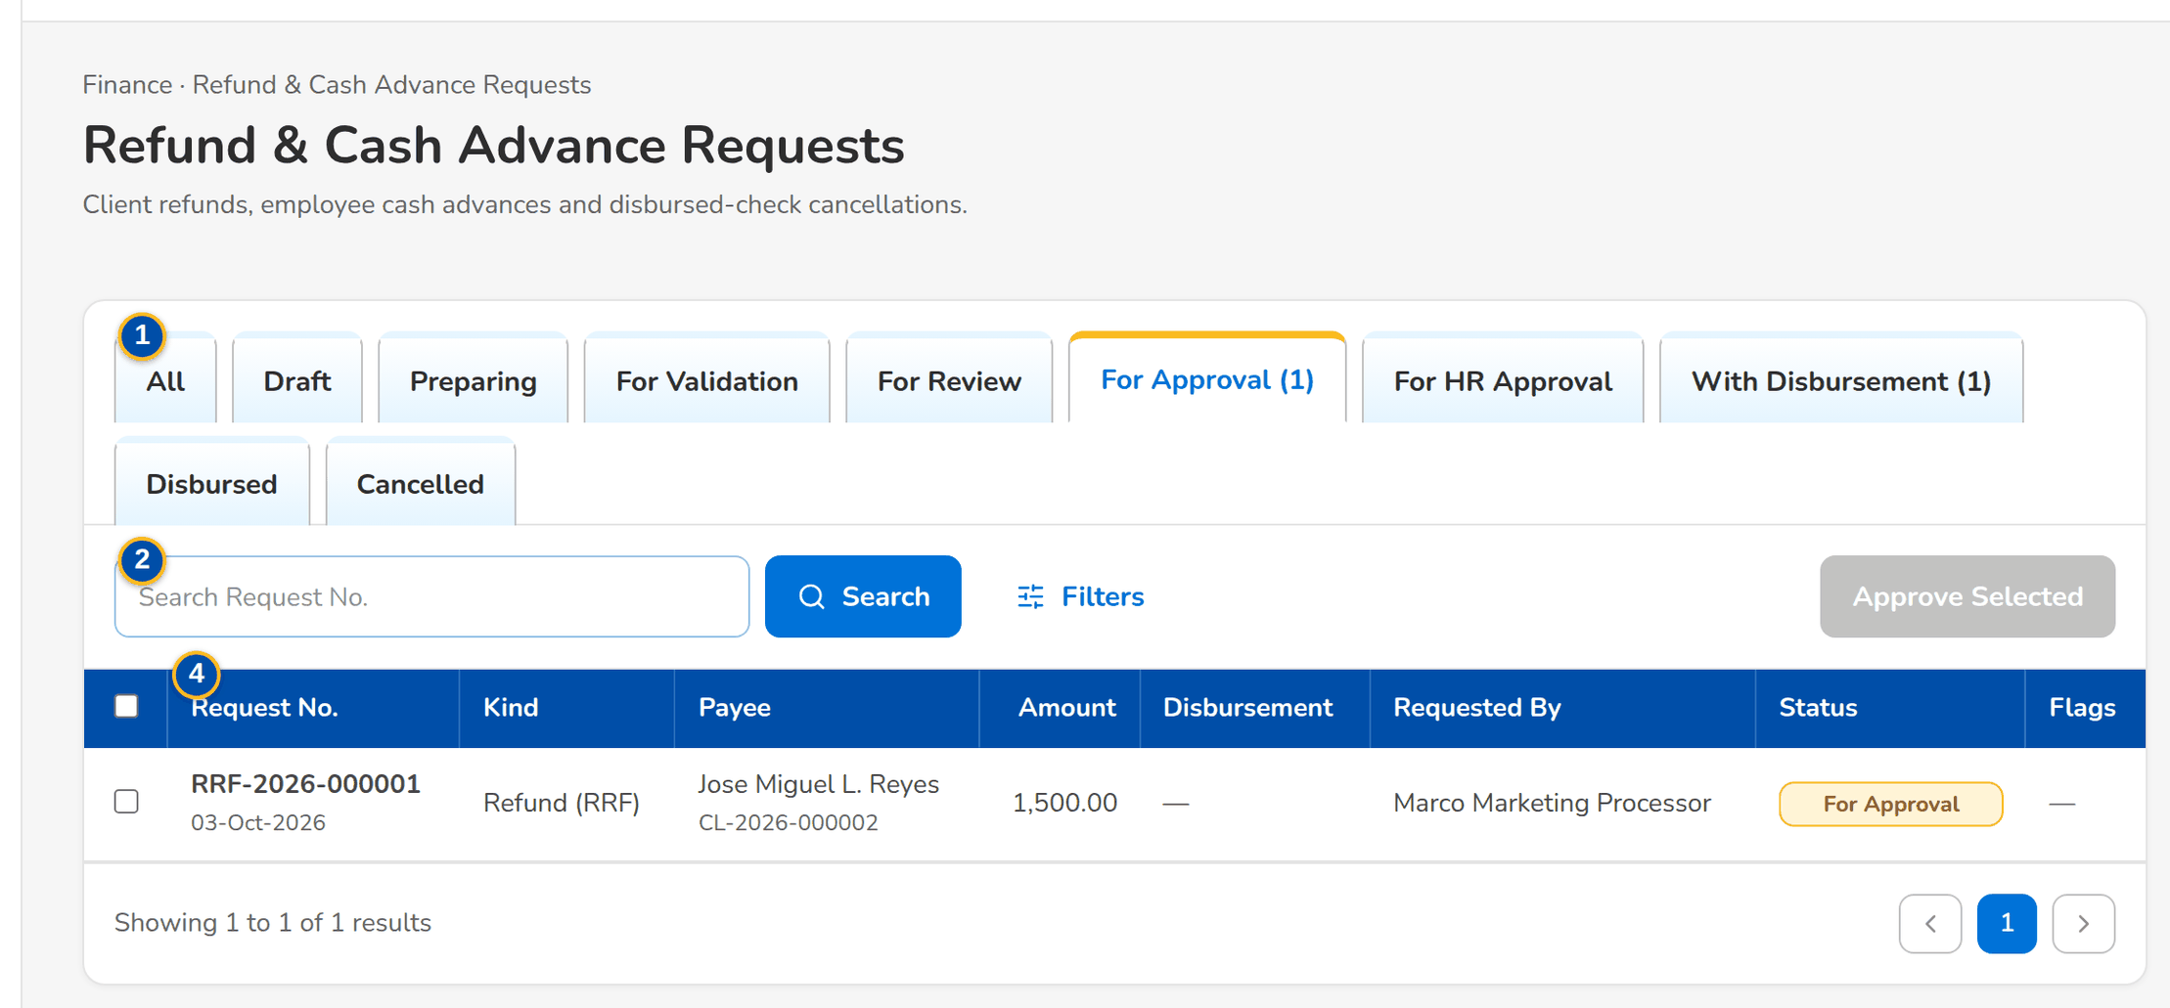
Figure 89: SCR-AC-39 For Approval: the requests selected for Approve Selected
Fields (No. = callout number on the first screenshot)
No. | Section | Field | Type | Length / format | Mand. | Source / list | Default | Editable in | Validation | Message when it fails
1 | Tabs | All / Draft / Preparing / For Validation / For Review / For Approval / For HR Approval / With Disbursement / Disbursed / Cancelled | Tab | With the count of each | - | Requests | All | - | - | -
2 | Toolbar | Search Request No. | Text | RRF, RFP or cancellation number | N | - | Blank | - | Contains | -
3 | Filters | Kind / Request Date From / Request Date To | Drop-down, date | Refund (RRF), Cash Advance (RFP), Check Cancellation; dd-MMM-yyyy | N | Fixed list | All | - | - | -
4 | List | Request No. / Kind / Payee / Amount / Disbursement / Requested By / Status / Flags | Column | The request number with its date; the payee by name; the DV and its status in Disbursement; the requester's name; Returned and Validation flags | - | Requests | - | Read only | - | -
5 | Bulk Decision Results dialog | Outcome of each request | Column | Each selected request with its outcome or the reason it was not moved | - | Requests | - | Read only | - | -

Actions
Button | Who | Enabled when | What happens | Resulting status | Notification
New Refund Request / New Cash Advance / Cancel a Check | Marketing Processor, Reviewer (request create) | Always | Opens the form | Draft | -
Endorse Selected | Marketing Reviewer (request review) | For Review tab, requests selected | Endorses each selected request on its own | For Approval | Workflow notice
Approve Selected / Approve Selected (HR) | Marketing Approver; HR Approver | For Approval or For HR Approval tab, requests selected | Approves each selected request; an approved request goes to Disbursement or to HR | For HR Approval or With Disbursement | Workflow notice
Row | Request users | Always | Opens the request | - | -

Business rules
• A request is never endorsed or approved by the user who raised it or last moved it (FR-PQ-008, FR-PQ-009).
• Approving several requests approves each on its own; the outcome of each is listed (FR-PQ-009).
Expected outcome
Marketing sees every request by stage and moves them on.
Test cases: TC-PQ-001.1-01, TC-PQ-001.2-01, TC-PQ-001.2-02, TC-PQ-001.3-01, TC-AC-SCR-39.

13.5.2 SCR-AC-40 New Refund Request
Purpose | The Refund Request Form (RRF) of a client: the segment, reference, requesting unit and purpose; the mode of payment with the client's account or the name on the check; and the accounts to refund, one line per AR number with the invoice, client, assured, amount, reason, branch or unit and the two categories.
Who can open it | Marketing Processor (AO), Marketing Reviewer (permission Prq create)
Navigation | • Menu: Finance › Refund & Cash Advance Requests › New Refund Request  • Requests Home › New Refund Request  • Request › Change (a draft or returned refund)
FRs | FR-PQ-003, FR-PQ-014, FR-PQ-016

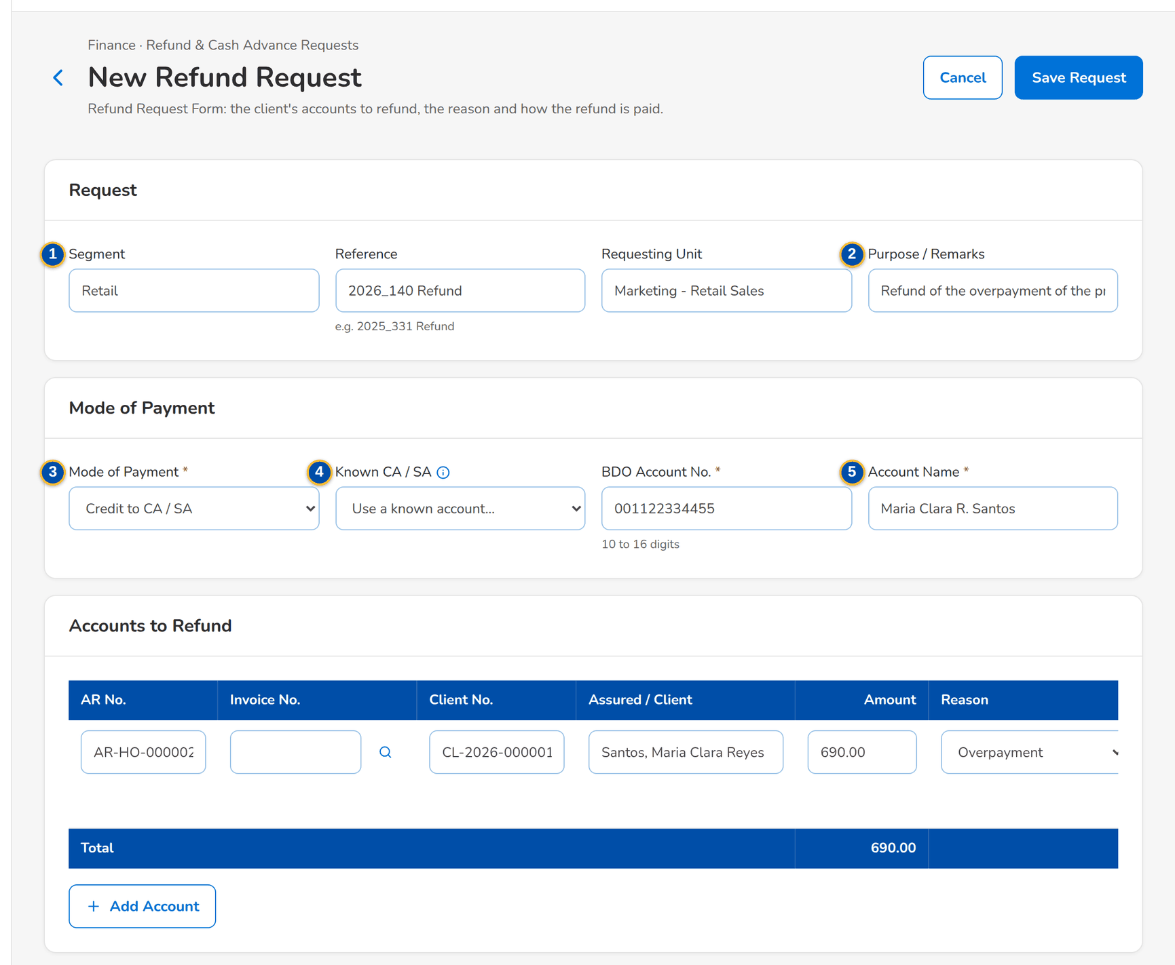
Figure 90: SCR-AC-40 New Refund Request: the request, the credit to the client's account and the account to refund
1 | Segment / Reference / Requesting Unit | 3 | Mode of Payment | 5 | Account No. / Account Name / Check / Payee Name
2 | Purpose / Remarks | 4 | Known CA / SA | 6 | AR No. / Invoice No. / Client No. / Assured / Client / Amount / Reason / Branch / Unit / Category A / B

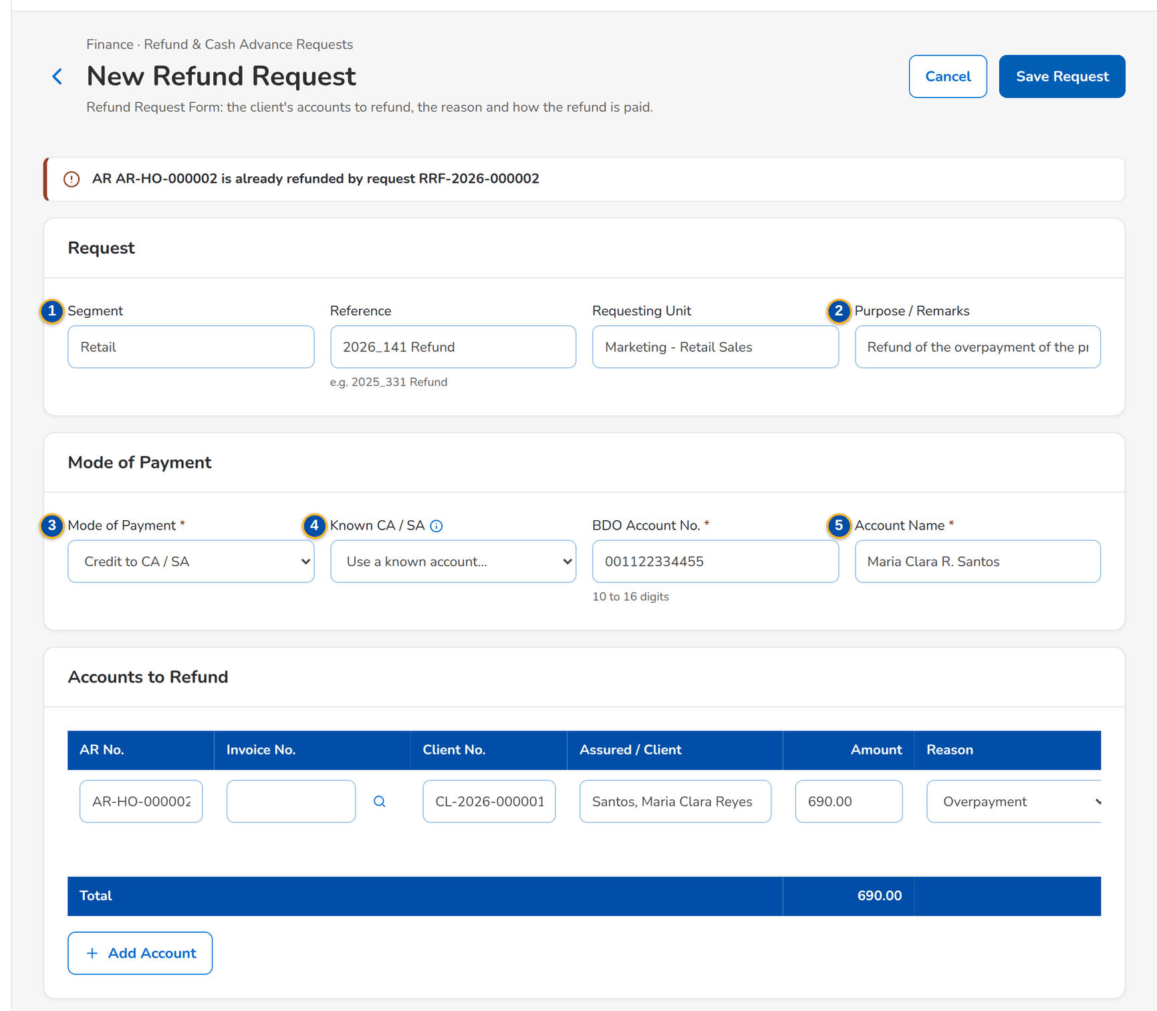
Figure 91: SCR-AC-40 An AR number already in another refund request: the request is refused

Fields (No. = callout number on the first screenshot)
No. | Section | Field | Type | Length / format | Mand. | Source / list | Default | Editable in | Validation | Message when it fails
1 | Request | Segment / Reference / Requesting Unit | Text | Up to 40, 80 and 60 characters; reference such as 2025_331 Refund | N | - | Blank | Draft, Returned | - | -
2 | Request | Purpose / Remarks | Text area | Up to 500 characters | N | - | Blank | Draft, Returned | - | -
3 | Mode of Payment | Mode of Payment | Drop-down | Credit to CA / SA or Check | Y | Payment mode list | Blank | Draft, Returned | - | Select the mode of payment
4 | Mode of Payment | Known CA / SA | Drop-down | Account captured from an earlier refund of the client | N | Client payout accounts | Blank | Draft, Returned | - | -
5 | Mode of Payment | Account No. / Account Name / Check / Payee Name | Text | BDO account of 10 to 16 digits and its name; or the name on the check | Cond.: mode | - | Blank | Draft, Returned | Digits only | Enter the account name
6 | Accounts to Refund | AR No. / Invoice No. / Client No. / Assured / Client / Amount / Reason / Branch / Unit / Category A / B | Row | One line per AR number; the invoice looked up; the reason from its list | Y / N / Y / Y / Y / Y / N / N | Receipts, invoice ledger, refund reason and category lists | Blank | Draft, Returned | An AR number in one open refund only; all lines of one client | -

Actions
Button | Who | Enabled when | What happens | Resulting status | Notification
Add Account / [Remove] | Marketing Processor | Draft or returned | Adds or removes an account line | - | -
Save Request | Marketing Processor, Reviewer (request create) | Mandatory fields filled | Saves the request and opens it | Draft | -
Cancel | Same users | Always | Leaves without saving | - | -

Business rules
• An AR number is refunded once: an AR already in another open or paid refund request is refused (FR-PQ-014).
• All accounts of one refund request belong to one client; the fields follow the Refund Request Form of Appendix D (FR-PQ-003).
• The client's account is recorded on the client record when the refund is approved, without duplicates (FR-PQ-016).
Expected outcome
The refund request is saved with its accounts to refund.
Test cases: TC-PQ-003.1-01, TC-PQ-003.2-01, TC-PQ-003.2-02, TC-PQ-003.2-03, TC-PQ-003.2-04, TC-PQ-003.3-01, TC-PQ-014.1-01, TC-PQ-014.1-02, TC-PQ-014.2-01, TC-PQ-016.1-01, TC-PQ-016.2-01, TC-AC-SCR-40.

13.5.3 SCR-AC-41 New Cash Advance
Purpose | The Request for Payment (RFP) of an employee cash advance: the employee, the type, the amount, the purpose, segment and requesting unit, and the mode of payment.
Who can open it | Marketing Processor (AO), Marketing Reviewer (permission Prq create)
Navigation | • Menu: Finance › Refund & Cash Advance Requests › New Cash Advance  • Requests Home › New Cash Advance
FRs | FR-PQ-004

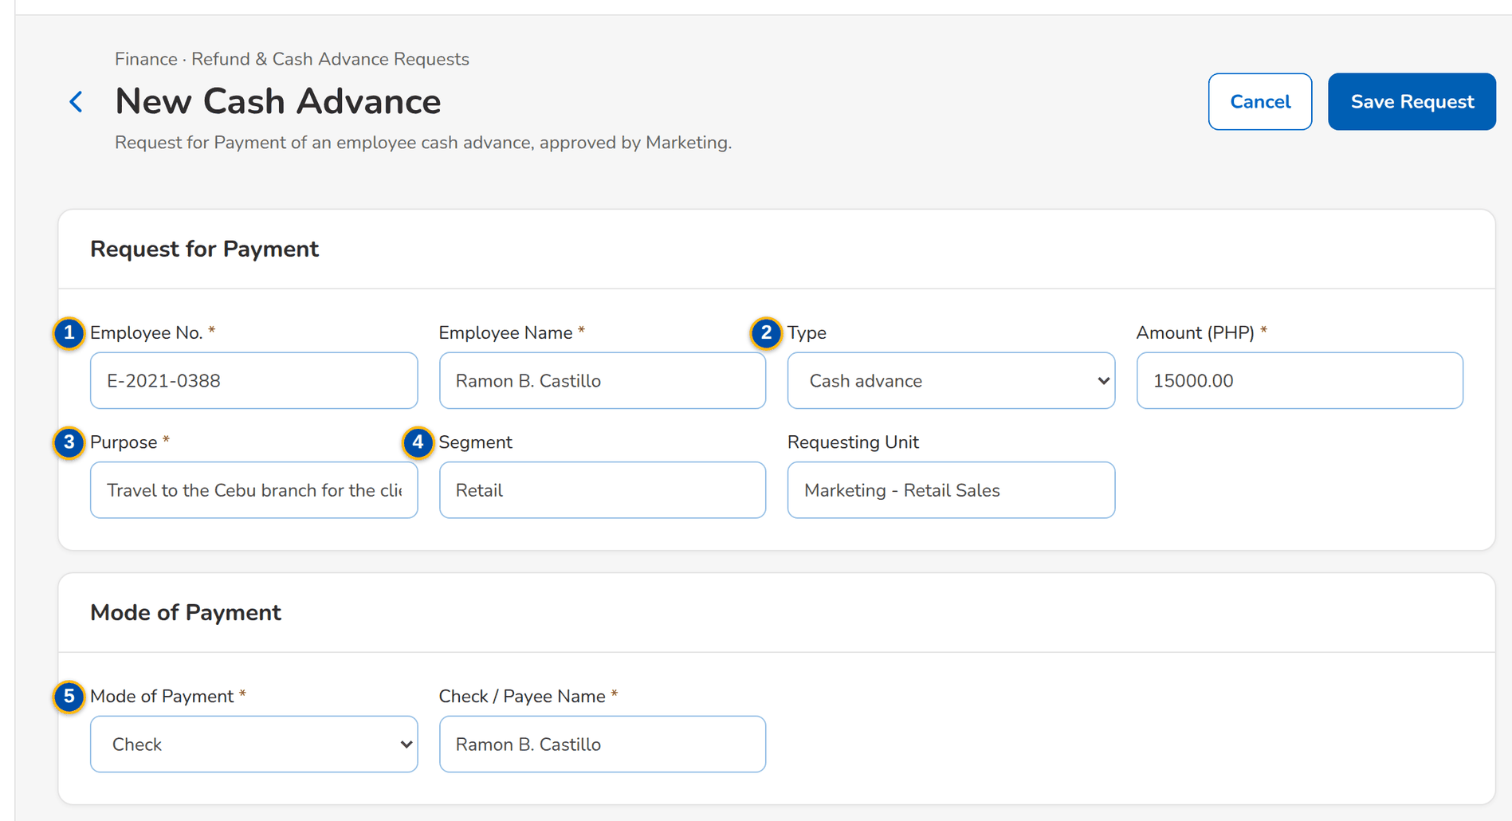
Figure 92: SCR-AC-41 New Cash Advance: the employee, amount and purpose, paid by credit to the employee's account
1 | Employee No. / Employee Name | 3 | Amount / Purpose | 5 | Mode of Payment / Account No. / Account Name
2 | Type | 4 | Segment / Requesting Unit

Fields (No. = callout number on the first screenshot)
No. | Section | Field | Type | Length / format | Mand. | Source / list | Default | Editable in | Validation | Message when it fails
1 | Request for Payment | Employee No. / Employee Name | Text | The employee of the employee master | Y | Employees | Blank | Draft, Returned | - | -
2 | Request for Payment | Type | Drop-down | Cash Advance and the other RFP types | Y | RFP type list | Cash Advance | Draft, Returned | - | -
3 | Request for Payment | Amount / Purpose | Number, text area | Amount above zero in the base currency; purpose up to 500 characters | Y | - | Blank | Draft, Returned | Above zero | -
4 | Request for Payment | Segment / Requesting Unit | Text | Up to 40 and 60 characters | N | - | Blank | Draft, Returned | - | -
5 | Mode of Payment | Mode of Payment / Account No. / Account Name | Drop-down, text | Credit to CA / SA or Check | Y | Payment mode list | Blank | Draft, Returned | - | Select the mode of payment

Actions
Button | Who | Enabled when | What happens | Resulting status | Notification
Save Request / Cancel | Marketing Processor, Reviewer (request create) | Mandatory fields filled | Saves the request and opens it | Draft | -

Business rules
• A cash advance is approved by Marketing, then by Human Resources, before it goes to Disbursement (FR-PQ-004, FR-PQ-015).
Expected outcome
The cash advance is requested.
Test cases: TC-PQ-004.1-01, TC-PQ-004.2-01, TC-PQ-004.2-02, TC-PQ-004.2-03, TC-AC-SCR-41.

13.5.4 SCR-AC-42 Cancel a Check
Purpose | Asks Disbursement to cancel the check of a paid refund or cash advance, after review and approval: the paid request, the check number, the reason and remarks.
Who can open it | Marketing Processor (AO), Marketing Reviewer (permission Prq create)
Navigation | • Menu: Finance › Refund & Cash Advance Requests › Cancel a Check  • Requests Home › Cancel a Check  • Request › Cancel the Check
FRs | FR-PQ-011

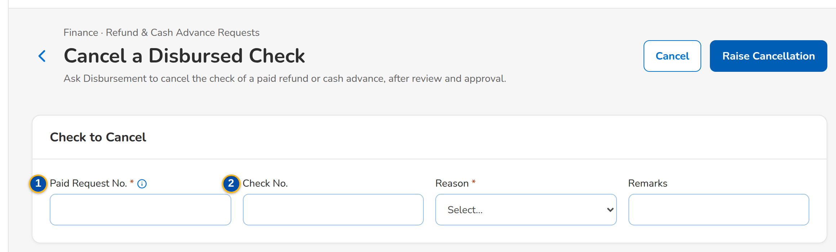
Figure 93: SCR-AC-42 Cancel a Disbursed Check: the paid request, the check and the reason
1 | Paid Request No. | 2 | Check No. / Reason / Remarks

Fields (No. = callout number on the first screenshot)
No. | Section | Field | Type | Length / format | Mand. | Source / list | Default | Editable in | Validation | Message when it fails
1 | Check to Cancel | Paid Request No. | Text | The RRF or RFP whose check was disbursed | Y | Requests | Blank | - | A disbursed request paid by check | -
2 | Check to Cancel | Check No. / Reason / Remarks | Text, drop-down | The check number; the reason from its list | N / Y / N | Cancellation reason list | Blank | - | - | Choose a reason

Actions
Button | Who | Enabled when | What happens | Resulting status | Notification
Raise Cancellation | Marketing Processor, Reviewer (request create) | Paid request and reason given | Raises a check-cancellation request for review and approval | Draft | -

Business rules
• After approval the cancellation is handed to the Disbursement approvers, who cancel the approved voucher (FR-PQ-011, FR-DS-044).
Expected outcome
The cancellation of the check is requested.
Test cases: TC-PQ-011.1-01, TC-PQ-011.2-01, TC-PQ-011.2-02, TC-PQ-011.2-03, TC-AC-SCR-42.

13.5.5 SCR-AC-43 Request
Purpose | One Marketing request: the payee, kind, amount, mode of payment, request date and DV number; the workflow (assign, submit, send for validation, endorse, approve, approve for HR, return, cancel); the tabs Details, Validation (the checks of ACSL and Cashiering on the refund of a cancelled policy), Disbursement (the voucher and its status), Liquidation (of a cash advance) and Documents.
Who can open it | Marketing Processor (AO), Marketing Reviewer, Marketing Approver, Human Resources Approver, System Administrator, Auditor (permission Prq view or Prq create or Prq review or Prq approve or Prq hr approve)
Navigation | • Menu: Finance › Refund & Cash Advance Requests › Requests Home › Request  • Requests Home › open a row  • New Refund Request, New Cash Advance › saved
FRs | FR-PQ-001, FR-PQ-005, FR-PQ-006, FR-PQ-007, FR-PQ-008, FR-PQ-009, FR-PQ-010, FR-PQ-012, FR-PQ-013, FR-PQ-015, FR-PQ-017

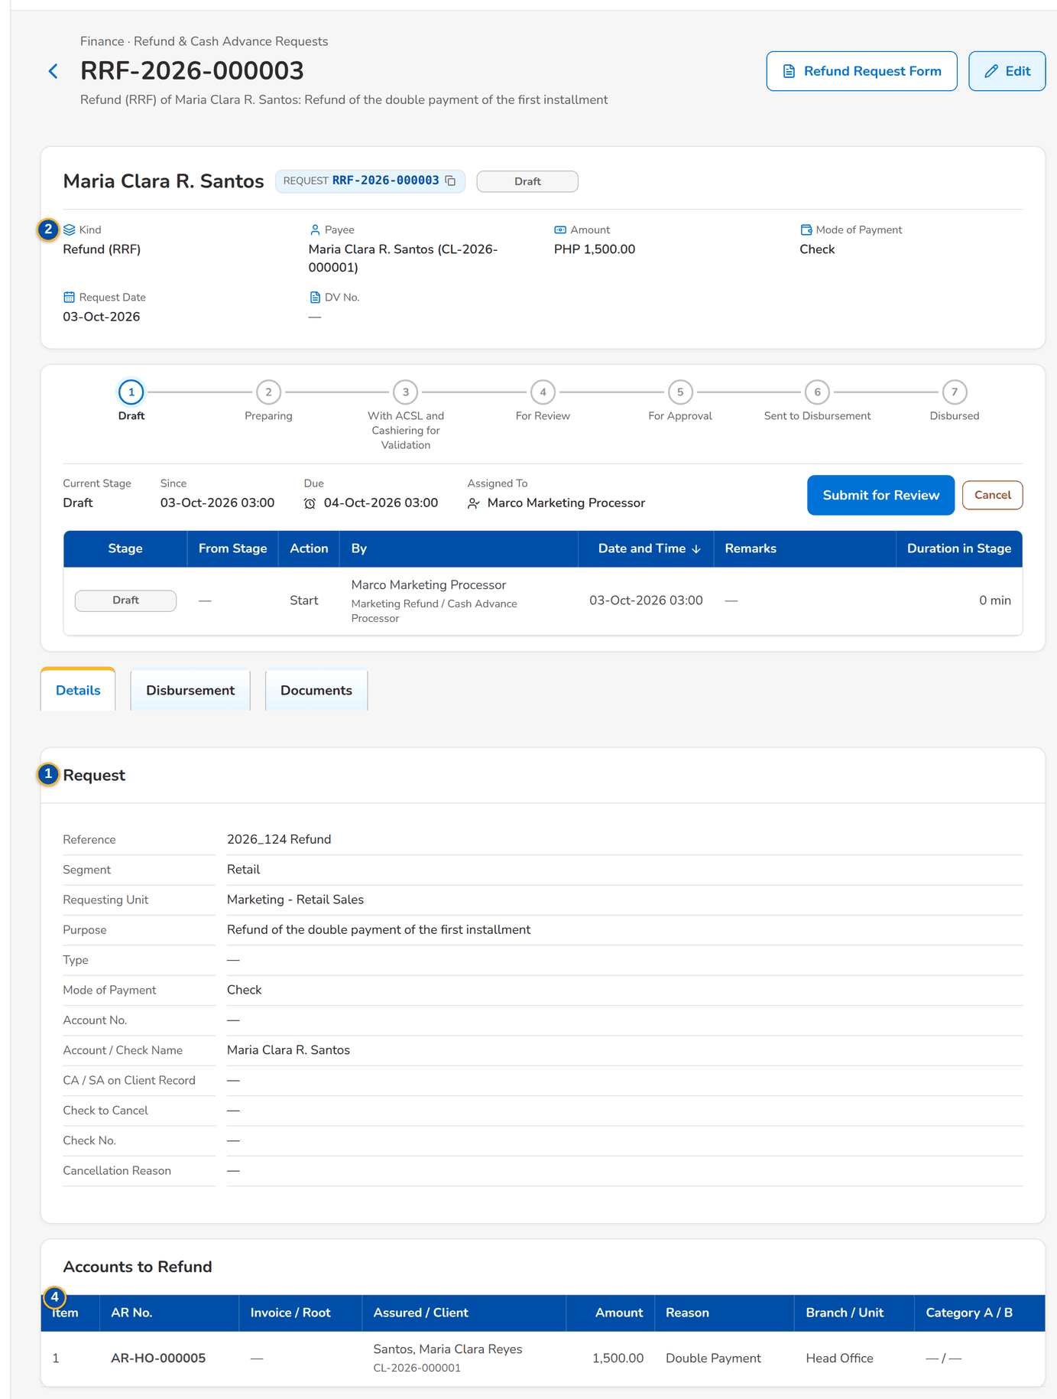
Figure 94: SCR-AC-43 A refund request: header, workflow and the accounts to refund
1 | Request and Root Invoice chips, status pill | 5 | Round / Item / Validator / Ticket / Status / Result | 9 | Date / Particulars / [Expense categories]
2 | Kind / Payee / Amount / Mode of Payment / Request Date / DV No. | 6 | Result / New AR No. / Remarks | 10 | Preparer
3 | Request details | 7 | DV, status and payment
4 | Item / AR No. / Invoice / Root / Assured / Client / Amount / Reason / Branch / Unit / Category A / B | 8 | Job Level / Cost Centre / Cash Advanced / Over / (Short)

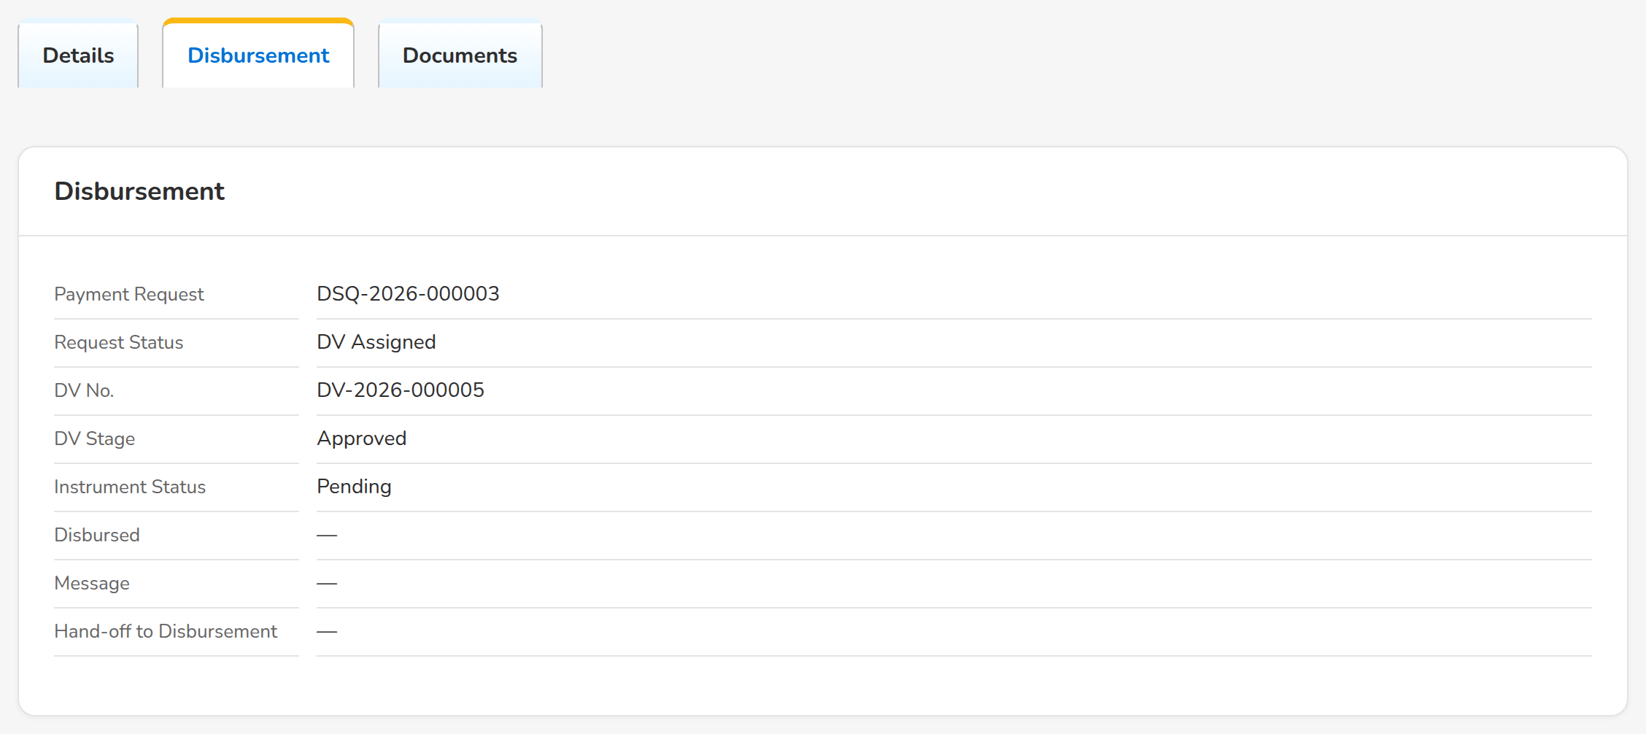
Figure 95: SCR-AC-43 Disbursement tab: the voucher of the refund and its status in Disbursement
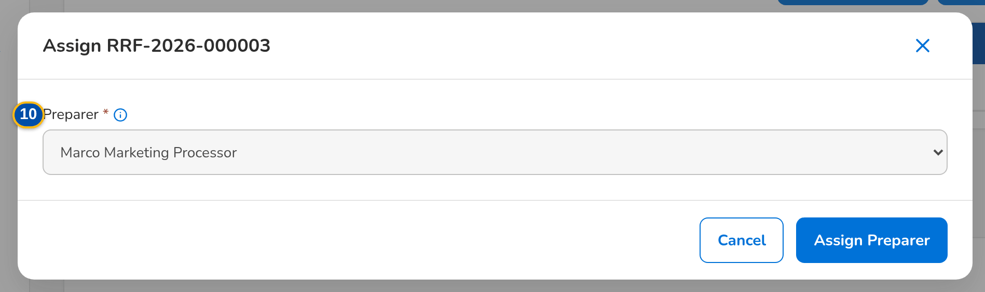
Figure 96: SCR-AC-43 Assign the request to the Marketing user who prepares it
Fields (No. = callout number on the first screenshot)
No. | Section | Field | Type | Length / format | Mand. | Source / list | Default | Editable in | Validation | Message when it fails
1 | Header | Request and Root Invoice chips, status pill | Reference chip, status pill | Request number; root invoice of the first line; the stage | - | Request | - | Read only | - | -
2 | Facts | Kind / Payee / Amount / Mode of Payment / Request Date / DV No. | Display | Refund (RRF), Cash Advance (RFP) or Check Cancellation; payee name; currency and amount | - | Request | - | Read only | - | -
3 | Details | Request details | Display | Segment, reference, requesting unit, purpose and the payout account | - | Request | - | Read only | - | -
4 | Details | Item / AR No. / Invoice / Root / Assured / Client / Amount / Reason / Branch / Unit / Category A / B | Column | The accounts to refund | - | Refund lines | - | Read only | - | -
5 | Validation | Round / Item / Validator / Ticket / Status / Result | Column | ACSL and Cashiering checks with their ticket and result; the new AR when the payment went back to unapplied | - | Validations | - | Read only | - | No validation needed for this request
6 | Record Result dialog | Result / New AR No. / Remarks | Drop-down, text | Confirmed or Rejected; the AR issued when the payment went back to unapplied | Y / N / N | - | - | For validation | - | -
7 | Disbursement | DV, status and payment | Display | The voucher of the request with its stage and the payment | - | Disbursement | - | Read only | - | -
8 | Liquidation | Job Level / Cost Centre / Cash Advanced / Over / (Short) | Drop-down, display | The job level and cost centre; the amounts | Y / Y / - / - | Liquidation accounts | - | Disbursed cash advance | - | -
9 | Liquidation | Date / Particulars / [Expense categories] | Row | One line per day with the per diem, representation, transport, lodging and others | Y | - | - | Disbursed cash advance | - | -
10 | Assign dialog | Preparer | Drop-down | A Marketing user who prepares refunds, by name | Y | Users who may create requests | Blank | Preparing | A user who may create requests | -

Actions
Button | Who | Enabled when | What happens | Resulting status | Notification
Assign Preparer | Marketing Reviewer (request assign) | Received refund | Assigns the request to a preparer | Preparing | Workflow notice
Submit for Review / Send for Validation | Preparer (request create) | Draft or preparing | Sends the request for review, or first to ACSL and Cashiering for a refund of a cancelled policy | For Review or For Validation | Workflow notice
Record Result | Marketing Reviewer (request assign) | Open validation | Records the result of a validation | For Review when all are confirmed | -
Endorse for Approval | Marketing Reviewer (request review) | For review | Endorses the request | For Approval | Workflow notice
Approve and Send / Approve and Send to HR / Approve (HR) and Send to Disbursement | Marketing Approver; HR Approver | For approval or HR approval | Approves the request; an approved request becomes a payment request in Disbursement | With Disbursement or For HR Approval | Workflow notice
Cancel the Check | Marketing Processor | A disbursed request paid by check | Opens Cancel a Check for the request | - | -
Add Day / Save Liquidation / Submit Liquidation / Return to Employee / Check and Post | Employee; reviewer | Disbursed cash advance | Records, submits, returns or posts the liquidation | Liquidated | -

Business rules
• The refund of a cancelled policy is validated by ACSL and Cashiering before the review (FR-PQ-006).
• A request is endorsed and approved by other users than the one who raised or last moved it; a returned request goes back to its maker with the reason (FR-PQ-005, FR-PQ-008, FR-PQ-009).
• An approved refund or check cancellation goes to Disbursement; an approved cash advance goes to HR, then to Disbursement (FR-PQ-015).
• Disbursement reports each stage of the voucher back to the request (FR-PQ-013).
• A cash advance is liquidated with its expenses by day; the excess or shortage is shown and the expenses post to the liquidation accounts (FR-PQ-017).
Expected outcome
The request is validated, approved, paid and, for a cash advance, liquidated.
Test cases: TC-PQ-005.1-01, TC-PQ-005.2-01, TC-PQ-005.2-02, TC-PQ-006.1-01, TC-PQ-007.1-01, TC-PQ-007.2-01, TC-PQ-008.1-01, TC-PQ-008.2-01, TC-PQ-008.3-01, TC-PQ-009.1-01, TC-PQ-009.2-01, TC-PQ-009.2-02, TC-PQ-009.3-01, TC-PQ-010.1-01, TC-PQ-010.2-01, TC-PQ-012.1-02, TC-PQ-013.1-01, TC-PQ-013.2-01, TC-PQ-013.2-02, TC-PQ-017.1-01, TC-PQ-017.2-01, TC-PQ-017.2-02, TC-PQ-017.3-01, TC-PQ-017.3-02, TC-PQ-017.3-03, TC-PQ-017.3-04, TC-PQ-017.3-05, TC-PQ-017.3-06, TC-AC-SCR-43, TC-AC-MSG-28, TC-AC-MSG-29.

13.5.6 SCR-AC-44 Liquidation Accounts
Purpose | The GL account each expense category of a cash-advance liquidation posts to (per diem, representation, transport, lodging, others, the excess and the shortage).
Who can open it | Comptrollership administrator (masters and rules), Marketing Reviewer (permission Accounting rule manage or Prq review)
Navigation | • Menu: Finance › Refund & Cash Advance Requests › Liquidation Accounts
FRs | FR-PQ-017

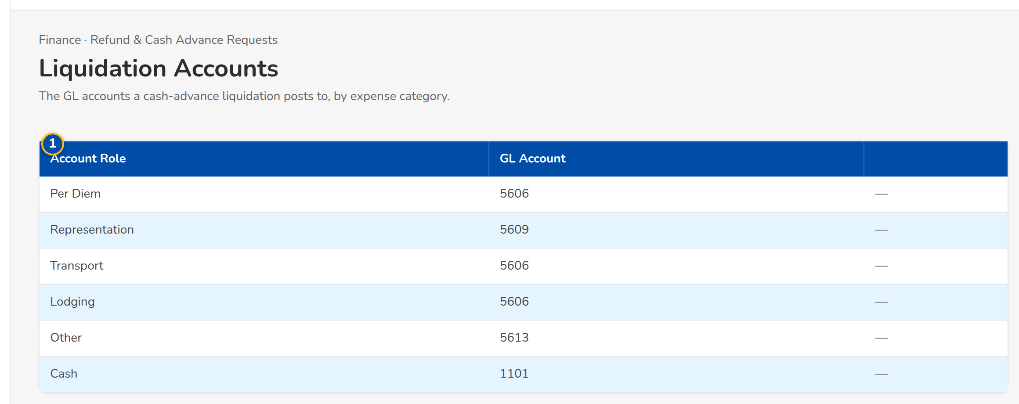
Figure 97: SCR-AC-44 Liquidation Accounts: the GL account of each expense category
1 | Account Role / GL Account

Fields (No. = callout number on the first screenshot)
No. | Section | Field | Type | Length / format | Mand. | Source / list | Default | Editable in | Validation | Message when it fails
1 | List | Account Role / GL Account | Column, text | The expense category and its account code | Y | Chart of accounts | Seed accounts | - | An active postable account | -

Actions
Button | Who | Enabled when | What happens | Resulting status | Notification
Save | Comptrollership administrator (accounting rule manage), Marketing Reviewer | Account changed | Saves the account of the category | - | -

Business rules
• The liquidation posts each expense category to its account against the advances to employees (FR-PQ-017).
Expected outcome
The liquidation posts to the right accounts.
Test cases: TC-AC-SCR-44, TC-AC-MSG-30.

13.6 Accounting Controls and Subsidiary Ledger (ACSL)

13.6.1 SCR-AC-45 ACSL Cases
Purpose | The cases of ACSL by stage (Received, Assigned, Investigating, Result Provided, Sent for Correction): account investigations, analysis requests of the other units, refunds to validate and payment reversals; the team leader opens a case and assigns it to a processor.
Who can open it | ACSL Processor, ACSL Team Leader, ACSL Head (approver), Comptrollership (read access), System Administrator, Auditor (permission ACSL view or ACSL process or ACSL assign or ACSL review or ACSL approve)
Navigation | • Menu: Finance › ACSL › ACSL Cases
FRs | FR-AS-010

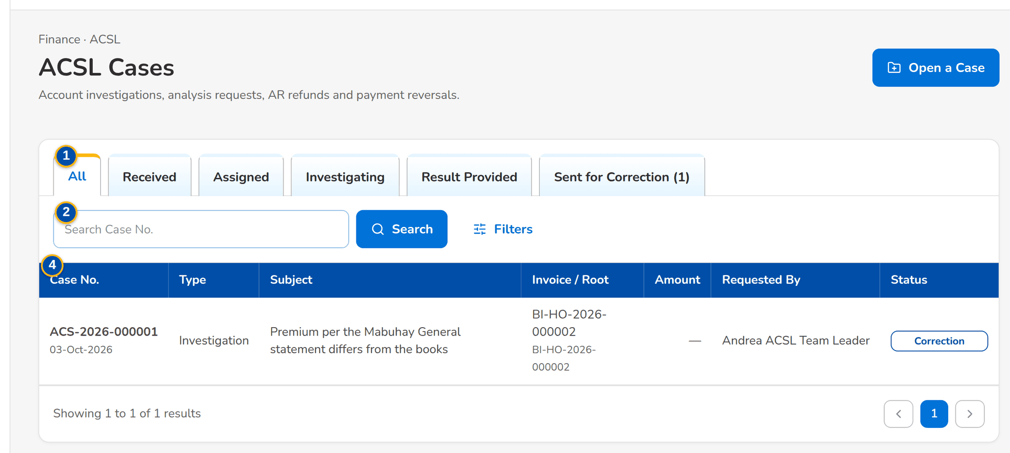
Figure 98: SCR-AC-45 ACSL Cases: the cases by stage with type, subject, invoice, amount, requester and status
1 | All / Received / Assigned / Investigating / Result Provided / Sent for Correction | 3 | Case Type | 5 | Case Type / Invoice No. / AR / OR No.
2 | Search Case No. | 4 | Case No. / Type / Subject / Invoice / Root / Amount / Requested By / Status | 6 | Subject / Details

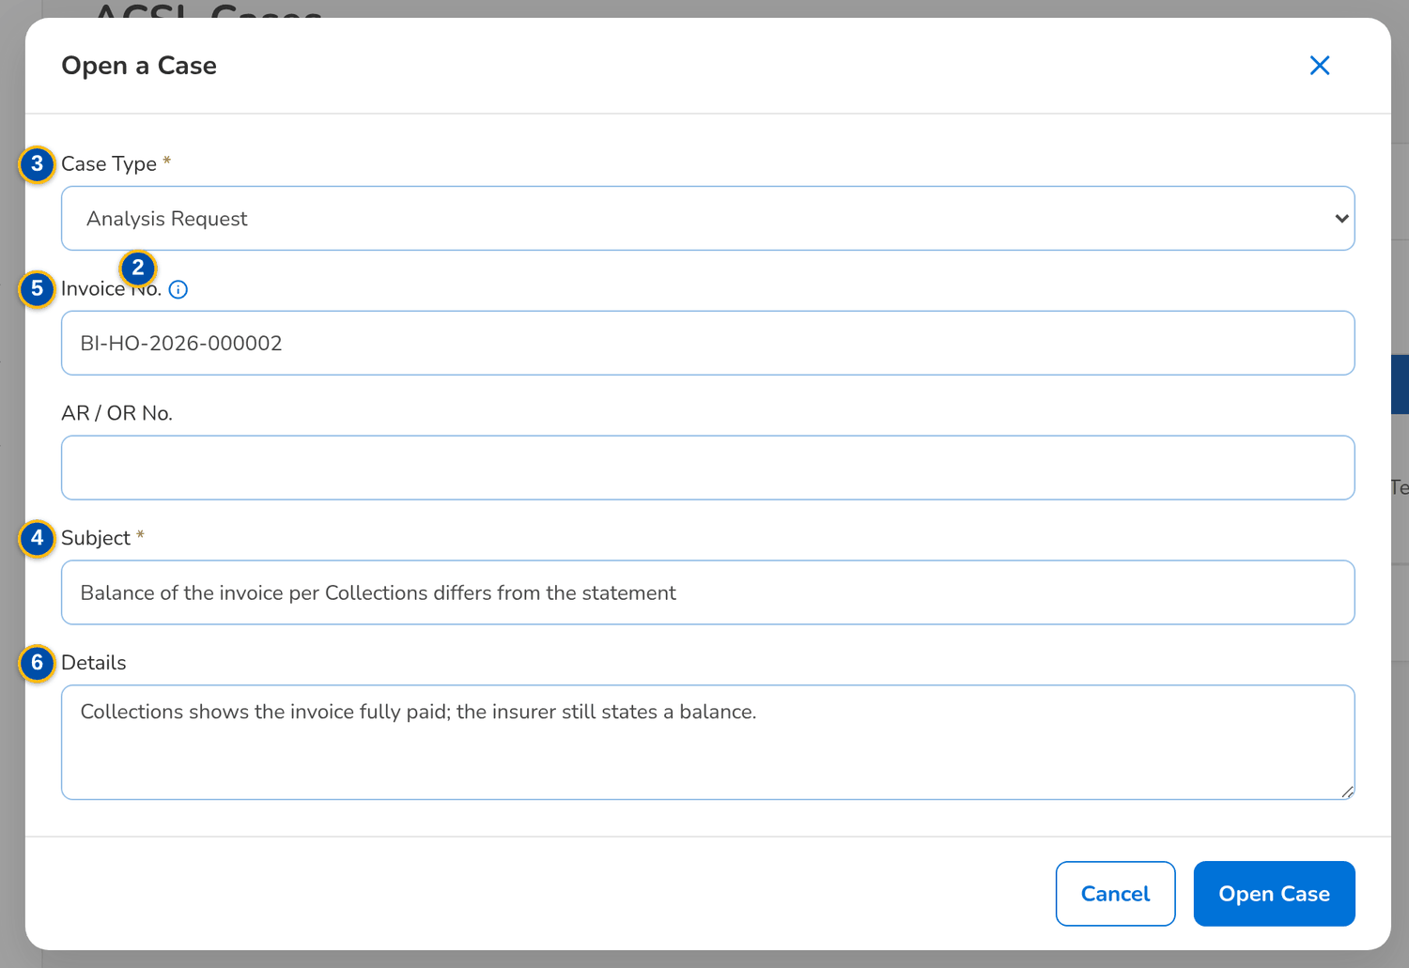
Figure 99: SCR-AC-45 Open a Case: type, invoice, AR or OR number, subject and details
Fields (No. = callout number on the first screenshot)
No. | Section | Field | Type | Length / format | Mand. | Source / list | Default | Editable in | Validation | Message when it fails
1 | Tabs | All / Received / Assigned / Investigating / Result Provided / Sent for Correction | Tab | With the count of each | - | Cases | All | - | - | -
2 | Toolbar | Search Case No. | Text | Case number | N | - | Blank | - | Contains | -
3 | Filters | Case Type | Drop-down | Investigation, Analysis request, Refund validation, Payment reversal | N | Case type list | All | - | - | -
4 | List | Case No. / Type / Subject / Invoice / Root / Amount / Requested By / Status | Column | The case number with its date; the invoice with its root invoice; the requester's name | - | Cases | - | Read only | - | -
5 | Open a Case dialog | Case Type / Invoice No. / AR / OR No. | Drop-down, text | The account investigated; its whole invoice family is linked | Y / N / N | Case type list, invoice ledger | Blank | - | - | -
6 | Open a Case dialog | Subject / Details | Text | The subject and the details of the case | Y / N | - | Blank | - | - | Enter the subject of the case

Actions
Button | Who | Enabled when | What happens | Resulting status | Notification
Open a Case / Open Case | ACSL Team Leader, Processor (ACSL process) | Always | Opens a case | Received | -
Row | ACSL users | Always | Opens the case | - | -

Business rules
• Cases also arrive from the other units: the validation of a refund of a cancelled policy and the analysis requests (FR-AS-010, FR-PQ-006).
Expected outcome
ACSL sees every case by stage.
Test cases: TC-AS-010.1-01, TC-AS-010.2-01, TC-AS-010.2-02, TC-AS-010.3-01, TC-AC-SCR-45, TC-AC-MSG-31.

13.6.2 SCR-AC-46 ACSL Case
Purpose | One case: the request (subject, details, requesting module and reference, client, insurer, root invoice), the investigation (findings, result, remarks), the follow-up (payment reversal and correction), the cases of the same invoice family and the documents; the actions of the stage: assign, record findings, provide the result, raise a correction entry, request a payment reversal, message the account officer.
Who can open it | ACSL Processor, ACSL Team Leader, ACSL Head (approver), Comptrollership (read access), System Administrator, Auditor (permission ACSL view or ACSL process or ACSL assign or ACSL review or ACSL approve)
Navigation | • Menu: Finance › ACSL › ACSL Cases › ACSL Case  • ACSL Cases › open a row  • Insurer SOA › a line to investigate
FRs | FR-AS-010, FR-AS-011, FR-AS-012, FR-AS-013, FR-AS-026, FR-DS-093

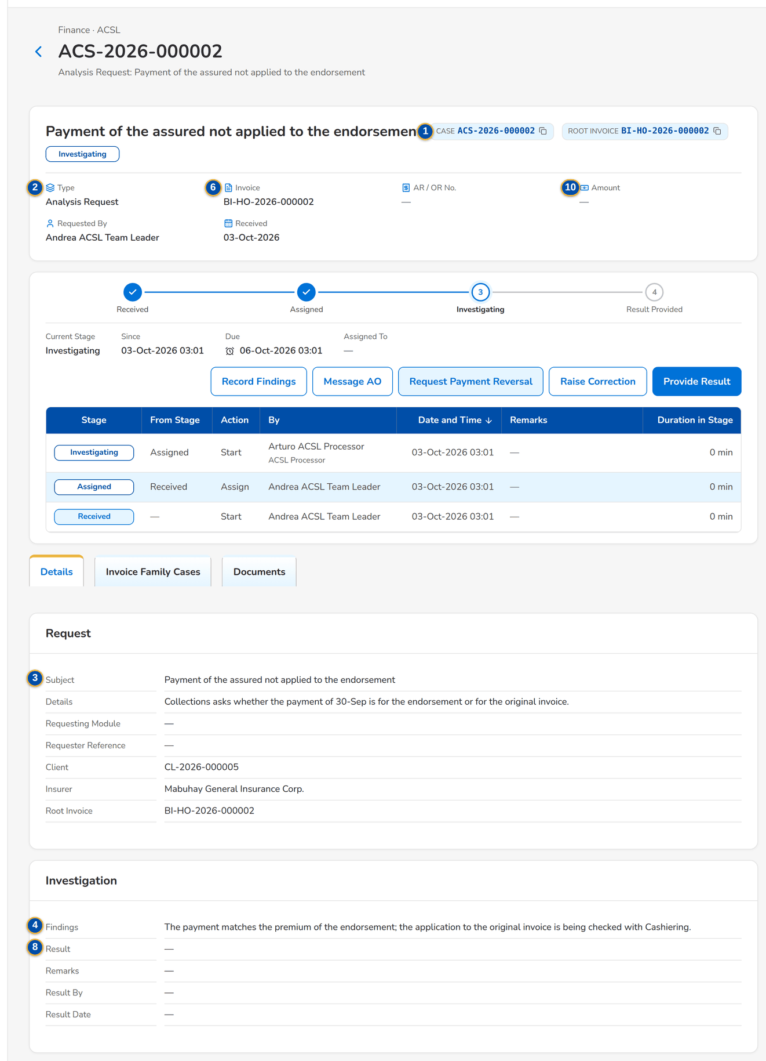
Figure 100: SCR-AC-46 An ACSL case under investigation: the request, the findings and the actions
1 | Case and Root Invoice chips, status pill | 5 | Payment Reversal / Reversal Status / Reversal Message | 9 | Correction Kind / Journal to Correct / Description
2 | Type / Invoice / AR / OR No. / Amount / Requested By / Received | 6 | Case No. / Type / Invoice / Subject / Received / Status | 10 | AR / OR No. / Amount / Reason
3 | Subject / Details / Requesting Module / Requester Reference / Client / Insurer / Root Invoice | 7 | Processor | 11 | Message
4 | Findings / Result / Remarks / Result By / Result Date | 8 | Result / Remarks

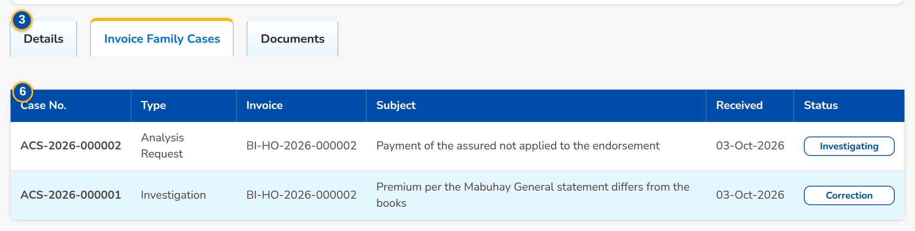
Figure 101: SCR-AC-46 Invoice Family Cases: the cases of the same root invoice
Fields (No. = callout number on the first screenshot)
No. | Section | Field | Type | Length / format | Mand. | Source / list | Default | Editable in | Validation | Message when it fails
1 | Header | Case and Root Invoice chips, status pill | Reference chip, status pill | Case number, root invoice; Received, Assigned, Investigating, Result Provided, Sent for Correction | - | Case | - | Read only | - | -
2 | Facts | Type / Invoice / AR / OR No. / Amount / Requested By / Received | Display | The type in words; the requester's name | - | Case | - | Read only | - | -
3 | Request | Subject / Details / Requesting Module / Requester Reference / Client / Insurer / Root Invoice | Display | The request as received | - | Case | - | Read only | - | -
4 | Investigation | Findings / Result / Remarks / Result By / Result Date | Display | The findings; Confirmed, Rejected or No action needed; the name and time | - | Case | - | Read only | - | -
5 | Follow-up | Payment Reversal / Reversal Status / Reversal Message | Display | The reversal requested to Cashiering and its status; the correction entry raised | - | Case | - | Read only | - | -
6 | Invoice Family Cases | Case No. / Type / Invoice / Subject / Received / Status | Column | The cases of the invoice family | - | Cases | - | Read only | - | -
7 | Assign the Case dialog | Processor | Drop-down | The ACSL processor, by name | Y | Users | Blank | Received | - | -
8 | Provide the Result dialog | Result / Remarks | Drop-down, text | Confirmed, Rejected, No action needed | Y / N | Fixed list | - | Investigating | - | -
9 | Raise a Correction Entry dialog | Correction Kind / Journal to Correct / Description | Drop-down, text | Posting to a wrong GL account, Wrong amount, Reclassification, Other correction; the journal batch if known | Y / N / Y | Fixed list | - | Investigating | - | -
10 | Request a Payment Reversal dialog | AR / OR No. / Amount / Reason | Text, number | Leave the amount empty to reverse the whole application | Y / N / Y | - | The AR of the case | Investigating | - | -
11 | Message the Account Officer dialog | Message | Text area | The short or over payment to settle | Y | - | Blank | Investigating | - | -

Actions
Button | Who | Enabled when | What happens | Resulting status | Notification
Assign | ACSL Team Leader (ACSL assign) | Received | Assigns the case to a processor | Assigned | Workflow notice
Record Findings | ACSL Processor (ACSL process) | Assigned or investigating | Records the findings | Investigating | -
Provide Result | ACSL Processor | Investigating | Gives the result to the requester | Result Provided | Notice to the requester
Raise Correction | ACSL Processor | Investigating | Raises a correction entry for the invoice and opens it | Sent for Correction | -
Request Payment Reversal | ACSL Processor (ACSL apply) | Investigating, an AR of the case | Asks Cashiering to reverse the application of the payment | - | Request to Cashiering
Message AO | ACSL Processor | Investigating | Sends the message to the account officer of the invoice | - | Notice to the AO

Business rules
• A case links the whole invoice family through the root invoice (FR-AS-010, FR-AS-026).
• A payment reversal is approved by a cashiering user who is not the requester (FR-AS-012).
• The result is sent to the requester and closes the validation of a refund (FR-AS-011, FR-PQ-006).
Expected outcome
The account is investigated and the result, reversal or correction follows.
Test cases: TC-PQ-006.2-01, TC-AS-011.1-01, TC-AS-012.1-01, TC-AS-012.2-01, TC-AS-013.1-01, TC-AS-013.2-01, TC-AC-SCR-46, TC-AC-MSG-32.

13.6.3 SCR-AC-47 Correction Entries
Purpose | The correction entries that reverse a wrong posting and post the right one, by stage (To Assign, Draft, For Review, For Approval, Posted, Cancelled); a new correction is raised for an invoice.
Who can open it | ACSL Processor, ACSL Team Leader, ACSL Head (approver), Comptrollership (read access), System Administrator, Auditor (permission ACSL view or ACSL process or ACSL assign or ACSL review or ACSL approve)
Navigation | • Menu: Finance › ACSL › Correction Entries  • GL-SL Reconciliation › a difference to correct
FRs | FR-AS-020

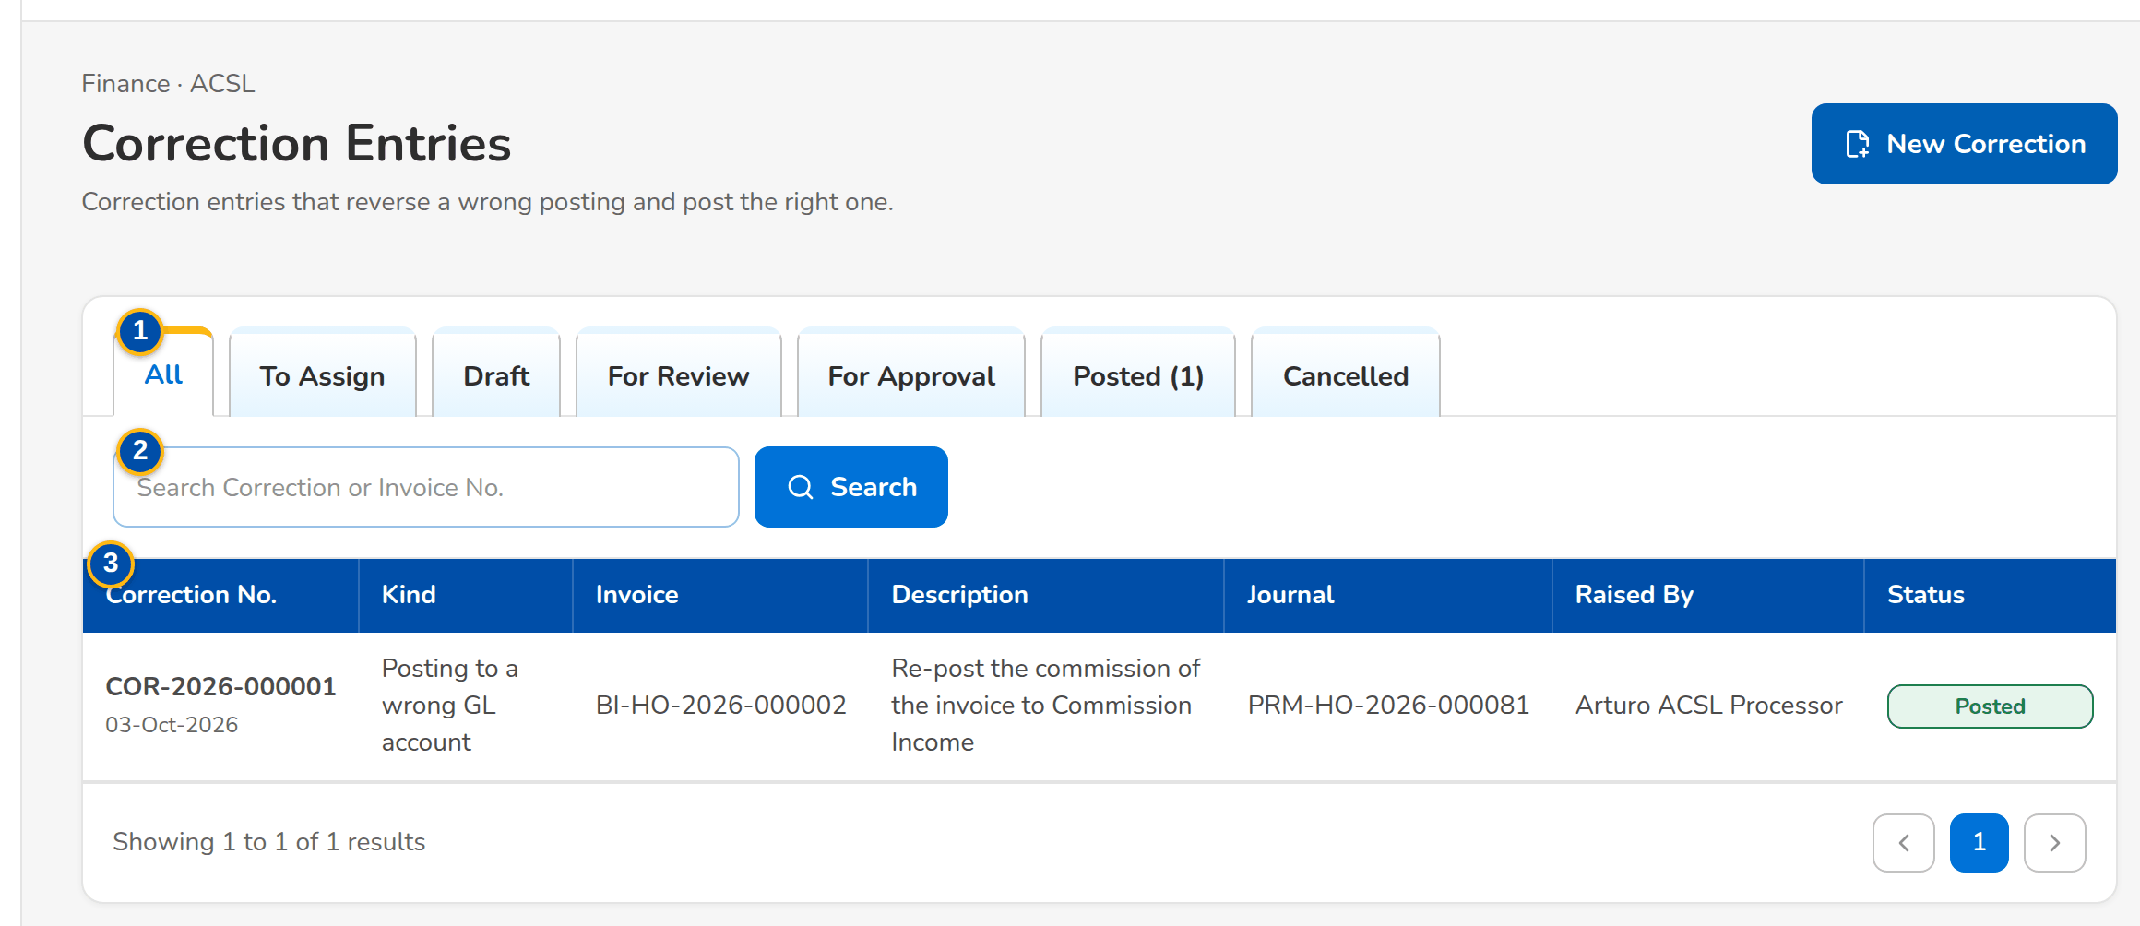
Figure 102: SCR-AC-47 Correction Entries: the corrections by stage with kind, invoice, journal, raiser and status
1 | All / To Assign / Draft / For Review / For Approval / Posted / Cancelled | 3 | Correction No. / Kind / Invoice / Description / Journal / Raised By / Status
2 | Search Correction or Invoice No. | 4 | Correction Kind / Invoice No. / Journal to Correct / Description

Fields (No. = callout number on the first screenshot)
No. | Section | Field | Type | Length / format | Mand. | Source / list | Default | Editable in | Validation | Message when it fails
1 | Tabs | All / To Assign / Draft / For Review / For Approval / Posted / Cancelled | Tab | With the count of each | - | Corrections | All | - | - | -
2 | Toolbar | Search Correction or Invoice No. | Text | - | N | - | Blank | - | Contains | -
3 | List | Correction No. / Kind / Invoice / Description / Journal / Raised By / Status | Column | The correction number with its date; the journal posted; the raiser's name | - | Corrections | - | Read only | - | -
4 | New Correction dialog | Correction Kind / Invoice No. / Journal to Correct / Description | Drop-down, text | The kind; the invoice; the journal batch if known | Y / Y / N / Y | Fixed list, invoice ledger | Blank | - | - | -

Actions
Button | Who | Enabled when | What happens | Resulting status | Notification
New Correction | ACSL Team Leader, Processor (ACSL process) | Always | Raises a correction | To Assign | -
Row | ACSL users | Always | Opens the correction | - | -

Business rules
• A correction is assigned, prepared, reviewed and approved by different users before it posts (FR-AS-020 to FR-AS-024).
Expected outcome
ACSL follows every correction to its posting.
Test cases: TC-AS-020.1-01, TC-AC-SCR-47.

13.6.4 SCR-AC-48 Correction Entry
Purpose | One correction entry: its kind, invoice, the journal corrected, total, raiser and date; the posted lines of the invoice family from which the preparer picks the wrong line to reverse and re-post; the correction lines (Dr / Cr, GL account, amount, party, invoice, component, cost centre, narration) that must balance; the workflow (assign the preparer, submit for review, endorse for approval, approve and post).
Who can open it | ACSL Processor, ACSL Team Leader, ACSL Head (approver), Comptrollership (read access), System Administrator, Auditor (permission ACSL view or ACSL process or ACSL assign or ACSL review or ACSL approve)
Navigation | • Menu: Finance › ACSL › Correction Entries › Correction Entry  • Correction Entries › open a row  • ACSL Case › Raise Correction
FRs | FR-AS-020, FR-AS-021, FR-AS-022, FR-AS-023, FR-AS-024

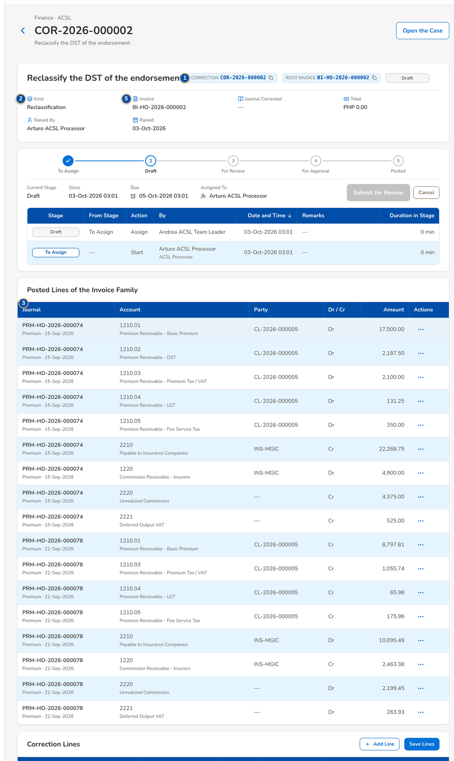
Figure 103: SCR-AC-48 A correction in draft: the posted lines of the invoice family and the correction lines
1 | Correction, Journal and Root Invoice chips, status pill | 3 | Journal / Account / Party / Dr / Cr / Amount | 5 | [Side] / GL Account / Amount / Party / Invoice / Component / Cost Centre / Narration
2 | Kind / Invoice / Journal Corrected / Total / Raised By / Raised | 4 | Right GL Account / Right Party / Ledger Component / Right Ledger Component | 6 | Preparer

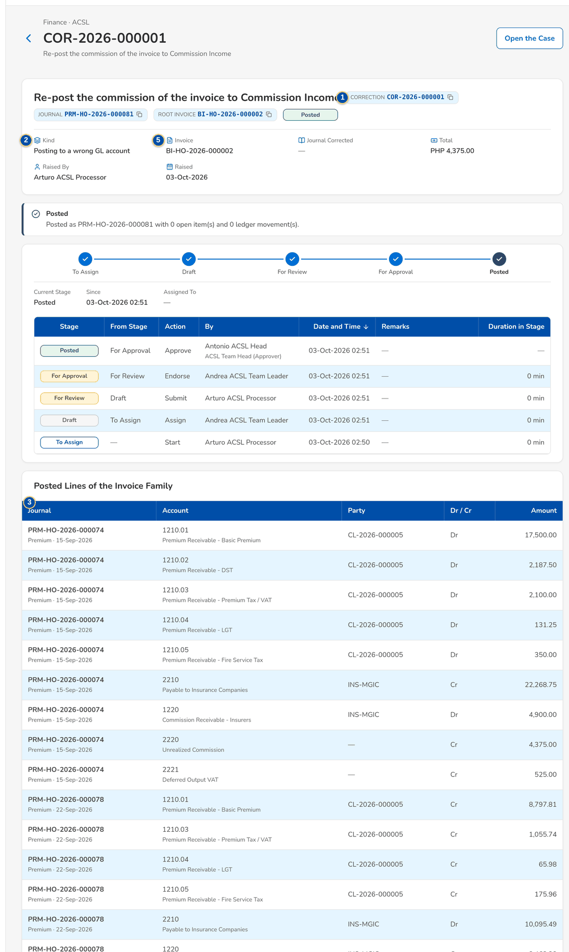
Figure 104: SCR-AC-48 A posted correction with its journal

Fields (No. = callout number on the first screenshot)
No. | Section | Field | Type | Length / format | Mand. | Source / list | Default | Editable in | Validation | Message when it fails
1 | Header | Correction, Journal and Root Invoice chips, status pill | Reference chip, status pill | To Assign, Draft, For Review, For Approval, Posted, Cancelled | - | Correction | - | Read only | - | -
2 | Facts | Kind / Invoice / Journal Corrected / Total / Raised By / Raised | Display | The kind in words; the invoice; the journal batch; currency and total debit; the raiser's name | - | Correction | - | Read only | - | -
3 | Posted Lines of the Invoice Family | Journal / Account / Party / Dr / Cr / Amount | Column | The posted lines of the invoice and its family | - | General ledger | - | Read only | - | -
4 | Correct dialog | Right GL Account / Right Party / Ledger Component / Right Ledger Component | Text | The account, party and component the line should have posted to | Y / N / N / N | Chart, business partners | The line's party | Draft | - | -
5 | Correction Lines | [Side] / GL Account / Amount / Party / Invoice / Component / Cost Centre / Narration | Row | The reversal and the re-post; debits equal credits | Y / Y / Y / N / N / N / N / N | Chart | - | Draft | A positive amount with two decimals; balanced | Enter a positive amount with at most two decimals
6 | Assign dialog | Preparer | Drop-down | The ACSL processor who prepares the correction, by name | Y | Users | Blank | To assign | - | -

Actions
Button | Who | Enabled when | What happens | Resulting status | Notification
Assign Preparer | ACSL Team Leader (ACSL assign) | To assign | Assigns the correction to a preparer | Draft | Workflow notice
Correct | Preparer (ACSL process) | Draft | Adds the reversal of the posted line and its re-post to the right account | Draft | -
Add Line / Save Lines | Preparer | Draft | Adds a line or saves the balanced lines | Draft | -
Submit for Review | Preparer | Draft with balanced lines | Sends the correction for review | For Review | Workflow notice
Endorse for Approval | ACSL Team Leader (ACSL review), not the preparer | For review | Endorses the correction | For Approval | Workflow notice
Approve and Post | ACSL Head (ACSL approve), not the maker | For approval | Posts the correction journal and corrects the invoice ledger | Posted | Workflow notice
Open the Case | ACSL users | A correction raised from a case | Opens the case | - | -

Business rules
• A correction is reviewed by another user than its preparer and approved by another user than its maker (FR-AS-022, FR-AS-023).
• Approval posts the correction journal at once, with the reversal of the wrong line and the re-post to the right account (FR-AS-024).
• The lines must balance before the correction is submitted (FR-AS-021).
Expected outcome
The wrong posting is reversed and posted right, with four eyes.
Test cases: TC-AS-021.1-01, TC-AS-021.2-01, TC-AS-021.2-02, TC-AS-021.3-01, TC-AS-021.3-02, TC-AS-021.3-03, TC-AS-021.3-04, TC-AS-021.3-05, TC-AS-021.3-07, TC-AS-021.4-01, TC-AS-022.1-01, TC-AS-022.1-02, TC-AS-022.2-01, TC-AS-023.1-01, TC-AS-023.2-01, TC-AS-023.2-02, TC-AS-024.1-01, TC-AS-024.2-01, TC-AS-024.2-02, TC-AC-SCR-48, TC-AC-MSG-33.

13.6.5 SCR-AC-49 Insurer SOA Reconciliation
Purpose | The statements of account (SOA) uploaded for the insurers, each reconciled line by line with the books: the upload number, insurer, period, file, rows loaded and failed, the lines with a variance and those not found; Upload SOA uploads a new statement and reconciles it.
Who can open it | ACSL Processor, ACSL Team Leader, ACSL Head (approver), Comptrollership (read access), System Administrator, Auditor (permission ACSL view or ACSL process or ACSL assign or ACSL review or ACSL approve or ACSL upload)
Navigation | • Menu: Finance › ACSL › Insurer SOA Reconciliation
FRs | FR-AS-002, FR-AS-003

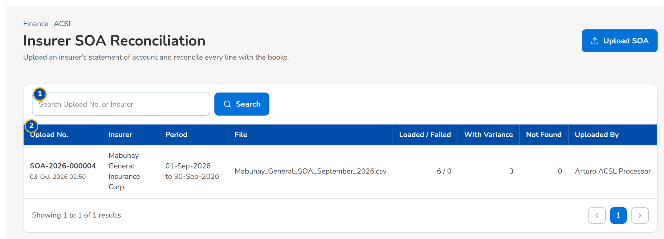
Figure 105: SCR-AC-49 Insurer SOA Reconciliation: the statements uploaded with their results
1 | Search Upload No. or Insurer | 3 | Insurer | 5 | Statement File
2 | Upload No. / Insurer / Period / File / Loaded / Failed / With Variance / Not Found / Uploaded By | 4 | Period From / Period To

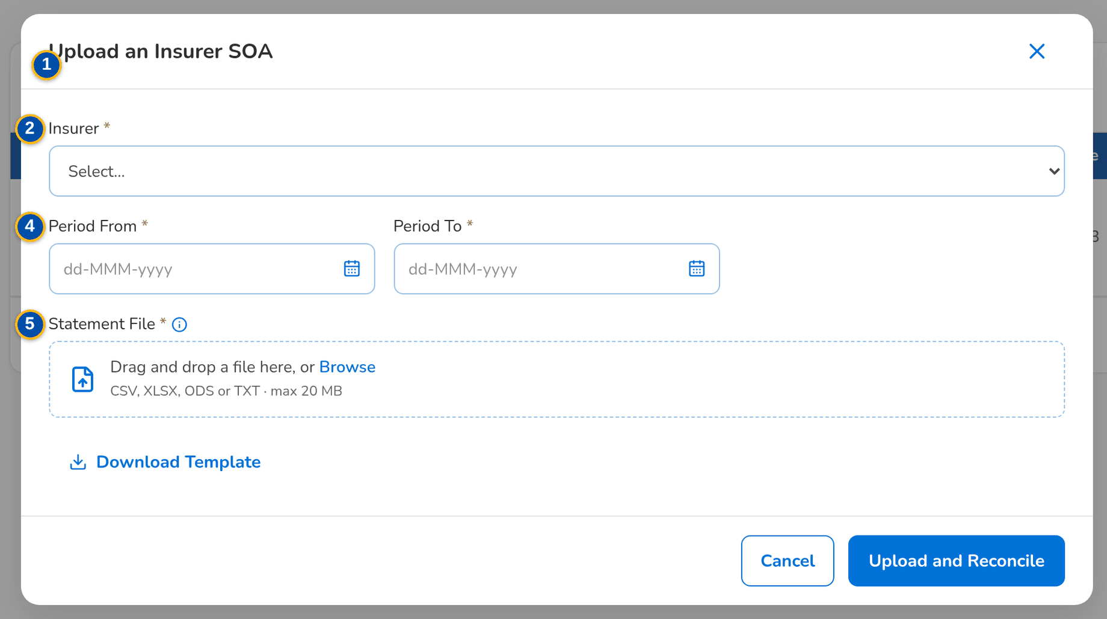
Figure 106: SCR-AC-49 Upload an Insurer SOA: the insurer, the period and the statement file
Fields (No. = callout number on the first screenshot)
No. | Section | Field | Type | Length / format | Mand. | Source / list | Default | Editable in | Validation | Message when it fails
1 | Toolbar | Search Upload No. or Insurer | Text | - | N | - | Blank | - | Contains | -
2 | List | Upload No. / Insurer / Period / File / Loaded / Failed / With Variance / Not Found / Uploaded By | Column | The upload number with its date; the insurer by name; the period on two lines; the uploader's name | - | SOA uploads | - | Read only | - | -
3 | Upload dialog | Insurer | Drop-down | The insurer of the statement, by name | Y | Insurers | Blank | - | - | Select the insurer
4 | Upload dialog | Period From / Period To | Date | dd-MMM-yyyy | Y | - | Blank | - | To on or after From | Enter an end on or after the start
5 | Upload dialog | Statement File | File | The statement in the standard layout (template) | Y | - | - | - | - | Choose the statement file

Actions
Button | Who | Enabled when | What happens | Resulting status | Notification
Upload SOA / Upload and Reconcile | ACSL Processor (ACSL upload) | Insurer, period and file given | Loads the rows and reconciles each line with the books | Reconciled | -
Download Template | ACSL users | Always | Downloads the standard layout | - | -
Row | ACSL users | Always | Opens the upload | - | -

Business rules
• A statement is read up to the maximum number of rows of the parameter and reconciled once loaded (FR-AS-002).
Expected outcome
Each insurer's statement is in BIBS with its reconciliation.
Test cases: TC-AS-002.1-01, TC-AS-002.2-01, TC-AS-002.3-01, TC-AS-002.3-02, TC-AS-002.3-03, TC-AS-002.3-04, TC-AS-002.3-05, TC-AC-SCR-49, TC-AC-MSG-34.

13.6.6 SCR-AC-50 Insurer SOA
Purpose | One uploaded statement with its reconciliation run: the counts per result, the lines by result tab (Outstanding, For Remittance, Remitted, Cancelled, Direct Billed, Not Found) with the premium and balance of the statement and of the books and their variances, the upload log of the rows that failed; Reconcile Again and Download Report.
Who can open it | ACSL Processor, ACSL Team Leader, ACSL Head (approver), Comptrollership (read access), System Administrator, Auditor (permission ACSL view or ACSL process or ACSL assign or ACSL review or ACSL approve or ACSL upload)
Navigation | • Menu: Finance › ACSL › Insurer SOA Reconciliation › Insurer SOA  • Insurer SOA Reconciliation › open a row
FRs | FR-AS-003

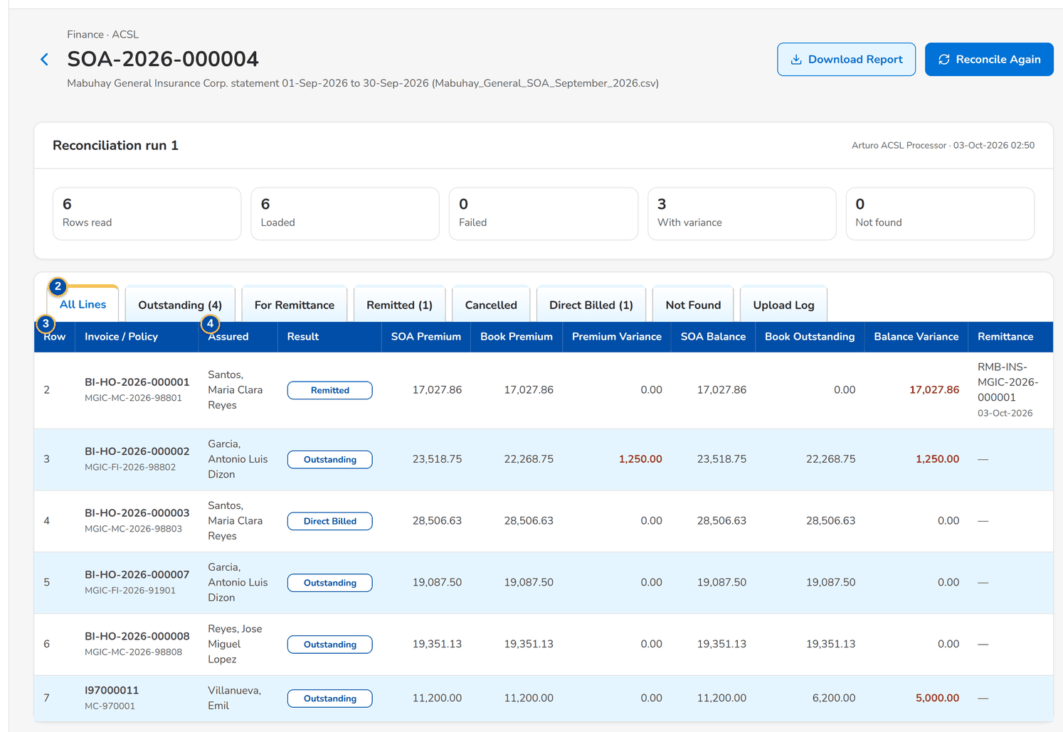
Figure 107: SCR-AC-50 An insurer SOA reconciled: the counts and the lines with their result and variances
1 | Counts per result | 3 | Row / Invoice / Policy / Assured / Result / SOA Premium / Book Premium / Premium Variance / SOA Balance / Book Outstanding / Balance Variance / Remittance
2 | All Lines / Outstanding / For Remittance / Remitted / Cancelled / Direct Billed / Not Found / Upload Log | 4 | Row / Status / Invoice / Policy / Assured / Gross Premium / Error

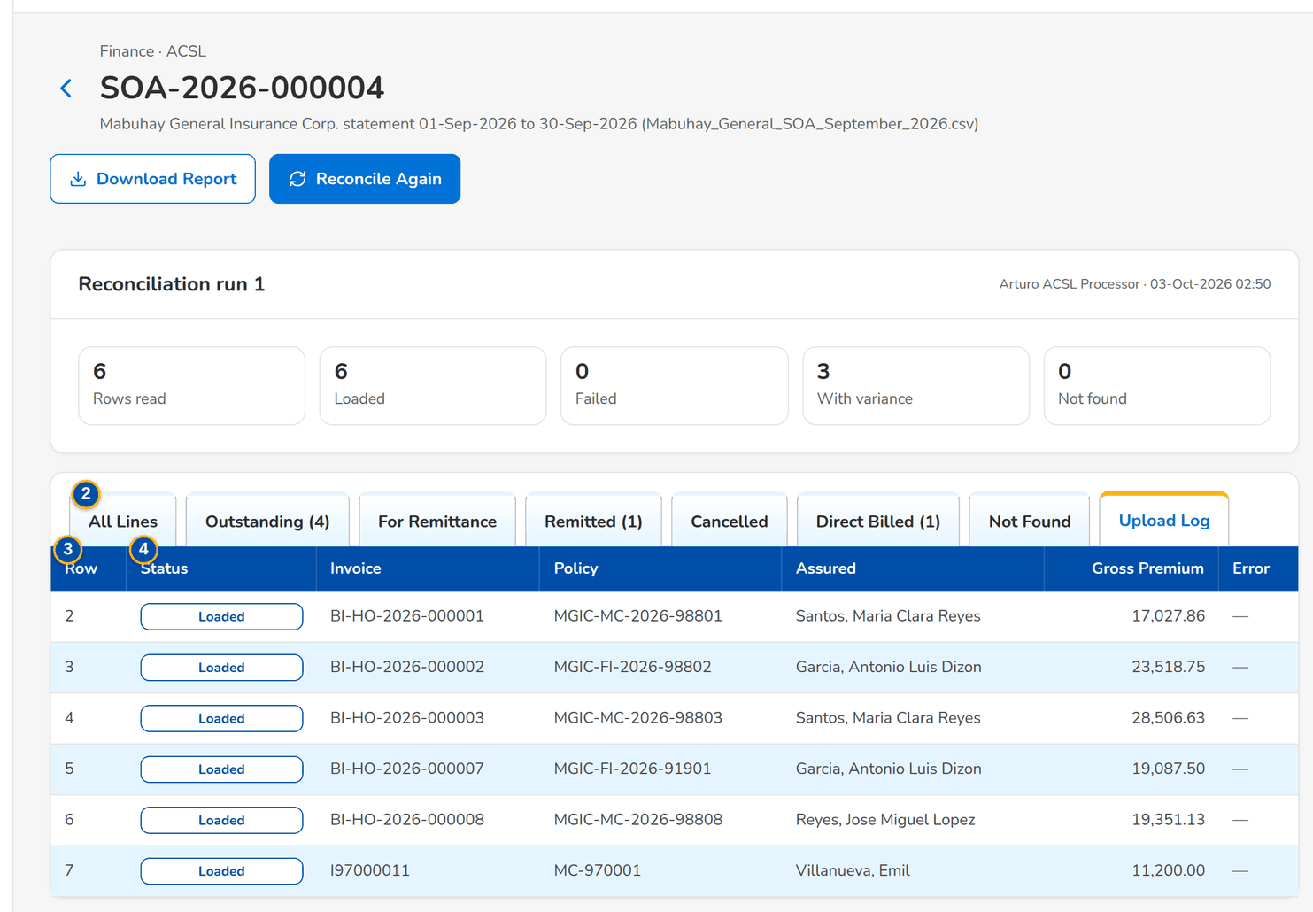
Figure 108: SCR-AC-50 Upload Log: the rows of the file and those that failed with their error
Fields (No. = callout number on the first screenshot)
No. | Section | Field | Type | Length / format | Mand. | Source / list | Default | Editable in | Validation | Message when it fails
1 | Run | Counts per result | Total | Rows, matched, With variance, Not found | - | Reconciliation run | - | Read only | - | Not reconciled yet
2 | Tabs | All Lines / Outstanding / For Remittance / Remitted / Cancelled / Direct Billed / Not Found / Upload Log | Tab | With the count of each | - | Reconciliation | All Lines | - | - | -
3 | Lines | Row / Invoice / Policy / Assured / Result / SOA Premium / Book Premium / Premium Variance / SOA Balance / Book Outstanding / Balance Variance / Remittance | Column | One row per statement line; variances highlighted | - | Reconciliation | - | Read only | - | -
4 | Upload Log | Row / Status / Invoice / Policy / Assured / Gross Premium / Error | Column | The rows of the file with the error of a row not loaded | - | Upload | - | Read only | - | -

Actions
Button | Who | Enabled when | What happens | Resulting status | Notification
Reconcile Again | ACSL Processor (ACSL process) | Always | Reconciles the statement again with the books of today | Reconciled | -
Download Report | ACSL users | Always | Downloads the reconciliation report | - | -

Business rules
• Each line is matched with the books by invoice number, then policy number; the result is the status of the invoice and the variances of premium and balance (FR-AS-003).
Expected outcome
The differences with the insurer are known line by line.
Test cases: TC-AS-003.1-01, TC-AS-003.2-01, TC-AS-003.3-01, TC-AC-SCR-50, TC-AC-MSG-35.

13.6.7 SCR-AC-51 GL-SL Reconciliation
Purpose | Compares the balance of each control account in the general ledger with its sub-ledger: run it now as of a date, the runs with their differences, the balances of a run, and the control accounts with their sub-ledger, components, document types and currency.
Who can open it | ACSL Processor, ACSL Team Leader, ACSL Head (approver), Comptrollership (read access), System Administrator, Auditor (permission ACSL view or ACSL process or ACSL assign or ACSL review or ACSL approve)
Navigation | • Menu: Finance › ACSL › GL-SL Reconciliation
FRs | FR-AS-004

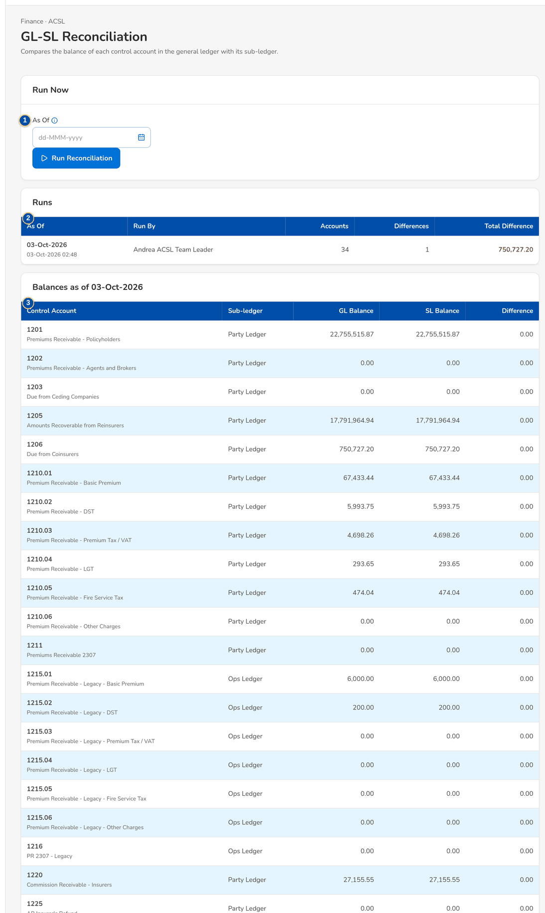
Figure 109: SCR-AC-51 GL-SL Reconciliation: the runs and the balances of the last run
1 | As Of | 3 | Control Account / Sub-ledger / GL Balance / SL Balance / Difference | 5 | Control Account / Sub-ledger / Ledger Components / Document Types / Currency / Status
2 | As Of / Run By / Accounts / Differences / Total Difference | 4 | Control Account / Sub-ledger / Components / Document Types / Currency / Status

Fields (No. = callout number on the first screenshot)
No. | Section | Field | Type | Length / format | Mand. | Source / list | Default | Editable in | Validation | Message when it fails
1 | Run Now | As Of | Date | dd-MMM-yyyy; empty for today | N | - | Today | - | - | -
2 | Runs | As Of / Run By / Accounts / Differences / Total Difference | Column | One row per run; the name of the user or System | - | GL-SL runs | - | Read only | - | -
3 | Balances | Control Account / Sub-ledger / GL Balance / SL Balance / Difference | Column | One row per control account | - | General ledger, sub-ledgers | - | Read only | - | -
4 | Control Accounts | Control Account / Sub-ledger / Components / Document Types / Currency / Status | Column | The accounts reconciled and their sub-ledger | - | GL-SL controls | - | Read only | - | -
5 | Control Account dialog | Control Account / Sub-ledger / Ledger Components / Document Types / Currency / Status | Text, drop-down | Party ledger, Open items or Operations ledger | Y / Y / N / N / N / Y | Chart | Active | - | - | -

Actions
Button | Who | Enabled when | What happens | Resulting status | Notification
Run Reconciliation | ACSL users (ACSL process) | Always | Runs the reconciliation as of the date | - | Alert on a difference
Add Control Account | ACSL Team Leader | Always | Adds or changes a control account | - | -

Business rules
• The reconciliation runs every night and at period end; a difference raises an alert to ACSL but does not stop the close (FR-AS-004).
Expected outcome
The GL agrees with the sub-ledgers, or the differences are known.
Test cases: TC-AS-004.1-01, TC-AS-004.2-01, TC-AC-SCR-51, TC-AC-MSG-36.

14 End-to-end walkthroughs
Five walkthroughs follow a case through the screens, persona by persona, with what the user does, what the user sees and the result of each step. They use seed data only and run in this order on the SIT environment. They are the script of the SIT review sessions of the Start Here guide.

14.1 WT-A A manual accrual from the voucher to its posting and automatic reversal
The GL Officer accrues an expense of the month with a voucher that reverses itself on the first day of the next month. The GL Team Lead assigns it to the GL Section Head, who posts it from the list of the journals assigned to her; the posted voucher shows its audit and its reversal date, and the expense is in the account.
Seed data: the seed chart of accounts of the company (accrued expenses and an expense account with its cost centre); the open periods of the current year
Step 1. GL Officer (FRBS) – New Journal and Edit Journal (SCR-AC-02)
Does | Enters an accrual on New Journal (value date today, Reverse on the first day of next month, a debit to the expense with its cost centre and a credit to accrued expenses), clicks Save & Submit and confirms
Sees | The journal with its batch number, Pending Approval, the lines and the automatic reversal date
Result | Submitted

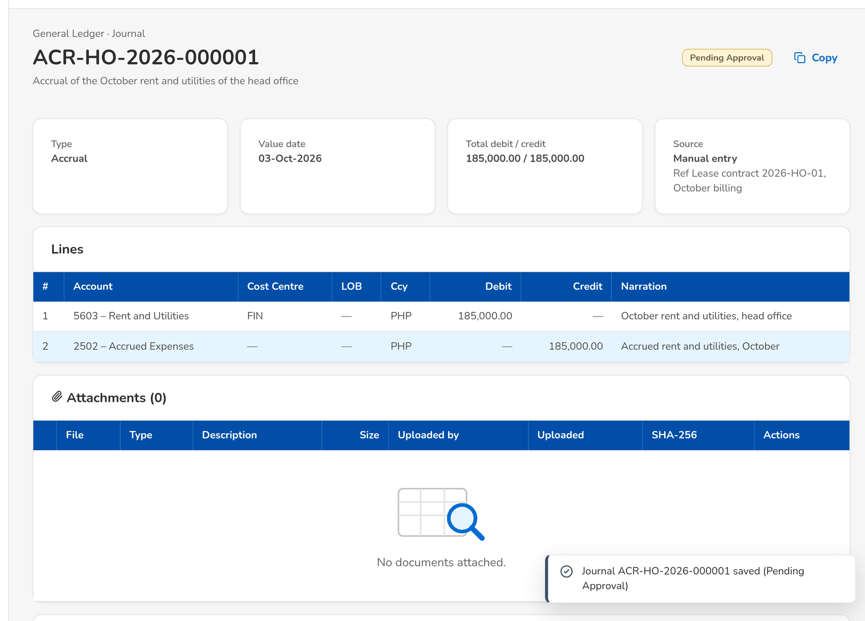
Figure 110: WT-A step 1: New Journal and Edit Journal
Step 2. GL Team Lead – Journals (SCR-AC-01)
Does | Selects the voucher on Journals, clicks Assign and chooses the GL Section Head
Sees | Message: 1 journal(s) assigned; Assigned To shows her name
Result | Assigned

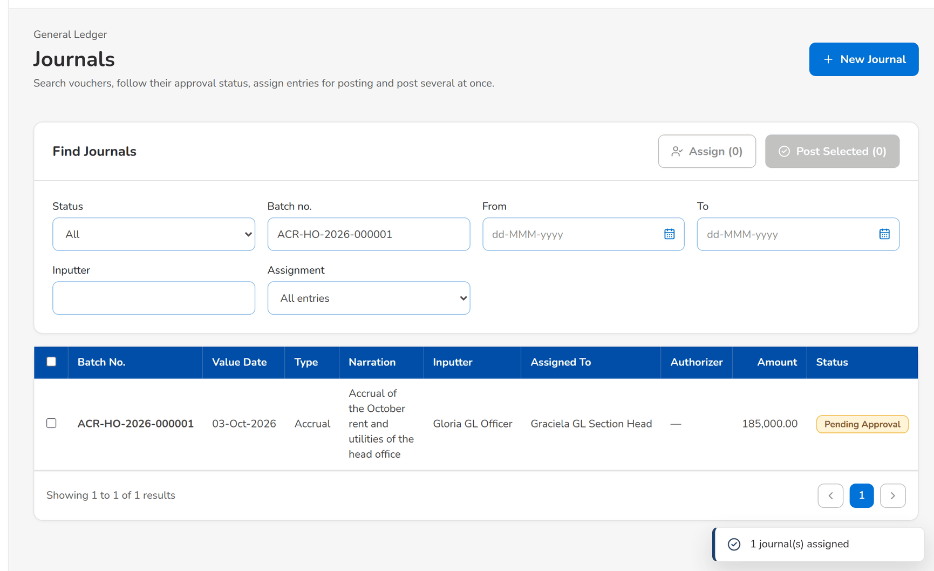
Figure 111: WT-A step 2: Journals
Step 3. GL Section Head – Journals (SCR-AC-01)
Does | Chooses Assigned to me, selects the voucher, clicks Post Selected and confirms
Sees | Message: 1 of 1 journal(s) posted; the voucher is Posted
Result | Posted

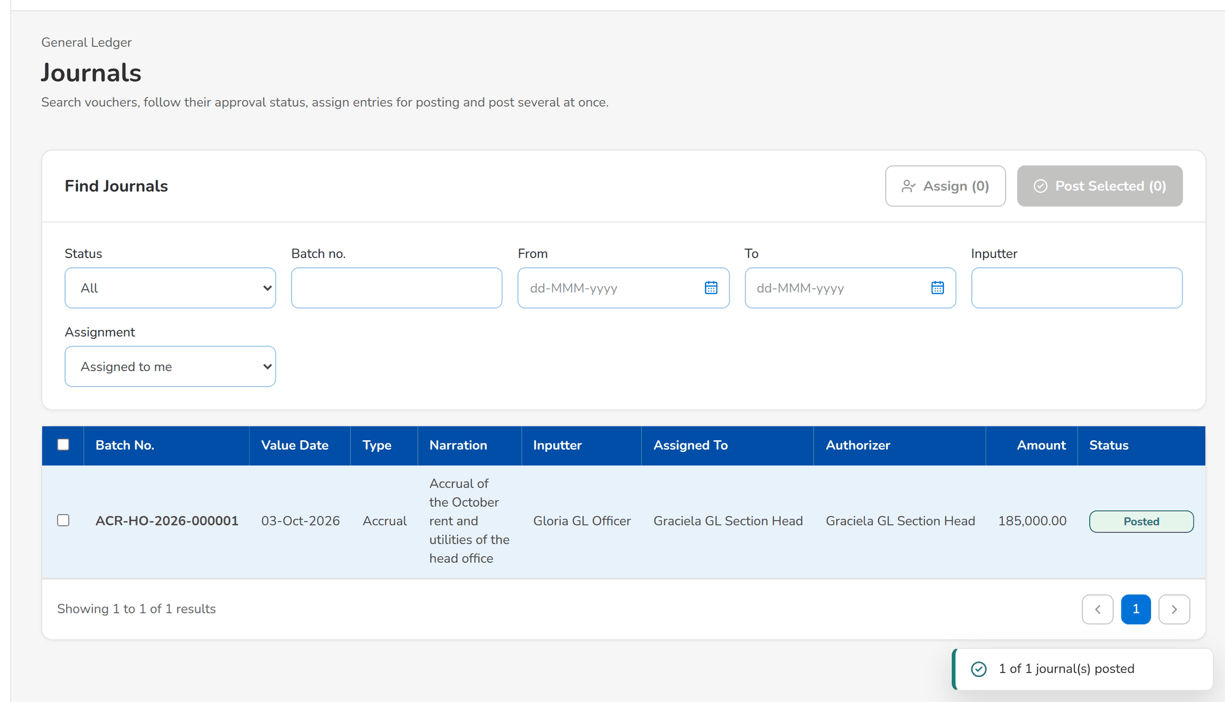
Figure 112: WT-A step 3: Journals
Step 4. GL Section Head – Journal (SCR-AC-03)
Does | Opens the journal
Sees | The posted voucher with Input by, Submitted by and Authorized by, and Automatic reversal on the first day of next month
Result | In the ledger

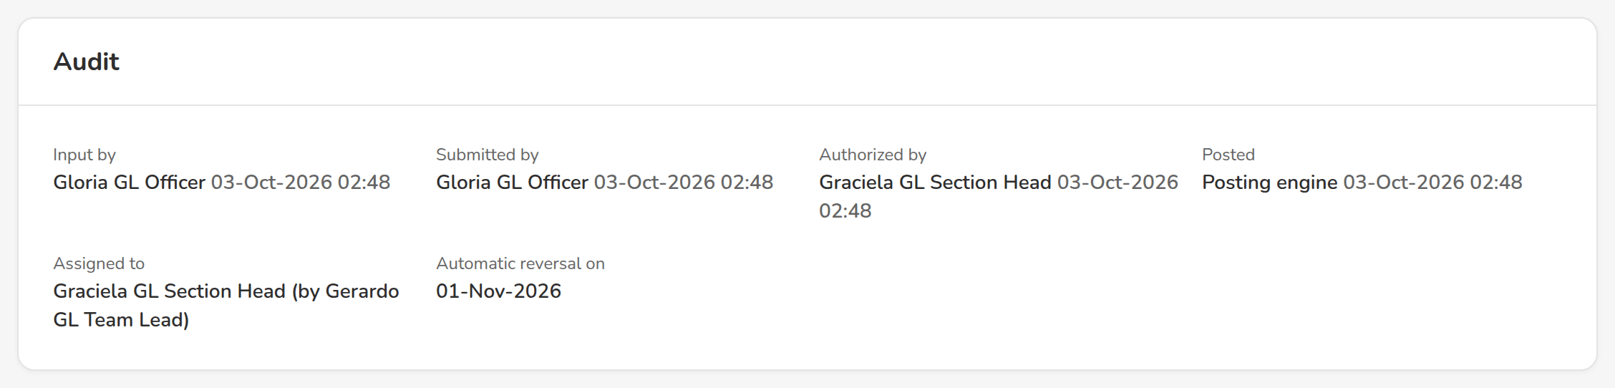
Figure 113: WT-A step 4: Journal
Step 5. GL Officer (FRBS) – Account Inquiry (SCR-AC-04)
Does | Opens Account Inquiry for the expense account of the month
Sees | The accrual among the posted lines, with the running balance
Result | Reported

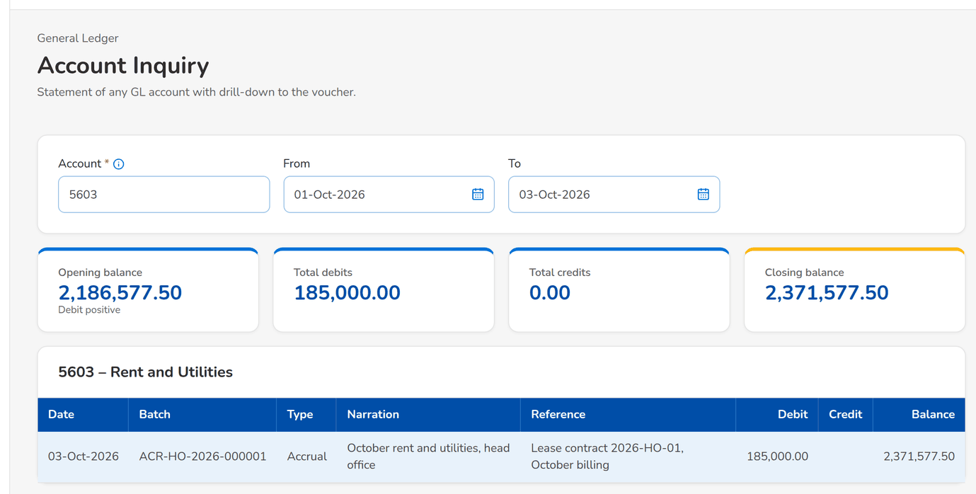
Figure 114: WT-A step 5: Account Inquiry
What happens next, downstream
• On the reversal date the automatic reversal posts the mirror of the accrual and the voucher shows Reversed.
• The accrual is in the trial balance and the schedules of the report pack of the month.

14.2 WT-B A client refund from the Refund Request Form to the payment
A client overpaid an account. The Marketing Processor raises the Refund Request Form with the AR of the payment, to be credited to the client's account; the Marketing Reviewer endorses it and the Marketing Approver approves it, which sends it to Disbursement. BIBS creates the voucher of the refund at once and routes it straight to the Disbursement Approver; the approver approves it, the entry posts and the credit to the account is issued. Marketing follows the payment on the request.
Seed data: client CL-2026-000001 maintained as a payee of Disbursement with a credit-to-account account; an AR of the cashiering seed
Step 1. Marketing Processor (AO) – New Refund Request (SCR-AC-40)
Does | Fills in New Refund Request (segment, reference, purpose, credit to the client's account) with one account to refund (AR number, client, assured, amount, reason Overpayment) and clicks Save Request
Sees | Message: <request> saved; the request opens in Draft with its account to refund
Result | Draft

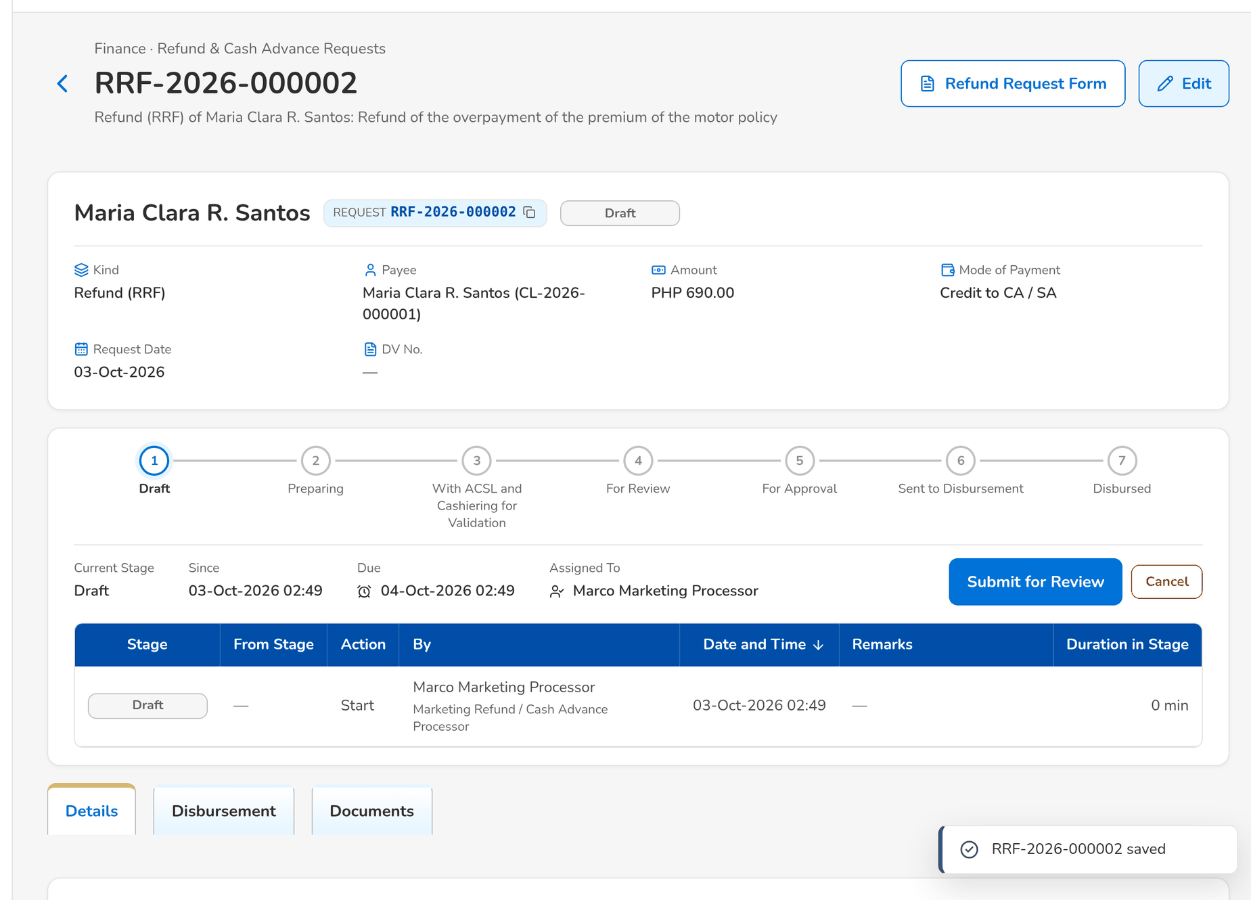
Figure 115: WT-B step 1: New Refund Request
Step 2. Marketing Processor (AO) – Request (SCR-AC-43)
Does | Clicks Submit for Review and confirms
Sees | The request For Review in the workflow header
Result | For review

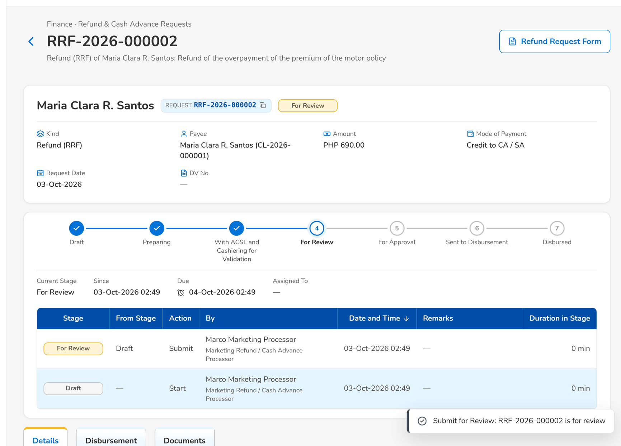
Figure 116: WT-B step 2: Request
Step 3. Marketing Reviewer – Request (SCR-AC-43)
Does | Opens the request and clicks Endorse for Approval
Sees | The request For Approval with the step in its history
Result | For approval

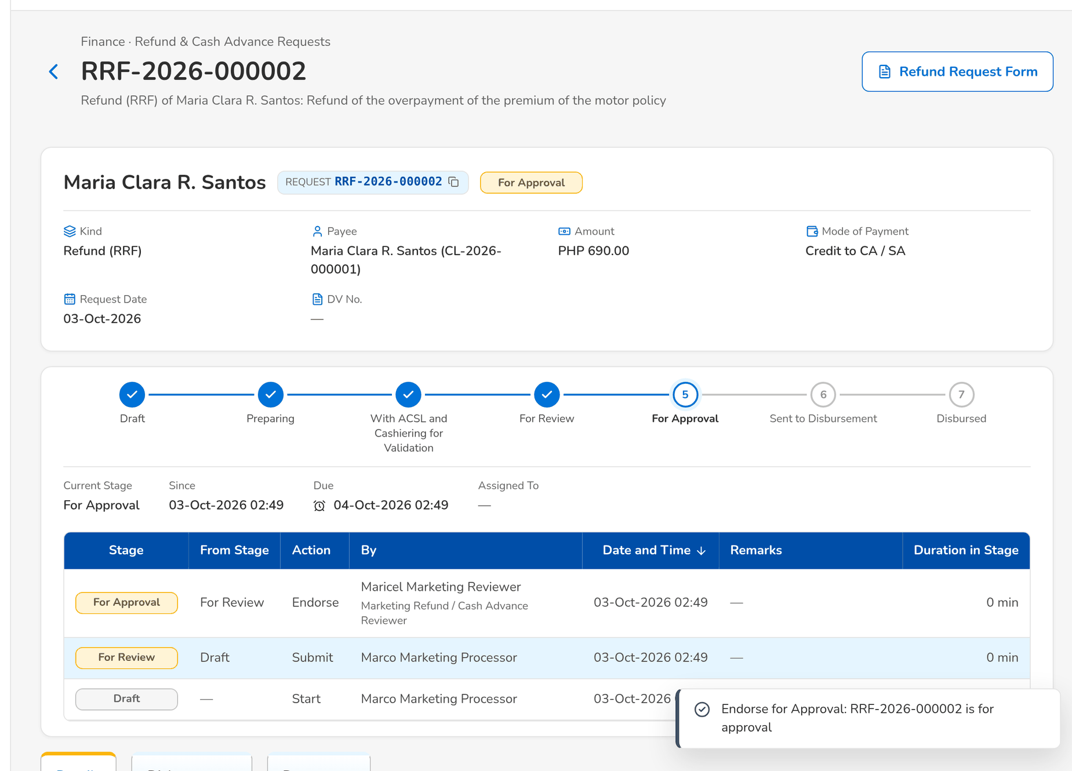
Figure 117: WT-B step 3: Request
Step 4. Marketing Approver – Request (SCR-AC-43)
Does | Clicks Approve and Send
Sees | The request With Disbursement
Result | Sent to Disbursement

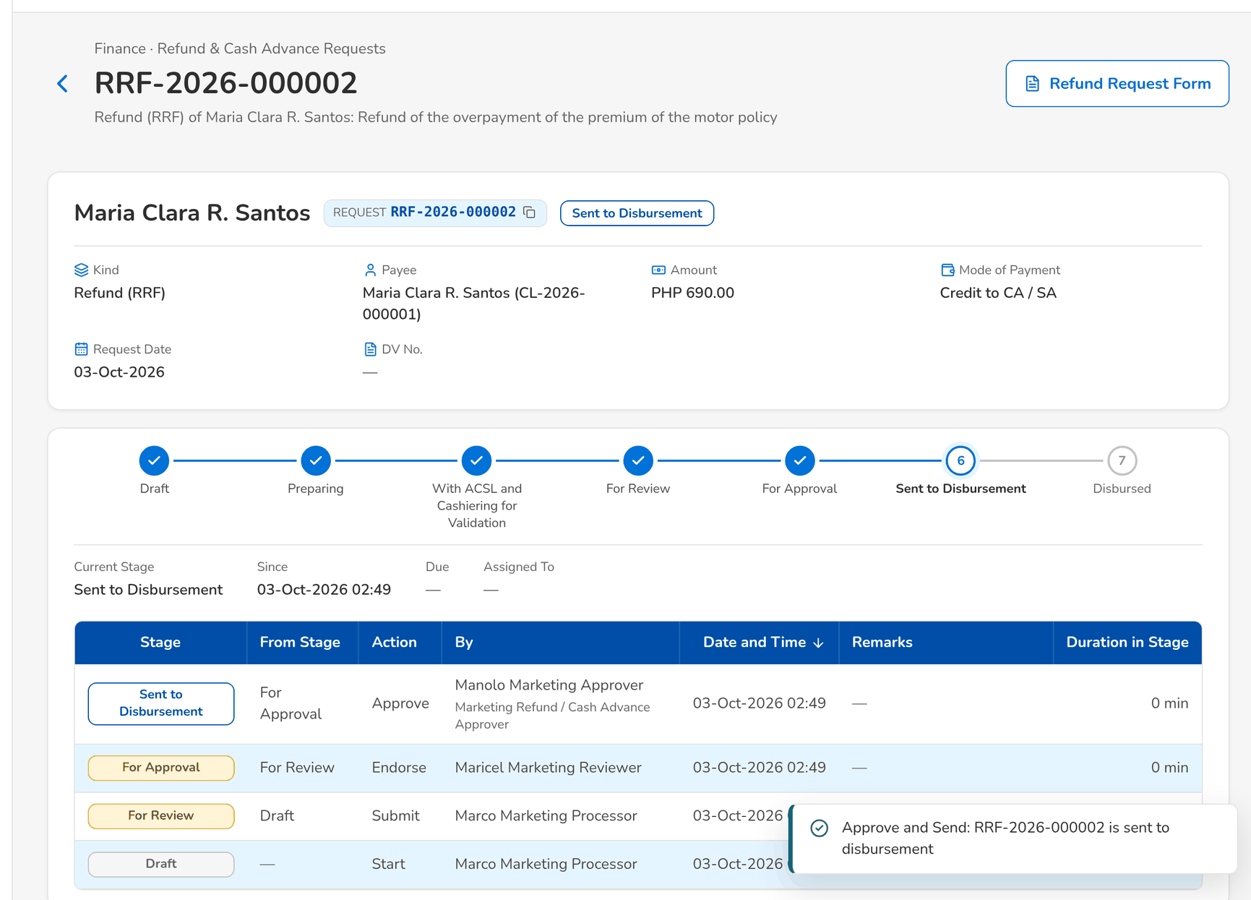
Figure 118: WT-B step 4: Request
Step 5. Disbursement Processor – Disbursement Workbench (SCR-AC-25)
Does | Opens For Approval on the Disbursement Workbench
Sees | The voucher of the refund, created automatically from the request with the client as payee and routed straight to the approver
Result | Voucher created

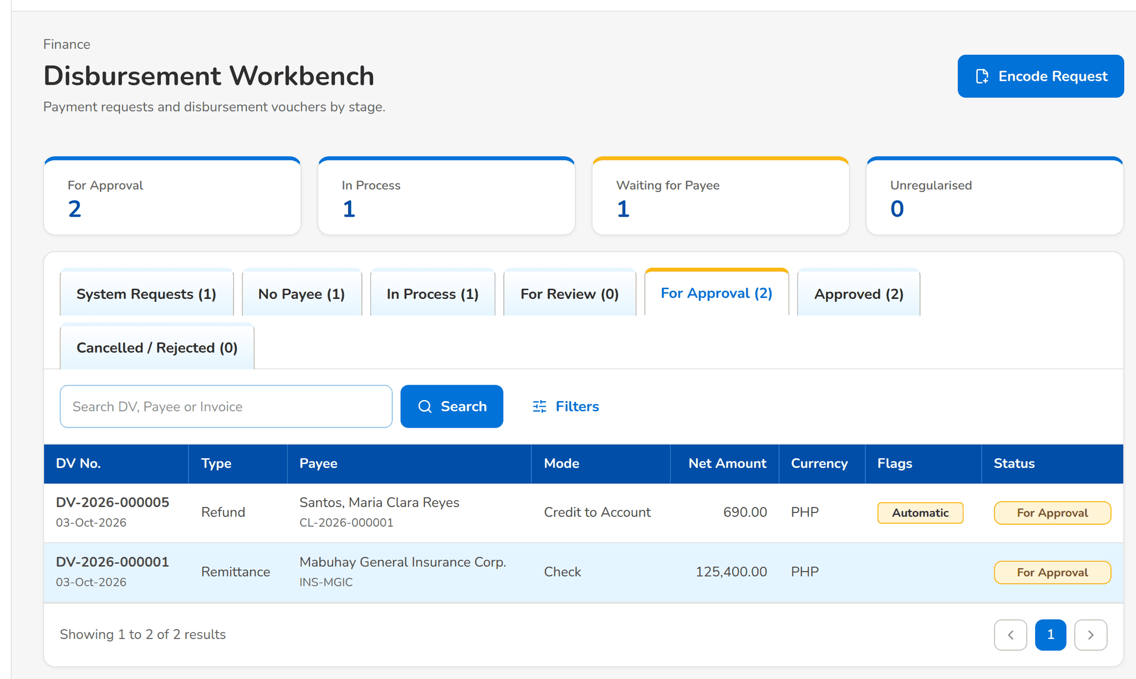
Figure 119: WT-B step 5: Disbursement Workbench
Step 6. Disbursement Processor – Disbursement Voucher (SCR-AC-27)
Does | Opens the voucher
Sees | The voucher For Approval: the client as payee, credit to account, the paying account, the net amount and the history that shows the automatic routing
Result | For approval

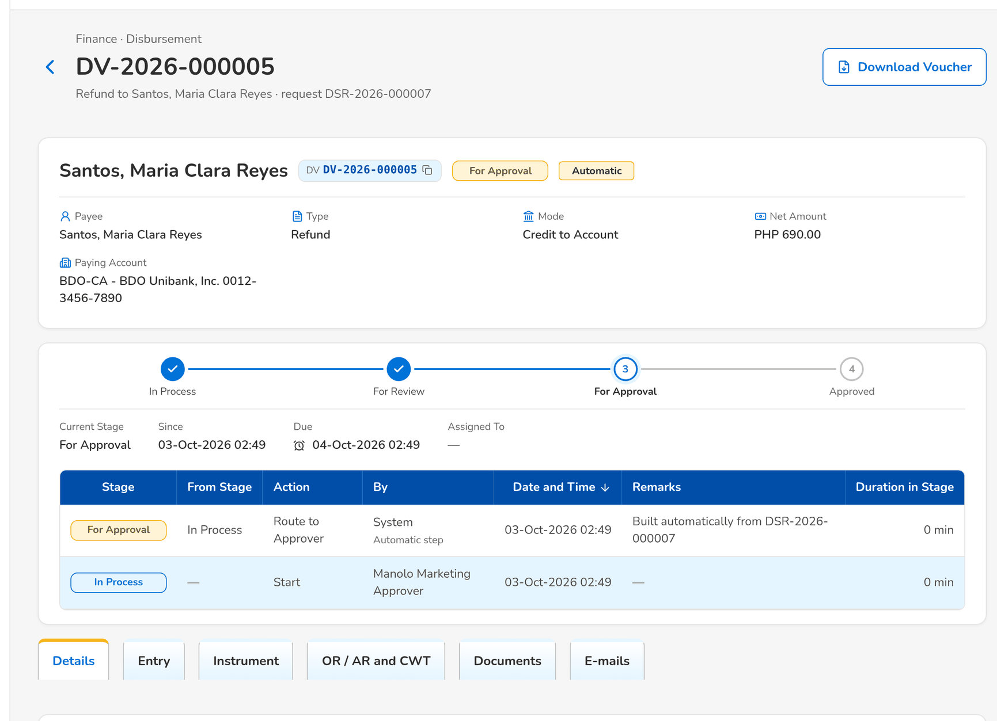
Figure 120: WT-B step 6: Disbursement Voucher
Step 7. Disbursement Approver – Disbursement Voucher (SCR-AC-27)
Does | Clicks Approve and Post and confirms
Sees | The voucher Approved; the journal posted and the credit to account issued
Result | Approved

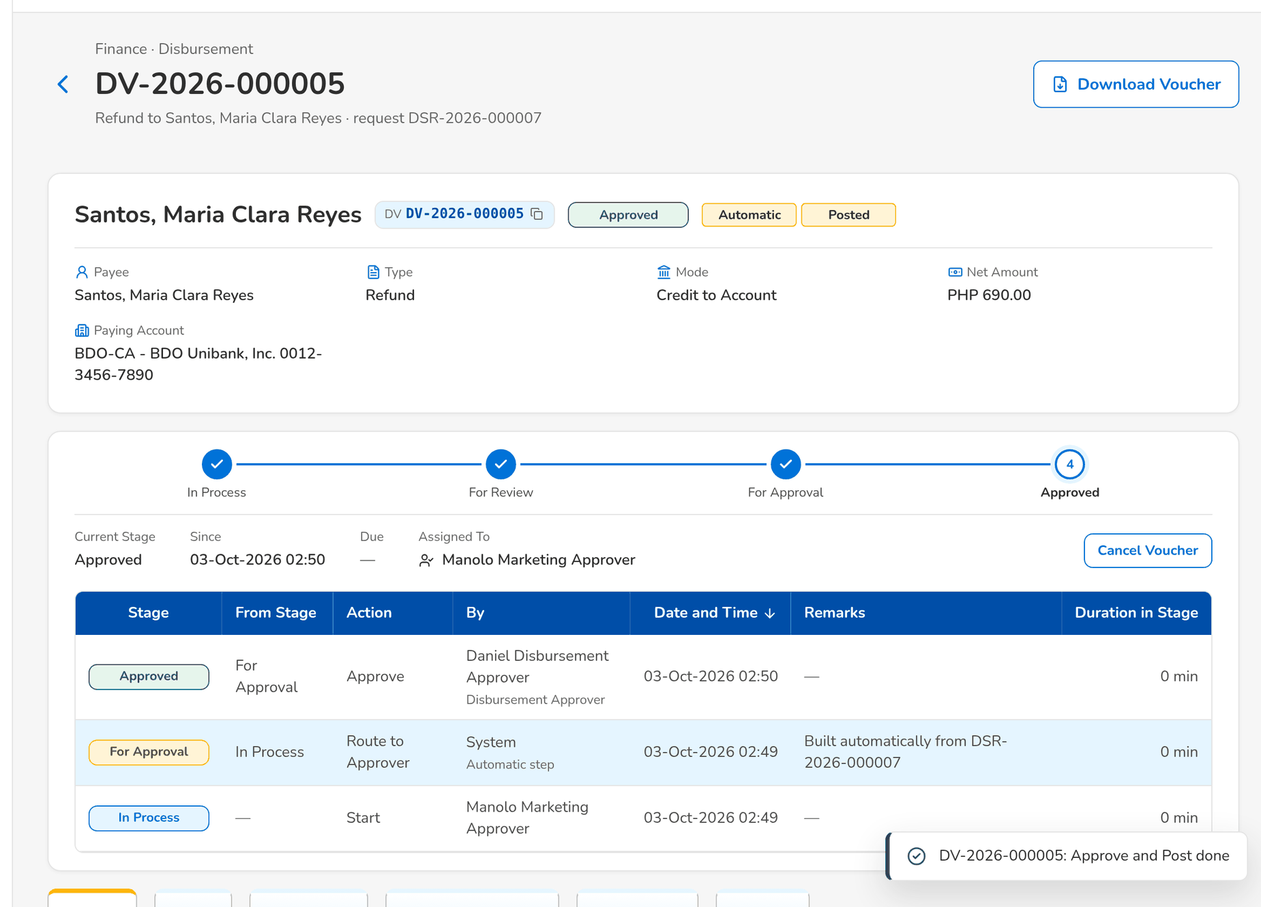
Figure 121: WT-B step 7: Disbursement Voucher
Step 8. Marketing Processor (AO) – Request (SCR-AC-43)
Does | Opens the Disbursement tab of the request
Sees | The voucher number and its status in Disbursement
Result | Followed

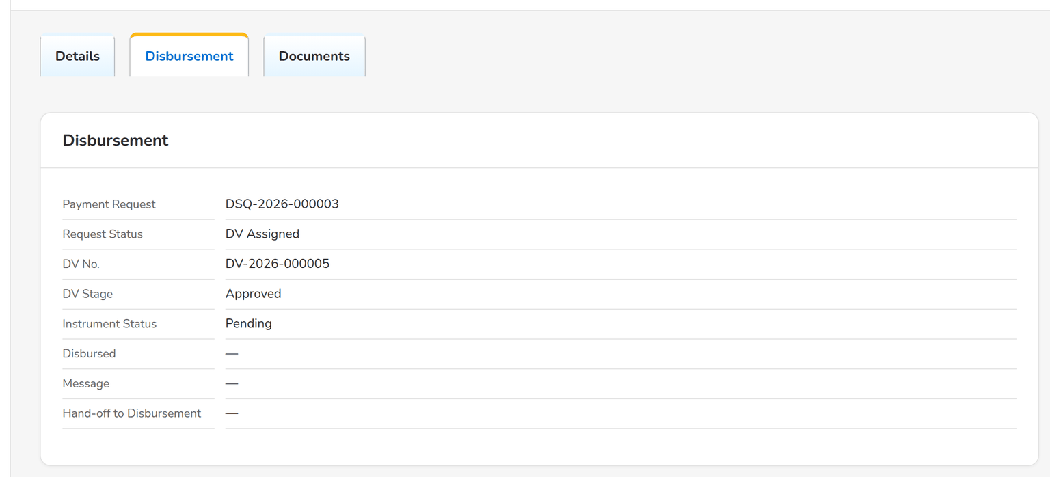
Figure 122: WT-B step 8: Request
What happens next, downstream
• The end of day of the date puts the credit in the Direct Credit Transaction File and e-mails the payment confirmation to the client.
• The client's account is recorded on the client record for the next refund.

14.3 WT-C An insurer's statement of account reconciled and a wrong posting corrected
The ACSL Processor uploads an insurer's statement of account; BIBS reconciles every line with the books. A line shows a variance, so the ACSL Team Leader opens a case on the invoice and assigns it. The processor records the findings and raises a correction entry; the correction is prepared by the processor, endorsed by the team leader and approved by the ACSL Head, which posts it.
Seed data: the booked invoices of the insurer in the Operations invoice ledger; the statement file prepared from the standard layout with lines of the insurer
Step 1. ACSL Processor – Insurer SOA Reconciliation (SCR-AC-49)
Does | Clicks Upload SOA, chooses the insurer, the period and the statement file, and clicks Upload and Reconcile
Sees | Message: <upload>: n of n rows loaded; the upload is listed with its results
Result | Reconciled

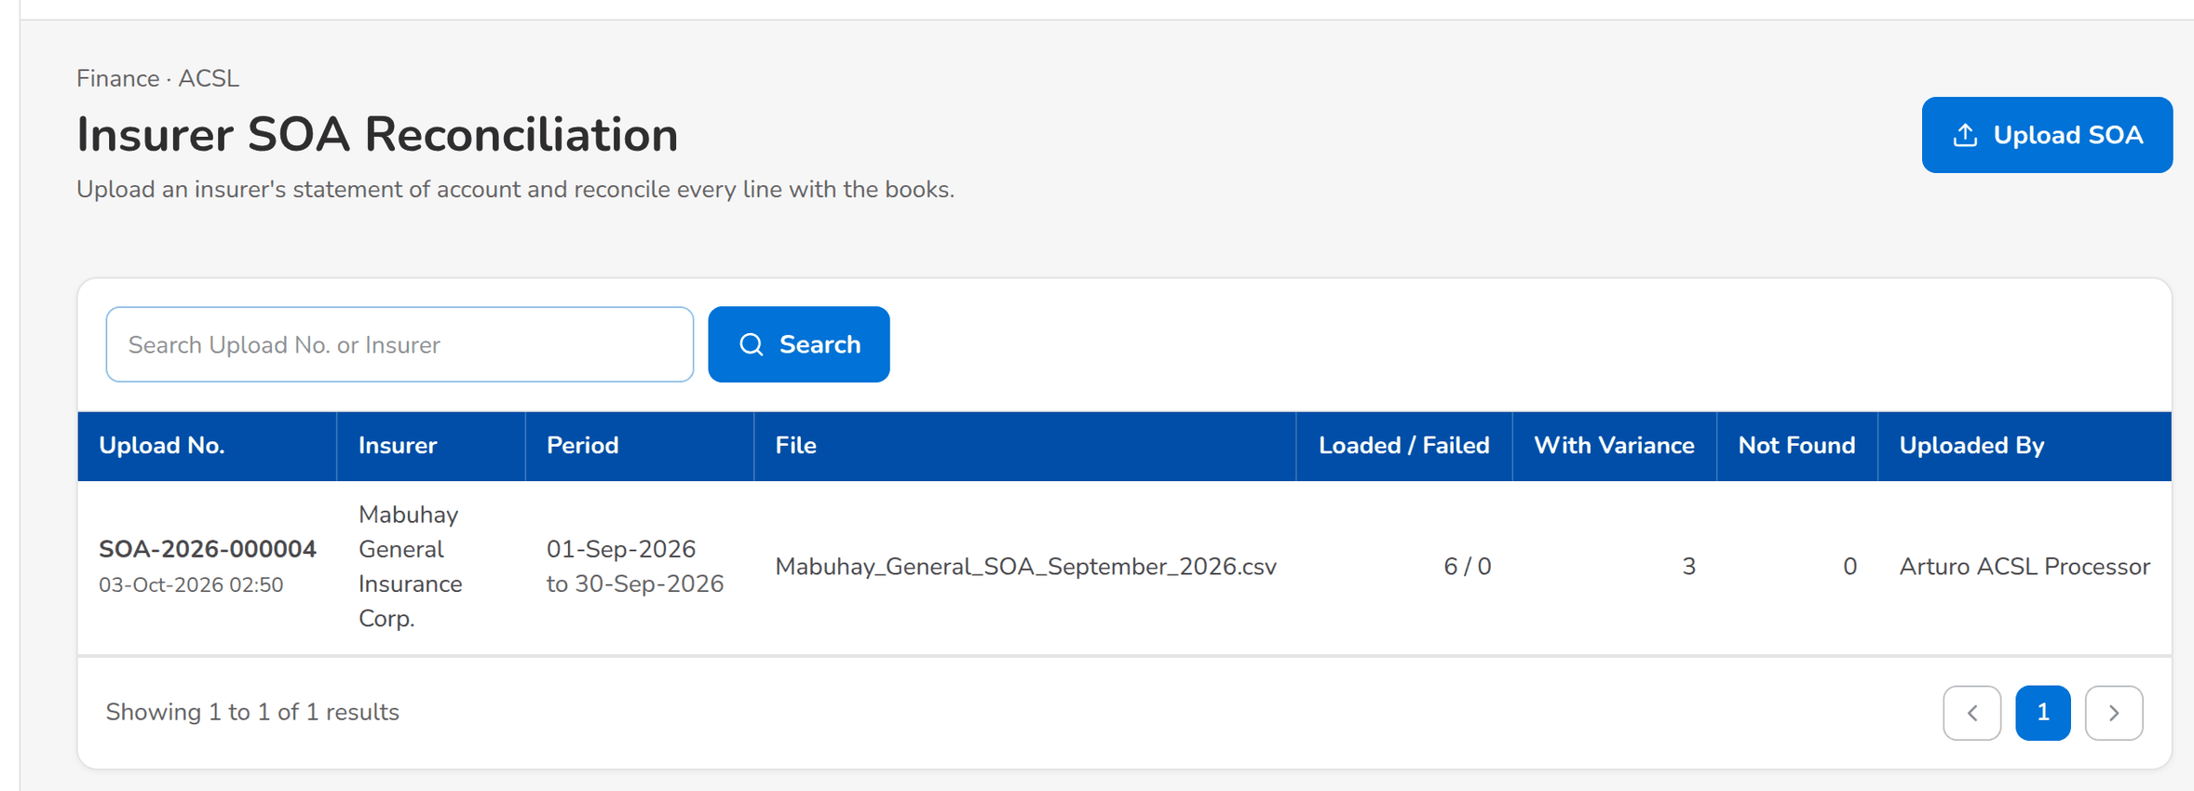
Figure 123: WT-C step 1: Insurer SOA Reconciliation
Step 2. ACSL Processor – Insurer SOA (SCR-AC-50)
Does | Opens the upload
Sees | The counts per result and the lines with their premium and balance variances
Result | Variances known

Figure 124: WT-C step 2: Insurer SOA
Step 3. ACSL Team Leader – ACSL Cases (SCR-AC-45)
Does | Clicks Open a Case: investigation of the invoice with a variance
Sees | Message: <case> opened; the case is Received
Result | Case opened

Figure 125: WT-C step 3: ACSL Cases
Step 4. ACSL Team Leader – ACSL Case (SCR-AC-46)
Does | Opens the case and assigns it to the ACSL Processor
Sees | The case Assigned with the step in its history
Result | Assigned

Figure 126: WT-C step 4: ACSL Case
Step 5. ACSL Processor – ACSL Case (SCR-AC-46)
Does | Clicks Start Investigation, records the findings and clicks Raise Correction (posting to a wrong GL account)
Sees | The correction entry opens, raised from the case
Result | Correction raised

Figure 127: WT-C step 5: ACSL Case
Step 6. ACSL Team Leader – Correction Entry (SCR-AC-48)
Does | Assigns the correction to the ACSL Processor as its preparer
Sees | The correction in Draft
Result | Draft

Figure 128: WT-C step 6: Correction Entry
Step 7. ACSL Processor – Correction Entry (SCR-AC-48)
Does | Picks the wrong line among the posted lines of the invoice family, clicks Correct with the right account, saves the lines and clicks Submit for Review
Sees | The correction For Review with its reversal and re-post lines
Result | For review

Figure 129: WT-C step 7: Correction Entry
Step 8. ACSL Team Leader – Correction Entry (SCR-AC-48)
Does | Clicks Endorse for Approval
Sees | The correction For Approval
Result | For approval

Figure 130: WT-C step 8: Correction Entry
Step 9. ACSL Head (approver) – Correction Entry (SCR-AC-48)
Does | Clicks Approve and Post and confirms
Sees | The correction Posted with its journal
Result | Posted

Figure 131: WT-C step 9: Correction Entry
What happens next, downstream
• The correction journal reverses the wrong line and posts it to the right account; the invoice ledger is corrected with it.
• The next GL-SL reconciliation shows the control account in agreement.

14.4 WT-D Month end: the revaluation rate, the revaluation, the GL close and the service fee
At the month end the GL Section Head enters the month-end rate of the US dollar; the GL Team Lead revalues the foreign-currency balances, schedules the close of the month and checks the cut-off of the broking books. The GL Officer tags the payout of the service fee released to its recipient.
Seed data: the foreign-currency accounts of the seed chart; the service-fee run of the month computed and approved by the seed GL team
Step 1. GL Section Head – Currencies & Rates (SCR-AC-08)
Does | Enters the month-end rate of USD for the previous month on Monthly revaluation rates and clicks Save Rate
Sees | The rate listed with the month end and her name
Result | Rate in force

Figure 132: WT-D step 1: Currencies & Rates
Step 2. GL Team Lead – FX Revaluation (SCR-AC-13)
Does | Chooses the previous month, checks the preview and clicks Post revaluation
Sees | The revaluation run of the month with its journal and its reversal
Result | Revalued

Figure 133: WT-D step 2: FX Revaluation
Step 3. GL Team Lead – GL Close & Cut-Off (SCR-AC-11)
Does | Clicks Schedule Close for the previous month at the proposed date and time
Sees | Message: the close of the month scheduled; listed as Scheduled
Result | Close scheduled

Figure 134: WT-D step 3: GL Close & Cut-Off
Step 4. GL Team Lead – GL Close & Cut-Off (SCR-AC-11)
Does | Opens Broking Books Cut-Off
Sees | The broking books of each period with who closed them and when
Result | Cut-off checked

Figure 135: WT-D step 4: GL Close & Cut-Off
Step 5. GL Officer (FRBS) – Service Fee Run (SCR-AC-22)
Does | Opens the service-fee run of the month and tags a line Released with the date the recipient was credited
Sees | The line Released with its date
Result | Released

Figure 136: WT-D step 5: Service Fee Run
What happens next, downstream
• At the scheduled time the checklist runs and the month closes, or the alert Scheduled close failed lists the blocking items.
• The revaluation reverses on the first day of the next month.

14.5 WT-E Controls and the messages the user sees
Four controls of the set, each with what the user sees: a voucher that does not balance, an AR refunded twice, an insurer statement uploaded twice and a payment request for a payee that is not maintained.
Seed data: the refund of walkthrough B; the statement uploaded in walkthrough C
Step 1. GL Officer (FRBS) – New Journal and Edit Journal (SCR-AC-02)
Does | Enters a voucher whose debit and credit differ
Sees | Under the lines: Difference with the amount; Save & Submit is not offered
Result | Refused

Figure 137: WT-E step 1: New Journal and Edit Journal
Step 2. Marketing Processor (AO) – New Refund Request (SCR-AC-40)
Does | Raises a refund with the AR of the refund of walkthrough B
Sees | The refusal: the AR is already refunded by the request named
Result | Refused

Figure 138: WT-E step 2: New Refund Request
Step 3. ACSL Processor – Insurer SOA Reconciliation (SCR-AC-49)
Does | Uploads the statement of walkthrough C again
Sees | The refusal: the file was already uploaded for the insurer as the upload named
Result | Refused

Figure 139: WT-E step 3: Insurer SOA Reconciliation
Step 4. Disbursement Processor – Disbursement Workbench (SCR-AC-25)
Does | Encodes a payment request for a payee code that is not maintained
Sees | The request on the No Payee tab, waiting for its payee; a payee request is raised
Result | Waiting for payee

Figure 140: WT-E step 4: Disbursement Workbench

15 Messages catalogue
Every message a user of this set can see, grouped by the screen or dialog that shows it, with its code, its type and what the user does. The texts are quoted exactly as the screens show them.
• Validation: shown on the screen while the user fills in a field or before the form is sent.
• Error: the system refused the action; nothing was saved. The code is shown under the message as the Reference.
• Warning: the action is possible, but the user should check something first.
• Confirmation and Information: the outcome of an action, or a hint on the screen.
378 messages: 70 confirmation, 190 error, 35 information, 83 validation. The text is quoted exactly as the system shows it; <name> marks a value filled in by the system. The user sees the message only, in the notice standard of the screen standards appendix; the code identifies the message for the project team and support and is not shown on the screen.

15.1 Encode Payment Request and the Disbursement forms (SCR-AC-26, SCR-AC-27)
ID | Code (not shown) | Message | Type | What the user does
MSG-AC-001 | - | Check | Validation | Check.
MSG-AC-002 | - | Enter a 3-letter currency | Validation | Enter a 3-letter currency.
MSG-AC-003 | - | Enter an amount above zero | Validation | Enter an amount above zero.
MSG-AC-004 | - | Enter the payee code | Validation | Enter the payee code.
MSG-AC-005 | - | Enter the purpose | Validation | Enter the purpose.
MSG-AC-006 | - | Select the disbursement type | Validation | Select the disbursement type.

15.2 Journals (SCR-AC-01)
ID | Code (not shown) | Message | Type | What the user does
MSG-AC-007 | - | No journal matches these filters | Information | No action.

15.3 New Journal and Edit Journal (SCR-AC-02)
ID | Code (not shown) | Message | Type | What the user does
MSG-AC-008 | - | Choose an account | Validation | Choose an account.
MSG-AC-009 | - | Must be after the value date | Validation | Enter a reversal date after the value date.
MSG-AC-010 | ASSIGNEE_IS_MAKER | <batch no> cannot be assigned to the user who submitted it | Error | Assign the journal to another user than the one who submitted it.
MSG-AC-011 | ASSIGNEE_NOT_AUTHORIZER | <user> is not allowed to authorize journals | Error | Choose a user who may post journals.
MSG-AC-012 | INVALID_JOURNAL_TYPE | Only MANUAL, ADJUSTMENT or ACCRUAL journals can be entered manually | Error | Choose Manual journal, Adjustment or Accrual.
MSG-AC-013 | NOT_MAKER | Only the maker (<created by>) can change this journal | Error | Ask the maker named to change the journal, or copy it into a new draft.
MSG-AC-014 | SHORT_CODE_TAKEN | Short code <short name> is already used by account <code> | Error | Choose another short code; the one typed belongs to the account named.
MSG-AC-015 | UNKNOWN_ACCOUNT | Unknown GL account <account code> | Error | Enter an account of the chart, by its code or short code.

15.4 Journal (SCR-AC-03)
ID | Code (not shown) | Message | Type | What the user does
MSG-AC-016 | - | The draft voucher is cancelled and can no longer be submitted. | Validation | Confirm to cancel the draft, or close the dialog to keep it.
MSG-AC-017 | - | The journal goes to an authorizer and can no longer be edited unless it is returned. | Validation | Check the totals, then confirm to submit the journal.
MSG-AC-018 | ALREADY_REVERSED | Journal <batch no> is already reversed | Error | No action; the journal is reversed already.
MSG-AC-019 | AUTHORIZATION_LIMIT_EXCEEDED | Journal total <amount> exceeds your authorization limit <limit> | Error | Assign the journal to a user whose limit covers the total.
MSG-AC-020 | INVALID_JOURNAL_STATUS | Cannot <action> journal <batch no> in status <status> | Error | Refresh the journal and use an action offered in its status.
MSG-AC-021 | MAKER_CHECKER_VIOLATION | A journal cannot be authorized by the user who submitted it | Error | Ask another user with the approval right to take the action.
MSG-AC-022 | REVERSAL_DATE_INVALID | The reversal date must be after the value date <value date> | Error | Enter a reversal date after the value date.
MSG-AC-023 | REVERSAL_DATE_NOT_ALLOWED | Only manual journals take an automatic reversal date | Error | Leave Reverse on empty, or enter the voucher as a manual accrual.
MSG-AC-024 | REVERSAL_PENDING | A reversal of <batch no> already exists | Error | Open the reversal journal already raised.
MSG-AC-025 | UNBALANCED_JOURNAL | Journal is not balanced: debit <total debit> vs credit <total credit> | Error | Correct the lines so that the debits equal the credits.

15.5 Chart of Accounts (SCR-AC-06)
ID | Code (not shown) | Message | Type | What the user does
MSG-AC-026 | - | Account <code> saved – pending authorization | Confirmation | No action.
MSG-AC-027 | - | Account <code> updated | Confirmation | No action.
MSG-AC-028 | CLASS_MISMATCH | Child account class must match parent <code> | Error | Choose a parent of the same class, or change the class of the account.
MSG-AC-029 | DUPLICATE | GL account already exists: <key> | Error | Use another code or name; the record exists already.
MSG-AC-030 | DUPLICATE | GL category already exists: <key> | Error | Use another code or name; the record exists already.
MSG-AC-031 | INVALID_TIER | A <level> account cannot be placed under a <level> | Error | Choose a parent of a higher tier (a main account above a sub account, a sub account above a micro account).
MSG-AC-032 | PARENT_HAS_POSTINGS | Account <code> already has postings and cannot become a heading | Error | Choose a parent without postings, or keep the account postable.
MSG-AC-033 | PARENT_REQUIRED | Sub and Micro GL accounts require a parent account | Error | Choose the parent account of the sub or micro account.

15.6 Chart Upload (SCR-AC-07)
ID | Code (not shown) | Message | Type | What the user does
MSG-AC-034 | - | <committed rows> account(s) created, pending authorization | Confirmation | No action.
MSG-AC-035 | - | No chart has been uploaded yet | Information | No action.
MSG-AC-036 | - | No numbering scheme: account codes are entered by hand | Information | No action.
MSG-AC-037 | - | No rows in this view | Information | No action.
MSG-AC-038 | - | Numbering under <parent code> saved: first child <example> | Confirmation | No action.
MSG-AC-039 | - | Upload discarded | Confirmation | Upload discarded.
MSG-AC-040 | ACCOUNT_CODE_REQUIRED | Enter the account code of a top-level account | Error | Enter the account code of a top-level account.
MSG-AC-041 | INVALID_NUMBERING | Separator must be none, '.' or '-' and width 1 to 6 digits | Error | Choose no separator, a dot or a dash, and 1 to 6 digits.
MSG-AC-042 | NO_NUMBERING | Enter the account code: no numbering scheme under <parent code> | Error | Enter the account code: no numbering scheme under <parent code>.
MSG-AC-043 | NUMBERING_EXHAUSTED | No free <width>-digit number under <parent code> | Error | Widen the digits of the numbering scheme, or key the code of the account.

15.7 Currencies & Rates (SCR-AC-08)
ID | Code (not shown) | Message | Type | What the user does
MSG-AC-044 | - | <currency code> <rate type> rate saved | Confirmation | No action.
MSG-AC-045 | - | <currency code> revaluation rate of <month> saved | Confirmation | No action.
MSG-AC-046 | - | <length> Book rate(s) created for the next month | Confirmation | No action.
MSG-AC-047 | INACTIVE_CURRENCY | Currency <code> is not active | Error | Choose an active currency, or ask the System Administrator to activate it.
MSG-AC-048 | INVALID_RATE | Exchange rate must be positive | Error | Enter a rate above zero.
MSG-AC-049 | RATE_NOT_FOUND | No <rate type> rate for <currency> on or before <date> | Error | Ask the GL Section Head to enter the month-end rate of the currency, then try again.

15.8 Cost-Centre Rules (SCR-AC-09)
ID | Code (not shown) | Message | Type | What the user does
MSG-AC-050 | - | No rule yet: lines without a cost centre are refused on accounts that require one | Information | No action.
MSG-AC-051 | - | Rule <priority> saved | Confirmation | No action.

15.9 Financial Periods (SCR-AC-10)
ID | Code (not shown) | Message | Type | What the user does
MSG-AC-052 | - | Enter the reason for reopening | Validation | Enter the reason for reopening.
MSG-AC-053 | - | Fiscal year <year code> created | Confirmation | No action.
MSG-AC-054 | - | Period <name> is now <status> | Confirmation | No action.
MSG-AC-055 | BOOKS_CLOSED | The <root> books of <name> are closed | Error | Post in the next open month, or ask the GL Team Lead to reopen the books.
MSG-AC-056 | DUPLICATE | Fiscal year already exists: <key> | Error | Use another code or name; the record exists already.
MSG-AC-057 | INVALID_PERIOD_TRANSITION | Period <name> cannot move from <status> to <target> | Error | Refresh the periods and use an action offered for the status of the period.
MSG-AC-058 | NO_FISCAL_YEAR | No fiscal year defined for <date> | Error | Ask the GL Team Lead to create the fiscal year of the date.
MSG-AC-059 | NO_PERIOD | No accounting period is defined for <date> | Error | Use a date of a defined period, or ask the GL Team Lead to create the fiscal year.
MSG-AC-060 | PERIOD_NOT_OPEN | Period <name> is <status> and does not accept this posting | Error | Use a date of an open period, or ask the GL Team Lead to open the period.
MSG-AC-061 | YEAR_ALREADY_CLOSED | Fiscal year <year code> is already closed | Error | No action; the fiscal year is closed already.
MSG-AC-062 | YEAR_CLOSED | Periods of a closed fiscal year cannot be reopened | Error | No action; post the adjustment in an open period of the next year.
MSG-AC-063 | YEAR_PERIODS_OPEN | All periods of fiscal year <year code> must be closed first | Error | Close every period of the year first.

15.10 GL Close & Cut-Off (SCR-AC-11)
ID | Code (not shown) | Message | Type | What the user does
MSG-AC-064 | - | Enter the reason | Validation | Enter the reason.
MSG-AC-065 | - | No close scheduled yet | Information | No action.
MSG-AC-066 | - | Only the month before <0> may be closed on that date | Validation | Choose the previous month, or another close date.
MSG-AC-067 | - | The broking books have not been closed yet | Information | No action.
MSG-AC-068 | CLOSE_ALREADY_SCHEDULED | <name> already has a scheduled close | Error | Withdraw the close already scheduled before scheduling another.
MSG-AC-069 | CLOSE_ONLY_PREVIOUS_MONTH | On <to local date> only the period of <previous> may be closed, not <name> | Error | Schedule the close of the previous month only.
MSG-AC-070 | CLOSE_SCHEDULE_NOT_ACTIVE | The scheduled close is already <status> | Error | No action; the scheduled close is no longer waiting.
MSG-AC-071 | PERIOD_NOT_CLOSABLE | <name> is <status> | Error | Choose a period that is open or closing.

15.11 Period-End & Year-End (SCR-AC-12)
ID | Code (not shown) | Message | Type | What the user does
MSG-AC-072 | - | FY <year code> closed, net result <net result> | Confirmation | No action.
MSG-AC-073 | - | FY <year code> verified: <true> | Confirmation | No action.
MSG-AC-074 | - | No income or expense balances to close. | Information | No action.
MSG-AC-075 | - | Period <name> is now <status> | Confirmation | No action.
MSG-AC-076 | NO_BRANCH | Company has no active branch | Error | Ask the System Administrator to set up an active branch of the company.
MSG-AC-077 | PERIOD_OTHER_COMPANY | Fiscal year belongs to another company | Error | Change the company in the header to the company of the period.
MSG-AC-078 | PERIOD_OTHER_COMPANY | Period belongs to another company | Error | Change the company in the header to the company of the period.
MSG-AC-079 | YEAR_NOT_CLOSED | The fiscal year has no year-end close to verify | Error | Close the fiscal year first, then verify it.

15.12 FX Revaluation (SCR-AC-13)
ID | Code (not shown) | Message | Type | What the user does
MSG-AC-080 | - | No foreign currency balances on revaluation accounts. | Information | No action.
MSG-AC-081 | - | No outstanding foreign currency open items. | Information | No action.
MSG-AC-082 | - | The revaluation journals of the period are posted. | Validation | Check the preview, then confirm to post the revaluation.
MSG-AC-083 | PERIOD_OTHER_COMPANY | Period belongs to another company | Error | Change the company in the header to the company of the period.
MSG-AC-084 | RATE_NOT_FOUND | No CLOSING rate for <new> | Error | Ask the GL Section Head to enter the month-end rate of the currency, then try again.

15.13 Bank Statement Layouts (SCR-AC-14)
ID | Code (not shown) | Message | Type | What the user does
MSG-AC-085 | - | Check No | Validation | Check No.
MSG-AC-086 | - | Layout of <bank account code> saved | Confirmation | No action.
MSG-AC-087 | - | No layout: statements use the standard columns date, description, reference, debit, credit, balance | Information | No action.
MSG-AC-088 | - | Statement <statement ref>: <line count> line(s), <matched> matched automatically | Confirmation | No action.

15.14 Bank Statements (SCR-AC-15)
ID | Code (not shown) | Message | Type | What the user does
MSG-AC-089 | - | <statement ref>: <line count> lines imported | Confirmation | No action.

15.15 Bank Reconciliation (SCR-AC-16)
ID | Code (not shown) | Message | Type | What the user does
MSG-AC-090 | - | None. | Information | No action.

15.16 Report Centre, Report Batch and Disbursement Reports (SCR-AC-17, SCR-AC-38)
ID | Code (not shown) | Message | Type | What the user does
MSG-AC-091 | - | Batch <batch no>: <status> | Confirmation | No action.
MSG-AC-092 | - | Checks past the stale period and their re-issue. | Validation | No action.

15.17 Report (SCR-AC-18)
ID | Code (not shown) | Message | Type | What the user does
MSG-AC-093 | - | Enter a name | Validation | Enter a name.
MSG-AC-094 | - | The saved parameter variant is deleted. | Validation | Confirm to delete the variant.
MSG-AC-095 | - | Variant "<name>" saved | Confirmation | No action.
MSG-AC-096 | - | Variant deleted | Confirmation | No action.

15.18 Report Pack (SCR-AC-19)
ID | Code (not shown) | Message | Type | What the user does
MSG-AC-097 | - | <title> exported | Confirmation | No action.

15.19 Account Schedules (SCR-AC-20)
ID | Code (not shown) | Message | Type | What the user does
MSG-AC-098 | - | Choose at least one figure | Validation | Choose at least one figure.
MSG-AC-099 | - | Comment on <row key> saved | Confirmation | No action.
MSG-AC-100 | - | Enter the as-of date | Validation | Enter the as-of date.
MSG-AC-101 | - | No rows to comment on | Information | No action.
MSG-AC-102 | - | No schedules defined | Information | No action.
MSG-AC-103 | - | Only a balance schedule can be aged | Validation | Choose a balance basis, or remove the ageing buckets.
MSG-AC-104 | - | Schedule <code> saved | Confirmation | No action.
MSG-AC-105 | - | Select a schedule | Validation | Select a schedule.
MSG-AC-106 | - | Starts after the as-of date | Validation | Enter a period start on or before the as-of date.
MSG-AC-107 | - | Use 2 to 40 letters, digits or dashes | Validation | Use 2 to 40 letters, digits or dashes.

15.20 Service Fee Runs (SCR-AC-21)
ID | Code (not shown) | Message | Type | What the user does
MSG-AC-108 | - | <run no> computed: <invoice count> invoice(s) | Confirmation | No action.
MSG-AC-109 | - | No items to display | Information | No action.
MSG-AC-110 | SERVICE_FEE_EMPTY | Run <run no> has no invoice to pay a fee on | Error | Recompute the run, or cancel it; no invoice qualifies for a fee.
MSG-AC-111 | SERVICE_FEE_FOUR_EYES | The run is approved by someone other than its preparer | Error | Ask another user with the approval right to approve the run.
MSG-AC-112 | SERVICE_FEE_NOTHING | No invoice fully paid from <from> to <to> is left for a service fee / (<size> paid invoice(s) have no rule) | Error | Choose another period, or add the rate of the segments of the paid invoices.
MSG-AC-113 | SERVICE_FEE_PERIOD | Give a period that ends on or before today and after it starts | Error | Give a period that ends on or before today and after it starts.

15.21 Service Fee Run (SCR-AC-22)
ID | Code (not shown) | Message | Type | What the user does
MSG-AC-114 | - | <label>: <run no> is <stage> | Confirmation | No action.
MSG-AC-115 | - | Ends before it starts | Validation | Correct the dates so that the end is not before the start.
MSG-AC-116 | - | Enter a rate above 0 and up to 100 | Validation | Enter a rate above 0 and up to 100.
MSG-AC-117 | - | Enter the <label> | Validation | Enter the <label>.
MSG-AC-118 | - | Enter the first day of the period | Validation | Enter the first day of the period.
MSG-AC-119 | - | Enter the last day of the period | Validation | Enter the last day of the period.
MSG-AC-120 | - | List the market segments covered | Validation | Tick the market segments the rate covers.
MSG-AC-121 | - | No lines | Information | No action.
MSG-AC-122 | - | Select the service-fee segment | Validation | Select the service-fee segment.
MSG-AC-123 | - | The period cannot end after today | Validation | Enter an end date of today or earlier.
MSG-AC-124 | - | The period ends before it starts | Validation | Correct the dates so that the period does not end before it starts.
MSG-AC-125 | SERVICE_FEE_DATES | Give a date that is not in the future | Error | Correct the dates so that the end is not before the start.
MSG-AC-126 | SERVICE_FEE_DATES | The liquidation date is before the release date <released on> | Error | Correct the dates so that the end is not before the start.
MSG-AC-127 | SERVICE_FEE_LINE_STATUS | Line <line no> is <status> and cannot be <action> | Error | Refresh the run and use an action offered for the line.
MSG-AC-128 | SERVICE_FEE_LIQUIDATION_REPORT | Attach the liquidation report of the unit | Error | Attach the liquidation report of the unit.
MSG-AC-129 | SERVICE_FEE_STAGE | Run <run no> is <stage> and cannot be <action> | Error | Refresh the run and use an action offered in its stage.

15.22 Service Fee Rates (SCR-AC-23)
ID | Code (not shown) | Message | Type | What the user does
MSG-AC-130 | - | <what> saved | Confirmation | No action.
MSG-AC-131 | - | No recipients: units are paid under their own code | Information | No action.
MSG-AC-132 | DUPLICATE | Service-fee recipient already exists: <key> | Error | Use another code or name; the record exists already.
MSG-AC-133 | SERVICE_FEE_DATES | The rule ends before it starts | Error | Correct the dates so that the end is not before the start.
MSG-AC-134 | SERVICE_FEE_RATE | The rate is a percentage above 0 | Error | Enter a rate above zero.
MSG-AC-135 | SERVICE_FEE_RECIPIENT | Give the payee code and name of the recipient | Error | Give the payee code and name of the recipient.
MSG-AC-136 | SERVICE_FEE_RULE | Give the segment, the rate and the start date | Error | Tick the market segments the rate covers.
MSG-AC-137 | SERVICE_FEE_RULE | List the market segments the rule covers | Error | Tick the market segments the rate covers.
MSG-AC-138 | SERVICE_FEE_UNIT | Give the sales unit | Error | Give the sales unit.

15.23 BIR Forms & Books (SCR-AC-24)
ID | Code (not shown) | Message | Type | What the user does
MSG-AC-139 | - | <title> (<output>) exported | Confirmation | No action.

15.24 Disbursement Workbench (SCR-AC-25)
ID | Code (not shown) | Message | Type | What the user does
MSG-AC-140 | - | <ok> approved; <length> failed: <failed[0]> | Error | Open each voucher that failed and correct the point named, then approve it again.
MSG-AC-141 | - | <ok> voucher(s) approved and posted | Confirmation | No action.
MSG-AC-142 | - | The documents are released to the payee. | Validation | Confirm to release the documents.
MSG-AC-143 | - | Voucher created for <request no> | Confirmation | No action.
MSG-AC-144 | DISB_AMOUNT | A payment request needs a positive amount | Error | Enter an amount above zero.
MSG-AC-145 | DISB_NOT_A_RELEASE | Only BIR 2307 requests are released without a voucher | Error | Create the voucher of the request instead.
MSG-AC-146 | DISB_PAYEE_NOT_MAINTAINED | Maintain payee <payee code> before creating the voucher | Error | Create and authorise the payee on Payees, then create the voucher.
MSG-AC-147 | DISB_REQUEST_DUPLICATE | Request <source ref> was already received | Error | No action; the request was received before.
MSG-AC-148 | DISB_REQUEST_IN_VOUCHER | Cancel or reject the voucher of <request no> | Error | Cancel or reject the voucher of the request first.
MSG-AC-149 | DISB_REQUEST_STATUS | Request <request no> is <status> | Error | Refresh the workbench; the request has moved on.
MSG-AC-150 | DISB_REQUEST_STATUS | Request <request no> is <status> and cannot be <action> | Error | Refresh the workbench; the request has moved on.

15.25 Encode Payment Request (SCR-AC-26)
ID | Code (not shown) | Message | Type | What the user does
MSG-AC-151 | - | Request <request no> encoded | Confirmation | No action.

15.26 Disbursement Voucher (SCR-AC-27)
ID | Code (not shown) | Message | Type | What the user does
MSG-AC-152 | - | <dv no>: <label> done | Confirmation | No action.
MSG-AC-153 | - | Enter an amount above zero | Validation | Enter an amount above zero.
MSG-AC-154 | - | Enter the <field label> | Validation | Enter the <field label>.
MSG-AC-155 | - | Enter the expense account of an other disbursement | Validation | Enter the expense account of an other disbursement.
MSG-AC-156 | - | Enter the purpose | Validation | Enter the purpose.
MSG-AC-157 | - | Enter the value date | Validation | Enter the value date.
MSG-AC-158 | - | Select a target account other than the source | Validation | Select a target account other than the source.
MSG-AC-159 | - | Select the payee account credited | Validation | Select the payee account credited.
MSG-AC-160 | - | Select the paying account | Validation | Select the paying account.
MSG-AC-161 | - | Select the source account | Validation | Select the source account.
MSG-AC-162 | - | Terms saved; the entry was prepared again from the rule | Confirmation | No action.
MSG-AC-163 | - | The withholding tax must be at least zero and below the gross | Validation | Enter a withholding tax of zero or more and below the gross amount.
MSG-AC-164 | DV_ALLOCATION_TOTAL | The allocation must add up to the gross amount <to plain string> | Error | Correct the rows so that they add up to the gross amount.
MSG-AC-165 | DV_BANK_CURRENCY | The paying account must be in <currency> | Error | Choose a paying account in the currency of the voucher.
MSG-AC-166 | DV_ENTRY_EMPTY | DV <dv no> has no entry | Error | Use Rebuild from Rule, or add the lines of the entry.
MSG-AC-167 | DV_EWT | The withholding tax must be at least zero and below the gross amount | Error | Enter a withholding tax of zero or more and below the gross amount.
MSG-AC-168 | DV_FOUR_EYES | The approver of a voucher cannot be its processor or checker | Error | Ask another user with the review or approval right to take the action.
MSG-AC-169 | DV_FOUR_EYES | The processor cannot check their own voucher | Error | Ask another user with the review or approval right to take the action.
MSG-AC-170 | DV_INCOMPLETE | Complete DV <dv no>: <missing> | Error | Complete DV <dv no>: <missing>.
MSG-AC-171 | DV_MODE | Mode <mode> is not allowed for payee <payee code> | Error | Choose a mode allowed for the payee, or ask the team leader to allow the mode on the payee.
MSG-AC-172 | DV_NOT_EDITABLE | DV <dv no> is <stage> and can no longer be changed | Error | Ask the approver to return the voucher; it can no longer be changed in its stage.
MSG-AC-173 | DV_NOT_EDITABLE | DV <dv no> is <stage>; return it first | Error | Ask the approver to return the voucher; it can no longer be changed in its stage.
MSG-AC-174 | DV_NOT_FOR_APPROVAL | DV <dv no> is <stage> | Error | Refresh the workbench; the voucher is not waiting for approval.
MSG-AC-175 | DV_PAYEE_ACCOUNT | Select an active account of the payee | Error | Select an active account of the payee.
MSG-AC-176 | DV_POSTING_FAILED | DV <dv no> could not be posted: <message> | Error | Correct the point named in the message (account, period or rule) and approve again; if it persists, ask Comptrollership.

15.27 Disbursement Voucher, Entry tab (SCR-AC-27)
ID | Code (not shown) | Message | Type | What the user does
MSG-AC-177 | - | Entry prepared again from the rule | Confirmation | No action.
MSG-AC-178 | - | Expense allocation applied | Confirmation | No action.
MSG-AC-179 | - | The rule could not prepare the entry yet; complete the details. | Information | No action.
MSG-AC-180 | DV_ENTRY_EMPTY | The proforma entry has no line | Error | Use Rebuild from Rule, or add the lines of the entry.
MSG-AC-181 | DV_INCOMPLETE | Select the paying bank account | Error | Select the paying bank account.

15.28 Disbursement Voucher, Instrument tab (SCR-AC-27)
ID | Code (not shown) | Message | Type | What the user does
MSG-AC-182 | - | <i n s t r u m e n t_ a c t i o n_ l a b e l s[action]> done | Confirmation | No action.
MSG-AC-183 | - | No history recorded | Information | No action.
MSG-AC-184 | - | Re-issue request <request no> created | Confirmation | No action.
MSG-AC-185 | - | Status edit approved | Confirmation | No action.
MSG-AC-186 | - | Status edit sent to the team leader | Confirmation | No action.
MSG-AC-187 | - | The instrument status is changed as requested. | Validation | Confirm to approve the status edit.
MSG-AC-188 | CHECK_NOT_STALE | Only a stale check is re-issued | Error | No action; only a stale check is re-issued.
MSG-AC-189 | DISB_NOT_ATD | Only an authority to debit is e-mailed | Error | No action; only an authority to debit is e-mailed to the branch.
MSG-AC-190 | DISB_NO_FORM | <mode> has no printed form; it is processed by file | Error | No action; the mode is processed by file, without a printed form.
MSG-AC-191 | DISB_NO_FORM | Mode <mode> has no printed form | Error | No action; the mode is processed by file, without a printed form.
MSG-AC-192 | DV_NOT_APPROVED | The DV has no instrument until it is approved | Error | Approve the voucher first.
MSG-AC-193 | INSTRUMENT_FINAL | <mode> <label> is <status> and cannot be cancelled | Error | No action; the instrument is final.
MSG-AC-194 | INSTRUMENT_STATUS | <mode> <label> is <status> and cannot become <to> | Error | Refresh the voucher and use an action offered for the status of the instrument.
MSG-AC-195 | MAKER_CHECKER_VIOLATION | A status edit cannot be approved by its requestor | Error | Ask another user with the approval right to take the action.
MSG-AC-196 | STATUS_EDIT_INVALID | <to> is not another status of a <mode> | Error | Choose another status of the mode.
MSG-AC-197 | STATUS_EDIT_PENDING | A status edit of this instrument already waits for approval | Error | Wait for the team leader's decision on the edit already requested.
MSG-AC-198 | STATUS_EDIT_STALE | The instrument is now <status>; request the edit again | Error | Request the status edit again from the current status.

15.29 Disbursement Voucher, OR / AR and CWT tab (SCR-AC-27)
ID | Code (not shown) | Message | Type | What the user does
MSG-AC-199 | - | No OR / AR or CWT tagged yet | Information | No action.
MSG-AC-200 | - | Tag saved | Confirmation | No action.
MSG-AC-201 | CWT_PERIOD | The period covered ends before it starts | Error | Correct the period so that it does not end before it starts.
MSG-AC-202 | DV_NOT_APPROVED | Only an approved DV is tagged; DV <dv no> is <stage> | Error | Approve the voucher first.

15.30 Payees (SCR-AC-28)
ID | Code (not shown) | Message | Type | What the user does
MSG-AC-203 | - | No open payee request | Information | No action.
MSG-AC-204 | - | Payee request closed | Confirmation | No action.
MSG-AC-205 | PAYEE_REQUEST_CLOSED | The payee request is <status> | Error | No action; the payee request is closed already.

15.31 Payee (SCR-AC-29)
ID | Code (not shown) | Message | Type | What the user does
MSG-AC-206 | - | <a c t i o n s[action]> done | Confirmation | No action.
MSG-AC-207 | - | A credit mode needs a bank account of the payee | Validation | Add an active bank account of the payee for the credit mode.
MSG-AC-208 | - | Account added; the payee goes back for authorisation | Confirmation | No action.
MSG-AC-209 | - | Account deactivated | Confirmation | No action.
MSG-AC-210 | - | Enter a 3-letter currency | Validation | Enter a 3-letter currency.
MSG-AC-211 | - | Enter a valid e-mail | Validation | Enter a valid e-mail.
MSG-AC-212 | - | Enter the account name | Validation | Enter the account name.
MSG-AC-213 | - | Enter the account number (digits) | Validation | Enter the account number (digits).
MSG-AC-214 | - | Enter the bank | Validation | Enter the bank.
MSG-AC-215 | - | Enter the payee (party) code | Validation | Enter the payee (party) code.
MSG-AC-216 | - | Enter the payee name | Validation | Enter the payee name.
MSG-AC-217 | - | No bank account; the payee is paid by check | Information | No action.
MSG-AC-218 | - | Payee <payee code> saved as draft | Confirmation | No action.
MSG-AC-219 | - | Payee deleted | Confirmation | No action.
MSG-AC-220 | - | Payee saved | Confirmation | No action.
MSG-AC-221 | - | Select the payee class | Validation | Select the payee class.
MSG-AC-222 | - | The payee is deleted; it was never used on a payment. | Validation | Confirm to delete the payee.
MSG-AC-223 | DUPLICATE | Disbursement payee already exists: <key> | Error | Use another code or name; the record exists already.
MSG-AC-224 | MAKER_CHECKER_VIOLATION | A payee cannot be authorised by the user who maintained it | Error | Ask another user with the approval right to take the action.
MSG-AC-225 | PAYEE_CODE | Company and payee code are required | Error | Enter the payee code and choose the company in the header.
MSG-AC-226 | PAYEE_IN_USE | Only a draft payee never used can be deleted; deactivate it instead | Error | Request the deactivation of the payee instead.
MSG-AC-227 | PAYEE_MODE | Select at least one mode of payment | Error | Choose a default mode among the allowed modes.
MSG-AC-228 | PAYEE_MODE | The default mode of payment must be one of the allowed modes | Error | Choose a default mode among the allowed modes.
MSG-AC-229 | PAYEE_NOT_EDITABLE | Payee <payee code> is <stage> | Error | Wait until the payee is authorised or returned, then change it.
MSG-AC-230 | PAYEE_NOT_MIGRATED | Payee <payee code> was not migrated | Error | No action; the payee was not loaded by the migration.

15.32 Disbursement Uploads (SCR-AC-30)
ID | Code (not shown) | Message | Type | What the user does
MSG-AC-231 | CHECK_NOT_FOUND | No printed or released check <check no> (<size> found) | Error | Correct the check number of the row; it must be a printed or released check.
MSG-AC-232 | DV_NOT_FOUND | No DV <dv no> | Error | Correct the voucher number of the row.
MSG-AC-233 | INSTRUMENT_AMOUNT | Amount <amount> differs from <to plain string> of <label> | Error | Correct the amount of the row to the amount of the instrument.
MSG-AC-234 | INSTRUMENT_MODE | DV <dv no> is paid by <mode>, not <mode> | Error | Upload the row in the file of the voucher's mode of payment.

15.33 Disbursement End of Day (SCR-AC-31)
ID | Code (not shown) | Message | Type | What the user does
MSG-AC-235 | - | <run no> completed | Confirmation | No action.
MSG-AC-236 | - | <run no>: payment confirmations sent | Confirmation | No action.
MSG-AC-237 | - | No end of day run yet | Information | No action.
MSG-AC-238 | EOD_ALREADY_RUN | The end of day of <business date> was already processed | Error | No action; open the run of the date already processed.
MSG-AC-239 | EOD_CONFIRMED | The confirmations of <run no> were already sent | Error | No action; the confirmations were sent.

15.34 Funding Request (SCR-AC-33)
ID | Code (not shown) | Message | Type | What the user does
MSG-AC-240 | - | <funding no> saved | Confirmation | No action.
MSG-AC-241 | FUNDING_AMOUNT | The amount must be positive | Error | Enter an amount above zero.
MSG-AC-242 | FUNDING_COMPANY | Select the company | Error | Choose the company in the header.
MSG-AC-243 | FUNDING_CURRENCY | Both accounts must be in <currency> | Error | Choose two accounts in the same currency.
MSG-AC-244 | FUNDING_FOUR_EYES | The maker cannot verify the funding request | Error | Ask another team leader or approver to take the action.
MSG-AC-245 | FUNDING_FOUR_EYES | The maker or verifier cannot approve the funding request | Error | Ask another team leader or approver to take the action.
MSG-AC-246 | FUNDING_FOUR_EYES | The second approval must be given by another approver | Error | Ask another team leader or approver to take the action.
MSG-AC-247 | FUNDING_NOT_EDITABLE | Funding request <funding no> is <stage> | Error | No action; the funding request can no longer be changed in its stage.
MSG-AC-248 | FUNDING_SAME_ACCOUNT | The source and target accounts must differ | Error | Choose a target account other than the source.

15.35 Bank Accounts and Checks (SCR-AC-34)
ID | Code (not shown) | Message | Type | What the user does
MSG-AC-249 | - | No check series | Information | No action.

15.36 Employees (SCR-AC-35)
ID | Code (not shown) | Message | Type | What the user does
MSG-AC-250 | - | Employee <employee no> saved | Confirmation | No action.
MSG-AC-251 | - | No employee found | Information | No action.

15.37 Certificates Received (SCR-AC-36)
ID | Code (not shown) | Message | Type | What the user does
MSG-AC-252 | - | Certificate <certificate no> cancelled and its posting reversed | Confirmation | No action.
MSG-AC-253 | - | Certificate <certificate no> recorded (journal <journal batch no>) | Confirmation | No action.
MSG-AC-254 | - | No items to display | Information | No action.

15.38 BIR Form 2307 (SCR-AC-37)
ID | Code (not shown) | Message | Type | What the user does
MSG-AC-255 | - | <batch no>: <certificate count> certificates issued<skipped> | Confirmation | No action.
MSG-AC-256 | - | Certificate <certificate no> cancelled | Confirmation | No action.

15.39 Requests Home (SCR-AC-39)
ID | Code (not shown) | Message | Type | What the user does
MSG-AC-257 | - | No items to display | Information | No action.

15.40 New Refund Request (SCR-AC-40)
ID | Code (not shown) | Message | Type | What the user does
MSG-AC-258 | - | <request no> saved | Confirmation | No action.

15.41 New Cash Advance (SCR-AC-41)
ID | Code (not shown) | Message | Type | What the user does
MSG-AC-259 | - | <request no> saved | Confirmation | No action.

15.42 Cancel a Check (SCR-AC-42)
ID | Code (not shown) | Message | Type | What the user does
MSG-AC-260 | - | <request no> raised for <request no> | Confirmation | No action.

15.43 Request (SCR-AC-43)
ID | Code (not shown) | Message | Type | What the user does
MSG-AC-261 | - | <label>: <request no> is <stage> | Confirmation | No action.
MSG-AC-262 | - | <validator> result recorded | Confirmation | No action.
MSG-AC-263 | - | Add at least one account | Validation | Add at least one account.
MSG-AC-264 | - | All accounts of a refund request belong to one client | Validation | Remove the accounts of the other client and raise a separate request.
MSG-AC-265 | - | Check Cancellation | Validation | Check Cancellation.
MSG-AC-266 | - | Enter a positive amount with at most two decimals | Validation | Enter a positive amount with at most two decimals.
MSG-AC-267 | - | Enter the account number (10 to 16 digits) | Validation | Enter the account number (10 to 16 digits).
MSG-AC-268 | - | Enter the employee name | Validation | Enter the employee name.
MSG-AC-269 | - | Enter the employee number | Validation | Enter the employee number.
MSG-AC-270 | - | Enter the purpose | Validation | Enter the purpose.
MSG-AC-271 | - | No validation needed for this request | Information | No action.
MSG-AC-272 | - | Select the mode of payment | Validation | Select the mode of payment.
MSG-AC-273 | PRQ_AMOUNT_INVALID | The amount must be positive with at most two decimals | Error | Enter an amount above zero with at most two decimals.
MSG-AC-274 | PRQ_CANCELLATION_PENDING | A cancellation of the check of <request no> is already in progress | Error | Open the cancellation already in progress.
MSG-AC-275 | PRQ_CURRENCY_INVALID | Currency must be a 3-letter code | Error | Enter a three-letter currency.
MSG-AC-276 | PRQ_DUPLICATE_AR | AR <ar no> appears twice on the request | Error | Remove the AR number from this request; it is refunded on the request named.
MSG-AC-277 | PRQ_DUPLICATE_AR | AR <first[0]> is already refunded by request <first[1]> | Error | Remove the AR number from this request; it is refunded on the request named.
MSG-AC-278 | PRQ_FOUR_EYES | You raised or already moved <request no>: another user decides | Error | Ask another Marketing user with the right to decide.
MSG-AC-279 | PRQ_INVOICE_UNKNOWN | Invoice <invoice no> is not in the ledger | Error | Correct the invoice number; it must be an invoice of the ledger.
MSG-AC-280 | PRQ_LINES_REQUIRED | A refund request has between 1 and 50 accounts | Error | Enter between 1 and 50 accounts to refund.
MSG-AC-281 | PRQ_LINE_INCOMPLETE | Every line needs the AR number and the assured name | Error | Enter the AR number and the assured name of every line.
MSG-AC-282 | PRQ_NO_BRANCH | The company has no branch | Error | Ask the System Administrator to set up a branch of the company.
MSG-AC-283 | PRQ_NO_FORM | A check cancellation has no request form; print the paid request's | Error | Print the form of the paid request instead.
MSG-AC-284 | PRQ_NO_LIQUIDATION | <request no> has no liquidation yet | Error | Record the liquidation first.
MSG-AC-285 | PRQ_ONE_CLIENT | All accounts of a refund request belong to one client | Error | Remove the accounts of the other client and raise a separate request.
MSG-AC-286 | PRQ_PAYEE_REQUIRED | Give the payee code and name | Error | Give the payee code and name.
MSG-AC-287 | PRQ_PURPOSE_REQUIRED | Give the purpose of the cash advance | Error | Give the purpose of the cash advance.
MSG-AC-288 | PRQ_TARGET_NOT_CHECK | <request no> was not paid by check | Error | No action; only a request paid by check is cancelled this way.
MSG-AC-289 | PRQ_TARGET_NOT_DISBURSED | <request no> has no disbursement voucher yet | Error | Wait until Disbursement creates the voucher of the request.
MSG-AC-290 | PRQ_TARGET_UNKNOWN | Request <target request no> is not a refund or cash advance | Error | Enter the number of a refund or cash-advance request.
MSG-AC-291 | PRQ_VALIDATION_DONE | This validation was already <status> | Error | No action; the validation was recorded already.
MSG-AC-292 | PRQ_WRONG_STAGE | <request no> can no longer be changed (<stage>) | Error | Refresh the request and use an action offered in its stage.
MSG-AC-293 | PRQ_WRONG_STAGE | <request no> is <stage> for this action | Error | Refresh the request and use an action offered in its stage.

15.44 Request, Liquidation tab (SCR-AC-43)
ID | Code (not shown) | Message | Type | What the user does
MSG-AC-294 | PRQ_AMOUNT_INVALID | Expenses are zero or positive with at most two decimals | Error | Enter an amount above zero with at most two decimals.
MSG-AC-295 | PRQ_FOUR_EYES | A liquidation is checked by someone other than the employee | Error | Ask another Marketing user with the right to decide.
MSG-AC-296 | PRQ_LIQUIDATION_EMPTY | Enter at least one fieldwork day before submitting | Error | Enter at least one fieldwork day before submitting.
MSG-AC-297 | PRQ_LIQUIDATION_LINE | Every fieldwork day needs its date and particulars | Error | Enter the date and the particulars of every fieldwork day.
MSG-AC-298 | PRQ_LIQUIDATION_LINES | A liquidation has up to 60 fieldwork days | Error | Keep the liquidation to at most 60 fieldwork days.
MSG-AC-299 | PRQ_LIQUIDATION_LOCKED | <liquidation no> is <status> | Error | Ask the reviewer to return the liquidation before changing it.
MSG-AC-300 | PRQ_NOT_LIQUIDABLE | Only a disbursed cash advance is liquidated | Error | Wait until the cash advance is disbursed.

15.45 Liquidation Accounts (SCR-AC-44)
ID | Code (not shown) | Message | Type | What the user does
MSG-AC-301 | - | <role> posts to <account code> | Confirmation | No action.
MSG-AC-302 | PRQ_LIQUIDATION_ACCOUNT_MISSING | Comptrollership has not set the account of <missing> for liquidations | Error | Ask Comptrollership to set the account of the category on Liquidation Accounts.
MSG-AC-303 | PRQ_LIQUIDATION_ROLE | Give one of the roles <roles> and an account code | Error | Give one of the roles <roles> and an account code.

15.46 ACSL Cases (SCR-AC-45)
ID | Code (not shown) | Message | Type | What the user does
MSG-AC-304 | - | <case no> opened | Confirmation | No action.
MSG-AC-305 | - | No items to display | Information | No action.
MSG-AC-306 | ACSL_WRONG_STAGE | <reference> is <actual>, not <expected> | Error | Refresh the case or correction and use an action offered in its stage.

15.47 ACSL Case (SCR-AC-46)
ID | Code (not shown) | Message | Type | What the user does
MSG-AC-307 | - | <l a b e l s[d]>: done | Confirmation | No action.
MSG-AC-308 | - | No items to display | Information | No action.
MSG-AC-309 | - | Record Findings | Validation | Record Findings.
MSG-AC-310 | - | Required | Validation | Complete the field.
MSG-AC-311 | ACSL_CASE_INCOMPLETE | Give the case type and subject | Error | Give the case type and subject.
MSG-AC-312 | ACSL_INVOICE_UNKNOWN | Invoice <invoice no> is not in the ledger | Error | Correct the invoice number; it must be an invoice of the ledger.
MSG-AC-313 | ACSL_NO_ACCOUNT_OFFICER | The case's invoice has no Account Officer, or the message is empty | Error | Write the message, or contact the account officer of the client outside BIBS when the invoice has none.
MSG-AC-314 | ACSL_OUTCOME_INVALID | Give the result: confirmed, rejected or no action | Error | Give the result: confirmed, rejected or no action.
MSG-AC-315 | ACSL_REVERSAL_INCOMPLETE | A payment reversal needs the case's invoice and the receipt | Error | Enter the invoice of the case and the AR or OR number.
MSG-AC-316 | ACSL_WRONG_STAGE | <case no> is <stage> | Error | Refresh the case or correction and use an action offered in its stage.
MSG-AC-317 | ACSL_WRONG_STAGE | <case no> is <stage>: no request can be made | Error | Refresh the case or correction and use an action offered in its stage.

15.48 Correction Entries (SCR-AC-47)
ID | Code (not shown) | Message | Type | What the user does
MSG-AC-318 | - | <correction no> created | Confirmation | No action.
MSG-AC-319 | - | No items to display | Information | No action.

15.49 Correction Entry (SCR-AC-48)
ID | Code (not shown) | Message | Type | What the user does
MSG-AC-320 | - | <c o r r e c t i o n_ l a b e l s[a]>: done | Confirmation | No action.
MSG-AC-321 | - | Lines saved | Confirmation | No action.
MSG-AC-322 | - | No items to display | Information | No action.
MSG-AC-323 | - | Reversal and re-post added | Confirmation | No action.
MSG-AC-324 | ACSL_ACCOUNT_NOT_POSTABLE | Account <code> is a heading | Error | Choose a postable account under the heading.
MSG-AC-325 | ACSL_ACCOUNT_UNKNOWN | Account <code> is not in the chart | Error | Enter an account of the chart.
MSG-AC-326 | ACSL_COMPONENT_INVALID | A ledger component (<components>) needs the invoice it corrects | Error | Enter the invoice of the line, or leave the ledger component empty.
MSG-AC-327 | ACSL_CORRECTION_UNBALANCED | A correction needs at least two lines and equal debits (<to plain string>) and credits (<to plain string>) | Error | Enter at least two lines with equal debits and credits.
MSG-AC-328 | ACSL_DESCRIPTION_REQUIRED | Describe the correction | Error | Describe the correction.
MSG-AC-329 | ACSL_FOUR_EYES | A correction is reviewed by someone other than its preparer | Error | Ask another ACSL user with the review or approval right to take the action.
MSG-AC-330 | ACSL_FOUR_EYES | The approver of a correction is not its maker | Error | Ask another ACSL user with the review or approval right to take the action.
MSG-AC-331 | ACSL_INVOICE_UNKNOWN | Invoice <invoice> is not in the ledger | Error | Correct the invoice number; it must be an invoice of the ledger.
MSG-AC-332 | ACSL_INVOICE_UNKNOWN | Invoice <no> is not in the ledger | Error | Correct the invoice number; it must be an invoice of the ledger.
MSG-AC-333 | ACSL_JOURNAL_UNKNOWN | Journal <batch no> not found | Error | Correct the journal batch number, or leave it empty.
MSG-AC-334 | ACSL_LINE_INVALID | Every line needs a GL account | Error | Complete the account, the side and the amount of every line.
MSG-AC-335 | ACSL_LINE_INVALID | Every line needs a side and a positive amount with two decimals | Error | Complete the account, the side and the amount of every line.
MSG-AC-336 | ACSL_LINE_UNKNOWN | Journal <batch no> has no line <line no> | Error | Pick the line from the posted lines of the invoice family.
MSG-AC-337 | ACSL_NO_BRANCH | The company has no branch | Error | Ask the System Administrator to set up a branch of the company.
MSG-AC-338 | ACSL_PARTY_REQUIRED | Control account <code> needs the sub-ledger party | Error | Enter the sub-ledger party of the control account line.
MSG-AC-339 | ACSL_PARTY_UNKNOWN | Party <code> of a correction line is not maintained | Error | Enter the code of a maintained party.
MSG-AC-340 | ACSL_TOO_MANY_LINES | A correction has at most 200 lines | Error | Split the correction into corrections of at most 200 lines.

15.50 Insurer SOA Reconciliation (SCR-AC-49)
ID | Code (not shown) | Message | Type | What the user does
MSG-AC-341 | - | <upload no>: <rows loaded> of <rows read> rows loaded | Confirmation | No action.
MSG-AC-342 | - | No items to display | Information | No action.
MSG-AC-343 | ACSL_SOA_LAYOUT_MISMATCH | The file does not follow the layout '<name>'; missing column(s): <missing> | Error | Use the standard layout (Download Template) with every column named.
MSG-AC-344 | ACSL_SOA_NO_LAYOUT | No SOA layout is configured | Error | Ask the System Administrator to set up the SOA layout.
MSG-AC-345 | ACSL_SOA_PERIOD | Give the insurer and the covered period of the statement | Error | Correct the period so that it does not end before it starts.
MSG-AC-346 | ACSL_SOA_PERIOD | The covered period ends before it starts | Error | Correct the period so that it does not end before it starts.
MSG-AC-347 | ACSL_SOA_TOO_LARGE | An SOA upload has at most <max> rows | Error | Split the statement into files within the limit and upload each.

15.51 Insurer SOA (SCR-AC-50)
ID | Code (not shown) | Message | Type | What the user does
MSG-AC-348 | - | No items to display | Information | No action.
MSG-AC-349 | - | Reconciled again | Confirmation | No action.
MSG-AC-350 | ACSL_SOA_TOO_LARGE | The file must be at most 10 MB | Error | Split the statement into files within the limit and upload each.

15.52 GL-SL Reconciliation (SCR-AC-51)
ID | Code (not shown) | Message | Type | What the user does
MSG-AC-351 | - | <account code> saved | Confirmation | No action.
MSG-AC-352 | - | <differences> difference(s) as of <as of> | Confirmation | No action.
MSG-AC-353 | - | No items to display | Information | No action.
MSG-AC-354 | ACSL_GLSL_SETTING | Give the sub-ledger, and the components (Operations ledger) or document types (open items) | Error | Give the sub-ledger, and the components (Operations ledger) or document types (open items).

15.53 Several screens
ID | Code (not shown) | Message | Type | What the user does
MSG-AC-355 | - | The account becomes active and can be posted to. | Validation | Confirm to authorise the account.
MSG-AC-356 | - | The bank account change takes effect. | Validation | Confirm to authorise the change.
MSG-AC-357 | - | The request is closed without creating a payee. | Validation | Confirm to close the payee request.
MSG-AC-358 | - | The status change is sent for authorisation. | Validation | Confirm to send the change for authorisation.

15.54 Disbursement Uploads (SCR-AC-30) and Chart Upload (SCR-AC-07): every upload type
ID | Code (not shown) | Message | Type | What the user does
MSG-AC-359 | - | <Column> '<value>' is not a valid <number, date (yyyy-mm-dd), Y/N value> | Validation | Correct the value in the file in the format of the column and upload the file again.
MSG-AC-360 | - | <Column> is mandatory | Validation | Fill in the column in the file and upload the file again.

15.55 Disbursement Uploads (SCR-AC-30) and Chart Upload (SCR-AC-07): Chart of accounts upload
ID | Code (not shown) | Message | Type | What the user does
MSG-AC-361 | - | <header> must be one of <details> | Validation | Enter one of the values named in the column of the row.
MSG-AC-362 | - | Account <code> already exists | Validation | Remove the row, or change the code of the account.
MSG-AC-363 | - | Account Code may hold digits, capital letters, '.' and '-' only | Validation | Correct the account code of the row.
MSG-AC-364 | - | Currencies must be three-letter codes separated by commas | Validation | Correct the currencies of the row.
MSG-AC-365 | - | Enter the account code of a top-level account | Validation | Enter the account code of a top-level account.
MSG-AC-366 | - | Parent <parent> is neither an account nor an earlier row of the file | Validation | Add the parent above the row, or correct the parent code.

15.56 Disbursement Uploads (SCR-AC-30) and Chart Upload (SCR-AC-07): Disbursement Requests
ID | Code (not shown) | Message | Type | What the user does
MSG-AC-367 | - | The amount must be positive | Validation | Enter an amount above zero in the row.
MSG-AC-368 | - | The currency must be a 3-letter code | Validation | Enter a three-letter currency in the row.
MSG-AC-370 | - | Unknown disbursement type <type> | Validation | Enter a disbursement type of the list in the row.

15.57 Disbursement Uploads (SCR-AC-30) and Chart Upload (SCR-AC-07): Payee Migration
ID | Code (not shown) | Message | Type | What the user does
MSG-AC-369 | - | The default mode must be one of the allowed modes | Validation | Correct the default mode or the allowed modes of the row.
MSG-AC-371 | - | Unknown mode of payment: <message> | Validation | Enter a mode of payment of the list in the row.

15.58 Every screen (Common screen elements)
ID | Code (not shown) | Message | Type | What the user does
MSG-AC-372 | ACCESS_DENIED | You are not permitted to perform this action | Error | Ask for the permission; the menu shows only the screens of your role.
MSG-AC-373 | CONCURRENT_MODIFICATION | The record was changed by another user. Please reload and try again. | Error | Reload the record; another user changed it. Enter the change again.
MSG-AC-374 | INTERNAL_ERROR | The system could not complete the request. Try again; if it continues, contact support with the reference. | Error | Report the message with its reference to the System Administrator.
MSG-AC-375 | MALFORMED_REQUEST | Parameter '<name>' has an invalid value | Error | Reload the screen and try again; if it persists, report it with the time to the System Administrator.
MSG-AC-376 | MALFORMED_REQUEST | Required parameter '<parameter name>' is missing | Error | Reload the screen and try again; if it persists, report it with the time to the System Administrator.
MSG-AC-377 | UPLOAD_TOO_LARGE | The uploaded file is too large | Error | Reduce the file (split it) and upload it again.
MSG-AC-378 | VALIDATION_FAILED | Invalid request | Error | Correct the fields listed under the message.

16 Notifications catalogue
The in-app notifications, alerts and e-mails of Accounting, Disbursement, the Marketing requests and ACSL: what triggers each, who receives it and what it contains. Each user chooses the in-app and e-mail channels of the events on Notification Settings. Payment confirmations to payees are e-mailed from the end of day.
Table 60: Notifications and e-mails of Accounting Disbursement ACSL
ID | Channel | Trigger | Recipient | Template and content | FR
NT-01 | In-app | A record with a workflow moves to another stage by a user action (a disbursement voucher, a payee, a funding request, a service-fee run, an ACSL case or correction) | The users of the next stage and the creator of the record, unless they made the move themselves | Title: <reference>: <new stage name>. Text: <description of the record> - <comment> | FR-DS-036, FR-DS-040, FR-DS-064, FR-AC-052, FR-AS-020, FR-AS-021, FR-AS-022, FR-AS-023
NT-02 | In-app | A Marketing request changes stage (assigned, submitted, sent for validation, endorsed, approved, returned, cancelled, sent to Disbursement, disbursed) | The next handler (the preparer, the reviewers, the approvers, HR) and the requester | Title: <request no>: <stage>. Text: <kind> of <payee> - <amount> | FR-PQ-005, FR-PQ-008, FR-PQ-009, FR-PQ-013
NT-03 | In-app | A payment request of another unit changes stage in Disbursement (voucher created, approved, paid, returned, cancelled) | The source unit of the request (Remittance, Cashiering, Marketing, Comptrollership) | Title: <request no>: <status>. Text: <payee> - <amount> - <DV no> | FR-DS-020, FR-DS-041, FR-DS-042, FR-DS-043, FR-DS-044, FR-DS-050
NT-04 | Alert | A payment request names a payee that is not maintained (alert Payment request without payee) | The Disbursement team leaders | Title: Payment request without payee. Text: the request, its source and the payee named | FR-DS-012, FR-DS-020, FR-DS-022
NT-05 | Alert | An approved voucher was cancelled and its source has not restored its records (alert Cancelled DV not regularised) | The Disbursement team leaders and Comptrollership | Title: Cancelled DV not regularised. Text: the voucher, its source and the days since the cancellation | FR-DS-044, FR-DS-045
NT-06 | Alert | A printed or released check reached the stale period, 180 days by default (alert Check staled) | The Disbursement team leaders | Title: Check staled. Text: the check, the payee and the amount moved to Miscellaneous Liability - stale checks | FR-DS-054
NT-07 | Alert | A check series of a paying account reached its warning threshold of remaining checks (alert Check series running low) | The Disbursement team leaders and approvers | Title: Check series running low. Text: the bank account and the checks left | FR-DS-062, FR-DS-070
NT-08 | E-mail | The end of day of a business date is confirmed (Send Confirmations) | Each payee of the day with an e-mail address | Subject: Payment confirmation <DV no>. Body: the amount, the mode, the value date and the reference of the payment | FR-DS-063
NT-09 | E-mail | An authority to debit is e-mailed to the branch (Email to Branch) | The mailbox of the processing branch, the requester in copy | Subject: Authority to Debit <ATD no>. Body: the account to debit, the amount and the value date, with the ATD form attached | FR-DS-034
NT-10 | Alert | A scheduled month-end close or the broking books close did not complete (alert Scheduled close failed) | The GL Team Lead and the GL Section Head | Title: Scheduled close failed. Text: the period and the blocking items of the checklist | FR-AC-040, FR-AC-042
NT-11 | Alert | The previous year is not closed and the year-end deadline is near (alert Year-end close due) | The GL Team Lead and the GL Section Head | Title: Year-end close due. Text: the fiscal year and the deadline | FR-AC-041
NT-12 | Alert | A posting to an account that requires a cost centre found no cost-centre rule (alert Cost centre missing) | The GL team and the Comptrollership administrators | Title: Cost centre missing. Text: the event, the account and the source of the posting | FR-AC-054
NT-13 | Alert | The GL-SL reconciliation found a control account whose sub-ledger differs from the general ledger (alert GL and sub-ledger differ) | The ACSL team | Title: GL and sub-ledger differ. Text: the control account, the GL and SL balances and the difference | FR-AS-004
NT-14 | In-app | An ACSL case is opened, assigned or given its result; an account officer is messaged from a case | The ACSL team (new case), the assignee, the requester of the case (result) and the account officer of the invoice (message) | Title: <case no>: <stage> or Message from ACSL. Text: <subject> - <result or message> | FR-AS-010, FR-AS-011, FR-AS-013
NT-15 | In-app | A journal is submitted, assigned or returned to its maker | The users who post journals (submitted), the assignee (assigned), the maker (returned) | My Approvals and the list Assigned to me show the journal; a returned journal shows its remarks in the journal list | FR-AC-031, FR-AC-032, FR-AC-036

17 Document outputs
The documents this set generates, with the BDO Insure letterhead, the "Confidential" footer and page numbers on the PDF documents. For each: the template, the format, the screen that produces it, the password protection, where every field comes from and the first page as generated from seed data. The files for the bank and the reports are shown with a selection of their columns.

17.1 DO-01 Disbursement voucher
Template | Disbursement voucher template (layout to confirm, AQ14)
Format | PDF, one per voucher; printed in batch by the end of day
Produced by | Disbursement Voucher › Download Voucher; Disbursement End of Day (vouchers of the day)
Password protected | No
FRs | FR-DS-030, FR-DS-062

Fields and their source
• Title and reference: Disbursement Voucher, DV number and date – from the voucher
• Payee: name, code, address and TIN – from the payee master
• Payment: disbursement type, mode of payment, paying account, value date, gross, withholding tax and net amount, purpose – from the voucher terms
• Accounting entry: the lines with account, cost centre, debit and credit – from the entry of the voucher
• Prepared, checked and approved by: the names of the processor, the team leader and the approver – from the voucher workflow
Figure 141: DO-01 Disbursement voucher: first page as generated

17.2 DO-02 Authority to Debit (bank form)
Template | Authority to Debit form of the bank (layout to confirm, AQ14)
Format | PDF, one per instrument; also the MC / DD, credit ticket and TT forms
Produced by | Disbursement Voucher › Instrument › Download Form; Disbursement End of Day (forms of the day)
Password protected | No
FRs | FR-DS-034, FR-DS-035

Fields and their source
• Bank and account: the BDOIR account to debit and the branch – from the paying account
• Payment: payee, amount in figures and words, value date and reference – from the voucher and its instrument
• Signatories of BDOI – from the approver of the voucher
Figure 142: DO-02 Authority to Debit (bank form): first page as generated

17.3 DO-03 Direct Credit Transaction File (DCTF)
Template | DCTF layout of Appendix B (header and 89-character detail lines; trailer to confirm, AQ09)
Format | Text file, one per end-of-day run, for TPD's automatic credit arrangement
Produced by | Disbursement End of Day › the DCTF output of the run
Password protected | No
FRs | FR-DS-061

Fields and their source
• Header: the company account and the business date – from the paying account and the run
• Detail line per credit to account: payee account number, payee name, amount and reference – from the vouchers paid by credit to account


Figure 143: DO-03 Direct Credit Transaction File (DCTF): first page as generated

17.4 DO-04 Refund Request Form (RRF)
Template | Refund Request Form of Appendix D
Format | PDF, one per refund request
Produced by | Request › Refund Request Form
Password protected | No
FRs | FR-PQ-003

Fields and their source
• Request: segment, request date, reference, requesting unit and purpose – from the request
• Lines: item, AR number, client number, assured or client name, amount, reason of refund, branch or unit, categories A and B – from the accounts to refund
• Total and the account name or check name – from the request
• Requested, reviewed and approved by – from the request workflow
Figure 144: DO-04 Refund Request Form (RRF): first page as generated

17.5 DO-05 BIR Form 2307 (certificate of creditable tax withheld at source)
Template | BIR Form 2307 of the BIR
Format | PDF, one per payee and quarter, or one file per batch
Produced by | BIR Form 2307 › PDF
Password protected | No
FRs | FR-DS-058

Fields and their source
• Payee: name, TIN and address – from the payee
• Payor: BDOI, its TIN and address – from the company
• Income payments: the ATC, the income and the tax withheld per month of the quarter – from the withholding tax of the payments
Figure 145: DO-05 BIR Form 2307 (certificate of creditable tax withheld at source): first page as generated

17.6 DO-06 Insurer SOA reconciliation report
Template | (report layout of the ACSL reports)
Format | Excel, one per uploaded statement
Produced by | Insurer SOA › Download Report
Password protected | No
FRs | FR-AS-003

Fields and their source
• Statement: insurer, period and upload number – from the upload
• Lines: invoice, policy, assured, result, the premium and balance of the statement and of the books and their variances, the remittance – from the reconciliation run

Figure 146: DO-06 Insurer SOA reconciliation report: first page as generated, with the report header and the reconciliation columns (the remittance, 2307 and cancellation columns of the workbook are left out of the image)

18 Upload screens
The uploads of this set run on the screen of the unit that owns them: download the template, upload the filled file, review every row with its message, then process the valid rows. A file uploaded before is refused. Each upload type below has its template columns; the column checks (mandatory, number, date, Y/N) apply to every type, and the row checks listed with each type come on top. The bank statements and the insurer statements of account are read on their own screens with the layouts given in their screen specifications (chapter 13).

18.1 Chart of accounts upload (COA_ACCOUNTS)
Permission | BULK_PROCESS and COA_UPLOAD
Instructions | List every parent before its children. Accounts are created pending authorization.

Table 61: Template columns of Chart of accounts upload
No. | Column | Mand. | Type | Content | Example
1 | Parent Code | N | Text | Code of the parent account; blank for a top-level group
2 | Account Code | N | Text | Account code; blank for the next number of the parent's scheme | 1210.07
3 | Account Name | Y | Text | Account name | Premium Receivable - Motor
4 | Short Code | N | Text | Unique short code used on journal lines | PRMOTOR
5 | Class | Y | Text | Class of the account | ASSET
6 | Level | Y | Text | Level of the account, one tier below the parent | SUB
7 | Category | N | Text | GL category
8 | Control Account | N | Yes/No | Control account | N
9 | Sub-ledger Type | N | Text | Sub-ledger the account controls; blank for none | POLICYHOLDER
10 | Currencies | N | Text | Currencies allowed on the account; blank for all | {baseCurrency}
11 | Manual Posting | N | Yes/No | Manual journals allowed; blank for Y | Y
12 | Cost Centre Required | N | Yes/No | Cost centre mandatory on journal lines | N
13 | Revaluation Required | N | Yes/No | Revalued at month end | N
14 | Report Group | N | Text | Financial statement line | Premium Receivable
15 | Opened On | N | Date | Opening date; blank for today | 2026-01-01
16 | Negative Balance | N | Text | What a negative balance does; blank for ALLOW | WARN

Row checks of this upload (besides the column checks)
• Account Code may hold digits, capital letters, '.' and '-' only
• Account <code> already exists
• Enter the account code of a top-level account
• Parent <parent> is neither an account nor an earlier row of the file
• <header> must be one of <details>
• Currencies must be three-letter codes separated by commas

18.2 BOB Approvals (Online Banking) (DISB_BOB_APPROVED)
Permission | BULK_PROCESS and DISB_UPLOAD
Instructions | -

Table 62: Template columns of BOB Approvals (Online Banking)
No. | Column | Mand. | Type | Content | Example
1 | Voucher reference | Y | Text | DV number entered in online banking | DV-2026-000001
2 | Amount | Y | Number | Amount approved | 12500.00
3 | BOB reference | N | Text | Transaction reference of online banking | BOB-778812

18.3 Deposited Checks (Negotiated) (DISB_CHECKS_NEGOTIATED)
Permission | BULK_PROCESS and DISB_UPLOAD
Instructions | -

Table 63: Template columns of Deposited Checks (Negotiated)
No. | Column | Mand. | Type | Content | Example
1 | Check no | Y | Text | Check number as printed | 100001
2 | Amount | Y | Number | Amount deposited | 12500.00
3 | Date deposited | N | Date | Date the check was deposited | 2026-09-25

18.4 Credited Accounts (Credit to Account) (DISB_CTA_CREDITED)
Permission | BULK_PROCESS and DISB_UPLOAD
Instructions | -

Table 64: Template columns of Credited Accounts (Credit to Account)
No. | Column | Mand. | Type | Content | Example
1 | Reference | Y | Text | Reference of the credit in the bank's file (DV number) | DV-2026-000001
2 | Amount | Y | Number | Amount credited | 12500.00
3 | Account no | N | Text | Account of the payee that was credited | 001234567890

18.5 Payee Migration (DISB_PAYEE_MIGRATION)
Permission | BULK_PROCESS and DISB_PAYEE_MAINTAIN
Instructions | -

Table 65: Template columns of Payee Migration
No. | Column | Mand. | Type | Content | Example
1 | Payee code | Y | Text | Party code of the payee | SUP-0001
2 | Payee class | Y | Text | Class of the payee | SUPPLIER
3 | Name | Y | Text | Payee name | Acme Office Supply
4 | Address | N | Text | Address | Makati City
5 | Email | N | Text | E-mail for payment advices | ap@acme.example
6 | TIN | N | Text | Tax identification number | 123-456-789-000
7 | Default mode | Y | Text | Mode of payment used by default | CHECK
8 | Allowed modes | Y | Text | Modes of payment allowed for the payee | CHECK|CTA
9 | Currency | Y | Text | Currency of payment | {baseCurrency}
10 | Bank | N | Text | Bank of the payee account | Philippine National Bank
11 | Account no | N | Text | Account number of the payee at the bank | 001234567890

Row checks of this upload (besides the column checks)
• The default mode must be one of the allowed modes
• Unknown mode of payment: <message>

18.6 Disbursement Requests (DISB_REQUESTS)
Permission | BULK_PROCESS and DISB_UPLOAD
Instructions | One row per payment request. Rows whose payee is not in the payee master wait as 'No payee' until it is maintained.

Table 66: Template columns of Disbursement Requests
No. | Column | Mand. | Type | Content | Example
1 | RFP no | Y | Text | Request-for-payment number of the requesting unit | RFP-2026-0101
2 | Disbursement type | Y | Text | Type of disbursement | SUPPLIER
3 | Payee code | Y | Text | Party code of the payee | SUP-0001
4 | Payee name | N | Text | Name of the payee, checked against the payee code | Acme Office Supply
5 | Currency | Y | Text | Currency of the payment | {baseCurrency}
6 | Amount | Y | Number | Gross amount | 12500.00
7 | Purpose | Y | Text | What is paid | Office supplies September
8 | Root invoice no | N | Text | Root invoice of the invoice family, when any
9 | Expense account | N | Text | GL expense account of the payment
10 | Cost centre | N | Text | Cost centre of the expense

Row checks of this upload (besides the column checks)
• Unknown disbursement type <type>
• The amount must be positive
• The currency must be a 3-letter code

19 Cross-BRD dependencies and interface contract
Accounting posts the journals of every module; Disbursement pays what the other BRDs request and reports the payment back; the Marketing requests come from the client records of New Business; ACSL reads the invoice ledger of Operations and corrects the postings of every module. The contract below lists each exchange: the BRD or system, the direction, what is exchanged, when and how, and who owns the data. Chapter 7 describes the interfaces with the external systems; the technical detail is in the Technical Specification, reviewed by BDOI IT.
Table 67: Interface contract of Accounting Disbursement ACSL
ID | BRD or system | Direction | What | When and how | Owner of the data | FR
IC-01 | Every BIBS module (New Business, Operations, Collections, Claims, Renewal) | In | The business events that post to the ledger (bookings, receipts, remittances, adjustments, commission, vouchers, corrections) with their amounts by component | Each event posts through the accounting rules when it happens; the journal keeps the source reference | The module of the event; the accounting rules by Comptrollership | FR-AC-030
IC-02 | BRD-2 Operations (Remittance) | In | The remittance of an approved remittance batch to the insurer, with the CPC2 and the early-incentive service invoice, the deductions applied and the insurer's DTIP | A payment request is created in the Disbursement Workbench when the batch is approved; the voucher is routed to the approver | Remittance (BRD-2) | FR-DS-020, FR-DS-090, FR-DS-091
IC-03 | BRD-2 Operations (Remittance, Cashiering, Adjustment) | Out | The status of each payment request (voucher created, approved, paid, returned, cancelled) and the regularisation of a cancelled approved voucher (the remittance restored, the refund put back) | Reported to the source at each stage of the voucher and of its instrument | Disbursement | FR-DS-041, FR-DS-044, FR-DS-050
IC-04 | BRD-2 Operations (Cashiering) | Out | The validation of the refund of a cancelled policy and the reversal of a payment application asked by ACSL | A task in the Incoming Requests of Cashiering; the result comes back to the request or the case | Cashiering | FR-PQ-006, FR-AS-012
IC-05 | BRD-2 Operations (Remittance Deductions) | Out | The deduction of an AR insurer's refund from the next remittance of the insurer, confirmed by the ACSL Team Leader on the insurer's confirmation | Recorded by ACSL on Remittance Deductions; consumed by the remittance batches of the insurer | ACSL | FR-AS-025
IC-06 | BRD-2 Operations (invoice ledger) | In | The invoices with their family (root invoice), components, payments and statuses, read by the SOA reconciliation, the cases and the corrections | Read live; a correction posted by ACSL also corrects the components of the invoice in the ledger | Operations | FR-AS-003, FR-AS-024, FR-AS-026, FR-DS-093
IC-07 | BRD-1 New Business (clients) | In / Out | The client of a refund and its CA / SA account; the account approved on a refund is written back to the client record | Read when the request is raised; written on approval without duplicates | New Business (client record) | FR-PQ-003, FR-PQ-016
IC-08 | BRD-1 New Business (booking) | In | The root invoice of each booking, endorsement and cancellation, and the service invoices of the early incentive | Carried by booking and the invoice ledger to every downstream document | Processing (BRD-1) | FR-DS-091, FR-DS-093
IC-09 | BRD-11 User Access Maintenance and BRD-1 (lists of values) | In | The users, roles and permissions of the BRD-5 personas; the lists of values (payee classes, disbursement types, reasons, categories) | Maintained through approved access requests and the Lists of Values screen | System Administrator, Business Administrator | FR-AC-070, FR-AC-071, FR-AC-072
IC-10 | BDO bank channels (TPD / ACA, branches, BDO Business Online Banking) | Out / In | The DCTF, the ATD, MC / DD, credit ticket and TT forms and the checks; back from the bank the credited accounts, the negotiated checks and the online banking approvals | Files and forms produced by the end of day; the bank files are uploaded on Disbursement Uploads | Disbursement; the bank | FR-DS-053, FR-DS-061, FR-DS-062
IC-11 | Insurers | In | The statements of account of each insurer, and the BIR 2307 certificates on commission and incentives | Uploaded on Insurer SOA Reconciliation; recorded on Certificates Received | The insurer; ACSL and Disbursement | FR-AS-002, FR-DS-057
IC-12 | BDO Unibank (GARD) and the BIR | Out | The GARD statements and schedules of the report pack; the BIR returns, alphalists and books of accounts | Produced on the Report Pack and BIR Forms & Books and sent by Comptrollership through the channels of BDO Unibank and the BIR | Comptrollership | FR-AC-060, FR-AC-063

Change against this signed set. A change to anything in this contract is raised in the Change Management Register and assessed with the owners of the other BRD: Disbursement pays what Operations, Marketing and Comptrollership request and reports the payment back, and ACSL corrects the postings of every module, so a change of a disbursement type, a request status or an accounting rule changes what the other BRDs send or receive and is signed by both owners as a delta.

20 Sign-off and change control

20.1 What is signed
The business sign-off covers the release set BRD-05 Accounting, Disbursement and ACSL v2.1:
Table 68: Documents of the release set
Document | Content
00 Start Here | The map of the pack, the reading order per role, the steps up to closure, who signs what and the dates
01 Sign-off Pack Guide (deck) | Purpose, approach and steps with who does what, the module at a glance, caveats and impacts on other modules, entry and exit criteria, handover and change control
02 This FRS v2.1 | Requirements (chapters 1-11), the business view of the system (chapters 12-19), sign-off (chapter 20), the proposed rules for confirmation (chapter 21) and the appendices: user-story view (22), storyboard index (23) and screen standards (24)
03 Sign-off workbook v2.1 | The screen standards, screens, fields, actions, rules, messages, notifications, menus, upload templates and contract of this FRS, one row each, with the BU review columns; the comments log, meeting minutes, version history and sign-off certificate
04 and 05 Test plan v2.1 and its summary | The test cases traced to the FRs and to the screens of chapter 13
07 to 09 UX screen documents | The UX Screen Deck, the UX screen register and the image package for the BDOI UX Design team, with the screens as specified in this FRS

Table 69: The set in numbers
Content of the set | Count
Screens specified | 51
Fields and columns described | 293
Actions described | 153
Business rules on screens | 98
Messages (server, screen and upload row) | 378
Notifications and e-mails | 15
Upload types | 6
Generated documents | 6
Walkthroughs | 5
Interface contract lines | 12
Personas with their menus | 19

20.2 How the review is recorded
Each unit records its review in the sign-off workbook: Accept, Change requested or Comment on each row of the screen standards, screen catalogue, field register, business rules and messages, with the comment, the reviewer and the date. Questions, corrections and change requests go to the comments log of the workbook, where the project team answers them. The project team answers every Change requested row in the comments log before sign-off: either the row is corrected in the next version of the set, or the change is raised as a change request (below) and the row is signed as specified.

20.3 What signing freezes
Signing this release set freezes, for Accounting, Disbursement, the Marketing requests and ACSL:
• the screens and their navigation (chapters 12 and 13), the fields with their order, labels, types, mandatory rules, lists and validations;
• the actions with their conditions and resulting statuses, and the business rules;
• the messages (chapter 15), the notifications (chapter 16) and the generated documents (chapter 17);
• the upload templates (chapter 18) and the interface contract with the other BRDs (chapter 19).
Configuration values marked "default" (accounting rules and their accounts, cost-centre rules, rates, parameters, schedules, list entries, templates and layouts, section 9) are not frozen; the Comptrollership administrators, the Business Administrator and the System Administrator change them in the system without a change request.

20.4 Change after sign-off
A change to anything frozen is raised in the Change Management Register. The request states the screen, field, rule or message concerned, the reason and the business priority. The project team assesses it, including its effect on the other BRDs through the interface contract of chapter 19 (for example a change of the disbursement types reaches the remittance and refund requests of Operations and the Marketing requests), and the owners of every BRD it touches approve it. An approved change is delivered as a new version of this release set (v2.1, v2.2 and so on) with its own Start Here guide, and only the changed pages and rows are reviewed and signed again (delta sign-off).

20.5 Proposed rules for confirmation
Chapter 21 lists the proposed business rules and screen behaviour that differ from the BRD or need a decision of BDOI. BDOI records its decision on each item with its review; a decision that changes a screen, field, rule or message is applied in the next version of this set.

20.6 Signatures
By signing, BDOI confirms that this FRS and the sign-off workbook describe the Accounting, Disbursement, Marketing request and ACSL functions, screens and messages it expects in BIBS, accepts the assumptions in section 10.1 and records its decisions on the items of chapter 21. Open questions in section 10.3 stay open; their answers are applied as configuration or through a change request. The signatories are those of the approval sheets of the BRD-5 documents.
Name | Role | Organisation | Signature | Date
Roda Lyn D. Gallardo | Business Analyst, ESG - Business Project Services (prepared by) | BDO Unibank ESG
Ma. Fides Rivera | MBS Team (input provider) | BDOI
Dan Ace R. Cauton | Program Manager, ESG - Business Project Services (reviewer) | BDO Unibank ESG
Freddie A. Atanque | Product Owner - Comptrollership - ACSL (reviewer) | BDOI
Jennifer T. Lugtu | Product Owner - Comptrollership - ACSL (reviewer) | BDOI
 | Information Technology Group (reviewer) | BDOI
Rodrigo R. Dela Cruz | Product Owner - Comptrollership - Disbursement | BDOI
Iris S. Marquez | Product Owner - Comptrollership - FRBS and ACSL | BDOI
Perjelyn Joy R. Gutierrez | Product Owner - Comptrollership and Operations | BDOI
Shellah Marie C. Miranda | AVP, Product Owner - Marketing, Processing and Collections | BDOI
Ronald Allan E. De Leon | VP, Head - Comptrollership | BDOI
Roderick L. Lim | FVP, Head - Institutional Banking, SM and BDO Accounts | BDOI
 | Project Manager | iorta TechNXT

21 Proposed business rules and clarifications for confirmation
The table lists each point where the proposed screen or rule differs from the BRD text, fills a gap the BRD leaves open, or needs a decision of BDOI. None of them removes a BRD requirement; most are settled by an answer of BDOI that is applied as configuration. BDOI records its decision with the review of this set (section 20.5); a decision that changes a screen, field, rule or message is applied in the next version of the FRS.
Table 70: Proposed business rules and clarifications for confirmation
Ref | Topic | Proposed rule or screen behaviour | Reason | Decision requested from BDOI
CLR-AC-01 | Revaluation rate (FRBS 2.2.0; FR-AC-010) | The monthly revaluation rate is the CLOSING rate of the month end; a job copies it as the BOOK rate of the next month (OPS_BOOK_RATE_SOURCE). | The BRD asks for a monthly input without saying which rate is used for booking (AQ03, OQ08). | Confirm the CLOSING and BOOK rates (AQ03, OQ08).
CLR-AC-02 | Account number (FRBS 2.3.2; FR-AC-013) | A number is proposed from the numbering scheme of the parent when the code is left blank; a user may still key the code. | BDOI's numbering convention is not given (AQ01). | Give the numbering convention (AQ01).
CLR-AC-03 | Negative balances (FRBS 2.5.4, 2.8.4; FR-AC-034) | Each account has a policy ALLOW, WARN or BLOCK; only BLOCK accounts refuse the journal. | The BRD does not name the accounts that may never be negative (AQ30). | Name the accounts that may never be negative (AQ30).
CLR-AC-04 | Return of a posting request (FRBS 2.5.7; FR-AC-036) | The journal action is labelled "Return to Maker"; a returned journal is edited and resubmitted. | The BRD says "return"; the label says to whom the journal goes. | Confirm the label.
CLR-AC-05 | GL close (FRBS 2.6.0 Add.1; FR-AC-040) | FRBS schedules the close (proposal: 2nd banking day, 17:00); the job runs the checklist and closes, or records the failure. | The preferred date and time are not given (AQ04). | Give the date and time of the close (AQ04).
CLR-AC-06 | Reversal of a manual journal (FRBS 2.8.1; FR-AC-032, 033) | The reversal posts in the GL; manual journals record no sub-ledger open items, so there is none to reverse. | The BRD reverses in the GL and the sub-ledger. | Confirm the reversal in the GL only.
CLR-AC-07 | Broking-books close (FRBS 3.4.0-3.4.1; FR-AC-042) | The broking books close on the last day of the month at 23:00 Manila; the list of pending broking items shows what the broking modules report; the TL may reopen the books with a reason. | The close time and whether a closed month may be reopened are open (AQ04). | Confirm the close time and the reopening (AQ04).
CLR-AC-08 | Revaluation frequency (FRBS 3.5.0; FR-AC-043) | Revaluation runs per period at the CLOSING rate with automatic reversal; daily revaluation is added only if BDOI confirms it. | The BRD says "previous date versus current date", which reads as daily (AQ03). | Choose monthly or daily revaluation (AQ03).
CLR-AC-09 | Early incentives (FRBS 3.1.2; FR-AC-055) | The incentive component posts to its own account (4130); placing 4130 under Other Income is a change to BDOI's chart. | The seed chart does not place 4130 under Other Income (AQ01). | Confirm the account of the early incentives in BDOI's chart (AQ01).
CLR-AC-10 | Board schedules in Word (FRBS 3.2.0; FR-AC-060) | Schedules export to Excel, PDF, ODS and CSV; the GARD, subsidiaries and Mancom schedules flagged "Word requested" are issued in PDF and Excel. | The report platform issues the listed formats; Word output would be an addition. | Confirm PDF and Excel, or ask for Word output as a change.
CLR-AC-11 | Appendix A reports (FRBS 3.2.0; FR-AC-060 to 063) | 28 schedule definitions and 58 report-pack entries have draft layouts (TO_CONFIRM); lease, DTA, ECL and placement data are not held in BIBS; payroll outputs are out of scope. | BDOI has not given the layouts (AQ05, AQ06). | Give the layouts and confirm the data out of scope (AQ05, AQ06).
CLR-AC-12 | BIR books and forms (FRBS 3.2.0 VII; FR-AC-063) | Worksheets and loose-leaf books; they are not eFPS, DAT or CAS files. | Electronic filing is not specified (AQ07). | Confirm the worksheets (AQ07).
CLR-AC-13 | Role permissions (BASAU 2.3.2; FR-AC-071) | A change of role permissions is an access request approved by a second user (MODIFY_ROLE_PERMISSIONS). | Four eyes on access changes (PQ17). | Confirm the approval (PQ17).
CLR-AC-14 | Return and bulk approval of requests (BASAU 2.4.1, 2.5.3, 2.6.x; FR-AC-072) | The approver returns an access request with remarks; the requester edits and resubmits it; My Approvals approves several items at once. Journals have their own bulk posting. | The BRD asks to return requests and to select several requests. | Confirm Return, Resubmit and bulk approval.
CLR-DS-01 | Request without a maintained payee (DIS 3.25.0; FR-DS-020) | By default the request waits as No Payee, a payee request is raised and the alert DISB_PAYEE_NO_MATCH is sent; it resumes when the payee is authorised. DISB_NO_PAYEE_ACTION = RETURN returns it at once, as the BRD says. | Waiting avoids the source sending the request again (AQ11, AQ12). | Choose HOLD or RETURN (AQ11, AQ12).
CLR-DS-02 | Delete payee details (DIS 2.2.4; FR-DS-013) | Only a draft payee never used is deleted; any other payee is deactivated with authorisation. | A payee used on a voucher must stay for audit (AQ11). | Confirm deactivation in place of deletion.
CLR-DS-03 | Editable proforma entry (DIS 2.7.6, 3.27.0; FR-DS-031) | Lines are editable until approval; edited lines are marked Edited and shown to the approver. | The BRD does not say who may edit and until when (AQ13). | Confirm the edit until approval (AQ13).
CLR-DS-04 | Check leaves and layout (DIS 2.8.1, 2.16.2; FR-DS-050) | A check takes the next leaf of the paying account's cheque book when printed; the layout is a draft template until BDOI gives it. | The check layout is not given (AQ14). | Give the check layout (AQ14).
CLR-DS-05 | DCTF file (DIS 2.16.1; FR-DS-061) | Header and 89-character details as Appendix B; no trailer or totals until BDOI gives them. | The trailer is not specified (AQ09). | Give the trailer and totals (AQ09).
CLR-DS-06 | Bank file uploads (DIS 2.22.0, 3.26.4, 3.26.7; FR-DS-053) | The uploads take a minimal CSV (DV or check number, amount, date) until the bank layouts are given. | The bank layouts are not given (AQ09). | Give the bank layouts (AQ09).
CLR-DS-07 | Cancel an approved DV (DIS 2.20.0; FR-DS-044) | The DV journal is reversed and the request goes back to its source; for a remittance DV, Remittance reverses the batch postings, gives the deductions back and returns the batch to review; it is sent again under a new cycle. | The BRD asks to regularise the source data without the steps (AQ15). | Confirm the regularisation (AQ15).
CLR-DS-08 | Account funding (DIS 2.17.x; FR-DS-064) | A BIBS workflow with four eyes; the BOB transaction itself is done in BOB and its reference recorded. | BOB is outside BIBS (AQ10). | Confirm the funding workflow (AQ10).
CLR-DS-09 | OR / AR tagging (DIS 2.10.x; FR-DS-056) | Every approved DV counts as unregularised until tagged. | Which DVs need an OR / AR back is open (AQ17). | Name the DV types that need an OR / AR (AQ17).
CLR-DS-10 | CWT tagging (DIS 2.11.x; FR-DS-057) | The tag records the certificate on the DV; the insurer certificates on commission are kept in one register in Tax (Certificates Received). | One register avoids keeping the same certificate twice (AQ16). | Confirm the register (AQ16).
CLR-DS-11 | One invoice number for related transactions (DIS 3.27.2, ACSL 2.16.0; FR-DS-093) | Endorsements and cancellations keep their own BIR invoice number and carry the root invoice number; booking sets the root invoice number and Invoice 360 shows the family. | Each BIR invoice needs its own number (AQ29). | Confirm the root invoice number (AQ29).
CLR-DS-12 | CPC2 incentive (DIS 3.29.2; FR-DS-090) | CPC2 is computed at the rate of the CPC2 tag of the booked transaction on the basic premium remitted, with output VAT, deducted from the remittance and posted as income (CLR-DS-16). | The base, VAT treatment, fixed-amount and rule criteria are open (AQ24, OQ39, PQ04). | Confirm the base, VAT and criteria (AQ24, OQ39, PQ04).
CLR-DS-13 | Early-incentive service invoice (DIS 3.29.1; FR-DS-091) | One service invoice per batch with 2% withholding; until AQ25 is answered the incentive is deducted in full from the remittance and the insurer's 2% is not posted. | The accounting of the insurer's 2% withholding is open (AQ25). | Give the accounting of the 2% withholding (AQ25).
CLR-DS-14 | CPC2 report (DIS 3.29.0; FR-DS-092) | A CPC2 report in Disbursement Reports lists the CPC2 lines of a period with the breakdown and totals that agree with the ledger. | The layout depends on the CPC2 definition (AQ24). | Give the CPC2 report layout (AQ24).
CLR-DS-16 | CPC2 follows the incentive tag of the booked transaction (DIS 3.29.2; FR-DS-090, 092) | A remittance line qualifies for CPC2 only when its booked transaction carries the CPC2 incentive tag set at booking by the CPC2 criteria of Product Maintenance; the CPC2 report lists only those lines. An endorsement that changes the qualification re-tags the transaction in New Business and Operations; Disbursement does not re-evaluate the criteria. | The minutes of 4-May-2026 state that CPC2 depends on the transaction tagging, that endorsement impacts are handled through the tagging and documented in the other BRDs, and that the CPC2 report is based only on the incentive tag of the booked transaction; they also confirm that the CPC2 criteria differ from the other incentives without stating them (AQ24, PQ04). | Confirm the tag as the basis of CPC2 and of its report; give the CPC2 criteria, base and rate (AQ24); confirm with the New Business and Operations owners that an endorsement re-evaluates the incentive tag.
CLR-DS-17 | Granularity and trigger of the incentive service invoice (DIS 3.29.1; FR-DS-091) | One EARLY_INCENTIVE service invoice per remittance batch, issued automatically when the batch is approved, with one line per qualified transaction linked to its originating transaction; the amount is the incentive of the batch with VAT and withholding tax. The batch lists its qualified transactions with the service invoice number. | DIS 3.29.1 asks for a service invoice for each qualified transaction, linked to it. The minutes of 4-May-2026 say that service invoices are generated per remittance batch with the amount of the batch incentive and its taxes, and also record a question on a screen that lists the transactions needing a service invoice and generates individual invoices per qualified transaction in one click. The two readings give different numbers of BIR invoices. | Confirm the granularity: one invoice per batch with a line per transaction (proposed), or one invoice per qualified transaction; and the trigger: automatic on approval of the batch (proposed), or generated by a user in one click from the list.
CLR-DS-18 | Report of qualified invoices (DIS 3.29.0; FR-DS-091, 092) | The CPC2 report lists the qualified CPC2 lines per batch; the early-incentive qualified transactions are listed with their service invoice on the remittance batch and its service invoice. No separate report is proposed. | The minutes say that a report of qualified invoices will be generated, without its content. | Confirm that the CPC2 report and the batch listing meet the need, or give the layout of a separate report of qualified incentive transactions and their service invoices.
CLR-DS-15 | Insurer's payment advice (FR-DS-063) | The payment advice of the day is e-mailed to each payee; the remittance schedule is not attached to the insurer's advice. | The BRD does not ask for the schedule with the advice; the insurer receives it from Remittance. | Confirm, or ask for the schedule to be attached.
CLR-PQ-01 | Unapplied payment report for Marketing (MKT 1.7.0; FR-PQ-002) | Marketing runs the Cashiering reports (OPS_REPORT_VIEW) without a segment filter. | A Marketing report per segment needs a layout (AQ18). | Confirm the Cashiering reports, or give the layout of a Marketing report (AQ18).
CLR-PQ-02 | Attachments (MKT 1.12.0, 1.13.0; FR-PQ-007) | .txt is not an accepted attachment type; files open one at a time in the viewer. | The accepted types are those of the document store for all BIBS modules. | Confirm the attachment types and the viewer.
CLR-PQ-03 | Details of the forms (MKT 1.10.0; FR-PQ-003, 004, 017) | The fields of Appendix D are used; all accounts of one refund request belong to one client. | The BRD list of fields is empty (AQ18). | Give the mandatory fields (AQ18).
CLR-PQ-04 | Cancellation of a disbursed check (MKT 1.19.0, 1.16.3; FR-PQ-011) | After approval the request is handed to the Disbursement approvers (hand-off DV_CANCELLATION); the approver cancels the DV, which closes the hand-off. | The BRD routes the request to Disbursement without the step (AQ15). | Confirm the hand-off (AQ15).
CLR-PQ-05 | CA / SA on the client record (MKT 2.25.0; FR-PQ-016) | Recorded on approval without duplicates; the BDO account number is checked as 10 to 16 digits. | The account number format is not given (AQ19). | Give the account number format (AQ19).
CLR-PQ-06 | Cash-advance liquidation (Appendix D; FR-PQ-017) | Liquidation, return of the excess and posting of the expenses are proposed as in FR-PQ-017. | The scope of the liquidation form is to be confirmed (AQ18). | Confirm the scope of the liquidation (AQ18).
CLR-AS-01 | SOA files (ACSL 2.4.0; FR-AS-002) | The SOA file is read in one request (up to ACSL_SOA_MAX_ROWS rows) and reconciled once loaded; layouts per insurer are configuration. | The insurer SOA layouts are not given (AQ21). | Give the SOA layouts (AQ21).
CLR-AS-02 | Remittance deduction (ACSL 2.9.2; FR-AS-025) | The deduction stays Confirmed while batches consume it and is Applied when every batch that used it has the insurer OR. | The sources of deductions and deductions spanning batches are open (AQ23). | Give the sources and confirm the spanning rule (AQ23).
CLR-AS-03 | Aging and schedule reports (ACSL 2.14.3, 2.14.4; FR-AS-005) | The ACSL aging and schedule reports age the open items per party in eight slots, in PHP and USD, with the GL balance and the SL-GL difference. | The ageing slots and layouts are not given (OQ43). | Confirm the slots and layouts (OQ43).
CLR-AS-04 | GL-SL reconciliation at period end (ACSL 2.13.2; FR-AS-004) | The reconciliation runs nightly and on demand; a difference raises an alert but does not stop the period close. | The BRD includes a period-end check without saying whether it stops the close. | Confirm the alert, or ask for the close to be stopped.
CLR-AC-15 | Bank reconciliation by the GL team (FRBS 3.3.0; FR-AC-050) | The bank statements, the statement layouts and the bank reconciliation are opened with the bank reconciliation permission, held today by the Accountant and the Finance Manager roles; the GL roles do not hold it. | The FR names the GL Officer as the actor, and the role matrix is to be confirmed (AQ28). | Confirm who reconciles the bank accounts, and the grant of the bank reconciliation permission to the GL Officer and the GL Team Lead.

22 Appendix: User-story view
One row per requirement of the BRD as issued on 8 October 2026: the requirement written as a user story ("As <persona>, I need <capability>, so that <business outcome>"), the functional requirements that meet it, their numbered acceptance criteria (chapter 4) and the test conditions of the test plan with the number of test cases. Where the BRD writes the requirement as a user story, its wording is kept; the personas are those of section 3.1. The traceability of chapter 11 gives the screens.
Table 71: User-story view of the BRD requirements
BRD ID | User story | FR IDs | Acceptance criteria | Test cases
FRBS 1.1.0 | As a GL Officer (FRBS Processor), I need to access the module/application using any BDO issued device, so that only authorised users reach Accounting from BDO devices. | FR-AC-001 | FR-AC-001 AC 1-2 | TC-AC-001.1 to 001.2 (4 cases)
FRBS 1.1.1 | As a GL Officer (FRBS Processor), I need to log in with a specific user profile, so that only authorised users reach Accounting from BDO devices. | FR-AC-001 | FR-AC-001 AC 1-2 | TC-AC-001.1 to 001.2 (4 cases)
FRBS 1.1.2 | As a GL Officer (FRBS Processor), I need to receive the inactivity warning after 15 minutes, so that an unattended session does not stay open. | FR-AC-002 | FR-AC-002 AC 1-2 | TC-AC-002.1 to 002.2 (4 cases)
FRBS 1.1.3 | As a GL Officer (FRBS Processor), I need to receive warning 30 minutes prior to system triggered log out, so that an unattended session does not stay open. | FR-AC-002 | FR-AC-002 AC 1-2 | TC-AC-002.1 to 002.2 (4 cases)
FRBS 2.2.0 | As a GL Team Head / Section Head, I need to input revaluation rate monthly, so that USD balances are revalued at the agreed month-end rate. | FR-AC-010 | FR-AC-010 AC 1-2 | TC-AC-010.1 to 010.4 (5 cases)
FRBS 2.3.0 | As a GL Team Lead, I need to set up chart of accounts, so that the chart of accounts is kept complete and controlled. | FR-AC-011 | FR-AC-011 AC 1-2 | TC-AC-011.1 to 011.4 (7 cases)
FRBS 2.3.1 | As a GL Team Lead, I need to upload file containing the parent and child account details (chart of accounts), so that the chart is loaded and changed in bulk without re-keying. | FR-AC-012 | FR-AC-012 AC 1-2 | TC-AC-012.1 to 012.3 (7 cases)
FRBS 2.3.2 | As a GL Team Lead, I need to view the system generated unique account number for each created parent or child account (no naming convention this depends on the solution), so that every account has a unique number and child accounts roll up to their parent. | FR-AC-013 | FR-AC-013 AC 1-2 | TC-AC-013.1 to 013.3 (5 cases)
FRBS 2.3.3 | As a GL Officer (FRBS Processor), I need to search chart of accounts by Name, Short Code, Account Number, so that the right account is found quickly when entries are made. | FR-AC-014 | FR-AC-014 AC 1-2 | TC-AC-014.1 to 014.2 (4 cases)
FRBS 2.3.4 | As a GL Team Lead, I need to view details of the chart of account, so that the chart of accounts is kept complete and controlled. | FR-AC-011 | FR-AC-011 AC 1-2 | TC-AC-011.1 to 011.4 (7 cases)
FRBS 2.3.5 | As a GL Team Lead, I need to edit chart of account details, so that the chart of accounts is kept complete and controlled. | FR-AC-011 | FR-AC-011 AC 1-2 | TC-AC-011.1 to 011.4 (7 cases)
FRBS 3.6.0 | As a GL Team Head / Section Head, I need the system to maintain Values, so that USD balances are revalued at the agreed month-end rate. | FR-AC-010, FR-AC-011 | FR-AC-010 AC 1-2; FR-AC-011 AC 1-2 | TC-AC-010.1 to 010.4; TC-AC-011.1 to 011.4 (12 cases)
FRBS 2.4.0 | As a GL Officer (FRBS Processor), I need to access system generated reports anytime when needed (user triggered), so that every report is available on demand without IT support. | FR-AC-020 | FR-AC-020 AC 1-2 | TC-AC-020.1 to 020.4 (4 cases)
FRBS 2.4.1 | As a GL Officer (FRBS Processor), I need to select a report, so that every report is available on demand without IT support. | FR-AC-020 | FR-AC-020 AC 1-2 | TC-AC-020.1 to 020.4 (4 cases)
FRBS 2.4.2 | As a GL Officer (FRBS Processor), I need to select a date range of the report, so that every report is available on demand without IT support. | FR-AC-020 | FR-AC-020 AC 1-2 | TC-AC-020.1 to 020.4 (4 cases)
FRBS 2.4.3 | As a GL Officer (FRBS Processor), I need to view the details of the selected report, so that every report is available on demand without IT support. | FR-AC-020 | FR-AC-020 AC 1-2 | TC-AC-020.1 to 020.4 (4 cases)
FRBS 2.4.4 | As a GL Officer (FRBS Processor), I need to filter each column of the report, so that the report shows only the rows needed. | FR-AC-021 | FR-AC-021 AC 1 | TC-AC-021.1 to 021.2 (2 cases)
FRBS 2.4.5 | As a GL Officer (FRBS Processor), I need to download single or multiple reports as needed, so that several reports are produced in one step. | FR-AC-022 | FR-AC-022 AC 1-2 | TC-AC-022.1 to 022.3 (5 cases)
FRBS 2.4.6 | As a GL Officer (FRBS Processor), I need to download in a .xlsx or .ods format, so that every report is available on demand without IT support. | FR-AC-020 | FR-AC-020 AC 1-2 | TC-AC-020.1 to 020.4 (4 cases)
FRBS 2.4.7 | As a GL Officer (FRBS Processor), I need to print single or multiple reports as needed in a .pdf format, so that several reports are produced in one step. | FR-AC-022 | FR-AC-022 AC 1-2 | TC-AC-022.1 to 022.3 (5 cases)
FRBS 2.4.8 | As a GL Officer (FRBS Processor), I need to preview the report as needed, so that every report is available on demand without IT support. | FR-AC-020 | FR-AC-020 AC 1-2 | TC-AC-020.1 to 020.4 (4 cases)
FRBS 2.4.9 | As a GL Officer (FRBS Processor), I need to set printing options, so that reports print in the layout needed. | FR-AC-023 | FR-AC-023 AC 1 | TC-AC-023.1 to 023.2 (3 cases)
FRBS 2.4.10 | As a GL Officer (FRBS Processor), I need to capture data needed from the report, so that every report is available on demand without IT support. | FR-AC-020 | FR-AC-020 AC 1-2 | TC-AC-020.1 to 020.4 (4 cases)
FRBS 3.2.0 | As a GL Officer (FRBS Processor), I need the system to generate reports, so that the report pack of Appendix A is produced from the ledger. | FR-AC-060, FR-AC-061, FR-AC-062, FR-AC-063 | FR-AC-060 AC 1-2; FR-AC-061 AC 1-2; FR-AC-062 AC 1-2; FR-AC-063 AC 1-2 | TC-AC-060.1 to 060.2; TC-AC-061.1 to 061.3; TC-AC-062.1 to 062.2; TC-AC-063.1 to 063.3 (22 cases)
FRBS 2.5.0 | As a GL Officer (FRBS Processor), I need to post transactions to general ledger (GL) and Subsidiary Ledge (SL), so that the GL and the sub-ledger always reflect every financial transaction. | FR-AC-030 | FR-AC-030 AC 1-2 | TC-AC-030.1 to 030.3 (5 cases)
FRBS 2.5.1 | As a GL Team Lead, I need to view the list of manual entries for posting assigned to me, so that every manual entry has an owner until it is posted. | FR-AC-031 | FR-AC-031 AC 1-2 | TC-AC-031.1 to 031.2 (4 cases)
FRBS 2.5.2 | As a GL Team Lead, I need to select a transaction, so that every manual entry has an owner until it is posted. | FR-AC-031 | FR-AC-031 AC 1-2 | TC-AC-031.1 to 031.2 (4 cases)
FRBS 2.5.3 | As a GL Team Lead, I need to view the transaction details for posting, so that every manual entry has an owner until it is posted. | FR-AC-031 | FR-AC-031 AC 1-2 | TC-AC-031.1 to 031.2 (4 cases)
FRBS 2.5.4 | As a GL Officer (FRBS Processor), I need to prevent posting transactions with errors, so that unbalanced or invalid entries never reach the books. | FR-AC-034 | FR-AC-034 AC 1-2 | TC-AC-034.1 to 034.3 (6 cases)
FRBS 2.5.5 | As a GL Officer (FRBS Processor), I need to receive warning and information messages for data entry error, so that unbalanced or invalid entries never reach the books. | FR-AC-034 | FR-AC-034 AC 1-2 | TC-AC-034.1 to 034.3 (6 cases)
FRBS 2.5.6 | As a GL Team Lead, I need to post single or multiple transaction, so that entries are posted or returned with an audit trail. | FR-AC-036 | FR-AC-036 AC 1-2 | TC-AC-036.1 to 036.3 (6 cases)
FRBS 2.5.7 | As a GL Team Lead, I need to return a transaction posting request, so that entries are posted or returned with an audit trail. | FR-AC-036 | FR-AC-036 AC 1-2 | TC-AC-036.1 to 036.3 (6 cases)
FRBS 2.5.8 | As a GL Team Lead, I need to add remarks, so that entries are posted or returned with an audit trail. | FR-AC-036 | FR-AC-036 AC 1-2 | TC-AC-036.1 to 036.3 (6 cases)
FRBS 2.5.9 | As a GL Team Lead, I need to save remarks, so that entries are posted or returned with an audit trail. | FR-AC-036 | FR-AC-036 AC 1-2 | TC-AC-036.1 to 036.3 (6 cases)
FRBS 2.5.10 | As a GL Officer (FRBS Processor), I need to receive transaction details confirmation message prior to pushing the account to the next workflow, so that only checked transactions are sent on. | FR-AC-035 | FR-AC-035 AC 1 | TC-AC-035.1 to 035.2 (3 cases)
FRBS 2.8.0 | As a GL Officer (FRBS Processor), I need to perform Manual entries, so that adjustments and accruals are recorded in the system. | FR-AC-032 | FR-AC-032 AC 1-2 | TC-AC-032.1 to 032.4 (5 cases)
FRBS 2.8.1 | As a GL Officer (FRBS Processor), I need to input the following details. - Transaction Description - Short code - GL Account Number - should be auto populated via the short code - Debit amount - Credit amount - Date for reversal (applicable to accruals), so that adjustments and accruals are recorded in the system. | FR-AC-032, FR-AC-033 | FR-AC-032 AC 1-2; FR-AC-033 AC 1 | TC-AC-032.1 to 032.4; TC-AC-033.1 to 033.2 (8 cases)
FRBS 2.8.2 | As a GL Officer (FRBS Processor), I need to save draft of the manual entries, so that adjustments and accruals are recorded in the system. | FR-AC-032 | FR-AC-032 AC 1-2 | TC-AC-032.1 to 032.4 (5 cases)
FRBS 2.8.3 | As a GL Officer (FRBS Processor), I need to receive details confirmation message prior to pushing the account to the account to next workflow, so that only checked transactions are sent on. | FR-AC-035 | FR-AC-035 AC 1 | TC-AC-035.1 to 035.2 (3 cases)
FRBS 2.8.4 | As a GL Officer (FRBS Processor), I need to receive warning and information message for transactions with data entry errors, so that unbalanced or invalid entries never reach the books. | FR-AC-034 | FR-AC-034 AC 1-2 | TC-AC-034.1 to 034.3 (6 cases)
FRBS 2.8.5 | As a GL Officer (FRBS Processor), I need to submit for review and posting, so that adjustments and accruals are recorded in the system. | FR-AC-032 | FR-AC-032 AC 1-2 | TC-AC-032.1 to 032.4 (5 cases)
FRBS 2.9.0 | As a GL Officer (FRBS Processor), I need to edit accounting entries, so that wrong entries are corrected before posting. | FR-AC-037 | FR-AC-037 AC 1-2 | TC-AC-037.1 to 037.2 (3 cases)
FRBS 3.1.0 | As a GL Officer (FRBS Processor), I need the system to record details of all transactions with financial impact and post to ledger, so that the GL and the sub-ledger always reflect every financial transaction. | FR-AC-030 | FR-AC-030 AC 1-2 | TC-AC-030.1 to 030.3 (5 cases)
FRBS 3.6.0b | As a GL Officer (FRBS Processor), I need to validate the entries before posting and refuse those with errors, so that unbalanced or invalid entries never reach the books. | FR-AC-034 | FR-AC-034 AC 1-2 | TC-AC-034.1 to 034.3 (6 cases)
FRBS 2.6.0 | As a GL Team Lead, I need to perform month-end closing of previous month GL books every 2nd banking day of the current month, so that the GL books close on the agreed date. | FR-AC-040 | FR-AC-040 AC 1-2 | TC-AC-040.1 to 040.4 (7 cases)
FRBS 2.6.1 | As a GL Team Lead, I need to select the closing date of the books, so that the GL books close on the agreed date. | FR-AC-040 | FR-AC-040 AC 1-2 | TC-AC-040.1 to 040.4 (7 cases)
FRBS 2.7.0 | As a GL Team Lead, I need to perform year-end closing of GL books on or before April 15 of the current year, so that the year closes on time with the nominal accounts at zero. | FR-AC-041 | FR-AC-041 AC 1-2 | TC-AC-041.1 to 041.3 (5 cases)
FRBS 2.7.1 | As a GL Team Lead, I need to receive a confirmation that all nominal accounts (income and expenses) are zeroed out and the GL book balance is 0, so that the year closes on time with the nominal accounts at zero. | FR-AC-041 | FR-AC-041 AC 1-2 | TC-AC-041.1 to 041.3 (5 cases)
FRBS 3.4.0 | As a GL Team Lead, I need the system to automatically perform closing of broking books, so that the broking books stop posting into a closed month. | FR-AC-042 | FR-AC-042 AC 1-2 | TC-AC-042.1 to 042.3 (4 cases)
FRBS 3.4.1 | As a GL Team Lead, I need the system to automatically close the current month broking books by month-end at an agreed time, so that the broking books stop posting into a closed month. | FR-AC-042 | FR-AC-042 AC 1-2 | TC-AC-042.1 to 042.3 (4 cases)
FRBS 3.5.0 | As a GL Team Lead, I need the system to automatically revaluate USD transactions with outstanding balance and create corresponding manual entries on the amount difference, so that USD balances show their peso value at month end. | FR-AC-043 | FR-AC-043 AC 1 | TC-AC-043.1 to 043.2 (4 cases)
FRBS 3.3.0 | As a GL Officer (FRBS Processor), I need the system to perform Reconciliation, so that bank reconciliation no longer needs manual matching. | FR-AC-050 | FR-AC-050 AC 1-2 | TC-AC-050.1 to 050.4 (6 cases)
FRBS 3.3.1 | As a GL Officer (FRBS Processor), I need the system to accept file upload containing cash in bank transaction in a .xlsx format, so that bank reconciliation no longer needs manual matching. | FR-AC-050 | FR-AC-050 AC 1-2 | TC-AC-050.1 to 050.4 (6 cases)
FRBS 3.3.2 | As a GL Officer (FRBS Processor), I need the system to reconcile cash balance per books with cash balance per bank, so that bank reconciliation no longer needs manual matching. | FR-AC-050 | FR-AC-050 AC 1-2 | TC-AC-050.1 to 050.4 (6 cases)
FRBS 3.3.3 | As a GL Officer (FRBS Processor), I need the system to generate a report containing the unmatched transactions, so that unmatched items are followed up. | FR-AC-051 | FR-AC-051 AC 1 | TC-AC-051.1 to 051.2 (2 cases)
FRBS 2.10.0 | As a GL Officer (FRBS Processor), I need to monitor Service Fee, so that referrers are paid their service fee correctly. | FR-AC-052 | FR-AC-052 AC 1-3 | TC-AC-052.1 to 052.4 (10 cases)
FRBS 2.10.1 | As a GL Officer (FRBS Processor), I need to receive liquidation report from different units, so that released and liquidated service fees are tracked. | FR-AC-053 | FR-AC-053 AC 1-2 | TC-AC-053.1 to 053.3 (6 cases)
FRBS 2.10.2 | As a GL Officer (FRBS Processor), I need to manually tag the status of the transaction as either "liquidated" or "released", so that released and liquidated service fees are tracked. | FR-AC-053 | FR-AC-053 AC 1-2 | TC-AC-053.1 to 053.3 (6 cases)
FRBS 3.1.1 | As a Comptrollership administrator, I need the system to derive the cost centre of every entry from the cost-centre rules and refuse an entry without it, so that every expense and income line carries its cost centre. | FR-AC-054 | FR-AC-054 AC 1-2 | TC-AC-054.1 to 054.3 (3 cases)
FRBS 3.1.2 | As a Comptrollership administrator, I need the system to account for early incentives as Other Income, separate from commission, so that early incentives are reported as Other Income apart from commission. | FR-AC-055 | FR-AC-055 AC 1 | TC-AC-055.1 to 055.2 (3 cases)
BASAU 1.1.0 | As a Business Administrator, I need to access the module/application using any BDO issued device, so that only authorised users reach Accounting from BDO devices. | FR-AC-001 | FR-AC-001 AC 1-2 | TC-AC-001.1 to 001.2 (4 cases)
BASAU 1.1.1 | As a Business Administrator, I need to log in with a specific user profile, so that only authorised users reach Accounting from BDO devices. | FR-AC-001 | FR-AC-001 AC 1-2 | TC-AC-001.1 to 001.2 (4 cases)
BASAU 1.1.2 | As a Business Administrator, I need to receive the inactivity warning after 15 minutes, so that an unattended session does not stay open. | FR-AC-002 | FR-AC-002 AC 1-2 | TC-AC-002.1 to 002.2 (4 cases)
BASAU 1.1.3 | As a Business Administrator, I need to receive warning 30 minutes prior to system triggered log out, so that an unattended session does not stay open. | FR-AC-002 | FR-AC-002 AC 1-2 | TC-AC-002.1 to 002.2 (4 cases)
BASAU 2.2.0 | As a Business Administrator, I need to maintain LOVs, so that lists of values change only with approval. | FR-AC-070 | FR-AC-070 AC 1-2 | TC-AC-070.1 to 070.4 (5 cases)
BASAU 2.2.1 | As a Business Administrator, I need to view defined LOVs, so that lists of values change only with approval. | FR-AC-070 | FR-AC-070 AC 1-2 | TC-AC-070.1 to 070.4 (5 cases)
BASAU 2.2.2 | As a Business Administrator, I need to add new LOVs, so that lists of values change only with approval. | FR-AC-070 | FR-AC-070 AC 1-2 | TC-AC-070.1 to 070.4 (5 cases)
BASAU 2.2.3 | As a Business Administrator, I need to edit defined LOVs, so that lists of values change only with approval. | FR-AC-070 | FR-AC-070 AC 1-2 | TC-AC-070.1 to 070.4 (5 cases)
BASAU 2.2.4 | As a Business Administrator, I need to deactivate defined LOVs, so that lists of values change only with approval. | FR-AC-070 | FR-AC-070 AC 1-2 | TC-AC-070.1 to 070.4 (5 cases)
BASAU 2.2.5 | As a Business Administrator, I need to select an effectivity date, so that lists of values change only with approval. | FR-AC-070 | FR-AC-070 AC 1-2 | TC-AC-070.1 to 070.4 (5 cases)
BASAU 2.3.0 | As a System Administrator, I need to manage users of the system, so that users and role profiles change only through approved requests. | FR-AC-071 | FR-AC-071 AC 1-2 | TC-AC-071.1 to 071.3 (8 cases)
BASAU 2.3.1 | As a System Administrator, I need to define User Profile/Role, so that users and role profiles change only through approved requests. | FR-AC-071 | FR-AC-071 AC 1-2 | TC-AC-071.1 to 071.3 (8 cases)
BASAU 2.3.2 | As a System Administrator, I need to define specific functionality or capability to a specific user profile/role, so that users and role profiles change only through approved requests. | FR-AC-071 | FR-AC-071 AC 1-2 | TC-AC-071.1 to 071.3 (8 cases)
BASAU 2.3.3 | As a System Administrator, I need to define group profile membership, so that users and role profiles change only through approved requests. | FR-AC-071 | FR-AC-071 AC 1-2 | TC-AC-071.1 to 071.3 (8 cases)
BASAU 2.4.0 | As a System Administrator, I need to request for manage user approval, so that users and role profiles change only through approved requests. | FR-AC-071 | FR-AC-071 AC 1-2 | TC-AC-071.1 to 071.3 (8 cases)
BASAU 2.4.1 | As a System Administrator, I need to receive notification on approved/declined/returned requests, so that administration requests are decided with a trail. | FR-AC-072 | FR-AC-072 AC 1-2 | TC-AC-072.1 to 072.4 (8 cases)
BASAU 2.4.2 | As a System Administrator, I need to view the list of requests for approval, so that users and role profiles change only through approved requests. | FR-AC-071 | FR-AC-071 AC 1-2 | TC-AC-071.1 to 071.3 (8 cases)
BASAU 2.5.0 | As an Approver (administration), I need to approve/decline requests, so that administration requests are decided with a trail. | FR-AC-072 | FR-AC-072 AC 1-2 | TC-AC-072.1 to 072.4 (8 cases)
BASAU 2.5.1 | As an Approver (administration), I need to receive notification for approval requests, so that administration requests are decided with a trail. | FR-AC-072 | FR-AC-072 AC 1-2 | TC-AC-072.1 to 072.4 (8 cases)
BASAU 2.5.2 | As an Approver (administration), I need to view the list for approval request, so that administration requests are decided with a trail. | FR-AC-072 | FR-AC-072 AC 1-2 | TC-AC-072.1 to 072.4 (8 cases)
BASAU 2.5.3 | As an Approver (administration), I need to select single or multiple request, so that administration requests are decided with a trail. | FR-AC-072 | FR-AC-072 AC 1-2 | TC-AC-072.1 to 072.4 (8 cases)
BASAU 2.6.0 | As an Approver (administration), I need to return approval request, so that administration requests are decided with a trail. | FR-AC-072 | FR-AC-072 AC 1-2 | TC-AC-072.1 to 072.4 (8 cases)
BASAU 2.6.1 | As an Approver (administration), I need to return requests, so that administration requests are decided with a trail. | FR-AC-072 | FR-AC-072 AC 1-2 | TC-AC-072.1 to 072.4 (8 cases)
BASAU 2.6.2 | As an Approver (administration), I need to add remarks, so that administration requests are decided with a trail. | FR-AC-072 | FR-AC-072 AC 1-2 | TC-AC-072.1 to 072.4 (8 cases)
BASAU 2.6.3 | As an Approver (administration), I need to save remarks, so that administration requests are decided with a trail. | FR-AC-072 | FR-AC-072 AC 1-2 | TC-AC-072.1 to 072.4 (8 cases)
DIS 1.1.0 | As a Disbursement Processor, I need to access the module/application using any BDO issued device, so that only authorised users reach Disbursement, Payment Requests and ACSL from BDO devices. | FR-DS-001 | FR-DS-001 AC 1-3 | TC-DS-001.1 to 001.3 (4 cases)
DIS 1.1.1 | As a Disbursement Processor, I need to log in with a specific user profile, so that only authorised users reach Disbursement, Payment Requests and ACSL from BDO devices. | FR-DS-001 | FR-DS-001 AC 1-3 | TC-DS-001.1 to 001.3 (4 cases)
DIS 1.1.2 | As a Disbursement Processor, I need to receive the inactivity warning after 15 minutes, so that only authorised users reach Disbursement, Payment Requests and ACSL from BDO devices. | FR-DS-001 | FR-DS-001 AC 1-3 | TC-DS-001.1 to 001.3 (4 cases)
DIS 1.1.3 | As a Disbursement Processor, I need to receive warning 30 minutes prior to system triggered log out, so that only authorised users reach Disbursement, Payment Requests and ACSL from BDO devices. | FR-DS-001 | FR-DS-001 AC 1-3 | TC-DS-001.1 to 001.3 (4 cases)
DIS 2.2.0 | As a Disbursement Team Leader, I need to maintain payees, so that payments go only to authorised payees. | FR-DS-010 | FR-DS-010 AC 1-3 | TC-DS-010.1 to 010.4 (9 cases)
DIS 2.2.1 | As a Disbursement Team Leader, I need to receive request, so that payee changes requested by other units reach Disbursement. | FR-DS-012 | FR-DS-012 AC 1 | TC-DS-012.1 to 012.2 (2 cases)
DIS 2.2.2 | As a Disbursement Team Leader, I need to add payee details, so that each payee is paid by an allowed mode of payment. | FR-DS-011 | FR-DS-011 AC 1 | TC-DS-011.1 to 011.2 (2 cases)
DIS 2.2.3 | As a Disbursement Team Leader, I need to update payee details, so that payments go only to authorised payees. | FR-DS-010 | FR-DS-010 AC 1-3 | TC-DS-010.1 to 010.4 (9 cases)
DIS 2.2.4 | As a Disbursement Team Leader, I need to delete payee details, so that payees no longer used cannot be paid while their history is kept. | FR-DS-013 | FR-DS-013 AC 1 | TC-DS-013.1 to 013.2 (3 cases)
DIS 2.2.5 | As a Disbursement Team Leader, I need to select a payment method, so that each payee is paid by an allowed mode of payment. | FR-DS-011 | FR-DS-011 AC 1 | TC-DS-011.1 to 011.2 (2 cases)
DIS 2.2.6 | As a Disbursement Team Leader, I need to save payee details, so that payments go only to authorised payees. | FR-DS-010 | FR-DS-010 AC 1-3 | TC-DS-010.1 to 010.4 (9 cases)
DIS 2.2.7 | As a Disbursement Team Leader, I need to save draft of the payee details, so that payments go only to authorised payees. | FR-DS-010 | FR-DS-010 AC 1-3 | TC-DS-010.1 to 010.4 (9 cases)
DIS 2.2.8 | As a Disbursement Team Leader, I need to view all maintained payee details, so that every payee is visible and the existing payees are carried over. | FR-DS-014 | FR-DS-014 AC 1-2 | TC-DS-014.1 to 014.2 (3 cases)
DIS 2.3.0 | As a Disbursement Processor, I need to access system generated reports that I need, so that Disbursement gets its reports on demand. | FR-DS-080 | FR-DS-080 AC 1 | TC-DS-080.1 to 080.2 (3 cases)
DIS 2.3.1 | As a Disbursement Processor, I need to select a date range/covered period of the report, so that Disbursement gets its reports on demand. | FR-DS-080 | FR-DS-080 AC 1 | TC-DS-080.1 to 080.2 (3 cases)
DIS 2.3.2 | As a Disbursement Processor, I need to select the needed report, so that Disbursement gets its reports on demand. | FR-DS-080 | FR-DS-080 AC 1 | TC-DS-080.1 to 080.2 (3 cases)
DIS 2.3.3 | As a Disbursement Processor, I need to view the details of the selected report, so that Disbursement gets its reports on demand. | FR-DS-080 | FR-DS-080 AC 1 | TC-DS-080.1 to 080.2 (3 cases)
DIS 2.3.4 | As a Disbursement Processor, I need to capture details from the report, so that Disbursement gets its reports on demand. | FR-DS-080 | FR-DS-080 AC 1 | TC-DS-080.1 to 080.2 (3 cases)
DIS 2.3.5 | As a Disbursement Processor, I need to download report in a .xlsx, .pdf, etc, so that Disbursement gets its reports on demand. | FR-DS-080 | FR-DS-080 AC 1 | TC-DS-080.1 to 080.2 (3 cases)
DIS 2.3.6 | As a Disbursement Processor, I need to save reports in a desired location, so that Disbursement gets its reports on demand. | FR-DS-080 | FR-DS-080 AC 1 | TC-DS-080.1 to 080.2 (3 cases)
DIS 2.3.7 | As a Disbursement Processor, I need to print reports, so that Disbursement gets its reports on demand. | FR-DS-080 | FR-DS-080 AC 1 | TC-DS-080.1 to 080.2 (3 cases)
DIS 2.3.8 | As a Disbursement Processor, I need to preview prior to printing, so that Disbursement gets its reports on demand. | FR-DS-080 | FR-DS-080 AC 1 | TC-DS-080.1 to 080.2 (3 cases)
DIS 2.3.9 | As a Disbursement Processor, I need to set print option, so that Disbursement gets its reports on demand. | FR-DS-080 | FR-DS-080 AC 1 | TC-DS-080.1 to 080.2 (3 cases)
DIS 3.28.0 | As a Disbursement Processor, I need the system to automatically generate reports, so that the end-of-day reports are produced every day. | FR-DS-081 | FR-DS-081 AC 1 | TC-DS-081.1 to 081.2 (2 cases)
DIS 3.28.1 | As a Disbursement Processor, I need the system to generate Payee reports, so that payees and upload fall-outs are reported. | FR-DS-083 | FR-DS-083 AC 1 | TC-DS-083.1 (2 cases)
DIS 3.28.2 | As a Disbursement Processor, I need the system to generate End-of-day reports, so that the end-of-day reports are produced every day. | FR-DS-081 | FR-DS-081 AC 1 | TC-DS-081.1 to 081.2 (2 cases)
DIS 3.28.3 | As a Disbursement Processor, I need the system to generate Real Time Reports, so that the current position is always visible. | FR-DS-082 | FR-DS-082 AC 1 | TC-DS-082.1 to 082.2 (4 cases)
DIS 3.28.4 | As a Disbursement Processor, I need the system to generate a disbursement request upload fall out report, so that payees and upload fall-outs are reported. | FR-DS-083 | FR-DS-083 AC 1 | TC-DS-083.1 (2 cases)
DIS 3.29.0 | As a Disbursement Processor, I need to generate the CPC2 incentive report, so that CPC2 income can be reviewed and agreed with the ledger. | FR-DS-092 | FR-DS-092 AC 1-2 | TC-DS-092.1 to 092.3 (4 cases)
DIS 3.30.2 | As a Comptrollership administrator, I need to generate the headcount report per cost centre, so that employee expenses carry the right cost centre and the headcount is reported. | FR-DS-037 | FR-DS-037 AC 1-2 | TC-DS-037.1 to 037.2 (6 cases)
DIS 2.4.0 | As a Disbursement Processor, I need to view the list of transactions for disbursement processing, so that the team sees all its work in one place. | FR-DS-025 | FR-DS-025 AC 1-2 | TC-DS-025.1 to 025.3 (3 cases)
DIS 2.4.1 | As a Disbursement Processor, I need to select a date range, so that the team sees all its work in one place. | FR-DS-025 | FR-DS-025 AC 1-2 | TC-DS-025.1 to 025.3 (3 cases)
DIS 2.4.2 | As a Disbursement Processor, I need to view and download attached documents, so that the team sees all its work in one place. | FR-DS-025 | FR-DS-025 AC 1-2 | TC-DS-025.1 to 025.3 (3 cases)
DIS 2.4.3 | As a Disbursement Processor, I need to view the captured payee details from the maintained payee list, so that the team sees all its work in one place. | FR-DS-025 | FR-DS-025 AC 1-2 | TC-DS-025.1 to 025.3 (3 cases)
DIS 2.4.4 | As a Disbursement Processor, I need to filter and sort the list of transactions as needed, so that the team sees all its work in one place. | FR-DS-025 | FR-DS-025 AC 1-2 | TC-DS-025.1 to 025.3 (3 cases)
DIS 2.5.0 | As a Disbursement Processor, I need to upload file in a .xlsx or .ods format containing the list of disbursement requests, so that requests arrive in bulk and the rejected rows are visible. | FR-DS-024 | FR-DS-024 AC 1 | TC-DS-024.1 to 024.2 (3 cases)
DIS 2.5.1 | As a Disbursement Processor, I need to view the payee fall out report, so that requests arrive in bulk and the rejected rows are visible. | FR-DS-024 | FR-DS-024 AC 1 | TC-DS-024.1 to 024.2 (3 cases)
DIS 2.6.0 | As a Disbursement Processor, I need to receive requests from other units, so that payment requests from the modules arrive without re-keying. | FR-DS-020 | FR-DS-020 AC 1-2 | TC-DS-020.1 to 020.3 (5 cases)
DIS 2.6.1 | As a Disbursement Processor, I need to manually encode individual receive email requests from different units, so that requests received by e-mail are processed in the system. | FR-DS-023 | FR-DS-023 AC 1 | TC-DS-023.1 to 023.2 (3 cases)
DIS 2.6.2 | As a Disbursement Processor, I need to view system triggered requests, so that payment requests from the modules arrive without re-keying. | FR-DS-020 | FR-DS-020 AC 1-2 | TC-DS-020.1 to 020.3 (5 cases)
DIS 3.25.0 | As a Disbursement Processor, I need the system to receive system triggered disbursement requests, so that payment requests from the modules arrive without re-keying. | FR-DS-020 | FR-DS-020 AC 1-2 | TC-DS-020.1 to 020.3 (5 cases)
DIS 3.25.1 | As a Disbursement Processor, I need the system to automatically classify the transactions, so that each request is processed by its disbursement type. | FR-DS-021 | FR-DS-021 AC 1 | TC-DS-021.1 to 021.2 (2 cases)
DIS 3.25.2 | As a Disbursement Processor, I need the system to automatically match the payee details to the maintained payee details, so that requests without a known payee are caught early. | FR-DS-022 | FR-DS-022 AC 1 | TC-DS-022.1 to 022.2 (3 cases)
DIS 2.7.0 | As a Disbursement Processor, I need to process Disbursement via different modes, so that each payment is made by the chosen mode. | FR-DS-033 | FR-DS-033 AC 1 | TC-DS-033.1 to 033.2 (4 cases)
DIS 2.7.1 | As a Disbursement Processor, I need to view the captured payee details from the maintained payee list, so that the team sees all its work in one place. | FR-DS-025 | FR-DS-025 AC 1-2 | TC-DS-025.1 to 025.3 (3 cases)
DIS 2.7.2 | As a Disbursement Processor, I need to select a transaction, so that the team sees all its work in one place. | FR-DS-025 | FR-DS-025 AC 1-2 | TC-DS-025.1 to 025.3 (3 cases)
DIS 2.7.3 | As a Disbursement Processor, I need to view the details of the selected transaction, so that the team sees all its work in one place. | FR-DS-025 | FR-DS-025 AC 1-2 | TC-DS-025.1 to 025.3 (3 cases)
DIS 2.7.4 | As a Disbursement Processor, I need to update necessary details, so that every payment has a disbursement voucher. | FR-DS-030 | FR-DS-030 AC 1-2 | TC-DS-030.1 to 030.3 (6 cases)
DIS 2.7.5 | As a Disbursement Processor, I need to create a disbursement voucher (DV), so that every payment has a disbursement voucher. | FR-DS-030 | FR-DS-030 AC 1-2 | TC-DS-030.1 to 030.3 (6 cases)
DIS 2.7.6 | As a Disbursement Processor, I need to create Proforma Entry, so that the accounting of each payment is right before approval. | FR-DS-031 | FR-DS-031 AC 1-2 | TC-DS-031.1 to 031.2 (4 cases)
DIS 2.7.7 | As a Disbursement Processor, I need to process Authority to Debit (ATD), so that the main account is debited with authority. | FR-DS-034 | FR-DS-034 AC 1 | TC-DS-034.1 to 034.2 (2 cases)
DIS 2.7.8 | As a Disbursement Processor, I need to process Demand Draft/Manager's check, so that manager's checks, demand drafts and transfers are processed in the system. | FR-DS-035 | FR-DS-035 AC 1 | TC-DS-035.1 to 035.2 (2 cases)
DIS 2.7.9 | As a Disbursement Processor, I need to process Credit Ticket/Telegraphic Transfer, so that manager's checks, demand drafts and transfers are processed in the system. | FR-DS-035 | FR-DS-035 AC 1 | TC-DS-035.1 to 035.2 (2 cases)
DIS 2.7.10 | As a Disbursement Processor, I need to attached file for Expense Allocation, so that expenses are charged to the right cost centres. | FR-DS-032 | FR-DS-032 AC 1 | TC-DS-032.1 (2 cases)
DIS 2.7.11 | As a Disbursement Processor, I need to submit for review/checking, so that vouchers go for review when complete. | FR-DS-036 | FR-DS-036 AC 1 | TC-DS-036.1 to 036.2 (2 cases)
DIS 2.7.12 | As a Disbursement Team Leader, I need the system to automatically send email confirmation and remittance schedule to intended recipient, so that payees know that they have been paid. | FR-DS-063 | FR-DS-063 AC 1 | TC-DS-063.1 to 063.2 (2 cases)
DIS 3.30.0 | As a Disbursement Processor, I need to allocate the expenses of a disbursement by cost centre, so that expenses are charged to the right cost centres. | FR-DS-032 | FR-DS-032 AC 1 | TC-DS-032.1 (2 cases)
DIS 3.30.1 | As a Business Administrator, I need to maintain the employee master with the cost centre of each employee, so that employee expenses carry the right cost centre and the headcount is reported. | FR-DS-037 | FR-DS-037 AC 1-2 | TC-DS-037.1 to 037.2 (6 cases)
DIS 2.8.0 | As a Disbursement Processor, I need to perform disbursement status tagging, so that the status of every payment instrument is known. | FR-DS-050 | FR-DS-050 AC 1 | TC-DS-050.1 to 050.2 (2 cases)
DIS 2.8.1 | As a Disbursement Processor, I need to tag check status, so that the status of every payment instrument is known. | FR-DS-050 | FR-DS-050 AC 1 | TC-DS-050.1 to 050.2 (2 cases)
DIS 2.8.2 | As a Disbursement Processor, I need to tag ATD status, so that the status of every payment instrument is known. | FR-DS-050 | FR-DS-050 AC 1 | TC-DS-050.1 to 050.2 (2 cases)
DIS 2.8.3 | As a Disbursement Processor, I need to change the Credit Ticket/Telegraphic Transfer status, so that the status of every payment instrument is known. | FR-DS-050 | FR-DS-050 AC 1 | TC-DS-050.1 to 050.2 (2 cases)
DIS 2.8.4 | As a Disbursement Processor, I need to change the Demand draft/Manager's check status, so that the status of every payment instrument is known. | FR-DS-050 | FR-DS-050 AC 1 | TC-DS-050.1 to 050.2 (2 cases)
DIS 2.8.5 | As a Disbursement Processor, I need to edit the status tagging, so that status corrections are controlled. | FR-DS-051 | FR-DS-051 AC 1 | TC-DS-051.1 to 051.2 (6 cases)
DIS 2.9.0 | As a Disbursement Processor, I need to cancel "In Process" transaction, so that vouchers not yet approved can be withdrawn. | FR-DS-043 | FR-DS-043 AC 1 | TC-DS-043.1 to 043.2 (3 cases)
DIS 2.22.0 | As a Disbursement Processor, I need to upload files to update status (i.e. text file, .csv, .xlsx., etc.), so that bank confirmations update the statuses in bulk. | FR-DS-053 | FR-DS-053 AC 1-2 | TC-DS-053.1 to 053.2 (4 cases)
DIS 3.26.0 | As a Disbursement Processor, I need the system to perform automatic disbursement status tagging, so that statuses follow the events without manual tagging. | FR-DS-052 | FR-DS-052 AC 1 | TC-DS-052.1 to 052.2 (3 cases)
DIS 3.26.1 | As a Disbursement Processor, I need the system to automatically tag check status as "Negotiated", so that bank confirmations update the statuses in bulk. | FR-DS-053 | FR-DS-053 AC 1-2 | TC-DS-053.1 to 053.2 (4 cases)
DIS 3.26.2 | As a Disbursement Processor, I need the system to automatically tag check status as "Staled", so that old checks are staled and re-issued. | FR-DS-054 | FR-DS-054 AC 1 | TC-DS-054.1 to 054.2 (3 cases)
DIS 3.26.3 | As a Disbursement Processor, I need the system to automatically tag ATD status, so that statuses follow the events without manual tagging. | FR-DS-052 | FR-DS-052 AC 1 | TC-DS-052.1 to 052.2 (3 cases)
DIS 3.26.4 | As a Disbursement Processor, I need the system to automatically tag Credit to Account status, so that bank confirmations update the statuses in bulk. | FR-DS-053 | FR-DS-053 AC 1-2 | TC-DS-053.1 to 053.2 (4 cases)
DIS 3.26.5 | As a Disbursement Processor, I need the system to automatically tag Credit Ticket/Telegraphic Transfer status, so that statuses follow the events without manual tagging. | FR-DS-052 | FR-DS-052 AC 1 | TC-DS-052.1 to 052.2 (3 cases)
DIS 3.26.6 | As a Disbursement Processor, I need the system to automatically tag Demand Draft/Manager's check status, so that statuses follow the events without manual tagging. | FR-DS-052 | FR-DS-052 AC 1 | TC-DS-052.1 to 052.2 (3 cases)
DIS 3.26.7 | As a Disbursement Processor, I need the system to automatically tag Online Banking status, so that statuses follow the events without manual tagging. | FR-DS-052 | FR-DS-052 AC 1 | TC-DS-052.1 to 052.2 (3 cases)
DIS 2.10.0 | As a Disbursement Processor, I need to perform Official Receipt (OR)/ Acknowledgement Receipt (AR)tagging, so that every payment is matched with its official or acknowledgement receipt. | FR-DS-056 | FR-DS-056 AC 1 | TC-DS-056.1 to 056.2 (3 cases)
DIS 2.10.1 | As a Disbursement Processor, I need to receive OR/AR, so that every payment is matched with its official or acknowledgement receipt. | FR-DS-056 | FR-DS-056 AC 1 | TC-DS-056.1 to 056.2 (3 cases)
DIS 2.10.2 | As a Disbursement Processor, I need to tag OR/AR status, so that every payment is matched with its official or acknowledgement receipt. | FR-DS-056 | FR-DS-056 AC 1 | TC-DS-056.1 to 056.2 (3 cases)
DIS 2.11.0 | As a Disbursement Processor, I need to perform CWT tagging, so that creditable withholding tax certificates are tracked. | FR-DS-057 | FR-DS-057 AC 1 | TC-DS-057.1 to 057.2 (6 cases)
DIS 2.11.1 | As a Disbursement Processor, I need to receive the actual Received/Released CWT, so that creditable withholding tax certificates are tracked. | FR-DS-057 | FR-DS-057 AC 1 | TC-DS-057.1 to 057.2 (6 cases)
DIS 2.11.2 | As a Disbursement Processor, I need to tag CWT status, so that creditable withholding tax certificates are tracked. | FR-DS-057 | FR-DS-057 AC 1 | TC-DS-057.1 to 057.2 (6 cases)
DIS 2.12.0 | As a Disbursement Processor, I need to generate CWT, so that suppliers receive their BIR Form 2307. | FR-DS-058 | FR-DS-058 AC 1 | TC-DS-058.1 to 058.2 (3 cases)
DIS 2.13.0 | As a Disbursement Team Leader, I need to review/check transactions, so that every voucher is checked before approval. | FR-DS-040 | FR-DS-040 AC 1 | TC-DS-040.1 to 040.2 (4 cases)
DIS 2.14.0 | As a Disbursement Team Leader, I need to return transactions, so that every voucher is checked before approval. | FR-DS-040 | FR-DS-040 AC 1 | TC-DS-040.1 to 040.2 (4 cases)
DIS 2.15.0 | As a Disbursement Team Leader, I need to submit transaction for approval, so that every voucher is checked before approval. | FR-DS-040 | FR-DS-040 AC 1 | TC-DS-040.1 to 040.2 (4 cases)
DIS 2.16.0 | As a Disbursement Team Leader, I need to perform End-of-day processing, so that the day's payments are closed and handed to the bank. | FR-DS-060 | FR-DS-060 AC 1-2 | TC-DS-060.1 to 060.2 (2 cases)
DIS 2.16.1 | As a Disbursement Team Leader, I need to access the autogenerated Direct Credit Transaction file (DCTF), so that credits to accounts are sent to the bank in its file format. | FR-DS-061 | FR-DS-061 AC 1 | TC-DS-061.1 to 061.2 (2 cases)
DIS 2.16.2 | As a Disbursement Processor, I need to access the autogenerated checks for printing, so that checks and vouchers are printed from the system. | FR-DS-062 | FR-DS-062 AC 1 | TC-DS-062.1 to 062.2 (2 cases)
DIS 2.16.3 | As a Disbursement Team Leader, I need to access the autogenerated Authority to debit (ATD), so that the day's payments are closed and handed to the bank. | FR-DS-060 | FR-DS-060 AC 1-2 | TC-DS-060.1 to 060.2 (2 cases)
DIS 2.16.4 | As a Disbursement Team Leader, I need to access the autogenerated Credit Tickets/Telegraphic Transfer Forms, so that the day's payments are closed and handed to the bank. | FR-DS-060 | FR-DS-060 AC 1-2 | TC-DS-060.1 to 060.2 (2 cases)
DIS 2.16.5 | As a Disbursement Team Leader, I need to access the autogenerated Manager's check/Demand Draft Form, so that the day's payments are closed and handed to the bank. | FR-DS-060 | FR-DS-060 AC 1-2 | TC-DS-060.1 to 060.2 (2 cases)
DIS 2.16.6 | As a Disbursement Processor, I need to print single or multiple voucher, so that checks and vouchers are printed from the system. | FR-DS-062 | FR-DS-062 AC 1 | TC-DS-062.1 to 062.2 (2 cases)
DIS 2.17.0 | As a Disbursement Team Leader, I need to fund the Main BDOIR China bank account, so that the main account is funded with four-eyes control. | FR-DS-064 | FR-DS-064 AC 1-2 | TC-DS-064.1 to 064.3 (7 cases)
DIS 2.17.1 | As a Disbursement Team Leader, I need to log in to BOB, so that the main account is funded with four-eyes control. | FR-DS-064 | FR-DS-064 AC 1-2 | TC-DS-064.1 to 064.3 (7 cases)
DIS 2.17.2 | As a Disbursement Team Leader, I need to route to verifier (another Team Leader), so that the main account is funded with four-eyes control. | FR-DS-064 | FR-DS-064 AC 1-2 | TC-DS-064.1 to 064.3 (7 cases)
DIS 2.17.3 | As a Disbursement Team Leader, I need to verify received request for funding of the Main BDOIR China bank account, so that the main account is funded with four-eyes control. | FR-DS-064 | FR-DS-064 AC 1-2 | TC-DS-064.1 to 064.3 (7 cases)
DIS 2.17.4 | As a Disbursement Team Leader, I need to approve/decline request for funding of the Main BDOIR China bank account, so that the main account is funded with four-eyes control. | FR-DS-064 | FR-DS-064 AC 1-2 | TC-DS-064.1 to 064.3 (7 cases)
DIS 2.18.0 | As a Disbursement Processor, I need to cancel "For review" transaction, so that vouchers not yet approved can be withdrawn. | FR-DS-043 | FR-DS-043 AC 1 | TC-DS-043.1 to 043.2 (3 cases)
DIS 2.19.0 | As a Disbursement Approver, I need to approve/decline transactions, so that approved vouchers are posted at once. | FR-DS-041 | FR-DS-041 AC 1-2 | TC-DS-041.1 to 041.3 (5 cases)
DIS 2.20.0 | As a Disbursement Approver, I need to cancel "Approved" transaction, so that a cancelled payment leaves the books right. | FR-DS-044 | FR-DS-044 AC 1-2 | TC-DS-044.1 to 044.3 (4 cases)
DIS 2.21.0 | As a Disbursement Approver, I need to reject transaction, so that wrong vouchers do not go through. | FR-DS-042 | FR-DS-042 AC 1 | TC-DS-042.1 to 042.2 (2 cases)
DIS 2.23.0 | As a Disbursement Approver, I need to maintain Check Series, so that check numbers are controlled. | FR-DS-070 | FR-DS-070 AC 1 | TC-DS-070.1 to 070.2 (4 cases)
DIS 2.23.1 | As a Disbursement Approver, I need to add beginning check series, so that check numbers are controlled. | FR-DS-070 | FR-DS-070 AC 1 | TC-DS-070.1 to 070.2 (4 cases)
DIS 2.23.2 | As a Disbursement Approver, I need to edit beginning check series, so that check numbers are controlled. | FR-DS-070 | FR-DS-070 AC 1 | TC-DS-070.1 to 070.2 (4 cases)
DIS 2.24.0 | As a Disbursement Approver, I need to maintain BDO Insurance and Reinsurance (BDOIR) bank account, so that only active bank accounts are used for payments. | FR-DS-071 | FR-DS-071 AC 1 | TC-DS-071.1 to 071.2 (2 cases)
DIS 2.24.1 | As a Disbursement Approver, I need to add BDO Insurance and Reinsurance bank account, so that only active bank accounts are used for payments. | FR-DS-071 | FR-DS-071 AC 1 | TC-DS-071.1 to 071.2 (2 cases)
DIS 2.24.2 | As a Disbursement Approver, I need to tag status of BDO Insurance and Reinsurance (BDOIR) bank account, so that only active bank accounts are used for payments. | FR-DS-071 | FR-DS-071 AC 1 | TC-DS-071.1 to 071.2 (2 cases)
DIS 3.27.0 | As a Disbursement Processor, I need the system to automatically regularize accounting entries and records for every disbursement transaction, so that the accounting of every voucher is regularised. | FR-DS-045 | FR-DS-045 AC 1 | TC-DS-045.1 to 045.2 (2 cases)
DIS 3.27.1 | As a Disbursement Processor, I need the system to automatically create a corresponding reversal entry in the GL and flow in to FRBS, so that negotiated and stale checks are reflected in the books. | FR-DS-055 | FR-DS-055 AC 1 | TC-DS-055.1 to 055.2 (3 cases)
DIS 3.27.2 | As a Disbursement Processor, I need the system to automatically link related transactions to a single invoice number, so that related transactions are traced through one invoice number. | FR-DS-093 | FR-DS-093 AC 1 | TC-DS-093.1 to 093.2 (2 cases)
DIS 3.29.1 | As a Disbursement Processor, I need the system to issue the service invoice of each qualified early incentive automatically, with VAT and withholding tax, so that every qualified early incentive is billed to the insurer with its taxes. | FR-DS-091 | FR-DS-091 AC 1-3 | TC-DS-091.1 to 091.3 (4 cases)
DIS 3.29.2 | As a Disbursement Processor, I need the system to account for the CPC2 incentive separately from the basic commission, so that the CPC2 incentive of each remittance is accounted for apart from commission. | FR-DS-090 | FR-DS-090 AC 1-3 | TC-DS-090.1 to 090.3 (4 cases)
MKT 1.1.0 | As a Marketing Processor (AO), I need to access the module/application using any BDO issued device, so that only authorised users reach Disbursement, Payment Requests and ACSL from BDO devices. | FR-DS-001 | FR-DS-001 AC 1-3 | TC-DS-001.1 to 001.3 (4 cases)
MKT 1.1.1 | As a Marketing Processor (AO), I need to log in with a specific user profile, so that only authorised users reach Disbursement, Payment Requests and ACSL from BDO devices. | FR-DS-001 | FR-DS-001 AC 1-3 | TC-DS-001.1 to 001.3 (4 cases)
MKT 1.1.2 | As a Marketing Processor (AO), I need to receive the inactivity warning after 15 minutes, so that only authorised users reach Disbursement, Payment Requests and ACSL from BDO devices. | FR-DS-001 | FR-DS-001 AC 1-3 | TC-DS-001.1 to 001.3 (4 cases)
MKT 1.1.3 | As a Marketing Processor (AO), I need to receive warning 30 minutes prior to system triggered log out, so that only authorised users reach Disbursement, Payment Requests and ACSL from BDO devices. | FR-DS-001 | FR-DS-001 AC 1-3 | TC-DS-001.1 to 001.3 (4 cases)
MKT 1.2.0 | As a Marketing Processor (AO), I need to receive Requests, so that refund and cash-advance requests are handled in one place. | FR-PQ-001 | FR-PQ-001 AC 1-2 | TC-PQ-001.1 to 001.3 (4 cases)
MKT 1.3.0 | As a Marketing Processor (AO), I need to view the list of all received requests, so that refund and cash-advance requests are handled in one place. | FR-PQ-001 | FR-PQ-001 AC 1-2 | TC-PQ-001.1 to 001.3 (4 cases)
MKT 1.4.0 | As a Marketing Processor (AO), I need to select single or multiple requests, so that refund and cash-advance requests are handled in one place. | FR-PQ-001 | FR-PQ-001 AC 1-2 | TC-PQ-001.1 to 001.3 (4 cases)
MKT 1.5.0 | As a Marketing Processor (AO), I need to view the details of the selected request, so that refund and cash-advance requests are handled in one place. | FR-PQ-001 | FR-PQ-001 AC 1-2 | TC-PQ-001.1 to 001.3 (4 cases)
MKT 1.6.0 | As a Marketing Processor (AO), I need to filter requests, so that refund and cash-advance requests are handled in one place. | FR-PQ-001 | FR-PQ-001 AC 1-2 | TC-PQ-001.1 to 001.3 (4 cases)
MKT 1.7.0 | As a Marketing Processor (AO), I need to access the unapplied payment report, so that unapplied payments can be identified for refund. | FR-PQ-002 | FR-PQ-002 AC 1 | TC-PQ-002.1 to 002.2 (2 cases)
MKT 1.7.1 | As a Marketing Processor (AO), I need to download Report, so that unapplied payments can be identified for refund. | FR-PQ-002 | FR-PQ-002 AC 1 | TC-PQ-002.1 to 002.2 (2 cases)
MKT 1.7.2 | As a Marketing Processor (AO), I need to save report in the desired location, so that unapplied payments can be identified for refund. | FR-PQ-002 | FR-PQ-002 AC 1 | TC-PQ-002.1 to 002.2 (2 cases)
MKT 1.7.3 | As a Marketing Processor (AO), I need to print Report, so that unapplied payments can be identified for refund. | FR-PQ-002 | FR-PQ-002 AC 1 | TC-PQ-002.1 to 002.2 (2 cases)
MKT 1.8.0 | As a Marketing Reviewer, I need to return request, so that each request has an owner. | FR-PQ-005 | FR-PQ-005 AC 1 | TC-PQ-005.1 to 005.2 (4 cases)
MKT 1.9.0 | As a Marketing Reviewer, I need to assign or reassign disbursement refund request/s, so that each request has an owner. | FR-PQ-005 | FR-PQ-005 AC 1 | TC-PQ-005.1 to 005.2 (4 cases)
MKT 1.10.0 | As a Marketing Processor (AO), I need to prepare disbursement template, so that client refunds are requested in the system. | FR-PQ-003, FR-PQ-004, FR-PQ-017 | FR-PQ-003 AC 1-2; FR-PQ-004 AC 1; FR-PQ-017 AC 1 | TC-PQ-003.1 to 003.3; TC-PQ-004.1 to 004.2; TC-PQ-017.1 to 017.3 (22 cases)
MKT 1.11.0 | As a Marketing Processor (AO), I need to send request for validation (for refund request due to policy cancellation only), so that refunds of cancelled policies are validated before payment. | FR-PQ-006 | FR-PQ-006 AC 1 | TC-PQ-006.1 to 006.3 (4 cases)
MKT 1.12.0 | As a Marketing Processor (AO), I need to upload supporting documents, so that each request carries its supporting documents. | FR-PQ-007 | FR-PQ-007 AC 1 | TC-PQ-007.1 to 007.2 (2 cases)
MKT 1.13.0 | As a Marketing Processor (AO), I need to access uploaded documents, so that each request carries its supporting documents. | FR-PQ-007 | FR-PQ-007 AC 1 | TC-PQ-007.1 to 007.2 (2 cases)
MKT 1.14.0 | As a Marketing Processor (AO), I need to submit request for review, so that requests are reviewed before approval. | FR-PQ-008 | FR-PQ-008 AC 1 | TC-PQ-008.1 to 008.3 (4 cases)
MKT 1.15.0 | As a Marketing Processor (AO), I need to review Disbursement Requests, so that requests are reviewed before approval. | FR-PQ-008 | FR-PQ-008 AC 1 | TC-PQ-008.1 to 008.3 (4 cases)
MKT 1.16.0 | As a Marketing Approver, I need to approve/Decline Requests, so that only approved requests are paid. | FR-PQ-009 | FR-PQ-009 AC 1 | TC-PQ-009.1 to 009.3 (5 cases)
MKT 1.16.1 | As a Marketing Approver, I need to approve/decline refund request, so that only approved requests are paid. | FR-PQ-009 | FR-PQ-009 AC 1 | TC-PQ-009.1 to 009.3 (5 cases)
MKT 1.16.2 | As Human Resources, I need to approve/decline Cash Advance request, so that only approved requests are paid. | FR-PQ-009 | FR-PQ-009 AC 1 | TC-PQ-009.1 to 009.3 (5 cases)
MKT 1.16.3 | As a Marketing Approver, I need to approve/decline Disbursed check, so that only approved requests are paid. | FR-PQ-009 | FR-PQ-009 AC 1 | TC-PQ-009.1 to 009.3 (5 cases)
MKT 1.17.0 | As a Marketing Processor (AO), I need to cancel request prior to disbursement, so that requests raised by mistake are stopped. | FR-PQ-010 | FR-PQ-010 AC 1 | TC-PQ-010.1 to 010.2 (3 cases)
MKT 1.18.0 | As a Marketing Processor (AO), I need to view the status of all request, so that requesters know where each request stands. | FR-PQ-012 | FR-PQ-012 AC 1 | TC-PQ-012.1 to 012.2 (3 cases)
MKT 1.18.1 | As a Marketing Processor (AO), I need to extract all requests with status, so that requesters know where each request stands. | FR-PQ-012 | FR-PQ-012 AC 1 | TC-PQ-012.1 to 012.2 (3 cases)
MKT 1.19.0 | As a Marketing Processor (AO), I need to request for cancellation of disbursed check, so that a disbursed check can be cancelled through Disbursement. | FR-PQ-011 | FR-PQ-011 AC 1 | TC-PQ-011.1 to 011.2 (5 cases)
MKT 1.20.0 | As a Marketing Processor (AO), I need to receive confirmation of the disbursed refund/cash advance, so that requesters know when the payment is made. | FR-PQ-013 | FR-PQ-013 AC 1 | TC-PQ-013.1 to 013.2 (3 cases)
MKT 2.22.0 | As a Marketing Processor (AO), I need the system to attach uploaded documents to a particular account and request, so that each request carries its supporting documents. | FR-PQ-007 | FR-PQ-007 AC 1 | TC-PQ-007.1 to 007.2 (2 cases)
MKT 2.23.0 | As a Marketing Processor (AO), I need the system to prevent processing of Duplicate Refund, so that the same receipt is never refunded twice. | FR-PQ-014 | FR-PQ-014 AC 1 | TC-PQ-014.1 to 014.2 (3 cases)
MKT 2.24.0 | As a Marketing Processor (AO), I need the system to send disbursement request, so that approved requests reach Disbursement and Human Resources without re-keying. | FR-PQ-015 | FR-PQ-015 AC 1 | TC-PQ-015.1 to 015.2 (2 cases)
MKT 2.25.0 | As a Marketing Processor (AO), I need the system to automatically maintain client CA/SA information, so that refunds go to the client's own account. | FR-PQ-016 | FR-PQ-016 AC 1 | TC-PQ-016.1 to 016.2 (3 cases)
MKT 2.25.1 | As a Marketing Processor (AO), I need the system to prevent addition of duplicate CA/SA information, so that refunds go to the client's own account. | FR-PQ-016 | FR-PQ-016 AC 1 | TC-PQ-016.1 to 016.2 (3 cases)
MKT 2.26.0 | As a Marketing Processor (AO), I need the system to track Status of each request, so that requesters know where each request stands. | FR-PQ-012 | FR-PQ-012 AC 1 | TC-PQ-012.1 to 012.2 (3 cases)
ACSL 1.1.0 | As an ACSL Processor, I need to access the module/application using any BDO issued device, so that only authorised users reach Disbursement, Payment Requests and ACSL from BDO devices. | FR-DS-001 | FR-DS-001 AC 1-3 | TC-DS-001.1 to 001.3 (4 cases)
ACSL 1.1.1 | As an ACSL Processor, I need to log in with a specific user profile, so that only authorised users reach Disbursement, Payment Requests and ACSL from BDO devices. | FR-DS-001 | FR-DS-001 AC 1-3 | TC-DS-001.1 to 001.3 (4 cases)
ACSL 1.1.2 | As an ACSL Processor, I need to receive the inactivity warning after 15 minutes, so that only authorised users reach Disbursement, Payment Requests and ACSL from BDO devices. | FR-DS-001 | FR-DS-001 AC 1-3 | TC-DS-001.1 to 001.3 (4 cases)
ACSL 1.1.3 | As an ACSL Processor, I need to receive warning 30 minutes prior to system triggered log out, so that only authorised users reach Disbursement, Payment Requests and ACSL from BDO devices. | FR-DS-001 | FR-DS-001 AC 1-3 | TC-DS-001.1 to 001.3 (4 cases)
ACSL 2.2.0 | As an ACSL Processor, I need to generate Input files, so that ACSL gets its input files and reports without IT support. | FR-AS-001 | FR-AS-001 AC 1 | TC-AS-001.1 to 001.2 (3 cases)
ACSL 2.2.1 | As an ACSL Processor, I need to receive input files from Insurer, so that insurer statements of account are loaded into the system. | FR-AS-002 | FR-AS-002 AC 1-2 | TC-AS-002.1 to 002.3 (7 cases)
ACSL 2.3.0 | As an ACSL Processor, I need to access system generated reports, so that ACSL gets its input files and reports without IT support. | FR-AS-001 | FR-AS-001 AC 1 | TC-AS-001.1 to 001.2 (3 cases)
ACSL 2.3.1 | As an ACSL Processor, I need to view the list of system generated reports, so that ACSL gets its input files and reports without IT support. | FR-AS-001 | FR-AS-001 AC 1 | TC-AS-001.1 to 001.2 (3 cases)
ACSL 2.3.2 | As an ACSL Processor, I need to select the needed system generated reports, so that ACSL gets its input files and reports without IT support. | FR-AS-001 | FR-AS-001 AC 1 | TC-AS-001.1 to 001.2 (3 cases)
ACSL 2.3.3 | As an ACSL Processor, I need to view the details of the selected report, so that ACSL gets its input files and reports without IT support. | FR-AS-001 | FR-AS-001 AC 1 | TC-AS-001.1 to 001.2 (3 cases)
ACSL 2.3.4 | As an ACSL Processor, I need to download system Generated Reports, so that ACSL gets its input files and reports without IT support. | FR-AS-001 | FR-AS-001 AC 1 | TC-AS-001.1 to 001.2 (3 cases)
ACSL 2.3.5 | As an ACSL Processor, I need to print system generated Reports, so that ACSL gets its input files and reports without IT support. | FR-AS-001 | FR-AS-001 AC 1 | TC-AS-001.1 to 001.2 (3 cases)
ACSL 2.3.6 | As an ACSL Processor, I need to save system generated Reports, so that ACSL gets its input files and reports without IT support. | FR-AS-001 | FR-AS-001 AC 1 | TC-AS-001.1 to 001.2 (3 cases)
ACSL 2.4.0 | As an ACSL Processor, I need to upload input file/s to trigger reconciliation, so that insurer statements of account are loaded into the system. | FR-AS-002 | FR-AS-002 AC 1-2 | TC-AS-002.1 to 002.3 (7 cases)
ACSL 2.13.0 | As an ACSL Processor, I need the system to perform automatic reconciliation, so that differences with the insurers are found by invoice. | FR-AS-003 | FR-AS-003 AC 1-2 | TC-AS-003.1 to 003.3 (3 cases)
ACSL 2.13.1 | As an ACSL Processor, I need the system to automatically reconcile uploaded SOA from Insurer against booked transactions, so that differences with the insurers are found by invoice. | FR-AS-003 | FR-AS-003 AC 1-2 | TC-AS-003.1 to 003.3 (3 cases)
ACSL 2.13.2 | As an ACSL Processor, I need the system to automatically reconcile General Ledger (GL) and Subsidiary Ledger (SL) balance, so that the GL and the sub-ledger agree. | FR-AS-004 | FR-AS-004 AC 1 | TC-AS-004.1 to 004.2 (2 cases)
ACSL 2.14.0 | As an ACSL Processor, I need the system to generate report, so that differences with the insurers are found by invoice. | FR-AS-003 | FR-AS-003 AC 1-2 | TC-AS-003.1 to 003.3 (3 cases)
ACSL 2.14.1 | As an ACSL Processor, I need the system to automatically generate SOA Reconciliation Report, so that differences with the insurers are found by invoice. | FR-AS-003 | FR-AS-003 AC 1-2 | TC-AS-003.1 to 003.3 (3 cases)
ACSL 2.14.2 | As an ACSL Processor, I need the system to automatically generate list of all booked accounts financial details, so that ACSL gets its input files and reports without IT support. | FR-AS-001 | FR-AS-001 AC 1 | TC-AS-001.1 to 001.2 (3 cases)
ACSL 2.14.3 | As an ACSL Processor, I need the system to automatically generate Aging report, so that aged balances are followed up. | FR-AS-005 | FR-AS-005 AC 1 | TC-AS-005.1 to 005.2 (2 cases)
ACSL 2.14.4 | As an ACSL Processor, I need the system to automatically generate Schedule report, so that aged balances are followed up. | FR-AS-005 | FR-AS-005 AC 1 | TC-AS-005.1 to 005.2 (2 cases)
ACSL 2.5.0 | As an ACSL Processor, I need to perform account investigation, so that account questions are investigated in the system. | FR-AS-010 | FR-AS-010 AC 1 | TC-AS-010.1 to 010.3 (5 cases)
ACSL 2.5.5 | As a Marketing Processor (AO), I need to receive account analysis requests, so that refunds of cancelled policies are validated before payment. | FR-AS-010, FR-PQ-006 | FR-AS-010 AC 1; FR-PQ-006 AC 1 | TC-AS-010.1 to 010.3; TC-PQ-006.1 to 006.3 (9 cases)
ACSL 2.5.1 | As an ACSL Processor, I need to search specific transaction, so that account questions are investigated in the system. | FR-AS-010 | FR-AS-010 AC 1 | TC-AS-010.1 to 010.3 (5 cases)
ACSL 2.5.2 | As an ACSL Processor, I need to select a transaction, so that account questions are investigated in the system. | FR-AS-010 | FR-AS-010 AC 1 | TC-AS-010.1 to 010.3 (5 cases)
ACSL 2.5.3 | As an ACSL Processor, I need to view the details of the transaction in the system, so that account questions are investigated in the system. | FR-AS-010 | FR-AS-010 AC 1 | TC-AS-010.1 to 010.3 (5 cases)
ACSL 2.5.4 | As an ACSL Processor, I need to receive account analysis requests, so that requesters receive the result of the investigation. | FR-AS-011 | FR-AS-011 AC 1 | TC-AS-011.1 to 011.2 (2 cases)
ACSL 2.6.0 | As an ACSL Processor, I need to perform Account Receivables (AR) refund payment application, so that refunds and payment reversals are applied correctly. | FR-AS-012 | FR-AS-012 AC 1 | TC-AS-012.1 to 012.2 (3 cases)
ACSL 2.6.1 | As an ACSL Processor, I need to initiate automatic Subsidiary Ledger (SL) payment reversal entry, so that refunds and payment reversals are applied correctly. | FR-AS-012 | FR-AS-012 AC 1 | TC-AS-012.1 to 012.2 (3 cases)
ACSL 2.6.2 | As an ACSL Processor, I need to coordinate short or overpayment to Account Officer (AO), so that short and over payments are resolved with the Account Officer. | FR-AS-013 | FR-AS-013 AC 1 | TC-AS-013.1 to 013.2 (2 cases)
ACSL 2.7.0 | As an ACSL Team Leader, I need to assign journal entry creation to user, so that each correction has an owner. | FR-AS-020 | FR-AS-020 AC 1 | TC-AS-020.1 to 020.2 (2 cases)
ACSL 2.8.0 | As an ACSL Team Leader, I need to reassign journal entry creation to a particular user, so that each correction has an owner. | FR-AS-020 | FR-AS-020 AC 1 | TC-AS-020.1 to 020.2 (2 cases)
ACSL 2.9.0 | As an ACSL Processor, I need to create a correction journal entry assigned to me, so that corrections are prepared and reviewed in the system. | FR-AS-021 | FR-AS-021 AC 1 | TC-AS-021.1 to 021.4 (11 cases)
ACSL 2.9.1 | As an ACSL Processor, I need to prepare a correction entry with its lines and route it for review, so that corrections are prepared and reviewed in the system. | FR-AS-021 | FR-AS-021 AC 1 | TC-AS-021.1 to 021.4 (11 cases)
ACSL 2.9.2 | As an ACSL Processor, I need to deduct from the remittance the amounts the insurer confirmed, so that amounts confirmed by the insurer are deducted from the remittance. | FR-AS-025 | FR-AS-025 AC 1-3 | TC-AS-025.1 to 025.3 (7 cases)
ACSL 2.10.0 | As an ACSL Team Leader, I need to review journal entry, so that corrections are checked before approval. | FR-AS-022 | FR-AS-022 AC 1 | TC-AS-022.1 to 022.2 (3 cases)
ACSL 2.11.0 | As an ACSL Head (Approver), I need to approve/decline journal entry, so that only approved corrections reach the books. | FR-AS-023 | FR-AS-023 AC 1 | TC-AS-023.1 to 023.2 (3 cases)
ACSL 2.11.1 | As an ACSL Head (Approver), I need to add comment, so that only approved corrections reach the books. | FR-AS-023 | FR-AS-023 AC 1 | TC-AS-023.1 to 023.2 (3 cases)
ACSL 2.11.2 | As an ACSL Head (Approver), I need to save comment, so that only approved corrections reach the books. | FR-AS-023 | FR-AS-023 AC 1 | TC-AS-023.1 to 023.2 (3 cases)
ACSL 2.12.0 | As an ACSL Head (Approver), I need to return journal entry to the requestor, so that only approved corrections reach the books. | FR-AS-023 | FR-AS-023 AC 1 | TC-AS-023.1 to 023.2 (3 cases)
ACSL 2.12.1 | As an ACSL Head (Approver), I need to add comment, so that only approved corrections reach the books. | FR-AS-023 | FR-AS-023 AC 1 | TC-AS-023.1 to 023.2 (3 cases)
ACSL 2.12.2 | As an ACSL Head (Approver), I need to save comment, so that only approved corrections reach the books. | FR-AS-023 | FR-AS-023 AC 1 | TC-AS-023.1 to 023.2 (3 cases)
ACSL 2.15.0 | As an ACSL Processor, I need the system to automatically post journal entries, so that approved corrections post without a separate unit. | FR-AS-024 | FR-AS-024 AC 1 | TC-AS-024.1 to 024.2 (3 cases)
ACSL 2.16.0 | As an ACSL Processor, I need the system to automatically link related transactions to a single invoice number, so that related transactions are tracked per invoice and insurer. | FR-AS-026 | FR-AS-026 AC 1 | TC-AS-026.1 to 026.2 (2 cases)

23 Appendix: Storyboard index
One row per frame of the walkthroughs of chapter 14: the persona, the screen, what the user does, what the user sees and the outcome, the screenshot of the frame (figure number of this FRS), the functional requirements it shows and the slide of the step in the 07 UX Screen Deck. A retired frame keeps its number and says why it was retired.
Table 72: Storyboard index of the walkthroughs
Frame | Persona | Screen | Action | What the user sees / outcome | Screenshot | FR | UX deck slide
WT-A.1 | GL Officer (FRBS) | SCR-AC-02 New Journal and Edit Journal | Enters an accrual on New Journal (value date today, Reverse on the first day of next month, a debit to the expense with its cost centre and a credit to accrued expenses), clicks Save & Submit and confirms | The journal with its batch number, Pending Approval, the lines and the automatic reversal date. Outcome: Submitted | Figure 110 | FR-AC-032, FR-AC-033 | 147
WT-A.2 | GL Team Lead | SCR-AC-01 Journals | Selects the voucher on Journals, clicks Assign and chooses the GL Section Head | Message: 1 journal(s) assigned; Assigned To shows her name. Outcome: Assigned | Figure 111 | FR-AC-031 | 148
WT-A.3 | GL Section Head | SCR-AC-01 Journals | Chooses Assigned to me, selects the voucher, clicks Post Selected and confirms | Message: 1 of 1 journal(s) posted; the voucher is Posted. Outcome: Posted | Figure 112 | FR-AC-036 | 149
WT-A.4 | GL Section Head | SCR-AC-03 Journal | Opens the journal | The posted voucher with Input by, Submitted by and Authorized by, and Automatic reversal on the first day of next month. Outcome: In the ledger | Figure 113 | FR-AC-036, FR-AC-033 | 150
WT-A.5 | GL Officer (FRBS) | SCR-AC-04 Account Inquiry | Opens Account Inquiry for the expense account of the month | The accrual among the posted lines, with the running balance. Outcome: Reported | Figure 114 | FR-AC-030 | 151
WT-B.1 | Marketing Processor (AO) | SCR-AC-40 New Refund Request | Fills in New Refund Request (segment, reference, purpose, credit to the client's account) with one account to refund (AR number, client, assured, amount, reason Overpayment) and clicks Save Request | Message: <request> saved; the request opens in Draft with its account to refund. Outcome: Draft | Figure 115 | FR-PQ-003, FR-PQ-014 | 154
WT-B.2 | Marketing Processor (AO) | SCR-AC-43 Request | Clicks Submit for Review and confirms | The request For Review in the workflow header. Outcome: For review | Figure 116 | FR-PQ-008 | 155
WT-B.3 | Marketing Reviewer | SCR-AC-43 Request | Opens the request and clicks Endorse for Approval | The request For Approval with the step in its history. Outcome: For approval | Figure 117 | FR-PQ-008 | 156
WT-B.4 | Marketing Approver | SCR-AC-43 Request | Clicks Approve and Send | The request With Disbursement. Outcome: Sent to Disbursement | Figure 118 | FR-PQ-009, FR-PQ-015 | 157
WT-B.5 | Disbursement Processor | SCR-AC-25 Disbursement Workbench | Opens For Approval on the Disbursement Workbench | The voucher of the refund, created automatically from the request with the client as payee and routed straight to the approver. Outcome: Voucher created | Figure 119 | FR-DS-020, FR-DS-025 | 158
WT-B.6 | Disbursement Processor | SCR-AC-27 Disbursement Voucher | Opens the voucher | The voucher For Approval: the client as payee, credit to account, the paying account, the net amount and the history that shows the automatic routing. Outcome: For approval | Figure 120 | FR-DS-030 | 159
WT-B.7 | Disbursement Approver | SCR-AC-27 Disbursement Voucher | Clicks Approve and Post and confirms | The voucher Approved; the journal posted and the credit to account issued. Outcome: Approved | Figure 121 | FR-DS-041 | 160
WT-B.8 | Marketing Processor (AO) | SCR-AC-43 Request | Opens the Disbursement tab of the request | The voucher number and its status in Disbursement. Outcome: Followed | Figure 122 | FR-PQ-012, FR-PQ-013 | 161
WT-C.1 | ACSL Processor | SCR-AC-49 Insurer SOA Reconciliation | Clicks Upload SOA, chooses the insurer, the period and the statement file, and clicks Upload and Reconcile | Message: <upload>: n of n rows loaded; the upload is listed with its results. Outcome: Reconciled | Figure 123 | FR-AS-002, FR-AS-003 | 165
WT-C.2 | ACSL Processor | SCR-AC-50 Insurer SOA | Opens the upload | The counts per result and the lines with their premium and balance variances. Outcome: Variances known | Figure 124 | FR-AS-003 | 166
WT-C.3 | ACSL Team Leader | SCR-AC-45 ACSL Cases | Clicks Open a Case: investigation of the invoice with a variance | Message: <case> opened; the case is Received. Outcome: Case opened | Figure 125 | FR-AS-010 | 167
WT-C.4 | ACSL Team Leader | SCR-AC-46 ACSL Case | Opens the case and assigns it to the ACSL Processor | The case Assigned with the step in its history. Outcome: Assigned | Figure 126 | FR-AS-010 | 168
WT-C.5 | ACSL Processor | SCR-AC-46 ACSL Case | Clicks Start Investigation, records the findings and clicks Raise Correction (posting to a wrong GL account) | The correction entry opens, raised from the case. Outcome: Correction raised | Figure 127 | FR-AS-011, FR-AS-021 | 169
WT-C.6 | ACSL Team Leader | SCR-AC-48 Correction Entry | Assigns the correction to the ACSL Processor as its preparer | The correction in Draft. Outcome: Draft | Figure 128 | FR-AS-020 | 170
WT-C.7 | ACSL Processor | SCR-AC-48 Correction Entry | Picks the wrong line among the posted lines of the invoice family, clicks Correct with the right account, saves the lines and clicks Submit for Review | The correction For Review with its reversal and re-post lines. Outcome: For review | Figure 129 | FR-AS-021 | 173
WT-C.8 | ACSL Team Leader | SCR-AC-48 Correction Entry | Clicks Endorse for Approval | The correction For Approval. Outcome: For approval | Figure 130 | FR-AS-022 | 176
WT-C.9 | ACSL Head (approver) | SCR-AC-48 Correction Entry | Clicks Approve and Post and confirms | The correction Posted with its journal. Outcome: Posted | Figure 131 | FR-AS-023, FR-AS-024 | 179
WT-D.1 | GL Section Head | SCR-AC-08 Currencies & Rates | Enters the month-end rate of USD for the previous month on Monthly revaluation rates and clicks Save Rate | The rate listed with the month end and her name. Outcome: Rate in force | Figure 132 | FR-AC-010 | 184
WT-D.2 | GL Team Lead | SCR-AC-13 FX Revaluation | Chooses the previous month, checks the preview and clicks Post revaluation | The revaluation run of the month with its journal and its reversal. Outcome: Revalued | Figure 133 | FR-AC-043 | 185
WT-D.3 | GL Team Lead | SCR-AC-11 GL Close & Cut-Off | Clicks Schedule Close for the previous month at the proposed date and time | Message: the close of the month scheduled; listed as Scheduled. Outcome: Close scheduled | Figure 134 | FR-AC-040 | 186
WT-D.4 | GL Team Lead | SCR-AC-11 GL Close & Cut-Off | Opens Broking Books Cut-Off | The broking books of each period with who closed them and when. Outcome: Cut-off checked | Figure 135 | FR-AC-042 | 187
WT-D.5 | GL Officer (FRBS) | SCR-AC-22 Service Fee Run | Opens the service-fee run of the month and tags a line Released with the date the recipient was credited | The line Released with its date. Outcome: Released | Figure 136 | FR-AC-053 | 188
WT-E.1 | GL Officer (FRBS) | SCR-AC-02 New Journal and Edit Journal | Enters a voucher whose debit and credit differ | Under the lines: Difference with the amount; Save & Submit is not offered. Outcome: Refused | Figure 137 | FR-AC-034 | 191
WT-E.2 | Marketing Processor (AO) | SCR-AC-40 New Refund Request | Raises a refund with the AR of the refund of walkthrough B | The refusal: the AR is already refunded by the request named. Outcome: Refused | Figure 138 | FR-PQ-014 | 192
WT-E.3 | ACSL Processor | SCR-AC-49 Insurer SOA Reconciliation | Uploads the statement of walkthrough C again | The refusal: the file was already uploaded for the insurer as the upload named. Outcome: Refused | Figure 139 | FR-AS-002 | 193
WT-E.4 | Disbursement Processor | SCR-AC-25 Disbursement Workbench | Encodes a payment request for a payee code that is not maintained | The request on the No Payee tab, waiting for its payee; a payee request is raised. Outcome: Waiting for payee | Figure 140 | FR-DS-022 | 194

24 Appendix: Screen standards
The screens of this set follow the screen standards of BIBS. They are the same standards in every FRS and are listed here so that BDOI can agree the look of the screens once and check the screenshots against it; they are not repeated in each screen specification.
Table 73: Screen standards of BIBS
Area | Standard
Record pages | Back arrow and breadcrumb, title, then the record header: name, reference chips, status pill, flags (for example Entry Edited on a disbursement voucher) and the key facts. Page actions on the right in one order: secondary, primary, and the destructive action last and apart.
Workflow header (step bar) | Every record with a workflow shows a stepper under the record header: the stages of the main path in their order, passed stages ticked in blue, the current stage highlighted, the stages ahead in grey with their number. A returned or on-hold stage shows in amber after the stage it came from; a rejected, cancelled or voided record shows that stage in red and the path ends there; the last stage turns green when it is reached. Under the stepper one row gives Current Stage, Since, Due (with the Overdue pill) and Assigned To, with the actions of the stage on the right. The history is a table (Stage, From Stage, Action, By, Date and Time, Remarks, Duration in Stage), newest first.
Messages (notice standard) | One standard for errors, warnings, information and success: a white notice with a thin bar and an icon in the colour of its kind (red, amber, blue, green), a bold short title, then the business message with one bullet per missing item. No codes, internal references or technical terms in what the user reads. Field errors appear under the field; a long form lists its errors at the top with a link to the first field. Only an unexpected system error offers Retry and a reference for support behind Details. Special instructions are one short information notice.
Tables, not highlight boxes | Records and lists of records are rows of a titled table (for example the lines of an accounting entry: Side, Account, Party, Cost Centre, Amount); key data is a label and value grid. A coloured box carries a short message only, never a record.
Tables | Header row in BDO blue that stays in view; rows alternate white and Background Blue, with a light hover and a stronger blue for the selected row; a list scrolls inside its card, the card as high as its rows and never higher than the window; text left, amounts right, dates in one format; one value per cell with at most one muted line under it; a dash for an empty value; the kind of a mixed list of records in a Type column; a due date on one line, in red with the warning icon once past due; ages and durations in words (for example 3 days); "Showing x to y of n results" with page numbers. A table fits the page: related values share a column (one under the other) rather than scrolling sideways.
Row actions | The actions on a record of a list are in one row action menu at the end of the row (the three-dot button), never buttons or links in the row; a destructive action is listed last, in red, and asks for confirmation.
Status labels | Statuses are outlined pills (a border and text in the colour of the state group on a light tint) of one size and never wrap. The full label is shown (for example For Approval, Sent for Payment); an agreed short form, with the full label in the tooltip, only for a label longer than 21 characters.
Labels and names | List values are shown by their label, never by their code; products by name with the code as a second line; insurers by name; users by their names, never by their user ID.
Dates, amounts and rates | One date picker; dates entered and shown as dd-MMM-yyyy, times as dd-MMM-yyyy HH:mm (Philippine time). Amounts with two decimals and thousand separators, negatives in brackets, the currency in the column header or before the amount. Rates as percentages with two to four decimals, as keyed; exchange rates with six decimals.
Period cell | A period (period of cover, a statement period, the fully paid period of a service-fee run, an effective period) is shown in lists on two lines, the start date and "to" the end date, each date kept whole; an open end reads "to open". In a sentence or a label and value grid it is one line: "01-Sep-2026 to 30-Sep-2026".
Forms | Labels above the fields, fields of one height on one line, required fields marked, the error under the field, and the actions in one place (Cancel, then the main action). Format hints only; other guidance is in the tooltip of the label.
Uploads | Download Template next to the upload; a drop zone with the accepted types and maximum size; every row checked before anything is saved; Rows Read, Valid and Rejected with the rows; valid rows are processed and the rejected rows are returned in the error file (the template layout with an Error column and the wrong cells highlighted); Upload Corrected File keeps the link to the first upload; a file uploaded before is refused.
Confirmations and reasons | Every approve, authorise, post, release, cancel, void or deactivate asks for confirmation in a dialog that names the record and the effect. Every reject, return, cancel and void needs a reason (from its list where there is one) before it can be confirmed. Destructive actions are confirmed with the red button. The reason is kept in the history and sent with the notification.
Notifications | The bell shows the unread count and opens the panel grouped by day (Today, Yesterday, then the date), each notice with its title, one-line summary, record reference and time; Mark Read, Mark All Read and View All; the Notifications page lists every notice with filters.
Documents | Generated documents carry the BDO Insure letterhead, the document name and reference, and a business footer with "Confidential" and page x of y.

The project team checks each screen against these standards before UAT and records the result in the screen readiness checklist. A screen found not to follow a standard during the review is recorded as Change requested in the sign-off workbook and corrected before UAT without a change request. The presentation choices that BDOI is asked to confirm are items of the clarifications chapter.

