

FUNCTIONAL REQUIREMENTS SPECIFICATION
Employee Benefits
BRD-8 Employee Benefits and Addendum, including the insurer and client portal
BIBS – BDOI Broker System
Client | BDO Insurance and Reinsurance Brokers, Inc.
Document | BIBS-FRS-BRD-08
Version | 1.0
Date | 25 September 2026
Status | Issued for BDOI review
Classification | Confidential

Prepared by iorta TechNXT for BDOI 
iNXT BrokerVerse. This document is confidential to BDO Insurance and Reinsurance Brokers, Inc. and iorta TechNXT.

Document Control
Version | Date | Author | Reviewer | Approver | Change
0.9 | 18 Sep 2026 | iorta TechNXT Business Analysis | iorta TechNXT Solution Architect |  | Internal draft from the BRD-8 baseline and the Employee Benefits build design
1.0 | 25 Sep 2026 | iorta TechNXT Business Analysis | iorta TechNXT Project Manager | BDOI Product Owner (pending) | First issue for BDOI review; aligned with the cross-BRD decisions D1, D3 and D7

Distribution List
Name / Unit | Role | Organisation | Purpose
Product Owner, Employee Benefits | Approver | BDOI | Review and sign-off
Marketing, Employee Benefits teams | Business owner | BDOI | Review of all FRs
Processing | Business user | BDOI | Review of placement, booking, SOA and member changes
Collections and Marketing Support | Business user | BDOI | Review of billing and payment tracking
Head, Comptrollership | Reviewer | BDOI | Review of booking and billing
BDO Information Security | Reviewer | BDO Unibank | Review of the internet-facing portal
Business Project Services | BRD owner | BDO Unibank ESG | Traceability check against the BRD
Project team | Delivery | iorta TechNXT | Build, test and UAT preparation

Contents

1 Introduction 5
1.1 Purpose 5
1.2 Scope 5
1.3 References 6
1.4 Definitions and acronyms 6
1.5 How to read the functional requirements 8
2 Business context and process overview 9
2.1 Business context 9
2.2 Process overview 9
2.3 New business and renewal cycles 11
3 Personas and roles 12
3.1 Personas 12
3.2 Permissions 12
3.3 Permissions matrix 13
4 Functional requirements 14
4.1 Access, documents and audit 14
FR-EB-001 Restrict documents and reports to authorised users 14
FR-EB-002 Link every document to its transaction and restrict it by department 15
FR-EB-003 Log key actions and keep the history of proposals and documents 16
FR-EB-004 Protect documents sent outside BDOI 17
4.2 Partner portal 18
FR-EB-010 Give insurers and client HR users a separate, secure portal 18
FR-EB-011 Provision portal users through User Access requests 20
FR-EB-012 Stage portal uploads and link them automatically 21
FR-EB-013 Review, validate or reject portal uploads 23
FR-EB-014 Insurer task inbox and structured proposal form 24
FR-EB-015 Client HR portal 25
4.3 Programme, business type and renewal start 26
FR-EB-020 Capture and tag new clients as prospect or client 26
FR-EB-021 Open an EB programme and its cycles with the business type 27
FR-EB-022 Send the renewal advice automatically before expiry 29
FR-EB-023 Collect and record client feedback 30
FR-EB-024 Send the incumbent's indicative renewal proposal 31
4.4 Documents, BOR, franchise and TOR 32
FR-EB-030 Upload TOR, master list and utilization report 32
FR-EB-031 Upload and validate the signed Broker on Record 33
FR-EB-032 Request franchise from insurers and record their decision 35
FR-EB-033 Advise the client of the franchise outcome 36
FR-EB-034 Submit the required documents to insurers per process 37
FR-EB-035 Prepare the TOR and distribute it to insurers 38
4.5 Proposals, comparative, approvals and client decision 39
FR-EB-040 Record and validate insurer proposals 39
FR-EB-041 Build and sign off the comparative analysis 40
FR-EB-042 Trigger approval when a value threshold is met 41
FR-EB-043 Present the comparative to the client 43
FR-EB-044 Capture client changes and relay them to insurers 43
FR-EB-045 Insurers update their proposals against a revision 44
FR-EB-046 Record the client's confirmation and trigger placement 45
4.6 Processing, booking, billing and member servicing 47
FR-EB-050 Assign, reassign and return work with remarks 47
FR-EB-051 Track policy issuance after placement 47
FR-EB-052 Book the account with an insurer billing number duplicate check 48
FR-EB-053 Receive, validate and release the SOA and track payment 49
FR-EB-054 Maintain the member roster from the master list 51
FR-EB-055 Capture member changes and relay them to the insurer 52
FR-EB-056 Upload insurer direct billing for member changes 53
FR-EB-057 Monitor contracts, HMO cards and billing with automatic follow-ups 54
4.7 Reports and monitoring 55
FR-EB-060 EB reports 55
FR-EB-061 New Business report, business type filter and Word export 56
FR-EB-062 TAT monitoring, EB home and alerts 57
5 Workflow and status model 59
5.1 EB cycle 59
5.2 Franchise 61
5.3 Member changes 61
5.4 SOA 62
5.5 Portal upload review 62
5.6 Turn-around times 62
6 Reports and documents 64
6.1 Reports 64
6.1.1 Renewal report (EB-RENEWAL) 64
6.1.2 Placement report (EB-PLACEMENT) 64
6.1.3 New Business report (EB-NEW-BUSINESS) 65
6.2 Documents 65
7 Interfaces and integration 66
8 Non-functional requirements 68
9 Configuration items 69
9.1 Parameters 69
9.2 Lists of values 69
9.3 Masters and rules maintained by the business 70
10 Assumptions, dependencies and open questions 71
10.1 Assumptions 71
10.2 Dependencies 71
10.3 Open questions 71
10.4 Differences between the design and the BRD 72
11 Traceability 73
12 Sign-off 75

1 Introduction

1.1 Purpose
This Functional Requirements Specification (FRS) states how BIBS (BDOI Broker System, on iNXT BrokerVerse) meets the Employee Benefits (EB) business requirements of BDO Insurance and Reinsurance Brokers, Inc. (BDOI). It turns each BRD requirement into functional requirements with actors, flows, rules, validations, screens, fields, notifications, audit and acceptance criteria.
BDOI uses this document to confirm that the system will behave as the business expects. The project team uses it to build, test and prepare user acceptance testing (UAT). Every functional requirement (FR) cites the BRD requirement it meets and the BRD page.
The Employee Benefits module and the partner portal are designed and not yet built. This FRS is written from the BRD, the requirements baseline (R3) and the build design (R4). Section 1.5 explains what that means for the screen, API and message-code entries.

1.2 Scope
The EB desk of Marketing places group benefit programmes (HMO, Group Life Insurance, Group Personal Accident) for corporate clients. The client is the employer, represented by its HR department; the risk is the membership roster. This FRS covers the EB cycle before the account (renewal advice, requirements, Broker on Record, franchise, Terms of Reference, insurer proposals, comparative analysis, approvals, client decision), the hand-over to the BRD-1 placement, issuance and booking, member servicing, billing, monitoring and reports, and the external portal through which insurers and client HR users take part.
Table 1: Scope of this FRS
Area | In scope | Source
Access, documents and audit | Authorised access to documents and reports, department access classes, protected outbound files, audit and versions | BRID-007, 023, 024, 025
Partner portal | Separate realm for insurers and client HR, user provisioning through User Access, staged uploads, review and validation, task inbox, structured proposal form, client HR views and uploads | BRID-005, 005.01-005.03, 014
Programme and renewal start | Client capture, programme and cycle, business type, renewal advice, client feedback, incumbent indicative proposal | BRID-001-003, 006, 022.01
BOR, franchise and TOR | Document register, BOR upload and validation, franchise request and decision, client advice, required documents per process, TOR distribution and remarketing | BRID-004, 007-009, 026, 027, 029
Proposals and decision | Proposal validation, comparative analysis and sign-off, value threshold approval, presentation to the client, revisions, updated proposals, client confirmation and placement trigger | BRID-010-012, 015-017
Processing, billing and servicing | Assignment and returns, issuance tracking, booking with billing number check, SOA intake and release, payment status, member roster and changes, direct billing, monitoring of contracts, cards and billing | BRID-013, 018-021, 025, 030
Reports | Production, Renewal, Placement, New Business, TAT, pending items, franchise; business type filter; Word export | BRID-022, 022.01

Out of scope for this phase:
• BRID-028, presentation of documents for high-risk accounts. The addendum states that high-risk accounts do not apply to Employee Benefits (Add. p.13).
• System-to-system insurer APIs, e-signature verification of the BOR, HRIS feeds of master lists and reading insurer mailboxes. Each has a seam and a question (section 7).
• Renewal of EB programmes by the general Renewal module (BRD-6). EB lines are excluded from the Renewal lists; EB renewals run in this module (decision D3).
• Booking in EBIX (TAT annex). Booking is done in BIBS (BRID-020).

1.3 References
Table 2: Reference documents
Ref. | Document | Version / date | Location
R1 | Employee Benefits Addendum, PDF pages 1-17 (BRID-005.01-005.03, 022.01, 025, 026, 028; volumes; target user matrix) | 23-Feb-2026; approved 26-Feb-2026 | docs/source-documents/Employee Benefits.pdf
R2 | Employee Benefits BRD, PDF pages 18-59 (BRID-001 to 030; usage requirements; current role matrix; TAT annex) | v1.0, 14-Nov-2025; signed 12 to 28-Nov-2025 | same file
R3 | BDOI Employee Benefits (BRD-8) requirements baseline and fit/gap | current | docs/requirements/BDOI_EB_BRD_SPEC.md
R4 | Employee Benefits build design (modules eb and portal) | proposal for review | docs/architecture/EMPLOYEE_BENEFITS_DESIGN.md
R5 | Cross-BRD decisions and answered questions (BRD-6 to BRD-12) | binding | docs/requirements/BDOI_CROSS_BRD_DECISIONS.md
R6 | User Access Maintenance build design (external user requests) | proposal for review | docs/architecture/USER_ACCESS_DESIGN.md
R7 | BDO UX guidelines (brand, screen patterns) | current | docs/design/BDO_UX_GUIDELINES.md

Page references: "Add. p.n" is page n of the addendum (PDF page n). "p.n" is page n of the main BRD, which is PDF page n + 17; for example BRID-001 (p.7) is on PDF page 24. The addendum overrides the main BRD; BRID-025 and BRID-026 are cited with the addendum text.

1.4 Definitions and acronyms
Term | Meaning
AO | Account Officer (Marketing, Employee Benefits)
ARN | Account Reference Number; the BIBS account created from the chosen proposal
BOR | Broker on Record; the client's signed appointment of BDOI as broker (BRID-008)
BRID | Requirement ID prefix of the EB BRD (BRID-001 to 030, 005.01-005.03, 022.01)
Business type | NEW_BUSINESS or RENEWAL, held on the account (shared work item BT0, decision D1)
COG | Named in the TAT annex as a recipient of cards and policies; not defined in the BRD (EBQ21)
Cycle | One EB marketing cycle of a programme for one policy year, typed new business or renewal
EBQnn | Open question on BRD-8 raised by the project team (section 10.3)
FR | Functional requirement of this document (FR-EB-nnn)
Franchise | The insurer's approval for BDOI to market the account to it (accreditation); meaning to confirm (EBQ07)
GLI | Group Life Insurance
GPA | Group Personal Accident
HMO | Health Maintenance Organization
ISACOM | Approval needed when a policy is awarded to a non-accredited provider (Add. p.4); not defined (EBQ24)
Master list | The roster of covered employees and dependants (named); the unnamed master list is a census without names
Portal | The BIBS partner portal; a separate sign-in and API for insurer and client HR users
Programme | One client's employee benefits, with its benefit lines, contacts and cycles
RA | Renewal Advice
SOA | Statement of Account issued by the insurer
TAT | Turn-around time (TAT annex, p.42)
TOR | Terms of Reference sent to insurers as the request for proposal
UAT | User acceptance testing
Utilization report | The claims use of the current programme, from the client or the incumbent

1.5 How to read the functional requirements
Each FR in section 4 has the same parts:
• A header table with the BRD trace (requirement ID and page), the actor, the BRD priority, the fit class of the baseline (R3), the screens and the API.
• Description, preconditions, main flow and alternate and exception flows.
• Business rules. Configurable rules are maintained in BIBS (parameter, list of values, rule table or template, section 9). Fixed rules are part of the system and change only through a change request.
• Validations and messages: the check, the message the user sees and its code. A "-" marks a screen check (for example a blank mandatory field).
• Screens and fields: label, type, whether mandatory ("Cond." = mandatory when the condition in the Validation column applies), the source list and the validation.
• Notifications, audit and numbered acceptance criteria. The acceptance criteria are the basis of the test cases of the BRD-8 test plan.
Designed, not built. Screen names, permissions, parameters and lists come from the build design (R4). API paths and business message codes are fixed when the modules are built: the API entry reads "To be assigned at build" (portal endpoints live under /api/portal) and the Code column reads "To be assigned at build". Codes quoted in this document exist in the platform today (for example ACCESS_DENIED). Values marked "default" are placeholders that BDOI confirms through the open questions in section 10.3; they are configuration, so a changed answer does not need a new build.

Table 3: Fit classes (from the requirements baseline, R3)
Class | Meaning
FIT | Works today with the platform built for BRD-1 and BRD-2
CONFIGURE | Needs set-up only (parameters, lists, rules)
CHANGE | Extends or re-purposes an existing capability
NEW | A capability that did not exist before BRD-8
OUT | Out of scope per the BRD

2 Business context and process overview

2.1 Business context
Business comes from five EB teams (Add. p.14): BDO (captive bank group accounts), SM, Voluntary, Solicited and New Business. Renewals dominate: about 4,150 of the 4,200 transactions of 2025 are renewals (Team 5 New Business has 50). Today renewal advices are prepared in Word or Excel, TOR, master lists, utilization and proposals travel by e-mail, comparatives are compiled by hand, and hand-offs between Marketing, Processing and Collection run on e-mail and spreadsheets (Add. p.3).
The BRD asks for an end-to-end, system-driven workflow (Add. p.4-5): automatic renewal advices with reminders, one repository of version-controlled documents, secure access for insurers and clients, standard comparative reports, placement triggered by the client's confirmation, structured hand-offs with notifications and audit, and real-time reports.
Table 4: Current and envisioned process (Add. p.3-5)
# | Current process (before) | Envisioned process in BIBS (after)
1 | Renewal advices are prepared manually in Word or Excel | A daily job sends the RA 135 days before expiry (default), with reminders and a feedback request
2 | TOR, master lists, utilization and proposals go by e-mail with no repository | Every document is registered with its cycle, type, process and version; outbound files are password protected
3 | Insurers and clients reply by e-mail | Insurers and client HR users work in the partner portal; nothing they upload takes effect before BDOI validates it
4 | The comparative is compiled by hand | BIBS builds the comparative from the validated proposals; sign-off and value threshold approval are workflow steps
5 | Placement starts on an e-mail to Processing | The client's confirmation triggers one account per benefit line and notifies Processing
6 | Member movements and billing are tracked in spreadsheets | Member changes, direct billing, contracts, HMO cards and SOAs are tracked items with automatic follow-ups
7 | Reports are produced manually | Production, Renewal, Placement, New Business and TAT reports run in BIBS with a business type filter

2.2 Process overview
The table lists the steps of an EB cycle, and Figure 1 shows them by actor. Steps 1 to 9 are stages of the workflow EB_CYCLE (section 5.1). From step 10 the BRD-1 spine takes over: account, placement, issuance and booking.
Table 5: Process steps
# | Step | Owner | What happens in BIBS | BRD
1 | Renewal advice | System, AO | RA sent before expiry to the HR contacts of programmes flagged for renewal | BRID-001
2 | Requirements and feedback | AO, client HR | Master list, utilization and feedback uploaded; incumbent's indicative proposal sent | BRID-002, 003, 007, 014
3 | BOR | AO, client | Signed BOR uploaded and validated; insurer requests blocked without it | BRID-008
4 | Franchise | AO, insurer | BOR and documents to each target insurer; insurer approves or rejects in the portal | BRID-026, 027, 029
5 | TOR to insurers | AO | TOR, unnamed master list and utilization released to insurers with approved franchise | BRID-004, 007, 009
6 | Proposals | Insurer, AO | Proposals submitted on the structured portal form; the AO validates them | BRID-005.01-005.03
7 | Comparative | System, AO, signatory | Comparative built from validated proposals and signed off | BRID-010
8 | Threshold approval | BDOI Management | Required when the TSI or premium meets a threshold rule | BRID-016
9 | Client decision | Client HR, AO | Comparative presented; revisions relayed to insurers; client confirms | BRID-011, 012, 015, 017
10 | Placement to booking | Processing | Accounts created from the chosen proposal; placement, issuance and booking with the billing number check | BRID-017-020
11 | SOA and payment | Processing, Collection | SOA received, validated and released; payment status from the invoice ledger | BRID-021
12 | Member servicing | AO, Processing, insurer | Member changes relayed and billed; contracts, cards and billing monitored | BRID-013, 025, 030

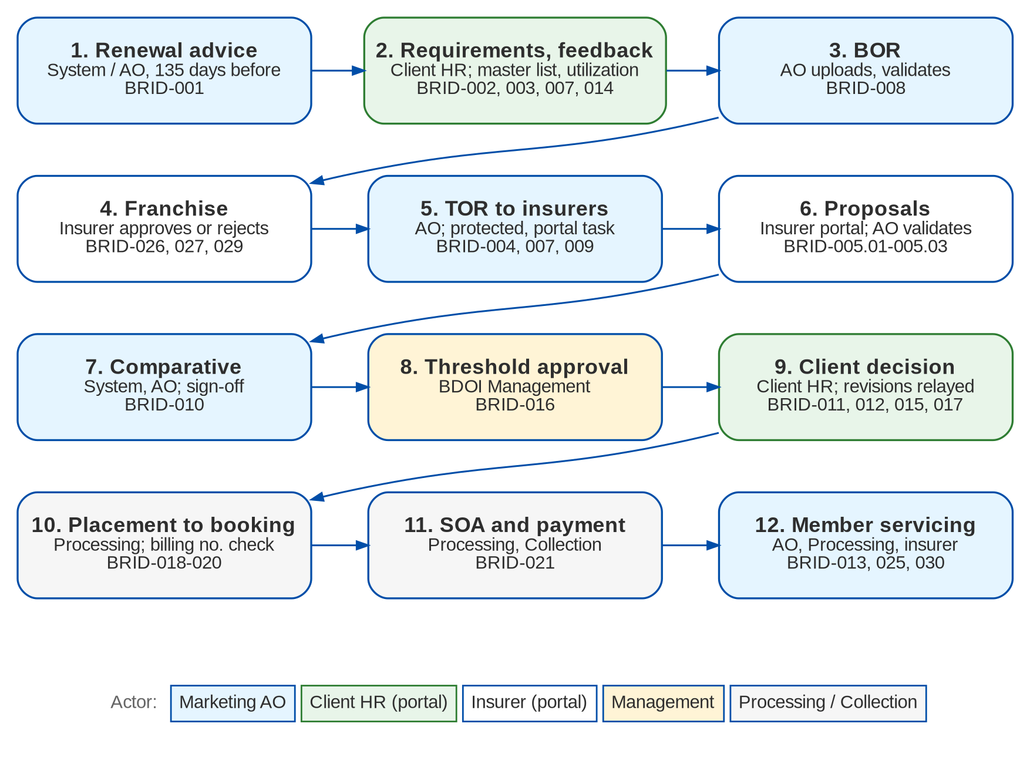
Figure 1: EB cycle by actor (Add. p.3-5; BRID-001-030)

2.3 New business and renewal cycles
Table 6: New business and renewal lanes (Add. p.4; main p.5)
Aspect | Renewal | New business
Start | The RA job opens the cycle before expiry | The AO opens the cycle for a new client or a new benefit line
Client record | Existing client | Captured as prospect and tagged (BRID-006)
Incumbent proposal | Indicative renewal terms sent to the client (BRID-003) | Not applicable
Remarketing | Optional; chosen by the AO when the client asks for other options | Always: TOR goes to the insurers with approved franchise
BOR | Required when remarketing (EBQ05) | Required before any insurer request
Business type on the account | RENEWAL, with a reference to the expiring ARN | NEW_BUSINESS

3 Personas and roles

3.1 Personas
Table 7: Personas and BIBS roles
Persona | BIBS role | Responsibilities in Employee Benefits | BRD
Marketing AO (EB) | EB_AO | Maker of almost every EB action: programmes, RA, feedback, BOR, franchise, TOR, requests, proposal validation, comparative, revisions, confirmation, placement trigger, member changes; requests portal users | Add. p.14-16; BRID-001-017
Marketing TL / UH (EB) | EB_TL | Authorised signatory of the comparative; assigns work | BRID-010
BDOI Management | EB_MANAGEMENT | Approves above the value threshold | BRID-016
Processing (EB) | EB_PROCESSOR | Validates member changes, policy forms and SOAs; completes placement, issuance and booking | BRID-018-021
Processing Supervisor | EB_PROC_SUPERVISOR | As Processing; assigns and approves where BDOI defines a step (EBQ23) | BRID-018
Collection (EB) | EB_COLLECTION | Billing, SOA and payment tracking | BRID-021, 025
Business Administrator | BUSINESS_ADMIN | EB set-up (threshold rules, required documents); approves portal user requests; locks and unlocks portal users | BRID-016, 005
Insurer user | Portal role INSURER_USER | Answers requests, submits proposals, decides franchise, bills member changes, uploads policy forms and SOAs, for its own insurer only | BRID-005.02, 015, 027
Client HR user | Portal role CLIENT_HR | Views its programmes and roster, uploads master lists, utilization, member changes and feedback, comments on and confirms the comparative, for its own company only | BRID-014, 011, 017

The addendum notes that approvals are conditional: the client approves proposals and placement, the insurer approves franchise, proposals and issuance, and BDOI Management approves above the value threshold; Processing and Collection validate and execute (Add. p.16). The roles above are the project's proposal until BDOI confirms the matrix (OQ48).

3.2 Permissions
Table 8: Employee Benefits permissions (build design R4, section 6.1)
Permission | Allows
EB_VIEW | EB screens, programmes, cycles and documents (subject to the access classes)
EB_MARKET | AO maker actions: programme, RA, feedback, BOR, franchise, TOR, requests, proposal entry and validation, comparative, revisions, confirmation, placement trigger, member changes
EB_COMPARATIVE_APPROVE | Sign off a comparative (never the maker)
EB_THRESHOLD_APPROVE | Approve above the value threshold
EB_PROCESS | Processing: validate member changes, policy forms and SOAs; completeness checks
EB_COLLECT | Collection: SOA and billing view; release acknowledgement
EB_SETUP | Threshold rules, required documents, EB parameters and templates
EB_REPORT_VIEW | EB reports
PORTAL_USER_REQUEST | Raise User Access requests of user type External (portal users)
PORTAL_USER_APPROVE | Decide User Access requests of user type External
PORTAL_ADMIN | Lock and unlock portal users; portal log-in and download logs

Portal users are not BIBS users and hold none of these permissions. Their portal role (INSURER_USER or CLIENT_HR) is valid only in the portal realm and is bound to one insurer or one client.

3.3 Permissions matrix
Table 9: Role-to-action matrix for Employee Benefits (proposal until OQ48)
Permission | EB AO | EB TL | EB Mgmt | EB Proc. | Proc. Sup. | EB Coll. | Bus. Admin | Auditor
EB_VIEW | Y | Y | Y | Y | Y | Y | Y | Y
EB_MARKET | Y
EB_COMPARATIVE_APPROVE |  | Y
EB_THRESHOLD_APPROVE |  |  | Y
EB_PROCESS |  |  |  | Y | Y
EB_COLLECT |  |  |  |  |  | Y
EB_SETUP |  |  |  |  |  |  | Y
EB_REPORT_VIEW | Y | Y | Y | Y | Y | Y | Y | Y
PORTAL_USER_REQUEST | Y
PORTAL_USER_APPROVE |  |  |  |  |  |  | Y
PORTAL_ADMIN |  |  |  |  |  |  | Y
WORK_ASSIGN (existing) |  | Y |  |  | Y

The EB roles also receive the BRD-1 and Collections permissions they need for the shared screens (for example CLIENT_VIEW and ACCOUNT_VIEW for the AO, the Processing permissions for EB_PROCESSOR, the Collections work permissions for EB_COLLECTION). Segregation of duties is enforced by the system: a comparative is never signed off by its maker, a threshold approval is never given by the AO of the cycle, and a portal user request is never approved by its requester.

4 Functional requirements

4.1 Access, documents and audit

FR-EB-001 Restrict documents and reports to authorised users
BRD trace | BRID-023 (p.30-31), BRID-005 (p.10-11) | Actor | System
Priority | Must have | Fit | FIT
Screens | All EB screens; Reports; Documents tabs | API | Every endpoint checks its permission

Description
Only authorised users view, download, print or access EB documents and reports. Each EB screen, action and report requires one of the permissions of section 3.2; menus show only what the user's roles allow. Document lists and downloads also apply the department access classes of FR-EB-002.
Insurer and client HR users never reach the core BIBS screens or API (FR-EB-010).
Preconditions
• The user is logged in.
Main flow
1. The user opens a screen, a document or a report.
2. BIBS checks the permission and, for a document, its access class.
3. BIBS shows the item or refuses the request.
Alternate and exception flows
• No permission. The action is not offered; a direct call is refused (HTTP 403) and logged.
Business rules
Rule | Statement | Kind | Maintained in
R1 | Roles are granted the permissions of section 3.3 until BDOI confirms the matrix. | Configurable | User Access Maintenance request

Validations and messages
Check | Message shown | Code
Action without permission | You are not permitted to perform this action | ACCESS_DENIED

Notifications
• None.
Audit
• Refused calls are logged with user, endpoint and time.
Acceptance criteria
1. A Collection user opens the EB SOA register and does not see the comparative approval action.
2. A user without EB_REPORT_VIEW cannot run the EB reports.
3. An authorised Processing user downloads a policy form without error.

FR-EB-002 Link every document to its transaction and restrict it by department
BRD trace | BRID-025 (Add. p.11; p.32) | Actor | Marketing AO; System
Priority | Must have | Fit | CHANGE
Screens | Programme page (Documents tab); Member Changes; SOA Register | API | Attachment service /api/v1/attachments (extended with access classes)

Description
Every document uploaded or generated in EB is linked to the client, the programme or policy, and the transaction (cycle, member change, SOA), and carries a process tag - new business placement, renewal placement, endorsement, adjustment, franchise or proposal. An EB upload without its tag and transaction is refused.
Each document type has an access class listing the departments that may see it - Marketing, Processing, Collection (section 6.2). Lists and downloads show only the documents of the user's classes. Collection users open billing documents, SOAs, endorsement files and collection supporting documents directly.
Preconditions
• The user has EB_VIEW (view) or EB_MARKET (upload).
Main flow
1. The AO uploads a document on a cycle or member change, selects its type and process tag.
2. BIBS stores it with the links and applies the access class of its type.
3. A user of another department opens the Documents tab; BIBS lists only the documents of the user's classes.
Business rules
Rule | Statement | Kind | Maintained in
R1 | Access classes per document type (section 6.3); types without a row keep today's behaviour. | Configurable | Document access classes
R2 | Process tags - NB placement, renewal placement, endorsement, adjustment, franchise, proposal. | Configurable | LOV EB_PROCESS_TYPE
R3 | The final confidentiality matrix, including the contact centre, is confirmed under XQ04. | Configurable | Document access classes

Validations and messages
Check | Message shown | Code
Process tag not selected | Select the process of the document | -
No transaction linked | Link the document to its cycle or member change | To be assigned at build
File type not allowed | The file type is not allowed | ATTACHMENT_TYPE_NOT_ALLOWED
Empty file | The file is empty | ATTACHMENT_EMPTY

Screens and fields: Upload document (EB)
Field | Type | Mand. | Source / LOV | Validation
Document type | List | Yes | DOCUMENT_TYPE (EB values) | -
Process | List | Yes | LOV EB_PROCESS_TYPE | -
Linked to | Display | Yes | Cycle / member change / SOA | From the screen
File | Attachment | Yes | - | Allowed file types and size of the platform

Notifications
• Processing and Collection are notified of billing documents uploaded on a member change (FR-EB-056).
Audit
• Upload, download and access refusal with user and time.
Acceptance criteria
1. A direct billing document uploaded by the AO on a member change is visible to Processing and Collection.
2. A utilization report is not listed for a Collection user.
3. An EB upload without a process tag is refused.

FR-EB-003 Log key actions and keep the history of proposals and documents
BRD trace | BRID-024 (p.31) | Actor | System; users with EB_VIEW (read)
Priority | Must have | Fit | CHANGE
Screens | Programme page (History tab); Proposal and comparative pages (Versions) | API | Audit service (existing); history to be assigned at build

Description
BIBS logs every key action with time, user and reference - RA sent, feedback received, proposals submitted and validated, documents uploaded and released, approvals, client confirmation, placement trigger and every portal action.
TOR, BOR, proposals, comparatives and member rosters are versioned. A submitted version is never changed; a change creates version n+1. Users review the version history and the differences between two versions of a proposal or TOR.
Preconditions
• None.
Main flow
1. A user or portal user performs an action.
2. BIBS writes the audit entry and, for a versioned item, the new version, in the same transaction.
3. The History tab lists the actions of the programme in time order.
Business rules
Rule | Statement | Kind | Maintained in
R1 | Audit and version rows are append-only. | Fixed | -
R2 | Portal actions are recorded under the portal user with the prefix portal and the bound party. | Fixed | -
R3 | Retention 5 years online and 15 years offline (p.37). | Configurable | Retention rules EB_PROGRAMME, EB_MEMBER

Notifications
• None.
Audit
• This FR is the audit.
Acceptance criteria
1. The History tab of a placed cycle lists the RA, the proposals, the comparative sign-off, the confirmation and the placement trigger with user and time.
2. A revised proposal shows version 2 and the differences from version 1.
3. No screen allows an audit or version row to be changed.

FR-EB-004 Protect documents sent outside BDOI
BRD trace | BRID-007 (p.12-13) | Actor | Marketing AO; System
Priority | Must have | Fit | CHANGE
Screens | Send dialogs of the Programme page (TOR, RA, comparative, franchise, revision) | API | Messaging outbox (existing, extended with DOCX protection)

Description
TOR, master lists, utilization reports, RAs, comparatives and other EB files leave BDOI encrypted and password protected, one or several files at a time. The password is a standard assigned value or a system-generated one following a defined syntax, and is always sent in a separate message. PDF, XLSX and DOCX files are protected; a file type that cannot be protected (CSV, images) is refused for outbound sending.
Preconditions
• A document is selected for sending.
Main flow
1. The AO sends one or several documents from a cycle.
2. BIBS protects each file and sends it; the password goes in a second e-mail.
3. BIBS logs both e-mails.
Alternate and exception flows
• File that cannot be protected. BIBS refuses it and names the file; the AO converts it to PDF or Excel.
Business rules
Rule | Statement | Kind | Maintained in
R1 | Every EB file sent outside BDOI is protected; protection cannot be switched off. | Fixed | -
R2 | Password convention (standard value or syntax) documented by BDOI under EBQ09; until then a password is generated per sending. | Configurable | Document password policy

Validations and messages
Check | Message shown | Code
File cannot be protected | <file> cannot be password protected. Send it as PDF, Excel or Word | To be assigned at build
Recipient address invalid | Enter a valid e-mail address | EMAIL_ADDRESS_INVALID

Notifications
• The recipient receives the protected files and, separately, the password.
Audit
• Each e-mail with recipient, time, subject, attachment names and hash.
Acceptance criteria
1. A TOR sent as Word arrives protected, and the password arrives in a separate e-mail.
2. A CSV master list is refused for outbound sending.

4.2 Partner portal

FR-EB-010 Give insurers and client HR users a separate, secure portal
BRD trace | BRID-005 (p.10-11), BRID-005.01 (Add. p.7-8), BRID-005.02 (Add. p.8-9), BRID-014 (p.20-22) | Actor | Insurer user; client HR user; System
Priority | Must have | Fit | NEW
Screens | Portal sign-in; Portal home; Accept invitation | API | Portal realm /api/portal (to be assigned at build)

Description
Insurers and client HR users interact with BDOI only through the partner portal, never the core system. The portal has its own sign-in and its own API; a portal token is refused by the core API and a core token by the portal. Each portal user is bound to one party - one insurer or one client - and every portal query is filtered on that party, so a user cannot see or reach another party's records.
The portal can run as a separate deployment in the internet zone. Its hosting, BDO Information Security approval and the multi-factor method are confirmed under EBQ13.
Preconditions
• The portal user was provisioned (FR-EB-011) and has set a password.
Main flow
1. The portal user opens the portal and signs in with e-mail and password.
2. BIBS sends a one-time code by e-mail when multi-factor authentication is on; the user enters it.
3. The portal home shows the user's open tasks and notices.
Alternate and exception flows
• Wrong credentials. The sign-in is refused; after three failures the portal user is locked (decision D5).
• Record of another party. BIBS answers "not found" and logs the attempt.
• Idle session. The session ends after the portal timeout.
Business rules
Rule | Statement | Kind | Maintained in
R1 | Separate realm and token audience; the core API refuses portal tokens. | Fixed | -
R2 | Every portal query is scoped to the bound insurer or client. | Fixed | -
R3 | Lockout after 3 failed sign-ins. | Configurable | Parameter PORTAL_MAX_FAILED_LOGINS
R4 | Session timeout 15 minutes (default). | Configurable | Parameter PORTAL_SESSION_MINUTES
R5 | E-mail one-time code on (default); final method under EBQ13. | Configurable | Parameter PORTAL_MFA_REQUIRED

Validations and messages
Check | Message shown | Code
Wrong e-mail or password | Invalid e-mail or password | -
Portal user locked | Your portal access is locked. Contact your BDOI account officer | -
One-time code wrong or expired | The code is not valid. Request a new code | -

Screens and fields: Portal sign-in
Field | Type | Mand. | Source / LOV | Validation
E-mail | Text | Yes | - | Registered portal user
Password | Password | Yes | - | Masked
One-time code | Text | Cond. | - | Required when multi-factor is on

Notifications
• Lockout raises the alert PORTAL_LOGIN_LOCKED to the portal administrators.
Audit
• Every sign-in (success or failure) with time, address and browser; every portal action under the portal user.
Acceptance criteria
1. An insurer user signs in and sees only the requests of its own insurer.
2. A portal token used on a core BIBS endpoint is refused.
3. The fourth failed sign-in locks the portal user.

FR-EB-011 Provision portal users through User Access requests
BRD trace | BRID-005 (p.10-11), BRID-014 (p.20-22) | Actor | Marketing AO (requester, PORTAL_USER_REQUEST); approver (PORTAL_USER_APPROVE); Business Administrator (PORTAL_ADMIN)
Priority | Must have | Fit | NEW
Screens | User Access Requests (user type External); Portal Users (Setup & Administration) | API | User Access request service (BRD-11); to be assigned at build

Description
Portal users are created, disabled and enabled only through User Access Maintenance requests of user type External (decision D7). The AO raises the request with the person's name and e-mail, the party kind (insurer or client), the party code and the portal role. A chosen approver other than the requester decides it, with the draft, return and history steps of User Access Maintenance.
On approval BIBS creates the portal user as INVITED and e-mails an invitation link, valid for 72 hours (default). The user sets the password through the link; no password is ever sent by e-mail. The Business Administrator locks and unlocks portal users and reviews the portal sign-in and download logs.
Preconditions
• The requester has PORTAL_USER_REQUEST.
Main flow
1. The AO opens User Access Requests and chooses user type External.
2. The AO enters the user and party details and submits to an approver.
3. The approver approves the request.
4. BIBS creates the portal user and sends the invitation.
5. The user opens the link, sets a password and signs in.
Alternate and exception flows
• The approver returns or rejects the request with a reason; no user is created.
• Invitation expired. The job expires unused invitations; the AO requests a new invitation.
• Disable. A disable request, once approved, blocks the user at once.
Business rules
Rule | Statement | Kind | Maintained in
R1 | The approver is never the requester. | Fixed | -
R2 | A portal user is bound to exactly one insurer or one client. | Fixed | -
R3 | Invitation valid 72 hours (default). | Configurable | Parameter PORTAL_INVITE_VALID_HOURS
R4 | Whether several users per insurer or client and delegated administration are allowed is confirmed under EBQ13. | Configurable | Change request after EBQ13

Validations and messages
Check | Message shown | Code
E-mail already used by a portal user | <e-mail> already has a portal user | To be assigned at build
Party not found | Select an existing insurer or client | -
Approver is the requester | An access request is approved by someone other than the requester | To be assigned at build

Screens and fields: User Access Request (External)
Field | Type | Mand. | Source / LOV | Validation
Full name | Text | Yes | - | Up to 200 characters
E-mail | Text | Yes | - | Valid e-mail; unique among portal users
Party kind | Option | Yes | Insurer / Client | -
Party | Look-up | Yes | Insurer master or client master | Active party
Portal role | List | Yes | INSURER_USER / CLIENT_HR | Must match the party kind
Request type | List | Yes | Create / Disable / Enable | -
Approver | List | Yes | Holders of PORTAL_USER_APPROVE | Not the requester

Notifications
• The approver on submission; the requester on the decision; the new user receives the invitation.
Audit
• Request, decision, provisioning, invitation, lock and unlock with users and times.
Acceptance criteria
1. A portal user exists only after another user approves the request.
2. The invitation e-mail contains a link and no password.
3. A client HR user created for client A cannot see client B's programmes.

FR-EB-012 Stage portal uploads and link them automatically
BRD trace | BRID-005.01 (Add. p.7-8), BRID-014 (p.20-22) | Actor | Insurer user; client HR user; System
Priority | Must have | Fit | NEW
Screens | Portal task pages (upload) | API | Portal realm /api/portal (to be assigned at build)

Description
Insurers upload proposals, policy forms and billing documents; client HR users upload master lists, utilization reports, member changes and feedback. Every upload is made against a task (an insurer request, a franchise request, a member change, an SOA request, a programme), so BIBS links it automatically to the right client, policy, member change or transaction.
Uploads are staged. They are virus scanned and checked for type, size and content, and take effect only when an internal user validates them (FR-EB-013). The portal user sees a confirmation or an error at once.
Preconditions
• The portal user has an open task for the target.
Main flow
1. The portal user opens the task and uploads one or more files with their document type.
2. BIBS checks each file and stores it as RECEIVED.
3. BIBS shows the confirmation and notifies the reviewer.
Alternate and exception flows
• Unsupported or infected file. BIBS refuses it with the reason; nothing is staged.
• No open task for the target. The upload is not possible (no request, no upload).
Business rules
Rule | Statement | Kind | Maintained in
R1 | Nothing uploaded through the portal takes effect before validation. | Fixed | -
R2 | Accepted formats PDF, Word, Excel and the other platform types; size limit 10 MB (default). | Configurable | Parameter PORTAL_MAX_UPLOAD_MB
R3 | A production virus scanner is required before the portal goes live; files stay RECEIVED until the scan passes. | Fixed | -

Validations and messages
Check | Message shown | Code
File type not allowed | The file type is not allowed | ATTACHMENT_TYPE_NOT_ALLOWED
File too large | The file is larger than the allowed size | ATTACHMENT_TOO_LARGE
Content does not match the type | The file content does not match its type | ATTACHMENT_CONTENT_MISMATCH
Virus found | The file failed the virus check | ATTACHMENT_INFECTED

Screens and fields: Portal upload
Field | Type | Mand. | Source / LOV | Validation
Task | Display | Yes | Open tasks of the party | -
Document type | List | Yes | Document types allowed for the task | -
Files | Attachment | Yes | - | One or more; allowed types and size
Remarks | Text | No | - | Up to 1000 characters

Notifications
• PORTAL_UPLOAD_WAITING alert when a staged upload is older than one working day.
Audit
• Each upload with portal user, party, target, file name, size, hash and scan result.
Acceptance criteria
1. An insurer's proposal upload is linked to the request and client without any selection by the insurer.
2. An executable file is refused with ATTACHMENT_TYPE_NOT_ALLOWED.
3. A staged master list does not change the roster until the AO validates it.

FR-EB-013 Review, validate or reject portal uploads
BRD trace | BRID-005.03 (Add. p.9-10), BRID-005.01 (Add. p.7-8) | Actor | Marketing AO (proposals, franchise, client documents); Processing (policy forms); Collection (billing)
Priority | Must have | Fit | NEW
Screens | Portal Uploads (review queue); EB Home (tile Portal uploads to review) | API | To be assigned at build

Description
Staged uploads appear in the Portal Uploads queue of the department that owns their target type. The reviewer opens the file, checks the mapping, and validates or rejects it with a reason. Before validation the reviewer can re-map an upload to another target of the same party. On validation the file becomes an attachment of the target (and, for a master list or proposal form, business data); on rejection the portal user is told why.
Preconditions
• The user has the review permission of the target type (EB_MARKET, EB_PROCESS or EB_COLLECT).
Main flow
1. The reviewer opens Portal Uploads and selects an upload.
2. The reviewer checks the file and its target.
3. The reviewer clicks Validate; BIBS creates the attachment and applies the data.
Alternate and exception flows
• Reject. The reviewer selects the reason; the portal user receives a notice.
• Wrong target. The reviewer re-maps the upload to another open target of the same party, then validates it.
Business rules
Rule | Statement | Kind | Maintained in
R1 | Reviewer by target - AO for proposals, franchise and client documents; Processing for policy forms and SOAs; Collection for billing. | Fixed | -
R2 | Reject reasons are maintained. | Configurable | LOV PORTAL_REJECT_REASON

Validations and messages
Check | Message shown | Code
Reject without reason | Select a reason for 'reject' | WORKFLOW_REASON_REQUIRED
Re-map to another party's target | The upload can only be linked to a record of the same party | To be assigned at build

Notifications
• The reviewer on arrival (in-app and e-mail); the portal user on validation or rejection.
Audit
• Validation, rejection and re-mapping with reviewer, time and reason.
Acceptance criteria
1. An insurer's policy form appears in the Processing queue, not the AO's.
2. A rejected upload shows the reason on the insurer's portal task.
3. A validated proposal counts in the comparative; a staged one does not.

FR-EB-014 Insurer task inbox and structured proposal form
BRD trace | BRID-005.02 (Add. p.8-9), BRID-005 (p.10-11) | Actor | Insurer user
Priority | Must have | Fit | NEW
Screens | Portal home (tasks); Requests for Proposal; Franchise Requests; Member Changes; SOA and Policy Forms | API | Portal realm /api/portal (to be assigned at build)

Description
The insurer's portal home lists its open tasks - requests for proposal to answer, franchise requests to decide, member changes to bill, SOAs and policy forms to send - with due dates.
A request for proposal shows the TOR and the documents to download, and a structured proposal form generated from the TOR items - per benefit line and plan, the insurer's offered value for each item, a deviation flag and remark, the premium per plan, the annual premium and TSI, exclusions and capability factors (company stability, clinic providers, hospital network, technology). Attachments go with the same submission.
Preconditions
• The insurer has an open request (FR-EB-035).
Main flow
1. The insurer user opens the request and downloads the TOR and documents.
2. The user completes the proposal form and attaches the insurer's proposal document.
3. The user submits; BIBS stores the proposal as SUBMITTED and notifies the AO.
Alternate and exception flows
• Decline. The insurer declines the request with a reason; the request closes as DECLINED.
• Save draft. The user saves the form and returns later before the due date.
Business rules
Rule | Statement | Kind | Maintained in
R1 | A proposal can only be submitted against an open request of the insurer. | Fixed | -
R2 | Every TOR item needs an offered value or a deviation remark. | Fixed | -
R3 | Capability factors are maintained. | Configurable | LOV EB_CAPABILITY_FACTOR

Validations and messages
Check | Message shown | Code
TOR item left blank | Answer every TOR item (<item>) or mark a deviation | To be assigned at build
Premium missing for a plan | Enter the premium of plan <plan> | -
Request closed or past due | This request is closed. Contact the BDOI account officer | To be assigned at build

Screens and fields: Proposal form (portal)
Field | Type | Mand. | Source / LOV | Validation
Benefit line | Display | Yes | TOR | -
TOR item | Display | Yes | TOR items | -
Offered value | Text | Cond. | - | Required unless deviation
Deviation | Check box | No | - | Remark required when ticked
Premium per plan | Amount | Yes | - | >= 0
Annual premium / TSI | Amount | Yes | - | >= 0
Capability factors | Rating and text | No | LOV EB_CAPABILITY_FACTOR | -
Validity date | Date | Yes | - | After today
Attachments | Attachment | No | - | Allowed types and size

Notifications
• The AO when a proposal is submitted or a request declined.
Audit
• Draft saves and submission under the portal user.
Acceptance criteria
1. A proposal form shows one line per TOR item of the request.
2. A submission with an unanswered TOR item is refused.
3. An insurer cannot submit a proposal without an open request.

FR-EB-015 Client HR portal
BRD trace | BRID-014 (p.20-22), BRID-011 (p.18) | Actor | Client HR user
Priority | Must have | Fit | NEW
Screens | Portal - Programmes; Members; Uploads; Comparative; Renewal Advice and Documents | API | Portal realm /api/portal (to be assigned at build)

Description
The client HR user sees only its own company - programme and policy summary, contacts, the member roster (read), the renewal advices and the documents released to the client. The user uploads master lists, utilization reports, member changes and feedback (staged, FR-EB-012), and views, comments on and, where allowed, confirms the comparative (FR-EB-043, 046).
Master lists uploaded in Excel are mapped automatically to the roster fields by a template with column mapping and row validation; the result is a staged roster version that the AO accepts (FR-EB-054). Every download is logged.
Preconditions
• The client HR user is provisioned for the client.
Main flow
1. The HR user signs in and opens Programmes.
2. The user downloads the renewal advice or a released document.
3. The user uploads the master list with the template; BIBS validates every row and stages the roster version.
Alternate and exception flows
• Rows with errors. BIBS lists each row and error; nothing is staged until the file is corrected.
Business rules
Rule | Statement | Kind | Maintained in
R1 | Client HR users view and upload only; no change to policy data (BRID-014). What 'manage policy' adds is confirmed under EBQ14. | Configurable | Change request after EBQ14
R2 | Downloads by portal users are logged. | Fixed | -

Validations and messages
Check | Message shown | Code
Template columns missing | The file does not have the column <column>. Use the master list template | To be assigned at build
Row error | Row <n>: <field> <error> | To be assigned at build

Notifications
• The AO when a master list, utilization report, member change or feedback is uploaded.
Audit
• Uploads and downloads under the portal user.
Acceptance criteria
1. A client HR user sees the roster of its company and no other company.
2. A master list with a missing birth date on row 12 is refused with the row named.
3. Each download appears in the portal download log.

4.3 Programme, business type and renewal start

FR-EB-020 Capture and tag new clients as prospect or client
BRD trace | BRID-006 (p.11-12) | Actor | Marketing AO
Priority | Must have | Fit | FIT
Screens | Client pages (CRM); New Programme (New Client) | API | Client service (existing)

Description
New EB clients are captured in the BIBS client master with the required fields and tagged as prospect or confirmed client by the onboarding workflow of BRD-1. Search filters by the tag. The duplicate check stops a second record of the same client. The EB programme is opened from the client page.
Preconditions
• The AO has CLIENT_MAINTAIN.
Main flow
1. The AO searches the client; none is found.
2. The AO creates the prospect with the required fields.
3. BIBS checks for duplicates and saves the prospect.
4. After KYC onboarding the client is confirmed.
Alternate and exception flows
• Duplicate found. BIBS refuses the new record and shows the existing client.
Business rules
Rule | Statement | Kind | Maintained in
R1 | Prospect = client of status PROSPECT; client = CONFIRMED. | Fixed | -

Validations and messages
Check | Message shown | Code
Client already exists | A client with the same identifiers already exists | CLIENT_DUPLICATE
Name blank | Enter the client name | CLIENT_NAME_REQUIRED

Notifications
• As the BRD-1 onboarding workflow.
Audit
• Client creation and status changes.
Acceptance criteria
1. A new EB prospect is created and appears in the prospect search.
2. A second record with the same identifiers is refused with CLIENT_DUPLICATE.

FR-EB-021 Open an EB programme and its cycles with the business type
BRD trace | BRID-022.01 (Add. p.10-11), BRID-006 (p.11-12) | Actor | Marketing AO (EB_MARKET)
Priority | Must have | Fit | CHANGE
Screens | New Programme; Programmes; Programme page | API | To be assigned at build

Description
A programme groups the client's benefit lines (HMO, GLI, GPA), the team (BDO, SM, Voluntary, Solicited, New Business), the funding (employer or voluntary), the HR contacts and the renewal flag. Each line holds the incumbent insurer, the current policy and ARN, the period and the headcount.
One cycle per policy year carries the business type, NEW_BUSINESS or RENEWAL. The type is required and travels to the accounts created from the cycle (shared work item BT0), so every report can be filtered by it.
Preconditions
• The client exists in BIBS.
Main flow
1. The AO clicks New Programme from the client page.
2. The AO enters the lines, team, funding and contacts, and saves; BIBS numbers the programme EBP-yyyy-nnnnnn.
3. The AO opens a new-business cycle, or the RA job opens a renewal cycle (FR-EB-022).
Business rules
Rule | Statement | Kind | Maintained in
R1 | Programme numbers EBP-<yyyy>-nnnnnn; cycle numbers EBC-<yyyy>-nnnnnn. | Configurable | Document number series
R2 | Business type required on every cycle and account. | Fixed | -
R3 | Benefit lines and teams are lists of values. | Configurable | LOV EB_BENEFIT_LINE, EB_TEAM

Validations and messages
Check | Message shown | Code
No benefit line | Add at least one benefit line | -
No HR contact | Add at least one HR contact | -
Open cycle exists for the policy year | Programme <no.> already has an open cycle for <year> | To be assigned at build

Screens and fields: New Programme
Field | Type | Mand. | Source / LOV | Validation
Client | Look-up | Yes | Client master | Prospect or confirmed client
Programme name | Text | Yes | - | Up to 200 characters
Team | List | Yes | LOV EB_TEAM | -
Funding | Option | Yes | Employer / Voluntary | EBQ27
Benefit lines | Table | Yes | LOV EB_BENEFIT_LINE | Line, product, incumbent insurer, policy, period, headcount
HR contacts | Table | Yes | - | Name, e-mail, mobile, role, receives RA / SOA
Eligible for renewal | Check box | No | - | -
Account officer | List | Yes | EB AOs | Default the user

Notifications
• None.
Audit
• Programme and cycle creation and changes.
Acceptance criteria
1. A programme with HMO and GLI lines is saved with an EBP number.
2. A renewal cycle creates accounts of business type RENEWAL.
3. A cycle cannot be saved without its business type.

FR-EB-022 Send the renewal advice automatically before expiry
BRD trace | BRID-001 (p.7) | Actor | System; Marketing AO
Priority | Must have | Fit | NEW
Screens | EB Home (tile RA due); Programmes (tab Renewal Due; bulk Send RA); Programme page | API | Job EB_RENEWAL_ADVICE; to be assigned at build

Description
A daily job opens a renewal cycle for each programme flagged for renewal whose line expires in the lead time, composes the RA from the template with the key programme details, and sends it to the programme's HR contacts that receive RAs. Reminders follow at set days while no feedback is recorded; each carries a feedback request with a link to the client portal.
The RA is stored as document type RENEWAL_ADVICE linked to the programme, the current ARN and the client, so the contact centre can view and resend it (decision D3). No RA goes to new, cancelled or ineligible programmes. The AO can also send the RA manually from the Programmes list.
Preconditions
• The programme is flagged for renewal and has at least one HR contact receiving RAs.
Main flow
1. The job runs daily at 06:00 PHT.
2. BIBS selects eligible programmes at the lead time and opens their renewal cycles.
3. BIBS generates and sends the RA protected, and stores it.
4. The cycle moves to RA_SENT; reminders are scheduled.
Alternate and exception flows
• No contact or no renewal flag inside the lead time. No RA is sent; the alert EB_RA_NOT_SENT goes to the AO.
• Manual send. The AO selects programmes in Renewal Due and clicks Send RA.
Business rules
Rule | Statement | Kind | Maintained in
R1 | Lead time 135 days before expiry (default, TAT annex); the BRD example is 180 days (EBQ02). | Configurable | Parameter EB_RA_LEAD_DAYS
R2 | Reminders at 120, 105 and 90 days (default). | Configurable | Parameter EB_RA_REMINDER_DAYS
R3 | Only programmes flagged for renewal; who sets the flag is confirmed under EBQ03. | Fixed | -
R4 | EB lines are excluded from the general Renewal lists (decision D3). | Fixed | -

Validations and messages
Check | Message shown | Code
Manual send to an ineligible programme | Programme <no.> is not flagged for renewal | To be assigned at build

Notifications
• RA and reminders to the HR contacts; EB_RA_NOT_SENT to the AO.
Audit
• RA sending, recipients, reminders and message references.
Acceptance criteria
1. A programme expiring in 135 days receives the RA and moves to RA_SENT.
2. A programme without the renewal flag receives no RA.
3. The RA is listed in the client's documents as a renewal advice.

FR-EB-023 Collect and record client feedback
BRD trace | BRID-002 (p.8) | Actor | Marketing AO; client HR user
Priority | Must have | Fit | NEW
Screens | Programme page (Cycle tab, Record Feedback); Portal - Uploads | API | To be assigned at build

Description
The AO records the client's feedback on the renewal cycle as text, attachments (PDF, Word, image) or both, with the channel (AO, portal, e-mail) and the date received. The client HR user can give the same feedback in the portal. BIBS links the feedback to the client and the cycle and confirms the entry. The first feedback moves the cycle from RA_SENT to REQUIREMENTS and stops the RA reminders.
Preconditions
• The cycle is open.
Main flow
1. The AO clicks Record Feedback.
2. The AO enters the text or attaches files and the date received.
3. BIBS saves the feedback and shows the confirmation.
Business rules
Rule | Statement | Kind | Maintained in
R1 | Feedback needs text or at least one file. | Fixed | -

Validations and messages
Check | Message shown | Code
Feedback empty | Enter the feedback or attach a file | To be assigned at build
File type not allowed | The file type is not allowed | ATTACHMENT_TYPE_NOT_ALLOWED

Screens and fields: Record Feedback
Field | Type | Mand. | Source / LOV | Validation
Channel | List | Yes | AO / Portal / E-mail | -
Date received | Date | Yes | - | Not after today
Feedback | Long text | Cond. | - | Required without a file
Files | Attachment | Cond. | - | Required without text

Notifications
• The AO when the client gives feedback in the portal.
Audit
• Feedback with user or portal user and time.
Acceptance criteria
1. Feedback without text or file is refused.
2. Feedback recorded on a renewal cycle stops the RA reminders.

FR-EB-024 Send the incumbent's indicative renewal proposal
BRD trace | BRID-003 (p.8-9) | Actor | Marketing AO; incumbent insurer
Priority | Must have | Fit | NEW
Screens | Programme page (Proposals tab, Indicative Proposal) | API | To be assigned at build

Description
For programmes flagged for renewal, the AO records the incumbent's indicative proposal (the latest incumbent rates and coverage) or the incumbent submits it in the portal. BIBS generates the letter with the policy number, coverage, incumbent rates, expiry and renewal instructions, and sends it protected to the client's HR contacts. The action is refused for new-business cycles and programmes not flagged for renewal.
Preconditions
• The cycle is a renewal cycle of a programme flagged for renewal.
Main flow
1. The AO enters or validates the incumbent's indicative terms.
2. The AO clicks Send Indicative Proposal; BIBS generates the letter.
3. BIBS sends it to the HR contacts and logs it.
Business rules
Rule | Statement | Kind | Maintained in
R1 | Only renewal cycles of flagged programmes. | Fixed | -
R2 | Whether the incumbent submits through the portal or the AO encodes the terms is confirmed under EBQ04. | Configurable | Change request after EBQ04

Validations and messages
Check | Message shown | Code
Cycle not a renewal | The indicative proposal applies to renewals only | To be assigned at build
Rates missing | Enter the incumbent rate of plan <plan> | -

Notifications
• The client's HR contacts receive the letter.
Audit
• Letter generation and sending.
Acceptance criteria
1. The indicative proposal of a renewal shows the current policy number, coverage and incumbent rates.
2. The action is not available on a new-business cycle.

4.4 Documents, BOR, franchise and TOR

FR-EB-030 Upload TOR, master list and utilization report
BRD trace | BRID-007 (p.12-13) | Actor | Marketing AO; client HR user; incumbent insurer
Priority | Must have | Fit | CHANGE
Screens | Programme page (Documents tab); Portal uploads | API | To be assigned at build

Description
The TOR, master list (named), unnamed master list, utilization report and other EB documents are uploaded single or in bulk (Word, Excel, PDF), registered with the cycle, type, process tag, version and source, and linked to the client, policy and renewal transaction. A new upload of the same type creates version n+1 and supersedes the previous one.
The incumbent insurer is notified through a portal task, with e-mail, to upload the unnamed master list.
Preconditions
• The cycle is open.
Main flow
1. The AO uploads one or several files and selects their types.
2. BIBS registers each file as a new version and confirms.
3. The AO clicks Request Unnamed Master List; BIBS creates the portal task for the incumbent and e-mails it.
Business rules
Rule | Statement | Kind | Maintained in
R1 | Documents are versioned per cycle and type. | Fixed | -
R2 | Outbound sending follows FR-EB-004. | Fixed | -

Validations and messages
Check | Message shown | Code
File type not allowed | The file type is not allowed | ATTACHMENT_TYPE_NOT_ALLOWED
Document type not selected | Select the document type | -

Screens and fields: EB document upload
Field | Type | Mand. | Source / LOV | Validation
Document type | List | Yes | TOR, master list, unnamed master list, utilization, others | -
Process | List | Yes | LOV EB_PROCESS_TYPE | -
Files | Attachment | Yes | - | One or more

Notifications
• The incumbent insurer receives the portal task and e-mail.
Audit
• Each version with uploader and time.
Acceptance criteria
1. Uploading a second master list makes it version 2 and marks version 1 superseded.
2. The incumbent sees the task "Upload unnamed master list" in the portal.

FR-EB-031 Upload and validate the signed Broker on Record
BRD trace | BRID-008 (p.14-15) | Actor | Marketing AO
Priority | Must have | Fit | NEW
Screens | Programme page (BOR tab) | API | To be assigned at build

Description
The AO uploads the client's signed BOR (PDF or Word). BIBS shows its status - Pending, Uploaded, Validated or Rejected. The validator confirms a checklist - signed by an authorised signatory, not blank, client name matches - and sets the validity dates. An invalid BOR is rejected and re-uploaded as a new version; the latest validated version is the active one.
Insurer requests and franchise requests of a new-business cycle, or of a renewal cycle that remarkets, are blocked until a validated BOR exists.
Preconditions
• The cycle is open.
Main flow
1. The AO uploads the signed BOR; the status becomes Uploaded.
2. The validator opens it and completes the checklist.
3. The validator clicks Validate; the BOR becomes the active version.
Alternate and exception flows
• Checklist not met. The validator rejects it with a reason; the AO uploads a corrected BOR as version n+1.
Business rules
Rule | Statement | Kind | Maintained in
R1 | Proposal and franchise requests need a validated BOR for new business and remarketing (renewal need confirmed under EBQ05). | Fixed | -
R2 | The signature check is an attestation by the validator; e-signature verification is a parked seam (EBQ06). | Fixed | -

Validations and messages
Check | Message shown | Code
Checklist incomplete | Complete the BOR checklist before validating | To be assigned at build
Request without a validated BOR | Cycle <no.> has no validated Broker on Record | To be assigned at build
File type not PDF or Word | Upload the BOR as PDF or Word | ATTACHMENT_TYPE_NOT_ALLOWED

Screens and fields: BOR
Field | Type | Mand. | Source / LOV | Validation
BOR file | Attachment | Yes | - | PDF or Word
Signed by an authorised signatory | Check box | Yes | - | Validator
Not blank | Check box | Yes | - | Validator
Client name matches | Check box | Yes | - | Validator
Valid from / to | Date | Yes | - | To after from

Notifications
• The AO when the BOR is validated or rejected.
Audit
• Upload, validation and rejection with user and time.
Acceptance criteria
1. A franchise request on a new-business cycle without a validated BOR is refused.
2. A rejected BOR re-uploaded becomes version 2 with status Uploaded.

FR-EB-032 Request franchise from insurers and record their decision
BRD trace | BRID-026 (Add. p.12-13), BRID-027 (p.32-33) | Actor | Marketing AO; insurer user
Priority | Must have | Fit | NEW
Screens | Programme page (Franchise tab); Portal - Franchise Requests | API | To be assigned at build

Description
For each target insurer the AO submits a franchise request with the BOR and the required documents. The insurer approves or rejects it in the portal with a reason; where the insurer answers by e-mail, the AO records the outcome with the e-mail as evidence. Only insurers with an approved franchise receive the TOR (FR-EB-035).
The insurer has 5 working days to decide (TAT annex). A request not decided after the TAT and a grace period expires and raises an alert to the AO.
Preconditions
• A validated BOR exists (FR-EB-031).
Main flow
1. The AO selects the insurers and clicks Request Franchise.
2. BIBS checks the required documents (FR-EB-034) and sends the requests (portal task and protected e-mail); the cycle moves to FRANCHISE.
3. The insurer user opens the request and approves or rejects it.
4. BIBS records the decision and notifies the AO.
Alternate and exception flows
• Decision by e-mail. The AO records the outcome and attaches the e-mail.
• No reply. The job expires the request; alert EB_FRANCHISE_OVERDUE to the AO.
Business rules
Rule | Statement | Kind | Maintained in
R1 | Franchise TAT 5 working days (default). | Configurable | Parameter EB_FRANCHISE_TAT_DAYS
R2 | A decision recorded by the AO needs the insurer's evidence. | Fixed | -
R3 | Whether franchise is needed for the incumbent, per insurer or once per cycle, is confirmed under EBQ07. | Configurable | Change request after EBQ07

Validations and messages
Check | Message shown | Code
Reject without reason | Select a reason for 'reject' | WORKFLOW_REASON_REQUIRED
Outcome recorded without evidence | Attach the insurer's reply | To be assigned at build

Screens and fields: Franchise decision (portal)
Field | Type | Mand. | Source / LOV | Validation
Decision | Option | Yes | Approve / Reject | -
Reason | List | Cond. | LOV EB_FRANCHISE_REJECT_REASON | Required for Reject
Remarks | Text | No | - | Up to 1000 characters

Notifications
• The insurer on the request; the AO on the decision; EB_FRANCHISE_OVERDUE on expiry.
Audit
• Request, decision and expiry with user or portal user and time.
Acceptance criteria
1. An insurer approves a franchise in the portal and the AO is notified.
2. A request without a decision after the TAT becomes EXPIRED and raises an alert.
3. The TOR cannot be released to an insurer whose franchise is rejected.

FR-EB-033 Advise the client of the franchise outcome
BRD trace | BRID-029 (p.33-34) | Actor | Marketing AO
Priority | Must have | Fit | NEW
Screens | Programme page (Franchise tab, Advise Client) | API | To be assigned at build

Description
After an insurer decides a franchise request, the AO advises the client of the approval or rejection by e-mail and portal notice, from the template. The advice is due within the agreed working days from the decision; an overdue advice raises an alert.
Preconditions
• The franchise request is APPROVED or REJECTED.
Main flow
1. The AO clicks Advise Client; BIBS generates the advice.
2. The AO confirms; BIBS sends it and marks the request ADVISED.
Business rules
Rule | Statement | Kind | Maintained in
R1 | Advice due 2 working days after the decision (default). | Configurable | Parameter EB_FRANCHISE_ADVICE_DAYS

Notifications
• The client's HR contacts receive the advice; the AO is alerted when it is overdue.
Audit
• Advice sending with user and time.
Acceptance criteria
1. The client receives the franchise outcome and the request shows ADVISED.
2. An outcome not advised within 2 working days raises an alert.

FR-EB-034 Submit the required documents to insurers per process
BRD trace | BRID-026 (Add. p.12-13) | Actor | Marketing AO
Priority | Must have | Fit | CHANGE
Screens | Programme page (Submissions); Member Changes; EB Setup (Required Documents) | API | To be assigned at build

Description
The AO submits the documents an insurer needs for new-business placement, renewal placement, adjustment or endorsement (financial and non-financial), franchise request and proposal - BOR, TOR, master list, utilization, indicative proposal, placement and adjustment requirements. A checklist per process type and benefit line lists the mandatory documents; BIBS refuses the submission while one is missing.
The submission goes to the insurer's portal and by protected e-mail, is logged and linked to the client, policy and transaction, and Processing and Collection are notified and can view it. Insurers see only the submissions addressed to them.
Preconditions
• The user has EB_MARKET.
Main flow
1. The AO opens New Submission, selects the process type and the insurer.
2. BIBS shows the checklist with the documents found on the cycle.
3. The AO adds missing documents and submits.
4. BIBS sends the documents and records the submission.
Business rules
Rule | Statement | Kind | Maintained in
R1 | Required documents per process type, benefit line and document type are maintained with maker-checker. | Configurable | Required Documents (EB_SETUP)

Validations and messages
Check | Message shown | Code
Mandatory document missing | Add the required document <type> for <process> | To be assigned at build
Insurer not selected | Select the insurer | -

Screens and fields: New Submission
Field | Type | Mand. | Source / LOV | Validation
Process type | List | Yes | LOV EB_PROCESS_TYPE | -
Insurer | List | Yes | Insurers of the cycle | -
Documents | Checklist | Yes | Required documents | All mandatory present

Notifications
• The insurer (portal task and e-mail); Processing and Collection (in-app).
Audit
• Submission, documents, recipient and time.
Acceptance criteria
1. A renewal placement submission without the master list is refused.
2. Processing sees the submission on the programme.

FR-EB-035 Prepare the TOR and distribute it to insurers
BRD trace | BRID-009 (p.15-16), BRID-004 (p.9-10), BRID-007 (p.12-13) | Actor | Marketing AO
Priority | Must have | Fit | CHANGE
Screens | Programme page (TOR tab; Insurer Requests tab) | API | To be assigned at build

Description
The AO prepares the TOR as structured items per benefit line and plan (item, description, requirement) and releases it. The AO then selects the insurers - only insurers with an approved franchise for the cycle - and distributes the TOR, the unnamed master list and the utilization report. BIBS creates one insurer request per insurer with the TOR version, documents and due date, as a portal task and a protected e-mail.
For a renewal, remarketing to other insurers uses the same request, and is possible only for programmes flagged for renewal (BRID-004).
Preconditions
• A validated BOR and at least one approved franchise exist.
Main flow
1. The AO maintains the TOR items and clicks Release TOR.
2. The AO selects the insurers and clicks Send Requests.
3. BIBS creates the requests (EBR-yyyy-nnnnnn), sends them and moves the cycle to PROPOSALS.
Alternate and exception flows
• TOR changed after release. The AO releases version n+1; open requests are updated and the insurers notified.
Business rules
Rule | Statement | Kind | Maintained in
R1 | Only insurers with an APPROVED franchise for the cycle receive requests. | Fixed | -
R2 | Reply due 5 working days after the request (default). | Configurable | Parameter EB_PROPOSAL_REPLY_DAYS
R3 | The standard TOR template per benefit line is confirmed under EBQ08. | Configurable | Template EB_TOR

Validations and messages
Check | Message shown | Code
Insurer without approved franchise | Insurer <code> has no approved franchise for this cycle | To be assigned at build
TOR without items | Add the TOR items before release | -

Notifications
• Each insurer (portal task and e-mail); EB_PROPOSAL_OVERDUE to the AO for requests past due.
Audit
• TOR versions, distribution and downloads per insurer.
Acceptance criteria
1. A TOR sent to three insurers creates three requests with the same TOR version.
2. An insurer with a rejected franchise cannot be selected.
3. Each insurer's download of the TOR is logged.

4.5 Proposals, comparative, approvals and client decision

FR-EB-040 Record and validate insurer proposals
BRD trace | BRID-005.02 (Add. p.8-9), BRID-005.03 (Add. p.9-10), BRID-010 (p.16-17) | Actor | Marketing AO
Priority | Must have | Fit | NEW
Screens | Programme page (Proposals tab); Proposal page | API | To be assigned at build

Description
Proposals come from the portal form (FR-EB-014) or are entered by the AO from an e-mailed proposal. Each proposal is SUBMITTED until the AO validates it; only validated proposals enter the comparative. The AO may reject a proposal with a reason, and the insurer can then submit a new version. The incumbent's indicative proposal counts as a proposal of kind INCUMBENT_INDICATIVE.
Preconditions
• The cycle is in PROPOSALS, INCUMBENT_TERMS or REVISION.
Main flow
1. The AO opens a submitted proposal and checks it against the TOR.
2. The AO clicks Validate; the proposal becomes VALIDATED.
Alternate and exception flows
• Reject. The AO rejects it with a reason; the insurer is notified.
• Entry by the AO. The AO enters the proposal on behalf of the insurer with the insurer's document attached.
Business rules
Rule | Statement | Kind | Maintained in
R1 | Only validated proposals count in the comparative. | Fixed | -
R2 | A new version supersedes the earlier one; history kept (FR-EB-003). | Fixed | -

Validations and messages
Check | Message shown | Code
Reject without reason | Select a reason for 'reject' | WORKFLOW_REASON_REQUIRED
AO entry without the insurer's document | Attach the insurer's proposal document | To be assigned at build

Notifications
• The insurer on validation or rejection.
Audit
• Validation and rejection with user and time.
Acceptance criteria
1. A submitted proposal is not in the comparative until validated.
2. A proposal entered by the AO shows the source AO and the attached document.

FR-EB-041 Build and sign off the comparative analysis
BRD trace | BRID-010 (p.16-17) | Actor | System; Marketing AO; authorised signatory (EB_COMPARATIVE_APPROVE)
Priority | Must have | Fit | CHANGE
Screens | Comparative page; Programme page (Comparative tab) | API | To be assigned at build

Description
BIBS builds the comparative from all validated proposals of the cycle - coverage per TOR item, premium rates and premium per plan, exclusions, terms, additional benefits, and capability factors such as company stability, clinic providers, hospitals and technology. It is a structured table linked to the client, the cycle and the proposals, stored as a snapshot version.
The comparative is due 3 working days after the last proposal (default). BIBS warns when requests are still open; the AO closes them explicitly or waits. The AO marks the recommended proposal per line and submits the comparative for sign-off by an authorised signatory other than the maker. It can be viewed, exported (PDF, Excel) and printed.
Preconditions
• At least one validated proposal exists.
Main flow
1. The AO clicks Build Comparative; BIBS creates the snapshot.
2. The AO reviews it, marks the recommendation and clicks Submit for Sign-off.
3. The signatory approves; BIBS evaluates the threshold rules (FR-EB-042) and moves the cycle to THRESHOLD_APPROVAL or READY_TO_PRESENT.
Alternate and exception flows
• Open requests. BIBS lists the insurers that have not answered; the AO closes their requests or waits.
• Return. The signatory returns the comparative with a reason; the AO rebuilds or edits it.
Business rules
Rule | Statement | Kind | Maintained in
R1 | Signatory never the maker. | Fixed | -
R2 | Due 3 working days after the last proposal (default); alert EB_COMPARATIVE_LATE. | Configurable | Parameter EB_COMPARATIVE_DAYS
R3 | Factors and scoring confirmed under EBQ10. | Configurable | LOV EB_CAPABILITY_FACTOR

Validations and messages
Check | Message shown | Code
Requests still open | <n> insurer requests are still open. Close them or wait for the proposals | To be assigned at build
No recommendation marked | Mark the recommended proposal of each line | -
Signatory is the maker | A comparative is signed off by someone other than its maker | To be assigned at build

Notifications
• The signatories on submission; the AO on sign-off or return.
Audit
• Snapshot versions, sign-off and return with users and times.
Acceptance criteria
1. A comparative of three validated proposals shows one column per insurer and the lowest premium per plan.
2. The maker cannot sign off the comparative.
3. The comparative exports to PDF and Excel with the same content.

FR-EB-042 Trigger approval when a value threshold is met
BRD trace | BRID-016 (p.23) | Actor | System; BDOI Management (EB_THRESHOLD_APPROVE)
Priority | Must have | Fit | CHANGE
Screens | EB Setup (Threshold Rules); My Approvals; Comparative page | API | To be assigned at build

Description
Threshold rules define, per benefit line or all lines, a measure (TSI or annual premium), an amount and currency, the approver permission and level, and effective dates. BIBS evaluates them on the recommended proposal when the comparative is signed off, and again on client confirmation. When a rule is met, the cycle waits in THRESHOLD_APPROVAL; approvers are notified and see the item in My Approvals, and placement is blocked until approval. Administrators maintain the rules with maker-checker.
Preconditions
• A comparative is signed off or the client confirms.
Main flow
1. BIBS evaluates the rules; a rule matches.
2. BIBS moves the cycle to THRESHOLD_APPROVAL and notifies the approvers.
3. An approver reviews the comparative and approves; the cycle moves on.
Alternate and exception flows
• Return. The approver returns the comparative with a reason.
• A new rule matches at confirmation. The cycle returns to THRESHOLD_APPROVAL.
Business rules
Rule | Statement | Kind | Maintained in
R1 | Seed values TSI >= 500M and premium >= 20M are examples; BDOI gives the values and levels (EBQ11). | Configurable | Threshold Rules (EB_SETUP)
R2 | The AO of the cycle never approves the threshold. | Fixed | -

Validations and messages
Check | Message shown | Code
Placement triggered while approval pending | Cycle <no.> waits for the threshold approval | To be assigned at build
Rule amount not positive | Enter an amount greater than zero | -

Screens and fields: Threshold rule
Field | Type | Mand. | Source / LOV | Validation
Benefit line | List | No | LOV EB_BENEFIT_LINE | Blank = all lines
Measure | List | Yes | TSI / Annual premium | -
Amount | Amount | Yes | - | > 0
Currency | List | Yes | Currency master | Default PHP
Approver permission and level | List | Yes | Permissions | Default EB_THRESHOLD_APPROVE
Effective from / to | Date | Yes | - | To after from

Notifications
• The approvers on entry; the AO on approval or return.
Audit
• Rule changes with maker and checker; approvals with user and time.
Acceptance criteria
1. A comparative with a recommended annual premium above the rule amount waits for Management approval.
2. Placement cannot be triggered before the threshold approval.
3. A rule changed by the administrator applies after authorisation without a new build.

FR-EB-043 Present the comparative to the client
BRD trace | BRID-011 (p.18) | Actor | Marketing AO; client HR user
Priority | Must have | Fit | NEW
Screens | Comparative page (Present to Client); Portal - Comparative | API | To be assigned at build

Description
The AO presents the approved comparative - table, summary and a downloadable PDF - to the client. BIBS publishes it on the client portal and sends it by protected e-mail, and notifies the HR contacts. The client HR user reads it in the portal and gives feedback or asks for clarification in a comment thread on the same page; the AO is notified and replies in the thread.
Preconditions
• The cycle is READY_TO_PRESENT.
Main flow
1. The AO clicks Present to Client.
2. BIBS publishes the comparative and sends it; the cycle moves to WITH_CLIENT.
3. The HR user comments; the AO replies.
Business rules
Rule | Statement | Kind | Maintained in
R1 | Only an approved comparative can be presented. | Fixed | -

Validations and messages
Check | Message shown | Code
Comment empty | Enter your comment | -

Notifications
• The HR contacts on presentation; the AO on each client comment.
Audit
• Presentation and comments with user or portal user and time.
Acceptance criteria
1. The client HR user sees the comparative in the portal and downloads the PDF.
2. A client comment notifies the AO.

FR-EB-044 Capture client changes and relay them to insurers
BRD trace | BRID-012 (p.19-20) | Actor | Marketing AO; client HR user
Priority | Must have | Fit | NEW
Screens | Programme page (Revisions); Portal tasks | API | To be assigned at build

Description
The AO captures the client's changes, additions or amendments as items (a TOR item or free text with the requested change) with documents, and selects the insurers to relay them to. BIBS relays the revision as a portal task and e-mail per insurer, tracks each insurer's status (open, answered) and confirms the relay. An empty revision is refused. The cycle moves to REVISION.
Preconditions
• The cycle is WITH_CLIENT.
Main flow
1. The AO clicks Request Revision and enters the items.
2. The AO selects the insurers and relays the revision.
3. BIBS creates the insurer tasks and confirms.
Business rules
Rule | Statement | Kind | Maintained in
R1 | A revision has at least one item with a requested change. | Fixed | -

Validations and messages
Check | Message shown | Code
Revision without items | Add at least one requested change | To be assigned at build
No insurer selected | Select the insurers | -

Notifications
• Each selected insurer (portal task and e-mail).
Audit
• Revision, items, targets and relay time.
Acceptance criteria
1. A revision relayed to two insurers shows two open targets.
2. A revision with no items is refused.

FR-EB-045 Insurers update their proposals against a revision
BRD trace | BRID-015 (p.22-23) | Actor | Insurer user
Priority | Must have | Fit | NEW
Screens | Portal - Requests for Proposal (revision); Proposal page (Versions) | API | Portal realm /api/portal (to be assigned at build)

Description
The insurer opens the revision task, which shows the requested items. The revised proposal is a new version that references the revision and must answer every requested item. BIBS notifies the AO, keeps the version history and shows the differences from the previous version. The target becomes answered.
Preconditions
• The insurer has an open revision target.
Main flow
1. The insurer opens the revision task and edits the proposal form.
2. The insurer answers each requested item and submits.
3. BIBS stores version n+1 and marks the target answered.
Business rules
Rule | Statement | Kind | Maintained in
R1 | Every requested item must be addressed. | Fixed | -

Validations and messages
Check | Message shown | Code
Requested item not addressed | Answer the requested change <item> | To be assigned at build

Notifications
• The AO on submission.
Audit
• Version with portal user and time.
Acceptance criteria
1. A revised proposal that skips a requested item is refused.
2. The proposal page shows version 2 with the changed items highlighted.

FR-EB-046 Record the client's confirmation and trigger placement
BRD trace | BRID-017 (p.24), BRID-019 (p.25-26) | Actor | Marketing AO; client HR user; System
Priority | Must have | Fit | CHANGE
Screens | Programme page (Confirm; Trigger Placement); Portal - Comparative (Confirm) | API | To be assigned at build

Description
The client's confirmation of the chosen proposal is recorded with its channel - in the system (portal), by e-mail or as a signed document; evidence is mandatory except for a portal confirmation. BIBS re-evaluates the threshold rules.
Trigger Placement creates one draft account per benefit line of the chosen proposal (EB product of the line, insurer, premium, business type), links the placement documents (confirmation, proposal, TOR, master list, BOR) to each account, submits it to Processing and notifies Processing and the insurer. It is blocked while a threshold approval, a required placement document or, for a non-accredited provider, the ISACOM approval is missing (EBQ24).
The cycle follows the account stages (placed, policy issued, booked) and becomes PLACED when all its accounts are booked.
Preconditions
• The cycle is WITH_CLIENT (confirmation) or CONFIRMED (trigger).
Main flow
1. The AO records the confirmation with its evidence, or the HR user confirms in the portal.
2. The AO clicks Trigger Placement.
3. BIBS checks approvals and documents, creates the accounts and submits them.
4. Processing receives the accounts in the placement queue.
Alternate and exception flows
• Placement document missing. BIBS lists it; nothing is created.
• Confirmation of the wrong proposal. The AO voids the confirmation before the trigger and records it again.
Business rules
Rule | Statement | Kind | Maintained in
R1 | One account per benefit line; business type from the cycle; a renewal account refers to the expiring ARN. | Fixed | -
R2 | Accepted evidence of confirmation confirmed under EBQ12. | Configurable | Change request after EBQ12
R3 | Placement documents from the required documents of NB_PLACEMENT / RENEWAL_PLACEMENT. | Configurable | Required Documents

Validations and messages
Check | Message shown | Code
Confirmation without evidence | Attach the client's confirmation | To be assigned at build
Threshold approval pending | Cycle <no.> waits for the threshold approval | To be assigned at build
Placement document missing | Add the required document <type> before placement | To be assigned at build

Screens and fields: Client confirmation
Field | Type | Mand. | Source / LOV | Validation
Chosen proposal per line | List | Yes | Validated proposals | One per line
Channel | List | Yes | System / E-mail / Signed document | -
Evidence | Attachment | Cond. | - | Required unless System
Confirmation date | Date | Yes | - | Not after today

Notifications
• Processing and the insurer on the trigger; the AO as the accounts progress.
Audit
• Confirmation, trigger and created ARNs.
Acceptance criteria
1. Triggering placement for an HMO and a GLI line creates two accounts with the cycle's business type.
2. The trigger is refused while the threshold approval is pending.
3. The cycle becomes PLACED when both accounts are booked.

4.6 Processing, booking, billing and member servicing

FR-EB-050 Assign, reassign and return work with remarks
BRD trace | BRID-018 (p.25) | Actor | Processing; Processing Supervisor; TL (WORK_ASSIGN)
Priority | Must have | Fit | FIT
Screens | My Work queues; workflow panels of the EB and account records | API | Workflow service (existing)

Description
Authorised users assign, reassign and return EB work items (accounts in placement, member changes, SOAs, portal uploads) with remarks; returns carry a reason and feedback that the maker sees. The Processing Supervisor approval applies only where BDOI defines such a step (EBQ23).
Preconditions
• The user holds WORK_ASSIGN (assign) or owns the stage (return).
Main flow
1. The supervisor selects work items and assigns them to a processor.
2. The processor works an item or returns it with a reason and remarks.
Business rules
Rule | Statement | Kind | Maintained in
R1 | Returns need a reason. | Fixed | -

Validations and messages
Check | Message shown | Code
Return without reason | Select a reason for 'return' | WORKFLOW_REASON_REQUIRED

Notifications
• The assignee on assignment; the maker on return.
Audit
• Assignment and return with remarks in the case history.
Acceptance criteria
1. A supervisor reassigns a member change; the new processor is notified.
2. A returned item shows the reason and remarks to the AO.

FR-EB-051 Track policy issuance after placement
BRD trace | BRID-019 (p.25-26), BRID-005.01 (Add. p.7-8) | Actor | Processing; insurer user
Priority | Must have | Fit | CHANGE
Screens | Account page (BRD-1); Programme page (Cycle tab); Pending Items | API | Existing placement and issuance services

Description
After the trigger, Processing completes placement and issuance on the BRD-1 screens with the EB documents already linked to each account. Insurers upload the policy form or contract through the portal; once Processing validates it (FR-EB-013) it is attached as the account's e-policy. The cycle shows the account stages so the AO sees progress, and the contract is a tracked item until received (FR-EB-057).
Preconditions
• The account was created by the placement trigger.
Main flow
1. Processing places the account with the insurer.
2. The insurer uploads the policy form; Processing validates it.
3. Processing records the policy number and books the account (FR-EB-052).
Business rules
Rule | Statement | Kind | Maintained in
R1 | Access to the account follows the BRD-1 roles. | Fixed | -

Notifications
• The AO at each account stage change.
Audit
• As BRD-1 placement and issuance.
Acceptance criteria
1. The EB documents linked at the trigger are on the account's Documents tab.
2. A validated policy form from the portal becomes the account's e-policy.

FR-EB-052 Book the account with an insurer billing number duplicate check
BRD trace | BRID-020 (p.26-27) | Actor | Processing
Priority | Must have | Fit | CHANGE
Screens | Book Account (BRD-1); Booking upload | API | Booking service (existing, extended)

Description
For EB products the insurer's billing number is mandatory at booking, on screen and in the booking upload. The combination company, insurer and billing number is unique; a duplicate blocks the booking and notifies the user. Success and duplicate outcomes are notified; the booking audit records the user, time and billing number.
Preconditions
• The account is ready to book.
Main flow
1. Processing enters the insurer billing number and books the account.
2. BIBS checks for duplicates and books.
Alternate and exception flows
• Duplicate billing number. BIBS refuses the booking and names the existing invoice.
Business rules
Rule | Statement | Kind | Maintained in
R1 | Billing number mandatory for the product lines in the parameter (EB lines). | Configurable | Parameter BOOKING_BILLING_NO_LINES
R2 | Which number is the billing number and its scope are confirmed under EBQ18. | Configurable | Change request after EBQ18

Validations and messages
Check | Message shown | Code
Billing number blank for an EB product | Enter the insurer billing number | -
Billing number already used | Billing number <no.> of <insurer> is already on invoice <invoice> | To be assigned at build

Screens and fields: Book Account (EB)
Field | Type | Mand. | Source / LOV | Validation
Insurer billing number | Text | Cond. | - | Required for EB lines; up to 60 characters; unique per insurer

Notifications
• Processing and the AO on booking or duplicate.
Audit
• Booking with user, time and billing number.
Acceptance criteria
1. Booking an HMO account without a billing number is refused.
2. A second booking with the same insurer and billing number is refused.

FR-EB-053 Receive, validate and release the SOA and track payment
BRD trace | BRID-021 (p.27-28) | Actor | Insurer user; Processing; Collection
Priority | Must have | Fit | CHANGE
Screens | SOA Register; Portal - SOA and Policy Forms; Programme page (Billing & SOA) | API | To be assigned at build

Description
The insurer's SOA (PDF or Excel) is received through the portal or uploaded by the AO. BIBS refuses a duplicate SOA (same insurer and SOA number, or the same file) and a corrupted file. Processing validates it (within 3 working days by default) and releases it to the client HR user and to Collection; a rejected SOA carries a reason.
The SOA is linked to the booked invoices. The payment status shown is the invoice ledger's; when an invoice becomes paid, BIBS notifies the AO and Collection with the document links.
Preconditions
• The programme has a booked account.
Main flow
1. The SOA arrives; BIBS registers it as RECEIVED (EBS-yyyy-nnnnnn).
2. Processing validates it and links the invoices.
3. Processing releases it; the client and Collection are notified.
4. Payment is applied in Cashiering; BIBS shows PAID and notifies.
Alternate and exception flows
• Reject. Processing rejects the SOA with a reason; the insurer is notified.
Business rules
Rule | Statement | Kind | Maintained in
R1 | Validation due 3 working days after receipt (default); alert EB_SOA_VALIDATION_LATE. | Configurable | Parameter EB_TAT_SOA_VALIDATION
R2 | EB keeps no copy of the payment status; it reads the invoice ledger. | Fixed | -

Validations and messages
Check | Message shown | Code
Duplicate SOA | SOA <no.> of <insurer> is already registered | To be assigned at build
Reject without reason | Select a reason for 'reject' | WORKFLOW_REASON_REQUIRED

Screens and fields: SOA intake
Field | Type | Mand. | Source / LOV | Validation
Insurer | List | Yes | Insurers of the programme | -
SOA number | Text | Yes | - | Unique per insurer
Period | Date range | Yes | - | To after from
Amount | Amount | Yes | - | >= 0
File | Attachment | Yes | - | PDF or Excel
Invoices | Multi-select | No | Booked invoices of the programme | -

Notifications
• The client HR user and Collection on release; the AO and Collection when an invoice is paid.
Audit
• Intake, validation, rejection and release with user and time.
Acceptance criteria
1. A second SOA with the same number from the same insurer is refused.
2. A released SOA is visible to the client HR user in the portal.
3. Paying the invoice in Cashiering notifies the AO and Collection.

FR-EB-054 Maintain the member roster from the master list
BRD trace | BRID-013 (p.20), BRID-014 (p.20-22) | Actor | Marketing AO; client HR user
Priority | Must have | Fit | NEW
Screens | Programme page (Members tab); Bulk Upload (EB_MASTERLIST) | API | To be assigned at build

Description
The roster holds, per programme and policy year, each member - employee number, name, birth date, gender, civil status, plan, dependants, effective and end dates, status. It is loaded from the master list through the template (column mapping, row validation) as a staged version. The AO reviews the staged version (headcount, additions and removals against the current one) and accepts or rejects it; an accepted version replaces the roster. The roster holds no health data (EBQ15).
Preconditions
• The programme has a policy year.
Main flow
1. The AO or HR user uploads the master list with the template.
2. BIBS validates every row and creates a staged version.
3. The AO reviews the differences and clicks Accept Roster.
Business rules
Rule | Statement | Kind | Maintained in
R1 | One employee number per programme and policy year in an accepted version. | Fixed | -
R2 | Roster fields confirmed under EBQ15; minimal fields until then. | Configurable | Master list template

Validations and messages
Check | Message shown | Code
Duplicate employee number | Row <n>: employee <no.> appears twice | To be assigned at build
Mandatory column blank | Row <n>: <field> is required | To be assigned at build

Notifications
• The AO when a staged version is waiting.
Audit
• Staged, accepted and rejected versions with user and time.
Acceptance criteria
1. A master list with a duplicate employee number is refused with the row named.
2. An accepted roster version replaces the previous one; the earlier version stays readable.

FR-EB-055 Capture member changes and relay them to the insurer
BRD trace | BRID-013 (p.20), BRID-025 (Add. p.11) | Actor | Marketing AO; client HR user; insurer user; Processing
Priority | Must have | Fit | NEW
Screens | Member Changes; Portal - Member Changes; Bulk Upload (EB_MEMBER_CHANGE) | API | To be assigned at build

Description
Member changes (new hires, deletions, plan changes, data changes) are entered on screen or uploaded by the AO or the client HR user, validated against the roster and linked to the programme and policy. BIBS relays them to the insurer as a portal task and e-mail. The insurer confirms and bills; Processing validates; the change closes.
A change with a premium effect raises an endorsement request in Operations (BRD-2), which re-rates and posts it. Under the parameter "no payment, no booking on adjustment" the request is raised only after the billing is paid (EBQ16).
Preconditions
• The programme has an accepted roster.
Main flow
1. The AO or HR user captures the change lines with the effective date.
2. BIBS validates them and numbers the change EBM-yyyy-nnnnnn.
3. The AO relays it; the insurer bills it (FR-EB-056).
4. Processing validates it; BIBS raises the endorsement request if financial and closes the change.
Alternate and exception flows
• Return. Processing returns the change to the AO with a reason.
• Cancel. The AO cancels a change before it is relayed.
Business rules
Rule | Statement | Kind | Maintained in
R1 | Change types - add, delete, change plan, change data. | Configurable | LOV EB_MEMBER_CHANGE_TYPE
R2 | Endorsement request only after payment when the parameter is on (default off). | Configurable | Parameter EB_ADJ_BOOKING_REQUIRES_PAYMENT

Validations and messages
Check | Message shown | Code
Delete of a member not on the roster | Employee <no.> is not on the roster | To be assigned at build
Add of an existing member | Employee <no.> is already on the roster | To be assigned at build
Effective date outside the policy period | The effective date must be within the policy period | To be assigned at build

Screens and fields: Member change line
Field | Type | Mand. | Source / LOV | Validation
Action | List | Yes | LOV EB_MEMBER_CHANGE_TYPE | -
Employee number | Text | Yes | Roster | Must exist (delete, change); must not exist (add)
Member data | Fields | Cond. | Master list template | Required for add and change data
Plan | List | Cond. | Plans of the line | Required for add and change plan
Effective date | Date | Yes | - | Within the policy period

Notifications
• The insurer on relay; Processing when billed; the AO on return.
Audit
• Every change, line and stage with user and time.
Acceptance criteria
1. A new hire entered by the HR user is relayed to the insurer as a task.
2. Deleting an employee who is not on the roster is refused.
3. A validated financial change raises an endorsement request with reference EBM-yyyy-nnnnnn.

FR-EB-056 Upload insurer direct billing for member changes
BRD trace | BRID-025 (Add. p.11) | Actor | Marketing AO; insurer user
Priority | Must have | Fit | CHANGE
Screens | Member Changes (Billing); Portal - Member Changes | API | To be assigned at build

Description
The AO uploads the insurer's direct billing documents for member changes (or the insurer uploads them in the portal). Each document is linked to the member change, the endorsement type, the client and the policy, with the Marketing, Processing and Collection access classes (FR-EB-002). The change is flagged as direct-billed. Processing validates completeness; Collection opens the billing directly.
Preconditions
• The member change is RELAYED.
Main flow
1. The AO uploads the direct billing on the member change.
2. BIBS links it and moves the change to BILLED.
3. Processing and Collection are notified.
Business rules
Rule | Statement | Kind | Maintained in
R1 | Who collects from the client for direct-billed changes is confirmed under EBQ17. | Configurable | Change request after EBQ17

Validations and messages
Check | Message shown | Code
Billing not linked to a member change | Select the member change of the billing | To be assigned at build

Notifications
• Processing and Collection on upload.
Audit
• Upload with user and time.
Acceptance criteria
1. A direct billing uploaded on a member change is opened by a Collection user.
2. The member change shows "Direct billed".

FR-EB-057 Monitor contracts, HMO cards and billing with automatic follow-ups
BRD trace | BRID-030 (p.34-35) | Actor | System; Marketing AO; Processing
Priority | Must have | Fit | NEW
Screens | Pending Items; Programme page (Pending Items tab); EB Home | API | Job EB_ITEM_FOLLOWUP; to be assigned at build

Description
BIBS creates a tracked item automatically for each expected deliverable - the contract after placement, the HMO card for each added member, a card replacement on request, the billing for each member change - with the responsible party (insurer, client or BDOI), status (pending, received, released, closed) and due date. Tags update automatically when the related upload is validated or the item is updated.
A daily job sends follow-up e-mails for items past due and escalates after a set number of follow-ups. Users view and filter pending items by programme, member, type, party and age.
Preconditions
• None.
Main flow
1. A trigger (placement, member added, member change) creates the tracked item.
2. The job at 07:00 PHT sends follow-ups for past-due items.
3. A validated upload or a manual update closes the item.
Business rules
Rule | Statement | Kind | Maintained in
R1 | Follow-up every 5 working days past due (default). | Configurable | Parameter EB_FOLLOWUP_DAYS
R2 | Escalation after 3 follow-ups (default). | Configurable | Parameter EB_FOLLOWUP_MAX
R3 | Statuses, thresholds and recipients confirmed under EBQ20. | Configurable | LOV EB_TRACKED_ITEM_TYPE

Validations and messages
Check | Message shown | Code
Close without a date received | Enter the date received | -

Notifications
• Follow-up e-mails to the responsible party; EB_ITEM_OVERDUE to the AO on escalation.
Audit
• Item creation, status changes and follow-ups.
Acceptance criteria
1. Adding a member creates a pending HMO card item.
2. An item 5 working days past due receives a follow-up e-mail.
3. The Pending Items list filters by member.

4.7 Reports and monitoring

FR-EB-060 EB reports
BRD trace | BRID-022 (p.28-30) | Actor | Marketing, Processing, Collection, Management (EB_REPORT_VIEW)
Priority | Must have | Fit | NEW
Screens | Reports (category Employee Benefits) | API | Report service /api/v1/reports; codes EB-PRODUCTION, EB-RENEWAL, EB-PLACEMENT, EB-PENDING-ITEMS, EB-FRANCHISE

Description
Reports are generated on request or on a schedule - Production (premium and commission by team, AO, line, insurer and business type), Renewal (programmes due with expiry, RA sent date, status, proposals, comparative result, client changes, BOR, TOR and remarketing actions), Placement (confirmation, insurer selected, coverage, commission, counter-proposals and revisions, final terms, document uploads and confirmation dates), Pending Items and Franchise.
Parameters include activity, team, AO, client, benefit line, insurer, business type and date range. Reports read live data, can be viewed, downloaded, printed and shared by e-mail from the report runner, and saved as variants.
Preconditions
• The user has EB_REPORT_VIEW.
Main flow
1. The user selects a report and the parameters.
2. BIBS runs it and shows the result.
3. The user exports it or e-mails the export.
Business rules
Rule | Statement | Kind | Maintained in
R1 | Layouts confirmed under EBQ21; columns of section 6.1 until then. | Configurable | Report definitions

Validations and messages
Check | Message shown | Code
Date range end before start | The end date must be on or after the start date | INVALID_REPORT_PARAMETERS

Notifications
• None.
Audit
• Each run, export and share with user and parameters.
Acceptance criteria
1. The Renewal report lists a programme with its RA sent date and the number of proposals received.
2. The Production report filtered by team BDO shows only that team's programmes.

FR-EB-061 New Business report, business type filter and Word export
BRD trace | BRID-022.01 (Add. p.10-11) | Actor | Marketing, Management (EB_REPORT_VIEW)
Priority | Must have | Fit | CHANGE
Screens | Reports (EB-NEW-BUSINESS; NB-BOOKED-REG, NB-PRODUCTION, NB-PLC-UPDATE) | API | Report service /api/v1/reports; code EB-NEW-BUSINESS

Description
The New Business report lists the new client accounts and policies of a period with client, line or product, effective date, insurer selected, premium, commission, AO, business type, date and status. The business type is required on every account (FR-EB-021, shared work item BT0) and is a filter on the EB reports and on the BRD-1 booked register, production and placement update reports. Every report exports to PDF, Excel, CSV and Word, within the user's authorisation.
Preconditions
• The user has EB_REPORT_VIEW.
Main flow
1. The user runs the New Business report for a period.
2. The user exports it to Word.
Business rules
Rule | Statement | Kind | Maintained in
R1 | Word export applies to every report (P2); whether BDOI needs it beyond EB is confirmed under EBQ21. | Fixed | -

Validations and messages
Check | Message shown | Code
Date range end before start | The end date must be on or after the start date | INVALID_REPORT_PARAMETERS

Notifications
• None.
Audit
• Runs and exports logged.
Acceptance criteria
1. The Production report filtered by business type Renewal excludes new-business accounts.
2. The New Business report exports to Word with the same rows as the PDF.

FR-EB-062 TAT monitoring, EB home and alerts
BRD trace | BRID-022 (p.28-30), TAT annex (p.42) | Actor | Marketing, Processing, Collection, Management
Priority | Must have | Fit | NEW
Screens | EB Home; Reports (EB-TAT) | API | Report service /api/v1/reports; code EB-TAT

Description
Each service records the received and released time stamps of the activities of the TAT annex (section 5.6). The TAT report shows, per activity, team or AO, the days taken and the breaches of the target. Alerts warn the owners of overdue franchise decisions, proposals, comparatives, SOA validations and tracked items.
EB Home shows tiles for RA due, awaiting feedback, franchise pending, proposals outstanding, comparatives to sign off, threshold approvals, with client, member changes open, pending items overdue and portal uploads to review; each opens its list.
Preconditions
• The user has EB_VIEW.
Main flow
1. The user opens EB Home and clicks a tile.
2. The manager runs the TAT report for a month.
Business rules
Rule | Statement | Kind | Maintained in
R1 | TAT targets per activity (section 5.6). | Configurable | Parameters EB_TAT_*
R2 | Start and stop events per activity confirmed under EBQ21. | Configurable | Report definition

Notifications
• EB_FRANCHISE_OVERDUE, EB_PROPOSAL_OVERDUE, EB_COMPARATIVE_LATE, EB_SOA_VALIDATION_LATE, EB_ITEM_OVERDUE, PORTAL_UPLOAD_WAITING.
Audit
• Report runs logged; alerts logged.
Acceptance criteria
1. A franchise decided in 7 working days appears as a breach in the TAT report.
2. The tile "Portal uploads to review" opens the review queue.

5 Workflow and status model

5.1 EB cycle
Figure 2 shows the workflow EB_CYCLE. Solid arrows are the main path, dashed arrows are returns and optional paths, and the dotted arrow closes a cycle without placement.
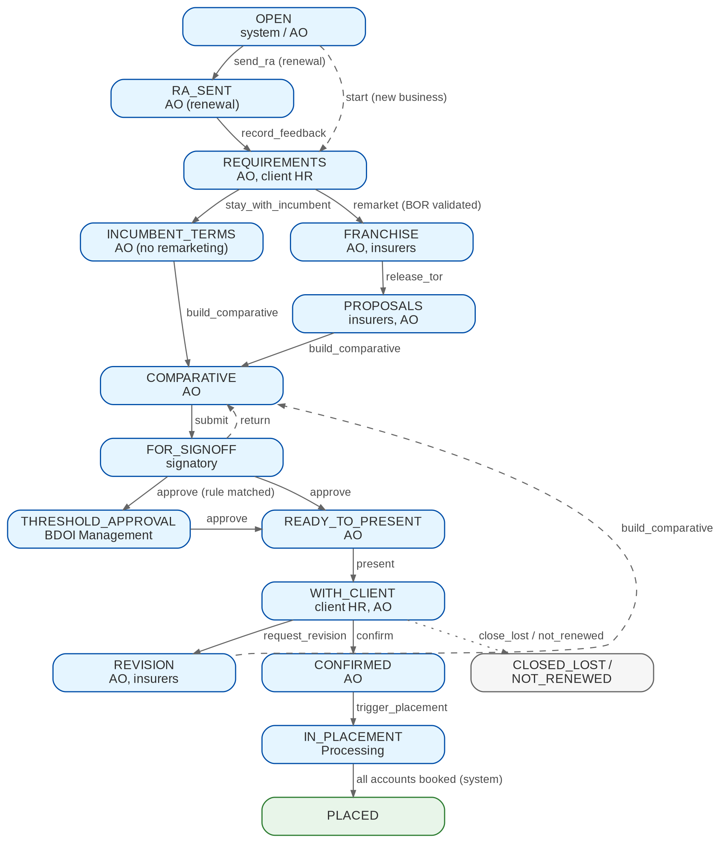
Figure 2: Workflow EB_CYCLE: stages and actions
Table 10: Stages of EB_CYCLE
Stage | Owner (permission) | Business actions
OPEN | System, AO (EB_MARKET) | Send RA (renewal); start (new business)
RA_SENT | AO (EB_MARKET) | Record feedback; reminders run
REQUIREMENTS | AO (EB_MARKET) | Documents, BOR, indicative proposal; stay with incumbent or remarket
INCUMBENT_TERMS | AO (EB_MARKET) | Validate the incumbent's terms; build comparative
FRANCHISE | AO; insurers (portal) | Franchise requests and decisions; release TOR
PROPOSALS | Insurers (portal); AO | Requests answered; proposals validated; build comparative
COMPARATIVE | AO (EB_MARKET) | Recommend; submit for sign-off
FOR_SIGNOFF | Signatory (EB_COMPARATIVE_APPROVE) | Approve or return
THRESHOLD_APPROVAL | Management (EB_THRESHOLD_APPROVE) | Approve or return
READY_TO_PRESENT | AO (EB_MARKET) | Present to client
WITH_CLIENT | Client HR; AO | Comment; request revision; confirm; close lost / not renewed
REVISION | AO; insurers | Relay; revised proposals; rebuild comparative
CONFIRMED | AO (EB_MARKET) | Trigger placement
IN_PLACEMENT | Processing | Placement, issuance and booking of the accounts (BRD-1)
PLACED | - | Terminal; servicing continues on the programme
CLOSED_LOST, NOT_RENEWED | - | Terminal, with reason (LOV EB_LOST_REASON)

Table 11: Main transitions of EB_CYCLE
From | Action | To | Condition
OPEN | send_ra | RA_SENT | Renewal cycle; job or AO
OPEN | start | REQUIREMENTS | New-business cycle
RA_SENT | record_feedback | REQUIREMENTS | Feedback recorded
REQUIREMENTS | stay_with_incumbent | INCUMBENT_TERMS | Renewal without remarketing
REQUIREMENTS | remarket | FRANCHISE | Validated BOR
FRANCHISE | release_tor | PROPOSALS | At least one franchise APPROVED; TOR released
INCUMBENT_TERMS, PROPOSALS, REVISION | build_comparative | COMPARATIVE | At least one validated proposal
COMPARATIVE | submit | FOR_SIGNOFF | Recommendation marked
FOR_SIGNOFF | approve | THRESHOLD_APPROVAL or READY_TO_PRESENT | Signatory not the maker; rule matched or not
FOR_SIGNOFF, THRESHOLD_APPROVAL | return | COMPARATIVE | Reason
THRESHOLD_APPROVAL | approve | READY_TO_PRESENT | Rule's approver permission
READY_TO_PRESENT | present | WITH_CLIENT | Approved comparative
WITH_CLIENT | request_revision | REVISION | At least one item
WITH_CLIENT | confirm | CONFIRMED | Evidence; threshold re-evaluated
CONFIRMED | trigger_placement | IN_PLACEMENT | Approvals and placement documents present
IN_PLACEMENT | (system) | PLACED | All accounts booked
any open stage | close_lost / not_renewed | CLOSED_LOST / NOT_RENEWED | Reason

5.2 Franchise
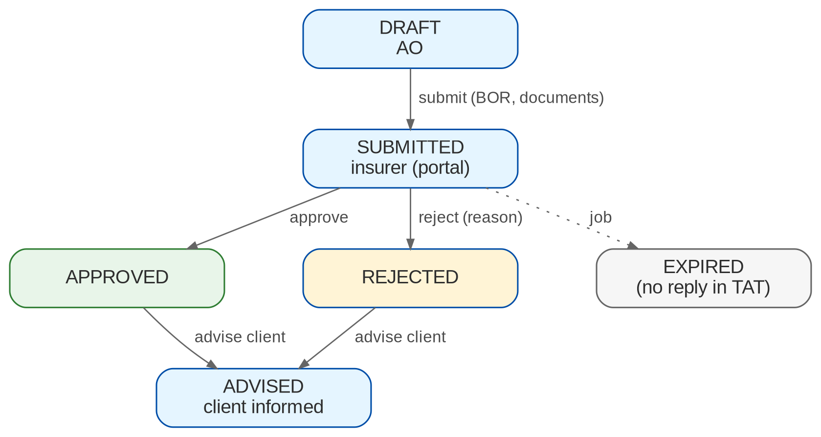
Figure 3: Workflow EB_FRANCHISE
A franchise request is DRAFT until submitted with the BOR and the required documents. The insurer approves or rejects it in the portal (or the AO records the decision with evidence). The job expires a request without a decision after the TAT and a grace period. Every decided request is advised to the client (FR-EB-033).

5.3 Member changes
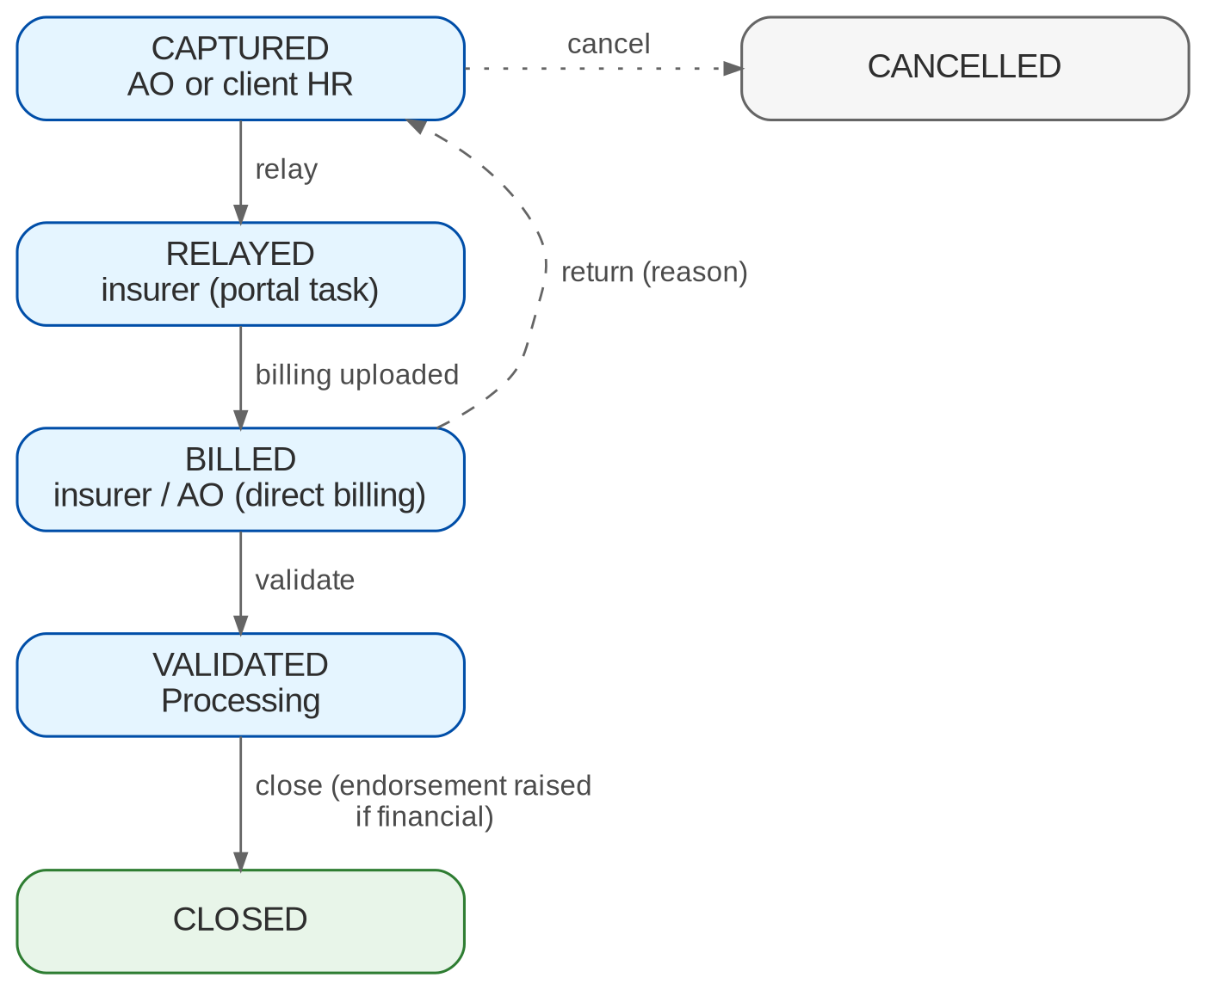
Figure 4: Workflow EB_MEMBER_CHANGE
A member change is CAPTURED by the AO or the client HR user, RELAYED to the insurer, BILLED when the insurer's billing or the AO's direct billing upload arrives, VALIDATED by Processing and CLOSED. A financial change raises an endorsement request in Operations on validation. Processing returns a change to CAPTURED with a reason; the AO cancels a change that was not relayed.

5.4 SOA
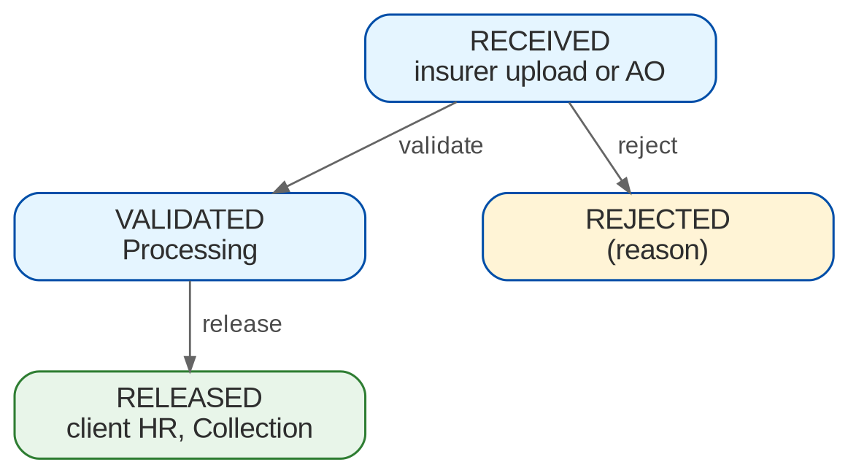
Figure 5: Workflow EB_SOA
An SOA is RECEIVED from the portal or the AO, VALIDATED by Processing and RELEASED to the client HR user and Collection, or REJECTED with a reason.

5.5 Portal upload review
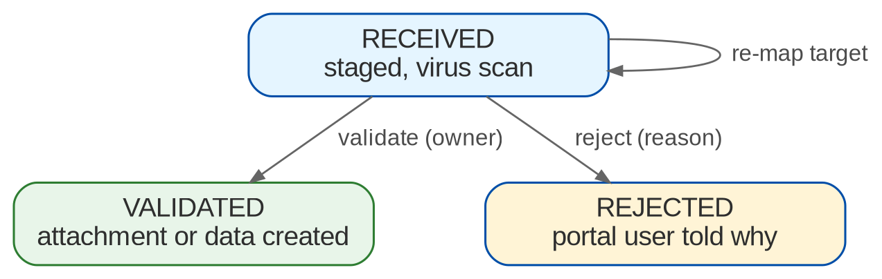
Figure 6: Workflow PORTAL_UPLOAD_REVIEW
A portal upload stays RECEIVED until it passes the virus scan and the owner of its target validates it; the owner can re-map it to another target of the same party before validation.

5.6 Turn-around times
The TAT annex (p.42) gives the targets below. They are parameters; the TAT report measures them (FR-EB-062).
Table 12: Turn-around times (TAT annex, p.42)
Activity | Responsible | TAT | Parameter
Submission of request for franchise | BDOI Marketing | 1-3 working days upon complete documents | EB_TAT_FRANCHISE_SUBMIT
Franchise approval | Insurance provider | 1-5 working days upon request | EB_FRANCHISE_TAT_DAYS
Submission of request for quotation (new) | BDOI Marketing | 1-3 working days upon franchise approval | EB_TAT_RFQ_SUBMIT
Submission of renewal advice | BDOI Marketing | 135 days before inception | EB_RA_LEAD_DAYS
Request renewal requirements | BDOI Marketing | 135 days before inception | EB_RA_LEAD_DAYS
Issuance of quotation (new / renewal) | Insurance provider | 1-5 working days upon complete documents | EB_PROPOSAL_REPLY_DAYS
Sending of proposal to client | BDOI Marketing | 1-5 working days from receipt of proposal | EB_COMPARATIVE_DAYS
Sending of client's confirmation | BDOI Marketing | 1-2 working days upon client confirmation | EB_TAT_CONFIRMATION
Sending of certificate of cover | Insurance provider | Within 1 working day | EB_TAT_COC
Request for placement and booking | BDOI Marketing | 1-5 working days upon client confirmation | EB_TAT_PLACEMENT_REQUEST
Submission of placement slip | BDOI Processing | 1-3 days upon request | EB_TAT_PLACEMENT_SLIP
Policy / contract and billing / SOA | Insurance provider | 1-10 working days from placement slip | EB_TAT_POLICY_SOA
Validation of SOA | BDOI Processing | Within 3 working days upon final SOA | EB_TAT_SOA_VALIDATION
Booking (EBIX in the BRD; BIBS) | BDOI Processing | Within 3 working days upon request | EB_TAT_BOOKING
Checking of policy / contract | BDOI Processing | Within 3 working days upon request | EB_TAT_POLICY_CHECK
Releasing of SOA and policy | BDOI Processing | Within 3 working days upon request | EB_TAT_RELEASE
Adjustments (inclusion / deletion) | BDOI Marketing / Processing | 1-3 working days per step | EB_TAT_MEMBER_CHANGE
Collection of premium | BDOI Collection | 1-2 working days upon SOA / billing receipt | EB_TAT_COLLECTION
Submission, validation, release of cards | Insurance provider / COG | 5-10 working days depending on volume | EB_TAT_CARDS
OR submission | Insurance provider | Weekly | EB_TAT_OR

6 Reports and documents

6.1 Reports
Table 13: Employee Benefits reports (category Employee Benefits)
Code | Name | Purpose | BRD
EB-PRODUCTION | Production | Premium and commission by team, AO, line, insurer and business type | BRID-022
EB-RENEWAL | Renewal | Programmes due for renewal and their progress | BRID-022
EB-PLACEMENT | Placement | Placed programmes, terms and confirmation dates | BRID-022
EB-NEW-BUSINESS | New Business | New client programmes of a period | BRID-022.01
EB-TAT | Turn-around Time | Days and breaches per TAT activity | BRID-022
EB-PENDING-ITEMS | Pending Items | Contracts, cards and billing pending, age, follow-ups | BRID-030
EB-FRANCHISE | Franchise | Franchise requests, outcomes and response times per insurer | BRID-026, 027
NB-BOOKED-REG, NB-PRODUCTION, NB-PLC-UPDATE (existing) | BRD-1 reports | Gain the business type filter | BRID-022.01

All EB reports need EB_REPORT_VIEW, export to PDF, XLSX, CSV, ODS and Word, support saved variants, and take the common parameters company, date range, team, AO, client, benefit line, insurer and business type. Layouts are the project's proposal until BDOI supplies its own (EBQ21).

6.1.1 Renewal report (EB-RENEWAL)
Table 14: EB-RENEWAL columns (BRID-022 AC5)
Column | Format | Content
Programme / Client | Text | Programme number and client name
Benefit line | Text | HMO, GLI, GPA
Team / AO | Text | EB team and account officer
Expiry | Date | End of the current policy
RA sent | Date | Date the RA was sent
Status | Text | Pending, confirmed, declined (cycle stage)
Proposals received | Number | Validated proposals
Comparative result | Text | Recommended insurer and premium
Client changes | Number | Revision requests
BOR / TOR / remarketing | Text | BOR status, TOR version, remarketing yes / no

6.1.2 Placement report (EB-PLACEMENT)
Table 15: EB-PLACEMENT columns (BRID-022 AC6)
Column | Format | Content
Programme / Client | Text | Programme number and client name
Client confirmation | Date | Confirmation date and channel
Insurer selected | Text | Chosen insurer per line
Coverage | Text | Benefit line and plans
Premium / Commission | Amount | Annual premium and commission
Counter-proposals and revisions | Number | Revisions and proposal versions
Final terms | Text | Chosen proposal version
Document uploads | Date | Last upload per required document
ARN / Stage | Text | Accounts created and their stage

6.1.3 New Business report (EB-NEW-BUSINESS)
Columns (Add. p.10): Client; Line of business / product; Effective date; Insurer selected; Premium; Commission; Account officer; Business type; Date; Status. Parameters: period, team, AO, benefit line.

6.2 Documents
Table 16: EB document types and access classes (spec R3, section 6.1)
Document type | Access classes | Source
RENEWAL_ADVICE | Marketing, Processing (and the contact centre, XQ04) | System
EB_CLIENT_FEEDBACK | Marketing | AO or client portal
EB_BOR | Marketing, Processing | AO or client
EB_TOR | Marketing, Processing | AO
EB_MASTERLIST | Marketing, Processing | Client HR or AO
EB_MASTERLIST_UNNAMED | Marketing | Incumbent insurer
EB_UTILIZATION | Marketing | Client HR or incumbent
EB_INDICATIVE_PROPOSAL | Marketing | Incumbent or AO
EB_PROPOSAL | Marketing | Insurer portal
EB_COMPARATIVE | Marketing | System
EB_FRANCHISE_FORM | Marketing | AO
EB_CLIENT_CONFIRMATION | Marketing, Processing | Client
EB_POLICY_FORM / EPOLICY | Marketing, Processing, Collection | Insurer
EB_DIRECT_BILLING | Marketing, Processing, Collection | AO
EB_SOA | Processing, Collection | Insurer
EB_MEMBER_CHANGE | Marketing, Processing | Client HR or AO
EB_ISACOM_APPROVAL | Marketing | AO

Templates (draft layouts until BDOI supplies its own, EBQ21): EB_RENEWAL_ADVICE, EB_RA_REMINDER, EB_INDICATIVE_PROPOSAL, EB_TOR, EB_RFP_COVER, EB_FRANCHISE_REQUEST, EB_FRANCHISE_ADVICE, EB_COMPARATIVE, EB_REVISION_RELAY, EB_ITEM_FOLLOWUP, PORTAL_INVITATION.

7 Interfaces and integration
Figure 7 shows the interfaces. External parties reach only the portal; the portal knows nothing about EB and hands staged uploads and tasks to the EB module through its ports. EB uses the BRD-1 and BRD-2 modules through their public services and events; none of them depends on EB.
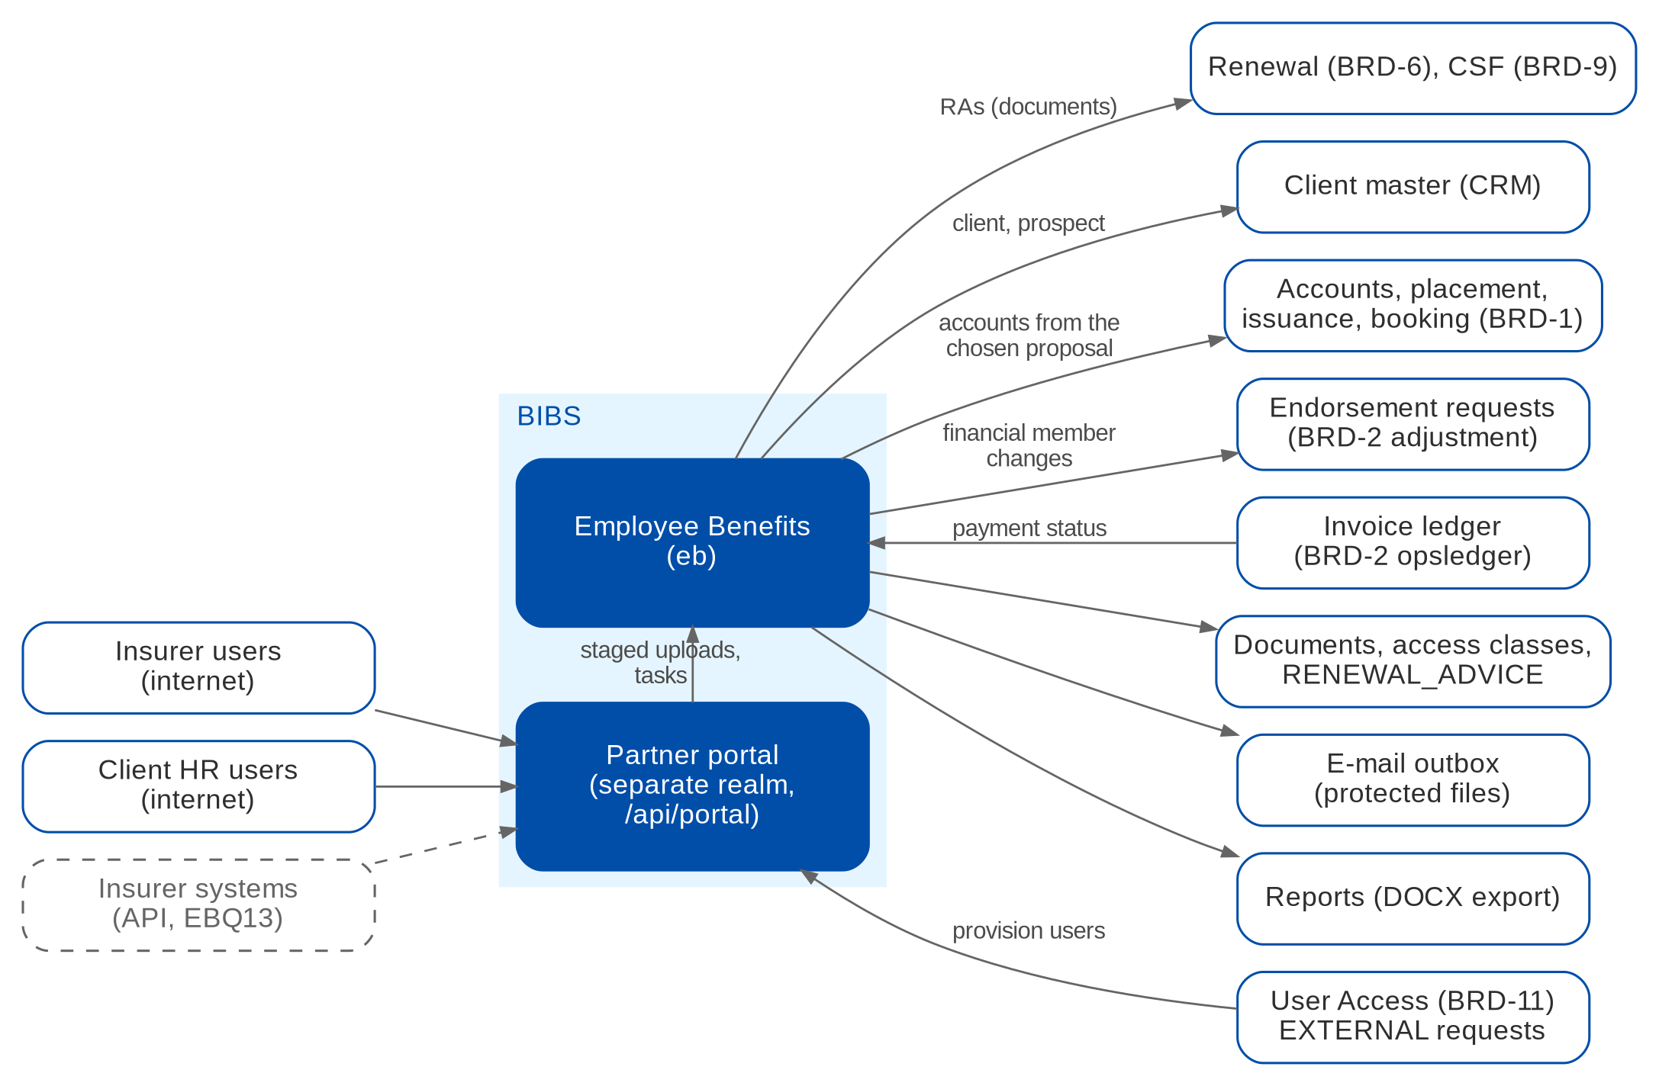
Figure 7: Interfaces of Employee Benefits and the partner portal (dashed = parked)
Parked seams. The insurer system-to-system API (OAuth2 client credentials on the portal endpoints), e-signature verification of the BOR, HRIS feeds of master lists, reading insurer mailboxes and SMS notices each have a seam and no simulation. The virus scanner adapter is required before the portal goes live.

Table 17: Interfaces
Interface | Direction | Content and trigger | BRD | Status
Partner portal | In / Out | Sign-in, tasks, staged uploads, notices, downloads for insurer and client HR users | BRID-005, 014 | DESIGNED
User Access Maintenance (BRD-11) | In | Approved External requests provision portal users (decision D7) | BRID-005, 014 | DESIGNED
Client master (CRM) | Out | Prospect and client capture; EB tab on the client page | BRID-006 | DESIGNED
Accounts (BRD-1, BT0) | Out | One account per line from the chosen proposal, with business type | BRID-017, 022.01 | DESIGNED
Placement, issuance, booking (BRD-1) | Out | Placement queue; e-policy from validated policy forms; billing number at booking | BRID-019, 020 | DESIGNED
Endorsement requests (BRD-2) | Out | Financial member changes | BRID-013 | DESIGNED
Invoice ledger (BRD-2) | In | Payment status and payment events | BRID-021 | DESIGNED
Documents | Out | Access classes, process tags, RENEWAL_ADVICE for Renewal and CSF | BRID-025; D3 | DESIGNED
E-mail outbox | Out | Protected TOR, RA, comparative, advices, follow-ups; separate password | BRID-007 | DESIGNED
Reports | Out | EB reports; Word export; business type filter | BRID-022, 022.01 | DESIGNED
Insurer API | In | System-to-system proposals and billing | BRID-005.01 | PARKED
HRIS master lists | In | Payroll feeds of master lists | BRID-014 | PARKED
BOR e-signature | In | Verification of the signature | BRID-008 | PARKED

8 Non-functional requirements
Table 18: Non-functional requirements (p.36-37; Add. p.14)
Topic | BRD value | BIBS target and approach | Status
Users | Marketing 13, Processing 4, Collection 3 (all concurrent); plus insurer and client HR portal users (not sized) | Within the BRD-1 sizing; portal sized separately (EBQ13) | FIT
Volumes | 2025 / 2026 transactions: BDO 400 / 550; SM 2,500 / 3,500; Voluntary 550 / 560; Solicited 700 / 900; New Business 50 / 55 | Low volume; the roster is the larger dataset and is indexed by programme and year | FIT
Peak | Month-end; 08:30-19:00 | Jobs run at 06:00 and 07:00, before the peak | CONFIGURE
Availability | 99.99%; used 08:30-19:00; maintenance per bank standard | 99.99% is above every other BRD (99.9%); HA deployment; the portal adds an internet-facing part (EBQ25, XQ08) | CONFIGURE
Recovery | RTO 4 hours; RPO 24 hours | Platform backup and recovery; one BIBS-wide NFR set is being agreed (XQ08) | FIT
Retention | Application, database, audit logs and historical data 5 years online, 15 years offline; backup every 4 hours, kept 7 years; no anonymisation | Retention rules EB_PROGRAMME and EB_MEMBER | CHANGE
Devices | Same speed on mobile and desktop | Responsive screens, portal included | FIT
Portal security (derived) | Portal or API with authentication, RBAC, audit, validation before effect (BRID-005, 014) | Separate realm, scoped queries, lockout, one-time code, virus scanning, download log; BDO Information Security approval (EBQ13) | NEW
Data privacy (derived) | Master lists hold personal data; utilization reports are health-related | Treated as sensitive personal information under the Data Privacy Act: access classes, encryption in transit and at rest, download logging, no health data in the roster (EBQ15) | NEW

9 Configuration items
The items below are changed in BIBS without a release. Changes to parameters and lists are audited.

9.1 Parameters
Table 19: Employee Benefits and portal parameters
Parameter | Default | Meaning
EB_RA_LEAD_DAYS | 135 | Days before expiry the RA is sent (EBQ02)
EB_RA_REMINDER_DAYS | 120, 105, 90 | Days before expiry of the RA reminders
EB_PROPOSAL_REPLY_DAYS | 5 | Working days insurers have to answer a request
EB_FRANCHISE_TAT_DAYS | 5 | Working days for the franchise decision
EB_FRANCHISE_ADVICE_DAYS | 2 | Working days to advise the client of the franchise outcome
EB_COMPARATIVE_DAYS | 3 | Working days from the last proposal to the comparative
EB_FOLLOWUP_DAYS | 5 | Working days between follow-ups of tracked items
EB_FOLLOWUP_MAX | 3 | Follow-ups before escalation
EB_TAT_* | Section 5.6 | TAT targets of the annex
EB_ADJ_BOOKING_REQUIRES_PAYMENT | false | Raise endorsement requests only after the billing is paid (EBQ16)
BOOKING_BILLING_NO_LINES | EB lines | Product lines that need the insurer billing number at booking
PORTAL_SESSION_MINUTES | 15 | Portal idle timeout
PORTAL_MAX_FAILED_LOGINS | 3 | Failed portal sign-ins before lockout
PORTAL_MFA_REQUIRED | true | E-mail one-time code at portal sign-in
PORTAL_INVITE_VALID_HOURS | 72 | Validity of a portal invitation
PORTAL_MAX_UPLOAD_MB | 10 | Maximum size of a portal upload
Job schedule eb-renewal-advice-cron | 06:00 PHT daily | RA and reminders
Job schedule eb-item-followup-cron | 07:00 PHT daily | Tracked item follow-ups

9.2 Lists of values
Table 20: Lists of values
List | Values delivered
EB_BENEFIT_LINE | HMO; GLI; GPA (EBQ01)
EB_TEAM | BDO; SM; Voluntary; Solicited; New Business (EBQ22)
EB_PROCESS_TYPE | NB placement; Renewal placement; Endorsement; Adjustment; Franchise; Proposal
EB_CAPABILITY_FACTOR | Company stability; Clinic providers; Hospital network; Technology (EBQ10)
EB_MEMBER_CHANGE_TYPE | Add; Delete; Change plan; Change data (EBQ16)
EB_TRACKED_ITEM_TYPE | Contract; HMO card; Card replacement; Billing invoice (EBQ20)
EB_LOST_REASON, EB_FRANCHISE_REJECT_REASON, EB_SOA_REJECT_REASON, PORTAL_REJECT_REASON | Delivered with generic values; BDOI supplies its own
DOCUMENT_TYPE (EB values) | The types of section 6.2

9.3 Masters and rules maintained by the business
Table 21: Masters and rules
Item | Maintained by (authorised by) | FR
Threshold rules | Business Administrator (authoriser) | FR-EB-042
Required documents per process type and line | Business Administrator (authoriser) | FR-EB-034, 046
Document access classes | System Administrator | FR-EB-002
EB templates and master list template | System Administrator | FR-EB-004, 054
EB products, lines and HMO providers as panel insurers | MBS through Product Maintenance (BRD-3) | FR-EB-046
Portal users | AO request, approver decides (User Access) | FR-EB-011

10 Assumptions, dependencies and open questions

10.1 Assumptions
Table 22: Assumptions
ID | Assumption | Related
A-EB-01 | The addendum (Add. p.1-17) overrides the main BRD (p.1-42); BRID-025 and 026 are read with the addendum text | R1, R2
A-EB-02 | HMO providers are set up as panel insurers of the EB lines in the catalogue | EBQ01
A-EB-03 | The BOR is required for new business and for renewals that remarket | EBQ05
A-EB-04 | The BOR signature check is an attestation by the validator | EBQ06
A-EB-05 | EB renewals are handled in this module; the general Renewal lists exclude EB lines | D3; EBQ28
A-EB-06 | Until the portal is approved for go-live, the AO uploads on behalf of insurers and clients | EBQ13
A-EB-07 | The roster keeps no health data | EBQ15

10.2 Dependencies
Table 23: Dependencies
ID | Dependency | Needed for
D-EB-01 | Shared work item BT0 (business type on the account) is merged | FR-EB-021, 046, 061
D-EB-02 | User Access Maintenance delivers the External request type and the provisioning port | FR-EB-011
D-EB-03 | BDO Information Security approves the portal hosting, MFA and virus scanner | FR-EB-010, 012
D-EB-04 | BDOI provides the TOR template, the threshold values and the password convention | FR-EB-035, 042, 004
D-EB-05 | The Operations owner accepts EB endorsement requests with an EB source reference | FR-EB-055
D-EB-06 | EB products and HMO providers are set up in Product Maintenance | FR-EB-046

10.3 Open questions
Table 24: Open questions on BRD-8 (status from the cross-BRD decisions, R5)
ID | Question | Affects | Status
EBQ01 | Full list of benefit lines; HMO providers as insurers; commission per provider | FR-EB-021, 046 | OPEN
EBQ02 | RA lead time 180 or 135 days; reminders; recipients | FR-EB-022 | OPEN
EBQ03 | Who flags a programme for renewal | FR-EB-022, 024 | OPEN
EBQ04 | Incumbent's indicative terms through the portal or by the AO | FR-EB-024 | OPEN
EBQ05 | BOR on renewal | FR-EB-031 | OPEN
EBQ06 | BOR signature validation; template; validity | FR-EB-031 | OPEN
EBQ07 | Meaning of franchise; incumbent; per insurer or per cycle; form content | FR-EB-032 | OPEN
EBQ08 | Standard TOR template per benefit line | FR-EB-014, 035 | OPEN
EBQ09 | Password convention for EB documents | FR-EB-004 | OPEN
EBQ10 | Comparative factors, scoring, due time, signatories | FR-EB-041 | OPEN
EBQ11 | Threshold values, measure and approver levels | FR-EB-042 | OPEN
EBQ12 | Evidence of client confirmation; separate placement approval | FR-EB-043, 046 | OPEN
EBQ13 | Portal hosting, authentication, user administration, API, virus scanner | FR-EB-010-012 | PARTIAL
EBQ14 | What "manage policy" adds for client HR users | FR-EB-015 | OPEN
EBQ15 | Master list fields; roster per member; privacy rules | FR-EB-054 | OPEN
EBQ16 | Movement types; pro-rata; MIS Credit; no payment no booking | FR-EB-055 | OPEN
EBQ17 | Collection of direct-billed changes; commission receivable | FR-EB-056 | OPEN
EBQ18 | Billing number definition and duplicate scope | FR-EB-052 | OPEN
EBQ19 | SOA formats, validation rules, recipients | FR-EB-053 | OPEN
EBQ20 | Statuses, thresholds and recipients of monitored items | FR-EB-057 | OPEN
EBQ21 | Report layouts; TAT events; Word export scope; meaning of COG | FR-EB-060-062 | OPEN
EBQ22 | Teams as programme attribute or sales units | FR-EB-021 | OPEN
EBQ23 | When the Processing Supervisor approves | FR-EB-050 | OPEN
EBQ24 | Meaning of ISACOM and when its approval is needed | FR-EB-046 | OPEN
EBQ25 | NFR alignment (99.99%, hours, RPO, portal availability) | Section 8 | OPEN
EBQ26 | No high-risk handling for EB (BRID-028 OUT) | Section 1.2 | OPEN
EBQ27 | Voluntary plans: billing per member or employer | FR-EB-021 | OPEN
EBQ28 | Boundary with the Renewal BRD | FR-EB-022 | ANSWERED

10.4 Differences between the design and the BRD
Table 25: Recorded differences
BRD item | BRD text | FRS and design
BRID-008 negative scenario | A BOR uploaded for a renewal transaction is invalid | Both flow charts ask for a BOR in the renewal lane; the BOR is required for renewals that remarket (EBQ05)
BRID-008 | The system validates that the BOR is signed | Validator attestation with a checklist; e-signature verification parked (EBQ06)
BRID-001 | RA a defined number of days before expiry (example 180) | Default 135 days from the TAT annex (EBQ02)
BRID-005 | Secure portal or API | Portal built; the system-to-system API is parked until an insurer asks for it
TAT annex | Booking in EBIX | Booking in BIBS (FR-EB-052)
Portal users | Not specified in the BRD | Provisioned through User Access requests of user type External (decision D7)
BRID-028 | Present documents for high-risk accounts | Out of scope per the addendum (Add. p.13)

11 Traceability
Every BRD-8 requirement is met by at least one FR, except BRID-028, which the addendum puts out of scope. The screen column names the main entry point; the last column names the section of the build design (R4). The non-functional requirements (p.36-37) are traced in section 8; the TAT annex (p.42) in section 5.6.
Table 26: BRD ID to FR, screen and design
BRD ID | FR | Screen | Design (R4)
BRID-001 | FR-EB-022 | Programmes (Renewal Due) | 7.1, 8.1
BRID-002 | FR-EB-023 | Programme page; portal | 4.2
BRID-003 | FR-EB-024 | Proposals tab | 4.3
BRID-004 | FR-EB-035 | Insurer Requests tab | 4.3
BRID-005 | FR-EB-010, 011, 014, 001 | Portal sign-in and home | 2, 6.3
BRID-005.01 | FR-EB-010, 012, 013, 051 | Portal uploads; Portal Uploads queue | 4.1, 6.3
BRID-005.02 | FR-EB-010, 014, 040 | Portal - Requests for Proposal | 10.2
BRID-005.03 | FR-EB-013, 040 | Portal Uploads | 7.2
BRID-006 | FR-EB-020, 021 | Client pages; New Programme | 11 (crm)
BRID-007 | FR-EB-030, 004 | Documents tab | 4.2, 11 (messaging)
BRID-008 | FR-EB-031 | BOR tab | 4.2
BRID-009 | FR-EB-035 | TOR and Insurer Requests tabs | 4.3
BRID-010 | FR-EB-041, 040 | Comparative page | 4.3, 7.1
BRID-011 | FR-EB-043, 015 | Comparative page; portal | 10.2
BRID-012 | FR-EB-044 | Revisions | 4.3
BRID-013 | FR-EB-054, 055 | Members; Member Changes | 4.4, 7.2
BRID-014 | FR-EB-015, 010, 011, 012, 054 | Portal - client HR | 6.3, 10.2
BRID-015 | FR-EB-045 | Portal - revision | 4.3
BRID-016 | FR-EB-042 | Threshold Rules; My Approvals | 4.3, 7.1
BRID-017 | FR-EB-046 | Programme page (Trigger Placement) | 4.3, 7.1
BRID-018 | FR-EB-050 | My Work | 7.2
BRID-019 | FR-EB-051, 046 | Account page (BRD-1) | 11 (issuance)
BRID-020 | FR-EB-052 | Book Account | 11 (booking)
BRID-021 | FR-EB-053 | SOA Register | 4.4, 7.2
BRID-022 | FR-EB-060, 062 | Reports; EB Home | 9
BRID-022.01 | FR-EB-061, 021 | Reports | 9, 11 (BT0)
BRID-023 | FR-EB-001 | All | 6.1
BRID-024 | FR-EB-003 | History tab | 1, 4
BRID-025 | FR-EB-002, 056, 055 | Documents; Member Changes | 11 (attachment)
BRID-026 | FR-EB-034, 032 | Submissions; Franchise tab | 4.3
BRID-027 | FR-EB-032 | Portal - Franchise Requests | 7.2
BRID-028 | Out of scope (Add. p.13) | - | -
BRID-029 | FR-EB-033 | Franchise tab | 7.2
BRID-030 | FR-EB-057 | Pending Items | 4.4, 8.1

12 Sign-off
By signing, BDOI confirms that this FRS describes the Employee Benefits and portal functions it expects in BIBS, and accepts the assumptions in section 10.1. Open questions in section 10.3 stay open; their answers are applied as configuration or through a change request.
Name | Role | Organisation | Signature | Date
 | Product Owner, Employee Benefits | BDOI
 | Head, Retail Marketing | BDOI
 | Unit Head, Combank / Corbank | BDOI
 | Team Head, Processing | BDOI
 | Head, Collections and Marketing Support | BDOI
 | Program Manager, Business Project Services | BDO Unibank ESG
 | Project Manager | iorta TechNXT

