

FUNCTIONAL REQUIREMENTS SPECIFICATION
Product Maintenance
BRD-3 Product Maintenance (Package) and Workshop Addendum
BIBS – BDOI Broker System
Client | BDO Insurance and Reinsurance Brokers, Inc.
Document | BIBS-FRS-BRD-03
Version | 2.0
Date | 27 September 2026
Status | Issued for BDOI business sign-off
Classification | Confidential

Prepared by iorta TechNXT for BDOI 
iNXT BrokerVerse. This document is confidential to BDO Insurance and Reinsurance Brokers, Inc. and iorta TechNXT.
Document Control
Version | Date | Author | Reviewer | Approver | Change
0.9 | 18 Sep 2026 | iorta TechNXT Business Analysis | iorta TechNXT Solution Architect |  | Internal draft from the BRD-3 baseline
1.0 | 25 Sep 2026 | iorta TechNXT Business Analysis | iorta TechNXT Project Manager | BDOI Product Owner (pending) | First issue for BDOI review; aligned with the screens and the cross-BRD decisions
2.0 | 27 Sep 2026 | iorta TechNXT Business Analysis | iorta TechNXT Project Manager | BDOI business units (sign-off) | Business sign-off pack: proposed business rules and clarifications for confirmation (chapter 22), navigation by persona, screen specifications with screenshots, walkthroughs, messages, notifications, document outputs, uploads, configuration inputs the business provides, cross-BRD contract, sign-off and change control (chapters 12-21). Issued 27-Sep-2026. Chapters 1-11 otherwise unchanged; FR, BRD and test IDs kept

Distribution List
Name / Unit | Role | Organisation | Purpose
Product Owner, Marketing Business System | Approver | BDOI | Review and sign-off
Marketing Business Services and System Support (MBS) | Business owner | BDOI | Review of all FRs
Technical Support Unit (TSU) | Business user | BDOI | Review of the negotiation and validation steps
Retail, Corporate and Commercial Marketing | Business user | BDOI | Review of the request and approval steps
Business Project Services | BRD owner | BDO Unibank ESG | Traceability check against the BRD
Project team | Delivery | iorta TechNXT | Delivery, test and UAT preparation

Contents

1 Introduction 7
1.1 Purpose 7
1.2 Scope 7
1.3 References 8
1.4 Definitions and acronyms 8
1.5 How to read the functional requirements 9
2 Business context and process overview 10
2.1 Business context 10
2.2 Process overview 10
2.3 Request types 11
3 Personas and roles 13
3.1 Personas 13
3.2 Permissions 13
3.3 Permissions matrix 14
4 Functional requirements 15
4.1 Access, security and audit 15
FR-PM-001 Log in to BIBS 15
FR-PM-002 Restrict each action to authorised roles 16
FR-PM-003 Change role permissions through an approved request 17
FR-PM-004 Protect documents that leave BIBS 18
FR-PM-005 Keep a complete audit trail and history 19
4.2 Product structure and master data 20
FR-PM-010 Maintain the product hierarchy 20
FR-PM-011 Maintain the clause library 22
FR-PM-012 Capture and validate product-specific fields 23
FR-PM-013 Use shared document templates with product-specific fields 24
FR-PM-014 Maintain insurer-specific package terms 25
4.3 Package request and approvals 27
FR-PM-020 Create and submit a Package Request Form 27
FR-PM-021 Approve a package request (Marketing) 29
FR-PM-022 Review and recommend a package request (TSU TL) 30
FR-PM-023 Approve a package request (TSU Head) 31
FR-PM-024 Receive, view and track package requests 32
4.4 Negotiation and comparative tables 33
FR-PM-030 Prepare, approve and send the quotation slip 33
FR-PM-031 Record insurer responses and outcomes 35
FR-PM-032 Run further negotiation rounds 36
FR-PM-033 Make the negotiated terms final 37
FR-PM-034 Compile one comparative master per package request 38
FR-PM-035 Generate a client-tailored comparative view 39
FR-PM-036 Review negotiated terms (TSU Head and Marketing) 41
4.5 Sign-off, set-up and release 42
FR-PM-040 Prepare and submit the requirements pack 42
FR-PM-041 Sign off package requirements (ManCom) 43
FR-PM-042 Set up the package (MBS) 44
FR-PM-043 Validate and release a package version 46
FR-PM-044 Draft and send package advisories 48
FR-PM-045 Retire a package 49
4.6 Versions and rate schemes 50
FR-PM-050 Keep package terms as versions 50
FR-PM-051 Price new business on the latest approved rate scheme 51
FR-PM-052 Archive expired packages 53
4.7 Expiry and renewal 54
FR-PM-060 Monitor package expiry and anniversary dates 54
FR-PM-061 Generate renewal requests 55
4.8 Monitoring, reports and notifications 56
FR-PM-070 Product Maintenance home and dashboard 56
FR-PM-071 Package reports 57
FR-PM-072 Notify users and publish product master changes 58
FR-PM-073 Enforce validations, approvals and SLAs 58
4.9 Incentive criteria 59
FR-PM-080 Maintain incentive criteria on the products matrix 59
FR-PM-081 Apply incentive criteria and review them when products end 61
5 Workflow and status model 63
5.1 Stages 63
5.2 Transitions 64
5.3 Package version states 65
5.4 SLA and escalation 66
6 Reports and documents 67
6.1 Reports 67
6.1.1 Package Status Update Report (PM-PKG-STATUS) 67
6.1.2 Package Expiry Report (PM-PKG-EXPIRY) 67
6.1.3 Package Version History (PM-VERSION-HISTORY) 68
6.2 Documents 68
7 Interfaces and integration 70
8 Non-functional requirements 71
9 Configuration items owned by the System Administrator 72
9.1 Parameters 72
9.2 Lists of values 72
9.3 Masters and rules maintained by the business 73
10 Assumptions, dependencies and open questions 74
10.1 Assumptions 74
10.2 Dependencies 74
10.3 Open questions 74
11 Traceability 76
12 Navigation 78
12.1 Screens of Product Maintenance 78
12.2 Screen flow 79
12.3 Menu by persona 81
12.3.1 Marketing Account Officer (MKT_AO) 81
12.3.2 Marketing TL / TH / UH (MKT_TL) 81
12.3.3 TSU Officer (TSU) 82
12.3.4 TSU Team Lead (TSU_TL) 83
12.3.5 TSU Head (TSU_HEAD) 83
12.3.6 Marketing Business Services (MBS) 83
12.3.7 ManCom member (MANCOM) 84
12.3.8 Business Administrator (BUSINESS_ADMIN) 84
12.3.9 New Business Approver (NB_APPROVER) 85
12.3.10 System Administrator (SYSADMIN) 86
12.3.11 Auditor (AUDITOR) 87
12.4 Common screen elements 88
13 Screen specifications 90
13.1 Package requests 90
13.1.1 SCR-PM-01 Product Maintenance Home 90
13.1.2 SCR-PM-02 Package Requests 92
13.1.3 SCR-PM-03 New Package Request and Edit Package Request 96
13.1.4 SCR-PM-04 Package Request record 104
13.1.5 SCR-PM-05 Package Request record: Negotiation tab 113
13.1.6 SCR-PM-06 Package Request record: Comparative tab 120
13.1.7 SCR-PM-07 Package Request record: Requirements & Sign-off tab 124
13.1.8 SCR-PM-08 Package Request record: Set-up and Advisories tabs 128
13.1.9 SCR-PM-09 TSU Workbench 133
13.1.10 SCR-PM-10 Package Expiry 137
13.2 Products and package versions 139
13.2.1 SCR-PM-11 Products 139
13.2.2 SCR-PM-12 Product record 147
13.2.3 SCR-PM-13 Package Version 153
13.2.4 SCR-PM-14 Validation Queue 164
13.2.5 SCR-PM-15 Coverages & Clauses 166
13.2.6 SCR-PM-16 Incentive Criteria 171
13.3 Insurers, rates and pricing 174
13.3.1 SCR-PM-17 Insurers 174
13.3.2 SCR-PM-18 Insurer record 178
13.3.3 SCR-PM-19 Rates & Taxes 181
13.3.4 SCR-PM-20 Sales Organisation 184
13.3.5 SCR-PM-21 Premium Calculator 191
13.3.6 SCR-PM-22 Quotation: package rate scheme and rate exception 194
14 End-to-end walkthroughs 201
14.1 WT-A A new package from the request to its first New Business quotation 201
14.2 WT-B Returns and refusals, and the messages the user sees 236
15 Messages catalogue 251
16 Notifications catalogue 266
17 Document outputs 268
17.1 DO-01 Package Request Form 268
17.2 DO-02 Package quotation slip 269
17.3 DO-03 Comparative table (audit master and client view) 270
17.4 DO-04 Package slip 271
17.5 DO-05 ManCom sign-off record 272
17.6 DO-06 Package advisory 273
18 Upload screens 275
19 Configuration inputs the business provides 276
19.1 CI-09 Lists of values and parameters 277
19.2 CI-01 Product catalogue 278
19.3 CI-02 Coverages, perils and field rules 279
19.4 CI-03 Clause library 280
19.5 CI-05 Insurers, branches and commission rates 281
19.6 CI-04 Rate tables 282
19.7 CI-10 Incentive criteria 282
19.8 CI-06 Packages in force at go-live 283
19.9 CI-07 Package map (legacy package to BIBS package version) 284
19.10 CI-08 Document templates 285
20 Cross-BRD dependencies and interface contract 287
21 Sign-off and change control 289
21.1 What is signed 289
21.2 How the review is recorded 289
21.3 What signing freezes 289
21.4 Change after sign-off 290
21.5 Proposed rules for confirmation 290
21.6 Signatures 291
22 Proposed business rules and clarifications for confirmation 292
23 Appendix: Screen standards 294

1 Introduction

1.1 Purpose
This Functional Requirements Specification (FRS) states how BIBS (BDOI Broker System, on iNXT BrokerVerse) meets the Product Maintenance business requirements of BDO Insurance and Reinsurance Brokers, Inc. (BDOI). It turns each BRD requirement into functional requirements with actors, flows, rules, validations, screens, fields, notifications, audit and acceptance criteria.
BDOI uses this document to confirm that the system behaves as the business expects. The project team uses it to deliver, test and prepare user acceptance testing (UAT). Every functional requirement (FR) cites the BRD requirement it meets and the BRD page.

1.2 Scope
The scope is the maintenance of package products: pre-arranged insurance programmes whose terms, rates and conditions BDOI negotiates with one or more insurers and then offers to clients through Marketing. It covers the whole package lifecycle, from the Package Request Form to release, advisory, expiry and renewal, and the product master data that quotations, accounts and booking read.
Table 1: Scope of this FRS
Area | In scope | Source
Access and audit | Log-in, role-to-action matrix, document protection, audit trail | BRPM.001, 002, 020, 024; PMADD05
Product structure | Hierarchy (line, cover type, subtype, coverage / peril), clause library, product-specific field rules, shared templates, insurer-specific terms | BRPM.003-005; PMADD01, PMADD02
Package request | Request form, Marketing approval, TSU TL review, TSU Head approval, work lists | BRPM.008, 009, 011, 021
Negotiation | Quotation slip, insurer responses and exception outcomes, revision rounds, comparative master and client views, Marketing review | BRPM.010, 012-014; PMADD03, PMADD04
Sign-off and set-up | Requirements pack, ManCom sign-off, MBS set-up, post-set-up validation, release, advisories, retirement | BRPM.015, 016; PMADD06
Versions and rate schemes | Package versions, latest approved scheme for new business, rate-scheme exceptions, archive of expired packages | BRPM.006, 007
Expiry and renewal | Expiry monitor, alerts, renewal requests | BRPM.017
Monitoring | Product Maintenance home, package reports, notifications | BRPM.018, 019, 022
Incentive criteria | Criteria (for example CPC2) on the products matrix | PMADD07, PMADD08

Out of scope for this phase:
• Maintenance of non-package products. The BRD revision log of 27-Oct-2025 (p.11) moved it to an addendum, and the April 2026 addendum does not add it (PQ19).
• Renewal of client policies (accounts). This is BRD-6 Renewal. BRD-3 covers the renewal of the package only.
• Computation and payout of incentives. PMADD07 and PMADD08 cover the criteria only (Q33).
• Transport of product master changes to other BDOI systems until BDOI names them (PQ16, section 7). BIBS records every change for that transport.

1.3 References
Table 2: Reference documents
Ref. | Document | Version / date
R1 | Product Maintenance (Package) BRD, pages 10-35 of the BRD-3 pack | v1.0, 24-Nov-2025; approved Nov-2025 to Jan-2026
R2 | Product Maintenance Addendum (Workshop), pages 1-9 of the BRD-3 pack | v1.1, 10-Apr-2026; signed 12 to 17-Apr-2026
R3 | Earlier signed version of the main BRD (BRQID numbering), pages 36-61; used only to trace changes | 16-Nov-2025
R4 | BDOI Product Maintenance (BRD-3) requirements baseline | current
R6 | Cross-BRD decisions and answered questions | current
R7 | BDO UX guidelines (brand, screen patterns) | current
R8 | BRD-1 New Business requirements baseline (shared platform capabilities) | current

Page references in this document ("p.18") are pages of the BRD-3 PDF (R1, R2).

1.4 Definitions and acronyms
Term | Meaning
AO | Account Officer (Marketing)
BRD | Business Requirements Document
BRPM | Requirement ID prefix of the main Product Maintenance BRD (BRPM.001-BRPM.024; there is no BRPM.023)
Client view | A comparative output derived from the current master with selected fields and insurers, for a client presentation (PMADD03)
Comparative master | The one current comparative table of a package request, compiled from the insurer responses of the latest round (BRPM.014)
CPC2 | An incentive criterion named in PMADD08 as an example; its definition is not in the BRD (PQ04)
FR | Functional requirement of this document (FR-PM-nnn)
LOB | Line of business; in BIBS the product line (for example Motor, Fire)
LOV | List of values maintained by the System Administrator
ManCom | Management Committee, which signs off package requirements (BRPM.015)
MBS | Marketing Business Services and System Support; sets up packages in the system
Package | A catalogue product flagged as packaged, with pre-negotiated terms, rates and insurers; generic for a segment or client-specific
Package version | One effective-dated set of package terms (rate scheme, coverages, insurers, dates); changed only through a new version
PKR | Prefix of package request numbers (PKR-yyyy-n)
PMADD | Requirement ID prefix of the Product Maintenance Addendum (PMADD01-PMADD08)
PQnn | Open question on BRD-3 raised by the project team (section 10.3)
PQS | Prefix of package quotation slip numbers (PQS-yyyy-n)
QS | Quotation Slip sent to insurers
Rate scheme | The package rate, minimum premium, commission and TSI limit of a package version
SLA | Service level agreement; here the target hours of a workflow stage
TH | Team Head
TL | Team Lead
TSI | Total sum insured
TSU | Technical Support Unit
UAT | User acceptance testing
UH | Unit Head (Marketing)

1.5 How to read the functional requirements
Each FR in section 4 has the same parts:
• A header table with the BRD trace (requirement ID and page), the actor, the BRD priority and the screens where the user performs it.
• Description, preconditions, main flow and alternate and exception flows.
• Business rules. Configurable rules are maintained by the System Administrator or the business owner in BIBS (parameter, list of values or master record, section 9). Fixed rules are part of the system and change only through a change request.
• Validations and messages: the check, the message the user sees and its code. The code is the one BIBS returns for a business rule. A "-" marks a screen or platform check (for example a blank mandatory field); its message follows the same wording but has no business code.
• Screens and fields: label, type, whether mandatory ("Cond." = mandatory when the condition in the Validation column applies), the source list and the validation.
• Notifications, audit and numbered acceptance criteria. The acceptance criteria are the basis of the test cases of the BRD-3 test plan.
Note. Values marked "default" (SLA hours, notice days, list entries) are placeholders that BDOI confirms through the open questions in section 10.3. They are configuration, so a changed answer does not need a change to the system. Where the proposed rule or screen differs from the BRD, or needs a decision of BDOI, chapter 22 lists it for confirmation.

2 Business context and process overview

2.1 Business context
BDOI sets up package products today through e-mail, Excel comparative tables, manual sign-off and spreadsheets for expiry monitoring (p.12-13). The BRD asks for one maintenance module in which MBS / Admin and TSU manage package products without IT, with automatic audit, enforced approvals, secure document sharing and monitoring of expiring packages (p.12).
Table 3: Current and envisioned process (BRD p.12-13)
# | Current process (before) | Envisioned process in BIBS (after)
1 | Marketing requests placements by e-mail using a TSU request form | Marketing logs the Package Request Form in BIBS; the system numbers it (PKR-yyyy-n) and tracks it
2 | TSU prepares and e-mails quotation slips to insurers | TSU prepares the QS in BIBS; it is approved and e-mailed per insurer, protected and logged
3 | Insurers reply by e-mail with signed slips or approved terms | TSU keys in each response with its outcome; every change is kept
4 | Comparative tables are compiled in Excel and shared by e-mail | BIBS compiles one comparative master per package and derives client views from it
5 | Sign-off and advisories are manual | ManCom signs off in BIBS; the advisory is drafted on release and sent with its documents
6 | Shared documents have no password protection | Documents leave BIBS password protected; the password goes in a separate e-mail
7 | Package expiry is monitored in spreadsheets or calendars | A daily job raises expiry alerts and can draft the renewal request
8 | Changes, approvals and documents are tracked in e-mail threads and files | Every action is in the request history and the audit trail

2.2 Process overview
The table lists the steps of the package lifecycle, and Figure 1 shows them by actor. Each step is a stage of the BIBS workflow PM_PACKAGE_REQUEST (section 5).
Table 4: Process steps
# | Step | Owner | What happens in BIBS | BRD
1 | Package Request Form | Marketing AO or TSU | Enters client or programme, line, cover type, requested terms and target insurers; submits | BRPM.008
2 | Marketing approval | Marketing TL, TH or UH | Approves or returns; never the maker | BRPM.008, 021
3 | TSU review and approval | TSU TL, then TSU TH | TL recommends with a written recommendation; TH approves; a round 1 opens | BRPM.009
4 | Negotiation | TSU Officer / TL | QS approved and sent per insurer; responses and outcomes keyed in; further rounds as needed | BRPM.010, 012, 013; PMADD04
5 | Comparative tables | TSU | One current master per request; client views derived from it | BRPM.014; PMADD03
6 | Marketing review | Marketing | Client-specific packages only: accept terms or request changes | BRPM.013
7 | Requirements pack | TSU | Scheme rate, dates, computation basis, insurers, signed package slip | BRPM.015
8 | ManCom sign-off | ManCom | Signs off or returns; the quotation slips lock | BRPM.015
9 | Package set-up | MBS | Creates the draft package version from the signed-off terms, or returns the pack as incomplete | BRPM.015
10 | Validation and release | TSU Head or Business Administrator | Confirms the checklist and releases the version, or returns it | PMADD06
11 | Advisory | TSU / Operations | Advisory drafted on release; sent only with the signed package slip and ManCom sign-off | BRPM.016
12 | Monitoring and renewal | TSU Officer, MBS | Expiry alerts; a renewal request pre-filled from the current version | BRPM.017, 006

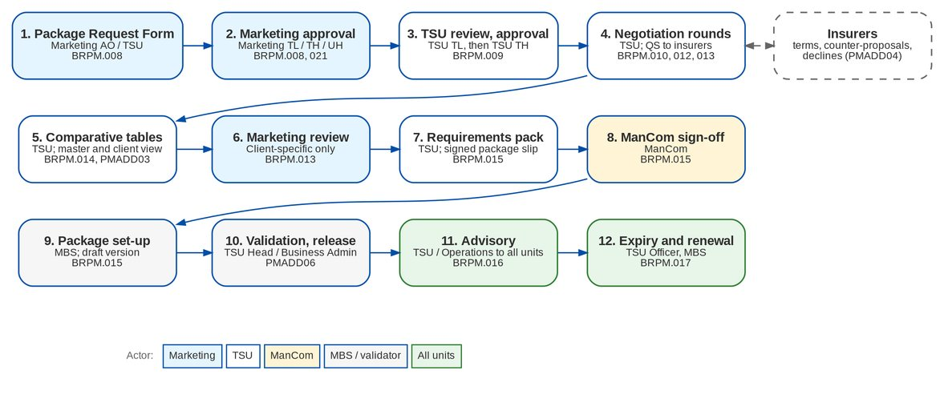
Figure 1: Package lifecycle by actor (BRPM.008-017, PMADD03/04/06)

2.3 Request types
A package request has one of six types (list PKG_REQUEST_TYPE). The type decides whether negotiation takes place and what the MBS step does.
Table 5: Request types
Type | Label | Negotiation | Result
NEW | New package | Always | A new packaged product and its version 1
AMEND | Amend package terms | Always | A new version of an existing package
UPDATE | Update package details | Chosen on the form | A new version of an existing package
RENEW | Renew package | Chosen on the form | A new version with the next term dates
REACTIVATE | Reactivate expired package | Chosen on the form | A new version of an expired package; the product becomes active again
RETIRE | Retire package | Never | The product is retired; no version is released (the BRD "deletion", BRPM.011)

3 Personas and roles

3.1 Personas
Table 6: Personas and BIBS roles
Persona | BIBS role | Responsibilities in Product Maintenance | BRD
Marketing AO | MKT_AO | Creates and submits package requests; views packages | BRPM.008
Marketing TL / TH / UH | MKT_TL | Approves package requests; reviews terms of client-specific packages; views reports | BRPM.008, 013, 021
TSU Officer | TSU | Creates requests; prepares quotation slips; keys in insurer responses; prepares requirements and advisories; monitors expiry | BRPM.010-013, 016, 017
TSU Team Lead | TSU_TL | Reviews and recommends requests; approves quotation slips (or a co-officer); negotiates | BRPM.009, 012
TSU Team Head / Head | TSU_HEAD | Approves requests; releases terms to Marketing; validates package versions | BRPM.009, 013; PMADD06
MBS | MBS | Sets up package versions; maintains incentive criteria and product masters; views archived packages | BRPM.015; PMADD07, 08
ManCom | MANCOM | Signs off package requirements | BRPM.015
Business Administrator | BUSINESS_ADMIN | Validates package versions; authorises product masters, incentive criteria and rate exceptions | PMADD05, 06
System Administrator | SYSADMIN | Maintains parameters, lists of values and roles (section 9); read access to Product Maintenance | PMADD05
Auditor | AUDITOR | Read access to packages, archive and reports | BRPM.024

The addendum states that user roles "will be further defined in succeeding documentations" (p.4, footnote 2). The roles above are the project's proposal until BDOI confirms the matrix (PQ17, OQ48).

3.2 Permissions
Table 7: Product Maintenance permissions and action classes (PMADD05)
Permission | Action class | Allows
PRODUCT_VIEW | VIEW | Open the Product Maintenance screens and the catalogue (read only)
PRODUCT_ARCHIVE_VIEW | VIEW | See expired and retired packages and their history (BRPM.006)
PKG_REPORT_VIEW | VIEW | Package reports and the Product Maintenance home
PKG_REQUEST | CREATE / AMEND | Create, edit and submit package requests; Marketing review of terms
PKG_REQUEST_APPROVE | APPROVE | Marketing approval of a package request
PKG_TSU_RECOMMEND | APPROVE | TSU TL review and recommendation
PKG_TSU_APPROVE | APPROVE | TSU TH approval; release of terms to Marketing
PKG_NEGOTIATE | CREATE / AMEND | Quotation slips, insurer responses, rounds, comparative outputs, requirements pack
PKG_QS_APPROVE | APPROVE | Approval of a quotation slip (not by its preparer)
PKG_MANCOM_SIGNOFF | APPROVE | ManCom sign-off
PKG_ADVISORY | CREATE | Draft and send advisories
PRODUCT_MAINTAIN | CREATE / AMEND | Package set-up (draft versions), coverages, clauses
PRODUCT_VALIDATE | APPROVE | Validation and release of package versions (PMADD06)
PRODUCT_AUTHORIZE | APPROVE | Authorisation of product masters, incentive criteria and rate-scheme exceptions
INCENTIVE_CRITERIA_MAINTAIN | CREATE / AMEND | Incentive criteria (PMADD07, 08)

3.3 Permissions matrix
The table below is the proposed role-to-action matrix ("Y" = granted). The System Administrator maintains it through role-permission change requests (FR-PM-003). The User Access Matrix screen shows it by permission and by action class and exports it to Excel.
Table 8: Role-to-action matrix for Product Maintenance (proposal until PQ17 / OQ48)
Permission | MKT AO | MKT TL | TSU | TSU TL | TSU Head | MBS | Man Com | Bus. Admin | NB Appr. | Auditor
PRODUCT_VIEW | Y | Y | Y | Y | Y | Y | Y | Y | Y | Y
PRODUCT_ARCHIVE_VIEW |  |  |  |  | Y | Y |  | Y |  | Y
PKG_REPORT_VIEW |  | Y |  | Y | Y | Y |  | Y |  | Y
PKG_REQUEST | Y | Y | Y
PKG_REQUEST_APPROVE |  | Y
PKG_TSU_RECOMMEND |  |  |  | Y
PKG_TSU_APPROVE |  |  |  |  | Y
PKG_NEGOTIATE |  |  | Y | Y
PKG_QS_APPROVE |  |  |  | Y
PKG_MANCOM_SIGNOFF |  |  |  |  |  |  | Y
PKG_ADVISORY |  |  | Y | Y
PRODUCT_MAINTAIN |  |  |  |  |  | Y
PRODUCT_VALIDATE |  |  |  |  | Y |  |  | Y
PRODUCT_AUTHORIZE |  |  |  |  |  |  |  | Y | Y
INCENTIVE_CRITERIA_MAINTAIN |  |  |  |  |  | Y

Segregation of duties is enforced by the system, whatever the role grants: a request is never approved by its maker, the TSU Head approval is never given by the recommender, a quotation slip is never approved by its preparer, ManCom never signs off requirements it submitted, and a package version is never validated by its maker or submitter.

4 Functional requirements

4.1 Access, security and audit

FR-PM-001 Log in to BIBS
BRD trace | BRPM.001 (p.15) | Actor | MBS, TSU, Marketing
Priority | Must have | Screens | Login

Description
Users of MBS, TSU and Marketing log in with their BIBS user ID and password. Product Maintenance uses the BIBS log-in of BRD-1; it adds no screen of its own.
Preconditions
• The user has an active BIBS account with at least one Product Maintenance role.
Main flow
1. The user enters the user ID and password on the Login screen.
2. BIBS checks the credentials and the account status.
3. BIBS opens the home page with the menu of the user's roles (Product Maintenance section).
Alternate and exception flows
• Wrong credentials. BIBS refuses the log-in and counts the failed attempt.
• Locked account. After the number of failed attempts set in LOGIN_MAX_FAILED_ATTEMPTS (3) the account locks; the System Administrator unlocks it.
• Repeated attempts. Too many log-in attempts from one address in a short time are refused for a while, before the password is checked.
• Idle session. The session ends after the configured idle time; the user logs in again.
Business rules
Rule | Statement | Kind | Maintained in
R1 | Log-in, lock-out and session rules follow the session policy of BRD-1 (BRNB.040). | Configurable | Session policy (System Administrator)
R2 | BDO single sign-on / Active Directory is not part of this phase (Q42). | Fixed | -

Validations and messages
Check | Message shown | Code
User ID or password wrong | Invalid user name or password | AUTHENTICATION_FAILED
Account locked | Account is locked. Contact your administrator. | AUTHENTICATION_FAILED

Notifications
• None.
Audit
• Every successful and failed log-in is recorded with user, time and source address.
Acceptance criteria
1. A user with valid credentials and a Product Maintenance role logs in and sees the Product Maintenance menu section.
2. A user with wrong credentials is refused and no session is created.
3. The account locks after three failed attempts (LOGIN_MAX_FAILED_ATTEMPTS).

FR-PM-002 Restrict each action to authorised roles
BRD trace | BRPM.002 (p.15), PMADD05 (p.5) | Actor | System
Priority | Must have | Screens | All Product Maintenance screens; User Access Matrix

Description
Every Product Maintenance screen, button and action requires a permission (section 3.2). Permissions carry an action class (VIEW, CREATE, AMEND, APPROVE), so the matrix answers the addendum's question "who may create, amend, approve or only view" per area.
Menus show only the screens that the user's roles allow. Buttons for actions the user may not perform are hidden.
Preconditions
• The user is logged in.
Main flow
1. The user opens a screen or starts an action.
2. BIBS checks the user's permissions for that screen or action.
3. BIBS shows the screen or performs the action.
Alternate and exception flows
• No permission. The screen is not in the menu; a direct link shows "You do not have access to this screen. Contact your administrator if you need it." A direct request is refused and logged.
• Segregation of duties. An action refused by a four-eyes rule (for example approving one's own request) is refused with its message even when the role has the permission.
Business rules
Rule | Statement | Kind | Maintained in
R1 | Each permission has an action class: VIEW, CREATE, AMEND or APPROVE. | Configurable | Role-permission change request (FR-PM-003)
R2 | Roles are granted permissions as in section 3.3 until BDOI confirms the matrix (PQ17 / OQ48). | Configurable | Role-permission change request
R3 | Four-eyes rules (maker never approves) cannot be switched off. | Fixed | -

Validations and messages
Check | Message shown | Code
Action without permission | You are not permitted to perform this action | ACCESS_DENIED

Screens and fields: User Access Matrix
Field | Type | Mand. | Source / LOV | Validation
View | Toggle | Yes | By Permission / By Action | -
Area | List | No | Permission areas (for example Product Maintenance, Package Request, Incentives) | -

Notifications
• None.
Audit
• Refused requests are logged with the user and time.
• The Excel export of the matrix is audited.
Acceptance criteria
1. A Marketing AO sees Product Maintenance Home, Package Requests and the catalogue screens, and does not see the Validation Queue or TSU Workbench.
2. A direct approval request by a user without the approval permission is refused and logged.
3. The User Access Matrix shows, for each role, which Product Maintenance areas it may view, create, amend and approve, and exports both views to Excel.

FR-PM-003 Change role permissions through an approved request
BRD trace | PMADD05 (p.5) | Actor | Business Administrator (requester), access approver, System Administrator
Priority | Must have | Screens | Access Requests; User Access Matrix

Description
Changes to the permissions of a role are requested, approved by someone other than the requester and then applied. This meets PMADD05 AC2 (changes auditable and traceable) and AC3 (Admin maintains roles and permissions). BRD-11 User Access Maintenance confirmed that group-profile changes are approved before the System Administrator implements them (PQ17, R6).
Preconditions
• The requester has the access-request permission.
Main flow
1. The requester opens Access Requests and chooses the type "Modify role permissions".
2. The requester selects the role, the permissions to add and to remove, and writes the justification.
3. The approver reviews and approves the request.
4. BIBS applies the change to the role as it is at approval and records the effective change.
Alternate and exception flows
• The approver rejects the request with a reason; the role does not change.
• Emergency change. The direct role edit of the System Administrator stays available only through the audited emergency parameter UAM_DIRECT_ROLE_EDIT (BRD-11).
Business rules
Rule | Statement | Kind | Maintained in
R1 | The approver is never the requester. | Fixed | -
R2 | The change applied is the difference between the role at approval and the request, so concurrent changes are not lost. | Fixed | -

Validations and messages
Check | Message shown | Code
No permission added or removed | Select at least one permission to add or remove | -
Approver is the requester | An access request is approved by someone other than the requester | ACCESS_FOUR_EYES

Screens and fields: Access Request (Modify role permissions)
Field | Type | Mand. | Source / LOV | Validation
Role | List | Yes | Roles | Active role
Permissions to add | Multi-select | No | Permissions | Not already granted
Permissions to remove | Multi-select | No | Permissions of the role | Granted to the role
Justification | Text | Yes | - | Up to 1000 characters

Notifications
• The approvers are notified when the request is submitted; the requester when it is decided.
Audit
• Request, decision and the applied change are recorded with users and times.
Acceptance criteria
1. A role change requested by the Business Administrator takes effect only after another user approves it.
2. The history of the role shows who requested, approved and applied each change.

FR-PM-004 Protect documents that leave BIBS
BRD trace | BRPM.020 (p.29-30) | Actor | System
Priority | Must have | Screens | Package Request page (E-mails, Documents tabs)

Description
The quotation slips to insurers, comparative outputs, package slip and advisories are e-mailed as password-protected PDF (AES) or protected XLSX, with the password in a separate e-mail. Inside BIBS, package documents open only for users with PRODUCT_VIEW or the Product Maintenance permissions of the request.
Preconditions
• A document is generated or attached on a package request.
Main flow
1. A user sends a document from a package request (QS, comparative, advisory).
2. BIBS protects the file and sends it; it sends the password in a second e-mail.
3. BIBS logs both e-mails in the request's E-mails tab.
Alternate and exception flows
• Delivery failure. The e-mail shows the failed status in the E-mails tab; the user resends it.
Business rules
Rule | Statement | Kind | Maintained in
R1 | Every Product Maintenance document e-mailed outside BIBS is protected; protection cannot be switched off per e-mail. | Fixed | -
R2 | The password convention is the one BDOI confirms under Q07; until then BIBS generates a password per e-mail. | Configurable | Messaging settings (on hold, Q07 / PQ21)

Validations and messages
Check | Message shown | Code
User without permission opens a document | You are not permitted to perform this action | ACCESS_DENIED

Notifications
• The recipient receives the protected document and, separately, its password.
Audit
• Each e-mail is logged with recipient, time, subject, attachment name and SHA-256 hash of the attachment.
Acceptance criteria
1. A QS e-mailed to an insurer arrives as a protected PDF, and the password arrives in a separate e-mail.
2. A user without Product Maintenance permissions cannot open the request's documents.

FR-PM-005 Keep a complete audit trail and history
BRD trace | BRPM.024 (p.31-32) | Actor | System; any user with PRODUCT_VIEW (read)
Priority | Must have | Screens | Package Request page (History tab); Product page (History); Package Version page

Description
BIBS records every creation, edit, approval, return, sending and generation for package requests, package versions, masters and incentive criteria. Users review the complete trail of a request or document on its History tab.
Preconditions
• None.
Main flow
1. A user performs an action on a request, version or master.
2. BIBS writes an audit row (who, when, what, before and after values where applicable) together with the change; one is never kept without the other.
3. The History tab shows the workflow history and the audit rows in time order.
Business rules
Rule | Statement | Kind | Maintained in
R1 | Audit entries can only be added; no user, including the System Administrator, can change or delete them. | Fixed | -
R2 | Retention follows the BRD-1 rule (5 years online, 15 years archive) until BDOI states a Product Maintenance retention (PQ18). | Configurable | Retention parameters

Notifications
• None.
Audit
• This FR is the audit.
Acceptance criteria
1. For a released package, the History tab lists every step from submission to release with user and time.
2. A changed insurer response shows its earlier values in the response history.
3. No screen or direct request allows audit rows to be edited or deleted.

4.2 Product structure and master data

FR-PM-010 Maintain the product hierarchy
BRD trace | PMADD01 (p.4) | Actor | MBS (maintain), Business Administrator (authorise)
Priority | Must have | Screens | Products; Product page; Coverages & Clauses

Description
BIBS holds one product hierarchy for all packages. Level 1 is the product line (LOB, for example Motor, Fire). Level 2 is the cover type, with an optional subtype under it (depth at most 2). Level 3 is the product (risk code). Level 4 is the coverage / peril of the line, used in each package version.
A packaged product cannot be saved without its cover type, and a package version cannot be submitted without at least one basic coverage. New risk codes must follow the naming convention of their line when BDOI has stated it.
Preconditions
• The user has PRODUCT_MAINTAIN.
Main flow
1. MBS creates or edits a line, cover type or subtype, coverage or product.
2. BIBS checks the hierarchy and the naming convention.
3. The record is saved as pending authorisation.
4. A PRODUCT_AUTHORIZE holder other than the maker authorises it; it becomes usable.
Alternate and exception flows
• The authoriser rejects the record with a reason; it stays unusable and the maker can correct it.
• A subtype is created under a subtype. BIBS refuses it (depth at most 2).
Business rules
Rule | Statement | Kind | Maintained in
R1 | Hierarchy levels: line > cover type > subtype (optional) > product; coverages / perils per line. | Fixed | -
R2 | A packaged product needs a cover type. | Fixed | -
R3 | Risk codes follow the pattern of their line (for example ^MTR\d{2}$) when the line has one. | Configurable | Product line, Code Pattern (values PQ02)
R4 | Coverage kinds: Section, Coverage, Peril, Extension. | Configurable | LOV COVERAGE_KIND
R5 | Every hierarchy record is maker-checker. | Fixed | -

Validations and messages
Check | Message shown | Code
Packaged product without cover type | A package needs its cover type (PMADD01) | PACKAGE_HIERARCHY_INCOMPLETE
Risk code does not match the line pattern | Risk code <code> does not follow the naming convention of <line> | PRODUCT_CODE_PATTERN

Screens and fields: Coverage (Coverages & Clauses)
Field | Type | Mand. | Source / LOV | Validation
Product line | List | Yes | Product lines | Active line
Code | Text | Yes | - | Unique within the line; letters, digits, hyphen
Name | Text | Yes | - | Up to 120 characters
Kind | List | Yes | LOV COVERAGE_KIND | -
Basic coverage | Check box | No | - | -
Display order | Number | No | - | Whole number

Notifications
• The authorisers see pending records in My Approvals.
Audit
• Create, edit, authorise, reject and deactivate are audited with before and after values.
Acceptance criteria
1. A packaged product without a cover type cannot be saved.
2. A risk code that does not follow its line's pattern is refused with PRODUCT_CODE_PATTERN.
3. A new coverage is usable in package versions only after another user authorises it.

FR-PM-011 Maintain the clause library
BRD trace | PMADD02 (p.4) | Actor | MBS / TSU with PRODUCT_MAINTAIN; Business Administrator (authorise)
Priority | Must have | Screens | Coverages & Clauses (Clauses)

Description
Warranties, clauses, exclusions and deductible wordings are held once in a clause library with their wording and effective dates. Package versions refer to clauses by code for each insurer and coverage (FR-PM-014).
Preconditions
• The user has PRODUCT_MAINTAIN.
Main flow
1. The user adds a clause with its kind, line (or all lines), title, wording and effective dates.
2. The clause is saved as pending authorisation.
3. Another user with PRODUCT_AUTHORIZE authorises it.
Business rules
Rule | Statement | Kind | Maintained in
R1 | Clause kinds: Warranty, Clause, Exclusion, Deductible wording. | Configurable | LOV CLAUSE_KIND
R2 | A clause is never deleted; it is end-dated or deactivated. | Fixed | -

Validations and messages
Check | Message shown | Code
Wording blank | Enter the wording | -
Effective to before effective from | The end date must be on or after the start date | -

Screens and fields: Clause
Field | Type | Mand. | Source / LOV | Validation
Code | Text | Yes | - | Unique
Kind | List | Yes | LOV CLAUSE_KIND | -
Product line | List | No | Product lines | Blank = all lines
Title | Text | Yes | - | Up to 200 characters
Effective from | Date | Yes | - | -
Effective to | Date | No | - | On or after effective from
Wording | Long text | Yes | - | -

Notifications
• Pending clauses appear in My Approvals.
Audit
• All changes audited with before and after values.
Acceptance criteria
1. A clause is selectable in insurer terms only after authorisation and within its effective dates.
2. An end-dated clause stays readable on the versions that used it.

FR-PM-012 Capture and validate product-specific fields
BRD trace | BRPM.003 (p.16), BRPM.004 (p.16) | Actor | MBS (rules); System (checks)
Priority | BRPM.003: not stated in the BRD; BRPM.004: Must have | Screens | Product page (Field Rules & Documents tab)

Description
MBS maintains, per line or per product, which fields a quotation or account must capture (presence) and how their values are checked (list, range, pattern). BIBS applies the rules of the product's type when a quotation or account is submitted, so each product line gets its own validation without IT.
Preconditions
• The user has PRODUCT_MAINTAIN.
Main flow
1. MBS adds a field rule with its scope (all products, line or product), target (account or item), field and check type.
2. The rule is authorised by another user.
3. When a quotation or account of that product is submitted, BIBS checks all rules in scope and lists every violation against its field.
Alternate and exception flows
• A pattern that cannot be evaluated safely (back-references, look-around) is refused when the rule is saved.
Business rules
Rule | Statement | Kind | Maintained in
R1 | Check types: Presence, List (LOV), Range (minimum / maximum), Pattern. | Configurable | Field rules
R2 | The most specific scope applies in addition to the wider ones (product + line + all). | Fixed | -
R3 | Patterns are evaluated in linear time; unsafe patterns are refused. | Fixed | -

Validations and messages
Check | Message shown | Code
Mandatory field blank on submission | <Field> is required for <product> | -
Value outside the range or list | <Field> must be between <min> and <max> / <Field> is not a valid value | -
Invalid pattern entered on a line rule | The risk-code pattern is not a valid regular expression | CODE_PATTERN_INVALID

Screens and fields: Field rule
Field | Type | Mand. | Source / LOV | Validation
Scope | List | Yes | All / Line / Product | -
Line or product | List | Cond. | Product lines / products | Required for Line or Product scope
Target | List | Yes | Account / Item | -
Field | List | Yes | Field catalogue | -
Check type | List | Yes | Presence / List / Range / Pattern | -
List type | List | Cond. | LOV types | Required for List
Minimum / Maximum | Number | Cond. | - | Required for Range; minimum <= maximum
Pattern | Text | Cond. | - | Required for Pattern; safe expression

Notifications
• None.
Audit
• Rule changes audited; violations are returned to the user and not stored.
Acceptance criteria
1. A Motor product rule "plate number required" stops submission of a Motor account without a plate number and names the field.
2. A range rule refuses a value outside the range and accepts the limits.
3. MBS adds a field rule for a line that has none, and the rule applies to the next account of that line.

FR-PM-013 Use shared document templates with product-specific fields
BRD trace | BRPM.005 (p.16-17) | Actor | System; MBS (templates)
Priority | Must have | Screens | Package Request page (form.pdf, QS, comparative, package slip, advisory downloads)

Description
Product Maintenance documents are generated from versioned templates with placeholders. The templates include line-specific sections, so one template serves Motor, Fire, CGL, Equipment Floater, Marine Cargo and other lines. Each generated document records the template version used.
Preconditions
• The templates PKG_REQUEST_FORM, PKG_QUOTATION_SLIP, PKG_COMPARATIVE, PKG_SLIP, PKG_ADVISORY and PKG_RENEWAL_ADVISORY exist.
Main flow
1. A user generates a document from a package request.
2. BIBS merges the request, terms and insurer data into the current template version.
3. BIBS stores the document with the template version and makes it available for download or sending.
Business rules
Rule | Statement | Kind | Maintained in
R1 | Template layouts are drafts until BDOI provides its layouts (Q03). | Configurable | Document templates
R2 | A document is always generated from stored values, so a regenerated file shows the same content. | Fixed | -

Validations and messages
Check | Message shown | Code
No active template of the type | The template <code> is not available | -

Notifications
• None.
Audit
• Document generation is audited with template code and version.
Acceptance criteria
1. A QS for a Motor package shows the Motor coverages and deductibles; a QS for a Fire package shows the Fire coverages.
2. Each generated document shows the template version in its record.

FR-PM-014 Maintain insurer-specific package terms
BRD trace | PMADD02 (p.4) | Actor | MBS (on a draft version); TSU (through negotiated terms)
Priority | Must have | Screens | Package Version (Insurers, Insurer Terms sections); Product page (Versions)

Description
Each package version lists its insurers with role (Lead, Participant or Panel), share (co-insurance), rate and minimum premium. For each insurer and coverage, the version holds whether the coverage is included, the limit, sub-limit, deductible (amount, percent or wording) and the clauses that apply.
Terms are maintained on a draft version only. They reach new business after validation and release (FR-PM-043), so a change never alters a package already on sale.
Preconditions
• A draft version exists (from the MBS set-up or "New Version").
Main flow
1. MBS opens the draft version.
2. MBS adds or edits insurers and the insurer x coverage terms.
3. MBS saves; BIBS checks the shares and the completeness of the terms.
4. MBS submits the version for validation (FR-PM-043).
Alternate and exception flows
• An insurer without its own terms receives the package's included coverages when the version is set up from a request, so every panel insurer has a term per included coverage.
Business rules
Rule | Statement | Kind | Maintained in
R1 | Insurer roles: Lead, Participant, Panel. | Fixed | -
R2 | When shares are used, they total 100%. | Fixed | -
R3 | Every insurer has a term for every included coverage before submission. | Fixed | -
R4 | Clauses come from the authorised clause library. | Fixed | -
R5 | A new-business transaction with an insurer outside a package's panel is refused. | Fixed | -

Validations and messages
Check | Message shown | Code
Shares do not total 100 | The co-insurance shares must add up to 100% | PACKAGE_SHARES_INVALID
Insurer lacks a term for an included coverage | Insurer <code> has no terms for coverage <coverage> | PACKAGE_INSURER_TERMS_MISSING
Non-panel insurer on a quotation | Insurer <code> is not on the panel of <package> | INSURER_NOT_ON_PACKAGE
Direct edit of a versioned field on the product | The rate, minimum premium, commission and TSI limit of package <code> change through a new version (Versions tab) | PRODUCT_FIELD_VERSIONED

Screens and fields: Package Version, Insurer Terms
Field | Type | Mand. | Source / LOV | Validation
Insurer | List | Yes | Insurer master | Active insurer
Role | List | Yes | Lead / Participant / Panel | -
Share % | Number | No | - | 0-100; total 100 when used
Rate % | Number | Cond. | - | Required when no package rate
Minimum premium | Amount | No | - | >= 0
Coverage | List | Yes | Coverages of the line | Authorised coverage
Included | Check box | Yes | - | -
Limit / Sub-limit | Amount | No | - | >= 0
Deductible amount / % / wording | Amount / Number / Text | No | - | >= 0
Clauses | Multi-select | No | Clause library | Effective on the version date

Notifications
• None until submission.
Audit
• Every change to insurers and terms on a draft is audited; released versions are read-only.
Acceptance criteria
1. MBS maintains different deductibles for two insurers on the same coverage without IT.
2. A version whose insurer has no term for an included coverage cannot be submitted.
3. A quotation on the package with an insurer outside the panel is refused.

4.3 Package request and approvals

FR-PM-020 Create and submit a Package Request Form
BRD trace | BRPM.008 (p.18-19), BRPM.011 (p.21) | Actor | Marketing AO; TSU Officer
Priority | Must have | Screens | Package Requests; New Package Request; Edit Package Request

Description
The requester enters the request type and scope, the client (client-specific packages) or programme name, the product line, cover type or existing package, the reason, the requested terms (sections, coverages with limits and deductibles, requested rate and dates) and the target insurers, and attaches documents.
For AMEND, UPDATE, RENEW and REACTIVATE requests, BIBS pre-fills the terms from the package's current version, so nothing is keyed in twice (BRPM.011 AC3-4).
The request is saved as a draft with a number PKR-yyyy-n and submitted for Marketing approval when complete.
Preconditions
• The user has PKG_REQUEST.
Main flow
1. The requester clicks New Package Request.
2. The requester selects the request type and scope and completes the header fields.
3. For a request on an existing package, BIBS loads the current terms of the package.
4. The requester enters or changes the requested terms and target insurers, and attaches documents.
5. The requester saves the draft. BIBS assigns the request number.
6. The requester clicks Submit for Approval. BIBS checks completeness and moves the request to FOR_MKT_APPROVAL.
Alternate and exception flows
• Incomplete request. BIBS lists what is missing and keeps the request in DRAFT.
• The requester voids a draft with a reason (list VOID_REASON); the request closes as VOIDED.
• A returned request (FR-PM-021 to FR-PM-023) comes back to DRAFT with the reason; the requester corrects and resubmits it.
Business rules
Rule | Statement | Kind | Maintained in
R1 | Request numbers are PKR-<yyyy>-<n>. | Configurable | Parameter PKG_REQUEST_PREFIX
R2 | A NEW request names the cover type; other types name the existing package. | Fixed | -
R3 | A client-specific request names the client; a generic programme does not need one (PQ14). | Fixed | -
R4 | NEW and AMEND requests always negotiate; RETIRE never; UPDATE, RENEW and REACTIVATE choose on the form. | Fixed | -
R5 | Before submission, a request other than RETIRE has requested terms, a package end date and, when negotiated, at least one target insurer. | Fixed | -
R6 | The type of a saved request cannot change. | Fixed | -

Validations and messages
Check | Message shown | Code
Package or programme name blank | Enter the package or programme name | PKG_REQUEST_INCOMPLETE
Line not selected | Select the product line | PKG_REQUEST_INCOMPLETE
Reason not selected | Select the reason | PKG_REQUEST_INCOMPLETE
NEW request without cover type | Select the cover type | PKG_REQUEST_INCOMPLETE
Other type without package | Select the package product of the <type> request | PKG_REQUEST_INCOMPLETE
Client-specific without client | Select the client of the client-specific package (PQ14) | PKG_REQUEST_INCOMPLETE
End date not after start date | The package end date must be after its start date | PKG_DATES_INVALID
Negative rate or amount | Rates and amounts cannot be negative | PKG_AMOUNT_NEGATIVE
Missing items on submit | Complete the request: <items> | PKG_REQUEST_INCOMPLETE
Type changed on a saved request | The type of a request cannot change | PKG_TYPE_FIXED

Screens and fields: New Package Request
Field | Type | Mand. | Source / LOV | Validation
Request type | List | Yes | LOV PKG_REQUEST_TYPE | Fixed after first save
Scope | Option | Yes | Generic programme / Client-specific package | -
Package / programme name | Text | Yes | - | Up to 200 characters
Client or prospect | Look-up | Cond. | Client master (CRM) | Required for client-specific
Product line | List | Yes | Product lines | Active line
Cover type / subtype | List | Cond. | Cover types of the line | Required for NEW
Package product | List | Cond. | Packaged products of the line | Required except for NEW
Market segments | Multi-select | No | Market segments | -
Reason | List | Yes | LOV PKG_REQUEST_REASON | -
Comment on the reason | Text | Cond. | - | Required when the reason is Others
Negotiation required | Check box | Cond. | - | Shown for UPDATE, RENEW and REACTIVATE
Requested terms | Sections | Cond. | Heading and details per section | Required on submission except RETIRE
Coverages | Table | No | Coverages of the line | Code, included, limit, deductible per line
Requested rate % / Minimum premium / Commission % / Package TSI limit | Number / Amount | No | - | >= 0
Effective from / Package start / Package end / Anniversary | Date | Cond. | - | Package end required on submission; end after start
Target insurers | Multi-select | Cond. | Insurer master | At least one when negotiated
Documents | Attachment | No | Document type PKG_REQUEST_FORM and others | Allowed file types and size of the platform

Notifications
• On submission, the holders of PKG_REQUEST_APPROVE are notified in BIBS (stage entry).
Audit
• Create, each save, submit and void are recorded in the request history.
Acceptance criteria
1. A Marketing AO submits a complete NEW request; it receives a PKR number and moves to FOR_MKT_APPROVAL.
2. Submission with missing mandatory fields is refused and each missing item is named.
3. An AMEND request opens with the current version's terms pre-filled.
4. A client-specific request without a client cannot be saved.

FR-PM-021 Approve a package request (Marketing)
BRD trace | BRPM.008 (p.18-19), BRPM.021 (p.30-31) | Actor | Marketing TL, TH or UH
Priority | Must have | Screens | Package Requests (tab For Approval); Package Request page

Description
A Marketing approver reviews the submitted request and approves it, which sends it to the TSU TL, or returns it to the requester with a reason. The BRD allows the TL, TH or UH to approve; BIBS accepts any one of them (PQ08).
Preconditions
• The request is in FOR_MKT_APPROVAL.
• The user has PKG_REQUEST_APPROVE and is not the maker or submitter.
Main flow
1. The approver opens the request from the For Approval tab.
2. The approver reviews the form, terms and documents.
3. The approver clicks Approve and send to TSU, optionally with a comment.
4. BIBS moves the request to FOR_TSU_REVIEW and notifies the TSU TL queue.
Alternate and exception flows
• Return. The approver clicks Return to Requester and selects a reason (list RETURN_REASON); the request goes back to DRAFT.
• Void. The requester or approver voids the request with a reason; it closes as VOIDED.
Business rules
Rule | Statement | Kind | Maintained in
R1 | The approver is never the maker or submitter of the request. | Fixed | -
R2 | One approval by TL, TH or UH is enough (a chain by segment or amount waits for PQ08). | Configurable | Workflow stage owner
R3 | SLA 24 hours (default). | Configurable | Parameter PKG_SLA_MKT_APPROVAL

Validations and messages
Check | Message shown | Code
Approver is the maker | A package request is approved by someone other than its maker | PKG_FOUR_EYES
Return without reason | Select a reason for '<action>' | WORKFLOW_REASON_REQUIRED

Notifications
• The TSU TL queue on approval; the requester on return or void.
• SLA alert to the stage owners when the SLA passes.
Audit
• Approval, return and void recorded with user, time, comment and reason.
Acceptance criteria
1. The requester cannot approve their own request.
2. An approved request appears in the TSU Review tab.
3. A returned request is back in DRAFT with the reason visible on the request.

FR-PM-022 Review and recommend a package request (TSU TL)
BRD trace | BRPM.009 (p.19-20) | Actor | TSU Team Lead
Priority | Must have | Screens | TSU Workbench; Package Request page

Description
The TSU TL checks the request for completeness, accuracy and compliance, may correct it, and writes a recommendation for the TSU Head. The recommendation is stored on the request and shown to the TSU Head.
Preconditions
• The request is in FOR_TSU_REVIEW; the user has PKG_TSU_RECOMMEND.
Main flow
1. The TSU TL opens the request from the TSU Workbench.
2. The TSU TL reviews the form and, where needed, edits it.
3. The TSU TL clicks Recommend for Approval and writes the recommendation.
4. BIBS stores the recommendation and moves the request to FOR_TSU_APPROVAL.
Alternate and exception flows
• Return. The TSU TL returns the request to the requester with a reason; it goes back to DRAFT.
Business rules
Rule | Statement | Kind | Maintained in
R1 | A recommendation text is mandatory. | Fixed | -
R2 | SLA 24 hours (default). | Configurable | Parameter PKG_SLA_TSU_REVIEW

Validations and messages
Check | Message shown | Code
Recommendation blank | Write the recommendation for the TSU Head | PKG_RECOMMENDATION_REQUIRED

Screens and fields: Recommend dialog
Field | Type | Mand. | Source / LOV | Validation
Recommendation | Long text | Yes | - | Up to 4000 characters

Notifications
• TSU Head queue on recommendation; requester on return.
Audit
• Edit, recommendation and return recorded with user and time.
Acceptance criteria
1. The request cannot reach the TSU Head without a recommendation.
2. The TSU Head sees the recommendation text on the request.

FR-PM-023 Approve a package request (TSU Head)
BRD trace | BRPM.009 (p.19-20) | Actor | TSU Team Head / Head
Priority | Must have | Screens | TSU Workbench; Package Request page

Description
The TSU Head approves the recommended request. For a negotiated request, BIBS opens negotiation round 1 with the target insurers. For a request without negotiation (RETIRE, or UPDATE / RENEW / REACTIVATE without negotiation) the requested terms become the proposed terms and the request goes to ManCom.
Preconditions
• The request is in FOR_TSU_APPROVAL; the user has PKG_TSU_APPROVE and did not recommend the request.
Main flow
1. The TSU Head reads the request and the TSU TL's recommendation.
2. The TSU Head clicks Approve.
3. BIBS moves the request to NEGOTIATION and opens round 1, or to FOR_MANCOM for a request without negotiation.
Alternate and exception flows
• Return to the requester with a reason (DRAFT).
Business rules
Rule | Statement | Kind | Maintained in
R1 | The TSU Head approval is never given by the recommender. | Fixed | -
R2 | The request cannot proceed without this approval (BRPM.009 AC4). | Fixed | -
R3 | SLA 24 hours (default). | Configurable | Parameter PKG_SLA_TSU_APPROVAL

Validations and messages
Check | Message shown | Code
Approver is the recommender | The TSU Head approval is given by someone other than the recommender | PKG_FOUR_EYES

Notifications
• TSU negotiation queue (or ManCom) on approval; requester on return.
Audit
• Approval and return recorded with user, time and comment.
Acceptance criteria
1. The recommender cannot give the TSU Head approval.
2. After approval of a NEW request, round 1 exists with the target insurers.
3. A retirement request goes to ManCom sign-off without a negotiation round.

FR-PM-024 Receive, view and track package requests
BRD trace | BRPM.011 (p.21) | Actor | TSU; Marketing; MBS
Priority | Must have | Screens | Package Requests; TSU Workbench; Package Request page

Description
All requests are listed with request number, type, scope, client or programme, line, product, stage, days in stage and assignee. Tabs group them by stage (Drafts, For Approval, TSU Review, Negotiation, ManCom, With MBS, For Validation, Released, Closed). The TSU Workbench shows the TSU queues as tiles.
The responsible users are notified when a request enters their stage. A TL or Head assigns requests to officers (bulk Assign), and an officer can claim a request.
Preconditions
• The user has PRODUCT_VIEW or PKG_REPORT_VIEW.
Main flow
1. The user opens Package Requests and selects a tab.
2. The user searches by request number or filters by type, or shows only their own requests.
3. The user opens a request to view its details, terms, negotiation, documents and history.
Alternate and exception flows
• A TL selects several requests and assigns them to an officer.
Business rules
Rule | Statement | Kind | Maintained in
R1 | Stage owners are notified on stage entry. | Fixed | -
R2 | "Deletion" of a product is a retirement request; nothing is physically deleted. | Fixed | -

Screens and fields: Package Requests (filters)
Field | Type | Mand. | Source / LOV | Validation
Search Request No. | Text | No | - | -
Type | List | No | LOV PKG_REQUEST_TYPE | -
Mine only | Check box | No | - | -

Notifications
• Stage-entry notification to the owners of the new stage.
Audit
• Assignment and claim recorded on the work case.
Acceptance criteria
1. A request submitted by Marketing appears in the TSU Review tab with its type, client, line and reason.
2. The TSU TL receives a notification when a request enters FOR_TSU_REVIEW.
3. A request assigned to an officer shows the officer as assignee.

4.4 Negotiation and comparative tables

FR-PM-030 Prepare, approve and send the quotation slip
BRD trace | BRPM.012 (p.22) | Actor | TSU Officer (prepare); TSU TL or co-officer (approve)
Priority | Must have | Screens | Package Request page (Negotiation tab)

Description
The QS of each round is generated from the request, so the Marketing details flow into it; TSU edits the insurers and notes of the round. The preparer submits the QS, which gets a number PQS-yyyy-n and a reply due date. A TL or co-officer approves it, and BIBS then sends one protected e-mail per insurer and opens a pending response for each.
The slips stay editable by TSU until the ManCom sign-off, when they lock.
Preconditions
• The request is in NEGOTIATION; a round is open.
Main flow
1. The TSU Officer opens the round and selects the insurers.
2. The officer submits the QS. BIBS numbers it and sets the reply due date.
3. The TSU TL (or a co-officer) reviews the QS PDF and clicks Approve and Send.
4. BIBS e-mails the protected QS to each insurer and shows the send status per insurer.
Alternate and exception flows
• Resend. The officer resends the QS to one insurer from the round (for example after a bounce); the resend is logged.
• Locked. After the ManCom sign-off any edit or resend is refused.
Business rules
Rule | Statement | Kind | Maintained in
R1 | QS numbers are PQS-<yyyy>-<n>. | Configurable | Parameter PKG_QS_PREFIX
R2 | Reply due date = send date + 5 days (default). | Configurable | Parameter PKG_QS_REPLY_DAYS
R3 | The QS is approved by someone other than its preparer. | Fixed | -
R4 | One protected e-mail per insurer; the password is sent separately. | Fixed | -
R5 | Slips lock at the ManCom sign-off. | Fixed | -

Validations and messages
Check | Message shown | Code
No insurer selected | Select at least one insurer for the quotation slip | QS_NO_INSURER
Approver is the preparer | The quotation slip is approved by a TL or a co-officer | QS_FOUR_EYES
Edit after sign-off | The slips are locked since the ManCom sign-off | QS_LOCKED
Round already sent | Round <n> is already sent | QS_ALREADY_SENT
Resend of a closed round | Only the slip of an open, sent round can be resent | QS_NOT_RESENDABLE

Screens and fields: Negotiation tab, round
Field | Type | Mand. | Source / LOV | Validation
Insurers | Multi-select | Yes | Insurer master | Active insurers
What changes in this round | Long text | No | - | Shown on rounds 2 and later
QS number | Display | - | System | PQS-yyyy-n
Reply due | Display | - | System | Send date + PKG_QS_REPLY_DAYS

Notifications
• The QS approvers are notified when a QS is submitted.
• The preparer sees the per-insurer send confirmation (BRPM.012 AC5).
Audit
• Submit, approve, send, resend: user, time, recipient, subject and attachment hash.
Acceptance criteria
1. The preparer cannot approve their own QS.
2. An approved QS is e-mailed to each insurer of the round as a protected PDF, and the E-mails tab lists each send.
3. The officer can view the sent history and resend to one insurer.
4. After ManCom sign-off the QS cannot be edited or resent.

FR-PM-031 Record insurer responses and outcomes
BRD trace | BRPM.013 (p.23), PMADD04 (p.5) | Actor | TSU Officer / TL
Priority | Must have | Screens | Package Request page (Negotiation tab, response dialog)

Description
TSU keys in each insurer's reply per round, with the outcome, the offered rate and minimum premium, the terms per coverage (included, limit, deductible, clauses), conditions and warranties, validity and remarks, and attaches the insurer's reply. The outcome list contains the exception states the addendum asks for, so a decline or a counter-proposal is a recorded outcome and not an e-mail.
Preconditions
• The QS of the round has been sent to the insurer.
Main flow
1. The officer opens the insurer's response in the round.
2. The officer selects the outcome and enters the offered terms.
3. The officer attaches the insurer's reply document.
4. The officer saves. BIBS keeps the previous values in the response history.
Alternate and exception flows
• No response by the due date. The officer records "No response".
• Correction. The officer edits a saved response; the history shows both values.
Business rules
Rule | Statement | Kind | Maintained in
R1 | Outcomes: Pending, Accepted as requested, Approved with changes, Counter-proposal, Declined, No response (list to confirm, PQ05). | Configurable | LOV PKG_RESPONSE_OUTCOME
R2 | An offer (accepted, approved with changes, counter-proposal) needs a rate. | Fixed | -
R3 | Every change to a response is kept in its history. | Fixed | -

Validations and messages
Check | Message shown | Code
Offer without rate | Enter the rate offered by <insurer> (<outcome>) | PKG_RESPONSE_RATE_REQUIRED
Negative rate or premium | Rates and amounts cannot be negative | PKG_AMOUNT_NEGATIVE

Screens and fields: Insurer response
Field | Type | Mand. | Source / LOV | Validation
Outcome | List | Yes | LOV PKG_RESPONSE_OUTCOME | -
Rate % | Number | Cond. | - | Required for an offer; >= 0
Minimum premium | Amount | No | - | >= 0
Valid until | Date | No | - | -
Coverage terms | Table | No | Coverages of the request | Included, limit, deductible, clauses per coverage
Conditions and warranties | Long text | No | - | -
Remarks | Text | No | - | -
Response document | Attachment | No | Document type PKG_INSURER_RESPONSE | Platform file rules

Notifications
• None; the round's status updates on the Negotiation tab and the dashboard.
Audit
• Each save creates a history row with the previous values, user and time.
Acceptance criteria
1. TSU records "Approved with changes" with a rate and changed deductibles for one insurer and "Declined" for another.
2. A counter-proposal without a rate is refused.
3. The response history shows every earlier value with user and time.

FR-PM-032 Run further negotiation rounds
BRD trace | PMADD04 (p.5), BRPM.010 (p.20) | Actor | TSU Officer / TL
Priority | Must have | Screens | Package Request page (Negotiation tab)

Description
When terms need another round, TSU clicks Revise Quotation Slip. BIBS closes the sent round and opens round n+1, by default with the insurers that did not decline, and the new QS goes through the same approval and sending (FR-PM-030). All rounds and their responses stay on the request.
Preconditions
• The request is in NEGOTIATION and the latest round has been sent.
Main flow
1. The officer clicks Revise Quotation Slip and states what changes in this round.
2. BIBS closes the current round and opens the next one with the proposed insurers.
3. The officer adjusts the insurers and submits the new QS.
Alternate and exception flows
• Marketing requests changes to the terms (FR-PM-036). The request returns to NEGOTIATION with the round still open, and TSU revises or makes the terms final again.
• Not proceeded. TSU or the TSU Head closes the request with a reason from PKG_NOT_PROCEEDED_REASON (for example "Declined by the insurers").
Business rules
Rule | Statement | Kind | Maintained in
R1 | Round n+1 proposes the insurers of round n that did not decline. | Fixed | -
R2 | There is no maximum number of rounds until BDOI states one (PQ05). | Configurable | -
R3 | Not-proceeded reasons: declined by the insurers, terms not accepted, client withdrew, business decision, others. | Configurable | LOV PKG_NOT_PROCEEDED_REASON

Validations and messages
Check | Message shown | Code
Revise before the current QS is sent | Send the slip of round <n> first | QS_NOT_SENT
Not proceeded without reason | Select a reason for '<action>' | WORKFLOW_REASON_REQUIRED

Notifications
• QS approvers on each new QS; the requester when a request is not proceeded.
Audit
• Opening and closing of each round and the not-proceeded decision are recorded.
Acceptance criteria
1. A request negotiated in two rounds shows both rounds, their QS numbers and the responses of each.
2. Round 2 opens by default without the insurers that declined in round 1.
3. A request closed as not proceeded shows the reason and cannot be reopened.

FR-PM-033 Make the negotiated terms final
BRD trace | BRPM.010 (p.20) | Actor | TSU Officer / TL
Priority | Must have | Screens | Package Request page (Negotiation tab, Terms Final dialog)

Description
When negotiation is complete, TSU chooses the insurer or insurers whose terms the package takes, with their roles and shares, and makes the terms final. BIBS refuses this while any insurer of the latest round has no outcome, so a package cannot be presented or encoded before negotiation is documented. The chosen terms become the proposed package terms and BIBS compiles the comparative master (FR-PM-034).
Preconditions
• The request is in NEGOTIATION.
Main flow
1. The officer clicks Terms Final.
2. The officer selects the chosen insurers and sets role and share for each.
3. BIBS checks the round and the choice, stores the proposed terms and compiles the comparative master.
4. The request moves to TERMS_REVIEW.
Business rules
Rule | Statement | Kind | Maintained in
R1 | Every insurer of the latest round has an outcome other than Pending. | Fixed | -
R2 | Only insurers that offered terms can be chosen. | Fixed | -
R3 | Shares, when used, total 100%. | Fixed | -
R4 | SLA of NEGOTIATION 120 hours (default). | Configurable | Parameter PKG_SLA_NEGOTIATION

Validations and messages
Check | Message shown | Code
An insurer still pending | Every insurer of round <n> needs an outcome before the terms are final (<insurers>) | NEGOTIATION_INCOMPLETE
No insurer chosen | Choose the insurer(s) whose terms the package takes | NEGOTIATION_INCOMPLETE
Chosen insurer did not offer | <insurer> did not offer terms in this round | PKG_INSURER_NOT_OFFERED
Shares do not total 100 | The co-insurance shares must add up to 100% | PKG_SHARES_INVALID

Screens and fields: Terms Final dialog
Field | Type | Mand. | Source / LOV | Validation
Chosen insurer | Check box per insurer | Yes | Insurers that offered terms | At least one
Role | List | Yes | Panel / Lead / Participant | -
Share % | Number | No | - | Total 100 when used

Notifications
• The TSU Head queue (TERMS_REVIEW).
Audit
• Terms final recorded with the chosen insurers and the proposed terms.
Acceptance criteria
1. Terms Final is refused while one insurer of the round is Pending.
2. After Terms Final, the request shows the proposed terms and a current comparative master.

FR-PM-034 Compile one comparative master per package request
BRD trace | BRPM.014 (p.24-25), BRPM.013 (p.23) | Actor | System; TSU
Priority | Must have | Screens | Package Request page (Comparative tab)

Description
BIBS compiles all insurer responses of the latest round into one comparative table per request, showing outcome, rate, minimum premium, coverages, deductibles, conditions, validity and remarks per insurer. A new master supersedes the previous one, so there is only one current master; earlier masters stay as superseded outputs. Each output is stored as a PDF and XLSX attachment with its hash. Marketing sees it read-only.
Preconditions
• The quotation slip of the latest round has been sent.
Main flow
1. BIBS compiles the master at Terms Final, or TSU clicks Compile Master during negotiation.
2. BIBS marks the previous master as superseded and stores the new one with template version, user, time and SHA-256.
3. Users with access view or download the master as PDF or Excel.
Business rules
Rule | Statement | Kind | Maintained in
R1 | One current MASTER per request. | Fixed | -
R2 | An output is rendered from the values stored at generation, so a file downloaded later shows the same content. | Fixed | -
R3 | Marketing has view-only access to comparative tables. | Fixed | -

Validations and messages
Check | Message shown | Code
Compile before the quotation slip of the round is sent | Send the quotation slip of round <n> first | COMPARATIVE_NO_TERMS

Notifications
• None.
Audit
• Every generation is audited with the output id, hash and user.
Acceptance criteria
1. A request with three responses has one current master listing the three insurers with their terms.
2. After a second compilation the first master is marked superseded and is still downloadable.
3. A Marketing user can open the master but has no Compile or Generate buttons.

FR-PM-035 Generate a client-tailored comparative view
BRD trace | PMADD03 (p.4) | Actor | TSU Officer / TL
Priority | Must have | Screens | Package Request page (Comparative tab, Generate Client View dialog)

Description
TSU generates a client view from the current master by choosing the fields and insurers to show, with a title. The view never edits values; it shows a selection of the master's stored content. Each client view keeps a link to its master.
Preconditions
• A current master exists.
Main flow
1. The officer clicks Generate Client View.
2. The officer enters the title and ticks the fields and insurers to include.
3. BIBS generates the PDF and Excel files, stores them with the selection and links them to the master.
Business rules
Rule | Statement | Kind | Maintained in
R1 | Selectable fields: Outcome, Rate %, Minimum Premium, Coverages, Deductibles, Conditions / Warranties, Valid Until, Remarks (to confirm, PQ06). | Configurable | Field catalogue (PQ06)
R2 | A client view is always derived from the current master. | Fixed | -

Validations and messages
Check | Message shown | Code
No current master | Compile the comparative master first | COMPARATIVE_NO_MASTER
Title blank | Enter the title of the view | COMPARATIVE_TITLE_REQUIRED
No insurer selected | Select at least one insurer of the master | COMPARATIVE_NO_INSURER

Screens and fields: Generate Client View
Field | Type | Mand. | Source / LOV | Validation
Title | Text | Yes | - | Up to 200 characters
Fields | Check boxes | Yes | Field catalogue | At least one
Insurers | Check boxes | Yes | Insurers of the master | At least one

Notifications
• None.
Audit
• Generation audited with the selection, master id, template version and hash.
Acceptance criteria
1. A client view that excludes one insurer and the Remarks field shows neither, and its values equal the master's.
2. The view lists the master it was derived from.

FR-PM-036 Review negotiated terms (TSU Head and Marketing)
BRD trace | BRPM.013 (p.23), BRPM.010 (p.20) | Actor | TSU Head; Marketing (client-specific packages)
Priority | Must have | Screens | Package Request page

Description
The TSU Head reviews the proposed terms. For a client-specific package, the TSU Head releases them to Marketing, who reviews them before any client presentation and accepts them or requests changes. A generic programme has no client presentation, so the TSU Head sends it straight to requirements preparation.
Preconditions
• The request is in TERMS_REVIEW.
Main flow
1. The TSU Head opens the request and reviews the proposed terms and the comparative master.
2. For a client-specific package, the TSU Head clicks Release Terms to Marketing (FOR_MKT_REVIEW).
3. Marketing reviews the terms and clicks Accept Terms (REQUIREMENTS_PREP).
Alternate and exception flows
• Generic programme. The TSU Head clicks Proceed to Requirements; the request moves to REQUIREMENTS_PREP.
• Marketing clicks Request Changes with a reason; the request returns to NEGOTIATION.
• Marketing closes the request as not proceeded with a reason.
Business rules
Rule | Statement | Kind | Maintained in
R1 | Marketing review is mandatory for client-specific packages and not offered for generic programmes. | Fixed | -
R2 | SLA of TERMS_REVIEW 24 hours and FOR_MKT_REVIEW 48 hours (defaults). | Configurable | Workflow stage SLA

Validations and messages
Check | Message shown | Code
Skip review on a client-specific package | Marketing reviews the terms of a client-specific package | PKG_SCOPE_CLIENT
Release to Marketing of a generic programme | A generic programme goes straight to the requirements | PKG_SCOPE_GENERIC
Request changes without reason | Select a reason for '<action>' | WORKFLOW_REASON_REQUIRED

Notifications
• Marketing on release of terms; TSU on acceptance or change request.
Audit
• Each decision recorded with user, time and reason.
Acceptance criteria
1. A client-specific package cannot skip the Marketing review.
2. Marketing's change request returns the request to NEGOTIATION with the reason shown.

4.5 Sign-off, set-up and release

FR-PM-040 Prepare and submit the requirements pack
BRD trace | BRPM.015 (p.25-26) | Actor | TSU Officer / TL
Priority | Must have | Screens | Package Request page (Requirements & Sign-off tab)

Description
TSU completes the product requirements that Marketing needs for its transactions, namely the scheme rate (or a rate per insurer), minimum premium, commission, package TSI limit, computation basis, effective date and package dates, the insurers, and the signed package slip. BIBS generates the unsigned package slip; TSU uploads the signed copy. Submission sends the pack to ManCom.
Preconditions
• The request is in REQUIREMENTS_PREP.
Main flow
1. The officer opens the Requirements & Sign-off tab; the negotiated terms are shown.
2. The officer completes the rate scheme, computation basis and dates.
3. The officer downloads the package slip, obtains signatures and uploads it as PKG_SLIP_SIGNED.
4. The officer clicks Submit Requirements. BIBS checks the pack and moves the request to FOR_MANCOM.
Alternate and exception flows
• Incomplete pack. BIBS lists every missing item and keeps the request in REQUIREMENTS_PREP.
Business rules
Rule | Statement | Kind | Maintained in
R1 | The pack needs: effective date, package end date, scheme rate or a rate per insurer, computation basis, at least one insurer, a signed package slip. | Fixed | -
R2 | SLA 48 hours (default). | Configurable | Workflow stage SLA

Validations and messages
Check | Message shown | Code
Pack incomplete | Complete the requirements: <missing items> | REQUIREMENTS_INCOMPLETE
End date not after effective date | The package end date must be after the effective date | PKG_DATES_INVALID

Screens and fields: Requirements & Sign-off
Field | Type | Mand. | Source / LOV | Validation
Scheme rate % | Number | Cond. | - | Required unless every insurer has a rate
Minimum premium | Amount | No | - | >= 0
Commission % | Number | No | - | >= 0
Package TSI limit | Amount | No | - | >= 0
Computation basis | Long text | Yes | - | As agreed with the insurers
Effective from | Date | Yes | - | -
Package start / Package end | Date | Yes (end) | - | End after effective date
Anniversary | Date | No | - | -
Signed package slip | Attachment | Yes | Document type PKG_SLIP_SIGNED | Platform file rules

Notifications
• ManCom members on submission.
Audit
• Changes to the pack and the submission recorded.
Acceptance criteria
1. Submission without a signed package slip is refused and names the missing slip.
2. A complete pack moves the request to FOR_MANCOM and notifies ManCom.

FR-PM-041 Sign off package requirements (ManCom)
BRD trace | BRPM.015 (p.25-26) | Actor | ManCom member
Priority | Must have | Screens | Package Request page (Requirements & Sign-off tab)

Description
A ManCom member reviews the requirements pack and signs off in BIBS. The sign-off locks the quotation slips and forwards the request to MBS automatically. A physically signed sheet can be uploaded as MANCOM_SIGNOFF; without an upload, BIBS attaches a generated sign-off record. The sign-off reference is MC-<request number>.
Preconditions
• The request is in FOR_MANCOM; the user has PKG_MANCOM_SIGNOFF and did not submit the requirements.
Main flow
1. The ManCom member opens the request and reviews the pack.
2. The member optionally uploads the signed sign-off sheet.
3. The member clicks Sign off and send to MBS.
4. BIBS records the sign-off, locks the slips and moves the request to WITH_MBS.
Alternate and exception flows
• Return. The member returns the pack to TSU with a reason (REQUIREMENTS_PREP); BIBS records a RETURNED sign-off.
Business rules
Rule | Statement | Kind | Maintained in
R1 | MBS cannot receive the requirements before the sign-off. | Fixed | -
R2 | One member's sign-off completes the step (quorum PQ07). | Configurable | Workflow stage owner (PQ07)
R3 | SLA 72 hours (default). | Configurable | Parameter PKG_SLA_MANCOM

Validations and messages
Check | Message shown | Code
Signer submitted the requirements | ManCom signs off requirements submitted by someone else | PKG_FOUR_EYES
Return without reason | Select a reason for '<action>' | WORKFLOW_REASON_REQUIRED

Screens and fields: Sign-off dialog
Field | Type | Mand. | Source / LOV | Validation
Comment | Text | No | - | -
Signed sign-off sheet | Attachment | No | Document type MANCOM_SIGNOFF | Platform file rules

Notifications
• MBS on sign-off; TSU on return.
Audit
• Sign-off or return recorded with user, time, comment and document.
Acceptance criteria
1. The requirements reach MBS only after the ManCom sign-off.
2. After sign-off, the QS of every round can no longer be edited or resent.
3. A request without an uploaded sheet carries a generated MANCOM_SIGNOFF document.

FR-PM-042 Set up the package (MBS)
BRD trace | BRPM.015 (p.25-26) | Actor | MBS
Priority | Must have | Screens | Package Request page (Set-up tab); Package Version

Description
MBS receives only signed-off requirements. MBS checks that they are complete and sets up the package, which creates a draft package version from the proposed terms (rate scheme, dates, coverages, insurers and insurer terms), with the request number and ManCom reference as its origin. For a NEW request MBS gives the risk code and name of the new product. MBS then completes and submits the version for validation (FR-PM-043).
Preconditions
• The request is in WITH_MBS; the user has PRODUCT_MAINTAIN.
Main flow
1. MBS opens the request in the With MBS tab and reviews the pack.
2. MBS clicks Set Up Package Version, enters the risk code and name (NEW) and a change summary.
3. BIBS creates the draft version and links it on the Set-up tab; the request moves to FOR_VALIDATION.
4. MBS opens the version, checks it and submits it for validation.
Alternate and exception flows
• Incomplete requirements. MBS clicks Return Incomplete with a reason; the request returns to REQUIREMENTS_PREP.
• A version returned by the validator comes back to WITH_MBS; MBS corrects the same draft and sets it up again.
• A package already has a version being set up. BIBS refuses a second draft.
Business rules
Rule | Statement | Kind | Maintained in
R1 | One draft or for-validation version per product at a time. | Fixed | -
R2 | A new product created by set-up stays pending until its first version is validated. | Fixed | -
R3 | Computation uses the rating methods of the platform (property, motor, generic); a new formula needs development (PQ12). | Fixed | -
R4 | SLA 48 hours (default). | Configurable | Parameter PKG_SLA_MBS_SETUP

Validations and messages
Check | Message shown | Code
Return without reason | Select a reason for '<action>' | WORKFLOW_REASON_REQUIRED
A version is already being set up | Product <code> already has a version being set up | VERSION_IN_PROGRESS
Risk code breaks the line's convention | Risk code <code> does not follow the naming convention of <line> | PRODUCT_CODE_PATTERN

Screens and fields: Set Up Package Version dialog
Field | Type | Mand. | Source / LOV | Validation
Risk code of the new package | Text | Cond. | - | Required for NEW; line pattern
Product name | Text | Cond. | - | Required for NEW
Change summary | Text | Yes | - | Up to 500 characters

Notifications
• Validators (PRODUCT_VALIDATE) when the version is submitted; TSU when requirements are returned.
Audit
• Set-up, return and the created version recorded with request number and ManCom reference.
Acceptance criteria
1. MBS cannot set up a package before ManCom sign-off.
2. Set-up creates a draft version whose terms equal the signed-off proposed terms.
3. Incomplete requirements returned by MBS reach TSU with the reason.

FR-PM-043 Validate and release a package version
BRD trace | PMADD06 (p.5), BRPM.015 (p.25-26) | Actor | TSU Head or Business Administrator (PRODUCT_VALIDATE)
Priority | Must have | Screens | Validation Queue; Package Version (Validation Checklist)

Description
A package version is not ready until it is validated. MBS submits the draft; BIBS checks completeness. The validator, who is neither the maker nor the submitter, confirms the checklist, reviews a test premium computed on a sample item, and releases the version or returns it with a reason.
On release the previous version ends the day before the new effective date, the product's commercial values are updated from the version, the request moves to RELEASED, Marketing is notified and the advisory is drafted (FR-PM-044).
Preconditions
• The version is FOR_VALIDATION.
Main flow
1. The validator opens the version from the Validation Queue.
2. The validator ticks each checklist item and reviews the test premium.
3. The validator clicks Validate and Release.
4. BIBS releases the version, records each check with its result and the figures compared, and publishes the release to Product Maintenance.
5. The Validation card of the version shows the result (Passed), the validator, the date and time, the test premium, and one row per check (hierarchy, insurer terms, co-insurance shares, rates and minimum premiums, dates and package term, test premium) with Passed, Failed or Not Applicable and its details, for example 3 of 3 insurers have terms for 2 included coverages.
Alternate and exception flows
• Return. The validator clicks Return to MBS with a reason; the version goes back to DRAFT and the request to WITH_MBS. The Validation card shows the result Returned, who returned it and when, the reason, and the checks as they stood, until MBS submits the version again.
• Submission refused. The draft is incomplete; BIBS names the missing item and it stays DRAFT.
Business rules
Rule | Statement | Kind | Maintained in
R1 | Checklist: hierarchy complete (cover type and basic coverage); every panel insurer has terms for each included coverage; rates and minimum premiums match the signed-off terms; dates and package term are correct; test premium reviewed (final list PQ09). | Configurable | Checklist (PQ09)
R2 | The validator is never the maker or submitter of the version. | Fixed | -
R3 | The effective date is today or later and after the latest released version. | Fixed | -
R4 | Only RELEASED versions are sold. | Fixed | -
R5 | SLA 24 hours (default). | Configurable | Workflow stage SLA

Validations and messages
Check | Message shown | Code
Hierarchy incomplete | A package needs its cover type (PMADD01) | PACKAGE_HIERARCHY_INCOMPLETE
Insurer terms missing | Insurer <code> has no terms for coverage <coverage> | PACKAGE_INSURER_TERMS_MISSING
No rate | Enter the package rate or a rate for every insurer | PACKAGE_RATE_MISSING
No effective date | Enter the effective date | PACKAGE_DATES_INVALID
Validator is maker or submitter | A package version is validated by someone other than its maker and submitter | MAKER_CHECKER_VIOLATION
Checklist not complete | Validate and Release stays disabled until every item is ticked | -

Screens and fields: Validation Checklist
Field | Type | Mand. | Source / LOV | Validation
Checklist items | Check boxes | Yes | Checklist | All ticked
Return reason | Text | Cond. | - | Required for Return (message: Enter the reason of the return, REASON_REQUIRED)
Validation result | Facts and table | - | Validation checkpoint | Result, validator, date and time, test premium, return reason; # / Check / Result / Details per check

Notifications
• Marketing (quotation users) on release; MBS on return.
Audit
• Submission, validation with the confirmed checklist and the checks run, return with reason, validator and time; release recorded on the product history.
Acceptance criteria
1. The MBS user who set up the version cannot validate it.
2. A released version is used by new quotations from its effective date; before release it is not.
3. A returned version is editable again and the request is back with MBS.

FR-PM-044 Draft and send package advisories
BRD trace | BRPM.016 (p.26-27), BRPM.017 (p.27-28) | Actor | TSU TL / TSU Officer / Operations (PKG_ADVISORY)
Priority | Must have | Screens | Package Request page (Advisories tab)

Description
On release BIBS drafts the advisory automatically, a new package advisory for a new or reactivated package, a renewal advisory for a renewal, a package update advisory otherwise, and a retirement advisory for a retired package. The user checks the recipients, subject and text and sends it. Sending is blocked until the supporting documents are on the request. Recipients receive an in-app notification, and e-mail addresses given on the advisory receive the protected advisory PDF.
Preconditions
• An advisory draft exists; the user has PKG_ADVISORY.
Main flow
1. The user opens the Advisories tab; the draft shows its type, recipient groups and the document check.
2. The user edits the subject, text, groups and optional e-mail addresses.
3. The user clicks Send. BIBS stores the advisory PDF, notifies each group and e-mails the addresses.
Alternate and exception flows
• Documents missing. BIBS blocks the send and names the missing documents.
Business rules
Rule | Statement | Kind | Maintained in
R1 | Required documents: signed package slip (PKG_SLIP_SIGNED) and ManCom sign-off (MANCOM_SIGNOFF); for a retirement only the ManCom sign-off. | Fixed | -
R2 | Recipient groups: Marketing, TSU, MBS, Processing, Operations; default Marketing, TSU, MBS, Operations. | Configurable | LOV PKG_ADVISORY_GROUP; parameter PKG_ADVISORY_GROUPS
R3 | Group to users: Marketing = quotation users, TSU = PKG_NEGOTIATE, MBS = PRODUCT_MAINTAIN, Processing = account processing, Operations = OPS_VIEW (PQ12). | Fixed | -

Validations and messages
Check | Message shown | Code
Documents missing | Attach the supporting documents before sending: <documents> | ADVISORY_DOCUMENTS_MISSING
Subject or text blank | Enter the subject and the text | -

Screens and fields: Advisory
Field | Type | Mand. | Source / LOV | Validation
Recipient groups | Multi-select | Yes | LOV PKG_ADVISORY_GROUP | At least one
E-mail to (optional) | Text | No | - | Valid e-mail addresses
Subject | Text | Yes | - | Up to 200 characters
Text | Long text | Yes | Template PKG_ADVISORY / PKG_RENEWAL_ADVISORY | -

Notifications
• In-app notification to each group's users; protected e-mail to the given addresses.
Audit
• Draft, edit and send recorded; the sent advisory PDF is kept as PKG_ADVISORY.
Acceptance criteria
1. An advisory cannot be sent while the signed package slip is missing.
2. A sent advisory reaches the users of each selected group in BIBS and lists the supporting documents.
3. The advisory PDF is stored on the request.

FR-PM-045 Retire a package
BRD trace | BRPM.011 (p.21), BRPM.006 (p.17) | Actor | Requester, approvers, ManCom, MBS
Priority | Must have | Screens | New Package Request (type RETIRE); Package Request page (Set-up tab)

Description
A package is removed from sale through a retirement request (request type Retire package), which follows the approvals and ManCom sign-off without negotiation. At the MBS step, MBS retires the product instead of setting up a version. The product and all its versions stay readable; nothing is deleted. Active incentive criteria on the product are flagged for review.
Preconditions
• A retirement request is at the stage With MBS for set-up.
Main flow
1. MBS clicks Retire Package.
2. BIBS sets the product to RETIRED, closes the request as RETIRED and drafts the retirement advisory.
Business rules
Rule | Statement | Kind | Maintained in
R1 | Only a retirement request retires a package; other types cannot. | Fixed | -
R2 | A retired product cannot be sold to new business. | Fixed | -

Validations and messages
Check | Message shown | Code
Retire on another request type | Only a request to retire the package can retire it | PKG_REQUEST_TYPE_MISMATCH
Set-up on a retirement request | A retirement request retires the package; it has no version to set up | PKG_REQUEST_TYPE_MISMATCH
Quotation on a retired product | Product <code> is RETIRED and cannot be sold | PRODUCT_NOT_SELLABLE

Notifications
• Retirement advisory; incentive review alert INCENTIVE_PRODUCT_INACTIVE to the incentive maintainers.
Audit
• Retirement recorded on the request and product history.
Acceptance criteria
1. After retirement, a new quotation on the product is refused.
2. The retired product and its versions stay searchable for users with PRODUCT_ARCHIVE_VIEW.

4.6 Versions and rate schemes

FR-PM-050 Keep package terms as versions
BRD trace | BRPM.007 (p.17-18) | Actor | MBS; System
Priority | Must have | Screens | Product page (Versions tab); Package Version

Description
The commercial terms of a package (rate scheme, coverages, insurers, insurer terms, dates) are held in numbered versions with an effective date. A package is never edited in place. MBS creates a new draft version, which is validated and released while the current version keeps selling. The Versions tab shows the timeline and compares two versions.
Preconditions
• The product is packaged.
Main flow
1. MBS opens the product and clicks New Version; BIBS copies the version in force, effective tomorrow.
2. MBS edits the draft and submits it for validation (FR-PM-043).
Alternate and exception flows
• A version created from a package request is set up through FR-PM-042.
Business rules
Rule | Statement | Kind | Maintained in
R1 | Version states: Draft, For validation, Released, Superseded, Expired (section 5.3). | Fixed | -
R2 | One released version is in force per product; the previous one ends the day before the next takes effect. | Fixed | -
R3 | Packages existing at go-live received version 1, effective 01-Jan-2020, validated by SYSTEM. | Fixed | -

Validations and messages
Check | Message shown | Code
Direct edit of a versioned field | The rate, minimum premium, commission and TSI limit of package <code> change through a new version (Versions tab) | PRODUCT_FIELD_VERSIONED
Second draft | Product <code> already has a version being set up | VERSION_IN_PROGRESS

Screens and fields: Package Version, Rate Scheme and Dates
Field | Type | Mand. | Source / LOV | Validation
Package Rate % | Number | Cond. | - | Required unless every insurer has a rate
Minimum Premium | Amount | Yes | - | >= 0
Commission % | Number | Yes | - | >= 0
Package TSI Limit | Amount | No | - | >= 0
Effective From | Date | Yes | - | Today or later; after the latest released version
Package Start / Package End / Anniversary | Date | No | - | End after effective date
Change Summary | Text | No | - | -
ManCom Sign-off Reference | Text | No | - | -
Computation Basis | Text | No | - | As agreed with the insurers

Notifications
• None until submission.
Audit
• Each version keeps its maker, submitter, validator, dates, checklist and source request.
Acceptance criteria
1. Changing the rate of a released package creates version n+1; version n stays in force until n+1 takes effect.
2. The Versions tab shows every version with status and effective dates.

FR-PM-051 Price new business on the latest approved rate scheme
BRD trace | BRPM.007 (p.17-18) | Actor | System; Marketing (quotation user); Business Administrator (exception approval)
Priority | Must have | Screens | Quotation (rate scheme panel, Request Rate Exception); rate exception record; Premium Calculator; My Approvals

Description
A new-business quotation or account on a package is priced on the version in force on the transaction date, whatever the period start, so an outdated rate cannot be selected. The version number is stored on the quotation, the account and the invoice.
An item rate different from the scheme (or panel insurer) rate, or the use of a version that is not current, needs an approved rate-scheme exception. Without it, submission is refused. Renewals and endorsements use the version of the original account (BRD-6 and BRD-1 contracts).
Preconditions
• The product is a package with a released version.
Main flow
1. The user creates a quotation; BIBS prices it on the current version and shows "Priced on version n".
2. The user submits the quotation; BIBS checks the scheme.
3. The quotation, the accounts created from it and the invoice carry the version number.
Alternate and exception flows
• Non-current rate. The user clicks Request Rate Exception with the reason. The approver (PRODUCT_AUTHORIZE, not the requester) opens the exception record from My Approvals, compares the requested rate or version with the scheme in force, and clicks Approve (optional comment) or Reject (reason required). The requester is notified of the decision. With the approved exception the quotation is submitted and the exception reference is stored.
• Version changed while the quotation was a draft. Submission is refused; the user reprices on the current version.
Business rules
Rule | Statement | Kind | Maintained in
R1 | New business uses the version in force on the transaction date. | Fixed | -
R2 | A deviating item rate or a non-current version needs an approved exception, found by the transaction reference. | Fixed | -
R3 | Exceptions expire after 30 days (default). | Fixed | -
R4 | Packages migrated as version 1 keep manual item rates until BDOI answers PQ10. | Configurable | Version flag manual rate allowed (PQ10)
R5 | Statutory rates (DST, VAT, premium tax, LGT) keep their own effective dates (PQ10). | Fixed | -
R6 | An exception is approved or rejected by a holder of the approval permission other than its requester; a rejection needs its reason, and the decision stays on the exception. | Fixed | -

Validations and messages
Check | Message shown | Code
Deviating rate without exception | Package <code> is priced on the current rate scheme: rate <n>% needs an approved rate exception | RATE_SCHEME_NOT_CURRENT
Rejection without a reason | Enter the reason for the rejection | RATE_EXCEPTION_REASON_REQUIRED
Decision by the requester | A rate exception is decided by someone other than its requester | MAKER_CHECKER_VIOLATION
Exception already decided | Rate exception <reference> is already decided | RECORD_NOT_PENDING
Product expired or retired | Product <code> is <status> and cannot be sold | PRODUCT_NOT_SELLABLE
No version in force | Package <code> has no released version in force on <date> | PRODUCT_NOT_SELLABLE

Screens and fields: Request Rate Exception; Approve and Reject on the exception record
Field | Type | Mand. | Source / LOV | Validation
Requested rate or version | Number | Yes | - | Different from the current scheme
Reason | Text | Yes | - | -
Approval comment | Text | No | - | Up to 1,000 characters
Rejection reason | Text | Yes | - | Up to 1,000 characters

Notifications
• Authorisers of rate exceptions in My Approvals; requester on decision.
Audit
• Exception request and decision (approver, date and time, comment or reason); the version used by each transaction.
Acceptance criteria
1. A quotation with a period start before the new version's effective date is priced on the new version.
2. Submission with a manual rate different from the scheme is refused without an approved exception and accepted with one.
3. The approver approves or rejects the exception on its record opened from My Approvals; the requester cannot decide it and a rejection needs its reason.
4. The quotation, account and invoice show the version number that priced them.

FR-PM-052 Archive expired packages
BRD trace | BRPM.006 (p.17) | Actor | System; MBS / TSU Head / Business Administrator / Auditor (PRODUCT_ARCHIVE_VIEW)
Priority | Must have | Screens | Products (Expired and Retired filters); Product page

Description
When a package end date passes and no newer version is released, the daily job sets the version to EXPIRED and the product to EXPIRED. Expired and retired packages are never deleted. They remain searchable with all versions, terms, documents and communications, are tagged "Expired" or "Retired", and are visible only to users with PRODUCT_ARCHIVE_VIEW. An expired package returns to sale only through a REACTIVATE request.
Preconditions
• None.
Main flow
1. The daily job PACKAGE_VERSION_LIFECYCLE expires packages whose end date passed.
2. An authorised user filters the Products list by Expired and opens the package and its history.
Business rules
Rule | Statement | Kind | Maintained in
R1 | Products and versions are never physically deleted. | Fixed | -
R2 | Expired and retired products are visible only with PRODUCT_ARCHIVE_VIEW. | Fixed | -
R3 | Reactivation only through a REACTIVATE request that releases a new version. | Fixed | -

Validations and messages
Check | Message shown | Code
User without archive permission filters expired products | You are not permitted to perform this action | ACCESS_DENIED

Notifications
• PKG_NEGOTIATE and PRODUCT_MAINTAIN holders when a package expires.
Audit
• Expiry recorded on the product and version history.
Acceptance criteria
1. A package past its end date without a renewal is tagged Expired and cannot be sold.
2. Its versions, documents and request history remain retrievable by authorised users.
3. A Marketing AO does not see expired packages.

4.7 Expiry and renewal

FR-PM-060 Monitor package expiry and anniversary dates
BRD trace | BRPM.017 (p.27-28) | Actor | TSU Officer; MBS; System
Priority | Must have | Screens | Package Expiry (tabs Expiring, Renewal in Progress, Expired); Product Maintenance Home

Description
The Package Expiry screen lists released packages by end date, with days left, anniversary date and the open renewal request and its stage. The daily job PACKAGE_EXPIRY_MONITOR raises the alert PACKAGE_EXPIRING at the notice period and again at the reminder days, and can draft the renewal request automatically.
Preconditions
• The user has PKG_NEGOTIATE, PRODUCT_MAINTAIN or PKG_REPORT_VIEW.
Main flow
1. The job runs daily (01:00 PHT) and raises PACKAGE_EXPIRING once per package, version and threshold.
2. The TSU Officer opens Package Expiry, sets "Packages ending within (days)" and reviews the list.
3. The officer exports the list with Generate Expiry List for a date range.
Business rules
Rule | Statement | Kind | Maintained in
R1 | First alert 60 days before the end date (default). | Configurable | Parameter PACKAGE_EXPIRY_NOTICE_DAYS
R2 | Reminders at 30 and 7 days (default). | Configurable | Parameter PACKAGE_EXPIRY_REMINDER_DAYS
R3 | Automatic drafting of renewal requests off by default. | Configurable | Parameter PACKAGE_RENEWAL_AUTODRAFT
R4 | Job time 01:00 PHT. | Configurable | Job schedule (System Administrator)

Screens and fields: Package Expiry
Field | Type | Mand. | Source / LOV | Validation
Packages ending within (days) | Number | Yes | - | 1-365
Generate Expiry List (from / to) | Date range | Yes | - | To after from

Notifications
• PACKAGE_EXPIRING to PKG_NEGOTIATE and PRODUCT_MAINTAIN holders at each threshold.
Audit
• Job runs and alerts are logged.
Acceptance criteria
1. A package ending in 45 days appears in the Expiring tab with 45 days left.
2. The alert is raised once at 60, 30 and 7 days, never twice for the same threshold.

FR-PM-061 Generate renewal requests
BRD trace | BRPM.017 (p.27-28) | Actor | TSU Officer
Priority | Must have | Screens | Package Expiry (bulk Generate Renewal Request); Package Request page

Description
The TSU Officer selects expiring packages and clicks Generate Renewal Request. BIBS drafts one renewal request (Renew package) per package, pre-filled from the current version, with the next term's dates (start = old end + 1 day, same length). The request follows the normal workflow; negotiation is optional. MBS accepts or returns the renewal documentation at the With MBS for set-up step, and the renewal advisory is FR-PM-044.
Preconditions
• The packages are released and have no open RENEW or REACTIVATE request.
Main flow
1. The officer ticks the packages and clicks Generate Renewal Request.
2. BIBS drafts the requests and shows their numbers.
3. The officer edits the dates, terms and rates as needed and submits each request.
Business rules
Rule | Statement | Kind | Maintained in
R1 | One open renewal request per package. | Fixed | -
R2 | Next term: start = previous end + 1 day, same length. | Fixed | -

Validations and messages
Check | Message shown | Code
No package selected | Select the packages to renew | PKG_RENEWAL_NONE

Notifications
• As FR-PM-020 on submission.
Audit
• Draft creation recorded with the source package and version.
Acceptance criteria
1. A generated renewal request has the terms of the current version and the next term's dates.
2. A package with an open renewal request cannot get a second one.

4.8 Monitoring, reports and notifications

FR-PM-070 Product Maintenance home and dashboard
BRD trace | BRPM.019 (p.29) | Actor | Marketing, TSU, MBS, validators
Priority | Must have | Screens | Product Maintenance Home

Description
The home page shows tiles by stage with SLA status (red past SLA, amber near SLA), packages expiring in 30, 60 and 90 days, versions for validation, advisories pending and comparative outputs of the week. Each tile opens its filtered list, which can be exported to Excel. Counts follow the user's access.
Preconditions
• The user has PRODUCT_VIEW or PKG_REPORT_VIEW.
Main flow
1. The user opens Product Maintenance Home.
2. The user clicks a tile; the filtered list opens.
3. The user exports the list.
Business rules
Rule | Statement | Kind | Maintained in
R1 | Amber from 80% of the stage SLA; red past the SLA. | Fixed | -

Notifications
• None.
Audit
• Exports are audited.
Acceptance criteria
1. A request past its stage SLA is counted in a red tile.
2. Clicking "Expiring in 30 days" opens the Package Expiry list filtered to 30 days.

FR-PM-071 Package reports
BRD trace | BRPM.018 (p.28-29), BRPM.017 (p.27-28), BRPM.006 (p.17) | Actor | Marketing, TSU, MBS (PKG_REPORT_VIEW)
Priority | Must have | Screens | Reports (category New Business)

Description
Three reports cover package creation status, expiry and version history (layouts in section 6). The Package Status Update Report runs for one request or for all, with filters. Reports export to PDF, Excel, ODS and CSV, can be saved as variants, and every run is logged.
Preconditions
• The user has PKG_REPORT_VIEW.
Main flow
1. The user selects the report and sets the parameters.
2. BIBS runs the report and shows the result.
3. The user exports it or saves the parameters as a variant.
Business rules
Rule | Statement | Kind | Maintained in
R1 | BRPM.018 is a package report distinct from the BRD-1 Placement Update Report (name and columns to confirm, PQ15). | Configurable | Report definition (PQ15)

Validations and messages
Check | Message shown | Code
Days not a whole number | <Parameter> must be a whole number | -

Notifications
• None.
Audit
• Each run and export logged with user, parameters and time.
Acceptance criteria
1. The Package Status Update Report for one request number shows only that request.
2. The report exports to PDF and Excel with the same rows.
3. A user without PKG_REPORT_VIEW cannot run the reports.

FR-PM-072 Notify users and publish product master changes
BRD trace | BRPM.022 (p.31) | Actor | System
Priority | Must have | Screens | Notifications (bell); E-mails tab

Description
BIBS notifies users on every stage entry, return, SLA breach, release, expiry and advisory. Released and expired package versions are also handed to the product master feed, which is the point where other BDOI tracking and reporting systems will receive product changes. The feed's transport is on hold until BDOI names the systems (PQ16); today it logs each change.
Preconditions
• None.
Main flow
1. An event occurs (stage change, release, expiry).
2. BIBS notifies the users concerned in the app and, where set in their preferences, by e-mail.
3. For release and expiry, BIBS passes the change to the product master feed.
Business rules
Rule | Statement | Kind | Maintained in
R1 | Users set their notification preferences (in-app / e-mail) per event type. | Configurable | Notification preferences
R2 | Product master feed: no transport until PQ16 is answered. | Fixed | -

Notifications
• This FR is the notification service.
Audit
• Notifications and feed calls are logged.
Acceptance criteria
1. The TSU TL receives a notification when a request enters FOR_TSU_REVIEW.
2. A release writes a product master feed log entry with product, version and effective date.

FR-PM-073 Enforce validations, approvals and SLAs
BRD trace | BRPM.021 (p.30-31) | Actor | System
Priority | Must have | Screens | Package Request page (workflow panel)

Description
Each stage has an owner permission and an SLA; each business action checks its data before the transition. A request or document cannot move, be sent or be finalised until its checks and approvals are complete (section 5). Pending actions appear in the owners' queues, and the SLA check alerts them when the SLA passes.
Preconditions
• None.
Main flow
1. A user starts an action from the workflow panel.
2. BIBS checks the permission, the four-eyes rule and the data of the action.
3. BIBS performs the transition, records it and notifies the next owners.
Business rules
Rule | Statement | Kind | Maintained in
R1 | Only the transitions of section 5.2 are possible. | Fixed | -
R2 | SLA hours per stage (defaults in section 5.1). | Configurable | Parameters PKG_SLA_*

Validations and messages
Check | Message shown | Code
Action not allowed in the stage | '<action>' is not allowed while <reference> is in stage <stage name> | WORKFLOW_TRANSITION_NOT_ALLOWED

Notifications
• Stage entry and SLA breach to the stage owners.
Audit
• Every transition with user, time, comment and reason.
Acceptance criteria
1. A request cannot be sent to MBS without the ManCom sign-off, even by a direct request.
2. A request past its stage SLA raises an SLA alert to the stage owners.

4.9 Incentive criteria

FR-PM-080 Maintain incentive criteria on the products matrix
BRD trace | PMADD07 (p.5-6), PMADD08 (p.6-7) | Actor | Incentive Maintenance user (MBS, INCENTIVE_CRITERIA_MAINTAIN); authoriser (PRODUCT_AUTHORIZE)
Priority | Must have | Screens | Incentive Criteria

Description
The Incentive Maintenance user defines criteria such as CPC2 with type, value basis, value, rule parameters, effective dates and the products they apply to, picked from the active products matrix (product, optional cover type, segment, channel and insurer). Each new or changed criterion is authorised by another user.
An active criterion is not edited. An amendment creates a successor that takes effect when authorised, and the old row is end-dated then. Deactivation end-dates the criterion. History is kept.
Preconditions
• The user has INCENTIVE_CRITERIA_MAINTAIN.
Main flow
1. The user clicks New Criterion and enters the attributes.
2. The user picks the applicable products from the products matrix.
3. The user saves; the criterion is pending authorisation.
4. The authoriser authorises it; it becomes active from its effective date.
Alternate and exception flows
• Amend an active criterion. BIBS creates a pending successor; on authorisation the old row is end-dated the day before.
• Deactivate. The user sets the end date; the criterion becomes inactive.
Business rules
Rule | Statement | Kind | Maintained in
R1 | Only active products (and active insurers) on the effective date can be selected. | Fixed | -
R2 | No overlapping periods for the same code. | Fixed | -
R3 | Incentive types to be supplied by BDOI (PQ04); today OTHERS and MIGRATED. | Configurable | LOV INCENTIVE_TYPE
R4 | Maker-checker on every change. | Fixed | -

Validations and messages
Check | Message shown | Code
No product selected | Select at least one product of the products matrix | INCENTIVE_PRODUCTS_REQUIRED
Product not active | Product <code> is not an active product of the matrix | INCENTIVE_PRODUCT_NOT_ACTIVE
Value missing | Enter the value of the incentive criterion | INCENTIVE_VALUE_REQUIRED
Period overlaps | Criterion <code> already covers part of this period | INCENTIVE_PERIOD_OVERLAP
Rule parameter without a value | Enter a value for each parameter | INCENTIVE_RULE_PARAMS_INVALID
Rule parameter value not a number | <parameter> must be a number | INCENTIVE_RULE_PARAMS_INVALID
Rule parameter below zero | <parameter> cannot be negative | INCENTIVE_RULE_PARAMS_INVALID
Parameter not of the incentive type | <parameter> is not a parameter of this incentive type | INCENTIVE_RULE_PARAMS_INVALID
Direct edit of an active row | An active criterion is changed by amending it (successor) | INCENTIVE_ACTIVE_LOCKED

Screens and fields: Incentive Criterion
Field | Type | Mand. | Source / LOV | Validation
Code | Text | Yes | - | For example CPC2; unique per period
Name | Text | Yes | - | Up to 120 characters
Incentive type | List | Yes | LOV INCENTIVE_TYPE | -
Value basis | List | Yes | Rate / Fixed amount / Rule | -
Value | Number | Cond. | - | Required for Rate and Fixed amount
Effective from | Date | Yes | - | -
Effective to | Date | No | - | On or after effective from
Rule parameters | Rows: parameter and value | No | Rule parameters of the incentive type (Minimum Gross Premium) | Each parameter once, with a value as the parameter asks (an amount, zero or more)
Description | Text | No | - | -
Products matrix | Picker | Yes | Active products; optional cover type, segment, channel, insurer | At least one

Notifications
• Authorisers in My Approvals; the maintainer on decision.
Audit
• Create, amend, authorise, deactivate with before and after values; successors linked.
Acceptance criteria
1. A criterion on an inactive product cannot be saved.
2. An amended active criterion stays active until its successor is authorised, with no gap.
3. The history shows every earlier version of the criterion.

FR-PM-081 Apply incentive criteria and review them when products end
BRD trace | PMADD07 (p.5-6), PMADD08 (p.6-7) | Actor | System; Incentive Maintenance user
Priority | Must have | Screens | Invoice (booking); Incentive Criteria

Description
At booking, BIBS matches the active criteria against the invoice facts (product, cover type, segment, channel, lead insurer, booking date) and stores the matched codes on the invoice; the BRD-1 incentive flag is set when at least one criterion matches. When a product expires or is retired, its active criteria are flagged with the alert INCENTIVE_PRODUCT_INACTIVE and never deleted. The former booking incentive rules were copied once into the criteria and are read-only.
Preconditions
• Active criteria exist.
Main flow
1. An invoice is booked.
2. BIBS finds the matching criteria and stores their codes on the invoice.
Business rules
Rule | Statement | Kind | Maintained in
R1 | Endorsements inherit the criteria codes and version of the original invoice. | Fixed | -
R2 | Computation and payout of incentives are outside BRD-3 (Q33); Operations schemes reference the criteria codes (OQ39). | Fixed | -

Validations and messages
Check | Message shown | Code
Change to a former booking incentive rule | The booking incentive rules are read-only; use Incentive Criteria | INCENTIVE_RULES_FROZEN

Notifications
• INCENTIVE_PRODUCT_INACTIVE to the incentive maintainers.
Audit
• Matched codes stored on the invoice.
Acceptance criteria
1. An invoice on a product covered by CPC2 carries CPC2 and the incentive flag.
2. Retiring the product raises INCENTIVE_PRODUCT_INACTIVE for CPC2.

5 Workflow and status model

5.1 Stages
Figure 2 shows the workflow PM_PACKAGE_REQUEST. Solid arrows are the main path, dashed arrows are returns and optional paths, and dotted arrows close a request.
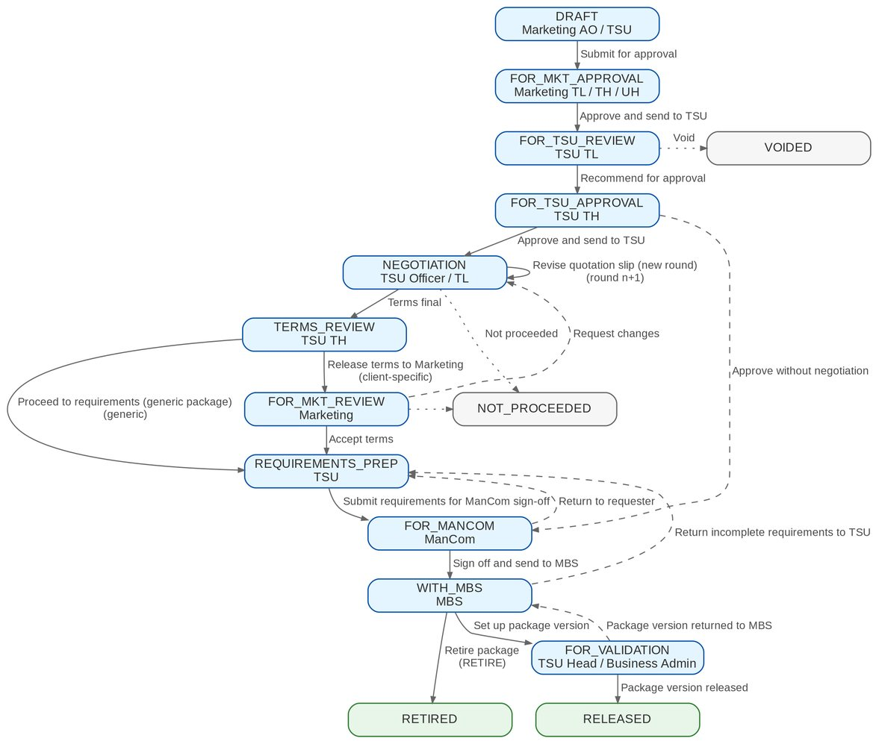
Figure 2: Workflow PM_PACKAGE_REQUEST: stages and actions
Table 9: Stages, owners and SLA
Stage | Owner (permission) | SLA hours (default) | SLA parameter | Business actions
DRAFT | Requester (PKG_REQUEST) | - | - | Save, submit, void
FOR_MKT_APPROVAL | Marketing TL / TH / UH (PKG_REQUEST_APPROVE) | 24 | PKG_SLA_MKT_APPROVAL | Approve, return, void
FOR_TSU_REVIEW | TSU TL (PKG_TSU_RECOMMEND) | 24 | PKG_SLA_TSU_REVIEW | Edit, recommend, return, void
FOR_TSU_APPROVAL | TSU TH (PKG_TSU_APPROVE) | 24 | PKG_SLA_TSU_APPROVAL | Approve, approve without negotiation, return, void
NEGOTIATION | TSU (PKG_NEGOTIATE) | 120 | PKG_SLA_NEGOTIATION | QS, responses, revise QS, terms final, not proceeded
TERMS_REVIEW | TSU TH (PKG_TSU_APPROVE) | 24 | stage setting | Release to Marketing or proceed to requirements
FOR_MKT_REVIEW | Marketing (PKG_REQUEST) | 48 | stage setting | Accept terms, request changes, not proceeded
REQUIREMENTS_PREP | TSU (PKG_NEGOTIATE) | 48 | stage setting | Complete and submit requirements
FOR_MANCOM | ManCom (PKG_MANCOM_SIGNOFF) | 72 | PKG_SLA_MANCOM | Sign off, return
WITH_MBS | MBS (PRODUCT_MAINTAIN) | 48 | PKG_SLA_MBS_SETUP | Set up, return incomplete, retire
FOR_VALIDATION | Validator (PRODUCT_VALIDATE) | 24 | stage setting | Validate and release, return (on the version)
RELEASED | - | terminal | - | Advisory drafted; Marketing notified
RETIRED | - | terminal | - | Retirement advisory
NOT_PROCEEDED | - | terminal | - | -
VOIDED | - | terminal | - | -

5.2 Transitions
Table 10: Transitions of PM_PACKAGE_REQUEST
From | Action | To | Permission | Reason list
DRAFT | Submit for approval | FOR_MKT_APPROVAL | PKG_REQUEST | -
FOR_MKT_APPROVAL | Approve and send to TSU | FOR_TSU_REVIEW | PKG_REQUEST_APPROVE | -
FOR_TSU_REVIEW | Recommend for approval | FOR_TSU_APPROVAL | PKG_TSU_RECOMMEND | -
FOR_TSU_APPROVAL | Approve for negotiation | NEGOTIATION | PKG_TSU_APPROVE | -
FOR_TSU_APPROVAL | Approve without negotiation | FOR_MANCOM | PKG_TSU_APPROVE | -
FOR_MKT_APPROVAL, FOR_TSU_REVIEW, FOR_TSU_APPROVAL | Return to requester | DRAFT | stage owner | RETURN_REASON
DRAFT to FOR_TSU_APPROVAL | Void | VOIDED | requester or stage owner | VOID_REASON
NEGOTIATION | Revise quotation slip (new round) | NEGOTIATION | PKG_NEGOTIATE | -
NEGOTIATION | Terms final | TERMS_REVIEW | PKG_NEGOTIATE | -
NEGOTIATION | Not proceeded | NOT_PROCEEDED | PKG_NEGOTIATE, PKG_TSU_APPROVE | PKG_NOT_PROCEEDED_REASON
TERMS_REVIEW | Release terms to Marketing | FOR_MKT_REVIEW | PKG_TSU_APPROVE | -
TERMS_REVIEW | Proceed to requirements (generic package) | REQUIREMENTS_PREP | PKG_TSU_APPROVE | -
FOR_MKT_REVIEW | Accept terms | REQUIREMENTS_PREP | PKG_REQUEST | -
FOR_MKT_REVIEW | Request changes | NEGOTIATION | PKG_REQUEST | RETURN_REASON
FOR_MKT_REVIEW | Not proceeded | NOT_PROCEEDED | PKG_REQUEST | PKG_NOT_PROCEEDED_REASON
REQUIREMENTS_PREP | Submit requirements for ManCom sign-off | FOR_MANCOM | PKG_NEGOTIATE | -
FOR_MANCOM | Sign off and send to MBS | WITH_MBS | PKG_MANCOM_SIGNOFF | -
FOR_MANCOM | Return to TSU | REQUIREMENTS_PREP | PKG_MANCOM_SIGNOFF | RETURN_REASON
WITH_MBS | Set up package version | FOR_VALIDATION | PRODUCT_MAINTAIN | -
WITH_MBS | Retire package | RETIRED | PRODUCT_MAINTAIN | -
WITH_MBS | Return incomplete requirements to TSU | REQUIREMENTS_PREP | PRODUCT_MAINTAIN | RETURN_REASON
FOR_VALIDATION | Package version released (automatic) | RELEASED | PRODUCT_VALIDATE | -
FOR_VALIDATION | Package version returned to MBS (automatic) | WITH_MBS | PRODUCT_VALIDATE | -

5.3 Package version states
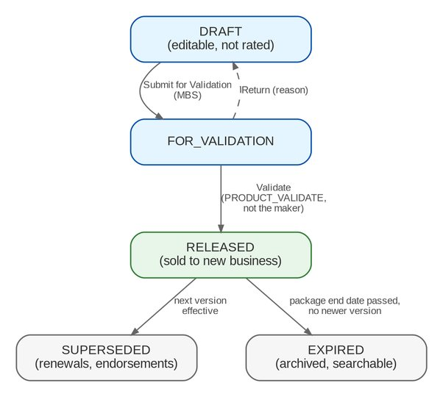
Figure 3: Package version states (catalogue)
Table 11: Version states
State | Meaning | Used for
DRAFT | Being set up by MBS; editable | Nothing; not rated
FOR_VALIDATION | Submitted; waiting for the validator | Nothing; not rated
RELEASED | Validated and in force from its effective date | New business, renewals, endorsements
SUPERSEDED | Ended by a newer released version | Renewals (RENEWAL purpose) and endorsements of accounts sold on it
EXPIRED | Package end date passed with no newer version | Reference only; archived and searchable (BRPM.006)

5.4 SLA and escalation
• SLA hours are held per stage and start when the request enters the stage. The defaults in section 5.1 are placeholders until BDOI answers PQ08. A changed PKG_SLA_* parameter is copied into the stage by the daily job.
• The SLA check marks a request amber from 80% of the stage SLA and red past it. Red requests raise an SLA alert to the stage owners and appear in the red tiles of the Product Maintenance home.
• Escalation beyond the stage owners (for example to the unit head) is not in the BRD and is not proposed (chapter 22, CLR-PM-16).

6 Reports and documents

6.1 Reports
Table 12: Product Maintenance reports
Code | Name | Purpose | BRD
PM-PKG-STATUS | Package Status Update Report | Status of package requests, one or all, with stage age, end date, rates and the last action | BRPM.018
PM-PKG-EXPIRY | Package Expiry Report | Released packages by end date with their renewal status | BRPM.017
PM-VERSION-HISTORY | Package Version History | Every version of the packaged products with validator, dates and change summary | BRPM.006, 007

All three are in the report category New Business, need PKG_REPORT_VIEW, export to PDF, XLSX, ODS and CSV, and support saved variants.

6.1.1 Package Status Update Report (PM-PKG-STATUS)
Parameters: Request No. (individual report); Status (all or one stage); Request Type; Line Code; Insurer Code; Package Ends Within (days). Layout: landscape, one row per request, sorted by request number, with the parameters printed in the report header.
Table 13: PM-PKG-STATUS columns
Column | Format | Content
Request No. | Text | PKR-yyyy-n
Type | Text | Request type
Client / Programme | Text | Client name (client-specific) or "Generic"
Package | Text | Package or programme name
Product | Text | Risk code
Version | Number | Resulting or base version
Stage | Text | Current stage
Days in Stage | Number | Days since stage entry
Package End | Date | Proposed or current package end date
Rate % | Percent | Scheme rate of the proposed terms
Insurers | Text | Chosen or target insurers
Last Action | Text | Last workflow action
On / By | Date / Text | Date and user of the last action

6.1.2 Package Expiry Report (PM-PKG-EXPIRY)
Parameter: Ending Within (days), default 90. Layout: portrait, sorted by package end date.
Table 14: PM-PKG-EXPIRY columns
Column | Format | Content
Product | Text | Risk code
Package | Text | Product name
Version | Number | Version in force
Package End | Date | End date of the version
Days Left | Number | Days from today to the end date
Anniversary | Date | Anniversary date, if any
Renewal Request | Text | Open RENEW / REACTIVATE request, or "None"
Renewal Stage | Text | Stage of that request

6.1.3 Package Version History (PM-VERSION-HISTORY)
Parameter: Product Code (optional). Layout: landscape, grouped by product, versions in ascending order.
Table 15: PM-VERSION-HISTORY columns
Column | Format | Content
Product | Text | Risk code
Version | Number | Version number
Status | Text | Version state
Effective From / Effective To | Date | Period in force
Package End | Date | Package end date
Submitted By / Validated By / Validated On | Text / Date | Checkpoint users and date (PMADD06)
Validation Result | Text | Passed or Returned, with the return reason
Source Request | Text | PKR number that produced the version
Change Summary | Text | Summary entered at set-up

6.2 Documents
Documents are generated from versioned templates (FR-PM-013). The layouts below are the proposed draft layouts; BDOI's own layouts replace them when provided (Q03).
Table 16: Product Maintenance documents
Template | Output | Sections
PKG_REQUEST_FORM | PDF | Header (request no., type, scope, date, requester); client or programme; line, cover type, product; reason; requested terms by section; coverages table (coverage, included, limit, deductible); requested rate scheme and dates; target insurers; approvals with names and dates
PKG_QUOTATION_SLIP | PDF, one per insurer | BDOI letterhead; QS no. and round; insurer; package and line; requested cover by section; coverages table; requested rate and minimum premium; period; reply due date; contact
PKG_COMPARATIVE | PDF and XLSX; MASTER or CLIENT | Title; request and round; one column per insurer; rows per selected field (outcome, rate, minimum premium, coverages, deductibles, conditions, valid until, remarks); lowest rate marked; generated by, date, template version
PKG_SLIP | PDF | Package name and code; insurers with role and share; rate scheme; coverages and insurer terms; clauses; package dates; signature blocks
PKG_ADVISORY | PDF, e-mail and in-app | Advisory type; package and version; effective date; what changed; list of supporting documents; instructions to units
PKG_RENEWAL_ADVISORY | PDF, e-mail and in-app | As PKG_ADVISORY, with the previous and new term dates

7 Interfaces and integration
Figure 4 shows the interfaces of Product Maintenance. Package requests talk to the catalogue only through its published services and events. The catalogue is read by new business, Operations and Renewal.
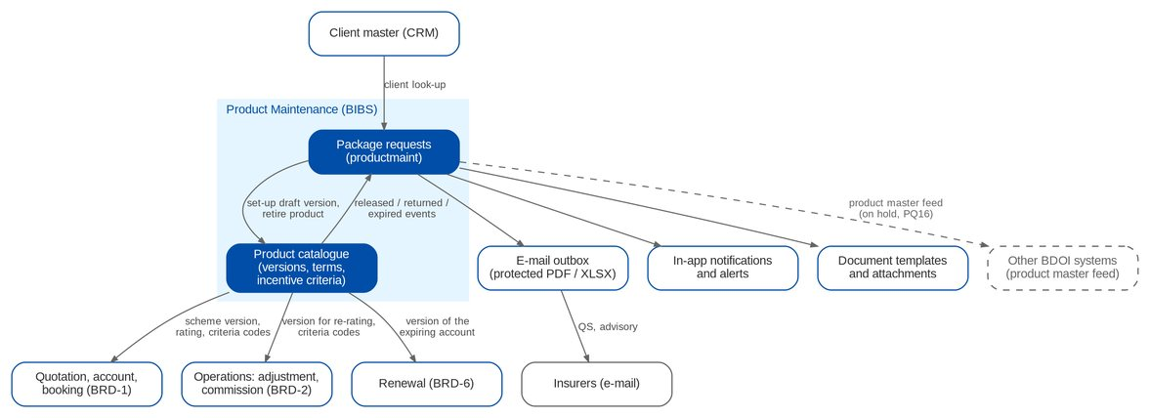
Figure 4: Interfaces of Product Maintenance (dashed = on hold)
Table 17: Interfaces
Interface | Direction | Content and trigger | BRD | Scope
Client master (CRM) | In | Client look-up on client-specific requests | BRPM.008 | IN SCOPE
Catalogue set-up | Out | Draft version from the proposed terms at MBS set-up; retirement | BRPM.015 | IN SCOPE
Catalogue events | In | Version released, returned, product expired | PMADD06, BRPM.017 | IN SCOPE
Outgoing e-mail | Out | Protected QS, comparative outputs and advisories; send log | BRPM.012, 016, 020 | IN SCOPE
Notifications and alerts | Out | Stage entry, SLA, release, expiry, incentive review | BRPM.021, 022 | IN SCOPE
New business (BRD-1) | Out | Scheme version and rating for quotations, accounts and invoices; incentive criteria codes | BRPM.007; PMADD07 | IN SCOPE
Operations (BRD-2) | Out | Version for endorsement re-rating; criteria codes for commission schemes (OQ39) | BRPM.007 | IN SCOPE
Renewal (BRD-6) | Out | Version of the expiring account for Renew As Is | BRPM.007 | IN SCOPE
Other BDOI systems | Out | Product master changes; BIBS records each change for the transfer | BRPM.022 | ON HOLD
Insurer portals | Out | Not requested; insurers are reached by e-mail | BRPM.012 | OUT

On hold until BDOI answers PQ16. BRPM.022 asks for data "synchronized with BDOI systems". The systems, format and timing are not in the BRD (PQ16). BIBS records every release and expiry in the product master log; the transfer to the systems BDOI names is added without a change to the package workflow.

8 Non-functional requirements
Table 18: Non-functional requirements (BRD p.33)
Topic | BRD value | BIBS target and approach
Users | Marketing 485 max / 145 concurrent; MBS 5 / 5; TSU 13 / 13 | Within the BRD-1 sizing (150 concurrent + 20% a year); the Marketing figures equal BRD-1's (PQ18)
Volumes | Not stated | Assumed tens of package requests a month; no special sizing
Response time | Under 5 seconds for every role | Online p95 under 3 seconds; documents and e-mails generated asynchronously
Peak | 15th and 30th of the month; 08:00-17:30 | Expiry monitor and version lifecycle run at 01:00
Availability | 99.9%; use 07:00-18:30; maintenance per bank standard | Same deployment as BRD-1 (window 07:00-22:00 governs, OQ44)
Recovery | RTO 4 hours, RPO 24 hours | Platform backup and recovery; one BIBS-wide NFR set is being agreed (XQ08)
Devices | Same performance on mobile and desktop | Responsive screens
Security | Authorised users only; protected documents | Role-based access, four-eyes rules, protected e-mails (FR-PM-002, 004)
Audit | All actions logged | Audit trail and workflow history that no user can change (FR-PM-005)
Retention | Not stated | BRD-1 rule (5 years online, 15 years archive); product versions never purged (PQ18)

9 Configuration items owned by the System Administrator
The items below are changed in BIBS without a release. Changes to parameters and lists are audited.

9.1 Parameters
Table 19: Product Maintenance parameters
Parameter | Default | Meaning
PKG_REQUEST_PREFIX | PKR- | Prefix of package request numbers; the year is appended (PKR-yyyy-n)
PKG_QS_PREFIX | PQS- | Prefix of quotation slip numbers (PQS-yyyy-n)
PKG_QS_REPLY_DAYS | 5 | Days insurers have to reply to a QS (1-60)
PACKAGE_EXPIRY_NOTICE_DAYS | 60 | Days before the package end date of the first expiry alert (1-365)
PACKAGE_EXPIRY_REMINDER_DAYS | 30,7 | Days of the further expiry reminders
PACKAGE_RENEWAL_AUTODRAFT | false | The expiry monitor drafts renewal requests at the notice period
PKG_ADVISORY_GROUPS | MARKETING, TSU, MBS, OPERATIONS | Default recipient groups of an advisory
PKG_SLA_MKT_APPROVAL | 24 | SLA hours of the Marketing approval
PKG_SLA_TSU_REVIEW | 24 | SLA hours of the TSU TL review
PKG_SLA_TSU_APPROVAL | 24 | SLA hours of the TSU Head approval
PKG_SLA_NEGOTIATION | 120 | SLA hours of the negotiation stage
PKG_SLA_MANCOM | 72 | SLA hours of the ManCom sign-off
PKG_SLA_MBS_SETUP | 48 | SLA hours of the MBS set-up
Job schedule (package expiry) | 01:00 PHT daily | Time of PACKAGE_EXPIRY_MONITOR and PACKAGE_VERSION_LIFECYCLE

9.2 Lists of values
Table 20: Lists of values
List | Values delivered
PKG_REQUEST_TYPE | New package; Amend package terms; Update package details; Renew package; Retire package; Reactivate expired package
PKG_REQUEST_REASON | Client requirement; New programme for a market segment; Market competitiveness; Change in insurer terms or rates; Loss experience; Regulatory change; Package expiry or anniversary; Others (see comment)
PKG_RESPONSE_OUTCOME | Pending; Accepted as requested; Approved with changes; Counter-proposal; Declined; No response
PKG_ADVISORY_GROUP | Marketing; Technical Support Unit; Marketing Business Services; Processing; Operations
PKG_NOT_PROCEEDED_REASON | Declined by the insurers; Negotiated terms not accepted; Client withdrew the request; Business decision; Others (see comment)
INCENTIVE_TYPE | Others (see description); Migrated (from the booking incentive rules). Types to be supplied by BDOI (PQ04)
COVERAGE_KIND | Section; Coverage; Peril; Extension
CLAUSE_KIND | Warranty; Clause; Exclusion; Deductible wording
DOCUMENT_TYPE (Product Maintenance values) | PKG_REQUEST_FORM; PKG_QUOTATION_SLIP; PKG_INSURER_RESPONSE; PKG_COMPARATIVE; PKG_SLIP_SIGNED; MANCOM_SIGNOFF; PKG_ADVISORY
RETURN_REASON, VOID_REASON | Shared platform lists

9.3 Masters and rules maintained by the business
Table 21: Masters and rules
Item | Maintained by (authorised by) | FR
Product lines, cover types and subtypes, code patterns | MBS (PRODUCT_AUTHORIZE) | FR-PM-010
Coverages / perils | MBS (PRODUCT_AUTHORIZE) | FR-PM-010
Clause library | MBS (PRODUCT_AUTHORIZE) | FR-PM-011
Field rules (presence, list, range, pattern) | MBS (PRODUCT_AUTHORIZE) | FR-PM-012
Document templates | System Administrator | FR-PM-013
Package versions and insurer terms | MBS (validated by PRODUCT_VALIDATE) | FR-PM-014, 043, 050
Rate-scheme exceptions | Requester (PRODUCT_AUTHORIZE) | FR-PM-051
Incentive criteria | Incentive Maintenance user (PRODUCT_AUTHORIZE) | FR-PM-080
Roles and permissions | Business Administrator via access request (approver) | FR-PM-003
Validation checklist | Change request until PQ09 is answered | FR-PM-043

10 Assumptions, dependencies and open questions

10.1 Assumptions
Table 22: Assumptions
ID | Assumption | Related
A-PM-01 | The final main BRD (pp.10-35) and the addendum (pp.1-9) are the baseline; the earlier version (pp.36-61) is used only to trace changes | R1-R3
A-PM-02 | A package is a catalogue product flagged as packaged, generic for a segment or client-specific; each package has its own risk code | PQ01
A-PM-03 | Any one of Marketing TL, TH or UH approves a request | PQ08
A-PM-04 | One ManCom member's sign-off completes the ManCom step | PQ07
A-PM-05 | "Deletion" in BRPM.011 means retirement; records are never deleted | PQ13
A-PM-06 | Maintenance of non-package products is out of scope in this phase | PQ19
A-PM-07 | BRPM.023 does not exist in either BRD version; no requirement is missing | PQ20
A-PM-08 | Package request volume is low (tens a month) | PQ18

10.2 Dependencies
Table 23: Dependencies
ID | Dependency | Needed for
D-PM-01 | BDOI provides the product matrix content: subtypes, coverages per line, naming convention | FR-PM-010 (Q01, Q02, PQ02)
D-PM-02 | BDOI provides the document layouts and the password convention | FR-PM-004, 013 (Q03, Q07, PQ21)
D-PM-03 | BDOI defines CPC2 and the other incentive criteria | FR-PM-080 (PQ04)
D-PM-04 | BDOI names the systems that receive product master changes | FR-PM-072 (PQ16)
D-PM-05 | BRD-6 Renewal passes the expiring account's version on Renew As Is | FR-PM-051 (PQ11)
D-PM-06 | The e-mail relay of the BIBS environment is available for insurer e-mails | FR-PM-030, 044

10.3 Open questions
Table 24: Open questions on BRD-3 (status from the cross-BRD decisions, R6)
ID | Question | Affects | Status
PQ02 | Subline / type / subtype values and coverage / peril list per line; naming convention for product codes | FR-PM-010 | OPEN
PQ03 | Which attributes vary by insurer in a package; co-insurance shares | FR-PM-014 | OPEN
PQ04 | Definition of CPC2 and other criteria; required attributes; who is the Incentive Maintenance user | FR-PM-080, 081 | OPEN
PQ05 | Full list of negotiation outcomes; maximum rounds; apply PMADD03/04 to non-package PRFs | FR-PM-031, 032 | OPEN
PQ06 | Fields of client views; client layout; who generates client outputs | FR-PM-035 | OPEN
PQ07 | ManCom membership, quorum, in-system versus signed sheet, SLA | FR-PM-041 | OPEN
PQ08 | Approval chain by segment or amount; QS co-officer; SLA of each stage | FR-PM-021, 030, 073 | OPEN
PQ09 | Validator role (TSU Head, Business Administrator or either); checklist content | FR-PM-043 | OPEN
PQ10 | Scope of a rate scheme (statutory rates?); approver of non-current rates; manual item rates on packages | FR-PM-051 | PARTIAL
PQ11 | Meaning of package expiry / anniversary; notice period; automatic renewal drafts | FR-PM-060, 061 | PARTIAL
PQ12 | Content of the requirements pack; formulas beyond the three rating methods; advisory recipients and channel | FR-PM-040, 042, 044 | OPEN
PQ14 | Mandatory fields of the Package Request Form; client for generic programmes | FR-PM-020 | OPEN
PQ15 | Name and columns of the BRPM.018 report | FR-PM-071 | OPEN
PQ16 | Systems that receive product master changes; format and timing | FR-PM-072 | OPEN
PQ17 | Final role-to-action matrix; approval of role changes | FR-PM-002, 003 | ANSWERED
PQ18 | Volumes, growth, availability window and retention | Section 8 | OPEN
PQ21 | Which documents leave BDOI and the password convention | FR-PM-004 | PARTIAL

PQ01, PQ13, PQ19 and PQ20 are covered by assumptions A-PM-02, A-PM-05, A-PM-06 and A-PM-07; BDOI confirms them with the sign-off of this document.

11 Traceability
Every BRD-3 requirement is met by at least one FR. The screen column names the main screen; the test cases are listed by test condition (TC-PM-nnn.n), and the test plan workbook lists each case.
Table 25: BRD ID to FR, screen and test cases
BRD ID | FR | Screen | Test cases
BRPM.001 | FR-PM-001 | Login | TC-PM-001.1, 001.2, 001.3, 001.4 (6 cases)
BRPM.002 | FR-PM-002 | All; User Access Matrix | TC-PM-002.1, 002.2, 002.3, 002.4 (6 cases)
BRPM.003 | FR-PM-012 | Product page (Field Rules) | TC-PM-012.1, 012.3, 012.4 (4 cases)
BRPM.004 | FR-PM-012 | Product page (Field Rules) | TC-PM-012.1, 012.2, 012.3 (3 cases)
BRPM.005 | FR-PM-013 | Package Request page (downloads) | TC-PM-013.1, 013.2, 013.3 (3 cases)
BRPM.006 | FR-PM-052, FR-PM-045, FR-PM-071 | Products (Expired / Retired) | TC-PM-045.1, 045.2, 045.3, 052.1, 052.2, 052.3, 071.1, 071.2, 071.3 (14 cases)
BRPM.007 | FR-PM-050, FR-PM-051 | Package Version; Quotation; Premium Calculator | TC-PM-050.1, 050.2, 050.3, 051.1, 051.2, 051.3, 051.4 (15 cases)
BRPM.008 | FR-PM-020, FR-PM-021 | New Package Request; Package Requests | TC-PM-020.1, 020.2, 020.3, 020.4, 020.5, 021.1, 021.2, 021.3 (16 cases)
BRPM.009 | FR-PM-022, FR-PM-023 | TSU Workbench; Package Request page | TC-PM-022.1, 022.2, 022.3, 023.1, 023.2, 023.3 (9 cases)
BRPM.010 | FR-PM-032, FR-PM-033, FR-PM-036 | Package Request page (Negotiation) | TC-PM-032.1, 032.2, 032.3, 032.4, 033.1, 033.2, 033.3, 036.1, 036.2, 036.3 (16 cases)
BRPM.011 | FR-PM-020, FR-PM-024, FR-PM-045 | Package Requests; TSU Workbench | TC-PM-020.1, 020.2, 020.3, 020.4, 020.5, 024.1, 024.2, 024.3, 024.4, 045.1, 045.2, 045.3 (22 cases)
BRPM.012 | FR-PM-030 | Package Request page (Negotiation) | TC-PM-030.1, 030.2, 030.3, 030.4, 030.5 (7 cases)
BRPM.013 | FR-PM-031, FR-PM-034, FR-PM-036 | Package Request page (Negotiation, Comparative) | TC-PM-031.1, 031.2, 031.3, 034.1, 034.2, 034.3, 034.4, 036.1, 036.2, 036.3 (17 cases)
BRPM.014 | FR-PM-034 | Package Request page (Comparative) | TC-PM-034.1, 034.2, 034.3, 034.4 (5 cases)
BRPM.015 | FR-PM-040, 041, 042, 043 | Requirements & Sign-off; Set-up; Validation Queue | TC-PM-040.1, 040.2, 040.3, 041.1, 041.2, 041.3, 041.4, 042.1, 042.2, 042.3, 042.4, 043.1, 043.2, 043.3, 043.4 (27 cases)
BRPM.016 | FR-PM-044 | Package Request page (Advisories) | TC-PM-044.1, 044.2, 044.3, 044.4 (7 cases)
BRPM.017 | FR-PM-060, FR-PM-061, FR-PM-044 | Package Expiry | TC-PM-044.1, 044.2, 044.3, 044.4, 060.1, 060.2, 060.3, 061.1, 061.2, 061.3 (17 cases)
BRPM.018 | FR-PM-071 | Reports | TC-PM-071.1, 071.2, 071.3 (5 cases)
BRPM.019 | FR-PM-070 | Product Maintenance Home | TC-PM-070.1, 070.2, 070.3 (5 cases)
BRPM.020 | FR-PM-004 | E-mails and Documents tabs | TC-PM-004.1, 004.2, 004.3 (4 cases)
BRPM.021 | FR-PM-073, FR-PM-021 | Workflow panel | TC-PM-021.1, 021.2, 021.3, 073.1, 073.2, 073.3 (10 cases)
BRPM.022 | FR-PM-072 | Notifications | TC-PM-072.1, 072.2 (4 cases)
BRPM.024 | FR-PM-005 | History tabs | TC-PM-005.1, 005.2, 005.3 (3 cases)
PMADD01 | FR-PM-010 | Products; Coverages & Clauses | TC-PM-010.1, 010.2, 010.3, 010.4 (7 cases)
PMADD02 | FR-PM-011, FR-PM-014 | Package Version (Insurer Terms); Coverages & Clauses | TC-PM-011.1, 011.2, 011.3, 014.1, 014.2, 014.3, 014.4 (10 cases)
PMADD03 | FR-PM-035 | Package Request page (Comparative) | TC-PM-035.1, 035.2, 035.3 (5 cases)
PMADD04 | FR-PM-031, FR-PM-032 | Package Request page (Negotiation) | TC-PM-031.1, 031.2, 031.3, 032.1, 032.2, 032.3, 032.4 (11 cases)
PMADD05 | FR-PM-002, FR-PM-003 | User Access Matrix; Access Requests | TC-PM-002.1, 002.2, 002.3, 002.4, 003.1, 003.2, 003.3, 003.4 (12 cases)
PMADD06 | FR-PM-043 | Validation Queue; Package Version | TC-PM-043.1, 043.2, 043.3, 043.4 (9 cases)
PMADD07 | FR-PM-080, FR-PM-081 | Incentive Criteria | TC-PM-080.1, 080.2, 080.3, 080.4, 081.1, 081.2, 081.3 (15 cases)
PMADD08 | FR-PM-080, FR-PM-081 | Incentive Criteria | TC-PM-080.1, 080.2, 080.3, 080.4, 081.1, 081.2, 081.3 (15 cases)

12 Navigation
This chapter shows how each Product Maintenance user reaches the screens. The sidebar shows a screen only when the user's role holds its permission (section 3.2), so each persona sees a different menu. The tables follow the proposed role grants.

12.1 Screens of Product Maintenance
The 22 screens specified in chapter 13, with the menu path and the roles that can open them. A screen without its own menu entry (a record, a form, a tab of a record) is reached from the screen before it; its path ends with that screen. The package request record is specified in five parts (SCR-PM-04 to SCR-PM-08) because its tabs are worked by different teams.
Table 26: Product Maintenance screens
ID | Screen | Menu path | Personas (role codes)
SCR-PM-01 | Product Maintenance Home | Client & Policy › Product Maintenance › Product Maintenance Home | MKT_AO, MKT_TL, TSU, TSU_TL, TSU_HEAD, MBS, MANCOM, BUSINESS_ADMIN, NB_APPROVER, SYSADMIN, AUDITOR
SCR-PM-02 | Package Requests | Client & Policy › Product Maintenance › Package Requests | MKT_AO, MKT_TL, TSU, TSU_TL, TSU_HEAD, MBS, MANCOM, BUSINESS_ADMIN, NB_APPROVER, SYSADMIN, AUDITOR
SCR-PM-03 | New Package Request and Edit Package Request | Client & Policy › Product Maintenance › Package Requests › New Package Request | MKT_AO, MKT_TL, TSU
SCR-PM-04 | Package Request record | Client & Policy › Product Maintenance › Package Requests › Package Request | MKT_AO, MKT_TL, TSU, TSU_TL, TSU_HEAD, MBS, MANCOM, BUSINESS_ADMIN, NB_APPROVER, SYSADMIN, AUDITOR
SCR-PM-05 | Package Request record: Negotiation tab | Client & Policy › Product Maintenance › Package Requests › Package Request | MKT_AO, MKT_TL, TSU, TSU_TL, TSU_HEAD, MBS, MANCOM, BUSINESS_ADMIN, NB_APPROVER, SYSADMIN, AUDITOR
SCR-PM-06 | Package Request record: Comparative tab | Client & Policy › Product Maintenance › Package Requests › Package Request | MKT_AO, MKT_TL, TSU, TSU_TL, TSU_HEAD, MBS, MANCOM, BUSINESS_ADMIN, NB_APPROVER, SYSADMIN, AUDITOR
SCR-PM-07 | Package Request record: Requirements & Sign-off tab | Client & Policy › Product Maintenance › Package Requests › Package Request | MKT_AO, MKT_TL, TSU, TSU_TL, TSU_HEAD, MBS, MANCOM, BUSINESS_ADMIN, NB_APPROVER, SYSADMIN, AUDITOR
SCR-PM-08 | Package Request record: Set-up and Advisories tabs | Client & Policy › Product Maintenance › Package Requests › Package Request | MKT_AO, MKT_TL, TSU, TSU_TL, TSU_HEAD, MBS, MANCOM, BUSINESS_ADMIN, NB_APPROVER, SYSADMIN, AUDITOR
SCR-PM-09 | TSU Workbench | Client & Policy › Product Maintenance › TSU Workbench | TSU, TSU_TL, TSU_HEAD
SCR-PM-10 | Package Expiry | Client & Policy › Product Maintenance › Package Expiry | MKT_TL, TSU, TSU_TL, TSU_HEAD, MBS, BUSINESS_ADMIN, AUDITOR
SCR-PM-11 | Products | Client & Policy › Product Maintenance › Products | MKT_AO, MKT_TL, TSU, TSU_TL, TSU_HEAD, MBS, MANCOM, BUSINESS_ADMIN, NB_APPROVER, SYSADMIN, AUDITOR
SCR-PM-12 | Product record | Client & Policy › Product Maintenance › Products › Product | MKT_AO, MKT_TL, TSU, TSU_TL, TSU_HEAD, MBS, MANCOM, BUSINESS_ADMIN, NB_APPROVER, SYSADMIN, AUDITOR
SCR-PM-13 | Package Version | Client & Policy › Product Maintenance › Product › Package Version | MKT_AO, MKT_TL, TSU, TSU_TL, TSU_HEAD, MBS, MANCOM, BUSINESS_ADMIN, NB_APPROVER, SYSADMIN, AUDITOR
SCR-PM-14 | Validation Queue | Client & Policy › Product Maintenance › Validation Queue | TSU_HEAD, BUSINESS_ADMIN
SCR-PM-15 | Coverages & Clauses | Client & Policy › Product Maintenance › Coverages & Clauses | MKT_AO, MKT_TL, TSU, TSU_TL, TSU_HEAD, MBS, MANCOM, BUSINESS_ADMIN, NB_APPROVER, SYSADMIN, AUDITOR
SCR-PM-16 | Incentive Criteria | Client & Policy › Product Maintenance › Incentive Criteria | MKT_AO, MKT_TL, TSU, TSU_TL, TSU_HEAD, MBS, MANCOM, BUSINESS_ADMIN, NB_APPROVER, SYSADMIN, AUDITOR
SCR-PM-17 | Insurers | Client & Policy › Product Maintenance › Insurers | MBS, BUSINESS_ADMIN, NB_APPROVER, SYSADMIN, AUDITOR
SCR-PM-18 | Insurer record | Client & Policy › Product Maintenance › Insurers › Insurer | MBS, BUSINESS_ADMIN, NB_APPROVER, SYSADMIN, AUDITOR
SCR-PM-19 | Rates & Taxes | Client & Policy › Product Maintenance › Rates & Taxes | MBS, BUSINESS_ADMIN, NB_APPROVER, SYSADMIN, AUDITOR
SCR-PM-20 | Sales Organisation | Client & Policy › Product Maintenance › Sales Organisation | MBS, BUSINESS_ADMIN, NB_APPROVER, SYSADMIN, AUDITOR
SCR-PM-21 | Premium Calculator | Client & Policy › Product Maintenance › Premium Calculator | MKT_AO, MKT_TL, TSU, NB_APPROVER, AUDITOR
SCR-PM-22 | Quotation: package rate scheme and rate exception | Client & Policy › Quotation / Proposal › Quotations › Quotation | MKT_AO, MKT_TL, TSU, NB_APPROVER, AUDITOR

12.2 Screen flow
How the screens link: from a list to its record, from a record action to the next screen, and from the package request to the catalogue version and to New Business pricing. The walkthroughs of chapter 14 follow these links with real steps.
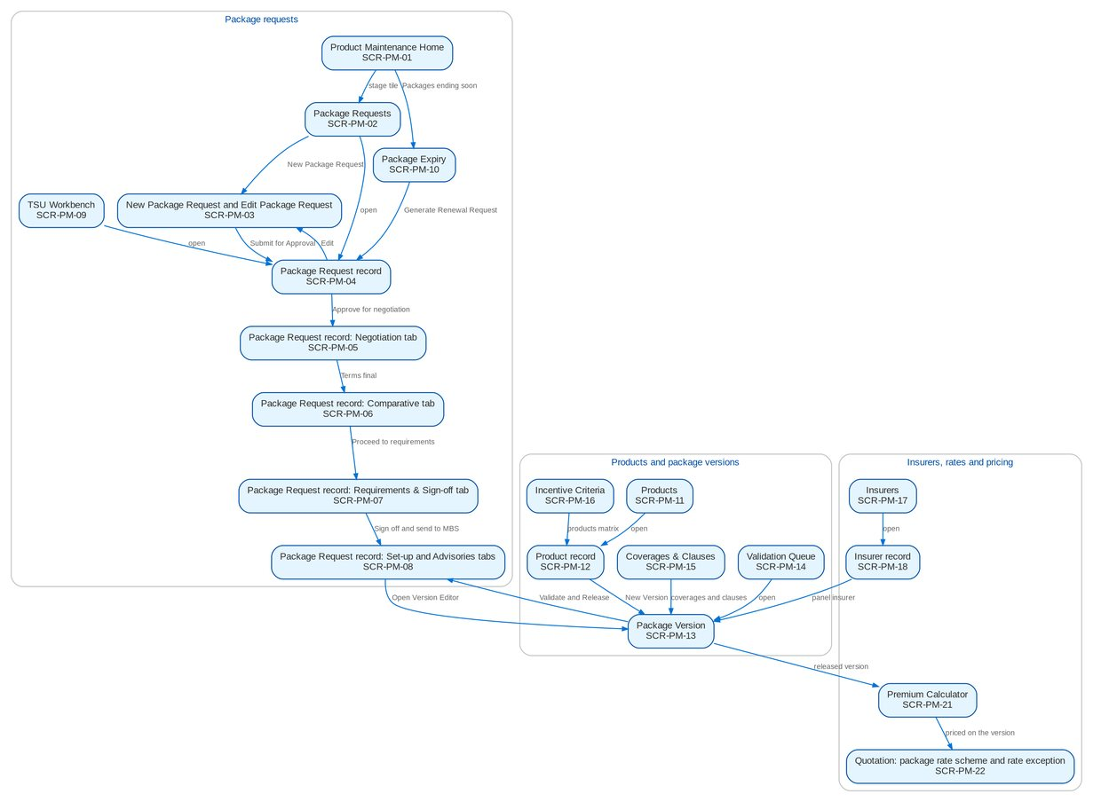
Figure 5: Screen flow of Product Maintenance: how the screens link (list, record, action, next screen)

12.3 Menu by persona
For each Product Maintenance persona, the SIT and UAT user of the seed data and the sidebar that user sees, section by section. The BRD column shows which BRD owns a section; entries of other BRDs are listed so the business unit sees the whole menu of its users.

12.3.1 Marketing Account Officer (MKT_AO)
SIT/UAT user ao. 61 menu entries, 6 of them Product Maintenance screens; the other entries belong to the BRD shown.
Table 27: Sidebar of the Marketing Account Officer
Group | Section | Screens | BRD
Home | Overview | My Approvals | Platform
Home | New Business Dashboard | NB Dashboard | BRD-1
Home | My Work | My Work | BRD-1
Client & Policy | Clients | Clients, New Client, KYC Reviews Due | BRD-1
Client & Policy | Quotation / Proposal | Quotations, New Quotation, Quotation Requests | BRD-1
Client & Policy | Accounts & Placement | Accounts, New Account, FFY Register, Direct Payment | BRD-1
Client & Policy | Non-Package Management | Proposal Requests, New Proposal Request | BRD-1
Client & Policy | Placement & Booking | Placement Workbench, Placement Slips | BRD-1
Client & Policy | Policy Issuance | Issuance Workbench, Insurance Advice | BRD-1
Client & Policy | Renewal | Renewal Home, Expiry List, My Dispositions, Transfers, Letters | BRD-6
Client & Policy | Submitted Policies | Submitted Policies Home, Masterlist, Extraction Review, Processing Runs, Reviews & IAAF, Terms of Reference, Renewal Work List | -
Client & Policy | Product Maintenance | Product Maintenance Home, Package Requests, Products, Coverages & Clauses, Incentive Criteria, Premium Calculator | BRD-3
Client & Policy | Bulk Processing | Bulk Uploads | BRD-1
Operations | Operations | Operations Home, Invoice Search, Hand-offs and Extracts, Notification Settings | BRD-2
Finance | Collections | Collections Home, PR Worklist, Installment Plans, Installments Due, Promises to Pay, Escalations, Billing Statements, Unapplied Payments, Requests to Cashiering, Collections Files | BRD-4
Finance | Refund & Cash Advance Requests | Requests Home, New Refund Request, New Cash Advance, Cancel a Check | BRD-5
Claims & Insurance | Claims Handling | Claims Reports | BRD-7
Reports | New Business Reports | New Business Reports | BRD-1
Reports | Reports | Report Centre | Platform
Setup & Administration | Help | Help Center, My Profile | Platform

12.3.2 Marketing TL / TH / UH (MKT_TL)
SIT/UAT user mkttl. 72 menu entries, 7 of them Product Maintenance screens; the other entries belong to the BRD shown.
Table 28: Sidebar of the Marketing TL / TH / UH
Group | Section | Screens | BRD
Home | Overview | My Approvals | Platform
Home | New Business Dashboard | NB Dashboard | BRD-1
Home | My Work | My Work | BRD-1
Client & Policy | Clients | Clients, New Client, KYC Reviews Due | BRD-1
Client & Policy | Quotation / Proposal | Quotations, New Quotation, Quotation Requests | BRD-1
Client & Policy | Accounts & Placement | Accounts, New Account, FFY Register, Direct Payment | BRD-1
Client & Policy | Non-Package Management | Proposal Requests, New Proposal Request | BRD-1
Client & Policy | Placement & Booking | Placement Workbench, Placement Slips | BRD-1
Client & Policy | Policy Issuance | Issuance Workbench, Insurance Advice | BRD-1
Client & Policy | Renewal | Renewal Home, Expiry List, My Dispositions, TL Review, Transfers, Letters | BRD-6
Client & Policy | Submitted Policies | Submitted Policies Home, Masterlist, Processing Runs, Reviews & IAAF, Terms of Reference, Renewal Work List, Submitted Policies Setup | -
Client & Policy | Adjustment | Adjustment Workbench, New Request | BRD-2
Client & Policy | Product Maintenance | Product Maintenance Home, Package Requests, Package Expiry, Products, Coverages & Clauses, Incentive Criteria, Premium Calculator | BRD-3
Client & Policy | Bulk Processing | Bulk Uploads | BRD-1
Operations | Operations | Operations Home, Invoice Search, Hand-offs and Extracts, Report Archive, Notification Settings | BRD-2
Finance | Collections | Collections Home, PR Worklist, Installment Plans, Installments Due, Promises to Pay, Escalations, Escalation Rules, Billing Statements, Unapplied Payments, Requests to Cashiering, Assignments, Collections Files | BRD-4
Finance | Cashiering | Cashiering Workbench, BIR 2307 | BRD-2
Finance | Remittance | Remittance Workbench, Remittance Holds, Special Remittance | BRD-2
Finance | Refund & Cash Advance Requests | Requests Home, Liquidation Accounts | BRD-5
Claims & Insurance | Claims Handling | Claims Reports | BRD-7
Reports | New Business Reports | New Business Reports, Production Targets | BRD-1
Reports | Reports | Report Centre | Platform
Setup & Administration | Help | Help Center, My Profile | Platform

12.3.3 TSU Officer (TSU)
SIT/UAT user tsu. 29 menu entries, 8 of them Product Maintenance screens; the other entries belong to the BRD shown.
Table 29: Sidebar of the TSU Officer
Group | Section | Screens | BRD
Home | Overview | My Approvals | Platform
Home | New Business Dashboard | NB Dashboard | BRD-1
Home | My Work | My Work | BRD-1
Client & Policy | Clients | Clients, KYC Reviews Due | BRD-1
Client & Policy | Quotation / Proposal | Quotations, Quotation Requests | BRD-1
Client & Policy | Accounts & Placement | Accounts, FFY Register, Direct Payment | BRD-1
Client & Policy | Non-Package Management | Proposal Requests, TSU Workbench | BRD-1
Client & Policy | Placement & Booking | Placement Workbench, Placement Slips | BRD-1
Client & Policy | Policy Issuance | Issuance Workbench, Insurance Advice | BRD-1
Client & Policy | Submitted Policies | Terms of Reference | -
Client & Policy | Product Maintenance | Product Maintenance Home, Package Requests, TSU Workbench, Package Expiry, Products, Coverages & Clauses, Incentive Criteria, Premium Calculator | BRD-3
Reports | New Business Reports | New Business Reports | BRD-1
Reports | Reports | Report Centre | Platform
Setup & Administration | Help | Help Center, My Profile | Platform

12.3.4 TSU Team Lead (TSU_TL)
SIT/UAT user tsulead. 17 menu entries, 7 of them Product Maintenance screens; the other entries belong to the BRD shown.
Table 30: Sidebar of the TSU Team Lead
Group | Section | Screens | BRD
Home | Overview | My Approvals | Platform
Home | New Business Dashboard | NB Dashboard | BRD-1
Home | My Work | My Work | BRD-1
Client & Policy | Clients | Clients, KYC Reviews Due | BRD-1
Client & Policy | Product Maintenance | Product Maintenance Home, Package Requests, TSU Workbench, Package Expiry, Products, Coverages & Clauses, Incentive Criteria | BRD-3
Reports | New Business Reports | New Business Reports, Production Targets | BRD-1
Reports | Reports | Report Centre | Platform
Setup & Administration | Help | Help Center, My Profile | Platform

12.3.5 TSU Head (TSU_HEAD)
SIT/UAT user tsuhead. 18 menu entries, 8 of them Product Maintenance screens; the other entries belong to the BRD shown.
Table 31: Sidebar of the TSU Head
Group | Section | Screens | BRD
Home | Overview | My Approvals | Platform
Home | New Business Dashboard | NB Dashboard | BRD-1
Home | My Work | My Work | BRD-1
Client & Policy | Clients | Clients, KYC Reviews Due | BRD-1
Client & Policy | Product Maintenance | Product Maintenance Home, Package Requests, TSU Workbench, Package Expiry, Products, Validation Queue, Coverages & Clauses, Incentive Criteria | BRD-3
Reports | New Business Reports | New Business Reports, Production Targets | BRD-1
Reports | Reports | Report Centre | Platform
Setup & Administration | Help | Help Center, My Profile | Platform

12.3.6 Marketing Business Services (MBS)
SIT/UAT user mbs. 43 menu entries, 9 of them Product Maintenance screens; the other entries belong to the BRD shown.
Table 32: Sidebar of the Marketing Business Services
Group | Section | Screens | BRD
Home | Overview | My Approvals | Platform
Home | New Business Dashboard | NB Dashboard | BRD-1
Home | My Work | My Work | BRD-1
Client & Policy | Clients | Clients, KYC Reviews Due | BRD-1
Client & Policy | Booking | Booking Setup | BRD-1
Client & Policy | Product Maintenance | Product Maintenance Home, Package Requests, Package Expiry, Products, Coverages & Clauses, Incentive Criteria, Insurers, Rates & Taxes, Sales Organisation | BRD-3
Finance | General Ledger | Chart of Accounts, Financial Periods | BRD-5
Finance | Payables & Cash | Bank Accounts | BRD-5
Finance | Assets & Investments | Asset Categories, Asset Register, Depreciation Run, Investment Portfolios, Investments, Accrual & Amortization, Maturities & Sales | BRD-5
Finance | Accounting Engine | Event Types, Accounting Rules, Rule Simulator | BRD-5
Reports | New Business Reports | New Business Reports, Production Targets | BRD-1
Reports | Reports | Report Centre | Platform
Setup & Administration | Broking Setup | Data Retention, Document Templates | BRD-1
Setup & Administration | Setup | Companies, Branches, Currencies & Rates, Dimensions, Business Partners, Employees, Cost-Centre Rules, Holiday Calendar | Platform
Setup & Administration | Help | Help Center, My Profile | Platform

12.3.7 ManCom member (MANCOM)
SIT/UAT user mancom. 14 menu entries, 5 of them Product Maintenance screens; the other entries belong to the BRD shown.
Table 33: Sidebar of the ManCom member
Group | Section | Screens | BRD
Home | Overview | My Approvals | Platform
Home | New Business Dashboard | NB Dashboard | BRD-1
Home | My Work | My Work | BRD-1
Client & Policy | Clients | Clients, KYC Reviews Due | BRD-1
Client & Policy | Product Maintenance | Product Maintenance Home, Package Requests, Products, Coverages & Clauses, Incentive Criteria | BRD-3
Reports | New Business Reports | New Business Reports | BRD-1
Reports | Reports | Report Centre | Platform
Setup & Administration | Help | Help Center, My Profile | Platform

12.3.8 Business Administrator (BUSINESS_ADMIN)
SIT/UAT user badmin. 80 menu entries, 10 of them Product Maintenance screens; the other entries belong to the BRD shown.
Table 34: Sidebar of the Business Administrator
Group | Section | Screens | BRD
Home | Overview | My Approvals | Platform
Home | New Business Dashboard | NB Dashboard | BRD-1
Home | My Work | My Work | BRD-1
Client & Policy | Employee Benefits | EB Home, Programmes, Member Changes, Pending Items, EB Setup | BRD-8
Client & Policy | Booking | Booking Setup | BRD-1
Client & Policy | Renewal | Renewal Home, Expiry List, Renewal Setup | BRD-6
Client & Policy | Product Maintenance | Product Maintenance Home, Package Requests, Package Expiry, Products, Validation Queue, Coverages & Clauses, Incentive Criteria, Insurers, Rates & Taxes, Sales Organisation | BRD-3
Client & Policy | Bulk Processing | Bulk Uploads | BRD-1
Operations | Operations | Operations Home, Invoice Search, Hand-offs and Extracts, Interfaces, Notification Settings | BRD-2
Finance | Collections | Collections Home, PR Worklist, Installment Plans, Installments Due, Promises to Pay, Escalations, Escalation Rules, Billing Statements, Unapplied Payments, Requests to Cashiering, Collections Setup | BRD-4
Finance | Accounting Reports | Account Schedules | BRD-5
Finance | General Ledger | Chart of Accounts, Financial Periods | BRD-5
Finance | Payables & Cash | Bank Accounts | BRD-5
Finance | Assets & Investments | Asset Categories, Asset Register, Depreciation Run, Investment Portfolios, Investments, Accrual & Amortization, Maturities & Sales | BRD-5
Finance | Accounting Engine | Event Types, Accounting Rules, Rule Simulator | BRD-5
Reports | New Business Reports | New Business Reports, Production Targets | BRD-1
Reports | Reports | Report Centre | Platform
Setup & Administration | Broking Setup | Lists of Values, Data Retention, Document Templates, Outbound Messages | BRD-1
Setup & Administration | Setup | Companies, Branches, Currencies & Rates, Dimensions, Business Partners, Employees, Cost-Centre Rules, Holiday Calendar | Platform
Setup & Administration | User Access | Access Requests, Group Profile Requests, Bulk Request, User Access Matrix, Separation of Duties, User Access Reports | BRD-11
Setup & Administration | Administration | Audit Trail, System Parameters, Scheduled Jobs, Application Info | Platform / BRD-11
Setup & Administration | Help | Help Center, My Profile | Platform

12.3.9 New Business Approver (NB_APPROVER)
SIT/UAT user approver. 59 menu entries, 9 of them Product Maintenance screens; the other entries belong to the BRD shown.
Table 35: Sidebar of the New Business Approver
Group | Section | Screens | BRD
Home | Overview | My Approvals | Platform
Home | New Business Dashboard | NB Dashboard | BRD-1
Home | My Work | My Work | BRD-1
Client & Policy | Clients | Clients, KYC Reviews Due | BRD-1
Client & Policy | Quotation / Proposal | Quotations, Quotation Requests | BRD-1
Client & Policy | Accounts & Placement | Accounts, FFY Register, Direct Payment | BRD-1
Client & Policy | Placement & Booking | Placement Workbench, Placement Slips | BRD-1
Client & Policy | Policy Issuance | Issuance Workbench, Insurance Advice | BRD-1
Client & Policy | Booking | Booking Setup | BRD-1
Client & Policy | Product Maintenance | Product Maintenance Home, Package Requests, Products, Coverages & Clauses, Incentive Criteria, Insurers, Rates & Taxes, Sales Organisation, Premium Calculator | BRD-3
Finance | Collections | Escalation Rules | BRD-4
Finance | Cashiering | Receipt Series | BRD-2
Finance | General Ledger | Chart of Accounts, Financial Periods | BRD-5
Finance | Payables & Cash | Bank Accounts | BRD-5
Finance | Assets & Investments | Asset Categories, Asset Register, Depreciation Run, Investment Portfolios, Investments, Accrual & Amortization, Maturities & Sales | BRD-5
Finance | Accounting Engine | Event Types, Accounting Rules, Rule Simulator | BRD-5
Reports | New Business Reports | New Business Reports, Production Targets | BRD-1
Reports | Reports | Report Centre | Platform
Setup & Administration | Broking Setup | Lists of Values, Data Retention, Document Templates | BRD-1
Setup & Administration | Setup | Companies, Branches, Currencies & Rates, Dimensions, Business Partners, Employees, Cost-Centre Rules, Holiday Calendar | Platform
Setup & Administration | User Access | Access Requests, Group Profile Requests, Bulk Request, User Access Matrix | BRD-11
Setup & Administration | Help | Help Center, My Profile | Platform

12.3.10 System Administrator (SYSADMIN)
SIT/UAT user admin. 116 menu entries, 8 of them Product Maintenance screens; the other entries belong to the BRD shown.
Table 36: Sidebar of the System Administrator
Group | Section | Screens | BRD
Home | Overview | My Approvals, Dashboard, Alerts | Platform
Home | New Business Dashboard | NB Dashboard | BRD-1
Home | My Work | My Work | BRD-1
Client & Policy | Sanction Screening | Screening Home, Cases, Matches, Screening Runs, High-risk Clients | BRD-10
Client & Policy | Employee Benefits | EB Home, Programmes, Member Changes, Pending Items | BRD-8
Client & Policy | Booking | Booking Setup | BRD-1
Client & Policy | Product Maintenance | Product Maintenance Home, Package Requests, Products, Coverages & Clauses, Incentive Criteria, Insurers, Rates & Taxes, Sales Organisation | BRD-3
Client & Policy | Bulk Processing | Bulk Uploads | BRD-1
Operations | Operations | Operations Home, Invoice Search, Hand-offs and Extracts, Interfaces, Report Archive, Notification Settings | BRD-2
Finance | Collections | Collections Home, PR Worklist, Installment Plans, Installments Due, Promises to Pay, Escalations, Escalation Rules, Billing Statements, Unapplied Payments, Requests to Cashiering, Collections Files, Collections Setup | BRD-4
Finance | Remittance | Remittance Deductions | BRD-2
Finance | Disbursement | Disbursement Workbench, Payees, Disbursement End of Day, Account Funding, Bank Accounts and Checks, Disbursement Reports | BRD-5
Finance | Refund & Cash Advance Requests | Requests Home | BRD-5
Finance | ACSL | ACSL Cases, Correction Entries, Insurer SOA Reconciliation, GL-SL Reconciliation | BRD-5
Finance | Accounting Reports | Report Pack, Account Schedules, Service Fee Runs, Service Fee Rates | BRD-5
Finance | General Ledger | Chart of Accounts, Financial Periods | BRD-5
Finance | Payables & Cash | Bank Accounts | BRD-5
Finance | Assets & Investments | Asset Categories, Asset Register, Depreciation Run, Investment Portfolios, Investments, Accrual & Amortization, Maturities & Sales | BRD-5
Finance | Accounting Engine | Event Types, Accounting Rules, Rule Simulator | BRD-5
Claims & Insurance | Claims Handling | Claims Home, Claims Worklist, My Diary, Claims Reports | BRD-7
Data Migration | Data Migration | Migration Home, Data Objects, Code Maps, Layouts and Rules, Batches, Reconciliation, Opening Adjustments, Cutover, Run-off and Decommissioning, Sign-off | -
Reports | New Business Reports | New Business Reports, Production Targets | BRD-1
Reports | Reports | Report Centre | Platform
Setup & Administration | Broking Setup | Lists of Values, Data Retention, Document Templates, Outbound Messages | BRD-1
Setup & Administration | Compliance Setup | Watchlist | BRD-10
Setup & Administration | Setup | Companies, Branches, Currencies & Rates, Dimensions, Business Partners, Employees, Cost-Centre Rules, Holiday Calendar | Platform
Setup & Administration | User Access | Access Requests, Group Profile Requests, Bulk Request, User Access Matrix, User Access Reports | BRD-11
Setup & Administration | Administration | Users, Roles & Permissions, Audit Trail, System Parameters, Exception Codes, Scheduled Jobs, Integration Events, Application Info | Platform / BRD-11
Setup & Administration | Help | Help Center, My Profile | Platform

12.3.11 Auditor (AUDITOR)
SIT/UAT user auditor. 150 menu entries, 10 of them Product Maintenance screens; the other entries belong to the BRD shown.
Table 37: Sidebar of the Auditor
Group | Section | Screens | BRD
Home | Overview | My Approvals, Dashboard, Alerts | Platform
Home | New Business Dashboard | NB Dashboard | BRD-1
Home | My Work | My Work | BRD-1
Client & Policy | Clients | Clients, KYC Reviews Due | BRD-1
Client & Policy | Sanction Screening | Screening Home, Cases, Matches, Screening Runs, High-risk Clients, STR | BRD-10
Client & Policy | Quotation / Proposal | Quotations, Quotation Requests | BRD-1
Client & Policy | Accounts & Placement | Accounts, FFY Register, Direct Payment | BRD-1
Client & Policy | Employee Benefits | EB Home, Programmes, Member Changes, Pending Items | BRD-8
Client & Policy | Placement & Booking | Placement Workbench, Placement Slips | BRD-1
Client & Policy | Policy Issuance | Issuance Workbench, Insurance Advice | BRD-1
Client & Policy | Booking | Booking Setup | BRD-1
Client & Policy | Renewal | Renewal Home, Expiry List | BRD-6
Client & Policy | Product Maintenance | Product Maintenance Home, Package Requests, Package Expiry, Products, Coverages & Clauses, Incentive Criteria, Insurers, Rates & Taxes, Sales Organisation, Premium Calculator | BRD-3
Operations | Operations | Operations Home, Invoice Search, Hand-offs and Extracts, Report Archive, Notification Settings | BRD-2
Finance | Collections | Collections Home, PR Worklist, Installment Plans, Installments Due, Promises to Pay, Escalations, Billing Statements, Unapplied Payments, Requests to Cashiering, Collections Files | BRD-4
Finance | Remittance | Remittance Deductions | BRD-2
Finance | Disbursement | Disbursement Workbench, Payees, Disbursement End of Day, Account Funding, Bank Accounts and Checks, Disbursement Reports | BRD-5
Finance | Refund & Cash Advance Requests | Requests Home | BRD-5
Finance | ACSL | ACSL Cases, Correction Entries, Insurer SOA Reconciliation, GL-SL Reconciliation | BRD-5
Finance | Accounting Reports | Report Pack, Account Schedules, Service Fee Runs, Service Fee Rates | BRD-5
Finance | General Ledger | Journals, Recurring Journals, Account Inquiry, Party Statement, Chart of Accounts, Financial Periods | BRD-5
Finance | Receivables & Banking | Receipts, Cheques & Deposits, PDC Received, Receivables Reports | BRD-5
Finance | Payables & Cash | Supplier Invoices, Payment Vouchers, PDC Issued, Petty Cash, Bank Accounts | BRD-5
Finance | Assets & Investments | Asset Categories, Asset Register, Depreciation Run, Investment Portfolios, Investments, Accrual & Amortization, Maturities & Sales | BRD-5
Finance | Planning & Closing | Budget vs Actual | BRD-5
Finance | Tax & Statutory | Tax Calendar, VAT Worksheet, Withholding Tax, Documentary Stamp Tax, Premium Tax, LGT & FST, Tax Returns, BIR Form 2307, Certificates Received, BIR Forms & Books, IC Schedules, Tax Codes & Forms, Party Tax Profiles, IC Mapping | BRD-5
Finance | Accounting Engine | Event Types, Accounting Rules, Rule Simulator, Event Register | BRD-5
Claims & Insurance | Claims Handling | Claims Home, Claims Worklist, My Diary, Claims Reports | BRD-7
Data Migration | Data Migration | Migration Home, Data Objects, Code Maps, Layouts and Rules, Batches, Reconciliation, Opening Adjustments, Cutover, Run-off and Decommissioning, Sign-off | -
Reports | New Business Reports | New Business Reports, Production Targets | BRD-1
Reports | Reports | Report Centre | Platform
Setup & Administration | Broking Setup | Data Retention, Document Templates, Outbound Messages | BRD-1
Setup & Administration | Compliance Setup | Watchlist | BRD-10
Setup & Administration | Setup | Companies, Branches, Currencies & Rates, Dimensions, Business Partners, Employees, Cost-Centre Rules, Holiday Calendar | Platform
Setup & Administration | User Access | Access Requests, Group Profile Requests, User Access Matrix, User Access Reports | BRD-11
Setup & Administration | Administration | Audit Trail, System Parameters, Exception Codes, Scheduled Jobs, Application Info | Platform / BRD-11
Setup & Administration | Help | Help Center, My Profile | Platform

12.4 Common screen elements
Elements that behave the same on every Product Maintenance screen are described once here and not repeated in the screen specifications.
Table 38: Common screen elements
Element | What the user sees and does
Page header and company | Every page shows its section (Product Maintenance) and title, a one-line description and its actions on the right. The company in the header decides the package requests, insurers, sales units and incentive criteria shown; products, coverages, clauses and rates are the same for every company.
Work lists | Lists show status tabs, a search box, a Filters button where the list has advanced filters, and the paged table ("Showing 1 to n of N results"). A row opens its record. Dates show as dd-MMM-yyyy and times as dd-MMM-yyyy HH:mm in Philippine time.
Record summary and reference chips | A record opens with its reference (package request number PKR-yyyy-nnnnnn, risk code, version), its status pill, its flags (Generic or Client-specific, No negotiation, Package, Version n Draft) and the key facts. A reference chip copies the reference.
Workflow header and history | A package request shows the workflow header under the record header: a stepper of the stages of the request in their order (passed stages ticked in blue, the current stage highlighted, the stages ahead in grey with their number; a returned stage in amber, a voided or not proceeded request in red, Released in green once reached), and under it one row with Current Stage, Since, Due (the service level due time, with the Overdue pill) and Assigned To (the user's name), with the actions the user may take now on the right. The History tab lists every step, newest first: Stage, From Stage, Action, By (name and role), Date and Time, Remarks and Duration in Stage. Actions that need a reason (Return to requester, Void, Not proceeded, Request changes, Return to TSU) open a dialog with the mandatory reason from its list of values and an optional comment; the comment is kept in the history and sent with the workflow notice.
Maker-checker on product masters | Products, coverages, clauses, field, document and TSU routing rules, insurers, branches, commission rates, rates and taxes, sales units and incentive criteria are saved with Save for Authorization and show Pending Authorization until a second user authorises them with Authorize (on the list row or in My Approvals). The maker never authorises his own record. An authorised record is not deleted: Deactivate ends its use and keeps its history. Package versions follow their own check: Submit for Validation, then Validate and Release by the TSU Head or the Business Administrator.
Status pills and tags | Stages and record statuses are pills of one size and colour per state group, with their full label (for example Pending Authorization, Requirements Preparation); a pill never wraps. Flags such as Generic, Client-specific, No negotiation, Package, Basic, Lowest rate and Locked are tags next to the name or in their own column. Records that belong to a record, such as the rate exceptions of a quotation, are rows of a titled table.
Dates, amounts and rates | Dates are entered with the date picker and shown as dd-MMM-yyyy (for example 27-Sep-2026). Amounts show two decimals and thousand separators in Philippine pesos. Rates are percentages with up to four decimals.
Documents panel | The Documents tab of a package request lists its files (File, Type, Description, Size, Uploaded by, Uploaded, SHA-256) with the upload bar (document type, description, files and the option to name the files after the request number), download of one file or a ZIP of the selected files, and removal. The signed package slip is uploaded here with the type Package slip (signed); the ManCom sign-off sheet with the type ManCom sign-off. File type, size, content and malware checks apply to every upload.
Protected e-mails | Quotation slips to insurers and advisories e-mailed outside BIBS are sent as password-protected PDF; the password follows in a separate e-mail. Every e-mail is listed on the request's E-mails tab with its outcome and in Outbound Messages.
Notifications and help | The bell in the header shows the unread count and opens the notifications panel, grouped by day; each notice opens its record. Mark Read, Mark All Read and View All are offered. The Help button of each page explains the screen.
Messages | Every message follows one notice standard: a white notice with a thin bar and an icon in the colour of its kind (red error, amber warning, blue information, green success), a bold short title, then the business message with one bullet per missing item. Field errors appear under the field with the field outlined, and a long form lists its errors in a notice at the top with a link to the first field. A refusal by a business rule shows the business message only, without codes or references; only an unexpected system error offers Retry and a reference for support behind Details. Success is confirmed by a short message in the same standard.

13 Screen specifications
One specification per screen, grouped by area. Each gives:
• Purpose, who can open it (personas and the permission), navigation (menu path and the other ways in) and the related FRs;
• screenshots of the SIT environment with seed data; the numbered markers on the first screenshot match the No. column of the field table;
• the field table: section of the screen, label as shown, type, length or format, mandatory (Y, N or the condition), source list or master, default, the statuses in which the field can be changed, the validation and the message shown when it fails, word for word;
• the actions table: button, who sees it, when it is enabled, what happens, the resulting status and the notification sent;
• the business rules of the screen with their FRs, the expected outcome and the test cases of the test plan that run on the screen.
A message in angle brackets (<risk code>) is completed by the system with the value shown. "Workflow notice" means the in-app notification NT-01 of chapter 16.

13.1 Package requests

13.1.1 SCR-PM-01 Product Maintenance Home
Purpose | The starting point of Product Maintenance: where every package request stands, by stage, with the requests past their service level; the packages ending within 30, 60 and 90 days; the package versions waiting for validation, the advisories not yet sent and the comparative outputs of the week. Every tile opens its list.
Who can open it | Marketing Account Officer, Marketing TL / TH / UH, TSU Officer, TSU Team Lead, TSU Head, Marketing Business Services, ManCom member, Business Administrator, New Business Approver, System Administrator, Auditor (permission PRODUCT_VIEW or PKG_REPORT_VIEW)
Navigation | • Menu: Client & Policy › Product Maintenance › Product Maintenance Home  • Sign in, then the sidebar entry Product Maintenance Home
FRs | FR-PM-070, FR-PM-073

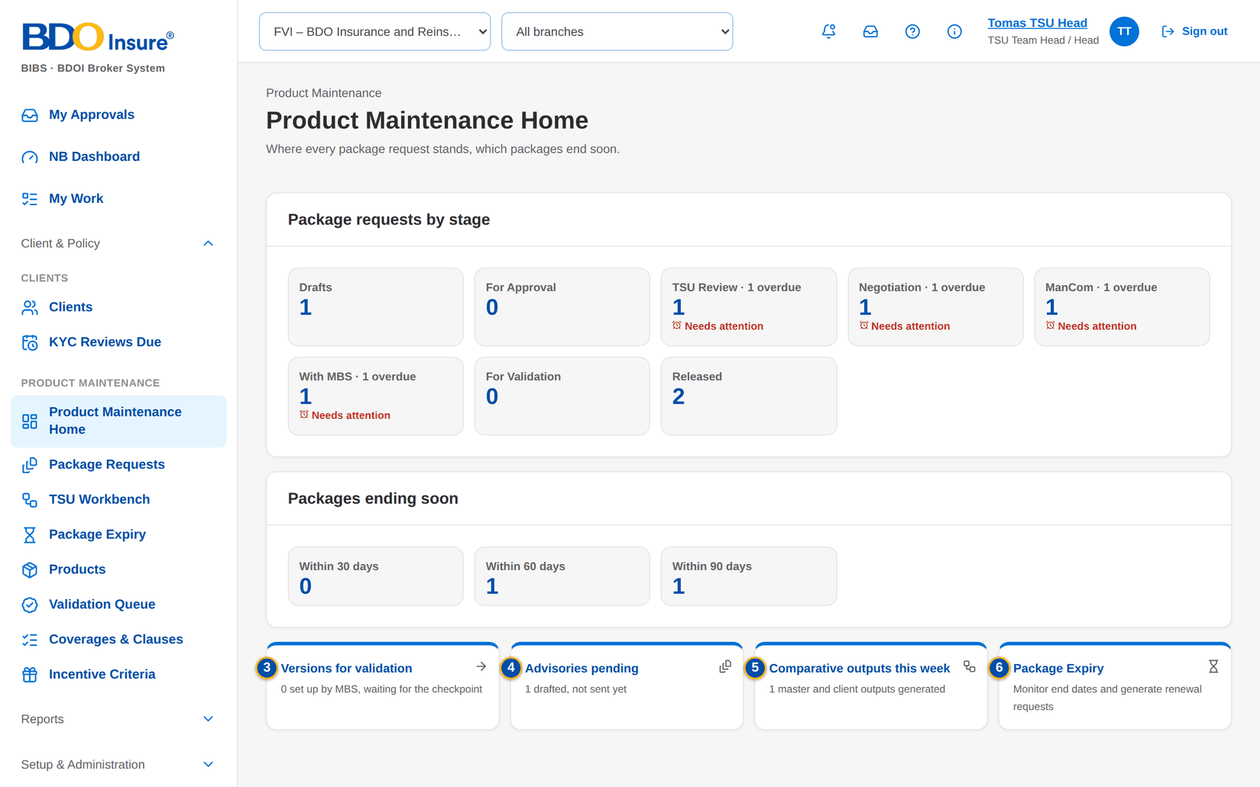
Figure 6: SCR-PM-01 Product Maintenance Home of the TSU Head
1 | Drafts / For Approval / TSU Review / Negotiation / ManCom / With MBS / For Validation / Released | 3 | Versions for validation | 5 | Comparative outputs this week
2 | Within 30 days / Within 60 days / Within 90 days | 4 | Advisories pending | 6 | Package Expiry

Fields (No. = callout number on the first screenshot)
No. | Section | Field | Type | Length / format | Mand. | Source / list | Default | Editable in | Validation | Message when it fails
1 | Package requests by stage | Drafts / For Approval / TSU Review / Negotiation / ManCom / With MBS / For Validation / Released | Tile | Count of requests; '· n overdue' added when a request of the tile is past its due time | - | Package requests of the company | - | Read only | Red marker when a request is overdue or due within eight hours | -
2 | Packages ending soon | Within 30 days / Within 60 days / Within 90 days | Tile | Count of released packages whose package end date falls in the window | - | Package versions in force | - | Read only | The 30-day tile is always marked | -
3 | Shortcuts | Versions for validation | Tile | 'n set up by MBS, waiting for the checkpoint' | - | Package requests in For Validation | - | Read only | - | -
4 | Shortcuts | Advisories pending | Tile | 'n drafted, not sent yet' | - | Draft advisories of the company | - | Read only | - | -
5 | Shortcuts | Comparative outputs this week | Tile | 'n master and client outputs generated' | - | Comparative outputs of the last seven days | - | Read only | - | -
6 | Shortcuts | Package Expiry | Tile | Link | - | - | - | Read only | - | -

Actions
Button | Who | Enabled when | What happens | Resulting status | Notification
New Package Request | Marketing AO, Marketing TL, TSU Officer (permission PKG_REQUEST) | Always | Opens the New Package Request form | - | -
A stage tile | Every user of the screen | Always | Opens Package Requests on the tab of the tile | - | -
An expiry tile | Every user of the screen | Always | Opens Package Expiry with the window of the tile | - | -

Business rules
• The counts are those of the company selected in the page header (FR-PM-070).
• A request is marked overdue when its stage due time has passed and due soon within eight hours of it; the due time comes from the service level hours of the stage (FR-PM-073).
Expected outcome
Each user sees at once the package work waiting in each stage and the packages that end soon, and opens the list in one click.
Test cases: TC-PM-070.1-01, TC-PM-070.1-02, TC-PM-070.2-01, TC-PM-070.3-01, TC-PM-SCR-01.

13.1.2 SCR-PM-02 Package Requests
Purpose | The work list of package requests of the company, by stage, from the draft to the released or closed request. Team leaders assign the selected requests of one stage to a user of the team.
Who can open it | Marketing Account Officer, Marketing TL / TH / UH, TSU Officer, TSU Team Lead, TSU Head, Marketing Business Services, ManCom member, Business Administrator, New Business Approver, System Administrator, Auditor (permission PRODUCT_VIEW or PKG_REPORT_VIEW)
Navigation | • Menu: Client & Policy › Product Maintenance › Package Requests  • Product Maintenance Home › a stage tile (opens the tab of the stage)  • Package Request record › back arrow
FRs | FR-PM-024, FR-PM-073

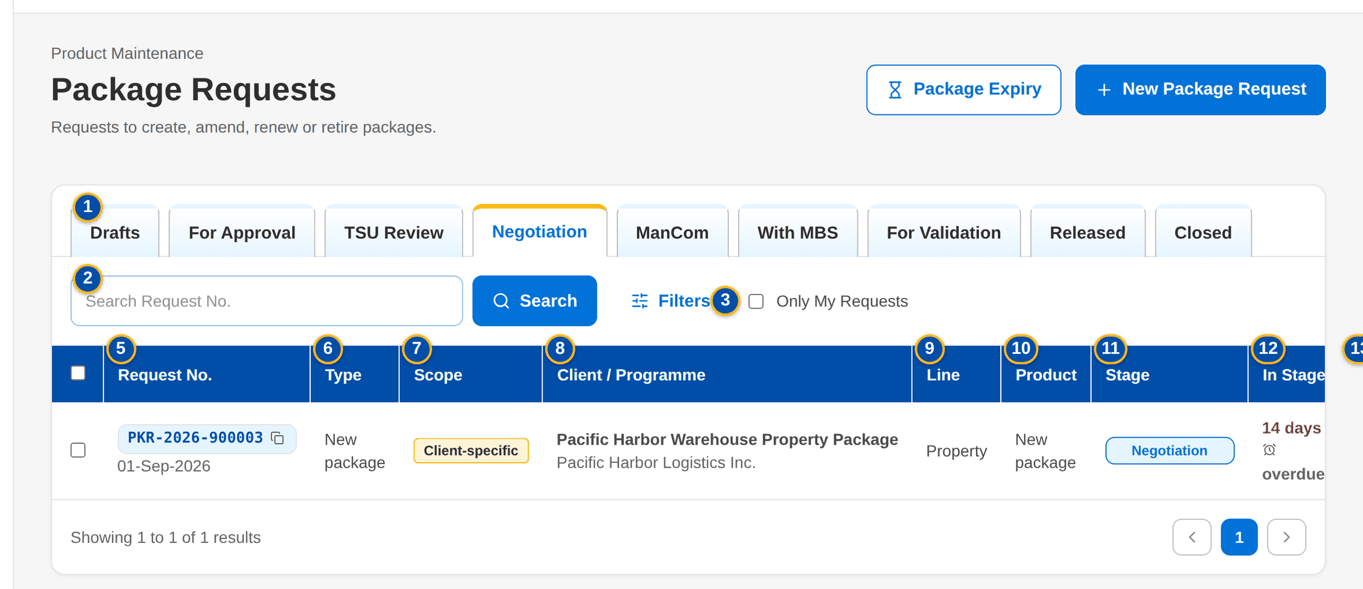
Figure 7: SCR-PM-02 Package Requests, Negotiation tab
1 | Drafts / For Approval / TSU Review / Negotiation / ManCom / With MBS / For Validation / Released / Closed | 6 | Type | 11 | Stage
2 | Search Request No. | 7 | Scope | 12 | In Stage
3 | Only My Requests | 8 | Client / Programme | 13 | Assignee
4 | Request type | 9 | Line
5 | Request No. | 10 | Product

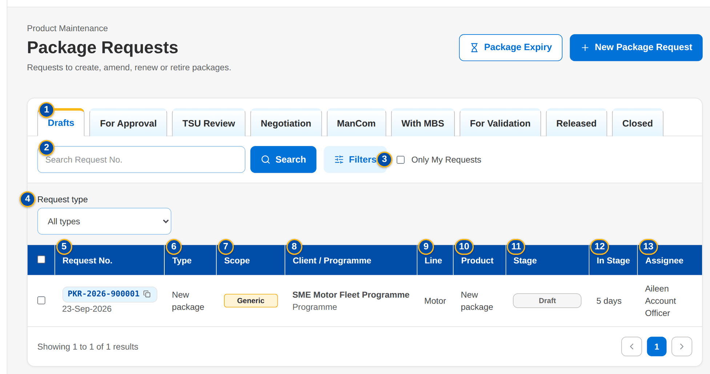
Figure 8: SCR-PM-02 Package Requests with the request type filter
Fields (No. = callout number on the first screenshot)
No. | Section | Field | Type | Length / format | Mand. | Source / list | Default | Editable in | Validation | Message when it fails
1 | Tabs | Drafts / For Approval / TSU Review / Negotiation / ManCom / With MBS / For Validation / Released / Closed | Tab | - | - | Fixed | Drafts (or the tab of the home tile) | - | Each tab lists its stages: TSU Review = TSU review and TSU Head approval; Negotiation = negotiation, terms review, Marketing review and requirements; Closed = retired, not proceeded and voided | -
2 | Search | Search Request No. | Text | PKR-yyyy-nnnnnn, part of a number allowed | N | - | Blank | - | Contains search on the request number | -
3 | Search | Only My Requests | Check box | - | N | - | Not ticked | - | Requests created by the user or assigned to the user | -
4 | Filters | Request type | Drop-down | All types, New package, Amend package terms, Update package details, Renew package, Retire package, Reactivate expired package | N | Fixed list | All types | - | - | -
5 | List | Request No. | Column | PKR-yyyy-nnnnnn with the creation date under it | - | Package request | - | Read only | - | -
6 | List | Type | Column | Request type | - | Package request | - | Read only | - | -
7 | List | Scope | Column | Generic or Client-specific tag | - | Package request | - | Read only | - | -
8 | List | Client / Programme | Column | Package or programme name, with the client name or Programme under it | - | Package request | - | Read only | - | -
9 | List | Line | Column | Product line | - | Package request | - | Read only | - | -
10 | List | Product | Column | Risk code and resulting version (v2), or New package | - | Package request | - | Read only | - | -
11 | List | Stage | Column | Status pill | - | Workflow | - | Read only | - | -
12 | List | In Stage | Column | n days, with overdue or due soon | - | Workflow | - | Read only | Red when past the due time | -
13 | List | Assignee | Column | User or a dash | - | Workflow | - | Read only | - | -

Actions
Button | Who | Enabled when | What happens | Resulting status | Notification
Package Expiry | Every user of the screen | Always | Opens Package Expiry | - | -
New Package Request | Marketing AO, Marketing TL, TSU Officer (PKG_REQUEST) | Always | Opens the New Package Request form | - | -
Assign | Team leaders (WORK_ASSIGN) | Rows of one stage are selected | Opens Assign Package Requests: choose a user of the team of the stage, or Team queue (unassigned), and click Assign | Unchanged | Assignment notice to the new assignee
Filters | Every user of the screen | Always | Shows or hides the request type filter | - | -
Open a row | Every user of the screen | Always | Opens the package request | - | -

Business rules
• The list shows the requests of the company selected in the page header (FR-PM-024).
• Assign is offered only for requests of one stage; the assignee is chosen among the users who work that stage (FR-PM-024).
• The time in stage turns red when the stage due time has passed (FR-PM-073).
Expected outcome
The user finds any package request by stage or number and opens it; team leaders spread the work.
Test cases: TC-PM-002.1-01, TC-PM-024.1-01, TC-PM-024.1-02, TC-PM-SCR-02, TC-PM-MSG-01.

13.1.3 SCR-PM-03 New Package Request and Edit Package Request
Purpose | The Package Request Form. Marketing or TSU describe the package: the request type and scope, the package or programme name, the client of a client-specific package, the product line, cover type and product, the reason, the requested terms by section and coverage, the requested rate scheme and package term, and the insurers to approach. The draft is saved at any time; submission checks that the request is complete. The TSU Team Lead can complete the form during the TSU review.
Who can open it | Marketing Account Officer, Marketing TL / TH / UH, TSU Officer (permission PKG_REQUEST)
Navigation | • Menu: Client & Policy › Product Maintenance › Package Requests › New Package Request  • Package Requests › New Package Request  • Product Maintenance Home › New Package Request  • Package Request record › Edit (draft, or TSU review for the TSU Team Lead)  • Package Expiry › Generate Renewal Request (opens the drafted renewal request)
FRs | FR-PM-020, FR-PM-010, FR-PM-045

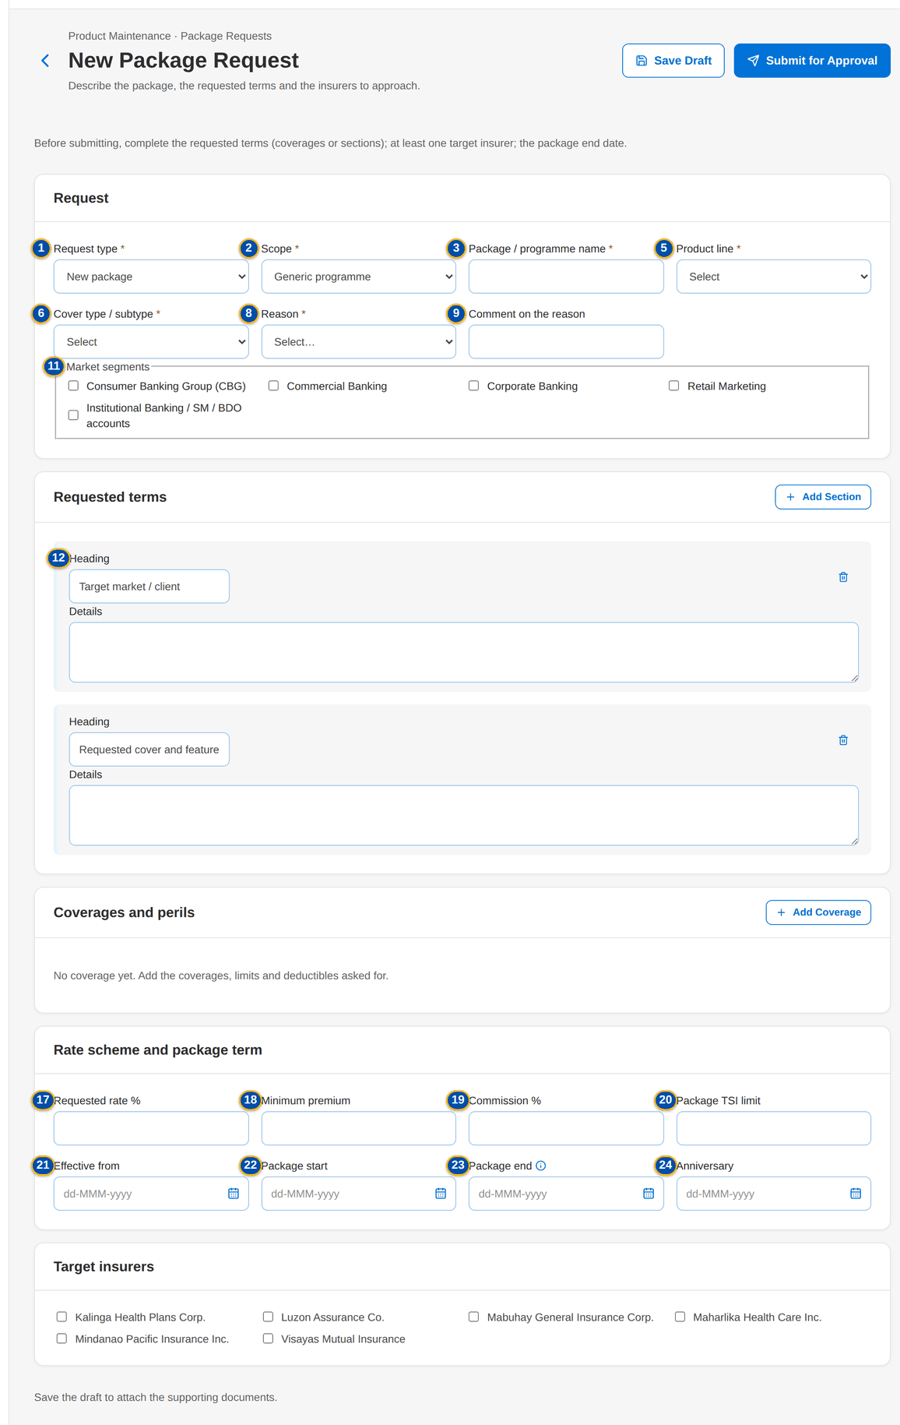
Figure 9: SCR-PM-03 New Package Request form
1 | Request type | 10 | Negotiate with the insurers | 19 | Commission %
2 | Scope | 11 | Market segments | 20 | Package TSI limit
3 | Package / programme name | 12 | Heading / Details | 21 | Effective from
4 | Client or prospect | 13 | Coverage code | 22 | Package start
5 | Product line | 14 | Included | 23 | Package end
6 | Cover type / subtype | 15 | Limit | 24 | Anniversary
7 | Package product | 16 | Deductible | 25 | Insurer check boxes
8 | Reason | 17 | Requested rate % | 26 | Documents panel
9 | Comment on the reason | 18 | Minimum premium

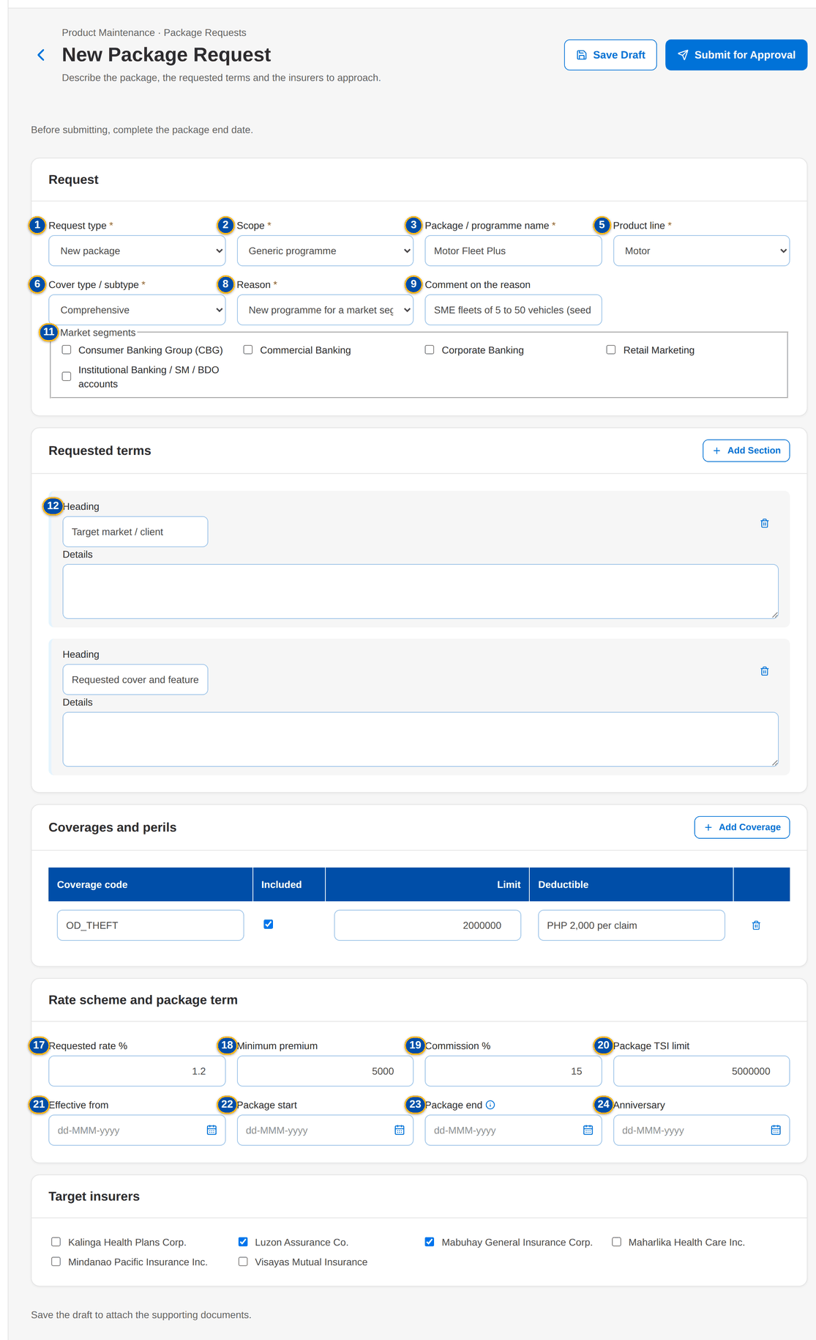
Figure 10: SCR-PM-03 New Package Request with the requested terms and target insurers entered

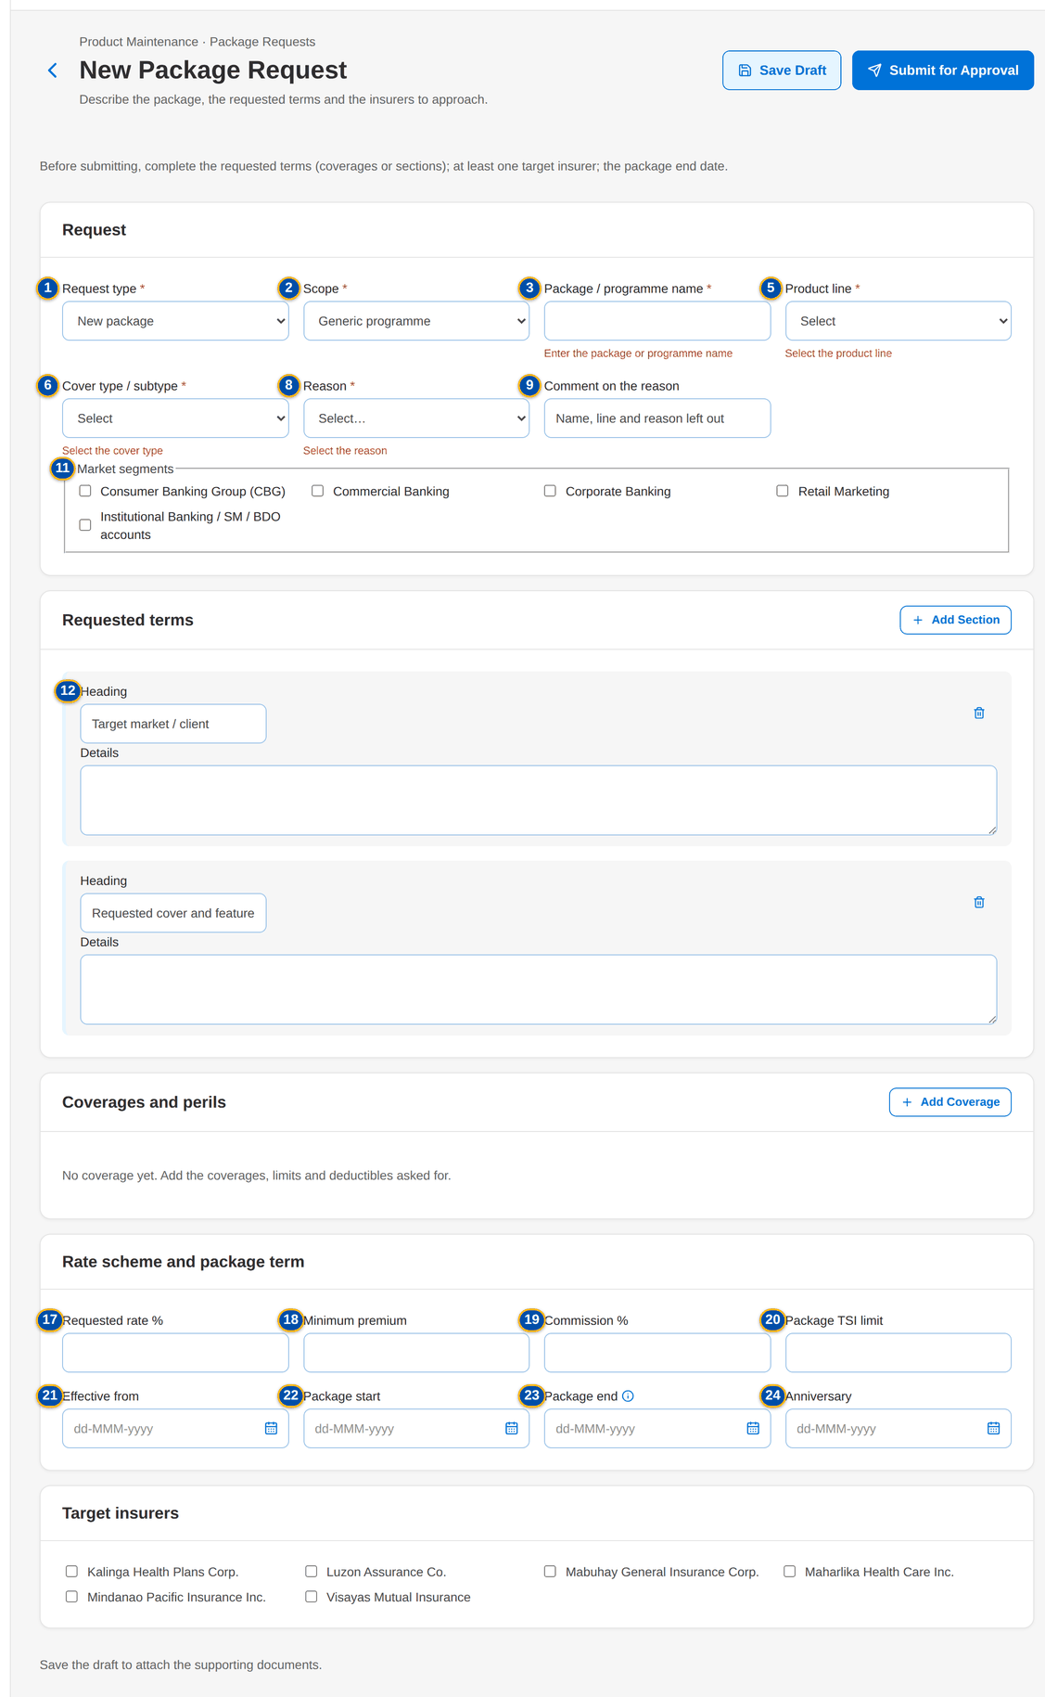
Figure 11: SCR-PM-03 Field messages after Save Draft without the name, line and reason

Fields (No. = callout number on the first screenshot)
No. | Section | Field | Type | Length / format | Mand. | Source / list | Default | Editable in | Validation | Message when it fails
1 | Request | Request type | Drop-down | New package, Amend package terms, Update package details, Renew package, Retire package, Reactivate expired package | Y | List PKG_REQUEST_TYPE | New package | New request only (fixed once saved) | The type of a saved request cannot change | The type of a request cannot change
2 | Request | Scope | Drop-down | Generic programme or Client-specific package | Y | Fixed list | Generic programme | Draft; TSU review | - | Select the request type and the package scope
3 | Request | Package / programme name | Text | Up to 200 characters | Y | - | Blank | Draft; TSU review | Not blank | Enter the package or programme name
4 | Request | Client or prospect | Look-up | Client code or name | Cond.: client-specific package | Client master (BRD-1) | Blank | Draft; TSU review | An active client | Select the client
5 | Request | Product line | Drop-down | Line name | Y | Product lines | Select | Draft; TSU review | An existing line | Select the product line
6 | Request | Cover type / subtype | Drop-down | Cover types of the line | Cond.: New package | Cover types | Select | Draft; TSU review | A cover type of the chosen line | Select the cover type
7 | Request | Package product | Drop-down | Code – name of the packaged products of the line | Cond.: every type except New package | Products flagged Package | Select | New request only (fixed once saved) | A packaged product of the chosen line | Select the package product
8 | Request | Reason | Drop-down | Client requirement, New programme for a market segment, Market competitiveness, Change in insurer terms or rates, Loss experience, Regulatory change, Package expiry or anniversary, Others | Y | List PKG_REQUEST_REASON | Select | Draft; TSU review | An active value of the list | Select the reason
9 | Request | Comment on the reason | Text | Up to 500 characters | N | - | Blank | Draft; TSU review | - | -
10 | Request | Negotiate with the insurers | Check box | Shown for Renew, Update and Reactivate | N | - | Ticked | Draft; TSU review | New and Amend always negotiate; Retire never | -
11 | Request | Market segments | Check boxes | One or more | N | List MARKET_SEGMENT | None | Draft; TSU review | Active values of the list | -
12 | Requested terms | Heading / Details | Text | Heading and up to 4,000 characters per section; suggested sections Target market / client and Requested cover and features | Cond.: sections or coverages before submission | - | Two empty sections | Draft; TSU review | Empty sections are dropped | Complete the request: the requested terms (coverages or sections)
13 | Coverages and perils | Coverage code | Text | Coverage code of the line, in capitals | Cond.: sections or coverages before submission | Coverages of the line | Blank | Draft; TSU review | Every line has a code | Enter a code for every coverage or remove the line
14 | Coverages and perils | Included | Check box | - | N | - | Ticked | Draft; TSU review | - | -
15 | Coverages and perils | Limit | Number | Amount in PHP | N | - | Blank | Draft; TSU review | Zero or more | Rates and amounts cannot be negative
16 | Coverages and perils | Deductible | Text | Wording, for example 1% of loss, minimum PHP 20,000 | N | - | Blank | Draft; TSU review | - | -
17 | Rate scheme and package term | Requested rate % | Number | Up to four decimals | N | - | Blank | Draft; TSU review | Zero or more | Rates and amounts cannot be negative
18 | Rate scheme and package term | Minimum premium | Number | Amount in PHP | N | - | Blank | Draft; TSU review | Zero or more | Rates and amounts cannot be negative
19 | Rate scheme and package term | Commission % | Number | Percentage | N | - | Blank | Draft; TSU review | Zero or more | Rates and amounts cannot be negative
20 | Rate scheme and package term | Package TSI limit | Number | Amount in PHP | N | - | Blank | Draft; TSU review | Zero or more | Rates and amounts cannot be negative
21 | Rate scheme and package term | Effective from | Date | dd-MMM-yyyy | N | - | Blank | Draft; TSU review | - | -
22 | Rate scheme and package term | Package start | Date | dd-MMM-yyyy | N | - | Blank | Draft; TSU review | - | -
23 | Rate scheme and package term | Package end | Date | dd-MMM-yyyy; monitored for expiry and renewal | Cond.: before submission (not for Retire) | - | Blank | Draft; TSU review | After the package start | The package end date must be after its start date
24 | Rate scheme and package term | Anniversary | Date | dd-MMM-yyyy | N | - | Blank | Draft; TSU review | - | -
25 | Target insurers | Insurer check boxes | Check boxes | Name of each insurer of the panel | Cond.: at least one when the insurers are approached | Insurers (authorised, active) | None | Draft; TSU review | Authorised and active insurers | Complete the request: at least one target insurer
26 | Documents | Documents panel | Upload | See Common screen elements | N | Document types | - | After the first save | File checks of every upload | Save the draft to attach the supporting documents.

Actions
Button | Who | Enabled when | What happens | Resulting status | Notification
Load Current Terms | Users of the form | Type other than New package and a package product chosen | Copies the terms of the version in force (coverages, rate scheme, dates, insurers) into the requested terms; the sections typed stay | Unchanged | -
Save Draft | Marketing AO, Marketing TL, TSU Officer (PKG_REQUEST); TSU Team Lead during the TSU review | No field message on the form | Checks the fields and saves the draft; a new request is numbered PKR-yyyy-nnnnnn | Draft request (new); unchanged (edit) | -
Submit for Approval | As Save Draft | No field message on the form | Saves the request, checks that it is complete (requested terms, target insurers when negotiated, package end date, cover type of a new package) and sends it to Marketing approval | For Marketing approval | Workflow notice to the Marketing approvers

Business rules
• The request number PKR-yyyy-nnnnnn is given at the first save (parameter PKG_REQUEST_PREFIX) (FR-PM-020).
• A new package needs its cover type; every other type needs the packaged product it changes, of the chosen line (FR-PM-010, FR-PM-020).
• A client-specific package needs an active client of the client master (FR-PM-020).
• New and Amend always go to the insurers; Retire never; Renew, Update and Reactivate go to the insurers only when Negotiate with the insurers is ticked (FR-PM-020, FR-PM-045).
• Before submission the request needs its requested terms (coverages or sections), at least one target insurer when negotiated, and the package end date; a retirement needs none of these (FR-PM-020).
• The type and the product of a saved request cannot change (FR-PM-020).
• A draft is edited by the Marketing or TSU users who create requests; during the TSU review, by the TSU Team Lead (FR-PM-020, FR-PM-022).
Expected outcome
The package request is numbered, complete and waiting for the Marketing approval, with its supporting documents attached.
Test cases: TC-PM-020.1-01, TC-PM-020.2-01, TC-PM-020.2-02, TC-PM-020.2-03, TC-PM-020.3-01, TC-PM-020.3-02, TC-PM-020.4-01, TC-PM-020.5-01, TC-PM-020.5-02, TC-PM-SCR-03, TC-PM-MSG-02.

13.1.4 SCR-PM-04 Package Request record
Purpose | One package request: its number, stage and flags, the key facts (type, client or programme, line and product, scheme rate, package term, insurers), the workflow header (stage stepper, then Current Stage, Since, Due and Assigned To) with the actions of the stage, and the tabs Details, Requested Terms, Negotiation, Comparative, Requirements & Sign-off, Set-up, Advisories, Documents, E-mails and History. This section specifies the header, the stage actions and the tabs Details, Requested Terms, Documents, E-mails and History; the other tabs have their own sections (SCR-PM-05 to SCR-PM-08).
Who can open it | Marketing Account Officer, Marketing TL / TH / UH, TSU Officer, TSU Team Lead, TSU Head, Marketing Business Services, ManCom member, Business Administrator, New Business Approver, System Administrator, Auditor (permission PRODUCT_VIEW or PKG_REPORT_VIEW)
Navigation | • Menu: Client & Policy › Product Maintenance › Package Requests › Package Request  • Package Requests › a row  • TSU Workbench › a row  • A workflow notice or an assignment notice (bell)  • Package Expiry › the renewal request number
FRs | FR-PM-021, FR-PM-022, FR-PM-023, FR-PM-024, FR-PM-005, FR-PM-073

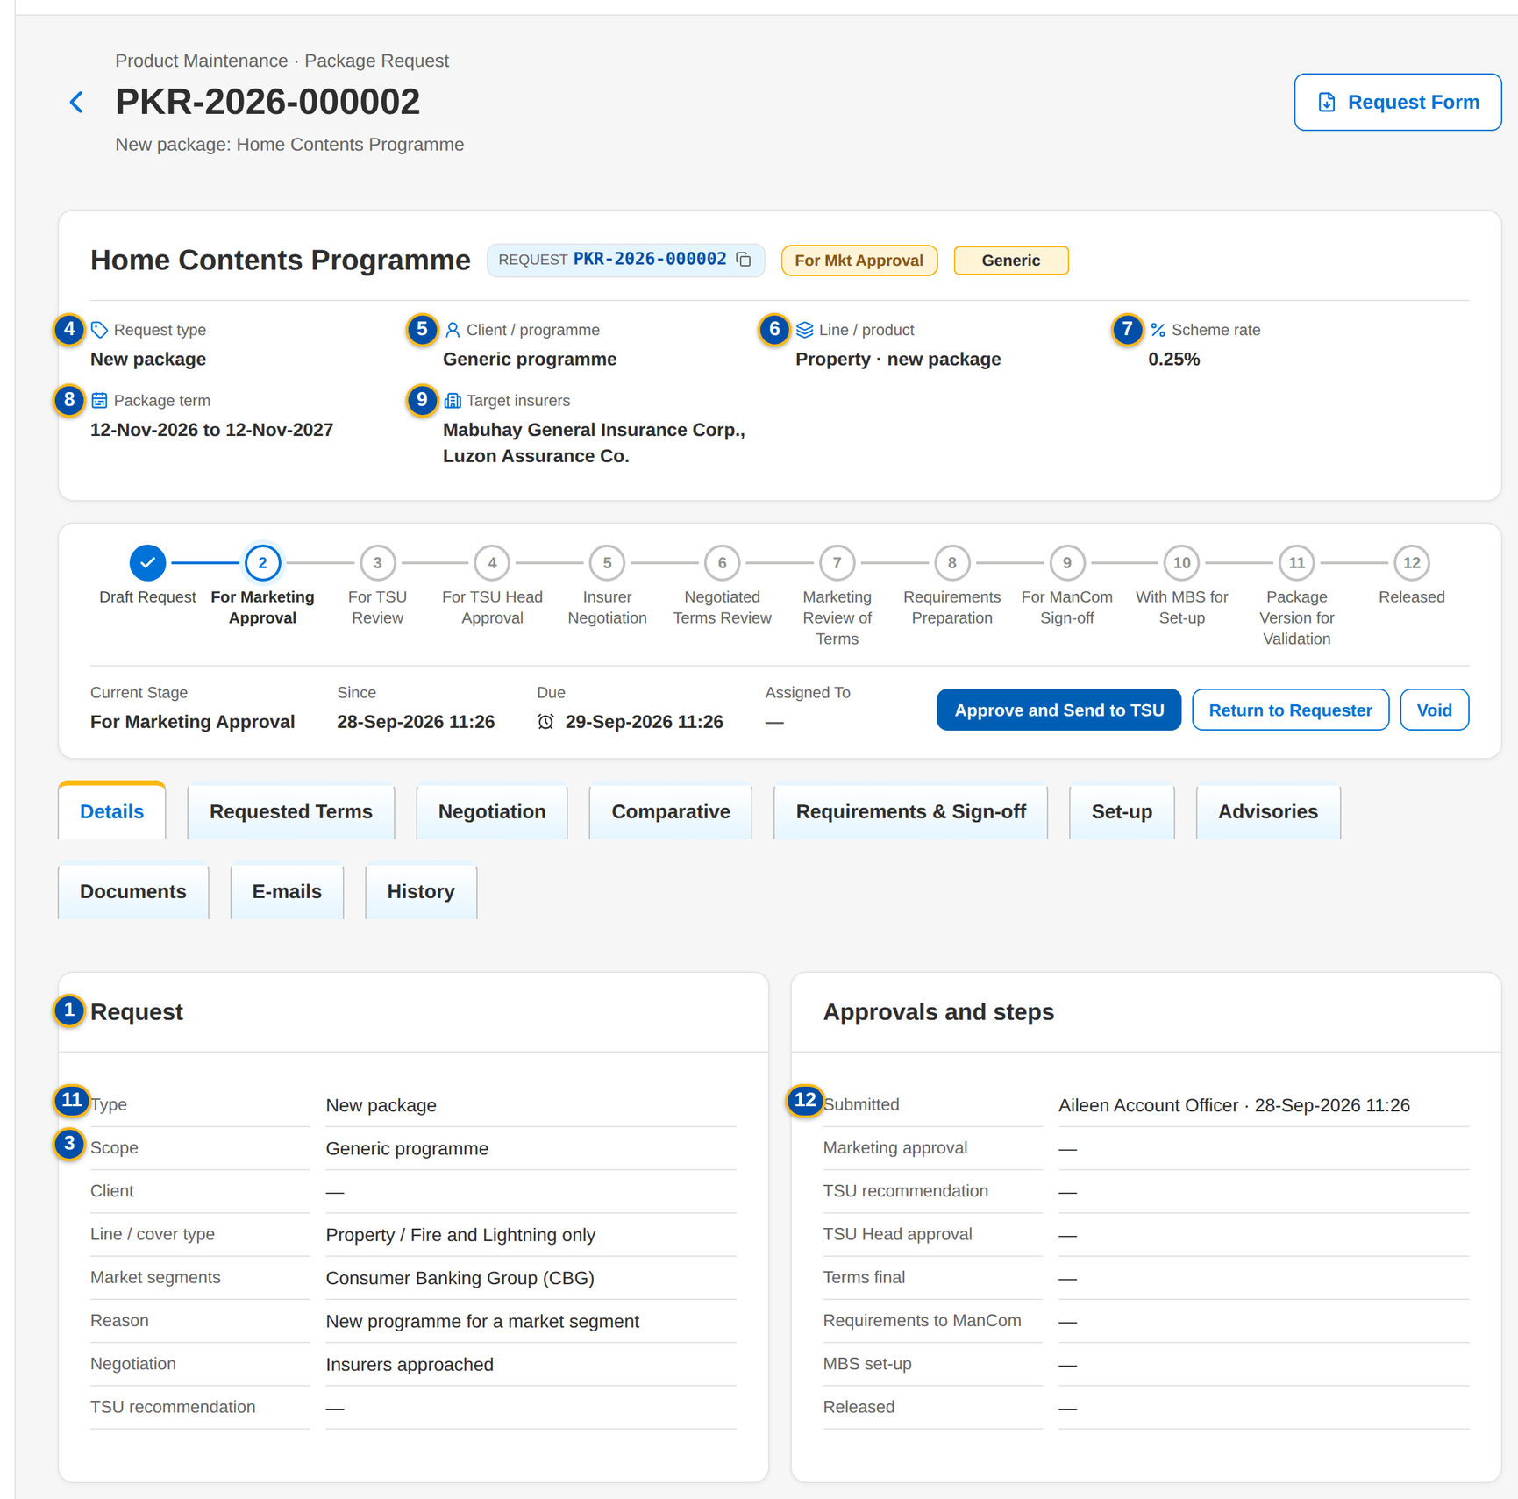
Figure 12: SCR-PM-04 Package request waiting for the Marketing approval, Details tab
1 | Request | 7 | Scheme rate | 13 | Sections, coverages, rate scheme, dates and insurers
2 | Stage pill | 8 | Package term | 14 | Stage / From Stage / Action / By / Date and Time / Remarks / Duration in Stage
3 | Scope and negotiation tags | 9 | Target insurers / Chosen insurers | 15 | Changed / By / Rev. / Outcome / Rate % / Remarks
4 | Request type | 10 | Stage stepper and meta row | 16 | Documents panel
5 | Client / programme | 11 | Type / Scope / Client / Line / cover type / Market segments / Reason / Negotiation / TSU recommendation | 17 | Sent e-mails
6 | Line / product | 12 | Submitted / Marketing approval / TSU recommendation / TSU Head approval / Terms final / Requirements to ManCom / MBS set-up / Released

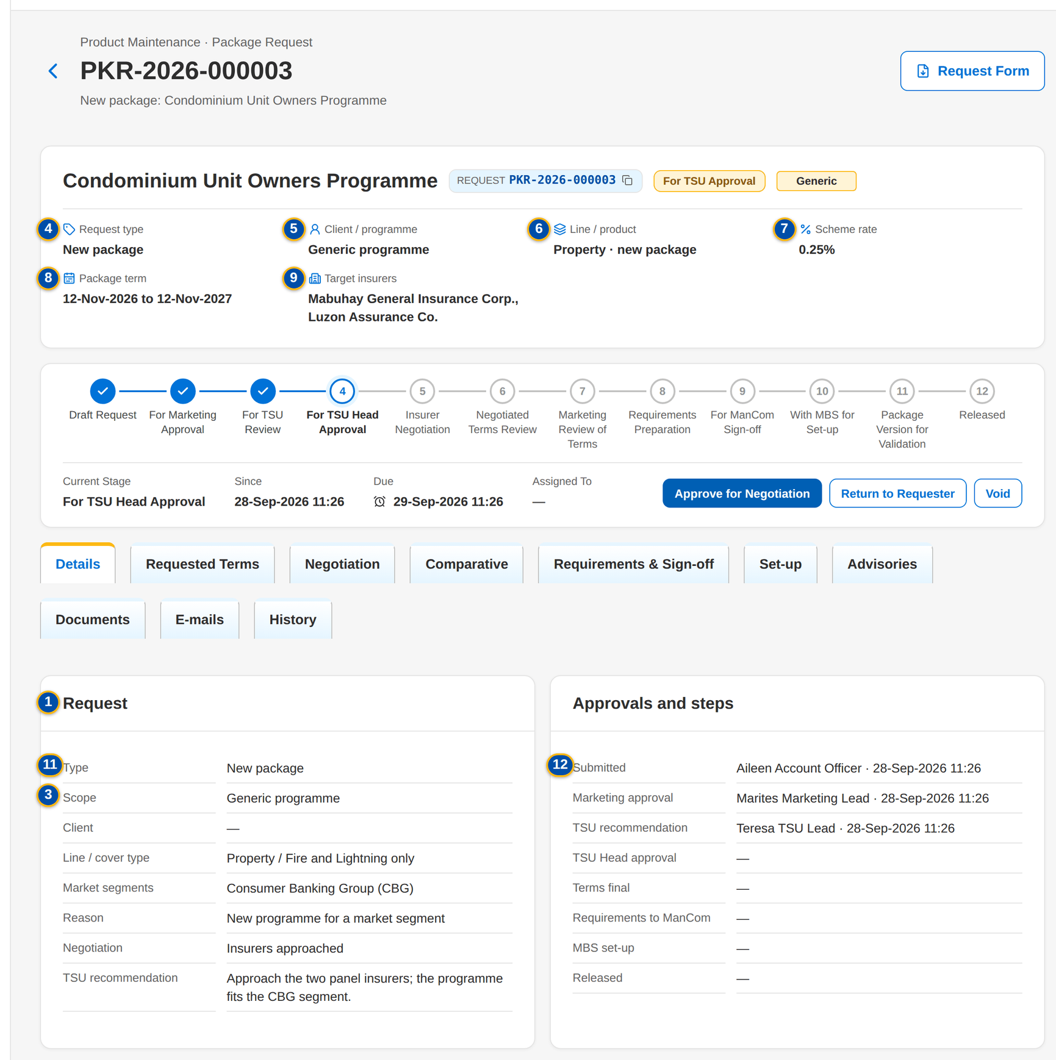
Figure 13: SCR-PM-04 TSU Head approval with the recommendation of the TSU Team Lead

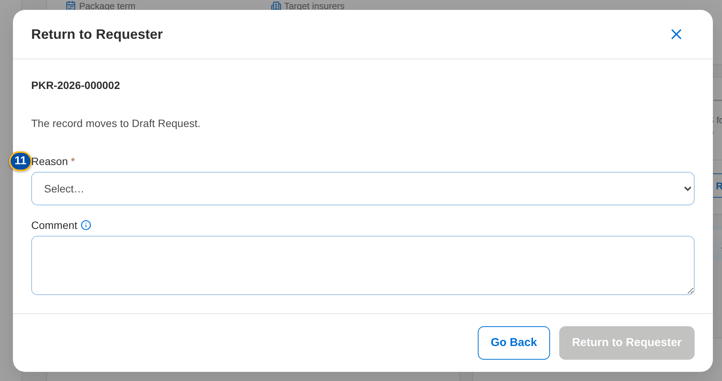
Figure 14: SCR-PM-04 Return to requester dialog with the mandatory reason

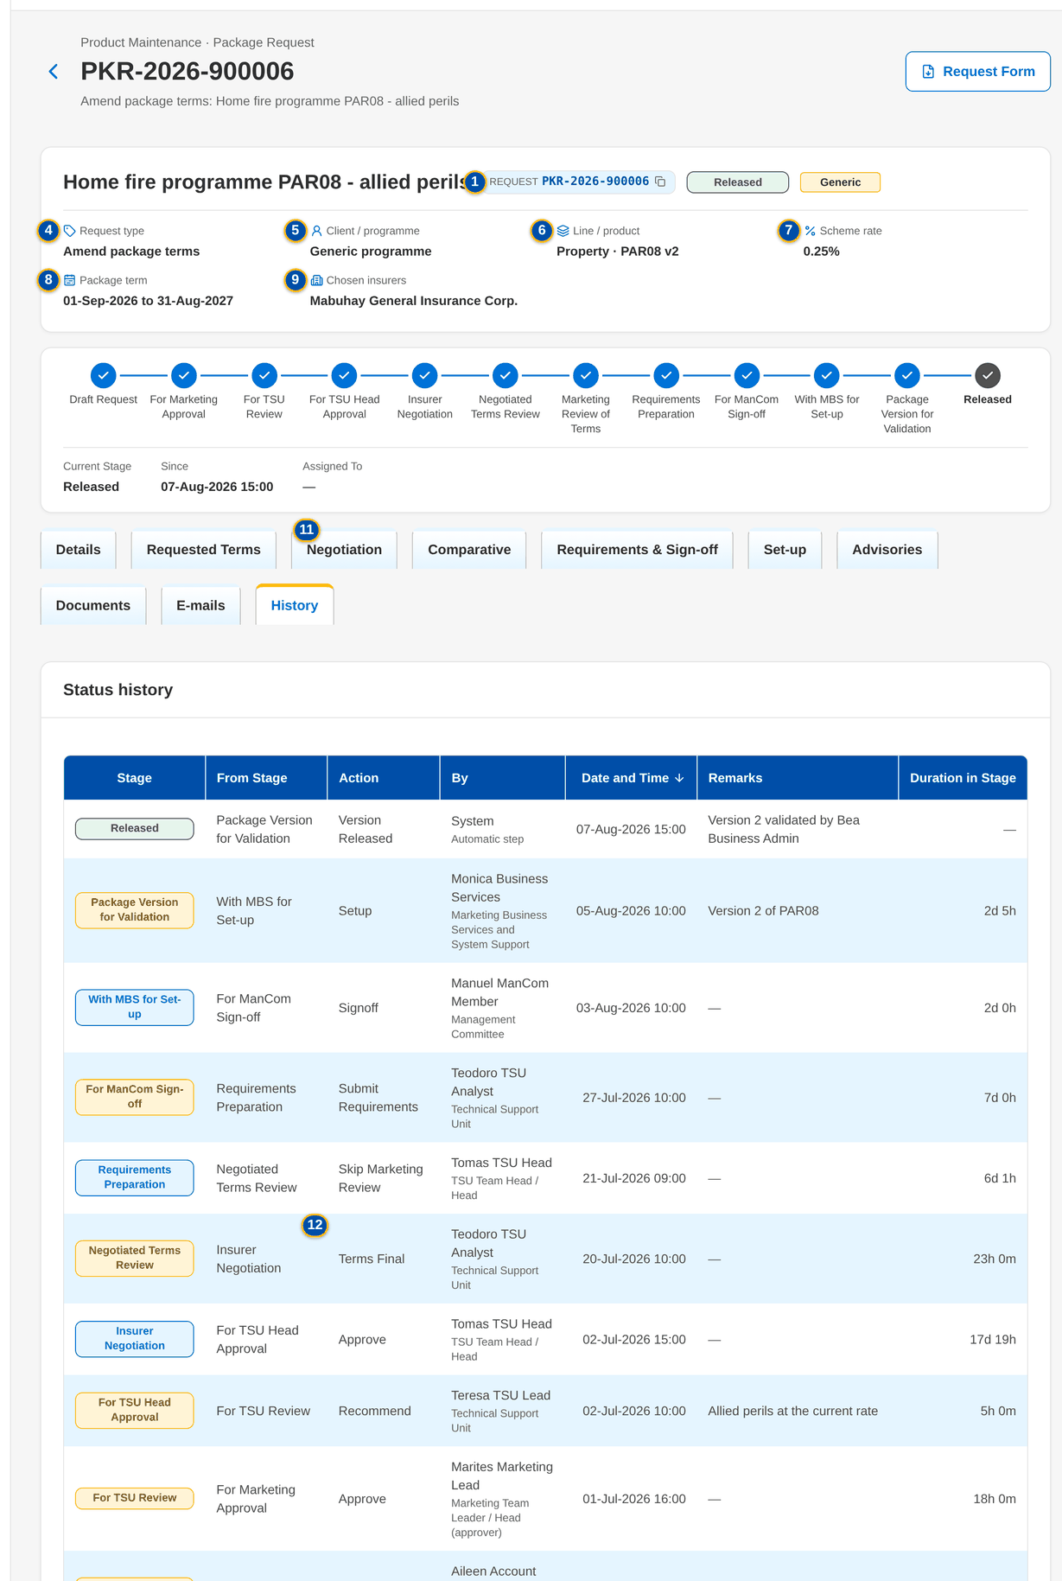
Figure 15: SCR-PM-04 History tab of a released request

Fields (No. = callout number on the first screenshot)
No. | Section | Field | Type | Length / format | Mand. | Source / list | Default | Editable in | Validation | Message when it fails
1 | Header | Request | Reference chip | PKR-yyyy-nnnnnn | - | Package request | - | Read only | - | -
2 | Header | Stage pill | Pill | Stage of the request | - | Workflow | - | Read only | - | -
3 | Header | Scope and negotiation tags | Tag | Generic or Client-specific; No negotiation | - | Package request | - | Read only | - | -
4 | Header | Request type | Fact | Request type | - | Package request | - | Read only | - | -
5 | Header | Client / programme | Fact | Client name or Generic programme | - | Package request | - | Read only | - | -
6 | Header | Line / product | Fact | Line · risk code and resulting version, or new package | - | Package request | - | Read only | - | -
7 | Header | Scheme rate | Fact | Rate % of the proposed terms, else of the requested terms | - | Terms | - | Read only | - | -
8 | Header | Package term | Fact | Package start – package end | - | Terms | - | Read only | - | -
9 | Header | Target insurers / Chosen insurers | Fact | Insurer codes; the chosen insurers once the terms are final | - | Terms | - | Read only | - | -
10 | Workflow | Stage stepper and meta row | Panel | The stages of the request in order, the current one highlighted; Current Stage, Since, Due, Assigned To | - | Workflow | - | Read only | Overdue pill after the due time | -
11 | Details › Request | Type / Scope / Client / Line / cover type / Market segments / Reason / Negotiation / TSU recommendation | Detail | As entered on the form; Negotiation: Insurers approached or No negotiation | - | Package request | - | Read only | - | -
12 | Details › Approvals and steps | Submitted / Marketing approval / TSU recommendation / TSU Head approval / Terms final / Requirements to ManCom / MBS set-up / Released | Detail | User · dd-MMM-yyyy HH:mm, or a dash | - | Request milestones | - | Read only | - | -
13 | Requested Terms | Sections, coverages, rate scheme, dates and insurers | Read-only view | Sections; Coverage, Included, Limit, Deductible; Rate / minimum premium; Commission / TSI limit; Computation basis; Effective from; Package term; Insurer, Role, Share %, Rate %, Minimum | - | Requested terms | - | Read only | - | -
14 | History › Status history | Stage / From Stage / Action / By / Date and Time / Remarks / Duration in Stage | Table | Newest first | - | Workflow history | - | Read only | - | -
15 | History › Insurer response revisions | Changed / By / Rev. / Outcome / Rate % / Remarks | Table | Every saved revision of every insurer response | - | Response history | - | Read only | - | No insurer response keyed in yet
16 | Documents | Documents panel | Table and upload | See Common screen elements | - | Attachments of the request | - | Every stage (PKG_REQUEST, PKG_NEGOTIATE, attachment permission) | File checks | -
17 | E-mails | Sent e-mails | Table | Recipient, subject, attachments, status | - | Outbound messages of the request | - | Read only | - | -

Actions
Button | Who | Enabled when | What happens | Resulting status | Notification
Request Form | Every user of the screen | Always | Downloads the Package Request Form (PDF) with the requested terms | Unchanged | -
Edit | PKG_REQUEST in Draft; PKG_TSU_RECOMMEND (TSU Team Lead) in For TSU review | Draft or For TSU review | Opens Edit Package Request | Unchanged | -
Submit for approval | PKG_REQUEST | Draft; the request is complete | Checks completeness and submits | For Marketing approval | Workflow notice
Approve and send to TSU | Marketing TL / TH / UH (PKG_REQUEST_APPROVE) | For Marketing approval; the user is not the maker or the submitter | Records the Marketing approval | For TSU review | Workflow notice
Return to requester | Marketing TL (For Marketing approval); TSU Team Lead (For TSU review); TSU Head (For TSU Head approval) | Those stages | Opens the reason dialog (Return reason, mandatory; Comment) and returns the request | Draft request | Workflow notice with the comment
Void | The requester (Draft, For Marketing approval); the Marketing approver; the TSU Team Lead; the TSU Head | Draft to For TSU Head approval | Opens the reason dialog (Void reason, mandatory) and closes the request without a package | Voided | Workflow notice
Recommend for approval | TSU Team Lead (PKG_TSU_RECOMMEND) | For TSU review | Opens Recommend for Approval: the Recommendation (mandatory, up to 2,000 characters) is kept on the request and shown to the TSU Head | For TSU Head approval | Workflow notice
Approve for negotiation | TSU Head (PKG_TSU_APPROVE) | For TSU Head approval; the request is negotiated; the user is not the recommender | Approves the request and opens negotiation round 1 with the target insurers | Insurer negotiation | Workflow notice
Approve without negotiation | TSU Head (PKG_TSU_APPROVE) | For TSU Head approval; no negotiation (Retire, or Renew, Update, Reactivate without insurers) | The requested terms become the proposed terms; the request goes to ManCom | For ManCom sign-off | Workflow notice
Not proceeded | TSU Officer or TSU Head (Insurer negotiation); Marketing (Marketing review of terms) | Those stages | Opens the reason dialog (Not proceeded reason, mandatory) and closes the request | Not proceeded | Workflow notice
Release terms to Marketing | TSU Head (PKG_TSU_APPROVE) | Negotiated terms review; client-specific package | Sends the negotiated terms to Marketing for the client | Marketing review of terms | Workflow notice
Proceed to requirements (generic package) | TSU Head (PKG_TSU_APPROVE) | Negotiated terms review; generic programme | Skips the Marketing review | Requirements preparation | Workflow notice
Accept terms | Marketing (PKG_REQUEST) | Marketing review of terms | Records the client's acceptance of the terms | Requirements preparation | Workflow notice
Request changes | Marketing (PKG_REQUEST) | Marketing review of terms | Opens the reason dialog; the latest round stays open so that TSU revises the slip or makes the terms final again | Insurer negotiation | Workflow notice with the comment
Return to TSU | ManCom (PKG_MANCOM_SIGNOFF) | For ManCom sign-off | Opens the reason dialog; the return is kept as a ManCom decision Returned | Requirements preparation | Workflow notice
Retire package | MBS (PRODUCT_MAINTAIN) | With MBS for set-up; request type Retire | Retires the product: it is no longer sold; its versions stay readable; the retirement advisory is drafted and incentive criteria on the product are flagged | Package retired | Workflow notice; incentive alert
Return incomplete requirements to TSU | MBS (PRODUCT_MAINTAIN) | With MBS for set-up | Opens Return Incomplete Requirements (Return reason, mandatory; Comment; Return to TSU) | Requirements preparation | Workflow notice

Business rules
• A request is never approved by its maker or submitter, and the TSU Head approval is never given by the recommender (FR-PM-021, FR-PM-023).
• The TSU Team Lead's recommendation is mandatory and is shown to the TSU Head (FR-PM-022).
• Return, void, not proceeded and request changes need a reason from their list of values; the comment is kept in the history (FR-PM-021, FR-PM-073).
• Void is possible from the draft to the TSU Head approval; after that a request ends as not proceeded, released or retired (FR-PM-073).
• Every stage has a due time from its service level hours (parameters PKG_SLA_*): Marketing approval 24, TSU review 24, TSU Head approval 24, negotiation 120, ManCom 72, MBS set-up 48 hours by default (FR-PM-073).
• Every action is written to the history and the audit trail; audit rows cannot be changed or deleted (FR-PM-005).
Expected outcome
The request moves stage by stage with every decision, reason and document recorded, and each user sees only the actions of his stage.
Test cases: TC-PM-002.3-01, TC-PM-004.1-01, TC-PM-004.2-01, TC-PM-004.3-01, TC-PM-005.1-01, TC-PM-020.5-04, TC-PM-021.1-01, TC-PM-021.2-01, TC-PM-021.3-01, TC-PM-021.3-02, TC-PM-021.3-03, TC-PM-022.2-01, TC-PM-036.1-01, TC-PM-036.1-02, TC-PM-036.2-01, TC-PM-036.2-02, TC-PM-036.3-01, TC-PM-036.3-02, TC-PM-SCR-04, TC-PM-MSG-03.

13.1.5 SCR-PM-05 Package Request record: Negotiation tab
Purpose | The negotiation with the insurers, one card per round, newest first. TSU prepares the quotation slip of the round (insurers and notes), a TSU Team Lead or a co-officer approves it and BIBS e-mails it to each insurer, password protected. TSU keys in each insurer's reply with its outcome, rate and terms; a further round revises the slip. When every insurer has answered, TSU makes the terms final with the insurers the package takes.
Who can open it | Marketing Account Officer, Marketing TL / TH / UH, TSU Officer, TSU Team Lead, TSU Head, Marketing Business Services, ManCom member, Business Administrator, New Business Approver, System Administrator, Auditor (permission PRODUCT_VIEW or PKG_REPORT_VIEW)
Navigation | • Menu: Client & Policy › Product Maintenance › Package Requests › Package Request  • Package Request record › Negotiation tab
FRs | FR-PM-030, FR-PM-031, FR-PM-032, FR-PM-033, FR-PM-004

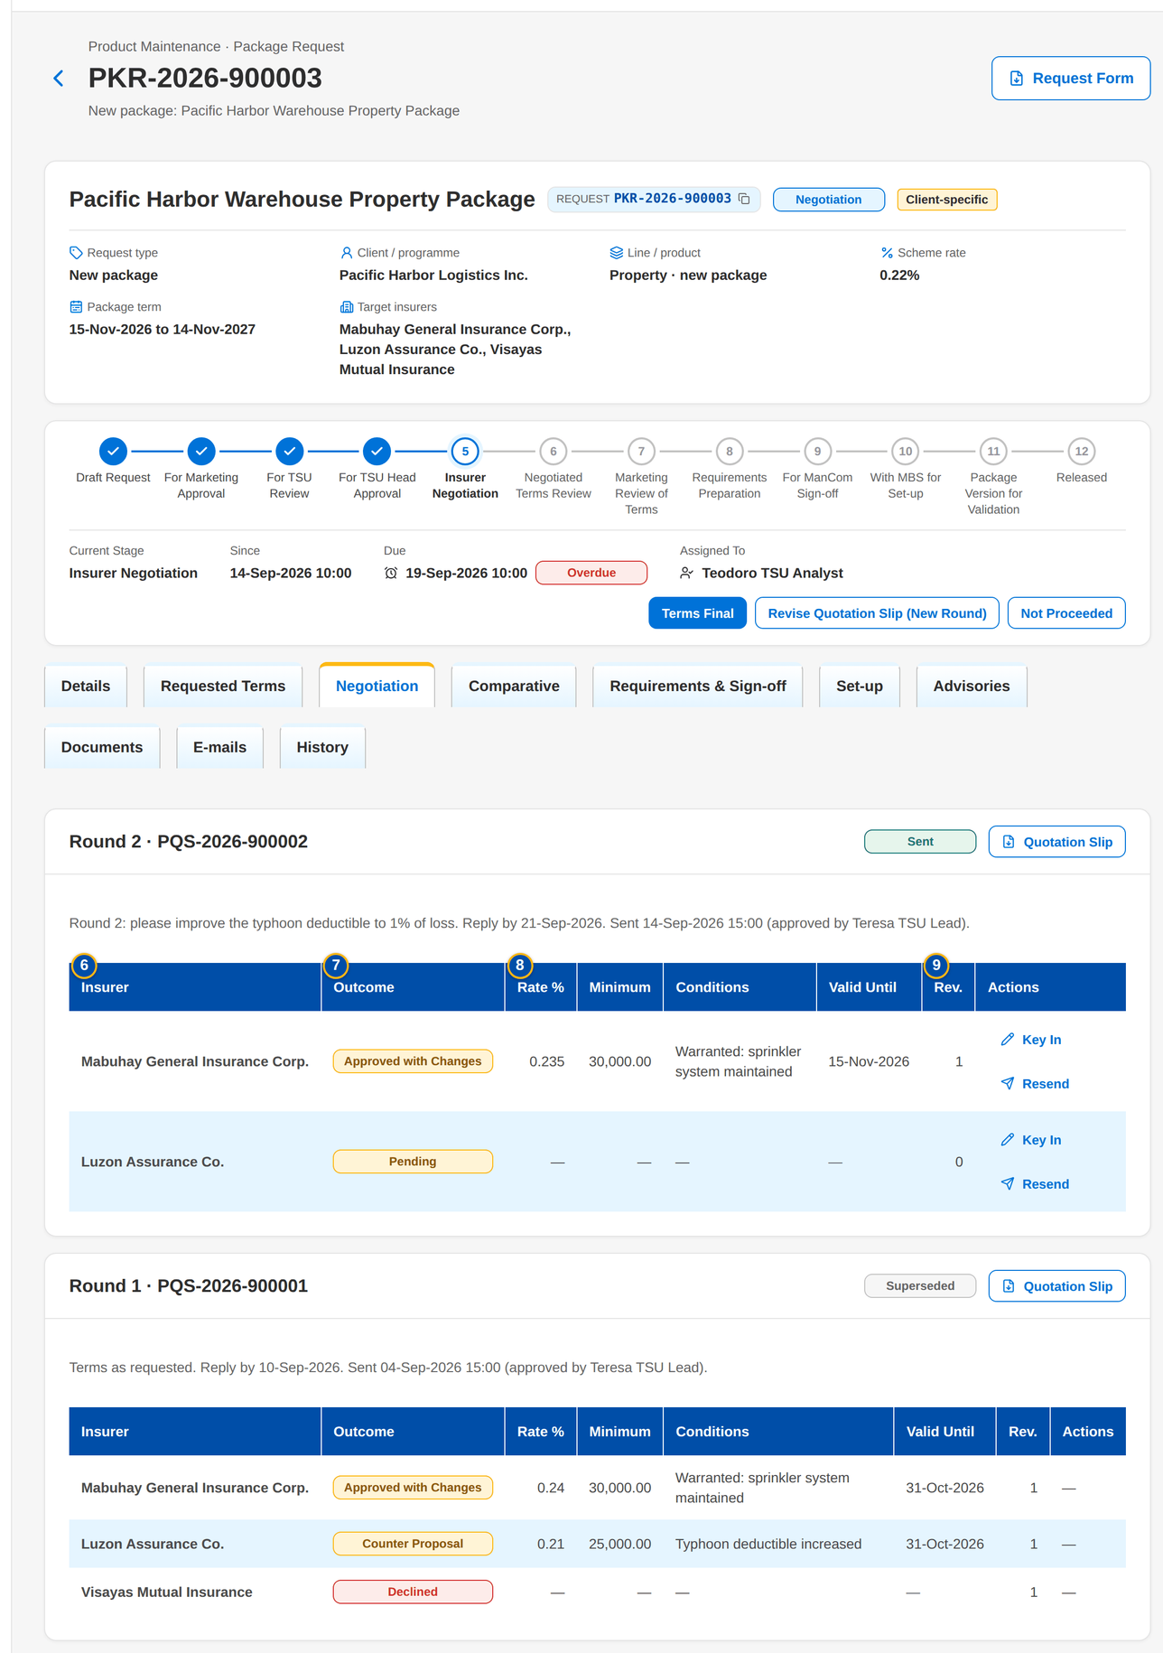
Figure 16: SCR-PM-05 Negotiation tab: round 2 sent, round 1 closed with three outcomes
1 | Round n · slip number | 9 | Rev. | 17 | Response document
2 | Round status pill and Locked tag | 10 | Outcome | 18 | Offer check box
3 | Round note | 11 | Rate % | 19 | Role
4 | Insurer check boxes | 12 | Minimum premium | 20 | Share %
5 | Notes to the insurers | 13 | Valid until | 21 | Comment
6 | Insurer | 14 | Deductible per coverage | 22 | Insurer check boxes
7 | Outcome | 15 | Conditions and warranties | 23 | What changes in this round
8 | Rate % / Minimum / Conditions / Valid Until | 16 | Remarks

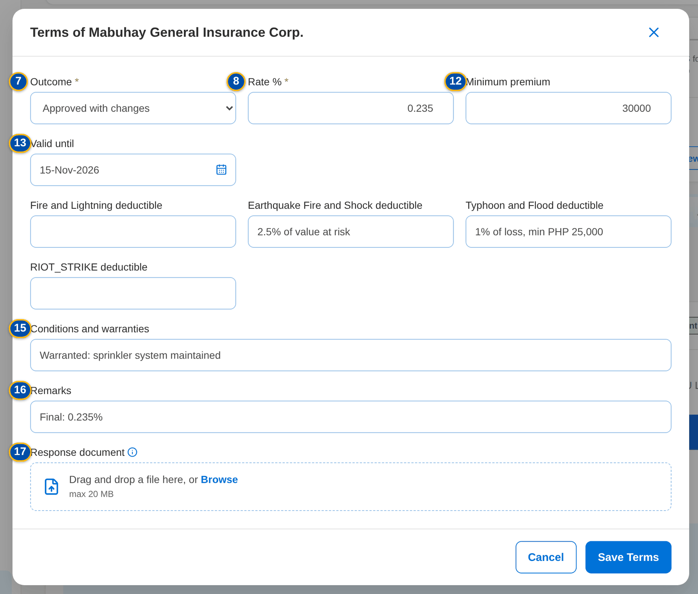
Figure 17: SCR-PM-05 Terms of an insurer: outcome, rate and deductibles

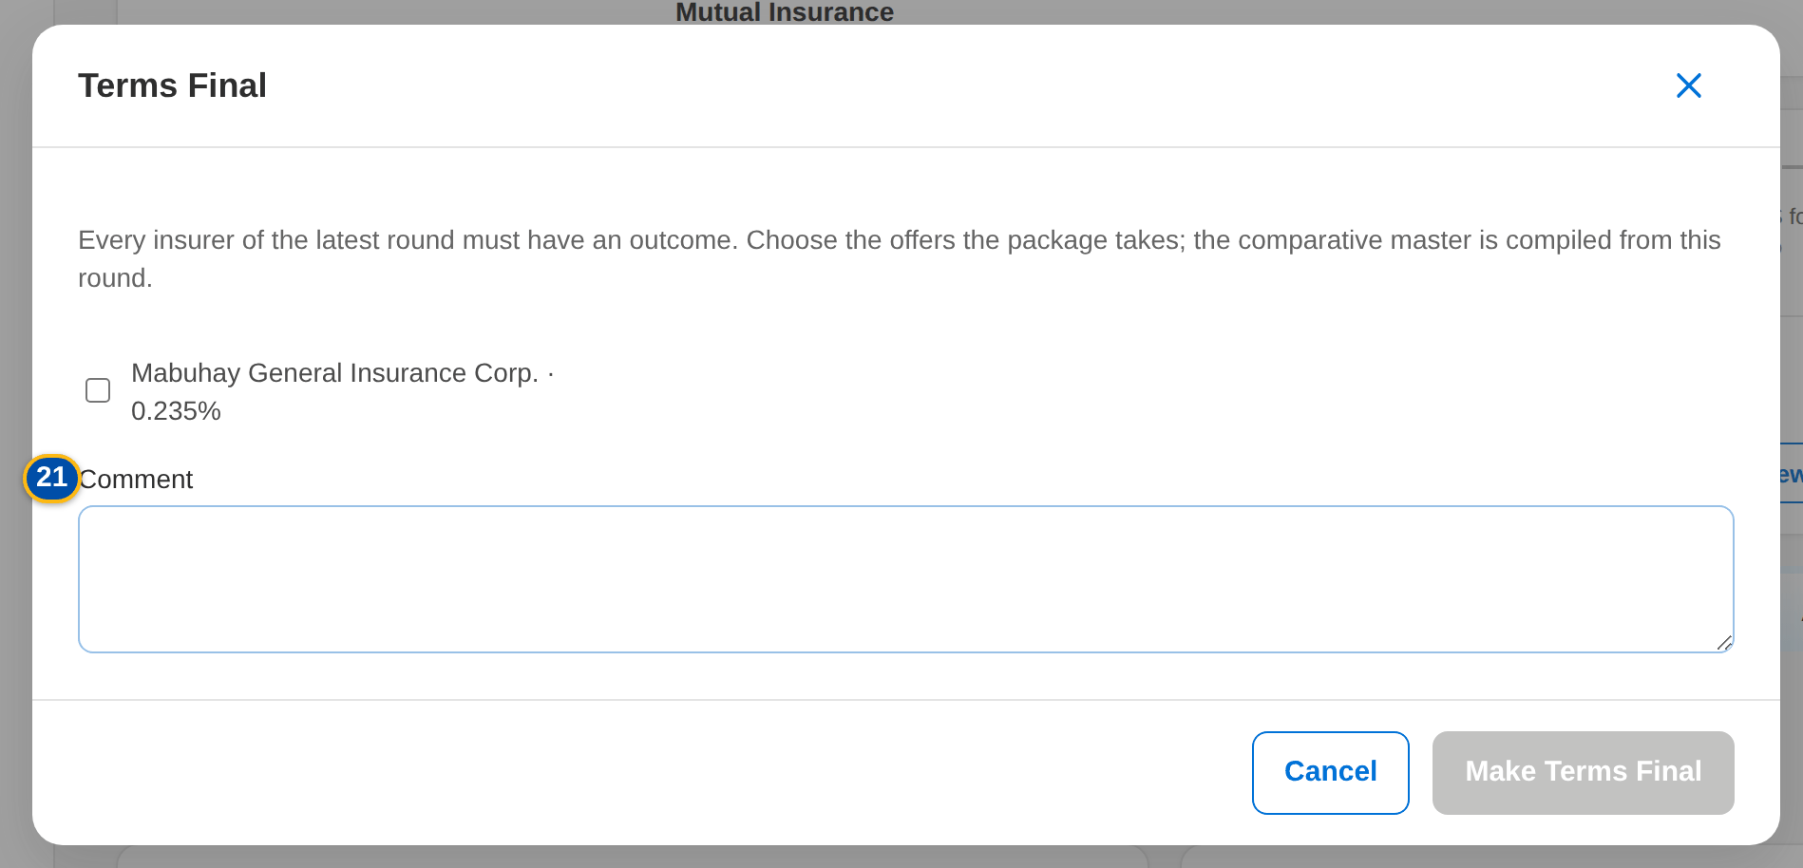
Figure 18: SCR-PM-05 Terms Final dialog: insurers, role and share
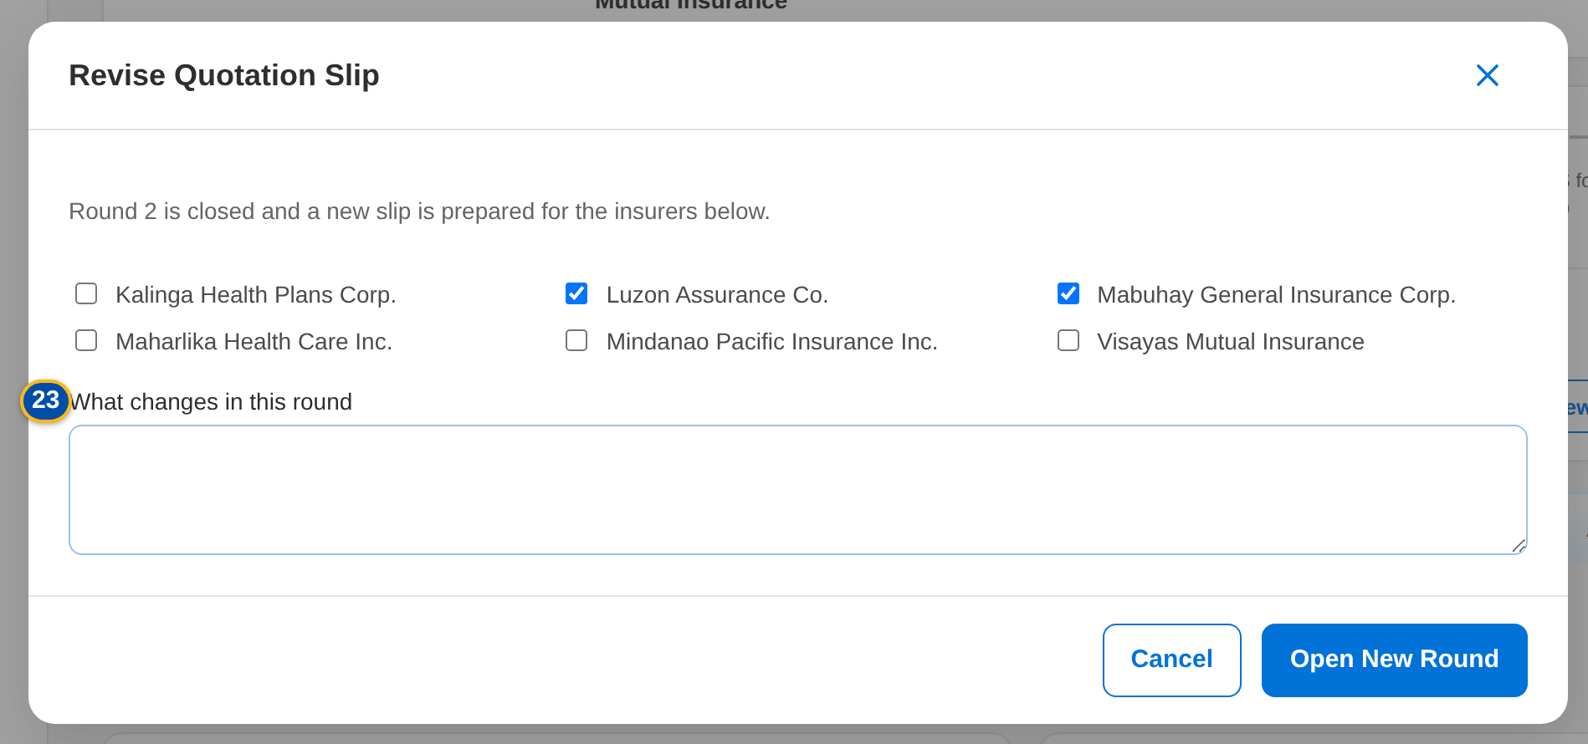
Figure 19: SCR-PM-05 Revise Quotation Slip dialog: insurers of the next round
Fields (No. = callout number on the first screenshot)
No. | Section | Field | Type | Length / format | Mand. | Source / list | Default | Editable in | Validation | Message when it fails
1 | Round card | Round n · slip number | Card title | Round number and quotation slip number | - | Negotiation round | - | Read only | - | -
2 | Round card | Round status pill and Locked tag | Pill | Preparation, For approval, Sent, Superseded; Locked after the ManCom sign-off | - | Negotiation round | - | Read only | - | -
3 | Round card | Round note | Text | Notes of the round; Reply by dd-MMM-yyyy; Sent dd-MMM-yyyy HH:mm (approved by user) | - | Negotiation round | - | Read only | - | -
4 | Slip preparation | Insurer check boxes | Check boxes | Insurers of the round | Y (at least one) | Insurers (authorised, active) | Target insurers (round 1) or the insurers chosen at the revision | Round in preparation | At least one insurer; each insurer authorised and with a placement e-mail | Select at least one insurer for the quotation slip
5 | Slip preparation | Notes to the insurers | Text | Up to 4,000 characters | N | - | Blank (round 1) or the change of the revision | Round in preparation | - | -
6 | Responses | Insurer | Column | Insurer name | - | Insurer response | - | Read only | - | -
7 | Responses | Outcome | Column | Pending, Accepted as requested, Approved with changes, Counter-proposal, Declined, No response | - | Insurer response | Pending | Read only | - | -
8 | Responses | Rate % / Minimum / Conditions / Valid Until | Column | As keyed in | - | Insurer response | - | Read only | - | -
9 | Responses | Rev. | Column | Revision number of the response | - | Insurer response | 0 | Read only | - | -
10 | Terms of <insurer> | Outcome | Drop-down | Accepted as requested, Approved with changes, Counter-proposal, Declined, No response | Y | List PKG_RESPONSE_OUTCOME | Blank for a pending response | Round sent and open | An active value of the list | -
11 | Terms of <insurer> | Rate % | Number | Up to four decimals | Cond.: an offer (accepted, approved with changes, counter-proposal) | - | Blank | Round sent and open | Zero or more | Enter the rate offered
12 | Terms of <insurer> | Minimum premium | Number | Amount in PHP | N | - | Blank | Round sent and open | Zero or more | Rates and amounts cannot be negative
13 | Terms of <insurer> | Valid until | Date | dd-MMM-yyyy | N | - | Blank | Round sent and open | - | -
14 | Terms of <insurer> | Deductible per coverage | Text | One field per requested coverage | N | Requested coverages | The requested deductible | Round sent and open | - | -
15 | Terms of <insurer> | Conditions and warranties | Text | Up to 2,000 characters | N | - | Blank | Round sent and open | - | -
16 | Terms of <insurer> | Remarks | Text | Up to 1,000 characters | N | - | Blank | Round sent and open | - | -
17 | Terms of <insurer> | Response document | File | The insurer's reply (PDF, e-mail or image) | N | - | - | Round sent and open | File checks of every upload | The file could not be read
18 | Terms Final | Offer check box | Check box | Insurer name · rate %, one per insurer that offered terms in the latest round | Y (at least one) | Latest round | Not ticked | Insurer negotiation | Only insurers that offered terms | Choose the insurer(s) whose terms the package takes
19 | Terms Final | Role | Drop-down | Panel, Lead, Participant | Y | Fixed list | Panel | Insurer negotiation | - | -
20 | Terms Final | Share % | Number | Co-insurance share | Cond.: co-insurance (lead and participants) | - | Blank | Insurer negotiation | Shares given for every co-insurer and totalling 100 | Co-insurance shares must be given for every insurer and total 100
21 | Terms Final | Comment | Text | Up to 1,000 characters | N | - | Blank | Insurer negotiation | - | -
22 | Revise Quotation Slip | Insurer check boxes | Check boxes | Insurers of the next round | Y (at least one) | Insurers | Every insurer of the latest round that did not decline | Insurer negotiation | - | -
23 | Revise Quotation Slip | What changes in this round | Text | Up to 4,000 characters | N | - | Blank | Insurer negotiation | - | -

Actions
Button | Who | Enabled when | What happens | Resulting status | Notification
Save Slip | TSU Officer or Team Lead (PKG_NEGOTIATE) | Round in preparation | Saves the insurers and notes of the slip | Round in preparation | -
Submit for Approval | TSU Officer or Team Lead (PKG_NEGOTIATE) | Round in preparation; at least one insurer | Saves the slip, numbers it PQS-yyyy-nnnnnn and sets the reply date (today + PKG_QS_REPLY_DAYS, 5 days) | Round for approval | -
Approve and Send | TSU Team Lead or a co-officer (PKG_QS_APPROVE), not the preparer | Round for approval | Approves the slip and e-mails it to each insurer, password protected; a pending response is opened per insurer | Round sent | Quotation slip e-mail to each insurer (NT-05)
Quotation Slip | Every user of the screen | The slip is numbered | Downloads the quotation slip PDF of the round | Unchanged | -
Key In | PKG_NEGOTIATE | Round sent, open and not locked | Opens Terms of <insurer> | Unchanged | -
Save Terms | PKG_NEGOTIATE | Outcome chosen; a rate for an offer | Saves the response as a new revision (the previous values stay in the history) and attaches the response document | Response outcome | -
Resend | PKG_NEGOTIATE | Round sent, open and not locked | E-mails the slip again to that insurer | Unchanged | Quotation slip e-mail (NT-05)
Revise quotation slip (new round) | PKG_NEGOTIATE | Insurer negotiation; the latest slip was sent | Opens Revise Quotation Slip; Open New Round closes the sent round and opens round n+1 with the chosen insurers | Insurer negotiation (round n+1) | Workflow notice
Terms final | PKG_NEGOTIATE | Insurer negotiation; every insurer of the latest round has an outcome | Opens Terms Final; Make Terms Final records the chosen insurers with role and share as the proposed terms and compiles the comparative master | Negotiated terms review | Workflow notice

Business rules
• A quotation slip is approved by a TSU Team Lead or a co-officer, never by its preparer (FR-PM-030).
• Each insurer receives its own protected e-mail; an insurer without a placement e-mail address stops the sending (FR-PM-030, FR-PM-004).
• An offer (accepted as requested, approved with changes, counter-proposal) needs the rate offered; every change of a response is kept as a revision (FR-PM-031).
• Only the latest round is keyed in; a sent round is revised through a new round, never changed (FR-PM-032).
• The terms are final only when every insurer of the latest round has an outcome and the chosen insurers offered terms; co-insurance shares total 100 (FR-PM-033).
• The slips are locked at the ManCom sign-off (FR-PM-041).
Expected outcome
The negotiated terms of each insurer are recorded round by round with their documents, and the insurers the package takes are chosen.
Test cases: TC-PM-005.2-01, TC-PM-013.1-01, TC-PM-023.2-01, TC-PM-030.1-01, TC-PM-030.2-01, TC-PM-030.3-01, TC-PM-030.3-02, TC-PM-030.4-01, TC-PM-030.4-02, TC-PM-030.5-01, TC-PM-031.1-01, TC-PM-031.1-02, TC-PM-031.2-01, TC-PM-031.2-02, TC-PM-031.2-03, TC-PM-031.3-01, TC-PM-032.1-01, TC-PM-032.2-01, TC-PM-032.3-01, TC-PM-032.4-01, TC-PM-032.4-02, TC-PM-033.1-01, TC-PM-033.2-01, TC-PM-033.2-02, TC-PM-033.2-03, TC-PM-033.3-01, TC-PM-041.2-01, TC-PM-SCR-05, TC-PM-MSG-04.

13.1.6 SCR-PM-06 Package Request record: Comparative tab
Purpose | The comparison of the insurer terms of the latest round, the one current comparative master kept for audit, and the client views derived from it for a client presentation. Every output is stored with its PDF and Excel file.
Who can open it | Marketing Account Officer, Marketing TL / TH / UH, TSU Officer, TSU Team Lead, TSU Head, Marketing Business Services, ManCom member, Business Administrator, New Business Approver, System Administrator, Auditor (permission PRODUCT_VIEW or PKG_REPORT_VIEW)
Navigation | • Menu: Client & Policy › Product Maintenance › Package Requests › Package Request  • Package Request record › Comparative tab
FRs | FR-PM-034, FR-PM-035

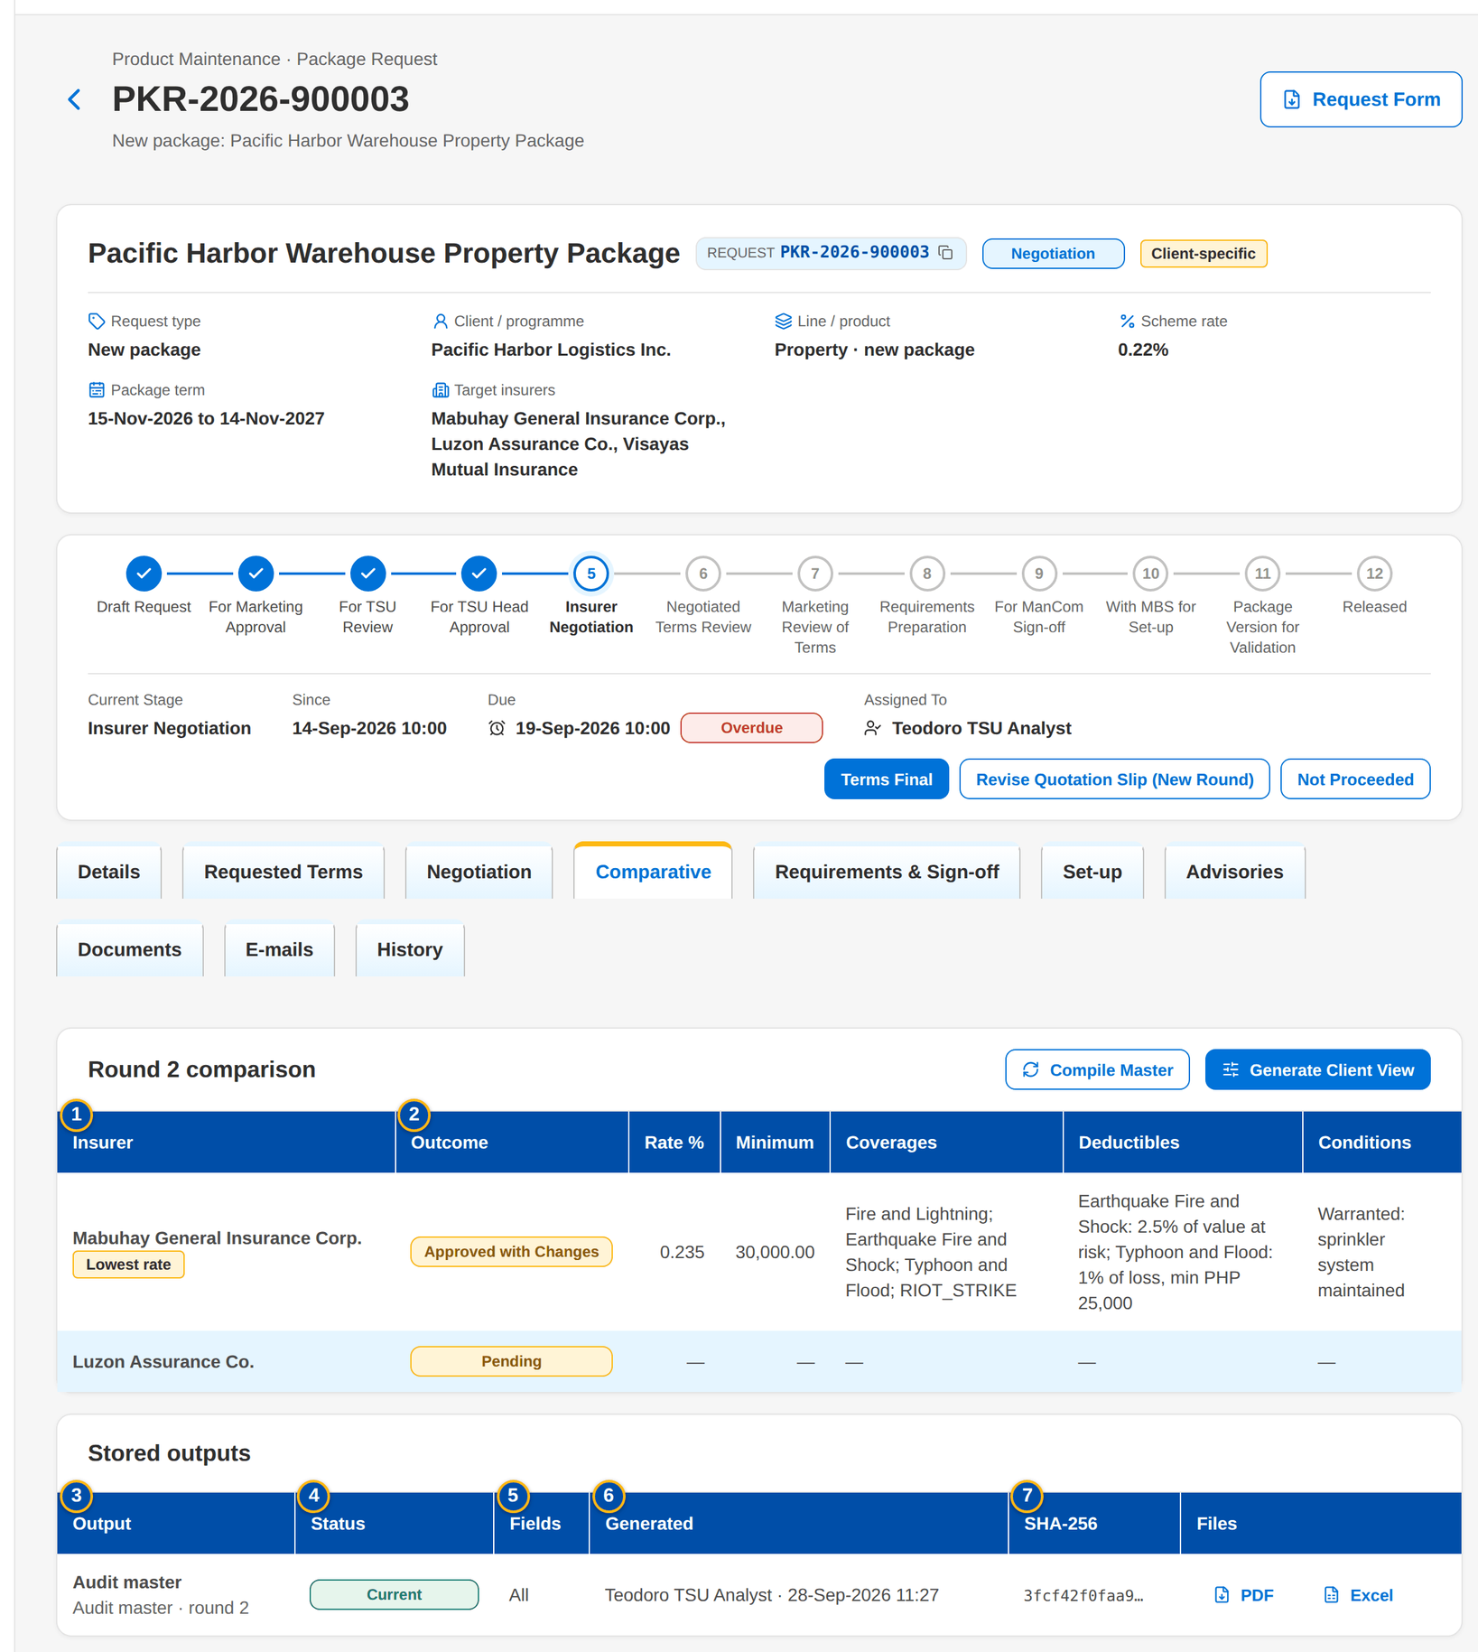
Figure 20: SCR-PM-06 Comparative tab with the round 2 comparison and the stored outputs
1 | Insurer | 5 | Fields | 9 | Fields shown
2 | Outcome / Rate % / Minimum / Coverages / Deductibles / Conditions | 6 | Generated | 10 | Insurers shown
3 | Output | 7 | SHA-256
4 | Status | 8 | Title

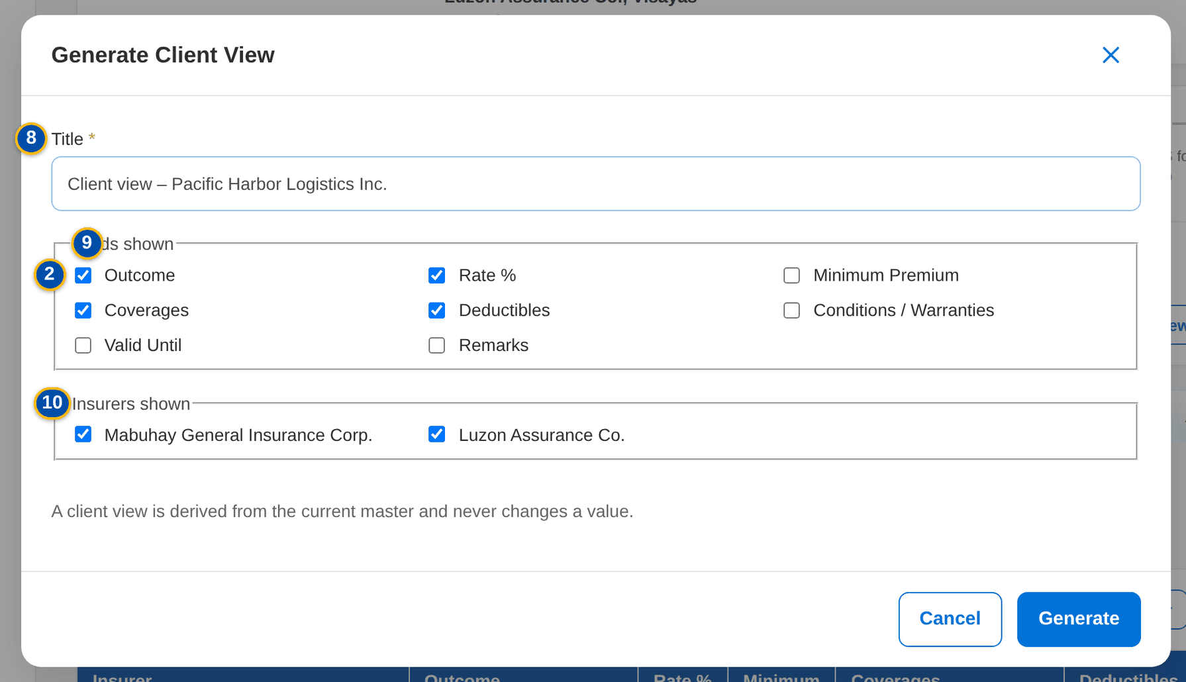
Figure 21: SCR-PM-06 Generate Client View dialog
Fields (No. = callout number on the first screenshot)
No. | Section | Field | Type | Length / format | Mand. | Source / list | Default | Editable in | Validation | Message when it fails
1 | Round n comparison | Insurer | Column | Insurer name, with the Lowest rate tag | - | Latest round | - | Read only | - | No insurer terms to compare yet
2 | Round n comparison | Outcome / Rate % / Minimum / Coverages / Deductibles / Conditions | Column | As keyed in | - | Insurer responses | - | Read only | - | -
3 | Stored outputs | Output | Column | Title, with Audit master or Client view and the round | - | Comparative outputs | - | Read only | - | No comparative output yet
4 | Stored outputs | Status | Column | Current or Superseded (master) | - | Comparative outputs | - | Read only | - | -
5 | Stored outputs | Fields | Column | All, or the number of fields shown | - | Comparative outputs | - | Read only | - | -
6 | Stored outputs | Generated | Column | User · dd-MMM-yyyy HH:mm | - | Comparative outputs | - | Read only | - | -
7 | Stored outputs | SHA-256 | Column | First 12 characters of the file fingerprint | - | Comparative outputs | - | Read only | - | -
8 | Generate Client View | Title | Text | Up to 200 characters | Y | - | Client view – <client or package name> | - | Not blank | Enter the title of the view
9 | Generate Client View | Fields shown | Check boxes | Outcome, Rate %, Minimum Premium, Coverages, Deductibles, Conditions / Warranties, Valid Until, Remarks | Y (at least one) | Fixed list | Outcome, Rate %, Coverages, Deductibles | - | Known fields only | -
10 | Generate Client View | Insurers shown | Check boxes | Insurers of the master | Y (at least one) | Current master | Every insurer | - | Insurers of the master | Select at least one insurer of the master

Actions
Button | Who | Enabled when | What happens | Resulting status | Notification
Compile Master | PKG_NEGOTIATE | The slip of the latest round was sent | Compiles a new comparative master from the latest round; the previous master becomes Superseded | - | -
Generate Client View | PKG_NEGOTIATE | A current master exists | Opens Generate Client View; Generate stores a view with the chosen fields and insurers, taken from the master's values | - | -
PDF / Excel | Every user of the screen | Always | Downloads the stored output | - | -

Business rules
• There is one current comparative master per request; a new master supersedes the previous one (FR-PM-034).
• A client view is taken from the current master and never changes a value; it shows only the fields and insurers chosen (FR-PM-035).
• Every output is attached to the request with its SHA-256 and written to the audit trail (FR-PM-034, FR-PM-005).
Expected outcome
TSU and Marketing compare the insurers on one current table and give the client a tailored view that matches it.
Test cases: TC-PM-034.1-01, TC-PM-034.2-01, TC-PM-034.3-01, TC-PM-034.4-01, TC-PM-035.1-01, TC-PM-035.2-01, TC-PM-035.3-01, TC-PM-035.3-02, TC-PM-035.3-03, TC-PM-SCR-06, TC-PM-MSG-05.

13.1.7 SCR-PM-07 Package Request record: Requirements & Sign-off tab
Purpose | The requirements pack that ManCom signs off: what the pack still lacks, the proposed rate scheme, computation basis and dates (editable while the requirements are prepared), the package slip to print and sign, and the ManCom decisions with their sign-off reference.
Who can open it | Marketing Account Officer, Marketing TL / TH / UH, TSU Officer, TSU Team Lead, TSU Head, Marketing Business Services, ManCom member, Business Administrator, New Business Approver, System Administrator, Auditor (permission PRODUCT_VIEW or PKG_REPORT_VIEW)
Navigation | • Menu: Client & Policy › Product Maintenance › Package Requests › Package Request  • Package Request record › Requirements & Sign-off tab
FRs | FR-PM-040, FR-PM-041, FR-PM-036

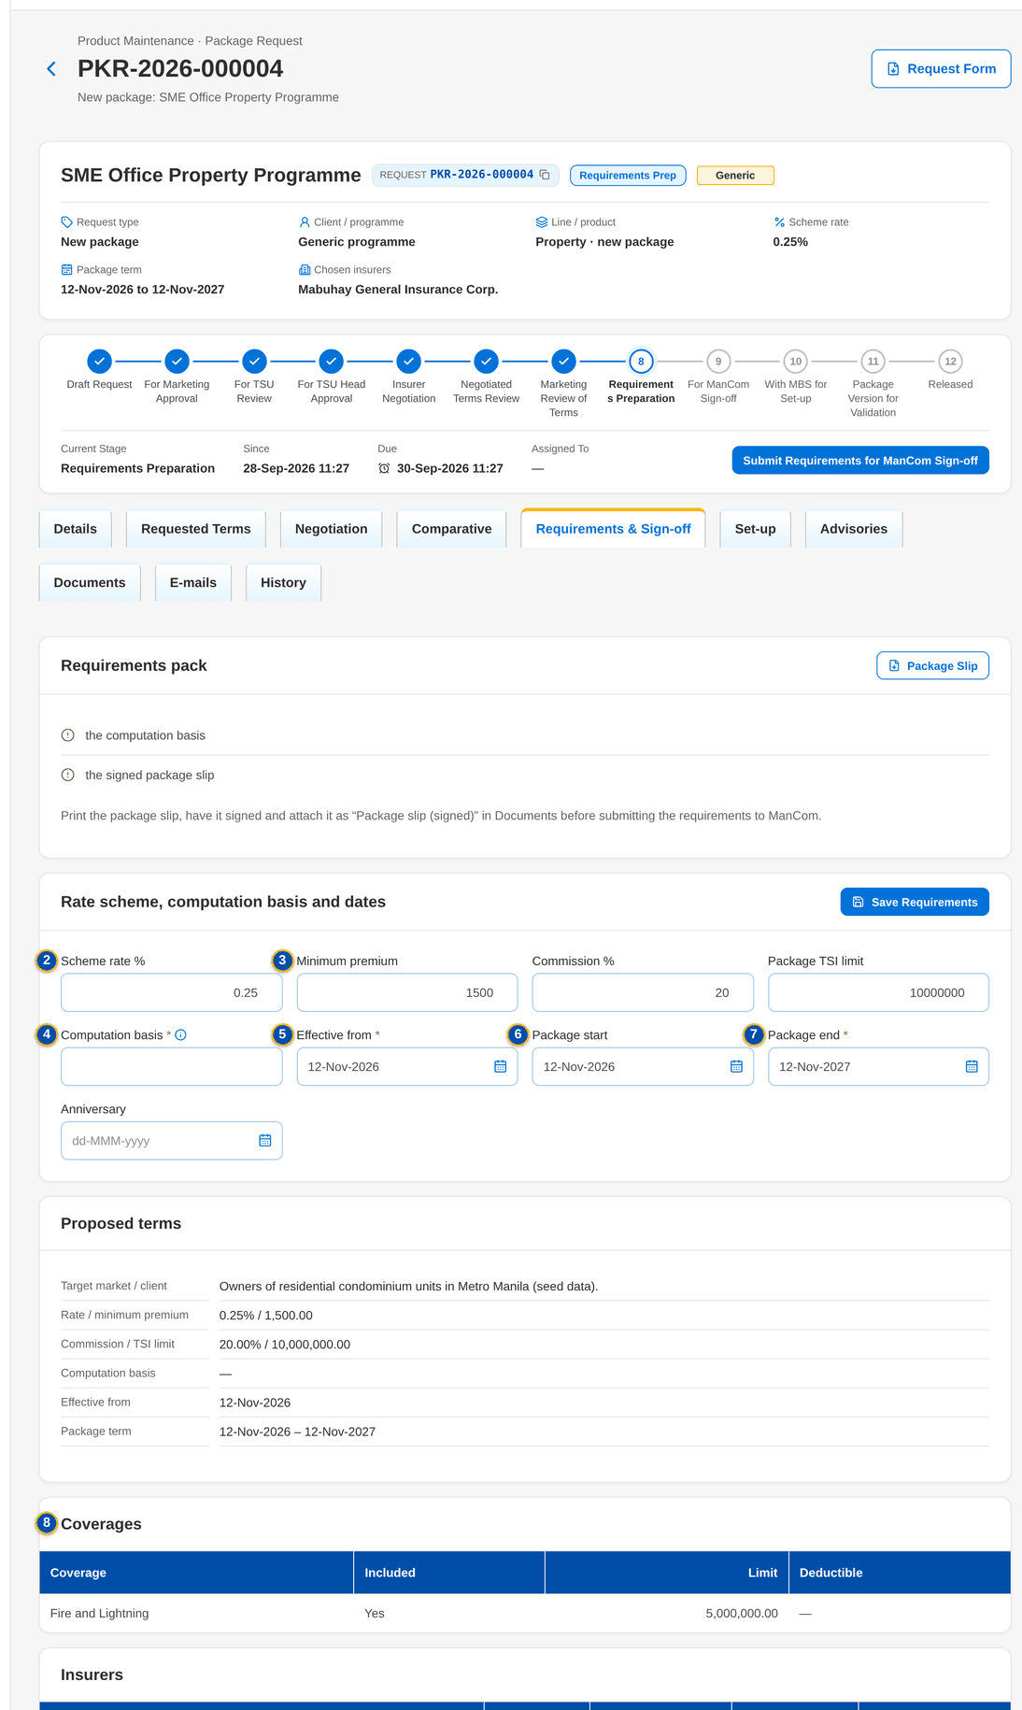
Figure 22: SCR-PM-07 Requirements & Sign-off tab during the requirements preparation
1 | Checklist | 4 | Computation basis | 7 | Package end
2 | Scheme rate % | 5 | Effective from | 8 | Sections, coverages, rate scheme, dates and insurers
3 | Minimum premium / Commission % / Package TSI limit | 6 | Package start / Anniversary | 9 | Reference / Decision / By / On / Comment

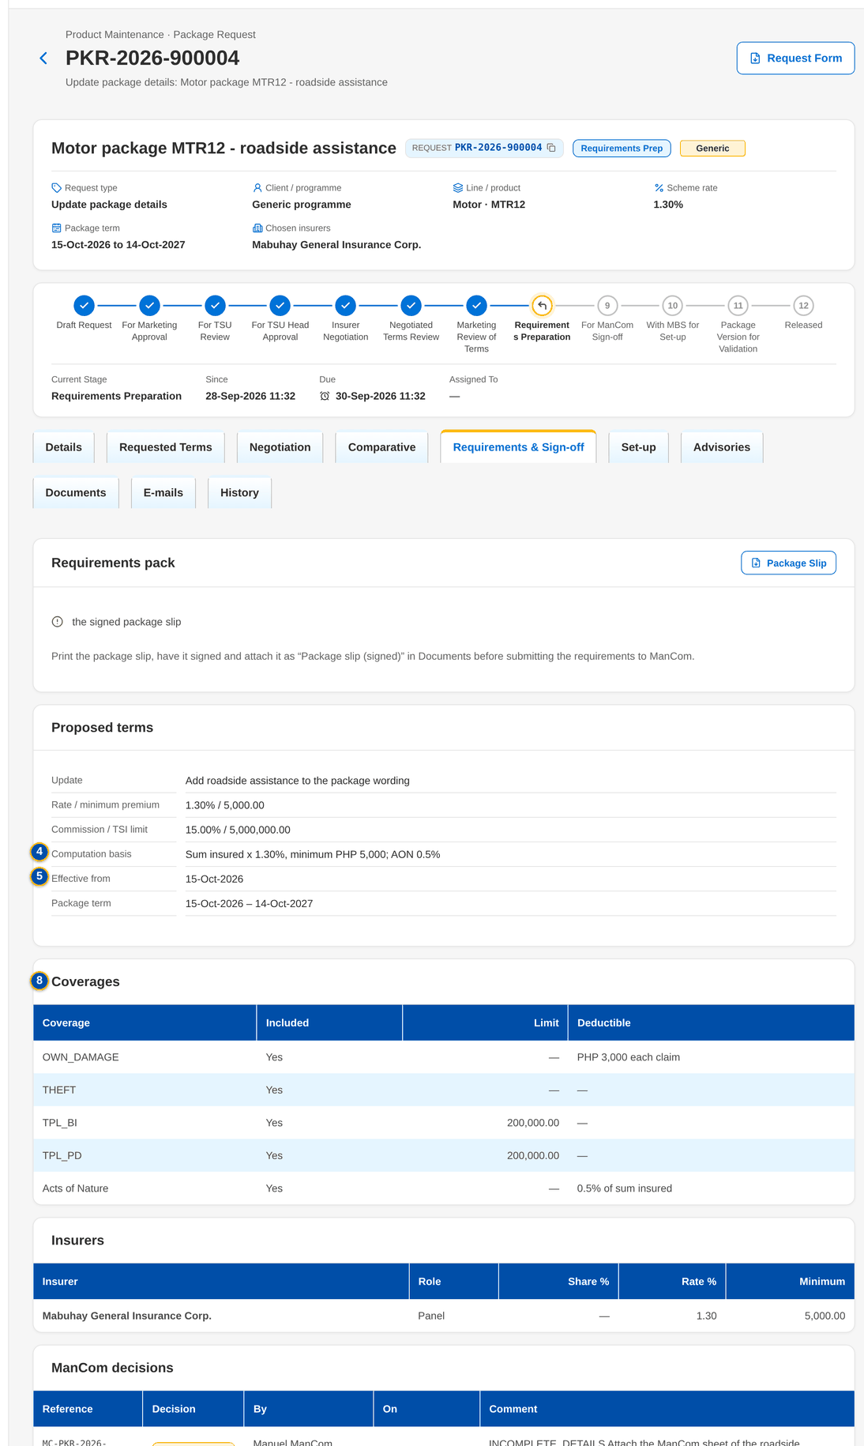
Figure 23: SCR-PM-07 ManCom view before the sign-off

Fields (No. = callout number on the first screenshot)
No. | Section | Field | Type | Length / format | Mand. | Source / list | Default | Editable in | Validation | Message when it fails
1 | Requirements pack | Checklist | Checklist | Missing items, or The requirements pack is complete. | - | Requirements check | - | Read only | The effective date and package end date, a scheme rate or a rate for every insurer, the computation basis, the chosen insurer(s) and the signed package slip | Complete the requirements: <missing>
2 | Rate scheme, computation basis and dates | Scheme rate % | Number | Up to four decimals | Cond.: or a rate for every insurer | Proposed terms | The negotiated rate | Requirements preparation | Zero or more | Rates and amounts cannot be negative
3 | Rate scheme, computation basis and dates | Minimum premium / Commission % / Package TSI limit | Number | Amount in PHP; percentage | N | Proposed terms | Negotiated values | Requirements preparation | Zero or more | Rates and amounts cannot be negative
4 | Rate scheme, computation basis and dates | Computation basis | Text | How the premium is computed | Y | Proposed terms | Blank | Requirements preparation | Not blank before submission | Complete the requirements: the computation basis
5 | Rate scheme, computation basis and dates | Effective from | Date | dd-MMM-yyyy | Y | Proposed terms | Requested date | Requirements preparation | - | Complete the requirements: the effective date and the package end date
6 | Rate scheme, computation basis and dates | Package start / Anniversary | Date | dd-MMM-yyyy | N | Proposed terms | Requested dates | Requirements preparation | - | -
7 | Rate scheme, computation basis and dates | Package end | Date | dd-MMM-yyyy | Y | Proposed terms | Requested date | Requirements preparation | After the effective date | The package end date must be after the effective date
8 | Proposed terms | Sections, coverages, rate scheme, dates and insurers | Read-only view | As on the Requested Terms tab | - | Proposed terms | - | Read only | - | -
9 | ManCom decisions | Reference / Decision / By / On / Comment | Table | MC-PKR-yyyy-nnnnnn; Signed or Returned | - | ManCom sign-offs | - | Read only | - | No ManCom decision yet

Actions
Button | Who | Enabled when | What happens | Resulting status | Notification
Package Slip | Every user of the screen | Always | Downloads the package slip (PDF) with the proposed terms, to be printed and signed | Unchanged | -
Save Requirements | PKG_NEGOTIATE | Requirements preparation | Saves the rate scheme, computation basis and dates of the proposed terms | Unchanged | -
Submit requirements for ManCom sign-off | PKG_NEGOTIATE | Requirements preparation; the pack is complete | Sends the pack to ManCom | For ManCom sign-off | Workflow notice
Sign off and send to MBS | ManCom (PKG_MANCOM_SIGNOFF), not the submitter of the requirements | For ManCom sign-off | Records the sign-off MC-<request no.>, locks the quotation slips and attaches the sign-off record (or links the uploaded ManCom sign-off sheet) | With MBS for set-up | Workflow notice

Business rules
• The requirements pack needs the effective date and package end date, a scheme rate or a rate for every insurer, the computation basis, at least one chosen insurer and the signed package slip attached as Package slip (signed) (FR-PM-040).
• ManCom never signs off requirements it submitted; a single ManCom sign-off is recorded (FR-PM-041).
• At the sign-off the quotation slips of every round are locked (FR-PM-041).
Expected outcome
ManCom signs off a complete pack in BIBS and the request goes to MBS for the set-up.
Test cases: TC-PM-040.1-01, TC-PM-040.1-02, TC-PM-040.2-01, TC-PM-040.3-01, TC-PM-040.3-02, TC-PM-041.1-01, TC-PM-041.3-01, TC-PM-041.4-01, TC-PM-041.4-02, TC-PM-SCR-07, TC-PM-MSG-06.

13.1.8 SCR-PM-08 Package Request record: Set-up and Advisories tabs
Purpose | MBS turns the signed-off terms into a draft catalog version (Set up package version), completes it in the version editor and submits it for validation; the request is released when the version is validated. On release (or retirement) BIBS drafts the advisory, which TSU edits and sends to the recipient groups once the signed package slip and the ManCom sign-off are attached.
Who can open it | Marketing Account Officer, Marketing TL / TH / UH, TSU Officer, TSU Team Lead, TSU Head, Marketing Business Services, ManCom member, Business Administrator, New Business Approver, System Administrator, Auditor (permission PRODUCT_VIEW or PKG_REPORT_VIEW)
Navigation | • Menu: Client & Policy › Product Maintenance › Package Requests › Package Request  • Package Request record › Set-up tab, Advisories tab
FRs | FR-PM-042, FR-PM-043, FR-PM-044, FR-PM-045

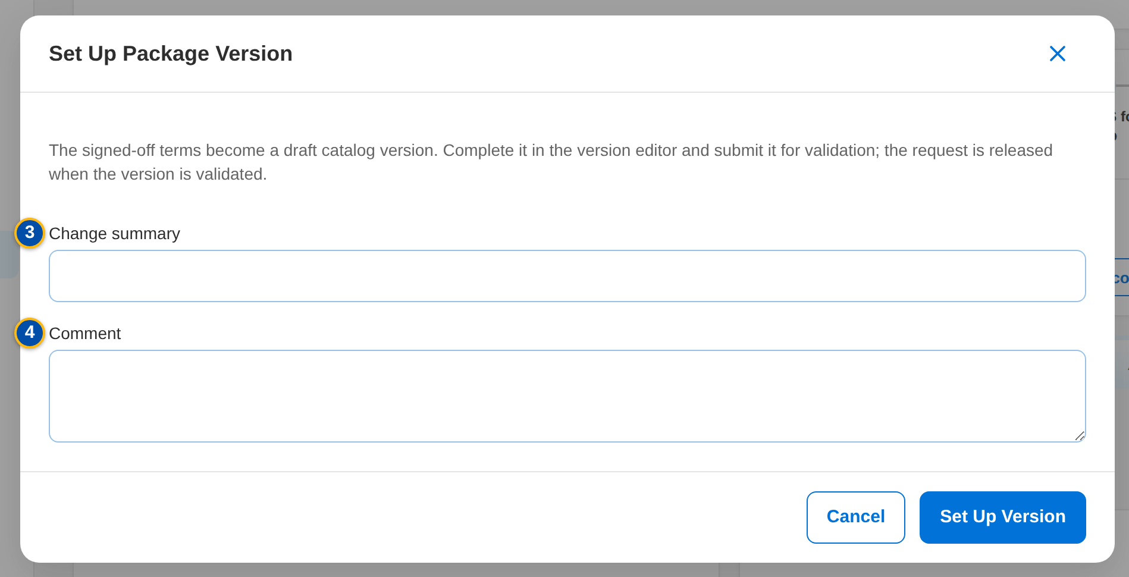
Figure 24: SCR-PM-08 Set Up Package Version dialog of MBS
1 | Risk code of the new package | 5 | Product / Version / Request stage | 9 | E-mail to (optional)
2 | Product name | 6 | Advisory card | 10 | Subject
3 | Change summary | 7 | Supporting documents checklist | 11 | Text
4 | Comment | 8 | Recipient groups

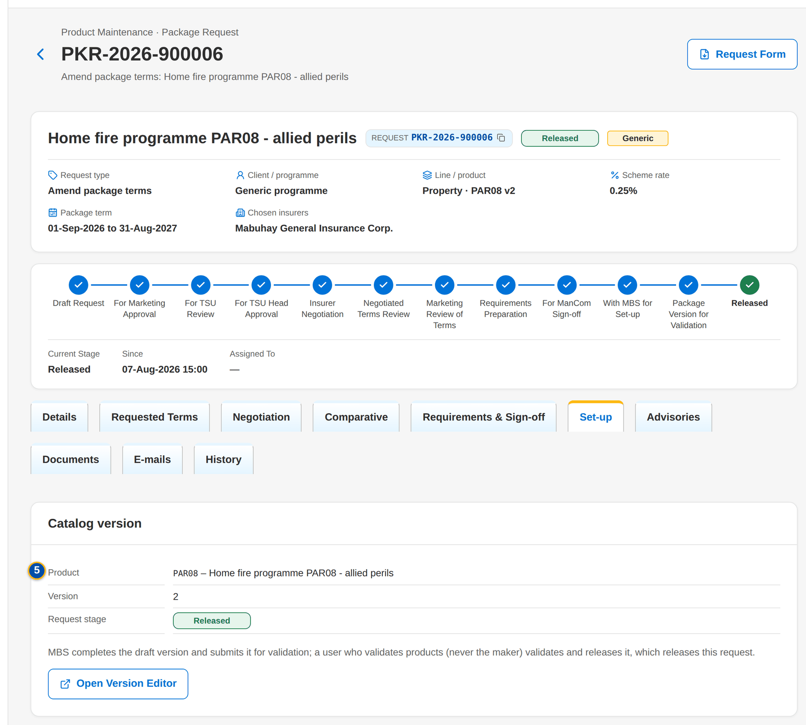
Figure 25: SCR-PM-08 Set-up tab with the catalog version

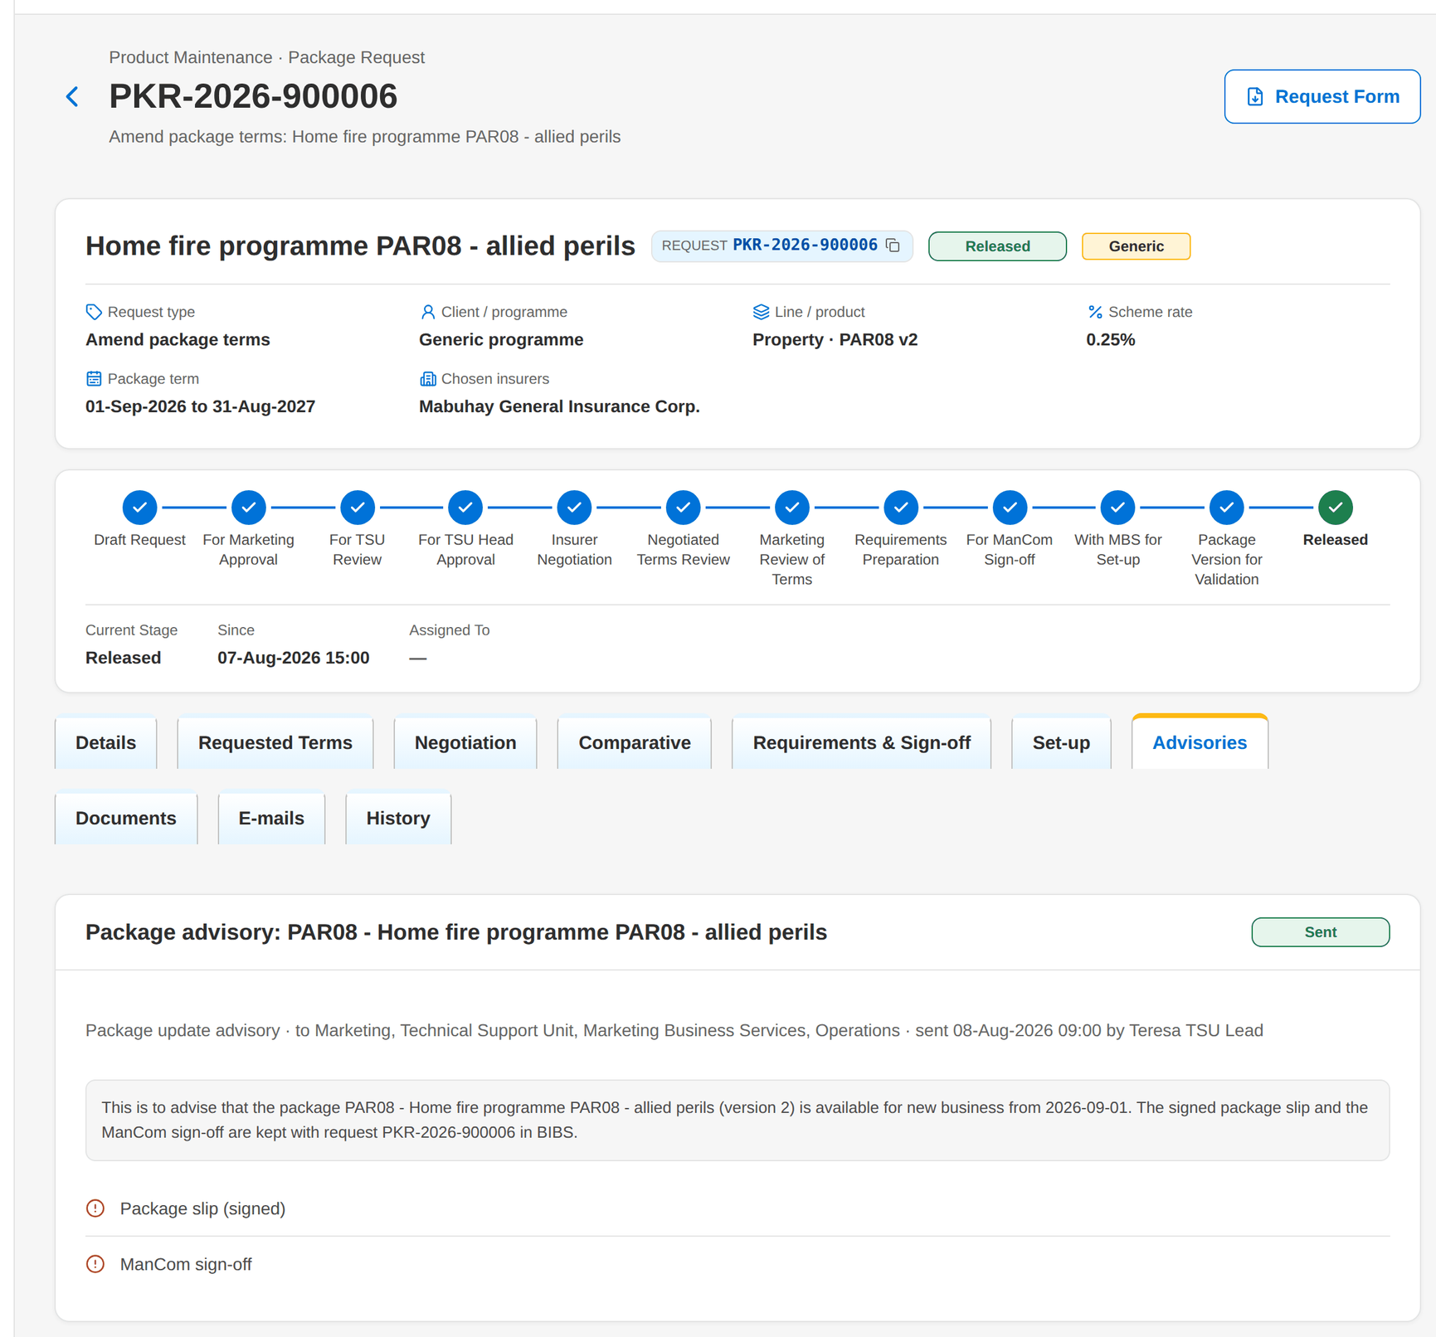
Figure 26: SCR-PM-08 Advisories tab of a released request

Fields (No. = callout number on the first screenshot)
No. | Section | Field | Type | Length / format | Mand. | Source / list | Default | Editable in | Validation | Message when it fails
1 | Set Up Package Version | Risk code of the new package | Text | Up to 20 capitals or digits; the naming convention of the line when set | Cond.: New package | - | Blank | With MBS for set-up | Not blank; not an existing product | Enter the risk code of the new package
2 | Set Up Package Version | Product name | Text | Up to 200 characters | N | - | The package or programme name | With MBS for set-up | - | -
3 | Set Up Package Version | Change summary | Text | Up to 500 characters | N | - | Blank | With MBS for set-up | - | -
4 | Set Up Package Version | Comment | Text | Up to 1,000 characters | N | - | Blank | With MBS for set-up | - | -
5 | Set-up › Catalog version | Product / Version / Request stage | Detail | Risk code, version number, stage pill | - | Package version | - | Read only | - | MBS sets the package up after the ManCom sign-off
6 | Advisories | Advisory card | Card | Subject, status pill, type · recipient groups, sent date and user, text | - | Advisory | Drafted on release or retirement | Draft | - | An advisory is drafted when the package is released or retired
7 | Advisories | Supporting documents checklist | Checklist | Package slip (signed) and ManCom sign-off (retirement: ManCom sign-off only), each Attached or Missing | - | Documents of the request | - | Read only | Both documents attached before sending | The advisory cannot be sent until the supporting documents are attached (Documents tab).
8 | Edit Advisory | Recipient groups | Check boxes | Marketing, TSU, MBS, Processing, Operations | Y (at least one) | List PKG_ADVISORY_GROUP | Parameter PKG_ADVISORY_GROUPS (Marketing, TSU, MBS, Operations) | Draft | Active values of the list | Select at least one recipient group
9 | Edit Advisory | E-mail to (optional) | Text | Comma-separated addresses | N | - | Blank | Draft | - | -
10 | Edit Advisory | Subject | Text | Up to 200 characters | Y | - | From the template PKG_ADVISORY or PKG_RENEWAL_ADVISORY | Draft | Not blank | Enter the subject and the text
11 | Edit Advisory | Text | Text | Up to 8,000 characters | Y | - | From the template | Draft | Not blank | Enter the subject and the text

Actions
Button | Who | Enabled when | What happens | Resulting status | Notification
Set up package version | MBS (PRODUCT_MAINTAIN) | With MBS for set-up; not a Retire request | Opens Set Up Package Version; Set Up Version creates the draft catalog version from the signed-off terms (a new package also creates its product, pending authorisation) | Package version for validation | Workflow notice
Open Version Editor | Every user of the screen | A version was set up | Opens the Package Version (SCR-PM-13) | - | -
Edit | TSU (PKG_ADVISORY) | Draft advisory | Opens Edit Advisory; Save keeps the changes | Draft | -
Send Advisory | TSU (PKG_ADVISORY) | Draft advisory; the supporting documents are attached | Stores the advisory PDF on the request, notifies the users of each recipient group in the app and, when addresses are given, e-mails the protected PDF | Sent | Advisory notice (NT-03); advisory e-mail (NT-06)

Business rules
• The set-up creates a draft version; a product can have only one version being set up at a time (FR-PM-042).
• A new package needs its risk code; the product is authorised when its first version is validated (FR-PM-042, FR-PM-043).
• The request is released automatically when its version is validated, and returns to MBS when the validator returns the version (FR-PM-043).
• An advisory is sent only with the signed package slip and the ManCom sign-off attached; a retirement advisory needs the ManCom sign-off only (FR-PM-044).
• Recipient groups are notified in the app: Marketing, TSU, MBS, Processing and Operations users by their permissions; e-mail addresses are optional (FR-PM-044).
Expected outcome
The signed-off terms reach the catalog without re-keying, and every unit is told, with the documents, that the package is available, changed or retired.
Test cases: TC-PM-042.2-01, TC-PM-042.2-02, TC-PM-042.3-01, TC-PM-042.3-02, TC-PM-042.4-01, TC-PM-042.4-02, TC-PM-044.1-01, TC-PM-044.2-01, TC-PM-044.3-01, TC-PM-044.3-02, TC-PM-044.4-01, TC-PM-044.4-02, TC-PM-045.1-01, TC-PM-045.1-02, TC-PM-045.1-03, TC-PM-SCR-08, TC-PM-MSG-07.

13.1.9 SCR-PM-09 TSU Workbench
Purpose | The package request queues of the TSU Officer, Team Lead and Head: one tile per stage they work (review, approval, negotiation, terms review, requirements), with the open and overdue counts, and the queue of the chosen stage, oldest due first. A user claims a request to work it; team leads assign requests.
Who can open it | TSU Officer, TSU Team Lead, TSU Head (permission PKG_NEGOTIATE or PKG_TSU_RECOMMEND or PKG_TSU_APPROVE)
Navigation | • Menu: Client & Policy › Product Maintenance › TSU Workbench  • Sidebar entry TSU Workbench
FRs | FR-PM-024, FR-PM-022, FR-PM-023

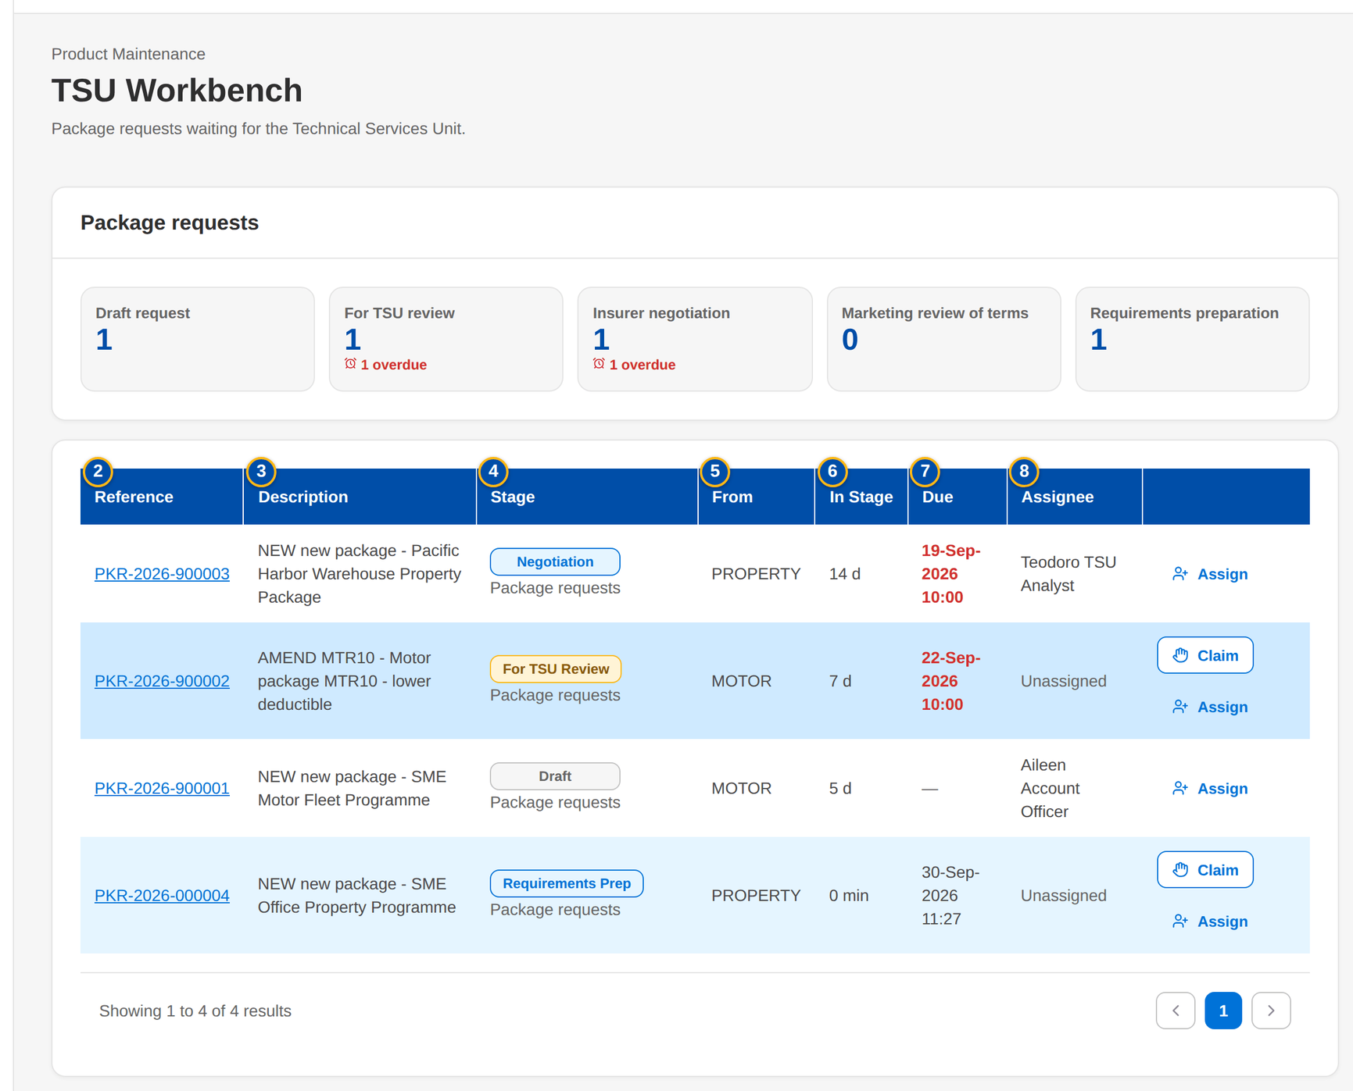
Figure 27: SCR-PM-09 TSU Workbench of the TSU Team Lead
1 | Stage tiles | 4 | Stage | 7 | Due
2 | Reference | 5 | From | 8 | Assignee
3 | Description | 6 | In Stage

Fields (No. = callout number on the first screenshot)
No. | Section | Field | Type | Length / format | Mand. | Source / list | Default | Editable in | Validation | Message when it fails
1 | Package requests | Stage tiles | Tile | Stage name, open count, 'n overdue', 'n mine' | - | Workflow queues | - | Read only | - | -
2 | Queue | Reference | Column | PKR-yyyy-nnnnnn | - | Work item | - | Read only | - | -
3 | Queue | Description | Column | Request type, product and name | - | Work item | - | Read only | - | -
4 | Queue | Stage | Column | Stage pill | - | Workflow | - | Read only | - | -
5 | Queue | From | Column | Unit or user that raised the request | - | Work item | - | Read only | - | -
6 | Queue | In Stage | Column | Time in the stage | - | Workflow | - | Read only | - | -
7 | Queue | Due | Column | dd-MMM-yyyy HH:mm; Overdue in red | - | Workflow | - | Read only | - | -
8 | Queue | Assignee | Column | User or unassigned | - | Workflow | - | Read only | - | -

Actions
Button | Who | Enabled when | What happens | Resulting status | Notification
A stage tile | Every user of the screen | Always | Shows the queue of that stage | - | -
Claim | A user of the stage | Unassigned item | Assigns the request to the user | Unchanged | -
Assign | Team leaders (WORK_ASSIGN) | Always | Opens the assignment dialog: a user of the stage or the team queue | Unchanged | Assignment notice
Open a row | Every user of the screen | Always | Opens the package request | - | -

Business rules
• Only the stages the user's permissions work are shown (FR-PM-024).
• A claimed request is worked by the user who claimed it; a team leader can re-assign it (FR-PM-024).
Expected outcome
TSU users pick up their package work by stage and due time; team leaders balance the queues.
Test cases: TC-PM-022.1-01, TC-PM-022.1-02, TC-PM-022.3-01, TC-PM-022.3-02, TC-PM-023.1-01, TC-PM-023.3-01, TC-PM-023.3-02, TC-PM-024.3-01, TC-PM-024.3-02, TC-PM-SCR-09.

13.1.10 SCR-PM-10 Package Expiry
Purpose | The released packages by package end date, with their renewal status: packages ending without a renewal request, packages whose renewal is in progress, and the pointer to the expired packages kept in the catalog. TSU drafts renewal requests for the selected packages, pre-filled from the version in force.
Who can open it | Marketing TL / TH / UH, TSU Officer, TSU Team Lead, TSU Head, Marketing Business Services, Business Administrator, Auditor (permission PKG_NEGOTIATE or PRODUCT_MAINTAIN or PKG_REPORT_VIEW)
Navigation | • Menu: Client & Policy › Product Maintenance › Package Expiry  • Product Maintenance Home › Packages ending soon tiles  • Package Requests › Package Expiry  • The expiry alert (Alert inbox) and the package expired notice
FRs | FR-PM-060, FR-PM-061, FR-PM-052

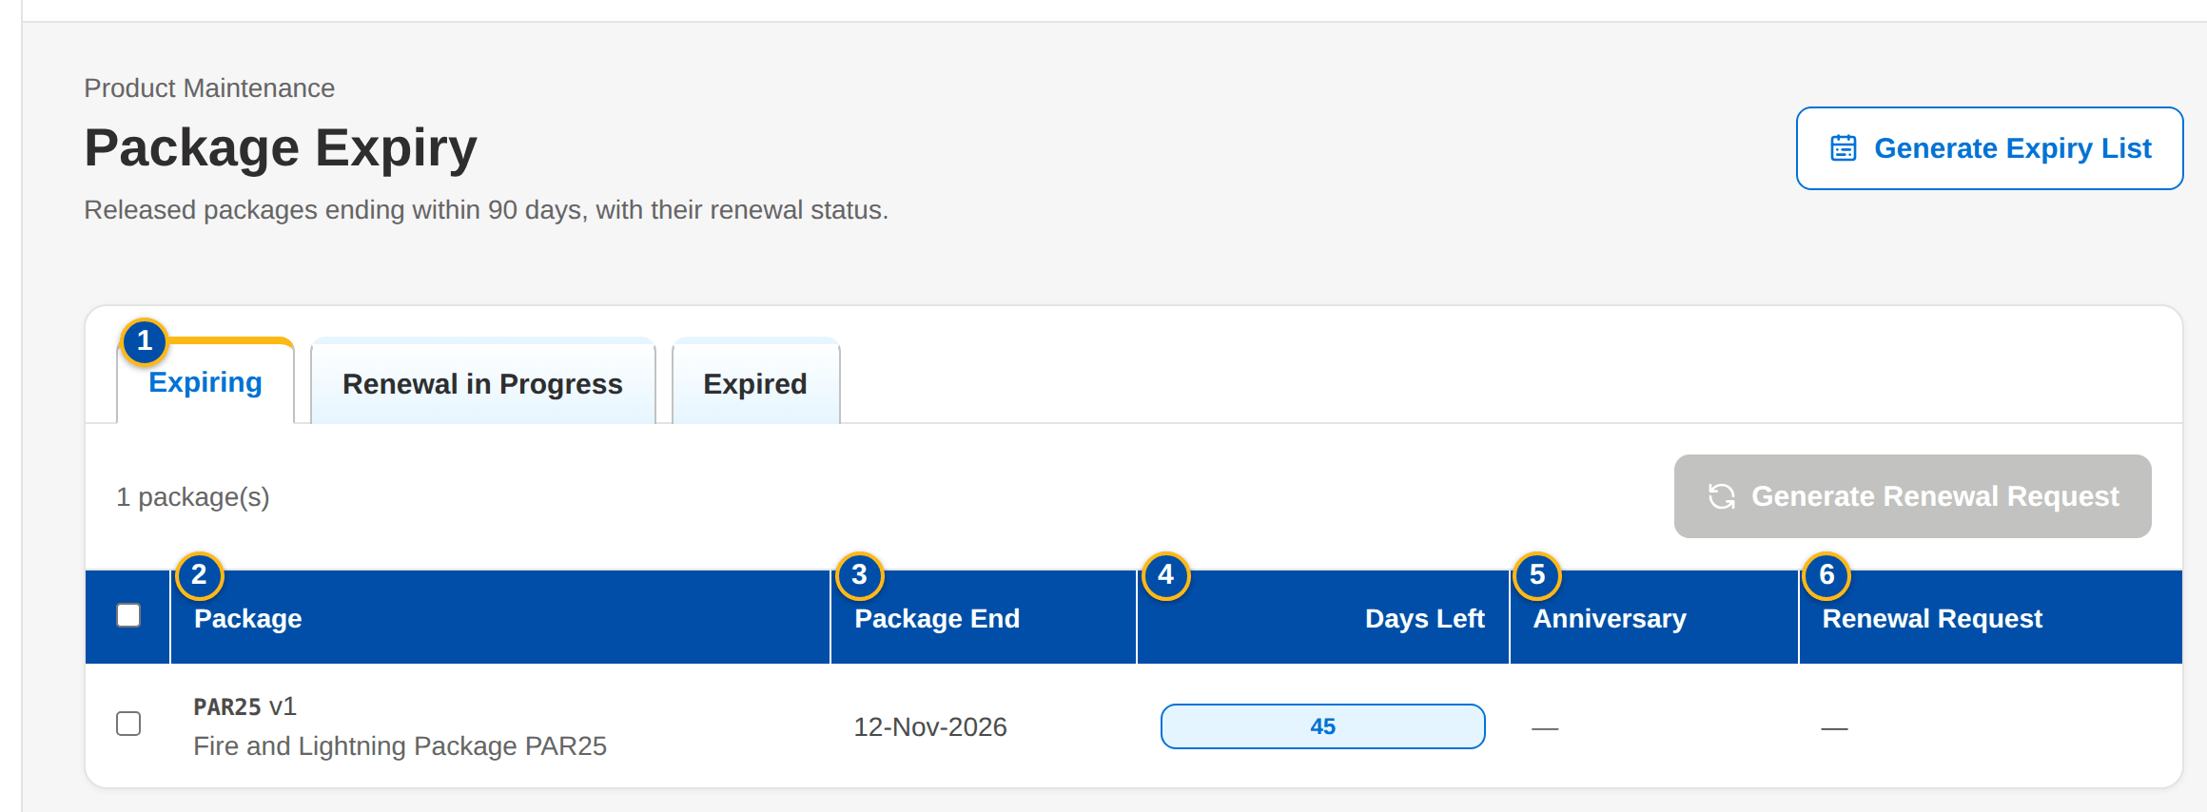
Figure 28: SCR-PM-10 Package Expiry, Expiring tab
1 | Expiring / Renewal in Progress / Expired | 4 | Days Left | 7 | Packages ending within (days)
2 | Package | 5 | Anniversary
3 | Package End | 6 | Renewal Request

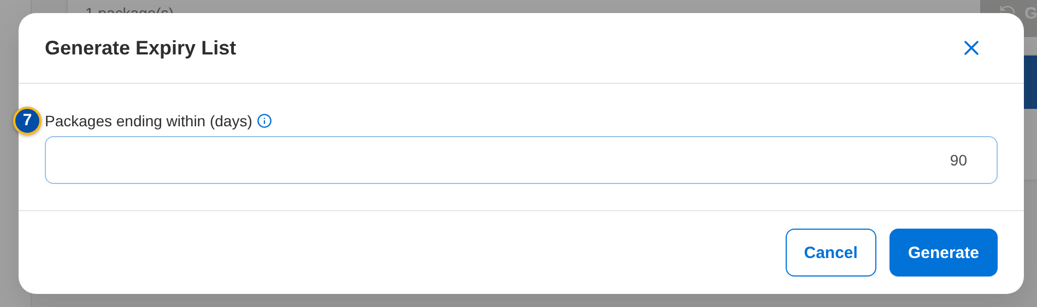
Figure 29: SCR-PM-10 Generate Expiry List dialog
Fields (No. = callout number on the first screenshot)
No. | Section | Field | Type | Length / format | Mand. | Source / list | Default | Editable in | Validation | Message when it fails
1 | Tabs | Expiring / Renewal in Progress / Expired | Tab | - | - | Fixed | Expiring | - | Expiring = no renewal request yet; Renewal in Progress = an open renewal or reactivation request | -
2 | List | Package | Column | Risk code v<version>, with the product name | - | Version in force | - | Read only | - | -
3 | List | Package End | Column | dd-MMM-yyyy | - | Version in force | - | Read only | - | -
4 | List | Days Left | Column | Days until the package end, red up to 7, amber up to 30 | - | Computed | - | Read only | - | -
5 | List | Anniversary | Column | dd-MMM-yyyy | - | Version in force | - | Read only | - | -
6 | List | Renewal Request | Column | Request number and its stage pill | - | Package requests | - | Read only | - | -
7 | Generate Expiry List | Packages ending within (days) | Number | Whole days from today | Y | - | 90 (or the window of the home tile) | - | Zero or more | -

Actions
Button | Who | Enabled when | What happens | Resulting status | Notification
Generate Expiry List | Every user of the screen | Always | Opens the dialog; Generate lists the packages ending within the days entered | - | -
Generate Renewal Request | TSU (PKG_NEGOTIATE) | Expiring tab; at least one package selected | Drafts one Renew request per package, pre-filled from the version in force with the next term (start = old end + 1 day, same length); a package with an open renewal keeps it; one request opens directly | Draft request | -

Business rules
• A package is listed from its version in force; the expiry monitor alerts at 60 days (PACKAGE_EXPIRY_NOTICE_DAYS) and again at 30 and 7 days (FR-PM-060).
• A renewal request is never drafted twice for the same package; when PACKAGE_RENEWAL_AUTODRAFT is on, the monitor drafts it itself (FR-PM-061).
• Expired packages stay readable on Products with the Expired filter; an expired package is sold again only through a Reactivate request (FR-PM-052).
Expected outcome
No package ends unnoticed, and its renewal request starts from the current terms without re-keying.
Test cases: TC-PM-060.1-01, TC-PM-060.1-02, TC-PM-060.3-01, TC-PM-060.3-02, TC-PM-061.1-01, TC-PM-061.2-01, TC-PM-061.3-01, TC-PM-SCR-10, TC-PM-MSG-08.

13.2 Products and package versions

13.2.1 SCR-PM-11 Products
Purpose | The product catalogue: every product (risk code) with its line, package flag, current version, market segments, rate and minimum premium, and its lifecycle; and, on their own tabs, the field rules, document rules and TSU routing rules that decide what an account needs and when TSU reviews it. MBS creates products and rules; a second user authorises them. Expired and retired products are listed for the users who may see the archive.
Who can open it | Marketing Account Officer, Marketing TL / TH / UH, TSU Officer, TSU Team Lead, TSU Head, Marketing Business Services, ManCom member, Business Administrator, New Business Approver, System Administrator, Auditor (permission PRODUCT_VIEW or MASTER_VIEW)
Navigation | • Menu: Client & Policy › Product Maintenance › Products  • Sidebar entry Products  • Package Expiry › Expired tab › Products  • Product record › back arrow
FRs | FR-PM-010, FR-PM-012, FR-PM-013, FR-PM-050, FR-PM-052

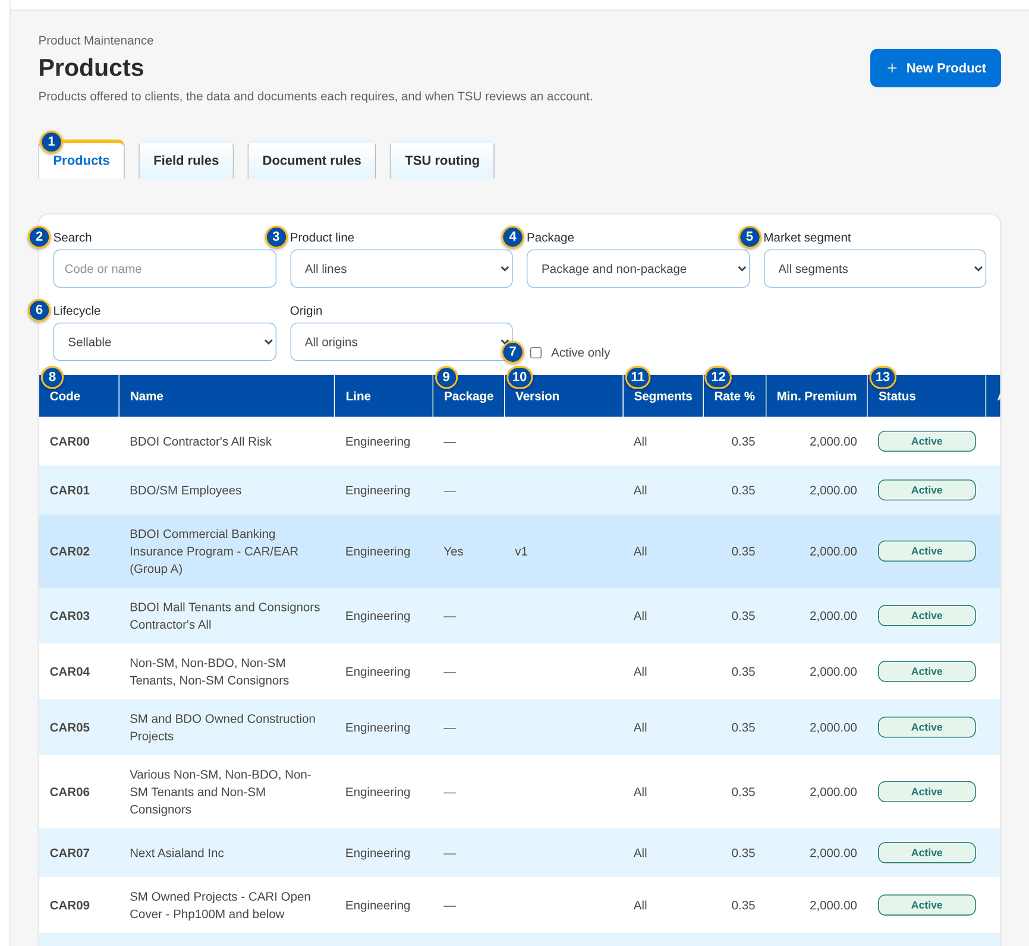
Figure 30: SCR-PM-11 Products with the package filter
1 | Products / Field rules / Document rules / TSU routing | 11 | Segments | 21 | Default commission %
2 | Search | 12 | Rate % / Min. Premium | 22 | Minimum premium
3 | Product line | 13 | Status | 23 | Package TSI limit
4 | Package | 14 | Code | 24 | Maximum term (years)
5 | Market segment | 15 | Name | 25 | Package product (fixed cover) / Fleet (several vehicles) / Mortgage / loan related / Direct payment to insurer allowed / Multi-year term allowed / Free First Year eligible
6 | Lifecycle | 16 | Product line | 26 | Market segments (none = all)
7 | Active only | 17 | Cover type | 27 | Applies to / Level / Field / Key / Mandatory / Status
8 | Code / Name / Line | 18 | Placement after | 28 | Applies to / Document / Before Submission / Status
9 | Package | 19 | TSU review | 29 | Priority / Code / Description / Criteria / TSI Above / Status
10 | Version | 20 | Default rate %

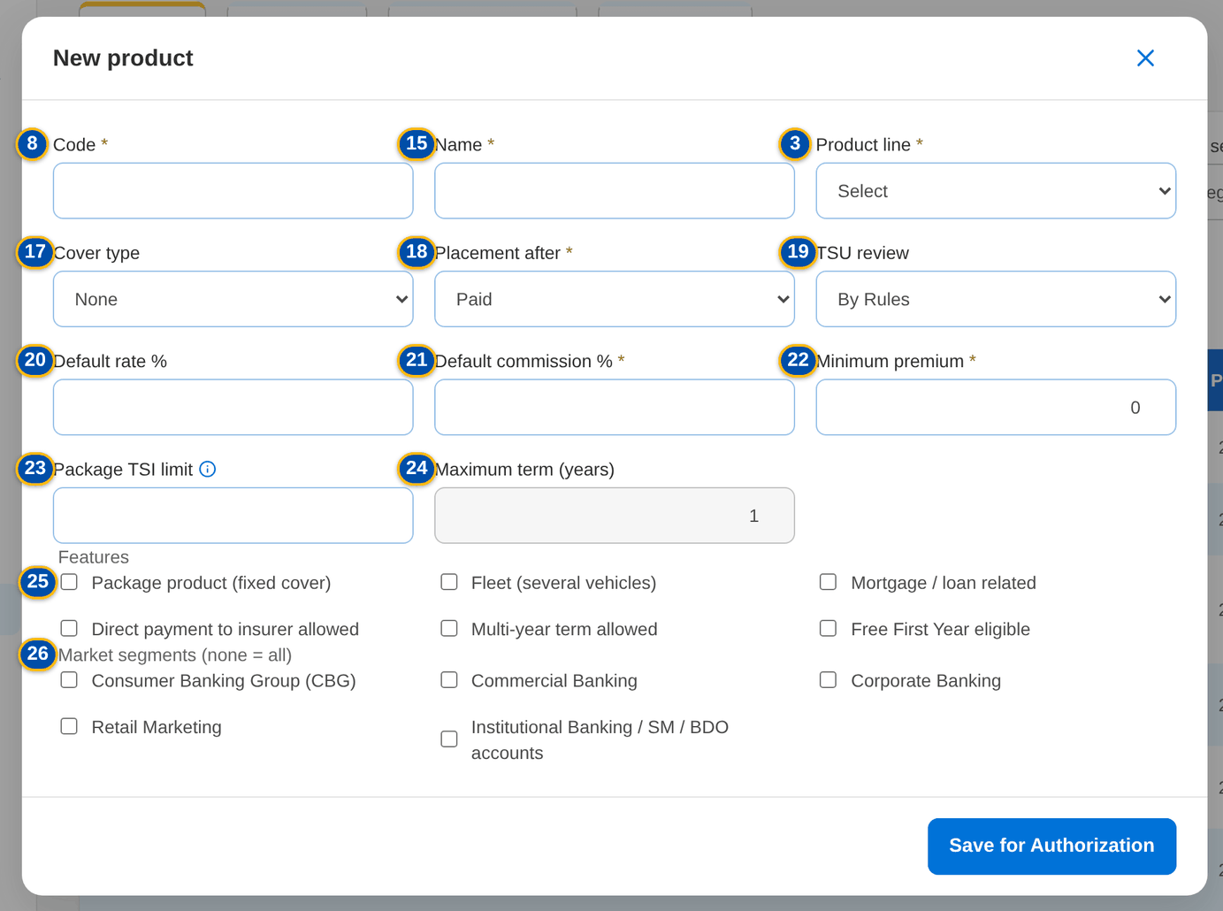
Figure 31: SCR-PM-11 New product dialog

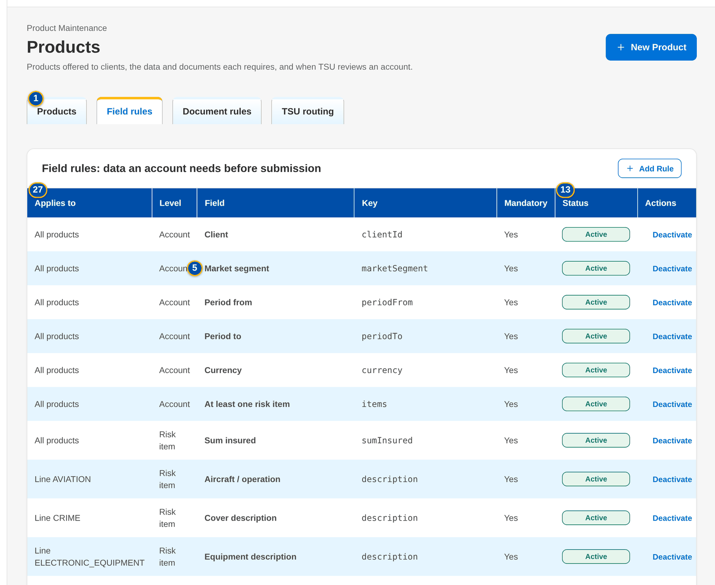
Figure 32: SCR-PM-11 Field rules tab with the authorisation actions

Fields (No. = callout number on the first screenshot)
No. | Section | Field | Type | Length / format | Mand. | Source / list | Default | Editable in | Validation | Message when it fails
1 | Tabs | Products / Field rules / Document rules / TSU routing | Tab | - | - | Fixed | Products | - | - | -
2 | Filters | Search | Text | Code or name | N | - | Blank | - | Contains search | -
3 | Filters | Product line | Drop-down | All lines or one line | N | Product lines | All lines | - | - | -
4 | Filters | Package | Drop-down | Package and non-package, Package only, Non-package only | N | Fixed list | Package and non-package | - | - | -
5 | Filters | Market segment | Drop-down | All segments or one | N | List MARKET_SEGMENT | All segments | - | - | -
6 | Filters | Lifecycle | Drop-down | Sellable, Expired, Retired | N | Fixed list | Sellable | - | Shown only to users who may see the archive (PRODUCT_ARCHIVE_VIEW) | -
7 | Filters | Active only | Check box | - | N | - | Not ticked | - | Authorised and active records only | -
8 | List | Code / Name / Line | Column | Risk code, product name, line code | - | Product master | - | Read only | - | No product matches the filters.
9 | List | Package | Column | Yes for a package product | - | Product master | - | Read only | - | -
10 | List | Version | Column | Current version (v2) and the pill of a version being set up (Draft, For validation) | - | Package versions | - | Read only | - | -
11 | List | Segments | Column | Market segments, or All | - | Product master | - | Read only | - | -
12 | List | Rate % / Min. Premium | Column | Product rate and minimum premium (of the version in force for a package) | - | Product master | - | Read only | - | -
13 | List | Status | Column | Pending Authorization, Active, Inactive; Expired or Retired for a package no longer sold | - | Product master | - | Read only | - | -
14 | New product | Code | Text | 1 to 20 capitals or digits | Y | - | Blank | New product only | Unique; the naming convention of the line when set | Code: 1 to 20 capital letters or digits.
15 | New product | Name | Text | Up to 200 characters | Y | - | Blank | Pending, active | Not blank | Name is required.
16 | New product | Product line | Drop-down | Line name | Y | Product lines | Select | Pending, active | - | Choose the product line.
17 | New product | Cover type | Drop-down | Cover types of the line | Cond.: package product | Cover types | None | Pending, active | A cover type of the line; a package needs one | A package needs its cover type
18 | New product | Placement after | Drop-down | Paid, Client confirmation | Y | Fixed list | Paid | Pending, active | - | -
19 | New product | TSU review | Drop-down | By rules, Always, Never | N | Fixed list | By rules | Pending, active | - | -
20 | New product | Default rate % | Number | Up to four decimals | N | - | Blank | Pending, active (package: through a new version) | 0 to 100 | The rate, minimum premium, commission and TSI limit of package <code> change through a new version (Versions tab)
21 | New product | Default commission % | Number | Percentage | Y | - | Blank | Pending, active (package: through a new version) | 0 to 100 | Default commission rate is required.
22 | New product | Minimum premium | Number | Amount in PHP | Y | - | 0 | Pending, active (package: through a new version) | Zero or more | The minimum premium cannot be negative
23 | New product | Package TSI limit | Number | Amount in PHP; above it the account goes to TSU | N | - | Blank | Pending, active (package: through a new version) | Zero or more | -
24 | New product | Maximum term (years) | Number | 1 to 10 | Cond.: multi-year term allowed | - | 1 | Pending, active | At least 2 for a multi-year product | A multi-year product needs a maximum term of at least 2 years.
25 | New product › Features | Package product (fixed cover) / Fleet (several vehicles) / Mortgage / loan related / Direct payment to insurer allowed / Multi-year term allowed / Free First Year eligible | Check box | - | N | - | Not ticked | Pending, active | - | -
26 | New product | Market segments (none = all) | Check boxes | Segments the product is offered to | N | List MARKET_SEGMENT | None (all segments) | Pending, active | Active values | -
27 | Field rules | Applies to / Level / Field / Key / Mandatory / Status | Column | All products, a line or a product; Account or Risk item | - | Field rules | - | Read only | - | -
28 | Document rules | Applies to / Document / Before Submission / Status | Column | Document type; Required or Optional | - | Document rules | - | Read only | - | -
29 | TSU routing | Priority / Code / Description / Criteria / TSI Above / Status | Column | Lower priority evaluated first | - | TSU routing rules | - | Read only | - | -

Actions
Button | Who | Enabled when | What happens | Resulting status | Notification
New Product | MBS (PRODUCT_MAINTAIN, MASTER_MAINTAIN) | Products tab | Opens New product; Save for Authorization saves it pending authorisation | Pending Authorization | -
Add Rule | MBS (PRODUCT_MAINTAIN), Business Administrator (MASTER_MAINTAIN) | Field rules, Document rules or TSU routing tab | Opens New Rule (see SCR-PM-12) | Pending Authorization | -
Authorize | PRODUCT_AUTHORIZE or MASTER_AUTHORIZE (Business Administrator, New Business Approver), not the maker | Row pending authorisation | Authorises the record; it is used by quotations, accounts and rating from now | Active | -
Deactivate | PRODUCT_MAINTAIN or MASTER_MAINTAIN | Active row | Ends the use of the record; its history stays | Inactive | -
Open a row | Every user of the screen | Products tab | Opens the product record | - | -

Business rules
• Every product and rule is maker-checker: saved changes wait for a second user's authorisation and are not used until then (FR-PM-010, FR-PM-012).
• A package product needs its cover type; the risk code follows the naming convention of its line once BDOI has stated it (FR-PM-010).
• The rate, minimum premium, commission and TSI limit of a package change only through a new version, so a released package stays sellable while it is changed (FR-PM-050).
• Sellable lists show active products only; expired and retired products are shown to the archive users and are never deleted (FR-PM-052).
• Field rules check presence, a list of values, a number range or a format; document rules name the documents an account needs before submission (FR-PM-012, FR-PM-013).
Expected outcome
The business finds any product with its current version and lifecycle, and maintains products and their rules under maker-checker.
Test cases: TC-PM-010.2-01, TC-PM-010.2-02, TC-PM-010.3-01, TC-PM-010.3-02, TC-PM-045.3-01, TC-PM-052.2-01, TC-PM-SCR-11, TC-PM-MSG-09.

13.2.2 SCR-PM-12 Product record
Purpose | One product: its risk code, lifecycle and authorisation status, package and version flags, line and cover type, current version, rate, package end and TSU review; the tabs Versions (every package version with its status, dates, source request and validator), Features (all product attributes) and Field Rules & Documents (the field matrix and the documents an account needs). MBS creates the next version of a package from here.
Who can open it | Marketing Account Officer, Marketing TL / TH / UH, TSU Officer, TSU Team Lead, TSU Head, Marketing Business Services, ManCom member, Business Administrator, New Business Approver, System Administrator, Auditor (permission PRODUCT_VIEW or MASTER_VIEW)
Navigation | • Menu: Client & Policy › Product Maintenance › Products › Product  • Products › a row  • Package Version › back arrow  • Incentive Criteria (products matrix)
FRs | FR-PM-050, FR-PM-012, FR-PM-013, FR-PM-042

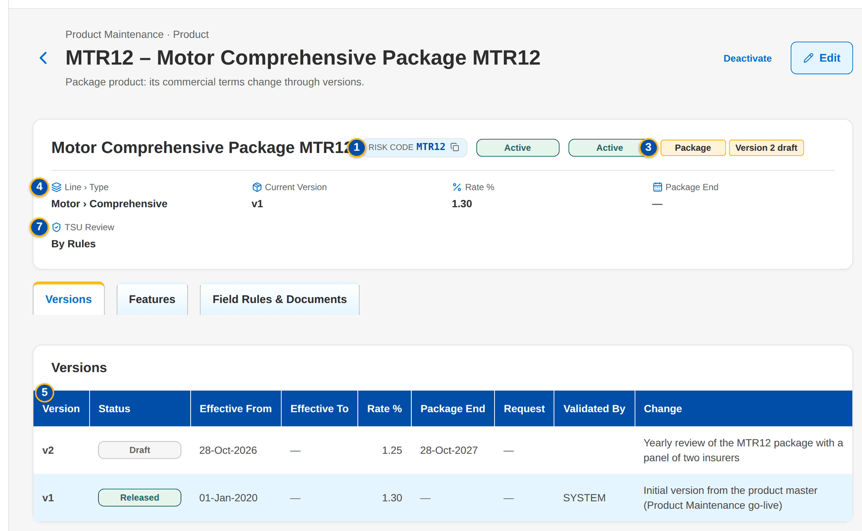
Figure 33: SCR-PM-12 Product record of a package, Versions tab
1 | Risk code | 7 | Line / Cover type / Risk items / Rating / Package / Package TSI limit / Fleet / Market segments / Mortgage related / Direct payment allowed / Multi-year / Free First Year / Placement after / Default rate % / Default commission % / Minimum premium / TSU review | 13 | Check
2 | Lifecycle and record status pills | 8 | Level / Field / Key / Mandatory / Check / From | 14 | List of values / Minimum / Maximum / Pattern
3 | Package and version tags | 9 | Documents required before submission | 15 | Document type
4 | Line › Type / Current Version / Rate % / Package End / TSU Review | 10 | Applies to | 16 | Mandatory
5 | Version / Status / Effective From / Effective To / Rate % / Package End / Request / Validated By / Change | 11 | Level
6 | What changes | 12 | Field key / Label

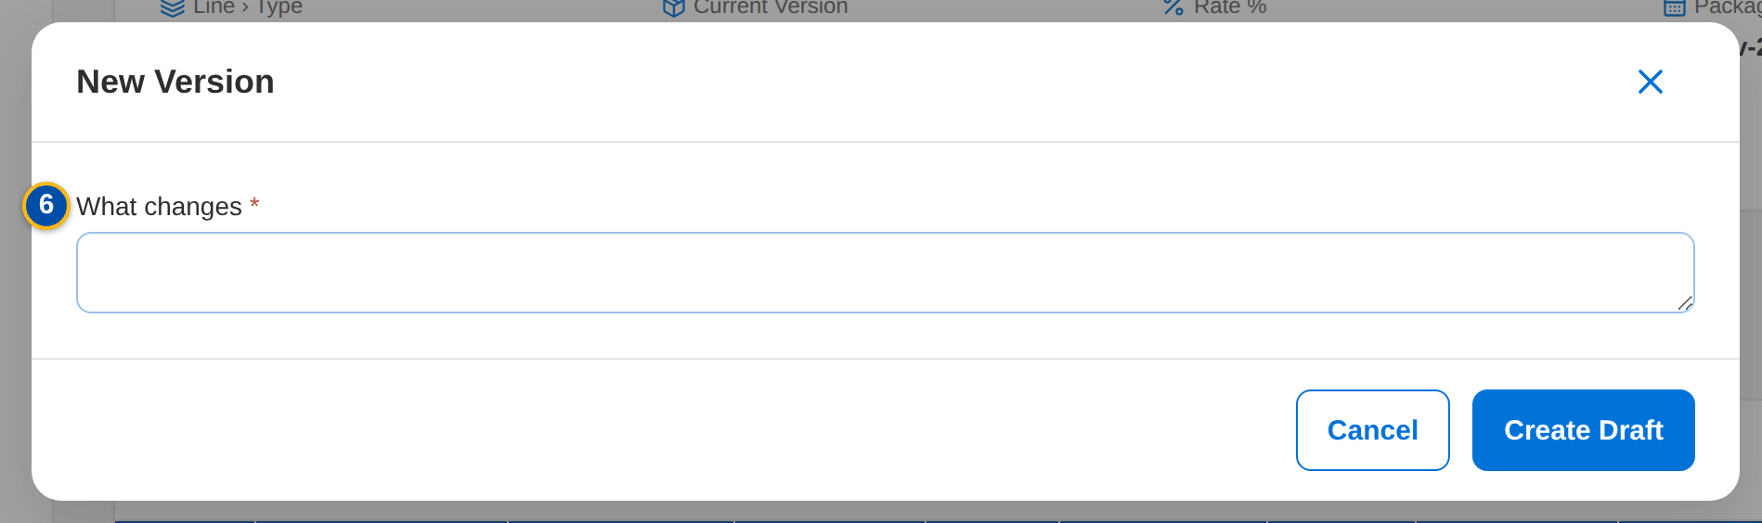
Figure 34: SCR-PM-12 New Version dialog

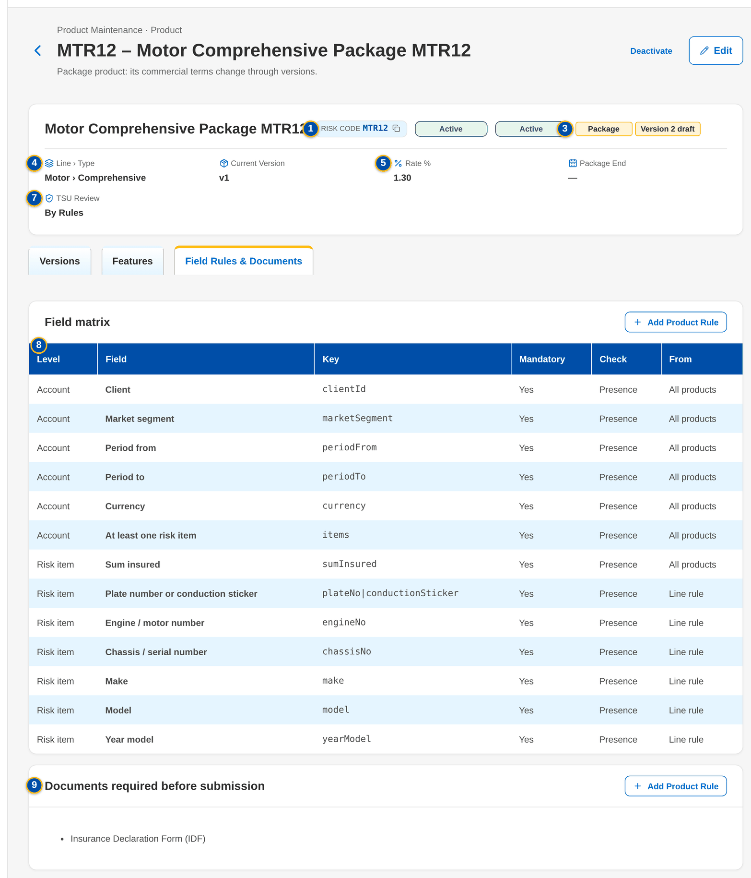
Figure 35: SCR-PM-12 Field Rules & Documents tab

Fields (No. = callout number on the first screenshot)
No. | Section | Field | Type | Length / format | Mand. | Source / list | Default | Editable in | Validation | Message when it fails
1 | Header | Risk code | Reference chip | Product code | - | Product master | - | Read only | - | -
2 | Header | Lifecycle and record status pills | Pill | Active, Expired, Retired; Pending Authorization, Active, Inactive | - | Product master | - | Read only | - | -
3 | Header | Package and version tags | Tag | Package; Version n Draft or For validation | - | Product master | - | Read only | - | -
4 | Header | Line › Type / Current Version / Rate % / Package End / TSU Review | Fact | As in the catalogue | - | Product master, version in force | - | Read only | - | -
5 | Versions | Version / Status / Effective From / Effective To / Rate % / Package End / Request / Validated By / Change | Column | Newest first; Draft, For validation, Released, Superseded, Expired | - | Package versions | - | Read only | - | No version yet.
6 | New Version | What changes | Text | Free text | Y | - | Blank | - | Not blank | Describe the change
7 | Features | Line / Cover type / Risk items / Rating / Package / Package TSI limit / Fleet / Market segments / Mortgage related / Direct payment allowed / Multi-year / Free First Year / Placement after / Default rate % / Default commission % / Minimum premium / TSU review | Detail | As on the product | - | Product master | - | Read only (Edit opens the product dialog) | - | -
8 | Field Rules & Documents › Field matrix | Level / Field / Key / Mandatory / Check / From | Column | Rules of all products, the line and the product | - | Field rules | - | Read only | - | No field rules apply.
9 | Field Rules & Documents | Documents required before submission | List | Document types | - | Document rules | - | Read only | - | No document is required.
10 | New Rule (field) | Applies to | Drop-down | All, Line, Product | Y | Fixed list | Product (from the product record) | New rule | Rules for every product use the scope code * | Rules for every product use the scope code '*'
11 | New Rule (field) | Level | Drop-down | Account or Risk item | N | Fixed list | Account | New rule | - | -
12 | New Rule (field) | Field key / Label | Text | Field key (one of several keys with a vertical bar) and its label | Y | - | Blank | New rule | Unique per scope | Minimum-field rule already exists: <key>
13 | New Rule (field) | Check | Drop-down | Presence only, List of values, Number range, Format (pattern) | N | Fixed list | Presence only | New rule | The parameters of the check are complete | Complete the parameters of the <type> rule
14 | New Rule (field) | List of values / Minimum / Maximum / Pattern | Text / Number | List code; range; regular expression | Cond.: by check | Lists of values | Blank | New rule | Known list; valid pattern | Unknown list of values <lov type>
15 | New Rule (document) | Document type | Drop-down | Document types | Y | List DOCUMENT_TYPE | Blank | New rule | Active value | -
16 | New Rule | Mandatory | Check box | - | N | - | Ticked | New rule | - | -

Actions
Button | Who | Enabled when | What happens | Resulting status | Notification
Edit | PRODUCT_MAINTAIN or MASTER_MAINTAIN | Always | Opens the product dialog (as New product, code fixed); Save for Authorization | Pending Authorization | -
Authorize / Deactivate | As on Products | As on Products | As on Products | Active / Inactive | -
New Version | MBS (PRODUCT_MAINTAIN) | Package product with a version in force and no version being set up | Opens New Version; Create Draft copies the version in force into a new draft effective tomorrow and opens it | Draft version | -
Add Product Rule | PRODUCT_MAINTAIN or MASTER_MAINTAIN | Field Rules & Documents tab | Opens New Rule with the scope set to this product; Save for Authorization | Pending Authorization | -
Open a version row | Every user of the screen | Versions tab | Opens the Package Version | - | -

Business rules
• A non-package product has no versions; it is rated on the product rate (FR-PM-050).
• A package has at most one version being set up (draft or for validation) at a time (FR-PM-042, FR-PM-050).
• Every version is kept: superseded and expired versions stay readable with their validator and source request (FR-PM-050, FR-PM-005).
• Field rules of all products, of the line and of the product apply together; the account checks refuse a missing or invalid value (FR-PM-012).
Expected outcome
MBS and the approvers see the whole history of a product and start its next version from the terms in force.
Test cases: TC-PM-012.1-02, TC-PM-012.4-01, TC-PM-012.4-02, TC-PM-014.4-01, TC-PM-050.1-01, TC-PM-050.2-01, TC-PM-050.3-01, TC-PM-050.3-02, TC-PM-SCR-12, TC-PM-MSG-10.

13.2.3 SCR-PM-13 Package Version
Purpose | One version of a package: the rate scheme, dates and origin, the coverages and perils, the insurers of the panel with their role, share, rate and minimum premium, and the insurer terms per coverage with their clauses. MBS edits a draft and submits it for validation; the validator (TSU Head or Business Administrator, never the maker or submitter) confirms the checklist and releases it, or returns it to MBS with a reason. Released versions are read only and show who validated them.
Who can open it | Marketing Account Officer, Marketing TL / TH / UH, TSU Officer, TSU Team Lead, TSU Head, Marketing Business Services, ManCom member, Business Administrator, New Business Approver, System Administrator, Auditor (permission PRODUCT_VIEW or MASTER_VIEW or PRODUCT_MAINTAIN or PRODUCT_VALIDATE)
Navigation | • Menu: Client & Policy › Product Maintenance › Product › Package Version  • Product record › Versions tab › a row  • Product record › New Version  • Package Request record › Set-up tab › Open Version Editor  • Validation Queue › a row
FRs | FR-PM-043, FR-PM-050, FR-PM-014, FR-PM-011, FR-PM-042

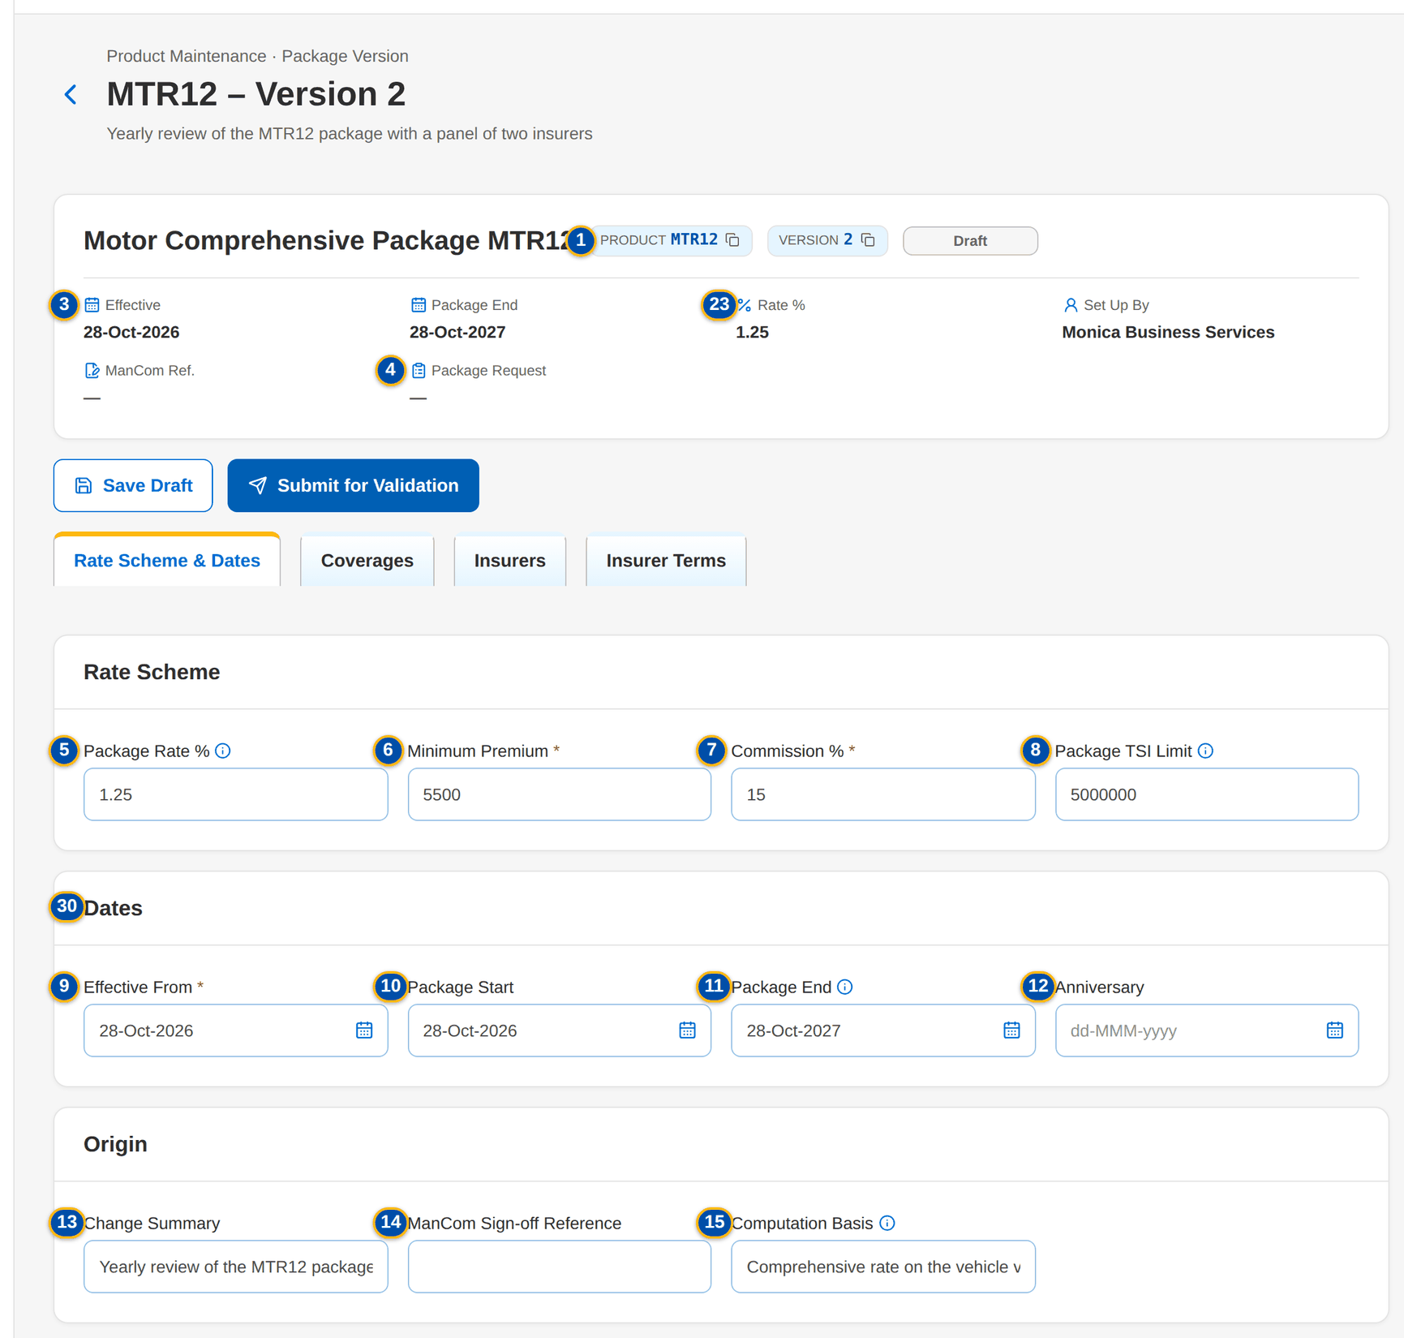
Figure 36: SCR-PM-13 Draft version of the MTR12 package, Rate Scheme & Dates tab
1 | Product / Version | 12 | Anniversary | 23 | Rate %
2 | Version status pill | 13 | Change Summary | 24 | Minimum Premium
3 | Effective / Package End / Rate % / Set Up By / ManCom Ref. | 14 | ManCom Sign-off Reference | 25 | Add insurer
4 | Package Request | 15 | Computation Basis | 26 | Insurer / Coverage
5 | Package Rate % | 16 | Coverage | 27 | Covered
6 | Minimum Premium | 17 | Included / Optional | 28 | Limit / Deductible / Deductible Wording
7 | Commission % | 18 | Limit / Deductible | 29 | Clauses
8 | Package TSI Limit | 19 | Add coverage | 30 | Hierarchy complete: cover type and basic coverage / Every panel insurer has terms for each included coverage / Rates and minimum premiums match the signed-off terms / Dates and package term are correct / Test premium reviewed
9 | Effective From | 20 | Insurer | 31 | Result / Validated By / Validated On / Test Premium / Return Reason
10 | Package Start | 21 | Role | 32 | # / Check / Result / Details
11 | Package End | 22 | Share % | 33 | Return reason / Comment

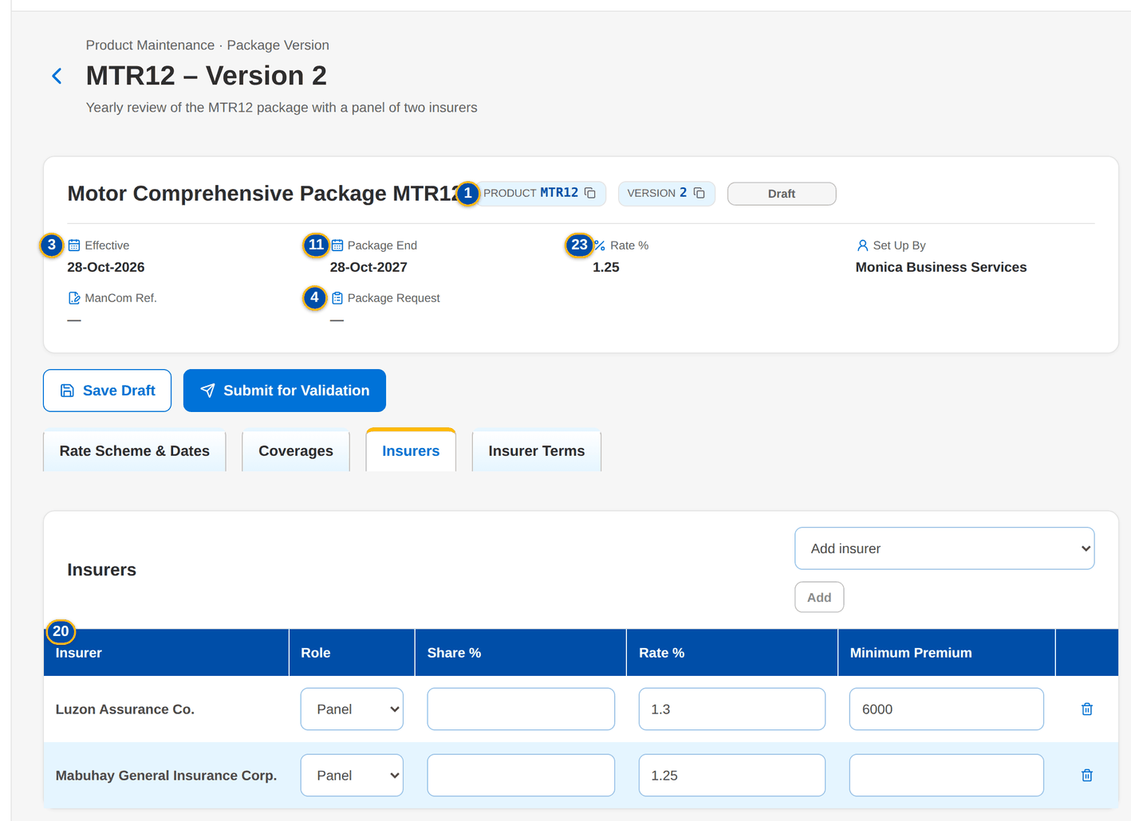
Figure 37: SCR-PM-13 Insurers tab of the draft

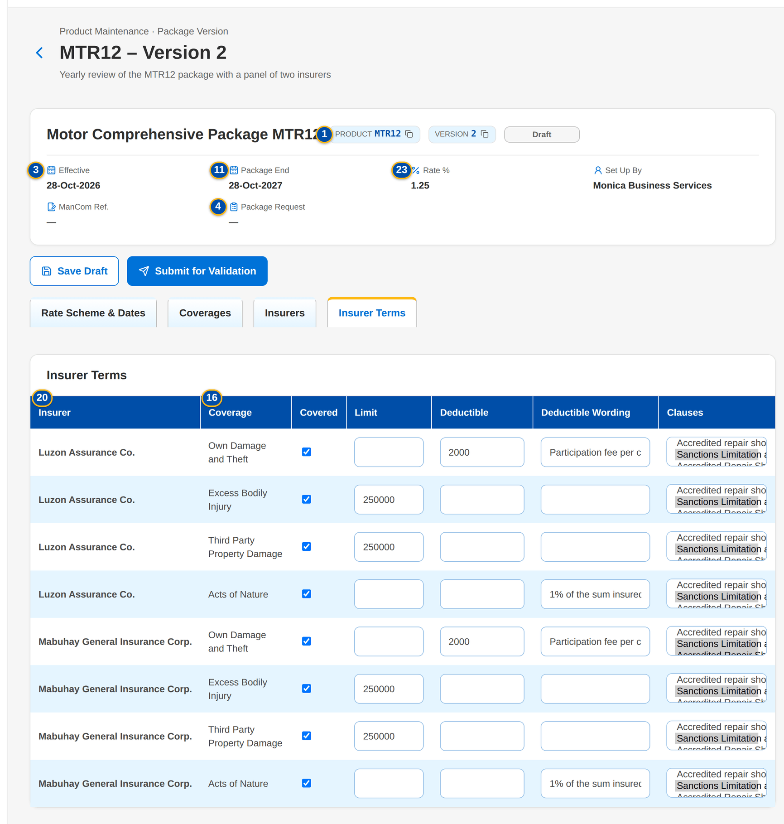
Figure 38: SCR-PM-13 Insurer Terms tab: terms and clauses per insurer and coverage

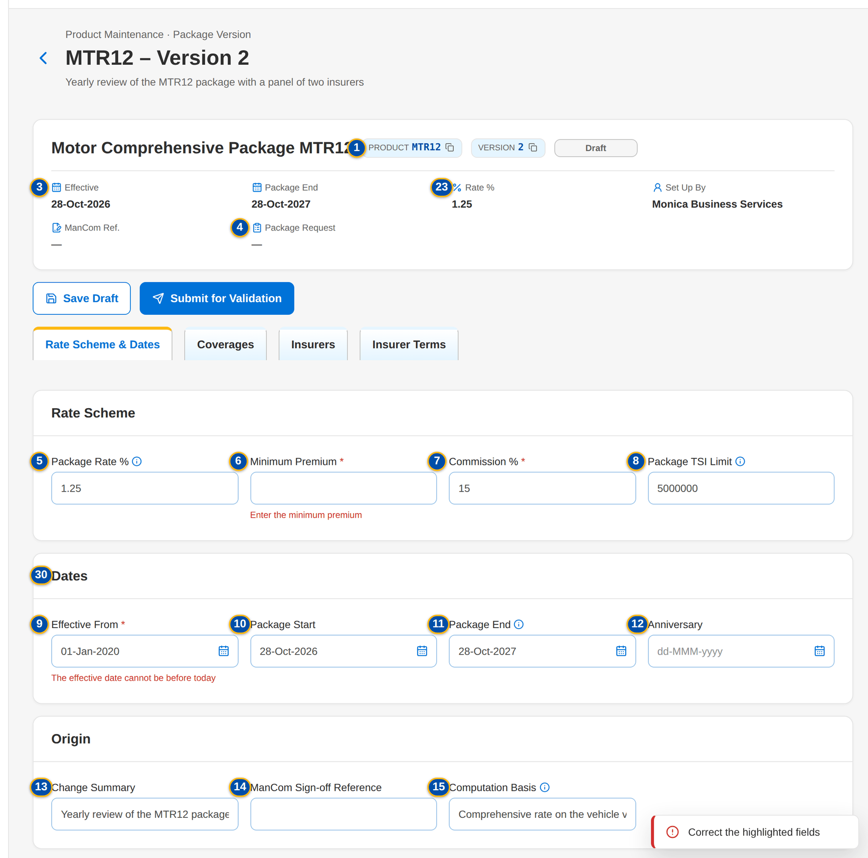
Figure 39: SCR-PM-13 Field messages of the version form

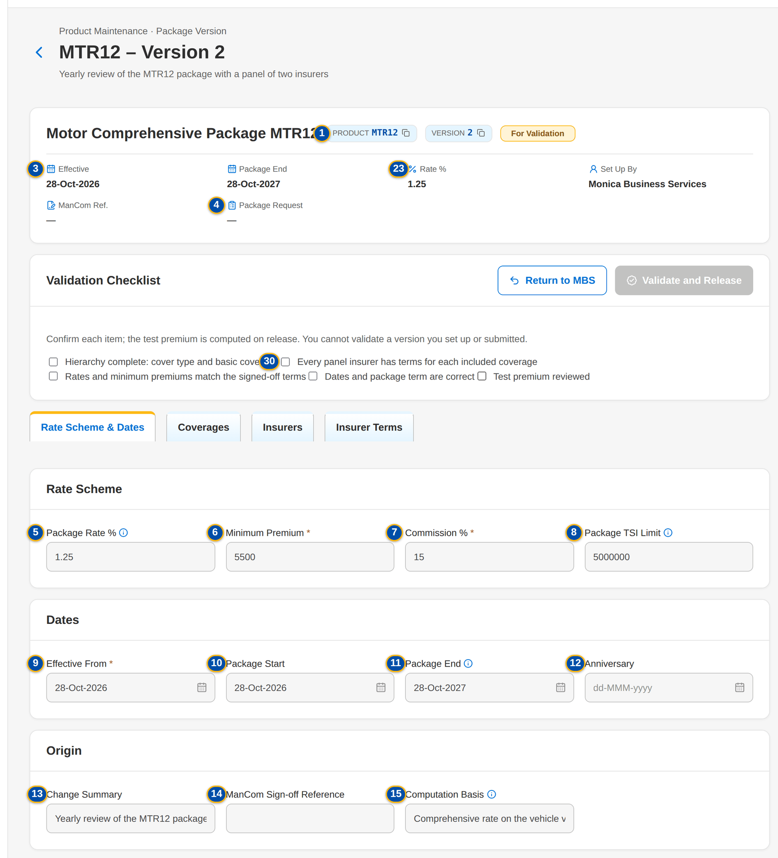
Figure 40: SCR-PM-13 Validation Checklist of the TSU Head

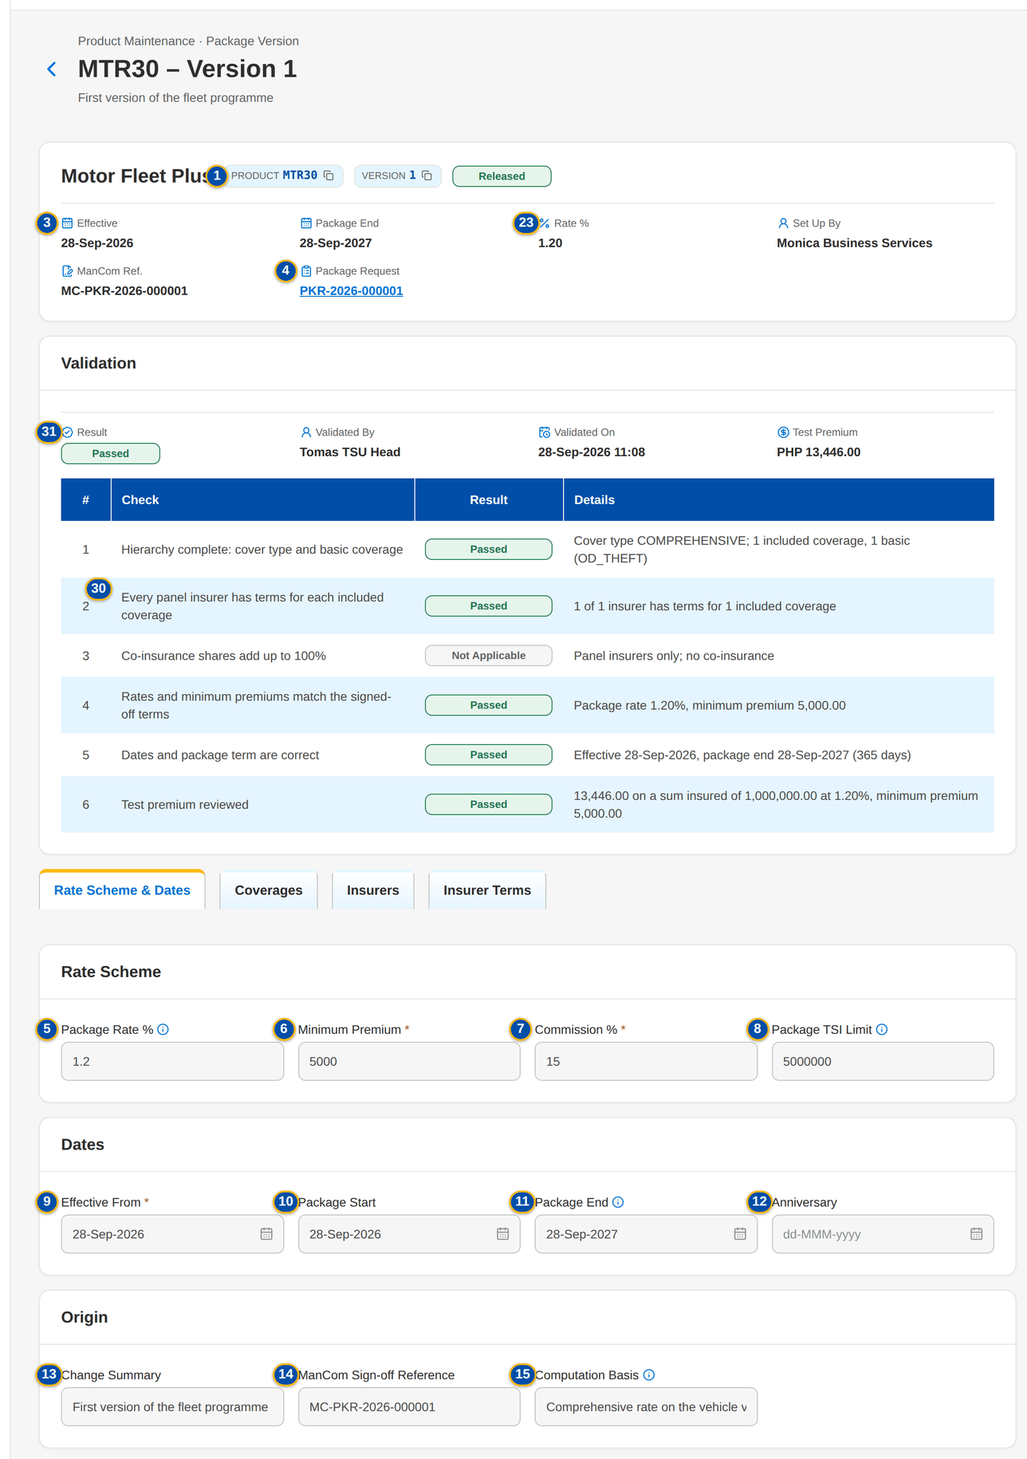
Figure 41: SCR-PM-13 Released version: header with the package request, and the Validation card with the checks

Fields (No. = callout number on the first screenshot)
No. | Section | Field | Type | Length / format | Mand. | Source / list | Default | Editable in | Validation | Message when it fails
1 | Header | Product / Version | Reference chip | Risk code; version number | - | Package version | - | Read only | - | -
2 | Header | Version status pill | Pill | Draft, For validation, Released, Superseded, Expired | - | Package version | - | Read only | - | -
3 | Header | Effective / Package End / Rate % / Set Up By / ManCom Ref. | Fact | Rate % shows Per insurer when every insurer has its own rate | - | Package version | - | Read only | - | -
4 | Header | Package Request | Fact | PKR-yyyy-nnnnnn of the request that produced the version, a link to the request | - | Package version | - | Read only | - | -
5 | Rate Scheme | Package Rate % | Number | Up to four decimals; empty when every insurer has its own rate | Cond.: or a rate for every insurer | - | Rate of the version it was copied from | Draft | 0 to 100; the package rate or a rate for every insurer | Enter a rate between 0 and 100 / Enter the package rate or a rate for every insurer
6 | Rate Scheme | Minimum Premium | Number | Amount in PHP | Y | - | Copied value | Draft | Zero or more | Enter the minimum premium
7 | Rate Scheme | Commission % | Number | Percentage | Y | - | Copied value | Draft | 0 to 100 | Enter a commission between 0 and 100
8 | Rate Scheme | Package TSI Limit | Number | Amount in PHP; above it TSU prices the risk | N | - | Copied value | Draft | Zero or more | Enter a positive amount
9 | Dates | Effective From | Date | dd-MMM-yyyy | Y | - | Tomorrow (new version) or the signed-off date | Draft | Today or later; after the start of the version in force | Enter the effective date / The effective date cannot be before today / The effective date must be after the start of version <version no>
10 | Dates | Package Start | Date | dd-MMM-yyyy | N | - | Copied value | Draft | - | -
11 | Dates | Package End | Date | dd-MMM-yyyy; expiry monitoring | N | - | Copied value | Draft | After the effective date | The package end date must be after the effective date
12 | Dates | Anniversary | Date | dd-MMM-yyyy | N | - | Copied value | Draft | - | -
13 | Origin | Change Summary | Text | Up to 500 characters | N | - | What changes (new version) or the request's summary | Draft | - | -
14 | Origin | ManCom Sign-off Reference | Text | MC-PKR-yyyy-nnnnnn | N | ManCom sign-off | From the request | Draft | - | -
15 | Origin | Computation Basis | Text | As agreed with the insurers | N | Proposed terms | From the request | Draft | - | -
16 | Coverages | Coverage | Column | Coverage name, with the Basic tag | Y (at least one included) | Coverages of the line | Copied coverages | Draft | At least one included coverage; a basic coverage | Include at least one coverage / The package needs its cover type and at least one included basic coverage
17 | Coverages | Included / Optional | Check box | - | N | - | Included | Draft | - | -
18 | Coverages | Limit / Deductible | Number | Amounts in PHP | N | - | Blank | Draft | Zero or more | -
19 | Coverages | Add coverage | Drop-down | Active coverages of the line not yet added, (basic) marked | N | Coverages & Clauses | - | Draft | - | -
20 | Insurers | Insurer | Column | Insurer name | N | Insurers (authorised, active) | Copied panel | Draft | Every insurer with terms is on the package | Insurer <insurer code> has terms but is not on the package
21 | Insurers | Role | Drop-down | Panel, Lead, Participant | Y | Fixed list | Panel | Draft | - | -
22 | Insurers | Share % | Number | Co-insurance share | Cond.: lead and participants | - | Blank | Draft | 0 to 100; lead and participant shares total 100% | Enter a share between 0 and 100 / The co-insurance shares must add up to 100%
23 | Insurers | Rate % | Number | Insurer's own rate; wins over the package rate | Cond.: when there is no package rate | - | Blank | Draft | 0 to 100 | Enter a rate between 0 and 100
24 | Insurers | Minimum Premium | Number | Insurer's own minimum premium | N | - | Blank | Draft | Zero or more | -
25 | Insurers | Add insurer | Drop-down | Active insurers not yet on the panel | N | Insurers | - | Draft | - | -
26 | Insurer Terms | Insurer / Coverage | Column | One row per panel insurer and included coverage | Y (every pair) | Panel and coverages | Added with the coverage's values | Draft | Every panel insurer has terms for each included coverage | Insurer <insurer code> has no terms for coverage <coverage>
27 | Insurer Terms | Covered | Check box | - | N | - | Ticked | Draft | - | -
28 | Insurer Terms | Limit / Deductible / Deductible Wording | Number / Text | Amounts in PHP; wording | N | - | The coverage's values | Draft | - | -
29 | Insurer Terms | Clauses | Multi-select | Active clauses of the line or of every line | N | Clause library | None | Draft | Active clauses | -
30 | Validation Checklist | Hierarchy complete: cover type and basic coverage / Every panel insurer has terms for each included coverage / Rates and minimum premiums match the signed-off terms / Dates and package term are correct / Test premium reviewed | Check box | Every item | Y (all five) | Fixed checklist | Not ticked | For validation | Every item confirmed | -
31 | Validation | Result / Validated By / Validated On / Test Premium / Return Reason | Fact | Passed or Returned pill; validator's name; dd-MMM-yyyy HH:mm; PHP amount; the reason when returned (Returned By / Returned On) | - | Validation checkpoint | - | Read only | - | -
32 | Validation | # / Check / Result / Details | Table | One row per check: hierarchy, insurer terms, co-insurance shares, rates and minimum premiums, dates and package term, test premium; Passed, Failed or Not Applicable with the figures compared (for example 3 of 3 insurers have terms for 2 included coverages) | - | Validation checkpoint | - | Read only | - | -
33 | Return Version to MBS | Return reason / Comment | Drop-down / Text | Return reason list; free text | Y (reason) | List RETURN_REASON | Select | For validation | Not blank | Enter the reason of the return

Actions
Button | Who | Enabled when | What happens | Resulting status | Notification
Save Draft | MBS (PRODUCT_MAINTAIN) | Draft | Checks the fields and saves the whole draft | Draft | -
Submit for Validation | MBS (PRODUCT_MAINTAIN) | Draft; no field message | Saves the draft and checks completeness (cover type and basic coverage, insurer terms for every included coverage, shares, rate, dates) | For validation | -
Validate and Release | TSU Head or Business Administrator (PRODUCT_VALIDATE), not the maker or the submitter | For validation; every checklist item ticked | Computes the test premium, releases the version and ends the previous version the day before; releases the source request, drafts its advisory and, for a new package, authorises the product | Released | Package available notice to Marketing (NT-02)
Return to MBS | As Validate and Release | For validation | Opens Return Version n to MBS; Return sends the version back to draft with the reason, and the request back to MBS | Draft | Workflow notice on the request

Business rules
• A draft is invisible to rating; only a released version prices new business (FR-PM-050, FR-PM-051).
• Submission needs the cover type and at least one included basic coverage, terms for every panel insurer on every included coverage, the package rate or a rate for every insurer, co-insurance shares totalling 100%, an effective date today or later and after the start of the version in force, and a package end after the effective date (FR-PM-043, FR-PM-014).
• The validator is never the maker or the submitter of the version; the validator confirms the five checklist items and a test premium is computed (FR-PM-043).
• At release and at return BIBS records each check with its result (Passed, Failed or Not Applicable) and the figures compared, with the validator, the time and, for a return, the reason; the Validation card shows them until the version is submitted again (FR-PM-043).
• On release the previous version ends the day before the new one takes effect and becomes Superseded; a version whose package end has passed without a renewal becomes Expired and the product is no longer sold (FR-PM-050, FR-PM-052).
• An insurer's own rate and minimum premium win over the package's; a package with a panel is placed only with its panel insurers (FR-PM-014, FR-PM-051).
Expected outcome
A package version is set up once, checked by a second person and released on its effective date; every earlier version stays on record.
Test cases: TC-PM-011.2-01, TC-PM-014.1-01, TC-PM-014.2-01, TC-PM-014.2-02, TC-PM-043.4-01, TC-PM-043.4-02, TC-PM-043.4-03, TC-PM-SCR-13, TC-PM-MSG-11.

13.2.4 SCR-PM-14 Validation Queue
Purpose | The package versions submitted by MBS that wait for the post-set-up validation, oldest first, with their age. A row opens the version with its checklist.
Who can open it | TSU Head, Business Administrator (permission PRODUCT_VALIDATE)
Navigation | • Menu: Client & Policy › Product Maintenance › Validation Queue  • Sidebar entry Validation Queue  • Product Maintenance Home › Versions for validation
FRs | FR-PM-043

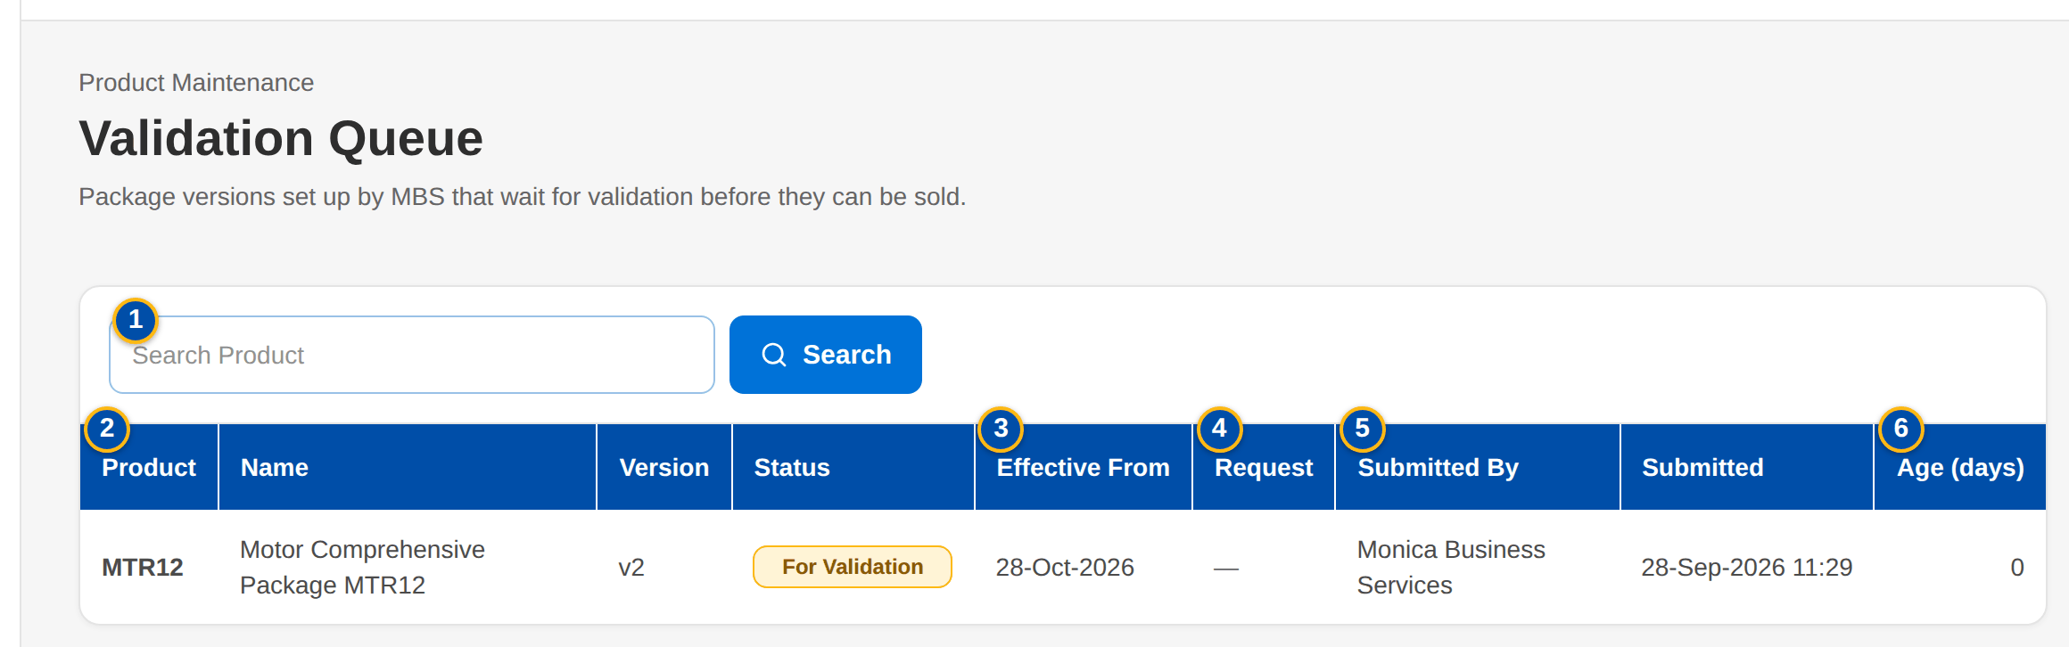
Figure 42: SCR-PM-14 Validation Queue of the TSU Head
1 | Search Product | 3 | Effective From | 5 | Submitted By / Submitted
2 | Product / Name / Version / Status | 4 | Request | 6 | Age (days)

Fields (No. = callout number on the first screenshot)
No. | Section | Field | Type | Length / format | Mand. | Source / list | Default | Editable in | Validation | Message when it fails
1 | Search | Search Product | Text | Code or name | N | - | Blank | - | Contains search | -
2 | List | Product / Name / Version / Status | Column | Risk code, product name, v<n>, For validation pill | - | Package versions | - | Read only | - | No package version waits for validation.
3 | List | Effective From | Column | dd-MMM-yyyy | - | Package version | - | Read only | - | -
4 | List | Request | Column | PKR-yyyy-nnnnnn | - | Package version | - | Read only | - | -
5 | List | Submitted By / Submitted | Column | User; dd-MMM-yyyy HH:mm | - | Package version | - | Read only | - | -
6 | List | Age (days) | Column | Whole days since the submission | - | Computed | - | Read only | - | -

Actions
Button | Who | Enabled when | What happens | Resulting status | Notification
Open a row | TSU Head, Business Administrator (PRODUCT_VALIDATE) | Always | Opens the Package Version with the Validation Checklist | - | -

Business rules
• Only users who validate package versions see the queue; a version they set up or submitted is shown but cannot be validated by them (FR-PM-043).
Expected outcome
No submitted version waits unseen; the validator works the oldest first.
Test cases: TC-PM-002.2-01, TC-PM-043.1-02, TC-PM-043.2-01, TC-PM-043.3-01, TC-PM-043.3-02, TC-PM-SCR-14.

13.2.5 SCR-PM-15 Coverages & Clauses
Purpose | The coverage and peril level of the product hierarchy, per line, and the clause library (warranties, clauses, exclusions and deductible wordings) that package versions use in their insurer terms. MBS maintains them; a second user authorises them.
Who can open it | Marketing Account Officer, Marketing TL / TH / UH, TSU Officer, TSU Team Lead, TSU Head, Marketing Business Services, ManCom member, Business Administrator, New Business Approver, System Administrator, Auditor (permission PRODUCT_VIEW or MASTER_VIEW)
Navigation | • Menu: Client & Policy › Product Maintenance › Coverages & Clauses  • Sidebar entry Coverages & Clauses
FRs | FR-PM-010, FR-PM-011

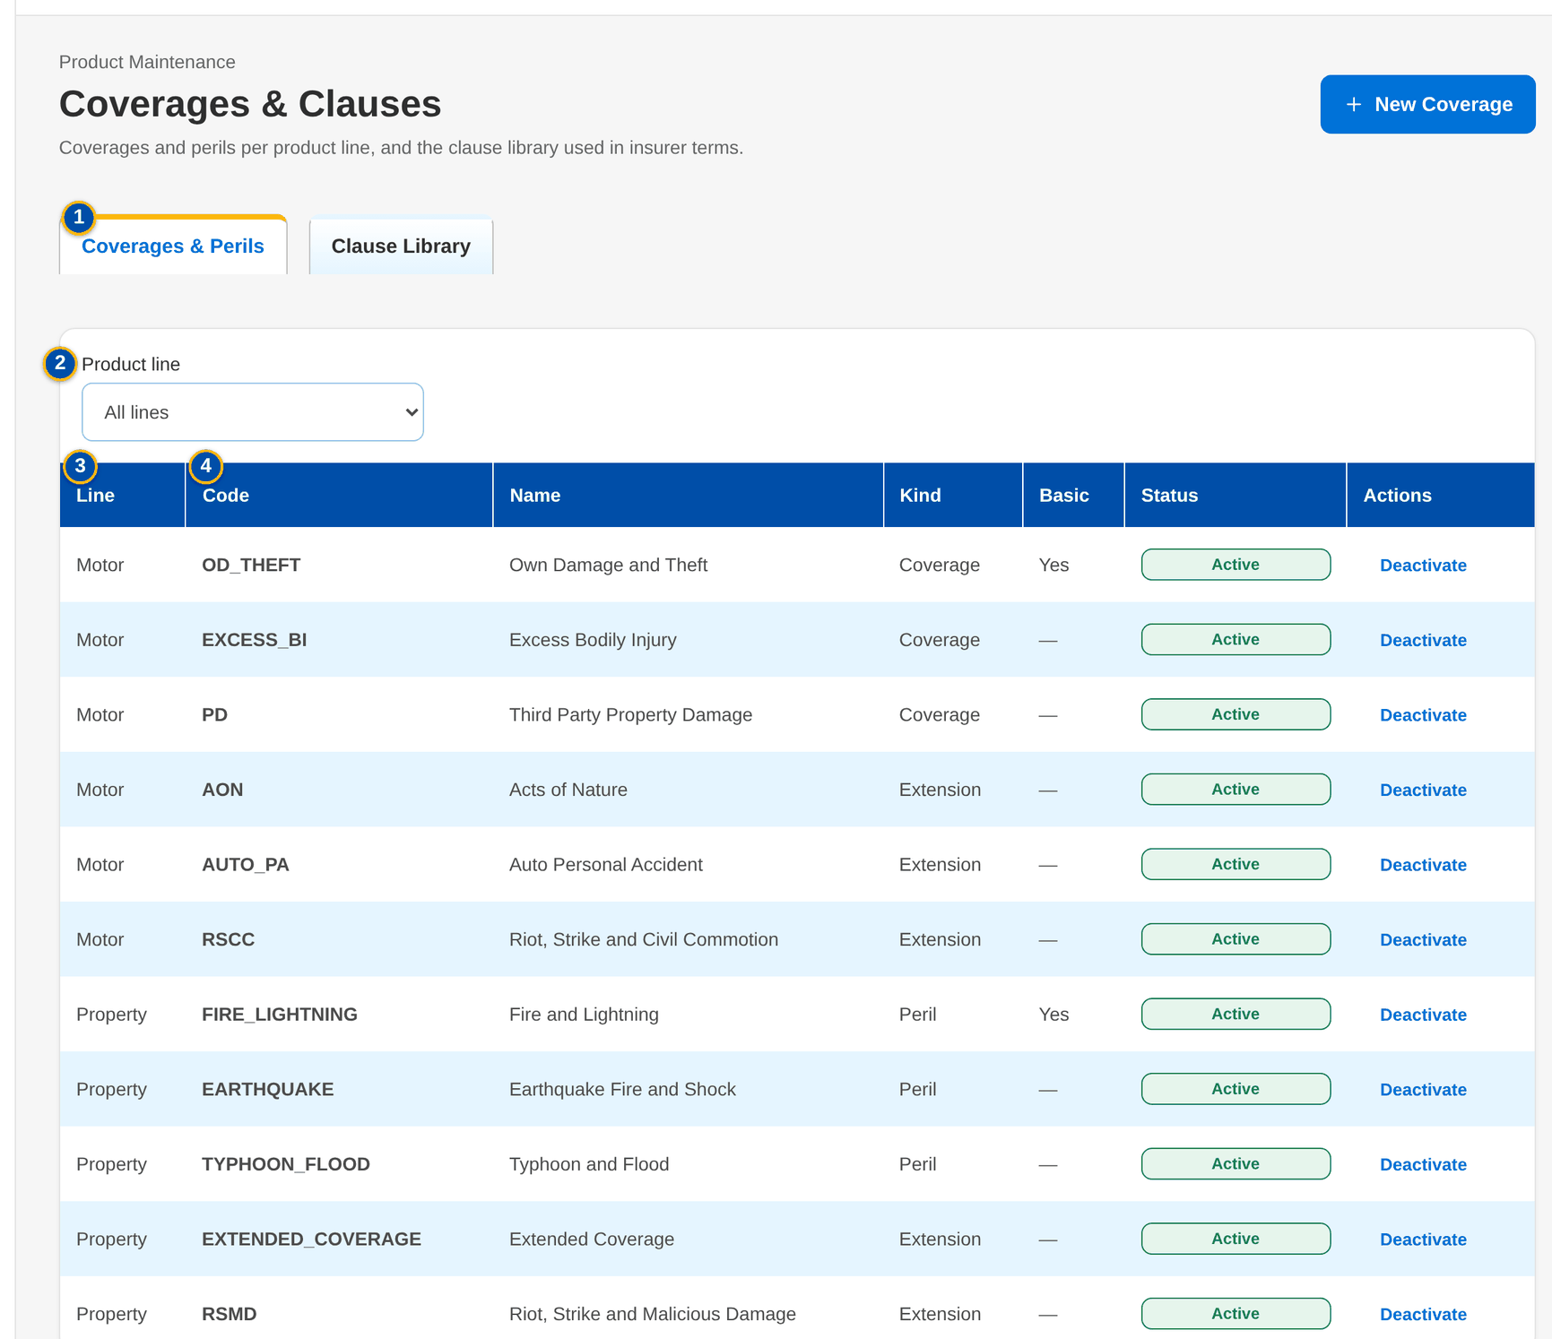
Figure 43: SCR-PM-15 Coverages & Perils tab
1 | Coverages & Perils / Clause Library | 7 | Name | 13 | Product line
2 | Product line | 8 | Kind | 14 | Title
3 | Line / Code / Name / Kind / Basic / Status | 9 | Display order | 15 | Effective from / Effective to
4 | Code / Kind / Title / Line / Effective / Until / Status | 10 | Basic coverage | 16 | Wording
5 | Product line | 11 | Code
6 | Code | 12 | Kind

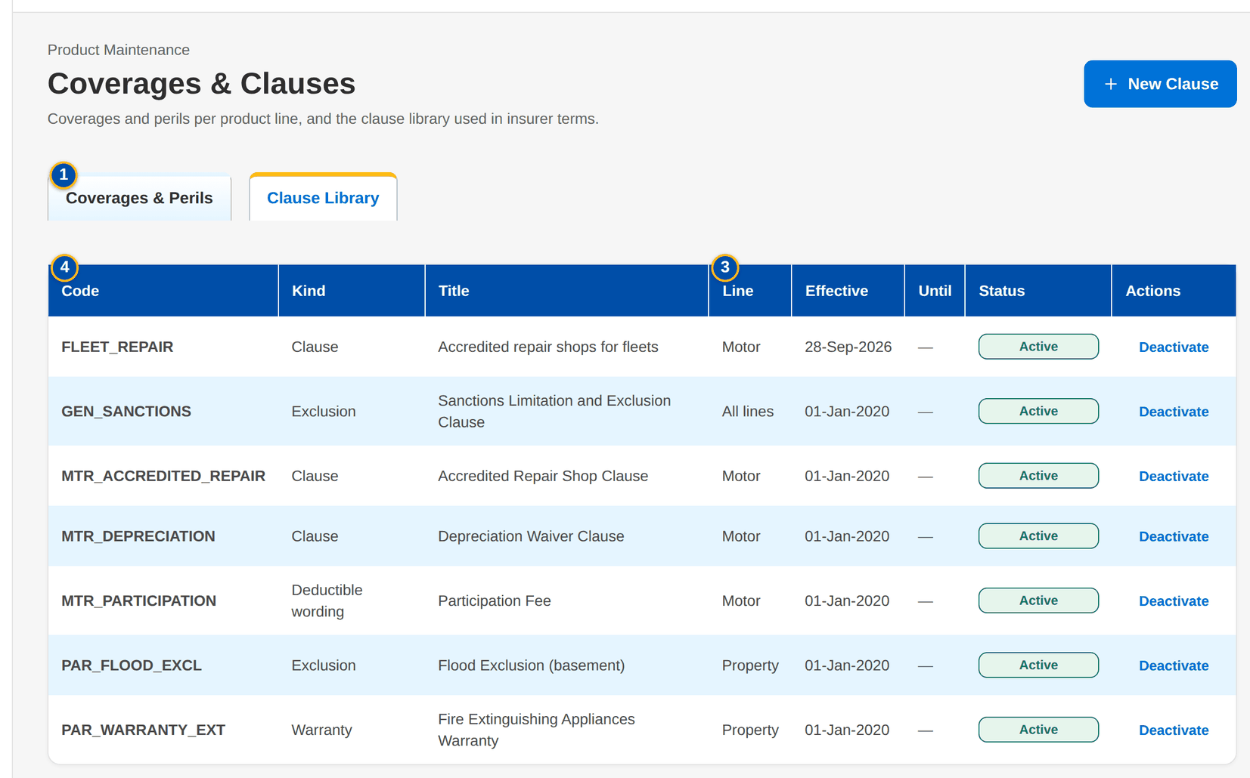
Figure 44: SCR-PM-15 Clause Library tab
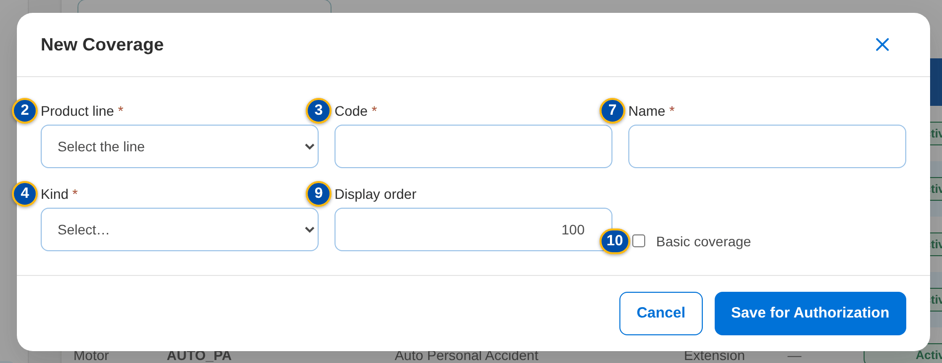
Figure 45: SCR-PM-15 New Coverage dialog
Fields (No. = callout number on the first screenshot)
No. | Section | Field | Type | Length / format | Mand. | Source / list | Default | Editable in | Validation | Message when it fails
1 | Tabs | Coverages & Perils / Clause Library | Tab | - | - | Fixed | Coverages & Perils | - | - | -
2 | Coverages & Perils | Product line | Drop-down | All lines or one line | N | Product lines | All lines | - | - | -
3 | Coverages & Perils | Line / Code / Name / Kind / Basic / Status | Column | Coverage of the line; Basic Yes | - | Coverages | - | Read only | - | No coverage is set up for this line.
4 | Clause Library | Code / Kind / Title / Line / Effective / Until / Status | Column | Line or All lines; dd-MMM-yyyy | - | Clauses | - | Read only | - | The clause library is empty.
5 | New Coverage | Product line | Drop-down | Line name | Y | Product lines | Select the line | New coverage only | - | Select the product line
6 | New Coverage | Code | Text | A-Z, 0-9 and _ | Y | - | Blank | New coverage only | Unique per line | Use A-Z, 0-9 and _
7 | New Coverage | Name | Text | Free text | Y | - | Blank | Pending, active | Not blank | Enter the name
8 | New Coverage | Kind | Drop-down | Coverage kinds | Y | List COVERAGE_KIND | Blank | Pending, active | Active value | Select the kind
9 | New Coverage | Display order | Number | Whole number | N | - | 100 | Pending, active | - | -
10 | New Coverage | Basic coverage | Check box | - | N | - | Not ticked | Pending, active | - | -
11 | New Clause | Code | Text | A-Z, 0-9 and _ | Y | - | Blank | New clause only | Unique | Use A-Z, 0-9 and _
12 | New Clause | Kind | Drop-down | Clause kinds | Y | List CLAUSE_KIND | Blank | Pending, active | Active value | Select the kind
13 | New Clause | Product line | Drop-down | Every line or one line | N | Product lines | Every line | Pending, active | - | -
14 | New Clause | Title | Text | Free text | Y | - | Blank | Pending, active | Not blank | Enter the title
15 | New Clause | Effective from / Effective to | Date | dd-MMM-yyyy | Y (from) | - | Blank | Pending, active | To on or after from | Enter the effective date / The end is before the start
16 | New Clause | Wording | Text | Full wording | Y | - | Blank | Pending, active | Not blank | Enter the wording

Actions
Button | Who | Enabled when | What happens | Resulting status | Notification
New Coverage / New Clause | MBS (PRODUCT_MAINTAIN) | Tab of the kind | Opens the dialog; Save for Authorization saves it pending authorisation | Pending Authorization | -
Open a row | MBS (PRODUCT_MAINTAIN) | Always | Opens the coverage or clause for change (code fixed) | Pending Authorization | -
Authorize | PRODUCT_AUTHORIZE (Business Administrator, New Business Approver), not the maker | Pending row | Authorises the coverage or clause | Active | -
Deactivate | PRODUCT_MAINTAIN | Active row | Ends its use; versions already released keep it | Inactive | -

Business rules
• The hierarchy is line, cover type with at most one subtype level, product, and coverage or peril of the line (FR-PM-010).
• A package version offers only the active coverages of its line and the active clauses of its line or of every line (FR-PM-010, FR-PM-011).
• Coverages and clauses are maker-checker and never deleted (FR-PM-011).
Expected outcome
The business keeps one library of coverages and clause wordings that every package version reuses.
Test cases: TC-PM-010.1-01, TC-PM-011.1-01, TC-PM-011.1-02, TC-PM-011.3-01, TC-PM-011.3-02, TC-PM-SCR-15, TC-PM-MSG-12.

13.2.6 SCR-PM-16 Incentive Criteria
Purpose | Incentive criteria, such as CPC2, on the products matrix: their value (rate, fixed amount or rule), the products and segments they apply to, and their effective dates. An active criterion is changed by an amendment that starts later and is deactivated, never deleted. Booking stamps on each invoice the criteria it matches.
Who can open it | Marketing Account Officer, Marketing TL / TH / UH, TSU Officer, TSU Team Lead, TSU Head, Marketing Business Services, ManCom member, Business Administrator, New Business Approver, System Administrator, Auditor (permission PRODUCT_VIEW or INCENTIVE_CRITERIA_MAINTAIN)
Navigation | • Menu: Client & Policy › Product Maintenance › Incentive Criteria  • Sidebar entry Incentive Criteria  • The incentive alert when a product of a criterion expires or is retired
FRs | FR-PM-080, FR-PM-081

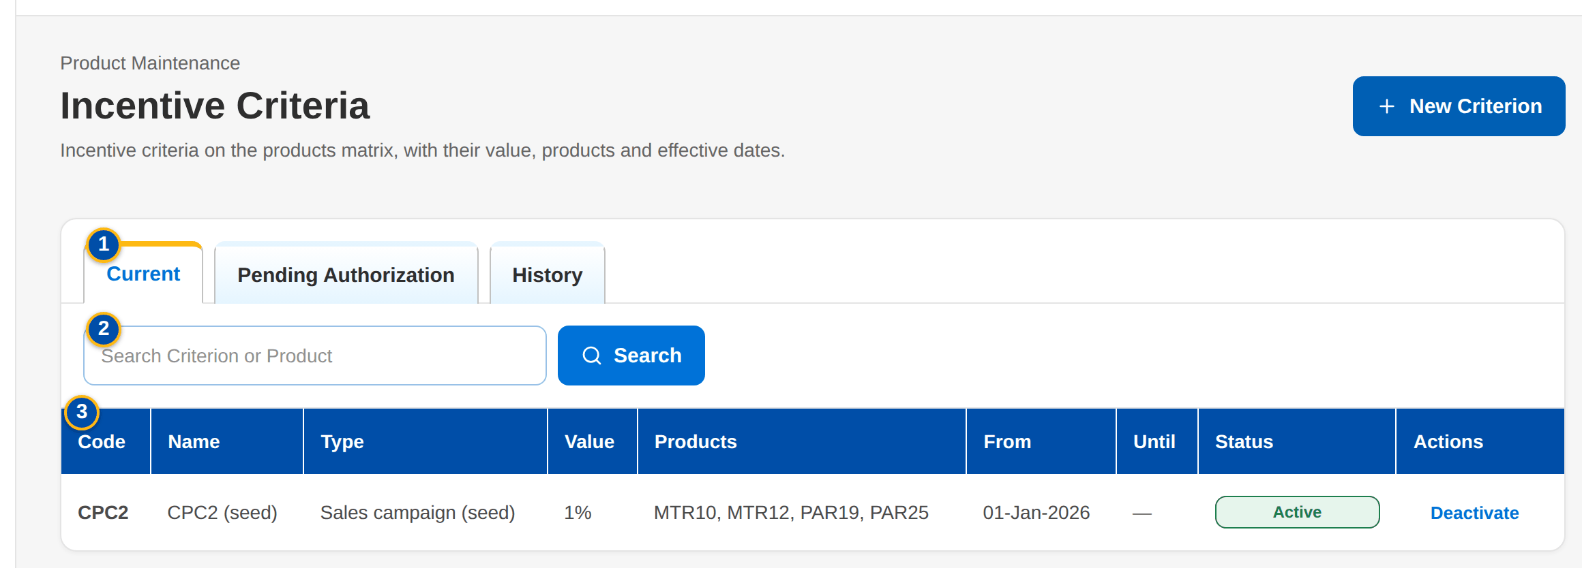
Figure 46: SCR-PM-16 Incentive Criteria, Current tab
1 | Current / Pending Authorization / History | 6 | Incentive type | 11 | Rule Parameters
2 | Search Criterion or Product | 7 | Value basis | 12 | Description
3 | Code / Name / Type / Value / Products / From / Until / Status | 8 | Value | 13 | Products matrix
4 | Code | 9 | Effective from
5 | Name | 10 | Effective to

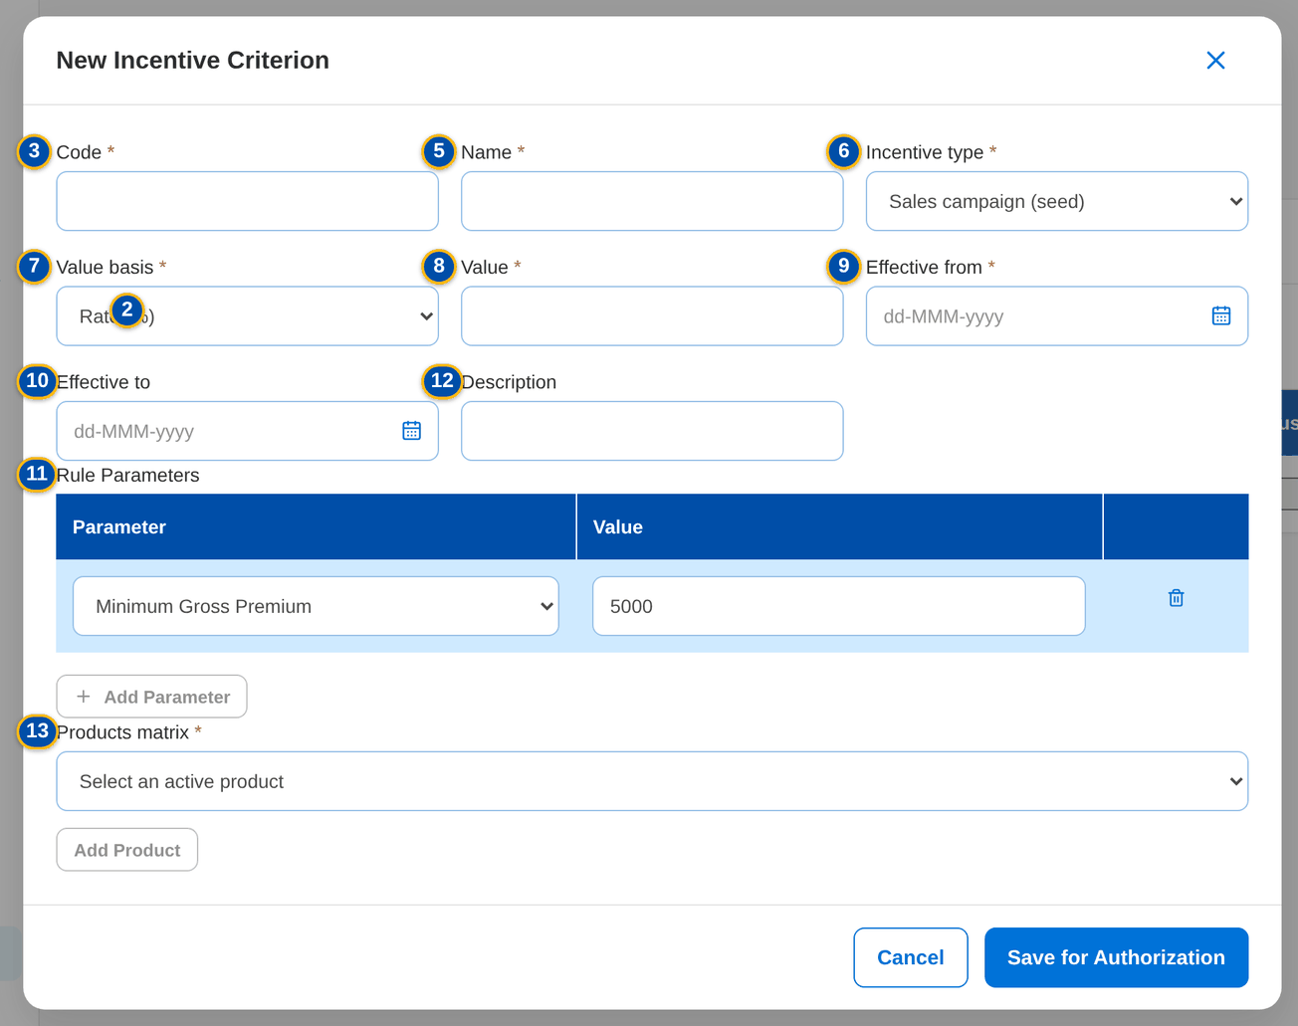
Figure 47: SCR-PM-16 New Incentive Criterion dialog with its rule parameters
Fields (No. = callout number on the first screenshot)
No. | Section | Field | Type | Length / format | Mand. | Source / list | Default | Editable in | Validation | Message when it fails
1 | Tabs | Current / Pending Authorization / History | Tab | - | - | Fixed | Current | - | Current = active and not ended; History = ended, replaced or inactive | -
2 | Search | Search Criterion or Product | Text | Code of a criterion or a product | N | - | Blank | - | Contains search | -
3 | List | Code / Name / Type / Value / Products / From / Until / Status | Column | Value as n%, an amount, or Rule | - | Incentive criteria | - | Read only | - | No incentive criterion in this list.
4 | New Incentive Criterion | Code | Text | A-Z, 0-9, _ and - | Y | - | Blank | New criterion only | Unique | Use A-Z, 0-9, _ and -
5 | New Incentive Criterion | Name | Text | Up to 150 characters | Y | - | Blank | Pending; amendment | Not blank | Enter the name
6 | New Incentive Criterion | Incentive type | Drop-down | Incentive types | Y | List INCENTIVE_TYPE | Blank | Pending; amendment | Active value | Select the type
7 | New Incentive Criterion | Value basis | Drop-down | Rate (%), Fixed amount, Rule (parameters) | Y | Fixed list | Rate (%) | Pending; amendment | - | -
8 | New Incentive Criterion | Value | Number | Rate 0 to 100 or an amount | Cond.: rate or fixed amount | - | Blank | Pending; amendment | Zero or more; a rate up to 100 | Enter the value / A rate is between 0 and 100
9 | New Incentive Criterion | Effective from | Date | dd-MMM-yyyy | Y | - | Blank | Pending; amendment | An amendment starts after the active row; no overlap with another row of the code | Enter the start date / The change must start after <active from> / Criterion <code> already covers part of this period
10 | New Incentive Criterion | Effective to | Date | dd-MMM-yyyy | N | - | Blank | Pending; amendment | On or after the start | The end is before the start
11 | New Incentive Criterion | Rule Parameters | Rows: parameter and value | Parameter from the parameters of the incentive type (Minimum Gross Premium); value as the parameter asks (an amount) | N (a value per row) | Rule parameters of the incentive type | None; Add Parameter adds a row | Pending; amendment | Each parameter once; a value for each parameter; a number, zero or more | Select the parameter / <parameter> is listed twice / Enter a value for each parameter / <parameter> must be a number / <parameter> cannot be negative
12 | New Incentive Criterion | Description | Text | Free text | N | - | Blank | Pending; amendment | - | -
13 | New Incentive Criterion | Products matrix | Drop-down and rows | Active product, with a segment per product (Any segment) | Y (at least one) | Active products; list MARKET_SEGMENT | None | Pending; amendment | Active products only | Select at least one product of the matrix

Actions
Button | Who | Enabled when | What happens | Resulting status | Notification
New Criterion | MBS (INCENTIVE_CRITERIA_MAINTAIN) | Always | Opens New Incentive Criterion; Save for Authorization | Pending Authorization | -
Open a row | MBS (INCENTIVE_CRITERIA_MAINTAIN) | Row not inactive | Opens Change <code> (pending row) or Amend <code> (active row: a successor from a later date) | Pending Authorization | -
Authorize | PRODUCT_AUTHORIZE (Business Administrator, New Business Approver), not the maker | Pending row | Authorises the criterion; an authorised amendment ends the active row the day before it starts | Active | -
Deactivate | MBS (INCENTIVE_CRITERIA_MAINTAIN) | Active row | Ends the criterion; its history stays | Inactive | -

Business rules
• A criterion names at least one active product of the matrix; a product that expires or is retired raises an alert to review or deactivate the criterion (FR-PM-080, FR-PM-081).
• An active criterion is changed only by an amendment starting after it; the active row ends when the amendment is authorised, so there is never a gap or an overlap (FR-PM-080).
• At booking, the invoice stores the codes of the criteria that match its product, cover type, segment, channel, lead insurer and booking date (FR-PM-081).
Expected outcome
The incentive criteria are maintained once, on the products matrix, and applied the same way to every booking.
Test cases: TC-PM-080.1-01, TC-PM-080.2-01, TC-PM-080.2-02, TC-PM-080.2-03, TC-PM-080.2-04, TC-PM-080.2-05, TC-PM-080.3-01, TC-PM-080.3-02, TC-PM-080.3-03, TC-PM-080.4-01, TC-PM-SCR-16, TC-PM-MSG-13.

13.3 Insurers, rates and pricing

13.3.1 SCR-PM-17 Insurers
Purpose | The insurer panel of the company: each accredited insurer with its accreditation date, placement channel and placement e-mails, and its credit days. Package versions, quotation slips and placement use this panel. A new insurer also creates its business partner for the ledger; both are authorised together.
Who can open it | Marketing Business Services, Business Administrator, New Business Approver, System Administrator, Auditor (permission MASTER_VIEW)
Navigation | • Menu: Client & Policy › Product Maintenance › Insurers  • Sidebar entry Insurers
FRs | FR-PM-014

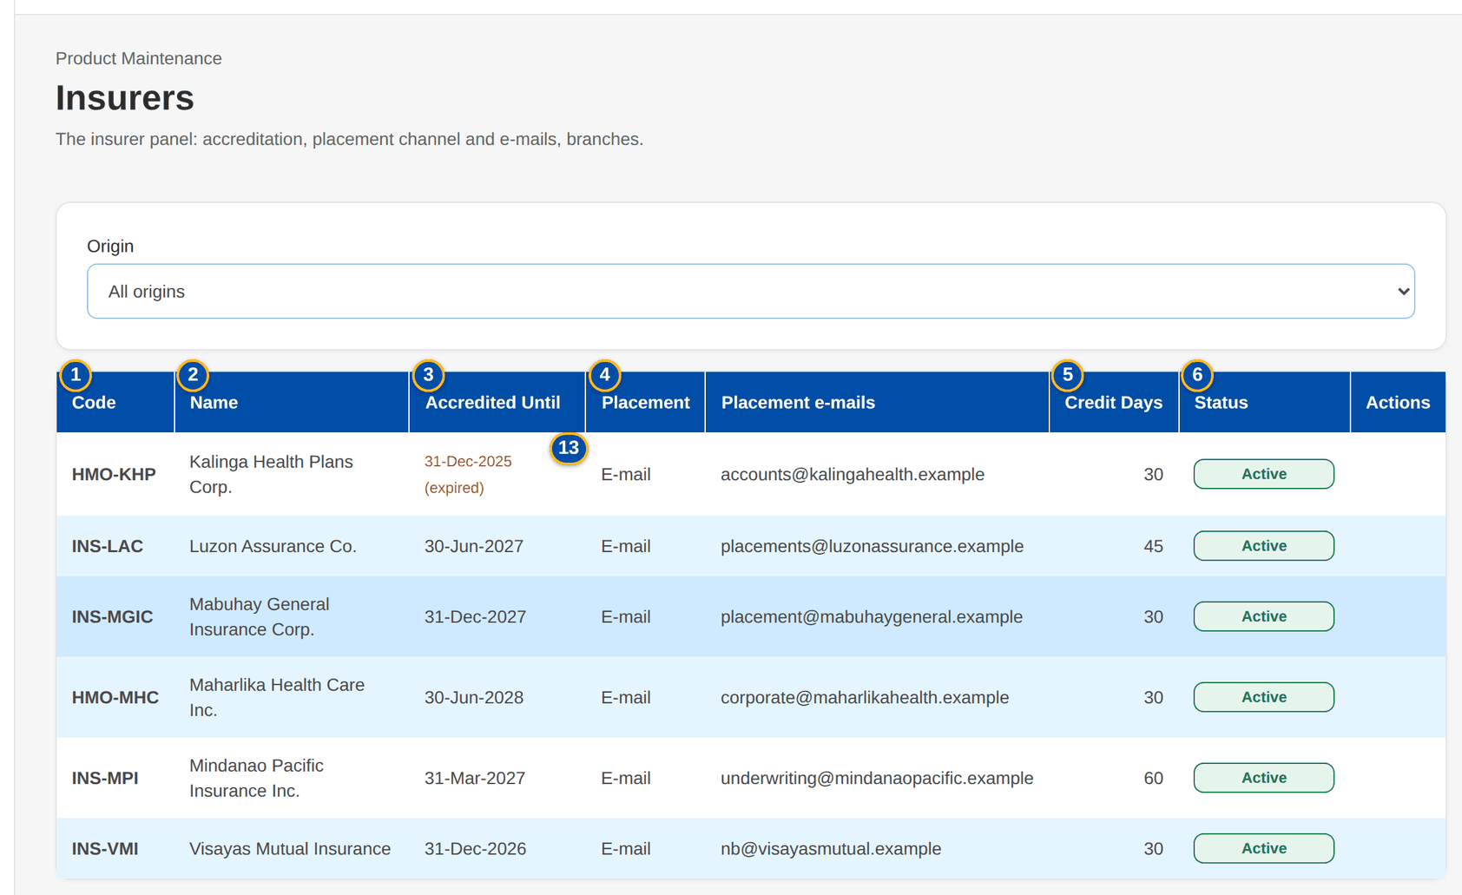
Figure 48: SCR-PM-17 Insurers list
1 | Code | 6 | Status | 11 | Placement e-mails
2 | Name | 7 | Partner code | 12 | Credit days
3 | Accredited Until | 8 | Name / Short name | 13 | TIN / Address / E-mail / Phone
4 | Placement / Placement e-mails | 9 | IC accreditation no. / Accredited until
5 | Credit Days | 10 | Placement channel

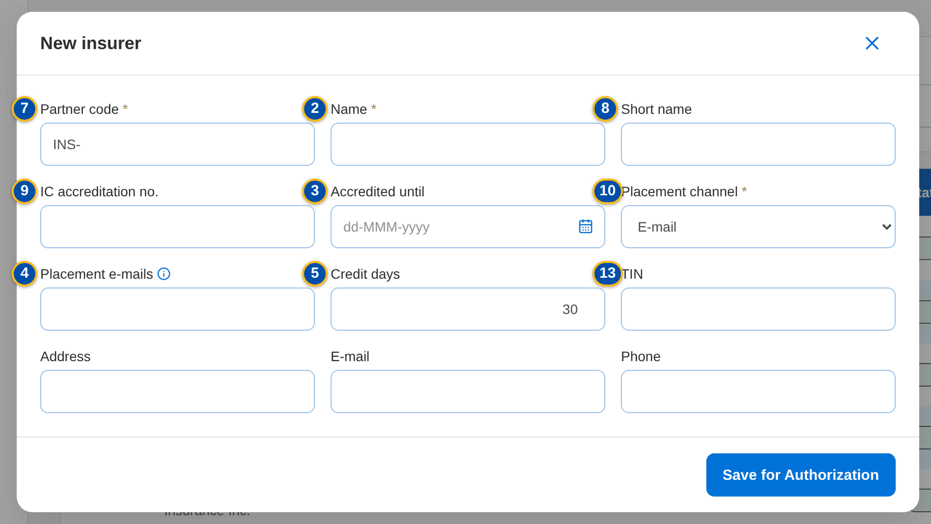
Figure 49: SCR-PM-17 New insurer dialog
Fields (No. = callout number on the first screenshot)
No. | Section | Field | Type | Length / format | Mand. | Source / list | Default | Editable in | Validation | Message when it fails
1 | List | Code | Column | Partner code INS-... | - | Insurer master | - | Read only | - | No insurer on the panel yet.
2 | List | Name | Column | Registered name | - | Insurer master | - | Read only | - | -
3 | List | Accredited Until | Column | dd-MMM-yyyy; (expired) in red once past | - | Insurer master | - | Read only | - | -
4 | List | Placement / Placement e-mails | Column | E-mail; addresses | - | Insurer master | - | Read only | - | -
5 | List | Credit Days | Column | Days | - | Insurer master | - | Read only | - | -
6 | List | Status | Column | Pending Authorization, Active, Inactive | - | Insurer master | - | Read only | - | -
7 | New insurer | Partner code | Text | INS- followed by capitals | Y | - | INS- | New insurer only | Unique; an existing party must be an insurer | Party <party code> exists and is not an insurer
8 | New insurer | Name / Short name | Text | Registered and short name | Y (name) | - | Blank | Pending, active | - | -
9 | New insurer | IC accreditation no. / Accredited until | Text / Date | Insurance Commission accreditation; dd-MMM-yyyy | N | - | Blank | Pending, active | - | -
10 | New insurer | Placement channel | Drop-down | E-mail | Y | Fixed list | E-mail | Pending, active | Only e-mail placement is available | Only e-mail placement is available; choose the e-mail placement channel
11 | New insurer | Placement e-mails | Text | Addresses separated by commas | N (needed to send quotation slips and placement slips) | - | Blank | Pending, active | - | <name> has no placement e-mail address
12 | New insurer | Credit days | Number | 0 to 365 | N | - | 30 | Pending, active | 0 to 365 | Default credit days must be between 0 and 365
13 | New insurer | TIN / Address / E-mail / Phone | Text | Business partner details | N | - | Blank | New insurer only | - | -

Actions
Button | Who | Enabled when | What happens | Resulting status | Notification
New Insurer | MASTER_MAINTAIN (Business Administrator) | Always | Opens New insurer; Save for Authorization | Pending Authorization | -
Authorize | MASTER_AUTHORIZE, not the maker | Pending row | Authorises the insurer and its business partner | Active | -
Deactivate | MASTER_MAINTAIN | Active row | The insurer is no longer offered | Inactive | -
Open a row | Every user of the screen | Always | Opens the insurer record | - | -

Business rules
• Only authorised, active insurers are offered in package requests, package versions and quotation slips (FR-PM-014, FR-PM-030).
• The insurer master is maintained under New Business rules (BRD-1, insurer panel); Product Maintenance uses it for the package panels (FR-PM-014).
Expected outcome
The insurer panel used by every package is maintained once, with the e-mail addresses the slips are sent to.
Test cases: TC-PM-SCR-17, TC-PM-MSG-14.

13.3.2 SCR-PM-18 Insurer record
Purpose | One insurer: its profile (partner code, accreditation, placement channel and e-mails, credit days, maker and authoriser), its branches with the local government tax rate, and its commission rates by product.
Who can open it | Marketing Business Services, Business Administrator, New Business Approver, System Administrator, Auditor (permission MASTER_VIEW)
Navigation | • Menu: Client & Policy › Product Maintenance › Insurers › Insurer  • Insurers › a row
FRs | FR-PM-014

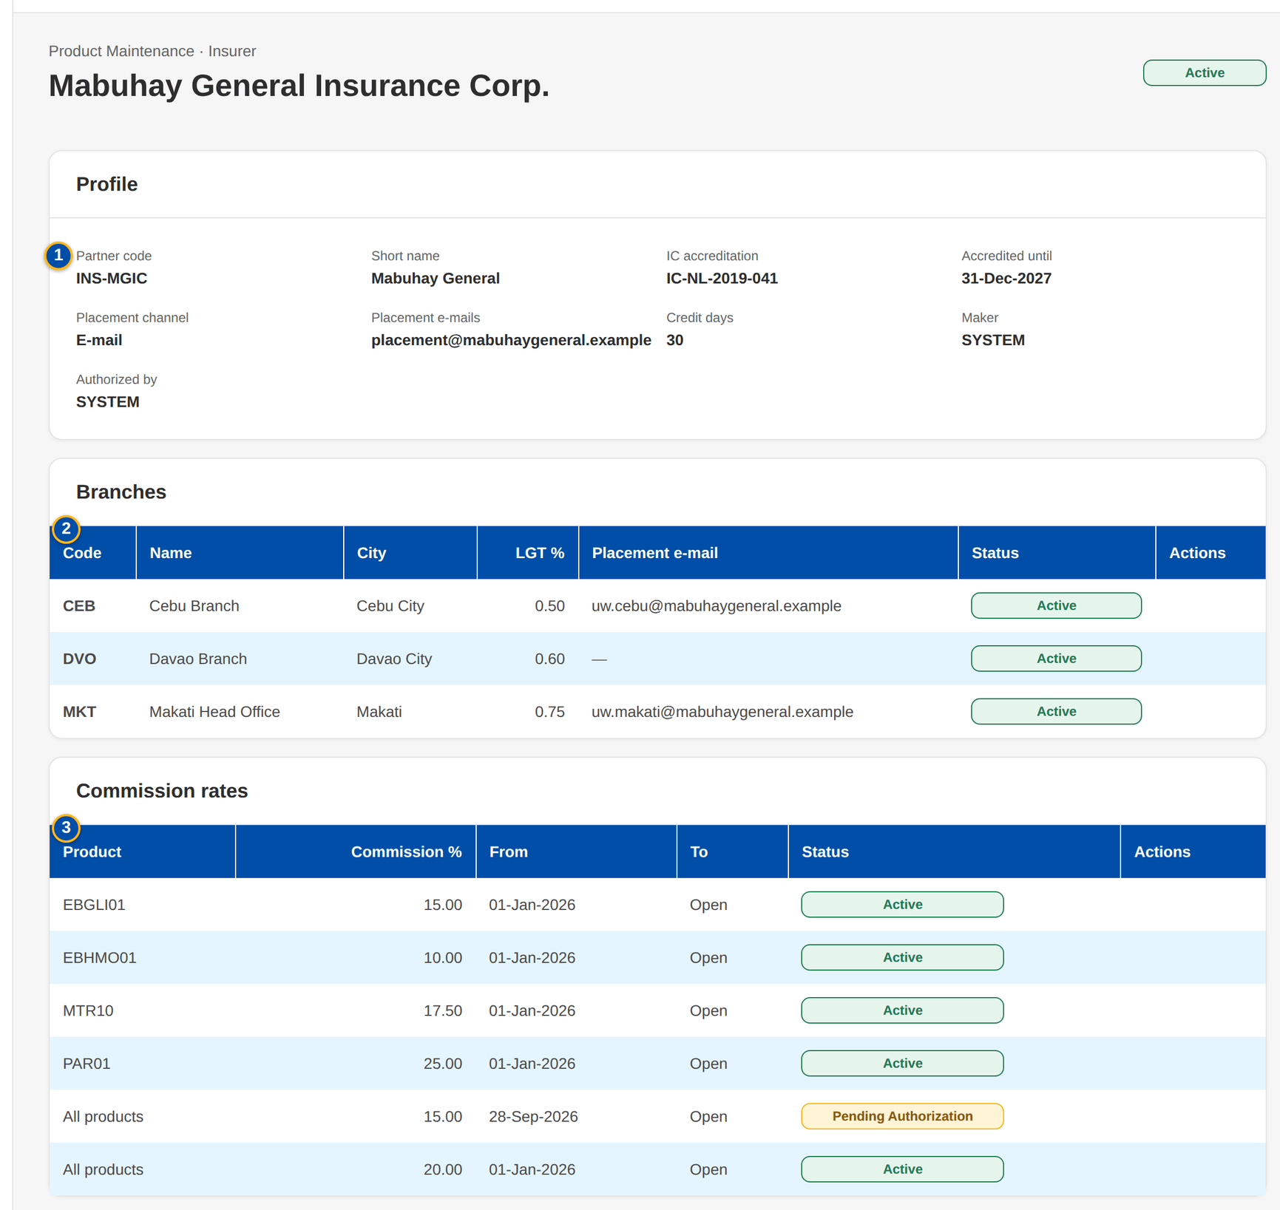
Figure 50: SCR-PM-18 Insurer record with branches and commission rates
1 | Partner code / Short name / IC accreditation / Accredited until / Placement channel / Placement e-mails / Credit days / Maker / Authorized by | 5 | City | 9 | Commission %
2 | Code / Name / City / LGT % / Placement e-mail / Status | 6 | LGT % | 10 | Effective from / Effective to
3 | Product / Commission % / From / To / Status | 7 | Placement e-mail
4 | Code / Name | 8 | Product

Fields (No. = callout number on the first screenshot)
No. | Section | Field | Type | Length / format | Mand. | Source / list | Default | Editable in | Validation | Message when it fails
1 | Profile | Partner code / Short name / IC accreditation / Accredited until / Placement channel / Placement e-mails / Credit days / Maker / Authorized by | Detail | As entered | - | Insurer master | - | Read only (Edit opens the insurer dialog) | - | -
2 | Branches | Code / Name / City / LGT % / Placement e-mail / Status | Column | Branch of the insurer | - | Insurer branches | - | Read only | - | No branch recorded.
3 | Commission rates | Product / Commission % / From / To / Status | Column | All products or one product; To shows Open | - | Commission rates | - | Read only | - | No commission rate: the product default applies.
4 | New Branch | Code / Name | Text | Branch code and name | Y | - | Blank | New branch | Unique per insurer | Insurer branch already exists: <key>
5 | New Branch | City | Text | Free text | N | - | Blank | New branch | - | -
6 | New Branch | LGT % | Number | Local government tax on premium, up to four decimals | Y | - | 0 | New branch | 0 to 100 | The LGT rate must be between 0 and 100 %
7 | New Branch | Placement e-mail | Text | Address | N | - | Blank | New branch | - | -
8 | New Commission Rate | Product | Drop-down | All products of the insurer or one active product | N | Active products | All products of the insurer | New rate | - | -
9 | New Commission Rate | Commission % | Number | Percentage | Y | - | Blank | New rate | 0 to 100 | The commission rate must be a percentage between 0 and 100
10 | New Commission Rate | Effective from / Effective to | Date | dd-MMM-yyyy | Y (from) | - | Today | New rate | To on or after from | Enter the effective-from date / The effective-to date is before the effective-from date

Actions
Button | Who | Enabled when | What happens | Resulting status | Notification
Edit | MASTER_MAINTAIN | Always | Opens the insurer dialog (partner code fixed); Save for Authorization | Pending Authorization | -
Add branch | MASTER_MAINTAIN | Always | Opens New Branch; Save for Authorization | Pending Authorization | -
Add rate | MASTER_MAINTAIN | Always | Opens New Commission Rate; Save for Authorization | Pending Authorization | -
Authorize / Deactivate | As on Insurers | As on Insurers | As on Insurers | Active / Inactive | -

Business rules
• The commission rate in force on the account's period start applies; without an insurer rate, the product default applies (FR-PM-014).
• A package version's own insurer rate and minimum premium win over the insurer's general terms for that package (FR-PM-014).
Expected outcome
The business sees and maintains everything that is specific to one insurer.
Test cases: TC-PM-SCR-18.

13.3.3 SCR-PM-19 Rates & Taxes
Purpose | The statutory charges and rating tables applied by the premium calculation: documentary stamp tax, premium tax, VAT, fire service tax and the motor own-damage factors; the short-period table; and the bodily injury and property damage limit premiums. Every row is effective-dated and maker-checker.
Who can open it | Marketing Business Services, Business Administrator, New Business Approver, System Administrator, Auditor (permission MASTER_VIEW)
Navigation | • Menu: Client & Policy › Product Maintenance › Rates & Taxes  • Sidebar entry Rates & Taxes
FRs | FR-PM-051

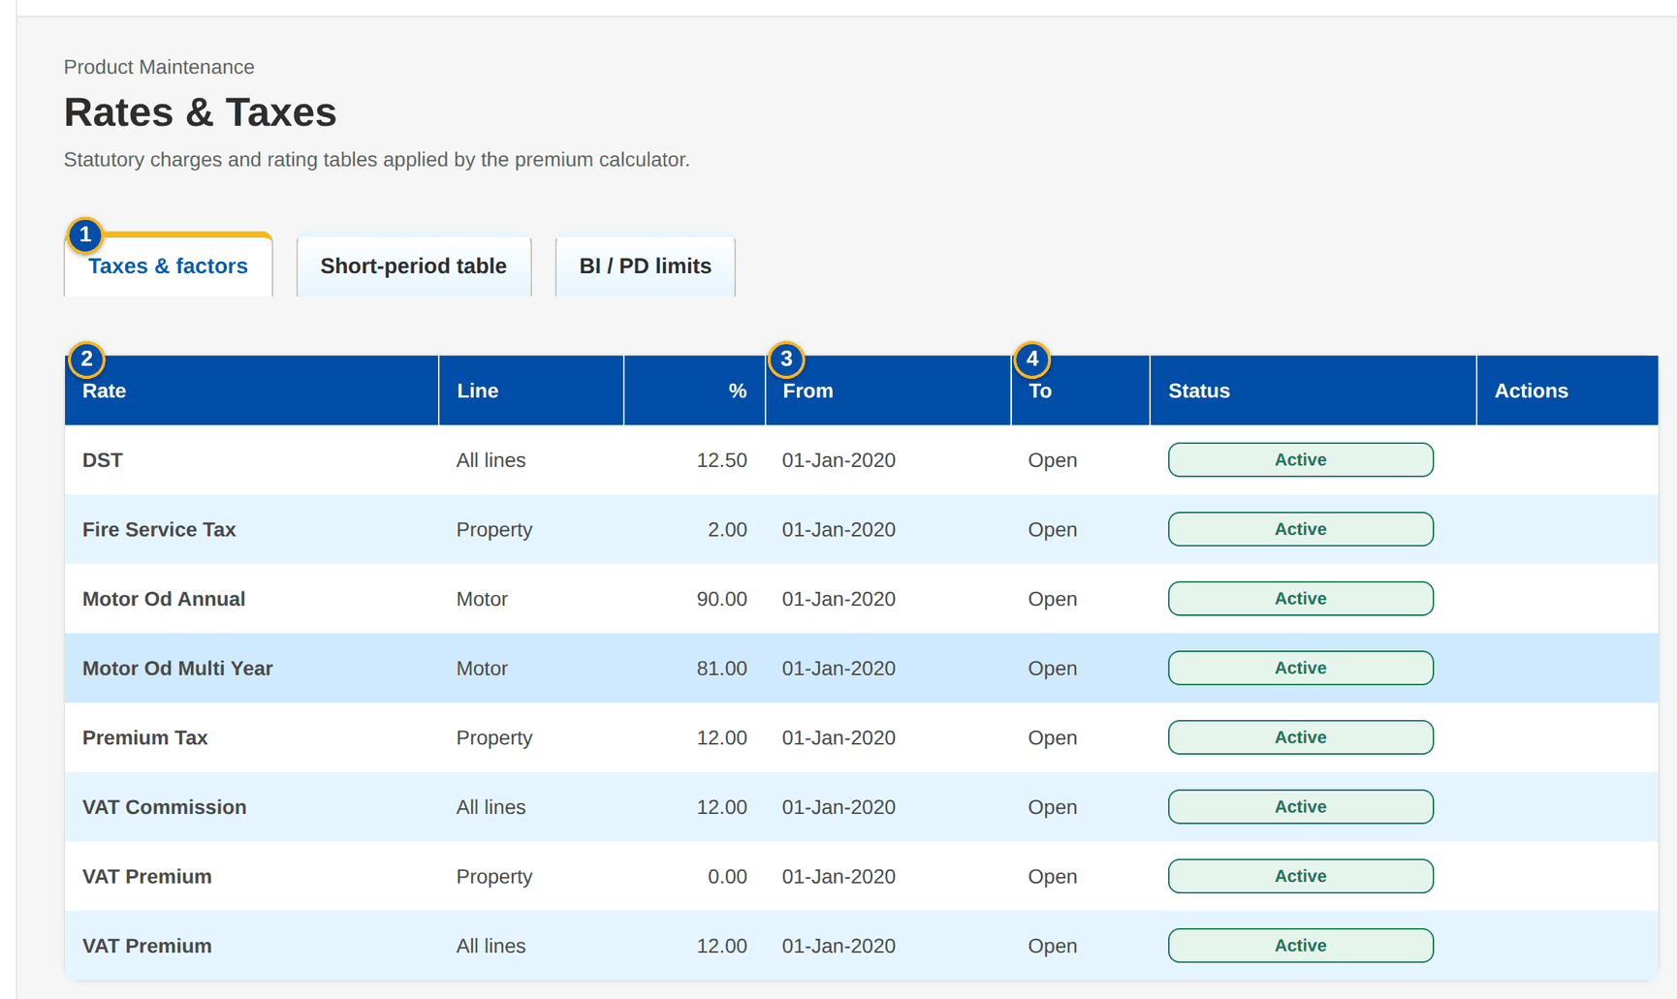
Figure 51: SCR-PM-19 Rates & Taxes, Taxes & factors tab
1 | Taxes & factors / Short-period table / BI / PD limits | 5 | Rate | 9 | Coverage / Limit / Premium
2 | Rate / Line / % / From / To / Status | 6 | Line code | 10 | Effective from / Effective to
3 | Months Covered (up To) / % of Annual Premium / From / To / Status | 7 | Rate % / % of annual premium
4 | Coverage / Limit / Premium / From / To / Status | 8 | Months covered

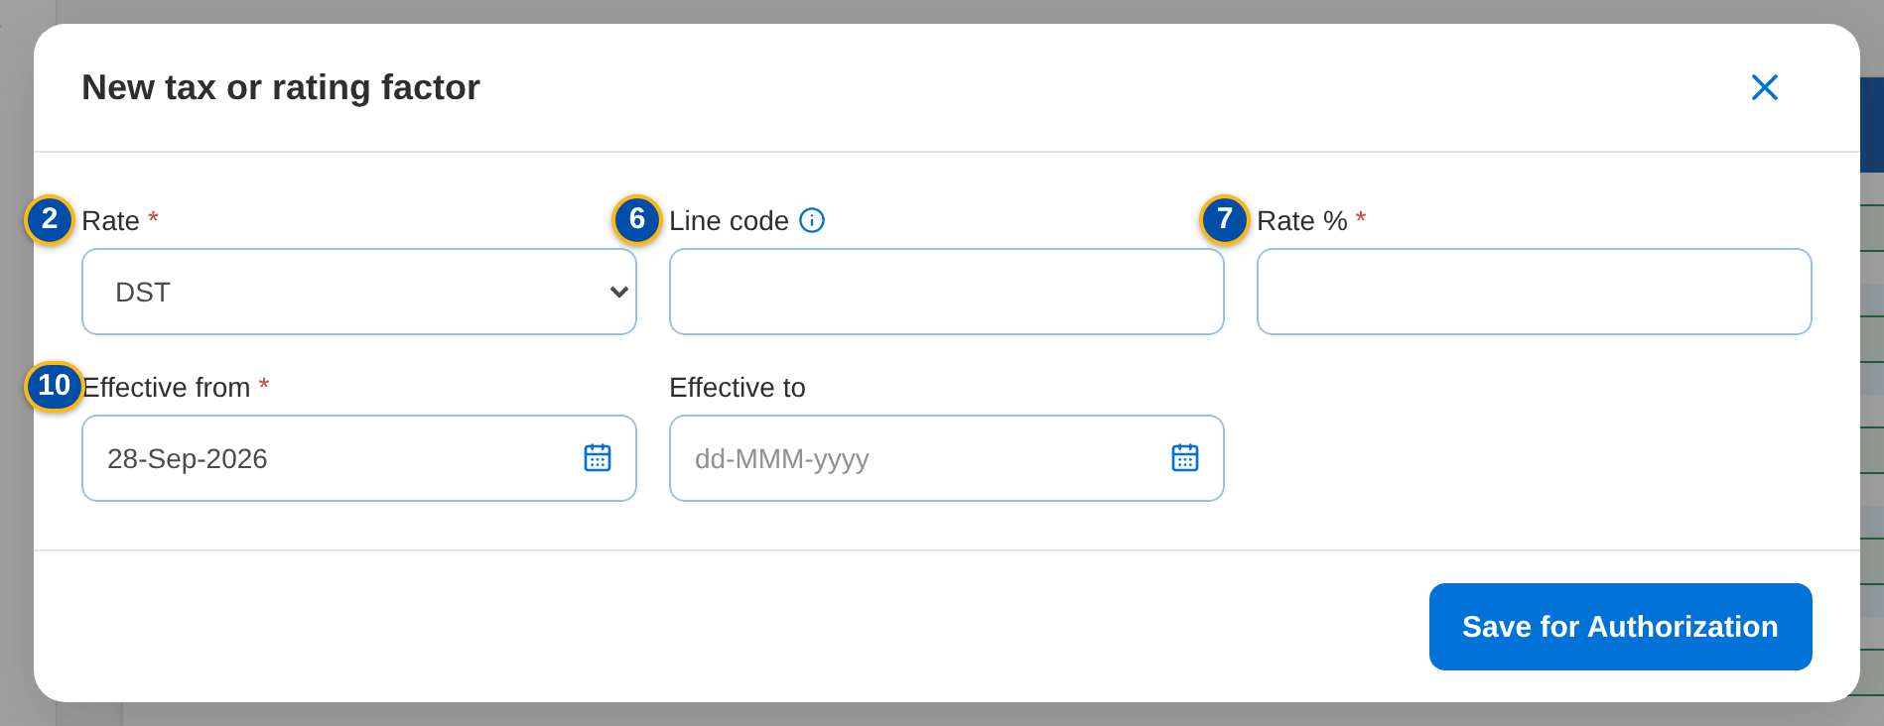
Figure 52: SCR-PM-19 New tax or rating factor dialog
Fields (No. = callout number on the first screenshot)
No. | Section | Field | Type | Length / format | Mand. | Source / list | Default | Editable in | Validation | Message when it fails
1 | Tabs | Taxes & factors / Short-period table / BI / PD limits | Tab | - | - | Fixed | Taxes & factors | - | - | -
2 | Taxes & factors | Rate / Line / % / From / To / Status | Column | Rate name; All lines or a line; percentage; dd-MMM-yyyy; Open | - | Rate table | - | Read only | - | -
3 | Short-period table | Months Covered (up To) / % of Annual Premium / From / To / Status | Column | Months 1 to 12; percentage | - | Short-period table | - | Read only | - | -
4 | BI / PD limits | Coverage / Limit / Premium / From / To / Status | Column | Bodily injury or Property damage; amounts | - | Motor limit table | - | Read only | - | -
5 | New rate | Rate | Drop-down | DST, premium tax, VAT, fire service tax and the motor factors | Y | Fixed list | DST | New row | - | -
6 | New rate | Line code | Text | Blank = every line | N | Product lines | Blank | New row | - | -
7 | New rate | Rate % / % of annual premium | Number | Percentage, up to four decimals | Y | - | Blank | New row | 0 to 100 | The rate must be a percentage between 0 and 100 / The short-period percentage must be a percentage between 0 and 100
8 | New rate | Months covered | Number | 1 to 12 | Y (short-period table) | - | Blank | New row | 1 to 12 | Months covered must be between 1 and 12
9 | New rate | Coverage / Limit / Premium | Drop-down / Number | Bodily injury (BI) or Property damage (PD); amounts | Y (limit table) | Fixed list | Bodily injury (BI) | New row | Limit greater than zero; premium zero or more | The limit must be greater than zero / The premium cannot be negative
10 | New rate | Effective from / Effective to | Date | dd-MMM-yyyy | Y (from) | - | Today | New row | To on or after from | Enter the effective-from date / The effective-to date is before the effective-from date

Actions
Button | Who | Enabled when | What happens | Resulting status | Notification
New Rate | MASTER_MAINTAIN (Business Administrator) | Always | Opens the dialog of the current tab; Save for Authorization | Pending Authorization | -
Authorize / Deactivate | MASTER_AUTHORIZE / MASTER_MAINTAIN | As on Insurers | Authorises the row or ends its use | Active / Inactive | -

Business rules
• The row in force on the rating date applies; statutory rates keep their effective-date look-up and do not follow the package version (FR-PM-051).
• A period without a short-period row, or a motor limit not in the table, is refused at rating (FR-PM-051).
Expected outcome
Every charge applied to a premium comes from one authorised, effective-dated table.
Test cases: TC-PM-SCR-19, TC-PM-MSG-15.

13.3.4 SCR-PM-20 Sales Organisation
Purpose | The sales organisation of the company as one tree table: regions, departments and teams with their cost centres, and the account officers of each team by name, role and assignment date. Accounts are stamped with the creator's units and cost centre when they are created.
Who can open it | Marketing Business Services, Business Administrator, New Business Approver, System Administrator, Auditor (permission MASTER_VIEW)
Navigation | • Menu: Client & Policy › Product Maintenance › Sales Organisation  • Sidebar entry Sales Organisation
FRs

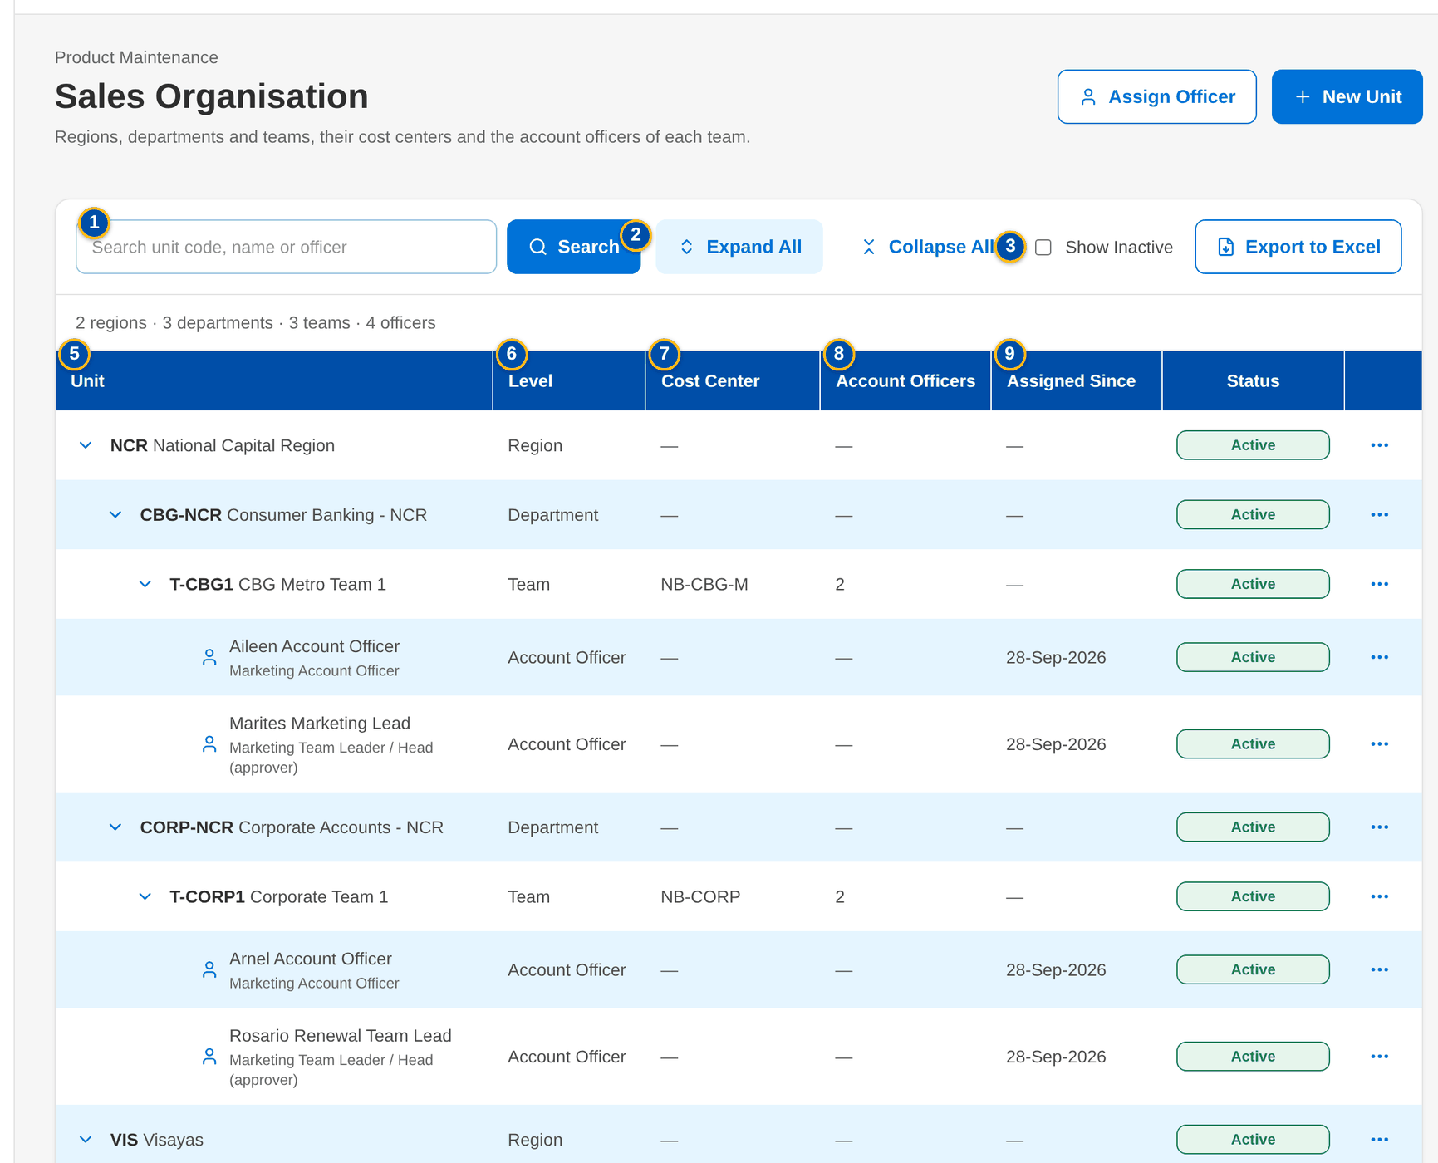
Figure 53: SCR-PM-20 Sales Organisation tree table, every branch expanded
1 | Search unit code, name or officer | 8 | Account Officers | 15 | Parent
2 | Expand All / Collapse All | 9 | Assigned Since | 16 | Code, Name, Level, Parent Unit, Cost Center, Unit Head, Sub-units, Account Officers, Status, Status Reason, Created, Last Changed, Authorized
3 | Show Inactive | 10 | Status | 17 | Team
4 | Summary | 11 | Actions | 18 | Account Officer
5 | Unit | 12 | Level | 19 | Reason
6 | Level | 13 | Code / Name
7 | Cost Center | 14 | Cost Center

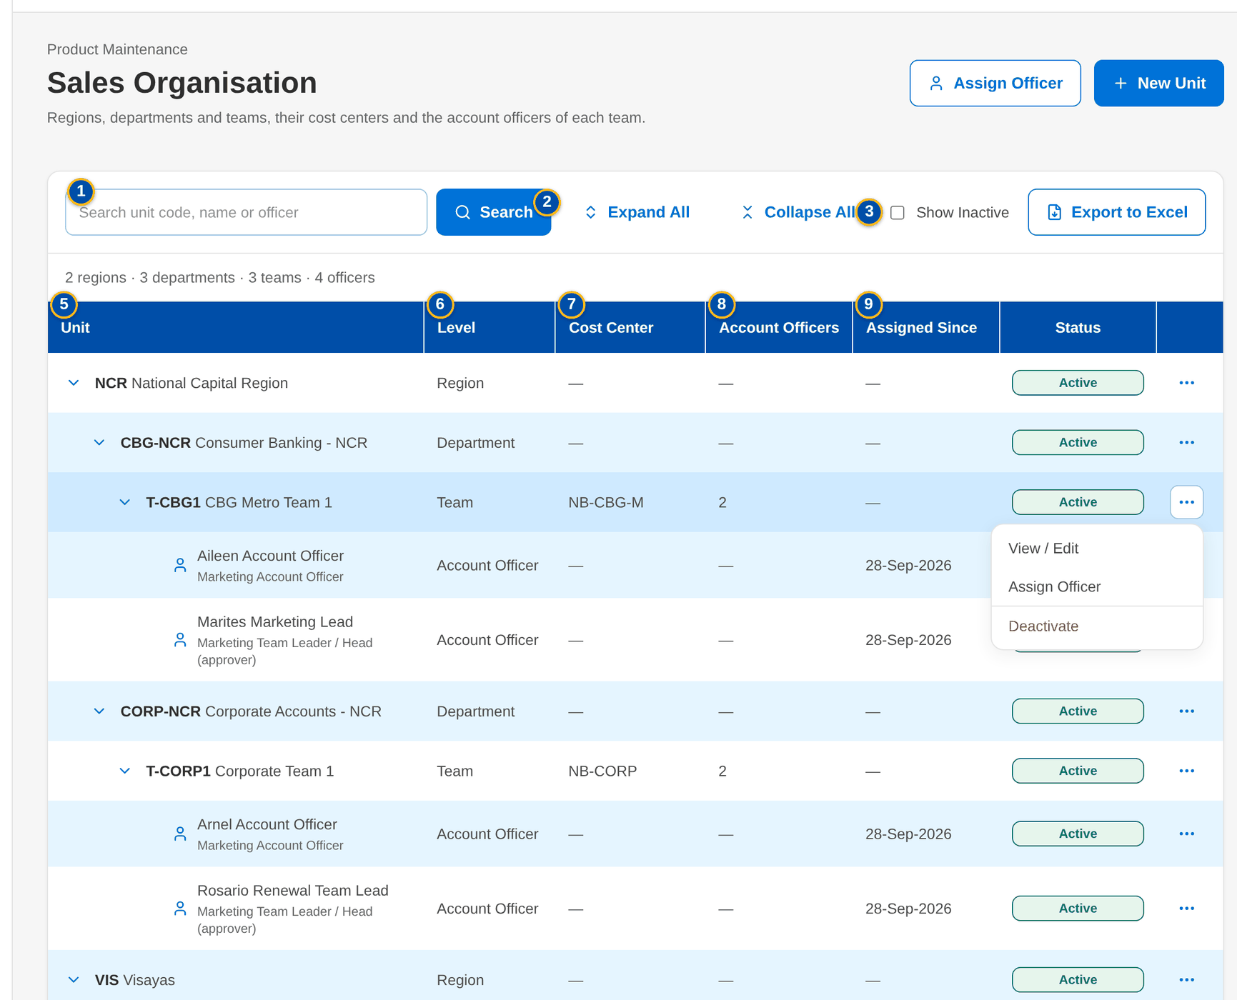
Figure 54: SCR-PM-20 Actions menu of a team

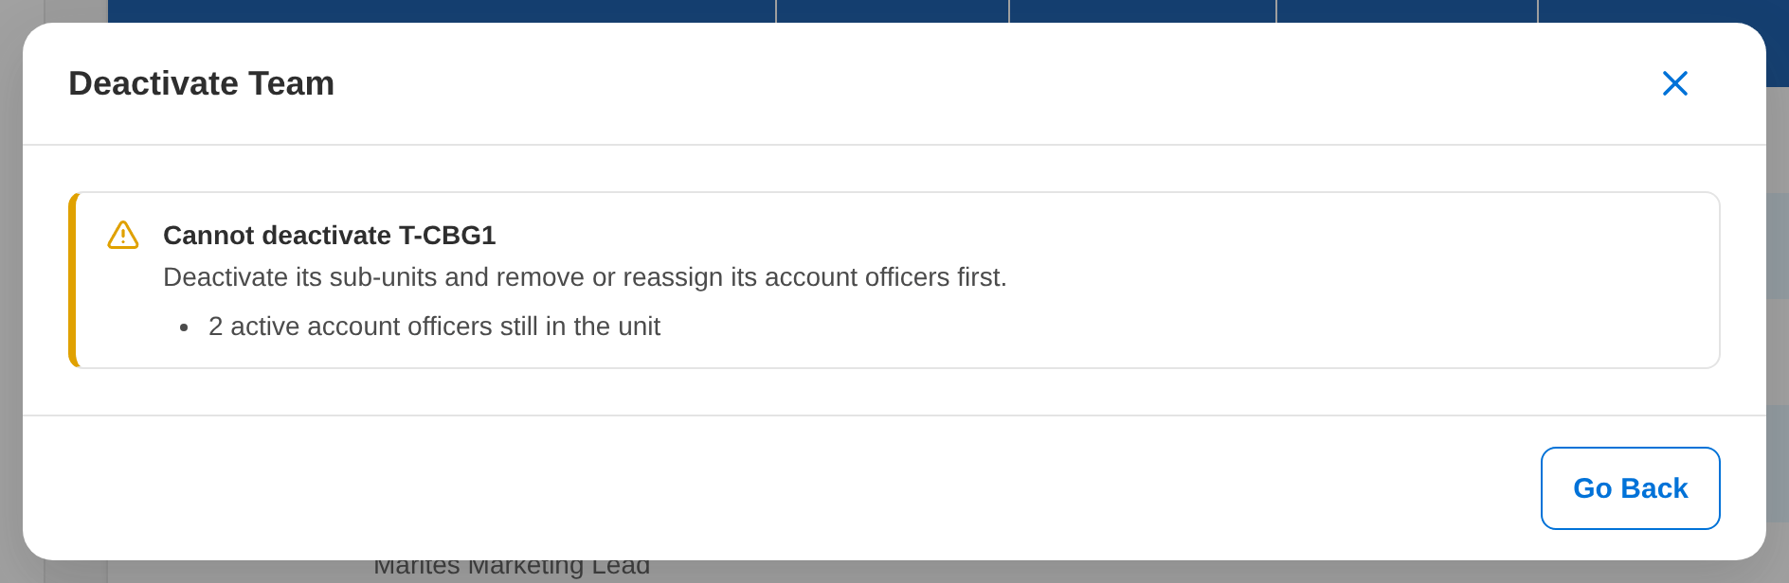
Figure 55: SCR-PM-20 Deactivation refused while the team still has active account officers
Fields (No. = callout number on the first screenshot)
No. | Section | Field | Type | Length / format | Mand. | Source / list | Default | Editable in | Validation | Message when it fails
1 | Toolbar | Search unit code, name or officer | Text | Unit code or name, or the officer's name | N | - | Blank | - | Contains search; the matching branches open | No unit or officer matches the search
2 | Toolbar | Expand All / Collapse All | Button | Opens or closes every branch | - | - | Regions and departments open | - | - | -
3 | Toolbar | Show Inactive | Check box | Lists deactivated units and removed officers in grey | N | - | Not ticked | - | - | -
4 | Toolbar | Summary | Text | n regions · n departments · n teams · n officers of the rows shown | - | Sales units and officers | - | Read only | - | -
5 | Tree table | Unit | Column | Chevron and indentation per level; code in bold and name; an officer by full name with the role below | - | Sales units; users | - | Read only | - | No sales unit defined yet
6 | Tree table | Level | Column | Region, Department, Team or Account Officer | - | Sales units | - | Read only | - | -
7 | Tree table | Cost Center | Column | The unit's own cost centre, or the cost centre in force with Inherited from <parent code> below it | - | Sales units | - | Read only | - | -
8 | Tree table | Account Officers | Column | Number of active officers of a team | - | Sales officers | - | Read only | - | -
9 | Tree table | Assigned Since | Column | dd-MMM-yyyy, date the officer joined the team | - | Sales officers | - | Read only | - | -
10 | Tree table | Status | Pill | Active, Pending Authorization, Inactive | - | Sales units and officers | - | Read only | - | -
11 | Tree table | Actions | Menu | The actions of the row (see Actions) | - | - | - | - | - | -
12 | New unit / Add sub-unit | Level | Drop-down | Region, Department, Team; fixed to the level below when opened from a unit | Y | Fixed list | Region | New unit | A department belongs to a region; a team to a department | A <level> must belong to an active <parent level>
13 | New unit / Add sub-unit | Code / Name | Text | Unit code and name | Y | - | Blank | New unit | Unique | Sales unit already exists: <key>
14 | New unit / Add sub-unit | Cost Center | Text | Blank = inherited from the parent | N | Cost centres | Blank | New unit; edit | A cost centre of the company | -
15 | New unit / Add sub-unit | Parent | Drop-down | Active units of the level above | Cond.: department and team | Sales units | The unit the action was opened from | New unit; edit | - | -
16 | Unit details | Code, Name, Level, Parent Unit, Cost Center, Unit Head, Sub-units, Account Officers, Status, Status Reason, Created, Last Changed, Authorized | Detail | Names of users, dd-MMM-yyyy HH:mm | - | Sales units | - | Read only; Edit for name, parent and cost centre | - | -
17 | Assign Account Officer / Reassign | Team | Drop-down | Active teams | Y | Sales units | The team the action was opened from | New assignment | An existing, active team | Team <team code> is unknown or inactive
18 | Assign Account Officer / Reassign | Account Officer | Drop-down | BIBS users by name and role | Y | Users | Select; fixed on Reassign | New assignment | An existing user | Unknown user <user>
19 | Deactivate / Reactivate / Remove from Team | Reason | Text | Why the unit or officer changes | Y | - | Blank | Dialog | Not blank | Enter the reason.

Actions
Button | Who | Enabled when | What happens | Resulting status | Notification
New Unit | MASTER_MAINTAIN | Always | Opens New unit; Save for Authorization | Pending Authorization | -
Assign Officer | MASTER_MAINTAIN | Always | Opens Assign Account Officer; Save for Authorization | Pending Authorization | -
View / Edit | Every user of the screen; Edit with MASTER_MAINTAIN | Unit row | Opens the unit details; Edit changes name, parent and cost centre, Save for Authorization | Pending Authorization | -
Add Department / Add Team | MASTER_MAINTAIN | Active region / department | Opens New unit at the level below, the parent filled | Pending Authorization | -
Assign Officer (row) | MASTER_MAINTAIN | Active team | Opens Assign Account Officer with the team filled | Pending Authorization | -
Authorize | MASTER_AUTHORIZE, not the maker | Pending unit or officer | Authorises the record | Active | -
Deactivate | MASTER_MAINTAIN | Active or pending unit without active sub-units or officers | Asks the reason and deactivates the unit; refused with a notice while sub-units or officers remain | Inactive | -
Reactivate | MASTER_MAINTAIN | Inactive unit whose parent is not inactive | Asks the reason; the unit waits for authorisation again | Pending Authorization | -
Reassign / Assign to a Team | MASTER_MAINTAIN | Officer row | Moves the officer to another team (or places a removed officer again) from today | Pending Authorization | -
Remove from Team | MASTER_MAINTAIN | Active or pending officer | Asks the reason and ends the officer's assignment | Inactive | -
Export to Excel | Every user of the screen | Always | Downloads the tree in tree order with the effective cost centres and the officers by name and role | - | -

Business rules
• The sales organisation is a New Business master (BRD-1, sales hierarchy and production reporting) kept in the Product Maintenance section of the menu; it is loaded at go-live by the data migration.
• A unit is deactivated only when none of its sub-units and account officers is still active or pending; a unit is reactivated only under an active or pending parent, and waits for authorisation again.
• Deactivation, reactivation and removal from a team need a reason, kept on the record and in the audit trail with the user and time.
• A team without its own cost centre uses the cost centre of the nearest parent that has one.
Expected outcome
Every account and production report is attributed to the right region, department, team and officer.
Test cases: TC-PM-SCR-20, TC-PM-MSG-16.

13.3.5 SCR-PM-21 Premium Calculator
Purpose | Rates a product with the charges in force, for an insurer and branch, annual, pro-rata or short period, for a new account or an endorsement over the remaining term, and shows every charge and the commission. For a package it shows the version that priced it; an earlier released version can be chosen for information.
Who can open it | Marketing Account Officer, Marketing TL / TH / UH, TSU Officer, New Business Approver, Auditor (permission ACCOUNT_VIEW)
Navigation | • Menu: Client & Policy › Product Maintenance › Premium Calculator  • Sidebar entry Premium Calculator
FRs | FR-PM-051, FR-PM-052

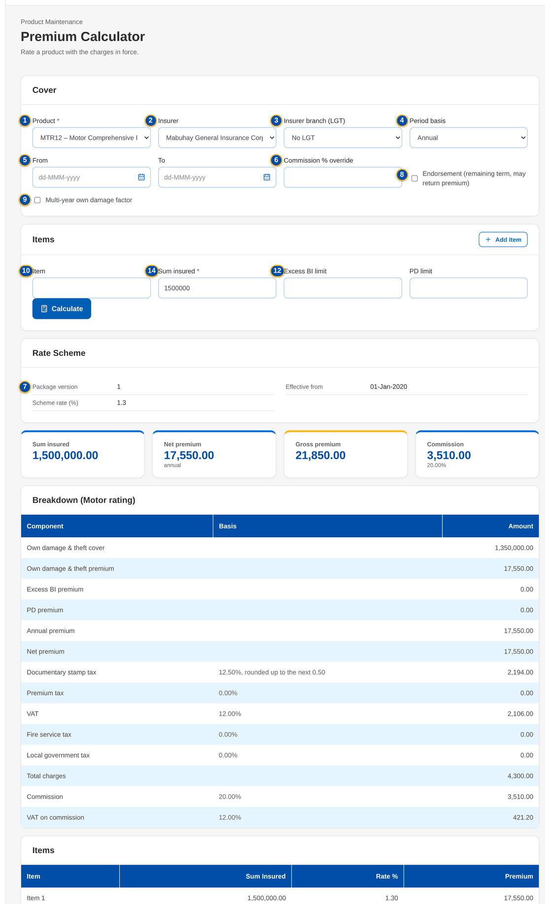
Figure 56: SCR-PM-21 Premium Calculator: a package priced on its version in force
1 | Product | 6 | Commission % override | 11 | Rate %
2 | Insurer | 7 | Package version | 12 | Excess BI limit / PD limit
3 | Insurer branch (LGT) | 8 | Endorsement (remaining term, may return premium) | 13 | Version line
4 | Period basis | 9 | Multi-year own damage factor | 14 | Sum insured / Net premium / Gross premium / Commission
5 | From / To | 10 | Item / Sum insured | 15 | Component / Basis / Amount

Fields (No. = callout number on the first screenshot)
No. | Section | Field | Type | Length / format | Mand. | Source / list | Default | Editable in | Validation | Message when it fails
1 | Cover | Product | Drop-down | Code – name of the active products | Y | Active products | Select | - | - | Choose a product.
2 | Cover | Insurer | Drop-down | Insurers of the panel | N | Insurers | Product default commission | - | A package with a panel accepts only its panel insurers | Insurer <insurer code> is not on the panel of <product code> version <version no>
3 | Cover | Insurer branch (LGT) | Drop-down | Branch name (LGT %) | N | Insurer branches | No LGT | - | An authorised branch of the insurer | Branch <branch code> is not authorized or inactive
4 | Cover | Period basis | Drop-down | Annual, Pro-rata (days), Short period (table) | N | Fixed list | Annual | - | Pro-rata and short period need the period | Pro-rata and short-period rating need the period (for endorsements: the remaining term).
5 | Cover | From / To | Date | dd-MMM-yyyy | Cond.: pro-rata or short period | - | Blank | - | To after From | The period end must be after the period start
6 | Cover | Commission % override | Number | Percentage | N | - | Blank | - | - | -
7 | Cover | Package version | Drop-down | Version in force, or an earlier released version | N | Released and superseded versions | Version in force | - | Shown when the package has two or more sold versions | -
8 | Cover | Endorsement (remaining term, may return premium) | Check box | - | N | - | Not ticked | - | Only an endorsement may reduce the sum insured | Only an endorsement may reduce the sum insured.
9 | Cover | Multi-year own damage factor | Check box | Motor multi-year products | N | - | Not ticked | - | - | -
10 | Items | Item / Sum insured | Text / Number | Label; amount in PHP | Y (a sum insured for at least one item) | - | Blank | - | Zero or more | Enter the sum insured of at least one item.
11 | Items | Rate % | Number | Blank = product default (non-motor) | N | - | Blank | - | A rate other than the scheme rate is priced but flagged | Enter the premium rate of <item>
12 | Items | Excess BI limit / PD limit | Number | Motor limits of the table | N | Motor limit table | Blank | - | A limit of the table | <coverage> limit <amount> is not in the limit table
13 | Result | Version line | Banner | Priced on package version n (effective dd-MMM-yyyy, scheme rate r%); not the current version; an item rate differs from the scheme rate | - | Package version | - | Read only | - | -
14 | Result | Sum insured / Net premium / Gross premium / Commission | Figure | Amounts in PHP | - | Premium computation | - | Read only | - | -
15 | Result | Component / Basis / Amount | Table | Annual premium, net premium, documentary stamp tax, premium tax, VAT, fire service tax, local government tax, total charges, commission, VAT on commission | - | Premium computation | - | Read only | - | -

Actions
Button | Who | Enabled when | What happens | Resulting status | Notification
Add Item / Remove | Every user of the screen | Always | Adds or removes an item | - | -
Calculate | Every user of the screen | Product chosen and a sum insured entered | Rates the cover and shows the result | - | -

Business rules
• New business is priced on the package version in force on the transaction date, not on the period start (FR-PM-051).
• A version other than the one in force is shown for information only; a quotation needs the current version or an approved rate exception (FR-PM-051).
• An item rate different from the scheme rate (or the panel insurer's rate) is priced but flagged; a quotation with it needs an approved rate exception (FR-PM-051).
• An expired or retired package, or a package with no version in force, cannot be priced for new business (FR-PM-052).
Expected outcome
Anyone can check what a package costs today, and on which version, before quoting it.
Test cases: TC-PM-051.1-02, TC-PM-SCR-21, TC-PM-MSG-17.

13.3.6 SCR-PM-22 Quotation: package rate scheme and rate exception
Purpose | Where New Business meets the package version: the quotation record of a package product shows the version that priced it and warns when an item rate differs from the scheme rate. The Account Officer then requests a rate exception. The approver opens the exception record from My Approvals, compares the requested rate with the scheme in force and approves it with a comment or rejects it with a reason; the requester is notified and the quotation is submitted with the approved exception. Only the Rate Exceptions card, the Request Rate Exception dialog and the exception record are specified here; the rest of the quotation record is specified in the New Business set (SCR-NB-07).
Who can open it | Marketing Account Officer, Marketing TL / TH / UH, TSU Officer, New Business Approver, Auditor (permission QUOTE_VIEW)
Navigation | • Menu: Client & Policy › Quotation / Proposal › Quotations › Quotation  • Quotations › a row (New Business)  • New Quotation › Submit for Review refused with the rate scheme message  • My Approvals › the rate exception row (the exception record)  • Notification of the decision › the exception record
FRs | FR-PM-051

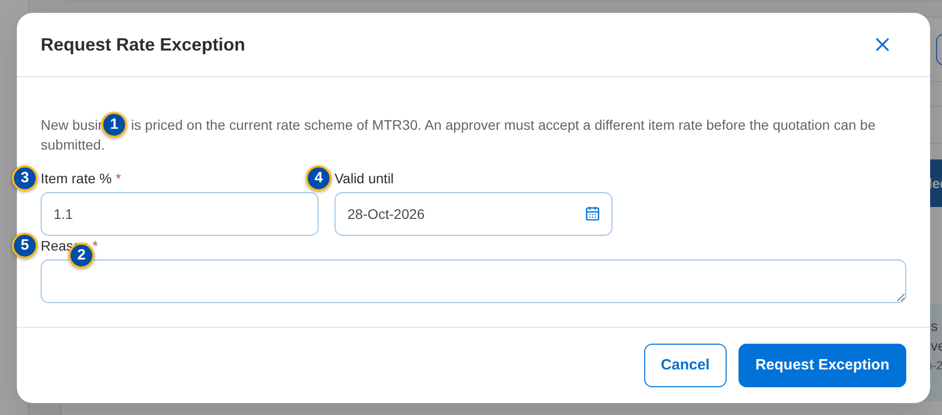
Figure 57: SCR-PM-22 Request Rate Exception dialog
1 | Pricing notice | 6 | Package | 11 | Reason for the exception
2 | Rate exceptions table | 7 | Requested rate | 12 | Decision
3 | Item rate % | 8 | Scheme in force | 13 | Comment
4 | Valid until | 9 | Quotation | 14 | Reason for the rejection
5 | Reason | 10 | Requested by

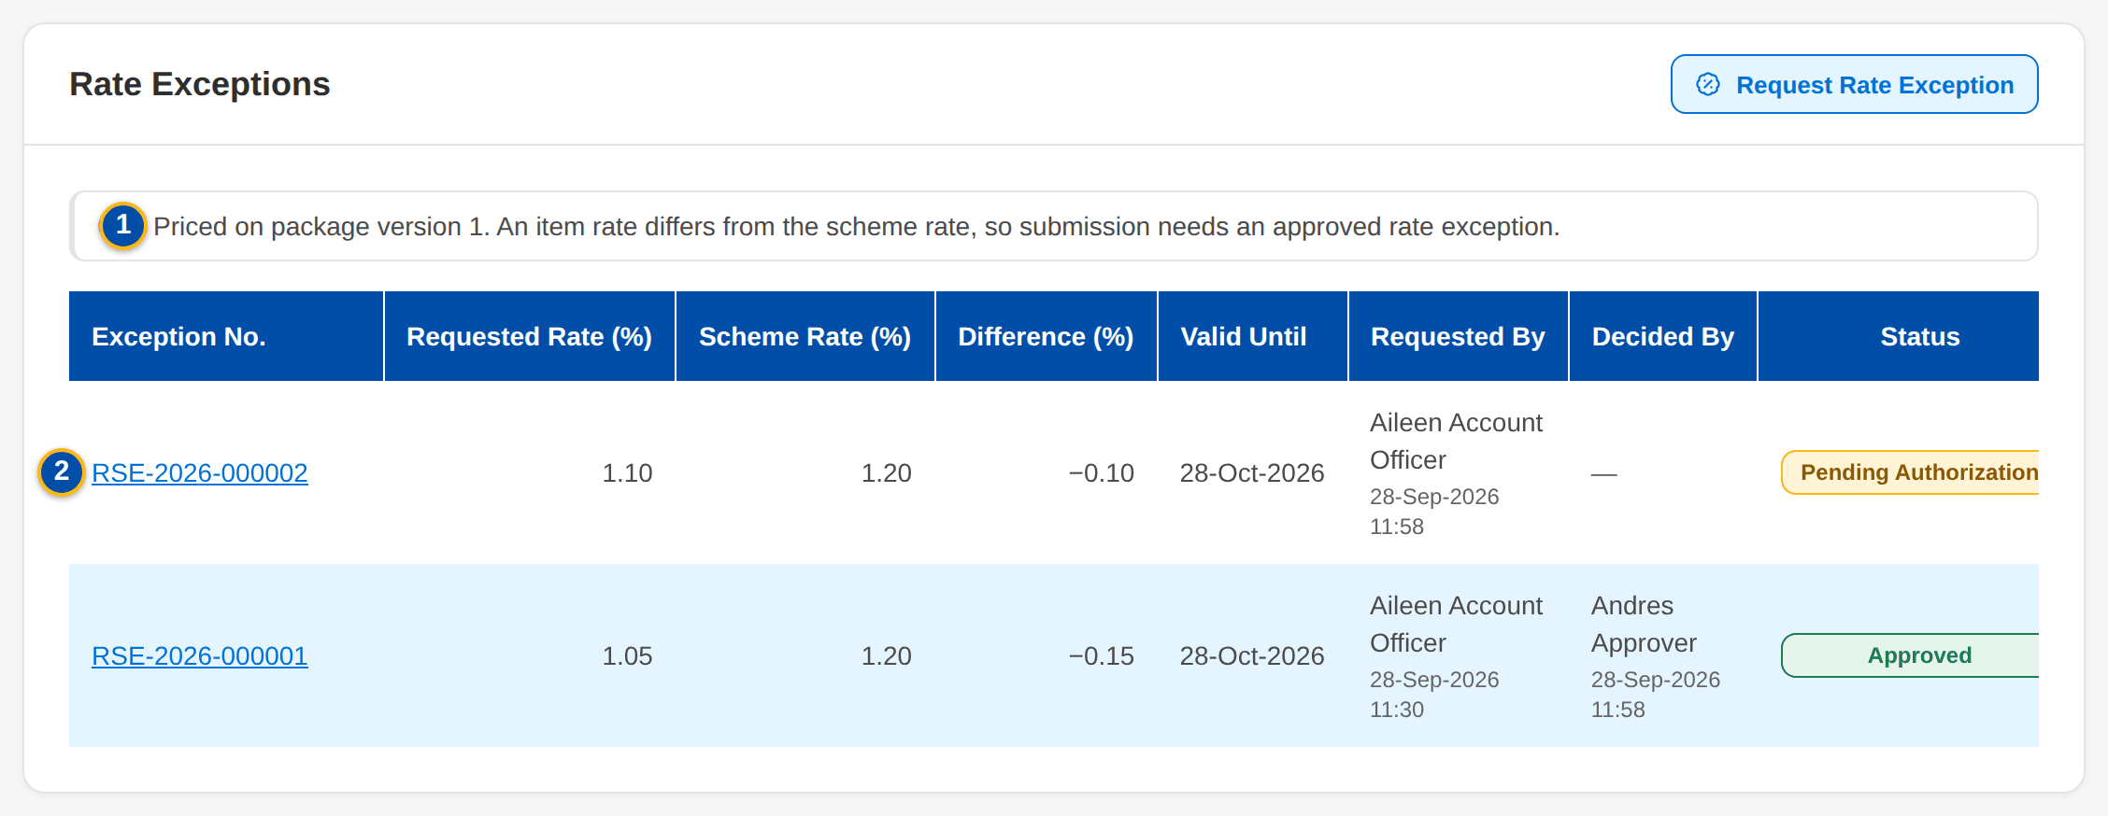
Figure 58: SCR-PM-22 Rate Exceptions card: an item rate differs from the scheme rate; each exception is a row of the table
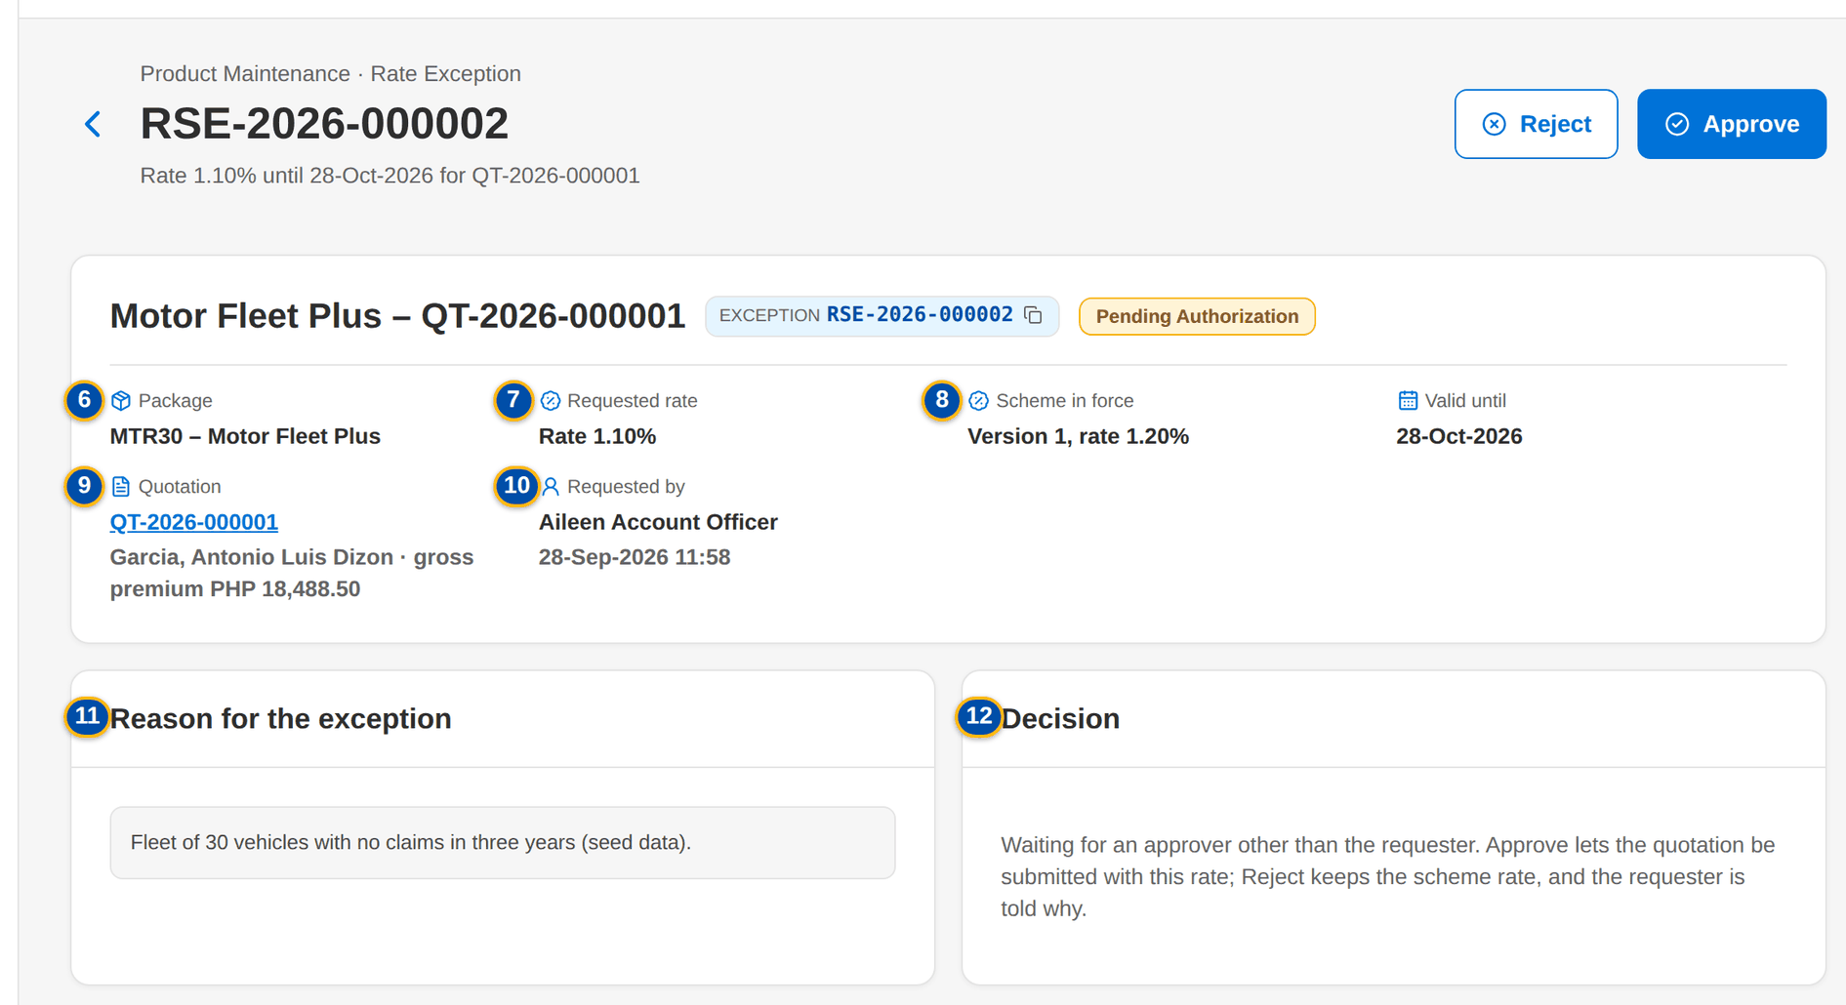
Figure 59: SCR-PM-22 Rate exception record opened from My Approvals: the requested rate against the scheme in force, with Approve and Reject
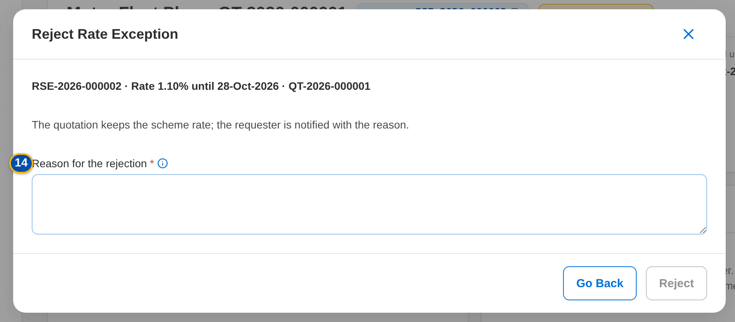
Figure 60: SCR-PM-22 Reject Rate Exception: the reason is required
Fields (No. = callout number on the first screenshot)
No. | Section | Field | Type | Length / format | Mand. | Source / list | Default | Editable in | Validation | Message when it fails
1 | Rate Exceptions card | Pricing notice | Notice | Priced on package version n. An item rate differs from the scheme rate, so submission needs an approved rate exception | - | Quotation pricing | - | Read only | Shown while an item rate differs | Package <product code> is priced on the current rate scheme: <what> needs an approved rate exception
2 | Rate Exceptions card | Rate exceptions table | Table | One row per exception: Exception No. (opens the exception record), Requested Rate (%), Scheme Rate (%), Difference (%) in percentage points with its sign, Valid Until, Requested By and on, Decided By and on, Status (Pending Authorization, Approved or Rejected) | - | Rate exceptions of the quotation | - | Read only | - | -
3 | Request Rate Exception | Item rate % | Number | 0 to 100 | Y | - | The rate of the first item | Draft quotation | 0 to 100 | Enter the item rate between 0 and 100
4 | Request Rate Exception | Valid until | Date | dd-MMM-yyyy | N | - | The quotation's valid-until date | Draft quotation | Not in the past | The validity date cannot be in the past
5 | Request Rate Exception | Reason | Text | Free text | Y | - | Blank | Draft quotation | Not blank | Explain why the scheme rate cannot be used
6 | Exception record | Package | Fact | Risk code – package name | - | Product master | - | Read only | - | -
7 | Exception record | Requested rate | Fact | Rate n.nn% (or the version requested) | - | Exception | - | Read only | - | -
8 | Exception record | Scheme in force | Fact | Version n, rate n.nn% (or rate per insurer) | - | Package version in force today | - | Read only | - | -
9 | Exception record | Quotation | Fact | Quotation number (opens the quotation), client and gross premium | - | Quotation | - | Read only | - | -
10 | Exception record | Requested by | Fact | Display name and date and time of the request | - | Exception | - | Read only | - | -
11 | Exception record | Reason for the exception | Text | As requested | - | Exception | - | Read only | - | -
12 | Exception record | Decision | Detail | Approved by or Rejected by (display name and role), On, Comment or Reason | - | Exception | - | Read only | - | -
13 | Approve Rate Exception | Comment | Text | Free text, up to 1,000 characters | N | - | Blank | Pending exception | - | -
14 | Reject Rate Exception | Reason for the rejection | Text | Free text, up to 1,000 characters | Y | - | Blank | Pending exception | Not blank | Enter the reason for the rejection

Actions
Button | Who | Enabled when | What happens | Resulting status | Notification
Request Rate Exception | Marketing (QUOTE_MAINTAIN) | Draft quotation of a package with an item rate that differs | Opens the dialog; Request Exception records the exception for this quotation, pending approval | Pending Authorization | My Approvals of the approvers
Open from My Approvals | Business Administrator, New Business Approver (PRODUCT_AUTHORIZE) | Exception pending | The rate exception row of My Approvals opens the exception record | - | -
Approve | Business Administrator, New Business Approver (PRODUCT_AUTHORIZE), not the requester | Exception pending | Opens the confirmation with an optional comment; Approve approves the exception, which prices the quotation from then on | Approved | Notification to the requester
Reject | Business Administrator, New Business Approver (PRODUCT_AUTHORIZE), not the requester | Exception pending | Opens the confirmation; the reason is required; Reject rejects the exception, which can no longer be used | Rejected | Notification to the requester with the reason

Business rules
• Only package rate schemes need an exception; an exception names the rate or the version it approves and the transaction (quotation number or ARN) (FR-PM-051).
• An exception is approved or rejected by a holder of the product approval permission other than its requester; the requester sees the record without the Approve and Reject buttons (FR-PM-051).
• A rejection needs its reason; the decision, its maker, date and comment or reason stay on the record and in the audit trail (FR-PM-051).
• Submission of the quotation (and of the account) is refused until an approved exception covers the differing rate or version (FR-PM-051).
• The approved exception is stored on the quotation and passed to the accounts created from it (FR-PM-051).
Expected outcome
A package is sold on its approved scheme, and any exception is approved by a second person and kept with the transaction.
Test cases: TC-PM-010.4-01, TC-PM-010.4-02, TC-PM-012.1-01, TC-PM-012.2-01, TC-PM-012.3-01, TC-PM-014.3-01, TC-PM-043.2-02, TC-PM-045.2-01, TC-PM-051.1-01, TC-PM-051.2-01, TC-PM-051.2-02, TC-PM-051.2-03, TC-PM-051.2-04, TC-PM-051.2-05, TC-PM-051.2-06, TC-PM-051.4-01, TC-PM-052.1-02, TC-PM-080.1-02, TC-PM-SCR-22, TC-PM-MSG-18.

14 End-to-end walkthroughs
Two walkthroughs follow a package through the screens, persona by persona, with what the user does, what the user sees and the result of each step. They use seed data only. They are the script of the SIT review sessions of the Start Here guide.

14.1 WT-A A new package from the request to its first New Business quotation
Marketing asks for a new generic motor package for SME fleets. MBS first adds a clause wording to the library, which the Business Administrator authorises. The request is approved by Marketing, recommended and approved by TSU, negotiated with two insurers and made final; the requirements pack with the signed package slip is signed off by ManCom. MBS sets up version 1 with its rate scheme, coverages, panel insurers and clauses; the TSU Head validates and releases it, the Business Administrator adds the insurer's commission rate for the new product and the New Business Approver authorises it. TSU sends the advisory. Marketing then prices the package and quotes it; a quotation with a different item rate needs a rate exception, which the New Business Approver opens from My Approvals and approves on its record, so the quotation can be submitted. The package documents use the templates of the Document Templates screen (New Business set, SCR-NB-44).
Seed data: new request Motor Fleet Plus (fictitious), line Motor, cover type Comprehensive, insurers Mabuhay General Insurance Corp. and Luzon Assurance Co., new risk code MTR30, client Garcia (seed client)
Step 1. Marketing Business Services – Coverages & Clauses (SCR-PM-15)
Does | Opens Coverages & Clauses › Clause Library, clicks New Clause, enters the code FLEET_REPAIR, kind, line Motor, title, effective date and wording, and clicks Save for Authorization
Sees | Toast: Clause FLEET_REPAIR saved – pending authorization; the row shows Pending Authorization
Result | Clause pending authorisation

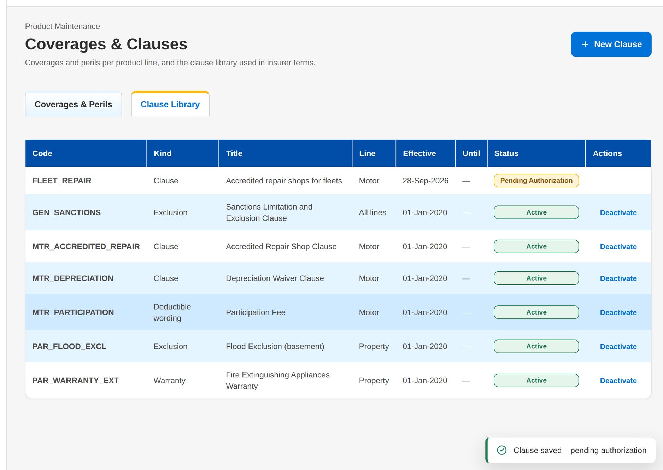
Figure 61: WT-A step 1: Coverages & Clauses
Step 2. Business Administrator – Coverages & Clauses (SCR-PM-15)
Does | Opens the Clause Library and clicks Authorize on FLEET_REPAIR
Sees | Toast: FLEET_REPAIR authorized; the status is Active
Result | Clause active

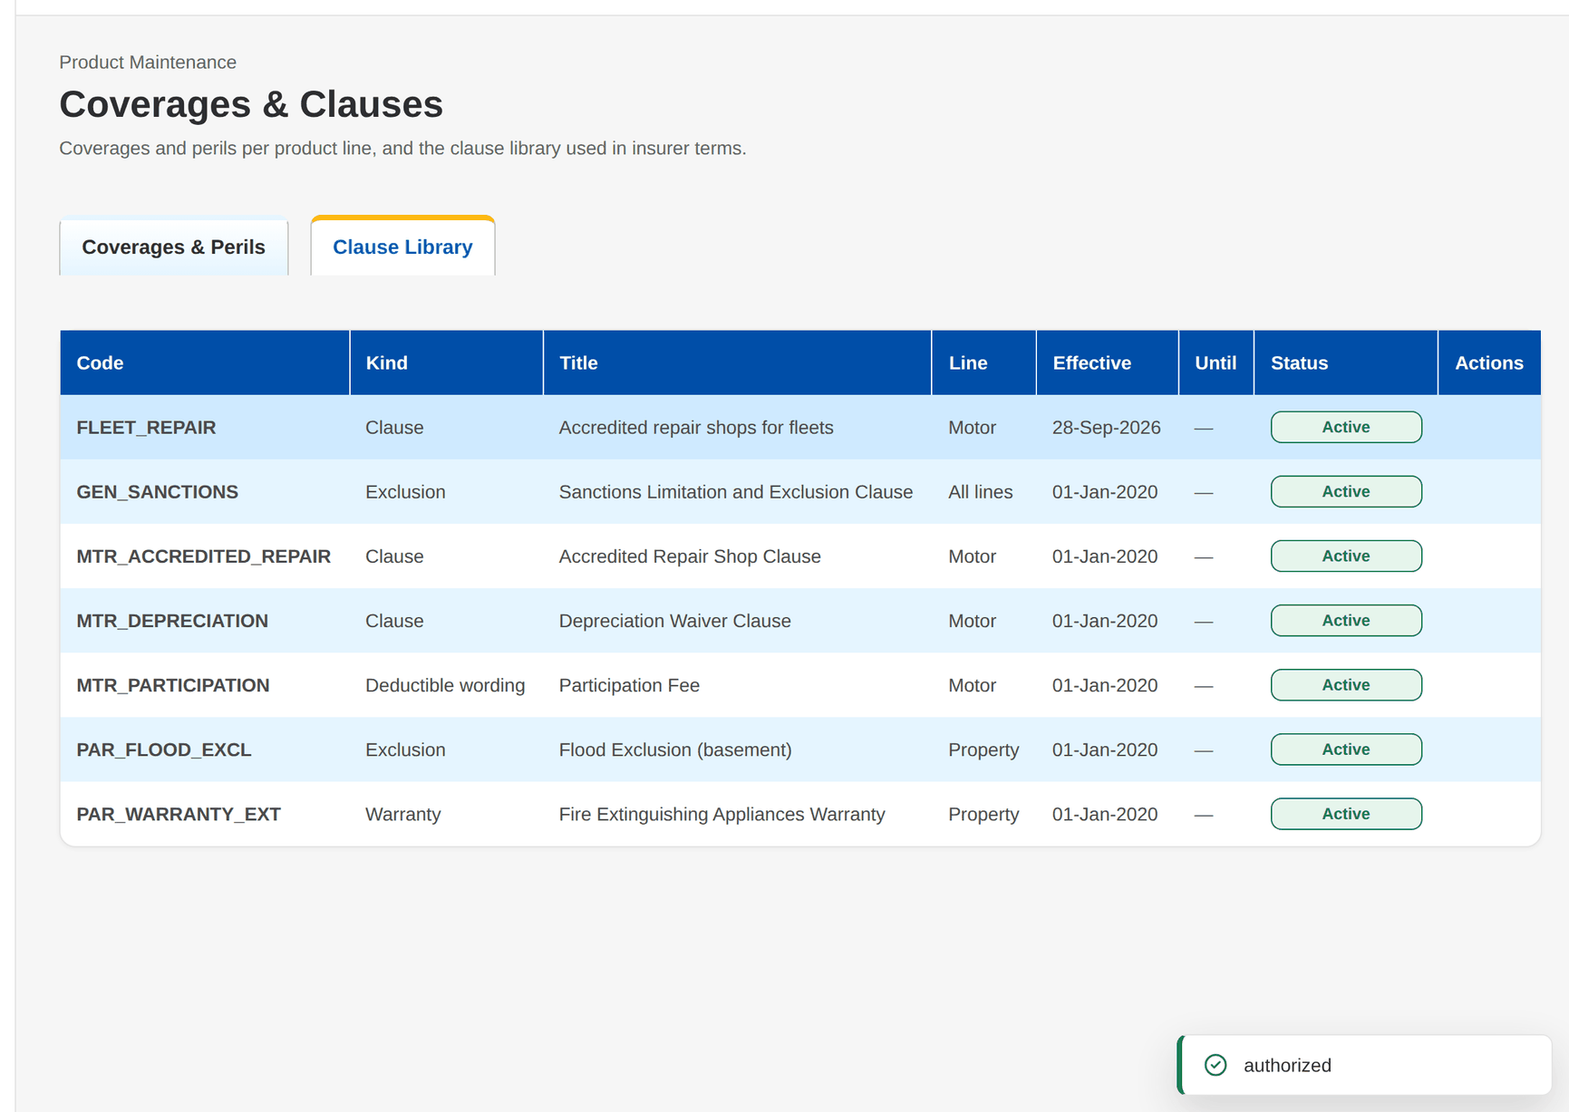
Figure 62: WT-A step 2: Coverages & Clauses
Step 3. Marketing Account Officer – New Package Request and Edit Package Request (SCR-PM-03)
Does | Opens Package Requests › New Package Request, chooses New package and Generic programme, enters Motor Fleet Plus, line Motor, cover type Comprehensive, reason New programme for a market segment, the segments, the requested coverages, rate 1.20%, minimum premium and package dates, ticks Mabuhay General Insurance Corp. and Luzon Assurance Co., and clicks Submit for Approval
Sees | Toast: PKR-yyyy-nnnnnn submitted for Marketing approval; the request opens in For Marketing approval
Result | For Marketing approval

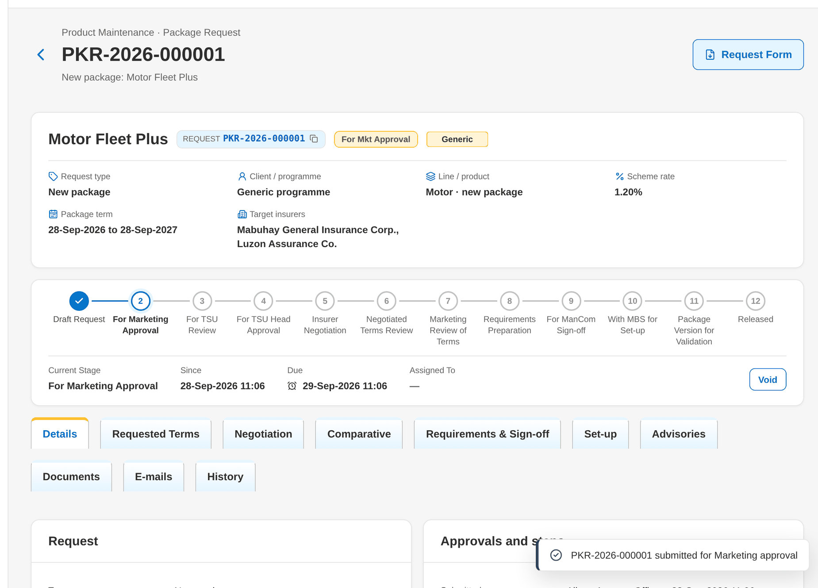
Figure 63: WT-A step 3: New Package Request and Edit Package Request
Step 4. Marketing TL / TH / UH – Package Request record (SCR-PM-04)
Does | Opens the request from the For Approval tab and clicks Approve and send to TSU
Sees | The stage becomes For TSU review; the history lists the approval
Result | For TSU review

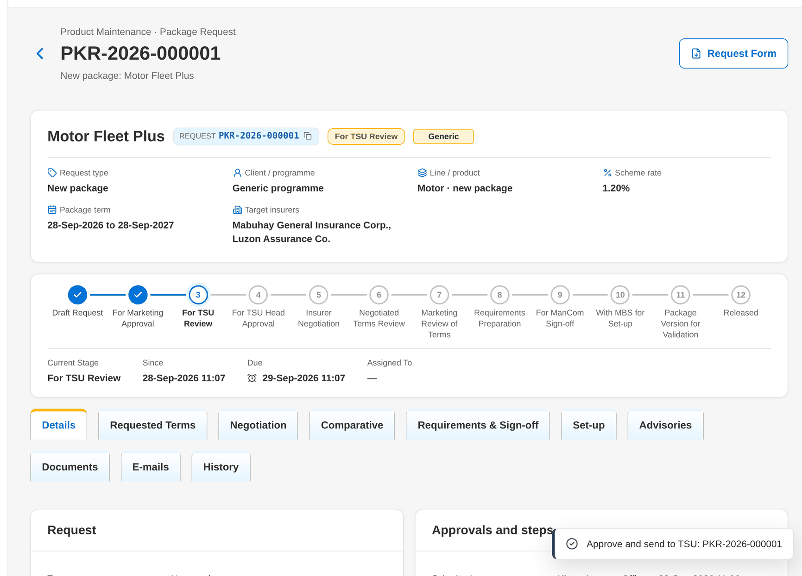
Figure 64: WT-A step 4: Package Request record
Step 5. TSU Team Lead – Package Request record (SCR-PM-04)
Does | Clicks Recommend for approval, writes the recommendation and clicks Recommend
Sees | The TSU recommendation shows on the Details tab; the stage becomes For TSU Head approval
Result | For TSU Head approval

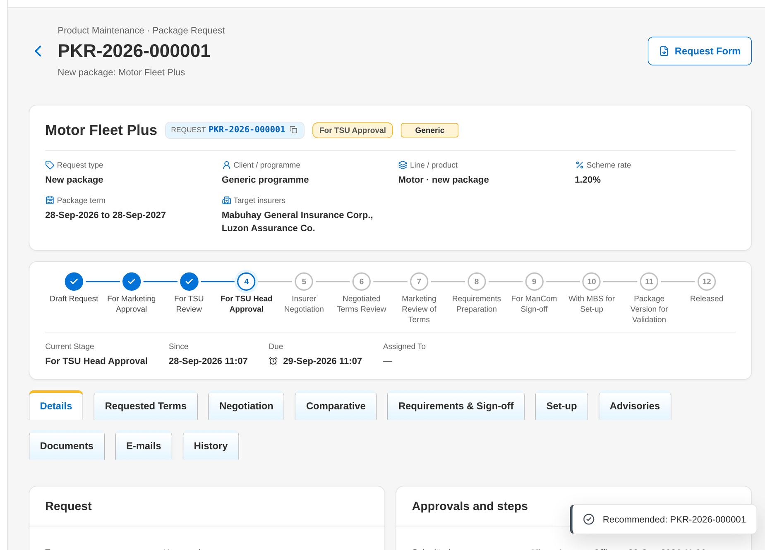
Figure 65: WT-A step 5: Package Request record
Step 6. TSU Head – Package Request record (SCR-PM-04)
Does | Reads the recommendation and clicks Approve for negotiation
Sees | The stage becomes Insurer negotiation; round 1 is opened with the two target insurers
Result | Insurer negotiation

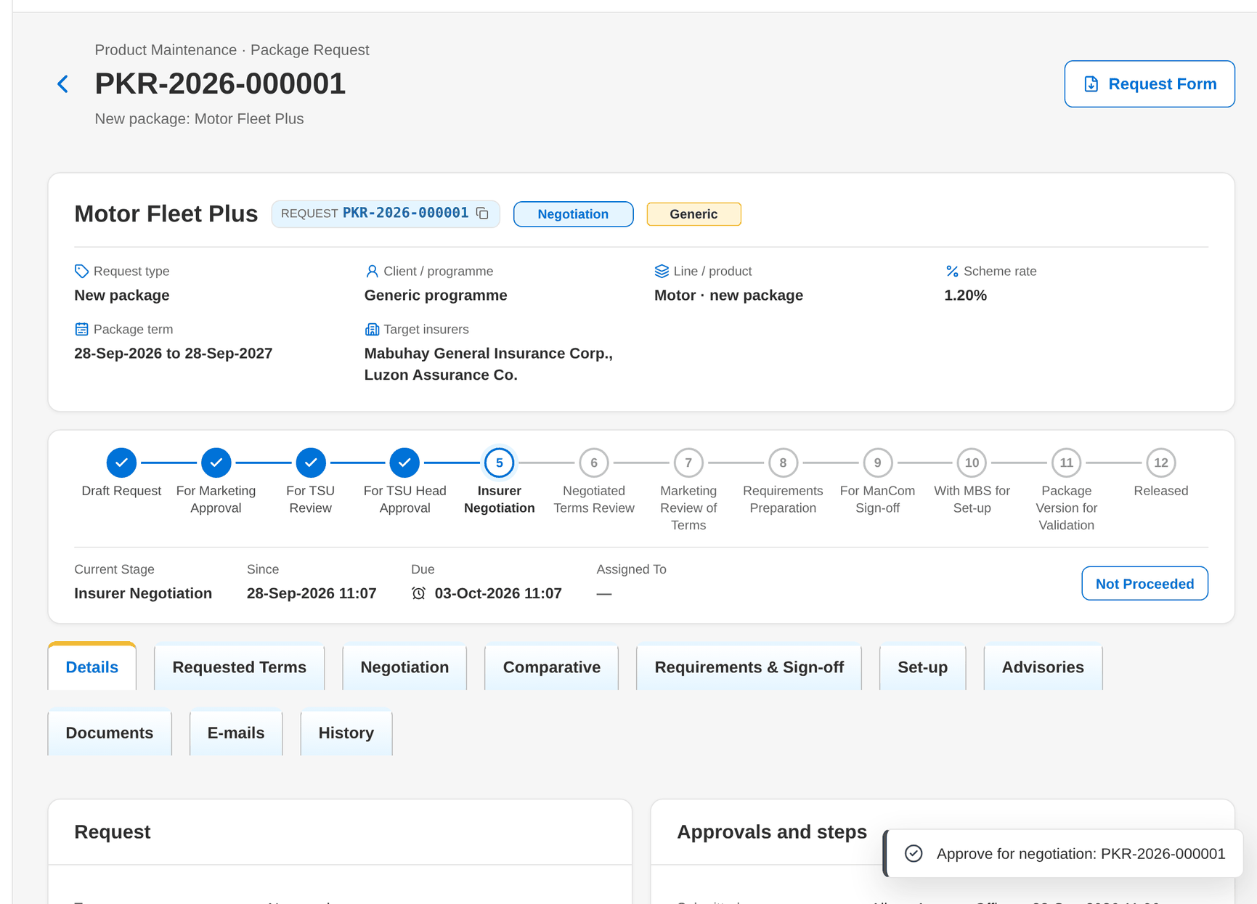
Figure 66: WT-A step 6: Package Request record
Step 7. TSU Officer – Package Request record: Negotiation tab (SCR-PM-05)
Does | Opens the Negotiation tab, adds a note to the insurers and clicks Submit for Approval
Sees | Toast: PQS-yyyy-nnnnnn submitted for approval; round 1 shows For approval
Result | Slip for approval

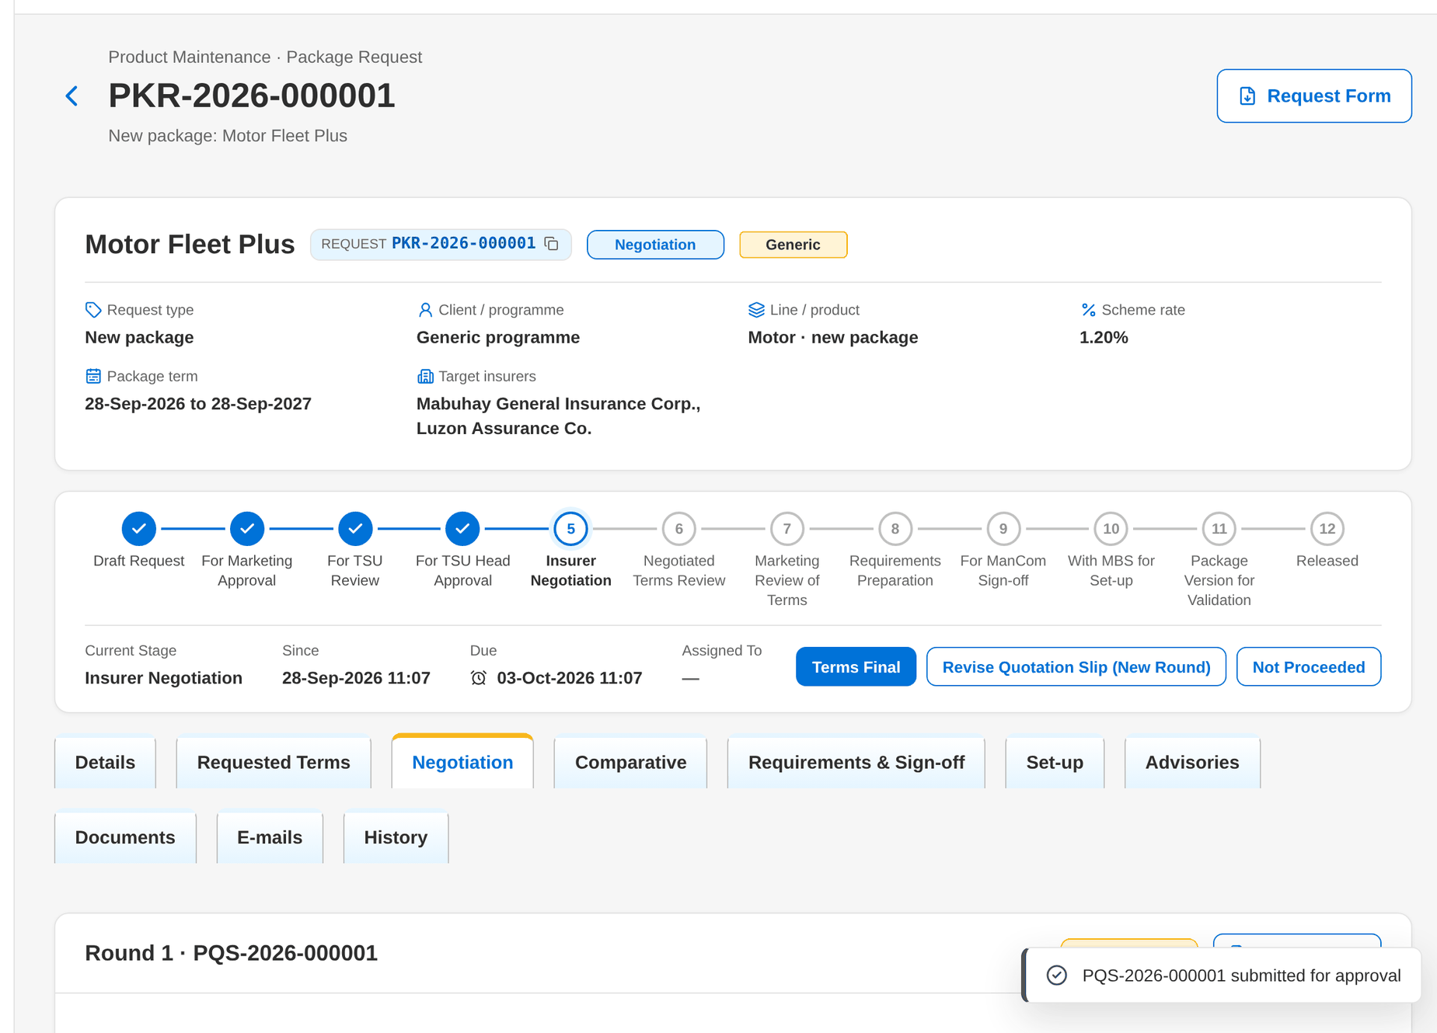
Figure 67: WT-A step 7: Package Request record: Negotiation tab
Step 8. TSU Team Lead – Package Request record: Negotiation tab (SCR-PM-05)
Does | Clicks Approve and Send on round 1
Sees | Toast: PQS-yyyy-nnnnnn sent to 2 insurer(s); both responses show Pending; the E-mails tab lists the slip and password e-mails
Result | Slip sent

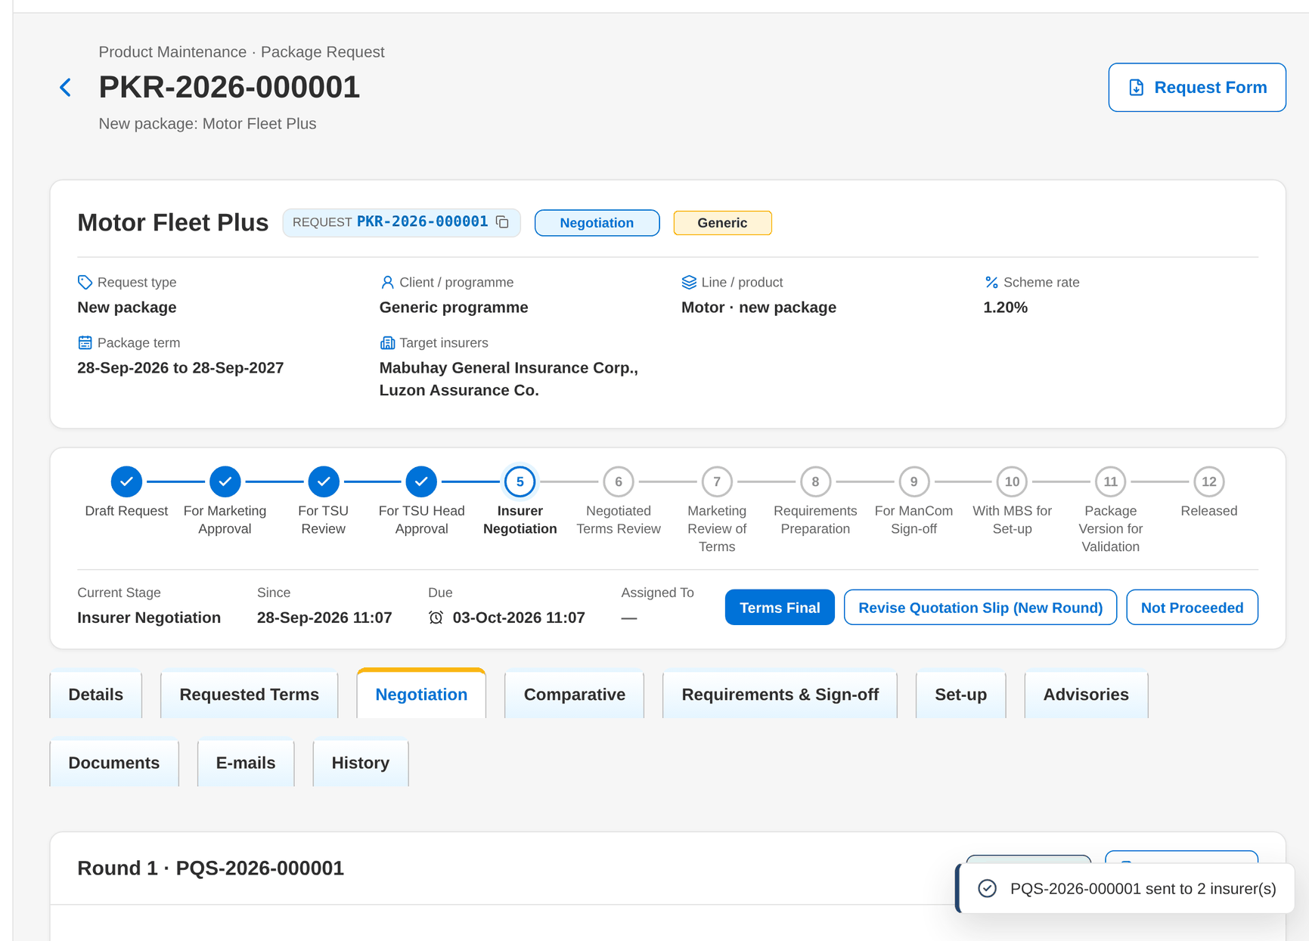
Figure 68: WT-A step 8: Package Request record: Negotiation tab
Step 9. TSU Officer – Package Request record: Negotiation tab (SCR-PM-05)
Does | Clicks Key In for each insurer, enters the outcome, rate, minimum premium and deductibles, attaches the insurer's reply and clicks Save Terms
Sees | Toast: Terms of <insurer> saved; the responses show Approved with changes and Counter-proposal with their rates
Result | Responses recorded

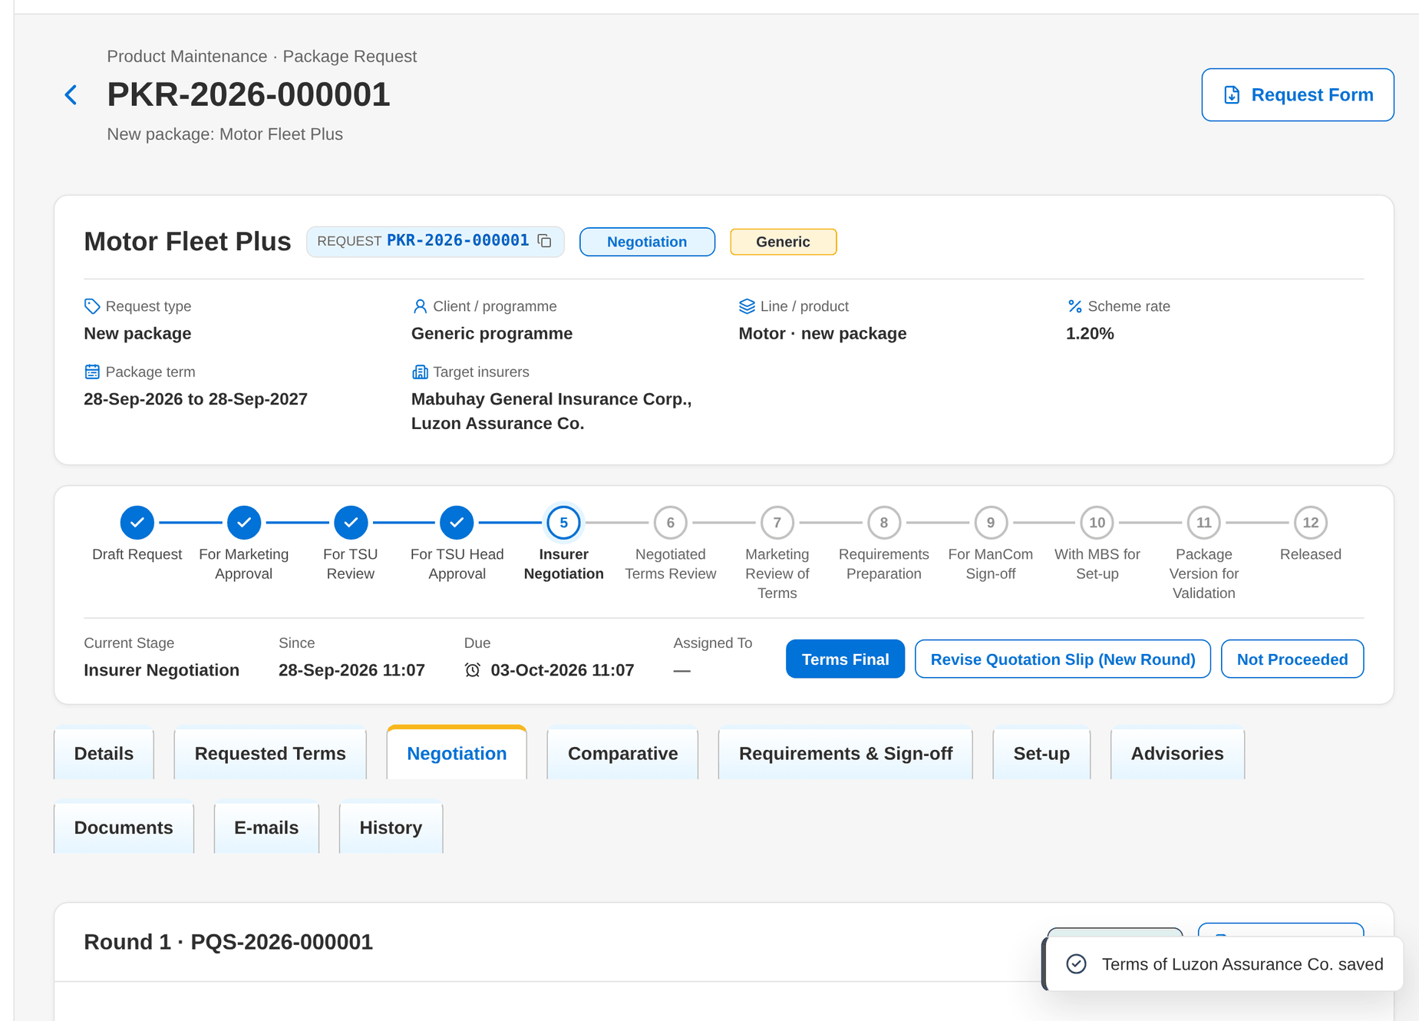
Figure 69: WT-A step 9: Package Request record: Negotiation tab
Step 10. TSU Officer – Package Request record: Negotiation tab (SCR-PM-05)
Does | Clicks Terms final, ticks the offer of Mabuhay General Insurance Corp. and clicks Make Terms Final
Sees | The stage becomes Negotiated terms review; the chosen insurer shows in the header
Result | Terms final

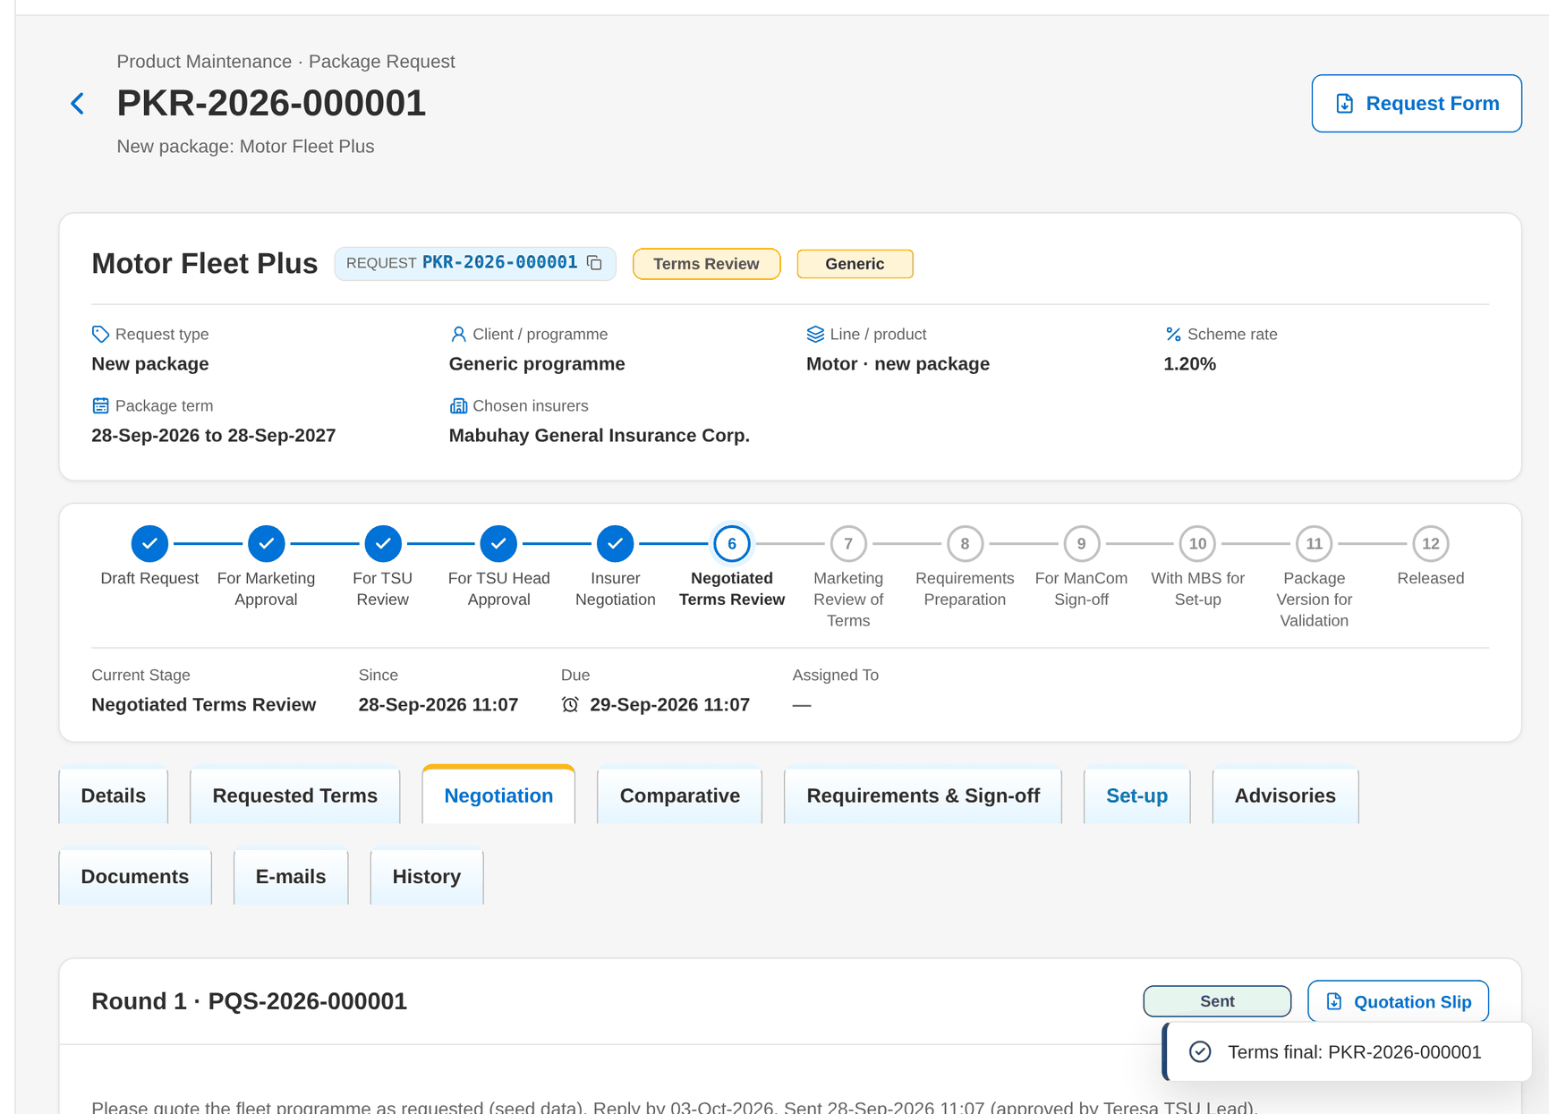
Figure 70: WT-A step 10: Package Request record: Negotiation tab
Step 11. TSU Officer – Package Request record: Comparative tab (SCR-PM-06)
Does | Opens the Comparative tab
Sees | The round 1 comparison with the Lowest rate tag and the current audit master in Stored outputs
Result | Comparative master stored

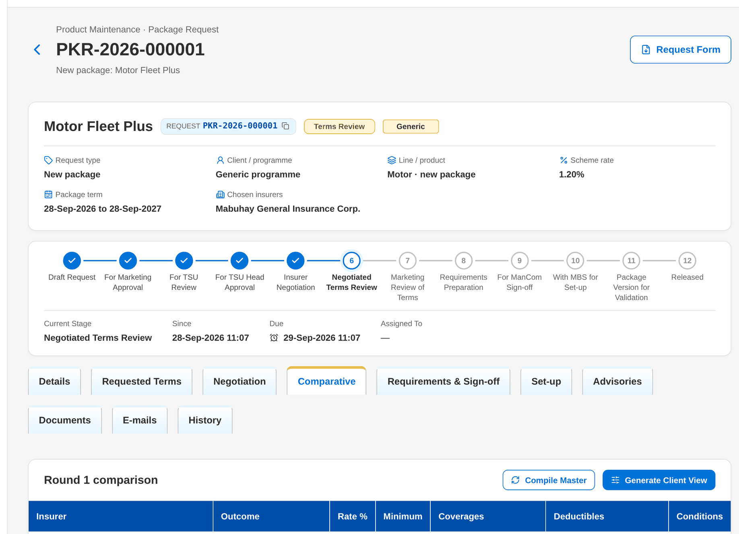
Figure 71: WT-A step 11: Package Request record: Comparative tab
Step 12. TSU Head – Package Request record (SCR-PM-04)
Does | Clicks Proceed to requirements (generic package)
Sees | The stage becomes Requirements preparation
Result | Requirements preparation

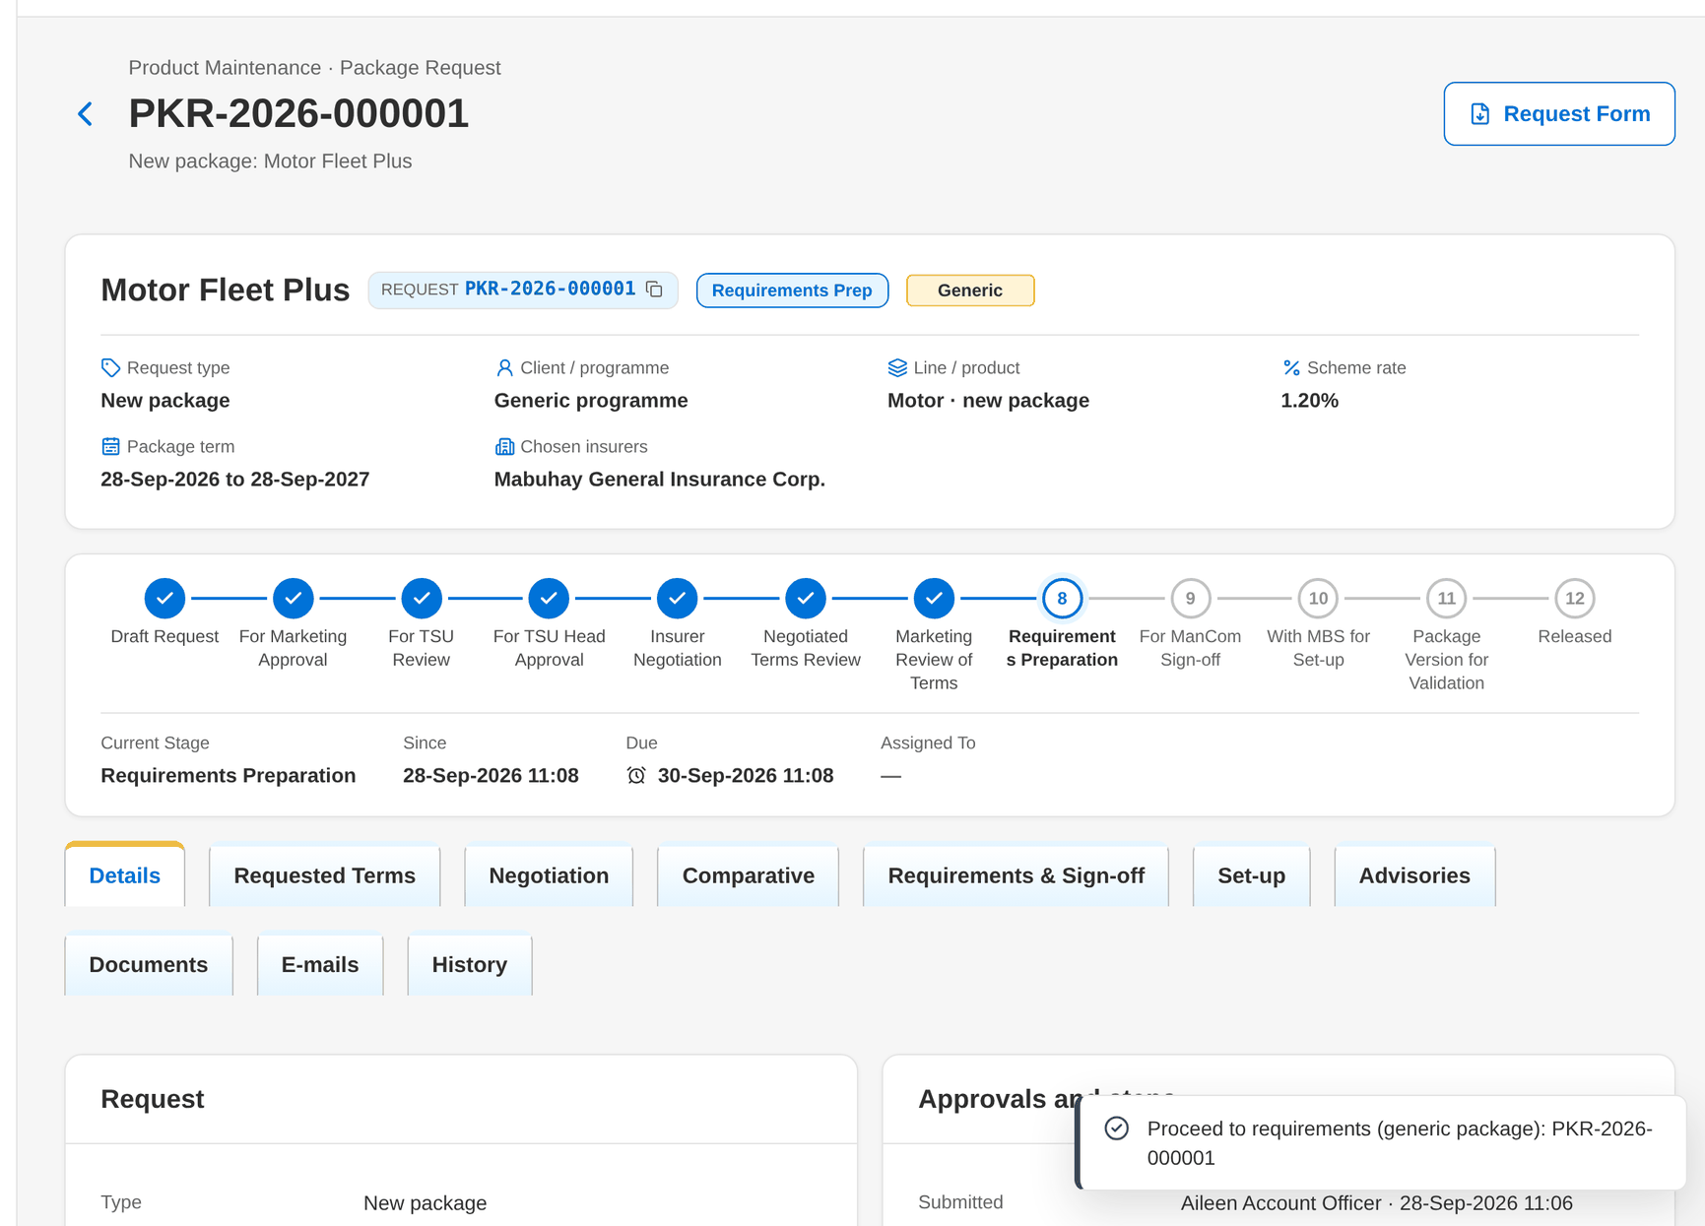
Figure 72: WT-A step 12: Package Request record
Step 13. TSU Officer – Package Request record: Requirements & Sign-off tab (SCR-PM-07)
Does | Enters the computation basis, clicks Save Requirements, downloads the Package Slip, uploads the signed slip on the Documents tab as Package slip (signed), and clicks Submit requirements for ManCom sign-off
Sees | The checklist reads The requirements pack is complete.; the stage becomes For ManCom sign-off
Result | For ManCom sign-off

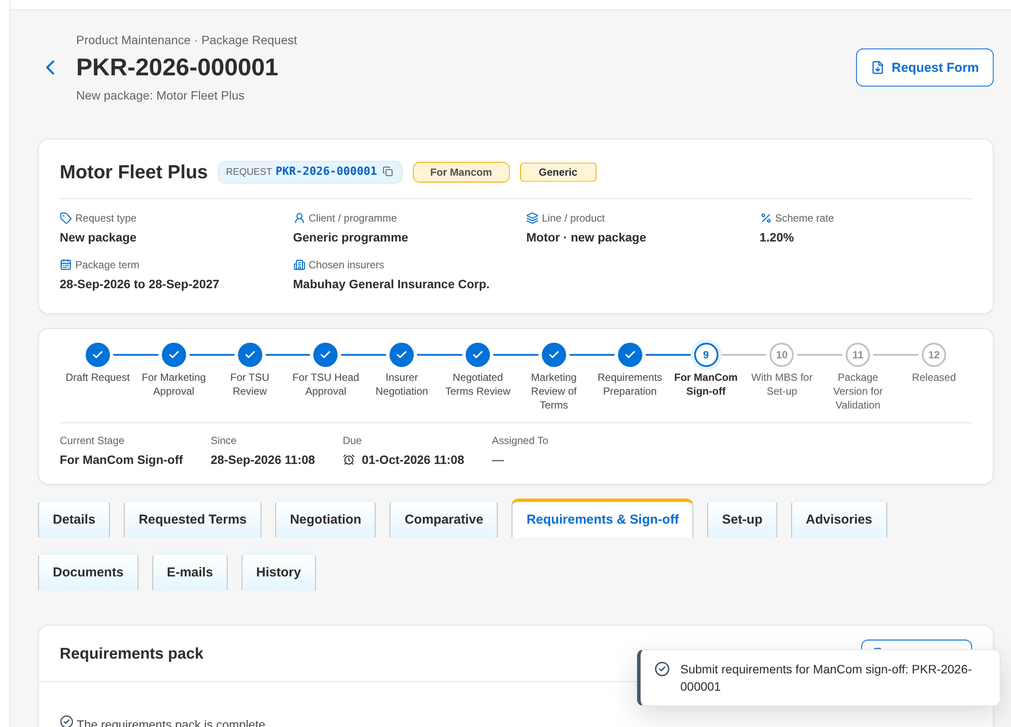
Figure 73: WT-A step 13: Package Request record: Requirements & Sign-off tab
Step 14. ManCom member – Package Request record: Requirements & Sign-off tab (SCR-PM-07)
Does | Reviews the proposed terms and clicks Sign off and send to MBS
Sees | ManCom decisions lists MC-PKR-yyyy-nnnnnn Signed; the slips show Locked; the stage becomes With MBS for set-up
Result | Signed off

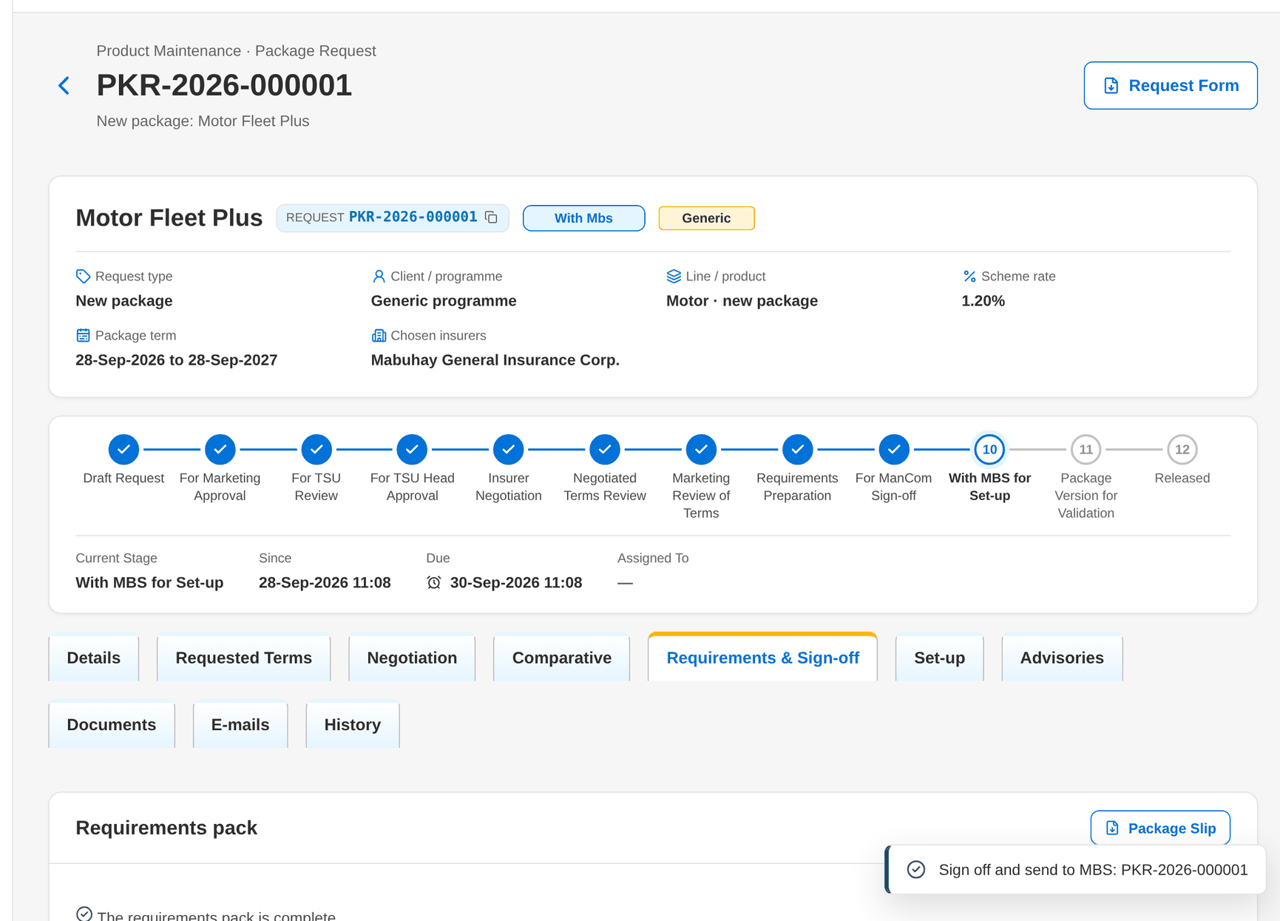
Figure 74: WT-A step 14: Package Request record: Requirements & Sign-off tab
Step 15. Marketing Business Services – Package Request record: Set-up and Advisories tabs (SCR-PM-08)
Does | Clicks Set up package version, enters the risk code MTR30 and the product name, and clicks Set Up Version
Sees | Toast: Version 1 set up; the Set-up tab shows MTR30 version 1; the stage becomes Package version for validation
Result | Draft version 1

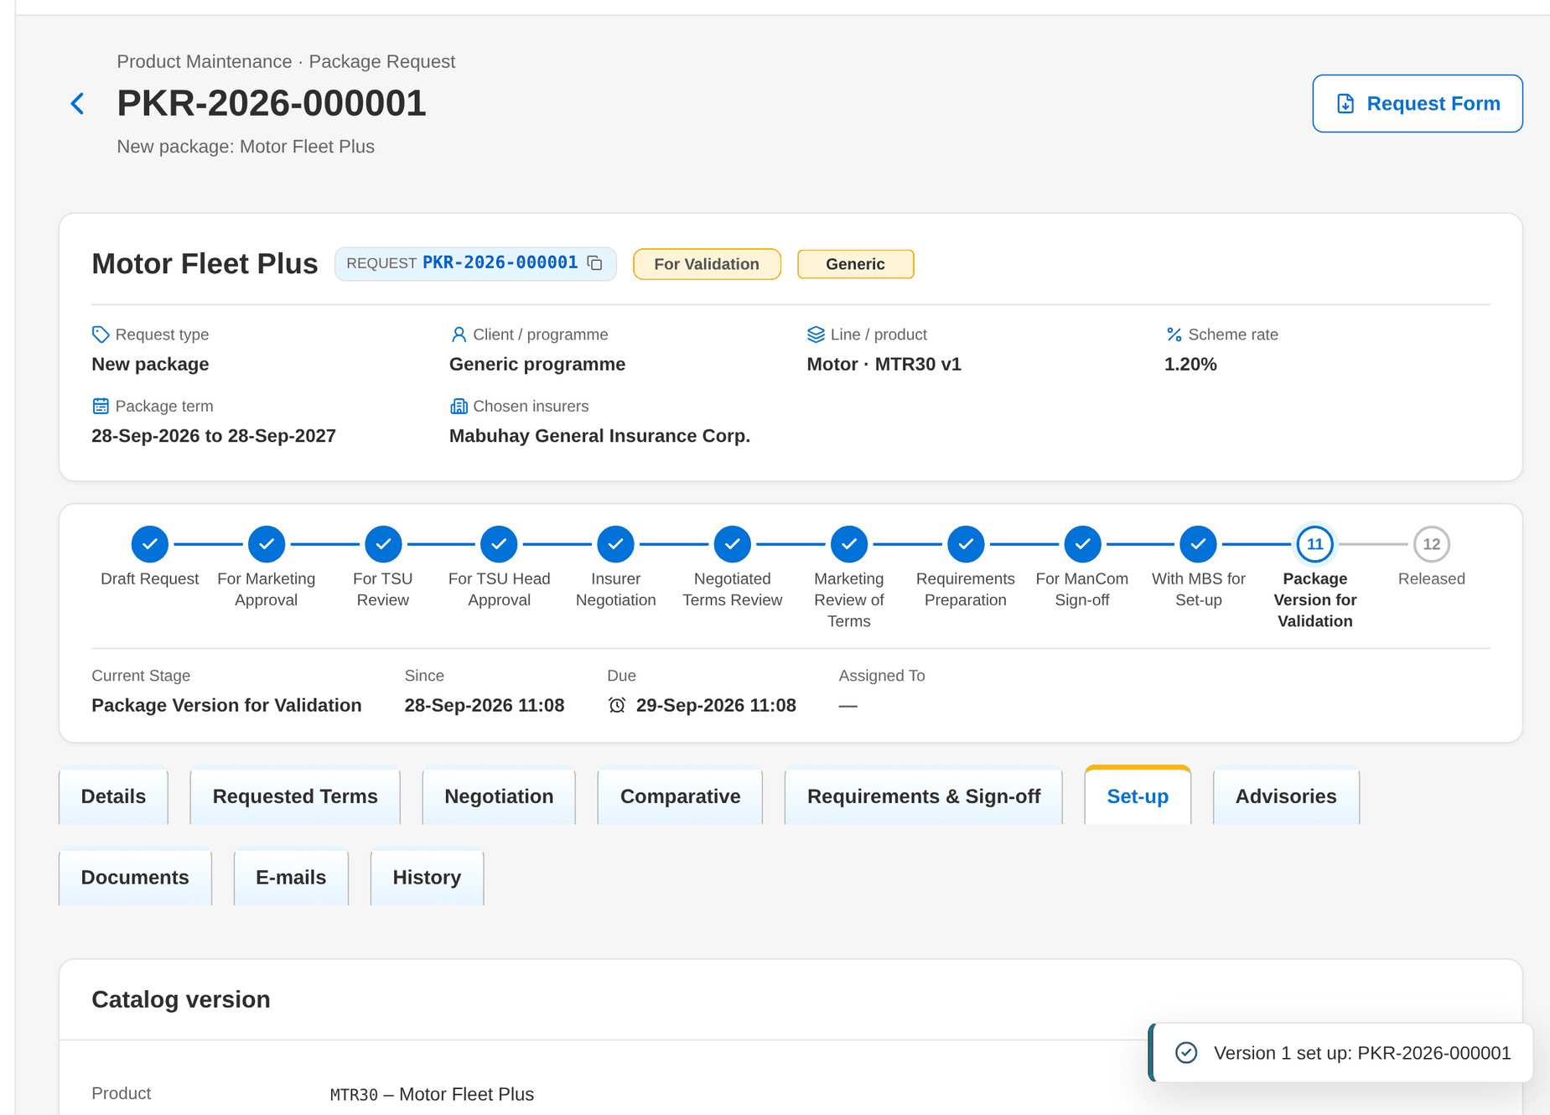
Figure 75: WT-A step 15: Package Request record: Set-up and Advisories tabs
Step 16. Marketing Business Services – Package Version (SCR-PM-13)
Does | Clicks Open Version Editor, adds the clause FLEET_REPAIR on the insurer terms, saves and clicks Submit for Validation
Sees | Toast: Version 1 submitted for validation; the version shows For validation
Result | For validation

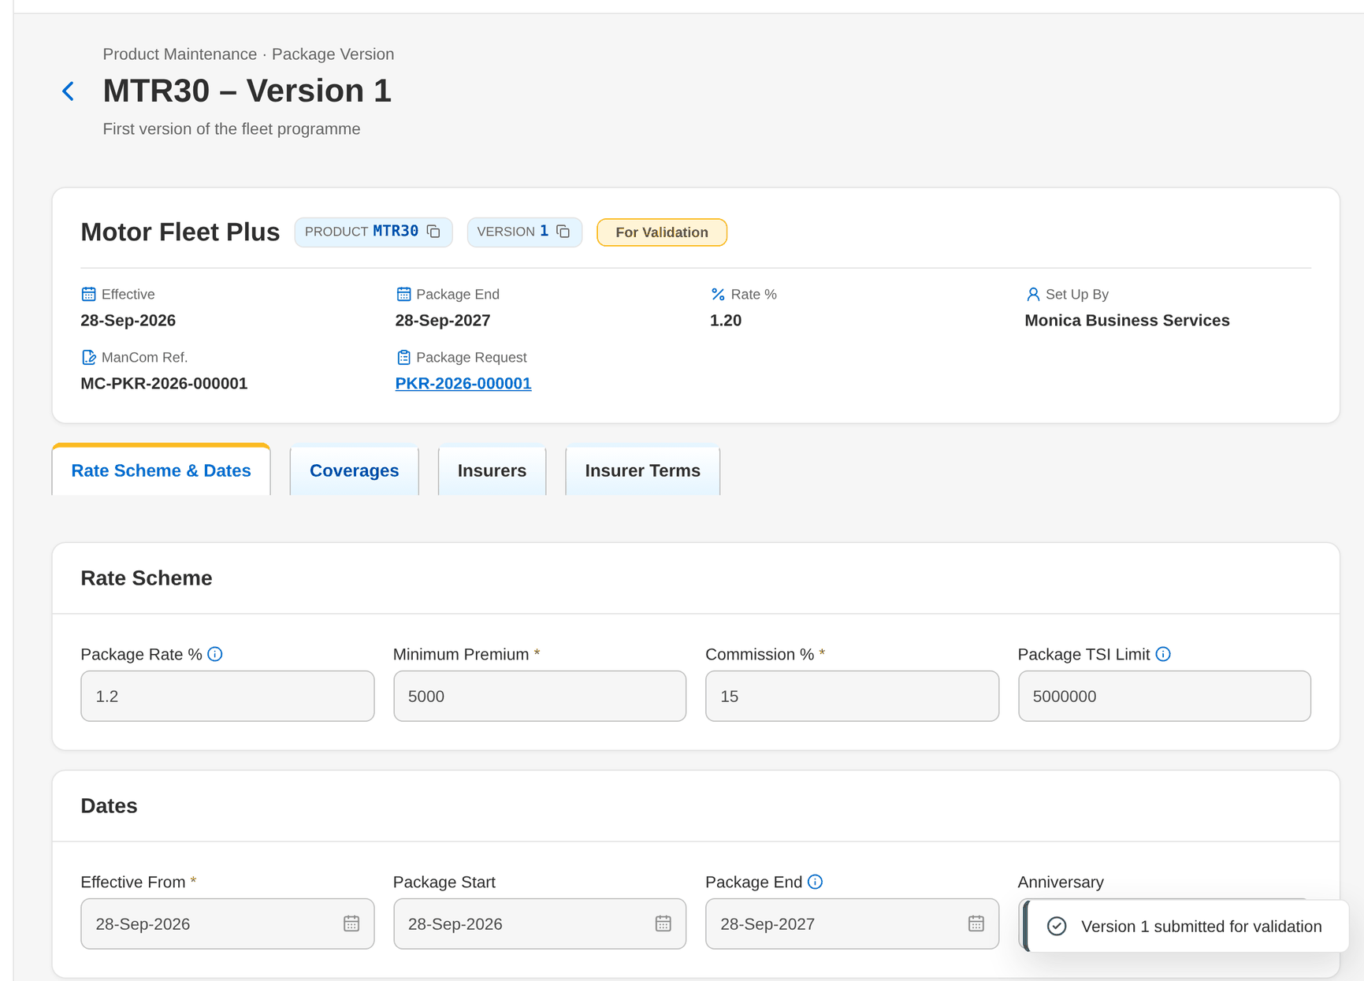
Figure 76: WT-A step 16: Package Version
Step 17. TSU Head – Package Version (SCR-PM-13)
Does | Opens the version from the Validation Queue, ticks the five checklist items and clicks Validate and Release
Sees | Toast: Version 1 released; the Validation card shows the result Passed, the validator, the date, the test premium and the checks with their figures
Result | Released

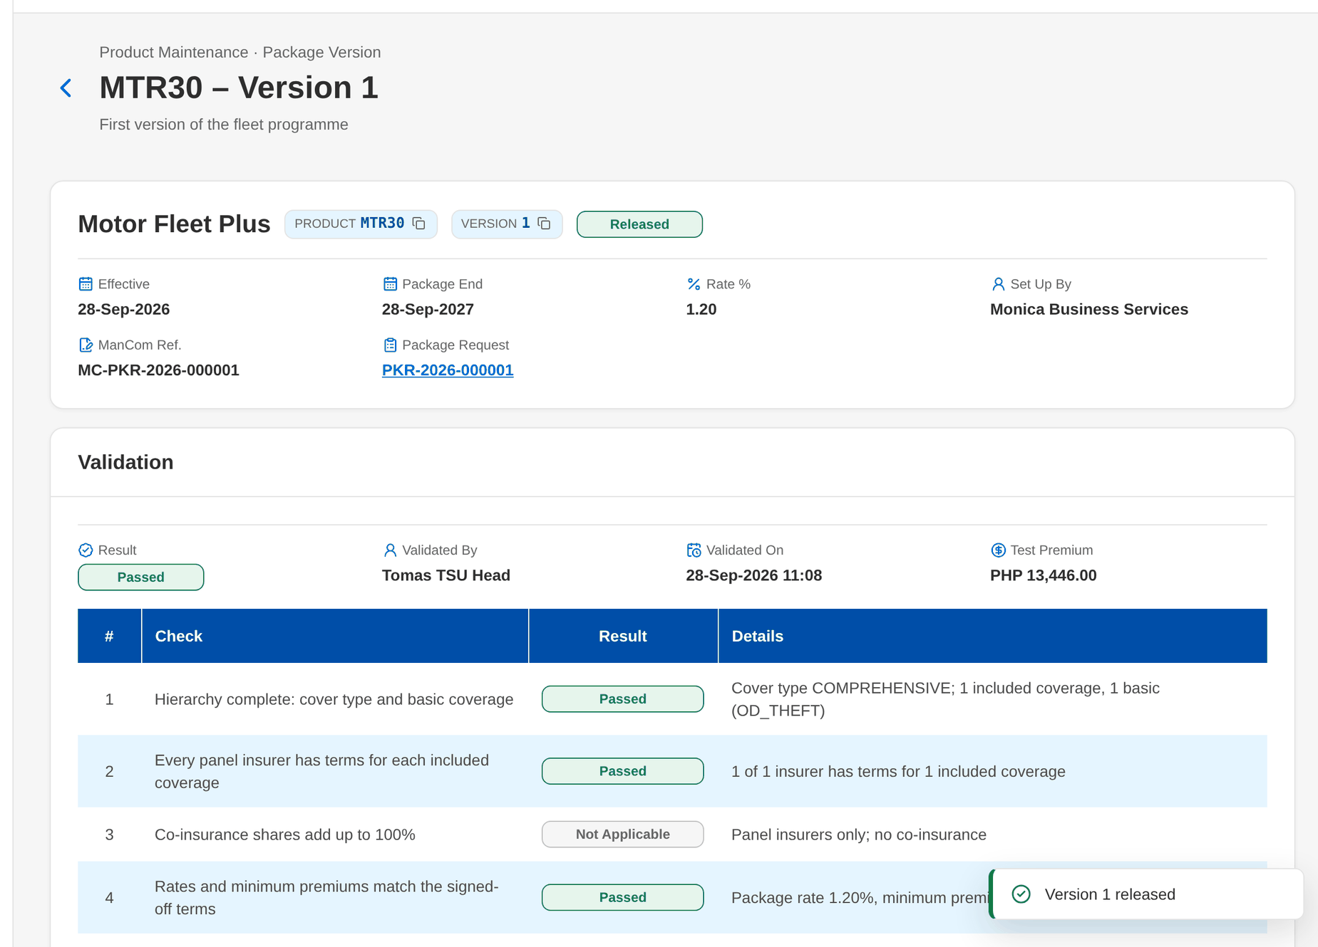
Figure 77: WT-A step 17: Package Version
Step 18. Business Administrator – Insurer record (SCR-PM-18)
Does | Opens Insurers › Mabuhay General Insurance Corp., clicks Add rate, chooses MTR30, 15% from today and clicks Save for Authorization
Sees | Toast: Commission rate saved – pending authorization
Result | Commission rate pending

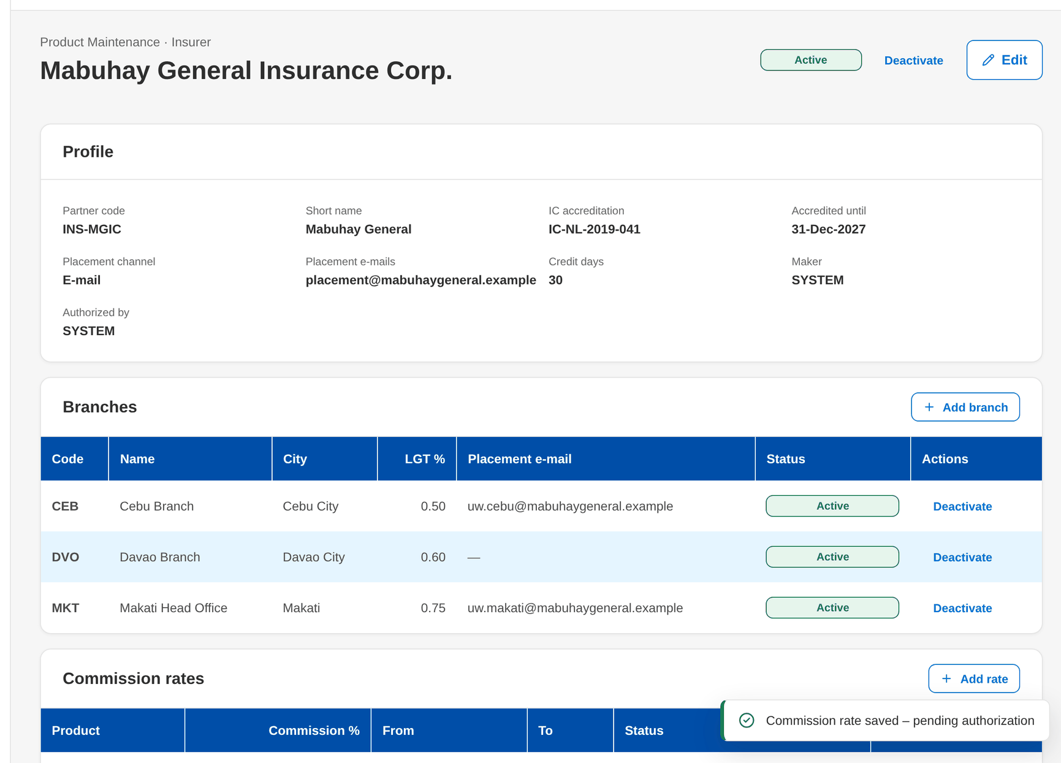
Figure 78: WT-A step 18: Insurer record
Step 19. New Business Approver – Insurer record (SCR-PM-18)
Does | Opens the insurer and clicks Authorize on the new commission rate
Sees | The rate for MTR30 shows Active
Result | Commission rate active

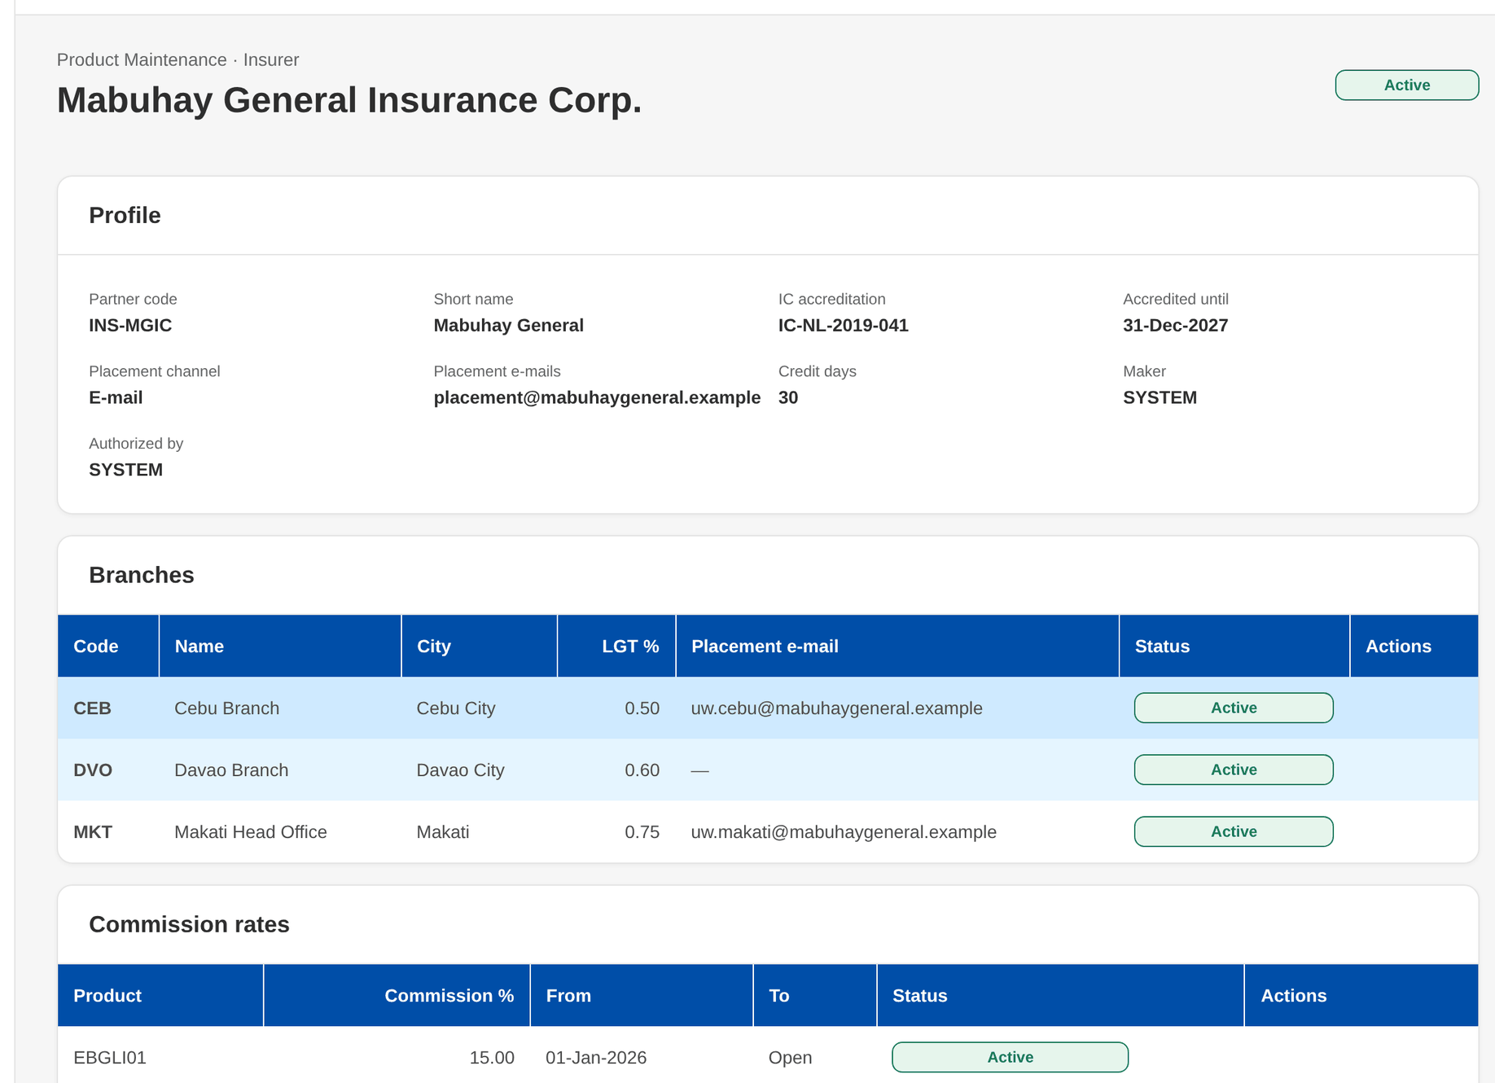
Figure 79: WT-A step 19: Insurer record
Step 20. TSU Officer – Package Request record: Set-up and Advisories tabs (SCR-PM-08)
Does | Opens the Advisories tab of the released request, checks that both supporting documents are Attached and clicks Send Advisory
Sees | Toast: Advisory sent; the advisory shows Sent with the date; Marketing users receive the notice
Result | Advisory sent

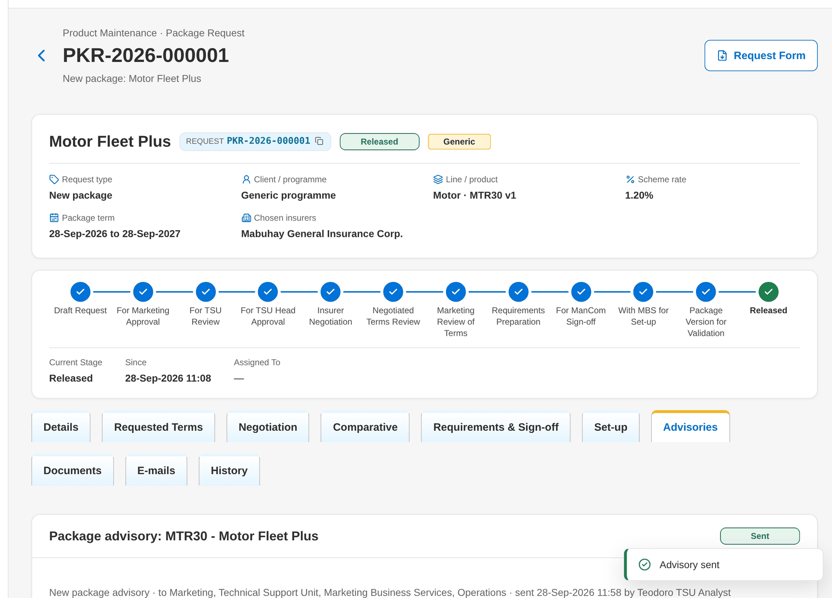
Figure 80: WT-A step 20: Package Request record: Set-up and Advisories tabs
Step 21. Marketing Account Officer – Premium Calculator (SCR-PM-21)
Does | Opens Premium Calculator, chooses MTR30 and Mabuhay General Insurance Corp., enters a vehicle value and clicks Calculate
Sees | Priced on package version 1 (effective <date>, scheme rate 1.2%) with every charge and the commission
Result | Priced on version 1

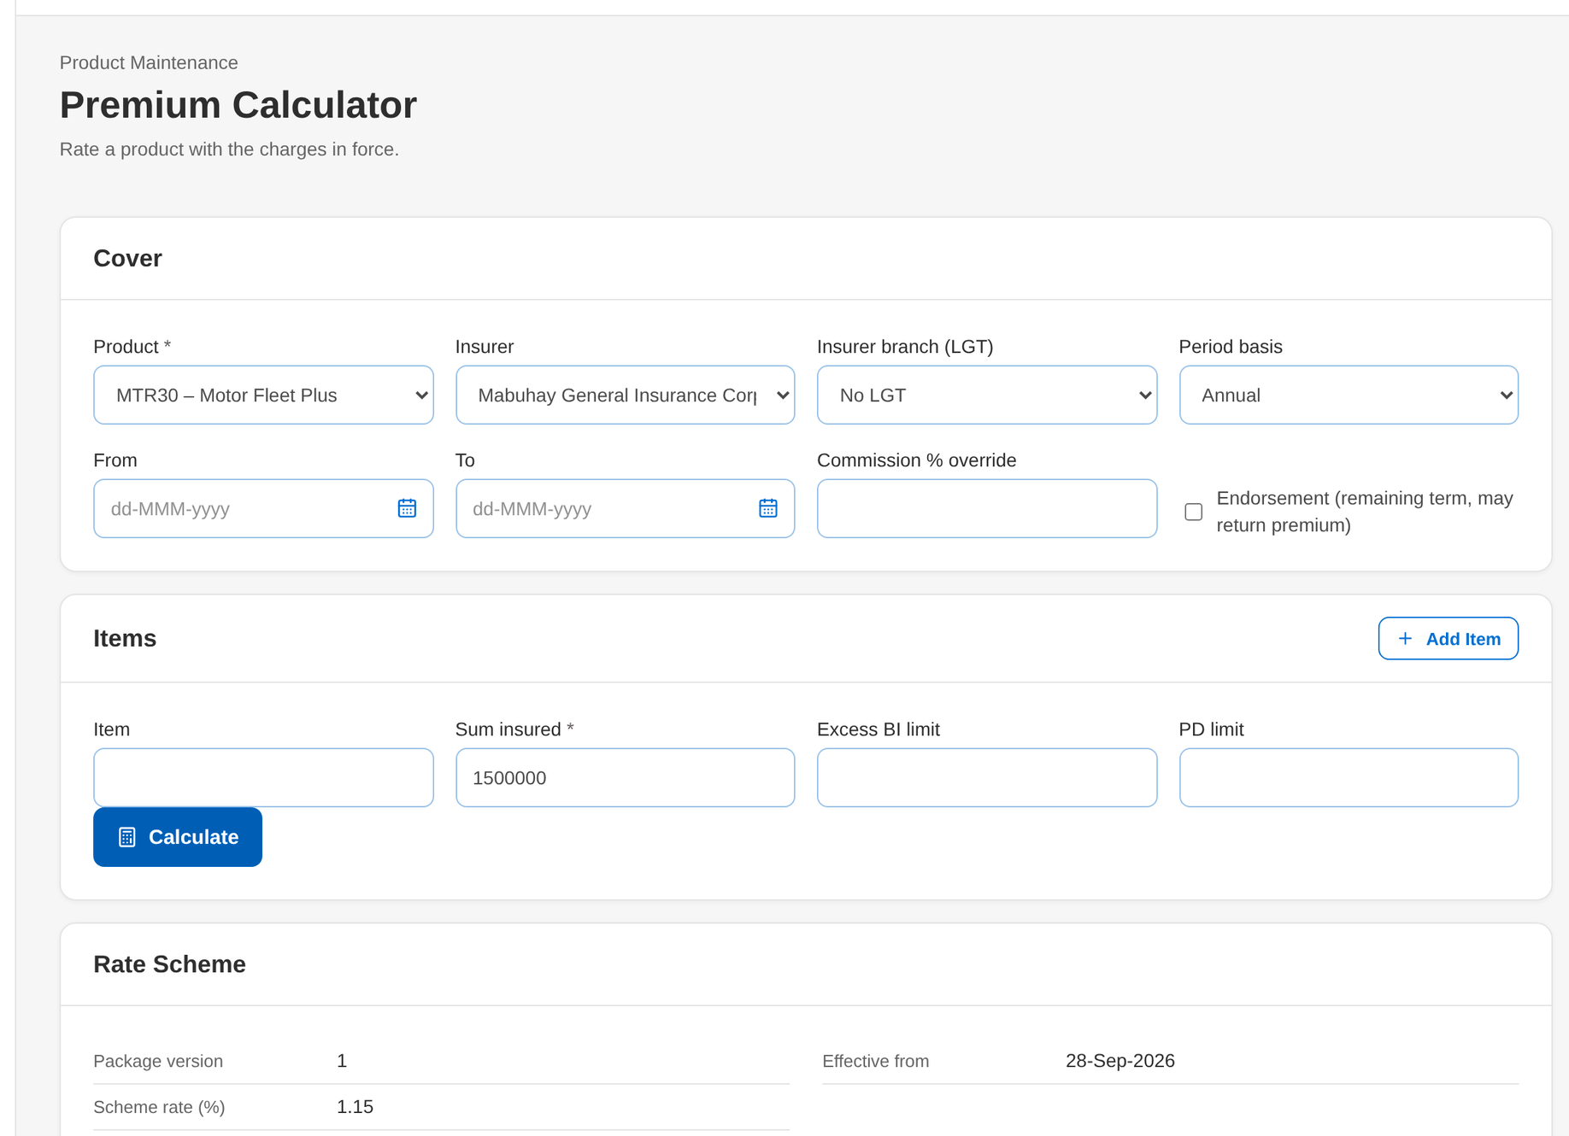
Figure 81: WT-A step 21: Premium Calculator
Step 22. Marketing Account Officer – Quotation: package rate scheme and rate exception (SCR-PM-22)
Does | Creates a New Business quotation of MTR30 for the seed client with an item rate of 1.10%, opens it and clicks Request Rate Exception with the reason
Sees | The rate scheme panel shows the exception pending approval
Result | Exception requested

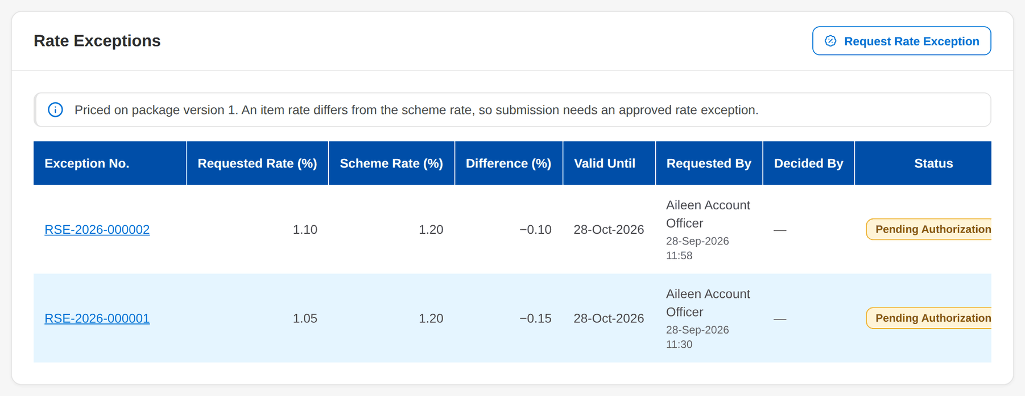
Figure 82: WT-A step 22: Quotation: package rate scheme and rate exception
Step 23. New Business Approver – Quotation: package rate scheme and rate exception (SCR-PM-22)
Does | Opens My Approvals, clicks the rate exception of the quotation, compares the requested rate with the scheme in force on the exception record, clicks Approve, writes the comment and confirms
Sees | Toast: Rate exception RSE-yyyy-nnnnnn approved; the record shows Approved with the approver, the date and the comment; the Account Officer receives the notice
Result | Exception approved

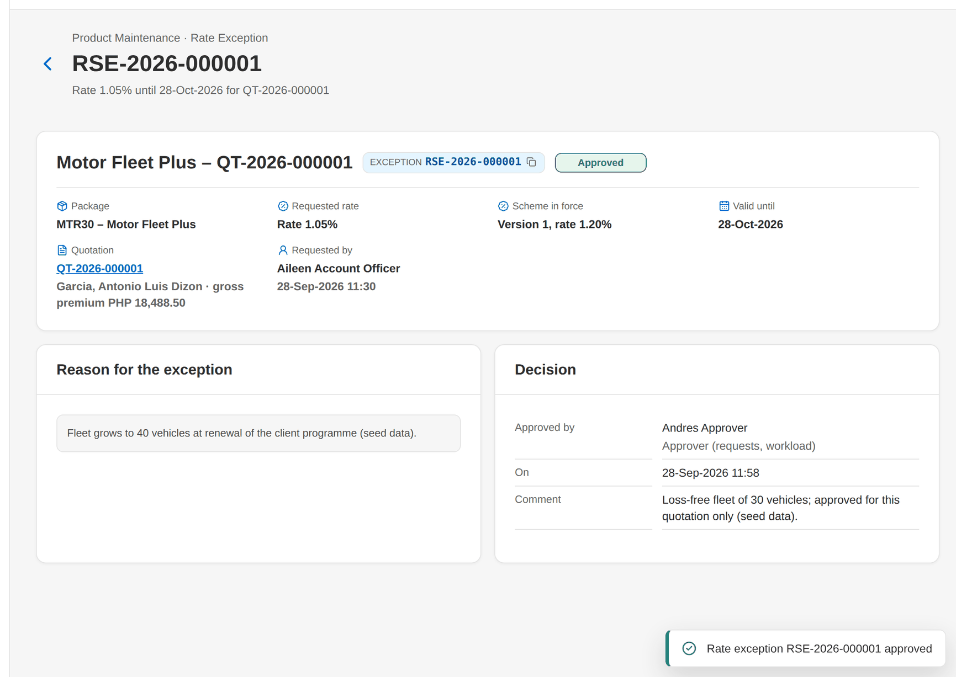
Figure 83: WT-A step 23: Quotation: package rate scheme and rate exception
Step 24. Marketing Account Officer – Quotation: package rate scheme and rate exception (SCR-PM-22)
Does | Opens the quotation again after the approval
Sees | The Rate Exceptions table lists the exception Approved; the quotation can be submitted for review
Result | Quotation ready for review

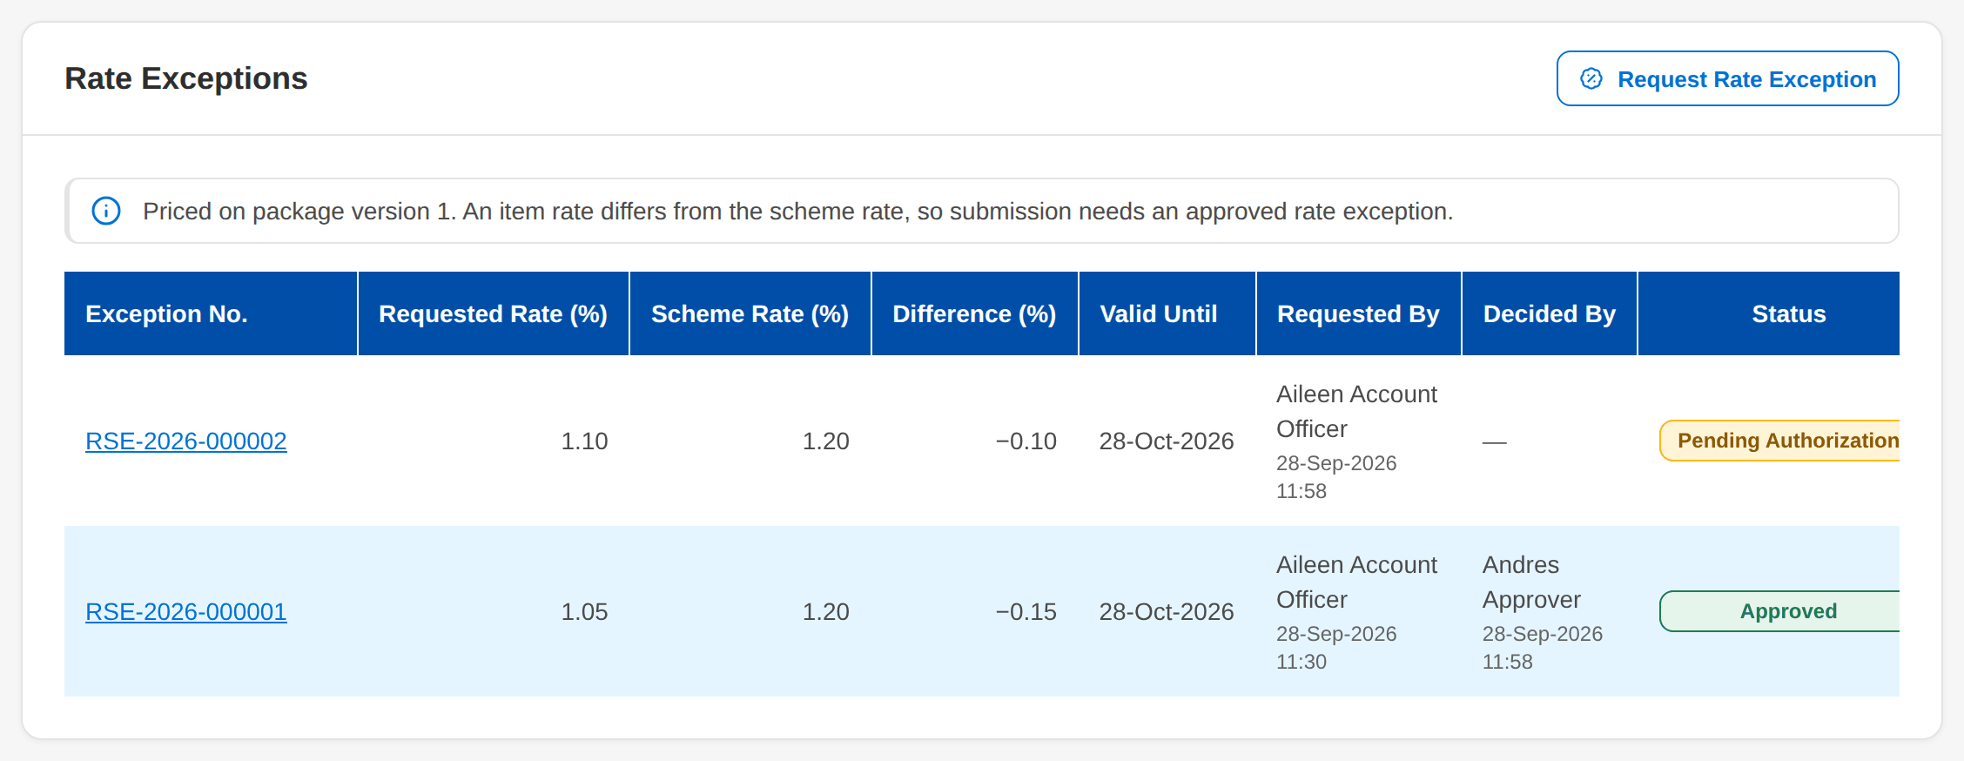
Figure 84: WT-A step 24: Quotation: package rate scheme and rate exception
What happens next, downstream
• New Business (BRD-1): New Quotation and New Account offer MTR30 to the segments of the package; the quotation, the account and the booked invoice keep version 1 and the approved exception.
• Booking and Operations: the booked invoice stores version 1 and the incentive criteria it matches; endorsements re-rate on version 1.
• Renewal (BRD-6): renewal candidates of MTR30 accounts are priced on version 1 while it is released or superseded; the package map of the data migration may name MTR30 version 1 as the target of a legacy package.
• Package Expiry: MTR30 appears on the Expiring tab 90 days before its package end date; the monitor alerts at 60, 30 and 7 days.

14.2 WT-B Returns and refusals, and the messages the user sees
The same process when something is missing or not allowed: an incomplete form, an approval by the maker, a return by TSU, a slip approved by its preparer, terms made final before every insurer answered, a ManCom return, a requirements pack without the signed slip, and a version returned by the validator. Each step shows the message on the screen and what the user does next.
Seed data: package requests PKR-2026-900002 (For TSU review), PKR-2026-900003 (round 2 with one insurer pending), PKR-2026-900004 (For ManCom sign-off), PKR-2026-900005 (With MBS) and the draft version 2 of MTR12
Step 1. Marketing Account Officer – New Package Request and Edit Package Request (SCR-PM-03)
Does | Opens New Package Request and clicks Save Draft without the name, line and reason
Sees | Under the fields: Enter the package or programme name; Select the product line; Select the reason. Nothing is saved
Result | Form corrected

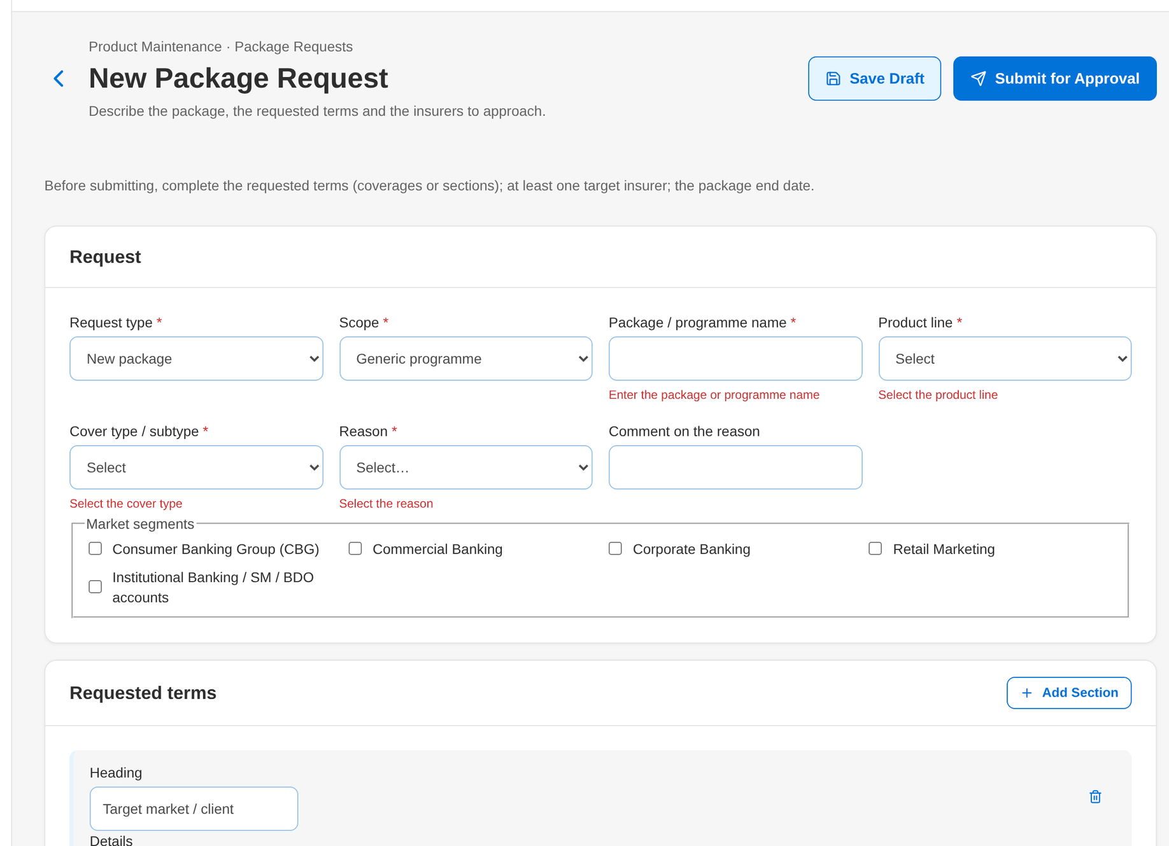
Figure 85: WT-B step 1: New Package Request and Edit Package Request
Step 2. Marketing Account Officer – New Package Request and Edit Package Request (SCR-PM-03)
Does | Completes the header only and clicks Submit for Approval
Sees | The hint Before submitting, complete the requested terms (coverages or sections); at least one target insurer; the package end date, and the refusal Complete the request: ... with its reference
Result | Request stays a draft

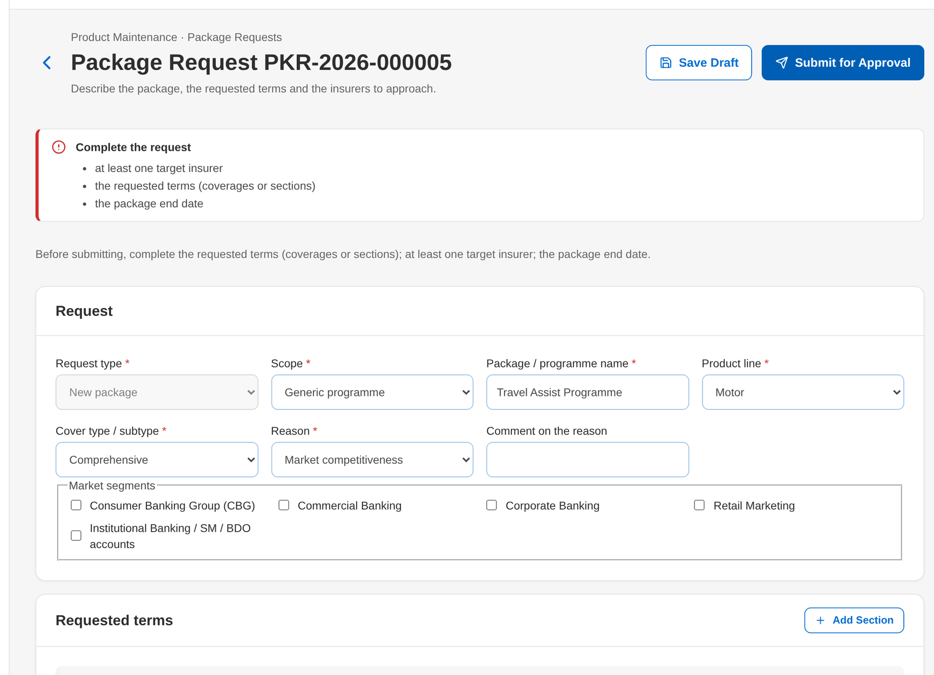
Figure 86: WT-B step 2: New Package Request and Edit Package Request
Step 3. Marketing TL / TH / UH – Package Request record (SCR-PM-04)
Does | Creates and submits a request himself, then clicks Approve and send to TSU on it
Sees | A package request is approved by someone other than its maker
Result | Another Marketing approver is needed

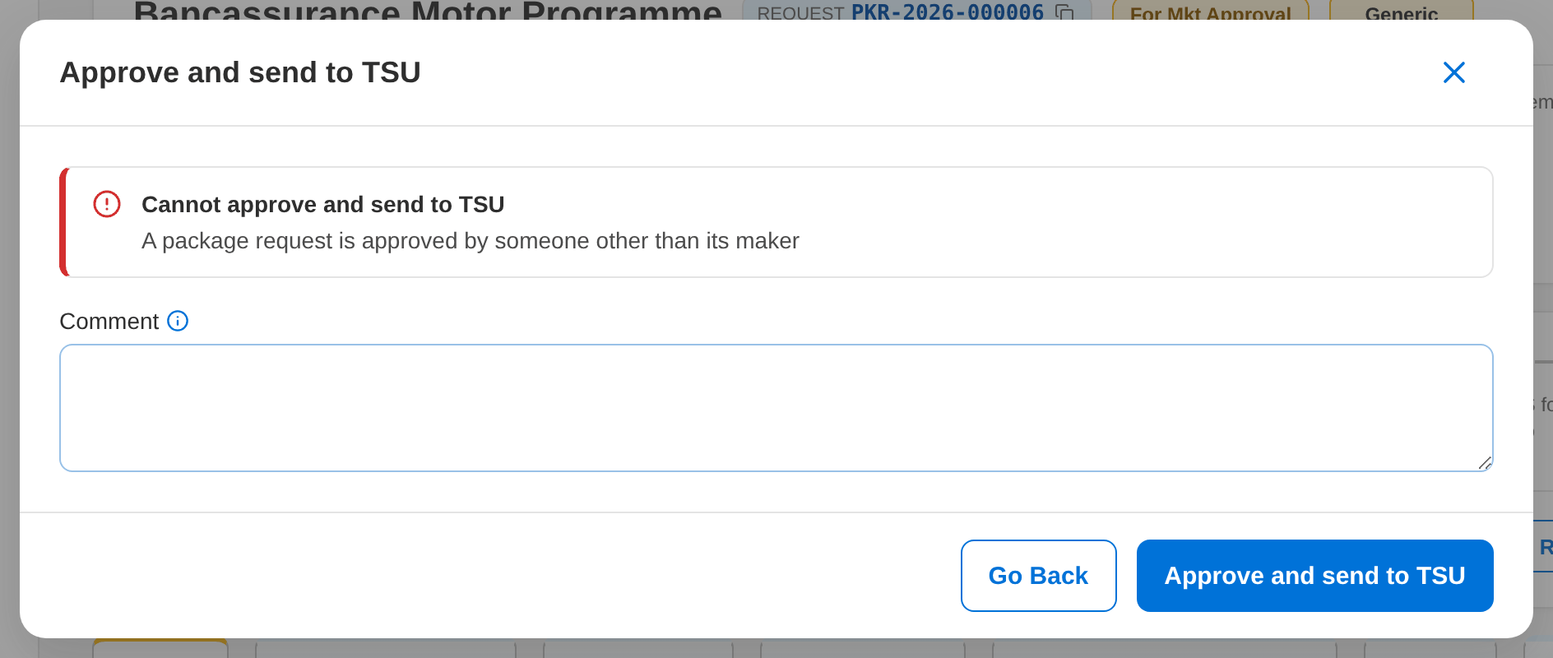
Figure 87: WT-B step 3: Package Request record
Step 4. TSU Team Lead – Package Request record (SCR-PM-04)
Does | Opens PKR-2026-900002 and clicks Return to requester, chooses the reason and writes what is missing
Sees | The stage becomes Draft request; the requester receives the workflow notice with the comment
Result | Returned to the requester

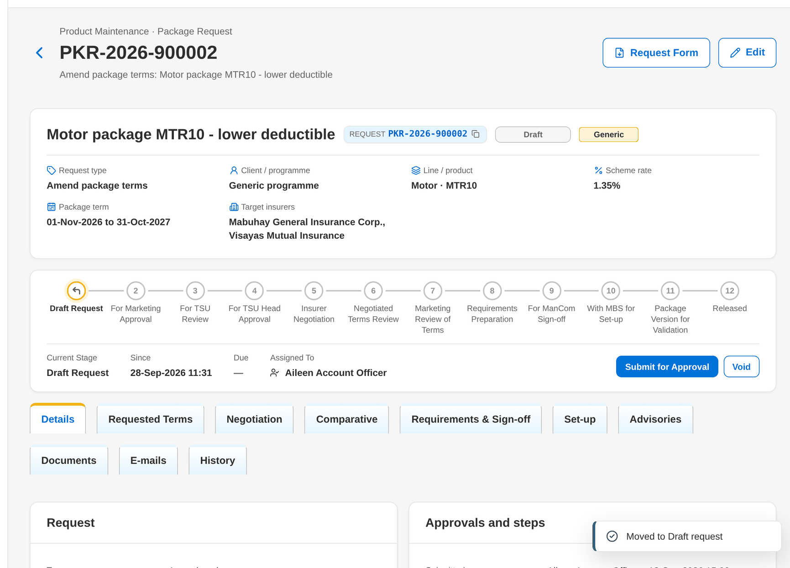
Figure 88: WT-B step 4: Package Request record
Step 5. TSU Team Lead – Package Request record: Negotiation tab (SCR-PM-05)
Does | Prepares and submits a slip himself, then clicks Approve and Send on it
Sees | The quotation slip is approved by a TL or a co-officer
Result | Another approver is needed

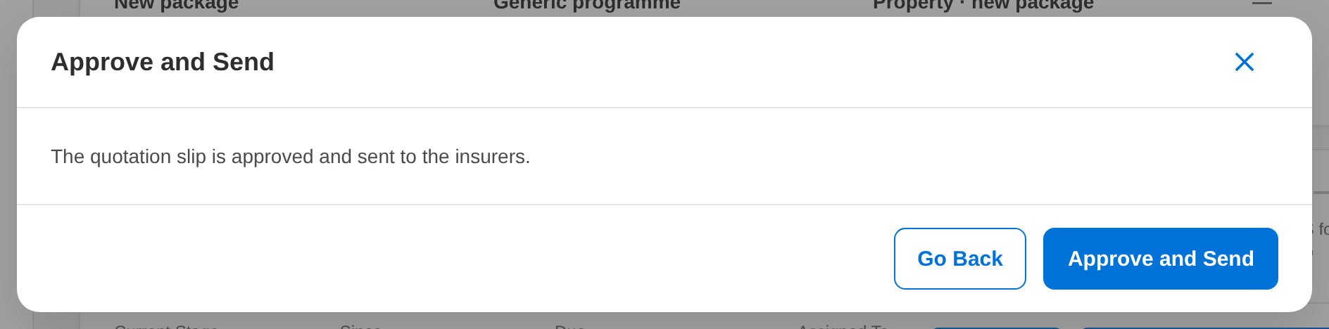
Figure 89: WT-B step 5: Package Request record: Negotiation tab
Step 6. TSU Officer – Package Request record: Negotiation tab (SCR-PM-05)
Does | Opens PKR-2026-900003 and clicks Terms final while Luzon Assurance is still pending in round 2
Sees | Every insurer of round 2 needs an outcome before the terms are final (1 pending)
Result | Outcome to be keyed in first

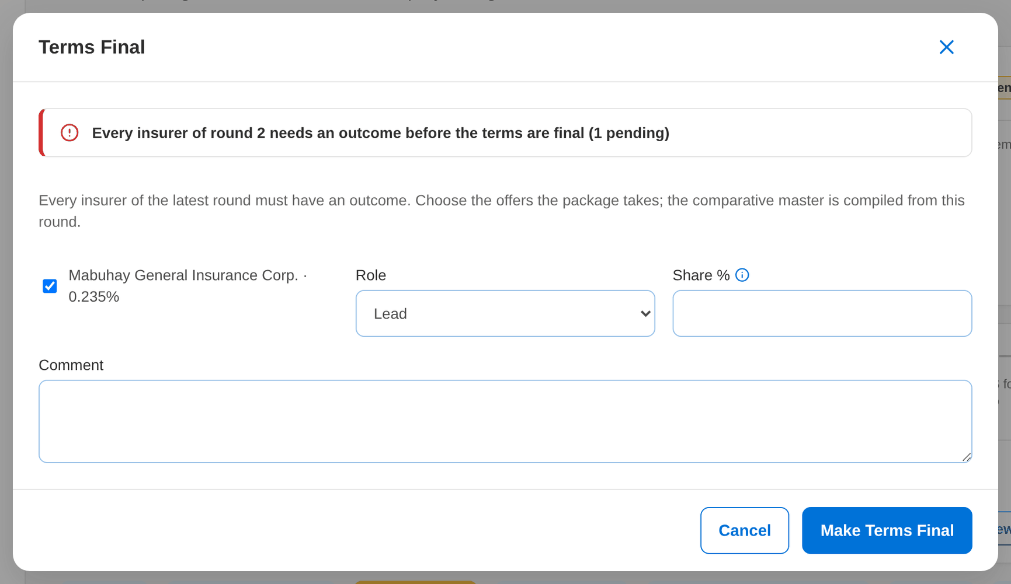
Figure 90: WT-B step 6: Package Request record: Negotiation tab
Step 7. ManCom member – Package Request record (SCR-PM-04)
Does | Opens PKR-2026-900004 and clicks Return to TSU with the reason
Sees | The stage becomes Requirements preparation; ManCom decisions lists the return
Result | Returned to TSU

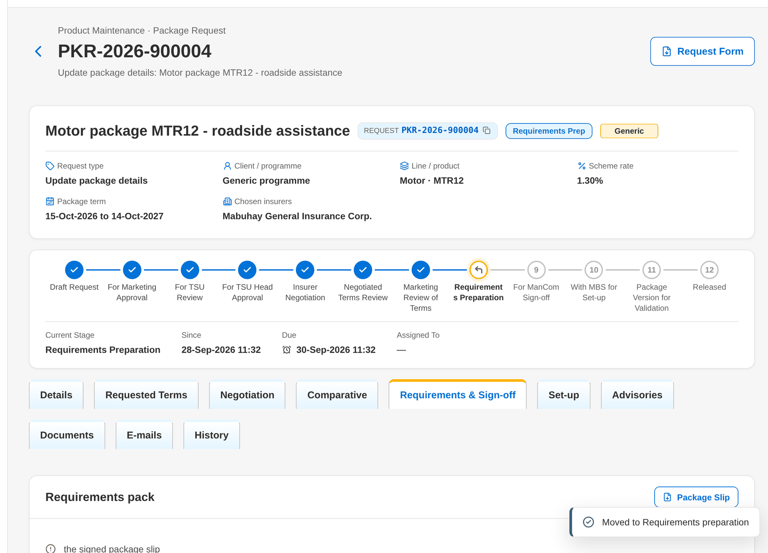
Figure 91: WT-B step 7: Package Request record
Step 8. TSU Officer – Package Request record: Requirements & Sign-off tab (SCR-PM-07)
Does | Clicks Submit requirements for ManCom sign-off before uploading the signed package slip
Sees | The checklist lists the missing signed package slip; the refusal Complete the requirements: ...
Result | Signed slip to be uploaded

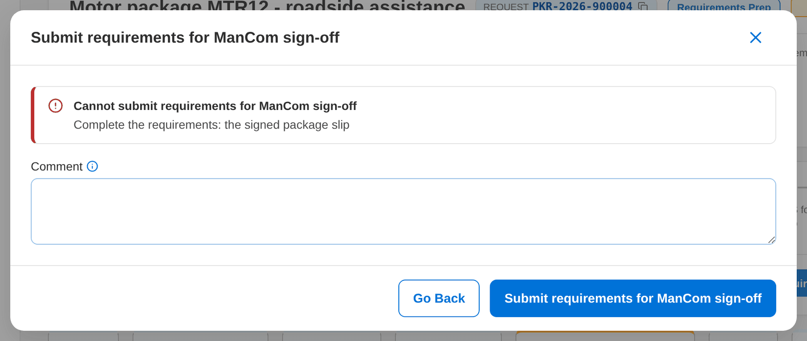
Figure 92: WT-B step 8: Package Request record: Requirements & Sign-off tab
Step 9. Marketing Business Services – Package Request record: Set-up and Advisories tabs (SCR-PM-08)
Does | Opens PKR-2026-900005 and clicks Return incomplete requirements to TSU with the reason
Sees | The stage becomes Requirements preparation
Result | Returned to TSU

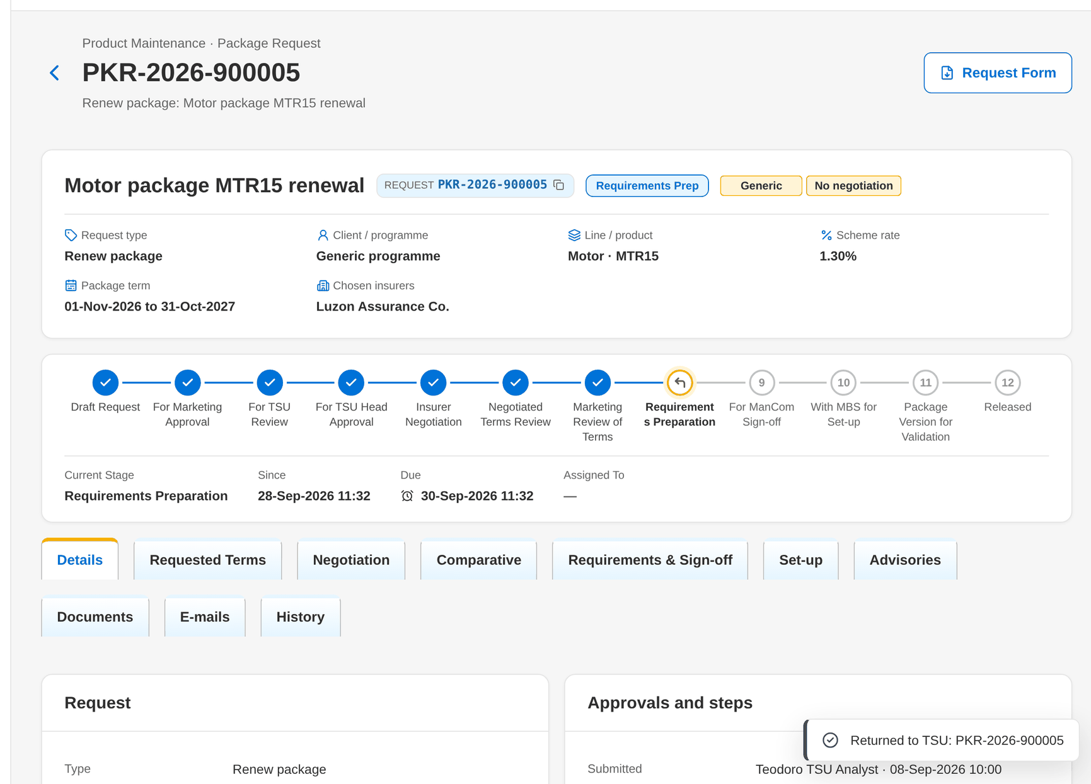
Figure 93: WT-B step 9: Package Request record: Set-up and Advisories tabs
Step 10. Marketing Business Services – Package Version (SCR-PM-13)
Does | Opens MTR12 version 2, clears the minimum premium and sets an effective date before today, then clicks Submit for Validation
Sees | Toast Correct the highlighted fields; under the fields Enter the minimum premium and The effective date cannot be before today
Result | Version stays a draft

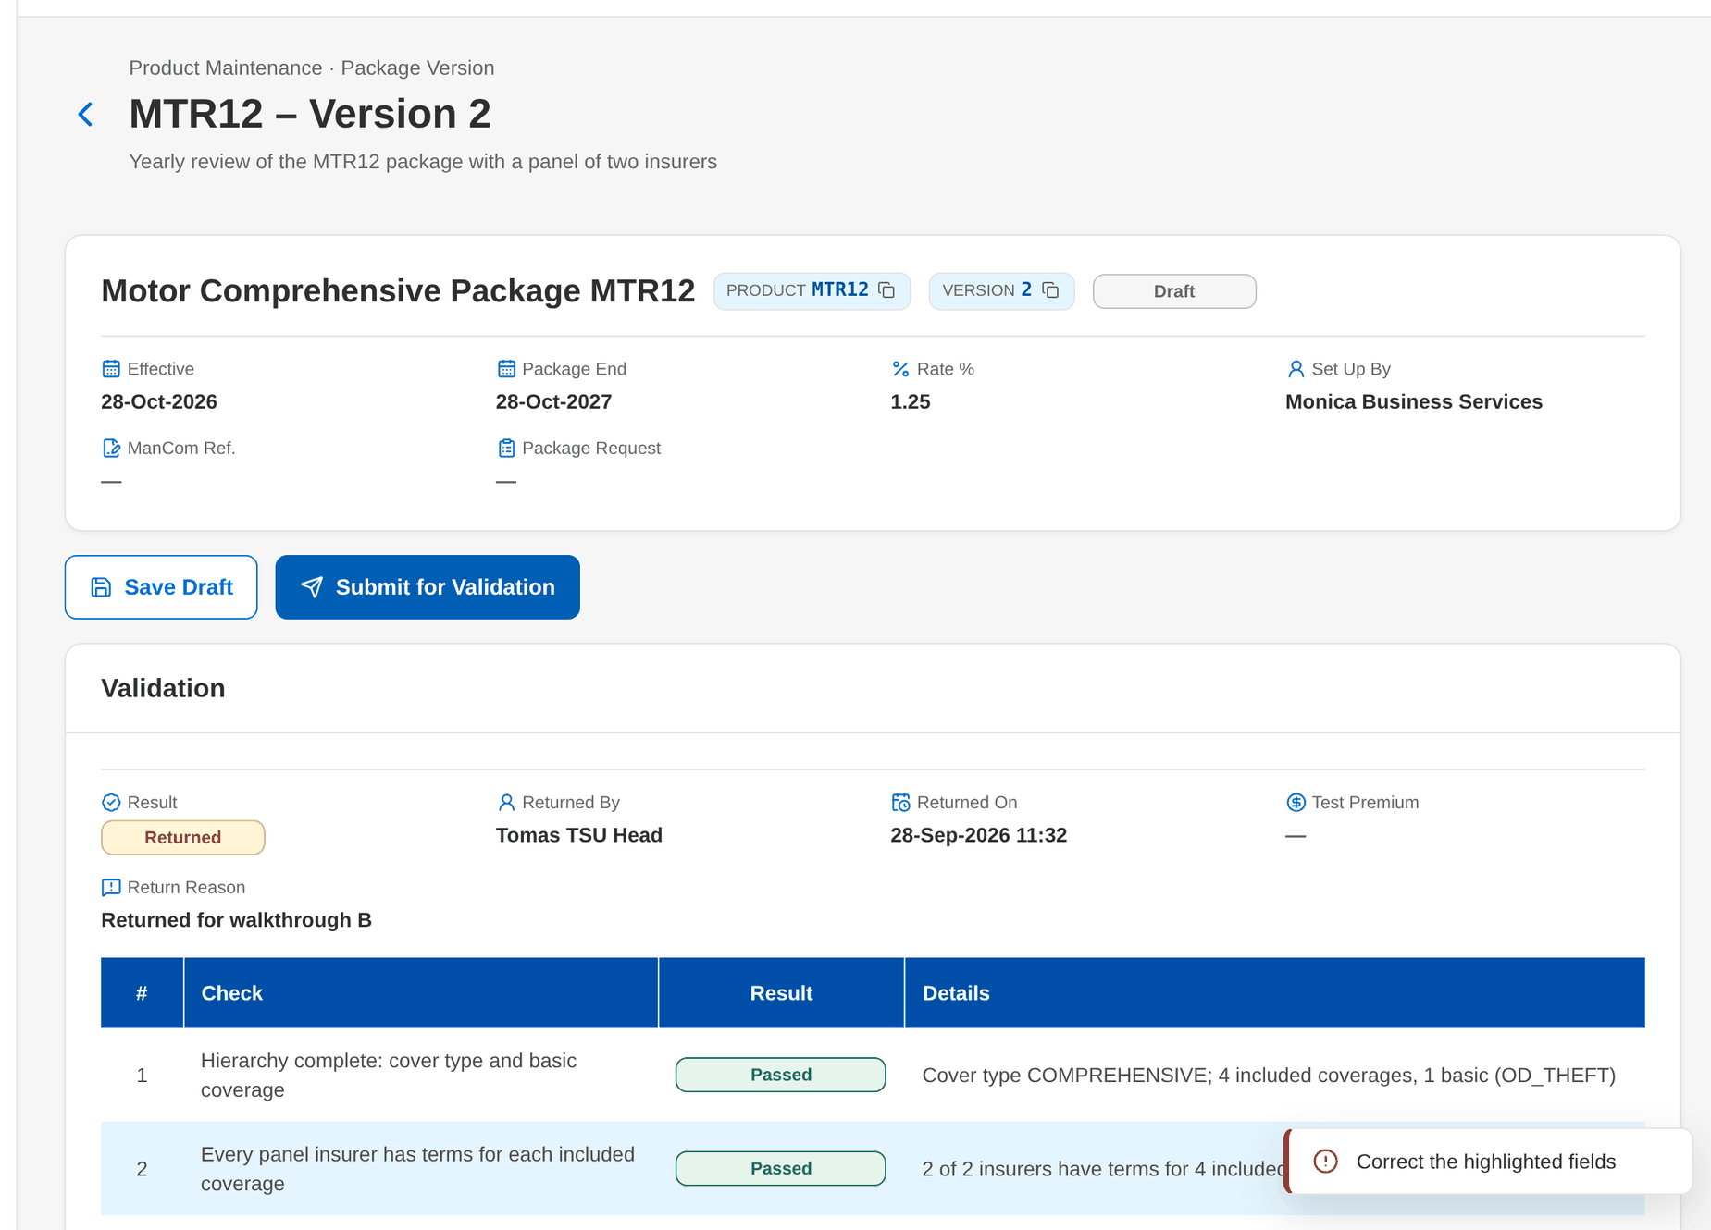
Figure 94: WT-B step 10: Package Version
Step 11. TSU Head – Package Version (SCR-PM-13)
Does | Opens the submitted MTR12 version 2 and clicks Return to MBS with the reason
Sees | Toast: Version 2 returned to MBS
Result | Returned to MBS

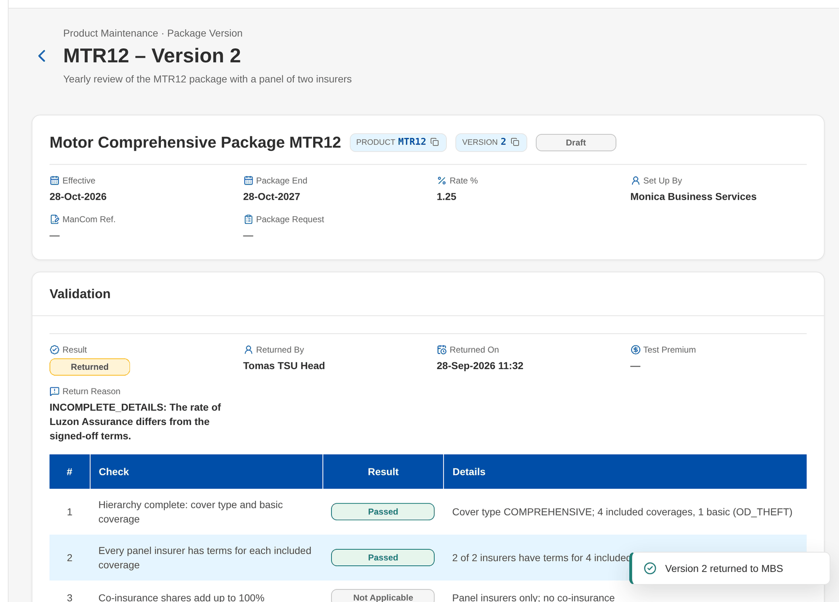
Figure 95: WT-B step 11: Package Version
Step 12. Marketing Business Services – Package Version (SCR-PM-13)
Does | Opens MTR12 version 2
Sees | The banner Returned by the validator: <reason> above the tabs; the draft can be corrected and submitted again
Result | Draft to correct

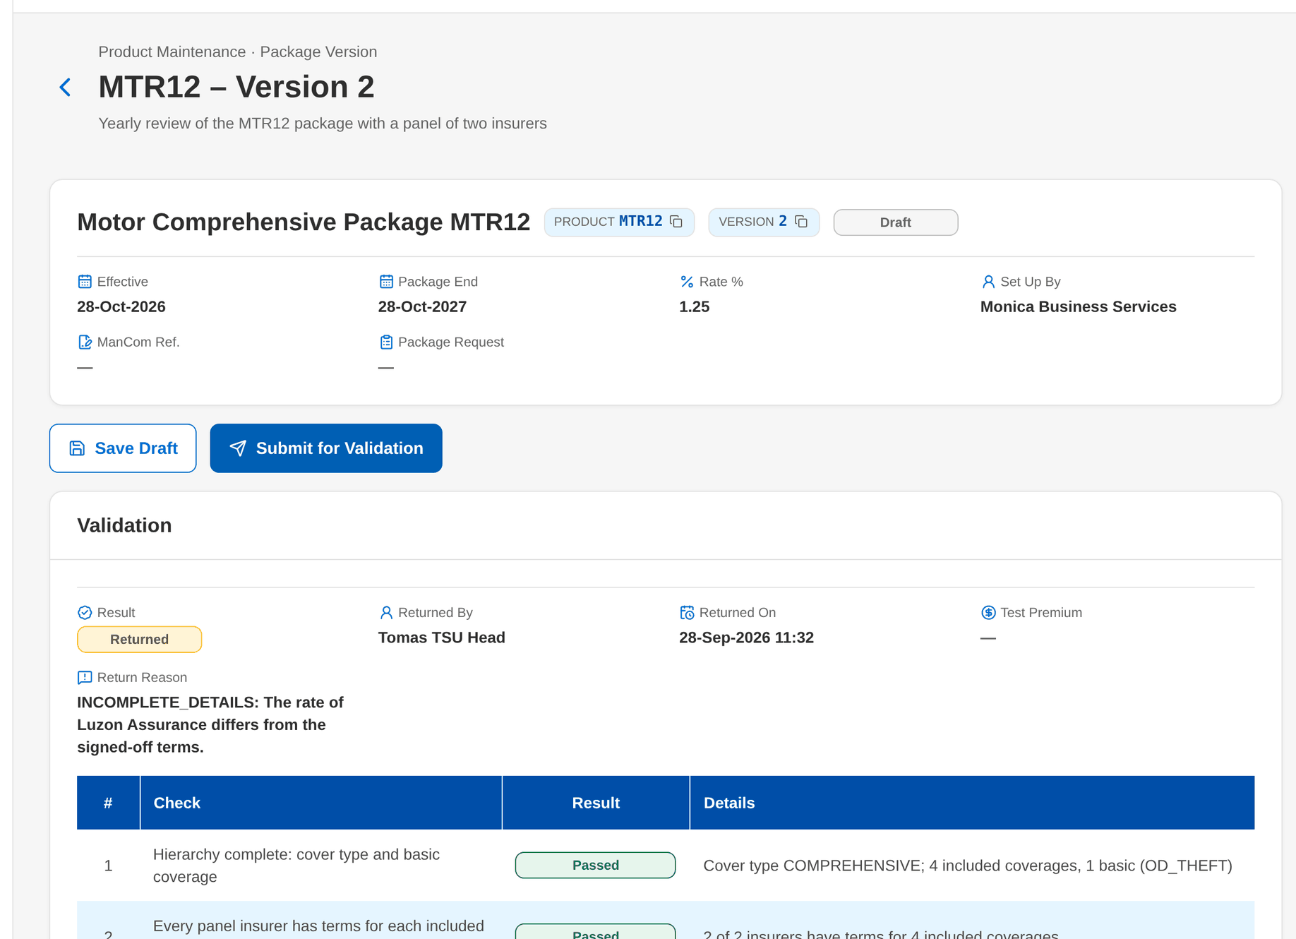
Figure 96: WT-B step 12: Package Version
What happens next, downstream
• Every return keeps its reason and comment in the history of the request, and the notice reaches the user who must act.
• A refused action changes nothing; the message names what to correct, and a server refusal shows its reference for support.

15 Messages catalogue
Every message a Product Maintenance user can see, grouped by the screen or dialog that shows it, with its code, its type and what the user does. The texts are quoted exactly as the screens show them.
• Validation: shown on the screen while the user fills in a field or before the form is sent.
• Error: the system refused the action; nothing was saved. The code is shown under the message as the Reference.
• Warning: the action is possible, but the user should check something first.
• Confirmation and Information: the outcome of an action, or a hint on the screen.
275 messages: 34 confirmation, 182 error, 19 information, 40 validation. The text is quoted exactly as the system shows it; <name> marks a value filled in by the system. The user sees the message only, in the notice standard of the screen standards appendix; the code identifies the message for the project team and support and is not shown on the screen.

15.1 Package Requests (SCR-PM-02)
ID | Code (not shown) | Message | Type | What the user does
MSG-PM-001 | - | Select requests of one stage | Validation | Select requests of one stage only.

15.2 New Package Request and Edit Package Request (SCR-PM-03)
ID | Code (not shown) | Message | Type | What the user does
MSG-PM-002 | - | <request no> saved | Confirmation | No action.
MSG-PM-003 | - | <request no> submitted for Marketing approval | Confirmation | No action.
MSG-PM-004 | - | Enter a code for every coverage or remove the line | Validation | Enter a code for every coverage or remove the line.
MSG-PM-005 | - | Enter the package or programme name | Validation | Enter the package or programme name.
MSG-PM-006 | - | Select the client | Validation | Select the client.
MSG-PM-007 | - | Select the cover type | Validation | Select the cover type.
MSG-PM-008 | - | Select the package product | Validation | Select the package product.
MSG-PM-009 | - | Select the product line | Validation | Select the product line.
MSG-PM-010 | - | Select the reason | Validation | Select the reason.
MSG-PM-011 | - | Terms of <product code> version <version no> loaded | Confirmation | No action.
MSG-PM-012 | - | The package end date must be after its start date | Validation | Enter a package end date after the package start.
MSG-PM-013 | COMPANY_REQUIRED | Select the company | Error | Select the company in the page header.
MSG-PM-014 | PKG_AMOUNT_NEGATIVE | Rates and amounts cannot be negative | Error | Correct the rate or amount; rates, limits, premiums and shares are zero or more.
MSG-PM-015 | PKG_COVER_TYPE_INVALID | <cover> is not a cover type of <line code> | Error | Choose a cover type of the selected product line.
MSG-PM-016 | PKG_DATES_INVALID | The package end date must be after its start date | Error | Correct the dates so that the package end date is after the start or effective date.
MSG-PM-017 | PKG_LINE_MISMATCH | <code> belongs to line <line code> | Error | Choose the product line of the package, or another package of the chosen line.
MSG-PM-018 | PKG_PRODUCT_NOT_PACKAGED | <code> is not a packaged product | Error | Choose a product flagged Package; a non-package product has no package request.
MSG-PM-019 | PKG_REQUEST_INCOMPLETE | Enter the package or programme name | Error | Enter the package or programme name.
MSG-PM-020 | PKG_REQUEST_INCOMPLETE | Select the client of the client-specific package | Error | Select the client of the client-specific package.
MSG-PM-021 | PKG_REQUEST_INCOMPLETE | Select the package product of the <type> request | Error | Select the package product of the <type> request.

15.3 Package Request record: stage actions (SCR-PM-04)
ID | Code (not shown) | Message | Type | What the user does
MSG-PM-022 | - | No coverage listed | Information | No action.
MSG-PM-023 | - | No insurer listed | Information | No action.
MSG-PM-024 | - | No insurer response keyed in yet | Information | No action.
MSG-PM-025 | NOT_FOUND | Package request not found: <id> | Error | Refresh the screen; the record was changed or removed. Report the message with its reference if it persists.
MSG-PM-026 | NOT_FOUND | Package version not found: <product code> | Error | Refresh the screen; the record was changed or removed. Report the message with its reference if it persists.
MSG-PM-027 | PKG_FOUR_EYES | A package request is approved by someone other than its maker | Error | Ask another user with the approval permission to take the action; the maker, submitter or recommender cannot.
MSG-PM-028 | PKG_FOUR_EYES | The TSU Head approval is given by someone other than the recommender | Error | Ask another user with the approval permission to take the action; the maker, submitter or recommender cannot.
MSG-PM-029 | PKG_RECOMMENDATION_REQUIRED | Write the recommendation for the TSU Head | Error | Write the recommendation for the TSU Head.
MSG-PM-030 | PKG_REQUEST_INCOMPLETE | Complete the request: <missing> | Error | Complete the request: <missing>.
MSG-PM-031 | PKG_REQUEST_INCOMPLETE | Select the request type and the package scope | Error | Select the request type and the package scope.
MSG-PM-032 | PKG_REQUEST_NOT_EDITABLE | Request <request no> cannot be changed at the stage <label> | Error | No change is possible in this stage; ask the owner of the stage to return the request if it must change.
MSG-PM-033 | PKG_TYPE_FIXED | The type of a request cannot change | Error | Void the request and create a new one of the right type.

15.4 Package Request record: Negotiation tab (SCR-PM-05)
ID | Code (not shown) | Message | Type | What the user does
MSG-PM-034 | - | <qs no> sent to <length> insurer(s) | Confirmation | No action.
MSG-PM-035 | - | <qs no> submitted for approval | Confirmation | No action.
MSG-PM-036 | - | Enter the rate offered | Validation | Enter the rate offered.
MSG-PM-037 | - | Quotation slip saved | Confirmation | No action.
MSG-PM-038 | - | Slip resent to <insurer name> | Confirmation | No action.
MSG-PM-039 | - | Terms of <insurer name> saved | Confirmation | No action.
MSG-PM-040 | - | The quotation slip is approved and sent to the insurers. | Validation | Confirm to approve and send the quotation slip, or cancel to review it first.
MSG-PM-041 | - | The slip has not been sent yet | Information | No action.
MSG-PM-042 | INSURER_NO_EMAIL | <name> has no placement e-mail address | Error | Ask the Business Administrator to add the insurer's placement e-mail on Insurers, then approve or resend the slip.
MSG-PM-043 | NEGOTIATION_INCOMPLETE | Choose the insurer(s) whose terms the package takes | Error | Key in the outcome of every insurer of the latest round (No response when the insurer did not reply) and choose the insurers the package takes.
MSG-PM-044 | NEGOTIATION_INCOMPLETE | Every insurer of round <round no> needs an outcome before the terms are final (<pending> pending) | Error | Key in the outcome of every insurer of the latest round (No response when the insurer did not reply) and choose the insurers the package takes.
MSG-PM-045 | NOT_FOUND | Insurer response not found: <insurer code> | Error | Refresh the screen; the record was changed or removed. Report the message with its reference if it persists.
MSG-PM-046 | NOT_FOUND | Insurer response not found: <response id> | Error | Refresh the screen; the record was changed or removed. Report the message with its reference if it persists.
MSG-PM-047 | NOT_FOUND | Negotiation round not found: <"/latest"> | Error | Refresh the screen; the record was changed or removed. Report the message with its reference if it persists.
MSG-PM-048 | NOT_FOUND | Negotiation round not found: <round no> | Error | Refresh the screen; the record was changed or removed. Report the message with its reference if it persists.
MSG-PM-049 | PKG_AMOUNT_NEGATIVE | Rates and amounts cannot be negative | Error | Correct the rate or amount; rates, limits, premiums and shares are zero or more.
MSG-PM-050 | PKG_INSURER_NOT_OFFERED | The insurer chosen did not offer terms in this round | Error | Choose only insurers whose outcome is an offer in the latest round.
MSG-PM-051 | PKG_INSURER_ROLE_INVALID | Unknown role <given> | Error | Choose Panel, Lead or Participant.
MSG-PM-052 | PKG_RESPONSE_RATE_REQUIRED | Enter the rate offered by <insurer name> (<outcome>) | Error | Enter the rate offered by <insurer name> (<outcome>).
MSG-PM-053 | PKG_ROUND_CLOSED | Round <round no> is closed: key in the latest round | Error | Open the latest round and key in the terms there.
MSG-PM-054 | PKG_SCOPE_CLIENT | Marketing reviews the terms of a client-specific package | Error | Use Release terms to Marketing; the terms of a client-specific package go to Marketing first.
MSG-PM-055 | PKG_SCOPE_GENERIC | A generic programme goes straight to the requirements | Error | Use Proceed to requirements (generic package).
MSG-PM-056 | PKG_SHARES_INVALID | Co-insurance shares must be given for every insurer and total 100 | Error | Give a share to every lead and participant insurer so that the shares total 100.
MSG-PM-057 | QS_ALREADY_SENT | Round <round no> was sent: revise the slip in a new round | Error | Use Revise quotation slip (new round) to change the slip.
MSG-PM-058 | QS_FOUR_EYES | The quotation slip is approved by a TL or a co-officer | Error | Ask the TSU Team Lead or another TSU officer to approve the slip.
MSG-PM-059 | QS_LOCKED | The slips are locked since the ManCom sign-off | Error | No action; the slips of a signed-off request cannot change.
MSG-PM-060 | QS_NOT_IN_PREPARATION | The slip of round <round no> is not in preparation | Error | Refresh the request; the slip was already submitted or sent.
MSG-PM-061 | QS_NOT_PREPARED | The slip of this round is not numbered yet | Error | Submit the slip for approval first; it is numbered then.
MSG-PM-062 | QS_NOT_RESENDABLE | Only the slip of an open, sent round can be resent | Error | Resend only from the latest sent round, before the ManCom sign-off.
MSG-PM-063 | QS_NOT_SENT | Send the slip of round <round no> before revising it | Error | Approve and send the slip of the round first.
MSG-PM-064 | QS_NOT_SUBMITTED | The slip of round <round no> is not submitted for approval | Error | Submit the slip for approval first.
MSG-PM-065 | QS_NO_INSURER | Select at least one insurer for the quotation slip | Error | Select at least one insurer for the quotation slip.
MSG-PM-066 | UPLOAD_FAILED | The file could not be read | Error | Check that the file opens and upload it again.

15.5 Package Request record: Comparative tab (SCR-PM-06)
ID | Code (not shown) | Message | Type | What the user does
MSG-PM-067 | - | Client view generated | Confirmation | No action.
MSG-PM-068 | - | Comparative master compiled | Confirmation | No action.
MSG-PM-069 | - | No comparative output yet | Information | No action.
MSG-PM-070 | - | No insurer terms to compare yet | Information | No action.
MSG-PM-071 | COMPARATIVE_FIELD_UNKNOWN | Unknown comparative field(s): <unknown> | Error | Choose the fields from the list shown.
MSG-PM-072 | COMPARATIVE_NO_INSURER | Select at least one insurer of the master | Error | Select at least one insurer of the master.
MSG-PM-073 | COMPARATIVE_NO_MASTER | Compile the comparative master first | Error | Click Compile Master first, then generate the client view.
MSG-PM-074 | COMPARATIVE_NO_TERMS | Send the quotation slip of round <round no> first | Error | Approve and send the quotation slip of the round first.
MSG-PM-075 | COMPARATIVE_TITLE_REQUIRED | Enter the title of the view | Error | Enter the title of the view.
MSG-PM-076 | NOT_FOUND | Comparative output not found: <output id> | Error | Refresh the screen; the record was changed or removed. Report the message with its reference if it persists.

15.6 Package Request record: Requirements & Sign-off tab (SCR-PM-07)
ID | Code (not shown) | Message | Type | What the user does
MSG-PM-077 | - | No ManCom decision yet | Information | No action.
MSG-PM-078 | - | Requirements saved | Confirmation | No action.
MSG-PM-079 | PKG_DATES_INVALID | The package end date must be after the effective date | Error | Correct the dates so that the package end date is after the start or effective date.
MSG-PM-080 | PKG_FOUR_EYES | ManCom signs off requirements submitted by someone else | Error | Ask another user with the approval permission to take the action; the maker, submitter or recommender cannot.
MSG-PM-081 | REQUIREMENTS_INCOMPLETE | Complete the requirements: <missing> | Error | Complete the requirements: <missing>.

15.7 Package Request record: Set-up and Advisories tabs (SCR-PM-08)
ID | Code (not shown) | Message | Type | What the user does
MSG-PM-082 | - | Advisory saved | Confirmation | No action.
MSG-PM-083 | - | Advisory sent | Confirmation | No action.
MSG-PM-084 | ADVISORY_ALREADY_SENT | The advisory was already sent | Error | No action; refresh the Advisories tab.
MSG-PM-085 | ADVISORY_CONTENT_REQUIRED | Enter the subject and the text | Error | Enter the subject and the text.
MSG-PM-086 | ADVISORY_DOCUMENTS_MISSING | Attach the supporting documents before sending: <missing> | Error | Attach the supporting documents before sending: <missing>.
MSG-PM-087 | ADVISORY_NO_RECIPIENT | Select at least one recipient group | Error | Select at least one recipient group.
MSG-PM-088 | DUPLICATE | Product already exists: <key> | Error | Use another code; the code already exists.
MSG-PM-089 | NOT_FOUND | Package advisory not found: <advisory id> | Error | Refresh the screen; the record was changed or removed. Report the message with its reference if it persists.
MSG-PM-090 | NOT_FOUND | Package version not found: <version no> | Error | Refresh the screen; the record was changed or removed. Report the message with its reference if it persists.
MSG-PM-091 | PACKAGE_TERM_INSURER_UNKNOWN | Insurer <insurer code> has terms but is not on the package | Error | Add the insurer to the Insurers tab, or remove its terms.
MSG-PM-092 | PKG_REQUEST_TYPE_MISMATCH | A retirement request retires the package; it has no version to set up | Error | Use Retire package for a retirement request and Set up package version for every other type.
MSG-PM-093 | PKG_REQUEST_TYPE_MISMATCH | Only a request to retire the package can retire it | Error | Use Retire package for a retirement request and Set up package version for every other type.
MSG-PM-094 | PRODUCT_CODE_REQUIRED | Enter the product code | Error | Enter the product code.
MSG-PM-095 | PRODUCT_CODE_REQUIRED | Enter the risk code of the new package | Error | Enter the risk code of the new package.
MSG-PM-096 | PRODUCT_NOT_ACTIVE | Product <product code> is <lifecycle status> already | Error | Choose an active, authorised product, or ask for its authorisation.
MSG-PM-097 | PRODUCT_NOT_PACKAGED | Product <product code> is not a package | Error | Choose a package product; non-package products are not versioned and need no exception.
MSG-PM-098 | PRODUCT_NOT_VERSIONED | Product <product code> has no version | Error | Ask MBS to set up the first version of the package through a package request.
MSG-PM-099 | VERSION_IN_PROGRESS | Product <code> already has a version being set up | Error | Complete, submit or return the version being set up before starting another.
MSG-PM-100 | VERSION_PRODUCT_MISMATCH | The content is for product <product code> | Error | Refresh the version and save it again.

15.8 TSU Workbench (SCR-PM-09)
ID | Code (not shown) | Message | Type | What the user does
MSG-PM-101 | - | <reference> is now yours | Confirmation | No action.

15.9 Package Expiry (SCR-PM-10)
ID | Code (not shown) | Message | Type | What the user does
MSG-PM-102 | - | <created> renewal request(s) drafted | Confirmation | No action.
MSG-PM-103 | COMPANY_REQUIRED | Select the company | Error | Select the company in the page header.
MSG-PM-104 | NOT_FOUND | Released package not found: <code> | Error | Refresh the screen; the record was changed or removed. Report the message with its reference if it persists.
MSG-PM-105 | PKG_RENEWAL_NONE | Select the packages to renew | Error | Select the packages to renew.

15.10 Products and the product dialog (SCR-PM-11)
ID | Code (not shown) | Message | Type | What the user does
MSG-PM-106 | - | No product matches the filters. | Information | No action.
MSG-PM-107 | - | Product <code> saved – pending authorization | Confirmation | No action.
MSG-PM-108 | CODE_PATTERN_INVALID | The risk-code pattern is not a valid regular expression | Error | Correct the risk-code pattern of the line (a regular expression without look-around or back-references).
MSG-PM-109 | COVER_TYPE_DEPTH | A subtype cannot have subtypes (Type > Subtype only) | Error | Attach the subtype to a cover type, not to another subtype.
MSG-PM-110 | COVER_TYPE_INVALID | Cover type <cover type code> does not belong to <line code> | Error | Choose a cover type of the product's line.
MSG-PM-111 | DUPLICATE | <label> already exists: <key> | Error | Use another code; the code already exists.
MSG-PM-112 | NOT_FOUND | <label> not found: <code> | Error | Refresh the screen; the record was changed or removed. Report the message with its reference if it persists.
MSG-PM-113 | NOT_FOUND | <label> not found: <id> | Error | Refresh the screen; the record was changed or removed. Report the message with its reference if it persists.
MSG-PM-114 | NOT_FOUND | <label> not found: <parent code> | Error | Refresh the screen; the record was changed or removed. Report the message with its reference if it persists.
MSG-PM-115 | PACKAGE_HIERARCHY_INCOMPLETE | A package needs its cover type | Error | Choose the cover type of the product and include at least one basic coverage in the version.
MSG-PM-116 | PRODUCT_CODE_PATTERN | Risk code <code> does not follow the naming convention of <line code> | Error | Enter a risk code that follows the naming convention of the line.
MSG-PM-117 | PRODUCT_FIELD_VERSIONED | The rate, minimum premium, commission and TSI limit of package <code> change through a new version (Versions tab) | Error | Change the rate, minimum premium, commission or TSI limit in a new version (Versions tab › New Version).
MSG-PM-118 | PRODUCT_MINIMUM_INVALID | The minimum premium cannot be negative | Error | Enter a minimum premium of zero or more.
MSG-PM-119 | PRODUCT_NOT_ACTIVE | Product <code> is not authorized or is inactive | Error | Choose an active, authorised product, or ask for its authorisation.
MSG-PM-120 | PRODUCT_NOT_SELLABLE | Package <code> has no released version in force on <date> | Error | Choose a product in force; an expired package is sold again only after a Reactivate request, a retired package not at all.
MSG-PM-121 | PRODUCT_NOT_SELLABLE | Product <code> is <root> and cannot be sold | Error | Choose a product in force; an expired package is sold again only after a Reactivate request, a retired package not at all.
MSG-PM-122 | PRODUCT_TERM_INVALID | The maximum term must be between 1 and 10 years | Error | Enter a maximum term between 1 and 10 years.

15.11 Product record: versions and rules (SCR-PM-12)
ID | Code (not shown) | Message | Type | What the user does
MSG-PM-123 | - | Describe the change | Validation | Describe the change.
MSG-PM-124 | - | Draft version <version no> created | Confirmation | No action.
MSG-PM-125 | - | No field rules apply. | Information | No action.
MSG-PM-126 | - | No version yet. | Information | No action.
MSG-PM-127 | - | Rule saved – pending authorization | Confirmation | No action.
MSG-PM-128 | DUPLICATE | <label> already exists: <key> | Error | Use another code; the code already exists.
MSG-PM-129 | FIELD_RULE_INCOMPLETE | Complete the parameters of the <type> rule | Error | Complete the parameters of the <type> rule.
MSG-PM-130 | LOV_TYPE_UNKNOWN | Unknown list of values <lov type> | Error | Enter the code of an existing list of values (Lists of Values screen).
MSG-PM-131 | NOT_FOUND | <label> not found: <id> | Error | Refresh the screen; the record was changed or removed. Report the message with its reference if it persists.
MSG-PM-132 | RULE_SCOPE_INVALID | Rules for every product use the scope code '*' | Error | Choose Applies to All for a rule of every product; the scope code is set by the system.

15.12 Package Version (SCR-PM-13)
ID | Code (not shown) | Message | Type | What the user does
MSG-PM-133 | - | Add insurers and included coverages to maintain their terms. | Information | Add insurers and included coverages to maintain their terms.
MSG-PM-134 | - | Correct the highlighted fields | Error | Correct the fields marked in red on each tab.
MSG-PM-135 | - | Enter a commission between 0 and 100 | Validation | Enter a commission between 0 and 100.
MSG-PM-136 | - | Enter a positive amount | Validation | Enter a positive amount.
MSG-PM-137 | - | Enter a rate between 0 and 100 | Validation | Enter a rate between 0 and 100.
MSG-PM-138 | - | Enter the effective date | Validation | Enter the effective date.
MSG-PM-139 | - | Enter the minimum premium | Validation | Enter the minimum premium.
MSG-PM-140 | - | Enter the package rate or a rate for every insurer | Validation | Enter the package rate or a rate for every insurer.
MSG-PM-141 | - | Include at least one coverage | Validation | Tick Included on at least one coverage, or add one.
MSG-PM-142 | - | No checks recorded | Information | No action.
MSG-PM-143 | - | No coverage yet: add the basic coverage first. | Information | No action.
MSG-PM-144 | - | No insurer yet: the package is placed with any insurer at the scheme rate. | Information | No action.
MSG-PM-145 | - | The effective date cannot be before today | Validation | Enter an effective date of today or later.
MSG-PM-146 | - | The package end date must be after the effective date | Validation | Enter a package end date after the effective date.
MSG-PM-147 | - | The package version is validated and released for use. | Validation | Confirm to validate and release the version, or cancel to review it first.
MSG-PM-148 | - | Version <version no> saved | Confirmation | No action.
MSG-PM-149 | - | Version <version no> submitted for validation | Confirmation | No action.
MSG-PM-150 | MAKER_CHECKER_VIOLATION | A package version is validated by someone other than its maker and submitter | Error | Ask another user with the permission to decide it; another validator (TSU Head or Business Administrator) validates a version, another approver decides a rate exception.
MSG-PM-151 | NOT_FOUND | Package version not found: <version no> | Error | Refresh the screen; the record was changed or removed. Report the message with its reference if it persists.
MSG-PM-152 | PACKAGE_DATES_INVALID | Enter the effective date | Error | Correct the dates on the Rate Scheme & Dates tab.
MSG-PM-153 | PACKAGE_DATES_INVALID | The effective date cannot be before today | Error | Correct the dates on the Rate Scheme & Dates tab.
MSG-PM-154 | PACKAGE_DATES_INVALID | The effective date must be after the start of version <version no> | Error | Correct the dates on the Rate Scheme & Dates tab.
MSG-PM-155 | PACKAGE_DATES_INVALID | The package end date must be after the effective date | Error | Correct the dates on the Rate Scheme & Dates tab.
MSG-PM-156 | PACKAGE_HIERARCHY_INCOMPLETE | The package needs its cover type and at least one included basic coverage | Error | Choose the cover type of the product and include at least one basic coverage in the version.
MSG-PM-157 | PACKAGE_INSURER_TERMS_MISSING | Insurer <insurer code> has no terms for coverage <coverage> | Error | Open the Insurer Terms tab and complete the terms of the insurer for that coverage.
MSG-PM-158 | PACKAGE_RATE_MISSING | Enter the package rate or a rate for every insurer | Error | Enter the package rate or a rate for every insurer.
MSG-PM-159 | PACKAGE_SHARES_INVALID | The co-insurance shares must add up to 100% | Error | Correct the shares of the lead and participant insurers so that they total 100%.
MSG-PM-160 | REASON_REQUIRED | Enter the reason of the return | Error | Give the reason (the return reason of a package version, or why a sales unit is deactivated or reactivated or an officer removed from a team).
MSG-PM-161 | VERSION_NOT_FOR_VALIDATION | Version <version no> is <status> | Error | Refresh the version; only a version submitted for validation is validated.

15.13 Coverages & Clauses (SCR-PM-15)
ID | Code (not shown) | Message | Type | What the user does
MSG-PM-162 | - | Clause <code> saved – pending authorization | Confirmation | No action.
MSG-PM-163 | - | Coverage <code> saved – pending authorization | Confirmation | No action.
MSG-PM-164 | - | Enter the effective date | Validation | Enter the effective date.
MSG-PM-165 | - | Enter the name | Validation | Enter the name.
MSG-PM-166 | - | Enter the title | Validation | Enter the title.
MSG-PM-167 | - | Enter the wording | Validation | Enter the wording.
MSG-PM-168 | - | No coverage is set up for this line. | Information | No action.
MSG-PM-169 | - | Select the kind | Validation | Select the kind.
MSG-PM-170 | - | Select the product line | Validation | Select the product line.
MSG-PM-171 | - | The clause library is empty. | Information | No action.
MSG-PM-172 | - | The end is before the start | Validation | Correct the end date so that it is on or after the start date.
MSG-PM-173 | - | Use A-Z, 0-9 and _ | Validation | Use A-Z, 0-9 and _.
MSG-PM-174 | DUPLICATE | <label> already exists: <key> | Error | Use another code; the code already exists.
MSG-PM-175 | NOT_FOUND | <label> not found: <code> | Error | Refresh the screen; the record was changed or removed. Report the message with its reference if it persists.
MSG-PM-176 | NOT_FOUND | <label> not found: <id> | Error | Refresh the screen; the record was changed or removed. Report the message with its reference if it persists.

15.14 Incentive Criteria (SCR-PM-16)
ID | Code (not shown) | Message | Type | What the user does
MSG-PM-177 | - | Criterion <code> deactivated | Confirmation | No action.
MSG-PM-178 | - | Criterion <code> saved – pending authorization | Confirmation | No action.
MSG-PM-179 | - | Enter a value for each parameter | Validation | Enter a value for each parameter.
MSG-PM-180 | - | Enter the name | Validation | Enter the name.
MSG-PM-181 | - | Enter the start date | Validation | Enter the start date.
MSG-PM-182 | - | Enter the value | Validation | Enter the value.
MSG-PM-183 | - | Select at least one product of the matrix | Validation | Select at least one product of the matrix.
MSG-PM-184 | - | Select the parameter | Validation | Select the parameter.
MSG-PM-185 | - | Select the type | Validation | Select the type.
MSG-PM-186 | - | The change must start after <active from> | Validation | Enter an effective-from date after the start of the active criterion.
MSG-PM-187 | - | The end is before the start | Validation | Correct the end date so that it is on or after the start date.
MSG-PM-188 | - | Use A-Z, 0-9, _ and - | Validation | Use A-Z, 0-9, _ and -.
MSG-PM-189 | INCENTIVE_ACTIVE_LOCKED | An active criterion is changed by amending it (successor) | Error | Open the active criterion and save the change as an amendment from a later date.
MSG-PM-190 | INCENTIVE_NOT_ACTIVE | Only an active criterion is amended; change the pending row | Error | Change the pending row itself; only an active criterion is amended.
MSG-PM-191 | INCENTIVE_PERIOD_INVALID | The amendment must start after <effective from> | Error | Enter an effective-from date after the start of the active criterion.
MSG-PM-192 | INCENTIVE_PERIOD_OVERLAP | Criterion <code> already covers part of this period | Error | Choose dates that do not overlap another row of the same code, or end the other row first.
MSG-PM-193 | INCENTIVE_PRODUCTS_REQUIRED | Select at least one product of the products matrix | Error | Select at least one product of the products matrix.
MSG-PM-194 | INCENTIVE_PRODUCT_NOT_ACTIVE | Product <product code> is not an active product of the matrix | Error | Remove the product from the matrix, or choose an active product.
MSG-PM-195 | INCENTIVE_RULE_PARAMS_INVALID | Enter the rule parameters as parameter and value rows | Error | Choose each parameter from the list of the incentive type and enter its value as the parameter asks (an amount or a number for the minimum gross premium).
MSG-PM-196 | INCENTIVE_VALUE_REQUIRED | Enter the value of the incentive criterion | Error | Enter the value of the criterion.
MSG-PM-197 | NOT_FOUND | <label> not found: <id> | Error | Refresh the screen; the record was changed or removed. Report the message with its reference if it persists.

15.15 Insurers (SCR-PM-17)
ID | Code (not shown) | Message | Type | What the user does
MSG-PM-198 | - | <name> saved – pending authorization | Confirmation | No action.
MSG-PM-199 | - | No insurer on the panel yet. | Information | No action.
MSG-PM-200 | CREDIT_DAYS_INVALID | Default credit days must be between 0 and 365 | Error | Enter credit days between 0 and 365.
MSG-PM-201 | DUPLICATE | <label> already exists: <key> | Error | Use another code; the code already exists.
MSG-PM-202 | INSURER_BRANCH_NOT_ACTIVE | Branch <branch code> is not authorized or inactive | Error | Choose an authorised, active branch, or ask for the branch's authorisation.
MSG-PM-203 | INSURER_BRANCH_UNKNOWN | Insurer <party code> has no branch <branch code> | Error | Choose a branch of the insurer.
MSG-PM-204 | INSURER_NOT_ACTIVE | Insurer <party code> is not authorized or is inactive | Error | Choose an authorised, active insurer, or ask for the insurer's authorisation.
MSG-PM-205 | NOT_FOUND | <label> not found: <branch id> | Error | Refresh the screen; the record was changed or removed. Report the message with its reference if it persists.
MSG-PM-206 | NOT_FOUND | <label> not found: <id> | Error | Refresh the screen; the record was changed or removed. Report the message with its reference if it persists.
MSG-PM-207 | NOT_FOUND | <label> not found: <party code> | Error | Refresh the screen; the record was changed or removed. Report the message with its reference if it persists.
MSG-PM-208 | PARTY_NOT_INSURER | Party <party code> exists and is not an insurer | Error | Use another partner code; the code belongs to another kind of business partner.
MSG-PM-209 | PLACEMENT_CHANNEL_PARKED | Only e-mail placement is available; choose the e-mail placement channel | Error | Choose E-mail as the placement channel.
MSG-PM-210 | RATE_INVALID | The LGT rate must be between 0 and 100 % | Error | Enter a percentage between 0 and 100.

15.16 Insurer record (SCR-PM-18)
ID | Code (not shown) | Message | Type | What the user does
MSG-PM-211 | - | No branch recorded. | Information | No action.
MSG-PM-212 | - | No commission rate: the product default applies. | Information | No action.

15.17 Rates & Taxes (SCR-PM-19)
ID | Code (not shown) | Message | Type | What the user does
MSG-PM-213 | - | Rate saved – pending authorization | Confirmation | No action.
MSG-PM-214 | EFFECTIVE_FROM_REQUIRED | Enter the effective-from date | Error | Enter the effective-from date.
MSG-PM-215 | EFFECTIVITY_INVALID | The effective-to date is before the effective-from date | Error | Correct the effective-to date so that it is on or after the effective-from date.
MSG-PM-216 | LIMIT_INVALID | The limit must be greater than zero | Error | Enter a limit greater than zero.
MSG-PM-217 | LIMIT_PREMIUM_INVALID | The premium cannot be negative | Error | Enter a premium of zero or more.
MSG-PM-218 | NOT_FOUND | <label> not found: <id> | Error | Refresh the screen; the record was changed or removed. Report the message with its reference if it persists.
MSG-PM-219 | RATE_INVALID | <label> must be a percentage between 0 and 100 | Error | Enter a percentage between 0 and 100.
MSG-PM-220 | SHORT_PERIOD_MONTHS_INVALID | Months covered must be between 1 and 12 | Error | Enter the months covered between 1 and 12.

15.18 Sales Organisation (SCR-PM-20)
ID | Code (not shown) | Message | Type | What the user does
MSG-PM-221 | - | <'officer'> authorized | Confirmation | No action.
MSG-PM-222 | - | <code> deactivated | Confirmation | No action.
MSG-PM-223 | - | <code> reactivated – pending authorization | Confirmation | No action.
MSG-PM-224 | - | <code> saved – pending authorization | Confirmation | No action.
MSG-PM-225 | - | <file name> downloaded | Confirmation | No action.
MSG-PM-226 | - | <username> removed from <team code> | Confirmation | No action.
MSG-PM-227 | - | Saved – pending authorization | Confirmation | No action.
MSG-PM-228 | DUPLICATE | <label> already exists: <key> | Error | Use another code; the code already exists.
MSG-PM-229 | NOT_FOUND | <label> not found: <id> | Error | Refresh the screen; the record was changed or removed. Report the message with its reference if it persists.
MSG-PM-230 | NOT_FOUND | <label> not found: <unit code> | Error | Refresh the screen; the record was changed or removed. Report the message with its reference if it persists.
MSG-PM-231 | REASON_REQUIRED | Enter the reason | Error | Give the reason (the return reason of a package version, or why a sales unit is deactivated or reactivated or an officer removed from a team).
MSG-PM-232 | SALES_OFFICER_INACTIVE | <> is already removed from the team | Error | No action; the officer is already removed from the team. Use Assign to a Team to place the officer again.
MSG-PM-233 | SALES_PARENT_INVALID | A <level> must belong to an active <parent level> | Error | Choose a parent unit of the level above (region for a department, department for a team).
MSG-PM-234 | SALES_PARENT_INVALID | Reactivate <parent code> before <code> | Error | Choose a parent unit of the level above (region for a department, department for a team).
MSG-PM-235 | SALES_TEAM_UNKNOWN | Team <team code> is unknown or inactive | Error | Choose an existing, active team; reactivate the team first if it was deactivated.
MSG-PM-236 | SALES_UNIT_INACTIVE | Unit <code> is already inactive | Error | No action; the unit is already inactive.
MSG-PM-237 | SALES_UNIT_IN_USE | <code> still has <open>: deactivate or move them before deactivating the unit | Error | Deactivate the sub-units of the unit and remove or reassign its account officers first (Show Inactive lists what is already inactive).
MSG-PM-238 | SALES_UNIT_NOT_INACTIVE | Unit <code> is not inactive | Error | No action; only an inactive unit is reactivated.
MSG-PM-239 | USER_UNKNOWN | Unknown user <head> | Error | Enter the user name of an existing BIBS user.
MSG-PM-240 | USER_UNKNOWN | Unknown user <username> | Error | Enter the user name of an existing BIBS user.

15.19 Premium Calculator (SCR-PM-21); pricing of quotations and accounts
ID | Code (not shown) | Message | Type | What the user does
MSG-PM-241 | INSURER_NOT_ON_PACKAGE | Insurer <insurer code> is not on the panel of <product code> version <version no> | Error | Choose an insurer of the package's panel.
MSG-PM-242 | MOTOR_LIMIT_UNKNOWN | <coverage> limit <to plain string> is not in the limit table | Error | Choose a limit of the BI / PD limit table, or ask the Business Administrator to add it.
MSG-PM-243 | PRODUCT_NOT_SELLABLE | Package <code> expired and has no current version | Error | Choose a product in force; an expired package is sold again only after a Reactivate request, a retired package not at all.
MSG-PM-244 | PRODUCT_NOT_SELLABLE | Package <code> has no released version in force | Error | Choose a product in force; an expired package is sold again only after a Reactivate request, a retired package not at all.
MSG-PM-245 | PRODUCT_NOT_SELLABLE | Package <code> is <lifecycle status>: it is locked for new business | Error | Choose a product in force; an expired package is sold again only after a Reactivate request, a retired package not at all.
MSG-PM-246 | RATING_NO_ITEMS | Enter at least one item to rate | Error | Enter at least one item to rate.
MSG-PM-247 | RATING_OD_FACTOR_MISSING | The motor OD/Theft coverage factor is not set up | Error | Ask the Business Administrator to set up the motor own-damage factor on Rates & Taxes.
MSG-PM-248 | RATING_PERIOD_INVALID | The period end must be after the period start | Error | Correct the period so that the end is after the start.
MSG-PM-249 | RATING_RATE_REQUIRED | Enter the premium rate of <item> | Error | Enter the premium rate of <item>.
MSG-PM-250 | RATING_SHORT_PERIOD_INVALID | No short-period percentage applies to this period | Error | Use the pro-rata basis, or ask for the short-period row of this period.
MSG-PM-251 | RATING_SUM_INSURED_INVALID | Enter a sum insured of zero or more for every item | Error | Enter a sum insured of zero or more for every item.
MSG-PM-252 | SHORT_PERIOD_RATE_MISSING | No short-period rate is set up for <months> month(s) | Error | Ask the Business Administrator to add the short-period row for this number of months.

15.20 Quotation: package rate scheme and rate exception (SCR-PM-22)
ID | Code (not shown) | Message | Type | What the user does
MSG-PM-253 | - | Rate exception <reference no> <' a c t i v e'> | Confirmation | No action.
MSG-PM-254 | MAKER_CHECKER_VIOLATION | A rate exception is decided by someone other than its requester | Error | Ask another user with the permission to decide it; another validator (TSU Head or Business Administrator) validates a version, another approver decides a rate exception.
MSG-PM-255 | NOT_FOUND | <label> not found: <reference> | Error | Refresh the screen; the record was changed or removed. Report the message with its reference if it persists.
MSG-PM-256 | PRODUCT_NOT_PACKAGED | Only package rate schemes need an exception | Error | Choose a package product; non-package products are not versioned and need no exception.
MSG-PM-257 | RATE_EXCEPTION_INCOMPLETE | Enter the version or the rate the exception is for | Error | Enter the item rate the exception is for.
MSG-PM-258 | RATE_EXCEPTION_VALIDITY_PAST | The validity date cannot be in the past | Error | Enter a validity date of today or later.
MSG-PM-259 | RATE_SCHEME_NOT_CURRENT | Package <product code> is priced on the current rate scheme: <what> needs an approved rate exception | Error | Use the scheme rate of the current version, or request a rate exception and submit once it is approved.
MSG-PM-260 | RATE_SCHEME_NOT_CURRENT | Rate exception <reference> does not approve <what> for <product code> | Error | Use the scheme rate of the current version, or request a rate exception and submit once it is approved.
MSG-PM-261 | RECORD_NOT_PENDING | Rate exception <reference no> is already decided | Error | Refresh the record; it has already been decided by another user.

15.21 Authorize and Deactivate on every product master (Common screen elements)
ID | Code (not shown) | Message | Type | What the user does
MSG-PM-262 | NOT_FOUND | <label> not found: <id> | Error | Refresh the screen; the record was changed or removed. Report the message with its reference if it persists.

15.22 Every screen (Common screen elements)
ID | Code (not shown) | Message | Type | What the user does
MSG-PM-263 | ACCESS_DENIED | You are not permitted to perform this action | Error | Ask for the permission; the menu shows only the screens of your role.
MSG-PM-264 | CONCURRENT_MODIFICATION | The record was changed by another user. Please reload and try again. | Error | Reload the record; another user changed it. Enter the change again.
MSG-PM-266 | INTERNAL_ERROR | The system could not complete the request. Try again; if it continues, contact support with the reference. | Error | Report the message with its reference to the System Administrator.
MSG-PM-268 | MALFORMED_REQUEST | Parameter '<name>' has an invalid value | Error | Reload the screen and try again; if it persists, report it with the time to the System Administrator.
MSG-PM-269 | MALFORMED_REQUEST | Required parameter '<parameter name>' is missing | Error | Reload the screen and try again; if it persists, report it with the time to the System Administrator.
MSG-PM-274 | UPLOAD_TOO_LARGE | The uploaded file is too large | Error | Reduce the file (split it or scan at a lower resolution) and upload it again.
MSG-PM-275 | VALIDATION_FAILED | Invalid request | Error | Correct the fields listed under the message.

15.23 Several screens
ID | Code (not shown) | Message | Type | What the user does
MSG-PM-265 | DUPLICATE | <label> already exists: <key> | Error | Use another code; the code already exists.
MSG-PM-267 | MAKER_CHECKER_VIOLATION | A rate exception is decided by someone other than its requester | Error | Ask another user with the permission to decide it; another validator (TSU Head or Business Administrator) validates a version, another approver decides a rate exception.
MSG-PM-270 | NOT_FOUND | <label> not found: <id> | Error | Refresh the screen; the record was changed or removed. Report the message with its reference if it persists.
MSG-PM-271 | PRODUCT_NOT_MIGRATED | Product <code> was not created by the migration | Error | No action on this screen; only products created by the data migration can be withdrawn by it. Report it to the data migration team if the product should be withdrawn.
MSG-PM-272 | RATE_EXCEPTION_REASON_REQUIRED | Enter the reason for the rejection | Error | Write why the exception is rejected; the requester receives it with the notice.
MSG-PM-273 | RECORD_NOT_PENDING | Rate exception <reference> is already decided | Error | Refresh the record; it has already been decided by another user.

16 Notifications catalogue
The in-app notifications, alerts and e-mails that Product Maintenance sends: what triggers each, who receives it and what it contains. Documents e-mailed outside BIBS are password protected; the password follows in a separate e-mail.
Table 39: Notifications and e-mails of Product Maintenance
ID | Channel | Trigger | Recipient | Template and content | FR
NT-01 | In-app | A package request moves to another stage (any workflow action, including return, void, not proceeded and the automatic release or return of its version) | The creator of the request and its current assignee, unless they made the move themselves | Title: <request no.>: <new stage name>. Text: <request description> - <comment> | FR-PM-024, FR-PM-072, FR-PM-073
NT-02 | In-app | A package version set up from a request is validated and released | Every user who creates quotations (QUOTE_MAINTAIN, Marketing) | Title: Package available: <risk code>. Text: <package name> (version <n>) sells from <effective date>. | FR-PM-043, FR-PM-072
NT-03 | In-app | TSU sends an advisory (Send Advisory) | The users of each recipient group: Marketing (QUOTE_MAINTAIN), TSU (PKG_NEGOTIATE), MBS (PRODUCT_MAINTAIN), Processing (ACCOUNT_PROCESS), Operations (OPS_VIEW) | Title: <advisory subject>. Text: <advisory text> | FR-PM-044
NT-04 | In-app | The daily package version step finds a package whose package end date has passed without a released renewal; the product becomes Expired | Every user with PKG_NEGOTIATE (TSU) and every user with PRODUCT_MAINTAIN (MBS) | Title: Package expired: <risk code>. Text: Version <n> ended on <package end date> without a renewal; the package is no longer sold for new business. | FR-PM-052, FR-PM-060
NT-05 | E-mail | A quotation slip is approved and sent (Approve and Send), or resent to one insurer (Resend) | The placement e-mail addresses of each insurer of the round | Subject: Package quotation slip <PQS no.> - <package name>. Body: Dear <insurer>, Please find attached our package quotation slip <PQS no.> (round <n>) for <package name>. Kindly send your best terms on or before <reply date>. The document is password protected; the password follows separately. BDO Insurance and Reinsurance Brokers, Inc. | FR-PM-030, FR-PM-004
NT-06 | E-mail | An advisory is sent with e-mail addresses in E-mail to (optional) | The addresses entered on the advisory | Subject: <advisory subject>. Body: <advisory text> The advisory is attached (password protected; the password follows separately). BDO Insurance and Reinsurance Brokers, Inc. | FR-PM-044, FR-PM-004
NT-07 | E-mail | Every e-mail sent with a password-protected attachment (NT-05, NT-06) | The same recipients as the document e-mail | Subject: Password for: <subject of the document e-mail>. Body: The documents sent to you in the e-mail "<subject>" are password protected. Password: <password>. This e-mail was sent separately for your security. Please do not forward it. | FR-PM-004
NT-08 | Alert inbox | The daily PACKAGE_EXPIRY_MONITOR job (01:00 PHT) finds a released package ending within 60 days (PACKAGE_EXPIRY_NOTICE_DAYS), then within 30 and 7 days (PACKAGE_EXPIRY_REMINDER_DAYS); once per threshold | Users of the Alerts screen (System Administrator, Auditor); in the app, every user with PKG_NEGOTIATE (TSU) and every user with PRODUCT_MAINTAIN (MBS) | Exception PACKAGE_EXPIRING (Package expiring): Package <risk code> version <n> ends on <dd-MMM-yyyy> (<n> days); no renewal request yet (or: renewal <request no.>). In-app notice: Title: Package ending: <risk code>, with the same text | FR-PM-060
NT-09 | Alert inbox | A package that an active incentive criterion names expires or is retired | Users of the Alerts screen (System Administrator, Auditor); in the app, every user with PKG_NEGOTIATE (TSU) and every user with PRODUCT_MAINTAIN (MBS) | Exception INCENTIVE_PRODUCT_INACTIVE (Incentive criterion on an inactive product): Incentive criterion <code> applies to package <risk code>, which <expired or retired>: review or deactivate it. In-app notice: Title: Incentive criterion to review: <code>, with the same text | FR-PM-081
NT-10 | In-app | A team leader assigns package requests (Package Requests › Assign, TSU Workbench › Assign) | The new assignee, unless the team leader assigns them to himself | Title: <request no.> assigned to you. Text: <request description> | FR-PM-024
NT-11 | Alert inbox | The daily alert check (09:30 PHT) finds package requests past their stage service level | Users of the Alerts screen (System Administrator, Auditor); the Product Maintenance roles see the same requests as overdue on the home tiles, Package Requests and TSU Workbench | Exception WORK_SLA_BREACH: Work item overdue | FR-PM-073

17 Document outputs
The documents Product Maintenance generates, each from a document template maintained on the Document Templates screen of the New Business set (SCR-NB-44), with the BDO Insure letterhead, the "Confidential" footer and page numbers. For each: the template, the format, the screen that produces it, the password protection, where every field comes from and the first page as generated from seed data. The templates delivered are draft layouts; BDOI's own layouts replace them as new template versions (configuration input CI-08).

17.1 DO-01 Package Request Form
Template | PKG_REQUEST_FORM
Format | PDF
Produced by | Package Request record › Request Form
Password protected | No (kept in BIBS)
FRs | FR-PM-020

Fields and their source
• Request: request number and type, package or programme name, scope, client, line and cover type, product – from the package request
• Requested terms: sections; coverages with Included, Limit, Sub-limit, Deductible; rate %, minimum premium, commission %, TSI limit, computation basis, effective from, package term, anniversary; insurers with role, share, rate and minimum premium – from the requested terms
• Opening text – merged from the template PKG_REQUEST_FORM; signature lines Prepared by and Approved by
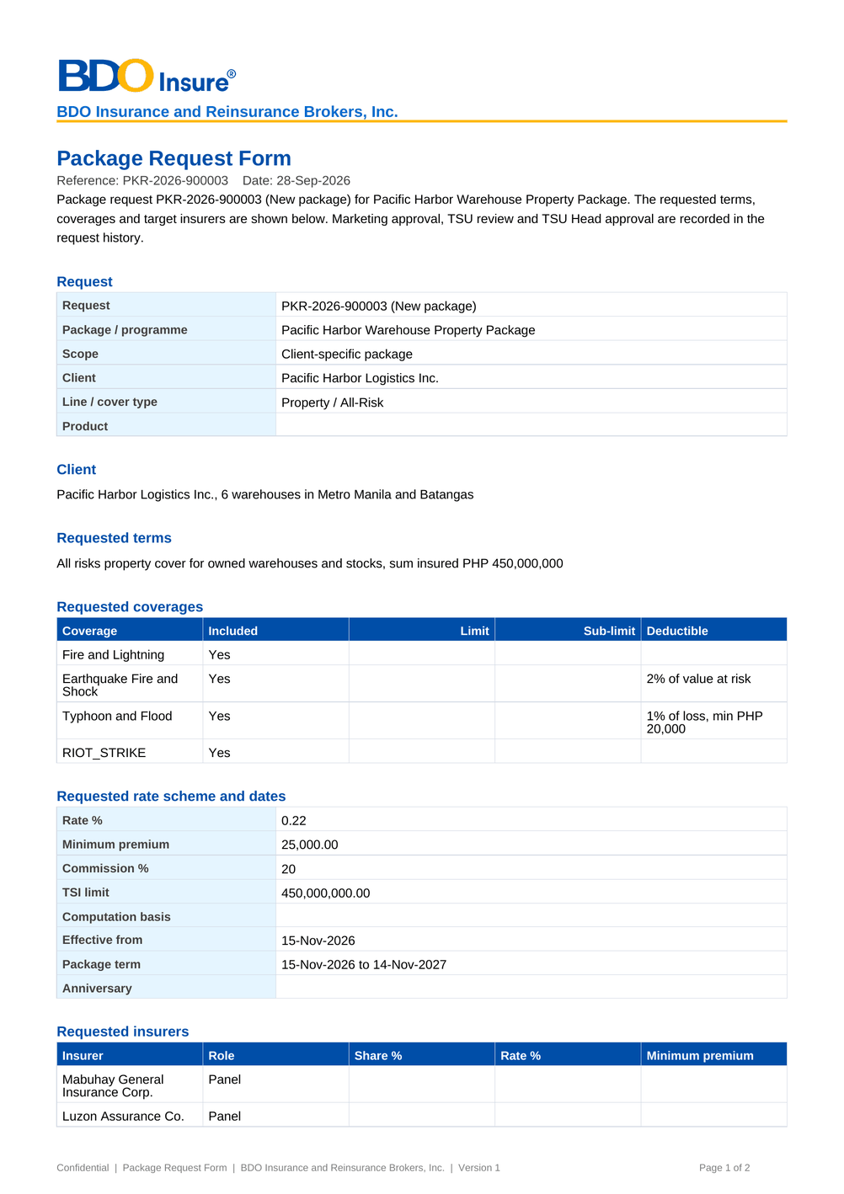
Figure 97: DO-01 Package Request Form: first page as generated

17.2 DO-02 Package quotation slip
Template | PKG_QUOTATION_SLIP
Format | PDF, one per round (the same slip to every insurer of the round)
Produced by | Negotiation tab › Quotation Slip; e-mailed at Approve and Send and at Resend
Password protected | Yes when e-mailed (password in a separate e-mail)
FRs | FR-PM-030

Fields and their source
• Slip number PQS-yyyy-nnnnnn, round, request, package, line, client or programme, reply date – from the round and the request
• Round notes – the notes of the round (What changes in this round)
• Requested terms as in DO-01
• Opening text with the slip number, round and reply date – merged from the template PKG_QUOTATION_SLIP
• Signature lines Prepared by and Approved by
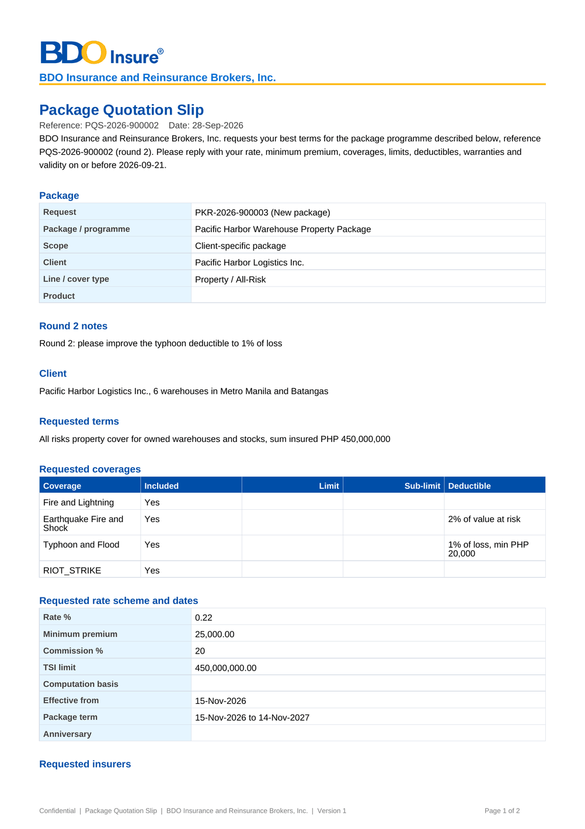
Figure 98: DO-02 Package quotation slip: first page as generated

17.3 DO-03 Comparative table (audit master and client view)
Template | PKG_COMPARATIVE
Format | PDF and Excel, one pair per stored output
Produced by | Comparative tab › PDF / Excel of each stored output
Password protected | Yes when e-mailed
FRs | FR-PM-034, FR-PM-035

Fields and their source
• Title (Audit master or the client view title), request, round – from the output
• Insurer terms: one row per insurer with the fields of the output (Outcome, Rate %, Minimum Premium, Coverages, Deductibles, Conditions / Warranties, Valid Until, Remarks) – from the insurer responses stored in the output
• Opening text with the request, round and variant – merged from the template PKG_COMPARATIVE (PDF only); the Excel file holds the table only
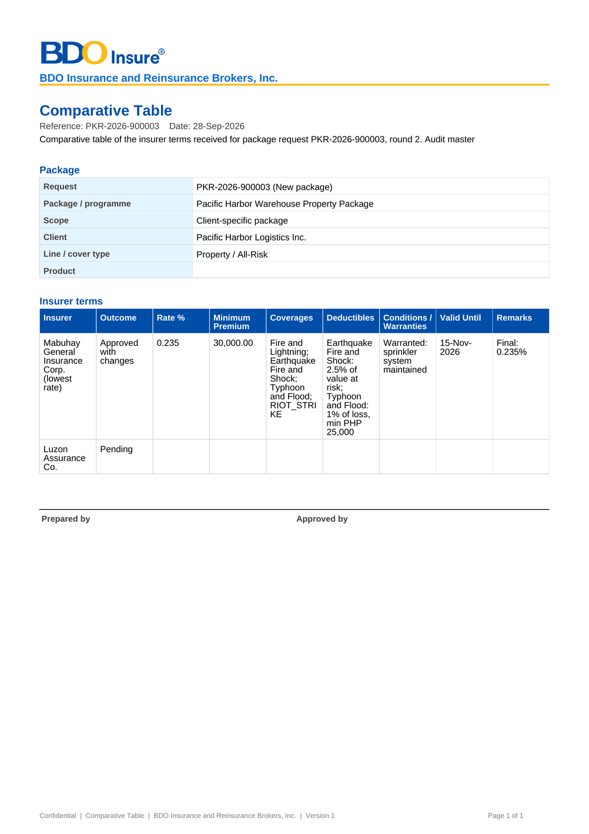
Figure 99: DO-03 Comparative table (audit master and client view): first page as generated

17.4 DO-04 Package slip
Template | PKG_SLIP
Format | PDF
Produced by | Requirements & Sign-off tab › Package Slip; printed, signed and uploaded as Package slip (signed)
Password protected | No (kept in BIBS)
FRs | FR-PM-040

Fields and their source
• Request, package, line, client or programme – from the request
• Proposed terms: coverages, rate scheme, computation basis, dates and chosen insurers with role and share – from the proposed terms
• Opening text – merged from the template PKG_SLIP; signature lines Prepared by and Approved by, signed on the printed slip
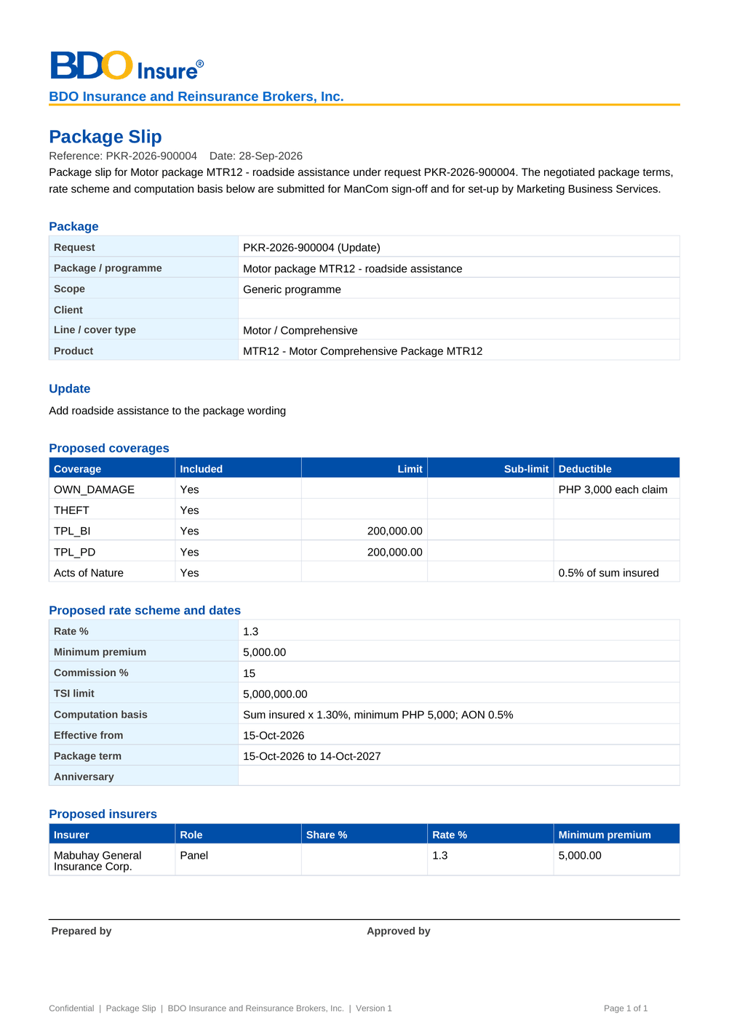
Figure 100: DO-04 Package slip: first page as generated

17.5 DO-05 ManCom sign-off record
Template | (built-in layout, ManCom Sign-off)
Format | PDF, attached as ManCom sign-off when no signed sheet was uploaded
Produced by | Automatically at Sign off and send to MBS
Password protected | No (kept in BIBS)
FRs | FR-PM-041

Fields and their source
• Package: request, package, line, client or programme – from the request
• Reference MC-PKR-yyyy-nnnnnn, Decision, Signed by, Signed at, Comment – from the ManCom decision; footer Signed in BIBS by <user>
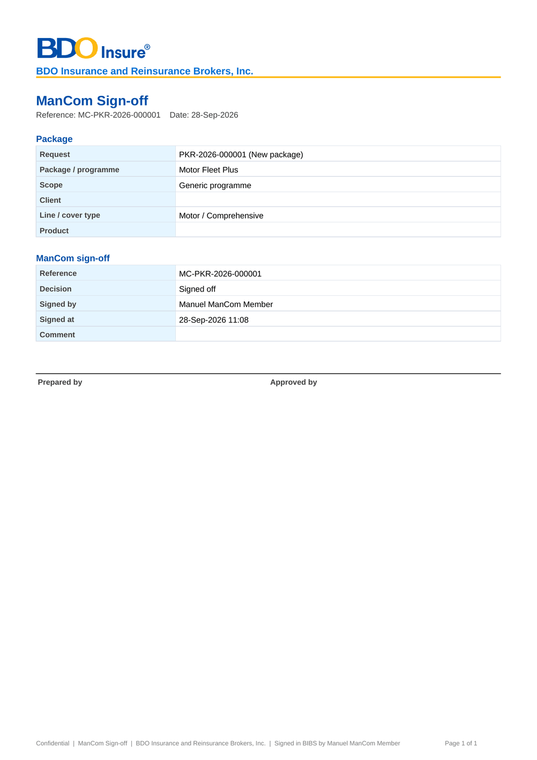
Figure 101: DO-05 ManCom sign-off record: first page as generated

17.6 DO-06 Package advisory
Template | PKG_ADVISORY (new, reactivated or updated package), PKG_RENEWAL_ADVISORY (renewed package); built-in text for a retirement
Format | PDF, stored on the request as Package advisory and e-mailed when addresses are given
Produced by | Advisories tab › Send Advisory
Password protected | Yes when e-mailed (password in a separate e-mail)
FRs | FR-PM-044

Fields and their source
• Subject and recipient groups – from the advisory as edited
• Advisory text – merged from the template with the risk code, package name, version, effective date and request number, then edited by TSU
• Supporting documents (kept in BIBS): the signed package slip and the ManCom sign-off with their file names
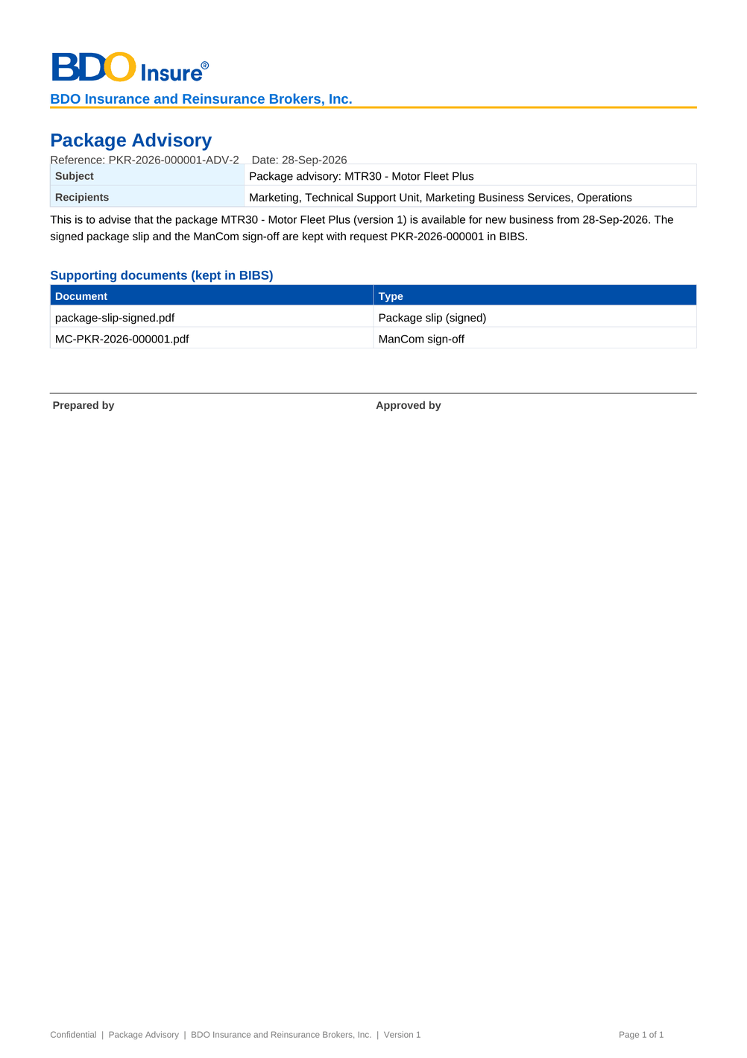
Figure 102: DO-06 Package advisory: first page as generated

18 Upload screens
Product Maintenance has no bulk upload screen. Files are added to a package request in three places, each with the file type, size, content and malware checks of every upload and with the SHA-256 fingerprint kept for audit:
Table 40: Uploads of Product Maintenance
Where | What is uploaded | Rules
Package Request record › Documents tab (and the form after the first save) | Supporting documents of the request; the signed package slip (type Package slip (signed)); the ManCom sign-off sheet (type ManCom sign-off) | The signed package slip is needed before the requirements go to ManCom and before an advisory is sent; the ManCom sign-off before an advisory is sent. Files can be named after the request number
Negotiation tab › Terms of an insurer › Response document | The insurer's reply (PDF, e-mail or image), stored with the type Insurer package terms | One file per saved response; a file that cannot be read is refused with its message
Advisories tab › Send Advisory | The advisory PDF is generated and stored by BIBS (type Package advisory) | No user upload

The product masters of go-live (lists of values, sales organisation, insurers, products, commission rates) and the package map are loaded by the data migration from the templates of chapter 19; after go-live they are changed on the screens of chapter 13 under maker-checker.

19 Configuration inputs the business provides
Product Maintenance is a setup object of Drop 0: before New Business, Renewal and the data migration can use it, BDOI provides the product catalogue, the rate tables, the packages in force, the document templates and the lists of values. Products, insurers, commission rates, lists and the sales organisation of the legacy systems are loaded by the data migration; the packages themselves are not migrated but set up by TSU and MBS through package requests, and the package map (object R06) tells Renewal which BIBS package version renews each legacy package at sanitation (check PACKAGE_REMAP). Each input has a template in the workbook of configuration input templates of this set (06). The workbook opens on a Start here sheet that lists the templates in the order they are filled in (a template whose codes others use comes first), with who provides each, when it is due, how it is loaded, the rows entered, the mandatory cells still missing and a status. Each template sheet is self-contained: its purpose, owner, due date and the templates it depends on, then directly above each column its guide (mandatory or not, format, allowed values, what to enter), one fictitious example row to overwrite, and drop-downs with the allowed values and the codes of the templates filled in before. The allowed values are listed on the sheet Reference lists; questions per template and column are raised on the sheet Questions and comments. The sections below follow the same order.
Table 41: Configuration inputs of Product Maintenance, in the order they are filled in
Step | ID | Template | Content | Provided by | Uses the codes of
1 | CI-09 | Lists of values and parameters | The values of the Product Maintenance lists (request reasons, response outcomes, advisory groups, not-proceeded reasons, incentive types, coverage kinds, clause kinds, document types, market segments) and the parameters (numbering, reply days, expiry notice, advisory groups, service levels) | Product Owner, MBS; System Administrator (entry) | -
2 | CI-01 | Product catalogue | Product lines, cover types and subtypes, and every product (risk code) with its features | Product Owner, Marketing Business System (MBS) | CI-09
3 | CI-02 | Coverages, perils and field rules | The coverage and peril level of each line, and the fields and documents each product needs on an account | MBS | CI-09, CI-01
4 | CI-03 | Clause library | Warranties, clauses, exclusions and deductible wordings used in the insurer terms of package versions | TSU (wordings); MBS (maintenance) | CI-09, CI-01
5 | CI-05 | Insurers, branches and commission rates | The insurer panel with accreditation and placement e-mails, the branches with their LGT rate, and the commission rates per product | Head of Operations; MBS (commission per package) | CI-01
6 | CI-04 | Rate tables | Statutory charges and rating factors, the short-period table and the motor BI / PD limit premiums | Product Owner, MBS; Comptrollership (taxes) | CI-01
7 | CI-10 | Incentive criteria | The incentive criteria (for example CPC2) with their value, the products matrix and the effective dates | Incentive Maintenance user (MBS); Comptrollership (CPC2 definition, PQ04) | CI-09, CI-01
8 | CI-06 | Packages in force at go-live | For every package sold at go-live: its terms as they will be set up in BIBS through a package request (TSU) and a package version (MBS): rate scheme, dates, coverages, panel insurers and their terms | TSU (prepares); Product Owner, MBS (approves) | CI-01, CI-02, CI-05, CI-03
9 | CI-07 | Package map (legacy package to BIBS package version) | Entries from each legacy package and version to the BIBS package version that renews it, with qualifiers where one legacy package splits; read at Renewal sanitation (check PACKAGE_REMAP) | TSU (prepares); Product Owner, MBS (approves each map version) | CI-01, CI-05, CI-06
10 | CI-08 | Document templates | The texts of the package documents: Package Request Form, quotation slip, comparative table, package slip, package advisory and package renewal advisory, with the merge fields each may use | TSU and MBS (texts); Business Administrator (maintenance) | -

19.1 CI-09 Lists of values and parameters
Content | The values of the Product Maintenance lists (request reasons, response outcomes, advisory groups, not-proceeded reasons, incentive types, coverage kinds, clause kinds, document types, market segments) and the parameters (numbering, reply days, expiry notice, advisory groups, service levels)
Provided by | Product Owner, MBS; System Administrator (entry)
Source | Delivered values (FRS chapter 9) confirmed or changed by BDOI
How it is loaded | Data migration object R01 for the values used by migrated records; the other values on Lists of Values and System Parameters
Uses the codes of | -
FRs | FR-PM-073, FR-PM-080

Table 42: Columns of the template Lists of values and parameters
No. | Column | Mand. | Format | Allowed values | What to enter | Example (fictitious)
1 | List or parameter | Y | Code of the list or parameter | List Product Maintenance list or parameter | For example PKG_REQUEST_REASON, PKG_SLA_NEGOTIATION | PKG_REQUEST_REASON
2 | Value code | Cond.: list | Up to 40 capitals | - | Code of the value | LOSS_EXPERIENCE
3 | Label or value | Y | Text; number for a parameter | - | Label shown to users, or the parameter value | Loss experience
4 | Order / Active | N | Number; Y or N | - | Display order and status | 50; Y
5 | Effective from | N | dd-MMM-yyyy | Date | From when the value applies | 01-Nov-2026

19.2 CI-01 Product catalogue
Content | Product lines, cover types and subtypes, and every product (risk code) with its features
Provided by | Product Owner, Marketing Business System (MBS)
Source | Legacy QPS and EBIX product lists, completed by MBS
How it is loaded | Data migration object R05 (product lines, cover types, products) through the catalogue services, pending authorisation; after go-live on Products (SCR-PM-11)
Uses the codes of | CI-09
FRs | FR-PM-010, FR-PM-012

Table 43: Columns of the template Product catalogue
No. | Column | Mand. | Format | Allowed values | What to enter | Example (fictitious)
1 | Line code | Y | Up to 30 capitals | - | Product line (level 1), for example MOTOR, PROPERTY | MOTOR
2 | Line name | Y | Text | - | Name shown in the drop-downs | Motor
3 | Risk-code pattern | N | Regular expression | - | Naming convention of the risk codes of the line, when BDOI states one | MTR[0-9]{2}
4 | Cover type code | Cond.: package products | Up to 30 capitals | - | Cover type (level 2) of the line | COMPREHENSIVE
5 | Cover type name | Cond.: with the code | Text | - | Name of the cover type | Comprehensive
6 | Parent cover type | N | Cover type code | Codes of CI-01 Product catalogue (Cover type code) | Only for a subtype (one level below a cover type) | -
7 | Risk code | Y | 1 to 20 capitals or digits | - | Product code (level 3); unique | MTR30
8 | Product name | Y | Up to 200 characters | - | Name shown to users | Motor Fleet Plus
9 | Legacy code | N | Text | - | Code of the product in QPS or EBIX, for the migration map | QPS-MFP
10 | Package | Y | Y or N | Y or N | Y for a package product (terms change through versions) | Y
11 | Market segments | N | Codes separated by commas; blank = all | List Market segment (one or more) | Segments the product is offered to (list MARKET_SEGMENT) | COMBANK
12 | Placement after | Y | PAID or CLIENT_CONFIRMATION | List Placement after | Payment gate before placement | PAID
13 | TSU review | N | BY_RULES, ALWAYS or NEVER | List TSU review | When TSU reviews an account of the product | BY_RULES
14 | Default rate % | N | Up to four decimals | Number 0 to 100 | Rate of a non-package product; for a package, of version 1 | 1.2000
15 | Default commission % | Y | Percentage | Number 0 to 100 | Commission when no insurer rate applies | 15
16 | Minimum premium | Y | Amount in PHP | Number | Minimum premium of the product | 5000.00
17 | Package TSI limit | N | Amount in PHP | Number | Above it the account goes to TSU | 5000000.00
18 | Fleet | N | Y or N | Y or N | Several vehicles on one account | Y
19 | Mortgage related | N | Y or N | Y or N | Mortgage or loan related | N
20 | Direct payment allowed | N | Y or N | Y or N | Premium may be paid directly to the insurer | N
21 | Multi-year / Maximum term | N | Y or N; 2 to 10 years | - | Multi-year term and its maximum | N
22 | Free First Year | N | Y or N | Y or N | Free First Year eligible | N

19.3 CI-02 Coverages, perils and field rules
Content | The coverage and peril level of each line, and the fields and documents each product needs on an account
Provided by | MBS
Source | MBS and TSU (product matrix, PQ02)
How it is loaded | Entered on Coverages & Clauses (SCR-PM-15) and on the rule tabs of Products (SCR-PM-11, SCR-PM-12) before UAT; not migrated
Uses the codes of | CI-09, CI-01
FRs | FR-PM-010, FR-PM-012, FR-PM-013

Table 44: Columns of the template Coverages, perils and field rules
No. | Column | Mand. | Format | Allowed values | What to enter | Example (fictitious)
1 | Record | Y | COVERAGE, FIELD_RULE or DOCUMENT_RULE | List Coverage and rule record | What the row defines | COVERAGE
2 | Line code / Risk code | Y | Line or product the row applies to; * = every product | Codes of CI-01 Product catalogue (Risk code) | Scope of the row | MOTOR
3 | Code or field key | Y | A-Z, 0-9 and _ (coverage); field key (rule) | - | Coverage code or the account field checked | OD_THEFT
4 | Name or label | Y | Text | - | Coverage name or field label | Own damage and theft
5 | Kind or check | Y | Coverage kind (Section, Coverage, Peril, Extension); check (Presence, List of values, Number range, Format) | - | Coverage kind or rule check | Coverage
6 | Basic | Cond.: coverage | Y or N | Y or N | A package needs at least one basic coverage | Y
7 | Parameters | Cond.: list, range or format rules | List code; minimum and maximum; pattern | - | Parameters of the check | -
8 | Document type | Cond.: document rule | List DOCUMENT_TYPE | List Document type | Document an account needs before submission | -
9 | Mandatory | Y | Y or N | Y or N | Required or optional | Y

19.4 CI-03 Clause library
Content | Warranties, clauses, exclusions and deductible wordings used in the insurer terms of package versions
Provided by | TSU (wordings); MBS (maintenance)
Source | Current package slips and insurer wordings
How it is loaded | Entered on Coverages & Clauses › Clause Library (SCR-PM-15); not migrated
Uses the codes of | CI-09, CI-01
FRs | FR-PM-011

Table 45: Columns of the template Clause library
No. | Column | Mand. | Format | Allowed values | What to enter | Example (fictitious)
1 | Clause code | Y | A-Z, 0-9 and _ | - | Unique code | FLEET_REPAIR
2 | Kind | Y | WARRANTY, CLAUSE, EXCLUSION or DEDUCTIBLE_WORDING | List Clause kind | Code of the list CLAUSE_KIND | CLAUSE
3 | Line code | N | Line code; blank = every line | Codes of CI-01 Product catalogue (Line code) | Lines the clause is offered for | MOTOR
4 | Title | Y | Text | - | Title shown in the pickers | Accredited repair shops for fleets
5 | Wording | Y | Full text | - | Wording printed on the package documents | Repairs are made at the accredited shops of the insurer...
6 | Effective from / to | Y (from) | dd-MMM-yyyy | - | Validity of the wording | 01-Jan-2027

19.5 CI-05 Insurers, branches and commission rates
Content | The insurer panel with accreditation and placement e-mails, the branches with their LGT rate, and the commission rates per product
Provided by | Head of Operations; MBS (commission per package)
Source | Legacy QPS and EBIX insurer masters
How it is loaded | Data migration objects R04 (insurers, branches, business partners) and R07 (commission rates); after go-live on Insurers (SCR-PM-17, SCR-PM-18)
Uses the codes of | CI-01
FRs | FR-PM-014

Table 46: Columns of the template Insurers, branches and commission rates
No. | Column | Mand. | Format | Allowed values | What to enter | Example (fictitious)
1 | Partner code | Y | INS- followed by capitals | - | Insurer code; unique | INS-MGIC
2 | Name / Short name | Y (name) | Text | - | Registered and short name | Mabuhay General Insurance Corp.
3 | TIN / Address | N | 000-000-000-000; text | - | Business partner details | 123-456-789-000
4 | IC accreditation no. / Accredited until | N | Text; dd-MMM-yyyy | - | Insurance Commission accreditation | IC-2026-001; 31-Dec-2027
5 | Placement e-mails | Y for package insurers | Addresses separated by commas | - | Where quotation and placement slips are sent | placement@insurer.example
6 | Credit days | N | 0 to 365 | Whole number 0 to 365 | Default credit days | 30
7 | Branch code / Branch name / City | Cond.: branch rows | Text | - | Branch of the insurer | MKT; Makati; Makati City
8 | LGT % | Cond.: branch rows | 0 to 100 | Number 0 to 100 | Local government tax on premium | 0.5000
9 | Commission product / Commission % / From / To | Cond.: commission rows | Risk code or blank for all; percentage; dd-MMM-yyyy | Codes of CI-01 Product catalogue (Risk code) | Commission rate of the insurer | MTR30; 15; 01-Jan-2028; -

19.6 CI-04 Rate tables
Content | Statutory charges and rating factors, the short-period table and the motor BI / PD limit premiums
Provided by | Product Owner, MBS; Comptrollership (taxes)
Source | BIR and LGU rates; current rating tables
How it is loaded | Entered on Rates & Taxes (SCR-PM-19), pending authorisation; not migrated (effective-dated from go-live)
Uses the codes of | CI-01
FRs | FR-PM-051

Table 47: Columns of the template Rate tables
No. | Column | Mand. | Format | Allowed values | What to enter | Example (fictitious)
1 | Table | Y | TAX, SHORT_PERIOD or MOTOR_LIMIT | List Rate table | Table of the row | TAX
2 | Rate | Cond.: TAX | DST, premium tax, VAT, fire service tax, motor factors | - | Charge or factor | DST
3 | Line code | N | Line; blank = every line | Codes of CI-01 Product catalogue (Line code) | Line the rate applies to | -
4 | Rate % | Cond.: TAX, SHORT_PERIOD | Up to four decimals, 0 to 100 | Number 0 to 100 | Rate, or % of the annual premium | 12.5000
5 | Months covered | Cond.: SHORT_PERIOD | 1 to 12 | Whole number 1 to 12 | Months covered, up to | 6
6 | Coverage / Limit / Premium | Cond.: MOTOR_LIMIT | BI or PD; amounts in PHP | - | Limit and its premium | BI; 100000.00; 350.00
7 | Effective from / to | Y (from) | dd-MMM-yyyy | - | Validity of the row | 01-Jan-2028

19.7 CI-10 Incentive criteria
Content | The incentive criteria (for example CPC2) with their value, the products matrix and the effective dates
Provided by | Incentive Maintenance user (MBS); Comptrollership (CPC2 definition, PQ04)
Source | Current incentive programmes; the booking incentive rules copied into the catalogue
How it is loaded | Entered on Incentive Criteria (SCR-PM-16), pending authorisation; the copied booking rules are reviewed there
Uses the codes of | CI-09, CI-01
FRs | FR-PM-080

Table 48: Columns of the template Incentive criteria
No. | Column | Mand. | Format | Allowed values | What to enter | Example (fictitious)
1 | Code / Name | Y | A-Z, 0-9, _ and -; text | - | Criterion | CPC2; CPC2 campaign 2028
2 | Incentive type | Y | List INCENTIVE_TYPE | List Incentive type | Type of criterion | CAMPAIGN
3 | Value basis / Value | Y (basis) | Rate (%), Fixed amount or Rule; number | - | Value of the criterion | Rate (%); 1.00
4 | Rule parameters | N | Parameter and value pairs separated by semicolons | - | Parameters of a rule criterion, as agreed with Comptrollership | Minimum premium 5000
5 | Products matrix: risk code / segment | Y (one product) | Active risk codes; segment or blank | Codes of CI-01 Product catalogue (Risk code) | Products and segments the criterion applies to | MTR30; COMBANK
6 | Effective from / to | Y (from) | dd-MMM-yyyy | - | Validity; no overlap with another row of the code | 01-Jan-2028

19.8 CI-06 Packages in force at go-live
Content | For every package sold at go-live: its terms as they will be set up in BIBS through a package request (TSU) and a package version (MBS): rate scheme, dates, coverages, panel insurers and their terms
Provided by | TSU (prepares); Product Owner, MBS (approves)
Source | Signed package slips and ManCom sign-offs in force
How it is loaded | Not migrated: TSU raises a package request per package (type New package, or Update for an existing risk code) and MBS sets up and validates the version before the map freeze; the Package Request Form accepts the same fields
Uses the codes of | CI-01, CI-02, CI-05, CI-03
FRs | FR-PM-020, FR-PM-042, FR-PM-050

Table 49: Columns of the template Packages in force at go-live
No. | Column | Mand. | Format | Allowed values | What to enter | Example (fictitious)
1 | Risk code | Y | Code of CI-01 | Codes of CI-01 Product catalogue (Risk code) | Package product | MTR30
2 | Package name / Scope / Client code | Y (name, scope) | Text; Generic or Client-specific; client code | - | As on the Package Request Form | Motor Fleet Plus; Generic
3 | Effective from / Package start / Package end / Anniversary | Y (effective from, package end) | dd-MMM-yyyy | - | Dates of the version | 01-Jan-2028; 01-Jan-2028; 31-Dec-2028; -
4 | Package rate % / Minimum premium / Commission % / Package TSI limit | Y (minimum, commission; rate or insurer rates) | Percentages and PHP amounts | - | Rate scheme of the version | 1.2000; 5000.00; 15; 5000000.00
5 | Computation basis | Y | Text | - | How the premium is computed | Comprehensive rate on the vehicle value
6 | Coverage code / Included / Optional / Limit / Deductible | Y (one basic coverage) | Codes of CI-02; Y or N; PHP | Codes of CI-02 Coverages, perils and field rules (Code or field key) | Coverages of the version | OD_THEFT; Y; N; -; 2000.00
7 | Insurer code / Role / Share % / Rate % / Minimum premium | Y (the panel) | Codes of CI-05; Panel, Lead or Participant; shares total 100 | Codes of CI-05 Insurers, branches and commission rates (Partner code) | Panel insurers | INS-MGIC; Panel; -; 1.2000; -
8 | Insurer terms: insurer / coverage / limit / deductible / clauses | Y (every insurer and included coverage) | Codes of CI-03 separated by commas | Codes of CI-03 Clause library (Clause code) | Terms per insurer and coverage | INS-MGIC; OD_THEFT; -; 2000.00; FLEET_REPAIR
9 | ManCom sign-off reference / Signed package slip | Y | Reference; the signed slip file | - | Evidence kept on the request | MC-2026-017

19.9 CI-07 Package map (legacy package to BIBS package version)
Content | Entries from each legacy package and version to the BIBS package version that renews it, with qualifiers where one legacy package splits; read at Renewal sanitation (check PACKAGE_REMAP)
Provided by | TSU (prepares); Product Owner, MBS (approves each map version)
Source | QPS package list of the in-force policies expiring from go-live
How it is loaded | Data migration object R06 (loaded as reference data and handed to the Renewal package map); new map versions until the map freeze (T-7), then maintained in Renewal
Uses the codes of | CI-01, CI-05, CI-06
FRs | FR-PM-050, FR-PM-061

Table 50: Columns of the template Package map (legacy package to BIBS package version)
No. | Column | Mand. | Format | Allowed values | What to enter | Example (fictitious)
1 | Legacy package code / Legacy version | Y | As stored in QPS | - | Package of the legacy policy headers | PKG-MOTOR-FLEET; 3
2 | Legacy package name | N | Text | - | For reading only | Motor fleet package 2025
3 | Qualifier: risk code | N | Risk code of CI-01 | Codes of CI-01 Product catalogue (Risk code) | When one legacy package maps to several BIBS packages by product | MTR30
4 | Qualifier: insurer | N | Partner code of CI-05 | Codes of CI-05 Insurers, branches and commission rates (Partner code) | When the split is by insurer | -
5 | Qualifier: sum insured from / to | N | PHP amounts | - | When the split is by sum-insured band | -
6 | BIBS risk code / BIBS version | Cond.: action MAP | A package version active in Product Maintenance | Codes of CI-06 Packages in force at go-live (Risk code) | Target of the entry | MTR30; 1
7 | Action | Y | MAP or REJECT | List Package map action | REJECT sends the candidate to the Renewal Exception bucket | MAP
8 | Remarks | N | Text | - | Reason of a REJECT or a split | -

19.10 CI-08 Document templates
Content | The texts of the package documents: Package Request Form, quotation slip, comparative table, package slip, package advisory and package renewal advisory, with the merge fields each may use
Provided by | TSU and MBS (texts); Business Administrator (maintenance)
Source | BDOI layouts of the current documents (Q03)
How it is loaded | Entered on Document Templates (New Business set, SCR-NB-44) as a new template version effective from a date; not migrated
Uses the codes of | -
FRs | FR-PM-013

Table 51: Columns of the template Document templates
No. | Column | Mand. | Format | Allowed values | What to enter | Example (fictitious)
1 | Template | Y | PKG_REQUEST_FORM, PKG_QUOTATION_SLIP, PKG_COMPARATIVE, PKG_SLIP, PKG_ADVISORY, PKG_RENEWAL_ADVISORY | List Package document template | Template code | PKG_ADVISORY
2 | Title | Y | Text | - | Title of the template version | Package advisory
3 | Text | Y | Text with merge fields in double braces | - | Opening text of the document | This is to advise that the package {{productCode}} - {{productName}} ...
4 | Merge fields used | N | PKG_REQUEST_FORM: reference, requestType, title; PKG_QUOTATION_SLIP: reference, roundNo, replyBy; PKG_COMPARATIVE: reference, roundNo, variant; PKG_SLIP: reference, title; advisories: productCode, productName, versionNo, effectiveFrom, reference | - | Fields filled in by BIBS | productCode, productName, versionNo, effectiveFrom, reference
5 | Effective from | Y | dd-MMM-yyyy | Date | Date from which the version is used | 01-Nov-2026

20 Cross-BRD dependencies and interface contract
Product Maintenance is the source of the products, package versions, rate schemes, rules and incentive criteria that the selling and servicing BRDs use, and it takes its clients, templates, users and go-live load from other BRDs. The contract below lists each exchange: the BRD or system, the direction, what is exchanged, when and how, and who owns the data. Chapter 7 describes the interfaces with the external systems.
Table 52: Interface contract of Product Maintenance
ID | BRD or system | Direction | What | When and how | Owner of the data | FR
IC-01 | BRD-1 New Business | Out | Product lines, cover types and products (risk codes) with their flags (package, fleet, mortgage related, direct payment allowed, multi-year and maximum term, Free First Year), market segments, payment gate and TSU review setting | Read when a quotation, PRF or account is created or saved; only authorised, active and sellable products of the segment are offered | MBS (maintained in Product Maintenance, authorised by the Business Administrator or the New Business Approver) | FR-PM-010, FR-PM-050
IC-02 | BRD-1 New Business | Out | The package version in force (rate scheme, minimum premium, commission, TSI limit, panel insurers with their own rates) for new business pricing; the version number is stored on the quotation, the account and the booked invoice | Every premium computation of a quotation or account prices a package on the version in force on the transaction date; submission is refused for a superseded version or a differing item rate without an approved rate exception | MBS (set-up), TSU Head or Business Administrator (validation) | FR-PM-051, FR-PM-043
IC-03 | BRD-1 New Business | Out | Rate exceptions approved for one transaction (quotation number or ARN) | Requested on the quotation, decided in My Approvals by PRODUCT_AUTHORIZE, stored on the quotation and passed to the accounts created from it | The approver of the exception | FR-PM-051
IC-04 | BRD-1 New Business | Out | Field rules and document rules per product (presence, list of values, number range, format), TSU routing rules and the package TSI limit | Checked when an account or PRF is submitted; the TSI limit and TSU rules decide the TSU route | Business Administrator and MBS (authorised) | FR-PM-012, FR-PM-013
IC-05 | BRD-1 New Business | In | Clients of client-specific packages; the Document Templates screen that holds the package templates; the workflow, documents, e-mail and report platform | A client-specific request picks an active client of the client master; package documents are merged from the templates PKG_REQUEST_FORM, PKG_QUOTATION_SLIP, PKG_COMPARATIVE, PKG_SLIP, PKG_ADVISORY and PKG_RENEWAL_ADVISORY | Marketing (clients); Business Administrator (templates) | FR-PM-020, FR-PM-013
IC-06 | BRD-6 Renewal | Out | Package versions for renewal pricing (purpose Renewal) and the sellable check of a product at renewal | A renewal priced as is keeps the expiring account's package version while it is released or superseded; an expired package with no current version is refused (check PRODUCT_RENEWABLE); Renewal uses these catalogue rules | MBS; TSU | FR-PM-050, FR-PM-051, FR-PM-052
IC-07 | BRD-6 Renewal and BRD-13 Data Migration | Out | The BIBS package versions named as targets of the package map (legacy package and version to BIBS package version) that the data migration loads (object R06) and the Renewal sanitation check PACKAGE_REMAP reads | TSU prepares each map version and the Product Owner of Marketing Business System approves it; every target must be a package version active in Product Maintenance; a legacy package without an entry sends the renewal candidate to the Exception bucket, where the Renewal processing team chooses the package and the choice goes back to TSU for the next map version | TSU (map and packages); Product Owner, MBS (approval) | FR-PM-050, FR-PM-061
IC-08 | BRD-8 Employee Benefits | Out | EB product lines (HMO, group life, group personal accident), EB products and HMO providers as panel insurers with commission rates | Configuration only, maintained through Product Maintenance; read when an EB programme is set up and priced | MBS; Business Administrator (insurers) | FR-PM-010, FR-PM-014
IC-09 | BRD-12 Submitted Policies | Out | Products and the package TSI limit of a product | Read when a submitted policy is recorded and checked against the limit; insurer acceptance limits stay in Submitted Policies until Product Maintenance takes them over | MBS | FR-PM-010
IC-10 | BRD-1 Booking and BRD-2 Operations | Out | Incentive criteria (for example CPC2) matched at booking; the package version of the account for endorsements and adjustments | Booking stores on each invoice the codes of the criteria matching product, cover type, segment, channel, lead insurer and booking date; endorsements and Operations adjustments re-rate with purpose Endorsement on the account's version | MBS (criteria, authorised by PRODUCT_AUTHORIZE) | FR-PM-080, FR-PM-081
IC-11 | BRD-5 Accounting (remittance and commission) | Out | Incentive criteria codes for commission incentive schemes and the CPC2 remittance incentive; insurer commission rates | Read by remittance per batch line and by the commission schemes, which reference the criteria code instead of product lists of their own | MBS; Business Administrator (commission rates) | FR-PM-080, FR-PM-081
IC-12 | BRD-11 User Access Maintenance | In | Users, roles and the role-to-action matrix of Product Maintenance; role-permission change requests | A role change is requested, approved by someone other than the requester and applied; the User Access Matrix shows Product Maintenance by permission and by action class | System Administrator; access approvers | FR-PM-002, FR-PM-003
IC-13 | BRD-13 Data Migration | In | The go-live load of the product masters from the legacy systems (QPS, EBIX) - lists of values (R01), sales organisation (R03), insurers and branches (R04), product lines, cover types and products (R05), commission rates (R07) - through the catalog services under maker-checker; the package map (R06) as in IC-07 | Loaded in the data migration mocks and at cut-over from the extract templates of the Data Requirements Workbook; the BIBS packages themselves are not migrated but set up by TSU and MBS in Product Maintenance before the map freeze | Product Owner, MBS (R01, R05, R06); Heads of Marketing (R03); Head of Operations (R04, R07) | FR-PM-010, FR-PM-050
IC-14 | Other BDOI systems (product master feed) | Out | Released, expired and retired package versions | Published to the product master port on release and expiry; the connection to the BDOI systems waits for their specification, so the port only records the change today | BDOI IT (receiving systems) | FR-PM-072

Change against this signed set. Product Maintenance is the source of the products, package versions and rate schemes that every selling and servicing BRD prices on. A later change in any of those BRDs that touches a line of this contract (a new product attribute, a different version rule, another rating purpose, a new incentive criterion basis) is raised as a change request against this signed set in the Change Management Register, assessed with its mandays and approved by the owners of both BRDs; the affected pages of this set are then re-issued and signed as a delta.

21 Sign-off and change control

21.1 What is signed
The business sign-off covers the release set BRD-03 Product Maintenance v2.0:
Table 53: Documents of the release set
Document | Content
Start Here guide | The map of the set, who reads what, the steps and the dates
Sign-off Pack Guide deck | Purpose, approach, the module at a glance, caveats, entry and exit criteria, change control
This FRS v2.0 | Requirements (chapters 1-11), the business view of the system (chapters 12-21) and the proposed rules for confirmation (chapter 22)
Sign-off workbook v2.0 | The screens, fields, actions, rules, messages, notifications, menus and contract of this FRS, one row each, with the BU review columns
Test plan v2.0 | The test cases traced to the FRs and to the screens of chapter 13
Configuration input templates | The templates of chapter 19

Table 54: The set in numbers
Content of the set | Count
Screens specified | 22
Fields and columns described | 324
Actions described | 104
Business rules on screens | 81
Messages (server, screen and upload row) | 275
Notifications and e-mails | 11
Upload types | 0
Generated documents | 6
Walkthroughs | 2
Interface contract lines | 14
Personas with their menus | 11

21.2 How the review is recorded
Each business unit records its review in the sign-off workbook: Accept, Change requested or Comment on each row of the screen catalogue, field register, business rules and messages, with the comment, the reviewer and the date. The project team answers every Change requested row before sign-off: either the row is corrected in the next version of the set, or the change is raised as a change request (below) and the row is signed as specified.

21.3 What signing freezes
Signing this release set freezes, for Product Maintenance:
• the screens and their navigation (chapters 12 and 13), the fields with their order, labels, types, mandatory rules, lists and validations;
• the actions with their conditions and resulting statuses, and the business rules;
• the messages (chapter 15), the notifications (chapter 16) and the generated documents (chapter 17);
• the configuration input templates (chapter 19) and the interface contract with the other BRDs (chapter 20).
The content of the configuration (products, versions, rates, clauses, templates, list values, parameters such as the service level hours) is not frozen: the business maintains it in the system under maker-checker without a change request.

21.4 Change after sign-off
A change to anything frozen is raised in the Change Management Register. The request states the screen, field, rule or message concerned, the reason and the business priority. The project team assesses it with its mandays, including its effect on the other BRDs through the interface contract of chapter 20, and the owners of every BRD it touches approve it. An approved change is delivered as a new version of this release set (v2.1, v2.2 and so on), and the changed rows are reviewed again.

21.5 Proposed rules for confirmation
Chapter 22 lists the proposed business rules and screen behaviour that differ from the BRD or need a decision of BDOI. BDOI records its decision on each item with its review; a decision that changes a screen, field, rule or message is applied in the next version of this set.

21.6 Signatures
By signing, BDOI confirms that this FRS and the sign-off workbook describe the Product Maintenance functions, screens and messages it expects in BIBS, accepts the assumptions in section 10.1 and records its decisions on the items of chapter 22. Open questions in section 10.3 stay open; their answers are applied as configuration or through a change request.
Name | Role | Organisation | Signature | Date
 | Product Owner, Marketing Business System | BDOI
 | Head, Marketing Business Services and System Support | BDOI
 | Head, Technical Support Unit | BDOI
 | Head, Retail Marketing | BDOI
 | Head, Comptrollership | BDOI
 | Program Manager, Business Project Services | BDO Unibank ESG
 | Project Manager | iorta TechNXT

22 Proposed business rules and clarifications for confirmation
The table lists each point where the proposed screen or rule differs from the BRD text, or where BIBS needs a decision of BDOI to complete the rule. Each item names the proposed behaviour, the reason and the decision requested. BDOI records its decision with the review of this set (section 21.5); a decision that changes a screen, field, rule or message is applied in the next version of the set, and an answer that only sets a value (a list, a parameter, a template) is applied as configuration.
Table 55: Proposed business rules and clarifications for confirmation
Ref | Topic | Proposed rule or screen behaviour | Reason | Decision requested from BDOI
CLR-PM-01 | Risk-code naming per line (BRPM.003, PMADD01; FR-PM-010) | Each product line can carry a risk-code pattern. BIBS refuses a new risk code that does not follow the pattern of its line. Until BDOI states the conventions, no pattern is set and every well-formed code is accepted. | The naming convention of each line is not in the BRD (PQ02). | State the naming convention of each line (PQ02).
CLR-PM-02 | Package documents (BRPM.005; FR-PM-013, 030) | Package documents are produced from versioned templates in draft layouts; BDOI's layouts are loaded as new template versions. The quotation slip is one document per round, e-mailed separately to each insurer. A package brochure is not among the generated documents. | BDOI's layouts are not yet provided (Q03); the BRD does not define a brochure. | Provide the layouts (Q03). Confirm one quotation slip per round sent separately to each insurer, and that no brochure is generated.
CLR-PM-03 | Marketing approval (BRPM.008, 021; FR-PM-021) | One Marketing approval stage: any holder of the approval permission other than the maker approves. | The BRD names the TL, TH or UH without an order or a limit (PQ08). | Confirm one approval by any of the TL, TH or UH, or give the approval chain by segment or amount (PQ08).
CLR-PM-04 | Deletion of a package (BRPM.011; FR-PM-045) | A package is retired, not deleted. The product and its versions stay readable for the policies sold on them. | Records are kept for audit and for the accounts that use the package (A-PM-05, PQ13). | Confirm retirement in place of deletion.
CLR-PM-05 | ManCom sign-off (BRPM.015; FR-PM-041) | The sign-off of one ManCom member in BIBS completes the step. An uploaded signed sheet is linked to the request; without it BIBS generates a sign-off record. | ManCom membership and quorum are not in the BRD (PQ07). | Confirm that one member's sign-off completes the step, or give the quorum (PQ07).
CLR-PM-06 | Advisories (BRPM.016; FR-PM-044) | Each advisory is an in-app notice to the users of each recipient group, chosen by permission; the protected PDF is also e-mailed when addresses are entered. | The recipients and the channel are not in the BRD (PQ12). | Name the recipient units and confirm the channel (PQ12).
CLR-PM-07 | Expiry and incentive alerts (BRPM.017, PMADD08; FR-PM-060, 081) | The alerts are raised in the Alert inbox (System Administrator, Auditor) and sent to TSU and MBS as in-app notices. | The BRD names TSU and MBS as recipients but no channel. | Confirm in-app notices to TSU and MBS as the channel of these alerts.
CLR-PM-08 | Package Status Update Report (BRPM.018; FR-PM-071) | Report PM-PKG-STATUS with draft columns, separate from the BRD-1 Placement Update Report. | The report name and columns are not in the BRD (PQ15). | Give the report name and columns (PQ15).
CLR-PM-09 | Password of protected documents (BRPM.020; FR-PM-004) | A password is generated for each e-mail and sent in a separate e-mail. | BDOI's password convention is not yet given (Q07, PQ21). | Confirm the generated password or give the convention (Q07, PQ21).
CLR-PM-10 | Synchronisation with BDOI systems (BRPM.022; FR-PM-072) | BIBS records every release and expiry in the product master log. The transfer to the receiving systems starts when BDOI names them. | The receiving systems, the format and the timing are not in the BRD (PQ16). | Name the systems, the format and the timing (PQ16).
CLR-PM-11 | Client-tailored comparative (PMADD03; FR-PM-035) | TSU chooses from a fixed catalogue of eight fields: Outcome, Rate %, Minimum Premium, Coverages, Deductibles, Conditions / Warranties, Valid Until and Remarks. | The fields of the client views are not in the addendum (PQ06). | Confirm the eight fields or give the fields (PQ06).
CLR-PM-12 | Client view without a field selected (FR-PM-035) | BIBS requires a title and at least one insurer for a client view; the field selection is not checked, so a view can show the insurers without comparison fields. | The addendum does not say whether a view needs at least one field. | Confirm whether a client view must have at least one field.
CLR-PM-13 | Master comparative before responses (BRPM.014; FR-PM-034) | BIBS refuses the master until the quotation slip of the round is sent. After that, a round whose insurers are all Pending gives a master with Pending rows, which TSU can share as a status view. | The BRD does not say when the master can first be compiled. | Confirm that a master with Pending rows is acceptable.
CLR-PM-14 | Package remapping at migration (BRD-13 BRID 3.1; FR-PM-050) | Legacy packages are mapped to BIBS package versions in the package map (migration object R06), which the Renewal check PACKAGE_REMAP uses. Product Maintenance provides the package versions that the map names. | Renewals of migrated policies must use BIBS package versions (BDOI answers DMQ36-DMQ38 of 26-Sep-2026). | Confirm that Product Maintenance provides the versions and that the map is prepared with the data migration.
CLR-PM-15 | Bulk upload of product masters (FR-PM-010, 014) | No bulk upload screen in Product Maintenance. The go-live load runs through the data migration (objects R01, R03-R05, R07); later changes are made on the screens under maker-checker. | Package volumes after go-live are low (A-PM-08). | Confirm that no bulk upload of product masters is needed after go-live.
CLR-PM-16 | Escalation beyond the stage owners (BRPM.021; FR-PM-073) | A request past its SLA alerts the owners of its stage and shows in the red tiles of the home page. It is not escalated to a higher level. | The BRD does not ask for escalation beyond the stage owners. | Confirm that no escalation to the unit head is needed.
CLR-PM-17 | Main path of the package request stepper | The stepper shows the main path from Draft Request to Released, through the stages of the request in their order; a returned request shows the stage it went back to in amber, and a voided or not proceeded request ends in red. | One path keeps the stepper readable. | Confirm the stage list of the package request.
CLR-PM-18 | Scheme rate compared in a rate exception (FR-PM-051) | The Scheme Rate of the Rate Exceptions table and of the exception record is the package rate of the version in force that priced the quotation, not the panel insurer's rate. | An exception is approved against the package scheme. | Confirm the rate the requested rate is compared with.
CLR-PM-19 | Difference column format (FR-PM-051) | The difference is shown in percentage points with its sign and two decimals (for example -0.10). | A percentage of the rate would read as a second rate. | Confirm percentage points with the sign.
CLR-PM-20 | Full status labels | Stages and statuses show their full label (for example Requirements Preparation, Pending Authorization); a short form with the full label in the tooltip is used only above 21 characters. | The client asked for full labels where they fit (27-Sep-2026). | Confirm full labels and the short forms of the longer ones.

23 Appendix: Screen standards
The Product Maintenance screens follow the screen standards of BIBS. They are listed here, in the same words in every FRS, so that BDOI can agree the look of the screens once and check the screenshots against it; they are not repeated in each screen specification.
Table 56: Screen standards of BIBS
Area | Standard
Record pages | Back arrow and breadcrumb, title, then the record header: name, reference chips, status pill, tags (for example a client tag such as BDO employee) and the key facts. Page actions on the right in one order: secondary, primary, and the destructive action last and apart.
Workflow header (step bar) | Every record with a workflow shows a stepper under the record header: the stages of the main path in their order, passed stages ticked in blue, the current stage highlighted, the stages ahead in grey with their number. A returned or on-hold stage shows in amber after the stage it came from; a rejected, cancelled or voided record shows that stage in red and the path ends there; the last stage turns green when it is reached. Under the stepper one row gives Current Stage, Since, Due (with the Overdue pill) and Assigned To, with the actions of the stage on the right. The history is a table (Stage, From Stage, Action, By, Date and Time, Remarks, Duration in Stage), newest first.
Messages (notice standard) | One standard for errors, warnings, information and success: a white notice with a thin bar and an icon in the colour of its kind (red, amber, blue, green), a bold short title, then the business message with one bullet per missing item. No codes, internal references or technical terms in what the user reads. Field errors appear under the field; a long form lists its errors at the top with a link to the first field. Only an unexpected system error offers Retry and a reference for support behind Details. Special instructions are one short information notice.
Tables, not highlight boxes | Records and lists of records are rows of a titled table (for example the Rate Exceptions of a quotation: Exception No., Requested Rate, Scheme Rate, Difference, Valid Until, Requested By, Decided By, Status); key data is a label and value grid. A coloured box carries a short message only, never a record.
Tables | Header row in BDO blue that stays in view; text left, amounts right, dates in one format; one value per cell with at most one muted line under it; a dash for an empty value; "Showing x to y of n results" with page numbers.
Status labels | Statuses are pills of one size and one colour per state group and never wrap. The full label is shown (for example Returned to Marketing, Pending Authorization); an agreed short form, with the full label in the tooltip, only for a label longer than 21 characters.
Labels and names | List values are shown by their label, never by their code; products by name with the code as a second line; insurers by name; users by their names, never by their user ID.
Dates, amounts and rates | One date picker; dates entered and shown as dd-MMM-yyyy, times as dd-MMM-yyyy HH:mm (Philippine time). Amounts with two decimals and thousand separators, negatives in brackets, the currency in the column header or before the amount. Rates as percentages with two to four decimals, as keyed.
Period cell | A period (period of cover, package term, statement period) is shown in lists on two lines, the start date and "to" the end date, each date kept whole; an open end reads "to open". In a sentence or a label and value grid it is one line: "20-Oct-2026 to 20-Oct-2027".
Forms | Labels above the fields, fields of one height on one line, required fields marked, the error under the field, and the actions in one place (Cancel, then the main action). Format hints only; other guidance is in the tooltip of the label.
Uploads | Download Template next to the upload; a drop zone with the accepted types and maximum size; every row checked before anything is saved; Rows Read, Valid and Rejected with the rows; valid rows are processed and the rejected rows are returned in the error file (the template layout with an Error column and the wrong cells highlighted); Upload Corrected File keeps the link to the first upload; a file uploaded before is refused.
Confirmations and reasons | Every approve, authorise, post, release, cancel, void or deactivate asks for confirmation in a dialog that names the record and the effect. Every reject, return, cancel and void needs a reason (from its list where there is one) before it can be confirmed. Destructive actions are confirmed with the red button. The reason is kept in the history and sent with the notification.
Notifications | The bell shows the unread count and opens the panel grouped by day (Today, Yesterday, then the date), each notice with its title, one-line summary, record reference and time; Mark Read, Mark All Read and View All; the Notifications page lists every notice with filters.
Documents | Generated documents carry the BDO Insure letterhead, the document name and reference, and a business footer with "Confidential" and page x of y.
Maker-checker | Save for Authorization on every product master; Pending Authorization until a second user authorises it; Deactivate instead of delete.

The project team checks each screen against these standards before UAT and records the result in the screen readiness checklist. A screen found not to follow a standard during the review is recorded as Change requested in the sign-off workbook and corrected before UAT without a change request. The presentation choices that BDOI is asked to confirm are items of the clarifications chapter.

