

PROGRAMME ALIGNMENT
Programme Alignment - Drops, Integrations and Infrastructure
BDOI drop plan, timeline and IER workbook against BIBS
BIBS – BDOI Broker System
Client | BDO Insurance and Reinsurance Brokers, Inc.
Document | BIBS-ALN-BRD-00
Version | 1.0
Date | 26 September 2026
Status | Issued for BDOI review
Classification | Confidential

Prepared by iorta TechNXT for BDOI 
iNXT BrokerVerse. This document is confidential to BDO Insurance and Reinsurance Brokers, Inc. and iorta TechNXT.
Document Control
Version | Date | Author | Reviewer | Approver | Change
1.0 | 26 Sep 2026 | iorta TechNXT Solution Architect | iorta TechNXT Project Manager | BDOI Program Manager (pending) | First issue, from the drop plan and timeline slides, the IER workbook v20, the early renewal concept paper and the BDOI answers of 26 September 2026

Distribution List
Name / Unit | Role | Organisation | Purpose
Program Manager, Business Project Services | Approver | BDO Unibank ESG | Drops, timeline, cut-over
BDOI IT (integration owners) | Approver | BDOI | Integration inventory and open questions IQ04-IQ19
Cloud and Digital Operations Engineering (IER owner) | Approver | BDO Unibank IT | Infrastructure alignment and the IER changes
Product Owner, Marketing Business System | Reviewer | BDOI | Drop mapping, renewal transition
Head, Comptrollership; Head, Operations | Reviewer | BDOI | Drop 1 downstream, EGL, bank channels
Project team | Delivery | iorta TechNXT | Delivery plan, test and migration plan

Contents

1 Introduction 4
1.1 Purpose 4
1.2 Sources 4
1.3 BDOI answers of 26 September 2026 4
1.4 Conventions 5
2 Drop mapping 6
2.1 The drops at a glance 6
2.2 Drop items against BRDs, FRS and BIBS 7
2.3 Gaps and mismatches in the drop plan 10
2.4 Drop-to-document map 10
3 Early renewal concept paper 12
3.1 What the paper proposed 12
3.2 Status: superseded 12
3.3 What remains from the paper 13
4 Timeline alignment 14
4.1 BDOI timeline against the BIBS plan 14
4.2 Go-live date 14
4.3 What each drop needs from us, and from BDOI 15
5 Integration inventory 16
5.1 Context 16
5.2 Inventory 17
5.3 Interfaces named in the BRDs but not on the slide 20
5.4 Integration summary 20
6 Infrastructure alignment 21
6.1 What the IER says 21
6.2 IER against BIBS 23
6.3 BIBS component baseline 26
6.4 Documents in S3 only 26
6.5 Kubernetes sizing of the BIBS workloads 27
6.6 Environments, hours and disaster recovery 28
6.7 Changes needed 28
7 Open questions for BDOI 29
Glossary 32

1 Introduction

1.1 Purpose
BDOI has issued a drop plan, a programme timeline, an infrastructure estimation and recommendation (IER) workbook and a concept paper on early renewal processing. This document sets each of them against BIBS (BDOI Broker System, on iNXT BrokerVerse) and its FRS, so that the requirements, delivery, tests and infrastructure follow BDOI's drops and process. For each topic it states what fits, what does not, what we deliver, and what we need from BDOI and by when.

1.2 Sources
Table 1: Sources
Ref | Document | Content used
S1 | Drop plan slide ("BDOI Drop Plan - modules and integrations") and its transcription | Drops 0, 1 and 2, the BRD column, the integrations per drop
S2 | Programme timeline slide | Requirements, development, SIT, UAT, migration, ORR / PRR bars; go-live January 2028
S3 | IER workbook v20 (FR-ITC-ENG007) | RPO / RTO, HW and SW requirements, VDI, architecture diagrams, environment and Kubernetes sheets, summary
S4 | Concept paper "Advance Implementation of Renewal Processing" V1.0, dated 06/09/2026 | Early renewal release by 15 August 2027 (superseded, see 1.3)
S5 | BDOI answers and integration list of 26 September 2026 | A1 to A6 below
S6 | Document storage proposal (26 September 2026) | S3 for file content, PostgreSQL for metadata

1.3 BDOI answers of 26 September 2026
Table 2: BDOI answers of 26 September 2026
Ref | Answer | Effect on this document
A1 | All modules go live together in January 2028. There is no early go-live. Drops split the requirements, delivery, test and sign-off workload; the platform goes to UAT complete, end to end | The concept paper is recorded as superseded (chapter 3); no separate release
A2 | Integration names and meanings (EIAM, UIDM-ISC, ECM, CCM, M365, LMS, HL-LOAS, LFS SaaS, PMS, CMS / New BOB, OBPCS, Old BOB, TFS, EDP, EGL, Bridger Insight XG); all touch-points are owned by BDOI IT | Used in the integration inventory (chapter 5)
A3 | Remittance handles the reinsurance transactions in Drop 1; the reinsurance module is phase 2 | Drop item 1.D3 (IQ20)
A4 | Documents and attachments are stored in an S3 bucket only | Section 6.3
A5 | BRDs, FRS, test plans and collaterals are grouped under the drops | Drop-to-document map, section 2.4
A6 | BDOI supplies the diagrams for the "Architecture Diagram" sheets of the IER | Figures 3 and 4, delivered as PNG files

1.4 Conventions
The ReInsurance BRD is phase 2. Questions to BDOI are numbered IQ01 to IQ35 (chapter 7); register items DCR-210 to DCR-235 are added to the discrepancy register.

2 Drop mapping

2.1 The drops at a glance
Figure 1 shows each drop item with the BIBS BRD that specifies it and the integrations of the drop.
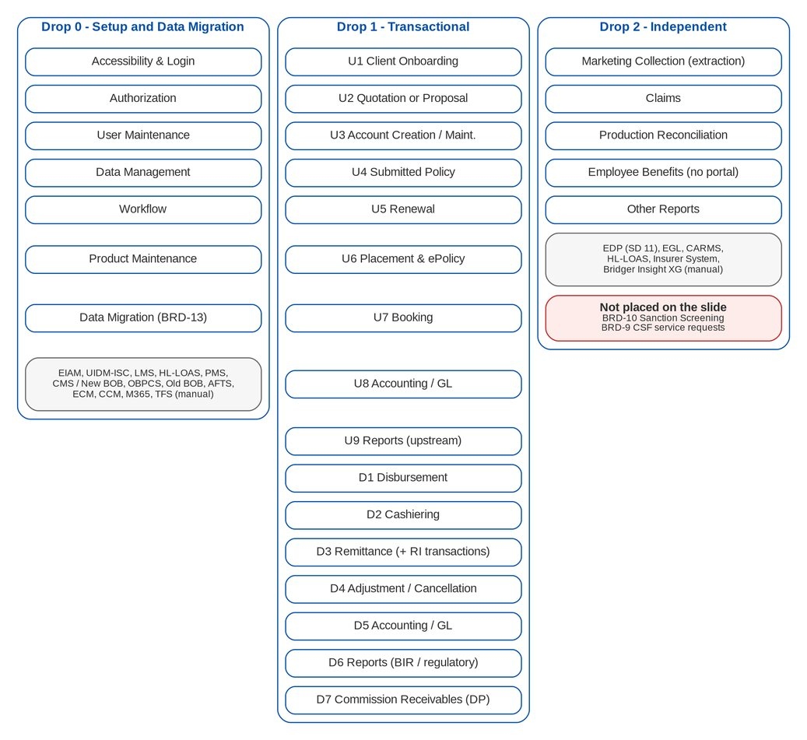
Figure 1: Drop items and the BIBS BRDs

2.2 Drop items against BRDs, FRS and BIBS
Table 3: Drop 0 - Setup and Data Migration
# | Drop item | BRD named by BDOI | BIBS BRD | FRS | Gap or mismatch | Refs
0.1 | Accessibility & Login | - | BRD-11 UAM; BRD-00 XC-01 | FR-UA (log-in, session, password); FR-CR | No BRD named. Log-in uses BIBS passwords; EIAM (Entra ID) single sign-on is a Drop 0 integration (INT-01). "Accessibility" may mean WCAG (UAM-NFR-05) or system access. | IQ04, IQ24; DCR-214, DCR-230
0.2 | Authorization | - | BRD-11 UAM | FR-UA | No BRD named. Access requests and approvals are in BIBS (BRD-11); UIDM-ISC (the IGA) may take them over. | IQ05; DCR-229
0.3 | User Maintenance | - | BRD-11 UAM | FR-UA | Provisioning by UIDM-ISC conflicts with BRD-11 principle "a request in BIBS is the only way to change access". | IQ05; DCR-229
0.4 | Data Management (GL accounts, reference tables) | - | BRD-00 CORE-17; BRD-5 (chart of accounts); BRD-1 (LOVs); BRD-3; BRD-13 (reference data R01-R09) | FR-CR (CORE-17); FR-AC (chart); FR-NB-132 (LOVs) | CORE-17 has no BRD: MIS field definition (CRQ09) and insurer management (one screen) are proposed in FRS BRD-00. Acceptance criteria not stated. | IQ24; DCR-214
0.5 | Workflow | - | Cross-BRD (every BRD with approvals) | Workflow chapters of each FRS | No BRD; accepted through the workflows of each BRD. | DCR-214
0.6 | Product Maintenance | - | BRD-3 PM | FR-PM | None. BRD-3 is also named for Quotation (1.U2). | -

Table 4: Drop 1 - Transactional, upstream (product inherent)
# | Drop item | BRD named by BDOI | BIBS BRD | FRS | Gap or mismatch | Refs
1.U1 | Client Onboarding | Data Migration BRD, New Business BRD | BRD-1 NB; BRD-13 DM (C01-C03); BRD-10 SANC (onboarding screening) | FR-NB (client); FR-DM; FR-SS | Client migration is part of BRD-13. Screening at onboarding (BRD-10) is in no drop. | IQ23; DCR-213
1.U2 | Quotation or Proposal | New Business BRD, Product Maintenance | BRD-1 NB (incl. Non-Package); BRD-3 PM | FR-NB; FR-PM | Non-Package Management (CORE-04) is not named; read as part of this item. | -
1.U3 | Account Creation and Maintenance | New Business BRD, CSF | BRD-1 NB; BRD-9 CSF | FR-NB; FR-CSF | Only the CSF maintenance functions (contact updates, service requests) are on the slide. The rest of CSF is in no drop. | IQ23; DCR-213
1.U4 | Submitted Policy | Submitted Policies | BRD-12 SP | FR-SP | Sources LFS, HL-LOAS, LMS (LAMD) are integrations. | IQ06, IQ07, IQ08
1.U5 | Renewal | Renewal | BRD-6 RN | FR-RN | The early renewal release is withdrawn (answer A1); legacy RMEL cohorts are carried forward at cut-over (P03). | IQ02, IQ03; DCR-218, DCR-219
1.U6 | Placement & ePolicy | New Business BRD, Renewal BRD, Employee Benefits | BRD-1 NB; BRD-6 RN; BRD-8 EB | FR-NB; FR-RN; FR-EB | EB placement is in Drop 1 while the EB module is in Drop 2. | IQ22; DCR-235
1.U7 | Booking | New Business BRD, Renewal BRD, Submitted Policies | BRD-1 NB; BRD-6; BRD-12 | FR-NB; FR-RN; FR-SP | Booking carries the business type (BT0) of renewal and submitted-policy accounts. | -
1.U8 | Accounting / GL | Accounting, Disbursement & ACSL BRD | BRD-5 ACCT | FR-AC | Listed again as downstream 1.D5. Read as: upstream = postings of booking; downstream = GL, FRBS and ACSL. | -
1.U9 | Reports (upstream) | NB, RN, SP, EB BRDs | BRD-1, 6, 12, 8; Report List | Report sections of each FRS | The Report List is not split by drop. | DCR-235

Table 5: Drop 1 - Transactional, downstream (product agnostic)
# | Drop item | BRD named by BDOI | BIBS BRD | FRS | Gap or mismatch | Refs
1.D1 | Disbursement | Accounting, Disbursement & ACSL BRD | BRD-5 ACCT (Vol. 2) | FR-DS, FR-PQ | Outward bank channel is CMS / New BOB (a file or host-to-host interface); until it is specified, BOB approvals are uploaded (DISB_BOB_APPROVED). | IQ10
1.D2 | Cashiering (Payments Acceptance and Application) | Operations BRD (Cashiering Addendum), Data Migration BRD | BRD-2 OPS; BRD-13 (legacy UPP, F02) | FR-OP (Cashiering); FR-DM | The "Cashiering Addendum" is not in the BIBS pack. Channels OBPCS, Old BOB, PMS and TFS feed this module. | IQ09, IQ10, IQ14, IQ20; DCR-215
1.D3 | Remittance | Operations BRD (Remittance Addendum), Reinsurance BRD | BRD-2 OPS; ReInsurance BRD (phase 2) | FR-OP (Remittance) | Answer A3: Remittance handles the reinsurance transactions in Drop 1; the reinsurance module is phase 2. Which RI transactions, and the "Remittance Addendum", are not defined. | IQ20; DCR-210, DCR-215
1.D4 | Adjustment / Cancellation | Operations BRD, Accounting BRD | BRD-2 OPS; BRD-5 | FR-OP (Adjustment) | None. | -
1.D5 | Accounting / GL | Accounting, Disbursement & ACSL BRD | BRD-5 ACCT (Vol. 1, 2) | FR-AC; FR-DS (ACSL) | EGL (Drop 2 integration, INT-17) takes GL data out of BIBS. | IQ16
1.D6 | Reports (BIR / Regulatory) | Accounting BRD, Data Migration BRD | BRD-5 ACCT; BRD-13 | FR-AC (BIR, IC) | Legacy-period figures in BIR reports depend on the migration of open items and the GL opening (DMQ18). | -
1.D7 | Collection of Commission Receivables (Direct Payment) | Collections BRD Addendum, Operations BRD | BRD-2 OPS (CMRID); BRD-4 BRCLXN.059-064 | FR-OP (Commission / DP); FR-CL | BRCLXN.061-064 are in the unsigned draft addendum only (CQ01). | -

Table 6: Drop 2 - Independent
# | Drop item | BRD named by BDOI | BIBS BRD | FRS | Gap or mismatch | Refs
2.1 | Marketing Collection (extraction) | - | BRD-4 CLXN; BRD-2 (MKTID) | FR-CL; FR-OP (Marketing Collection items) | BRD-4 is a BIBS module fed by the Operations ledger; "extraction" is undefined (a feed to a separate CMS application, or the daily files?). | IQ21; DCR-212, DCR-221
2.2 | Claims | - | BRD-7 CLM | FR-CM | Open-claims migration (F07) is conditional (CLQ14). | -
2.3 | Production Reconciliation | - | BRD-2 OPS (PRCID) | FR-OP (Production Reconciliation) | Specified in the Operations FRS; tested in SIT Drop 2 as BDOI plans. Insurer feedback files are an Insurer System integration. | IQ18
2.4 | Employee Benefits (no portal feature) | - | BRD-8 EB | FR-EB | BRD-8 BRID-005, 005.01, 014 and FRS BRD-8 use an insurer / client-HR portal; the IER diagram shows an "EB Insurer Portal" tenant. | IQ22; DCR-211
2.5 | Other Reports | - | Report List; BRD-00 CORE-21 | FR-CR (reports) | "Other" is not defined; propose: every Report List item not owned by a Drop 1 module. | DCR-235

2.3 Gaps and mismatches in the drop plan
Table 7: Gaps and mismatches in the drop plan
# | Finding | Proposal | Refs
M1 | Reinsurance under Remittance (1.D3). The slide names the Reinsurance BRD for Remittance; the ReInsurance BRD is phase 2. BDOI answered that Remittance handles the reinsurance transactions (A3), but which transactions and with which accounting is not written anywhere | BDOI names the transactions and supplies the "Remittance Addendum"; BIBS handles them in Remittance as insurer-like counterparties; the treaty and facultative module stays phase 2 | IQ20, DCR-210
M2 | Employee Benefits "no portal feature" (2.4). BRD-8 (BRID-005, 005.01, 014) and FRS BRD-8 use an insurer and client-HR portal; the IER diagram shows an "EB Insurer Portal" tenant | No portal for EB; insurers and client HR send documents by e-mail and EB users upload them; FRS BRD-8 re-issued | IQ22, DCR-211
M3 | "Marketing Collection (extraction)" in Drop 2. BRD-4 Collections is a BIBS module fed by the Operations ledger; no extraction is needed inside BIBS. The item may assume the legacy Collection Management System stays | BDOI confirms that BRD-4 in BIBS replaces the Collection Management System; the item then means the Collections daily files | IQ21, DCR-212
M4 | Claims and Production Reconciliation in Drop 2. Both are specified. No conflict: they are tested in SIT Drop 2 (Jul - Sep 2027); Production Reconciliation is a chapter of the BRD-2 FRS, which is otherwise in Drop 1 | Split the BRD-2 test plan by chapter | -
M5 | Data Management, Workflow, Accessibility & Login (Drop 0) have no BRD. Data Management is umbrella capability CORE-17 (MIS fields and insurer management, proposed in FRS BRD-00); Workflow is platform; "Accessibility" can mean sign-in or WCAG accessibility | Use CORE-17, BRD-11 plus EIAM, and each BRD's workflows as the acceptance basis; the accessibility statement (deliverable 40) covers WCAG | IQ24, DCR-214
M6 | BRDs not on the slide. BRD-10 Sanction Screening and the CSF service-request functions are in no drop | BRD-10 in Drop 1 with Client Onboarding; CSF service requests in Drop 2 | IQ23, DCR-213
M7 | Documents we do not have. "Operations BRD (Cashiering Addendum)" and "(Remittance Addendum)" are named on the slide; the BIBS pack has only Operations Addendum 1 (RMTID.002, ADJID.014) | BDOI supplies them | IQ20, DCR-215
M8 | EB in Drop 1. Placement & ePolicy and Reports (upstream) name Employee Benefits, while the EB module is Drop 2 | EB programmes are placed through the NB placement screens in Drop 1; EB servicing in Drop 2 | IQ22, DCR-235
M9 | One system in two drops. HLS (Drop 0) and LOAS (Drop 2) are HL-LOAS | One interface specification, delivered in Drop 0 | IQ07, DCR-216
M10 | CMS means two things. In the BIBS documents CMS is the Collection Management System (BRD-4); on the slide it is the Cash Management System (outward payments) | Use "CMS / New BOB" for the bank channel and "Collection Management System" in full | DCR-221

2.4 Drop-to-document map
BDOI groups the BRDs, FRS, test plans and collaterals under the drops (A5). The folder restructure follows the column "Drop (folder)"; documents used by more than one drop stay in one folder and are cross-referenced. Programme documents sit in a Programme folder.
Table 8: Drop-to-document map
Document | Kind | Drop (folder) | Shared with | Note
BRD-00 Core Replacement (umbrella) | FRS, spec | Programme | All drops (cross-cutting FR-CR, NFRs) | Stays at programme level
BRD-11 User Access Maintenance | FRS, test plan | Drop 0 | - | Items 0.1-0.3; EIAM and UIDM-ISC change it
BRD-3 Product Maintenance | FRS, test plan | Drop 0 | Drop 1 (quotation, 1.U2) | Item 0.6
BRD-13 Data Migration | FRS, test plan, migration pack (strategy, workbook, runbook, reconciliation, templates) | Drop 0 | Drop 1 (client onboarding, cashiering, BIR reports) and the migration stream | Migration has its own timeline row
BRD-1 New Business | FRS, test plan | Drop 1 | - | Upstream items 1.U1-1.U3, 1.U6, 1.U7, 1.U9
BRD-6 Renewal | FRS, test plan | Drop 1 | - | Upstream 1.U5
BRD-12 Submitted Policies | FRS, test plan | Drop 1 | - | Upstream 1.U4
BRD-10 Sanction Screening and Risk Profiling | FRS, test plan | Drop 1 (proposed) | Drop 2 (Bridger Insight XG) | Not on the slide; proposed with Client Onboarding (IQ23)
BRD-9 Customer Servicing Facility | FRS, test plan | Drop 1 | Drop 2 (proposed for the service-request functions) | Only account maintenance is on the slide (IQ23)
BRD-5 Accounting, Disbursement and ACSL | FRS (cover note, Vol. 1, Vol. 2), test plans | Drop 1 | Drop 0 (GL accounts, item 0.4) | Upstream 1.U8, downstream 1.D1, 1.D5, 1.D6
BRD-2 Operations | FRS, test plan | Drop 1 | Drop 2 (Production Reconciliation chapter, 2.3) | Test plan sheets split by chapter
BRD-4 Collections | FRS, test plan | Drop 1 | Drop 2 (Marketing Collection extraction, 2.1) | DP rows BRCLXN.059-064 in Drop 1 (1.D7); rest per IQ21
BRD-7 Claims | FRS, test plan | Drop 2 | - | 2.2
BRD-8 Employee Benefits | FRS, test plan | Drop 2 | Drop 1 (EB placement and reports, 1.U6, 1.U9) | Portal requirements out (answer, IQ22)
Report List as of 27-Apr-2026 | Report catalogue | Programme | Each report goes with the drop of its owning module | Split rule: 1.U9, 1.D6, 2.5
Discrepancy and clarification register | Register (Excel) | Programme | Filter column Drop to be added | DCR-210 to DCR-235 from this document
Business process deck | PowerPoint | Programme | All drops | -
Programme alignment and integration inventory (this document) | Word, Excel | Programme | All drops | Integration rows carry their drop
Bill of materials, technical and deployment architecture (items 4, 12) | Word, Excel (to write) | Drop 0 | - | From section 6 and the IER
Security and data-protection mapping (item 26) | Word, Excel (to write) | Drop 0 | - | EIAM, UIDM-ISC, S3 encryption, masking
Interface specifications (one per integration) | Word (to write) | Drop of the integration | - | After BDOI IT answers the IQ questions
UAT plans and sign-off forms (item 30) | Word (to write) | Per drop | End-to-end UAT script is programme level | UAT runs end to end (answer A1)
Performance, penetration test, ORR / PRR evidence (items 28, 37) | Word, Excel (to write) | Programme | - | Nov 2027 - Jan 2028

3 Early renewal concept paper

3.1 What the paper proposed
The concept paper (S4), prepared by the Project Manager and reviewed by the BU Project Lead (signature dates 06/09/2026), proposed a pre-cut-over release of renewal processing by 15 August 2027, for policies expiring from January to May 2028. The date matches the renewal lead time: 140 days before 1 January 2028 is 14 August 2027. It included the renewal core (RMEL ingestion, sanitation, disposition, proposal, insurer approval, renewal advice, NAL and NRL), TSU Product / Package Maintenance and quotation, Submitted Policy and Free First Year renewal, and the early migration of the client master and renewal reference data. Placement, booking and the back-office functions were to wait for the January 2028 cut-over.

3.2 Status: superseded
BDOI answered that every module goes live together in January 2028 and that there is no early go-live (A1). The paper is therefore recorded as superseded as an operating model. Nothing is prepared for a separate early release: no pre-cut-over production environment, no early client migration, and no legacy-to-BIBS client synchronisation for August to December 2027.
The capabilities the paper lists remain in scope for January 2028. The table below maps them to the FRS.
Table 9: Concept paper capabilities against the FRS
Concept paper capability | Where the FRS covers it | Note
Renewal intake and pipeline tracking | FRS BRD-6: Renewal Home, Expiry List | -
RMEL extract ingestion and validation | FRS BRD-6: extraction from the ledger; renewals at go-live from the migrated policy headers (BRD-13, P03) | P03 layout in the migration workbook
Data sanitation and enrichment | FRS BRD-6: checks and buckets Clean / Review / Exception (BRRN.020-023) | Check content still open (RQ01)
Disposition management | FRS BRD-6: assignment, disposition, TL review | -
Proposal / quotation generation | FRS BRD-1 quotation and non-package, linked to the renewal reference | -
Insurer engagement and approval tracking | FRS BRD-6: insurer batches and responses | Insurer channel is INT-19
Renewal advice, NAL, NRL | FRS BRD-6: letters, protected e-mail via CCM | -
Pre-placement adjustments | FRS BRD-1: account amendment before placement | Meaning to confirm
Product / Package Maintenance (TSU) | FRS BRD-3 | -
Quotation capability for renewals | FRS BRD-3 rating for renewals; business type BT0 | -
Submitted Policy renewal | FRS BRD-12 hand-off to Renewal (FRS BRD-6 FR-RN-090) | -
Free First Year renewal | FRS BRD-6 FFY Renewal Advice template; FRS BRD-12 FFY buckets | Q36 payer open
Early migration of client master and reference data | FRS BRD-13: R01-R09, C01-C03 pre-loaded two weeks before go-live | No longer early (answer A1)

3.3 What remains from the paper
Renewals around the cut-over (IQ02). Legacy keeps extracting, disposing, placing and booking renewals until the freeze. At go-live (T), the RMEL cohorts expiring from T to T + 140 days are already in disposition in legacy; they are carried forward into BIBS Renewal with their disposition, handler and status (migration object P03), and renew on the new-business path pre-filled from the migrated header. Later cohorts are extracted by BIBS. Renewals expiring between the freeze and T must be placed in legacy before the freeze or held by hold covers.
Package remapping (IQ03). The paper's first risk remains: legacy package names must map to the BIBS packages, for the migrated headers (P01), the carried-forward cohorts (P03) and the package versions (R06). Options:
Table 10: Package remapping options
Option | How | For | Against
1. At upload | A versioned PACKAGE code map applied at migration intake; unmapped codes stop the batch | One decision per legacy package, signed at gate G2, reconciled | A package that needs a per-policy decision (split packages) cannot be mapped one to one
2. In sanitation | A renewal check proposes the package per candidate; TSU confirms | Handles per-policy cases | Thousands of manual decisions; inconsistent results
3. Both (recommended) | Code map at intake for every one-to-one mapping; a renewal sanitation check sends candidates with an unmapped, retired or split package to the Review bucket for TSU; each TSU decision can add a code map version | Deterministic for the bulk, controlled for exceptions | Two places to explain in training

Recommendation: option 3, owned by TSU (Product Maintenance) with the MBS data steward; the mapping rules are agreed before the first full extract (15 January 2027) and tested with sample RMEL files in Trial migration 1.
The early renewal release. Not planned (A1). Renewal follows the drops: it is delivered with Drop 1 (November 2026 to February 2027) and tested in SIT and UAT Drop 1.

4 Timeline alignment

4.1 BDOI timeline against the BIBS plan
The slide (S2) runs requirements and development in three periods of about two months: first setup and upstream, then downstream, then the independent modules. Read from the bars, the requirements of Drop 1 run from September to November 2026 (the transcription says September to October) and those of Drop 2 from December 2026 to February 2027. Drop 0 has no bar of its own; it is part of the first period.
The BDOI development windows cover the Drop 1 and Drop 2 BRDs, the integrations, the S3 document store and the changes that come out of the FRS sign-off.
Table 11: BDOI timeline against the BIBS plan
Stream | BDOI window | What we deliver, by when
Requirements Drop 1 (with Drop 0 setup) | Sep - Nov 2026 (slide bar; the transcription says Sep - Oct) | FRS v1.0 of BRD-00, 1, 2, 3, 5, 6, 9, 10, 11, 12, 13 and register v1.1 issued 25-26 Sep 2026; FRS v1.1 with BDOI comments by 13 Nov 2026; sign-off by 30 Nov 2026; answers to the priority-1 IQ / DCR items by 16 Oct 2026
Requirements / mapping Migration | Sep - Nov 2026 | Migration pack v1.0 issued 26 Sep 2026 (strategy, workbook, runbook, reconciliation); object decisions (G1) and layouts frozen by 30 Nov 2026; first full extracts by 15 Jan 2027
Requirements Drop 2 | Dec 2026 - Feb 2027 | FRS v1.0 of BRD-4, 7, 8 issued; EB FRS re-issued without the portal; sign-off by 26 Feb 2027; EGL, EDP, CARMS and insurer specifications from BDOI IT by 31 Jan 2027
Development Drop 1 | Nov 2026 - Feb 2027 | Submitted Policies, Renewal, CSF account maintenance, EIAM, UIDM-ISC, the S3 document store, bank channel layouts and the changes from the signed FRS
Development Migration | Nov 2026 - Mar 2027 | Migration Console and loaders by 31 Mar 2027
Development Drop 2 | Mar - Apr 2027 | Claims, EB without portal, CSF, EGL / EDP / insurer interfaces and other reports by 30 Apr 2027
SIT Drop 1 | Jan - Jul 2027 | Test plans v1.0 for BRD-1 to BRD-13 issued; test plans approved by 18 Dec 2026; SIT environment with S3, MSK and ElastiCache by 4 Jan 2027
SIT Migration | Apr - Jul 2027 | Trial migration 1 Apr-May 2027 (reference, clients, headers); Trial migration 2 Jun-Jul 2027 (all objects, L1-L5)
SIT Drop 2 | Jul - Sep 2027 | Drop 2 test plans approved by 30 Jun 2027
UAT Drop 1 (end to end) | Aug - Dec 2027 | UAT readiness statement by 30 Jul 2027; UAT plans and sign-off forms by 16 Jul 2027; UAT runs on migrated, masked data (Trial migration 3)
UAT Migration | Aug - Oct 2027 | Trial migration 3 = UAT load in Aug 2027; Trial migration 4 re-load in Oct 2027 after fixes
UAT Drop 2 | Oct - Nov 2027 | Readiness statement for Drop 2 by 30 Sep 2027
Performance / penetration test | Nov - Dec 2027 | Performance plan (item 28), peak 429 concurrent until DCR-166; Pre-Prod ready by 1 Oct 2027; an early security scan in SIT (Jun 2027) proposed so findings do not arrive in December
Full migration and cut-over | Nov 2027 - Jan 2028 | Cutover runbook v1.0 (T-30 to T+30); dress rehearsal on Pre-Prod in Nov - Dec 2027; go / no-go on T-1
ORR / PRR | Dec 2027 - Jan 2028 | Runbook, observability, alerts and error catalogue (items 24, 35, 38); evidence pack by 15 Dec 2027
Go-live | January 2028 (answer A1: all modules together) | T to be fixed (IQ01): proposed Mon 3 Jan 2028, legacy freeze after the EOD of Wed 29 Dec 2027

4.2 Go-live date
BDOI has fixed January 2028 but not the day (IQ01). The migration strategy takes T as the first business day of a month after a legacy month-end close. For January 2028 this gives Monday 3 January 2028: legacy freeze after the EOD of Wednesday 29 December 2027 (30 December, 31 December and 1 January are non-working days), final extracts and loads over the long weekend, go / no-go on Sunday 2 January. The legacy December and year-end close must then be complete in legacy before the final GL extract. The slide places the go-live marker at the end of January; a later date in January needs a short January period in the GL opening (DMQ18).

4.3 What each drop needs from us, and from BDOI
Table 12: What each drop needs, and by when
When | From iorta TechNXT | From BDOI
By 16 Oct 2026 | This document; register rows DCR-210 to DCR-235 | Priority 1 answers (IQ01, IQ04, IQ05, IQ10, IQ15, IQ16, IQ20, IQ22, IQ25, IQ26, IQ31)
By 30 Nov 2026 | FRS v1.1 of the Drop 0 and Drop 1 BRDs with BDOI comments answered | FRS sign-off, Drop 0 and Drop 1; migration object decisions (G1)
By 18 Dec 2026 | Test plans of Drop 0 and Drop 1 re-issued under the drops; SIT entry criteria | Test plan approval; SIT environment (EKS, RDS, ElastiCache, MSK, S3)
By 15 Jan 2027 | Interface specifications drafted from the IQ answers | First full migration extracts; interface layouts from BDOI IT
By 26 Feb 2027 | Drop 1 ready for SIT; FRS v1.1 of Drop 2 | FRS sign-off, Drop 2
By 30 Apr 2027 | Drop 2 ready for SIT; Migration Console ready (31 Mar) | Integration test connections for EGL, EDP, insurer channels
Apr - Jul 2027 | Trial migration 1 and Trial migration 2 in SIT | Extracts per trial migration; data steward reviews
By 30 Jul 2027 | UAT readiness statement, UAT plans and sign-off forms; security scan in SIT | UAT users set up through EIAM and UIDM-ISC
Aug - Dec 2027 | UAT support on migrated data (Trial migration 3 in August, re-load in October) | UAT execution and sign-off per drop
By 1 Oct 2027 | Performance test plan and scripts | Pre-Prod environment, production-sized
Nov 2027 - Jan 2028 | Performance and penetration test fixes; dress rehearsal on Pre-Prod; ORR / PRR evidence by 15 Dec 2027 | Penetration test, ORR / PRR, go / no-go

5 Integration inventory

5.1 Context
Figure 2 shows BIBS and the systems BDOI named. All external touch-points are owned by BDOI IT (A2). The meanings are BDOI's; "our understanding" is the project team's reading and is confirmed through the IQ questions. The Integration Inventory workbook holds the same rows with every column.
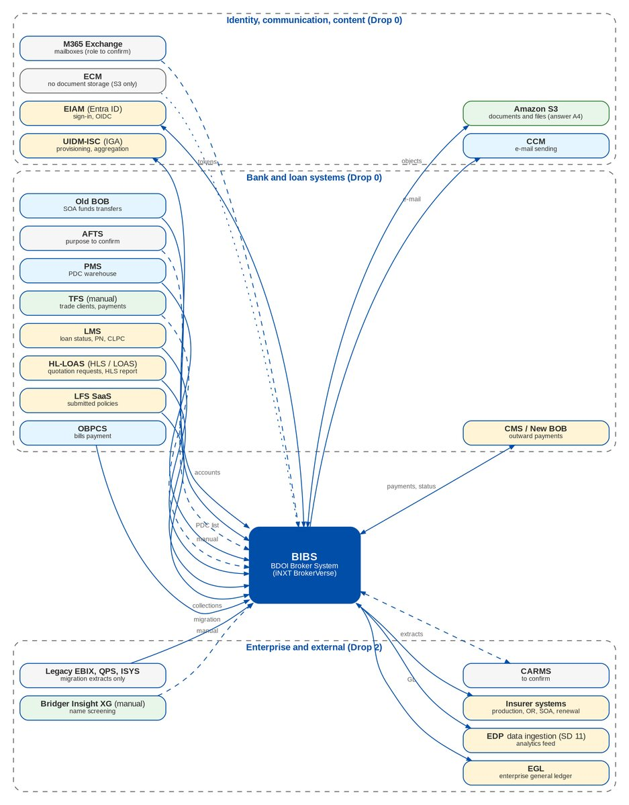
Figure 2: BIBS integration context (all touch-points owned by BDOI IT)

5.2 Inventory
Table 13: Integration inventory (summary)
ID | Integration | Drop | BDOI meaning | Direction | Questions
INT-01 | EIAM (Entra ID) | Drop 0 | Enterprise Identity Access Management, on Microsoft Entra ID | Both (browser redirect; tokens to BIBS) | IQ04
INT-02 | UIDM-ISC (IGA) | Drop 0 | User ID Maintenance - Identity Security Cloud, the identity governance and administration (IGA) tool | Inbound (provisioning) and outbound (account and entitlement aggregation) | IQ05
INT-03 | LMS | Drop 0 | Loans Management System | Inbound | IQ06
INT-04 | HL-LOAS (HLS / LOAS) | Drop 0 (HLS) and Drop 2 (LOAS) | Home Loan System (Loan Origination and Admin) | Inbound | IQ07
INT-05 | LFS SaaS | Not on the slide | Loan Front-End System (SaaS) | Inbound | IQ08
INT-06 | PMS | Drop 0 | PDC Management System | Inbound; outbound status to confirm | IQ09
INT-07 | CMS / New BOB | Drop 0 | Cash Management System, outward payments (also called New BOB) | Outbound (payment instructions); inbound (status, debit confirmation) | IQ10
INT-08 | OBPCS | Drop 0 | Online Bills Payment Consolidation System | Inbound | IQ10
INT-09 | Old BOB | Drop 0 | Old Business Online Banking Collection System; SOA bills payments via funds transfer | Inbound | IQ10
INT-10 | AFTS | Drop 0 | Automatic Fund Transfer System (on the slide; not explained in the answers) | To confirm | IQ10
INT-11 | ICBS | Drop 0 (struck through) | Struck through on the slide | - | IQ10
INT-12 | ECM | Drop 0 | Enterprise Content Management | To confirm (possibly inbound legacy documents only) | IQ13
INT-13 | CCM | Drop 0 | Centralized Communications Management, e-mail sending | Outbound; delivery status inbound | IQ11
INT-14 | M365 Exchange | Drop 0 | M365 Exchange | Inbound (mailbox reading) and/or outbound | IQ12
INT-15 | TFS (manual) | Drop 0 | Trade Finance System - client onboarding and payment (manual) | Manual inbound | IQ14
INT-16 | EDP - Data Ingestion (SD 11) | Drop 2 | Enterprise Data Platform | Outbound | IQ15
INT-17 | EGL | Drop 2 | Enterprise General Ledger | Outbound | IQ16
INT-18 | CARMS | Drop 2 | Not explained in the answers | To confirm | IQ17
INT-19 | Insurer System | Drop 2 | Insurer systems (not detailed) | Both | IQ18
INT-20 | Bridger Insight XG (manual) | Drop 2 | Bridger Insight XG (screening) | Manual | IQ19

Table 14: Integration inventory (detail)
ID | Integration | Our understanding (to confirm) | Data | Open points
INT-01 | EIAM (Entra ID) | Single sign-on of BDO users. BIBS redirects to Entra ID (OpenID Connect, authorisation code with PKCE) and maps the returned identity to the BIBS user; roles stay in BIBS. | User identity (UPN or Windows ID, name, e-mail); optional group claims | Protocol and claims, MFA and conditional access, session life against the 30-minute inactivity rule, non-BDO users
INT-02 | UIDM-ISC (IGA) | Joiner, mover and leaver provisioning and access certification from the IGA. We read "Identity Security Cloud" as the SailPoint product; to confirm. | User accounts, enable / disable, group profiles (BIBS roles) as entitlements | Who owns requests and approvals, connector type, entitlement level, certification
INT-03 | LMS | Bank loan data used by Renewal (paid-off and RMU loans, BRRN.029), Submitted Policies (loan snapshot, PN) and CLPC billing. Probably the source of the "LAMD reports". | PN number, loan status (paid-off, RMU), loan release and amortisation for CLPC | Which LMS extracts, layouts, frequency, transport
INT-04 | HL-LOAS (HLS / LOAS) | One system shown twice on the slide. Origination side sends home-insurance quotation requests (BRNB.023) and the daily HLS insurance report (Submitted Policies, CBG Fire); admin side gives the HLS amortised loan data for CLPC billing. | Quotation requests (borrower, property, sum insured, PN); HLS insurance report; amortised loan release | One interface or two, formats, frequency, transport
INT-05 | LFS SaaS | Source of the LFS insurance report for Submitted Policies (BRD-12 p.4-5). | Loan-linked policies submitted by borrowers | Drop, layout, transport
INT-06 | PMS | Holds the post-dated checks in the warehouse. BIBS Cashiering receives the daily PDC list and matures PDCs on their date (CSHID.008 item 4). | PDC number, bank, date, amount, payor, account / invoice reference; possibly deposit, return and pull-out status | Layout (OQ03), direction, frequency
INT-07 | CMS / New BOB | Bank channel for BDOI's outgoing payments (insurer remittances, refunds, supplier and commission payments) from Disbursement; the bank returns the debit status. | Payee, account, amount, currency, value date, voucher reference; status per transaction | Layout, host-to-host or upload, cut-off times, approvals in CMS
INT-08 | OBPCS | The consolidated bills-payment collections file (today "Bills Payment FS01") that Cashiering uploads and automatches. | Payment date, reference (ARN, invoice, PN), payor, amount, channel | Layout, frequency, transport
INT-09 | Old BOB | Corporate clients pay statements of account by funds transfer; the collection file is applied in Cashiering. | Funds-transfer credits with SOA or invoice reference | Layout, SOA reference, frequency
INT-10 | AFTS | Unknown. Possibly auto-debit of client accounts for premium, or automatic transfers for disbursement. | To confirm | Purpose, direction, layout
INT-11 | ICBS | Out of scope (core banking system replaced by the channels above). | - | Confirm out of scope
INT-12 | ECM | Answer A4 places every BIBS document and attachment in Amazon S3, not in ECM. A remaining ECM role is not stated (source of legacy documents for the archive, or records transfer at end of retention). | Legacy documents (H02) if ECM holds them | Any ECM touch-point left
INT-13 | CCM | All outbound BIBS e-mail (renewal advices, protected PDFs, notifications, job-failure mails) goes through CCM. | Recipient, subject, body, attachments (password-protected PDFs), template id | SMTP or API, attachment limits, volume, bounce feedback, sender domains
INT-14 | M365 Exchange | Mailboxes. Candidate uses are reading e-mailed quotation requests (BRNB.041, Q12 on hold) and insurer replies, or relaying mail if CCM does not cover a case. | E-mails and attachments | Role against CCM, mailboxes, permissions
INT-15 | TFS (manual) | Trade (CIB) clients and their payments; no system interface. Users key the client in BIBS and upload the Trade payment file. | Trade client details; Trade payment file | Which onboarding data, layout of the Trade file
INT-16 | EDP - Data Ingestion (SD 11) | BIBS data delivered to the BDO data platform for analytics. "SD 11" is not explained (a data standard or source-delivery specification). | To agree (clients, accounts, invoices, receipts, remittances, GL; history and daily changes) | What SD 11 is, objects, format, frequency, push or pull
INT-17 | EGL | The BDO group ledger receives BDOI accounting from the BIBS GL (journal detail or balances) for consolidation. | Journals or trial balance by account, branch, cost centre, currency; mapping to EGL accounts | Level of detail, frequency, mapping, layout, transport
INT-18 | CARMS | Unknown. | To confirm | Purpose, data, direction
INT-19 | Insurer System | Files exchanged with each insurer today by e-mail: production reports and feedback (PRCID.009), remittance schedules and ORs (RMTID.012), DP billing responses (CMRID.009), renewal responses, SOAs (ACSL 2.2.1), e-policies, claims. | Per process | Insurers, processes, channel, layouts
INT-20 | Bridger Insight XG (manual) | Compliance screens names in Bridger Insight XG by hand and records the result in the BIBS screening case. | Screening result and evidence | Does Bridger replace or complement BIBS list matching

5.3 Interfaces named in the BRDs but not on the slide
Table 15: Interfaces named in the BRDs but not on the slide
Interface | Named in | To confirm
LAMD reports (paid-off, RMU) | BRD-6 BRRN.029; BRD-12 | Covered by LMS (INT-03)?
CLPC loan credits and billing | BRD-1 BRNB.067; Report List #65-67 | Covered by LMS / HL-LOAS?
NLDS PEP list and AML advisory | BRD-10 SNSRP-201, p.7 | Transport (SQ01)
Mail house (printed letters) | BRD-12; BRD-6 letters | Channel and layout
BIR eFPS / eBIRForms, CAS books | BRD-5 Appendix A VII | Manual upload by Comptrollership
BDO Unibank GARD submission | BRD-5 Appendix A II | AQ31; relation to EGL
Legacy EBIX, QPS, ISYS, Collection Management System (migration sources) | BRD-13 | Extract transport (DMQ28)

5.4 Integration summary
• Drop 0: EIAM sign-in (OIDC), UIDM-ISC provisioning, CCM (configuration if SMTP), bank and PDC file layouts (configuration of the payment-file uploads), CMS / New BOB outward payment file, HL-LOAS quotation requests.
• Drop 1: LMS and LFS intakes with Submitted Policies and Renewal.
• Drop 2: EGL extract, EDP ingestion per SD 11, insurer channels, CARMS (unknown), Bridger evidence set-up.
• Not in scope: ECM storage (A4), ICBS (struck through).

6 Infrastructure alignment

6.1 What the IER says
The IER (S3) sets RPO 15 minutes and RTO 4 hours; RDS PostgreSQL 16 (Single-AZ in DEV, SIT, UAT; Multi-AZ in Pre-Prod and PROD, 2,000 GB in PROD), ElastiCache Redis 7 and Amazon MSK (Kafka 3.6, three brokers in Pre-Prod, PROD and DR), a GitLab runner and SSM bastion, S3 as document store and EFS as shared volume; a DR standby with asynchronous replication; 15 VDI users; 12 x 5 hours for non-production; 15 % growth a year over 60 months. It matches the BIBS technology baseline for the database and event streaming. For the cache, BIBS uses Valkey 8 (Amazon ElastiCache for Valkey) in place of Redis 7, and Kafka 3.9 in place of 3.6 (component baseline below).
It does not match BIBS on the application: the diagram in the "Architecture Diagram" sheet and the Kubernetes sheets describe ten microservices, three tenants, Aurora and MongoDB, Apigee, Istio and EventBridge. BIBS is one modular monolith whose business record, journal and ledger rows commit in one database transaction; splitting it would break that guarantee. The IER should describe the BIBS architecture (IQ25). Figures 3 and 4 are the diagrams for the two "Architecture Diagram" sheets (A6).

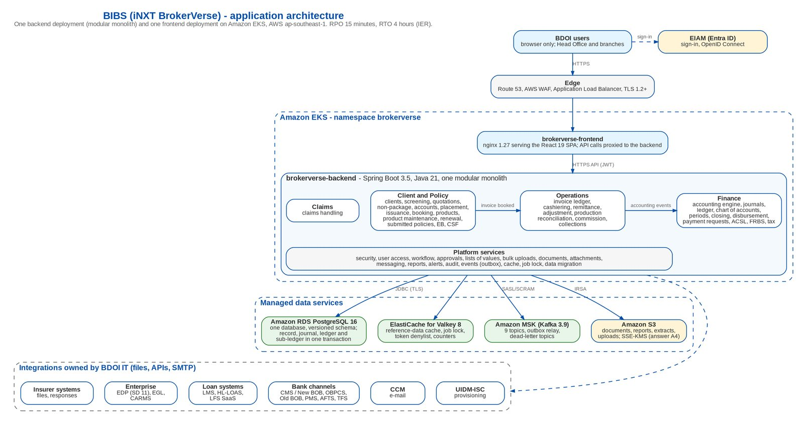
Figure 3: BIBS application architecture (for the IER "Architecture Diagram" sheet)
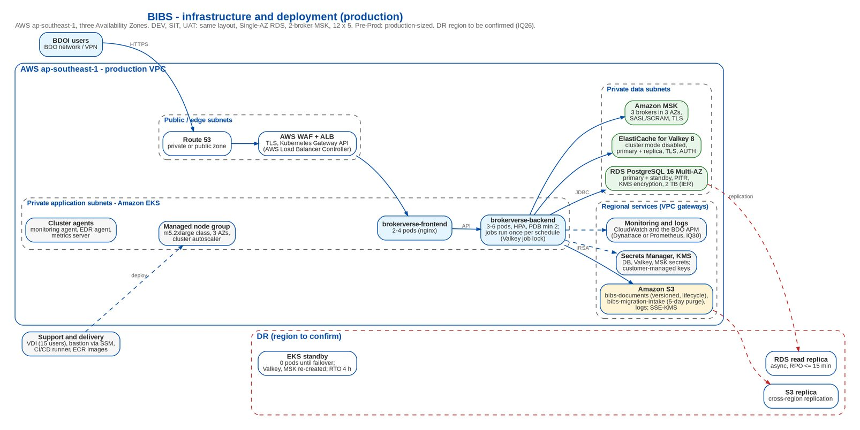
Figure 4: BIBS infrastructure and deployment (for the IER "Architecture Diagram (Infra)" sheet)

6.2 IER against BIBS
Table 16: IER against BIBS
Topic | IER (BDOI IT) | BIBS | Assessment | Change needed | Ref
Application architecture | Diagram sheet: multi-tenant microservices (identity, audit, workflow, document, notification, reference, tenant; client, policy, quotation, cashiering, billing, accounting, product; nb, sp, acc, clxn, rn, clm, ops, pm, eb, rl), Istio + OPA per pod, "no cross-DB transactions" | One Spring Boot 3.5 modular monolith (backend) and one React SPA served by nginx (frontend); a business record, its journal, ledger and sub-ledger rows commit in one PostgreSQL transaction | Mismatch | Replace the diagram with the BIBS diagrams of this document; state the modular monolith in the IER | DCR-222; IQ25
Tenancy | Three tenants: BDOI internal ~1,200 users, EB insurer portal ~50 partners, broker / RI network ~200 accounts; a tenant key and row-level security per data layer | Single tenant (company, branch scope, role scope); no portal (EB portal dropped by answer); RI network is phase 2 | Mismatch | Remove tenants 2 and 3; size for internal users | DCR-222, DCR-232
Kubernetes workloads | Ten services bv-policy-admin-svc, bv-claims-svc, bv-billing-collections-svc, bv-distribution-svc, bv-web-portal, bv-api-gateway, bv-iam-svc, bv-integration-svc, bv-document-svc, bv-batch-notification-svc in namespaces brokerverse-core / -platform | Two deployments: brokerverse-backend (2 replicas, 500m / 1 Gi requests, 2 CPU / 2 Gi limits) and brokerverse-frontend (2 replicas); one namespace | Mismatch | Re-state the K8s sheets with the sizing of section 6.4 | DCR-223
Database | HW sheet: "RHEL 9.x + PostgreSQL 16 (Amazon RDS)", Single-AZ DEV / SIT / UAT, Multi-AZ Pre-Prod / PROD; diagram: Aurora and MongoDB per tenant | PostgreSQL 16 with versioned schema scripts, JSONB where needed; Amazon RDS Multi-AZ in production (deploy notes); no MongoDB | Aligned (RDS); Mismatch (Aurora, Mongo, "RHEL 9") | Drop "RHEL 9.x" from RDS rows (managed engine); remove Mongo; RDS PostgreSQL 16 or Aurora PostgreSQL both work | DCR-224
Cache | ElastiCache for Redis 7.x; "(cluster)" in Pre-Prod, PROD | Valkey 8 (BSD-3-Clause, same protocol as Redis; Amazon ElastiCache for Valkey) with cluster mode disabled (one shard, primary + replica, TLS, AUTH); the cache clear uses SCAN and the job lock uses scripts on single keys | Mismatch (engine, wording) | IER: ElastiCache for Valkey 8 in place of Redis 7.x (client decision of 08-Oct-2026: Redis 7.4 and later are no longer under the BSD licence); cluster mode disabled, Multi-AZ replica. A change in BIBS only if cluster mode enabled is imposed | DCR-228; IQ34
Event streaming | Amazon MSK (Kafka 3.6), 3 brokers in Pre-Prod / PROD / DR; diagram: MSK + EventBridge, Glue Schema Registry, ~80 topics | MSK Kafka 3.9 (KRaft) with SASL/SCRAM + TLS, 9 topics plus dead-letter topics, transactional outbox; no EventBridge, no schema registry | Aligned (MSK); Mismatch (version, EventBridge, 80 topics) | IER: Kafka 3.9 (KRaft), 3 brokers kafka.m5.large class, 9 topics x 3 partitions; DEV / SIT with 2 brokers need a replication factor of 2 | IQ25
Documents and files | Amazon S3 (document store) + Amazon EFS (shared K8s PV); K8s sheets: "Total PV (GB) EFS" of 21,800 GB (DEV), 32,760 GB (UAT) and 43,600 to 87,200 GB (PROD Y1 to Y5) | File content in PostgreSQL; no volume on the pods | Mismatch | Answer A4 and the document storage decision (option C): S3 for the file content, PostgreSQL for metadata; no EFS for BIBS. The EFS totals are a formula error (Total PV = max replicas x CPU limit) | DCR-227, DCR-223; IQ31
Edge and ingress | Diagram: CloudFront + WAF, Apigee X (OIDC validation, quotas), Istio ingress mTLS; infra diagram: Route 53 + ALB; K8s sheets: ingress-nginx | Kubernetes Gateway API: Route 53 + AWS WAF + internal ALB (AWS Load Balancer Controller) for users, Apigee X for the system APIs; HTTPS to the pods; JWT issued by BIBS; login rate limit in the application | Mismatch | IER: a Gateway API controller in place of ingress-nginx (retired by the Kubernetes project in March 2026): the AWS Load Balancer Controller, or Envoy Gateway where an environment needs it; no CloudFront, no Istio | IQ25
Runtime and images | VDI: OpenJDK Temurin 17 for the BrokerVerse services, Node 20, Angular SPA | Java 21 (Temurin 21 JRE Alpine image), Spring Boot 3.5, Node 22, React 19, Vite 8 | Mismatch | VDI list: Temurin 21, Maven 3.9, Node 22 LTS; no Angular. Base images RHEL UBI 9 only if BDO requires | DCR-224; IQ28, IQ29
CI / CD | HW sheet: GitLab Runner, AWS SSM, kubectl / helm on a bastion; infra diagram: a second CI toolchain named in the IER; diagram: ArgoCD GitOps + Helm, Terraform + Crossplane | One delivery pipeline with SonarQube analysis; plain Kubernetes manifests; no Helm chart | Gap | Helm chart (or Kustomize overlays) per environment; pipeline on the BDO toolchain once named | IQ29
Observability | VDI and K8s sheets: Dynatrace (ActiveGate, OneAgent); diagram: CloudWatch, X-Ray, Prometheus, Node Exporter, Loki, Grafana | Health checks and Prometheus metrics; structured logs with CR/LF neutralised; alert catalogue planned (deliverable 38) | Gap | Choose Dynatrace or Prometheus / Grafana; ship logs to the BDO log platform | IQ30
Recovery objectives | RPO 15 minutes, RTO 4 hours (both diagram sheets); DR standby with async replication, RPO <= 15 min | Register proposal DCR-135: RPO 15 min (continuous WAL archiving), RTO 4 h; RUNBOOK: daily full backup + WAL archiving, quarterly restore test | Aligned | Record the IER as the BDOI answer to DCR-135 (to confirm by the BRD owners) | DCR-135, DCR-225
Disaster recovery | PROD DR: "cross-region read replica" (HW sheet); diagram: "ap-southeast-1 primary + DR warm-standby"; DR environment at 12 x 7 hours | Hosting appendix: AWS ap-southeast-1; access restricted to personnel in the Philippines | Gap | Name the DR region and confirm data residency; S3 cross-region replication and MSK / ElastiCache re-created in DR; DR runbook | DCR-225; IQ26
Environments | DEV, SIT, UAT, Pre-Prod, PROD, DR; K8s sheets only for DEV, SIT, UAT, PROD Y1-Y5; the Pre-Prod sheet is titled "UAT ENVIRONMENT"; environment cost sheets hold template rows (Windows Server, EXACC, ON PREM, 0 CPU) | Needs all six; Pre-Prod for the dress rehearsal and performance tests; DR for the failover test | Gap | Add Pre-Prod and DR cluster sheets; replace template rows; re-cost | DCR-223; IQ33
Operating hours | Non-production 12 x 5 (260.7 h / month); PROD 24 x 7; DR 12 x 7 | Night jobs in PHT: EOD booking and remittance extraction 20:00, Collections 22:15-23:00, renewal extraction 01:00, screening 01:00-01:30, application file 05:00, alerts 06:00 | Mismatch | Non-production crons shifted into the window by environment variables; extended hours for batch, month-end and migration rehearsal cycles; MSK and ElastiCache run 24 x 7 anyway | DCR-226; IQ27
Sizing basis | YoY growth 15 %, 60 months; ~1,200 internal users (diagram) | Umbrella BRD p.42: 1,344 named / 429 concurrent (DCR-166); renewal 25,800 accounts and NB 21,200 bookings a month | Gap | One user figure for sizing and the performance test | DCR-232; IQ32
VDI | 15 users: 8 developers (24 months), 4 testers (18), 3 production support (60); 12 x 5 | Hosting appendix: access restricted to personnel in the Philippines; migration staging purged within 5 days | Gap | Confirm who needs VDI and from where; update the software list | DCR-231; IQ28

6.3 BIBS component baseline
The client confirmed the component baseline on 8 October 2026. Valkey replaces Redis, whose releases from 7.4 on are no longer under the BSD licence; the Kubernetes Gateway API replaces ingress-nginx, which the Kubernetes project retired in March 2026.
Table 17: BIBS component baseline
Component | Version baseline | Licence | Function
PostgreSQL | 16.x | PostgreSQL Licence | Relational data store
Valkey | 8.x | BSD-3-Clause | Cache, job locks, token deny-list, counters
Apache Kafka | 3.9 (KRaft) | Apache 2.0 | Event streaming, transactional outbox
OpenJDK (Eclipse Temurin) | 21 LTS | GPLv2 with Classpath Exception | Application runtime
Spring Boot | 3.5.x | Apache 2.0 | Application framework
React | 19.x | MIT | Web user interface
Node (JavaScript runtime) | 22 LTS | MIT | Compiles the web user interface for release (not a production runtime)
nginx (unprivileged image) | 1.30 | BSD-2-Clause | Serves the web user interface, proxies the API
Kubernetes (managed) | Provider-supported version | Apache 2.0 | Container orchestration
Gateway API controller | Gateway API v1 controller: the managed provider's controller or Envoy Gateway | Apache 2.0 | Ingress and traffic routing

Support horizon. Each component stays within the support window its upstream project publishes: PostgreSQL 16 until 9 November 2028, Eclipse Temurin 21 until at least December 2029, Node 22 until 30 April 2027, each Kubernetes version on Amazon EKS for 14 months of standard support; the end dates of Valkey 8, Kafka 3.9, Spring Boot 3.5, nginx 1.30 and the gateway controller are to be confirmed at each annual technology review. The baseline is reviewed every year and before go-live, and a component that reaches its support end within the following twelve months is planned for upgrade.

6.4 Documents in S3 only
BDOI's instruction (A4) is met by the document storage proposal (S6): option C, S3 for the file content and PostgreSQL for the metadata, 5-minute signed links issued after the BIBS permission check and audit, four buckets per environment (documents, reports, inbound quarantine, migration with 5-day expiry), SSE-KMS, IRSA and a VPC gateway, Object Lock in governance mode with legal hold, and cross-region replication for DR. Existing files are copied and verified before go-live. The table below lists the proposal and the changes in the IER.
Table 18: Documents in S3 only
Area | Proposal
Files and their metadata | Every file of every module is stored in Amazon S3; PostgreSQL keeps the metadata of each file (owner, document type, name, size, checksum, bucket, key, version, retention class, legal hold)
Attachments (all modules) | Stored in the documents bucket of the environment
Generated business documents | Placement slips, insurance advices, service invoices, remittance and billing documents, print batches and end-of-day outputs are written to the documents bucket; each rendition keeps its specification and checksum
Report archive and batch files | Stored in the reports bucket, with the expiry of the report archive setting (default 400 days); users get a link
Operations extracts, e-mail attachments | Extracts are written to S3; e-mail attachments and ZIP bundles are read from S3
Uploads and inbound files | Inbound bucket with a quarantine area until the malware scan marks the file clean; kept 90 days; large files uploaded directly with a signed link
Migration files | Migration bucket, expiry after 5 days, migration role only
Access and audit | A signed link valid 5 minutes (FILE_LINK_TTL_SECONDS), issued after the BIBS permission check, each issue audited; files are downloaded, not cached
Security | SSE-KMS with a customer-managed key per environment; non-TLS and unencrypted uploads refused; access through the application role and an S3 gateway; keys without personal data
Retention, legal hold, DR | Versioning; lifecycle Standard, Standard-IA after 90 days, Glacier Instant Retrieval after 1 year; Object Lock governance mode with legal hold; cross-region replication with replication time control
Existing content | One-time copy of the existing files with a checksum check before go-live
IER: new rows | Four buckets per environment; storage estimate per year (to size from the document volumes); KMS keys per environment; S3 gateway; replication to the DR region; malware scanning of uploads (GuardDuty Malware Protection for S3 or the BDO scanner); Object Lock enabled at bucket creation
IER: rows to remove | Amazon EFS (shared K8s PV), the efs-csi-controller pods and the "Total PV (GB) EFS" column: not used by BIBS for documents; pods are stateless
IER: database size | PROD RDS 2,000 GB was sized with documents in mind; re-size RDS without file content once the volumes are known; backups and the cross-region replica get smaller

6.5 Kubernetes sizing of the BIBS workloads
The IER Kubernetes sheets size ten bv-* services. BIBS runs two deployments. The table below replaces those rows; the values are a starting point to be proved by the performance test at the peak case (429 concurrent sessions until DCR-166 is answered). Scheduled jobs run once per schedule whatever the number of pods, through the Valkey job lock. The cluster add-ons of the IER sheets (kube-system, monitoring and EDR agents) stay, with a Gateway API controller in place of ingress-nginx; the EFS controller is not needed.
Table 19: Proposed Kubernetes sizing of the BIBS workloads
Environment | Deployment | Min | Max | Requests CPU / memory | Limits CPU / memory | Note
DEV | brokerverse-backend | 1 | 2 | 500m / 1.5 Gi | 2 / 3 Gi | Seed data; jobs run on the single pod
DEV | brokerverse-frontend | 1 | 2 | 50m / 64 Mi | 500m / 256 Mi | nginx static files and /api proxy
SIT | brokerverse-backend | 2 | 3 | 500m / 1.5 Gi | 2 / 3 Gi | Two pods to test the Valkey job lock and cache eviction across pods
SIT | brokerverse-frontend | 2 | 2 | 50m / 64 Mi | 500m / 256 Mi | -
UAT | brokerverse-backend | 2 | 4 | 1 / 2 Gi | 2 / 4 Gi | Trial-migration loads run here (Trial migration 3)
UAT | brokerverse-frontend | 2 | 3 | 50m / 64 Mi | 500m / 256 Mi | -
Pre-Prod | brokerverse-backend | 3 | 6 | 1 / 2 Gi | 2 / 4 Gi | Production-sized; performance test and dress rehearsal
Pre-Prod | brokerverse-frontend | 2 | 4 | 50m / 64 Mi | 500m / 256 Mi | -
PROD (Y1) | brokerverse-backend | 3 | 6 | 1 / 2 Gi | 2 / 4 Gi | HPA on CPU; pod disruption budget minAvailable 2; spread over 3 AZs
PROD (Y1) | brokerverse-frontend | 2 | 4 | 50m / 64 Mi | 500m / 256 Mi | PDB minAvailable 1
PROD (Y5) | brokerverse-backend | 4 | 8 | 1 / 2 Gi | 2 / 4 Gi | 15 % growth a year; to be proved by the performance test
DR | brokerverse-backend | 0 | 6 | 1 / 2 Gi | 2 / 4 Gi | Scaled up at failover (warm standby); images and configuration kept current

6.6 Environments, hours and disaster recovery
• Six environments are needed: DEV, SIT, UAT, Pre-Prod (dress rehearsal and performance test), PROD and DR. The IER has Kubernetes sheets for DEV, SIT, UAT and PROD only, and its Pre-Prod sheet is titled "UAT ENVIRONMENT" (IQ33).
• 12 x 5 non-production hours do not cover the BIBS night jobs (EOD booking and remittance extraction at 20:00, Collections files from 22:15 to 23:00, renewal extraction and screening at 01:00, application file at 05:00). In non-production the schedules are moved into the working window by configuration, and extended hours are booked for batch and month-end test cycles, trial migrations (weekend loads) and the dress rehearsal. MSK and ElastiCache cannot be stopped, so only the EKS nodes and RDS instances follow the 12 x 5 hours (IQ27).
• RPO 15 minutes and RTO 4 hours answer register item DCR-135 (the register proposed the same values); RDS point-in-time recovery and the cross-region replica meet the RPO, and S3 replication with replication time control covers the documents.
• DR region. The HW sheet names a cross-region read replica; the diagram names ap-southeast-1 with a warm standby; the hosting appendix places BIBS in ap-southeast-1 with access restricted to personnel in the Philippines. The DR region and data residency must be confirmed (IQ26). At failover the backend is scaled up in DR, Valkey is re-created (caches refill; revoked tokens are lost until they expire, at most 8 hours) and MSK is recreated; events not yet delivered are resent from the database outbox.

6.7 Changes needed
Table 20: Changes needed
Area | Change | Owner
IER | Replace the architecture diagrams with Figures 3 and 4; restate the Kubernetes sheets with the sizing of section 6.4; add Pre-Prod and DR cluster sheets; retitle the Pre-Prod sheet; replace the template rows of the environment cost sheets; remove EFS; add the S3, KMS, VPC gateway, replication and malware-scanning rows; "RHEL 9.x" removed from the RDS rows; ElastiCache for Valkey 8 with "cluster mode disabled"; MSK Kafka 3.9; a Gateway API controller in place of ingress-nginx; VDI software list with Temurin 21, Maven 3.9 and Node 22 | BDOI IT with iorta TechNXT
BIBS | S3 document store and the copy of the existing files; EIAM OIDC sign-in; UIDM-ISC provisioning; bank channel files; EGL and EDP extracts; non-production schedules by configuration | iorta TechNXT
BIBS deployment | Helm chart or Kustomize overlays per environment (replicas, HPA, PDB, IRSA service account, topology spread); Kafka replication factor 2 on 2-broker MSK in DEV and SIT; pipeline on the BDO toolchain (IQ29) | iorta TechNXT
Documents | Bill of materials and deployment architecture (deliverables 4 and 12) from this chapter; security mapping (deliverable 26) with EIAM, UIDM-ISC and S3 encryption; DR runbook | iorta TechNXT

7 Open questions for BDOI
Priority 1 questions shape the scope and are needed by 16 October 2026; priority 2 by 30 November 2026; priority 3 before the delivery of the item concerned.
Table 21: Open questions for BDOI, by priority
ID | Prio. | Topic | Question | Source
IQ01 | 1 | Go-live date | Which date in January 2028 is T? We propose Monday 3 January 2028, with the legacy freeze after the EOD of Wednesday 29 December 2027 and the legacy December / year-end close completed in legacy before the final extracts. If T is later in January, the migration rule "first business day of a month after a legacy month-end close" (DMQ25) no longer holds and the GL opening needs a short January period. | Timeline slide; answer A1; DMQ25, DMQ18
IQ04 | 1 | EIAM (Entra ID) | Please confirm OpenID Connect (authorisation code with PKCE) against Entra ID; the claim that identifies the user (UPN, Windows ID or employee number); MFA and conditional access; token and session lifetimes against the 30-minute inactivity rule; whether EIAM replaces EUA (DCR-143); how non-BDO users (if any) sign in; and whether a local break-glass administrator is allowed. | Drop plan Drop 0; answer A2; UAM-NFR-11, 17, 19
IQ05 | 1 | UIDM-ISC (IGA) | Does UIDM-ISC own access requests and approvals, replacing the BRD-11 request workflow in BIBS, or does it only provision approved changes? Which connector (SCIM 2.0, REST, flat file)? Are entitlements the BIBS group profiles (roles) only? Frequency of aggregation and certification; leaver timing. | Drop plan Drop 0; answer A2; BRD-11
IQ10 | 1 | Bank channels | For CMS / New BOB (outward payments), OBPCS (bills payment), Old BOB (SOA funds transfers) and AFTS: file layouts or APIs, host-to-host or user upload, cut-off times, status and debit confirmation. What is AFTS used for? Is ICBS out of scope (struck through)? | Drop plan Drop 0; answer A2; AQ09, OQ03
IQ15 | 1 | EDP (SD 11) | What is SD 11? Which BIBS data does EDP ingest, at what frequency and in which format (files to S3, change-data capture, events)? Masking of personal data? | Drop plan Drop 2; answer A2
IQ16 | 1 | EGL | Does EGL take journal detail or balances, daily or monthly? Mapping of the BIBS chart to EGL accounts and segments, currency handling, layout and transport, reconciliation owner; relation to the GARD submission (AQ31). | Drop plan Drop 2; answer A2
IQ20 | 1 | Reinsurance transactions in Remittance | Which reinsurance transactions does Remittance handle in Drop 1 (premium received from cedants and remitted to reinsurers, RI claims recoveries), with which accounting? Please send the "Operations BRD (Remittance Addendum)" and "(Cashiering Addendum)" named on the slide. | Drop plan 1.D2, 1.D3; answer A3
IQ22 | 1 | Employee Benefits without portal | Please confirm that insurers and client HR send EB documents by e-mail and BDOI users upload them (BRID-005, 005.01, 014 changed), and that EB placement (Drop 1) uses the NB placement screens. | Drop plan 2.4, 1.U6; BRD-8
IQ25 | 1 | Architecture in the IER | Please confirm that the IER describes the BIBS architecture: one backend (modular monolith) and one frontend on EKS, RDS PostgreSQL 16, ElastiCache Redis 7, MSK Kafka, S3; not the ten bv-* microservices, Aurora / MongoDB, Istio / OPA or EventBridge. Which edge is the BDO standard: ALB + WAF, CloudFront, Apigee X? | IER Architecture Diagram, K8s sheets
IQ26 | 1 | Disaster recovery | Which region hosts DR (the HW sheet says cross-region read replica; the diagram says ap-southeast-1 warm standby)? Does data residency allow a second region? DR drill frequency? | IER HW & SW Requirements; hosting appendix; DCR-135
IQ31 | 1 | S3 document store | Please confirm the five decisions of the document storage proposal (section 6.3): option C with 5-minute presigned links (or option B, streaming through BIBS); the malware scanning service; Object Lock mode and the records under legal hold; KMS key ownership and rotation; whether ECM receives copies of any record class. Also the bucket account and the DR region for replication. | Answer A4; section 6.3
IQ02 | 2 | Renewals around cut-over | With the early renewal release withdrawn, please confirm that (a) legacy extracts, disposes, places and books all renewals up to T, (b) the RMEL cohorts expiring from T to T+140 days are carried forward into BIBS with their disposition (object P03), and (c) renewals expiring between the freeze and T are placed in legacy before the freeze or covered by hold covers. | Concept paper (superseded); answer A1; DMQ26
IQ03 | 2 | Package remapping | Who owns the remapping of legacy package names to BIBS packages, and where does it happen? We recommend a versioned PACKAGE code map applied at migration intake, plus a renewal sanitation check that sends unmapped or retired packages to Review for TSU. | Concept paper VII, VIII, Annex C
IQ06 | 2 | LMS | Which LMS data does BIBS receive (paid-off and RMU loans for renewal, loan snapshot for Submitted Policies, CLPC loan credits), in which layout, how often and by which transport? Is LMS the system behind the LAMD reports? | Answer A2; BRRN.029; SP-SQ06
IQ07 | 2 | HL-LOAS | HLS (Drop 0) and LOAS (Drop 2) are one system: is there one interface or two (quotation requests, HLS insurance report, amortised loan data)? Formats, frequency and transport. | Drop plan; answer A2; Q11
IQ09 | 2 | PMS | Layout of the daily PDC list from the PDC Management System; does BIBS also send PDC status (deposited, returned, pulled out) back to PMS? Frequency and transport. | Answer A2; OQ03; CSHID.008
IQ11 | 2 | CCM | Does BIBS send through CCM by SMTP relay or by API? Attachment size limit, password-protected PDFs, volume (renewal advice batches), delivery status and bounces, sender addresses. | Answer A2
IQ17 | 2 | CARMS | What is CARMS, and which data flows between it and BIBS in which direction? | Drop plan Drop 2
IQ18 | 2 | Insurer System | Which insurers and which exchanges (production feedback, remittance ORs, DP billing responses, renewal responses, SOAs, e-policies, claims) are in scope, and by which channel (SFTP, API, e-mail)? | Drop plan Drop 2; Q06, OQ22
IQ21 | 2 | Marketing Collection (extraction) | What is "Marketing Collection (extraction)" in Drop 2? BRD-4 Collections is a BIBS module fed by the Operations ledger; is a separate Collection Management System kept, with an extraction from BIBS? | Drop plan 2.1; BRD-4
IQ23 | 2 | Unplaced BRDs | In which drop are BRD-10 Sanction Screening (we propose Drop 1 with Client Onboarding) and the CSF service-request functions (we propose Drop 2)? | Drop plan
IQ24 | 2 | Drop 0 items without a BRD | Which requirements govern Drop 0 items 1 (Accessibility & Login: sign-in, or WCAG accessibility, or both), 4 (Data Management) and 5 (Workflow)? We propose BRD-11 + EIAM, CORE-17 of the umbrella BRD, and the workflows of each BRD. | Drop plan Drop 0
IQ27 | 2 | Non-production hours | What are the 12 x 5 hours? We need extended hours for batch and month-end test cycles, weekend trial migrations and the dress rehearsal; MSK and ElastiCache cannot be stopped. | IER Assumptions 3
IQ28 | 2 | VDI and access | Does "access restricted to personnel in the Philippines" apply to DEV and SIT with masked data? Which vendor staff need VDI? Software list: Temurin 21, Maven 3.9, Node 22 (not JDK 17, Node 20, Angular). | IER VDI Requirements; hosting appendix
IQ29 | 2 | CI / CD toolchain | Which toolchain applies: GitLab (HW sheet), a second CI toolchain named in the IER (infra diagram) or ArgoCD + Helm (diagram)? Container registry, image base (RHEL UBI or Alpine), SonarQube instance. | IER sheets
IQ32 | 2 | Sizing basis | Which user figures size the platform: 1,200 internal users (IER diagram) or 1,344 named / 429 concurrent (umbrella BRD p.42)? Transactions per second per year (IER K8s guideline 3). | IER; DCR-166
IQ33 | 2 | IER completeness | Will BDOI IT add the Pre-Prod and DR cluster sheets, retitle the Pre-Prod sheet (it reads "UAT ENVIRONMENT") and replace the template rows of the environment cost sheets with the sizing of this document? | IER Pre-Prod, K8s sheets
IQ35 | 2 | Security testing | Who runs the performance and penetration tests of Nov - Dec 2027, and may an earlier scan run in SIT in June 2027? | Timeline slide
IQ08 | 3 | LFS SaaS | In which drop is the LFS interface, and what is its layout and transport? | Answer A2; BRD-12 p.4-5
IQ12 | 3 | M365 Exchange | What does BIBS do with M365 Exchange that CCM does not cover (read the mailboxes of e-mailed quotation requests or insurer replies through Microsoft Graph)? | Answer A2; Q12
IQ13 | 3 | ECM | With documents in S3 only, is there any ECM touch-point left (source of legacy documents for the archive, transfer of records at the end of retention)? | Answers A2, A4
IQ14 | 3 | TFS | Which client onboarding data comes from TFS, and what is the layout of the Trade payment file uploaded to Cashiering? | Answer A2; CSHID.008
IQ19 | 3 | Bridger Insight XG | Is Bridger the screening engine (BIBS records its results) or a second check next to BIBS list matching (SNSRP-201, 301)? Is a batch export of clients for Bridger needed? | Drop plan Drop 2; answer A2; SQ01
IQ30 | 3 | Observability | Dynatrace (VDI, K8s sheets) or CloudWatch, X-Ray, Prometheus, Loki, Grafana (diagram)? Log platform and alert routing. | IER sheets
IQ34 | 3 | ElastiCache mode | Please confirm cluster mode disabled (one shard, Multi-AZ replica) for Pre-Prod and PROD; "cluster" in the HW sheet would need a change in BIBS. | IER HW & SW Requirements

Glossary
Term | Meaning
BIBS | BDOI Broker System, on iNXT BrokerVerse
CCM | Centralized Communications Management (e-mail sending)
CMS / New BOB | Cash Management System, outward payments
DR | Disaster recovery
EDP | Enterprise Data Platform
EGL | Enterprise General Ledger
EIAM | Enterprise Identity Access Management (Entra ID)
EKS | Amazon Elastic Kubernetes Service
FFY | Free First Year
Gateway API | Kubernetes standard for routing traffic into the cluster, successor of Ingress
HL-LOAS | Home Loan System (Loan Origination and Admin)
IER | Infrastructure Estimation and Recommendation workbook
IRSA | IAM Roles for Service Accounts (EKS)
LFS SaaS | Loan Front-End System
LMS | Loans Management System
MSK | Amazon Managed Streaming for Apache Kafka
OBPCS | Online Bills Payment Consolidation System
Old BOB | Old Business Online Banking Collection System
ORR / PRR | Operational / production readiness review
PMS | PDC Management System
RMEL | The expiring-policy list extracted for renewal
RPO / RTO | Recovery point objective / recovery time objective
TFS | Trade Finance System
UIDM-ISC | User ID Maintenance - Identity Security Cloud (IGA)
Valkey | Open-source in-memory data store (BSD-3-Clause, Linux Foundation, continues Redis) used for the cache

