
PRJ0012475 - BDO Insure Brokering System (BIBS) - Product Maintenance: To-Be Process and Storyboards -
Release 1 / Drop 0
Prepared by: iorta TechNXT Project Team

Template Reference No. | D051
Document No. | PRJ0012475-PM-BPS
Prepared by: | iorta TechNXT Project Team
Drafting support: | iorta TechNXT Project Team
Creation Date: | 10/16/2026
Revision No. | 1.4
Last Updated by: | iorta TechNXT Project Team
Last Updated Date: | 10/16/2026

Document Revision Log
Date | Revision | Description | Updated by
16 Oct 2026 | 1.4 | First issue as a separate document of the Product Maintenance set (taken out of the annexes of the FRS v1.3 and aligned with the system delivered). Numbered 1.4 to match the FRS. | iorta TechNXT Project Team (drafting support); for review by the BDOI Product Owner

Table of Contents
Document Revision Log 3
Table of Contents 4
Introduction 5
End-to-end Journey 6
To-be Processes 8
P-PM-01 Package request and approval 8
P-PM-02 Negotiation, comparative table and terms 8
P-PM-03 Requirements and ManCom sign-off 8
P-PM-04 Set-up, validation and release 8
P-PM-05 New business on the rate scheme and rate exceptions 8
P-PM-06 Expiry, renewal and deactivation 9
P-PM-07 Master maintenance under maker-checker 9
Stages of a package request 9
Storyboards 10
SB-01 A new package from the request to its release 10
SB-02 New business on the released package 30
SB-03 Expiry, deactivation and transfer to other systems 34
SB-04 Returns and refusals 39

Introduction
This document shows how Product Maintenance works end to end. The requirements are in the FRS v1.4; the screens in the UX Design v1.4; the reports and notices in the Reports, Notifications and Outputs v1.4.
Each storyboard step is illustrated by a full-page screenshot taken on a test environment. The people, clients and insurers are fictitious.
Table 1: Personas
Persona | Does | Screens | Walkthrough account
Marketing Account Officer | Raises and submits package requests; reviews the terms of a client-specific package; prices new business on a package; requests rate exceptions. | Home, Package Requests, Products, Premium Calculator | Aileen Torres
Marketing Approver | Marketing Team Leader, Team Head or Unit Head: approves or returns package requests of Marketing. | Package Requests, Dashboard | Marites Herrera
TSU Officer | Prepares quotation slips, keys in insurer terms, compiles the comparative table, prepares the product requirements, sends advisories, generates renewal requests. | TSU Workbench, Package Requests, Package Expiry, Placement Update Reports | Teodoro Vergara
TSU Team Lead | Reviews and recommends package requests, approves quotation slips of others, assigns work. | TSU Workbench, Package Requests, Dashboard | Teresa Yap
TSU Head | Approves package requests for negotiation, reviews negotiated terms, validates and releases package versions. | TSU Workbench, Validation Queue, Dashboard | Tomas Villareal
ManCom Member | Approves the product requirements; the President approves last. | Package Requests (Routing & Approvals) | Manuel Valdez; Patricia Vergara (President)
MBS | Sets up package versions, maintains coverages, clauses, field rules, insurers, rates and incentive criteria; requests deactivations; follows the product master transfer. | Products, Package Version, Coverages & Clauses, Incentive Criteria, Insurers, Rates & Taxes, Deactivation Requests, Product Master Transfers | Monica Villareal
Business Administrator | Authorises product masters, clauses, incentive criteria and the sales organisation; may validate package versions. | Products, Coverages & Clauses, Sales Organisation, Validation Queue | Bea Garcia
Auditor | Reads every Product Maintenance screen, runs the reports and the audit logs. Changes nothing. | Dashboard, Package Requests, Products, Audit Logs, reports | Audrey Lim

End-to-end Journey
Fifteen steps from the package request to the end of the package.
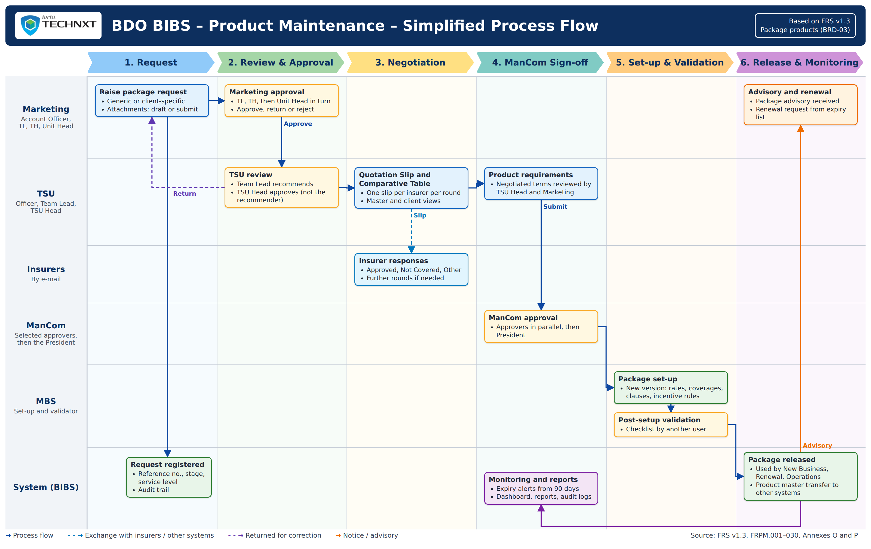
Figure 1: Product Maintenance: simplified process flow (swimlanes by actor)
Table 2: The 15 steps
Step | Who | What happens
1 | Marketing | The Account Officer raises a package request with the requested terms and target insurers.
2 | Marketing | A Marketing approver approves it for TSU.
3 | TSU | The TSU Team Lead reviews and recommends; the TSU Head approves it for negotiation.
4 | TSU | A TSU officer prepares the quotation slip; the Team Lead approves it; BIBS e-mails it to each insurer as a protected PDF.
5 | Insurers | Insurers reply by e-mail; TSU keys in each response (outcome, rate, minimum premium, terms).
6 | TSU | TSU compiles the comparative table, opens further rounds if needed, and makes the terms final.
7 | TSU, Marketing | The TSU Head reviews the terms; for a client-specific package, Marketing reviews them.
8 | TSU | TSU completes the product requirements with the signed package slip.
9 | ManCom | The selected ManCom approvers approve, the President last.
10 | MBS | The request goes to MBS, which sets up the package version and submits it.
11 | TSU Head | The TSU Head validates the version against the checklist and releases it.
12 | BIBS | Marketing is told; the advisory is drafted; the product master change is queued for transfer.
13 | TSU | TSU sends the advisory with the supporting documents.
14 | Marketing | New business is priced on the released version; a different rate needs a rate exception.
15 | TSU, MBS | Expiry alerts, renewal requests or deactivation close the cycle of the package.

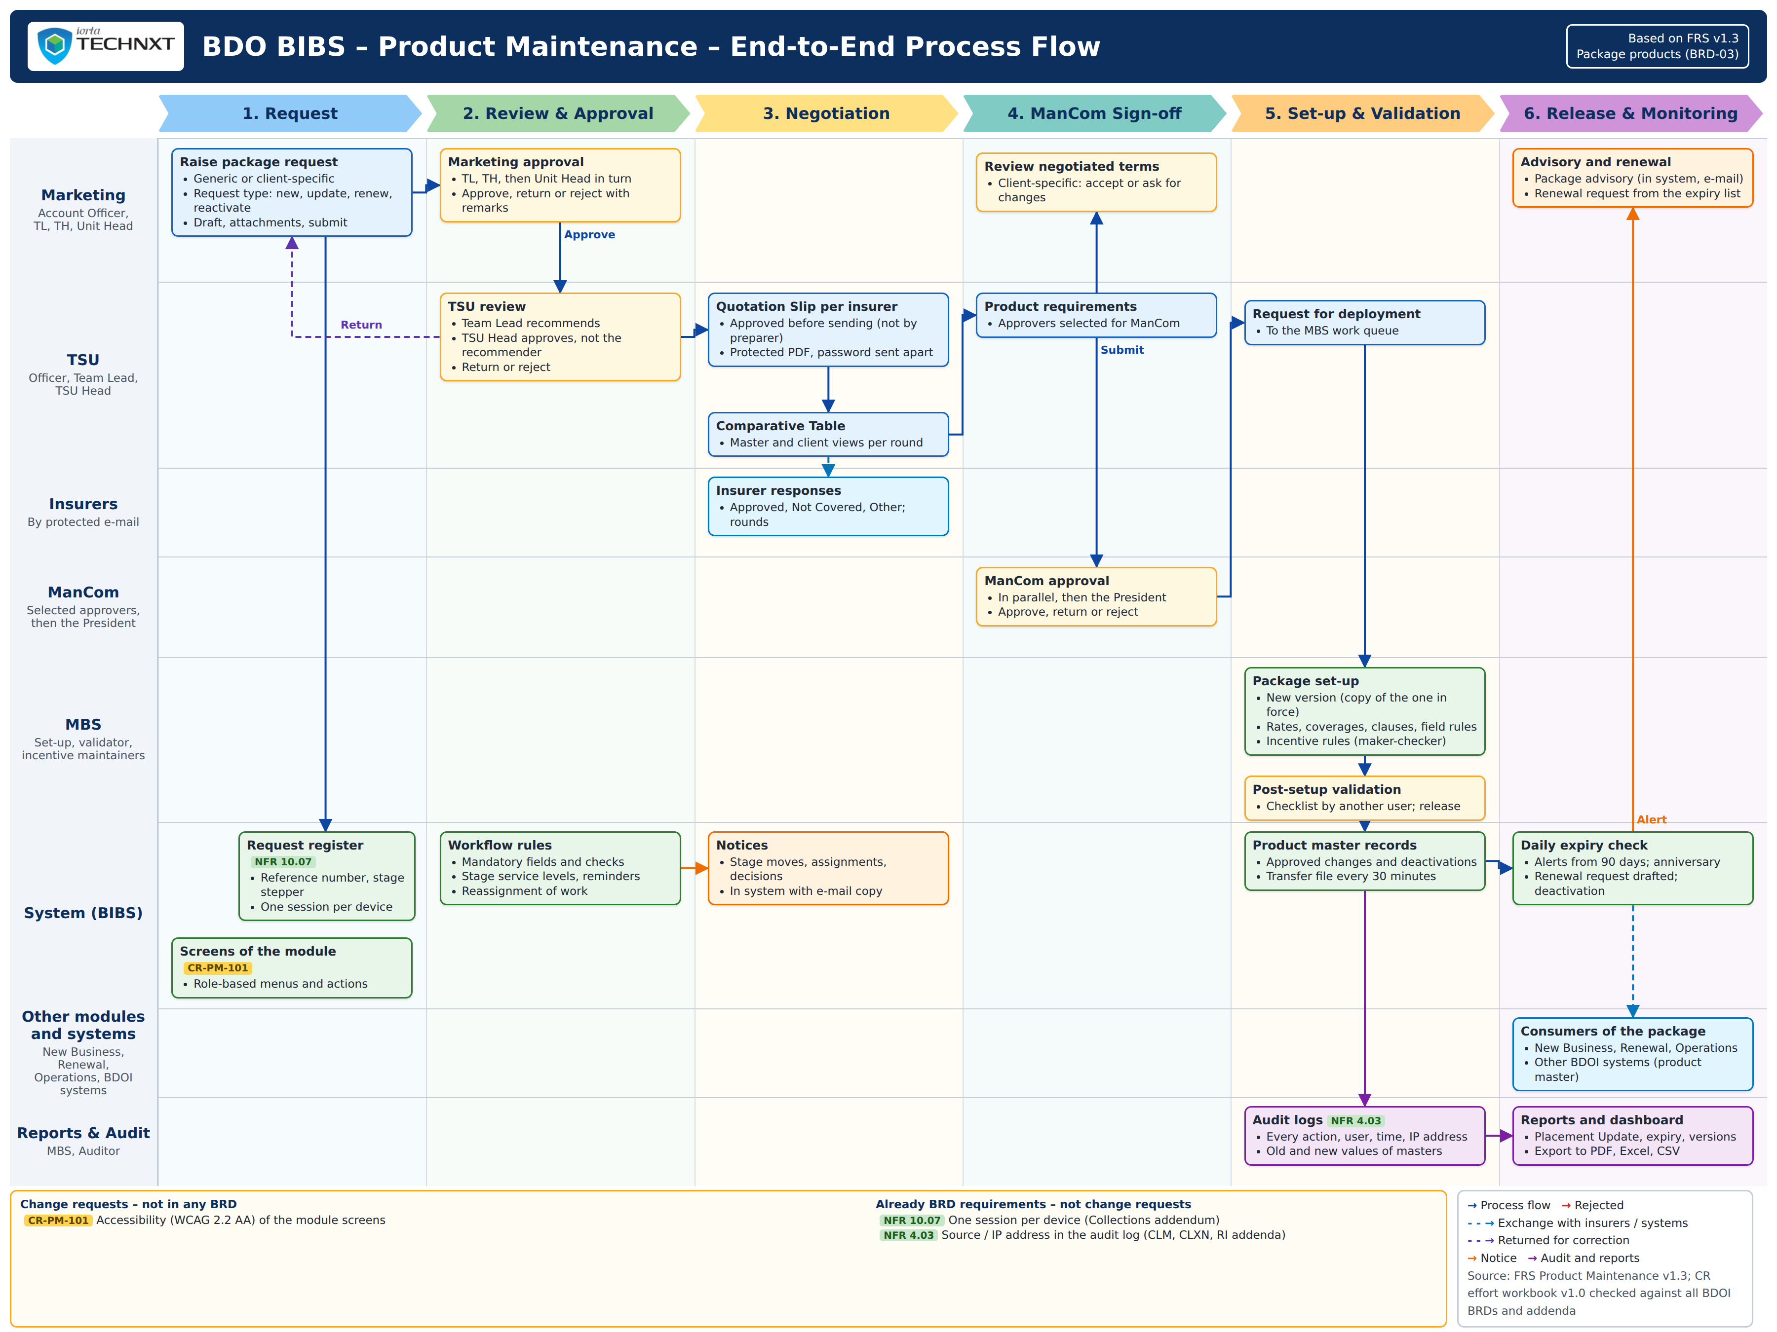
Figure 2: Product Maintenance: end-to-end flow by actor and system

To-be Processes

P-PM-01 Package request and approval
Item | Value
Journey steps | 1 to 3
Trigger | A Marketing, TSU or insurer need for a new or changed package.
Actors | Marketing Account Officer, Marketing Approver, TSU Team Lead, TSU Head
Outcome | Request approved for negotiation, or returned, voided or not proceeded.
Controls | BR-PM-01; service levels PKG_SLA_MKT_APPROVAL, PKG_SLA_TSU_REVIEW, PKG_SLA_TSU_APPROVAL.

P-PM-02 Negotiation, comparative table and terms
Item | Value
Journey steps | 4 to 7
Trigger | TSU Head approval.
Actors | TSU Officer, TSU Team Lead, TSU Head, Marketing, insurers
Outcome | Final terms with the insurers of the package, roles and shares.
Controls | BR-PM-01, BR-PM-04, BR-PM-11; PKG_SLA_NEGOTIATION.

P-PM-03 Requirements and ManCom sign-off
Item | Value
Journey steps | 8 to 9
Trigger | Terms reviewed.
Actors | TSU Officer, ManCom members, President
Outcome | Requirements signed off (MC-<request number>); slips locked.
Controls | BR-PM-01, BR-PM-07, BR-PM-08; PKG_SLA_MANCOM.

P-PM-04 Set-up, validation and release
Item | Value
Journey steps | 10 to 13
Trigger | ManCom approval (automatic or Request for Deployment).
Actors | MBS, TSU Head or Business Administrator, TSU Officer
Outcome | Released version sold from its effective date; advisory sent; product master change transferred.
Controls | BR-PM-01, BR-PM-02, BR-PM-09, BR-PM-14; PKG_SLA_MBS_SETUP.

P-PM-05 New business on the rate scheme and rate exceptions
Item | Value
Journey steps | 14
Trigger | A quotation on a package.
Actors | Marketing Account Officer, approver
Outcome | Quotation priced on the version in force, or at an approved exception rate.
Controls | BR-PM-03; RATE_EXCEPTION_VALIDITY_DAYS.

P-PM-06 Expiry, renewal and deactivation
Item | Value
Journey steps | 15
Trigger | Daily expiry check, or a deactivation request.
Actors | TSU Officer, MBS, approver
Outcome | Renewal request raised, or package retired or expired and transferred to other systems.
Controls | BR-PM-05, BR-PM-06, BR-PM-12.

P-PM-07 Master maintenance under maker-checker
Item | Value
Journey steps | -
Trigger | A new or changed coverage, clause, field rule, insurer, rate or incentive criterion.
Actors | MBS (maker), Business Administrator (checker)
Outcome | Authorised master record.
Controls | BR-PM-01, BR-PM-05, BR-PM-13.

Stages of a package request
Figure 3: Stages of a package request

Storyboards

SB-01 A new package from the request to its release
Motor Fleet Plus, a new generic programme, goes from Marketing to release in one pass.
Table 3: SB-01 steps
Step | Who | Screen | Does | Sees
1 | MBS | Coverages & Clauses | Adds the clause 'Accredited repair shops for fleets' and saves it for authorisation. | The clause is pending authorisation.
2 | Business Administrator | Coverages & Clauses | Authorises the clause. | The clause is active.
3 | Marketing Account Officer | New Package Request | Enters the request, terms and two insurers; submits. | The request is numbered and For Marketing approval.
4 | Marketing Approver | Package Request | Approves and sends it to TSU. | For TSU review.
5 | TSU Team Lead | Package Request | Recommends it with a comment. | For TSU Head approval.
6 | TSU Head | Package Request | Approves it for negotiation. | Insurer negotiation, round 1.
7 | TSU Officer | Negotiation tab | Writes the notes to the insurers and submits the slip. | Slip for approval.
8 | TSU Team Lead | Negotiation tab | Approves and sends the slip. | Slip sent; one e-mail per insurer.
9 | TSU Officer | Negotiation tab | Keys in the two insurer responses with the reply documents. | Responses with rate and minimum premium.
10 | TSU Officer | Negotiation tab | Makes the terms final with the chosen insurer. | Negotiated terms review.
11 | TSU Officer | Comparative tab | Opens the comparative table. | Offers side by side, lowest first.
12 | TSU Head | Package Request | Sends the generic programme to the requirements. | Requirements preparation.
13 | TSU Officer | Requirements, Routing | Completes the requirements, attaches the signed package slip and sends to the selected ManCom approvers. | For ManCom sign-off.
14 | ManCom Member and President | Routing & Approvals tab | Approve, the President last. | Signed off; with MBS for set-up.
15 | MBS | Package Request | Sets up version 1 with the new risk code. | Draft version linked to the request.
16 | MBS | Package Version | Completes the insurer terms and submits for validation. | For validation.
17 | TSU Head | Package Version | Ticks the checklist and validates and releases. | Released; Marketing told.
18 | Business Administrator | Insurer | Adds the commission rate of the insurer for the new product. | Rate pending authorisation.
19 | Approver | Insurer | Authorises the commission rate. | Rate active.
20 | TSU Officer | Advisories tab | Sends the drafted new-package advisory. | Advisory sent and stored.

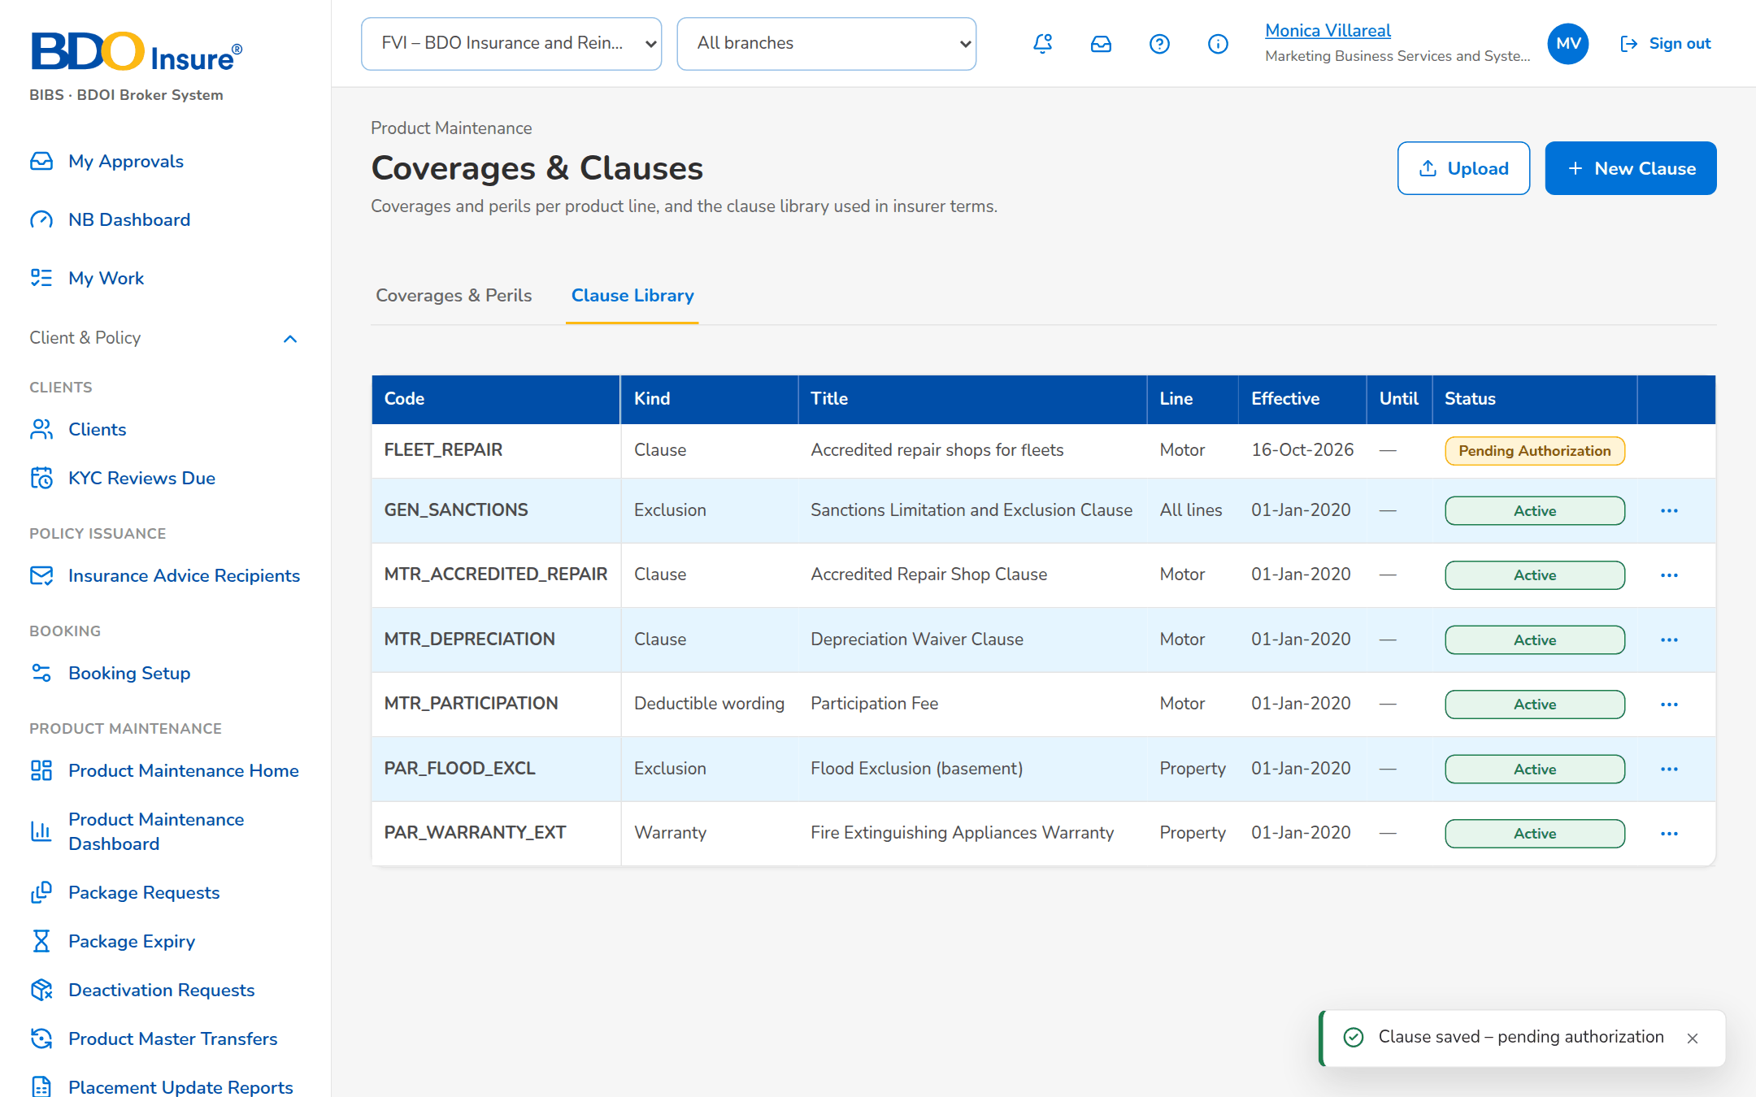
Figure 4: SB-01 step 1: MBS, Coverages & Clauses
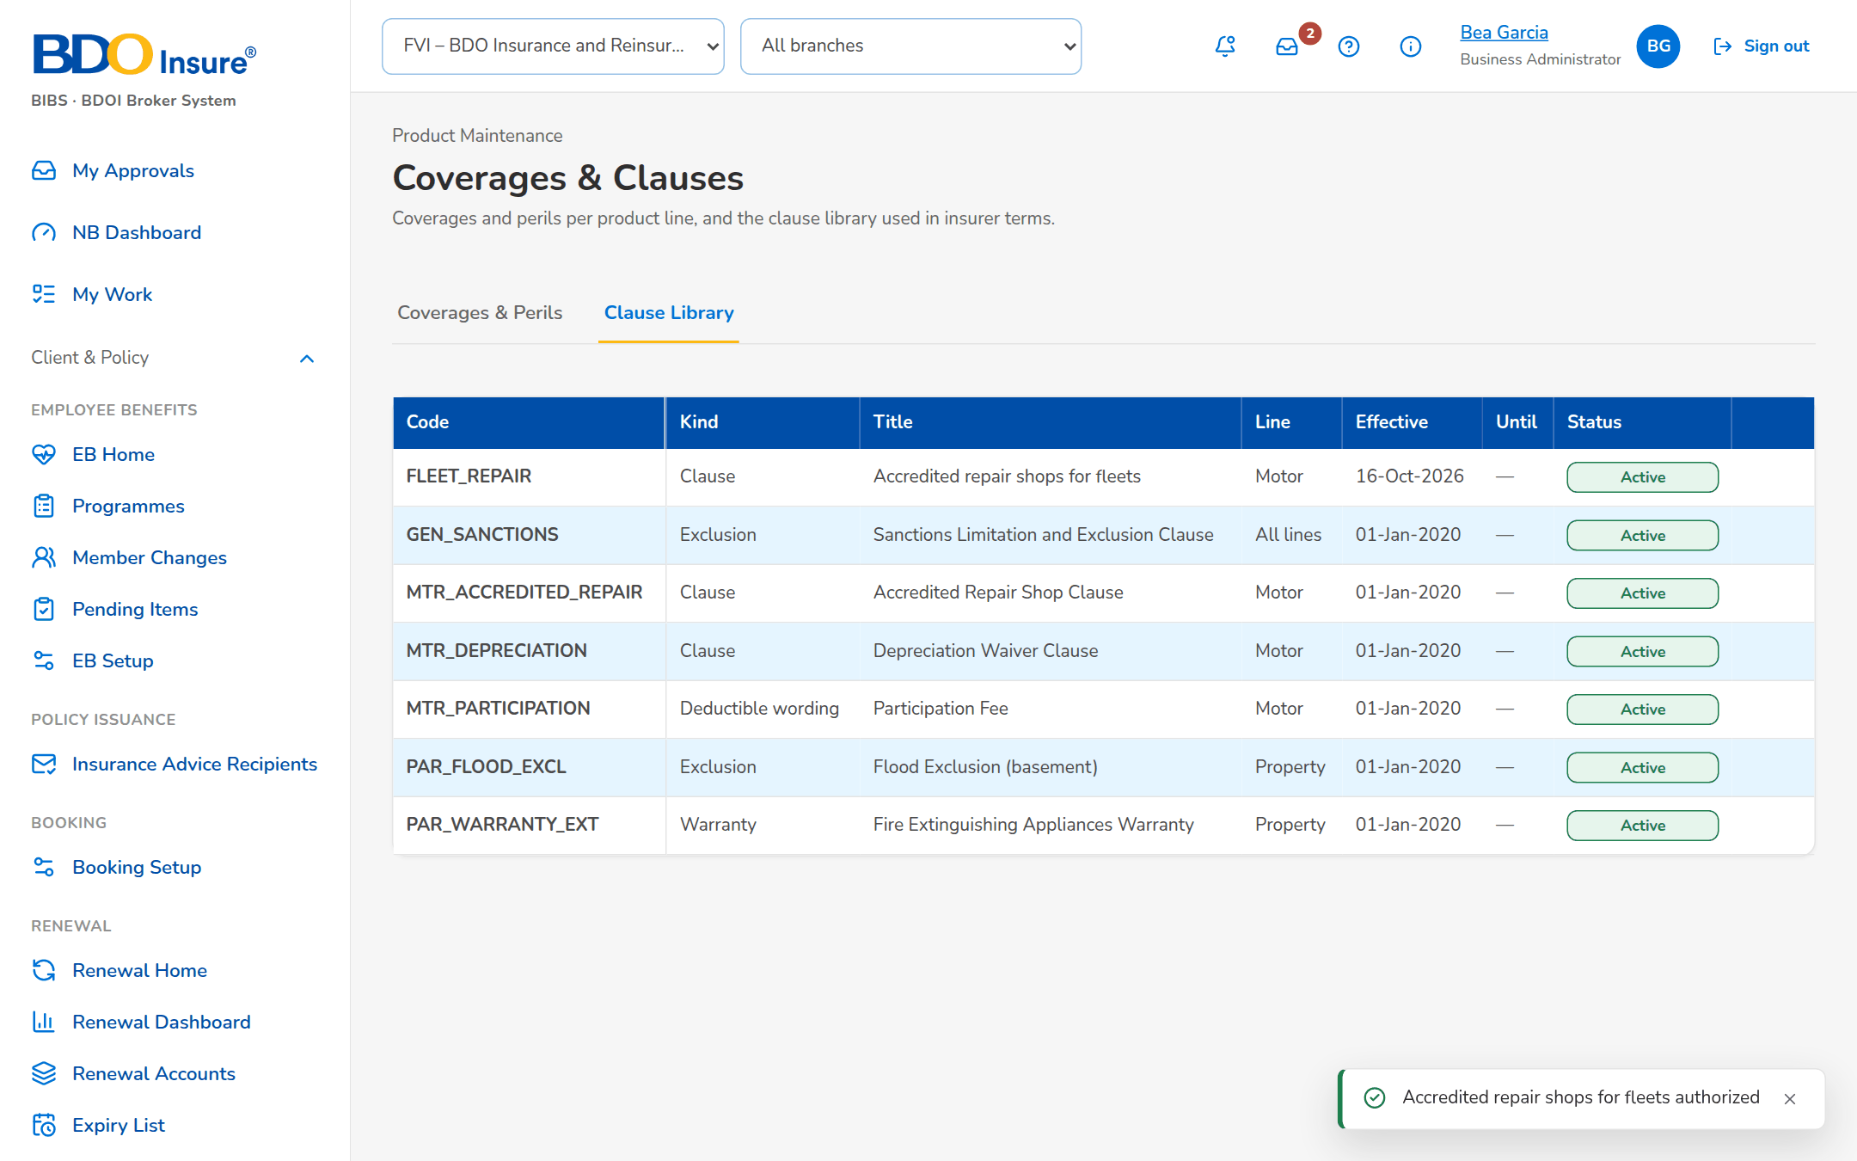
Figure 5: SB-01 step 2: Business Administrator, Coverages & Clauses
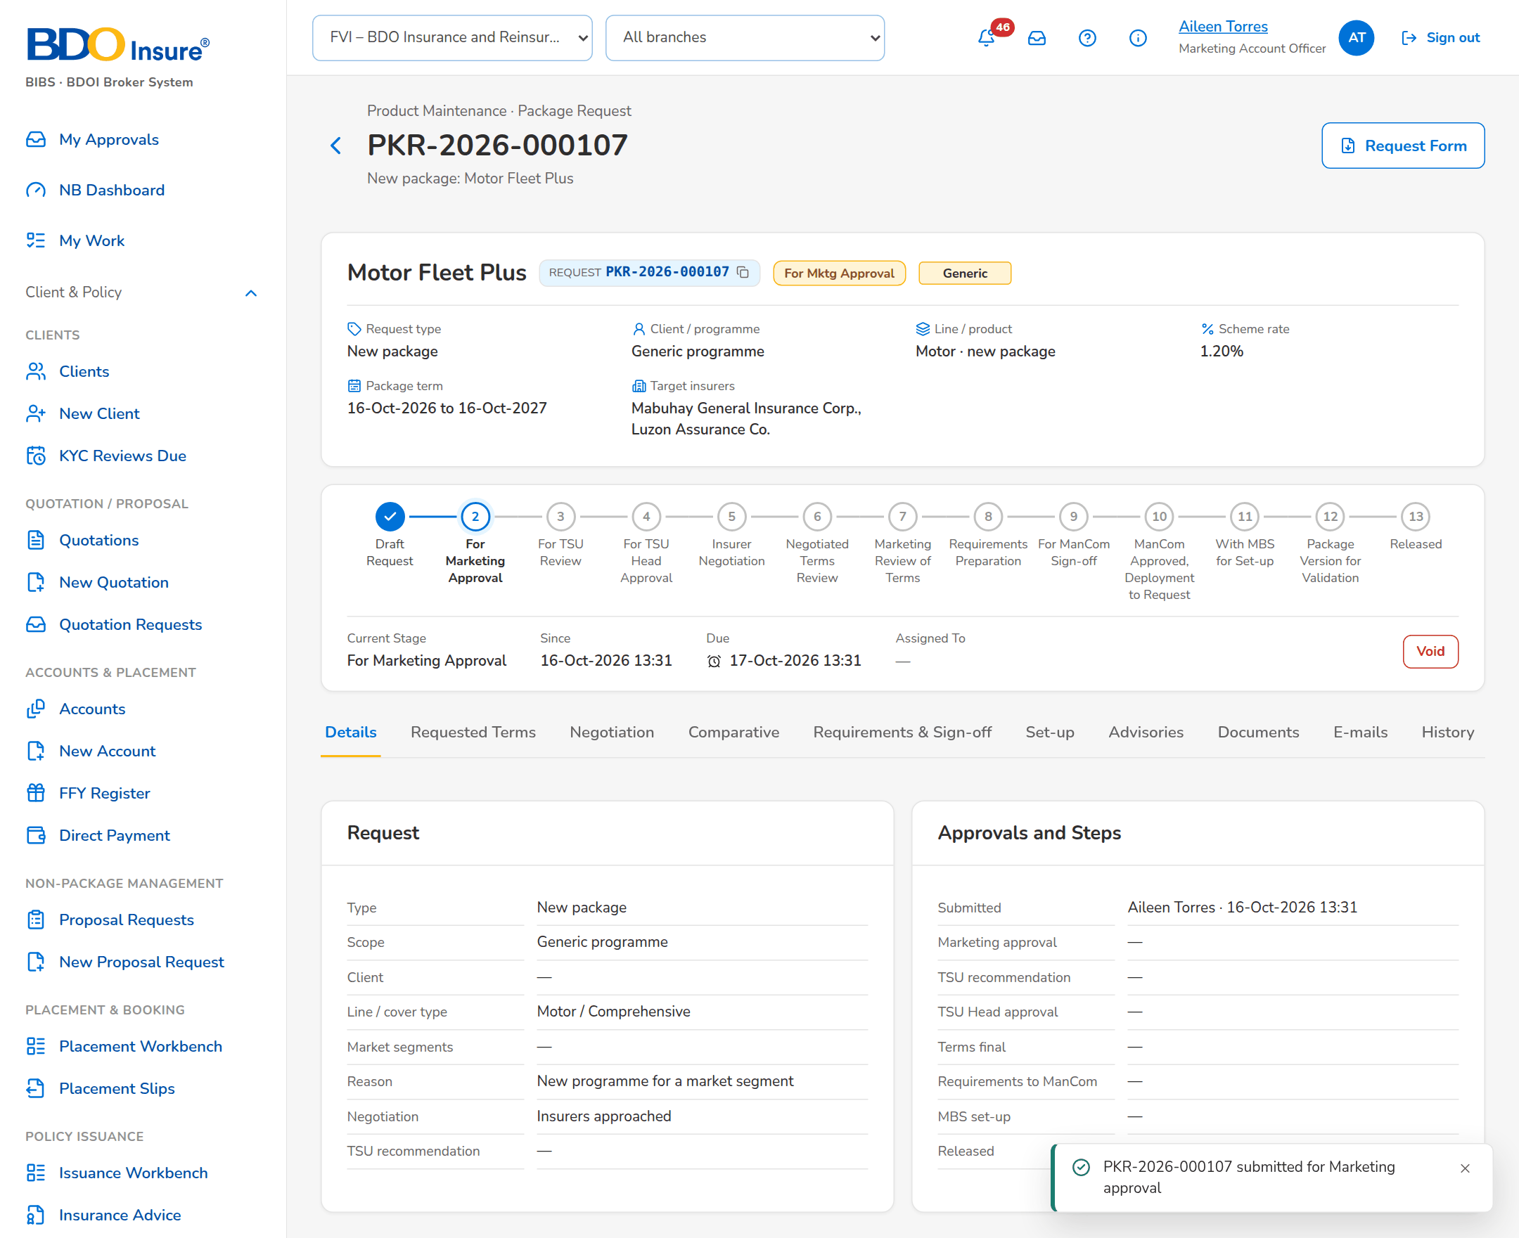
Figure 6: SB-01 step 3: Marketing Account Officer, New Package Request
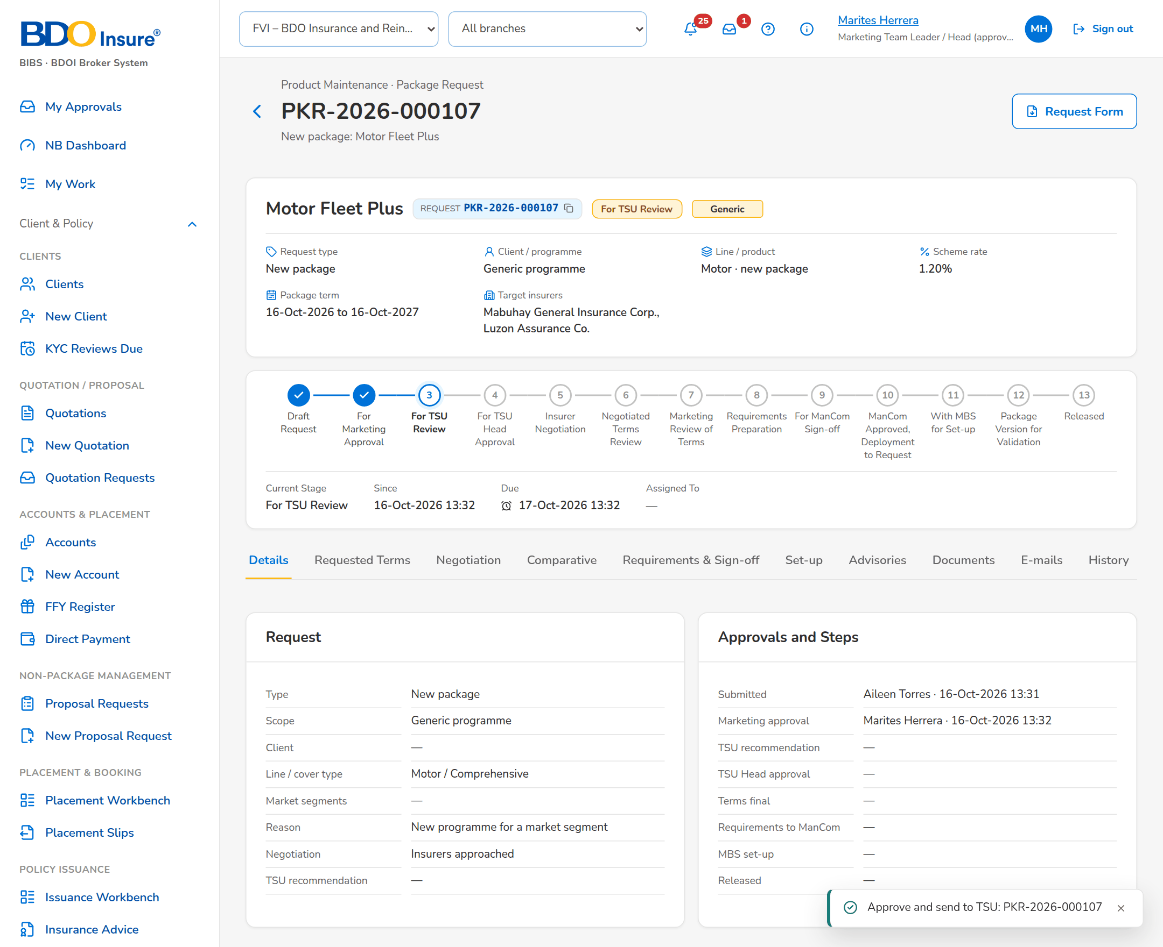
Figure 7: SB-01 step 4: Marketing Approver, Package Request
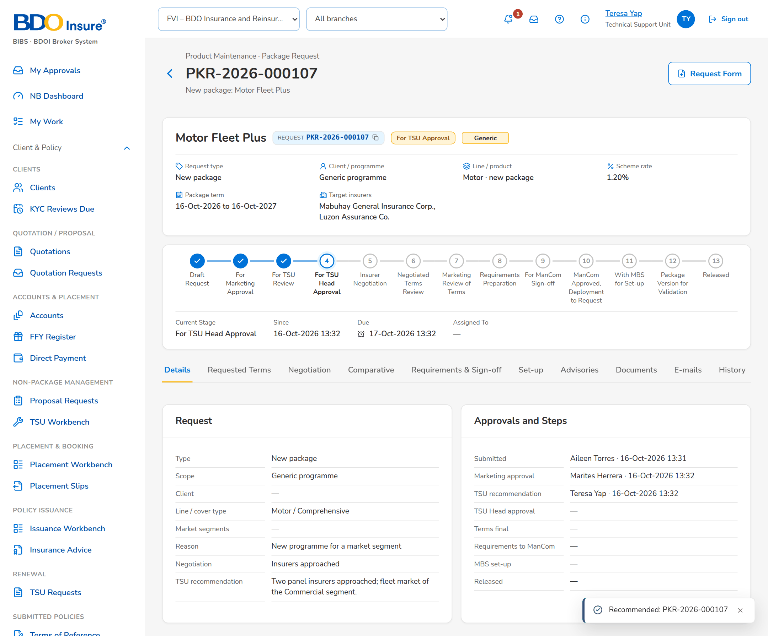
Figure 8: SB-01 step 5: TSU Team Lead, Package Request
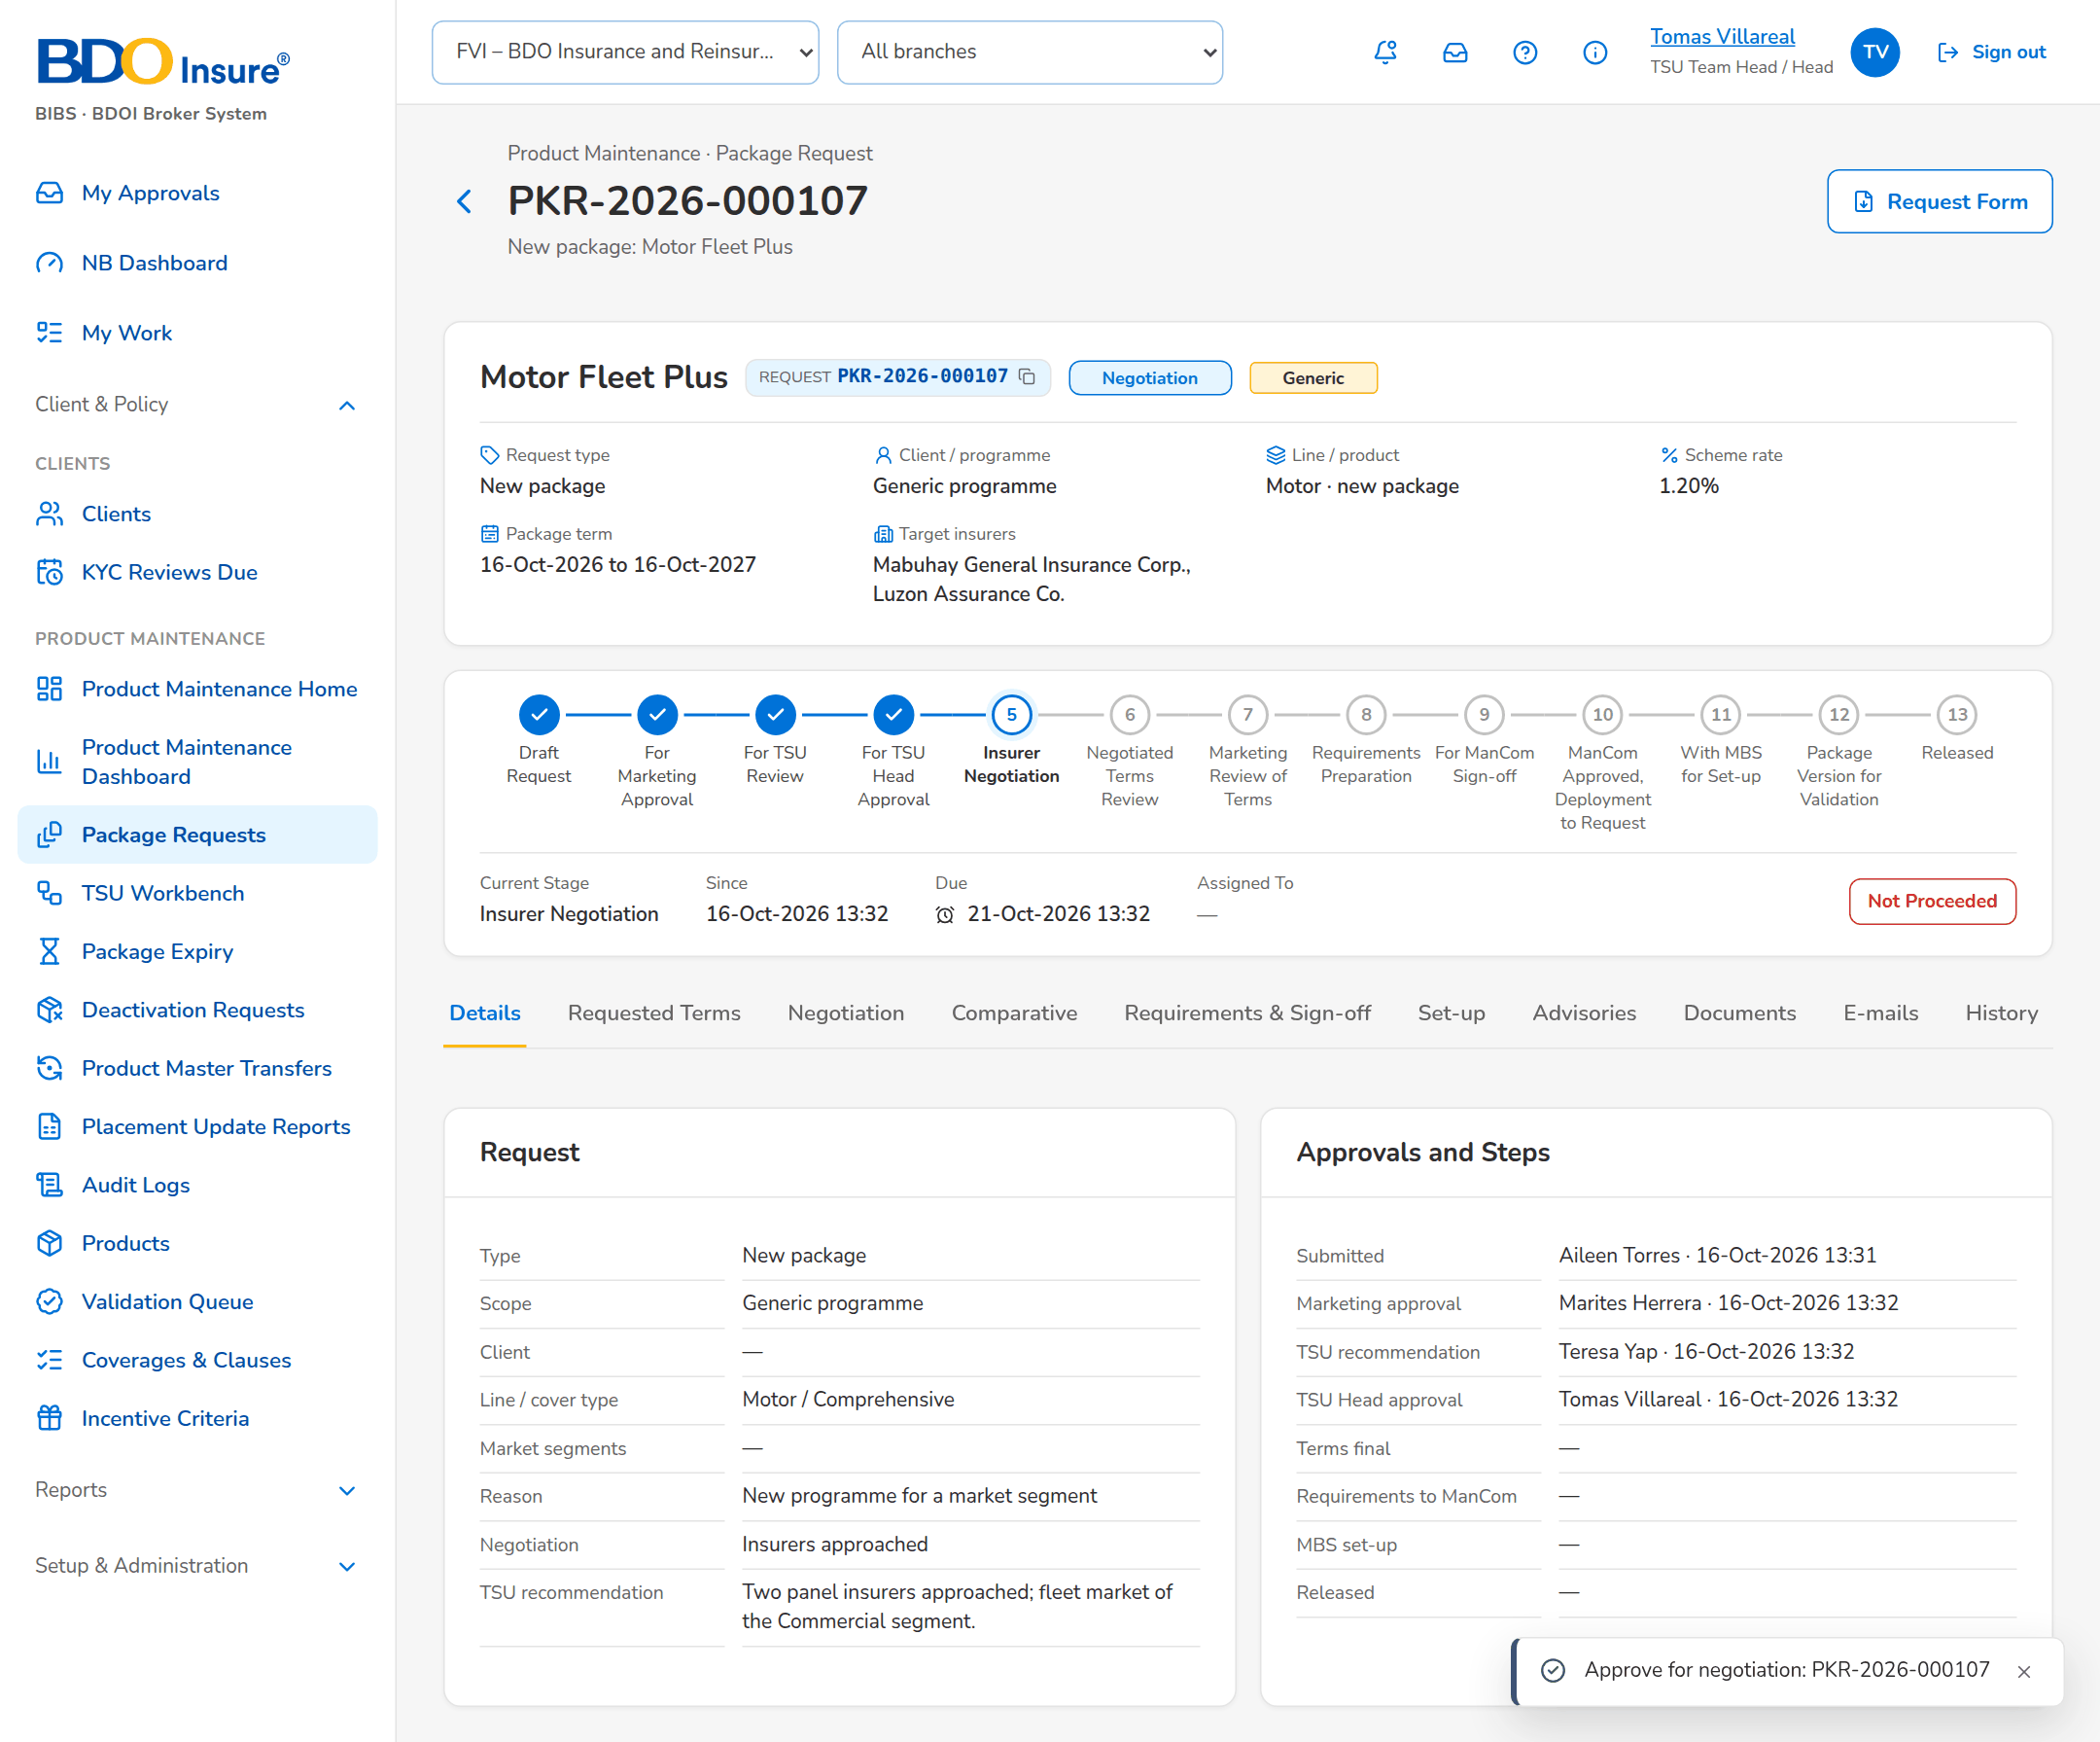
Figure 9: SB-01 step 6: TSU Head, Package Request
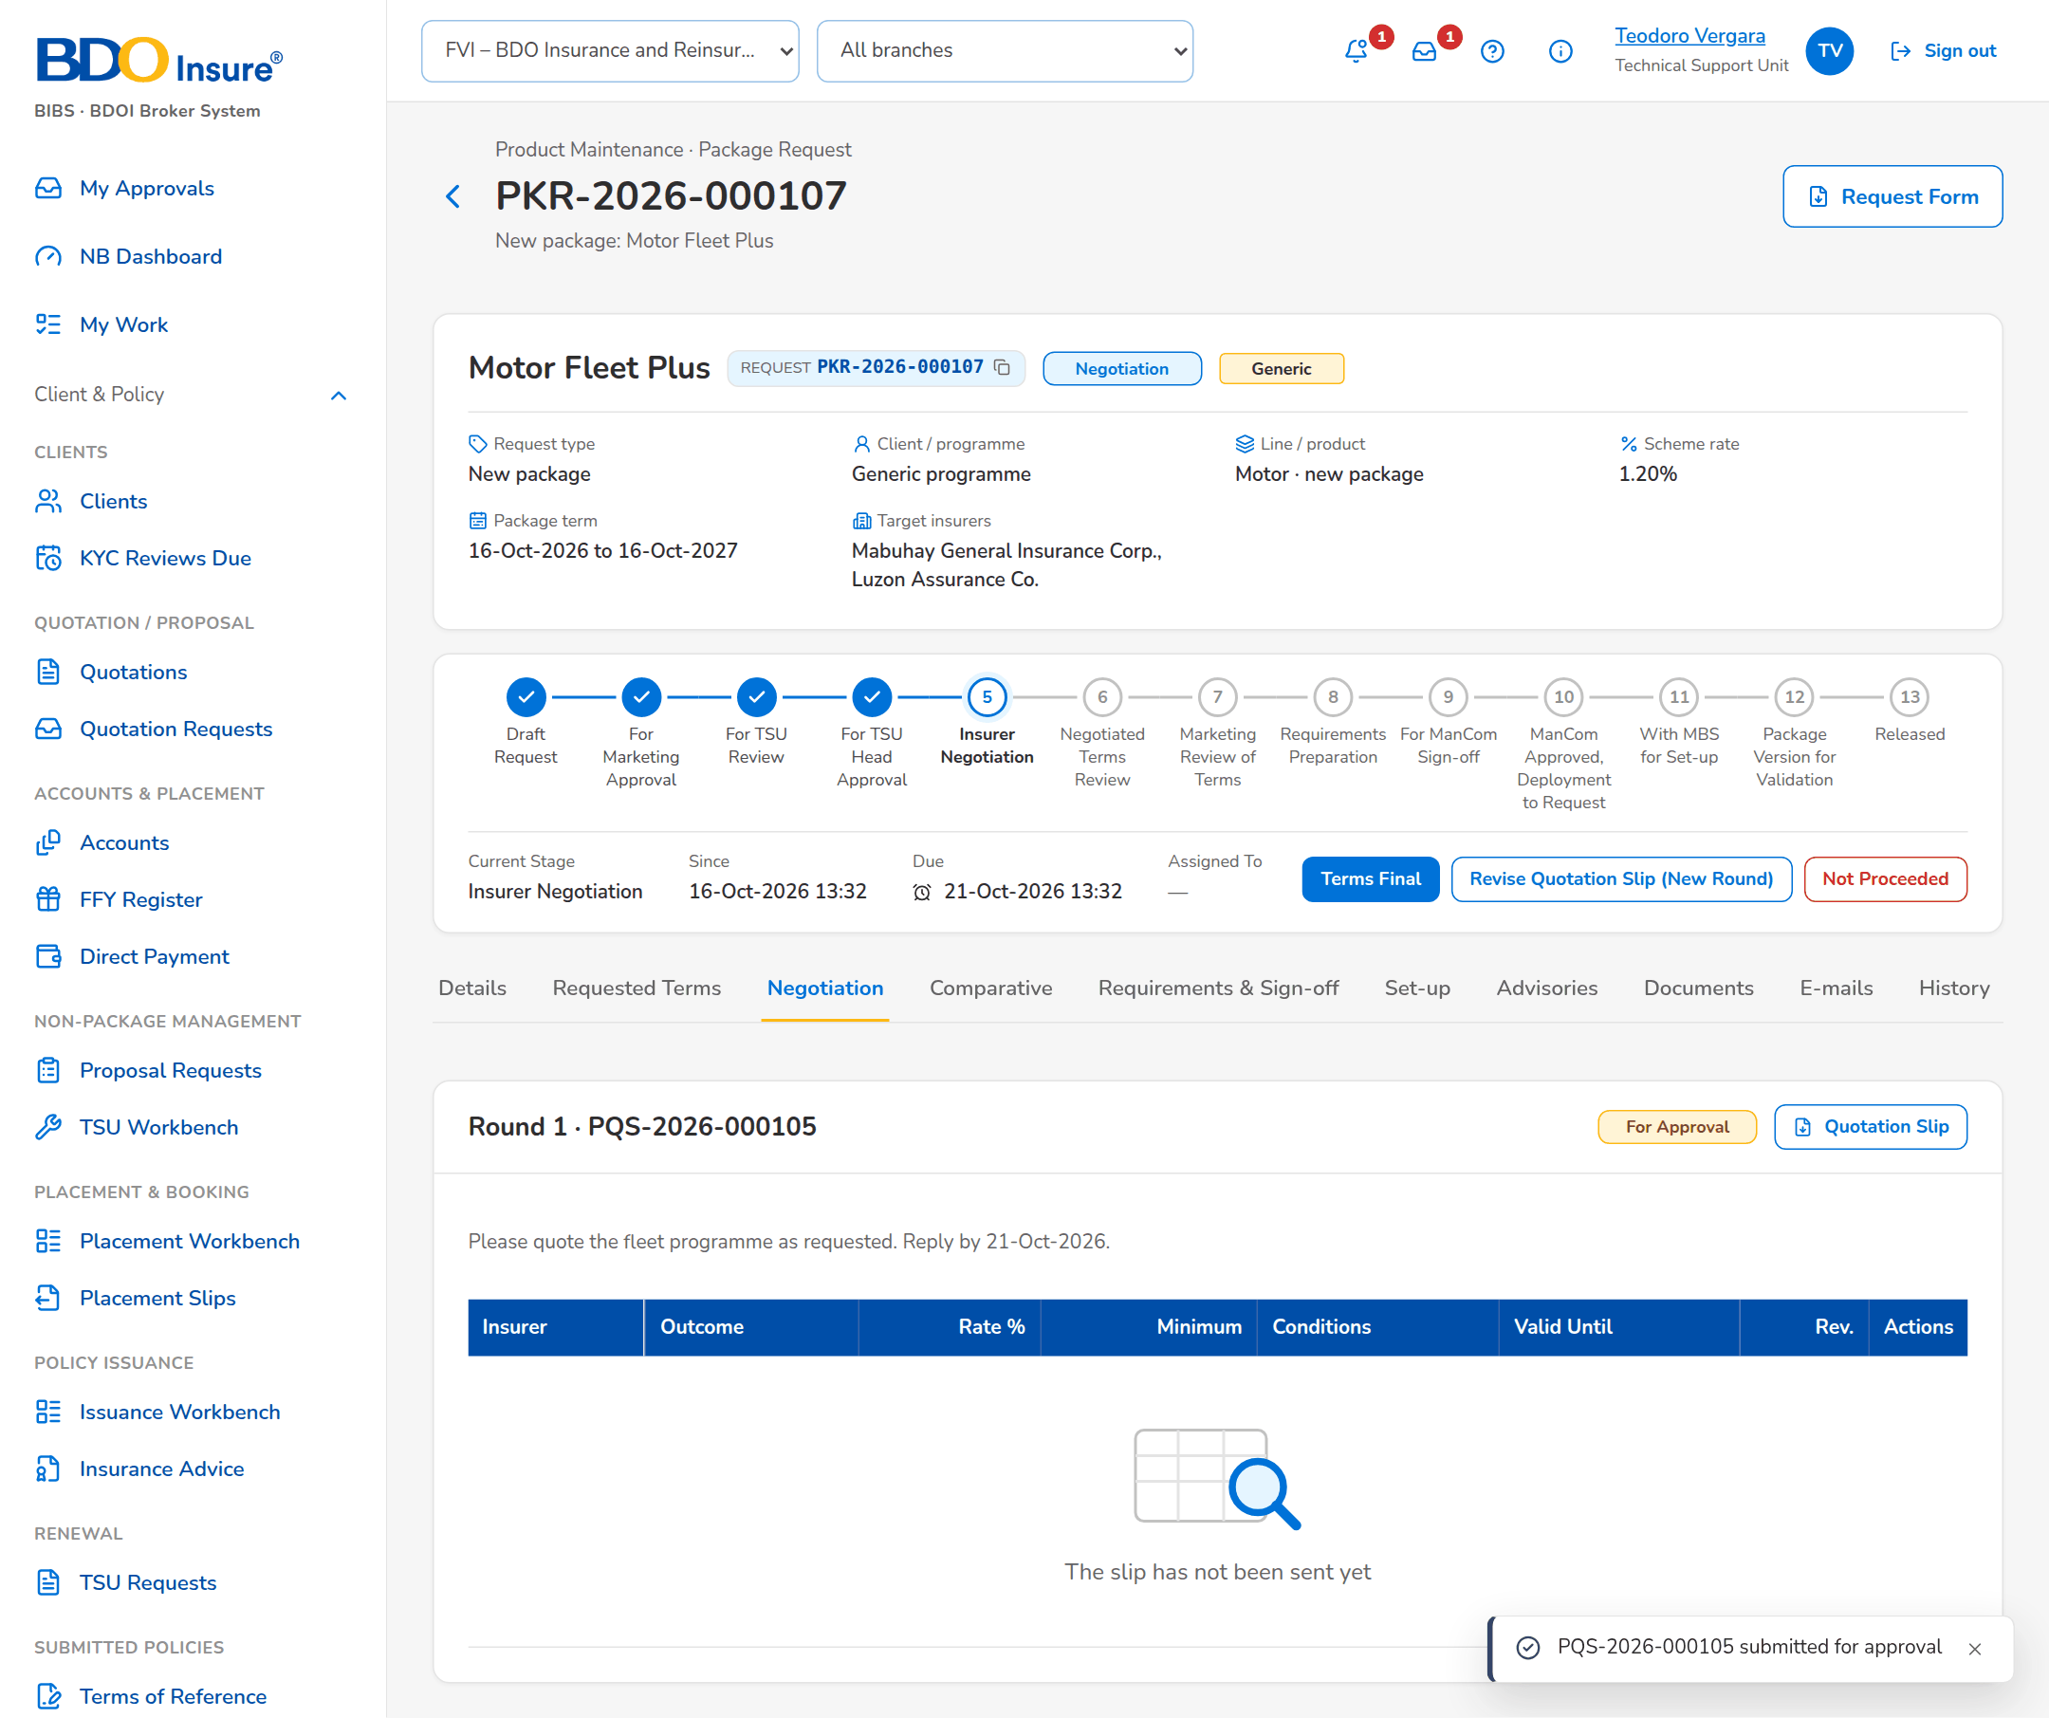
Figure 10: SB-01 step 7: TSU Officer, Negotiation tab
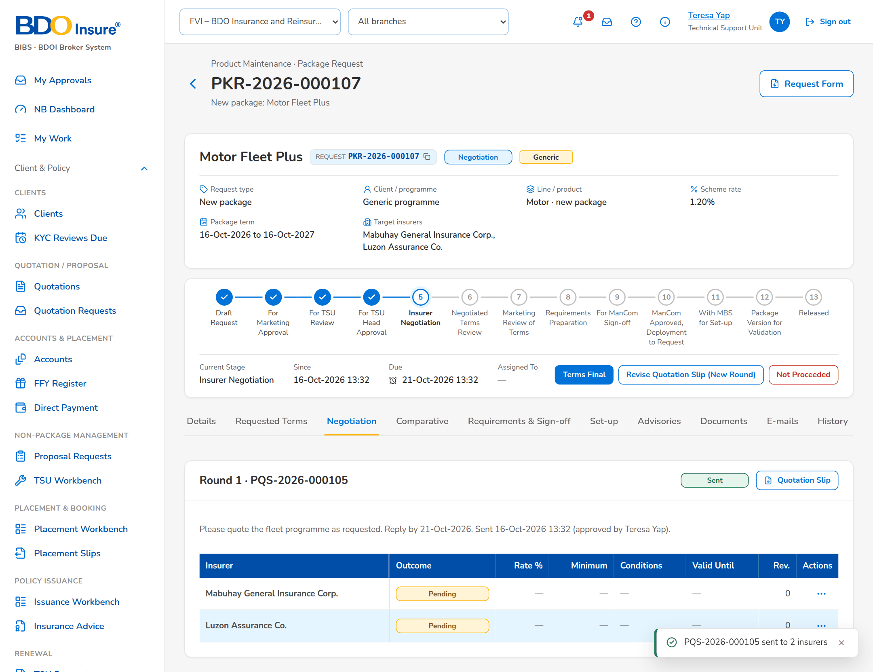
Figure 11: SB-01 step 8: TSU Team Lead, Negotiation tab
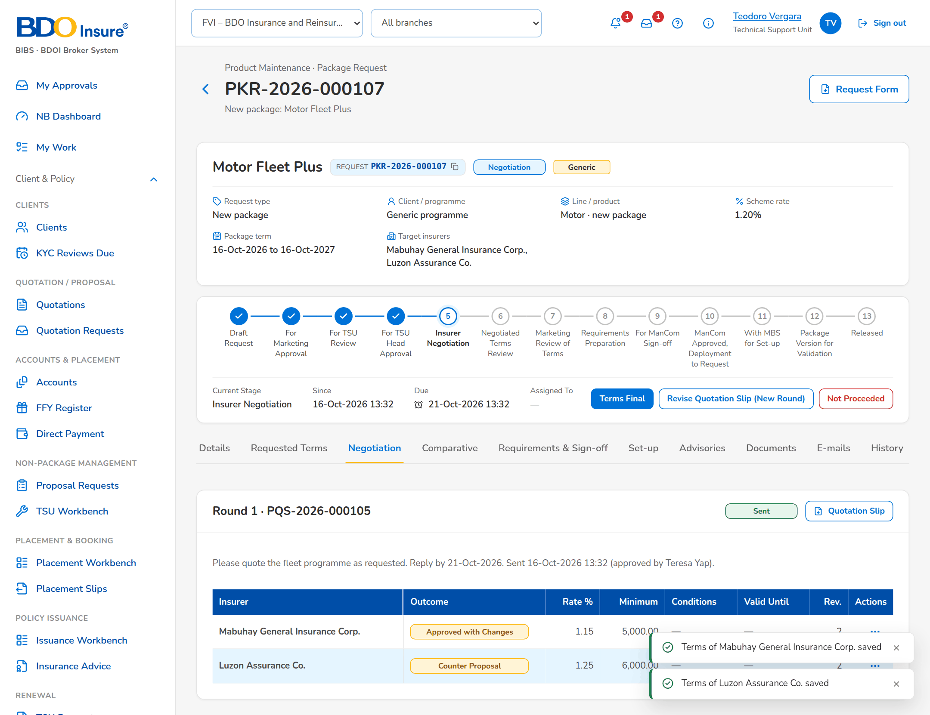
Figure 12: SB-01 step 9: TSU Officer, Negotiation tab
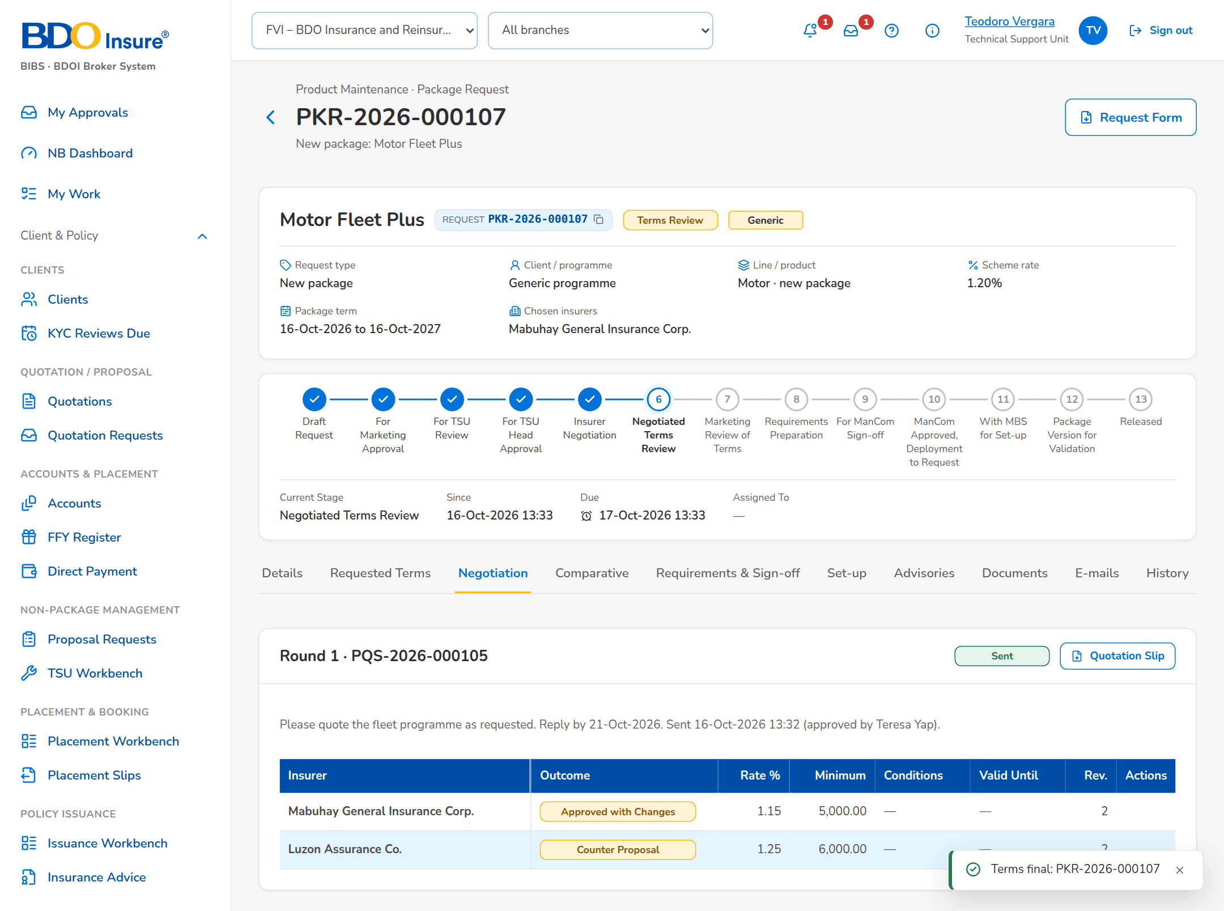
Figure 13: SB-01 step 10: TSU Officer, Negotiation tab
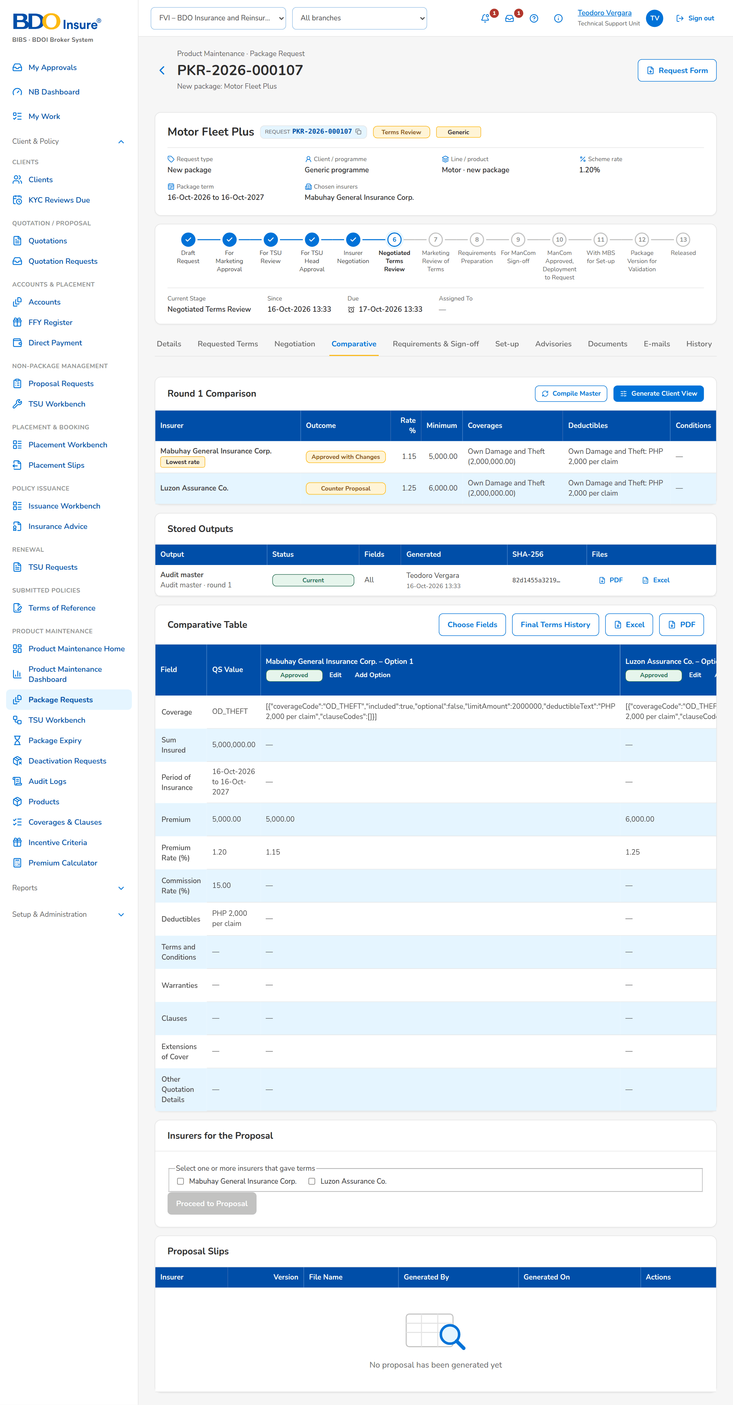
Figure 14: SB-01 step 11: TSU Officer, Comparative tab
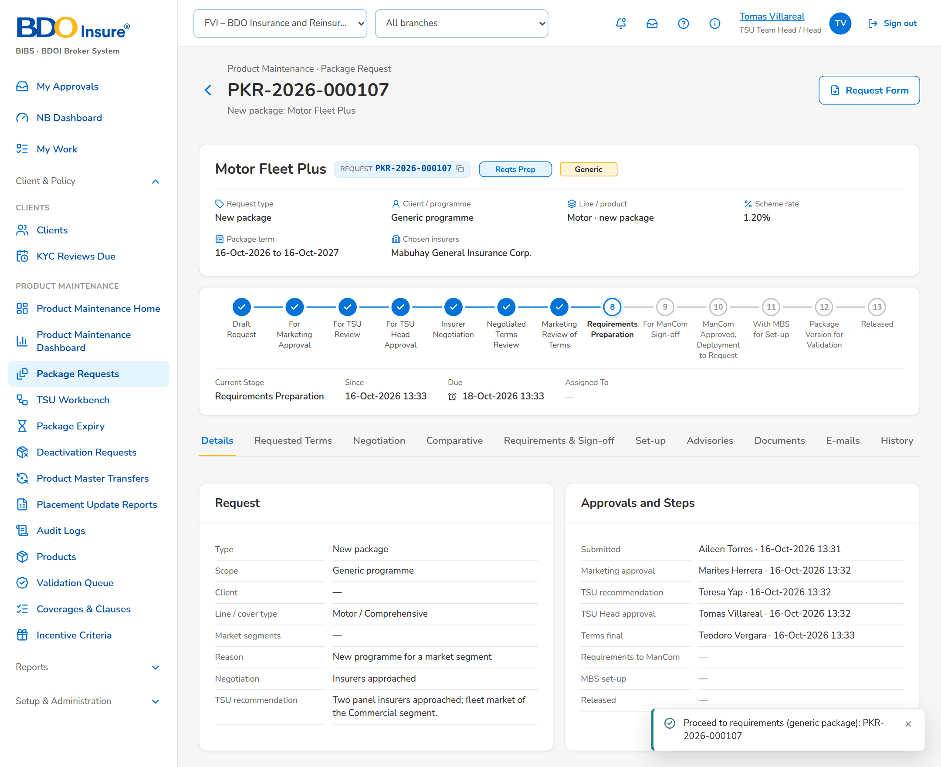
Figure 15: SB-01 step 12: TSU Head, Package Request
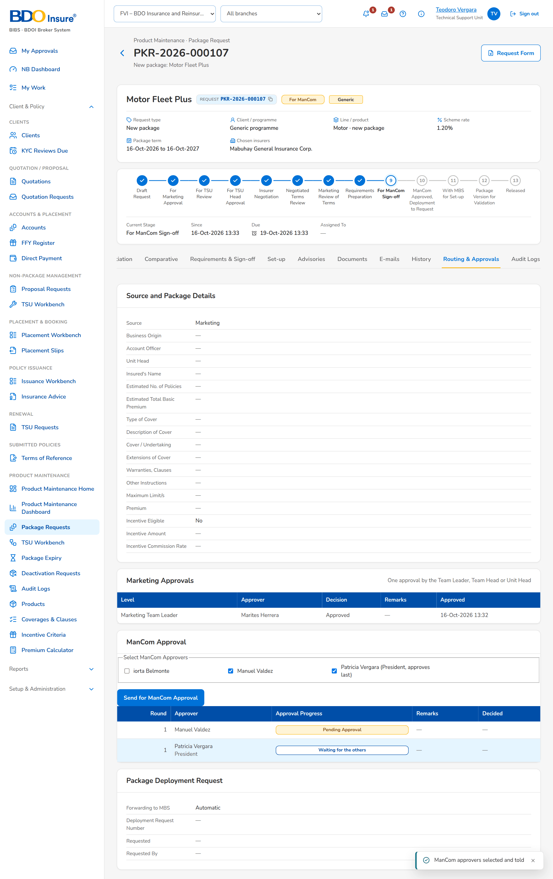
Figure 16: SB-01 step 13: TSU Officer, Requirements, Routing
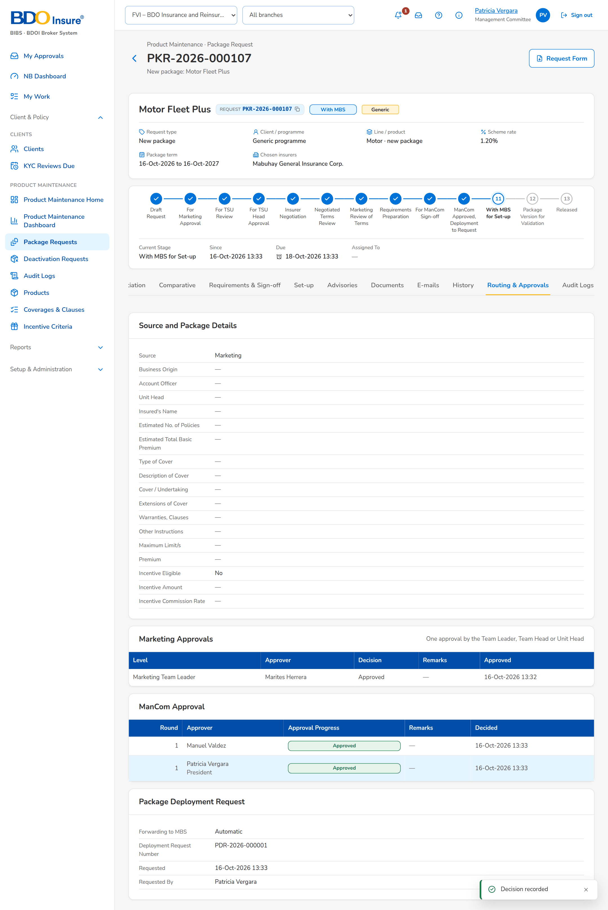
Figure 17: SB-01 step 14: ManCom Member and President, Routing & Approvals tab
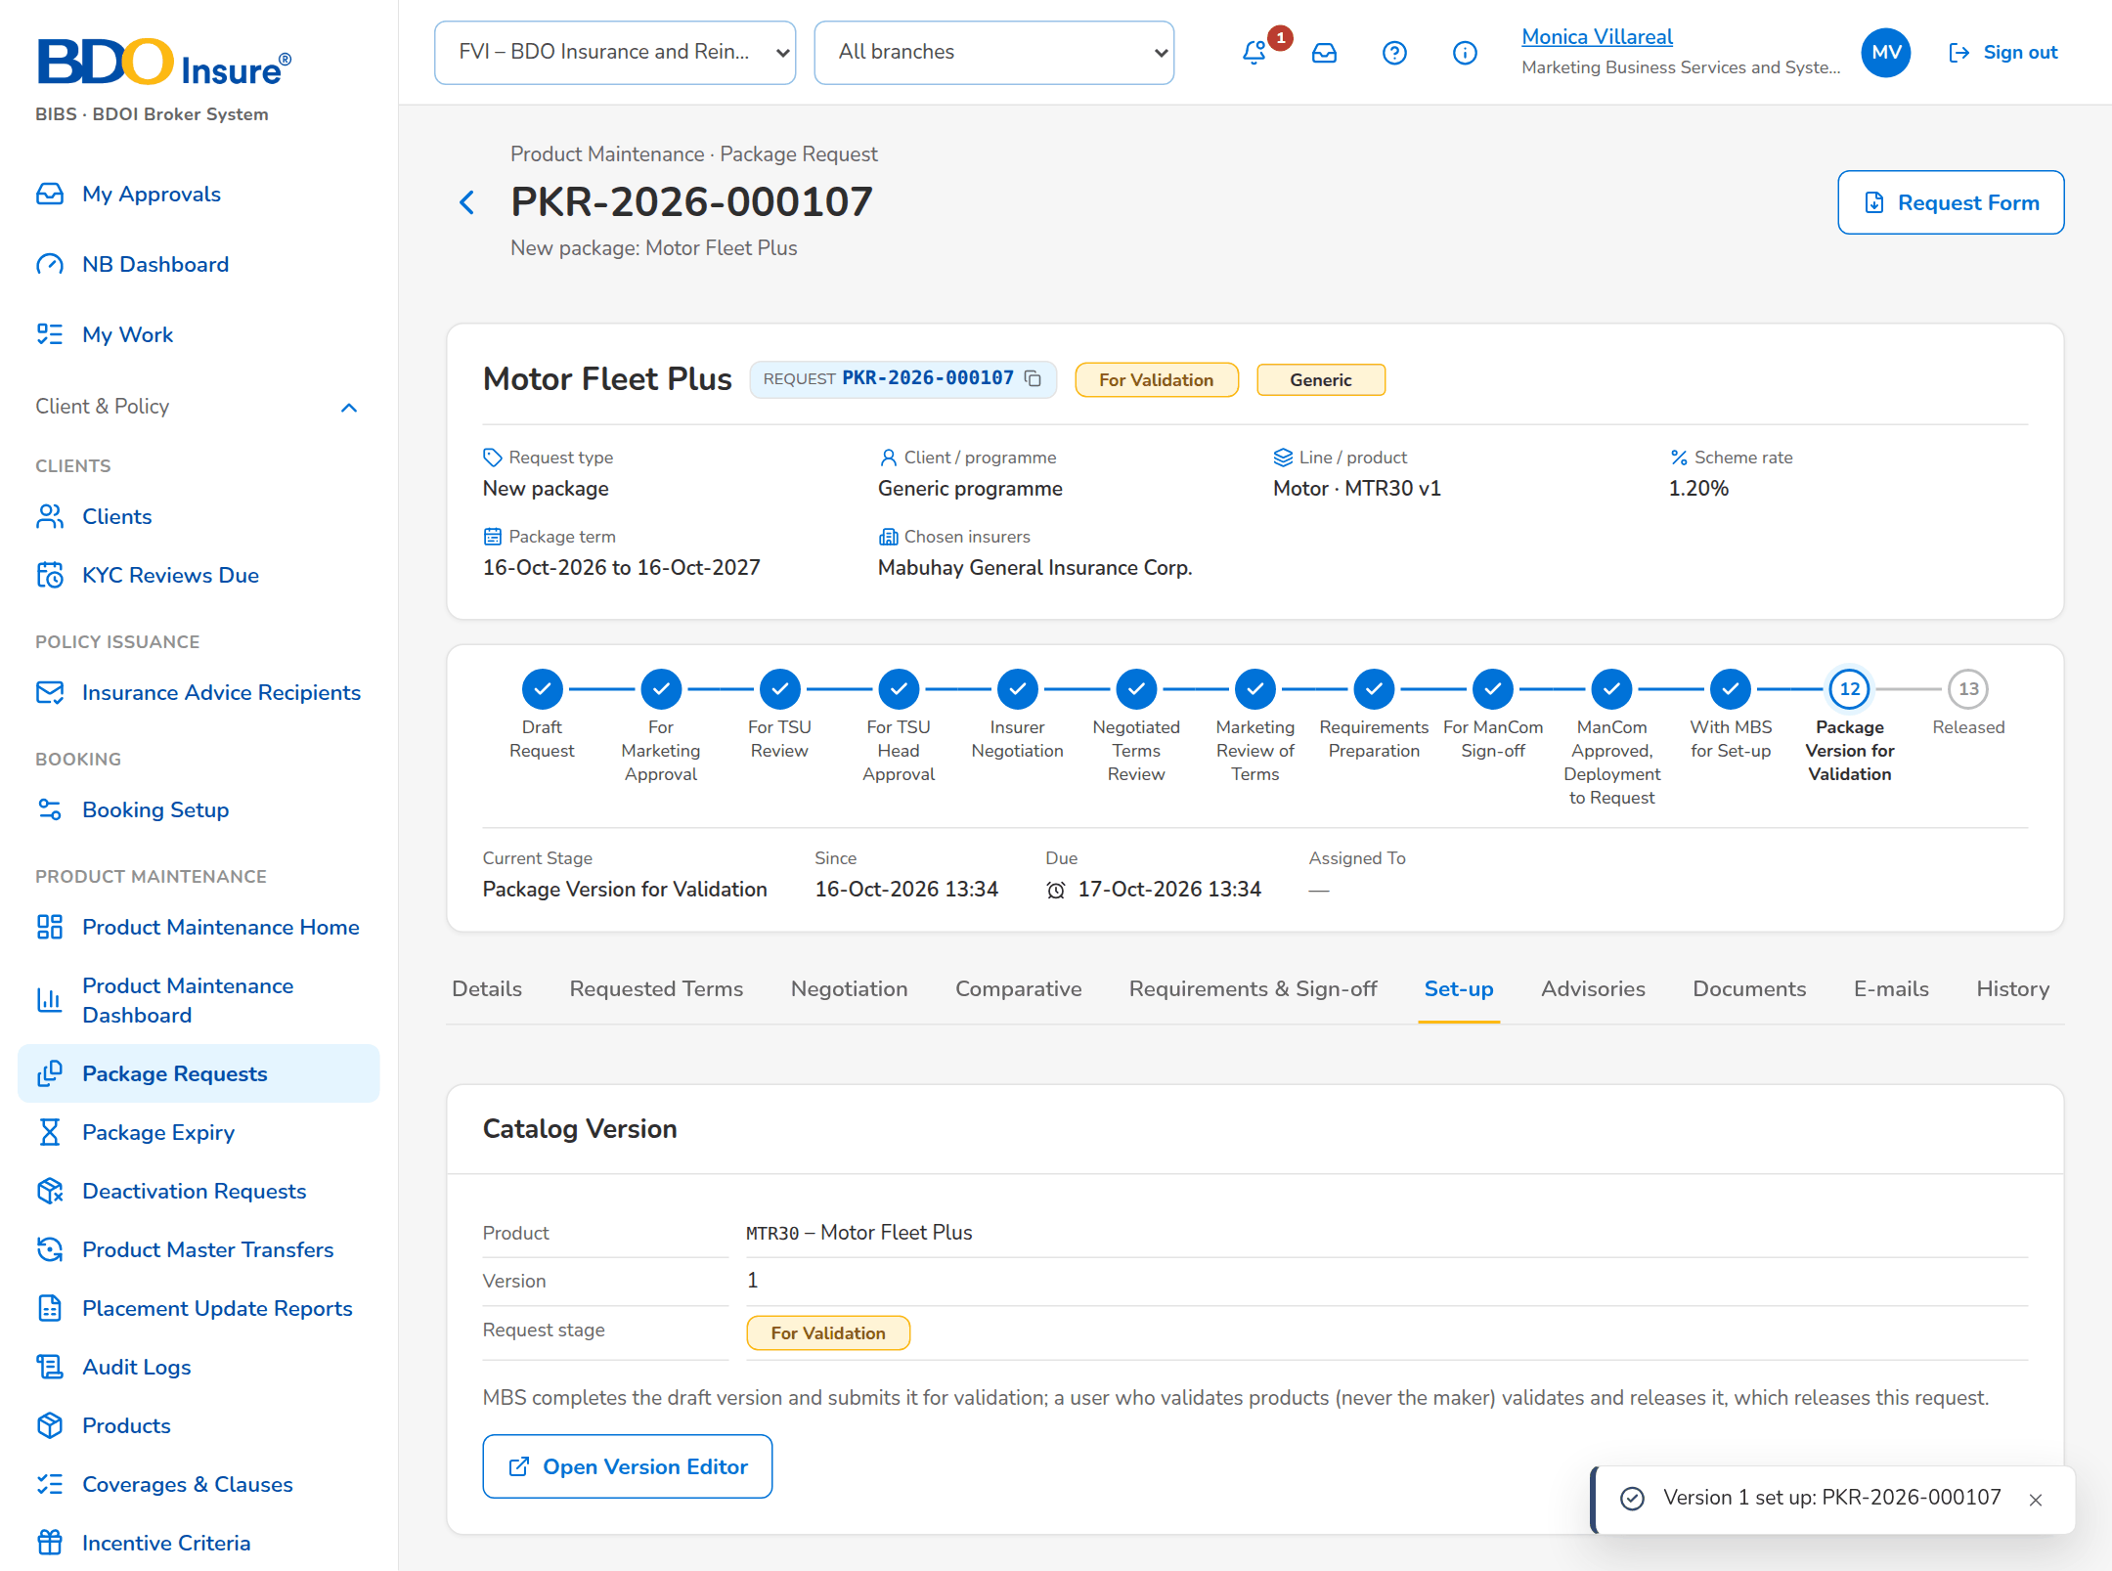
Figure 18: SB-01 step 15: MBS, Package Request
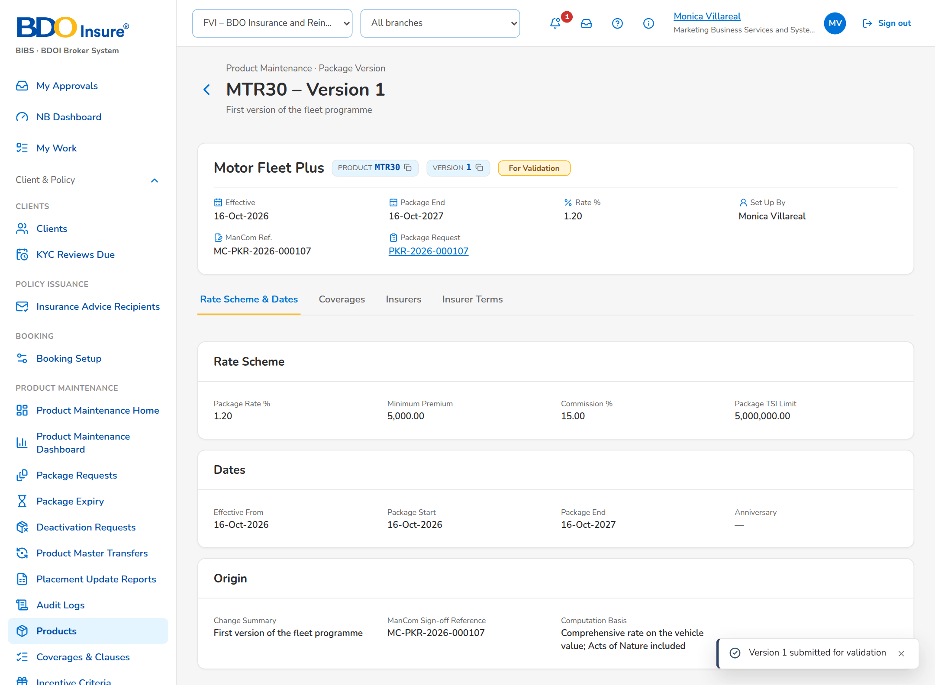
Figure 19: SB-01 step 16: MBS, Package Version
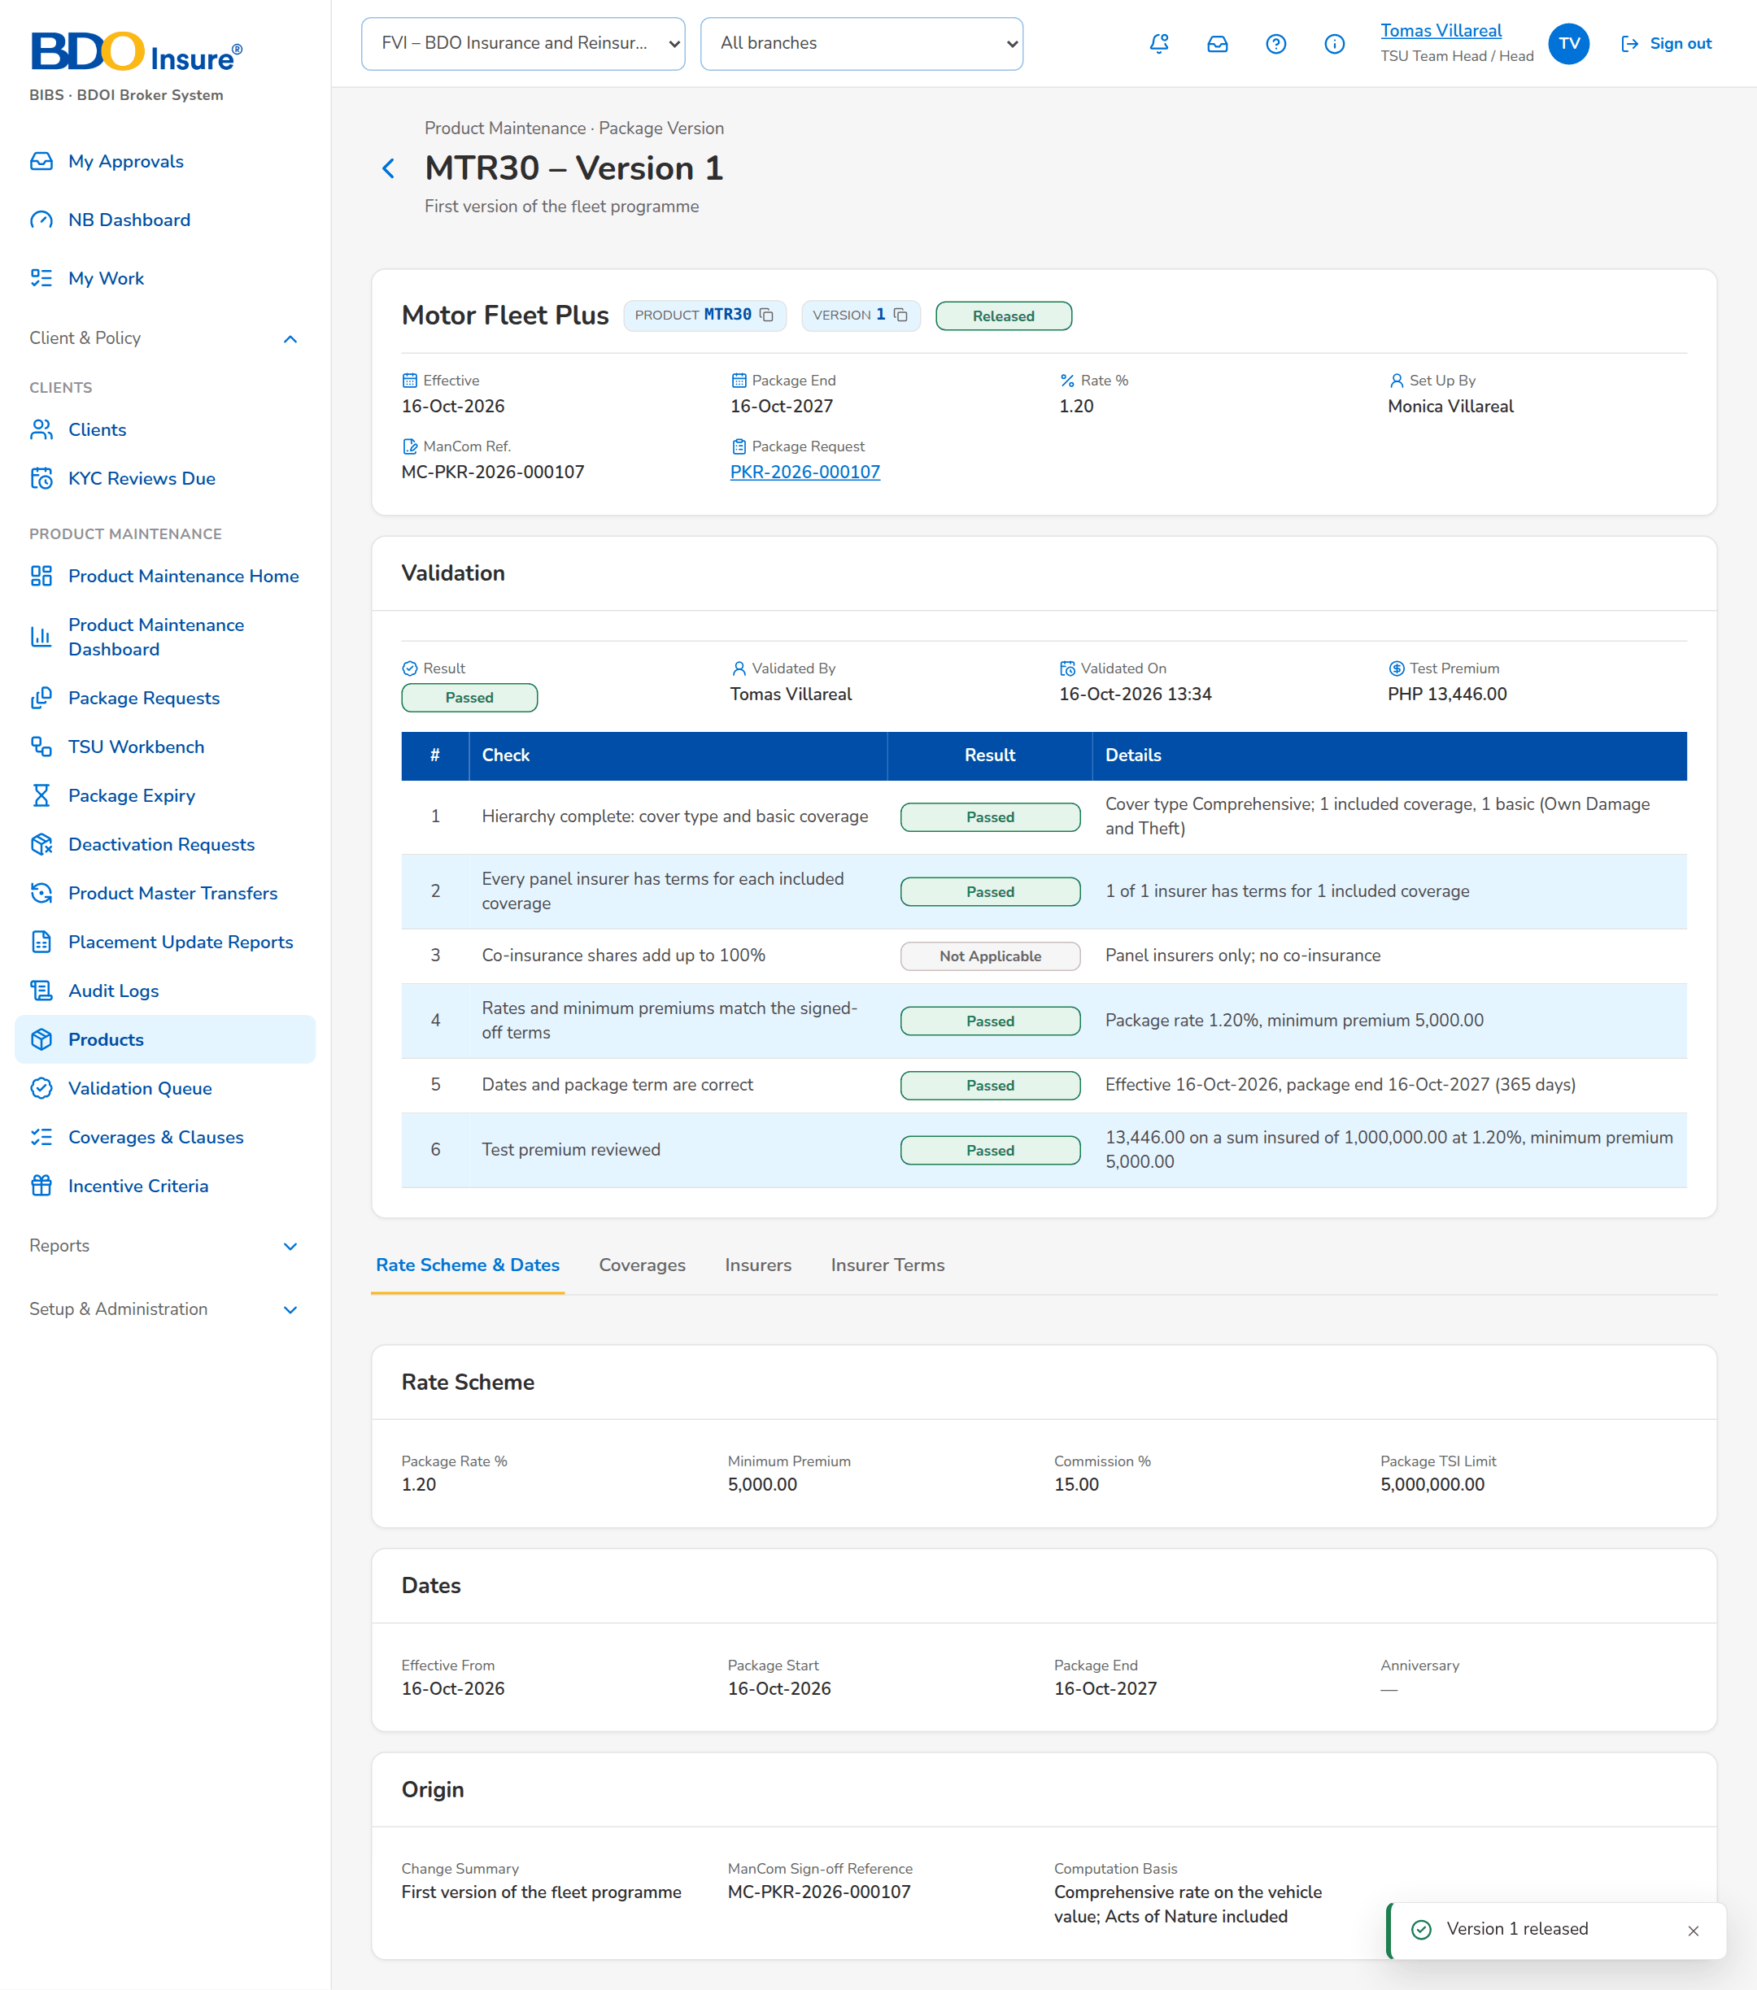
Figure 20: SB-01 step 17: TSU Head, Package Version
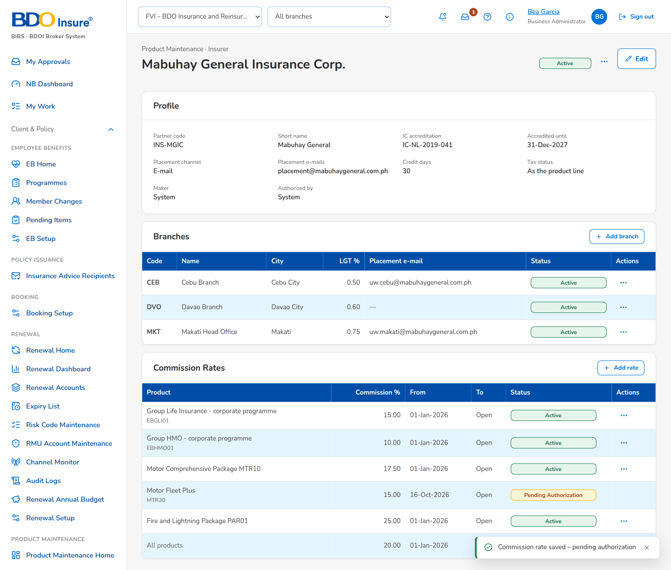
Figure 21: SB-01 step 18: Business Administrator, Insurer
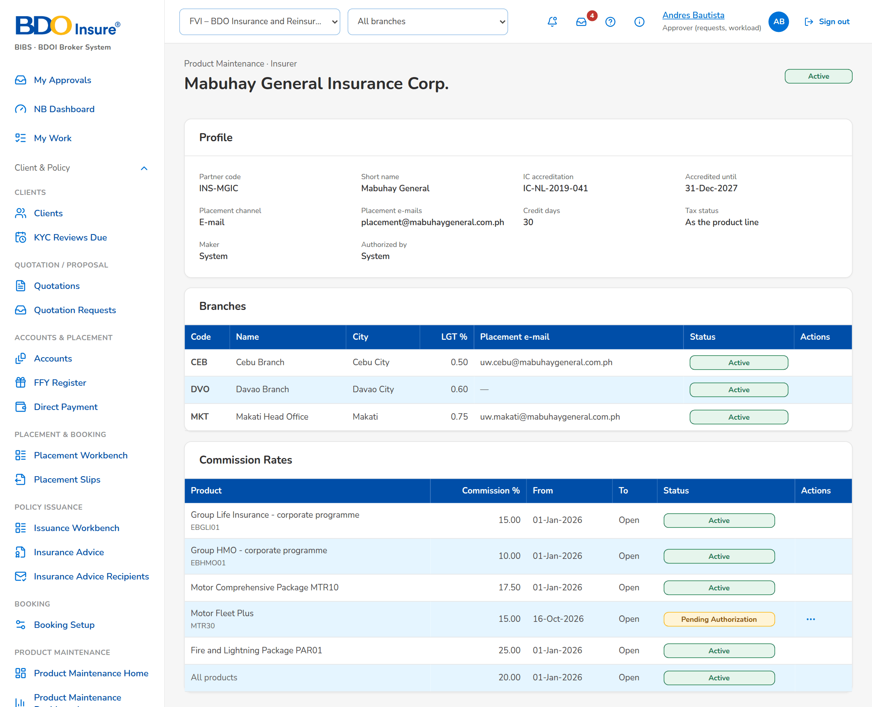
Figure 22: SB-01 step 19: Approver, Insurer
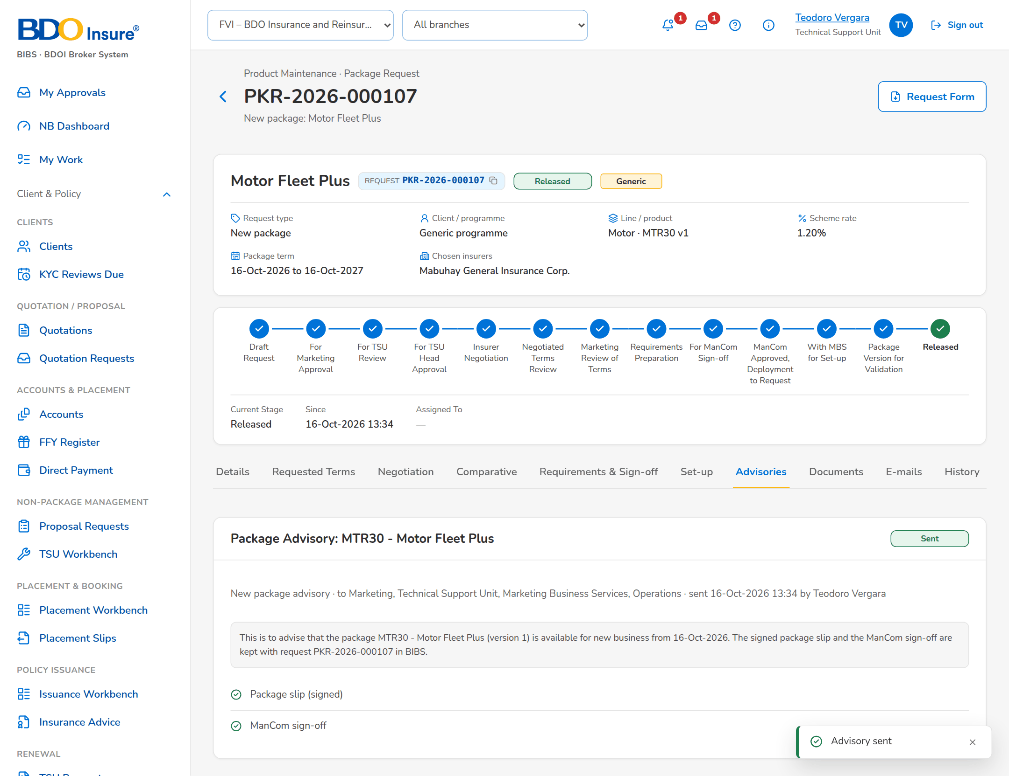
Figure 23: SB-01 step 20: TSU Officer, Advisories tab

SB-02 New business on the released package
Marketing prices a quotation on Motor Fleet Plus and obtains a rate exception.
Table 4: SB-02 steps
Step | Who | Screen | Does | Sees
1 | Marketing Account Officer | Premium Calculator | Calculates the premium on the package. | Premium on the version in force.
2 | Marketing Account Officer | Quotation | Requests a rate exception for a lower item rate. | Exception pending approval.
3 | Approver | Rate Exception | Approves the exception with a comment. | Exception approved, valid 30 days.
4 | Marketing Account Officer | Quotation | Opens the quotation. | The approved exception is shown.

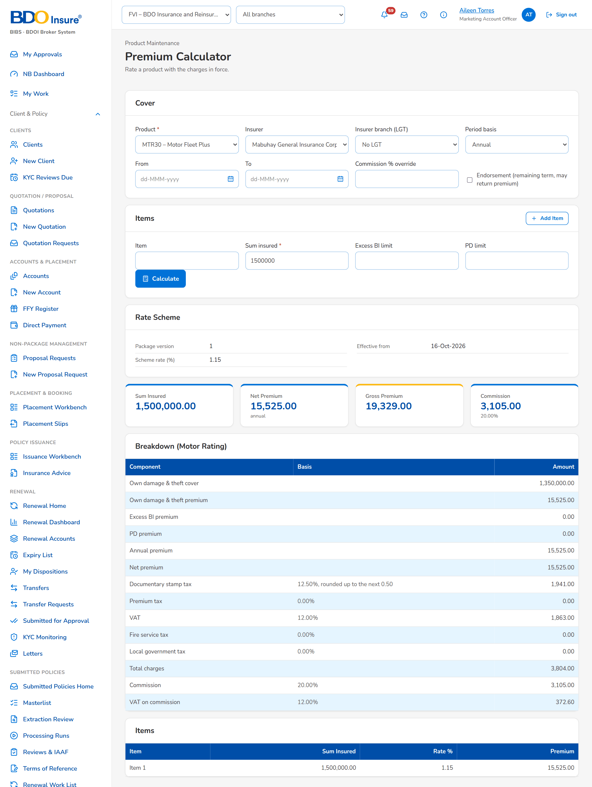
Figure 24: SB-02 step 1: Marketing Account Officer, Premium Calculator
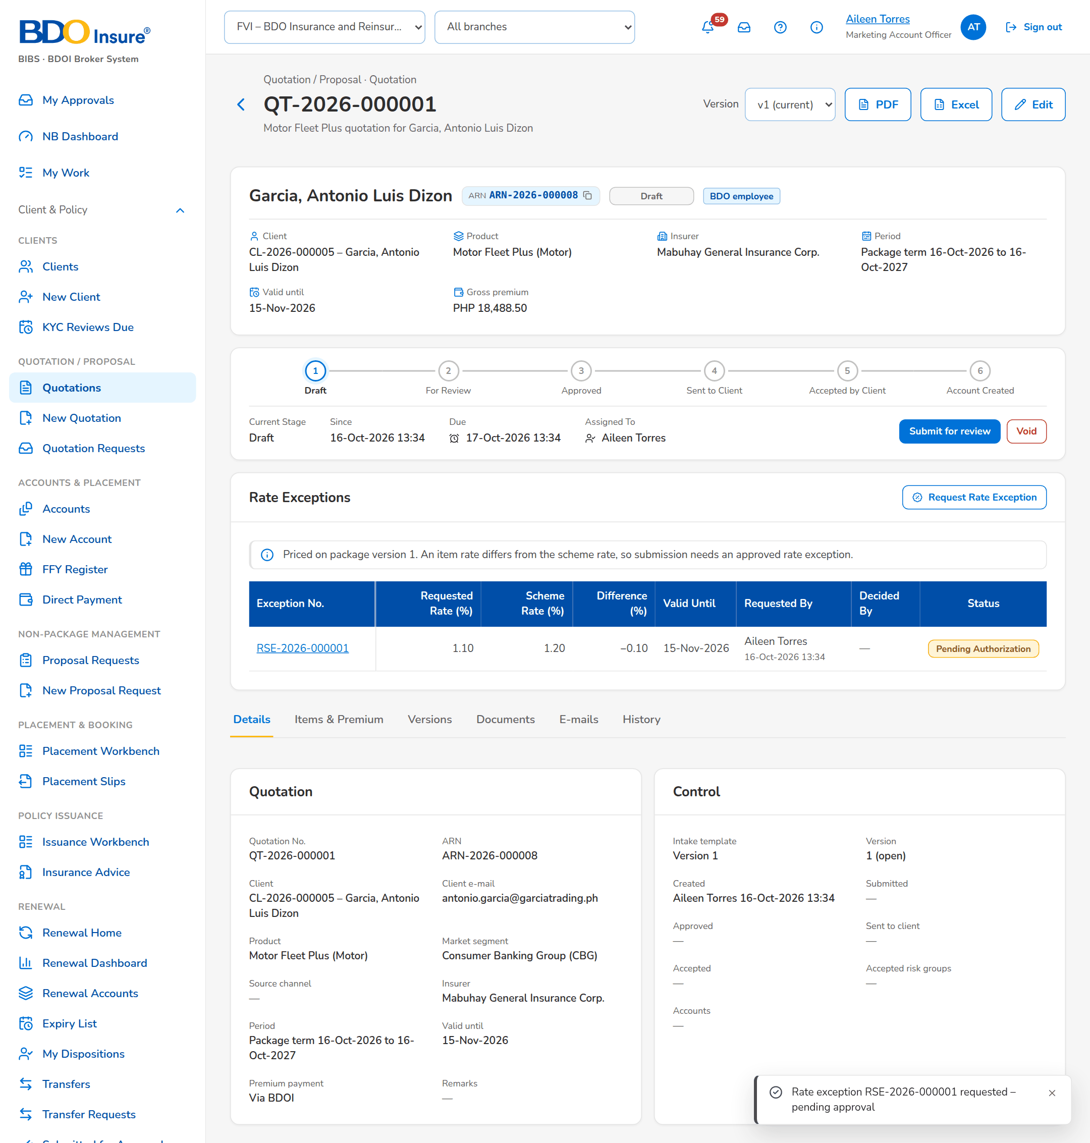
Figure 25: SB-02 step 2: Marketing Account Officer, Quotation
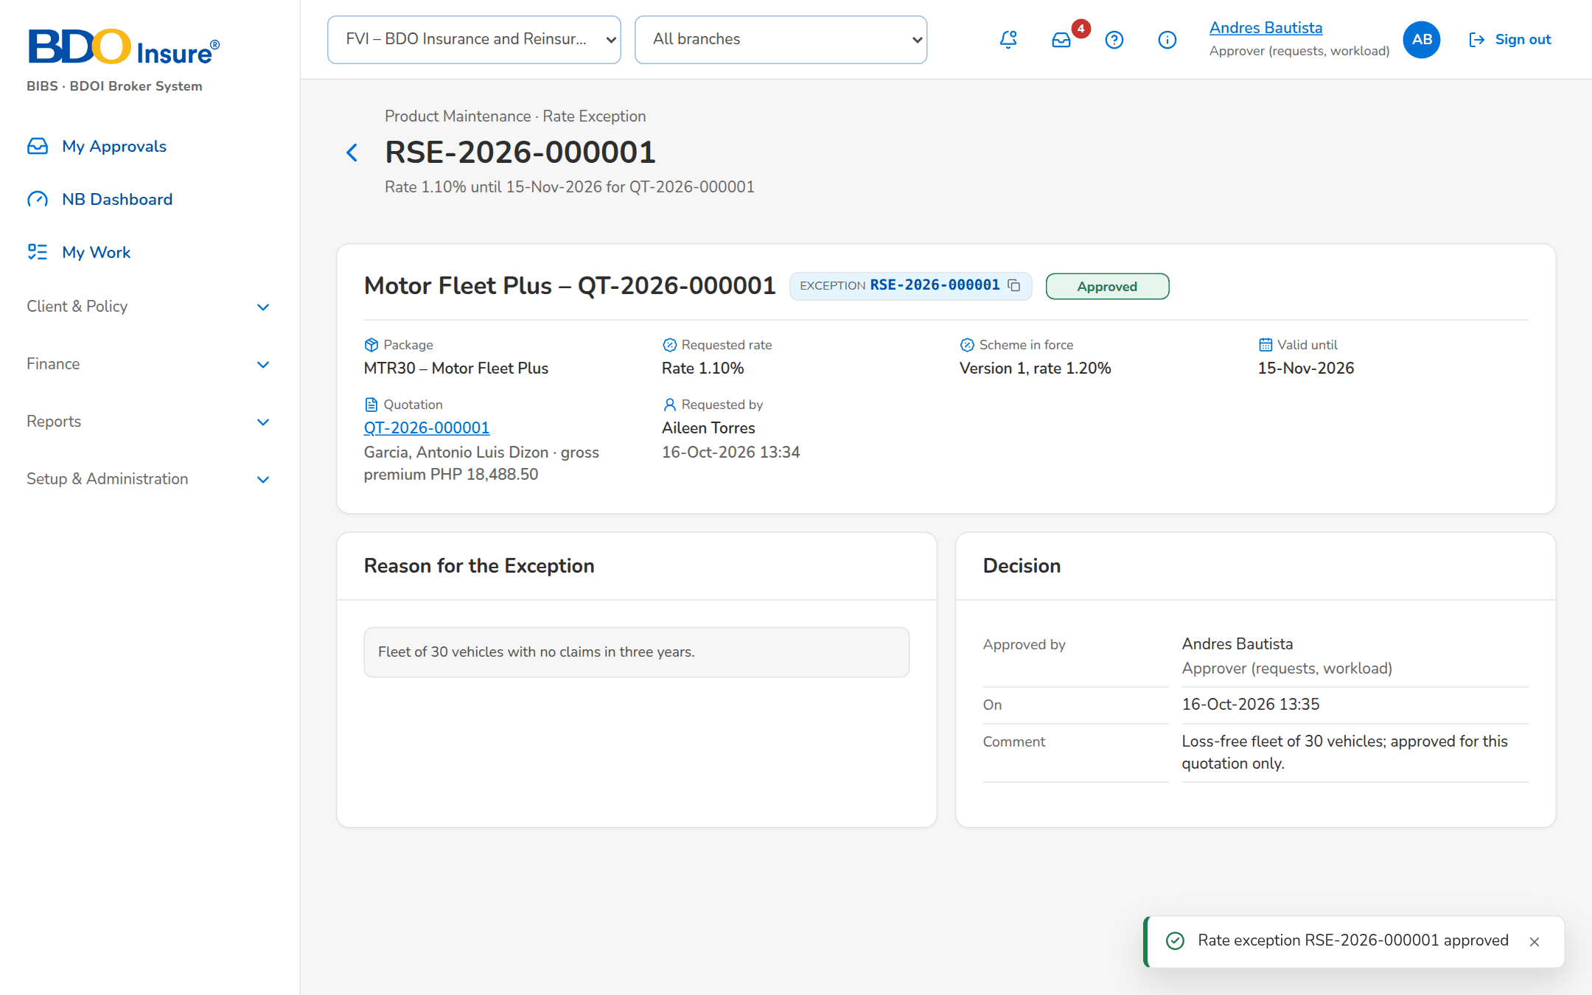
Figure 26: SB-02 step 3: Approver, Rate Exception
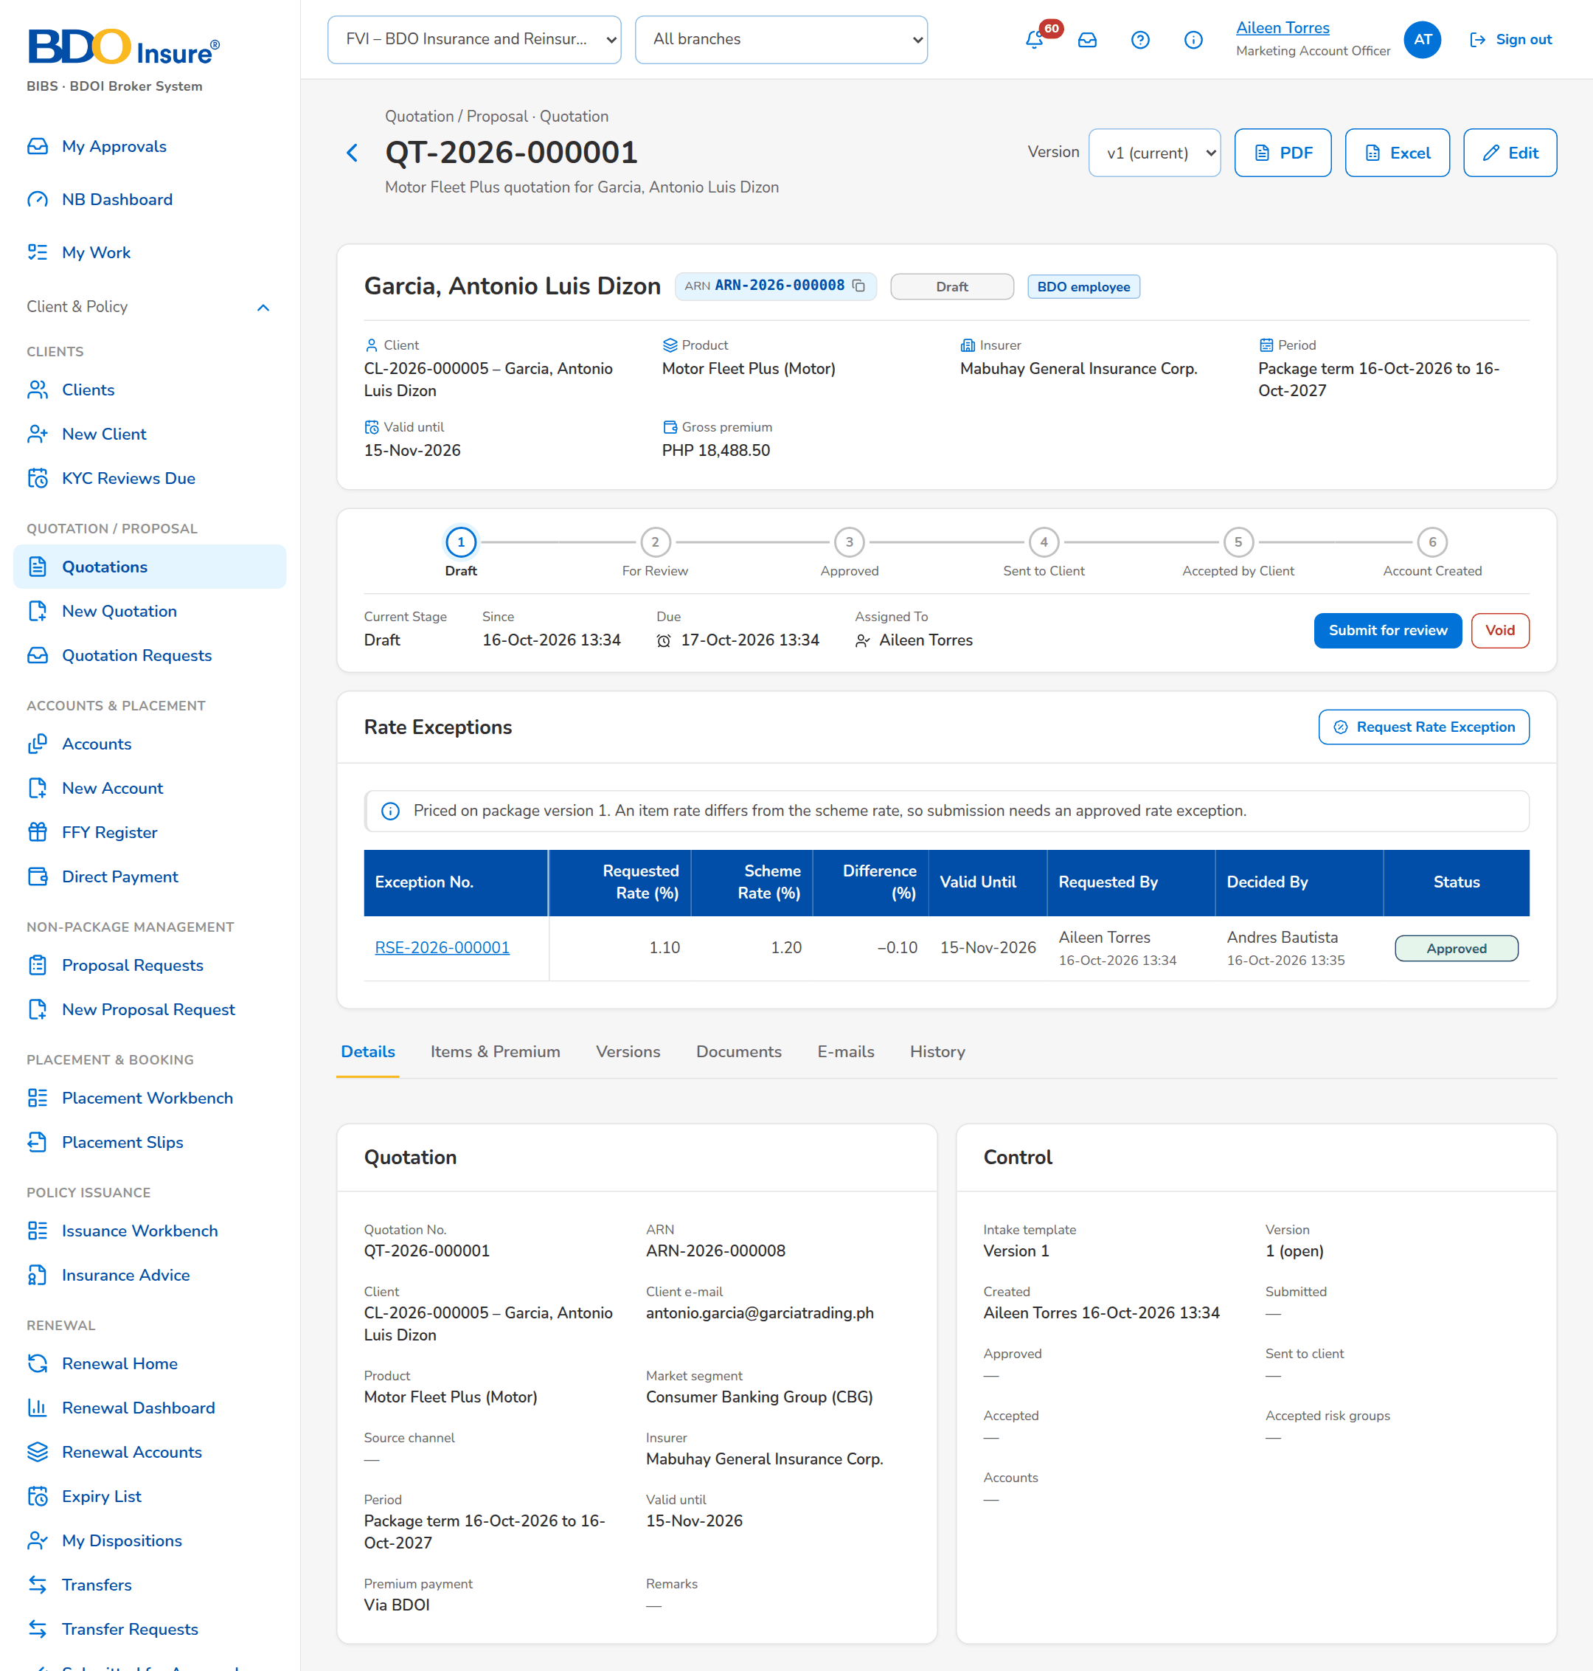
Figure 27: SB-02 step 4: Marketing Account Officer, Quotation

SB-03 Expiry, deactivation and transfer to other systems
TSU follows the packages that end; MBS deactivates a package; the changes go to other systems.
Table 5: SB-03 steps
Step | Who | Screen | Does | Sees
1 | TSU Officer | Package Expiry | Reviews the packages ending within 90 days. | Days left and renewal requests.
2 | MBS | Product | Opens Deactivate Package and enters date, reason, remarks and approver. | The request is ready to submit.
3 | MBS | Deactivation Requests | Follows the requests and decisions. | Status of each request.
4 | MBS | Product Master Transfers | Checks the changes sent to the receiving systems. | Each change with its file and status.

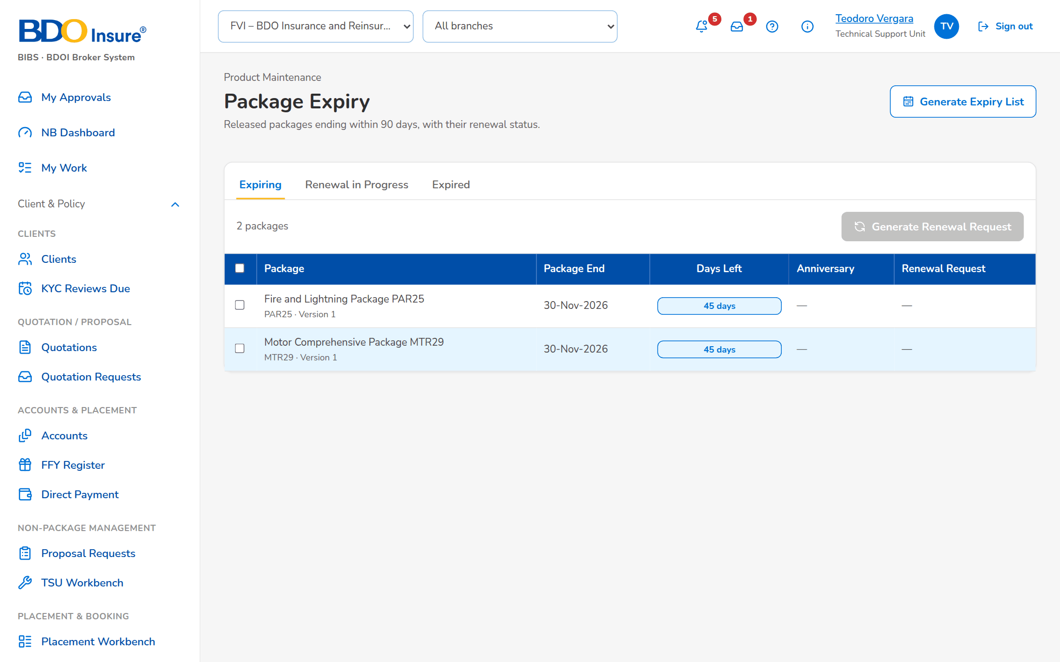
Figure 28: SB-03 step 1: TSU Officer, Package Expiry
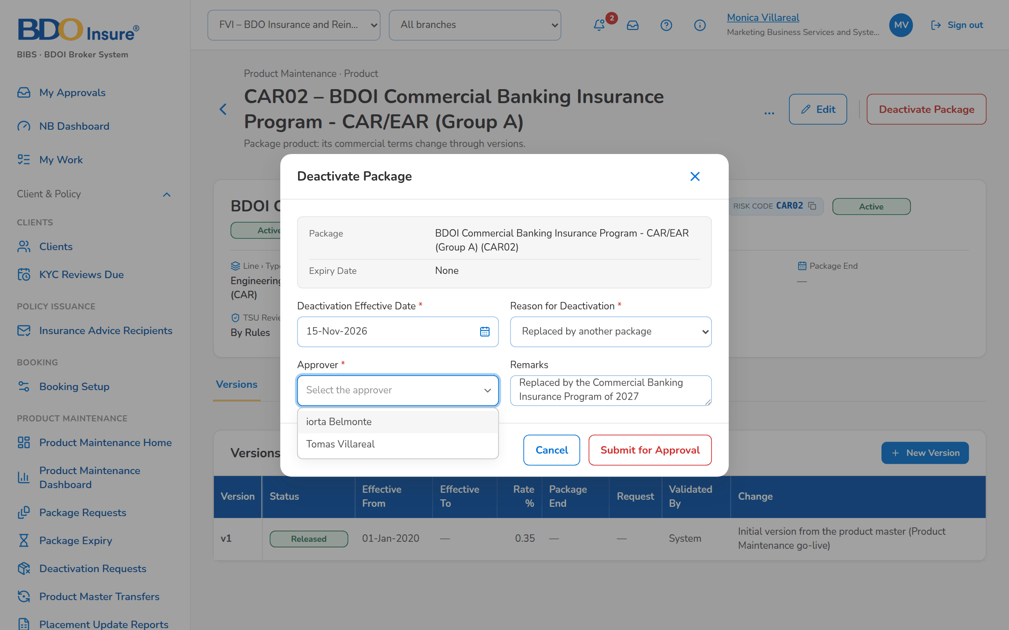
Figure 29: SB-03 step 2: MBS, Product
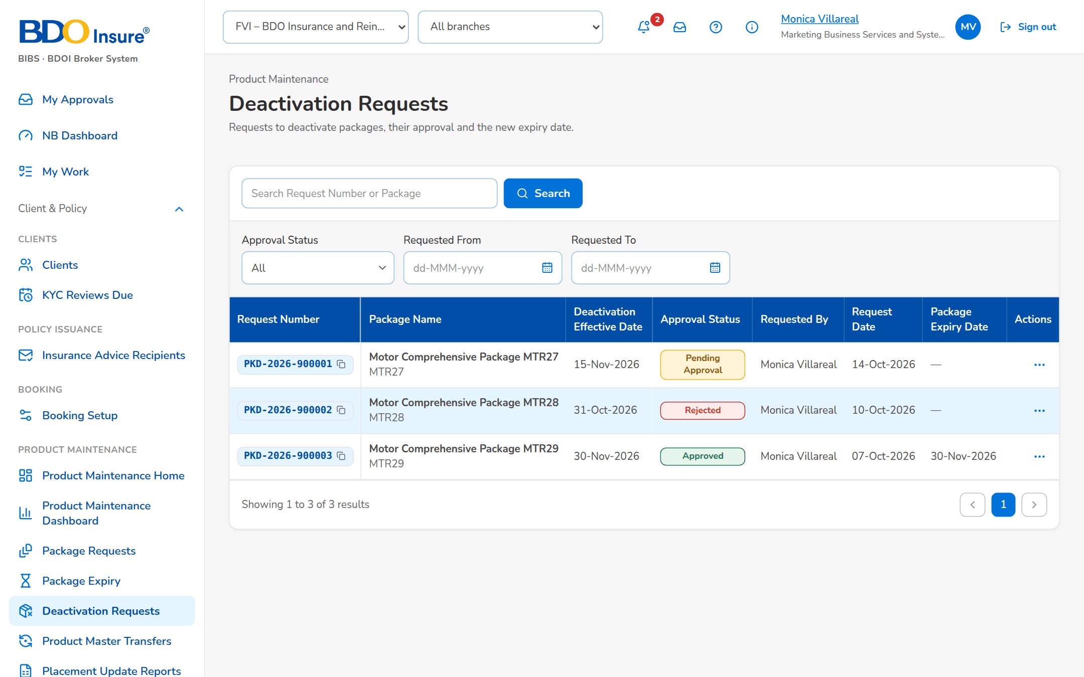
Figure 30: SB-03 step 3: MBS, Deactivation Requests
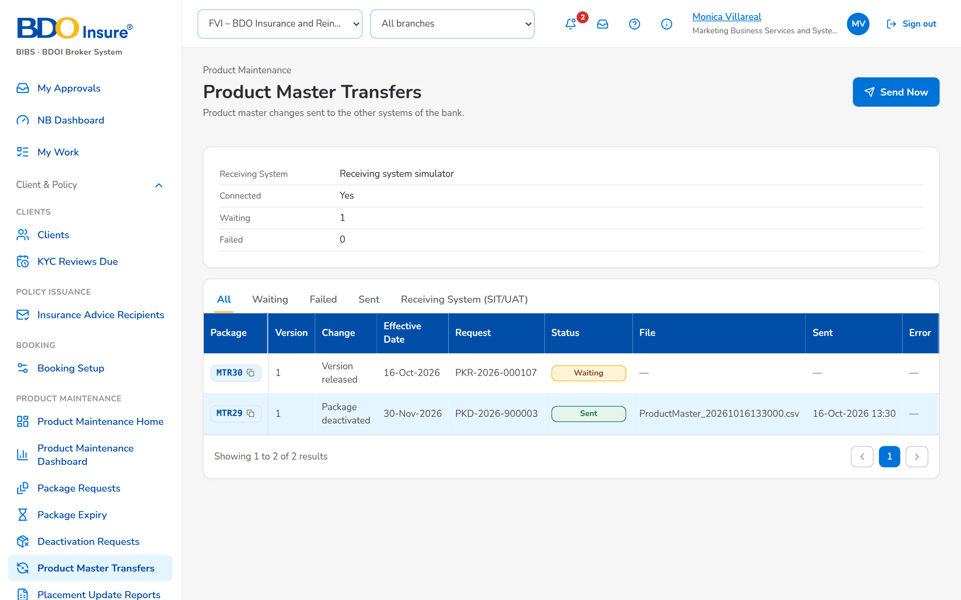
Figure 31: SB-03 step 4: MBS, Product Master Transfers

SB-04 Returns and refusals
The checks and returns a user meets, and the messages shown.
Table 6: SB-04 steps
Step | Who | Screen | Does | Sees
1 | Marketing Account Officer | New Package Request | Saves an empty draft. | Field messages.
2 | Marketing Account Officer | New Package Request | Submits a request without terms. | Completeness message.
3 | Marketing Approver | Package Request | Approves a request of another user. | For TSU review.
4 | TSU Team Lead | Package Request | Returns a request with a reason. | Back to the requester.
5 | TSU Team Lead | Negotiation tab | Clicks Approve and Send on the slip he prepared. | The confirmation; on confirming, the approval is refused: another officer approves (BR-PM-01).
6 | TSU Officer | Negotiation tab | Makes the terms final while an insurer has no outcome. | Refused: every insurer of the round needs an outcome.
7 | ManCom Member | Package Request | Returns the requirements to TSU. | Requirements preparation.
8 | TSU Officer | Requirements tab | Resubmits for ManCom sign-off. | For ManCom sign-off.
9 | MBS | Package Request | Returns incomplete requirements to TSU. | Requirements preparation.
10 | MBS | Package Version | Submits a version with a past date and no minimum premium. | Field messages.
11 | TSU Head | Package Version | Returns the version to MBS with a reason. | Draft again.
12 | MBS | Package Version | Opens the returned version. | The return reason is shown.

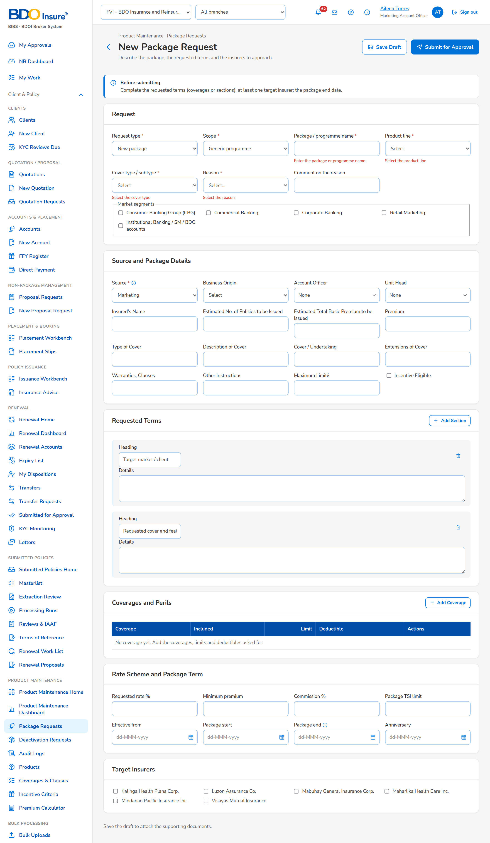
Figure 32: SB-04 step 1: Marketing Account Officer, New Package Request
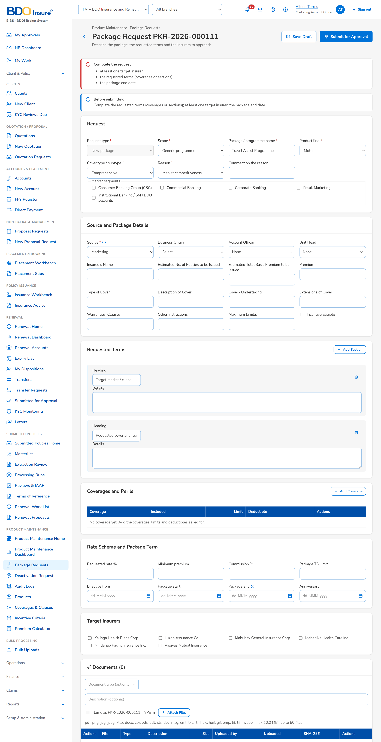
Figure 33: SB-04 step 2: Marketing Account Officer, New Package Request
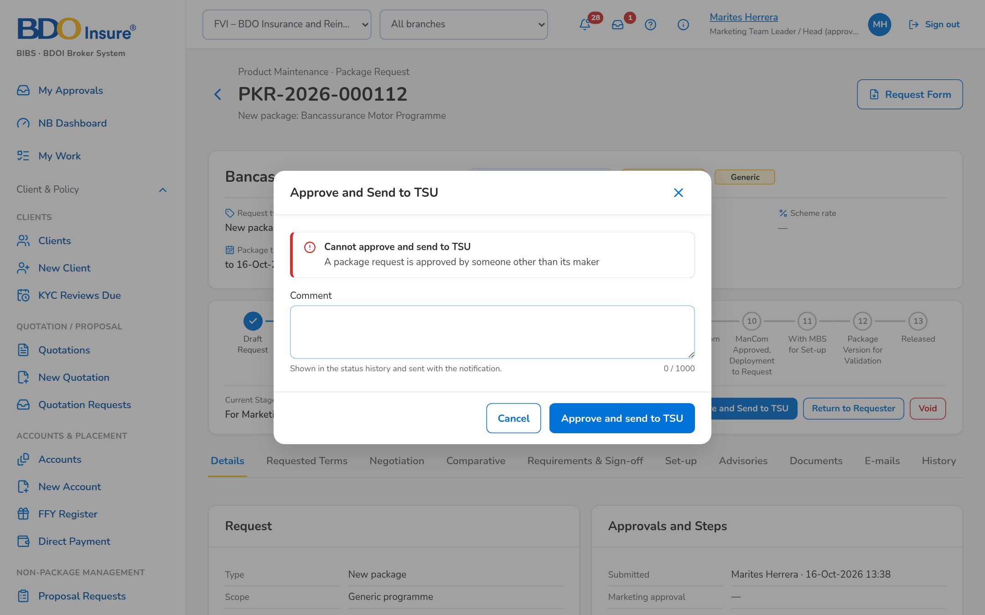
Figure 34: SB-04 step 3: Marketing Approver, Package Request
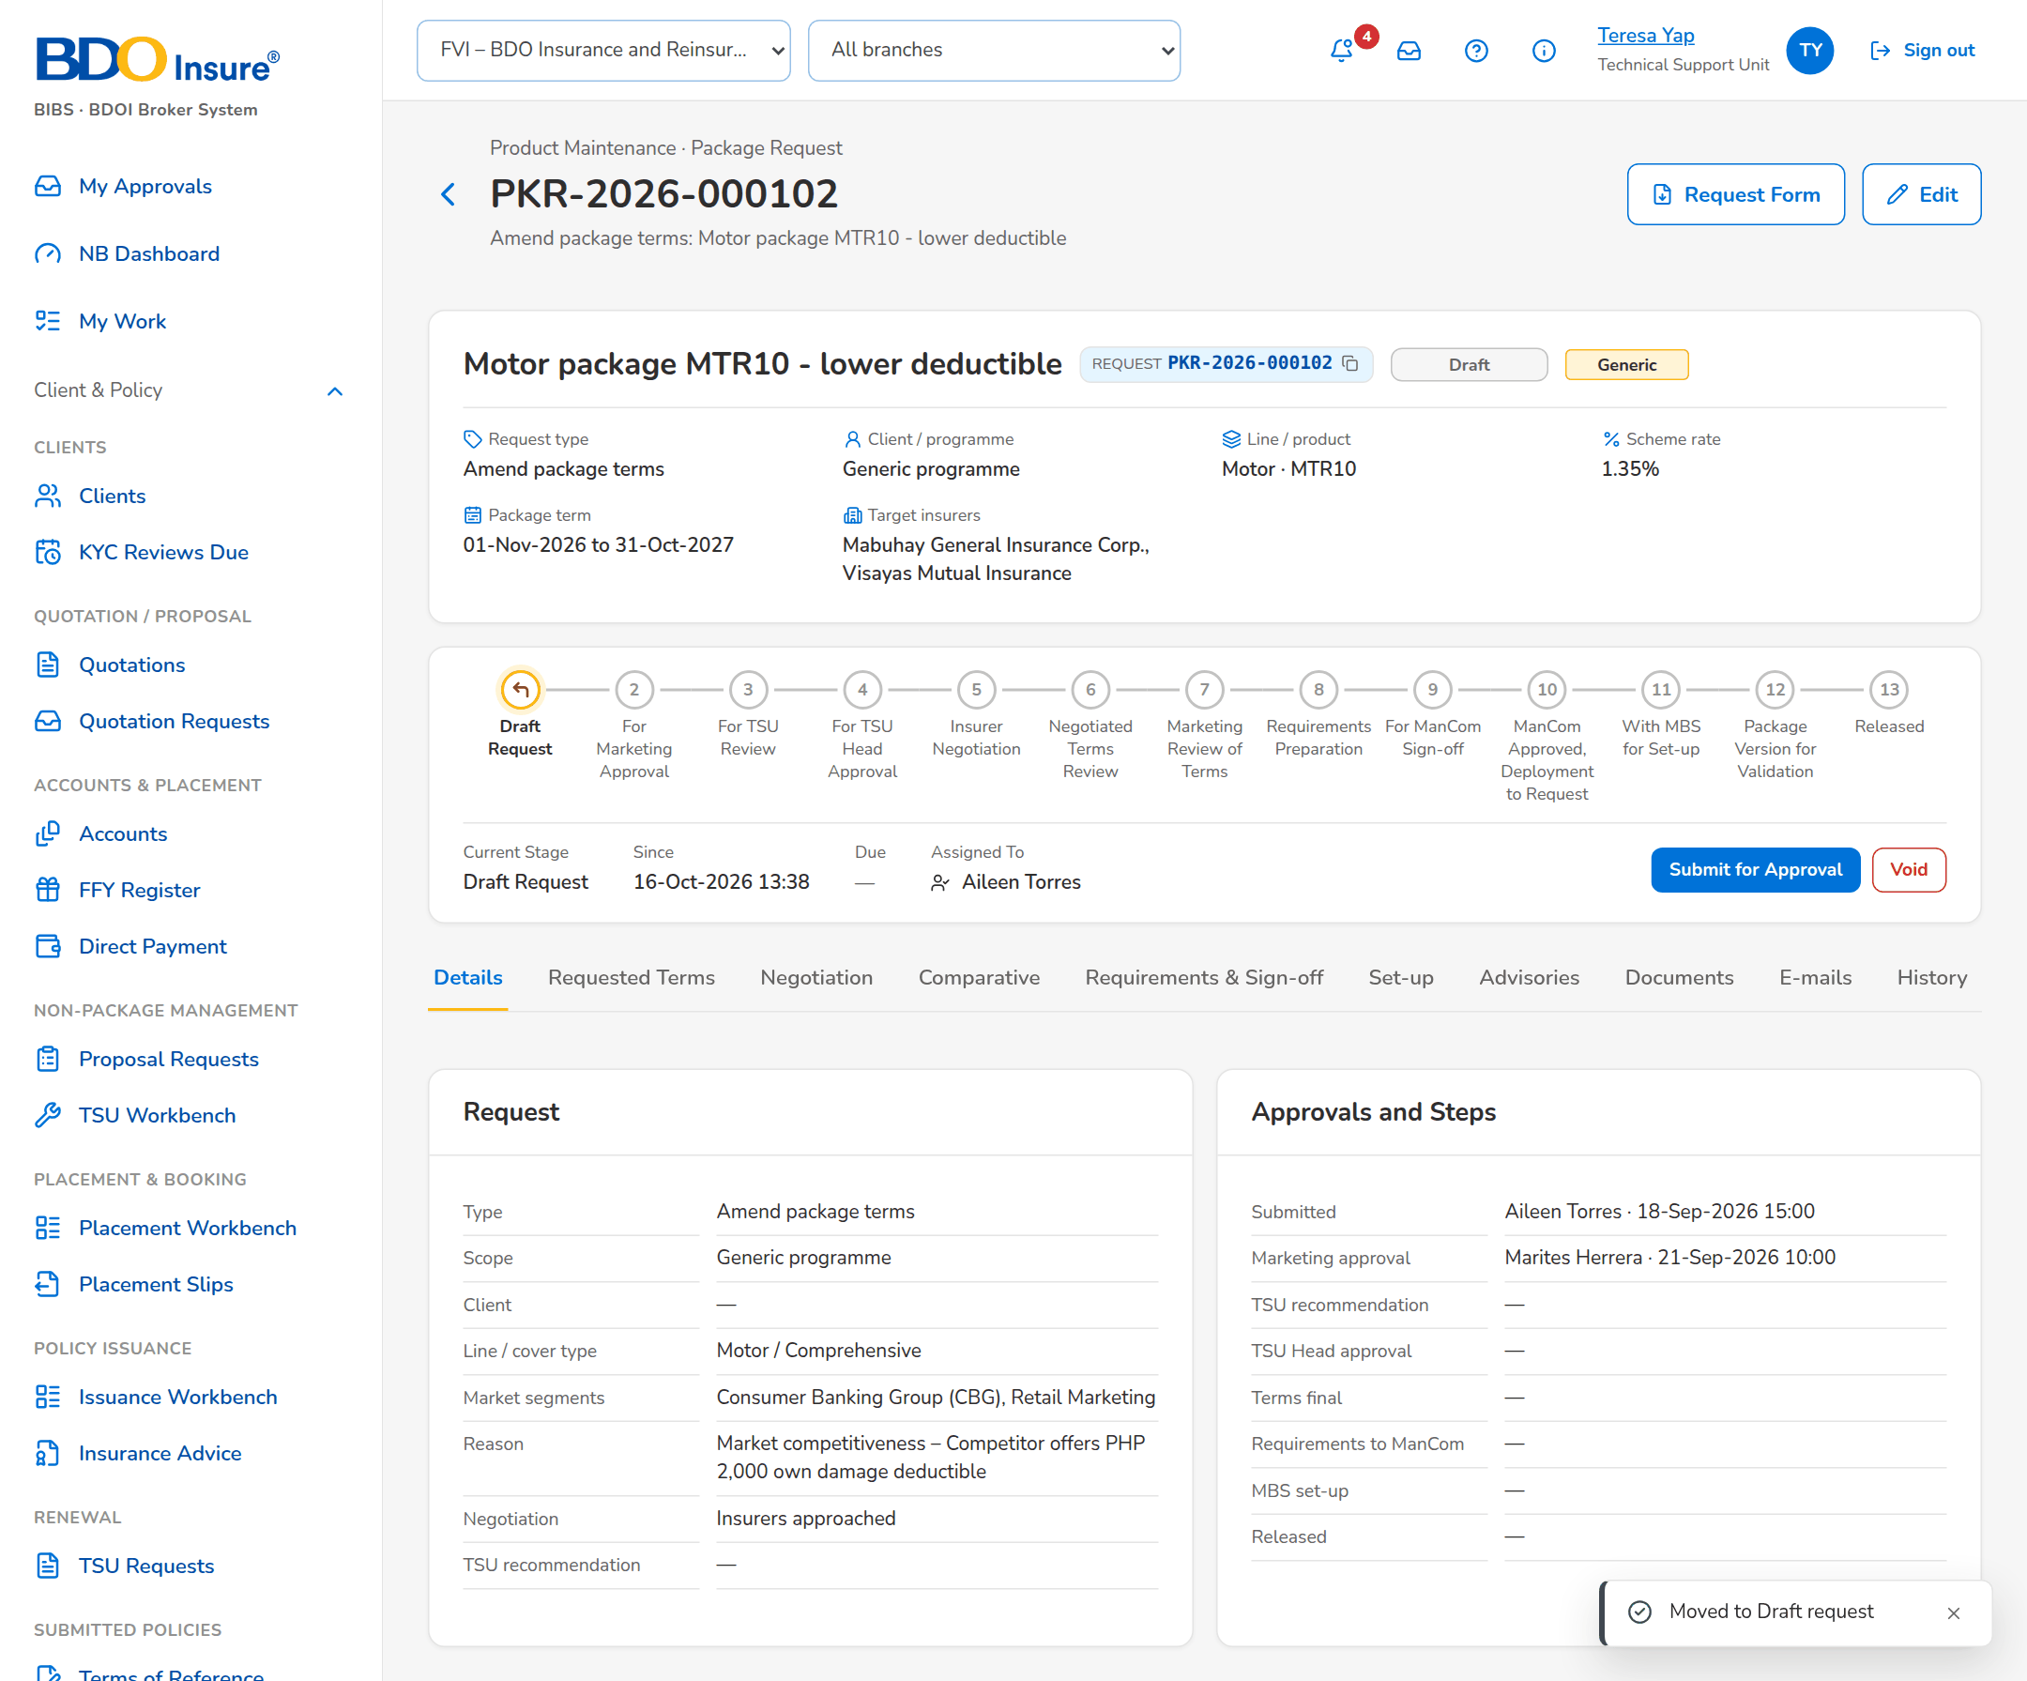
Figure 35: SB-04 step 4: TSU Team Lead, Package Request
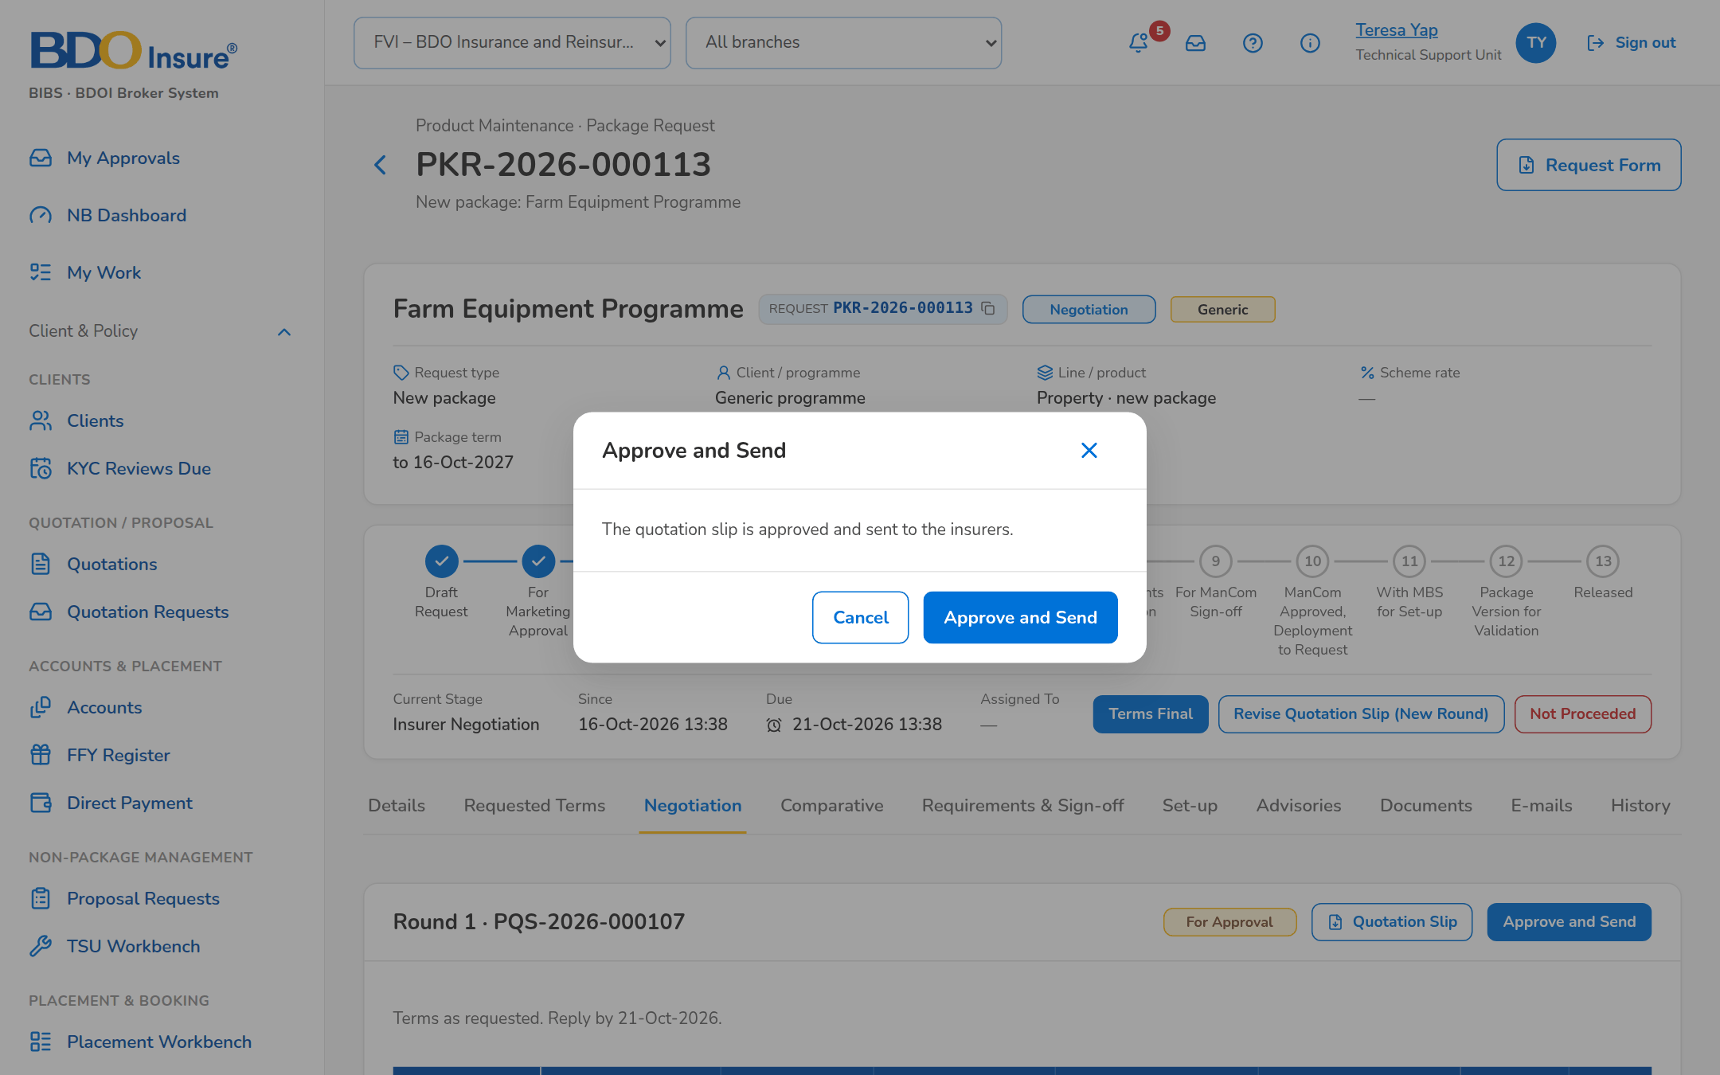
Figure 36: SB-04 step 5: TSU Team Lead, Negotiation tab
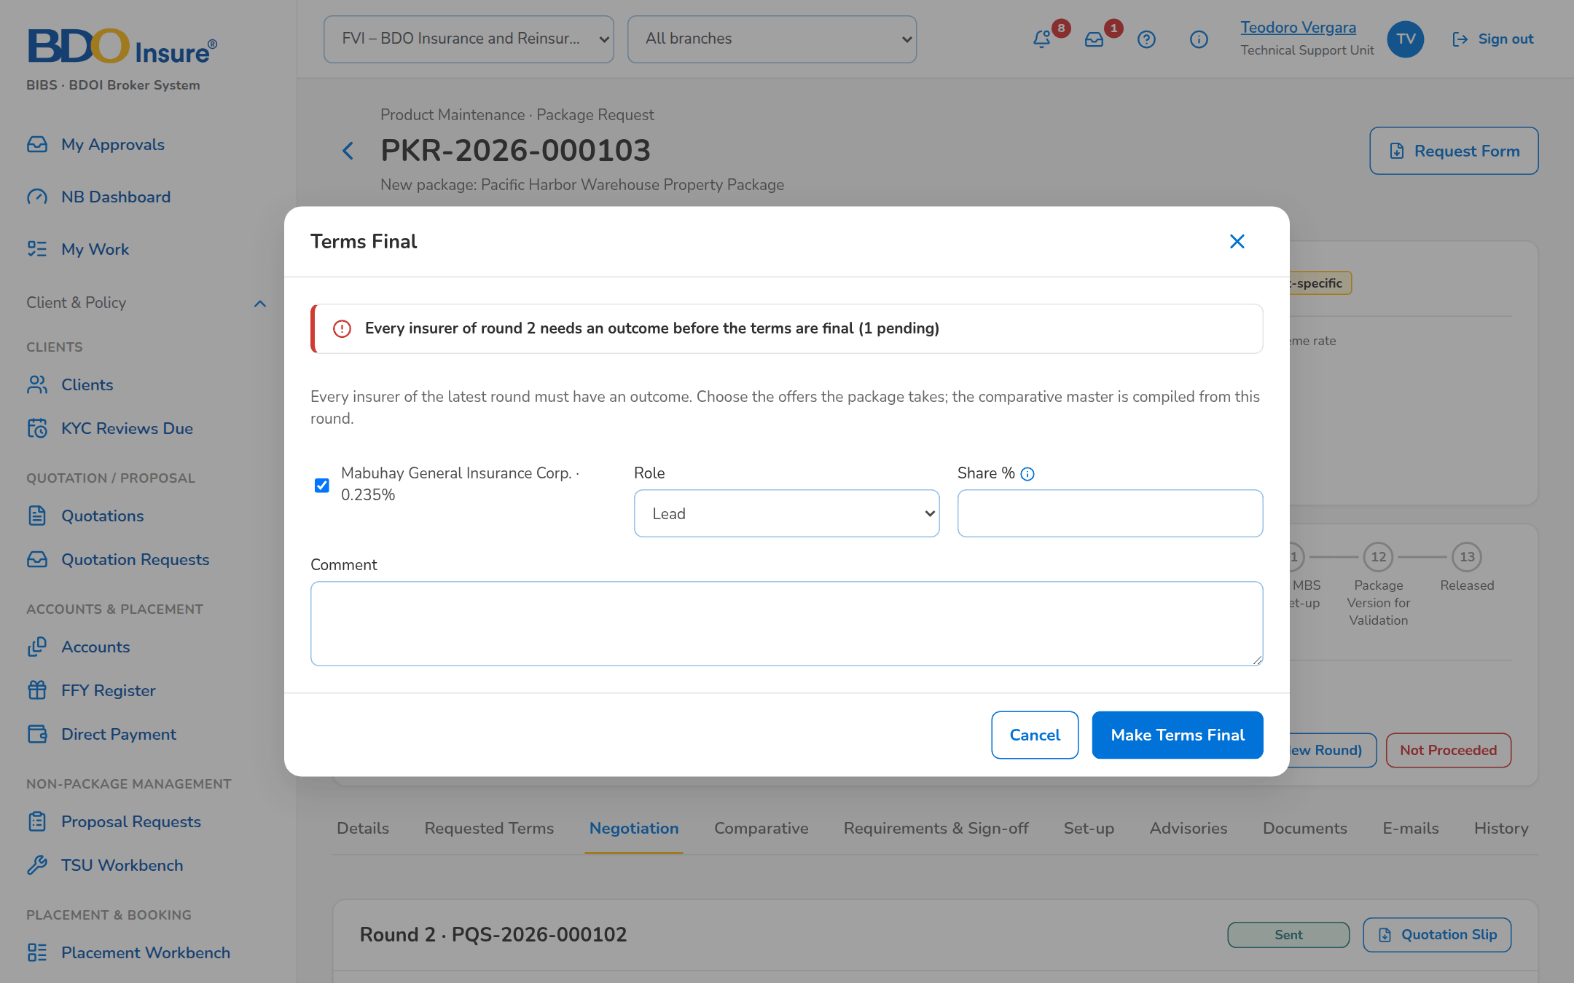
Figure 37: SB-04 step 6: TSU Officer, Negotiation tab
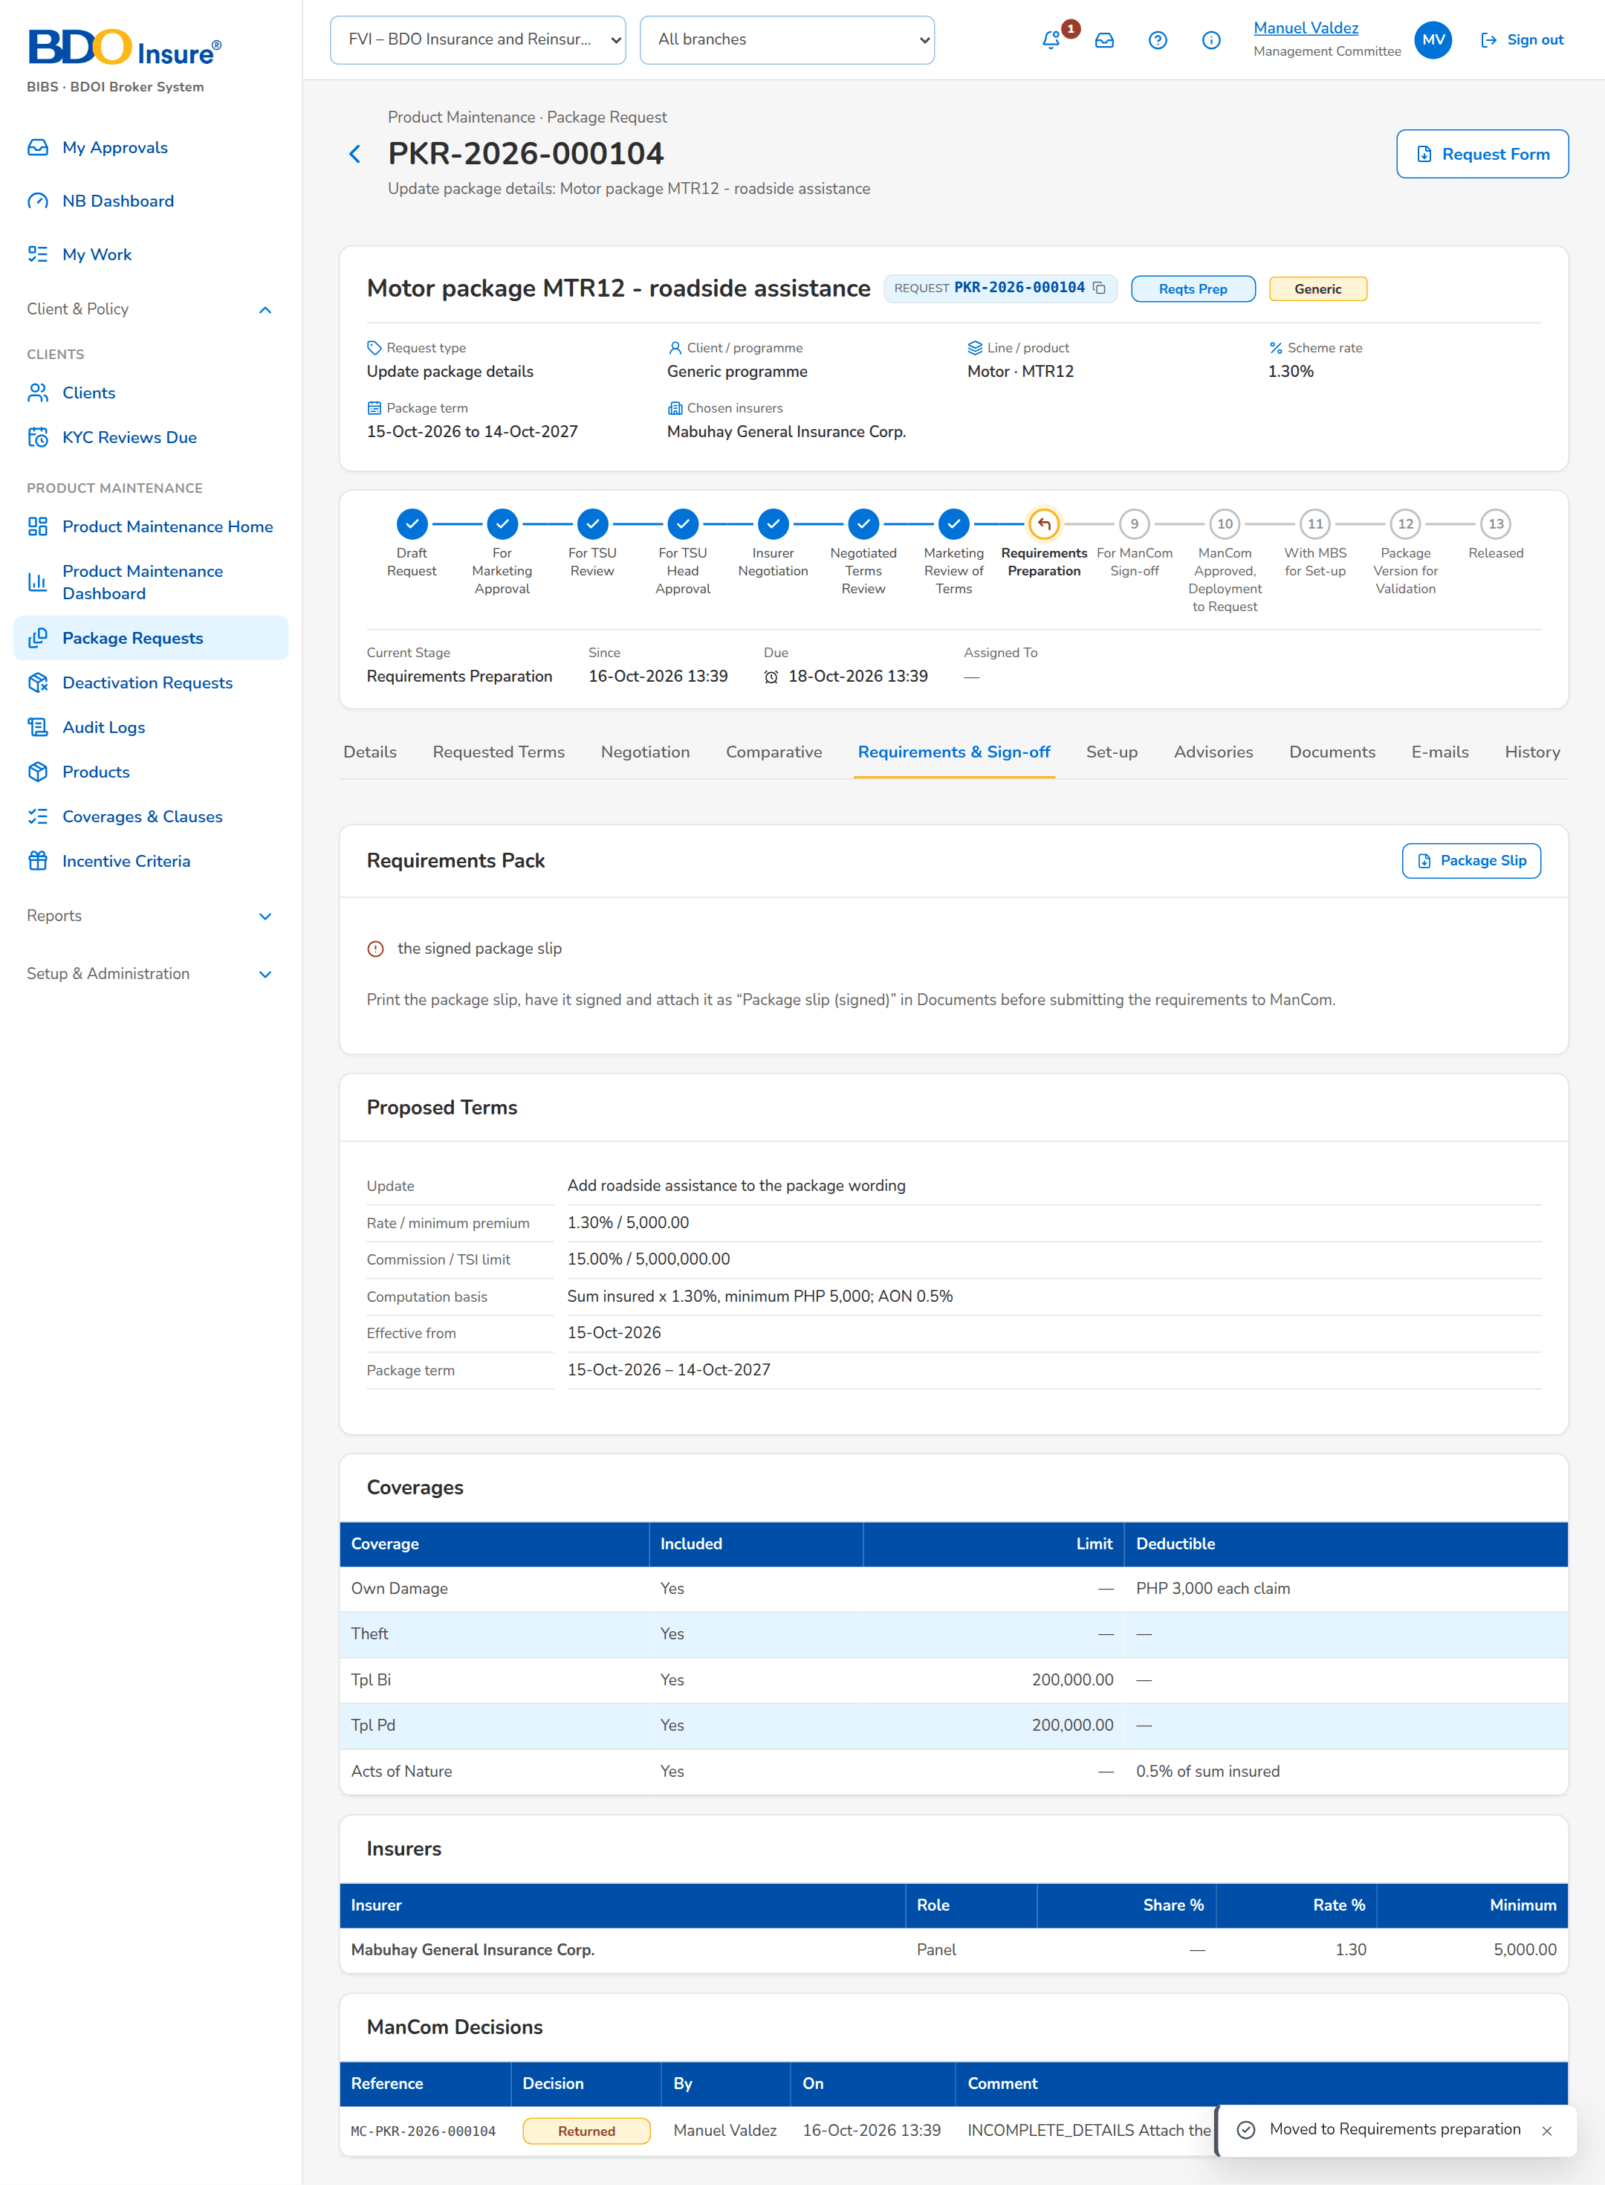
Figure 38: SB-04 step 7: ManCom Member, Package Request
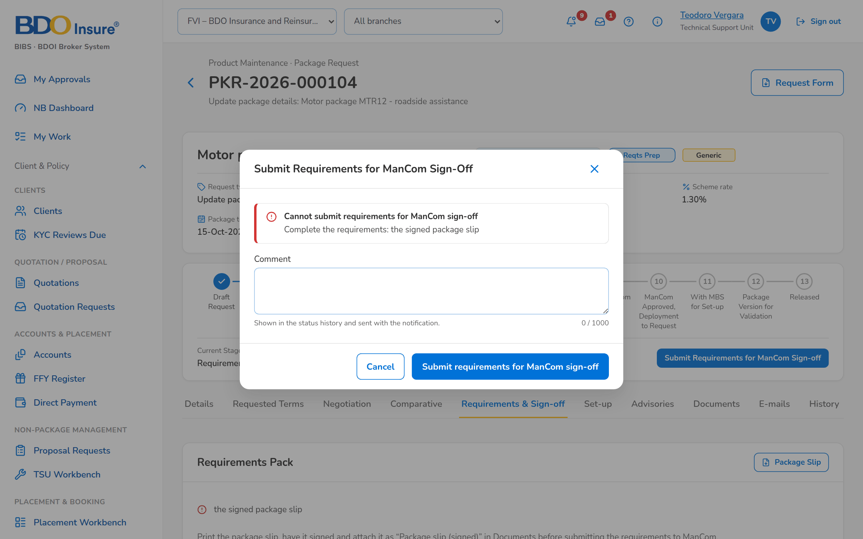
Figure 39: SB-04 step 8: TSU Officer, Requirements tab
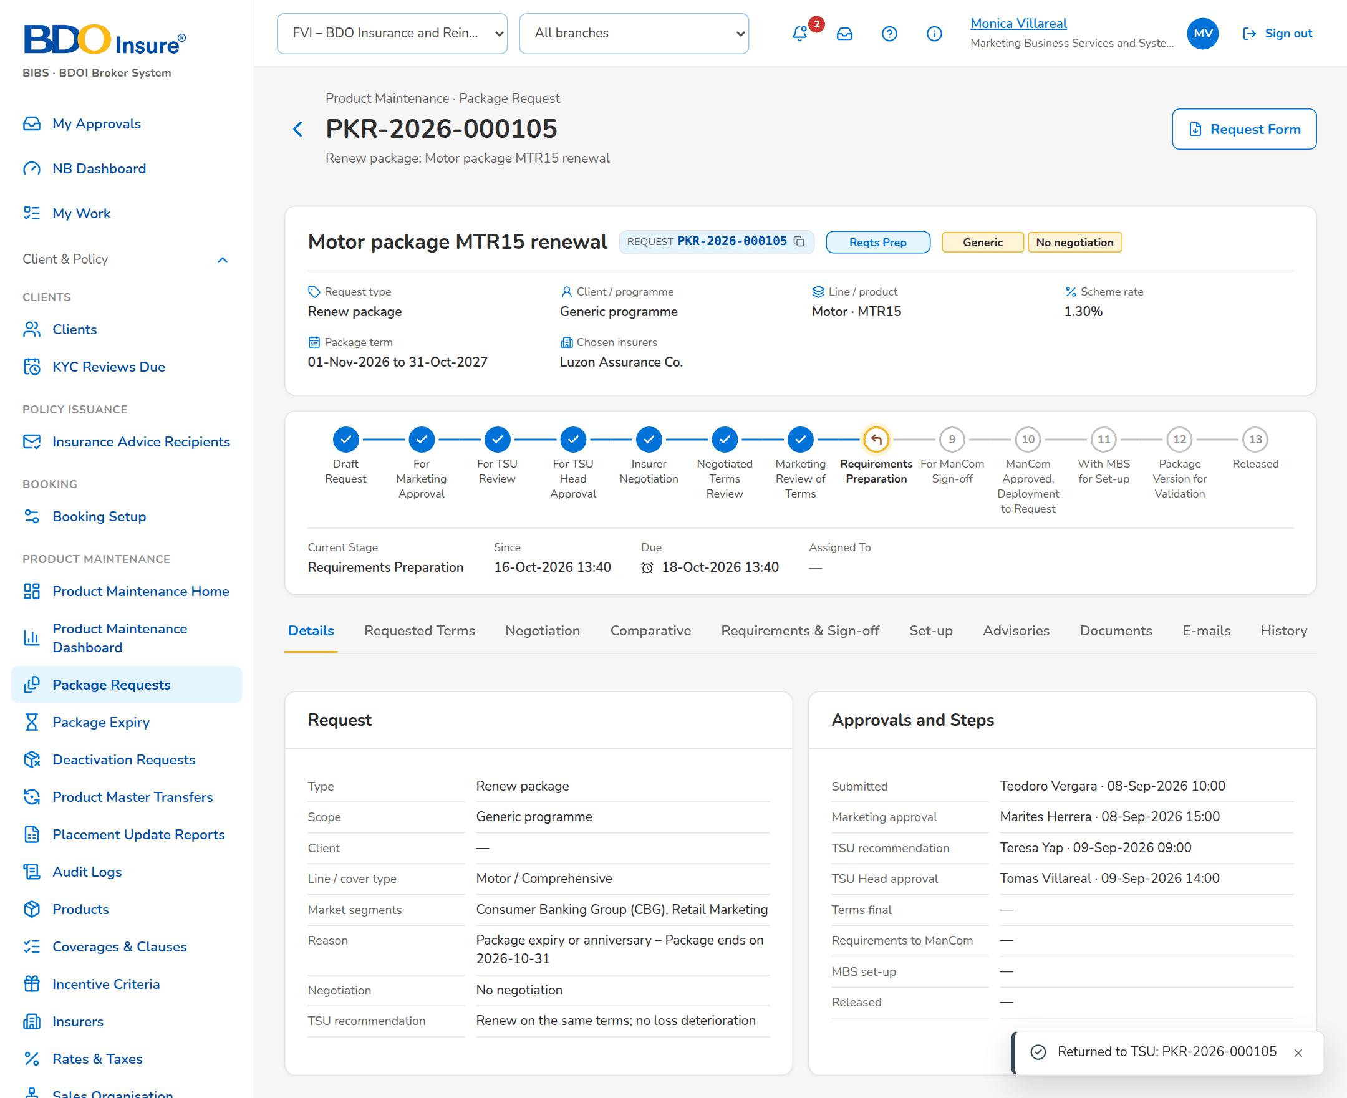
Figure 40: SB-04 step 9: MBS, Package Request
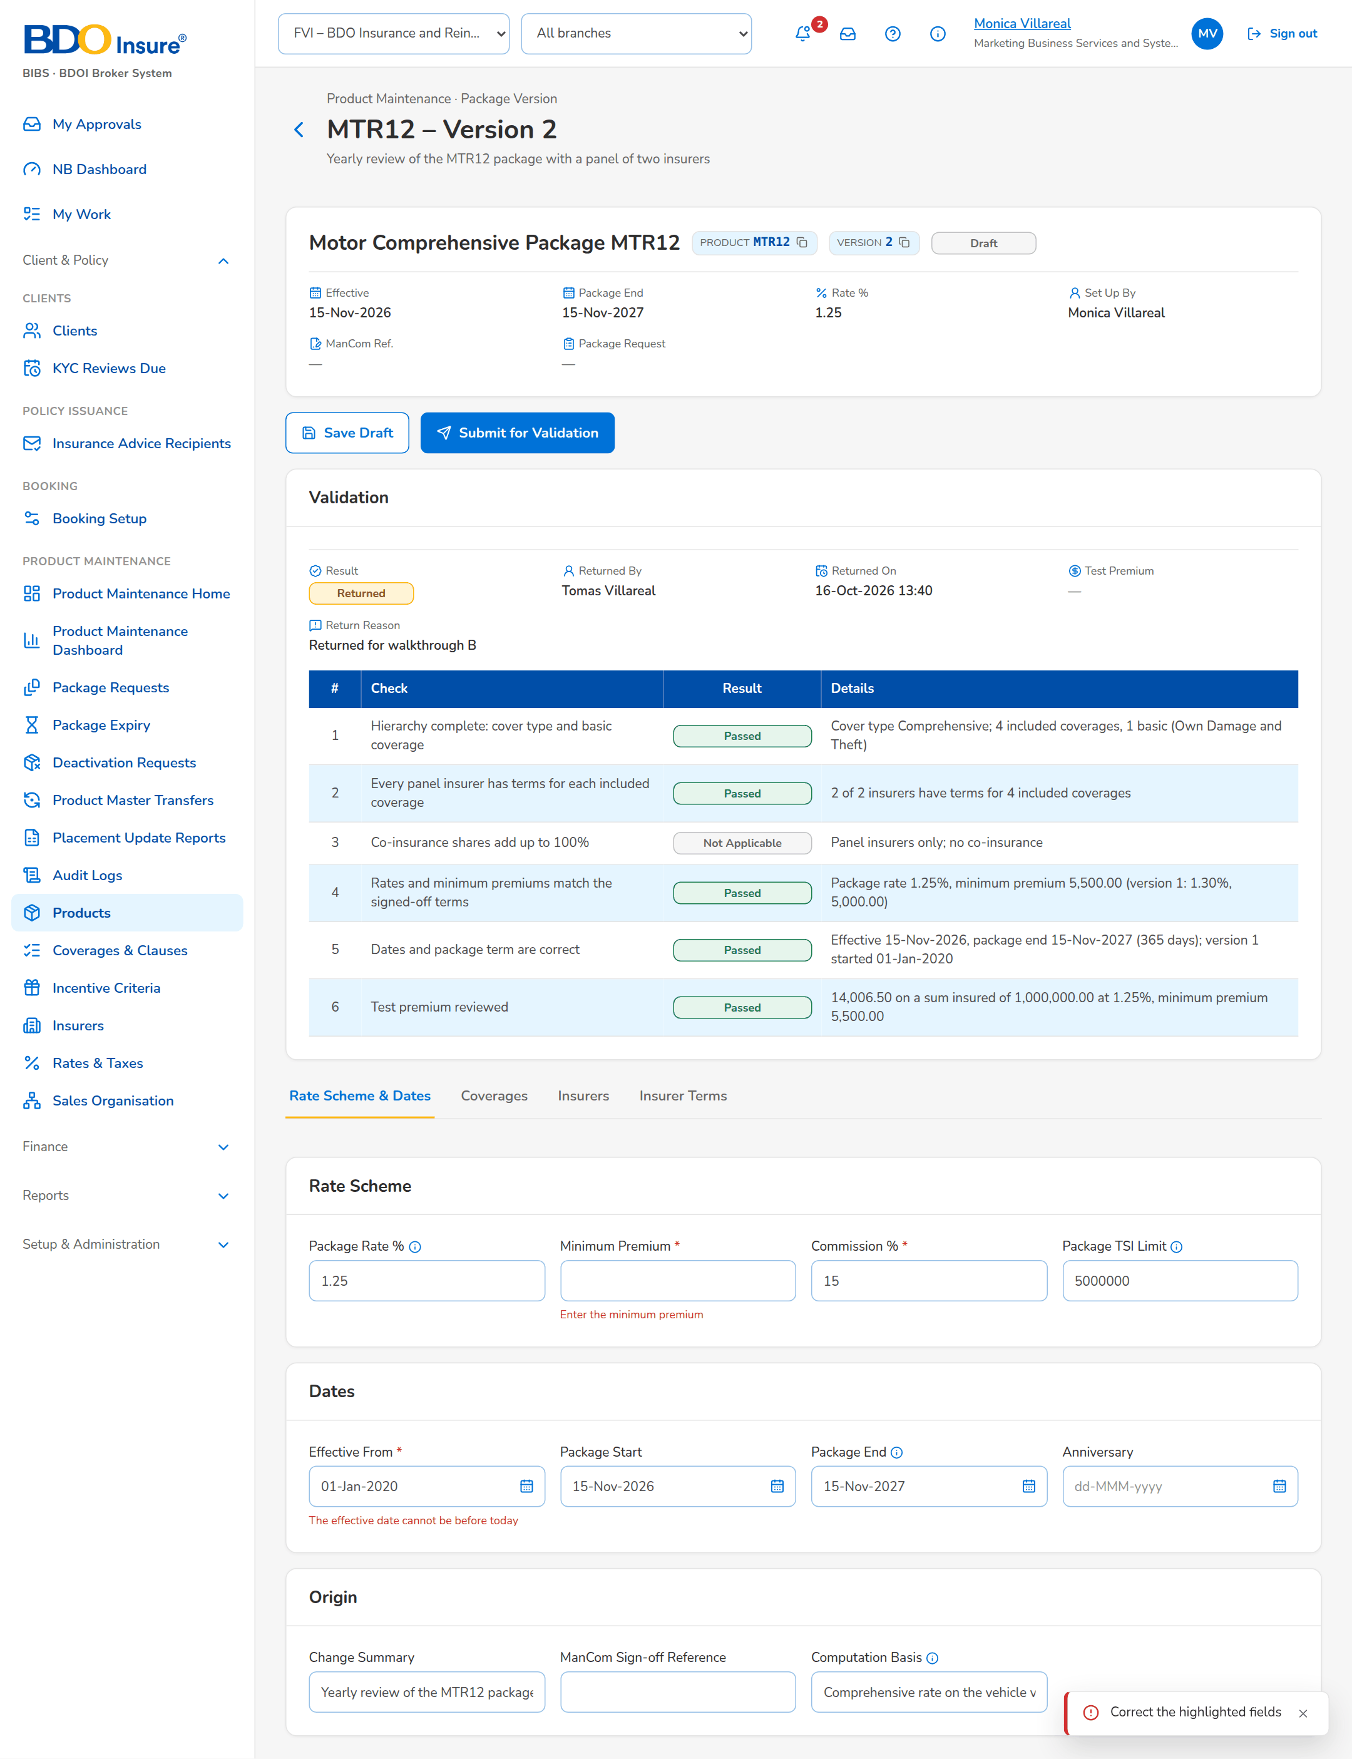
Figure 41: SB-04 step 10: MBS, Package Version
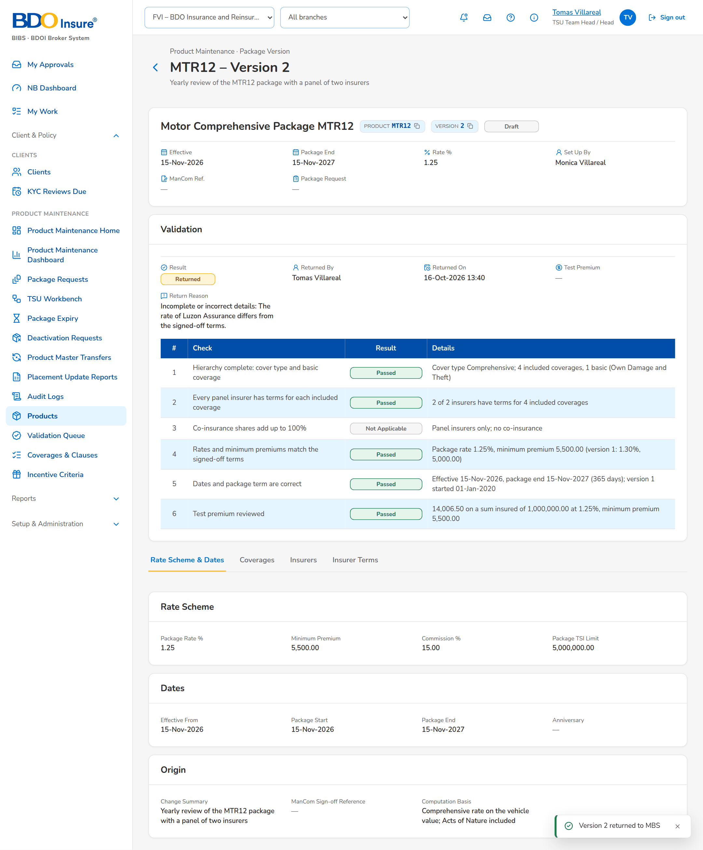
Figure 42: SB-04 step 11: TSU Head, Package Version
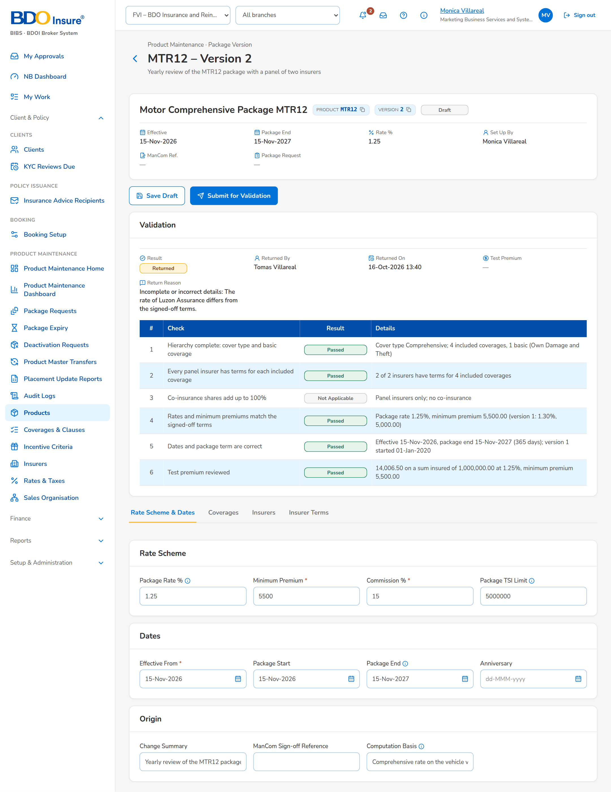
Figure 43: SB-04 step 12: MBS, Package Version

