
PRJ0012475 - BDO Insure Brokering System (BIBS) - Product Maintenance: Interface Specification -
Release 1 / Drop 0
Prepared by: iorta TechNXT Project Team

Template Reference No. | D051
Document No. | PRJ0012475-PM-ICD
Prepared by: | iorta TechNXT Project Team
Drafting support: | iorta TechNXT Project Team
Creation Date: | 10/16/2026
Revision No. | 1.0
Last Updated by: | iorta TechNXT Project Team
Last Updated Date: | 10/16/2026

Document Revision Log
Date | Revision | Description | Updated by
16 Oct 2026 | 1.0 | First issue: product master transfer file and e-mail channel of Product Maintenance. | iorta TechNXT Project Team (drafting support); for review by the BDOI Product Owner

Table of Contents
Document Revision Log 3
Table of Contents 4
Introduction 5
IF-PM-01 Product Master Transfer 6
Trigger and content 6
File 6
Errors and recovery 6
IF-PM-02 E-mail Channel 8
Open Points 9

Introduction
This document specifies the interfaces of Product Maintenance with systems outside BIBS. Both are Integration scope (FRS v1.4, FRPM.029.02 and FRPM.027.01). The links with other BIBS modules (New Business, Operations, Renewal, User Access) are internal and not listed here.
Table 1: Interfaces
ID | Interface | Direction | Means | Frequency | Content
IF-PM-01 | Product master transfer | BIBS to the receiving BDOI systems (to be named by BDOI IT) | CSV file in a folder | Every 30 minutes and Send Now | Released, retired and expired packages
IF-PM-02 | E-mail channel | BIBS to insurers and recipients of advisories | SMTP through BDOI's mail relay | On each send; queue every 2 minutes | Quotation slips, advisories, password e-mails

IF-PM-01 Product Master Transfer

Trigger and content
• A package version is released (change RELEASED), a package is retired (RETIRED) or a package expires without a newer version (EXPIRED): BIBS records a product master change.
• The job PRODUCT_MASTER_TRANSFER runs every 30 minutes; Send Now on Product Master Transfers runs it at once. It writes every pending change, oldest first, in one file.
• No file is written when no change is pending or no folder is set; the changes wait.

File
Table 2: File
Item | Value
Name | ProductMaster_yyyyMMddHHmmss.csv (Manila time of the run)
Format | Text, UTF-8, comma separated, one record per line
Records | One header (H), one detail (D) per change, one trailer (T)
Delivery | Written to the folder of the receiving systems under the name .part, then renamed, so that a reader never sees half a file
Folder | Set at deployment with the details given by BDOI IT (D-PM-01)

Table 3: Records of the file
Record | No. | Field | Format | Example
H (header) | 1 | Record type | H | H
H | 2 | File name | ProductMaster_yyyyMMddHHmmss.csv | ProductMaster_20261016093000.csv
H | 3 | Business date | yyyy-MM-dd (Manila) | 2026-10-16
H | 4 | Source system | BIBS | BIBS
D (detail) | 1 | Record type | D | D
D | 2 | Product code (risk code) | Text, up to 30 | MTR30
D | 3 | Product name | Text; quoted when it holds a comma or quote | Motor Fleet Plus
D | 4 | Line of insurance | Code | MOTOR
D | 5 | Version | Whole number; empty for a retirement | 1
D | 6 | Change | RELEASED, RETIRED or EXPIRED | RELEASED
D | 7 | Effective date | yyyy-MM-dd | 2026-10-16
D | 8 | Source package request | PKR-yyyy-n; empty when none | PKR-2026-000107
T (trailer) | 1 | Record type | T | T
T | 2 | Number of detail records | Whole number | 1

Errors and recovery
• A file that cannot be written marks its changes Failed with the error and raises the alert PM_MASTER_TRANSFER_FAILED on the Alerts screen.
• Process Again on a failed change returns it to the queue and runs the transfer; a change that did not fail is refused ("Only a failed product master change is processed again").
• Each delivered file is recorded in the audit trail with the number of changes and the target.
• In test environments the file goes to a simulated receiving system whose files are listed on Product Master Transfers.
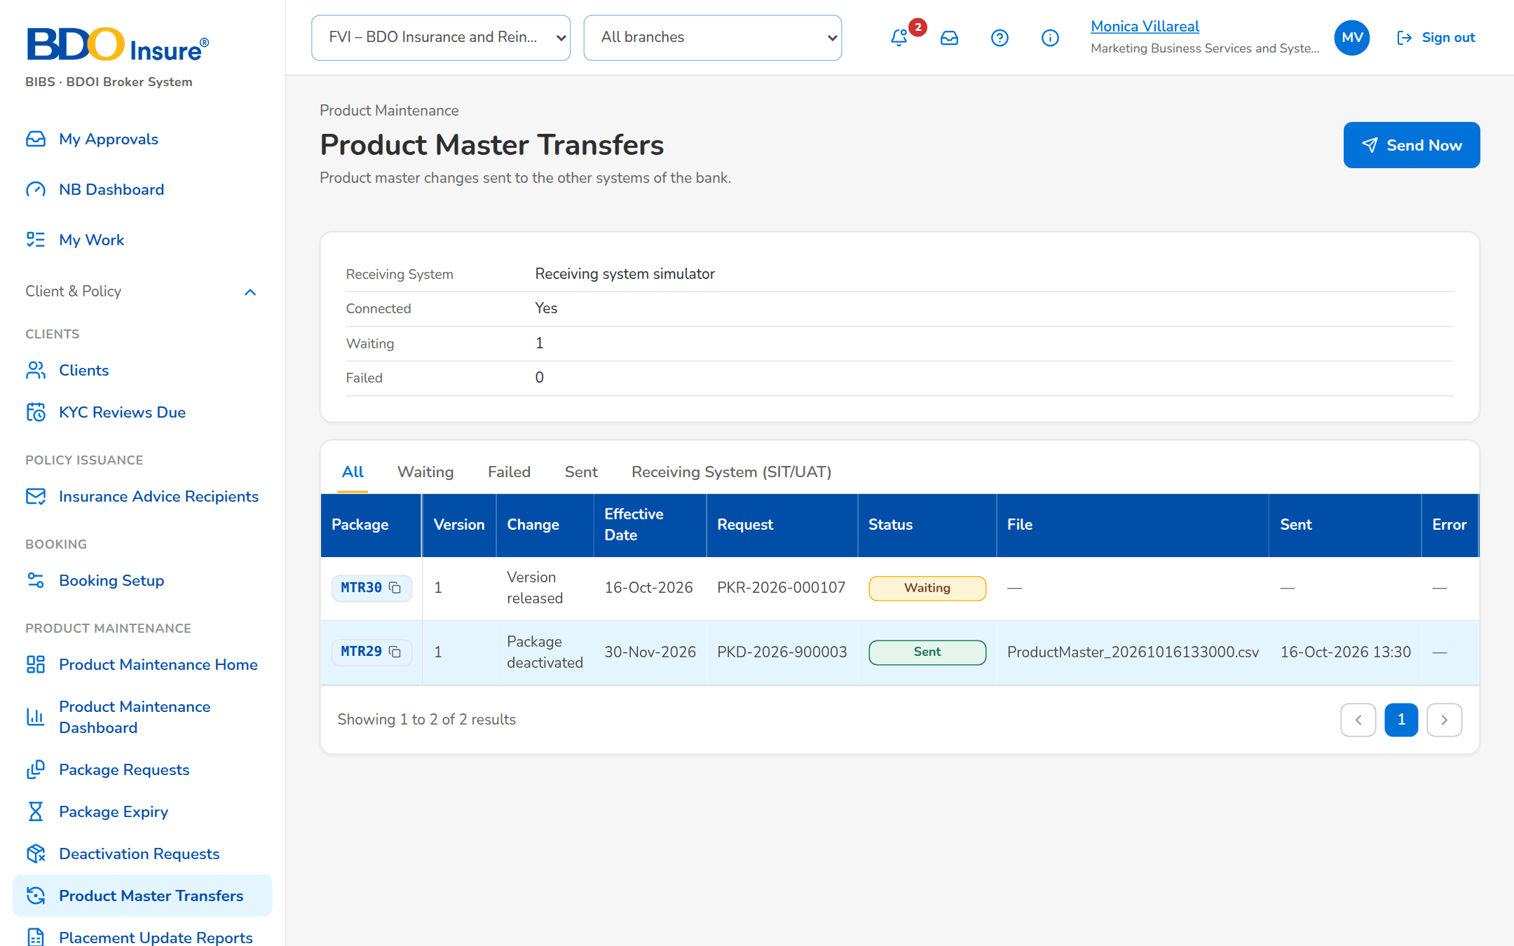
Figure 1: Product Master Transfers (SCR-PM-25)

IF-PM-02 E-mail Channel
• Quotation slips (NT-04), advisories (NT-09) and the password e-mails (NT-05) are queued by BIBS and sent through the mail relay of BDOI; the job MAIL_DISPATCH sends the queue every 2 minutes.
• Each e-mail is logged on its record with recipients, subject, attachment and status; a failed e-mail can be resent.
• Attachments are password-protected PDF or Excel files; the password follows in a separate e-mail.
• BDOI IT gives the relay, the sender mailbox and its credentials (D-PM-02).

Open Points
Table 4: Open points
ID | Point | Owner
Q-PM-08 | Receiving systems, folder and timing of the product master file. | Product Owner; BDO ITG
D-PM-02 | Mail relay and sender mailbox. | BDO ITG

