
PRJ0012475 - BDO Insure Brokering System (BIBS) - Product Maintenance: Reports, Notifications and Outputs -
Release 1 / Drop 0
Prepared by: iorta TechNXT Project Team

Template Reference No. | D051
Document No. | PRJ0012475-PM-RNO
Prepared by: | iorta TechNXT Project Team
Drafting support: | iorta TechNXT Project Team
Creation Date: | 10/16/2026
Revision No. | 1.4
Last Updated by: | iorta TechNXT Project Team
Last Updated Date: | 10/16/2026

Document Revision Log
Date | Revision | Description | Updated by
16 Oct 2026 | 1.4 | First issue as a separate document of the Product Maintenance set (taken out of the annexes of the FRS v1.3 and aligned with the system delivered). Numbered 1.4 to match the FRS. | iorta TechNXT Project Team (drafting support); for review by the BDOI Product Owner

Table of Contents
Document Revision Log 3
Table of Contents 4
Introduction 5
Reports 6
Documents 9
Exports 10
Notices and E-mails 11
Scheduled Jobs 13

Introduction
This document lists the reports, documents, exports, notices and e-mails and the scheduled jobs of Product Maintenance. Times are Manila time. Documents e-mailed outside BIBS are password protected and the password follows in a separate e-mail (BR-PM-11).

Reports
Table 1: Product Maintenance reports
ID | Report | BRD | Parameters | Columns | Output
RPT-PM-01 | Dashboard (KPIs and drill-down) | BRPM.019 | Period, TSU Officer, Product Line, Package Type | Request No., type, line, requested by, TSU officer, status, submitted, aging | Screen; Excel, PDF, CSV
RPT-PM-02 | Consolidated Placement Update Report | BRPM.018 | Report date; period (7 days); scope | Item No., insured, segment, team, Account Officer, TSU handler, line, sub-line, PRF received date and time, aging, status | Excel, PlacementUpdate_MMDDYYYY.xlsx
RPT-PM-03 | Package Status Update Report | BRPM.018 | Request No.; stage; type; line; insurer; ends within | Request No., type, client or programme, package, product, version, stage, days in stage, package end, rate, insurers, last action | PDF, Excel, CSV
RPT-PM-04 | Renewal Request Report | BRPM.017 | Period | Package, version, expiry date, days left, renewal request, stage | PDF, Excel, CSV
RPT-PM-05 | Package Expiry Report | BRPM.017 | Ending within (days), default 90 | Product, package, version, package end, days left, anniversary, renewal request, stage | PDF, Excel, CSV
RPT-PM-06 | Package Version History | BRPM.006 | Product (optional) | Product, version, status, dates, package end, submitted by, validated by and on, result, source request, change summary | PDF, Excel, CSV
RPT-PM-07 | Product Matrix | BRPM.003 | Line, status | Line, sub-line, package, description, insurer, status, effective and expiry dates, last update | PDF, Excel, CSV
RPT-PM-08 | Product Maintenance audit report | BRPM.024 | Dates, action, reference, user | Time, module, reference, client, action, description, old and new value, user, remarks | PDF, Excel, CSV
RPT-PM-09 | Reports builder | BRPM.005 | Fields of the data source; dates | As chosen | PDF, Excel, CSV

Every report run is logged with the user, the parameters and the time. Reports open in the report runner of BIBS with their parameters.
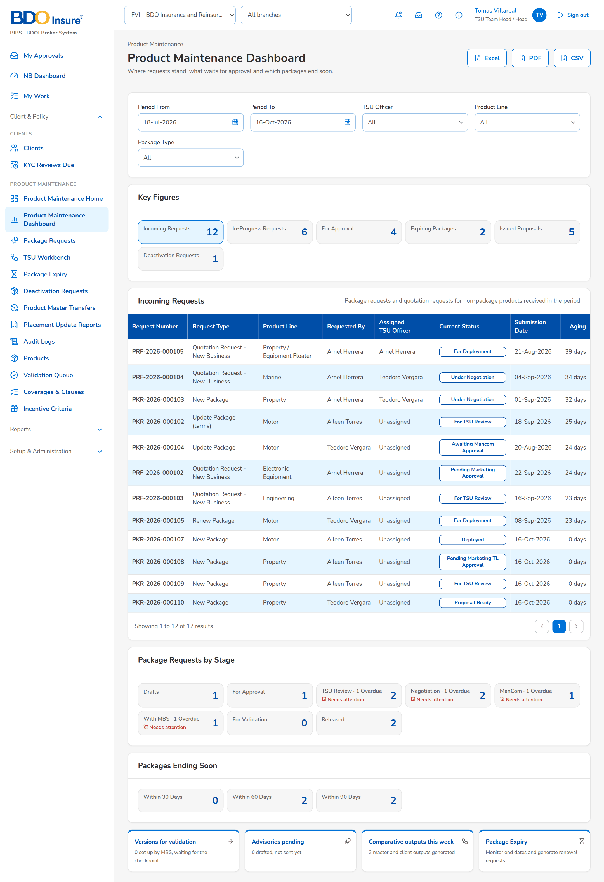
Figure 1: Product Maintenance Dashboard (RPT-PM-01)
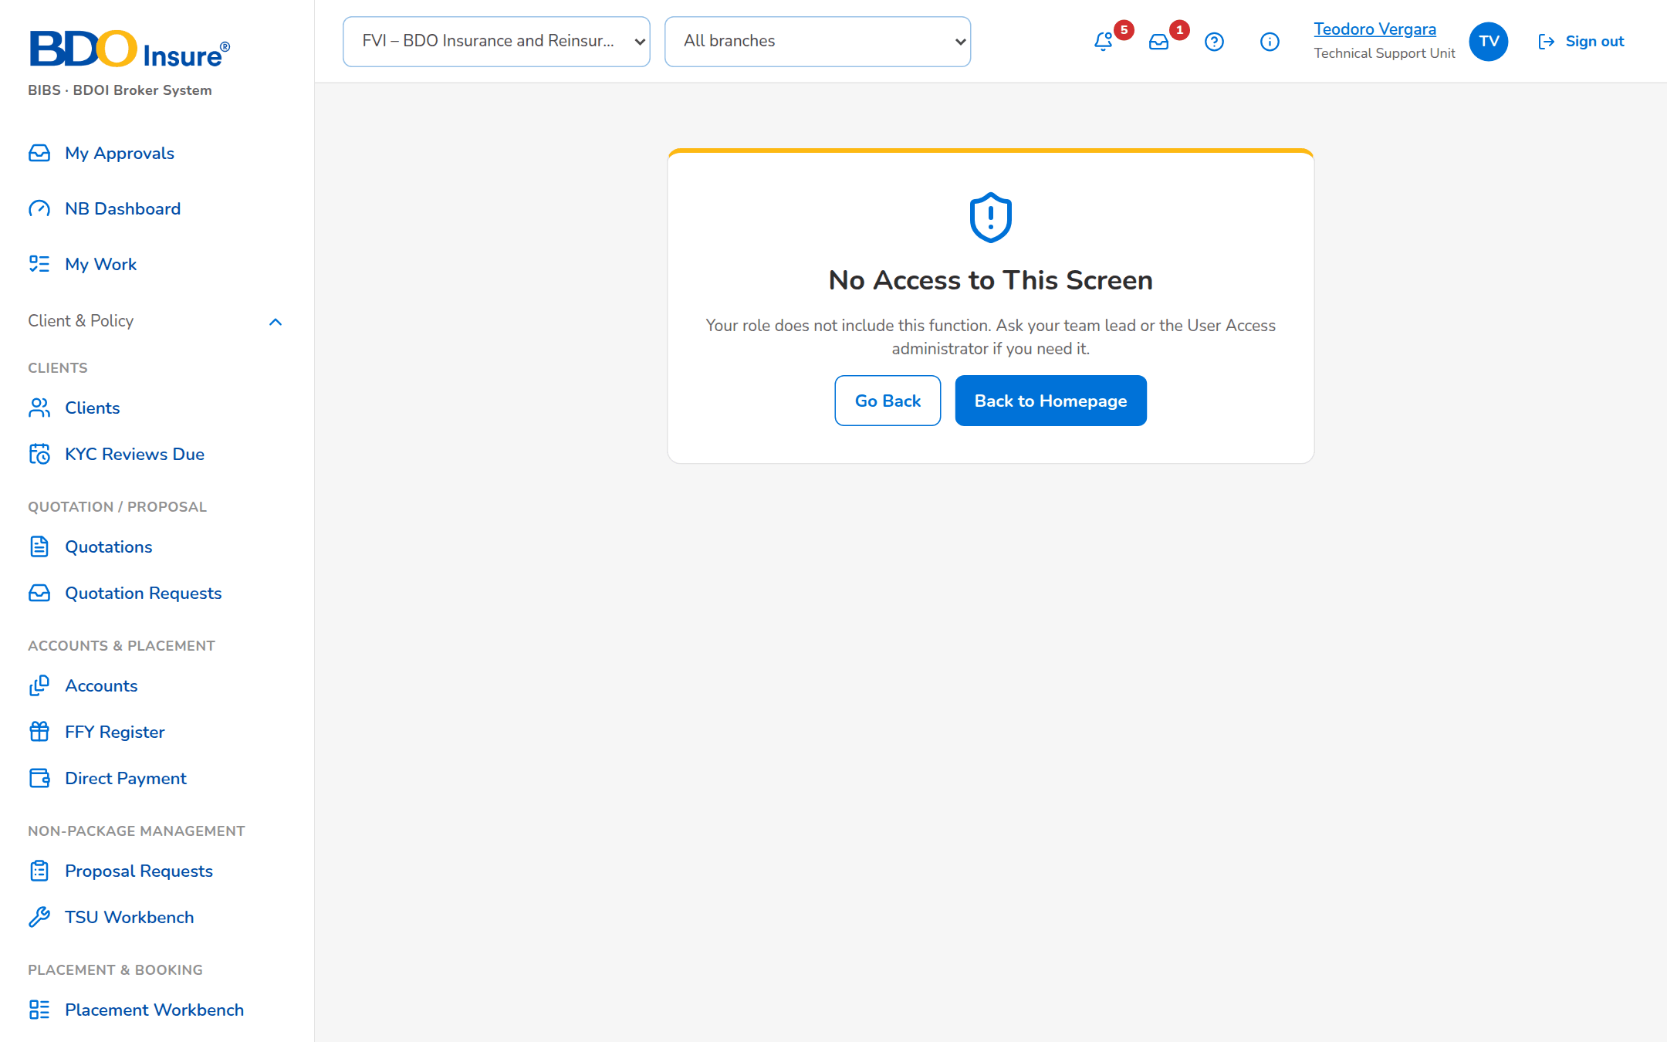
Figure 2: Placement Update Reports (RPT-PM-02)

Documents
Table 2: Documents produced
ID | Document | Format and file name | Protection | FRPM
DO-01 | Package Request Form | PDF | Kept in BIBS | FRPM.011.02, FRPM.030.01
DO-02 | Package Quotation Slip | PDF per insurer and round; QS_<reference>_<insurer>_MMDDYYYY.pdf | Password protected when e-mailed | FRPM.012.01
DO-03 | Comparative Table (master and client view) | PDF and Excel | Password protected when e-mailed | FRPM.012.04
DO-04 | Package slip | PDF (unsigned, for signature) | Kept in BIBS | FRPM.014.01
DO-05 | ManCom sign-off record | PDF, MC-<request number> | Kept in BIBS | FRPM.014.02
DO-06 | Package advisory | PDF, stored on the request | Password protected when e-mailed | FRPM.025.01
DO-07 | Non-package Quotation Slip and Proposal Slip | PDF; QS_ and ProposalSlip_ names | Password protected | FRPM.006.01, FRPM.009.02
DO-08 | Product master file | CSV, ProductMaster_yyyyMMddHHmmss.csv | Folder of the receiving systems | FRPM.029.02

Exports
Table 3: Exports
Output | Format | Where | Content
Product Matrix list | Excel, PDF, CSV | Products | The filtered rows
Package Requests list | Excel | Package Requests | The rows of the tab and filters
Dashboard drill-down | Excel, PDF, CSV | Dashboard | The rows of the KPI
Expiry list | Excel | Package Expiry | Packages ending within the days chosen
Audit logs | CSV, Excel; Audit Logs_MMDDYYYY | Audit Logs | The filtered entries
Sales organisation | Excel | Sales Organisation | Units and officers

Notices and E-mails
Notices appear under the bell and, where shown, by e-mail. Text in angle brackets is filled in. Alerts appear on the Alerts screen.
Table 4: Notices and e-mails
ID | Event | To | Title | Text | Channel
NT-01 | Request enters TSU review | TSU Team Leads | <request no.> for TSU review | <title> | Bell
NT-02 | Request waits for a Marketing approval level | Marketing approvers of the level (not the maker) | <request no.> for <level> approval | <title> | Bell; e-mail
NT-03 | Request assigned | The new assignee | <request no.> assigned to you | <title> | Bell
NT-04 | Package quotation slip sent | Placement e-mails of each insurer | Package quotation slip <PQS no.> - <package> | Please find attached our package quotation slip ... Kindly send your best terms on or before <reply date>. The password follows separately. | E-mail
NT-05 | Protected document sent | Same recipients | Password for: <subject> | The password of the attached documents. | E-mail
NT-06 | ManCom approval needed | Each selected approver; the President when his turn comes | <request no.> for your ManCom approval | <title> | Bell; e-mail
NT-07 | Deployment request | MBS | Package deployment request <PDR no.> | <title> | Bell; e-mail
NT-08 | Version released | Marketing users who quote | Package available: <risk code> | <package> (version <n>) sells from <date>. | Bell
NT-09 | Advisory sent | Users of each recipient group; e-mail addresses given | <advisory subject> | <advisory text> | Bell; e-mail (protected PDF)
NT-10 | Package ending (90, 30, 7 days) | TSU Officers and Team Leads (MBS when set); Alerts | Package ending: <risk code> | Version <n> ends on <date> (<n> days). | Bell; alert
NT-11 | Package anniversary | As NT-10 | Package anniversary: <risk code> | <text> | Bell; alert
NT-12 | Package expired | TSU and MBS users | Package expired: <risk code> | Version <n> ended on <date> without a renewal; the package is no longer sold for new business. | Bell
NT-13 | Incentive criterion on an ended product | TSU and MBS users; Alerts | Incentive criterion to review: <code> | <text> | Bell; alert
NT-14 | Product Matrix record for approval | The approver named | Product Matrix record for approval: <code> | <user> sent <product> for your approval. | Bell; e-mail
NT-15 | Deactivation request and decision | Approver; then the requester | Package deactivation <status>: <PKD no.> | <package> will be deactivated after <date> / stays active. | Bell; e-mail
NT-16 | Rate exception decided | The requester | Rate exception <reference> approved / rejected | <details> by <approver>. | Bell
NT-17 | Placement Update Report generated | Users with the report permission | <file name> generated | <n> request(s) of <period> | Bell
NT-18 | Non-package proposal decided or terms agreed | TSU officer; requestor | <reference>: Proposal Ready / Terms Agreed | <text> | Bell
NT-19 | Client response recorded | TSU officer; requestor | <reference>: client response <response> | <client> - <remarks> | Bell
NT-20 | Work item overdue; product master transfer failed | Alerts screen (System Administrator, Auditor) | Work item overdue / PM_MASTER_TRANSFER_FAILED | <reference> | Alert

Scheduled Jobs
Table 5: Jobs
Job | When | What it does | Notices
PACKAGE_EXPIRY_MONITOR | Daily 01:00 | Expiry and anniversary alerts; renewal drafts when set. | NT-10, NT-11
PACKAGE_VERSION_LIFECYCLE | Daily 01:00 | Supersedes versions whose selling period ended; expires packages past their end date; flags incentive criteria. | NT-12, NT-13
PACKAGE_DEACTIVATION | Daily 01:05 | Retires packages whose approved deactivation is effective. | NT-15
PLACEMENT_UPDATE_REPORT | Hourly; runs on the set weekday and time | Generates the Consolidated Placement Update Report. | NT-17
PRODUCT_MASTER_TRANSFER | Every 30 minutes; Send Now | Writes the pending product master changes to the file for the receiving systems. | NT-20

Every run is recorded with its start, end, outcome and counts, and can be started at once from Operations › Jobs by a user with the job permission.

