

DATABASE DESIGN
Database Design
Default database design of BIBS on iNXT BrokerVerse, with the notes for data migration
BIBS – BDOI Broker System
Client | BDO Insurance and Reinsurance Brokers, Inc.
Document | BIBS-DBD-BRD-00
Version | 1.0
Date | 13 October 2026
Status | Issued for BDOI review
Classification | Confidential

Prepared by iorta TechNXT for BDOI
iNXT BrokerVerse. This document is confidential to BDO Insurance and Reinsurance Brokers, Inc. and iorta TechNXT.
Document Control
Version | Date | Author | Reviewer | Approver | Change
1.0 | 13 Oct 2026 | iorta TechNXT Data Architect | iorta TechNXT Solution Architect; Migration Lead | BDOI IT (pending) | First issue, read from the system catalogue of a PostgreSQL 16 database holding the BIBS schema of 13 October 2026; supersedes the Data Dictionary v1.0 and the Entity Relationship Diagrams v1.0 of 08 October 2026 for the physical design

Distribution List
Name / Unit | Role | Organisation | Purpose
BDOI Information Technology Group (BDOI IT) | Approver | BDOI | Database design, administration, reporting and extracts
Data Migration Lead and data owners | Reviewer | BDOI | Target tables, keys, code lists and load order of the migration objects (BRD-13)
BIBS Product Owner | Reviewer | BDOI | Data migration preparation
Project team | Delivery | iorta TechNXT | Data architecture, migration, reports, interfaces

Contents

1 Introduction 6
1.1 Purpose and scope 6
1.2 Database platform 6
1.3 How the content was obtained 6
2 Principles and conventions 8
2.1 Design principles 8
2.2 Keys 8
2.3 Column types 8
2.4 Data domains and modules 9
2.5 Document numbering 11
2.6 Audit, history and soft delete 11
2.7 Constraints and indexes 13
3 Entity relationship diagrams 15
3.1 D01 Security and User Access 15
3.1.1 Module SECURITY 15
3.1.2 Module NBADMIN 17
3.1.3 Module IDENTITY 18
3.2 D02 Platform Services 19
3.2.1 Module SYSTEM 19
3.2.2 Module AUDIT 20
3.2.3 Module LOV 20
3.2.4 Module WORKFLOW 20
3.2.5 Module MESSAGING 21
3.2.6 Module ALERT 22
3.2.7 Module BULK 22
3.2.8 Module ATTACHMENT 23
3.2.9 Module DOCGEN 24
3.2.10 Module STORAGE 24
3.2.11 Module REPORT 24
3.2.12 Module EVENTS 25
3.2.13 Module COMMON 25
3.2.14 Module CONFIGPROMO 26
3.3 D03 Organisation and Reference Data 26
3.3.1 Module ORGANIZATION 27
3.3.2 Module CURRENCY 27
3.3.3 Module DIMENSION 28
3.3.4 Module PERIOD 28
3.4 D04 Client and Party 29
3.4.1 Module CRM 29
3.4.2 Module PARTY 30
3.5 D05 Product Catalogue and Maintenance 31
3.5.1 Module CATALOG 31
3.5.2 Module PRODUCTMAINT 34
3.6 D06 New Business 37
3.6.1 Module QUOTATION 37
3.6.2 Module NONPACKAGE 38
3.6.3 Module ACCOUNT 39
3.6.4 Module PLACEMENT 40
3.6.5 Module ISSUANCE 42
3.6.6 Module BOOKING 43
3.6.7 Module NBREPORT 44
3.7 D07 Operations 45
3.7.1 Module OPSLEDGER 45
3.7.2 Module CASHIERING 48
3.7.3 Module REMITTANCE 53
3.7.4 Module PRODRECON 55
3.7.5 Module ADJUSTMENT 56
3.7.6 Module COMMISSION 57
3.8 D08 Collections 58
3.8.1 Module COLLECTIONS 59
3.9 D09 General Ledger and Finance 62
3.9.1 Module COA 62
3.9.2 Module JOURNAL 63
3.9.3 Module LEDGER 64
3.9.4 Module SUBLEDGER 65
3.9.5 Module ACCOUNTING 66
3.9.6 Module CLOSING 66
3.9.7 Module BUDGET 67
3.9.8 Module FINREPORT 68
3.9.9 Module FRBS 69
3.9.10 Module RECEIVABLES 70
3.9.11 Module FIXEDASSET 73
3.9.12 Module INVESTMENT 73
3.9.13 Module TAX 74
3.10 D10 Disbursement and ACSL 76
3.10.1 Module DISBURSEMENT 76
3.10.2 Module PAYABLES 79
3.10.3 Module PAYREQUEST 81
3.10.4 Module ACSL 82
3.11 D11 Renewal 83
3.11.1 Module RENEWAL 84
3.12 D12 Claims Broking 91
3.12.1 Module BROKERCLAIMS 92
3.13 D13 Employee Benefits 94
3.13.1 Module EB 94
3.14 D14 Customer Servicing Facility 101
3.14.1 Module CSF 101
3.15 D15 Sanction Screening 102
3.15.1 Module SCREENING 102
3.16 D16 Submitted Policies 107
3.16.1 Module SUBMITTED 107
3.17 D17 Data Migration 113
3.17.1 Module MIGRATION 113
4 Table catalogue 119
4.1 D01 Security and User Access 119
4.2 D02 Platform Services 121
4.3 D03 Organisation and Reference Data 124
4.4 D04 Client and Party 125
4.5 D05 Product Catalogue and Maintenance 125
4.6 D06 New Business 129
4.7 D07 Operations 133
4.8 D08 Collections 141
4.9 D09 General Ledger and Finance 143
4.10 D10 Disbursement and ACSL 149
4.11 D11 Renewal 153
4.12 D12 Claims Broking 158
4.13 D13 Employee Benefits 159
4.14 D14 Customer Servicing Facility 163
4.15 D15 Sanction Screening 164
4.16 D16 Submitted Policies 167
4.17 D17 Data Migration 170
5 Reference data and lists of values 174
5.1 Lists of values 174
5.2 Allowed values (enumerations) 174
5.3 Masters 175
6 Data migration notes 176
6.1 Master and reference tables against transactional tables 176
6.2 Natural keys and code columns for legacy mapping 176
6.3 Mandatory columns 176
6.4 Origin of migrated rows 177
6.5 Number series and sequences 178
6.6 Load order 178
7 Data retention 179
8 Time zone, date and amount handling 180
9 Decisions and open points for BDOI 181
References 182

1 Introduction

1.1 Purpose and scope
This document describes the default database design of BIBS (BDOI Broker System, on iNXT BrokerVerse): the principles and conventions, the schema by data domain and module, the entity relationship diagrams of each module, the table catalogue with the purpose, keys and relationships of every table, the reference data and code lists, audit and history, document numbering, data retention, and the facts the data migration team needs to map and load the legacy data (master and reference tables against transactional tables, natural keys and code columns, mandatory columns, allowed values, number series and the load order).
Its companion workbook, BIBS Database Inventory v1.0, lists every table and column with data type, nullability, default, keys, indexes and allowed values, every foreign key, the load order and the enumerations. The two follow the structure of the iNXT BrokerVerse OOTB documents 02 Database Design and 03 Database Inventory, which describe the out-of-the-box platform; this document describes the BIBS database.

1.2 Database platform
Table 1: Database platform
Item | Design
Engine | PostgreSQL 16 (Amazon RDS for PostgreSQL in the BDOI AWS accounts; Multi-AZ in production)
Schemas | One application schema (PUBLIC) holds every table; the schema version history is kept in its own table
Logins | The schema owner applies the versioned schema changes; the application connects with a least-privilege runtime role that has row access only (no DDL, no TRUNCATE, cannot disable a trigger)
Time | Time stamps are TIMESTAMPTZ and stored in UTC; business dates are DATE in the Asia/Manila calendar
Character set | UTF-8
Schema changes | Versioned, forward-only change scripts applied in order at deployment, one transaction per version; a version is never edited once applied

1.3 How the content was obtained
The content is read from the database, not written by hand, so it matches the schema exactly:
1. An empty PostgreSQL 16 database was created.
2. All schema versions were applied in order, one transaction per version, without starting the application; reference rows for test environments were not applied.
3. Tables, columns, types, nullability, defaults, keys, foreign keys, check constraints, indexes, triggers, sequences and views were read from the PostgreSQL system catalogue.
4. The purpose of each table is the first sentence of the documentation of its entity; shared columns carry a standard meaning, other columns are described from their name and foreign key.
5. The class of a table (reference, master, transactional, audit and log, migration control, system) and the load order are derived from the catalogue (sections 6.1 and 6.6).
6. The database was dropped after the extraction.
Table 2: The BIBS database in figures
Measure | Value
Schema versions applied | 255
Tables | 621
Columns | 10,525
Foreign keys | 916
Secondary indexes (of which unique) | 1168 (473)
Check constraints | 983
Triggers | 35
Insert-only tables | 15
Views | 2
Sequences | 562
Load levels | 9
Entity relationship figures | 80

2 Principles and conventions

2.1 Design principles
• One modular database. Each module (bounded context) owns its tables, recognisable by their prefix (for example RNW for renewal, CSH for cashiering, GL for the general ledger). A module reads another module's tables only through foreign keys to masters and through the platform services.
• Surrogate keys, business keys unique. Every table has a surrogate primary key; business numbers and codes are unique keys of their own (section 2.2).
• Data scope on every business row. Business tables carry COMPANY_ID and, where the record belongs to a branch, BRANCH_ID; the data scope of a user restricts the rows the user sees.
• Maker-checker on masters. Masters carry RECORD_STATUS, AUTHORIZED_BY and AUTHORIZED_AT; the checker is never the maker.
• Optimistic locking. VERSION is incremented on every update; a stale update is refused.
• Who and when. CREATED_AT, CREATED_BY, UPDATED_AT and UPDATED_BY on every table that is changed by users.
• Insert-only evidence. The audit trail, the ledger entries and the histories listed in section 2.6 refuse UPDATE, DELETE and TRUNCATE at database level; corrections are made by reversal.
• Allowed values in the database. Status, type and kind columns are restricted by check constraints to their list of codes (section 5).
• Origin of a row. The tables that receive migrated data record the origin of each row (BIBS or MIGRATED), the legacy system, the legacy reference and the migration batch (section 6.4).

2.2 Keys
• Primary key: ID BIGINT, an identity column (BY DEFAULT) (a load may supply the value; the identity is then advanced past the highest loaded value). Link tables and counters use their natural composite key.
• Business keys: numbers (policy, invoice, receipt, claim, request numbers) and codes (clients, insurers, products, accounts, list values) are unique, per company where the number series is per company. Case-insensitive uniqueness uses an index on LOWER(column).
• Foreign keys reference the surrogate ID of the parent. Some modules also hold a business code of a master (for example INSURER_CODE, CLIENT_CODE) for reporting and for matching legacy data; the code is checked by the application.
• Partial unique indexes enforce one active row where the business requires it (for example one open renewal candidate per policy).

2.3 Column types
Table 3: Column data types
Data type | Columns | Used for
VARCHAR | 5172 | Codes, names, numbers, statuses (length set per column)
BIGINT | 2042 | Surrogate keys, foreign keys, counters
TIMESTAMPTZ | 1451 | Time stamps (stored in UTC)
NUMERIC | 562 | Amounts (NUMERIC(18,2)), rates and percentages (higher scale)
INTEGER | 506 | Counts, sequence numbers, years
DATE | 432 | Business dates (effective, due, posting)
BOOLEAN | 294 | Flags
TEXT | 38 | Long free text
BYTEA | 13 | Binary content (encrypted values, files)
TIMESTAMP | 8 | Local time stamps of external files
UUID | 3 | Correlation identifiers
JSONB | 3 | Structured documents (events)
SMALLINT | 1 | Small codes

Amounts are NUMERIC with two decimals in the currency of the row; the currency is the ISO 4217 code in CURRENCY or a column named for its role (for example PREMIUM_CURRENCY). Rates and percentages use a larger scale. Free text is VARCHAR with a length set per column, so a migrated value longer than the column is refused, not cut.

2.4 Data domains and modules
The tables fall into the data domains below. Each domain has one data owner at BDOI who approves changes to its master data, its retention and its quality rules.
Table 4: Data domains of the production schema
ID | Domain | BRD | Modules | Tables | Columns
D01 | Security and User Access | BRD-11 | SECURITY, NBADMIN, IDENTITY | 27 | 320
D02 | Platform Services | BRD-00 | SYSTEM, AUDIT, LOV, WORKFLOW, MESSAGING, ALERT, BULK, ATTACHMENT, DOCGEN, STORAGE, REPORT, EVENTS, COMMON, CONFIGPROMO | 43 | 592
D03 | Organisation and Reference Data | BRD-00 | ORGANIZATION, CURRENCY, DIMENSION, PERIOD | 10 | 149
D04 | Client and Party | BRD-01 | CRM, PARTY | 7 | 142
D05 | Product Catalogue and Maintenance | BRD-03 | CATALOG, PRODUCTMAINT | 45 | 715
D06 | New Business | BRD-01 | QUOTATION, NONPACKAGE, ACCOUNT, PLACEMENT, ISSUANCE, BOOKING, NBREPORT | 48 | 828
D07 | Operations | BRD-02 | OPSLEDGER, CASHIERING, REMITTANCE, PRODRECON, ADJUSTMENT, COMMISSION | 86 | 1705
D08 | Collections | BRD-04 | COLLECTIONS | 23 | 438
D09 | General Ledger and Finance | BRD-05 | COA, JOURNAL, LEDGER, SUBLEDGER, ACCOUNTING, CLOSING, BUDGET, FINREPORT, FRBS, RECEIVABLES, FIXEDASSET, INVESTMENT, TAX | 72 | 1150
D10 | Disbursement and ACSL | BRD-05 | DISBURSEMENT, PAYABLES, PAYREQUEST, ACSL | 41 | 805
D11 | Renewal | BRD-06 | RENEWAL | 59 | 998
D12 | Claims Broking | BRD-07 | BROKERCLAIMS | 13 | 229
D13 | Employee Benefits | BRD-08 | EB | 38 | 608
D14 | Customer Servicing Facility | BRD-09 | CSF | 6 | 74
D15 | Sanction Screening | BRD-10 | SCREENING | 34 | 553
D16 | Submitted Policies | BRD-12 | SUBMITTED | 34 | 618
D17 | Data Migration | BRD-13 | MIGRATION | 35 | 601
 | Total |  |  | 621 | 10525

Table 5: Tables, columns and foreign keys per domain and class
ID | Domain | Tables | Cols | FKs | Ref | Master | Trans | Log | Mig | Sys
D01 | Security and User Access | 27 | 320 | 11 | - | 21 | - | 3 | - | 3
D02 | Platform Services | 43 | 592 | 36 | 3 | - | 10 | 5 | - | 25
D03 | Organisation and Reference Data | 10 | 149 | 12 | - | 10 | - | - | - | -
D04 | Client and Party | 7 | 142 | 10 | - | 6 | - | 1 | - | -
D05 | Product Catalogue and Maintenance | 45 | 715 | 46 | - | 42 | - | 3 | - | -
D06 | New Business | 48 | 828 | 73 | - | 1 | 45 | 2 | - | -
D07 | Operations | 86 | 1705 | 129 | - | 1 | 83 | 2 | - | -
D08 | Collections | 23 | 438 | 36 | - | 1 | 20 | 2 | - | -
D09 | General Ledger and Finance | 72 | 1150 | 124 | - | 14 | 56 | 2 | - | -
D10 | Disbursement and ACSL | 41 | 805 | 84 | - | 2 | 39 | - | - | -
D11 | Renewal | 59 | 998 | 78 | - | 4 | 53 | 2 | - | -
D12 | Claims Broking | 13 | 229 | 21 | - | 2 | 8 | 3 | - | -
D13 | Employee Benefits | 38 | 608 | 95 | - | 2 | 35 | 1 | - | -
D14 | Customer Servicing Facility | 6 | 74 | 4 | - | - | 4 | 2 | - | -
D15 | Sanction Screening | 34 | 553 | 57 | - | - | 31 | 3 | - | -
D16 | Submitted Policies | 34 | 618 | 51 | - | 5 | 28 | 1 | - | -
D17 | Data Migration | 35 | 601 | 49 | - | - | - | - | 35 | -
 | Total | 621 | 10525 | 916 | 3 | 111 | 412 | 32 | 35 | 28

Table 6: Data domains and their owners
ID | Domain | BRD | Data owner (BDOI)
D01 | Security and User Access | BRD-11 | BDOI Information Security (policy); Business Administration (user access requests); System Administrator (role implementation)
D02 | Platform Services | BRD-00 | BDOI IT (platform operation); System Administrator (parameters, jobs, templates)
D03 | Organisation and Reference Data | BRD-00 | Head - Comptrollership (companies, branches, cost centres, periods, currencies)
D04 | Client and Party | BRD-01 | Product Owner, Marketing Business System (clients); Head - Comptrollership (business partners)
D05 | Product Catalogue and Maintenance | BRD-03 | Product Owner, Marketing Business System (with the Technical Support Unit for package requests)
D06 | New Business | BRD-01 | Product Owner, Marketing Business System; Unit Head - Processing (placement, issuance, booking)
D07 | Operations | BRD-02 | Operations: Financial Transactions and Processing
D08 | Collections | BRD-04 | Collections and Marketing Support
D09 | General Ledger and Finance | BRD-05 | Product Owner - Comptrollership - FRBS and ACSL; Head - Comptrollership
D10 | Disbursement and ACSL | BRD-05 | Product Owner - Comptrollership - Disbursement; Product Owners - Comptrollership - ACSL
D11 | Renewal | BRD-06 | Product Owner, Renewal
D12 | Claims Broking | BRD-07 | Product Owner, Claims (with the Unit Head - Claims and Risk Management)
D13 | Employee Benefits | BRD-08 | Product Owner, Employee Benefits
D14 | Customer Servicing Facility | BRD-09 | Product Owner, Customer Servicing Facility
D15 | Sanction Screening | BRD-10 | Compliance Officer (AMLA), with the Unit Head - Claims and Risk Management for risk profiling
D16 | Submitted Policies | BRD-12 | Product Owner, Submitted Policies
D17 | Data Migration | BRD-13 | Data Migration Lead (BDOI), with the data owner of each object

2.5 Document numbering
Document numbers come from number series kept in the database, so two users never receive the same number and a number is not reused after a rollback where the series requires gapless numbering:
Table 7: Number series, counters and sequences
Object | Kind | Use
DOCUMENT_SEQUENCE | Number series table | Counter per document number series (series key and next value)
SYS_SHARED_COUNTER | Number series table | Shared counters (key, value, expiry) used across application instances
CSH_RECEIPT_SERIES | Number series table | Official and acknowledgement receipt series per branch, with the BIR authority to print, range and next number
COA_NUMBERING | Number series table | Numbering of the chart of accounts below a parent account (separator, width)
561 identity sequences | Identity | One per surrogate key ID (identity BY DEFAULT): a load may supply the identifier; the sequence is then advanced past the highest loaded value
SYS_JOB_LOCK_FENCE_SEQ | Free sequence | Fencing token of the job lock

The format of each series (prefix, branch, year, running number) is configuration. For data migration, documents keep their legacy number; the running number of each BIBS series is set above the highest migrated number of the same series before go-live, and BIR-registered receipt series continue from the next unused number of the authority to print.

2.6 Audit, history and soft delete
Every create, update, authorisation, posting, reversal, sign-in and export is written to the audit trail in the same transaction as the change. Masters are not deleted: they are deactivated (ACTIVE false, or an inactive record status) or end-dated (EFFECTIVE_TO). Documents are cancelled or reversed, never deleted.
Table 8: Audit, history and log tables
Table | Module | Purpose | Insert-only
NBA_ACCESS_REQUEST_EVENT | NBADMIN | One event in the history of an access request with its remarks (BRD 1.002.1.1.4-5 "add / save remarks", 1.006, 1.008, 2.002.7). | Yes
SEC_ACCESS_CHANGE_LOG | SECURITY | One changed attribute of a user or role: from, to, the request that asked for it, who did it and who approved it (BRD 4.003.1, reports A-D; UAM-NFR-41). | Yes
SEC_PASSWORD_HISTORY | SECURITY | A previous password hash of a user, kept for the reuse rule (UAM-NFR-36, PASSWORD_HISTORY_COUNT). | -
AUDIT_LOG | AUDIT | Immutable audit trail record of a financial or non-financial action. * Captures originator, modifier and authorizer activity with timestamps, as required by the GL audit trail control. | Yes
EVT_ARCHIVE | EVENTS | Archive records. | -
EVT_DEAD_LETTER | EVENTS | Dead letter records. | -
EVT_OUTBOX | EVENTS | Outbox records. | -
WF_CASE_HISTORY | WORKFLOW | One status change (insert only): from, to, action, reason, comment, who and when. | -
CRM_CLIENT_NOTE_HISTORY | CRM | Insert-only history of a client tag or instruction change: who, when, from and to (BRNB.091). | Yes
PM_FINAL_TERM_HISTORY | PRODUCTMAINT | A change of a Final Terms for Proposal value (history, BDOI FRS FRPM.009.01). | -
PM_INSURER_RESPONSE_HISTORY | PRODUCTMAINT | Insert-only snapshot of a package insurer response after each change (PMADD04: every revision and outcome change is logged). | -
PM_MASTER_SIM_INBOX | PRODUCTMAINT | A file of product master changes received by the simulated receiving system (SIT and UAT). | -
BKG_INCENTIVE_EVALUATION | BOOKING | One evaluation of the incentive indicator of a transaction (FR-NB-118, FR-RN-087 audit): the trigger, the criteria matched, the endorsements considered, the result and the reason. | Yes
NPK_INSURER_RESPONSE_HISTORY | NONPACKAGE | Insert-only snapshot of an insurer response after each change (BRNB.009 version history). | -
CSH_SEARCH_LOG | CASHIERING | Search log records. | -
OPS_INVOICE_ORIGIN_SNAPSHOT | OPSLEDGER | The frozen original values of an open legacy invoice: header amounts and, per component, the booked, adjusted, paid, remitted, written-off and open amounts at cut-over, written once by the legacy invoice intake and never updated. | Yes
CLX_INBOX | COLLECTIONS | An item Operations sent to Collections through an outbound COLLECTION_* feed: a direct payment account returned by the insurer (CMRID.009) or a refund (BRCLXN.040), with the flow-in run it arrived in and what Collections did with it. | -
CLX_OUTBOX | COLLECTIONS | An item Collections hands to Operations through an inbound COLLECTION_* feed: a BIR 2307 tag for Cashiering, a direct payment account for Commission or a check pick-up request for Cashiering. | -
ACC_EVENT_LOG | ACCOUNTING | Register of processed accounting events (event monitor and failed-event report). | -
GL_LEDGER_ENTRY | LEDGER | Immutable posted GL transaction line — the book of record. * Written only by the posting engine. | Yes
RNW_BUCKET_HISTORY | RENEWAL | A change of bucket (BRRN.023 AC 6): from, to, rule set version and rule, check run, cause (rule or override), user (created by) and remarks. | -
RNW_BUDGET_HISTORY | RENEWAL | One change of a budget amount (FRRN.042.06): the field, the previous and the updated value, the user and the time. | -
BCL_INSURER_UPDATE | BROKERCLAIMS | A communication received from an insurer about a claim: date, source (BCL_UPDATE_SOURCE), the insurer's reference, remarks and the attachments that carry the insurer's document, optionally tied to one insurer line. | Yes
BCL_RESERVE_CHANGE | BROKERCLAIMS | One amendment of an insurer reserve: previous and new amount, reason, user and time. | Yes
BCL_STATUS_HISTORY | BROKERCLAIMS | One status change of a claim: from and to status and phase, user, time, remark and the days spent in the previous status, which the ageing per status report reads. | Yes
EB_ACTIVITY_LOG | EB | A received / released stamp of an activity of the TAT annex (BRID-022, 024; design 4.2): written by the EB services at each step, read by the EB-TAT report. | -
CSF_ACTIVITY | CSF | One action of an agent in the Customer Servicing Facility (FR-CSF-042): searches with their criteria, views, downloads, resends, uploads, verifications, contact changes and referrals. | Yes
CSF_SYNC_OUTBOX | CSF | One contact change to send to one legacy system (FR-CSF-022, CSQ01): the payload is kept with every row, so the outbox can be replayed once the interface is specified. | -
SCR_CASE_EVENT | SCREENING | One entry of the insert-only case timeline (SNSRP-401, 404, 405, 701-704, 902, 903; design 4.4): the event, the round, the stages and values before and after, the reason, the remarks, the actor and the time. | Yes
SCR_CLIENT_RISK_PROFILE | SCREENING | One change of a client's risk profile made by screening (SNSRP-302, 304; FR-SS-033, 035): the category, the rating before and after, the tags added and ended, the source (RULE with the rule, the match and the run; MANUAL with the justification and the evidence) and the time. | Yes
SCR_COMMITTEE_VOTE | SCREENING | An AML Committee member's decision on a case round (SNSRP-704; FR-SS-064): APPROVE_STR, NO_STR or COMMITTEE_RETURN with remarks. | Yes
SBM_POLICY_HISTORY | SUBMITTED | One field change of a masterlist record with its source (BRIDSP-29). | -

2.7 Constraints and indexes
Foreign keys are declared for every link between tables of BIBS; most use the default rule (a parent row cannot be deleted while children exist), and the lines of a document cascade with their header. Check constraints hold the lists of allowed values, the ranges (for example a percentage between 0 and 100) and the cross-column rules (for example an end date not before the start date). Secondary indexes support the foreign keys of growing tables, the search screens and the jobs.
Table 9: Hierarchies (a row references a row of the same table)
Table | Column referencing the same table
BCL_INSURER_UPDATE | CORRECTS_UPDATE_ID
BUD_BUDGET | BASED_ON_ID
CAT_COVER_TYPE | LINE_CODE, PARENT_CODE
CAT_INCENTIVE_CRITERIA | SUCCESSOR_OF
CFP_IMPORT | ROLLBACK_OF_ID
COA_ACCOUNT | PARENT_ID
EB_COMMENT | REPLY_TO_ID
JNL_BATCH | CORRECTS_BATCH_ID
JNL_BATCH | REVERSAL_OF_ID
JNL_BATCH | REVERSED_BY_ID
MIG_BATCH | PARENT_BATCH_ID
MSG_OUTBOUND | PASSWORD_FOR_ID
PAY_PDC_ISSUED | REPLACED_BY_ID
PAY_PDC_ISSUED | REPLACES_ID
PM_COMPARATIVE_OUTPUT | PARENT_OUTPUT_ID
RCV_PDC | REPLACED_BY_ID
SCR_CONFIG_VERSION | BASE_VERSION_ID

3 Entity relationship diagrams
Each figure shows the tables of one module with their primary key (PK) and the foreign key columns (FK) drawn in the figure; "+ n columns" counts the other columns, which are in the inventory. A line runs from the foreign key column of the child table to the parent table: the crow's foot marks the "many" end; two bars at the parent end mean a mandatory link, a bar and a circle an optional link. A grey rounded box is a table of another module. The links to ORG_COMPANY and ORG_BRANCH are drawn only in the Organisation figures.
80 figures follow, grouped by data domain and module.

3.1 D01 Security and User Access
Users, roles, permissions, data scope (companies and branches), sign-in sessions, second factor, single sign-on requests and tickets, password history, user access requests with their approvers and events, separation-of-duties rules, access change log and the retention rules of the broking records. Owner: BDOI Information Security (policy); Business Administration (user access requests); System Administrator (role implementation). BRD: BRD-11. 27 tables, 320 columns.

3.1.1 Module SECURITY
Table 10: Tables of module SECURITY (D01)
Table | Description | Cols | Links | Figure
SEC_ACCESS_CHANGE_LOG | One changed attribute of a user or role: from, to, the request that asked for it, who did it and who approved it (BRD 4.003.1, reports A-D; UAM-NFR-41). | 13 | - | Listed only (no link)
SEC_MFA_RECOVERY_CODE | A single-use recovery code of the second factor; only its SHA-256 is kept. | 6 | - | Listed only (no link)
SEC_MFA_RESET_REQUEST | An administrator's request to reset a user's second factor: applied only when a holder of MFA_RESET_APPROVE other than the requester approves it (four eyes); the requester may withdraw it. | 10 | - | Listed only (no link)
SEC_MFA_TRUSTED_DEVICE | A device remembered for the second factor until it expires (parameter MFA_REMEMBER_DEVICE_DAYS, off as delivered); only the SHA-256 of its token is kept. | 5 | - | Listed only (no link)
SEC_PASSWORD_HISTORY | A previous password hash of a user, kept for the reuse rule (UAM-NFR-36, PASSWORD_HISTORY_COUNT). | 4 | - | Listed only (no link)
SEC_PASSWORD_RESET_TOKEN | A "Forgot password?" link (UAM-NFR-37; FR-UA-005 R3): single use and valid for a limited time. | 7 | - | Listed only (no link)
SEC_PERMISSION_ACTION | Permission action records. | 4 | - | Listed only (no link)
SEC_REVOKED_TOKEN | Revoked token records. | 4 | - | Listed only (no link)
SEC_ROLE | A named bundle of permissions assigned to users (e.g. | 13 | - | D01 SECURITY
SEC_ROLE_PERMISSION | Role permission records. | 2 | SEC_ROLE | D01 SECURITY
SEC_SSO_REQUEST | A sign-in sent to the identity provider: the SHA-256 of its state, the PKCE verifier and nonce (OIDC) or the request ID (SAML). | 10 | - | Listed only (no link)
SEC_SSO_TICKET | The one-time ticket of a single sign-on: the web client redeems it for the session once the identity provider answered. | 8 | - | Listed only (no link)
SEC_USER | Application user. * Carries the security controls required by the GL: account lockout after repeated failed logins, a home branch, and an authorization limit capping the value of batches the user may authorize. * BRD-11 adds the directory identity (Windows ID), the business unit group and user level (BRD 1.002.1.1.1), the password dates and the forced change flag (UAM-NFR-36) and the last sign-out (UAM-NFR-35). | 24 | - | D01 SECURITY
SEC_USER_DATA_SCOPE | One granted company (with all its branches, branchId null) or one granted branch of a user whose data scope is not "all companies". | 6 | SEC_USER | D01 SECURITY
SEC_USER_MFA | The authenticator app of a user: the TOTP secret encrypted at rest, PENDING until the first code confirms the enrolment, then ACTIVE. | 9 | - | Listed only (no link)
SEC_USER_ROLE | User role records. | 2 | SEC_ROLE, SEC_USER | D01 SECURITY
SEC_USER_SESSION | A sign-in session, keyed by the token id (jti) of its access token: issued, last seen, ended and why (UAM-NFR-35 logout logging; the "online" status, UQ13; a later single-session rule, UQ09). | 14 | - | Listed only (no link)

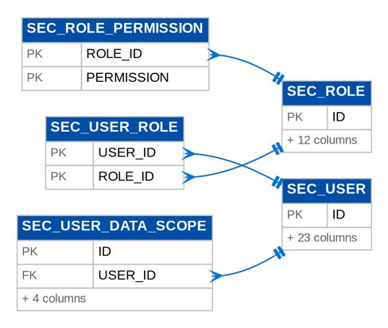
Figure 1: D01 SECURITY: tables, primary keys and the foreign keys inside the module

3.1.2 Module NBADMIN
Table 11: Tables of module NBADMIN (D01)
Table | Description | Cols | Links | Figure
NBA_ACCESS_REQUEST | A request to enrol, modify, deactivate or reactivate a user, or to create, change, deactivate or reactivate a group profile (BRNB.085; BRD 1.002-1.009, 3.002; PMADD05). | 50 | NBA_ACCESS_REQUEST_BATCH | D01 NBADMIN
NBA_ACCESS_REQUEST_APPROVER | One approver of an access request, in order (BRD 1.002.1.1.3 "select approver", BRD 3.002.x "approver/s"): user requests have one, group-profile requests one or more, each deciding in turn. | 12 | NBA_ACCESS_REQUEST | D01 NBADMIN
NBA_ACCESS_REQUEST_BATCH | A bulk access request: one line request per row of the uploaded file. | 11 | - | D01 NBADMIN
NBA_ACCESS_REQUEST_EVENT | One event in the history of an access request with its remarks (BRD 1.002.1.1.4-5 "add / save remarks", 1.006, 1.008, 2.002.7). | 10 | NBA_ACCESS_REQUEST | D01 NBADMIN
NBA_RETENTION_RULE | A data retention rule (BRNB.106, NFR retention): records of a type in one of the statuses become eligible once they have been inactive for yearsOnline years; they are then kept yearsArchive more years in the archive. | 13 | - | D01 NBADMIN
NBA_RETENTION_RUN | Result of one retention review of one rule: how many records were eligible (BRNB.106). | 8 | NBA_RETENTION_RULE | D01 NBADMIN
NBA_SOD_RULE | A separation-of-duties rule: two group profiles that one user may not hold together. | 15 | - | Listed only (no link)

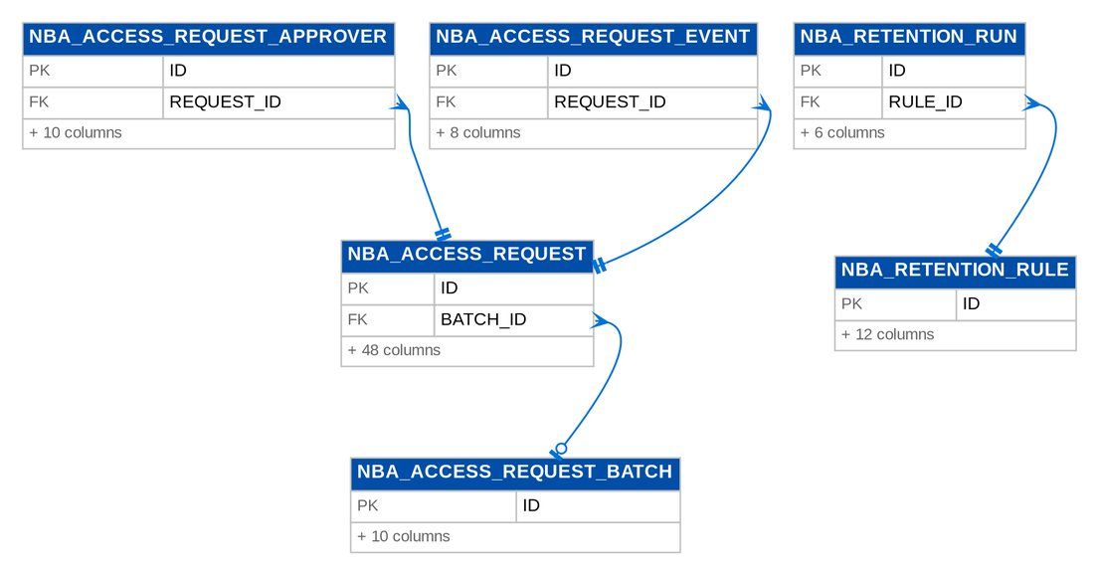
Figure 2: D01 NBADMIN: tables, primary keys and the foreign keys inside the module

3.1.3 Module IDENTITY
Table 12: Tables of module IDENTITY (D01)
Table | Description | Cols | Links | Figure
IDN_DIRECTORY_PROFILE | The directory details of a user retrieved from the Enterprise SSO platform, with the last synchronisation (BDOI FRS FRUM.002.01, FRUM.002.02 and FRUM.003.03: the latest synchronisation status and time of the user). | 27 | - | Listed only (no link)
IDN_IDENTITY_EVENT | A provisioning event received from UIDM-ISC or the Enterprise SSO platform, or an on-demand synchronisation, with its outcome (BDOI FRS FRUM.002.02: "log all user synchronization activities and processing results"; "identify and record synchronization failures for administrative review"). | 15 | - | Listed only (no link)
IDN_SIM_DIRECTORY_ACCOUNT | An account of the Enterprise SSO simulator of SIT and UAT: the directory that the simulated sign-in page and the simulated UIDM-ISC events use, so that the flows run end to end before BDOI IT connects the real platform. | 18 | - | Listed only (no link)

3.2 D02 Platform Services
System parameters and scheduled jobs, the insert-only audit trail, lists of values, workflow cases and history, notifications and messages, alerts, bulk uploads, attachments and file metadata, document templates and renditions, the report framework, the transactional outbox of integration events and the document number sequences. Owner: BDOI IT (platform operation); System Administrator (parameters, jobs, templates). BRD: BRD-00. 43 tables, 592 columns.

3.2.1 Module SYSTEM
Table 13: Tables of module SYSTEM (D02)
Table | Description | Cols | Links | Figure
SYS_JOB_RUN | One execution of a background job (job monitor and batch processing history). | 14 | - | Listed only (no link)
SYS_MODULE_PROFILE | A named set of module switches (for example the profile of an insurance broker). | 9 | - | D02 SYSTEM
SYS_MODULE_PROFILE_MODULE | Module profile module records. | 3 | SYS_MODULE_PROFILE, SYS_PRODUCT_MODULE | D02 SYSTEM
SYS_PARAMETER | Editable business parameter (configuration repository). | 16 | - | Listed only (no link)
SYS_PRODUCT_MODULE | Product module records. | 17 | - | D02 SYSTEM
SYS_SHARED_COUNTER | Shared counter records. | 3 | - | Listed only (no link)

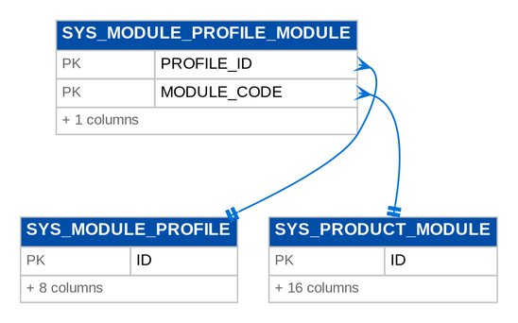
Figure 3: D02 SYSTEM: tables, primary keys and the foreign keys inside the module

3.2.2 Module AUDIT
Table 14: Tables of module AUDIT (D02)
Table | Description | Cols | Links | Figure
AUDIT_LOG | Immutable audit trail record of a financial or non-financial action. * Captures originator, modifier and authorizer activity with timestamps, as required by the GL audit trail control. | 12 | - | Listed only (no link)

3.2.3 Module LOV
Table 15: Tables of module LOV (D02)
Table | Description | Cols | Links | Figure
LOV_TYPE | A list of values, e.g. | 11 | - | D02 LOV
LOV_VALUE | One value of a list, valid from effectiveFrom to effectiveTo (inclusive, open ended when null). | 16 | LOV_TYPE | D02 LOV

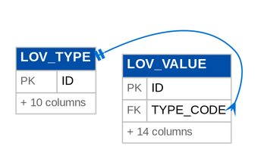
Figure 4: D02 LOV: tables, primary keys and the foreign keys inside the module

3.2.4 Module WORKFLOW
Table 16: Tables of module WORKFLOW (D02)
Table | Description | Cols | Links | Figure
WF_CASE | The workflow position of one business record (quotation, proposal request, account...). | 19 | WF_STAGE | D02 WORKFLOW
WF_CASE_HISTORY | One status change (insert only): from, to, action, reason, comment, who and when. | 10 | WF_CASE | D02 WORKFLOW
WF_STAGE | A stage of a workflow (seeded by migrations, read-only at run time). | 9 | - | D02 WORKFLOW
WF_TRANSITION | An allowed move between two stages (seeded by migrations, read-only at run time). | 10 | LOV_TYPE, WF_STAGE | D02 WORKFLOW

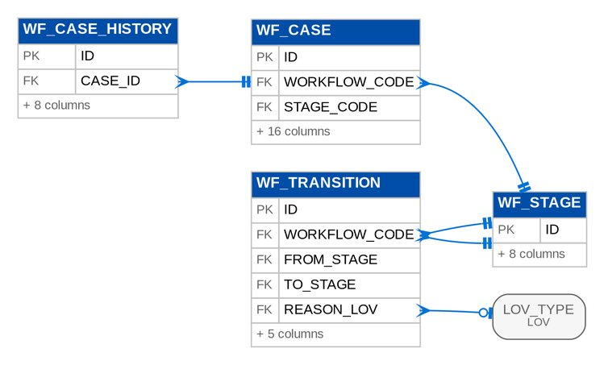
Figure 5: D02 WORKFLOW: tables, primary keys and the foreign keys inside the module

3.2.5 Module MESSAGING
Table 17: Tables of module MESSAGING (D02)
Table | Description | Cols | Links | Figure
MSG_NOTIFICATION | An in-app notification for one user (header bell), e.g. "Account returned by Processing". | 9 | - | Listed only (no link)
MSG_NOTIFICATION_EVENT | An event users can be notified about, with its default channels (RMTID.034). | 7 | - | D02 MESSAGING
MSG_NOTIFICATION_PREFERENCE | A user's choice of channels for one notification event (RMTID.034). | 10 | MSG_NOTIFICATION_EVENT | D02 MESSAGING
MSG_OUTBOUND | An e-mail in the outbox. | 22 | MSG_OUTBOUND | D02 MESSAGING
MSG_OUTBOUND_ATTACHMENT | A file attached to an outbound e-mail, stored as sent (protected when requested). | 9 | MSG_OUTBOUND, STORED_FILE | D02 MESSAGING

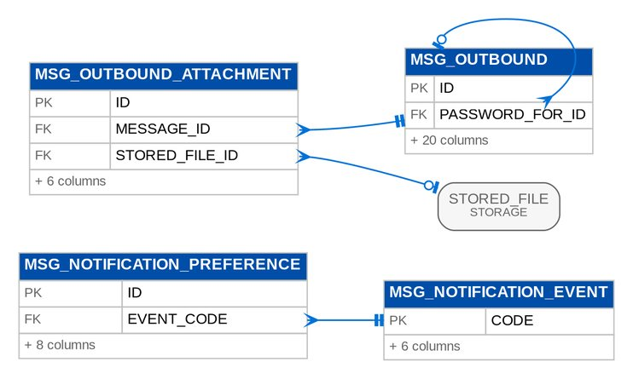
Figure 6: D02 MESSAGING: tables, primary keys and the foreign keys inside the module

3.2.6 Module ALERT
Table 18: Tables of module ALERT (D02)
Table | Description | Cols | Links | Figure
ALT_ALERT | Alert records. | 23 | ALT_EXCEPTION_CODE | D02 ALERT
ALT_EXCEPTION_CODE | Exception Codes Master entry: an exception condition with its severity and the thresholds that trigger it. | 14 | - | D02 ALERT

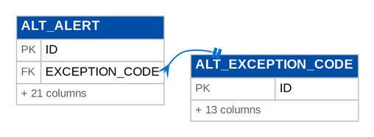
Figure 7: D02 ALERT: tables, primary keys and the foreign keys inside the module

3.2.7 Module BULK
Table 19: Tables of module BULK (D02)
Table | Description | Cols | Links | Figure
BULK_JOB | One uploaded file for a bulk handler, with its validation and commit counts. | 25 | - | D02 BULK
BULK_ROW | One uploaded row as sanitised, with its outcome. | 10 | BULK_JOB | D02 BULK

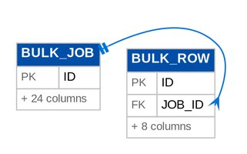
Figure 8: D02 BULK: tables, primary keys and the foreign keys inside the module

3.2.8 Module ATTACHMENT
Table 20: Tables of module ATTACHMENT (D02)
Table | Description | Cols | Links | Figure
ATT_DOCUMENT_ACCESS | Access class row of a document type: a permission that may list and download documents of the type. | 9 | - | Listed only (no link)
DOC_ATTACHMENT | Metadata of a document attached to any record, identified by entity type and id. | 19 | STORED_FILE | D02 ATTACHMENT
DOC_ATTACHMENT_CONTENT | File bytes of an Attachment, stored separately so listings never load them. | 2 | DOC_ATTACHMENT | D02 ATTACHMENT
DOC_ATTACHMENT_LINK | Makes an uploaded file part of another record's documents without copying it (BRNB.026: link one file to several accounts). | 10 | DOC_ATTACHMENT | D02 ATTACHMENT

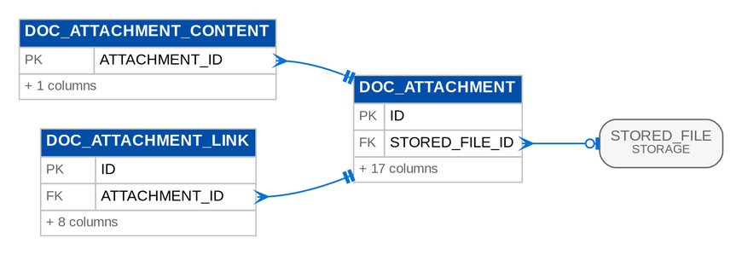
Figure 9: D02 ATTACHMENT: tables, primary keys and the foreign keys inside the module

3.2.9 Module DOCGEN
Table 21: Tables of module DOCGEN (D02)
Table | Description | Cols | Links | Figure
DOC_RENDITION | Content of each composed PDF by SHA-256, for its Word copy (client requirement 16) | 11 | - | Listed only (no link)
DOC_TEMPLATE | One version of a document template. | 12 | - | Listed only (no link)

3.2.10 Module STORAGE
Table 22: Tables of module STORAGE (D02)
Table | Description | Cols | Links | Figure
STO_LEGAL_HOLD_REQUEST | A request to place or release the legal hold of a stored file (DOCUMENT_STORAGE_DECISION, decision 3): raised by a holder of FILE_LEGAL_HOLD_REQUEST with a reason, applied only when another user holding FILE_LEGAL_HOLD_APPROVE (the DOA roles) approves it. | 15 | STORED_FILE | D02 STORAGE
STO_RECORD_CLASS | A record class of stored files (DOCUMENT_STORAGE_DECISION, decisions 3 and 5): its bucket, its retention (the retention rules of {@link #getRetentionRecordType()}, else {@link #getRetentionPeriod()}), whether its files are under legal hold from the start and whether its final records are archived to ECM. | 15 | - | D02 STORAGE
STORED_FILE | Metadata of a stored object (table STORED_FILE, DOCUMENT_STORAGE_DECISION section 3): owner, type, name, size, SHA-256, bucket and key, retention, legal hold, malware scan state and ECM archive state. | 36 | STO_RECORD_CLASS | D02 STORAGE

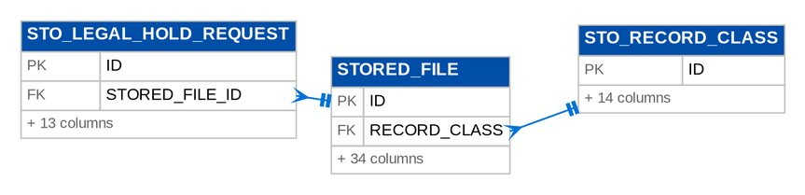
Figure 10: D02 STORAGE: tables, primary keys and the foreign keys inside the module

3.2.11 Module REPORT
Table 23: Tables of module REPORT (D02)
Table | Description | Cols | Links | Figure
REPORT_BATCH | Several reports run together with shared parameters and downloaded as one file (FRBS 2.4.5 / 2.4.7): a ZIP of the individual files, or one merged PDF. | 21 | STORED_FILE | D02 REPORT
REPORT_BATCH_ITEM | Batch item records. | 12 | REPORT_BATCH | D02 REPORT
REPORT_RUN | One archived run (on-screen view) or export of a report (CSHID.018: generated reports with name, date and creator, downloadable only by users allowed to export). | 18 | STORED_FILE | D02 REPORT
REPORT_RUN_FILE | The file of an archived report export (CSHID.018), kept apart from the run list. | 2 | REPORT_RUN | D02 REPORT

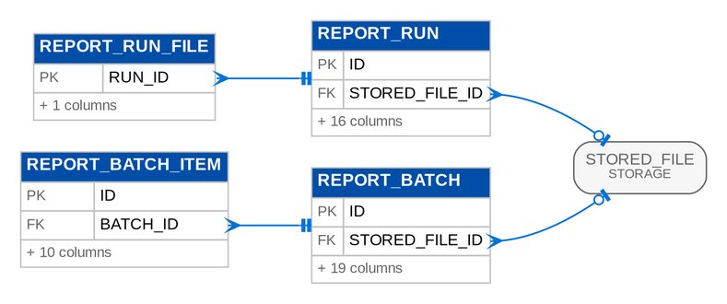
Figure 11: D02 REPORT: tables, primary keys and the foreign keys inside the module

3.2.12 Module EVENTS
Table 24: Tables of module EVENTS (D02)
Table | Description | Cols | Links | Figure
EVT_ARCHIVE | Archive records. | 12 | - | Listed only (no link)
EVT_DEAD_LETTER | Dead letter records. | 14 | - | Listed only (no link)
EVT_OUTBOX | Outbox records. | 17 | - | Listed only (no link)

3.2.13 Module COMMON
Table 25: Tables of module COMMON (D02)
Table | Description | Cols | Links | Figure
DOCUMENT_SEQUENCE | Gapless counter per sequence key (e.g. "JV-HO-2026"). | 2 | - | Listed only (no link)

3.2.14 Module CONFIGPROMO
Table 26: Tables of module CONFIGPROMO (D02)
Table | Description | Cols | Links | Figure
CFP_BASELINE | A package marked as the configuration baseline of this environment (for example the UAT signed-off configuration); the drift report compares the current configuration with it. | 11 | CFP_PACKAGE | D02 CONFIGPROMO
CFP_IMPORT | An import of a configuration package into this environment: options, the summary of the dry run, the maker-checker decision, the apply and its snapshot. | 33 | CFP_IMPORT, CFP_PACKAGE | D02 CONFIGPROMO
CFP_IMPORT_DATASET | The difference and the reconciliation of one dataset of an import; the items are kept as JSON for the difference viewer. | 20 | CFP_IMPORT | D02 CONFIGPROMO
CFP_PACKAGE | A configuration package kept by this environment; its file is in the file store. | 23 | STORED_FILE | D02 CONFIGPROMO

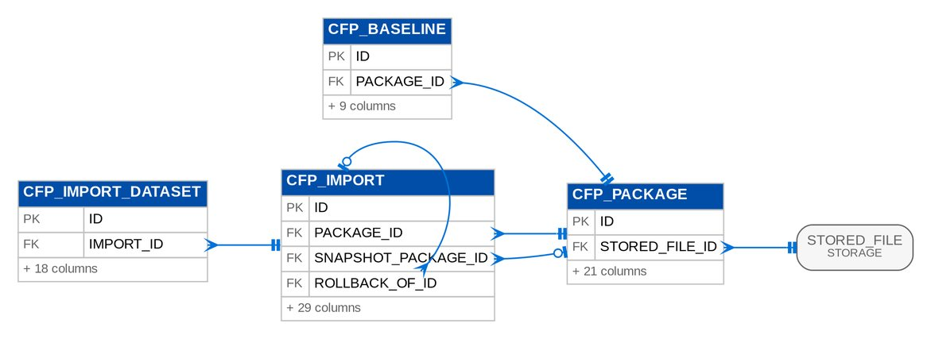
Figure 12: D02 CONFIGPROMO: tables, primary keys and the foreign keys inside the module

3.3 D03 Organisation and Reference Data
Companies, branches (Office Master), employees, holiday calendars, currencies and exchange rates, cost centres and other dimensions, fiscal years and periods. Owner: Head - Comptrollership (companies, branches, cost centres, periods, currencies). BRD: BRD-00. 10 tables, 149 columns.

3.3.1 Module ORGANIZATION
Table 27: Tables of module ORGANIZATION (D03)
Table | Description | Cols | Links | Figure
ORG_BRANCH | Branch / office / customer centre of a company (Office Master). | 23 | ORG_COMPANY | D03 ORGANIZATION
ORG_COMPANY | Legal entity keeping its own books (base currency, fiscal calendar and posting windows). * backValueDays/forwardValueDays implement the company-level value-date window for journals (supplementary / back-dated transaction control). * The company also carries the client profile used by documents, screens and labels (short name, group name, logo reference, head-office code, default bank account code), so no client ... | 29 | - | D03 ORGANIZATION
ORG_EMPLOYEE | Employee with the cost centre used for employee payments, cash advances and headcount reports (DIS 3.30.1 / 3.30.2). | 17 | ORG_BRANCH, ORG_COMPANY | D03 ORGANIZATION
ORG_HOLIDAY | Holiday calendar entry. | 10 | ORG_BRANCH, ORG_COMPANY | D03 ORGANIZATION

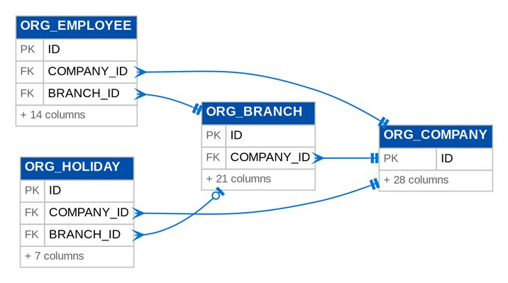
Figure 13: D03 ORGANIZATION: tables, primary keys and the foreign keys inside the module

3.3.2 Module CURRENCY
Table 28: Tables of module CURRENCY (D03)
Table | Description | Cols | Links | Figure
CUR_CURRENCY | ISO 4217 currency master. | 5 | - | D03 CURRENCY
CUR_EXCHANGE_RATE | Exchange rate: base-currency units per one unit of currencyCode, effective from a date until superseded by a later rate of the same type. | 10 | CUR_CURRENCY | D03 CURRENCY

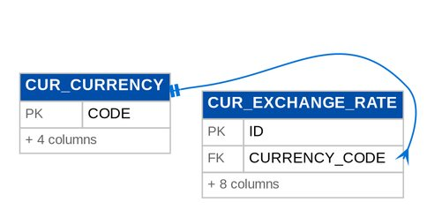
Figure 14: D03 CURRENCY: tables, primary keys and the foreign keys inside the module

3.3.3 Module DIMENSION
Table 29: Tables of module DIMENSION (D03)
Table | Description | Cols | Links | Figure
DIM_VALUE | A value of a financial dimension, e.g. cost centre "FIN" or business line "MOTOR". | 11 | - | Listed only (no link)

3.3.4 Module PERIOD
Table 30: Tables of module PERIOD (D03)
Table | Description | Cols | Links | Figure
ACC_PERIOD_MODULE_LOCK | Cut-off of one group of books in a period (FRBS 3.4.0): while locked, postings of the group's source modules into the period are refused, even though the period itself stays open for GL adjustments. | 15 | PER_PERIOD | D03 PERIOD
PER_FISCAL_YEAR | Financial year of a company (fiscal or calendar, per company parameter). | 13 | - | D03 PERIOD
PER_PERIOD | Monthly accounting period with a controlled status lifecycle. | 16 | PER_FISCAL_YEAR | D03 PERIOD

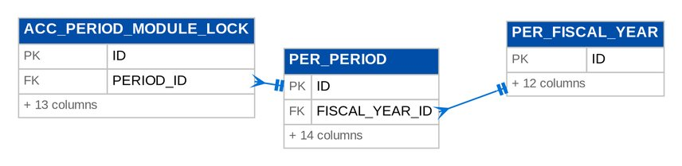
Figure 15: D03 PERIOD: tables, primary keys and the foreign keys inside the module

3.4 D04 Client and Party
Clients (prospect and confirmed) with KYC documents, contacts, tags, special instructions and note history; the business partner master shared with the finance modules. Owner: Product Owner, Marketing Business System (clients); Head - Comptrollership (business partners). BRD: BRD-01. 7 tables, 142 columns.

3.4.1 Module CRM
Table 31: Tables of module CRM (D04)
Table | Description | Cols | Links | Figure
CRM_CLIENT | A broking client. | 58 | - | D04 CRM
CRM_CLIENT_INSTRUCTION | A special instruction on a client (BRNB.091): type, text and effectivity, shown as a banner on every screen of the client's quotations and accounts while in force. | 12 | CRM_CLIENT | D04 CRM
CRM_CLIENT_NOTE_HISTORY | Insert-only history of a client tag or instruction change: who, when, from and to (BRNB.091). | 9 | CRM_CLIENT | D04 CRM
CRM_CLIENT_PAYOUT_ACCOUNT | CA / SA information of a client (MKT 2.25.0, Addendum 1): the BDO account a refund is credited to with its payee name, or the payee name of a check. | 18 | CRM_CLIENT | D04 CRM
CRM_CLIENT_TAG | A controlled tag on a client (list of values CLIENT_TAG), e.g. | 11 | CRM_CLIENT | D04 CRM
CRM_KYC_DOCUMENT | A KYC document of a client: an attachment of entity type Client with its document type (list of values DOCUMENT_TYPE), checked against the KYC checklist (BRNB.030/090). | 9 | CRM_CLIENT, DOC_ATTACHMENT | D04 CRM

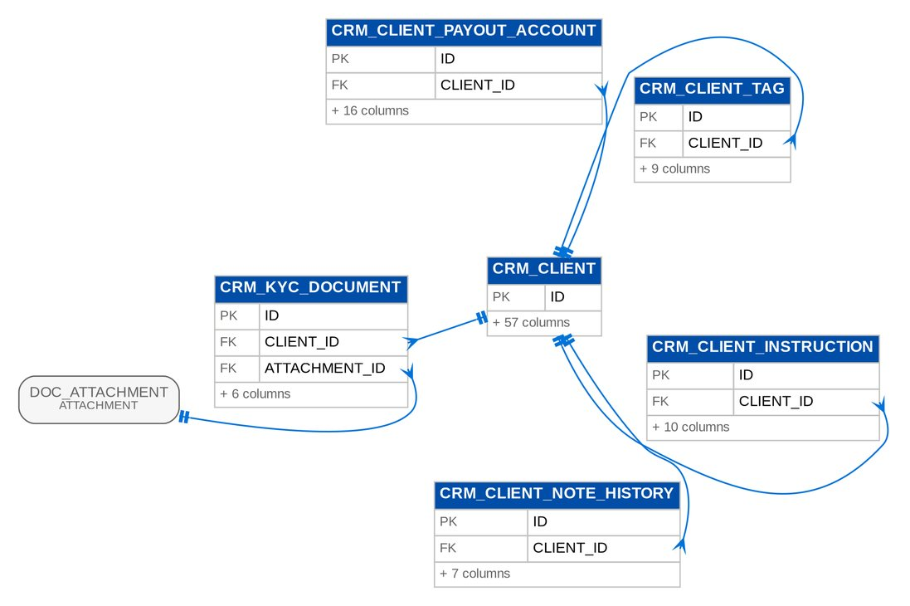
Figure 16: D04 CRM: tables, primary keys and the foreign keys inside the module

3.4.2 Module PARTY
Table 32: Tables of module PARTY (D04)
Table | Description | Cols | Links | Figure
PTY_PARTY | Business partner master: policyholders, intermediaries, reinsurers, coinsurers and suppliers. * The party code is the sub-ledger key carried on journal lines (PARTY_CODE) and open items, so control account balances can be analysed by party. | 25 | - | Listed only (no link)

3.5 D05 Product Catalogue and Maintenance
Insurers and their branches, product lines, products, packages and their versions, rates, commission and incentive set-up, package requests and negotiation. Owner: Product Owner, Marketing Business System (with the Technical Support Unit for package requests). BRD: BRD-03. 45 tables, 715 columns.

3.5.1 Module CATALOG
Table 33: Tables of module CATALOG (D05)
Table | Description | Cols | Links | Figure
CAT_CLAUSE | An entry of the clause library (PMADD02): a warranty, clause, exclusion or deductible wording, for one product line or every line, with its effective period. | 16 | CAT_PRODUCT_LINE | D05 CATALOG (2 of 2)
CAT_COMMISSION_RATE | Commission the insurer pays BDOI on a product (percent of net premium), effective dated. | 19 | CAT_INSURER, CAT_PRODUCT | D05 CATALOG (1 of 2)
CAT_COVER_TYPE | Type of cover within a product line (Annex II), e.g. | 14 | CAT_COVER_TYPE, CAT_PRODUCT_LINE | D05 CATALOG (1 of 2)
CAT_COVERAGE | A coverage or peril of a product line, the lowest level of the product hierarchy (PMADD01: LOB &gt; Subline / Type &gt; Subtype &gt; Coverage / Peril). | 15 | CAT_PRODUCT_LINE | D05 CATALOG (2 of 2)
CAT_DOCUMENT_RULE | Mandatory document (DOCUMENT_TYPE list of values) of every product, a line or one product, checked when Marketing submits an account (BRNB.026/051, e.g. the IDF for motor). | 13 | - | Listed only (no link)
CAT_FIELD_RULE | One row of the minimum-field matrix (BRNB.002/003/093): a field of the account or of every risk item that is mandatory for every product, a product line or one product. | 21 | - | Listed only (no link)
CAT_INCENTIVE_CRITERIA | An incentive criterion on the maintained products matrix, for example "CPC2". | 20 | CAT_INCENTIVE_CRITERIA | D05 CATALOG (1 of 2)
CAT_INCENTIVE_CRITERIA_PRODUCT | Incentive criteria product records. | 7 | CAT_INCENTIVE_CRITERIA, CAT_PRODUCT | D05 CATALOG (1 of 2)
CAT_INSURER | Panel insurer: the broking profile of a party of type INSURER (accreditation, placement channel and mailboxes, default credit days). | 23 | - | D05 CATALOG (1 of 2)
CAT_INSURER_BRANCH | Branch of a panel insurer with its Local Government Tax rate (Appendix A: "LGT value is dependent on the Insurer Branch") and optional placement mailbox. | 15 | CAT_INSURER | D05 CATALOG (1 of 2)
CAT_MOTOR_LIMIT | Motor excess BI / PD limit and its premium (Appendix A: "Excess BI / PD premium amounts per limit table"), effective dated. | 14 | - | Listed only (no link)
CAT_OTHER_CHARGE | A charge billed with the premium besides the taxes (BDOI inputs TX-Q04, template PM-04 Charges): CTPL COCAF / LTO authentication fee, notarial fee, policy or documentation fee. | 19 | CAT_PRODUCT, CAT_PRODUCT_LINE | D05 CATALOG (1 of 2)
CAT_PACKAGE_COVERAGE | Package coverage records. | 11 | CAT_PRODUCT_VERSION | D05 CATALOG (1 of 2)
CAT_PACKAGE_INSURER | Package insurer records. | 9 | CAT_INSURER, CAT_PRODUCT_VERSION | D05 CATALOG (1 of 2)
CAT_PACKAGE_INSURER_TERM | Package insurer term records. | 12 | CAT_PRODUCT_VERSION | D05 CATALOG (1 of 2)
CAT_PRODUCT | A BDOI risk product (risk code, e.g. | 38 | CAT_COVER_TYPE, CAT_PRODUCT_LINE | D05 CATALOG (1 of 2)
CAT_PRODUCT_LINE | Product line of Annex II (Property, Motor, Engineering...). | 15 | - | D05 CATALOG (1 of 2)
CAT_PRODUCT_VERSION | One version of a packaged product: the rate scheme, package term, coverages, insurers and insurer x coverage terms, and the validation checkpoint. | 33 | CAT_PRODUCT | D05 CATALOG (1 of 2)
CAT_RATE | A tax or rating factor of Appendix A (DST, premium tax, VAT, FST, VAT on commission, motor OD/Theft coverage factors) in percent, for every line or one product line, effective dated. | 14 | CAT_PRODUCT_LINE | D05 CATALOG (2 of 2)
CAT_RATE_SCHEME_EXCEPTION | An approval to price one transaction on a non-current package version or on a rate other than the scheme rate (BRPM.007 "a non-current rate triggers an approval workflow and is logged"). | 20 | CAT_PRODUCT | D05 CATALOG (1 of 2)
CAT_SALES_OFFICER | An account officer (user) of a sales team (BRNB.075 production per user). | 14 | CAT_SALES_UNIT | D05 CATALOG (2 of 2)
CAT_SALES_UNIT | Sales organisation unit (region, department or team) for production statistics (BRNB.075) with the default cost center of a team (BRNB.108, dimension COST_CENTER). | 17 | - | D05 CATALOG (2 of 2)
CAT_SHORT_PERIOD_RATE | Short-period (short-term) table row (Appendix A): the percentage of the annual premium charged for a cover of a number of months, e.g. cancellation before expiry. | 13 | - | Listed only (no link)
CAT_TSU_RULE | TSU routing rule (BRNB.098): an account needs TSU clearance when every criterion set on the rule holds (product class, line, fleet units, locations, total sum insured, endorsement type). | 18 | CAT_PRODUCT_LINE | D05 CATALOG (2 of 2)
CAT_VERSION_VALIDATION_CHECK | Version validation check records. | 6 | CAT_PRODUCT_VERSION | D05 CATALOG (1 of 2)

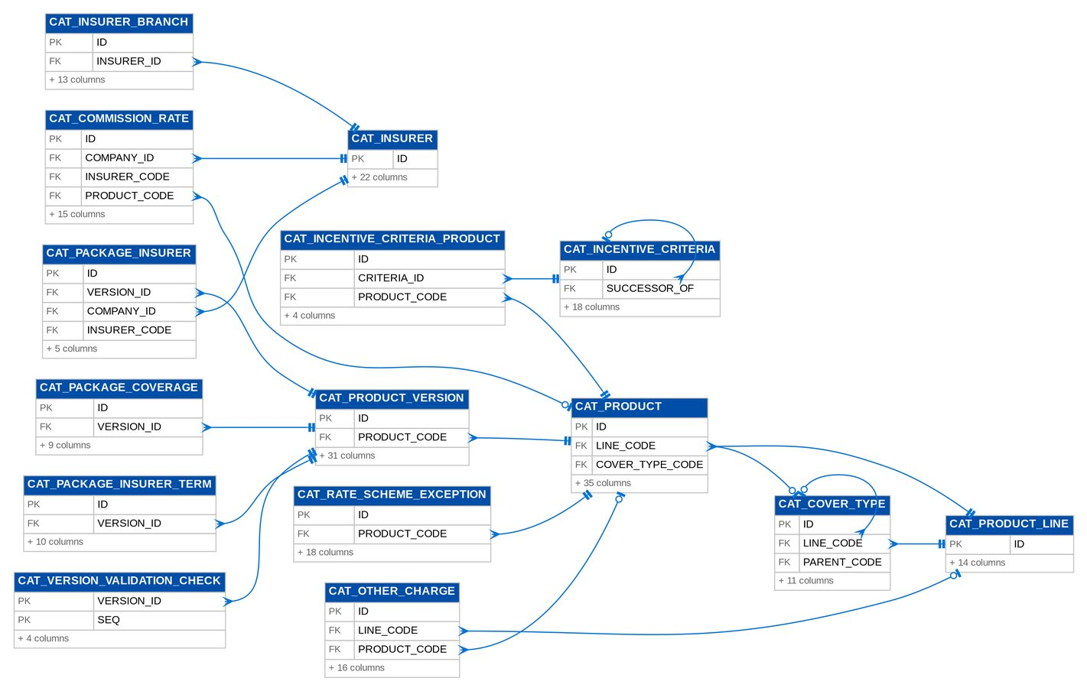
Figure 17: D05 CATALOG (1 of 2): tables, primary keys and the foreign keys inside the module
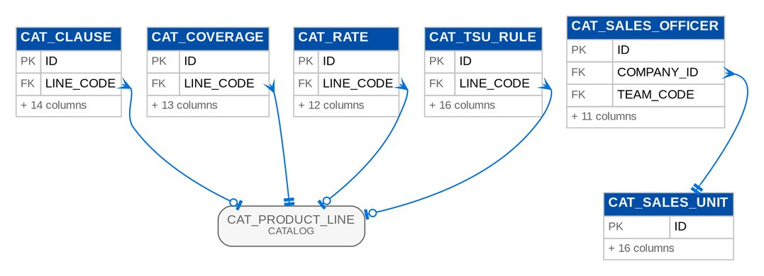
Figure 18: D05 CATALOG (2 of 2): tables, primary keys and the foreign keys inside the module

3.5.2 Module PRODUCTMAINT
Table 34: Tables of module PRODUCTMAINT (D05)
Table | Description | Cols | Links | Figure
PM_ADVISORY | A package advisory (BRPM.016): drafted automatically when a request's version is released or its package retired, edited by TSU, and sent to the recipient groups (list PKG_ADVISORY_GROUP) with the supporting documents. | 21 | PM_REQUEST | D05 PRODUCTMAINT (1 of 2)
PM_CLIENT_RESPONSE | The client's response to a proposal (BDOI FRS FRPM.010.01): Accepted (with the insurers accepted), Rejected or Return for Revision, with the response date, the client remarks and who recorded it when. | 9 | - | Listed only (no link)
PM_COMPARATIVE_OUTPUT | A stored comparative output of a package request (BRPM.014, PMADD03): the audit MASTER compiled from a negotiation round (one current master per request; earlier masters are kept as superseded), or a CLIENT view derived from a master with selected fields and insurers. | 18 | PM_COMPARATIVE_OUTPUT, PM_REQUEST | D05 PRODUCTMAINT (1 of 2)
PM_DEACTIVATION_REQUEST | A package deactivation request (BDOI FRS FRPM.003.04 to FRPM.003.07): the package, its deactivation effective date (today or later), the reason, remarks and the approver chosen by the requestor. | 21 | CAT_PRODUCT | D05 PRODUCTMAINT (2 of 2)
PM_FINAL_TERM | Final term records. | 10 | - | Listed only (no link)
PM_FINAL_TERM_HISTORY | A change of a Final Terms for Proposal value (history, BDOI FRS FRPM.009.01). | 8 | - | Listed only (no link)
PM_INSURER_RESPONSE | The response of one insurer in one negotiation round (BRPM.013, PMADD04): the outcome (list PKG_RESPONSE_OUTCOME, including the exception states), rate, minimum premium, terms per coverage (JSON), conditions, validity and the response document. | 21 | PM_NEGOTIATION_ROUND | D05 PRODUCTMAINT (1 of 2)
PM_INSURER_RESPONSE_HISTORY | Insert-only snapshot of a package insurer response after each change (PMADD04: every revision and outcome change is logged). | 13 | PM_INSURER_RESPONSE | D05 PRODUCTMAINT (1 of 2)
PM_MANCOM_APPROVAL | Mancom approval records. | 13 | PM_REQUEST | D05 PRODUCTMAINT (1 of 2)
PM_MARKETING_APPROVAL | One Marketing approval of a package request (BDOI FRS FRPM.011.02: "Each approver shall approve or reject independently. | 7 | PM_REQUEST | D05 PRODUCTMAINT (1 of 2)
PM_MASTER_CHANGE | A product master change waiting for, or sent to, the other BDOI systems (BDOI FRS FRPM.029.01): the product, version, kind of change (RELEASED, RETIRED, EXPIRED) and effective date, with the transfer file, the status (PENDING, SENT, FAILED), the attempts and the last error. | 16 | - | Listed only (no link)
PM_MASTER_SIM_INBOX | A file of product master changes received by the simulated receiving system (SIT and UAT). | 5 | - | Listed only (no link)
PM_NEGOTIATION_ROUND | One negotiation round of a package request (BRPM.010/012, PMADD04): its quotation slip (number, template version, notes, reply date), the insurers approached, the four-eyes approval and the send time. | 19 | PM_REQUEST | D05 PRODUCTMAINT (1 of 2)
PM_PLACEMENT_REPORT | A generated Consolidated Placement Update Report in the repository (BDOI FRS FRPM.007.01): the company, report date and reporting period, the file name and the archived run to download, the rows shown in the preview, and who generated it when (the job or a user on request). | 13 | - | Listed only (no link)
PM_PROPOSAL_FILE | A proposal slip of one insurer and version (BDOI FRS FRPM.009.02 and FRPM.013.01): the file name, the stored document, who generated it and when. | 10 | - | Listed only (no link)
PM_REQUEST | A package request (BRPM.008-017; design section 4.4): the Package Request Form with its client or programme, line, cover type, target product, reason and requested terms; the approvals of Marketing, the TSU Team Lead and the TSU Head; the proposed terms after negotiation; and the catalog version the MBS set-up produced. | 51 | CAT_PRODUCT_LINE | D05 PRODUCTMAINT (1 of 2)
PM_ROUND_INSURER | Round insurer records. | 3 | PM_NEGOTIATION_ROUND | D05 PRODUCTMAINT (1 of 2)
PM_SIGNOFF | Signoff records. | 14 | PM_REQUEST | D05 PRODUCTMAINT (1 of 2)
PM_TERMS_OPTION | One quotation option of an insurer in the comparative table (BDOI FRS FRPM.006.02 and FRPM.012.02): an insurer may give several options (coverage, premium, commission, deductibles, terms, warranties, clauses, extensions, other details), each with the insurer response Approved, Not Covered or Others (with the insurer's own wording). | 14 | - | Listed only (no link)
PM_TERMS_SETTING | The choices of a comparative table (BDOI FRS FRPM.006.02, FRPM.008.01): the fields shown in the table, the fields sent to the client, and the insurers the requestor selected for the proposal. | 13 | - | Listed only (no link)

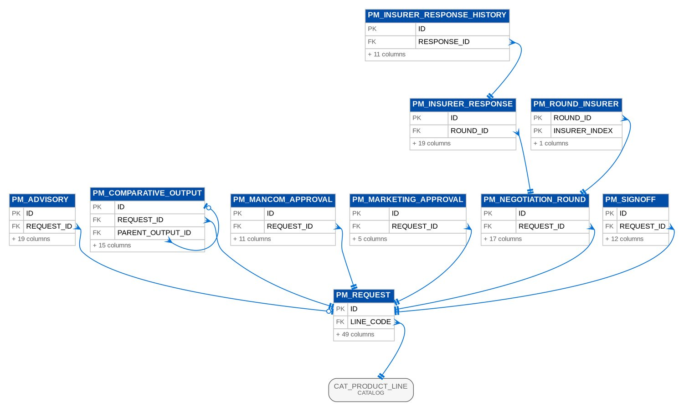
Figure 19: D05 PRODUCTMAINT (1 of 2): tables, primary keys and the foreign keys inside the module
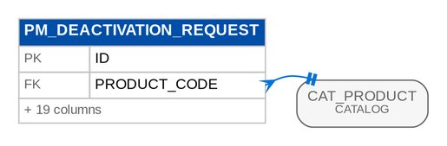
Figure 20: D05 PRODUCTMAINT (2 of 2): tables, primary keys and the foreign keys inside the module

3.6 D06 New Business
Package quotations, non-package proposal requests, accounts and their risk items, placement with insurers (slips, payment gates, hold covers), policy issuance, booking and the booked invoices, and the saved report variants of New Business. Owner: Product Owner, Marketing Business System; Unit Head - Processing (placement, issuance, booking). BRD: BRD-01. 48 tables, 828 columns.

3.6.1 Module QUOTATION
Table 35: Tables of module QUOTATION (D06)
Table | Description | Cols | Links | Figure
QUO_QUOTATION | A package quotation (BRNB.043): one client (a prospect is allowed, BRNB.063), one product, its Account Reference Number from creation (BRNB.102) and numbered versions of its content (BRNB.020). | 47 | CAT_PRODUCT, CRM_CLIENT, QUO_REQUEST | D06 QUOTATION
QUO_QUOTATION_ACCOUNT | Quotation account records. | 3 | QUO_QUOTATION | D06 QUOTATION
QUO_REQUEST | A quotation request waiting to be quoted (BRNB.041, staging of BRNB.023): captured from an e-mail (attached as REQUEST_EMAIL), uploaded in bulk or delivered by a source system. | 21 | CAT_PRODUCT, CRM_CLIENT | D06 QUOTATION
QUO_VERSION | One version of a quotation's content (BRNB.020), stored as JSON. | 14 | QUO_QUOTATION | D06 QUOTATION

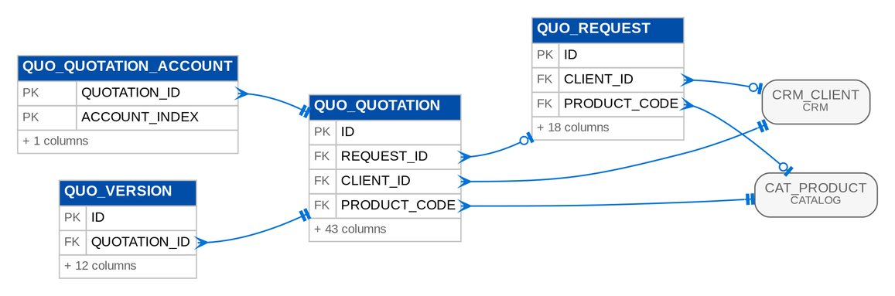
Figure 21: D06 QUOTATION: tables, primary keys and the foreign keys inside the module

3.6.2 Module NONPACKAGE
Table 36: Tables of module NONPACKAGE (D06)
Table | Description | Cols | Links | Figure
NPK_INSURER_RESPONSE | The response of one insurer to the quotation slip of a PRF (BRNB.009): premium, rate, deductibles, conditions, validity, remarks and the response document; the recommended flag feeds the comparative table (BRNB.010). | 20 | NPK_PROPOSAL | D06 NONPACKAGE
NPK_INSURER_RESPONSE_HISTORY | Insert-only snapshot of an insurer response after each change (BRNB.009 version history). | 14 | NPK_INSURER_RESPONSE | D06 NONPACKAGE
NPK_PROPOSAL | A Proposal Request Form (BRNB.005/006): a non-package risk that TSU prices with the insurers. | 46 | CAT_PRODUCT, CRM_CLIENT | D06 NONPACKAGE
NPK_PROPOSAL_ACCOUNT | Proposal account records. | 3 | NPK_PROPOSAL | D06 NONPACKAGE
NPK_PROPOSAL_INSURER | Proposal insurer records. | 3 | NPK_PROPOSAL | D06 NONPACKAGE

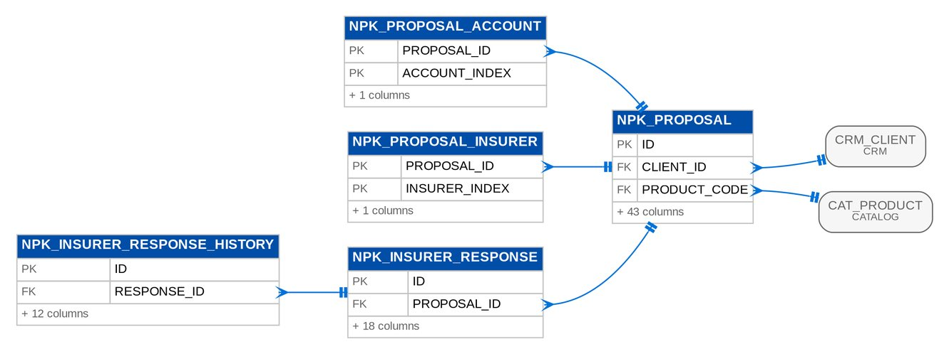
Figure 22: D06 NONPACKAGE: tables, primary keys and the foreign keys inside the module

3.6.3 Module ACCOUNT
Table 37: Tables of module ACCOUNT (D06)
Table | Description | Cols | Links | Figure
ACC_ACCOUNT | An account: the risk record to be placed with an insurer, one per policy, identified by its Account Reference Number from quotation to invoice (BRNB.102). | 86 | CAT_PRODUCT, CRM_CLIENT | D06 ACCOUNT
ACC_ACCOUNT_LEGACY | The legacy header of an account imported from a legacy system: source system, legacy policy reference, policy and cover numbers, the legacy package kept as given until Renewal sanitation remaps it, the legacy status and the migration batch that loaded it. | 20 | ACC_ACCOUNT | D06 ACCOUNT
ACC_ACCOUNT_PN | Account pn records. | 3 | ACC_ACCOUNT | D06 ACCOUNT
ACC_ACCOUNT_POLICY | Account policy records. | 3 | ACC_ACCOUNT | D06 ACCOUNT
ACC_RISK_ITEM | One insured item of an account (BRNB.051): a vehicle, a location of risk with its items insured, an insured person or a generic risk, with its sum insured, rate and premium. | 34 | ACC_ACCOUNT | D06 ACCOUNT
ACC_RISK_ITEM_DETAIL | Risk item detail records. | 4 | ACC_RISK_ITEM | D06 ACCOUNT

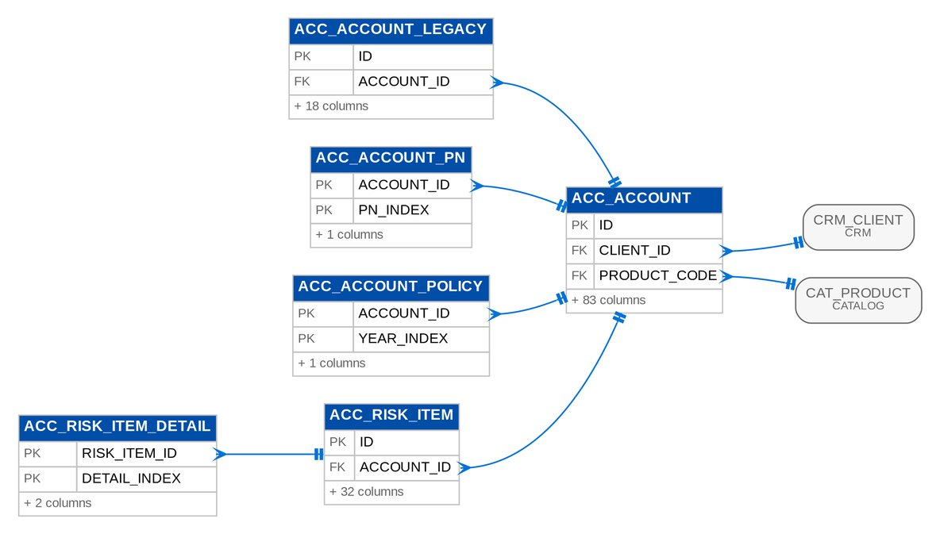
Figure 23: D06 ACCOUNT: tables, primary keys and the foreign keys inside the module

3.6.4 Module PLACEMENT
Table 38: Tables of module PLACEMENT (D06)
Table | Description | Cols | Links | Figure
PLC_BILLING_BATCH | A CLPC billing batch (BRNB.067): the CBG Fire accounts awaiting payment billed on one file. | 12 | - | D06 PLACEMENT (1 of 2)
PLC_BILLING_ITEM | One account on a CLPC billing batch (BRNB.067) with its payment outcome. | 14 | ACC_ACCOUNT, PLC_BILLING_BATCH | D06 PLACEMENT (1 of 2)
PLC_HOLD_COVER | A hold cover requested from the insurer while the placement completes (BRNB.072) and its confirmation by the insurer with reference and date (BRNB.103). | 22 | ACC_ACCOUNT | D06 PLACEMENT (1 of 2)
PLC_INSURER_RETURN | A placement returned by the insurer with its reason and remarks (BRNB.034/059), and how the return was resolved: resubmitted, returned to Marketing or cancelled (return queue). | 15 | ACC_ACCOUNT | D06 PLACEMENT (1 of 2)
PLC_PAYMENT_EVIDENCE | The evidence behind a payment gate decision (BRD 2.3.1, BRNB.067/068/114): a matched payment with its source and reference, or a client confirmation with the user and date (created by / at). | 18 | ACC_ACCOUNT | D06 PLACEMENT (1 of 2)
PLC_PAYMENT_GATE_RULE | One row of the payment gate rule table (BRD 2.3.1, BRNB.068): the rule for a market segment and product line; a blank segment or line matches any. | 12 | CAT_PRODUCT_LINE | D06 PLACEMENT (2 of 2)
PLC_PAYMENT_REPORT | An uploaded payment report and its match (BRNB.067/068): a CLPC report matched by PN or loan application number against a billing batch, or a report of the other segments matched by ARN. | 14 | PLC_BILLING_BATCH | D06 PLACEMENT (1 of 2)
PLC_PAYMENT_REPORT_LINE | One line of a payment report with its match (matched, unpaid, unmatched or ambiguous). | 15 | ACC_ACCOUNT, PLC_PAYMENT_REPORT | D06 PLACEMENT (1 of 2)
PLC_SLIP | A placement slip PL-yyyy-nnnnnn for one insurer branch (BRNB.069), covering one or more accounts. | 17 | - | D06 PLACEMENT (1 of 2)
PLC_SLIP_ACCOUNT | Slip account records. | 4 | ACC_ACCOUNT, PLC_SLIP | D06 PLACEMENT (1 of 2)
PLC_SLIP_FILE | A rendered placement slip file (PDF or XLSX) with its checksum. | 7 | PLC_SLIP, STORED_FILE | D06 PLACEMENT (1 of 2)

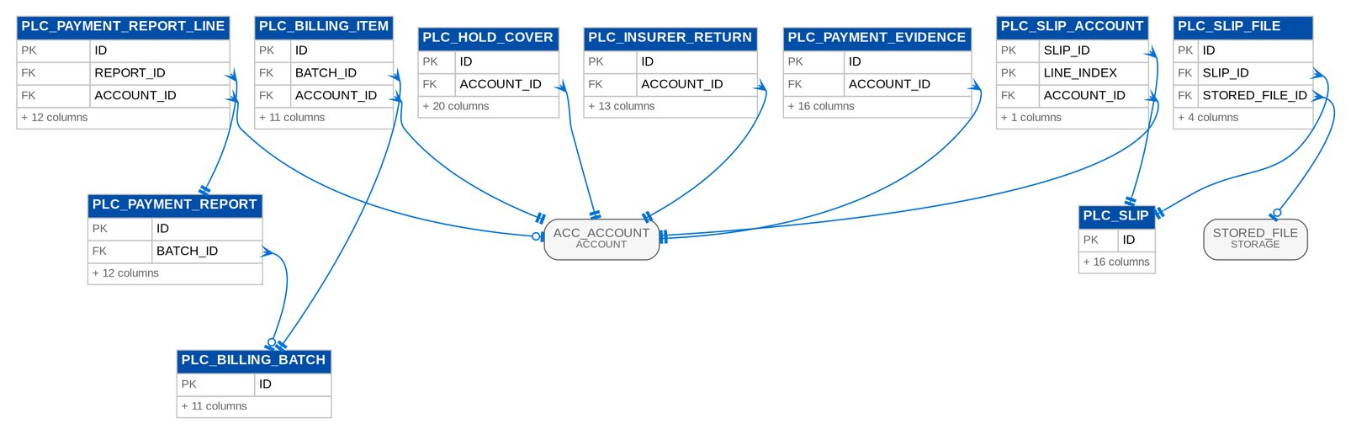
Figure 24: D06 PLACEMENT (1 of 2): tables, primary keys and the foreign keys inside the module
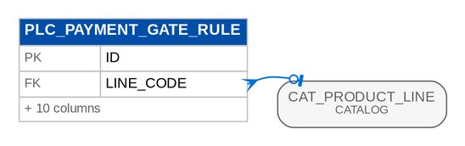
Figure 25: D06 PLACEMENT (2 of 2): tables, primary keys and the foreign keys inside the module

3.6.5 Module ISSUANCE
Table 39: Tables of module ISSUANCE (D06)
Table | Description | Cols | Links | Figure
ISS_ADVICE_RECIPIENT | The recipient of the Insurance Advices of a mortgagee bank (FR-NB-107): the e-mail addresses and the enrolment for automatic sending, for the bank as a whole or for one market segment of it. | 17 | - | Listed only (no link)
ISS_DOCUMENT_TRIGGER | A document trigger rule (BRNB.105): uploading a document of a type starts a business action, e.g. an e-policy opens an extraction review task. | 10 | - | Listed only (no link)
ISS_EPOLICY | An e-policy received from the insurer (BRNB.073), stored as an EPOLICY document of the account, with the data extracted from it (BRNB.104), the review that updates the policy number (BRNB.074) and its dispatch to the client (BRNB.077). | 26 | ACC_ACCOUNT, DOC_ATTACHMENT | D06 ISSUANCE
ISS_EXTRACTION_PATTERN | A regular expression that reads one field of an insurer's e-policy text (BRNB.104); the first capture group is the value. | 13 | - | Listed only (no link)
ISS_INSURANCE_ADVICE | An Insurance Advice IA-yyyy-nnnnnn (BRNB.070): the notice to the mortgagee bank that a mortgaged account is insured, generated from the INSURANCE_ADVICE template. | 27 | ACC_ACCOUNT, STORED_FILE | D06 ISSUANCE
ISS_UPLOAD_BATCH | A bulk e-policy upload (BRNB.073): the files are held with the account proposed for each (ARN in the file name or in the document) until the user reviews the matches and confirms. | 9 | - | D06 ISSUANCE
ISS_UPLOAD_ITEM | One file of a bulk e-policy upload with its proposed (or chosen) account and outcome. | 13 | ISS_EPOLICY, ISS_UPLOAD_BATCH, STORED_FILE | D06 ISSUANCE

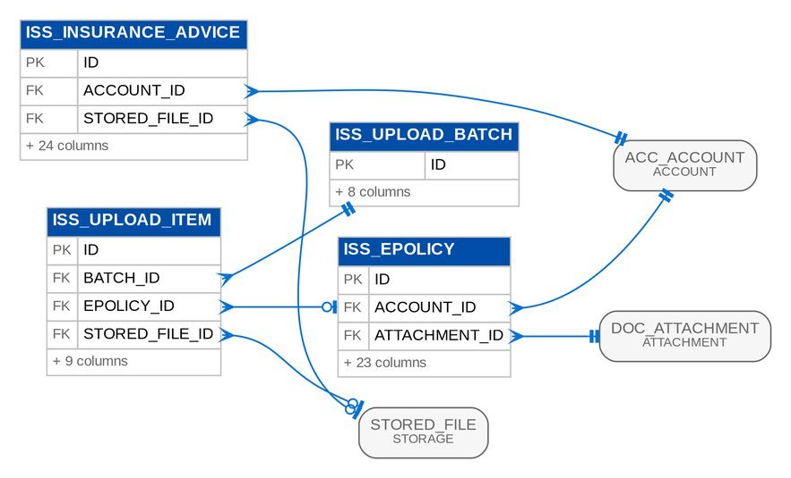
Figure 26: D06 ISSUANCE: tables, primary keys and the foreign keys inside the module

3.6.6 Module BOOKING
Table 40: Tables of module BOOKING (D06)
Table | Description | Cols | Links | Figure
BKG_AUTO_BOOK_RULE | Auto-book rule (BRNB.076): an account of the product and market segment entering POLICY_ISSUED is queued for the next booking batch. | 11 | - | Listed only (no link)
BKG_BATCH_ROW | Batch row records. | 6 | BKG_BATCH_RUN | D06 BOOKING
BKG_BATCH_RUN | One booking batch run (BRNB.036): who or what started it, the business date and the result of every account (partial success: each account is booked in its own transaction). | 15 | - | D06 BOOKING
BKG_ENDORSEMENT | An endorsement or cancellation posted on a booked account (BRNB.076/081/094). | 21 | - | Listed only (no link)
BKG_INCENTIVE_EVALUATION | One evaluation of the incentive indicator of a transaction (FR-NB-118, FR-RN-087 audit): the trigger, the criteria matched, the endorsements considered, the result and the reason. | 10 | - | Listed only (no link)
BKG_INCENTIVE_RULE | Incentive eligibility rule (BRNB.107): a booking of the product, market segment and source channel dated within the period is flagged incentive eligible. | 14 | - | Listed only (no link)
BKG_INVOICE | A booked invoice (BRNB.027/061): the broker's billing of one transaction of an account - the original booking (one per policy year of a multi-year account, BRNB.112), a financial endorsement or a cancellation. | 61 | - | D06 BOOKING
BKG_INVOICE_JOURNAL | Invoice journal records. | 3 | BKG_INVOICE | D06 BOOKING
BKG_INVOICE_OPEN_ITEM | Invoice open item records. | 4 | BKG_INVOICE, SL_OPEN_ITEM | D06 BOOKING
BKG_INVOICE_SHARE | Invoice share records. | 4 | BKG_INVOICE | D06 BOOKING
BKG_QUEUE | An account queued for the next booking batch (BRNB.036/076), with the optional booking date and cost center the user set before the batch runs. | 18 | - | Listed only (no link)
BKG_SERVICE_INVOICE | A service invoice or credit (BRNB.100/100b): BIR-sequential SI-- number, commission, VAT on commission and withholding tax lines, the PDF generated from the document template (stored as issued) and its e-mail dispatch. | 33 | BKG_SI_TYPE, STORED_FILE | D06 BOOKING
BKG_SI_TYPE | Service invoice type (BRNB.100): recipient, trigger (on booking, on endorsement, manual), owner (a team through a permission, or a user) notified of the dispatch, and the document template. | 14 | - | D06 BOOKING

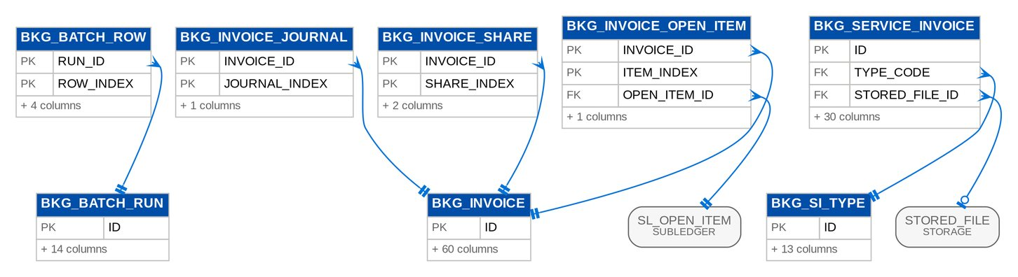
Figure 27: D06 BOOKING: tables, primary keys and the foreign keys inside the module

3.6.7 Module NBREPORT
Table 41: Tables of module NBREPORT (D06)
Table | Description | Cols | Links | Figure
NBR_REPORT_VARIANT | A saved report variant (BRNB.057): the parameters of a report saved by a user under a name, optionally shared with every user who may run the report. | 13 | - | Listed only (no link)
NBR_SALES_TARGET | Production target of a sales unit for a period, in PHP (BRNB.075): booked accounts, premium and commission. | 15 | - | Listed only (no link)

3.7 D07 Operations
The invoice ledger and its movements, cashiering (receipts, payment intake, matching and application, unapplied payments), remittance to insurers, production reconciliation, endorsements and adjustments, and commission receivables with incentive schemes. Owner: Operations: Financial Transactions and Processing. BRD: BRD-02. 86 tables, 1,705 columns.

3.7.1 Module OPSLEDGER
Table 42: Tables of module OPSLEDGER (D07)
Table | Description | Cols | Links | Figure
OPS_DISBURSEMENT_REQUEST | Disbursement request records. | 36 | - | Listed only (no link)
OPS_EXTRACT_FILE | Extract file records. | 16 | STORED_FILE | D07 OPSLEDGER (2 of 2)
OPS_FLOW_IN_FEED | Flow in feed records. | 15 | - | D07 OPSLEDGER (1 of 2)
OPS_FLOW_IN_RECORD | One record received through a feed, keyed by its idempotency key so it is processed once (BRQID.005 "no duplicates"), with the hash of its payload. | 9 | OPS_FLOW_IN_FEED, OPS_FLOW_IN_RUN | D07 OPSLEDGER (1 of 2)
OPS_FLOW_IN_RUN | One run of a feed with its counts and outcome: the fetch log of BRQID.005 (timestamp, status, records read, accepted, duplicates and failures, error detail). | 20 | OPS_FLOW_IN_FEED | D07 OPSLEDGER (1 of 2)
OPS_HANDOFF | Work handed over through a port whose owning module is not active: an OR to issue or an unapplied item to set up by hand. | 19 | - | Listed only (no link)
OPS_INVOICE | A booked invoice or endorsement invoice in the Operations ledger: header facts, insurer shares (ADJID.027), components with balances, payment and remittance status (RMTID.019/032), flags and the lock of the module working on it (RMTID.040). | 57 | - | D07 OPSLEDGER (1 of 2)
OPS_INVOICE_ADJUSTMENT_TOTAL | Cumulative adjustments of an original invoice against its original premium, DTIP and commission (ADJID.028 over-adjustment control): every endorsement or cancellation invoice booked against the original adds its amounts. | 14 | - | Listed only (no link)
OPS_INVOICE_COMPONENT | One component of an Operations invoice with its buckets and outstanding balance (CSHID.022, RMTID.038): balance = booked + adjusted - applied + reversed - remitted - writtenOff. | 15 | OPS_INVOICE | D07 OPSLEDGER (1 of 2)
OPS_INVOICE_MOVEMENT | One movement of one invoice component, immutable (RMTID.038 payment and remittance history, ADJID.024). | 15 | OPS_INVOICE | D07 OPSLEDGER (1 of 2)
OPS_INVOICE_ORIGIN_LINE | Invoice origin line records. | 9 | OPS_INVOICE_ORIGIN_SNAPSHOT | D07 OPSLEDGER (1 of 2)
OPS_INVOICE_ORIGIN_SNAPSHOT | The frozen original values of an open legacy invoice: header amounts and, per component, the booked, adjusted, paid, remitted, written-off and open amounts at cut-over, written once by the legacy invoice intake and never updated. | 20 | OPS_INVOICE | D07 OPSLEDGER (1 of 2)
OPS_INVOICE_SHARE | Invoice share records. | 5 | OPS_INVOICE | D07 OPSLEDGER (1 of 2)
OPS_INVOICE_STATUS_CHANGE | One change of an invoice's statuses, flags or lock, with who, when and why (RMTID.032 hold and remittance status history, RMTID.040 lock log). | 9 | OPS_INVOICE | D07 OPSLEDGER (1 of 2)

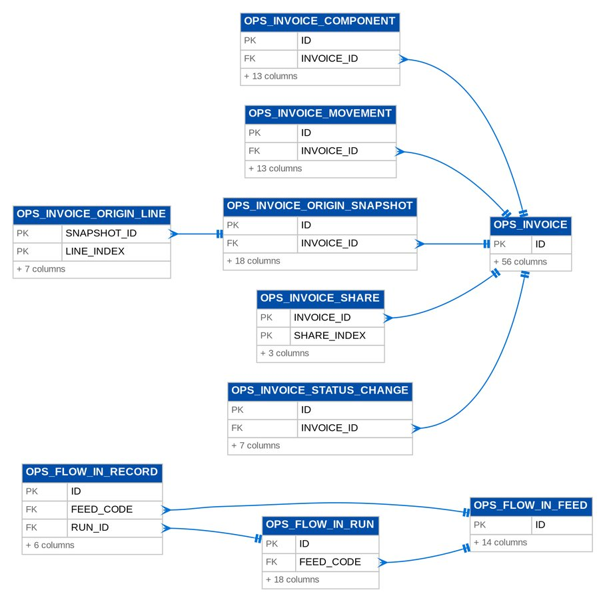
Figure 28: D07 OPSLEDGER (1 of 2): tables, primary keys and the foreign keys inside the module
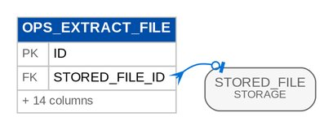
Figure 29: D07 OPSLEDGER (2 of 2): tables, primary keys and the foreign keys inside the module

3.7.2 Module CASHIERING
Table 43: Tables of module CASHIERING (D07)
Table | Description | Cols | Links | Figure
CSH_APPLICATION | Money of a receipt (or of an unapplied item) applied to one booked invoice, split by premium component in the hierarchy (CSHID.020/022). | 24 | CSH_RECEIPT, CSH_UNAPPLIED | D07 CASHIERING (1 of 3)
CSH_APPLICATION_LINE | Application line records. | 4 | CSH_APPLICATION | D07 CASHIERING (1 of 3)
CSH_BANK_ACCOUNT | An entry of the maintained list "Post to Bank Account" (FRS.CSH.02.01.02, 02.02.02): the bank account a receipt is posted to, its currency, whether it is the default of its currency and its GL account (set by Comptrollership; without it the collection account parameter applies). | 13 | - | Listed only (no link)
CSH_CERTIFICATE_OF_PAYMENT | Certificate of payment records. | 9 | CSH_RECEIPT | D07 CASHIERING (3 of 3)
CSH_CHANNEL_FILE | A payment file received by upload or via MFT (FRS.CSH.05.01.02 to 05.01.06, 02.02.03 to 02.02.04.05): its upload reference, type, name, size and checksum, the source, the checks it passed or the reason it was refused, its raw copy kept read-only (source file), the uploader, the processing time and the run that processed its rows. | 26 | CSH_CHANNEL_PROFILE | D07 CASHIERING (2 of 3)
CSH_CHANNEL_PROFILE | The profile of a payment file type (FRS.CSH.05.01.06; Appendix D): the file name convention, the format of BDOI's file (separator, header line, header and detail record types, TOTAL row, date format), the map of BDOI's fields to the fields of the system, the size limit and the MFT folder. | 21 | - | D07 CASHIERING (2 of 3)
CSH_COLLECTOR_REQUEST | Collector request records. | 21 | CSH_DISPOSITION, CSH_UNAPPLIED | D07 CASHIERING (1 of 3)
CSH_COMMISSION_LINE | A commission payment detail uploaded from Collection (CSHID.007): staged until the official receipts are issued, one OR per insurer, payee, certificate and payment (OQ49). | 21 | - | Listed only (no link)
CSH_CWT_BATCH | A validated batch of BIR 2307 certificates of one insurer (CSHID.027): its transaction report is posted and routed to Disbursement, which releases the certificates to the insurer (DBMID.001). | 15 | - | D07 CASHIERING (2 of 3)
CSH_CWT_TAG | A BIR 2307 reversal tagged by Marketing Collection with its CWT- reference (MKTID.013, CSHID.026): the 2% creditable withholding tax of an invoice settled in cash or by the client's certificate. | 25 | CSH_CWT_BATCH | D07 CASHIERING (2 of 3)
CSH_DISPOSITION | A disposition assigned to an unapplied item (CSHID.024): apply to another invoice, DST application, refund, reclass, transfer to another marketing unit or others, with the target fields of its type, the four-eyes approval and the execution result. | 27 | CSH_APPLICATION, CSH_DISPOSITION_TYPE_RULE, CSH_UNAPPLIED | D07 CASHIERING (1 of 3)
CSH_DISPOSITION_TYPE_RULE | What a disposition type of LOV DISPOSITION_TYPE does and whether it needs the team leader's approval (CSHID.024, OQ15). | 7 | - | D07 CASHIERING (1 of 3)
CSH_LEGACY_BATCH | A Cashiering batch of the legacy context: the reclassification of old unapplied payments to other income, approved by the Cashiering team lead and then by top management, or the reversal of legacy PR 2307 balances against the insurer, approved by the team lead. | 24 | - | D07 CASHIERING (2 of 3)
CSH_LEGACY_BATCH_LINE | A line of a Cashiering legacy batch: an unapplied item taken to income, or a legacy invoice whose PR 2307 is reversed against the insurer; posted in its own transaction. | 13 | CSH_LEGACY_BATCH | D07 CASHIERING (2 of 3)
CSH_LEGACY_REFERENCE | A legacy number of an account migrated at go-live (QPS, ISYS, Ebix, PN or Loan Application Number) and the account it stands for, so that a payment quoting it is matched (FRS.CSH.05.01.08; Appendix P). | 10 | - | Listed only (no link)
CSH_MINIMAL_BALANCE | Minimal balance records. | 13 | - | Listed only (no link)
CSH_MINIMAL_BALANCE_RULE | The maintained minimal-balance table (CSHID.016, Cashiering summary 5.f, OQ11): the maximum amount per kind of balance, the exclusions of CSHID.016 and the action. | 8 | - | Listed only (no link)
CSH_PAYMENT | A payment received through a channel (file row, over the counter, matured PDC, check pick-up), with the raw references it carried and the matching result (CSHID.008/020, BRQID.006). | 31 | CSH_RECEIPT | D07 CASHIERING (1 of 3)
CSH_PAYMENT_FILE_LAYOUT | The layout of a payment file handler's TXT files (CSHID.008): auto-detected, delimited with a separator, or fixed width with Header:start:length fields separated by ;. | 7 | - | Listed only (no link)
CSH_PAYMENT_REVERSAL | Payment reversal records. | 23 | CSH_UNAPPLIED | D07 CASHIERING (1 of 3)
CSH_PDC_ITEM | A post-dated check in the warehouse (CSHID.008 item 4): stored with a traceable PDCW- number, it becomes a payment with an AR at maturity (PDC_MATURITY job) or is returned, replaced or pulled out before. | 24 | CSH_PAYMENT | D07 CASHIERING (1 of 3)
CSH_PICKUP_REQUEST | A check tagged "for check pick-up" by Collection (CSHID.009, OQ01/OQ13): queued by pick-up date; printing the ARs of the due requests allocates their AR numbers. | 24 | CSH_PAYMENT | D07 CASHIERING (1 of 3)
CSH_PREBOOKED | A payment matched to an account that is not booked yet (CSHID.020, OQ12). | 20 | CSH_APPLICATION, CSH_PAYMENT, CSH_RECEIPT | D07 CASHIERING (1 of 3)
CSH_PRINT_BATCH | A batch print of receipts (CSHID.019): the receipts printed or failed, and the merged PDF kept as the copy of the batch. | 19 | STORED_FILE | D07 CASHIERING (2 of 3)
CSH_PRINT_LINE | Print line records. | 8 | CSH_PRINT_BATCH, CSH_RECEIPT | D07 CASHIERING (2 of 3)
CSH_REAPPLICATION | Reapplication records. | 12 | - | Listed only (no link)
CSH_RECEIPT | An acknowledgement receipt (premium or non-premium payment, CSHID.001) or a Head Office official receipt (BDOI income, CSHID.002). | 42 | CSH_RECEIPT_SERIES | D07 CASHIERING (1 of 3)
CSH_RECEIPT_ACTION | A cancellation or reinstatement of a receipt (CSHID.001-005) with its own transaction number, reason and, for a reinstatement, the encoded fields of CSHID.005. | 23 | CSH_RECEIPT | D07 CASHIERING (3 of 3)
CSH_RECEIPT_FORM | A version of the AR or OR form (FRS.CSH.02.06.01 to 02.06.03): the header (company name, description, address and VAT TIN, blank for the company record), the note line of the AR and the four footer lines with the tokens {COMPANY_NAME}, {CERTIFICATE_NO}, {PRINT_DATE}, {SERIES_RANGE} and {COPY_LABEL}. | 23 | - | Listed only (no link)
CSH_RECEIPT_LINE | Receipt line records. | 9 | CSH_RECEIPT | D07 CASHIERING (3 of 3)
CSH_RECEIPT_RECORD | BDOI's record of an AR or OR to create, cancel or reinstate (FRS.CSH.02.01, 02.02, 02.05, 03.01, 04.01): the creator saves it (Created), may edit or cancel it, and submits it for posting; the Approver/Poster, who is not the creator, posts it (the AR / OR number is issued, cancelled or reinstated) or returns it with a reason. | 49 | CSH_RECEIPT | D07 CASHIERING (2 of 3)
CSH_RECEIPT_RECORD_ACCOUNT | Receipt record account records. | 4 | CSH_RECEIPT_RECORD | D07 CASHIERING (2 of 3)
CSH_RECEIPT_SERIES | A receipt number series of a branch (CSHID.006/015, OQ05): AR per branch, OR for Head Office only. | 24 | - | D07 CASHIERING (3 of 3)
CSH_REFUND_VALIDATION | A refund validation Cashiering answers (MKT 1.11.0): for the refund of a cancelled account, Cashiering confirms that the premium is back in the unapplied list with a new AR number, or rejects it. | 23 | CSH_UNAPPLIED | D07 CASHIERING (1 of 3)
CSH_SEARCH_LOG | Search log records. | 6 | - | Listed only (no link)
CSH_SETTLEMENT_OR | The commission or incentive OR of an insurer settlement kept until Disbursement approves the payment request (FRS.CSH.07.01.01; Appendix R, C12): the request of the source module, the payment request it waits for, and the OR issued. | 20 | - | Listed only (no link)
CSH_UNAPPLIED | An unapplied payment or excess waiting for a disposition (CSHID.024/025). | 31 | CSH_PAYMENT, CSH_RECEIPT | D07 CASHIERING (1 of 3)

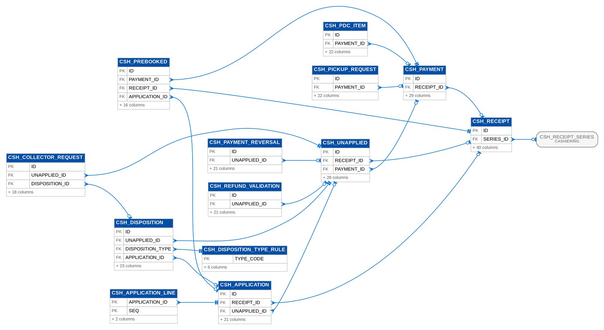
Figure 30: D07 CASHIERING (1 of 3): tables, primary keys and the foreign keys inside the module
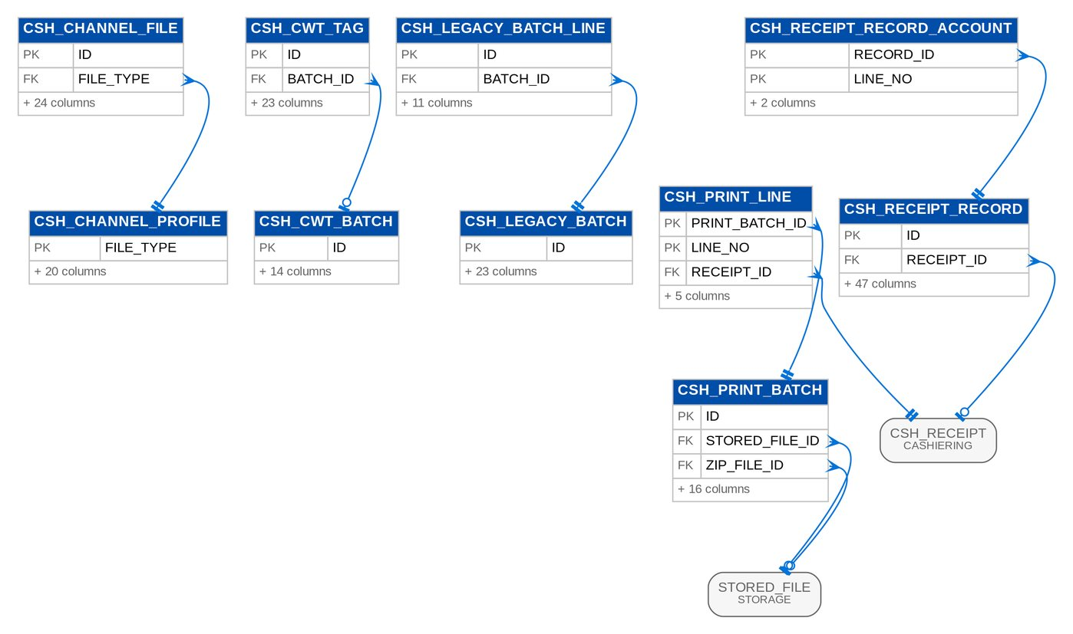
Figure 31: D07 CASHIERING (2 of 3): tables, primary keys and the foreign keys inside the module
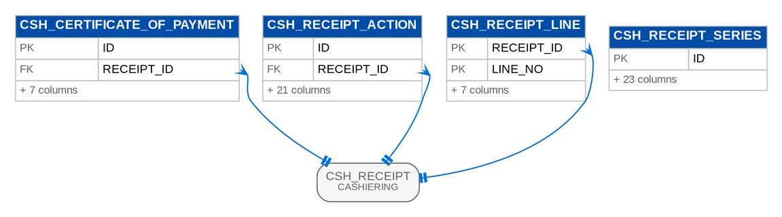
Figure 32: D07 CASHIERING (3 of 3): tables, primary keys and the foreign keys inside the module

3.7.3 Module REMITTANCE
Table 44: Tables of module REMITTANCE (D07)
Table | Description | Cols | Links | Figure
REM_BATCH | A remittance batch RMB-- of one insurer, remittance type and currency (RMTID.007/008): its lines, the totals of the lines not excluded (RMTID.002), the stage of the Process Remittance workflow (RMTID.009-011/019/036), the Disbursement request and DV number, the commission and incentive ORs (CSHID.007, RMTID.023) and the schedule sent to the insurer (MKTID.001). | 50 | REM_EXTRACTION_RUN | D07 REMITTANCE
REM_BATCH_DOCUMENT | A document stored on a batch at submission (RMTID.011): the remittance schedule (PDF and Excel) and the payment request, with the template version used (BRNB.004 convention). | 13 | REM_BATCH, STORED_FILE | D07 REMITTANCE
REM_BATCH_LINE | One invoice of a remittance batch: the invoice facts printed on the schedule, the read-only amounts (RMTID.002 addendum), the exclusion with its reason, user and restore (RMTID.002), the insurer OR and its comparison with the paid AR (RMTID.012/013/016). | 48 | REM_BATCH | D07 REMITTANCE
REM_DEDUCTION | A remittance deduction RDN--n: an amount the insurer confirmed in writing (for example an AR insurer's refund after a return premium) that BDOI deducts from its next remittance to that insurer. | 23 | - | D07 REMITTANCE
REM_DEDUCTION_APPLICATION | The part of a remittance deduction consumed by one send cycle of a batch (ACSL 2.9.2), with the journal of its OPS_REMIT_DEDUCTION posting; reversed when the batch's DV is cancelled (DIS 2.20.0). | 15 | REM_BATCH, REM_DEDUCTION | D07 REMITTANCE
REM_EOD_REQUEST | An invoice looked up for remittance during the day and queued for the end-of-day extraction (RMTID.005): one request per invoice and day, so a search never triggers twice; the run records the tag it gave. | 13 | - | Listed only (no link)
REM_EXTRACTION_RUN | One remittance extraction run (RMTID.001/003/004/005): trigger, scope (insurer, type or invoice), business date, counts per tag and the batches created. | 22 | - | D07 REMITTANCE
REM_EXTRACTION_TAG | The extraction tag an invoice received (RMTID.003): EXTRACTED with its batch, UNEXTRACTED_DUE with the exclusion reasons (RMTID.014/017/020/022/031), UNEXTRACTED_NOT_DUE, or RETURNED when a user returned it from a batch (RMTID.029). | 18 | REM_EXTRACTION_RUN | D07 REMITTANCE
REM_HOLD_REQUEST | A Marketing request to hold an invoice from remittance until a date HLD- (MKTID.003/005/007): reason (LOV HOLD_REASON), hold-until date and extensions, approval (MKTID.006), the processor it is assigned to (MKTID.004), release or expiry (MKTID.002, RMTID.021). | 29 | - | Listed only (no link)
REM_INCENTIVE_RULE | An early-remittance incentive rule (RMTID.023, PRCID.028): an insurer pays rate percent of the basic premium when BDOI remits within windowDays of the inception or booking date, optionally only for a product line and a segment. | 17 | - | Listed only (no link)
REM_SPECIAL_REQUEST | A special remittance request SPR- (MKTID.009, RMTID.030): an invoice to remit outside the regular schedule for a condition (LOV SPECIAL_REMIT_CONDITION: claims, renewal, installment due, immediate OR). | 26 | - | Listed only (no link)

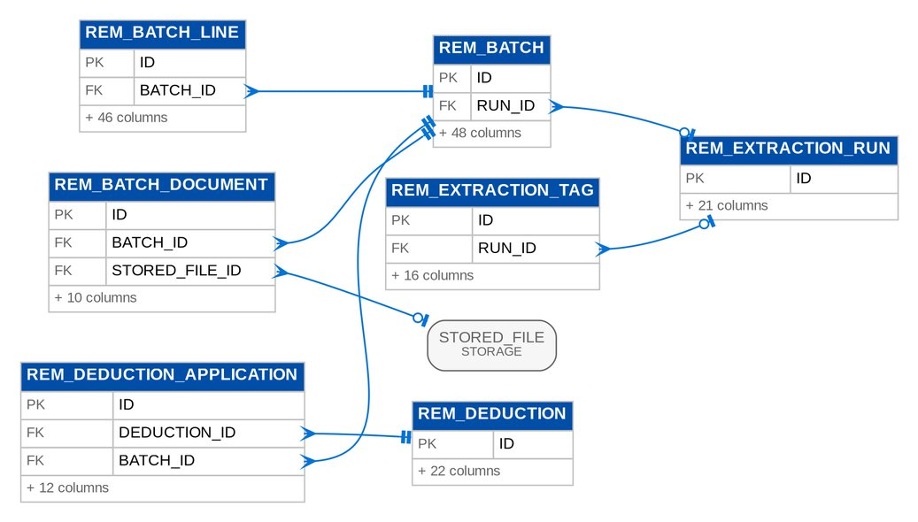
Figure 33: D07 REMITTANCE: tables, primary keys and the foreign keys inside the module

3.7.4 Module PRODRECON
Table 45: Tables of module PRODRECON (D07)
Table | Description | Cols | Links | Figure
PRC_CYCLE | A reconciliation cycle: one insurer and one production month: register extracted, sent to the insurer, insurer feedback uploaded and reconciled, closed. | 16 | - | D07 PRODRECON
PRC_EXTRACT | A production register extract of a cycle (PRCID.001-008/011/020/034): booking period, trigger, file name (PRODRECON_FILE_PATTERN), repository file and checksum, number of lines, and when and to whom it was sent. | 20 | OPS_EXTRACT_FILE, PRC_CYCLE | D07 PRODRECON
PRC_EXTRACT_LINE | One booked invoice of a production register as it was sent (Annex IV #5 Production Register, PRCID.006/020): an immutable snapshot of the ledger invoice at extraction time. | 31 | PRC_EXTRACT | D07 PRODRECON
PRC_ITEM | One reconciliation item of a cycle (PRCID.012-030/033): a booked invoice (BDOI side), an insurer production line (insurer side) or both once paired, with its status bucket, the fields that differ beyond the tolerance, the pre-booked account found for insurer production, and the feedback and disposition recorded by the reconciliation handler. | 52 | PRC_CYCLE, PRC_EXTRACT_LINE, PRC_UPLOAD | D07 PRODRECON
PRC_SCHEDULE | Extraction schedule of an insurer's production register (PRCID.001): frequency, run day and the next run date (rolled to the next working day by the job). | 16 | - | Listed only (no link)
PRC_UPLOAD | One attempt to upload an insurer production report (PRCID.009/010/031/032): file, checksum, attempt number per insurer and month, outcome with row counts and the flow-in run, including refused duplicates. | 19 | PRC_CYCLE | D07 PRODRECON

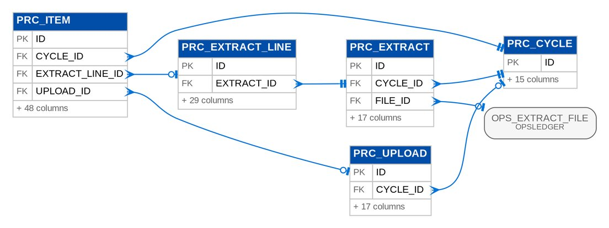
Figure 34: D07 PRODRECON: tables, primary keys and the foreign keys inside the module

3.7.5 Module ADJUSTMENT
Table 46: Tables of module ADJUSTMENT (D07)
Table | Description | Cols | Links | Figure
ADJ_MIN_BALANCE_ITEM | One invoice balance written off or credited by the minimal balance file (ADJID.026): at most once per invoice. | 15 | - | Listed only (no link)
ADJ_POSTING_BATCH | A posting batch (validation batch VB-, ADJID.006/017): the requests posted together with the outcome of each; a request that fails stays for posting and does not stop the others. | 12 | - | D07 ADJUSTMENT
ADJ_POSTING_BATCH_LINE | Posting batch line records. | 7 | ADJ_POSTING_BATCH, ADJ_REQUEST | D07 ADJUSTMENT
ADJ_REQUEST | An endorsement or cancellation request on a booked invoice: what is asked, the recompute per component and per insurer, the processing trail and what the posting produced. | 70 | - | D07 ADJUSTMENT
ADJ_REQUEST_COMPONENT | Request component records. | 5 | ADJ_REQUEST | D07 ADJUSTMENT
ADJ_REQUEST_JOURNAL | Request journal records. | 3 | ADJ_REQUEST | D07 ADJUSTMENT
ADJ_REQUEST_SHARE | Request share records. | 8 | ADJ_REQUEST | D07 ADJUSTMENT

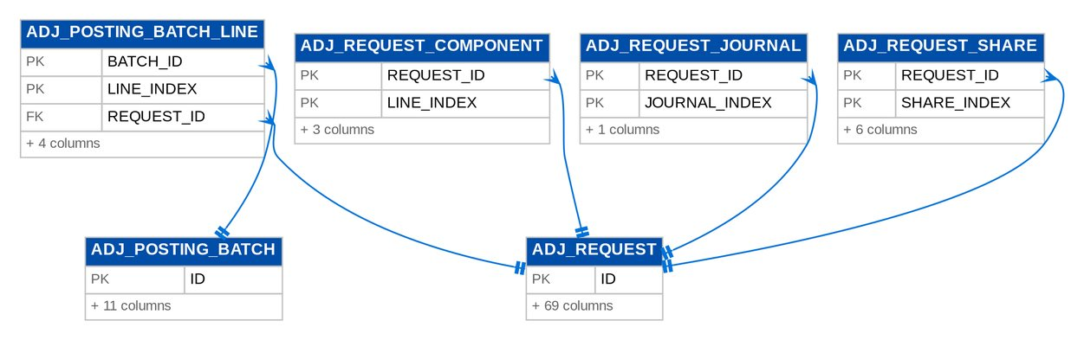
Figure 35: D07 ADJUSTMENT: tables, primary keys and the foreign keys inside the module

3.7.6 Module COMMISSION
Table 47: Tables of module COMMISSION (D07)
Table | Description | Cols | Links | Figure
CMR_BILLING | A commission billing of direct payment accounts to one insurer (CMRID.009-012, workflow OPS_DP_BILLING): handler, totals, the billing file sent with password protection, the feedback due date in working days (CMR_FEEDBACK_WORKING_DAYS), the insurer's answer and the commission OR. | 26 | OPS_EXTRACT_FILE | D07 COMMISSION (1 of 2)
CMR_CERTIFICATE | A BIR withholding tax certificate of an insurer tagged to the ORs issued for its commissions and submitted digitally to Comptrollership (CMRID.010/015, workflow OPS_BIR_CERT): form, number, period and tax withheld, the ORs it covers, the scans (attachments) and the decision (acknowledged, or rejected with a reason and resubmitted). | 19 | - | D07 COMMISSION (1 of 2)
CMR_CERTIFICATE_OR | Certificate OR records. | 4 | CMR_CERTIFICATE | D07 COMMISSION (1 of 2)
CMR_DP_ITEM | A direct payment account of a DP list (CMRID.001-013, MKTID.012): what the branch submitted, the commission receivable computed from the Operations ledger (commission, VAT, withholding tax, net, CMRID.007), the sanitation and rule results, the tag through billing, insurer feedback, collection with its OR, and the premium receivable reversal. | 39 | CMR_BILLING, CMR_DP_LIST | D07 COMMISSION (1 of 2)
CMR_DP_LIST | A direct payment list submitted by Head Office or a branch's Marketing Collection, or received from the Collection feed (CMRID.001): branch, submission date from the file name convention _DP_, file checksum and the counts after consolidation. | 17 | - | D07 COMMISSION (1 of 2)
CMR_DPPR_BATCH | A legacy direct payment PR reversal batch: legacy invoices the client paid directly to the insurer, whose open premium receivable and due to insurer are reversed once the batch is approved; the maker never approves. | 20 | - | D07 COMMISSION (2 of 2)
CMR_DPPR_BATCH_LINE | A legacy invoice of a direct payment PR reversal batch, posted in its own transaction. | 9 | CMR_DPPR_BATCH | D07 COMMISSION (2 of 2)
CMR_INCENTIVE_RUN | A computed incentive run of a scheme for a period (CMRID.003/005/006): eligible production, exclusions, the tier applied, the incentive, the pass-on to branches, and once posted the accrual (OPS_INCENTIVE_ACCRUE) and pass-on (OPS_INCENTIVE_PASS_ON) journals. | 22 | CMR_INCENTIVE_SCHEME | D07 COMMISSION (1 of 2)
CMR_INCENTIVE_RUN_LINE | One invoice of an incentive run (CMRID.003/005/006): its production, whether an exclusion rule removed it (negative amounts, erroneous bookings) and the incentive it earns. | 12 | CMR_INCENTIVE_RUN | D07 COMMISSION (1 of 2)
CMR_INCENTIVE_SCHEME | An incentive scheme (CMRID.003/005/006): No Touch and Top Up (production targets with rates and multipliers per period) and Motor Mania (fixed amount per policy by minimum basic premium, passed on to branches), with the production it covers (insurer, segments, product lines) and its tiers. | 20 | - | D07 COMMISSION (1 of 2)
CMR_INCENTIVE_TIER | Incentive tier records. | 7 | CMR_INCENTIVE_SCHEME | D07 COMMISSION (1 of 2)

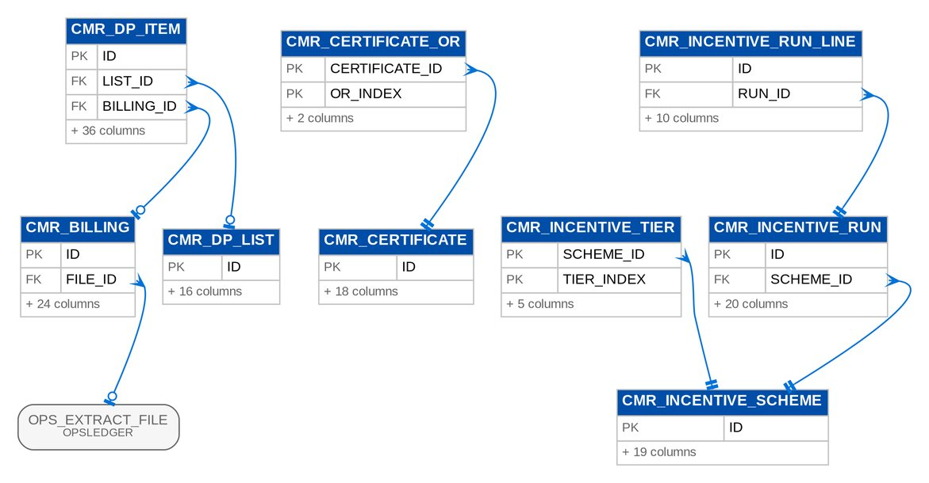
Figure 36: D07 COMMISSION (1 of 2): tables, primary keys and the foreign keys inside the module
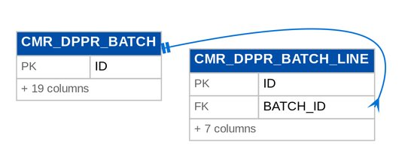
Figure 37: D07 COMMISSION (2 of 2): tables, primary keys and the foreign keys inside the module

3.8 D08 Collections
The collection worklist, collection accounts and items, dispositions, promises to pay, instalments, escalations, billing statements and unapplied payment requests. Owner: Collections and Marketing Support. BRD: BRD-04. 23 tables, 438 columns.

3.8.1 Module COLLECTIONS
Table 48: Tables of module COLLECTIONS (D08)
Table | Description | Cols | Links | Figure
CLX_APPLICATION_REQUEST | Application request records. | 29 | - | D08 COLLECTIONS (1 of 2)
CLX_ASSIGNMENT | One assignment of a collection item to a handler (BRCLXN.052): by rule, permanent, temporary with an end date, or the automatic return at the end of a temporary assignment. | 17 | CLX_ITEM | D08 COLLECTIONS (1 of 2)
CLX_ASSIGNMENT_RULE | A default assignment rule (BRCLXN.052): the handler of the new items matching segment, sales unit, client, amount and aging criteria, tried in priority order by the daily refresh. | 18 | - | Listed only (no link)
CLX_BILLING_DOCUMENT | The rendered PDF of a statement of account (BRCLXN.058), kept apart from the statement. | 11 | CLX_BILLING_STATEMENT, STORED_FILE | D08 COLLECTIONS (2 of 2)
CLX_BILLING_STATEMENT | A statement of account (SOA) for one billing cycle of an installment plan (BRCLXN.058/060, CQ18): the client and account, the cycle's coverage period and due date, the installment of the cycle and any earlier one still unpaid, the totals, the document rendered from the template CLX_SOA and when it was sent. | 28 | CLX_INSTALLMENT_PLAN | D08 COLLECTIONS (2 of 2)
CLX_BILLING_STATEMENT_LINE | A line of a statement of account (BRCLXN.058/060): the installment of the cycle or an earlier one still unpaid, with the invoice, policy year, coverage period, amount, paid and balance. | 13 | CLX_BILLING_STATEMENT | D08 COLLECTIONS (2 of 2)
CLX_DISPOSITION | A PR collector disposition of a collection item (BRCLXN.016-023): code of LOV CLX_PR_DISPOSITION with the category, tagging owner and Operations action of its attributes, remarks and the hand-off details (pick-up date and address, certificate number ...). | 19 | CLX_ITEM | D08 COLLECTIONS (1 of 2)
CLX_EFFORT | A collection effort on an item (p.43-46, p.59; BRCLXN.021): code of LOV CLX_EFFORT_CODE, when, channel, contact person and remarks. | 14 | CLX_ITEM | D08 COLLECTIONS (1 of 2)
CLX_ESCALATION | An escalation of a collection account (BRCLXN.049/050): raised automatically by a rule or manually for one or several invoices of an account, routed to the team lead or the unit / section head, and worked in the workflow CLX_ESCALATION, whose stage it mirrors. | 26 | - | D08 COLLECTIONS (2 of 2)
CLX_ESCALATION_ITEM | One invoice of an escalation with its outstanding and aging when escalated (BRCLXN.050 AC 1). | 6 | CLX_ESCALATION | D08 COLLECTIONS (2 of 2)
CLX_ESCALATION_RULE | An escalation rule (BRCLXN.049, CQ14): a basis and threshold, optional filters on the account (segment, sales unit, product line, outstanding range), the level that receives the escalation, its SLA and whether to notify. | 26 | - | Listed only (no link)
CLX_FIELD_CHANGE | One field change of a Collections record with its "from" and "to" values, user, time and source IP (BRCLXN.043, NFR audit logging); immutable. | 12 | CLX_ITEM | D08 COLLECTIONS (1 of 2)
CLX_INBOX | An item Operations sent to Collections through an outbound COLLECTION_* feed: a direct payment account returned by the insurer (CMRID.009) or a refund (BRCLXN.040), with the flow-in run it arrived in and what Collections did with it. | 16 | CLX_ITEM | D08 COLLECTIONS (1 of 2)
CLX_INSTALLMENT | One installment of a plan = one billing cycle (BRCLXN.053/058): its due date, the coverage period it bills, the amount and the payments allocated to it from the invoice ledger, oldest due first (BRCLXN.054). | 18 | CLX_INSTALLMENT_PLAN | D08 COLLECTIONS (2 of 2)
CLX_INSTALLMENT_PLAN | An installment plan of a collection account (BRCLXN.053/058, CQ15): the schedule of billing cycles of a multi-year account (one or more installments per policy-year invoice) or of one invoice, with the payments allocated to each installment. | 23 | - | D08 COLLECTIONS (2 of 2)
CLX_ITEM | A collection item: one ledger invoice that has ever been listed in the worklist. | 56 | - | D08 COLLECTIONS (1 of 2)
CLX_ITEM_BALANCE | Item balance records. | 7 | CLX_ITEM | D08 COLLECTIONS (1 of 2)
CLX_LEGACY_STATE | A row of the open collection follow-up carried from legacy for a legacy invoice: the latest disposition, a promise to pay, an installment of a plan or the collector assignment. | 20 | - | Listed only (no link)
CLX_LOV_ATTRIBUTE | An attribute of a Collections LOV value: category, TAGGING_OWNER, OPS_ACTION, ALLOWED_ROLES of the PR collector dispositions and REQUIRES_INVOICE, CASHIERING_ACTION of the unapplied-payment dispositions. LOV_VALUE has no attribute columns, so Collections keeps them by type, code and attribute. | 10 | LOV_TYPE, LOV_VALUE | D08 COLLECTIONS (2 of 2)
CLX_OUTBOX | An item Collections hands to Operations through an inbound COLLECTION_* feed: a BIR 2307 tag for Cashiering, a direct payment account for Commission or a check pick-up request for Cashiering. | 14 | CLX_DISPOSITION | D08 COLLECTIONS (1 of 2)
CLX_PROMISE | A client's promise to pay an amount on a collection account (an invoice), or on one of its installments, by a date (BRCLXN.055, CQ16). | 23 | CLX_INSTALLMENT | D08 COLLECTIONS (2 of 2)
CLX_SCHEDULED_FILE | A Collections file published by a job or on request (BRCLXN.024-029, 045): the report, its period and scope (unit and branch of a weekly file), the archived report run holding the file and the time from which users may download it. | 18 | REPORT_RUN | D08 COLLECTIONS (2 of 2)
CLX_UNAPPLIED_DISPOSITION | A collector disposition of an unapplied payment (BRCLXN.031/033, 040): the value of LOV CLX_UPP_DISPOSITION, the target invoice when the value requires one (047/048), the amount and remarks, and the request sent to Cashiering when the value has a Cashiering action. | 14 | CLX_APPLICATION_REQUEST | D08 COLLECTIONS (1 of 2)

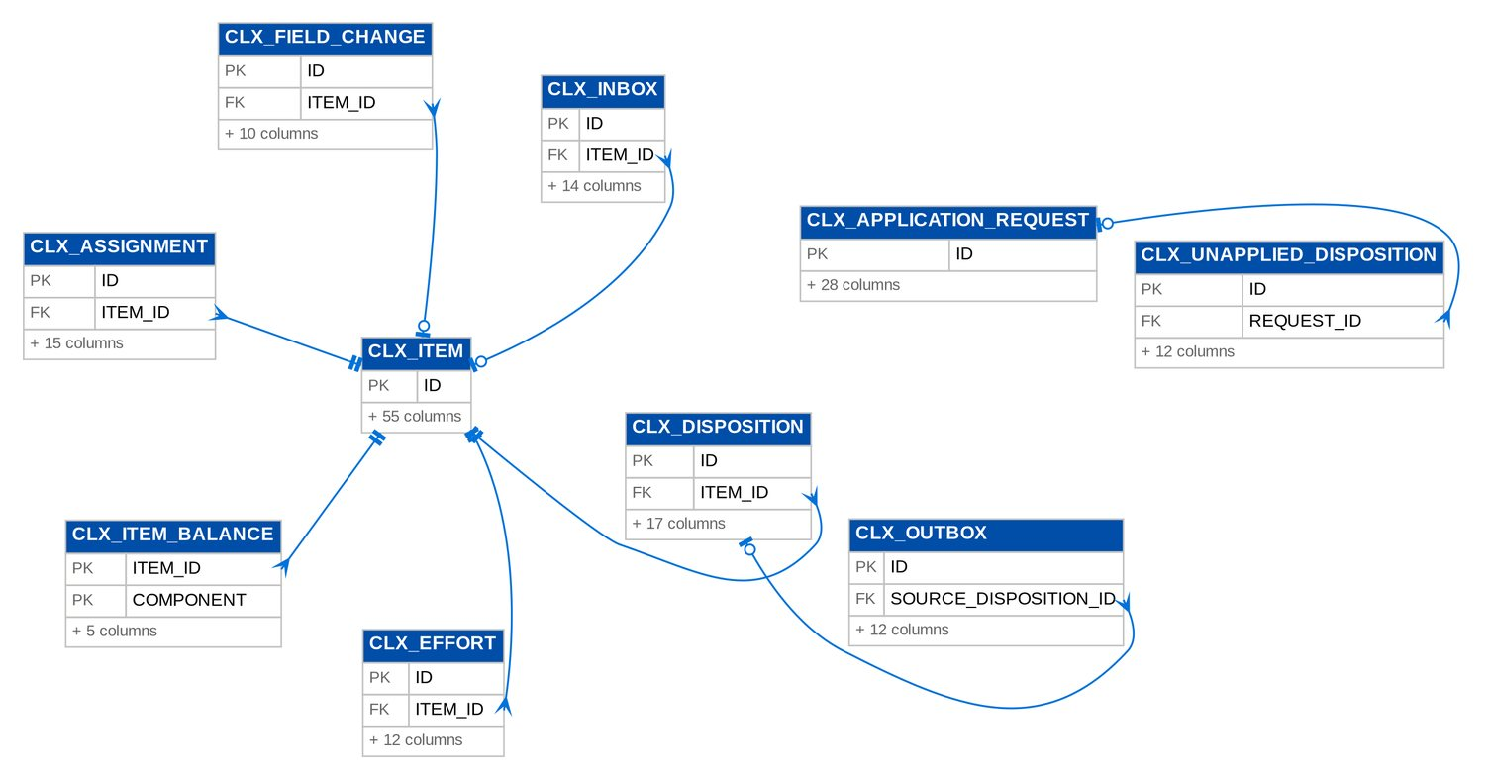
Figure 38: D08 COLLECTIONS (1 of 2): tables, primary keys and the foreign keys inside the module
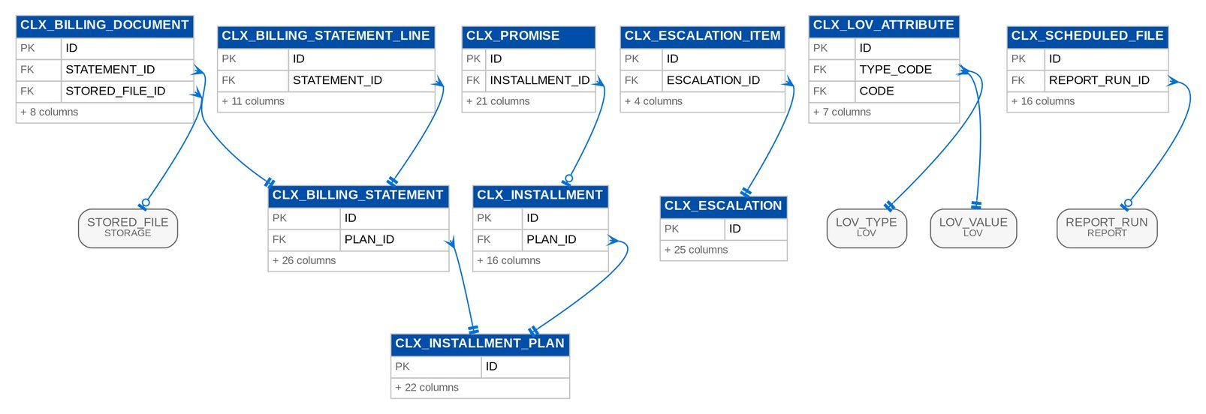
Figure 39: D08 COLLECTIONS (2 of 2): tables, primary keys and the foreign keys inside the module

3.9 D09 General Ledger and Finance
Chart of accounts, journals, the immutable ledger and daily balances, open items, the accounting event register and rules, period close and year-end, budgets, financial statements and schedules, the BDOI report pack, bank reconciliation, fixed assets, investments and the BIR tax returns and certificates. Owner: Product Owner - Comptrollership - FRBS and ACSL; Head - Comptrollership. BRD: BRD-05. 72 tables, 1,150 columns.

3.9.1 Module COA
Table 49: Tables of module COA (D09)
Table | Description | Cols | Links | Figure
COA_ACCOUNT | GL Head of Account (Main / Sub / Micro GL) in the multi-tier chart of accounts. * Holds every posting control defined by the GL maintenance programs: allowed currencies, allowed posting branches, role based access codes, freeze, closure, manual posting allowance, mandatory dimensions and sub-ledger control. | 33 | COA_ACCOUNT, COA_CATEGORY | D09 COA
COA_ACCOUNT_BRANCH | Account branch records. | 2 | COA_ACCOUNT | D09 COA
COA_ACCOUNT_CURRENCY | Account currency records. | 2 | COA_ACCOUNT | D09 COA
COA_ACCOUNT_ROLE | Account role records. | 2 | COA_ACCOUNT | D09 COA
COA_CATEGORY | General Ledger Category Master: groups accounts by nature (e.g. | 10 | - | D09 COA
COA_NUMBERING | Numbering scheme of the children of a parent account (FRBS 2.3.2): a child's number is the parent code, an optional separator and the next sequence of a fixed width, e.g. parent 1210, separator ., width 2 gives 1210.01, 1210.02... | 11 | - | Listed only (no link)

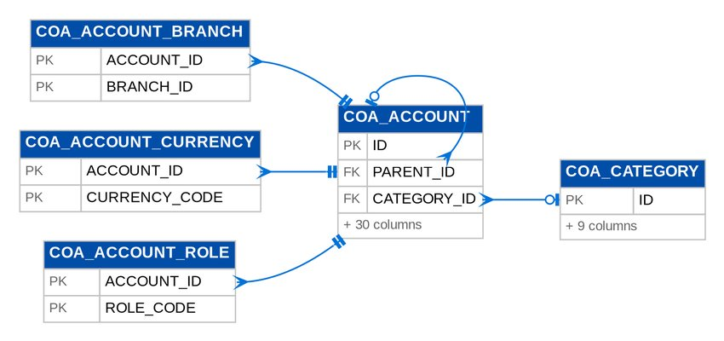
Figure 40: D09 COA: tables, primary keys and the foreign keys inside the module

3.9.2 Module JOURNAL
Table 50: Tables of module JOURNAL (D09)
Table | Description | Cols | Links | Figure
JNL_BATCH | Journal batch (voucher): a balanced set of debit and credit lines posted as one unit. * Supports every batch shape (1Dr-1Cr, 1Dr-nCr, nDr-1Cr, nDr-nCr). | 37 | JNL_BATCH, PER_PERIOD | D09 JOURNAL
JNL_LINE | One debit or credit line of a journal batch. * amount is in the line currency; baseAmount is the company base currency equivalent at exchangeRate. | 15 | COA_ACCOUNT, JNL_BATCH | D09 JOURNAL
JNL_RECURRING_LINE | Recurring line records. | 13 | JNL_RECURRING_TEMPLATE | D09 JOURNAL
JNL_RECURRING_OCCURRENCE | A generated occurrence of a recurring template. | 7 | JNL_BATCH, JNL_RECURRING_TEMPLATE | D09 JOURNAL
JNL_RECURRING_TEMPLATE | Recurring (standing) journal template, e.g. monthly rent or an accrual that is reversed at the start of the next period. | 21 | - | D09 JOURNAL

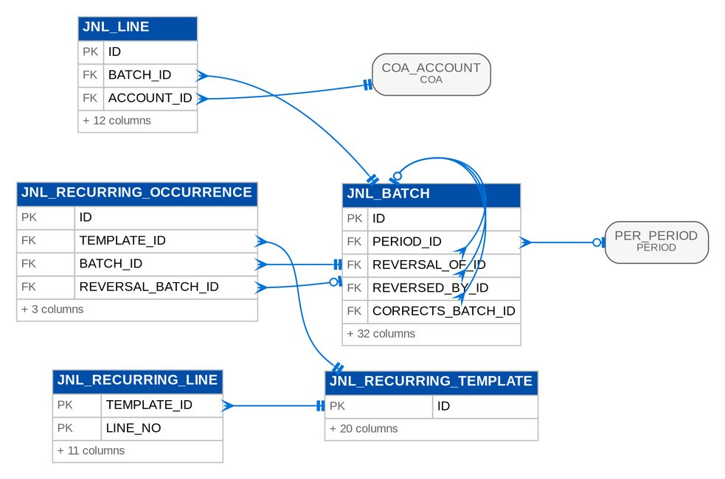
Figure 41: D09 JOURNAL: tables, primary keys and the foreign keys inside the module

3.9.3 Module LEDGER
Table 51: Tables of module LEDGER (D09)
Table | Description | Cols | Links | Figure
GL_DAILY_BALANCE | Daily balance records. | 9 | COA_ACCOUNT | D09 LEDGER
GL_LEDGER_ENTRY | Immutable posted GL transaction line — the book of record. * Written only by the posting engine. | 22 | COA_ACCOUNT, JNL_BATCH, PER_PERIOD | D09 LEDGER

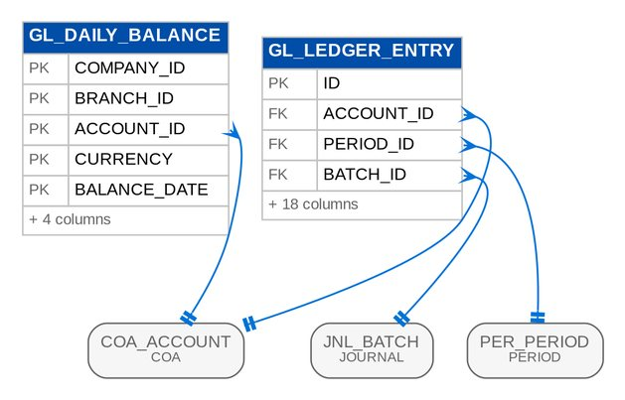
Figure 42: D09 LEDGER: tables, primary keys and the foreign keys inside the module

3.9.4 Module SUBLEDGER
Table 52: Tables of module SUBLEDGER (D09)
Table | Description | Cols | Links | Figure
SL_ITEM_MATCH | Settlement of a DEBIT open item by a CREDIT open item (knock-off / allocation). | 10 | SL_OPEN_ITEM | D09 SUBLEDGER
SL_OPEN_ITEM | Open item of a party sub-ledger (receivables, payables, reinsurance and coinsurance balances). * Each business document that creates a party balance (debit note, supplier invoice, receipt, claim payable, reinsurance statement) records one open item alongside its GL posting. | 24 | PTY_PARTY | D09 SUBLEDGER

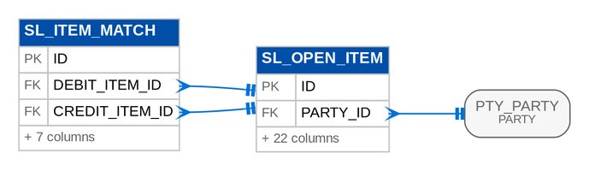
Figure 43: D09 SUBLEDGER: tables, primary keys and the foreign keys inside the module

3.9.5 Module ACCOUNTING
Table 53: Tables of module ACCOUNTING (D09)
Table | Description | Cols | Links | Figure
ACC_COST_CENTER_RULE | Standard rule for capturing the cost / responsibility centre (FRBS 3.1.1, DIS 3.30.0; AQ26): the accounting engine gives a journal line that needs a cost centre, and has none, the cost centre of the first active rule (lowest priority number) whose criteria all match. | 16 | - | Listed only (no link)
ACC_EVENT_LOG | Register of processed accounting events (event monitor and failed-event report). | 14 | - | Listed only (no link)
ACC_EVENT_TYPE | Accounting event master (e.g. | 7 | - | D09 ACCOUNTING
ACC_RULE | Accounting rule: how an event type is journalised, optionally specialised by line of business and currency and valid for a date range. * Selection: among active rules of the company and event type whose conditions match the event, the most specific (most non-blank conditions) wins; ties are broken by the lowest priority value. | 17 | ACC_EVENT_TYPE | D09 ACCOUNTING
ACC_RULE_LINE | One debit or credit instruction of an accounting rule. * accountCode is either a GL account code or an account role placeholder starting with {@value #ROLE_PREFIX} (e.g. @BANK) resolved from the event at posting time. | 8 | ACC_RULE | D09 ACCOUNTING

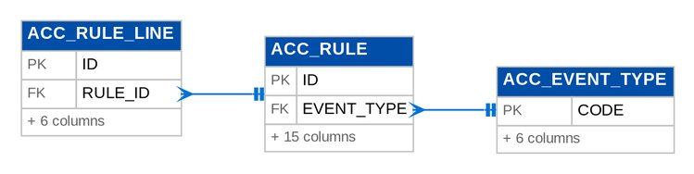
Figure 44: D09 ACCOUNTING: tables, primary keys and the foreign keys inside the module

3.9.6 Module CLOSING
Table 54: Tables of module CLOSING (D09)
Table | Description | Cols | Links | Figure
ACC_PERIOD_CLOSE_SCHEDULE | Scheduled month-end close of a period (FRBS 2.6.0 / Addendum 1): the GL Team Lead picks the date and time; the job GL_PERIOD_CLOSE runs the checklist then and closes the period, or records why it could not and raises GL_CLOSE_FAILED. | 12 | PER_PERIOD | D09 CLOSING
FX_REVALUATION_LINE | Revalued balance recorded in a revaluation run (FX Revaluation Register). | 13 | COA_ACCOUNT, FX_REVALUATION_RUN | D09 CLOSING
FX_REVALUATION_RUN | FX revaluation run of a company for one accounting period (unique per period: a period is revalued once). | 18 | PER_PERIOD | D09 CLOSING
YEC_YEAR_END_CLOSE | Record of a completed year-end close: closing journals, net result transferred to retained earnings and the fiscal year opened next. | 19 | PER_FISCAL_YEAR | D09 CLOSING

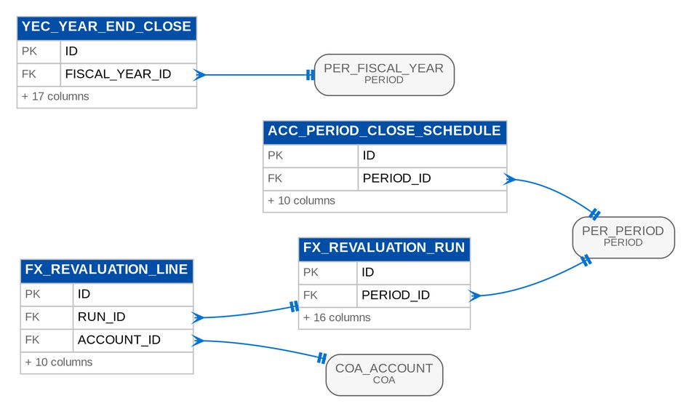
Figure 45: D09 CLOSING: tables, primary keys and the foreign keys inside the module

3.9.7 Module BUDGET
Table 55: Tables of module BUDGET (D09)
Table | Description | Cols | Links | Figure
BUD_BUDGET | Budget records. | 19 | BUD_BUDGET | D09 BUDGET
BUD_BUDGET_AMOUNT | Budget amount records. | 3 | BUD_BUDGET_LINE | D09 BUDGET
BUD_BUDGET_LINE | Budget line: one GL account (optionally per cost centre) with twelve monthly amounts in natural sign (income and expense budgets are both positive). | 5 | BUD_BUDGET, COA_ACCOUNT | D09 BUDGET

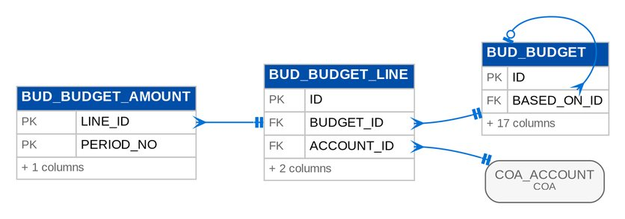
Figure 46: D09 BUDGET: tables, primary keys and the foreign keys inside the module

3.9.8 Module FINREPORT
Table 56: Tables of module FINREPORT (D09)
Table | Description | Cols | Links | Figure
FIN_SCHEDULE_COLUMN | Schedule column records. | 5 | FIN_SCHEDULE_DEF | D09 FINREPORT
FIN_SCHEDULE_DEF | An account schedule of the BDOI report pack (FRBS 3.2.0, Appendix A II-IV; report list #9, #45, #46): which accounts, how the rows are grouped, which figures are shown, optional ageing, a comparative period and a commentary column. | 24 | - | D09 FINREPORT
FIN_STATEMENT_COMMENT | Commentary on one row of a schedule for one month (Appendix A II-45 "variance analysis with commentary", III FS analysis): kept per company, schedule, period (yyyy-MM) and row key, printed in the schedule's commentary column. | 11 | - | Listed only (no link)
FIN_STATEMENT_FORMAT | Statement format records. | 10 | - | D09 FINREPORT
FIN_STATEMENT_FORMAT_LINE | Statement format line records. | 10 | FIN_STATEMENT_FORMAT | D09 FINREPORT

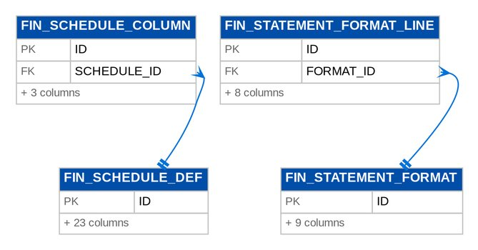
Figure 47: D09 FINREPORT: tables, primary keys and the foreign keys inside the module

3.9.9 Module FRBS
Table 57: Tables of module FRBS (D09)
Table | Description | Cols | Links | Figure
FRBS_REPORT_PACK_ENTRY | Report pack entry records. | 10 | - | Listed only (no link)
FRBS_SERVICE_FEE_ITEM | A fully paid invoice counted in a service-fee line (FRBS 2.10.0). | 15 | FRBS_SERVICE_FEE_LINE, FRBS_SERVICE_FEE_RUN | D09 FRBS
FRBS_SERVICE_FEE_LINE | A line of a service-fee run (FRBS 2.10.0-2.10.2): the fee of one service-fee segment, sales unit and currency, its accrual journal, its payout request to Disbursement and the RELEASED and LIQUIDATED tags with their dates and the unit's liquidation report. | 34 | FRBS_SERVICE_FEE_RUN | D09 FRBS
FRBS_SERVICE_FEE_RECIPIENT | Who receives the service fee of a sales unit (FRBS 2.10.0; recipients to confirm, AQ20): the payee sent to Disbursement and the cost centre charged by the accrual (account 5614 requires one). | 12 | - | Listed only (no link)
FRBS_SERVICE_FEE_RULE | A service-fee rate (FRBS 2.10.0, Appendix A VI): the share of fully paid commission, net of the insurer's withholding tax, paid to the units and referrers of a service-fee segment (LOV SERVICE_FEE_SEGMENT) for the market segments it covers. | 15 | - | Listed only (no link)
FRBS_SERVICE_FEE_RUN | A service-fee run (FRBS 2.10.0; design 5.4, 7.3): the service fee of the invoices fully paid in a period, one line per service-fee segment, unit and currency. | 18 | - | D09 FRBS

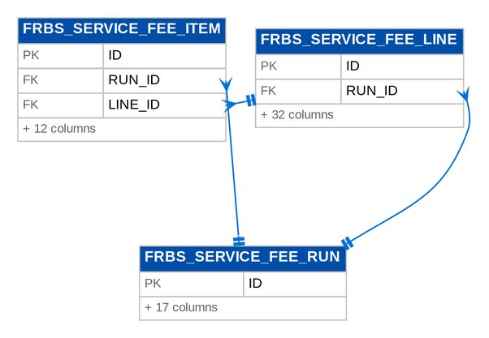
Figure 48: D09 FRBS: tables, primary keys and the foreign keys inside the module

3.9.10 Module RECEIVABLES
Table 58: Tables of module RECEIVABLES (D09)
Table | Description | Cols | Links | Figure
BRS_MATCH | Reconciliation match: one or more ledger entries of a bank GL account agreed with one or more bank statement lines of the same (signed) total. | 11 | - | D09 RECEIVABLES
BRS_MATCH_BOOK | Match book records. | 9 | BRS_MATCH, GL_LEDGER_ENTRY | D09 RECEIVABLES
BRS_MATCH_RULE | Auto-matching rule of a bank account (FRBS 3.3.2): CHECK_NO_AND_AMOUNT matches a bank line and a book entry with the same cheque number and amount before the STANDARD rules (amount within the date window, reference preference, deposit slips). | 11 | - | Listed only (no link)
BRS_RECONCILIATION | Bank reconciliation of one GL bank account as of a statement date: the saved Bank Reconciliation Statement figures. | 20 | - | Listed only (no link)
BRS_STATEMENT | Imported bank statement of one GL bank account. | 17 | - | D09 RECEIVABLES
BRS_STATEMENT_LAYOUT | Column mapping of the spreadsheet statements (.xlsx / .ods) of one bank account (FRBS 3.3.1; AQ08): which column holds the date, description, reference (cheque number), debit and credit or one signed amount, and the running balance. | 17 | - | Listed only (no link)
BRS_STATEMENT_LINE | One line of a bank statement. | 17 | BRS_MATCH, BRS_STATEMENT | D09 RECEIVABLES
RCV_DEPOSIT_SLIP | Bank deposit (pay-in) slip grouping cash and cheque receipts taken to one bank account. | 17 | - | D09 RECEIVABLES
RCV_PDC | Post-dated cheque received (PDC register). * Accounting treatment: memorandum only while the cheque is held (ON_HAND / DUE); nothing is posted to the GL. | 28 | PTY_PARTY, RCV_PDC, RCV_RECEIPT, SL_OPEN_ITEM | D09 RECEIVABLES
RCV_PDC_EVENT | Status change of a post-dated cheque (confirmation audit trail). | 12 | RCV_PDC | D09 RECEIVABLES
RCV_RECEIPT | Official receipt (collection) of money from a policyholder, intermediary, reinsurer or other payer. * Maker-checker: a receipt is entered PENDING_APPROVAL and accounted for only when a different user approves it. | 41 | PTY_PARTY, RCV_DEPOSIT_SLIP, RCV_PDC, SL_OPEN_ITEM | D09 RECEIVABLES
RCV_RECEIPT_ALLOCATION | Part of a receipt applied to one debit open item (debit note). | 12 | RCV_RECEIPT, SL_OPEN_ITEM | D09 RECEIVABLES

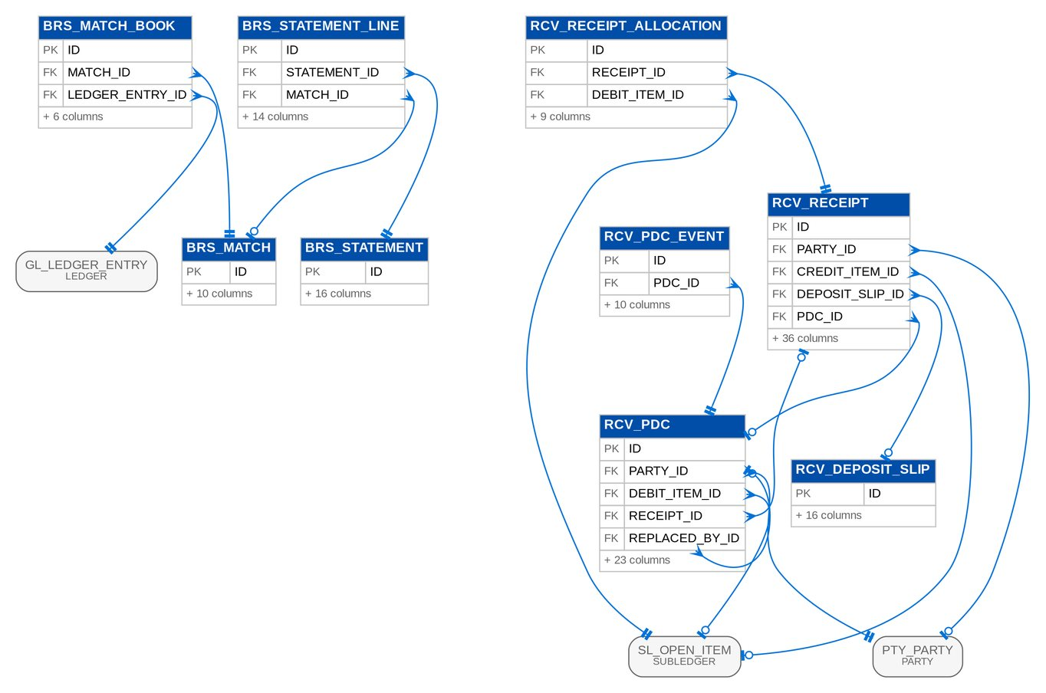
Figure 49: D09 RECEIVABLES: tables, primary keys and the foreign keys inside the module

3.9.11 Module FIXEDASSET
Table 59: Tables of module FIXEDASSET (D09)
Table | Description | Cols | Links | Figure
FA_ASSET | Fixed asset register entry. * Registered by a maker (PENDING_CAPITALIZATION), capitalized by a checker (posting the acquisition or, for assets taken over from a legacy register, the opening balance), then depreciated monthly until fully depreciated or disposed. | 34 | FA_CATEGORY | D09 FIXEDASSET
FA_CATEGORY | Fixed asset category: the GL accounts an asset posts to and its default depreciation policy (method, useful life, residual value %). | 18 | - | D09 FIXEDASSET
FA_DEPRECIATION_LINE | Depreciation charged to one asset in a run, with its position after the charge. | 14 | FA_ASSET, FA_DEPRECIATION_RUN | D09 FIXEDASSET
FA_DEPRECIATION_RUN | A posted monthly depreciation run. | 11 | - | D09 FIXEDASSET
FA_MOVEMENT | An addition, disposal or inter-branch transfer of a fixed asset, with the values moved and the journal that accounted for it. | 20 | FA_ASSET | D09 FIXEDASSET

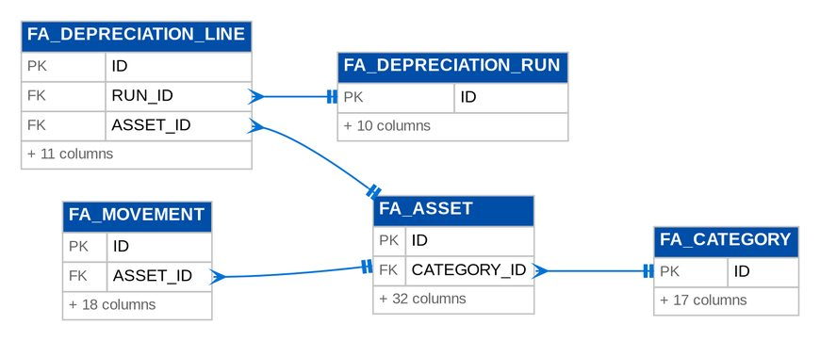
Figure 50: D09 FIXEDASSET: tables, primary keys and the foreign keys inside the module

3.9.12 Module INVESTMENT
Table 60: Tables of module INVESTMENT (D09)
Table | Description | Cols | Links | Figure
INV_HOLDING | An investment holding (one purchase of one security or deposit). * Captured by a maker (PENDING_APPROVAL); a checker's approval posts the purchase (or, for a holding brought over from a previous system, the take-on opening balance). | 44 | INV_PORTFOLIO | D09 INVESTMENT
INV_PORTFOLIO | Investment portfolio: a PFRS 9 classification with the GL accounts its holdings post to (investment, accrued interest, interest income, realized gain / loss and, for fair valued portfolios, the fair value account - the equity reserve for FVOCI or a profit or loss account for FVPL). | 18 | - | D09 INVESTMENT
INV_RUN | A posted month-end accrual or amortization run; unique per company, type and period, so posting a period twice returns the existing run. | 12 | - | D09 INVESTMENT
INV_TRANSACTION | A posted event of a holding, with the holding's position after it. | 21 | INV_HOLDING, INV_RUN | D09 INVESTMENT

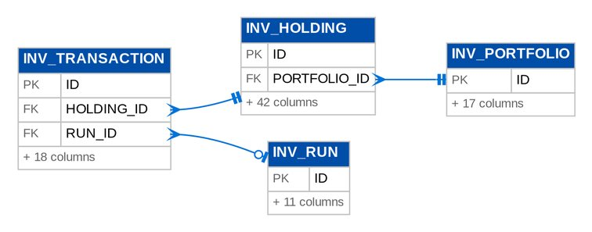
Figure 51: D09 INVESTMENT: tables, primary keys and the foreign keys inside the module

3.9.13 Module TAX
Table 61: Tables of module TAX (D09)
Table | Description | Cols | Links | Figure
TAX_2307_BATCH | A batch run that issued BIR Form 2307 certificates for one quarter. | 13 | - | D09 TAX
TAX_2307_CERTIFICATE | BIR Form 2307 — Certificate of Creditable Tax Withheld at Source, issued to one payee for one quarter. | 25 | TAX_2307_BATCH | D09 TAX
TAX_2307_LINE | Part II line of BIR Form 2307: income by month of the quarter and tax withheld for one ATC. | 10 | TAX_2307_CERTIFICATE | D09 TAX
TAX_BOOK_DEF | Book def records. | 7 | - | Listed only (no link)
TAX_CERTIFICATE_RECEIVED | A BIR 2307 certificate BDOI received from a withholding agent (DIS 2.11.0-2.11.2, OQ41, AQ16): the insurer's certificate of the tax it withheld on BDOI's commission and incentives. | 23 | - | D09 TAX
TAX_CERTIFICATE_RECEIVED_LINE | Certificate received line records. | 7 | TAX_CERTIFICATE_RECEIVED | D09 TAX
TAX_CODE | Tax code master (maker-checker): a tax with its rate in percent and the GL account the tax is booked to. | 20 | - | Listed only (no link)
TAX_FORM | Form records. | 21 | - | Listed only (no link)
TAX_FORM_OUTPUT_LINE | Form output line records. | 6 | - | Listed only (no link)
TAX_PARTY_PROFILE | Tax profile of a business partner, kept beside the party master so the party module is not altered: BIR TIN and branch code, registered name, registered address, VAT treatment, the default ATC applied to income payments to the party, and its withholding status and tax exemption certificate. * ... | 29 | PTY_PARTY | D09 TAX
TAX_REMITTANCE | Payment of a filed return (one per return): what was paid, when, from which bank account, the bank / eFPS payment reference and the journal that cleared the tax payable. | 19 | TAX_RETURN | D09 TAX
TAX_RETURN | A tax return for one form and filing period. * Lifecycle: DRAFT (figures computed from the worksheet and refreshable) → FILED (figures frozen, filed by a user other than the preparer, with the eFPS / eBIRForms reference) → PAID (remittance posted). | 26 | - | D09 TAX
TAX_RETURN_LINE | One line of a return: a worksheet summary figure frozen when the return is filed. | 7 | TAX_RETURN | D09 TAX

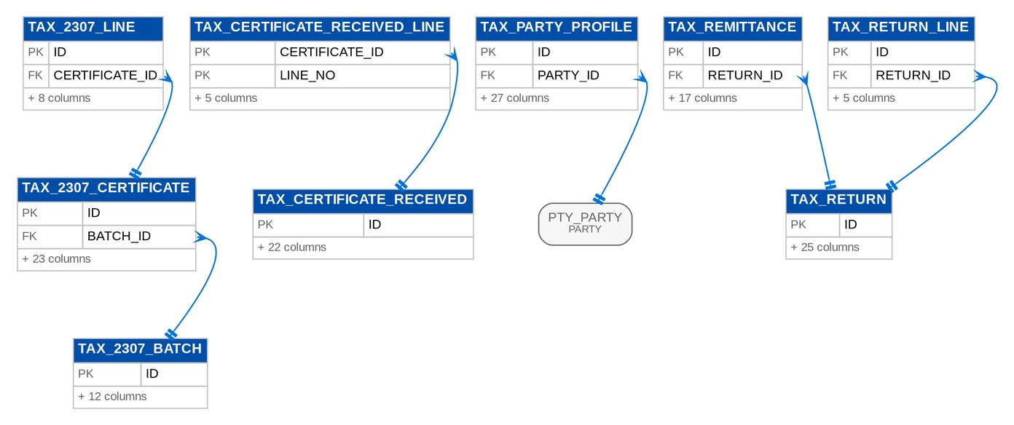
Figure 52: D09 TAX: tables, primary keys and the foreign keys inside the module

3.10 D10 Disbursement and ACSL
Payees, disbursement requests and vouchers with their payment instruments, payables masters, Marketing refund and cash-advance requests, insurer statement of account and GL-SL reconciliation, investigation cases and correction entries. Owner: Product Owner - Comptrollership - Disbursement; Product Owners - Comptrollership - ACSL. BRD: BRD-05. 41 tables, 805 columns.

3.10.1 Module DISBURSEMENT
Table 62: Tables of module DISBURSEMENT (D10)
Table | Description | Cols | Links | Figure
DSB_EOD_OUTPUT | A file produced by an end-of-day run (DIS 2.16.1-2.16.6, 3.28.2): the DCTF, the check print batch, the ATD / MC-DD / credit ticket / TT forms, the day's vouchers and the EOD reports. | 14 | DSB_EOD_RUN, STORED_FILE | D10 DISBURSEMENT (1 of 2)
DSB_EOD_RUN | An end-of-day run of a business date (DIS 2.16.0-2.16.6, 3.28.0-3.28.2, 2.7.12): the approved vouchers it froze and the counts of its outputs (checks, DCTF credits, forms, reports) and of the payment confirmations e-mailed afterwards. | 17 | - | D10 DISBURSEMENT (1 of 2)
DSB_FUNDING_REQUEST | Funding of the main BDOIR account through BDO Business Online Banking (DIS 2.17.0-2.17.4, AQ10): source and target bank accounts, amount, purpose, the BOB reference and the maker, verifier and two approvers of workflow DISB_FUNDING. | 20 | PAY_BANK_ACCOUNT | D10 DISBURSEMENT (2 of 2)
DSB_INSTRUMENT | The payment instrument of an approved voucher (DIS 2.7.0, 2.8.x, 3.26.x): check, authority to debit, credit to account, manager's check / demand draft, credit ticket, telegraphic transfer or online banking, with its number, status and the time of each step. | 26 | DSB_EOD_RUN, DSB_VOUCHER, PAY_BANK_ACCOUNT | D10 DISBURSEMENT (1 of 2)
DSB_INSTRUMENT_EVENT | One status change of an instrument (DIS 2.8.0, 3.26.0): from and to status, what changed it (user, system, uploaded file, job), a note and the file reference; shown as the status timeline. | 12 | DSB_INSTRUMENT | D10 DISBURSEMENT (1 of 2)
DSB_PAYEE | A Disbursement payee (DIS 2.2.0-2.2.8): the payment profile of a party code with its class (LOV PAYEE_CLASS), default and allowed modes of payment, disbursement types, currency, default cost centre (DIS 3.30.0) and bank accounts. | 27 | - | D10 DISBURSEMENT (1 of 2)
DSB_PAYEE_ACCOUNT | A bank account of a payee (DIS 2.2.0, AQ11): bank, branch, account number (masked in lists without DISB_PAYEE_VIEW_FULL), account name, currency and the mode it serves (credit to account, telegraphic transfer, online banking). | 15 | DSB_PAYEE | D10 DISBURSEMENT (1 of 2)
DSB_PAYEE_REQUEST | A request to maintain a payee (DIS 2.2.1): from a Marketing refund request form (RRF, MKT 2.25.0), from a Disbursement user, or raised automatically when a payment request names a payee that is not in the master (DIS 3.25.2). | 16 | DSB_PAYEE | D10 DISBURSEMENT (1 of 2)
DSB_REQUEST | A payment request received by Disbursement (DIS 2.4.0-2.6.2, 3.25.0-3.25.2): from a module through the gateway (with the linked Operations request), from an upload row or encoded by a user. | 32 | DSB_PAYEE, DSB_VOUCHER | D10 DISBURSEMENT (1 of 2)
DSB_STATUS_EDIT | A request to correct the status tag of an instrument (DIS 2.8.5, AQ15), approved or rejected by the team leader under workflow DISB_STATUS_EDIT. | 14 | DSB_INSTRUMENT | D10 DISBURSEMENT (1 of 2)
DSB_VOUCHER | A disbursement voucher (DV, DIS 2.7.0-2.7.12, 2.13-2.21): the payment of one request to one payee with its mode, paying bank account, gross / EWT / net, purpose, root invoice (DIS 3.27.2) and the editable proforma entry (DIS 2.7.6), moved through workflow DISB_VOUCHER. | 43 | DSB_EOD_RUN, DSB_PAYEE, DSB_PAYEE_ACCOUNT, DSB_REQUEST, PAY_BANK_ACCOUNT | D10 DISBURSEMENT (1 of 2)
DSB_VOUCHER_LINE | A line of the proforma entry of a voucher (DIS 2.7.6, 2.7.10, 3.30.0): side, account, sub-ledger party, cost centre, line of business, amount and the event component it comes from, with its origin (from the accounting rule, edited by the processor, or from the expense allocation). | 17 | DSB_VOUCHER | D10 DISBURSEMENT (1 of 2)
DSB_VOUCHER_TAG | A tag on a voucher (DIS 2.10.0-2.11.2): the official / acknowledgement receipt received from the payee (number, date, date received), or a creditable withholding tax certificate received from an insurer or released to a supplier (period covered, date received / released, amount, certificate reference). | 18 | DSB_VOUCHER | D10 DISBURSEMENT (1 of 2)

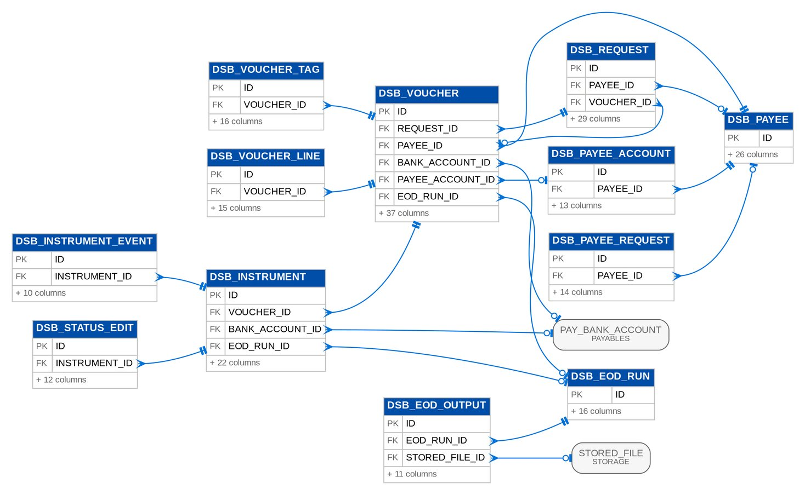
Figure 53: D10 DISBURSEMENT (1 of 2): tables, primary keys and the foreign keys inside the module
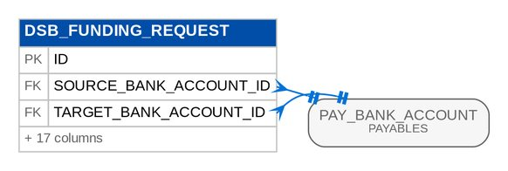
Figure 54: D10 DISBURSEMENT (2 of 2): tables, primary keys and the foreign keys inside the module

3.10.2 Module PAYABLES
Table 63: Tables of module PAYABLES (D10)
Table | Description | Cols | Links | Figure
PAY_BANK_ACCOUNT | Company bank account (house bank). | 22 | CUR_CURRENCY | D10 PAYABLES (1 of 2)
PAY_CHEQUE_BOOK | Range of pre-printed cheque leaves of a bank account; hands out leaves in order. | 15 | PAY_BANK_ACCOUNT | D10 PAYABLES (1 of 2)
PAY_PDC_EVENT | Status history (confirmation audit trail) of a post-dated cheque issued. | 12 | PAY_PDC_ISSUED | D10 PAYABLES (1 of 2)
PAY_PDC_ISSUED | Post-dated cheque issued (PDC register entry), created when a PDC payment voucher is approved. * Status flow: ISSUED → DUE (cheque date reached) → PRESENTED (confirmed; PDC liability cleared against the bank) → CLEARED (matched with the bank statement). | 30 | PAY_BANK_ACCOUNT, PAY_PDC_ISSUED, PAY_VOUCHER, PTY_PARTY | D10 PAYABLES (1 of 2)
PAY_PETTY_CASH_DISBURSEMENT | Petty cash disbursement voucher: an expense paid in cash from a fund. | 23 | PAY_PETTY_CASH_FUND, PAY_PETTY_CASH_REIMBURSEMENT | D10 PAYABLES (1 of 2)
PAY_PETTY_CASH_FUND | Imprest petty cash fund (box) of a branch. * Imprest rule: the fund is established at its imprest amount; disbursements reduce the cash in the box and can never exceed it; reimbursements restore the cash but never above the imprest amount. | 20 | PAY_BANK_ACCOUNT | D10 PAYABLES (1 of 2)
PAY_PETTY_CASH_REIMBURSEMENT | Reimbursement (replenishment) claim of a petty cash fund: groups approved disbursement vouchers; once approved the bank refills the box by their total (Dr petty cash / Cr bank). | 19 | PAY_BANK_ACCOUNT, PAY_PETTY_CASH_FUND | D10 PAYABLES (1 of 2)
PAY_SUPPLIER_INVOICE | Supplier invoice (accounts payable document). * Lifecycle DRAFT → PENDING_APPROVAL → APPROVED, or CANCELLED before approval. | 31 | PTY_PARTY, SL_OPEN_ITEM | D10 PAYABLES (2 of 2)
PAY_SUPPLIER_INVOICE_LINE | Expense line of a supplier invoice with its computed input VAT and withholding tax. | 9 | PAY_SUPPLIER_INVOICE | D10 PAYABLES (2 of 2)
PAY_VOUCHER | Payment voucher: pays one or more open CREDIT items (payables) of one party by cheque, bank transfer or post-dated cheque. * Lifecycle DRAFT → PENDING_APPROVAL → APPROVED (posted) → VOIDED (reversal of an unpresented cheque or a cancelled PDC); CANCELLED before approval. | 34 | PAY_BANK_ACCOUNT, PTY_PARTY, SL_OPEN_ITEM | D10 PAYABLES (1 of 2)
PAY_VOUCHER_ALLOCATION | Payable open item settled by a payment voucher, with the amount paid against it. | 8 | PAY_VOUCHER, SL_OPEN_ITEM | D10 PAYABLES (1 of 2)

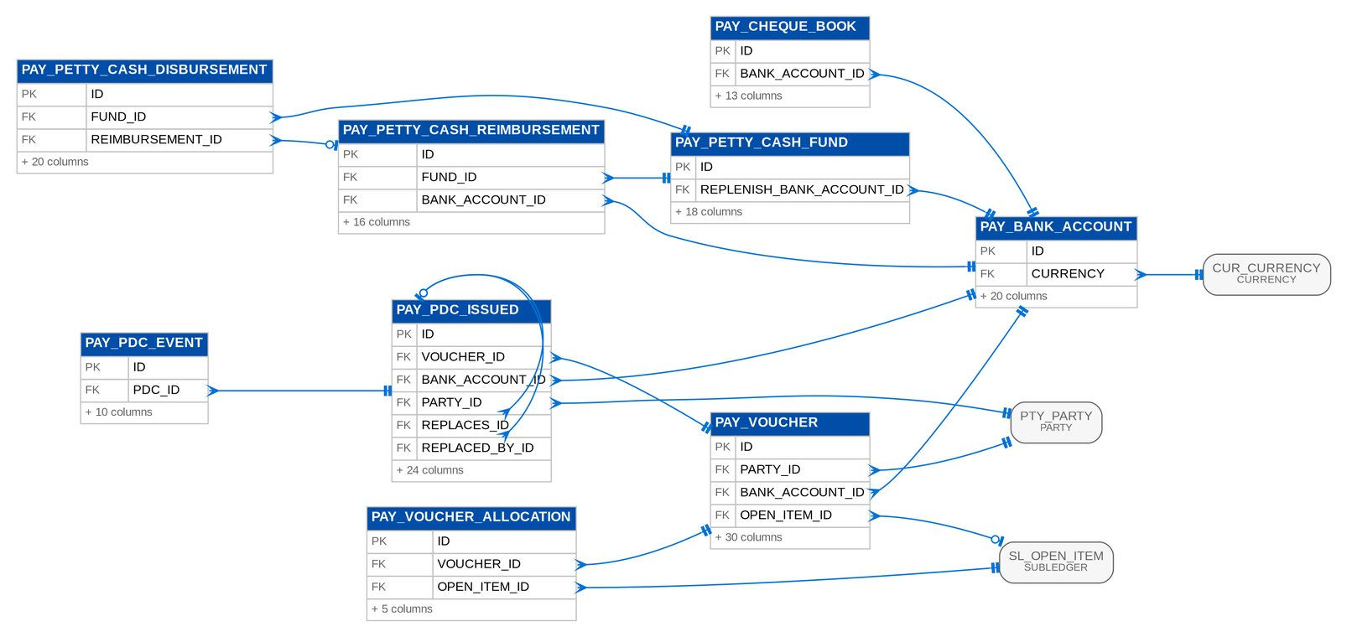
Figure 55: D10 PAYABLES (1 of 2): tables, primary keys and the foreign keys inside the module
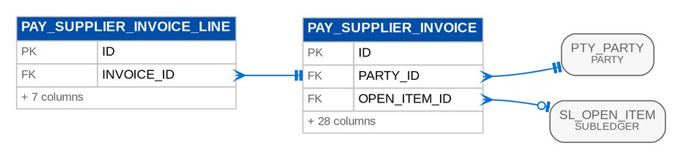
Figure 56: D10 PAYABLES (2 of 2): tables, primary keys and the foreign keys inside the module

3.10.3 Module PAYREQUEST
Table 64: Tables of module PAYREQUEST (D10)
Table | Description | Cols | Links | Figure
PRQ_LIQUIDATION | Liquidation of a disbursed cash advance (Appendix D Cash Advance Liquidation Form; in scope if confirmed, AQ18): fieldwork days with their expenses, the over / (short) against the cash advanced, and the journal of event PRQ_CA_LIQUIDATION once posted. | 20 | PRQ_REQUEST | D10 PAYREQUEST
PRQ_LIQUIDATION_ACCOUNT | The GL account Comptrollership assigns to an account role of the liquidation event PRQ_CA_LIQUIDATION (PER_DIEM, REPRESENTATION, TRANSPORT, LODGING, OTHER, CASH). | 9 | - | Listed only (no link)
PRQ_LIQUIDATION_LINE | One fieldwork day of a Cash Advance Liquidation Form (Appendix D): date, particulars and the expenses per category. | 10 | PRQ_LIQUIDATION | D10 PAYREQUEST
PRQ_REQUEST | A Marketing request for a payment or a check cancellation: a Refund Request Form with its lines, a Request for Payment of an employee cash advance, or the cancellation of a disbursed check. | 51 | - | D10 PAYREQUEST
PRQ_REQUEST_LINE | One account of a Refund Request Form (Appendix D, MKT 1.10.0): AR number, client, assured, amount, reason, branch / unit, categories and account or check name. | 16 | PRQ_REQUEST | D10 PAYREQUEST
PRQ_VALIDATION | A validation task of a refund of a cancelled policy (MKT 1.11.0, ACSL 2.5.5): ACSL checks the cancelled premium and the insurer's return, Cashiering confirms the reinstatement to the unapplied list with a new AR number. | 18 | PRQ_REQUEST | D10 PAYREQUEST

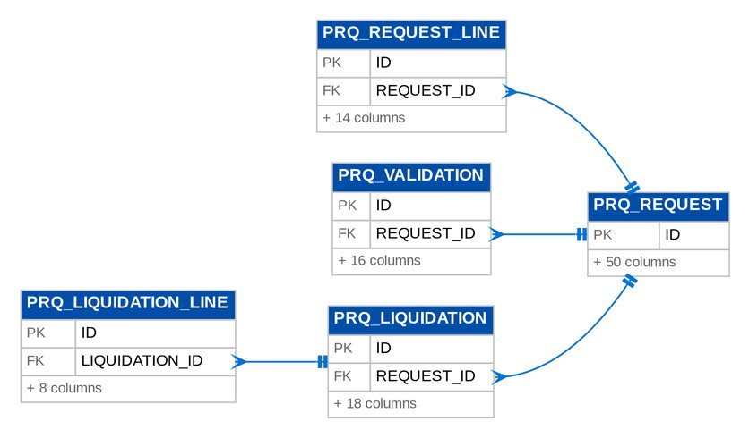
Figure 57: D10 PAYREQUEST: tables, primary keys and the foreign keys inside the module

3.10.4 Module ACSL
Table 65: Tables of module ACSL (D10)
Table | Description | Cols | Links | Figure
ACSL_CASE | An ACSL case: an account investigation, an account analysis request (the validation of a refund of a cancelled account asked by payrequest, MKT 1.11.0), an AR refund application or a sub-ledger payment reversal. | 31 | ACSL_CORRECTION | D10 ACSL
ACSL_CORRECTION | A correction entry: assigned by the team leader, prepared, reviewed and approved, then posted as a system journal whose lines are the correction's. | 28 | ACSL_CASE | D10 ACSL
ACSL_CORRECTION_LINE | One line of a correction entry (ACSL 2.9.0-2.9.1): the account, side and amount with the party, invoice and component it corrects, and the original journal line it reverses when it does. | 15 | ACSL_CORRECTION | D10 ACSL
ACSL_GLSL_CONTROL | Which sub-ledger backs a control account in the GL-SL reconciliation (ACSL 2.13.2). | 14 | - | Listed only (no link)
ACSL_GLSL_RECON | One control account in a GL-SL reconciliation (ACSL 2.13.2): the GL balance, the sub-ledger balance and the difference, all debit positive in base currency. | 8 | ACSL_GLSL_RUN | D10 ACSL
ACSL_GLSL_RUN | One GL-SL reconciliation of a company as of a date (ACSL 2.13.2), with its totals. | 8 | - | D10 ACSL
ACSL_RECON_RESULT | The reconciliation of one SOA line (ACSL 2.13.1, 2.14.1; Appendix C "SOA reconciliation"): the bucket, the book figures of the matched invoice (premium, outstanding, for remittance, remitted with batch and date, 2307 with batch and date, cancellation reference, direct billed), the insurer's figures and the variances. | 23 | ACSL_RECON_RUN | D10 ACSL
ACSL_RECON_RUN | One reconciliation of an insurer SOA against the books (ACSL 2.13.0-2.14.0), with the number of lines per bucket; the upload's latest run is its reconciliation report. | 12 | ACSL_SOA_UPLOAD | D10 ACSL
ACSL_SOA_LAYOUT | The layout of an insurer's statement of account (ACSL 2.4.0): the column header of each field in the insurer's file. | 17 | - | Listed only (no link)
ACSL_SOA_LINE | One row of an insurer statement of account (ACSL 2.4.0): loaded with the insurer's invoice, policy, assured, dates, gross premium, balance and payments, or failed with the reason (the upload log). | 13 | ACSL_SOA_UPLOAD | D10 ACSL
ACSL_SOA_UPLOAD | An insurer statement of account uploaded for a covered period (ACSL 2.2.1, 2.4.0): the file and its checksum, the layout used, the rows read, loaded and failed (the upload log proving every row was loaded) and the latest reconciliation run. | 18 | ACSL_RECON_RUN | D10 ACSL

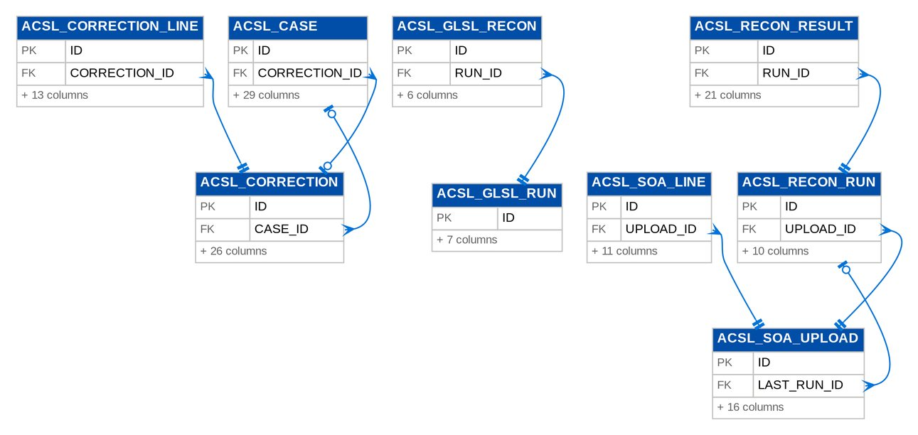
Figure 58: D10 ACSL: tables, primary keys and the foreign keys inside the module

3.11 D11 Renewal
Renewal candidates and their extraction runs, checks, dispositions, renewal letters, insurer quotations and acceptances. Owner: Product Owner, Renewal. BRD: BRD-06. 59 tables, 998 columns.

3.11.1 Module RENEWAL
Table 66: Tables of module RENEWAL (D11)
Table | Description | Cols | Links | Figure
RNW_ACCEPTANCE | The client's acceptance of a renewal (BRRN.040, BRRN.038 AC 3): method, evidence (attachment or the payment gate's reference), date, source and the acknowledgement of a financial impact. | 14 | RNW_CANDIDATE | D11 RENEWAL (3 of 5)
RNW_ASSIGNMENT | An assignment of a renewal to a Marketing AO or a Processing Officer (BRD 1.005, 3.005): from, to, reason, user and time. | 11 | RNW_CANDIDATE | D11 RENEWAL (3 of 5)
RNW_BDOFC_LINE | Bdofc line records. | 17 | RNW_CANDIDATE | D11 RENEWAL (3 of 5)
RNW_BILLING_FILE | A CLPC billing file (FRRN.027): the Built-in (amortized) or Non-Built-in accounts of a product line For Billing Generation, generated by the daily CBG Home job, the FFY job or by hand, with its delivery to the nominated recipients and its upload to the shared LMS directory. | 19 | - | Listed only (no link)
RNW_BUCKET_HISTORY | A change of bucket (BRRN.023 AC 6): from, to, rule set version and rule, check run, cause (rule or override), user (created by) and remarks. | 14 | RNW_CANDIDATE | D11 RENEWAL (3 of 5)
RNW_BUCKET_RULE | Bucket rule records. | 12 | RNW_BUCKET_RULE_SET | D11 RENEWAL (1 of 5)
RNW_BUCKET_RULE_SET | A versioned bucket rule set (BRRN.023): rules by priority turn the check results into Clean, Review or Exception. | 16 | - | D11 RENEWAL (1 of 5)
RNW_BUDGET | A record of the Annual Renewal Budget (BDOI Renewal FRS FRRN.042.02): a fiscal year, a market segment and the hierarchy it is set for, with the new, renewal and organic budget of each month. | 19 | - | D11 RENEWAL (1 of 5)
RNW_BUDGET_HISTORY | One change of a budget amount (FRRN.042.06): the field, the previous and the updated value, the user and the time. | 7 | RNW_BUDGET | D11 RENEWAL (1 of 5)
RNW_BUDGET_MONTH | Budget month records. | 5 | RNW_BUDGET | D11 RENEWAL (1 of 5)
RNW_CANDIDATE | A renewal candidate: one expiring root invoice and policy year (BRRN.005), or one migrated or submitted policy, from extraction to closure. | 129 | RNW_EXTRACTION_RUN | D11 RENEWAL (1 of 5)
RNW_CANDIDATE_ENDORSEMENT | An endorsement of the expiring invoice family linked to a renewal (BRRN.032 AC 3): the endorsement or request number, where it comes from (booking or Adjustment) and its status when it was linked. | 11 | RNW_CANDIDATE | D11 RENEWAL (3 of 5)
RNW_CHANNEL_EVENT | A status change of a channel message, kept for the delivery history (append-only). | 6 | RNW_CHANNEL_MESSAGE | D11 RENEWAL (1 of 5)
RNW_CHANNEL_MESSAGE | A message of a delivery channel (CCM to clients, MFT with insurers, or e-mail): the document it carries, its recipients, the external transaction reference and its delivery status. | 28 | RNW_CANDIDATE | D11 RENEWAL (1 of 5)
RNW_CHECK_RESULT | Check result records. | 13 | RNW_CANDIDATE, RNW_CHECK_RUN | D11 RENEWAL (1 of 5)
RNW_CHECK_RUN | One run of the checks of a candidate (BRRN.020): what triggered it, when, and the bucket before and after with the rule-set version (BRRN.023). | 14 | RNW_CANDIDATE | D11 RENEWAL (1 of 5)
RNW_CHECK_SETTING | Setting of one renewal check: active or not, the severity of a failure and optional parameters. | 13 | - | Listed only (no link)
RNW_DECISION_MATRIX | A versioned decision matrix (BRRN.031/034): rules by priority propose a disposition and whether it is applied automatically. | 16 | - | D11 RENEWAL (2 of 5)
RNW_DECISION_RULE | Decision rule records. | 21 | RNW_DECISION_MATRIX | D11 RENEWAL (2 of 5)
RNW_DISPOSITION | A disposition row: append-only. | 15 | RNW_CANDIDATE | D11 RENEWAL (3 of 5)
RNW_EPOLICY_LINE | Epolicy line records. | 11 | RNW_CANDIDATE, RNW_EPOLICY_RECEIPT | D11 RENEWAL (2 of 5)
RNW_EPOLICY_RECEIPT | A receipt of e-policy files (FRRN.033.01, FRRN.033.02): the summary file and the ZIP of e-policy documents of an insurer, uploaded or received by MFT, with its processing outcome. | 15 | - | D11 RENEWAL (2 of 5)
RNW_EXTRACTION_RUN | One extraction of expiring policies: the daily job, a range generated on demand, an upload of legacy policies or the go-live take-over, with its range and counts. | 21 | - | D11 RENEWAL (3 of 5)
RNW_FOLLOWUP | A Contact Center follow-up of a renewal (BRRN.026): channel, outcome, remarks and the next action date. | 11 | RNW_CANDIDATE | D11 RENEWAL (3 of 5)
RNW_HISTORY_VIEW | A view of the account history of a renewal (BRRN.027 AC 4): who opened it (created by), when, and which sections; the disposition is refused until the user has viewed it. | 8 | RNW_CANDIDATE | D11 RENEWAL (4 of 5)
RNW_HOLD_COVER_REQUEST | A hold cover request of a renewal account to one insurer (FRRN.036): the initial request, an extension, the request of a Clean CBG account in the file of its insurer, or the monthly CBG Home extension; with how it was sent and the insurer's response (FRRN.037). | 22 | RNW_CANDIDATE | D11 RENEWAL (4 of 5)
RNW_INSURANCE_ADVICE | A version of the Insurance Advice of a mortgaged renewal account (FRRN.032): generated when the placement is sent and again when the placement changes; earlier versions are kept. | 14 | RNW_CANDIDATE | D11 RENEWAL (4 of 5)
RNW_INSURER_ALLOCATION | The share of an insurer in a renewal account allocated to several insurers (FRRN.014.03). | 7 | RNW_CANDIDATE | D11 RENEWAL (4 of 5)
RNW_INSURER_BATCH | A batch of For Renewal accounts sent to one insurer (BRD 3.009, 4.007): the insurer, the expiry range, the extract file (attachment of type INSURER_RENEWAL_FILE), the protected e-mail and the reply date (alert RNW_INSURER_OVERDUE after it). | 19 | - | D11 RENEWAL (2 of 5)
RNW_INSURER_BATCH_LINE | Insurer batch line records. | 10 | RNW_CANDIDATE, RNW_INSURER_BATCH | D11 RENEWAL (2 of 5)
RNW_INSURER_DISPOSITION_LINE | Insurer disposition line records. | 12 | RNW_CANDIDATE | D11 RENEWAL (4 of 5)
RNW_INSURER_DISPOSITION_MAP | Insurer disposition map records. | 8 | - | Listed only (no link)
RNW_INSURER_RENEWABLE_RISK | A risk code an insurer renews (insurer renewable list, Annex BRRN.020 SC-10; FR-RN-020). | 15 | - | Listed only (no link)
RNW_INSURER_RESPONSE | An insurer's response to a renewal (BRD 3.009.6; BRRN.035): append-only. | 23 | RNW_CANDIDATE | D11 RENEWAL (4 of 5)
RNW_KYC_ACTIVITY | KYC activity records. | 8 | RNW_CANDIDATE | D11 RENEWAL (4 of 5)
RNW_LAMD_LINE | Lamd line records. | 16 | RNW_CANDIDATE, RNW_LAMD_REPORT | D11 RENEWAL (2 of 5)
RNW_LAMD_LOAN | Lamd loan records. | 25 | RNW_CANDIDATE | D11 RENEWAL (4 of 5)
RNW_LAMD_REPORT | A LAMD report uploaded by the LAMD user (BRRN.029): paid-off or RMU loans of a month, with the upload job and the number of lines matched to renewals by PN. | 13 | - | D11 RENEWAL (2 of 5)
RNW_LETTER | A renewal letter: Renewal Advice (first or second notice), No Advice Letter, Not for Renewal Letter, NRNS reminder or non-acceptance letter. | 27 | RNW_CANDIDATE | D11 RENEWAL (4 of 5)
RNW_LETTER_BATCH | A batch generation or sending of renewal letters (BRRN.010; job RNW_LETTER_BATCH): the selection, the counts and the messages of the failures. | 18 | - | Listed only (no link)
RNW_NON_RENEWABLE_RISK_CODE | A risk code that is not renewable (BRRN.009): renewals on it are tagged Not for Renewal by the system and receive the Not for Renewal Letter. | 18 | - | Listed only (no link)
RNW_OVERRIDE | A controlled override (BRD 1.011; BRRN.023/031/035): explicit, with a reason and mandatory remarks, logged with the user and time. | 14 | RNW_CANDIDATE | D11 RENEWAL (4 of 5)
RNW_PACKAGE_CHOICE | The BIBS package version chosen for a migrated policy whose legacy package the map does not resolve (DMQ36; FR-RN-028): chosen with a reason by a member of the Renewal processing team (maker, created by) and approved or rejected by a second member. | 16 | RNW_CANDIDATE | D11 RENEWAL (5 of 5)
RNW_PACKAGE_MAP | An entry of the PACKAGE code map: a legacy package code and version, optionally narrowed by risk code, insurer or sum-insured band, maps to a BIBS package version, or is marked REJECT (no BIBS package). | 22 | - | Listed only (no link)
RNW_PAID_OFF_ACCOUNT | Paid off account records. | 12 | - | Listed only (no link)
RNW_PLACEMENT | The placement of a renewal account with one insurer (FRRN.029, FRRN.030): its placement slip, the consolidated placement file it is in, how it was sent, the turnaround time with the With Issue tag and the insurer's response. | 30 | RNW_CANDIDATE, RNW_PLACEMENT_FILE | D11 RENEWAL (2 of 5)
RNW_PLACEMENT_FILE | The consolidated placement file of an insurer (FRRN.029.02.02): one workbook of the packaged renewal accounts placed with the insurer, with how it was sent. | 15 | - | D11 RENEWAL (2 of 5)
RNW_PLACEMENT_TRACKING | Placement tracking records. | 15 | - | Listed only (no link)
RNW_PROCESSING_ASSIGNMENT | Processing assignment records. | 9 | - | Listed only (no link)
RNW_PROPOSAL | A proposal of a renewal account (FRRN.017, FRRN.018): a Quick or Full Proposal generated from the account, or the proposal completed by TSU, with its signatories and its sending through CCM. | 16 | RNW_CANDIDATE | D11 RENEWAL (5 of 5)
RNW_RA_SENT_REQUEST | The correction of a rejected row of the Renewal Advices already sent before go-live (DMQ38; FR-RN-016): prepared by a member of the Renewal processing team (maker, created by) and applied only after a second member approves it. | 20 | RNW_CANDIDATE | D11 RENEWAL (5 of 5)
RNW_REFERRAL | A transfer request for a New Business opportunity (BDOI Renewal FRS FRRN.011): a referral of a renewal account to another Marketing unit, which accepts it and opens a New Business account from the copied data; the renewal account keeps its unit and Account Officer. | 19 | RNW_CANDIDATE | D11 RENEWAL (5 of 5)
RNW_REMARK | A remark on a renewal (BRD 2.004.6-8): at most 200 characters, stamped with the user, time and stage; never edited. | 9 | RNW_CANDIDATE | D11 RENEWAL (5 of 5)
RNW_RMU_OFFICER | Rmu officer records. | 11 | - | Listed only (no link)
RNW_SUBMITTED_HANDOFF | The terms a submitted policy was handed to Renewal with: the RA template (generic or Free First Year), the insurer assigned by the insurer rules of Submitted Policies, the handler and Account Officer, the mailing address of printed letters and whether the renewal was started by hand (Renew with BDOI). | 15 | RNW_CANDIDATE | D11 RENEWAL (5 of 5)
RNW_TRANSFER | A transfer of a renewal to another Marketing unit (BRD 1.006, 1.007, 2.005): requested with remarks, accepted or declined with remarks by a Team Leader of the receiving unit, or cancelled by the sender. | 16 | RNW_CANDIDATE | D11 RENEWAL (5 of 5)
RNW_TSU_QUOTE | Tsu quote records. | 8 | RNW_TSU_REQUEST | D11 RENEWAL (3 of 5)
RNW_TSU_REQUEST | A quotation request of a renewal account For Quotation to TSU (FRRN.018.01): submitted for the Team Lead's approval, approved, rejected or returned for revision, assigned to a TSU Officer and completed with the comparative table and the proposal. | 15 | RNW_CANDIDATE | D11 RENEWAL (3 of 5)
RNW_UPLOAD_SCOPE | The declared scope of a renewal upload (BRD 3.004.4): the expiry range and unit a dispositioned file covers and whether it is complete. | 15 | - | Listed only (no link)

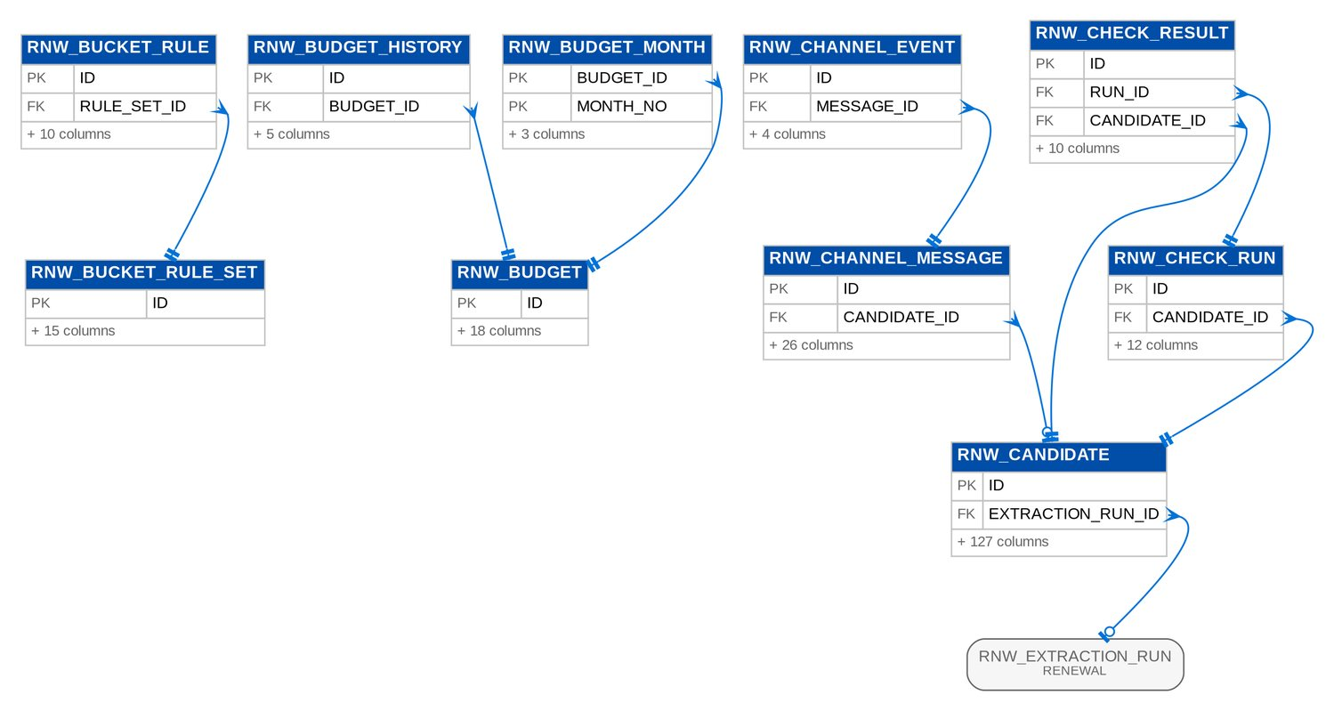
Figure 59: D11 RENEWAL (1 of 5): tables, primary keys and the foreign keys inside the module
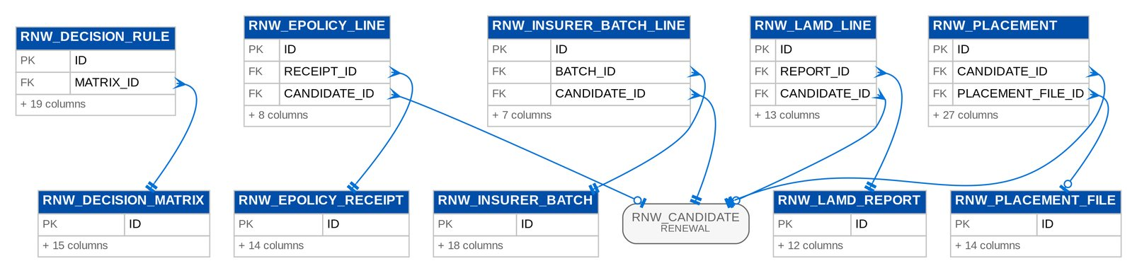
Figure 60: D11 RENEWAL (2 of 5): tables, primary keys and the foreign keys inside the module
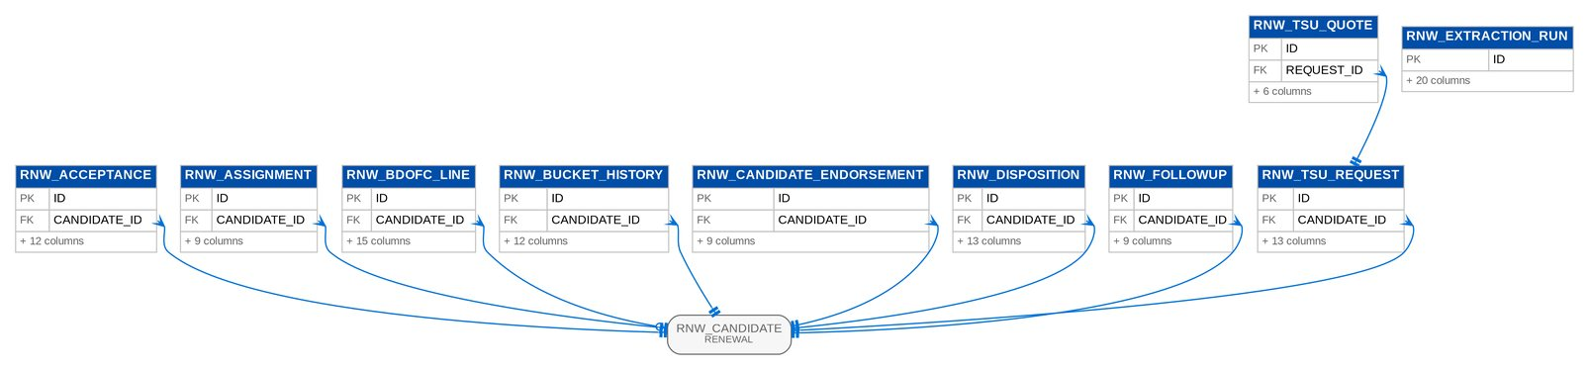
Figure 61: D11 RENEWAL (3 of 5): tables, primary keys and the foreign keys inside the module
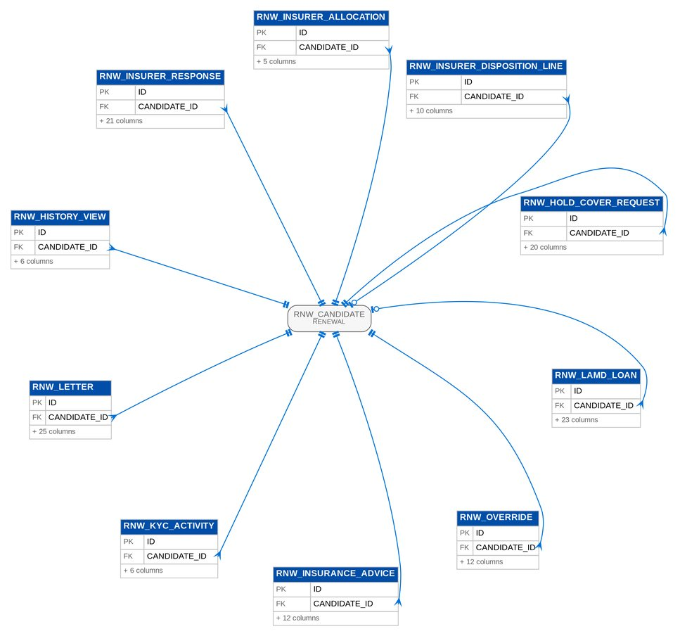
Figure 62: D11 RENEWAL (4 of 5): tables, primary keys and the foreign keys inside the module
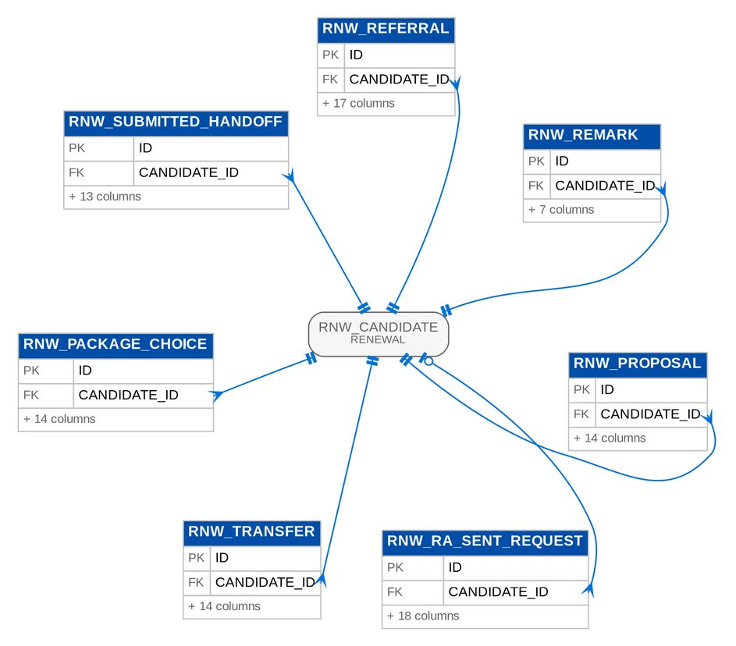
Figure 63: D11 RENEWAL (5 of 5): tables, primary keys and the foreign keys inside the module

3.12 D12 Claims Broking
Claims reported by clients and followed with the insurers, insurer lines and updates, reserve changes as advised, status history, diary and documents. BIBS posts no claim journal. Owner: Product Owner, Claims (with the Unit Head - Claims and Risk Management). BRD: BRD-07. 13 tables, 229 columns.

3.12.1 Module BROKERCLAIMS
Table 67: Tables of module BROKERCLAIMS (D12)
Table | Description | Cols | Links | Figure
BCL_ATTRIBUTE_CHANGE | A proposed value of an attribute of a status or settlement type (BRCLM.010/014, FR-CM-040/043): it waits for another BCL_SETUP user to authorize it, then applies to BCL_LOV_ATTRIBUTE. | 13 | LOV_TYPE, LOV_VALUE | D12 BROKERCLAIMS (1 of 2)
BCL_CLAIM | A BDOI claim case file: one claim reference per loss incident whatever the number of locations and insurers (037 AC4, 043 AC3), numbered BCL--nnnnnn (CLQ13). | 67 | - | D12 BROKERCLAIMS (1 of 2)
BCL_CLAIM_EVENT | One change of a tracked field of a claim with its old and new value, reason, user and time. | 13 | BCL_CLAIM | D12 BROKERCLAIMS (1 of 2)
BCL_CLAIM_LOCATION | An insured location of the cover linked to a claim: the risk item of kind location with a snapshot of its address, city, province and normalised location key, and the damage at that location. | 13 | BCL_CLAIM | D12 BROKERCLAIMS (1 of 2)
BCL_DIARY_ENTRY | A diary entry of a claim (BRCLM.022, NFR 15.08; FR-CM-052): a call, e-mail, meeting, note or follow-up with its date, optional due date and assignee, and the text; marked done when completed. | 15 | BCL_CLAIM | D12 BROKERCLAIMS (1 of 2)
BCL_HANDLER | A claims handler of the register: the unit of the user drives the status access matrix and the default assignment, the team is shown on the reports. | 11 | LOV_VALUE | D12 BROKERCLAIMS (1 of 2)
BCL_INSURER_CLAIM | One insurer's side of a claim incident: the insurer, its share, the insurer's own claim number and the date the loss was reported to it, the insurer reserve and settled amount as reported by the insurer (information only, BDOI posts no journal, Q44) and the adjuster the insurer appointed. | 15 | BCL_CLAIM | D12 BROKERCLAIMS (1 of 2)
BCL_INSURER_UPDATE | A communication received from an insurer about a claim: date, source (BCL_UPDATE_SOURCE), the insurer's reference, remarks and the attachments that carry the insurer's document, optionally tied to one insurer line. | 17 | BCL_CLAIM, BCL_INSURER_CLAIM, BCL_INSURER_UPDATE | D12 BROKERCLAIMS (1 of 2)
BCL_LOCATION_REF | The reference an insurer uses for an insured location of a cover, valid from a date. | 15 | - | Listed only (no link)
BCL_LOV_ATTRIBUTE | An attribute of a Claims list value: the phase, waiting party, follow-up days and "awaiting premium remittance" flag of a claim status, and the outcome, closure and amount rules of a settlement type. | 10 | LOV_TYPE, LOV_VALUE | D12 BROKERCLAIMS (2 of 2)
BCL_RESERVE_CHANGE | One amendment of an insurer reserve: previous and new amount, reason, user and time. | 12 | BCL_INSURER_CLAIM | D12 BROKERCLAIMS (1 of 2)
BCL_STATUS_ACCESS | A row of the status access matrix: the status may be selected by a holder of the role in the unit (null = any unit). | 13 | LOV_VALUE, SEC_ROLE | D12 BROKERCLAIMS (2 of 2)
BCL_STATUS_HISTORY | One status change of a claim: from and to status and phase, user, time, remark and the days spent in the previous status, which the ageing per status report reads. | 15 | BCL_CLAIM | D12 BROKERCLAIMS (1 of 2)

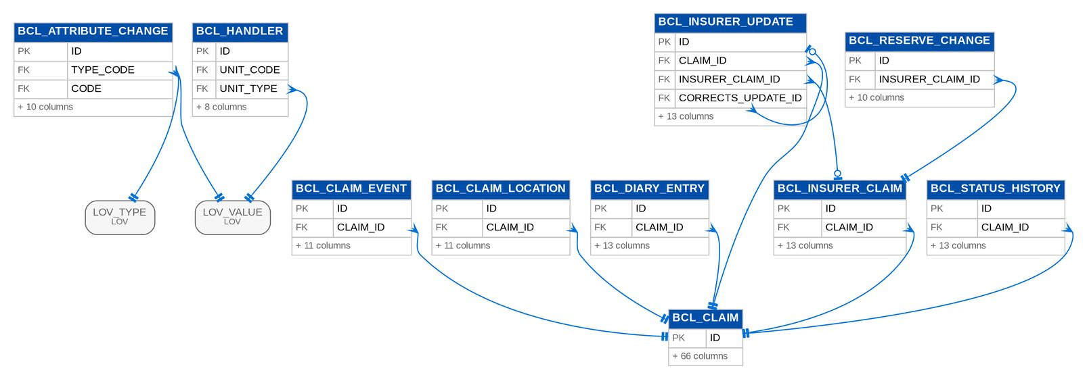
Figure 64: D12 BROKERCLAIMS (1 of 2): tables, primary keys and the foreign keys inside the module
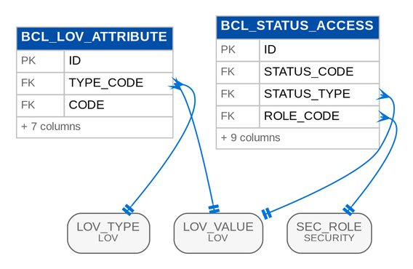
Figure 65: D12 BROKERCLAIMS (2 of 2): tables, primary keys and the foreign keys inside the module

3.13 D13 Employee Benefits
Employee benefits programmes, proposals, benefit lines and plans, census and member movements, billing cycles, tracked items and turnaround times. Owner: Product Owner, Employee Benefits. BRD: BRD-08. 38 tables, 608 columns.

3.13.1 Module EB
Table 68: Tables of module EB (D13)
Table | Description | Cols | Links | Figure
EB_ACTIVITY_LOG | A received / released stamp of an activity of the TAT annex (BRID-022, 024; design 4.2): written by the EB services at each step, read by the EB-TAT report. | 15 | EB_CYCLE, EB_PROGRAMME | D13 EB (2 of 4)
EB_BOR | A version of the client's signed Broker on Record for a cycle: the file, the validator's checklist, the validity dates and the decision. | 20 | DOC_ATTACHMENT, EB_CYCLE, EB_PROGRAMME | D13 EB (2 of 4)
EB_CLIENT_CONFIRMATION | The client's confirmation of the chosen proposals (BRID-017; FR-EB-046): channel (e-mail or signed document; no portal), date and the evidence, and per programme line the chosen proposal and insurer, later the account created at placement. | 16 | DOC_ATTACHMENT, EB_COMPARATIVE, EB_CYCLE, EB_PROGRAMME | D13 EB (3 of 4)
EB_COMMENT | A comment on a comparative (FR-EB-043): an internal note or reply, or the client's comment received by e-mail and entered by the AO. | 10 | EB_COMMENT, EB_COMPARATIVE | D13 EB (3 of 4)
EB_COMPARATIVE | A comparative analysis of the validated proposals of a cycle (BRID-010, 011, 016; FR-EB-041 to 043), numbered EBCA--nnnnnn: a snapshot of the rows (JSON) and, per benefit line, the lowest premium and the proposal the AO recommends. | 22 | DOC_ATTACHMENT, EB_CYCLE, EB_PROGRAMME | D13 EB (3 of 4)
EB_COMPARATIVE_LINE | Comparative line records. | 10 | EB_COMPARATIVE, EB_PROPOSAL | D13 EB (3 of 4)
EB_COMPARATIVE_SIGNOFF | A sign-off or threshold decision on a comparative: signatory, role, decision and remarks. | 12 | EB_COMPARATIVE | D13 EB (3 of 4)
EB_CONFIRMATION_LINE | Confirmation line records. | 14 | EB_CLIENT_CONFIRMATION, EB_PROPOSAL | D13 EB (3 of 4)
EB_CYCLE | One policy year of a programme (design 4.2, 7.1): numbered EBC--nnnnnn, with its business type NEW_BUSINESS or RENEWAL (BRID-022.01; carried to the accounts created at placement, shared work item BT0), the stage mirrored from its EB_CYCLE work case, the outcome and the ARNs created for it. | 18 | EB_PROGRAMME | D13 EB (1 of 4)
EB_CYCLE_ACCOUNT | Cycle account records. | 3 | EB_CYCLE | D13 EB (3 of 4)
EB_DOCUMENT | A document in the EB register (BRID-007, 008, 024, 025; design 4.2): the attachment with its document type, process tag and version on a programme and optionally a cycle, and where it came from. | 15 | DOC_ATTACHMENT, EB_CYCLE, EB_PROGRAMME | D13 EB (3 of 4)
EB_FEEDBACK | The client's feedback on a cycle (BRID-002, 003; FR-EB-023): channel, date received, the text and / or the files (stored as EB_CLIENT_FEEDBACK documents of the cycle). | 13 | EB_CYCLE, EB_PROGRAMME | D13 EB (3 of 4)
EB_FRANCHISE_REQUEST | A franchise request to an insurer (BRID-026, 027, 029; FR-EB-032, 033), numbered EBF--nnnnnn, with its EB_FRANCHISE work case whose stage it mirrors. | 24 | DOC_ATTACHMENT, EB_CYCLE, EB_PROGRAMME | D13 EB (4 of 4)
EB_INSURER_REQUEST | A request for proposal sent to an insurer (BRID-009; FR-EB-035), numbered EBR--nnnnnn: the TOR version, documents and due date, sent by e-mail. | 20 | EB_CYCLE, EB_PROGRAMME, EB_TOR | D13 EB (1 of 4)
EB_MEMBER | A member of a roster version (FR-EB-054): employee number, name, birth date, gender, civil status, plan, dependants and effective dates. | 20 | EB_PROGRAMME, EB_ROSTER_VERSION | D13 EB (2 of 4)
EB_MEMBER_CHANGE | A member change of a programme line (BRID-013, 025; FR-EB-055, 056), numbered EBM--nnnnnn, with its EB_MEMBER_CHANGE work case whose stage it mirrors: lines adding, deleting or changing members, relayed to the insurer, billed (insurer billing or direct billing), validated by Processing (raising the endorsement request of a change with a premium effect) and closed, when its lines are applied to the roster. | 27 | EB_PROGRAMME | D13 EB (2 of 4)
EB_MEMBER_CHANGE_LINE | Member change line records. | 19 | EB_MEMBER, EB_MEMBER_CHANGE | D13 EB (2 of 4)
EB_PROGRAMME | An Employee Benefits programme of a client (BRID-006, 022.01; design 4.2): the benefit lines (HMO, GLI, GPA) with the incumbent insurer and current policy, the team, the funding, the HR contacts and the account officer. | 18 | - | D13 EB (2 of 4)
EB_PROGRAMME_CONTACT | A client contact of a programme (design 4.2): HR head, HR officer or finance, with the flags for the renewal advice and SOA e-mails (BRID-001, 021). | 14 | EB_PROGRAMME | D13 EB (4 of 4)
EB_PROGRAMME_LINE | A benefit line of a programme (design 4.2): benefit line (list EB_BENEFIT_LINE), product, the incumbent insurer, the current policy and ARN (the ARN a renewal renews, BT0 RENEWAL_OF_REF), the period and the headcount. | 17 | EB_PROGRAMME | D13 EB (4 of 4)
EB_PROPOSAL | An insurer proposal on a cycle (BRID-005.02, 005.03, 010, 015; FR-EB-040, 045), numbered EBPR--nnnnnn: the incumbent's indicative terms, a proposal answering a request, or a revised proposal answering a revision request. | 26 | DOC_ATTACHMENT, EB_CYCLE, EB_INSURER_REQUEST, EB_PROGRAMME, EB_REVISION_REQUEST | D13 EB (3 of 4)
EB_PROPOSAL_FACTOR | A capability factor of a proposal (list EB_CAPABILITY_FACTOR): value and rating 1 to 5. | 10 | EB_PROPOSAL | D13 EB (4 of 4)
EB_PROPOSAL_ITEM | The answer of a proposal to a TOR item: what is offered and whether it deviates. | 11 | EB_PROPOSAL, EB_TOR_ITEM | D13 EB (1 of 4)
EB_PROPOSAL_LINE | The premium of one plan of a benefit line in a proposal. | 15 | EB_PROPOSAL | D13 EB (4 of 4)
EB_RENEWAL_ADVICE | The renewal advice of a renewal cycle (BRID-001, 002; design 4.2, 8.1): when and to whom it was sent, by the job EB_RENEWAL_ADVICE or the AO, the outbox message, the stored RENEWAL_ADVICE document, the reminders sent and the time the client's feedback stopped them. | 19 | DOC_ATTACHMENT, EB_CYCLE, EB_PROGRAMME | D13 EB (4 of 4)
EB_REQUIRED_DOCUMENT | A document required for a process (BRID-026; FR-EB-034): process type x benefit line (blank for every line) x document type, mandatory or optional. | 14 | - | Listed only (no link)
EB_REVISION_ITEM | Revision item records. | 10 | EB_REVISION_REQUEST, EB_TOR_ITEM | D13 EB (1 of 4)
EB_REVISION_REQUEST | The client's changes relayed to insurers (BRID-012, 015; FR-EB-044, 045): requested changes on TOR items or in free text, and the insurers asked to revise their proposals, each OPEN until its revised proposal is recorded. | 15 | EB_CYCLE, EB_PROGRAMME | D13 EB (1 of 4)
EB_REVISION_TARGET | Revision target records. | 11 | EB_PROPOSAL, EB_REVISION_REQUEST | D13 EB (1 of 4)
EB_ROSTER_VERSION | A version of the member roster of a programme and policy year (BRID-013, 014; FR-EB-054), loaded from the master list through the bulk handler EB_MASTERLIST as STAGED; the AO reviews the differences with the accepted version and accepts it (the earlier accepted version is superseded and stays readable) or rejects it. | 16 | EB_PROGRAMME | D13 EB (2 of 4)
EB_SOA | An insurer statement of account of a programme (BRID-021; FR-EB-053), numbered EBS--nnnnnn, with its EB_SOA work case whose stage it mirrors: the insurer's SOA number, period, amount, the stored file and its hash (duplicate check) and the booked invoices it bills. | 26 | DOC_ATTACHMENT, EB_PROGRAMME | D13 EB (1 of 4)
EB_SOA_INVOICE | SOA invoice records. | 8 | EB_SOA | D13 EB (1 of 4)
EB_SUBMISSION | Documents submitted to an insurer for a process (BRID-026; FR-EB-034): new-business or renewal placement, adjustment, endorsement, franchise or proposal, on a cycle or a member change, sent by protected e-mail after the required-document check. | 18 | EB_CYCLE, EB_MEMBER_CHANGE, EB_PROGRAMME | D13 EB (2 of 4)
EB_SUBMISSION_DOCUMENT | Submission document records. | 9 | DOC_ATTACHMENT, EB_SUBMISSION | D13 EB (2 of 4)
EB_THRESHOLD_RULE | A value threshold above which a comparative needs Management approval (BRID-016; FR-EB-042): per benefit line or all lines, on the TSI or the annual premium of the recommended (or chosen) proposal, with the approver permission and level and the effective dates. | 19 | - | Listed only (no link)
EB_TOR | A version of the Terms of Reference of a cycle (BRID-009; FR-EB-035): structured items per benefit line and plan, maintained while DRAFT and frozen when released. | 14 | DOC_ATTACHMENT, EB_CYCLE, EB_PROGRAMME | D13 EB (1 of 4)
EB_TOR_ITEM | An item of the Terms of Reference: benefit line, plan, description and requirement. | 12 | EB_TOR | D13 EB (1 of 4)
EB_TRACKED_ITEM | A deliverable BDOI waits for (BRID-030; FR-EB-057): the contract after placement, an HMO card, a card replacement or a billing, owed by the insurer, the client or BDOI, with its due date. | 28 | EB_CYCLE, EB_MEMBER, EB_MEMBER_CHANGE, EB_PROGRAMME | D13 EB (2 of 4)

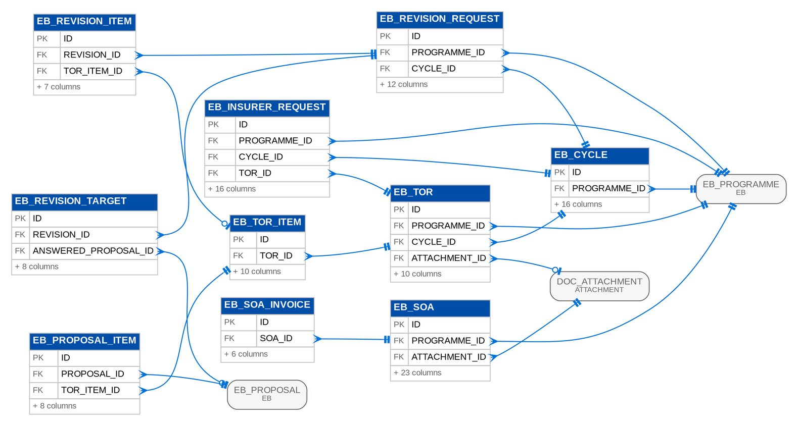
Figure 66: D13 EB (1 of 4): tables, primary keys and the foreign keys inside the module
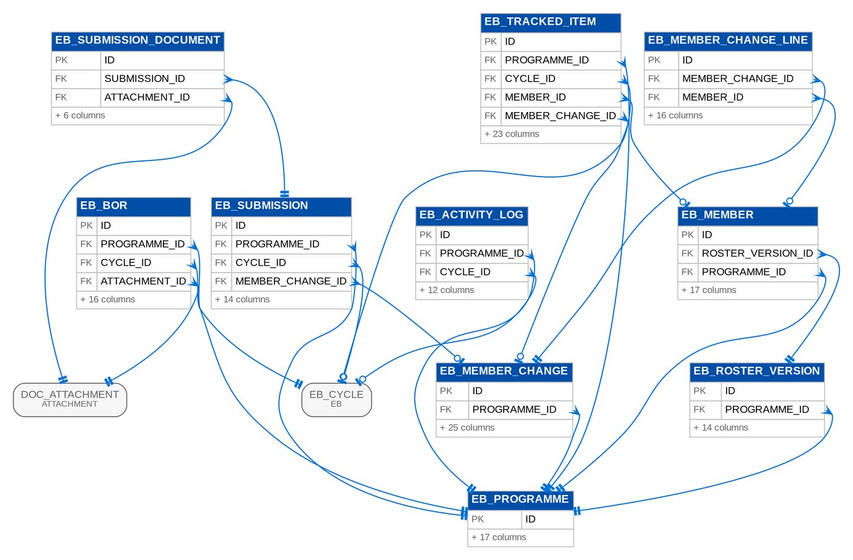
Figure 67: D13 EB (2 of 4): tables, primary keys and the foreign keys inside the module
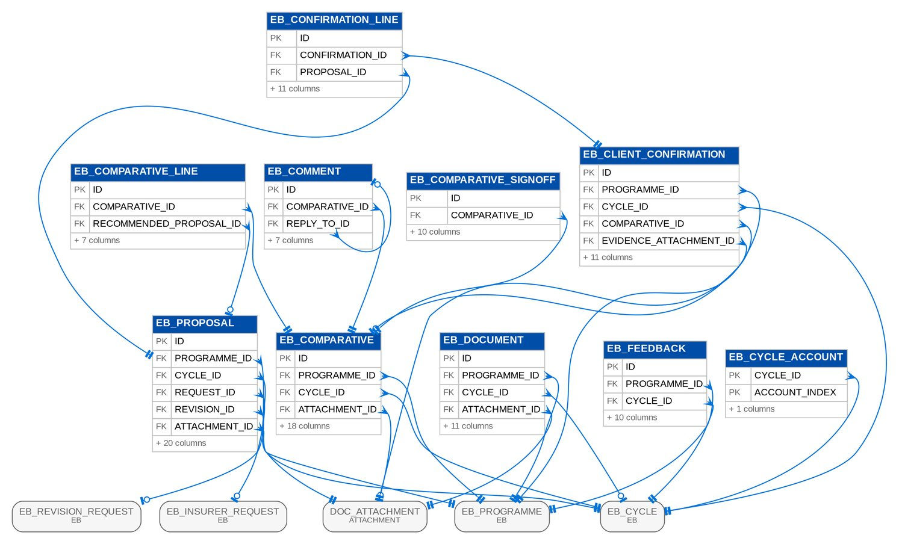
Figure 68: D13 EB (3 of 4): tables, primary keys and the foreign keys inside the module
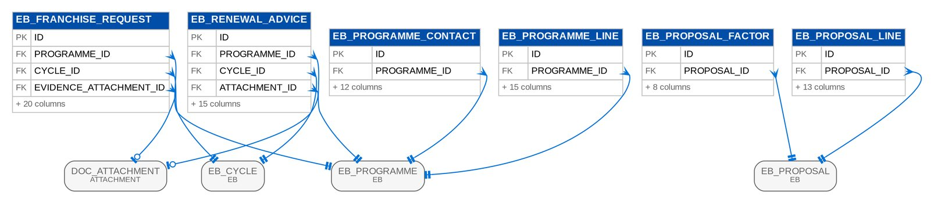
Figure 69: D13 EB (4 of 4): tables, primary keys and the foreign keys inside the module

3.14 D14 Customer Servicing Facility
Client service requests, contact changes with their verification and synchronisation, activities and referrals. Owner: Product Owner, Customer Servicing Facility. BRD: BRD-09. 6 tables, 74 columns.

3.14.1 Module CSF
Table 69: Tables of module CSF (D14)
Table | Description | Cols | Links | Figure
CSF_ACTIVITY | One action of an agent in the Customer Servicing Facility (FR-CSF-042): searches with their criteria, views, downloads, resends, uploads, verifications, contact changes and referrals. | 14 | - | Listed only (no link)
CSF_CONTACT_CHANGE | A contact change made from the Customer Servicing Facility (FR-CSF-021, 022, 040): applied to the client master, refused (a field the contact centre cannot change) or referred to the fulfilment unit, with the verification of the caller, the reason, the field rows with the values before and after, and the legacy write-back state. | 20 | CSF_VERIFICATION | D14 CSF
CSF_CONTACT_CHANGE_FIELD | Contact change field records. | 5 | CSF_CONTACT_CHANGE | D14 CSF
CSF_SYNC_OUTBOX | One contact change to send to one legacy system (FR-CSF-022, CSQ01): the payload is kept with every row, so the outbox can be replayed once the interface is specified. | 14 | CSF_CONTACT_CHANGE | D14 CSF
CSF_VERIFICATION | Verification of a caller before a contact change (FR-CSF-020; e-mail topic 5): the checks asked, whether each answer matched, the result and how long a passed verification stays valid. | 17 | - | D14 CSF
CSF_VERIFICATION_CHECK | Verification check records. | 4 | CSF_VERIFICATION | D14 CSF

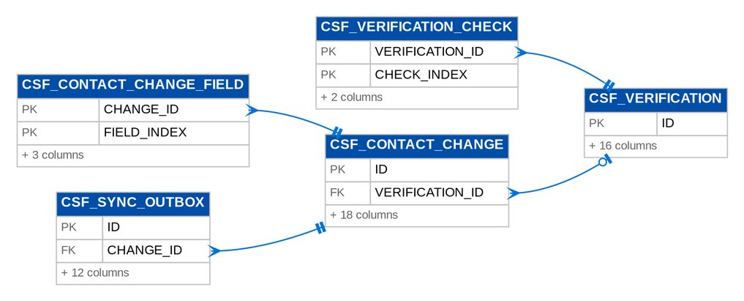
Figure 70: D14 CSF: tables, primary keys and the foreign keys inside the module

3.15 D15 Sanction Screening
Watchlists and their changes, screening runs and hits, cases with reviews and committee votes, client risk profiles, configuration versions and validation rules, and suspicious transaction reports. Owner: Compliance Officer (AMLA), with the Unit Head - Claims and Risk Management for risk profiling. BRD: BRD-10. 34 tables, 553 columns.

3.15.1 Module SCREENING
Table 70: Tables of module SCREENING (D15)
Table | Description | Cols | Links | Figure
SCR_APPROVAL_ROUTE | A route of an APPROVAL_MATRIX version (SNSRP-103, 703). | 16 | SCR_CONFIG_VERSION | D15 SCREENING (3 of 4)
SCR_ASSIGNMENT_RULE | A scenario of an ASSIGNMENT_MATRIX version (SNSRP-106). | 16 | SCR_CONFIG_VERSION | D15 SCREENING (3 of 4)
SCR_CASE | A screening case (SNSRP-303, 401-405, 501, 502, 701-706; design 4.4): the client, what opened it, its type and risk category, the active-policy flag, the marketing unit and unit head, the stage of workflow SCR_CASE (mirrored), the assignee, the disposition and recommendation, the SLA state of the current stage entry and the configuration versions in force when it was opened (FR-SS-034 R4). | 54 | SCR_CONFIG_VERSION, WF_CASE | D15 SCREENING (1 of 4)
SCR_CASE_ANSWER | The answer to one template field of a case review (SNSRP-501): text (text, long text, list and check box fields), number (number and amount), date or attachment. | 12 | SCR_CASE_REVIEW | D15 SCREENING (1 of 4)
SCR_CASE_DOCUMENT | The metadata of a document uploaded on a case (SNSRP-601; FR-SS-052): form type, document type, date received, source, the sequence among the case's documents of the type and the name of the BRD naming convention ____. | 15 | SCR_CASE | D15 SCREENING (1 of 4)
SCR_CASE_EVENT | One entry of the insert-only case timeline (SNSRP-401, 404, 405, 701-704, 902, 903; design 4.4): the event, the round, the stages and values before and after, the reason, the remarks, the actor and the time. | 17 | SCR_CASE | D15 SCREENING (1 of 4)
SCR_CASE_REVIEW | The review of a case on its template (SNSRP-501; FR-SS-050): the template version fixed when the review started (SNSRP-104 "applies to new reviews only") and its status. | 12 | SCR_CASE, SCR_CONFIG_VERSION | D15 SCREENING (1 of 4)
SCR_CLIENT_RISK_PROFILE | One change of a client's risk profile made by screening (SNSRP-302, 304; FR-SS-033, 035): the category, the rating before and after, the tags added and ended, the source (RULE with the rule, the match and the run; MANUAL with the justification and the evidence) and the time. | 25 | SCR_CONFIG_VERSION, SCR_MATCH, SCR_SCREENING_RUN | D15 SCREENING (2 of 4)
SCR_COMMITTEE_VOTE | An AML Committee member's decision on a case round (SNSRP-704; FR-SS-064): APPROVE_STR, NO_STR or COMMITTEE_RETURN with remarks. | 12 | SCR_CASE | D15 SCREENING (1 of 4)
SCR_CONFIG_VERSION | One version of a screening configuration set (SNSRP-101-109; design 4.1). | 20 | SCR_CONFIG_VERSION | D15 SCREENING (1 of 4)
SCR_INGESTION_ERROR | A list record that failed ingestion, with its line, raw record and reason (SNSRP-202). | 11 | SCR_INGESTION_RUN | D15 SCREENING (2 of 4)
SCR_INGESTION_RUN | The log of one ingestion of a list file (SNSRP-201): source, trigger, file, records received, added, updated, delisted, unchanged and failed, status and reason for failure. | 23 | SCR_WATCHLIST_SOURCE | D15 SCREENING (2 of 4)
SCR_MATCH | A client matched against a watchlist entry version under a configuration version (SNSRP-301, FR-SS-031): score, algorithm, matched fields and status POTENTIAL, TRUE_MATCH or FALSE_POSITIVE. | 28 | SCR_CONFIG_VERSION, SCR_SCREENING_RUN, SCR_WATCHLIST_ENTRY | D15 SCREENING (2 of 4)
SCR_MATCH_RULE | A matching rule of a MATCH_CRITERIA version (SNSRP-101). | 14 | SCR_CONFIG_VERSION | D15 SCREENING (3 of 4)
SCR_MATCH_SUPPRESSION | A client cleared as a false positive for one watchlist entry version (SNSRP-304; FR-SS-035 R2; SQ12): the pair is not matched again until the entry changes (a new entry version). | 14 | SCR_MATCH, SCR_WATCHLIST_ENTRY | D15 SCREENING (2 of 4)
SCR_NAME_KEY | A blocking key of a client or watchlist entry name (SNSRP-301; design 4.2 SCR_NAME_KEY). | 10 | - | Listed only (no link)
SCR_RISK_CATEGORY | A risk-profile category of a RISK_RULES version (SNSRP-102). | 14 | SCR_CONFIG_VERSION | D15 SCREENING (3 of 4)
SCR_RISK_RULE | A tagging rule of a RISK_RULES version (SNSRP-102). | 12 | SCR_CONFIG_VERSION | D15 SCREENING (3 of 4)
SCR_SCREENING_RUN | The log of one screening run (SNSRP-602 "every activity is logged and traceable"; FR-SS-030): trigger, scope, configuration versions, clients and entries screened, matches recorded, risk changes and cases opened, status, start and end time. | 24 | SCR_CONFIG_VERSION | D15 SCREENING (2 of 4)
SCR_SLA_RULE | An SLA row of an SLA_MATRIX version (SNSRP-108). | 14 | SCR_CONFIG_VERSION | D15 SCREENING (3 of 4)
SCR_STR | A suspicious transaction report of a screening case (SNSRP-705, 706; FR-SS-070 to 072): number, template version, the subject snapshot taken when it was prepared (later client changes do not alter it, FR-SS-070 R1), reason codes, status, the committee decision time, the extraction and the AMLC filing reference. | 23 | SCR_CASE, SCR_CONFIG_VERSION, SCR_STR_EXTRACTION | D15 SCREENING (1 of 4)
SCR_STR_EXTRACTION | An extraction of AML Committee-approved STRs in the AMLC layout (SNSRP-706; FR-SS-071): batch, period, layout version, count, file (name, SHA-256, report archive run), whether it is a re-extraction with its reason, user and time, and the STRs in the file. | 19 | SCR_CONFIG_VERSION | D15 SCREENING (1 of 4)
SCR_STR_EXTRACTION_ITEM | STR extraction item records. | 2 | SCR_STR, SCR_STR_EXTRACTION | D15 SCREENING (1 of 4)
SCR_STR_FIELD | The value of one STR template field (SNSRP-705; FR-SS-070): prefilled from the case and editable while the STR is a draft. | 9 | SCR_STR | D15 SCREENING (1 of 4)
SCR_STR_LAYOUT | The layout of an STR_LAYOUT version (SNSRP-105, 706). | 10 | SCR_CONFIG_VERSION | D15 SCREENING (3 of 4)
SCR_STR_LAYOUT_COLUMN | A column of an STR layout (SNSRP-105, 706). | 14 | SCR_STR_LAYOUT | D15 SCREENING (3 of 4)
SCR_STR_TRANSACTION | A transaction reported on an STR (SNSRP-705; FR-SS-070): reference (account, invoice, receipt or policy), date, amount (greater than 0), currency, type and description; prefilled from the client's records and editable. | 13 | SCR_STR | D15 SCREENING (1 of 4)
SCR_TEMPLATE | The template of a TEMPLATE version (SNSRP-104, 105). | 9 | SCR_CONFIG_VERSION | D15 SCREENING (3 of 4)
SCR_TEMPLATE_FIELD | A field of a template (SNSRP-104, 501). | 16 | SCR_TEMPLATE | D15 SCREENING (3 of 4)
SCR_VALIDATION_RULE | A rule of a VALIDATION_RULES version (SNSRP-701, 802). | 12 | SCR_CONFIG_VERSION | D15 SCREENING (4 of 4)
SCR_WATCHLIST_ALIAS | An alias of a watchlist entry (AKA, FKA, spelling); replaced as a whole when a change applies. | 9 | SCR_WATCHLIST_ENTRY | D15 SCREENING (2 of 4)
SCR_WATCHLIST_CHANGE | A change of a watchlist entry with its before and after values (SNSRP-203, 204). | 16 | SCR_INGESTION_RUN, SCR_WATCHLIST_ENTRY | D15 SCREENING (2 of 4)
SCR_WATCHLIST_ENTRY | A sanctioned-name, PEP or internal watchlist entry (SNSRP-201, 203). | 22 | SCR_WATCHLIST_SOURCE | D15 SCREENING (2 of 4)
SCR_WATCHLIST_SOURCE | A watchlist source (SNSRP-201): the AML advisory, NLDS-PEP or the internal list. | 16 | - | D15 SCREENING (2 of 4)

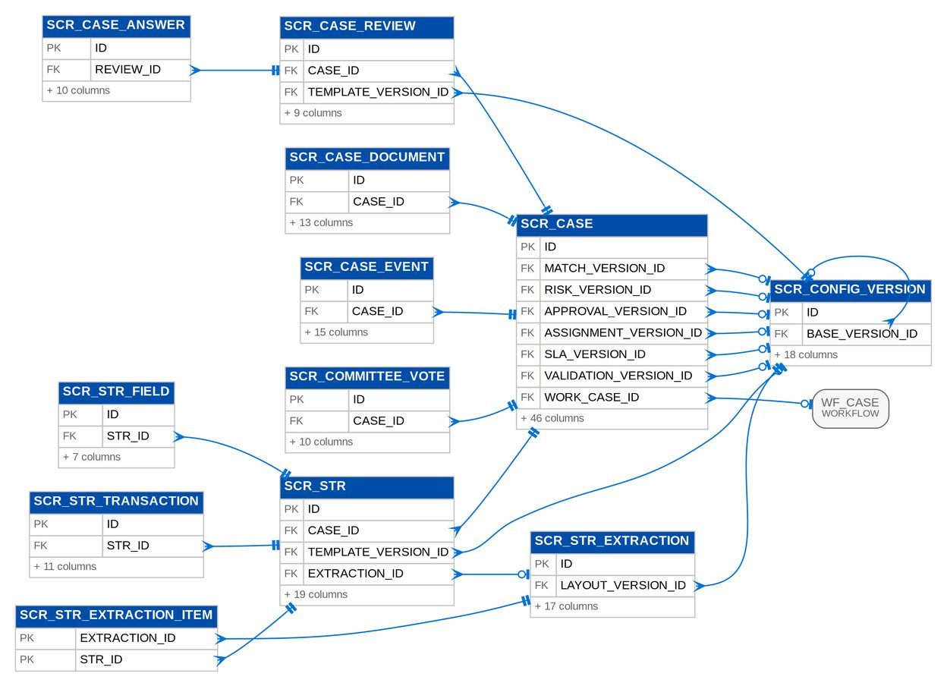
Figure 71: D15 SCREENING (1 of 4): tables, primary keys and the foreign keys inside the module
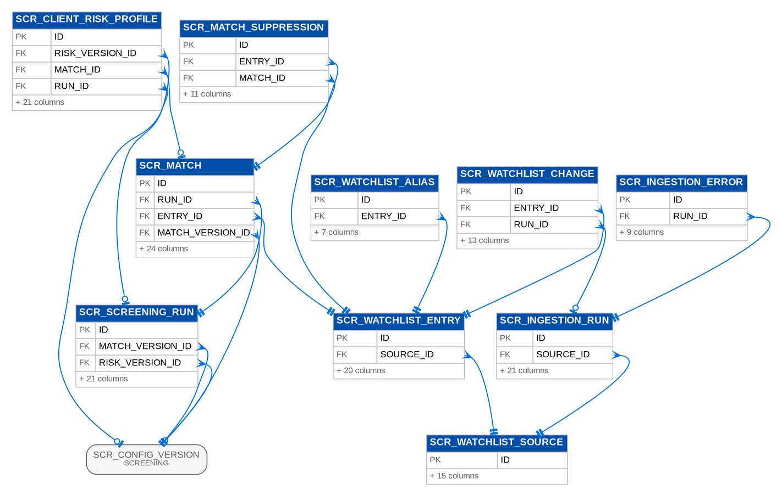
Figure 72: D15 SCREENING (2 of 4): tables, primary keys and the foreign keys inside the module
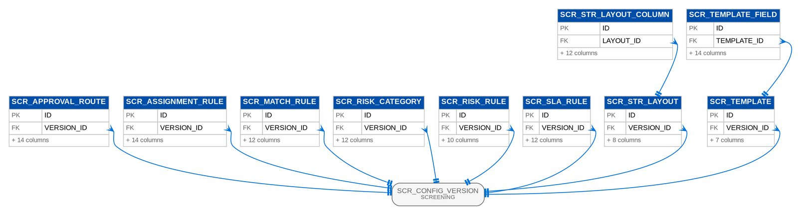
Figure 73: D15 SCREENING (3 of 4): tables, primary keys and the foreign keys inside the module
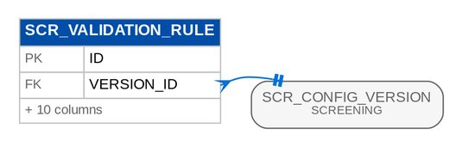
Figure 74: D15 SCREENING (4 of 4): tables, primary keys and the foreign keys inside the module

3.16 D16 Submitted Policies
The masterlist of policies submitted by insurers and partners, reviews, IAAF and TOR records, letters, fees and the renewal hand-off. Owner: Product Owner, Submitted Policies. BRD: BRD-12. 34 tables, 618 columns.

3.16.1 Module SUBMITTED
Table 71: Tables of module SUBMITTED (D16)
Table | Description | Cols | Links | Figure
SBM_APPROVAL_MATRIX | A level of the IAAF or TSU (TOR) approval matrix (BRIDSP-07, 18): per document, segment and sum insured band, the permission or named approver of the level and the signatory title printed on the PDF. | 18 | - | Listed only (no link)
SBM_EXTRACTION | A document extraction (BRIDSP-02): the fields proposed from an uploaded policy document, for a new record or an existing one. | 20 | SBM_POLICY | D16 SUBMITTED (2 of 3)
SBM_EXTRACTION_FIELD | Extraction field records. | 4 | SBM_EXTRACTION | D16 SUBMITTED (2 of 3)
SBM_HANDLING_FEE | A handling fee billed on a CBG Motor submitted account (BRIDSP-31; design section 3.6): its PN (CLPC payments) or location reference (OTC payments), amount and billing date; TAGGED when a payment matched and the income request went to Cashiering, APPLIED when Cashiering recognised it with the official receipt. | 25 | SBM_POLICY | D16 SUBMITTED (3 of 3)
SBM_IAAF | The Insurance Adequacy Assessment Form of a policy (BRIDSP-05-07): one per policy, generated once the last review is adequate, approved by the IAAF matrix and sent to the bank counterpart. | 18 | SBM_POLICY | D16 SUBMITTED (1 of 3)
SBM_IAAF_LINK | A policy related to an IAAF (BRIDSP-05): previous term, same borrower or other. | 9 | SBM_IAAF, SBM_POLICY | D16 SUBMITTED (1 of 3)
SBM_IAAF_REVIEW | A policy review (BRIDSP-06): number, date, reviewer, adequacy, findings and remarks. | 16 | SBM_IAAF, SBM_POLICY | D16 SUBMITTED (1 of 3)
SBM_INSURER_RULE | An insurer assignment rule of the expiry scan (BRIDSP-23; SP SQ11): per segment, vehicle type or occupancy, the insurer to propose, highest priority first, optionally never the expiring insurer. | 17 | - | Listed only (no link)
SBM_INTAKE_RUN | An intake run (BRIDSP-01): one source file loaded, with its file hash and the counts of the rows received, created, updated, duplicated and failed, and the processing run it started. | 21 | - | D16 SUBMITTED (3 of 3)
SBM_LAMD_LOAN | A loan of a loan file of the bank (BRIDSP-02/13; FR-SP-035): the loan report (LAMD, LMS or LAD), the PN number or the loan application number, the loan status, the amortised flag, the maturity date, the branch and segment, and the collateral numbers the matching step compares with the policy. | 22 | - | D16 SUBMITTED (1 of 3)
SBM_LETTER | A letter of this module (BRIDSP-22): a reminder, renewal notice or renewal proposal sent by e-mail, through the bank counterpart or printed in a batch for the mail house. | 22 | SBM_LETTER_RULE, SBM_POLICY, SBM_PRINT_BATCH | D16 SUBMITTED (2 of 3)
SBM_LETTER_RULE | A letter rule (BRIDSP-22; SP SQ09): the letter of a type sent to the records of a segment, bucket and status on the day that is the given number of days from their expiry (negative before), by a channel, from a template. | 18 | - | D16 SUBMITTED (2 of 3)
SBM_LIMIT_CHECK | One limit checked for a record in a run (BRIDSP-16): the limit, the value and the result. | 13 | SBM_LIMIT_RULE, SBM_POLICY, SBM_RUN | D16 SUBMITTED (1 of 3)
SBM_LIMIT_RULE | An acceptance or coverage limit of an insurer (BRIDSP-16; design section 4.2), maintained with maker and checker until Product Maintenance takes the limits over (SP SQ08): the maximum sum insured, the maximum vehicle age and one other attribute limit, per insurer and segment. | 18 | - | D16 SUBMITTED (1 of 3)
SBM_LOAN_MATCH | The matching of a record with the loan files in a processing run (FR-SP-035): the loan file used (report, date and upload), the key that matched, or the reason the record is unmatched, with the time stamp. | 17 | SBM_LAMD_LOAN, SBM_POLICY, SBM_RUN | D16 SUBMITTED (1 of 3)
SBM_NO_TOUCH_BATCH | A No Touch billing batch of one insurer and month (Report List #164; OQ39): exported with the premium and fee columns blank, returned by the insurer with the validated values, then billed with a service invoice. | 21 | - | D16 SUBMITTED (2 of 3)
SBM_NO_TOUCH_LINE | A policy of a No Touch billing batch with the values returned by the insurer (RL #164). | 18 | SBM_NO_TOUCH_BATCH, SBM_POLICY | D16 SUBMITTED (2 of 3)
SBM_NOMINATED_RATE | A nominated package rate (FR-SP-066; BRIDSP-18): per segment, vehicle classification (blank for every classification) and insurer, the rate in percent of the sum insured proposed for the renewal. | 16 | - | Listed only (no link)
SBM_POLICY | Policy records. | 80 | SBM_INTAKE_RUN | D16 SUBMITTED (1 of 3)
SBM_POLICY_HISTORY | One field change of a masterlist record with its source (BRIDSP-29). | 12 | SBM_POLICY | D16 SUBMITTED (3 of 3)
SBM_PRINT_BATCH | A print batch for the mail house (BRIDSP-22; SP SQ09): the letters of one type and day merged into one PDF with a control list, kept in the file store until the mail house collects them. | 16 | - | D16 SUBMITTED (2 of 3)
SBM_PROPOSAL | A renewal proposal of a record (FR-SP-066, 067): one per record and version in a batch, with the default and the chosen insurer, the nominated and the applied rate (with the reason of a change) and the premium. | 21 | SBM_POLICY, SBM_PROPOSAL_BATCH | D16 SUBMITTED (3 of 3)
SBM_PROPOSAL_BATCH | A batch of renewal proposals SBP-yyyy-nnnnnn (FR-SP-066). | 8 | - | D16 SUBMITTED (3 of 3)
SBM_RENEWAL | The renewal hand-off of a masterlist record (BRIDSP-23, 25, 32; design section 4.4): pending until the Renewal module takes it, then the renewal reference, the insurer assigned, the renewal account and its hold cover as Submitted Policies follows them, the re-assignments and the outcome read from the Renewal module. | 22 | SBM_POLICY | D16 SUBMITTED (3 of 3)
SBM_RULE | A rule of a rule set (BRIDSP-08): priority, conditions, outcome, reason code and stop flag. | 17 | SBM_RULE_SET | D16 SUBMITTED (2 of 3)
SBM_RULE_CONDITION | Rule condition records. | 5 | SBM_RULE | D16 SUBMITTED (2 of 3)
SBM_RULE_SET | A version of a rule set of one processing step, segment and business type (BRIDSP-08; design section 4.2): drafted and submitted by the maker, activated from its effective date by a checker who is not the maker, retired when a later version of the same code is activated. | 20 | - | D16 SUBMITTED (2 of 3)
SBM_RUN | A processing run (BRIDSP-09; design section 3.2): its trigger and scope and the counts of the records passed, bucketed, fallen out, overridden by a manual tag and above an insurer limit. | 18 | - | D16 SUBMITTED (1 of 3)
SBM_RUN_RESULT | The result of one step of a run for one record (BRIDSP-08-10; design principle 3): outcome, bucket, reason code and the rule and rule-set version that produced it, so every result explains itself. | 17 | SBM_POLICY, SBM_RUN | D16 SUBMITTED (1 of 3)
SBM_SIGNATURE | The signature of an approval level of an IAAF or TOR (BRIDSP-07, 18). | 15 | - | Listed only (no link)
SBM_SOURCE | An approved source of submitted policies (BRIDSP-01; FRS BRD-12 FR-SP-001): its segment and business type when fixed, the bulk handler that loads its files and, for manual entry, the mandatory fields. | 14 | - | Listed only (no link)
SBM_STATUS_MAP | Legacy status of the Excel masterlists mapped to a status and bucket (BRIDSP-33). | 9 | - | Listed only (no link)
SBM_TOR | Terms of Reference of an account above the insurer limits (BRIDSP-17-19): the breached limits and the proposed terms, approved by the TSU matrix and released when the Account Officer opens or downloads it. | 21 | SBM_POLICY | D16 SUBMITTED (3 of 3)
SBM_USER_SCOPE | The data scope of a user (BRIDSP-28): the segments the user sees and, for account officers, only the records they handle or own. | 10 | - | Listed only (no link)

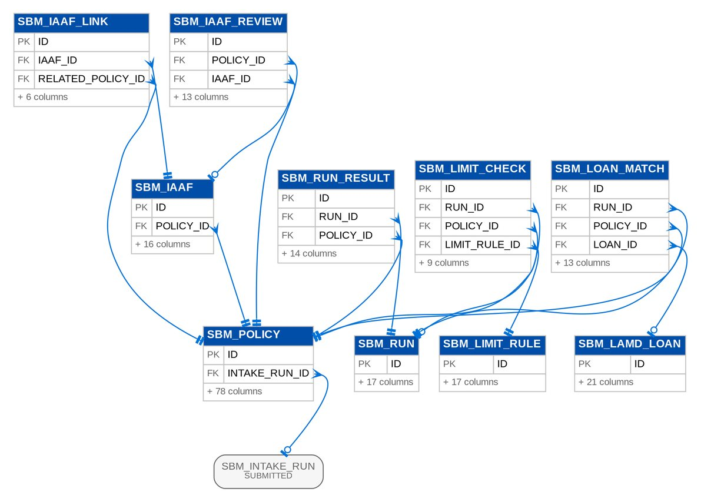
Figure 75: D16 SUBMITTED (1 of 3): tables, primary keys and the foreign keys inside the module
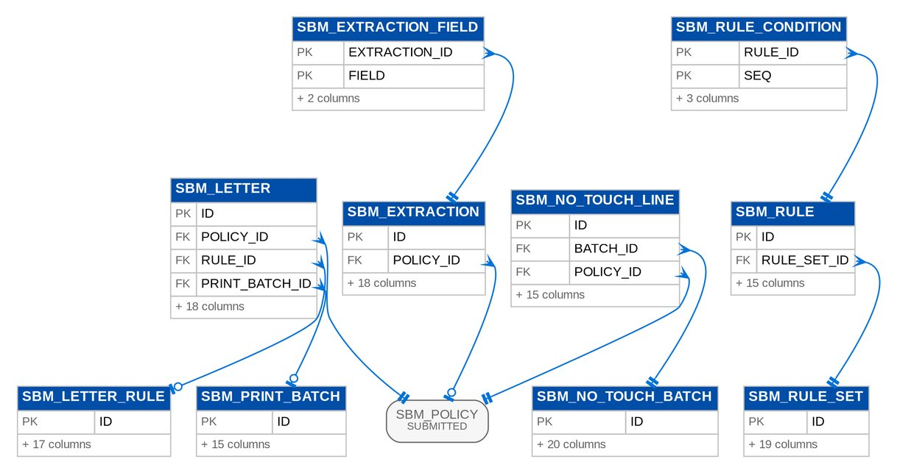
Figure 76: D16 SUBMITTED (2 of 3): tables, primary keys and the foreign keys inside the module
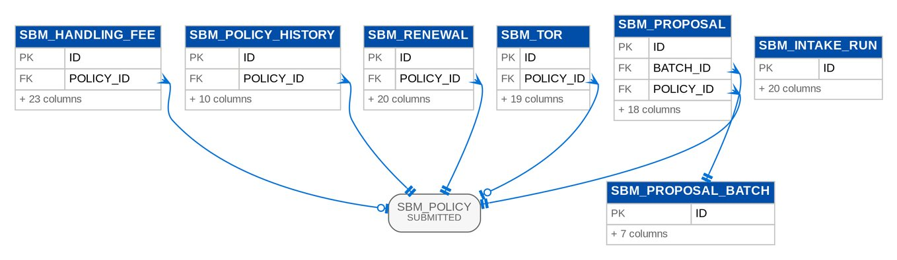
Figure 77: D16 SUBMITTED (3 of 3): tables, primary keys and the foreign keys inside the module

3.17 D17 Data Migration
Migration objects, load batches and staging rows, code maps, quality rules and results, reconciliation, sign-off gates, the legacy archive with its access log, and decommissioning. Owner: Data Migration Lead (BDOI), with the data owner of each object. BRD: BRD-13. 35 tables, 601 columns.

3.17.1 Module MIGRATION
Table 72: Tables of module MIGRATION (D17)
Table | Description | Cols | Links | Figure
MIG_ACCESS_LOG | An access to the legacy archive: user, time, source address, action (search, view, download, export), criteria, record keys, result count and reason. | 11 | - | Listed only (no link)
MIG_ARCHIVE_RECORD | A legacy archive record: the searchable keys of a closed legacy transaction or history record with its labelled legacy columns. | 24 | MIG_BATCH | D17 MIGRATION (2 of 3)
MIG_BATCH | A migration batch: one object loaded from one checked extract of each of its layouts, validated with the approved code map versions it records, approved for load (gate G4) by a user other than the operator, loaded, reconciled and signed off, or rolled back. | 42 | MIG_BATCH, MIG_DATA_OBJECT | D17 MIGRATION (1 of 3)
MIG_BATCH_EXTRACT | Batch extract records. | 2 | MIG_BATCH, MIG_EXTRACT | D17 MIGRATION (1 of 3)
MIG_BATCH_LOG | A step of the run log of a batch: plan, validation, matching, approval, load, reconciliation, sign-off, rollback and purge, with counts and time. | 8 | MIG_BATCH | D17 MIGRATION (3 of 3)
MIG_BATCH_MAP_VERSION | Batch map version records. | 3 | MIG_BATCH | D17 MIGRATION (3 of 3)
MIG_CLIENT_MATCH | A matched pair of legacy clients: the two staged rows (or a staged row and a client already in BIBS), the score, the keys that matched, the decision (merged automatically, waiting for review, merged or kept separate by the Data Steward) and the values that lost to the survivor. | 20 | MIG_BATCH | D17 MIGRATION (3 of 3)
MIG_CODE_MAP_ENTRY | An entry of a code map version: the legacy code of a source system and its action (MAP to a target code, DEFAULT, REJECT or CREATE). | 10 | MIG_CODE_MAP_VERSION | D17 MIGRATION (2 of 3)
MIG_CODE_MAP_SET | A code map set: one per coded domain, for example INSURER, PRODUCT, PACKAGE, LOV:MARKET_SEGMENT, GL_ACCOUNT or STATUS:UPP, with its target domain, the kind of target the approval checks, a default target for DEFAULT entries, and the business owner and data steward. | 17 | - | D17 MIGRATION (2 of 3)
MIG_CODE_MAP_VERSION | A version of a code map set (gate G2; FR-DM-011): DRAFT while the Data Steward edits it, SUBMITTED to the business owner, APPROVED (one per set; the previous approved version becomes SUPERSEDED). | 15 | MIG_CODE_MAP_SET | D17 MIGRATION (2 of 3)
MIG_CUTOVER_PLAN | A cutover plan: a mock, the dress rehearsal or the production cut-over, with its environment, go-live date, freeze window and status; its tasks and go / no-go criteria are separate records. | 16 | - | D17 MIGRATION (2 of 3)
MIG_CUTOVER_TASK | A task of a cutover plan: sequence, phase, task, owner role, the object it loads, dependencies, planned and actual times, status and evidence. | 21 | MIG_CUTOVER_PLAN | D17 MIGRATION (2 of 3)
MIG_DATA_OBJECT | A data object of the migration register (BRID 1.1a; FR-DM-001): source systems, target in BIBS, business owner and data steward, the four criteria of the BRD (Day-1 need, compliance need, read-only / archival option, data trust), the proposed and the decided class, dependencies and load order. | 33 | - | D17 MIGRATION (1 of 3)
MIG_DECOMMISSION_ITEM | A criterion of a decommissioning checklist: per legacy system (milestone SYSTEM) or for the legacy context in BIBS (milestone CONTEXT), with its evidence, status and signature. | 16 | - | Listed only (no link)
MIG_EXTRACT | A source extract: one file of one layout, source system and as-of date with its control file, the SHA-256, the declared and parsed counts, the control totals and the result of the intake checks. | 35 | MIG_DATA_OBJECT | D17 MIGRATION (1 of 3)
MIG_GONOGO_CRITERION | A go / no-go criterion of a plan with its threshold and its measured value: measured by BIBS for the reconciliation, sign-off and queue criteria, entered with a note for the manual ones (smoke test, snapshot, roster, signatures). | 16 | MIG_CUTOVER_PLAN | D17 MIGRATION (2 of 3)
MIG_GONOGO_DECISION | A go / no-go decision of a plan (gate G7) with the criteria met at the time. | 8 | MIG_CUTOVER_PLAN | D17 MIGRATION (2 of 3)
MIG_ISSUE | A data-quality issue of a staged row: the rule, its severity, the field and value and the message, and how the issue was resolved (fixed at source, mapped, waived by the data owner with a reason, or the row excluded with a manual-entry plan). | 18 | MIG_STAGE_ROW | D17 MIGRATION (1 of 3)
MIG_KEY_XREF | The cross-reference of a loaded record from its legacy key: source system, object and legacy key to the BIBS entity, id and code, the batch that loaded it and the hash of the loaded row. | 14 | MIG_BATCH | D17 MIGRATION (3 of 3)
MIG_LAYOUT | A version of an extract layout: the columns of one file of a data object, its key and the rule of the hash total of its control file. | 17 | MIG_DATA_OBJECT | D17 MIGRATION (1 of 3)
MIG_LAYOUT_COLUMN | A column of a layout version: name as in the header row, type, length, mandatory (Y, N or C for conditional), allowed values, the code map set of a coded column, format, example, BIBS target and the validation rule, as published in the data requirements workbook. | 15 | MIG_LAYOUT | D17 MIGRATION (1 of 3)
MIG_MASKING_RULE | A masking rule: a column of a layout whose values are masked before staging when the environment is not production. | 10 | - | Listed only (no link)
MIG_OBJECT_DECISION | A decision of the class of a data object (gate G1; FR-DM-002): submitted by the Data Migration Lead with the criteria and the rationale, approved or returned by the business owner of the object, never by the submitter. | 20 | MIG_DATA_OBJECT | D17 MIGRATION (1 of 3)
MIG_PACKAGE_MAP | An entry of the package map of the legacy packages: a legacy package and version, optionally split by risk code, insurer or sum-insured band, mapped to a BIBS package version maintained by TSU or rejected. | 20 | MIG_BATCH | D17 MIGRATION (3 of 3)
MIG_RA_SENT | A renewal advice sent by hand before go-live: linked to the migrated header by the legacy policy reference, served to Renewal with the header in the go-live extraction so that the advice is not sent again. | 24 | MIG_BATCH | D17 MIGRATION (3 of 3)
MIG_RECON_LINE | A line of a reconciliation run: level, measure and currency with the source (control file), staged and target values, the difference against the tolerance and the status. | 23 | MIG_RECON_RUN | D17 MIGRATION (2 of 3)
MIG_RECON_RUN | A reconciliation run of a batch or of a true-up: its lines per level (L1 count, L2 amount, L3 hash, L4 field, L5 GL; TU for the true-up checks) and its status: MATCHED, BREAKS while a break is open, EXPLAINED when every break has an approved explanation, SIGNED at gate G5. | 16 | MIG_BATCH | D17 MIGRATION (2 of 3)
MIG_RESUBMISSION | A resubmission of corrected rejected rows: the maker's corrected file of a batch, approved or returned by a checker who is never the maker; an approved resubmission is loaded as a RERUN batch of the parent. | 19 | MIG_BATCH, MIG_DATA_OBJECT, MIG_EXTRACT | D17 MIGRATION (1 of 3)
MIG_RULE | A data-quality rule of the catalogue: layouts it applies to, columns, kind, severity and the message shown on the issue. | 15 | - | Listed only (no link)
MIG_RUNOFF_COHORT | A run-off cohort of a monthly snapshot: the migrated headers in force at go-live expiring in a month, per source system, with how many were renewed in BIBS, not renewed, lapsed or are still open. | 12 | - | Listed only (no link)
MIG_SIGNOFF | A sign-off of a gate: object, batch, gate, the role and user who signed, the decision, comment, time and optional evidence file. | 13 | MIG_BATCH | D17 MIGRATION (3 of 3)
MIG_STAGE_ROW | A staged row of an extract: the raw values as received (masked outside production), the values after the code maps, the SHA-256 of the raw values, the status and, once loaded, the target record. | 17 | MIG_EXTRACT | D17 MIGRATION (1 of 3)
MIG_SURVIVORSHIP_RULE | A survivorship rule of client matching: for a field of the merged client, the first non-blank value by source priority, or the most recently updated value. | 9 | - | Listed only (no link)
MIG_TB_LINE | A line of a legacy trial balance loaded by object G01: the provisional opening or a true-up version (TU1-TU3, FINAL), mapped to the BIBS account, kept for the movement and balance checks of the true-up reconciliation. | 17 | MIG_BATCH | D17 MIGRATION (3 of 3)
MIG_TRUEUP | A FY2027 opening-balance true-up: prepared by the Comptrollership GL lead from a validated G03 batch and the legacy trial balance of the same true-up, approved by the Head of Comptrollership (never the preparer), posted as opening-balance adjustment journals and open-item adjustments, reconciled and signed. | 25 | MIG_BATCH | D17 MIGRATION (3 of 3)

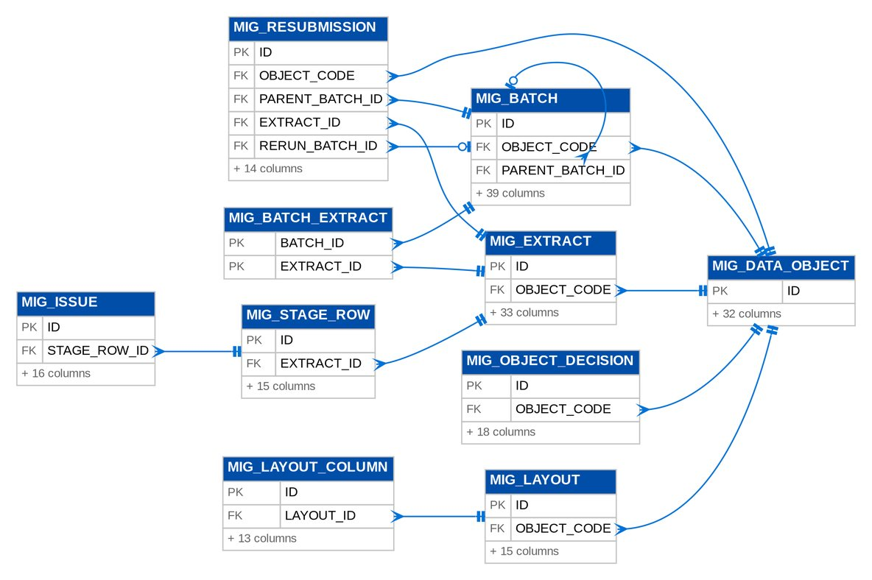
Figure 78: D17 MIGRATION (1 of 3): tables, primary keys and the foreign keys inside the module
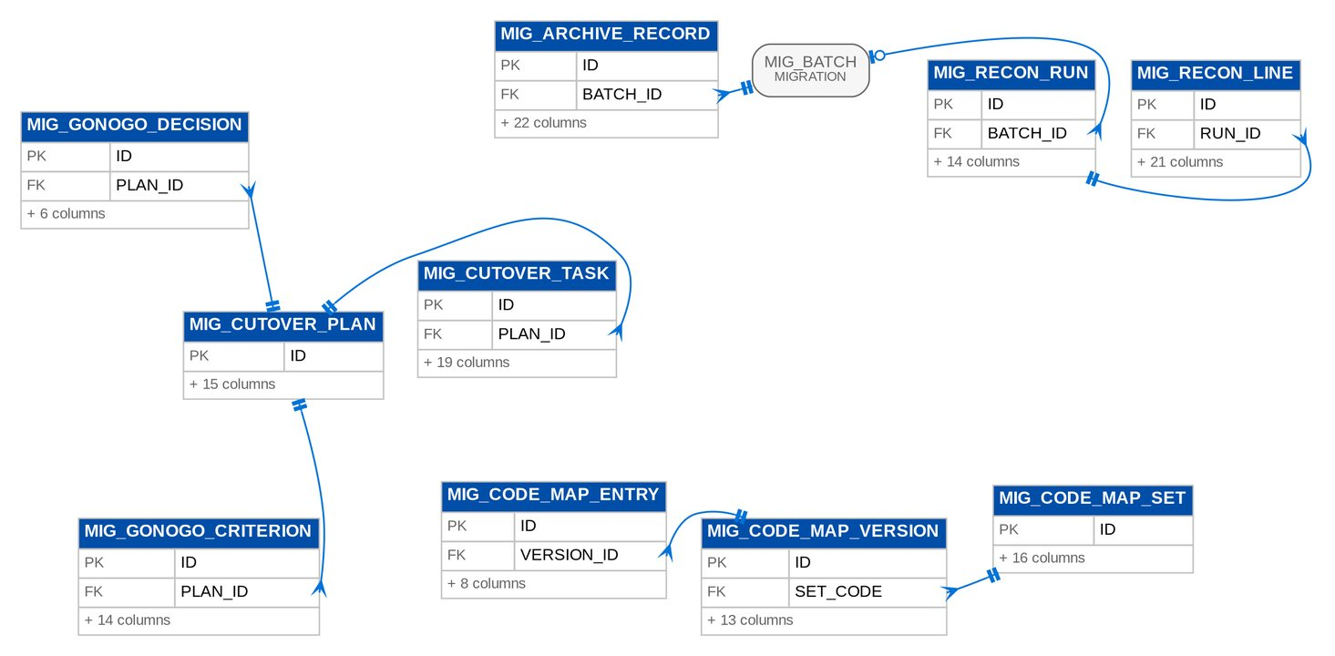
Figure 79: D17 MIGRATION (2 of 3): tables, primary keys and the foreign keys inside the module
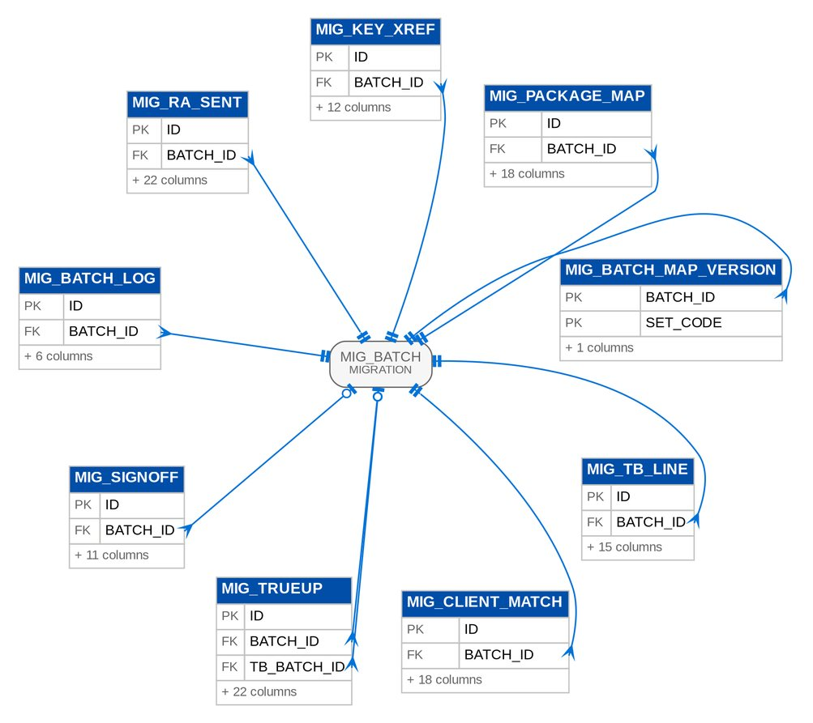
Figure 80: D17 MIGRATION (3 of 3): tables, primary keys and the foreign keys inside the module

4 Table catalogue
One row per table: its purpose, class for data migration, primary key, natural or unique keys, the tables it references and its load level (Lvl, section 6.6). Columns, types and indexes are in the inventory workbook.

4.1 D01 Security and User Access
Users, roles, permissions, data scope (companies and branches), sign-in sessions, second factor, single sign-on requests and tickets, password history, user access requests with their approvers and events, separation-of-duties rules, access change log and the retention rules of the broking records. Modules: SECURITY, NBADMIN, IDENTITY. 27 tables, 320 columns.
Table 73: Table catalogue of D01 Security and User Access
Table | Purpose | Class | PK | Natural / unique key | References | Lvl
IDN_DIRECTORY_PROFILE | The directory details of a user retrieved from the Enterprise SSO platform, with the last synchronisation (BDOI FRS FRUM.002.01, FRUM.002.02 and FRUM.003.03: the latest synchronisation status and time of the user). | System | ID | USERNAME | - | 1
IDN_IDENTITY_EVENT | A provisioning event received from UIDM-ISC or the Enterprise SSO platform, or an on-demand synchronisation, with its outcome (BDOI FRS FRUM.002.02: "log all user synchronization activities and processing results"; "identify and record synchronization failures for administrative review"). | System | ID | - | - | 1
IDN_SIM_DIRECTORY_ACCOUNT | An account of the Enterprise SSO simulator of SIT and UAT: the directory that the simulated sign-in page and the simulated UIDM-ISC events use, so that the flows run end to end before BDOI IT connects the real platform. | System | ID | WINDOWS_ID | - | 1
NBA_ACCESS_REQUEST | A request to enrol, modify, deactivate or reactivate a user, or to create, change, deactivate or reactivate a group profile (BRNB.085; BRD 1.002-1.009, 3.002; PMADD05). | Master | ID | REQUEST_NO | NBA_ACCESS_REQUEST_BATCH, ORG_BRANCH | 3
NBA_ACCESS_REQUEST_APPROVER | One approver of an access request, in order (BRD 1.002.1.1.3 "select approver", BRD 3.002.x "approver/s"): user requests have one, group-profile requests one or more, each deciding in turn. | Master | ID | REQUEST_ID, SEQUENCE | NBA_ACCESS_REQUEST | 4
NBA_ACCESS_REQUEST_BATCH | A bulk access request: one line request per row of the uploaded file. | Master | ID | BATCH_NO | - | 1
NBA_ACCESS_REQUEST_EVENT | One event in the history of an access request with its remarks (BRD 1.002.1.1.4-5 "add / save remarks", 1.006, 1.008, 2.002.7). | Audit and log | ID | - | NBA_ACCESS_REQUEST | 4
NBA_RETENTION_RULE | A data retention rule (BRNB.106, NFR retention): records of a type in one of the statuses become eligible once they have been inactive for yearsOnline years; they are then kept yearsArchive more years in the archive. | Master | ID | RECORD_TYPE, STATUSES | - | 1
NBA_RETENTION_RUN | Result of one retention review of one rule: how many records were eligible (BRNB.106). | Master | ID | - | NBA_RETENTION_RULE | 2
NBA_SOD_RULE | A separation-of-duties rule: two group profiles that one user may not hold together. | Master | ID | RULE_CODE | - | 1
SEC_ACCESS_CHANGE_LOG | One changed attribute of a user or role: from, to, the request that asked for it, who did it and who approved it (BRD 4.003.1, reports A-D; UAM-NFR-41). | Audit and log | ID | - | - | 1
SEC_MFA_RECOVERY_CODE | A single-use recovery code of the second factor; only its SHA-256 is kept. | Master | ID | - | - | 1
SEC_MFA_RESET_REQUEST | An administrator's request to reset a user's second factor: applied only when a holder of MFA_RESET_APPROVE other than the requester approves it (four eyes); the requester may withdraw it. | Master | ID | LOWER(USERNAME) (when ((STATUS) = 'PENDING')) | - | 1
SEC_MFA_TRUSTED_DEVICE | A device remembered for the second factor until it expires (parameter MFA_REMEMBER_DEVICE_DAYS, off as delivered); only the SHA-256 of its token is kept. | Master | ID | TOKEN_HASH | - | 1
SEC_PASSWORD_HISTORY | A previous password hash of a user, kept for the reuse rule (UAM-NFR-36, PASSWORD_HISTORY_COUNT). | Audit and log | ID | - | - | 1
SEC_PASSWORD_RESET_TOKEN | A "Forgot password?" link (UAM-NFR-37; FR-UA-005 R3): single use and valid for a limited time. | Master | ID | TOKEN_HASH | - | 1
SEC_PERMISSION_ACTION | Permission action records. | Master | ID | PERMISSION, ACTION | - | 1
SEC_REVOKED_TOKEN | Revoked token records. | Master | JTI | - | - | 1
SEC_ROLE | A named bundle of permissions assigned to users (e.g. | Master | ID | CODE | - | 1
SEC_ROLE_PERMISSION | Role permission records. | Master | ROLE_ID, PERMISSION | - | SEC_ROLE | 2
SEC_SSO_REQUEST | A sign-in sent to the identity provider: the SHA-256 of its state, the PKCE verifier and nonce (OIDC) or the request ID (SAML). | Master | ID | STATE_HASH | - | 1
SEC_SSO_TICKET | The one-time ticket of a single sign-on: the web client redeems it for the session once the identity provider answered. | Master | ID | TICKET_HASH | - | 1
SEC_USER | Application user. * Carries the security controls required by the GL: account lockout after repeated failed logins, a home branch, and an authorization limit capping the value of batches the user may authorize. * BRD-11 adds the directory identity (Windows ID), the business unit group and user level (BRD 1.002.1.1.1), the password dates and the forced change flag (UAM-NFR-36) and the last sign-out (UAM-NFR-35). | Master | ID | USERNAME; LOWER(WINDOWS_ID) (when (WINDOWS_ID IS NOT NULL)) | - | 1
SEC_USER_DATA_SCOPE | One granted company (with all its branches, branchId null) or one granted branch of a user whose data scope is not "all companies". | Master | ID | USER_ID, COMPANY_ID, BRANCH_ID (when (BRANCH_ID IS NOT NULL)); USER_ID, COMPANY_ID (when (BRANCH_ID IS NULL)) | ORG_BRANCH, ORG_COMPANY, SEC_USER | 3
SEC_USER_MFA | The authenticator app of a user: the TOTP secret encrypted at rest, PENDING until the first code confirms the enrolment, then ACTIVE. | Master | ID | LOWER(USERNAME), STATUS | - | 1
SEC_USER_ROLE | User role records. | Master | USER_ID, ROLE_ID | - | SEC_ROLE, SEC_USER | 2
SEC_USER_SESSION | A sign-in session, keyed by the token id (jti) of its access token: issued, last seen, ended and why (UAM-NFR-35 logout logging; the "online" status, UQ13; a later single-session rule, UQ09). | Master | ID | SESSION_ID; REFRESH_HASH (when (REFRESH_HASH IS NOT NULL)) | - | 1

4.2 D02 Platform Services
System parameters and scheduled jobs, the insert-only audit trail, lists of values, workflow cases and history, notifications and messages, alerts, bulk uploads, attachments and file metadata, document templates and renditions, the report framework, the transactional outbox of integration events and the document number sequences. Modules: SYSTEM, AUDIT, LOV, WORKFLOW, MESSAGING, ALERT, BULK, ATTACHMENT, DOCGEN, STORAGE, REPORT, EVENTS, COMMON, CONFIGPROMO. 43 tables, 592 columns.
Table 74: Table catalogue of D02 Platform Services
Table | Purpose | Class | PK | Natural / unique key | References | Lvl
ALT_ALERT | Alert records. | System | ID | DEDUP_KEY (when ((STATUS) <> 'RESOLVED')) | ALT_EXCEPTION_CODE, ORG_BRANCH, ORG_COMPANY | 3
ALT_EXCEPTION_CODE | Exception Codes Master entry: an exception condition with its severity and the thresholds that trigger it. | System | ID | CODE | - | 1
ATT_DOCUMENT_ACCESS | Access class row of a document type: a permission that may list and download documents of the type. | Transactional | ID | DOCUMENT_TYPE, PERMISSION | - | 1
DOC_ATTACHMENT | Metadata of a document attached to any record, identified by entity type and id. | Transactional | ID | - | STORED_FILE | 3
DOC_ATTACHMENT_CONTENT | File bytes of an Attachment, stored separately so listings never load them. | Transactional | ATTACHMENT_ID | - | DOC_ATTACHMENT | 4
DOC_ATTACHMENT_LINK | Makes an uploaded file part of another record's documents without copying it (BRNB.026: link one file to several accounts). | Transactional | ID | ATTACHMENT_ID, ENTITY_TYPE, ENTITY_ID | DOC_ATTACHMENT | 4
AUDIT_LOG | Immutable audit trail record of a financial or non-financial action. * Captures originator, modifier and authorizer activity with timestamps, as required by the GL audit trail control. | Audit and log | ID | - | - | 1
BULK_JOB | One uploaded file for a bulk handler, with its validation and commit counts. | System | ID | JOB_NO | ORG_COMPANY | 2
BULK_ROW | One uploaded row as sanitised, with its outcome. | System | ID | JOB_ID, ROW_NO | BULK_JOB | 3
DOCUMENT_SEQUENCE | Gapless counter per sequence key (e.g. "JV-HO-2026"). | System | SEQUENCE_KEY | - | - | 1
CFP_BASELINE | A package marked as the configuration baseline of this environment (for example the UAT signed-off configuration); the drift report compares the current configuration with it. | Transactional | ID | NAME | CFP_PACKAGE | 4
CFP_IMPORT | An import of a configuration package into this environment: options, the summary of the dry run, the maker-checker decision, the apply and its snapshot. | Transactional | ID | IMPORT_NO | CFP_IMPORT, CFP_PACKAGE | 4
CFP_IMPORT_DATASET | The difference and the reconciliation of one dataset of an import; the items are kept as JSON for the difference viewer. | Transactional | ID | IMPORT_ID, DATASET_CODE | CFP_IMPORT | 5
CFP_PACKAGE | A configuration package kept by this environment; its file is in the file store. | Transactional | ID | PACKAGE_NO | STORED_FILE | 3
DOC_RENDITION | Content of each composed PDF by SHA-256, for its Word copy (client requirement 16) | Transactional | ID | SHA256 | - | 1
DOC_TEMPLATE | One version of a document template. | Transactional | ID | CODE, VERSION_NO | - | 1
EVT_ARCHIVE | Archive records. | Audit and log | ID | EVENT_ID | - | 1
EVT_DEAD_LETTER | Dead letter records. | Audit and log | ID | DLT_TOPIC, KAFKA_PARTITION, KAFKA_OFFSET | - | 1
EVT_OUTBOX | Outbox records. | Audit and log | ID | EVENT_ID | - | 1
LOV_TYPE | A list of values, e.g. | Reference | ID | CODE | - | 1
LOV_VALUE | One value of a list, valid from effectiveFrom to effectiveTo (inclusive, open ended when null). | Reference | ID | TYPE_CODE, CODE | LOV_TYPE | 2
MSG_NOTIFICATION | An in-app notification for one user (header bell), e.g. "Account returned by Processing". | System | ID | - | - | 1
MSG_NOTIFICATION_EVENT | An event users can be notified about, with its default channels (RMTID.034). | System | CODE | - | - | 1
MSG_NOTIFICATION_PREFERENCE | A user's choice of channels for one notification event (RMTID.034). | System | ID | USERNAME, EVENT_CODE | MSG_NOTIFICATION_EVENT | 2
MSG_OUTBOUND | An e-mail in the outbox. | System | ID | - | MSG_OUTBOUND, ORG_COMPANY | 2
MSG_OUTBOUND_ATTACHMENT | A file attached to an outbound e-mail, stored as sent (protected when requested). | System | ID | - | MSG_OUTBOUND, STORED_FILE | 3
REPORT_BATCH | Several reports run together with shared parameters and downloaded as one file (FRBS 2.4.5 / 2.4.7): a ZIP of the individual files, or one merged PDF. | System | ID | BATCH_NO | ORG_COMPANY, STORED_FILE | 3
REPORT_BATCH_ITEM | Batch item records. | System | ID | BATCH_ID, ITEM_NO | REPORT_BATCH | 4
REPORT_RUN | One archived run (on-screen view) or export of a report (CSHID.018: generated reports with name, date and creator, downloadable only by users allowed to export). | System | ID | - | STORED_FILE | 3
REPORT_RUN_FILE | The file of an archived report export (CSHID.018), kept apart from the run list. | System | RUN_ID | - | REPORT_RUN | 4
STO_LEGAL_HOLD_REQUEST | A request to place or release the legal hold of a stored file (DOCUMENT_STORAGE_DECISION, decision 3): raised by a holder of FILE_LEGAL_HOLD_REQUEST with a reason, applied only when another user holding FILE_LEGAL_HOLD_APPROVE (the DOA roles) approves it. | System | ID | STORED_FILE_ID (when ((STATUS) = 'PENDING')) | STORED_FILE | 3
STO_RECORD_CLASS | A record class of stored files (DOCUMENT_STORAGE_DECISION, decisions 3 and 5): its bucket, its retention (the retention rules of {@link #getRetentionRecordType()}, else {@link #getRetentionPeriod()}), whether its files are under legal hold from the start and whether its final records are archived to ECM. | System | ID | CODE | - | 1
STORED_FILE | Metadata of a stored object (table STORED_FILE, DOCUMENT_STORAGE_DECISION section 3): owner, type, name, size, SHA-256, bucket and key, retention, legal hold, malware scan state and ECM archive state. | System | ID | BUCKET, OBJECT_KEY | ORG_COMPANY, STO_RECORD_CLASS | 2
SYS_JOB_RUN | One execution of a background job (job monitor and batch processing history). | System | ID | - | - | 1
SYS_MODULE_PROFILE | A named set of module switches (for example the profile of an insurance broker). | System | ID | CODE | - | 1
SYS_MODULE_PROFILE_MODULE | Module profile module records. | System | PROFILE_ID, MODULE_CODE | - | SYS_MODULE_PROFILE, SYS_PRODUCT_MODULE | 2
SYS_PARAMETER | Editable business parameter (configuration repository). | Reference | ID | PARAM_KEY | - | 1
SYS_PRODUCT_MODULE | Product module records. | System | ID | CODE | - | 1
SYS_SHARED_COUNTER | Shared counter records. | System | COUNTER_KEY | - | - | 1
WF_CASE | The workflow position of one business record (quotation, proposal request, account...). | System | ID | ENTITY_TYPE, ENTITY_ID | ORG_COMPANY, WF_STAGE | 2
WF_CASE_HISTORY | One status change (insert only): from, to, action, reason, comment, who and when. | Audit and log | ID | - | WF_CASE | 3
WF_STAGE | A stage of a workflow (seeded by migrations, read-only at run time). | System | ID | WORKFLOW_CODE, STAGE_CODE | - | 1
WF_TRANSITION | An allowed move between two stages (seeded by migrations, read-only at run time). | System | ID | WORKFLOW_CODE, FROM_STAGE, ACTION | LOV_TYPE, WF_STAGE | 2

4.3 D03 Organisation and Reference Data
Companies, branches (Office Master), employees, holiday calendars, currencies and exchange rates, cost centres and other dimensions, fiscal years and periods. Modules: ORGANIZATION, CURRENCY, DIMENSION, PERIOD. 10 tables, 149 columns.
Table 75: Table catalogue of D03 Organisation and Reference Data
Table | Purpose | Class | PK | Natural / unique key | References | Lvl
CUR_CURRENCY | ISO 4217 currency master. | Master | CODE | - | - | 1
CUR_EXCHANGE_RATE | Exchange rate: base-currency units per one unit of currencyCode, effective from a date until superseded by a later rate of the same type. | Master | ID | CURRENCY_CODE, RATE_TYPE, EFFECTIVE_DATE | CUR_CURRENCY | 2
DIM_VALUE | A value of a financial dimension, e.g. cost centre "FIN" or business line "MOTOR". | Master | ID | COMPANY_ID, DIMENSION_TYPE, CODE | ORG_COMPANY | 2
ORG_BRANCH | Branch / office / customer centre of a company (Office Master). | Master | ID | COMPANY_ID, CODE | ORG_COMPANY | 2
ORG_COMPANY | Legal entity keeping its own books (base currency, fiscal calendar and posting windows). * backValueDays/forwardValueDays implement the company-level value-date window for journals (supplementary / back-dated transaction control). * The company also carries the client profile used by documents, screens and labels (short name, group name, logo reference, head-office code, default bank account code), so no client ... | Master | ID | CODE | - | 1
ORG_EMPLOYEE | Employee with the cost centre used for employee payments, cash advances and headcount reports (DIS 3.30.1 / 3.30.2). | Master | ID | COMPANY_ID, EMPLOYEE_NO | ORG_BRANCH, ORG_COMPANY | 3
ORG_HOLIDAY | Holiday calendar entry. | Master | ID | - | ORG_BRANCH, ORG_COMPANY | 3
ACC_PERIOD_MODULE_LOCK | Cut-off of one group of books in a period (FRBS 3.4.0): while locked, postings of the group's source modules into the period are refused, even though the period itself stays open for GL adjustments. | Master | ID | PERIOD_ID, MODULE | ORG_COMPANY, PER_PERIOD | 4
PER_FISCAL_YEAR | Financial year of a company (fiscal or calendar, per company parameter). | Master | ID | COMPANY_ID, YEAR_CODE | ORG_COMPANY | 2
PER_PERIOD | Monthly accounting period with a controlled status lifecycle. | Master | ID | FISCAL_YEAR_ID, PERIOD_NO | ORG_COMPANY, PER_FISCAL_YEAR | 3

4.4 D04 Client and Party
Clients (prospect and confirmed) with KYC documents, contacts, tags, special instructions and note history; the business partner master shared with the finance modules. Modules: CRM, PARTY. 7 tables, 142 columns.
Table 76: Table catalogue of D04 Client and Party
Table | Purpose | Class | PK | Natural / unique key | References | Lvl
CRM_CLIENT | A broking client. | Master | ID | COMPANY_ID, CLIENT_CODE; COMPANY_ID, PROSPECT_CODE | ORG_COMPANY | 2
CRM_CLIENT_INSTRUCTION | A special instruction on a client (BRNB.091): type, text and effectivity, shown as a banner on every screen of the client's quotations and accounts while in force. | Master | ID | - | CRM_CLIENT | 3
CRM_CLIENT_NOTE_HISTORY | Insert-only history of a client tag or instruction change: who, when, from and to (BRNB.091). | Audit and log | ID | - | CRM_CLIENT | 3
CRM_CLIENT_PAYOUT_ACCOUNT | CA / SA information of a client (MKT 2.25.0, Addendum 1): the BDO account a refund is credited to with its payee name, or the payee name of a check. | Master | ID | CLIENT_ID, ACCOUNT_NO (when (ACTIVE AND (ACCOUNT_NO IS NOT NULL))); CLIENT_ID, PAYEE_KEY (when (ACTIVE AND ((MODE) = 'CHECK'))) | CRM_CLIENT, ORG_COMPANY | 3
CRM_CLIENT_TAG | A controlled tag on a client (list of values CLIENT_TAG), e.g. | Master | ID | CLIENT_ID, TAG_CODE (when ACTIVE) | CRM_CLIENT | 3
CRM_KYC_DOCUMENT | A KYC document of a client: an attachment of entity type Client with its document type (list of values DOCUMENT_TYPE), checked against the KYC checklist (BRNB.030/090). | Master | ID | - | CRM_CLIENT, DOC_ATTACHMENT | 4
PTY_PARTY | Business partner master: policyholders, intermediaries, reinsurers, coinsurers and suppliers. * The party code is the sub-ledger key carried on journal lines (PARTY_CODE) and open items, so control account balances can be analysed by party. | Master | ID | COMPANY_ID, CODE | ORG_BRANCH, ORG_COMPANY | 3

4.5 D05 Product Catalogue and Maintenance
Insurers and their branches, product lines, products, packages and their versions, rates, commission and incentive set-up, package requests and negotiation. Modules: CATALOG, PRODUCTMAINT. 45 tables, 715 columns.
Table 77: Table catalogue of D05 Product Catalogue and Maintenance
Table | Purpose | Class | PK | Natural / unique key | References | Lvl
CAT_CLAUSE | An entry of the clause library (PMADD02): a warranty, clause, exclusion or deductible wording, for one product line or every line, with its effective period. | Master | ID | CODE | CAT_PRODUCT_LINE | 2
CAT_COMMISSION_RATE | Commission the insurer pays BDOI on a product (percent of net premium), effective dated. | Master | ID | - | CAT_INSURER, CAT_PRODUCT, ORG_COMPANY | 4
CAT_COVER_TYPE | Type of cover within a product line (Annex II), e.g. | Master | ID | LINE_CODE, CODE | CAT_COVER_TYPE, CAT_PRODUCT_LINE | 2
CAT_COVERAGE | A coverage or peril of a product line, the lowest level of the product hierarchy (PMADD01: LOB &gt; Subline / Type &gt; Subtype &gt; Coverage / Peril). | Master | ID | LINE_CODE, CODE | CAT_PRODUCT_LINE | 2
CAT_DOCUMENT_RULE | Mandatory document (DOCUMENT_TYPE list of values) of every product, a line or one product, checked when Marketing submits an account (BRNB.026/051, e.g. the IDF for motor). | Master | ID | SCOPE, SCOPE_CODE, DOCUMENT_TYPE | - | 1
CAT_FIELD_RULE | One row of the minimum-field matrix (BRNB.002/003/093): a field of the account or of every risk item that is mandatory for every product, a product line or one product. | Master | ID | SCOPE, SCOPE_CODE, TARGET, FIELD_KEY | - | 1
CAT_INCENTIVE_CRITERIA | An incentive criterion on the maintained products matrix, for example "CPC2". | Master | ID | COMPANY_ID, CODE, EFFECTIVE_FROM | CAT_INCENTIVE_CRITERIA, ORG_COMPANY | 2
CAT_INCENTIVE_CRITERIA_PRODUCT | Incentive criteria product records. | Master | ID | - | CAT_INCENTIVE_CRITERIA, CAT_PRODUCT | 4
CAT_INSURER | Panel insurer: the broking profile of a party of type INSURER (accreditation, placement channel and mailboxes, default credit days). | Master | ID | COMPANY_ID, PARTY_CODE | ORG_COMPANY | 2
CAT_INSURER_BRANCH | Branch of a panel insurer with its Local Government Tax rate (Appendix A: "LGT value is dependent on the Insurer Branch") and optional placement mailbox. | Master | ID | INSURER_ID, CODE | CAT_INSURER | 3
CAT_MOTOR_LIMIT | Motor excess BI / PD limit and its premium (Appendix A: "Excess BI / PD premium amounts per limit table"), effective dated. | Master | ID | - | - | 1
CAT_OTHER_CHARGE | A charge billed with the premium besides the taxes (BDOI inputs TX-Q04, template PM-04 Charges): CTPL COCAF / LTO authentication fee, notarial fee, policy or documentation fee. | Master | ID | - | CAT_PRODUCT, CAT_PRODUCT_LINE | 4
CAT_PACKAGE_COVERAGE | Package coverage records. | Master | ID | VERSION_ID, COVERAGE_CODE | CAT_PRODUCT_VERSION | 5
CAT_PACKAGE_INSURER | Package insurer records. | Master | ID | VERSION_ID, INSURER_CODE | CAT_INSURER, CAT_PRODUCT_VERSION, ORG_COMPANY | 5
CAT_PACKAGE_INSURER_TERM | Package insurer term records. | Master | ID | VERSION_ID, INSURER_CODE, COVERAGE_CODE | CAT_PRODUCT_VERSION | 5
CAT_PRODUCT | A BDOI risk product (risk code, e.g. | Master | ID | CODE | CAT_COVER_TYPE, CAT_PRODUCT_LINE | 3
CAT_PRODUCT_LINE | Product line of Annex II (Property, Motor, Engineering...). | Master | ID | CODE | - | 1
CAT_PRODUCT_VERSION | One version of a packaged product: the rate scheme, package term, coverages, insurers and insurer x coverage terms, and the validation checkpoint. | Master | ID | PRODUCT_CODE, VERSION_NO; PRODUCT_CODE (when (((STATUS) = 'RELEASED') AND (EFFECTIVE_TO IS NULL))) | CAT_PRODUCT | 4
CAT_RATE | A tax or rating factor of Appendix A (DST, premium tax, VAT, FST, VAT on commission, motor OD/Theft coverage factors) in percent, for every line or one product line, effective dated. | Master | ID | - | CAT_PRODUCT_LINE | 2
CAT_RATE_SCHEME_EXCEPTION | An approval to price one transaction on a non-current package version or on a rate other than the scheme rate (BRPM.007 "a non-current rate triggers an approval workflow and is logged"). | Master | ID | REFERENCE_NO | CAT_PRODUCT | 4
CAT_SALES_OFFICER | An account officer (user) of a sales team (BRNB.075 production per user). | Master | ID | COMPANY_ID, USERNAME | CAT_SALES_UNIT, ORG_COMPANY | 3
CAT_SALES_UNIT | Sales organisation unit (region, department or team) for production statistics (BRNB.075) with the default cost center of a team (BRNB.108, dimension COST_CENTER). | Master | ID | COMPANY_ID, CODE | ORG_COMPANY | 2
CAT_SHORT_PERIOD_RATE | Short-period (short-term) table row (Appendix A): the percentage of the annual premium charged for a cover of a number of months, e.g. cancellation before expiry. | Master | ID | - | - | 1
CAT_TSU_RULE | TSU routing rule (BRNB.098): an account needs TSU clearance when every criterion set on the rule holds (product class, line, fleet units, locations, total sum insured, endorsement type). | Master | ID | CODE | CAT_PRODUCT_LINE | 2
CAT_VERSION_VALIDATION_CHECK | Version validation check records. | Master | VERSION_ID, SEQ | - | CAT_PRODUCT_VERSION | 5
PM_ADVISORY | A package advisory (BRPM.016): drafted automatically when a request's version is released or its package retired, edited by TSU, and sent to the recipient groups (list PKG_ADVISORY_GROUP) with the supporting documents. | Master | ID | - | ORG_COMPANY, PM_REQUEST | 3
PM_CLIENT_RESPONSE | The client's response to a proposal (BDOI FRS FRPM.010.01): Accepted (with the insurers accepted), Rejected or Return for Revision, with the response date, the client remarks and who recorded it when. | Master | ID | - | - | 1
PM_COMPARATIVE_OUTPUT | A stored comparative output of a package request (BRPM.014, PMADD03): the audit MASTER compiled from a negotiation round (one current master per request; earlier masters are kept as superseded), or a CLIENT view derived from a master with selected fields and insurers. | Master | ID | REQUEST_ID (when (((KIND) = 'MASTER') AND IS_CURRENT)) | PM_COMPARATIVE_OUTPUT, PM_REQUEST | 3
PM_DEACTIVATION_REQUEST | A package deactivation request (BDOI FRS FRPM.003.04 to FRPM.003.07): the package, its deactivation effective date (today or later), the reason, remarks and the approver chosen by the requestor. | Master | ID | REQUEST_NO | CAT_PRODUCT, ORG_COMPANY | 4
PM_FINAL_TERM | Final term records. | Master | ID | RECORD_TYPE, RECORD_ID, FIELD_KEY | - | 1
PM_FINAL_TERM_HISTORY | A change of a Final Terms for Proposal value (history, BDOI FRS FRPM.009.01). | Audit and log | ID | - | - | 1
PM_INSURER_RESPONSE | The response of one insurer in one negotiation round (BRPM.013, PMADD04): the outcome (list PKG_RESPONSE_OUTCOME, including the exception states), rate, minimum premium, terms per coverage (JSON), conditions, validity and the response document. | Master | ID | ROUND_ID, INSURER_CODE | PM_NEGOTIATION_ROUND | 4
PM_INSURER_RESPONSE_HISTORY | Insert-only snapshot of a package insurer response after each change (PMADD04: every revision and outcome change is logged). | Audit and log | ID | - | PM_INSURER_RESPONSE | 5
PM_MANCOM_APPROVAL | Mancom approval records. | Master | ID | - | PM_REQUEST | 3
PM_MARKETING_APPROVAL | One Marketing approval of a package request (BDOI FRS FRPM.011.02: "Each approver shall approve or reject independently. | Master | ID | - | PM_REQUEST | 3
PM_MASTER_CHANGE | A product master change waiting for, or sent to, the other BDOI systems (BDOI FRS FRPM.029.01): the product, version, kind of change (RELEASED, RETIRED, EXPIRED) and effective date, with the transfer file, the status (PENDING, SENT, FAILED), the attempts and the last error. | Master | ID | - | - | 1
PM_MASTER_SIM_INBOX | A file of product master changes received by the simulated receiving system (SIT and UAT). | Audit and log | ID | - | - | 1
PM_NEGOTIATION_ROUND | One negotiation round of a package request (BRPM.010/012, PMADD04): its quotation slip (number, template version, notes, reply date), the insurers approached, the four-eyes approval and the send time. | Master | ID | REQUEST_ID, ROUND_NO; QS_NO | PM_REQUEST | 3
PM_PLACEMENT_REPORT | A generated Consolidated Placement Update Report in the repository (BDOI FRS FRPM.007.01): the company, report date and reporting period, the file name and the archived run to download, the rows shown in the preview, and who generated it when (the job or a user on request). | Master | ID | - | ORG_COMPANY | 2
PM_PROPOSAL_FILE | A proposal slip of one insurer and version (BDOI FRS FRPM.009.02 and FRPM.013.01): the file name, the stored document, who generated it and when. | Master | ID | RECORD_TYPE, RECORD_ID, INSURER_CODE, VERSION_NO | - | 1
PM_REQUEST | A package request (BRPM.008-017; design section 4.4): the Package Request Form with its client or programme, line, cover type, target product, reason and requested terms; the approvals of Marketing, the TSU Team Lead and the TSU Head; the proposed terms after negotiation; and the catalog version the MBS set-up produced. | Master | ID | REQUEST_NO | CAT_PRODUCT_LINE, ORG_COMPANY | 2
PM_ROUND_INSURER | Round insurer records. | Master | ROUND_ID, INSURER_INDEX | - | PM_NEGOTIATION_ROUND | 4
PM_SIGNOFF | Signoff records. | Master | ID | - | PM_REQUEST | 3
PM_TERMS_OPTION | One quotation option of an insurer in the comparative table (BDOI FRS FRPM.006.02 and FRPM.012.02): an insurer may give several options (coverage, premium, commission, deductibles, terms, warranties, clauses, extensions, other details), each with the insurer response Approved, Not Covered or Others (with the insurer's own wording). | Master | ID | RECORD_TYPE, RECORD_ID, INSURER_CODE, OPTION_NO | - | 1
PM_TERMS_SETTING | The choices of a comparative table (BDOI FRS FRPM.006.02, FRPM.008.01): the fields shown in the table, the fields sent to the client, and the insurers the requestor selected for the proposal. | Master | ID | RECORD_TYPE, RECORD_ID | - | 1

4.6 D06 New Business
Package quotations, non-package proposal requests, accounts and their risk items, placement with insurers (slips, payment gates, hold covers), policy issuance, booking and the booked invoices, and the saved report variants of New Business. Modules: QUOTATION, NONPACKAGE, ACCOUNT, PLACEMENT, ISSUANCE, BOOKING, NBREPORT. 48 tables, 828 columns.
Table 78: Table catalogue of D06 New Business
Table | Purpose | Class | PK | Natural / unique key | References | Lvl
ACC_ACCOUNT | An account: the risk record to be placed with an insurer, one per policy, identified by its Account Reference Number from quotation to invoice (BRNB.102). | Transactional | ID | ARN | CAT_PRODUCT, CRM_CLIENT, ORG_COMPANY | 4
ACC_ACCOUNT_LEGACY | The legacy header of an account imported from a legacy system: source system, legacy policy reference, policy and cover numbers, the legacy package kept as given until Renewal sanitation remaps it, the legacy status and the migration batch that loaded it. | Transactional | ID | ACCOUNT_ID; COMPANY_ID, SOURCE_SYSTEM, LEGACY_REF (when (ROLLED_BACK_AT IS NULL)) | ACC_ACCOUNT, ORG_COMPANY | 5
ACC_ACCOUNT_PN | Account pn records. | Transactional | ACCOUNT_ID, PN_INDEX | - | ACC_ACCOUNT | 5
ACC_ACCOUNT_POLICY | Account policy records. | Transactional | ACCOUNT_ID, YEAR_INDEX | - | ACC_ACCOUNT | 5
ACC_RISK_ITEM | One insured item of an account (BRNB.051): a vehicle, a location of risk with its items insured, an insured person or a generic risk, with its sum insured, rate and premium. | Transactional | ID | ACCOUNT_ID, ITEM_NO | ACC_ACCOUNT | 5
ACC_RISK_ITEM_DETAIL | Risk item detail records. | Transactional | RISK_ITEM_ID, DETAIL_INDEX | - | ACC_RISK_ITEM | 6
BKG_AUTO_BOOK_RULE | Auto-book rule (BRNB.076): an account of the product and market segment entering POLICY_ISSUED is queued for the next booking batch. | Transactional | ID | - | ORG_COMPANY | 2
BKG_BATCH_ROW | Batch row records. | Transactional | RUN_ID, ROW_INDEX | - | BKG_BATCH_RUN | 3
BKG_BATCH_RUN | One booking batch run (BRNB.036): who or what started it, the business date and the result of every account (partial success: each account is booked in its own transaction). | Transactional | ID | RUN_NO | ORG_COMPANY | 2
BKG_ENDORSEMENT | An endorsement or cancellation posted on a booked account (BRNB.076/081/094). | Transactional | ID | ENDORSEMENT_NO; COMPANY_ID, SOURCE_REFERENCE (when (SOURCE_REFERENCE IS NOT NULL)) | ORG_COMPANY | 2
BKG_INCENTIVE_EVALUATION | One evaluation of the incentive indicator of a transaction (FR-NB-118, FR-RN-087 audit): the trigger, the criteria matched, the endorsements considered, the result and the reason. | Audit and log | ID | - | ORG_COMPANY | 2
BKG_INCENTIVE_RULE | Incentive eligibility rule (BRNB.107): a booking of the product, market segment and source channel dated within the period is flagged incentive eligible. | Transactional | ID | - | ORG_COMPANY | 2
BKG_INVOICE | A booked invoice (BRNB.027/061): the broker's billing of one transaction of an account - the original booking (one per policy year of a multi-year account, BRNB.112), a financial endorsement or a cancellation. | Transactional | ID | ARN, TRANSACTION_NO; INVOICE_NO; COMPANY_ID, INSURER_CODE, INSURER_BILLING_NO (when (INSURER_BILLING_NO IS NOT NULL)) | ORG_BRANCH, ORG_COMPANY | 3
BKG_INVOICE_JOURNAL | Invoice journal records. | Transactional | INVOICE_ID, JOURNAL_INDEX | - | BKG_INVOICE | 4
BKG_INVOICE_OPEN_ITEM | Invoice open item records. | Transactional | INVOICE_ID, ITEM_INDEX | - | BKG_INVOICE, SL_OPEN_ITEM | 5
BKG_INVOICE_SHARE | Invoice share records. | Transactional | INVOICE_ID, SHARE_INDEX | - | BKG_INVOICE | 4
BKG_QUEUE | An account queued for the next booking batch (BRNB.036/076), with the optional booking date and cost center the user set before the batch runs. | Transactional | ID | ARN (when ((STATUS) = 'QUEUED')) | ORG_COMPANY | 2
BKG_SERVICE_INVOICE | A service invoice or credit (BRNB.100/100b): BIR-sequential SI-- number, commission, VAT on commission and withholding tax lines, the PDF generated from the document template (stored as issued) and its e-mail dispatch. | Transactional | ID | SI_NO | BKG_SI_TYPE, ORG_BRANCH, ORG_COMPANY, STORED_FILE | 3
BKG_SI_TYPE | Service invoice type (BRNB.100): recipient, trigger (on booking, on endorsement, manual), owner (a team through a permission, or a user) notified of the dispatch, and the document template. | Transactional | ID | CODE | - | 1
ISS_ADVICE_RECIPIENT | The recipient of the Insurance Advices of a mortgagee bank (FR-NB-107): the e-mail addresses and the enrolment for automatic sending, for the bank as a whole or for one market segment of it. | Master | ID | - | ORG_COMPANY | 2
ISS_DOCUMENT_TRIGGER | A document trigger rule (BRNB.105): uploading a document of a type starts a business action, e.g. an e-policy opens an extraction review task. | Transactional | ID | DOCUMENT_TYPE, ACTION | - | 1
ISS_EPOLICY | An e-policy received from the insurer (BRNB.073), stored as an EPOLICY document of the account, with the data extracted from it (BRNB.104), the review that updates the policy number (BRNB.074) and its dispatch to the client (BRNB.077). | Transactional | ID | - | ACC_ACCOUNT, DOC_ATTACHMENT, ORG_COMPANY | 5
ISS_EXTRACTION_PATTERN | A regular expression that reads one field of an insurer's e-policy text (BRNB.104); the first capture group is the value. | Transactional | ID | - | - | 1
ISS_INSURANCE_ADVICE | An Insurance Advice IA-yyyy-nnnnnn (BRNB.070): the notice to the mortgagee bank that a mortgaged account is insured, generated from the INSURANCE_ADVICE template. | Transactional | ID | IA_NO | ACC_ACCOUNT, ORG_COMPANY, STORED_FILE | 5
ISS_UPLOAD_BATCH | A bulk e-policy upload (BRNB.073): the files are held with the account proposed for each (ARN in the file name or in the document) until the user reviews the matches and confirms. | Transactional | ID | - | ORG_COMPANY | 2
ISS_UPLOAD_ITEM | One file of a bulk e-policy upload with its proposed (or chosen) account and outcome. | Transactional | ID | BATCH_ID, LINE_NO | ISS_EPOLICY, ISS_UPLOAD_BATCH, STORED_FILE | 6
NBR_REPORT_VARIANT | A saved report variant (BRNB.057): the parameters of a report saved by a user under a name, optionally shared with every user who may run the report. | Transactional | ID | LOWER(OWNER), REPORT_CODE, LOWER(NAME) | - | 1
NBR_SALES_TARGET | Production target of a sales unit for a period, in PHP (BRNB.075): booked accounts, premium and commission. | Transactional | ID | COMPANY_ID, UNIT_LEVEL, UNIT_CODE, PERIOD_FROM | ORG_COMPANY | 2
NPK_INSURER_RESPONSE | The response of one insurer to the quotation slip of a PRF (BRNB.009): premium, rate, deductibles, conditions, validity, remarks and the response document; the recommended flag feeds the comparative table (BRNB.010). | Transactional | ID | PROPOSAL_ID, INSURER_CODE | NPK_PROPOSAL | 5
NPK_INSURER_RESPONSE_HISTORY | Insert-only snapshot of an insurer response after each change (BRNB.009 version history). | Audit and log | ID | - | NPK_INSURER_RESPONSE | 6
NPK_PROPOSAL | A Proposal Request Form (BRNB.005/006): a non-package risk that TSU prices with the insurers. | Transactional | ID | ARN; PRF_NO; RENEWAL_REF (when (RENEWAL_REF IS NOT NULL)) | CAT_PRODUCT, CRM_CLIENT, ORG_COMPANY | 4
NPK_PROPOSAL_ACCOUNT | Proposal account records. | Transactional | PROPOSAL_ID, ACCOUNT_INDEX | - | NPK_PROPOSAL | 5
NPK_PROPOSAL_INSURER | Proposal insurer records. | Transactional | PROPOSAL_ID, INSURER_INDEX | - | NPK_PROPOSAL | 5
PLC_BILLING_BATCH | A CLPC billing batch (BRNB.067): the CBG Fire accounts awaiting payment billed on one file. | Transactional | ID | BATCH_NO | ORG_COMPANY | 2
PLC_BILLING_ITEM | One account on a CLPC billing batch (BRNB.067) with its payment outcome. | Transactional | ID | BATCH_ID, LINE_NO | ACC_ACCOUNT, PLC_BILLING_BATCH | 5
PLC_HOLD_COVER | A hold cover requested from the insurer while the placement completes (BRNB.072) and its confirmation by the insurer with reference and date (BRNB.103). | Transactional | ID | - | ACC_ACCOUNT, ORG_COMPANY | 5
PLC_INSURER_RETURN | A placement returned by the insurer with its reason and remarks (BRNB.034/059), and how the return was resolved: resubmitted, returned to Marketing or cancelled (return queue). | Transactional | ID | - | ACC_ACCOUNT, ORG_COMPANY | 5
PLC_PAYMENT_EVIDENCE | The evidence behind a payment gate decision (BRD 2.3.1, BRNB.067/068/114): a matched payment with its source and reference, or a client confirmation with the user and date (created by / at). | Transactional | ID | ARN, SOURCE, REFERENCE | ACC_ACCOUNT, ORG_COMPANY | 5
PLC_PAYMENT_GATE_RULE | One row of the payment gate rule table (BRD 2.3.1, BRNB.068): the rule for a market segment and product line; a blank segment or line matches any. | Transactional | ID | - | CAT_PRODUCT_LINE | 2
PLC_PAYMENT_REPORT | An uploaded payment report and its match (BRNB.067/068): a CLPC report matched by PN or loan application number against a billing batch, or a report of the other segments matched by ARN. | Transactional | ID | REPORT_NO | ORG_COMPANY, PLC_BILLING_BATCH | 3
PLC_PAYMENT_REPORT_LINE | One line of a payment report with its match (matched, unpaid, unmatched or ambiguous). | Transactional | ID | REPORT_ID, ROW_NO | ACC_ACCOUNT, PLC_PAYMENT_REPORT | 5
PLC_SLIP | A placement slip PL-yyyy-nnnnnn for one insurer branch (BRNB.069), covering one or more accounts. | Transactional | ID | SLIP_NO, VERSION_NO | ORG_COMPANY | 2
PLC_SLIP_ACCOUNT | Slip account records. | Transactional | SLIP_ID, LINE_INDEX | - | ACC_ACCOUNT, PLC_SLIP | 5
PLC_SLIP_FILE | A rendered placement slip file (PDF or XLSX) with its checksum. | Transactional | ID | SLIP_ID, FORMAT | PLC_SLIP, STORED_FILE | 3
QUO_QUOTATION | A package quotation (BRNB.043): one client (a prospect is allowed, BRNB.063), one product, its Account Reference Number from creation (BRNB.102) and numbered versions of its content (BRNB.020). | Transactional | ID | ARN; QUOTATION_NO; RENEWAL_REF (when (RENEWAL_REF IS NOT NULL)) | CAT_PRODUCT, CRM_CLIENT, ORG_COMPANY, QUO_REQUEST | 5
QUO_QUOTATION_ACCOUNT | Quotation account records. | Transactional | QUOTATION_ID, ACCOUNT_INDEX | - | QUO_QUOTATION | 6
QUO_REQUEST | A quotation request waiting to be quoted (BRNB.041, staging of BRNB.023): captured from an e-mail (attached as REQUEST_EMAIL), uploaded in bulk or delivered by a source system. | Transactional | ID | REQUEST_NO; CHANNEL, EXTERNAL_REF (when (EXTERNAL_REF IS NOT NULL)) | CAT_PRODUCT, CRM_CLIENT, ORG_COMPANY | 4
QUO_VERSION | One version of a quotation's content (BRNB.020), stored as JSON. | Transactional | ID | QUOTATION_ID, VERSION_NO | QUO_QUOTATION | 6

4.7 D07 Operations
The invoice ledger and its movements, cashiering (receipts, payment intake, matching and application, unapplied payments), remittance to insurers, production reconciliation, endorsements and adjustments, and commission receivables with incentive schemes. Modules: OPSLEDGER, CASHIERING, REMITTANCE, PRODRECON, ADJUSTMENT, COMMISSION. 86 tables, 1,705 columns.
Table 79: Table catalogue of D07 Operations
Table | Purpose | Class | PK | Natural / unique key | References | Lvl
ADJ_MIN_BALANCE_ITEM | One invoice balance written off or credited by the minimal balance file (ADJID.026): at most once per invoice. | Transactional | ID | INVOICE_NO | ORG_COMPANY | 2
ADJ_POSTING_BATCH | A posting batch (validation batch VB-, ADJID.006/017): the requests posted together with the outcome of each; a request that fails stays for posting and does not stop the others. | Transactional | ID | BATCH_NO | ORG_COMPANY | 2
ADJ_POSTING_BATCH_LINE | Posting batch line records. | Transactional | BATCH_ID, LINE_INDEX | - | ADJ_POSTING_BATCH, ADJ_REQUEST | 4
ADJ_REQUEST | An endorsement or cancellation request on a booked invoice: what is asked, the recompute per component and per insurer, the processing trail and what the posting produced. | Transactional | ID | REQUEST_NO | ORG_BRANCH, ORG_COMPANY | 3
ADJ_REQUEST_COMPONENT | Request component records. | Transactional | REQUEST_ID, LINE_INDEX | - | ADJ_REQUEST | 4
ADJ_REQUEST_JOURNAL | Request journal records. | Transactional | REQUEST_ID, JOURNAL_INDEX | - | ADJ_REQUEST | 4
ADJ_REQUEST_SHARE | Request share records. | Transactional | REQUEST_ID, SHARE_INDEX | - | ADJ_REQUEST | 4
CSH_APPLICATION | Money of a receipt (or of an unapplied item) applied to one booked invoice, split by premium component in the hierarchy (CSHID.020/022). | Transactional | ID | - | CSH_RECEIPT, CSH_UNAPPLIED, ORG_COMPANY | 7
CSH_APPLICATION_LINE | Application line records. | Transactional | APPLICATION_ID, SEQ | - | CSH_APPLICATION | 8
CSH_BANK_ACCOUNT | An entry of the maintained list "Post to Bank Account" (FRS.CSH.02.01.02, 02.02.02): the bank account a receipt is posted to, its currency, whether it is the default of its currency and its GL account (set by Comptrollership; without it the collection account parameter applies). | Transactional | ID | COMPANY_ID, CODE | ORG_COMPANY | 2
CSH_CERTIFICATE_OF_PAYMENT | Certificate of payment records. | Transactional | ID | - | CSH_RECEIPT, ORG_COMPANY | 5
CSH_CHANNEL_FILE | A payment file received by upload or via MFT (FRS.CSH.05.01.02 to 05.01.06, 02.02.03 to 02.02.04.05): its upload reference, type, name, size and checksum, the source, the checks it passed or the reason it was refused, its raw copy kept read-only (source file), the uploader, the processing time and the run that processed its rows. | Transactional | ID | COMPANY_ID, UPLOAD_REF | CSH_CHANNEL_PROFILE, ORG_COMPANY | 2
CSH_CHANNEL_PROFILE | The profile of a payment file type (FRS.CSH.05.01.06; Appendix D): the file name convention, the format of BDOI's file (separator, header line, header and detail record types, TOTAL row, date format), the map of BDOI's fields to the fields of the system, the size limit and the MFT folder. | Transactional | FILE_TYPE | - | - | 1
CSH_COLLECTOR_REQUEST | Collector request records. | Transactional | ID | REQUEST_NO; SOURCE, SOURCE_REF | CSH_DISPOSITION, CSH_UNAPPLIED, ORG_COMPANY | 9
CSH_COMMISSION_LINE | A commission payment detail uploaded from Collection (CSHID.007): staged until the official receipts are issued, one OR per insurer, payee, certificate and payment (OQ49). | Transactional | ID | JOB_NO, ROW_NO | ORG_COMPANY | 2
CSH_CWT_BATCH | A validated batch of BIR 2307 certificates of one insurer (CSHID.027): its transaction report is posted and routed to Disbursement, which releases the certificates to the insurer (DBMID.001). | Transactional | ID | BATCH_NO | ORG_COMPANY | 2
CSH_CWT_TAG | A BIR 2307 reversal tagged by Marketing Collection with its CWT- reference (MKTID.013, CSHID.026): the 2% creditable withholding tax of an invoice settled in cash or by the client's certificate. | Transactional | ID | REFERENCE | CSH_CWT_BATCH, ORG_COMPANY | 3
CSH_DISPOSITION | A disposition assigned to an unapplied item (CSHID.024): apply to another invoice, DST application, refund, reclass, transfer to another marketing unit or others, with the target fields of its type, the four-eyes approval and the execution result. | Transactional | ID | - | CSH_APPLICATION, CSH_DISPOSITION_TYPE_RULE, CSH_UNAPPLIED | 8
CSH_DISPOSITION_TYPE_RULE | What a disposition type of LOV DISPOSITION_TYPE does and whether it needs the team leader's approval (CSHID.024, OQ15). | Transactional | TYPE_CODE | - | - | 1
CSH_LEGACY_BATCH | A Cashiering batch of the legacy context: the reclassification of old unapplied payments to other income, approved by the Cashiering team lead and then by top management, or the reversal of legacy PR 2307 balances against the insurer, approved by the team lead. | Transactional | ID | BATCH_NO | ORG_COMPANY | 2
CSH_LEGACY_BATCH_LINE | A line of a Cashiering legacy batch: an unapplied item taken to income, or a legacy invoice whose PR 2307 is reversed against the insurer; posted in its own transaction. | Transactional | ID | BATCH_ID, LINE_NO | CSH_LEGACY_BATCH | 3
CSH_LEGACY_REFERENCE | A legacy number of an account migrated at go-live (QPS, ISYS, Ebix, PN or Loan Application Number) and the account it stands for, so that a payment quoting it is matched (FRS.CSH.05.01.08; Appendix P). | Transactional | ID | COMPANY_ID, REF_TYPE, REF_NO | ORG_COMPANY | 2
CSH_MINIMAL_BALANCE | Minimal balance records. | Transactional | ID | KIND, SUBJECT_REF | ORG_COMPANY | 2
CSH_MINIMAL_BALANCE_RULE | The maintained minimal-balance table (CSHID.016, Cashiering summary 5.f, OQ11): the maximum amount per kind of balance, the exclusions of CSHID.016 and the action. | Transactional | KIND | - | - | 1
CSH_PAYMENT | A payment received through a channel (file row, over the counter, matured PDC, check pick-up), with the raw references it carried and the matching result (CSHID.008/020, BRQID.006). | Transactional | ID | PAYMENT_NO; COMPANY_ID, CHANNEL, SOURCE_KEY | CSH_RECEIPT, ORG_BRANCH, ORG_COMPANY | 5
CSH_PAYMENT_FILE_LAYOUT | The layout of a payment file handler's TXT files (CSHID.008): auto-detected, delimited with a separator, or fixed width with Header:start:length fields separated by ;. | Transactional | HANDLER_CODE | - | - | 1
CSH_PAYMENT_REVERSAL | Payment reversal records. | Transactional | ID | REQUEST_NO; SOURCE_MODULE, SOURCE_REF | CSH_UNAPPLIED, ORG_COMPANY | 7
CSH_PDC_ITEM | A post-dated check in the warehouse (CSHID.008 item 4): stored with a traceable PDCW- number, it becomes a payment with an AR at maturity (PDC_MATURITY job) or is returned, replaced or pulled out before. | Transactional | ID | WAREHOUSE_NO; COMPANY_ID, BANK_CODE, CHECK_NO | CSH_PAYMENT, ORG_BRANCH, ORG_COMPANY | 6
CSH_PICKUP_REQUEST | A check tagged "for check pick-up" by Collection (CSHID.009, OQ01/OQ13): queued by pick-up date; printing the ARs of the due requests allocates their AR numbers. | Transactional | ID | COMPANY_ID, COLLECTION_REF | CSH_PAYMENT, ORG_BRANCH, ORG_COMPANY | 6
CSH_PREBOOKED | A payment matched to an account that is not booked yet (CSHID.020, OQ12). | Transactional | ID | PAYMENT_ID | CSH_APPLICATION, CSH_PAYMENT, CSH_RECEIPT, ORG_COMPANY | 8
CSH_PRINT_BATCH | A batch print of receipts (CSHID.019): the receipts printed or failed, and the merged PDF kept as the copy of the batch. | Transactional | ID | BATCH_NO | ORG_COMPANY, STORED_FILE | 3
CSH_PRINT_LINE | Print line records. | Transactional | PRINT_BATCH_ID, LINE_NO | - | CSH_PRINT_BATCH, CSH_RECEIPT | 5
CSH_REAPPLICATION | Reapplication records. | Transactional | ID | SOURCE_MODULE, SOURCE_REF, INVOICE_NO | ORG_COMPANY | 2
CSH_RECEIPT | An acknowledgement receipt (premium or non-premium payment, CSHID.001) or a Head Office official receipt (BDOI income, CSHID.002). | Transactional | ID | RECEIPT_NO; COMPANY_ID, SOURCE_MODULE, SOURCE_REF; CERTIFICATE_NO (when (CERTIFICATE_NO IS NOT NULL)) | CSH_RECEIPT_SERIES, ORG_BRANCH, ORG_COMPANY | 4
CSH_RECEIPT_ACTION | A cancellation or reinstatement of a receipt (CSHID.001-005) with its own transaction number, reason and, for a reinstatement, the encoded fields of CSHID.005. | Transactional | ID | TRANSACTION_NO | CSH_RECEIPT, ORG_COMPANY | 5
CSH_RECEIPT_FORM | A version of the AR or OR form (FRS.CSH.02.06.01 to 02.06.03): the header (company name, description, address and VAT TIN, blank for the company record), the note line of the AR and the four footer lines with the tokens {COMPANY_NAME}, {CERTIFICATE_NO}, {PRINT_DATE}, {SERIES_RANGE} and {COPY_LABEL}. | Transactional | ID | COMPANY_ID, FORM_KIND, VERSION_NO | ORG_COMPANY | 2
CSH_RECEIPT_LINE | Receipt line records. | Transactional | RECEIPT_ID, LINE_NO | - | CSH_RECEIPT | 5
CSH_RECEIPT_RECORD | BDOI's record of an AR or OR to create, cancel or reinstate (FRS.CSH.02.01, 02.02, 02.05, 03.01, 04.01): the creator saves it (Created), may edit or cancel it, and submits it for posting; the Approver/Poster, who is not the creator, posts it (the AR / OR number is issued, cancelled or reinstated) or returns it with a reason. | Transactional | ID | COMPANY_ID, RECORD_NO | CSH_RECEIPT, ORG_BRANCH, ORG_COMPANY | 5
CSH_RECEIPT_RECORD_ACCOUNT | Receipt record account records. | Transactional | RECORD_ID, LINE_NO | - | CSH_RECEIPT_RECORD | 6
CSH_RECEIPT_SERIES | A receipt number series of a branch (CSHID.006/015, OQ05): AR per branch, OR for Head Office only. | Master | ID | COMPANY_ID, PREFIX, FROM_NO | ORG_BRANCH, ORG_COMPANY | 3
CSH_REFUND_VALIDATION | A refund validation Cashiering answers (MKT 1.11.0): for the refund of a cancelled account, Cashiering confirms that the premium is back in the unapplied list with a new AR number, or rejects it. | Transactional | ID | TASK_NO; SOURCE_MODULE, SOURCE_REF | CSH_UNAPPLIED, ORG_COMPANY | 7
CSH_SEARCH_LOG | Search log records. | Audit and log | ID | - | - | 1
CSH_SETTLEMENT_OR | The commission or incentive OR of an insurer settlement kept until Disbursement approves the payment request (FRS.CSH.07.01.01; Appendix R, C12): the request of the source module, the payment request it waits for, and the OR issued. | Transactional | ID | SOURCE_MODULE, SOURCE_REF | ORG_COMPANY | 2
CSH_UNAPPLIED | An unapplied payment or excess waiting for a disposition (CSHID.024/025). | Transactional | ID | REFERENCE; COMPANY_ID, SOURCE_MODULE, SOURCE_REF | CSH_PAYMENT, CSH_RECEIPT, ORG_BRANCH, ORG_COMPANY | 6
CMR_BILLING | A commission billing of direct payment accounts to one insurer (CMRID.009-012, workflow OPS_DP_BILLING): handler, totals, the billing file sent with password protection, the feedback due date in working days (CMR_FEEDBACK_WORKING_DAYS), the insurer's answer and the commission OR. | Transactional | ID | BILLING_NO | OPS_EXTRACT_FILE, ORG_COMPANY | 4
CMR_CERTIFICATE | A BIR withholding tax certificate of an insurer tagged to the ORs issued for its commissions and submitted digitally to Comptrollership (CMRID.010/015, workflow OPS_BIR_CERT): form, number, period and tax withheld, the ORs it covers, the scans (attachments) and the decision (acknowledged, or rejected with a reason and resubmitted). | Transactional | ID | SUBMISSION_NO | ORG_COMPANY | 2
CMR_CERTIFICATE_OR | Certificate OR records. | Transactional | CERTIFICATE_ID, OR_INDEX | - | CMR_CERTIFICATE | 3
CMR_DP_ITEM | A direct payment account of a DP list (CMRID.001-013, MKTID.012): what the branch submitted, the commission receivable computed from the Operations ledger (commission, VAT, withholding tax, net, CMRID.007), the sanitation and rule results, the tag through billing, insurer feedback, collection with its OR, and the premium receivable reversal. | Transactional | ID | - | CMR_BILLING, CMR_DP_LIST, ORG_COMPANY | 5
CMR_DP_LIST | A direct payment list submitted by Head Office or a branch's Marketing Collection, or received from the Collection feed (CMRID.001): branch, submission date from the file name convention _DP_, file checksum and the counts after consolidation. | Transactional | ID | LIST_NO; COMPANY_ID, SHA256 (when (SHA256 IS NOT NULL)) | ORG_COMPANY | 2
CMR_DPPR_BATCH | A legacy direct payment PR reversal batch: legacy invoices the client paid directly to the insurer, whose open premium receivable and due to insurer are reversed once the batch is approved; the maker never approves. | Transactional | ID | BATCH_NO | ORG_COMPANY | 2
CMR_DPPR_BATCH_LINE | A legacy invoice of a direct payment PR reversal batch, posted in its own transaction. | Transactional | ID | BATCH_ID, LINE_NO | CMR_DPPR_BATCH | 3
CMR_INCENTIVE_RUN | A computed incentive run of a scheme for a period (CMRID.003/005/006): eligible production, exclusions, the tier applied, the incentive, the pass-on to branches, and once posted the accrual (OPS_INCENTIVE_ACCRUE) and pass-on (OPS_INCENTIVE_PASS_ON) journals. | Transactional | ID | RUN_NO | CMR_INCENTIVE_SCHEME, ORG_COMPANY | 3
CMR_INCENTIVE_RUN_LINE | One invoice of an incentive run (CMRID.003/005/006): its production, whether an exclusion rule removed it (negative amounts, erroneous bookings) and the incentive it earns. | Transactional | ID | - | CMR_INCENTIVE_RUN | 4
CMR_INCENTIVE_SCHEME | An incentive scheme (CMRID.003/005/006): No Touch and Top Up (production targets with rates and multipliers per period) and Motor Mania (fixed amount per policy by minimum basic premium, passed on to branches), with the production it covers (insurer, segments, product lines) and its tiers. | Transactional | ID | COMPANY_ID, CODE | ORG_COMPANY | 2
CMR_INCENTIVE_TIER | Incentive tier records. | Transactional | SCHEME_ID, TIER_INDEX | - | CMR_INCENTIVE_SCHEME | 3
OPS_DISBURSEMENT_REQUEST | Disbursement request records. | Transactional | ID | REQUEST_NO; SOURCE_MODULE, SOURCE_REF | ORG_COMPANY | 2
OPS_EXTRACT_FILE | Extract file records. | Transactional | ID | COMPANY_ID, FOLDER, FILE_NAME | ORG_COMPANY, STORED_FILE | 3
OPS_FLOW_IN_FEED | Flow in feed records. | Transactional | ID | CODE | - | 1
OPS_FLOW_IN_RECORD | One record received through a feed, keyed by its idempotency key so it is processed once (BRQID.005 "no duplicates"), with the hash of its payload. | Transactional | ID | FEED_CODE, IDEMPOTENCY_KEY | OPS_FLOW_IN_FEED, OPS_FLOW_IN_RUN | 3
OPS_FLOW_IN_RUN | One run of a feed with its counts and outcome: the fetch log of BRQID.005 (timestamp, status, records read, accepted, duplicates and failures, error detail). | Transactional | ID | RUN_NO | OPS_FLOW_IN_FEED | 2
OPS_HANDOFF | Work handed over through a port whose owning module is not active: an OR to issue or an unapplied item to set up by hand. | Transactional | ID | PORT, SOURCE_MODULE, SOURCE_REF | ORG_COMPANY | 2
OPS_INVOICE | A booked invoice or endorsement invoice in the Operations ledger: header facts, insurer shares (ADJID.027), components with balances, payment and remittance status (RMTID.019/032), flags and the lock of the module working on it (RMTID.040). | Transactional | ID | INVOICE_NO | ORG_BRANCH, ORG_COMPANY | 3
OPS_INVOICE_ADJUSTMENT_TOTAL | Cumulative adjustments of an original invoice against its original premium, DTIP and commission (ADJID.028 over-adjustment control): every endorsement or cancellation invoice booked against the original adds its amounts. | Transactional | ID | ORIGINAL_INVOICE_NO | - | 1
OPS_INVOICE_COMPONENT | One component of an Operations invoice with its buckets and outstanding balance (CSHID.022, RMTID.038): balance = booked + adjusted - applied + reversed - remitted - writtenOff. | Transactional | ID | INVOICE_ID, COMPONENT | OPS_INVOICE | 4
OPS_INVOICE_MOVEMENT | One movement of one invoice component, immutable (RMTID.038 payment and remittance history, ADJID.024). | Transactional | ID | SOURCE_MODULE, SOURCE_REF, INVOICE_ID, COMPONENT, MOVEMENT_TYPE | OPS_INVOICE | 4
OPS_INVOICE_ORIGIN_LINE | Invoice origin line records. | Transactional | SNAPSHOT_ID, LINE_INDEX | - | OPS_INVOICE_ORIGIN_SNAPSHOT | 5
OPS_INVOICE_ORIGIN_SNAPSHOT | The frozen original values of an open legacy invoice: header amounts and, per component, the booked, adjusted, paid, remitted, written-off and open amounts at cut-over, written once by the legacy invoice intake and never updated. | Audit and log | ID | INVOICE_ID | OPS_INVOICE, ORG_COMPANY | 4
OPS_INVOICE_SHARE | Invoice share records. | Transactional | INVOICE_ID, SHARE_INDEX | - | OPS_INVOICE | 4
OPS_INVOICE_STATUS_CHANGE | One change of an invoice's statuses, flags or lock, with who, when and why (RMTID.032 hold and remittance status history, RMTID.040 lock log). | Transactional | ID | - | OPS_INVOICE | 4
PRC_CYCLE | A reconciliation cycle: one insurer and one production month: register extracted, sent to the insurer, insurer feedback uploaded and reconciled, closed. | Transactional | ID | CYCLE_NO; COMPANY_ID, INSURER_CODE, PRODUCTION_MONTH (when (CLOSED = FALSE)) | ORG_COMPANY | 2
PRC_EXTRACT | A production register extract of a cycle (PRCID.001-008/011/020/034): booking period, trigger, file name (PRODRECON_FILE_PATTERN), repository file and checksum, number of lines, and when and to whom it was sent. | Transactional | ID | EXTRACT_NO | OPS_EXTRACT_FILE, PRC_CYCLE | 4
PRC_EXTRACT_LINE | One booked invoice of a production register as it was sent (Annex IV #5 Production Register, PRCID.006/020): an immutable snapshot of the ledger invoice at extraction time. | Transactional | ID | EXTRACT_ID, LINE_NO | PRC_EXTRACT | 5
PRC_ITEM | One reconciliation item of a cycle (PRCID.012-030/033): a booked invoice (BDOI side), an insurer production line (insurer side) or both once paired, with its status bucket, the fields that differ beyond the tolerance, the pre-booked account found for insurer production, and the feedback and disposition recorded by the reconciliation handler. | Transactional | ID | CYCLE_ID, INVOICE_NO (when (INVOICE_NO IS NOT NULL)) | PRC_CYCLE, PRC_EXTRACT_LINE, PRC_UPLOAD | 6
PRC_SCHEDULE | Extraction schedule of an insurer's production register (PRCID.001): frequency, run day and the next run date (rolled to the next working day by the job). | Transactional | ID | COMPANY_ID, INSURER_CODE | ORG_COMPANY | 2
PRC_UPLOAD | One attempt to upload an insurer production report (PRCID.009/010/031/032): file, checksum, attempt number per insurer and month, outcome with row counts and the flow-in run, including refused duplicates. | Transactional | ID | - | ORG_COMPANY, PRC_CYCLE | 3
REM_BATCH | A remittance batch RMB-- of one insurer, remittance type and currency (RMTID.007/008): its lines, the totals of the lines not excluded (RMTID.002), the stage of the Process Remittance workflow (RMTID.009-011/019/036), the Disbursement request and DV number, the commission and incentive ORs (CSHID.007, RMTID.023) and the schedule sent to the insurer (MKTID.001). | Transactional | ID | BATCH_NO | ORG_COMPANY, REM_EXTRACTION_RUN | 3
REM_BATCH_DOCUMENT | A document stored on a batch at submission (RMTID.011): the remittance schedule (PDF and Excel) and the payment request, with the template version used (BRNB.004 convention). | Transactional | ID | BATCH_ID, KIND | REM_BATCH, STORED_FILE | 4
REM_BATCH_LINE | One invoice of a remittance batch: the invoice facts printed on the schedule, the read-only amounts (RMTID.002 addendum), the exclusion with its reason, user and restore (RMTID.002), the insurer OR and its comparison with the paid AR (RMTID.012/013/016). | Transactional | ID | BATCH_ID, INVOICE_NO | REM_BATCH | 4
REM_DEDUCTION | A remittance deduction RDN--n: an amount the insurer confirmed in writing (for example an AR insurer's refund after a return premium) that BDOI deducts from its next remittance to that insurer. | Transactional | ID | DEDUCTION_NO | ORG_COMPANY | 2
REM_DEDUCTION_APPLICATION | The part of a remittance deduction consumed by one send cycle of a batch (ACSL 2.9.2), with the journal of its OPS_REMIT_DEDUCTION posting; reversed when the batch's DV is cancelled (DIS 2.20.0). | Transactional | ID | - | REM_BATCH, REM_DEDUCTION | 4
REM_EOD_REQUEST | An invoice looked up for remittance during the day and queued for the end-of-day extraction (RMTID.005): one request per invoice and day, so a search never triggers twice; the run records the tag it gave. | Transactional | ID | INVOICE_NO, REQUESTED_ON | ORG_COMPANY | 2
REM_EXTRACTION_RUN | One remittance extraction run (RMTID.001/003/004/005): trigger, scope (insurer, type or invoice), business date, counts per tag and the batches created. | Transactional | ID | RUN_NO | ORG_COMPANY | 2
REM_EXTRACTION_TAG | The extraction tag an invoice received (RMTID.003): EXTRACTED with its batch, UNEXTRACTED_DUE with the exclusion reasons (RMTID.014/017/020/022/031), UNEXTRACTED_NOT_DUE, or RETURNED when a user returned it from a batch (RMTID.029). | Transactional | ID | - | ORG_COMPANY, REM_EXTRACTION_RUN | 3
REM_HOLD_REQUEST | A Marketing request to hold an invoice from remittance until a date HLD- (MKTID.003/005/007): reason (LOV HOLD_REASON), hold-until date and extensions, approval (MKTID.006), the processor it is assigned to (MKTID.004), release or expiry (MKTID.002, RMTID.021). | Transactional | ID | REQUEST_NO; INVOICE_NO (when ((STAGE) = ANY ((ARRAY['DRAFT', 'FOR_APPROVAL', 'ACTIVE', 'EXTENSION_FOR_APPROVAL', 'CANCEL_FOR_APPROVAL'])))) | ORG_COMPANY | 2
REM_INCENTIVE_RULE | An early-remittance incentive rule (RMTID.023, PRCID.028): an insurer pays rate percent of the basic premium when BDOI remits within windowDays of the inception or booking date, optionally only for a product line and a segment. | Transactional | ID | - | ORG_COMPANY | 2
REM_SPECIAL_REQUEST | A special remittance request SPR- (MKTID.009, RMTID.030): an invoice to remit outside the regular schedule for a condition (LOV SPECIAL_REMIT_CONDITION: claims, renewal, installment due, immediate OR). | Transactional | ID | REQUEST_NO; INVOICE_NO (when ((STAGE) = ANY ((ARRAY['REQUESTED', 'FOR_APPROVAL', 'IN_PROCESS_REMITTANCE'])))) | ORG_COMPANY | 2

4.8 D08 Collections
The collection worklist, collection accounts and items, dispositions, promises to pay, instalments, escalations, billing statements and unapplied payment requests. Modules: COLLECTIONS. 23 tables, 438 columns.
Table 80: Table catalogue of D08 Collections
Table | Purpose | Class | PK | Natural / unique key | References | Lvl
CLX_APPLICATION_REQUEST | Application request records. | Transactional | ID | SOURCE_REF | ORG_COMPANY | 2
CLX_ASSIGNMENT | One assignment of a collection item to a handler (BRCLXN.052): by rule, permanent, temporary with an end date, or the automatic return at the end of a temporary assignment. | Transactional | ID | - | CLX_ITEM, ORG_COMPANY | 4
CLX_ASSIGNMENT_RULE | A default assignment rule (BRCLXN.052): the handler of the new items matching segment, sales unit, client, amount and aging criteria, tried in priority order by the daily refresh. | Transactional | ID | - | ORG_COMPANY | 2
CLX_BILLING_DOCUMENT | The rendered PDF of a statement of account (BRCLXN.058), kept apart from the statement. | Transactional | ID | STATEMENT_ID | CLX_BILLING_STATEMENT, STORED_FILE | 4
CLX_BILLING_STATEMENT | A statement of account (SOA) for one billing cycle of an installment plan (BRCLXN.058/060, CQ18): the client and account, the cycle's coverage period and due date, the installment of the cycle and any earlier one still unpaid, the totals, the document rendered from the template CLX_SOA and when it was sent. | Transactional | ID | SOA_NO; PLAN_ID, CYCLE_SEQ (when ((STATUS) <> 'CANCELLED')) | CLX_INSTALLMENT_PLAN, ORG_COMPANY | 3
CLX_BILLING_STATEMENT_LINE | A line of a statement of account (BRCLXN.058/060): the installment of the cycle or an earlier one still unpaid, with the invoice, policy year, coverage period, amount, paid and balance. | Transactional | ID | STATEMENT_ID, LINE_NO | CLX_BILLING_STATEMENT | 4
CLX_DISPOSITION | A PR collector disposition of a collection item (BRCLXN.016-023): code of LOV CLX_PR_DISPOSITION with the category, tagging owner and Operations action of its attributes, remarks and the hand-off details (pick-up date and address, certificate number ...). | Transactional | ID | - | CLX_ITEM, ORG_COMPANY | 4
CLX_EFFORT | A collection effort on an item (p.43-46, p.59; BRCLXN.021): code of LOV CLX_EFFORT_CODE, when, channel, contact person and remarks. | Transactional | ID | - | CLX_ITEM, ORG_COMPANY | 4
CLX_ESCALATION | An escalation of a collection account (BRCLXN.049/050): raised automatically by a rule or manually for one or several invoices of an account, routed to the team lead or the unit / section head, and worked in the workflow CLX_ESCALATION, whose stage it mirrors. | Transactional | ID | ESCALATION_NO; DEDUP_KEY (when (DEDUP_KEY IS NOT NULL)) | ORG_COMPANY | 2
CLX_ESCALATION_ITEM | One invoice of an escalation with its outstanding and aging when escalated (BRCLXN.050 AC 1). | Transactional | ID | ESCALATION_ID, INVOICE_NO | CLX_ESCALATION | 3
CLX_ESCALATION_RULE | An escalation rule (BRCLXN.049, CQ14): a basis and threshold, optional filters on the account (segment, sales unit, product line, outstanding range), the level that receives the escalation, its SLA and whether to notify. | Master | ID | COMPANY_ID, CODE | ORG_COMPANY | 2
CLX_FIELD_CHANGE | One field change of a Collections record with its "from" and "to" values, user, time and source IP (BRCLXN.043, NFR audit logging); immutable. | Transactional | ID | - | CLX_ITEM, ORG_COMPANY | 4
CLX_INBOX | An item Operations sent to Collections through an outbound COLLECTION_* feed: a direct payment account returned by the insurer (CMRID.009) or a refund (BRCLXN.040), with the flow-in run it arrived in and what Collections did with it. | Audit and log | ID | FEED_CODE, IDEMPOTENCY_KEY | CLX_ITEM, ORG_COMPANY | 4
CLX_INSTALLMENT | One installment of a plan = one billing cycle (BRCLXN.053/058): its due date, the coverage period it bills, the amount and the payments allocated to it from the invoice ledger, oldest due first (BRCLXN.054). | Transactional | ID | PLAN_ID, SEQ | CLX_INSTALLMENT_PLAN | 3
CLX_INSTALLMENT_PLAN | An installment plan of a collection account (BRCLXN.053/058, CQ15): the schedule of billing cycles of a multi-year account (one or more installments per policy-year invoice) or of one invoice, with the payments allocated to each installment. | Transactional | ID | PLAN_NO; COMPANY_ID, ARN (when (((STATUS) = 'ACTIVE') AND ((SOURCE) = 'POLICY_YEARS'))); COMPANY_ID, INVOICE_NO (when (((STATUS) = 'ACTIVE') AND (INVOICE_NO IS NOT NULL))) | ORG_COMPANY | 2
CLX_ITEM | A collection item: one ledger invoice that has ever been listed in the worklist. | Transactional | ID | COMPANY_ID, INVOICE_NO | ORG_BRANCH, ORG_COMPANY | 3
CLX_ITEM_BALANCE | Item balance records. | Transactional | ITEM_ID, COMPONENT | - | CLX_ITEM | 4
CLX_LEGACY_STATE | A row of the open collection follow-up carried from legacy for a legacy invoice: the latest disposition, a promise to pay, an installment of a plan or the collector assignment. | Transactional | ID | - | ORG_COMPANY | 2
CLX_LOV_ATTRIBUTE | An attribute of a Collections LOV value: category, TAGGING_OWNER, OPS_ACTION, ALLOWED_ROLES of the PR collector dispositions and REQUIRES_INVOICE, CASHIERING_ACTION of the unapplied-payment dispositions. LOV_VALUE has no attribute columns, so Collections keeps them by type, code and attribute. | Transactional | ID | TYPE_CODE, CODE, ATTRIBUTE | LOV_TYPE, LOV_VALUE | 3
CLX_OUTBOX | An item Collections hands to Operations through an inbound COLLECTION_* feed: a BIR 2307 tag for Cashiering, a direct payment account for Commission or a check pick-up request for Cashiering. | Audit and log | ID | FEED_CODE, IDEMPOTENCY_KEY | CLX_DISPOSITION, ORG_COMPANY | 5
CLX_PROMISE | A client's promise to pay an amount on a collection account (an invoice), or on one of its installments, by a date (BRCLXN.055, CQ16). | Transactional | ID | - | CLX_INSTALLMENT, ORG_COMPANY | 4
CLX_SCHEDULED_FILE | A Collections file published by a job or on request (BRCLXN.024-029, 045): the report, its period and scope (unit and branch of a weekly file), the archived report run holding the file and the time from which users may download it. | Transactional | ID | COMPANY_ID, REPORT_CODE, PERIOD_KEY, SCOPE | ORG_COMPANY, REPORT_RUN | 4
CLX_UNAPPLIED_DISPOSITION | A collector disposition of an unapplied payment (BRCLXN.031/033, 040): the value of LOV CLX_UPP_DISPOSITION, the target invoice when the value requires one (047/048), the amount and remarks, and the request sent to Cashiering when the value has a Cashiering action. | Transactional | ID | - | CLX_APPLICATION_REQUEST, ORG_COMPANY | 3

4.9 D09 General Ledger and Finance
Chart of accounts, journals, the immutable ledger and daily balances, open items, the accounting event register and rules, period close and year-end, budgets, financial statements and schedules, the BDOI report pack, bank reconciliation, fixed assets, investments and the BIR tax returns and certificates. Modules: COA, JOURNAL, LEDGER, SUBLEDGER, ACCOUNTING, CLOSING, BUDGET, FINREPORT, FRBS, RECEIVABLES, FIXEDASSET, INVESTMENT, TAX. 72 tables, 1,150 columns.
Table 81: Table catalogue of D09 General Ledger and Finance
Table | Purpose | Class | PK | Natural / unique key | References | Lvl
ACC_COST_CENTER_RULE | Standard rule for capturing the cost / responsibility centre (FRBS 3.1.1, DIS 3.30.0; AQ26): the accounting engine gives a journal line that needs a cost centre, and has none, the cost centre of the first active rule (lowest priority number) whose criteria all match. | Transactional | ID | - | ORG_BRANCH, ORG_COMPANY | 3
ACC_EVENT_LOG | Register of processed accounting events (event monitor and failed-event report). | Audit and log | ID | - | - | 1
ACC_EVENT_TYPE | Accounting event master (e.g. | Transactional | CODE | - | - | 1
ACC_RULE | Accounting rule: how an event type is journalised, optionally specialised by line of business and currency and valid for a date range. * Selection: among active rules of the company and event type whose conditions match the event, the most specific (most non-blank conditions) wins; ties are broken by the lowest priority value. | Master | ID | - | ACC_EVENT_TYPE, ORG_COMPANY | 2
ACC_RULE_LINE | One debit or credit instruction of an accounting rule. * accountCode is either a GL account code or an account role placeholder starting with {@value #ROLE_PREFIX} (e.g. @BANK) resolved from the event at posting time. | Transactional | ID | RULE_ID, LINE_NO | ACC_RULE | 3
BUD_BUDGET | Budget records. | Transactional | ID | COMPANY_ID, FISCAL_YEAR, VERSION_NO | BUD_BUDGET, ORG_COMPANY | 2
BUD_BUDGET_AMOUNT | Budget amount records. | Transactional | LINE_ID, PERIOD_NO | - | BUD_BUDGET_LINE | 4
BUD_BUDGET_LINE | Budget line: one GL account (optionally per cost centre) with twelve monthly amounts in natural sign (income and expense budgets are both positive). | Transactional | ID | BUDGET_ID, ACCOUNT_CODE, COALESCE(COST_CENTER, '') | BUD_BUDGET, COA_ACCOUNT | 3
ACC_PERIOD_CLOSE_SCHEDULE | Scheduled month-end close of a period (FRBS 2.6.0 / Addendum 1): the GL Team Lead picks the date and time; the job GL_PERIOD_CLOSE runs the checklist then and closes the period, or records why it could not and raises GL_CLOSE_FAILED. | Transactional | ID | PERIOD_ID (when ((STATUS) = 'SCHEDULED')) | ORG_COMPANY, PER_PERIOD | 4
FX_REVALUATION_LINE | Revalued balance recorded in a revaluation run (FX Revaluation Register). | Transactional | ID | RUN_ID, LINE_NO | COA_ACCOUNT, FX_REVALUATION_RUN, ORG_BRANCH | 5
FX_REVALUATION_RUN | FX revaluation run of a company for one accounting period (unique per period: a period is revalued once). | Transactional | ID | COMPANY_ID, PERIOD_ID | ORG_COMPANY, PER_PERIOD | 4
YEC_YEAR_END_CLOSE | Record of a completed year-end close: closing journals, net result transferred to retained earnings and the fiscal year opened next. | Transactional | ID | FISCAL_YEAR_ID | ORG_COMPANY, PER_FISCAL_YEAR | 3
COA_ACCOUNT | GL Head of Account (Main / Sub / Micro GL) in the multi-tier chart of accounts. * Holds every posting control defined by the GL maintenance programs: allowed currencies, allowed posting branches, role based access codes, freeze, closure, manual posting allowance, mandatory dimensions and sub-ledger control. | Master | ID | COMPANY_ID, CODE; COMPANY_ID, LOWER(SHORT_NAME) (when (SHORT_NAME IS NOT NULL)) | COA_ACCOUNT, COA_CATEGORY, ORG_COMPANY | 2
COA_ACCOUNT_BRANCH | Account branch records. | Master | ACCOUNT_ID, BRANCH_ID | - | COA_ACCOUNT, ORG_BRANCH | 3
COA_ACCOUNT_CURRENCY | Account currency records. | Master | ACCOUNT_ID, CURRENCY_CODE | - | COA_ACCOUNT | 3
COA_ACCOUNT_ROLE | Account role records. | Master | ACCOUNT_ID, ROLE_CODE | - | COA_ACCOUNT | 3
COA_CATEGORY | General Ledger Category Master: groups accounts by nature (e.g. | Master | ID | CODE | - | 1
COA_NUMBERING | Numbering scheme of the children of a parent account (FRBS 2.3.2): a child's number is the parent code, an optional separator and the next sequence of a fixed width, e.g. parent 1210, separator ., width 2 gives 1210.01, 1210.02... | Master | ID | COMPANY_ID, PARENT_CODE | ORG_COMPANY | 2
FIN_SCHEDULE_COLUMN | Schedule column records. | Transactional | ID | SCHEDULE_ID, MEASURE | FIN_SCHEDULE_DEF | 2
FIN_SCHEDULE_DEF | An account schedule of the BDOI report pack (FRBS 3.2.0, Appendix A II-IV; report list #9, #45, #46): which accounts, how the rows are grouped, which figures are shown, optional ageing, a comparative period and a commentary column. | Transactional | ID | CODE | - | 1
FIN_STATEMENT_COMMENT | Commentary on one row of a schedule for one month (Appendix A II-45 "variance analysis with commentary", III FS analysis): kept per company, schedule, period (yyyy-MM) and row key, printed in the schedule's commentary column. | Transactional | ID | COMPANY_ID, SCHEDULE_CODE, PERIOD, ROW_KEY | ORG_COMPANY | 2
FIN_STATEMENT_FORMAT | Statement format records. | Transactional | ID | COMPANY_ID, CODE | ORG_COMPANY | 2
FIN_STATEMENT_FORMAT_LINE | Statement format line records. | Transactional | ID | FORMAT_ID, LINE_NO | FIN_STATEMENT_FORMAT | 3
FA_ASSET | Fixed asset register entry. * Registered by a maker (PENDING_CAPITALIZATION), capitalized by a checker (posting the acquisition or, for assets taken over from a legacy register, the opening balance), then depreciated monthly until fully depreciated or disposed. | Master | ID | COMPANY_ID, TAG_NO | FA_CATEGORY, ORG_BRANCH, ORG_COMPANY | 3
FA_CATEGORY | Fixed asset category: the GL accounts an asset posts to and its default depreciation policy (method, useful life, residual value %). | Master | ID | COMPANY_ID, CODE | ORG_COMPANY | 2
FA_DEPRECIATION_LINE | Depreciation charged to one asset in a run, with its position after the charge. | Transactional | ID | - | FA_ASSET, FA_DEPRECIATION_RUN, ORG_BRANCH | 4
FA_DEPRECIATION_RUN | A posted monthly depreciation run. | Transactional | ID | COMPANY_ID, PERIOD | ORG_COMPANY | 2
FA_MOVEMENT | An addition, disposal or inter-branch transfer of a fixed asset, with the values moved and the journal that accounted for it. | Transactional | ID | - | FA_ASSET, ORG_BRANCH, ORG_COMPANY | 4
FRBS_REPORT_PACK_ENTRY | Report pack entry records. | Transactional | ID | GROUP_CODE, SEQ | - | 1
FRBS_SERVICE_FEE_ITEM | A fully paid invoice counted in a service-fee line (FRBS 2.10.0). | Transactional | ID | INVOICE_NO (when LIVE) | FRBS_SERVICE_FEE_LINE, FRBS_SERVICE_FEE_RUN | 4
FRBS_SERVICE_FEE_LINE | A line of a service-fee run (FRBS 2.10.0-2.10.2): the fee of one service-fee segment, sales unit and currency, its accrual journal, its payout request to Disbursement and the RELEASED and LIQUIDATED tags with their dates and the unit's liquidation report. | Transactional | ID | RUN_ID, LINE_NO | FRBS_SERVICE_FEE_RUN | 3
FRBS_SERVICE_FEE_RECIPIENT | Who receives the service fee of a sales unit (FRBS 2.10.0; recipients to confirm, AQ20): the payee sent to Disbursement and the cost centre charged by the accrual (account 5614 requires one). | Transactional | ID | COMPANY_ID, SALES_UNIT | ORG_COMPANY | 2
FRBS_SERVICE_FEE_RULE | A service-fee rate (FRBS 2.10.0, Appendix A VI): the share of fully paid commission, net of the insurer's withholding tax, paid to the units and referrers of a service-fee segment (LOV SERVICE_FEE_SEGMENT) for the market segments it covers. | Transactional | ID | - | - | 1
FRBS_SERVICE_FEE_RUN | A service-fee run (FRBS 2.10.0; design 5.4, 7.3): the service fee of the invoices fully paid in a period, one line per service-fee segment, unit and currency. | Transactional | ID | RUN_NO | ORG_COMPANY | 2
INV_HOLDING | An investment holding (one purchase of one security or deposit). * Captured by a maker (PENDING_APPROVAL); a checker's approval posts the purchase (or, for a holding brought over from a previous system, the take-on opening balance). | Master | ID | COMPANY_ID, HOLDING_NO | INV_PORTFOLIO, ORG_BRANCH, ORG_COMPANY | 3
INV_PORTFOLIO | Investment portfolio: a PFRS 9 classification with the GL accounts its holdings post to (investment, accrued interest, interest income, realized gain / loss and, for fair valued portfolios, the fair value account - the equity reserve for FVOCI or a profit or loss account for FVPL). | Master | ID | COMPANY_ID, CODE | ORG_COMPANY | 2
INV_RUN | A posted month-end accrual or amortization run; unique per company, type and period, so posting a period twice returns the existing run. | Transactional | ID | COMPANY_ID, RUN_TYPE, PERIOD | ORG_COMPANY | 2
INV_TRANSACTION | A posted event of a holding, with the holding's position after it. | Transactional | ID | - | INV_HOLDING, INV_RUN, ORG_COMPANY | 4
JNL_BATCH | Journal batch (voucher): a balanced set of debit and credit lines posted as one unit. * Supports every batch shape (1Dr-1Cr, 1Dr-nCr, nDr-1Cr, nDr-nCr). | Transactional | ID | COMPANY_ID, BATCH_NO | JNL_BATCH, ORG_BRANCH, ORG_COMPANY, PER_PERIOD | 4
JNL_LINE | One debit or credit line of a journal batch. * amount is in the line currency; baseAmount is the company base currency equivalent at exchangeRate. | Transactional | ID | BATCH_ID, LINE_NO | COA_ACCOUNT, JNL_BATCH, ORG_BRANCH | 5
JNL_RECURRING_LINE | Recurring line records. | Transactional | TEMPLATE_ID, LINE_NO | - | JNL_RECURRING_TEMPLATE, ORG_BRANCH | 4
JNL_RECURRING_OCCURRENCE | A generated occurrence of a recurring template. | Transactional | ID | TEMPLATE_ID, OCCURRENCE_DATE | JNL_BATCH, JNL_RECURRING_TEMPLATE | 5
JNL_RECURRING_TEMPLATE | Recurring (standing) journal template, e.g. monthly rent or an accrual that is reversed at the start of the next period. | Transactional | ID | COMPANY_ID, NAME | ORG_BRANCH, ORG_COMPANY | 3
GL_DAILY_BALANCE | Daily balance records. | Transactional | COMPANY_ID, BRANCH_ID, ACCOUNT_ID, CURRENCY, BALANCE_DATE | - | COA_ACCOUNT | 3
GL_LEDGER_ENTRY | Immutable posted GL transaction line — the book of record. * Written only by the posting engine. | Audit and log | ID | BATCH_ID, LINE_NO | COA_ACCOUNT, JNL_BATCH, ORG_BRANCH, ORG_COMPANY, PER_PERIOD | 5
BRS_MATCH | Reconciliation match: one or more ledger entries of a bank GL account agreed with one or more bank statement lines of the same (signed) total. | Transactional | ID | - | ORG_COMPANY | 2
BRS_MATCH_BOOK | Match book records. | Transactional | ID | LEDGER_ENTRY_ID | BRS_MATCH, GL_LEDGER_ENTRY | 6
BRS_MATCH_RULE | Auto-matching rule of a bank account (FRBS 3.3.2): CHECK_NO_AND_AMOUNT matches a bank line and a book entry with the same cheque number and amount before the STANDARD rules (amount within the date window, reference preference, deposit slips). | Transactional | ID | COMPANY_ID, BANK_ACCOUNT_CODE, RULE_CODE | ORG_COMPANY | 2
BRS_RECONCILIATION | Bank reconciliation of one GL bank account as of a statement date: the saved Bank Reconciliation Statement figures. | Transactional | ID | COMPANY_ID, BANK_ACCOUNT_CODE, AS_OF_DATE | ORG_COMPANY | 2
BRS_STATEMENT | Imported bank statement of one GL bank account. | Transactional | ID | COMPANY_ID, BANK_ACCOUNT_CODE, STATEMENT_REF | ORG_COMPANY | 2
BRS_STATEMENT_LAYOUT | Column mapping of the spreadsheet statements (.xlsx / .ods) of one bank account (FRBS 3.3.1; AQ08): which column holds the date, description, reference (cheque number), debit and credit or one signed amount, and the running balance. | Transactional | ID | COMPANY_ID, BANK_ACCOUNT_CODE | ORG_COMPANY | 2
BRS_STATEMENT_LINE | One line of a bank statement. | Transactional | ID | STATEMENT_ID, LINE_NO | BRS_MATCH, BRS_STATEMENT, ORG_COMPANY | 3
RCV_DEPOSIT_SLIP | Bank deposit (pay-in) slip grouping cash and cheque receipts taken to one bank account. | Transactional | ID | COMPANY_ID, SLIP_NO | ORG_BRANCH, ORG_COMPANY | 3
RCV_PDC | Post-dated cheque received (PDC register). * Accounting treatment: memorandum only while the cheque is held (ON_HAND / DUE); nothing is posted to the GL. | Transactional | ID | COMPANY_ID, PDC_NO | ORG_BRANCH, ORG_COMPANY, PTY_PARTY, RCV_PDC, RCV_RECEIPT, SL_OPEN_ITEM | 5
RCV_PDC_EVENT | Status change of a post-dated cheque (confirmation audit trail). | Transactional | ID | - | RCV_PDC | 6
RCV_RECEIPT | Official receipt (collection) of money from a policyholder, intermediary, reinsurer or other payer. * Maker-checker: a receipt is entered PENDING_APPROVAL and accounted for only when a different user approves it. | Transactional | ID | COMPANY_ID, RECEIPT_NO | ORG_BRANCH, ORG_COMPANY, PTY_PARTY, RCV_DEPOSIT_SLIP, RCV_PDC, SL_OPEN_ITEM | 5
RCV_RECEIPT_ALLOCATION | Part of a receipt applied to one debit open item (debit note). | Transactional | ID | - | RCV_RECEIPT, SL_OPEN_ITEM | 6
SL_ITEM_MATCH | Settlement of a DEBIT open item by a CREDIT open item (knock-off / allocation). | Transactional | ID | - | SL_OPEN_ITEM | 5
SL_OPEN_ITEM | Open item of a party sub-ledger (receivables, payables, reinsurance and coinsurance balances). * Each business document that creates a party balance (debit note, supplier invoice, receipt, claim payable, reinsurance statement) records one open item alongside its GL posting. | Transactional | ID | COMPANY_ID, SOURCE_MODULE, SOURCE_REFERENCE (when (SOURCE_REFERENCE IS NOT NULL)) | ORG_BRANCH, ORG_COMPANY, PTY_PARTY | 4
TAX_2307_BATCH | A batch run that issued BIR Form 2307 certificates for one quarter. | Transactional | ID | COMPANY_ID, BATCH_NO | ORG_COMPANY | 2
TAX_2307_CERTIFICATE | BIR Form 2307 — Certificate of Creditable Tax Withheld at Source, issued to one payee for one quarter. | Transactional | ID | COMPANY_ID, CERTIFICATE_NO; COMPANY_ID, PARTY_CODE, PERIOD_START (when ((STATUS) = 'ISSUED')) | ORG_COMPANY, TAX_2307_BATCH | 3
TAX_2307_LINE | Part II line of BIR Form 2307: income by month of the quarter and tax withheld for one ATC. | Transactional | ID | CERTIFICATE_ID, LINE_NO | TAX_2307_CERTIFICATE | 4
TAX_BOOK_DEF | Book def records. | Transactional | CODE | - | - | 1
TAX_CERTIFICATE_RECEIVED | A BIR 2307 certificate BDOI received from a withholding agent (DIS 2.11.0-2.11.2, OQ41, AQ16): the insurer's certificate of the tax it withheld on BDOI's commission and incentives. | Transactional | ID | COMPANY_ID, AGENT_CODE, CERTIFICATE_NO (when ((STATUS) <> 'CANCELLED')) | ORG_COMPANY | 2
TAX_CERTIFICATE_RECEIVED_LINE | Certificate received line records. | Transactional | CERTIFICATE_ID, LINE_NO | - | TAX_CERTIFICATE_RECEIVED | 3
TAX_CODE | Tax code master (maker-checker): a tax with its rate in percent and the GL account the tax is booked to. | Master | ID | COMPANY_ID, CODE | ORG_COMPANY | 2
TAX_FORM | Form records. | Master | ID | COMPANY_ID, CODE | ORG_COMPANY | 2
TAX_FORM_OUTPUT_LINE | Form output line records. | Transactional | FORM_CODE, LINE_NO | - | - | 1
TAX_PARTY_PROFILE | Tax profile of a business partner, kept beside the party master so the party module is not altered: BIR TIN and branch code, registered name, registered address, VAT treatment, the default ATC applied to income payments to the party, and its withholding status and tax exemption certificate. * ... | Master | ID | COMPANY_ID, PARTY_ID | ORG_COMPANY, PTY_PARTY | 4
TAX_REMITTANCE | Payment of a filed return (one per return): what was paid, when, from which bank account, the bank / eFPS payment reference and the journal that cleared the tax payable. | Transactional | ID | RETURN_ID | ORG_COMPANY, TAX_RETURN | 3
TAX_RETURN | A tax return for one form and filing period. * Lifecycle: DRAFT (figures computed from the worksheet and refreshable) → FILED (figures frozen, filed by a user other than the preparer, with the eFPS / eBIRForms reference) → PAID (remittance posted). | Transactional | ID | COMPANY_ID, RETURN_NO; COMPANY_ID, FORM_CODE, PERIOD_START (when ((STATUS) <> 'CANCELLED')) | ORG_COMPANY | 2
TAX_RETURN_LINE | One line of a return: a worksheet summary figure frozen when the return is filed. | Transactional | ID | RETURN_ID, LINE_NO | TAX_RETURN | 3

4.10 D10 Disbursement and ACSL
Payees, disbursement requests and vouchers with their payment instruments, payables masters, Marketing refund and cash-advance requests, insurer statement of account and GL-SL reconciliation, investigation cases and correction entries. Modules: DISBURSEMENT, PAYABLES, PAYREQUEST, ACSL. 41 tables, 805 columns.
Table 82: Table catalogue of D10 Disbursement and ACSL
Table | Purpose | Class | PK | Natural / unique key | References | Lvl
ACSL_CASE | An ACSL case: an account investigation, an account analysis request (the validation of a refund of a cancelled account asked by payrequest, MKT 1.11.0), an AR refund application or a sub-ledger payment reversal. | Transactional | ID | CASE_NO; REQUESTER_MODULE, REQUESTER_REF (when (REQUESTER_REF IS NOT NULL)) | ACSL_CORRECTION, ORG_COMPANY | 3
ACSL_CORRECTION | A correction entry: assigned by the team leader, prepared, reviewed and approved, then posted as a system journal whose lines are the correction's. | Transactional | ID | CORRECTION_NO | ACSL_CASE, ORG_BRANCH, ORG_COMPANY | 3
ACSL_CORRECTION_LINE | One line of a correction entry (ACSL 2.9.0-2.9.1): the account, side and amount with the party, invoice and component it corrects, and the original journal line it reverses when it does. | Transactional | ID | - | ACSL_CORRECTION | 4
ACSL_GLSL_CONTROL | Which sub-ledger backs a control account in the GL-SL reconciliation (ACSL 2.13.2). | Transactional | ID | COMPANY_ID, ACCOUNT_CODE | ORG_COMPANY | 2
ACSL_GLSL_RECON | One control account in a GL-SL reconciliation (ACSL 2.13.2): the GL balance, the sub-ledger balance and the difference, all debit positive in base currency. | Transactional | ID | - | ACSL_GLSL_RUN | 3
ACSL_GLSL_RUN | One GL-SL reconciliation of a company as of a date (ACSL 2.13.2), with its totals. | Transactional | ID | - | ORG_COMPANY | 2
ACSL_RECON_RESULT | The reconciliation of one SOA line (ACSL 2.13.1, 2.14.1; Appendix C "SOA reconciliation"): the bucket, the book figures of the matched invoice (premium, outstanding, for remittance, remitted with batch and date, 2307 with batch and date, cancellation reference, direct billed), the insurer's figures and the variances. | Transactional | ID | - | ACSL_RECON_RUN | 3
ACSL_RECON_RUN | One reconciliation of an insurer SOA against the books (ACSL 2.13.0-2.14.0), with the number of lines per bucket; the upload's latest run is its reconciliation report. | Transactional | ID | UPLOAD_ID, RUN_NO | ACSL_SOA_UPLOAD | 2
ACSL_SOA_LAYOUT | The layout of an insurer's statement of account (ACSL 2.4.0): the column header of each field in the insurer's file. | Transactional | ID | INSURER_CODE | - | 1
ACSL_SOA_LINE | One row of an insurer statement of account (ACSL 2.4.0): loaded with the insurer's invoice, policy, assured, dates, gross premium, balance and payments, or failed with the reason (the upload log). | Transactional | ID | UPLOAD_ID, ROW_NO | ACSL_SOA_UPLOAD | 3
ACSL_SOA_UPLOAD | An insurer statement of account uploaded for a covered period (ACSL 2.2.1, 2.4.0): the file and its checksum, the layout used, the rows read, loaded and failed (the upload log proving every row was loaded) and the latest reconciliation run. | Transactional | ID | UPLOAD_NO; COMPANY_ID, INSURER_CODE, SHA256 | ACSL_RECON_RUN, ORG_COMPANY | 2
DSB_EOD_OUTPUT | A file produced by an end-of-day run (DIS 2.16.1-2.16.6, 3.28.2): the DCTF, the check print batch, the ATD / MC-DD / credit ticket / TT forms, the day's vouchers and the EOD reports. | Transactional | ID | - | DSB_EOD_RUN, STORED_FILE | 3
DSB_EOD_RUN | An end-of-day run of a business date (DIS 2.16.0-2.16.6, 3.28.0-3.28.2, 2.7.12): the approved vouchers it froze and the counts of its outputs (checks, DCTF credits, forms, reports) and of the payment confirmations e-mailed afterwards. | Transactional | ID | COMPANY_ID, BUSINESS_DATE; RUN_NO | ORG_COMPANY | 2
DSB_FUNDING_REQUEST | Funding of the main BDOIR account through BDO Business Online Banking (DIS 2.17.0-2.17.4, AQ10): source and target bank accounts, amount, purpose, the BOB reference and the maker, verifier and two approvers of workflow DISB_FUNDING. | Transactional | ID | FUNDING_NO | ORG_COMPANY, PAY_BANK_ACCOUNT | 4
DSB_INSTRUMENT | The payment instrument of an approved voucher (DIS 2.7.0, 2.8.x, 3.26.x): check, authority to debit, credit to account, manager's check / demand draft, credit ticket, telegraphic transfer or online banking, with its number, status and the time of each step. | Transactional | ID | VOUCHER_ID | DSB_EOD_RUN, DSB_VOUCHER, PAY_BANK_ACCOUNT | 5
DSB_INSTRUMENT_EVENT | One status change of an instrument (DIS 2.8.0, 3.26.0): from and to status, what changed it (user, system, uploaded file, job), a note and the file reference; shown as the status timeline. | Transactional | ID | - | DSB_INSTRUMENT | 6
DSB_PAYEE | A Disbursement payee (DIS 2.2.0-2.2.8): the payment profile of a party code with its class (LOV PAYEE_CLASS), default and allowed modes of payment, disbursement types, currency, default cost centre (DIS 3.30.0) and bank accounts. | Transactional | ID | COMPANY_ID, PAYEE_CODE | ORG_COMPANY | 2
DSB_PAYEE_ACCOUNT | A bank account of a payee (DIS 2.2.0, AQ11): bank, branch, account number (masked in lists without DISB_PAYEE_VIEW_FULL), account name, currency and the mode it serves (credit to account, telegraphic transfer, online banking). | Transactional | ID | - | DSB_PAYEE | 3
DSB_PAYEE_REQUEST | A request to maintain a payee (DIS 2.2.1): from a Marketing refund request form (RRF, MKT 2.25.0), from a Disbursement user, or raised automatically when a payment request names a payee that is not in the master (DIS 3.25.2). | Transactional | ID | - | DSB_PAYEE, ORG_COMPANY | 3
DSB_REQUEST | A payment request received by Disbursement (DIS 2.4.0-2.6.2, 3.25.0-3.25.2): from a module through the gateway (with the linked Operations request), from an upload row or encoded by a user. | Transactional | ID | REQUEST_NO; SOURCE_MODULE, SOURCE_REF | DSB_PAYEE, DSB_VOUCHER, ORG_COMPANY | 4
DSB_STATUS_EDIT | A request to correct the status tag of an instrument (DIS 2.8.5, AQ15), approved or rejected by the team leader under workflow DISB_STATUS_EDIT. | Transactional | ID | - | DSB_INSTRUMENT, ORG_COMPANY | 6
DSB_VOUCHER | A disbursement voucher (DV, DIS 2.7.0-2.7.12, 2.13-2.21): the payment of one request to one payee with its mode, paying bank account, gross / EWT / net, purpose, root invoice (DIS 3.27.2) and the editable proforma entry (DIS 2.7.6), moved through workflow DISB_VOUCHER. | Transactional | ID | DV_NO; REQUEST_ID | DSB_EOD_RUN, DSB_PAYEE, DSB_PAYEE_ACCOUNT, DSB_REQUEST, ORG_BRANCH, ORG_COMPANY, PAY_BANK_ACCOUNT | 4
DSB_VOUCHER_LINE | A line of the proforma entry of a voucher (DIS 2.7.6, 2.7.10, 3.30.0): side, account, sub-ledger party, cost centre, line of business, amount and the event component it comes from, with its origin (from the accounting rule, edited by the processor, or from the expense allocation). | Transactional | ID | - | DSB_VOUCHER | 5
DSB_VOUCHER_TAG | A tag on a voucher (DIS 2.10.0-2.11.2): the official / acknowledgement receipt received from the payee (number, date, date received), or a creditable withholding tax certificate received from an insurer or released to a supplier (period covered, date received / released, amount, certificate reference). | Transactional | ID | - | DSB_VOUCHER | 5
PAY_BANK_ACCOUNT | Company bank account (house bank). | Master | ID | COMPANY_ID, CODE; COMPANY_ID, GL_ACCOUNT_CODE | CUR_CURRENCY, ORG_BRANCH, ORG_COMPANY | 3
PAY_CHEQUE_BOOK | Range of pre-printed cheque leaves of a bank account; hands out leaves in order. | Transactional | ID | - | PAY_BANK_ACCOUNT | 4
PAY_PDC_EVENT | Status history (confirmation audit trail) of a post-dated cheque issued. | Transactional | ID | - | PAY_PDC_ISSUED | 7
PAY_PDC_ISSUED | Post-dated cheque issued (PDC register entry), created when a PDC payment voucher is approved. * Status flow: ISSUED → DUE (cheque date reached) → PRESENTED (confirmed; PDC liability cleared against the bank) → CLEARED (matched with the bank statement). | Transactional | ID | BANK_ACCOUNT_ID, CHEQUE_NO | ORG_BRANCH, ORG_COMPANY, PAY_BANK_ACCOUNT, PAY_PDC_ISSUED, PAY_VOUCHER, PTY_PARTY | 6
PAY_PETTY_CASH_DISBURSEMENT | Petty cash disbursement voucher: an expense paid in cash from a fund. | Transactional | ID | COMPANY_ID, DOCUMENT_NO | ORG_BRANCH, ORG_COMPANY, PAY_PETTY_CASH_FUND, PAY_PETTY_CASH_REIMBURSEMENT | 6
PAY_PETTY_CASH_FUND | Imprest petty cash fund (box) of a branch. * Imprest rule: the fund is established at its imprest amount; disbursements reduce the cash in the box and can never exceed it; reimbursements restore the cash but never above the imprest amount. | Master | ID | COMPANY_ID, CODE | ORG_BRANCH, ORG_COMPANY, PAY_BANK_ACCOUNT | 4
PAY_PETTY_CASH_REIMBURSEMENT | Reimbursement (replenishment) claim of a petty cash fund: groups approved disbursement vouchers; once approved the bank refills the box by their total (Dr petty cash / Cr bank). | Transactional | ID | COMPANY_ID, DOCUMENT_NO | ORG_BRANCH, ORG_COMPANY, PAY_BANK_ACCOUNT, PAY_PETTY_CASH_FUND | 5
PAY_SUPPLIER_INVOICE | Supplier invoice (accounts payable document). * Lifecycle DRAFT → PENDING_APPROVAL → APPROVED, or CANCELLED before approval. | Transactional | ID | COMPANY_ID, DOCUMENT_NO | ORG_BRANCH, ORG_COMPANY, PTY_PARTY, SL_OPEN_ITEM | 5
PAY_SUPPLIER_INVOICE_LINE | Expense line of a supplier invoice with its computed input VAT and withholding tax. | Transactional | ID | INVOICE_ID, LINE_NO | PAY_SUPPLIER_INVOICE | 6
PAY_VOUCHER | Payment voucher: pays one or more open CREDIT items (payables) of one party by cheque, bank transfer or post-dated cheque. * Lifecycle DRAFT → PENDING_APPROVAL → APPROVED (posted) → VOIDED (reversal of an unpresented cheque or a cancelled PDC); CANCELLED before approval. | Transactional | ID | COMPANY_ID, VOUCHER_NO | ORG_BRANCH, ORG_COMPANY, PAY_BANK_ACCOUNT, PTY_PARTY, SL_OPEN_ITEM | 5
PAY_VOUCHER_ALLOCATION | Payable open item settled by a payment voucher, with the amount paid against it. | Transactional | ID | VOUCHER_ID, OPEN_ITEM_ID | PAY_VOUCHER, SL_OPEN_ITEM | 6
PRQ_LIQUIDATION | Liquidation of a disbursed cash advance (Appendix D Cash Advance Liquidation Form; in scope if confirmed, AQ18): fieldwork days with their expenses, the over / (short) against the cash advanced, and the journal of event PRQ_CA_LIQUIDATION once posted. | Transactional | ID | LIQUIDATION_NO; REQUEST_ID | PRQ_REQUEST | 4
PRQ_LIQUIDATION_ACCOUNT | The GL account Comptrollership assigns to an account role of the liquidation event PRQ_CA_LIQUIDATION (PER_DIEM, REPRESENTATION, TRANSPORT, LODGING, OTHER, CASH). | Transactional | ID | COMPANY_ID, ACCOUNT_ROLE | ORG_COMPANY | 2
PRQ_LIQUIDATION_LINE | One fieldwork day of a Cash Advance Liquidation Form (Appendix D): date, particulars and the expenses per category. | Transactional | ID | LIQUIDATION_ID, LINE_NO | PRQ_LIQUIDATION | 5
PRQ_REQUEST | A Marketing request for a payment or a check cancellation: a Refund Request Form with its lines, a Request for Payment of an employee cash advance, or the cancellation of a disbursed check. | Transactional | ID | REQUEST_NO | ORG_BRANCH, ORG_COMPANY | 3
PRQ_REQUEST_LINE | One account of a Refund Request Form (Appendix D, MKT 1.10.0): AR number, client, assured, amount, reason, branch / unit, categories and account or check name. | Transactional | ID | REQUEST_ID, LINE_NO; AR_NO (when LIVE) | PRQ_REQUEST | 4
PRQ_VALIDATION | A validation task of a refund of a cancelled policy (MKT 1.11.0, ACSL 2.5.5): ACSL checks the cancelled premium and the insurer's return, Cashiering confirms the reinstatement to the unapplied list with a new AR number. | Transactional | ID | REQUEST_ID, ROUND_NO, LINE_NO, VALIDATOR; VALIDATOR, SOURCE_REF | PRQ_REQUEST | 4

4.11 D11 Renewal
Renewal candidates and their extraction runs, checks, dispositions, renewal letters, insurer quotations and acceptances. Modules: RENEWAL. 59 tables, 998 columns.
Table 83: Table catalogue of D11 Renewal
Table | Purpose | Class | PK | Natural / unique key | References | Lvl
RNW_ACCEPTANCE | The client's acceptance of a renewal (BRRN.040, BRRN.038 AC 3): method, evidence (attachment or the payment gate's reference), date, source and the acknowledgement of a financial impact. | Transactional | ID | - | RNW_CANDIDATE | 4
RNW_ASSIGNMENT | An assignment of a renewal to a Marketing AO or a Processing Officer (BRD 1.005, 3.005): from, to, reason, user and time. | Transactional | ID | - | RNW_CANDIDATE | 4
RNW_BDOFC_LINE | Bdofc line records. | Transactional | ID | - | ORG_COMPANY, RNW_CANDIDATE | 4
RNW_BILLING_FILE | A CLPC billing file (FRRN.027): the Built-in (amortized) or Non-Built-in accounts of a product line For Billing Generation, generated by the daily CBG Home job, the FFY job or by hand, with its delivery to the nominated recipients and its upload to the shared LMS directory. | Transactional | ID | - | ORG_COMPANY | 2
RNW_BUCKET_HISTORY | A change of bucket (BRRN.023 AC 6): from, to, rule set version and rule, check run, cause (rule or override), user (created by) and remarks. | Audit and log | ID | - | RNW_CANDIDATE | 4
RNW_BUCKET_RULE | Bucket rule records. | Transactional | ID | RULE_SET_ID, PRIORITY | RNW_BUCKET_RULE_SET | 3
RNW_BUCKET_RULE_SET | A versioned bucket rule set (BRRN.023): rules by priority turn the check results into Clean, Review or Exception. | Transactional | ID | COMPANY_ID, VERSION_NO; COMPANY_ID (when ((STATUS) = 'ACTIVE')) | ORG_COMPANY | 2
RNW_BUDGET | A record of the Annual Renewal Budget (BDOI Renewal FRS FRRN.042.02): a fiscal year, a market segment and the hierarchy it is set for, with the new, renewal and organic budget of each month. | Transactional | ID | COMPANY_ID, NATURAL_KEY | ORG_COMPANY | 2
RNW_BUDGET_HISTORY | One change of a budget amount (FRRN.042.06): the field, the previous and the updated value, the user and the time. | Audit and log | ID | - | RNW_BUDGET | 3
RNW_BUDGET_MONTH | Budget month records. | Transactional | BUDGET_ID, MONTH_NO | - | RNW_BUDGET | 3
RNW_CANDIDATE | A renewal candidate: one expiring root invoice and policy year (BRRN.005), or one migrated or submitted policy, from extraction to closure. | Transactional | ID | COMPANY_ID, RENEWAL_REF; COMPANY_ID, EXPIRING_INVOICE_NO (when (EXPIRING_INVOICE_NO IS NOT NULL)); COMPANY_ID, SOURCE, SOURCE_REF (when (SOURCE_REF IS NOT NULL)) | ORG_COMPANY, RNW_EXTRACTION_RUN | 3
RNW_CANDIDATE_ENDORSEMENT | An endorsement of the expiring invoice family linked to a renewal (BRRN.032 AC 3): the endorsement or request number, where it comes from (booking or Adjustment) and its status when it was linked. | Transactional | ID | CANDIDATE_ID, REFERENCE | RNW_CANDIDATE | 4
RNW_CHANNEL_EVENT | A status change of a channel message, kept for the delivery history (append-only). | Transactional | ID | - | RNW_CHANNEL_MESSAGE | 5
RNW_CHANNEL_MESSAGE | A message of a delivery channel (CCM to clients, MFT with insurers, or e-mail): the document it carries, its recipients, the external transaction reference and its delivery status. | Transactional | ID | COMPANY_ID, MESSAGE_NO | ORG_COMPANY, RNW_CANDIDATE | 4
RNW_CHECK_RESULT | Check result records. | Transactional | ID | - | RNW_CANDIDATE, RNW_CHECK_RUN | 5
RNW_CHECK_RUN | One run of the checks of a candidate (BRRN.020): what triggered it, when, and the bucket before and after with the rule-set version (BRRN.023). | Transactional | ID | - | ORG_COMPANY, RNW_CANDIDATE | 4
RNW_CHECK_SETTING | Setting of one renewal check: active or not, the severity of a failure and optional parameters. | Master | ID | CHECK_CODE | - | 1
RNW_DECISION_MATRIX | A versioned decision matrix (BRRN.031/034): rules by priority propose a disposition and whether it is applied automatically. | Transactional | ID | COMPANY_ID, VERSION_NO; COMPANY_ID (when ((STATUS) = 'ACTIVE')) | ORG_COMPANY | 2
RNW_DECISION_RULE | Decision rule records. | Transactional | ID | MATRIX_ID, PRIORITY | RNW_DECISION_MATRIX | 3
RNW_DISPOSITION | A disposition row: append-only. | Transactional | ID | - | RNW_CANDIDATE | 4
RNW_EPOLICY_LINE | Epolicy line records. | Transactional | ID | - | RNW_CANDIDATE, RNW_EPOLICY_RECEIPT | 4
RNW_EPOLICY_RECEIPT | A receipt of e-policy files (FRRN.033.01, FRRN.033.02): the summary file and the ZIP of e-policy documents of an insurer, uploaded or received by MFT, with its processing outcome. | Transactional | ID | COMPANY_ID, RECEIPT_NO | ORG_COMPANY | 2
RNW_EXTRACTION_RUN | One extraction of expiring policies: the daily job, a range generated on demand, an upload of legacy policies or the go-live take-over, with its range and counts. | Transactional | ID | COMPANY_ID, RUN_NO | ORG_COMPANY | 2
RNW_FOLLOWUP | A Contact Center follow-up of a renewal (BRRN.026): channel, outcome, remarks and the next action date. | Transactional | ID | - | RNW_CANDIDATE | 4
RNW_HISTORY_VIEW | A view of the account history of a renewal (BRRN.027 AC 4): who opened it (created by), when, and which sections; the disposition is refused until the user has viewed it. | Transactional | ID | - | RNW_CANDIDATE | 4
RNW_HOLD_COVER_REQUEST | A hold cover request of a renewal account to one insurer (FRRN.036): the initial request, an extension, the request of a Clean CBG account in the file of its insurer, or the monthly CBG Home extension; with how it was sent and the insurer's response (FRRN.037). | Transactional | ID | COMPANY_ID, REQUEST_NO | ORG_COMPANY, RNW_CANDIDATE | 4
RNW_INSURANCE_ADVICE | A version of the Insurance Advice of a mortgaged renewal account (FRRN.032): generated when the placement is sent and again when the placement changes; earlier versions are kept. | Transactional | ID | CANDIDATE_ID, VERSION_NO | ORG_COMPANY, RNW_CANDIDATE | 4
RNW_INSURER_ALLOCATION | The share of an insurer in a renewal account allocated to several insurers (FRRN.014.03). | Transactional | ID | CANDIDATE_ID, INSURER_CODE | RNW_CANDIDATE | 4
RNW_INSURER_BATCH | A batch of For Renewal accounts sent to one insurer (BRD 3.009, 4.007): the insurer, the expiry range, the extract file (attachment of type INSURER_RENEWAL_FILE), the protected e-mail and the reply date (alert RNW_INSURER_OVERDUE after it). | Transactional | ID | COMPANY_ID, BATCH_NO | ORG_COMPANY | 2
RNW_INSURER_BATCH_LINE | Insurer batch line records. | Transactional | ID | BATCH_ID, CANDIDATE_ID | RNW_CANDIDATE, RNW_INSURER_BATCH | 4
RNW_INSURER_DISPOSITION_LINE | Insurer disposition line records. | Transactional | ID | - | ORG_COMPANY, RNW_CANDIDATE | 4
RNW_INSURER_DISPOSITION_MAP | Insurer disposition map records. | Transactional | CODE | - | - | 1
RNW_INSURER_RENEWABLE_RISK | A risk code an insurer renews (insurer renewable list, Annex BRRN.020 SC-10; FR-RN-020). | Master | ID | - | ORG_COMPANY | 2
RNW_INSURER_RESPONSE | An insurer's response to a renewal (BRD 3.009.6; BRRN.035): append-only. | Transactional | ID | - | RNW_CANDIDATE | 4
RNW_KYC_ACTIVITY | KYC activity records. | Transactional | ID | - | ORG_COMPANY, RNW_CANDIDATE | 4
RNW_LAMD_LINE | Lamd line records. | Transactional | ID | - | RNW_CANDIDATE, RNW_LAMD_REPORT | 4
RNW_LAMD_LOAN | Lamd loan records. | Transactional | ID | - | ORG_COMPANY, RNW_CANDIDATE | 4
RNW_LAMD_REPORT | A LAMD report uploaded by the LAMD user (BRRN.029): paid-off or RMU loans of a month, with the upload job and the number of lines matched to renewals by PN. | Transactional | ID | COMPANY_ID, REPORT_NO; JOB_NO | ORG_COMPANY | 2
RNW_LETTER | A renewal letter: Renewal Advice (first or second notice), No Advice Letter, Not for Renewal Letter, NRNS reminder or non-acceptance letter. | Transactional | ID | COMPANY_ID, LETTER_NO; CANDIDATE_ID, LETTER_TYPE (when (((LETTER_TYPE) = ANY ((ARRAY['NRNS_REMINDER', 'NON_ACCEPTANCE']))) AND ((STATUS) <> 'CANCELLED'))) | ORG_COMPANY, RNW_CANDIDATE | 4
RNW_LETTER_BATCH | A batch generation or sending of renewal letters (BRRN.010; job RNW_LETTER_BATCH): the selection, the counts and the messages of the failures. | Transactional | ID | COMPANY_ID, BATCH_NO | ORG_COMPANY | 2
RNW_NON_RENEWABLE_RISK_CODE | A risk code that is not renewable (BRRN.009): renewals on it are tagged Not for Renewal by the system and receive the Not for Renewal Letter. | Master | ID | - | ORG_COMPANY | 2
RNW_OVERRIDE | A controlled override (BRD 1.011; BRRN.023/031/035): explicit, with a reason and mandatory remarks, logged with the user and time. | Transactional | ID | - | RNW_CANDIDATE | 4
RNW_PACKAGE_CHOICE | The BIBS package version chosen for a migrated policy whose legacy package the map does not resolve (DMQ36; FR-RN-028): chosen with a reason by a member of the Renewal processing team (maker, created by) and approved or rejected by a second member. | Transactional | ID | - | RNW_CANDIDATE | 4
RNW_PACKAGE_MAP | An entry of the PACKAGE code map: a legacy package code and version, optionally narrowed by risk code, insurer or sum-insured band, maps to a BIBS package version, or is marked REJECT (no BIBS package). | Master | ID | - | ORG_COMPANY | 2
RNW_PAID_OFF_ACCOUNT | Paid off account records. | Transactional | ID | COMPANY_ID, PN_NO, COALESCE(SERIAL_NO, ''), COALESCE(MOTOR_NO, '') | ORG_COMPANY | 2
RNW_PLACEMENT | The placement of a renewal account with one insurer (FRRN.029, FRRN.030): its placement slip, the consolidated placement file it is in, how it was sent, the turnaround time with the With Issue tag and the insurer's response. | Transactional | ID | - | ORG_COMPANY, RNW_CANDIDATE, RNW_PLACEMENT_FILE | 4
RNW_PLACEMENT_FILE | The consolidated placement file of an insurer (FRRN.029.02.02): one workbook of the packaged renewal accounts placed with the insurer, with how it was sent. | Transactional | ID | - | ORG_COMPANY | 2
RNW_PLACEMENT_TRACKING | Placement tracking records. | Transactional | ID | COMPANY_ID, ARN | ORG_COMPANY | 2
RNW_PROCESSING_ASSIGNMENT | Processing assignment records. | Transactional | ID | COMPANY_ID, ARN | ORG_COMPANY | 2
RNW_PROPOSAL | A proposal of a renewal account (FRRN.017, FRRN.018): a Quick or Full Proposal generated from the account, or the proposal completed by TSU, with its signatories and its sending through CCM. | Transactional | ID | COMPANY_ID, PROPOSAL_NO | ORG_COMPANY, RNW_CANDIDATE | 4
RNW_RA_SENT_REQUEST | The correction of a rejected row of the Renewal Advices already sent before go-live (DMQ38; FR-RN-016): prepared by a member of the Renewal processing team (maker, created by) and applied only after a second member approves it. | Transactional | ID | - | ORG_COMPANY, RNW_CANDIDATE | 4
RNW_REFERRAL | A transfer request for a New Business opportunity (BDOI Renewal FRS FRRN.011): a referral of a renewal account to another Marketing unit, which accepts it and opens a New Business account from the copied data; the renewal account keeps its unit and Account Officer. | Transactional | ID | COMPANY_ID, REFERRAL_NO | ORG_COMPANY, RNW_CANDIDATE | 4
RNW_REMARK | A remark on a renewal (BRD 2.004.6-8): at most 200 characters, stamped with the user, time and stage; never edited. | Transactional | ID | - | RNW_CANDIDATE | 4
RNW_RMU_OFFICER | Rmu officer records. | Transactional | ID | COMPANY_ID, AO_CODE | ORG_COMPANY | 2
RNW_SUBMITTED_HANDOFF | The terms a submitted policy was handed to Renewal with: the RA template (generic or Free First Year), the insurer assigned by the insurer rules of Submitted Policies, the handler and Account Officer, the mailing address of printed letters and whether the renewal was started by hand (Renew with BDOI). | Transactional | ID | CANDIDATE_ID; COMPANY_ID, SBM_NO | ORG_COMPANY, RNW_CANDIDATE | 4
RNW_TRANSFER | A transfer of a renewal to another Marketing unit (BRD 1.006, 1.007, 2.005): requested with remarks, accepted or declined with remarks by a Team Leader of the receiving unit, or cancelled by the sender. | Transactional | ID | CANDIDATE_ID (when ((STATUS) = 'REQUESTED')) | RNW_CANDIDATE | 4
RNW_TSU_QUOTE | Tsu quote records. | Transactional | ID | REQUEST_ID, INSURER_CODE | RNW_TSU_REQUEST | 5
RNW_TSU_REQUEST | A quotation request of a renewal account For Quotation to TSU (FRRN.018.01): submitted for the Team Lead's approval, approved, rejected or returned for revision, assigned to a TSU Officer and completed with the comparative table and the proposal. | Transactional | ID | COMPANY_ID, REQUEST_NO | ORG_COMPANY, RNW_CANDIDATE | 4
RNW_UPLOAD_SCOPE | The declared scope of a renewal upload (BRD 3.004.4): the expiry range and unit a dispositioned file covers and whether it is complete. | Transactional | ID | JOB_NO | ORG_COMPANY | 2

4.12 D12 Claims Broking
Claims reported by clients and followed with the insurers, insurer lines and updates, reserve changes as advised, status history, diary and documents. BIBS posts no claim journal. Modules: BROKERCLAIMS. 13 tables, 229 columns.
Table 84: Table catalogue of D12 Claims Broking
Table | Purpose | Class | PK | Natural / unique key | References | Lvl
BCL_ATTRIBUTE_CHANGE | A proposed value of an attribute of a status or settlement type (BRCLM.010/014, FR-CM-040/043): it waits for another BCL_SETUP user to authorize it, then applies to BCL_LOV_ATTRIBUTE. | Master | ID | - | LOV_TYPE, LOV_VALUE | 3
BCL_CLAIM | A BDOI claim case file: one claim reference per loss incident whatever the number of locations and insurers (037 AC4, 043 AC3), numbered BCL--nnnnnn (CLQ13). | Transactional | ID | AUTHORIZATION_CODE; COMPANY_ID, CLAIM_NO | ORG_BRANCH, ORG_COMPANY | 3
BCL_CLAIM_EVENT | One change of a tracked field of a claim with its old and new value, reason, user and time. | Transactional | ID | - | BCL_CLAIM | 4
BCL_CLAIM_LOCATION | An insured location of the cover linked to a claim: the risk item of kind location with a snapshot of its address, city, province and normalised location key, and the damage at that location. | Transactional | ID | CLAIM_ID, ACCOUNT_ITEM_NO | BCL_CLAIM | 4
BCL_DIARY_ENTRY | A diary entry of a claim (BRCLM.022, NFR 15.08; FR-CM-052): a call, e-mail, meeting, note or follow-up with its date, optional due date and assignee, and the text; marked done when completed. | Transactional | ID | - | BCL_CLAIM | 4
BCL_HANDLER | A claims handler of the register: the unit of the user drives the status access matrix and the default assignment, the team is shown on the reports. | Transactional | ID | USERNAME | LOV_VALUE | 3
BCL_INSURER_CLAIM | One insurer's side of a claim incident: the insurer, its share, the insurer's own claim number and the date the loss was reported to it, the insurer reserve and settled amount as reported by the insurer (information only, BDOI posts no journal, Q44) and the adjuster the insurer appointed. | Transactional | ID | CLAIM_ID, INSURER_CODE, COALESCE(INSURER_CLAIM_NO, '') | BCL_CLAIM, ORG_COMPANY | 4
BCL_INSURER_UPDATE | A communication received from an insurer about a claim: date, source (BCL_UPDATE_SOURCE), the insurer's reference, remarks and the attachments that carry the insurer's document, optionally tied to one insurer line. | Audit and log | ID | - | BCL_CLAIM, BCL_INSURER_CLAIM, BCL_INSURER_UPDATE | 5
BCL_LOCATION_REF | The reference an insurer uses for an insured location of a cover, valid from a date. | Transactional | ID | COMPANY_ID, ARN, ACCOUNT_ITEM_NO, INSURER_CODE (when (EFFECTIVE_TO IS NULL)) | ORG_COMPANY | 2
BCL_LOV_ATTRIBUTE | An attribute of a Claims list value: the phase, waiting party, follow-up days and "awaiting premium remittance" flag of a claim status, and the outcome, closure and amount rules of a settlement type. | Transactional | ID | TYPE_CODE, CODE, ATTRIBUTE | LOV_TYPE, LOV_VALUE | 3
BCL_RESERVE_CHANGE | One amendment of an insurer reserve: previous and new amount, reason, user and time. | Audit and log | ID | - | BCL_INSURER_CLAIM | 5
BCL_STATUS_ACCESS | A row of the status access matrix: the status may be selected by a holder of the role in the unit (null = any unit). | Master | ID | STATUS_CODE, ROLE_CODE, COALESCE(UNIT_CODE, '') | LOV_VALUE, SEC_ROLE | 3
BCL_STATUS_HISTORY | One status change of a claim: from and to status and phase, user, time, remark and the days spent in the previous status, which the ageing per status report reads. | Audit and log | ID | - | BCL_CLAIM | 4

4.13 D13 Employee Benefits
Employee benefits programmes, proposals, benefit lines and plans, census and member movements, billing cycles, tracked items and turnaround times. Modules: EB. 38 tables, 608 columns.
Table 85: Table catalogue of D13 Employee Benefits
Table | Purpose | Class | PK | Natural / unique key | References | Lvl
EB_ACTIVITY_LOG | A received / released stamp of an activity of the TAT annex (BRID-022, 024; design 4.2): written by the EB services at each step, read by the EB-TAT report. | Audit and log | ID | - | EB_CYCLE, EB_PROGRAMME, ORG_COMPANY | 4
EB_BOR | A version of the client's signed Broker on Record for a cycle: the file, the validator's checklist, the validity dates and the decision. | Transactional | ID | CYCLE_ID, VERSION_NO | DOC_ATTACHMENT, EB_CYCLE, EB_PROGRAMME, ORG_COMPANY | 4
EB_CLIENT_CONFIRMATION | The client's confirmation of the chosen proposals (BRID-017; FR-EB-046): channel (e-mail or signed document; no portal), date and the evidence, and per programme line the chosen proposal and insurer, later the account created at placement. | Transactional | ID | CYCLE_ID (when ((STATUS) = 'ACTIVE')) | DOC_ATTACHMENT, EB_COMPARATIVE, EB_CYCLE, EB_PROGRAMME, ORG_COMPANY | 5
EB_COMMENT | A comment on a comparative (FR-EB-043): an internal note or reply, or the client's comment received by e-mail and entered by the AO. | Transactional | ID | - | EB_COMMENT, EB_COMPARATIVE | 5
EB_COMPARATIVE | A comparative analysis of the validated proposals of a cycle (BRID-010, 011, 016; FR-EB-041 to 043), numbered EBCA--nnnnnn: a snapshot of the rows (JSON) and, per benefit line, the lowest premium and the proposal the AO recommends. | Transactional | ID | COMPANY_ID, COMPARATIVE_NO; CYCLE_ID, VERSION_NO | DOC_ATTACHMENT, EB_CYCLE, EB_PROGRAMME, ORG_COMPANY | 4
EB_COMPARATIVE_LINE | Comparative line records. | Transactional | ID | COMPARATIVE_ID, BENEFIT_LINE | EB_COMPARATIVE, EB_PROPOSAL | 7
EB_COMPARATIVE_SIGNOFF | A sign-off or threshold decision on a comparative: signatory, role, decision and remarks. | Transactional | ID | - | EB_COMPARATIVE | 5
EB_CONFIRMATION_LINE | Confirmation line records. | Transactional | ID | CONFIRMATION_ID, LINE_NO | EB_CLIENT_CONFIRMATION, EB_PROPOSAL | 7
EB_CYCLE | One policy year of a programme (design 4.2, 7.1): numbered EBC--nnnnnn, with its business type NEW_BUSINESS or RENEWAL (BRID-022.01; carried to the accounts created at placement, shared work item BT0), the stage mirrored from its EB_CYCLE work case, the outcome and the ARNs created for it. | Transactional | ID | CYCLE_NO; PROGRAMME_ID, POLICY_YEAR (when (CLOSED_AT IS NULL)) | EB_PROGRAMME, ORG_COMPANY | 3
EB_CYCLE_ACCOUNT | Cycle account records. | Transactional | CYCLE_ID, ACCOUNT_INDEX | - | EB_CYCLE | 4
EB_DOCUMENT | A document in the EB register (BRID-007, 008, 024, 025; design 4.2): the attachment with its document type, process tag and version on a programme and optionally a cycle, and where it came from. | Transactional | ID | - | DOC_ATTACHMENT, EB_CYCLE, EB_PROGRAMME, ORG_COMPANY | 4
EB_FEEDBACK | The client's feedback on a cycle (BRID-002, 003; FR-EB-023): channel, date received, the text and / or the files (stored as EB_CLIENT_FEEDBACK documents of the cycle). | Transactional | ID | - | EB_CYCLE, EB_PROGRAMME, ORG_COMPANY | 4
EB_FRANCHISE_REQUEST | A franchise request to an insurer (BRID-026, 027, 029; FR-EB-032, 033), numbered EBF--nnnnnn, with its EB_FRANCHISE work case whose stage it mirrors. | Transactional | ID | COMPANY_ID, FRANCHISE_NO; CYCLE_ID, INSURER_CODE (when (((STATUS) = ANY ((ARRAY['DRAFT', 'SUBMITTED']))) OR ((DECISION) = 'APPROVED'))) | DOC_ATTACHMENT, EB_CYCLE, EB_PROGRAMME, ORG_COMPANY | 4
EB_INSURER_REQUEST | A request for proposal sent to an insurer (BRID-009; FR-EB-035), numbered EBR--nnnnnn: the TOR version, documents and due date, sent by e-mail. | Transactional | ID | COMPANY_ID, REQUEST_NO; CYCLE_ID, INSURER_CODE (when ((STATUS) = 'OPEN')) | EB_CYCLE, EB_PROGRAMME, EB_TOR, ORG_COMPANY | 5
EB_MEMBER | A member of a roster version (FR-EB-054): employee number, name, birth date, gender, civil status, plan, dependants and effective dates. | Transactional | ID | ROSTER_VERSION_ID, LOWER(EMPLOYEE_NO) | EB_PROGRAMME, EB_ROSTER_VERSION | 4
EB_MEMBER_CHANGE | A member change of a programme line (BRID-013, 025; FR-EB-055, 056), numbered EBM--nnnnnn, with its EB_MEMBER_CHANGE work case whose stage it mirrors: lines adding, deleting or changing members, relayed to the insurer, billed (insurer billing or direct billing), validated by Processing (raising the endorsement request of a change with a premium effect) and closed, when its lines are applied to the roster. | Transactional | ID | COMPANY_ID, CHANGE_NO | EB_PROGRAMME, ORG_COMPANY | 3
EB_MEMBER_CHANGE_LINE | Member change line records. | Transactional | ID | - | EB_MEMBER, EB_MEMBER_CHANGE | 5
EB_PROGRAMME | An Employee Benefits programme of a client (BRID-006, 022.01; design 4.2): the benefit lines (HMO, GLI, GPA) with the incumbent insurer and current policy, the team, the funding, the HR contacts and the account officer. | Transactional | ID | PROGRAMME_NO | ORG_COMPANY | 2
EB_PROGRAMME_CONTACT | A client contact of a programme (design 4.2): HR head, HR officer or finance, with the flags for the renewal advice and SOA e-mails (BRID-001, 021). | Transactional | ID | - | EB_PROGRAMME | 3
EB_PROGRAMME_LINE | A benefit line of a programme (design 4.2): benefit line (list EB_BENEFIT_LINE), product, the incumbent insurer, the current policy and ARN (the ARN a renewal renews, BT0 RENEWAL_OF_REF), the period and the headcount. | Transactional | ID | PROGRAMME_ID, LINE_NO | EB_PROGRAMME | 3
EB_PROPOSAL | An insurer proposal on a cycle (BRID-005.02, 005.03, 010, 015; FR-EB-040, 045), numbered EBPR--nnnnnn: the incumbent's indicative terms, a proposal answering a request, or a revised proposal answering a revision request. | Transactional | ID | COMPANY_ID, PROPOSAL_NO; CYCLE_ID, INSURER_CODE, VERSION_NO | DOC_ATTACHMENT, EB_CYCLE, EB_INSURER_REQUEST, EB_PROGRAMME, EB_REVISION_REQUEST, ORG_COMPANY | 6
EB_PROPOSAL_FACTOR | A capability factor of a proposal (list EB_CAPABILITY_FACTOR): value and rating 1 to 5. | Transactional | ID | PROPOSAL_ID, FACTOR_CODE | EB_PROPOSAL | 7
EB_PROPOSAL_ITEM | The answer of a proposal to a TOR item: what is offered and whether it deviates. | Transactional | ID | PROPOSAL_ID, TOR_ITEM_ID | EB_PROPOSAL, EB_TOR_ITEM | 7
EB_PROPOSAL_LINE | The premium of one plan of a benefit line in a proposal. | Transactional | ID | - | EB_PROPOSAL | 7
EB_RENEWAL_ADVICE | The renewal advice of a renewal cycle (BRID-001, 002; design 4.2, 8.1): when and to whom it was sent, by the job EB_RENEWAL_ADVICE or the AO, the outbox message, the stored RENEWAL_ADVICE document, the reminders sent and the time the client's feedback stopped them. | Transactional | ID | CYCLE_ID | DOC_ATTACHMENT, EB_CYCLE, EB_PROGRAMME, ORG_COMPANY | 4
EB_REQUIRED_DOCUMENT | A document required for a process (BRID-026; FR-EB-034): process type x benefit line (blank for every line) x document type, mandatory or optional. | Master | ID | COMPANY_ID, PROCESS_TYPE, COALESCE(BENEFIT_LINE, '*'), DOCUMENT_TYPE | ORG_COMPANY | 2
EB_REVISION_ITEM | Revision item records. | Transactional | ID | - | EB_REVISION_REQUEST, EB_TOR_ITEM | 6
EB_REVISION_REQUEST | The client's changes relayed to insurers (BRID-012, 015; FR-EB-044, 045): requested changes on TOR items or in free text, and the insurers asked to revise their proposals, each OPEN until its revised proposal is recorded. | Transactional | ID | CYCLE_ID, REVISION_NO | EB_CYCLE, EB_PROGRAMME, ORG_COMPANY | 4
EB_REVISION_TARGET | Revision target records. | Transactional | ID | REVISION_ID, INSURER_CODE | EB_PROPOSAL, EB_REVISION_REQUEST | 7
EB_ROSTER_VERSION | A version of the member roster of a programme and policy year (BRID-013, 014; FR-EB-054), loaded from the master list through the bulk handler EB_MASTERLIST as STAGED; the AO reviews the differences with the accepted version and accepts it (the earlier accepted version is superseded and stays readable) or rejects it. | Transactional | ID | SOURCE_REF; PROGRAMME_ID, POLICY_YEAR, VERSION_NO; PROGRAMME_ID, POLICY_YEAR (when ((STATUS) = 'ACCEPTED')) | EB_PROGRAMME, ORG_COMPANY | 3
EB_SOA | An insurer statement of account of a programme (BRID-021; FR-EB-053), numbered EBS--nnnnnn, with its EB_SOA work case whose stage it mirrors: the insurer's SOA number, period, amount, the stored file and its hash (duplicate check) and the booked invoices it bills. | Transactional | ID | COMPANY_ID, SOA_NO; COMPANY_ID, FILE_HASH (when ((STATUS) <> 'REJECTED')); COMPANY_ID, INSURER_CODE, LOWER(INSURER_SOA_NO) (when ((STATUS) <> 'REJECTED')) | DOC_ATTACHMENT, EB_PROGRAMME, ORG_COMPANY | 4
EB_SOA_INVOICE | SOA invoice records. | Transactional | ID | SOA_ID, INVOICE_NO | EB_SOA | 5
EB_SUBMISSION | Documents submitted to an insurer for a process (BRID-026; FR-EB-034): new-business or renewal placement, adjustment, endorsement, franchise or proposal, on a cycle or a member change, sent by protected e-mail after the required-document check. | Transactional | ID | - | EB_CYCLE, EB_MEMBER_CHANGE, EB_PROGRAMME, ORG_COMPANY | 4
EB_SUBMISSION_DOCUMENT | Submission document records. | Transactional | ID | SUBMISSION_ID, ATTACHMENT_ID | DOC_ATTACHMENT, EB_SUBMISSION | 5
EB_THRESHOLD_RULE | A value threshold above which a comparative needs Management approval (BRID-016; FR-EB-042): per benefit line or all lines, on the TSI or the annual premium of the recommended (or chosen) proposal, with the approver permission and level and the effective dates. | Master | ID | - | ORG_COMPANY | 2
EB_TOR | A version of the Terms of Reference of a cycle (BRID-009; FR-EB-035): structured items per benefit line and plan, maintained while DRAFT and frozen when released. | Transactional | ID | CYCLE_ID, VERSION_NO; CYCLE_ID (when ((STATUS) = 'DRAFT')) | DOC_ATTACHMENT, EB_CYCLE, EB_PROGRAMME, ORG_COMPANY | 4
EB_TOR_ITEM | An item of the Terms of Reference: benefit line, plan, description and requirement. | Transactional | ID | - | EB_TOR | 5
EB_TRACKED_ITEM | A deliverable BDOI waits for (BRID-030; FR-EB-057): the contract after placement, an HMO card, a card replacement or a billing, owed by the insurer, the client or BDOI, with its due date. | Transactional | ID | - | EB_CYCLE, EB_MEMBER, EB_MEMBER_CHANGE, EB_PROGRAMME, ORG_COMPANY | 5

4.14 D14 Customer Servicing Facility
Client service requests, contact changes with their verification and synchronisation, activities and referrals. Modules: CSF. 6 tables, 74 columns.
Table 86: Table catalogue of D14 Customer Servicing Facility
Table | Purpose | Class | PK | Natural / unique key | References | Lvl
CSF_ACTIVITY | One action of an agent in the Customer Servicing Facility (FR-CSF-042): searches with their criteria, views, downloads, resends, uploads, verifications, contact changes and referrals. | Audit and log | ID | - | - | 1
CSF_CONTACT_CHANGE | A contact change made from the Customer Servicing Facility (FR-CSF-021, 022, 040): applied to the client master, refused (a field the contact centre cannot change) or referred to the fulfilment unit, with the verification of the caller, the reason, the field rows with the values before and after, and the legacy write-back state. | Transactional | ID | CHANGE_NO | CSF_VERIFICATION | 2
CSF_CONTACT_CHANGE_FIELD | Contact change field records. | Transactional | CHANGE_ID, FIELD_INDEX | - | CSF_CONTACT_CHANGE | 3
CSF_SYNC_OUTBOX | One contact change to send to one legacy system (FR-CSF-022, CSQ01): the payload is kept with every row, so the outbox can be replayed once the interface is specified. | Audit and log | ID | CHANGE_ID, TARGET_SYSTEM | CSF_CONTACT_CHANGE | 3
CSF_VERIFICATION | Verification of a caller before a contact change (FR-CSF-020; e-mail topic 5): the checks asked, whether each answer matched, the result and how long a passed verification stays valid. | Transactional | ID | - | - | 1
CSF_VERIFICATION_CHECK | Verification check records. | Transactional | VERIFICATION_ID, CHECK_INDEX | - | CSF_VERIFICATION | 2

4.15 D15 Sanction Screening
Watchlists and their changes, screening runs and hits, cases with reviews and committee votes, client risk profiles, configuration versions and validation rules, and suspicious transaction reports. Modules: SCREENING. 34 tables, 553 columns.
Table 87: Table catalogue of D15 Sanction Screening
Table | Purpose | Class | PK | Natural / unique key | References | Lvl
SCR_APPROVAL_ROUTE | A route of an APPROVAL_MATRIX version (SNSRP-103, 703). | Transactional | ID | VERSION_ID, SORT_ORDER | SCR_CONFIG_VERSION | 3
SCR_ASSIGNMENT_RULE | A scenario of an ASSIGNMENT_MATRIX version (SNSRP-106). | Transactional | ID | VERSION_ID, SORT_ORDER | SCR_CONFIG_VERSION | 3
SCR_CASE | A screening case (SNSRP-303, 401-405, 501, 502, 701-706; design 4.4): the client, what opened it, its type and risk category, the active-policy flag, the marketing unit and unit head, the stage of workflow SCR_CASE (mirrored), the assignee, the disposition and recommendation, the SLA state of the current stage entry and the configuration versions in force when it was opened (FR-SS-034 R4). | Transactional | ID | CASE_NO; CLIENT_ID, CASE_TYPE (when ((STATUS) = 'OPEN')) | ORG_COMPANY, SCR_CONFIG_VERSION, WF_CASE | 3
SCR_CASE_ANSWER | The answer to one template field of a case review (SNSRP-501): text (text, long text, list and check box fields), number (number and amount), date or attachment. | Transactional | ID | REVIEW_ID, FIELD_CODE | SCR_CASE_REVIEW | 5
SCR_CASE_DOCUMENT | The metadata of a document uploaded on a case (SNSRP-601; FR-SS-052): form type, document type, date received, source, the sequence among the case's documents of the type and the name of the BRD naming convention ____. | Transactional | ID | - | SCR_CASE | 4
SCR_CASE_EVENT | One entry of the insert-only case timeline (SNSRP-401, 404, 405, 701-704, 902, 903; design 4.4): the event, the round, the stages and values before and after, the reason, the remarks, the actor and the time. | Audit and log | ID | - | SCR_CASE | 4
SCR_CASE_REVIEW | The review of a case on its template (SNSRP-501; FR-SS-050): the template version fixed when the review started (SNSRP-104 "applies to new reviews only") and its status. | Transactional | ID | CASE_ID | SCR_CASE, SCR_CONFIG_VERSION | 4
SCR_CLIENT_RISK_PROFILE | One change of a client's risk profile made by screening (SNSRP-302, 304; FR-SS-033, 035): the category, the rating before and after, the tags added and ended, the source (RULE with the rule, the match and the run; MANUAL with the justification and the evidence) and the time. | Audit and log | ID | - | ORG_COMPANY, SCR_CONFIG_VERSION, SCR_MATCH, SCR_SCREENING_RUN | 5
SCR_COMMITTEE_VOTE | An AML Committee member's decision on a case round (SNSRP-704; FR-SS-064): APPROVE_STR, NO_STR or COMMITTEE_RETURN with remarks. | Audit and log | ID | CASE_ID, ROUND_NO, MEMBER | SCR_CASE | 4
SCR_CONFIG_VERSION | One version of a screening configuration set (SNSRP-101-109; design 4.1). | Transactional | ID | COMPANY_ID, CONFIG_TYPE, SCOPE, VERSION_NO; COMPANY_ID, CONFIG_TYPE, SCOPE, EFFECTIVE_FROM (when ((STATUS) = 'ACTIVE')); COMPANY_ID, CONFIG_TYPE, SCOPE (when ((STATUS) = ANY ((ARRAY['DRAFT', 'PENDING'])))) | ORG_COMPANY, SCR_CONFIG_VERSION | 2
SCR_INGESTION_ERROR | A list record that failed ingestion, with its line, raw record and reason (SNSRP-202). | Transactional | ID | - | SCR_INGESTION_RUN | 3
SCR_INGESTION_RUN | The log of one ingestion of a list file (SNSRP-201): source, trigger, file, records received, added, updated, delisted, unchanged and failed, status and reason for failure. | Transactional | ID | RUN_NO | SCR_WATCHLIST_SOURCE | 2
SCR_MATCH | A client matched against a watchlist entry version under a configuration version (SNSRP-301, FR-SS-031): score, algorithm, matched fields and status POTENTIAL, TRUE_MATCH or FALSE_POSITIVE. | Transactional | ID | CLIENT_ID, ENTRY_ID, ENTRY_VERSION, MATCH_VERSION_ID | ORG_COMPANY, SCR_CONFIG_VERSION, SCR_SCREENING_RUN, SCR_WATCHLIST_ENTRY | 4
SCR_MATCH_RULE | A matching rule of a MATCH_CRITERIA version (SNSRP-101). | Transactional | ID | VERSION_ID, LIST_TYPE, SUBJECT_TYPE, ALGORITHM | SCR_CONFIG_VERSION | 3
SCR_MATCH_SUPPRESSION | A client cleared as a false positive for one watchlist entry version (SNSRP-304; FR-SS-035 R2; SQ12): the pair is not matched again until the entry changes (a new entry version). | Transactional | ID | CLIENT_ID, ENTRY_ID, ENTRY_VERSION | ORG_COMPANY, SCR_MATCH, SCR_WATCHLIST_ENTRY | 5
SCR_NAME_KEY | A blocking key of a client or watchlist entry name (SNSRP-301; design 4.2 SCR_NAME_KEY). | Transactional | ID | - | - | 1
SCR_RISK_CATEGORY | A risk-profile category of a RISK_RULES version (SNSRP-102). | Transactional | ID | VERSION_ID, CODE | SCR_CONFIG_VERSION | 3
SCR_RISK_RULE | A tagging rule of a RISK_RULES version (SNSRP-102). | Transactional | ID | VERSION_ID, PRIORITY | SCR_CONFIG_VERSION | 3
SCR_SCREENING_RUN | The log of one screening run (SNSRP-602 "every activity is logged and traceable"; FR-SS-030): trigger, scope, configuration versions, clients and entries screened, matches recorded, risk changes and cases opened, status, start and end time. | Transactional | ID | RUN_NO | ORG_COMPANY, SCR_CONFIG_VERSION | 3
SCR_SLA_RULE | An SLA row of an SLA_MATRIX version (SNSRP-108). | Transactional | ID | VERSION_ID, STAGE, COALESCE(CASE_TYPE, ''), COALESCE(RISK_CATEGORY, '') | SCR_CONFIG_VERSION | 3
SCR_STR | A suspicious transaction report of a screening case (SNSRP-705, 706; FR-SS-070 to 072): number, template version, the subject snapshot taken when it was prepared (later client changes do not alter it, FR-SS-070 R1), reason codes, status, the committee decision time, the extraction and the AMLC filing reference. | Transactional | ID | AMLC_REFERENCE; CASE_ID; STR_NO | ORG_COMPANY, SCR_CASE, SCR_CONFIG_VERSION, SCR_STR_EXTRACTION | 4
SCR_STR_EXTRACTION | An extraction of AML Committee-approved STRs in the AMLC layout (SNSRP-706; FR-SS-071): batch, period, layout version, count, file (name, SHA-256, report archive run), whether it is a re-extraction with its reason, user and time, and the STRs in the file. | Transactional | ID | BATCH_NO | ORG_COMPANY, SCR_CONFIG_VERSION | 3
SCR_STR_EXTRACTION_ITEM | STR extraction item records. | Transactional | EXTRACTION_ID, STR_ID | - | SCR_STR, SCR_STR_EXTRACTION | 5
SCR_STR_FIELD | The value of one STR template field (SNSRP-705; FR-SS-070): prefilled from the case and editable while the STR is a draft. | Transactional | ID | STR_ID, FIELD_CODE | SCR_STR | 5
SCR_STR_LAYOUT | The layout of an STR_LAYOUT version (SNSRP-105, 706). | Transactional | ID | VERSION_ID | SCR_CONFIG_VERSION | 3
SCR_STR_LAYOUT_COLUMN | A column of an STR layout (SNSRP-105, 706). | Transactional | ID | LAYOUT_ID, SORT_ORDER | SCR_STR_LAYOUT | 4
SCR_STR_TRANSACTION | A transaction reported on an STR (SNSRP-705; FR-SS-070): reference (account, invoice, receipt or policy), date, amount (greater than 0), currency, type and description; prefilled from the client's records and editable. | Transactional | ID | - | SCR_STR | 5
SCR_TEMPLATE | The template of a TEMPLATE version (SNSRP-104, 105). | Transactional | ID | VERSION_ID | SCR_CONFIG_VERSION | 3
SCR_TEMPLATE_FIELD | A field of a template (SNSRP-104, 501). | Transactional | ID | TEMPLATE_ID, CODE | SCR_TEMPLATE | 4
SCR_VALIDATION_RULE | A rule of a VALIDATION_RULES version (SNSRP-701, 802). | Transactional | ID | - | SCR_CONFIG_VERSION | 3
SCR_WATCHLIST_ALIAS | An alias of a watchlist entry (AKA, FKA, spelling); replaced as a whole when a change applies. | Transactional | ID | - | SCR_WATCHLIST_ENTRY | 3
SCR_WATCHLIST_CHANGE | A change of a watchlist entry with its before and after values (SNSRP-203, 204). | Transactional | ID | ENTRY_ID (when ((STATUS) = 'PENDING')) | SCR_INGESTION_RUN, SCR_WATCHLIST_ENTRY | 3
SCR_WATCHLIST_ENTRY | A sanctioned-name, PEP or internal watchlist entry (SNSRP-201, 203). | Transactional | ID | SOURCE_ID, EXTERNAL_REF | SCR_WATCHLIST_SOURCE | 2
SCR_WATCHLIST_SOURCE | A watchlist source (SNSRP-201): the AML advisory, NLDS-PEP or the internal list. | Transactional | ID | CODE | - | 1

4.16 D16 Submitted Policies
The masterlist of policies submitted by insurers and partners, reviews, IAAF and TOR records, letters, fees and the renewal hand-off. Modules: SUBMITTED. 34 tables, 618 columns.
Table 88: Table catalogue of D16 Submitted Policies
Table | Purpose | Class | PK | Natural / unique key | References | Lvl
SBM_APPROVAL_MATRIX | A level of the IAAF or TSU (TOR) approval matrix (BRIDSP-07, 18): per document, segment and sum insured band, the permission or named approver of the level and the signatory title printed on the PDF. | Master | ID | - | ORG_COMPANY | 2
SBM_EXTRACTION | A document extraction (BRIDSP-02): the fields proposed from an uploaded policy document, for a new record or an existing one. | Transactional | ID | EXTRACTION_NO | ORG_COMPANY, SBM_POLICY | 4
SBM_EXTRACTION_FIELD | Extraction field records. | Transactional | EXTRACTION_ID, FIELD | - | SBM_EXTRACTION | 5
SBM_HANDLING_FEE | A handling fee billed on a CBG Motor submitted account (BRIDSP-31; design section 3.6): its PN (CLPC payments) or location reference (OTC payments), amount and billing date; TAGGED when a payment matched and the income request went to Cashiering, APPLIED when Cashiering recognised it with the official receipt. | Transactional | ID | FEE_NO | ORG_COMPANY, SBM_POLICY | 4
SBM_IAAF | The Insurance Adequacy Assessment Form of a policy (BRIDSP-05-07): one per policy, generated once the last review is adequate, approved by the IAAF matrix and sent to the bank counterpart. | Transactional | ID | IAAF_NO; POLICY_ID | ORG_COMPANY, SBM_POLICY | 4
SBM_IAAF_LINK | A policy related to an IAAF (BRIDSP-05): previous term, same borrower or other. | Transactional | ID | IAAF_ID, RELATED_POLICY_ID | SBM_IAAF, SBM_POLICY | 5
SBM_IAAF_REVIEW | A policy review (BRIDSP-06): number, date, reviewer, adequacy, findings and remarks. | Transactional | ID | POLICY_ID, REVIEW_NO | SBM_IAAF, SBM_POLICY | 5
SBM_INSURER_RULE | An insurer assignment rule of the expiry scan (BRIDSP-23; SP SQ11): per segment, vehicle type or occupancy, the insurer to propose, highest priority first, optionally never the expiring insurer. | Master | ID | - | ORG_COMPANY | 2
SBM_INTAKE_RUN | An intake run (BRIDSP-01): one source file loaded, with its file hash and the counts of the rows received, created, updated, duplicated and failed, and the processing run it started. | Transactional | ID | RUN_NO; COMPANY_ID, BULK_JOB_NO | ORG_COMPANY | 2
SBM_LAMD_LOAN | A loan of a loan file of the bank (BRIDSP-02/13; FR-SP-035): the loan report (LAMD, LMS or LAD), the PN number or the loan application number, the loan status, the amortised flag, the maturity date, the branch and segment, and the collateral numbers the matching step compares with the policy. | Transactional | ID | COMPANY_ID, LOAN_REPORT, SNAPSHOT_DATE, COALESCE(PN_NO, ''), COALESCE(LOAN_APPLICATION_NO, '') | ORG_COMPANY | 2
SBM_LETTER | A letter of this module (BRIDSP-22): a reminder, renewal notice or renewal proposal sent by e-mail, through the bank counterpart or printed in a batch for the mail house. | Transactional | ID | LETTER_NO; POLICY_ID, RULE_ID | ORG_COMPANY, SBM_LETTER_RULE, SBM_POLICY, SBM_PRINT_BATCH | 4
SBM_LETTER_RULE | A letter rule (BRIDSP-22; SP SQ09): the letter of a type sent to the records of a segment, bucket and status on the day that is the given number of days from their expiry (negative before), by a channel, from a template. | Master | ID | - | ORG_COMPANY | 2
SBM_LIMIT_CHECK | One limit checked for a record in a run (BRIDSP-16): the limit, the value and the result. | Transactional | ID | - | SBM_LIMIT_RULE, SBM_POLICY, SBM_RUN | 4
SBM_LIMIT_RULE | An acceptance or coverage limit of an insurer (BRIDSP-16; design section 4.2), maintained with maker and checker until Product Maintenance takes the limits over (SP SQ08): the maximum sum insured, the maximum vehicle age and one other attribute limit, per insurer and segment. | Master | ID | - | ORG_COMPANY | 2
SBM_LOAN_MATCH | The matching of a record with the loan files in a processing run (FR-SP-035): the loan file used (report, date and upload), the key that matched, or the reason the record is unmatched, with the time stamp. | Transactional | ID | - | ORG_COMPANY, SBM_LAMD_LOAN, SBM_POLICY, SBM_RUN | 4
SBM_NO_TOUCH_BATCH | A No Touch billing batch of one insurer and month (Report List #164; OQ39): exported with the premium and fee columns blank, returned by the insurer with the validated values, then billed with a service invoice. | Transactional | ID | BATCH_NO; COMPANY_ID, INSURER_CODE, PERIOD | ORG_COMPANY | 2
SBM_NO_TOUCH_LINE | A policy of a No Touch billing batch with the values returned by the insurer (RL #164). | Transactional | ID | BATCH_ID, POLICY_ID | SBM_NO_TOUCH_BATCH, SBM_POLICY | 4
SBM_NOMINATED_RATE | A nominated package rate (FR-SP-066; BRIDSP-18): per segment, vehicle classification (blank for every classification) and insurer, the rate in percent of the sum insured proposed for the renewal. | Master | ID | - | ORG_COMPANY | 2
SBM_POLICY | Policy records. | Transactional | ID | SBM_NO; COMPANY_ID, SEGMENT, BUSINESS_TYPE, NATURAL_KEY, EXPIRY_DATE | ORG_COMPANY, SBM_INTAKE_RUN | 3
SBM_POLICY_HISTORY | One field change of a masterlist record with its source (BRIDSP-29). | Audit and log | ID | - | SBM_POLICY | 4
SBM_PRINT_BATCH | A print batch for the mail house (BRIDSP-22; SP SQ09): the letters of one type and day merged into one PDF with a control list, kept in the file store until the mail house collects them. | Transactional | ID | BATCH_NO | ORG_COMPANY | 2
SBM_PROPOSAL | A renewal proposal of a record (FR-SP-066, 067): one per record and version in a batch, with the default and the chosen insurer, the nominated and the applied rate (with the reason of a change) and the premium. | Transactional | ID | POLICY_ID, VERSION_NO | ORG_COMPANY, SBM_POLICY, SBM_PROPOSAL_BATCH | 4
SBM_PROPOSAL_BATCH | A batch of renewal proposals SBP-yyyy-nnnnnn (FR-SP-066). | Transactional | ID | BATCH_NO | ORG_COMPANY | 2
SBM_RENEWAL | The renewal hand-off of a masterlist record (BRIDSP-23, 25, 32; design section 4.4): pending until the Renewal module takes it, then the renewal reference, the insurer assigned, the renewal account and its hold cover as Submitted Policies follows them, the re-assignments and the outcome read from the Renewal module. | Transactional | ID | POLICY_ID | ORG_COMPANY, SBM_POLICY | 4
SBM_RULE | A rule of a rule set (BRIDSP-08): priority, conditions, outcome, reason code and stop flag. | Transactional | ID | RULE_SET_ID, PRIORITY | SBM_RULE_SET | 3
SBM_RULE_CONDITION | Rule condition records. | Transactional | RULE_ID, SEQ | - | SBM_RULE | 4
SBM_RULE_SET | A version of a rule set of one processing step, segment and business type (BRIDSP-08; design section 4.2): drafted and submitted by the maker, activated from its effective date by a checker who is not the maker, retired when a later version of the same code is activated. | Transactional | ID | COMPANY_ID, CODE, VERSION_NO | ORG_COMPANY | 2
SBM_RUN | A processing run (BRIDSP-09; design section 3.2): its trigger and scope and the counts of the records passed, bucketed, fallen out, overridden by a manual tag and above an insurer limit. | Transactional | ID | RUN_NO | ORG_COMPANY | 2
SBM_RUN_RESULT | The result of one step of a run for one record (BRIDSP-08-10; design principle 3): outcome, bucket, reason code and the rule and rule-set version that produced it, so every result explains itself. | Transactional | ID | - | SBM_POLICY, SBM_RUN | 4
SBM_SIGNATURE | The signature of an approval level of an IAAF or TOR (BRIDSP-07, 18). | Transactional | ID | - | - | 1
SBM_SOURCE | An approved source of submitted policies (BRIDSP-01; FRS BRD-12 FR-SP-001): its segment and business type when fixed, the bulk handler that loads its files and, for manual entry, the mandatory fields. | Transactional | ID | CODE | - | 1
SBM_STATUS_MAP | Legacy status of the Excel masterlists mapped to a status and bucket (BRIDSP-33). | Transactional | ID | LEGACY_STATUS | - | 1
SBM_TOR | Terms of Reference of an account above the insurer limits (BRIDSP-17-19): the breached limits and the proposed terms, approved by the TSU matrix and released when the Account Officer opens or downloads it. | Transactional | ID | TOR_NO | ORG_COMPANY, SBM_POLICY | 4
SBM_USER_SCOPE | The data scope of a user (BRIDSP-28): the segments the user sees and, for account officers, only the records they handle or own. | Transactional | ID | COMPANY_ID, USERNAME | ORG_COMPANY | 2

4.17 D17 Data Migration
Migration objects, load batches and staging rows, code maps, quality rules and results, reconciliation, sign-off gates, the legacy archive with its access log, and decommissioning. Modules: MIGRATION. 35 tables, 601 columns.
Table 89: Table catalogue of D17 Data Migration
Table | Purpose | Class | PK | Natural / unique key | References | Lvl
MIG_ACCESS_LOG | An access to the legacy archive: user, time, source address, action (search, view, download, export), criteria, record keys, result count and reason. | Migration control | ID | - | ORG_COMPANY | 2
MIG_ARCHIVE_RECORD | A legacy archive record: the searchable keys of a closed legacy transaction or history record with its labelled legacy columns. | Migration control | ID | COMPANY_ID, SOURCE_SYSTEM, RECORD_TYPE, LEGACY_KEY | MIG_BATCH, ORG_COMPANY | 3
MIG_BATCH | A migration batch: one object loaded from one checked extract of each of its layouts, validated with the approved code map versions it records, approved for load (gate G4) by a user other than the operator, loaded, reconciled and signed off, or rolled back. | Migration control | ID | BATCH_NO | MIG_BATCH, MIG_DATA_OBJECT, ORG_COMPANY | 2
MIG_BATCH_EXTRACT | Batch extract records. | Migration control | BATCH_ID, EXTRACT_ID | - | MIG_BATCH, MIG_EXTRACT | 3
MIG_BATCH_LOG | A step of the run log of a batch: plan, validation, matching, approval, load, reconciliation, sign-off, rollback and purge, with counts and time. | Migration control | ID | - | MIG_BATCH | 3
MIG_BATCH_MAP_VERSION | Batch map version records. | Migration control | BATCH_ID, SET_CODE | - | MIG_BATCH | 3
MIG_CLIENT_MATCH | A matched pair of legacy clients: the two staged rows (or a staged row and a client already in BIBS), the score, the keys that matched, the decision (merged automatically, waiting for review, merged or kept separate by the Data Steward) and the values that lost to the survivor. | Migration control | ID | - | MIG_BATCH | 3
MIG_CODE_MAP_ENTRY | An entry of a code map version: the legacy code of a source system and its action (MAP to a target code, DEFAULT, REJECT or CREATE). | Migration control | ID | VERSION_ID, SOURCE_SYSTEM, LEGACY_CODE, QUALIFIER, QUALIFIER_VALUE | MIG_CODE_MAP_VERSION | 3
MIG_CODE_MAP_SET | A code map set: one per coded domain, for example INSURER, PRODUCT, PACKAGE, LOV:MARKET_SEGMENT, GL_ACCOUNT or STATUS:UPP, with its target domain, the kind of target the approval checks, a default target for DEFAULT entries, and the business owner and data steward. | Migration control | ID | CODE | - | 1
MIG_CODE_MAP_VERSION | A version of a code map set (gate G2; FR-DM-011): DRAFT while the Data Steward edits it, SUBMITTED to the business owner, APPROVED (one per set; the previous approved version becomes SUPERSEDED). | Migration control | ID | SET_CODE, VERSION_NO; SET_CODE (when ((STATUS) = 'APPROVED')) | MIG_CODE_MAP_SET | 2
MIG_CUTOVER_PLAN | A cutover plan: a mock, the dress rehearsal or the production cut-over, with its environment, go-live date, freeze window and status; its tasks and go / no-go criteria are separate records. | Migration control | ID | PLAN_NO | ORG_COMPANY | 2
MIG_CUTOVER_TASK | A task of a cutover plan: sequence, phase, task, owner role, the object it loads, dependencies, planned and actual times, status and evidence. | Migration control | ID | PLAN_ID, SEQ | MIG_CUTOVER_PLAN | 3
MIG_DATA_OBJECT | A data object of the migration register (BRID 1.1a; FR-DM-001): source systems, target in BIBS, business owner and data steward, the four criteria of the BRD (Day-1 need, compliance need, read-only / archival option, data trust), the proposed and the decided class, dependencies and load order. | Migration control | ID | CODE | - | 1
MIG_DECOMMISSION_ITEM | A criterion of a decommissioning checklist: per legacy system (milestone SYSTEM) or for the legacy context in BIBS (milestone CONTEXT), with its evidence, status and signature. | Migration control | ID | COMPANY_ID, SYSTEM_CODE, MILESTONE, CRITERION | ORG_COMPANY | 2
MIG_EXTRACT | A source extract: one file of one layout, source system and as-of date with its control file, the SHA-256, the declared and parsed counts, the control totals and the result of the intake checks. | Migration control | ID | EXTRACT_NO | MIG_DATA_OBJECT, ORG_COMPANY | 2
MIG_GONOGO_CRITERION | A go / no-go criterion of a plan with its threshold and its measured value: measured by BIBS for the reconciliation, sign-off and queue criteria, entered with a note for the manual ones (smoke test, snapshot, roster, signatures). | Migration control | ID | PLAN_ID, CRITERION_NO | MIG_CUTOVER_PLAN | 3
MIG_GONOGO_DECISION | A go / no-go decision of a plan (gate G7) with the criteria met at the time. | Migration control | ID | - | MIG_CUTOVER_PLAN | 3
MIG_ISSUE | A data-quality issue of a staged row: the rule, its severity, the field and value and the message, and how the issue was resolved (fixed at source, mapped, waived by the data owner with a reason, or the row excluded with a manual-entry plan). | Migration control | ID | - | MIG_STAGE_ROW | 4
MIG_KEY_XREF | The cross-reference of a loaded record from its legacy key: source system, object and legacy key to the BIBS entity, id and code, the batch that loaded it and the hash of the loaded row. | Migration control | ID | COMPANY_ID, SOURCE_SYSTEM, OBJECT_CODE, LEGACY_KEY | MIG_BATCH, ORG_COMPANY | 3
MIG_LAYOUT | A version of an extract layout: the columns of one file of a data object, its key and the rule of the hash total of its control file. | Migration control | ID | CODE, VERSION_NO | MIG_DATA_OBJECT | 2
MIG_LAYOUT_COLUMN | A column of a layout version: name as in the header row, type, length, mandatory (Y, N or C for conditional), allowed values, the code map set of a coded column, format, example, BIBS target and the validation rule, as published in the data requirements workbook. | Migration control | ID | LAYOUT_ID, NAME | MIG_LAYOUT | 3
MIG_MASKING_RULE | A masking rule: a column of a layout whose values are masked before staging when the environment is not production. | Migration control | ID | LAYOUT_CODE, COLUMN_NAME | - | 1
MIG_OBJECT_DECISION | A decision of the class of a data object (gate G1; FR-DM-002): submitted by the Data Migration Lead with the criteria and the rationale, approved or returned by the business owner of the object, never by the submitter. | Migration control | ID | DECISION_NO | MIG_DATA_OBJECT, ORG_COMPANY | 2
MIG_PACKAGE_MAP | An entry of the package map of the legacy packages: a legacy package and version, optionally split by risk code, insurer or sum-insured band, mapped to a BIBS package version maintained by TSU or rejected. | Migration control | ID | - | MIG_BATCH, ORG_COMPANY | 3
MIG_RA_SENT | A renewal advice sent by hand before go-live: linked to the migrated header by the legacy policy reference, served to Renewal with the header in the go-live extraction so that the advice is not sent again. | Migration control | ID | COMPANY_ID, LEGACY_POLICY_REF (when (NOT ROLLED_BACK)) | MIG_BATCH, ORG_COMPANY | 3
MIG_RECON_LINE | A line of a reconciliation run: level, measure and currency with the source (control file), staged and target values, the difference against the tolerance and the status. | Migration control | ID | - | MIG_RECON_RUN | 4
MIG_RECON_RUN | A reconciliation run of a batch or of a true-up: its lines per level (L1 count, L2 amount, L3 hash, L4 field, L5 GL; TU for the true-up checks) and its status: MATCHED, BREAKS while a break is open, EXPLAINED when every break has an approved explanation, SIGNED at gate G5. | Migration control | ID | RUN_NO | MIG_BATCH, ORG_COMPANY | 3
MIG_RESUBMISSION | A resubmission of corrected rejected rows: the maker's corrected file of a batch, approved or returned by a checker who is never the maker; an approved resubmission is loaded as a RERUN batch of the parent. | Migration control | ID | RESUBMISSION_NO | MIG_BATCH, MIG_DATA_OBJECT, MIG_EXTRACT, ORG_COMPANY | 3
MIG_RULE | A data-quality rule of the catalogue: layouts it applies to, columns, kind, severity and the message shown on the issue. | Migration control | ID | CODE | - | 1
MIG_RUNOFF_COHORT | A run-off cohort of a monthly snapshot: the migrated headers in force at go-live expiring in a month, per source system, with how many were renewed in BIBS, not renewed, lapsed or are still open. | Migration control | ID | COMPANY_ID, SNAPSHOT_DATE, EXPIRY_MONTH, SOURCE_SYSTEM | ORG_COMPANY | 2
MIG_SIGNOFF | A sign-off of a gate: object, batch, gate, the role and user who signed, the decision, comment, time and optional evidence file. | Migration control | ID | - | MIG_BATCH, ORG_COMPANY | 3
MIG_STAGE_ROW | A staged row of an extract: the raw values as received (masked outside production), the values after the code maps, the SHA-256 of the raw values, the status and, once loaded, the target record. | Migration control | ID | - | MIG_EXTRACT | 3
MIG_SURVIVORSHIP_RULE | A survivorship rule of client matching: for a field of the merged client, the first non-blank value by source priority, or the most recently updated value. | Migration control | ID | FIELD | - | 1
MIG_TB_LINE | A line of a legacy trial balance loaded by object G01: the provisional opening or a true-up version (TU1-TU3, FINAL), mapped to the BIBS account, kept for the movement and balance checks of the true-up reconciliation. | Migration control | ID | - | MIG_BATCH, ORG_BRANCH, ORG_COMPANY | 3
MIG_TRUEUP | A FY2027 opening-balance true-up: prepared by the Comptrollership GL lead from a validated G03 batch and the legacy trial balance of the same true-up, approved by the Head of Comptrollership (never the preparer), posted as opening-balance adjustment journals and open-item adjustments, reconciled and signed. | Migration control | ID | REFERENCE; COMPANY_ID, TRUEUP_NO | MIG_BATCH, ORG_COMPANY | 3

5 Reference data and lists of values

5.1 Lists of values
The code lists that users maintain are held in two tables: a list type and its values, each value with a code, a label, an order, an optional parent code (for dependent lists) and effective dates. System parameters hold the configurable values of the rules (limits, days, switches) with their type and owner.
Table 90: Reference tables
Table | Module | Purpose | Natural key
LOV_TYPE | LOV | A list of values, e.g. | CODE
LOV_VALUE | LOV | One value of a list, valid from effectiveFrom to effectiveTo (inclusive, open ended when null). | TYPE_CODE, CODE
SYS_PARAMETER | SYSTEM | Editable business parameter (configuration repository). | PARAM_KEY

5.2 Allowed values (enumerations)
Codes that drive the processing (statuses, kinds, types, sources) are fixed lists held as check constraints of their column. A migrated row must carry one of the listed codes; the legacy value is translated through the code maps of the migration. The inventory sheet Enumerations lists every check constraint with its values.
Table 91: The 25 columns most often restricted to a list (610 lists in all)
Column | Tables | Most common list of allowed values
STATUS | 171 | PENDING, APPROVED, REJECTED
KIND | 29 | BOOKING, ENDORSEMENT_PLUS, ENDORSEMENT_MINUS, CANCELLATION
SOURCE | 29 | SCREEN, COLLECTION_FEED
ACTION | 19 | APPLY_TO_INVOICE, REFUND, RECLASS, TRANSFER, RECOGNIZE_INCOME
STAGE | 16 | RECEIVED, ASSIGNED, INVESTIGATING, RESULT_PROVIDED, CORRECTION
ORIGIN | 12 | BIBS, MIGRATED
TRIGGER_TYPE | 9 | SCHEDULED, MANUAL
OUTCOME | 8 | POSTED, AWAITING_REAPPLICATION, FAILED
BUSINESS_TYPE | 7 | NB, RB
MODE | 7 | FULL, INCREMENTAL
DECISION | 7 | APPROVED, RETURNED
SEVERITY | 6 | LOW, MEDIUM, HIGH, CRITICAL
CHANNEL | 6 | EMAIL, PRINT, BANK_COUNTERPART
SIDE | 5 | DEBIT, CREDIT
ROLE | 5 | CLIENT_PREMIUM, INSURER_DTIP, INSURER_COMMISSION
LEDGER_CONTEXT | 4 | NEW, LEGACY
RECORD_STATUS | 4 | PENDING_AUTHORIZATION, ACTIVE, INACTIVE
METHOD | 4 | AUTO, MANUAL
BASIS | 4 | AMOUNT, RATE
FREQUENCY | 4 | DAILY, WEEKLY, MONTHLY, ON_REQUEST
PAYMENT_STATUS | 3 | UNPAID, PAID, CLIENT_CONFIRMED, DIRECT
ATTRIBUTE | 3 | PHASE, WAITING_ON, FOLLOW_UP_DAYS, AWAITING_PREMIUM_REMITTANCE, OUTCOME, CLOSES_CLAIM, REQUIRES_SETTLEMENT_AMOUNT
RESULT | 3 | PENDING, ELIGIBLE, NOT_ELIGIBLE
SCOPE | 3 | ALL, LINE, PRODUCT
TRIGGER_KIND | 3 | JOB, MANUAL

5.3 Masters
The masters (organisation, currency, periods, product catalogue, chart of accounts, users and roles, insurers, clients and the other maker-checker masters) are listed with class Master in the table catalogue. They are loaded or configured before the transactions that reference them, and each is approved by its data owner.

6 Data migration notes

6.1 Master and reference tables against transactional tables
Table 92: Tables by class
Class | Tables | Columns | Content | Data migration
Reference | 3 | 43 | Code lists and parameters (LOV types and values, system parameters) | Configured or loaded first (code lists)
Master | 111 | 1788 | Masters with maker-checker approval or owned by a master module (organisation, currency, period, product catalogue, chart of accounts, users and roles) | Loaded from legacy masters after reference data
Transactional | 412 | 7282 | Business documents and their lines, balances and work items | Loaded from legacy transactions (open items and history in scope)
Audit and log | 32 | 417 | Audit trail, histories, event and message logs; insert-only where marked | Not loaded; written by the system
Migration control | 35 | 601 | Batches, staging rows, mappings and logs of the migration console | Written by the migration console
System | 28 | 394 | Technical state: counters, sessions, jobs, workflow, messaging, report and file management | Not loaded; technical state of the system
Total | 621 | 10525

The class is derived from the catalogue: Reference for the code list and parameter tables; Migration control for the tables of the migration console; Audit and log for the trail, histories, logs and insert-only tables; System for the technical state; Master for tables with maker-checker approval or owned by a master module; Transactional for the rest. The data migration team confirms the class of each table in the Migration Workbook (BRD-13).

6.2 Natural keys and code columns for legacy mapping
Legacy records are matched to BIBS rows by the natural or unique keys of the table catalogue (for example the client code, the policy number with its insurer, the invoice number) and not by the surrogate ID. The column "Code and number columns" of the inventory lists, per table, the columns that hold codes, numbers and references usable for mapping. Foreign keys are resolved at load time from the business code of the parent to its ID.

6.3 Mandatory columns
A column that is NOT NULL and has no default must be provided by every loaded row; the inventory lists these columns per table (All tables sheet) and marks them in the column sheets (Mandatory). Columns with a default (for example VERSION, CREATED_AT, ACTIVE, RECORD_STATUS) take it when the load leaves them out.

6.4 Origin of migrated rows
Table 93: Tables that record the origin of a row
Table | Module | Origin columns
CRM_CLIENT | CRM | ORIGIN, SOURCE_SYSTEM, LEGACY_REF, MIGRATION_BATCH
CAT_COMMISSION_RATE | CATALOG | ORIGIN, SOURCE_SYSTEM, LEGACY_REF, MIGRATION_BATCH
CAT_INSURER | CATALOG | ORIGIN, SOURCE_SYSTEM, LEGACY_REF, MIGRATION_BATCH
CAT_PRODUCT | CATALOG | ORIGIN, SOURCE_SYSTEM, LEGACY_REF, MIGRATION_BATCH
ACC_ACCOUNT | ACCOUNT | ORIGIN
ACC_ACCOUNT_LEGACY | ACCOUNT | SOURCE_SYSTEM, LEGACY_REF, MIGRATION_BATCH
CSH_CHANNEL_PROFILE | CASHIERING | SOURCE_SYSTEM
CSH_RECEIPT_SERIES | CASHIERING | ORIGIN, SOURCE_SYSTEM, LEGACY_REF, MIGRATION_BATCH
CSH_UNAPPLIED | CASHIERING | ORIGIN, SOURCE_SYSTEM, LEGACY_REF, MIGRATION_BATCH
OPS_INVOICE | OPSLEDGER | ORIGIN, SOURCE_SYSTEM, LEGACY_REF, MIGRATION_BATCH
OPS_INVOICE_ORIGIN_SNAPSHOT | OPSLEDGER | SOURCE_SYSTEM, LEGACY_REF, MIGRATION_BATCH
CLX_ITEM | COLLECTIONS | ORIGIN, SOURCE_SYSTEM, LEGACY_REF, MIGRATION_BATCH
CLX_LEGACY_STATE | COLLECTIONS | SOURCE_SYSTEM, MIGRATION_BATCH
ACSL_CORRECTION_LINE | ACSL | ORIGIN
DSB_PAYEE | DISBURSEMENT | ORIGIN, SOURCE_SYSTEM, LEGACY_REF, MIGRATION_BATCH
DSB_VOUCHER_LINE | DISBURSEMENT | ORIGIN
RNW_LETTER | RENEWAL | LEGACY_REF
RNW_RA_SENT_REQUEST | RENEWAL | LEGACY_REF
BCL_CLAIM | BROKERCLAIMS | LEGACY_REF
SBM_POLICY | SUBMITTED | LEGACY_REF
MIG_ARCHIVE_RECORD | MIGRATION | SOURCE_SYSTEM
MIG_CODE_MAP_ENTRY | MIGRATION | SOURCE_SYSTEM
MIG_EXTRACT | MIGRATION | SOURCE_SYSTEM
MIG_KEY_XREF | MIGRATION | SOURCE_SYSTEM
MIG_RUNOFF_COHORT | MIGRATION | SOURCE_SYSTEM

ORIGIN is BIBS or MIGRATED; SOURCE_SYSTEM names the legacy system; LEGACY_REF holds the legacy key; MIGRATION_BATCH the batch of the migration console that loaded the row, so a batch can be reconciled and rolled back.

6.5 Number series and sequences
Identity values come from one sequence per table. When a load supplies identifiers, each sequence is advanced past the highest loaded value before the system is opened to users. The document number series (section 2.5) are set above the highest migrated number of each series.

6.6 Load order
The load level of a table is one more than the highest level of the tables it references; a table of level 1 references no other table. Loading the levels in order satisfies every foreign key. Tables in the same level can be loaded in parallel.
Table 94: Load levels
Level | Tables | Classes | Examples (most referenced first)
1 | 88 | Master 30; Transactional 27; System 13; Audit and log 11; Migration control 5; Reference 2 | ORG_COMPANY, CAT_PRODUCT_LINE, LOV_TYPE, MIG_DATA_OBJECT, SEC_ROLE, WF_STAGE
2 | 150 | Transactional 95; Master 37; Migration control 9; System 7; Reference 1; Audit and log 1 | ORG_BRANCH, SCR_CONFIG_VERSION, EB_PROGRAMME, MIG_BATCH, STORED_FILE, COA_ACCOUNT
3 | 136 | Transactional 80; Master 27; Migration control 19; System 6; Audit and log 4 | RNW_CANDIDATE, EB_CYCLE, DOC_ATTACHMENT, SBM_POLICY, CAT_PRODUCT, PAY_BANK_ACCOUNT
4 | 142 | Transactional 116; Master 13; Audit and log 9; System 2; Migration control 2 | ACC_ACCOUNT, CSH_RECEIPT, SL_OPEN_ITEM, JNL_BATCH, CAT_PRODUCT_VERSION, DSB_VOUCHER
5 | 70 | Transactional 60; Audit and log 6; Master 4 | CSH_PAYMENT, RCV_PDC, DSB_INSTRUMENT, EB_TOR_ITEM, PAY_VOUCHER, QUO_QUOTATION
6 | 21 | Transactional 20; Audit and log 1 | EB_PROPOSAL, CSH_UNAPPLIED, PAY_PDC_ISSUED, ACC_RISK_ITEM_DETAIL, BRS_MATCH_BOOK, CSH_PDC_ITEM
7 | 10 | Transactional 10 | CSH_APPLICATION, CSH_PAYMENT_REVERSAL, CSH_REFUND_VALIDATION, EB_COMPARATIVE_LINE, EB_CONFIRMATION_LINE, EB_PROPOSAL_FACTOR
8 | 3 | Transactional 3 | CSH_DISPOSITION, CSH_APPLICATION_LINE, CSH_PREBOOKED
9 | 1 | Transactional 1 | CSH_COLLECTOR_REQUEST

Table 95: Tables that reference each other
Group | Tables | Links (optional links are loaded empty, then updated)
Group 1 | ACSL_CASE, ACSL_CORRECTION | ACSL_CASE.CORRECTION_ID -> ACSL_CORRECTION (optional); ACSL_CORRECTION.CASE_ID -> ACSL_CASE (optional)
Group 2 | ACSL_RECON_RUN, ACSL_SOA_UPLOAD | ACSL_RECON_RUN.UPLOAD_ID -> ACSL_SOA_UPLOAD (mandatory); ACSL_SOA_UPLOAD.LAST_RUN_ID -> ACSL_RECON_RUN (optional)
Group 3 | DSB_REQUEST, DSB_VOUCHER | DSB_REQUEST.VOUCHER_ID -> DSB_VOUCHER (optional); DSB_VOUCHER.REQUEST_ID -> DSB_REQUEST (mandatory)
Group 4 | RCV_PDC, RCV_RECEIPT | RCV_PDC.RECEIPT_ID -> RCV_RECEIPT (optional); RCV_RECEIPT.PDC_ID -> RCV_PDC (optional)

Hierarchies within one table (section 2.7) are loaded parents first, or with the parent link empty and updated after the load.

7 Data retention
Retention is configuration: retention rules per record type (years online, years in archive, statuses, action REVIEW or ARCHIVE) and record classes of stored files (retention period, legal hold, archive). A monthly job counts the records past their online period for the data owner's review; archive or disposal needs the owner's approval, and legal hold blocks both. The proposed schedule (BIR 10 years after the taxable year for books and tax records, AMLA 5 years after the end of the relationship for clients and screening, 15 years for the access change log and the legacy archive) is in the Data Architecture v1.0, chapter 7, and remains to be confirmed by BDOI.
Migrated history keeps the retention of its record type from its original date. Legacy records that are not migrated as BIBS transactions are kept in the legacy archive tables (D17), with every inquiry logged.

8 Time zone, date and amount handling
• Time stamps are stored in UTC (TIMESTAMPTZ) and shown in Asia/Manila time; a migrated local time is converted to UTC on load.
• Business dates (effective, expiry, due, posting, value dates) are DATE without time.
• Amounts are NUMERIC with the currency of the row; amounts in a foreign currency carry the exchange rate and the amount in pesos where the ledger needs it. No amount is stored as a floating-point number.
• Rounding to two decimals follows the rule of the document (premium, taxes, commission) at the time the amount is computed; migrated amounts are loaded as recorded in the legacy system, not recomputed.

9 Decisions and open points for BDOI
Table 96: Decisions and open points
Ref | Point | Our proposal | Owner | Needed by
DBD-01 | Class of each table for the migration | Confirm the class (Reference, Master, Transactional) and the in-scope history per table in the Migration Workbook | Data Migration Lead | 30 Nov 2026
DBD-02 | Cut-over of the number series | Set each series above the highest migrated number; BIR receipt series continue from the next unused number of the authority to print | BDOI Comptrollership; iorta TechNXT | Mock migration 1
DBD-03 | Retention values | Confirm the retention schedule of the Data Architecture v1.0 (RET-01 to RET-04) | BDOI Compliance; BDOI IT | 31 Jan 2027
DBD-04 | Refresh of this document | Refreshed from the catalogue at every release that changes the schema | iorta TechNXT | Each release

References
Table 97: References
Document | Use
BIBS Database Inventory v1.0 (Excel) | Every table and column, foreign keys, load order, enumerations, number series
iNXT BrokerVerse OOTB 02 Database Design and 03 Database Inventory v1.2 | Design of the out-of-the-box platform; the structure this document follows
BIBS Data Architecture v1.0 | Conceptual model, master data, lineage, audit, retention, data quality
BIBS Data Dictionary v1.0 and Entity Relationship Diagrams v1.0 (08 Oct 2026) | Superseded by this document and the inventory for the physical design
BRD-13 Data Migration Handbook and Migration Workbook | Migration objects, templates and code maps

