
PRJ0012475 - BDO Insure Brokering System (BIBS) - Operations Cashiering: Screens and UX Design -
Release 1 / Drop 0
Prepared by: iorta TechNXT Project Team

Template Reference No. | D051
Document No. | PRJ0012475-CSH-UXD
Prepared by: | iorta TechNXT Project Team
Drafting support: | iorta TechNXT Project Team
Creation Date: | 10/16/2026
Revision No. | 3.4
Last Updated by: | iorta TechNXT Project Team
Last Updated Date: | 10/16/2026

Document Revision Log
Date | Revision | Description | Updated by
16 Oct 2026 | 3.4 | First issue as a separate document of the Operations Cashiering set (taken out of the appendices of the FRS v3.3 and aligned with the system delivered). Numbered 3.4 to match the FRS. | iorta TechNXT Project Team (drafting support); for review by the BDOI Product Owner

Table of Contents
Document Revision Log 3
Table of Contents 4
Introduction 5
Menu by Persona 6
Screens 7
SCR-CSH-01 Cashiering Dashboard 7
SCR-CSH-02 Create AR/OR and Edit Record 9
SCR-CSH-03 Cashiering Record 16
SCR-CSH-04 Posting 21
SCR-CSH-05 Receive Payment 24
SCR-CSH-06 Receipts 27
SCR-CSH-07 Receipt 31
SCR-CSH-08 Unapplied Payments 36
SCR-CSH-09 Unapplied Payment 39
SCR-CSH-10 Unapplied Payment List 43
SCR-CSH-11 Day-End List 45
SCR-CSH-12 Search Log 47
SCR-CSH-13 Incoming Requests 49
SCR-CSH-14 Pre-booked Payments 53
SCR-CSH-15 Payment Uploads 55
SCR-CSH-16 Payment Files 57
SCR-CSH-17 Settlement ORs 60
SCR-CSH-18 PDC Warehouse 62
SCR-CSH-19 Batch Print 65
SCR-CSH-20 BIR 2307 67
SCR-CSH-21 Commission ORs 71
SCR-CSH-22 AR and OR Forms 73
SCR-CSH-23 Receipt Series 75
SCR-CSH-24 Cashiering Setup 78
SCR-CSH-25 Unapplied to Income 81
SCR-CSH-26 Legacy PR 2307 Reversal 83
SCR-CSH-27 Check Pick-up 85
SCR-CSH-28 Report Centre (Operations reports) 87
SCR-CSH-29 Report 89

Introduction
This document describes every Operations Cashiering screen of BIBS: purpose, users, access, rules and states, fields with their type, whether they are required, default, rule and message, and the actions. The requirements and rules are in the FRS v3.4. Each screen state is shown by one full-page screenshot on its own page, taken on a test environment with fictitious data.
Codes used: Y required, N optional, Cond. required on a condition, - display only. Dates show as dd-MMM-yyyy, times in Manila time, amounts with two decimals.

Menu by Persona
The screens are under Finance › Cashiering; the Report Centre under Reports. A persona sees only its entries.
Table 1: Cashiering menu by persona
Screen | Purpose | Personas
Cashiering Dashboard | Counts and amounts of the work waiting, search, main navigation | Cashier, Team Leader, Mkt Collection
Create AR/OR | AR and OR creation records | Cashier, Team Leader
Posting | Creation, cancellation and reinstatement records for posting | Team Leader
Receive Payment | Payment over the counter when the posting step is off | Cashier, Team Leader
Receipts | Issued ARs and ORs; cancellation and reinstatement | Cashier, Team Leader, Auditor
Unapplied Payments | Dispositions of unapplied payments | Cashier, Team Leader
Unapplied Payment List | Inquiry of unapplied payments | Cashier, Team Leader, Mkt Collection
Day-End List | Records of the day with totals | Cashier, Team Leader
Search Log | Searches made on Cashiering | Team Leader, Auditor
Incoming Requests | Collector, refund validation and payment reversal requests | Cashier, Team Leader
Pre-booked Payments | Payments waiting for the booking | Cashier, Team Leader
Payment Uploads | Upload of payment files | Cashier, Team Leader
Payment Files | Payment files and their runs | Cashier, Team Leader
Settlement ORs | ORs of insurer settlements | Cashier, Team Leader
PDC Warehouse | Post-dated checks | Cashier, Team Leader
Batch Print | Printing and re-printing | Cashier, Team Leader
BIR 2307 | BIR 2307 tags and batches | Cashier, Team Leader, Mkt Collection
Commission ORs | ORs of Commission Schedules | Cashier, Team Leader
Unapplied to Income | Old unapplied payments to other income | Cashier, Team Leader, Top Mgmt
Legacy PR 2307 Reversal | PR 2307 of legacy invoices | Cashier, Team Leader
AR and OR Forms | Layout of the receipts | Team Leader
Receipt Series | AR and OR number series | Team Leader
Cashiering Setup | File layouts, minimal balance rules, settings | Team Leader
Check Pick-up | Checks for pick-up by Collection (CSHID.009 removed from the BRD; Q-CSH-07) | Cashier, Team Leader

Screens

SCR-CSH-01 Cashiering Dashboard
Item | Value
Purpose | The landing page of Cashiering as BDOI's FRS sets it: for each item of the user's role the count and the amount per currency - the AR/OR, cancellation and reinstatement records for posting per receipt type, the returned records, the unapplied payments for disposition per type and the payment files waiting for automatic processing - each opening its list already filtered; the search of an account, invoice, ARN, AR or OR number; and the main navigation of Cashiering.
Access | Cashiering › Cashiering Workbench
Requirements | FRS.CSH.01.03
Outcome | The Cashiering team sees the records, payments and files waiting for each of them and opens the list in one click.

Rules and states:
• Each user sees only the groups of the role: the posting groups for the Approver/Poster, the returned list for the creators, the unapplied payments for the disposition and application rights, the payment files for the upload right.
• The counts and amounts are taken when the screen opens or is refreshed, per currency.
Table 2: SCR-CSH-01 fields
Field | Type | Req. | Default | Rule | Message
Search: Search account, invoice, ARN, AR or OR number | Text | N | Blank | Account, invoice, ARN, AR or OR number; Source: Receipts and the invoice ledger | -
AR/OR for Posting / Cancellation (AR/OR) for Posting / Reinstatement (AR/OR) for Posting: Item / Count / Amount (PHP) | Table | - | - | One row per receipt type: AR - Premium, AR - Non-Premium (Refund, Other Expenses, AR Insurance), OR - Service Fee, Insurance Profit Share, Commissions, Incentives, Others; count and amount per currency; Source: Creation, cancellation and reinstatement records; Editable: Read only | Nothing to show
Returned List: Item / Count / Amount (PHP) | Table | - | - | AR and OR issuance, cancellation and reinstatement records returned to their creator; Source: Records; Editable: Read only | -
Unapplied Payments for Disposition: Item / Count / Amount (PHP) | Table | - | - | Pre-Booked, Excess, Refund to Client, Refund to Insurer, Unbooked/Unmatched, Unapplied, Unapplied Commission; Source: Unapplied payments; Editable: Read only | -
For Auto Payment Processing: Item / Count / Amount (PHP) | Table | - | - | PDC, Bills Payment, CLPC, Trade, Direct Credit files waiting; Source: Payment files; Editable: Read only | -
Main Navigation: Create AR/OR / Post - Issuance / Cancel AR/OR / Post - Cancellation / Reinstate AR/OR / Post - Reinstatement / Batch Print AR/OR Facility / Unapplied Payments Facility / Automatic Payment Processing Uploading Facility / Reports Generation | Links | - | - | Shown by the user's role | -

Table 3: SCR-CSH-01 actions
Action | Who | Available when | What happens | Result
Refresh | Every Cashiering user | Always | Counts the items again | -
Search | Every Cashiering user | A number entered | Opens the receipt found, or Invoice Search with the number | -
[An item row] | Every Cashiering user | Always | Opens its list already filtered (Posting, Unapplied Payments, Payment Files) | -

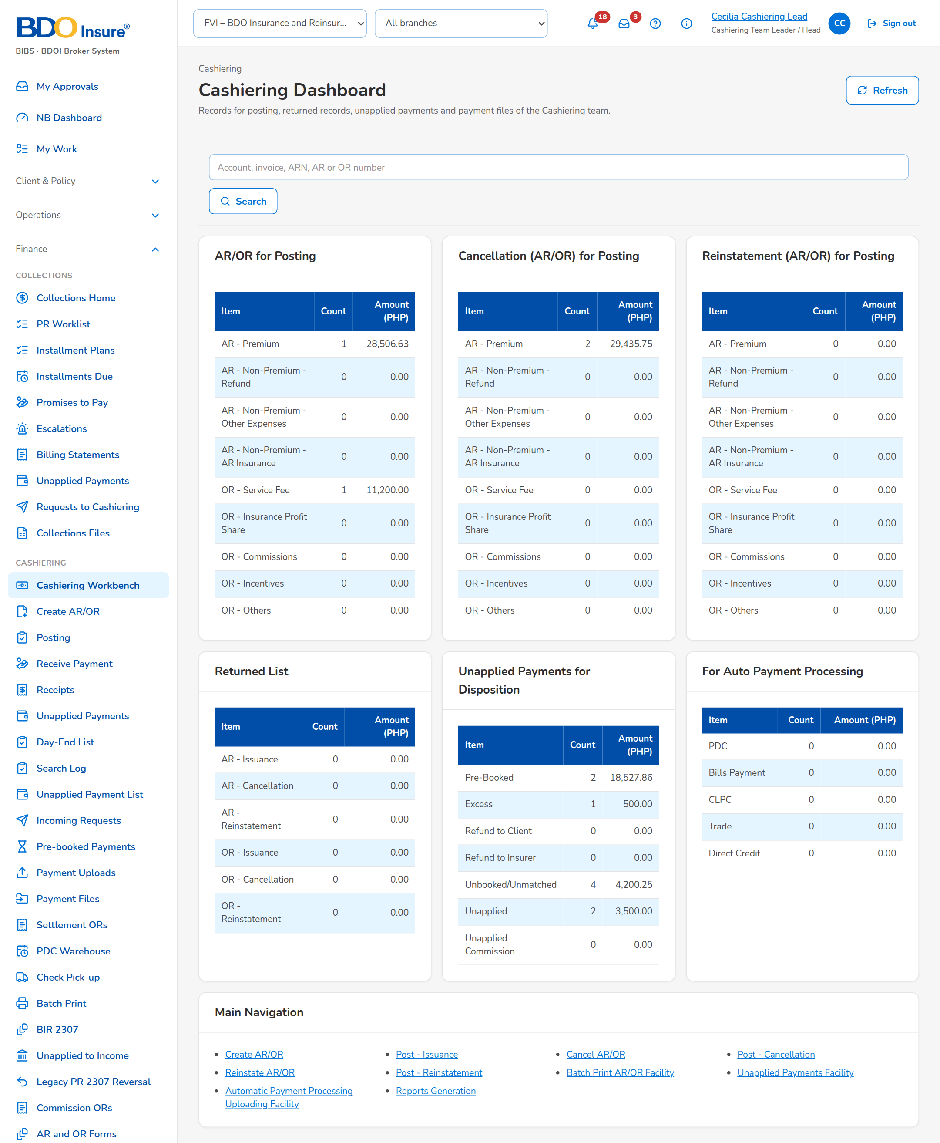
Figure 1: SCR-CSH-01: Cashiering Dashboard of the Cashiering Team Leader

SCR-CSH-02 Create AR/OR and Edit Record
Item | Value
Purpose | The creation record of an acknowledgement receipt or an official receipt, as BDOI's FRS sets it: the receipt type and the AR or OR type, the receipting branch, the payor (client, insurer or other), the payment (type, currency, bank account, paid amount, with VAT, withholding tax and the BIR 2307 reference of an OR), the check details and remarks, and the accounts paid with the amount of each. The receipt number is issued when the record is posted by the Approver/Poster.
Access | Cashiering Dashboard › Create AR/OR; Posting › Create AR, Create OR; Receive Payment and Receipts › Create OR (posting step on)
Requirements | FRS.CSH.02.01, FRS.CSH.02.02
Outcome | The cashier records the payment received in BDOI's layout and sends it for posting.

Rules and states:
• As delivered the ARs and ORs are issued through the posting step (setting Posting step of ARs and ORs): the record is created, submitted for posting and posted by an Approver/Poster other than its creator, who issues the receipt number.
• No account added: the payment will be recorded as unbooked / unmatched.
• A check dated within the holding period (4 working days as delivered) is refused at receipting while the check date rule is on (setting).
• An OR is created only for the Head Office.
Table 4: SCR-CSH-02 fields
Field | Type | Req. | Default | Rule | Message
Receipt: Receipt Type | Drop-down | Y | From the entry | Acknowledgement Receipt or Official Receipt (from the entry); Source: Fixed list | -
Receipt: Acknowledgement Receipt Type | Drop-down | Y (AR) | Premium Payment | Premium Payment; Non-Premium Payment: Refund from Insurer, Other Expenses, AR Insurance; Source: Fixed list; Editable: Created, Returned | AR Type is required
Receipt: Official Receipt Type | Drop-down | Y (OR) | Select… | Service Fee Income, Insurance Profit Share, Commissions (with VAT / withholding tax), Incentives, Handling Fee, Others (discount); Source: List of values OR type; Editable: Created, Returned | OR Type is required
Receipt: Receipting Branch | Drop-down | Y | The user's branch | Branches of the user; Head Office only for an OR; Source: Branches; Editable: Created, Returned | Receipting Branch is required
Receipt: Receipt Number | Text | - | - | To be generated once posted; Source: Receipt series; Editable: Read only | -
Payor: Entry Type | Drop-down | Y | Client | Client, Insurer, Other; Insurer for a non-premium AR; Source: Fixed list; Editable: Created, Returned | -
Payor: Client / Client Name | Look-up | Cond.: entry type Client | Blank | Client code and name; Source: Clients; Editable: Created, Returned; An active client | Client is required
Payor: Insurer / Bank Name | Drop-down, text | Cond.: entry type Insurer or a non-premium AR | Select… | Insurers by name; bank from the insurer banking list; Source: Insurers; Editable: Created, Returned | Insurer is required
Payor: Payor Name | Text | Y | Blank | Up to 250 characters; proposed from the client or insurer; Editable: Created, Returned | Payor Name is required
Payment: Payment Type | Drop-down | Y | Cash | Cash, Check; Direct Credit for an OR; Source: Fixed list; Editable: Created, Returned | -
Payment: Currency / Rate of the Day | Drop-down, value | Y | PHP | PHP, USD; the rate of the day for a foreign currency; Source: Currencies of the bank accounts; Editable: Created, Returned | Currency is required
Payment: Post to Bank Account | Drop-down | Y | The default account of the currency | DFLB - Current (BDO Ortigas), DFLB Savings (BDO Ortigas), DFLB Savings Mall (Peso), DFLB Savings Trade (Peso), DFLB Savings FX (BDO Ortigas); Source: Bank accounts; Editable: Created, Returned | Post to Bank Account is required
Payment: Paid Amount | Number | Y | Blank | Two decimals; at most 1,000,000,000.00; Editable: Created, Returned; Above zero and at most the maximum; equal to the sum of the accounts | Paid Amount must be above zero and not more than 1,000,000,000.00
Payment (OR): VAT / Withholding Tax / BIR 2307 Certificate Reference / SOA or Fee Invoice | Numbers, text, look-up | N | Blank | Two decimals; the statement or fee invoice paid; Source: Statements of account and fee invoices; Editable: Created, Returned | -
Check and Remarks: Check Number / Check Date / Bank of the Check | Text, date | Cond.: check payment | Blank | Up to 40 characters; dd-MMM-yyyy, with the holding period shown; Editable: Created, Returned; Date not within the holding period (setting) | Check Number is required; Check Date is required
Check and Remarks: Receipt Issuance Date | Date | N (AR) | Today | dd-MMM-yyyy; Editable: Created, Returned | -
Check and Remarks: Remarks | Text | Y as delivered (setting) | Blank | Up to 200 characters; Editable: Created, Returned | Remarks is required
Accounts: Account Number | Look-up | N | Blank | Account, invoice or ARN number; Source: Invoice ledger; Editable: Created, Returned | -
Accounts: Account Number / Premium Receivable / Commission Receivable / Total Invoice Amount / Total Paid Amount / Outstanding Balance / BIR 2307 Tag / PR 2307 Amount / Paid Amount / Excess Amount | Columns | Cond.: paid amount per account | Outstanding balance | Amounts with two decimals; the paid amount keyed per account; the excess computed; Source: Invoice ledger; Editable: Created, Returned; The paid amounts add up to the Paid Amount | The amounts of the accounts must add up to the Paid Amount

Table 5: SCR-CSH-02 actions
Action | Who | Available when | What happens | Result
Save | The creator (receipt right) | Required fields entered | Saves the record numbered CR-AR-nnnnnn or CR-OR-nnnnnn and opens it | Created
Cancel | The creator | Always | Leaves the form without saving | -

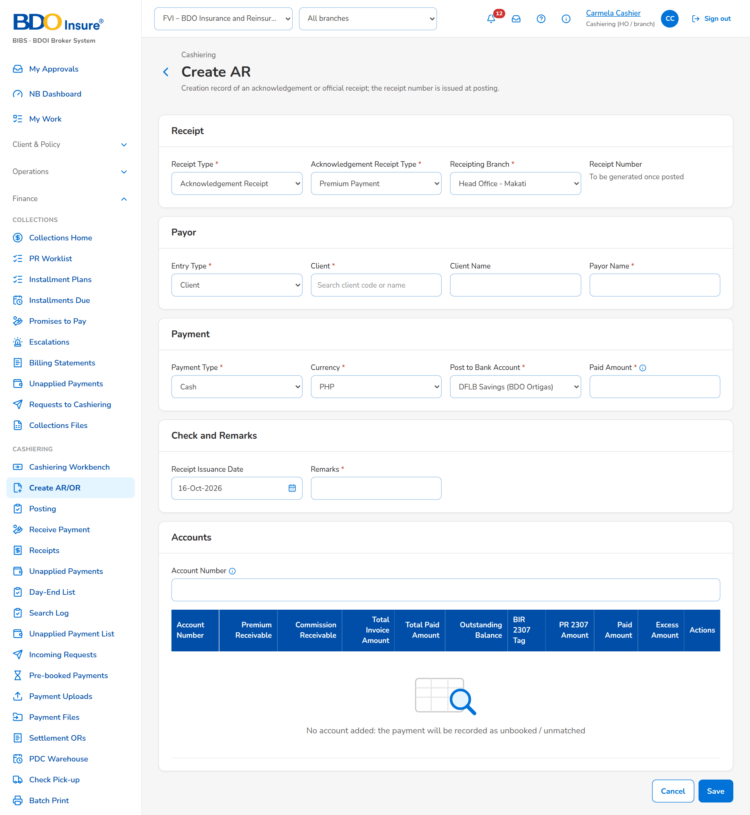
Figure 2: SCR-CSH-02: Create AR: the creation record of an acknowledgement receipt
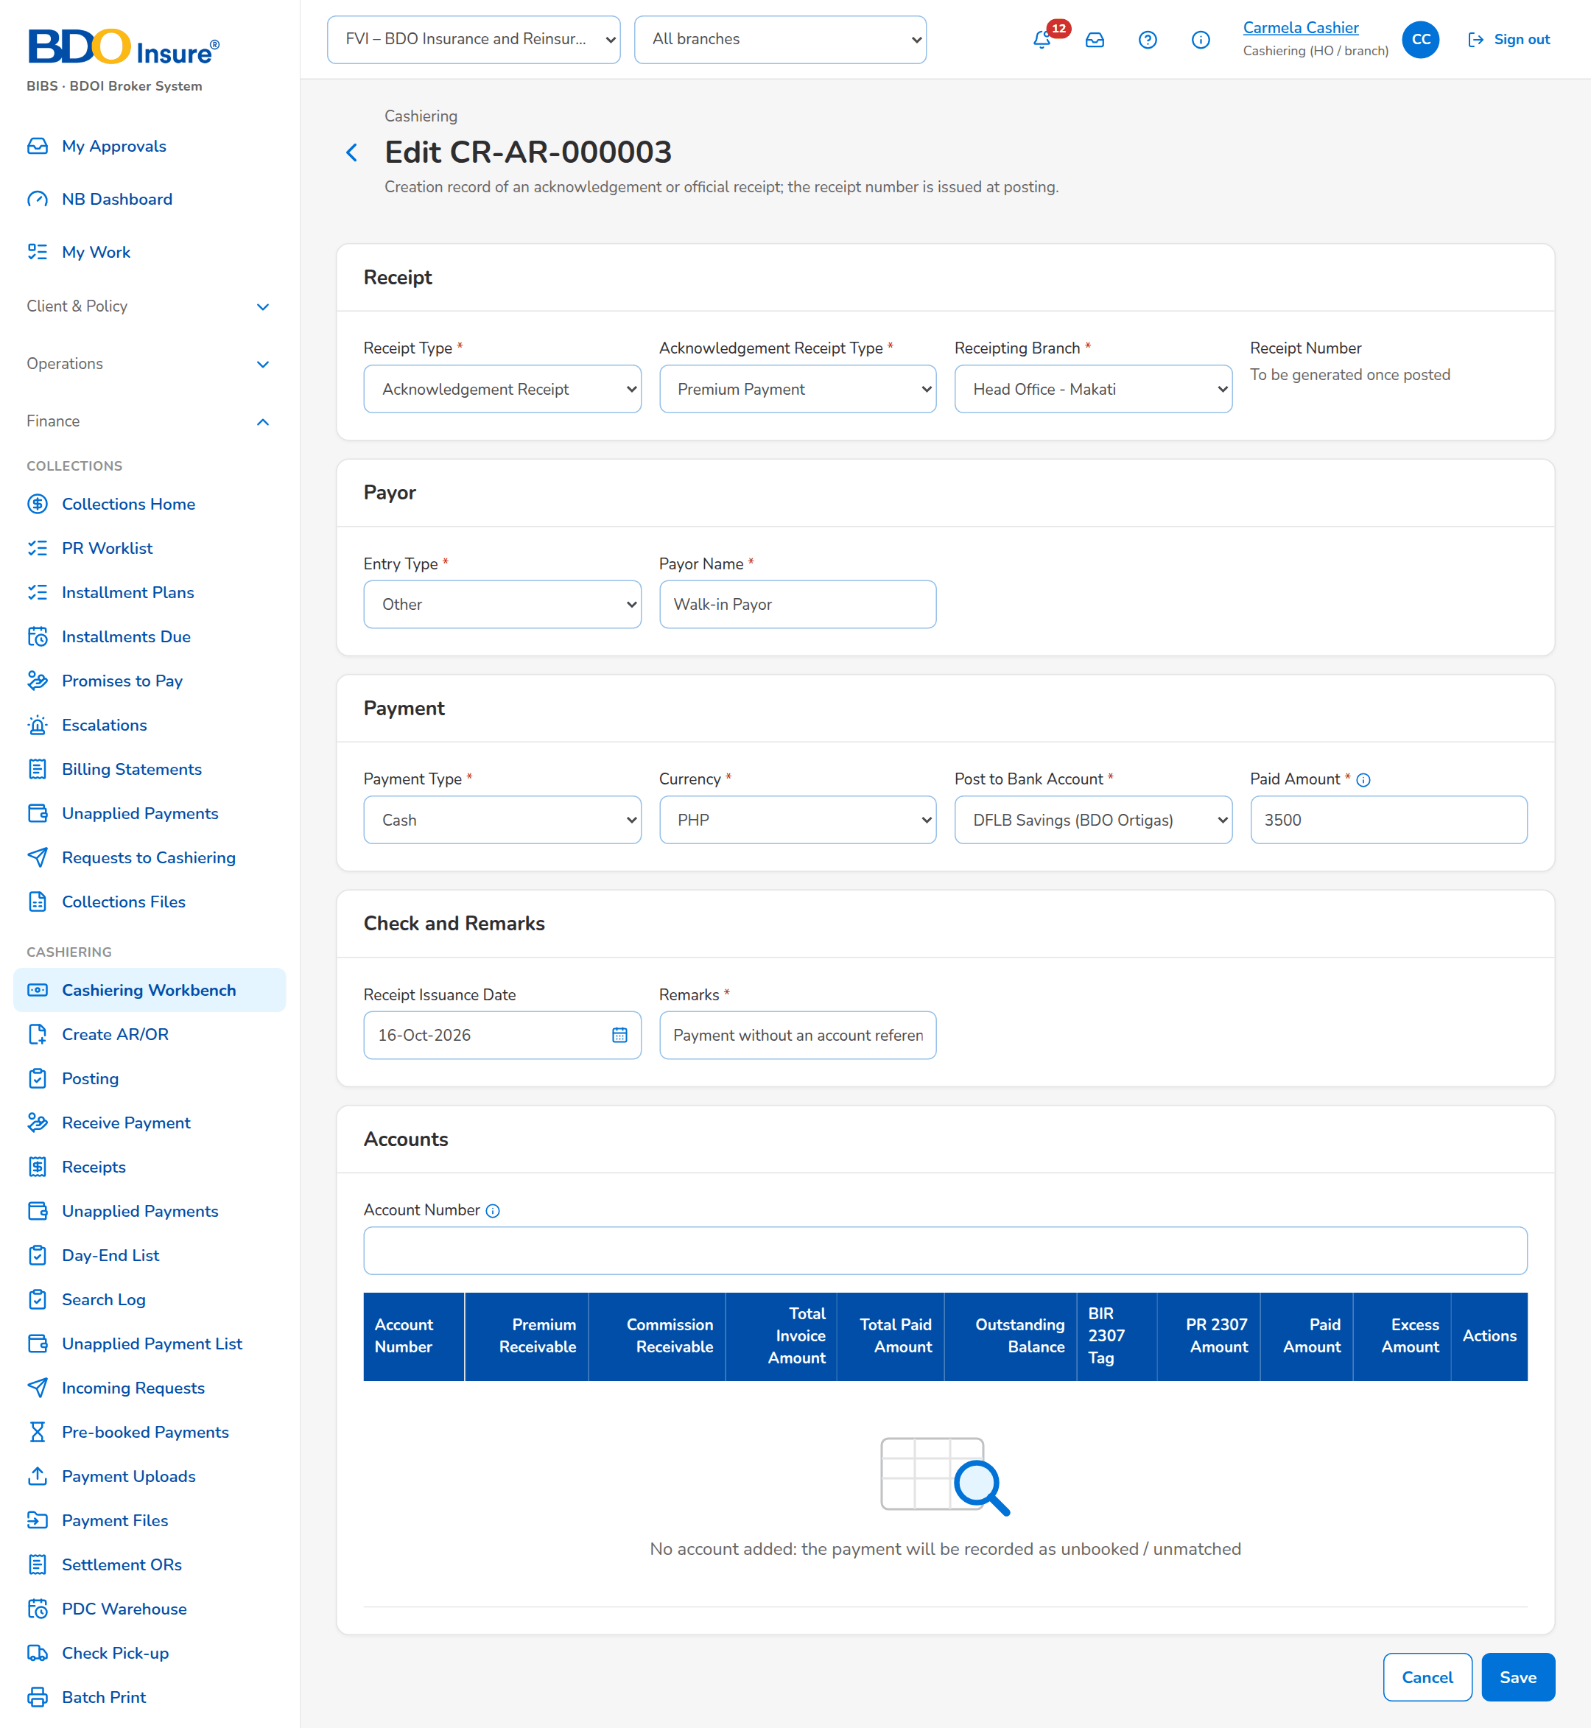
Figure 3: SCR-CSH-02: Edit Record of an AR creation record
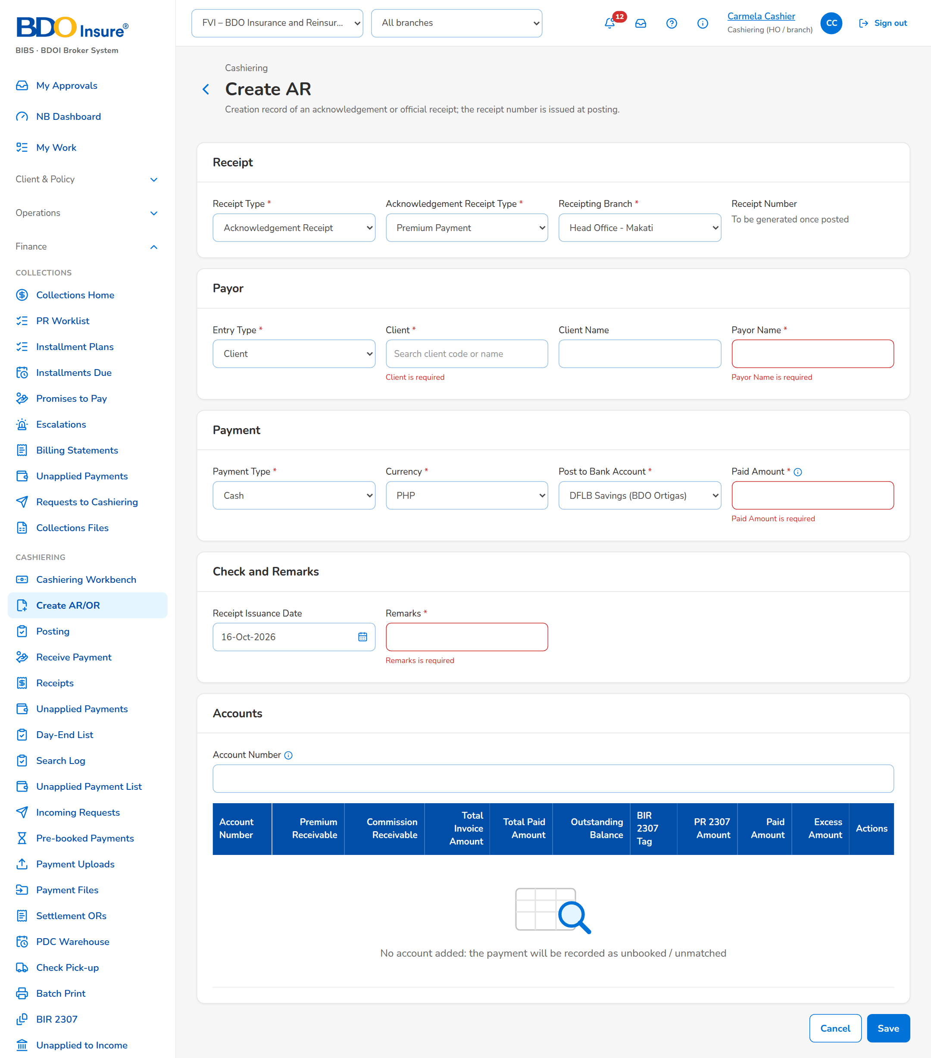
Figure 4: SCR-CSH-02: Create AR with the messages of the required fields
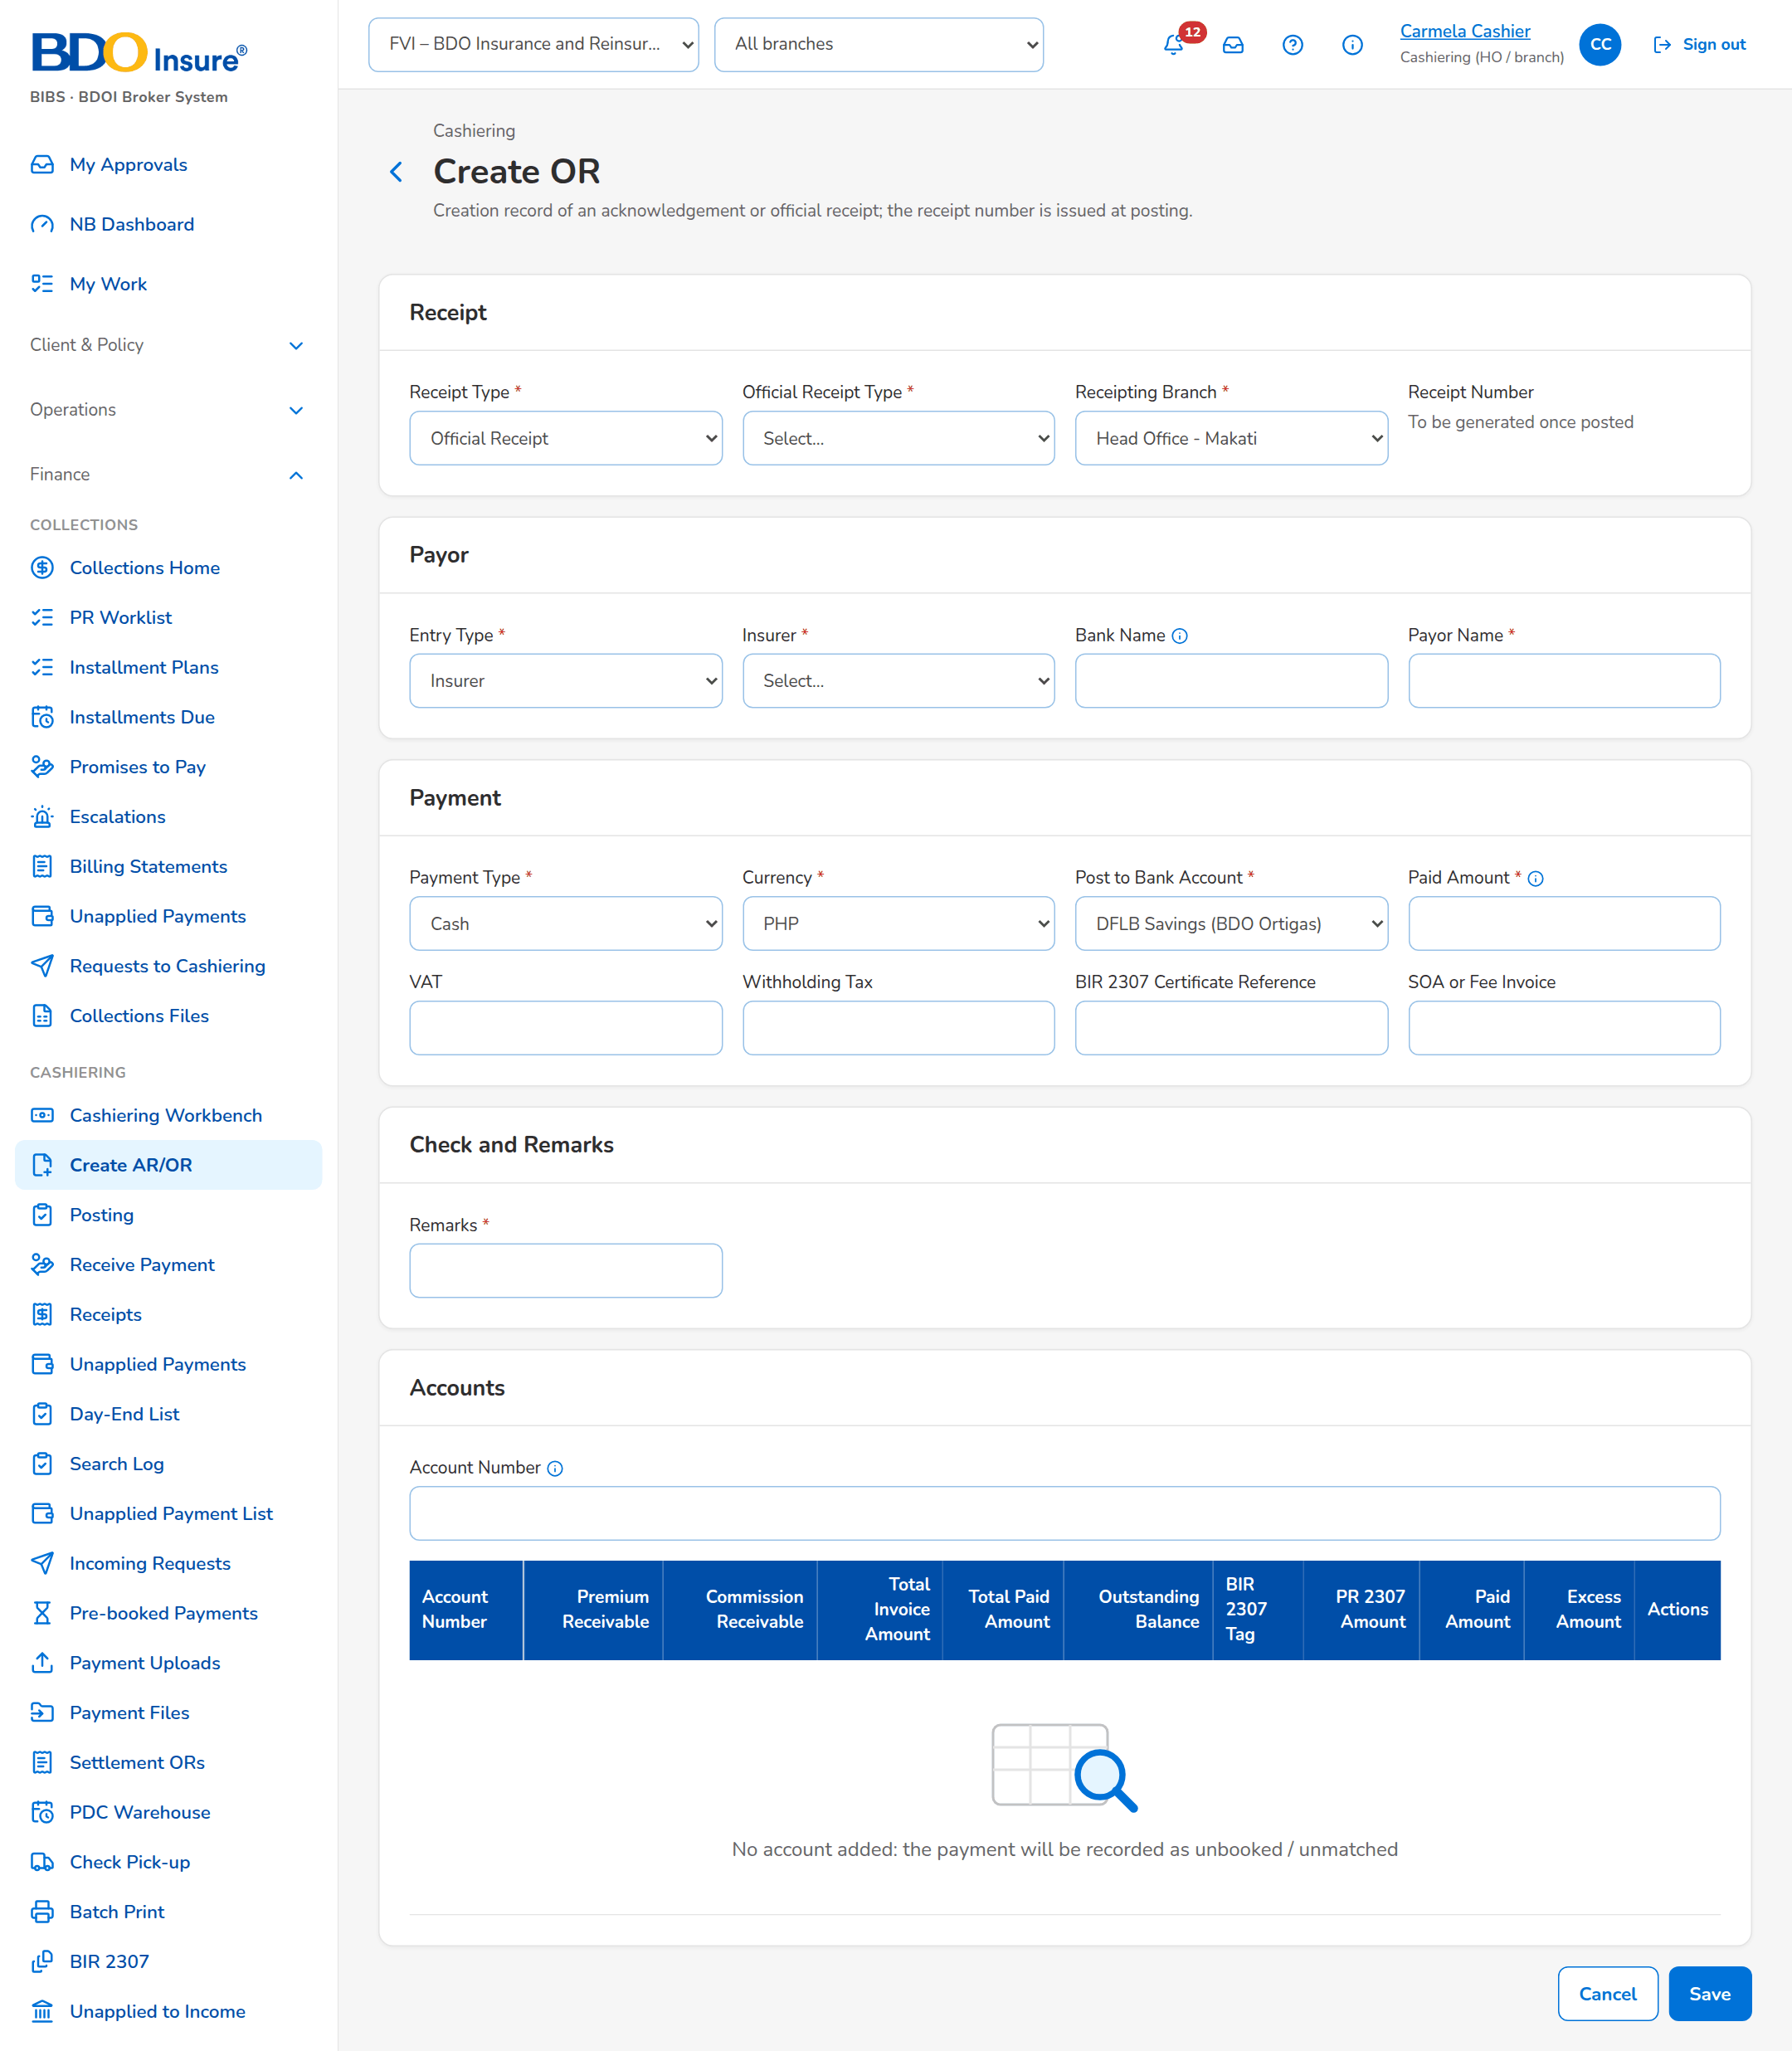
Figure 5: SCR-CSH-02: Create OR with the OR types, VAT, withholding tax and the SOA or fee invoice

SCR-CSH-03 Cashiering Record
Item | Value
Purpose | One creation, cancellation or reinstatement record of an AR or OR: its details, the accounts paid, its history, and the actions of the user - Edit, Submit for Posting and Cancel Record for the creator; Post and Return for the Approver/Poster, who is never the creator.
Access | Posting › a row; Cashiering Dashboard › an item of the posting groups or the returned list
Requirements | FRS.CSH.02.05, FRS.CSH.03.01, FRS.CSH.04.01
Outcome | Every receipt is issued, cancelled or reinstated by a second person, with its history.

Rules and states:
• The creator never posts the own record.
• Posting issues the receipt number from the series of the branch in its number format and posts the accounting entries; a record that cannot be posted keeps its status with the reason in Last posting attempt.
• Checks are posted and applied before cash in one posting run as delivered (setting).
• The cancellation of an AR already remitted turns the payment into an AR Insurer Refund as delivered (setting).
Table 6: SCR-CSH-03 fields
Field | Type | Req. | Default | Rule | Message
Record: Record Number / Receipt Type / AR / OR Type / Receipt Number / Receipting Branch | Values | - | - | CR-, CN- or RE- with AR or OR and a sequence; the receipt number once posted; Source: Record; Editable: Read only | -
Record: Payor Name / Client / Insurer / Payment Type / Post to Bank Account / Paid Amount / Currency / Check | Values | - | - | As entered; the check as bank, number and date; Source: Record; Editable: Read only | -
Record (cancellation, reinstatement): Reason / Type of Reinstatement / Unit Head / Remarks | Values | - | - | The reason of the list; Full or Partial Reinstatement; Source: Record; Editable: Read only | -
Record: Returned / Last posting attempt / Created by / Posted by | Values | - | - | Reason and user of a return; result of the last posting; names with date and time; Source: Record; Editable: Read only | -
Accounts: Account Number / Invoice Number / Amount | Columns | - | - | Accounts of the record; Source: Record accounts; Editable: Read only | No account on the record
History: Date and Time / User / Activity / Details | Columns | - | - | Every action on the record; Source: Record history; Editable: Read only | No activity yet
Return to Creator: Reason | Text area | Y | Blank | Why the record goes back; Editable: Dialog | -

Table 7: SCR-CSH-03 actions
Action | Who | Available when | What happens | Result
Edit | The creator | Created or Returned | Opens Edit Record | -
Submit for Posting | The creator | Created or Returned | Asks for confirmation (The record goes to the Approver/Poster for posting); toast Record is now submitted for Posting | For Posting
Cancel Record | The creator | Created or Returned | Record will be Cancelled. Do you wish to continue? | Record Cancelled
Post | Approver/Poster (posting right), not the creator | For Posting | Creation: AR/OR will be issued. Payments will be applied. Any excess payments will be reflected in the Unapplied List. Cancellation: AR/OR will be cancelled. Payments will be cancelled once cancellation is posted. Reinstatement: AR/OR will be reinstated. Payments will be reinstated once posted | AR/OR Issued, Cancelled or Reinstated
Return | Approver/Poster | For Posting | Returns the record to its creator with the reason | Returned; Notice to the creator

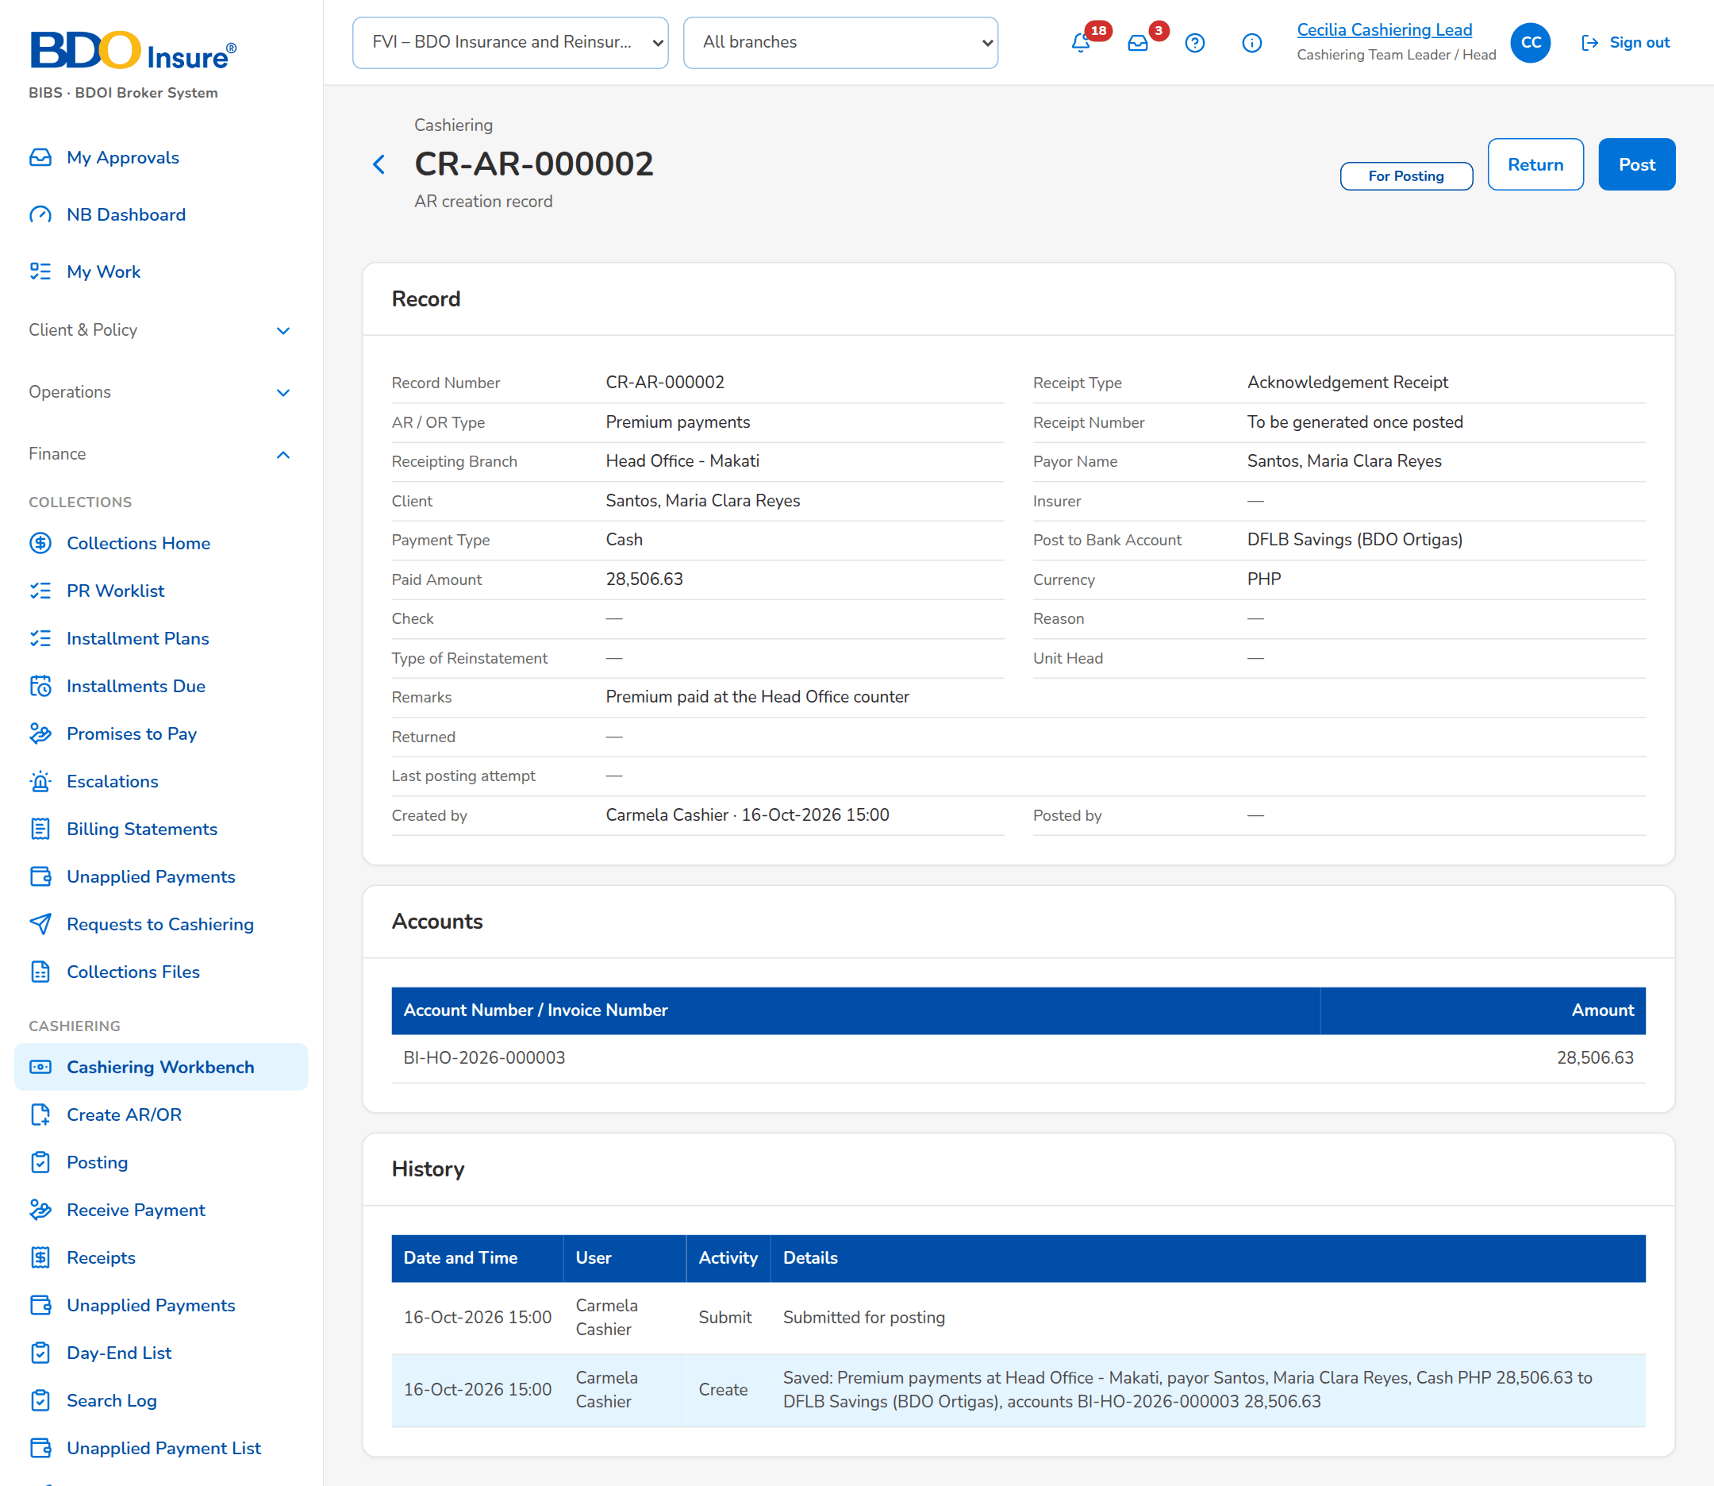
Figure 6: SCR-CSH-03: AR creation record for posting, as the Approver/Poster sees it
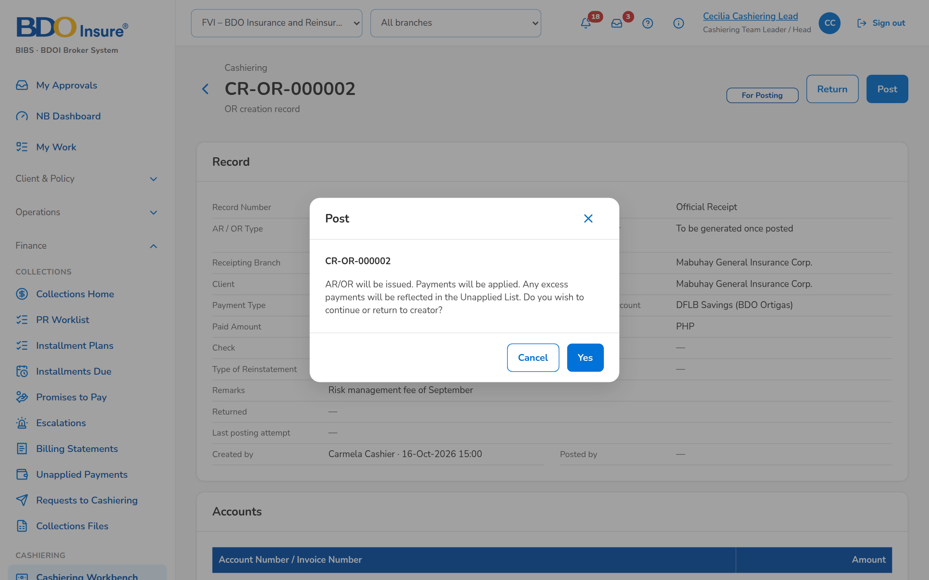
Figure 7: SCR-CSH-03: Post confirmation of an OR creation record
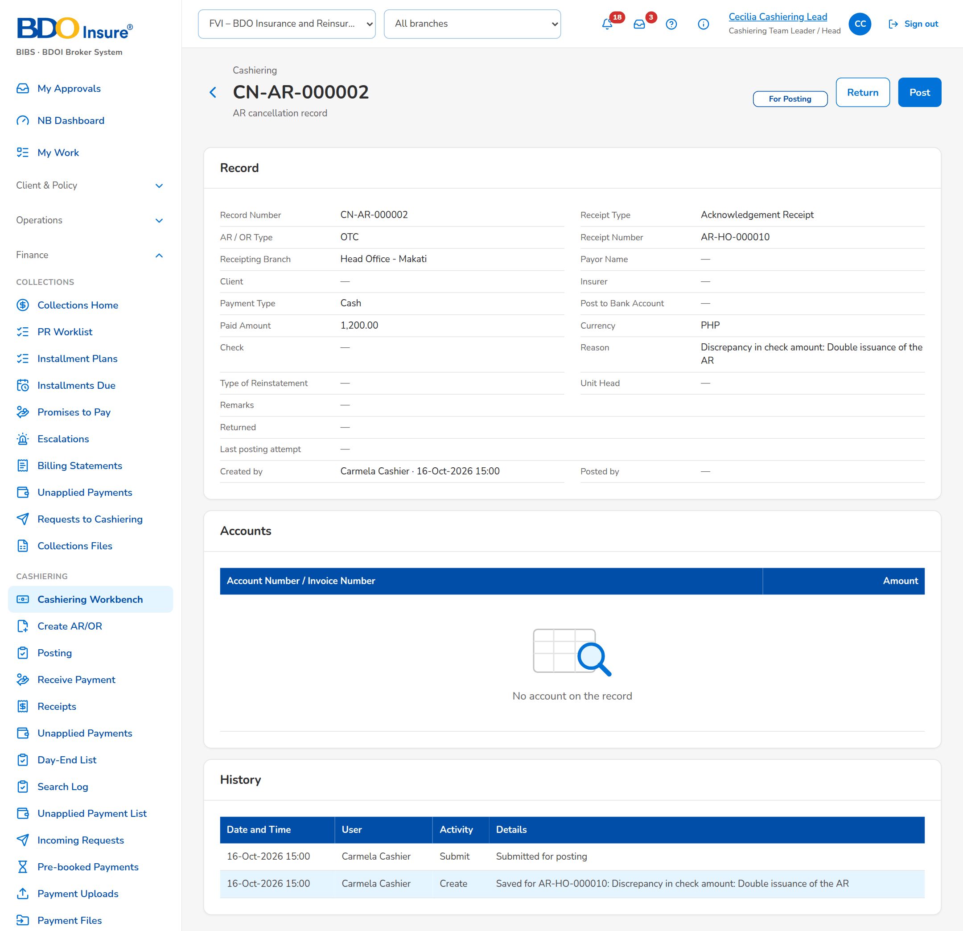
Figure 8: SCR-CSH-03: Cancellation record of an issued AR for posting

SCR-CSH-04 Posting
Item | Value
Purpose | The lists of the records waiting for posting or returned, in three tabs - AR/OR for Issuance Posting, Cancellation (AR/OR) for Posting and Reinstatement (AR/OR) for Posting - with their filters, the posting of several records at once, the export to Excel and the creation of a new AR or OR.
Access | Cashiering Dashboard › Post - Issuance, Post - Cancellation, Post - Reinstatement
Requirements | FRS.CSH.02.05, FRS.CSH.03.01, FRS.CSH.04.01
Outcome | The Approver/Poster posts the records of the day in one run and returns the ones to correct.

Rules and states:
• A user posts only the records he did not create.
Table 8: SCR-CSH-04 fields
Field | Type | Req. | Default | Rule | Message
Tabs: [Tabs: AR/OR for Issuance Posting, Cancellation (AR/OR) for Posting, Reinstatement (AR/OR) for Posting] | Tab | - | AR/OR for Issuance Posting | Source: Fixed | -
Filters: Record Status / Receipt Type / Record Number / Client or Insurer Name / Created From / Created To | Drop-downs, text, dates | N | For Posting | For Posting, Returned, Created, Posted, Record Cancelled; All, Acknowledgement Receipt, Official Receipt; Source: Fixed lists | -
Records: Record Number / Receipt Type / Record Type / AR/OR Number / Amount | Columns | - | - | Creation, Cancellation or Reinstatement Record Number; AR or OR; the type; the receipt number; Source: Records; Editable: Read only | No records match the filters
Records: Account Number / Invoice Number / Client Name / Insurer Name / Receipting Branch / Created by / Date Created / Record Status | Columns | - | - | As recorded; Source: Records; Editable: Read only | -
Records not posted: [Outcome of a posting run] | Table | - | - | The records the run could not post, with the reason; Source: Posting run; Editable: Read only | -

Table 9: SCR-CSH-04 actions
Action | Who | Available when | What happens | Result
Post Selected (n) | Approver/Poster | Records For Posting selected | Posts the selected records, checks before cash; lists those not posted with the reason | AR/OR Issued, Cancelled or Reinstated
Open, Post, Return, Edit | As on the record | A row | From the row menu | -
Create AR / Create OR | Cashier | Always | Opens Create AR/OR | -
Export to Excel | Every user of the screen | Always | Downloads the list of the filters | -

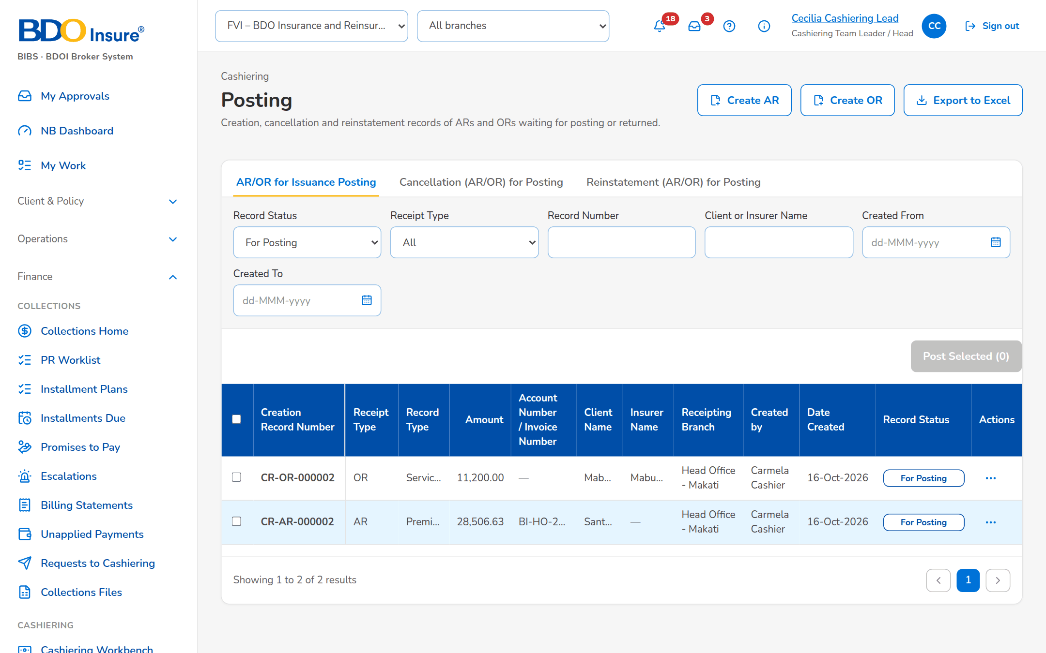
Figure 9: SCR-CSH-04: Posting: AR/OR records for issuance posting
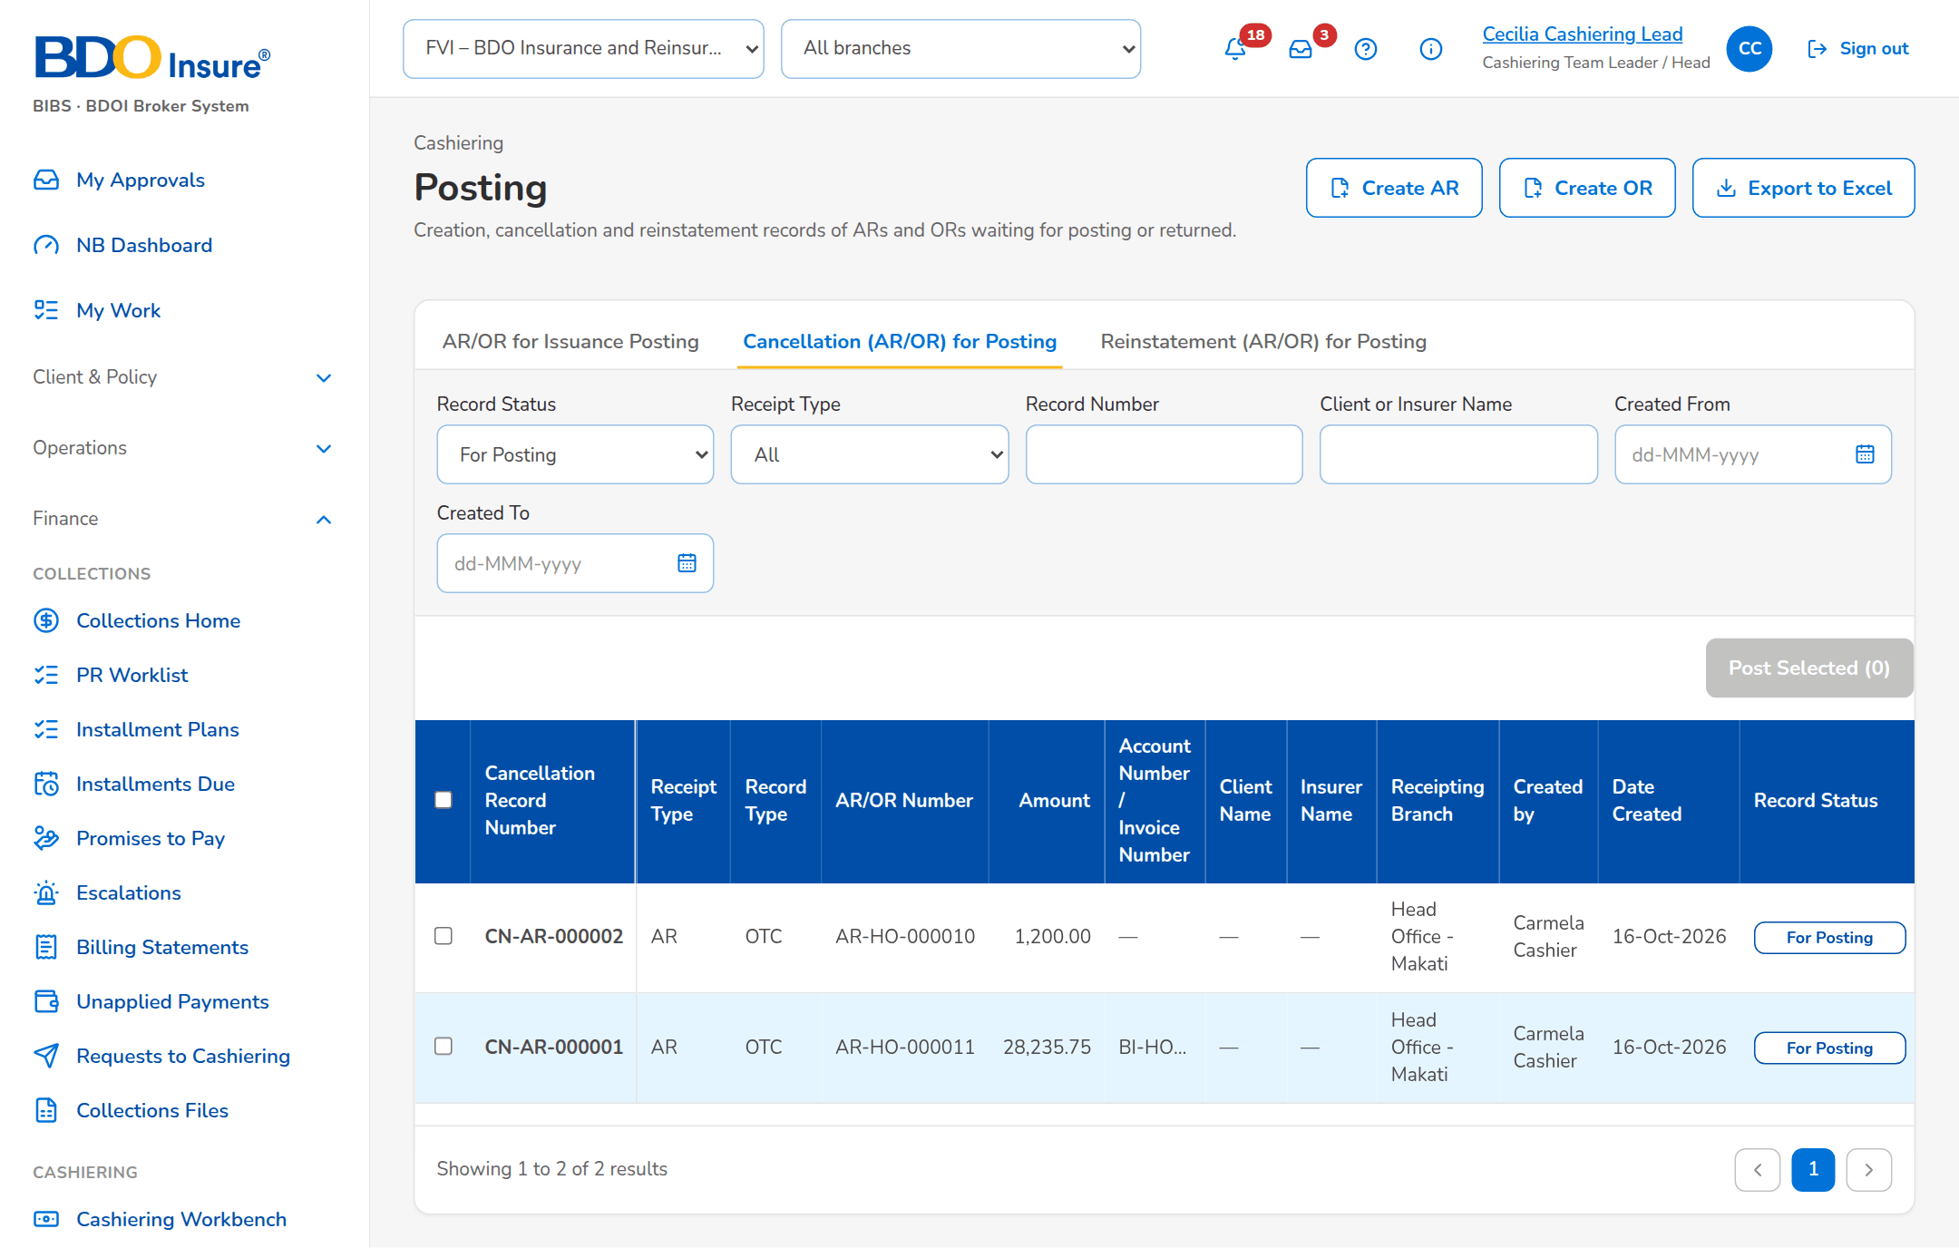
Figure 10: SCR-CSH-04: Posting: cancellation records for posting

SCR-CSH-05 Receive Payment
Item | Value
Purpose | The over-the-counter payment of a walk-in payor: the references typed are matched on ARN, invoice, policy or PN number, the live preview shows how the money is applied component by component, and Issue AR and Apply issues the acknowledgement receipt, applies the payment and leaves any excess in unapplied collections. Shown when the posting step of ARs is off (setting); as delivered BDOI's posting step applies and the entry opens Create AR (SCR-CSH-02).
Access | Cashiering Workbench
Requirements | FRS.CSH.02.05, FRS.CSH.05.03
Outcome | The AR is issued and the payment is applied, waiting for booking or kept unapplied.

Rules and states:
• A payment is matched at acceptance on the ARN, invoice, policy or PN number: a booked invoice is applied at once, an account not yet booked waits in the pre-booked queue, a cancelled or unknown reference becomes an unapplied payment.
• Payments are applied in the order DST, VAT / premium tax, LGT, fire service tax, other charges, basic premium; the premium due to the insurer is never applied.
• The payment of a 2% CWT client is applied up to 98% of the premium; the 2% waits for the BIR 2307 and anything above it stays unapplied.
• The amount is converted at the BOOK rate of the currency and the AR takes the next number of the branch series.
• A non-premium payment of an insurer (refund, other expenses) is received as AR Insurance, apart from premium.
Table 10: SCR-CSH-05 fields
Field | Type | Req. | Default | Rule | Message
Payor and Payment: ARN, Invoice, Policy or PN No. | Text area | Y | Blank | One or more references separated by commas or lines; applied oldest first; Source: Invoice ledger, pre-booked accounts; At least one reference | Enter at least one reference, or the payor code for an unmatched payment
Payor and Payment: Payor Name | Text | Y | Blank | Up to 250 characters; Not blank | Payor name is required
Payor and Payment: Payor / Client Code | Text | N | Blank | Up to 30 characters; Source: Clients (BRD-01) | -
Payor and Payment: Assured Name | Text | N | Blank | Up to 250 characters | -
Payor and Payment: AR Class | Drop-down | Y | OTC | Premium payments: Bills Payment, OTC, Trade, CLPC, PDC, Direct Credit; Non-premium payments (insurance payments): Refund, Other expenses, AR Insurance; Source: List of values AR class | -
Payor and Payment: Amount | Number | Y | Blank | Two decimals; Above zero | Enter an amount above zero
Payor and Payment: Currency | Text | Y | PHP | 3 letters; Source: Currencies; Converted at the BOOK rate of the day | -
Payor and Payment: Payment Date | Date | Y | Today | dd-MMM-yyyy | -
Payor and Payment: Mode of Payment | Drop-down | Y | Cash | Cash, Check, Direct Credit, ADA, Credit to Account; Source: Fixed list | -
Payor and Payment: Check No. / Bank | Text | Cond.: check number for a check | Blank | Up to 40 / 60 characters; shown for a check; Check number for a check payment | Check number is required for a check payment
Application Preview: [Match outcome and BOOK rate] | Status pill and chip | - | - | Booked, Pre-booked, Cancelled or No match; <currency> · BOOK <rate>; Source: Payment matching; Editable: Read only | Enter an ARN, invoice, policy or PN number to preview the application.
Application Preview: Component / Balance / Applied | Column | - | - | One table per invoice: DST, VAT / Premium Tax, LGT, FST, Other Charges, Basic Premium with the total; Source: Invoice ledger; Editable: Read only; Applied in this order | -
Application Preview: Applied / 2% CWT Withheld / Excess to Unapplied | Display | - | 0.00 | Amount; Source: Computed; Editable: Read only; A 2% CWT client is applied up to 98% of the premium | -

Table 11: SCR-CSH-05 actions
Action | Who | Available when | What happens | Result
Issue AR and Apply | Cashier | The form is complete | Issues the AR from the branch series, applies the payment by component and opens the receipt; an account not yet booked waits in the pre-booked queue, anything else goes to unapplied collections | AR issued
Clear | Cashier | Always | Empties the form | -

Figure 11: SCR-CSH-05: Receive Payment with the posting step of ARs on: the payment is taken on Create AR/OR

SCR-CSH-06 Receipts
Item | Value
Purpose | The search over acknowledgement receipts and Head Office official receipts with ten criteria, the open cancellation and reinstatement requests for approval, and the issue of an official receipt for BDOI income (service fee, profit share, commission, incentive, others).
Access | Cashiering Workbench › Cancellations and Reinstatements for Approval tile
Requirements | FRS.CSH.03.01, FRS.CSH.04.01, FRS.CSH.08.01
Outcome | Receipts are found and ORs for BDOI income are issued.

Rules and states:
• An OR is issued only from a Head Office series; an AR from the series of the receiving branch.
• The receipt search has ten criteria and every search is logged.
• A cancellation or reinstatement is approved by a Cashiering Team Leader other than its requester.
Table 12: SCR-CSH-06 fields
Field | Type | Req. | Default | Rule | Message
Tabs: Receipts / Cancellations and Reinstatements | Tab | - | Receipts | Source: Fixed | -
Toolbar: Search Receipt No. | Text | N | Blank | Receipt number; Source: Receipts | -
Filters: Client Code / Invoice No. / Policy No. / Payor Name / Assured Name / Insurer | Text, drop-down | N | Blank | Insurers by name; Contains | -
Filters: Amount / Date From / Date To | Number, Date | N | Blank | dd-MMM-yyyy | -
Filters: Kind / Status | Drop-down | N | All | All, AR, OR / All, Issued, Cancelled, Reinstated; Source: Fixed list | -
List: Receipt No. / Date / Payor / Assured / Mode / Amount / Applied / Unapplied / Status | Column | - | - | Receipt number with its kind and class; payor with the assured or payor code; Source: Receipts; Editable: Read only | No receipts match the search
Cancellations and Reinstatements: Transaction No. / Reason / Amount / Requested / Status | Column | - | - | CAN-yyyy-n or RIN-yyyy-n with the action; requester name and time; Source: Receipt actions; Editable: Read only | -
Issue Official Receipt dialog: OR Type | Drop-down | Y | Blank | Service fee, profit share, commission, incentive, others; Source: List of values OR type | Select the OR type
Issue Official Receipt dialog: Payor Name / Payor Code | Text | Y / N | Blank | Up to 250 / 30 characters; Payor name not blank | Payor name is required
Issue Official Receipt dialog: Currency / Mode of Payment / Check No. | Text, Drop-down | Y / N / N | PHP / Check | Cash, Check, Direct Credit, Credit to Account, Non Cash | -
Issue Official Receipt dialog: Gross Amount / VAT / Withholding Tax | Number | Y / N / N | Blank / 0 / 0 | Two decimals; Gross above zero; VAT and withholding tax not negative | Enter the gross amount / VAT and withholding tax cannot be negative
Issue Official Receipt dialog: 2307 Certificate Ref. / Description | Text | N | Blank | Up to 60 / 250 characters | -

Table 13: SCR-CSH-06 actions
Action | Who | Available when | What happens | Result
Create OR | Cashier (Head Office) | The posting step of ORs is on (as delivered) | Opens Create OR (SCR-CSH-02); the OR number is issued when the record is posted | Created
Issue Official Receipt / Issue OR | Cashier (Head Office) | The posting step of ORs is off | Issues the OR from the Head Office series with its VAT and withholding tax lines and opens it | OR issued
Search / Filters | Every Cashiering user | Always | Filters the receipts | -
Open Receipt | Every Cashiering user | Always | Opens the receipt of the request | -
Approve | Cashiering Team Leader | Request for approval | Asks for confirmation and applies the cancellation or reinstatement to the receipt with its postings | Posted; Workflow notice (NT-01)
Resubmit | Cashier who requested it | Request returned to Requested | Sends the request for approval again | For approval; Cashiering approval request (NT-07)

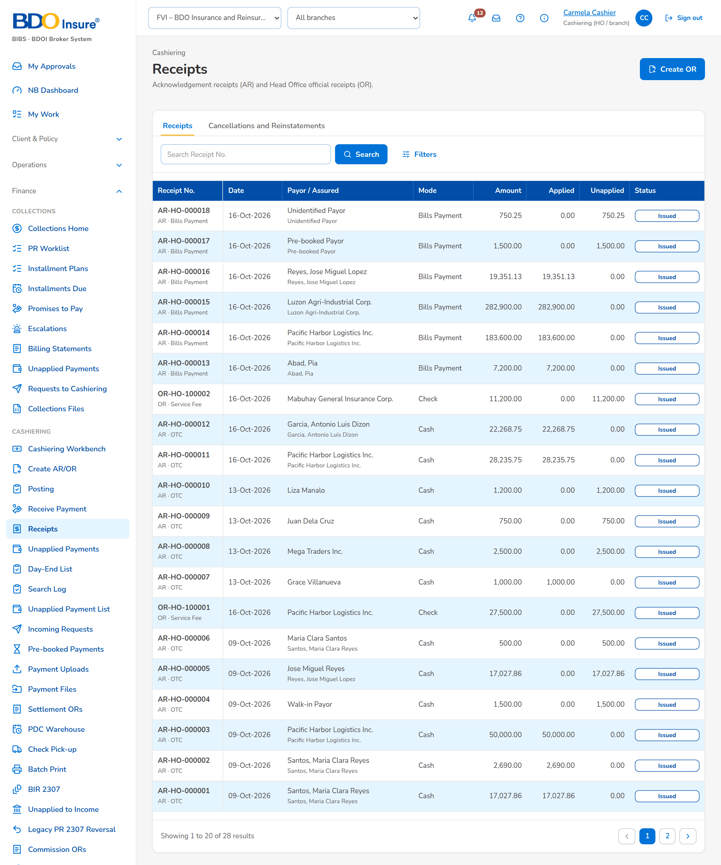
Figure 12: SCR-CSH-06: Receipts: acknowledgement and official receipts
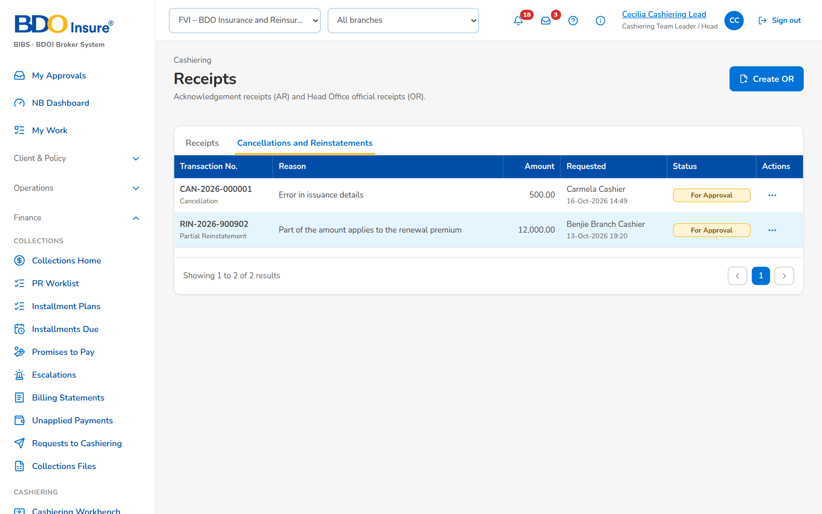
Figure 13: SCR-CSH-06: Cancellations and Reinstatements tab of the Cashiering Team Leader

SCR-CSH-07 Receipt
Item | Value
Purpose | One AR or OR: payor, number, status and flags, the amounts applied and unapplied with the BOOK rate, the workflow of an open cancellation or reinstatement, and the tabs Applications, Lines, Journal and History. Print produces the receipt PDF; Cancel Receipt and Reinstate go to the Cashiering Team Leader.
Access | Receipts › open a row; Receive Payment (after Issue AR and Apply); Unapplied Payment › Open Receipt
Requirements | FRS.CSH.02.04, FRS.CSH.02.06, FRS.CSH.03.01, FRS.CSH.04.01, FRS.CSH.08.03
Outcome | The receipt, its applications and its postings are visible; cancellations and reinstatements are approved by a second user.

Rules and states:
• A cancellation reverses every active application, reverses the receipt entry and closes the unapplied balance of the receipt.
• A reinstatement restores the receipt for the full or partial amount, applies it to the invoice encoded and leaves the rest unapplied; a bounced check needs no encoded fields.
• The requester never approves the own request.
• As delivered (posting step on) Cancel Receipt and Reinstate create a cancellation or reinstatement record, CN- or RE- numbered, that the Approver/Poster posts or returns on Posting (SCR-CSH-03, SCR-CSH-04).
• Every action on a receipt records the receipt number, the user and the time in the audit trail.
Table 14: SCR-CSH-07 fields
Field | Type | Req. | Default | Rule | Message
Header: [Receipt No. chip and status pill] | Reference chip, status pill | - | - | AR or OR number; Issued, Cancelled, Reinstated; Source: Receipts; Editable: Read only | -
Header: [Flags] | Tag | - | - | With Unapplied, Printed <n>x, Reinstated; Source: Receipts; Editable: Read only | -
Header: Receipt Date / Payor / Amount / Applied / Unapplied / Mode / Currency / BOOK Rate | Display | - | - | Amounts with two decimals; mode with the check number; Source: Receipts; Editable: Read only | -
Workflow: [Receipt action workflow header] | Stepper | - | - | Requested, For approval, Posted with the history table; Source: Receipt action; Editable: Read only | -
Tabs: Applications / Lines / Journal / History / Documents | Tab | - | Applications | Source: Fixed | -
Documents: Document / Printed By / Printed | Column | - | - | Every print of the receipt (client's and company copy, re-prints) with its PDF; Source: Print lines; Editable: Read only | -
Applications: Invoice / Reference / By Component / Applied / Commission Realized / Value Date / Status | Column | - | - | Invoice with its ARN; the amount by component; Source: Applications; Editable: Read only | Nothing applied from this receipt
Lines: Invoice / Item / Insurer / Gross / VAT / WTAX / Net | Column | - | - | OR lines; Source: Receipt lines; Editable: Read only | -
Journal: Journal Batch / Posting | Column | - | - | Receipt, each application and each action; Source: Journals (BRD-5); Editable: Read only | No journal posted yet
History: Transaction No. / Action / Reason / Amount / Requested / Approved / Status | Column | - | - | Names and times; Source: Receipt actions; Editable: Read only | No cancellation or reinstatement
Cancel Receipt dialog: Reason | Drop-down | Y | Blank | Source: List of values receipt cancellation reason; Editable: Issued, no open request | Select a reason
Cancel Receipt dialog: Comment | Text area | Cond. | Blank | Mandatory for the reason Others; Editable: Issued | -
Reinstate dialog: Full / Partial | Radio | Y | Full | Full = the receipt amount; Editable: Cancelled, no open request | -
Reinstate dialog: Reason Group / Reason | Drop-down | Y | Premium (AR) | Premium or Direct Payment; the reasons of the group; Source: List of values reinstatement reason; Editable: Cancelled | Select a reason
Reinstate dialog: Amount to Reinstate | Number | Cond.: partial | Blank | Above zero, at most the receipt amount; Editable: Cancelled; Within the receipt amount | Enter an amount above zero and at most <amount>
Reinstate dialog: Invoice No. / AR / OR No. / Assured / Payor / Account Officer / Unit Head / Team Leader / Remarks | Text | Y (Remarks N) | AR / OR number and payor of the receipt | Up to 250 characters; the Account Officer, Unit Head and Team Leader for the premium group; Editable: Cancelled; Not blank | <field> is required

Table 15: SCR-CSH-07 actions
Action | Who | Available when | What happens | Result
Print (PDF) | Every Cashiering user | Always | Downloads the receipt PDF; the print count is kept | -
Cancel Receipt | Cashier | Issued and no request open | Asks for the reason and submits the cancellation for approval | Cancellation for approval; Cashiering approval request (NT-07)
Reinstate | Cashier | Cancelled and no request open | Opens the reinstatement dialog and submits it for approval | Reinstatement for approval; Cashiering approval request (NT-07)
Approve and Post | Cashiering Team Leader other than the requester | Request for approval | Posts the cancellation (reverses every application and the receipt) or the reinstatement (restores the receipt and applies the amount) | Posted; Workflow notice (NT-01)
Return to Requester | Cashiering Team Leader | Request for approval | Asks for the reason and returns the request | Requested; Workflow notice (NT-01)

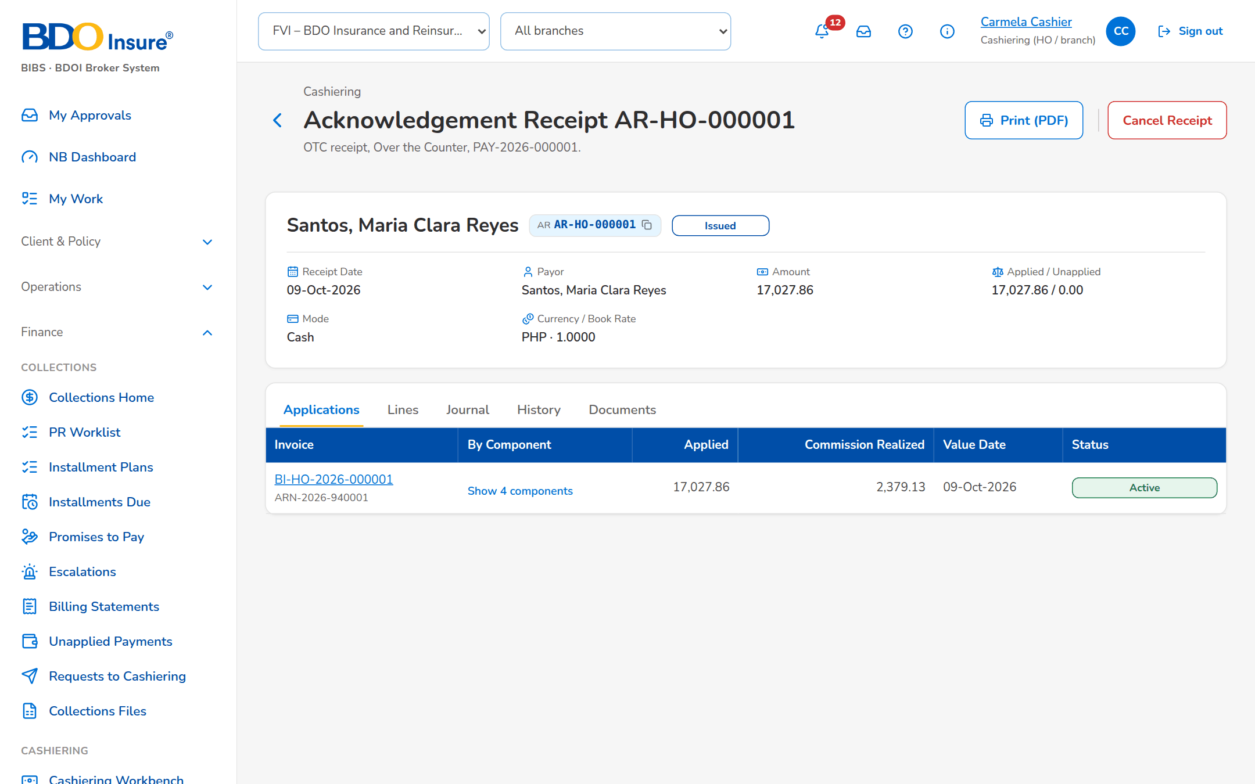
Figure 14: SCR-CSH-07: Receipt with its applications by component
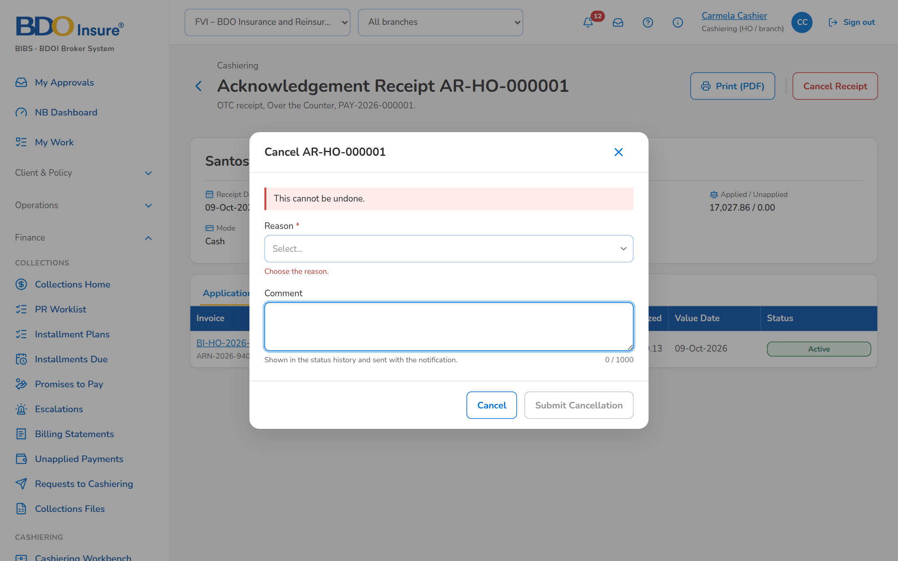
Figure 15: SCR-CSH-07: Cancel Receipt dialog with the reason
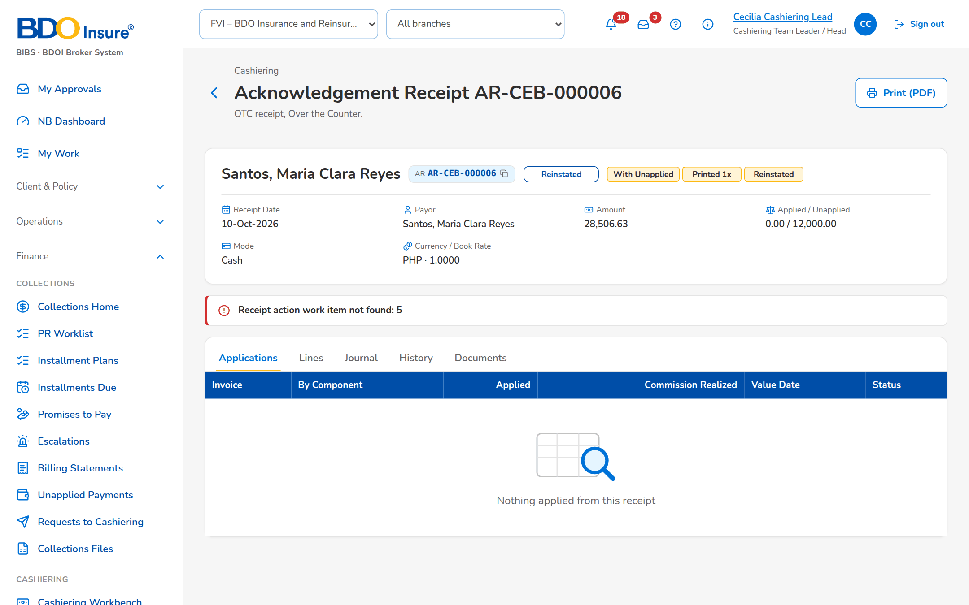
Figure 16: SCR-CSH-07: Receipt with a cancellation request for approval: workflow header and Approve and Post

SCR-CSH-08 Unapplied Payments
Item | Value
Purpose | Payments not applied to an invoice (no match, excess, cancelled reference, adjustment, cancellation, remittance return, re-application, pre-booked and others) by stage: the cashier assigns a disposition, submits it and a second user approves it; selected items are submitted or approved in one action.
Access | Cashiering Workbench › Unapplied Payments and Dispositions for Approval tiles
Requirements | FRS.CSH.06.01, FRS.CSH.06.02
Outcome | Unapplied money is followed by stage until it is applied, refunded, reclassed or transferred.

Rules and states:
• Every unapplied balance keeps its origin until it is disposed of.
• Bulk submit and approve process each item on its own, so one failure does not stop the others.
• The approver is never the requester of the disposition.
Table 16: SCR-CSH-08 fields
Field | Type | Req. | Default | Rule | Message
Tabs: Unapplied / Monitoring / For Approval / For Reversal / Done | Tab | - | Unapplied | Source: Fixed | -
Toolbar: Search Reference or Payor | Text | N | Blank | Contains | -
Toolbar: Origin | Drop-down | N | All origins | All origins, BIBS, Migrated; Source: Fixed list | -
List: Select | Check box | N | Not ticked | On Monitoring and For Approval | -
List: Reference / Payor / Client / Unit / Amount / Balance / Disposition / Received / Stage | Column | - | - | UNP-yyyy-n with why it is unapplied; the unit by name; the disposition in words with its amount; Source: Unapplied payments; Editable: Read only | No items to display
Bulk Action Results dialog: [Outcome per item] | Table | - | - | Done, or the message of the item; Editable: Read only | -

Table 17: SCR-CSH-08 actions
Action | Who | Available when | What happens | Result
Submit Selected | Cashier | Monitoring, rows selected | Submits the disposition of each selected item on its own and lists the outcome of each | For approval; Cashiering approval request (NT-07)
Approve Selected | Cashiering Team Leader | For Approval, rows selected | Approves each selected disposition on its own (never one's own) and lists the outcome of each | In process or Completed; Workflow notice (NT-01)
Open a row | Every Cashiering user | Always | Opens the unapplied payment | -

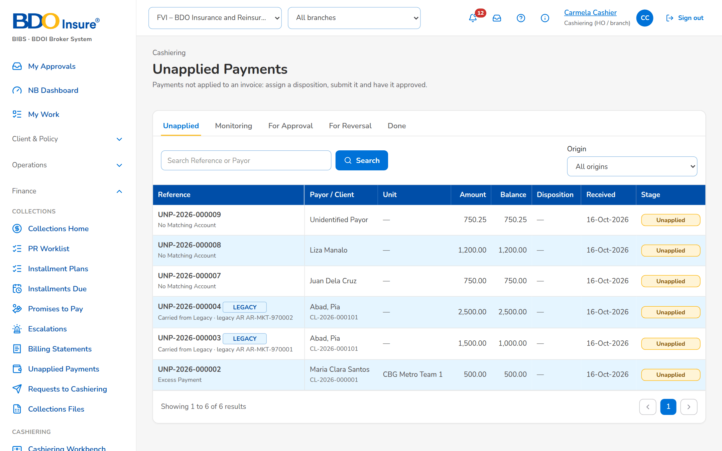
Figure 17: SCR-CSH-08: Unapplied Payments, Unapplied tab
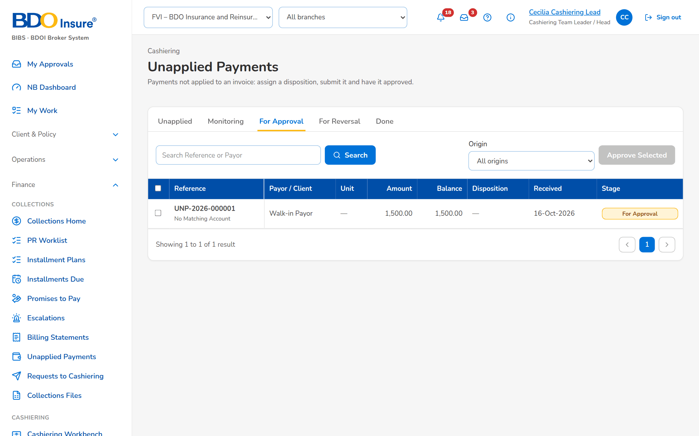
Figure 18: SCR-CSH-08: For Approval tab of the Cashiering Team Leader with Approve Selected

SCR-CSH-09 Unapplied Payment
Item | Value
Purpose | One unapplied payment with its amount and balance, payor, client and unit and its source, the disposition workflow, the disposition form (apply to an invoice, apply to its DST, refund, reclass to another client, transfer to another unit, others) and the disposition history.
Access | Unapplied Payments › open a row
Requirements | FRS.CSH.06.01, FRS.CSH.06.02
Outcome | The unapplied money is applied, refunded, reclassed or transferred, with a second user's approval where the type needs it.

Rules and states:
• The disposition type decides the fields to fill and whether a second user approves it.
• A refund goes to the Disbursement queue and is completed when Disbursement pays it.
• A balance left after a partial disposition returns to the Unapplied tab.
• Minimal excess amounts within the threshold (default PHP 10.00) never reach this list: they are moved to AP overages when the payment is processed.
Table 18: SCR-CSH-09 fields
Field | Type | Req. | Default | Rule | Message
Header: [Reference chip, origin tag and stage pill] | Reference chip, tag, status pill | - | - | UNP-yyyy-n; No Match, Excess, Cancelled Reference and the other origins; Source: Unapplied payments; Editable: Read only | -
Header: Amount / Balance / Payor / Marketing Unit / Source / Received | Display | - | - | Amounts with two decimals; the unit by name; the source by its module and document number; Source: Unapplied payments; Editable: Read only | -
Workflow: [Disposition workflow header] | Stepper | - | - | Unapplied, Monitoring, For approval, In process, Completed; For reversal and Closed when reached; Source: Disposition; Editable: Read only | -
Assign Disposition: Disposition Type | Drop-down | Y | Blank | The disposition types with their description; Source: Disposition types; Editable: Unapplied, Monitoring | Select the disposition type
Assign Disposition: Amount | Number | Y | The balance | Above zero, at most the balance; a reclass or transfer moves the whole balance; Editable: Unapplied, Monitoring; Within the balance | Enter an amount above zero and at most <balance> / A reclass or transfer moves the whole balance
Assign Disposition: Apply to Invoice No. / Reclass to Client Code / Transfer to Marketing Unit / Refund Payee | Text | Cond. | Payor for a refund | Shown for the type: apply, reclass, transfer, refund; Source: Invoice ledger, clients, sales organisation; Editable: Unapplied, Monitoring; Required for this disposition type | Required for this disposition type
Assign Disposition: Remarks | Text area | N | Blank | Up to 250 characters; Editable: Unapplied, Monitoring | -
Disposition History: Disposition / Amount / Target / Requested / Approved / Document / Status | Column | - | - | Payment request or journal in Document; Source: Dispositions; Editable: Read only | No disposition yet
Mark for Reversal dialog: Reason / Comment | Drop-down, text area | Y / N | Blank | Source: List of values return reason; Editable: Completed | -

Table 19: SCR-CSH-09 actions
Action | Who | Available when | What happens | Result
Save Disposition | Cashier | Unapplied or Monitoring | Assigns or updates the disposition | Monitoring
Submit for Approval | Cashier | Monitoring, the type needs approval | Sends the disposition to a second user | For approval; Cashiering approval request (NT-07)
Process Disposition | Cashier | Monitoring, the type needs no approval | Processes the disposition at once | In process or Completed
Approve | Cashiering Team Leader other than the requester | For approval | Approves and processes it: an application posts at once, a refund is sent to the Disbursement queue, a reclass or transfer moves the balance | In process or Completed; Workflow notice (NT-01)
Return to Cashier | Cashiering Team Leader | For approval | Returns the disposition with a reason | Monitoring; Workflow notice (NT-01)
Withdraw Disposition | Cashier | For approval | Takes the disposition back | Monitoring
Mark for Reversal / Approve Reversal | Cashier / Cashiering Team Leader | Completed / For reversal | Reverses a completed disposition on approval; a refund only after Disbursement returned it | For reversal / Unapplied; Workflow notice (NT-01)
Open Receipt | Every Cashiering user | The item came from a receipt | Opens the receipt | -

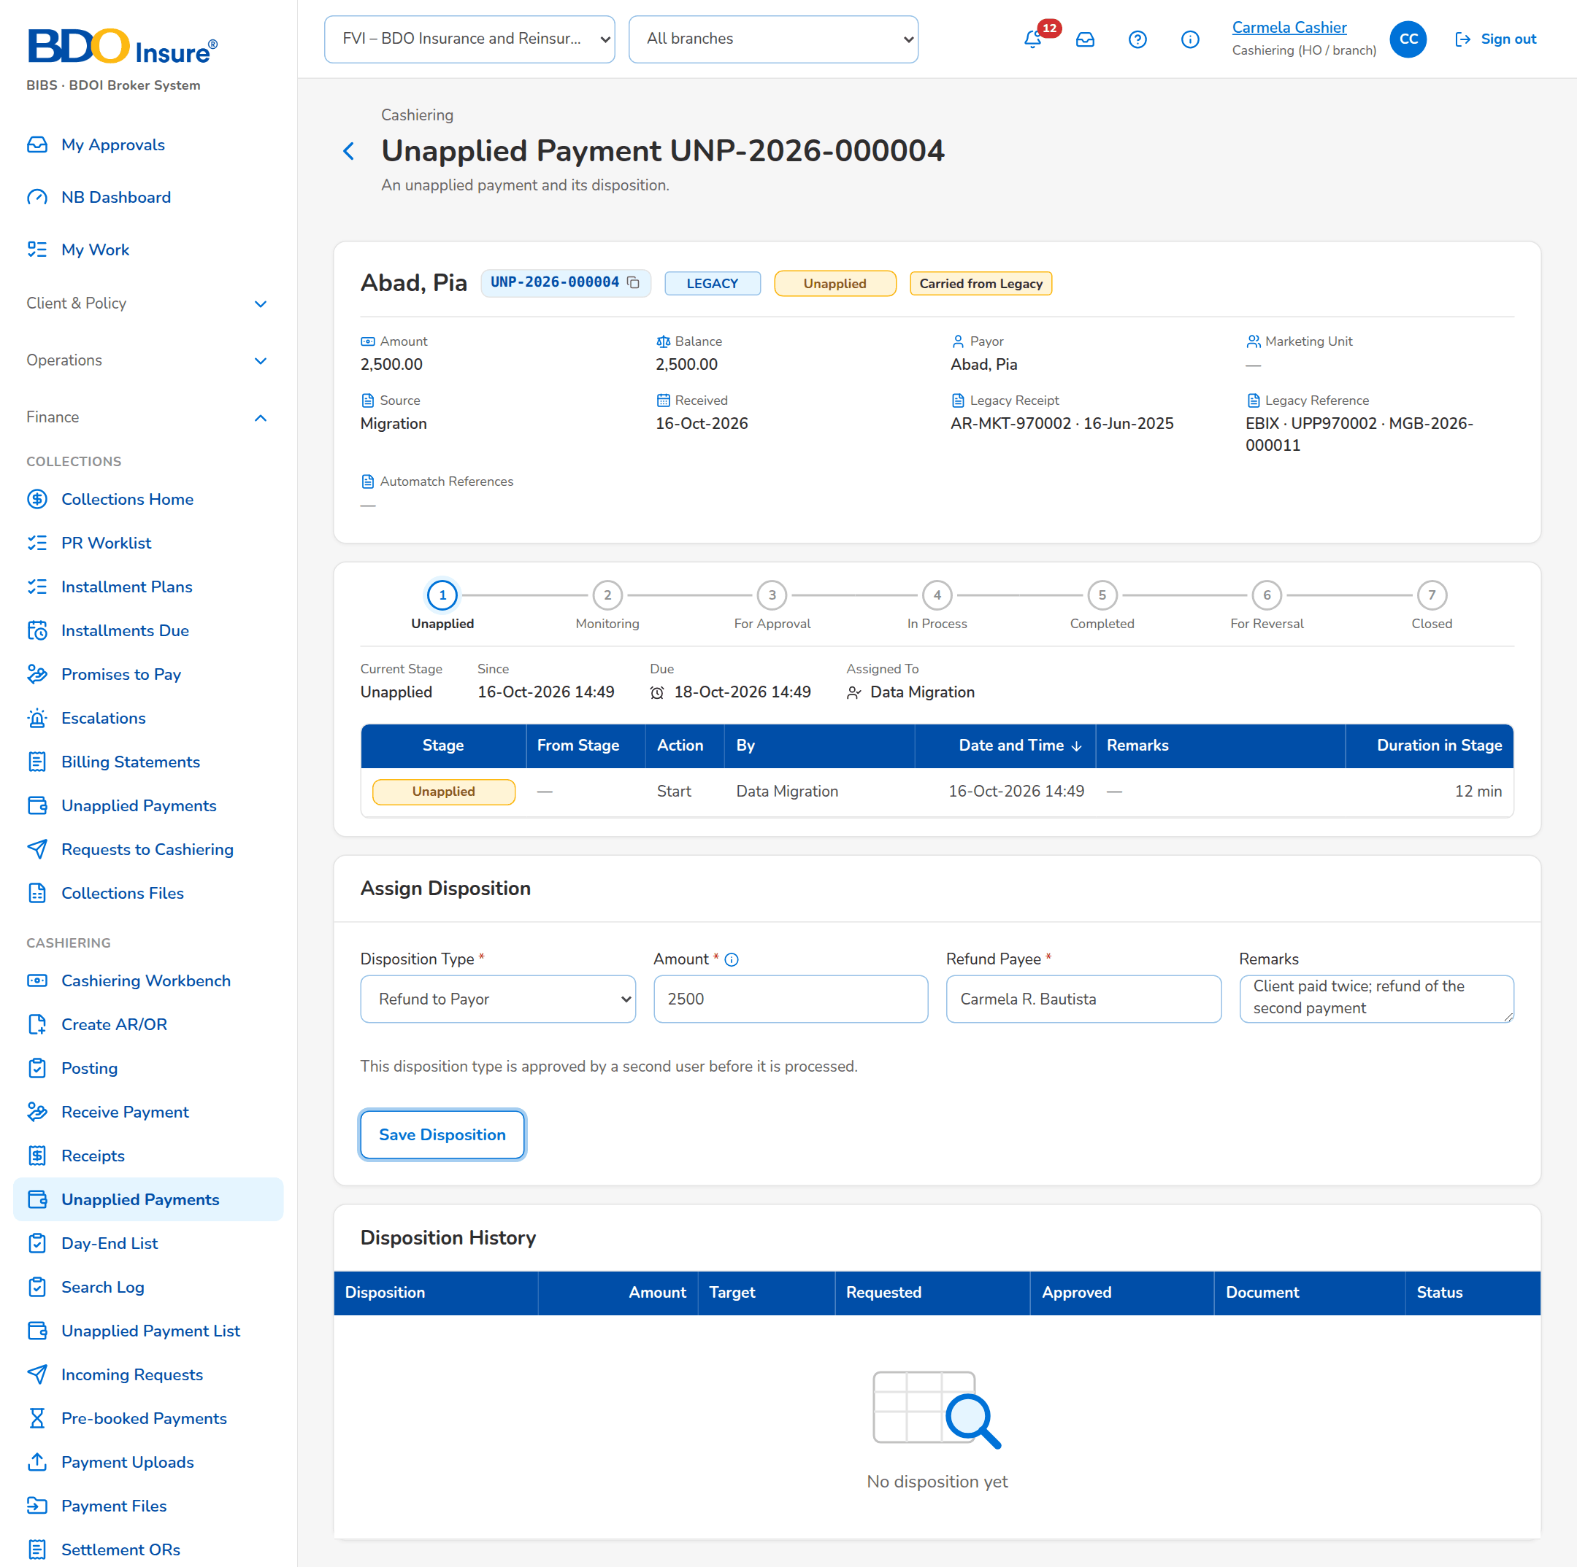
Figure 19: SCR-CSH-09: Unapplied payment with the disposition form filled for a refund
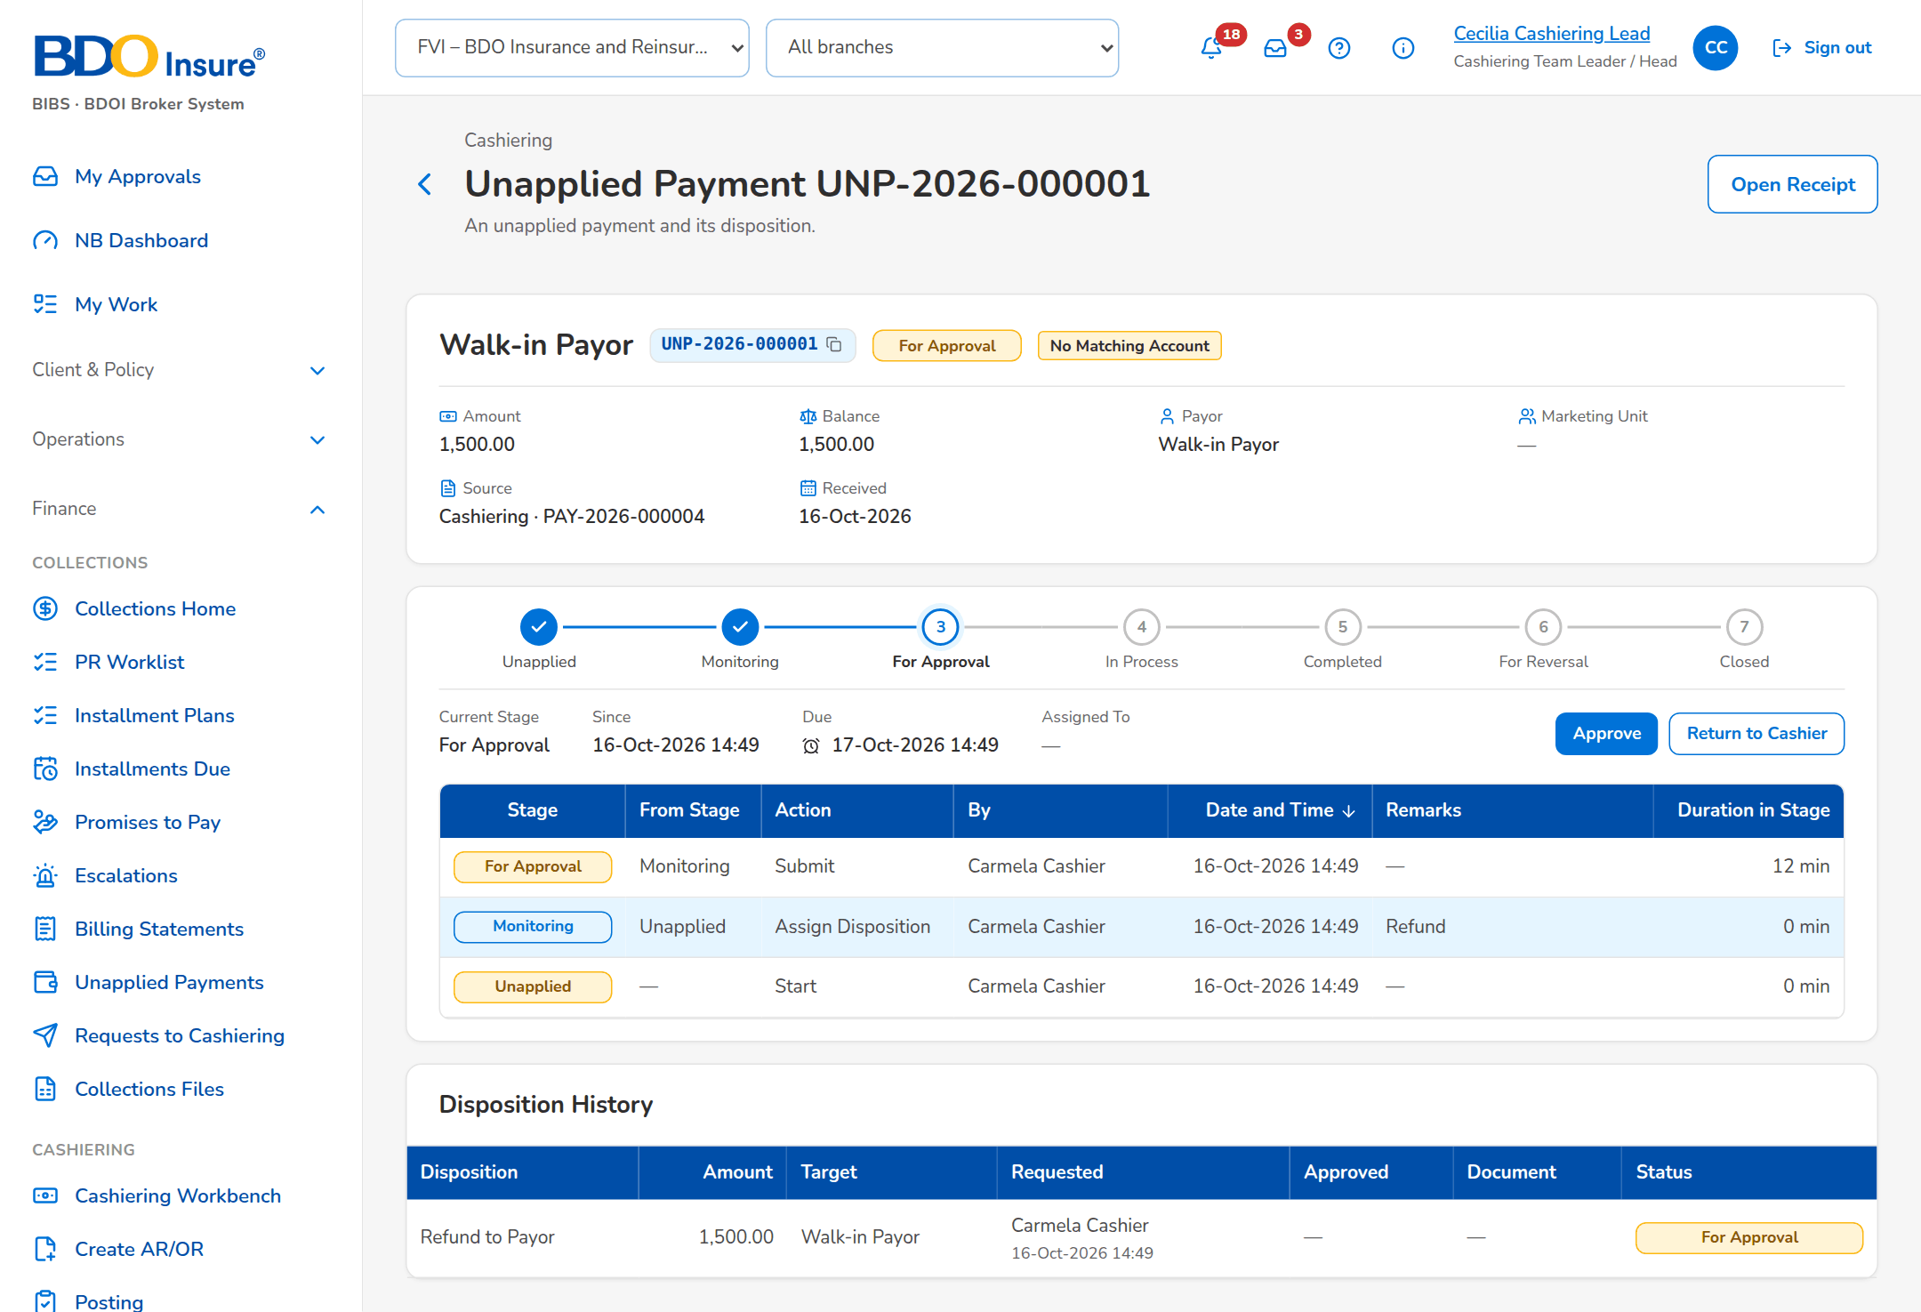
Figure 20: SCR-CSH-09: Unapplied payment with a refund for approval: workflow header, Approve and the disposition history

SCR-CSH-10 Unapplied Payment List
Item | Value
Purpose | The unapplied payments with an outstanding amount, by type, payment date, insurer, client and account, as BDOI's FRS lists them for inquiry.
Access | Cashiering › Unapplied Payment List
Requirements | FRS.CSH.06.01
Outcome | Cashiering and Marketing find every unapplied payment still outstanding.

Rules and states:
• A Marketing user sees the unapplied payments of his or her marketing unit as delivered (setting Unapplied payments seen by Marketing).
Table 20: SCR-CSH-10 fields
Field | Type | Req. | Default | Rule | Message
Filters: Unapplied Payment Type | Drop-down | N | All types | Excess Payment, Unapplied Payment, AR Insurer Refund, Unbooked/Unmatched Payment, Pre-booked Payment, AP Unapplied Commission; Source: Fixed list | -
Filters: Payment Date From / Payment Date To / Insurer / Client Code / Assured's Name / Account Reference Number / Unapplied Payment No., Reference or Payor | Dates, drop-down, text | N | Blank | dd-MMM-yyyy; insurers by name | -
List: Source / Unapplied Payment Type / Unapplied Payment No. / Payment/Creation Date / Account No. / PN / Loan Application No. | Columns | - | - | Origin of the payment; UNP-yyyy-nnnnnn; dd-MMM-yyyy; Source: Unapplied payments; Editable: Read only | -
List: Client Name / Insurer Name / Unapplied Payment Amount / Unapplied Payment Outstanding / Unapplied Payment Status | Columns | - | - | Names; amounts; Unapplied, Monitoring, For Approval, For Reversal, Done; Source: Unapplied payments; Editable: Read only | -

Table 21: SCR-CSH-10 actions
Action | Who | Available when | What happens | Result
Search | Every Cashiering user | Always | Lists the unapplied payments of the filters | -

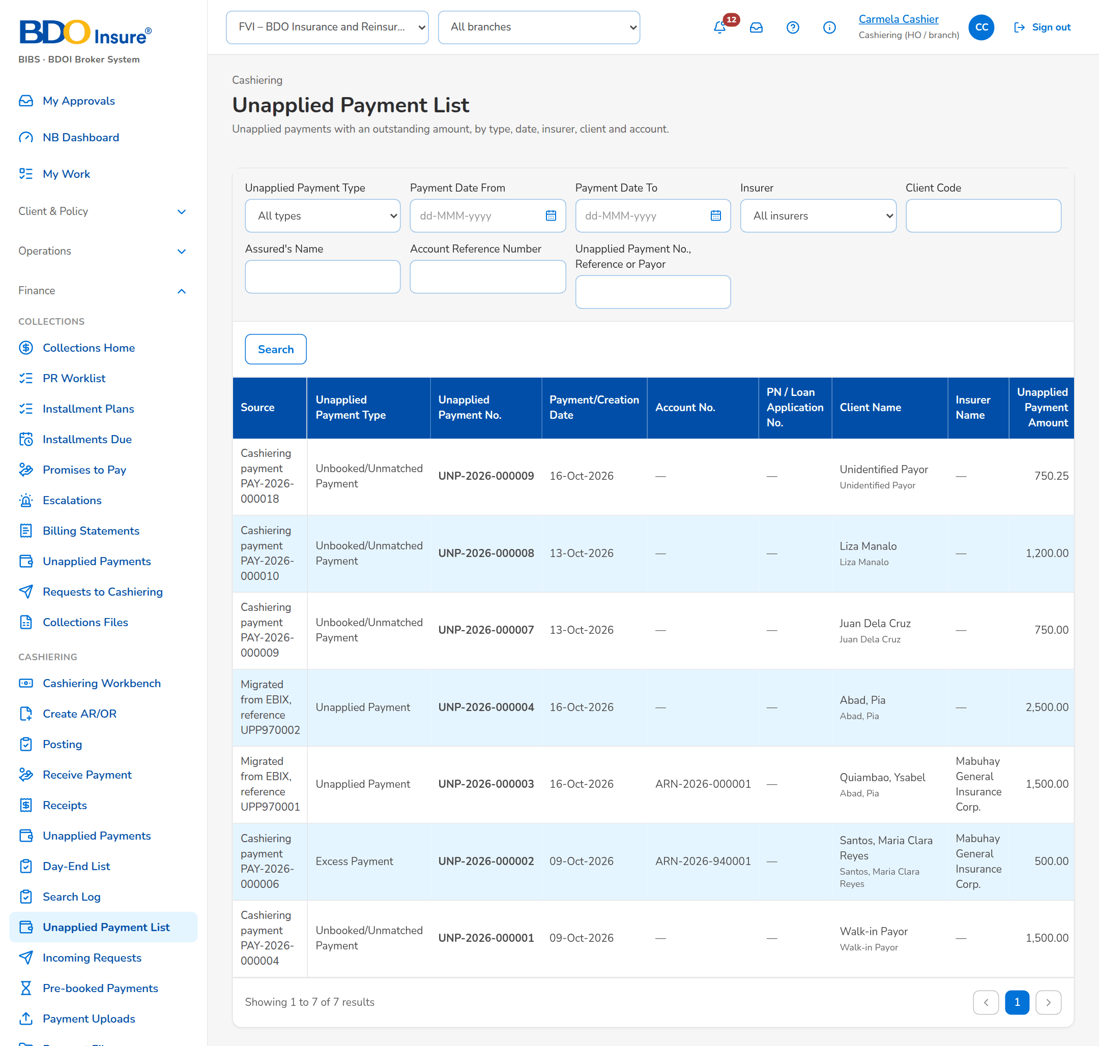
Figure 21: SCR-CSH-10: Unapplied Payment List

SCR-CSH-11 Day-End List
Item | Value
Purpose | The records of a day with the totals per payment type and bank account, for the day-end balancing of the cashier.
Access | Cashiering › Day-End List
Requirements | FRS.CSH.02.01
Outcome | The cashier balances the day's collections per payment type and bank account.

Rules and states:
• The list holds the AR and OR records of the company of the chosen day with their status.
Table 22: SCR-CSH-11 fields
Field | Type | Req. | Default | Rule | Message
Filter: Date | Date | Y | Today | dd-MMM-yyyy | -
Totals: Total per / Payment Type / Bank Account / Currency / Records / Amount | Columns | - | - | Payment type or bank account; count; amount; Source: Records of the day; Editable: Read only | No record on this day
Records of the Day: Record Number / Receipt Type / AR / OR Number / Payor / Bank Account / Amount / Status | Columns | - | - | As recorded; Source: Records of the day; Editable: Read only | No record on this day

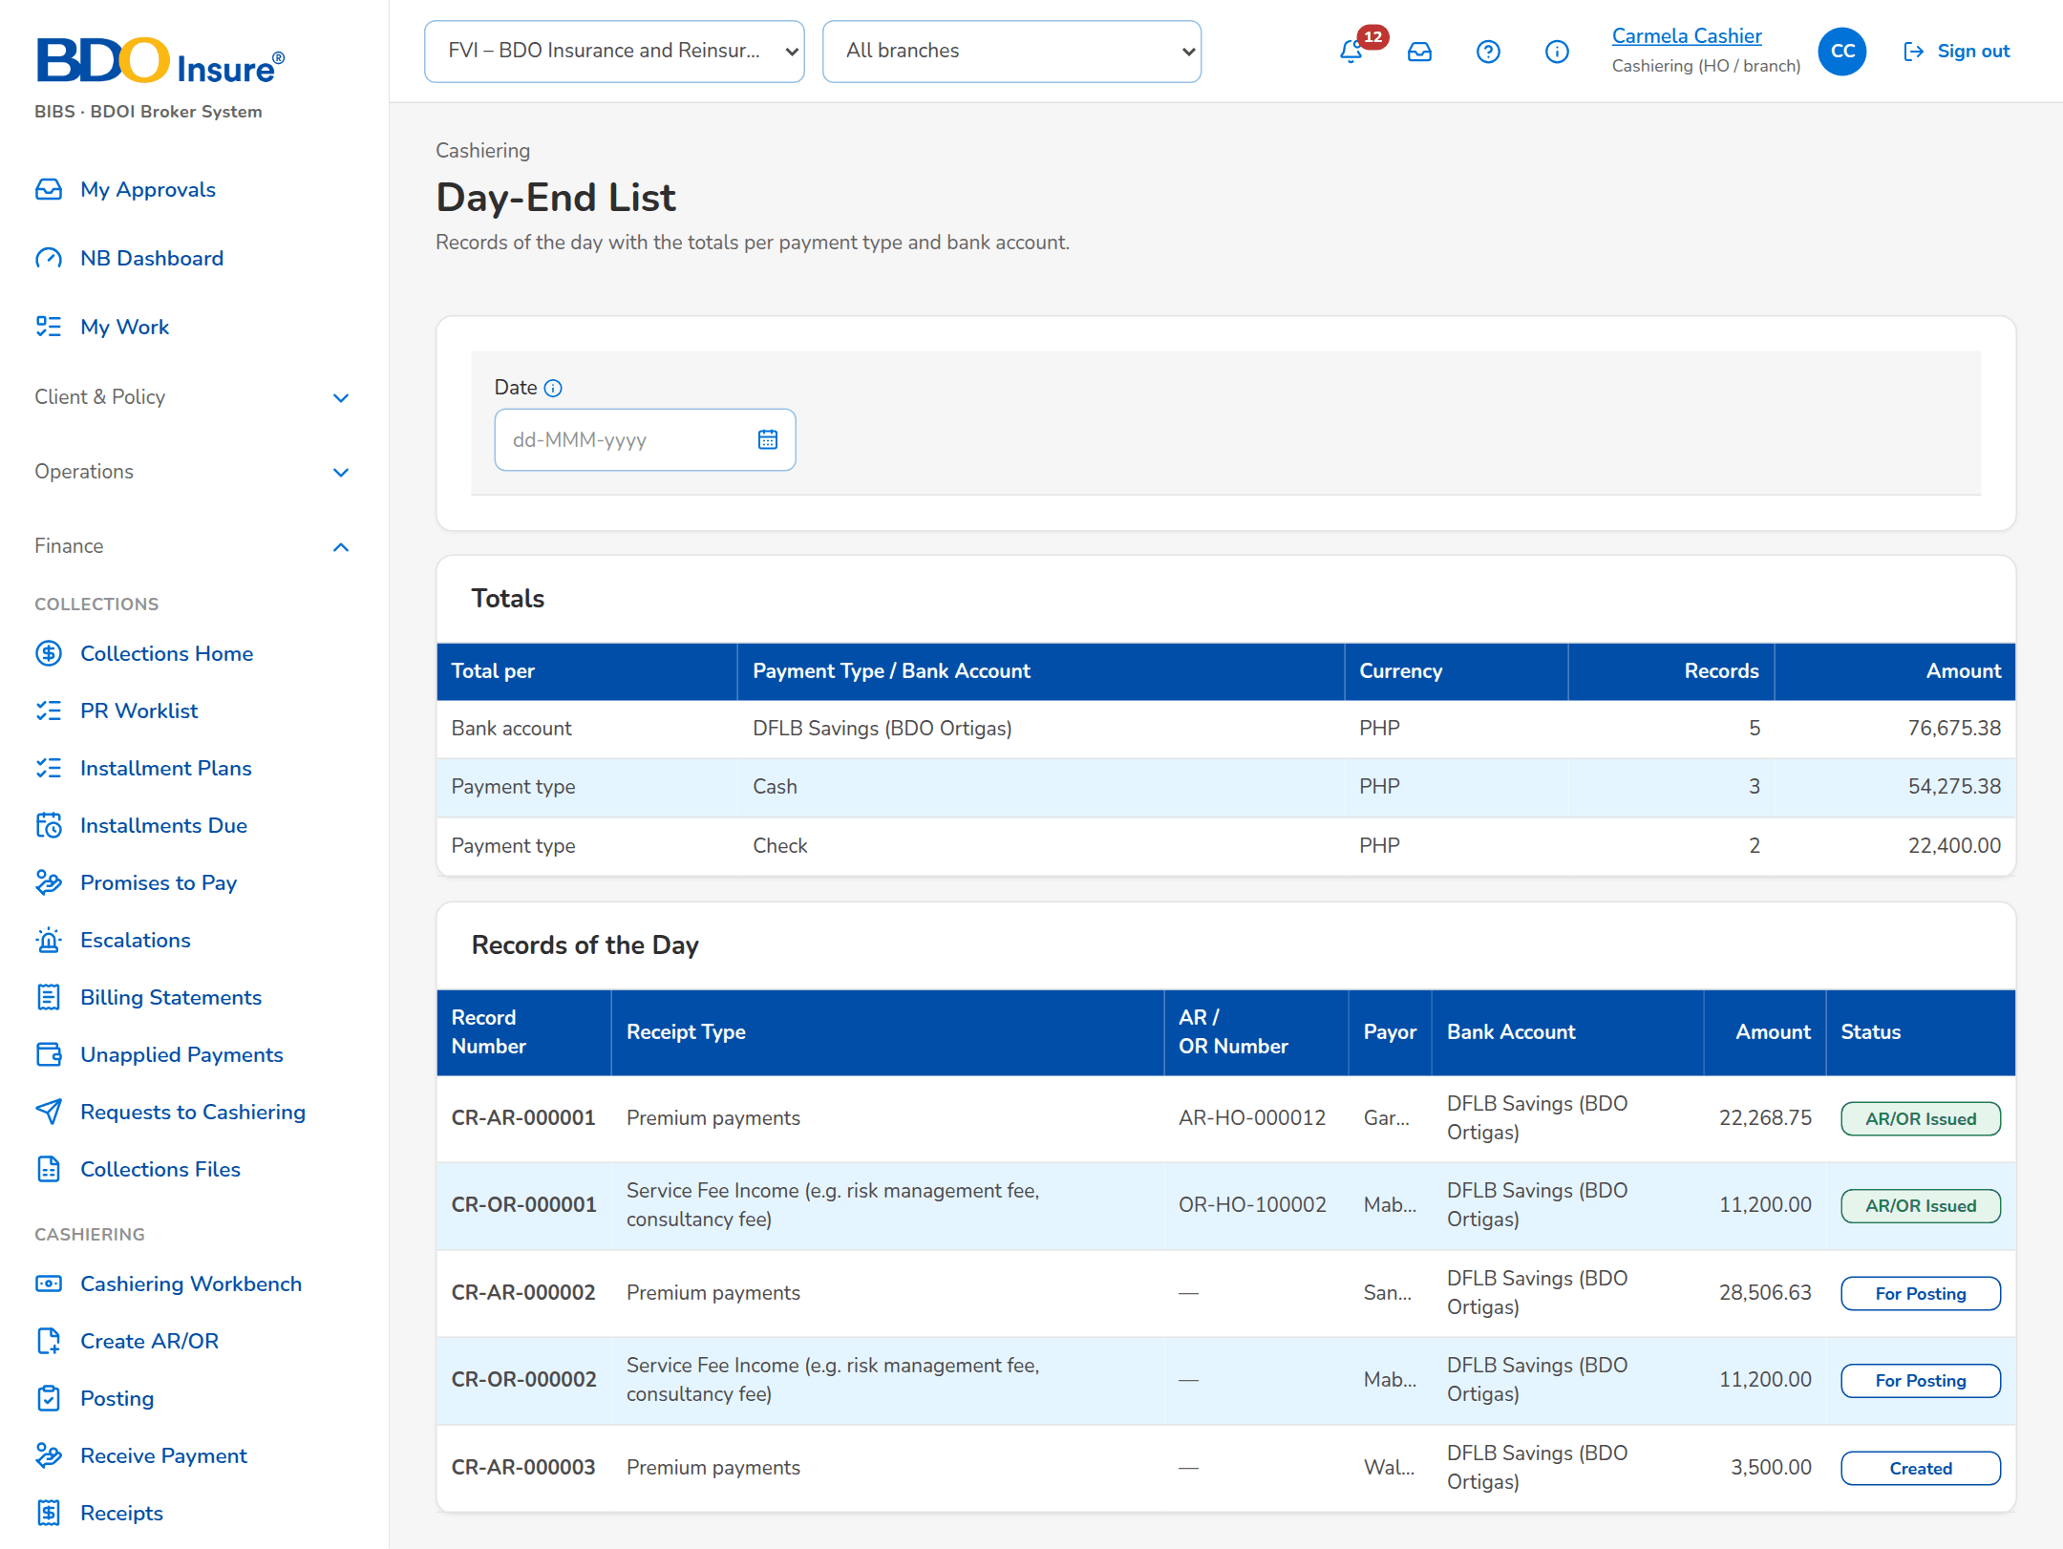
Figure 22: SCR-CSH-11: Day-End List with the totals of the day

SCR-CSH-12 Search Log
Item | Value
Purpose | The receipt searches with their user, criteria and number of results, kept as evidence of the inquiries.
Access | Cashiering › Search Log
Requirements | FRS.CSH.08.01
Outcome | Audit sees who searched which receipts and when.

Rules and states:
• Every receipt search is logged; no user can change the log.
Table 23: SCR-CSH-12 fields
Field | Type | Req. | Default | Rule | Message
Filters: User / From / To | Look-up, dates | N | All | Name; dd-MMM-yyyy; Source: Users | -
List: Date and Time / User / Criteria / Results | Columns | - | - | dd-MMM-yyyy HH:mm; name; the criteria entered; number of receipts found; Source: Search log; Editable: Read only | -

Table 24: SCR-CSH-12 actions
Action | Who | Available when | What happens | Result
Search | Cashiering Team Leader (posting right) | Always | Lists the searches of the filters | -

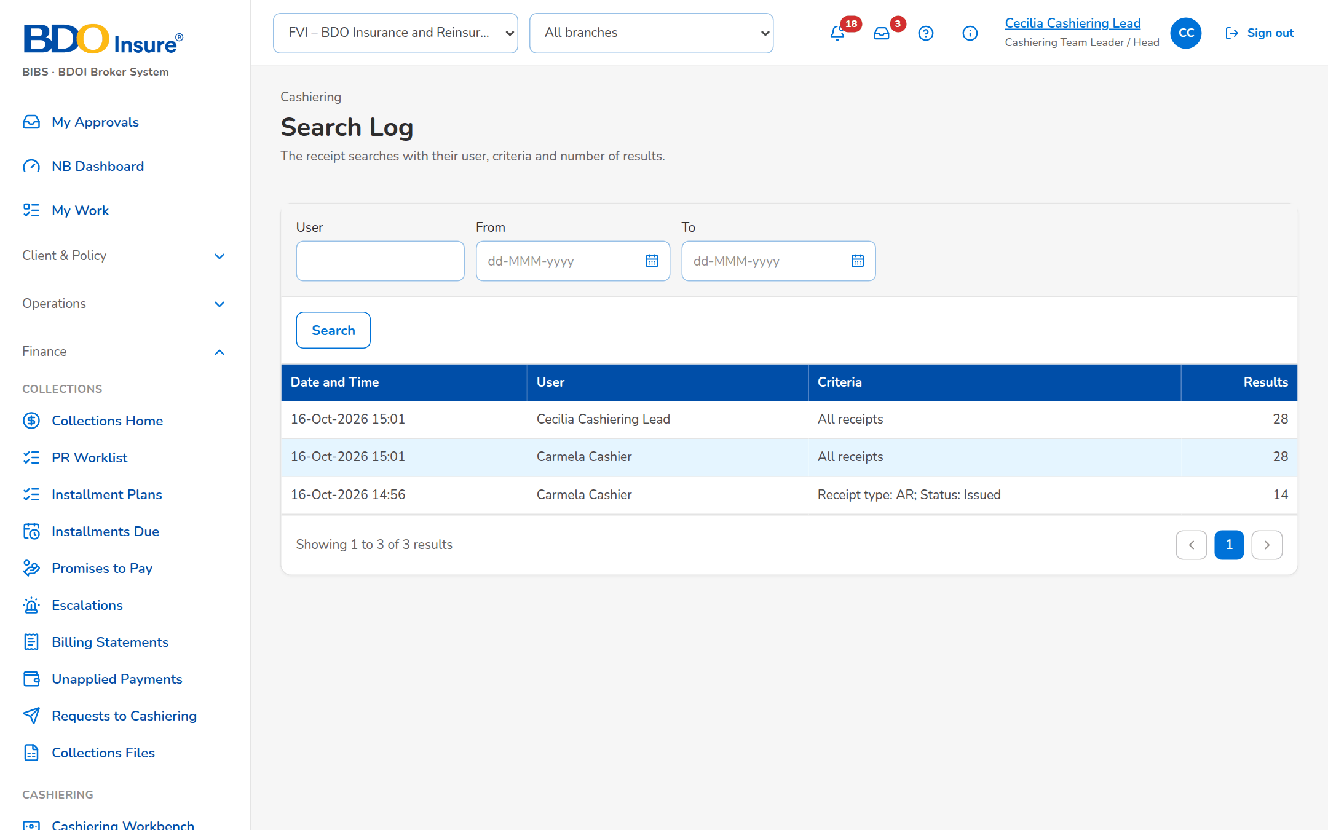
Figure 23: SCR-CSH-12: Search Log of the receipt searches

SCR-CSH-13 Incoming Requests
Item | Value
Purpose | What the other modules ask of Cashiering: collector requests on unapplied payments from Collections (apply, refund, reclass, transfer), refund validations from Payment Requests and payment reversals from ACSL, each queue with its open and decided items.
Access | Cashiering Workbench
Requirements | FRS.CSH.06.03
Outcome | Requests of Collections, Payment Requests and ACSL are decided by Cashiering and answered.

Rules and states:
• Collections asks Cashiering to dispose of an unapplied payment; Cashiering decides and the collector sees the outcome.
• A refund validation confirms that the premium of a cancelled invoice is back in the unapplied list before Payment Requests refunds it.
Table 25: SCR-CSH-13 fields
Field | Type | Req. | Default | Rule | Message
Tabs: Collector Requests / Refund Validations / Payment Reversals | Tab | - | Collector Requests | With the number of open items; Source: Fixed | -
Tabs: To Do / Decided | Tab | - | To Do | Source: Fixed | -
Collector Requests: Request No. / Collector Asks / Payor / Unapplied / Amount / Requested By / Remarks / Status | Column | - | - | CRQ-yyyy-n with the unapplied reference; Whole balance when no amount; Source: Collections (BRD-4); Editable: Read only | -
Refund Validations: Validation No. / Cancelled Invoice / AR of the Payment / Refund / Requested By / New AR / Remarks / Status | Column | - | - | Source: Payment Requests (BRD-5); Editable: Read only | -
Payment Reversals: Reversal No. / Invoice No. / Receipt / Amount / Value Date / Reason / Requested By / Status | Column | - | - | Whole application when no amount; Source: ACSL (BRD-5); Editable: Read only | -
Accept Request dialog: Disposition Type / Amount / Client to Reclass To / Marketing Unit / Refund Payee / Remarks | Drop-down, number, text | Cond. | The request's values | Amount above zero and at most the unapplied balance; Source: Disposition types; Editable: Queued | Enter the client to reclass to / Enter the marketing unit to transfer to / Enter an amount above zero and at most the unapplied balance
Accept Request dialog: Submit the disposition now (an application is processed at once) | Check box | N | Ticked | Editable: Queued | -
Confirm Validation dialog: Unapplied Item / New AR No. / Remarks | Drop-down, text | Y / N / N | Blank | The unapplied item holding the returned premium; Source: Unapplied payments; Editable: Open | Choose the unapplied item that holds the returned premium
Reject dialog: Reason | Text | Y | Blank | Editable: Open; Not blank | Enter the reason

Table 26: SCR-CSH-13 actions
Action | Who | Available when | What happens | Result
Accept Request | Cashier | Collector request queued, row selected | Creates the disposition of the unapplied item and, when ticked, submits it | Accepted; The collector is told the outcome
Reject Request | Cashier | Collector request queued | Rejects the request with a reason | Rejected; The collector is told the outcome
Confirm Validation / Reject Validation | Cashier | Refund validation open | Confirms that the premium is back in the unapplied list (with its new AR) or rejects it | Confirmed / Rejected; Payment Requests is told the result
Approve Reversal / Reject Reversal | Cashiering Team Leader | Payment reversal open | Asks for confirmation and reverses the application as requested, or rejects it with a reason | Approved / Rejected; ACSL is told the result

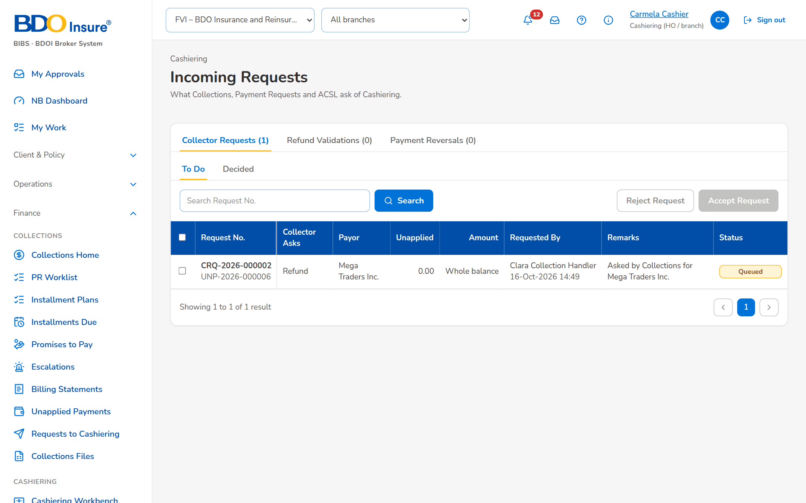
Figure 24: SCR-CSH-13: Incoming Requests: Collector Requests, To Do
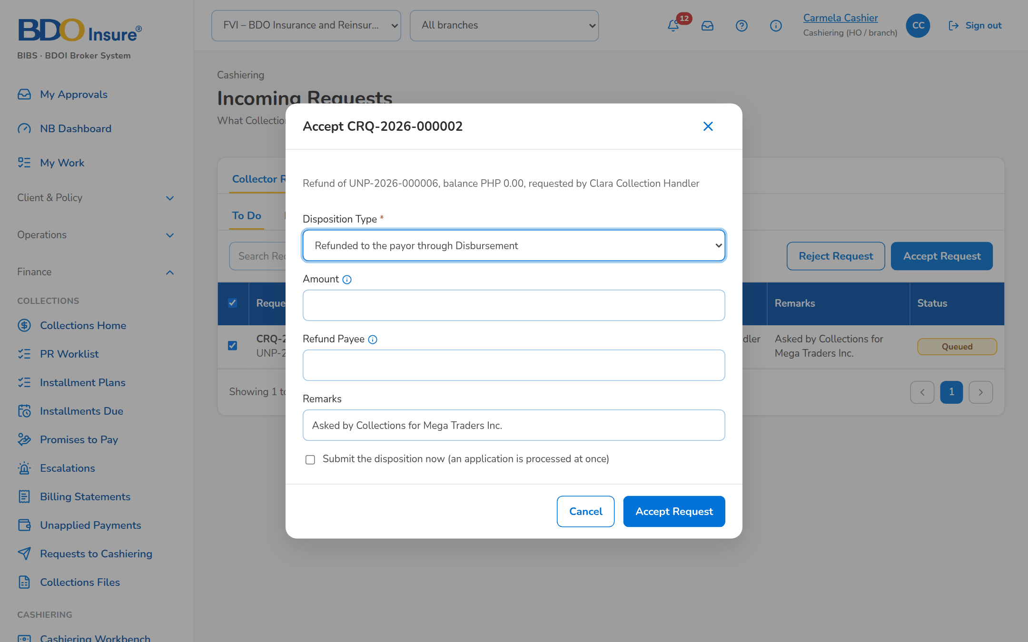
Figure 25: SCR-CSH-13: Accept Request dialog of a collector request

SCR-CSH-14 Pre-booked Payments
Item | Value
Purpose | Payments received for accounts not yet booked: they wait with their age and re-match attempts and are applied automatically once the account is booked; an ageing item can be re-matched now or released to the unapplied payments.
Access | Cashiering Workbench › Pre-booked Payments tile
Requirements | FRS.CSH.05.03, FRS.CSH.05.04
Outcome | Payments received before booking are applied as soon as the account is booked.

Rules and states:
• A payment for an account not yet booked waits in the queue and opens the New Business payment gate.
• It is applied when the invoice is booked, or by the scheduled re-match every two hours; an ageing item raises an alert.
Table 27: SCR-CSH-14 fields
Field | Type | Req. | Default | Rule | Message
Tabs: Waiting for Booking / Applied / Released to Unapplied | Tab | - | Waiting for Booking | Source: Fixed | -
List: Account (ARN) / Reference / Amount / Received / Age / Re-match Attempts / Receipt / Status | Column | - | - | Age in days, amber after 7 and red after 30 days; Open AR opens the receipt; Source: Pre-booked payments; Editable: Read only | No items to display
Release dialog: Comment | Text area | N | Released by cashier | Editable: Waiting for booking | -

Table 28: SCR-CSH-14 actions
Action | Who | Available when | What happens | Result
Run Matching Now | Cashier with the application permission | Always | Matches every waiting payment and unapplied item again and applies those whose invoice is now booked | Applied
Open Receipt | Every Cashiering user | Always | Opens the AR of the payment | -
Re-match Now | Cashier with the application permission | Waiting for booking | Matches the payment again | Applied or unchanged
Release to Unapplied | Cashier with the application permission | Waiting for booking | Moves the payment to the unapplied payments | Released

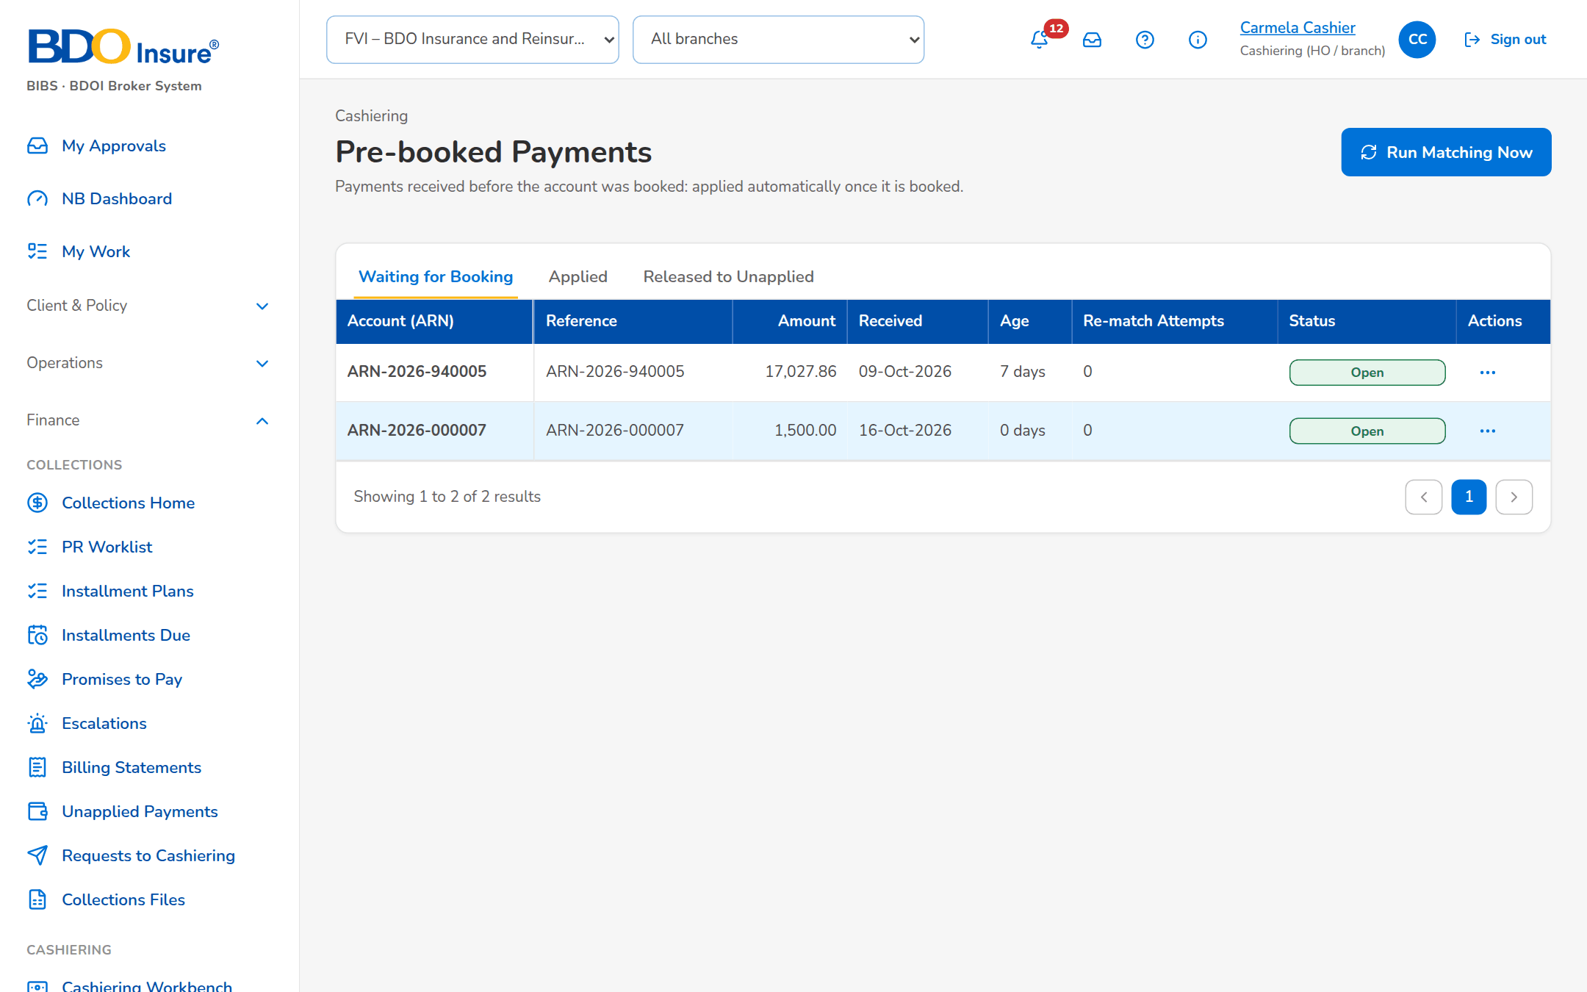
Figure 26: SCR-CSH-14: Pre-booked Payments waiting for booking

SCR-CSH-15 Payment Uploads
Item | Value
Purpose | The payment files of the banks and channels (Bills Payment, Trade, CLPC, Direct Credit) and the file of post-dated checks, each in its template: every row is validated first, the valid rows become payments with their AR and are matched at once, and the run summary counts applied, unapplied, pre-booked, excess and failed rows.
Access | Cashiering Workbench
Requirements | FRS.CSH.02.02, FRS.CSH.05.01
Outcome | Bank and channel payments are receipted and applied in bulk.

Rules and states:
• Every row is a payment: an AR is issued and the payment is matched at once; the same file cannot be uploaded twice.
• A failed row never stops the run; the failed rows are corrected in the report and uploaded again as a new file.
• The layout of each bank file is set on Cashiering Setup until BDOI confirms the bank layouts.
Table 29: SCR-CSH-15 fields
Field | Type | Req. | Default | Rule | Message
Tabs: Bills Payment / Trade / CLPC / Direct Credit / PDC | Tab | - | Bills Payment | One file type per tab; Source: Fixed | -
1. Template: Download Template | Button | - | - | The columns of the file type (chapter 18); Source: Upload template; Headers unchanged | -
2. Upload: File | File | Y | - | Drag and drop or Browse; the accepted types and the maximum size are shown; A file already uploaded is refused | This file was already uploaded
Run Summary: Applied / Unapplied / Pre-booked / With Excess / Failed Rows | Tile | - | - | Counts of the run; Source: Upload run; Editable: Read only | -
Run Summary: Row / Reference / Payor / Amount / Applied / Unapplied / Outcome / Message | Column | - | - | One row per payment of the run; Source: Payments; Editable: Read only | No payment accepted in this run

Table 30: SCR-CSH-15 actions
Action | Who | Available when | What happens | Result
Download Template | Cashier | Always | Downloads the template of the file type | -
Upload and Validate | Cashier | File chosen | Validates every row and shows Rows Read, Valid and Rejected with the rows | -
[Process the valid rows] | Cashier | Rows validated | Creates the payments with their ARs and matches them | AR issued per payment
Download Report | Cashier | Run done | Downloads the run report with the failed rows and their messages | -

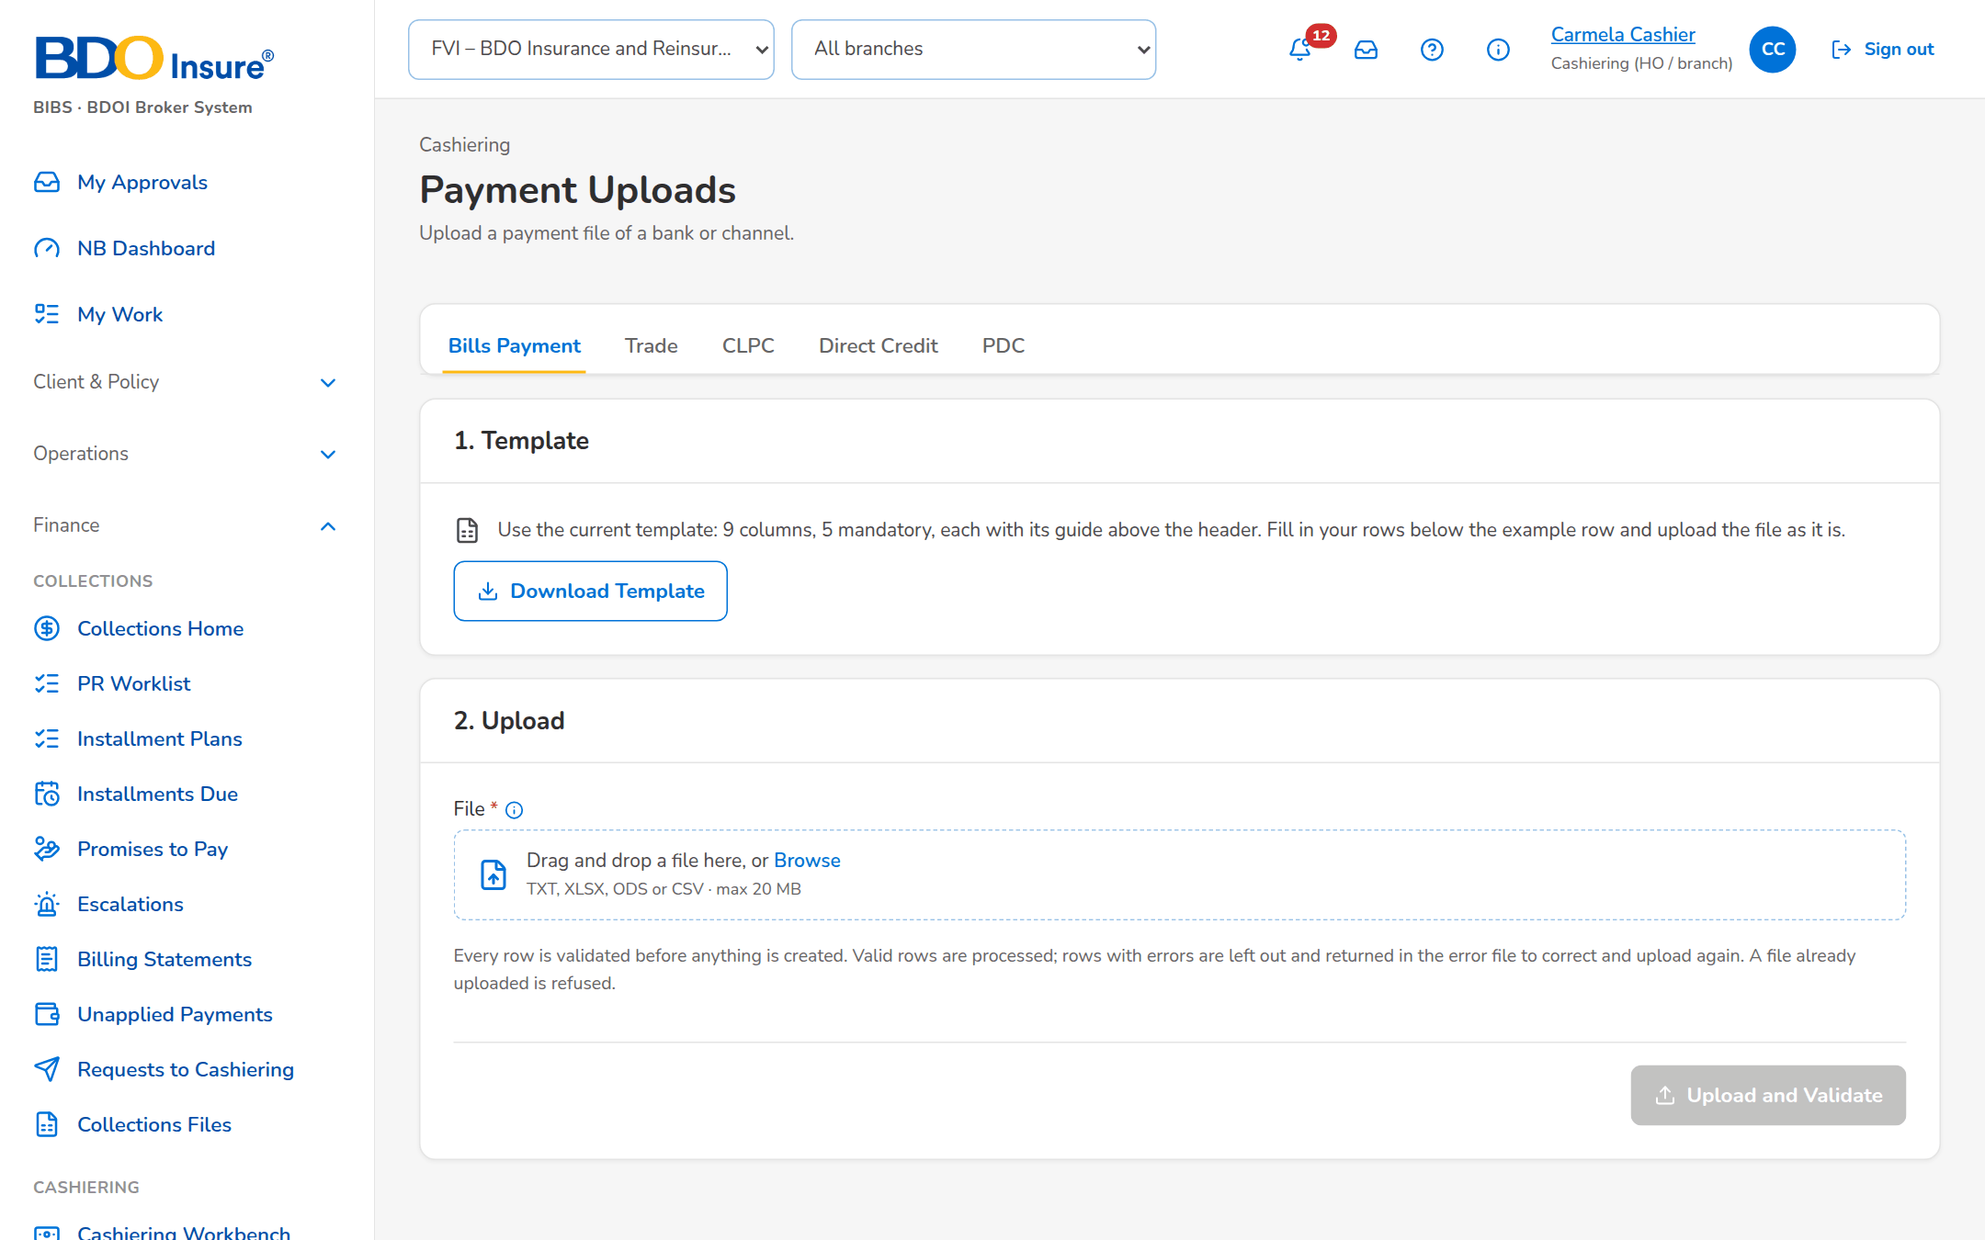
Figure 27: SCR-CSH-15: Payment Uploads, Bills Payment: template and upload steps

SCR-CSH-16 Payment Files
Item | Value
Purpose | The payment files of the banks and channels in BDOI's layouts - Bills Payment, CLPC, Trade, Direct Credit, post-dated checks (PMS) and Commission Schedule - uploaded several at a time or received via MFT, with the checks each file passed or the reason it was refused, and for each file the run report per category, the validation report, the failed rows to correct, the raw file and processing again.
Access | Cashiering Dashboard › Automatic Payment Processing Uploading Facility, For Auto Payment Processing
Requirements | FRS.CSH.05.01, FRS.CSH.10.02, FRS.CSH.10.03
Outcome | The channel payments are received in BDOI's layouts, applied, and the exceptions are listed for follow-up.

Rules and states:
• The file names follow BDOI's conventions (for example BDOIyyyymmddn.TXT for Bills Payment, CLPC-MmmDDYYYY.xlsx, UploadTrade_dd.mm.yyyy.TXT); a file with a wrong name, a size above the limit, a duplicate or a header or TOTAL that does not agree is refused with the reason.
• The Direct Credit file identifies payments already received (BP filename and transaction number) as delivered (setting); the Commission Schedule processes its valid lines as delivered (setting).
• The files of the MFT folders are taken at the times agreed with BDOI IT for the company of the setting MFT receiving company; in SIT and UAT a channel simulator writes the files in BDOI's layouts.
Table 31: SCR-CSH-16 fields
Field | Type | Req. | Default | Rule | Message
Upload Payment Files: Payment File Type | Drop-down | Y | Bills Payment | Bills Payment, CLPC, Trade, Direct Credit, Post-dated checks (PMS), Commission Schedule; Source: Payment file types | -
Upload Payment Files: File | File | Y | - | One file per line; several lines and types in one upload; File name, size, duplicate, header and TOTAL checks of the type | -
Files Received: Upload Reference / Payment File Type / File Name / Source / Rows / Failed / Received / Status | Columns | - | - | Upload or MFT; counts; dd-MMM-yyyy HH:mm; Received, Refused, Processed, Partly processed; Source: Payment files; Editable: Read only | No payment file received yet
Run Report: Category / Count / Amount | Columns | - | - | Applied Payment, Excess Payment, Matched on Pre-booked, Unbooked/Unmatched, Invalid BP filename, Invalid Transaction Number, Duplicate, Failed; Source: Run of the file; Editable: Read only | No payment record
Run Report: Transaction Date / BP Filename / Transaction Number / Amount / Reference Number / Account Number / Record Status / Reason for Failure | Columns | - | - | One row per payment record; Source: Run of the file; Editable: Read only | -

Table 32: SCR-CSH-16 actions
Action | Who | Available when | What happens | Result
Add File / Upload | Cashier (upload right) | Files chosen | Checks and processes each file; refused files are listed with the reason | Processed, Partly processed or Refused
Receive MFT Files Now | Cashier (upload right) | Always | Takes the files placed in the MFT folders now instead of at the next scheduled run | Alert Payment file refused
Run Report / Download Run Report / Validation Report / Failed Rows / Raw File | Cashier | A file | Shows or downloads the report or file | -
Process Again | Cashier | Partly processed file | Processes the corrected failed rows again | Processed

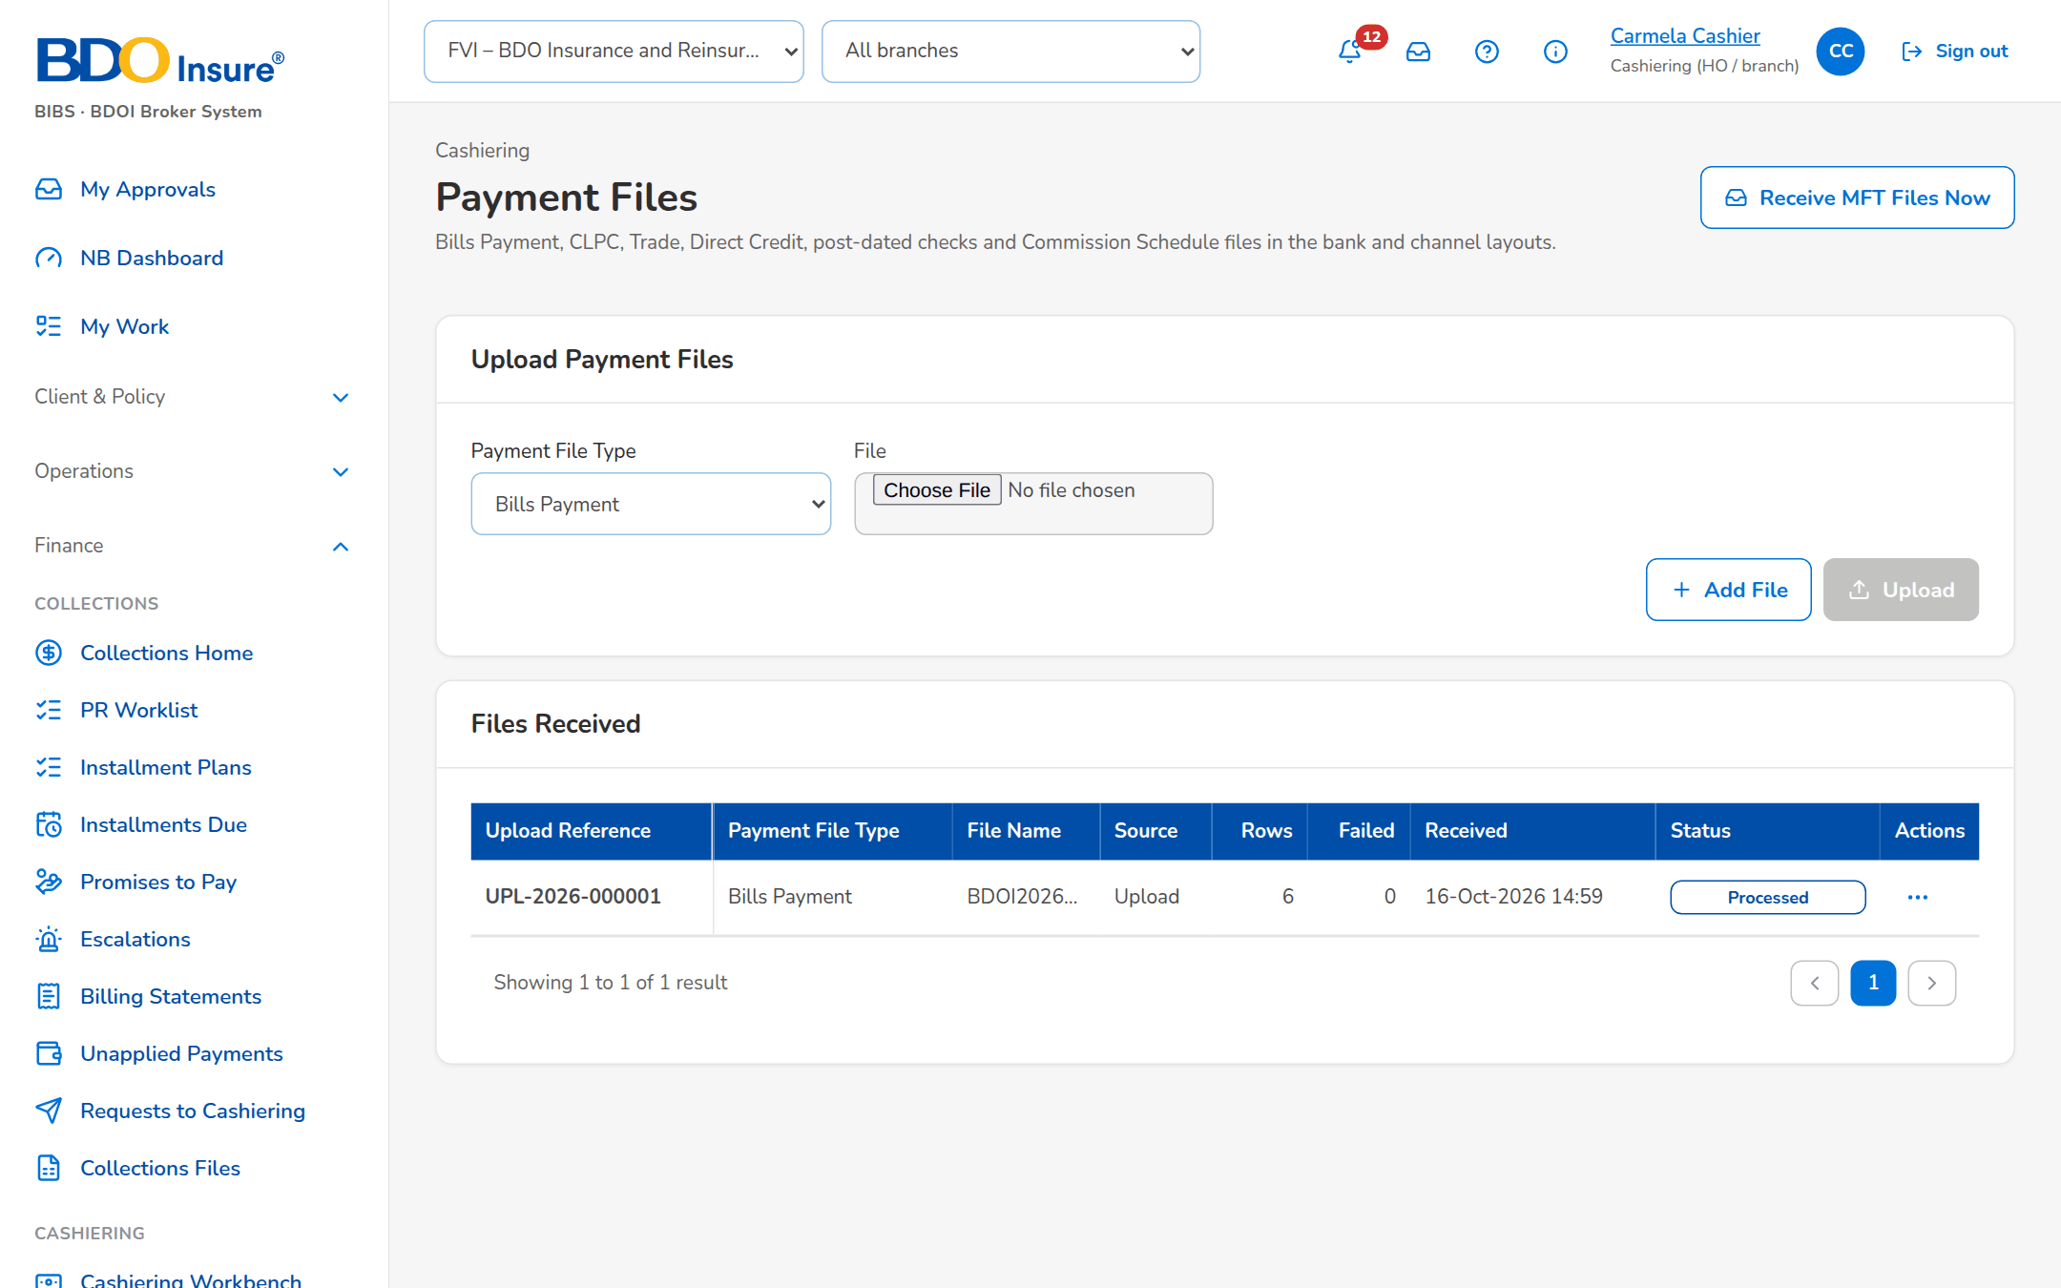
Figure 28: SCR-CSH-16: Payment Files with the Bills Payment file processed
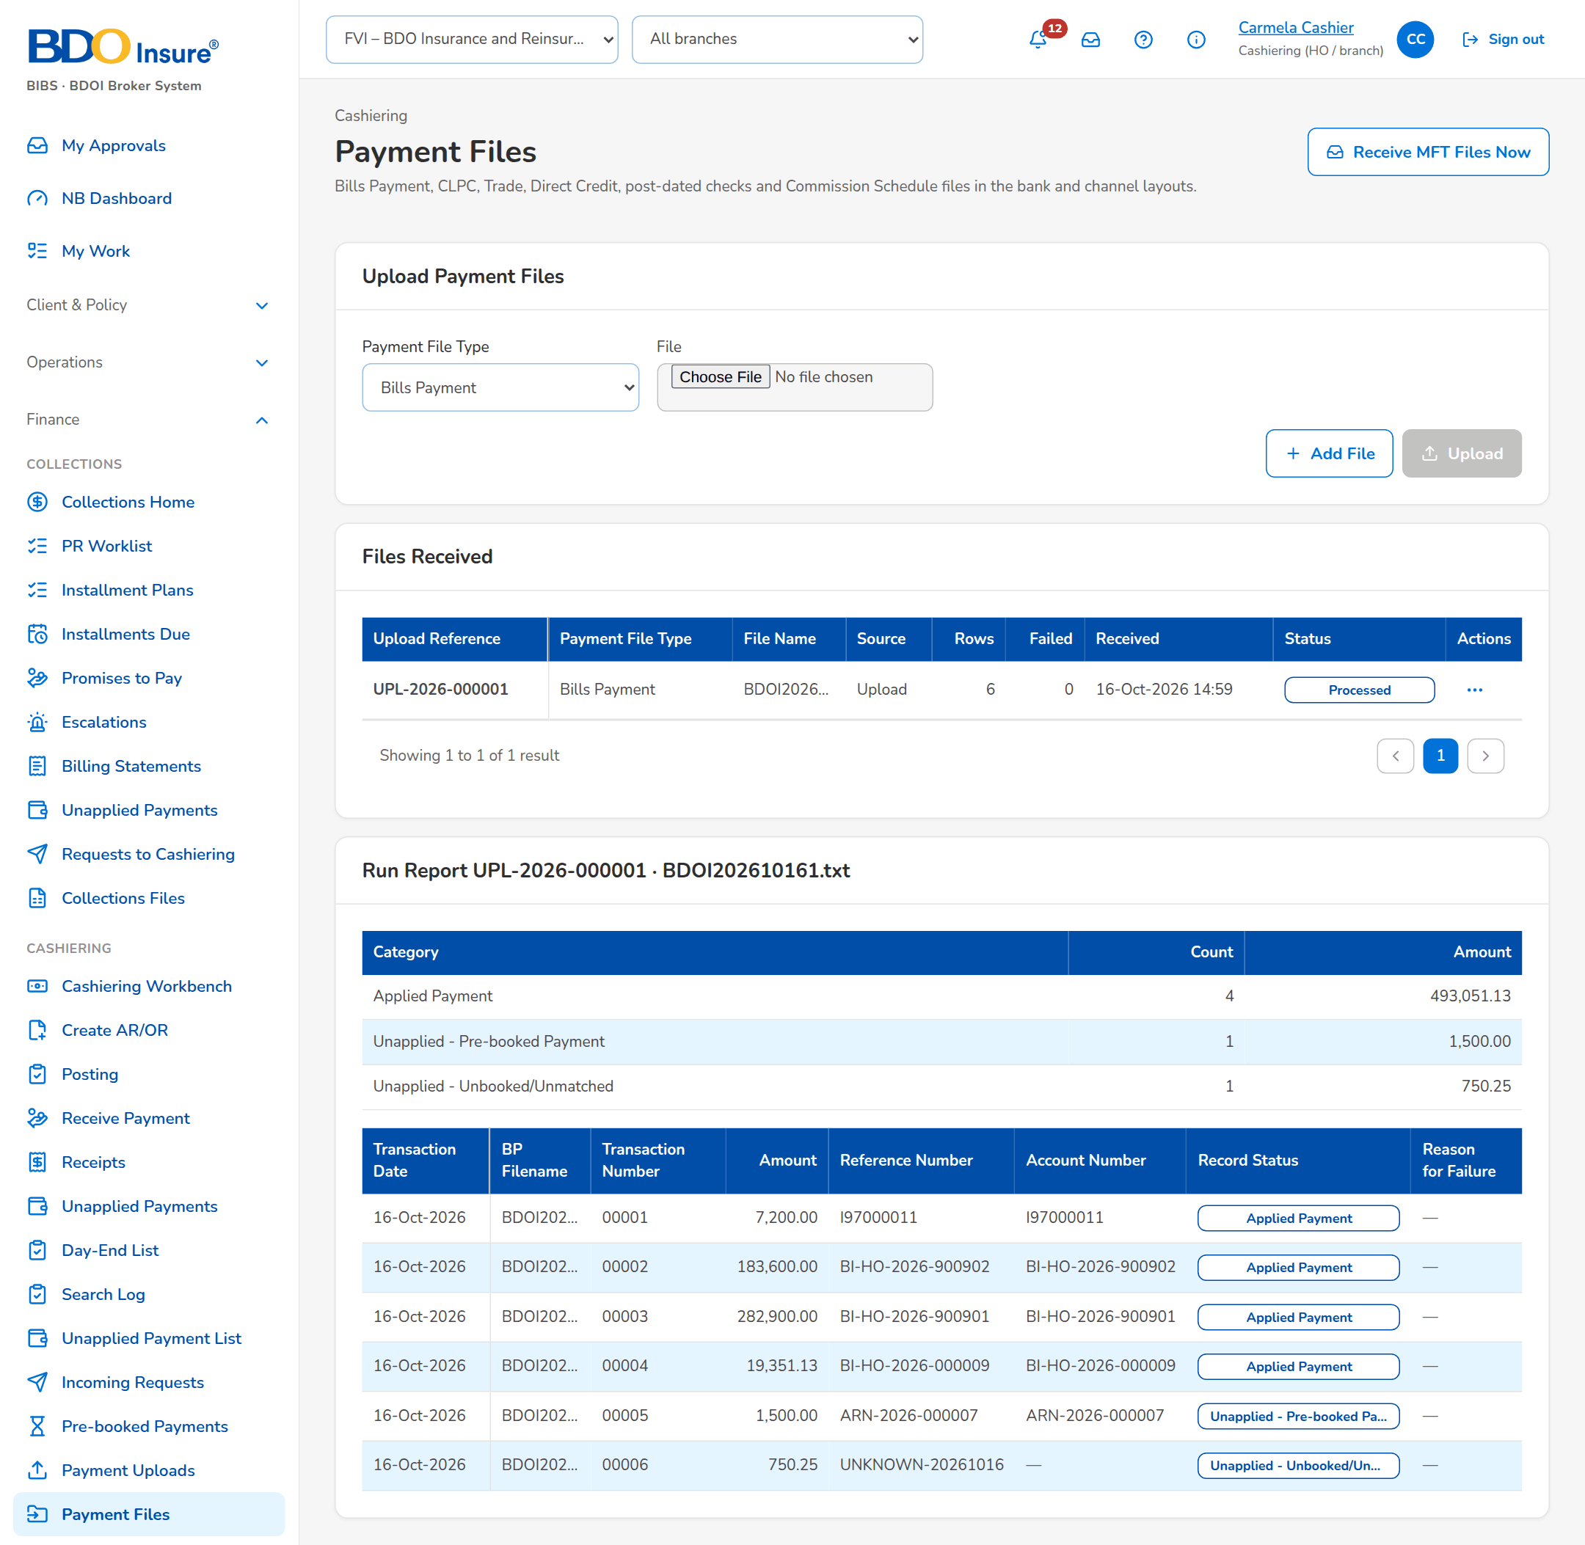
Figure 29: SCR-CSH-16: Run report of a payment file per category and payment record

SCR-CSH-17 Settlement ORs
Item | Value
Purpose | The commission and incentive ORs of the insurer settlements, issued once Disbursement approves the payment request (as delivered), with the ones waiting and the ones that could not be issued.
Access | Cashiering › Settlement ORs
Requirements | FRS.CSH.07.01
Outcome | The commission and incentive ORs follow the settlement without manual issue.

Rules and states:
• The ORs of a settlement are issued when Disbursement approves the payment request as delivered, or at the approval of the remittance (setting When the settlement ORs are issued).
Table 33: SCR-CSH-17 fields
Field | Type | Req. | Default | Rule | Message
List: Settlement Batch / OR Type / Insurer / Payment Request / Currency / Amount | Columns | - | - | Remittance batch; Commission or Incentive; insurer; payment request; amount; Source: Settlement ORs; Editable: Read only | -
List: OR Number / Requested / Issued / Status / Remarks | Columns | - | - | OR number once issued; dates; Waiting for Disbursement approval, Issued, Cancelled, Failed; Source: Settlement ORs; Editable: Read only | -

Table 34: SCR-CSH-17 actions
Action | Who | Available when | What happens | Result
Issue Again | Cashier | An OR that could not be issued | Issues the OR again | Issued

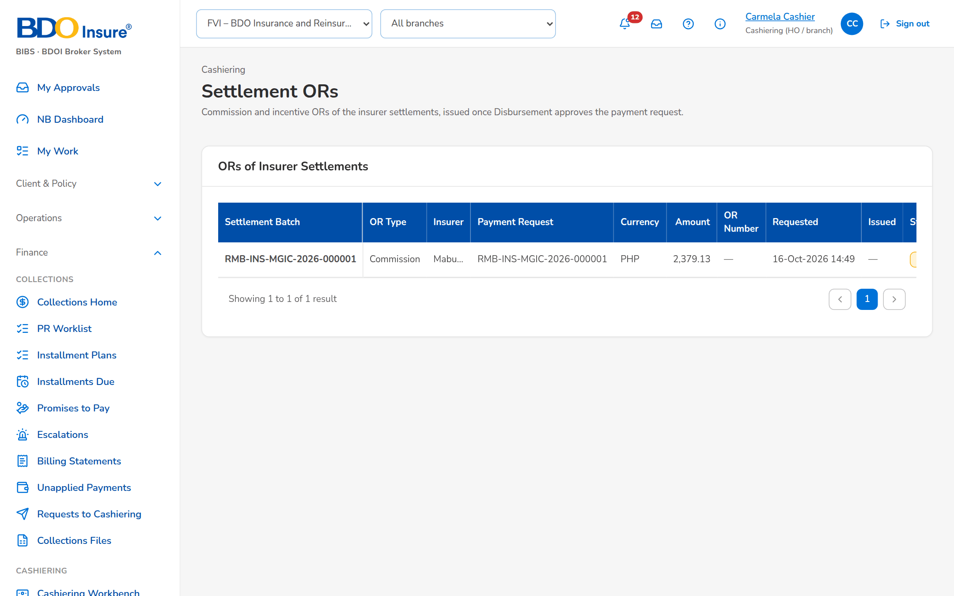
Figure 30: SCR-CSH-17: Settlement ORs waiting for the Disbursement approval

SCR-CSH-18 PDC Warehouse
Item | Value
Purpose | Post-dated checks kept in the warehouse with a PDCW- number, grouped by maturity month; the maturity job turns a matured check into a payment with its AR, and before maturity a check can be returned, replaced or pulled out.
Access | Cashiering Workbench › Post-dated Checks in the Warehouse tile
Requirements | FRS.CSH.05.02
Outcome | Post-dated checks are kept until maturity and receipted on the day.

Rules and states:
• A post-dated check waits in the warehouse until its maturity date; the daily maturity job receipts it then.
Table 35: SCR-CSH-18 fields
Field | Type | Req. | Default | Rule | Message
Tabs: In Warehouse / Applied / Matured (Unapplied) / All | Tab | - | In Warehouse | Source: Fixed | -
List: [Maturity month and total] | Heading | - | - | Month, number of checks and total; Source: PDC warehouse; Editable: Read only | -
List: Warehouse No. / Payor / Reference / Maturity / Amount / AR / Status | Column | - | - | PDCW-yyyy-n with the bank and check number; Source: PDC warehouse; Editable: Read only | -
Warehouse Post-dated Check dialog: Payor Name / Client Code / ARN, Invoice, Policy or PN No. / Check No. / Bank / Bank Branch / Maturity Date / Amount / Market Segment | Text, date, number | Payor, reference, check, bank, maturity date and amount Y | Blank | Maturity date dd-MMM-yyyy; Not blank; amount above zero | <field> is required / Enter an amount above zero
Release dialog: Outcome / Reason | Drop-down, text | Y | Returned | Returned, Replaced, Pulled out; Source: Fixed list; Editable: Warehoused; Reason not blank | Reason is required

Table 36: SCR-CSH-18 actions
Action | Who | Available when | What happens | Result
Warehouse Check | Cashier | Always | Stores the check in the warehouse | Warehoused
Process Maturities Now | Cashier | Always | Turns every matured check into a payment with its AR, matched at once | Applied or Matured (unapplied)
Release / Release Check | Cashier | Warehoused | Takes the check out before maturity with the outcome and reason | Returned, Replaced or Pulled out

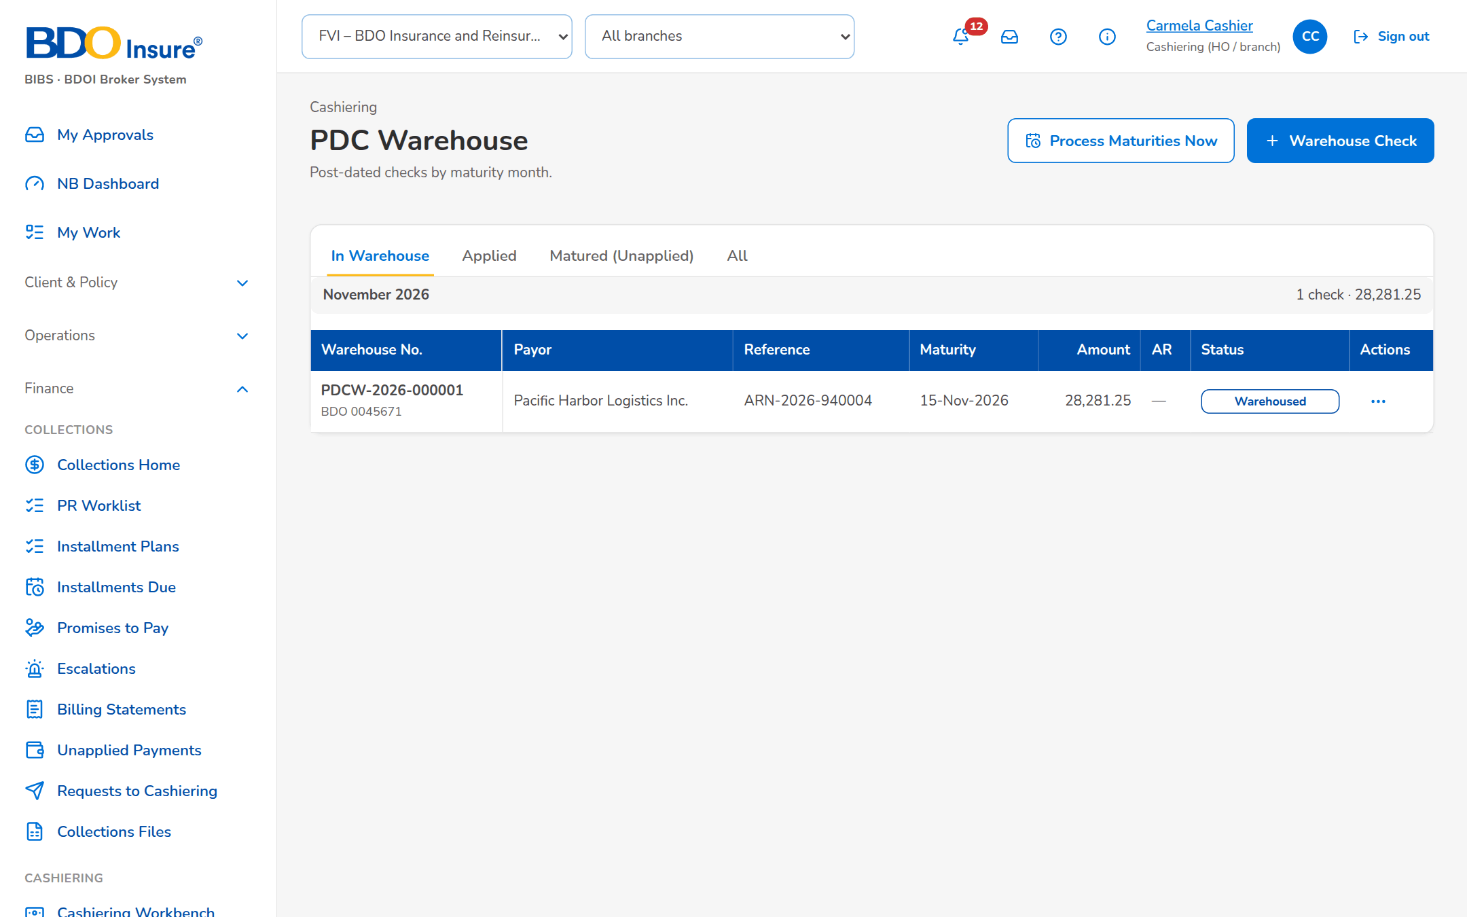
Figure 31: SCR-CSH-18: PDC Warehouse by maturity month
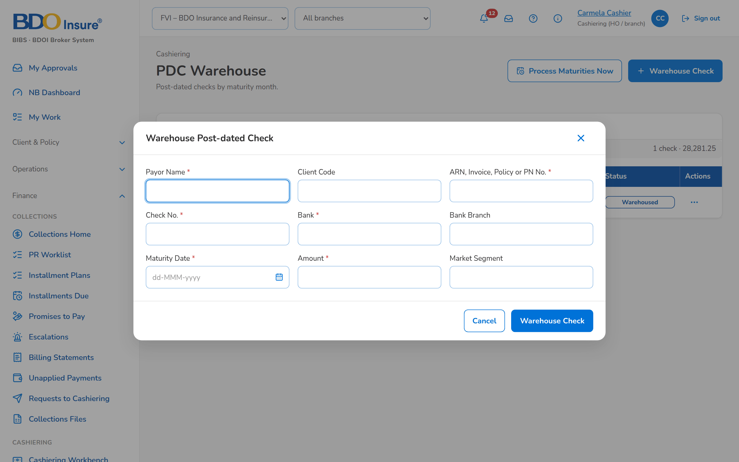
Figure 32: SCR-CSH-18: Warehouse Post-dated Check dialog

SCR-CSH-19 Batch Print
Item | Value
Purpose | Print and re-print ARs and ORs in their forms, at most 500 per batch: choose the receipts by type, branch and issue date, choose the copy (Client's Copy, Company Copy or both), print the selected receipts and follow the print batches with their log, preview, PDF or ZIP of single PDFs, and the retry or skip of the failures.
Access | Cashiering Dashboard › Batch Print AR/OR Facility
Requirements | FRS.CSH.02.04
Outcome | Receipts are printed in one run with a record of what was printed and re-printed.

Rules and states:
• A batch records each receipt printed with its certificate number, so a failure is retried without printing the others again.
• A re-printed receipt is marked REPRINT.
• The receipt is printed in the AR or OR form in force (AR and OR Forms, SCR-CSH-22), with the amount in words of its currency (setting).
Table 37: SCR-CSH-19 fields
Field | Type | Req. | Default | Rule | Message
Tabs: Print / Print Queue / Re-print | Tab | - | Print | Receipts not printed yet; the print batches; receipts already printed; Source: Fixed | -
Print: Receipt Type / Receipting Branch / Issued From / Issued To | Drop-down, date | N | Acknowledgement Receipt | Acknowledgement Receipt, Official Receipt; branches; dd-MMM-yyyy | -
Print: Copy | Drop-down | Y | Client's Copy | Client's Copy, Company Copy, Client's Copy and Company Copy; Source: Fixed list | -
Print: AR or OR Number / Receipting Branch / Issued / Client Name / Insurer Name / AR or OR Amount / Printed | Columns | - | - | For Printing, or the number of prints; Source: Receipts; Editable: Read only | No receipts match the criteria
Print Queue: Batch No. / Criteria / Copy / Printed / Not Printed / Skipped / Printed By / Status | Columns | - | - | Counts of the batch; Source: Print batches; Editable: Read only | -
Print Log: Receipt Number / Certificate No. / Reprint / Status / Reason | Columns | - | - | The acknowledgement certificate number of each print (AC_<branch>_<MMYYYY>_<sequence> as delivered); REPRINT on a re-print; Source: Print lines; Editable: Read only | -

Table 38: SCR-CSH-19 actions
Action | Who | Available when | What happens | Result
Search | Cashier | Always | Lists the receipts of the criteria | -
Print Selected (n) | Cashier (print right) | Receipts selected, at most 500 | Prints the selected receipts in their form with the copy chosen and records each | Printed
Print Log / Print Preview / Download PDF / Download ZIP | Cashier | A print batch | Shows the log; previews; downloads one PDF or a ZIP of one PDF per receipt | -
Retry Failures / Skip Failures | Cashier | Batch with failures | Prints the failed receipts again, or closes them as skipped | -

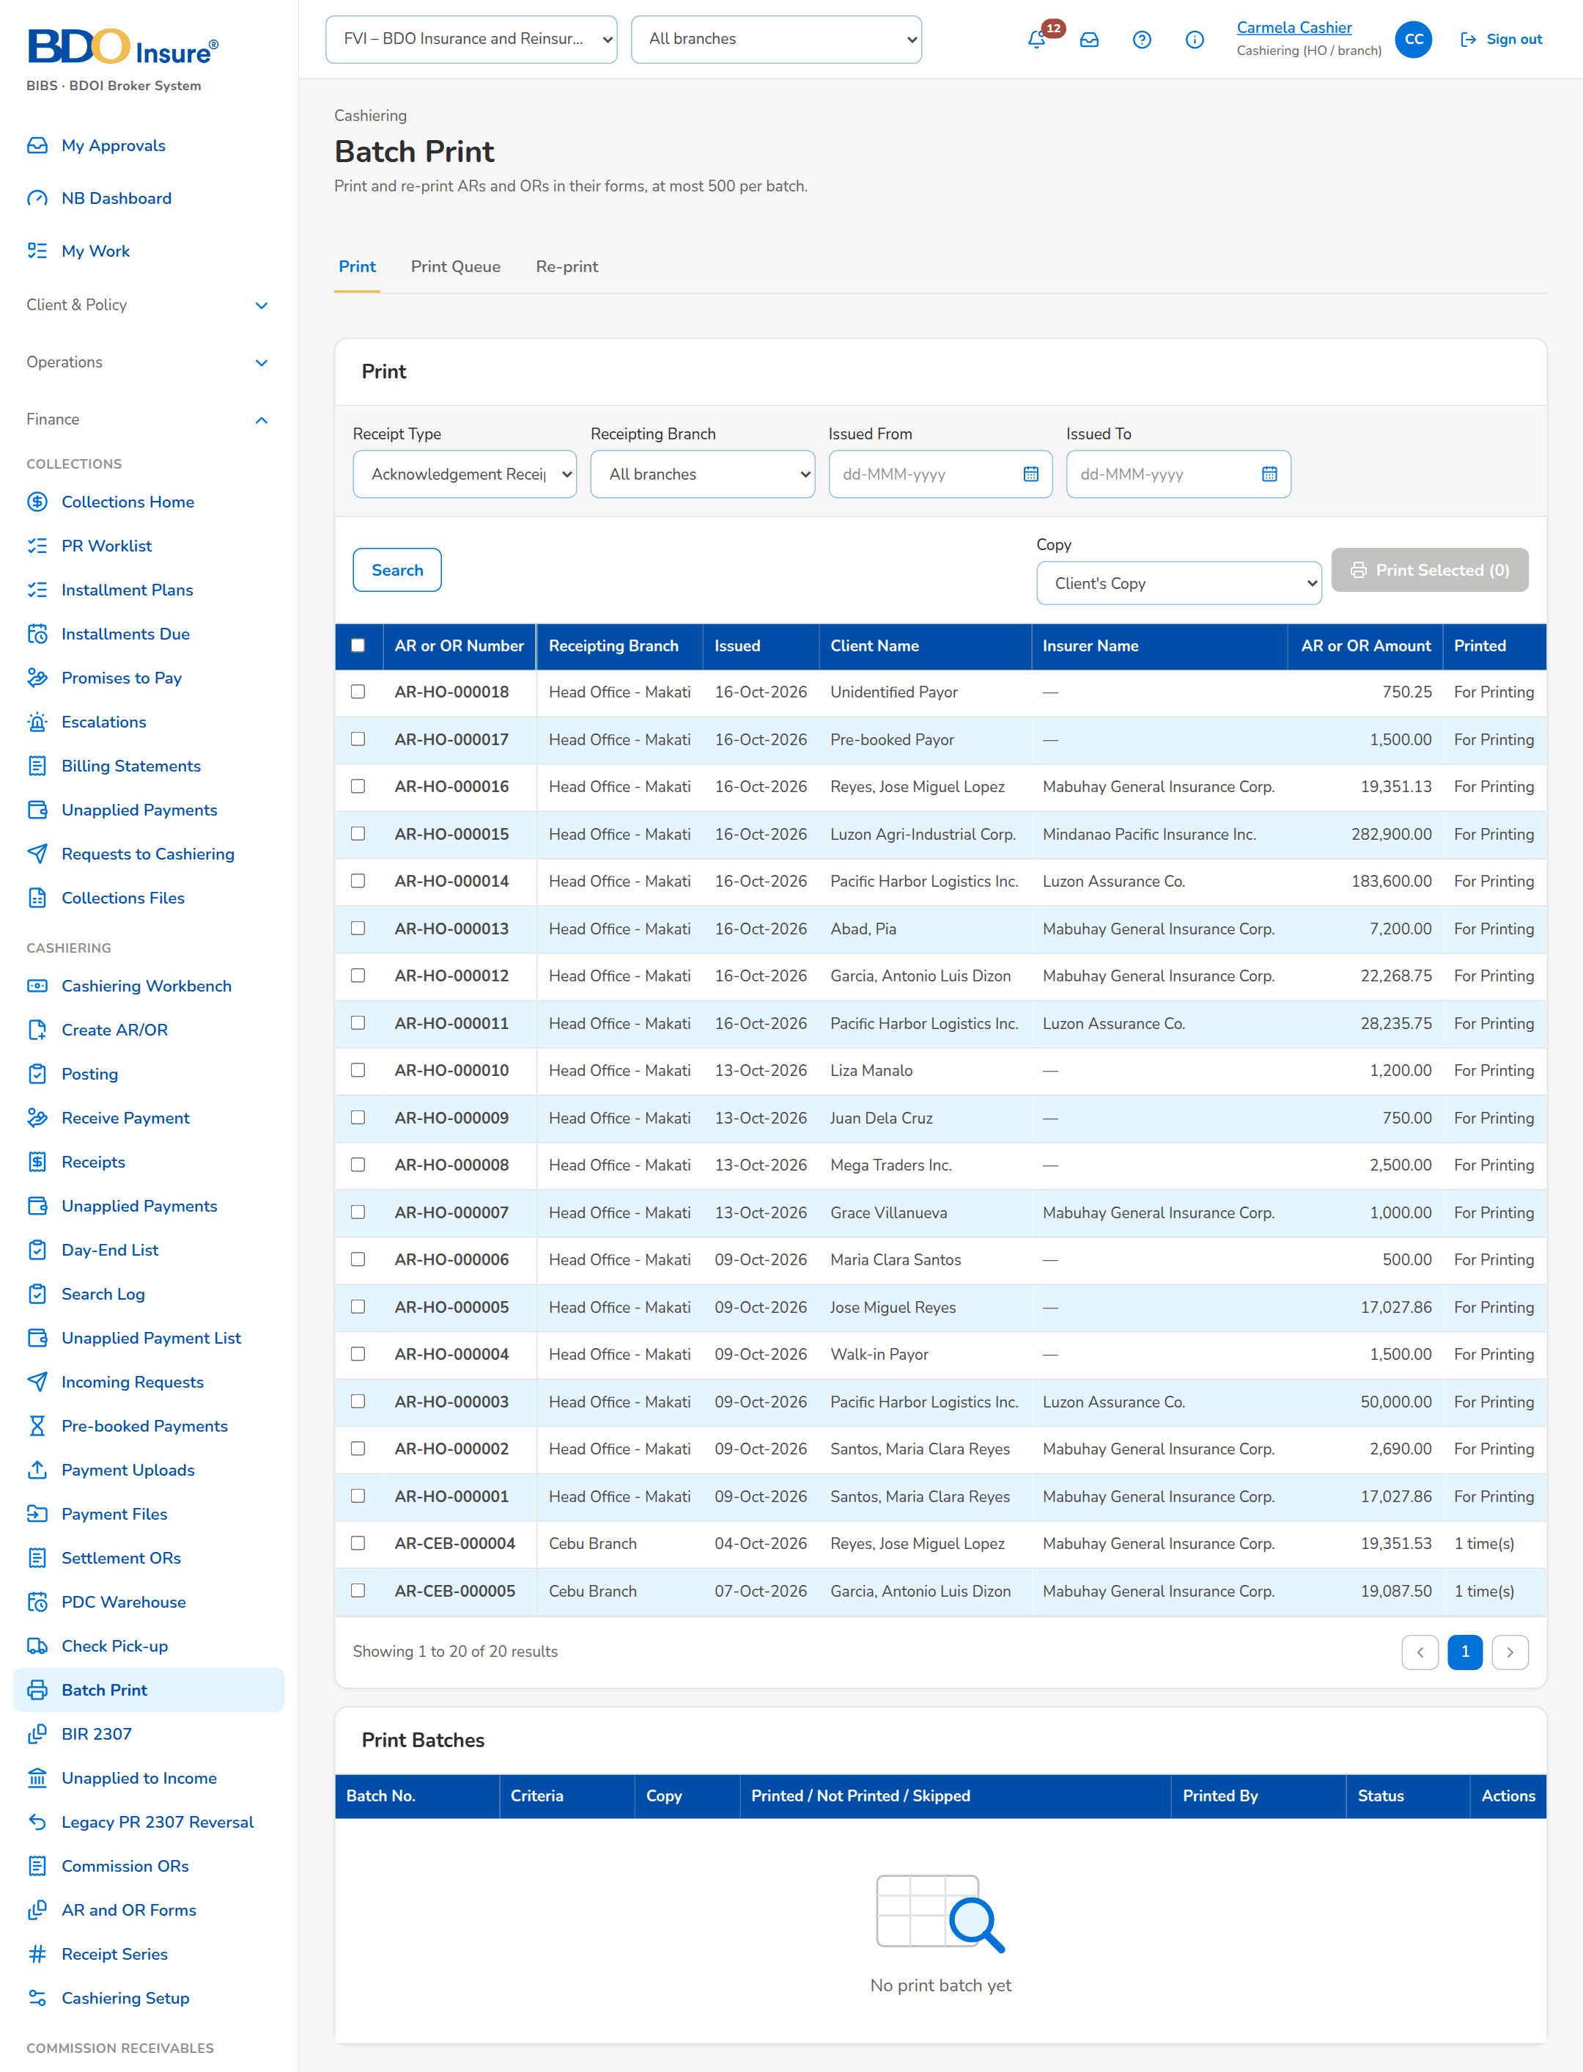
Figure 33: SCR-CSH-19: Batch Print: receipts for printing with the copy to print

SCR-CSH-20 BIR 2307
Item | Value
Purpose | The PR 2307 reversal of 2% CWT clients: tagged by Marketing Collection with the BIR 2307 certificate, checked against the computed PR 2307 amount, the outstanding premium and any commission receivable, validated per insurer into a report that is posted and routed to Disbursement, and released to the insurer. In v2.1 Marketing Collection performs every step up to the routing; the screenshots show the v2.0 screen, where the Cashier receives, validates and routes.
Access | Cashiering Workbench › BIR 2307 to Validate tile
Requirements | FRS.CSH.02.05
Outcome | The 2% CWT of the premium is reversed by Marketing Collection and the certificates are released to the insurer.

Rules and states:
• At tagging the certificate amount is checked against the computed PR 2307 amount and the outstanding premium receivable, and an outstanding commission receivable flags the tag For Commission Receivable.
• Posting the report zeroes the premium receivable; the release to the insurer posts nothing.
• A report holds the certificates of one insurer.
• A payment already remitted goes to Unapplied Payments with the insurer's written confirmation of refund attached.
Table 39: SCR-CSH-20 fields
Field | Type | Req. | Default | Rule | Message
Tabs: Tagged by Marketing / Validation / Reports and Routing / Released / Settled | Tab | - | Tagged by Marketing | Source: Fixed | -
Tags: Reference / Client / Insurer / Path / Amount / Checklist / Tagged / Stage | Column | - | - | CWT-yyyy-n with the invoice and ARN; path Certificate or Cash; checklist CWT Copy, Remitted; Source: BIR 2307 tags; Editable: Read only | No items to display
Validation: CWT Copy Received | Row action (Mark / Clear CWT Copy Received) | N | Not received | Editable: Validating | -
Reports and Routing: Batch No. / Insurer / Certificates / Total / Disbursement / Status | Column | - | - | Source: 2307 report batches; Editable: Read only | No 2307 report yet
Tag BIR 2307 dialog: Invoice No. | Text | Y | Blank | Source: Invoice ledger; Not blank | Invoice number is required
Tag BIR 2307 dialog: Path | Drop-down | Y | Certificate | Certificate or Cash; Source: Fixed list | -
Tag BIR 2307 dialog: Amount | Number | N | Blank | Blank = the expected 2%; Above zero when given | Enter an amount above zero, or leave it empty for the expected 2%
Tag BIR 2307 dialog: Certificate No. / Period From / Period To / Remarks | Text, date | Cond. | Blank | Certificate number for the certificate path; Certificate number for a certificate | Certificate number is required for a certificate

Table 40: SCR-CSH-20 actions
Action | Who | Available when | What happens | Result
Tag 2307 | Marketing Collection | Always | Tags the certificate or the cash path of the invoice | Tagged by Marketing
Receive | Marketing Collection (Cashier in v2.0) | Tagged and checked | Takes the tag into validation against the certificates | Validating
Validate and Post Report | Marketing Collection (Cashier in v2.0) | Validated certificates of one insurer selected | Asks for confirmation, generates the BIR 2307 transaction report, posts the reversal and zeroes the premium receivable (proposed entry Dr DTIP / Cr PR,) | Report posted
Settle in Cash | - | Withdrawn in v2.1 | A 2% paid in cash is received as an ordinary payment | -
Route to Disbursement | Marketing Collection (Cashier in v2.0) | Report posted | Sends the report and the certificates sorted per insurer to the Disbursement queue | With Disbursement; Disbursement request received (NT-03)
Release to Insurer | Disbursement | Report received and checked | Releases the certificates to the insurer; no accounting entry | Released to insurer
Return to Marketing / Cancel Tag | Disbursement / Marketing Collection | With Disbursement or tagged | Returns the report for completion or cancels the tag | Validating / Cancelled; Workflow notice (NT-01)

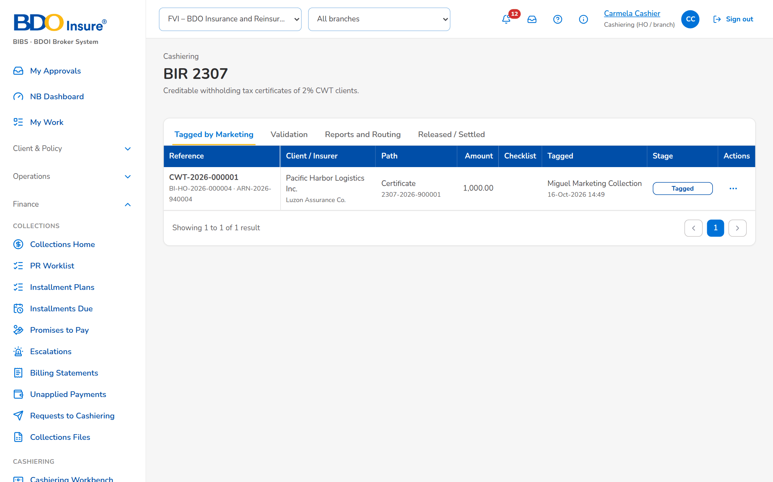
Figure 34: SCR-CSH-20: BIR 2307, Tagged by Marketing tab
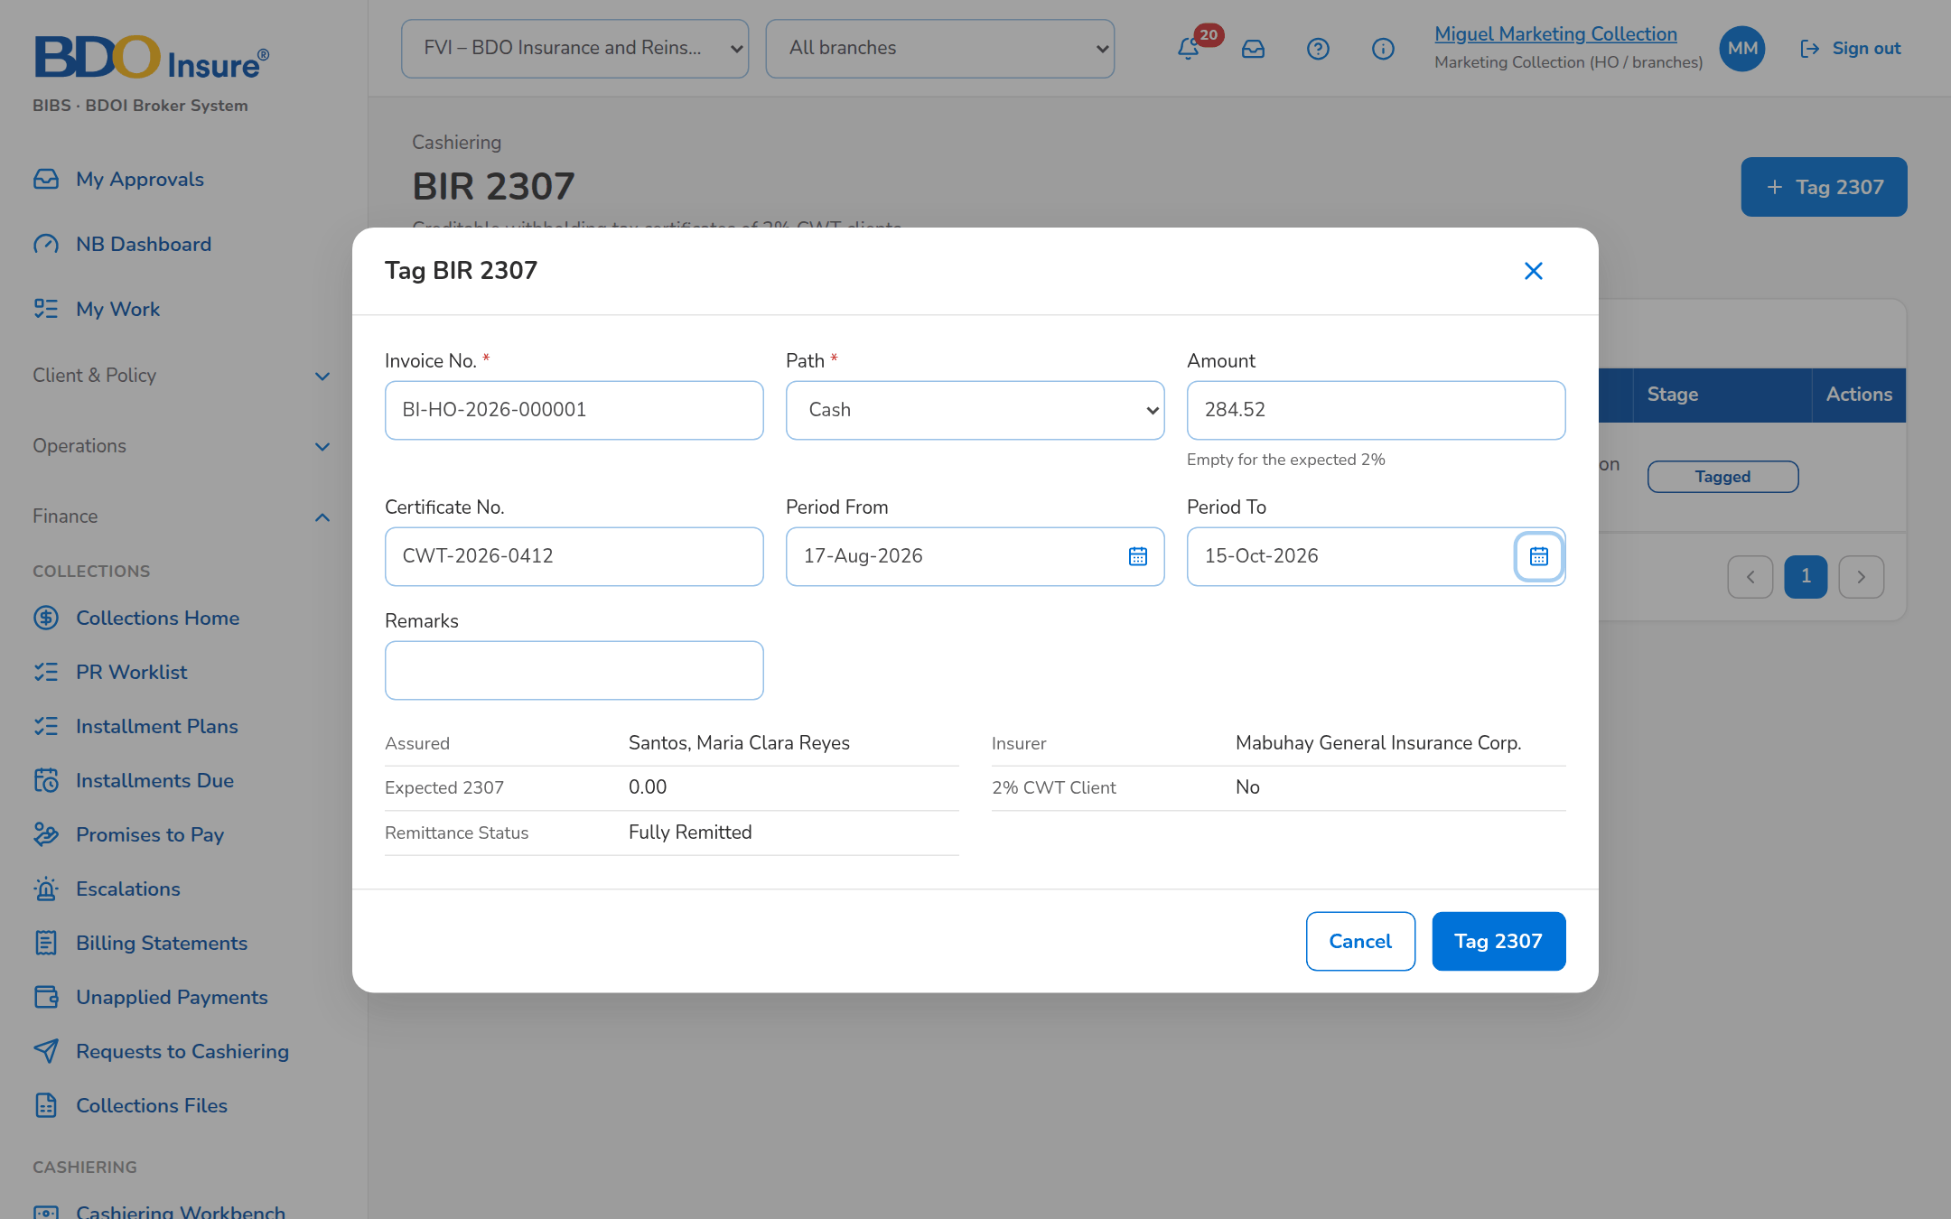
Figure 35: SCR-CSH-20: Tag BIR 2307 dialog of Marketing Collection

SCR-CSH-21 Commission ORs
Item | Value
Purpose | The commission payments of the insurers uploaded from the payment details, staged until Issue ORs issues one official receipt per payment with its VAT and withholding tax.
Access | Cashiering Workbench
Requirements | FRS.CSH.02.02, FRS.CSH.07.01
Outcome | The insurers' commission payments are receipted.

Rules and states:
• One OR is issued per staged commission payment.
Table 41: SCR-CSH-21 fields
Field | Type | Req. | Default | Rule | Message
1. Template / 2. Upload: [Commission Payment Details upload] | Upload | Y | - | Template columns of chapter 18; Source: Upload template; Every row checked first | The basic commission must be above zero
Staged Commission Payments: Upload / Insurer / Payee / Payment Ref. / Invoice / Gross / VAT / WTAX / Paid / OR / Status | Column | - | - | Source: Staged commission payments; Editable: Read only | No commission payment waiting for an OR

Table 42: SCR-CSH-21 actions
Action | Who | Available when | What happens | Result
Upload and Validate | Cashier | File chosen | Validates and stages the commission payments | Staged
Issue ORs | Cashier | Staged payments | Issues one OR per staged payment | OR issued

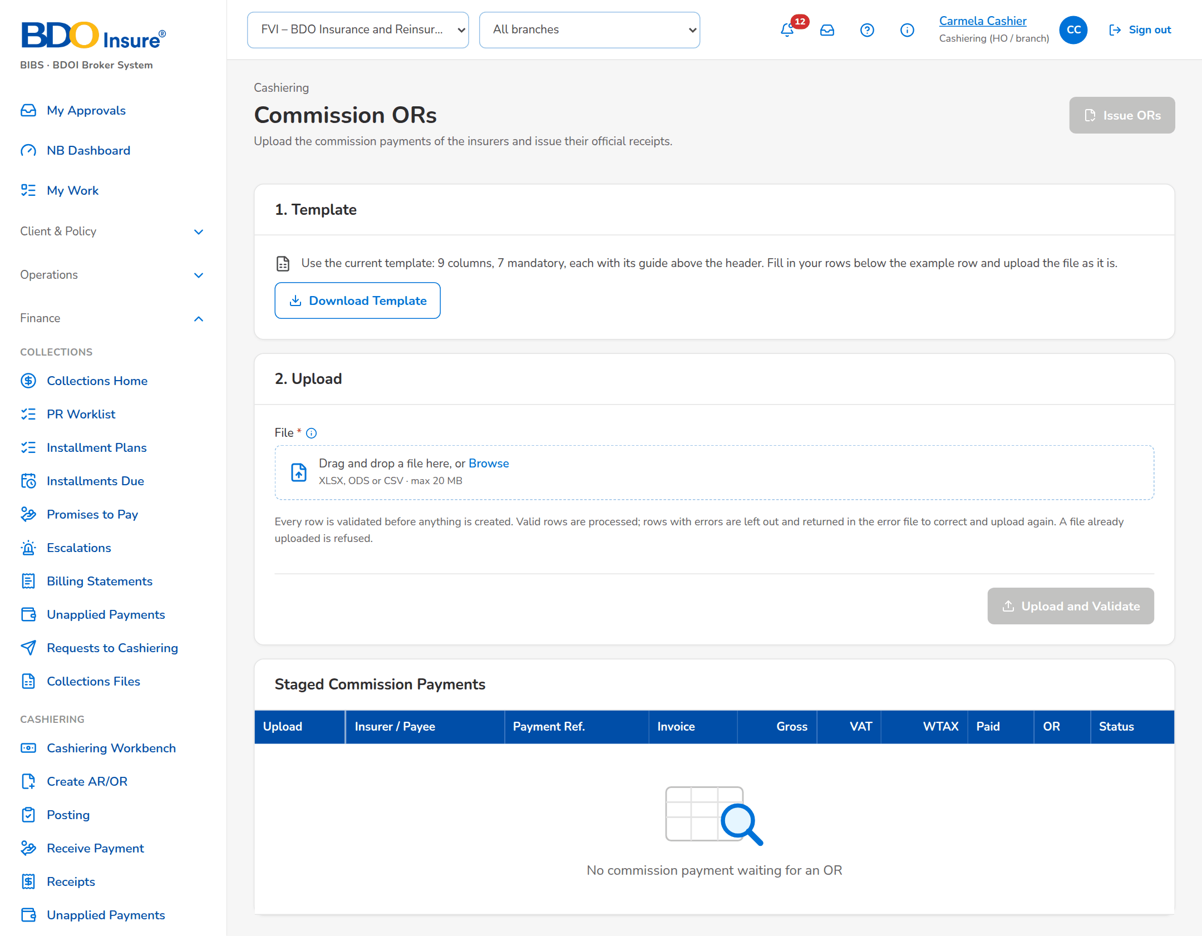
Figure 36: SCR-CSH-21: Commission ORs: upload steps and the staged commission payments

SCR-CSH-22 AR and OR Forms
Item | Value
Purpose | The header, note and footer lines of the printed AR and OR, with their versions: a change takes effect on its effective date once approved by a second user.
Access | Cashiering › AR and OR Forms
Requirements | FRS.CSH.02.06
Outcome | The printed receipts carry BDOI's approved header and footer without a release.

Rules and states:
• The receipt prints the form in use on its print date, with the amount in words in the words of its currency (setting Amount in words per currency).
Table 43: SCR-CSH-22 fields
Field | Type | Req. | Default | Rule | Message
Tabs: AR Form / OR Form | Tab | - | AR Form | Source: Fixed | -
Form: Company Name / Company Description / Company Address / Company VAT TIN / Note Line (AR) / Footer Line 1 / Footer Line 2 / Footer Line 3 / Footer Line 4 | Text | Y (name, address) | The form in use | As printed on the receipt; Editable: New version | -
Form: Effective From | Date | Y | Today | dd-MMM-yyyy; Editable: New version | -
Versions: Version / Effective From / Footer Line 1 / Changed By / Approved / Rejected By / Status | Columns | - | - | Pending approval, In use, earlier versions, Rejected; Source: Receipt forms; Editable: Read only | -

Table 44: SCR-CSH-22 actions
Action | Who | Available when | What happens | Result
[Change AR Form, Change OR Form] | Users with the series right | Always | Opens the form lines of the version in use for a change | -
Submit for Approval | Users with the series right | Lines entered | Saves a new version for approval | Pending approval; Notice Receipt form for approval
Approve / Reject | A second user with the series or authorisation right, not the maker | Pending approval | Puts the version in use from its effective date, or rejects it | In use or Rejected

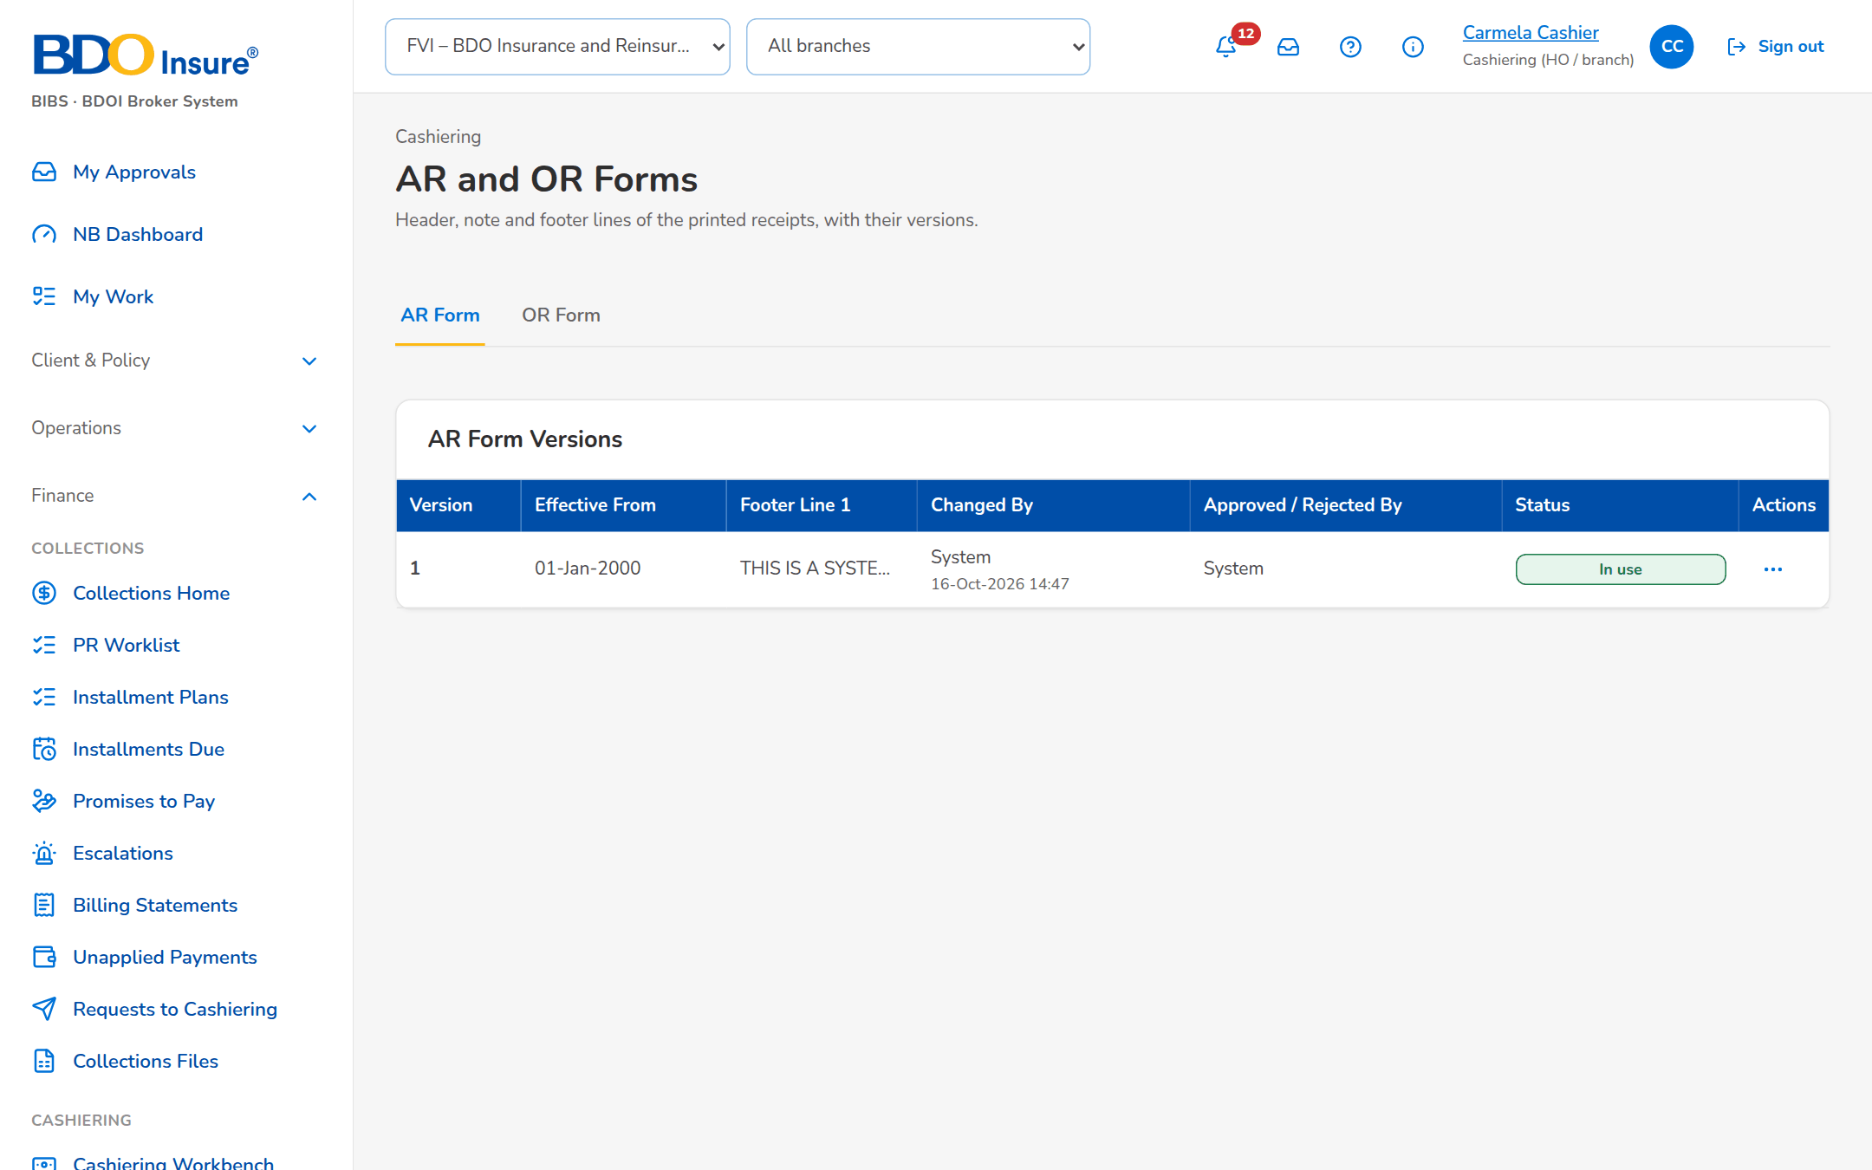
Figure 37: SCR-CSH-22: AR and OR Forms with the versions of the AR form

SCR-CSH-23 Receipt Series
Item | Value
Purpose | The AR and OR number ranges per branch with their BIR Authority to Print, the next number and the numbers left before the series runs out; a new series is authorised by a second user before it is used.
Access | Cashiering Workbench
Requirements | FRS.CSH.02.03
Outcome | Receipt numbers come from authorised series and the team is warned before a series runs out.

Rules and states:
• Each receipt takes the next number of its series; a depleted series refuses the receipt.
• When the numbers left reach the warning level, the Cashiering team is alerted.
• ORs are issued only from Head Office series.
Table 45: SCR-CSH-23 fields
Field | Type | Req. | Default | Rule | Message
Toolbar: Origin | Drop-down | N | All origins | All origins, BIBS, Migrated; Source: Fixed list | -
List: Series / Branch / Range / Year / Next Number / Used / Status | Column | - | - | Prefix with the kind and ATP; year or Every year; next number in its format; gauge with the numbers left; Source: Receipt series; Editable: Read only | No receipt series yet
New Receipt Series dialog: Kind / Branch | Drop-down | Y | AR | AR or OR; an OR series only for the Head Office; Source: Branches | -
New Receipt Series dialog: Prefix | Text | Y | Blank | For example AR-HO-; Not blank | Prefix is required
New Receipt Series dialog: From No. / To No. | Number | Y | Blank | The range ends at or after its start; Valid range | The range must end at or after its start
New Receipt Series dialog: BIR ATP No. / Warn When Remaining At | Text, number | N | Blank | - | -
New Receipt Series dialog: Year | Number | N | Blank | Year of the series; blank for every year | -
New Receipt Series dialog: Number Format | Text | N | The proposed format | Parts {PREFIX}, {YEAR}, {BRANCH}, {SEQ}; the first number is shown below the form; blank = prefix and sequence; Source: Number format setting; Only the parts listed | -

Table 46: SCR-CSH-23 actions
Action | Who | Available when | What happens | Result
New Series / Save Series | Cashiering Team Leader | Always | Saves the series for authorisation | Pending authorization
Authorize | A second user with the authorisation permission | Series pending | Asks for confirmation and activates the series | Active
Deactivate | Cashiering Team Leader | Series active | Asks for confirmation; no more receipts are issued from it | Inactive

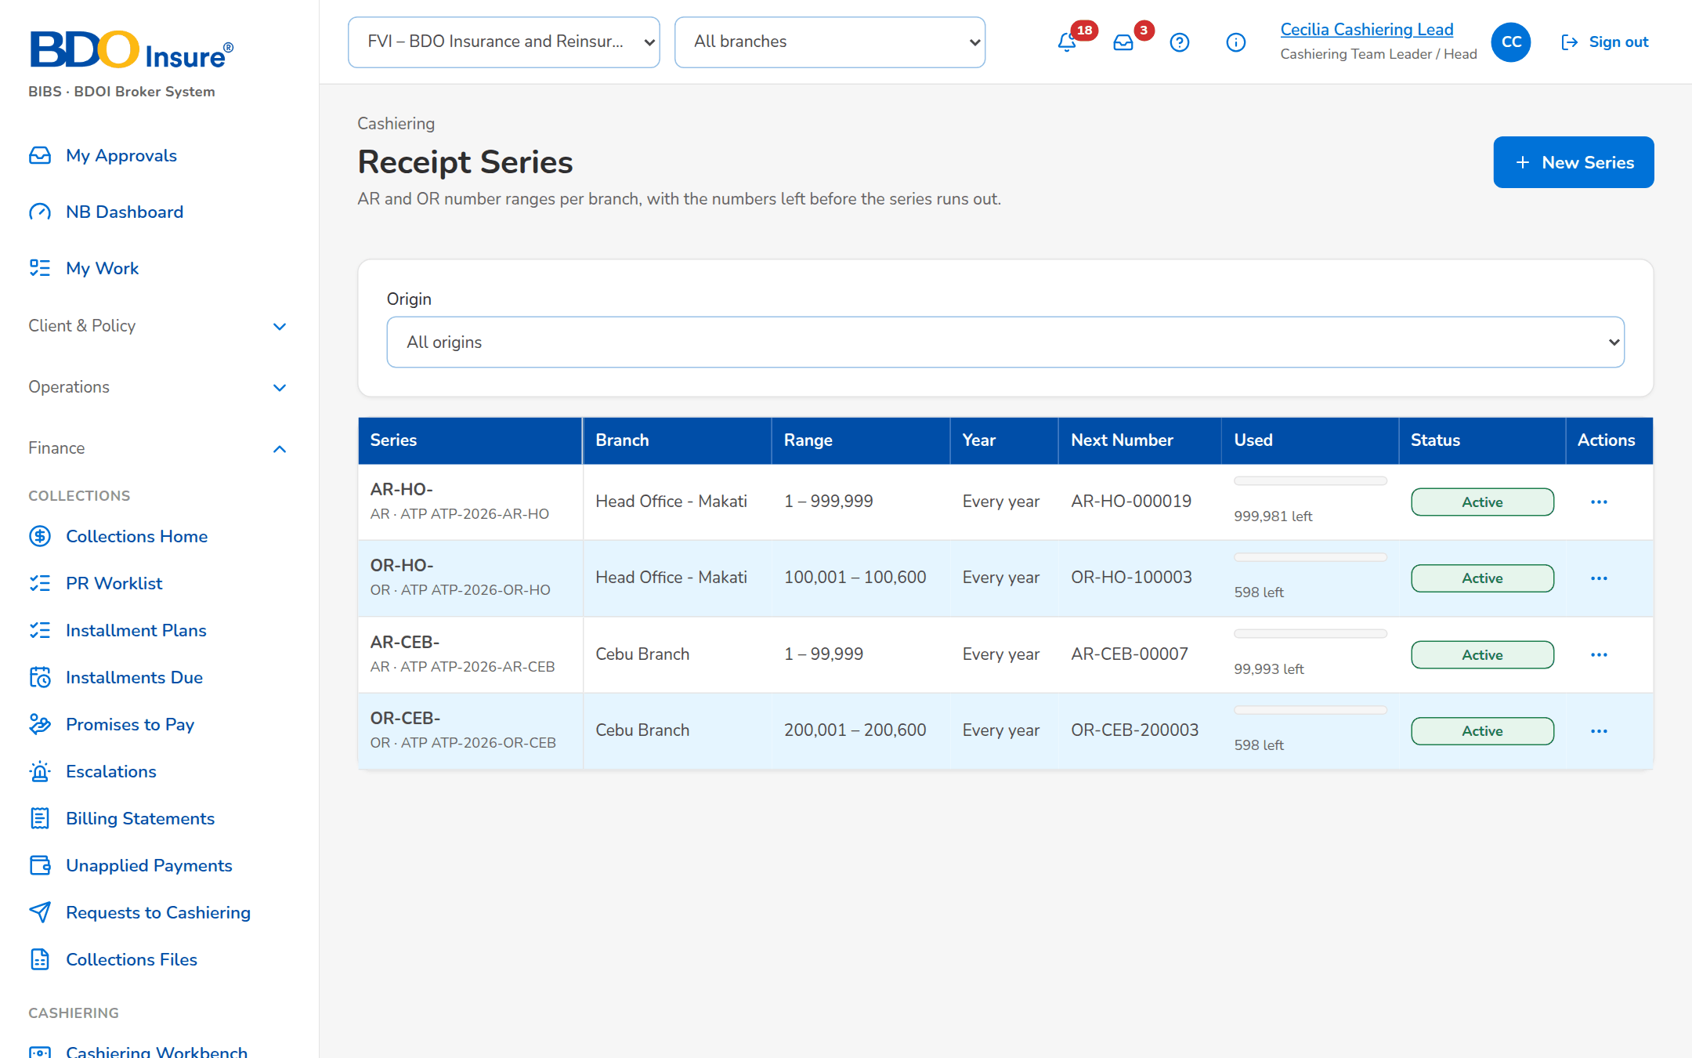
Figure 38: SCR-CSH-23: Receipt Series with the numbers left
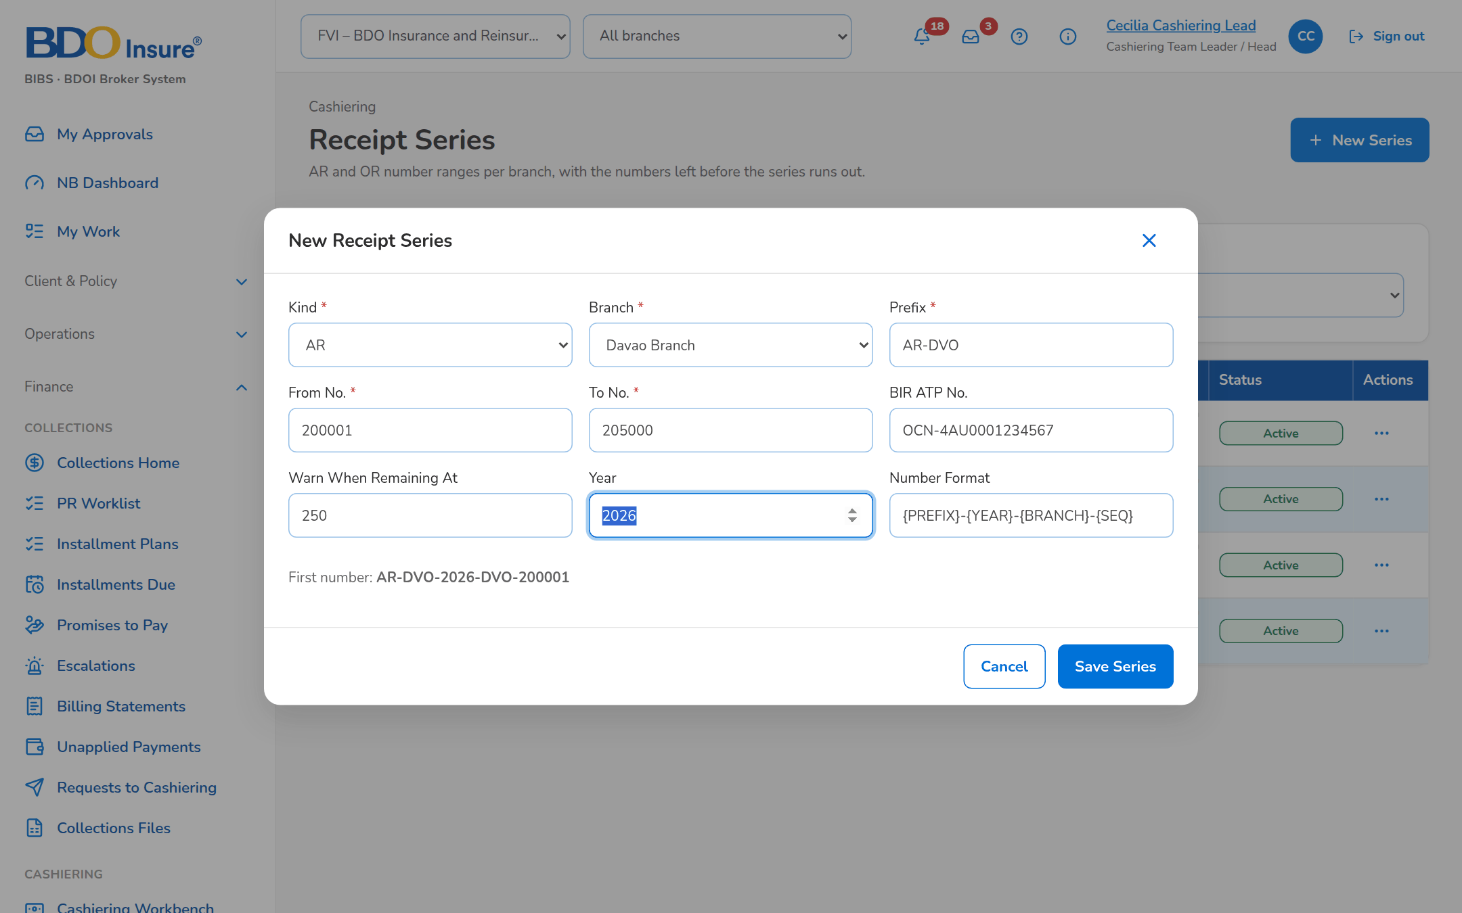
Figure 39: SCR-CSH-23: New Receipt Series dialog

SCR-CSH-24 Cashiering Setup
Item | Value
Purpose | The layouts of the bank and channel payment files and the minimal balance rules (thresholds and exceptions), with the manual run of the safety-net sweep.
Access | Cashiering Workbench
Requirements | FRS.CSH.02.05, FRS.CSH.05.01
Outcome | File layouts and minimal balance rules are kept by the business.

Rules and states:
• Premium balances and excess amounts within the threshold (default PHP 10.00) are cleared when the payment is processed, never routed to Unapplied Payments; a balance equal to the 2% CWT, the DST or the whole premium, and an invoice already written off, are skipped.
• The thresholds are configurable; the daily sweep is only a safety net for balances that later events leave within the threshold.
Table 47: SCR-CSH-24 fields
Field | Type | Req. | Default | Rule | Message
Tabs: Payment File Layouts / Minimal Balance | Tab | - | Payment File Layouts | Source: Fixed | -
Payment File Layouts: File / Kind / Separator / Last Changed | Column | - | - | Automatic, delimited or fixed width; Source: Payment file layouts; Editable: Read only | -
Edit layout dialog: Fields / Separator / Fields (Header:start:length separated by ;, start is 1-based) | Drop-down, text | Y | The current layout | Fields for a fixed-width file | -
Minimal Balance: Balance / Up To / Excludes / Action / Status | Column | - | - | For example premium balances up to 10.00, excluding the 2% CWT, the DST and the whole premium; Source: Minimal balance rules; Editable: Read only | -

Table 48: SCR-CSH-24 actions
Action | Who | Available when | What happens | Result
Edit Layout / Save Layout | Cashiering Team Leader | Always | Changes the layout of a payment file | -
Run Sweep Now | Cashiering Team Leader | Always | Runs the safety-net sweep now and reports the balances cleared that later events left within the threshold | -

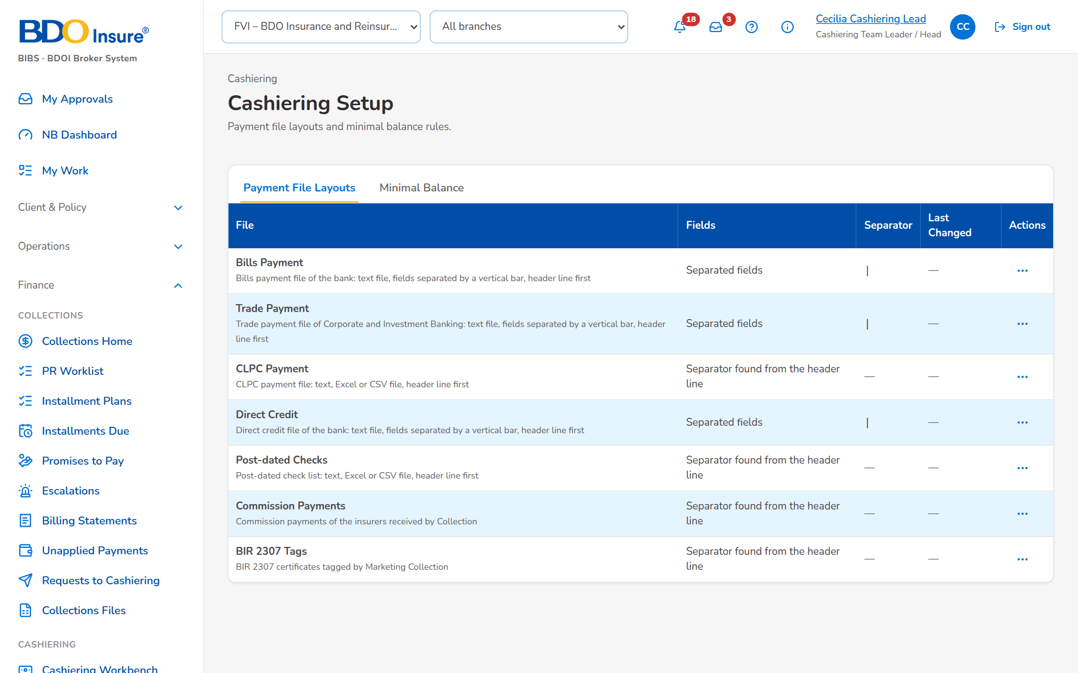
Figure 40: SCR-CSH-24: Cashiering Setup, Payment File Layouts tab
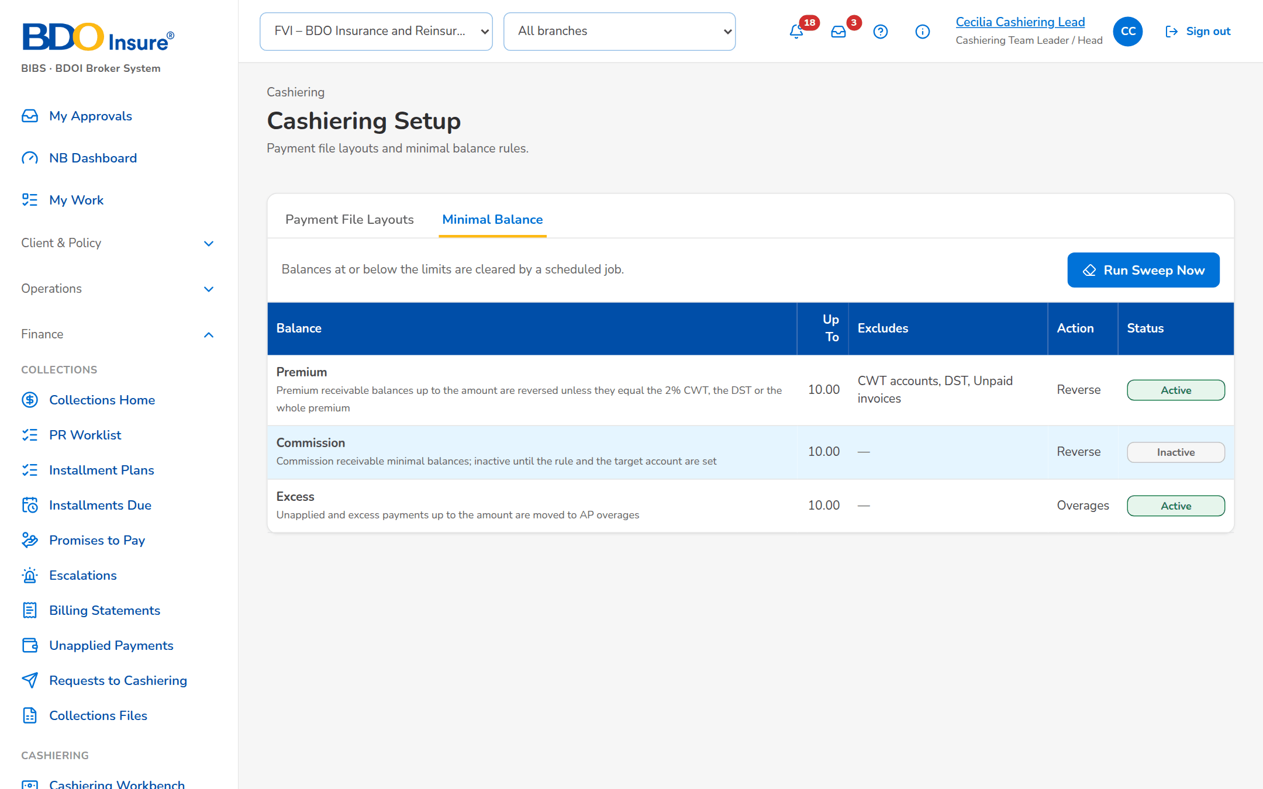
Figure 41: SCR-CSH-24: Cashiering Setup, Minimal Balance tab with the rules

SCR-CSH-25 Unapplied to Income
Item | Value
Purpose | Batches of old unapplied payments, new and legacy, reclassified to other income (unclaimed collections) after the approval of the Cashiering Team Leader and then of Top Management. [Data Migration scope]
Access | Cashiering › Unapplied to Income
Requirements | FRS.CSH.06.01
Outcome | Old unapplied payments are reclassified to other income with two approvals.

Rules and states:
• The requester never approves the batch (BR-CSH-01).
• The lines post to other income after the second approval; the unapplied payments close.
Table 49: SCR-CSH-25 fields
Field | Type | Req. | Default | Rule | Message
Batches: Batch / Lines / Total / Requested / Approved / Posted / Status | Table | - | - | One row per batch; Source: Batches; Editable: Read only | No batch yet
New Batch: Reason | Text | Y | Blank | Up to 200 characters; Not blank | Enter the reason
New Batch: Currency | Drop-down | Y | PHP | PHP, USD; Source: Currencies | -

Table 50: SCR-CSH-25 actions
Action | Who | Available when | What happens | Result
New Batch | Cashier | Always | Opens a batch in Draft for its lines | Draft
Add Unapplied Payments | Cashier | Draft | Adds unapplied payments received at least the days chosen, with the reason of the lines | Lines added
Submit Batch | Cashier | Draft with a line | Sends the batch to the Team Leader | For approval; Notice to the Team Leader
Approve Batch / Return Batch | Team Leader, then Top Management | For approval | Approves, or returns with a reason; the lines post after the second approval | Posted

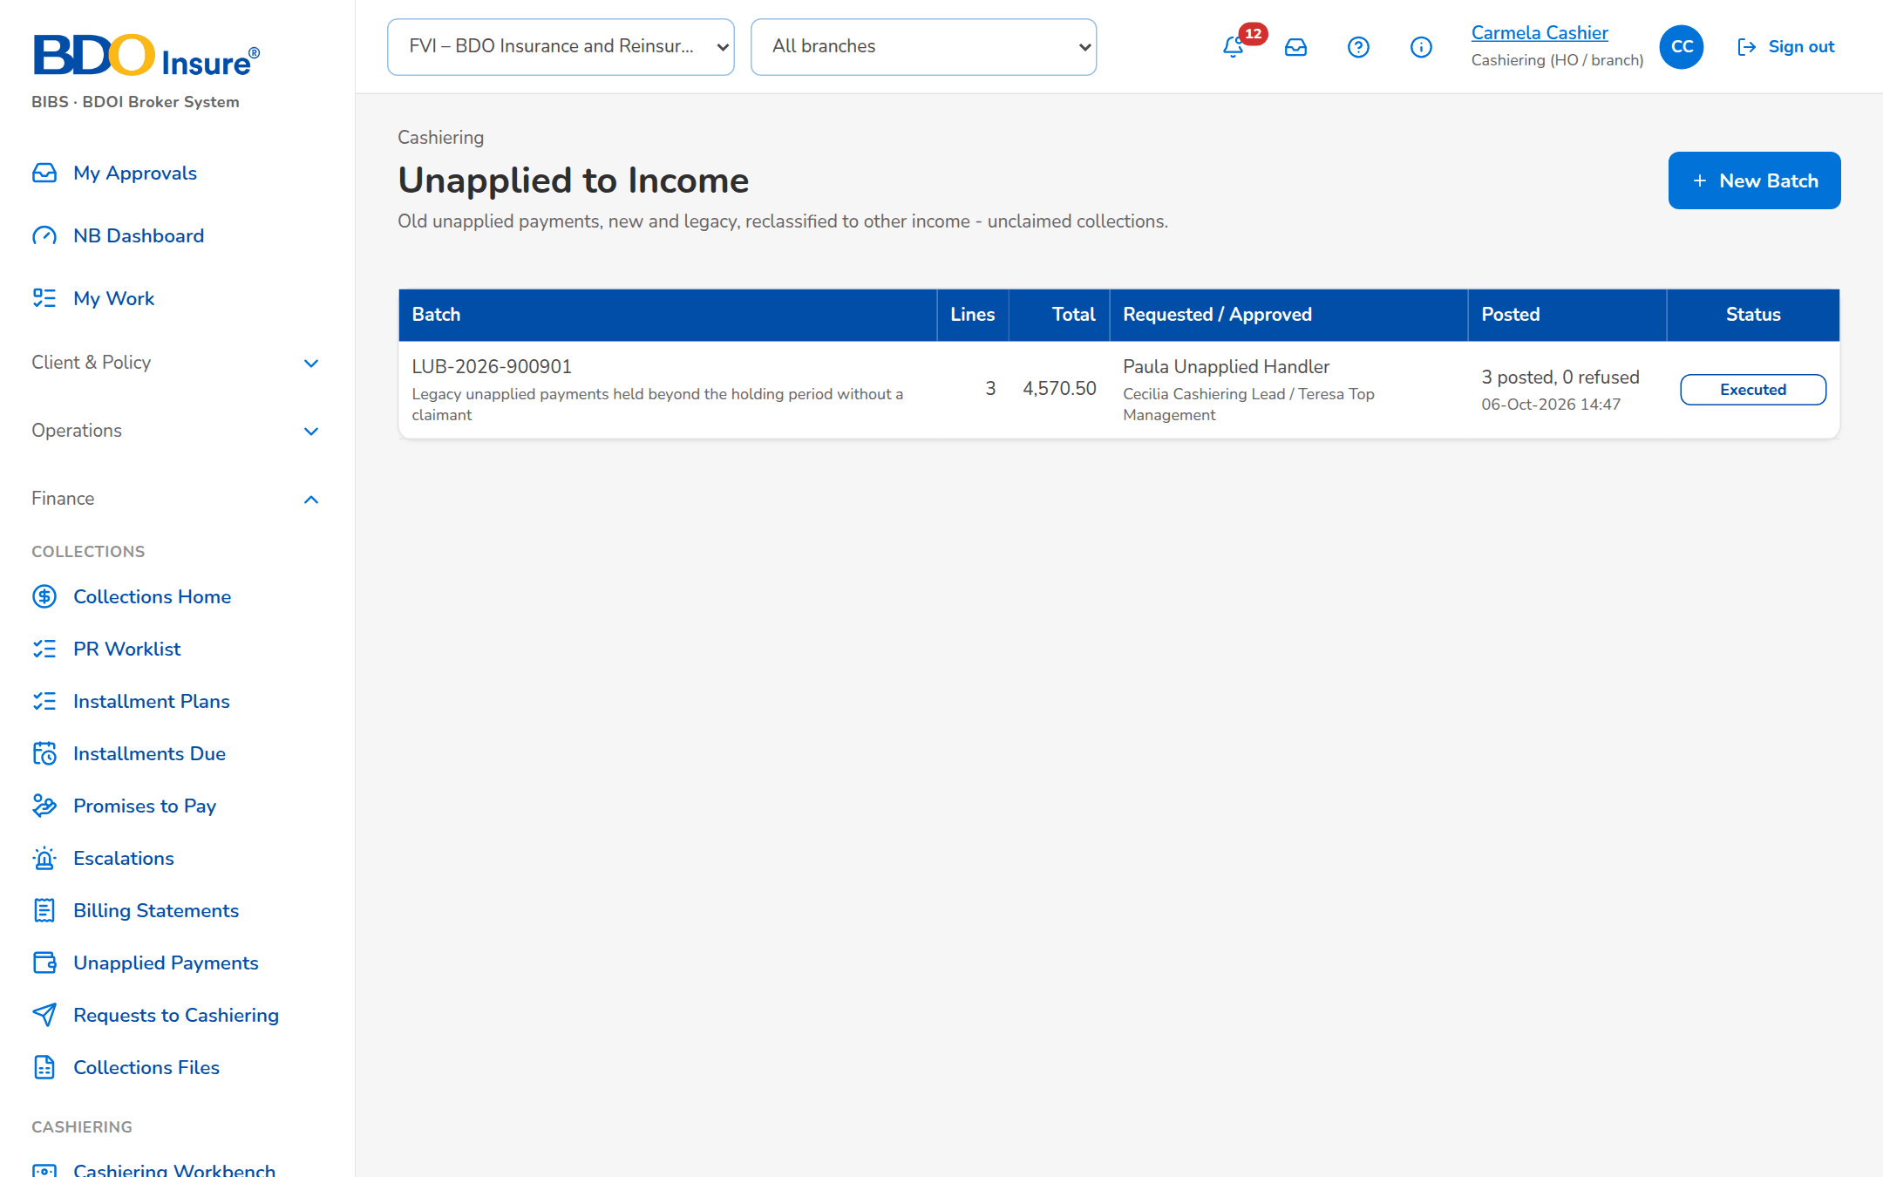
Figure 42: SCR-CSH-25: Unapplied to Income: the batches and their status

SCR-CSH-26 Legacy PR 2307 Reversal
Item | Value
Purpose | Batches that settle the PR 2307 balances of legacy invoices against the amount due to the insurer. [Data Migration scope]
Access | Cashiering › Legacy PR 2307 Reversal
Requirements | FRS.CSH.06.01
Outcome | Legacy PR 2307 balances are settled with the amount due to the insurer.

Rules and states:
• The requester never approves the batch (BR-CSH-01).
• Any premium receivable needed is first moved to PR 2307; each line posts on its own.
Table 51: SCR-CSH-26 fields
Field | Type | Req. | Default | Rule | Message
Batches: Batch / Lines / Total / Requested / Approved / Posted / Status | Table | - | - | One row per batch; Source: Batches; Editable: Read only | No batch yet
Add a Legacy Invoice: Invoice No. | Text | Y | Blank | Legacy invoice number; Source: Legacy invoices; A legacy invoice | <invoice> is not a legacy invoice
Add a Legacy Invoice: Amount | Number | Y | Blank | Two decimals; Within the open PR 2307 and the due to insurer | <invoice>: the amount must be positive and within the open PR 2307 and due to insurer

Table 52: SCR-CSH-26 actions
Action | Who | Available when | What happens | Result
New Batch | Cashier | Always | Opens a batch in Draft | Draft
Submit Batch | Cashier | Draft with a line | Sends the batch to the Team Leader | For approval
Approve Batch / Return Batch | Team Leader | For approval | Posts the lines, or returns the batch with a reason | Posted

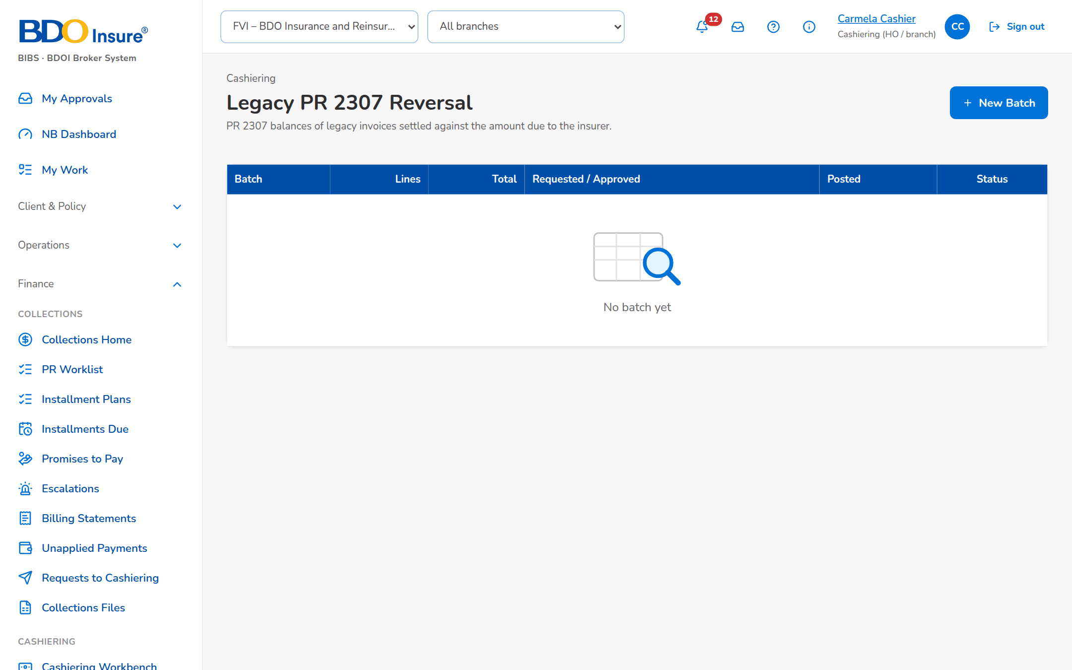
Figure 43: SCR-CSH-26: Legacy PR 2307 Reversal: the batches

SCR-CSH-27 Check Pick-up
Item | Value
Purpose | Checks tagged for pick-up by Collection, with the ARs of the checks picked up. CSHID.009 is removed from the BRD; the screen stays in the Cashier profile until BDOI decides (Q-CSH-07).
Access | Cashiering › Check Pick-up
Requirements | FRS.CSH.05.01
Outcome | The ARs of the checks picked up are printed.

Rules and states:
• A collection reference is queued once.
Table 53: SCR-CSH-27 fields
Field | Type | Req. | Default | Rule | Message
Filters: Pick-up From / Pick-up To | Date | N | Blank | dd-MMM-yyyy | -
Requests: Collection Ref. / Payor / Pick-up Date / Requested By / Check No. / Amount / AR / Status | Table | - | - | One row per request; Source: Collection; Editable: Read only | -

Table 54: SCR-CSH-27 actions
Action | Who | Available when | What happens | Result
Import | Cashier | Always | Reads the pick-up requests of Collection | Requests listed
Print ARs | Cashier with the print permission | Requests due selected | Issues and prints the ARs of the checks picked up | AR Printed

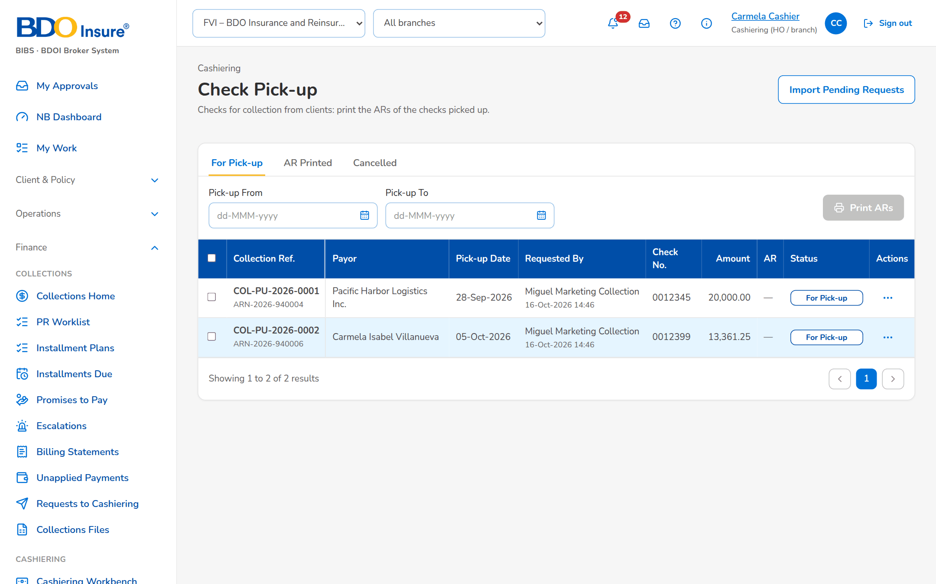
Figure 44: SCR-CSH-27: Check Pick-up: requests of Collection

SCR-CSH-28 Report Centre (Operations reports)
Item | Value
Purpose | The Operations reports of the Report Centre, by team: Cashiering, Remittance, Adjustment, Production Reconciliation and Commission Receivables, each card with its title, code and a one-line description; a card opens the report.
Access | Reports › Report Centre
Requirements | FRS.CSH.09.01, FRS.CSH.09.02
Outcome | Every Operations report is found in one place.

Rules and states:
• The Operations reports are in the category Operations; viewing and exporting are separate permissions.
• The layouts the BRD does not detail are proposed layouts for BDOI to confirm.
Table 55: SCR-CSH-28 fields
Field | Type | Req. | Default | Rule | Message
Toolbar: Search reports | Text | N | Blank | Search by title or code; Source: Report catalogue | -
Report cards: [Operations report cards] | Card | - | - | Title, code and description; the Operations group lists the Cashiering (CSH), Remittance (REM), Adjustment (ADJ), Production Reconciliation (PRC) and Commission Receivables (CMR) reports; Source: Report catalogue; Editable: Read only | -
My report batches: Batch No. / Run At / Output / Status | Column | - | - | Reports run in a batch; Source: Report batches; Editable: Read only | -

Table 56: SCR-CSH-28 actions
Action | Who | Available when | What happens | Result
[Open a report card] | Users who may view Operations reports | Always | Opens the report with its parameters | -
Report Batch | Users who may view Operations reports | Always | Runs several reports in one batch | -

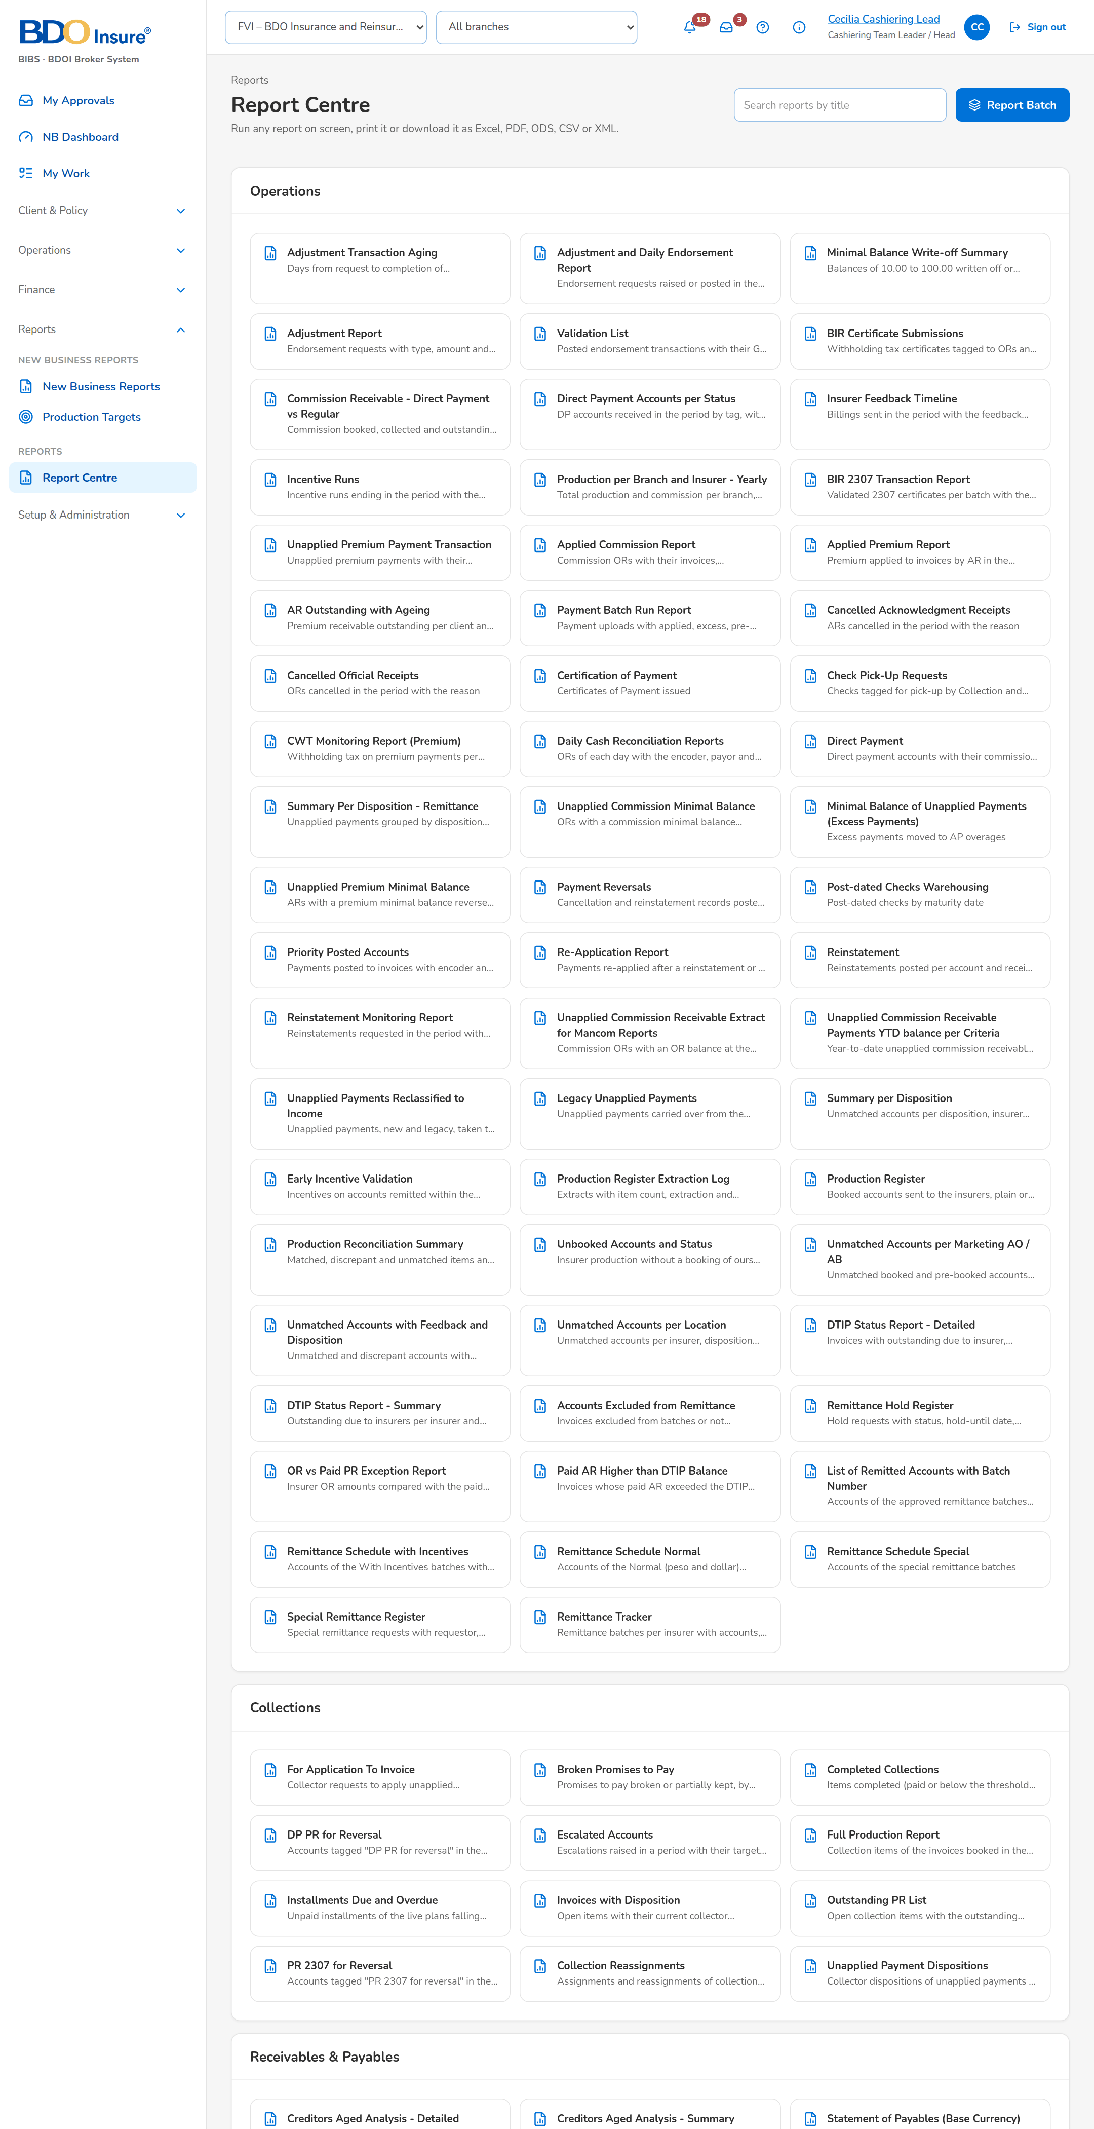
Figure 45: SCR-CSH-28: Report Centre: the Cashiering reports

SCR-CSH-29 Report
Item | Value
Purpose | One Operations report: its parameters (with saved variants), run on screen, printed or exported to Excel, PDF, ODS, CSV or XML; each run is archived with its parameters.
Access | Report Centre › a report card; Report Archive › a run
Requirements | FRS.CSH.09.01, FRS.CSH.09.02
Outcome | The user runs, prints and exports the Operations reports.

Rules and states:
• A view-only user runs the report on screen; the export and print buttons are not offered.
• Every run and export is archived with its parameters, user and time.
Table 57: SCR-CSH-29 fields
Field | Type | Req. | Default | Rule | Message
Parameters: [Report parameters] | Date, drop-down, text | Per report | The report's defaults | For example Company, From, To, Insurer, Origin; Source: Report parameters; Mandatory parameters given | -
Parameters: Saved Variant / Variant Name | Drop-down, text | N | Blank | The user's and the shared variants; Source: Report variants | -
Print options: Paper / Orientation / Width | Drop-down | N | Automatic (by width) | Orientation Automatic (by width), Portrait, Landscape; Source: Fixed list | -
Result: [Report table] | Table | - | - | The columns of the report with its totals; Source: Report; Editable: Read only | -

Table 58: SCR-CSH-29 actions
Action | Who | Available when | What happens | Result
Run Report | Users who may view the report | Parameters given | Runs the report on screen and archives the run | -
Print | Users who may export the report | Parameters given | Produces the printable PDF | -
[Export buttons] | Users who may export the report | Report run | Downloads the report as Excel, PDF, ODS, CSV or XML | -
Save Variant / Delete Variant | Every user of the screen | Always | Saves the parameters as a named variant, or deletes one's own | -

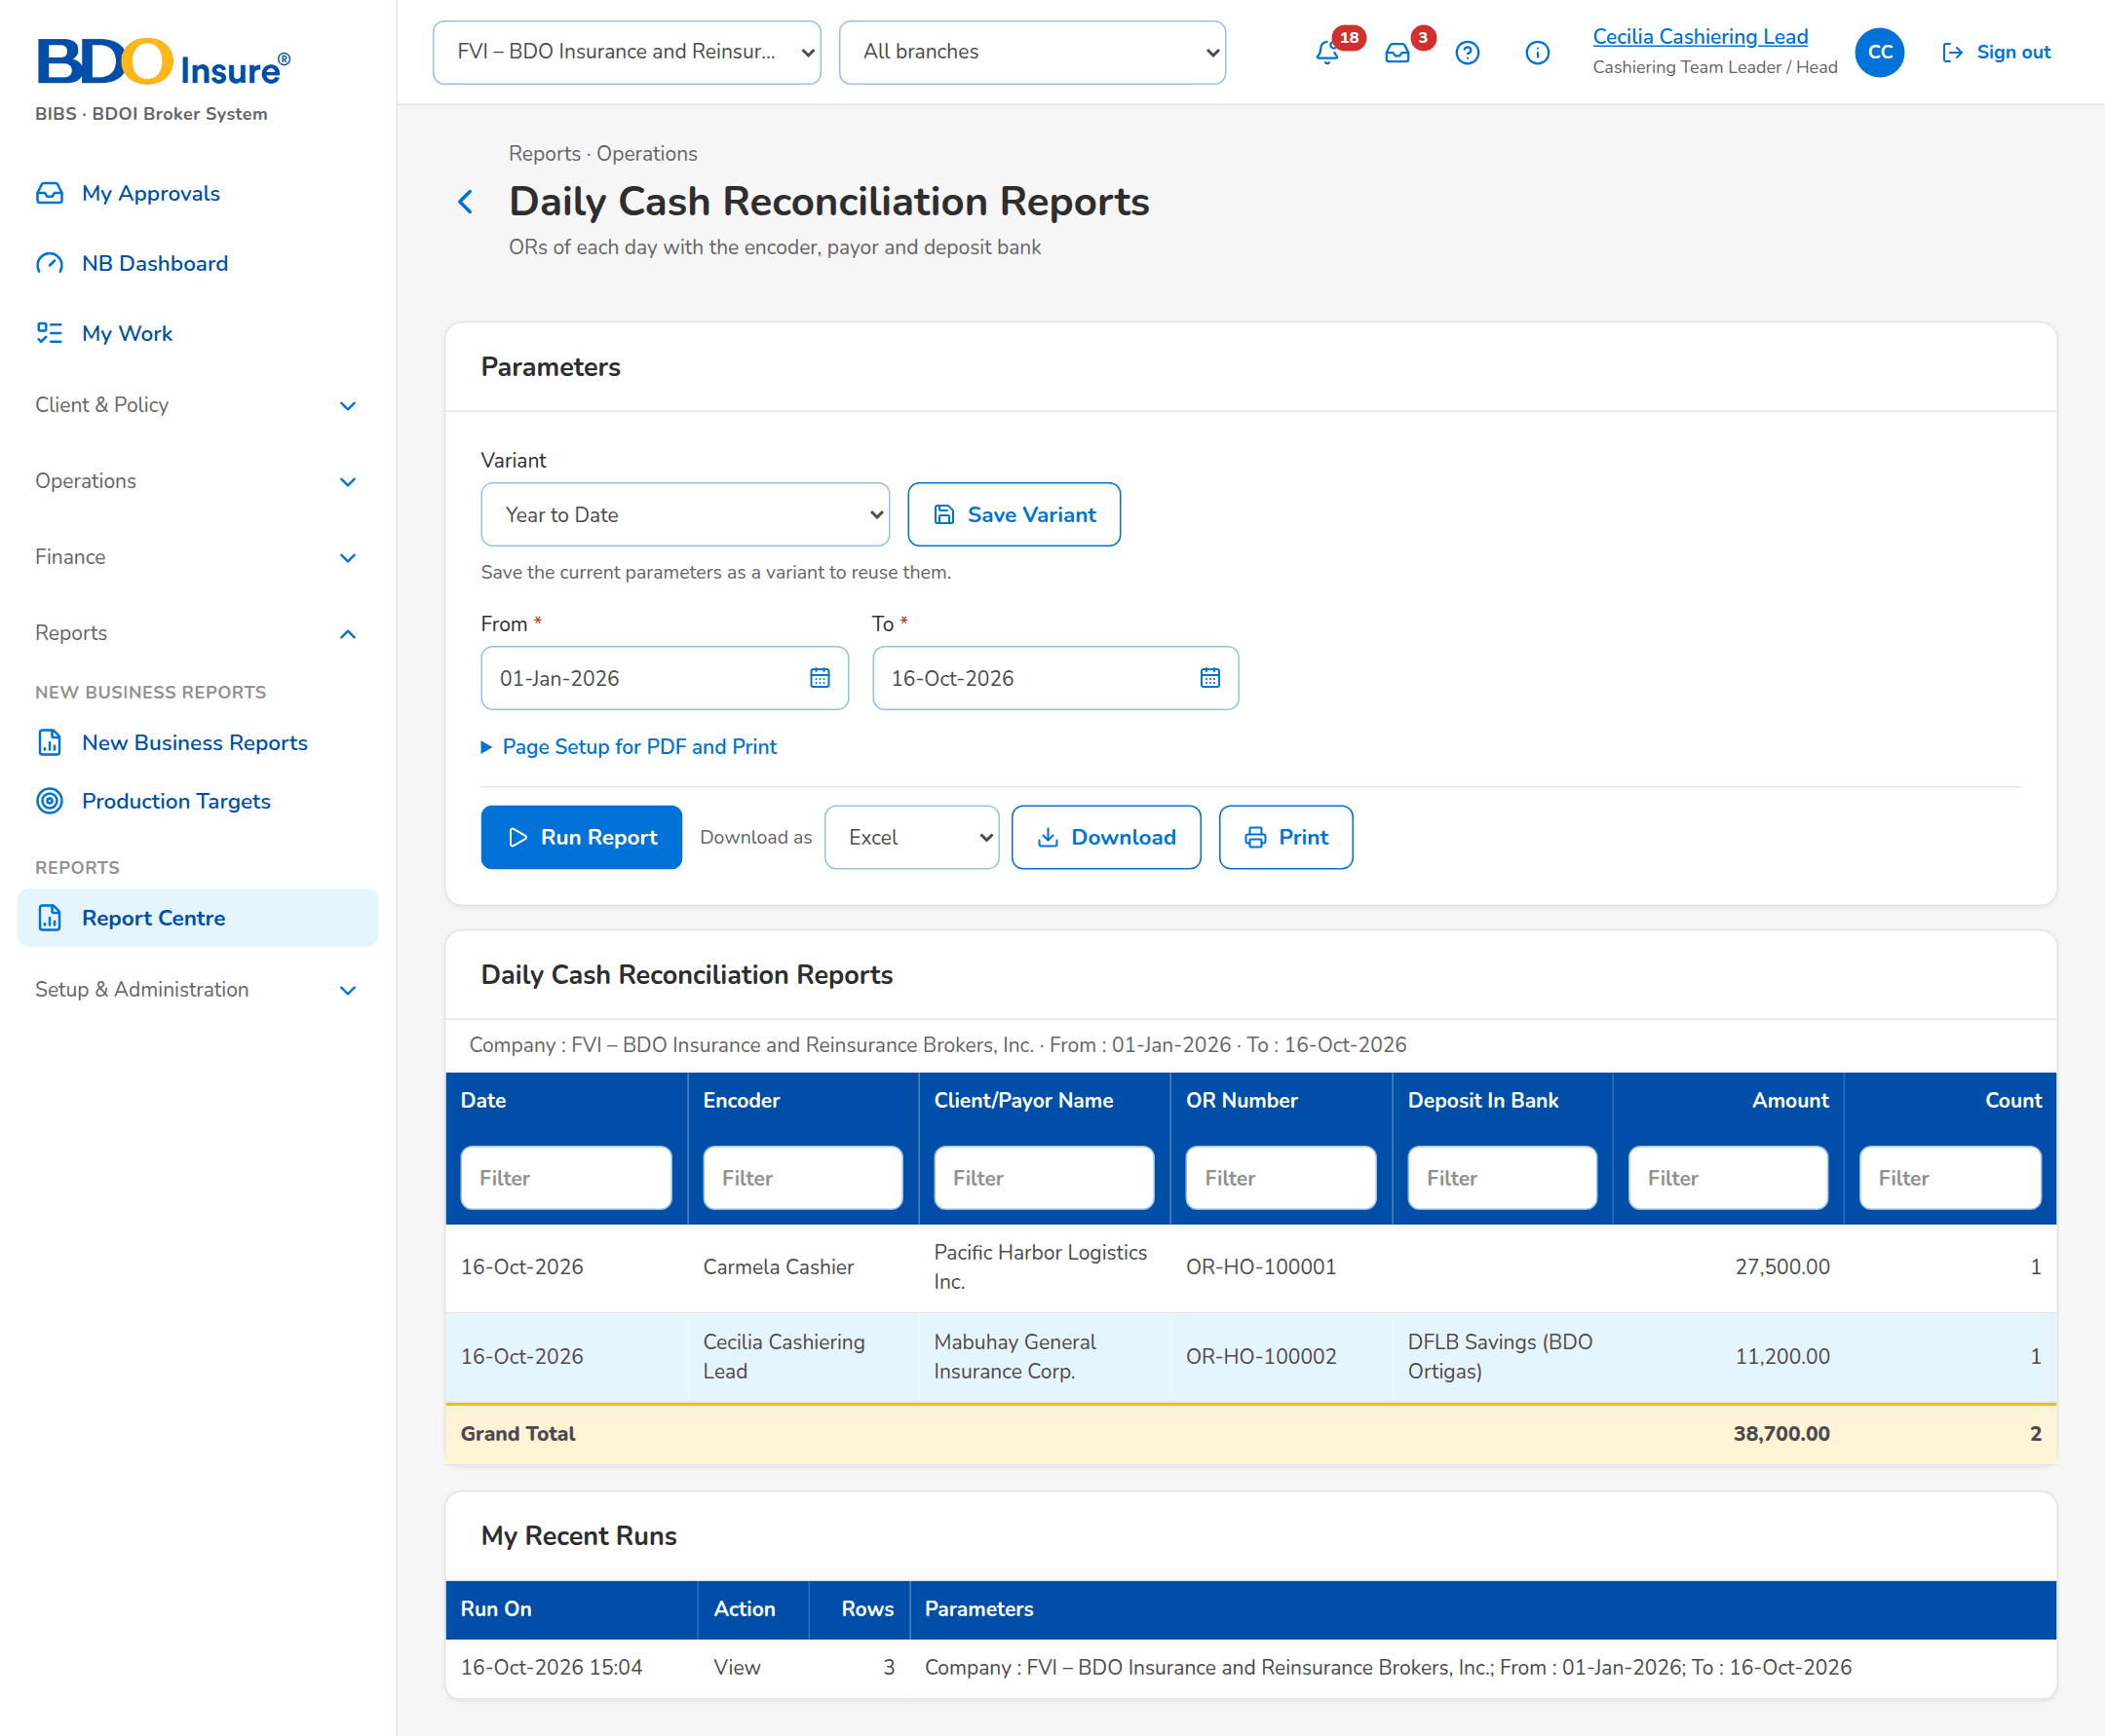
Figure 46: SCR-CSH-29: Daily Cash Reconciliation Reports run on screen

