
PRJ0012475 - BDO Insure Brokering System (BIBS) - Operations Remittance: To-Be Process and Storyboards -
Release 1 / Drop 0
Prepared by: iorta TechNXT Project Team

Template Reference No. | D051
Document No. | PRJ0012475-RMT-BPS
Prepared by: | iorta TechNXT Project Team
Drafting support: | iorta TechNXT Project Team
Creation Date: | 10/17/2026
Revision No. | 1.0
Last Updated by: | iorta TechNXT Project Team
Last Updated Date: | 10/17/2026

Document Revision Log
Date | Revision | Description | Updated by
17 Oct 2026 | 1.0 | First issue, with the FRS Operations Remittance v1.0. | iorta TechNXT Project Team (drafting support); for review by the BDOI Product Owner

Table of Contents
Document Revision Log 3
Table of Contents 4
Introduction 5
End-to-end Journey 6
To-be Processes 7
P-RMT-01 Extraction 7
P-RMT-02 Process Remittance 7
P-RMT-03 Insurer OR update 7
P-RMT-04 Hold and special remittance 7
Statuses 8
Storyboards 9
SB-RMT-01 Evening extraction to approved batch 9
SB-RMT-02 Schedule to the insurer and OR upload 9
SB-RMT-03 Hold requested and released 9

Introduction
This document shows how Operations Remittance works end to end. The requirements are in the FRS v1.0; the screens in the UX Design v1.0; the reports, documents and notices in the Reports, Notifications and Outputs v1.0.
The storyboards use the walkthrough accounts and fictitious clients, insurers and amounts; the screens they name are described in the UX Design.
Table 1: Personas
Persona | Does | Screens | Walkthrough account
Remittance Processor | Runs manual extractions, reviews the batches assigned to him, excludes and restores accounts, submits, holds or returns batches, sends the schedule to the insurer and uploads the insurer ORs. | Remittance Workbench, Extraction, Remittance Batches, Insurer OR Upload, DTIP Status | Rosa Remittance Processor
Remittance Team Leader | Approves or returns submitted batches, reassigns batches, approves special remittance requests, keeps the early remittance incentive rules and follows the extraction runs. | Remittance Batches, Special Remittance, Incentive Rules, Report Centre | Ramon Remittance Lead
Marketing Collection | Requests holds and special remittances for the accounts of the marketing unit and asks for a remittance schedule to be sent to the insurer. | Remittance Holds, Special Remittance | Miguel Marketing Collection
Marketing Team Leader | Approves hold requests, extensions and cancellations. | Remittance Holds | Marta Marketing Lead
Disbursement | Receives the payment request of each approved batch and pays the insurer; the payment status comes back to Remittance. | Disbursement Queue (BRD-05) | Dante Disbursement
Comptrollership | Reads the remittance reports and the DTIP status. | Report Centre, DTIP Status | Consuelo Comptroller
Auditor | Reads batches, holds, special remittances, their history and the reports. Changes nothing. | Remittance Batches, Report Centre | Audrey Auditor
System Administrator | Keeps the group profiles, the lists of values and the extraction schedule. | User Access screens (BRD-11), Job Monitor | SIT System Administrator

End-to-end Journey
12 steps from the posting of the payment to the insurer's official receipt.
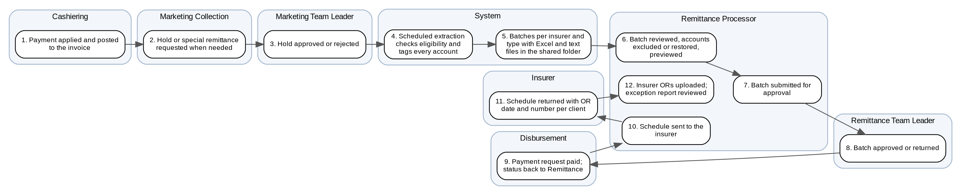
Figure 1: Operations Remittance: process flow (swimlanes by actor)
Table 2: The 12 steps
Step | Who | What happens
1 | Cashiering | Payment applied and posted to the invoice
2 | Marketing Collection | Hold or special remittance requested when needed
3 | Marketing Team Leader | Hold approved or rejected
4 | System | Scheduled extraction checks eligibility and tags every account
5 | System | Batches per insurer and type with Excel and text files in the shared folder
6 | Remittance Processor | Batch reviewed, accounts excluded or restored, previewed
7 | Remittance Processor | Batch submitted for approval
8 | Remittance Team Leader | Batch approved or returned
9 | Disbursement | Payment request paid; status back to Remittance
10 | Remittance Processor | Schedule sent to the insurer
11 | Insurer | Schedule returned with OR date and number per client
12 | Remittance Processor | Insurer ORs uploaded; exception report reviewed

To-be Processes

P-RMT-01 Extraction
Item | Value
Journey steps | 4, 5
Trigger | Schedule; manual extraction; end-of-day queue; approved special remittance
Actors | System, Remittance Processor
Outcome | Batches with their files; tags and reasons for the accounts not extracted
Controls | BR-RMT-02 to BR-RMT-05, BR-RMT-13
Requirements | FRID.RMT.001, 003, 004, 005

P-RMT-02 Process Remittance
Item | Value
Journey steps | 6 to 9
Trigger | Batch in Review in Process
Actors | Remittance Processor, Remittance Team Leader, Disbursement
Outcome | Approved batch paid to the insurer
Controls | BR-RMT-01, BR-RMT-06, BR-RMT-07
Requirements | FRID.RMT.002, 006, 007, 013, 015

P-RMT-03 Insurer OR update
Item | Value
Journey steps | 10 to 12
Trigger | Approved batch; insurer's returned schedule
Actors | Remittance Processor, Insurer
Outcome | Invoices with the insurer OR; exceptions listed
Controls | BR-RMT-10, BR-RMT-11
Requirements | FRID.RMT.007, 008

P-RMT-04 Hold and special remittance
Item | Value
Journey steps | 2, 3
Trigger | Marketing request
Actors | Marketing Collection, Marketing Team Leader, Remittance Team Leader
Outcome | Account held, released or remitted at once
Controls | BR-RMT-01, BR-RMT-08
Requirements | FRID.RMT.010, 011

Statuses
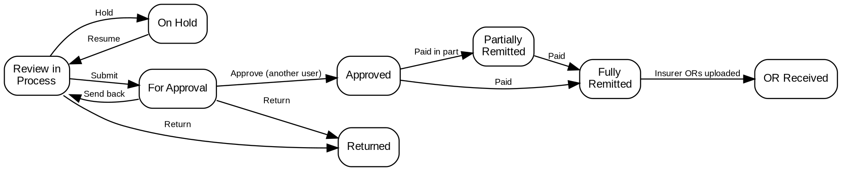
Figure 2: Stages of a remittance batch
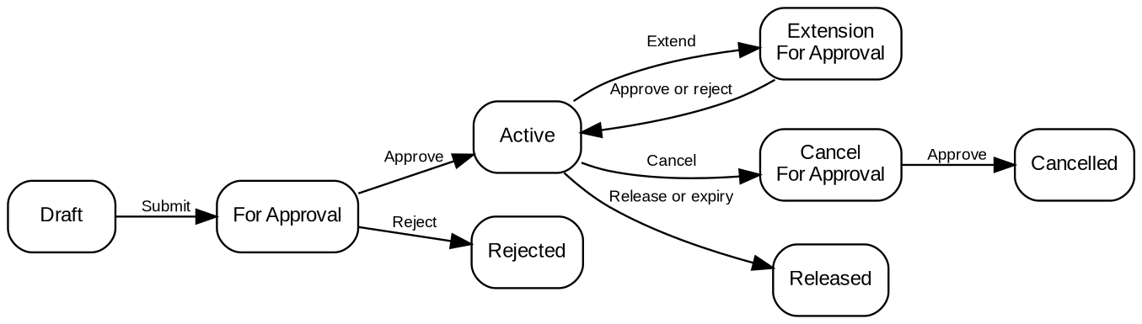
Figure 3: Stages of a hold request

Storyboards
Each storyboard is a walkthrough of the to-be process with the walkthrough accounts of the Walkthrough Users workbook and fictitious clients and insurers. The screens are described in the UX Design.

SB-RMT-01 Evening extraction to approved batch
The scheduled run extracts the eligible accounts, the processor reviews the batch and excludes one, the Team Leader approves and Disbursement receives the payment request.
Test data: insurer Alpha Insurance (code ALPHA), three invoices paid in cash, one by a check deposited yesterday.
Table 3: SB-RMT-01 steps
Step | Who | Screen | Does | Sees
1 | System | Extraction | The evening run checks the four invoices | Three extracted; the check payment Unextracted - due: check within the holding period
2 | Remittance Processor | Remittance Workbench | Opens the notice of the run | Batch ALPHA00000001 Normal - Peso with 3 accounts
3 | Remittance Processor | Remittance Batch | Excludes one account with a reason, previews | 2 accounts and their totals; the exclusion in the history
4 | Remittance Processor | Remittance Batch | Submits the batch | For Approval; the Team Leader is told
5 | Remittance Team Leader | Remittance Batch | Approves | Approved; payment request in the Disbursement queue

SB-RMT-02 Schedule to the insurer and OR upload
The schedule is sent to the insurer, who returns it with its ORs; the upload updates the invoices and lists one exception.
Test data: the approved batch of SB-RMT-01.
Table 4: SB-RMT-02 steps
Step | Who | Screen | Does | Sees
1 | Marketing Collection | Remittance Batch | Asks to send the schedule | Request recorded
2 | Remittance Processor | Remittance Batch | Sends the schedule | Schedule sent with date and recipient
3 | Remittance Processor | Insurer OR Upload | Uploads the returned file | 2 lines read; 1 updated; 1 Amount mismatch
4 | Remittance Processor | Insurer OR Upload | Opens the exception report | The mismatch with OR amount and paid PR

SB-RMT-03 Hold requested and released
Marketing holds an account; it is excluded from extraction until released.
Test data: an invoice of the Cebu marketing unit.
Table 5: SB-RMT-03 steps
Step | Who | Screen | Does | Sees
1 | Marketing Collection | Remittance Holds | Requests a hold until 30-Nov with a reason | For Approval
2 | Marketing Team Leader | Remittance Holds | Approves | Active; assigned to a processor
3 | System | Extraction | The evening run | Invoice Unextracted - due: account on hold
4 | Marketing Collection | Remittance Holds | Releases the hold | Released; extracted by the next run

