
PRJ0012475 - BDO Insure Brokering System (BIBS) - Product Maintenance: Screens and UX Design -
Release 1 / Drop 0
Prepared by: iorta TechNXT Project Team

Template Reference No. | D051
Document No. | PRJ0012475-PM-UXD
Prepared by: | iorta TechNXT Project Team
Drafting support: | iorta TechNXT Project Team
Creation Date: | 10/17/2026
Revision No. | 1.8
Last Updated by: | iorta TechNXT Project Team
Last Updated Date: | 10/17/2026

Document Revision Log
Date | Revision | Description | Updated by
17 Oct 2026 | 1.4 | First issue as a separate document of the Product Maintenance set (taken out of the annexes of the FRS v1.3 and aligned with the system delivered). Numbered 1.4 to match the FRS. | iorta TechNXT Project Team (drafting support); for review by the BDOI Product Owner
16 Oct 2026 | 1.5 | Insurer Record (SCR-PM-18) with its tabs: details, contacts, payment terms and remittance, bank accounts, products, branches and commissions, change history; Change History tab on the product record. Numbered 1.5 to match the FRS. | iorta TechNXT Project Team (drafting support); for review by the BDOI Product Owner
17 Oct 2026 | 1.6 | Ledger Accounts tab on the Insurer Record (SCR-PM-18); the Master Data Change Log screen. Numbered 1.6 to match the FRS. | iorta TechNXT Project Team (drafting support); for review by the BDOI Product Owner
17 Oct 2026 | 1.7 | Co-insurance / Risk Participation tab on the Insurer Record (SCR-PM-18). Numbered 1.7 to match the FRS. | iorta TechNXT Project Team (drafting support); for review by the BDOI Product Owner
17 Oct 2026 | 1.7 | Screenshots of the Ledger Accounts and Change History tabs of the Insurer Record (SCR-PM-18) and of the Master Data Change Log (SCR-PM-27); no change of the requirements. | iorta TechNXT Project Team (drafting support); for review by the BDOI Product Owner
17 Oct 2026 | 1.8 | Screenshot of the Co-insurance / Risk Participation tab of the Insurer Record (SCR-PM-18), captured from the running application on seed data. | iorta TechNXT Project Team (drafting support); for review by the BDOI Product Owner

Table of Contents
Document Revision Log 3
Table of Contents 4
Introduction 5
Menu by Persona 6
Screens 7
SCR-PM-01 Product Maintenance Home 7
SCR-PM-02 Package Requests 9
SCR-PM-03 New Package Request and Edit Package Request 12
SCR-PM-04 Package Request Record 18
SCR-PM-05 Package Request Record: Negotiation Tab 24
SCR-PM-06 Package Request Record: Comparative Tab 28
SCR-PM-07 Package Request Record: Requirements & Sign-off Tab 31
SCR-PM-08 Package Request Record: Set-up and Advisories Tabs 34
SCR-PM-09 TSU Workbench 38
SCR-PM-10 Package Expiry 40
SCR-PM-11 Products 42
SCR-PM-12 Product Record 46
SCR-PM-13 Package Version 50
SCR-PM-14 Validation Queue 56
SCR-PM-15 Coverages & Clauses 58
SCR-PM-16 Incentive Criteria 61
SCR-PM-17 Insurers 64
SCR-PM-18 Insurer Record 66
SCR-PM-19 Rates & Taxes 72
SCR-PM-20 Sales Organisation 74
SCR-PM-21 Premium Calculator 77
SCR-PM-22 Quotation: Package Rate Scheme and Rate Exception 80
SCR-PM-23 Product Maintenance Dashboard 83
SCR-PM-24 Deactivation Requests 85
SCR-PM-25 Product Master Transfers 89
SCR-PM-26 Placement Update Reports 91
SCR-PM-27 Audit Logs 93
SCR-PM-28 Proposal Request: Comparative Table, Proposal Slips and Client Response 96
SCR-PM-29 Package Request Record: Routing & Approvals Tab 99

Introduction
This document describes every Product Maintenance screen of BIBS: purpose, users, access, rules and states, fields with their type, whether they are required, format and source, validation and message, and the actions. The requirements and rules are in the FRS v1.7. Each screen state is shown by one full-page screenshot on its own page, taken on a test environment with fictitious data.
Codes used: Y required, N optional, Cond. required in the case stated, - display only.

Menu by Persona
The screens are under Client & Policy › Product Maintenance; the proposal requests of SCR-PM-28 are under New Business. A persona sees only its entries.
Table 1: Product Maintenance menu by persona
Screen | Purpose | Personas
Product Maintenance Home | Tiles by stage with overdue counts; Product Matrix tabs | AO, Mkt approver, TSU, TSU TL, TSU Head, ManCom, MBS, Bus. Admin, Auditor
Product Maintenance Dashboard | KPIs, drill-down, export | Mkt approver, TSU, TSU TL, TSU Head, MBS, Bus. Admin, Auditor
Package Requests | Work list by stage; new request | AO, Mkt approver, TSU, TSU TL, TSU Head, ManCom, MBS, Bus. Admin, Auditor
TSU Workbench | TSU queues by stage; assign and claim | TSU, TSU TL, TSU Head
Package Expiry | Expiring, in renewal, expired; renewal requests | TSU, TSU TL, TSU Head, MBS, Auditor
Deactivation Requests | Deactivation requests and decisions | TSU, TSU TL, TSU Head, MBS, Bus. Admin, Auditor
Product Master Transfers | Changes for other BDOI systems; transfer status | MBS, Bus. Admin, Auditor
Placement Update Reports | Weekly and on-request reports | Mkt approver, TSU, TSU TL, TSU Head, MBS, Auditor
Audit Logs | Audit trail of Product Maintenance | TSU Head, MBS, Bus. Admin, Auditor
Products | Product Matrix: packages and non-package products | AO, Mkt approver, TSU, TSU TL, TSU Head, MBS, Bus. Admin, Auditor
Validation Queue | Package versions waiting for validation | TSU Head, Bus. Admin
Coverages & Clauses | Lines, cover types, coverages, clause library, field rules | TSU, TSU TL, TSU Head, MBS, Bus. Admin, Auditor
Incentive Criteria | Incentive eligibility rules | MBS, Bus. Admin, Auditor
Insurers | Insurer profiles, branches, placement e-mails, commission | TSU, TSU TL, TSU Head, MBS, Bus. Admin, Auditor
Rates & Taxes | Rate tables, short-period rates, statutory charges | MBS, Bus. Admin, Auditor
Sales Organisation | Sales units and officers | Bus. Admin, Auditor
Premium Calculator | Premium on the package rate scheme | AO, Mkt approver, TSU, MBS

Screens

SCR-PM-01 Product Maintenance Home
Item | Value
Purpose | The workspace of Product Maintenance: the Product Matrix of every package and non-package product (active, expiring within 90 days and expired) with its filters and exports, the Quotation Request List of the non-package products and the Package Request List, each with its row actions; the figures and stage tiles are on the Product Maintenance Dashboard (SCR-PM-23).
Access | Sign in, then the sidebar entry Product Maintenance Home
Requirements | FRPM.001.01, FRPM.002.01, FRPM.002.02, FRPM.003.01, FRPM.003.02, FRPM.003.06, FRPM.011.01, FRPM.011.03, FRPM.016.01, FRPM.017.01, FRPM.022.01

Rules and states:
• The lists are those of the company selected in the page header (FRPM.001.01).
• Expiring Products lists the packages that end within 90 days, the alert period of BDOI's FRPM.004.01 (FRPM.004.01, FRPM.001.01).
• The Product Matrix is maintained directly by MBS with approval while the setting Direct maintenance of the Product Matrix is on (by default); with the setting off new packages come only from package requests (FRPM.003.01, FRPM.001.01).
Table 2: SCR-PM-01 fields
Field | Type | Req. | Format, list or source | Validation and message
Product Matrix: Active Products / Expiring Products (90 days) / Expired Products | Tab | - | Products in force, ending within 90 days, ended; Products and package versions | -
Product Matrix: Search Package Name or Risk Code | Text | N | Part of the name or the risk code | -
Product Matrix: Line of Insurance / Product Type | Filters | N | Line names; Package, Non-Package; Product lines; fixed list | -
Product Matrix: Line of Insurance / Sub-Line / Package Name | Columns | - | Line; sub-line; name with the risk code and Package or Non-Package; Products | -
Product Matrix: Package Description / Insurer / Status | Columns | - | Description; insurer of the package; Active, Expiring, Expired, Deactivated; Products | -
Product Matrix: Effective Date / Expiry Date | Columns | - | dd-MMM-yyyy; Package versions | -
Product Matrix: Last Updated By / Last Updated Date | Columns | - | Name; dd-MMM-yyyy; Products | -
Quotation Request List: Search Request Number or Assured / Open Requests Only | Text; check box | N | Part of the number or the name | -
Quotation Request List: Quotation Request Number / Related Reference Number / Business Type / Assured's Name | Columns | - | PRF-yyyy-nnnnnn with its date; ARN; New Business or Renewal; name; Proposal requests | -
Quotation Request List: Product Line / Account Officer / Assigned TSU User / Submission Date | Columns | - | Line; names; dd-MMM-yyyy; Proposal requests | -
Quotation Request List: Effective / Expiry Date / Current Status / Aging (Days) | Columns | - | Period; status; working days since the submission; Proposal requests | -
Package Request List: Search Request Number or Package | Text | N | Part of the number or the name | -
Package Request List: Package Request Number / Reference Number / Request Type / Product Line | Columns | - | PKR-yyyy-nnnnnn; package code; type; line; Package requests | -
Package Request List: Account Officer / Assigned TSU User / Submission Date / Current Status | Columns | - | Names; dd-MMM-yyyy; status; Package requests | -

Table 3: SCR-PM-01 actions
Action | Who | Available when | What happens | Result
New Package Request | Marketing AO, Marketing TL, TSU Officer (package request right) | Always | Opens the New Package Request form | -
Excel / PDF / CSV | Every user of the screen | Always | Exports the Product Matrix of the filters on screen, named by the convention <name>_MMDDYYYY | -
View Package / Update Package | Every user; Update Package for MBS while direct maintenance is on | A row of the Product Matrix | Opens the product record, or its editor for the update with approval | -
View Quotation Request | Every user of the screen | A row of the Quotation Request List | Opens the proposal request (SCR-PM-28) | -
[A row of the Package Request List] | Every user of the screen | Always | Opens the package request (SCR-PM-04) | -

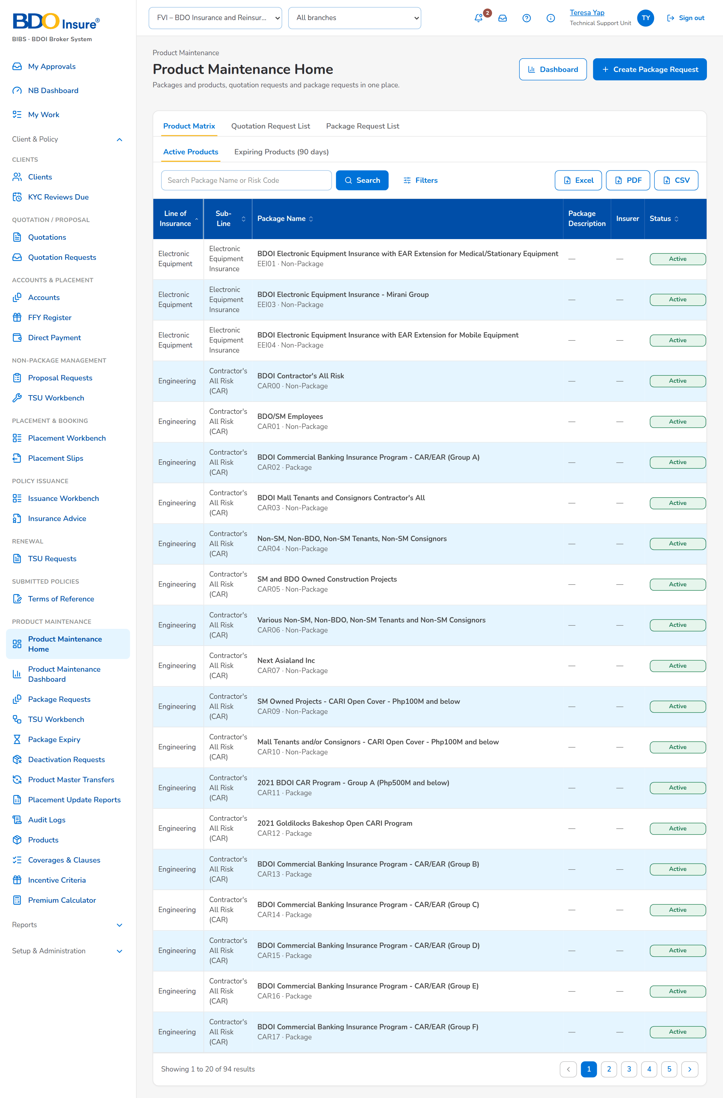
Figure 1: SCR-PM-01 Product Maintenance Home (TSU Team Lead)

SCR-PM-02 Package Requests
Item | Value
Purpose | The work list of package requests of the company, by stage, from the draft to the released or closed request. Team leaders assign the selected requests of one stage to a user of the team.
Access | Product Maintenance Home › a stage tile (opens the tab of the stage); Package Request record › back arrow
Requirements | FRPM.001.01, FRPM.002.02, FRPM.003.06, FRPM.003.07, FRPM.011.01, FRPM.011.03, FRPM.015.01, FRPM.016.01, FRPM.017.01, FRPM.028.01

Rules and states:
• The list shows the requests of the company selected in the page header (FRPM.002.02).
• Assign is offered only for requests of one stage; the assignee is chosen among the users who work that stage (FRPM.002.02).
• The time in stage turns red when the stage due time has passed (FRPM.001.01).
Table 4: SCR-PM-02 fields
Field | Type | Req. | Format, list or source | Validation and message
Tabs: Drafts / For Approval / TSU Review / Negotiation / ManCom / With MBS / For Validation / Released / Closed | Tab | - | Fixed | Each tab lists its stages: TSU Review = TSU review and TSU Head approval; Negotiation = negotiation, terms review, Marketing review and requirements; Closed = retired, not proceeded and voided
Search: Search Request No. | Text | N | PKR-yyyy-nnnnnn, part of a number allowed | Contains search on the request number
Search: Only My Requests | Check box | N | - | Requests created by the user or assigned to the user
Filters: Request type | Drop-down | N | All types, New package, Amend package terms, Update package details, Renew package, Retire package, Reactivate expired package; Fixed list | -
List: Request No. | Column | - | PKR-yyyy-nnnnnn with the creation date under it; Package request | -
List: Type | Column | - | Request type; Package request | -
List: Scope | Column | - | Generic or Client-specific tag; Package request | -
List: Client / Programme | Column | - | Package or programme name, with the client name or Programme under it; Package request | -
List: Line | Column | - | Product line; Package request | -
List: Product | Column | - | Risk code and resulting version (v2), or New package; Package request | -
List: Stage | Column | - | Status pill; Workflow | -
List: In Stage | Column | - | n days, with overdue or due soon; Workflow | Red when past the due time
List: Assignee | Column | - | User or a dash; Workflow | -

Table 5: SCR-PM-02 actions
Action | Who | Available when | What happens | Result
Package Expiry | Every user of the screen | Always | Opens Package Expiry | -
New Package Request | Marketing AO, Marketing TL, TSU Officer | Always | Opens the New Package Request form | -
Assign | Team leaders | Rows of one stage are selected | Opens Assign Package Requests: choose a user of the team of the stage, or Team queue (unassigned), and click Assign | Unchanged
Filters | Every user of the screen | Always | Shows or hides the request type filter | -
[Open a row] | Every user of the screen | Always | Opens the package request | -

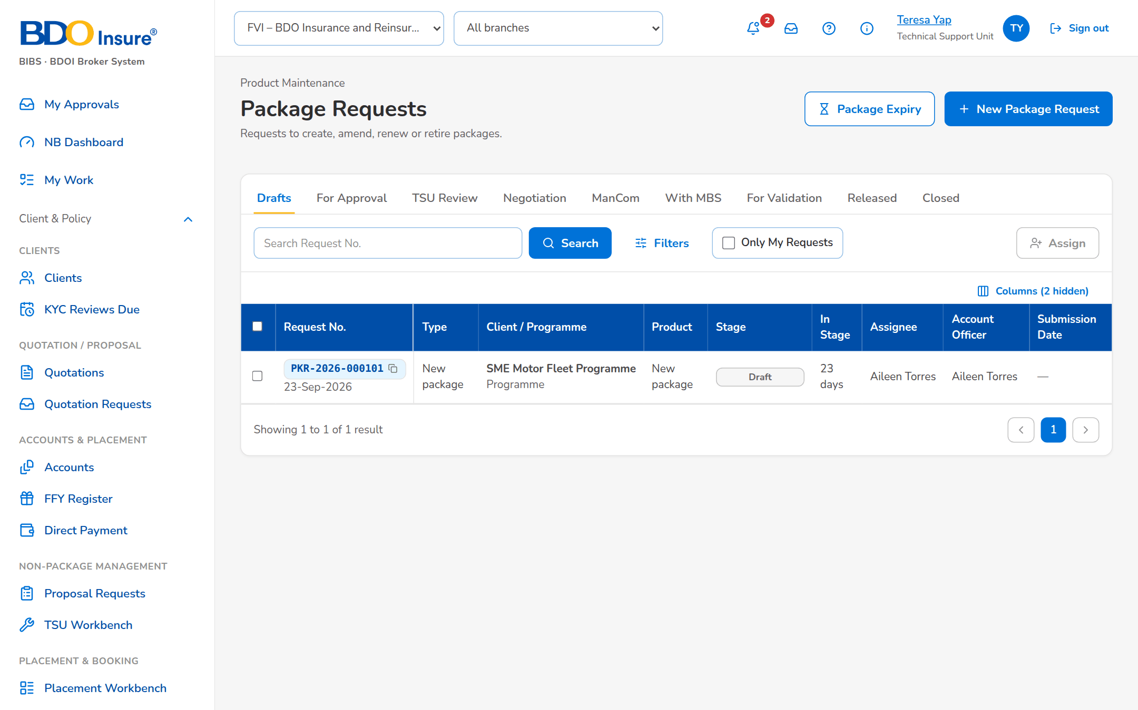
Figure 2: SCR-PM-02 Package Requests work list

SCR-PM-03 New Package Request and Edit Package Request
Item | Value
Purpose | The Package Request Form. Marketing or TSU describe the package: the request type and scope, the package or programme name, the client of a client-specific package, the product line, cover type and product, the reason, the requested terms by section and coverage, the requested rate scheme and package term, and the insurers to approach. The draft is saved at any time; submission checks that the request is complete. The TSU Team Lead can complete the form during the TSU review.
Access | Package Requests › New Package Request; Product Maintenance Home › New Package Request; Package Request record › Edit (draft, or TSU review for the TSU Team Lead); Package Expiry › Generate Renewal Request (opens the drafted renewal request)
Requirements | FRPM.003.01, FRPM.003.02, FRPM.003.04, FRPM.003.06, FRPM.003.07, FRPM.011.02, FRPM.022.01

Rules and states:
• The request number PKR-yyyy-nnnnnn is given at the first save (parameter request number prefix) (FRPM.011.02).
• A new package needs its cover type; every other type needs the packaged product it changes, of the chosen line (FRPM.003.01, FRPM.011.02).
• A client-specific package needs an active client of the client master (FRPM.011.02).
• New and Amend always go to the insurers; Retire never; Renew, Update and Reactivate go to the insurers only when Negotiate with the insurers is ticked (FRPM.011.02, FRPM.003.04).
• Before submission the request needs its requested terms (coverages or sections), at least one target insurer when negotiated, and the package end date; a retirement needs none of these (FRPM.011.02).
• What is still missing for the submission is shown in the information notice Before submitting above the form; the coverages are chosen by name from the coverages of the product line (FRPM.011.02).
• The type and the product of a saved request cannot change (FRPM.011.02).
• A request from Marketing goes to the Marketing approval first; a request from TSU or from an insurer goes to the TSU review at once (FRPM.011.02, FRPM.011.02).
• The least estimated number of policies and the least estimated total basic premium are settings (20 and 5,000,000.00 by default) (FRPM.011.02).
• A draft is edited by the Marketing or TSU users who create requests; during the TSU review, by the TSU Team Lead (FRPM.011.02, FRPM.011.03).
Table 6: SCR-PM-03 fields
Field | Type | Req. | Format, list or source | Validation and message
Source and Package Details: Source | Radio buttons | Y | Marketing (Marketing approval first, then TSU review), TSU (goes to TSU review at once), Insurer; Fixed list | -
Source and Package Details: Business Origin | Drop-down | N | Bank referral, Direct client, Insurer offer, Affinity or programme; List of values | -
Source and Package Details: Account Officer / Unit Head | Look-up | N | Names of the Marketing users; Users | -
Source and Package Details: Insured's Name / Type of Cover / Description of Cover / Cover / Undertaking / Extensions of Cover / Warranties, Clauses / Other Instructions / Maximum Limit/s / Premium | Text | N | As BDOI's Annex E of the request form | -
Source and Package Details: Estimated No. of Policies to be Issued | Number | N | Whole number | At least the least number of policies (20 by default); Enter at least 20 policies
Source and Package Details: Estimated Total Basic Premium to be Issued | Number | N | Amount in PHP | At least the least premium (5,000,000.00 by default); Enter at least 5,000,000.00
Source and Package Details: Incentive Eligible / Incentive Amount / Incentive Commission Rate (%) | Check box; numbers | Cond.: amount or rate when eligible | Amount in PHP; percentage | Amount above zero; rate above 0% and at most 100%; Enter the incentive amount or the incentive commission rate
Request: Request type | Drop-down | Y | New package, Amend package terms, Update package details, Renew package, Retire package, Reactivate expired package; List request type list | The type of a saved request cannot change; The type of a request cannot change
Request: Scope | Drop-down | Y | Generic programme or Client-specific package; Fixed list | Select the request type and the package scope
Request: Package / programme name | Text | Y | Up to 200 characters | Not blank; Enter the package or programme name
Request: Client or prospect | Look-up | Cond.: client-specific package | Client code or name; Client master (BRD-1) | An active client; Select the client
Request: Product line | Drop-down | Y | Line name; Product lines | An existing line; Select the product line
Request: Cover type / subtype | Drop-down | Cond.: New package | Cover types of the line; Cover types | A cover type of the chosen line; Select the cover type
Request: Package product | Drop-down | Cond.: every type except New package | Code – name of the packaged products of the line; Products flagged Package | A packaged product of the chosen line; Select the package product
Request: Reason | Drop-down | Y | Client requirement, New programme for a market segment, Market competitiveness, Change in insurer terms or rates, Loss experience, Regulatory change, Package expiry or anniversary, Others; List request reason list | An active value of the list; Select the reason
Request: Comment on the reason | Text | N | Up to 500 characters | -
Request: Negotiate with the insurers | Check box | N | Shown for Renew, Update and Reactivate | New and Amend always negotiate; Retire never
Request: Market segments | Check boxes | N | One or more; List market segment list | Active values of the list
Requested terms: Heading / Details | Text | Cond.: sections or coverages before submission | Heading and up to 4,000 characters per section; suggested sections Target market / client and Requested cover and features | Empty sections are dropped; Complete the request: the requested terms (coverages or sections)
Coverages and perils: Coverage | Drop-down | Cond.: sections or coverages before submission | Name of each active coverage of the product line, (basic) after a basic coverage; Choose the line first until a product line is chosen; Coverages of the line | Every line has a coverage; Enter a code for every coverage or remove the line
Coverages and perils: Included | Check box | N | - | -
Coverages and perils: Limit | Number | N | Amount in PHP | Zero or more; Rates and amounts cannot be negative
Coverages and perils: Deductible | Text | N | Wording, for example 1% of loss, minimum PHP 20,000 | -
Rate scheme and package term: Requested rate % | Number | N | Up to four decimals | Zero or more; Rates and amounts cannot be negative
Rate scheme and package term: Minimum premium | Number | N | Amount in PHP | Zero or more; Rates and amounts cannot be negative
Rate scheme and package term: Commission % | Number | N | Percentage | Zero or more; Rates and amounts cannot be negative
Rate scheme and package term: Package TSI limit | Number | N | Amount in PHP | Zero or more; Rates and amounts cannot be negative
Rate scheme and package term: Effective from | Date | N | dd-MMM-yyyy | -
Rate scheme and package term: Package start | Date | N | dd-MMM-yyyy | -
Rate scheme and package term: Package end | Date | Cond.: before submission (not for Retire) | dd-MMM-yyyy; monitored for expiry and renewal | After the package start; The package end date must be after its start date
Rate scheme and package term: Anniversary | Date | N | dd-MMM-yyyy | -
Target insurers: [Insurer check boxes] | Check boxes | Cond.: at least one when the insurers are approached | Name of each insurer of the panel; Insurers (authorised, active) | Authorised and active insurers; Complete the request: at least one target insurer
Documents: [Documents panel] | Upload | N | See Common screen elements; Document types | File checks of every upload; Save the draft to attach the supporting documents.

Table 7: SCR-PM-03 actions
Action | Who | Available when | What happens | Result
Load Current Terms | Users of the form | Type other than New package and a package product chosen | Copies the terms of the version in force (coverages, rate scheme, dates, insurers) into the requested terms; the sections typed stay | Unchanged
Save Draft | Marketing AO, Marketing TL, TSU Officer; TSU Team Lead during the TSU review | No field message on the form | Checks the fields and saves the draft; a new request is numbered PKR-yyyy-nnnnnn | Draft request (new); unchanged (edit)
Submit for Approval | As Save Draft | No field message on the form | Saves the request, checks that it is complete (requested terms, target insurers when negotiated, package end date, cover type of a new package) and sends it to Marketing approval | For Marketing approval

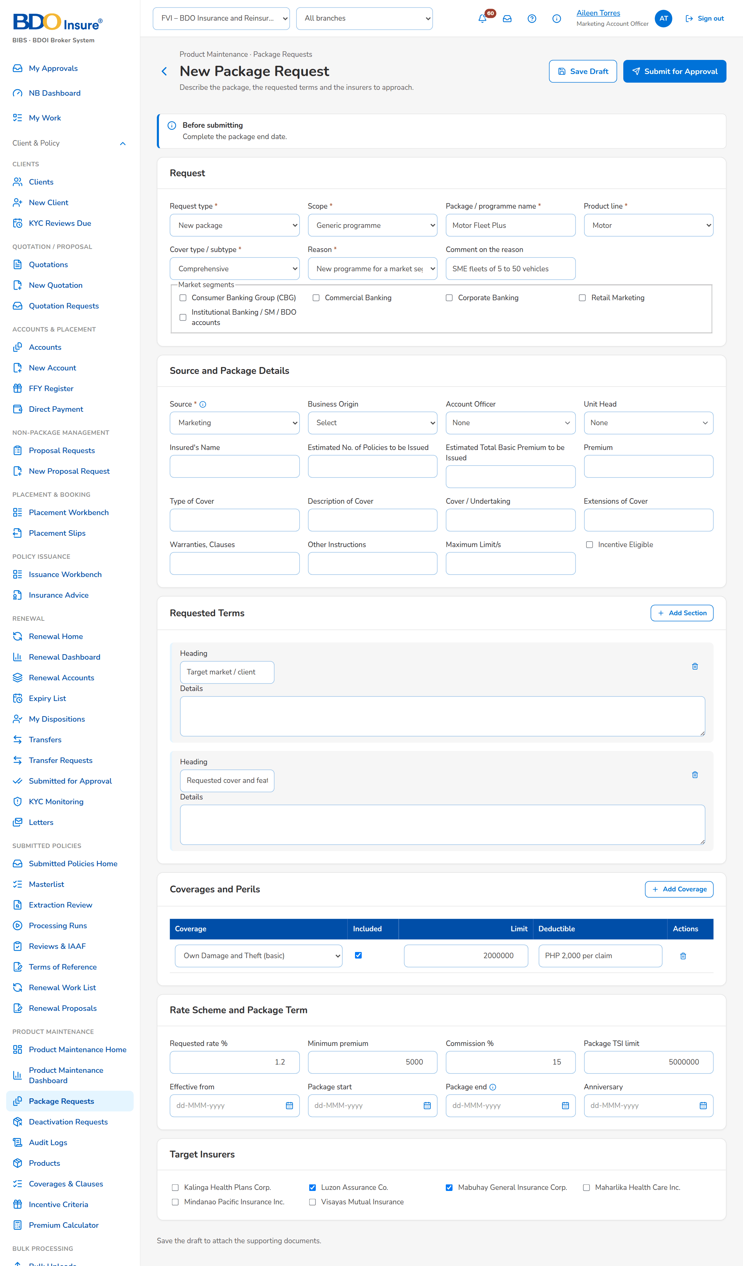
Figure 3: SCR-PM-03 New Package Request, filled
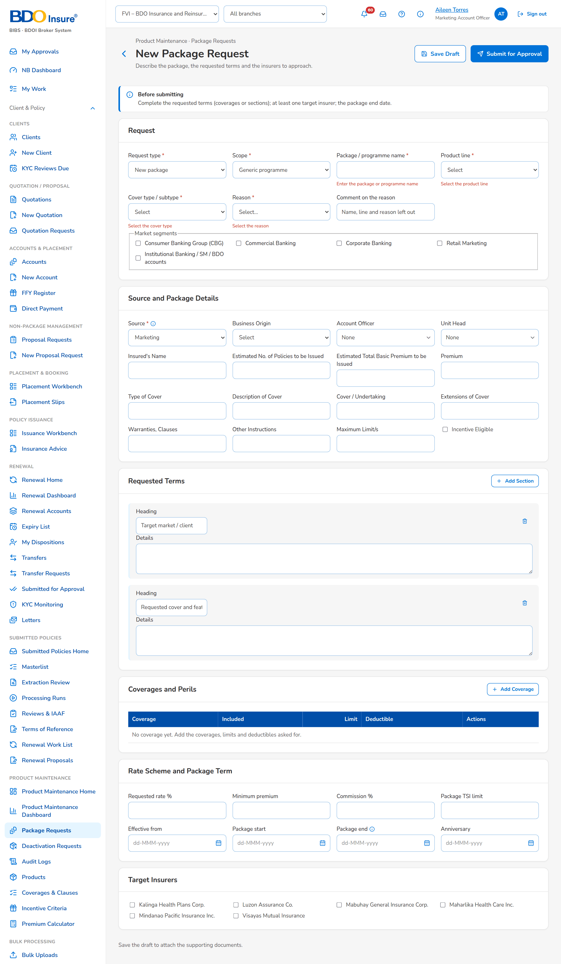
Figure 4: SCR-PM-03 New Package Request, field messages

SCR-PM-04 Package Request Record
Item | Value
Purpose | One package request: its number, stage and flags, the key facts (type, client or programme, line and product, scheme rate, package term, insurers), the workflow header (stage stepper, then Current Stage, Since, Due and Assigned To) with the actions of the stage, and the tabs Details, Requested Terms, Negotiation, Comparative, Requirements & Sign-off, Set-up, Advisories, Documents, E-mails, History, Routing & Approvals and Audit Logs. This section specifies the header, the stage actions and the tabs Details, Requested Terms, Documents, E-mails, History and Audit Logs; the other tabs have their own sections (SCR-PM-05 to SCR-PM-08, Routing & Approvals SCR-PM-29).
Access | Package Requests › a row; TSU Workbench › a row; A workflow notice or an assignment notice (bell); Package Expiry › the renewal request number
Requirements | FRPM.001.01, FRPM.002.02, FRPM.003.06, FRPM.003.07, FRPM.011.01, FRPM.011.02, FRPM.011.03, FRPM.015.01, FRPM.016.01, FRPM.017.01, FRPM.021.01, FRPM.021.02, FRPM.028.01

Rules and states:
• A request is never approved by its maker or submitter, and the TSU Head approval is never given by the recommender (FRPM.011.02, FRPM.011.03).
• The TSU Team Lead's recommendation is mandatory and is shown to the TSU Head (FRPM.011.03).
• Return, void, not proceeded and request changes need a reason from their list of values; the comment is kept in the history (FRPM.011.02, FRPM.001.01).
• The actions of the stage stay on one row of the step bar; an action that closes the request off its path (Not Proceeded, Void) is shown in red (FRPM.001.01).
• Void is possible from the draft to the TSU Head approval; after that a request ends as not proceeded, released or retired (FRPM.001.01).
• Every stage has a due time from its service level hours (parameters the service level settings*): Marketing approval 24, TSU review 24, TSU Head approval 24, negotiation 120, ManCom 72, MBS set-up 48 hours by default (FRPM.001.01).
• Every action is written to the history and the audit trail; audit rows cannot be changed or deleted (FRPM.021.01).
Table 8: SCR-PM-04 fields
Field | Type | Req. | Format, list or source | Validation and message
Header: Request | Reference chip | - | PKR-yyyy-nnnnnn; Package request | -
Header: [Stage pill] | Pill | - | Stage of the request; Workflow | -
Header: [Scope and negotiation tags] | Tag | - | Generic or Client-specific; No negotiation; Package request | -
Header: Request type | Fact | - | Request type; Package request | -
Header: Client / programme | Fact | - | Client name or Generic programme; Package request | -
Header: Line / product | Fact | - | Line · risk code and resulting version, or new package; Package request | -
Header: Scheme rate | Fact | - | Rate % of the proposed terms, else of the requested terms; Terms | -
Header: Package term | Fact | - | Package start – package end; Terms | -
Header: Target insurers / Chosen insurers | Fact | - | Insurer codes; the chosen insurers once the terms are final; Terms | -
Workflow: [Stage stepper and meta row] | Panel | - | The stages of the request in order, the current one highlighted; Current Stage, Since, Due, Assigned To; Workflow | Overdue pill after the due time
Details › Request: Type / Scope / Client / Line / cover type / Market segments / Reason / Negotiation / TSU recommendation | Detail | - | As entered on the form; Negotiation: Insurers approached or No negotiation; Package request | -
Details › Approvals and steps: Submitted / Marketing approval / TSU recommendation / TSU Head approval / Terms final / Requirements to ManCom / MBS set-up / Released | Detail | - | User · dd-MMM-yyyy HH:mm, or a dash; Request milestones | -
Requested Terms: [Sections, coverages, rate scheme, dates and insurers] | Read-only view | - | Sections; Coverage, Included, Limit, Deductible; Rate / minimum premium; Commission / TSI limit; Computation basis; Effective from; Package term; Insurer, Role, Share %, Rate %, Minimum; Requested terms | -
History › Status history: Stage / From Stage / Action / By / Date and Time / Remarks / Duration in Stage | Table | - | Newest first; Workflow history | -
History › Insurer response revisions: Changed / By / Rev. / Outcome / Rate % / Remarks | Table | - | Every saved revision of every insurer response; Response history | No insurer response keyed in yet
Documents: [Documents panel] | Table and upload | - | See Common screen elements; Attachments of the request | File checks
E-mails: [Sent e-mails] | Table | - | Recipient, subject, attachments, status; Outbound messages of the request | -
Audit Logs: Timestamp / Action Type / Description / Old Value / New Value / Performed By / Remarks | Table | - | Every change of the request, newest first; CSV and Excel exports; Audit trail | No activity recorded yet.

Table 9: SCR-PM-04 actions
Action | Who | Available when | What happens | Result
Request Form | Every user of the screen | Always | Downloads the Package Request Form (PDF) with the requested terms | Unchanged
Edit | requesters in Draft; TSU Team Lead in For TSU review | Draft or For TSU review | Opens Edit Package Request | Unchanged
Submit for approval | requesters | Draft; the request is complete | Checks completeness and submits | For Marketing approval
Approve and send to TSU | Marketing TL / TH / UH | For Marketing approval; the user is not the maker or the submitter | Records the Marketing approval | For TSU review
Return to requester | Marketing TL (For Marketing approval); TSU Team Lead (For TSU review); TSU Head (For TSU Head approval) | Those stages | Opens the reason dialog (Return reason, mandatory; Comment) and returns the request | Draft request
Void | The requester (Draft, For Marketing approval); the Marketing approver; the TSU Team Lead; the TSU Head | Draft to For TSU Head approval | Opens the reason dialog (Void reason, mandatory) and closes the request without a package | Voided
Recommend for approval | TSU Team Lead | For TSU review | Opens Recommend for Approval: the Recommendation (mandatory, up to 2,000 characters) is kept on the request and shown to the TSU Head | For TSU Head approval
Approve for negotiation | TSU Head | For TSU Head approval; the request is negotiated; the user is not the recommender | Approves the request and opens negotiation round 1 with the target insurers | Insurer negotiation
Approve without negotiation | TSU Head | For TSU Head approval; no negotiation (Retire, or Renew, Update, Reactivate without insurers) | The requested terms become the proposed terms; the request goes to ManCom | For ManCom sign-off
Not proceeded | TSU Officer or TSU Head (Insurer negotiation); Marketing (Marketing review of terms) | Those stages | Opens the reason dialog (Not proceeded reason, mandatory) and closes the request | Not proceeded
Release terms to Marketing | TSU Head | Negotiated terms review; client-specific package | Sends the negotiated terms to Marketing for the client | Marketing review of terms
Proceed to requirements (generic package) | TSU Head | Negotiated terms review; generic programme | Skips the Marketing review | Requirements preparation
Accept terms | Marketing | Marketing review of terms | Records the client's acceptance of the terms | Requirements preparation
Request changes | Marketing | Marketing review of terms | Opens the reason dialog; the latest round stays open so that TSU revises the slip or makes the terms final again | Insurer negotiation
Return to TSU | ManCom | For ManCom sign-off | Opens the reason dialog; the return is kept as a ManCom decision Returned | Requirements preparation
Retire package | MBS | With MBS for set-up; request type Retire | Retires the product: it is no longer sold; its versions stay readable; the retirement advisory is drafted and incentive criteria on the product are flagged | Package retired
Return incomplete requirements to TSU | MBS | With MBS for set-up | Opens Return Incomplete Requirements (Return reason, mandatory; Comment; Return to TSU) | Requirements preparation

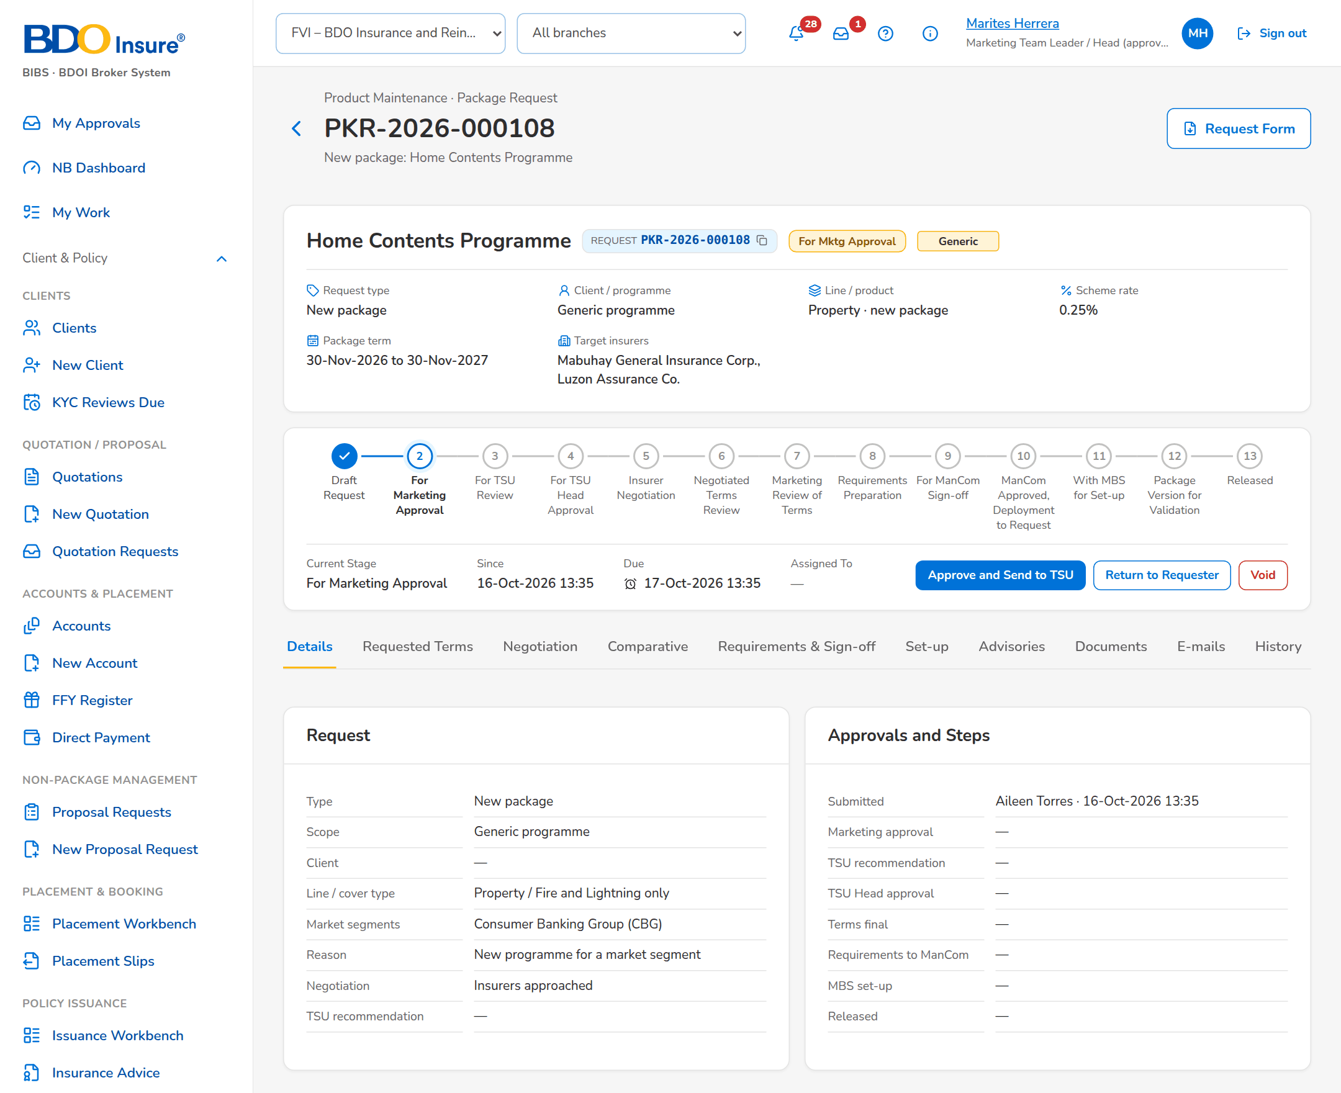
Figure 5: SCR-PM-04 Request for Marketing approval (Marketing approver)
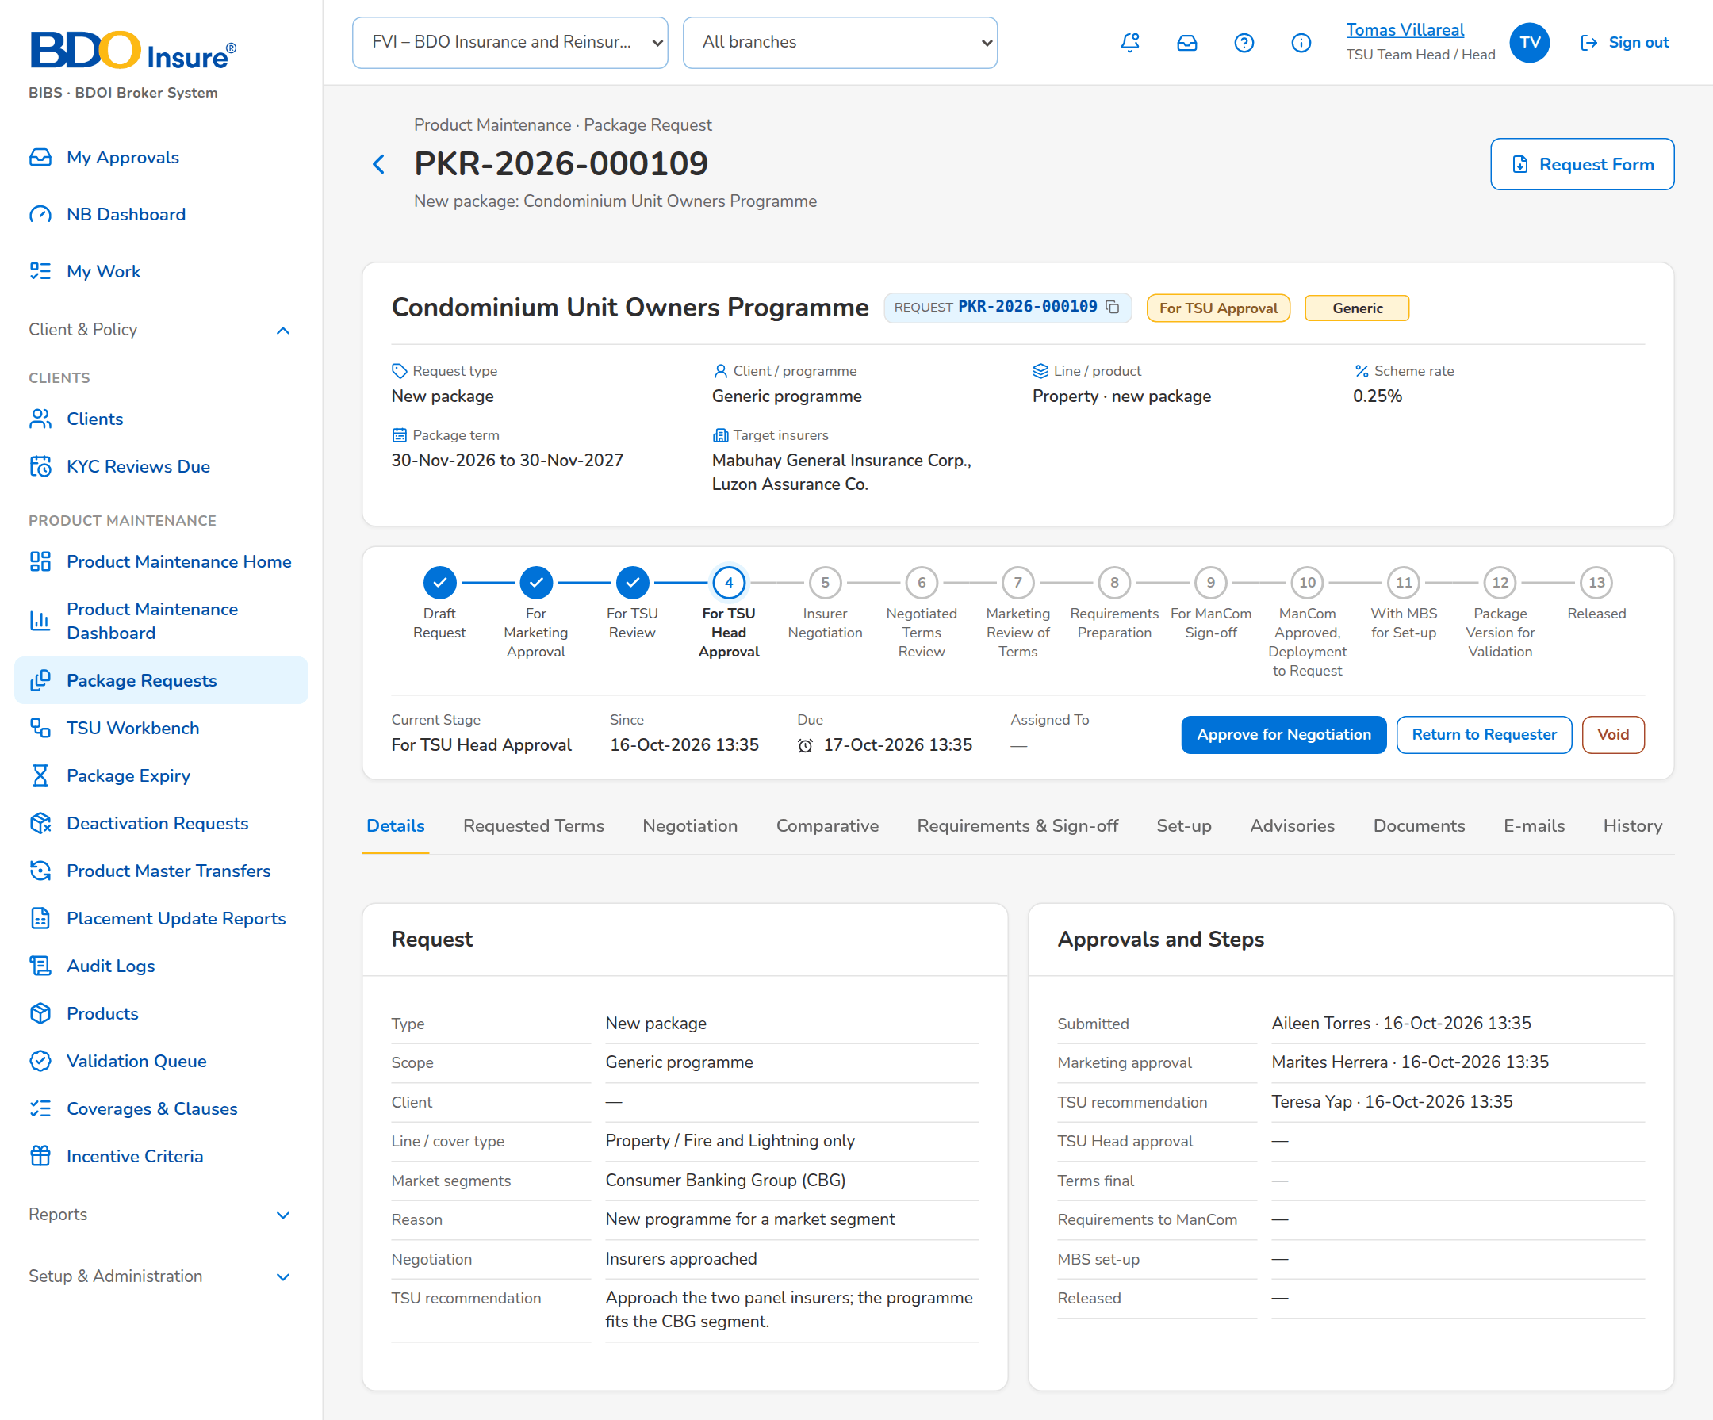
Figure 6: SCR-PM-04 Request for TSU Head approval

SCR-PM-05 Package Request Record: Negotiation Tab
Item | Value
Purpose | The negotiation with the insurers, one card per round, newest first. TSU prepares the quotation slip of the round (insurers and notes), a TSU Team Lead or a co-officer approves it and the system e-mails it to each insurer, password protected. TSU keys in each insurer's reply with its outcome, rate and terms; a further round revises the slip. When every insurer has answered, TSU makes the terms final with the insurers the package takes.
Access | Package Request record › Negotiation tab
Requirements | FRPM.012.01, FRPM.012.02, FRPM.012.03, FRPM.013.01, FRPM.027.01

Rules and states:
• A quotation slip is approved by a TSU Team Lead or a co-officer, never by its preparer (FRPM.012.01).
• Each insurer receives its own protected e-mail; an insurer without a placement e-mail address stops the sending (FRPM.012.01, FRPM.027.01).
• An offer (accepted as requested, approved with changes, counter-proposal) needs the rate offered; every change of a response is kept as a revision (FRPM.012.02).
• Only the latest round is keyed in; a sent round is revised through a new round, never changed (FRPM.012.03).
• The terms are final only when every insurer of the latest round has an outcome and the chosen insurers offered terms; co-insurance shares total 100 (FRPM.013.01).
• The slips are locked at the ManCom sign-off (FRPM.014.01).
Table 10: SCR-PM-05 fields
Field | Type | Req. | Format, list or source | Validation and message
Round card: [Round n · slip number] | Card title | - | Round number and quotation slip number; Negotiation round | -
Round card: [Round status pill and Locked tag] | Pill | - | Preparation, For approval, Sent, Superseded; Locked after the ManCom sign-off; Negotiation round | -
Round card: [Round note] | Text | - | Notes of the round; Reply by dd-MMM-yyyy; Sent dd-MMM-yyyy HH:mm (approved by user); Negotiation round | -
Slip preparation: [Insurer check boxes] | Check boxes | Y (at least one) | Insurers of the round; Insurers (authorised, active) | At least one insurer; each insurer authorised and with a placement e-mail; Select at least one insurer for the quotation slip
Slip preparation: Notes to the insurers | Text | N | Up to 4,000 characters | -
Responses: Insurer | Column | - | Insurer name; Insurer response | -
Responses: Outcome | Column | - | Pending, Accepted as requested, Approved with changes, Counter-proposal, Declined, No response; Insurer response | -
Responses: Rate % / Minimum / Conditions / Valid Until | Column | - | As keyed in; Insurer response | -
Responses: Rev. | Column | - | Revision number of the response; Insurer response | -
Responses: [Row action menu] | Row action menu | - | Key In and Resend of the insurer's row | -
Terms of <insurer>: Outcome | Drop-down | Y | Accepted as requested, Approved with changes, Counter-proposal, Declined, No response; List response outcome list | An active value of the list
Terms of <insurer>: Rate % | Number | Cond.: an offer (accepted, approved with changes, counter-proposal) | Up to four decimals | Zero or more; Enter the rate offered
Terms of <insurer>: Minimum premium | Number | N | Amount in PHP | Zero or more; Rates and amounts cannot be negative
Terms of <insurer>: Valid until | Date | N | dd-MMM-yyyy | -
Terms of <insurer>: [Deductible per coverage] | Text | N | One field per requested coverage; Requested coverages | -
Terms of <insurer>: Conditions and warranties | Text | N | Up to 2,000 characters | -
Terms of <insurer>: Remarks | Text | N | Up to 1,000 characters | -
Terms of <insurer>: Response document | File | N | The insurer's reply (PDF, e-mail or image) | File checks of every upload; The file could not be read
Terms Final: [Offer check box] | Check box | Y (at least one) | Insurer name · rate %, one per insurer that offered terms in the latest round; Latest round | Only insurers that offered terms; Choose the insurer(s) whose terms the package takes
Terms Final: Role | Drop-down | Y | Panel, Lead, Participant; Fixed list | -
Terms Final: Share % | Number | Cond.: co-insurance (lead and participants) | Co-insurance share | Shares given for every co-insurer and totalling 100; Co-insurance shares must be given for every insurer and total 100
Terms Final: Comment | Text | N | Up to 1,000 characters | -
Revise Quotation Slip: [Insurer check boxes] | Check boxes | Y (at least one) | Insurers of the next round; Insurers | -
Revise Quotation Slip: What changes in this round | Text | N | Up to 4,000 characters | -

Table 11: SCR-PM-05 actions
Action | Who | Available when | What happens | Result
Save Slip | TSU Officer or Team Lead | Round in preparation | Saves the insurers and notes of the slip | Round in preparation
Submit for Approval | TSU Officer or Team Lead | Round in preparation; at least one insurer | Saves the slip, numbers it PQS-yyyy-nnnnnn and sets the reply date (today + insurer reply days, 5 days) | Round for approval
Approve and Send | TSU Team Lead or a co-officer, not the preparer | Round for approval | Approves the slip and e-mails it to each insurer, password protected; a pending response is opened per insurer | Round sent
Quotation Slip | Every user of the screen | The slip is numbered | Downloads the quotation slip PDF of the round | Unchanged
Key In | TSU | Round sent, open and not locked | Opens Terms of <insurer> from the row action menu | Unchanged
Save Terms | TSU | Outcome chosen; a rate for an offer | Saves the response as a new revision (the previous values stay in the history) and attaches the response document | Response outcome
Resend | TSU | Round sent, open and not locked | From the row action menu: e-mails the slip again to that insurer | Unchanged
Revise quotation slip (new round) | TSU | Insurer negotiation; the latest slip was sent | Opens Revise Quotation Slip; Open New Round closes the sent round and opens round n+1 with the chosen insurers | Insurer negotiation (round n+1)
Terms final | TSU | Insurer negotiation; every insurer of the latest round has an outcome | Opens Terms Final; Make Terms Final records the chosen insurers with role and share as the proposed terms and compiles the comparative master | Negotiated terms review

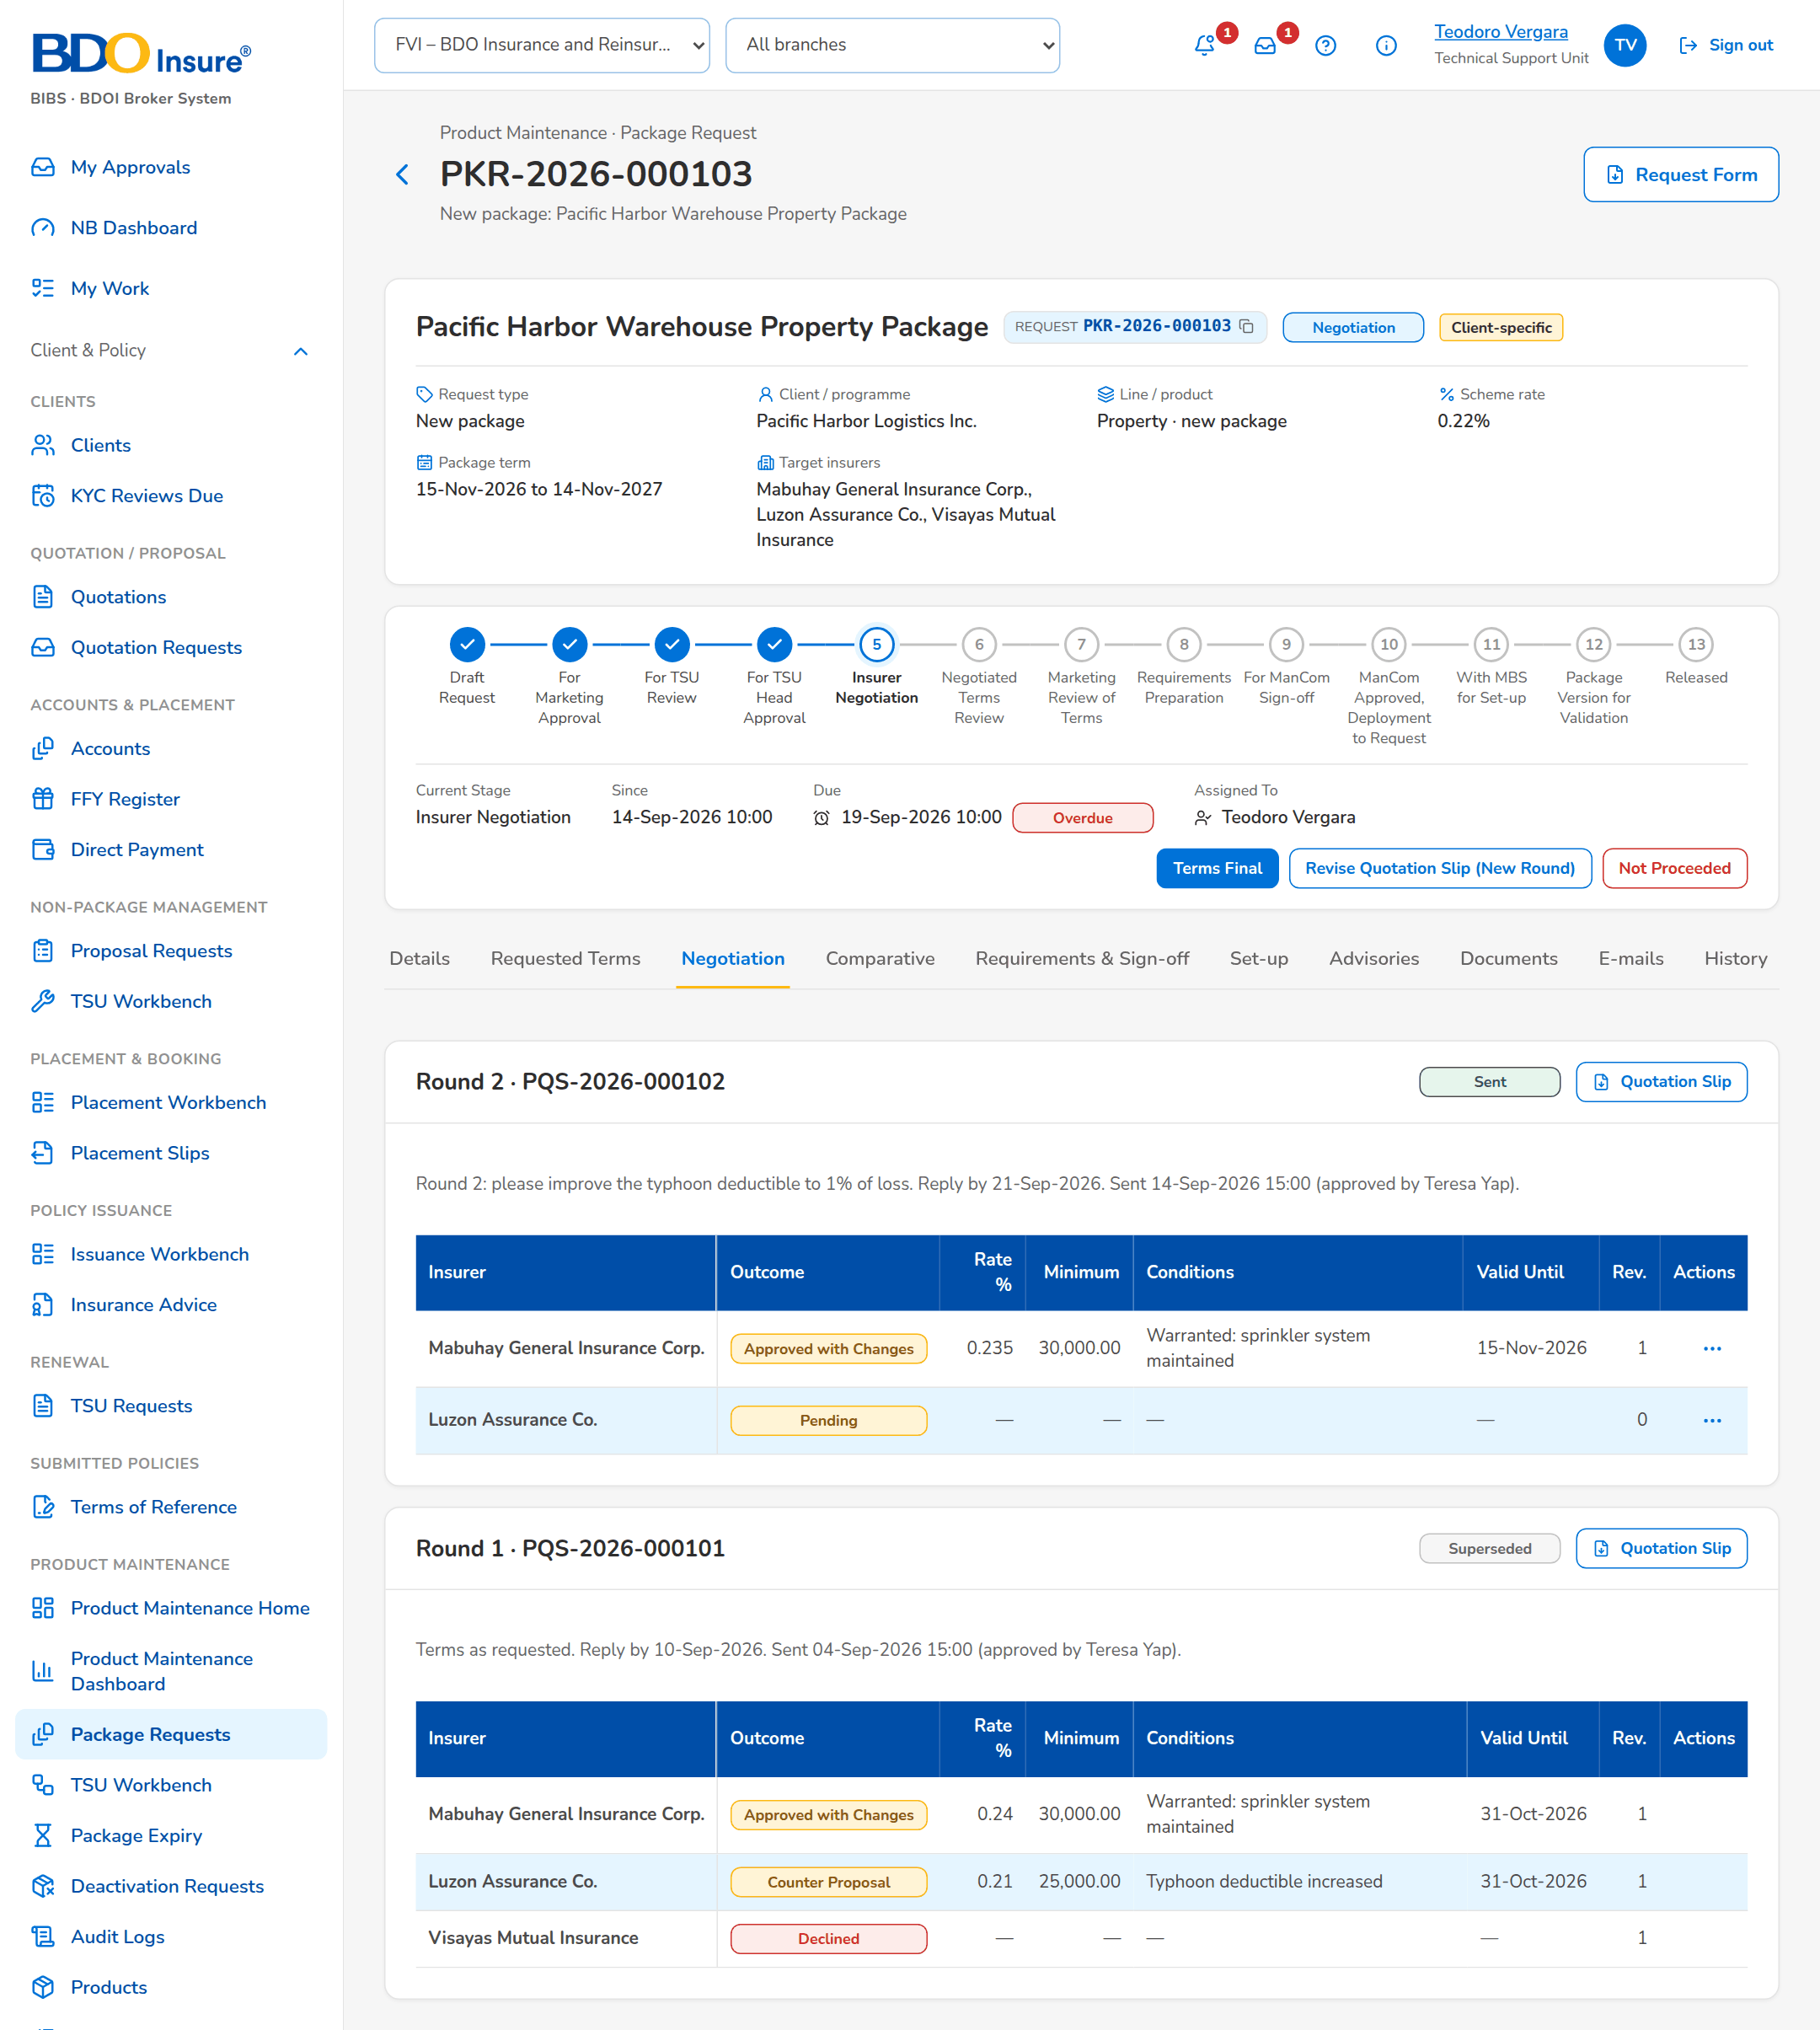
Figure 7: SCR-PM-05 Negotiation tab

SCR-PM-06 Package Request Record: Comparative Tab
Item | Value
Purpose | The comparison of the insurer terms of the latest round, the one current comparative master kept for audit, the client views derived from it for a client presentation, and the comparative table with the options of each insurer and the final terms, from which the proposal slips per insurer are generated (as for the quotation requests, SCR-PM-28). Every output is stored with its PDF and Excel file.
Access | Package Request record › Comparative tab
Requirements | FRPM.012.02, FRPM.012.04

Rules and states:
• There is one current comparative master per request; a new master supersedes the previous one (FRPM.012.02).
• The comparative table shows the value of the quotation slip, every option of every insurer and the final terms for the proposal; every change of a final term is kept with its old and new value (FRPM.013.01, FRPM.012.02).
• A client view is taken from the current master and never changes a value; it shows only the fields and insurers chosen (FRPM.012.04).
• Every output is attached to the request with its Fingerprint and written to the audit trail (FRPM.012.02, FRPM.021.01).
Table 12: SCR-PM-06 fields
Field | Type | Req. | Format, list or source | Validation and message
Round n comparison: Insurer | Column | - | Insurer name, with the Lowest rate tag; Latest round | No insurer terms to compare yet
Round n comparison: Outcome / Rate % / Minimum / Coverages / Deductibles / Conditions | Column | - | As keyed in; Insurer responses | -
Stored outputs: Output | Column | - | Title, with Audit master or Client view and the round; Comparative outputs | No comparative output yet
Stored outputs: Status | Column | - | Current or Superseded (master); Comparative outputs | -
Stored outputs: Fields | Column | - | All, or the number of fields shown; Comparative outputs | -
Stored outputs: Generated | Column | - | User · dd-MMM-yyyy HH:mm; Comparative outputs | -
Stored outputs: Fingerprint | Column | - | First 12 characters of the file fingerprint; Comparative outputs | -
Generate Client View: Title | Text | Y | Up to 200 characters | Not blank; Enter the title of the view
Generate Client View: Fields shown | Check boxes | Y (at least one) | Outcome, Rate %, Minimum Premium, Coverages, Deductibles, Conditions / Warranties, Valid Until, Remarks; Fixed list | Known fields only
Generate Client View: Insurers shown | Check boxes | Y (at least one) | Insurers of the master; Current master | Insurers of the master; Select at least one insurer of the master
Comparative Table: Field / QS Value / Final Terms for Proposal | Grid | - | One row per comparison field (Coverage, Sum Insured, Period of Insurance, Premium, Premium Rate (%), Commission Rate (%), Deductibles, Terms and Conditions, Warranties, Clauses, Extensions of Cover, Other Quotation Details); the value of the quotation slip; one column per option of each insurer with its response; the final terms keyed by TSU; Insurer responses and options | -
Comparative Table: Insurer Response | Drop-down | Y | Approved, Not Covered, Others; Fixed list | Others needs the actual response; Specify the insurer's actual response for Others
Insurers for the Proposal: [Insurer check boxes] | Check boxes | Y (at least one) | Insurers that gave terms; Insurer responses | -
Proposal Slips: Insurer / Version / File Name / Generated By / Generated On | Table | - | One proposal slip per selected insurer, numbered by version; Proposal files | No proposal has been generated yet

Table 13: SCR-PM-06 actions
Action | Who | Available when | What happens | Result
Compile Master | TSU | The slip of the latest round was sent | Compiles a new comparative master from the latest round; the previous master becomes Superseded | -
Generate Client View | TSU | A current master exists | Opens Generate Client View; Generate stores a view with the chosen fields and insurers, taken from the master's values | -
PDF / Excel | Every user of the screen | Always | Downloads the stored output | -
Choose Fields | TSU (negotiation right) | Always | Chooses the comparison fields shown in the table and to the client | -
Edit / Add Option | TSU (negotiation right) | Insurer column | Keys the response of the insurer and its values, or a further option of the same insurer | -
Final Terms History | Every user of the screen | Always | Shows every change of the final terms with the previous and new value, by whom and when | -
Proceed to Proposal | TSU (negotiation right) | Terms agreed; at least one insurer selected | Generates one proposal slip per selected insurer and lists it under Proposal Slips | -

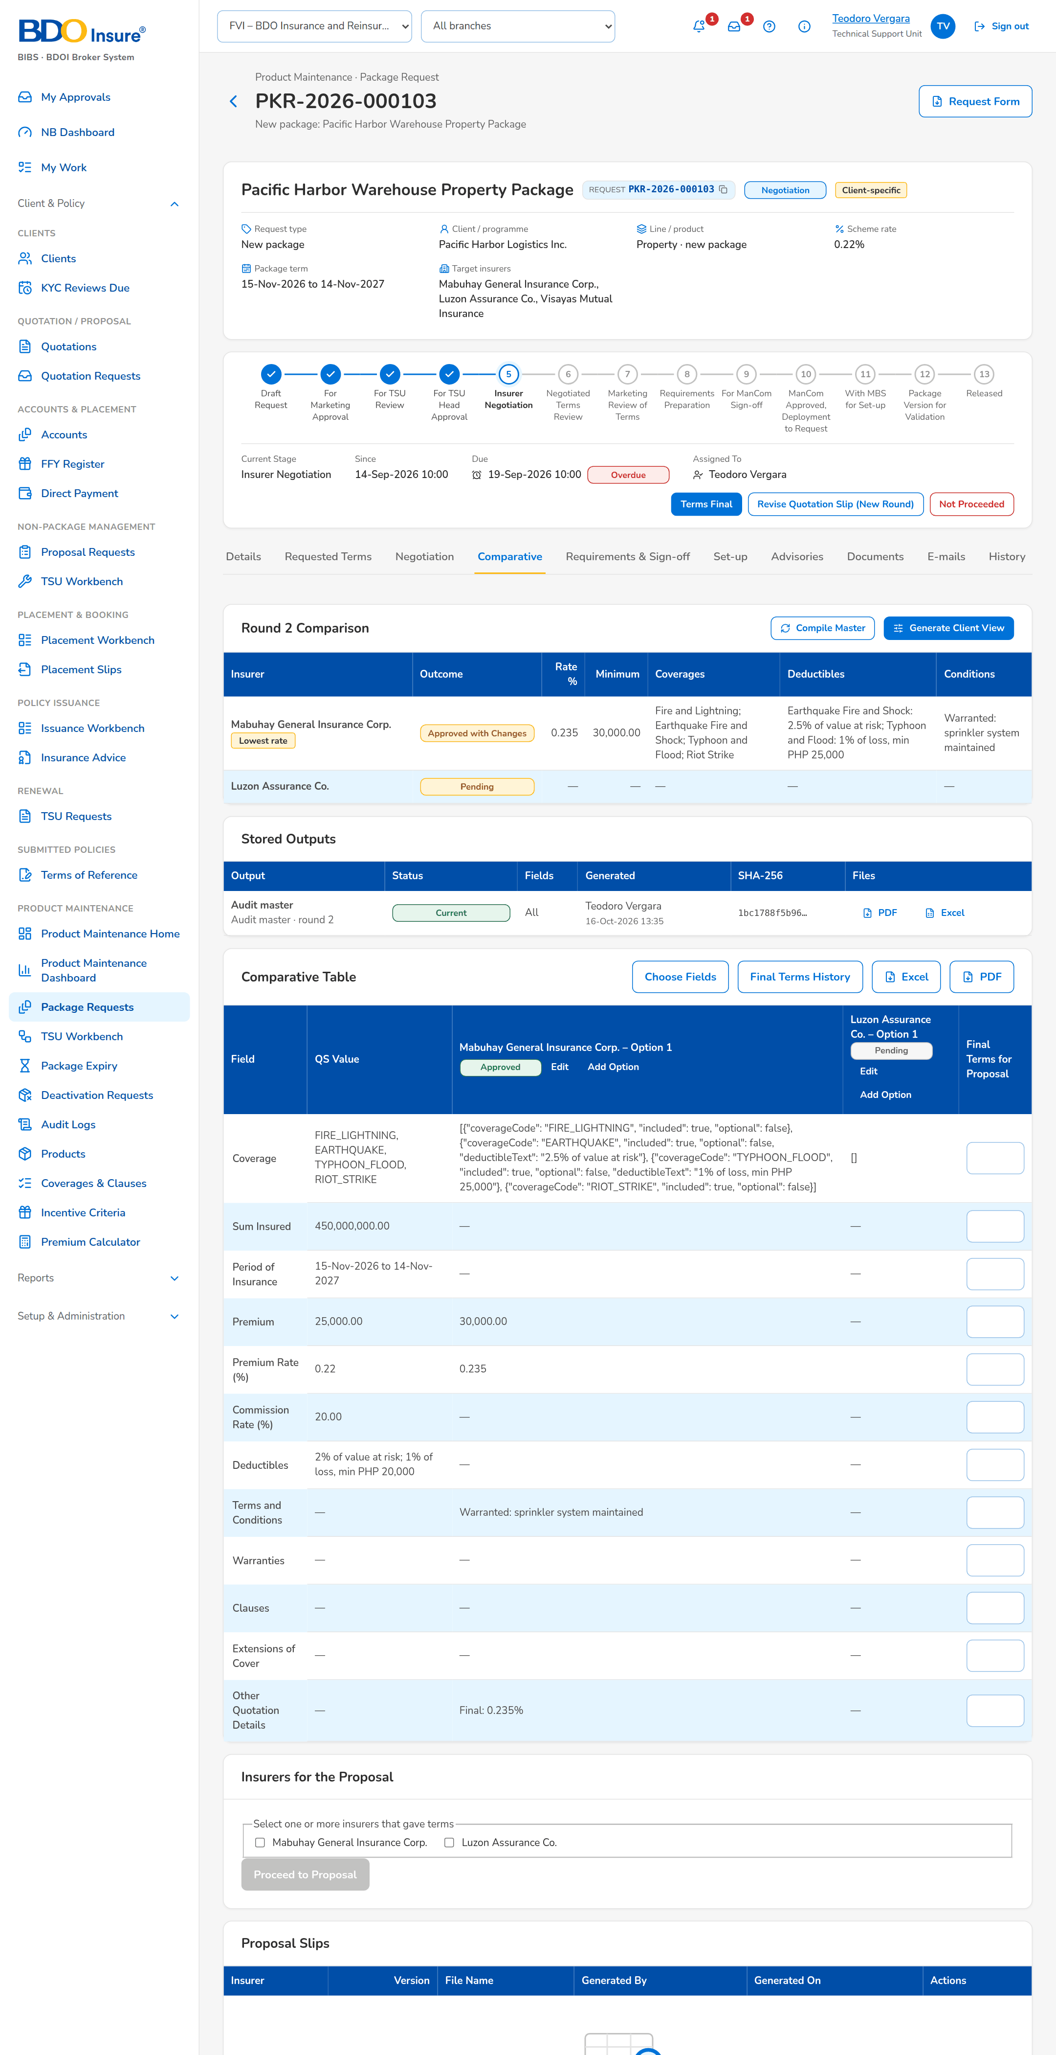
Figure 8: SCR-PM-06 Comparative tab with the current master

SCR-PM-07 Package Request Record: Requirements & Sign-off Tab
Item | Value
Purpose | The requirements pack that ManCom signs off: what the pack still lacks, the proposed rate scheme, computation basis and dates (editable while the requirements are prepared), the package slip to print and sign, and the ManCom decisions with their sign-off reference.
Access | Package Request record › Requirements & Sign-off tab
Requirements | FRPM.013.01, FRPM.013.02, FRPM.014.01, FRPM.014.02, FRPM.015.01

Rules and states:
• The requirements pack needs the effective date and package end date, a scheme rate or a rate for every insurer, the computation basis, at least one chosen insurer and the signed package slip attached as Package slip (signed) (FRPM.013.01).
• ManCom never signs off requirements it submitted; a single ManCom sign-off is recorded (FRPM.014.01).
• At the sign-off the quotation slips of every round are locked (FRPM.014.01).
Table 14: SCR-PM-07 fields
Field | Type | Req. | Format, list or source | Validation and message
Requirements pack: [Checklist] | Checklist | - | Missing items, or The requirements pack is complete.; Requirements check | The effective date and package end date, a scheme rate or a rate for every insurer, the computation basis, the chosen insurer(s) and the signed package slip; Complete the requirements: <missing>
Rate scheme, computation basis and dates: Scheme rate % | Number | Cond.: or a rate for every insurer | Up to four decimals; Proposed terms | Zero or more; Rates and amounts cannot be negative
Rate scheme, computation basis and dates: Minimum premium / Commission % / Package TSI limit | Number | N | Amount in PHP; percentage; Proposed terms | Zero or more; Rates and amounts cannot be negative
Rate scheme, computation basis and dates: Computation basis | Text | Y | How the premium is computed; Proposed terms | Not blank before submission; Complete the requirements: the computation basis
Rate scheme, computation basis and dates: Effective from | Date | Y | dd-MMM-yyyy; Proposed terms | Complete the requirements: the effective date and the package end date
Rate scheme, computation basis and dates: Package start / Anniversary | Date | N | dd-MMM-yyyy; Proposed terms | -
Rate scheme, computation basis and dates: Package end | Date | Y | dd-MMM-yyyy; Proposed terms | After the effective date; The package end date must be after the effective date
Proposed terms: [Sections, coverages, rate scheme, dates and insurers] | Read-only view | - | As on the Requested Terms tab; Proposed terms | -
ManCom decisions: Reference / Decision / By / On / Comment | Table | - | MC-PKR-yyyy-nnnnnn; Signed or Returned; ManCom sign-offs | No ManCom decision yet

Table 15: SCR-PM-07 actions
Action | Who | Available when | What happens | Result
Package Slip | Every user of the screen | Always | Downloads the package slip (PDF) with the proposed terms, to be printed and signed | Unchanged
Save Requirements | TSU | Requirements preparation | Saves the rate scheme, computation basis and dates of the proposed terms | Unchanged
Submit requirements for ManCom sign-off | TSU | Requirements preparation; the pack is complete | Sends the pack to ManCom | For ManCom sign-off
Sign off and send to MBS | ManCom, not the submitter of the requirements | For ManCom sign-off, with the ManCom routing set to one sign-off by any member (under the routing by selected approvers the request is signed off by their approvals on the Routing & Approvals tab, SCR-PM-29) | Records the sign-off MC-<request no.>, locks the quotation slips and attaches the sign-off record (or links the uploaded ManCom sign-off sheet) | With MBS for set-up

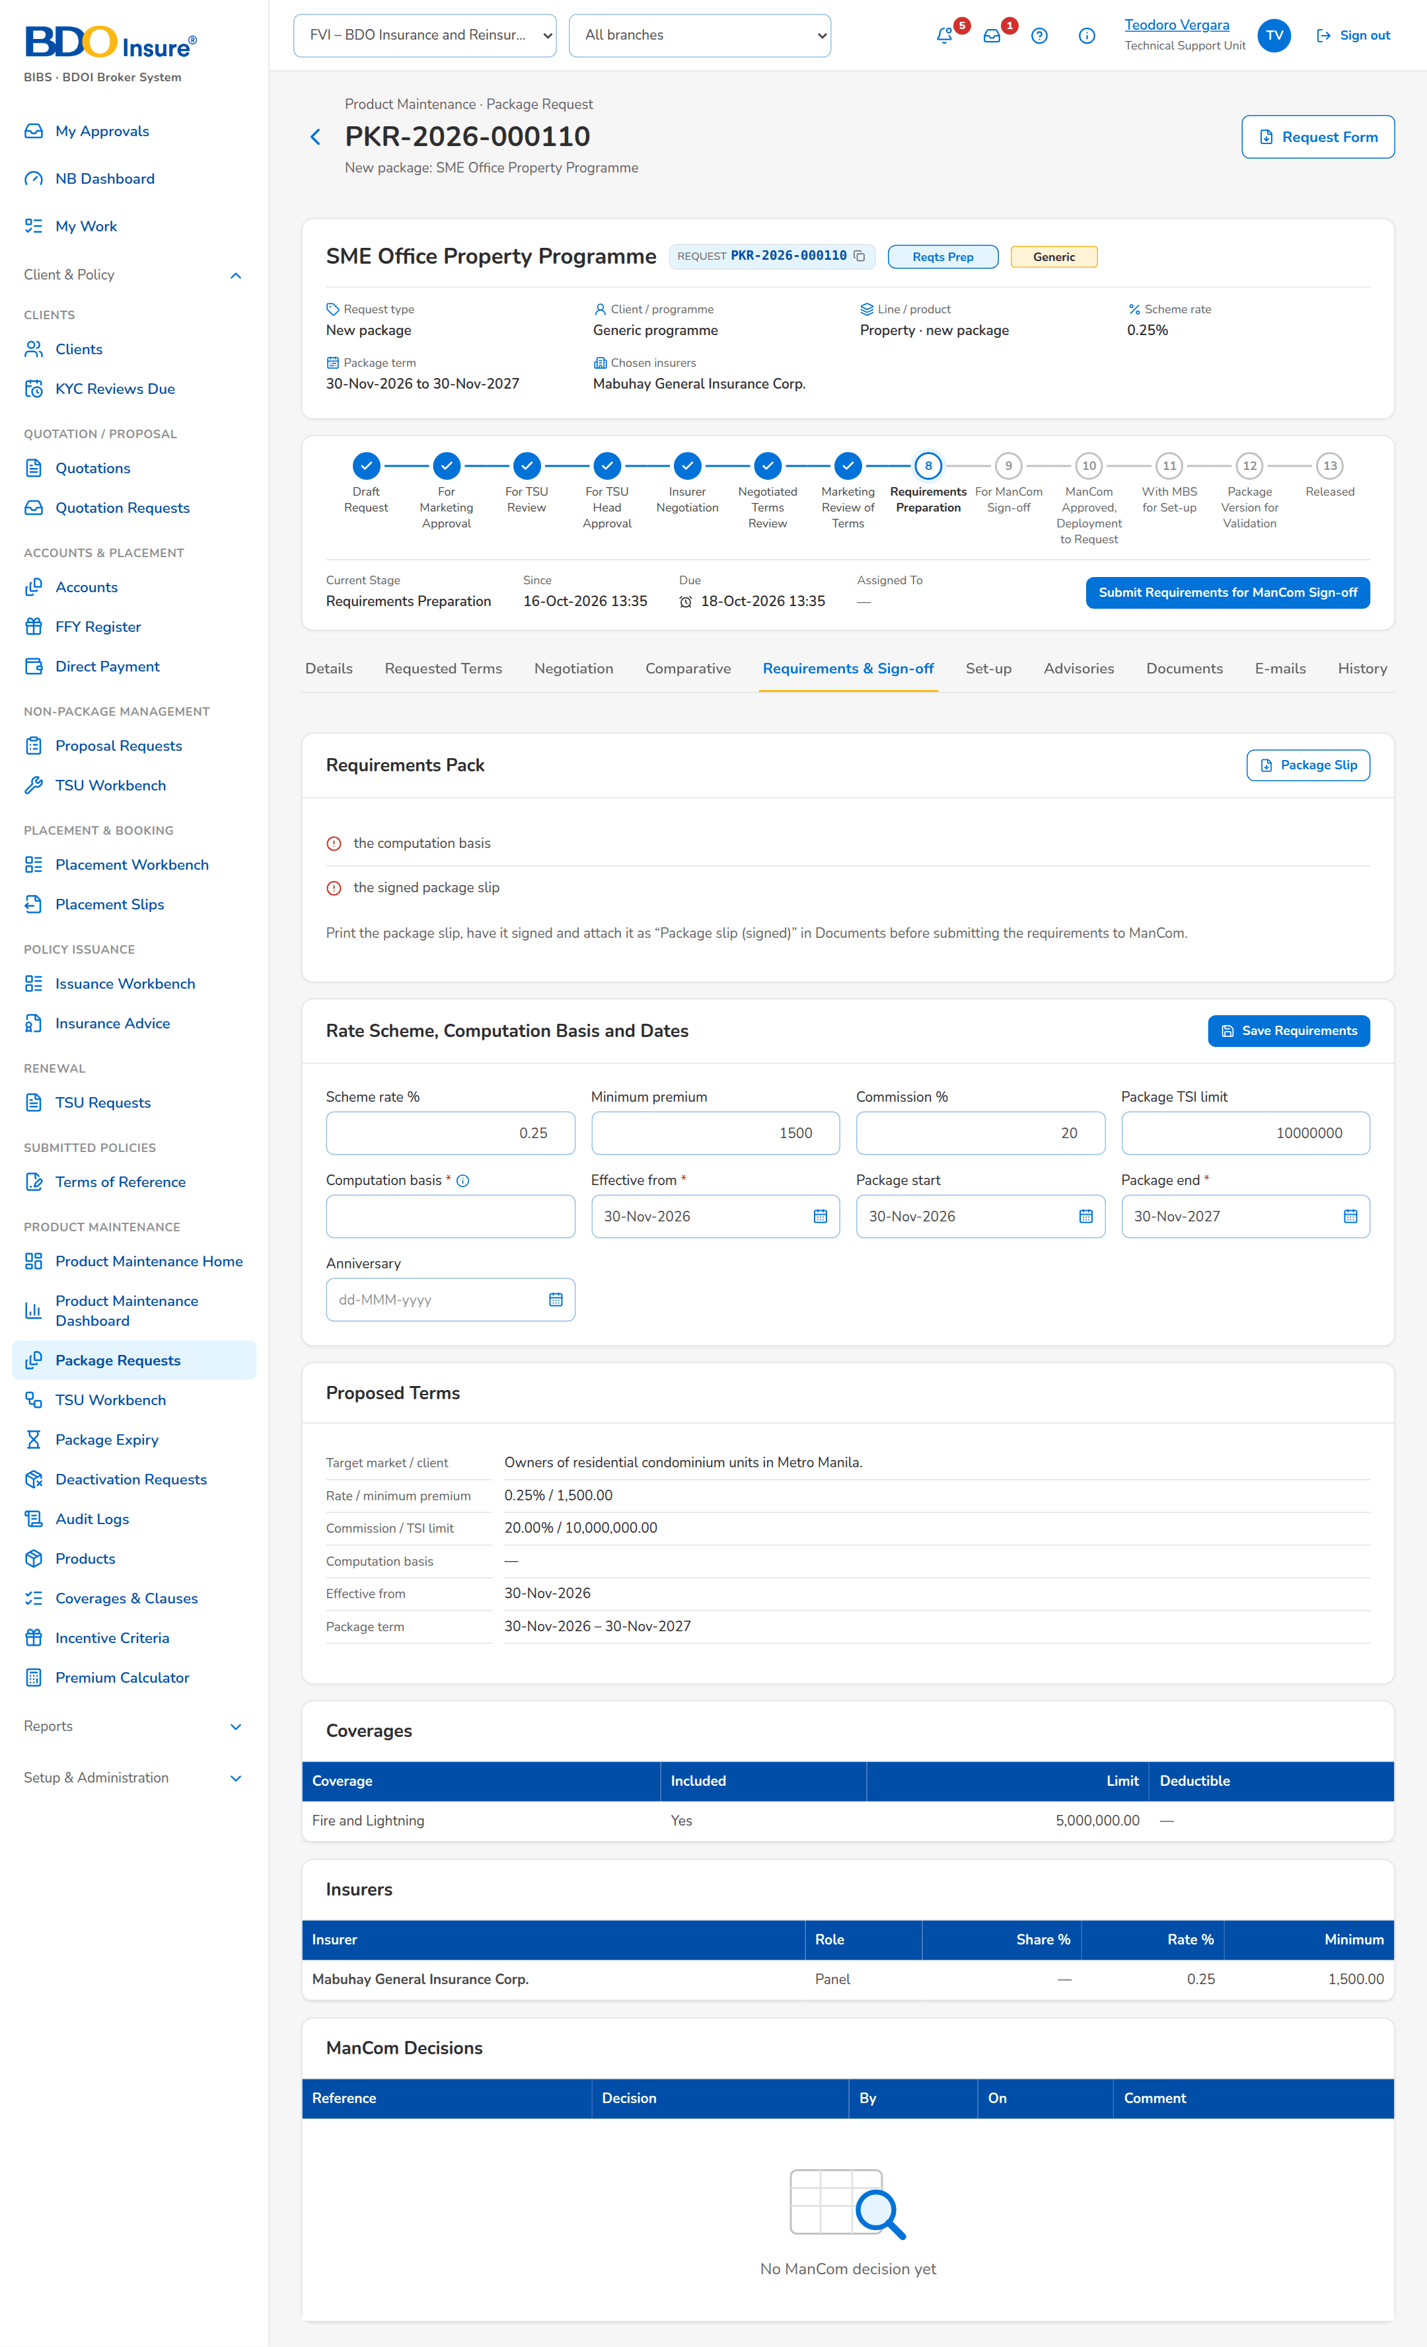
Figure 9: SCR-PM-07 Requirements & Sign-off tab

SCR-PM-08 Package Request Record: Set-up and Advisories Tabs
Item | Value
Purpose | MBS turns the signed-off terms into a draft catalog version (Set up package version), completes it in the version editor and submits it for validation; the request is released when the version is validated. On release (or retirement) the system drafts the advisory, which TSU edits and sends to the recipient groups once the signed package slip and the ManCom sign-off are attached.
Access | Package Request record › Set-up tab, Advisories tab
Requirements | FRPM.003.03, FRPM.003.04, FRPM.003.06, FRPM.003.07, FRPM.016.01, FRPM.016.02, FRPM.025.01

Rules and states:
• The set-up creates a draft version; a product can have only one version being set up at a time (FRPM.016.01).
• A new package needs its risk code; the product is authorised when its first version is validated (FRPM.016.01, FRPM.003.03).
• The request is released automatically when its version is validated, and returns to MBS when the validator returns the version (FRPM.003.03).
• An advisory is sent only with the signed package slip and the ManCom sign-off attached; a retirement advisory needs the ManCom sign-off only (FRPM.025.01).
• Recipient groups are notified in the system: Marketing, TSU, MBS, Processing and Operations users by their permissions; e-mail addresses are optional (FRPM.025.01).
Table 16: SCR-PM-08 fields
Field | Type | Req. | Format, list or source | Validation and message
Set Up Package Version: Risk code of the new package | Text | Cond.: New package | Up to 20 capitals or digits; the naming convention of the line when set | Not blank; not an existing product; Enter the risk code of the new package
Set Up Package Version: Product name | Text | N | Up to 200 characters | -
Set Up Package Version: Change summary | Text | N | Up to 500 characters | -
Set Up Package Version: Comment | Text | N | Up to 1,000 characters | -
Set-up › Catalog version: Product / Version / Request stage | Detail | - | Risk code, version number, stage pill; Package version | MBS sets the package up after the ManCom sign-off
Advisories: [Advisory card] | Card | - | Subject, status pill, type · recipient groups, sent date and user, text; Advisory | An advisory is drafted when the package is released or retired
Advisories: [Supporting documents checklist] | Checklist | - | Package slip (signed) and ManCom sign-off (retirement: ManCom sign-off only), each Attached or Missing; Documents of the request | Both documents attached before sending; The advisory cannot be sent until the supporting documents are attached (Documents tab).
Edit Advisory: Recipient groups | Check boxes | Y (at least one) | Marketing, TSU, MBS, Processing, Operations; List advisory recipient group list | Active values of the list; Select at least one recipient group
Edit Advisory: E-mail to (optional) | Text | N | Comma-separated addresses | -
Edit Advisory: Subject | Text | Y | Up to 200 characters | Not blank; Enter the subject and the text
Edit Advisory: Text | Text | Y | Up to 8,000 characters | Not blank; Enter the subject and the text

Table 17: SCR-PM-08 actions
Action | Who | Available when | What happens | Result
Set up package version | MBS | With MBS for set-up; not a Retire request | Opens Set Up Package Version; Set Up Version creates the draft catalog version from the signed-off terms (a new package also creates its product, pending authorisation) | Package version for validation
Open Version Editor | Every user of the screen | A version was set up | Opens the Package Version (SCR-PM-13) | -
Edit | TSU | Draft advisory | Opens Edit Advisory; Save keeps the changes | Draft
Send Advisory | TSU | Draft advisory; the supporting documents are attached | Stores the advisory PDF on the request, notifies the users of each recipient group in the system and, when addresses are given, e-mails the protected PDF | Sent

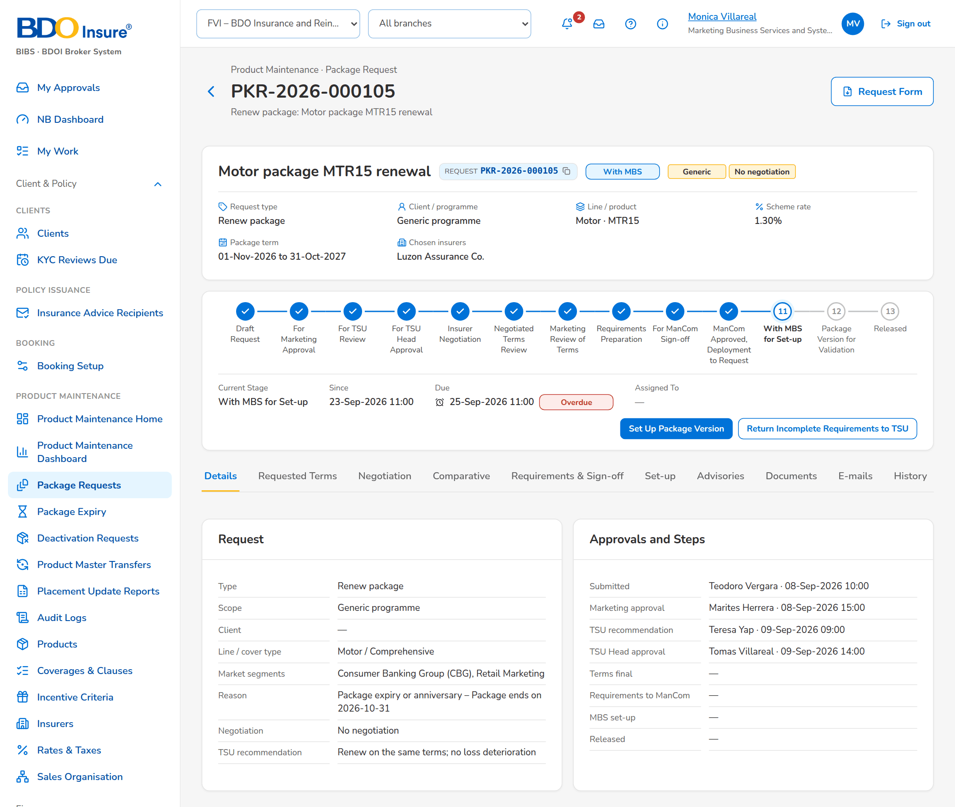
Figure 10: SCR-PM-08 Request with MBS (set-up)
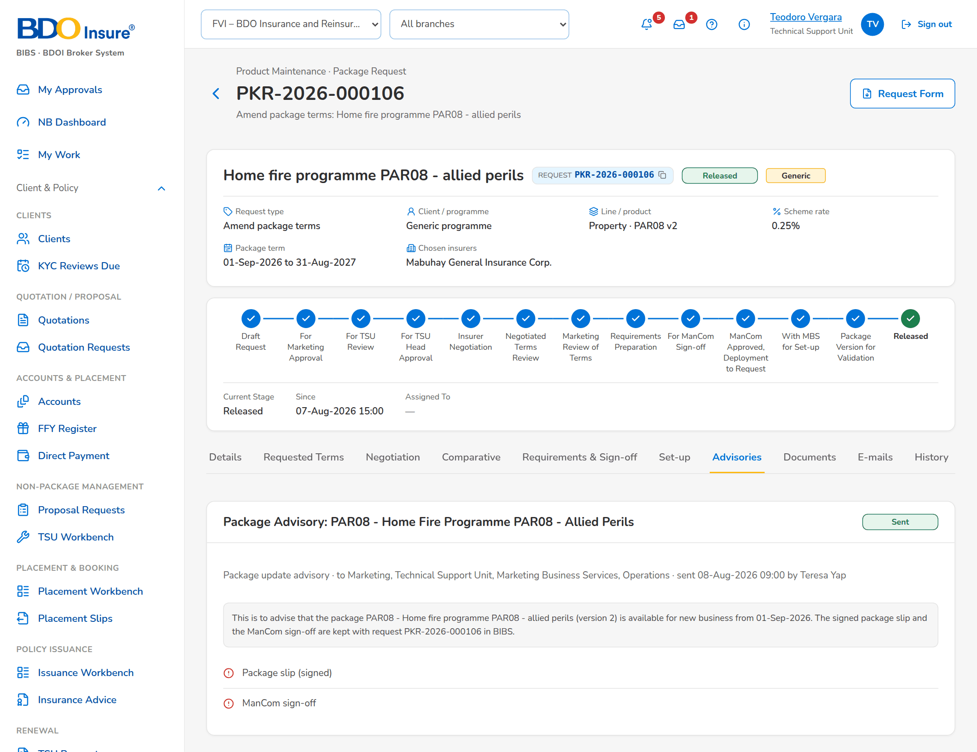
Figure 11: SCR-PM-08 Advisories tab of a released request

SCR-PM-09 TSU Workbench
Item | Value
Purpose | The package request queues of the TSU Officer, Team Lead and Head: one tile per stage they work (review, approval, negotiation, terms review, requirements), with the open and overdue counts, and the queue of the chosen stage, oldest due first. A user claims a request to work it; team leads assign requests.
Access | Sidebar entry TSU Workbench
Requirements | FRPM.002.02, FRPM.003.06, FRPM.011.01, FRPM.011.03, FRPM.016.01, FRPM.017.01

Rules and states:
• Only the stages the user's permissions work are shown (FRPM.002.02).
• A claimed request is worked by the user who claimed it; a team leader can re-assign it (FRPM.002.02).
Table 18: SCR-PM-09 fields
Field | Type | Req. | Format, list or source | Validation and message
Package requests: [Stage tiles] | Tile | - | Stage name, open count, 'n overdue', 'n mine'; Workflow queues | -
Queue: Reference | Column | - | PKR-yyyy-nnnnnn; Work item | -
Queue: Description | Column | - | Request type, product and name; Work item | -
Queue: Stage | Column | - | Stage pill; Workflow | -
Queue: From | Column | - | Unit or user that raised the request; Work item | -
Queue: In Stage | Column | - | Time in the stage; Workflow | -
Queue: Due | Column | - | dd-MMM-yyyy HH:mm; Overdue in red; Workflow | -
Queue: Assignee | Column | - | User or unassigned; Workflow | -

Table 19: SCR-PM-09 actions
Action | Who | Available when | What happens | Result
[A stage tile] | Every user of the screen | Always | Shows the queue of that stage | -
Claim | A user of the stage | Unassigned item | Assigns the request to the user | Unchanged
Assign | Team leaders | Always | Opens the assignment dialog: a user of the stage or the team queue | Unchanged
[Open a row] | Every user of the screen | Always | Opens the package request | -

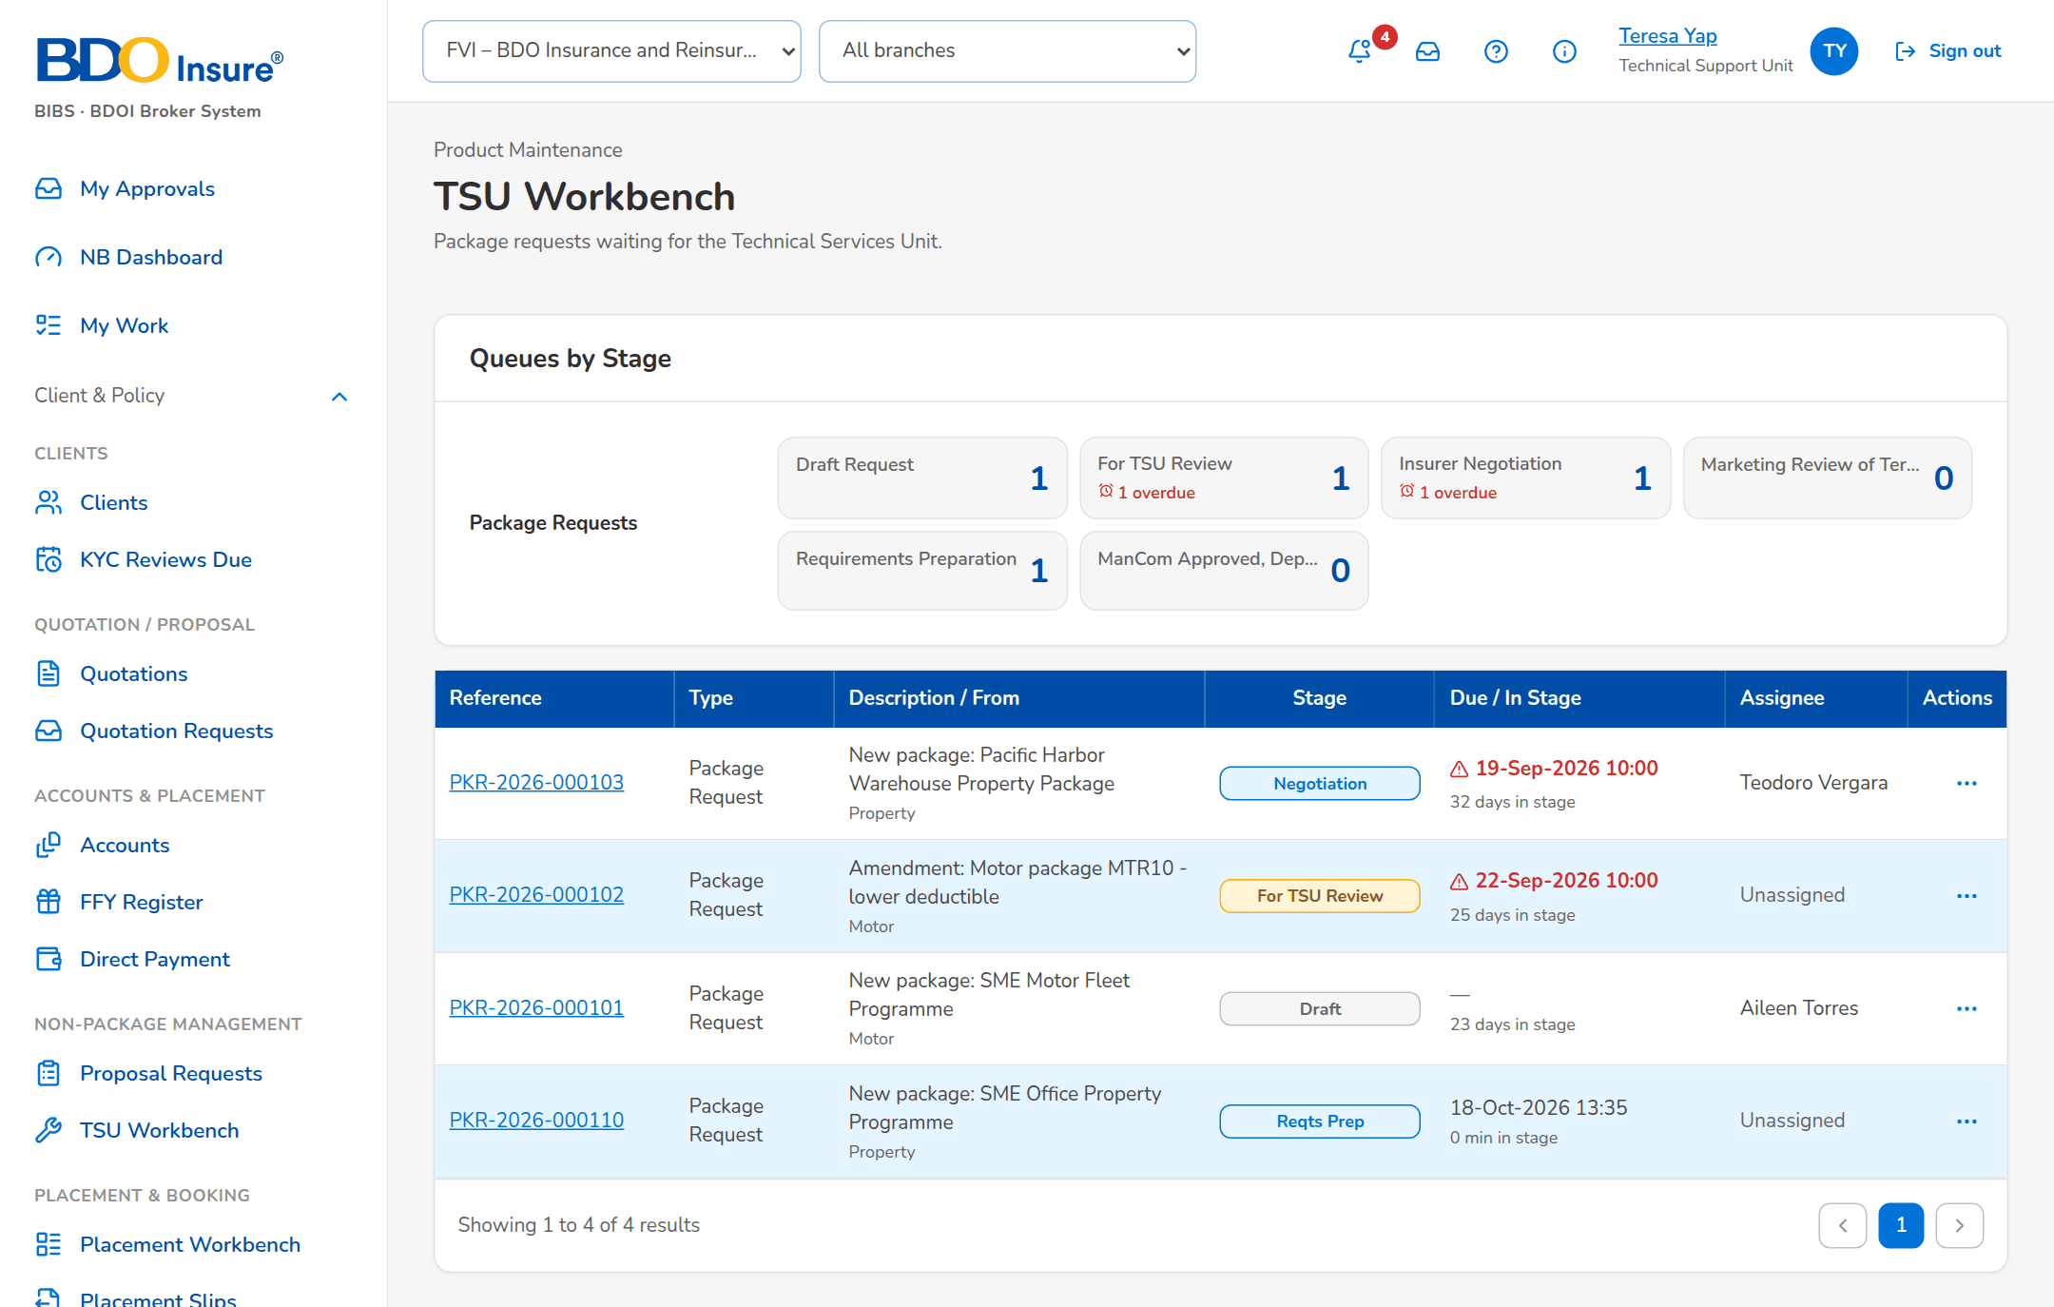
Figure 12: SCR-PM-09 TSU Workbench

SCR-PM-10 Package Expiry
Item | Value
Purpose | The released packages by package end date, with their renewal status: packages ending without a renewal request, packages whose renewal is in progress, and the pointer to the expired packages kept in the catalog. TSU drafts renewal requests for the selected packages, pre-filled from the version in force.
Access | Product Maintenance Home › Packages ending soon tiles; Package Requests › Package Expiry; The expiry alert (Alert inbox) and the package expired notice
Requirements | FRPM.002.02, FRPM.003.01, FRPM.003.05, FRPM.004.01, FRPM.019.01, FRPM.019.02, FRPM.026.01

Rules and states:
• A package is listed from its version in force; the expiry alerts start 90 days before the expiry date, with the configured reminder days (FRPM.004.01).
• A renewal request is never drafted twice for the same package; when the automatic drafting setting is on, the monitor drafts it itself (FRPM.026.01).
• Expired packages stay readable on Products with the Expired filter; an expired package is sold again only through a Reactivate request (FRPM.002.02).
Table 20: SCR-PM-10 fields
Field | Type | Req. | Format, list or source | Validation and message
Tabs: Expiring / Renewal in Progress / Expired | Tab | - | Fixed | Expiring = no renewal request yet; Renewal in Progress = an open renewal or reactivation request
List: Package | Column | - | Risk code v<version>, with the product name; Version in force | -
List: Package End | Column | - | dd-MMM-yyyy; Version in force | -
List: Days Left | Column | - | Days until the package end, red up to 7, amber up to 30; Computed | -
List: Anniversary | Column | - | dd-MMM-yyyy; Version in force | -
List: Renewal Request | Column | - | Request number and its stage pill; Package requests | -
Generate Expiry List: Packages ending within (days) | Number | Y | Whole days from today | Zero or more

Table 21: SCR-PM-10 actions
Action | Who | Available when | What happens | Result
Generate Expiry List | Every user of the screen | Always | Opens the dialog; Generate lists the packages ending within the days entered | -
Generate Renewal Request | TSU | Expiring tab; at least one package selected | Drafts one Renew request per package, pre-filled from the version in force with the next term (start = old end + 1 day, same length); a package with an open renewal keeps it; one request opens directly | Draft request

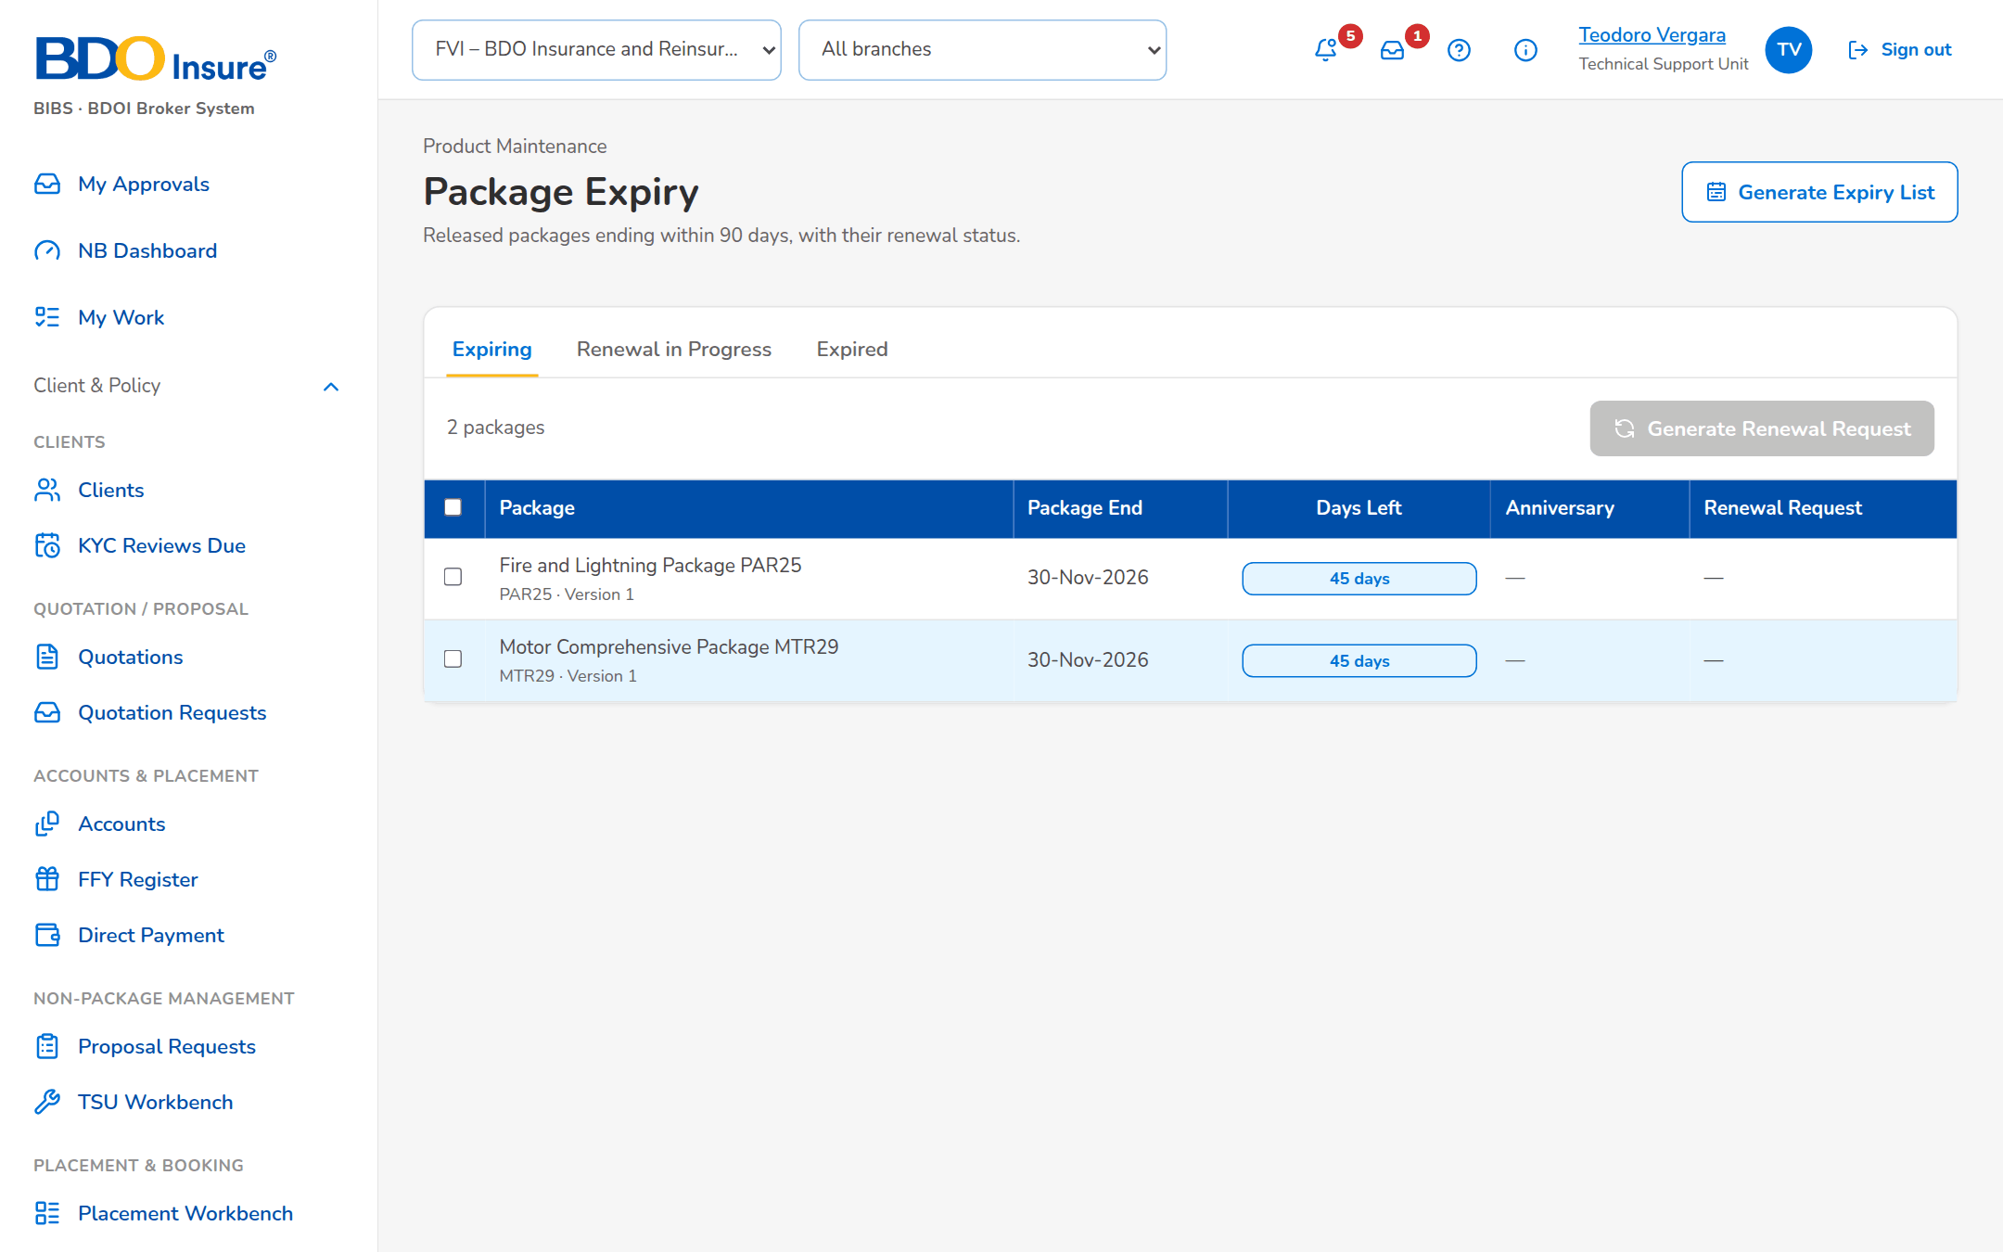
Figure 13: SCR-PM-10 Package Expiry

SCR-PM-11 Products
Item | Value
Purpose | The product catalogue: every product (risk code) with its line, package flag, current version, market segments, rate and minimum premium, and its lifecycle; and, on their own tabs, the field rules, document rules and TSU routing rules that decide what an account needs and when TSU reviews it. MBS creates products and rules; a second user authorises them. Expired and retired products are listed for the users who may see the archive.
Access | Sidebar entry Products; Package Expiry › Expired tab › Products; Product record › back arrow
Requirements | FRPM.002.02, FRPM.003.01, FRPM.003.02, FRPM.003.03, FRPM.003.05, FRPM.003.08, FRPM.012.01, FRPM.019.03, FRPM.022.01, FRPM.024.01, FRPM.030.01

Rules and states:
• Every product and rule is maker-checker: saved changes wait for a second user's authorisation and are not used until then (FRPM.003.01, FRPM.003.02).
• A package product needs its cover type; the risk code follows the naming convention of its line once BDOI has stated it (FRPM.003.01).
• The rate, minimum premium, commission and TSI limit of a package change only through a new version, so a released package stays sellable while it is changed (FRPM.003.01).
• Sellable lists show active products only; expired and retired products are shown to the archive users and are never deleted (FRPM.002.02).
• Field rules check presence, a list of values, a number range or a format; document rules name the documents an account needs before submission (FRPM.003.02, FRPM.012.01).
Table 22: SCR-PM-11 fields
Field | Type | Req. | Format, list or source | Validation and message
Tabs: Products / Field rules / Document rules / TSU routing | Tab | - | Fixed | -
Filters: Search | Text | N | Code or name | Contains search
Filters: Product line | Drop-down | N | All lines or one line; Product lines | -
Filters: Package | Drop-down | N | Package and non-package, Package only, Non-package only; Fixed list | -
Filters: Market segment | Drop-down | N | All segments or one; List market segment list | -
Filters: Lifecycle | Drop-down | N | Sellable, Expired, Retired; Fixed list | Shown only to users who may see the archive
Filters: Active only | Check box | N | - | Authorised and active records only
List: Code / Name / Line | Column | - | Risk code, product name, line code; Product master | No product matches the filters.
List: Package | Column | - | Yes for a package product; Product master | -
List: Version | Column | - | Current version (v2) and the pill of a version being set up (Draft, For validation); Package versions | -
List: Segments | Column | - | Market segments, or All; Product master | -
List: Rate % / Min. Premium | Column | - | Product rate and minimum premium (of the version in force for a package); Product master | -
List: Status | Column | - | Pending Authorization, Active, Inactive; Expired or Retired for a package no longer sold; Product master | -
New product: Code | Text | Y | 1 to 20 capitals or digits | Unique; the naming convention of the line when set; Code: 1 to 20 capital letters or digits.
New product: Name | Text | Y | Up to 200 characters | Not blank; Name is required.
New product: Product line | Drop-down | Y | Line name; Product lines | Choose the product line.
New product: Cover type | Drop-down | Cond.: package product | Cover types of the line; Cover types | A cover type of the line; a package needs one; A package needs its cover type
New product: Placement after | Drop-down | Y | Paid, Client confirmation; Fixed list | -
New product: TSU review | Drop-down | N | By rules, Always, Never; Fixed list | -
New product: Default rate % | Number | N | Up to four decimals | 0 to 100; The rate, minimum premium, commission and TSI limit of package <code> change through a new version (Versions tab)
New product: Default commission % | Number | Y | Percentage | 0 to 100; Default commission rate is required.
New product: Minimum premium | Number | Y | Amount in PHP | Zero or more; The minimum premium cannot be negative
New product: Package TSI limit | Number | N | Amount in PHP; above it the account goes to TSU | Zero or more
New product: Maximum term (years) | Number | Cond.: multi-year term allowed | 1 to 10 | At least 2 for a multi-year product; A multi-year product needs a maximum term of at least 2 years.
New product › Features: Package product (fixed cover) / Fleet (several vehicles) / Mortgage / loan related / Direct payment to insurer allowed / Multi-year term allowed / Free First Year eligible | Check box | N | - | -
New product: Market segments (none = all) | Check boxes | N | Segments the product is offered to; List market segment list | Active values
Field rules: Applies to / Level / Field / Key / Mandatory / Status | Column | - | All products, a line or a product; Account or Risk item; Field rules | -
Document rules: Applies to / Document / Before Submission / Status | Column | - | Document type; Required or Optional; Document rules | -
TSU routing: Priority / Code / Description / Criteria / TSI Above / Status | Column | - | Lower priority evaluated first; TSU routing rules | -

Table 23: SCR-PM-11 actions
Action | Who | Available when | What happens | Result
New Product | MBS (master data maintainers) | Products tab | Opens New product; Save for Authorization saves it pending authorisation | Pending Authorization
Add Rule | MBS, Business Administrator | Field rules, Document rules or TSU routing tab | Opens New Rule (see SCR-PM-12) | Pending Authorization
Authorize | authorizers or authorizers (Business Administrator, New Business Approver), not the maker | Row pending authorisation | From the row action menu, after the confirmation: authorises the record; it is used by quotations, accounts and rating from now | Active
Deactivate | MBS or master data maintainers | Active row | From the row action menu (last, in red); asks the reason, kept in the audit trail, and ends the use of the record; its history stays | Inactive
[Open a row] | Every user of the screen | Products tab | Opens the product record | -

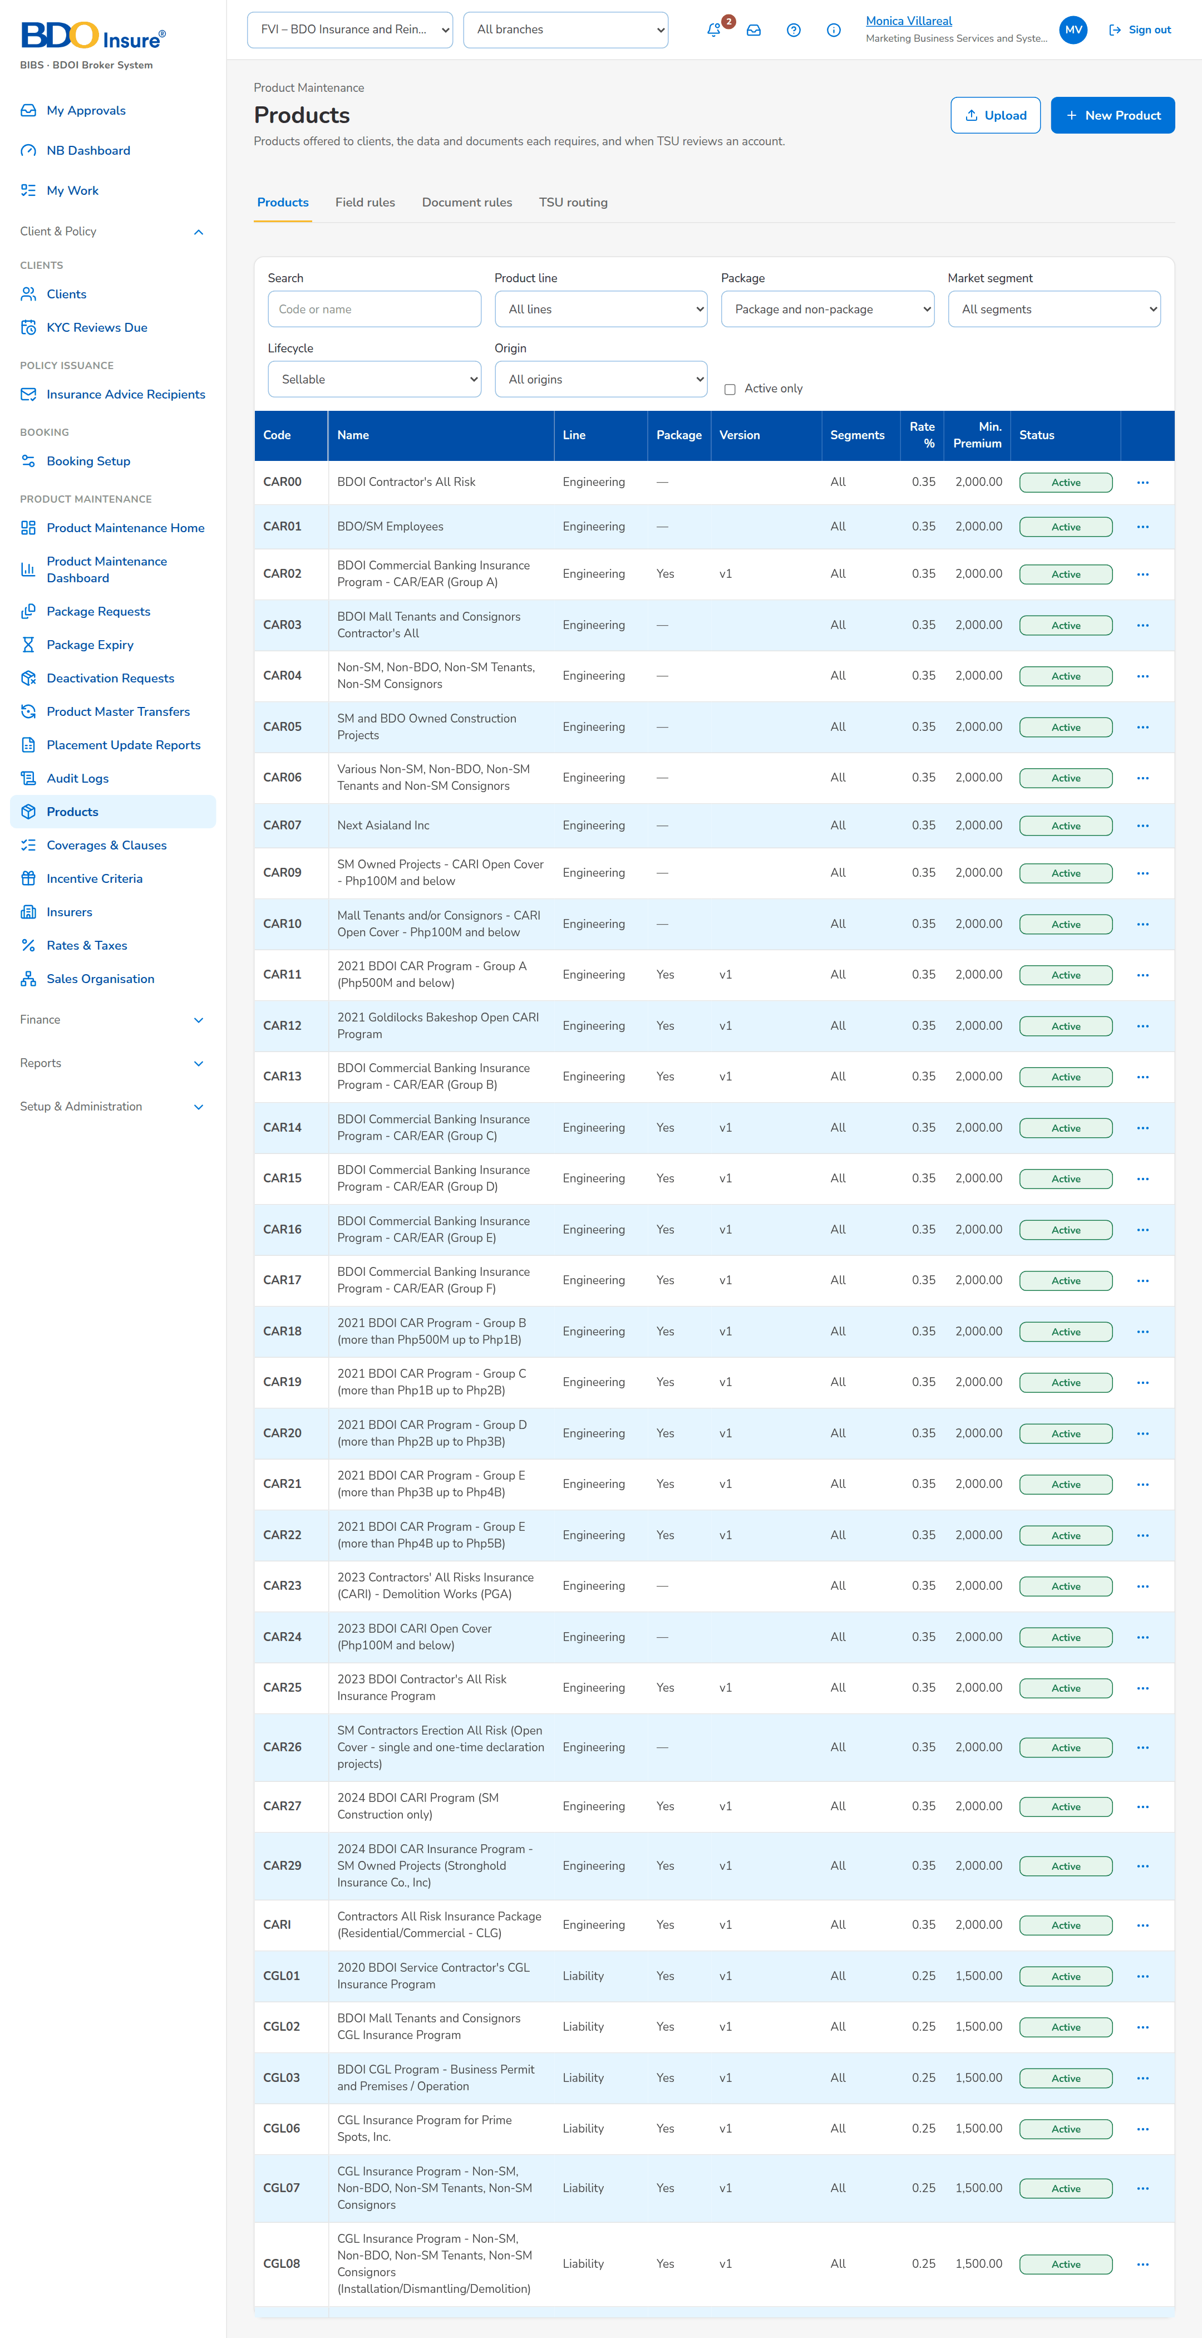
Figure 14: SCR-PM-11 Products (Product Matrix)

SCR-PM-12 Product Record
Item | Value
Purpose | One product: its risk code, lifecycle and authorisation status, package and version flags, line and cover type, current version, rate, package end and TSU review; the tabs Versions (every package version with its status, dates, source request and validator), Features (all product attributes) and Field Rules & Documents (the field matrix and the documents an account needs). MBS creates the next version of a package from here.
Access | Products › a row; Package Version › back arrow; Incentive Criteria (products matrix)
Requirements | FRPM.003.01, FRPM.003.02, FRPM.003.03, FRPM.003.08, FRPM.012.01, FRPM.016.01, FRPM.016.02, FRPM.019.03, FRPM.024.01, FRPM.030.01

Rules and states:
• A non-package product has no versions; it is rated on the product rate (FRPM.003.01).
• The product dialog carries the Product Matrix fields of BDOI's FRS: Policy Type, Insured's Name, Incentive Amount, Incentive Commission Rate (%) and the Approver of the change; a change made directly on the Product Matrix waits for that approval (setting Direct maintenance of the Product Matrix) (FRPM.003.01, FRPM.018.01).
• The Audit Logs of the product list every change with the old and new value, by whom and when (FRPM.021.01).
• A package has at most one version being set up (draft or for validation) at a time (FRPM.016.01, FRPM.003.01).
• Every version is kept: superseded and expired versions stay readable with their validator and source request (FRPM.003.01, FRPM.021.01).
• Field rules of all products, of the line and of the product apply together; the account checks refuse a missing or invalid value (FRPM.003.02).
Table 24: SCR-PM-12 fields
Field | Type | Req. | Format, list or source | Validation and message
Header: Risk code | Reference chip | - | Product code; Product master | -
Header: [Lifecycle and record status pills] | Pill | - | Active, Expired, Retired; Pending Authorization, Active, Inactive; Product master | -
Header: [Package and version tags] | Tag | - | Package; Version n Draft or For validation; Product master | -
Header: Line › Type / Current Version / Rate % / Package End / TSU Review | Fact | - | As in the catalogue; Product master, version in force | -
Versions: Version / Status / Effective From / Effective To / Rate % / Package End / Request / Validated By / Change | Column | - | Newest first; Draft, For validation, Released, Superseded, Expired; Package versions | No version yet.
New Version: What changes | Text | Y | Free text | Not blank; Describe the change
Features: Line / Cover type / Risk items / Rating / Package / Package TSI limit / Fleet / Market segments / Mortgage related / Direct payment allowed / Multi-year / Free First Year / Placement after / Default rate % / Default commission % / Minimum premium / TSU review | Detail | - | As on the product; Product master | -
Field Rules & Documents › Field matrix: Level / Field / Key / Mandatory / Check / From | Column | - | Rules of all products, the line and the product; Field rules | No field rules apply.
Field Rules & Documents: Documents required before submission | List | - | Document types; Document rules | No document is required.
New Rule (field): Applies to | Drop-down | Y | All, Line, Product; Fixed list | Rules for every product use the scope code *; Rules for every product use the scope code '*'
New Rule (field): Level | Drop-down | N | Account or Risk item; Fixed list | -
New Rule (field): Field key / Label | Text | Y | Field key (one of several keys with a vertical bar) and its label | Unique per scope; Minimum-field rule already exists: <key>
New Rule (field): Check | Drop-down | N | Presence only, List of values, Number range, Format (pattern); Fixed list | The parameters of the check are complete; Complete the parameters of the <type> rule
New Rule (field): List of values / Minimum / Maximum / Pattern | Text / Number | Cond.: by check | List code; range; pattern; Lists of values | Known list; valid pattern; Unknown list of values <lov type>
New Rule (document): Document type | Drop-down | Y | Document types; List document type list | Active value
New Rule: Mandatory | Check box | N | - | -
Product dialog: Policy Type / Insured's Name | Drop-down; text | N | Package or non-package policy type; name of the insured of a client-specific package; List of values | -
Product dialog: Incentive Amount / Incentive Commission Rate (%) / Approver | Numbers; look-up | Cond.: Approver for a direct change | Amount in PHP; percentage; name of the approver of the change; Users with the approval right | Amount above zero; rate above 0% and at most 100%
Audit Logs: Timestamp / Action Type / Description / Old Value / New Value / Performed By / Remarks | Table | - | Every change of the product, newest first; CSV and Excel exports; Audit trail | No activity recorded yet.

Table 25: SCR-PM-12 actions
Action | Who | Available when | What happens | Result
Edit | MBS or master data maintainers | Always | Opens the product dialog (as New product, code fixed); Save for Authorization | Pending Authorization
Authorize / Deactivate | As on Products | As on Products | As on Products | Active / Inactive
New Version | MBS | Package product with a version in force and no version being set up | Opens New Version; Create Draft copies the version in force into a new draft effective tomorrow and opens it | Draft version
Add Product Rule | MBS or master data maintainers | Field Rules & Documents tab | Opens New Rule with the scope set to this product; Save for Authorization | Pending Authorization
[Open a version row] | Every user of the screen | Versions tab | Opens the Package Version | -
Deactivate Package | MBS (product maintenance right) | Active package without a deactivation waiting | Opens Deactivate Package (SCR-PM-24): effective date, reason, approver and remarks; Submit for Approval | Pending Approval

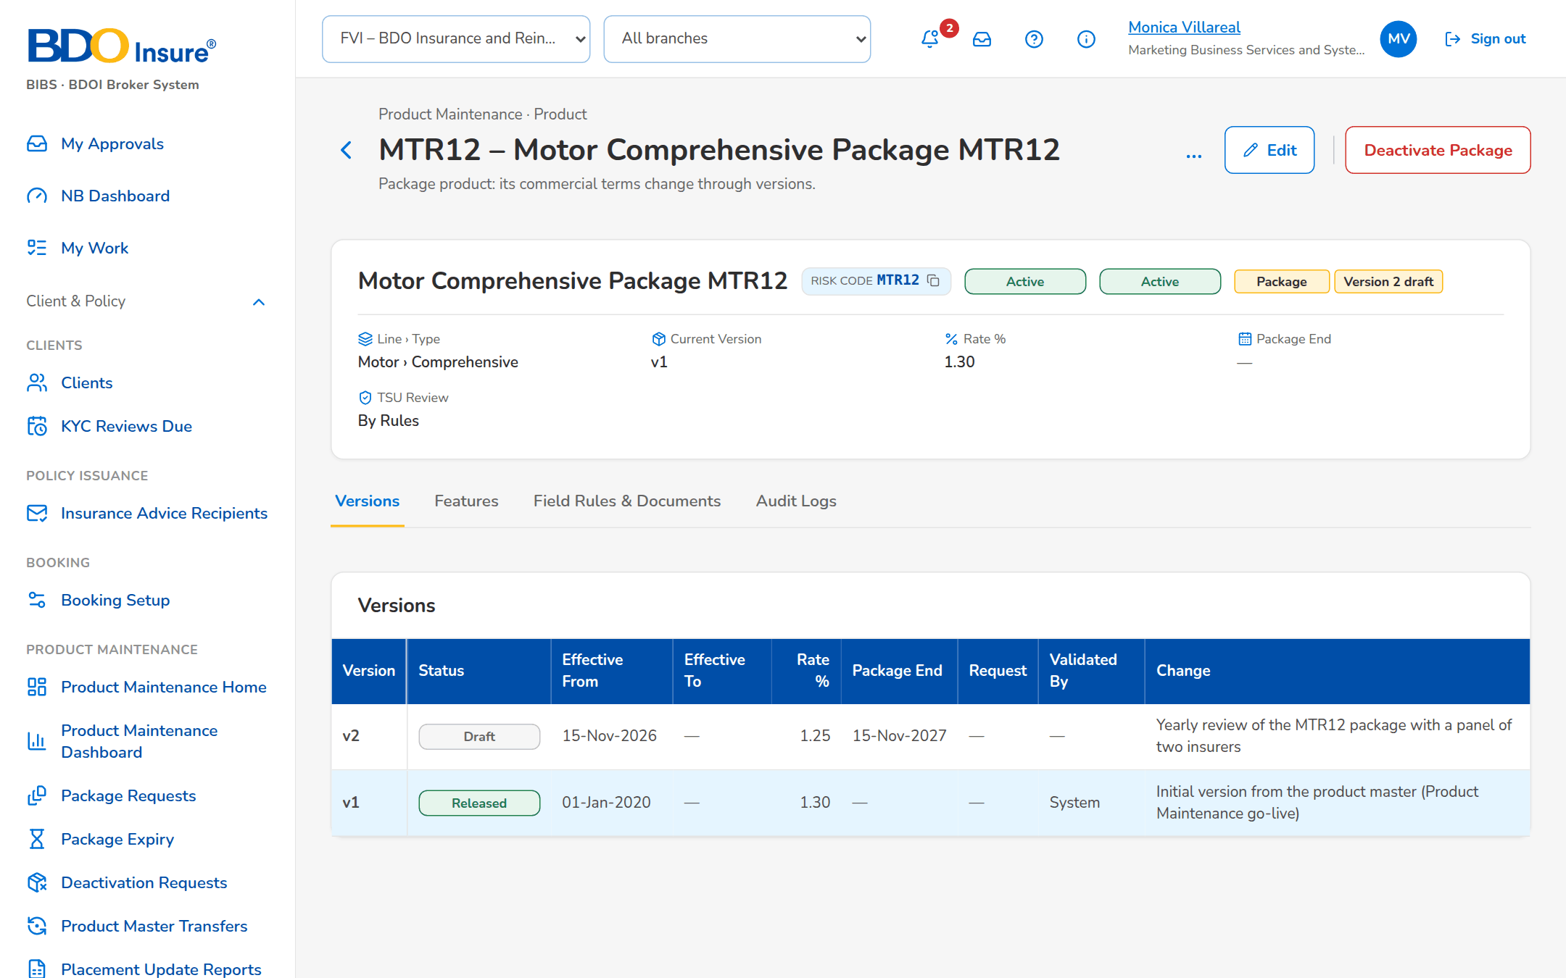
Figure 15: SCR-PM-12 Product record

SCR-PM-13 Package Version
Item | Value
Purpose | One version of a package: the rate scheme, dates and origin, the coverages and perils, the insurers of the panel with their role, share, rate and minimum premium, and the insurer terms per coverage with their clauses. MBS edits a draft and submits it for validation; the validator (TSU Head or Business Administrator, never the maker or submitter) confirms the checklist and releases it, or returns it to MBS with a reason. Released versions are read only and show who validated them.
Access | Product record › Versions tab › a row; Product record › New Version; Package Request record › Set-up tab › Open Version Editor; Validation Queue › a row
Requirements | FRPM.003.01, FRPM.003.02, FRPM.003.03, FRPM.016.01, FRPM.016.02, FRPM.019.03, FRPM.022.02, FRPM.023.01, FRPM.024.01

Rules and states:
• A draft is invisible to rating; only a released version prices new business (FRPM.003.01, FRPM.024.02).
• Submission needs the cover type and at least one included basic coverage, terms for every panel insurer on every included coverage, the package rate or a rate for every insurer, co-insurance shares totalling 100%, an effective date today or later and after the start of the version in force, and a package end after the effective date (FRPM.003.03, FRPM.003.02).
• The validator is never the maker or the submitter of the version; the validator confirms the five checklist items and a test premium is computed (FRPM.003.03).
• At release and at return the system records each check with its result (Passed, Failed or Not Applicable) and the figures compared, with the validator, the time and, for a return, the reason; the Validation card shows them until the version is submitted again (FRPM.003.03).
• The Details of a check name the cover type, the coverages and the insurers by their names; a released version shows its rate scheme, dates and terms as values (amounts with separators, rates with their decimals, a dash when empty, long texts wrapped) (FRPM.003.03, FRPM.003.01).
• On release the previous version ends the day before the new one takes effect and becomes Superseded; a version whose package end has passed without a renewal becomes Expired and the product is no longer sold (FRPM.003.01, FRPM.002.02).
• An insurer's own rate and minimum premium win over the package's; a package with a panel is placed only with its panel insurers (FRPM.003.02, FRPM.024.02).
Table 26: SCR-PM-13 fields
Field | Type | Req. | Format, list or source | Validation and message
Header: Product / Version | Reference chip | - | Risk code; version number; Package version | -
Header: [Version status pill] | Pill | - | Draft, For validation, Released, Superseded, Expired; Package version | -
Header: Effective / Package End / Rate % / Set Up By / ManCom Ref. | Fact | - | Rate % shows Per insurer when every insurer has its own rate; Package version | -
Header: Package Request | Fact | - | PKR-yyyy-nnnnnn of the request that produced the version, a link to the request; Package version | -
Rate Scheme: Package Rate % | Number | Cond.: or a rate for every insurer | Up to four decimals; empty when every insurer has its own rate | 0 to 100; the package rate or a rate for every insurer; Enter a rate between 0 and 100 / Enter the package rate or a rate for every insurer
Rate Scheme: Minimum Premium | Number | Y | Amount in PHP | Zero or more; Enter the minimum premium
Rate Scheme: Commission % | Number | Y | Percentage | 0 to 100; Enter a commission between 0 and 100
Rate Scheme: Package TSI Limit | Number | N | Amount in PHP; above it TSU prices the risk | Zero or more; Enter a positive amount
Dates: Effective From | Date | Y | dd-MMM-yyyy | Today or later; after the start of the version in force; Enter the effective date / The effective date cannot be before today / The effective date must be after the start of version <version no>
Dates: Package Start | Date | N | dd-MMM-yyyy | -
Dates: Package End | Date | N | dd-MMM-yyyy; expiry monitoring | After the effective date; The package end date must be after the effective date
Dates: Anniversary | Date | N | dd-MMM-yyyy | -
Origin: Change Summary | Text | N | Up to 500 characters | -
Origin: ManCom Sign-off Reference | Text | N | MC-PKR-yyyy-nnnnnn; ManCom sign-off | -
Origin: Computation Basis | Text | N | As agreed with the insurers; Proposed terms | -
Coverages: Coverage | Column | Y (at least one included) | Coverage name, with the Basic tag; Coverages of the line | At least one included coverage; a basic coverage; Include at least one coverage / The package needs its cover type and at least one included basic coverage
Coverages: Included / Optional | Check box | N | - | -
Coverages: Limit / Deductible | Number | N | Amounts in PHP | Zero or more
Coverages: Add coverage | Drop-down | N | Active coverages of the line not yet added, (basic) marked; Coverages & Clauses | -
Insurers: Insurer | Column | N | Insurer name; Insurers (authorised, active) | Every insurer with terms is on the package; Insurer <insurer code> has terms but is not on the package
Insurers: Role | Drop-down | Y | Panel, Lead, Participant; Fixed list | -
Insurers: Share % | Number | Cond.: lead and participants | Co-insurance share | 0 to 100; lead and participant shares total 100%; Enter a share between 0 and 100 / The co-insurance shares must add up to 100%
Insurers: Rate % | Number | Cond.: when there is no package rate | Insurer's own rate; wins over the package rate | 0 to 100; Enter a rate between 0 and 100
Insurers: Minimum Premium | Number | N | Insurer's own minimum premium | Zero or more
Insurers: Add insurer | Drop-down | N | Active insurers not yet on the panel; Insurers | -
Insurer Terms: Insurer / Coverage | Column | Y (every pair) | One row per panel insurer and included coverage; Panel and coverages | Every panel insurer has terms for each included coverage; Insurer <insurer code> has no terms for coverage <coverage>
Insurer Terms: Covered | Check box | N | - | -
Insurer Terms: Limit / Deductible / Deductible Wording | Number / Text | N | Amounts in PHP; wording | -
Insurer Terms: Clauses | Multi-select | N | Active clauses of the line or of every line; Clause library | Active clauses
Validation Checklist: Hierarchy complete: cover type and basic coverage / Every panel insurer has terms for each included coverage / Rates and minimum premiums match the signed-off terms / Dates and package term are correct / Test premium reviewed | Check box | Y (all five) | Every item; Fixed checklist | Every item confirmed
Validation: Result / Validated By / Validated On / Test Premium / Return Reason | Fact | - | Passed or Returned pill; validator's name; dd-MMM-yyyy HH:mm; PHP amount; the reason when returned (Returned By / Returned On); Validation checkpoint | -
Validation: # / Check / Result / Details | Table | - | One row per check: hierarchy, insurer terms, co-insurance shares, rates and minimum premiums, dates and package term, test premium; Passed, Failed or Not Applicable with the figures compared (for example 3 of 3 insurers have terms for 2 included coverages); Validation checkpoint | -
Return Version to MBS: Return reason / Comment | Drop-down / Text | Y (reason) | Return reason list; free text; List return reason list | Not blank; Enter the reason of the return

Table 27: SCR-PM-13 actions
Action | Who | Available when | What happens | Result
Save Draft | MBS | Draft | Checks the fields and saves the whole draft | Draft
Submit for Validation | MBS | Draft; no field message | Saves the draft and checks completeness (cover type and basic coverage, insurer terms for every included coverage, shares, rate, dates) | For validation
Validate and Release | TSU Head or Business Administrator, not the maker or the submitter | For validation; every checklist item ticked | Computes the test premium, releases the version and ends the previous version the day before; releases the source request, drafts its advisory and, for a new package, authorises the product | Released
Return to MBS | As Validate and Release | For validation | Opens Return Version n to MBS; Return sends the version back to draft with the reason, and the request back to MBS | Draft

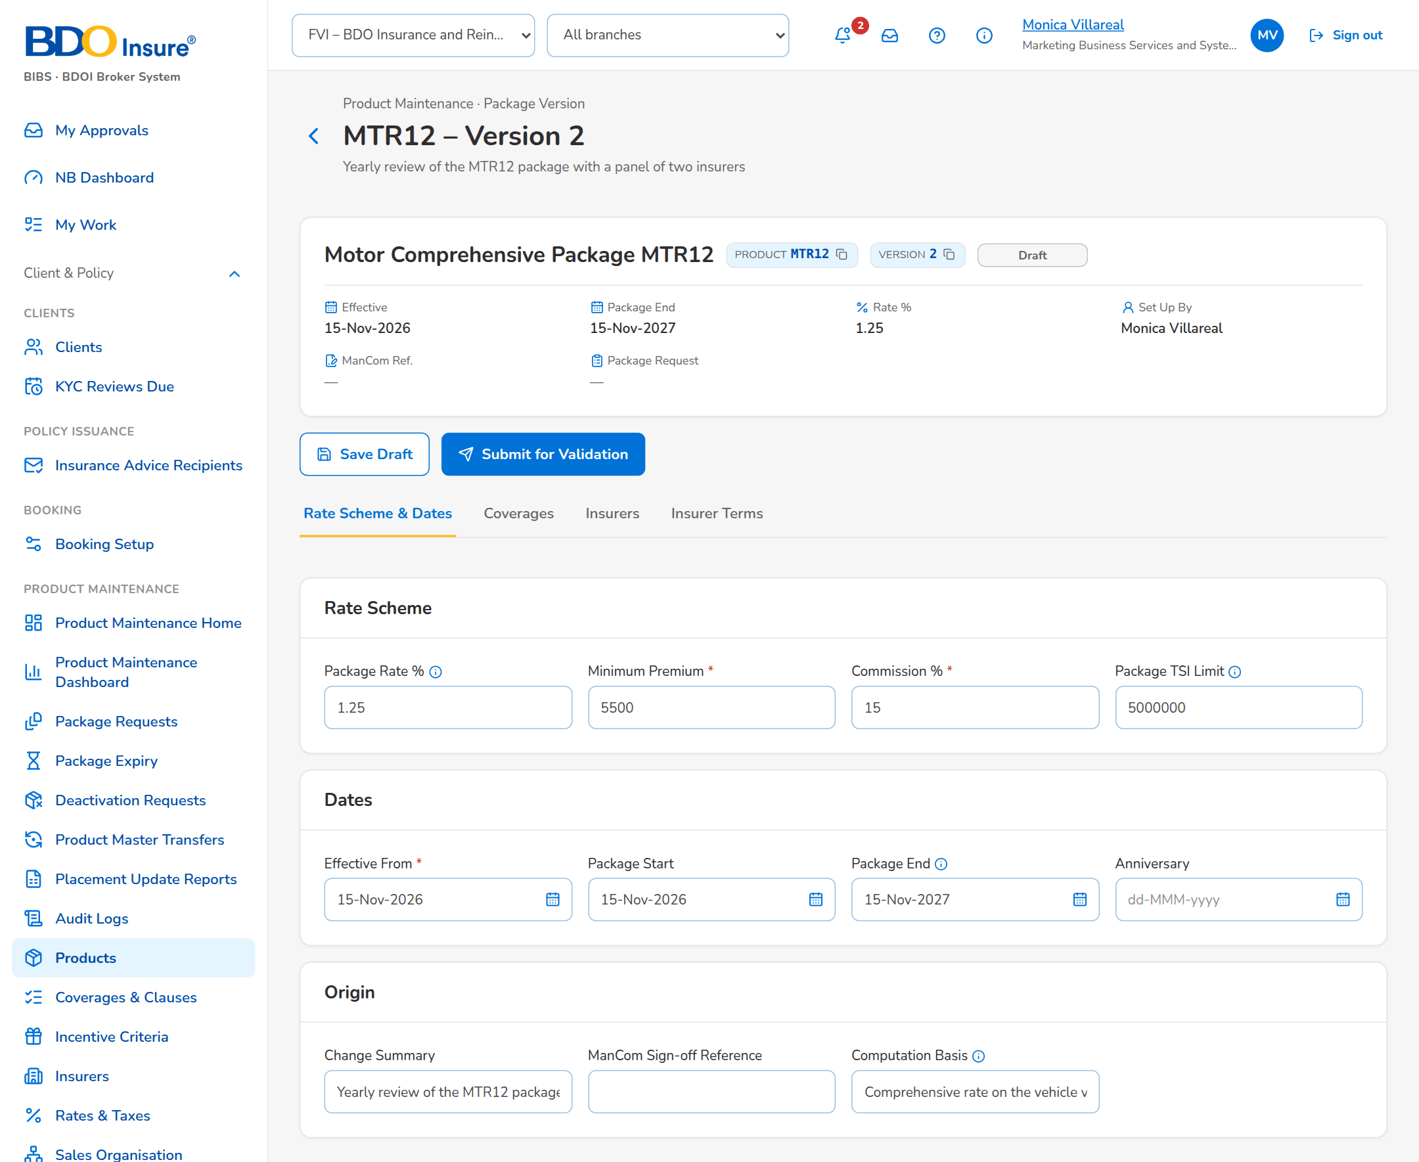
Figure 16: SCR-PM-13 Draft version (MBS)
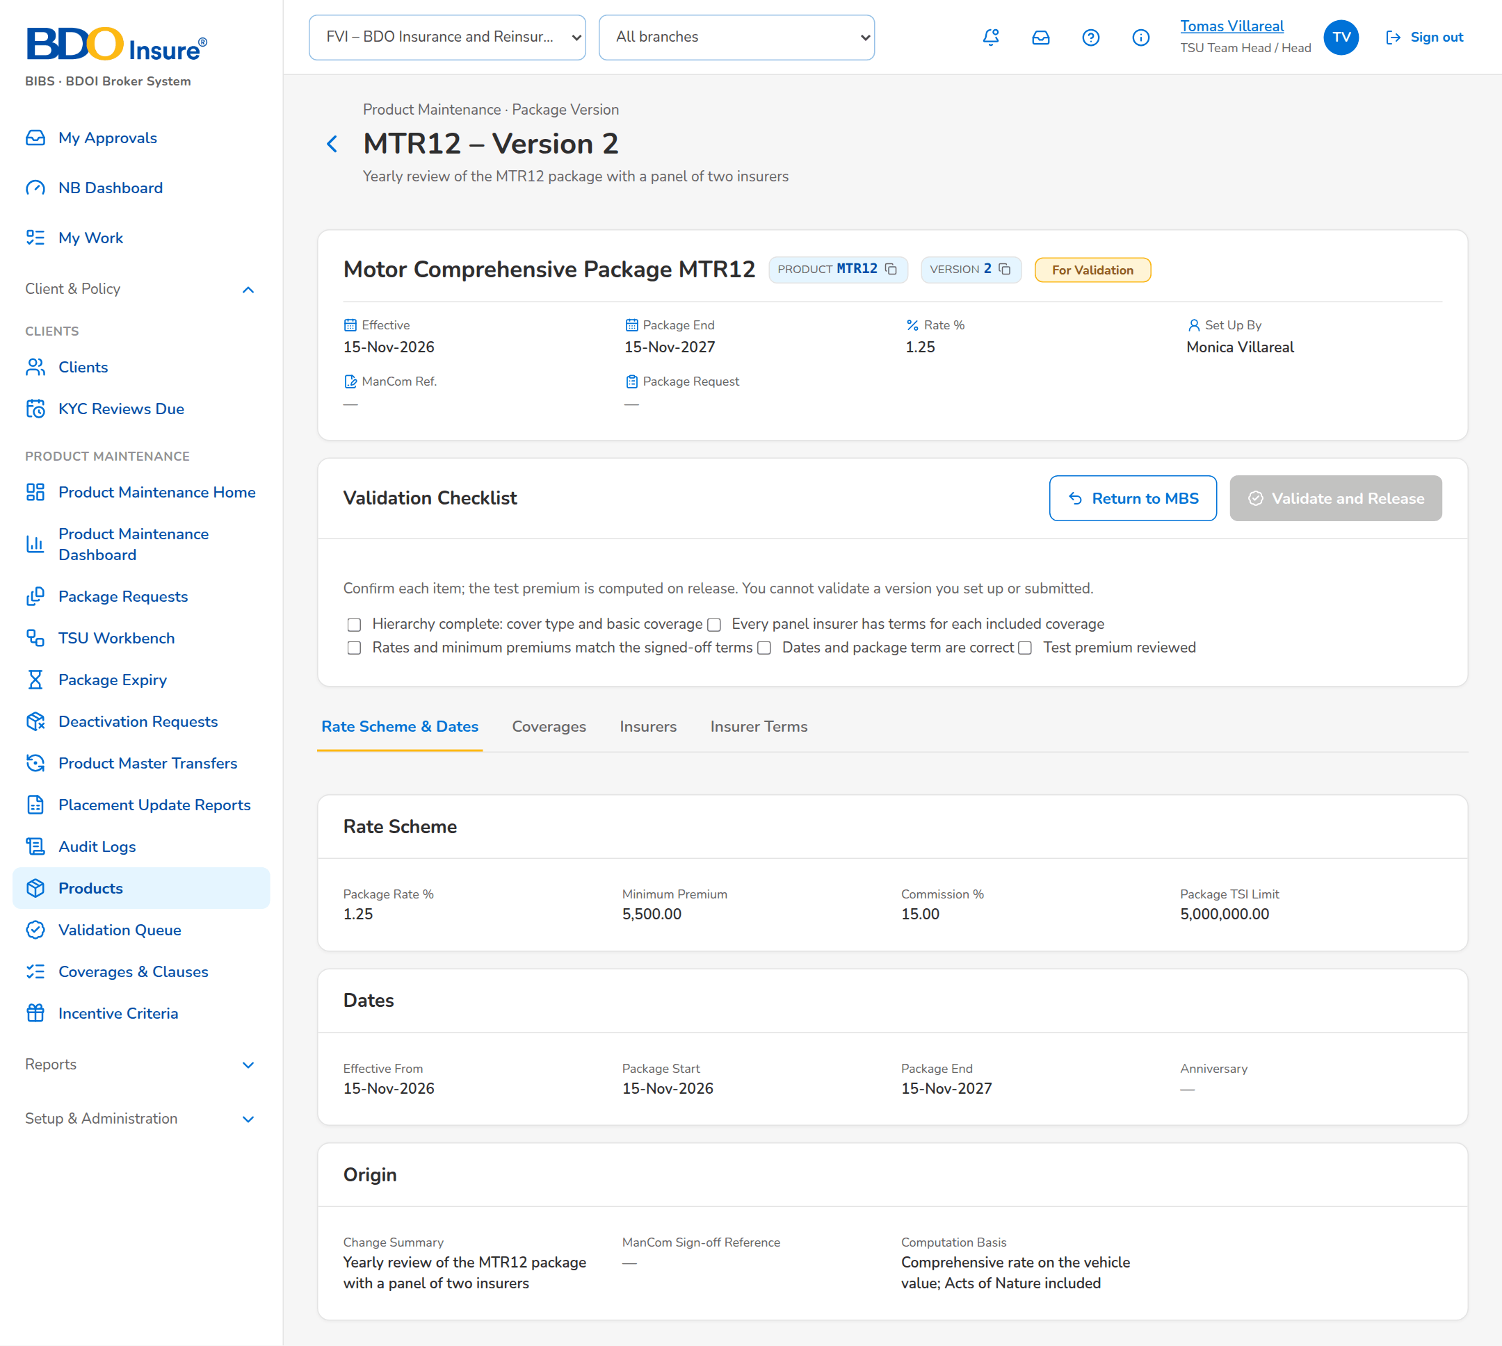
Figure 17: SCR-PM-13 Version for validation (TSU Head)

SCR-PM-14 Validation Queue
Item | Value
Purpose | The package versions submitted by MBS that wait for the post-set-up validation, oldest first, with their age. A row opens the version with its checklist.
Access | Sidebar entry Validation Queue; Product Maintenance Home › Versions for validation
Requirements | FRPM.003.03, FRPM.016.02

Rules and states:
• Only users who validate package versions see the queue; a version they set up or submitted is shown but cannot be validated by them (FRPM.003.03).
Table 28: SCR-PM-14 fields
Field | Type | Req. | Format, list or source | Validation and message
Search: Search Product | Text | N | Code or name | Contains search
List: Product / Name / Version / Status | Column | - | Risk code, product name, v<n>, For validation pill; Package versions | No package version waits for validation.
List: Effective From | Column | - | dd-MMM-yyyy; Package version | -
List: Request | Column | - | PKR-yyyy-nnnnnn; Package version | -
List: Submitted By / Submitted | Column | - | User; dd-MMM-yyyy HH:mm; Package version | -
List: Age (days) | Column | - | Whole days since the submission; Computed | -

Table 29: SCR-PM-14 actions
Action | Who | Available when | What happens | Result
[Open a row] | TSU Head, Business Administrator | Always | Opens the Package Version with the Validation Checklist | -

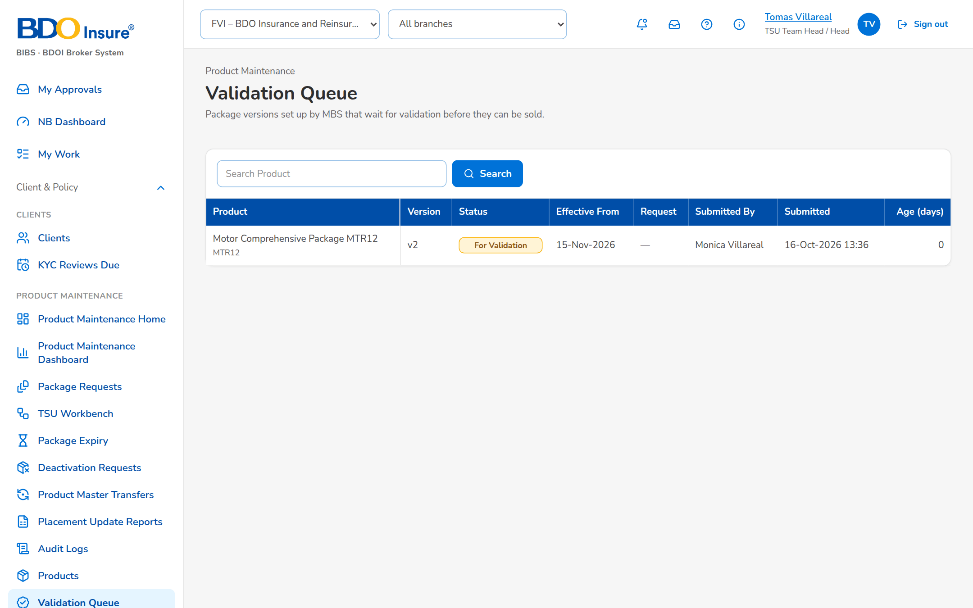
Figure 18: SCR-PM-14 Validation Queue

SCR-PM-15 Coverages & Clauses
Item | Value
Purpose | The coverage and peril level of the product hierarchy, per line, and the clause library (warranties, clauses, exclusions and deductible wordings) that package versions use in their insurer terms. MBS maintains them; a second user authorises them.
Access | Sidebar entry Coverages & Clauses
Requirements | FRPM.003.01, FRPM.003.02, FRPM.022.01, FRPM.022.02

Rules and states:
• The hierarchy is line, cover type with at most one subtype level, product, and coverage or peril of the line (FRPM.003.01).
• A package version offers only the active coverages of its line and the active clauses of its line or of every line (FRPM.003.01, FRPM.022.02).
• Coverages and clauses are maker-checker and never deleted (FRPM.022.02).
Table 30: SCR-PM-15 fields
Field | Type | Req. | Format, list or source | Validation and message
Tabs: Coverages & Perils / Clause Library | Tab | - | Fixed | -
Coverages & Perils: Product line | Drop-down | N | All lines or one line; Product lines | -
Coverages & Perils: Line / Code / Name / Kind / Basic / Status | Column | - | Coverage of the line; Basic Yes; Coverages | No coverage is set up for this line.
Clause Library: Code / Kind / Title / Line / Effective / Until / Status | Column | - | Line or All lines; dd-MMM-yyyy; Clauses | The clause library is empty.
New Coverage: Product line | Drop-down | Y | Line name; Product lines | Select the product line
New Coverage: Code | Text | Y | A-Z, 0-9 and _ | Unique per line; Use A-Z, 0-9 and _
New Coverage: Name | Text | Y | Free text | Not blank; Enter the name
New Coverage: Kind | Drop-down | Y | Coverage kinds; List coverage kind list | Active value; Select the kind
New Coverage: Display order | Number | N | Whole number | -
New Coverage: Basic coverage | Check box | N | - | -
New Clause: Code | Text | Y | A-Z, 0-9 and _ | Unique; Use A-Z, 0-9 and _
New Clause: Kind | Drop-down | Y | Clause kinds; List clause kind list | Active value; Select the kind
New Clause: Product line | Drop-down | N | Every line or one line; Product lines | -
New Clause: Title | Text | Y | Free text | Not blank; Enter the title
New Clause: Effective from / Effective to | Date | Y (from) | dd-MMM-yyyy | To on or after from; Enter the effective date / The end is before the start
New Clause: Wording | Text | Y | Full wording | Not blank; Enter the wording

Table 31: SCR-PM-15 actions
Action | Who | Available when | What happens | Result
New Coverage / New Clause | MBS | Tab of the kind | Opens the dialog; Save for Authorization saves it pending authorisation | Pending Authorization
[Open a row] | MBS | Always | Opens the coverage or clause for change (code fixed) | Pending Authorization
Authorize | authorizers (Business Administrator, New Business Approver), not the maker | Pending row | From the row action menu, after the confirmation: authorises the coverage or clause | Active
Deactivate | MBS | Active row | From the row action menu (last, in red); asks the reason, kept in the audit trail, and ends its use; versions already released keep it | Inactive

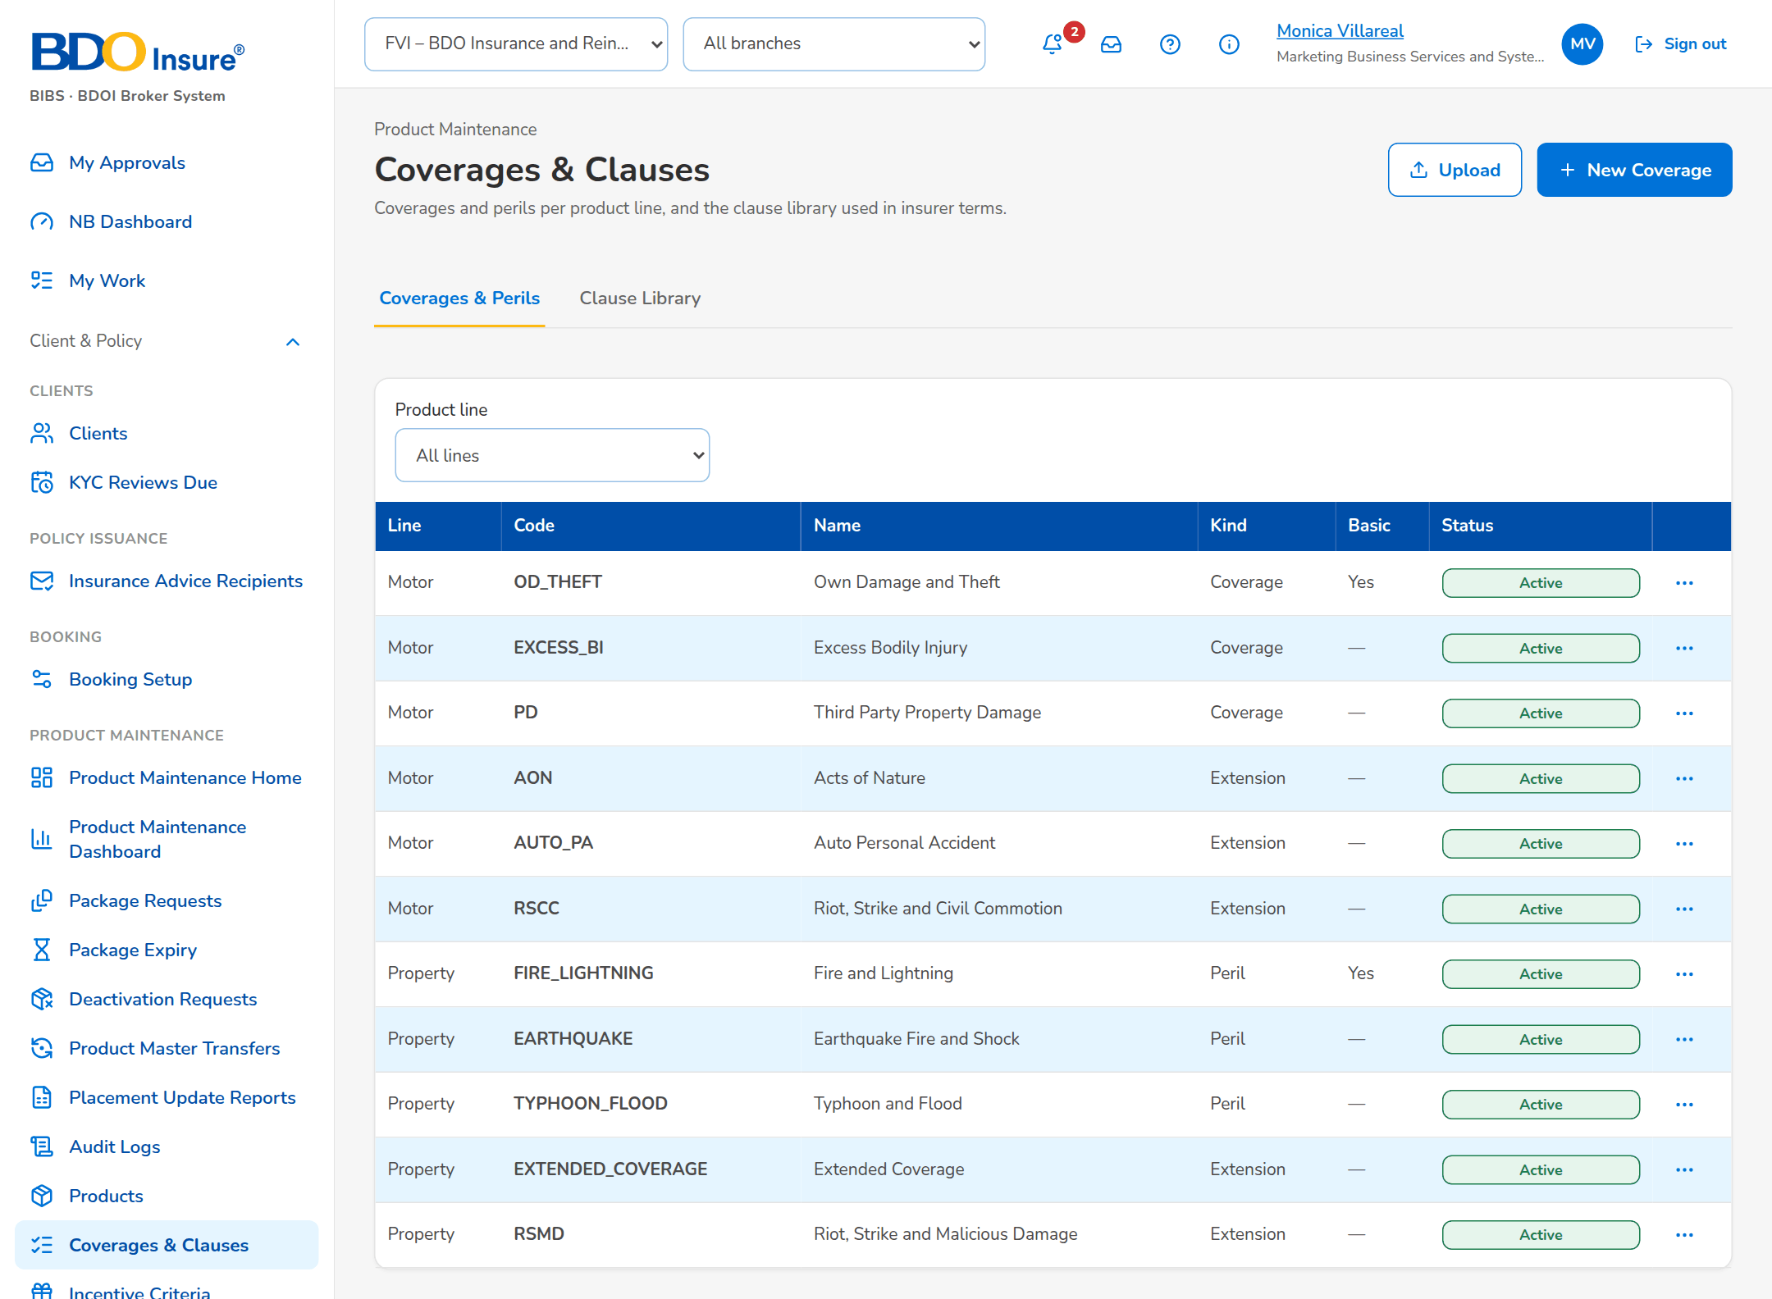
Figure 19: SCR-PM-15 Coverages
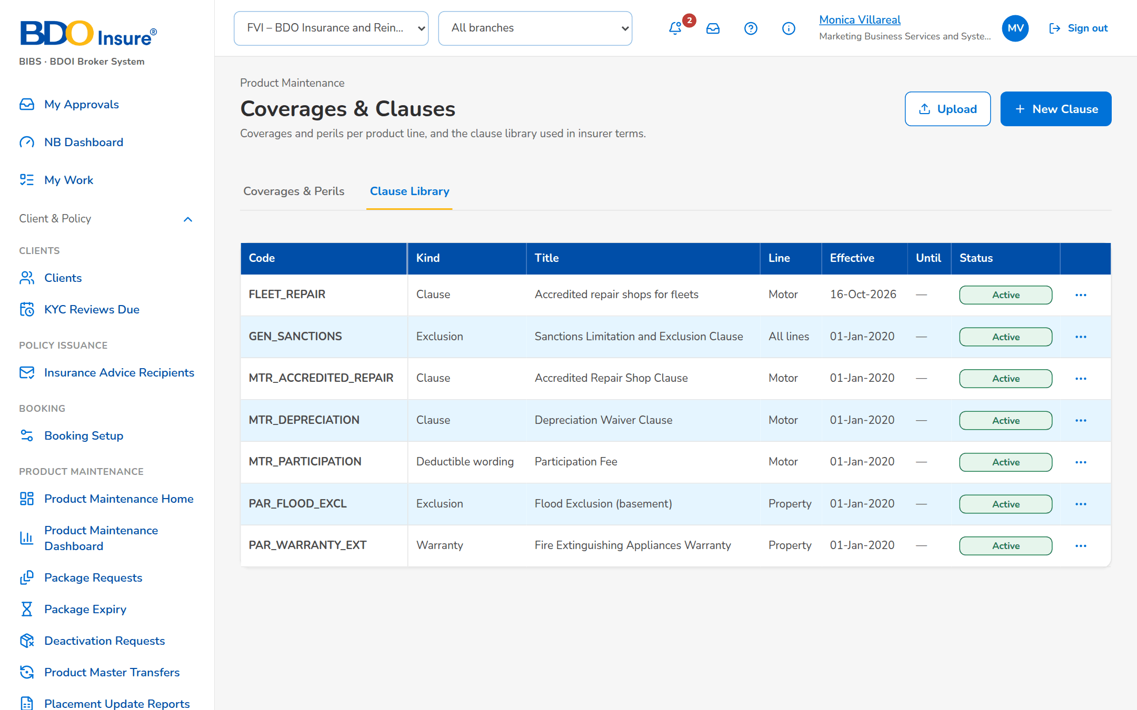
Figure 20: SCR-PM-15 Clause Library

SCR-PM-16 Incentive Criteria
Item | Value
Purpose | Incentive criteria, such as CPC2, on the products matrix: their value (rate, fixed amount or rule), the products and segments they apply to, and their effective dates. An active criterion is changed by an amendment that starts later and is deactivated, never deleted. Booking stamps on each invoice the criteria it matches.
Access | Sidebar entry Incentive Criteria; The incentive alert when a product of a criterion expires or is retired
Requirements | FRPM.018.01, FRPM.018.02

Rules and states:
• A criterion names at least one active product of the matrix; a product that expires or is retired raises an alert to review or deactivate the criterion (FRPM.018.01, FRPM.018.02).
• An active criterion is changed only by an amendment starting after it; the active row ends when the amendment is authorised, so there is never a gap or an overlap (FRPM.018.01).
• At booking, the invoice stores the codes of the criteria that match its product, cover type, segment, channel, lead insurer and booking date (FRPM.018.02).
Table 32: SCR-PM-16 fields
Field | Type | Req. | Format, list or source | Validation and message
Tabs: Current / Pending Authorization / History | Tab | - | Fixed | Current = active and not ended; History = ended, replaced or inactive
Search: Search Criterion or Product | Text | N | Code of a criterion or a product | Contains search
List: Code / Name / Type / Value / Products / From / Until / Status | Column | - | Value as n%, an amount, or Rule; Incentive criteria | No incentive criterion in this list.
New Incentive Criterion: Code | Text | Y | A-Z, 0-9, _ and - | Unique; Use A-Z, 0-9, _ and -
New Incentive Criterion: Name | Text | Y | Up to 150 characters | Not blank; Enter the name
New Incentive Criterion: Incentive type | Drop-down | Y | Incentive types; List incentive type list | Active value; Select the type
New Incentive Criterion: Value basis | Drop-down | Y | Rate (%), Fixed amount, Rule (parameters); Fixed list | -
New Incentive Criterion: Value | Number | Cond.: rate or fixed amount | Rate 0 to 100 or an amount | Zero or more; a rate up to 100; Enter the value / A rate is between 0 and 100
New Incentive Criterion: Effective from | Date | Y | dd-MMM-yyyy | An amendment starts after the active row; no overlap with another row of the code; Enter the start date / The change must start after <active from> / Criterion <code> already covers part of this period
New Incentive Criterion: Effective to | Date | N | dd-MMM-yyyy | On or after the start; The end is before the start
New Incentive Criterion: Rule Parameters | Rows: parameter and value | N (a value per row) | Parameter from the parameters of the incentive type (Minimum Gross Premium); value as the parameter asks (an amount); Rule parameters of the incentive type | Each parameter once; a value for each parameter; a number, zero or more; Select the parameter / <parameter> is listed twice / Enter a value for each parameter / <parameter> must be a number / <parameter> cannot be negative
New Incentive Criterion: Description | Text | N | Free text | -
New Incentive Criterion: Products matrix | Drop-down and rows | Y (at least one) | Active product, with a segment per product (Any segment); Active products; list market segment list | Active products only; Select at least one product of the matrix

Table 33: SCR-PM-16 actions
Action | Who | Available when | What happens | Result
Add Incentive Criterion | MBS | Always | Opens New Incentive Criterion; Save for Authorization | Pending Authorization
[Open a row] | MBS | Row not inactive | Opens Change <code> (pending row) or Amend <code> (active row: a successor from a later date) | Pending Authorization
Authorize | authorizers (Business Administrator, New Business Approver), not the maker | Pending row | From the row action menu, after the confirmation: authorises the criterion; an authorised amendment ends the active row the day before it starts | Active
Deactivate | MBS | Active row | From the row action menu (last, in red); asks the reason, kept in the audit trail, and ends the criterion; its history stays | Inactive

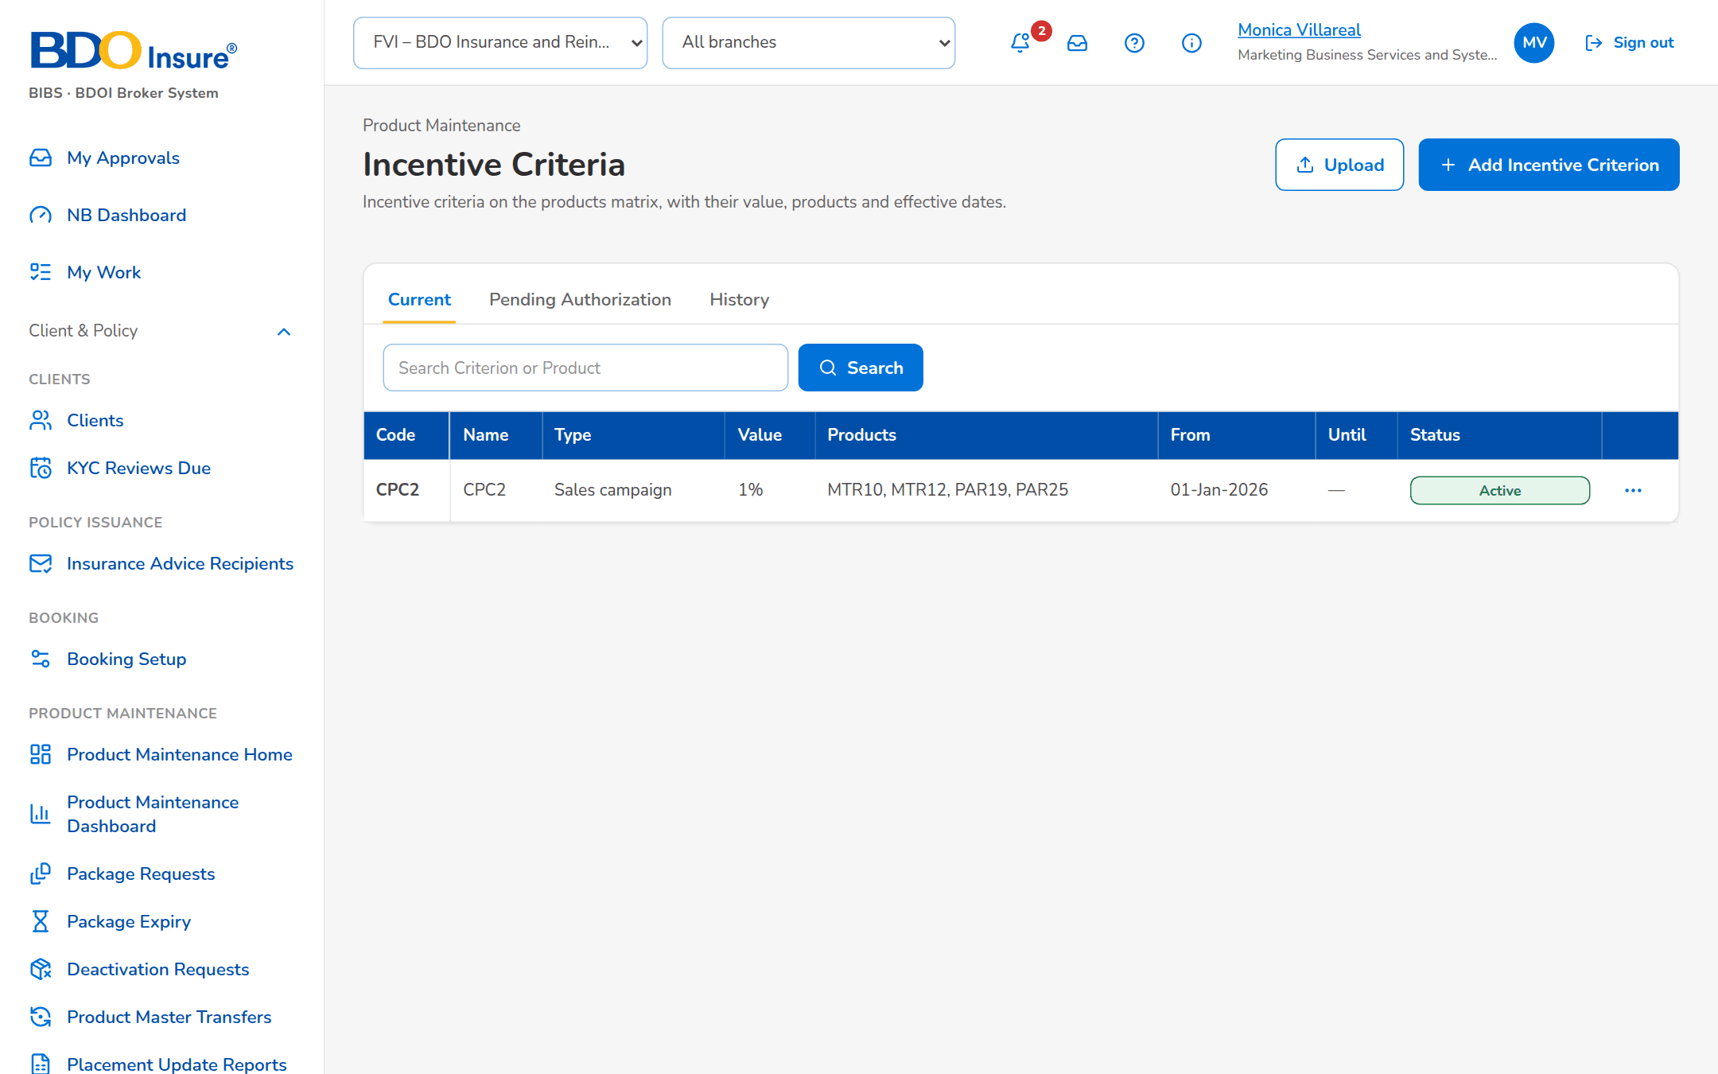
Figure 21: SCR-PM-16 Incentive Criteria

SCR-PM-17 Insurers
Item | Value
Purpose | The insurer panel of the company: each accredited insurer with its accreditation date, placement channel and placement e-mails, and its credit days. Package versions, quotation slips and placement use this panel. A new insurer also creates its business partner for the ledger; both are authorised together.
Access | Sidebar entry Insurers
Requirements | FRPM.003.02, FRPM.023.01, FRPM.023.02, FRPM.021.03

Rules and states:
• Only authorised, active insurers are offered in package requests, package versions and quotation slips (FRPM.003.02, FRPM.012.01).
• The insurer master is maintained under New Business rules (BRD-1, insurer panel); Product Maintenance uses it for the package panels (FRPM.003.02).
Table 34: SCR-PM-17 fields
Field | Type | Req. | Format, list or source | Validation and message
List: Code | Column | - | Partner code INS-...; Insurer master | No insurer on the panel yet.
List: Name | Column | - | Registered name; Insurer master | -
List: Accredited Until | Column | - | dd-MMM-yyyy; (expired) in red once past; Insurer master | -
List: Placement / Placement e-mails | Column | - | E-mail; addresses; Insurer master | -
List: Credit Days | Column | - | Days; Insurer master | -
List: Status | Column | - | Pending Authorization, Active, Inactive; Insurer master | -
New insurer: Partner code | Text | Y | INS- followed by capitals | Unique; an existing party must be an insurer; Party <party code> exists and is not an insurer
New insurer: Name / Short name | Text | Y (name) | Registered and short name | -
New insurer: IC accreditation no. / Accredited until | Text / Date | N | Insurance Commission accreditation; dd-MMM-yyyy | -
New insurer: Placement channel | Drop-down | Y | E-mail; Fixed list | Only e-mail placement is available; Only e-mail placement is available; choose the e-mail placement channel
New insurer: Placement e-mails | Text | N (needed to send quotation slips and placement slips) | Addresses separated by commas | <name> has no placement e-mail address
New insurer: Credit days | Number | N | 0 to 365 | 0 to 365; Default credit days must be between 0 and 365
New insurer: TIN / Address / E-mail / Phone | Text | N | Business partner details | -

Table 35: SCR-PM-17 actions
Action | Who | Available when | What happens | Result
New Insurer | master data maintainers (Business Administrator) | Always | Opens New insurer; Save for Authorization | Pending Authorization
Authorize | authorizers, not the maker | Pending row | From the row action menu, after the confirmation: authorises the insurer and its business partner | Active
Deactivate | master data maintainers | Active row | From the row action menu (last, in red); asks the reason, kept in the audit trail; the insurer is no longer offered | Inactive
[Open a row] | Every user of the screen | Always | Opens the insurer record | -

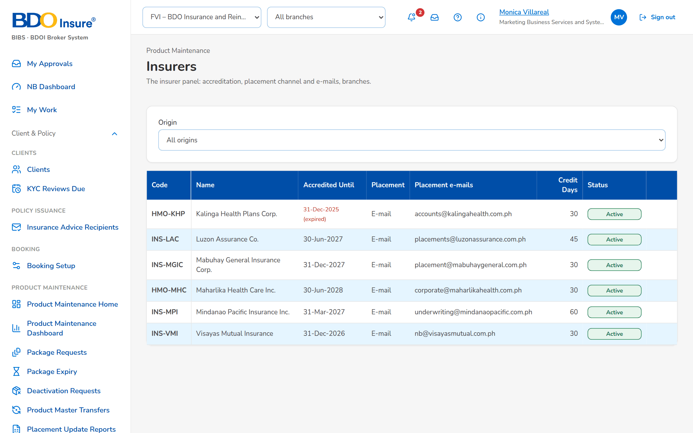
Figure 22: SCR-PM-17 Insurers

SCR-PM-18 Insurer Record
Item | Value
Purpose | One insurer, in tabs: its profile (partner code, accreditation, placement channel and e-mails, credit days, maker and authoriser), contact persons, payment terms and remittance details, bank accounts, the products linked, its ledger accounts (read-only), its branches with the local government tax rate and its commission rates, and the field-level change history.
Access | Insurers › a row
Requirements | FRPM.003.02, FRPM.023.01, FRPM.023.02, FRPM.021.03

Rules and states:
• The commission rate in force on the account's period start applies; without an insurer rate, the product default applies (FRPM.003.02).
• A package version's own insurer rate and minimum premium win over the insurer's general terms for that package (FRPM.003.02).
Table 36: SCR-PM-18 fields
Field | Type | Req. | Format, list or source | Validation and message
Profile: Partner code / Short name / IC accreditation / Accredited until / Placement channel / Placement e-mails / Credit days / Maker / Authorized by | Detail | - | As entered; Insurer master | -
Contacts: Handles / Name / Position / E-mail / Phone / Status | Column | - | Contact persons of the insurer; Insurer contacts | No contact recorded.
Payment & Remittance: Payment terms / Credit days / Remittance cycle / Remittance mode / Remittance advice e-mail / Remittance currency | Detail | - | Cycle: Daily, Weekly, Twice a month, Monthly; Mode: Check, Fund transfer, Online banking | -
Bank Accounts: Purpose / Bank / Branch / Account number / Account name / Currency / Primary / Status | Column | - | Purpose: Premium remittance, Refunds, Commissions; Insurer bank accounts | No bank account recorded.
Products: Product / Role / Latest version / Own commission rate | Column | - | Package versions naming the insurer and product commission rates | No product is linked to this insurer.
Ledger Accounts: Account / Name / Class / Sub-ledger / Entries / Debit / Credit / Balance / Last entry; Sub-ledger open items: Document type / Direction / Currency / Status / Items / Amount / Settled / Outstanding | Column | - | Read-only; general ledger entries and sub-ledger open items of the insurer as party | No ledger entry posted for this insurer.
Change History: Field / Old value / New value / Maker / Changed / Checker / Authorized | Column | - | Master change log, latest first | No change recorded yet.
Branches: Code / Name / City / LGT % / Placement e-mail / Status | Column | - | Branch of the insurer; Insurer branches | No branch recorded.
Commission rates: Product / Commission % / From / To / Status | Column | - | All products or one product; To shows Open; Commission rates | No commission rate: the product default applies.
New Branch: Code / Name | Text | Y | Branch code and name | Unique per insurer; Insurer branch already exists: <key>
New Branch: City | Text | N | Free text | -
New Branch: LGT % | Number | Y | Local government tax on premium, up to four decimals | 0 to 100; The LGT rate must be between 0 and 100 %
New Branch: Placement e-mail | Text | N | Address | -
New Commission Rate: Product | Drop-down | N | All products of the insurer or one active product; Active products | -
New Commission Rate: Commission % | Number | Y | Percentage | 0 to 100; The commission rate must be a percentage between 0 and 100
New Commission Rate: Effective from / Effective to | Date | Y (from) | dd-MMM-yyyy | To on or after from; Enter the effective-from date / The effective-to date is before the effective-from date

Table 37: SCR-PM-18 actions
Action | Who | Available when | What happens | Result
Edit | master data maintainers | Always | Opens the insurer dialog (partner code fixed); Save for Authorization | Pending Authorization
Add branch | master data maintainers | Always | Opens New Branch; Save for Authorization | Pending Authorization
Add rate | master data maintainers | Always | Opens New Commission Rate; Save for Authorization | Pending Authorization
Authorize / Deactivate | As on Insurers | As on Insurers | As on Insurers | Active / Inactive

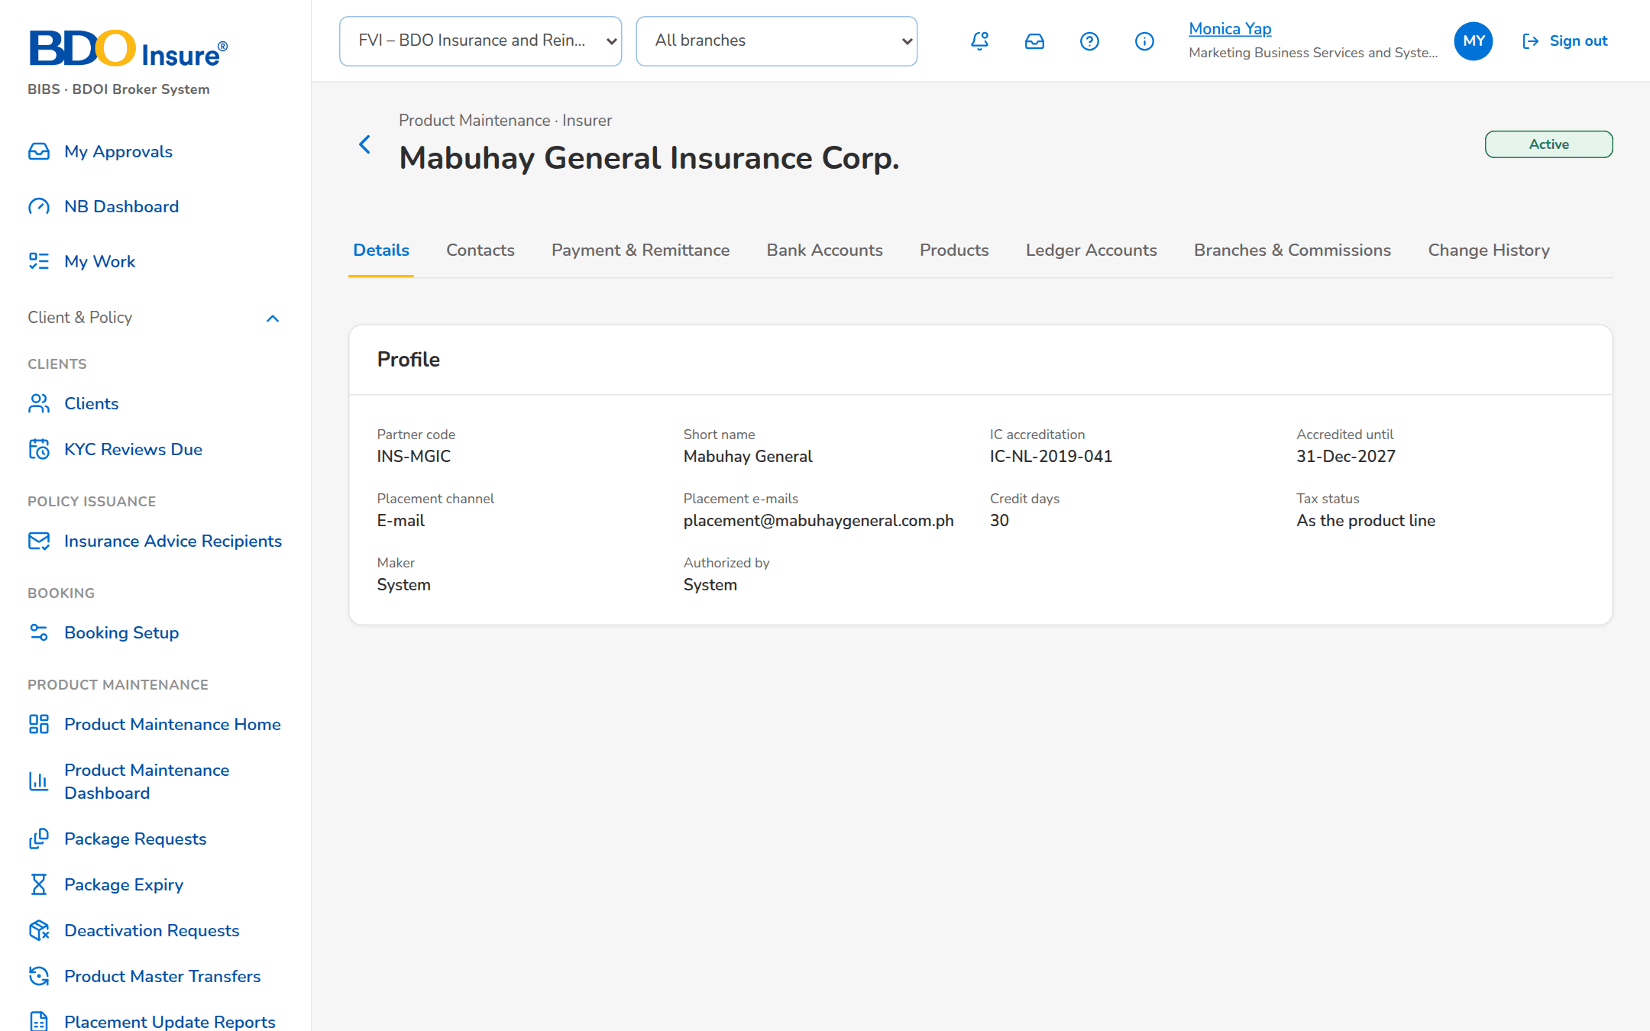
Figure 23: SCR-PM-18 Insurer record
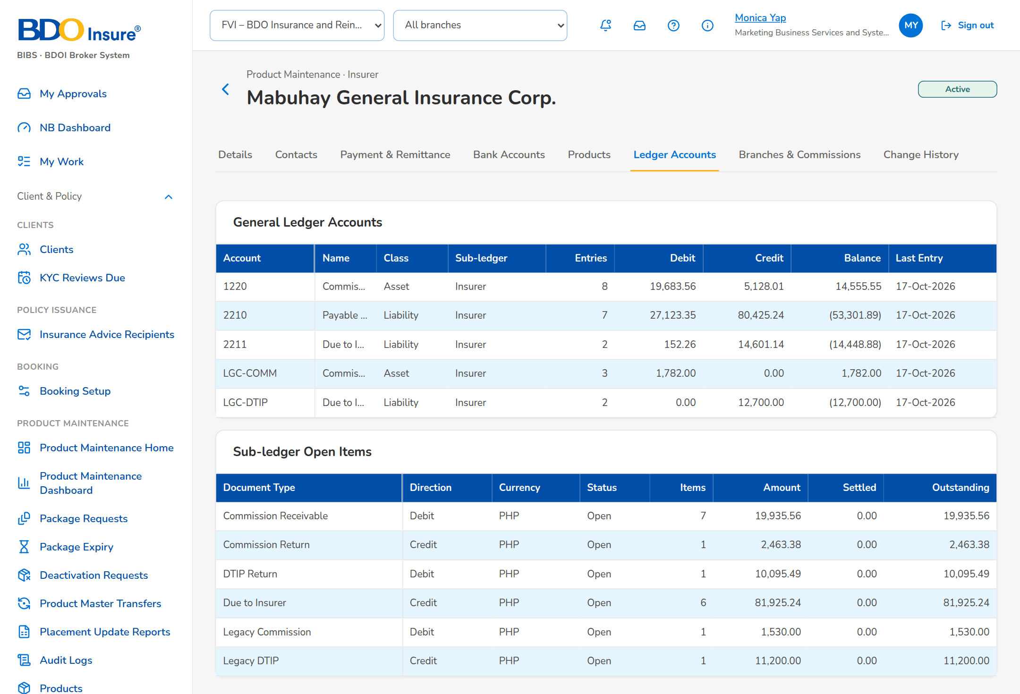
Figure 24: SCR-PM-18 Insurer record, Ledger Accounts tab
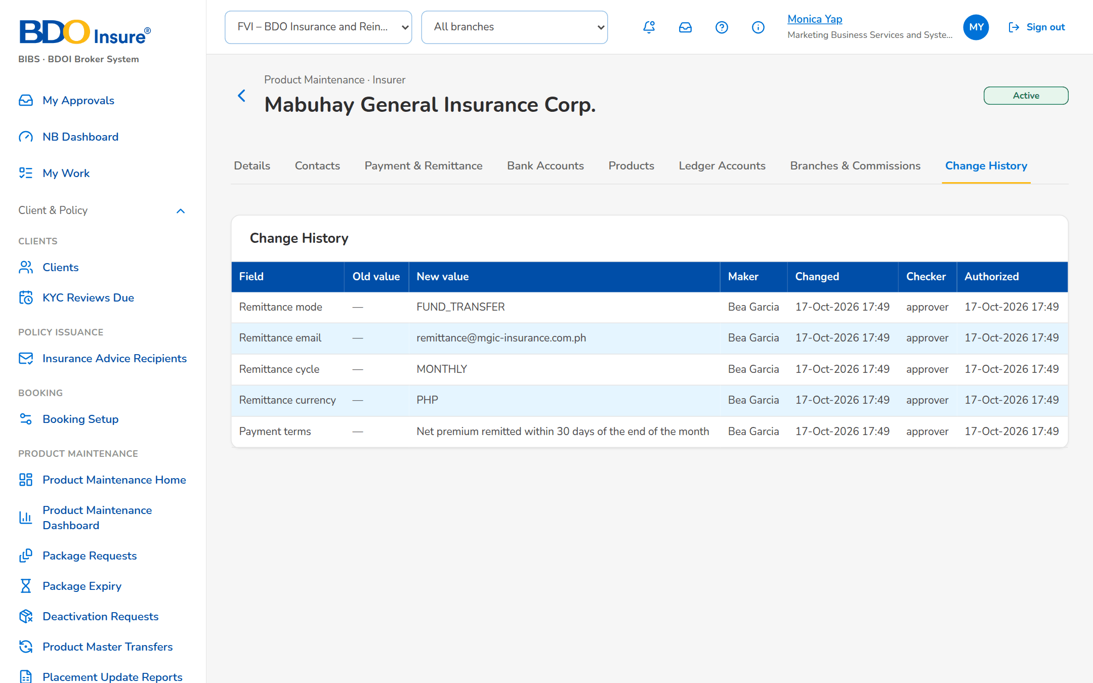
Figure 25: SCR-PM-18 Insurer record, Change History tab
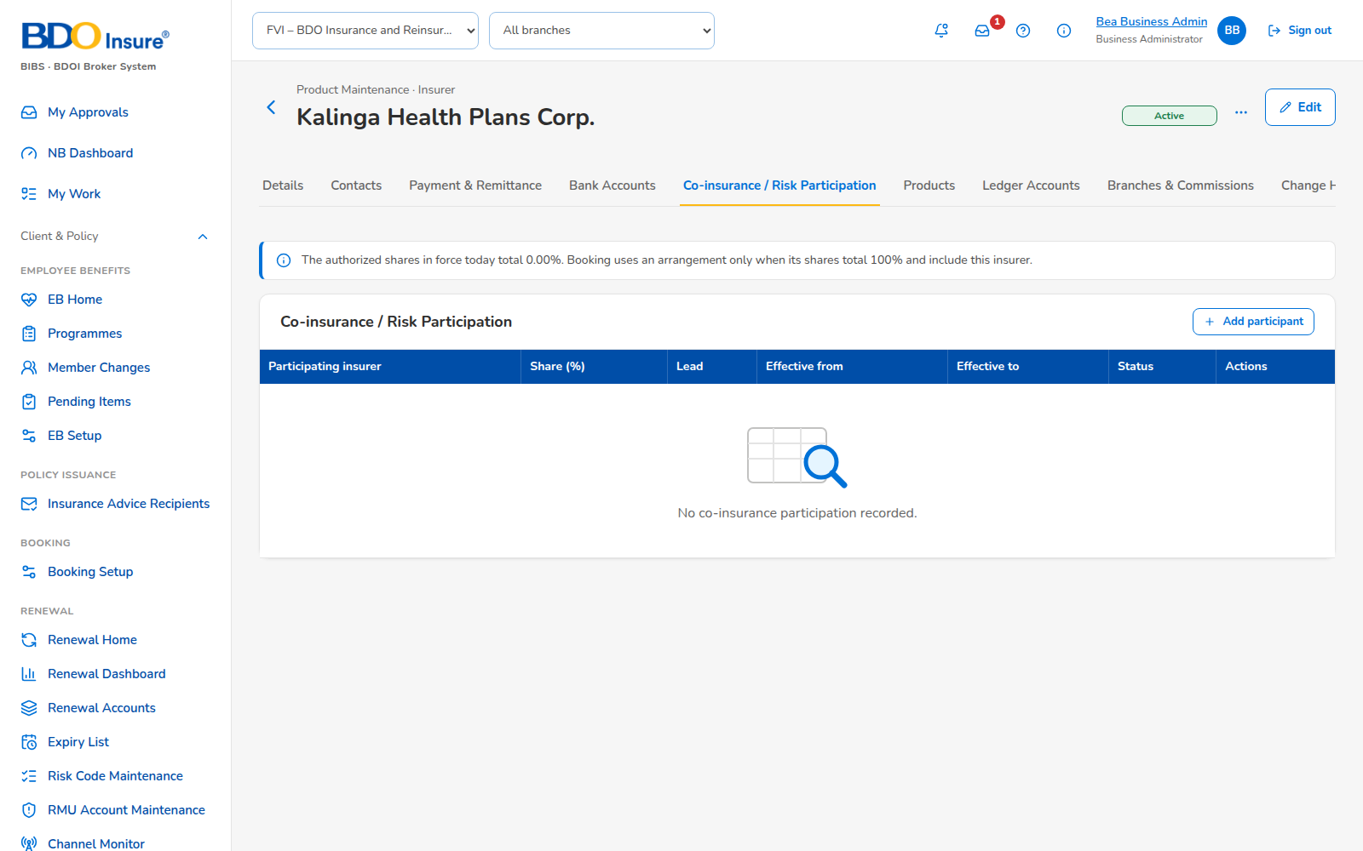
Figure 26: SCR-PM-18 Insurer record, Co-insurance / Risk Participation tab

SCR-PM-19 Rates & Taxes
Item | Value
Purpose | The statutory charges and rating tables applied by the premium calculation: documentary stamp tax, premium tax, VAT, fire service tax and the motor own-damage factors; the short-period table; and the bodily injury and property damage limit premiums. Every row is effective-dated and maker-checker.
Access | Sidebar entry Rates & Taxes
Requirements | FRPM.024.02

Rules and states:
• The row in force on the rating date applies; statutory rates keep their effective-date look-up and do not follow the package version (FRPM.024.02).
• A period without a short-period row, or a motor limit not in the table, is refused at rating (FRPM.024.02).
Table 38: SCR-PM-19 fields
Field | Type | Req. | Format, list or source | Validation and message
Tabs: Taxes & factors / Short-period table / BI / PD limits | Tab | - | Fixed | -
Taxes & factors: Rate / Line / % / From / To / Status | Column | - | Rate name; All lines or a line; percentage; dd-MMM-yyyy; Open; Rate table | -
Short-period table: Months Covered (up To) / % of Annual Premium / From / To / Status | Column | - | Months 1 to 12; percentage; Short-period table | -
BI / PD limits: Coverage / Limit / Premium / From / To / Status | Column | - | Bodily injury or Property damage; amounts; Motor limit table | -
New rate: Rate | Drop-down | Y | DST, premium tax, VAT, fire service tax and the motor factors; Fixed list | -
New rate: Line code | Text | N | Blank = every line; Product lines | -
New rate: Rate % / % of annual premium | Number | Y | Percentage, up to four decimals | 0 to 100; The rate must be a percentage between 0 and 100 / The short-period percentage must be a percentage between 0 and 100
New rate: Months covered | Number | Y (short-period table) | 1 to 12 | 1 to 12; Months covered must be between 1 and 12
New rate: Coverage / Limit / Premium | Drop-down / Number | Y (limit table) | Bodily injury (BI) or Property damage (PD); amounts; Fixed list | Limit greater than zero; premium zero or more; The limit must be greater than zero / The premium cannot be negative
New rate: Effective from / Effective to | Date | Y (from) | dd-MMM-yyyy | To on or after from; Enter the effective-from date / The effective-to date is before the effective-from date

Table 39: SCR-PM-19 actions
Action | Who | Available when | What happens | Result
New Rate | master data maintainers (Business Administrator) | Always | Opens the dialog of the current tab; Save for Authorization | Pending Authorization
Authorize / Deactivate | authorizers / master data maintainers | As on Insurers | Authorises the row or ends its use | Active / Inactive

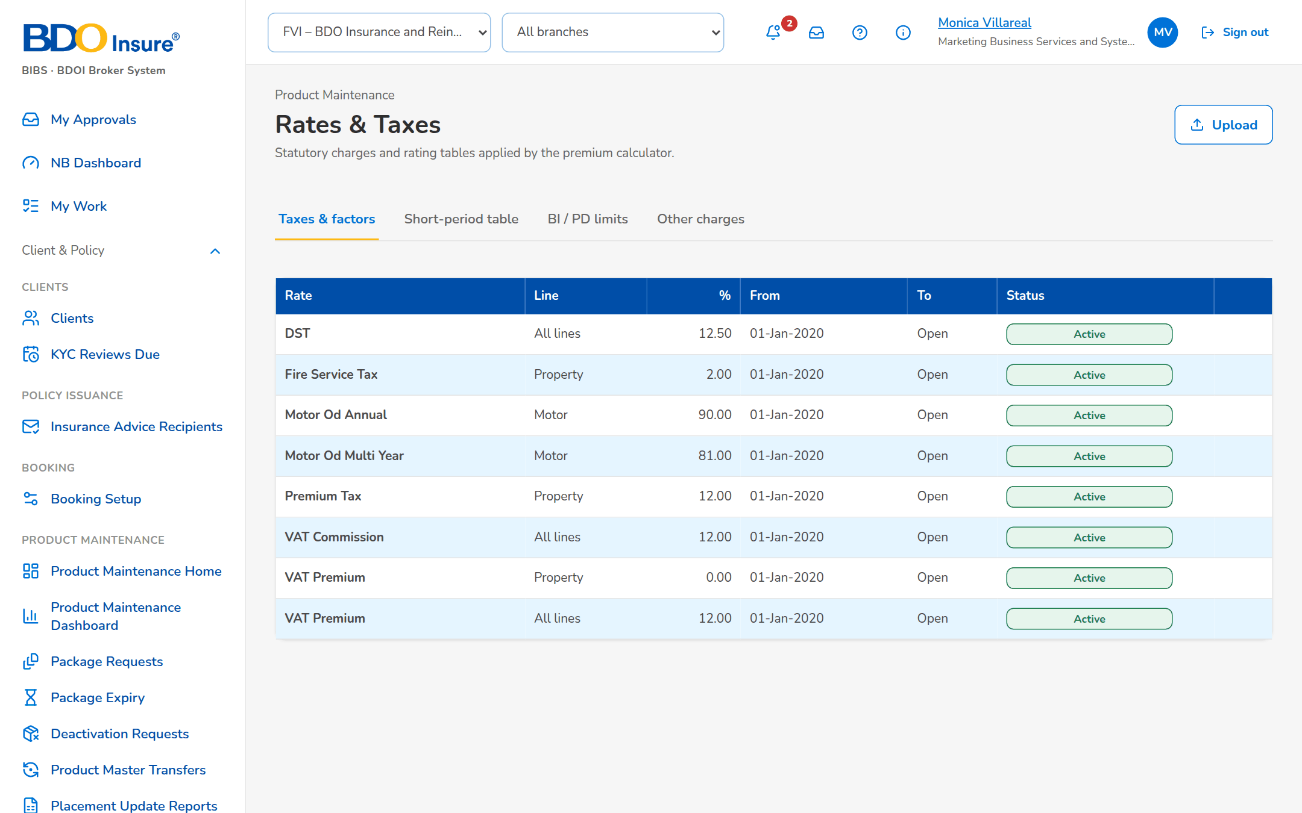
Figure 27: SCR-PM-19 Rates & Taxes

SCR-PM-20 Sales Organisation
Item | Value
Purpose | The sales organisation of the company as one tree table: regions, departments and teams with their cost centres, and the account officers of each team by name, role and assignment date. Accounts are stamped with the creator's units and cost centre when they are created.
Access | Sidebar entry Sales Organisation
Requirements | FRPM.002.01 (master used by New Business)

Rules and states:
• The sales organisation is a New Business master (BRD-1, sales hierarchy and production reporting) kept in the Product Maintenance section of the menu; it is loaded at go-live by the data migration.
• A unit is deactivated only when none of its sub-units and account officers is still active or pending; a unit is reactivated only under an active or pending parent, and waits for authorisation again.
• Deactivation, reactivation and removal from a team need a reason, kept on the record and in the audit trail with the user and time.
• A team without its own cost centre uses the cost centre of the nearest parent that has one.
Table 40: SCR-PM-20 fields
Field | Type | Req. | Format, list or source | Validation and message
Toolbar: Search unit code, name or officer | Text | N | Unit code or name, or the officer's name | Contains search; the matching branches open; No unit or officer matches the search
Toolbar: Expand All / Collapse All | Button | - | Opens or closes every branch | -
Toolbar: Show Inactive | Check box | N | Lists deactivated units and removed officers in grey | -
Toolbar: [Summary] | Text | - | n regions · n departments · n teams · n officers of the rows shown; Sales units and officers | -
Tree table: Unit | Column | - | Chevron and indentation per level; code in bold and name; an officer by full name with the role below; Sales units; users | No sales unit defined yet
Tree table: Level | Column | - | Region, Department, Team or Account Officer; Sales units | -
Tree table: Cost Center | Column | - | The unit's own cost centre, or the cost centre in force with Inherited from <parent code> below it; Sales units | -
Tree table: Account Officers | Column | - | Number of active officers of a team; Sales officers | -
Tree table: Assigned Since | Column | - | dd-MMM-yyyy, date the officer joined the team; Sales officers | -
Tree table: Status | Pill | - | Active, Pending Authorization, Inactive; Sales units and officers | -
Tree table: [Actions] | Menu | - | The actions of the row (see Actions) | -
New unit / Add sub-unit: Level | Drop-down | Y | Region, Department, Team; fixed to the level below when opened from a unit; Fixed list | A department belongs to a region; a team to a department; A <level> must belong to an active <parent level>
New unit / Add sub-unit: Code / Name | Text | Y | Unit code and name | Unique; Sales unit already exists: <key>
New unit / Add sub-unit: Cost Center | Text | N | Blank = inherited from the parent; Cost centres | A cost centre of the company
New unit / Add sub-unit: Parent | Drop-down | Cond.: department and team | Active units of the level above; Sales units | -
Unit details: Code, Name, Level, Parent Unit, Cost Center, Unit Head, Sub-units, Account Officers, Status, Status Reason, Created, Last Changed, Authorized | Detail | - | Names of users, dd-MMM-yyyy HH:mm; Sales units | -
Assign Account Officer / Reassign: Team | Drop-down | Y | Active teams; Sales units | An existing, active team; Team <team code> is unknown or inactive
Assign Account Officer / Reassign: Account Officer | Drop-down | Y | the system users by name and role; Users | An existing user; Unknown user <user>
Deactivate / Reactivate / Remove from Team: Reason | Text | Y | Why the unit or officer changes | Not blank; Enter the reason.

Table 41: SCR-PM-20 actions
Action | Who | Available when | What happens | Result
New Unit | master data maintainers | Always | Opens New unit; Save for Authorization | Pending Authorization
Assign Officer | master data maintainers | Always | Opens Assign Account Officer; Save for Authorization | Pending Authorization
View / Edit | Every user of the screen; Edit with master data maintainers | Unit row | Opens the unit details; Edit changes name, parent and cost centre, Save for Authorization | Pending Authorization
Add Department / Add Team | master data maintainers | Active region / department | Opens New unit at the level below, the parent filled | Pending Authorization
Assign Officer (row) | master data maintainers | Active team | Opens Assign Account Officer with the team filled | Pending Authorization
Authorize | authorizers, not the maker | Pending unit or officer | From the row action menu, after the confirmation: authorises the record | Active
Deactivate | master data maintainers | Active or pending unit without active sub-units or officers | Asks the reason and deactivates the unit; refused with a notice while sub-units or officers remain | Inactive
Reactivate | master data maintainers | Inactive unit whose parent is not inactive | Asks the reason; the unit waits for authorisation again | Pending Authorization
Reassign / Assign to a Team | master data maintainers | Officer row | Moves the officer to another team (or places a removed officer again) from today | Pending Authorization
Remove from Team | master data maintainers | Active or pending officer | Asks the reason and ends the officer's assignment | Inactive
Export to Excel | Every user of the screen | Always | Downloads the tree in tree order with the effective cost centres and the officers by name and role | -

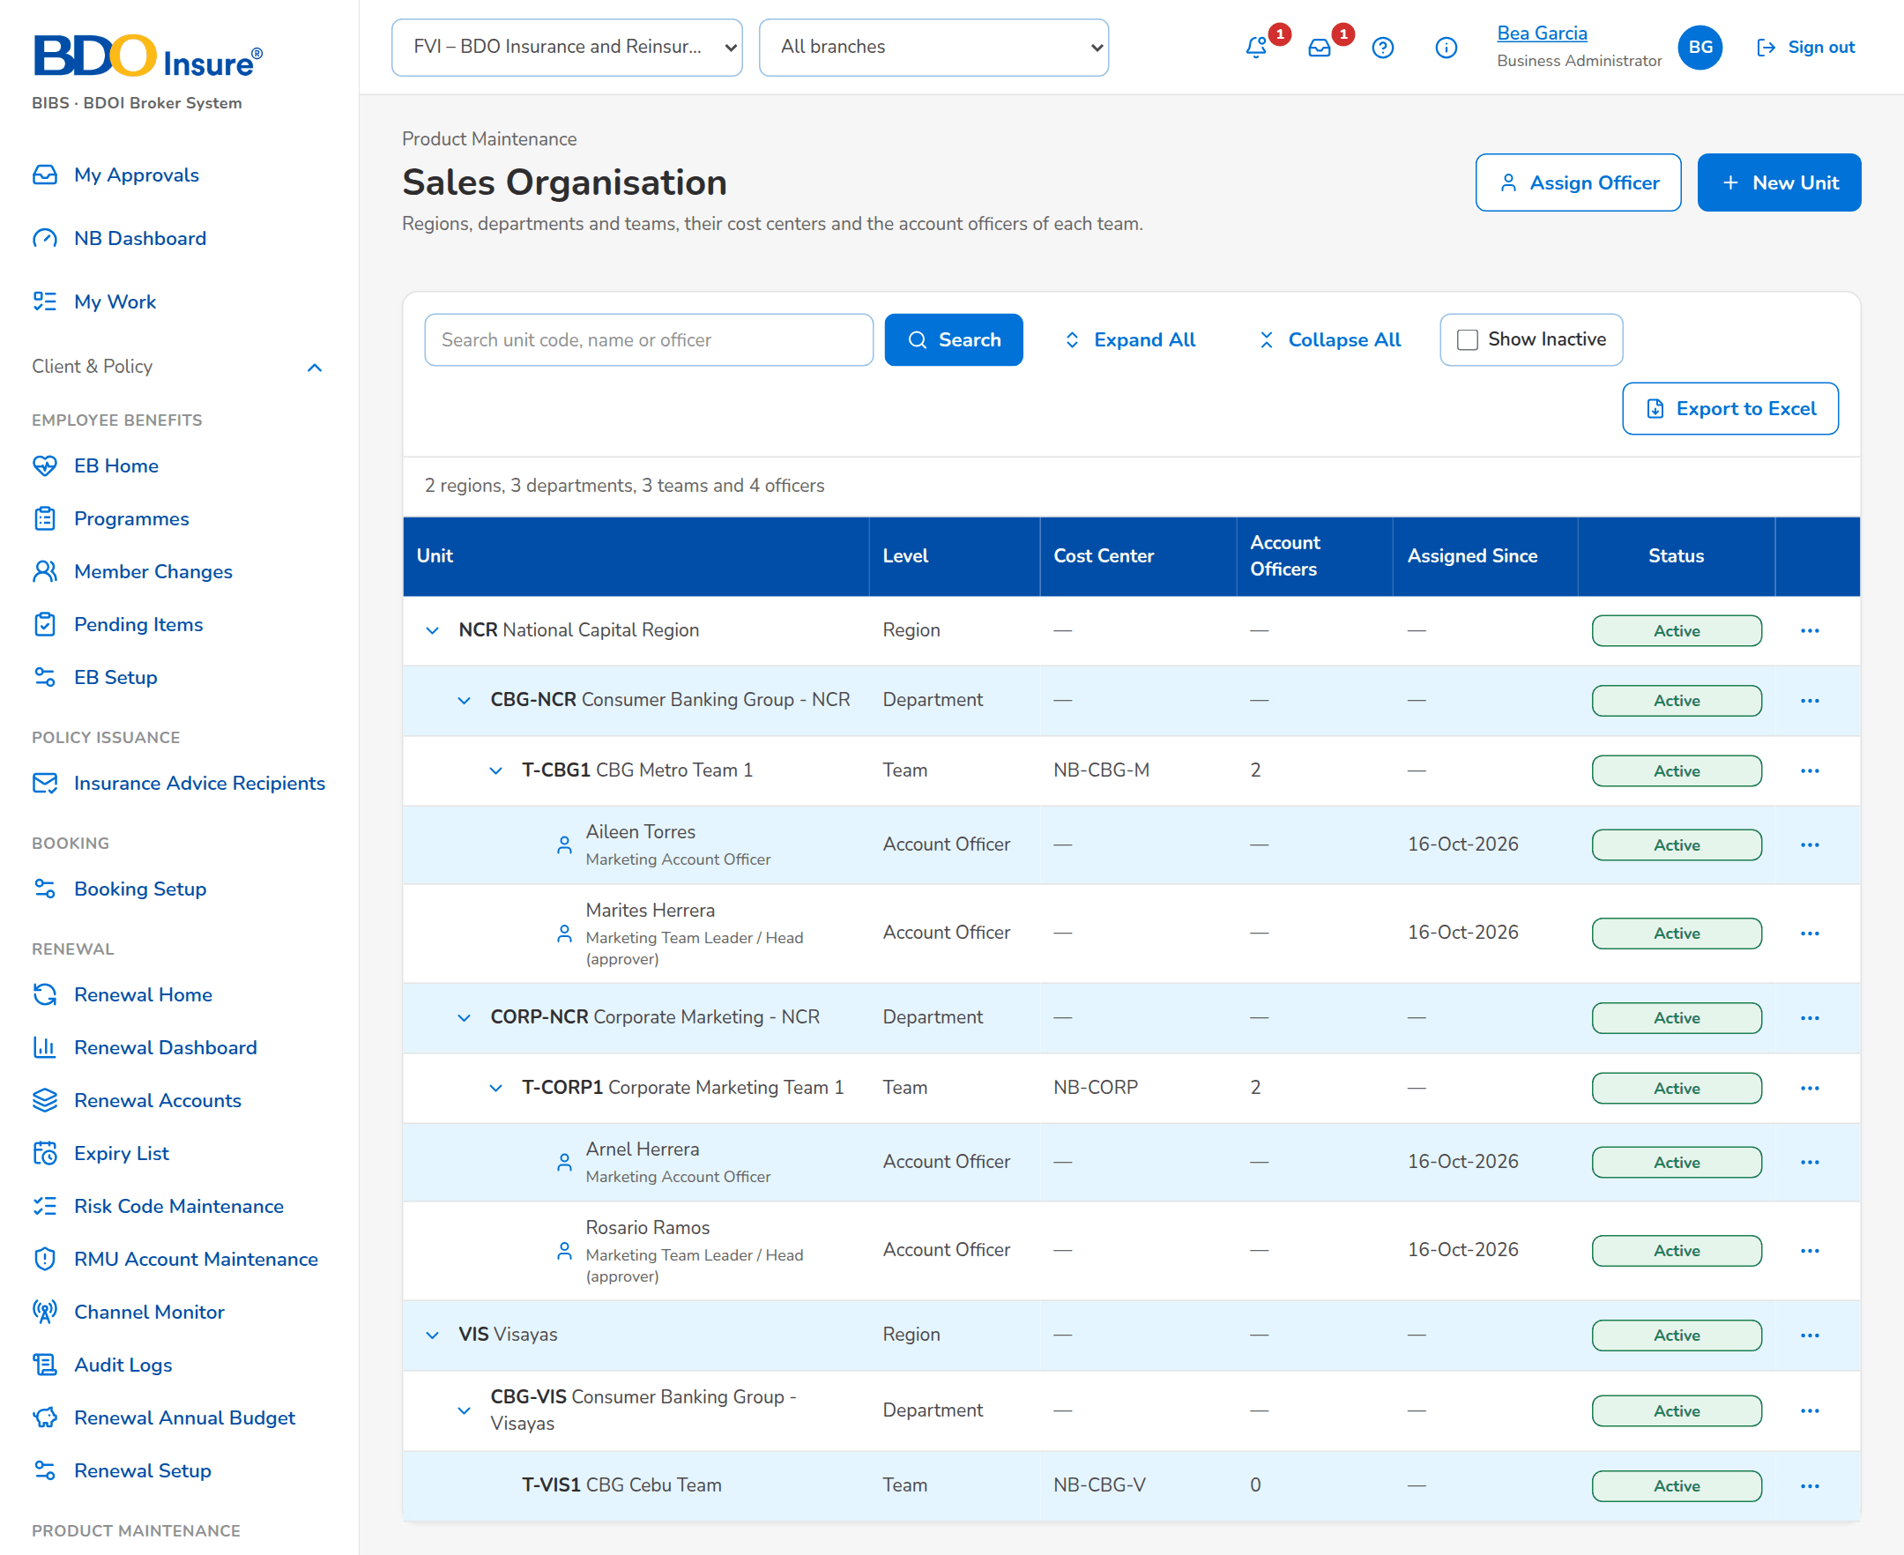
Figure 28: SCR-PM-20 Sales Organisation

SCR-PM-21 Premium Calculator
Item | Value
Purpose | Rates a product with the charges in force, for an insurer and branch, annual, pro-rata or short period, for a new account or an endorsement over the remaining term, and shows every charge and the commission. For a package it shows the version that priced it; an earlier released version can be chosen for information.
Access | Sidebar entry Premium Calculator
Requirements | FRPM.002.02, FRPM.003.01, FRPM.003.05, FRPM.024.02

Rules and states:
• New business is priced on the package version in force on the transaction date, not on the period start (FRPM.024.02).
• A version other than the one in force is shown for information only; a quotation needs the current version or an approved rate exception (FRPM.024.02).
• An item rate different from the scheme rate (or the panel insurer's rate) is priced but flagged; a quotation with it needs an approved rate exception (FRPM.024.02).
• An expired or retired package, or a package with no version in force, cannot be priced for new business (FRPM.002.02).
Table 42: SCR-PM-21 fields
Field | Type | Req. | Format, list or source | Validation and message
Cover: Product | Drop-down | Y | Code – name of the active products; Active products | Choose a product.
Cover: Insurer | Drop-down | N | Insurers of the panel; Insurers | A package with a panel accepts only its panel insurers; Insurer <insurer code> is not on the panel of <product code> version <version no>
Cover: Insurer branch (LGT) | Drop-down | N | Branch name (LGT %); Insurer branches | An authorised branch of the insurer; Branch <branch code> is not authorized or inactive
Cover: Period basis | Drop-down | N | Annual, Pro-rata (days), Short period (table); Fixed list | Pro-rata and short period need the period; Pro-rata and short-period rating need the period (for endorsements: the remaining term).
Cover: From / To | Date | Cond.: pro-rata or short period | dd-MMM-yyyy | To after From; The period end must be after the period start
Cover: Commission % override | Number | N | Percentage | -
Cover: Package version | Drop-down | N | Version in force, or an earlier released version; Released and superseded versions | Shown when the package has two or more sold versions
Cover: Endorsement (remaining term, may return premium) | Check box | N | - | Only an endorsement may reduce the sum insured; Only an endorsement may reduce the sum insured.
Cover: Multi-year own damage factor | Check box | N | Motor multi-year products | -
Items: Item / Sum insured | Text / Number | Y (a sum insured for at least one item) | Label; amount in PHP | Zero or more; Enter the sum insured of at least one item.
Items: Rate % | Number | N | Blank = product default (non-motor) | A rate other than the scheme rate is priced but flagged; Enter the premium rate of <item>
Items: Excess BI limit / PD limit | Number | N | Motor limits of the table; Motor limit table | A limit of the table; <coverage> limit <amount> is not in the limit table
Result: [Version line] | Banner | - | Priced on package version n (effective dd-MMM-yyyy, scheme rate r%); not the current version; an item rate differs from the scheme rate; Package version | -
Result: Sum insured / Net premium / Gross premium / Commission | Figure | - | Amounts in PHP; Premium computation | -
Result: Component / Basis / Amount | Table | - | Annual premium, net premium, documentary stamp tax, premium tax, VAT, fire service tax, local government tax, total charges, commission, VAT on commission; Premium computation | -

Table 43: SCR-PM-21 actions
Action | Who | Available when | What happens | Result
Add Item / Remove | Every user of the screen | Always | Adds or removes an item | -
Calculate | Every user of the screen | Product chosen and a sum insured entered | Rates the cover and shows the result | -

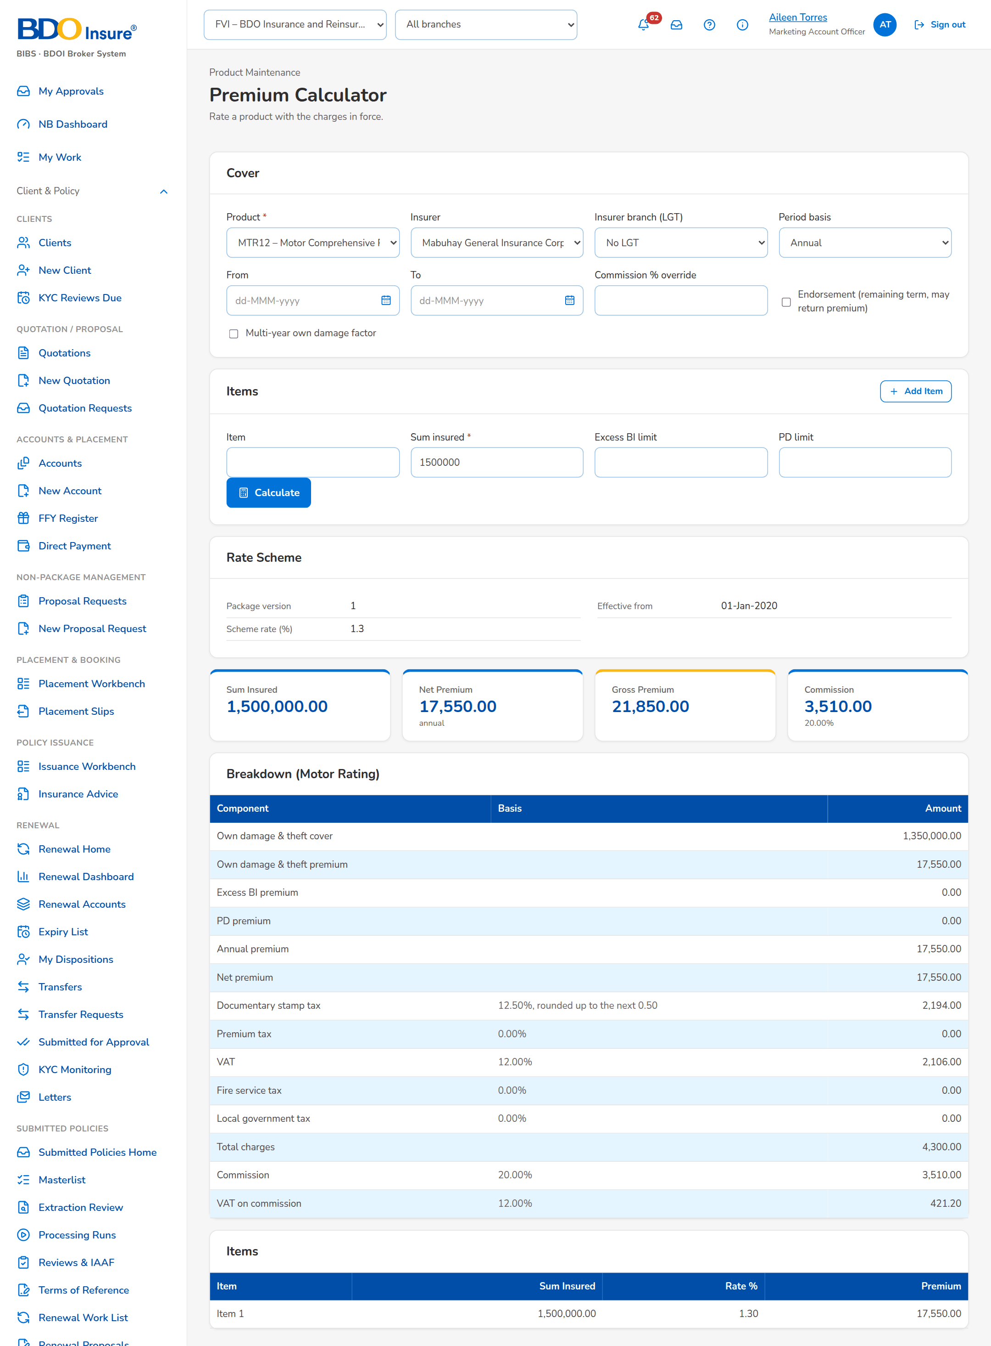
Figure 29: SCR-PM-21 Premium Calculator with a result

SCR-PM-22 Quotation: Package Rate Scheme and Rate Exception
Item | Value
Purpose | Where New Business meets the package version: the quotation record of a package product shows the version that priced it and warns when an item rate differs from the scheme rate. The Account Officer then requests a rate exception. The approver opens the exception record from My Approvals, compares the requested rate with the scheme in force and approves it with a comment or rejects it with a reason; the requester is notified and the quotation is submitted with the approved exception. Only the Rate Exceptions card, the Request Rate Exception dialog and the exception record are specified here; the rest of the quotation record is specified in the New Business set (SCR-NB-07).
Access | Quotations › a row (New Business); New Quotation › Submit for Review refused with the rate scheme message; My Approvals › the rate exception row (the exception record); Notification of the decision › the exception record
Requirements | FRPM.024.02

Rules and states:
• Only package rate schemes need an exception; an exception names the rate or the version it approves and the transaction (quotation number or ARN) (FRPM.024.02).
• An exception is approved or rejected by a holder of the product approval permission other than its requester; the requester sees the record without the Approve and Reject buttons (FRPM.024.02).
• A rejection needs its reason; the decision, its maker, date and comment or reason stay on the record and in the audit trail (FRPM.024.02).
• Submission of the quotation (and of the account) is refused until an approved exception covers the differing rate or version (FRPM.024.02).
• The approved exception is stored on the quotation and passed to the accounts created from it (FRPM.024.02).
Table 44: SCR-PM-22 fields
Field | Type | Req. | Format, list or source | Validation and message
Rate Exceptions card: [Pricing notice] | Notice | - | Priced on package version n. An item rate differs from the scheme rate, so submission needs an approved rate exception; Quotation pricing | Shown while an item rate differs; Package <product code> is priced on the current rate scheme: <what> needs an approved rate exception
Rate Exceptions card: [Rate exceptions table] | Table | - | One row per exception: Exception No. (opens the exception record), Requested Rate (%), Scheme Rate (%), Difference (%) in percentage points with its sign, Valid Until, Requested By and on, Decided By and on, Status (Pending Authorization, Approved or Rejected); Rate exceptions of the quotation | -
Request Rate Exception: Item rate % | Number | Y | 0 to 100 | 0 to 100; Enter the item rate between 0 and 100
Request Rate Exception: Valid until | Date | N | dd-MMM-yyyy | Not in the past; The validity date cannot be in the past
Request Rate Exception: Reason | Text | Y | Free text | Not blank; Explain why the scheme rate cannot be used
Exception record: Package | Fact | - | Risk code – package name; Product master | -
Exception record: Requested rate | Fact | - | Rate n.nn% (or the version requested); Exception | -
Exception record: Scheme in force | Fact | - | Version n, rate n.nn% (or rate per insurer); Package version in force today | -
Exception record: Quotation | Fact | - | Quotation number (opens the quotation), client and gross premium; Quotation | -
Exception record: Requested by | Fact | - | Display name and date and time of the request; Exception | -
Exception record: Reason for the exception | Text | - | As requested; Exception | -
Exception record: Decision | Detail | - | Approved by or Rejected by (display name and role), On, Comment or Reason; Exception | -
Approve Rate Exception: Comment | Text | N | Free text, up to 1,000 characters | -
Reject Rate Exception: Reason for the rejection | Text | Y | Free text, up to 1,000 characters | Not blank; Enter the reason for the rejection

Table 45: SCR-PM-22 actions
Action | Who | Available when | What happens | Result
Request Rate Exception | Marketing | Draft quotation of a package with an item rate that differs | Opens the dialog; Request Exception records the exception for this quotation, pending approval | Pending Authorization
[Open from My Approvals] | Business Administrator, New Business Approver | Exception pending | The rate exception row of My Approvals opens the exception record | -
Approve | Business Administrator, New Business Approver, not the requester | Exception pending | Opens the confirmation with an optional comment; Approve approves the exception, which prices the quotation from then on | Approved
Reject | Business Administrator, New Business Approver, not the requester | Exception pending | Opens the confirmation; the reason is required; Reject rejects the exception, which can no longer be used | Rejected

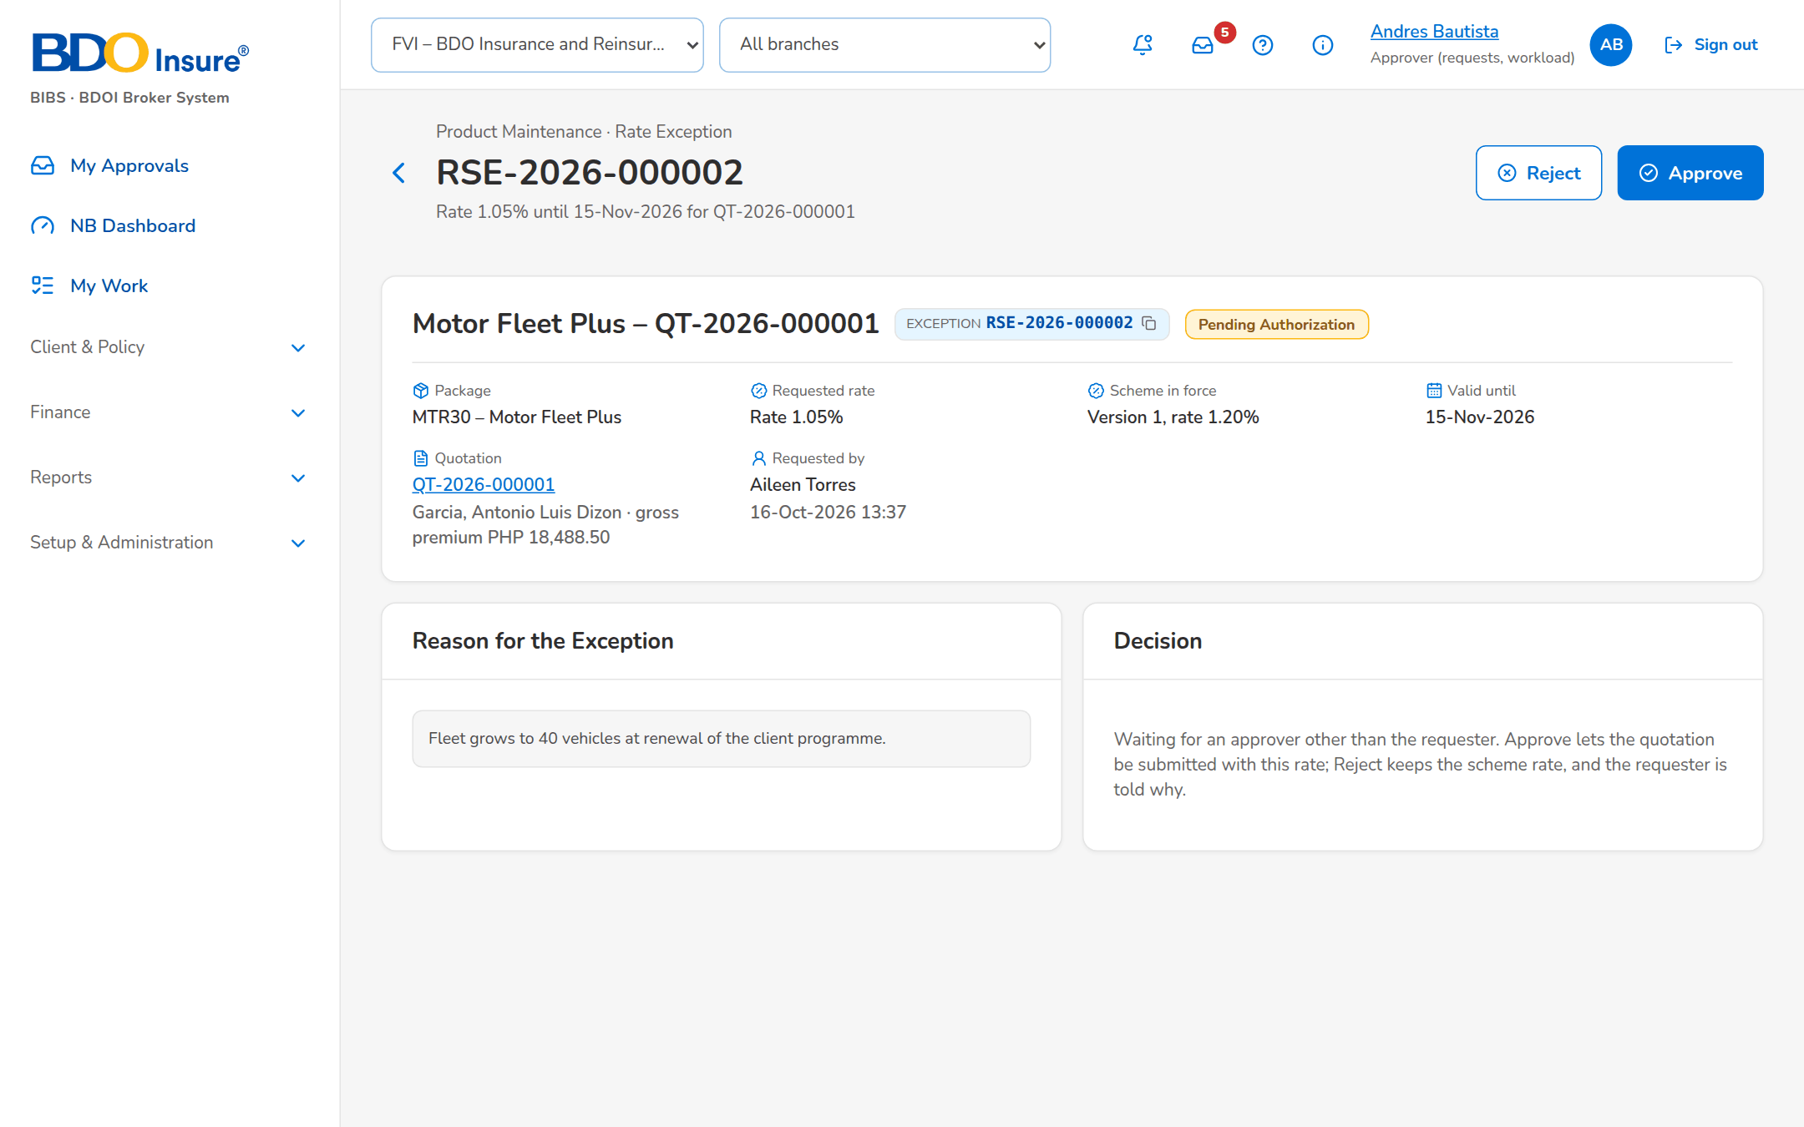
Figure 30: SCR-PM-22 Rate exception for approval

SCR-PM-23 Product Maintenance Dashboard
Item | Value
Purpose | The figures of Product Maintenance for a period: incoming, in-progress, for-approval, expiring, issued and deactivation figures, each opening its list of requests with the request type, line, requester, assigned TSU officer, status, submission date and aging; the package requests by stage with the overdue ones; the packages ending within 30, 60 and 90 days; and the shortcuts to the versions for validation, the advisories not sent and the comparative outputs of the week. Exported to Excel, PDF and CSV.
Access | Product Maintenance › Product Maintenance Dashboard
Requirements | FRPM.001.01, FRPM.002.01, FRPM.002.02, FRPM.003.07, FRPM.007.02, FRPM.015.01, FRPM.019.01, FRPM.019.02, FRPM.019.03, FRPM.020.01, FRPM.028.01

Rules and states:
• The figures are those of the company selected in the page header and of the filters (FRPM.001.01).
• A request is overdue when its stage due time has passed; the due time comes from the service level hours of the stage (FRPM.001.01).
Table 46: SCR-PM-23 fields
Field | Type | Req. | Format, list or source | Validation and message
Filters: Period From / Period To | Date | N | dd-MMM-yyyy | To on or after From; The end date must be on or after the start date
Filters: TSU Officer / Product Line / Package Type | Look-up; drop-downs | N | Names of the TSU officers; lines; Package, Non-Package; Users; product lines; fixed list | -
Key Figures: Incoming Requests / In-Progress Requests / For Approval / Expiring Packages / Issued Proposals / Deactivation Requests | Tile | - | Count of the period; the chosen tile opens its list below; Package and quotation requests, package versions, deactivation requests | -
[List of the chosen figure]: Request Number / Request Type / Product Line / Requested By / Assigned TSU Officer / Current Status / Submission Date / Aging | Columns | - | PKR or PRF number; type; line; names; status; dd-MMM-yyyy; working days; Requests | -
Package requests by stage: Drafts / For Approval / TSU Review / Negotiation / ManCom / With MBS / For Validation / Released | Tile | - | Count of requests; '· n Overdue' and Needs attention when a request of the tile is past its due time; Package requests | -
Packages ending soon: Within 30 Days / Within 60 Days / Within 90 Days | Tile | - | Count of released packages whose end date falls in the window; Package versions in force | -
Shortcuts: Versions for validation / Advisories pending / Comparative outputs this week / Package Expiry | Tile | - | 'n set up by MBS, waiting for the checkpoint'; 'n drafted, not sent yet'; 'n master and client outputs generated'; Requests, advisories, outputs | -

Table 47: SCR-PM-23 actions
Action | Who | Available when | What happens | Result
Excel / PDF / CSV | Every user of the screen | Always | Exports the figures and the list on screen, named by the convention <name>_MMDDYYYY | -
[A key figure] | Every user of the screen | Always | Shows the list of the figure under the tiles | -
[A stage or expiry tile] | Every user of the screen | Always | Opens Package Requests on the tab of the tile, or Package Expiry with the window | -

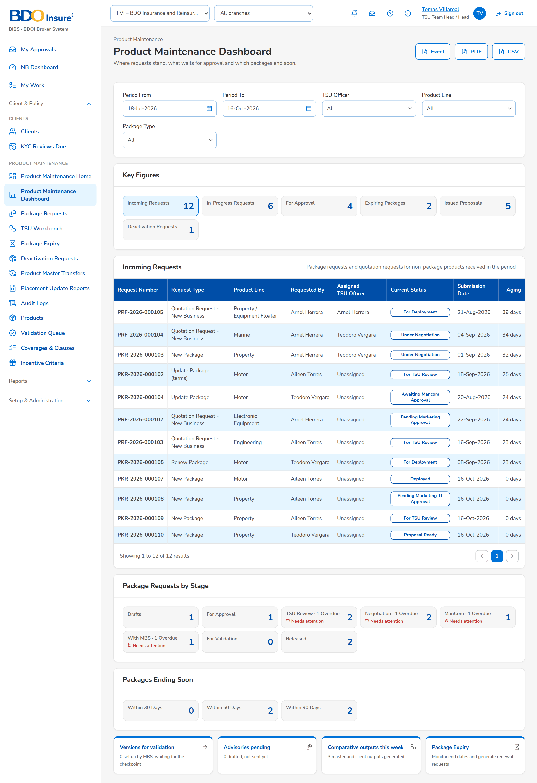
Figure 31: SCR-PM-23 Product Maintenance Dashboard

SCR-PM-24 Deactivation Requests
Item | Value
Purpose | The requests to deactivate a package with an effective date: the list with the approval status and the new expiry date, the request with its details, supporting documents and audit log, and the decision of the approver (approve or reject with remarks); the Deactivate Package dialog of the product record raises the request.
Access | Product Maintenance › Deactivation Requests; Products › a package › Deactivate Package; The notice <request no>: deactivation of <risk code> for your approval
Requirements | FRPM.003.04, FRPM.003.06, FRPM.003.07, FRPM.021.01, FRPM.021.02, FRPM.029.01

Rules and states:
• By default (setting Package deactivation route: effective-dated) a package is deactivated through this request; the earlier retirement through a package request stays available by the setting (FRPM.003.04).
• The approver never approves his own request; every decision and every change of the request is in its audit log (FRPM.003.04, FRPM.021.01).
• On the effective date the daily run sets the package to expired, it is no longer offered for new business and the change is sent to the receiving systems (FRPM.003.04, FRPM.029.01).
Table 48: SCR-PM-24 fields
Field | Type | Req. | Format, list or source | Validation and message
List: Search Request Number or Package | Text | N | Part of the number or the package name | -
List: Approval Status / Requested From / Requested To | Drop-down; dates | N | Pending Approval, Approved, Rejected, Cancelled; dd-MMM-yyyy; Fixed list | -
List: Request Number / Package Name / Deactivation Effective Date / Approval Status | Columns | - | PKD-yyyy-nnnnnn; name with the risk code; dd-MMM-yyyy; status; Deactivation requests | -
List: Requested By / Request Date / Package Expiry Date | Columns | - | Name; dd-MMM-yyyy; the new expiry date once approved; Deactivation requests | -
Deactivate Package: Package / Expiry Date | Values | - | Name and risk code; current expiry date or None; Product | -
Deactivate Package: Deactivation Effective Date | Date | Y | dd-MMM-yyyy | Today or later; Enter the deactivation effective date; The deactivation effective date must be today or later
Deactivate Package: Reason for Deactivation | Drop-down | Y | Insurer withdrew the terms, Replaced by another package, Loss experience, Low uptake, Regulatory change, Others (see remarks); List of values | Select the reason for deactivation
Deactivate Package: Approver | Look-up | Y | Users with the deactivation approval right; Users | Select the approver
Deactivate Package: Remarks / Supporting Documents | Text area; files | N | Up to 1,000 characters; documents named PKD-yyyy-nnnnnn_TYPE_n | File checks of every upload
Deactivation Request: Request Number / Package / Deactivation Effective Date / Approval Status / Reason / Remarks / Requested By / Request Date / Approver / Package Expiry Date / Approval Remarks / Approval Date and Time / New Expiry Date | Values | - | As recorded; Deactivation request | -
Deactivation Request: Approval Remarks | Text area | Cond.: rejection | Up to 1,000 characters | Mandatory to reject; Enter the approval remarks of the rejection
Deactivation Request: Reassign To | Look-up | Cond.: reassignment | Approvers other than the current one; Users | Select the new approver

Table 49: SCR-PM-24 actions
Action | Who | Available when | What happens | Result
Deactivate Package | MBS (product maintenance right) | Active package without a deactivation waiting | Opens the dialog | -
Submit for Approval | The requester | Fields complete | Records the request PKD-yyyy-nnnnnn and sends it to the approver | Pending Approval
View Details | Every user of the screen | Always | Opens the request | -
Approve | The approver named on the request | Pending Approval | Approves; the package expires on the effective date (daily run) and the change goes to the product master transfer | Approved
Reject | The approver named on the request | Pending Approval; approval remarks entered | Rejects; the package stays active | Rejected
Reassign | A team head (work assignment or TSU Head approval right) | Pending Approval | Gives the request to another approver | Pending Approval
Withdraw | The requester | Pending Approval | Withdraws the request | Cancelled

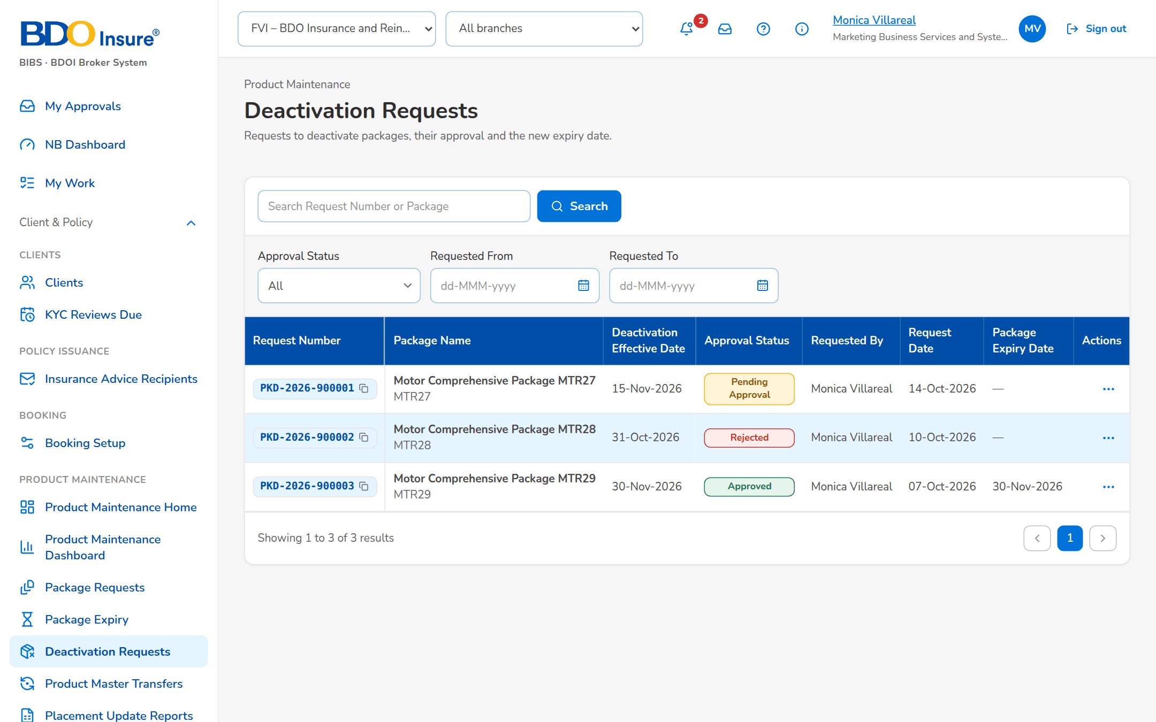
Figure 32: SCR-PM-24 Deactivation Requests
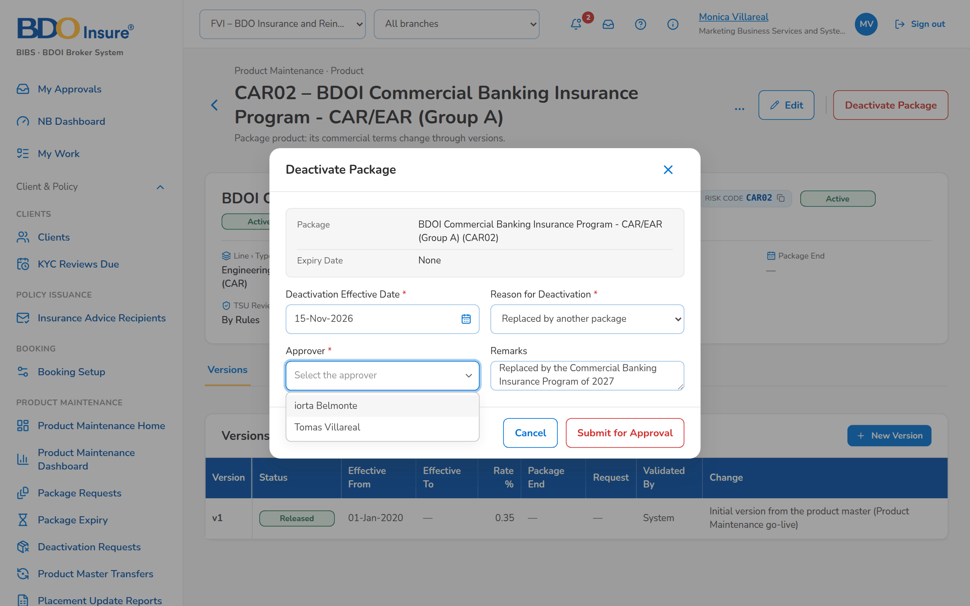
Figure 33: SCR-PM-24 Deactivate Package dialog

SCR-PM-25 Product Master Transfers
Item | Value
Purpose | The product master changes (new, updated, deactivated or expired packages) sent to the other systems of the bank: every change with its package, version, effective date, request, status, file and time sent, the error of a failed transfer and Send Now.
Access | Product Maintenance › Product Master Transfers
Requirements | FRPM.029.01

Rules and states:
• Every approved change of the Product Matrix, every deactivation and every expiry is queued for the receiving systems and sent by the scheduled transfer or Send Now (FRPM.029.01).
• The folder of the receiving systems is set with the details of BDOI IT before SIT; until then the transfer fails with an alert (FRPM.029.01).
Table 50: SCR-PM-25 fields
Field | Type | Req. | Format, list or source | Validation and message
Receiving System: Receiving System / Connected / Waiting / Failed | Values | - | Name of the receiving system; Yes or No; counts; Transfer settings | -
Changes: All / Waiting / Failed / Sent | Tab | N | Status filter; Fixed list | -
Changes: Package / Version / Change / Effective Date / Request | Columns | - | Risk code; version; Package added, updated, deactivated or expired; dd-MMM-yyyy; request number; Product master changes | -
Changes: Status / File / Sent / Error | Columns | - | Waiting, Sent, Failed; ProductMaster_yyyyMMddHHmmss.csv; dd-MMM-yyyy HH:mm; reason of a failure; Product master changes | -

Table 51: SCR-PM-25 actions
Action | Who | Available when | What happens | Result
Send Now | MBS (product maintenance right) | Changes waiting or failed | Writes the waiting changes to the transfer file now instead of at the next scheduled run | Sent or Failed

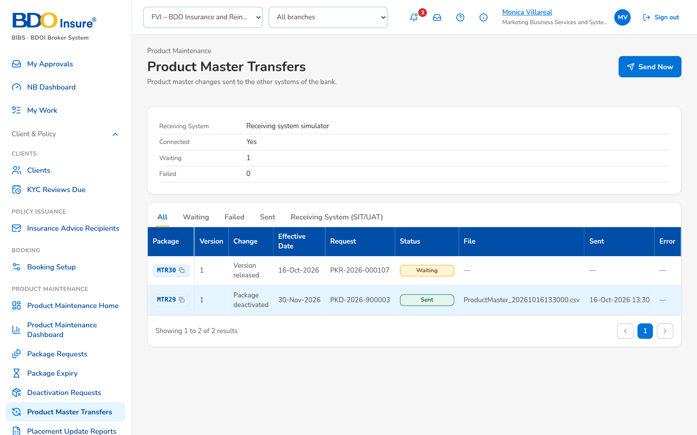
Figure 34: SCR-PM-25 Product Master Transfers

SCR-PM-26 Placement Update Reports
Item | Value
Purpose | The Consolidated Placement Update Report of the quotation requests: its schedule (every Thursday at 08:00 for the last 7 days by default), the scope, Generate Now, the Report Builder and the repository of every report generated, with preview and download.
Access | Product Maintenance › Placement Update Reports; The notice PlacementUpdate_<MMDDYYYY>.xlsx generated
Requirements | FRPM.007.02, FRPM.019.01, FRPM.019.02, FRPM.019.03, FRPM.020.01

Rules and states:
• The day, time, period and scope of the scheduled report are settings (Thursday, 08:00, 7 days, quotation requests by default) (FRPM.019.01).
• Every report generated is kept in the repository with who generated it and when (FRPM.019.01, FRPM.021.01).
Table 52: SCR-PM-26 fields
Field | Type | Req. | Format, list or source | Validation and message
Schedule: Schedule / Next Run / Scope | Values | - | Weekday, time and reporting period; dd-MMM-yyyy HH:mm; Quotation requests, or Quotation and package requests; Settings of the report | -
Repository: File Name / Report Date / Reporting Period | Columns | - | PlacementUpdate_MMDDYYYY.xlsx; dd-MMM-yyyy; from – to; Placement reports | No Placement Update Report has been generated yet
Repository: Generated Date/Time / Generated By / Run / Records | Columns | - | dd-MMM-yyyy HH:mm; name or System; Scheduled or On request; count; Placement reports | -

Table 53: SCR-PM-26 actions
Action | Who | Available when | What happens | Result
Generate Now | Users of the Product Maintenance reports | Always | Generates the report for the period ending today and stores it in the repository | -
Report Builder | Users of the Product Maintenance reports | Always | Opens the report builder of the Product Maintenance reports (columns, filters, sort) | -
Preview / Download | Users of the Product Maintenance reports | A report of the repository | Shows the report on screen, or downloads the Excel file | -

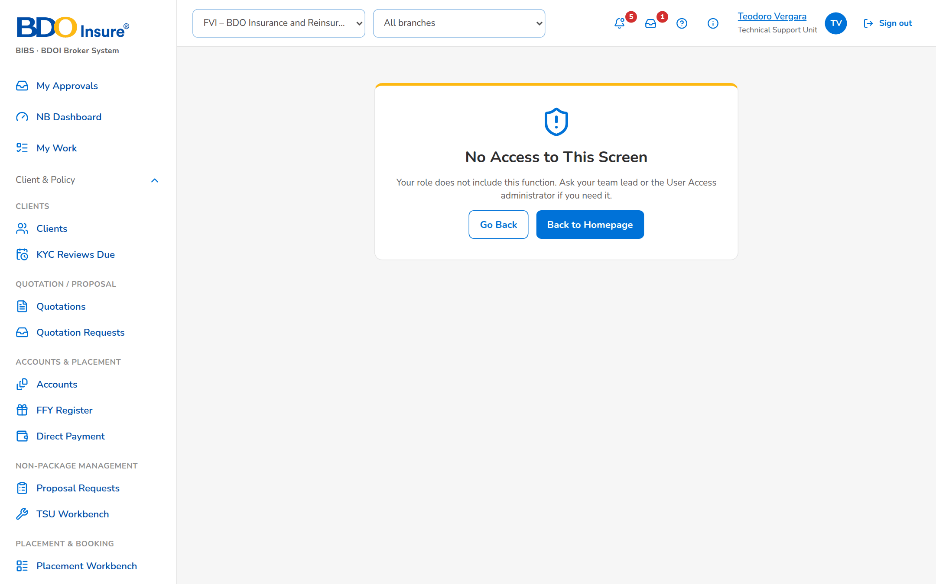
Figure 35: SCR-PM-26 Placement Update Reports

SCR-PM-27 Audit Logs
Item | Value
Purpose | Who changed packages, products and requests, and when: every action of Product Maintenance with the module, reference number, client or assured, action type, description, old and new value, the user and the remarks, with filters and the CSV and Excel exports named Audit Logs_MMDDYYYY.
Access | Product Maintenance › Audit Logs
Requirements | FRPM.021.01, FRPM.021.02

Rules and states:
• No user can change or delete an audit record (FRPM.021.01).
Table 54: SCR-PM-27 fields
Field | Type | Req. | Format, list or source | Validation and message
Filters: From / To | Date | N | dd-MMM-yyyy | To on or after From; The end date must be on or after the start date
Filters: Action Type / Reference Number / User | Drop-down; text; look-up | N | Action types; part of the number; name; Fixed list; users | -
List: Timestamp / Module / Reference Number / Client/Assured's Name | Columns | - | dd-MMM-yyyy HH:mm; Product Maintenance area; request, package or product number; name; Audit trail | No activity for these filters.
List: Action Type / Description / Old Value / New Value / Performed By / Remarks | Columns | - | Action; what changed; values before and after; name; remarks; Audit trail | -

Table 55: SCR-PM-27 actions
Action | Who | Available when | What happens | Result
CSV / Excel | Every user of the screen | Always | Downloads the audit log of the filters on screen, named Audit Logs_MMDDYYYY | -

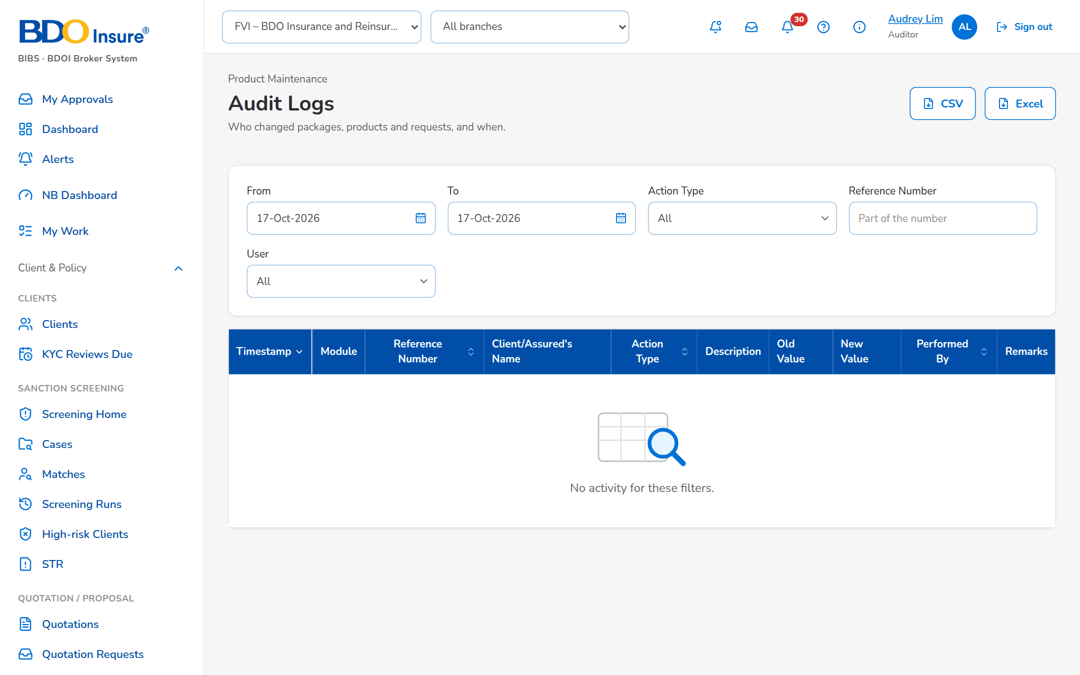
Figure 36: SCR-PM-27 Audit Logs (Auditor)
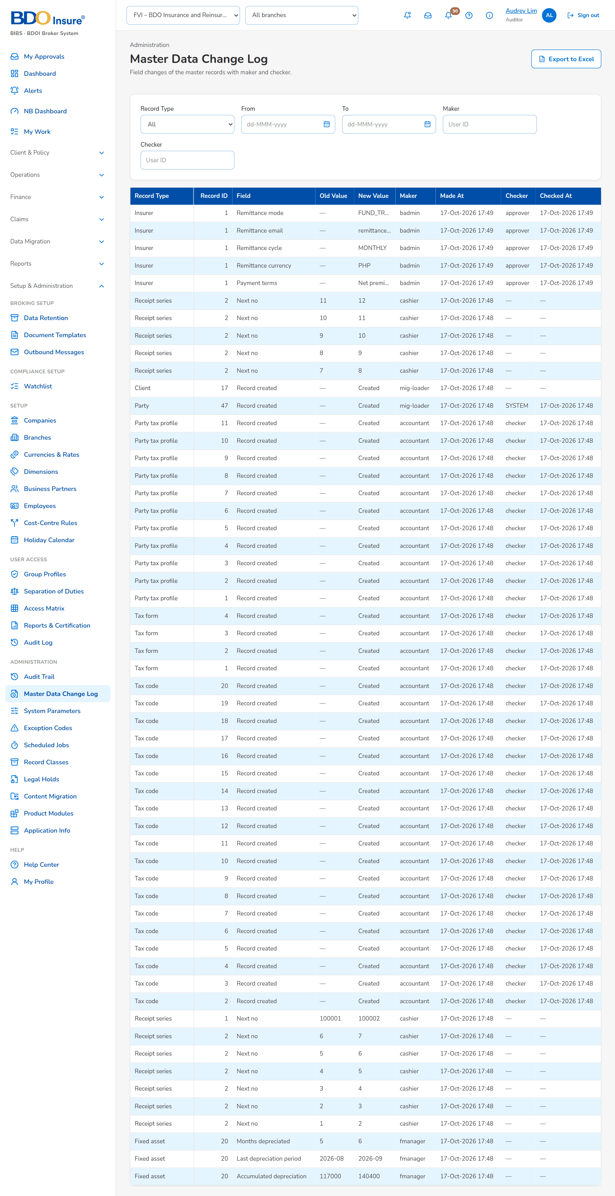
Figure 37: SCR-PM-27 Master Data Change Log (Auditor)

SCR-PM-28 Proposal Request: Comparative Table, Proposal Slips and Client Response
Item | Value
Purpose | The quotation request of a non-package product (proposal request PRF-yyyy-nnnnnn), as TSU and Marketing see it on the Comparative Table and Proposal Slip tabs: the insurer responses, the comparative table with the value of the quotation slip, every option of each insurer and the Final Terms for Proposal, the insurers chosen for the proposal, the proposal slip generated per insurer, and the client response recorded by Marketing.
Access | Product Maintenance Home › Quotation Request List › View Quotation Request; Proposal request › Comparative Table, Proposal Slip
Requirements | FRPM.012.02, FRPM.012.04, FRPM.013.01, FRPM.013.02

Rules and states:
• The final terms are keyed by TSU in the table; every change is kept with the previous and new value (FRPM.013.01).
• A proposal slip is generated for each insurer selected by the requestor, numbered by version (FRPM.012.04, FRPM.025.01).
• The client response is recorded once the proposal is sent to the client; a returned proposal goes back to TSU for revision (FRPM.013.02).
Table 56: SCR-PM-28 fields
Field | Type | Req. | Format, list or source | Validation and message
Comparative Table: Field / QS Value | Rows | - | Coverage, Sum Insured, Period of Insurance, Premium, Premium Rate (%), Commission Rate (%), Deductibles, Terms and Conditions, Warranties, Clauses, Extensions of Cover, Other Quotation Details; the value of the quotation slip; Quotation slip | -
Comparative Table: [Insurer – Option n] | Column | - | Response (Approved, Not Covered, Others) and the values of the option; Insurer responses and options | -
Comparative Table: Final Terms for Proposal | Column | Cond.: before Proceed to Proposal | Value of each field for the proposal | -
Option: Insurer Response | Drop-down | Y | Approved, Not Covered, Others; Fixed list | -
Option: Insurer's Response | Text | Cond.: Others | The actual response of the insurer | Mandatory for Others; Specify the insurer's actual response for Others
Choose Comparison Fields: [Field check boxes] | Check boxes | Y (at least one) | Fields shown in the table and to the client; Comparison fields | -
Final Terms History: Field / Previous Value / New Value / Changed By / Changed On | Table | - | Every change of a final term; Final terms history | -
Insurers for the Proposal: [Insurer check boxes] | Check boxes | Y (at least one) | Insurers that gave terms; Insurer responses | An insurer of the request; <insurer> is not an insurer of this request
Proposal Slips: Insurer / Version / File Name / Generated By / Generated On | Table | - | One proposal slip per selected insurer, by version; Proposal files | No proposal has been generated yet
Client Response: Response / Response Date / Client Remarks / Recorded By / Recorded On | Table | - | Accepted, Rejected or Returned; dd-MMM-yyyy; remarks; name; date and time; Client responses | No client response recorded yet
Record Client Response: Client Response / Response Date / Client Remarks | Drop-down; date; text | Y (response) | Accepted, Rejected, Returned; Fixed list | -

Table 57: SCR-PM-28 actions
Action | Who | Available when | What happens | Result
Edit / Add Option | TSU (negotiation right) | Terms received | Keys the response and values of an insurer, or a further option of the same insurer | -
Choose Fields / Final Terms History / Excel / PDF | TSU and Marketing | Always | Chooses the fields shown; shows the changes of the final terms; exports the table | -
Proceed to Proposal | The requestor (Marketing) or TSU | Terms received; at least one insurer selected | Records the insurers chosen; the TSU officer who prepared the quotation slip is told to generate the proposal | Terms agreed
[Generate proposal] | TSU (negotiation right) | Terms agreed | Generates one proposal slip per selected insurer (PDF), listed under Proposal Slips | Proposal slip for approval
Record Client Response | Marketing | Sent to Client | Records Accepted, Rejected or Returned with the date and remarks; Returned sends the request back to TSU for revision | Accepted, Rejected or Terms received

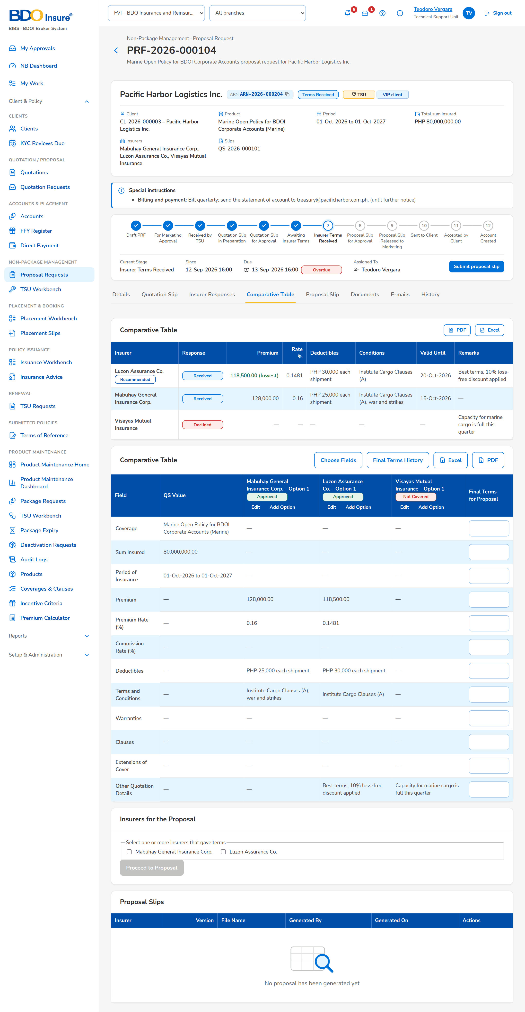
Figure 38: SCR-PM-28 Proposal request, Comparative Table tab

SCR-PM-29 Package Request Record: Routing & Approvals Tab
Item | Value
Purpose | The routing of a package request as BDOI's FRS sets it: the source and package details of the request form, the Marketing approvals by level, the ManCom approval with the selected approvers and the President last, and the package deployment request that forwards the approved package to MBS.
Access | Package Request record › Routing & Approvals
Requirements | FRPM.011.02, FRPM.014.01, FRPM.015.01, FRPM.016.01, FRPM.016.02

Rules and states:
• The Marketing chain is a setting: one approval by the Team Leader, Team Head or Unit Head (by default), or the three in order (BDOI's FRS) (FRPM.011.02).
• The ManCom routing is a setting: the selected approvers in parallel, then the President (by default, BDOI's FRS), or one sign-off by any member (FRPM.014.01).
• The forwarding to MBS is a setting: automatic at the ManCom approval (by default) or by the Request for Deployment button (FRPM.014.01, FRPM.016.01).
Table 58: SCR-PM-29 fields
Field | Type | Req. | Format, list or source | Validation and message
Source and Package Details: Source / Business Origin / Account Officer / Unit Head / Insured's Name / Estimated No. of Policies / Estimated Total Basic Premium / Type of Cover / Description of Cover / Cover / Undertaking / Extensions of Cover / Warranties, Clauses / Other Instructions / Maximum Limit/s / Premium / Incentive Eligible / Incentive Amount / Incentive Commission Rate | Values | - | As entered on the request form; Package request | -
Marketing Approvals: [Chain] | Text | - | One approval by the Team Leader, Team Head or Unit Head; or Team Leader, then Team Head, then Unit Head; Setting of the Marketing chain | -
Marketing Approvals: Level / Approver / Decision / Remarks / Approved | Columns | - | Marketing Team Leader, Team Head or Unit Head; name; decision; remarks; dd-MMM-yyyy HH:mm; Marketing approvals | No Marketing approval yet.
ManCom Approval: Select ManCom Approvers | Check boxes | Y (at least one) | ManCom members; the President marked (President, approves last); ManCom members | -
ManCom Approval: Round / Approver / Approval Progress / Remarks / Decided | Columns | - | Round; name; Pending Approval, Waiting for the others, Approved, Returned for Revision, Rejected; remarks; date and time; ManCom approvals | No ManCom approvers selected yet.
ManCom Approval: Remarks | Text area | Cond.: return or rejection | Up to 1,000 characters | Enter the remarks of the rejection or the return
Package Deployment Request: Forwarding to MBS / Deployment Request Number / Requested / Requested By | Values | - | Automatic or By the Request for Deployment button; PDR-yyyy-nnnnnn; date and time; name; Deployment request | -

Table 59: SCR-PM-29 actions
Action | Who | Available when | What happens | Result
Send for ManCom Approval | TSU (negotiation or TSU Head approval right) | For ManCom sign-off; at least one approver selected | Sends the request to the selected ManCom approvers at once, the President after the others | For ManCom sign-off
Approve / Return for Revision / Reject | The selected ManCom approver | His approval pending | Records the decision; a return or rejection needs remarks | Approved, returned or rejected
Request for Deployment | TSU | ManCom approved; forwarding by the button | Raises the deployment request PDR-yyyy-nnnnnn and forwards the package to MBS for set-up | With MBS for set-up

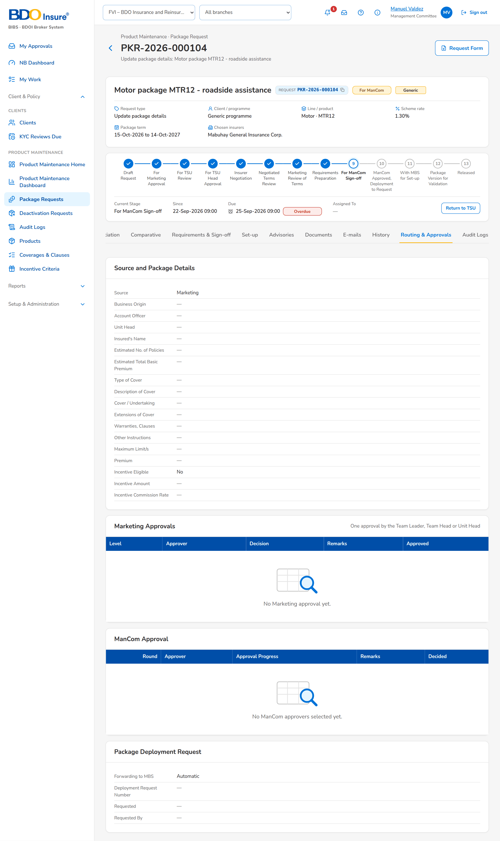
Figure 39: SCR-PM-29 Routing & Approvals tab (ManCom member)

